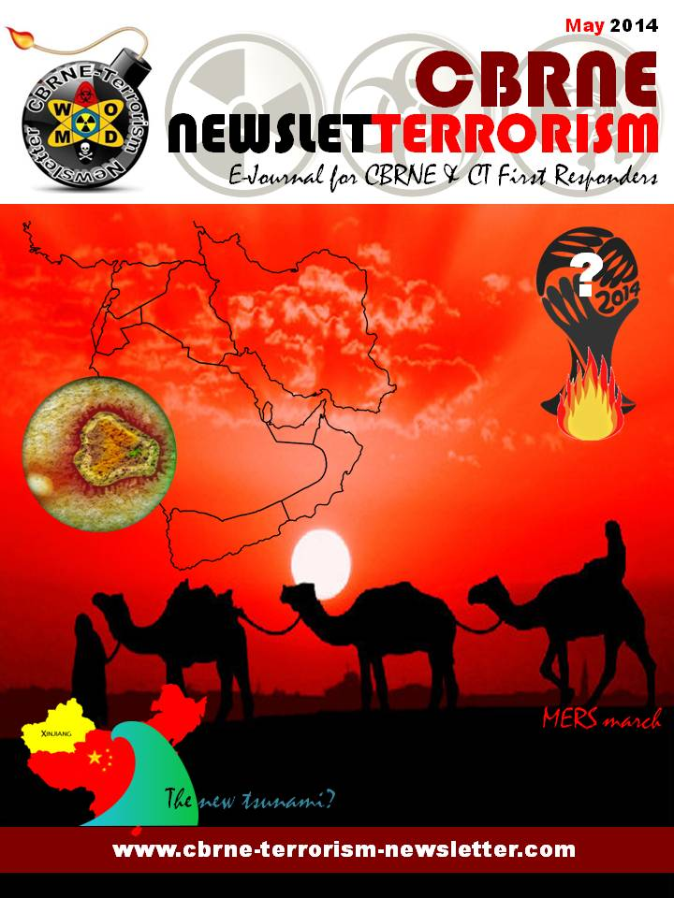
CBRNE-Terrorism Newsletter – 2014©
May 2014

Website: www.cbrne-terrorism-newsletter.com

Editor-in-Chief
BG (ret) Ioannis Galatas MD, MA, MC
PhD cand
Consultant in Allergy & Clinical Immunology
Medical/Hospital CBRNE Planner
Senior Asymmetric Threats Analyst
CBRN Scientific Coordinator @ RIEAS
Athens, Greece

Contact e-mail: igalatas@yahoo.com

Assistant Editor
Panagiotis Stavrakakis MEng, PhD, MBA, MSc
Hellenic Navy Capt (ret)
Athens, Greece

Co-Editors/Text Supervisors
- Steve Photiou, MD, MSc (Italy)
- Dr. Sarafis Pavlos, Captain RN(ret’d), PhD, MSc (Greece)
- Kiourktsoglou George, BSc, Dipl, MSc, MBA, PhD (cand) (UK)

Advertise with us! (New price list)
CBRNE-Terrorism Newsletter is published on-line monthly and distributed free of charge. Starting from 2014 issue all advertisements will be charged as following:
Full page (A4) 100€
Double pages (A4X2) 200€

EDITOR
Mendor Editions S.A.
3 Selinountos Street
14231 Nea Ionia
Athens, Greece
Tel: +30 210 2723094/-5
Fax: +30 210 2723698

Contact e-mail: Valia Kalantzi info@mendor.gr

DISCLAIMER: The CBRNE-Terrorism Newsletter® is a free online publication for the fellow civilian/military First Responders worldwide. The Newsletter is a collection of papers related to the stated thematology, relevant sources are provided and all info provided herein is from open Internet sources. Opinions and comments from the Editorial group or the authors publishing in the Newsletter do not necessarily represent those of the Publisher.

CBRNE-Terrorism Newsletter is:

- Read by First Responders in more than 80 countries around the globe (below right: top-20 countries);

- Distributed to more than 700 institutions, organizations, state agencies, think tanks, defense companies, institutions and universities.

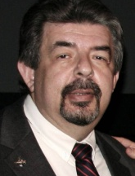
Editorial
Brig Gen (ret’d) Ioannis Galatas, MD, MA, MC

Editor-in-Chief
CBRNE-Terrorism Newsletter

Dear Colleagues,
As we are heading towards Summer, all they eyes are focusing on the 2014 World Cup to be held in various Brasilian cities. I was not planning to repeat my security concerns related to the Games – you can read them in the Threat Assessment I uploaded together with May 2014 issue. But I read to day (May 24) that Brazilian officials are setting aside about $856 million and preparing 157,000 soldiers and police officers for the security plan for the monthlong World Cup! It is supposed to be fun! It is supposed that the best national teams worldwide are competing in order to offer some moments of pleasure and promote athletic values by playing soccer (or football)! If you need an army to do that is not fun anymore…

Malaysian flight MH370 is still missing and most probably we get to know the real story behind this after a few decades – most probably when all those involved directly or indirectly will have passed away. And as it always happens with unfortunate events the first book on this issue has already been published (claiming that missing Malaysia Airlines Flight MH370 may have been accidentally shot down and the search for survivors covered up)! Perhaps a movie will follow soon…

Syria’s chemical weapons removal and destruction is progressing slowly and without the globally requested clarity that make Mediterranean citizens worry (really but mainly politically). There are now indications that “clorine bombs” have been used and who knows what else will follow in this bloody rival with hecatombs of innocent victims.

And of course MERS keeps on marching – especially in S. Arabia BUT also new cases have been recorded in both US and Canada. Just another proof that nothing is far away anymore. And an alarm bell for high officials to take their heads out of the sand and start taking serious measures to counter a future threat. I will also add another parameter of the problem: In Africa, cases of severe respiratory disease in humans have probably not been routinely tested for the MERS-CoV. But camels from Africa have tested positive for the virus in Egypt. Frighteningly, given the high mortality rate of those infected with MERS, human exposure to camels may be higher in Africa than in the Middle East. According to the FAO, in 2012 there were about 260,000 camels in Saudi Arabia, but there are almost a million in Ethiopia, 4.8 million in Sudan, and over 7 million in Somalia. If MERS is as pervasive among camels in these countries (and others) as it has proven to be in Saudi Arabia, will there be resources and infrastructure to deal with a pandemic?

Finally the brutality of Boko Haram in Nigeria and extremists in China’s XinJang territory wrote a new chapter in terrorists’ modus operandi and the definition of terrorism itself. Is the international society willing to take measures? Are they going to say “enough” of bloodsed or they will be consumed in useless rhetorics (as usual)?

Situation in Greece is stably unstable – at least we are consistent with that! Tomorrow our new game – EU elections and municipality elections will come to an end. Perhaps after that progress will return to Greece unless it will prefer to enjoy summer vacations and come back later! The main conclusion of the days is that citizens do have the governance they deserve. Simple as that! And although I often personalize the fact that not all are we responsible for current situation I accept the fact that majority of the few is the modern democracy of today. I am sorry to say that our continent is steadily becoming problematic in many espects of life: boys at schools were skirts for sex equality (France), having sex with animals is officially permitted (Germany), woman (?) with beard wins European song competition (Eurovision), neo-nazis kill, burn, poison with chloroform opposing citizens (Ukraine) – just to name a few of the strange things happened lately. My only question is: are all these happen accidentally or there a carefully executed plan directing towards loss of identity in the long run?

Newsletter is doing well thanks to your preference and contribution. We now appear in many major security/CBRNE events and we would like to sincerely thank you for that! Early in June I will deliver a couple of lectures in two important training schools - NMIOTC - NATO Maritime Interdiction Operational Training Centre (NMIOTIC Course 6000/WMD; Chania, Greece) and NATO School at Oberammergau (NSO, Germany).

The Editor-in-Chief

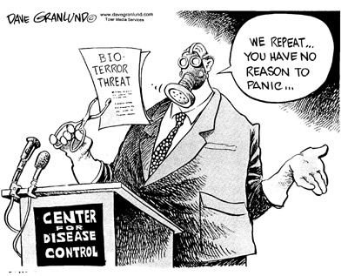

The World Cup and Olympics threaten to overwhelm Rio – yet there is time to create a sensation out of disaster
By Simon Jenkins
Source: http://www.theguardian.com/cities/2014/apr/23/world-cup-olympics-rio-de-janeiro-brazil-sensa tion-disaster
Rio de Janeiro's Christ the Redeemer statue towers above the Maracana stadium, a venue for the 2014 World Cup and 2016 Olympics. Photograph: AFP/Getty Images

Has Rio de Janeiro the guts? The city is now desperately behind schedule for its 2016 Olympics – one insider put it at 10% ready, where London was 60% ready at the same stage. But a visit earlier this month left me with an intriguing question. Could Rio’s chaotic planners make virtue of necessity? Could they be the first city to haul the Olympics back from its fixation with money and buildings, and restore them to sport? Could Rio fashion a sensation from a disaster?
The main Olympic park at Barra da Tijuca was until recently strike-bound. The secondary one at Deodoro is a military base and not even started. This month, the International Olympic Committee in Turkey declared “a critical situation” and demanded the Brazilian government do something. It set up a committee. The IOC spokesman, Mark Adams, had to deny rumours of plan B, to move the games from Rio altogether, but significantly failed to rule this out, merely saying “at this stage that would be far too premature”.
No one visiting Rio at present can imagine cancellation as anything but devastating. In this fantasy world of prestige, multibillion dollar budgets and white elephants, even a shambles is thought better than cancellation. But the city could yet seize the initiative. With domestic elections in October and the games faced with plummeting domestic support, Brazil’s politicians could plead force majeur, call the IOC’s bluff and stage a slimmed down “austerity” games, as did Britain in 1948.
They could abandon the unbuilt cluster at Deodoro, intended for events such as rugby, kayaking and mountain biking. They could cancel some of the IOC’s “toff” sports such as tennis, golf, sailing and equestrianism, as well as the absurdity of staging a second soccer competition just two years after this year’s World Cup. They could slash arena and stadium capacity to what it can already offer, and tell thousands of gilded IOC officials, sponsors and VIPs there will be no luxury apartments, limousines and private traffic lanes, just camping on Copacabana beach.
The catalyst might well be this June’s Olympics-lite, otherwise known as the football World Cup. It is costing Brazil $4bn (£2.4bn) on stadiums alone for 64 football matches – a staggering $62m per match – plus some $7bn for associated infrastructure. Only generals at war and Swiss sports officials contemplate such obscene spending. When Fifa’s secretary-general, Jerome Valcke, came to inspect preparations last month, he professed himself appalled. Two years ago he had warned Brazil to give itself “a kick up the backside”. His boss Sepp Blatter said the place was “the most delayed World Cup since I have been at Fifa.” They treated Brazil as a badly behaved child.
The main Olympic park at Barra da Tijuca (above) has been hit by strikes. The secondary one at Deodoro has not been started. Photograph: AFP/Getty

In truth Fifa was a fool. It had staged the 2010 World Cup in South Africa by the skin of its teeth, the country recouping a mere 10% of its $3bn outlay. Studies of such mega-events, financed by their sponsors, invariably estimate huge profits, later declaring little more than “goodwill and reputational gain”. Brazil’s World Cup spending was wild from the start. Domestic politics made it increase Fifa’s requirement of eight venues to 12, including new stadiums in Manaus and Brasilia that are not needed locally and may never see more than four football matches.
In June last year, the unheard-of occurred, with urban riots nationwide against even hosting the cup. Public support fell from 80% when the cup was “awarded” to Brazil in 2007 to under 50% now. At the last count, 55% of Brazilians think the cup will harm their economy rather than benefit it. While urban bus fares were being raised, millions of dollars were vanishing into corrupt building contracts. Demonstrators shouting “There will be no World Cup” fought police. The protests continued sporadically and last month the army had to invade some of Rio’s favelas to restore some semblance of control ahead of the June deadline.
More worrying for Rio is the political backwash from the World Cup on to the Olympics. At present the talk is that if Brazil wins the cup (it is sixth in the Fifa rankings), the public may just tolerate the Olympics, but if not, “the games are dead”. As the city’s famously short-fused mayor Eduardo Paes recently told the press: “Don’t ever in your life do a World Cup and an Olympic Games at the same time … I am not cut out to be a masochist.”
These mega-events traumatise a complex modern city. They upset the rhythms of its politics and infrastructure investment. They clear thousands from their homes and virtually close down whole cities for a month. IOC plutocrats arrive like visiting princelings long accustomed to living at the expense of others. In London they demanded and got exclusive limousine lanes (including outside Harrods) and traffic lights switched to green as they drove to their venues. They block-booked luxury hotels and dumped unwanted rooms onto the market when it was too late for re-letting. Their sponsors demanded the removal of rival advertisements anywhere near the venues (even on toilet equipment). They expected some 40,000 security staff to be on hand, or four times the number of athletes, to protect “the Olympic family”.
Even after shaking off past corruption scandals, the IOC is addicted to extravagance. The games nowadays float on national hyperbole and civic rivalry, festivals not of sport but of competitive mega-structures. The IOC requires each venue to meet meticulous specifications at whatever cost. The number of sports increases each time (currently 26 covering some 400 events), all craving their hour in the television spotlight.
Some 95% of the budget of a modern Olympics goes not on sport but on steel, concrete, bricks and mortar, even in cities such as London with perfectly adequate facilities already. “Starchitects” propose ever wilder arenas that everyone knows will come in at double or treble their estimates. They absorb labour, energy, materials, land and effort which are then not available for urban investment elsewhere. The global scale of such evanescent spending over the decades must be staggering.
Under the IOC’s new president, Thomas Bach, there have been some signs of concern, if not of remorse, at this extravagance. Bach has declared his commitment to “sustainable development”, whatever that means. This has mostly taken the form of preferring rich hosts and stable governments able to deliver soaring budgets without significant protest from local people, such as Beijing and Sochi (and indeed London).
In these terms Brazil was always a gamble. Earlier this month one of London’s Olympic organisers, Lord Dyson, visited Rio to brief its team on “lessons from London”. He brought two messages, the need for “total engagement” in the games of the whole host nation and the need for a palpable legacy. It was good advice. Rio’s vanity is much resented elsewhere in Brazil, and a host city in crisis will need its nation on board. Rio has taken one bit of advice from London and hired the American project contractor, Aecom, to “deliver” the games.
Meanwhile legacy has become a ruling obsession of Olympics public relations. As one Rio official put it: “Without legacy, there is no way so much money can justifiably be spent on a fortnight of sport.” But what is legacy? All that is certain is that the sums spent on construction are gargantuan. The Brazil World Cup was originally bid at a cost of $1bn for new stadiums and upgrades. This swiftly rose with associated infrastructure to over $8bn, with only the vaguest concept of audit.
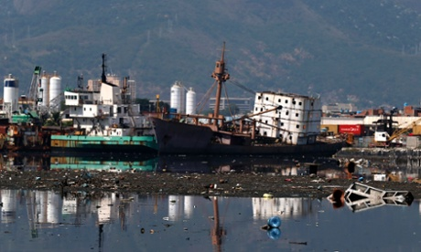
When Rio won the games in 2009, to ecstatic scenes on Copacabana beach, the talk was of holding down costs by re-using facilities built for the Pan-American games of 2007. The latest official count has this cost at $15bn, more than London. But estimates of committed “Olympics-related legacy” stretch as high as $90bn over the current decade. This must imply a severe distortion of Brazil’s normal infrastructure planning.
Guanabara Bay – Rio's Olympic sailing venue – has been promised a cleanup. Photograph: Sergio Moraes/Reuters
On the Games themselves, 52 projects were to be located in four hubs. “Nomadic architecture” would be employed, whereby stadiums could be dismantled and rebuilt as schools. In addition there was a new “Transcarioca” urban highway with rapid transit bus track, two other lines, 57 new hotels and the renewal of the semi-derelict port area of the city. The city’s Guanabara Bay would be relieved of its flotsam and of the pollution pouring into it from surrounding favelas – essential for the sailing events.
Most exciting of all was the first coherent plan for investment in favela “urbanisation”, the so-called Morar Carioca. Fashioned in partnership with the Institute of Brazilian Architects, it committed $4.5bn to “infrastructure, landscaping, leisure and living … generating comfort and dignity for more than 200,000 people”. This was to run in parallel with the favela “pacification” programme instituted by the state governor, Sergio Cabral, and security secretary, José Beltrame. Begun in 2008, this determined to liberate the fifth of the city’s inhabitants living in mostly hillside districts outside the rule of law, rife with anarchy, drug-dealing, violence and few utilities of public services. The plan would be true legacy, one of the most imaginative urban renewal projects I have seen anywhere.
The legacy of the legacy has been bitter disappointment. The cross-town highway has been built and the port area is being revived. But the bay remains polluted. There have been battles over favela clearances to make way for games sites, notably at Vila Autodromo next to the main Olympic park. Activists from the “Popular Committee for the World Cup and Olympics” claim more than 170,000 people are being driven from their homes for games-related purposes. Rio may not match Beijing’s record for Olympic eviction, when a reported 1.5 million people were cleared for 2008, but it is rising fast.
Even in the favelas, Brazilians supposedly enjoy a right to consultation before compulsory removal and to being rehoused near their existing homes – chief reason for the rarity of slum clearance. But the popular committee’s Renato Consentino says: “When your home is impeding the Olympics, everything is short-circuited.” Some eviction notices even carry the Olympic logo, hardly enhancing the games’ popularity. After such elevated expectations, to be hit by two mega-events in succession, says Consentino, “has emptied out any time for democracy”.
Brazilians are habitual sceptics of what their rulers say to them. Theirs is not the instinctive deference to government of Russians, Chinese or even Britons. The promises of power mean little since they are so rarely kept. In Rio, the tide of opinion appears at last to be turning. For Fifa’s World Cup, celebrity “ambassadors” were chosen from the nation’s soccer stars, such as Pele and Ronaldo. Both have been ridiculed by street protesters as “enemies of the people”. Meanwhile their former colleague, Romario, footballer turned politician, has taken to the airwaves and is running for the senate, hurling abuse at Fifa’s extravagance and deriding Blatter and Valcke as “thieves and sons of bitches” (and worse). He asks how they can demand that Brazil pay for “first-world stadiums when we cannot afford first-world hospitals and schools”.
Saddest of all has been the virtual abandonment of Morar Carioca. While the pacification programme has been moderately successful, with roughly half the favelas “retaken” by the police from gangsters, there has been little or no follow-up with sewers, water supply, streets and social infrastructure. By the end of last year, the Catalytic Communities website recorded that of the 219 favelas initially designated, “upgrades have begun in none”.
At the Institute of Brazilian Architects, its president Sergio Magalhaes shuffles gloomily over the plans and drawings of what had been proposed for his city and is now in abeyance. He sees the backtracking as “recklessly adding to a general sense of dissatisfaction” with mega-events as a whole. Infrastructure projects such as the urban highway merely “link rich area to rich area”. An interview with him in the Brazilian magazine Veja is headlined simply, “The architects are furious.”
Any visitor to Rio is left puzzled at the naivety with which it ever believed the IOC’s hyperbole. There is no Midas touch to grand sporting occasions, just cost. An extravagant opening and closing ceremony, some gold medals for the hosts and good public relations can generate a passing feel-good effect, as they did in Barcelona and London. Even when the cost is crippling, as with Athens, the IOC’s salesmen declared a “return in glory, reputation and future tourism”.
Serious economists despair of these events. The founder of the modern Olympics, Pierre de Coubertin, saw them as forging peace between peoples. With the Berlin Games of 1936 they became more a festival of chauvinism, a beauty contest between nations and ideologies, reaching a sort of nadir at the Sochi Winter Olympics. A report by Bloomberg suggests the chief gain is not in peace but in construction company share prices. A study by Simon Kuper and Stefan Szymanski predicts that this year’s World Cup will see “a transfer of wealth from Brazil as a whole to various interest groups”, mostly soccer clubs and private corporations. It will “not be an economic bonanza”.
The much-vaunted extra tourism is an Olympic chimera. Sydney in 2000 was told it would see a boom in visits and when this failed it ran angry advertisements with the slogan, “So where the bloody hell are you?” Athens and Beijing were half-deserted for the Olympics, and South Africa’s World Cup saw barely two-thirds of the predicted visitors. British tourism was blitzed by the 2012 Olympics and is still 3% down on 2011.
The nearest parallel to the Olympics nowadays is probably a war, an outburst of patriotic fervour, fathered by mild mendacity out of public expenditure. Criticism is suppressed. Medals tables are listed like battle honours. Home contestants are “heroes”. Winners are showered with state baubles and losers stripped of grants.
Some of Rio’s more cynical citizens even give this parallel a sort of welcome. They hope the Olympics might discipline a lethargic city bureaucracy, defeating the nay-sayers as deadlines fall due and yielding at least some projects of lasting usefulness. They are pleased that Rio is now the focus of world attention, with resulting self-criticism. The favelas are crawling with academics and camera crews as never before, as if waiting for them to explode for the World Cup and the Games.
This could suggest a new phenomenon, the mega-event as the critical mover in cities where the politics of urban renewal has seized up. Whether such a trauma is the best way of ordering any society is another matter. Any city that can blow billions of dollars on a fortnight’s party and not repair public services such as Rio’s has its governance seriously awry.
Even before the party has begun, much of Rio seems to be suffering from a hangover. The mayor is talking masochism and there are plenty of others, including within the IOC, wondering if it is too late to stop. The planning professor at the Federal University of Rio de Janeiro, Orlando dos Santos Junior, sees dire conflict ahead in the clash between spending on white elephants and crying needs elsewhere in the city – producing what he calls “an agony of disappointed loyalties”.
I believe Rio still has time to show the courage London lacked in 2005. London boasted it would stage “a People’s Games”, a low-cost festival of urban fun. But it capitulated to the IOC’s grandiosity, building a new stadium rather than using Wembley and raising a $4bn budget to $13bn.
Rio could do the precise opposite. It could welcome the world to whatever stadiums and arenas are left from the 2007 Pan-American games, and rely on television to reach audiences. It could tailor the Olympics to Rio rather than Rio to the Olympics. The city of carnival would offer a carnival of sport, proving that poor cities as well as rich ones can sometimes stage these mega-events. Do that and instead of being abused for delay and incompetence, this magnificent city would have the world cheering its daring and its guts. Go for it, Rio.

Simon Jenkins is a journalist and author. He writes a column twice weekly for the Guardian and weekly for the Sunday Times, as well as broadcasting for the BBC. Previously he wrote columns for the Times and the London Evening Standard, both of which newspapers he edited. His career began on Country Life magazine and continued on the Times Educational Supplement, the Economist (political editor) and the Sunday Times (books editor). He served on the board of British Rail and London Transport in the 80s and was deputy chairman of English Heritage and a Millennium commissioner. He was Journalist of the Year in 1988 and Columnist of the Year in 1993. His books include works on London architecture, the press and politics and, more recently, England's Thousand Best Churches (1999) and Thousand Best Houses (2003).

EDITOR’S COMMENT: Perhaps the first “public” article speaking the truth about both coming mega events to be organized in a great country. This article is also a good answer to some of our readers and friends who commented on the way we approach both events – although we anly focused to CBRNE preparedness. In that respect I will repeat once more that “Olympic Business Games” should become again “Olympic Sports Games” or cancelled for ever (since the return of the Games in Ancient Olympia, Greece, sounds chauvinistic).

In reply to one of the public comments (outdated photo from the Guanabara Bay) posted for the article above:

Brazil promises Guanabara Bay to be clean for 2016 Olympics
Source: http://www.sailingscuttlebutt.com/2014/03/21/brazil-promises-guanabara-bay-clean-2016-olympics/

March 21, 2014 – Waters polluted by sewage off the coast of Rio remain a concern for organisers of the 2016 Olympics, but the International Olympic Committee insisted Friday (March 21) that the sea will be safe for competition.
Guanabara Bay, which will host the sailing at the Games, has caused consternation amongst some athletes with the water quality condemned as “disgusting” by one sailor.
IOC co-ordination commission chair Nawal el Moutawakel noted on a sixth visit Friday that authorities have pledged to deliver a huge increase in sewage treatment by 2015.
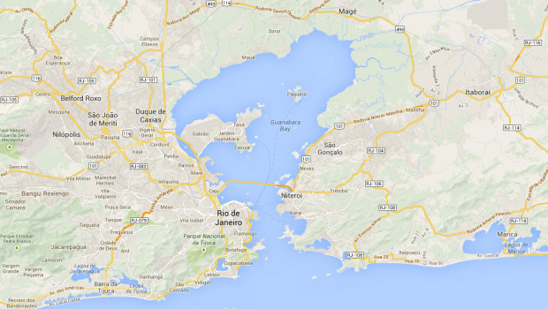
“There will be a seven-fold increase in treated sewage around the Guanabara Bay by 2015,” she said, with sailing test events slated for August serving as an environmental catalyst for the city authorities.
Environmental officials said late last year that more than two thirds of sewage goes untreated in the Bay, which will also host marathon swimming — a statistic which left sailors aghast.
British Olympic 2000 silver medalist Ian Barker last year described the site as “disgusting” and “a sewer.”
Plans to bring new treatment plants on stream have lagged and pollution levels running way above official tolerance levels have not gone unnoticed by water sports federations.
With the test events in the Bay only five months away, el Moutawakel would only point to the organizers’ planned campaign to boost sewage treatment as a matter of urgency.
“We’ve been given assurances that Guanabara Bay will be clean for athletes,” she said at the end of her team’s visit.

IOC 'very concerned' about Rio 2016 Games after 'worst ever preparations'

Source: http://www.independent.ie/incoming/ioc-very-concerned-about-rio-2016-games-after-worst-ever-preparations-30228976.html

April 29 – In a stinging rebuke to Games organisers and Brazilian politicians, Coates said preparations were critically behind schedule and that the IOC had been forced to take the unprecedented step of sending in its own task force, including a construction project manager, to speed up building work.
Coates, a member of the IOC’s coordination commission which is overseeing Games preparations, said he had made six visits to Rio and the situation was worse than Athens in 2004, where the city came close to being stripped of the Games because of the massive delays.
But Coates warned there was no alternative to Rio and that the city simply had to meet its deadlines.
"The IOC has adopted a more hands-on role,” said Coates. “It is unprecedented for the IOC but there is no plan B. We are going to Rio.
“We have become very concerned. They are not ready in many, many ways. We have to make it happen and that is the IOC approach. You can't walk away from this."
Speaking at an Olympic forum in Sydney, Australia, Coates said the situation in Rio was “critical”, with construction yet to begin on some venues and significant delays to infrastructural projects. He also said the city faced major social issues.
His remarks echo concerns raised previously by football’s world governing body, Fifa, who criticised the long delays in the delivery of stadiums and infrastructure for the World Cup, which kicks off on June 12.
Coates, who headed the Australian Olympic Committee when Sydney hosted the Olympics in 2000, said: "I think this is a worse situation than Athens. In Athens we were dealing with one government and some city responsibilities. Here, there are three.
"There is little co-ordination between the federal, the state government and the city, which is responsible for a lot of the construction, and this is against a city that's got social issues that also have to be addressed and a country that's also trying to deal with the Fifa World Cup coming up in a few months. It's the worst that I've experienced."

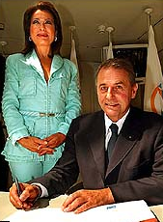
EDITOR’S COMMENT: Reminder for Coates:
In his closing speech for the 2004 Olympic Games in Athens, Greece, International Olympic committee president Jacques Rogge told the city: "You have won. These were unforgettable, dream Games."
And Athens’ Games boss Gianna Angelopoulos (left) added: "The Olympics came home and we've shown the world the great things Greeks can do."

Why he is not commenting on IOC’s decision to award the Games to Brazil? What changed in this country from nominating year 2009? Nothing. During Athens’ Olympiad ALL Greeks were enthusiastically involved in the preparation phase. Are they sure that Brasilians will do the same? It is wise to think before speaking…

The Brazilian bar where you can buy a beer from Osama bin Laden
Source: http://www.theguardian.com/travel/shortcuts/2014/apr/27/brazilian-bar-sao-paolo-osama-bin-laden

Of the many strange sights awaiting England football fans in Brazil, a Sao Paulo bar named after Osama bin Laden – and run by a Bin Laden lookalike – may be the most unexpected.
According to his tumblr page, Ceará Francisco Helder Braga Fernandes, a Sao Paulo resident since 1978, renamed his bar soon after 9/11. With a long grey beard and thick dark eyebrows, he had been a lookalike without knowing it. But when Osama bin Laden became the world's most wanted man, appearing on TV screens around the world, one alarmed customer called the police to report he was lying low as a downtown barman.
Police arrived, laughed, and posed for pictures with him. He appeared on local TV and became a local celebrity. After he changed the name of the bar to cash in on his newfound fame, it became a hub for local goths and rockers. British blogger and Sao Paulo resident Andrew Creelman says the bar has become a home for metal fans, who spill out on to the pavement on weekends, listening to Led Zeppelin and Black Sabbath.
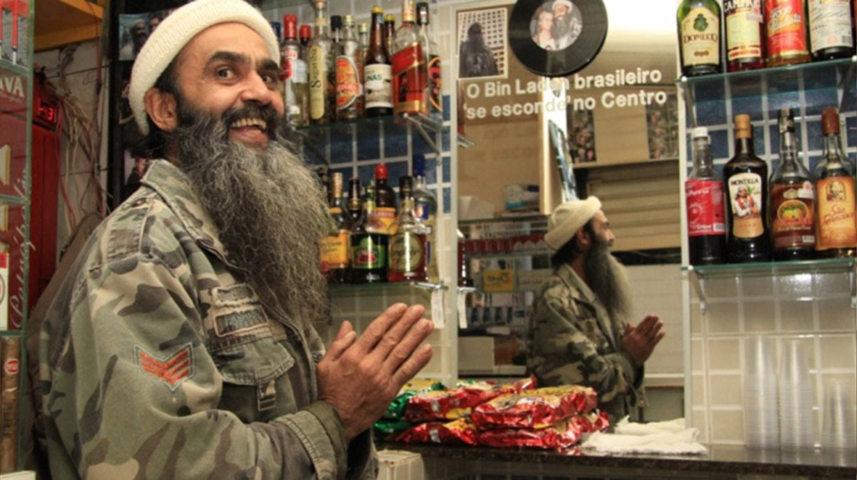
There are others too. Among them, in the seaside city of Niterói, across the bay from Rio de Janeiro, a pool hall and bar named the Caverna do Bin Laden – Bin Laden's Cave; and in Juiz de Fora to the north, another Bin Laden's Bar, with a lookalike of its own behind the counter. Mac Margolis, of online news site Vocativ, searched online and found "nearly a dozen Brazilian establishments" named after the former Al-Qaida leader, "including bars, luncheonettes and one sit-down restaurant called Bin Laden and Family".
England may well come home empty-handed, but fans looking for a memorable way to drown their sorrows will have no shortage of interesting options.

What tourism security means to Greece
By the Editor-in-Chief

Greece is one of the preferred tourist destinations worldwide and tourist industry is one of the few pylons surviving current financial/ethical turmoil we are experiencing the last three years. My country is located in a very important geostrategic cross point and is one of the important entries/hubs to European Community. Despite the benefits location would and should provide one of the major problems we experience is the mass illegal migration mainly from Asia and Africa. Among those infiltrating Greek society and local communities are elements coming from combat zones and rogue states that take advantage of the current situation and organize in already existing foreign communities. These communities are in close contact with local and transnational organized crime in the Balkans but also internationally.
In this rapidly changing environment and given the friction with neighboring Turkey and its expanding policy in SE Europe and near East, no one can predict how these new comers will behave in case of a serious incident between the two countries despite the fact that both are NATO members and the Turkish ambitions for becoming an EU member. Among the soft targets to be at stake, hotel industry is in the top position for many reasons – political, strategic and financial.
Although hotel security is very important it is not recognized as such by local hotel managers and this reluctance to invest in security is based on two inherent beliefs: the first one is that “it will not happen to us!” (supporting Brian Jenkins’ conclusion that fewer than 500 hotel guests worldwide have been killed by terrorists over the past 40 years, out of a total global hotel guest population at any time of nearly 10 million) while the second is that “we traditionally have good relations with the neighboring Arab world (near and middle East).” But they are missing the very important point that the “unexpected always happens” and that a terrorist attack against an international hotel usually hosting guests from many countries around the globe – i.e. in Athens, Rhodes Island, Mykonos Island or Santorin Island, would have a tremendous impact and will hurt not only people but also one of the very few industries bringing money to this country.
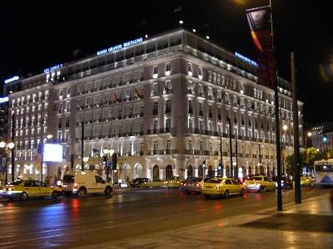
Terrorists have discovered that a successful attack on a 5-star property can yield rewards equivalent to an attack on an embassy, including scores of casualties, widespread panic, and extensive media attention – all of which are a boon to recruitment. Close proximity to Syrian chaos and uncertainty about country’s chemical weapons pose an additional threat. Are our hotels CBRNE-ready?
Preventing attacks like those carried out against Marriott in Islamabad and Jakarta is largely impossible once they have reached their operational stage;
Hotels need to focus attention on measures that discourage such attacks in the first place, and involve “target hardening”.
One of the biggest challenges hotel operators face in shielding their guests from possible terrorist attacks is that many existing properties were built with aesthetics, convenience, and cost uppermost in mind – not safety from suicide bombers and urban guerrillas. As such they often have built-in features that make them vulnerable to Mumbai-style assaults including long hallways, spiral staircases, and towering atriums. CBRNE hardening is the only solution and it is not that costly as it sounds.
Nevertheless, unless there is a “paradigm shift” in the way hotels around the world conceive of and manage these new and rapidly evolving threats, the lives of their guests and employees, their reputations, and indeed their long-term economic viability will be at risk. Let us all support the idea: “5-star hospitality along with 5-star security!”

Miami’s Airport: How to Secure a Monster
Source: http://i-hls.com/2014/04/miamis-airport-secure-monster/

How do you keep airport runways safe and clean? That’s how it’s done at Miami’s huge airport.
The presence of unidentified objects, people, vehicles and unauthorized aircraft on airport runways is a significant aviation threat. Routine measures are undertaken at civilian and military airports to locate these foreign objects – in military airports, for example, squads of soldiers routinely scan runways for any anomaly.
The Miami Airport is one of the busiest airports in the world, a gateway into the Caribbean and Latin America serving over 40 million passengers annually. A wide variety of measures and technologies protect taxiways and runways from dangerous objects such as people, vehicles and aircraft. One of the Airport’s directors, Ray Davalos, went into detail about the defense and alert system keeping the airport’s runways clean, a system designed and implemented by two companies: The Israeli NICE Systems and the American UNICOM.
The Federal Aviation Authority in the United States defines runway incursion as an event occurring in the vicinity of the airport’s runways, involving vehicles, aircraft, people or objects obstructing the runways, leading to a threat of collision between them and an aircraft attempting to land or take off.
Davalos explained that the airport has installed runway incursion detection systems as part of a special, 10 million-dollar project, including recording systems, video, tracking cameras, GPS and sensors. At the heart of the project is the NICE Situator, improving real-time response and detection capabilities, locating unidentified objects and facilitating quick response in order to mitigate any possible damage caused by an accident or a security breach. The system fuses information received from visual means such as video camera, sensors, tracking radars and communication systems, all of which alert quick response teams in real time.
Davalos added that the integration of all these measures is aimed at keeping the runways safe and clean. “The system can locate people, vehicles and unidentified or unauthorized objects on the primary and secondary runways which might pose a threat or cause a disturbance. It automatically sends alerts to the command center and to quick response units. NICE’s visual measures and video analytics solutions aid the airport authorities in locating and reporting unidentified objects. Identification is precise, alerts are quick and almost never false.”
NICE company representatives added that the system installed in the Miami Airport is capable of analyzing and cross-referencing data received from a large number of systems, such as PTZ cameras tracking the targets, video, radar, sensors and communications. Yaron Tchwella, NICE Security Group President, added that “the Miami Airport is one of the busiest airports in the world. The NICE Situator event management system is an example of efficient management of resources and existing technologies at airports, providing solutions for security and safety challenges.”

I wish many academicians thought that way!

No Offence; but don’t be so Defensive

By Phil Wood MBE MSc CPP PSP FSyI MInstLM AMBCI

Source:http://buckssecurity.wordpress.com/2014/05/02/no-offence-but-dont-be-so-defensive/#like-1909

Protecting the assets of an organisation of any size involves a blended and assimilated approach, I feel. It’s quite negative to build protective measures that are difficult to employ and perhaps are perceived as cumbersome or a waste of time. It’s quite positive to build the mythical ‘awareness and culture’ that we often read about but find quite challenging to achieve.
So, resilience people, is there a better way? First of all, we really do need to recognise our deficiencies and failings. Are we flexible in thought, do we understand risks and impacts, do we believe in anticipation of risk probability at all; or are we impact or ‘all-hazards’ focused? Is it our way or no way? Do we understand that if our organisations want things ‘their’ way, then our approach may need to change? In other words, are we effective in role by knowing our business and what it needs, then able and willing to meet its needs? If not, we may have a problem.
Of course, as human beings we are totally focused on ourselves. We may not want to admit it but everything that we do is about making our own existence the best that it can be. Altruistic acts such as helping others, giving to charity, protecting our loved ones will benefit others – but they also make our own lives better. We are naturally egocentric; and in resilience we should accommodate that and understand that what we are doing is not led by us, nor really influenced by us at all. If there was not an organisation to protect, and adversaries or unwanted events to affect it – we could all concentrate on ourselves and get on with living life. But life is not like that.
So – making organisations resilient, and enhancing our contributions to that, perhaps means that we need to self analyse first of all and try to figure out what we need to focus on, and which parts of our perceptions and biases, viewpoints and prejudices we should modify. We should try to learn more, grow our experience, see how others do things, share our own knowledge and enthusiasm. Effective organisational resilience can be achieved by collaboration and understanding of what is required and what is not. This is kind of the first step of any risk analysis in any case; and should be extended to the personal approach of resilience professionals. Barriers are great, but thoughts and ideas need to come in, while preconceptions, prejudices and our own little world views and egos may need to be kept

Phil Wood is Head of Department, Security and Resilience at Buckinghamshire New University

Zaatari: birth of a new city in EU neighbourhood
By Andrew Rettman
Source: http://euobserver.com/foreign/123997

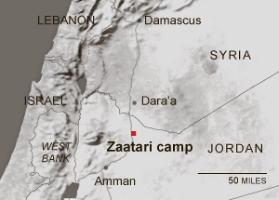
ZAATARI - “Welcome to my neighbourhood: District 5, Street 18,” says Nour, a Syrian school teacher, as she leads EUobserver to her home: a metal container and a tent in the Zaatari refugee camp in the Jordanian desert.
She is doing well.
Her husband has a job in a fruit and vegetable shop on the “Champs-Elysees” - the UN’s humorous name for the camp’s main street.
They have saved up for a washing machine, a fan, and a TV. Two of their four children go to school and Nour finds time to read her favourite writer, Syrian love poet Nizar Qabbani.
In February last year, things were different.
The family fled their village, near Daraa in southern Syria, when government snipers started shooting people from the tops of tall buildings. The Free Syrian Army (FSA), a rebel group, drove them through the countryside in a three-day trip to the border, where they walked for one hour before Jordanian guards took them to a UN registration point.
“It was very cold, especially at night. We had to hide from government helicopters. The children were very frightened and they were crying all the way,” Nour said.
Zaatari has also come a long way in the past 14 months.
Kilian Kleinschmidt, the UN “mayor” in charge, told this website that for the first year after it opened in mid-2012 it was “a storage facility for human beings” with tents on naked sand.
“The situation was tense. There was lots of violence. We had more than 100 violent demonstrations - stone throwing at our base camp and injured staff every month.”
Heinke Veit, an official at the EU embassy in Amman, which has spent more than €50 million on aid in the past two years, noted: “People came from green fields in Syria to this dust bowl. They felt like they had landed on Mars.”
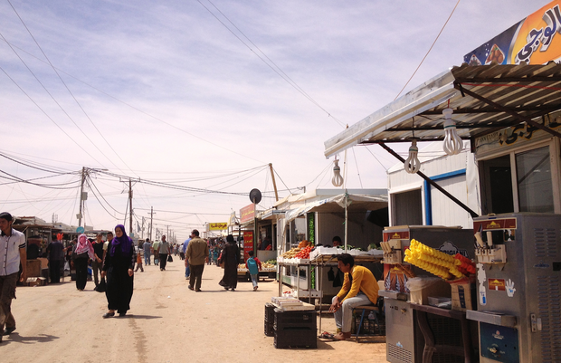
Today, Zaatari is home to 100,000 Syrians from the Sunni Muslim majority which opposes President Bashar Assad’s Alawite Muslim government. It is the second largest refugee camp in the world after Dadaab in Kenya and what Kleinschmidt calls the fourth largest “city” in Jordan.
It has six schools, four hospitals, and several kindergartens, playgrounds, and mosques, donated by Bahrain, Italy, Morocco, Qatar, Saudi Arabia, and the US.
The Champs-Elysees area (photo – left) hosts 4,000 small businesses. There are mini-supermarkets with trolleys, karate clubs, wedding-dress hire, pet shops, and travel agencies. Kleinschmidt estimates that €10 million a month changes hands in the camp’s “GDP.”
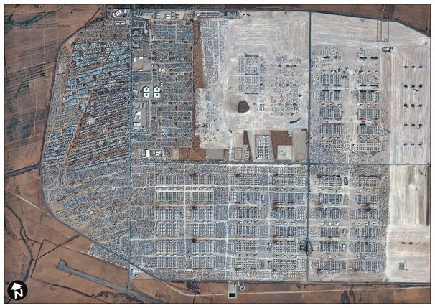
People have moved around to create neighbourhoods of extended families. In some places, they have poured concrete between containers, built fountains and hung cages with song birds in imitation of their former life.
They live on UN coupons which they exchange for food and other essentials.
But many of them sneak back and forth past the Jordanian gendarmes and Bedouin guards who patrol the perimeter to work on the black in local villages.
There is far less unrest, but there is crime - mafias control the market, and Jordanian farms alongside roads to the camp are littered with white tarpaulins bearing blue UN logos, which cost the UN $500 to supply, but which are sold for as little as 10 Jordanian Dinars ($14 or €10) on the outside.
“Call it organised crime or disorganised crime: Everything that can be stolen is stolen," Kleinschmidt noted.
“Professionals, those who have money, find ways to leave the camp and make arrangements for themselves in Amman. Those who are left are mostly former traders or border smugglers … They are incredibly active people,” he added.
The criminality extends to arranged marriages.
In Syria, the minimum legal age for girls to wed is 14, and some Zaatari fathers sell young daughters to men in Jordan, where the legal age is 18 and where Muslims can have up to four wives, in snap ceremonies officiated by Zaatari clerics.
The UN and Jordan do not like to talk about it and initiatives to control the practice have reduced the numbers. But Carlos Gallegos, another EU official in Amman, said: “It’s a big issue for us.”
Khaled, a Jordanian policeman from a nearby town, told EUobserver about a marriage which took place in March.
He said: “A man and his wife went to Zaatari to buy UN food from the refugees. The man said: ‘I will stay and guard the car.’ While his wife was gone, they came and made him a proposal. He married a girl right there and then. His wife came back with bags. ‘Who’s this?’ she asked. ‘She is a poor refugee. We’ll drive her so that she can join her family in Jordan. It’s on our way home,’ he said. They drive. They drive. ‘Where is she is getting off?’ the wife asked. ‘Soon.' They drive again. ‘Is it near?’ the wife asked. ‘It’s near.' They get home. ‘So where does she live?’ the wife asked. ‘She lives with us now. She is my wife number one and if you don’t like it, you can go to hell.' So what can his old wife do? She is no longer attractive. No one else wants her. So she accepts it. It's true. It's true. And I know many cases like this.”

Small part
The camp is a small part of the Syrian civil war.
The UN has registered 2.7 million refugees in Jordan, Egypt, Iraq, Lebanon, and Turkey since it began in 2011. It says more than 6 million have fled their homes but are still in Syria.
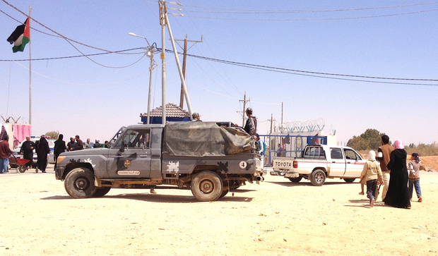
It stopped counting the dead at 100,000 for lack of data.
One official from the EU embassy in Amman drives to Damascus and back each month under Assad’s protection to appeal for more access. But the embassy’s Veit said Syria remains closed. “How much do we know about the death toll? How many people have really been displaced? We work on estimates,” she noted.
There are five camps in Jordan and a sixth one, to house 130,000 people, is being built.
Jordan’s top interior ministry official in charge of refugees, Saleh Kilani, told this website he has more than 600,000 registered persons, and up to 1.3 million Syrians in total trapped in his country.
There are signs that Jordan's patience is wearing thin.
Most refugees used to come via crossing points in north-west Jordan near the roads from Daraa. But the flow recently dropped to as few as 500 a month, mainly via the harsh deserts in the north-east, where Jordan borders Iraq and Syria and where people’s journeys can last weeks.
Kilani told this website that his “[north-eastern] borders are not closed” and that the change is “because of the situation on the other side [in Syria].”
But the UN and the EU suspect Jordanian guards in the north-east are pushing people back. “This is an issue that we are constantly trying to raise - that people who need protection should be able to cross wherever they are,” the EU’s Gallegos said.
Meanwhile, back in Zaatari, Dima’s daily routine goes on.
She wakes at 5am, prays, and goes to get bread for breakfast. She takes her two older daughters to school, where some classes have 150 students, but keeps her youngest daughter and her son at home.
“I don’t let the children play outside our caravan because I am frightened for them to learn something bad … my son is an only boy, he has no brother to protect him, and there are too many bad boys here,” she says. She does housework. She cooks in the communal kitchens. The children go to bed at 9pm. She sleeps at 11pm. She does not go out in the evening because it is considered indecent for Muslim women to walk alone after dark.
Despite the semblance of normality, the war is near.
The camp is 12km from the Syrian border and people hear bombs and artillery shells on the other side. “When we hear the explosions, we remember everything: how we had to hide, the crying,” Nour said.
It is not her real name. Few adults in Zaatari want to be named in press reports or photographed because they have relatives in Syria and they fear that if Syrian authorities identify them they will come to harm.
One new family, which arrived the day EUobserver visited the camp, hid in an iron shack at the gate.
The man said through an intermediary that he, his wife, and their one-year-old child had been on the road for two weeks, that they crossed near the Iraqi border, and that they wanted to leave Zaatari because they think Syrian secret police has infiltrators inside.
Even those who are doing well long to leave the camp despite the UN's improvements. None of them want to be resettled in Europe.
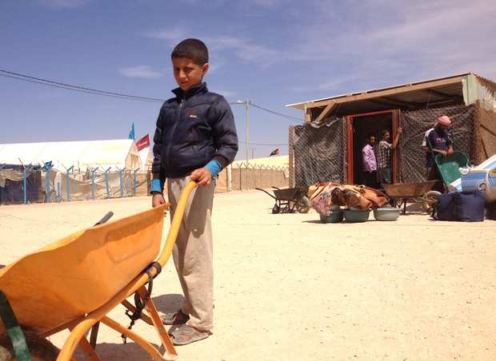
“We just hope to go back to Syria. It’s our country, our home … Nobody likes life here. It feels like a big prison,” Nour said.
“It was better in my village. I want to go back,” Bashar, an 11-year-old boy (photo) who earns 1 to 3 Jordanian Dinars (JDs) a day working from 9am to 3pm carrying things in a wheelbarrow at the Zaatari gate, noted.
Isam, a 40-year-old Syrian businessman, who earns 8 JDs a day doing odd jobs for the UN, added: “A man needs money to develop himself and there is no honest way to make money here.”
He is the only one earning cash for a family which includes his and his brother’s wives and 42 children. But many men sit around doing nothing while their wives and sons, who get jobs more easily because they are paid less, become the breadwinners.
The EU’s Veit said Syrian men reject psychological help, but their frustration causes domestic violence: “I once attended a women’s group in the camp and they told me: ‘We have two problems in our lives: One is [Syrian leader] Assad and the other is our husbands’.”
The camp still sees occasional protests. In April, fighting between Jordanian gendarmes and Zaatari stone throwers saw one man shot dead and 20 injured.
“They say: 'So what that you spend $500,000 a day on us? That’s the price of half a missile that America could fire at Assad’,” the UN’s Kleinschmidt said.
Some men and boys sneak back to Syria to join the Jabhat al-Nusra rebel group, which is considered stronger than the FSA.

’We can live together again’
For his part, Adnan (not his real name), a 42-year-old Sunni imam, tries to make sure they have their parents’ written permission if they are minors.
When he leads prayers for his congregation of more than 400 each Friday he calls for peace so they can return to Syria. But his contacts tell him that Assad is now using chlorine gas to kill civilians. Asked by EUobserver if people in Zaatari feel God has betrayed them, he said: “No. They accept God’s will.”
He also voiced anger: “Assad is like a bacteria, a germ. God wants him to go, but many countries in the world want him to stay: Iran; Iraq; Hezbollah [a Shia Muslim militia in Lebanon].”
Two ideas make him laugh.
One: that Assad’s decision to hold elections in June will end the conflict. Two: that Western countries will intervene.
“It’s a big joke. There can be no election when someone is killing his own people. He will elect himself again, but nobody will elect him … If America and other countries wanted to help, why have they waited until he killed half his people? It’s a black future for us,” Adnan said.
He believes peace will come in the end.
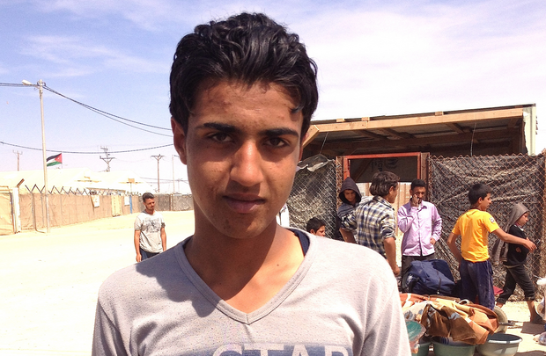
“People don’t have this feeling - to kill Alawis. Our war is not against Syrian citizens. It’s Assad who is trying to create a war between Alawi and Sunni. We can live together again. Sunni people want peace. A grieving mother, when she loses her child, grieves in the same way whether she is Sunni, Alawi, or Christian,” he added.
Hais, a 16-year-old boy from Daraa (photo), whose father died fighting with the FSA, echoes the imam.
When asked by this website if he wants to take up arms, he said: “I don’t want to fight. I want to live. There has been enough killing in Syria.”
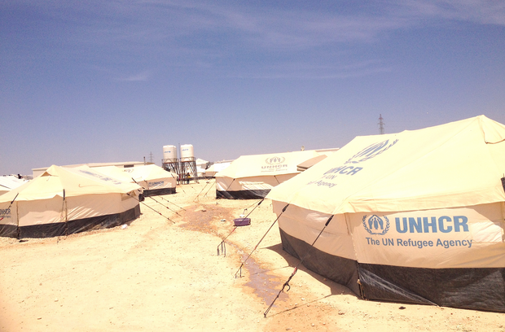
As the EU considers how to spend aid in its next budgetary period, officials on the ground do not expect the crisis to end soon.
“Everybody [in the media] is writing about Ukraine now. It’s natural. But if there is less interest in Syria, there's likely to be less money,” the Amman embassy’s Veit noted.
The EU's Gallegos said: “If Zaatari becomes a permanent settlement, it wouldn’t be the first one in Jordan. There are 2 million Palestinian refugees here from the 1940s whose camps became cities long ago, even if the Jordanians still call them 'camps’.”

Andrew Rettman is a Brussels based reporter at the EUobserver.com
Carl Bildt: Suggests & Sees Eastern Orthodoxy is main threat to western civilization
Source: http://www.abovetopsecret.com/forum/thread1011150/pg1

Carl Bildt, Sweden’s Minister for Foreign Affairs and one of the architects of the EU Eastern policy, thinks Russia has changed for the worse in the past several years. While it demonstrated attachment to western values in the first decade after the Soviet Union fell apart and tried to impose them on its citizens, Russia’s current leadership takes a firm stand against the West, the Russian agency REX reported.

In the words of Mr Bildt, Vladimir Putin demonstrates attachment not to world but to Eastern Orthodox values, which becomes clear from a Twitter post of his [Bildt’s].

”The new anti-west and anti-decadent line [of conduct] of Putin is based on the deep conservatism of Eastern Orthodox ideas,” Carl Bildt is convinced.

The Swedish minister explains the striving to destroy the Ukrainian church and bring the Ukrainian autocephaly back into the fold of the Moscow Patriarchate with Putin’s striving to gain control over Ukraine. But precisely Eastern Orthodoxy, according to Bildt, is the main threat to western civilisation.
The same Carl Bildt the Swedish minster whom has shown no remorse for those that were burnt by the Pro Kiev forces in Odessa and believed that those Russian protesters only burnt themselves now suggests that Eastern Orthodoxy which includes nearly half of the eastern Christians in Eastern Europe and the Balkans as a main western civilization threat to its every own existence.

How do we know this true?
- Bildt Shows a number of support for the Ottoman Empire era Ukrainian tatars whom only make up of 5% of the population in Crimea they are what remains from the Ottoman Empire era Turks whom still believe that the Ottoman Empire will return.
- Bildt has made anti Serbian Orthodoxy statements
- Sweden has shown support for the Syrian Rebels. And was the only nation that would have supported a military action in Syria along with the France.
Either way a lot of people were disgusted with Carl Bildt and his statements on twitter that he made about the deaths on Odessa even dispute that he still showed no emotions.

Some posts under this article:

LightningStrikesHere
“Check it out, as Muslim my self I can say this guy is a completely wrong for saying this. On the contrary! Easter orthodoxy in my opinion is the PUREST form of Christianity. And it is very much needed in the west to educate these western evangelical sects of Christianity... When I enguage in debates About Christanity I always always use eastern ordthdoxy doctrine to explain the Trinity to Muslims and christans who don't fully understand it. “
Thanks for the post
S+F

gosseyn
“Pffft, give me a break. The biggest threat to western civilisation IS western civilisation, eaten from the inside by its own ideologies: economics, politics, the media, education, debt slavery etc..., lies almost everywhere you look.”

EDITOR’S COMMENT: Above statement – if expressed – was hidden or buried by European mass media. If true is just another proof of what people do to gain or regain a few minutes of publicity… If it is true it is also very annoying since it comes from a high official of a remote beautiful country that contributed nothing to European progress through time.

Watch UFO attack Taliban camp in Afghanistan
Source: http://www.youtube.com/watch?v=YQWqiI0jlQc

This incredible video shows the moment a UFO attacks and destroys a Taliban base in Afghanistan.
The one minute 35 second clip, uploaded to YouTube, begins with footage of a large, grey triangular-shaped 'craft' hovering in the sky above the eastern city of Asadabad.
As the crew of a Nato armoured vehicle watch on in the foreground, flashing lights suddenly flash spit forth from the underside of the mysterious object.
It quickly becomes apparent that the craft has opened fire (circle) on something or someone, for barely a second later, explosions can be seen and heard and a huge plume of smoke mushrooms into the firmament.
For a while, the cloud of smoke is so large, the UFO is completely obscured.
But then the camera operator zooms in, giving viewers a close up of the remarkable object.
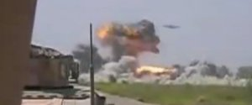
The video, entitled UFO attacks Taliban camp, was reportedly filmed by US Marines in March 2014.
YouTube users have been quick to comment on the film, which has been viewed more than 37,000 times since it was uploaded on Monday.
One, Brian Hix, whose avatar is a tabby cat, wrote: "US Military controlled UFO attacking Taliban camp."
Other social media fans claimed the craft was a drone, while some insist it is a fake.
Over to you….

Greece – Ground breaking atom laser developed in Crete
Source: http://www.thetoc.gr/eng/technology/article/ground-breaking-atom-laser-developed-in-crete

A team of scientists working on the island of Crete (Greece) has created the world's most powerful atom laser, fully seven times stronger than any developed to date.
The new 'ultra-bright atom laser' was presented in a paper submitted to the international science periodical "New Journal of Physics".
One of about a dozen involved in this sector worldwide, the team is based at the Institute of Electronic Structure and Laser at the Foundation for Research and Technology (FORTH) on Crete, led by the German physicist Wolf von Klitzing and with postgraduate researcher Vasiliki Bolpasi heading the list of authors.
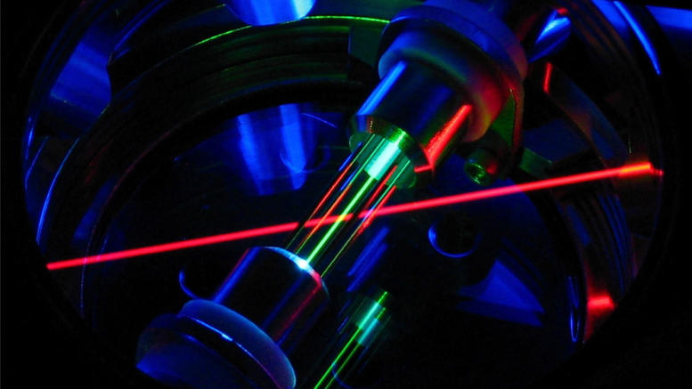
The other collaborators included Nikos Efremidis of Crete University's Applied Mathematics Department, Pavlos Condylis of the Quantum Technology Centre at the National University of Singapore, Michael Morrissey and Mark Baker from FORTH and Daniel Sahagun from Singapore.
Atom lasers emit beams of matter instead of the beams of light emitted by conventional optical lasers, with millions of atoms taking the place of photons in a cohesive beam.
Now still at an early stage, there are a number of issues that need to be resolved before atom lasers can find practical applications. According to the researchers, among the most exciting possible applications for a bright atom laser will be a matter–wave interferometer, where the wave-nature of the atoms will be exploited to make ultra-accurate measurements of gravitation or rotation or to probe the magnetic and electric properties of surfaces.

The decline of deterrence
Source: http://www.economist.com/news/united-states/21601538-america-no-longer-alarming-its-foes-or-reassuring-its-friends-decline?fsrc=scn/tw/te/pe/ed/declineofdeterrence
AMERICA’S allies are nervous. With Russia grabbing territory, China bullying its neighbours and Syria murdering its people, many are asking: where is Globocop? Under what circumstances will America act to deter troublemakers? What, ultimately, would America fight for?
The answer to this question matters. Rogue states will behave more roguishly if they doubt America’s will to stop them. As a former head of Saudi intelligence recently said of Vladimir Putin’s land grab in Ukraine: “While the wolf is eating the sheep, there is no shepherd to come to the rescue.” Small wonder that Barack Obama was asked, at every stop during his just-completed four-country swing through Asia, how exactly he plans to wield American power. How would the president respond if China sought to expand its maritime borders by force? How might he curb North Korea’s nuclear provocations? At every press conference he was also quizzed about Ukraine, for world news follows an American president everywhere.
When it came to formal pledges of reassurance, Mr Obama did not stint. In Tokyo he offered fresh guarantees that the defence treaty between Japan and America covers all Japanese-administered territory, including the Senkaku islands, which China also claims. While visiting some of the 28,000 American troops stationed in South Korea, he vowed that his government would not hesitate to use “military might to defend our allies”. In the Philippines Mr Obama signed a new, ten-year agreement to give American forces greater access to local bases.
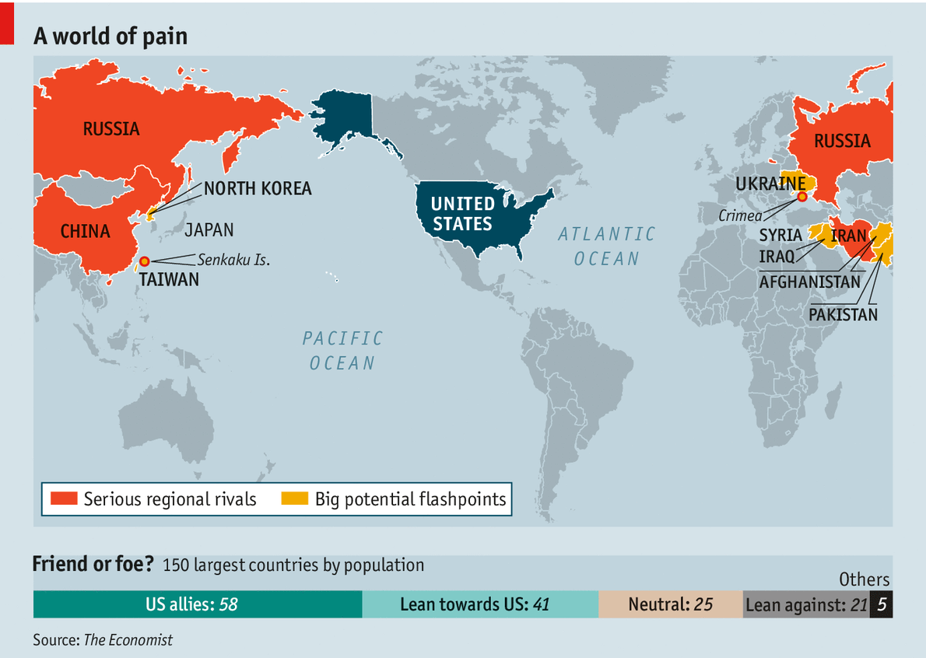
While Mr Obama was in Asia on April 28th American officials unveiled new sanctions against Russia: visa bans and asset freezes for Putin cronies such as Igor Sechin, the boss of Rosneft, a big state oil firm. On the same day a final detachment of American paratroopers arrived in Estonia, bringing to about 600 the number of American soldiers now on exercises in Poland and the three Baltic countries (all of which fear Russia). Whereas Russia tried to mask its deeds in Ukraine by deploying troops with no insignia, the whole point of America’s action was to show off the Stars and Stripes on the uniforms.
Philosopher-in-chief
Yet even as he did his duties as planetary peacekeeper, Mr Obama could not help pondering the limits of American power, out loud. There are “no guarantees” that sanctions will change Mr Putin’s thinking over Ukraine, he mused on April 25th. He said it would be in Mr Putin’s interests to behave better, but he might not.
In recent years, Mr Obama went on, people have taken to thinking that hard foreign-policy problems may actually have a definitive answer, typically involving the use of force. Mr Obama disagrees. “Very rarely have I seen the exercise of military power providing a definitive answer,” he told an audience in Seoul.
In the Philippines he was asked whether his handling of crises from Ukraine to Syria might have emboldened America’s enemies. He retorted that his tactics “may not always be sexy”, but have strengthened America’s global position. Many of his hawkish critics, he said, were the same people who supported the “disastrous” war in Iraq and who “haven’t really learned the lesson of the last decade.”
Such sentiments may appeal to war-weary voters back home. Most Americans say that defending the security of allies is “very important”, but just 6% would use force over Ukraine, says a Pew poll, and huge majorities oppose action in Syria. For countries that rely on American protection, this is troubling. The Baltic states of Estonia, Latvia and Lithuania, for example, feel exposed. Like Ukraine, they were once part of the Soviet Union, have Russophone minorities and doubt that Mr Putin respects their borders.
For Toomas Hendrik Ilves, the president of Estonia, the legal order preserving Europe’s borders changed utterly when Russia invaded Crimea. The European Union’s meek response has made it a laughing stock. “There is nothing left to hold on to,” declares Mr Ilves.
Except NATO. Unlike Ukraine, the Balts are members of the NATO military alliance, under whose founding treaty an armed attack on any member is considered an attack on all. This means America is committed to protecting its European allies. And for now, they believe it will. “I do believe that the borders of NATO are a red line. I have faith in that,” declares President Ilves. If any NATO ally tried to block a response to an armed attack, NATO would, in effect, cease to exist, he says.
In recent years, Mr Obama has scaled back plans for missile defence in Europe and reduced America’s military presence there to two brigade combat teams. But Russia’s aggression has had the unintended consequence of giving NATO a renewed sense of purpose: hence those American paratroopers in Poland.
François Heisbourg, of the Fondation pour la Recherche Stratégique in Paris, reckons America would still fight to defend the Baltic states: “The moment a Russian tank crosses the bridge at Narva [on Estonia’s border with Russia] it will be zapped.” But America’s commitment to defend Europe is undermined by the Europeans’ tendency to freeload, which American taxpayers resent. Few allies except Britain meet the NATO target to maintain military spending at 2% of GDP.
In the short term there are two military concerns. One is that the Baltic states are difficult to defend. Their airspace is entirely covered by Russian missiles. A greater worry is that Russia’s aggression might be stealthy, as in Ukraine. “Mr Putin does not do frontal attack; he does judo,” says Mr Heisbourg. What would America and NATO do if Russia starts to undermine the Balts by stirring unrest among ethnic Russians there and deploying mysterious armed men? NATO was not designed for such contingencies.

Middle Eastern gloom
Nowhere is the perception of growing American timidity so strong as in the Middle East. Eleven years ago America conquered Iraq in a matter of weeks. Yet when Mr Obama pulled America’s last troops out in 2011, there was little to show for all the lives lost and billions spent. The regime America has left behind in Baghdad is barely friendly.
In the rest of the region the story is not much cheerier. The new government in Egypt ignores American finger-wagging about human rights and buys lots of Russian weapons. In Syria President Bashar Assad was caught red-handed last year gassing his own people, an act that Mr Obama had specifically warned would trigger American punishment. Yet this “red line” was crossed almost with impunity.
There were sound arguments for all these apparent American retreats. Yet the widespread impression in the Middle East is that the lion has turned into a pussycat. Its foes rejoice; its allies bewail their perceived abandonment.
Iraq’s leader, Nuri al-Maliki, is chummier with Iran than America. Iran jauntily backs militias and political parties in Iraq. It sends bullets and “advisers” to Syria via Iraqi airspace. It sponsors Iraqi Shia volunteers to fight American-supplied Sunni rebels in Syria.
Of late, America has sometimes taken a back seat to other countries, as with France’s intervention in Mali and NATO’s in Libya. Or it has simply shied from doing anything much, as in Syria.
Yet reports of the death of American influence in the Middle East are exaggerated. Mr Obama can claim some successes: oil prices are stable, Israel has never been so prosperous or secure and Iran has agreed (under intense pressure) to curb its nuclear ambitions somewhat. Terrorism now poses far more danger within the Middle East than to the rest of the world.
America’s regional military bootprint has shrunk, but only from the inflated dimensions of the Bush-era “surge” in Iraq. A constellation of American military bases dots the region, from the 5th Fleet’s headquarters in Bahrain to Central Command’s massive base in Qatar, to secret airstrips sending drones into the skies of Yemen. No outside power can plausibly replace America there. The Gulf monarchies still rely on American protection, as do Jordan and (to a lesser extent than before) Israel.
The perception of American timidity has yet to do serious damage to American interests in the Middle East. It has, however, spurred allies to look out for themselves. Israel has cultivated military and economic ties with China and India. Gulf states are arming themselves: Saudi Arabia, Qatar and the UAE have all recently ordered huge arsenals.

Facing China
Moving to Asia, America has been fighting in Afghanistan for more than a decade now. This year Mr Obama plans to bring home almost all of the more than 30,000 American troops there. It may yet be all of them. Afghanistan’s president, Hamid Karzai, has refused to sign an agreement that would allow 5,000-10,000 or so to stay on in non-combat roles. But both candidates in the run-off election to succeed him are supporters of the agreement. So American boots will still be on the ground, providing targets for insurgents. Even if a broader civil war is avoided, America may find itself an unwilling party to bloodshed. If the American-backed government in Kabul finds itself unable to control swathes of the country, al-Qaeda or other groups with global terrorist ambitions might regroup there, as they might in the ungoverned tribal areas of Pakistan. Should they succeed in staging an attack on mainland America, the cycle might start again: experience shows that to avenge the victims of murder at home, America will fight.
It seems far-fetched to think that America would go to war over the islands known to Japan as the Senkakus and to China as the Diaoyus. Nestling in the East China Sea between the two countries, they are tiny, barren and uninhabited save for hundreds of goats and the elusive “Senkaku mole” (a critter, not a double agent). When America administered the islands from 1945-72, it used them for bombing practice.
Yet Mr Obama has put American military credibility on the line over the Senkakus (even if he did not explicitly promise that the 50,000 American troops stationed in Japan would help fight for them). For more than two years now China has been buzzing the islands by air and sea to challenge Japan’s claim of control, and last November included them in an “Air Defence Identification Zone”. There is a real risk that an accidental clash might escalate. So these desolate rocks may pose the most immediate test of Mr Obama’s “pivot” towards Asia.
The South China Sea sets others. Five countries have claims there that overlap with China’s. The Philippines’ dispute is the most active. In 1995 China evicted it from one reef, and two years ago from another. America takes no position on sovereignty, but backs Manila’s efforts to contest Beijing’s claims under international law.
In South Korea 28,000 American troops sit near the border to deter the North Korean regime. Few expect that regime to last for ever (see Banyan). Should it collapse, China, fearing the abrupt arrival of a unified Korea on its borders that is America’s ally and stuffed with American armour, might intervene. Loth to upset its erratic ally, China refuses to co-ordinate contingency plans for a North Korean implosion with America.
Both big powers hope that Taiwan’s deepening economic ties with mainland China will dampen the island’s enthusiasm for formal independence. But as Yan Xuetong, a Chinese scholar, has noted, at least 70% of people on Taiwan still see themselves as “Taiwanese” first, “Chinese” second. One day Beijing’s impatience at Taiwan’s failure to submit may force America into very difficult choices. A 1979 law binds America’s government to deem any attempt at forcible reunification “as a threat to the peace and security of the Western Pacific Area and of grave concern to the United States”.
Would America really go to war with China? China plainly seeks to become the dominant power in Asia. Many Asians doubt that America is reconciled to being number two. That said, many Asians also doubt that America would risk a shooting war with a nuclear power. They point to American silence when China seized the Scarborough shoal from the Philippines in 2012; and to its advice to American airlines late last year to comply with China’s air-defence zone over the Senkakus. In Asia, as elsewhere, America’s allies are boosting their armed forces. Some suspect that America’s security umbrella has holes in it. Sotto voce, a Japanese diplomat says Japan has never relied on it—though what he perhaps means is that it no longer does.
Under its pacifist constitution, imposed by America after the second world war, Japan is barred from “collective self-defence”, even if it means shooting down a North Korean missile on its way to Hawaii. Its current prime minister, Shinzo Abe, wants to change this. The aim, as one scholar puts it, is to become a “normal” ally, like a NATO member, partly to encourage America to keep defending it, and partly because it is not sure it will.

The trigger-point
Mr Obama’s hands-off approach dismays the foreign-policy establishment back home. Democrats and Republicans alike chide him for leaving a security vacuum for enemies to fill. Yet others note that he does not want to be the American president who failed to honour a treaty. He chose to deploy ground forces to the Baltics and Poland, when he could have sent only a few ships or planes.
A defender of the president, Ivo Daalder, American ambassador to NATO from 2009-13, suggests that if NATO allies suffered provocations short of an invasion (eg, Russian passports being distributed to Russian-speakers, challenges to Baltic frontiers) more troops, ships and warplanes would be deployed, making America’s commitment to collective security ever-more visible. It was also under Mr Obama that NATO finally drew up contingency plans to cover threats to all members.
Kurt Volker, George W. Bush’s final NATO ambassador and Mr Obama’s first, suggests that—despite Mr Obama’s distrust of military force—he would still act if there were a loud enough “domestic outcry”. An outright invasion of a NATO ally would trigger such an outcry, Mr Volker says, as would a serious attack on Israel. But short of that, Mr Volker worries that other countries see within Team Obama “a creeping willingness to let things go”.
A senior former defence official says that Mr Obama acted slowly in sending reinforcements to NATO members, and would do so again. “I think Mr Putin is going to keep coming until someone stands up to him,” says this source. In the case of Russian adventurism inside NATO’s borders, he predicts that Team Obama would respond: “I would worry that it would be late. Not too late, but late, and that would send a message around the world.”
America’s obligations in Asia are “nuanced”, says another senior figure. Where American troops are stationed in large numbers—in South Korea, or on the main islands of Japan—the security commitment is “absolute”. Under Mr Obama, American forces have pushed back (somewhat) against Chinese sabre-rattling in disputed seas. Should China threaten Taiwan, America would feel a “moral obligation” to send ships or planes to serve as a referee. Yet during previous crises, as in 1996, when China tested missiles before a Taiwanese election and America sent warships to the area, even hawkishly pro-Taiwan members of Congress privately told officials “you’d sure as hell better not get us into a war with the Chinese”, this source recalls.
A skirmish over the Senkakus would trigger help of some sort, says another veteran of many crises: perhaps early-warning planes to patrol the skies for Japan, and warships to show the American flag. But the American public “would not be excited to go to war over a bunch of rocks”.
So much for America’s formal commitments. When it comes to other countries and regions, insiders worry that Mr Obama sees the world as a jungle full of thugs, forever causing crises that America cannot fix. His failure to enforce his own “red line” over chemical weapons in Syria gravely damaged his credibility.
Team Obama is divided, with an unhappy State Department under John Kerry desperate to see more help for anti-Assad forces in Syria, while the Pentagon has spent months explaining why extra weapons shipments cannot work. Meanwhile, Mr Obama is described as analysing every option to exhaustion before concluding that inaction is the prudent course.
In a few areas, a toughening of current policies is possible. Mr Obama’s guiding principle is to avoid new wars. Because a nuclear-armed Iran might start a war which drags in America, he treats Iranian talks with great seriousness.
There are few overt hawks in Congress: the Republican Party of the Bush era, with its dreams of creating democracies across the world, is a distant memory. But some senators are pushing Mr Obama to take tougher, faster action against Russia. On a visit to Ukraine on April 25th Carl Levin, the Democratic chairman of the Senate Armed Services Committee, called for harsher sanctions on Russian banks and energy interests. Bob Corker, the top Republican on the Senate Foreign Relations Committee, grumbles that the Russian stockmarket actually rose after the latest American sanctions were announced, suggesting those sanctions are weaker than the world expected. Mr Corker says several senators want the government to examine the pros and cons of permanently stationing American NATO forces in such countries as the Baltic republics. Russia maintains that any such move would breach understandings reached with NATO in the 1990s. But Mr Obama will be under pressure to declare that the world has changed, and ignore Russian complaints.
Some will celebrate the decline of America’s ability to deter. But wherever they live, they may find that whatever replaces the old order is much worse. American power is not half as scary as its absence would be.

The less Americans know about Ukraine’s location, the more they want U.S. to intervene

By Kyle Dropp, Joshua D. Kertzer and Thomas Zeitzoff

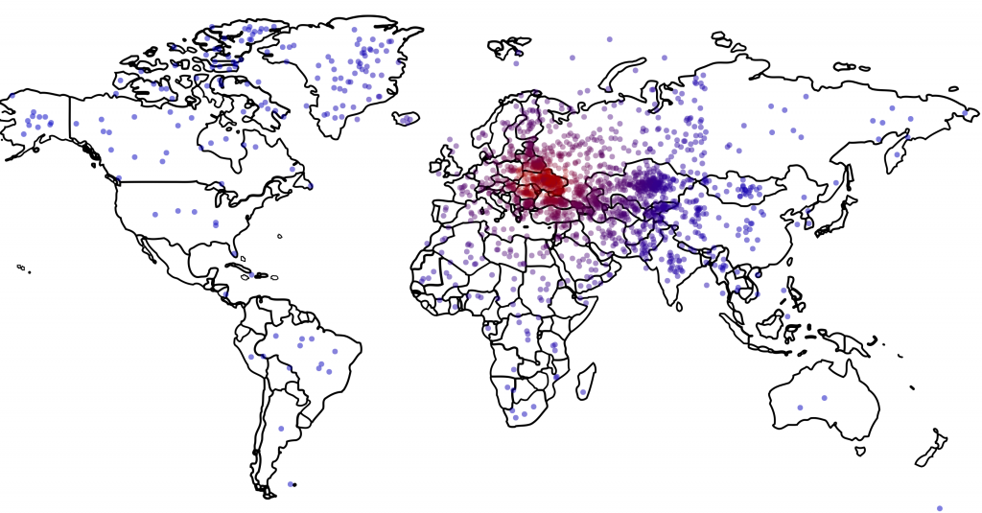
Source: http://www.washingtonpost.com/blogs/monkey-cage/wp/2014/04/07/the-less-americans-know-about-ukraines-location-the-more-they-want-u-s-to-intervene/
Where’s Ukraine? Each dot depicts the location where a U.S. survey respondent situated Ukraine; the dots are colored based on how far removed they are from the actual country, with the most accurate responses in red and the least accurate ones in blue. (Data: Survey Sampling International; Figure: Thomas Zeitzoff/The Monkey Cage)

The following is a guest post from political scientists Kyle Dropp (Dartmouth College) Joshua D. Kertzer (Harvard University) and Thomas Zeitzoff (Princeton University).

Since Russian troops first entered the Crimean peninsula in early March, a series of media polling outlets have asked Americans how they want the U.S. to respond to the ongoing situation. Although two-thirds of Americans have reported following the situation at least “somewhat closely,” most Americans actually know very little about events on the ground — or even where the ground is.
On March 28-31, 2014, we asked a national sample of 2,066 Americans (fielded via Survey Sampling International Inc., or SSI), what action they wanted the U.S. to take in Ukraine, but with a twist: In addition to measuring standard demographic characteristics and general foreign policy attitudes, we also asked our survey respondents to locate Ukraine on a map as part of a larger, ongoing project to study foreign policy knowledge. We wanted to see where Americans think Ukraine is and to learn if this knowledge (or lack thereof) is related to their foreign policy views. We found that only one out of six Americans can find Ukraine on a map, and that this lack of knowledge is related to preferences: The farther their guesses were from Ukraine’s actual location, the more they wanted the U.S. to intervene with military force.

Ukraine: Where is it?
Survey respondents identified Ukraine by clicking on a high-resolution world map, shown above. We then created a distance metric by comparing the coordinates they provided with the actual location of Ukraine on the map. Other scholars, such as Markus Prior, have used pictures to measure visual knowledge, but unlike many of the traditional open-ended items political scientists use to measure knowledge, distance enables us to measure accuracy continuously: People who believe Ukraine is in Eastern Europe clearly are more informed than those who believe it is in Brazil or in the Indian Ocean.
About one in six (16 percent) Americans correctly located Ukraine, clicking somewhere within its borders. Most thought that Ukraine was located somewhere in Europe or Asia, but the median respondent was about 1,800 miles off — roughly the distance from Chicago to Los Angeles — locating Ukraine somewhere in an area bordered by Portugal on the west, Sudan on the south, Kazakhstan on the east, and Finland on the north.

Who is more accurate?
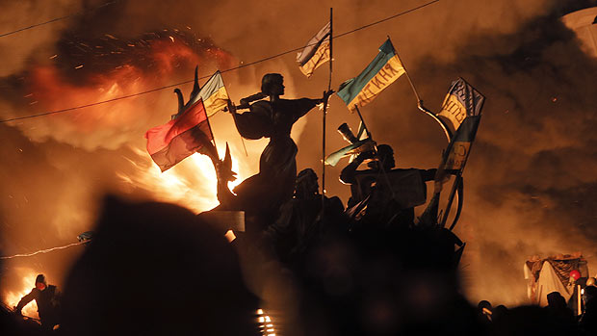
Accuracy varies across demographic groups. In general, younger Americans tended to provide more accurate responses than their older counterparts: 27 percent of 18-24 year olds correctly identified Ukraine, compared with 14 percent of 65+ year-olds. Men tended to do better than women, with 20 percent of men correctly identifying Ukraine and 13 percent of women. Interestingly, members of military households were no more likely to correctly locate Ukraine (16.1 percent correct) than members of non-military households (16 percent correct), but self-identified independents (29 percent correct) outperformed both Democrats (14 percent correct) and Republicans (15 percent correct). Unsurprisingly, college graduates (21 percent correct) were more likely to know where Ukraine was than non-college graduates (13 percent correct), but even 77 percent of college graduates failed to correctly place Ukraine on a map; the proportion of college grads who could correctly identify Ukraine is only slightly higher than the proportion of Americans who told Pew that President Obama was Muslim in August 2010.

Does accuracy matter?
Does it really matter whether Americans can put Ukraine on a map? Previous research would suggest yes: Information, or the absence thereof, can influence Americans’ attitudes about the kind of policies they want their government to carry out and the ability of elites to shape that agenda. Accordingly, we also asked our respondents a variety of questions about what they thought about the current situation on the ground, and what they wanted the United States to do. Similarly to other recent polls, we found that although Americans are undecided on what to do with Ukraine, they are more likely to oppose action in Ukraine the costlier it is — 45 percent of Americans supported boycotting the G8 summit, for example, while only 13 percent of Americans supported using force.
However, the further our respondents thought that Ukraine was from its actual location, the more they wanted the U.S. to intervene militarily. Even controlling for a series of demographic characteristics and participants’ general foreign policy attitudes, we found that the less accurate our participants were, the more they wanted the U.S. to use force, the greater the threat they saw Russia as posing to U.S. interests, and the more they thought that using force would advance U.S. national security interests; all of these effects are statistically significant at a 95% confidence level. Our results are clear, but also somewhat disconcerting: The less people know about where Ukraine is located on a map, the more they want the U.S. to intervene militarily.

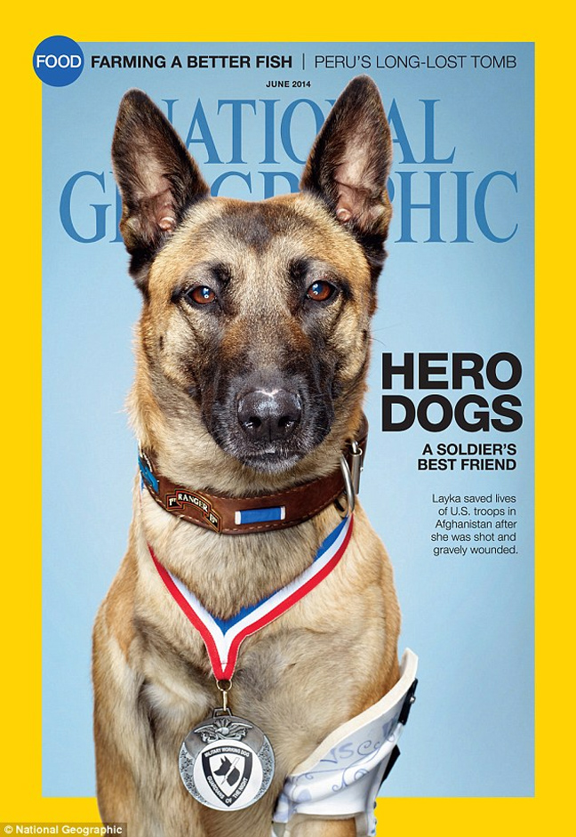

Syrian chemical weapons deadline passes with 92 percent of materials removed
Source: http://www.upi.com/Top_News/World-News/2014/04/28/Syrian-chemical-weapons-deadline-passes-with-92-percent-of-materials-removed/9291398692362/

As of the April 27 deadline, "The Syrian Arab Republic has now removed from its territory or destroyed in-country more than 92% of its declared stockpile of chemical weapons material."
Sigrid Kaag, Special Coordinator of the OPCW-UN Joint Mission in Damascus, said that while "This is a significant achievement ... nearly 8% of Syria's declared weapons material remains on its territory."
Kaag expressed optimism that the Syrian government, "having come this close to meeting the target date for the removal of chemical weapons material ... will take the final step very soon."
Syria should strive to complete the removal "in the shortest possible timeframe," the OPCW-UN Joint Mission special coordinator said, while acknowledging the difficult security conditions.
"Should this material be removed soon, the Syrian Arab Republic will have successfully carried out a major obligation that is a focus of much international attention."
UN Security Council Resolution 2118 for the "Scheduled Destruction of Syria's Chemical Weapons" was adopted on September 27, 2013.

EDITOR’S COMMENT: It is most possible that Assad will keep the remaining 8% until the June 3 elections as a safeguard of his trembling authority. Elections results will define the completion of the destruction of Syria’s chemical arsenal. On the other hand I was always wondering if all countries that destroyed their chemical weapons (i.e. Albania, Libya) did that in a 100% manner or kept a few barrels just for “scientific research”… Of course if you did it once you can do it again even if the country is under strict international surveillance.

… what a coincidence!

Western intelligence: Assad plans to retain residual chemical weapons capability
Source: http://www.homelandsecuritynewswire.com/dr20140430-western-intelligence-assad-plans-to-retain-residual-chemical-weapons-capability

Israeli intelligence officials say the regime of President Bashar Assad in Syria may be concealing a small amount of the chemical weapons in its possession, while pretending that it is fully cooperating with the process to remove all chemical weapons from Syria. This assessment is similar to conclusions reached by the U.S. and U.K. intelligence communities in the past two weeks.

To date, about 92 percent of the Syrian chemical weapons have been dismantled, and the production facilities for such weapons have been destroyed.
On 27 April the Assad regime missed a second deadline for the destruction of its chemical arsenal.
Haaretz reports that recently, Western intelligence services, relying on information sources they regard as reliable, have concluded that the regime has been trying secretly to keep a residual chemical capability, probably for the purpose of warning the opposition in the country’s civil war. In recent months reports emerged again of a renewed use by the regime of chemical weapons against rebels and against civilians in rebel-controlled neighborhoods.
The reports from the field say that unlike earlier employments of chemical weapons, which culminated in the August 2013 attack on the outskirts of Damascus in which more than 1,000 civilians were killed, the recent use of chemical weapons saw chemical weapons which neutralize and disable people for a few hours, but do not kill. There have been reports from different rebel-held regions in Syria it that the Syrian air force was dropping chlorine bombs on populated areas.
Israeli military sources told Haaretz that the use of chemicals is an indication that the government is encountering difficulties in conducting ground operations against the rebels. This view is supported by the recent increase use by the regime of dropping barrel and incendiary bombs from planes and the increasing use of missiles and rockets.
The Israeli view is that the retention of chemicals by the Assad regime has to do with the ongoing fight against the rebels, and is not an indication that the regime is contemplating their use against Israel. Accordingly, Israel has not changed its policy, announced earlier this year, of ending the distribution of gas masks.
Israel says that there is also no evidence that Syria is transferring chemical weapons to Hezbollah, eve as the Assad regime continues to try to transfer other advanced weapons systems to the Lebanese Shi’aorganization.
Haaretz notes that in a conversation with a senior Israeli intelligence official, the official acknowledged that the intelligence community has amended its assessments of the likelihood of survival of the Assad regime, compared to the estimates two years ago which said that the regime was approaching its end. The source said that current estimates have concluded that the regime is more stable than a year ago, and in many parts of Syria has successfully checked the progress of the rebels, thanks to massive assistance from Iran, Hezbollah, and Russia.
The senior intelligence source also said that unlike the consensus in the intelligence community a year or two ago, the Israeli defense establishment no longer considers bringing down the regime in Damascus as necessarily positive for Israel. The main reason is that it has become increasingly clear that if the Assad regime falls, the dominant forces among the rebels who will take over the country will be extremist Islamist organizations, some of which are affiliated with a Qaeda.
“Morally speaking, it’s impossible to ignore the fact that Assad is a war criminal who is murdering tens of thousands of civilians. But in terms of security, it’s not that we have positive expectations of those likely to replace him,” the senior official told the newspaper.
He added that it is not Israel who will determine the outcome of the internal war being fought in Syria, “but it’s clear that in terms of the balance of deterrence, it’s easier for us when we’re dealing with an official address in Damascus, rather than a chaos of gangs as in Somalia.”

Battelle Introduces Next Generation, Smart Technology for Biodefense and Hazard Avoidance
Source: http://www.cbrneportal.com/battelle-introduces-next-generation-smart-technology-for-bio defense-and-hazard-avoidance/

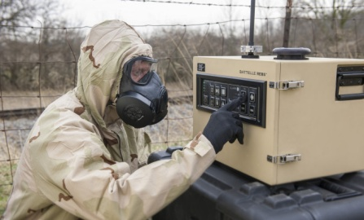
REBS™ Eliminates Need for Costly and Perishable Reagents, Decreasing Lifecycle Costs to Pennies per Day – Battelle, the world’s largest independent research and development organization, today announced production of the next generation chemical and biological hazard sensor system that operates at a fraction of the cost of current technologies.
Battelle is offering the technology, known as the Resource Effective BioIdentification System (REBS), for U.S. Department of Defense, homeland security, and other federal biodefense initiatives, and to commercial industries for contaminant detection, for instance, where sterile production operations must be maintained.
REBS is a rugged, battery-powered system capable of autonomous and continuous use with operating costs of less than $1 per day per unit (compared to current system costs that can range from $500 – $3,000 per day) and assay costs of just $0.04 per sample (compared to current systems at over $100 per sample). These cost savings come from Battelle’s new “smart technology” that eliminates the need for perishable reagents. Instead, REBS relies on a combination of patented aerosol collection and optical spectroscopy to detect hundreds of threats ranging from bacteria, viruses and toxins to aerosolized chemicals, and even mixed threats.
“Our warfighters, first responders, security personnel, and many in industry, need an affordable, reliable, high tech detection system capable of identifying new biological and chemical materials quickly, no matter the environment. REBS is that solution. Its elegant, automated design eliminates the need for constant maintenance and support, saving an estimated $56 million for every 1,000 units,” said Matthew Shaw, vice president and general manager of the CBRNE Defense business unit of Battelle.
“Unlike current systems, with REBS there is no need to constantly purchase and replenish the system with expensive, messy chemistries and consumables to keep their identification systems running. REBS can run continuously, without operator intervention, for weeks at a time…that’s like having a car that drives me 90 miles to work and back, day in and day out, without the need to fill it with gas for weeks at a time.”
REBS has been demonstrated in multiple government and independent trials, including successful operational testing in the Boston subway and, separately, successful developmental testing with “live” biological agents, such as anthrax spores, in 2013.
By eliminating the need for laboratory analysis of field-collected samples, the self-contained REBS design reduces the amount of time required to identify agents from hours or days, on average, to as little as 15 minutes, providing early warning and valuable guidance to the user.
The system “smart tech” capabilities also preserve samples for subsequent confirmation, is network-ready, and is able to look for new or emerging threat materials within 24 hours of their identification. Samples are automatically preserved and archived, providing seamless integration into high-level bio-surveillance operations at home or abroad.
REBS can be installed in a fixed site or used in mobile applications; as a single device or as an array of hundreds of systems configured into a network to a single command post. The system can be operated, monitored, and updated via the internet.
For more than 70 years Battelle has helped government agencies and industry solve some of their most complex Chemical, Biological, Radiological, Nuclear & Explosive (CBRNE) defense challenges.
Battelle spearheaded development of the military’s current automated bio-detection system, the Joint Biological Point Detection System (JBPDS), in the 1990s in response to the U.S. Army’s call for a reliable and automated way to detect and identify biological weapon threats. Today, there are roughly 700 JBPDS deployed worldwide, from Navy ships to the Stryker NBCRV and the M31A2 Biological Integrated Detection System, each containing bio-suite components manufactured by Battelle.

3 charged conspiring to smuggle chemical lab equipment to Syria
Source: http://rt.com/news/154448-chemical-equipment-syria-charged/

April 24 – Three men including an American have been charged with plotting to illegally export lab equipment and chemical warfare devices to Syria, according to an unsealed indictment.
US prosecutors have charged a 72-year-old Pennsylvania man Harold Rinko, the owner of Global Parts Supply, which exported illegal goods, and brothers Ahmad Deri, a UK national and Moawea Diri, Syrian national for smuggling contraband via third states.
According to the Justice Department, Diri was arrested in London in March 2013 and is facing extradition to the United States, while his brother Deri remains at large. Prosecution has offered Rinko a plea agreement that is pending court approval.
A federal judge in Scranton, Pennsylvania, unsealed the case 17 months after Assistant US Attorney Todd Hinkley, signed a plea agreement for one of three men charged in 2012.
Three men stand accused of illegal export of goods, money laundering, conspiracy, wire fraud, and making false statements. Their criminal actions, the investigators believe range from creating false invoices, undervalued and mislabeled the items, to listing false purchases and buyers before smuggling the goods via United Arab Emirates, Jordan and the United Kingdom for nine years, between 2003 and late 2012.
Investigation believes that men sold portable instruments used to detect chemical agents, industrial engines used in oil and gas fields, laboratory equipment, a device used to locate buried pipelines and masks used against chemical agents.
The goods, which are restricted for export by US law, were never sent, Reuters reports, but the men allegedly circumvented federal law that requires a license to export goods, other than humanitarian supplies and medicines, to Syria under the sanctions imposed on Damascus in 2004.
“No good comes of illegal exports to Syria during this time of gross misgovernment and civil strife,” said John Kelleghan, special agent in charge of Homeland Security Investigations in Philadelphia, The Times-Tribune quotes. “HSI will do all in its power . . . to ensure that sensitive technology doesn’t fall into the wrong hands in Syria.”’
The 31-page indictment does not describe how the authorities were able to track down the scheme with Hinkley saying he was unable to comment on it.
Authorities also claim they do not know who the goods were intended to reach, the government forces or the rebels. “We know they were exported to Syria,” Hinkley said. “The end user information we weren't able, at least to this point, to develop in the investigation.”

Chapter 4: The Global Challenge of Chemical, Biological, Radiological, or Nuclear (CBRN) Terrorism
Bureau of Counterterrorism
Country Reports on Terrorism 2013 Report
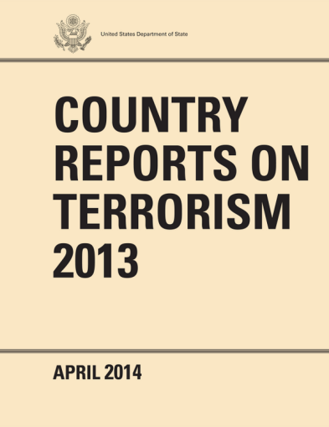
Source: http://www.state.gov/j/ct/rls/crt/2013/224827.htm

April 30 – Nonproliferation efforts have been a top U.S. national security priority for decades. The past decade has seen a growing recognition that our strategic counterterrorism posture is strengthened by counter and nonproliferation programs that aim to reduce the amount of chemical, biological, radiological, or nuclear (CBRN) material produced and stored by states; restrict the diversion of materials and expertise for illicit use; and prevent the trafficking of CBRN weapons and related material. Yet CBRN materials and expertise remain a significant terrorist threat as demonstrated by terrorists’ stated intent to acquire and use these materials; the nature of injury and damage these weapons can inflict; the ease with which information on these topics now flows; and the dual-use nature of many relevant technologies and material. While efforts to secure CBRN material across the globe have been largely successful, the illicit trafficking of these materials persists, including instances involving highly enriched uranium in 2010 and 2011. These examples suggest that caches of dangerous material may exist on the black market and that we must complement our efforts to consolidate CBRN materials and secure facilities with broader efforts to detect, investigate, and secure those materials that have fallen outside of regulatory control. We must remain vigilant to prevent terrorist groups from obtaining the means and methods to develop and deploy CBRN weapons.

A number of international partnerships have either the explicit or the implicit purpose of countering the CBRN threat from terrorists and other non-state actors. Organizations and initiatives concerned with chemical and biological weapons use international conventions and regulations to reduce stockpiles of material, regulate the acquisition of dual-use technology, and to regulate trade of specific goods. International nuclear and radiological initiatives and programs focus on promoting peaceful uses of nuclear material and energy, safeguarding materials and expertise against diversion, and countering the smuggling of radioactive and nuclear material. The United States routinely provides technical and financial assistance and training to ensure that partner nations have the ability to adequately protect and secure CBRN-applicable expertise, technologies, and material. U.S. participation within, and contribution to these groups, is vital to ensure our continued safety from the CBRN threat.

The Proliferation Security Initiative (PSI): Launched in 2003, the PSI has increased international capability to address the challenges associated with stopping the trafficking of weapons of mass destruction (WMD), their related components, and their means of delivery. The PSI remains an important tool in the global effort to combat CBRN material transfers to both state and non-state actors of proliferation concern. As of December 31, 2013, 102 states have endorsed the PSI Statement of Interdiction Principles, by which states commit to take specific actions to support efforts to halt the trafficking of WMD and related materials.

The Global Initiative to Combat Nuclear Terrorism (GICNT): The GICNT, which is co-chaired by the United States and Russia, is an international partnership of 85 nations and four official observers dedicated to strengthening individual and collective capacity to prevent, detect, and respond to a nuclear terrorist event. Partners engage in multilateral activities and exercises designed to share best practices and lessons learned on a wide range of nuclear security and terrorism issues. To date, partners have conducted over 60 multilateral activities and eight senior-level plenary meetings in support of these nuclear security goals. In 2013, there were eight multilateral activities to promote the sharing of best practices on the topics of nuclear forensics, nuclear detection, and emergency preparedness and response.

Nuclear Trafficking Response Group (NTRG): The NTRG is an interagency group focused on coordinating the U.S. government response to incidents of illicit trafficking in nuclear and radioactive materials overseas, including radiation alarms. The NTRG works with foreign governments to secure smuggled nuclear material, prosecute those involved, and develop information on smuggling-related threats including potential links between smugglers and terrorists. The U.S. Department of State chairs the NTRG, which includes representatives from the U.S. government’s nonproliferation, law enforcement, and intelligence communities.
Preventing Nuclear Smuggling Program (PNSP): Continuing seizures of nuclear and radioactive material suggest these dangerous materials remain in illegal circulation. Securing these materials before they reach the hands of terrorists or other malicious actors is critical to U.S. national security, and that of U.S. allies. Using PNSP funds, the U.S. Department of State utilizes outreach and programmatic capabilities to partner with key governments to broadly enhance capabilities to prevent, detect, and respond effectively to nuclear smuggling attempts. PNSP funds enable the U.S. Department of State to develop joint action plans with partner governments to specify priority steps to be taken to improve counter-nuclear smuggling capabilities. As a result, the U.S. Department of State has developed donor partnerships to assist with joint action plan implementations, resulting in foreign contributions of more than US $72 million to anti-nuclear smuggling projects. To date, 15 countries have developed joint action plans and the U.S Department of State has programmatically engaged 12 countries using PNSP-funded projects to enhance nuclear smuggling response procedures, improve nuclear forensics capabilities, and enable the successful prosecution of smugglers. The U.S. Department of State also uses PNSP funds to lead a U.S. effort to develop specialized counter-nuclear smuggling capabilities for foreign partners that integrate law enforcement, intelligence, and technical reach-back capabilities. All PNSP-funded efforts advance the objectives in the 2010 Nuclear Security Summit Work Plan and the 2010 and 2012 Nuclear Security Summit Communiqués.

Export Control and Related Border Security Program (EXBS): Through the EXBS Program, the U.S. Department of State leads the interagency effort to strengthen export control systems to improve national capabilities to detect, deter, interdict, investigate, and prosecute illicit transfers of WMD, WMD-related items, and advanced conventional arms in over 60 countries. EXBS delivered over 200 information sharing and training activities in 2013, promoting the adoption, implementation, and enforcement of comprehensive strategic trade controls. These activities improve the capability of partner states to prevent transfers of dual-use items to end-users for purposes of proliferation or terrorism. EXBS is also actively involved in efforts to combat WMD smuggling through enhanced border security and has provided equipment and training to develop the ability to detect, deter, and interdict illicit smuggling of radioactive and nuclear materials, WMD components, and other weapons-related items at ports of entry and across borders.
In 2013, the EXBS program oversaw over 200 bilateral and regional training activities involving 77 countries, and delivered detection and identification equipment to bolster border security in over 25 countries. EXBS works in harmony with and complements the DHS Container Security Initiative, the U.S. Department of Energy International Nonproliferation Export Control Program, the Second Line of Defense Program, the Megaports Initiative, and other international donor assistance programs. EXBS programs fulfill important U.S. and international commitments, including under UNSC Resolution 1540 (2004), the National Security Strategy, and adherence to the guidelines of multilateral export control regimes.

Second Line of Defense (SLD): Under its SLD Program, the U.S. Department of Energy’s National Nuclear Security Administration cooperates with partner countries to provide radiation detection systems and associated training to enhance their capabilities to deter, detect, and interdict illicit trafficking of special nuclear and radiological materials across international borders. The SLD Program provides mobile radiological detection equipment to selected countries for use at land borders and internal checkpoints and includes two components: the Core Program and the Megaports Initiative. The Core Program began with work in Russia and has since expanded to include states in the Caucasus, Eastern Europe, and other key regions, providing equipment for land border crossings, feeder seaports, and international airports.

Global Threat Reduction (GTR): GTR programs work to prevent terrorists from acquiring CBRN expertise, materials, and technology across the globe. By engaging scientists, technicians, and engineers with CBRN expertise, GTR seeks to prevent terrorist access to knowledge, materials, and technologies that could be used in a CBRN attack against the U.S. homeland. In 2013, GTR was actively engaged in countries and regions at high risk of proliferation and terrorism. GTR programs have expanded to meet emerging CBRN proliferation threats worldwide and focus on promoting biological, chemical, and nuclear security in those countries where there is a high risk of CBRN proliferation.

Biological Weapons Convention Inter-Sessional Work Program (BWC): The December 2011 BWC Review Conference adopted a program of work aimed at strengthening international capacities to prevent, detect, and respond to the proliferation or use of biological weapons, whether by state or non-state actors. In 2013, the United States continued efforts in this forum to: acquire better information about BWC parties’ implementing measures, and enhance such measures; promote sustainable, effective approaches to laboratory biosecurity; raise international awareness of the need for appropriate, balanced oversight of dual-use life science research with significant potential for harm; and identify and address impediments to international coordination and response in the event of a bioterrorism attack or a significant disease outbreak of unknown origin.

Quiz
Can you imagine where this photo was taken?
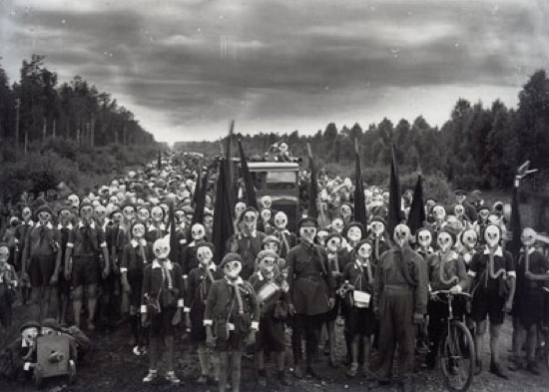
Read about this photo at the end of this chapter.

Activated Carbon Fibres and Fabrics for NBC Clothing and Filters
Source: http://www.army-technology.com/contractors/nbc/taiwan_carbon/

Activated carbons were traditionally in the form of powder or granule. It was not until the last few decades when the third form, Activated Carbon Fibre / Fabric (ACF), was successively developed.
ACF has been widely used in the industries of chemistry, pharmacy and environmental protection for adsorbing toxic molecules. Its performance is particularly effective in shielding the attack of toxic chemical agents, making it ideal for Nuclear, Biological and Chemical (NBC) protective clothing and filters.

Improved NBC protection over powder and granule coating
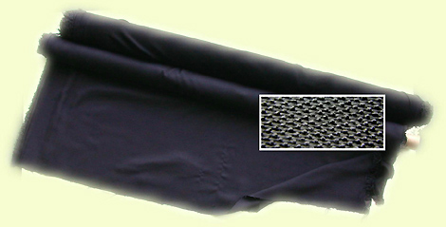
Thanks to the characteristic of reduced diffusion resistance during the process of adsorption and desorption, ACF has much greater capacity and higher speed in performing adsorption and desorption than powders and granules. Another advantage of ACF is its easy-forming property that can be fabricated into cloth, felt and paper to meet different demands in application. This new and advanced material is the answer to demands for improved military and industrial NBC protection.
The ACF made by Taiwan Carbon Technology is a high performance activated carbon existing in the form of woven fibres, not the impregnated into cloth and / or coated with granular activated carbon. It is made of PAN (Polyacrylonitrile) fibre, heat-treated in the process of carbonization and activation, resulting in a much more powerful capacity and efficiency in adsorption than any of the existing powdered and granular activated carbons.

Activated carbon fibre (ACF) fabric for NBC suits
ACF, in fabric, outperforms Granular Activated Carbon (GAC) and Powdered Activated Carbon (PAC) in the respect of formation. With the help of corrugation and sewing technology, it can be made into whatever forms to meet any unique requirement in applications.
ACF effectively removes aliphatic, hydrocarbons, halogenated, aromatic, aldehydes, ketoses, acids, alcohols, phosphorus compounds, ethers, esters, sulphur and nitrogen compounds. ACF also removes hydrogen sulphide, sulphur dioxide, chloride and formaldehyde.

Lighter, more efficient, NBC filter material
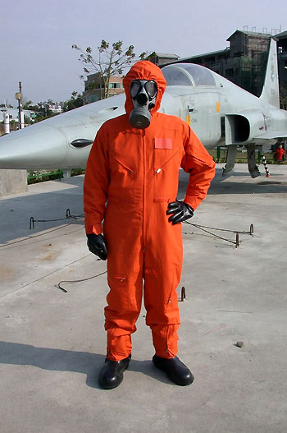
Being in the form of fabric, the ACF still maintains 100% of activated carbon and, in addition to the advantages of even distribution of micropores and high value of surface areas, it has much greater dynamic adsorption capacity and adsorption rate as well as smaller critical bed depth than that of GAC. ACF is a lighter, more efficient, more convenient and less bulky material when used for NBC filter systems. Through the process of impregnation, ACF can also be equipped with added catalytic, chemisorbic and bactericidal properties.
ACF has long been proved as having outstanding performance in adsorbing odours, solvents, bacteria, virus and all of the contaminants that exist in air, gas, water and other liquids.

Advantages of ACF over granular activated carbon (GAC)
The advantages of ACF include huge adsorption volume, heat-resistance, acid-proof and base-proof. ACF's capacity for adsorption of organic vapours, such as gasoline, aldehydes, alcohols and phenol, is seven to ten times that of GAC. It also has significant capability in adsorbing inorganic gas (e.g. NO, NO2, SO2, H2S, HF, HCl etc.) as well as substances in water solution (e.g. dyes, COD, BOD, oils, metal ions, precious metal ions). It also exhibits outstanding ability in the adsorption of bacteria.
A bed of 3mm to 4mm thickness of ACF can have similar adsorption performance as a bed of 20mm to100mm thickness of GAC. ACF does not only perform remarkably for high concentration substances but also for low concentration. For instance, ACF adsorbs toluene when the gas concentration is diminished to 100ppm, whereas GAC starts to adsorb only when the concentration is more than 100ppm. Furthermore, ACF performs normal adsorption even if the concentration of phenol in wastewater is lowed down to 5ppm to10ppm, which is not achievable by other adsorption materials.

European Commission proposes to boost defence efforts against terrorism
Source: http://www.shanghaidaily.com/article/article_xinhua.aspx?id=216584

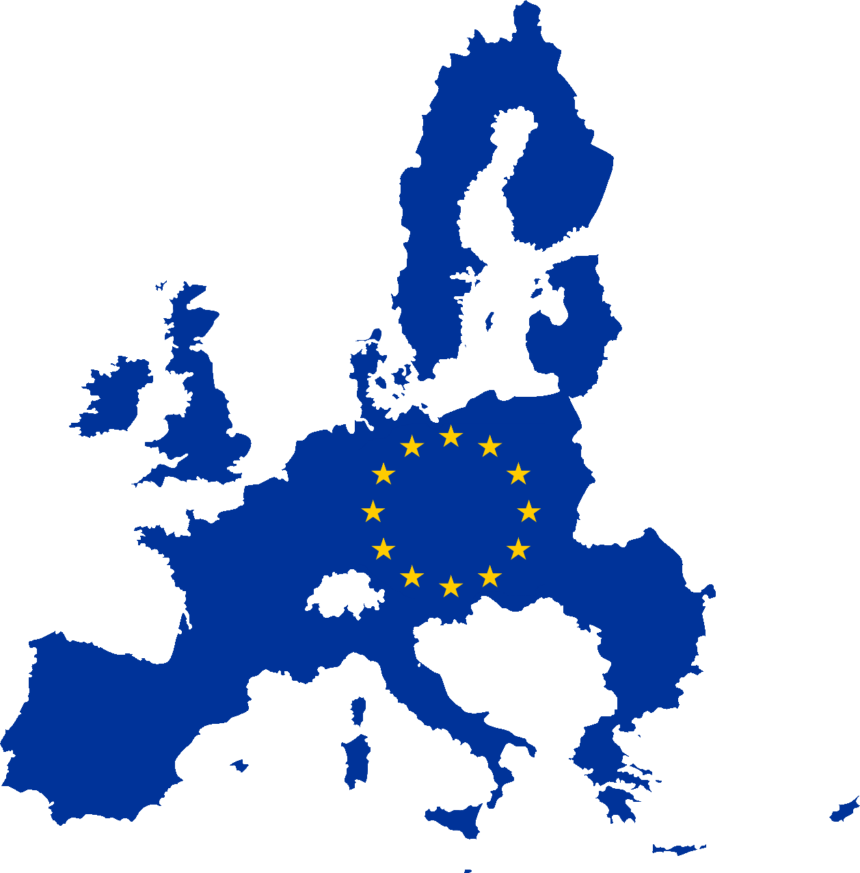
May 5 – The European Commission (EC) is proposing to strengthen Europe's efforts to better detect explosives and dangerous materials, intensify research across Europe, and build awareness in member states, the bloc announced on its website Monday.
These actions are aiming at preventing chemical, biological, radiological and nuclear materials and explosives (CBRN-E) ending up in the hands of terrorists, the EC said.
"We are faced with a clear reality: Terrorists and criminal organisations want get their hands on CBRN-E weaponry. We need to intensify our work across borders to prevent that from happening. By strengthening our common efforts, we will be able to better recognise and assess risks, and develop effective security standards," said Cecilia Malmstrom, EU Commissioner for Home Affairs.
The terrorist attacks such as those in Madrid, London, Moscow and at the Boston Marathon revealed the high level of innovation of attackers, and the relative ease with which some CBRN-E materials and components can be obtained.
The EC proposed to facilitate practical cooperation for the detection and mitigation of CBRN-E risks at EU level, including working with the industry, operators of facilities handling CBRN-E materials (equipment manufacturers and security services providers) and other stakeholders.
To boost the efforts against terrorism, the EC said concrete tools will be developed, ranging from guidance materials, training and awareness.
Recently, advanced mobile CBRN-E detection equipments are tested through practical trials and will be soon come into use. The light-weight portable electrical devices could yield results in real-time within seconds.
With around 60 CBRN-related projects and more than 15 projects focusing on explosives, the EC pledged to ensure that the results of research activities are better disseminated and translated into useful commercial products.
More work will be done to enhance training initiatives, and improve awareness and capacity building through sharing best practices and developing guidance material, the EC said.
In mid-2014, the Commission will publish a handbook for airport protection of civilians, carried out within the EU Airpol police network. Such guidance material would then be disseminated and used by practitioners across member states.
The EC also volunteered to support preparedness and detection measures in third countries through technical assistance, training, and sharing of information.

How to communicate with the public about chemical, biological, radiological, or nuclear terrorism: a systematic review of the literature.
By Rubin GJ, Chowdhury AK, Amlôt R.
Biosecur Bioterror. 2012 Dec;10(4):383-95. doi: 10.1089/bsp.2012.0043. Epub 2012 Dec 7.

A deliberate attack involving chemical, biological, radiological, or nuclear (CBRN) material has the potential to cause substantial fear among the public. This presents problems for communicators, who will need to provide information quickly after an attack while ensuring that their messages are easily understood and likely to be attended to by members of the public. Identifying in advance what people would want to know, where they would get information from, and how messages should be presented might allow communicators to ensure that their messages have the best chance of having their desired effect. In this review, we identified all peer-reviewed studies that have assessed communication strategies or information needs using hypothetical CBRN scenarios or in actual CBRN incidents. We identified 33 relevant studies. Their results support existing psychological models of why people engage in health protective behaviors, with information about the severity of the incident, the likelihood of being exposed, the efficacy and costs or risks of recommended behaviors, and the ability of individuals to perform recommended behaviors being sought by the public. Trust plays a crucial role in ensuring that people attend to messages. Finally, while a large variety of spokespeople and sources were identified as being turned to in the event of an incident, the use of multiple information sources was also common, affirming the importance of communicating a consistent message through multiple channels. Further research is required to extend these predominantly US-based findings to other countries and to confirm the findings of research using hypothetical scenarios.

Is preparedness for CBRN incidents important to general practitioners in East London?
By Dabrera G, Anyaegbu E, Addiman S, Keeling D, Ashton C, Whala S, Dunne A, Figueroa J, Lovitt C, Basnett I, Balasegaram S.
J Bus Contin Emer Plan. 2012 Summer;6(1):47-54.

General practitioners (GPs) have an important role in public health response to CBRN incidents, including disseminating information to worried patients and undertaking risk assessments of patients. The authors undertook the first known UK survey of GPs' CBRN preparedness to assess knowledge and attitudes towards CBRN preparedness among GPs in East London, in the area of the Olympic Park. A questionnaire was developed, focusing on GPs' self-preparedness for, and perceived roles in CBRN incidents, and GPs' access to resources and policies for dealing with such incidents. Of 157 GPs, 56 responded, although some responded collectively for their practice. The majority of respondents recognised roles for themselves in CBRN incidents, including recognition of illness, supporting decontamination, and appropriate reporting. However, 79 per cent of GPs also felt unprepared for such incidents. The most popular topic for training to address this was clinical presentation of CBRN exposures. Most practices had no policy for dealing with suspect packages and white powder incidents. Since this survey, guidance and training has been made available to local GPs. As the UK will host more events like the 2012 Olympics, preparedness for GPs will continue to be an important consideration in the UK.

EDITOR’S COMMENT: 56 out of 157 resopnded. This is the first problem in preparedness. 79% felt unprepared. This is the second problem. It would be HIGHLY interesting to repeat the same study two years after London 2014. It would be a proof if the problem remains or if it gets bigger. And it would be even MORE interesting to expand the study to all London GPs and include a pool of GPs from other Olympic cities. But now that the big problem (Olympiad) is over who cares about the CBRN preparedness of GPs?

New synthetic catalysts could offer protection against biothreats
Source: http://bioprepwatch.com/countermeasures/new-synthetic-catalysts-could-offer-protection-against-biothreats/337375/

Scientists recently developed a catalyst using their knowledge of quantum mechanics that could be used to protect warfighters against chemical and biological threats more quickly and efficiently.
As part of a Defense Threat Reduction Agency’s Chemical and Biological Technologies Department (DTRA CB)/Joint Science and Technology Office (JSTO)-funded research effort, researchers from Temple University and the University of California at Los Angeles accomplished a series of catalytic reactions using spiroligomers. Spiroligomers are small, non-neutral, shape-programmable scaffolds. By learning to develop and control the catalysts, the researchers may open the door to developing catalysts for chemical and biological defense, Dvidshub.net reports.
In the study, which was published in the Journal of the American Chemical Society, the scientists developed a catalyst that accelerated the aromatic Claisen rearrangement, an important carbon-carbon bond forming reaction. The reaction is a model towards the understanding of how enzymes work.
After developing a series of molecules, the researchers determined which synthetic catalysts resulted in the largest accelerations of the aromatic Claisen rearrangement.
The scientists began their efforts five years ago after demonstrating a method to synthesize shape-programmable spiroligomer macromolecules. The latest study represented the third DTRA-funded catalyst for the aromatic Claisen rearrangement.
Going forward, the researchers plan to construct larger spiroligomer scaffolds, allowing more complex active sites to be displayed based on the ideas developed in earlier works, Dvidshub.net reports.

Our last occupation
Source: http://www.theguardian.com/world/2003/apr/19/iraq.arts

No one, least of all the British, should be surprised at the state of anarchy in Iraq. We have been here before. We know the territory, its long and miasmic history, the all-but-impossible diplomatic balance to be struck between the cultures and ambitions of Arabs, Kurds, Shia and Sunni, of Assyrians, Turks, Americans, French, Russians and of our own desire to keep an economic and strategic presence there.
Laid waste, a chaotic post-invasion Iraq may now well be policed by old and new imperial masters promising liberty, democracy and unwanted exiled leaders, in return for oil, trade and submission. Only the last of these promises is certain. The peoples of Iraq, even those who have cheered passing troops, have every reason to mistrust foreign invaders. They have been lied to far too often, bombed and slaughtered promiscuously.
Iraq is the product of a lying empire. The British carved it duplicitously from ancient history, thwarted Arab hopes, Ottoman loss, the dunes of Mesopotamia and the mountains of Kurdistan at the end of the first world war. Unsurprisingly, anarchy and insurrection were there from the start.
The British responded with gas attacks by the army in the south, bombing by the fledgling RAF in both north and south. When Iraqi tribes stood up for themselves, we unleashed the flying dogs of war to "police" them. Terror bombing, night bombing, heavy bombers, delayed action bombs (particularly lethal against children) were all developed during raids on mud, stone and reed villages during Britain's League of Nations' mandate. The mandate ended in 1932; the semi-colonial monarchy in 1958. But during the period of direct British rule, Iraq proved a useful testing ground for newly forged weapons of both limited and mass destruction, as well as new techniques for controlling imperial outposts and vassal states.
The RAF was first ordered to Iraq to quell Arab and Kurdish and Arab uprisings, to protect recently discovered oil reserves, to guard Jewish settlers in Palestine and to keep Turkey at bay. Some mission, yet it had already proved itself an effective imperial police force in both Afghanistan and Somaliland (today's Somalia) in 1919-20. British and US forces have been back regularly to bomb these hubs of recalcitrance ever since.
Winston Churchill, secretary of state for war and air, estimated that without the RAF, somewhere between 25,000 British and 80,000 Indian troops would be needed to control Iraq. Reliance on the airforce promised to cut these numbers to just 4,000 and 10,000. Churchill's confidence was soon repaid.
An uprising of more than 100,000 armed tribesmen against the British occupation swept through Iraq in the summer of 1920. In went the RAF. It flew missions totalling 4,008 hours, dropped 97 tons of bombs and fired 183,861 rounds for the loss of nine men killed, seven wounded and 11 aircraft destroyed behind rebel lines. The rebellion was thwarted, with nearly 9,000 Iraqis killed. Even so, concern was expressed in Westminster: the operation had cost more than the entire British-funded Arab rising against the Ottoman Empire in 1917-18.
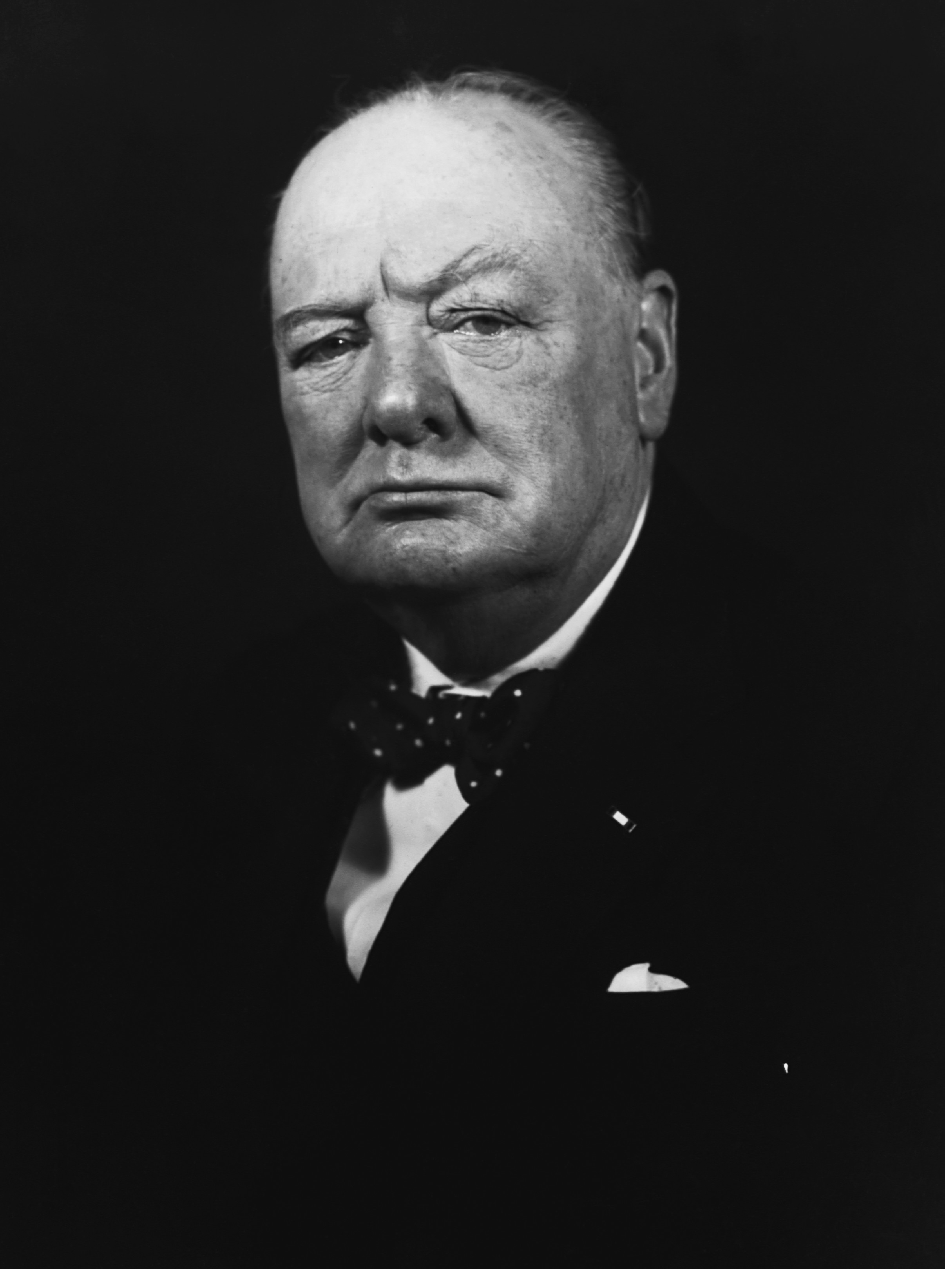
The RAF was vindicated as British military expenditure in Iraq fell from £23m in 1921 to less than £4m five years later. This was despite the fact that the number of bombing raids increased after 1923 when Squadron Leader Arthur Harris - the future hammer of Hamburg and Dresden, whose statue stands in Fleet Street in London today - took command of 45 Squadron. Adding bomb-racks to Vickers Vernon troop car riers, Harris more or less invented the heavy bomber as well as night "terror" raids. Harris did not use gas himself - though the RAF had employed mustard gas against Bolshevik troops in 1919, while the army had gassed Iraqi rebels in 1920 "with excellent moral effect".
Churchill was particularly keen on chemical weapons, suggesting they be used "against recalcitrant Arabs as an experiment". He dismissed objections as "unreasonable". "I am strongly in favour of using poisoned gas against uncivilised tribes _ [to] spread a lively terror _" In today's terms, "the Arab" needed to be shocked and awed. A good gassing might well do the job.
Conventional raids, however, proved to be an effective deterrent. They brought Sheikh Mahmoud, the most persistent of Kurdish rebels, to heel, at little cost. Writing in 1921, Wing Commander J A Chamier suggested that the best way to demoralise local people was to concentrate bombing on the "most inaccessible village of the most prominent tribe which it is desired to punish. All available aircraft must be collected the attack with bombs and machine guns must be relentless and unremitting and carried on continuously by day and night, on houses, inhabitants, crops and cattle."
"The Arab and Kurd now know", reported Squadron Leader Harris after several such raids, "what real bombing means within 45 minutes a full-sized village can be practically wiped out, and a third of its inhabitants killed or injured, by four or five machines which offer them no real target, no opportunity for glory as warriors, no effective means of escape."
In his memoir of the crushing of the 1920 Iraqi uprising, Lieutenant-General Sir Aylmer L Haldane, quotes his own orders for the punishment of any Iraqi found in possession of weapons "with the utmost severity": "The village where he resides will be destroyed _ pressure will be brought on the inhabitants by cutting off water power the area being cleared of the necessaries of life". He added the warning: "Burning a village properly takes a long time, an hour or more according to size".
Punitive British bombing continued throughout the 1920s. An eyewitness account by Saleh 'Umar al Jabrim describes a raid in February 1923 on a village in southern Iraq, where bedouin were celebrating 12 weddings. After a visit from the RAF, a woman, two boys, a girl and four camels were left dead. There were many wounded. Perhaps to please his British interrogators, Saleh declared: "These casualties are from God and no one is to be blamed."
One RAF officer, Air Commodore Lionel Charlton, resigned in 1924 when he visited a hospital after such a raid and faced armless and legless civilian victims. Others held less generous views of those under their control. "Woe betide any native [working for the RAF] who was caught in the act of thieving any article of clothing that may be hanging out to dry", wrote Aircraftsman 2nd class, H Howe, based at RAF Hunaidi, Baghdad. "It was the practice to take the offending native into the squadron gymnasium. Here he would be placed in the boxing ring, used as a punch bag by members of the boxing team, and after he had received severe punishment, and was in a very sorry condition, he would be expelled for good, minus his job."
At the time of the Arab revolt in Palestine in the late 1930s, Air Commodore Harris, as he then was, declared that "the only thing the Arab understands is the heavy hand, and sooner or later it will have to be applied". As in 1921, so in 2003.

Carbon nanotube clothing could protect against chemical weapons of mass destruction
Source: http://www.extremetech.com/extreme/182065-carbon-nanotube-clothing-could-protect-from-poison-gas

Chemical weapons are undeniably nasty — some of the most vile things science has ever created — but now maybe science is close to finding a reliable way to neutralize some of these terrible weapons. By weaving carbon nanotubes into clothing, a team from the National Institute of Standards and Technology (NIST) may have figured out a simple way to deconstruct nerve gases, like sarin, in moments.
On a molecular level, it’s the physical shape and charge pattern of a molecule that allows it to interact with other molecules. In the case of sarin gas, its shape gives it devastatingly toxic properties (this was the nerve gas used in the now infamous 1995 Tokyo subway attacks). Exposure to sarin, either by inhalation or contact with the skin, causes the neurotransmitter acetylcholine to build up in the nervous system, which makes muscles seize up. When this effect reaches the diaphragm and other muscles responsible for breathing, asphyxiation is not far behind. The key to deconstructing sarin and similar organophosphate compounds is breaking the P-F bond, and this is what the NIST team has figured out how to do with specially treated carbon nanotubes.
Catalyzing the breakdown of sarin isn’t terribly difficult in a laboratory setting, but doing so passively in a real world situation is the challenge, thus carbon nanotubes are the perfect solution. They are lightweight, durable, and have high surface area relative to volume. This allowed the researchers to coat nanotubes with a catalytic polymer compound known as a copper-chelating bipyridine. When sarin comes in contact with these compounds, the P-F bond is hydrolyzed (broken) and its deadly effects are neutralized.
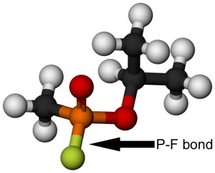
Working with real sarin gas is not only dangerous, it’s completely unnecessary in this case. The researchers instead performed their experiments on a safe molecule that contained the same P-F bond that is the weak point of sarin. They used UV-vis spectroscopy to monitor the breakdown rate of the molecule when exposed to the treated carbon nanotubes, finding that it was breaking bonds approximately 63 times faster than sarin’s natural decay rate. If clothing and other materials had these nanotubes woven in, it could easily be the difference between lethal exposure and a survivable incident for the victims of poison gas attacks.
The researchers see this as a perfect approach to creating self-decontaminating materials, which would be a boon to those tasked with cleaning up after an organophosphate accident or attack. These gasses often become embedded in fabrics, allowing them to be re-dispersed later. Now it’s a matter of determining whether the nanotubes are more effective when coated with the reactive polymer before or after being incorporated into fabrics. It may also be possible to tweak the formulation and coating process to make the polymer even more reactive, which may break down organophosphates more quickly.
Of course, this all assumes such a material can be made safe, comfortable for the wearer, and somewhat affordable — far from a sure thing when working with exotic nanoparticles.

Army develops smartphone system to detect chemical, biological threats
Source: http://defensesystems.com/Articles/2014/04/16/Army-chem-bio-smartphone-detector.aspx

Soldiers facing a situation with a potential biological or chemical threat could soon have a way to assess the threat on the spot, using specially equipped smartphones.
A public/private team of researchers under the Army’s Research, Development and Engineering Command have developed Volatile Organic Compound (VOC) strips that work with a device called a Biotouch, which relays information from the VOC for analysis. The results then appear on a soldier’s Nett Warrior smartphone.
“The idea is to have two smartphones: the Biotouch that could test the VOC and the Nett Warrior phone that would receive the information from a different location,” Peter Emanuel, biosciences division chief for the Army’s Edgewood Chemical Biological Center (ECBC), said in a release. “The two will be able to communicate with each other through a phone portal within the encrypted network.”
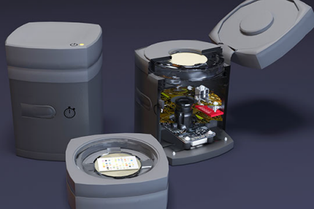
The project is a collaborative effort by ECBC, iSense, the Army Communications-Electronics Research, Development and Engineering Center, and the Defense Threat Reduction Agency.
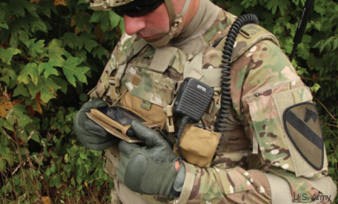
At the heart of the project are the VOC strips, colorimetric sensor assays that each are about the size of a postage stamp and have 88 indicator dyes—specific to defense purposes—developed by iSense. When faced with a potential threat, a soldier could use a strip to take an environmental sample, such as soil, or biomedical sample, such as urine, ECBC said.

A chest-mounted Galaxy Note II gives Nett Warrior users situational awareness.

The strip is then loaded into the Biotouch, a 3-by-3-by-5-inch device that doesn’t look much like a smartphone but has the ability to geo-tag the strip and connect to the Army’s network. The soldier can then retrieve the results on a Nett Warrior phone, a Samsung Galaxy Note II adapted for military use.

Mobile CBRN Detector Box
Source:http://www.cbrnhungary.hu/?mnuGrp=&module=products&lang=eng&group=epuletfelugyelet_epuletfelugyelet&product=mobilecbrn&termek=&menupath=-epuletfelugyelet-epuletfelugyelet_ epuletfel ugyelet&csoport=Building%20monitoring%20systems

Fields of application
- Securing VIP meetings, mobile facilities
- High-security buildings

Features
- Provides comprehensive protection against CBRN threats
- Simultaneously used CBRN Boxes automatically set up a communication network
- Monitoring capability of a large area via the network of CBRN boxes
- Extends the capability of the common security elements
- Portable, easy to install
- Does not require expert personnel
- Rugged, can be used under extreme weather conditions
The CBRN Detector Box detects the presence of chemical, biological substances and nuclear radiation. The system offers an overall view and fast response to nearly all challenges. It detects chemical warfare agents (CWAs) and a wide range of toxic industrial chemicals (TICs). The applied biological alarm monitor is continuously analyzing particles in the air searching for specific signatures of bacteria or toxins such as anthrax, plague, Botox, legionella, etc., and alarms when the concentration of those particles increases. The system contains a gamma dose rate meter with an extremely wide measurement range as well and can optionally be completed with a highly sensitive scintillation detector for radiation reconnaissance. The detector box also includes a combined meteorological sensor for providing measurement data that supports the users in determining the direction of the spread of actual or potential hazardous materials and to find safe escape routes.

Separatists claim government troops used chemical weapons in Mariupol
Source: http://www.kyivpost.com/content/ukraine/separatists-claim-government-troops-used-chemical-weapons-in-mariupol-347059.html

The leaders of the "Donetsk People's Republic" claimed that self-defense forces in Mariupol came under a chemical attack when the City Council building was being stormed by Kyiv-controlled armed units.
"Armed groups controlled by Kyiv used unidentified chemical weapons on May 6 while storming the City Council headquarters," the foreign ministry of the "Donetsk People's Republic" said in a statement, posted in the Donetsk "people's governor" Pavlo Hubarev's Facebook account.
"The defenders of the City Council have left the contaminated area. Many of them had their breathing systems damaged, which is likely to have consequences and probably be a danger to their lives," the statement says.
"Kyiv bears the entire responsibility not only for their state agencies' actions, but also for the actions by citizens who illegally apply means of chemical warfare," the statement says.
The statement urges the world community to condemn the use of a toxic choking gas in Mariupol and to take comprehensive measures to subject the Kyiv authorities to international isolation."
The authors also urged Russia to influence the Organization for the Prohibition of Chemical Weapons into organizing a full-scale probe in Mariupol into the use of chemical weapons by the Kyiv authorities."
No confirmation of this information from other sources is available to Interfax-Ukraine. The Ukrainian leadership has not commented on it, either.

Deformed babies born in Syria after Ghouta gas attack
Source:http://www.telegraph.co.uk/news/worldnews/middleeast/syria/10831062/Deformed-babies-born-in-Syria-after-Ghouta-gas-attack.html

May 14 – The Syrian regime is facing accusations from medics that its use of chemical weapons against rebel-held areas is now resulting in birth defects and genetically malformed newborns.
One doctor said the incidents of stillborns at a clinic for refugees across the border in Arsal, Lebanon, was running at more than one in 10 births, while videos posted by activists show badly damaged infants being born in local clinics.
The parents of a baby born with a deformed face who died last week near Damascus have also said they are convinced that exposure to gas is responsible.
The baby girl, called Fatma Abdul Ghafar, from the suburb of eastern Ghouta was born last Tuesday but died nine hours later.
Mahmoud Abdul, 26, the father, told the Telegraph that the doctor supervising the birth had said exposure to what the United Nations confirmed was sarin gas was the most likely explanation for her deformity.
Sarin is a nerve agent - clear, colourless, and tasteless, with no odour.
His wife inhaled the gas during an attack on the suburb last August, while she was in her first month of pregnancy, but had appeared to recover.
“When the chemical attack happened Marwa my wife smelled gas and was ill,” he said. “We took her to a medical point where she was showered and got better. The baby was born in a very bad way. So she died the next morning.”
Mr Ghafar dismissed suggestions that hereditary defects or other environmental factors could have been the cause. Neither his family or that of his 17-year old wife had suffered previous incidents of deformities.
Activists in eastern Ghouta are convinced the child died as a result of the mother’s exposure.
More than 1,000 people including women and children were killed on August 21 when regime forces dropped bombs and rockets on two separate areas of Ghouta in an effort to dislodge entrenched rebel resistance.
Some 3,600 people affected were treated for symptoms, according to a report by the charity, Medecins Sans Frontieres. “The family of the baby are from east Ghouta but they live now in another area which is under the control of the regime” said Ali Baz, the head of a network of citizen journalists in the area, Syria Mubashr.
The network published a video and issued reports on the fate of Fatma. “Doctors who examine the case of the dead baby confirmed that it is the first case after the use of the chemical weapons at this region” he said.
A second child died in the same area on Tuesday this week according to Beirut’s Daily Star newspaper. Abu Ibrahim Bakr, the chief gynaecologist at the Zahraa Gynaecological Center in eastern Ghouta, said the latest victim had also been exposed to the attack. “The exposure to chemical weapons can absolutely cause the fetus’ deformations, especially if the pregnancy is in its first three months,” he told The Daily Star.
Nidhal Shikhani, another activist, said there were widespread fears the sarin attacks on Damascus have caused abnormalities in newborns.
“These distortions are the result of the chemical weapons used by the Syrian regime last August, said Mr Shaikhani. “Fatma was born congenitally deformed because of exposure to toxic gases and chemicals many times. She is the first case to be registered in the region since the beginning of the revolution. She died few hours after her birth.”
Even outside the immediate area, the effects of the attacks are marked.
“We have noticed an increase of the percentage of stillborn deliveries and an increasing need to use incubators, as well as growth retardation” said Kasem al-Zein, a doctor who runs medical operations for Syrians in Arsal.
“We are receiving pregnant women in Arsal from many areas such as Qusair, Homs, Kalamoon, and [outer] Damascus, they come across the border for giving birth but in some cases the result is tragedy.”
“We are receiving around 100 births a month in Arsal, about 12 per cent in the average out of them are stillborn,” he said. “The problems for newborn children are mostly occurring in women who were exposed to the chemical weapons, but also we have noticed that all women who lived in areas exposed to shelling by barrels and missiles are suffering fetal diseases.”
The Foreign Office said the reports of deformation and deaths of newborns added to the urgency of efforts to remove chemical weapons in Syria.
“We are aware of these reports and images and are deeply disturbed by the suffer of the families concerned,” a spokesman said.
In another case, a four-month-old baby girl called Jood is receiving treatment in an hospital in Idlib province after she was born with the bottom half of her left leg and several fingers missing.
Jood’s mother was two months pregnant when she was exposed to gas during fighting in Homs last July while she was in the early stage of pregnancy.
“Nine women came to the hospital (in Arsal) from Gouta, near the aria attacked by the Chemical Weapons, three of them had suffered the death of the child and one meningocele,” said Dr Kasem. “I’m pretty sure that the increasing use of internationally banned weapons will lead to increasing of distortions and tumours for newborn babies.”
Christine Gosden, a British academic who has studied the after effects of exposure to chemical weapons, has identified congenital abnormalities in the offspring of survivors as well as a higher incident of miscarriages, stillbirths, neonatal and infant deaths.
Testifying to the US congress she said that mustard gas attacks in Halabja, Iraq, had long lasting consequences. “I was shocked by the devastating effects of these weapons which have caused problems such as cancers, blindness and congenital malformations,” she said.
Human Rights Watch said this week that the Syrian regime continues to use gas attacks against rebels, having dropped chlorine bombs on insurgents in several cities last month.
“Evidence strongly suggests that Syrian government helicopters dropped barrel bombs embedded with cylinders of chlorine gas on three towns in Northern Syria in mid-April 2014,” the human rights group said.
Earlier reports said chlorine gas was used in clashes between the Syrian Army and rebels near the town of Kfar Zeita on April 11-13, which resulted in two killed and about a hundred injured.
Damascus blamed the chemical attack on the Islamic group Jabhat Al-Nusra, a branch of al-Qaeda operating in Syria and Lebanon.
Over 92 per cent of Syria’s chemical stockpile has been removed from the country, the Organisation for the Prohibition of Chemical Weapons (OPCW) said at the end of April. The remaining 16 containers with chemical weapons are stored near Damascus in the area occupied by opposition groups.

Leveraging Social Media in a Sarin Attack
Source: http://www.upmchealthsecurity.org/

As the use of mobile phone-based technology has increased, there has been much discussion about how the widespread availability of these and related devices can augment the provision of health care. Mobile phones are capable of doing much more than facilitating voice communication and text messaging. Much of the interest to date has focused on the ability to survey social media sites such as Twitter and Facebook to determine the trajectory of an infectious disease outbreak such as influenza. However, the use of cameras with video recording capabilities also can provide real-time viewing of actual patients facilitating telemedicine interventions. A new paper details how this technology can be used in a setting far removed from traditional healthcare settings: the sarin attacks employed in the Syrian conflict.

Social Media Videos Reviewed
On August 21, 2013, approximately 1,400 individuals were killed and thousands more were injured during a sarin attack in Damascus. Myriad videos portraying the victims were posted to YouTube. An Israeli research team, in a paper published in Annals of Internal Medicine, attempted to determine if social media videos could be used in diagnosing sarin poisoning.
In this study, Rosman et al. searched for videos on YouTube that were uploaded between August 21, 2013, and September 15, 2013, with relevant keywords. Videos that focused on victims for at least 3 seconds were sought. Ultimately, 67 videos of 130 casualties (amounting to 114 minutes) were included in the analysis. Two experienced physicians analyzed the video and scored each video for several signs consistent with sarin poisoning (eg, miosis, diaphoresis, etc), the presence of decontamination procedures, and treatment interventions.
Interestingly, the researchers found no evidence of standard monitoring equipment, only 25% of videos showed evidence of decontamination procedures, and no personal protective equipment was employed in any video. The percentages were congruent with official UN estimates.

A New Paradigm?
This study is a proof-of-concept showing that social media videos can provide accurate and timely information needed in a complex mass casualty situation. Furthermore, such information is interpretable by physicians and capable of providing a realistic assessment of a situation. Future events will undoubtedly prompt further use of social media. Preparedness and response efforts should be poised to use the data generated in order to gain situational awareness and optimize operational activities.

Reference
Rosman Y, Eisenkraft A, Milk N, et al. Lessons learned from the Syrian sarin attack: evaluation of a clinical syndrome through social media. Ann Intern Med 2014;160:644-648.

►Requests for Single Reprints: Yossi Rosman, MD, Hashaked 4/19, Givat Shemuel, 54044, Israel;
E-mail: rosmanyossi@gmail.com

EDITOR’S COMMENT: This is a unique and usefull paper! A small comment though: I would be interested to read in the statistical analysis of clinical observations the percentage of victims in videos with both “miosis” and “dyspnea” or similar combined symptomatology. On the other hand I understand the limitations already mentioned in the article.

Interior Ministry: Chloroform discovered in Odessa Trade Unions building where 32 died
Source: http://www.kyivpost.com/content/ukraine/interior-ministry-chloroform-discovered-in-odessa-trade-unions-building-348449.html

May 19 – A top Ukrainian Interior Ministry official said on May 19 that 32 pro-Russia protesters who retreated inside Odessa’s Trade Unions building after clashes with pro-Ukraine activists and later died when the building was torched on May 2 might have been poisoned with chloroform.
Vitaliy Sakal, Ukraine's deputy interior minister and chief investigator, told journalists in Kyiv on May 19 that chloroform, a chemical that restricts the ability to breath, was discovered by his investigative team inside the Trade Unions building.
"Chloroform was found in the litter and soot when the House of Unions was being examined. Chloroform is normally used in surgical operations. We have yet to establish why this substance was there," Sakal said.
"According to experts, inhaling chloroform vapors obstructs the breathing, which is what happened in our case. The cause of the 32 deaths in Odessa on May 2 was heart failure and breathlessness under the impact of an unidentified substance, not as a result of the high temperature," he said.
Sakal added that the mixture containing chloroform had been in the Trade Unions building for several days.
"According to experts, if the substance remains in the open air, it becomes toxic. Heating is not needed in this case. Inhaling its vapors leads to irreparable damage for humans," he said.
Sakal said that an investigation to determine the substance’s origin is ongoing and that Ukrainian investigators have urged the Israeli Embassy to provide skilled professions to assist Ukrainain specialists in the matter.
Forty-eight people were killed and some 250 were injured during clashes between pro-Ukraine football fanatics and pro-Russia separatists in Odessa on May 2. Thirty-two people were suffocated and burned in the Trade Unions building as it was engulfed in flames, six died from gunshot wounds and 10 were killed after they leapt from the buildings windows several stories.

Mustard plants help detect use of chemical weapons
Source: http://www.homelandsecuritynewswire.com/dr20140522-mustard-plants-help-detect-use-of-chemical-weapons

Making nations comply with the Chemical Weapons Convention requires that scientists can accurately detect the use of chemical warfare agents. Currently they carry out tests on soil from areas where use is suspected. Many nerve agents composed of organo-phosophorous compounds, however, leach from soil over time, removing the evidence of use and making verifying the deployment of chemical weapons like sarin, soman, and VX difficult. Researchers report that white mustard plants can help by allowing detection for up to forty-five days after the chemical weapons were used.
The Chemical Weapons Convention prohibits the use of chemical weapons by its 190 member states. Making sure members comply with the convention requires that scientists can accurately detect the use of chemical warfare agents. Currently they carry out tests on soil from areas where use is suspected. Many nerve agents composed of organo-phosophorous compounds, however, leach from soil over time, removing the evidence of use and making verifying the deployment of chemical weapons like sarin, soman, and VX difficult.
A Royal Society release reports that today a collaborative team of scientists from the University of Central Lancashire and the U.K. Defense Science and Technology Laboratory present a method to detect chemical weapon use by analyzing the compounds present in white mustard plants. The plants, which grow wildly across the world, are pollutant tolerant and can absorb nerve agent chemicals through their roots.
The plants retain compounds from the agents for longer than soil can and act as a sort of ‘time capsule’ protecting the evidence of chemical weapon use for at least forty-five days.
The team of researchers grew white mustard plants in three different types of soil spiked with VX to see if the type of soil affected how long the plants retained traces of compounds from chemical weapon use. After eight days, plants grown in sandy soil had absorbed more VX than those grown in loam or clay soils, however, by 16, 33, and 45 days after the seeds were sown, the amount of VX in the plants from the different soils had converged. The team says this shows that regardless of soil type “evidence for the prior presence of VX in soil can be downloaded from the plant at least 45 days after application.”
As well as being useful for detecting chemical weapons use the team say their results show that the plants could also be used in the further as a sort of “green manure” absorbing chemicals from soil in polluted sites. The team even found some evidence that the plants may be able metabolize nerve agents, breaking them down into their less harmful degradation products and helping to reduce the “toxic environmental legacy” of chemical weapons from areas where they have been deployed.

— Read more in Matthew R. Gravett et al., “Evidence of VX nerve agent use from contaminated white mustard plants,” Proceedings of the Royal Society A 470, no. 2168 (21 May 2014)

Argon CBRN Response Training Simulators Bring Realism to Training
Source: http://www.hstoday.us/single-article/argon-cbrn-response-training-simulators-bring-realism-to-training/428f8e2297229a812530fe7f810fb9a9.html

Argon Electronics said its range of CBRN response training simulators offers realism that has significantly enhanced training exercises for law enforcement and military.
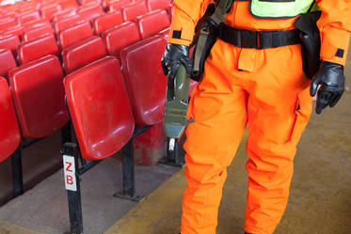
The company said in an announcement that at an exercise staged for police in the South West of the United Kingdom, “Argon equipment was supplied by the Police National CBRN Center at Ryton-on-Dunsmore in Warwickshire which oversees the police’s capacity and capability to deal with CBRN incidents, and was a highly valuable tool in the exercise as a means of improving the quality and value of training.”
Avon and Somerset police used the simulators for a training exercise at the Bristol City football ground. The premise of the exercise, Argon said, was that the police were present to provide security and safety at a half marathon charity event in support of military charities, starting and finishing at Bristol City Football Club.
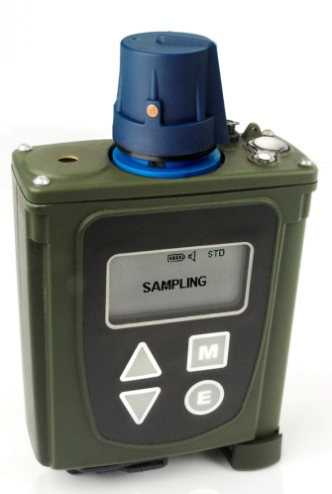
“The inventory comprised a variety of CBRN training simulators, including Argon’s PlumeSIMsystem, which enables a single instructor to configure simulated chemical and radiological releases across a wide area, and then to monitor and manage multiple trainees in real time from a central location,” Argon said.
“For the purpose of the exercise,” Argon said,” advance intelligence had suggested that some chemical weapons had been smuggled out from Syria for possible terrorist use in the UK. Police were also informed of a known active Syrian community in Bristol with both pro and anti-government factions represented and told that tensions in the area had been apparent for some weeks.”
On the day of the exercise, organizers arrived early to plan the full day in detail, which played a key role in the success of the training. “Had the trainees arrived and been forced to wait while organizers spent the first two hours planning they would have lost focus,” Argon said. “The emergency services may face many occasions in real life where planning isn’t possible, but there are often many incidents where advance intelligence tells the police to expect an incident. The premise of the pre-planned exercise carried out at Bristol City Football Ground was that the police force had received advance intelligence that something was possibly going to happen and on this occasion the organizer’s pre-planning supported the event and the premise.”
Argon said “realism was introduced at every opportunity,” noting that “the release of agents took place while the commanders were still delivering their briefings, at which point two smoke machines went off and a hundred people started screaming. The training was not only physical, where trainees gain familiarity with the equipment, but also emotional."
"The purpose of this was to enable trainees to cope effectively with a frightening scene to be prepared for a real life situation," Argone said. "To the trainees listening to the briefing who may have been relaxed and waiting for the training to begin shortly, the sudden sound of a hundred people screaming and the sight of smoke billowing out of the stadium immediately put them into an alert and focused frame of mind. This ensured that everyone -- the police included -- reacted to the circumstances as if it was a real life emergency. This realism was supported by the use of the Argon equipment, which enabled the trainees to start trying to locate the source immediately as if in a real life situation.”
The quality of the training exercise was further enhanced by using electronic simulators which support emergency services with preparations for situations similar to real life. For the training organizers, the alternatives to electronic simulators are live simulants, such as deep heat, but exercises can become unrealistic as training personnel have to be so close to these to get a detector reading, Argon explained.
But “With Argon equipment the police were able to simulate a faraway plume, which is similar to how it would be in a real incident,” the company said, adding that, “Another alternative is to simulate particular forms of contamination with special liquids, however simulated substances don’t lend themselves to repeated training, as they cause lasting contamination. A key advantage of electronic detector simulators is that they look, feel and function exactly like the real detectors but respond to safe electronic sources. With electronic simulation equipment the trainees can realistically carry out their roles without risk of harm or damage to themselves, other participants, their equipment or the environment.”
In the end, the trainees were able to learn more effectively from practical training, “which is why electronic simulators are so important in successful CBRN training as they offer the opportunity to put learned knowledge into practice,” Argone said.

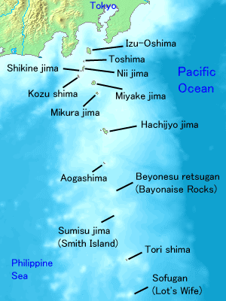
Quiz answer: Izu Islands, Japan
The Izu Islands are a group of volcanic islands stretching south and east from the Izu Peninsula of Honshū, Japan. Administratively, they form two towns and six villages; all part of Tokyo. The largest is Izu Ōshima, usually called simply Ōshima.

Because of their volcanic nature, the islands are constantly filled with the stench of sulfur.

Residents were evacuated from the islands in 1953 and 2000 due to volcanic activity and dangerously high levels of gas.

The people returned in 2005 but are now required to carry gas masks with them at all times in case gas levels rise unexpectedly.

Camel connection to Mers coronavirus needs better understanding
Source: http://www.thenational.ae/uae/health/camel-connection-to-mers-coronavirus-needs-better-understanding#full
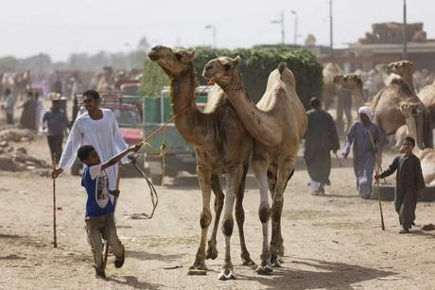

It is a year since the World Health Organisation officially named a new virus that had never before been seen in humans and was killing almost half the people it infected.
The Middle East Respiratory Syndrome Coronavirus was billed as the new Sars, the viral respiratory disease that killed hundreds in 2003. Many thought it was only a matter of time before airport screening and travel restrictions were introduced.
As its first anniversary approaches, Mers is still with us but the official response is unchanged, and the number of cases is still increasing slowly. As of yesterday (April 28), the number of laboratory confirmed cases was 254 including 93 deaths, the first being identified in September 2012.
Professor Andrew Rambaut, of the School of Biological Sciences at the University of Edinburgh, says while much has been learnt about the virus there are still big knowledge gaps to be filled if the transmission of Mers-Coronavirus (Mers CoV) is to be stopped.
“I think the fact that it’s not spread outside the Middle East in the last two years suggests it’s still tied to the camel population,” said Prof Rambaut, who has collaborated on Mers-CoV research projects. “Clearly we are getting onward transmission from human to human, but there are many cases for which this seems to have a direct link to camels. Most of the onward transmission has occurred in hospital or health care environments.
“That suggests to me that the virus isn’t taking hold in the human population. It is being helped along in the health care situations because there are people who are sick and shedding the virus.”
Up to now most of the human-to-human cases have been in health care settings.
“There does seem to be a very high level of hospital transmission or health care based transmission that seems to me could be addressed,” said Prof Rambaut, “and there are lots of protocols since Sars on how to deal with that.”
WHO is clear about what Mers affected countries need to be doing, regularly releasing material highlighting infection prevention and control measures..
These hospital transmissions do not necessarily mean that the virus is getting stronger. Health care facilities often see transmission of viruses and bacteria that are not able to survive as well in the outside world, like Methicillin-resistant Staphylococcus aureus (MRSA).
Fears have been raised recently about a “spike” in cases, suggesting the virus is getting stronger and deadlier. Experts, however, urge caution about spreading such messages.
Dr Mansour Al Zarouni, a medical and molecular microbiologist and executive director of SRL Diagnostics in Dubai, says the outbreak is spreading “slowly but surely”.
“The threat is there, precautions need to be in place both for public as well as health care workers,” he says. “And this opportunity could be used to strengthen the processes for infection prevention, especially the transmission of infections in health care settings.”
Dr Al Zarouni, who spent 20 years as director of Pathology and Laboratory Medicine at the Ministry of Health, says countries where Mers is prevalent are conscious of damaging their reputations or economies.
Prof Rambaut suggests the recent increase in reported cases in the UAE is more likely linked to tracing contacts, rather than an increase in incidence.
“I don’t think this is necessarily indicative of a spike in incidence, it’s a more aggressive forms of screening as a result of a parent case.
“It’s not the same pattern that we have seen in Saudi Arabia. Most detected cases have been severe cases and detected because they are severe. They arrive in the hospital and have particular morbidities that are indicative of Mers.
“It’s very difficult to sit here and look at press reports and patch the story together. It’s still a big unknown about how many missed diagnoses there are, particularly of milder cases.
On Wednesday the regional WHO office offered to send “international expertise” to Saudi Arabia and the UAE in light of the current outbreaks to help determine the transmission chain.
Referring to several people who had contracted the disease in a health care setting, WHO said: “Although the majority of the cases had either no or only minor symptoms, and most do not continue to spread the virus, WHO acknowledges that some critical information gaps remain to better understand the transmission of the virus as well as the route of infection.”
The advice to the public is limited but clear. Anyone whose live is likely to be threatened by contracting Mer — the elderly and those with an existing medical condition should avoid close contact with animals when visiting farms or barn areas where the virus could potentially be circulating. People should also adopt good hygiene measures such as regular hand washing when visiting a farm or barn and avoid contact with sick animals.
Because the risk of human-to-human transmission remains low, travel restrictions and border screen remains unlikely. Restrictions are only enforced during a “public health emergency of international concern.” While there have been a limited number of cases diagnosed abroad, the disease has failed to spread.
At the moment, Prof Rambaut says, efforts should be focused on learning more about the virus itself at the source.
“We need to really nail down the connection with camels. Do widespread surveillance in camels and look at the genetics of the viruses we find, and see how widespread and diverse they are, and how much mixing is going on, and ask how we could possibly try to prevent exposure.”
It is important, he says, to look at those cases that have appeared in people who have not had any contact with camels and are not in a health care setting.
“When we are seeing a health care worker who has been caring for a human Mers case, that’s a known problem and it’s known how to address it. If you don’t know where the source is, it will continue to linger on. That’s why it has been lingering on for the best part of two years.”
WHO confirmed in March that while the virus might have originated in bats, it was much more likely that camels are the source of infection for humans.
“As such, discovery of the route of transmission between camels and humans remains critical to stopping the initial introduction into human populations,” it said.
A report released by the Centers for Disease Control and Prevention last week evaluated the prevalence of Mers-CoV in a dromedary adult and calf camel herd in Al Hasa, Saudi Arabia.
A study team from King Faisal University and the University of Hong Kong concluded, after testing adult and calves, that dromedaries might be the natural host for the virus and that nasal aspirates and faecal matter could both be the possible source of transmission to humans.
In November, a WHO report on Mers in humans identified some common characteristics of the laboratory confirmed cases up until that point. The median age was 50 years, and almost two thirds were male. Eight out of 10 people had at least one underlying medical condition, the most common being chronic renal failure, diabetes and heart disease.
The research team classified 51 patients as “sporadic” or index cases, meaning they had no exposure to other known cases, occurred in an area with no recent previous cases or were the first to report symptoms in a cluster of cases. Ninety five had epidemiological links to other diagnosed cases, and there was 17 whose “epidemiological classifications remain unclear as no information about contact with other cases is available.”
Five months on and little has changed in terms of the demographics. The median age of all cases (primary and secondary) remains at 52 years, and 67 per cent are male.
There are two clear messages to be taken from the existing body of the research. The first is scientists must find the exact route of transmission between camels and humans and understand all they can about the virus itself. Second, infection control measures and surveillance in hospitals much be boosted to limit preventible human-to-human transmissions.
“The continued occurrence of transmission between humans in health care settings and in households is an ongoing concern,” says Prof Rambaut.
The likelihood of Mers turning into a pandemic such as Sars, which killed 770 people over two years, is slim. In most cases, Prof Rambaut says, the “big pandemics have become pandemics” before scientists are aware of the virus.
It will be time to worry if the virus starts to mutates and becomes stronger. A genetic mutation that allows it to to bind to particular cells, for example, would be a concern.
“The best way of detecting it would be to do very good surveillance and observe if the virus starts to change its epidemiology,” says Prof Rambaut.
Another key factor for epidemiologists when evaluating the threat of a particular virus is the susceptibility of the population.
“It might be that there are many cases in North Africa that have far more camels than Saudi Arabia. It may be that this disease has been happening for years undetected, which again suggests it’s not something that’s going to take off in a human population.
“The only caveat is if the virus got into some population in which it was able to spread more freely; somewhere where the conditions were such that however it is transmitted is given a high opportunity. Where there’s more transmission of diseases through fecal or oral contact, for example. It’s possible that that would be the kind of environment in which it would do well.
“That would be a concern but there’s no particular evidence [of that].”
For now though, the virus seems to be limited to the Middle East and relatively difficult to catch but until the source has been eliminated, or at least better understood, the threat of spread among the human population remains.

U.N. Struggles to Stem Haiti Cholera Epidemic
Source: http://www.nytimes.com/2014/04/20/world/americas/un-struggles-to-stem-haiti-cholera-epide mic.html?ref=americas&utm_source=Sailthru&utm_medium=email&utm_term=*Morning%20Brief&utm_campaign=MB%2004.21.14&_r=0

For three years, the United Nations has refused to address whether its peacekeepers brought a deadly strain of cholera to Haiti, insisting instead that it was more important to help the country stanch the disease once and for all.
But on that score, it is still very far behind. In some ways, Haiti is even less equipped to tackle cholera than it was three years ago.
The United Nations raised barely a fourth of the $38 million it needed last year to provide lifesaving supplies, including the most basic, like water purification tablets. Clinics have run short of oral rehydration salts to treat the debilitating diarrhea that accompanies the disease. Some treatment centers in the countryside have shut down as the aid groups that ran them have moved on to other crises. And a growing share of patients are dying after they finally reach hospitals, according to the United Nations’ own assessments.
Josilia Fils-Aime, 11, who lives in this village on an isolated spit of land near the Artibonite River, where the epidemic first began, knows these shortcomings all too well. Her family had run out of water purification tablets, and she drank water from what must have been a polluted stream nearby.
“I felt dizzy and sick,” the girl said. She was struck by sudden vomiting and diarrhea. Doctors diagnosed cholera.
Her predicament has multiplied across Haiti, which has had the most cholera cases in the world for three years in a row.
The United Nations has yet to raise the $5 million necessary to vaccinate 600,000 vulnerable people right away — as the rainy season approaches and the threat of waterborne illnesses like cholera looms — let alone the $2 billion that it promised to raise from rich countries to build Haiti’s water and sanitation infrastructure, which public health experts say is vital to ridding the country of cholera.
Pedro Medrano Rojas, the United Nations secretary general’s newly appointed envoy for the cholera outbreak, attributed the shortfall to global “donor fatigue” in the face of other humanitarian crises.
“Had we had the resources it would have been different,” Mr. Medrano said. “It’s not expensive. No one should be dying from cholera.”
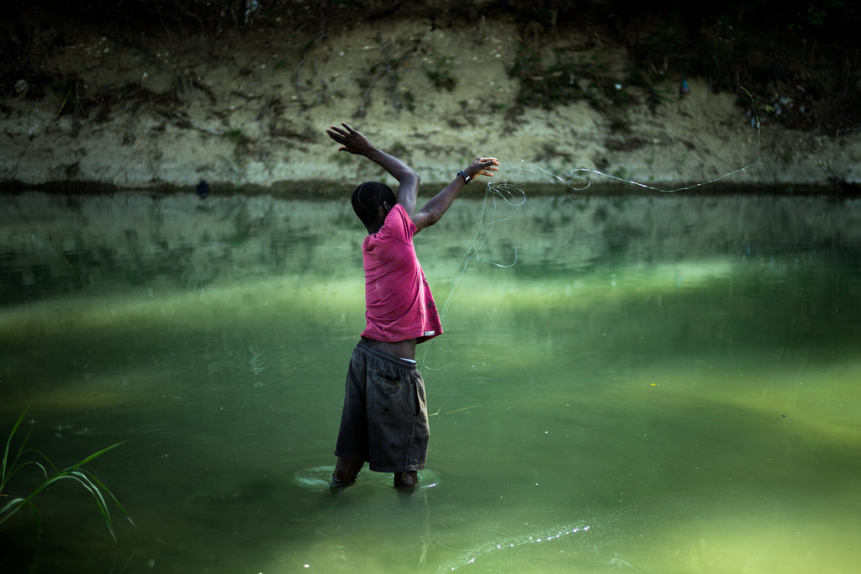
Since the outbreak began in October 2010, 8,562 people in Haiti have died of cholera. New infections have declined, following the typical trajectory of an epidemic, from a peak of more than 350,000 reported cases in 2011 to a little more than 50,000 cases in 2013.
A young Haitian fishing in the Latem River, known to be contaminated.
The United Nations is essential to solving the problem because, like many of the country’s institutions since the January 2010 earthquake, Haiti’s own health care system remains in shambles. Clean drinking water and sanitation remain as scarce as when the epidemic began. And where international nonprofit groups, along with the government, once operated 120 cholera treatment centers across the nation, the number has shrunk to barely 40 as aid groups have pulled out.
Perhaps that most troubling measure of all is the rising percentage of cholera patients who die in the treatment facilities that remain. As the United Nations mission said in its report to the Security Council in March, “That reflects weaknesses in the capacity of health centers to provide timely and adequate health services to patients affected by cholera and the longer travel time required for treatment as a result of the closure of many cholera treatment centers.”
Josilia Fils-Aime, for instance, most likely survived because Partners in Health, a nonprofit that has worked in Haiti for years, opened a satellite clinic near her home. The next closest cholera treatment center would have required a two-hour trek, including a boat ride.
“In any other country, you would declare it a humanitarian disaster,” said Dr. Louise Ivers, a health policy adviser for Partners in Health. “What’s going to happen when the rainy season starts?”
By Mr. Medrano’s estimates, as many as 40,000 people could become infected once the clouds break and the rivers swell.
Haiti’s cholera outbreak has spread to three countries across the region: the Dominican Republic, Cuba and Mexico. The fatality rates have been much lower in those countries, which have far better public health systems; it is a measure of how easy it can be to treat the disease.
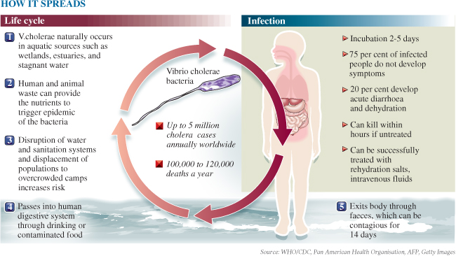
Forensic studies, including one ordered by the United Nations, have concluded that the bacteria found in Haiti is an Asian strain common in Nepal, where hundreds of United Nations peacekeepers in Haiti came from. The forensic studies have also linked the spread of cholera to a flawed sanitation system at the Nepalese peacekeeper base, which contaminated a river tributary that many Haitians used for drinking and bathing water. The wastewater from the peacekeeping base, now occupied by Uruguayans, still flows into that stream, though the United Nations insists it is now treated.
The United Nations has maintained a steely silence about whether it is responsible for importing the disease to Haiti, where cholera had not been previously recorded.
In a stinging report in March, Gustavo Gallon, a special envoy for human rights in Haiti, took the United Nations to task for its failure to explain how the disease had spread to Haiti and who was responsible. He urged the United Nations to establish a commission “to enable damages to be recorded, corresponding benefits or compensation to be paid, the persons responsible to be identified, the epidemic to be stopped and other measures to be implemented.”
Three class-action lawsuits have been filed against the United Nations in American courts, asserting it was responsible for the outbreak. Responding for the United Nations, the United States attorney in Manhattan, Preet Bharara, said in early March that he believed the United Nations Charter rendered the organization “absolutely immune from legal process and suit absent an express waiver.”
All three cases seek hefty compensation for victims. That is not only a costly proposition, but it also could set a daunting precedent for future peacekeeping missions around the world, Mr. Medrano cautioned.
To assuage the Haitian government, whose officials have sharply urged the United Nations to take “moral responsibility” for the outbreak, Mr. Medrano has agreed to be part of a high-level government committee to discuss how to address the needs of cholera victims, an issue that Mr. Medrano said the government has been “adamant” about.
“We would like to see how we can assist those communities, those persons who are affected by cholera,” he said.
The committee has not yet held its first meeting.
“I’m not so sure we will use the word ‘compensation,’ ” Mr. Medrano added.
Officials have often trumpeted their progress — the Haitian government last year declared the decline in cases as a sign that the epidemic was “under control,” despite disagreement from international doctors — which has sometimes undermined the sense of urgency.
“If they try to sound like there is no cholera, then when they ask for money to treat it, donors get confused,” said Oliver Schulz, the chief of mission for Doctors Without Borders, which runs several clinics.
All the while, Haitian government health workers involved in cholera treatment centers have not been paid in months, some for almost a year, according to the United Nations Office for the Coordination of Humanitarian Affairs. A disease surveillance system that enabled workers around the country to send text messages about suspected cholera cases to the ministry of health does not always work, “delaying the response time,” according to a review by the humanitarian affairs office, which also recommended more systematic use of tests to differentiate cholera from other causes of diarrhea.
The ranks of malnourished children, who are most susceptible to cholera because of low immunity, have also grown in the last year. Less than two-thirds of the population has access to clean drinking water. According to the United Nations humanitarian office’s latest country report, published at the end of 2013, “the main cause for the persistence of cholera in Haiti is the lack of access to clean water and sanitation facilities and poor hygienic practices.”
That is what brought Jislaine Marc, 15, to the general hospital in Port-au-Prince in early April. Her family said the girl had suddenly been struck by violent vomiting and diarrhea — the telltale, debilitating signs of cholera. Had she reached a hospital on time, she could have been saved, with one of the cheapest, easiest remedies of all: oral rehydration salts. But she did not. She died.
At the hospital, the girl was not tested for cholera. Hospital workers told the family she was dead on arrival. They ordered family members to take the body home. At first, the family refused to believe she was dead.
Soon, another family member showed symptoms and was rushed to a clinic run by Doctors Without Borders, which dispatched health workers to Jislaine’s house, sprayed it with a disinfectant bleach solution and informed the health ministry to remove the girl’s corpse.
“It was so sudden,” the girl’s aunt said, as the health workers adjusted a white tarp over Jislaine. “She was just a normal kid who went to school and church.”

France lost 2,300 tubes of a deadly virus

By Terrence McCoy
Source: http://www.washingtonpost.com/news/morning-mix/wp/2014/04/16/france-lost-2300-tubes-of-a-deadly-virus/

April 16 – Test tubes at the infectious diseases unit at France’s Tourcoing Hospital on May 14. (Philippe Huguen/AFP/Getty Images)
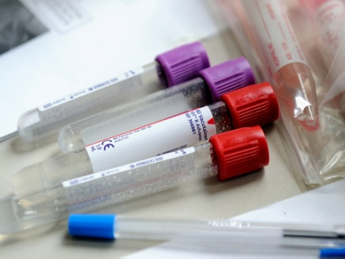
In the world of European medical research, few names carry more clout and prestige than the Institut Pasteur. In 1983, the French non-profit discovered HIV, and three years later found another strain of the disease. It has posted groundbreaking research in the study of diseases from yellow fever to tetanus to diphtheria. In all, its scientists have netted numerous Nobel Prizes, one of which came in 2008.
Now it’s in the news for something equally remarkable — but for a very different reason.
Days ago, the Paris institute announced that it lost more than 2,300 vials of SARS, a disease that killed more than 770 people and infected 8,000 more a decade ago, according to the Center for Disease Control and Prevention.
A routine inventory turned up the disappearance of the tubes. The institute suspects they’ve been missing since January, and as of Wednesday morning, no one knows what happened to them.
When scientists realized the vials had gone missing, they called France’s drug and health safety agency to see if it would have any more luck. It didn’t, reports the Local. Last week, the agency looked for the 2,300 missing vials in what the Institute calls an “in-depth” investigation at an unnamed lab.
But don’t worry, Pasteur says. “The tubes concerned have no infectious potential,” its statement said. “Independent experts referred by health authorities have qualified the risk as ‘nil.’”
Scientists dismissed the possibility that someone could put the virus to nefarious use.
“We knew from the beginning that the samples were not infectious, as the independent experts confirmed,” said Christian Brechot, Pasteur’s president, in an interview. He added that a malfunctioning freezer door would have killed the virus.
“[But] losing the samples is an unacceptable mistake,” he said. “We took a decision to inform the public. We want to be perfectly transparent. It is the first time that the institute has lost samples in this manner.”
Nonetheless, the disappearance of a deadly respiratory virus isn’t the sort of thing one shrugs off. The disease ripped through China in 2003 and hopped to Taiwan and Singapore, where dozens more died before it was stamped out.
It’s anyone’s guess what happened to the missing vials. ”The theory of human error is the most probable, but we are not ruling anything out,” Bréchot said.

Terrence McCoy is a foreign affairs writer at the Washington Post. He served in the U.S. Peace Corps in Cambodia and studied international politics at Columbia University.

EDITOR’S COMMENT: “Transparecy”, “no infectious potential”, “BS” – if I may add! Someone has to be responsible for the loss – we will follow the incident and see if that “someone” will ever been spotted. The latter was a joke!

First large-scale dengue vaccine efficacy study achieves primary clinical goals
Source: http://www.homelandsecuritynewswire.com/dr20140429-first-largescale-dengue-vaccine-efficacy-study-achieves-primary-clinical-goals

Sanofi Pasteur, the vaccines division of Sanofi, yesterday announced that the first of two pivotal Phase III efficacy studies with its dengue vaccine candidate has achieved its primary clinical endpoint. The efficacy study showed a significant reduction of 56 percent of dengue disease cases. Initial safety data are consistent with the good safety profile observed in previous studies.
The company says that full analysis of the data will be undertaken in the coming weeks and reviewed by external experts prior to disclosure at an upcoming international scientific congress and publication in a peer-reviewed journal later this year.
Dengue is a threat to nearly half the world’s population, and is a pressing public health priority in many countries in Asia and Latin America where epidemics occur. The annual incidence rate of 4.7 percent observed in the control group demonstrates the very high burden of disease in Asia.
“This achievement is the result of more than 20 years of work in the field of dengue, collaborating with investigators, volunteers, authorities, scientific experts and international organizations,” said Olivier Charmeil, president and CEO of Sanofi Pasteur. “Developing a dengue vaccine for the benefit of children and their parents is at the heart of our mission. Our goal is to make dengue the next vaccine-preventable disease and to support the WHO’s ambition to reduce dengue mortality by 50 percent and morbidity by 25 percent by 2020.”
“This is the first time ever a dengue vaccine successfully completed a Phase III efficacy study,” said Dr. Capeding, principal investigator, Research Institute for Tropical Medicine, the Philippines. “These significant clinical results, associated with the good safety profile of the vaccine, bring real hope to more than 100 million people affected each year by dengue, a disease without any specific treatment today.”
►The Dengue Map – source: http://www.healthmap.org/dengue/en/

The company notes that the results of this first, large-scale efficacy study will be further complemented by results in Q3 2014 from a second, large-scale study currently conducted in Latin America, including more than 20,000 volunteers from Brazil, Colombia, Honduras, Mexico, and Puerto Rico.

1918 pandemic flu virus mystery solved
Source: http://www.homelandsecuritynewswire.com/dr20140430-1918-pandemic-flu-virus-mystery-solved

University of Arizona researcher Michael Worobey and his team have discovered that the key to understanding influenza pandemics may lie in flu exposure during childhood.
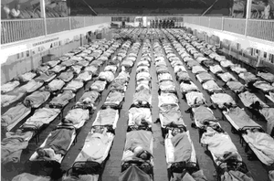
Just as the world was recovering from the devastation of the First World War, another killer swept across the globe. A deadly flu virus attacked more than one-third of the world’s population, and within months had killed more than fifty million people — three times as many as the war — and had done it more quickly than any other illness in recorded history.
Until now, the origin of the 1918 pandemic flu virus and its unusual severity have vexed health experts. A UA release reports that a new study, led by Michael Worobey, professor in the University of Arizona Department of Ecology and Evolutionary Biology within of the College of Science, not only sheds light on the devastating 1918 pandemic, but could also improve vaccination strategies, and pandemic prevention and preparedness.
“If our model is correct, then current medical interventions, especially antibiotics and vaccines, against several pneumonia-causing bacteria, could be expected to dramatically reduce mortality, if we were faced today with a similar set of pandemic ingredients,” Worobey said.
“Ever since the great flu pandemic of 1918, it has been a mystery where that virus came from and why it was so severe and, in particular, why it killed young adults in the prime of life,” Worobey added. “It has been a huge question whether there was something special about that situation, and whether we should expect the same thing to happen tomorrow.”
Worobey and his colleagues developed an unprecedentedly accurate “molecular clock” approach to untangle the origins of the 1918 pandemic H1N1 influenza A virus, the classical swine H1N1 influenza virus, and the post-pandemic seasonal H1N1 lineage that circulated from 1918 until 1957. A molecular clock is a technique used in evolutionary biology to reconstruct family trees of organisms — or viruses — based on the number of genetic mutations accumulating over time.
The researchers discovered that the pandemic virus arose shortly before 1918, when a human H1 virus, which they infer had already been circulating in the human population since about 1900, picked up genetic material from a bird flu virus.
The Human influenza A virus usually sees higher mortality rates for infants and the elderly, but the pandemic virus caused extensive deaths in people ages 20 to 40, primarily from secondary bacterial infections, especially pneumonia.
The authors suggest that this likely was because many young adults born from about 1880 to 1900 were exposed during childhood to a putative H3N8 virus circulating in the population, which had surface proteins that were very different from those of the H1N1 virus. In contrast, most individuals born earlier or later than 1880-1900 would have had better protection because they were more likely to have been exposed a virus variant more similar to the 1918 virus.
“You can picture the flu virus as a tiny soccer ball studded with lollipops,” Worobey explained. “The candy part of the lollipop is by far the most potent part of the flu virus, against which our immune system can make antibodies. If antibodies cover all the lollipop heads, the virus can’t even infect you.”
For example, a person exposed to a flu strain studded with blue candy lollipops would have antibodies protecting it from future infections with that flu virus. If faced with a different strain containing red candy, however, that same person would get sick because the “anti-blue” antibodies would not recognize the red lollipops, allowing the virus to slip through the body’s immune defenses unscathed.
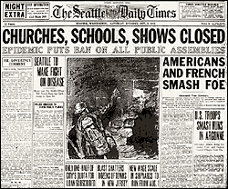
“We believe that the mismatch between antibodies trained to H3 virus protein and the H1 protein of the 1918 virus may have resulted in the heightened mortality in the age group that happened to be in their late 20s during the pandemic,” Worobey said.
Worobey said the new perspective applies not only to the pandemic of 1918, but might also explain patterns of seasonal flu mortality and the mysterious patterns of mortality when humans are infected by highly pathogenic avian-origin H5N1 and H7N9 viruses, commonly known as the “bird flu.”
H5N1causes higher mortality rates in young people, and H7N9 causes higher mortality in the elderly. In both cases, the researchers found that the more susceptible age groups were exposed initially, as children, to viruses with a mismatched HA, and may suffer severe consequences similar to young adults faced with a mismatched virus in 1918.
The authors suggest that immunization strategies mimicking the often impressive protection provided by initial childhood exposure to influenza virus variants encountered later in life might dramatically reduce mortality due to both seasonal and novel IAV strains.
The release notes that earlier this year, Worobey and his collaborators published a study in the journal Nature providing the most comprehensive analysis to date of the evolutionary relationships of flu virus across different host species over time. The results revealed a rapid, global replacement of the genes in the avian flu virus coinciding closely with a horse flu outbreak in the 1870s that crippled the economy. They also challenged the accepted wisdom of wild birds as the major reservoir harboring the flu virus, from where it jumps to domestic birds and other species, including humans. Instead, the researchers found a very strong indication of spillover from domestic birds to wild birds.

— Read more in Michael Worobey et al., “Genesis and pathogenesis of the 1918 pandemic H1N1 influenza A virus,” Proceedings of the National Academy of Sciences (8 April 2014)

DHS cancels acquisition of BioWatch’s Generation 3 technology
Source: http://www.homelandsecuritynewswire.com/dr20140430-dhs-cancels-acquisition-of-biowatch-s-generation-3-technology

Owing to concerns about BioWatch effectiveness and high cost, DHS has canceled plans to install an automated technology meant to speed the 24-hour operations of the program, the nation’s system for detecting a biological attack.
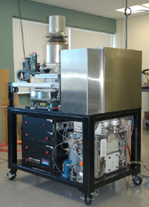
BioWatch Gen 2 in New York

BioWatch is deployed in more than thirty metropolitan areas throughout the country. DHS secretary Jeh Johnson cancelled the Generation 3 acquisition last Thursday, according to a memorandum circulated by Michael Walter, the BioWatch program manager. Initially, DHS told companies interested in supplying the technology that the department would spend $3.1 billion for the system during its first five years of operation.
The Los Angeles Times reports that in his memorandum, Walter said DHS “remains committed to the BioWatch program and the importance of improving our early warning and detection technologies.”
DHS spokesman S. Y. Lee said the cancellation of the automated technology reflects a commitment to “cost-effective acquisition without compromising our security.”
When Generation 3 technology was unveiled, under the George W. Bush administration, DHS officials told Congress that it was a “lab in a box” which could identify biological threats and relay findings electronically, and that it was a worthwhile investment. Automated prototypes for BioWatch were installed in the New York City subway system in 2007 and 2008, followed by a field testing in Chicago in 2011, but the test installations revealed that the system generated multiple false readings and the need for weekly manual servicing.
BioWatch Gen 3

In February 2007, Jay Cohen, former DHS undersecretary for science and technology, told a House committee that the automated Generation 3 system would be “four times cheaper to operate” than the current manual system. Last August, House members asked the U.S. Government Accountability Office (GAO) to study the performance of the existing BioWatch system and assess the additional benefits of the proposed Generation 3 technology. The GAO review has not been released, but a September 2012 GAO report estimated that annual costs to operate the Generation 3 technology would be “about four times more” than the existing BioWatch system.

MERS-CoV from Saudi camels matches human isolates

Source: http://www.cidrap.umn.edu/news-perspective/2014/04/study-mers-cov-saudi-camels-matches-human-isolates

US and Saudi scientists reported today that MERS-CoV (Middle East respiratory syndrome coronavirus) isolates from camels in Saudi Arabia match MERS-CoV samples from humans and can be grown in nonhuman primate cells in a lab, further augmenting the evidence that camels are a source of human infections.
The team generated complete genetic sequences for MERS-CoV isolates from five camels and determined that they were identical to published sequences of human isolates, according to their report in mBio. In addition, they succeeded in culturing viruses from two of the camels in Vero (African green monkey) cells in their lab.
They also found that viral particles from individual camels contained more genetic variation than is true of MERS-CoV isolates from humans, which suggests that, if camels are passing the virus to humans, only certain genotypes can infect humans. That may partially explain why human MERS cases are uncommon, they say.

Role of camels
The study was conducted by researchers from three centers in the United States and two in Saudi Arabia, with W. Ian Lipkin, MD, director of the Center for Infection and Immunity at Columbia University's Mailman School of Public Health, as senior author.
"Here, we report recovery of MERS-CoV from nasal swabs of dromedaries, demonstrate that MERS-CoV whole-genome consensus sequences from dromedaries and humans are indistinguishable, and show that dromedaries can be simultaneously infected with more than one MERS-CoV," the report states.
"Together with data indicating widespread dromedary infection in the Kingdom of Saudi Arabia, these findings support the plausibility of a role for dromedaries in human infection."
A number of other recent studies have produced evidence of the virus, or of antibodies indicating past exposure, in camels on the Arabian Peninsula and in Africa. In March the World Health Organization voiced the conclusion that camels are a source of human infections, but just how the virus reaches humans—by air, via camel milk or meat, or by some other vehicle—remains unclear.
In February Lipkin and colleagues reported that they found pieces of MERS-CoV in 35% of young camels and 15% of adult camels among a sample of a few hundred camels from various sites around Saudi Arabia. They also found that 74% of the camels had MERS-CoV–like antibodies, suggesting past exposure to the virus or similar one.

Generating complete sequences
The scientists used nasal swab samples collected in that earlier survey for the new study. They used one method to generate complete genome sequences for samples from three camels and another method to generate complete sequences for two other camels. The report says one of the camels was a 1-year-old imported from Africa and anther was a 1-year-old Arabian breed; information on the other camels was not listed.
With the intent to grow the virus in their lab, the team also inoculated Vero cells with nasal swab samples from two camels and a rectal swab sample from another camel. They found that the nasal samples yielded viral growth, but the rectal sample didn't. A full-length genomic sequence was obtained from the cultured virus.
The researchers compared their five camel MERS-CoV sequences with full-length human sequences available in GenBank. They concluded that the results confirmed earlier findings which were based on partial sequences that suggested that camels in Saudi Arabia "harbor the same virus that causes MERS in humans," the report says.
Their analysis of the camel sequences also revealed signs of multiple variants among the viruses from each individual camel, and additional testing through amplification and sequencing of certain pieces of the genome confirmed this finding, according to the report.
The team also found that in the Vero cell culture, the number of MERS-CoV genetic variants decreased over a period of 48 hours.
"Here, we confirm that DC [dromedary camels] may harbor infectious virus and that whole-genome consensus sequences obtained from nasal isolates align with whole-genome sequences recovered from humans," the report states.

Widely varying MERS-CoV in camels
In an interview, Lipkin commented that sequencing studies indicate that MERS-CoV has not mutated significantly since it was first described in 2012. He said it seems there are only a few MERS-CoV genotypes that can infect humans.
"There appears to be a wide range of different viruses present within camels," Lipkin said. Given that a similar wide range has not been reported for human isolates, "we think there may be bottleneck selection in humans that may be restrictive. In Vero cells, the complexity of the virus pool began to decrease," which would be consistent with a narrower range of variants in humans.
This limitation on the range of MERS-CoV variants that can infect humans may help explain why the human disease is not common, said first author Thomas Briese, PhD, associate director of the Center for Infection and Immunity, in a Columbia University press release.
Lipkin said his group is now aiming to find out if MERS-CoV is present in camel milk and meat in Saudi Arabia. He noted that a recent study led by Vincent Munster, PhD, of the National Institute of Allergy and Infectious Diseases showed that the virus was stable in camel's milk.
"We've begun collecting camel's milk and looking at and swabbing meats in butcher shops where people are getting access to meat, in Saudi Arabia," he said. He declined to disclose any early results.
In response to a question, Lipkin said he believes that when his group submitted the current paper for publication, it was the first report of culturing of MERS-CoV from camels, but there may be other such reports on the way.
About a week ago, officials in Qatar reported via the World Organization for Animal Health (OIE) that MERS-CoV collected from a camel in that country was grown in a lab culture of human hepatoma cells. Those findings apparently have not yet been reported in a scientific journal, however.

Still unanswered: how people get infected
Another MERS-CoV researcher, Marion Koopmans, DVM, PhD, welcomed Lipkin's findings, but said the major problem of figuring how the virus finds its way into humans still remains. She is head of virology at the Laboratory for Infectious Diseases of the National Institute of Public Health and the Environment in the Netherlands.
"The culturing is a confirmation of the PCR findings that already made it clear that camels can be infected with MERS COV," she commented via e-mail. "The previous paper from Lipkin was informative in that it showed that camels are infected with a diversity of MERS-CoV genetic variants, and that really put a strong message forward, ie: this virus is endemic in camels.
"Culturing the virus is nice, but (to me) not a major step (even if we have a similar paper on the way, to be entirely transparent). What we need now is studies that show how primary cases get infected. Likely to involve camels or camel products but still unclear."

Briese T, Mishra N, Jain K, et al. Middle East respiratory syndrome coronavirus quasispecies that include homologues of human isolates revealed through whole-genome analysis and virus cultured from dromedary camels in Saudi Arabia. mBio 2014 Apr 29 (Early online publication)

Promising agents breach superbug defenses to fight antibiotic resistance
Source: http://www.homelandsecuritynewswire.com/dr20140501-promising-agents-breach-superbug-defenses-to-fight-antibiotic-resistance

In the fight against superbugs, scientists have discovered a class of agents that can make some of the most notorious strains vulnerable to the same antibiotics that they once handily shrugged off. The report on the promising agents called metallopolymers appears in the Journal of the American Chemical Society.
An ACS release reports that Chuanbing Tang and colleagues note that the antibiotic-resistant bacteria known as MRSA (methicillin-resistant Staphylococcus aureus) is responsible for a significant fraction of the infections that patients acquire in hospitals. According to the Centers for Disease Control and Prevention (CDC), MRSA usually spreads in hospitals when a health care provider with contaminated hands unknowingly passes it along to a patient. It can cause serious problems such as pneumonia, and can lead to death. One of the ways MRSA undermines conventional treatments is by producing enzymes that inactivate traditional antibiotics such as penicillin.
Scientists have been developing new agents to combat these enzymes, but the agents so far have fallen short. Tang’s team wanted to find a better alternative.
They tested a recently discovered class of metallopolymers — large, metal-containing molecules — against several strains of MRSA. When paired with the same antibiotics MRSA normally dispatches with ease, the polymer/antibiotic combo evaded the bacteria’s defensive enzymes and destroyed its protective walls, causing the bacteria to burst. Also, the metallopolymers mostly left red blood cells alone, which suggests they might have minimal side effects. “These discoveries could pave a new platform to design antibiotics and antimicrobial agents to battle multidrug-resistant bacteria and superbugs,” the researchers state.

— Read more in Jiuyang Zhang et al., “Antimicrobial Metallopolymers and Their Bioconjugates with Conventional Antibiotics against Multidrug-Resistant Bacteria,” Journal of the American Chemical Society 136, no. 13 (17 March 2014): 4873-76

WHO’s first global report on antibiotic resistance reveals serious, worldwide threat to public health
Source: http://www.nzdoctor.co.nz/un-doctored/2014/may-2014/01/who%E2%80%99s-first-global-report-on-antibiotic-resistance-reveals-serious,-worldwide-threat-to-public-health.aspx
May 1 – A new report by WHO-its first to look at antimicrobial resistance, including antibiotic resistance, globally-reveals that this serious threat is no longer a prediction for the future, it is happening right now in every region of the world and has the potential to affect anyone, of any age, in any country. Antibiotic resistance-when bacteria change so antibiotics no longer work in people who need them to treat infections-is now a major threat to public health.
"Without urgent, coordinated action by many stakeholders, the world is headed for a post-antibiotic era, in which common infections and minor injuries which have been treatable for decades can once again kill," says Dr Keiji Fukuda, WHO's Assistant Director-General for Health Security. "Effective antibiotics have been one of the pillars allowing us to live longer, live healthier, and benefit from modern medicine. Unless we take significant actions to improve efforts to prevent infections and also change how we produce, prescribe and use antibiotics, the world will lose more and more of these global public health goods and the implications will be devastating."

Key findings of the report
The report, "Antimicrobial resistance: global report on surveillance", notes that resistance is occurring across many different infectious agents but the report focuses on antibiotic resistance in seven different bacteria responsible for common, serious diseases such as bloodstream infections (sepsis), diarrhoea, pneumonia, urinary tract infections and gonorrhoea. The results are cause for high concern, documenting resistance to antibiotics, especially "last resort" antibiotics, in all regions of the world.
Key findings from the report include:
• Resistance to the treatment of last resort for life-threatening infections caused by a common intestinal bacteria, Klebsiella pneumoniae-carbapenem antibiotics-has spread to all regions of the world. K. pneumoniae is a major cause of hospital-acquired infections such as pneumonia, bloodstream infections, infections in newborns and intensive-care unit patients. In some countries, because of resistance, carbapenem antibiotics would not work in more than half of people treated for K. pneumoniae infections.
• Resistance to one of the most widely used antibacterial medicines for the treatment of urinary tract infections caused by E. coli-fluoroquinolones-is very widespread. In the 1980s, when these drugs were first introduced, resistance was virtually zero. Today, there are countries in many parts of the world where this treatment is now ineffective in more than half of patients.
• Treatment failure to the last resort of treatment for gonorrhoea-third generation cephalosporins-has been confirmed in Austria, Australia, Canada, France, Japan, Norway, Slovenia, South Africa, Sweden and the United Kingdom. More than 1 million people are infected with gonorrhoea around the world every day.
• Antibiotic resistance causes people to be sick for longer and increases the risk of death. For example, people with MRSA (methicillin-resistant Staphylococcus aureus) are estimated to be 64% more likely to die than people with a non-resistant form of the infection. Resistance also increases the cost of health care with lengthier stays in hospital and more intensive care required.
Ways to fight antibiotic resistance
The report reveals that key tools to tackle antibiotic resistance-such as basic systems to track and monitor the problem-show gaps or do not exist in many countries. While some countries have taken important steps in addressing the problem, every country and individual needs to do more.
Other important actions include preventing infections from happening in the first place-through better hygiene, access to clean water, infection control in health-care facilities, and vaccination-to reduce the need for antibiotics. WHO is also calling attention to the need to develop new diagnostics, antibiotics and other tools to allow healthcare professionals to stay ahead of emerging resistance.
This report is kick-starting a global effort led by WHO to address drug resistance. This will involve the development of tools and standards and improved collaboration around the world to track drug resistance, measure its health and economic impacts, and design targeted solutions.
How to tackle resistance
People can help tackle resistance by:
• using antibiotics only when prescribed by a doctor;
• completing the full prescription, even if they feel better;
• never sharing antibiotics with others or using leftover prescriptions.
Health workers and pharmacists can help tackle resistance by:
• enhancing infection prevention and control;
• only prescribing and dispensing antibiotics when they are truly needed;
• prescribing and dispensing the right antibiotic(s) to treat the illness.
Policymakers can help tackle resistance by:
• strengthening resistance tracking and laboratory capacity;
• regulating and promoting appropriate use of medicines.

Policymakers and industry can help tackle resistance by:
• fostering innovation and research and development of new tools;
• promoting cooperation and information sharing among all stakeholders.
The report-which also includes information on resistance to medicines for treating other infections such as HIV, malaria, tuberculosis and influenza-provides the most comprehensive picture of drug resistance to date, incorporating data from 114 countries.
Highlights of the report by WHO region

WHO African Region
The report reveals major gaps in tracking of antibiotic resistance in the WHO African Region, with data gathered in a limited number of countries. While it is not possible to assess the true extent of the problem with the data available, that which is available is worrying. Significant resistance is reported for several bacteria that are spread in hospitals and communities. This includes significant E. coli resistance to third generation cephalosporins and fluoroquinolones-two important and commonly used types of antibacterial medicine. In some parts of the region, as many as 80% of Staphylococcus aureus infections are reported to be resistant to methicillin (MRSA), meaning treatment with standard antibiotics does not work.
WHO Region of the Americas
The Pan American Health Organization, WHO's Regional Office for the Americas, coordinates the collection of data on antibiotic resistance from hospitals and laboratories in 21 countries in the Region. The results show high levels of E. coli resistance to third generation cephalosporins and fluoroquinolones-two important and commonly used types of antibacterial medicine-in the Americas. Resistance to third generation cephalosporins in K. pneumoniae is also high and widespread. In some settings, as many as 90% of Staphylococcus aureus infections are reported to be methicillin-resistant (MRSA), meaning treatment with standard antibiotics does not work.
WHO Eastern Mediterranean Region
Data in the report show extensive antibiotic resistance across the WHO Eastern Mediterranean Region. In particular, there are high levels of E. coli resistance to third generation cephalosporins and fluoroquinolones-two important and commonly used types of antibacterial medicine. Resistance to third generation cephalosporins in K. pneumoniae is also high and widespread. In some parts of the Region, more than half of Staphylococcus aureus infections are reported to be methicillin-resistant (MRSA), meaning that treatment with standard antibiotics does not work. The report reveals major gaps in tracking of antibiotic resistance in the Region. WHO's Regional Office for the Eastern Mediterranean has identified strategic actions to contain drug resistance and is supporting countries to develop comprehensive national policies, strategies and plans.
WHO European Region
The report reveals high levels of resistance to third generation cephalosporins in K. pneumoniae throughout the WHO European Region. In some settings, as many as 60% of Staphylococcus aureus infections are reported to be methicillin-resistant (MRSA), meaning that treatment with standard antibiotics does not work. The report finds that although most countries in the EU have well-established national and international systems for tracking antibiotic resistance, countries in other parts of the Region urgently need to strengthen or establish such systems. WHO's Regional Office for Europe and its partners are supporting these countries through the newly-established Central Asian and Eastern European Surveillance of Antimicrobial Resistance network (CAESAR). The aim of CAESAR is to set up a network of national systems to monitor antibiotic resistance in all countries of the WHO European Region for standardized data collection so that information is comparable.
WHO South-East Asia Region
The available data reveal that antibiotic resistance is a burgeoning problem in WHO's South-East Asia Region, which is home to a quarter of the world's population. The report's results show high levels of E. coli resistance to third generation cephalosporins and fluoroquinolones-two important and commonly used types of antibacterial medicine-in the Region. Resistance to third generation cephalosporins in K. pneumoniae is also high and widespread. In some parts of the Region, more than one quarter of Staphylococcus aureus infections are reported to be methicillin-resistant (MRSA), meaning that treatment with standard antibiotics does not work. In 2011, the health ministers of the Region articulated their commitment to combat drug resistance through the Jaipur Declaration. Since then, there has been growing awareness of the need for appropriate tracking of drug resistance, and all countries have agreed to contribute information to a regional database. Dr Poonam Khetrapal Singh, WHO Regional Director for South-East Asia, has identified drug resistance as a priority area of WHO's work in the Region.
WHO Western Pacific Region
Collaboration on tracking of antibiotic resistance between countries in the WHO Western Pacific Region was established in the 1980s, but suffered setbacks following a series of emergencies in the early 2000s. However, many countries in the region have long-established national systems for tracking resistance. Recently, WHO's Regional Office for the Western Pacific has taken steps to revive the regional collaboration. The report reveals high levels of E. coli resistance to fluoroquinolones-an important and commonly used type of antibacterial medicine-in the Region. Resistance to third generation cephalosporins in K. pneumoniae is also widespread. In some parts of the Region, as many as 80% of Staphylococcus aureus infections are reported to be methicillin-resistant (MRSA), meaning that treatment with standard antibiotics does not work.

Cleaner hospital hands, fewer hospital viruses
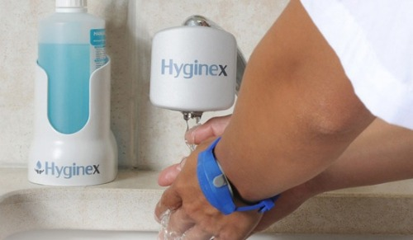
Source: http://israel21c.org/health/cleaner-hospital-hands-fewer-hospital-viruses/

It’s one of healthcare’s biggest ironies: going to a hospital for life-saving treatment can actually cost you your life. More than one million people in America each year get sick from infections they contract in hospitals, resulting in about 100,000 deaths. Fighting these infections costs the healthcare system about $30 billion every year.
The main reason, says Efrat Raichman, is poor hand hygiene of the hospital staff.
In response, Raichman has developed Hyginex, a new high-tech system to keep hospital workers’ hands clean. If everyone from nurses and doctors to orderlies and candy-stripers — even food handlers in the cafeteria — are required to use it, hospital administrators can help ensure the highest sanitary standards.
At its core, Hyginex is an online software solution that communicates with a bracelet resembling a sports watch. Worn by every shift worker, the bracelet is equipped with gyroscopes and other movement sensors and emits a gentle red LED light to remind personnel to wash their hands between patients — or however frequently the system is programmed to provide alerts.

Hyginex aims to improve hand-washing compliance and quality without requiring any special training.

Measures quantity and quality
“Today the hand hygiene in hospitals is so poor, that when I talk to [the managers] they report that the staff is just doing it about 20 percent of the time it is required,” says Raichman, the founder and CEO of the company. “They say even a 50% compliance would be great. The system can be programmed to meet any requirement.”
Raichman tells ISRAEL21c that other products with the same goal are on the market. “But we have a patent and they can’t match us. Ours is the only system that can test the compliance of the staff and also test the quality of the hand washing. Simply opening the tap doesn’t mean you’ve washed your hands, or if you stand near the hand sanitizer, that they are sanitized,” she claims.
The Hyginex system incorporates sensors on the bracelet, in the dispensers and in the tap to measure the duration of vigorous hand washing, and then transfers that information to a computer.
“With this information, we can understand the status of the worker so the department head or staff can be alerted to any problems,” she says.
In the future, the bracelet will be equipped with an optional watch that can be programmed for other functions including security — so that staff might be able to open or close doors using the bracelet as a remote control device. But Raichman’s primary goal is cleaner hands to save lives.
This passion came out of a personal tragedy: Her uncle died from a hospital-contracted infection. “It’s scary. I am afraid to go to the hospital,” says Raichman, who has a degree in electronics and computer science from the Holon Academic Institute of Technology in Israel. She brings a lot of R&D experience to the table, having worked at a number of startups and co-founded, with her husband, a successful toy business called Indot.

Online reports to manager’s desk
Hyginex was founded in 2008 and is based in Tel Aviv, funded by private investors from Europe and Israel.
The staff of five is already seeing sales in several Israeli hospitals, including one of the country’s largest, Rambam Health Care Campus in Haifa, which has 3,000 employees.
The cost is less than $100 per month per bracelet. That includes installation of the system on water taps, plus maintenance and performance reports that go to management. The reports detail how well the hospital is performing hand washing overall; they can even single out specific personnel who need better encouragement.
Raichman says the cost savings for hospitals is potentially much greater that the outlay for the system. Using Hyginex could save the institution money on antibiotics and on the amount of days patients must be hospitalized due to hospital-acquired infections. Insurance companies may not cover illnesses picked up in the hospital.
The company is now starting to market the system to US hospitals.

New Virus Related To Smallpox Is Found In Republic Of Georgia
Source: http://www.npr.org/blogs/health/2014/05/01/308357520/new-virus-related-to-smallpox-is-found-in-republic-of-georgia

May 1 – Two herdsmen in the country of Georgia have been infected with a brand-new virus, scientists from the Centers for Disease Control and Prevention said Thursday.
The newly identified virus is a second cousin to smallpox. And, like smallpox, it causes painful blisters on the hands and arms‎. Other symptoms include a fever, swollen lymph nodes and overall weakness, CDC scientists at a meeting in Atlanta.
"We consider this family of viruses very important because smallpox could be used as a bioterrorism agent," says disease detective Neil Vora, who led the team that made the discovery.
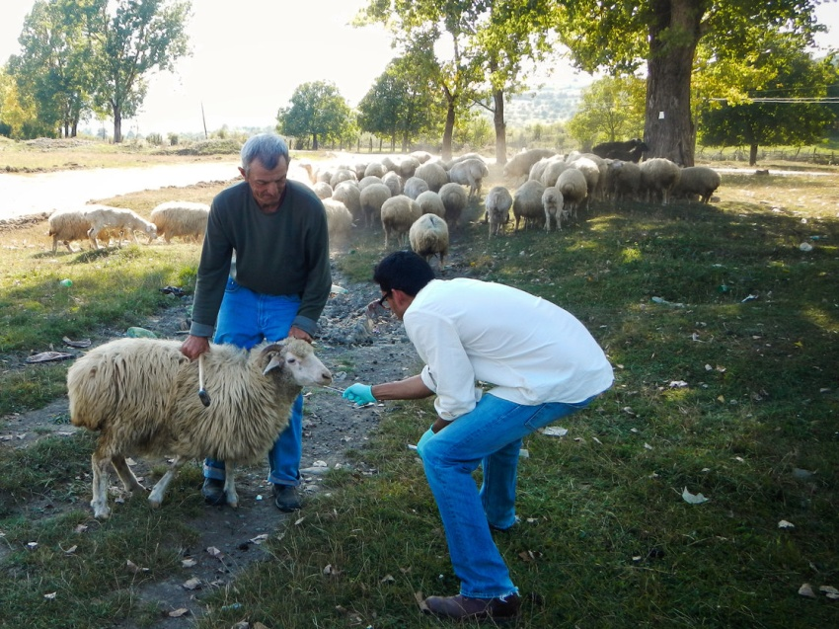
The virus doesn't yet have a name, Vora says, because so little is known about it.
"We haven't found any evidence of human-to-human transmission, so far," Vora tells Shots. "But how many people are getting sick? Are animals getting sick? We don't know. ... We don't know if it has caused any deaths."
Both of the men who caught the virus fully recovered. But related viruses, such as, can be deadly for people with suppressed immune systems. And had a fatality rate of about 30 percent before the illness was eradicated in 1980.
Since then, widespread vaccinations for smallpox have stopped. And this immunization gap seems to be opening the door for other viruses in the family — known as — to resurface, Vora says.
"When you vaccinate a person with one of these viruses, it protects [against] other viruses in the family," Vora says. "Since smallpox vaccinations stopped, there's some indication that other ... orthopoxviruses have started to increase in their incidence because there's less immunity."
Four other viruses in that family infect people: cowpox, monkeypox, vaccinia and smallpox. All but smallpox generally infects animals — cows, cats or monkeys — then jump to people opportunistically.
Both of the infected Georgian men caught the new virus from dairy cattle. At first, local health workers thought one man had anthrax — anthrax infections of the skin are in rural parts of that country. But when tests came back negative, the public health department contacted the CDC for help.

Disease detective Neil Vora of the Centers for Disease Control and Prevention looks for the new smallpox-like virus in Georgian cattle.

Vora and his team quickly figured out they were dealing with a poxvirus. But it turned out to be one that had never been seen before.
"The discovery brings up the question of what other viruses might be circulating out there that are even more closely related to smallpox and cowpox," Vora says.
Although smallpox was eliminated in the wild, stores of the virus still exist in a few American and Russian laboratories. And there's growing concern that it could be used for.
Last year the U.S. government spent about $460 million on a relatively new smallpox medicine, in case the virus was deliberately released in a bioterrorism attack. That could treat about 2 million people.

New lab-on-a-chip device overcomes miniaturisation problems
Source: http://newsroom.unsw.edu.au/news/science/new-lab-chip-device-overcomes-miniaturisation-problems

UNSW chemists have invented a new type of tiny lab-on-a-chip device that could have a diverse range of applications, including to detect toxic gases, fabricate integrated circuits and screen biological molecules.
The novel technique developed by the team involves printing a pattern of miniscule droplets of a special solvent onto a gold-coated or glass surface.
“We use a class of ‘green’ solvents called ionic liquids, which are salts that are liquid at room temperature. They are non-volatile, so this overcomes one of the main problems in making useful miniaturised devices - rapid evaporation of the solvents on the chip,” says Dr Chuan Zhao, senior author of the study.
“The versatility of our chips means they could have a wide range of prospective functions, such as for use in fast and accurate hand-held sensors for environmental monitoring, medical diagnosis and process control in manufacturing.”
The research is published in the journal Nature Communications. It was carried out by Dr Zhao, Christian Gunawan and Mengchen Ge from the UNSW School of Chemistry.
Lab-on-a- chip devices, where chemical reactions are carried out on a miniature scale, are under intensive development because they offer the promise of faster reaction times, reduced use of materials and high yields of product.
Evaporation of solvents on the chip, however, is a big problem because this can affect the concentration of substances and disrupt the reactions. Attempted solutions include containing the solvents within tiny channels or “walls”, and having reservoirs to store extra solvent on the chip.
The “wall-less” design developed by the UNSW team - using non-volatile ionic liquids as solvents to fabricate a microarray of droplets chemically anchored to the chip - has several significant advantages.
“Ionic liquids are designer solvents and have wide application. We can now carry out many reactions or analytical procedures in ionic liquids at the micro-scale on a chip with enhanced yields and efficiency,” says Dr Zhao.
“These microarray chips can be easily produced in high numbers and are very stable. They can survive being turned upside down and heated to 50 degrees and some can even survive being immersed in another liquid. These properties will be important for commercial applications, including storage and transportation of microchips.”
The droplets of ionic liquid are about 50 micrometres across (about half the width of a human hair) and 10 micrometres high.
The UNSW researchers demonstrated several potential uses of the microarrays.
They showed the tiny droplets can act as rapid, sensitive monitors of the presence of a gas, due to their small volume.
They also demonstrated that metal salts dissolved in the droplets could be electrically deposited as microstructures, a technique which could be of use in fabrication of integrated circuits.
Some biological molecules added to the droplets also remained stable and active, opening up the possibility of using the microarrays for diagnostic purposes.

From the American Academy of Pediatrics
Clinical Report : Pediatrics Vol. 133 No. 5 May 1, 2014; pp. e1411 -e1436

Pediatric Anthrax Clinical Management
By John S. Bradley, Georgina Peacock, Steven E. Krug, William A. Bower, Amanda C. Cohn, Dana Meaney-Delman, Andrew T. Pavia, and AAP COMMITTEE ON INFECTIOUS DISEASES and DISASTER PREPAREDNESS ADVISORY COUNCIL
Source: http://pediatrics.aappublications.org/content/133/5/e1411.abstract

Abstract
Anthrax is a zoonotic disease caused by Bacillus anthracis, which has multiple routes of infection in humans, manifesting in different initial presentations of disease. Because B anthracis has the potential to be used as a biological weapon and can rapidly progress to systemic anthrax with high mortality in those who are exposed and untreated, clinical guidance that can be quickly implemented must be in place before any intentional release of the agent. This document provides clinical guidance for the prophylaxis and treatment of neonates, infants, children, adolescents, and young adults up to the age of 21 (referred to as “children”) in the event of a deliberate B anthracis release and offers guidance in areas where the unique characteristics of children dictate a different clinical recommendation from adults.

EDITOR’S COMMENT: This is an article you have to download (free), print and keep – especially the appendixes on treatment schedules at the end of the article.

New antibacterial fabric kills infectious bacteria within 10 minutes
By Nick Lavars
Source: http://www.gizmag.com/antibacterial-fabric-infectious-bacteria-10-minutes/31922/

With a well established ability to kill off bacteria, silver has come to play a significant role in the development of antimicrobial materials. Indeed, we've seen it used in keyboards, built into water filtration systems and deployed in washing machines as a means of fending off germs. The latest effort to harness the bacteria-fighting qualities of silver comes from researchers at Australia's RMIT University working with scientists from the CSIRO, who have developed an antibacterial fabric capable of killing off E. coli and other infectious bacteria within 10 minutes of contact.
The team developed the antibacterial fabric by embedding sets of nanowires loaded with silver-TCNQ into a cotton textile. After being coated in a silver solution, the nanoarrays began to slowly release silver-ions that killed off bacteria as they came into contact.
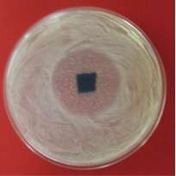
"The fabric can be built into most materials, such as cotton or nylon," Vipul Bansal, Associate Professor at RMIT's School of Applied Sciences and leader of the research team tells Gizmag. "And from there it is a simple step. We took a T-shirt and dipped it into the silver solution under some controlled conditions to enable the nanowires. It then killed off the bacteria within 10 minutes of being exposed to the organisms."
Further to the fast-acting nature of the fabric, Bansal also emphasized its longevity as a potential advantage over other antibacterial fabrics.
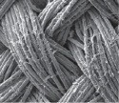
"Our approach involves the nanowires dissolving slowly, which will work to extend the life of the material," says Bansal. "In our studies, we observed that after dipping the fabric in the solution, the silver ions responsible for killing off the bacteria were still being released after five days."
Bansal says these materials hold great potential for curtailing hospital-acquired infections through applications such as antibacterial bed linen and surgical aprons, and could also be used to produce antibacterial "dressings and Band-Aids that could kill bacteria in the wound, resulting in faster healing." The researchers will now turn their attention to establishing the safety of the material in hospital environments.
"We've established the nanowires are toxic to the bacteria," says Bansal. "Our next phase is to test its toxicity against human cells."
The team's research was published the journal Advanced Functional Materials.

Nick Lavars was born outside of Melbourne, Australia, with a general curiosity that has drawn him to some distant (and very cold) places. Somewhere between enduring a winter in the Canadian Rockies and trekking through Chilean Patagonia, he graduated from university and pursued a career in journalism. He now writes for Gizmag, excited by tech and all forms of innovation, Melbourne's bizarre weather and curried egg sandwiches.

Study Validates Air Sampling Techniques To Fight Bioterrorism
By Alexander Garza
Source: http://www.newswise.com/articles/study-by-slu-researcher-validates-air-sampling-techniques-to-fight-bioterrorism

Air and surface sampling techniques currently used by the US government are effective in fighting bioterrorism and potentially saving lives, a Saint Louis University researcher finds.
Results published in Biosecurity and Bioterrorism by Alexander Garza, M.D., MPH, former chief medical officer at the Department of Homeland Security and a team of researchers from Los Alamos National Lab reviewed the data from a series of experiments simulating a bioterrorism attack against the Pentagon. Garza is now the associate dean for public health practice and associate professor of epidemiology at Saint Louis University College for Public Health and Social Justice.
In 2005 and 2009, the Pentagon Force Protection Agency (PFPA) in order to simulate a deliberate attack, staged the release of a harmless bacteria that is biological similar to Bacillus anthracis, the bacteria that causes the disease anthrax. They then evaluated the local response procedures to such an attack. In conjunction with this exercise, the Department of Homeland Security ran its own experiments to test the efficacy of an air and surface sampling system known as BioWatch in detecting these biological agents in the environment.
In the experiments, multiple kilograms of benign material were released, which included a small portion of the anthrax simulant. The team collected samples of the air through several portable sampling units and had them analyzed at specialized laboratories.
“We were able to detect the biological organisms released several kilometers from where the agent was originally released,” Garza said. “We were not entirely surprised by the results. Since all of the modeling that had been done to date showed that air samplers should be able to detect these types of attack, what was missing was empirical evidence showing that these systems would work in real world conditions. We now have that evidence.”
“The traditional way to detect that someone has been exposed to a biological agent is to wait until a person becomes symptomatic and then hope that the clinician is able to correctly diagnose the patient,” Garza said, “which is exactly what happened during the anthrax attacks in 2001.”
Garza points out the problem with this approach is that once people become sick they are likely to die, which can potentially lead to significant casualties in a large-scale attack.
“This experiment confirmed that a biological attack could be detected earlier using air sampling which means public health would have more time to respond.”
Air sampling has been readily accepted for similar uses such as measuring for particulate matter, however using it to detect bacteria in biological terrorism was a new concept instituted after the 9/11 attacks. This type of sampling is now part of a sophisticated system used by the Department of Homeland Security and the Department of Defense.
However, in order for the system to work more efficiently in the real world, Garza believes the detection cycle, which currently takes between 12-36 hours, would need to produce results in a shorter time frame.
“The current process is labor-intensive and time-consuming. It takes a lot of manual labor and time to do the laboratory work,” he said.
Since it usually takes at least a couple of days for a person to show symptoms from a biological attack, Garza emphasizes the importance of an improved detecting system that would give officials more time to investigate and ramp up a medical response plan to save lives.
“If we can detect a dangerous pathogen in the environment at an earlier stage, we can quickly start planning the response procedure for it like distributing antibiotics,” Garza said. “The sooner we pick up clues, the sooner we can act and save more lives.”
The Saint Louis University College for Public Health and Social Justice is the only academic unit of its kind among the nearly 250 Catholic institutions of higher education in the United States.
With a focus on finding innovative and collaborative solutions for complex global health problems, the College offers nationally recognized programs in global public health, social work, health management and health policy, epidemiology, biostatistics, environmental and occupational health, behavioral science and health education, emergency management, biosecurity and disaster preparedness, and criminology and criminal justice.

Alexander Garza, M.D., MPH, is the associate dean for public health practice and associate professor of epidemiology at Saint Louis University College for Public Health and Social Justice.

World facing polio health emergency
Source: http://www.bbc.com/news/world-27284389

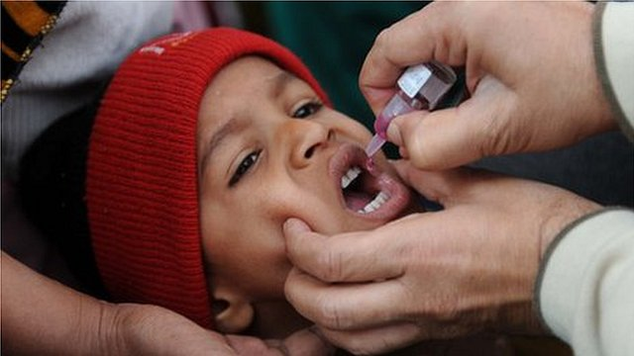
May 5 – The World Health Organization (WHO) has declared the spread of polio is an international public health emergency.
Outbreaks in Asia, Africa and Middle East are an "extraordinary event" needing a co-ordinated "international response", the agency says.
It recommends citizens of affected countries travelling abroad carry a vaccination certificate.
It says Pakistan, Cameroon, and Syria "pose the greatest risk of further wild poliovirus exportations in 2014."
The WHO recorded 417 cases of polio worldwide for the whole of 2013. For 2014, it had already recorded 68 cases by 30 April - up from 24 in the same period last year.
Polio mainly affects children under five years old.
The virus is transmitted through contaminated food and water, and multiplies in the intestine. It can then invade the nervous system, causing paralysis in one in every 200 infections. It is capable of causing death within hours.

'Ongoing risk'
"The conditions for a public health emergency of international concern have been met," said Bruce Aylward, WHO Assistant Director General.
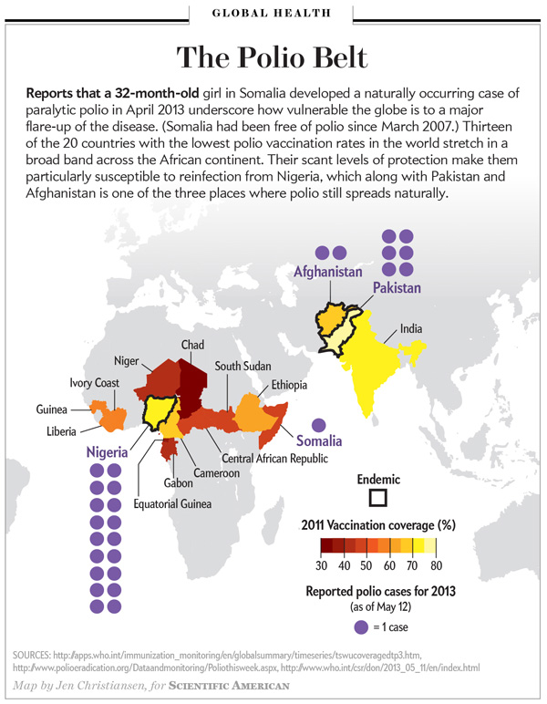
He was speaking after last week's emergency meeting in Geneva on the spread of polio which included representatives of the affected countries.
"The international spread of polio to date in 2014 constitutes an 'extraordinary event' and a public health risk to other states for which a co-ordinated international response is essential," the WHO's International Health Regulations Emergency Committee said in statement.
"If unchecked, this situation could result in failure to eradicate globally one of the world's most serious vaccine preventable diseases."
The WHO also lists Afghanistan, Equatorial Guinea, Ethiopia, Iraq, Israel, Somalia and Nigeria as "posing an ongoing risk for new wild poliovirus exportations in 2014."
It is only the second time in the WHO's history it has made such a declaration, the first being during the swine flu pandemic of 2009, the BBC's Imogen Foulkes in Geneva reports.
The polio virus is endemic in just three countries - Pakistan, Afghanistan, and Nigeria. But attacks on vaccination campaigns in Pakistan in particular have allowed the virus to spread across borders.
Syria, which was polio-free for 14 years, was re-infected with the virus from Pakistan.
Refugees are still pouring out of Syria, to Jordan, Lebanon and Turkey, and checking whether all of them have been vaccinated will be impossible, our correspondent says.

New technology to detect previously undetectable fecal contamination in water
Source: http://www.homelandsecuritynewswire.com/dr20140507-new-technology-to-detect-previously-undetectable-fecal-contamination-in-water

Technology capable of sampling water systems to find indicators of fecal matter contamination that are thousandths and even millionths of times smaller than those found by conventional methods is being developed by a team of researchers at Texas A&M University.
Working with a team of collaborators, Vladislav Yakovlev, professor in the Department of Biomedical Engineering, has developed an ultrasensitive detection method that can detect molecules associated with human and animal fecal matter in water systems. These extremely small indicators, he explains, have been traditionally difficult to detect but can signal greater levels of contamination, which can lead to illness and even death.
A Texas A&M release reports that the team’s research is funded by the National Science Foundation and is featured in the journal Proceedings of the National Academy of Sciences. It details the development of technology that Yakovlev characterizes as affordable, highly sensitive, easy to implement and capable of delivering analysis of water samples in real time. That combination of benefits, he says, gives the system a leg up on other detection technologies, making it ideal for use not only in the United States but in developing countries, which often face water quality issues.
At home and abroad, animal and human waste can contaminate both recreational and source waters, carrying with diseases such as polio, typhoid, and cholera. This form of contamination can even result in environmental crises, such as devastation to the aquatic population and red-tide blooms. Yakovlev notes. These types of contamination events, Yakovlev explains, might be mitigated or even avoided if samples from water systems are more thoroughly analyzed so that they can provide a better picture of what is in the water. In other words, finding trace amounts of contaminants such as fecal matter in water systems can help sound the alarm for a serious contamination event because these trace amounts likely originate from a larger source in the water system, he notes.
Detecting these trace amounts, however, is not easy, especially in a timely manner, Yakovlev says. High costs, sample-size limitations and lengthy analysis times, he notes, have prevented environmental researchers from employing highly sensitive techniques that can deliver real-time analysis — until now.
Yakovlev and his colleagues are poised to change things with an innovative approach to detecting something known as urobilin. Urobilin is a byproduct excreted in the urine and feces of many mammals, including humans and livestock such as cows, horses and pigs. Urobilin molecules, Yakovlev notes, are small and diffuse quickly so they easily occupy large volumes, such as lakes and reservoirs, for example.
In addition, urobilin possesses another interesting property; it glows — or more accurately, it can be made to glow. When mixed with zinc ions, urobilin forms a phosphorescent compound, Yakovlev explains. This means if urobilin is present in a water sample — and zinc ions have been added — the sample will give off a greenish glow when examined under an ultraviolet light, he says. There is just one catch. In some samples with low concentrations of urobilin, the glow, or phosphorescent emission, can be weak, making it difficult to analyze the sample.
Researchers, Yakovlev says, must be able to thoroughly excite the sample (causing the reaction), observe the glow and then measure it in order to perform an accurate analysis.
The release notes that toward that goal, Yakovlev and his team have developed technology that allows them to thoroughly excite extremely small amounts of urobilin in large samples of water and then efficiently collect the resulting phosphorescent emission, regardless of how weak that emission might be. It is done with the help of device researchers refer to as an “integrated cavity.”
The integrated cavity used by the team of researchers is essentially a hollow, cylindrical container manufactured in Yakovlev’s laboratory. A water sample is placed inside the cylinder where it interacts with zinc ions, and a laser light is beamed into the object and onto the sample through a small hole, Yakovlev explains. The light excites the urobilin compound present in the sample, causing it to emit a glow. The only way for the light to exit the cylinder, he notes, is through the hole that it initially entered. Not only does this ensure that all the light that enters the cylinder is used to excite the entire sample, it also enables researchers to efficiently collect the resulting phosphorescent emission so that it can be directed to a photo detector, such as a spectrometer, for analysis, Yakovlev says.
Employing the integrated cavity in their detection efforts, Yakovlev and his team have detected the presence of urobilin down to a nanomole per liter. A mole is a common unit of measurement in chemistry, and a nanomole is one billionth of that measurement. What is more the technology provides actual concentration levels of the contaminant, and it does so much quicker than other methods, he notes.
“We can demonstrate detection of ultralow concentrations of urobilin in solution,” Yakovlev says. “This is a huge improvement in terms of sensitivity, and our technique has tremendous potential for analysis of global drinking water supplies, particularly in developing nations and following natural disasters, where sophisticated laboratory equipment may not be available.”
Another key element of the technology, which can be produced for a few hundred dollars, is its ability to analyze large samples, Yakovlev notes. Conventional methods are not capable of analyzing large samples. This is a problem, he adds, because it is unlikely that an accurate analysis of an overall water system can be derived from a small sample. For example, researchers might collect a small sample that is free of the contaminant, but that does not mean the entire water system is contaminant free. A larger sample, he says, gives researchers a better predictive power about the water system contains.
“The bigger the sample, the better,” Yakovlev says. “And with our technology the sensitivity scales with the amount of water in our sample. Using one liter will increase sensitivity by a factor of 20, and an additional 10 liters result in another order of magnitude increase in sensitivity.
As it stands, Yakovlev and his team are working to commercialize the technology for urobilin detection. Because it delivers nearly instantaneous results, it could serve as the basis for in-home detection systems that alert users if the water coming from their faucets is suddenly contaminated, he says. Think smoke detector for a water faucet. Equally as important, he notes, the technology can be used for detection of other types of toxic compounds in both liquids and gases, lending itself to anti-terrorism applications, among other uses.

— Read more in Joel N. Bixler et al., “Ultrasensitive detection of waste products in water using fluorescence emission cavity-enhanced spectroscopy,” Proceedings of the National Academy of Sciences (2014) (doi: 10.1073/pnas.1403175111)

Successful Completion of a Comprehensive Laboratory Validation of the Tetracore BioThreat Alert Lateral Flow Assay
Source:http://www.domesticpreparedness.com/Industry/Industry_Updates/Successful_Completion_of_a_Comprehensive_Laboratory_Validation_of_the_Tetracore_BioThreat_Alert_Lateral_Flow_Assay/

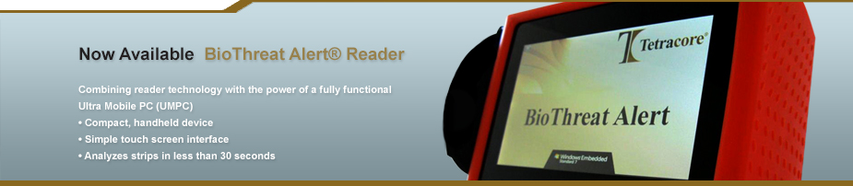
May 5 – Tetracore Inc., a biotechnology company, announces the successful completion of an extensive study of its Ricin BioThreat Alert Lateral Flow Assay (LFA) and BioThreat Alert LFA Reader by the Department of Homeland Security (DHS). Tetracore Ricin BioThreat Alert LFA is designed to deliver quick and accurate results in the field or laboratory at an affordable cost while being easy to use and store. The results of this study have produced a comprehensively validated rapid assay for the detection of ricin.
Public safety and health concerns lead DHS to perform a comprehensive laboratory validation study of a commercially available LFA for the rapid detection of ricin. When suspect environmental samples, including unknown white powders, are discovered in the field authorities are tasked to determine if ricin or another biological threat agent is present. The goal of this study was to provide a reliable rapid field test for ricin, to enable better informed decisions by first responders and public health officials. This will provide for better public safety and reduce the economic impact of false alarms.
The study was coordinated by DHS scientists Dr. David Hodge (Program Manager) and Dr. Segaran Pillai (Chief Science and Medical Advisor) in collaboration with HHS CDC, HHS ASPR/BARDA, FDA CFSAN, FDA CDRH, DHS S&T, DHS CBP, DHS OCAO, FBI, USSS and USDA. The Tetracore Ricin BioThreat Alert LFA and Reader were evaluated at five different testing locations: the Centers for Disease Control (CDC), the Food and Drug Administration (FDA) Center for Food Safety and Applied Nutrition (CFSAN), Massachusetts Department of Public Health, Texas Department of State Health Services and the Virginia Division of Consolidated Laboratory Services. The study consisted of seven phases to thoroughly test each performance aspect of the LFA, including a repeatability study, an inclusivity panel, an informational panel, a lectin panel, a near-neighbor panel, a white powder panel and testing of BioWatch filter extract. The panels utilized in validating this assay were very extensive and provided a highly robust process to ascertain valuable information regarding the performance of the assay. No other commercial lateral flow assay developed for field screening of ricin has been comprehensively and independently validated until now.
“Tetracore respects our on-going collaboration with DHS and will continue to validate our BioThreat Alert LFA products rigorously, so that public health laboratories and first responders have confidence in screening for biological threats,” stated Dr. Tom O’Brien, Vice President of Tetracore, Inc.

Debate intensifies over whether or not to destroy last stockpile of smallpox
Source: http://www.homelandsecuritynewswire.com/dr20140508-debate-intensifies-over-whether-or-not-to-destroy-last-stockpile-of-smallpox

The world’s health ministers are scheduled to meet later this month to discuss the fate of the last known stockpiles of smallpox, held under tight security in two labs— one in the United States and the other in Russia.
Smallpox has been eradicated for more than three decades, but some U.S. health officials say the remaining stockpiles should be kept for further studies. The smallpox virus is being used to develop drugs and safer vaccines in case the virus returns through terrorism or a lab accident. Member nations of the World Health Organization (WHO) once agreed that the last virus strains known to officials would eventually be destroyed, but a set date was never agreed upon.
Columbia Daily Tribune reports that last fall, two WHO committees reviewed smallpox research and one group found no further need for the smallpox virus. “We believe that the smallpox research program is effectively complete and the case for destruction is stronger than ever,” said Lim Li Ching, on behalf of the Third World Network, which lobbies on behalf of developing countries and wants the virus eliminated within two years.
Keeping the virus on hand is scientifically unnecessary now that the virus’ genetic makeup is known, said Dr. D. A Henderson, former head of the WHO’s global eradication campaign and now with the nonprofit UPMCCenter for Health Security. “Let’s destroy the virus and be done with it. We would be better off spending our money in better ways,” such as protecting against other viruses that could be used for bioterrorism.
The Centers for Disease Control and Prevention (CDC) poxvirus chief Dr. Inger Damon disagrees with eliminating the virus, since smallpox research has aided in recognition and treatment of related diseases such as monkeypox. There are now new generations of smallpox vaccine, and two pending antiviral treatments, but Damon wrote in the journal PLoS Pathogens that “despite these advances, we argue that there is more to be done” in improving protections.
A recent WHO meeting raised concerns about advances in synthetic biology, which could make it technologically possible to design a synthetic version of smallpox. “The synthetic biology adds a new wrinkle to it,” Jimmy Kolker, Health and Human Services assistant secretary for global affairs, told the AP. “We now aren’t as sure that our countermeasures are going to be as effective as we’d thought even five years ago.”
In response, Dr. Sylvie Briand, WHO’s director of pandemic diseases, cautioned that synthetic biology is “not something you can do in your garage.” She insists that destroying the smallpox virus is not the fundamental issue, instead “the real debate is what is the public health risk nowadays, and what are the response measures we have in hand to mitigate those risks.”

New biodefense centers offer modernized approach, face criticism
Source: http://www.homelandsecuritynewswire.com/dr20140509-new-biodefense-centers-offer-modernized-approach-face-criticism

A new facility at Texas A&M University is one of three new biodefense centers created by the U.S. Department of Health and Human Services (HHS) to revolutionize the way fatal viruses are countered in the event of an emergency.
The $286-million lab, known as a Center for Innovation in Advanced Development and Manufacturing (CIADM) and which is situated in a rural warehouse, features mobile clean rooms that can be detached and moved to form different production or testing systems as the need arises. Additionally, separate sections of the facility can work independently, or be reconfigured into any number of combinations.
As Nature reports, Gerald Parker, director of the center, said regarding the flexibility of the site, “We need to be prepared for all hazards, not just the last one that hit us.”
HHS says it will invest $2-billion over the course of the next twenty-five years in countermeasures at the lab, including the resources to stockpile viruses for research and immunization purposes.
The CIADMs will also work on developing countermeasures to bioterror threats. Brett Giroir, executive vice-president of the Texas A&M Health Science Center, told the magazine, “We just hope the bad guys attack us with what we stockpiled.”
Others, however, have been critical of the design and capabilities of the CIADMs. Keith Wells, a consultant at BioProcess Technology Consultants, is critical of overworking countermeasures in advance, “They’re going to have a lot of challenges.” Nature also cites a 2008 report for the Defense Advanced Research Projects Agency (DARPA) which “Recommended the creation of a single development and manufacturing facility to serve both the military and civilians.”
Philip Russel, a retired Army major general, told the magazine, “Rather than one good operation that meets the government’s needs, we got three operations that spread the money around.”
CIADM supporters counter with the argument that three sites create flexibility and allow for backup procedures in the event of an emergency.
The facilities will be tested later this year when the government places its first orders for countermeasures to be developed.

Use of Infrared to detect elevated Body temperatures
Source: http://www.flir.com/cs/emea/en/view/?id=52294

Infrared thermography can help detect elevated body temperatures which may indicate the presence of a fever. As such, the use of infrared as an adjunctive diagnostic tool to help detect people with a potential fever may contain or limit the spread of viral diseases such as bird and swine flu, or bacterial infections such as SARS.
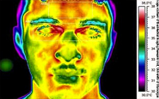
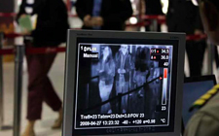
The growth of international travel and economic migration require a consistent, prompt, effective and global disease prevention policy. Elevated human body temperature, or fever, is often a reliable indicator of many serious infections. Since the recent outbreak of serious flu strains such as H1N1, and the spread of severe acute respiratory syndrome (SARS), public health authorities have been looking for a fast, easy, contactless ( non-invasive), and reliable method to detect elevated human body temperature. When used properly, infrared screening is such a method: a vital tool in the detection of elevated body temperatures in high-risk groups such as travelers. It is being used by health authorities around the world to screen passengers entering a country via mass transportation, and has proven itself as an effective monitoring method.
Viral and bacterial infections that spread through human contact and airborne transmission pose a serious health problem, including the possibility of pandemics, as shown by recent flu outbreaks. Image courtesy of the Medical Imaging Research Unit, University of Glamorgan
FLIR IR cameras automatically detect elevated skin temperatures that may indicate a fever and underlying infection. Each camera's unique Automatic Temperature Compensator (ATC) adjusts for ambient conditions to minimize false readings. The color image, temperature scale, and alarm mechanism make it easy to decide when a person needs further examination.
Use of Infrared to detect elevated Body temperatUres Use of Infrared to detect elevated Body temperatUres This makes IR cameras a cost- effective way to help prevent pandemic outbreaks and the deaths that often follow. Public health authorities remember all too well that SARS took the lives of some 10% of infected people. Similarly, the H5N1 strain of avian influenza at one point had a death rate of over 50% in Asia and Europe. Since influenza viruses have the ability to quickly mutate, scientists are concerned about their ability to make effective vaccines that prevent high death rates among weaker members of the global population. Infrared thermography: an effective tool to detect elevated body temperatures An infrared camera produces thermal images or heat pictures that display even the smallest temperature differences.
Human body temperature is a complex phenomenon. Humans are homeothermic; they radiate heat, which must be lost to the environment to control their internal temperature. The interface between that heat production and the environment is the skin. This dynamic organ is constantly adjusting the optimum balance between the physiologic demands of the body and external environmental conditions.
Infrared thermography provides a visual map of skin temperatures in real time. In addition, IR cameras are very sensitive devices. FLIR cameras measure temperature differences as small as 0.07 °C.

Fixed-mount FLIR A320 with the color alarming in progress
The built-in functions of FLIR IR cameras include color images and temperature scales, and sound alarms that can be set to go off when a certain temperature threshold is exceeded. These functions make it easy for an operator to instantly decide whether the subject needs to be referred for medical examination. Since the cameras produces images in real time the total evaluation process takes less than a second. This makes infrared technology very useful for rapidly screening large groups of people.

Unique atc feature minimizes false readings
A person's general skin temperature is not equal to the person's core temperature. The most practical spot on the body giving the most reliable result (where the skin temperature approaches the core temperature of the human body) is in the corner of the eyes where the lachrymal (tear) duct comes to the surface. (See adjacent images.)
Still, skin temperature is affected by one's surroundings, even if they have a fever. Nevertheless, their skin will be hotter than other nearby persons (affected by those same surroundings) who do not have a fever. FLIR's unique Automatic Temperature Compensator feature takes this

Setting up a FLIR IR camera with Automatic Temperature Compensator (ATC) for elevated body temperature detection
Use of Infrared to Detect Elevated Body Temperatures 3 into account and improves the reliability of temperature measurements. FLIR has verified that a person who is hotter than those around them, at a given time under a given ambient condition, has a higher probability of an elevated temperature, and warrants further screening. When doing mass screenings, the company's ATC technology is much more accurate at finding elevated body temperature than simply setting a fixed alarm threshold of 38 °C. (An absolute internal body temperature is more appropriate for screening individuals with a thermometer, because it is not affected by one's surroundings.) For example, all people exiting a warm or cool airplane environment will have been affected by its passenger compartment temperature. If the passenger compartment was cool enough, it would have lowered the skin temperature of someone with a fever to a certain degree. It would also have lowered the skin temperatures of those passengers without a fever. Therefore, a relative temperature comparison of several passengers will more accurately reveal someone with a fever and prevent false readings. This is what FLIR's ATC feature does. In addition to calculating relative temperature readings, it automatically adjusts the generation of visible and audible alarms, thereby greatly improving the screening reliability. For consistent measurements, it is recommended that subjects be placed in front of the camera at a fixed distance. In general, a distance of 1 to 1.6 meters away from the camera lens allows the subject's face to fill the entire image display. The subject only needs to look into the camera for less than a second. As the highest temperature will be measured in the corner of the eyes, people can continue to wear a mouth mask or their headwear without influencing the measurement. Glass and plastic do not transmit infrared radiation, so people need to remove their glasses in order to be examined. It is also advisable to set up the IR camera in a location where people form a queue, such as passport or customs control points. This allows persons to be screened on an individual basis. It is also recommended, though not mandatory, to install the camera on a tripod and connect it to a video monitor to facilitate observations by the camera operator. Proof that infrared thermography works Studies have shown that it is not necessary to measure absolute temperatures to determine whether a person has a fever or not. After measuring the true body temperature of many healthy people with a medical ear thermometer, and the face temperature of these same people with a FLIR IR camera, the average temperature difference was calculated. The average difference between their true body temperature and face temperature was found to be fairly constant It varies between 0.8 and 1.2 °C, depending on the environmental conditions of the test area.
This corresponds to the principle that the body temperature of a feverish person is likely to be at least 1–2 °C higher compared to a healthy person. Whether the skin temperature turns out to be 32, 34, or 36 °C is less important than substantial variations from the norm. It should correlate to the core body temperature and remain stable.
The purpose of IR screening is to differentiate people who are well from those who have a fever, not to measure absolute body temperatures. The absolute error measured on both the threshold values and the subjects who are screened will be the same, as long as the camera temperature is stable.
In practice, infrared cameras with the Ambient Temperature Compensator (ATC) feature can be quickly installed and used immediately: After setup, these ATC cameras measure the skin temperature of the first group of scanned subjects and then calculate an average. An alarm is automatically configured to go off when a measured temperature reaches that average plus 2 °C. To allow for changing ambient conditions, a moving average is used as additional subjects are screened.

Quick scans of large groups, with color images and sound alarms
Temperatures are measured by full radiometric infrared cameras. FLIR Systems offers its A320 and T360 Series as optimum solutions. These systems can be battery-operated for over 2 hours or continuously connected to main power. Adhering to the IP 54 standard, they can be used either indoor or outdoor.
FLIR cameras have built-in functions to measure the highest temperature inside a given field of view area. These cameras can be configured to automatically detect the hottest spot. Its value is immediately displayed on the camera's built-in LCD monitor, and may be connected to a video monitor. The cameras are also optimized for fever detection by recalibrating themselves frequently. FLIR cameras are factory calibrated with NIST certified equipment.
A built-in color temperature scale enables an immediate decision on whether or not the subject requires further examination. All areas within the camera's field of view that are hotter than a predefined temperature can be easily and immediately recognized on the image display.
In addition, FLIR cameras are equipped with a sound alarm. If the temperature exceeds a predefined setpoint value, the audible alarm goes on. A subject activating the alarm can then be isolated for further examination, on site or at a medical centre.

A small investment to protect public health
Major airports are already using FLIR cameras and have successfully applied this methodology to screen passengers entering and leaving the country.
Infrared cameras:
- Allow to screen large numbers of people anywhere at any time
- Display and detect critical temperature elevations in real-time
- Activate color and sound alarm
- Are easy to set up and use
- Can be smoothly integrated in public area pedestrian traffic streams
- Are able to store evidence
- Protect public health is a quick and contactless method, which is perfectly safe for both the camera operator and the screened subject.
FLIR IR cameras have proven themselves as tools that can be operated by non-specialists after a few hours of training. They enable a quick and accurate scan of a large number of people to trace fever, a major symptom of viral and bacterial infections. As some officials have put it, it is a very small investment to protect public health worldwide.

5 Hong Kong Airport Authority Hong Kong Airport Authority Use of Infrared to detect elevated Body temperatUres proven track record
The deployment of FLIR cameras in airports, terminals and company facilities is providing a noninvasive and highly effective method to screen passing crowds for elevated skin temperatures that might suggest a person has the H1N1 virus.
The adoption of FLIR IR cameras is one small, but vital measure, to combat the spread of swine flu. A selection of companies and organisations that have FLIR IR temperature screening systems in place:

- Algeria Ministry of Health
- ALSTOM Power Service
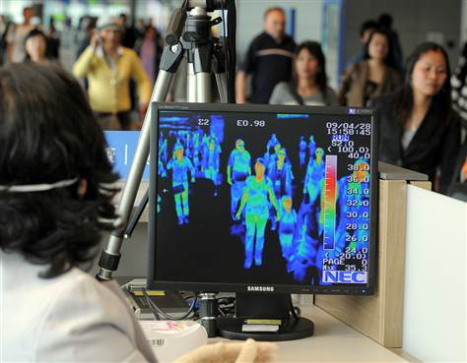
- Australian International Airports
- Bank Audi
- CEAT Electronique
- Chunghwa Telecom
- Compai Electronics
- Egyptian Airports
- French Ministry of Health
- Formosa Plastic Group
- Greek Airports
- Malaysia Ministry of Health
- Morocco Ministry of Health
- Rock Production
- Saudi Airports Star
- Cruises Tunisia
- Ministry of Health Turkey
- Ministry of Health UAE Ministry of Health
- …and more
►Read also a comparison paper at: http://wwwnc.cdc.gov/eid/article/16/11/10-0703_article.htm

Novavax, Inc. (NASDAQ:NVAX): Taking MERS by the Horns
Source: http://basicsmedia.com/novavax-inc-nasdaqnvax-taking-mers-by-the-horns-9412

May 13 – Novavax, Inc. believes that it can use the spikes (corona) of the virus to fight back MERS.
The biotech company, in conjunction with researchers from the University of Maryland’s School of Medicine, said that they had come up a potential vaccine which obstructed MERS infections in laboratory-based trials experiments. The design of the vaccine candidate is based upon a platform that is said to protect people from SARS (Severe Acute Respiratory Syndrome), which is also a coronavirus.
Dr. Gregory Glenn, the Senior VP of research at Novavax said that they were essentially preventing the attachment of the virus to human cells, and that when you have an immune-based response to the virus, the virus is eradicated.

Novavax’s work on MERS was made available in the latest issue of the journal, Vaccine (April 13).

Novavax structures its vaccines by first downloading the sequenced genome of the virus they’re dealing with. They then use that code to design a vaccine to target how a virus attacks the human body.
The vaccine is still considered highly experimental and would need additional safety and efficacy tests before it could be used in humans. But researchers contend their findings are a promising development for health officials.

Pandemics: who should be given life-saving treatment first? Who should make the decision?
Source: http://www.homelandsecuritynewswire.com/dr20140515-pandemics-who-should-be-given-lifesaving-treatment-first-who-should-make-the-decision

In the event of a flu pandemic, who should have priority access to life-saving ventilators, and who should make that determination? Few disaster preparedness plans have taken community values regarding allocation into account, but a new study is aiming to change that through public engagement with Maryland residents.
“In the event of a healthcare crisis, understanding the community perspective and having citizen buy-in will be critical to avoid compounding the initial disaster with further social upheaval,” says principal investigator Elizabeth L. Daugherty Biddison, MD, MPH, Vice Chair for Clinical Operations in the Department of Medicine, Johns Hopkins School of Medicine.
“When life-saving medical resources become scarce, there are no ideal options, even among ethically-permissible ones. Understanding community perspectives and values will help policy-makers craft guidelines for those difficult choices,” Biddison says.
A JHU release reports that to gain this perspective, Biddison and colleagues from the Johns Hopkins Berman Institute of Bioethics, Carnegie Mellon University, and University of Pittsburgh Medical Center are exploring the use of “deliberative democratic methods” typically employed to understand how the public views potential policy changes. A pilot study consisted of two community meetings — one in affluent Howard County, which ranks top among the state’s county health rankings, and the other in a neighborhood near Johns Hopkins Hospital in inner Baltimore City, which ranks last. The results were published online ahead of print in April in the Annals of the American Thoracic Society.
“We found that participants’ ethical perspectives were framed in large part by their place-based life experiences,” says Ruth R. Faden, PhD, MPH, director of the Johns Hopkins Berman Institute of Bioethics, a member of the study team. “Our results thus far underscore the importance of broad and diverse community input, to capture more fully the issues that matter to people of various backgrounds.”
The community meetings followed the same procedures used to gather information on views related to controversial policy issues including marriage equality, regional tax sharing, and economic redevelopment. According to the study results, the Baltimore City group spent significant time discussing whether particular groups should be disqualified from access to ventilators, such as convicted felons and undocumented immigrants. The study authors connect these concerns directly to crime-rate and demographic trends in the area.
Members of the Howard County community group were recruited by a private-public partnership focused on strengthening local resilience to disasters, and focused on logistical concerns.
According to the study, “County residents struggled with the implementation timeframe required by different approaches: would someone die without a ventilator while decision-makers were still making up their minds? County residents also expressed greater concern about the potential for bias in decision making.”
Regarding the differences in focus between the two groups, the study states, “[T]he differences reflected distinct ways of thinking about the issues. This finding underscores the importance of achieving a diverse, regionally varied sample of Marylanders” for the project’s planned expansion across the state. With such diverse feedback from citizens, “health authorities and elected officials will be better prepared both to shape and to communicate the content of Maryland’s future framework in meaningful ways,” the study concludes.
Biddison says that the state-wide expansion of the study will include at least ten forums, five for general community members and five for healthcare professionals. The results will be shared with Maryland health officials for practical application to the state’s policy on healthcare resource allocation in the event of a disaster.

— Read more in Elizabeth L. Daugherty Biddison et al., “The Community Speaks: Understanding Ethical Values in Allocation of Scarce Lifesaving Resources during Disasters,” Annals of the American Thoracic Society (24 April 2014)

DOD Has Strengthened Coordination on Medical Countermeasures but Can Improve Its Process for Threat Prioritization

GAO-14-442: Published: May 15, 2014. Publicly Released: May 15, 2014.

Source: http://www.gao.gov/products/GAO-14-442

From fiscal years 2001 through 2013, the Department of Defense (DOD) received over $4.3 billion in total funding (in constant fiscal year 2013 dollars) to research, develop, and make available medical countermeasures that respond to biological threat agents. Of that $4.3 billion, approximately $3.75 billion was for the research and development of new medical countermeasures.
DOD has made progress in researching, developing, and making available medical countermeasures against biological threat agents, but does not use its established process for annually updating its list of threat priorities. DOD's Chemical and Biological Defense Program (CBDP) is researching, is developing, or has obtained Food and Drug Administration approval for countermeasures that address 10 of the 19 biological threat agents DOD has identified as threats to the warfighter. Of DOD's 43 candidates for medical countermeasures, 13 use technologies that may allow them to respond to various emerging or genetically modified biological threat agents. However, DOD does not use its established process to annually update its list of biological threat priorities. DOD Directive 6205.3, DOD Immunization Program for Biological Warfare Defense , establishes roles and responsibilities and an annual process for updating DOD's biological threat list. GAO found that the list has not been updated annually and, when it was updated in 2001 and 2012, DOD did not receive input from key stakeholders. By not following its established process for annually updating its biological threat list, DOD cannot ensure that its investments—and those of its partners—are applied toward responding to the most-serious and likely biological threats.
CBDP has taken steps to increase transparency and improve coordination practices within DOD to allocate resources to address biological threats. In response to concerns raised by military service officials that CBDP was not completely transparent in how it prioritized requirements and made resourcing decisions, CBDP issued a business plan in 2012 to update its coordination methods. While military service officials were supportive of CBDP's actions, they stressed the need for continuing dialogue and collaboration in the future.
DOD's efforts to coordinate with the Department of Health and Human Services (HHS) and the Department of Homeland Security (DHS) align with best practices GAO has identified for collaborating across agency boundaries—specifically, to leverage available resources; establish mutually reinforcing joint strategies; and develop compatible policies, procedures, and other tools to operate across agency boundaries. DOD, HHS, and DHS share a joint research campus—the National Interagency Biodefense Campus at Fort Detrick, Maryland—to study biological threat agents. The campus has its own governance structure, which allows the agencies to leverage available resources and facilitate scientific exchange. Senior leaders at DOD and HHS also have developed interagency agreements and other tools that facilitate communication on the various stages of medical countermeasure development. Finally, DOD and DHS have established processes for identifying biological agents that pose domestic threats and risks.

Why GAO Did This Study
The spread of the scientific capabilities to produce effective biological weapons has contributed to concerns about the threat posed to the warfighter from biological attacks.
GAO was mandated to review DOD's efforts to research and develop medical counter-measures against prioritized biological threat agents. This report (1) describes DOD's funding of medical countermeasures against biological threat agents from fiscal years 2001 through 2013; (2) evaluates DOD's progress in researching, developing, and making available medical countermeasures against biological threat agents, including DOD's prioritization process; (3) describes DOD's internal coordination to allocate resources to medical countermeasures against biological threat agents; and (4) evaluates DOD's coordination with HHS and DHS to research and develop medical countermeasures against biological threat agents.
GAO analyzed DOD budget information from fiscal years 2001 through 2013, policies, and strategies relating to biological medical countermeasures and analyzed information and interviewed officials from DOD, HHS, and DHS on collaborative efforts to research and develop biological medical countermeasures.

What GAO Recommends
GAO recommends that DOD implement a process to update its list of biological threats according to its current policies. DOD concurred and identified steps to address the recommendation.

How contagious pathogens could lead to nuke-level casualties
Source: http://med.stanford.edu/ism/2014/may/bioterror-0519.html

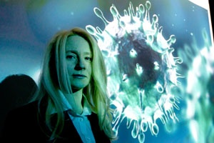
Milana Trounce (photo) offers a course called Biosecurity and Bioterrorism Response, which aims to get students thinking about how to prevent bioterror and, in the event of a biological attack, what to do about it.
What if nuclear bombs could reproduce? Get your hands on one today, and in a week's time you've got a few dozen.
Of course, nukes don't double on their own. But contagious, one-celled pathogens do. Properly packaged as a bioweapon, they could kill as many people as a hydrogen bomb would, or more.
Milana Trounce, MD, a clinical associate professor of emergency medicine, wants to get people to worry about this possibility. For the fourth year in a row, she is presiding over a course called Biosecurity and Bioterrorism Response, which aims to get students thinking about how to prevent bioterror and, in the event of a biological attack, what to do about it. More than 100 Stanford undergraduate, graduate, postdoctoral and professional students, representing disciplines ranging from public policy to biological science to engineering and bioengineering, have enrolled.
The course, which Trounce considers more of a forum or workshop, brings students together with guest lecturers from Stanford and other universities, as well as with biotech-company executives, think-tank denizens and current and former public-health and other government officials.
"I'm hoping to continue to grow this forum to figure out real-world solutions," she said.
Authorities on bioterrorism and biosecurity say that more thinking about how to handle this threat is desperately needed. Steven Block, PhD, professor of biological sciences and of applied physics at Stanford, is a member of a scientific advisory group that meets several times a year to report to the federal government on national-security issues, including bioterrorism. "The advent of modern molecular genetic technologies is making it increasingly feasible to engineer bioweapons," said Block, who is also the Stanford W. Ascherman Professor of Sciences and a guest lecturer in Trounce's class. "It's making people with even moderate skills able to create threats they couldn't before."
A natural anthrax strain mailed to public officials in a series of homegrown terrorist incidents in late 2001 — while deadly — was treatable, Block said. But the technology for making drug-resistant anthrax — or, for that matter, creating all manner of novel "designer diseases" — is becoming increasingly available worldwide, not to mention cheaper and more sophisticated.
Trounce agrees. "We are undergoing a biotechnology revolution," she said. "Even in the last 10 years, science has advanced so much that you can engineer some of the scariest organisms — for example, smallpox."
In laboratory experiments, scientists have mutated H5N1 — a deadly influenza strain that so far has been transmitted to humans only by birds — to become transmissible by other humans. They have synthesized the Spanish flu virus, a naturally occurring strain that swept the globe in a 1918 pandemic, killing far more people than died in all the battles of World War I. What if any of those were to get out of the lab?
"Unfortunately, it's a real possibility, because with advances in technology it's now much easier to create these weapons than ever before," Trounce said. "A few people with modern resources can create a bioweapon. This is something we don't typically think about."

Something old, something new
Long before the advent of high-tech laboratories, bioweapons had earned a perch in the annals of infamy. The ancient Romans, like others before them, threw carrion into wells to poison their adversaries' drinking water. In 1347, the Tatars catapulted the bodies of bubonic-plague victims over the defensive walls of the Crimean Black Sea port city now called Feodosia, then a gateway to the Silk Road trade route. That effort apparently succeeded a bit too well. Some of the city's residents escaped in sailing ships that, alas, were infested with rats. The rats carried fleas. The fleas carried Yersinia pestis, the bacterial pathogen responsible for bubonic plague. The escapees docked in various Italian ports, from which the disease spread northward over the next three years. Thus ensued the Black Death, a scourge that wiped out nearly a third of western Europe's population.
In more recent times, the Cold War spurred experimentation in developing deadly pathogens both in the Soviet Union and the West. The U.S. program was abruptly terminated in 1969 under President Richard Nixon's executive order, and within three years all American stockpiles of biological weapons were destroyed. On April 10, 1972, an international treaty banning such weapons was instituted.
"The United States abandoned offensive bioweapons research," Trounce said. "Unfortunately, the Soviets did not." Despite signing the treaty, the Soviet Union conducted a massive, ultra-secret bioweapons effort that continued through the early 1990s.
Trounce has first-hand experience with the aftermath of that effort. She grew up in the Ukrainian city of Odessa when it was still part of the Soviet Union. She began training in ballet at age 7, eventually dancing as a professional ballerina. Her career ended in 1991, when her family hurriedly exited the crumbling Soviet Union. "We left in December. By January, there was no Soviet Union," she said.
Her family relocated to San Francisco. She earned a bachelor's degree in biology at the University of California-Berkeley in 1997 followed by a medical degree at UC-San Francisco in 2001. In 2004, having completed a residency in emergency medicine at Harvard and begun a fellowship in disaster medicine there, she made a State Department-funded trip to biological weapons facilities in Russia as part of a consortium of scientists, engineers and other physicians. The visit's purpose was to help the State Department find ways of redirecting former bioweapons scientists, whose sponsoring institutions were now losing funding because the country was poor, toward peaceful pursuits. The worry was that these scientists' talents could be bought by bad actors.
At its peak, the Soviets' bioweapons program, called Biopreparat, employed close to 60,000 people at nearly 40 facilities throughout the country. As she examined one of those facilities, which housed dangerous microorganisms, Trounce said, "It immediately struck me that it was not in good shape. The only barrier to entry was a barbed-wire fence, with nobody at the gate. I saw cats wandering in and out.
"It blew my mind," Trounce continued. "As a Soviet citizen, I had had no idea these facilities even existed. To come as a U.S. citizen and see these facilities where thousands of scientists had been working on the deadliest pathogens was unbelievable. Who knows what I didn't see?"
Did that massive Soviet bioweapons inventory ever get entirely dismantled? "I don't know," says Trounce. "I don't think anybody really does, and if they do it's classified information. What we do know is that there are three Russian Ministry of Defense bioweapons laboratories that remain closed to international examination."
In any case, nobody harboring these weapons today would admit it, because it is in defiance of international law. But the fact is that thousands of Soviet scientists at numerous facilities kept producing offensive bioweapons for 20 years after signing a treaty banning them.
Retired Rear Adm. Ken Bernard, MD, a guest speaker for the course, said that any claims that such programs have been eliminated should be treated with skepticism. "The Soviets completely lied to us before," he said. "Throughout the 1980s, they were producing tons and tons of smallpox and anthrax, even as the U.S. stopped vaccinating for smallpox."
Bernard, whose immersion in government service as a biosecurity official dates back to 1980, was a special assistant on biosecurity matters to presidents Bill Clinton and George W. Bush. In any case, focusing on existing inventories isn't enough, Trounce said. "Somebody can just come out with these things in a short amount of time. You don't have to build a nuclear reactor, which takes years, and procure exotic materials."
If bioweaponry itself is nothing new, there's been a twist on it in the past few decades: A shift from biowarfare to bioterrorism.
"What took hundreds of scientists and huge resources just a few decades ago now can be done within just a few weeks," Trounce said. Moreover, it can be done without the massive footprint characterizing both Cold War bioweapons projects and current nuclear-weapons programs.
A bioweapon is a poor man's nuke. The secrets involved in building one aren't hard to come by, said David Relman, MD, the new co-director of Stanford's Center for International Security Cooperation. "It takes only the skills a good laboratory technician has mastered," said Relman, professor of microbiology and immunology and the Thomas C. and Joan M. Merigan Professor. Former technicians retain the skills they've learned, he noted. "That adds up to a lot of people who know a lot and know their way around labs."
You can say "don't build a nuclear facility" and monitor for compliance. How do you tell someone not to build a biology lab?

Easy to get, easy to make
That gives rise to another, extremely disturbing consideration: Plausible deniability.
It's easy to mask bioweapons research. You can buy equipment such as gene and protein synthesizers over the Internet. "They're the same as what you see in the legitimate biotech industry, so it wouldn't look suspicious," Trounce said. The materials and equipment you'd use are largely ubiquitous laboratory reagents and glassware, as opposed to the hard-to-get raw materials and instrumentation needed for making nuclear weapons. Information on how to configure pathogens' underlying genetic structures is public.
"Smallpox has a 35-40 percent fatality rate and is not as contagious as measles," said Block. "Now imagine an organism as fatal as HIV and as contagious as measles. With modern air travel, a pandemic caused by a pathogen of this sort could take out maybe 90 percent of the people it reached. That would destroy a society."
A high-tech bioweapon could cost only $1 million to build, Block said. "That's thousands of times cheaper than going nuclear. Iran's centrifuges alone cost them billions."
But there's no need to create a brand-new organism from scratch. Lots of potentially suitable pathogens are ready-made, courtesy of Mother Nature. The bacterial pathogens that cause anthrax and botulinum, to name a couple, are found in the wild. Once you have such a biological agent, you can have 10 times as much of it tomorrow, because it grows exponentially. It costs only a few thousand dollars to culture it. You can store it in a freezer.
"Botulinum toxin is about the most poisonous compound known," said Bernard. "Physicians buy it legally, to inject into people's eyebrows. Who can be sure there's no off-site, illegal production? Suppose a stranger were to say, 'I want 5 grams — here's $500,000'"?
Five grams — 1 teaspoon — of botulinum toxin is easily enough to kill hundreds of thousands of people The paralytic toxin, secreted by the bacterial organism Clostridium botulinum, can be countered with an antitoxin, but patient survival may require months of mechanical ventilation on an artificial respirator. In a 2005 study, Lawrence Wein, PhD, the Business School Trust Faculty Fellow and the Jeffrey S. Skoll Professor of Management in the Graduate School of Business, explored the hypothetical effects of dropping botulinum toxin into the milk supply. Milk from myriad farms gets bottlenecked in a relatively small number of large temporary storage vats, and then dispersed to a wide network of retail outlets. Tampering with the country's food supply is surprisingly effective when a foodstuff goes through a production or distribution bottleneck, Wein discovered.
"It's generally possible to know who was behind a nuclear attack, because you can trace material by its composition 'signature,'" said Trounce. "Biological agents are ubiquitous. You could even obtain them within the target country. It may be impossible to figure out who the bad guy is. That's ideal for terrorism."

Progress since 9/11?
There was a big expansion of public-health funding at the federal level in the first five years or so after 9/11, with several concrete payoffs. "We've come a long way to solving the mass-smallpox-scenario problem," Bernard said.
Smallpox — a viral pestilence characterized by high fever, pustules that spread from the forehead to the feet within two or three days, and the breakdown of multiple bodily organs — killed an estimated 300 million-500 million people in the 20th century. Smallpox would be very hard for a terrorist to get his hands on, but it does exist in two labs, one in the United States and one in Russia, Bernard said. "In the old days everybody in the United States used to get vaccinated for smallpox. We stopped in the 1970s, except for the military. Everybody under 34 years old — more than half of our population — has never been immunized."
Working in the White House under President George W. Bush, Bernard spearheaded Project Bioshield, a $5.6 billion initiative to hand out grants for pharmaceutical countermeasures. Among the products being developed under the Bioshield aegis are two new antivirals for smallpox and a new vaccine that's safer for immunocompromised people, pregnant women, and people with eczema whose permeable skin makes the traditional live-virus-based vaccine risky.
"We have 20 million doses in the U.S. Strategic National Stockpile, mostly for people who can't take the regular vaccine," said Trounce.
"Like aircraft carriers, anti-bioterror medicinals are by their very nature only going to be sold to one customer — the federal government — and used, perhaps only under duress, during a crisis," Bernard said. "For both ethical and financial reasons, they can't be put through normal clinical trials as medicinals for human use must be. But the Secretary of Health and Human Services could grant initial pre-licensure approval for these products' use in an emergency."
Another federal government project is Biowatch, a $50- to $75-million per year early-warning system for dangerous microorganisms. Germ-monitoring sensors are attached to existing environmental air-quality-sampling platforms in major cities. The system has its drawbacks, though. A few false alarms have been triggered, and it takes a full 24 hours to get results, which could be too late.
Early, accurate diagnosis is crucial, said Relman: "In a lot of cases, people benefit from antimicrobial drugs only if they start taking them within 48 hours — and they've got to be taking the right drug. That's also the hardest time to get an accurate diagnosis, because the earliest phases of many of these diseases are often nonspecific."
But if anything, Relman said, "the situation has gotten worse in the past decade as budgets for the Centers for Disease Control and Prevention and for state and local health facilities have been actually cut. We know we need much greater surge capacity, for example hospitals to take care of respiratory illness. But we haven't invested in it. Public health is dying by attrition."
It's politically tough to justify expenditures for things that haven't happened, Relman added.
"The fact that somebody hasn't used a biological weapon since 2001 doesn't mean it couldn't happen," Bernard said. "No one thought they could fly two airplanes into a tower prior to September 2011. We haven't had a nuke go off since 1945, and nobody's saying that couldn't happen."
Indeed, the United States government has spent trillions of dollars and enormous brainpower investing against nukes. Trounce wants to divert some fraction of those resources to inoculating the country against the arguably more imminent threat of bioterrorism, by coming to terms with the monumentally interdisciplinary, interconnected problems it raises.
"Stanford's unique blend of expertise in medicine, business, and engineering, our public-policy program, and its location in the center of Silicon Valley make this the perfect place to get started," she said.

Lawmakers Mull Biological Weapons Threat From Russia
Source: http://time.com/91820/russia-putin-congress-biological-weapons/

Beware Russian germs!
So warned a panel of witnesses at a congressional hearing Wednesday, as lawmakers looked to asses the potential biological weapons threat posed by a nuclear superpower defying the West in its clash with Ukraine.
“It is an existential risk to society,” Dr. Christopher Davis, a biomedical weapons expert and former member of the U.K.’s Defense Intelligence staff, said of infectious diseases and the “rapid emergence of multi-drug resistant forms.”
“Some of the most vexing security problems facing the United States and the international community originate with disease,” Dr. Amy E. Smithson, a senior fellow at the James Martin Center for Nonproliferation Studies, said in her opening statement. “Enter the prospect of a state or terrorist group deliberately releasing disease… and the problems for public health services multiply exponentially.”
House Foreign Affairs Chairman Ed Royce (R-Calif.) told TIME that “biological weapons are among the most frightening possibilities facing this country and the world.” The hearing was hosted by a Foreign Affairs subcommittee.
Davis called on Congress to persuade Russia to abandon its biological weapons—“lift the veil that hides the elephant in the room”—an effort that has largely been on the back-burner of American diplomacy since the George W. Bush Administration. Russia at one point had at least eight weaponized agents, including small pox, Davis told TIME.
Russia denies keeping a stockpile of biological weapons or engaging in illegal development of them, according to the nonprofit monitoring group Nuclear Threat Initiative, but President Vladimir Putin has also raised the prospect of creating experimental weapons in the future.
Milton Leitenberg, a senior research scholar at the University of Maryland, said he’s troubled by comments Putin made two years ago raising the prospect of new genetic weapons, which could alter pathogens to make them resistant to vaccines. That endeavor would be illegal under the Biological Weapons Convention—which bans the development, production and stockpiling of biological weapons—but not unprecedented. The former Soviet Union, which was a party to the BWC, repeatedly thumbed its nose at the organization. In 1992, Russian President Boris Yeltsin admitted that a deadly anthrax accident at Sverdlovsk in 1979 had been caused by ”our military development.”
Leitenberg said it’s almost impossible to evaluate the extent of the Russian biological weapons stockpile because three Russian laboratories remain closed to outside inspection. “We don’t know what they’re doing,” Leitenberg said. “They may or may not have an active offensive program—I presume they do. I do not believe that the U.S. government thinks they are producing and stockpiling agent any more, but we don’t know that.”
Many American politicians and biological weapons experts don’t believe it’s possible or necessary for the Biological Weapons Convention to enforce compliance. Some business interests, including those represented by the Pharmaceutical Manufacturers Association, oppose allowing inspectors on site, Smithson said, because they feel it would jeopardize trade secrets.
“The Biological Weapons Convention is an important element in the global effort to ban these weapons because it establishes an international consensus against their development and use,” Royce told TIME in an email. “Its major limitation is that is cannot be adequately verified. Even legitimate research on pathogens can be used to develop weapons.”
In 2011, then-Secretary of State Hillary Clinton said it’s “not possible” to create a verification system that would allow the international community to believe all countries are living up to the obligations under the Convention. Without a push by the Obama Administration or Congress, it’s unlikely there will be much movement to change the laws governing biological weapons.
But Smithson rejects the U.S. government’s argument that it’s impossible to enforce the BWC. She pointed to the efforts of the United Nations biological inspection team in Iraq after the first Gulf War, which compelled the country to acknowledge its biochemical weapons. “With ordinary inspection tools−observation, document tracking, interviews−and old-fashioned gum-shoe detective work, UNSCOM’s inspectors collected considerable evidence of bioweapons program, despite the façade of civilian activity,” Smithson said.
As Leitenberg put it during the hearing: “One can never know more by not having on-site inspection. You’re not going to learn more by not getting in the front door than you will if you go through the front door.”

Polio and the Syrian Crisis: The Accidental Bioterrorist
By Jennifer Cole and Raffaello Pantucci
Source: https://www.rusi.org/analysis/commentary/ref:C537CC4E77BC53/#.U3195XZA3Mg

The World Health Organization’s recent declaration of a public-health emergency due to the re-emergence of polio in countries including Syria and Somalia highlights the nexus between insecurity, violent Islamist groups and the spread of deadly diseases.
The continual use of chemical weapons in Syria has shocked the world. It has also reopened speculation around the possible use of biological weapons. In January 2014, US Director of National Intelligence James Clapper suggested in a statement to the US Senate Intelligence Committee that the Assad regime is capable of producing lethal agents, though it may not yet have an effective delivery mechanism.
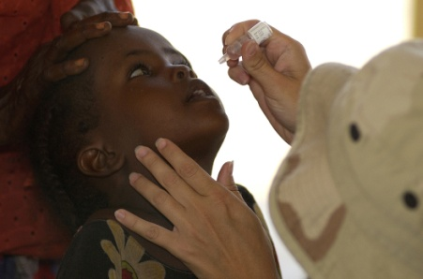
But the potential use of such weapons is not the most pressing biological threat emanating from Syria. Earlier this month, the World Health Organization (WHO) declared a Public Health Emergency of International Concern (PHIEC)[1] as a result of an unintentional bio-crisis: the re-emergence of polio, a deadly killer which was once almost eradicated. Over the last twelve months, twenty-five cases of polio have been confirmed in Syria, putting neighbouring Jordan, Iraq, Lebanon and Turkey at risk. Prior to its ongoing civil war, Syria had been polio-free for fourteen years but the country’s immunisation rates have plummeted from more than 95 per cent of eligible children before the conflict to around 52 per cent at the time of the polio outbreak.[2] Tellingly, the majority of the children affected were born after the vaccination programme fell apart.

(In)security and Bio-Threats
The global, long-term impact of what appears to be a lost opportunity to rid the world of this crippling disease is just as devastating as any deliberate act of bioterrorism.
The challenging security environment that has facilitated its spread should sound alarm bells for the future. Genetic sequencing has linked the strain of polio responsible for the October 2013 outbreak in the Deir Al-Zour province in eastern Syria to one of Pakistani origin that has also been found in Egypt, Israel and the Palestinian territories in recent months. The speculation is that Pakistani fighters battling the Assad regime, or Syrian military personnel who have undergone training in Pakistan, may have inadvertently brought the virus to Syria with them.
Two-thirds of the 400 or so polio cases recorded globally in 2013 were caused by strains imported to the affected country from elsewhere, again largely from Pakistan – while ninety-two actually occurred in Pakistan.[3]. Sixty-nine per cent of these were concentrated in the Federally Administered Tribal Areas (FATA),[4] where the Taliban is particularly active, while Peshawar – the main city that is a way station for people transiting to Afghanistan – is the largest polio reservoir in the world.

Islamist Resistance to Vaccination
The apparent link between polio and Islamist activity is no coincidence: efforts to eradicate the disease in Pakistan, Afghanistan and Nigeria – the only three countries where the disease remains endemic, with ‘wild’ or naturally occurring strains still circulating – have long been challenged by Islamist militants who claim that the vaccinations are a Western plot to make their children infertile, to spread AIDS, or that health workers are undercover Western spies. The latter claim is not without substance: Dr Shakil Afridi, a Pakistani physician working for the CIA, famously obtained DNA from children in Abbottabad in the hunt for Osama bin Laden, under the cover of a fake immunisation campaign. Such suspicion can have a devastating impact: twenty-seven polio workers have been assassinated in Pakistan since December 2012.[5] Nonetheless, as long as the virus remains endemic in Pakistan, jihadist fighters will be able to inadvertently carry it to other areas of instability across the globe.
This problem is not exclusive to Pakistan. In May 2013, cases of the disease were recorded in Somalia’s capital Mogadishu for the first time since 2007, caused by strains imported from northern Nigeria, where imams and local political leaders issued a polio-vaccination boycott in 2003. In February 2013, the Islamist group Boko Haram murdered nine young women working on polio-vaccination programmes. Meanwhile, the spread of the disease across Somalia itself has been further helped by Al-Qa’ida-affiliated Al-Shabaab extremists discouraging parents from vaccinating their children by claiming that the vaccines contain AIDS.

A Polio-Free World?
How the world reacts to this global public-health emergency in the coming months – particularly over the summer, which heralds what is traditionally the high-transmission season for polio – will determine whether we can realistically continue to aim for a world that is polio-free.
Co-ordinating international efforts to support vaccination programmes in failed and fragile states is one response. Another measure – that has now been implemented by WHO – is to limit international travel from affected regions by those who have been recently vaccinated. – an approach that has also been replicated within countries. For example, Pakistani President Nawaz Sharif has stipulated that no unvaccinated child from FATA be allowed to enter the settled areas of Pakistan. He has also ordered army protection for polio vaccinators going into volatile regions of the country.
Other more creative measures should also be considered. The Organization of the Islamic Conference has issued fatwas in support of polio vaccination, and Pakistan has encouraged senior imams to speak out on the topic. On 16 May, the White House issued a statement that the CIA will no longer make operational use of vaccination workers.
But beyond these, there needs to be greater awareness amongst the broader security community of how this niche problem can develop into a global threat – an ancillary product of instability and violence that can have deep, longer-term ramifications. Security issues and the success or failure of WHO’s Global Polio Eradication Initiative are clearly, if intricately, linked. As such, efforts to wipe out polio in its last few remaining strongholds must be approached with both in mind.

Jennifer Cole is Senior Research Fellow, Resilience & Emergency Management; Raffaello Pantucci is Senior Research Fello, RUSI.

Scientists Are Creating New, Incurable Diseases in Labs
Is that reasonable?
By Olga Khazan
Source: http://www.theatlantic.com/health/archive/2014/05/when-viruses-escape-the-lab/371202/

Swine flu, or H1N1, had been dead for 20 years when it suddenly re-emerged in 1977 with a curious twist. The new strain was genetically similar to one from the 1950s, almost as though it had been sitting frozen in a lab since then. Indeed, it eventually became clear that the late-70s flu outbreak was likely the result of a lowly lab worker’s snafu.
Lab accidents like that are extremely rare. Still, two scientists are now arguing that it’s not worth continuing to create new, transmissible versions of deadly viruses in labs because the risk that the diseases will escape and infect the public is too great.
The H5N1 avian flu killed two dozen people in Hong Kong in 1997. It has only killed about 400 people worldwide since then, though, because it doesn’t pass easily from human to human.
In recent years, scientists have found a way to make H5N1 jump between ferrets, the best animal model for flu viruses in humans. They say they need to create a transmissible version in order to better understand the disease and to prepare potential vaccines.
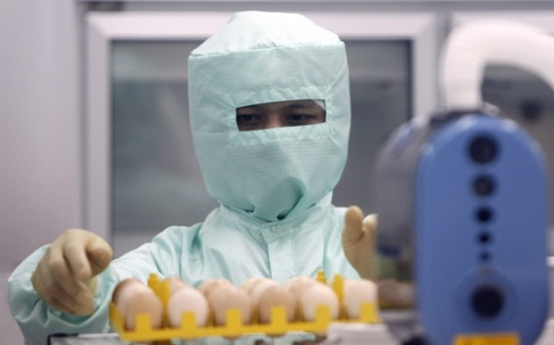
That worries people like Marc Lipsitch and Alison P. Galvani, two epidemiologists who write in a PLoS Medicine editorial today that creating these types of new infectious agents puts human life at risk. They estimate that if 10 American laboratories ran these types of experiments for a decade, there would be a 20 percent chance that a lab worker would become infected with one of these new super-flus and potentially pass it on to others.
“The concern is that you're making something that doesn't exist in nature and combines high virulence for people with the ability to transmit efficiently,” Lipsitch told me.
Accidents involving lab-grown pathogens aren’t just the stuff of sci-fi movies. A Singaporean lab worker was inadvertently infected with SARS in 2003. In 2004, a Russian scientist died after accidentally sticking herself with a needle contaminated with Ebola at a Siberian lab. In April, Paris’ Pasteur Institute lost 2,000 vials containing the SARS virus. And in March, the Galveston National Laboratory in Texas lost a vial containing Guanarito virus, which causes "bleeding under the skin, in internal organs or from body orifices like the mouth, eyes, or ears.”
The medical world seems perpetually torn between the desire to eliminate horrific diseases entirely and the need to preserve them for future study. Thanks to vaccination, smallpox was eradicated in 1980, but there are still two samples of it living in labs—one in the U.S. and one in Russia. Some scientists argue that those vials should be destroyed because there’s a chance they could be used in bioterrorism. There is no cure for smallpox, and it kills a third of its victims. The rest suffer permanent scarring from the thousands of “pox,” or fluid-filled cysts.
“The hazard is, could it ever by accident or by evil design leave those two containments and actually be introduced into the population again and spread?” William Schaffner, chair of preventive medicine at Vanderbilt University Medical Center in Nashville told ABC News. The World Health Assembly is deciding this week whether to destroy the vials.
Most labs have near-bulletproof safety standards, with workers wearing plastic hoods and working behind heavy steel doors. Still, leaks can happen because of failures in respiratory equipment, Lipsitch said, or if a worker accidentally touches their eyes or nose with a contaminated glove.
“We have data from past experience in various labs that human infection in those labs are not a common event, but with enough labs working for enough years, it's been observed over and over again,” Lipsitch said. “Marburg and Ebola viruses have both infected lab workers at a higher level of containment than these [H5N1] experiments.”
He added that past lab accidents haven’t resulted in worldwide spread partly because the viruses weren’t as contagious in those cases.
“In the case of Ebola and Marburg—they aren't that readily transmissible,” he said. “In the case of SARS, which has been involved in at least three separate lab accidents, there was onward transmission in one case, but it was contained, so we got lucky.”
Lipsitch suggests that, rather than breed the new mammal-transmissible viruses, scientists just use pieces of the H5N1 strain for their research or work on ancestors of the virus.
The scientists conducting the ferret-based H5N1 experiments went through a year-long voluntary moratorium after a controversy over the studies’ safety flared in 2011. In January 2013, they declared that the experiments would resume because the lab conditions for the experiments met the necessary safety checks. “Because H5N1 virus transmission studies are essential for pandemic preparedness and understanding the adaptation of influenza viruses to mammals,” they wrote in Science, “researchers who have approval from their governments ... have a public health responsibility to resume this important work.”

Olga Khazan is an associate editor at The Atlantic, where she covers health.

