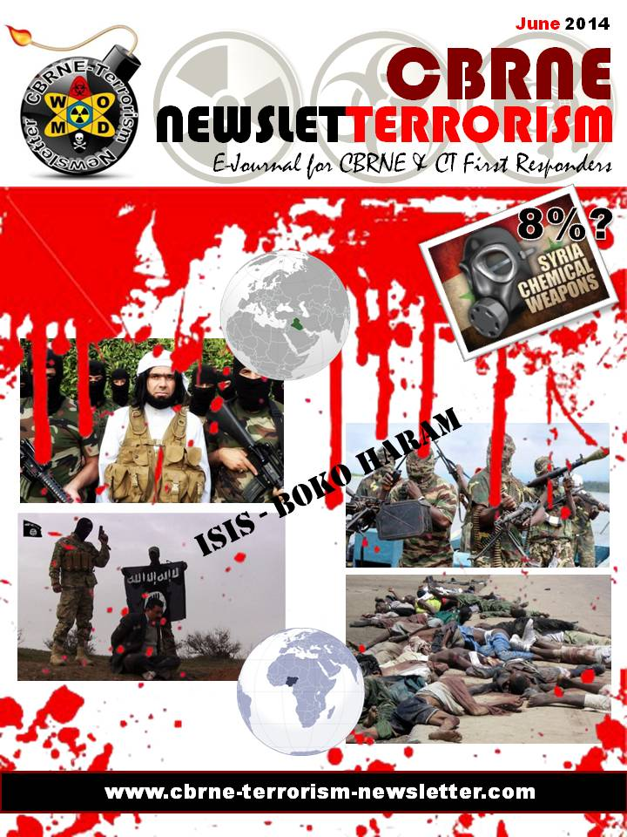
Economic relationships, not terrorism fears, drive visa decisions: study
Source: http://www.homelandsecuritynewswire.com/dr20140612-economic-relationships-not-terrorism-fears-drive-visa-decisions-study

Despite heightened focus on preventing global terrorism since the 9/11 attacks in 2001, a University of Kansas researcher has found that the economic relationship between two countries is the most significant factor in determining the acceptance or rejection rate of visas.
“The general trend seems to be the case that despite much ado about security and how that’s going to impact closed borders, we don’t really see that at the aggregate. The data is not in line with that,” said Nazli Avdan, assistant professor of political science who examined data that covered visa rejection rates from 1968 to 2007 of 207 countries and independent political units.
A KU release reports that Avdan detailed her findings in the article “Controlling Access to Territory: Economic Interdependence, Transnational Terrorism and Visa Policies,” published in the June print edition of the Journal of Conflict Resolution. Past political science research on the topic has largely ignored visa policies.
She said the findings that trade interdependence influences visa acceptance and rejection rates more so than security factors do seem to oppose conventional wisdom, especially based on the amount of attention transnational terrorism receives post-9/11.
“The unexpected side of the story is that states are reluctant to impose these short-term restrictions upon countries with which they enjoy bilateral trade ties,” Avdan said.
She did find security concerns do have a direct effect on visa restrictions and other measures in the wake of a direct terrorist attack on a country’s own soil, such as 9/11, the 2004 Madrid train bombings or the 2005 bombings in London.
“That’s more visible. It’s more tangible,” Avdan said. “It’s more likely to foment anger on the part of the public.”
Absent a direct incident of terrorism, however, the data supports that countries will be less likely to reject a visa from a resident of a country that is a key trade partner. For instance, fifteen of the nineteen plane hijackers on 9/11 were citizens of Saudi Arabia, which still enjoys an important trade relationship with the United States.
“Surprisingly what I find is the global reputation a state garners as a prominent origin of terrorism has a very minute impact when you take into account trade interdependence,” Avdan said.
Visa controls enable countries to screen threats from people who are seeking to enter their borders but do not officially represent another state, and it is one way countries can seek to guard against threats from potential terrorists, illegal migrants, smugglers and traffickers.
She said the findings that economic ties influence visa policies would likely excite researchers who examine globalization and conflict behavior, because a major theory is that economic interdependence can stop countries from going to war against each other. Avdan said, however, that economic interdependence and security has implications for controlling human mobility as well.
Avdan said she originally took an interest in how countries consider visas after growing up in Turkey and noticing the glaring discrepancy between how citizens of countries in the industrialized West have a great degree of freedom to travel compared with citizens of the developing world. She has also found that when certain countries do reach agreements with each other, such as the Organisation for Economic Co-operation and Development, or OECD, which includes the United States, they relax visa restrictions for countries which belong to the group. It is more likely, however, for citizens of non-OECD countries to have a visa application rejected.
“It’s very limited to this club. The reciprocity and relaxation of visas doesn’t apply outside of that,” Avdan said. “If you want to foster economic exchange and make it easier, then you basically have to rethink this automatic sort of mimicking behavior of imposing a visa.”

— Read more in Nazli Avdan et al., “Controlling Access to Territory Economic Interdependence, Transnational Terrorism, and Visa Policies,” Journal of Conflict Resolution 58 no. 4 (June 2014): 592-624

Bulletproof blanket seeks to shield kids during school shootings
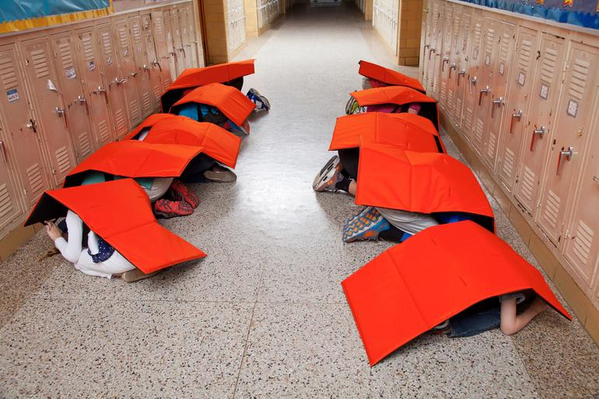
Source: http://www.cnet.com/news/bulletproof-bodyguard-blanket-designed-to-shield-schoolkids/
Bodyguard Blankets deployed during a tornado drill. ProTecht

School shootings are a tragic reality. While much discussion has centered around prevention, ProTecht, a protective and safety products company in Oklahoma, has created a product it hopes kids will use in case such a tragedy strikes their schools. The Bodyguard Blanket is designed to offer a temporary shelter during dangerous situations, particularly school shootings.
While the Bodyguard is also built to help protect children from falling debris during natural disasters like tornadoes, much of the marketing around the product concerns the potential for school shootings. It's the reason the blanket was created in the first place.
Technically, the Bodyguard is bullet-resistant. It's made from the same materials used in military and law enforcement body armor. Instead of having kids put on a flak vest, though, it puts the material in a form that can be folded up and then unfolded to create a body shelter. It has straps that help hold it in place like a backpack. ProTecht posted a video of the blanket undergoing a ballistics test, if you're curious about how it behaves under fire.
Bullet-resistant materials aren't cheap. The Bodyguard comes with a price tag just shy of $1,000, though ProTecht hopes to partner with schools and nonprofits to make it more affordable to buy in bulk. Even with a substantial discount, it will likely be out of reach for many school districts.
This isn't the first time we've seen a bulletproof product for the classroom. A bulletproof whiteboard that doubles as a shield appeared early last year. In a better world, no one would even have the impetus to dream up products like these. The Bodyguard Blanket will likely rouse a lot of differing opinions. Do you think it's excessive or practical? Tell us in the comments.
The Bodyguard is worn like a backpack.

Where Terrorists Attacked in 2013
Source: http://warontherocks.com/2014/06/infographic-where-terrorists-attacked-in-2013/

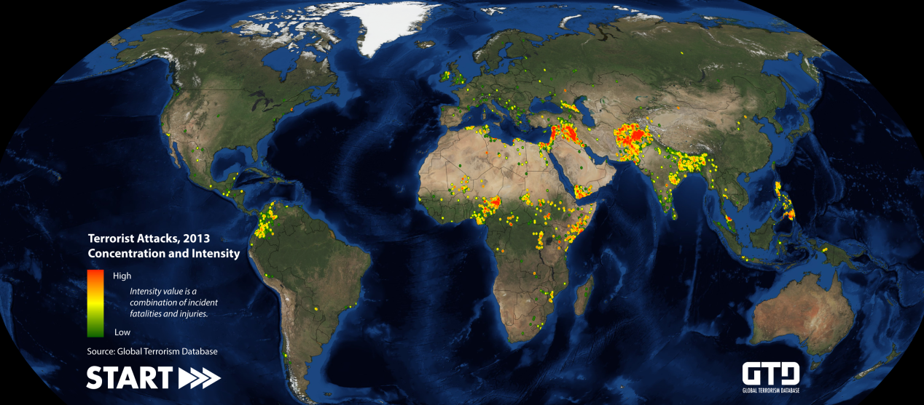
Terrorism’s footprint is truly global. In 2013, according to data collected by START, incidents of terrorism were recorded in 94 countries around the world. But the threat is far from uniform. The map below depicts the intensity and concentration of terrorist violence in 2013. We’ll follow up on this global picture with new infographic sets each week that examine some of the most interesting current and historical trends in terrorist activity.
2013 Terrorist Attacks Concentration Intensity Map (START Global Terrorism Database)
Graphic designed by William Kammerer, START.
Note: This graphic is based on preliminary data that is subject to change. 2013 GTD data is not yet available for public download or distribution. It will be released via the GTD website later this summer.

Karachi airport attack signals tactical shift by Taliban
Source: http://www.reuters.com/article/2014/06/12/us-pakistan-airport-attack-insight-idUSKBN0EN0ED 20140612

June 12 – It was the shoes that betrayed Corporal Faiz Mohammad's would-be killers.
When 10 Taliban militants attacked Pakistan's busiest airport on Sunday night, sparking a five-hour gun battle that killed at least 34 people, Mohammad and his fellow officers from the Airports Security Force (ASF) were the first line of defense.
"There was a moment of confusion because the militants had the same ASF uniforms as us," said Mohammad, 30. "But then we saw their shoes." ASF officers wear black leather shoes, but the men who stormed Jinnah International Airport in Karachi, Pakistan's chaotic commercial capital, wore white-soled sneakers.
All 10 militants were dead by dawn, shot down by the security forces or blown up by their own suicide vests. That the Taliban failed in its main objective - to hijack an aircraft and hold its passengers hostage - should bring no comfort to embattled Prime Minister Nawaz Sharif, since the attack signals an alarming shift in tactics by an increasingly formidable foe.
The strike at the airport in Karachi, home to 18 million people, deals a blow to Sharif's bid to attract foreign investors to revive the economy. It has also destroyed prospects for peace talks with the Taliban and made an all-out military offensive against militant strongholds along the Afghan border a near-certainty.
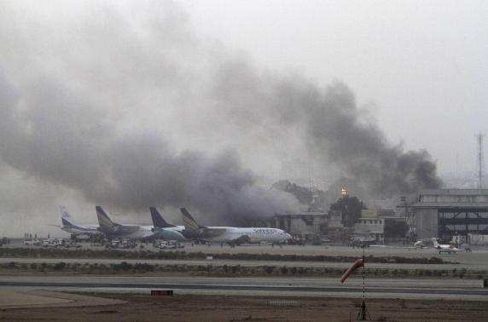
Government air strikes on the strongholds in the North Waziristan region triggered the tactical shift, said sources at Tehrik-e-Taliban Pakistan (TTP), as the Pakistani Taliban is formally known. Angered by the raids and anticipating a ground assault, the militants are targeting Pakistan's heartland.
A top Taliban commander confirmed to Reuters that attacks involving aircraft were part of a new strategy to counter the government's preparations for a full-scale operation against them in North Waziristan.
"We decided to change our strategy and hit their main economic centers," he said. "They will kill innocent people by their bombs and we will hit their nerve-centers in major cities."
Tariq Azeem, a senior official in Sharif’s administration, said a full-scale military operation was imminent in North Waziristan, and seemed resigned to it sparking terror attacks elsewhere in Pakistan. "Everybody knows there is going to be blowback," he said.

Pattern of Mumbai, Westgate Mall
The Taliban is most likely to rely on small militant teams, emulating the protracted, high-impact operations like those in Mumbai in 2008 and Nairobi's Westgate mall last year.
"In Mumbai, and in Kenya, you will find a lot of similarities," said Muhammad Amir Rana, director of the Islamabad-based think tank Pak Institute for Peace Studies. "They (the Taliban) are adopting this as their prime strategy."
The similarities between the Karachi and Mumbai incidents are startling and instructive.
The attack on Mumbai, India's largest city, was carried out by a Pakistan-based anti-India group called Lashkar-e-Taiba, or Army of the Pure. It lasted three days, killed 166 people and transfixed the world.
As with Karachi, it was meticulously planned and involved well-trained and heavily armed militants. In both cases, a 10-man team quickly split into pairs and carried provision-stuffed knapsacks in preparation for a long siege. In Mumbai, militants used mobile phones to coordinate with handlers in Pakistan and with each other in the heat of battle. Their Karachi counterparts were also seen using mobile phones during the assault.
Lashkar-e-Taiba has said it has no connection with any attacks on Pakistani soil and there is no evidence that it works with the Taliban. India accuses elements in Pakistan's large army and its pervasive Inter-Services Intelligence (ISI) spy agency of shielding or working with the group.
But neither the military nor the ISI could forestall the havoc caused by 10 men who got out of a minivan near Karachi's cargo terminal on Sunday night.
The attack began at 11.05 p.m., with five of the militants breaching the Fokker Gate with assault rifles and grenades. Minutes later, as the ASF fought back, a second five-strong squad attacked the nearby Cargo Gate. Both gates granted access to the cargo area in the airport's west.
Azeem, the administration official, praised the ASF while admitting how hard it was to protect the sprawling airport.
"You need almost two brigades to cover . . . every inch of it," he said. "Any entrance will have two, three, four people who are fully armed, but one burst of machinegun (fire) will kill all four of them and you can enter."
When Faiz Mohammed ran across the tarmac, shouldering his AK-47, to reinforce his fellow ASF officers, four were already dead. "Our men were fighting relentlessly," he said.
Mohammad was shot in the thigh and, like other wounded ASF, waited hours until it was safe for ambulances to evacuate him.
"The ASF put up very stiff resistance and that apparently sowed panic among the attackers, who then split up and were eventually taken out by security forces," said a senior Pakistani security official, speaking on condition of anonymity.
The militants' dispersal added to the mayhem and drew in more security forces.
By 11.30 p.m., a contingent of police and paramilitary Rangers had arrived at the airport, followed 30 minutes later by an army unit. They formed what Azeem called "the second or the third layer" of airport security which stopped the militant advance on the main passenger terminal further east.

"I was terrified"
The gunfire was now punctuated by the boom of militants firing rocket-propelled grenades (RPGs). They had come prepared for a long fight.
Their knapsacks contained water, medicine and food. Some were spotted using cellphones during the attack, said a security official involved in the investigation, although it was unclear who they were talking to - each other, or distant commanders.
Phimraphat Wisetsoem could see and hear explosions from her seat on a Thai International Airways aircraft. It was trapped near the runway along with an Emirates jet and contained hundreds of passengers. Phimraphat suspected that hijackers in disguise had already boarded her plane.
"I was terrified," she told reporters as she arrived back in Bangkok. "I sat still and didn’t dare move around." Passengers on both planes were later safely evacuated.
Just after midnight, as all outbound flights were suspended and inbound flights diverted to other airports, there was a large explosion near Fokker Gate: the first militant had detonated his suicide vest.
By now, dead and wounded were being ferried to the nearby Jinnah Hospital. Their numbers rose steadily through the night - by morning, the hospital would report 16 dead and dozens injured - as security forces intensified their counter-attack.
As the fighting raged outside, seven employees from a cargo company took refuge in a warehouse - as it turned out, a fateful decision. They burned to death.
Elsewhere, Hamid Khan, 22, a junior technician, hid with eight other men in the washroom of an aircraft maintenance company. A hand-grenade blew off part of the roof and bullets peppered a nearby container. "If anyone is inside, come out now!" shouted someone - friend or foe, Hamid couldn't tell.
He and his colleagues kept silent and stayed put. "I was so afraid that I started reading my last prayers," he said, his voice still shaking with emotion days later.
Two more militants would blow themselves up. By 4 a.m., all 10 were dead, their shattered bodies sprawled in pairs across the tarmac. It had taken 150 security personnel to counter them.
The Rangers identified them as ethnic Uzbeks. Pakistani officials often accuse foreign militants of staging attacks alongside the Pakistani Taliban. "We admit we carried out ‎this attack with the help of our other brotherly mujahideen groups," the senior member of the Pakistani Taliban told Reuters.

A second attack
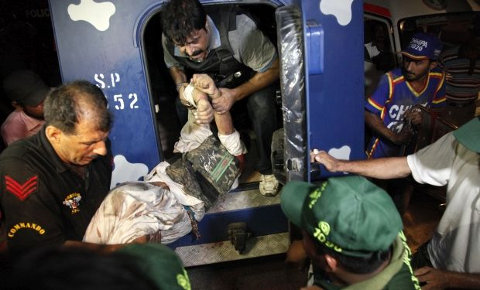
In daylight, Pakistan's busiest airport resembled a war zone. Smoke billowed from gutted buildings. Rescue workers retrieved the seven cargo company employees, their corpses charred beyond recognition, and raised the death toll to 34.
Junior technician Hamid Khan and the other eight emerged unscathed from their washroom refuge. "I felt as if God had heard our prayers," he said.
At least three passenger aircraft, all unoccupied, were damaged during the battle, a senior Pakistani security official told Reuters. A satellite photo on Google Earth showed a fourth aircraft in the cargo area completely destroyed, its broken wings lying amid the blackened remains of its fuselage.
However, officials have not confirmed the destruction of any aircraft.
Even as flights resumed and the clean-up began, the Taliban struck the airport again. On Tuesday evening, gunmen on motorbikes opened fire on an ASF academy, although there were no casualties. There would be "many more such attacks" in future, Pakistani Taliban spokesman Shahidullah Shahid told Reuters.
Adil Najam, dean of Boston University's Pardee School of Global Studies, agreed. Karachi was "not just another terrorist attack," he said. "It is among the latest skirmishes in what is now an actual war between the Pakistan Army and the Taliban. The war is on - and expect escalation."

What's behind Karachi airport attack?
By Imtiaz Gul
Source: http://edition.cnn.com/2014/06/09/opinion/pakistan-karachi-gul-explainer/

Editor's note: Imtiaz Gul is head of the independent Center for Research and Security Studies, and author of the book "The Most Dangerous Place," as well as "Pakistan: Before and After Osama." The views expressed in this commentary are solely those of Imtiaz Gul.

The brazen terrorist assault on Pakistan's largest Karachi Airport that began near midnight Sunday left almost everybody stunned.
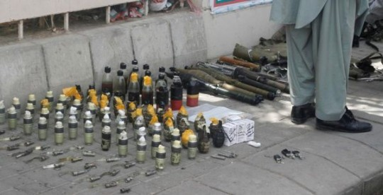
It was the Pakistani Taliban's biggest strike on state security apparatus -- in terms of human casualties -- and is a reminder of the massive security challenge that comes from affiliates of al Qaeda holed up in the mountainous Pakistan-Afghanistan border terrain.
Of the 28 dead, 10 were attackers who were killed during a firefight which latest several hours. Almost all of the suspected gunmen were reportedly wearing suicide vests, devices usually worn by terrorists on termination missions.
Military officials said two of the terrorists had detonated suicide vests.
By putting down the attackers, the security forces most probably preempted a big hostage-taking too; reports the terrorists had foodstuffs like dates, chickpeas, hand-grenades and petrol bombs suggest they came for the long haul.

What was the motive for the attack?
As usual, the outlawed Tehreek-i-Taliban Pakistan (TTP) claimed responsibility for the Karachi carnage.
"This was revenge for Hakimullah Mehsud's martyrdom" (Mehsud was killed in a U.S. drone strike in November, 2013), and a warning against the impending military operation the government is preparing against the "helpless and innocent tribes in Waziristan," a TTP statement sent to media via email said.
In an earlier message on their Facebook page, the TTP said: "The biggest reason for attacking Karachi airport is because it serves as the biggest air logistics center supplying goods for the Crusaders' war in Afghanistan and Pakistan," referring to the Karachi Port which handles the Afghanistan-bound U.S.-NATO cargo.

Is the first such assault
TTP made a similar claim following a dramatic raid on Peshawar's Bacha Khan International Airport on December 15, 2012.
The TTP again appears to be at the center of a terrorist pattern that ostensibly aims to hurt he country's economic interests and isolate it internationally.
The group also took responsibility for similar commando raids on the Pakistan Navy airbase PNS Mehran near Karachi in May 2011, followed by a deadly assault on a Pakistan Air Force base at Kamra, 70 kilometers north of the capital, in August 2012.
All three resulted in damage to several air-surveillance and combat aircraft, including a multi-million dollar Saab 2000 surveillance aircraft.
The TTP justified the three attacks as "revenge" for the May 2, 2011 secret U.S. raid that killed Osama Bin Laden in his Abbottabad compound.
At the early stage of investigations, a number of questions and theories can be raised.

Were attackers trying to discredit Pakistan?
The TTP again appears to be at the center of a terrorist pattern that ostensibly aims to hurt he country's economic interests and isolate it internationally.
Following a brazen daylight attack on the visiting Sri Lankan cricket team in March 2009, for instance, all foreign cricket teams refused to visit Pakistan, thus bringing an end to international cricket in the country.
"The only message flowing from these strikes is that foreigners and foreign airlines should not fly into Pakistan," Talat Masood, a retired general told me.
He also recalled the coldblooded execution on June 23, 2013, of 10 foreign tourists in an unprecedented attack in the Himalayas of Nanga Parbat, one of the highest peaks in the world.
The nighttime raid at a height of over 4,000 feet killed three Ukrainians, two Slovakians, one Lithuanian, two Chinese, one Chinese-American, one Nepali and their Pakistani guide -- in what was the worst attack on foreigners in Pakistan in a decade.

What was the role of foreign fighters in the Karachi attack?
Major General Rizwan Akhtar, the head of the paramilitary outfit Rangers, who led the operation, hinted at the possible involvement of Uzbek militants in the deadly attack.
"From their appearances they look like Uzbeks but we will wait for DNA tests to say something with authority," Akhtar responded when asked whether foreign terrorists carried out the assault. And this is not the first time officials named Uzbeks as part of an extremely well-coordinated strike.
The TTP appears to enjoy active support of fighters that belong to the Islamic Movement of Uzbekistan (IMU), a dissident group that escaped persecution in Uzbekistan and settled down in the mountainous region of Waziristan between Pakistan and Afghanistan following the Taliban regime's defeat in December 2011.
Particularly since the killing of its leader Tahir Yuldashev in an August 2009 drone strike, the IMU has increasingly gravitated towards al Qaeda central and acted as its militant arm against the Pakistani security apparatus, which it sees as the major stumbling block in its fight for survival in Pakistan.

Did the attackers have inside information?
TTP and its foreign affiliates draw support from "the enemy within."
"Such a coordinated attack is not possible without inside information," Jalam Hussein, a former Pakistan Air Force commodore told me.
"We really have to think very seriously of purging the security apparatus of such inside supporters," he said.

What was the influence of recent peace talks?
The recent breakdown of TTP talks with government also revived a new string of attacks against security and strategic targets; despite a several week engagement, the talks offered by Prime Minister Nawaz Sharif in an attempt to improve internal security led nowhere.
The government and the security forces found it impossible to accept TTP demands like enforcement of Sharia across the board, withdrawal of the army from the tribal regions and a peace zone for itself. And soon after the stalemate became evident, the army began pounding IMU and Chinese Uyghur hideouts in the Waziristan mountains, where the TTP provides them social cover.
The East Turkestan Islamic Movement (ETIM) represents Uyghur Muslims who want an independent Xinjiang and have been reportedly waging a war on Chinese interests from the Pakistan-Afghan border region.

Was the attack linked to a "proxy war?"
Some officials tie the TTP-led terror campaign to the proxy war that both Pakistan and India have been involved in for quite some time.
Some Pakistanis accuse the TTP of being an Indian proxy, while among the Indian and Afghan establishments there are those who treat Afghanistan's Taliban, particularly the Haqqani Network, as Pakistani proxies.
Often, Indian officials blame attacks on Indian interests on the Pakistani spy agency ISI, including the suicide strike at India's consulate in the western Afghan city of Herat last month.

What does the attack reveal about security in Karachi?
Lastly, the Karachi attack, too, exposed the weaknesses in the early warning capacity of the Pakistani security apparatus; while forces on ground managed to engage and neutralize the attackers within five hours -- restoring air traffic by noon -- questions loom over the intelligence.
Hasan Askari Rizvi, a prominent security commentator based at Lahore, wonders as to how such a big number of attackers remained undetected.
This requires a deep introspection and represents a huge challenge for the government and the entire security agencies.
Counter-terrorism would require extremely close coordination, which could possibly help in early warning as well, he said.

Is Boko Haram forming an enclave in northeast Nigeria?

Source: http://csmonitor.com/World/Africa/Africa-Monitor/2014/0610/Is-Boko-Haram-forming-an-enclave-in-northeast-Nigeria

On June 5 the Wall Street Journal reported that Boko Haram has “tightened its grip” over a 1,200 square mile area of northeastern Nigeria. For the sake of comparison, this area is about the size of the state of Rhode Island, including Narragansett Bay.
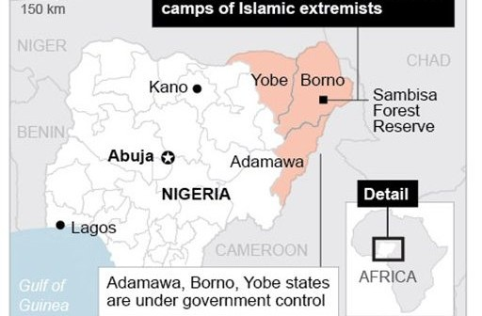
It looks like Boko Haram’s strategy has been to destroy all vestiges of authority in the affected area, centered on the Gwoza local government area in Borno State.
Earlier, Boko Haram murdered the emir of Gwoza, Idrissa Timta, who had publicly warned against Boko Haram.
Boko Haram has also steadily carried out sustained attacks on villages in the district, burning the houses and killing hundreds of residents.
If Boko Haram has destroyed government and traditional authorities in Gwoza, it has not replaced that governance with its own; it has not established any state structures apparent to outside observers.
However, the Boko Haram black flag is flying in several villages, according to the BBC.
According to the Wall Street Journal, Boko Haram is using rocket-propelled grenades, night-vision goggles, pickup trucks with heavy machine guns, and satellite phones. The government’s Joint Task Force (JTF), which includes army and police units, appears unable to stop Boko Haram in the Gwoza region.
Where is Boko Haram going next? On June 4, it attacked two villages on the outskirts of Maiduguri (Borno state’s capital), killed 48 in one, and 45 in the other, according to the WSJ.
Maiduguri was long the center of Boko Haram until 2011 when government forces largely cleared the city of its operatives. It now may be seeking to retake the city, which in 2014 had an estimated population of about one million.
It is hard to know how many people are there in Maiduguri however, since media and other access has been severely curtailed by the violence. Presumably many town dwellers have gone elsewhere as Boko Haram violence has increased.
On the other hand, there likely has been an influx of internally displaced persons to the city who have fled Boko Haram attacks in villages. Maiduguri has a large military base, Giwa Barracks, which was successfully attacked by Boko Haram in March though they did not attempt to hold it.
In the aftermath of that attack, the JTF carried out atrocities against detainees charged with no crime that was widely reported by human rights organizations and the media. The town is also the seat of the federal University of Maiduguri.
If Boko Haram were to take Maiduguri, it presumably would be forced to establish some type of administration, which it has not done in any region under its influence up to now.
Controlling a large and complex city would likely require Boko Haram to move in new directions
.Far-right Violence in the United States: 1990-2013
Source:http://www.start.umd.edu/pubs/START_ECDB_FarRightViolence_FactSheet_June2014.pdf?utm_source=START+Announce&utm_campaign=0d709cca8d-START+Far-right+Violence+Fact+Sheet&utm_medium=email&utm_term=0_a60ca8c769-0d709cca8d-14081393

Following the June 8, 2014 shootings in Las Vegas that resulted in the murders of two police officers and one civilian, START researchers compiled background information from the United States Extremist Crime Database (ECDB) on ideologically motivated far-right violence in the United States, generally, and far-right extremist crimes related to law enforcement, specifically. In addition, information on ideologically motivated far-right suicide attacks is also presented, as preliminary reporting seems to indicate that the suspects were not expecting to live through their confrontation with law enforcement.
Although the ECDB includes crimes committed by individuals with varying ideologies, this report focuses exclusively on far-right violence and crime due to reports that the alleged perpetrators in Las Vegas were motivated by anti-government and white supremacist ideology. Should additional information about the ideological motivation for the attack confirm the initial reporting, this fact sheet may help to contextualize the event.

Ideologically motivated Far-Right homicides
- Between 1990 and 2013, there were 155 ideologically motivated homicide events committed by far-right extremists in the United States. About 13 percent of these were anti-government in nature.
Including the Oklahoma City Bombing, which killed 168 individuals, far-right extremists killed 368 individuals during ideologically motivated homicide events between 1990 and 2013.
- 50 federal, state, and local law enforcement officers were killed in the line of duty by far-right extremists between 1990 and 2013 in 33 separate incidents. More than two-thirds were killed during ideologically motivated attacks; the remaining officers were killed in non-ideological confrontations (e.g., while arresting an individual during a bank-robbery). In addition, corrections officers, private security guards, and a judge have been killed during ideologically motivated attacks.
- The two most common circumstances in which law enforcement officers are killed by far-right extremists are traffic stops (19%) and disturbance calls (19%).
- Excluding the Oklahoma City Bombing, ambushes of officers make up approximately 14 percent of all far-right homicide incidents of law enforcement personnel.
- Excluding the Oklahoma City Bombing, approximately 60 percent of the victims of ideologically motivated far-right violence were killed by perpetrators using firearms.
Close to 50 percent of these homicide incidents were perpetrated by more than one suspect.
- In five of the deadly attacks against law enforcement, evidence suggests that the offenders initiated their acts of violence with the expectation that they would not survive, as their actions would directly or indirectly lead to their own deaths.
- Since 1990, more than 30 far-right violent extremists have been killed by law enforcement during violent encounters.

Recent examples of law enforcement officers killed by Far-Right violent extremists
- In September 2012, Officer Youngstrom of the California Highway Patrol was shot during a traffic stop in Alamo, Calif. The offender, who was killed during the incident, has since been tied to the sovereign citizen movement.
- In August 2012, Deputy Sheriffs Triche and Nielson of the St. John the Baptist Parish Sheriff’s Office were ambushed and killed while conducting an investigation in LaPlace, La. Suspects connected to the sovereign citizen movement were arrested and are awaiting trial. Two are charged with first degree murder, one with attempted murder, and others pleaded guilty to reduced but related charges.
- In May 2010, Officer Evans and Sergeant Paudert of the West Memphis Police Department were shot and killed while conducting a traffic stop in West Memphis, Ark. The suspects, a father and son who were tied to the sovereign citizen movement, were killed in a subsequent shootout with law enforcement.

Priest killed, another one injured in attack at Catholic church in Phoenix
Source: http://edition.cnn.com/2014/06/12/justice/arizona-church-shooting/

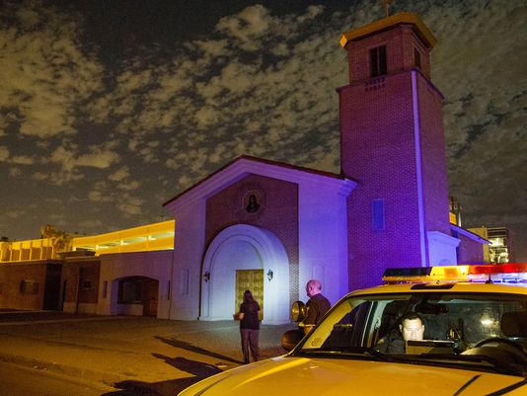
June 12 – A priest was killed and another critically wounded in an attack at a Catholic church in Phoenix, police said early Thursday.
The Rev. Kenneth Walker was fatally shot, and the Rev. Joseph Terra (photo) is hospitalized in critical condition, police and church officials said. It was not clear what type of weapon was used to attack Terra, Sgt. Steve Martos of the Phoenix Police Department said.
A 911 call came in about 9 p.m. Wednesday (12 a.m. ET Thursday) from the Mater Misericordiae (Mother of Mercy) Mission Catholic Church, Martos said.
The emergency call to police was for a burglary and was made by Terra, Martos said. It was unclear if Terra made the phone call before or after he was injured.
When police arrived, they found the two priests badly injured. Walker died at the hospital.
Terra, the injured priest, was only able to minimally speak with authorities about what happened, Martos said. The priority is for him to be treated.
"Hopefully, once that individual receives treatment and is able to pull through, we can gather more information," Martos said.
The church, in a statement on its website, referred to more than one armed burglar breaking into and entering the property. Police have not confirmed or denied that assertion, saying only that it is not an official police statement.
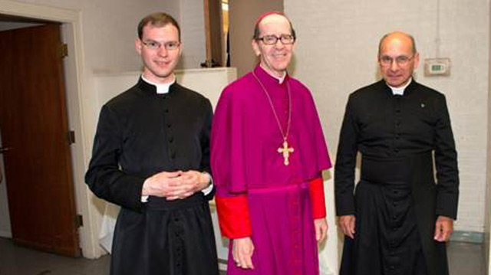
A green 2003 Mazda Tribute was stolen from church property, police said, and it was found abandoned.
The vehicle is being examined for clues, but as of Thursday morning, nothing significant had been found, Martos said.
"The police are still gathering information and trying to sort through the details of this senseless act of violence," the Diocese of Phoenix said in a statement. "We ask that people offer prayers for both priests, the religious community, their families and the parish."
Walker, 29, was a member of the Priestly Fraternity of St. Peter, a small community of priests founded in 1988 and dedicated to reviving the traditional Latin Mass. Terra, 56, is also a member.
A Catholic blog, Rorate Caeli, said Walker was born in upstate New York in a family that became intrigued by the traditional Latin Mass. He was ordained as a priest two years ago.
The blog described the area around the church in downtown Phoenix as "deserted and dangerous at night" but asked followers to avoid speculation about a motive for the crime. It suggested prayer instead.
"May justice be done," the blog said.

The terrorist suspected of carrying out the shooting attack at the Jewish Museum in Brussels has been identified as a French Muslim jihadist.

Source: http://www.terrorism-info.org.il/en/article/20654

1. On May 24, 2014, a shooting attack was carried out at the Jewish Museum in Brussels, killing four people, two of them Israeli tourists. The following week, on June 1, 2014, a suspect was detained in Marseilles. He was found with the weapons used in the attack and articles of clothing identical to those in pictures taken by the security camera at the museum at the time of the shooting. He also had a camera with a video where he claimed responsibility for the shooting.
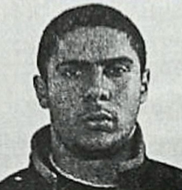
2. The suspected terrorist is Mehdi Nemmouche, a French Muslim of Algerian extraction, who has a criminal record. He was also carrying a white cloth with the name of the Islamic State in Iraq and Greater Syria (ISIS) on it. The ISIS is a jihadist organization in Syria which, along with the Al-Nusra Front, serves as a magnet for European foreign fighters. According to the French prosecutor, Mehdi Nemmouche went to Syria and joined the ISIS in January 2013. After a number of months he left Syria for Germany and from there returned to France.
3. France and Belgium are the two European countries from where the largest number of foreign fighters have gone to Syria (hundreds from each) to fight in the ranks of Al-Qaeda and the global jihad. Mehdi Nemmouche fits the profile of European foreign fighters who have the potential to carry out acts of subversion and terrorism. His case may be an indication of potential translated into action and a sign that more terrorist attacks may be carried out in the West by jihadists who participated the fighting in Syria.
4. The French authorities are aware of the potential dangers posed by returning veterans of the Syrian civil war. During the past year they engaged in a series of preventive activities against those who had returned and those who dispatch them. According to the French media, the authorities prevented a terrorist attack in which a fighter who returned from Syria was involved. Nevertheless, in ITIC assessment, the attack at the Jewish Museum in Brussels shows that the steps taken by the European security services in general and the French security service in particular, and the pan-European cooperation regarding the issue of foreign fighters in Syria, are still not sufficiently effective. It would seem that France, Belgium and other European countries have been made aware the potential dangers presented by veterans of the Syrian war who return to their countries of origin. However, a variety of operative, intelligence, social and legal difficulties may still prevent them from translating their awareness into an effective campaign to deal with the problem.

The Terrorist Attack at the Jewish Museum in Brussels
5. At around 1550 hours on Saturday, May 24, 2014, a man parked his vehicle near the entrance of the Jewish Museum in the Sablon district of Brussels. He wore a blue shirt and a baseball cap. He entered the museum and began indiscriminately shooting at museum visitors with a Kalashnikov assault rifle. The attack lasted about a minute and a half. He exited the museum and fled.
6. Four people were killed in the attack (one, who had been critically wounded, later died). Two of them were a middle-aged Israeli man and wife from Tel Aviv who were on vacation and in the museum foyer at the time of the attack.
7. The day after the attack the Belgian authorities released the video of the shooting taken by the museum security camera. It showed a man wearing a baseball cap enter the museum carrying two bags. He retraced his steps, put the bags down and extracted a gun from one of them. He raised it and began shooting, continuing for less than a minute and a half. He then returned the gun to the bag and left the museum. The security cameras outside the museum recorded him leaving on foot.
Security camera photos. Left: The terrorist fires a rifle. Right: He exists the building (Facebook page of the Brussels police department).

8. No terrorist organization claimed responsibility for the attack. The Belgian prosecutor said it had been carried out by a lone, well-prepared, well-armed terrorist operative. It was also reported that it is being considered a terrorist attack and not a felony. The Belgian department of justice said in a statement that an examination of the security camera photos indicated that the terrorist acted alone and behaved calmly, which might indicate that he was experienced. That led the investigators to think it was a terrorist attack. Following the shooting, the Belgian minister of the interior said that security would be increased at Jewish institutions.

Apprehending the Suspect
9. On June 1, 2014, the French authorities announced that on May 30, 2014, Mehdi Nemmouche had been detained in the south of France on suspicion of having carried out the attack at the Jewish Museum in Brussels. At a press conference held by the French security authorities, the French prosecutor said that the suspect, who was exercising his right to remain silent, had been detained in a routine customs check on a train that had come to Marseilles from Amsterdam via Brussels. (According to another version, the customs check had been carried out a bus terminal the suspect arrived at; he came from Brussels to Marseilles via Amsterdam).
10. The suspect is a 29 year-old French Muslim. At the time of his detention he had two rifles, one of them a Kalashnikov assault rifle identical to the one used by the terrorist in the attack. He was also found to be carrying a white cloth with the name of the ISIS (a jihadist organization operating in Syria and Iraq in whose ranks are European and Arab-Muslim foreign fighters) on it. In his possession there was also a camera with a 40-second video on it of the two rifles. In the background his voice could be heard claiming responsibility for the attack (BBC, June 1, 2014).

Biographical Information
11. Mehdi Nemmouche is a French citizen. He was born in Roubaix, an industrial town in northern France.^{[1]} His family comes from Algeria (Annahar.com, Al-Arabiya, June 4, 2014). He did not know his father and was abandoned by his mother when he was three months old. He was raised in foster homes until he was 17, when he went to live with his grandmother. An aunt related that he was nice, intelligent and educated, and had studied at a university for a year.^{[2]}
12. According to the French prosecutor, he had previously been convicted seven times for various felonies and had served a number of prison terms. The last time he was imprisoned for five years, during which he joined groups of Islamist extremist prisoners. In December 2012 he was released from prison, and three weeks later, in January 2013, he went to Syria, where he joined the ISIS. After a number of months in Syria he flew to Frankfurt, Germany, and according to one media report, his arrival was reported to the authorities but his name was spelled incorrectly (Note: Foreign fighters assume aliases when they arrive in Syria). However, the French authorities are currently investigating to discover if he worked alone or was part of an organization.
13. So far Mehdi Nemmouche refuses to leave France and give himself up to the Belgian authorities. His lawyer said that he could be tried in a French court. He claimed his client did not carry out the attack at the museum but rather stole the weapons found in his possession from a car parked in Brussels, and that he planned to sell them in Marseilles (Jpost.com, June 6, 2014). (Note: In 2004 the EU passed a system of interstate detention orders meant to ensure simple deportations between EU countries, making it possible to complete them within 48 hours (Nrg.co.il, June 5, 2014).

Al-Qaeda and Global Jihad Recruitment in France and Belgium
14. The number of European fighters in the ranks of Al-Qaeda and the global jihad in Syria is estimated by the ITIC at more than 2,000 (according to other estimates, there are as many as 3,000). France and Belgium are the two European countries with the greatest number of fighters in Syria, which the ITIC estimates at several hundred each.^{[3]}
15. According to various estimates previously issued in the French media relying on French security and intelligence sources, between 200 and 220 Frenchmen have been recruited into global jihad organizations in Syria. Several months ago French President François Hollande reported that about 700 young Frenchmen had gone to Syria, some of whom had been killed (AFP.com, January 14, 2014). In ITIC assessment, there are several hundred French fighters in Syria, some of whom have already returned to France.
16. Several hundred Belgianshave also joined the ranks of the fighters in Syria, a relatively large number for a country as small as Belgium. One factor is the existence of a Salafist-jihadi infrastructure within the local Muslim community which helps recruit fighters and send them to Syria. Prominent was a network called Sharia4Belgium, whose stated objective was the institution of the Sharia (Muslim religious law) in Belgium. In October 2012 the local authorities outlawed the organization, which did not stem the stream of Belgian fighters making their way to Syria. At this point it is unclear whether the French terrorist who carried out the attack in Brussels received support from a local Salafist-jihadi network.

Does Mehdi Nemmouche Fit the Profile of a French Foreign Fighter?
17. In ITIC assessment, the description of Mehdi Nemmouche as it appeared in the media corresponds to the profile of the French fighters who join the jihad organizations in Syria (as described in the ITIC study from January 2014). The components of his profile are suitable, as follows:
1) Age– Most of the French fighters in Syria are relatively young, aged between 20 and 30. Mehdi Nemmouche is 29 years old.
2) Extraction– Most of the French fighters are of North African extraction, most of them second and third generation immigrants. Mehdi Nemmouche is second generation, born to Algerian immigrant parents.
3) Religion– Most of the French fighters are Muslims. They are characterized by religious extremism, the result of a process which occurs over the years before they go to Syria. The process is usually initiated by a personal or economic crisis, feelings of deprivation, or the influence of local preachers. Mehdi Nemmouche is a Muslim who joined extremist Islamist groups in prison and was exposed to their influence.
4) Relatively low socio-economic situation– Most of the French fighters come from the immigrant slums in the big cities or industrial towns in regions with high unemployment. Mehdi Nemmouche comes from a poor industrial town in northern France, where a Muslim gang was active in the 1990s. The gang integrated criminal activities with jihad terrorism.
5) Criminal record– Many of the French fighters have criminal records and served time in prison. Mehdi Nemmouche has a criminal record and spent a number or years in French prisons.

Preventive Action Taken by the French against Foreign Fighters
18. As far as the French authorities are concerned, the fighters returning from Syria have the potential to carry out acts of terrorism and subversion. The authorities say the fighters can be expected to return as trained jihadists, and that at least some of them may join local jihadist groups. They may be handled either locally or by operatives abroad to carry out terrorist attacks against France, against Western targets or targets identified with the West, Israel or Jews (such as the Jewish Museum in Brussels). However, despite its awareness of the danger, France finds it difficult to take action against the fighters because the country formally supports the overthrow of the Assad regime and because of various internal legal, social and political difficulties.
19. This past year France began taking steps to prevent French fighters from leaving for Syria or returning to France. The catalyst was apparently the shooting attack at the Jewish school in Toulouse, carried out by a terrorist (of Algerian extraction) who had been trained abroad (perhaps in Afghanistan), and was affiliated with the global jihad. The case signaled that jihadist veterans of the war in Syria could also carry out terrorist attacks against Jewish and/or French targets. The result was that the French authorities began detaining not only those returning from Syria (against whom it could be claimed they had broken the law by belonging to a terrorist organization) but also local activists who recruited fighters and sent them to Syria. However, there are still legal and political problems that make it difficult for the French to deal with the phenomenon (the French minister of the interior said that he and the minister of justice would work to get a law passed that would make it possible to arrest and try individuals planning terrorist activities even if no action had been undertaken).
20. The following are examples of preventive actions taken by the French authorities in recent years:
1) In June 2013 the French minister of the interior reported that the police had detained three suspects belonging of a group that had been in Syria and then returned to France (Reuters.com, June 25, 2013).
2) In July 2013 the French security and intelligence services uncovered two cells of operatives planning to go to Syria. With one exception they had converted to Islam, and had criminal records (Libération, July 22, 2013).
3) In November 2013 the French police detained four suspects who belonged to a network sending fighters to Syria to join Islamist groups. They were between the ages of 22 and 35, and were detained in a Paris suburb following an investigation that had begun midway through 2012. One of the suspects was in contact with middlemen who organized passage from Turkey to Syria, while the others had previously fought in Syria (Jihadwatch.org, November 17, 2014).
4) In March 2014 a unit of the French counterterrorism force prevented a terrorist action on the Riviera by operatives who had returned from Syria. The suspect detained was Ibrahim B., who went to Syria with two friends in September 2012. Once there they joined the Al-Nusra Front, the Al-Qaeda branch in Syria. Ibrahim B. first came to the attention of the Greek authorities on January 3, 2014, when he was on his way back to Syria. On January 16, 2014, he was detained in Italy and sent back to France, where he was arrested. On February 17, 2014, his temporary lodgings near Cannes were searched and 900 grams of acetone peroxide (TATP), an organic compound and a primary high explosive, were found (English.rfi.fr, March 24, 2014).
5) On June 2, 2014, the French authorities detained four men during a raid on jihad recruiters. The raid was conducted after the investigation of a French suspect who had spent time in Syria. The authorities claimed that the raid was not related to the shooting in the Jewish Museum in Brussels and that the men arrested were part of a network operating in Paris and the south of France (Al-monitor.com, June 2, 2014).
21. The case of Mehdi Nemmouche shows that the preventive steps taken by the French and other European authorities are not particularly effective, and that veterans of the Syrian civil war who are potential terrorists can avoid the security services. A report issued by the Investigative Report on Terrorism about the attack at the Jewish Museum in Brussels stated that "In fact, Nemmouche himself was on the French officials' radar." That was because he had previously been arrested for armed robbery and because he was known to have fought in the ranks of jihadist groups in Syria. Nevertheless, stated the report, he somehow managed to enter Belgium, walk into the Jewish Museum with guns, and use them to carry out the attack.^{[4]}

Greece – Fake US Army IDs
Source: Local press

Hellenic Police arrested 3 Iranians who during the last four years had set up a high tech counterfitting lab in Athens (Patissia). Among other findings four fake US Army IDs were discovered. Arrested Iranians were also connected with illegal immigrants trafficking.

The New York Times Defends Al-Qaeda
By Raymond Ibrahim
Source: http://www.meforum.org/4722/the-new-york-times-defends-al-qaeda

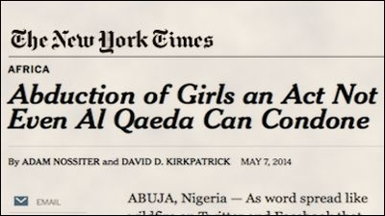
Why are some of the biggest Western mainstream media outlets—especially the New York Times (NYT)—often apologetic, not only for radical Islamists, but for al-Qaeda, an organization responsible for, among other atrocities, killing nearly 3000 Americans on September 11, 2001?
A recent NYT report titled "Abduction of Girls an Act Not Even Al Qaeda Can Condone" tries to exonerate al-Qaeda of the actions of another jihadi organization, Nigeria's Boko Haram—when both groups are not only affiliated but remarkably similar in outlook and method. The report's opening sentence summarizes its thesis: "As word spread like wildfire on Twitter and Facebook that Nigerian militants were preparing to auction off more than 200 kidnapped schoolgirls in the name of Islam, a very different Internet network started quietly buzzing too," one which, according to the NYT, reflects "the dismay of fellow jihadists at the innocent targets of Boko Haram's violence":
"Such news [abduction of Nigerian schoolgirls] is spread to taint the image of the Mujahedeen," wrote one dubious poster on a web forum used by Islamic militants whose administrator uses a picture of Osama bin Laden. "I have brothers from Africa who are in this group," attested another, insisting that they were like "the Quran walking the earth [i.e., righteous and just]."
Boko Haram, the cultlike Nigerian group that carried out the kidnappings, was rejected long ago by mainstream Muslim scholars and Islamist parties around the world for its seemingly senseless cruelty and capricious violence against civilians. But this week its stunning abduction appeared too much even for fellow militants normally eager to condone terrorist acts against the West and its allies.
"There is news that they attacked a girls' school!" another astonished poster wrote on the same jihadi forum …
The NYT's assertion that Boko Haram's "stunning abduction appeared too much even for fellow militants" is strange indeed.
The fact is, this "stunning abduction" pales in comparison to the many other atrocities Boko Haram has committed, and as documented in Gatestone Institute's Muslim Persecution of Christians series, where not a month goes by without numerous atrocities committed by the Nigerian jihadis, including the bombing or burning of hundreds of churches, especially on Christmas Day and Easter Day, which have left hundreds of worshippers dead or dismembered in the last few years.
Indeed, Boko Haram's jihad has resulted in more Christians killed than in the rest of the world combined.
As for the recent abduction, there is certainly nothing "stunning" about it. In fact, back in 2012, Boko Haram warned that it would do just this, declaring that it was preparing to "strike fear into the Christians of the power of Islam by kidnapping their women." Before and since then it, has kidnapped, raped, and/or converted countless Christian girls.
Perhaps the only thing "stunning" is that this latest raid on schoolgirls, the majority of whom are Christian, was widely reported and managed to reach the Western mainstream.
Thus it's not the act of abduction itself that, as the NYT puts it, is "too much even for fellow militants"—but rather that the world heard about it. Hence why Muslim clerics and the NYT had to respond—the former with formal disavowals of Boko Haram, the latter with articles like this.
Next the NYT quotes a supposed al-Qaeda expert saying, "The violence most of the African rebel groups practice makes Al Qaeda look like a bunch of schoolgirls."
This is strange indeed. Is the incineration of nearly 3,000 Americans on 9/11 the act of a "bunch of schoolgirls"?
The NYT also fails to mention that most African Islamic groups waging jihad to enforce Islamic law—from Nigeria's Boko Haram to Somalia's al-Shabaab—are closely affiliated to al-Qaeda, often seen as regional branches of the terrorist organization.
The NYT is never the first to report on atrocities committed by jihadis against Christians and other minorities, but it is always first to try to whitewash and apologize for the jihadis' role whenever news of jihadi atrocities appears from other media outlets. The article, by Adam Nossiter and David Kirkpatrick, continues with information that is simply false:
Its [Boko Haram's] violence is broader and more casual than Al Qaeda or other jihadist groups. Indeed, its reputation for the mass murder of innocent civilians is strikingly inconsistent with a current push by Al Qaeda's leaders to avoid such deaths for fear of alienating potential supporters (emphasis added).
All this is nonsense. For example, in 2012—after it had decapitated countless Christian men and women on the accusation of apostasy as well as any number of other atrocities—far from being ostracized, Somalia's al-Shabaab was heartily welcomed into the al-Qaeda fold by Ayman Zawahiri.
As for Boko Haram, it too has deep connections to al-Qaeda. According to the United Nations Al-Qaida Sanctions Committee, Boko Haram is affiliated with the core leadership of al-Qaeda as well as its nearby Maghrebi branch.
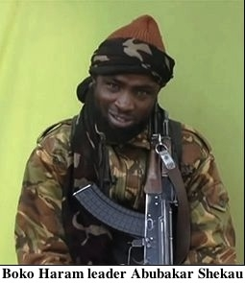
Next the NYT declares that Boko Haram's extreme violence "was the subject of the dispute that led to Al Qaeda's recent break with its former affiliate, the Islamic State of Iraq and Syria."
This invention seems meant to distance al-Qaeda from yet another brutal savage Islamic organization, the Islamic State of Iraq and Syria [ISIS], which has also been committing any number of atrocities—including crucifying people, bombing churches, and raping non-Muslims. In reality, "atrocities" are hardly the reason for the conflict between ISIS and al-Qaeda. ISIS was committing atrocities even when it was connected to al-Qaeda. The dispute was about power politics.

Why is the NYT trying so hard to make al-Qaeda and other Islamists look better—to exonerate them of the widely exposed crimes of Boko Haram and ISIS?
If people started to connect the dots and understand that all Islamists (al-Qaeda, Boko Haram, ISIS, al-Shabaab, al-Nusra Front, etc.), when they commit atrocities against non-Muslims, do it simply out of religious hate, the narrative that Western governments and mainstream media so stubbornly uphold—that al-Qaeda's terrorism, including 9/11, is based on "grievances against the West and Israel," and not Islamic supremacism and religious hate—would quickly unravel.
The NYT article even manages to invoke the grievance paradigm when discussing Boko Haram's terror: "Boko Haram tapped into growing anger among northern Nigerians at their poverty and lack of opportunity as well as the humiliating abuses of the government's security forces." Boko Haram may well have tapped into a poverty level— most people in "developing countries," including southern Nigeria, are poor—but the NYT totally disregards that many noted jihadis are doctors, engineers, well-educated and often affluent, including al-Qaeda leader Dr. Ayman al-Zawahiri, Mohammed Atta, and Major Nidal Hasan.
A recent Danish statistical study of immigrant families even finds that "Muslims [are] 218 percent more criminal in second generation than first," despite the fact that the second generation are more prosperous and educated than their first generation parents.
Yet the NYT insists on portraying terrorists as victims.
Al-Qaeda itself already put this question of grievances to rest. The late Osama bin Laden, in a private letter to Saudi Muslims, rhetorically asked:
Our talks with the infidel West and our conflict with them ultimately revolve around one issue… Does Islam, or does it not, force people by the power of the sword to submit to its authority corporeally if not spiritually? Yes. There are only three choices in Islam… Either submit, or live under the suzerainty of Islam, or die.

Raymond Ibrahim, author of Crucified Again: Exposing Islam's New War on Christians (Regnery, April, 2013) is a Shillman Fellow at the David Horowitz Freedom Center and an Associate Fellow at the Middle East Forum.

Hague Security Delta
Source: https://thehaguesecuritydelta.com/about-hsd

The Hague Security Delta (HSD) is the largest security cluster in Europe. In this Dutch cluster, companies, governments, and research institutions work together on innovations and knowledge in the field of cyber security, national and urban security, protection of critical infrastructure, and forensics. They have a shared ambition: a secure world and economic development.
The region of The Hague is the core of the cluster, where 400 security companies realise a total turnover of € 1.7 billion and employ 13,400 people. In February 2014, the Dutch Minister of Security & Justice opened the HSD Campus, the national innovation centre for security with state-of-the-art labs for serious gaming, real-time intelligence and incident experience, education and training facilities, flexible office space, and meeting rooms. HSD has strong ties with other innovative and influential regions in the Netherlands and abroad, including Twente, Brainport Eindhoven and Brussels.

History
By the end of 2010, the HSD 'Pieken in de Delta project' was initiated by a consortium of TNO, Twynstra Gudde, The Hague University of Applied Sciences, HCSS, Chamber of Commerce The Hague, Netherlands Forensic Institute and West Holland Foreign Investment Agency. The aim was to professionalise the security network, to investigate the possibilities for a financial fund or development organisation and to develop innovation houses on the most important themes —national, urban and cyber security, forensics and protection of critical infrastructures. In addition, the Municipality of The Hague initiated a stakeholder dialogue with a number of large employers in security, including Siemens, Thales, Fox-IT, Trigion and the Ministry of Security & Justice. The Hague Security Delta was officially launched as a 2-year project in March 2012, with support of The Municipality of The Hague and the Dutch Ministry of Economic Affairs. On 9 July 2013, The Hague Security Delta has officially been established as a foundation.

The Hague Security Delta Foundation
The security cluster aims to stimulate economic development and innovation in security. The newly established foundation acts as driving force, responsible for the implementation of the strategic direction and the international promotion of the security cluster, through trade missions, communication and acquisition of companies, institutions and conferences. Other tasks include:
- Alignment of supply and demand, by encouraging businesses, government and knowledge institutions to cooperate;
- Strengthen relationships with government, other economic regions in the Netherlands (e.g. Eindhoven and Twente), the European Union and overseas security clusters (e.g. Canada, USA, Singapore and United Kingdom);
- Alignment of funds and resources for innovation projects;
- Increase the availability of specialized staff and graduates in security;
- Improve the business climate for organizations in the security cluster.

Challenges with Selected Port Security Programs Remain, But Progress Made
Source: http://www.hstoday.us/single-article/challenges-with-selected-port-security-programs-remain-but-progress-made/475f9aad12cd19b4800216c0a19a8829.html

The US Coast Guard and Customs and Border Protection (CBP) have made substantial progress in three key areas of port security since the September 11, 2001 terrorist attacks, but challenges remain, a new federal audit report said.
In the area of maritime domain awareness and information sharing, Department of Homeland Security (DHS) “agencies, along with other port partners have taken actions to enhance visibility over the maritime domain and facilitate cooperation among partners by collecting, assessing and sharing key information," the Government Accountability Office (GAO) stated in an audit report provided to Congress this week.
However, “some challenges remain in implementing the tools necessary to maintain this focus and increase coordination among stakeholders,” GAO said.
“For example,” GAO said, “in multiple reports since 2011, GAO found the Coast Guard's weak management of technology acquisitions—that were focused on enhancing maritime awareness and increasing communication among partners— resulted in these acquisitions not fully achieving their intended purposes.”
DHS concurred with GAO's recommendations for addressing these weaknesses.
With regard to security at domestic ports, GAO said that “since 9/11, DHS components have taken a wide variety of actions to better secure domestic ports. For example, the Coast Guard has assessed risks to cruise ships in accordance with DHS guidance and is providing escorts for high-risk vessels such as cruise ships and ferries while CBP is reviewing passenger and crew data to target inspections.”
In addition, since 2002, the Federal Emergency Management Agency (FEMA) has provided almost $2.9 billion in federal funding through the Port Security Grant Program (PSGP) to help defray the cost of implementing security efforts in many ports and has established measures to improve the administration of the PSGP.
“However, in 2014 FEMA stated that it is unable—due to resource constraints—to annually measure reduced vulnerability attributed to enhanced PSGP-funded security measures,” GAO reported. “Meanwhile, the Transportation Security Administration (TSA) and the Coast Guard have been administering a program requiring maritime workers to obtain a biometric identification card to gain access to certain facilities.”
GAO told lawmakers that in 2011 it “recommended that DHS assess internal controls to identify actions needed to address, among other things, weaknesses governing enrollment and background checks. As of March 2014, this action had not been completed.”
Continuing, GAO said “DHS agencies, especially CBP, have taken steps to enhance the security of the global supply chain—particularly for cargo bound for the United States,” and that “efforts have focused on assessing and mitigating cargo risk before it enters US ports by better targeting and scanning cargo, and establishing security partnerships with the foreign countries and companies that ship cargo to the United States.”
But in multiple reports since 2005, GAO said it “found that DHS programs focused on protecting the global supply chain have been implemented with varying degrees of success and that many would benefit from the DHS agencies conducting further assessments of the programs, among other things.”
GAO has made recommendations to address these issues and “DHS has concurred or generally concurred with most of these recommendations and has taken actions to address many of them.”
GAO pointed out that “ports, waterways and vessels handle billions of dollars in cargo annually, and an attack on our nation's maritime transportation system could have dire consequences. Ports are inherently vulnerable to terrorist attacks because of their size, general proximity to metropolitan areas, the volume of cargo being processed, and their link to the global supply chain—that is, the flow of goods from manufacturers to retailers. Balancing security concerns with facilitation of the free flow of people and commerce remains an ongoing challenge for federal, state, local and private stakeholders operating in ports.”
In prior audit reports, GAO made recommendations to DHS to strengthen various port security programs. Overall, DHS generally concurred with the recommendations and has taken actions, or has actions under way, to address most of them, GAO said.

Read the report at: http://www.gao.gov/assets/670/663784.pdf

European R&D Project Aims To Enhance Security of Goods In Transit
Source: http://www.hstoday.us/single-article/european-r-d-project-aims-to-enhance-security-of-goods-in-transit/08415efca45080bf0b1c413eea850246.html

Terror organizations have demonstrated their willingness to target mass transportation networks along with other areas of critical infrastructure. The theft of high value, high risk products in transit cost European businesses over €8.2 billion a year, according to recent European Union (EU) figures. These ill-gotten gains, and in some cases, the stolen goods themselves, can be used to fund or assist terrorist activities.
After the Sept. 11, 2001 attacks, the United Nations agreed on proposals to enhance the security of dangerous goods in transport. Unfortunately, monitoring systems, early warning and deterrent technology have not been available to address this problem at an affordable cost. As a result, there has been an uneasy acceptance that in certain parts of the world, piracy, hijacking or theft are facts of commercial life.
However, a solution has been developed through the Architecture for Recognition of Threats to Mobile Assets Using Networks of Affordable Sensors (ARENA) research and development project funded in part by the EU’s FP7 security research program.
Maria Andersson, at FOI, the Swedish Defense Research Agency and Technical Coordinator for ARENA explained how the generic surveillance system that has been developed could provide robust, proactive threat detection and recognition while being able to differentiate between real threats and false alarms across a range of environments using an affordable system of sensors.
“FOI coordinated the seven-strong research partnership drawn from five EU countries,” Andersson said. “The project is coming to a close in July at the end of its three-year lifespan. Over that time the project sought to investigate a system applicable to a range of different deployments: stationary platforms relative to the land, such as a truck or train stop; stationary platforms relative to the sea, such as ships in port or oil rigs; mobile platforms relative to land, such as trucks or trains in transit; and mobile platforms relative to the sea, such as ships at sea or oil rig support vessels.”
“Its research built on existing work on the surveillance of public spaces,” Andersson said. “No new sensor development was done. Instead, the team focused on exploiting existing, low-cost sensor technologies like visual and infra-red video, acoustic sensors, seismic sensors and radar. It also built on other work, such as the Integrated Mobile Security Kit where a multi-sensor surveillance system is installed in a van which can be brought to public space when needed. Another contributing technology, known as ADABTS (Automatic Detection of Abnormal Behaviour and Threats in crowded Spaces), addresses automatic detection of abnormal human behavior that might signal crime is afoot. And another, called SECTRONIC, is a 24-hour small area surveillance system for maritime application.”
ARENA also aims to minimize nuisance the system might cause if it were to go off for no reason.
“Humans are naturally good at putting together lots of fragmentary information and signals and spotting what is a threat and what is not. Machines on the other hand are not,” said Andersson. “The ARENA system combines complementary sensors to reduce false alarm rates. The threat-detection task was also broken down into four interconnected steps: object detection, object tracking; event recognition; and threat recognition. The fewer the bystanders to the vehicle, the easier the system could interpret what is going on, meaning that it would be easier to detect a threat in a quiet railway siding than when standing by a busy platform. For the same reason, trains may, on the whole, prove easier to protect than trucks, which often park in places where there is innocent foot traffic.”
The project also tackled the sensitive legal and ethical issues involved in surveillance and electronic security, particularly those revolving around privacy. Andersson said that it will be crucial to have the consent of the driver for any camera system which secures a vehicle on the basis of facial recognition. Facial recognition cameras are only used in the cab of a vehicle, so present no challenge in respect of the privacy of passers-by.
FOI's partners were: Maritime Design and Engineering Company, BMT Group; ITTI, an IT company from Poland; hi-tech firm SAFRAN Sagem Défense Sécurité of France; electronic security company SAFRAN MORPHO, the Netherlands Organisation for Applied Scientific Research (TNO); and the University of Reading in the UK.
Over 70 per cent of all goods transported in the EU are transported using road haulage, a transport method which carries one of the highest risks of being victim of criminal activity. Truck thieves generally steal the whole vehicle or break into trailers to take the contents, sometimes cutting panels and causing other costly damage to gain access. Drivers are also vulnerable to attack and theft. The most common place for a truck to be attacked is at an unguarded parking lot while the driver is asleep. Large cities, like London and Madrid, are the biggest hot spots, but countries like Belgium also have a problem. In the UK alone, 324,000 crimes were recorded against the transport and storage sector in 2012.
The threat is equally pressing at sea as it is on land. Modern day piracy has presented a significant challenge since civil war broke out in Somalia in the early 1990s with an upsurge in recent years posing a threat to critical maritime infrastructure. There were 49 piracy incidents in the first quarter of 2014, according to the International Maritime Bureau. Two of these vessels were hijacked, 37 boarded and five fired on board. Five more attempted attacks were reported. There were 12 reports off the Africa's west coast, including the hijacking of two vessels with 39 crew taken hostage and two kidnapped.
ARENA may signal the beginning of a fundamental shift in the balance of power away from criminals, improving the safety of transport personnel and, ultimately, cutting costs.

Mosul Seized: Jihadis Loot $429m from City's Central Bank to Make Isis World's Richest Terror Force
By Jack Moore
Source: http://www.ibtimes.co.uk/mosul-seized-jihadis-loot-429m-citys-central-bank-make-isis-worlds-richest-terror-force-1452190

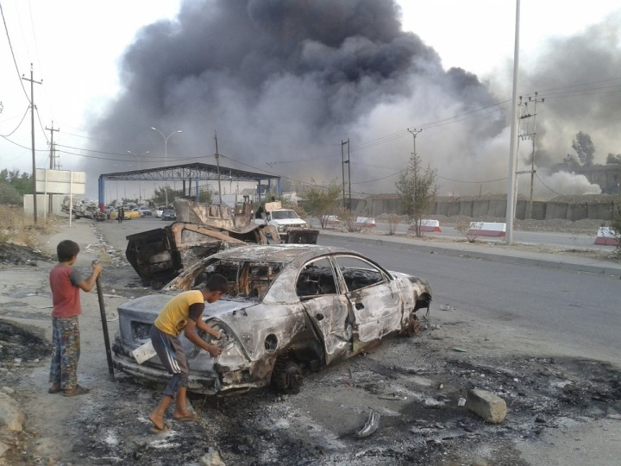
Civilian children stand next to a burnt vehicle during clashes between Iraqi security forces and al Qaeda-linked Islamic State in Iraq and the Levant (Isis) in the northern Iraq city of Mosul.Reuters

The Islamic State of Iraq and al-Shams (Isis) has become the richest terror group ever after looting 500 billion Iraqi dinars - the equivalent of $429m (£256m) - from Mosul's central bank, according to the regional governor.
Nineveh governor Atheel al-Nujaifi confirmed Kurdish televison reports that Isis militants had stolen millions from numerous banks across Mosul. A large quantity of gold bullion is also believed to have been stolen.
Following the siege of the country's second city, the bounty collected by the group has left it richer than al-Qaeda itself and as wealthy as small nations such as Tonga, Kiribati, the Marshall Islands and the Falkland Islands.

Richest Terror Factions in the World (as of 2011)
1) Taliban - $70m - $400m
2) Hezbollah $200m - $500m ($120m from Iran)
3) Farc - $80m - $350m
4) Hamas - $70m
5) Al-Shabaab - $70m - 100m
Source: Money Jihad

The financial assets that Isis now possess are likely to worsen the Iraqi governement's struggle to defeat the insurgency, which is aimed at creating an Islamic state across the Syrian-Iraqi border.
The Islamist militants took control of Mosul after hundreds of its fighters overwhelmed government military forces in a lightening attack on Monday, forcing up to 500,000 people to flee the city and Iraqi prime minister Nouri al-Maliki to call a national state of emergency.
The militants freed up to 1,000 inmates from Mosul's central prison, according to senior police officials. They are also in control of Mosul airport and local television stations.
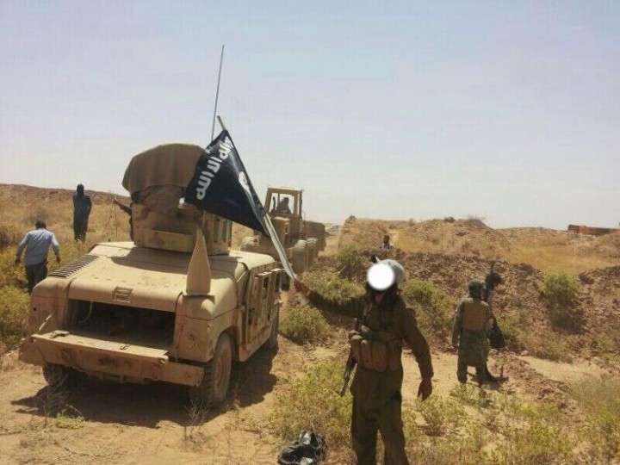
They also seized considerable amounts of US-supplied military hardware. Photos have already emerged of Isis parading captured Humvees in neighbouring Syria where they are also waging war against President Bashar al-Assad's regime.
US-supplied humvees captured by Islamic insurgents in the battle for MosulTwitter / @jenanmoussa

In a televised news conference, Maliki said "Iraq is undergoing a difficult stage" and urged the public and government to unite "to confront this vicious attack, which will spare no Iraqi."
The US State Department has released a statement saying that it is "deeply concerned" by the Islamist militants' siege of Mosul.
"The situation remains extremely serious. Senior U.S. officials in both Washington and Baghdad are tracking events closely in coordination with the Government of Iraq," the statement read.
"The United States stands with the Iraqi people," it continued.
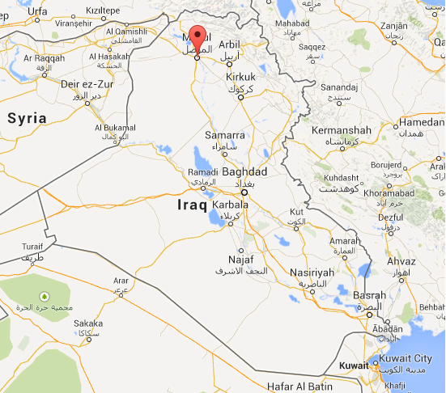
Mosul lays in northern Iraq near the Syrian border.Google Maps

Isis captured the city Falluja, 40 miles west of Baghdad, in January and currently controls large swathes of northern Iraq.
The Iraqi government has launched a number of failed assaults on the city leaving hopes of retaking Mosul slim.
An Iraqi army officer told the Independent: "We can't beat them."
"They're trained in street fighting and we're not. We need a whole army to drive them out of Mosul. They're like ghosts; they appear to hit and disappear within seconds."

ISIS Trophies
Source: http://www.trackingterrorism.org/article/was-isiss-plunder-mosul-insider-job/heist
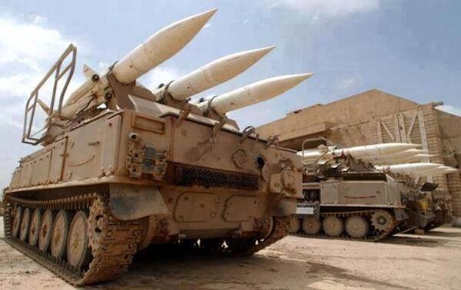
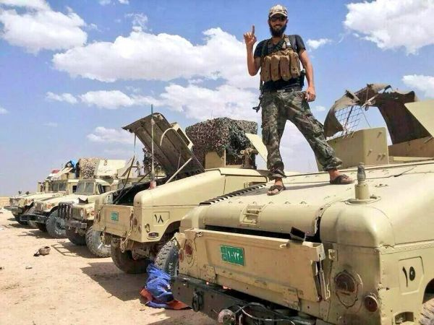
The ISIS captured military vehicles from fleeing Iraqi soldiers; government buildings, television stations and military installations where U.S.-supplied fighter airplanes, helicopters and other heavy weaponry are based. General Najim al-Jabouri, a former mayor of Tel Afar, told The Daily Beast the bases seized by ISIS this week provided the group with “Iraqi army helicopters, Humvees, cargo planes and other heavy machine guns, along with body armour and uniforms.” TRAC sources also report that the Apache Helicopters are equipped with “door guns,” which are Dillion machine guns. According to another TRAC contributor, ISIS also seized fighter jets and were looking online for pilots. Reportedly, two pilots answered the advertisement the next day, one from Chechen Republic; the other from Iraq who allegedly "test drove" the fighter jets June 12th, 2014. Yet another TRAC source has mentioned an “unknown quantity of armed “consultants” plus support equipment is being readied to fly in and join forces with the local militia called "Popular Comittees" to protect the infrastructure against ISIS.

Terrorism in Greece – An overview
By Alexandros Niklan
Source: http://www.rieas.gr/images/niklan14.pdf

On March of 2011, many believed that this was indeed the “fat’s lady song” on terrorism in Greece. A simple camera device and a long, in duration, surveillance and forensics data analysis, resulted to the arrest of multiple core members, of the terrorist group Fire Nuclei Conspiracy which was thought as the continuous stage of former group 17N [1]. But facts since then changed and lead now to a different direction.
A member of 17N ( C. Ksiros ) who was accused for 28 crime/terrorism hits, convicted and served time in prison, managed to escape during his official “leave” (!!!) [2] and turned all things around again. Today Police and Anti-terrorism unit, think that he conspired with imprisoned members of Fire Nuclei Conspiracy and might have met with members who are still at large to possibly, design and execute new hits. A recent attack at the Greek National Bank with a car bomb, resulted by forensics analysis, to be their coordinated handiwork [3].
On March of 2013, Stratfor’s vice president, Scott Stewart, published a report [4] where it was explaining on the radicalization process at Greece. On this report serious arguments were pointed out. One of many, was the long lasting leftish ideology (Anarchists) prevailing among youngsters, along with the continuous social and economic crisis at Greece.
In this report, he writes: “Because unemployment is so pervasive, jobless, disenchanted people are joining radical parties espousing a wide variety of ideologies. …… far-right parties, such as Greece's Golden Dawn party; and anti-austerity leftist groups, such as Greece's Coalition of the Radical Left, or Syriza. With unemployment in Greece at 27 percent, it is not surprising to see both radical right-wing and radical left-wing groups gaining support from those who have become deeply disaffected by the crises.”
On 30.5.2013, US State Department’s office, publishes a world-wide report regarding terrorism, where, Intelligence services of US reach to same outcome about presence of modern terrorism at Greece [5], but from a different perspective. This perspective presented a threat that, Greece is possible to face foreign terrorists entrance via under guarded borders. In quotes:
“The porous nature of Greece’s borders is of concern. While Greek border authorities try to stem the flow of illegal migration, its ability to control large-scale illegal migration via its land and sea borders with Turkey is limited. The recent political upheavals in North Africa and the Middle East have intensified illegal migration to and through Greece via the Greece-Turkey border and the Greek Aegean islands.”
Both reports now, show one thing: A transformation process that shows a possible shift in terrorism’s nature for Greece, on origin and attack methods. Until 2011, most of the attacks were targeting persons and buildings of political and authority importance. But this changed with the attack at a commercial center in Athens [6] and the IED bomb parcel attacks at various foreign embassies in 2010 and references to FAI (Informal Anarchist Federation).
Additional elements/facts that showed a change in terrorism’s nature and modus operandi in Greece were also presented by the terrorists. For example the bomb device at the commercial center of Athens, was built inside a pressure cook pot, containing nails and metal objects (claymore-like IED) just like most Islamic groups build them!!! On top of that, all statements in manifesto by these terrorists, were mentioning, foreign names and organizations [7] as support/demands. These findings helped Authorities to verify their theory that Greece has left the sphere of domestic terrorism/extremism and went on International level “standards”.
This does not seem to be the only security issue related to terrorism, though. Greece according to US state dpt. is a country with an advantageous geographical position, but with a proven disability of border control, as shown on previous mentioned report by Stratfor.
On August of 2013 Stratfor publishes a report presenting all dangers and threats of Jihadists fighting in Syria and elsewhere, returning to Europe [8]. Greece as geographical entry point to European Union has already serious issues with border control (illegal immigration) even though FRONTEX is providing a significant aid on this effort. A simple proof is the increase of illegal immigrants entering the country [9]. This poses as backdoor for terrorists to enter as it was verified by the arrest of four Turkish terrorists of DHKP-C terrorist group [10] on February of 2014, who illegally entered Greece, arrested and extradited to Turkey for further actions. An also important report on Greece security and safety status was published by OSAC institution [11] which is taking under consideration recent political and economic crisis for Greece.
Last but not least of security concerns related to terrorism, is the recent uprising of Golden Dawn political party which is under prosecution as a criminal organization[12].Golden Dawn’s members attacks on individuals or/and group of people based upon their nationality, skin color and other racial characteristics showing a terrorism form that Greece did not experience in the past.
In conclusion Greece, based on previous mentioned reports and data, seems to be fulfilling uneasy terms, of being a possible safe haven destination for many kind of threats. A possible “terrorism transit station” for terrorism and organized crime cells along with “lone wolves”, since authorities are lacking resources and an organized assertion plan to deal with those threats, in and around country’s borders. Domestic terrorism is also evolving into a much different form while it is getting more recruits, as a result of many and high-tensed social grievances due to recent economy and political crisis.
It is essential for local authorities and state government, to make sure via a more intense cooperation with international institutions and services along with a better risk/threat assessment plan, since terrorism (along with other security issues) seem to be on a path for a “caterpillar transformation” where nothing good will come out of the cocoon.

References are available at source’s URL.

Alexandros Niklan is Security Consultant/CEO, IISCA group.

Kenya's case study in homegrown terrorism
Source:http://www.globalpost.com/dispatch/news/regions/africa/140609/kenyas-case-study-homegrown-terrorism

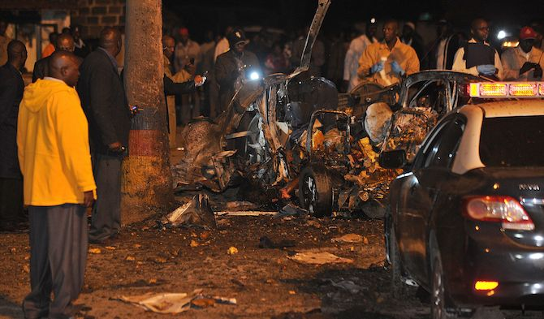
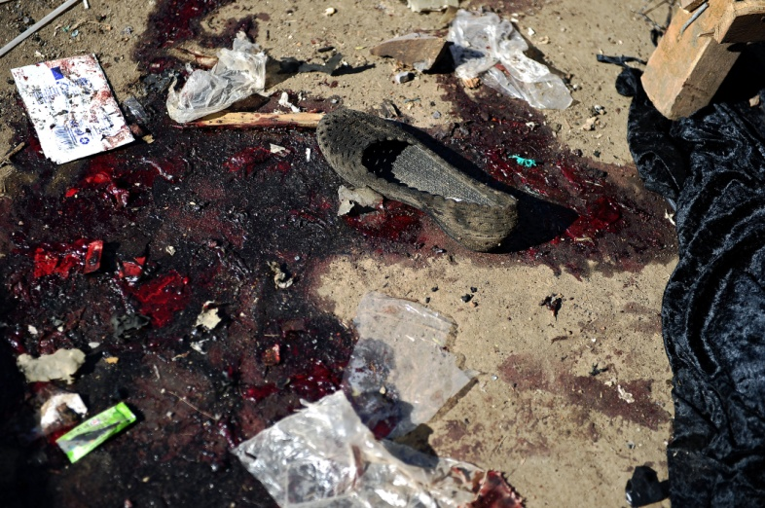
Terrorist attacks in Kenya are on the rise, triggering travel warnings from foreign governments and scaring ordinary Kenyans. Islamic militants from neighboring Somalia are blamed for most of the attacks and in response the government here is cracking down on ethnic Somalis, hoping to halt the escalation. But Al Shabaab has grown and evolved in recent years: Now it looks like the threat may come from within.
Though the attack on the Westgate Mall last fall is the driver of Kenya’s current anti-terrorism campaign, the country knows terrorism well. From the 1998 bombing of the US embassy in Nairobi onward, terrorist attacks by Al Qaeda and its affiliates have occurred regularly, if not often.
Attacks increased after Kenyan troops were sent into Somalia in October 2011 following a spate of kidnappings that Kenya’s government blamed on Al Shabaab, Somalia’s Al Qaeda affiliate.
Most of the acts of terrorism that followed were low-level and ineffective in their aim of shaking Kenya’s resolve to keep its soldiers in Somalia. Attacks in the poor and neglected northeast were ignored, and when terrorists tossed grenades into late-night bars or dropped bombs at bus stops in Nairobi or Mombasa, the handful of civilians killed caused the government little concern.
Westgate was different. At least 67 people died in the initial assault and subsequent security operation at an upmarket mall in the heart of the capital. Among the dead was a nephew of President Uhuru Kenyatta.
Al Shabaab justified Westgate as retaliation for Kenyan attacks in Somalia. The threats have continued since.
Daveed Gartenstein-Ross, a senior fellow at the Washington-based Foundation for the Defense of Democracies, keeps a database of terror attacks in Somalia and the region. It reveals that those in Kenya are becoming more sophisticated and more deadly. “Clearly there is a focus on Kenya and an increased pace of activities in Kenya,” he said.
The escalation is easily observed in fatality counts. With the exception of the armed assault on the Westgate Mall, the deadliest incident of 2013 was a December grenade attack in Nairobi that killed six and injured 34. In contrast, bombs placed in Nairobi’s Gikomba market on May 16 of this year killed 10 and injured 70. Explosions in Mombasa and Nairobi over a single weekend in early May killed seven and injured 80.
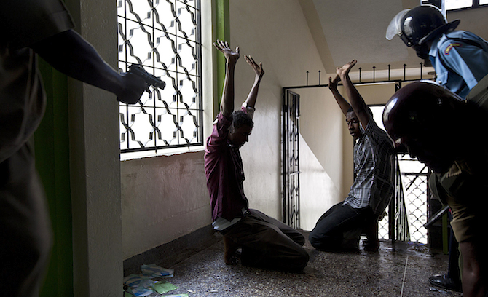
The technological sophistication is increasing, as well. In March police in Mombasa belatedly discovered a large and sophisticated truck bomb in a vehicle impounded by officers days earlier. A Western diplomat said the device was “on a scale not previously seen in Africa.”
The concern is that suicide bombings — used by Al Shabaab as a prelude to gunmen in their more complex attacks in Somalia — may be the next step. Djibouti, another country that hosts both US and French military bases and contributes troops to the African Union force battling Al Shabaab in Somalia, suffered its first suicide bombing in May. Uganda, the first country to send troops to Somalia under the AU banner, was hit by suicide bombers during live screening of the 2010 World Cup soccer tournament.
A car bomb that exploded at Nairobi’s Pangani police station on April 23 could either have been a bombing gone wrong or Kenya’s first suicide attack.
“The concern is whether [Al Shabaab] are going to be able to find and deploy fighters willing to die for the cause here,” said Matt Bryden, director of the Nairobi-based think tank Sahan Research. Until then grenade attacks and improvised explosive devides (IEDs) are probably “the limits of their capabilities,” said Bryden.
The Kenyan response
Kenya’s response to the terrorism threat has included mass roundups of predominately ethnic Somalis suspected of being illegal aliens. Thousands have been detained, and at least 359 deported to Somalia since "Operation Usalama Watch" began in April. Others have chosen to leave. Human rights groups have criticized the crackdown.
“It appears that Operation Usalama Watch is being used as a pretext for the blanket punishment of the Somali community in Kenya,” said Michelle Kagari, East Africa regional director at Amnesty International.
The Masjid Musa mosque in Mombasa was raided in February by armed police officers wearing body armor and helmets. One person died and more than 100 were rounded up in the daylight assault. Most suspects were subsequently released without charge.
There are fears that violent and indiscriminate security operations based on ethnic and religious profiling are counterproductive and may work as a recruiting tool for militants.
In an audio and video message posted online last month, for example, Al Shabaab’s leader Ahmed Godane threatened Kenya and urged Muslims to avenge the deaths of two radical preachers from the same mosque that was targeted by police officers in February.
Abubakar Shariff Ahmed, aka Makaburi, and Aboud Rogo, who both preached jihad and were accused of being Al Shabaab recruiters, were shot dead in Mombasa in April 2014 and August 2012, respectively. No one has been charged with either murder. Human rights and Muslim groups blame Kenya’s US-funded Anti-Terrorism Police Unit for these and other extrajudicial killings.
Though the facts of those killings are difficult to establish, the widespread indiscriminate harassment of ethnic Somalis is well-established.
“It’s hard to judge how many terrorist attacks have really been averted by these operations,” said Jonathan Horowitz, legal officer at the Open Society Justice Initiative in New York. “What we do know is there are very few successful prosecutions or convictions and very high numbers of human rights violations.”
Horowitz said the Kenyan government is expending “massive amounts of resources in a manner that has been proven to be ineffective.”

The threat from within
Still more worrisome is the possibility that the Kenyan government is targeting the wrong demographic entirely — that, in fact, officials have missed a crucial development: the internationalization of Al Shabaab and the growing presence of a homegrown Kenyan terrorist threat.
“If Somalia were pacified tomorrow it wouldn’t make Kenya’s problems go away,” said Bryan Kahumbura, Horn of Africa analyst at the International Crisis Group think tank in Nairobi.
In fact, the few arrests and fewer convictions in connection with Kenya’s terrorist attacks point to a domestic threat, not a foreign one. Kenyan police identified one of the suspected Pangani car bombers as a Kenyan university student and son of a military officer. A man convicted in October 2011 of a Nairobi grenade attack was a Muslim convert from western Kenya.
“Just because the group presenting the threat is Somali-based that doesn’t mean the agents it uses to carry out attacks are Somalis from Somalia,” said J Peter Pham, director of the Africa Center at the Atlantic Council in Washington.
“Al Shabaab is increasingly taking on a regional dynamic and agenda, trying to project themselves as Al Qaeda’s primary African operation,” said Pham.
Non-ethnic-Somali Kenyans have always been a large cohort within Al Shabaab, but as the group faces military pressure and territorial losses in Somalia, the Kenyan mujahedeen are thought to be coming home.
“There are hundreds of Kenyans who have been in Somalia since 2007, who have been trained and had exposure to battlefield conditions. We should expect to see a hardcore among them willing and able to carry out the kind of complex attacks that Shabaab is now capable of,” said Bryden.
What the returning militants find in Kenya is a large pool of potential recruits among a marginalized and threatened Muslim and Somali minority in the coastal region, the northeast and Nairobi.
“There is a mass of young people in Kenya who, because of their economic and social circumstances, are a resource for terrorists that is not Somalia-based that can be manipulated and used,” said Kahumbura.
“A small number of Al Qaeda or Al Shabaab followers are able to mobilise a much larger group,” he said.

Adoption of battlefield surveillance system in urban settings raises privacy concerns
Source: http://www.homelandsecuritynewswire.com/dr20140422-adoption-of-battlefield-surveillance-system-in-urban-settings-raises-privacy-concerns

Compton, California has adopted a wide-area surveillance system as a means of monitoring criminal activities. Built by Ohio-based Persistent Surveillance Systems (PSS), the system provided the U.S. military an aerial view which allows soldiers to hunt down bombing suspects in Iraq and Afghanistan.
Networkworld reports that with the system’s success on the battlefield, Ross McNutt, retired Air Force veteran and president of PSS, convinced the Los Angeles County Sheriff’s department to use PSS’s high-resolution system to monitor the city of Compton. “We literally watched all of Compton during the time that we were flying, so we could zoom in anywhere within the city of Compton and follow cars and see people,” McNutt said. “Our goal was to basically jump to where reported crimes occurred and see what information we could generate that would help investigators solve the crimes.”
According to the Center for Investigative Reporting, the surveillance cameras, fitted on a small plane, can record a 25-square-mile area for up to six hours, and cost less than the price of a police helicopter. The PSS system also has the capability of watching 10,000 times the area that a police helicopter could watch. McNutt estimates that PSS’s advanced cameras could capture up to fifty crimes per six-hour flight if the system were employed in high crime areas of Washington, D.C.
Operators using the system are able to rewind footage and track the movement of residents and cars as they conduct daily commutes and transactions. “With wide-area surveillance, all the activity in an entire community or area is monitored with a single camera system,” states a PSS “Airborne” brochure. In Philadelphia, the system was used to track the killer’s and accomplice’s vehicles hours after the murder of a gang member. The Dayton, Ohio SWAT team also used the system in a dogfighting operation raid.
Despite successful operations with the PSS system, privacy advocates are concerned that law enforcement may develop a database of footage showing innocent residents. “There are an infinite number of surveillance technologies that would help solve crimes . . . but there are reasons that we don’t do those things, or shouldn’t be doing those things,” said Joel Pruce, a University of Dayton postdoctoral fellow in human rights who opposed the plan. “You know where there’s a lot less crime? There’s a lot less crime in China.”
Responding to concerns about privacy, McNutt notes that he sought advice from the American Civil Liberties Union when writing the privacy policy for PSS. The policy contains rules governing length of data storage and who may access images and footage from the PSS.

EDITOR’S COMMENT: We do not want crime! We do not want terrorism! We do not want to be watched! What do we really want?

Digital birth card to help Kenya fight terrorist infiltration
Source: http://www.homelandsecuritynewswire.com/dr20140612-digital-birth-card-to-help-kenya-fight-terrorist-infiltration

The influx of immigrants from neighboring African states includes Islamic militants, some belonging to terrorist group al-Shabaab. Maintaining proper records of every Kenyan and immigrant will offer authorities leads on who is in the country and potentially a threat to national security. Some suggests the adoption of a Digital Birth Card (DBC) as a way to curb Kenya’s terrorism fears.
Robert Malanya, a student at Jomo Kenyatta University of Agriculture and Technology (JKUAT), is proposing the adoption of a Digital Birth Card (DBC) as a way to curb Kenya’s terrorism fears. The influx of immigrants from neighboring African states includes Islamic militants, some belonging to terrorist group al-Shabaab. Maintaining proper records of every Kenyan and immigrant will offer authorities leads on who is in the country and potentially a threat to national security.
“Our biggest problem is that due to a poor record management system, our government and security forces do not have the records of everyone in the country. My innovation — the Digital Birth Card — will rectify this,” says twenty-two-year-old Malanya.
According to Standard Media, DBCs are readable with a barcode scanner and store information backed on a server accessible to county and federal government agencies. Malanya insists that all children born in Kenya should receive the card before their parents receive a printed birth certificate. “The information is counter-checked by approved people and it is from this information that a birth certificate is printed automatically and sent to the child’s parents. The card reader machines can be installed in any government establishment and with a swipe of the card, all information related to the child appears whenever needed.”
Hospital and education records would be accessible on DBCs and holders of the cards could be notified by authorized agencies when due for vital immunizations or college entrance exams. Even notification of expired identification cards and passports could be sent via mobile text message to residents who have DBCs. The DBC system has been tested on residents of Homa Bay County and among students at JKUAT; and participants consider it reliable and an effective way to streamline management of records.
“With this technology, the government has control of who is in the country and can tell who is here illegally because their birth cannot be tracked digitally. It also saves people the inconvenience of queuing for IDs,” says Malanya.

ISIS Rampages, the Middle East Shakes
By Daniel Pipes
Source: http://www.meforum.org/4723/isis-syria-iraq

The jihadis' takeover of Mosul on June 9 won them control of Iraq's second-largest city, a major haul of weapons, $429 million in gold, and an open path to conquer Tikrit, Samarra, and perhaps the capital city of Baghdad. The Iraqi Kurds have seized Kirkuk. This is the most important event in the Middle East since the Arab upheavals began in 2010. Here's why:
Regional threat: The Islamic State in Iraq and Syria (ISIS), a designated terror group, is in a position to overthrow the governments of Iraq and Syria and perhaps beyond, starting with Jordan. Straddling the Iraq-Syria frontier, it may both erase the nearly century-old border between these two colonial creations and end their existence as unitary states, thereby overturning the Middle Eastern political order as it emerged from World War I. Rightly does the U.S. government call ISIS "a threat to the entire region."
Unexpected strength: These developments establish that the most extreme and violent form of Islamism, as represented by al-Qaeda and like groups, can go beyond terrorism to form guerrilla militias that conquer territory and challenge governments. In this, ISIS joins the Taliban in Afghanistan, Al-Shabaab in Somalia, Al-Nusra Front in Syria, Ansar Dine in Mali, and Boko Haram in Nigeria.
Muslims hate Islamism: Thanks to the ferocious reputation ISIS has established in its capital city of Raqqa, Syria, and elsewhere, an estimated quarter of Mosul's population of almost two million has fled. The current round of ISIS brutality will newly render Islamism obnoxious to millions more Muslims.
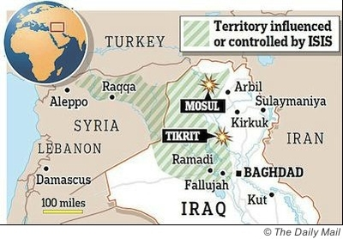
Ultimate frustration: Therefore, however much damage the al-Qaeda-type organizations can do to property and lives, they ultimately cannot emerge victorious (meaning, a caliph applying Islamic law in its entirety and severity) because their undiluted extremism both alienates Muslims and scares non-Muslims. In the end, tactically cautious forms of Islamism (e.g., that of Fethullah Gülen in Turkey) have the greatest potential, because they appeal to a broader swath of Muslims and worry non-Muslims less.
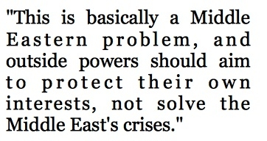
Sunnis vs. Shiites: ISIS military advances directly threaten Iraq's Shiite-dominated, pro-Iran regime. Tehran cannot allow it to go under; accordingly, Iranian forces have already helped retake Tikrit and greater Iranian involvement has been promised. This points to a replica of the ethnic lines in Syria's civil war, with Turkish-backed Sunni jihadis rebelling against an Iranian-backed Shiite-oriented central government. As in Syria, this confrontation leads to a humanitarian disaster even as it turns Islamists against each other, thereby serving Western interests.
The Mosul Dam looms: In the 1980s, Saudis and other Arabs funded a poorly constructed quickie dam on the Tigris River about 35 miles northwest of Mosul. Substandard construction means it leaks and needs constant grouting and other expensive measures to avoid cataclysmic collapse. Will ISIS hotheads continue these repair works? Or might they skimp on them, thereby threatening not just Mosul but much of inhabited Iraq with catastrophic flooding?
American failure: More clearly than ever, the success of ISIS forces exposes the overambitious goals of the U.S.-led invasion of Iraq (and, likewise, of Afghanistan), which cost the West thousands of lives and over a trillion dollars. The fancy façade of $53 billion in American-sponsored institutions, from failed hospitals to the Iraqi National Symphony, have been exposed as the fiasco they are. ISIS soldiers standing triumphant atop U.S.-supplied military equipment bring home the folly of once-high American hopes for "a stable, democratic, and prosperous Iraq."
Republicans: Republicans unfairly blame the ISIS victories on Barack Obama. No: George W. Bush made the commitment to remake Iraq, and in 2008 he signed the Status of Forces Agreement that terminated the American military presence in Iraq at the close of 2011. For the Republican party to move forward in foreign policy, it must acknowledge these errors and learn from them, not avoid them by heaping blame on Obama.
Democrats: The execution of Osama bin Laden three years ago was an important symbolic step of vengeance. But it made almost no difference operationally and it's time for Obama to stop crowing about al-Qaeda being defeated. In fact, al-Qaeda and its partners are more dangerous than ever, having moved on from terrorism to conquering territory. The well-being of Americans and others depend on this reality's being recognized and acted upon.
Western policy: This is basically a Middle Eastern problem, and outside powers should aim to protect their own interests, not solve the Middle East's crises. Tehran, not we, should fight ISIS.

Daniel Pipes is president of the Middle East Forum.

The Battle for Iraq Is a Saudi War on Iran

Source: http://www.terrorismwatch.org/2014/06/the-battle-for-iraq-is-saudi-war-on-iran.html?utm_source =feedburner&utm_medium=email&utm_campaign=Feed%3A+terrorismwatch%2FJTvK+%28Terrorism+Watch%29

The ISIS invasion of Iraq reflects a wider war between Shiites and Sunnis for control of the Middle East.
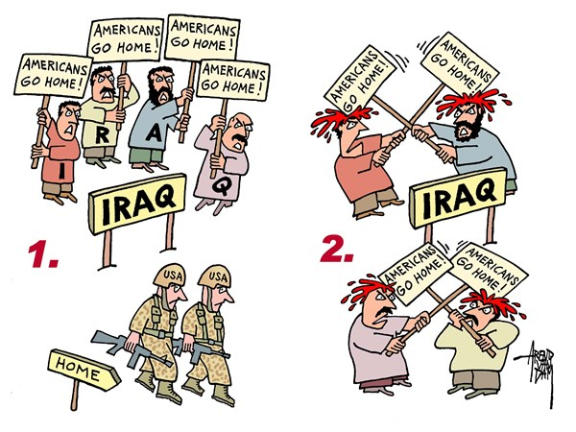
"Be careful what you wish for" could have been, and perhaps should have been, Washington's advice to Saudi Arabia and other Gulf states which have been supporting Sunni jihadists against Bashar al-Assad's regime in Damascus. The warning is even more appropriate today as the bloodthirsty fighters of the Islamic State of Iraq and al-Sham (ISIS) sweep through northwest Iraq, prompting hundreds of thousands of their Sunni coreligionists to flee and creating panic in Iraq's Shiite heartland around Baghdad, whose population senses, correctly, that it will be shown no mercy if the ISIS motorcades are not stopped.
Such a setback for Iraqi Prime Minister Nouri al-Maliki has been the dream of Saudi Arabia's King Abdullah for years. He has regarded Maliki as little more than an Iranian stooge, refusing to send an ambassador to Baghdad and instead encouraging his fellow rulers of the Gulf Cooperation Council (GCC) -- Kuwait, Bahrain, Qatar, the United Arab Emirates, and Oman -- to take a similar standoff-ish approach. Although vulnerable to al Qaeda-types at home, these countries (particularly Kuwait and Qatar) have often turned a blind eye to their citizens funding radical groups like Jabhat al-Nusra, one of the most active Islamist groups opposed to Bashar al-Assad in Syria.
Currently on vacation in Morocco, King Abdullah has so far been silent on these developments. At 90-plus years old, he has shown no wish to join the Twitter generation, but the developments on the ground could well prompt him to cut short his stay and return home. He has no doubt realized that -- with his policy of delivering a strategic setback to Iran by orchestrating the overthrow of Bashar al-Assad in Damascus showing little sign of any imminent success -- events in Iraq offer a new opportunity.
This perspective may well confuse many observers. In recent weeks, there has been a flurry of reports of an emerging -- albeit reluctant -- diplomatic rapprochement between the Saudi-led GCC and Iran, bolstered by the apparently drunken visit to Tehran by the emir of Kuwait, and visits by trade delegations and commerce ministers in one direction or the other. This is despite evidence supporting the contrary view, including Saudi Arabia's first public display of Chinese missiles capable of hitting Tehran and the UAE's announcement of the introduction of military conscription for the country's youth.
The merit, if such a word can be used, of the carnage in Iraq is that at least it offers clarity. There are tribal overlays and rival national identities at play, but the dominant tension is the religious difference between majority Sunni and minority Shiite Islam. This region-wide phenomenon is taken to extremes by the likes of ISIS, which also likely sees its action in Iraq as countering Maliki's support for Assad. ISIS is a ruthless killing machine, taking Sunni contempt for Shiites to its logical, and bloody, extreme. The Saudi monarch may be more careful to avoid direct religious insults than many other of his brethren, but contempt for Shiites no doubt underpinned his Wikileaked comment about "cutting off the head of the snake," meaning the clerical regime in Tehran. (Prejudice is an equal opportunity avocation in the Middle East: Iraqi government officials have been known to ask Iraqis whether they are Sunni or Shiite before deciding how to treat them.)
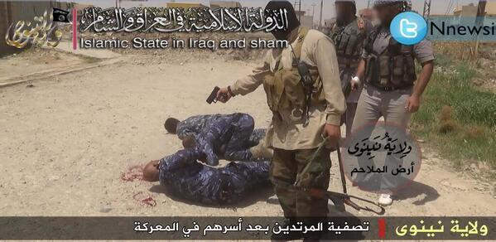
Despite the attempts of many, especially in Washington, to write him off, King Abdullah remains feisty, though helped occasionally by gasps of oxygen -- as when President Barack Obama met him in March and photos emerged of breathing tubes inserted in his nostrils. When Sheikh Mohammed bin Zayed, the crown prince of Abu Dhabi -- and, after his elder brother's recent stroke, the effective ruler of the UAE -- visited King Abdullah on June 4, the Saudi monarch was shown gesticulating with both hands. The subject under discussion was not revealed, but since Zayed was on his way to Cairo it was probably the election success of Egypt's new president, Abdel Fattah el-Sisi, considered a stabilizing force by Riyadh and Abu Dhabi. Of course, Sisi gets extra points for being anti-Muslim Brotherhood, a group whose Islamist credentials are at odds with the inherited privileges of Arab monarchies. For the moment, Abdullah, Zayed, and Sisi are the three main leaders of the Arab world. Indeed, the future path of the Arab countries could well depend on these men (and whomever succeeds King Abdullah).
For those confused by the divisions in the Arab world and who find the metric of "the enemy of my enemy is my friend" to be of limited utility, it is important to note that the Sunni-Shiite divide coincides, at least approximately, with the division between the Arab and Persian worlds. In geopolitical terms, Iraq is at the nexus of these worlds -- majority Shiite but ethnically Arab. There is an additional and often confusing dimension, although one that's historically central to Saudi policy: a willingness to support radical Sunnis abroad while containing their activities at home. Hence Riyadh's arms-length support for Osama bin Laden when he was leading jihadists in Soviet-controlled Afghanistan, and tolerance for jihadists in Chechnya, Bosnia, and Syria.
When the revolt against Bashar al-Assad grew in 2011 -- and Riyadh's concern at Iran's nuclear program mounted -- Saudi intelligence re-opened its playbook and started supporting the Sunni opposition, particularly its more radical elements, a strategy guided by its intelligence chief, former ambassador to Washington, Prince Bandar bin Sultan. The operation's leadership changed in April, when Bandar resigned in apparent frustration over dealing with the cautious approach of the Obama administration, but Saudi support for jihadi fighters appears to be continuing. (The ISIS operation in Iraq almost seems the sort of tactical surprise that Bandar could have dreamt up, but there is no actual evidence.)
In the fast-moving battle that is now consuming northern Iraq, there are many variables. For Washington, the option of inaction has to be balanced by the fate of the estimated 20,000 American civilians still left in the country (even though the U.S. military is long-departed). Qatar, the region's opportunist, is likely balancing its options of irritating its regional rival, Saudi Arabia, while trying not to poke the Iranian bear. There are no overt Qatari fingerprints yet visible and Sheikh Tamim bin Hamad al-Thani, just celebrating his first full year in power after his father's abdication in 2013, may be chastened by the public scolding he received from the rest of the GCC after he was accused of interference in the domestic affairs of his brother rulers. Additionally, Doha may be cautious in risking Iran's ire by an adventure in Iraq. Having just given five Taliban leaders refuge as part of the Bowe Bergdahl swap, Qatar has effectively clearly stated where it lies in the Sunni-Shiite divide.
There is a potentially important historical precedent to Saudi Arabia's current dilemma of rooting for ISIS but not wanting its advances to threaten the kingdom. In the 1920s, the religious fanatic Ikhwan fighters who were helping Ibn Saud to conquer Arabia were also threatening the British protectorates of Iraq and Transjordan. Ibn Saud, the father of the current Saudi king, gave carte blanche to the British to massacre the Ikhwan with machine-gun equipped biplanes, personally leading his own forces to finish the job, when the Ikhwan threatened him at the battle of Sabilla in 1929.
It's hard to imagine such a neat ending to the chaos evolving in the Euphrates river valley. At this stage, a direct confrontation between Saudi and Iranian forces seems very unlikely, even though, as in Syria, the direct involvement of the Iranian Revolutionary Guard Corps cannot be ruled out. What is clear is that the Syrian civil war looks like it will be joined by an Iraqi civil war. ISIS already has a name for the territory, the al-Sham caliphate. Washington may need to find its own name for the new area, as well as a policy.

Simon Henderson is the Baker Fellow and director of the Gulf and Energy Policy Program at The Washington Institute.

Hezbollah and the Use of Drones as a Weapon of Terrorism
By Milton Hoenig
Source: http://fas.org/pir-pubs/hezbollah-use-drones-weapon-terrorism/

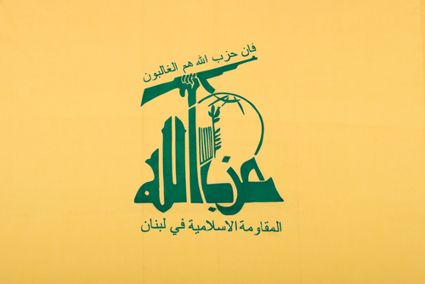
The international terrorist group Hezbollah, driven by resistance to Israel, now regularly sends low flying drones into Israeli airspace. These drones are launched and remotely manned from the Hezbollah stronghold in Lebanon and presumably supplied by its patron and strategic partner, Iran. On the U.S. State Department’s list of terrorist organizations since 1995, Hezbollah has secured its presence in Lebanon through various phases. It established a strong social services network, and in 2008 it became the dominant political party in the Lebanese government and supported the Assad regime in the Syrian Civil War.

Hezbollah’s drone flights into Israeli airspace
Hezbollah’s first flight of an unmanned aerial vehicle (UAV) or drone, into Israeli airspace for reconnaissance purposes occurred in November 2004, catching Israeli intelligence off guard. A Mirsad-1 drone (an updated version of the early Iranian Mohajer drone used for reconnaissance of Iraqi troops during the 1980s Iran-Iraq War), flew south from Lebanon into Israel, hovered over the Western Galilee town of Nahariya for about 20 minutes and then returned to Lebanon before the Israeli air force could intercept it.
Hezbollah leader Hassan Nasrallah boasted that the Mirsad could reach “anywhere, deep, deep” into Israel with 40 to 50 kilograms of explosives. ¹⁾ One report at the time was that Iran had supplied Hezbollah with eight such drones, and over two years some 30 Lebanese operatives had undergone training at Iran Revolutionary Guard Corps bases near Isfahan to fly missions similar to the Mirsad aircraft. ²⁾
The second drone flight into Israel was a short 18-mile incursion in April 2005 (again by a Mirsad-1 drone), that eluded Israeli radar and returned to Lebanon before Israeli fighter planes could be scrambled to intercept it. ³⁾ A third drone mission in August 2006 during the Lebanon War was intended for attack; Hezbollah launched three small Ababil drones into Israel each carrying a 40-50 kilogram explosive warhead intended for strategic targets. This time Israeli F-16s shot them down, one on the outskirts of Haifa, another in Western Galilee, and the third in Lebanon near Tyre. ⁴⁾ ⁵⁾
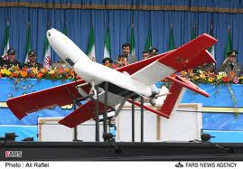
Abruptly, the incursion of Hezbollah drones into Israeli airspace stopped – only to be started up again after a six year hiatus. Presumably, drone launches by Hezbollah into Israel are planned and carried out to meet the political agenda of Iran, while shielding Iran’s involvement and allowing a measure of deniability. The involvement of Shiite Hezbollah with Iran dates back to financial support and training from the Iran Revolutionary Guard Corps and the suicide attacks in Beirut in October 1983 on the U.S. embassy and the Marine Corps barracks attacks. This was followed by Iranian sponsorship of Hezbollah attacks on the Israeli embassy and the Jewish Community Center in Buenos Aires, Argentina in 1992 and 1994, and the Khobar Towers bombing in Saudi Arabia in 1996.
The drones sent out from Lebanon were small objects moving at slow speed and low elevation and as such they were difficult to detect by radar. The Mirsad-1 (bottom) and the Ababil (top) were each only about 9.5 feet in length. The low speed (120 miles per hour for the Mirsad-1 and 180 miles per hour for the Ababil) minimized the Doppler shift in the reflected radar beam and made detection difficult. The low ceiling (6,500 feet for the Mirsad-1 and 9,800 feet for the Ababil) would limit detection as it is obscured by ground clutter, glare, and other environmental conditions. ⁶⁾ In the past it has been reported that drones could penetrate Israel’s radar and air defense systems, even the Iron Dome. But ongoing upgrades in detection capability suggest progress has been made in improving sensitivity and limiting detection failure to areas lacking air defenses, or suppressed defenses, or when the drones are indeed very small. ⁷⁾

A daring mission to the nuclear complex at Dimona
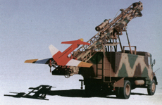
The next appearance of a Hezbollah drone on October 6, 2012, was a spectacular foray that took Israel by surprise. An Iranian drone called “Ayub” flew south from Lebanon over the Mediterranean and into Israel via the Gaza Strip, moving westward about 35 miles into the Negev and penetrating to a point near the town of Dimona, the site of Israel’s nuclear weapons complex. There it was shot down over a forest by Israeli aircraft. Examining the wreckage, Israeli military said that it was possible the drone could have transmitted imagery of the nuclear research center.
Observers immediately interpreted this incursion as a message from Iran that Israel’s nuclear facilities were vulnerable to attack should Israel attempt any military action against Iran’s nuclear facilities. Apparently the propaganda victory was significant enough for Iran to admit spying on Israel several weeks later: an influential member of the Iranian Parliament announced that Iran had pictures of sensitive Israeli facilities transmitted by the drone. ⁸⁾
In a more recent flight in April 2013, an unmanned aircraft attributed to Hezbollah reached the coast near the city of Haifa, where an Israeli warplane brought it down, demonstrating that these drones are still vulnerable to counter-attack. ⁹⁾
Each drone flight into Israel is potentially a significant propaganda victory for Hezbollah. As Matthew Levitt of the Washington Institute has noted, “They love being able to say, ‘Israel is infiltrating our airspace, so we’ll infiltrate theirs, drone for drone.’” ¹⁰⁾
Israeli drones are sophisticated, deadly and widely used in policing and assassinations of Hamas operatives in Gaza, while Hezbollah’s drones appear to lag behind. While the 145 mile excursion from Lebanon to Dimona in October 2012 showed substantial gain in Hezbollah’s reconnaissance capability, a willingness by Iran to transfer its latest designs to give Hezbollah deadly capabilities is questionable since Iran is unlikely to risk having their advanced drones shot down over Israel. In addition, Hezbollah would surely have second thoughts about using drones in an assassination campaign in Israel since this would be met with a strong military response.

Emerging strategies and possibilities
Primarily sent to cause panic in Israel, Hezbollah’s drones that were shot down in 2006 were armed with explosive warheads. As their sophistication grows, Hezbollah’s drones will be increasingly valuable for reconnaissance missions to: gather information on troop movements and facilities, in prepare for future infiltrations or rocket attacks, and calibrate the accuracy of rocket targeting in real time. Adding weight to a drone’s load reduces its range; but once developed to carry heavier loads, drones become launching platforms for guided missiles or bombs. Drones could potentially carry and launch some weapons of mass destruction — biological and chemical weapons and even radioactive “dirty” bombs. In the hands of a jihadist group such as Al Qaeda, they could be used to kill civilians as a substitute for on-ground suicide attacks.
All sides in the worldwide drone wars have been working on countermeasures to neutralize each other’s attacks. Aside from radar detection and shooting drones down with land based missiles or airplanes, one viable countermeasure is jamming the frequencies used for navigation. A further step would be to intercept or “hack” into the signal that the controller transmits via satellite/aircraft and thereby gain control of the drone and its technology. ¹¹⁾ Iran claims to have done this in the mysterious landing of a U.S. RQ-170 drone in Iran in 2011.
Important legal, moral and humanitarian challenges are being raised in connection with the use of drones for targeted killings by the United States in Yemen, Pakistan, and Afghanistan and by Israel in Gaza. ¹²⁾ Drones are a surgical tool that shields the people guiding them from the real horrors of war fighting. Their effectiveness in military attacks has been well demonstrated by the U.S. military in attacks to ferret out suspected terrorists. Drones are cheap, so other countries might be expected to follow suit; whether this is a desirable outcome is open to question.

Limiting drone proliferation
The export of large drones for military purposes raises issues for arms control and nonproliferation; exports are already a major multi-billion dollar business for both Israel and the United States. The sales are currently limited to drones for reconnaissance missions and civilian use, except for the U.S. supplying military attack drones to Britain. ¹³⁾ The Missile Technology Control Regime (MTCR) is a voluntary agreement between 34 countries that was initiated some three decades ago to stop the export of ballistic missiles with nuclear payloads greater 500 kilograms and ranges greater than 300 kilometers and was amended in 1992 to cover proliferation of UAV’s carrying all weapons of mass destruction. While Israel is not a member, it has agreed to follow the MTCR export rules. Nevertheless, there is increasing pressure on the U.S. government to liberalize and weaken controls, so that U.S. manufacturers of military aircraft are not left out of the burgeoning drone market. ¹⁴⁾
The prospects for Hezbollah’s future drone force are closely aligned with political decisions made by Iran. Although information about Iran’s drone fleet remains hidden, Iran has made great strides in range, speed and lethality. In mid-2010, it unveiled the “Ambassador of Death” drone which can carry four cruise missiles or two large bombs with a range of 250 miles, and in November 2013, it announced the missile-carrying Fotros drone that could fly over 430 miles and remain aloft for 30 hours. In May 2014, Iran unveiled what it says is a reverse-engineered copy of the CIA RQ-170 stealth reconnaissance drone, which, it claims the Iranian Armed Forces’ electronic warfare unit commandeered and brought to a safe landing in Iran in December 2011. If Iran now has a copy of an advanced U.S. drone, this raises its drone capabilities to yet another level, as it seeks to play a dominant role in the Middle East. ¹⁵⁾

Conclusion
Incursions of Hezbollah drones supplied by its patron Iran into Israel from Lebanon have occurred with increased frequency and sophistication since 2012. Now used only for purposes of reconnaissance, they have the potential for future attacks on military and civilian targets. Much depends on the political agenda of Iran. For the present, attacks on Israel from Lebanon either with drones or rockets may be receiving only divided attention from Hezbollah, as it focuses on pressing its support for Syria’s president Bashar Assad in the Syrian civil war. ¹⁶⁾
Only a handful of countries presently manufacture military drones; the United States and Israel are the two major manufacturers. Russia and China have shown an interest in producing drones for military purposes, and India and Pakistan may also have developed them. Now is the time to give serious thought to a convention or treaty to ban the manufacture and use of UAVs for military purposes. In the United States, drones for commercial purposes are expected to be licensed in the next few years and the “rules of the road” in space are being considered by the Federal Aeronautics Administration. A focus on ensuring the benefits of drones in civil society should take the highest priority.

References are available at source’s URL.

Milton Hoenig is a nuclear physicist and consultant on weapons of mass destruction and nonproliferation issues.

Al-Qaida video urges Muslims in Kashmir to wage jihad on India
Source: http://www.theguardian.com/world/2014/jun/14/al-qaida-video-muslims-kashmir-jihad-india

June 14 – Senior militants from al-Qaida's central command have released a video calling on Muslims in the disputed Himalayan region of Kashmir to follow the example of "brothers" in Syria and Iraq and wage a violent jihad against Indian authorities.
The video, which cites the "new Afghanistan being created in Syria" as inspiration, is the first to specifically target Kashmir.
Entitled "War should continue, message to the Muslims of Kashmir", the video was uploaded in recent days to a website where statements by other leaders of al-Qaida and its affiliates have been released in the past.
It is unclear when the video was made, although its production apparently preceded the advances made by the Islamic State in Iraq and the Levant (Isis) in Iraq this week. However, the timing of its release will underline the impression that senior al-Qaida leaders based in Pakistan, who have suffered heavy losses in recent years, are increasingly marginal to the global jihadi movement.
Led by Ayman al-Zawahiri, an Egyptian-born veteran militant who took over after the death of Osama bin Laden in May 2011, the group has made increasing efforts in recent years to mobilise the nearly half a billion Muslims who live in Pakistan, India and Bangladesh.
Zawahiri released a set of strategic guidelines last year that mentioned Kashmir. Last July, a cleric who has been linked to al-Qaida issued a video statement that reprimanded Indian Muslims for their supposed lack of interest in "global jihad".
The campaign does not appear to have had much success beyond Pakistan, where the serious threat posed by jihadi violence was underlined by a major attack on the international airport in Karachi, the southern port city and commercial capital, last week.
Though there are some signs of increasing radicalisation in India, recruitment to extremist networks there is negligible.
Indian newspapers have reported a case of two Chennai college students whom intelligence services believe to be training with jihadist groups in Syria, while a handful of volunteers from the Maldive Islands have been reported to have gone to Syria to fight.
The video appears to have been produced by As Sahab, al-Qaida's in-house media production unit, and includes a statement read by Maulana Asim Umar, a leader of al-Qaida's Pakistan cell. It begins with a montage of pictures of violent demonstrations in Kashmir in 2010, in which scores of civilian protesters were killed by Indian security forces, and shows pictures of the famous Dal Lake.
Muslim-majority Kashmir was ruled by a Hindu king before being split between Pakistan and India immediately after the two countries gained independence from Britain in 1947. That division remains a source of resentment locally and regionally, even though an insurgency pitting Islamists and separatists against Indian security forces that started in the late 1980s has waned in recent years.
In the video Kashmiri Muslims are urged to join the global jihadi movement.
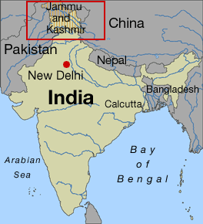
"Now Muslims all over the world have picked up arms … are marching in the field of jihad. Even those who rejected armed jihad are now joining this path after being disillusioned with democratic ways of peaceful protests," it says.
The video mentions Afghanistan, Syria, Iraq, Algeria and other theatres of recent Islamic extremism as inspirations to aspirant militants. It also refers to "attacks" in Europe, such as the killing of soldier Lee Rigby in London last year.
Specific messages are addressed to Kashmiri Muslims living on both sides of the de facto border between Pakistan and India, as well as to the broader Muslim populations of both countries.
Many within the Indian security establishment are concerned that the US and Nato withdrawal of forces from Afghanistan may lead to extremists fighting there transferring to a new "front" in Kashmir. The video promises a "caravan" of "heroic martyrs" coming from Afghanistan to "liberate Kashmir".
Western security officials have previously expressed concern that the recent election victory of the Hindu nationalist Bharatiya Janata party may lead to intensified militant activity in the region.
Allegations that the prime minister, Narendra Modi, allowed, or even encouraged violence in which 1,000 predominantly Muslim people died in Gujarat in 2002 have made him a target for Islamic extremists.
A video issued by a little-known group called the Ansar-ut-Tawheed fi Bilaad Hind (Brotherhood for Monotheism in the land of Hind) immediately after Modi's win referred repeatedly to the events in 2002. Officials believe the group is comprised of a small number of Indian nationals based in the restive semi-autonomous border zone of western Pakistan who may have connections with al-Qaida's senior leadership and local Pakistani militants.
India has suffered repeatedly from domestic and international terrorist attacks. The most devastating was in 2008 when militants from Lashkar-e-Taiba, a Pakistan-based organisation with links to the country's security establishment, made a bloody assault on Mumbai.

Terror court case in U.K. continues to be held in secret, alarming critics
Source: http://www.homelandsecuritynewswire.com/dr20140617-terror-court-case-in-u-k-continues-to-be-held-in-secret-alarming-critics

A major terrorism trial in the United Kingdom has also become a media cause célèbre as media representatives challenge senior judges, leading to a case which is both mysterious and well known.
As theTelegraph reports, the Court of Appeals has ruled in favor of multiple British media organizations, including the Telegraph, regarding the identities of two men — Erol Incedal and Mounir Rarmoul-Bohhadjar — reportedly connected to an alleged terror plot.
That came after the Crown Prosecution Service (CSP) had persuaded the case judge that the entire trial should take place in secret. No further reasons for the case have been made public, and it still remains uncertain whether the full trial will be reportable, despite the sentencing outcome. Before the appeal, the media was not legally allowed to acknowledge that the case was even to occur.
Senior Presiding Judge Lord Justice Peter Gross ruled in favor of further transparency on the Appeal Court when he said that “Open justice is both a fundamental principle of the common law and a means of ensuring public confidence in our legal system.” The court ruled that not revealing the identities of the men was too “draconian.”
He also acknowledged, however, the hurdles facing secretive and classified cases. “This case is exceptional,” he told theTelegraph. “We are persuaded on the evidence before us that there is a significant risk — at the very least a serious possibility — that the administration of justice would be frustrated were the trial to be conducted in open court.”
It has been rumored that the CSP was considering dropping the case altogether if it was forced to be public. While that has yet to play out, the beginning and end of the trial will be held in an open court, and a selected group of “accredited journalists” are allowed to sit in on the case - though with specific rules and instructions.
This clash comes in the wake of continued concerns that a trend of secretive sentencing continues as an “outrageous assault” and a “very dangerous precedent,” according to watchful civil rights groups.
The trial is set to take place this week.

Pentagon is capable of tracking the Taliban 5 freed from Guantanamo: experts
Source: http://www.homelandsecuritynewswire.com/dr20140617-pentagon-is-capable-of-tracking-the-taliban-5-freed-from-guantanamo-experts

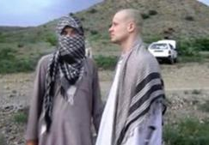
Critics of the White House’s release of five Taliban prisoners (Taliban 5) from Guantanamo Bay to Qatar are concerned that the group will eventually return to the battlefield in Afghanistan, posing a threat to American forces. The Daily Beast reported earlier this month that U.S. intelligence officials expect four of the five former prisoners to rejoin Taliban forces. Secretary of State John Kerry has said that doing so will open the terrorists to possible drone strikes; but that requires knowledge of their whereabouts.
How might intelligence analysts track the Taliban 5 during and after their stay in Qatar? Experts say that the Pentagon is capable of tracking the former detainees using algorithms that predict terrorists’ movements based on their personal history and network.
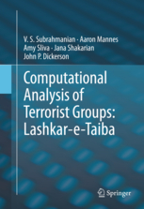
Former prisoners can be tracked with GPS if they have been implanted with trackers, but the United States has not disclosed whether it engages in the practice. Defense One reports that V. S. Subrahmanian, a computer science professor at the University of Maryland, suggests that his computer model, built to anticipate terrorist movements, is an option for tracking the Taliban 5. In the book Computational Analysis of Terrorist Groups: Lashkar-e-Taiba, Subrahmanian and fellow researchers used complex data analysis to predict the behavior of the Lashkar-e-Taiba and Indian Mujahideen terrorist groups. Their model has been credited with forecasting October 2013 attacks on the life of Indian prime ministerial Candidate Narendra Modi in Patna, India; as well as finding weapons caches in Iraq and Afghanistan.
“It works like a beacon,” Subrahmanian said. “When the condition is lit or not lit, you have a good understanding of whether or not the attack would occur in the next few months. You want to see if multiple of these conditions are turned on. If they are lit then you have great confidence of an attack.”
Subrahmanian added, “in our Lashkar-e-Taiba study, we looked at 770 variables about the group as a whole. Here, what I would do is look at variables associated with each individual. These would include family members, people they have carried out attacks within the past, organizations that they were associated with in the past like madrassas and charitable organizations. We would try to build a dataset to look at how these connections over the years have evolved, and links between those organizations are correlated with…So instead of just trying to predict how a network would evolve over time, you would be trying to predict who in the network these individuals would stay in touch with and then you would monitor those people extremely closely in addition to trying to monitor these individuals directly.”
Subrahmanian believes that the intelligence accumulated by U.S. officials throughout the years of the Taliban 5’s imprisonment in Guantanamo Bay is enough to build a model that can predict, with 80 percent accuracy, revealing who the Taliban 5 is likely to connect with in Qatar but also how those networks would change. “When they leave Qatar, they will have to rely on someone for logistical and financial support,” he said, assuming the group rejoins the battle against U.S forces. “The information gathered from all these people will allow U.S. military and intelligence sources to have a great picture of how these groups are connected to jihadists in Pakistan and Afghanistan.”

EDITOR’S COMMENT: Capable of tracking? With software? I do not think so! Unless they have inserted a tiny GPS system into their body. This might work. Anything else is just a bad academic joke…

How has Iraq lost a third of its territory to ISIS in three days?
By Ali Mamouri
Source: http://www.homelandsecuritynewswire.com/dr20140617-how-has-iraq-lost-a-third-of-its-territory -to-isis-in-three-days

The extremist Islamic State of Iraq and the Levant (ISIL), also known as ISIS, has captured a third of Iraq’s territory within a few days. Iraq’s third-biggest city, Mosul, fell within hours of being attacked despite having a government force of around 27,000 troops to defend it.
ISIL is an amalgam of Sunni paramilitary forces that operate in Iraq and Syria. It is the latest and most successful extremist group to emerge in the region and combines former Ba’ath era military officers, former al-Qaeda members and fundamentalists from countries energized by the Arab Spring. Alienated Muslims from the West have also been attracted by the achievements of ISIL in Syria’s civil war.
Recent territorial gains by ISIL mean the group controls practically the entire Sunni majority regions of Iraq along the Syrian frontier. How could a rebel force of fewer than 10,000 fighters defeat Iraq’s security apparatus of over a million personnel? Can Iraq’s elected government overcome this threat to its authority and very existence?

Why has Iraq’s military failed?
A new Iraqi army was re-established from militia members and low-ranking members of the Ba’ath army when it was dissolved in 2003. Senior officers in Saddam Hussein’s forces were dismissed, which gave rise to at least two security issues. Firstly, military officers of the previous army were steered towards terrorist groups. Secondly, Iraq’s new military suffered from the loss of expertise and military discipline instilled by their former officers.
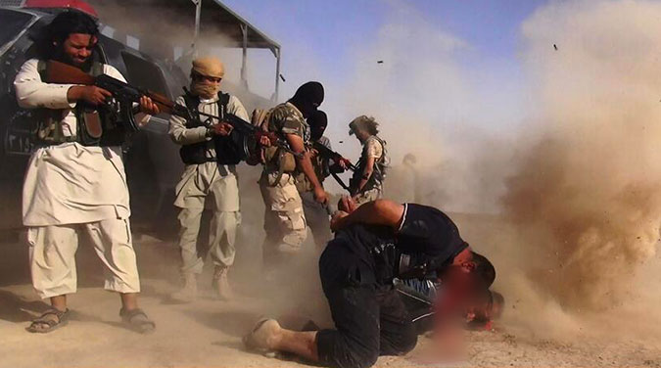
As a result, Iraq’s army lacks the essential expertise and discipline to fight a terrorist group. ISIL fighters in most situations have superior combat experience to the government’s better-equipped forces.
The lack of an effective intelligence agency in Iraq has also enabled ISIL to infiltrate the army. Additionally, political leaders who make the final decisions on military operations are typically inefficient, as the government does not have a clear vision, strategy and effective tactics to overcome national problems.
Poor governance has led to widespread corruption in both political and military spheres. Military personnel are routinely reported to be soliciting bribes, especially in Sunni areas of Iraq.
One of the most dramatic and comical examples of corruption was a recent $85 million contract to acquire ADE 651 bomb-detection devices. At $40,000 per unit it was later revealed that the delivered sonar was a hoax, not more than a child’s toy.
The British government intervened by suspending production, closing the manufacturing company and investigating the contractor, Jim McCormick; he was sentenced to ten years’ jail in 2013. Despite the ineffectiveness of this military hardware, Iraq’s government still uses these devices without trying to find functional alternatives.

The failure of transitional justice
Transitional justice is one of the most important components of the democratization process in countries such as Iraq, which has suffered from the long-term effects of dictatorship followed by violent sectarianism. This project has been another policy failure by Iraq’s new government.
Iraq’s elected government officials have tried and punished a few prominent criminals associated with the former regime. They have, however, neglected other aspects of the transitional justice process: truth-seeking, national reconciliation and the combatting of sectarianism and discrimination.
Sunni Iraqis now experience the same issues that Shiites used to endure under Saddam Hussein’s regime. Significant numbers of Sunnis are imprisoned without charge. National and international organizations report a variety of human rights violations involving the government. High rates of sectarianism and discrimination are perpetrated against Sunnis by military forces.
Iraq’s government also discriminates in favor of Shiite militias to the detriment of Sunni militias. The government permits Shiite militias to operate freely across Iraq and Syria and does not consider them terrorists. Some, such as Al-Asaeb, even operate as government allies.
At the same time, the government suppresses any kind of Sunni opposition militia groups — including some civilian-dominated ones. This has all led to a widespread discontent among Sunni people. They may not subscribe to ISIL, but welcome any alternative to their current situation.

Iraq as a regional sectarian warfront
Iraq has become a battleground for competing sectarian interests in the Middle East. Saudi Arabia and Qatar have thrown their support behind Sunni militias in Iraq to pressure Iran and distract it from supporting Bashar al-Assad in Syria. Iran, for its part, has stuck to extremist Shiite parties, showing no tolerance towards moderate Sunni or even moderate Shiite parties.
This has led to the opening of a deadly rift within Iraqi society. Sunnis accuse Shiites of following Iranian agendas. Shiites accuse Sunnis of being the fifth column of Saudi Arabia and Qatar because they do not want to live under the rule of the Shiite majority in their own country.
Even though ISIL cannot maintain its recently gained territory, the current situation is far from optimistic and remains very fragile. Serious problems resulting from decades of dictatorship have combined with the issues arising from a failed new regime.
At the same time, the solution of dividing the country along sectarian lines is rejected by vast numbers of Iraqis, who want to live in a united Iraq. The continued existence of common Sunni-Shiite areas makes any carve-up of Iraq along sectarian lines a very painful and bloody process — one that ISIL’s victories may have initiated.

Ali Mamouri is a PhD Candidate at Institute for Social Justice at Australian Catholic University.

EDITOR’S COMMENT: The academic reasoning is valid but misses’ reality. Same reality that US officials are missing in both Iraq and Afghanistan. You do not organize these countries the same way Western countries are organizing their defense structures. You do that taken into account other factors as well such as religion, ethnicities, heritage, tradition and alike. These are the factors leading to ISIL’s march in such a short period of time practically with no restistance; only by using brutal force and intimidation via executions and murders. Why nobody pays any attention to “know the enemy” instead of trying to copy and paste them western values that are not applicable in this part of our world?

Second Front Opens in the Sunni-Shia War
By Jonathan Spyer
Source: http://www.meforum.org/4728/second-front-opens-in-the-sunni-shia-war

The Islamic State in Iraq and the Levant (ISIL) organization swept into the city of Mosul in western Iraq last week. No one has any right to be surprised. ‬
ISIL has held a large swath of western Iraq since January – including the city of Fallujah. The organization was clearly planning a larger scale offensive action into Iraq. ‬
In January it had carried out a strategic withdrawal from large swaths of Idleb and Aleppo provinces in Syria. This was intended to consolidate its lines in northern Syria, so as to move fighters out toward Iraq. ISIL controls a contiguous bloc of territory stretching from western Iraq up through eastern and northern Syria to the Turkish border. ‬
Its "Islamic State" is already an existing, if precarious fact, no longer a mere aspiration. So, like a state at war, it moves its forces to the front where they are most needed‬.
The rapid collapse of Nouri al-Maliki's garrison in Mosul in the face of the ISIL assault should also come as no surprise. These forces are hollow. ‬
Saddam Hussein maintained a huge army by coercion. Shirkers and deserters could expect to be executed. But Maliki's army consists of poorly paid conscripts and often corrupt officers. The Shia among them in Mosul saw no reason to fight and die for what seemed to them to be Sunni, alien territory. Sunni officers among the garrison, meanwhile, may well have been working with ISIL itself or with one of the other Sunni Islamist or nationalist formations fighting alongside them. ‬
So what will happen now? The pattern of developing events is already clear, and much may be learned from the experience of Syria. ‬
Bashar Assad, when rebellion broke out against him in March 2011, sought to use his huge conscript army to crush it. But the Syrian dictator rapidly found out that his supposedly 295,000-strong army was largely a fiction. Sunni conscripts refused to engage against the rebels, and Bashar was able to make use only of certain units composed largely of members of his own Alawi sect — units such as the Republican Guard and the 4th Armored Division. ‬
How did Assad address this problem? The answer is that he didn't — Iran did. ‬
Realizing that their Syrian ally was facing defeat because of an absence of reliable manpower, the Quds Force of the Iranian Revolutionary Guards Corps stepped in to effectively create a new, sectarian military for the Assads. In addition, Iran introduced its various regional paramilitary proxies into the Syrian battlefield. ‬
By mid-2013, the new, sectarian infantry force trained by the Quds Force and Hizballah – named the National Defense Force – was beginning to be deployed against the Syrian rebellion. In addition, Hizballah, and Iraqi Shia volunteers of Sadrist and other loyalties began to fill the gaps in manpower for Assad. ‬
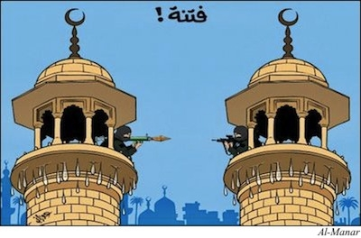
These units turned the tide of the Syrian war. But they have brought Assad survival, not victory. The dictator rules over only about 40% of the territory of what was once Syria. The rest is under the control of ISIL, the Kurds, and the Sunni Arab rebels. ‬
It is likely that a similar pattern will now emerge in Iraq. Quds Force commander Qassem Suleimani has been in Baghdad since Friday. He is in the process of organizing Iraqi Shia volunteers, who in the months to come are likely to be transformed into a sectarian military force resembling the Syrian National Defense Force. ‬
In addition to the new volunteers, Iraqi Shia militiamen in Shia southern Iraq and in Syria are flocking toward the battlefront, eager to do battle with ISIL on their home soil. ‬
These hastily assembled forces, along with the reliable elements of Maliki's military, are likely to prove sufficient to defend the capital and perhaps to prevent further gains by ISIL, which may have over-reached itself. But the new, openly sectarian Shia forces behind Maliki are unlikely to succeed in re-taking the entirety of ISIL's territorial gains in Anbar and Ninewah provinces. ‬
Iran is a leading world expert in the creation of proxy sectarian military forces. But given the demographic balance in present day Iraq, and in Syria, Iran's assistance is likely to ensure the survival of the non-Sunni population only in a part of the country in question. That is – ISIL and Iran's intervention into Iraq may well portend the de facto partition of that country, and its plunging into a prolonged conflict, along the lines of what is currently taking place in Syria. ‬
Indeed, given the players engaging in Iraq, it is more sensible to see the Syrian civil war and the renewed Iraq conflict as different battlefronts in a single, sectarian war — in which Sunni and Shia/Alawi forces are clashing. The latter are backed crucially by Iran. The former receive far less systematic and determined backing from a variety of sources, including private elements in the Gulf and perhaps the intelligence services of a number of Gulf states.
Only in Lebanon, which lacks a native Sunni military tradition, have the Iranian proxy forces managed to secure near complete military domination of the country. In the very different and far more consequential contexts of Iraq and Syria, Sunni rebellion and Iranian reaction are likely to produce the fracturing of the countries in question along sectarian lines. ‬
The Kurds, possessors of a strong, largely secular nationalist tradition and identity, may emerge as major winners from this process of fragmentation, in the context both of Syria and Iraq (as witnessed by the rapid gains made by the Iraqi Kurdish Peshmerga forces in recent days). ‬
As for the warring Arab Islamic sects, they are set to continue to battle one another, with ready foreign help, over the ruins of the countries once known as Iraq and Syria. This war is just beginning. Any attempts to portray either of the warring sides as "anti-terrorist" or "pro-western" should be stubbornly resisted. Acceptance of such definitions is the entry hall to new policy failures and wasted lives. ISIL and the Quds Force differ in organizational structure, but are similarly anti-western — and similarly vile. They should be left to bleed one another white.‬

Jonathan Spyer is a senior research fellow at the Global Research in International Affairs (GLORIA) Center and a fellow at the Middle East Forum.

ISIS insurgents take over Iraq’s largest refinery, continue advance toward Baghdad
Source: http://www.homelandsecuritynewswire.com/dr20140618-isis-insurgents-take-over-iraq-s-largest-refinery-continue-advance-toward-baghdad

June 18 – ISIS Islamic militants took over Iraq’s biggest oil refinery, located near the town of Baiji, 130 miles north of Baghdad.
The fall of the refinery is a major blow to the already-reeling government of Nouri al-Maliki. The refinery provides about 40 percent of Iraq’s refined oil needs, and if the supplies dry up, the Iraqi economy would be paralyzed within a few days, and Iraqi citizens would be without power or gas for their cars.
As was the case since the ISIS campaign began late last week, the Iraqi military and security forces put up only a token resistance, with most of their units melting away and leaving their arms and equipment behind without even engaging the militants.
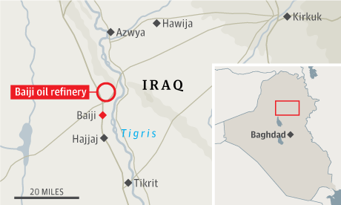
The capture of the Baiji refinery, and the ability to sell the oil refined there, would add an important source of income to ISIS, similar to its sources of income in Syria. In Syria, the Assad regime, since last summer, has stopped attacking ISIS formations – and release from jails all the ISIS fighters it was holding – in an effort to strengthen the Islamists. The regime allowed the Islamist organization to solidify its hold on vast areas in east Syria, including oil-producing areas, from which the organization has been selling oil for the last eight months. The Assad regime continued to attack the moderate anti-regime rebels, and encouraged the ISIS and al-Nusra Islamists to do the same. Assad reckoned that if the opposition to his regime would be perceived as consisting mostly of Islamist fanatics, it would be more difficult for Western powers to support the opposition, and would also make it more difficult for moderate Syrian Sunnis to support the rebels.
An Iraqi military spokesman, Gen. Qassim Atta, appearing on Iraqi TV, denied that the Baiji refinery had fallen, but little of what the Maliki government and its spokesmen have said in the last five days corresponded to reality on the ground.
ISIS fighters have set up checkpoints to control access to the sprawling refinery area.
The refinery had been under siege for about a week, after the surrounding Salahuddin Province had fallen to the rebels.
The German company Siemens said it had evacuated its fifty employees from the facility over the weekend. ISIS militants have allowed both foreign and Iraqi employees to leave the refinery without harassing them.
The refinery security contractor, Olive Group, said earlier it has evacuated all the foreign workers from the site.
The Baiji complex, in addition to including Iraq’s largest refinery, is also the site of a 600-megawatt power plant, which supplies electricity to much of northern Iraq.
The New York Times reports that the refinery has the capacity to process 310,000 barrels of oil produced in northern Iraq, and provides refined products to eleven Iraqi provinces, including Baghdad, chiefly for domestic consumption. Iraqi officials said that the insurgents shut down the refinery, but that it was not damaged.
Iraq is the second largest oil producer in OPEC, representing the largest source of oil-production growth among the twelve member countries.

EDITOR’S COMMENT: It would be easy to fight back ISIS by all means of military arsenal available. But how can you regain a refinery intact???

UPDATE [June 19]: Iraqi army regain refinery practically without a fight… This is encouraging!

Growing Jihadist threat demands new U.S. strategy to combat terrorism: RAND study
Source: http://www.homelandsecuritynewswire.com/dr20140605-growing-jihadist-threat-demands-new-u-s-strategy-to-combat-terrorism-rand-study

There is a growing terrorist threat to the United States from a rising number of Salafi-jihadist groups overseas, according to a RAND Corporation study.
Since 2010, there has been a 58 percent increase in the number of jihadist groups, a doubling of jihadist fighters, and a tripling of attacks by al Qaeda affiliates. The most significant threat to the United States, the report concludes, comes from terrorist groups operating in Yemen, Syria, Afghanistan, and Pakistan.
“Based on these threats, the United States cannot afford to withdraw or remain disengaged from key parts of North Africa, the Middle East and South Asia,” said Seth Jones, author of the study and associate director of the International Security and Defense Policy Center at RAND, a nonprofit research organization (also see Seth G. Jones, “The Accelerating Spread of Terrorism,” Wall Street Journal, 3 June 2014). “After more than a decade of war in Afghanistan and Iraq, it may be tempting for the U.S. to turn its attention elsewhere and scale back on counterterrorism efforts. But this research indicates that the struggle is far from over.”
A RAND release reports that for the RAND study, Jones examined thousands of unclassified and declassified primary source documents, including public statements and internal memorandums of al Qaeda and other Salafi-jihadist leaders. The study also includes a database of information such as the number of Salafi-jihadist groups, their approximate size and their activity — attacks, fatalities and other casualties.
The RAND study focuses on Salafi-jihadist groups, a particular strand of militant Sunni Islamism. These groups, which include al Qaeda and its affiliates, emphasize the importance of returning to a “pure” Islam, that of the Salaf, the pious ancestors. They also believe that violent jihad is a personal religious duty for every devout Muslim, Jones said.
One reason for the increase in groups, fighters, and attacks is the weakness of governments across North Africa and the Middle East. Weak governments have difficulty establishing law and order, which allows militant groups and other sub-state actors to fill the vacuum.
These trends suggest that the United States needs to remain focused on countering the proliferation of Salafi-jihadist groups, despite the temptation to shift attention and resources to the Asia-Pacific or other regions and to significantly decrease counterterrorism budgets in an era of fiscal constraint, Jones said
The report documents how the broader Salafi-jihadist movement has become more decentralized among four tiers: core al Qaeda in Pakistan; formal affiliates that have sworn allegiance to al Qaeda; Salafi-jihadist groups that have not sworn allegiance to al Qaeda, but are committed to establishing an extremist Islamic emirate; and inspired individuals and networks.
Jones says the threat posed by these diverse groups varies widely. Some are locally focused and have shown little interest in attacking Western targets. Others, like al Qaeda in the Arabian Peninsula, present an immediate threat to the U.S. homeland, along with inspired individuals like the Tsarnaev brothers who perpetrated the April 2013 Boston bombings. Others threaten U.S. interests overseas, but not the homeland.
In addition to high-level threats from Yemen, Syria, Afghanistan, and Pakistan, the RAND study concludes that there is a medium-level threat from terrorist groups operating in Somalia, Iraq, Libya, Lebanon, Nigeria, and Algeria. There is also a low-level threat from Salafi-jihadist groups operating in such countries as Tunisia, Mali, and Morocco.
In response to these threats, Jones says the United States should establish a more-adaptive counterterrorism strategy, pursuing engagement — the use of special operations, intelligence, diplomatic, and other capacities to conduct precision targeting of these groups and their financial, logistical, and political support networks — where there is a high threat to the United States and a low local government capacity.
In other cases, the United States may adopt a “forward-partnering” strategy, Jones said. Forward partnering involves deploying small numbers of U.S. military forces, intelligence operatives, diplomats and other governmental personnel to train local security forces, collect intelligence, and undermine terrorist financing. Unlike an engagement strategy, however, U.S. forces would not directly become involved in the war by conducting raids or drone strikes.
A third strategy, “offshore balancing,” should be used in cases where there is little or no direct threat to the United States. Offshore balancing involves relying on allies and local governments to counter terrorist groups, while avoiding direct engagement or forward partnering.

— Read more in Seth G. Jones, A Persistent Threat: The Evolution of al Qa’ida and Other Salafi Jihadists (RAND Corporation, June 2014)

The Financial Legacy of Iraq and Afghanistan: How Wartime Spending Decisions Will Constrain Future National Security Budgets
By Bilmes, Linda J. HKS Faculty Research Working Paper Series RWP13-006, March 2013.
Source:https://research.hks.harvard.edu/publications/workingpapers/citation.aspx?PubId=8956&type=WPN

Abstract
The Iraq and Afghanistan conflicts, taken together, will be the most expensive wars in US history – totaling somewhere between $4 to $6 trillion. This includes long-term medical care and disability compensation for service members, veterans and families, military replenishment and social and economic costs. The largest portion of that bill is yet to be paid. Since 2001, the US has expanded the quality, quantity, availability and eligibility of benefits for military personnel and veterans. This has led to unprecedented growth in the Department of Veterans Affairs and the Department of Defense budgets. These benefits will increase further over the next 40 years. Additional funds are committed to replacing large quantities of basic equipment used in the wars and to support ongoing diplomatic presence and military assistance in the Iraq and Afghanistan region. The large sums borrowed to finance operations in Iraq and Afghanistan will also impose substantial long-term debt servicing costs. As a consequence of these wartime spending choices, the United States will face constraints in funding investments in personnel and diplomacy, research and development and new military initiatives. The legacy of decisions taken during the Iraq and Afghanistan wars will dominate future federal budgets for decades to come.

Has the US-UK War for Oil Detonated the “New Iraq”?
By Felicity Arbuthnot
Source: http://dissidentvoice.org/2014/06/has-the-us-uk-war-for-oil-detonated-the-new-iraq/

What a black, tragic irony. Just two months ago, on the 11th anniversary of the (illegal) invasion of Iraq, the Guardian reminded that the mass slaughter, the incineration of swathes of towns, cities and the use of US-UK weapons of mass destruction was not about Iraq’s weapons of mass destruction, but about oil (a fact long established for any one with even minimal gray matter.)
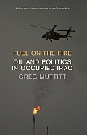
Today flames are rising from Iraq’s largest oil refinery at Baiji, 130 miles north of Baghdad, the result of mortar attacks by the varying forces sweeping towards the capitol city.
The Guardian outlined the invasion’s “real goal, as Greg Muttitt documented in his book Fuel on the Fire, citing declassified Foreign Office files … was stabilising global energy supplies (especially) ensuring the free flow of Iraqi oil to world markets” with advantage to US and UK companies. “The most important strategic interest lay in expanding global energy supplies, through foreign investment, in some of the world’s largest oil reserves – in particular Iraq.”
The documents showed that the US and UK sought to privatise Iraq’s oil production and carve it up amongst favored investors.
Further, according to the Independent, in March 2003, just before Britain went to war, Shell denounced reports that it had held talks with Downing Street about Iraqi oil as “highly inaccurate”. BP denied that it had any “strategic interest” in Iraq, while Tony Blair described “the oil conspiracy theory” as “the most absurd.”
As ever, it seems Tony Blair had tossed truth under a bus. In October and November 2002, documents came to light showing that then, just months before the invasion, Baroness Symons, then the Trade Minister, told BP that the Government believed British energy firms should be given a share of Iraq’s enormous oil and gas reserves as a reward for Tony Blair’s military commitment to US plans for regime change.
Further, Lady Symons agreed to lobby the Bush administration on BP’s behalf because the oil giant feared it was being “locked out” of deals that Washington was quietly striking with US, French and Russian governments and their energy firms.
Minutes of a meeting with BP, Shell and BG (formerly British Gas) on 31 October 2002 read:
Baroness Symons agreed that it would be difficult to justify British companies losing out in Iraq in that way if the UK had itself been a conspicuous supporter of the US government throughout the crisis.
On 6 November 2002, the Foreign and Commonwealth Office invited BP for a chat to discuss opportunities in Iraq “post regime change”. Minutes of the meeting record:
Iraq is the big oil prospect. BP is desperate to get in there and anxious that political deals should not deny them the opportunity.
The previous month the Foreign Office’s then Middle East Director, Edward Chaplin, noted: “Shell and BP could not afford not to have a stake in (Iraq) … We were determined to get a fair slice of the action for UK companies in a post-Saddam Iraq.” BP representatives told the Foreign Office that Iraq was: “more important than anything we’ve seen for a long time”.
Moreover, Greg Muttit’s Fuel on the Fire revealed that:
The 20-year contracts signed in the wake of the invasion were the largest in the history of the oil industry. They covered half of Iraq’s reserves – 60 billion barrels of oil, bought up by companies such as BP and CNPC (China National Petroleum Company), whose joint consortium alone stands to make £403m ($658m) profit per year … (Emphasis mine.)
On February 6th, 2003 Tony Blair stated:
Let me just deal with the oil thing because… the oil conspiracy theory is honestly one of the most absurd when you analyse it. The fact is that, if the oil that Iraq has were our concern, I mean we could probably cut a deal with Saddam tomorrow in relation to the oil. It’s not the oil that is the issue, it is the weapons…
However, overnight and this morning (Wednesday, June 18th) it looks as if the plotting, illegal carve-up and grand theft of Iraq’s major resource might have come back to haunt them as the rebels sweeping the country are widely reported to control much of Iraq’s largest refinery. BP has evacuated 20 percent of staff so far from the southern oilfields although far from Baiji, and Exxon Mobile has conducted a “major evacuation.”
One thousand Chinese oil workers are reported trapped further north, with forty-nine Turkish Embassy staff and other Turkish citizens held hostage.
Foreign workers are reported to have been helicoptered out of Baiji, now seemingly almost entirely under control of the rebels, who “are in control of the production units, administration building and four watch towers. This is seventy five percent of the refinery.” The flames, however, still rise over parts of this vast, volatile complex. As I write, a report has just come in on a live feed to the Guardian from a government employee, Salah Majed, at Baiji who says the plant is on the verge of falling entirely to the rebels.
Meanwhile, as the Iraqi “government” (most of them fled for the airport and anywhere not in Iraq over the weekend) comprising near singularly of “Prime Minister” Nouri Al Maliki – who has not yet formed a parliament after the crooked elections of April 30th from which Anbar, the largest governorate in Iraq. was excluded – has asked for US air intervention against the “rebels.” So, again, Iraq is to be potentially bombed into “peace” for oil — Illegal, genocidal, insanity. Iraq was today designated a UN level three humanitarian disaster.
Ironically, Baiji was 80 percent destroyed in the first Gulf war in 1991. In spite of the crippling US-UK driven UN embargo where no spare parts for anything were allowed, it was rebuilt in about two months.
Further ironically, Baiji was where British hostages captured in Kuwait were held during the first Gulf War. It may yet hold Iraq’s US imposed puppet and the remnants of his regime hostage.
The complex sits in what the US occupiers simplistically called “the Sunni Triangle”, largely supporters of the former secular Iraq, rather than the sectarian tragedy, the feckless open-bordered disaster that the invasion sponsored.
Will it yet, between oil and nationalism, hold the key to Iraq’s future and escape from those who came in and imposed murderous dictats and their despot on a “far away place of which (they) knew nothing”?

Felicity Arbuthnot is a journalist with special knowledge of Iraq. Author, with Nikki van der Gaag, of Baghdad in the Great City series for World Almanac books, she has also been Senior Researcher for two Award winning documentaries on Iraq, John Pilger's Paying the Price: Killing the Children of Iraq and Denis Halliday Returns for RTE (Ireland).

WHAT IF
ISIS (Iraq) joins operations
with Ukraine insurgents,
Al Shabaab (Somalia) and Boko Haram (Nigeria)?

Europe faces 'greatest terror threat ever' from jihadists in Iraq and Syria
Source: http://edition.cnn.com/2014/06/19/world/europe/lister-european-jihadists/

The city of Cannes on the French Riviera is best known as a hang-out of the rich, and for its film festival, not as a terrorist hide-out. But police recently swooped on an apartment on its outskirts -- and discovered soda cans converted into crude bombs. The devices contained nearly one kilogram of the high explosive TATP -- a substance used to make detonators in multiple al Qaeda bomb plots against the West in the years after the September 11, 2001 attacks on the United States.
The apartment was the home of a 23-year old man -- named by prosecutors only as Ibrahim B -- who had swapped online messages that talked of "punishing France." He had spent 18 months in Syria fighting with the al Qaeda affiliated Jabhat al Nusra before being arrested in February after returning to France.
The case of Ibrahim B is one of dozens in recent months involving European jihadists returning from Syria and Iraq, after joining groups like al-Nusra and the Islamic State in Iraq and Syria (ISIS) -- gaining combat experience, training and an extremist mindset.
A European counter-terrorism official told CNN up to 300 veterans of the Syrian Jihad have already come back to Europe.
"The threat of attacks has never been greater -- not at the time of 9/11, not after the war in Iraq -- never," the European counter-terrorism official told CNN. He envisaged a flood of small-scale but effective and chilling attacks.
Speaking to parliament in London Wednesday, British Prime Minister David Cameron said ungoverned space across a huge area must be closed down.
"We must do that not only in Syria, but in Iraq, Somalia, Nigeria and Mali, because these problems will come back and hit us at home if we do not," he said.
An early indicator of the potential threat came last month when a gunman opened fire at a Jewish museum in the Belgian capital, Brussels, killing four people. Authorities are investigating whether ISIS had a role in what was the first terror attack on Western soil linked to Syria.
The man accused of the murders is Mehdi Nemmouche, a French-Algerian extremist who travelled to Syria after being radicalized in a French jail, according to prosecutors. When French police arrested him a week after the attack they found a Kalashnikov wrapped in a flag with ISIS insignia in his possession.
Just hours after his arrest was made public a French ISIS fighter based in Syria tweeted that Nemmouche had fought with ISIS under the name Abu Omar al Firansi. The posting was then deleted, according to a senior Belgian counter-terrorism official.
It was the "strongest indication we have so far that Nemmouche was part of the ISIS but by no means proves it," the official told CNN. But he added: "We can't rule out that he was thinking of launching an attack even before leaving for Syria." ISIS has not claimed responsibility for the attack and Nemmouche has yet to enter a plea.
Aggravating the threat, according to a European-counter-terrorism official, is woefully inadequate intelligence-sharing in Europe. Nemmouche, a French citizen, was on a European watch-list. But he took precautions to try to mask his time in Syria -- flying into Frankfurt from Bangkok in March after spending several weeks in south-east Asia.
German authorities informed French police when he arrived at Frankfurt airport. But Nemmouche traveled to Belgium, where authorities were unaware of his time in Syria. European Union treaties allow individuals to travel across much of the continent without showing their passport.
The official said a central European database was needed to track extremists leaving to and returning from Syria. He said European governments were beginning to understand the need for better collaboration.
There was a sign of that last weekend with the arrest of a French citizen, Tewffiq Bouallag, who arrived in Berlin from Istanbul last weekend. The day before his arrival, France issued an international arrest warrant for Bouallag (there was no such warrant for Nemmouche.) Bouallag had joined ISIS in Syria, according to postings on social media sites, and uploaded photos of himself and other ISIS fighters, encouraged others to follow his example and even indicated he was preparing to return to Europe.
But scouring social media and jihadist forums is labor-intensive and demands language
skills. And the most dangerous militants won't be so transparent about their intentions.

The numbers
European officials believe about 2,000 EU citizens have answered the call to jihad, including the wives of fighters. Perhaps 500 to 1,000 of them have joined ISIS, officials say.
France, Germany and the UK account for the largest numbers, all with hundreds of citizens fighting in Syria.
But in per capita terms more have travelled from Belgium than any other EU country. A Belgian counter-terrorism official says they are aware of 150 Belgian fighters in Syria -- most of them with ISIS. Up to 15 more were leaving every month. About 35 are thought to have been killed, and 60-70 had returned home. Round-the-clock surveillance is impossible for all but a very small number because of the prohibitive expense.
Belgium has sizeable North African and Turkish Muslim populations and active radical groups such as Sharia4Belgium, some of whose supporters traveled to Syria back in 2012, laying the groundwork for more to follow and communicating with friends via social media to encourage them to make the journey.
One figure of particular concern is Azzedine Kbir Bounekoub -- a Belgian in his 20s who is thought to be in Raqqa in Syria, ISIS' main hub, and who has called for further attacks in Belgium.
"May Allah raise up more young people who take the example of those who committed the attack in the Jewish museum ... their blood, wealth and honor is halal for us," he wrote on his Facebook page on June 3.
The official told CNN that authorities were often playing "catch-up" -- sometimes finding out about suspicious travel months after someone had packed their bags. Inevitably, he said, some escaped detection altogether. The task was made more difficult by the fact that a lot of Belgians go on vacation to Turkey.
European officials say there needs to be closer co-operation with Turkey, which should be given a list of people suspected of intending travel to Syria. Turkish authorities say such individuals should be prevented from leaving their countries of origin, but travel bans are often difficult to impose through the courts. Nor is travel to Syria illegal in itself; authorities have to show membership of designated terror groups or the intention to commit an act of terror in order to bring charges.
It's not solely a European problem either. A group of Canadians is known to be fighting for ISIS. One of them, Salman Ashrafi from Calgary, was eulogized after carrying out a suicide attack that left at least 19 people dead. And a young U.S. citizen became the first American to carry out a suicide bombing in Syria last month.

'Worse than al Qaeda'
As yet neither ISIS nor al-Nusra has shown any intention to export jihad to Europe, but militants returning home may need no encouragement, and may have bomb-making skills. Both groups carry out suicide bomb attacks on an almost daily basis.
"The worry is that Europeans in the group may out of their own initiative return home to launch attacks. The question becomes to what extent will the ISIS leadership try to control this?" said a European counter-terrorism official.
The extremist discourse in Europe is now dominated by ISIS, which "is winning the battle for hearts and minds much more than al Qaeda," thanks to its lightning offensive across Iraq, says the official. It's a replay of the jihadist fervor generated by al Qaeda in Iraq when it captured the city of Falluja in 2004.
"There's huge excitement on online jihadist forums," said the official. "It's a further catalyst for radicalization and could lead to a surge in travel flows."
Some militants return to Europe traumatized and frustrated by the brutality and infighting in Syria and appear to want no further part in jihad, according to counter-terrorism sources. But many would-be jihadists think nothing of brutal videos showing Shia getting their throats slit. And rather than being angered by specific events, such as the U.S. invasion of Iraq, they are motivated by an ingrained loathing of the West.
ISIS is beginning to tap into this vein. This week it issued a five-minute video in German entitled "Haya Alal Jihad" (Let's Go For Jihad) on its Twitter account. According to the SITE Intelligence Group, which monitors jihadist communications, a "voice that sounds like German jihadist Denis Cuspert (Abu Talha al-Almani) calls on Muslims to join jihad and seek martyrdom."
"Brothers, it's time to rise, set forth for the battle if you are truthful, either achieve victory or the shahadah [martyrdom]," the narrator says.
The call is being answered.

EDITOR’S COMMENT: A naïve question: since everybody knows the numbers of those European, Americans, Canadians etc fighting in Syria and Iraq why don’t they shut them down upon attempting to return back home?

2014 Global Peace Index
Source: http://www.visionofhumanity.org/#/page/our-gpi-findings

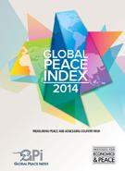
We are living in the most peaceful century in human history; however the 2014 Global Peace Index shows that the last seven years has shown a notable deterioration in levels of peace.
The Global Peace Index measures peace in 162 countries according to 22 indicators that gauge the absence of violence or the fear of violence. This is the 8th year the index has been produced.

Highlights
Since 2008, 111 countries have deteriorated in levels of peace, while only 51 have increased.
Europe retains its position as the most peaceful region with 14 of the top 20 most peaceful countries.
The world has become less peaceful over the last year, mainly due to a rise in terrorist activity, the number of conflicts fought and the number of refugees and displaced people.
500 million people live in countries at risk of instability and conflict, 200 million of whom live below the poverty line.
The Global Economic Impact of violence reached US$9.8 trillion last year, which is equal to 2 times the total GDP of Africa.

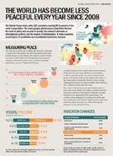
Results
The most peaceful countries are Iceland, Denmark and New Zealand.
Georgia, Cote d’Ivoire and Libya all made the biggest improvements in peace since last year. A common characteristic in all these countries is the ongoing improvement in political stability in the wake of conflict.
Syria replaces Afghanistan as the world’s least peaceful country. South Sudan experienced the largest fall on the Global Peace Index and dropping 16 places to rank 160th of 162 countries.

Quote from Steve Killelea*
“Given the deteriorating global situation we cannot be complacent about the institutional bedrocks for peace: our research shows that peace is unlikely to flourish without deep foundations. This is a wakeup call to governments, development agencies, investors and the wider international community that building peace is the prerequisite for economic and social development.”

Trends in Peace
Trends in peace are shifting from hostility between states, to a rise in the number and intensity of internal conflicts.
Since 2008 only four of the Global Peace Index’s 22 indicators showed improvement, while 18 deteriorated.

Assessing Country Risk
This year the analysis includes findings from a new country risk analysis. The research has identified 10 countries likely to deteriorate in peace over the next two years are: Zambia, Haiti, Argentina, Chad, Bosnia and Herzegovina, Nepal, Burundi, Georgia, Liberia and Qatar.
Countries at risk span all regions and represent all government types except for full democracies. To find out more about countries at risk, download the Global Peace Index 2014 Report and skip to page 55.

Economic Impact
The economic cost of violence to the global economy is equivalent to around US$1,350 per person, or twice the size of Africa’s economy.
To explore violence containment spending by country, download the Economic Impact of Violence Containment, a report that details the cost of violence in over 150 countries according to 13 different types of violence related spending.

Methodology
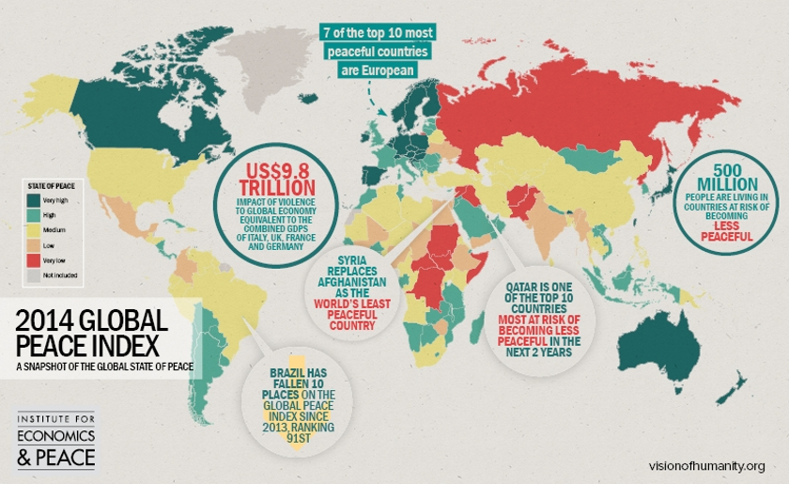
The Global Peace Index ranks 162 countries covering 99.6% of the world’s population. The Index gauges global peace using three themes: the level of safety and security in society, the extent of domestic or international conflict, and the degree of militarisation. It ranks countries according to 22 indicators of peace. Read the Global Peace Index methodology article for a full list of indicators, scores, weighting and more.

Explore
Explore the Global Peace Index interactive map to see where the countries of the world rank according to their peacefulness.

Download the 2014 Global Peace Index Report to read an analysis of the state of peace, as well as the countries most at risk of becoming less peaceful at:
http://www.visionofhumanity.org/sites/default/files/2014%20Global%20Peace%20Index%20REPORT.pdf

*Steve Killelea is an accomplished entrepreneur in high technology and international business development and at the forefront of philanthropic activities focused on peace and sustainable development. With over 30 years experience in the information technology industry, Steve is highly skilled in international marketing, business and product strategy, and has developed two highly profitable global companies with exceptional track records. Steve founded the Institute for Economics and Peace to focus on better understanding the linkages between business, peace and economic development. He is also the founder of the Global Peace Index the first ever tool for measuring the peacefulness of countries and identifying the drivers of peace.

Country-Specific Trends in Terrorism, 2012-2013
Source: http://www.terrorismwatch.org/2014/06/infographic-country-specific-trends-in.html?utm_source =feedburner&utm_medium=email&utm_campaign=Feed%3A+terrorismwatch%2FJTvK+%28Terrorism+Watch%29
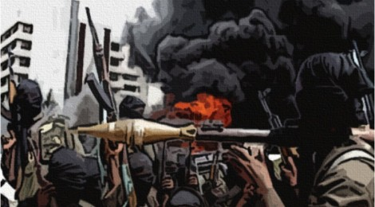
Editor’s note: We’ve partnered with the National Consortium for the Study of Terrorism and Responses to Terrorism (START) to publish a series of infographics based on data from their Global Terrorism Database and related START projects. Each week we’ll release a new set of graphics that depict trends in global terrorism activity.
Last week we published a global heat map that depicted the intensity and concentration of terrorist violence in 2013. This week, we look at those country es that saw the greatest increase, greatest decrease, and most stability in levels of terrorism between 2012 and 2013. The graphics are again produced by START and are based on data from their Global Terrorism Database.
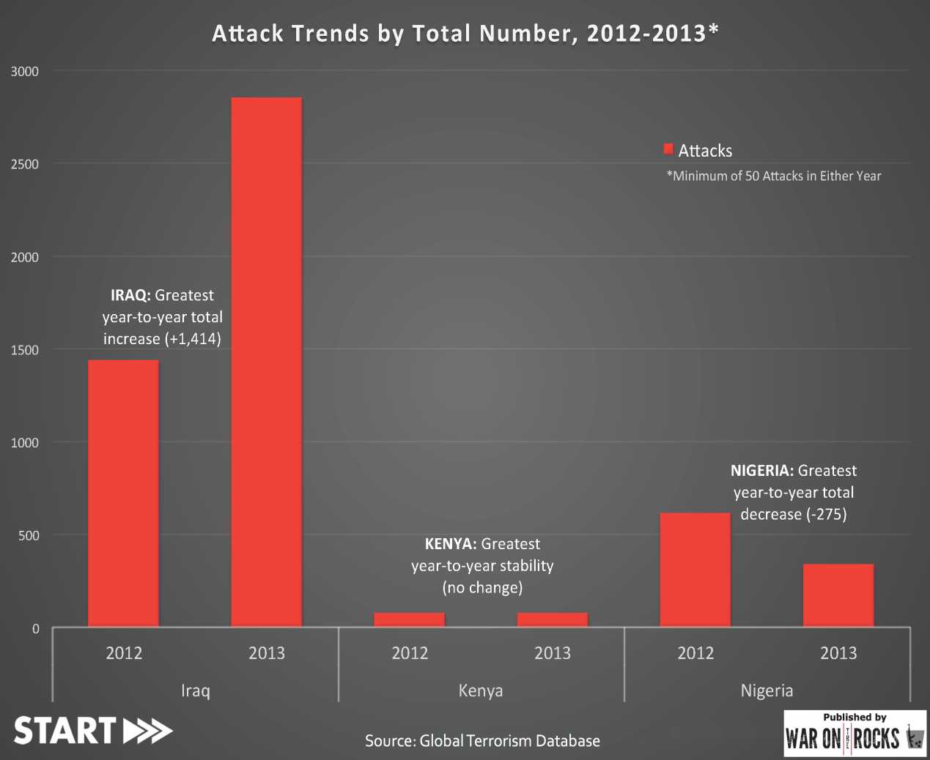
The first chart depicts trends based on raw numbers.
Attack Trends by Total Number, 2012-2013

But the picture changes when we look at percentages rather than total change.
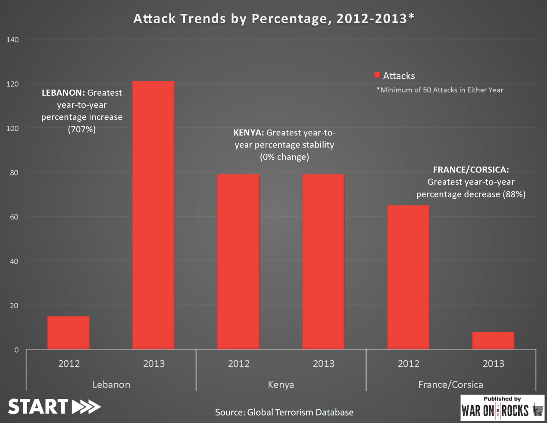
Attack Trends by Percentage, 2012-2013

So we can see that Iraq experienced the largest jump in terrorist incidents between the two years. And although the increase of 1,414 represented a leap of approximately 100%, this was far from the largest percentage gain. That distinction goes to Lebanon, which saw the number of terrorist incidents grow by more than 700%. Similarly, the largest decrease in real terms occurred in Nigeria, whereas the biggest percentage drop was in France/Corsica. Kenya saw the exact same number of attacks in both years, so of course appears in both graphics.
So what can we learn from these charts? First, it shows that the method in which data is modeled can yield different pictures, so it’s important to bear that in mind. Nevertheless, whether year-over-year change is examined in real numbers or percentage terms, the data can be used to either validate or challenge our assumptions that are based on empirical observation and media reporting. So for instance:
- The Iraq figures are not surprising, especially in light of recent events. According to the UN, 2013 was the country’s deadliest year since 2008.
- Nigeria’s decrease, while important, does not appear to be a sign that things have improved considerably. 2013 was still a very bad year, as the country witnessed more than 300 attacks and more than 2000 terrorism-related fatalities. Early indicators suggest that 2014 may be even worse than 2013. The decrease in 2013 was likely driven in part by reinvigorated CT efforts, rather than being reflective of a scaling back of ambitions on the part of Boko Haram.
- In Lebanon, the increase is driven almost entirely by spillover from the ongoing war in Syria. The border areas of Lebanon, in particular, have become a virtual extension of the Syrian battlefield.
- The decrease in France/Corsica is illuminating, mainly because the current paradigm through which most of us view terrorism pays disproportionate attention to that which is motivated by the jihadist ideology, and less to groups like the Corsican National Liberation Front. That group was responsible for more than 50 non-lethal bombings of vacation homes and businesses in 2012, but did not commit a single attack in 2013.
- The fact that there was no change at all in attack numbers in Kenya between the two years suggests a certain enduring characteristic to the threat posed to that country by al-Shabaab, at least in one sense (though not necessarily in terms of scale)

Plans for Redrawing the Middle East: The Project for a “New Middle East”

Source: http://www.globalresearch.ca/plans-for-redrawing-the-middle-east-the-project-for-a-new-middle-east/3882

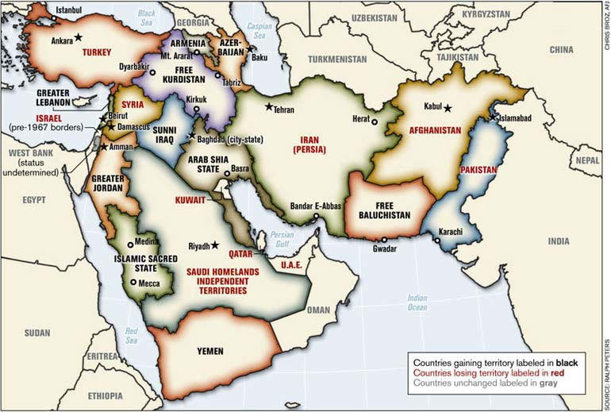
A relatively unknown map of the Middle East, NATO-garrisoned Afghanistan, and Pakistan has been circulating around strategic, governmental, NATO, policy and military circles since mid-2006. It has been causally allowed to surface in public, maybe in an attempt to build consensus and to slowly prepare the general public for possible, maybe even cataclysmic, changes in the Middle East. This is a map of a redrawn and restructured Middle East identified as the “New Middle East.”

Read more at source’s URL.

Mapping the Earth's Trouble Spots and the People Who Live There
By John M. Doyle
Source: http://www.hstoday.us/single-article/mapping-the-earth-s-trouble-spots-and-the-people-who-live-there/3f9301afde495322520030287c76fbef.html

There's more to geography than maps or the statistics on population and exports that are found in almanacs.
In an era of low intensity conflicts and asymmetric warfare, grassroots diplomacy and cultural sensitivity can be as important as attack helicopters, night vision goggles and satellite imagery.
“You can't understand economics without understanding the culture, how the society is organized, what are the power relationships,” said Lt. Col. Andrew Lohman, an associate professor in the Geography Department at the US Military Academy at West Point, NY.
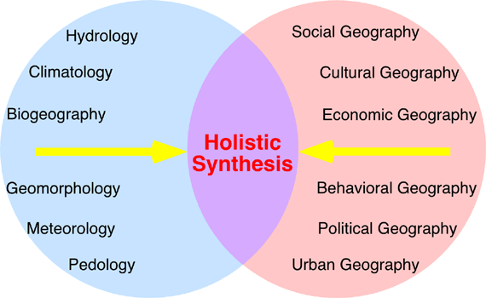
At a human geography conference last fall in Arlington, Va. Lohman explained how the study of geography is making a comeback in Army circles. Its popularity is growing at West Point where every year 50 to 60 cadets pick it as their major, he said.
Human geography is a multi-discipline study of the Earth and how people move across it, where they gather and how they interact there. It combines numerous fields including history, political science, economics, geology, urban studies and anthropology. Studying human geography can be very important for soldiers, Lohman said, noting on-the-ground knowledge can indicate what is normal and what is out of place in a society, a province or a village.
In five deployments to Iraq with Special Forces, Lohman said, “we learned everything about an area before going there.” The important part of that learning, wasn't just the facts like what percentage of the populations was urban or who the local power players were, but “how is this going to affect what we're doing when we're there.” In short, area analysis and mission analysis, he said.
While human geography isn't a panacea for every military challenge, “it can provide a greater understanding of this world we live in and hopefully, we'll make fewer mistakes,” he said.
A cultural misunderstanding can lead to a confrontation that can get you killed, but it can also lead to the failure of assistance and development programs – even ones as basic as agriculture education.
After decades of war, farming is still the largest source of income in Afghanistan – although only 12 percent of the land is arable, and only half of that is currently under cultivation. Fruit orchards were cut down or bombed out during the Soviet occupation in the 1980s. Forests were decimated and irrigation canals destroyed or allowed to deteriorate.
Now, the Afghans lack everything, says retired Army Lt. Col. Craig Beardsley, including basic education in agriculture. Beardsley is administrator of a program at Kansas State University that trains National Guard teams from farm states how to teach better farming and livestock raising to the Afghans.
The National Agricultural Biosecurity Center has trained four Kansas National Guard Agribusiness Development Teams and two from the South Carolina National Guard. They have also trained several units assigned to the 1st Infantry Division – including a Female Engagement Team.
The emphasis is on keeping instruction simple and practical – something the Afghans can continue and maintain after the US advisors leave. For example, Beardsley said, it's a mistake to assume the introduction of US agricultural techniques, equipment and seed “will solve all problems.”
Beardsley said the teams his school sent to Afghanistan are educated in Afghanistan culture and economics. They're also trained in business development and business management to help Afghan farmers market their products and manage their resources.
“In the home, the women have more influence than we give credit for,” Beardsley said, noting that's where the Female Engagement Teams – squads of female soldiers or Marines who accompany patrols – prove their value. The can glean a lot of information, both military and economic, by talking to Afghan women, something their male counterparts cannot do because of cultural taboos.
While doing research years ago at the US Naval Historical Center on a possible naval solutions to piracy off the Horn of Africa, Gary Weir says he learned that one factor that drove many fishermen in Somalia to take up piracy was the collapse of their government and its inability to deter large commercial foreign factory ships from coming in and taking away their livelihood.
“Now this does not justify piracy,” Weir, chief historian of the National Geo-spatial Intelligence Agency (NGIA), told a recent conference at the Council on Foreign Relations.
But he noted, it illustrates that a solution to East African piracy has got to be on land, not the sea. “The land is the problem, the political instability and difficulties they've had there. That's the real problem,” Weir said, stressing that he was not speaking for the NGIA or the US government.
He noted that NGIA had a major pilot project on human geography in Africa, “understanding the people of the region as intimately as we possibly can, because strategic threats emerge in those areas, and that knowledge is an advantage.” NGIA also has a support team at US Africa Command “giving them the advantage of our human geography work and all the other things that we do so well that I can't possibly talk about here,” he said.

John M. Doyle is a Washington-based defense and homeland security writer. A former congressional editor at Aviation Week & Space Technology, he has written about military and homeland security issues for Defense Technology International, Seapower, Smithsonian Air & Space and Unmanned Systems. Before that he was an editor and reporter with the Associated Press in the Midwest, New York and Washington.

IDF gets set to target 50,000 Al Qaeda fighters piling up around Israel in Syria and Iraq
Source: http://www.debka.com/article/23984/Gantz-IDF-gets-set-to-target-50-000-Al-Qaeda-fighters-piling-up-around-Israel-in-Syria-and-Iraq

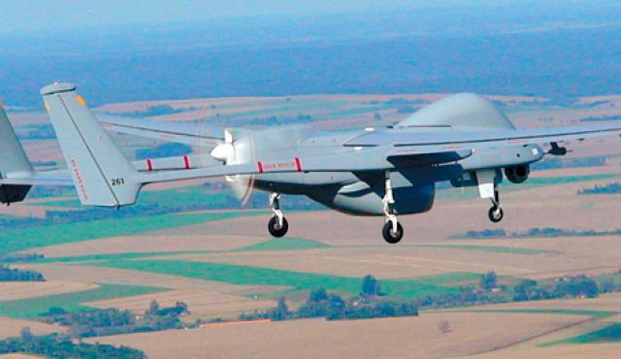
IDF Chief of Staff Lt. Gen. Benny Gantz’s cryptic remark Monday, June 6, that “The Israeli Air Force will next month dramatically change its mode of operation,” meant that a decision has been taken to start directing the IAF’s fire power against military and terrorist targets in the Syrian and Iraqi arenas – in particular the al Qaeda forces foregathering ever closer to Israel’s borders with Syria, Iraq and Jordan. By aerial fire power, the general meant not just warplanes but also Israel’s long-range unmanned aerial vehicles and helicopters.
He was lecturing to the Herzliya meeting of the Interdisciplinary Center’s policy and strategy institute.
On May 28, foreign sources were quoted as reporting that the Israeli Air force had shut down its last AH-1 Cobra attack helicopters squadron, which had served manly for strikes against armored and ground targets. Instead, lighter and cheaper drones have been commissioned for use against those targets.
Asked what he meant by “a dramatic change in the IAF’s mode of operations,” Gen. Gantz replied: A different kind of enemy is at our door. It is “more mobile, better at concealment and comes from farther away.”
If we count the jihadists present in the northern part of the map (.i.e., north of Israel) and add them to those scattered in the south and east (Iraq, Jordan and the Sinai Peninsula), we come to a total of 50,000 armed Islamist fighters, he said..
So how do we handle them? Two divisions? That may work for the Gaza Strip. But this enemy is widely scattered and not susceptible to our usual military tools. Still, we are obliged to deal with this menace and “we also have the opportunity to do so.” That was all the chief of staff was ready to say on the subject.
He made it clear that conventional military divisions are obviously no use for combating Al Qaeda’s 50,000 terrorists because they are not a standing, regular army deployed on fixed front lines. They move around stealthily in deeply remote desert regions and wadis, which are often unmarked even on military maps.
But they do have command centers, some of them mobile, and are beginning to take over strategic points in Syria and Iraq, including main road hubs, bridges, small towns and oil fields and pipelines.
The intelligence to support aerial combat against these targets is also different from the kind which supported the IDF hitherto.
Gen. Gantz touched on this when he said: “We understand that we must turn to a method of warfare that hinges on intelligence, which means bringing our intelligence into those places.”
In other words, before Israeli aerial vehicles approach jihadist targets, Military Intelligence Corps combat field units must be on hand, operating over broader stretches of terrain than ever before.
All this adds up to the IDF and IAF undergoing a process of radical change in its military-air-intelligence strategy, which, say debkafile's military sources, brings them close to the American methods of operation in Afghanistan and Pakistan to be introduced after the US troop withdrawal at the end of the year.
It is safe to assume that the two armies will work together in close rapport in the war on Al Qaeda.
The Gantz doctrine has not been accepted by all of Israel’s generals and commanders. On May 21, former Navy Chief, Brig. (Res.) Elie Merom made bluntly critical remarks on what he referred to as the “monopoly on firepower in depth” which Defense Minister Moshe Ya’alon proposed to award the IAF. He said this imbalance was unhealthy, that the air force has many limitations and putting all one’s eggs in one basket is asking for glitches and uncertain consequences.
Merom added: “These days, automatic fire can be initiated from any platform just as well and accurately as from airplanes. It’s also cheaper.”
A kind of competitive dispute has sprung up among the IDF’s top generals and commanders over whether it is the task of the armed forces to define and locate targets for the air force to strike, or whether other combat units can manage to provide firepower of the same quality, efficacy and precision as the air force.

Pirates In Southeast Asia Are Threatening One Of The World's Busiest Shipping Lanes
Source: http://www.businessinsider.com/pirates-in-southeast-asia-are-threatening-one-of-the-worlds-busiest-shipping-lanes-2014-6

A spate of daring high-seas attacks off Southeast Asia is stoking fears that its vital shipping lanes could once again become a hotspot for piracy unless regional powers act fast.
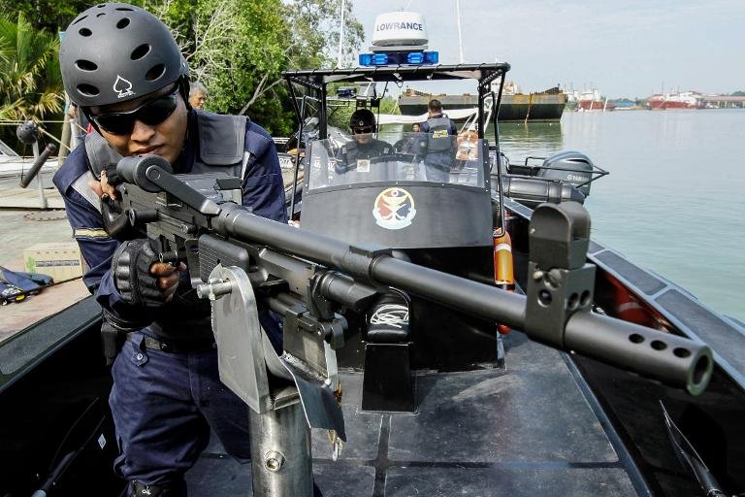
For centuries, pirates were the scourge of the Malacca Strait -- the strategic channel between Indonesia, Malaysia, and Singapore through which a third of global trade now passes.
They were largely put out of business about five years ago by stepped-up patrols.
But several tankers or cargo ships have been attacked in Southeast Asian waters since April, with pirates hijacking the vessels before siphoning off hundreds of tonnes of valuable fuel or oil.
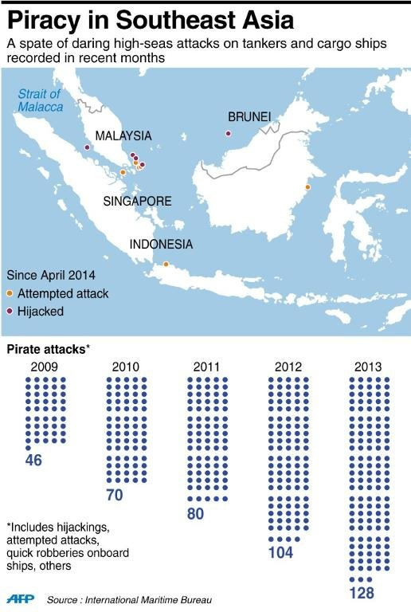
The increasing booty of oil and other cargo floating through local seaways appears to be drawing in new players, possibly underpinned by organized criminal syndicates, according to anti-piracy experts.
"Everybody is concerned about these latest attacks because they know it will worsen," said Noel Choong, head of the International Maritime Bureau's (IMB) piracy reporting centre in Malaysia.
"It will become rampant again and you will have a hard time stopping it. That's how Somalia got started."
In recent years, global concern over piracy has focused on attacks by trigger-happy Somali pirates off East Africa.
An international naval effort has virtually stamped out that threat -- but in the meantime, Southeast Asian piracy attacks have crept back up, increasing from 46 in 2009 to 128 last year, according to the IMB, and are on a similar pace for 2014.
Most are localized robbery attempts in Indonesia's vast waters for relatively small stakes, the IMB says. It adds that major lanes like the Malacca Straits remain safe, with only one attack this year.
Tens of thousands of ships pass through the strait annually.

Rich cargoes draw pirates
But the spurt of brazen incidents raises fears of a return to the frequent hijackings and kidnappings by mostly Indonesia-based armed pirates seen a decade ago, especially as successful piracy usually breeds more.
In one attack on May 28, the Thai tanker MT Orapin 4 was hijacked north of Indonesia's Bintan Island.
The pirates reportedly painted over its name, destroyed communications equipment and brought in a smaller tanker vessel to siphon off much of the ship's 3,700 metric tonne oil cargo. The vessel and crew were later released.
Similar incidents have been repeated, possibly indicating serial action by the same gangs.
The elaborate operations, say experts, suggest coordination with criminal syndicates organised enough to move such large cargoes to market.
"Maritime crime has always been an issue in the region, but we are seeing an increase in hijackings for cargo. The black market for marine gas oil is extremely lucrative," said David Rider, editor of the Maritime Security Review, who wrote recently that the new attacks had "taken everyone by surprise".
Southeast Asian piracy remains relatively benign compared to a decade ago. Pirates rarely carry guns, while taking hostages for ransom has stopped, said Choong.
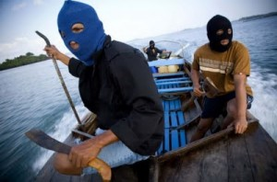
But the lucrative stakes could lead to more attacks, with East and West Africa offering chilling cautionary examples.
The lust for tanker cargoes has turned waters near oil-rich Nigeria into the world's major area of piracy concern due to the often deadly shoot-first attacks by gun-toting pirates, Choong said.
Martin Sebastian, head of Malaysia's Centre for Maritime Security and Diplomacy, said growing Southeast Asian sea traffic complicates enforcement while offering increasingly enticing pickings.
"Where there is money, the pirates emerge," he said.

Call for stepped-up patrols
The IMB is urging regional authorities to beef up naval patrols, and recommending round-the-clock anti-piracy watches on vessels.
Some calls have emerged for armed private security on ships -- but that's expensive, and in any case banned in Indonesian, Malaysian and Thai waters.
Piracy experts said the region is better-positioned today to snuff out any resurgence following the successful suppression of recent years.
An Indonesian navy spokesman said his country's forces are continuing to coordinate on patrols with its neighbours.
But pirates are also smarter, and are exploiting national sea boundaries and the limitations of regional naval forces to evade detection, said Bantarto Bandoro, a security expert at the Indonesian Defence University.
"They have good information on who is being monitored, where the sea is being monitored -- and their intelligence gathering is improving," he said, adding that international coordination remains insufficient.
Southeast Asia has a checkered history of cooperation on various issues, and combating resurgent piracy will ultimately require close coordination to root out onshore criminal gangs believed to be fueling it, Sebastian said.
Regional economies will be burdened with extra costs, including higher shipping insurance rates and more spending on security assets, "if we don't nip it in the bud", he warned.

Albanian Islamists prepare for suicide attacks in the Balkans

Source: http://www.echedoros-a.gr/2014/06/blog-post_9321.html

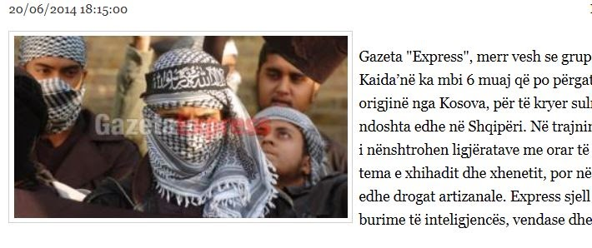
According to Kosovo’s newspaper Gazeta Express, Albanians former members of UCK from Kosovo and Skopje have joined ISIS in Iraq and are prepared for suicide bobings in the Balkans. The newspaper reveals that 10 Albanians for the last six months are trained for suicide operations in Kosovo and possibly in Albania. Their main goal is to implement sharia in these countries where the majority of the population is Muslims. Their training includes issues related to jihad, of life after death, religious ceremonies and lectures while during the last phase of their training they are under drugs and medications. The newspaper bases its article on information from local and international intelligence services (not revealed).

Hamas’ Summer Training Camps
Source: http://www.dailymail.co.uk/news/article-2653860/Summer-camp-Hamas-style-young-boys-endure.html

It is not for the faint hearted - a Hamas-run summer camp for school kids to take part in gruelling physical activities, military exercises and political demonstrations.
Thousands of Palestinian students have gathered to take part in the brutal summer camps, organised by the political organisation Hamas, in the Southern Gaza Strip.
Photos from the camps show children climbing obstacles above open flames, running in formation and standing at attention.
They also include political demonstrations for the students to show their solidarity for Palestinian prisoners currently held in Israeli jails.
Some countries and organisations, including Israel, the United States and the European Union, classify Hamas as a terrorist organisation, while others, including many Arab states, do not.
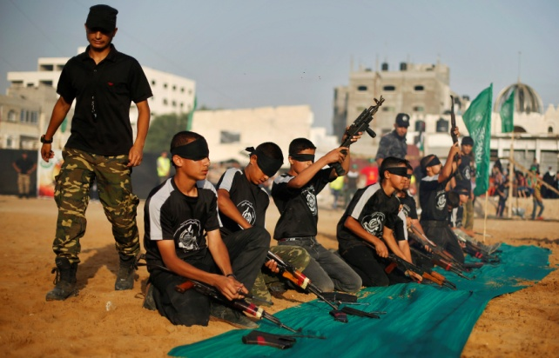 | 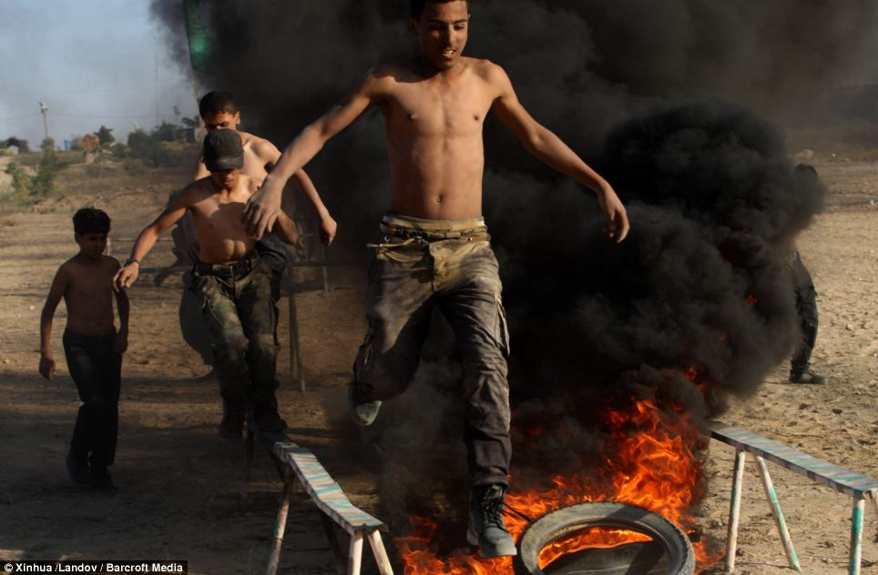
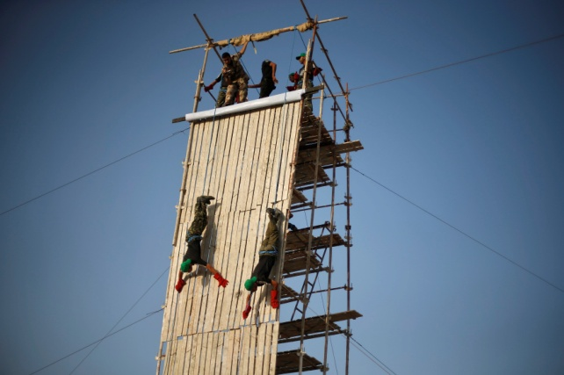 | 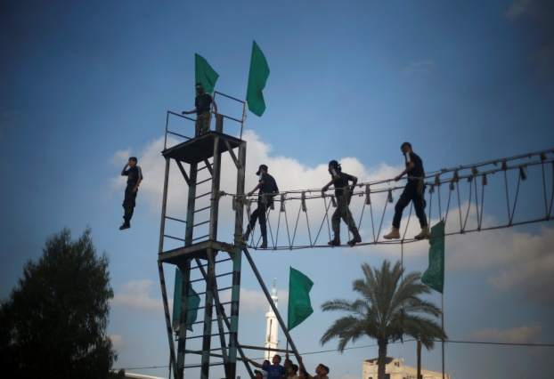
Jihadi death camp - training how best to die in a foreign country
Source:http://www.liveleak.com/view?i=531_1403281788#jeu6PmGFhQvOM0F2.99

Watch the video at source’s URL.

DHS Releases Second Quadrennial Homeland Security Review

Source: http://www.homelandsecurity.org/node/1320

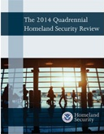
June 19 – DHS recently released its 2014 Quadrennial Homeland Security Review (QHSR). Secretary of Homeland Security Jeh Johnson opened the report with, “This report provides a strong analytic and strategic foundation for one of my highest priorities, which is ensuring that the Department invests and operates in a cohesive, unified fashion and makes decisions that strengthen departmental unity of effort.”
The department will continue to adhere to the five basic homeland security missions set forth in the first Quadrennial Homeland Security Review report in 2010, but that these missions must be refined to reflect the evolving landscape of homeland security threats and hazards.
The department’s five basic homeland security missions, revised to address threats and hazards over the next four years, include: prevent terrorism and enhance security, secure and manage our borders, enforce and administer our immigration laws, safeguard and secure cyberspace, and strengthen national preparedness and resilience.

HSSAI and the 2014 QHSR
In 2013, HSSAI once again had the opportunity to work on the QHSR, the chief policy and strategy document released by DHS. A key goal of QHSR 2014 is to obtain a better understanding of homeland security strategic environment, both now and in the future, and to identify areas where the department must shift its strategies to address changes in that environment.
Based on our successful involvement with the first QHSR four years ago, the DHS Office of Strategy, Planning, Analysis and Risk (SPAR), within the Office of Policy, involved HSSAI in the second QHSR process. Our involvement spanned the preparatory phase through the execution phase and the decision phase. More than 30 analysts from across HSSAI worked closely on a daily basis with SPAR staff, both from HSSAI headquarters and at the SPAR offices.
The task was designed to assist SPAR with numerous strategic and analytical efforts that would lead to a well-founded QHSR. The task team accomplished this by providing analytic insight to the core QHSR team, the study teams, and the outreach and engagement team.
As part of the preparatory phase, HSSAI analysts leveraged innovative analysis that helped SPAR understand and assess the homeland security strategic environment, as well as analysis that provided a baseline look at the department’s major undertakings since the previous QHSR. These base cases provided a sound foundation for assessing environmental, policy, and program changes in each of the five 2010 QHSR mission areas.
To bolster the execution phase, HSSAI analysts were embedded with each of SPAR’s three QHSR teams. The HSSAI analysts helped frame studies, conduct research and literature reviews, and identify relevant stakeholders. In addition, analysts working with the core team developed analytic studies addressing terrorism and cybersecurity that were used to inform the development of those sections in the QHSR.
The analysts embedded with the outreach and engagement team provided inventive ideas for the QHSR engagement plan and rollout strategy. They also helped identify imaginative approaches for engaging those outside the department to participate in the development process.
At one study team’s request, HSSAI analysts performed a unique system mapping of homeland security threats by merging five previously developed system maps: drug trafficking, human smuggling, counterfeit goods trade, terrorism, and illicit finance. This new “master map” enabled the team to uncover previously hidden relationships and dependencies between these threats and activities. From this, the study team was better able to conceptualize how different elements of the homeland security environment come together.

Lebanon releases 13 detained in Beirut raid
Source: http://www.dailystar.com.lb/News/Lebanon-News/2014/Jun-21/261043-lebanon-releases-13-detained-in-beirut-raid.ashx

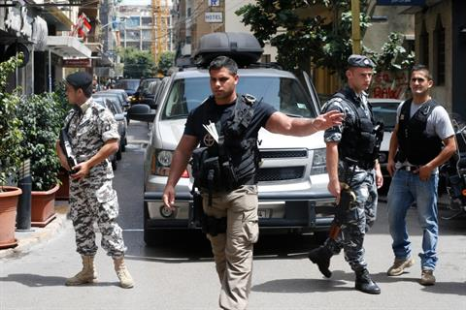
June 21 – Lebanese authorities released 13 people detained in a police raid Friday for lack of evidence, leaving four others suspected of having links to terrorist groups in detention, a high-ranking judicial source said Saturday.
"Between last night and this morning, we only have a Lebanese and three others of Arab nationalities in detention,” the source, speaking on condition of anonymity, told The Daily Star.
Police are interrogating the four remaining suspects and the judiciary will make a decision later in the day, the source said.
On Friday morning after receiving a tip-off that a group of Islamists planning an assassination plot against Speaker Nabih Berri were in a Beirut hotel, a joint raid by police intelligence and General Security resulted in the apprehension of 17 people.
Berri was to speak during a conference at UNESCO Friday morning. Western intelligence informed security agencies in Lebanon of an imminent terrorist attack against a gathering, prompting the speaker to cancel the event altogether, Interior Minister Nouhad Machnouk has said.
Hours later, a suicide car bombing targeted a police checkpoint in east Lebanon, killing a 49-year-old officer and wounding 32 other people. Authorities say the target of the attack was a location in Beirut.
The bombing and the security measures throughout the day Friday heightened fears of a return to the series of car bombing attack that hit Lebanon earlier this year and last year.
During an urgent security meeting late Friday, Prime Minister Tammam Salam said Lebanese security forces would continue implementing a nationwide security plan that curbed the rise of terrorism in the country for a three-month period.
The shadowy group Free Sunnis of Baalbek Brigade claimed responsibility for the bombing, saying they could not “reach their target today but they will do so later.”

After fighting in Syria 250 British jihadis are 'back in the UK' say intelligence officers
Source: http://www.mirror.co.uk/news/world-news/after-fighting-syria-250-british-3739504

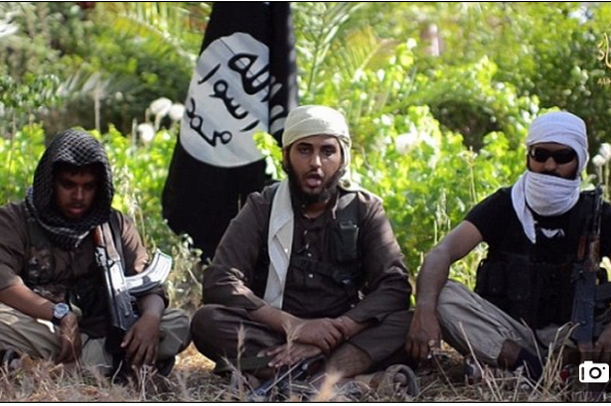
At least 250 British jihadists who have fought in war-torn Syria are feared to be back on the streets in the UK – posing a massive threat to our security.
Counter terrorism cops yesterday confirmed that around 500 British extremists had made the journey to the Middle East to fight. But we can reveal that at least half of those fanatics have already returned to the UK.
MI5 have made tracking down the jihadists their number one priority fearing they will use their newly-acquired skills to launch terror attacks in the UK.
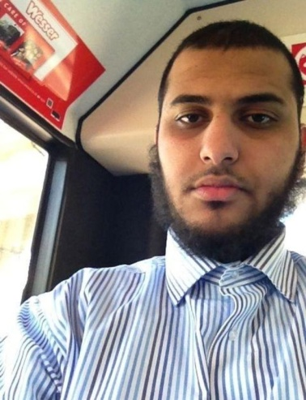
Intelligence services will monitor the 250 jihadists – many of whom will have been trained in bomb-making and how to launch insurgent attacks.
A security official said: “Of the several hundred British people who have gone to Syria to fight, around 250 have returned to the UK.
“The number returning is a real fear and there is the threat of them taking action here.
“The security services are managing and monitoring those people and it is our job to gather evidence against them that we can hand to the police.”
Sir Peter Fahy, who leads on the Prevent counter-terrorism strategy for the Association of Chief Police Officers, said that hundreds of British fighters were thought to have been recruited into Islamist groups waging war in Syria. Some estimates put the number higher, with the true figure still unknown.
He said: “Our estimate at the moment is around 500 people.
“There is a huge amount of effort going on both abroad and in this country in trying to identify people who may have gone out there, to track their movements and, particularly, to make sure that we detain them when they try to get back into this country.”
Sir Peter added that “large amounts” of material was being taken down from the internet every week to try to stop people being radicalised.
Brits have been recruited by Sunni terrorist group the Islamic State of Iraq and al-Sham, which has a significant presence in Syria and is engaged in fierce fighting in Iraq.
On Friday, a chilling video emerged showing three Brits among a group of jihadis trying to lure fellow UK Muslims to join the battle in Iraq and Syria.
One of them was British gap year medical student, Nasser Muthana, 20, from Cardiff, who is filmed bragging about fighting for ISIS (small photo).
The video was professionally shot and edited before being uploaded to YouTube by ISIS Al Hayat Media Center. Prime Minister David Cameron warned last week that the UK was under threat from terrorist attacks from those fighting in Syria or Iraq.
Downing Street said 65 people have been arrested in the past 18 months for Syria-related jihadist activities.
We can also reveal that a British jihadist, so dangerous that he was once monitored 24 hours a day by police, is thought to be masterminding the recruitment of young Brits to fight in Syria and for ISIS.
The 32-year-old – who for legal reasons can only be referred to by the initials AY – is suspected by the US of enabling many of the Britons fighting in the region.
FBI agents constantly studying hundreds of thousands of social media postings by suspected extremists are understood to have told the UK authorities that father-of-two AY is “esteemed and influential”.
In January, a two-year government monitoring order against him, known as a TPIM, came to an end.
An FBI source with close links to the British security forces said last night: “We have asked our UK counterparts to pay particular attention to AY.
“We have legitimate fears that he is facilitating and inspiring British jihadis to connect with ISIS. He is like the poster boy for British fighters.”

EDITOR’S COMMENT: We have heard these “fears” and “numbers” so many times… What we have not seen yet is some serious action to counter this problem. If they know the numbers, they should have known the persons. And if they know the persons why they let them come back home? Forbit entrance to countries of origin and let them wonder around the globe or return to the environment they fought for! (just follow the Australian example) 24hrs monitoring or arresting them sounds so inefficient not to say ridiculous (cannot even write their names for LEGAL REASONS! On both sides of the ocean.

Kurdish Advances
Source: http://www.meforum.org/4733/iraq-kurds-isis-isil

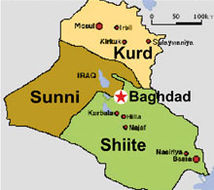
The stunning collapse of the Iraqi army in Mosul, and the rapid advance of the fighters of the Islamic State of Iraq and Syria (ISIS) through Tikrit and toward Baghdad has created a new reality in Iraq.
ISIS advances have continued this week; the organization has now taken the town of Tel Afar, with its 200,000 inhabitants, located west of Mosul.
Iraq is now divided on a de facto basis into a Shi'ite south and center, including Baghdad, a Sunni, ISIS-dominated west and a Kurdish-ruled north.
The biggest winners from this situation, apart perhaps from ISIS itself, are the Iraqi Kurds. The conflict between the Sunni jihadis and the Iran-supported Baghdad authorities has enabled the Kurds to add a number of key building blocks to the nearly completed edifice of Kurdish independence in the area once known as northern Iraq.
Largely ignored by the Western media, the Kurds have been quietly building their autonomy in the three northern provinces of Erbil, Sulaymaniyah and Dohuk, granted to them by the Iraqi Constitution of 2005.
A stable political system protected by a powerful armed force of around 100,000 men (the Peshmerga) has been out in place.
In the weeks prior to the current crisis in Iraq, the Kurdish Regional Government (KRG) began to independently export crude oil, via Turkey, without seeking the approval of Nouri al-Maliki's government in Baghdad. Maliki struck back by cutting funding to the KRG in Erbil.
The dispute remained unresolved in the days prior to the sudden eruption of the ISIS offensive in early June. The disagreement over oil exports formed part of a larger standoff between the Baghdad government and the KRG over control of oil-rich, majority Kurdish areas in Kirkuk, Ninawa, Salahaddin and Diyala provinces. The Maliki government threatened to exclude any oil company that began to drill under KRG auspices from access to the giant oil fields in Shi'ite southern Iraq.
The complex standoff now appears to have been resolved – entirely in the KRG's favor. As Iraqi forces fled from the ISIS advance, the Kurdish Peshmerga swiftly moved in to the long-disputed town of Kirkuk. The Kurds refer to Kirkuk as their "Jerusalem," and their population was largely ethnically cleansed from the city in the 1980s by Saddam Hussein's regime. They have long sought its reincorporation into their area of control.
This is not a matter only of sentiment: Kirkuk sits on an area of vast oil wealth, considered to contain nearly 9 billion barrels of oil reserves. By comparison, according to the International Energy Agency, the entire KRG area without Kirkuk contains around 4 billion barrels of proven oil reserves.
The taking of Kirkuk, along with the recent opening of the pipeline to Turkey and thence to international markets, means the emergence of a Kurdish regional oil power is now a reality. The Kurds have already built a link that connects Kirkuk to their pipeline to Turkey.
The political confusion, meanwhile, and the push east by ISIS and associated Sunni forces has demonstrated that the Peshmerga are the most powerful military force in Iraq. They are now deployed along the newly expanded borders of the KRG, and are directly facing the fighters of ISIS. Some clashes have already taken place.
But, for the most part, ISIS and its allies appear to prefer to advance against Iraqi government forces and in the direction of Baghdad, while leaving the more formidable Kurdish fighters alone. Certainly, unlike the Iraqi government-controlled towns still falling to the advance of the Sunni fighters, the Kurdish-controlled areas do not appear vulnerable.
Kurdish Prime Minister Nechirvan Barzani has also made clear that the Peshmerga will not assist the Iraqi army in the effort to retake Mosul. The Kurds, rather, will focus on securing their own borders.
Barzani this week expressed support for an autonomous zone for Sunnis in Iraq, and laid the blame for the current situation largely at the feet of Maliki. Barzani told the BBC, "We have to leave it to Sunni areas to decide, but I think this is the best model for them as well. First, they have to take a decision: what they want exactly. And in our view… the best way is to have a Sunni region, like we have in Kurdistan."
What all this means is that there exists today an economically powerful, politically stable, well-defended Kurdish entity, with a population of 5 million people, in what was once northern Iraq.
The effective collapse of any authority on the part of Baghdad over this entity means that the latter is now a Kurdish state in all but name.
So will the KRG soon declare independence, turning the de facto state that the Kurds have quietly built up into a de jure sovereign area? The answer is that while it is now clear that statehood is the goal, an early, open declaration of independence by the Kurds remains unlikely.
A source in the KRG told this reporter (Juresalem Post), that Turkish opposition to any declaration of Kurdish statehood had been the main obstacle to any such move. Turkish lobbying in Washington and in the capitals of Europe meant that Western countries remained opposed to Kurdish independence.
The US has also, for its own reasons, remained throughout staunchly in favor of the "territorial integrity" of Iraq. Secretary of State John Kerry reiterated this stance in a statement this week. The Turkish position in this regard appears to be softening, according to a number of reports.
But for as long as the clear US and Western position remains (somewhat bafflingly) opposed to the aspirations of the powerful and openly pro-Western Kurdish de facto sovereign entity in northern Iraq, its independence is likely to remain undeclared.
The collapse of Iraq into renewed sectarian war, and the powerful assertion of Kurdish self-government in the north are the latest evidence that the region – and specifically the area known formally as Iraq, Syria and Lebanon – is in the midst of a historic convulsion whose end is not near.
Whatever the final outcome of all this, Kurdish sovereignty in practice is today a reality in the former northern Iraq. And if the KRG can successfully navigate the difficult diplomacy of the months and years ahead, at a certain point it is likely that the world will have little option but to adjust – and formally recognize this reality.

