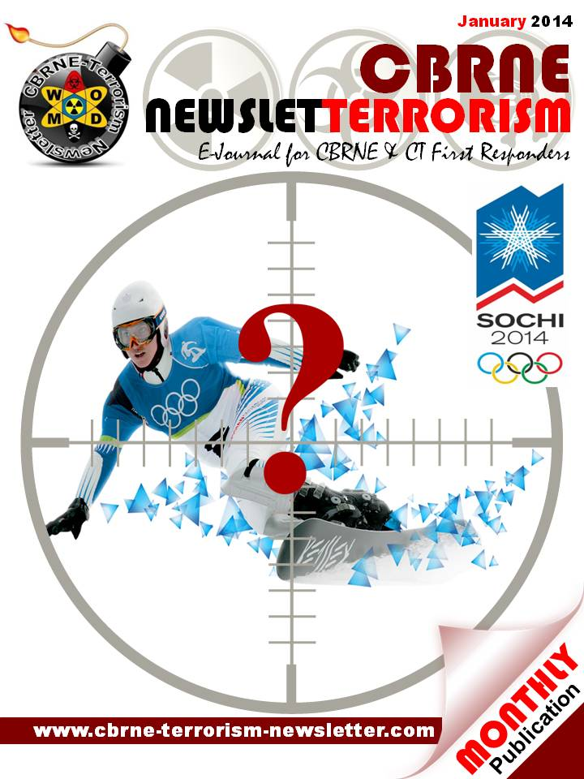
Simultaneous Attacks by Terrorist Organisations
By Kathleen Deloughery
Source: http://www.terrorismanalysts.com/pt/index.php/pot/article/view/312/html

Abstract
While terror attacks that are a part of a coordinated effort receive attention in the popular media, they have not received much attention in the academic literature. The decision to carry out simultaneous attacks should be examined as one of the choices a terrorist organisation makes about the method of attack. Determining the impact of simultaneous attacks vis-à-vis a single attack can explain why groups would use this method. Up to one quarter of all attacks coded in two major databases, GTD and ITERATE, may be part of a simultaneous campaign. Empirical analysis shows simultaneous attacks are more likely to be successful and cause more fatalities, though not in a one-to-one fashion. These results underline the importance of considering simultaneous attacks in empirical analysis.

Introduction
Why do some terrorist organisations group their attacks close together, while others spread them out? For instance, Al-Qaeda is well known for carrying out simultaneous attacks—that is, having different terror cells hit more than one location at approximately the same time. It is accepted in the literature that terrorist organisations choose the method and location of their attack in order to achieve political or economic destabilization of the targeted government and to garner media attention for their cause. To carry out a single attack versus a simultaneous campaign is a decision for terrorists to consider, yet researchers have not examined these decisions closely. This article will examine why groups would carry out simultaneous campaigns over single attacks: what are the benefits?
In two of the largest terrorism datasets, International Terrorism: Attributes of Terrorist Events (ITERATE) [1] and the Global Terrorism Database (GTD) [2], attacks are coded as single events, even when they are carried out as part of a coordinated campaign.[3] Unfortunately, neither dataset specifically denotes whether or not attacks are coordinated. In order to complete any analysis, this project will first determine which attacks formed part of a coordinated campaign.
Since the most commonly used datasets disaggregate simultaneous attacks, the empirical literature on terrorism has a dearth of academic studies on this type of attack. Theoretical papers have examined the scale of terrorist attacks. Past research shows that the scale of a terrorist attack can help the targeted government to estimate the size of the organisation’s resources.[4] Coordinated attacks are by definition of a larger scale. The terror attacks of September 11, 2001 (a simultaneous attack with four component attacks), was of a scale not seen before.[5] Economic impact models of terror attacks have shown that simultaneous attacks can magnify the impact of a terror attack.[6] This article will differentiate between simultaneous attacks and single attacks using empirical analysis. In the past, empirical investigations of terrorism have largely ignored the presence of simultaneous attacks in the ITERATE and the GTD datasets. Not recognising that these attacks can be very different from single attacks may have biased the results of many past studies.
Potentially biased studies fall into two main categories: examining the level of terrorism or examining the impact of terrorism. In the former, terrorism is the dependent variable, while in the latter it is the independent variable. When a researcher is predicting the level of terrorism in a country/region/year given certain attributes, each attack, even if part of a coordinated effort, is coded separately. This coding is potentially problematic since attacks that are part of a coordinated effort are made under the same decision making process. For instance, terrorist organisations consider military expenditures when choosing a country to attack; that decision should only matter one time for a coordinated campaign. If all attacks are thought to be single attacks, then the terrorist organisation would be making that decision every time they carried out an attack. Therefore, the dependent variable would be systematically higher than the true value when coordinated attacks are present in the system. Such a measurement of the dependent variable is problematic, but only detrimental to the predictions of the past models if the measurement error is correlated with the independent variables, thus biasing the parameter estimates. It is highly likely that simultaneous attacks, the source of the measurement error, are correlated with some of the variables that factor into the resulting level of terrorism.
Potentially more problematic are the implications for studies assessing the impact of terrorism. For instance, there have been studies looking into the impact of terrorism on tourism [7], urban development [8], public opinion [9], and industry.[10] In these studies, terrorism is used as an independent variable to explain another phenomenon. Therefore, if any of the attacks coded are part of a coordinated effort, then that independent variable will be measured with error, i.e. the measure of terrorism will be overestimated. This counting system assumes that the individual attacks within a simultaneous effort have a one-to-one additive effect, which may not be true. For instance, if a coordinated attack consists of two attacks, then this counting system implies that each of the two attacks have the same impact as a different single attack. If an independent variable is measured with such an error then this can lead to biased estimates of the parameters. Therefore, the impact of terrorism that these empirical studies are obtaining may not be the true parameter estimates.
Given the potential for bias in results ignoring simultaneous attacks, it is worthwhile to explore how common this type of attack is in terrorism datasets. First, the theoretical arguments surrounding simultaneous campaigns and impact of attacks are discussed. Second, the data used in the analysis will be presented. Third, follows an examination of the methodology and results from the empirical analysis. Finally, suggestions will be offered for future research and analysis on simultaneous attacks.

Theoretical Arguments
Which is better for the terrorist organisation, carrying out many individual attacks throughout the year or concentrating on one large simultaneous set of attacks? To make an assessment of this, we must start from the assumption that terrorist organisations are choosing their optimal number of attacks given their budget constraints and the role that attacks play in their main goals: destabilization, media attention, and recruiting new members.[11] Due to budget and training constraints, organisations must decide whether to apply their resources to single attacks spread out over time or devote time and energy to a smaller number of coordinated attacks.
Coordinated attacks are likely to kill more people than single attacks. First, since these attacks usually take place in two or more separate locations, there tends to be an increase in the total number of potential victims. Additionally, individuals with greater skills and capabilities are assigned to harder terrorist attacks and these individuals tend to be both more successful and kill more people on average.[12] Simultaneous attacks require more planning and coordination; everything else being equal, they are harder to execute than single attacks, thus individuals with more advanced abilities will be assigned to these tasks. As a result, coordinated attacks should cause more deaths than single attacks.
Similarly, coordinated attacks could be more successful than single attacks. There are two ways to calculate the success of simultaneous attacks. First, one can use the maximum success of all attacks within the campaign. Only one portion of the attack needs be successful in order to incite fear and create direct victims. Second, the average of the success of each attack within the coordinated effort can be used to accurately measure the effectiveness of the campaign. Simultaneous attacks should be more successful than single attacks for two reasons. If a single attack that is part of a coordinated effort is unsuccessful, the campaign can still be a success if one of the other parts of the effort is successful. Additionally, more able individuals are assigned to harder tasks [13]. Therefore, due to planning and coordination issues, more able individuals should be assigned to coordinated terrorist efforts, thus leading to more successful simultaneous attacks.
If simultaneous attacks tend to produce more fatalities and are more successful, these attacks should receive more media coverage. A single unsuccessful attack may not receive media attention, but a coordinated campaign with one unsuccessful component is likely to be reported. Additionally, the higher the number of casualties, the greater amount of media attention the attack is likely to receive.[14] Therefore, if coordinated attacks do generate more fatalities, then simultaneous attacks in developed countries are more likely to garner media attention than single attacks. This increased news coverage can have the effect of bringing the motives of the terrorist organisation to the forefront, thus satisfying one of their main goals. In fact, the coordinated attacks on September 11th had a permanent effect of increasing the number of news stories on terrorism.[15]
Based on these reflections, two hypotheses concerning the impact of simultaneous attacks will be tested in the empirical section:
H1: Simultaneous campaigns tend to kill more people than single attacks.
H2: Simultaneous campaigns tend to have higher success rates than unsuccessful campaigns.

Data
Data for this project were derived from three main sources. Data on terrorist attacks come mostly from the University of Maryland’s Global Terrorism Database (GTD). The GTD is a comprehensive dataset covering both domestic and transnational terrorist events from 1970 until 2007 and beyond to the present day. It is one of the very few datasets with a worldwide coverage that also contains information on domestic terror events. Therefore, by using the GTD, we are able to obtain a fuller picture of the total amount of terrorism occurring in the world.[16]
However, this dataset is not without its shortcomings. First, the information in the GTD was collected entirely from open sources. Therefore, bias could be introduced to the model if attacks are not reported in public sources. Attacks that are stopped in the planning stages and not reported to the media are also not included. Additionally, the GTD does not contain full data for the year 1993. Finally, the GTD uses an operationalised definition of success, resulting in over 90 percent of attacks being coded as successes.
The ITERATE dataset, which was developed by Edward Mickolus, contains more granular information on the success of terror attacks. In ITERATE, success is coded on a 0-6 scale, with information on attacks stopped in the planning stages, attacks executed unsuccessfully, and attacks carried out as intended. For instance, the four attacks comprising the events of September 11th, 2001 are all coded as successes in the GTD. However, ITERATE codes the attacks on the World Trade Center and the Pentagon as successes, but the crash of United Flight 93 is coded as an attack that was executed, but unsuccessfully. This information provides a much sharper picture of the difference in success between different attacks than the information in the GTD. Therefore, the analysis on the success of simultaneous attacks vis-à-vis single attacks will be carried out using ITERATE.[17]
Since neither dataset separately denotes when attacks are a part of a coordinated event, the available data was used to construct which attacks are most likely to constitute simultaneous attacks. Several different definitions of coordinated events were considered; however, in order to not overstate the effects of simultaneous attacks in this article, the strictest definition of simultaneous attacks was chosen. In order for two or more attacks to be considered part of a simultaneous campaign, the attacks must be carried out on the same day, in the same country, by the same group, using the same method.
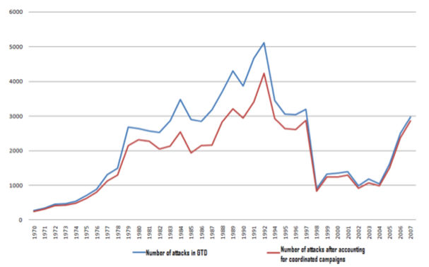
Figure I: Number of Terror Attacks per Year

Under this definition, approximately 25 percent of the attacks coded in the GTD are part of a simultaneous campaign. The breakdown of simultaneous campaigns by year can be seen in Figure 1. This definition probably understates the proportion of simultaneous campaigns in the dataset. By definition, if the group perpetrating the attack is unknown, the attack cannot be part of a simultaneous campaign. Approximately 38 percent of all attacks in the dataset were carried out by unknown perpetrators. Relaxing the definition of simultaneous attacks to only consider the day, location, and method of attack shows approximately 30 percent of all attacks listed in the GTD as being part of simultaneous campaigns. Additionally, groups can carry out coordinated attacks in different countries. For example, in 1998 local members of the Egyptian Islamic Jihad (affiliated with the global Al-Qaeda network) carried out coordinated truck bombs in Kenya and Tanzania. Since these attacks took place in separate countries, they will not be coded as simultaneous attacks. However, relaxing the definition of simultaneous attacks to only consider the day, method, and group, shows 26 percent of all attacks listed in the GTD are part of simultaneous campaigns. Using the strictest definition may exclude some attacks that are part of coordinated efforts, but it should minimise the number of single attacks which are incorrectly classified as part of a simultaneous campaign.
When utilising the information from ITERATE, the same technique is used to define simultaneous attacks – the attacks must have taken place on the same day, location, method, and group. Approximately 13 percent of the total attacks in the ITERATE dataset are part of a coordinated campaign. This number is lower than the corresponding calculations in the GTD dataset. ITERATE only contains information on transnational terrorism, therefore suggesting that coordinated campaigns happen at higher rates in domestic attacks than in transnational attacks. However, this finding may be due to peculiarities of the data available. Transnational attacks can occur in many different countries, while domestic attacks must by definition take place in the same country where the group is located. Therefore, since the definition of a simultaneous attack in this article requires that the attacks occur in the same country, we may be undercounting the number of transnational simultaneous attacks. For this reason, the data from ITERATE will only be used when testing Hypothesis H2 – calculating the impact of simultaneous attacks on success or failure of attacks.
A third set of data is derived from the Big Allied and Dangerous (BAAD I) dataset.[18] This dataset codes information on terrorist group characteristics. The dataset contains a snapshot of each terrorist organisation at one point in time between 1998 and 2005. Information offering insight into group capability includes data on age, size, ideology, territorial holdings, and number of alliances. Information from BAAD will be used to control for the characteristics of terrorist organisations that may lead to more terror fatalities.

Results
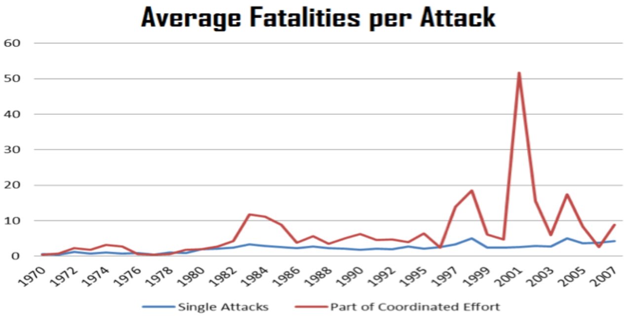
First the number of fatalities will be examined. Since some terrorist organisations do not intend to kill individuals with their attacks, group characteristics from the BAAD dataset will be added to this analysis. Figure II shows the number of fatalities in single attacks and attacks that are part of a coordinated campaign. II.
Figure II

Since the early 1980s, attacks as part of a coordinated effort have led to more fatalities. In order to verify this relationship, other characteristics that also determine the number of fatalities must be added to a regression equation. When information from the BAAD dataset is used in the regression analysis, only attacks carried out by perpetrators in the BAAD dataset between 1998 and 2005 are included, which further restricts the sample. While this sub-sample is non-random, the groups in the BAAD dataset were not selected based on whether or not they carried out simultaneous attacks. Therefore, it is plausible that the sub-sample is random on the known characteristics, and especially our characteristic of interest – simultaneous attacks. In Figure II, the time period from 1998-2005 records a larger divergence in fatalities from single attacks versus coordinated campaigns than earlier time periods. This divergence may indicate that coordinated campaigns are different in this time period than earlier. However, in Figure I, this time period experienced fewer attacks that were part of a coordinated effort. These issues need to be remembered when generalisations are made.
In this regression, the number of people killed in each attack will be a function of whether or not the attack was simultaneous, whether or not there were regional effects, year effects, attack type effects, group ideology, number of allies, and whether or not the attack was a suicide attack. The number of people killed is censored at 0 – meaning that many attacks result in no fatalities, so a Tobit model will be employed. The Tobit model allows the econometrician to account for different types of 0’s in the dependent variable.[19] In this case, the number of people killed may be 0 because the attack was unsuccessful in killing anyone or because the group never had any intention of causing casualties.
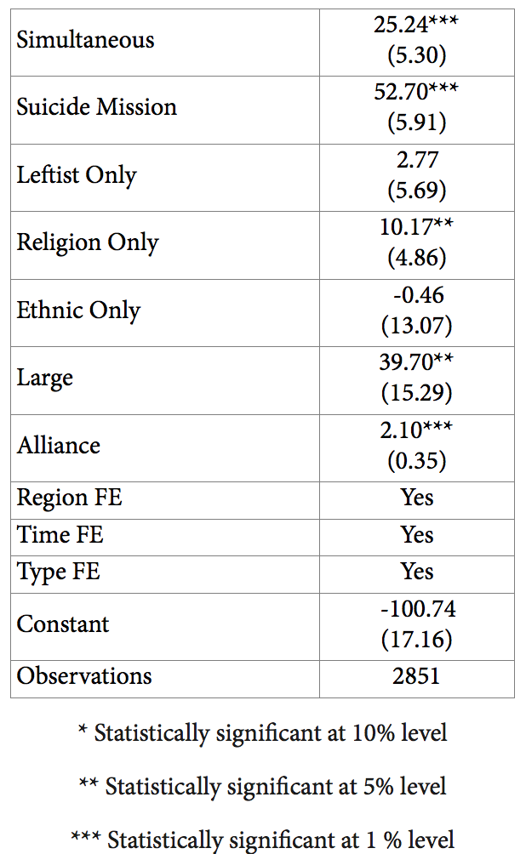
The results from the Tobit estimation can be seen in Table I. The coefficient of simultaneous is positive and significant, implying that attacks that are a part of simultaneous campaigns tend to kill more people. On average, 45 percent more fatalities occur in simultaneous campaigns than in single attacks, all else being held constant. Note that while the number of people killed increases with simultaneous attacks, the increase is not one-to-one with the scale of the attack. By definition, a simultaneous attack must have at least two attacks as components. However, the number of people killed in a coordinated effort less than doubles. This finding lends credence to the issues raised earlier, namely that using counts to measure the impact of terror attacks could lead to biased results when single and simultaneous accounts are treated the same way.

Table I: Number of Individuals Killed by Terror Attack 1998-2005

Next, how simultaneous attacks impact the success of terrorist attacks was examined using the ITERATE dataset. Since information on group characteristics are not used to explain success, the regression is no longer restricted to only the years where BAAD data is available. The impact of simultaneity on success is weaker, as can be seen in Table II, but provides evidence that simultaneous attacks are more successful than single attacks.
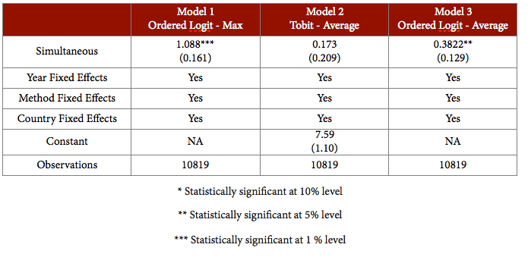
Table II: Success of Terror Attacks 1968-2004

Three specifications of the model were run. For each specification, attacks that are part of a coordinated effort are combined to count as a single attack and denoted as “simultaneous”. Other variables in the regression that may characterize success include location of attack, method of attack, and year of attack.
Country and year fixed effects are included in this regression. The level of success by year varies from a low of 4.5 to a high of 5.8 on a six point scale. The average level of successful terror attacks in individual countries varies between 2.5 and 6.0 on a six point scale. Therefore, differences between different countries and years need to be taken into account in the regression model. One reason for these differences in success may be the level of deterrence by the targeted country; this should help determine success. Therefore, countries that spend more on deterrence should experience fewer successful attacks. The amount of money spent on deterrence depends on the country’s determination of the risk they may face. Controlling for the year of attack will control for differences in deterrence by year. However, deterrence spending is not the only factor that determines success. Method of attack also plays a role. For instance, suicide attacks may be harder to deter than other methods. ITERATE codes the method of attack into twenty-five broad categories including assassination, bombing, hostage taking, hijacking, and armed assault, etc. The average success by type of attack varies from 2.5 to 5.9 on ITERATE’s six point scale.
Three models, referring to three ways to operationalise success, are presented in Table 2. In Model 1, success of a coordinated campaign is assigned the value of its most successful component. In a coordinated campaign, only one component of the attack has to be successful in order for the public to view the attack as a success. Since the dependent variable is an ordinal variable between 0 and 6, an ordered logit estimation is run. In this model, simultaneous attacks are more successful than single attacks. Next, success of a coordinated campaign is assigned the value of the average success of each of its components. This definition of success is the most intuitive in operational terms, but it is more difficult to address empirically. The success variable is still between 0 and 6, but for simultaneous campaigns the variable is not necessarily an integer. In Model 2, a Tobit estimation is run on the average success variable. Tobit was used since there are many censored variables at both the upper and lower limits of the success scale. The results of this estimation model show no relationship between simultaneous attacks and success. In Model 3, the average success of each terrorist campaign is still used, but this number is rounded to its nearest integer value, allowing an ordered logit regression. Model 3 reveals a positive relationship between simultaneous attacks and success. Examining the odds ratio for Model 1 and Model 3 reveals that a coordinated campaign increases the probability of success by between 46 and 172 percent.
Both hypotheses, H1 and H2, were supported by the empirical analysis – simultaneous campaigns generate more fatalities and are more successful. However, the number of fatalities increases by only 45 percent, while the number of attacks involved at least doubles. The impact of the simultaneous attack is greater than the impact of a single attack, but in a smaller proportion to the increase in size. If the goal of the terrorist group is maximizing the number of deaths on a specific day, then it would make sense to use simultaneous attacks. If the goal of the group is to maximize the total number of fatalities in a year, single attacks may be more worthwhile. Hypothesis H2 is also supported, though results depend on how success for coordinated campaigns is defined. A terrorist group that is interested in successfully carrying out their planned attacks may be more interested in using simultaneous campaigns. Given the support for H1 and H2, considering each part of the campaign individually, as has been done by the past literature, may not be appropriate.

Conclusions
Simultaneous attacks have been largely ignored by the empirical literature on terrorism. In this article, several specifications are considered to classify which events are a part of simultaneous campaigns. The strictest definition - same day, group, location, and type of attack - is used in all analyses to protect against incorrectly classifying attacks as simultaneous. The goal of this article was to examine the impact of simultaneous attacks. The hypotheses stated that simultaneous attacks would be more successful and lethal. The empirical results suggest that simultaneous attacks have a higher probability of success. Additionally, simultaneous attacks generate more fatalities, but not on a “one-to-one” basis. This research has established that single attacks are different from attacks that are part of a coordinated effort, even though these two types of attacks are treated the same by the empirical quantitative literature. This difference should be considered in the future to ensure that results obtained from using terrorism counts are not biased. A closer look should also be given in future analyses with regard to the definition of “success”. An attack, or a set of attacks, might be “successful” in tactical terms but be a strategic failure. Beyond the “success” of individual or coordinated acts of terrorism, there is the issue of long-term effects. Terrorism as a mode of conflict waging has a poor record of achieving its ultimate objectives.[20]

Notes
[1] Edward Mickolus, Todd Sandler, Jean Murdock, and Peter Flemming. International Terrorism: Attributes of Terrorist Events Data Codebook, July 2002.
[2] National Consortium for the Study of Terrorism and Responses to Terrorism (START). (2012). Global Terrorism Database [Data file]. Retrieved from http://www.start.umd.edu/gtd
[3] For instance, both datasets code the events of September 11th, 2001, as four separate attacks.
[4] Per Baltzer Overgaard (1994). “The Scale of Terrorist Attacks as a Signal of Resources.” The Journal of Conflict Resolution. Vol. 38, No. 3, pp. 452-478.
[5] Hoffman, Bruce (2002). “Rethinking Terrorism and Counterterrorism Since 9/11.” Studies in Conflict & Terrorism. Vol 25, Issue 5, pp 303-316.
[6] Gordon, Peter; Moore, James E. II; Richardson, Harry W.; and Pan, Qisheng, "The Economic Impact of a Terrorist Attack on the Twin Ports of Los Angeles- Long Beach" (2005). Non-published Research Reports. Paper 23. http://research.create.usc.edu/nonpublished_reports/23
[7] Walter Enders, Todd Sandler, and Gerald F. Parise (1992). An Econometric Analysis of the Impact of Terrorism on Tourism. Kyklos 45, pp. 531-554.
[8] Edward Glaeser and Jesse Shapiro (2002). “Cities and Warfare: The Impact of Terrorism on Urban Form.” Journal of Urban Economics. Volume 51, Issue 2, pp. 205-224.
[9] Theodore Downes-Le Guin and Bruce Hoffman (1993). The Impact of Terrorism on Public Opinion - 1988-1989. Santa Monica, CA: RAND Corporation.
[10] Claude Berrebi and Esteban Klor (2005). “The Impact of Terrorism across Industries: An Empirical Study.” C.E.P.R. Discussion Papers 5360.
[11] Frey, B.S. and S. Luechinger (2008). "Three Strategies to Deal with Terrorism." Economic Papers Vol. 27, No. 2, pp.107-114.
[12] Effi Benmelech and Claude Berrebi (2007) “Human Capital and the Productivity of Suicide Bombers.” Journal of Economic Perspectives, Vol. 21, No. 3, pp. 223-238.
[13] Ibid.
[14] Dominic Rohner and Bruno S. Frey. (2007) “Blood and ink! The common-interest-game between terrorists and the media.” Public Choice, Volume 133, pp. 129-145.
[15] Ibid.
[16] National Consortium for the Study of Terrorism and Responses to Terrorism (2012).
[17] Mickolus, et al. International Terrorism. July 2002.
[18] Victor H. Asal and R. Karl Rethemeyer. (2008). “The Nature of the Beast: Terrorist Organisational Characteristics and Organisational Lethality.” Journal of Politics, Vol. 70, No. 2, pp. 437- 449.
[19] A zero inflated negative binomial was also run. The results are robust and available upon request.
[20] Cf. Alex P. Schmid and Rashmi Singh. Measuring Success and Failure in Terrorism and Counter-Terrorism: US Government Metrics of the Global War on Terror. In: Alex P. Schmid and Garry F. Hindle. After the War on Terror. Regional and Multilateral Perspectives on Counter-Terrorism Strategy. London: RUSI, 2009, pp. 33-61; Max Abrahms. The Political Effectiveness of Terrorism Revisited. Comparative Political Studies, Vol. 45, No. 3, pp. 266 -293.

Kathleen Deloughery is an Assistant Professor of Public Administration and Policy at the University at Albany, SUNY. She received her Ph.D. in Economics from The Ohio State University in 2009. Professor Deloughery’s main research interests include the economics of terrorism, radicalization, and political violence.

Risks of Terrorism, Homicide, and Illness: a Methodological Consideration
By Richard J. Chasdi
Source: http://www.terrorismanalysts.com/pt/index.php/pot/article/view/316/html

Abstract
A recurring question posed to researchers is whether or not terrorism poses similar degrees of risk as other man-made or natural disasters. There are some specialists, such as John Mueller, who argue that somewhat ironically, the threat of terrorism is vastly exaggerated.[1] This begs the question : compared to what? The underlying aim of this Research Note is to point out some basic methodological and contextual issues to consider, rather than making an attempt to provide hard answers regarding relative individual and collective risks. However, an effort is made to place some empirical findings into appropriate political and social contexts. The framework for discussion includes: basic conceptual problems regarding the notion of “risk”; a comparison of certain basic terrorism incident rates with rates for homicides and illness; and identification of possible future directions to gauge risk assessment within the context of a more holistic systems perspective.

Introduction
The conceptualization of risk requires much more than a delineation of type of risk from specific threats. Indeed, John Monahan suggests that even within the realm of terrorism studies, terrorism is a necessary but insufficient term that clusters a wide ranging group of phenomena, thereby in effect working to provide impediments to meaningful research about explanatory variables for specific (sub-) types of terrorist assaults.[2] For Monahan, it follows there should be efforts to standardize understandings of seminal concepts such as whether terrorist assaults comprise “a process” or are composed of discrete “events” or perhaps are either or both under certain select circumstances.[3] Still another critical issue that Monahan points to is that scholars must differentiate between the risk of terrorist assaults associated with recruitment of terrorist activists by contrast to the risk of terrorism with recruitment of constituency groups in what Monahan calls “supply roles.”[4]
Equally important, there is no one generally recognizable and widely shared conceptualization or definition of the broader notion of “risk.”[5] As David Shields at Walsh College puts it, “there is a difference between ‘risk to’ and ‘risk of’ conceptualizations.” To extrapolate, what seems significant in the case of the “risk to” notion is that underlying emphasis is placed on the object of risk (i.e., what will happen to that object), by contrast to the “risk of” notion that places emphasis on the sources and origins of “risk” as a driver of action.
At the same time, “risk to” is a more active, temporal, and proximate conceptualization of the risk condition, while “risk of” is a more dormant condition or tense that has inherent potential for change into a more active form. Moreover, there is also a range of risk “perception or misperception” that in some circumstances might contribute to an increase or decrease of overall risk, whatever that risk is all about.[6] Put another way, there must be some way to account for “subjective risk” appraisal that essentially amounts to a random variable in data testing in survey (i.e., questionnaire) formats for example.
Seen from a slightly different angle, Monahan also notes there is a clear distinction between “risk reduction,” a concept that requires almost singular focus on “causal factors” as Kraemer et. al. (1997) put it, and “risk assessment,” that in turn revolves around “likelihood” or “probability.”[7] Indeed, what is significant here is Monahan suggestion that there are fundamental differences between threat assessment of victimization - which is the focus of this Research Note - and assessment of risk focused on the individual, namely those who are deemed to present various degrees of threat or potential threat to society as political terrorists do.[8]

Disparate Measures of Terrorism and Other Calamitous Threats
Much of what is available to the researcher when thinking about “risk assessment” with respect to terrorist assaults is a set of disparate empirical studies about patterns or trends of terrorism or related phenomena that all too often rely on aggregated data results with limited utility.[9] To be sure, those broader patterns are useful, as trend assessments of terrorism have at least some predictive value for public policy initiatives.[10] Nonetheless, such aggregate results do precious little to help illuminate individual or collective risk for terrorist assaults at specific geographical locales at specific moments in time.[11]
For instance, a range of empirical results about terrorism compiled by the National Consortium for the Study of Terrorism and Responses to Terrorism (START) is presented by the U.S. Department of State for the evaluation of terrorism trends in 2012, presumably to help gauge risk for a variety of actors. Those data are as good an example as any of broad types of data with a range of problems that include the implicit assumption that different types of targets share the same degree of threat even at different geographical locales and at different periods of time.[12] For example, consider the chart from the START- U.S. Department of State data reproduced below.
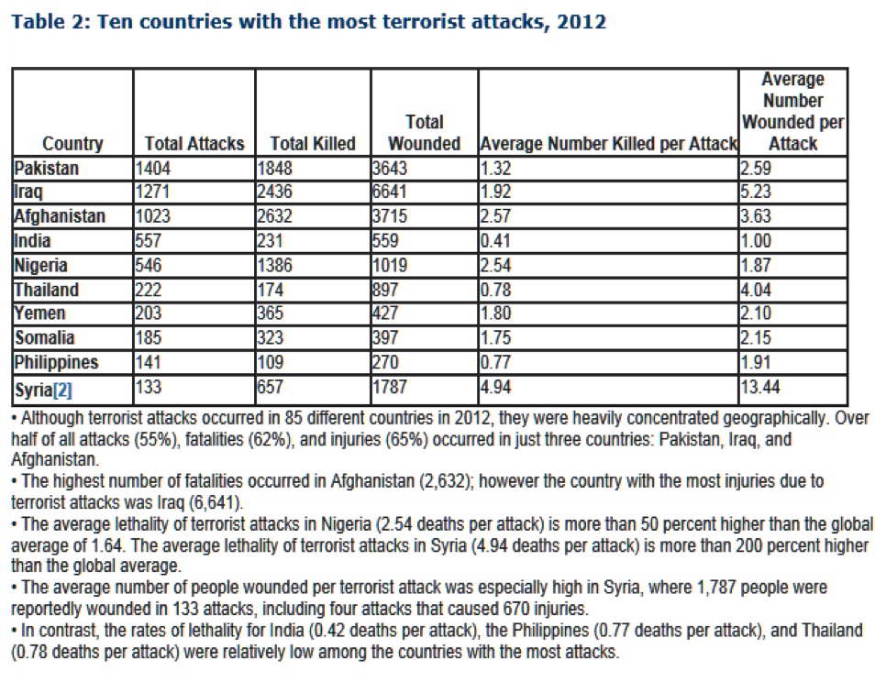
Such relative frequencies by country are important findings that articulate the basic parameters of terrorism: the ten highest numerical amounts of terrorist assault incidents per country. As this report points out, the top four countries, namely Pakistan, Iraq, Afghanistan, and India are found in Asia, with three out of four of those countries with over 1,000 incidents. In addition, the Philippines in South East Asia ranks ninth out of the ten countries that experienced the highest number of terrorist assaults in 2012.[13]

While these findings are useful, what is also significant is that the foregoing are aggregated measures of attacks by country that do not distinguish between urban and rural locales, region of the country, locales rich with precious metals and other natural resources, neighborhood clusters, and individual neighborhoods. [14] The variation in the range of “average numbers killed per attack” from .41 in the case of India, to 4.94 persons killed per incident in the case of Syria underscores the importance of “contextual factors” intrinsic to specific operational environments such as the “civil war” in Syria that began in 2010.[15] What seems significant for our purposes, namely to acquire some rough assessment of risk from available data, are mean number of deaths and injuries that result from terrorist assaults. Plainly, the mean rates are comparatively low when terrorism is compared to other broader forms of political violence and armed conflict that do not have a clear beginning, middle, and end point as do terrorist assaults or other specific acts of force.
For example, Syria, in the throes of a full blown civil war where the highest means of death and injury were found, had a mean for death of only 4.94 persons killed (657/133) per attack, by contrast to a rate of injuries over 2.7 times as large, but still with a mean of only 13.44 (1,787/133). In turn, the average rate of death in Afghanistan, itself characterized by an insurgency between the Taliban and affiliate groups against the Karzai government and its ISAF allies, experienced terrorist assaults where the mean for deaths, presumably over the entire country, was only 2.57 (2,632/1,023), in comparison to the mean for injuries that was not much higher at 3.63 (3,715/1,023). Clearly, these are rather crude indicators for the reasons previously mentioned, but it is probably no exaggeration to say that the likelihood of victimization by means of a terrorist assault is less than the likelihood for certain other discrete acts of political violence such as sustained warfare or large scale natural disasters like floods or pandemics.[16]
To reiterate, the problems associated with an assessment of accurate measures of risk across different types of “man-made” or natural phenomena is from the start hampered in many data compilations by the absence of more specific disaggregated data for specific geographical locales and political factors such as holidays or commemoration of landmark events that are inextricably bound up with increased risk.[17] Put another way, political events are a dynamic and critically important part of any “contextual environment” and commemoration of major or minor political events, landmark events, religious holidays, or secular holidays as well as reactions to government assassinations or war may increase - or conceivably decrease by means of “augmented security” - the likelihood of terrorist assaults and victimization.

Homicide Rates Worldwide
As if that were not enough of a problem, there is no standardized unit of measurement to compare terrorism assault rates of death to rates of death for other calamitous events. To the best of my knowledge, this appears to be the case for measurement across countries and within particular countries, as there is no completed data set I am aware of that uniformly drills down to “city-suburb/town/village” designations within regions of a country for the broad spectrum of assaults under consideration, that also simultaneously promotes standardization efforts across data compilations.[18] For example, the “Global Peace Index-2013”(GPI) produced by the Institute for Economics Peace, reports that homicide rates in the world increased precisely due to the fact that murder rates in South America, the Caribbean, Sub-Saharan Africa, and Central America have risen, “....skewing what is the declining trend for the rest of the world.”[19] In the Global Peace Index -2013, “Figure 1.14” provides a rather broad brushed appraisal of the mean homicide rate for chosen GPI countries that presumably derives from United Nations data.[20] The aggregate mean for the basket of GPI countries reflects an average of relative frequencies of homicide per 100,000 of the population for the 2008-2013 interval.
This chart reflects findings where a basket of GPI countries had a mean of 6.7 murders per 100,000 of the population in 2008, by contrast to slightly less in 2009. A spike begins from 2009-2010, and the murder rate per 100,000 people continues to increase with an average rate of 10.9 per 100,000 in 2013. At this moment in time, there is no effective way to compare data on terrorism offered by START’s GTD- Department of State cited earlier to the aggregate country homicide rates provided by the “Global Peace Index 2013” study because of standardization measurement problems.[21] In the broader sense, this is an underlying problem with many data sets that makes comparisons of relative frequencies of events and next, calculating accurate risk assessment exceedingly difficult.
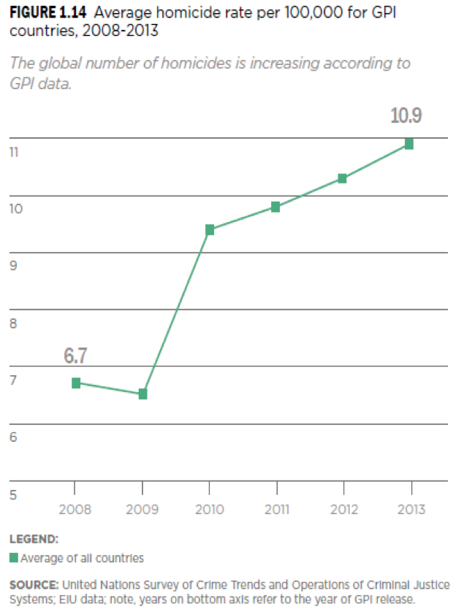
At the same time, it is probably no exaggeration to say that while environmental infrastructure effects, such as economic blight, overcrowding and crime, coupled with family and small group interactions motivate a very small percentage of individuals to “act out” based on political motivations (i.e., terrorism) by contrast to a somewhat larger percentage who engage in common criminal activity, the number of people exposed to economic blight conditions and disruptions in family and social circles but who somehow navigate through by means of self medication (i.e., drugs or alcohol) is far greater.[22] In turn, that suggests that such effective and sustained environmental pressures have greater effects on a larger segment of society with continuous duration thereby in effect making rates of homicide, rape, and suicide as well as other crimes a more significant cause for concern than terrorism when thinking about the chances of victimization.

A Comparison: Intentionally Inflicted Deaths and Other Forms of Violent Death
Much of the data compiled in the “Global Burden of Armed Violence 2011” report are consistent with the aforementioned data compiled by the “Global Peace Index”.[23]
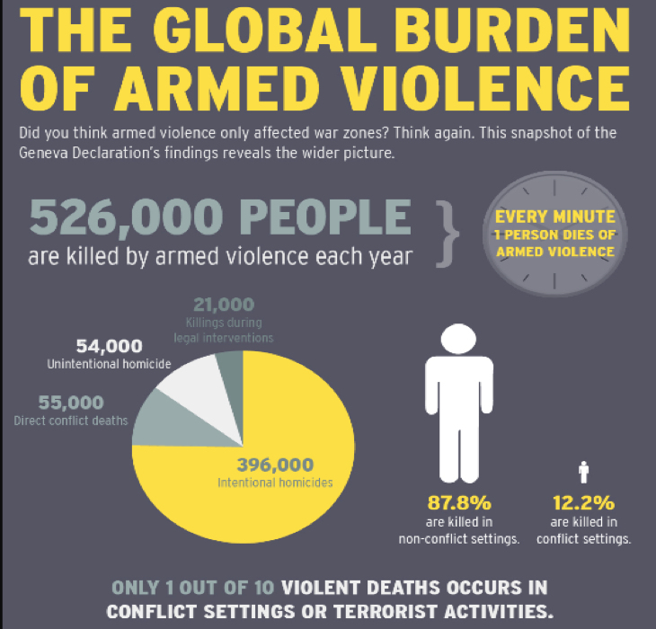
In the broadest sense, those findings chronicle that out of 526,000 violent deaths worldwide from 2004-2009, some 75.285% or 396,000 were classified as “intentional homicides,” by contrast to 54,000 or some 10.26% of the total that are classified as “unintentional homicides.” In turn, 21,000 deaths or almost 4.0% of the total amount are classified as “killings during legal interventions,” defined by the “Global Burden of Armed Violence 2011” report as “...violent deaths of civilians by law enforcement and state security forces during legal interventions -....”[24] What seems significant here is that only some 10.45 % of violent deaths (55,000/526,000) happened within the context of “direct conflict deaths” (i.e., “terrorist activities” and/or “conflict settings”) and that is only 1,000 more chronicled cases compared to the 54,000 “unintentional homicides” chronicled. [25] At the same time, the term “terrorist activities” is an extremely imprecise and nebulous term; it might conceivably include deaths of civilians in counterterror assaults or civilian deaths as terrorists prepare explosives improperly. That sort of imprecision might skew results in data replication efforts. Notwithstanding that, based on “Global Burden of Armed Violence” data, the amount of death associated with common criminal activity (i.e., “interpersonal violence,” “gang violence,” “economically motivated crime”) far exceeds, by a factor of at least 7.2, the amount of death associated with terrorism (55,000 X 7.2 = 396,000).
In turn, additional data from the “Global Burden of Armed Violence 2011” provides a breakdown by country and region of “violent death per 100,000 of population” from 2004 to 2009.” It identifies 58 countries with 10 or more violent deaths per 100,000 of a country’s population. The five countries that are found to have the highest annual “violent death” rate per 100,000 of the population are: El Salvador (62.0), Iraq (60.0), Jamaica (58.1), Honduras (49.0), and Colombia (44.5). In addition, those data illustrate that many countries with comparatively high rates of “violent deaths” per 100,000 of the population are found in the developing world. The glaring exceptions are Puerto Rico and the Russian Federation that are found to have a “violent death” rate of about 20 per 100,000 of the populace and 17.2 per 100,000 respectively.[26] To put those results in some perspective, the World Health Organization (WHO) “Leading Cause of Death” global statistics for 2011 report that the risk of “lower respiratory infections” that result in death is “46 deaths per 100,000 population,” by contrast to “43 deaths per 100,000 population” elicited by “chronic obstructive pulmonary disease.”[27]
The WHO report illustrates that almost one third of those countries (27.5% or 16/58 states) has been characterized by a “main armed conflict” or one that has recently passed into eclipse. In 10 of those 16 states, “...the incidence of homicide is actually greater than the number of direct conflict deaths.”[28] The underlying focus on intra-national violence as opposed to interstate war dovetails well with the perspective taken by Cooper, Merz, and Shah’s work where specific sets of empirical findings are framed by descriptions and statistics that point to a general decrease in international conflict and the intensity of warfare deaths in the contemporary world.[29]

The Interlocking Condition of Natural Disasters, Illness, and Violence
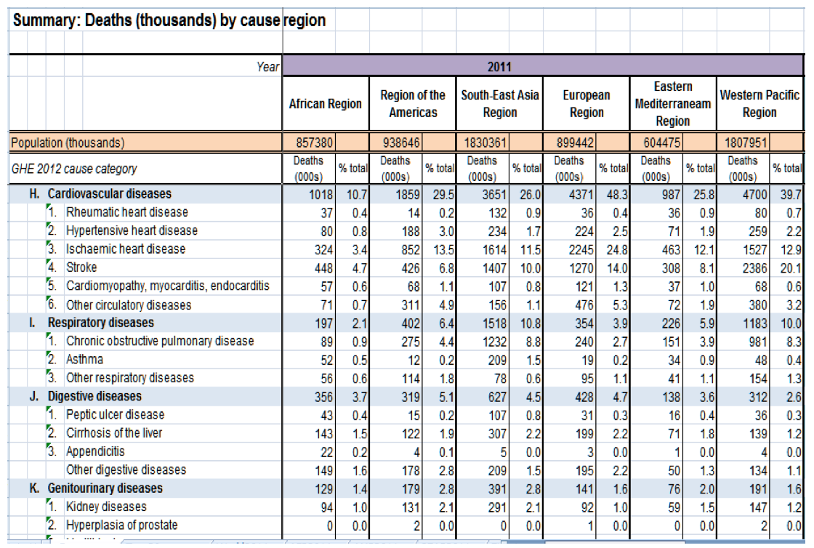
Turning to the matter of comparison between murder rates, other forms of violent events, and deaths from illness and environmental factors, it is clear that illness and deaths from so-called “natural factors” are inextricably bound up with one another; man-made environmental factors or “natural” ecological dynamics are influenced by human behaviour.[30] For example there are a series of cities in China where it is commonplace to note that cancer rates and, by extrapolation cancer related deaths are extremely high. Such figures point to the ineluctable conclusion that a more holistic or systems-wide set of approaches for thinking about risk is called for, to elicit the generation of cumulative statistics of deaths for a more accurate appraisal of death risks. Indeed, it is entirely possible that government negligence or malfeasance associated with environmental disaster areas could spawn political terrorism or deaths related to criminal activities in some countries. To be sure, the Chinese example also underscores the essential need for analysis by region or city clusters including efforts to isolate and identify modalities between types of death outcomes and complex sources and origins of causal factors.
Much of the data available from IGO and NGO sources about death from illness is also comprised of aggregate data by country or region.[31] At the same time, it is probably no exaggeration to say that disaggregated data is more intrinsic to methodologies in this public policy domain as specific geographical locales afflicted with such problems are oftentimes almost the sole focus of many studies. In the case of broader overviews of death rates from illness by region, WHO statistics for the single most predominant causes of death provide numerical amounts and percentage rates.
For example, there were 1,018,000 “cardiovascular diseases” related deaths in the “African Region” in 2011 or 10.7 % of the total number of deaths (9,538,000) across articulated “cause” categories. In a similar vein, there were 1,859,000 cardiovascular disease related deaths in the “Region of the Americas” that comprised 29.5% of the 6,302,000 deaths total across categories. Plainly, we can extrapolate that the scope of deaths for illness by region eclipses rates for terrorist assaults.

Final Reflections
There are several underlying themes throughout this Research Note that deserve attention. First, there is a significant difference between risk appraisal and the presentation of cumulative statistics about terrorism, related events, and a variety of natural calamities caused by illness - be it directly or as a result of other natural events such as tornadoes, flood, earthquakes, or hurricanes. All too frequently, there is no standardized unit of measurement available to make even the roughest comparisons between frequency rates, let alone intensity magnitude rates. As if that were not enough of a problem, there are different ways of appraising risk: the notions of “risk of” and “risk to” that Shields described are only two conceptualizations of risk. Indeed, that condition parallels the many and competing definitions of the notion of “resiliency” found in the literature.[32] In future endeavors, scholars might have to develop parallel conceptualizations of risk appraisal for what Zinnes would call “integrative” studies.[33] This is also warranted by the fact that relative occurrences of terrorist attacks and/or death, homicide and different types of illnesses are usually associated with broader “conflict conditions”- a term which itself is problematic as all societies are plagued with social, economic, and political inequalities and consequently, a host of “conflict conditions.”[34]
At the same time, the problem or set of challenges and opportunities is much more fundamental and even more complex. Plainly, we can extrapolate from some of the data presented to see how “feedback loops” between disease and malnutrition (e.g., malnutrition leads to illness; a mother who is ill cannot provide for children who become malnourished), indirect pathways of effect between “disease” and “malnutrition,” and “educational attainment” influence outcomes.[35] Indeed, it is not difficult to see how links between lack of educational attainment, and the low socio-economic status (SES) that follows, can lead to a condition of “frustration-aggression” that for some, but certainly not all, may lead to criminality and for a smaller number, to terrorism or other forms of political violence.[36]
As previously mentioned, it is not difficult to conceive of a situation where government mismanagement or malfeasance with respect to public policy (e.g., pollutants, resource distribution) could trigger both non-violent demonstrations and the use of force from those affected directly or indirectly. What this means is that in the future, more holistic models that take into account different frameworks (e.g., issue areas such as malnutrition, illness, suicide, socioeconomic status, terrorism, refugee and internally displaced persons) and the set of interconnections within each and across such frameworks, should be crafted with standardized units of measurement, thereby in effect working to delineate sub-systems of cause and effect.[37] Such a “systems approach” to thinking about the effect and risk of terrorism, whether it uses a “complex” pathway analysis methodology over and beyond one directional path analysis, or some other methodology, is a goal worthy of future research endeavors.

►Notes – are available at souce’s URL

Richard J. Chasdi is Associate Professor of Management in the Department of Management at Walsh College, Troy, Michigan. He is a participating faculty member in the newly established Center for Strategic Analysis and Assessment (CSSA) led by Professor Sheila R. Ronis and Walsh College. The CSSA derives from the Project on National Security Reform (PNSR), a bipartisan Washington, DC based policy group focused on national security reform.

“Counterterrorism Bookshelf” – 20 Important Books on Terrorism & Counterterrorism Related Subjects
By Joshua Sinai
Source: http://www.terrorismanalysts.com/pt/index.php/pot/article/view/319/html

This review column is the first in a series of columns that will provide a selective listing of important books by leading publishers on terrorism and counterterrorism-related subjects. The listings of publishers and their books are arranged in alphabetical order by publishers’ names, with their imprints included in their particular section. Within each section, the books are listed in alphabetical order, according to the lead author’s last name. Although most of the reviewed books are current, a few were published within the last several years, but are still considered to be important. Future columns will review books by publishers such as CRC Press, Hurst, Oxford University Press, Routledge, Stanford University Press, Springer, and University of Chicago Press.

ABC Clio/Praeger
James Dingley, The IRA: The Irish Republican Army. Santa Barbara, CA: Praeger, 2012. 242 pages, US$52.00 [Hardcover], ISBN: 978-0-313-38703-6.
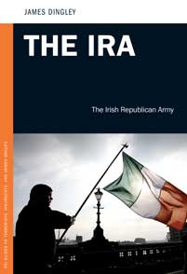
A comprehensive and authoritative examination of the IRA’s ideological and organizational origins and evolution and how these trends have influenced its terrorist warfare until the beginning of the peace process that resolved the Northern Ireland conflict. Chapters cover topics such as the philosophy and theology of Irish Republicanism, a history of Ireland and the emergence of the IRA, the transformation of the IRA into PIRA (Provisional IRA), strategic and tactics, weapons and targets, organization and structure, the imprisonment of IRA operatives, the role of Sinn Fein (its political front), and funding. Although these topics are well covered, one of the book’s flaws is its lack of coverage of the peace process that was led by the British and Irish governments, which enabled PIRA and its leaders and operatives to re-integrate into Northern Ireland society and politics, thereby depriving the book of a wider context in which to understand the latest developments affecting IRA/PIRA. The author, a visiting research fellow at Queens University in Belfast, is a veteran analyst on terrorism and counterterrorism in Northern Ireland.

Daniel E. Price, Sacred Terror: How Faith Becomes Lethal. Santa Barbara, CA: Praeger, 2012. 268 pages, US$48.00, [Hardcover], ISBN: 978-0-313-38638-1.
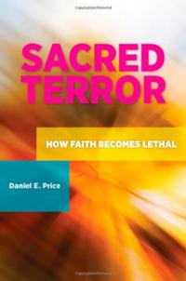
An examination of whether and under what circumstances the theology and ideology of religion (whether Christian, Jewish, or Islamic) "causes" terrorism, when the same religious texts and traditions may be utilized by different elements to promote peaceful or violent objectives. To validate this hypothesis, the author examines how religion-based terrorism has manifested itself throughout history, including how it compares with other forms of terrorism. One of the book’s findings is that the “real causes” of religion-based terrorism are influenced by other forces in society, such as uthoritarianism, global power imbalance, foreign invasion and occupation, globalization of the world economy, rapid modernization, and group psychology. The author is an assistant professor at Westfield State University, Massachusetts.
Amsterdam University Press
Joseph Alagha, The Shifts in Hizbullah’s Ideology: Religious Ideology, Political Ideology, and Political Program. Amsterdam, The Netherlands: Amsterdam University Press, 2006. 380 pages, US$49.50 [Paperback], ISBN-13: 978-9053569108.
An examination of the origins and evolution of Hizballah’s ideology since its founding as a Lebanese Shi’ite organization in 1978. The volume covers topics such as Hizballah’s history from 1978 to 2005, changes in its religious and political ideology, and the implications of such changes on its political program and militant activities. The book is based on the author’s doctoral dissertation. The author is Associate Professor of Islamic Studies at Radboud University Nijmegen, the Netherlands.

Joseph Alagha, Hizbullah’s Documents: From the 1985 Open Letter to the 2009 Manifesto. Amsterdam, The Netherlands: Pallas Publications/Amsterdam University Press, 2011. 222 pages, US$24.95 [Paperback] ISBN-13: 978-9085550372.
A valuable compilation of primary documents about Hizballah’s political program, beginning with the party’s 1985 “Open Letter to the Oppressed in Lebanon” through its November 2009 Political Manifesto. These documents, which provide a firsthand portrait of Hizballah’s political evolution over the years, are accompanied by an introductory chapter, extensive footnotes, commentary, background information, glossary, and chronology. The author is Associate Professor of Islamic Studies at Radboud University Nijmegen, the Netherlands.

Joseph Alagha, Hizbullah’s Identity Construction. Amsterdam, The Netherlands: Amsterdam University Press, 2011. 308 pages, US$29.95 [Paperback], ISBN-13: 978-9089642974.
An examination of the historical origin and evolution of Hizballah’s political program, including its attitudes toward terrorism and suicide martyrdom operations, as well as involvement in Lebanese politics. The author is Associate Professor of Islamic Studies at Radboud University Nijmegen, the Netherlands.
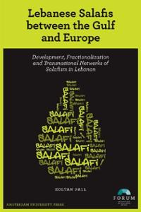
Zoltan Pall, Lebanese Salafis Between the Gulf and Europe: Development, Fractionalization and Transnational Networks of Salafism in Lebanon. Amsterdam, The Netherlands: Amsterdam University Press, 2013. 120 pages, US$25.00 [Paperback], ISBN-13: 978-9089644510.
An innovative and interesting exploration of the dynamics of the Salafi movement worldwide and how these dynamics are reflected in the actions of their networks in Lebanon. The author is Ph.D. candidate at the Faculty of Humanities, Utrecht University, the Netherlands.

The Netherlands Scientific Council for Government Policy, Dynamism in Islamic Activism: Reference Points for Democratization and Human Rights. Amsterdam, The Netherlands: Amsterdam University Press, 2006. 238 pages, US$49.95 [Paperback], ISBN-13: 978-9053569184.
A conceptually important examination of the interplay between Islamic beliefs, political activism, society and law in twelve Islamic countries since the 1970s.

Ashgate
Imran Awan and Brian Blakemore, editors, Extremism, Counter-Terrorism and Policing. Burlington, VT: Ashgate, 2013. 174 pages, US$99.95, [Hardcover], ISBN: 978-1-4094-5321-5
The contributors to this important volume examine how violent extremism proliferates in society and the types of measures (including policing) required to counter extremism at the international and community levels. Chapters cover topics such as the origins and psychology of extremism, the nature of extremist groups and organizations, and the relationship between extremism, counterterrorism, and policing.
Warren Chin, Britain and the War on Terror: Policy, Strategy and Operations. Burlington, VT: Ashgate, 2013. 250 pages, US$99.95 [Hardcover], ISBN-978-0-7546-9528-8.
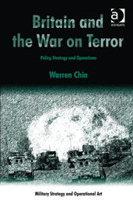
A critical examination of the nature of Britain’s role in the “war on terror” and how, according to the author, the military component became the dominant theme of what is basically an ideological and political conflict. To examine this thesis, the author discusses Britain’s strategic framework for conducting the “war on terror”, al Qaida’s strategic framework for its political, religious, and military warfare, the decision of the British government to intervene in Iraq in 2003 and its involvement in the country through 2009, British strategy and operations in Afghanistan from 2006 to 2010, and British countermeasures against the terrorist warfare waged by al Qaida and its affiliates in the United Kingdom. The author is Senior Lecturer in the Defence Studies Department, King's College London, UK, and Visiting Scholar at the International Centre for Muslim and non-Muslim Understanding, University of South Australia.

Michael Freeman, editor. Financing Terrorism: Case Studies. Burlington, VT: Ashgate, 2012. 256 pages, US$99.95 [Hardcover], ISBN-13: 978-1409442615.
The contributors to this important volume examine issues involved in financing terrorism and the countermeasures required in response. Chapters cover topics such as the theory and typology of different sources of terrorist financing, as well as case studies of financing by terrorist insurgents in Iraq, the Lebanese Hizballah, the Kurdish PKK, the Pakistani LeT, the Taliban in Pakistan and Afghanistan, the Sri Lankan LTTE, terrorist groups in the Philippines, the Loyalists in Northern Ireland, Islamist militants in Albania, and the FARC and ELN in Colombia. The concluding chapter discusses how to “think critically” about terrorist financing. Michael Freeman, the volume’s editor, is an Assistant Professor at the Naval Postgraduate School.

Bloomsbury
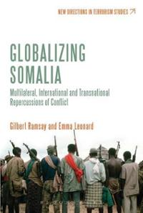
Emma Leonard and Gilbert Ramsay, editors. Globalizing Somalia: Multilateral, International, and Transnational Repercussions of Conflict. New York, NY: Bloomsbury, 2013. 304 pages, US$34.95 [Paperback], ISBN-13: 978-1780935690.
The contributors to this volume examine the repercussions at the regional and international levels of the inability of the international and multilateral community (such as the United Nations) to resolve the conflict in Somalia, particularly the failure (also by local actors) to establish a stable government in this war-torn country. Chapters cover topics such as the effectiveness of international and regional peacekeeping forces in Somalia, the nature of the “Jihadi” insurgency in Somalia and the involvement in foreign fighters in its warfare, the threat posed by Somali piracy and its links to international crime, the nature of involvement by the United States, Japan, China, and the European Union in Somalia, and recommendations for new intervention measures that may be more effective at resolving the conflict in Somalia.

Gilbert Ramsay, Jihadi Culture on the World Wide Web. New York, NY: Bloomsbury, 2013. 272 pages, US$130.00 [Hardcover], ISBN-13: 978-1441175625.
An examination of the utilization of the Internet by militant Jihadis for objectives such as propaganda, radicalization and recruitment of new adherents. Using both Arabic and English primary source materials, the author examines the interaction between the “producers” of such content and their “consumers” in order to demonstrate how Jihadism is practiced in cyberspace. Also discussed are the measures used by those who are opposed to such extremist activities. The author is Lecturer at The Handa Centre for the Study of Terrorism and Political Violence, University of St Andrews.

Columbia University Press
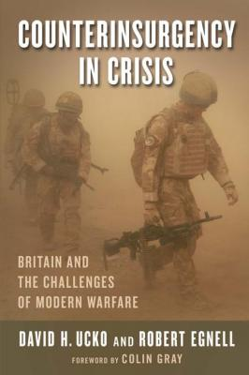
David H. Ucko and Robert Egnell. Counterinsurgency in Crisis: Britain and the Challenges of Modern Warfare. New York, NY: Columbia University Press, 2013. 248 pages, US$50.00 [Hardcover], ISBN: 978-0-231-16426-9.
An examination of the effectiveness of Britain’s counterinsurgency campaigns in Iraq and Afghanistan, where (the authors contend) they failed to defeat the insurgents, particularly in Basra (in Iraq) and Helmand (in Afghanistan). One of the authors’ conclusions is that “an ‘indirect’ means of intervention, centered on advising, training, and employing a foreign fighting force rather than on relying primarily on your own troops” (page 156) may be more effective than conducting “direct” counterinsurgency campaigns, since it is the local actors who must be responsible for defending themselves against their own internal threats. David Ucko is associate professor at the College of International Security Affairs, National Defense University, and Robert Egnell is visiting associate professor and Director of Teaching in the Security Studies Program at Georgetown University, both in Washington, DC.

Cornell University Press
Carolyn Gallaher, After the Peace: Loyalist Paramilitaries in Post-Accord Northern Ireland. Ithaca, NY: Cornell University Press, 2007. 272 pages, US$28.50 [Paperback], ISBN-13: 978-0801474262.
An important, field research-based examination of the state of the Protestant Loyalist paramilitaries in Northern Ireland, almost a decade after the signing of the peace accords that ended the conflict. The author discusses the problems that plagued the demilitarization of the Loyalist paramilitaries, which were due to factors such as internecine personal and political divisions and rivalries and reluctance by some to give up their criminal enterprises. Others, nevertheless, sought to utilize the peace process to rebuild their communities and participate in the political process. All these factors are crucial in understanding the current situation in Northern Ireland’s post-accord era from the Loyalists’ vantage point. The author is Associate Professor, School of International Service, American University, Washington, DC.

Ahmed S. Hashim, Insurgency and Counter-Insurgency in Iraq. Ithaca, NY: Cornell University Press, 2006. 512 pages, $25.12 [Hardcover], ISBN-13: 978-0801444524.
A well-informed account of the nature, motives, tactics and effectiveness of the many groups that formed the insurgency in Iraq and the U.S.-led counterinsurgency campaign against it, following the overthrow of Saddam Hussein’s regime in March 2003. The author is Associate Professor in Security Studies at the Rajaratnam School of International Studies at Nanyang Technological University in Singapore (but taught at the U.S. Naval War College when the book was published).
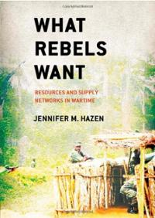
Jennifer M. Hazen, What Rebels Want: Resources and Supply Networks in Wartime. Ithaca, NY: Cornell University Press, 2013. 208 pages, US $45.00 [Hardcover], ISBN-13: 978-0801451669.
An innovative account of the methods and tactics used by rebel groups to finance their activities in order to obtain weapons, ammunition, and other vital supplies, which is an important factor in understanding the trajectory of their capabilities and options in conducting their insurgencies. The author argues that rebel groups often fail to obtain what they require, with this thesis examined in the cases of civil wars in Sierra Leone, Liberia, and Côte d'Ivoire. The author has extensive experience working with NGOs in West Africa and is currently a senior analyst with BAE Systems.

Helen M. Kinsella, The Image Before the Weapon: A Critical History of the Distinction Between Combatant and Civilian. Ithaca, NY: Cornell University Press, 2011. 264 pages, US$39.95 [Hardcover], ISBN13: 9780801449031.
A valuable discussion of the difficulty of applying international humanitarian law in distinguishing between combatant and civilian in warfare – whether regular or irregular, such as terrorism. The author is Assistant Professor of Political Science at the University of Wisconsin–Madison.

Zachariah Cherian Mampilly, Rebel Rulers: Insurgent Governance and Civilian Life During War. Ithaca, NY: Cornell University Press, 2011. 320 pages, US$45.00 [Hardcover], ISBN-13: 978-0801449130.
A theoretically important examination of the nature of “governance” by rebel groups when they succeed in seizing power, whether over a portion of territory or an entire state, because such an aspect of insurgencies is generally overlooked by the literature on insurgency and its aftermath. Components of rebel governance are examined, such as the capacity to deliver public services to the populations under their control, ranging from police and courts, schools, hospitals, and taxation systems, as well as symbolic expressions such as adherence to “official” flags and anthems, in order to generate and sustain compliance to their rule. This framework is applied comparatively to the case studies of three diverse insurgent organizations—the Liberation Tigers of Tamil Eelam (LTTE) in Sri Lanka, the Rally for Congolese Democracy (RCD) in Congo, and the Sudan People's Liberation Movement/Army (SPLM/A) in Sudan. The author is Associate Professor of Political Science and Director of Africana Studies at Vassar College.

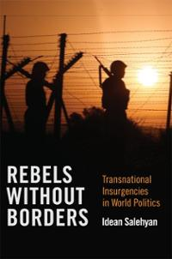
Idean Salehyan, Rebels Without Borders: Transnational Insurgencies in World Politics. Ithaca, NY: Cornell University Press, 2009. 216 pages, US$21.00 [Paperback], ISBN-13: 978-0801477546.
A conceptually innovative account of how conflicts that are considered to be primarily “internal” wars often spill across their national boundaries, with rebel organizations finding sanctuaries among supporting elements in neighboring countries, with such spillover potentially giving rise to wider regional conflicts and diplomatic and military disputes between such states. To examine this thesis, the author formulates a theory of transnational rebellions which is based on cross-national datasets and case studies of cross-border insurgencies, such as the Contra bases in Honduras and Costa Rica (which facilitated the Nicaraguan civil war), the Rwandan civil war (which spilled over into the Democratic Republic of the Congo), as well as the Kurdish PKK and Taliban forces in Afghanistan and Pakistan. The concluding chapter presents a summary of findings, recommendations for improving theories of conflict, and policy implications. The author is Associate Professor of Political Science at the University of North Texas.

Claudia Verhoeven, The Odd Man Karakozov: Imperial Russia, Modernity and the Birth of Terrorism. Ithaca, NY: Cornell University Press, 2009. 248 pages, US$42.50 [Hardcover], US$23.95 [Paperback], ISBN-13: 978-0801477577.
A highly interesting account of the modern origins of the revolutionary political violence known as terrorism through the persona of Dmitry Karakozov, a revolutionary anarchist, who pulled out a pistol and shot at Czar Alexander II, on April 4, 1866. Although the shot missed, this “unheard-of-act” of rebellion against authority served to change the course of Russian history and inaugurated the first wave of terrorism’s modern era. The author is Assistant Professor of Modern European History at George Mason University.

About the Reviewer: Dr. Joshua Sinai is the Book Reviews Editor of ‘Perspectives on Terrorism’.

CIA declassifies report on Armenian terrorist groups in US, Europe
Source: http://www.news.az/articles/armenia/85156

U.S. Central Intelligence Agency has declassified its report dated 1984 on the Armenian terrorist groups (JCAG, ASALA, etc.), which operated in the United States, Europe and worldwide under the Freedom of Information Act.
"Armenian Secret Army for the Liberation of Armenia” (ASALA) is a growing threat to a number of U.S. political interests. Although most of the attacks were carried out against Turks, ASALA, several facilities in Western Europe and the United States were also affected,” CIA says in its report.
In addition, a significant intensification of contacts with Libya and Syria could lead the Marxist-oriented Asala to additional anti-American influence," it says in a declassified report.
The report also said that the Armenian terrorist organization of fighters for justice for the "Armenian genocide” (Justice Commandos against Armenian Genocide, JCAG, JSAG) has focused almost exclusively on targets against the Turks.
"In a plot that has ominous implications for international cooperation in combating terrorism, some Western European countries reached agreement with ASALA, giving terrorists a freedom to prosecute Turkish targets in exchange for a promise not to attack the indigenous citizens of these countries," the report says.
According to the report, the Turks were very angry at this development and in response announced that they witness European indifference and connivance to ASALA terrorism.
Despite some setbacks, major Armenian terrorist groups have retained much of their activities. As a result of this activity ASALA and JCAG have killed 50 officials and citizens of Turkey and organized more than 200 explosions since 1975.
"Over the past four years, an indiscriminate violence by ASALA resulted in large-scale losses. The last split within ASALA and Armenian political groups, according to our estimates, increases the risk of terrorist violence, particularly in Western Europe, as various splinter groups vie for the attention of the Armenian community," the report says.
The report also provides detailed chronology of the Armenian terrorism from January 1975 to December 1983.

►Read the full report at:

http://www.foia.cia.gov/sites/default/files/document_conversions/89801/DOC_0005462031.pdf

Pirates abduct Greek, Ukrainian from ship off Nigeria
Source: http://www.terrorismwatch.org/2013/12/pirates-abduct-greek-ukrainian-from.html?utm_source= feedburner&utm_medium=email&utm_campaign=Feed%3A+terrorismwatch%2FJTvK+%28Terrorism+Watch%29&utm_content=Yahoo!+Mail

Pirates have attacked an oil products tanker off the coast of Nigeria and kidnapped its Ukrainian captain and a Greek engineer, Greek coast guard officials said on Tuesday.
The 6,500 tonne Marshall Islands-flagged MT ALTHEA with 18 crew on board was attacked by a group of 10 pirates, the officials said. The ship's manager, Piraeus-based Medtankers Management, confirmed the attack.
"We are doing everything we can for their release," an official at the firm said on condition of anonymity, adding that so far, no ransom demand had been received.
"They kidnapped the two men but did not touch the cargo (oil) or injure anyone."
The ship was attacked late on Monday around 35 nautical miles off the oil-producing Niger Delta coastline, a Nigerian security source said. The armed pirates fled with the two hostages in a speedboat, the source said.
The Nigerian navy is investigating, a spokesman said.
Pirate attacks off Nigeria have jumped by a third this year as ships passing through West Africa's Gulf of Guinea, a major commodities route, have come under threat from gangs wanting to snatch cargoes and crews.
Unlike the waters off Somalia on the east African coast, where ships now speed through with armed guards on board, there is little protection for many vessels which have to anchor off West African countries to do business.
This makes them targets for criminals and raises insurance costs. Kidnapped sailors and oil workers taken in Nigerian waters are usually released after a ransom is paid.

►Update: Both sailors were freed on Jan 6, 2014. No info if ransoms were paid.

Is the Terrorist Threat Declining? The Use and Abuse of Statistics
By Daveed Gartenstein-Ross
Source: http://warontherocks.com/2013/12/is-the-terrorist-threat-declining-the-use-and-abuse-of-statistics/?goback=.gde_1528217_member_5818676221591986177#!

Earlier this month, terrorism analyst Peter Bergen wrote at CNN that the declining number of jihadists indicted in the United States demonstrates that the domestic terrorist threat has “markedly declined over the past couple of years.” His view is a counterpoint to the proclamations of Senate and House intelligence committee heads Sen. Dianne Feinstein (D.-Calif.) and Rep. Mike Rogers (R.-Mich.), who have claimed that the U.S. is no safer than it was in 2011. Who is right?
Bergen, the head of the National Security Program at the New America Foundation (NAF), contends that though Feinstein and Rogers might be on firm ground in arguing that al-Qaeda is resurgent in the Middle East, a NAF study of jihadist militants shows a substantial decline in the number of indicted extremists since 2010. Bergen contends that this establishes a declining domestic threat:
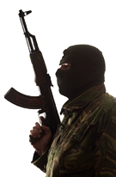
The total number of such indicted extremists has declined substantially from 33 in 2010 to nine in 2013. And the number of individuals indicted for plotting attacks within the United States, as opposed to being indicted for traveling to join a terrorist group overseas or for sending money to a foreign terrorist group, also declined from 12 in 2011 to only three in 2013.
Of course, a declining number of indictments doesn’t mean that the militant threat has disappeared. One of the militants indicted in 2013 was Dzhokhar Tsarnaev, who is one of the brothers alleged to be responsible for the Boston Marathon bombings in April. But a sharply declining number of indictments does suggest that fewer and fewer militants are targeting the United States….
In short, the data on al-Qaeda-linked or -influenced militants indicted in the United States suggests that the threat of terrorism has actually markedly declined over the past couple of years.
Here’s the interesting thing, to me, about Bergen’s analysis: it depends almost entirely on how one reads a sudden spike in homegrown terrorist cases that occurred in 2009-10. Exactly four years ago, in December 2009, Bergen’s view of the homegrown terrorist threat, based on the sudden rise in cases we were then experiencing, was that “there is no denying it is increasing.” He explained that a trend toward more homegrown jihadism “is just a fact,” since the phenomenon had “sort of grown exponentially in the last two years.” In other words, Bergen assessed at the time that the rising cases weren’t aberrant, but rather part of a trend of increased homegrown jihadist violence that would continue.
At the time, I disagreed in print with Bergen’s confidence that we were seeing a definite trend toward a persistently higher number of homegrown terrorism cases. Now that the 2009-10 spike in cases has receded, Bergen argues just as confidently that we are safer. I disagree with this conclusion, too. Much of our disagreement boils down to differences between my methodology of interpreting statistics and Bergen’s. In turn, this discussion has implications for broader efforts to assess U.S. counterterrorism policies: are we drawing the right lessons from the statistics and evidence that we gather, or are we being fooled by our own numbers?

The 2009-10 Spike in Homegrown Terrorist Cases
2009 saw almost twice as many people in the U.S. indicted for illegally supporting the jihadist cause as any previous year. According to NAF’s database of homegrown terrorism cases, there were 43 such cases in 2009, when the highest number in any other year since the 9/11 attacks had been 23, in 2003. The following year, in 2010, the number of homegrown jihadist terrorism cases declined to 34, but that still represented more such cases than any year but 2009.
As previously noted, Bergen viewed this sudden spike in homegrown terrorist cases at the time as an undeniable increase in the threat. I wasn’t so sure. In an article I published in the summer of 2010, I concluded that it wasn’t “clear that homegrown terrorism is increasing,” for two reasons. The first was that the perceived spike could be based on changes in policing strategies and tactics. If authorities started making arrests at a different point relative to a suspect undertaking illegal activities, that could artificially trigger perceptions of a major increase in homegrown terrorists; and so too could an increase in the number of sting operations. Second, I raised the possibility that this could be a statistical aberration:
Another possibility is that the current rash of homegrown terror cases is an aberration. In a statistical sequence measured over the course of years (such as weather patterns or a baseball player’s career), aberrant sequences will frequently arise. A spike or precipitous decline in numbers does not mean the numerical trajectory will extend indefinitely. For example, an unusually cold May does not mean that July will also be unusually cold. While in the middle of an unusual statistical sequence, it can be hard to have perspective; and in five years, 2009-2010 may seem exceptional in terms of the level of homegrown terrorist activity, rather than the beginning of a new trend.
Now that five years have passed since the onset of that spike in cases, it appears to have been just that, an aberrational sequence. And we can pinpoint the precise development that drove the 2009-10 rise in cases: the Somalia war.
In December 2008, the U.S. media first reported authorities’ discovery that more than a dozen young Somali men from Minnesota’s Twin Cities area (which has the U.S.’s largest Somali community) had disappeared, going abroad to join jihadist groups in Somalia. They decided to fight there after Ethiopia’s U.S.-backed invasion of Somalia in 2006, which was designed to shore up the country’s U.N.-recognized transitional federal government and push back its main adversary, the Islamic Courts Union. In addition to the young men being driven by nationalist sentiments, jihadist recruiters focused their efforts on the Twin Cities area—a somewhat unique dynamic for domestic terrorist cases, the vast majority of which do not feature recruiters from any established militant organization.
Thereafter, domestic law enforcement made apprehension of the young men who went to fight abroad, and the networks encouraging and supporting them, a top priority. Terrorism-related indictments increased as a result: the NAF dataset suggests that 14 indictments in 2009 and 16 in 2010 were related to the Somalia conflict. If you subtract these figures from the number of total indictments for both years, the numerical spike becomes less extreme, with only 29 indictments in 2009 and 18 in 2010 that were unrelated to the Somalia war. Though 2009 still would have a higher number of indictments than any year preceding it even with the adjusted figures, 2010 would be more in line with the numbers from previous years, featuring fewer terrorism indictments than either 2003 or 2006.
As recruiting for the Somalia conflict has declined, the number of indictments has also gone down. So the question remains: how do we interpret the lower numbers we are seeing now? Has the threat of homegrown terrorism “markedly declined,” as Bergen insists, or is there a better way to understand the number of homegrown jihadist cases that we have seen in 2012-13?

The Longer View
Fortunately, there has always been a relatively small number of homegrown jihadist terrorism cases in the United States. The fact that these numbers are small should make us hesitant to infer too much from numerical fluctuations. Take a look at the number of homegrown jihadists who have been indicted or killed by year, per the NAF database:
2002: 16
2003: 23
2004: 8
2005: 12
2006: 19
2007: 16
2008: 6
2009: 43
2010: 34
2011: 22
2012: 7
2013: 10
Bergen asserted that there had been nine indictments this year, but his article came out before Terry Loewen’s arrest, which pushes the number to ten. Looking at the full data by year, it’s not clear that there is a declining threat. Ten indictments in 2013 is three more than there were last year; it’s also a higher number than we saw in either 2004 or 2008. Indeed, there were only six such cases in 2008—the year before we saw the sudden jump to forty-three indictments.
In fact, rather than basing our assessment on indictments, there’s an entirely different statistic for measuring whether we face a declining threat: the number of people killed or injured by homegrown terrorists in the U.S. in any given year. That number was zero in 2011, while in 2013 three people were killed and 264 injured (in the Boston bombings).
The bottom line is that it’s perilous to infer too much from the data when the numbers in question are rather small, because small numbers makes it extraordinarily difficult to measure trends reliably. All it takes is one unusual development—such as the outbreak of war in Somalia, and its resulting impact on Minneapolis-St. Paul—to make it appear that everything has changed from a numerical perspective.
There is thus little proof that “the threat of terrorism has actually markedly declined over the past couple of years.” The core problem with Bergen’s use of statistics is evident when you compare his analysis in 2009 with his assessment today: his methodology is prone to perceiving a significant change in the level of threat based upon the direction that the numerical trend line is pointing at any given time. If the number of indictments doubled to twenty next year, by Bergen’s established methodology the threat would seem to be increasing again—even though the absolute numbers would still be lower than 2003, 2009, 2010, or 2011.
In attempting to determine whether we are grappling with an increasing or declining threat, it’s important to view the most recent data in as broad a context as possible. We should be wary of any method of statistical interpretation wherein temporary fluctuations in one direction or another can be mistaken for massive shifts in the threat we confront.

Daveed Gartenstein-Ross is a senior fellow at the Foundation for Defense of Democracies, an adjunct assistant professor in Georgetown University’s security studies program, and the author of Bin Laden’s Legacy (Wiley, 2011). He worked as a statistics tutor while an undergraduate at Wake Forest University.

The Islamic State of Iraq and Al-Sham (ISIS)
By Aymenn Jawad Al-Tamimi
Source: http://www.meforum.org/3697/islamic-state-iraq-al-sham

INTRODUCTION: THE IDEOLOGY
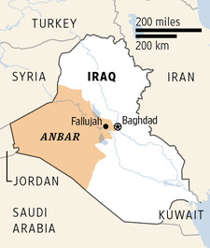
The group under consideration in this paper–like al-Qa'ida central under Usama bin Ladin and subsequently Ayman al-Zawahiri, the Tehrik-e-Taliban of Waziristan, and others–is part of what one might term the "global jihad" movement. This movement is not a coherent whole organized by a strict central hierarchy, but rather one defined by a shared ideology. This ideology aims firstly to reestablish a system of governance known as the Caliphate–an Islamic form of government that first came into being after Muhammad's death under Abu Bakr and saw its last manifestation in the Ottoman Empire–across the entire Muslim world. From there, the intention is to spread the Caliphate across the entire world.[1]
This worldview is one of many answers formulated to answer a question posed in the wider Muslim world: Namely, what has been the cause of decline of the Muslim world–and the Arab world in particular–in contrast to the apparent success of the West since the nineteenth century? The answer formulated by ideologues of the global jihad movement is that the cause of this decline is rooted in the Muslim world's deviation from the path of Islam by not applying Islamic law to governance in its totality. This is to be contrasted with the "Islamic Golden Age" in Islam's first five centuries or so–idealized in different ways by others not of this orientation–when the Muslim world was supposedly uncontaminated by foreign influences. Of course, given that era's exploitation of the classical Greek heritage through the translation movement under the Abbasids- the global jihad movement's portrayal of this era is blatantly unhistorical. Nonetheless, the perception is what matters.
In light of the ISIS' ambitious goals, it is imperative to consider the group's fortunes in Syria, which in turn will allow policymakers to assess what threat, if any, the group poses to the wider international order in the long-term.

►Read the full paper at source’s URL

Aymenn Jawad Al-Tamimi is a student at Brasenose College, Oxford University, and a Shillman-Ginsburg Fellow at the Middle East Forum.

Gunman kills 1, fatally shoots self in Reno hospital spree
Source: http://www.foxnews.com/us/2013/12/18/police-gunman-wounds-4-kills-self-at-reno-hospital/

A gunman opened fire at a hospital campus in Reno, Nevada, on Tuesday, (Dec 18, 2013) killing one person and critically wounding two others before turning the weapon on himself.
The Nevada Department of Public Safety said the wounded victims were in surgery and one of them is a doctor.
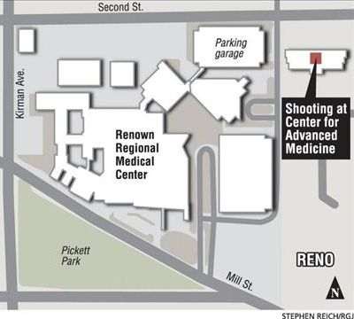
Police initially said the gunman shot four people before killing himself, but they later said he wounded two people and killed another before committing suicide.
"We have two people confirmed deceased in the building, two others injured," said Reno Police Deputy Police Chief Tom Robison.
Department of Public Safety spokeswoman Gail Powell said the wounded doctor is a woman but she had no more information about the identity of the victims or the gunman, the type of weapon used or a motive for the attack. She said the shooting happened at the Center for Advanced Medicine and Neurology of Nevada.
Renown Regional Medical Center was put on lockdown amid the chaos of the shooting as law enforcement rushed to the scene and victims were treated by doctors on the hospital campus. More than three dozen police cars, including SWAT team vehicles, surrounded the sprawling medical complex and closed off a three-block area near downtown Reno.
State Sen. Debbie Smith said she was at Renown for an appointment and was trying to leave a nearby building around 2:45 p.m. when the shooting occurred.
"I encountered some SWAT team guys, they said nobody was leaving," she said. "A police officer was at the door and said I couldn't go out there."
Renown Regional Medical Center posted a notice on its website less than two hours after the shooting saying that operations had returned to normal at the main hospital but police were still investigating the shooting in an office building on the northeast corner of the campus.
The Center for Advanced Medicine building is a modern four-story structure connected by a second-floor walkway to the hospital and a parking structure.
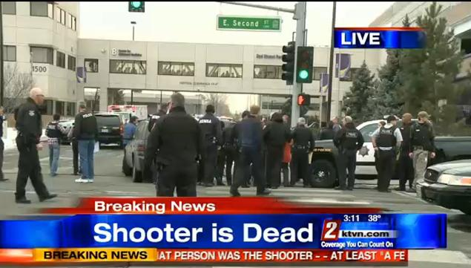
Gov. Brian Sandoval said on Twitter that he and his staff were monitoring the situation and his thoughts and prayers were with those affected by the tragedy.
Renown Regional Medical Center is the largest hospital in northern Nevada. It has played an important role in responding to several recent tragedies in northern Nevada, including a crash at a Reno air race in 2011 that killed 11 people and a rampage at a Carson City restaurant the same year that killed three uniformed Nevada National Guard members.

Threat of 3D-printed guns expected to grow
Source: http://www.pressherald.com/news/Threat_of_3D-printed_guns_expected_to_grow_.html? pagenum=full

Undetectable plastic handguns can be produced with equipment readily available in Maine, but law enforcement officials here and around the country say such weapons have yet to become a serious threat to public safety.
On Monday, Congress renewed a 10-year federal ban on undetectable firearms, including 3D-printed guns made entirely of plastic. Representatives of local, state and federal law enforcement agencies said 3D-printed guns are still crude and unreliable, but the relatively new consumer technology that can produce a working plastic gun at home is expected to get better and cheaper in coming years.
Officials said they were not aware of any arrests in Maine or elsewhere for illegal use or possession of 3D-printed guns, but because such weapons can pass unseen through a metal detector, “they definitely pose a threat to our nation’s airports” and other locations, said Debra Seifert, spokeswoman for the Bureau of Alcohol, Tobacco, Firearms and Explosives in Boston.
Seifert said 3D-printed guns also pose a danger to the people who try to use them, because they could explode when the trigger is pulled.
For that reason, the ATF considers 3D-printed guns more of a potential problem for the future, Seifert said, although she acknowledged that there is no simple way to stop people from making them now.
There are at least 200 3D printers in Maine that are capable of producing a working gun, said Sarah Boisvert, owner of a digital design and fabrication firm in Rockport, 3DMicroFactory, and an organizer of the nonprofit 3D-printing center Maine FabLab.
Boisvert estimated that 10 percent of Maine’s 1,800 manufacturers use 3D printers, along with at least 30 schools.
It’s impossible to say how many individuals in the state own 3D printers, she said, but she suspects that it’s a relatively low number.
Police in Portland have never seen anyone with a 3D-printed gun, said Assistant Police Chief Vern Malloch. And Maine State Police spokesman Stephen McCausland said he was not aware of a single arrest in the state for illegal use or possession of a plastic, 3D-printed gun. In fact, no such arrest has been made worldwide, according to media reports.
Plastic weapons of one kind or another have existed for decades, and are illegal unless they contain enough metal to be detected with a standard metal detector. Seifert said the ATF’s concern is that plastic guns are becoming easier and cheaper to make as 3D printing becomes more ubiquitous. “What’s changed is the technology,” she said.
Authorities in Europe, which has stricter gun-control laws than the U.S., have said they fear that the advent of consumer 3D-printing technology will make it easier to obtain a usable deadly weapon.
Police in Manchester, England, raided a man’s home in October and seized what they believed to be parts for a 3D-printed gun. The items turned out to be plastic replacement parts for the man’s 3D printer.
Three-dimensional printing, also called additive manufacturing, involves special printers that can construct a solid, three-dimensional object from a digital design.
Despite the recent introduction of 3D printers priced as low as $300, experts said a higher-end printer is needed to produce a usable plastic gun. Such printers generally cost $1,000 to $5,000, and can sell for much more at the very high end.
The design for a gun can be obtained for free through peer-to-peer file-sharing services such as BitTorrent. Earlier this year, a law student in Texas posted directions online for making a 3D-printed handgun. A designer in Canada recently released a design for a 3D-printed rifle.
Greg Comcowich, spokesman for the FBI’s Boston field office, said it’s difficult to understand how an all-plastic gun could even be put to practical use. Plastic doesn’t hold up well to the explosive force of a bullet being fired, he said.
“Our Glocks (handguns) are made out of a high-grade polymer plastic, but the barrel is made of metal,” he said.
Law enforcement officials in the U.S. and Europe say they have tested 3D-printed guns after downloading design files from the Internet, and have fired multiple shots from single guns. However, each shot damaged the barrel of the gun, which had to be replaced between firings.
The ban on undetectable guns that Congress renewed Monday has been in force since the Reagan administration, long before the advent of 3D printing, and was due to expire the next day. The Republican-led House approved the extension last week, and President Obama signed the bill late Monday.
The National Rifle Association, which has helped scuttle proposals for tougher firearms restrictions this year, did not oppose the decade-long extension, The Associated Press reported. It did oppose an effort by Sen. Chuck Schumer, D-N.Y., and other Democrats to strengthen the law by requiring that any plastic firearm include a detectable metal component that cannot be removed. Senate Republicans defeated that proposal.
Some plastic firearms technically comply with the quarter-century-old law by containing a detachable metal part, but the part can be slipped off to evade airport security. Democrats said the stricter language is needed in an era when improved and increasingly accessible 3D printers can produce functioning guns.
Democrats who support tightening the rules said the 10-year renewal helps the gun lobby because it inhibits lawmakers’ ability to revisit the issue, the AP reported.
“It’s time that we recognize that the future is here; plastic guns are real,” said Sen. Chris Murphy, D-Conn.

EDITOR’S COMMENT: A problem started in 2013 with the rapid progress in 3D printing and most probably we will witness its “dark” applications in 2014. Screening industry take time to adjust, terrorists adapt faster and when we will be ready to detect them a new tow will appear in the market. C’est la vie!

Despite fewer attacks in Western world, global terrorism increasing
Source:http://start.umd.edu/start/announcements/announcement.asp?id=633&utm_source=START+Announce&utm_campaign=d8601ea10a-START_Newsletter_September9_26_2013&utm_medium=email &utm_term=0_a60ca8c769-d8601ea10a-14081393

Although terrorism touched 85 countries in 2012, just three - Pakistan, Iraq and Afghanistan - suffered more than half of 2012’s attacks (54%) and fatalities (58%), according to new data released today by the National Consortium for the Study of Terrorism and Responses to Terrorism (START) Global Terrorism Database (GTD), based at the University of Maryland. The next five most frequently targeted countries were India, Nigeria, Somalia, Yemen and Thailand.
“While terrorist attacks have in large part moved away from Western Europe and North America to Asia, the Middle East and Africa, worldwide terrorism is reaching new levels of destructiveness,” said Gary LaFree, START director and professor of criminology and criminal justice at the University of Maryland.
In addition to illustrating a continued shift in location of attacks, the new data -- with more than 8,400 terrorist attacks killing more than 15,400 people in 2012 -- also show an increase in attacks and fatalities over the past decade. The previous record for attacks was set in 2011 with more than 5,000 incidents; for fatalities, the previous high was 2007 with more than 12,500 deaths. A map showing concentration and intensity of 2012 attacks is available in next page.

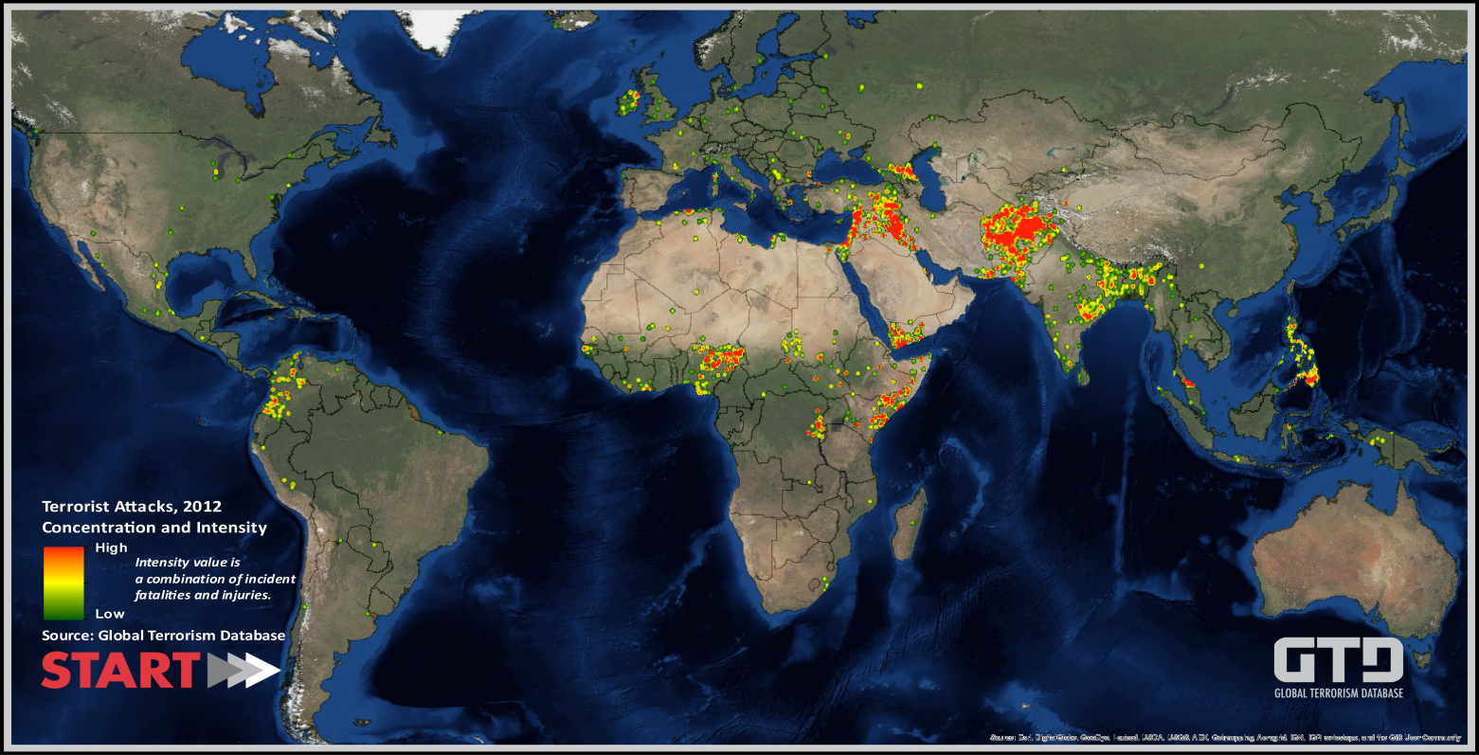
It is critical to note that beginning with 2012 data collection, START made several important changes to the GTD collection methodology, improving the efficiency and comprehensiveness of the process. As a result of these improvements, a direct comparison between 2011 and 2012 likely overstates the increase in total attacks and fatalities worldwide during this time period. However, analysis of the data indicates that this increase began before the shift in data collection methodology, and important developments in key conflicts around the world suggest that considerable upward trends remain even when accounting for the possibility of methodological artifacts.
In the 1970s, most attacks occurred in Western Europe. In the 1980s, Latin America saw the most terrorist acts. Beginning with the 1990s, South Asia, North Africa and the Middle East have seen steadily rising numbers of attacks, a trend that has accelerated in recent years.
“The other striking development in recent years is the incredible growth in terrorist attacks linked to al-Qaida affiliates,” LaFree said.
Though al-Qaida central was not directly responsible for any attacks in 2012, the six deadliest terrorist groups in the world were all affiliated to some extent with the organization. These include the Taliban (more than 2,500 fatalities), Boko Haram (more than 1,200 fatalities), al-Qaida in the Arabian Peninsula (more than 960 fatalities), Tehrik-e Taliban Pakistan (more than 950 fatalities), al-Qaida in Iraq (more than 930 fatalities) and al-Shabaab (more than 700 fatalities).
Attacks in Yemen, Nigeria and Iraq were among the deadliest in 2012.
- On Jan. 5, unidentified Sunni perpetrators in Dhi Qar, Al Anbar and Baghdad, Iraq bombed various Shiite civilian targets, including pilgrims and laborers, in six separate attacks. Nearly 120 people were killed across all six attacks, including at least two suicide bombers.
- In Nigeria on Jan. 20, approximately 190 people were killed in bombings targeting government, police, media, schools, utilities and private citizens, primarily in Kano. Boko Haram claimed responsibility for the attacks, indicating that they were carried out in response to Nigerian authorities detaining and killing Boko Haram members.
- On March 4, al-Qaida in the Arabian Peninsula attacked a series of military targets in Zinjibar, Yemen, killing a total of 195 soldiers and kidnapping 73. More than 40 perpetrators were also killed in these attacks, and the hostages were released the following month.
GTD data files and documentation are available for download from the START website for users who would like to conduct custom analysis of the data. In addition to the methodological improvements made in the collection and coding process, the GTD team has added elements to improve the experience for those using the database. 2012 is the first year of data that includes geocodes for all attacks that occurred worldwide. Efforts to geocode the historical data back to 1970 are ongoing, and with the current update the geocoding process was completed for an additional 20 countries in North Africa and Southeast Asia. This information makes it possible for analysts to explore geospatial patterns of terrorist violence and more easily identify the sub-national concentrations of attacks.
Other new variables include target subtypes, which systematically classify targets into more specific categories. For example, while previous versions of the data allowed users to explore a subset of attacks against transportation targets, now analysts can easily identify attacks that target buses (42% of all transportation attacks), trains (33%), bridges and tunnels (9%), stations (7%), roads (4%), subways (2%), or taxis (1%).
“This update includes a number of improvements that we have been working on for several years, in response to common requests from users,” said Erin Miller, GTD program manager. “We are always happy to get feedback on what types of information would make this a more useful resource and better serve the needs of researchers and practitioners.”
According to Miller, the most commonly requested feature is the ability to distinguish between international and domestic attacks. To address this need, the GTD team developed a set of indicators that classify attacks as international or domestic across several dimensions, including logistics (whether the perpetrator group crossed a border to carry out the attack) and ideology (whether the perpetrator group was attacking a target of a different nationality, regardless of where the attack took place). The domestic/international indicators and other new variables are currently included in the downloadable data files. START plans to incorporate them into the online user interface in a future update. More information about the new variables can be found in the GTD Codebook.
With this data release, the GTD now contains information on more than 113,000 domestic and international terrorist attacks between 1970 and 2012 that resulted in more than 243,000 deaths and more than 324,000 injuries. These attacks are defined as the threatened or actual use of illegal force and violence by a non-state actor to attain a political, economic, religious or social goal through fear, coercion or intimidation.
The GTD is funded through START by the Department of Homeland Security Science and Technology Directorate’s Office of University Programs, the U.S. Department of State’s Bureau of Counterterrorism, and the Department of Homeland Security Science and Technology Directorate’s Resilient Systems Division.

►GTD Codebook: http://start.umd.edu/gtd/downloads/Codebook.pdf

The National Consortium for the Study of Terrorism and Responses to Terrorism (START) is supported in part by the Science and Technology Directorate of the U.S. Department of Homeland Security through a Center of Excellence program based at the University of Maryland. START uses state‐of‐the‐art theories, methods and data from the social and behavioral sciences to improve understanding of the origins, dynamics and social and psychological impacts of terrorism.

New Terrorist Group Posing Threat to U.S. Interests in Africa
Source: http://www.nytimes.com/2013/12/19/world/africa/state-dept-warns-of-new-terrorist-group-posing-threat-to-us-interests-in-africa.html?ref=world&_r=1&

The State Department warned Wednesday that a new terrorist group linked to an Algerian militant has emerged as “the greatest near-term threat to U.S. and Western interests” in the Sahel region of Africa. The State Department’s move underscored the resilience of the militant factions and their ability to forge new terrorist alliances, even in the face of Western pressure.
“We are seeing a dangerous mutation of the threat,” said Bruce Hoffman, an expert on terrorism at Georgetown University. “Splinters can become even more consequential than their parent organization.”
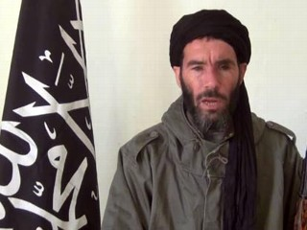
The source of much of the concern is Mokhtar Belmokhtar, an Algerian militant who has long been a notorious figure in the Sahel region — a vast area on the southern flank of the Sahara that stretches from Senegal to Chad — and who appears to have become more dangerous even as his ties to Al Qaeda seem to have become more tenuous. Known as Laaouar, or the one-eyed, after losing an eye to shrapnel, Mr. Belmokhtar fought against a Soviet-installed government in Afghanistan.
After returning to Algeria in the 1990s, he joined a militant Algerian group and took refuge in Mali, where he was involved in smuggling and kidnapping for ransom, including the abduction of a Canadian diplomat in 2008.
Mr. Belmokhtar became a leading figure in Al Qaeda in the Islamic Maghreb, or A.Q.I.M., the Qaeda affiliate in North Africa.
But in 2012, he split with the group to lead the Al Mulathameen Battalion, which was officially designated as a foreign terrorist organization by the State Department on Wednesday.
“The finding reflects the fact that the terrorist groups in the region are in flux, although certain individuals remain constant,” said Michael R. Shurkin, a former C.I.A. analyst who is now at the RAND Corporation.
Since breaking with the Qaeda affiliate, Mr. Belmokhtar has shown a penchant for carrying out headline-grabbing attacks against Western interests.
“He is a more adventurous, perhaps even more reckless operator than the A.Q.I.M. leadership has shown itself to be,” said Daniel Benjamin, the former senior counterterrorism official at the State Department who is now a scholar at Dartmouth College. “And that translates into a threat.”
In January, Mr. Belmokhtar led the attack on a gas plant in Algeria that resulted in the death of 38 civilians, including three Americans. Four months later, his group joined with a Western African terrorist faction — the Movement for Oneness and Jihad in West Africa — to carry out attacks in Niger that killed at least 20 people, the State Department said.
In August, Mr. Belmokhtar’s faction and the West African extremists announced that they were joining to establish yet another group: Al Murabitoun.
The new terrorist group, a State Department official said, “concerns us more than any in the region.”
Even before joining with Mr. Belmokhtar’s organization, the West African group was a concern in its own right: It participated in the push toward Bamako, Mali’s capital, which led to the French intervention in January.
Designating Mr. Belmokhtar’s faction as a foreign terrorist group allows the United States to take legal action against it, such as arresting individuals in the United States who provide “material support” and seizing assets in American-based banks. It does not authorize military action, but it is a useful form of diplomatic pressure on other nations to take steps to crack down on the group and its supporters.
The Obama administration has not always seemed to be of one mind on how aggressively to pursue Mr. Belmokhtar, especially when it comes to considering military action or providing intelligence to Algeria or other nations that would enable them to take such action.
Mr. Belmokhtar’s precise whereabouts is not known, though he and his group are believed to operate in Libya, southern Algeria and northern Mali.

Report breaks down FARC military strategy
Source: http://www.ww4report.com/node/12849

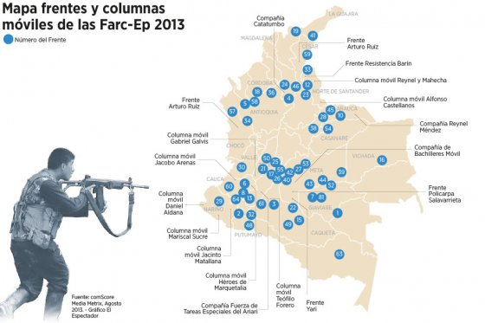
Colombia's oldest rebel group FARC has undergone significant changes concerning military strategy since entering the ongoing peace talks with the government, according to a new report. The report by think tank Fundación Paz y Reconciliación which was partly released in national newspaper El Espectador on Dec. 17 revealed how the rebel organization changed their military strategies, adapting to the rhythm of this year's peace talks. "In September and October when the negotiations were in a crisis due to a lack of progress concerning the point of political participation, [the FARC] launched a minor offensive, attacking the oil and energy infrastructure that left Tumaco 20 days without power. This shows that the operational capacity of the FARC is not that decimated," the report was quoted in El Espectador.
Another aspect of the FARC’s new flexibility is the return to classic guerrilla warfare strategies, avoiding open combat with the armed forces. Instead, the rebel troupes have been divided in smaller units for quick hit-and-run raids. According to the report, this is also due to the loss of man-power after the state's military offensive against the rebel group during the period from 2002 to 2008.
The FARC now boasts 12,000 combatants, while the Defense Ministry puts the figure at 8,000. The report, however, emphasizes the FARC's networks in society, counting "40,000 people with some kind connection to the organization."
The report also claimed renewed efforts by the FARC to infiltrate social and political movements that have been involved in the numerous uprisings in Colombia this year. "It is no secret that in the zones where the FARC are exercising influence, the population has been actively participating in the strikes, protests, roadblocks, marches for peace, and the events that have to do with the negotiations in Havana," as it was stated in the report.
The report also saw a shift in the rebel group's operational alignment, increasingly attacking Colombia's oil and energy infrastructure. As the report mentioned there have been about 200 attacks against infrastructural targets in 2013. This new focus on the oil and energy sector also implied an increase of extortion against businesses in that sector.
This new operational focus stands in line with an agreement between the FARC and Colombia’s second rebel group ELN, cemented after a meeting of their leaders about six weeks ago near the border of Venezuela. There, they decided to join forces in attacks against Colombia's oil and energy infrastructure of Colombia.
However, the new cooperation also points to the potential for the ELN to join the FARC at the peace table in Havana. The Colombian government earlier this month broached a figure of 20,000 fighters that that would need to demobilize in the event of a peace agreement with both rebel groups. (Colombia Reports, Dec. 19)

Gauging the Jihadist Movement
By Scott Stewart
Source: http://www.stratfor.com/weekly/gauging-jihadist-movement-part-1-goals-jihadists

Quite often when I am doing speaking engagements, client briefings or press interviews, I am asked questions like: “Given the events in Syria and Libya, is the jihadist movement stronger than ever?” It is a good question, but it is also one that is not easily answered in a five-second sound bite or a succinct quote for print media -- it really requires some detailed explanation. Because of this, I’ve decided to take some time to provide a more thorough treatment of the subject in written form for Stratfor readers. As I thought through the various aspects of the topic, I came to believe that adequately covering it requires more than one Security Weekly, so I will dedicate a series of articles to it.
When gauging the current state of the jihadist movement, I believe it is useful to use two different standards. The first is to take jihadists' goals and objectives and measure their progress toward achieving them. The second is to take a look at insurgent theory and terrorism models to see what they can tell us about the state of jihadist militant networks and their efforts. This week we will discuss the first standard: the jihadists’ goals and objectives. Next week we will discuss insurgency and terrorism theories, and then once we have established these two benchmarks we can use them to see how the various elements of the jihadist movement measure up.
- Part 1: The goals of the Jihadists (at source’s URL)
- Part 2: Insurgent and Terrorist Theory
- Part 3: Where We Stand with Jihadists
- Part 4: Jihadist Franchises and Grassroots
- Part 5: Implications of Jihadist Movements

Scott Stewart supervises the day-to-day operations of Stratfor's intelligence team and plays a central role in coordinating the company's analytical process with its business goals. Before joining Stratfor, he was a special agent with the U.S. State Department for 10 years and was involved in hundreds of terrorism investigations.

EDITOR’S COMMENT: A very interesting series of Dec 2013 articles worth reading!

Piracy in West Africa: A bumpy road to maritime security
Source: http://vibeghana.com/2013/12/13/piracy-in-west-africa-a-bumpy-road-to-maritime-security/

For many people, the phrase maritime piracy evokes images of a one-eyed sailor drinking rum and singing obscene songs. For some younger people, piracy may bring to mind the picture of Hollywood actor Johnny Depp, wearing a headband in a scene from the film Pirates of the Caribbean.
But maritime piracy is not just an action movie. The UN Convention on the Law of the Sea defines piracy as “illegal acts of violence or detention” committed on the high seas against ships or aircrafts. Piracy is a serious problem and it poses a real threat not only to the safety of vessels and their crews, but also to the economies of affected countries.
In Africa, while piracy in Somalia’s Gulf of Aden is currently on the decline, it has spread to West Africa. Although most attacks in the region take place in Nigeria’s Niger Delta region, there have also been attacks in Benin, Côte d’Ivoire, Ghana, Guinea and Togo, among others, according to the UN Office on Drugs and Crime (UNODC).
Reuters news agency reported that one such attack took place in October 2013 off Nigeria’s coast, where pirates attacked an oil supply vessel and kidnapped the captain and chief engineer, both American citizens,. The report says that “pirate attacks off Nigeria’s coast have jumped by a third this year as ships passing through West Africa’s Gulf of Guinea, a major commodities route, have increasingly come under threat from gangs wanting to snatch cargoes and crews.”
Unlike pirates along Somalia’s coast, who are often only after ransom, pirates in West Africa also steal goods, particularly oil. Many attacks end up with crew members injured or killed. But pirate attacks do not only result in killings and injuries, tragic as those are; they also damage the economy. In some cases, affected countries in West Africa have become less concerned with direct losses from piracy than with the ways in which these losses affect international insurance rates and other trade-related costs.
In Benin, for example, taxes on trade account for half of government revenue, and 80% of these are derived from the port of Cotonou, according to UNODC figures published in March 2013. Last year the spike in pirate attacks in West Africa led London-based Lloyd’s Market Association, an umbrella group of maritime insurers, to list Nigeria, neighboring Benin and nearby waters in the same risk category as Somalia, says Claims Journal, a magazine for insurance professionals. The result was a significant decrease in maritime traffic in the region, which meant a 28% loss in Benin’s government revenue. The decrease also affected the livelihoods of the country’s citizens, says UNODC, by increasing the cost of imports and decreasing the competitiveness of exports.
According to Reuters, though ships now speed with armed guards on board through the dangerous waters off Somalia and the Horn of Africa on the east coast of the continent, many vessels have to anchor to do business with West African countries, with little protection. This makes them a soft target for criminals, says Reuters, and jacks up insurance costs.

Corruption drives piracy
As is often the case, corruption, weak law enforcement and poverty are the main causes of piracy, according to Dr. Christian Bueger, a Cardiff University researcher and editor of Piracy-Studies.org, an online research portal. In an interview with Africa Renewal, Dr. Bueger said, “Piracy tends to be conducted or supported by marginalized communities that have not been participating in economic development.”
This appears to be the case for Nigeria, for example, where the majority of the recent African pirate attacks have occurred, driven mainly by corruption in the oil sector. Chatham House, a British research group, reported in September 2013 that “corruption and fraud are rampant in the country’s oil sector,” and “lines between legal and illegal supplies of Nigerian oil can be blurry.” In such a climate pirates have an incentive to steal oil, since they know that they will be able to sell it on the black market.
“Illegal bunkering [filling ships with fuel] is enormously profitable” in Nigeria, writes Martin Murphy, a professor at Georgetown University in Washington D.C. and a senior fellow at the Atlantic Council of the United States, a policy think tank, in his article “Petro-Piracy: Oil and Troubled Waters,” published in Orbis for the Foreign Policy Research Institute. “The scale of losses is staggering—more than $100 billion worth of oil has gone missing since 1960,” says Professor Murphy.
The damage caused by thieves has forced oil companies to shut down pipelines. Royal Dutch Shell is selling off four of its onshore Nigerian oil blocks because of the constant theft of large volumes of oil from its pipelines, United Press International reported in October 2013. As a result of the shutting down of pipelines, Nigeria is producing about 400,000 barrels a day below its capacity of 2.5 million barrels a day, according to the Economist, a British weekly.
The New York Times reported in September 2013 that Nigeria’s former top anti-corruption official, Nuhu Ridabu, had written a report in 2012 charging that over the preceding decade, thieves had stolen between 6% and 30% of the country’s oil production.

Countering piracy
In his interview with Africa Renewal, Dr. Bueger suggested four steps to counter piracy. First, the key is for affected states to share information on what’s happening on their coastlines and their neighbours’. Second, joint training activities are required so countries can develop procedures and learn how to use technology. Training not only educates future generations of maritime security professionals, but also creates confidence and trust between different agencies. Third, states that face maritime and piracy challenges should develop strong legislation to prosecute criminals.
And finally, states should set aside enough money to build local capacity. “Even if a state has the information, even if the state has well-trained coast guards, and even if the state has incorporated all the right laws,” Dr. Bueger explains, “without vessels, the state is powerless.” At the moment, of the states most affected by piracy, only South Africa and Nigeria have a professional navy. Most other countries have small and outdated coast guards with no more than three to five skiffs.

What has been done?
Several international legal instruments are in place to combat threats posed by piracy. The key agreement is the UN Convention on the Law of the Sea, which prescribes exclusive economic zones over which individual states have the rights for exploration, energy production from water and wind, and the use of marine resources. For this agreement to be operative, states have to adopt and incorporate it into their national laws. All West African countries have signed and ratified the Law of the Sea Convention.
However, the UN Security Council has yet to call for concerted international action against piracy along the Gulf of Guinea, as it did in the Somali case when, in June 2008, it authorized other countries to enter Somali territorial waters to stop pirates. In 2011 the council passed two resolutions expressing its concern about piracy in the Gulf of Guinea and urging states to reinforce domestic legislation, develop a comprehensive regional counter-piracy framework, issue appropriate guidance to shipping and cooperate in prosecuting pirates and their backers.
Despite the absence of any Security Council action so far, and unlike in the Gulf of Aden, in West Africa there is already an institutional infrastructure to combat piracy. The Economic Community for West African States (ECOWAS) has in its treaty of 1993 a maritime component intended to harmonize all maritime issues across the region; the Maritime Organization of West and Central Africa, established in the 1970s, holds member countries to a similar agreement. Last year ECOWAS, the Gulf of Guinea Commission and the Economic Community of Central African States signed a memorandum of understanding between the International Maritime Organization and the Maritime Organization of West and Central Africa, to establish a subregional integrated coast guard network in West and Central Africa, among other things.
Records show that despite these regional actions, the number of pirate attacks continues to increase. The International Maritime Bureau, a specialised division of the International Chamber of Commerce, reports that while pirate attacks (actual and attempted) in the Gulf of Guinea fell from 54 in 2008 to 37 in 2010, there has been a steady increase since then: 49 in 2011 and 58 in 2012. As of August 2013, there were 28 attacks in Nigeria alone. These numbers, however, might be deceptive because many attacks go unreported.
But piracy is not the only security threat at sea. “Piracy has drawn attention to wider problems of maritime insecurity,” says Dr. Bueger, such as trafficking and smuggling of humans, weapons and narcotics, and illegal and unregulated fishing activities. Hence, he says, the attention currently being given to the fight against piracy could be used as a stepping stone by the international community to create sustainable institutions of maritime security.
International institutions are crucial for counter-piracy efforts, but they require long-term commitment. The African Union has already declared that its objective is to implement the African Maritime Security Strategy by 2050. Among the strategy’s goals are to “ensure security and safety of maritime transportation systems,” and to “prevent hostile and criminal acts at sea, and to coordinate/harmonize the prosecution of the offenders.”
It’s a long-term strategy, but without a doubt concerted action is needed now to stop piracy in West Africa before it deteriorates and spreads to other African coastal areas.

NASATKA crash tests

Source: http://www.youtube.com/watch?v=40Bc7J8G8EM#t=82

Established in 1975, Nasatka Security (www.nasatka.com) has provided barrier protection for some of the highest profile government agencies, military installations and corporate facilities in the United States and around the world. Based in the Washington, D.C. area, Nasatka Security is the originator of the first, crash-tested barrier systems developed, manufactured, and installed in the United States. Nasatka Security’s ongoing commitment to research and development enables it to remain industry leader. In actual use, Nasatka’s perimeter barrier solutions have proven to be an effective vehicle threat deterrent, as well as a reassuring security measure for employees and other authorized personnel.

EDITOR’S COMMENT: A very impressive video (source’s URL) on Nasatka’s barrier products. The “nest on the road” might be very useful in police ambushes pursuing dangerous criminals en route!

9/11 truth vs. Takfiri terror
By Kevin Barrett
Source: http://www.presstv.ir/detail/2013/12/23/341443/911-truth-vs-takfiri-terror/

In her article “Security arc forms against Mideast terror,” Sharmine Narwani writes of a rapid regional re-alignment “guided primarily by the 'security threat' posed by the proliferation of extremist, sectarian … fighters in numbers unseen even in Afghanistan or Iraq.”
Narwani is not just talking about the Takfiris who are running wild in Syria beheading Christians, traditional Sunni, Shi'a, and Alawi Muslims, and anyone else who disagrees with them. The same kind of terrorists are also committing countless atrocities in Iraq, while sectarian extremism is likewise growing in Libya, Lebanon, and elsewhere.
In response, governments in the region and around the world are re-orienting and re-aligning. Even the USA, the failed world hegemon, is on the brink of a 180-degree shift. Narwani explains: “The Americans are in an extremely difficult position: to tackle the spread of extremists, they will have to support military and security solutions from old foes in the region – Iran, Syria, Hezbollah. For starters, this means that 30-plus years of 'policy' will literally be flushed away and Washington risks alienating longtime regional allies. Moreover, a successful outcome, i.e. eliminating extremism, will almost certainly mean the ascendency of Iran and the downfall of the US’ ally Saudi Arabia – among the many other reverberations throughout the Mideast that this will entail.”
US policy pivoted away from the Saudis and their Israeli allies in the wake of the August false-flag chemical weapons attack near Damascus. Seymour Hersh recently revealed that top US officials knew in August that Saudi Intelligence chief Bandar Bin Sultan, rather than Syrian President Assad, was probably responsible. At first, the Obama Administration tried to deceive the world. Then it began to re-think the wisdom of helping Bandar and his band of Takfiri terrorists overthrow Assad.
The downfall of Saudi Arabia as a US ally is evidenced by the sudden re-opening of long-dormant 9/11 investigations and lawsuits focusing on – who else – Bandar Bin Sultan, sometimes known as “Bandar Bush” due to his position as an honorary member of the Bush (crime) family. In Washington, D.C., Reps. Walter Jones (R-NC) and Stephen Lynch (D-Mass.) are sending chills up Bandar's spine by calling for the declassification of the 2002 “Joint Inquiry Into Intelligence Community Activities Before and After the Terrorist Attacks of September 11, 2001.”
Jones and Lynch say they are “absolutely shocked” by the report. They say it reveals that one or more foreign states were deeply involved in the 9/11 attacks. Though the report is classified, leaks have revealed that it targets Saudi Arabia, whose intelligence service apparently ran fifteen of the nineteen patsy “hijackers” who were – in reality – never even on the planes.
This story isn't new. Sen. Bob Graham (D-FL), Chair of the Joint Committee on 9/11, has been saying the same thing since 2002. Graham charges the Bush Administration, which classified the Joint Inquiry report, with orchestrating a cover-up. Many suspect Graham was forced to retire from the Senate due to his speaking out on 9/11 – just as Sen. Mark Dayton (D-MN) was forced to evacuate his entire staff from Washington and announce his retirement due to death threats he received after denouncing the US military's lying to the American people about why America's air defenses stood down on 9/11.
Dayton and Graham were lucky; they were merely forced out of the US Senate. Two other Senators who wanted to investigate 9/11, Tom Daschle (D-SD) and Patrick Leahy (D-VT) were mailed ultra-weapons-grade US military anthrax, which fortunately did not kill them but did succeed in shutting them up. The one Senator who would never shut up, Paul Wellstone (D-MN), was murdered, along with his wife and daughter, in a rigged plane crash. Wellstone's colleague and friend, Sen. Barbara Boxer (D-CA) confirmed that Wellstone had obviously been murdered, calling the killing “a message t o us all.”
9/11 is a sensitive and dangerous topic in some quarters.
And yet today, as the US pivots away from Saudi Arabia and Israel, the 9/11 case is being re-opened – not only in the US Congress, but also in the federal court. A recent ABC News story headlined “9/11 Families 'Ecstatic' They Can Finally Sue Saudi Arabia” reported the 2nd Circuit Court's ruling re-instating a 9/11 family members' lawsuit against the Saudis.
The million-dollar question: If the 9/11 case is re-opened, will the investigation stop with the Saudis? What about their American and Israeli accomplices?
A recent article by Paul Sperry of the Hoover Institute, published by the New York Post, ties President George W. Bush to 9/11 conspiracies involving then-Saudi Ambassador “Bandar Bush.” Sperry describes Bush and Bandar breaking out expensive cigars to celebrate the success of 9/11: “The two old family friends shared cigars on the Truman Balcony [of the White House] while discussing the attacks.” Bush and Bandar's cigar celebration occurred on September 13th, 2001, just two days after 9/11.
Could the truth about these events change the world?
9/11 officially launched the “war on terror,” which is actually a disguised war on Islam. Ironically, the West's invasion of Muslim countries, and its controlled demolition of the rule of law, have created far more terrorism than they have stamped out.
The myth of 9/11 – the claim that “al-Qaeda extremists were responsible” – has helped fuel the rise of Takfiri terrorism. The Takfiris imagine that heroic al-Qaeda hijackers struck an immense blow against the West on 9/11.
The revelation of the truth about 9/11 would humiliate the Takfiri terrorists.
The truth is that the Saudis and “al-Qaeda” are hapless, inept patsies. The Saudis can't even fly and maintain the military planes they buy from the US with unearned oil money; while the four pilots blamed for the 9/11 attacks could not even fly Cessna training aircraft, much less jetliners.
The nineteen alleged hijackers (or the intelligence agents who impersonated at least some of them) were alcohol-abusing, drug-snorting playboys. The Mohamed Atta who supposedly trained in Florida for 9/11 was an aggressive loudmouth who was fluent in Hebrew and whose favorite food was pork chops. This “Atta” walked into a Small Business Administration office shortly before 9/11 demanding a loan to buy a crop-duster. He let it be known that he wanted an aircraft to drop chemical weapons on Washington, DC, and ranted about his love for Bin Laden. “Atta” grew violently angry and refused to leave unless the SBA official handed him hundreds of thousands of dollars in cash to buy his crop-duster. The SBA person thought “Atta” was crazy and chased him out of the office.
The Atta who visited the SBA was obviously an intelligence agent creating a “legend,” not a cunning terrorist planning the biggest attack in history.
“Al-Qaeda” is a fake organization consisting of idiots, dupes, patsies, and infiltrators, along with a smattering of mercenaries, drug smugglers, and brainwashed extremists. “Al-Qaeda” operatives like Abdulmutallab the Underwear Bomber forget their passports, yet manage to board planes with the help of well-dressed security men. They are too stupid to know that plastic explosives will not explode without a detonator. They are barely capable of getting a match lit in their pathetic efforts to burn their own feet, or their own crotches, with the equivalent of sterno camping fuel.
Mohamed Heikal, the Arab world's leading political commentator, literally broke out laughing when he was told that the attacks on the Trade Center and the Pentagon were being blamed on “al-Qaeda”: "I laugh because I know what is there. Bin Laden has been under surveillance for years: every telephone call was monitored and al-Qaida has been penetrated by American intelligence, Pakistani intelligence, Saudi intelligence, Egyptian intelligence. They could not have kept secret an operation that required such a degree of organization and sophistication."
Yet, the Takfiri terrorists in Syria rally behind the black banner of “al-Qaeda.” The Takfiris include large numbers of prisoners fresh from Saudi jails. Fighting alongside the common criminals are mercenaries, fanatics, and passionate but unsophisticated young men drunk on the myth of the “magnificent 19” who supposedly brought down three World Trade Center skyscrapers with two jetliners.
By puncturing that myth with 9/11 truth, we can ruin the “al-Qaeda” brand forever, and strike a powerful blow against Takfiri terrorism.

Dr. Kevin Barrett, a Ph.D. Arabist-Islamologist, is one of America's best-known critics of the War on Terror. Dr. Barrett has appeared many times on Fox, CNN, PBS and other broadcast outlets, and has inspired feature stories and op-eds in the New York Times, the Christian Science Monitor, the Chicago Tribune, and other leading publications. Dr. Barrett has taught at colleges and universities in San Francisco, Paris, and Wisconsin, where he ran for Congress in 2008. He is the co-founder of the Muslim-Christian-Jewish Alliance, and author of the books Truth Jihad: My Epic Struggle Against the 9/11 Big Lie (2007) and Questioning the War on Terror: A Primer for Obama Voters (2009).

Assessing the Terrorist Threat to the Sochi Olympics
By Laurent Vinatier
Source: http://www.geopoliticalmonitor.com/assessing-the-terrorist-threat-against-the-sochi-olympics-4897/#!

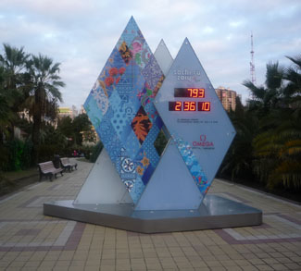
On July 3rd 2013, in a video published on YouTube that was almost immediately taken down, Doku Umarov, the self-proclaimed emir of a Caucasus Emirate in the southwest of the Russian Federation, lifted the moratorium on military operations targeting civilians that he unilaterally declared several months ago. He also called on his troops to do everything possible to oppose and to prevent the proper execution of the Sochi Winter Games in February 2014. The Caucasian leader could not forego this ideal occasion to remind the world of the enduring struggle led first by the Chechens in their fight for independence (1994-2005) and then taken up by a very loose network of Islamist armed groups that thrived in the neighboring republics of Dagestan, Ingushetia and Kabardino-Balkaria. What does this Caucasus Emirate represent today? And what can its fighters do?
Russian federal security forces regularly launch operations to eliminate local or regional emirs throughout region. In Dagestan for instance, the “republic” leader hardly ever survives for more than one year at a time. In Kabardino-Balkaria as well, the insurgency has been successively decapitated in 2010, in 2011 and in 2012, losing not only its leader but all of its deputies as well. In Chechnya, in January 2013, the Gakaev brothers, famous and well-respected warlords among the Chechen guerillas, were killed after six days of fighting. It is said that, almost out of ammunition, they asked their comrades to shoot them. The two brothers were the last of the reputed second-generation combatants who inherited the historical independence struggle, and who in 2013 were still in control of the most important insurgent groups in Chechnya. As for the Ingush, after losing Commandant Magas, their hero, in 2010, who has been imprisoned in Moscow, his successor, Emir Adam was killed in May 2013. The North-Caucasian guerillas, usually loosely structured, are now outright destabilized. To cope with these recurrent strategic losses, the armed groups have retreated to reorganize and recoup their tactical capacity.
Thus, insurgent actions in the region have become rarer and rarer. Neither Doku Umarov nor any of his regional emirs have engaged in any coordinated and significant operations for at least two years. The guerilla groups have entered into a defensive survival strategy, more reactive and resource-light. In Kabardino-Balkaria, the leadership vacuum has advanced quite a bit, resulting in autonomous groups of just a few fighters, around five usually though sometimes one or two, who get together and act by themselves, without any orders from above. Elsewhere, in Dagestan for instance, the relevant level seems to be the city or the village, where locally-active insurgents operate. Only at this very small scale do engagement and decision-making exist. North-Caucasian armed mobilizations are working on a bottom-up model. This explains the absence of overall coherence between the different victims targeted by the Emirate and the much more diversified militant groups dispersed throughout the region.
The Caucasus Emirate, clearly losing strength against Russia, is benefitting from the growing role played by Syria insofar that some Caucasian nationals have successfully waged war against Assad’s loyalist forces. One of them is Abu-Umar ash-Shishani, a Chechen from Georgia (ethnic Kist living in the Pankissi Valley), who has attained a high position in the Islamic State of Iraq and Sham, one of the most powerful organizations within the Syrian opposition. His authority and prestige stem mainly from his operational capabilities, as well as his men’s fighting skills. The “advertisement” effect for the Caucasus Emirate works perfectly here. Beyond Sochi, the Caucasian Islamist struggle has been forgotten by the world. The Syrian struggle has afforded it a chance to recover some visibility. Gradually then, thanks to a few Caucasian relays in Syria, Doku Umarov’s Caucasus Emirate has been noticed by international Salafist-Jihadist movements, and it is now recognized as one of the global Jihad fronts alongside Yemen, Afghanistan or Somalia.
The North-Caucasian insurgency resembles a myriad of anarchic armed groups rather than a proactive and structured movement. It undeniably maintains a capacity to cause harm, but it does not seem to be able to translate that nuisance into an operational and strategic breakthrough. For example, an isolated suicide attack, as the one on October 21st in Volgograd, where a young woman entered a city bus and triggered a bomb, may still theoretically be possible. But considering the heavy security presence that the Russian forces have implemented around Sochi, a successful attack would require an effective and powerful organization behind it. That’s why it is rather unlikely that a suicide bomber, sent by the Emirate, will manage to attack the Games.

Dr. Laurent Vinatier is a research assistant at the Thomas More Institute and a contributor to the Geopoliticalmonitor.com

Global Terror in 2014 – a Forecast
Source: http://i-hls.com/2013/12/global-terror-in-2014-a-forecast/

Terror will continue to be a major part of our lives in 2014, according to the assessment of the experts. Terror in Israel will continue as the fact that the “peace talks” with the Palestinians lead to nowhere becomes clear.
The stronghold of the extreme terror in the Sinai peninsula in Egypt will continue to “export” acts of terror to neighboring countries, but not only. The Hezbollah in Lebanon will continue to increase its potential fire power in spite of the problems it faces in the country.
The experts also see a possible cooperation between terrorists in the Palestinian Authority and “imported elements” that are part of what is referred to as the “Jihadi Islam”. And so the world will continue to be threatened by many kinds of terror.
The Center for Preventive Action/Council on Foreign Relations has prepared a forecast that is quoted by the Atlantic magazine. The forecast is based on a recent survey which asked more than 1,200 U.S. government officials, academics, and experts to assess the impact and likelihood of 30 scenarios. It divides the results into three tiers of risk, and some of the findings are alarming.
Beyond the familiar flashpoints – military intervention in Syria’s civil war, strikes against Iran’s nuclear facilities – the report raises concerns about overlooked threats ranging from turmoil in Jordan to civil war in Iraq to a border clash between China and India. The study is also notable for the risks it downplays, including armed confrontation between China and its neighbors over territorial disputes in the East and South China Seas.
The most threatening and most likely conflicts include some you might expect: limited military intervention in Syria’s deteriorating civil war; a cyberattack on critical infrastructure in the U.S.; military strikes against Iran if nuclear talks fail or Tehran advances its nuclear program; a North Korean CRISIS sparked by military provocation or internal political instability; a major terrorist attack on the U.S. or an ally; and greater turmoil in Afghanistan and Pakistan as U.S. troops withdraw from the region and Afghanistan holds elections.
But other potential crises in this category have received less attention and were deemed less threatening in last year’s survey, including the “strengthening of al-Qaeda in the Arabian Peninsula resulting from continued political instability in Yemen and/or backlash from U.S. counterterrorism operations” (in the latest example of those operations, a drone strike hit a Yemeni wedding); “civil war in Iraq due to rising Sunni-Shia sectarian violence” (the civilian death toll in the country more than doubled this year); and “growing political instability and civil violence in Jordan triggered by spillover from the Syrian civil war” (according to the experts polled, there is less of a risk of a similar phenomenon occurring in Lebanon, where a bombing near the Iranian embassy in Beirut recently killed 23 people).
Second-tier risks , according to the report, include a “severe Indo-Pakistani military confrontation triggered by a major terrorist attack or heightened violence in Kashmir” and “escalating violence and risk of mass atrocities in the Central African Republic,” where a wave of sectarian killings has raised fears of a coming genocide.
In what may be the most striking finding, military conflict between China and neighbors like Japan and the Philippines in the East and South China Seas is judged to be less of a threat than it was in 2013, even after a tense year capped most recently by Beijing’s creation of an Air Defense Identification Zone in the East China Sea. The thinking, perhaps, is that China’s has tested the limits of its assertiveness in the region and will show more restraint in the coming year, or that the countries involved have now established mechanisms to resolve disputes before they devolve into armed confrontation.
Some of the least likely and threatening conflicts have never before been included in the study, including China and India butting heads over disputed territory, Venezuela succumbing to political CRISIS in the wake of Hugo Chavez’s death, and Buddhists and Muslim Rohingyas clashing in Myanmar. South Sudan is mentioned, but only in the context of possible military conflict with Sudan—not in terms of South Sudan itself imploding (the survey was conducted in November, before internal fighting erupted in the country).

After latest shooting, murder manual author calls for book to be taken 'immediately' out of print
Source: http://usnews.nbcnews.com/_news/2013/12/17/21938739-after-latest-shooting-murder-manual-author-calls-for-book-to-be-taken-immediately-out-of-print?lite

It was an accessory in the arsenal of Karl Pierson, the student who opened fire last week inside a Colorado high school, leaving one girl in a coma before taking his own life.
“The Anarchist Cookbook,” which Pierson read before his rampage, isn’t a guide to culinary revolution. It’s the original how-to of homicide and mass murder — and sales are still raging, with distribution from the likes of Amazon and Barnes & Noble, even as the work is linked to terrorist acts around the world.
Now, in rare interviews with NBC News, the publisher and the author of the "Cookbook" are trading blows about the book’s future.
“'The Anarchist Cookbook' should go quietly and immediately out of print,” says William Powell, who wrote the book as a stern 19-year-old, an opponent of the Vietnam War who felt violence was justified if it could prevent even greater violence in the process. He has since renounced that position, but never so forcefully, telling NBC in an email that “it is no longer responsible or defensible to keep it in print.”
Published in 1971, the book has sold more than two million copies and influenced hundreds of malcontents, mischief makers, and killers. Police have linked it to the Croatian radicals who bombed Grand Central Terminal and hijacked a TWA flight in 1976; the Puerto Rican separatists who bombed FBI headquarters in 1981; Thomas Spinks, who led a group that bombed 10 abortion clinics in the 1980s; Timothy McVeigh, who bombed the Alfred P. Murrah Federal Building in Oklahoma City in 1995; the Columbine High School shooters of 1999; and the 2005 London public transport bombers.
Just in the last two years, law enforcement has tied the volume to Arizona shooter Jared Loughner, the Boston Marathon bombers, and at least a half dozen alleged terrorists and school shooters.
Powell, meanwhile, has apologized for the destructive cultural force that bears his name, and posted an eight-paragraph warning to would-be buyers on the book’s Amazon page. But Powell has no say: the rights belong to the publisher and always have — and the publisher has never wavered in his commitment to selling.
“You know, we don’t ban books in America,” says Billy Blann, who bought the rights to the "Cookbook" in 2002, just as digital sales took off. Blann is the founder of Delta Press, “the world’s most outrageous catalog,” as he calls it, and the purveyor of guides on “Justifiable Homicide,” “The Poor Man’s Nuclear Bomb,” and “The Butane Lighter Hand Grenade.”
Of hundreds of titles offering frank tips on bombs, bullets and blades, however, "The Anarchist Cookbook" remains his most-asked-for volume, he says, contributing largely to his $3 million in annual revenue and supporting a semi-retired life in a 6,000 square foot home in southern Arkansas.
“I’m sure I got my money back,” he says of the deal.
Web searches for the "Cookbook" have grown “more than 5,000 percent” in the last decade, according to an estimate by Google Trends. At the same time sales of the book have surged past the Penguin and Signet editions of Moby Dick, according to Amazon rankings, and Blann has no plans to pull back now.
When told of this latest school shooting, he goes silent a moment on the phone. “I feel bad about that,” he says at last. “But there’s victims of almost anything and everything, and I just don’t think we need to start banning books in America.”
This isn’t Blann’s first public fight over violent literature. A little more than a decade ago, a former police chief and several preachers in his hometown of El Dorado, where he serves on the city council, tried to shutter Delta Press, calling it a “satanic stronghold” and a cesspool for violence and subversion. “God showed me the city of El Dorado,” said Dwain Miller, a pastor at Second Baptist Church, waving a copy of the Delta Press catalog, “and he said, ‘there is a dark cloud over the city.’” Blann said his books were for “entertainment” and “academic” use only, a line he echoes today.
But what about Amazon and Barnes & Noble? Neither bookseller responded to NBC’s requests for comment. Both companies show the "Cookbook" in stock and ready to ship in time for Christmas. Both will even gift-wrap it, and ship some of Blann’s other titles — including primers on how to garrote, stab, and burn — in the same bundle for free.
Legally, this is all protected, says Christina Wells, a First Amendment scholar at the University of Missouri Law School. As public expression, a book can only be prohibited or punished if it “is likely to incite imminent lawless action,” according to a 1969 Supreme Court ruling.
It’s hard to prove that an act was aided or abetted by a given book, or that the influence was imminent, so there’s never been a successful lawsuit against "The Anarchist Cookbook"—or any how-to guide to violence for that matter. Corporate booksellers have escaped legal action as well. “Their First Amendment defense is pretty strong,” says Wells.
In 2010, after a father-son team of British white supremacists drew on "The Anarchist Cookbook" to make a jar of ricin, a London judge joined police in calling for a ban on the title. But Amazon said the law could not compel them to stop selling the book. “Our goal is to support freedom of expression and to provide customers with the broadest selection possible so they can find, discover and buy any title,” a spokesperson for the bookseller said at the time, adding that they would only remove a book if the law specifically found it to be illegal.
On Monday the parents of Colorado school gunman Karl Pierson said they were "shattered" by their son’s actions. They don’t understand why he made three Molotov cocktails, grabbed a shotgun and a machete, and slipped into a side door of his high school, gun drawn. Perhaps the "Cookbook" wasn’t pivotal, although machetes and Molotov cocktails are included. It’s a mystery and a tragedy for everyone.
But for William Powell, it’s also an opportunity, a chance to make the two chapters of his life into one. In the 40-plus years since he wrote "The Anarchist Cookbook," he has reinvented himself as an educator on the international stage, running a series of elite schools abroad, before settling in Malaysia. There he owns a teacher training center and writes books on pedagogy for the State Department.
One of his fundamental ideas is that schools need to be made safer, and, ironically, a way to move toward that goal is to pull "The Anarchist Cookbook" out of print.

2014 Winter Olympics: The Terrorism Threat
Source: http://www.isvg.org/follow/blog/2013/08/15/2014-winter-olympics-the-terrorism-threat/?goback =.gde_1528217_member_5821345046716260354#!

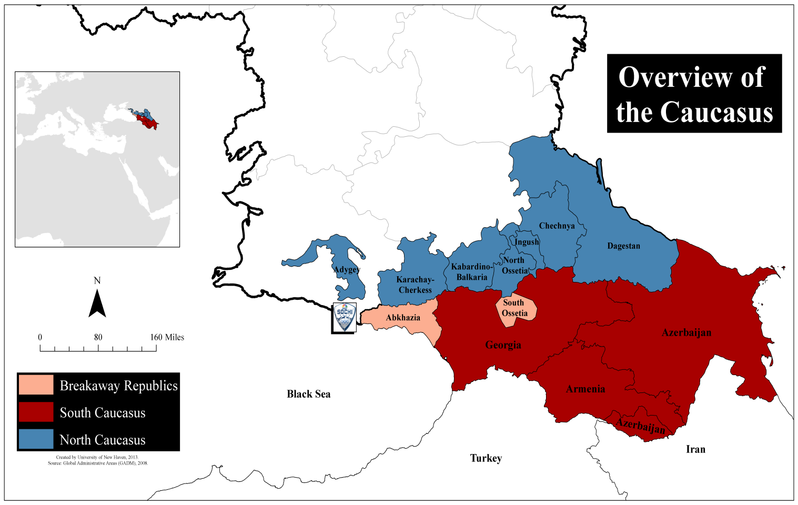
Every two years athletes and spectators from around the globe turn their attention to the Olympic Games. There have been two violent attacks throughout the 117 year history of the modern Olympic Games, the 1972 hostage taking in Munich, and the 1996 bombing in Atlanta. The upcoming Sochi Winter Games will be located within 300 miles of Chechnya, Dagestan, and Ingushetia, an area within the North Caucasus that has experienced ongoing violence from separatist and Islamic fundamentalist organizations since the Chechen independence movement began during the 1990s. Recently, Doku Umarov, emir of the Caucasus Emirate, made threats directly targeting the Winter Olympics. The capabilities of these groups and proximity of these groups creates a substantial threat to the Olympic Games and the subsequent influx of athletes and spectators in the region.
On July 3, 2013, Doku Umarov released a video statement urging Islamic militants to “’do their utmost to derail’ the (Sochi Olympic) games… ‘We have an obligation to use all means to prevent this.’” [1] The Caucasus Emirate, a terrorist organization that conducts near daily attacks throughout the Russian North Caucasus; has proven their ability to carry out high profile terrorist attacks in areas outside the Caucasus, having claimed responsibility for several terrorist incidents throughout Russia. [1] The most notable attacks include, the November 2009 training bombing that killed 26, the March 2010 suicide bombing by two females on Moscow’s Metro, and the January 2011 suicide bombing of the Moscow airport. [2]
Umarov described the games as “satanic dances on the bones of our ancestors,” in reference to the location of Sochi, which sits on land depopulated of Muslim Circassian tribes during the Russian invasion of the Caucasus in the 1800s. [1][3] The video provides the most specific threat to the games so far; contradicting orders issued previously, which urged fighters under his command to avoid targeting civilians, and to avoid carrying out attacks outside the Caucasus. [1][3] Sochi is located in Krasnodar-Krai, which is not considered part of the Caucasus, due to its Russian ethnic majority. The Olympic Games in Sochi, viewed by many as a pet project for Russian President Vladimir Putin, provides an international platform for the Caucasus Emirate to demonstrate its strength, and further its efforts of creating an Islamic caliphate in the Caucasus.
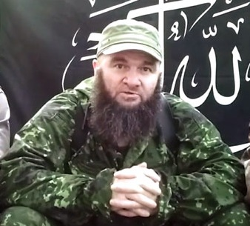

Foiled Terror Plot
In May 2012, Russian Federal Security Service (FSB) personnel arrested three Caucasus Emirate rebels and seized a large number of weapons including surface-to-air missiles (SAMs), TNT, and grenade launchers. The FSB was able to establish that members of Caucasus Emirate were planning on transporting the weapons to Sochi in order to conduct a terrorist attack during the Olympic Games in February. The detained militants claimed that the plot had been created by Umarov. A statement released by the Russian anti-terror committee alleged, “Umarov, while maintaining close contacts with the Georgian special services, coordinated all activities to organize the delivery of materials to carry out acts of terror.” [4]
The raid occurred in Abkhazia, the border of which is approximately 10 miles from Sochi. [4] Abkhazia, considered by Georgia to be a “breakaway region,” declared independence in 1999. Originally part of Georgia when the Soviet Union fell in 1991, the Abkhaz people revolted and drove Georgian soldiers out of the territory during an armed conflict that occurred throughout 1992 and 1993. Russia was the first country to formally recognize Abkhazia’s independence, and utilized the Abkhaz-Georgian border to invade Georgia proper in 2008 during the conflict between the two nations over South Ossetia. Since that time Russia has maintained a strong military presence along the Abkhaz-Georgian border with permission of the Abkhaz government. [5]

Russian Efforts to Secure the Games
Russia has taken a number of steps to ensure the safety and security of the Sochi Games. On July 5, 2013, Russia announced that 37,000 police officer will be deployed to Sochi. [6] Additionally, Russia has announced that drones, high-speed boat patrols, and explosive-seeking robotic vehicles will be used to provide continuous security of the Olympic site. In an effort to prevent “lone wolf” terrorist attacks, the Sochi games will employ a “spectator pass.” The pass will require individuals to disclose personal background information to the Russian government such as passport details and biographical information. The pass will be required for entry into the Olympic park. [7]

Analysis of Threats in the Region
According to the ISVG database, there have been 1,560 violent events have occurred throughout the Caucasus region, resulting in 3,449 casualties since January 1, 2010. These attacks predominately take place in the North Caucasus, within the borders of Russia. The majority of attacks have occurred within 500 miles of the Olympic Games; Dagestan (832), Ingushetia (256), Karbardino-Balkaria (246), and Chechnya (159) have all experienced a large number of violent events.
The most violent attack type has been bombings, resulting in 1,844 casualties in 644 events, an average of 2.86 casualties per event. Armed assaults resulted in 1,570 casualties in 847 events, an average of 1.85 casualties per event.
While all of the events collected for this report were conducted by militants, only a small number of attacks are actually claimed by terrorist organizations. The NVF (Незаконные вооружённые формирования) or Nezakonnye Vooružënnye Formirovanija in latin, which translated means “Illegal Armed Group,” was responsible for 59 violent events, while unidentified Chechen rebel groups were responsible for 18 events, and the Caucasus Emirate was responsible for 15.
Law enforcement officials are the most common targets of attacks, having been targeted in 2,047 violent events. While the number of attacks per quarter has decreased over the last two and a half years the high level of violence that has occurred within 500 miles of Sochi poses the greatest threat to the safety and security of the 2014 Winter Olympic Games in Sochi.
Below is an interactive Tableau dashboard illustrating violent events throughout the Caucasus from January 01, 2010 to July 15, 2013. We invite you to utilize interactive features by clicking on data-points throughout the visualization below. When you select a data-point all graphs will automatically update to reflect accurate data pertinent to your selection. For example, if you were to click on “Caucasus Emirate” the remaining fields would update to show data specifically pertaining to that group. Graphs can be reset by clicking in the white space of the graph where you made your selection.

►References are available at source’s URL; both incident maps are interactive.

The Violent Extremism Knowledge Base
Source: http://vkb.isvg.org/wiki
VEKB is a single resource for information and research on violent extremism. For the initial launch in February 2011 the VKB consists of a wiki on violent extremism, a free basic Data Analysis and Visualization Environment that we call DAVE, and our growing library on terrorism and extremism.

Time to move beyond the 'war on terror' narrative in UK
Source: http://www.terrorismwatch.org/2013/12/time-to-move-beyond-on-terror-narrative.html

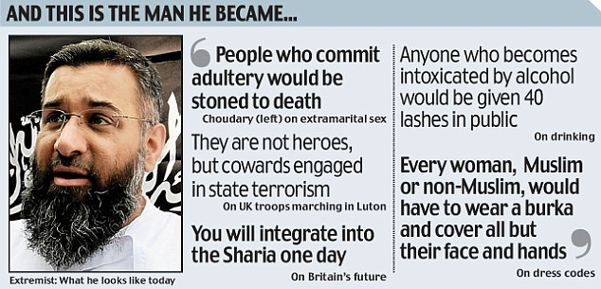
You could say that once or twice is just careless and ill-advised, but now it is starting to look like a bad habit. Following last week's verdict over the bloody murder of Lee Rigby - the British soldier hacked to death on the street in Woolwich in May - British media has been following an all-too-predictable format for the required commentary.
We need, after all, to be told how to think about this grotesque killing by Muslim converts who claim to be acting in the name of Allah. And so, up pops Anjem Choudary - at the behest of the BBC. You know Choudary: hate preacher, frontman for the violent Islamist group al-Muhajiroon until the UK banned it, utterly unrepresentative of British Muslims, and at the same time, the one that's "allowed" to point out that British foreign policy in Arab and Muslim lands can lead to blowback on UK soil.
Following the Rigby verdict, Choudary was given the agenda-setting Radio 4 Today's prime slot and another hefty reference on the BBC's political flagship Newsnight programme (which had wheeled him out for airtime at the time of the Woolwich killing). He is usually set against someone from the security establishment or from, say, the Quilliam foundation, the "moderate Muslim", "counter-extremism think tank" that is at war with "Islamism".
Newsnight feasted on this formulation last week: After a report featuring Choudary, the show spoiled us with insights from the neocon, Muslim-bashing Henry Jackson society, the Quilliam foundation and a former counter-terrorism minister all in one sitting. Thus the frames of the debate are set: there are the "baddies" like Choudary, who rant about deadly British wars in the Middle East, and then there is everyone else rushing to dismiss such ludicrous assertions. The message is clear; who do you want to be: Choudary, or a reasonable person who condemns any link to foreign policy?
When British media discusses extremism strictly within the same, narrowly proscribed frame, that's dangerously unhelpful - and it ultimately fails us all.

Counterproductive measures
And so, as permitted commentators and politicians wring their hands over "not doing enough" to combat violent extremism, they shut down the very discussion we urgently need to have, the one that might actually help: the one about the impact, the horrifying recruitment power, the consequences of Britain's involvement in the endless war on terror.
It isn't just the perpetrators of bloody acts of violence in the UK that cite bloody wars on Muslim soils as motivation; Britain's own security chiefs have long warned that foreign policy in Iraq will bring ugly consequences back in the UK. And, after all, as Asim Qureshi, research director at CAGE, told an Al Jazeera investigation last week, it is the war on terror's instigators that claim this war is everywhere. The US, says Qureshi, "started this conflict without jurisdictional boundaries, without any rules, or regulations, that basically says: the law doesn't matter anymore".
It should by now go without saying that to discuss British foreign policy is not to condone the butchering to death of a soldier in south London, and that most British Muslims - just like the more helpful category "most British people" - are repulsed by it. Not every critic of British foreign policy turns to violence; clearly, other factors are at work. The trouble is, as long as we continue to place a sort of silent ban, a muzzle, on making the association between such violent radicalisation and the wars in Iraq and Afghanistan, we are making any efforts to tackle such extremism utterly ineffectual.
Counter-terrorism projects that were supposed to be Muslim-community-led perversely turned into surveillance projects: thus cementing the assumption, (actually shown to be fact) that criticising the war on terror while being Muslim would get you placed on a watch list. Indeed, those with experience of counter-terrorism projects, such as the former government's much-criticised Prevent scheme, say that one of the "triggers" for such monitoring would be an interest in the Palestine cause, or Afghanistan.
Like many community workers, Jahan Mahmood, a Birmingham-based historian who has advised the government on this issue and now mentors young people, urges open discussion: "I don't see it [violent extremism] stopping until we have a sensible, open debate about this at every level of society. It would be ugly, but at least have the debate, encourage it - let it come out of their system into the open. Let people express their thoughts so that others can deconstruct and counter them."

What's to blame?
It isn't just foreign policy in itself - the ravaging of Arab and Muslim countries, the spiralling, medieval death tolls, the drones, the maiming and killing of innocents, the prisons and humiliations and renditions and torture.
Part of the problem is a hypocrisy that community workers say they struggle to counter. If, for example, the government stated aim is to counter al-Qaida, why would Britain at times - such as during the West's intervention in Libya in 2011 - align with affiliates of this organisation?
In the face of a constant refusal at government level to engage with such points, those who work to help counter violent radicalisation are now running out of options: "This is why more and more people are now less willing to be involved in counter-terrorism policy," says Mahmood. "The government isn't paying enough attention to the actual grievances and is utterly obsessed with ideology."
Relying on religious radicalism as the sole explaination isn't just counterproductive, it is separatist - turning the issue of extremism on British streets into a "Muslim problem" rather than a collective issue urgently in need of collective responses. Of course ideology is a factor (who would argue otherwise?), but it is not the only one: In addition to foreign policy, community workers talk about the impact of gang culture, exclusion, deprivation and Islamophobia.
Reducing all that to ideology is a lazy cop-out, a blind insistence on the crass "us against them" false binary of the war on terror. And when British media discusses extremism strictly within the same, narrowly proscribed frame, that's dangerously unhelpful - and it ultimately fails us all.

Rachel Shabi is a journalist and author of Not the Enemy: Israel's Jews from Arab Lands.

Threat Watch 2014: Terrorism risks in Western Europe
Source: http://www.intersecmag.co.uk/threat-watch-1/

The IHS Country Risk team highlights the European states most likely to face security threats in 2014

Greece
Terrorist activity in Greece is likely to emanate largely from numerous left-wing and anarchist groups, such as the Conspiracy of Fire Nuclei (CFN), who are likely to continue staging attacks with varying capability, from IEDs and arson attacks to targeted assassinations. These groups are also likely to continue recruitment from among violent protesters, and will periodically produce new “generations” of militants.
The decline in risk of large-scale bombings is likely to come to an end in the next year, as CFN are acquiring the skill to produce larger IEDs (but not to car-bomb levels as yet). Arrests and findings in August and September 2012 already suggested a new generation of the CFN had been preparing a renewed campaign learning from past mistakes. While we do not know what exact targets such a campaign had, it is quite likely that the attack on Microsoft offices in June 2012 was part of a series of attacks of a new cell of militants. The terrorism risk is concentrated almost exclusively in Athens, and to a lesser extent Thessaloniki, however.

Germany
German unions are likely to resort mostly to one-day strikes during negotiations over employment contracts, salary rises and in order to protest against job cuts. Industrial action is likely as Germany is faring much better economically than other European nations and unions are feeling they should get a bigger share of company profits, especially since they agreed to keep wage increases low in recent years in order not to undermine competitiveness. This risk of strikes, however, will be mitigated if, as is likely, centre-right CDU and centre-left SPD agree a grand coalition pursuing centrist policies, including introduction of a minimum wage.
Generally, unions have seen a decline in effectiveness as they have been in a weak bargaining position because companies are threatening to outsource labour abroad if German workers cause difficulties. Production relocation is most likely in the household-appliances and entertainment-electronics sectors and in the furniture, car and motorcycle industries, while pharmaceutical and foodstuff companies are unlikely to move production. The fact that unemployment is at historically low levels, however, makes it easier for unions to exercise pressure, and negotiate aggressively, including by threatening and sometimes using strikes.

UK
Intent to stage attacks targeting civilians and to cause financial loss to the UK persists among jihadist militants. Plots intercepted since the 7 July 2005 London bombings have indicated a consistent intention to cause casualties. The ability of the Pakistan-based core al-Qaeda leadership to recruit and train UK militants in Pakistan has declined since 2009, however, while the capability of UK security services has improved, reducing the risk of high-capability spectacular attacks.
While the risk from jihadist militants persists, the frequency of intercepted plots has declined since 2007. Nowadays, the main threat is likely to be from self-starter, single individuals who are less capable of inflicting mass casualties. An example is student Roshonara Choudhry who stabbed her MP in May 2010 over his support for the Iraq war, and two young British men of Nigerian origin who ran over and stabbed a soldier in Woolwich, south London, in May 2013; they had been radicalised with Jihadist advocacy groups in the UK and claimed to act in retaliation for atrocities committed by British soldiers in Afghanistan.
In Northern Ireland, dissident republican groups the Real IRA, Continuity IRA and Oglaigh na hEireann (ONH) are engaged in a campaign of shootings and explosive-device attacks against members of the police and army. A series of IED attacks in 2010 and 2011 showed an increased capability to construct devices of up to car-bomb size. This is likely to reflect expertise obtained by recruitment of former members of the Provisional IRA (PIRA). The groups are hindered by police capability to disrupt networks. Rare – and small – attacks on the mainland, intended mainly to gain publicity and cause economic disruption rather than mass casualties, are likely to be within their present capability. A sustained campaign of large-scale attacks outside Northern Ireland is unlikely at the moment, however.

Italy
On 21 October, Italy’s three largest trade union organisations – the Italian General Confederation of Labour (CGIL), Italian Confederation of Trade Unions (CISL) and Italian Labour Union (UIL) – announced a series of co-ordinated four-hour work stoppages until mid-November in protest over the government’s 2014 budget package. Italy’s trade unions are mobilising on a local and regional level, such that the frequency and scale of the announced strikes has in actuality been slightly milder than expected. Trade union leaders stated their intention to escalate industrial action in the next two-month outlook, however, unless the government grants budgetary concessions by reducing labour taxes. Trade unions will reassess the programme of rolling strikes after 15 November. At that stage there is a heightened risk a general strike will be called ahead of a parliamentary vote on the budget in December. Potential infiltration of trade union demonstrations by Black Block anarchist groups raises the likelihood of low-level street violence targeting banks, and commercial and multinational companies. Anti-austerity rallies in Rome on 19 October saw fighting between anarchist groups and police outside finance ministry buildings and small-scale vandalism against banks.

Russia
The North Caucasus insurgency is likely to persist at least over the next five years. The insurgency is driven by a combination of Islamist ideology, high levels of unemployment and a lack of opportunities for economic advancement. Insurgent activity spans all of the North Caucasus republics, but terrorism risks are highest in Dagestan, Ingushetia and Kabardino-Balkaria. The insurgents’ primary targets are state security personnel, local authorities and pro-government religious figures, critical infrastructure including above-ground pipelines and telecoms installations, and large and economically symbolic state-funded projects. IED and firearm attacks and counter-attacks occur on a daily basis; according to regional website Caucasian Knot, 77 security personnel and 220 militants were killed in the region in January-September 2013, and 211 security personnel and 379 militants in 2012.
In the six-month outlook, there is a specific high risk of IED attacks against softer targets as the insurgency seeks to disrupt the Sochi Winter Olympic Games, scheduled for 7-23 February 2014. In an online video released in July 2013, insurgent leader Dokku Umarov lifted a 17-month-old moratorium on attacks deliberately targeting civilians, and called on militants to actively disrupt the Games. Sochi is located within the geographical area the insurgency considers Russia to be occupying, and the Games are symbolically important for the Russian authorities. The end of the moratorium makes it likely that the insurgents will attempt mass-casualty attacks similar to the January 2011 suicide IED attack on the arrivals hall of Moscow’s Domodedovo Airport, which killed 37 and wounded 173. The most likely tactic is suicide or vehicle-borne IED attacks. The intent and capability to stage such attacks outside the North Caucasus was confirmed by the 21 October 2013 suicide IED attack on a bus in the southern city of Volgograd, which killed six and wounded 28.

Greece: Shooting against the house of German Ambassador in Athens
December 30, 2013
Source: Local media

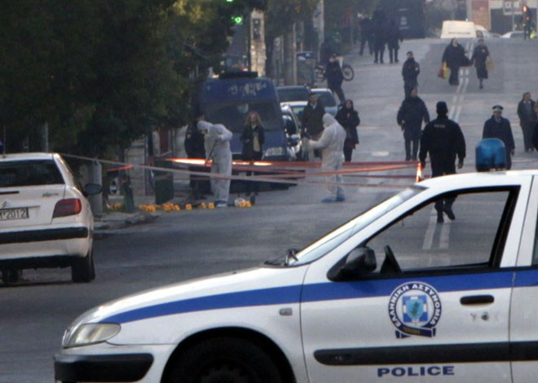
Unknown individuals shot with AK-47 (around 60 buds collected on site) against the residence of the German Ambassador in Athens at 52 National Resistance Street at Chalandi. Immediately alarm sounded in the Greek Police and the government, since the incident “woke up” memories of 16 May 1999, when the terrorist organization "November 17" hit with a rocket the residence of the German Ambassador.
The shooting occurred at the home of Wolfgang Dold shortly after 3:30 in the morning. Prime Minister A. Samaras contacted the German Ambassador.
Case is handled by the Counterterrorism Office, since both the house of the German Ambassador and the Embassy are considered “No.1” targets, after the predatory policy of memorandum imposed by Berlin in Greece.
According to preliminary information, the assailants who fired the outdoor enclosure were two, maybe more (the guard on duty said four), and disappeared immediately after the attack probably with a motorcycle.
The guard who was outside the residence of the German Ambassador did not shoot back fearing that he might accidentally injure civilians living in apartments opposite the Ambassador’s residence.

EDITOR’S COMMENT: Some people will never know! After the RPG fire against US Embassy in Athens (2007) it was made obvious that the fortification of buildings is not enough since terrorists always adapt fast to new security measures. A second perimeter should be established that will servile the main target and counter-attack in events like this one. Of course there are some interesting observations regarding this incident. For example: How can one shoot a building when firing from behind a very high perimeter (~2.5m) and manage to hit the walls and windows (they say that 4 buds were found inside the Ambassador’s daughter room? On the other hand, the fact that Greece will chair EU for the coming months evolves asymmetric thoughts about the motives and timing of this attack. What a wonderful world announcing a very interesting New Year!

How al-Qaeda Changed the Syrian War
By Sarah Birke
Source: http://www.nybooks.com/blogs/nyrblog/2013/dec/27/how-al-qaeda-changed-syrian-war/?insrc =hpss
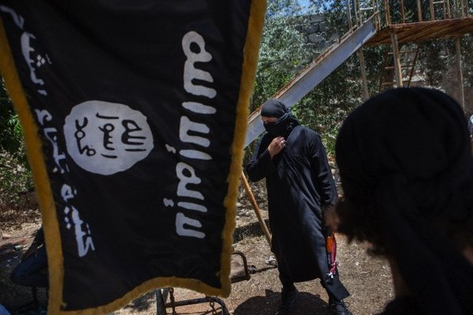
Fighters from the al-Qaeda-linked Islamic State of Iraq and Greater Syria, Aleppo, Syria, July 4, 2013

Talk to any Syrian you meet on the Syrian-Turkish border these days, and in less than five minutes the conversation is likely to turn to Da’ash—the Arabic acronym for the rebel organization known as the Islamic State of Iraq and Greater Syria, or ISIS. Linked to al-Qaeda, the fearsome group has swept across northern Syria, imposing sharia law, detaining and even beheading Syrians who don’t conform to its purist vision of Islam, and waging war on rival militias. In early December, the group killed a foreign journalist, Iraqi cameraman Yasser Faisal al-Joumali, who was reporting in northern Syria. Even using the word Da’ash—seen as derogatory by the group’s members—is punishable by eighty lashes, a twenty-three-year-old wounded fighter from a rival Islamist group told me from his bed in a Syrian-run makeshift clinic in Turkey.
Since its appearance last April, ISIS has changed the course of the Syrian war. It has forced the mainstream Syrian opposition to fight on two fronts. It has obstructed aid getting into Syria, and news getting out. And by gaining power, it has forced the US government and its European allies to rethink their strategy of intermittent support to the moderate opposition and rhetoric calling for the ouster of Syrian president Bashar al-Assad. After months of shunning Islamist groups in Syria, the Obama administration has now said it may need to talk to the Islamist Front, a new coalition of hard-line rebel groups, in part, because they might prove a buffer against the more extreme ISIS. Ryan Crocker, a former top US State Department official in the Middle East, has told The New York Times that American officials, left with few other options, should quietly start to reengage with the Assad regime. In December, US and Britain suspended non-lethal assistance to rebel groups in northern Syria after one base fell into Islamist hands.
“Syria is now viewed as a security problem, not one about ousting Bashar and helping the Syrians get what they want,” a Western diplomat in Istanbul told me.
The influence of the Islamic State of Iraq and Greater Syria is all the more startling given how recently the group entered the conflict. Consider the eastern city of Raqqa, which was first captured by various rebel forces in early March 2013. When I visited that month, the city was ruled by a coalition of militias, and it was possible to move around as a woman without a headscarf. I met with an Alawite nurse who worked alongside Sunni peers. And I talked to Abdullah al-Khalil, a prominent lawyer before the war, who as head of the local council continued to pay street cleaners salaries and was trying to secure enough money to keep other services going.
But within two months, ISIS was firmly in charge. The group beheaded three Alawites in the city’s central square, and established sharia courts and policing. Abdullah al-Khalil, the head councilman, was himself kidnapped by ISIS or its allies. Women have been told to cover up, smoking banned, and girls and boys segregated in school. Minorities have been hounded out of the city, and foreign journalists and aid workers are no longer welcome: dozens are currently in ISIS captivity.
In the months since its takeover of Raqqa, ISIS has quickly become one of the most powerful forces on the ground, despite its modest manpower estimated at some 7,000 fighters. It has started expanding north and west, all along the border with Turkey. In August ISIS fighters led the rebel capture of Minbegh, an airbase close to Aleppo. And the group has kicked out other rebel militias to gain control of Atmeh, al-Bab, Azaz, and Jarablus, four border towns that serve as the gateways to the outside for northern Syria and which are now known as mini-emirates. According to Syrian rebels, aid workers, and civilians I spoke to, they are using such strategic towns to control who and what can move in and out of Syria. When I visited the Turkish side of the border, trucks were lined up for miles waiting to transfer goods to other Syrian vehicles at the border: drivers are unwilling to enter the country. For their part, Syrian civilians and rebels who had just crossed from Syria into Turkey said they were terrified by ISIS checkpoints. “None of us can go in any more,” an aid worker in Antakya said.
ISIS’s spread along the border is particularly ominous for the more moderate rebel groups, loosely allied militias known as the Free Syrian Army, which have long depended on access routes from Turkey into northern Syria. A year ago, the main groups fighting on the rebel side were disorganized and badly behaved, but most of them still identified—at least in their core aims of toppling Assad and building a nation state open to all Syrians—with the street movement that started in 2011. And while Salafist-Islamist rebel groups began taking a larger part in the conflict in 2012, most of them were Syrian and viewed as part of the communities in which they established themselves.
In contrast, ISIS is a group with an international profile and an extremist view of Islamic rule. And it has shown its readiness to take on any Syrians it doesn’t like, whether opposition or regime supporters. In September ISIS ousted the moderately Islamist Ahfad al-Rasoul from Raqqa by using suicide bombings (Jabhat al-Nusra, another al-Qaeda offshoot, had clashed with the group, but had not gone this far). It pushed out Northern Storm, a local rebel band, from the town of Azaz, a staging post between Aleppo and the Turkish border. And it’s also been fighting the armed wing of Syria’s Kurdish party, the PYD, in the northeast. All of which has left little doubt about its strength, or the damage it has caused to the rebellion itself.
The mainstream opposition is in a tricky position. On December 19, its exiled leadership council, the Syrian National Coalition, issued a blunt statement accusing ISIS of “abducting people for not abiding by their self-imposed regulations” and declaring that “the Coalition does not consider ISIS a part of the opposition. Its actions serve the regime’s interests.” But the Coalition has wavered on other groups with extreme views, since disavowing them highlights the lack of fighters allied with it on the ground. For example, it denounced the US’s designation of Jabhat al-Nusra as a terrorist group in 2012 and today has an unclear relationship with other Islamist groups.
ISIS originated as an Iraq-based al-Qaeda affiliate, al-Qaeda in Iraq. The organization is led by Abu Bakr al-Baghdadi, an ambitious Iraqi extremist who has overseen relentless attacks in Iraq, causing civilian casualties, and who was designated a Global Terrorist by the US State Department in October 2011, with a $10 million bounty on his head. As the war in Syria progressed, al-Baghdadi saw an opportunity for al-Qaeda, and in January 2012, sent some footmen to found Jabhat al-Nusra with the aim of creating a new transnational state ruled by sharia law and a belief in using violence to get there.

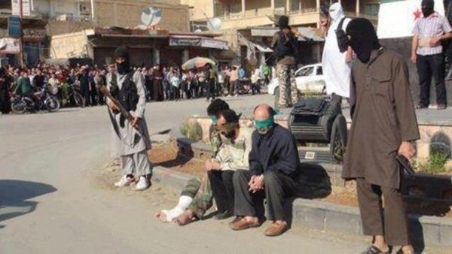
Three Syrian Alawites, shortly before their execution by ISIS in Raqqa, Syria, May, 2013
Over the following year Nusra steadily gained strength, and in April 2013 al-Baghdadi decided it was time to merge Nusra with al-Qaeda in Iraq, expanding the geographical spread of the organization, which doesn’t recognize national borders but seeks to unite the entire umma, or Muslim community of believers, under one rule. He declared the two branches would be known as the Islamic State of Iraq and al-Sham. Al-Sham refers to Greater Syria, the whole expanse of the Levant that holds a special place in jihadist thought for being the heart of the region and close to Jerusalem. But Jabhat al-Nusra’s leader Mohammed al-Jolani, who is Syrian, refused the merger, possibly because it had not been sanctioned by al-Qaeda’s chief, Ayman Zawahiri, who later ruled that the two groups should remain separate (a ruling ignored by the ambitious Baghdadi, leading some to consider ISIS outside al-Qaeda).
In fact, while ISIS and Nusra share many aims, and both are well funded and trained, there are significant differences between the two groups. Jabhat al-Nusra stresses the fight against Assad, while ISIS tends to be more focused on establishing its own rule on conquered territory. Nusra has pursued a strategy of slowly building support for an Islamic state, while ISIS is far more ruthless, carrying out sectarian attacks and imposing sharia law immediately. And while Nusra, despite its large contingent of foreign fighters, is seen as a home-grown problem, Syrians at the border frequently described Da’ash as foreign “occupiers” in their country.
In its active online media presence ISIS, like some other groups, portrays itself as a social movement with an armed wing rather than a mere rebel group. “They are there for a political reason: to lay the groundwork for a caliphate,” Charles Lister, an analyst of Syria’s rebels, told me. In recent weeks ISIS’s attacks in Iraq have increased, making it the bloodiest period since 2008. Much of its activity has focused on the western provinces adjacent to eastern Syria, a stronghold for the group.
ISIS’s vision is phenomenally popular with hardline jihadists and their supporters—more so than Jabhat al-Nusra’s—which helps explain why the conflict has managed to attract so many foreign fighters. Fundraising campaigns on Twitter by such figures as the Kuwaiti Sheikh Hajjaj al-Ajmi indicate that significant money is coming to ISIS from private donors in the Gulf. And on every trip I have made to the Turkish towns along the border with Syria in the last two years, I have come across foreign fighters heading to fight. Many of them in recent months are coming to join ISIS.
Some analysts have argued that ISIS has learned from its experience in Iraq where Sunni tribes, communities, and fellow insurgents turned against al-Qaeda, leading to the Awakenings, when tribes, funded by the US, began fighting the group. In areas of Syria where it has gained control, ISIS has begun increasing outreach to the local communities. It has just launched a newspaper in northern Syria. Videos the have posted on Twitter show tug-of-war events or festivals in village squares after Friday prayers, often packed with enthusiastic-seeming young men. In Raqqa, the group has been handing out stickers for buses telling women how to dress. Children have been a special focus. Purple gift bags have gone to girls in some rebel-held areas near Damascus, an area where the group is gradually expanding. It has ensured a food supply in towns it controls, often pushing out any other providers so as to make the population dependent on it alone.
But ISIS’s real power comes from the fear it seeks and manages to inspire. The group has shown zero tolerance for political dissent. Many Syrians I met along the border mentioned with horror ISIS’s execution of two young boys in Aleppo due to alleged heresy. The kidnappings of local activists and journalists has deterred dissent while also whipping up anti-ISIS sentiment. The group has blown up Shiite shrines, but has also shown few qualms about Sunni civilians getting killed in the process. Beheadings have become common. Father Paolo dall’Oglio, an Italian Jesuit priest who has lived in Syria for thirty years, and who campaigns for inter-religious tolerance, is missing, abducted by ISIS during a visit to the city of Raqqa in late July. As with dozens of others who remain in captivity, ISIS has not demanded ransom or announced his execution; rather it appears to be holding hostages as an insurance against attacks.
This has caused many Syrians to despise ISIS. Since June, there have been anti-ISIS protests in Raqqa—something which requires courage given ISIS’s ruthlessness. More recently, even Islamist activists such as Hadi al-Abdullah, a prominent Syrian from Homs, have criticized the group, describing them as “Dawlet al-Baghdadi,” or Baghdadi’s state, echoing “Suria al-Assad”, Assad’s Syria, the way regime supporters refer to the country. And yet ISIS continues to recruit Syrian fighters. Some say that Syrians joined because the group offers better money and protection than other rebel outfits. In an interview posted to YouTube, Saddam al-Jamal, a former leader of Ahfad al-Rasoul, explains that he defected to ISIS, because moderate fighters are subject to too much foreign interference and are pressured to fight Islamists as well as the regime.
His view is symptomatic of how hostile many Syrians have become to outside powers, which, according to many opposition supporters, have done more harm than good by supporting the opposition just enough to continue the war, but not enough to ensure a decisive victory. When discussing ISIS with Syrians at the border, I often saw arguments break out. Some claimed that ISIS was better than other less devout groups because it was less corrupt (though there is some evidence of racketeering) while local criminals with guns steal cars and occupy houses. But I found hardly anyone who supported ISIS’s extremist vision of society. Most rebels and Syrians are prepared for a second war against ISIS, though they disagree whether to do so now or—assuming that happens—“when Assad goes.”
ISIS’s rapid growth is subject to much conjecture. The most common speculation I encountered was that ISIS is a creation of Damascus, or its ally Iran, intended to fragment the opposition and ruin the revolution. “Simply, we see it as an extension of the regime,” Khaled Kamal, a sheikh from Latakia now based in Antakya said.
While there is little evidence of any direct ties to the Syrian government, it is true that Assad has done all he can encourage the impression that the rebels are foreign-sponsored “terrorists” attacking the regime. And he has helped that come about. Syrian lawyers have documented how in the early weeks of the revolt, the regime let out Islamist prisoners from Saidnaya prison—probably to foment radical Islamism within the opposition. While ISIS wages battles against the regime, including currently in the eastern province of Deir Ezzor, Aleppo, and Qalamoun, near Damascus, the goal of defeating Assad appears to be secondary to consolidating their own rule in rebel-held areas.
But Turkey, now a sworn enemy of Damascus, has also done much to allow ISIS to grow by allowing foreign jihadists to cross its border into Syria. A large majority of foreign fighters who have entered Syria come through Turkey, including many Iraqis who share their own border with the country. Since late 2012 houses in Reyhanli, a border town, have been turned into staging posts for foreigners; I have visited one. The Alice Hotel in the same town is known as something of a jihadi hangout. The plane from Istanbul is known as the jihadi express. At points foreign jihadis have been present among other groups manning the border of Bab Hawa. On my most recent trip to the border, I saw very few Turkish police. Five minutes in Kilis, a town on the Turkish side of the border north of Aleppo, was enough to spot foreign fighters hailing a taxi to the Syrian border.
A Syrian with close ties to Turkish officials told me that the Turks pass the buck: “the third countries let them leave so why should we stop them?” Last month, perhaps in a sign of the mounting pressure, Turkey reported that it had kicked out 1,100 European fighters. At points it has seemed upset at the foreign fighters, closing the border this fall when ISIS took over nearby areas. Still, Ankara seems reluctant to clamp down on ISIS in areas where it has battled the Kurdish PYD, whose growing strength is a threat to Turkey. (The PYD has close ties to the PKK, the militant Kurdish group in Turkey which Ankara is now trying to make peace with.)
On the ground, ISIS’s relations with other rebel groups often depends on the area in question and the local emirs in charge. Fights have broken out in Latakia, a northwestern province, where Abu Ayman al-Iraqi, the local emir, has made trouble, assassinating a local commander. The north and east have also seen outbreaks of violence. A lack of more clashes may simply reflect ISIS’s consolidation of power. Small groups tend to join ISIS, for protection or to avoid risking trouble. If they are big enough, there is a pragmatic stand-off.
If rebel commanders are reluctant to be openly critical of ISIS, their subordinates are less so. “They are foreigners occupying our land,” one fighter for Ahrar al-Sham, a large Salafist network, told me. “They ban people from smoking straight away—not even a doctor would prescribe that!” another rebel fighter, a nineteen-year-old from Aleppo, said. ISIS has also changed Syrians’ view of the war. “If the choice is between ISIS and Assad, I’ll take Assad,” says a Syrian friend who enthusiastically supported the protests.
As significant, if not more so, is the shift I have noticed in conversations with Western officials about the Syrian crisis in recent months. Since early September, when President Barack Obama sought, and failed to win, Congress’s approval for limited strikes following Assad’s use of chemical weapons, talk of intervention has been replaced by a growing push for a political solution. In recognition of the lack of power wielded by Western-backed fighters, American officials have recently met with the Islamic Front, the new coalition of seven rebel groups, and have said they may pursue more such talks—although the Front has so far refused.
Meanwhile, some intelligence agencies, including Germany’s, have reopened links with the Syrian government. It is possible to imagine a further rehabilitation of the Assad regime, as the al-Qaeda threat continues to grow. Some analysts have suggested the West should pursue a Sunni Awakening strategy for Syria along the Iraqi model—paying tribal Sunni militias to fight al-Qaeda—though so far there is no sign of that happening.
What is indisputable is that the Salafist-jihadist insurgency, and the emergence of one of al-Qaeda’s most fearsome affiliates within it, has fundamentally changed the war in Syria. In a conflict in which some 6,000 people continue to die every month and a third or more of the population have been forced to leave their homes, the problem of basic security has almost completely supplanted the aspirations of a once-peaceful protest movement trying to take on an autocratic, militarized, and sectarian regime. And as the regime—with its own outside support from Hezbollah and other foreign fighters—has resorted to increasingly brutal attacks, organizations like ISIS have spread unprecedented terror on the rebel side.
While Syrians continue to suffer, sandwiched between a brutal dictatorship and extremist groups, Arab and European jihadists are being indoctrinated and trained in the world’s most active battle zone–experience they may someday bring home.

Sarah Birke is a Middle East correspondent for The Economist.

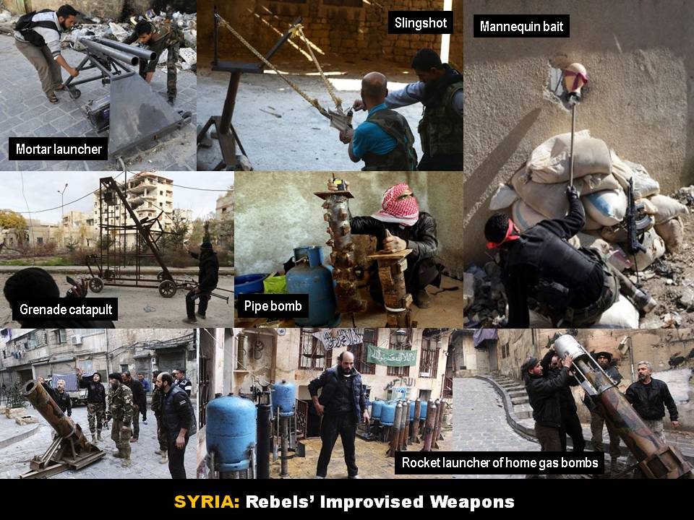
Improvisation at modern wars…

Canada designates Boko Haram a terrorist organization
Source: http://www.homelandsecuritynewswire.com/dr20140103-canada-designates-boko-haram-a-terrorist-organization

Canada, under its Criminal Code, has designated Boko Haram as a terrorist organization. The United States did so three weeks ago. The Canadian government also listed the Caucasus Emirate, a Dagestan-based Islamist group, as a terrorist organization. The group is blamed for the recent bombings in Volgograd.

Maritime piracy: not so bad in 2013
Source: http://blogs.ft.com/beyond-brics/2013/12/31/maritime-piracy-not-so-bad-in-2013/?goback=.gde_ 1528217_member_5824614106421821440#axzz2pHCrqtRR

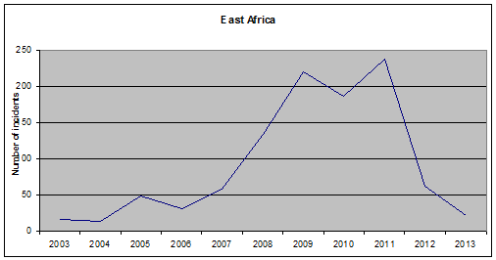
Piracy is one of the shipping industry’s biggest headaches. But it seems to be getting less severe. The number of reported incidents peaked in 2011, but has since fallen significantly. In 2013 the number of attacks, including both failed and successful attempts, dropped to its lowest level since 2007, according to the International Maritime Organization.
Over 40 per cent of attacks in 2011 took place off the east coast of Africa and around the Gulf. But in the last two years the number has fallen to one eleventh of the previous figure.
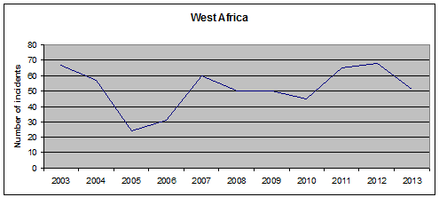
So what’s changed? “Firstly, the standard industry practice, which involves training and lock down of a boat, has become the norm,” says Rob Andrew, managing director of Newport Africa Group which offers maritime security services in east Africa. “Secondly, almost every vessel has armed security now and it is working as a deterrent.”
Before on-board weapons became widespread, ships were engaged in an elaborate game of cat and mouse, venturing further and further from the Somali coastline. The pirates responded by upgrading to bigger boats that could travel greater distances.
Meanwhile, West Africa’s piracy problems show no signs of abating. While the number of incidents (see below) appears not to be rising too steeply, anecdotal evidence suggests that this may be down to lower reporting rates.

EDITOR’S COMMENT: Piracy started as a response of Somalians to preserve their fish “stolen” from their seas. In the years that followed became an uncontrolled prospering enterprise affecting international trade. Of course it is obvious that if and when Somalia will become a real state with governance, policy and laws this phenomenon will eclipse together with national civil war directed from Al Shabaab and AQ affiliates. In the meantime rules of engagement changed with the presence of armed teams on board. At the same time many pirates are procecuted and convicted. But these steps alone did not eliminate the problem. Profit is great and there will be always people willing to take the risks. Perhaps it is time to change the rools again and move from defensive to offensive measures at sea – since land operations against pirates’ hubs are out of the plan and will stay that way [due to the Mogadishu nightmare].

I recently watched a YouTube video (http://www.youtube.com/watch?v=IT0HXb2SnM4) from an incident involving a Russian warship and a pirate boat. Despite the unacceptable “fun” of the crew [including officers] and the loss of lives [pirates], they shoot them with all they had on board – RPG incuding. “Shoot-to-kill” and “take-no-prisoners” might be the only solution and a global statement that piracy must come to an end. Right here, right now!

Volgograd and the Conquest of Eurasia: Has the House of Saud seen its Stalingrad?
By Mahdi Darius Nazemroaya
Source: http://www.globalresearch.ca/volgograd-and-the-conquest-of-eurasia-will-the-house-of-saud-see-its-stalingrad/5363440

The events in Volgograd are part of a much larger body of events and a multi-faceted struggle that has been going on for decades as part of a cold war after the Cold War—the post-Cold War cold war, if you please—that was a result of two predominately Eurocentric world wars. When George Orwell wrote his book 1984 and talked about a perpetual war between the fictional entities of Oceania and Eurasia, he may have had a general idea about the current events that are going on in mind or he may have just been thinking of the struggle between the Soviet Union and, surrounded by two great oceans, the United States of America.

So what does Volgograd have to do with the dizzying notion presented? Firstly, it is not schizophrenic to tie the events in Volgograd to either the conflict in the North Caucasus and to the fighting in Syria or to tie Syria to the decades of fighting in the post-Soviet North Caucasus. The fighting in Syria and the North Caucuses are part of a broader struggle for the mastery over Eurasia. The conflicts in the Middle East are part of this very grand narrative, which to many seems to be so far from the reality of day to day life.

“Bandar Bush” goes to Mother Russia
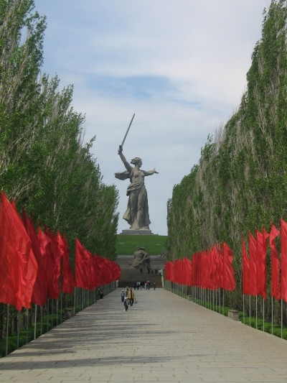
For the purposes of supporting such an assertion we will have to start with the not-so-secret visit of a shadowy Saudi regime official to Moscow. Prince Bandar bin Sultan bin Abdulaziz Al-Saud, the infamous Saudi terrorist kingpin and former House of Saud envoy to Washington turned intelligence guru, last visited the Russian Federation in early-December 2013. Bandar bin Sultan was sent by King Abdullah to solicit the Russian government into abandoning the Syrians. The goal of Prince Bandar was to make a deal with the Kremlin to let Damascus be overtaken by the Saudi-supported brigades that were besieging the Syrian government forces from Syria’s countryside and border regions since 2011. Bandar met with Russian President Vladimir Putin and the two held closed-door discussions about both Syria and Iran at Putin’s official residence in Novo-Ogaryovo.
The last meeting that Bandar had with Putin was a few months earlier in July 2013. That meeting was also held in Russia. The July talks between Prince Bandar and President Putin also included Secretary Nikolai Patrushev, the head of the Security Council of the Russian Federation. One would also imagine that discussion about the Iranians increased with each visit too, as Bandar certainly tried to get the Russians on bad terms with their Iranian allies.
After Bandar’s first meeting with President Putin, it was widely reported that the House of Saud wanted to buy Russia off. Agence France-Presse and Reuters both cited the unnamed diplomats of the Arab petro-monarchies, their March 14 lackeys in Lebanon, and their Syrian opposition puppets as saying that Saudi Arabia offered to sign a lucrative arms contract with Moscow and give the Kremlin a guarantee that the Arab petro-sheikdoms would not threaten the Russian gas market in Europe or use Syria for a gas pipeline to Europe.
Russia knew better than to do business with the House of Saud. It had been offered a lucrative arms deal by the Saudi regime much earlier, in 2008, to make some backdoor compromises at the expense of Iran. After the compromises were made by Moscow the House of Saud put the deal on ice. If the media leaks in AFP and Reuters were not tactics or lies in the first place aimed at creating tensions between the Syrian and Russian governments, the purportedly extravagant bribes to betray Syria were wasted on the ears of Russian officials.
The House of Saud and the undemocratic club of Arab petro-monarchies that form the Gulf Cooperation Council (GCC) have always talked large about money. The actions of these self portrayed lords of the Arabia Peninsula have almost never matched their words and promises. To anyone who deals with them, the House of Saud and company are known for habitually making grand promises that they will never keep, especially when it comes to money. Even when money is delivered, the full amount committed is never given and much of it is stolen by their corrupt partners and cronies. Whether it is the unfulfilled 2008 arms contract with Russia that was facilitated with the involvement of Iraqi former CIA asset Iyad Allawi or the overabundant commitments of financial and logistical aid to the Lebanese and Palestinian peoples that never materialized, the Arab petro-sheikhdoms have never done more than talk grandly and then get their propagandist to write articles about their generosity and splendor. Underneath all the grandeur and sparkles there has always been bankruptcy, insecurity, and emptiness.
A week after the first meeting with Bandar, the Kremlin responded to the media buzz about the attempted bribe by Saudi Arabia. Yury Ushakov, one of Putin’s top aides and the former Russian ambassador to the US, categorically rejected the notion that any deal was accepted or even entertained by the Kremlin. Ushakov avowed that not even bilateral cooperation was discussed between the Saudis and Russia. According to the Kremlin official, the talks between Bandar and Putin were simply about the policies of Moscow and Riyadh on Syria and the second international peace conference being planned about Syria in Geneva, Switzerland.

More Leaks: Fighting Fire with Fire?
If his objective was to get the Russians to abandon Syria, Prince Bandar left both meetings in Russia empty-handed. Nevertheless, his visit left a trail of unverifiable reports and speculation. Discretion is always needed when analyzing these accounts which are part of the information war about Syria being waged on all sides by the media. The planted story from the Saudi side about trying to buy the Russians was not the only account of what took place in the Russian-Saudi talks. There was also a purported diplomatic leak which most likely surfaced as a counter-move to the planted story about Bandar’s proposal. This leak elaborated even further on the meeting between Bandar and Putin. Threats were made according to the second leak that was published in Arabic by the Lebanese newspaper As-Safir on August 21, 2013.
According to the Lebanese newspaper, not only did Prince Bandar tell the Russians during their first July meeting that the regimes of the GCC would not threaten the Russian gas monopoly in Europe, but he made promises to the Russians that they could keep their naval facility on the Mediterranean coast of Syria and that he would give the House of Saud’s guarantee to protect the 2014 Winter Olympics being held in the North Caucasian resort city of Sochi, on the eastern coast of the Black Sea, from the Chechen separatist militias under Saudi control. If Moscow cooperated with Riyadh and Washington against Damascus, the leak discloses that Bandar also stated that the same Chechen militants fighting inside Syria to topple the Syrian government would not be given a role in Syria’s political future.
When the Russians refused to betray their Syrian allies, Prince Bandar then threatened Russia with the cancellation of the second planned peace conference in Geneva and with the unleashing of the military option against the Syrians the leak imparts.
This leak, which presents a veiled Saudi threat about the intended attacks on the Winter Olympics in Sochi, led to a frenzy of speculations internationally until the end of August 2013, amid the high tensions arising from the US threats to attack Syria and the threats coming from Iran to intervene on the side of their Syrians allies against the United States. Originating from the same politically affiliated media circle in Lebanon, reports about Russian military preparations to attack Saudi Arabia in response to a war against Syria began to circulate from the newspaper Al-Ahed also, further fueling the chain of speculations.

A House of Saud Spin on the Neo-Con “Redirection”
Seymour Hersh wrote in 2007 that after the 2006 defeat of Israel in Lebanon that the US government had a new strategy called the “redirection.” According to Hersh, the “redirection” had “brought the United States closer to an open confrontation with Iran and, in parts of the region, propelled it into a widening sectarian conflict between Shiite and Sunni Muslims.” With the cooperation of Saudi Arabia and all the same players that helped launch Osama bin Ladin’s career in Afghanistan, the US government took “part in clandestine operations aimed at Iran and its ally Syria.” The most important thing to note is what Hersh says next: “A by-product of these activities has been the bolstering of Sunni extremist groups that espouse a militant vision of Islam and are hostile to America and sympathetic to Al Qaeda.”
A new House of Saud spin on the “redirection” has begun. If there is anything the House of Saud knows well, it is rounding up fanatics as tools at the service of Saudi Arabia’s patrons in Washington. They did it in Afghanistan, they did it Bosnia, they have done it in Russia’s North Caucasus, they did it in Libya, and they are doing it in both Lebanon and Syria. It does not take the British newspaper The Independent to publish an article titled “Mass murder in the Middle East is funded by our friends the Saudis” for the well-informed to realize this.
The terrorist bombings in Lebanon mark a new phase of the conflict in Syria, which is aimed at forcing Hezbollah to retreat from Syria by fighting in a civil war on its home turf. The attacks are part of the “redirection.” The House of Saud has accented this new phase through its ties to the terrorist attacks on the Iranian Embassy in Beirut on November 19, 2013. The attacks were carried out by individuals linked to the notorious Ahmed Al-Assir who waged a reckless battle against the Lebanese military from the Lebanese city of Sidon as part of an effort to ignite a sectarian civil war in Lebanon.
Al-Assir’s rise, however, was politically and logistically aided by the House of Saud and its shameless Hariri clients in Lebanon. He is also part of the same “redirection” policy and current that brought Fatah Al-Islam to Lebanon. This is why it is no surprise to see Hariri’s Future Party flag flying alongside Al-Qaeda flags in Lebanon. After Al-Assir’s failed attempt to start a sectarian Lebanese civil war, he went into hiding and it was even alleged that he was taken in by one of the GCC embassies.
In regard to the House of Saud’s roles in the bombings in Lebanon, Hezbollah would confirm that the attack on the Iranian Embassy in Beirut was linked to the House of Saud. Hezbollah’s leadership would report that the Abdullah Izzam Brigade, which is affiliated to Al-Qaeda and tied to the bombings, is directly linked to the intelligence services of Saudi Arabia.
Moreover, the Saudi agent, Majed Al-Majed, responsible for the attack would be apprehended by Lebanese security forces in late-December 2013. He had entered Lebanon after working with Al-Nusra in Syria. Fars News Agency, an Iranian media outlet, would report on January 2, 2014 that unnamed Lebanese sources had also confirmed that they had discovered that the attack was linked to Prince Bandar.

Wrath of the House of Saud Unleashed?
A lot changed between the first and second meetings that Prince Bandar and Vladimir Putin had, respectively in July 2013 and December 2013. The House of Saud expected its US patron to get the Pentagon involved in a conventional bombing campaign against Syria in the month of September. It is more than likely that Riyadh was in the dark about the nature of secret negotiations that the US and Iran were holding through the backchannel of Oman in the backdrop of what appeared to be an escalation towards open war.
Bandar’s threat to reassess the House of Saud’s ties with Washington is probably a direct result of the US government keeping the House of Saud in the dark about using Syria as a means of negotiating with the Iranian government. US officials may have instigated the House of Saud to intensify its offensive against Syria to catalyze the Iranians into making a deal to avoid an attack on Syria and a regional war. Moreover, not only did the situation between the US and Iran change, Russia would eventually sign an important energy contract for Syrian natural gas in the Mediterranean Sea. The House of Saud has been undermined heavily in multiple ways and it is beginning to assess its own expendability.
If one scratches deep enough, they will find that the same ilk that attacked the Iranian Embassy in Beirut also attacked the Russian Embassy in Damascus. Both terrorist attacks were gifts to Iran and Russia, which served as reprisals for the Iranian and Russian roles in protecting Syria from regime change and a destructive war. It should, however, be discerned if the House of Saud is genuinely lashing out at Iran and Russia or if it being manipulated to further the goals of Washington in the US negotiations with Tehran, Moscow, and Damascus.
In the same manner, the House of Saud wants to generously reward Hezbollah too for its role in protecting Syria by crippling Hezbollah domestically in Lebanon. Riyadh may possibly not want a full scale war in Lebanon like the Israelis do, but it does want to neutralize and eliminate Hezbollah from the Lebanese landscape. In this regard, Saudi Arabia has earnestly been scheming to recruit Lebanon’s President Michel Suleiman and the Lebanese military against Hezbollah and its supporters.
The Saud grant of three billion dollars to the Lebanese Armed Forces is not only blood money being given to Lebanon as a means of exonerating Saudi Arabia for its role in the terrorist bombings that have gripped the Lebanese Republic since 2013, the Saudi money is also aimed at wishfully restructuring the Lebanese military as a means of using it to neutralize Hezbollah. In line with the House of Saud’s efforts, pledges from the United Arab Emirates and reports that NATO countries are also planning on donating money and arms to the Lebanese military started.
In addition to the terrorists bombings in Lebanon and the attack on the Russian Embassy in Damascus, Russia has also been attacked. Since the Syrian conflict intensified there has been a flaring of tensions in Russia’s North Caucasus and a breakout of terrorist attacks. Russian Muslim clerics, known for their views on co-existence between Russia’s Christian and Muslim communities and anti-separatist views, have been murdered. The bombings in Volgograd are just the most recent cases and an expansion into the Volga of what is happening in the North Caucasus, but they come disturbingly close to the start of the Winter Olympics that Prince Bandar was saying would be “protected” if Moscow betrayed Syria.

Can the House of Saud Stand on its Own Feet?
It is a widely believed that you will find the US and Israelis pulling a lot of the strings if you look behind the dealings of the House of Saud. That view is being somewhat challenged now. Prince Mohammed bin Nawaf bin Abdulaziz Al-Saud, Saudi Arabia’s ambassador to the UK, threatened that Saudi Arabia will go it alone against Syria and Iran in a December 2013 article. The letter, like the Saudi rejection of their UN Security Council seat, was airing the House of Saud’s rage against the realists running US foreign policy.
In this same context, it should also be noted for those that think that Saudi Arabia has zero freedom of action that Israeli leaders have stressed for many years that Tel Aviv needs to cooperate secretly with Saudi Arabia to manipulate the US against Iran. This is epitomized by the words of Israeli Brigadier-General Oded Tira: “We must clandestinely cooperate with Saudi Arabia so that it also persuades the US to strike Iran.”
Along similar lines, some may point out that together the House of Saud and Israel got France to delay an interim nuclear agreement between the Iranians and the P5+1 in Geneva. The House of Saud rewarded Paris through lucrative deals, which includes making sure that the grant it gives to the Lebanese military is spent on French military hardware. Saad Hariri, the main Saudi client in Lebanon, even met Francois Hollande and French officials in Saudi Arabia in context of the deal. Appeasing the House of Saud and Israel, French President Hollande has replicated France’s stonewalling of the P5+1 interim nuclear deal with Iran by trying to spoil the second Syria peace conference in Geneva by saying that there can be no political solution inside Syria if President Bashar Al-Assad stays in power.
gain, however, it has to be asked, is enraging Saudi Arabia part of a US strategy to make the Saudis exert maximum pressure on Tehran, Moscow, and Damascus so that the United States can optimize its gains in negotiations? After all, it did turn out that the US was in league with France in Geneva and that the US used the French stonewalling of an agreement with Iran to make additional demands from the Iranians during the negotiations. Russian Foreign Minister Sergey Lavrov revealed that the US negotiation team had actually circulated a draft agreement that had been amended in response to France’s demands before Iran and the other world powers even had a chance to study them. The draft by the US team was passed around, in Foreign Minister Lavrov’s own words, “literally at the last moment, when we were about to leave Geneva.”
Instead of debating on the level of independence that the House of Saud possesses, it is important to ask if Saudi Arabia can act on its own and to what degree can the House of Saud act as an independent actor. This looks like a far easier question to answer. It is highly unlikely that Saudi Arabia can act on its own in most instances or even remain an intact state. This is why Israeli strategists very clearly state that Saudi Arabia is destined to fall apart. “The entire Arabian Peninsula is a natural candidate for dissolution due to internal and external pressures, and the matter is inevitable especially in Saudi Arabia,” the Israeli Yinon Plan deems. Strategists in Washington are also aware of this and this is also why they have replicated models of a fragmented Saudi Arabia. This gives rise to another important question: if they US assess that the Kingdom of Saudi Arabia is not a sustainable entity, will it use it until the burns out like a flame? Is this what is happening and is Saudi Arabia being sacrificed or setup to take the blame as the “fall guy” by the United States?

Who is Hiding Behind the House of Saud?
Looking back at Lebanon, the messages from international media outlets via their headlines is that the bombings in Lebanon highlight or reflect a power struggle between the House of Saud and Tehran in Lebanon and the rest of the region. Saying nothing about the major roles of the US, Israel, and their European allies, these misleading reports by the likes of journalists like Anne Barnard casually blame everything in Syria and Lebanon on a rivalry between Saudi Arabia and Iran, erasing the entire history behind what has happened and casually sweeping all the interests behind the conflict(s) under the rug. This is dishonest and painting a twisted Orientalist narrative.
The outlets trying to make it sound like all the Middle East’s problems are gravitating around some sort of Iranian and Saudi rivalry might as well write that “the Saudis and Iranians are the sources behind the Israeli occupation of Palestine, the sources behind the Anglo-American invasion of Iraq that crippled the most advanced Arab country, the ones that are blockading medication from reaching Gaza due to their rivalry, the ones who enforced a no-fly zone over Libya, the ones that are launching killer drone attacks on Yemen, and the ones that are responsible for the billions of dollars that disappeared from the Iraqi Treasury in 2003 after Washington and London invaded that country and controlled its finances.” These outlets and reports are tacitly washing the hands of actors like Washington, Tel Aviv, Paris, and London clean of blood by trying to construct a series of false narratives that either blame everything on a regional rivalry between Tehran and Riyadh or the premise that the Sunni Muslims and Shia Muslims are fighting an eternal war that they are biologically programmed to wage against one another.
Arabs and Iranians and Shias and Sunnis are tacitly painted as un-human creatures that cannot be understood and savages to audiences. The New York Times even dishonestly implies that the Sunni Muslims and Shiite Muslims in Lebanon are killing one another in tit-for-tat attacks. It sneakily implies that Hezbollah and its Lebanese rivals are assassinating one another. Bernard, its reporter in Lebanon who was mentioned earlier, along with another colleague writes:
In what have been seen as tit-for-tat attacks, car bombs have targeted Hezbollah-dominated neighborhoods in the southern suburbs of Beirut and Sunni mosques in the northern city of Tripoli.
On Friday, a powerful car bomb killed Mohamad B. Chatah, a former Lebanese finance minister who was a major figure in the Future bloc, a political group that is Hezbollah’s main Sunni rival.
The New York Times is cunningly trying to make its readers think that Hezbollah was responsible for the bombing as part of a Shiite-Sunni sectarian conflict by concluding with an explanation that the slain former Lebanese finance minister belonged to “Hezbollah’s main Sunni rival” after saying that the bombings in Lebanon “have been seen as tit-for-tat attacks” between the areas that support Hezbollah and “Sunni mosques” in Tripoli
The US and Israel wish that a Shiite-Sunni sectarian conflict was occurring in Lebanon and the rest of the Middle East. They have been working for this. It has been them that have been manipulating Saudi Arabia to instigate sectarianism. The US and Israel have been prodding the House of Saud—which does not represent the Sunni Muslims, let alone the people of Saudi Arabia which are under its occupation—against Iran, all the while trying to conceal and justify the conflict being instigated as some sort of “natural” rivalry between Shiites and Sunnis that is being played out across the Middle East.
It has been assessed with high confidence by outsiders concerned by the House of Saud’s inner dealings that Prince Bandar is one of the three Al-Saud princes managing Saudi Arabia’s security and foreign policy; the other two being Prince Abdulaziz bin Abdullah bin Abdulaziz Al-Saud, the Saudi deputy foreign minister and one of King Abdullah’s point men on Syria due to his ties to Syria from his maternal side, and Prince Mohammed bin Nayef bin Abdulaziz Al-Saud, the interior minister. All three of them are tied to the United States more than any of their predecessors. Prince Bandar himself has a long history of working closely with the United States, which explains the endearing moniker of “Bandar Bush” that he is widely called by. “Chemical Bandar” can be added to the list too, because of the reports about his ties to the Syrian chemical weapon attacks in Ghouta.
As a US client, Saudi Arabia is a source of instability because it has been conditioned hence by Washington. Fighting the terrorist and extremist threat is now being used by the US as a point of convergence with Iran, which coincidently has authored the World Against Violence and Extremism (WAVE) motion at the United Nations. In reality, the author of the regional problems and instability has been Washington itself. In a masterstroke, the realists now at the helm of foreign policy are pushing American-Iranian rapprochement on the basis of what Zbigniew Brzezinski, the former national security advisor of the US, said would be based on Tehran and Washington working together to secure Iran’s “volatile regional environment.” “Any eventual reconciliation [between the US and Iranian governments] should be based on the recognition of a mutual strategic interest in stabilizing what currently is a very volatile regional environment for Iran,” he explains. The point should not be lost either that Brzezinski is the man who worked with the Saudis to arm the Afghan Mujahedeen against the Soviets after he organized an intelligence operation to fool the Soviets into militarily entering Afghanistan in the first place.
The House of Saud did not work alone in Afghanistan during the Cold War either. It was rigorously backed by Washington. The United States was even more involved in the fighting. It is the same in Syria. If the diplomatic leak is to be believed about the meeting between Bandar and Putin, it is of merit to note that “Bandar Bush” told Putin that any “Saudi-Russian understanding” would also be part of an “American-Russian understanding.”

Has the “Redirection” Seen its Stalingrad?
Volgograd was called Stalingrad for a part of Soviet history, in honour of the Republic of Georgia’s most famous son and Soviet leader Joseph Stalin. It was Volgograd, back then called Stalingrad, where the Germans were stopped and the tide of war in Europe was turned against Hitler and his Axis allies in Europe. The Battle of Stalingrad was where the Nazis were defeated and it was in the Soviet Union and Eastern Europe where the bulk of the fighting against the Germans was conducted. Nor is it any exaggeration to credit the Soviets—Russian, Kazakh, Uzbek, Tajik, Tartar, Georgian, Armenian, Ukrainian, Belarusian, Chechen, and all—for doing most of the fighting to defeat the Germans in the Second World War.
Judging by the bellicose 2013 New Years Eve speech of Russian President Vladimir Putin, the terrorist attacks in Volgograd will be the start of another Battle of Stalingrad of some sorts and the launch of another Russian “war on terror.” Many of the terrorists that Russia will go after are in Syria and supported by the House of Saud.
The opponents of the Resistance Bloc that Iran, Syria, Hezbollah, and the Palestinian resistance groups form have called the battlefields in Syria the Stalingrad of Iran and its regional allies. Syria has been a Stalingrad of some sorts too, but not for the Resistance Bloc. The alliance formed by the US, Britain, France, Saudi Arabia, Qatar, Turkey, and Israel has begun to unravel in its efforts to enforce regime change in Syria. The last few years have marked the beginning of a humiliating defeat for those funding extremism, separatism, and terrorism against countries like Russia, China, Iran, and Syria as a means of preventing Eurasian cohesion. Another front of this same battle is being politically waged by the US and the EU in the Ukraine in a move to prevent the Ukrainians from integrating with Belarus, Russia, and Kazakhstan.

Volgograd and the Conquest of Eurasia
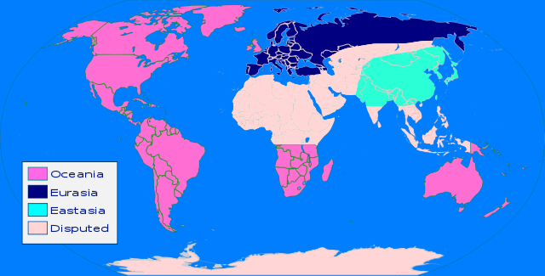
While speculation has been entertained with warning in this text, most of what has been explained has not been speculative. The House of Saud has had a role in destabilizing the Russian Federation and organizing terrorist attacks inside Russia. Support or oppose the separatist movements in the North Caucasus, the point is that they have been opportunistically aided and used by the House of Saud and Washington. Despite the authenticity of the narrative about Bandar’s threats against Russia, Volgograd is about Syria and Syria is about Volgograd. Both are events taking place as part of the same struggle. The US has been trying to encroach into Syria as a means of targeting Russia and encroaching deeper in the heart of Eurasia.
When George Orwell wrote 1984 he saw the world divided into several entities (map above) at constant or “eternal” war with one another. His fictitious superst
ates police language, use total surveillance, and utterly manipulate mass communication to indoctrinate and deceive their peoples. Roughly speaking, Orwell’s Oceania is formed by the US and its formal and informal territories in the Western Hemisphere, which the Monroe Doctrine has essentially declared are US colonies, confederated with Britain and the settler colonies-cum-dominions of the former British Empire (Australia, Canada, Ireland, New Zealand, and South Africa). The Orwellian concept of Eurasia is an amalgamation of the Soviet Union with continental Europe. The entity of Eastasia on the other hand is formed around China. Southeast Asia, India, and the parts of Africa that do not fall under the influence of Oceanic South Africa are disputed territory that is constantly fought for. Although not specifically mentioned, it can be extrapolated that Southwest Asia, where Syria is located, or parts of it are probably part of this fictional disputed territory, which includes North Africa.
If we try to fit Orwellian terms onto the present set of global relations, we can say that Oceania has made its moves against Eurasia/ Eastasia for control of disputed territory (in the Middle East and North Africa).
1984 is not just a novel; it is a warning from the farseeing Orwell. Nonetheless, never did he imagine that his Eurasia would make cause with or include Eastasia through a core triple alliance and coalition comprised of Russia, China, and Iran. Eurasia will finish, in one way or another, what Oceania has started. All the while, as the House of Saud and the other rulers of the Arab petro-sheikhdoms continue to compete with one another in building fancy towers, the Sword of Damocles is getting heavier over their heads.

An award-winning author and geopolitical analyst, Mahdi Darius Nazemroaya is the author of The Globalization of NATO (Clarity Press) and a forthcoming book The War on Libya and the Re-Colonization of Africa. He has also contributed to several other books ranging from cultural critique to international relations. He is a Sociologist and Research Associate at the Centre for Research on Globalization (CRG), a contributor at the Strategic Culture Foundation (SCF), Moscow, and a member of the Scientific Committee of Geopolitica, Italy.

EDITOR’S COMMENT: Another fascinating “chess” article…

The Fighters of Lashkar‐e‐Taiba: Recruitment, Training, Deployment and Death
Source: http://www.isn.ethz.ch/Digital-Library/Publications/Detail/?lng=en&id=163497#!

This paper is an analysis of over 900 biographies of the deceased militants of Lashkar-e-Taiba (LeT), the group responsible for the 2008 Mumbai attacks. It aims to provide baseline data about LeT’s local recruits, the nature of the time they spend with the group and how these dynamics have changed over time. The analysis is based on the assumption that LeT’s local activity and infrastructure are and will remain the key source of its strength, even if the group decides it is in its interest to become more active in the international arena.

►You can download the full paper from a link at source’s URL.
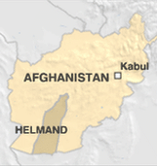

Afghanistan girl wearing suicide vest detained
Source: http://www.bbc.co.uk/news/world-asia-25620543

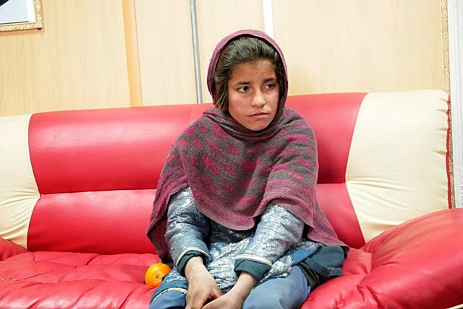
Jan 6, 2014 – A young Afghan girl has been detained wearing a suicide vest in southern Afghanistan, officials say.
She was held on Sunday night in Helmand province, as she tried to carry out an attack on border police, an interior ministry spokesman told the BBC.
The girl, reported to be as young as ten and thought to be the sister of a prominent Taliban commander, is said to be in a state of shock and confusion.
Police told the BBC she was encouraged to carry out the attack by her brother.
According to interior ministry spokesman Sediq Sediqi, one of the Afghan soldiers spotted the girl wearing a suicide jacket. But she could not operate the button to detonate the suicide vest or she was arrested before she could carry the attack, the BBC's Bilal Sarwary reports from the Afghan capital, Kabul.
The girl has now been transferred to the provincial capital of Lashkar Gah.
June 27, 2011 – Taliban militants forced an 8-year-old girl to carry a bag filled with explosives to an Afghan police checkpoint where it went off and killed her, authorities said.
No one else was hurt, but the chilling episode is believed to have involved the youngest child ever used in a suicide attack in Afghanistan. The incident happened Saturday in central Uruzgan province, the Interior Ministry said.
"The insurgents handed over a bag with a homemade bomb to an eight-year-old girl and asked her to take it to police forces," the ministry said in a statement, the Guardian newspaper reported. "As the girl was getting close to the police, it exploded and killed the girl."

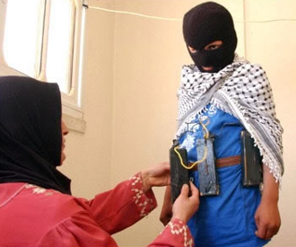
December 13, 2010 – Taliban terrorists used a two-year-old girl as the trigger for an improvised explosive device in Afghanistan, killing the child and five Afghan police officers. Afghan National Police officers near Kandahar stopped their vehicle to comfort the child who they saw sobbing by the side of the road. The Islamist insurgents had ordered the toddler not to move, in order to lure the hapless officers who were being trained by British troops at the Helmand police training center in Lashkar Gah.

Pakistan: Terrorism surged in 2013
Source: http://tribune.com.pk/story/655329/vicious-year-terrorism-surged-in-2013-says-report/

Since 2010, the number of overall incidents of violence saw a downwards trend for the two subsequent years. This trend could not persist in 2013 and took a slight upward curve, mainly, during the campaigning phase of the general elections and sustained until the year’s end.
This was revealed in a report titled ‘Pakistan Security Report 2013’ compiled by Pak Institute for Peace Studies (PIPS), said a press release issued on Sunday.
According to the report, militant, nationalist insurgent and violent sectarian groups carried out a total of 1,717 terrorist attacks across Pakistan in 2013, claiming the lives of 2,451 people and causing injuries to another 5,438.
Compared to 2012, the number of reported terrorist attacks in Pakistan posted a nine per cent increase while the number of people killed and injured in these attacks increased by 19 per cent and 42 per cent, respectively.
Despite the killing of its top brass in drone attacks and military operations by Pakistani security forces, the Tehreek-e-Taliban Pakistan (TTP) remained the major actor of instability in the country in 2013 through its alliance with numerous militant groups. It carried out 645 terrorist attacks in 50 districts, claiming the lives of 732 civilians and 425 security forces personnel.
Meanwhile, a rise in sectarian violence that started in 2011 continued through towards end of 2013, with the number of people killed and injured in such incidents increasing significantly.
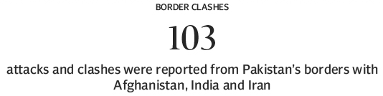
The number of suicide attacks across the country rose by 39 per cent, with 46 suicide attacks in 2013 compared to 33 in the previous year. As many as 18 (39 per cent) out of the total suicide attacks in 2013 were recorded in Khyber-Pakhtunkhwa (K-P), 12 in FATA, nine in Balochistan, five in Sindh and one each in Rawalpindi and Azad Kashmir.
Of the total, 34 suicide attacks were perpetrated by the TTP and its affiliated groups. Nine were sectarian-related mainly carried out by Lashkar-e-Jhangvi and one suicide blast was carried out by nationalist insurgents. Another two attacks were carried out in inter-militant clashes.
US drone strikes on the other hand saw a 31 per cent decrease in 2013. Out of 31 reported drone attacks, around 24 struck militants and their hideouts in North Waziristan Agency, in FATA. Five drone strikes were reported in South Waziristan, and one each in Khyber Agency and Hangu, a settled district of K-P. Fatalities in these attacks also fell by 39 per cent.
The number of overall cross-border attacks and clashes increased in 2013 mostly along Pak-India border, but the casualties in these attacks decreased. Also, 26 and nine attacks were reported from Pakistan’s borders with Afghanistan and Iran respectively.
On the whole, 103 border attacks and clashes were reported from Pakistan’s borders with Afghanistan, India and Iran, which were 30 per cent more than such incidents in 2012. As many as 59 Pakistani citizens including personnel of security forces and civilians lost their lives in these incidents, 82 per cent less than the killings in such incidents in 2012.
The incidents of ethno-political violence in Pakistan increased by 22 per cent, from 183 in 2012 to 224 in 2013, but the fatalities in these incidents slightly decreased from 288 in 2012 to 283 in 2013. While most incidents of ethno-political violence in 2013 were concentrated in Karachi (over 81 per cent), such incidents were reported from a total of 28 districts in all four provinces of Pakistan.
Apparently, the May 2013 elections made the ethno-political violence in the country a more complex phenomenon with increasing number of political parties becoming either a part of it or being beleaguered in politically motivated targeted killings.
Interestingly, the number of militants killed in 2013, in overall incidents of violence, declined by 28 per cent while fatalities among security forces personnel decreased by a meager two per cent.
The report, while endorsing the establishment of the Cabinet Committee on National Security (CCNS), recommends the expansion in its role from a consultative and decision-making body to implementing and monitoring secretariat of National Security Initiatives (NSI).

US report indicates al Qaeda cores in Attica, Greece

Source: http://www.defencenet.gr (translated from Greece)

A recent report issued by the American security institute TCS (Tech Central Station) argues that in the Attica region there are at least three organized nuclei of al Qaeda which are located in specific areas of the Mesogia perfecture, Attica (Pallini, Gerakas , Markopoulo and Koropi – red dots on map below).

The cores consist of Pakistanis and Afghans who have contineous contacts with centers in Afghanistan and Pakistan.

The area is of particular security importance since it surounds Athens’ Eleftherios Venizelos International Airport and an attack can be executed from a safe distance.

In the same area there are also several high technology companies related to Greek Armed Forces, US, NATO etc.

Mesogia perfecture hosts tens of thousands of Pakistanis and Afghans that can in complete secrecy encourage illegal immigrantsprimarily enables them to operate with complete secrecy encouraging illegal immigrants to riot in Athens in order to create chaos

TCS also relates these episodes with the spread of Wahhabism in Greece. This Islamic doctrine supports hatred, contempt and distrust of Jews, Christians and non- Muslims while their mosques are used to gather money for the Jihad!

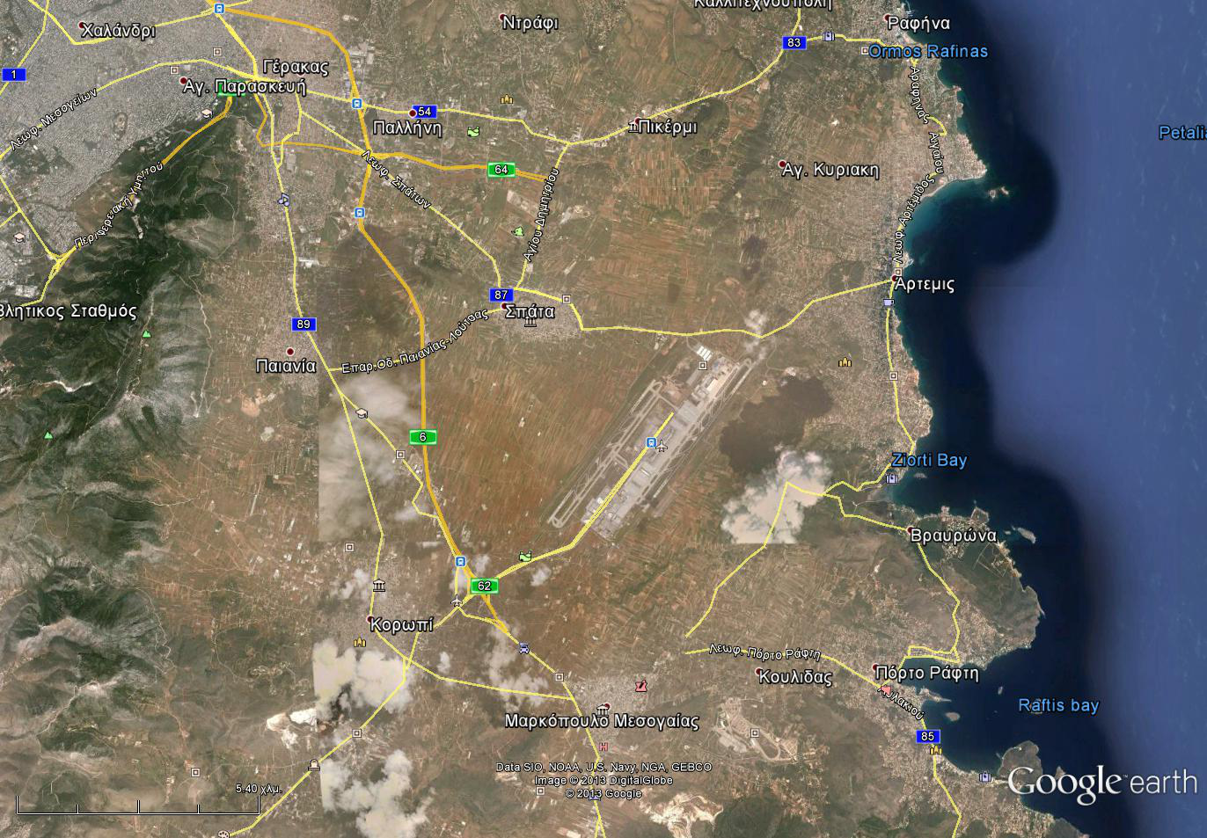

Greek Police Hunt for Convicted Terrorist Who Disappeared on Furlough
Source: http://www.nytimes.com/2014/01/08/world/europe/greek-authorities-seek-convicted-terrorist-who-violated-furlough.html?_r=0

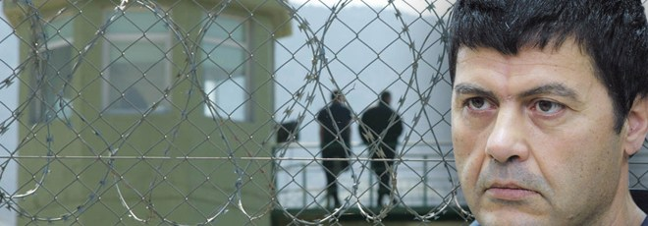
Jan 7, 2014 – The Greek authorities on Tuesday began a nationwide search for a convicted member of the dismantled November 17 group, once the country’s deadliest guerrilla organization, after he failed to report to the police during a prison furlough, fueling fears of a resurgence of political violence.
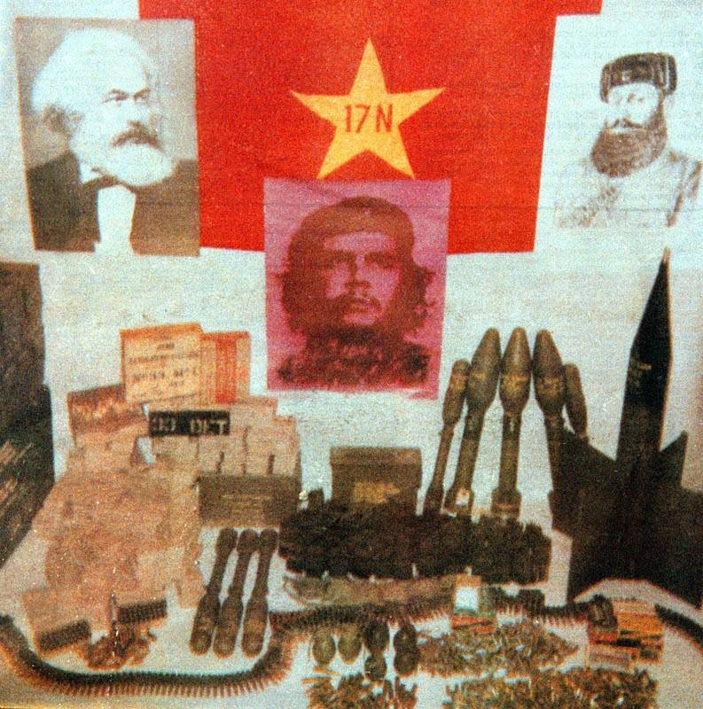
The inmate, Christodoulos Xiros, 55, was serving multiple (6) life terms at the high-security Korydallos Prison near Athens for a series of deadly attacks carried out by the group, chiefly against Greek, British and American business and political targets. Fifteen members of the group, which blended Marxist ideals with nationalism, were convicted in 2003 for 23 killings and dozens of bombings over nearly three decades. Mr. Xiros, a maker of musical instruments, and two of his brothers were among those jailed.
According to a police spokesman, Mr. Xiros was granted a nine-day furlough on Jan. 1 to visit his family in Halkidiki, in northern Greece. He failed to report to a police station on Monday, after checking in regularly on the previous days.
Mr. Xiros’s lawyer, Fragiskos Ragousis, said he was not in contact with his client but interpreted his disappearance as “a political escape.” “It is a political decision in line with his beliefs and his opinions about freedom,” he told Greek television.
The Greek news media, which had been focusing on preparations for Greece’s official assumption of the European Union’s rotating six-month presidency on Wednesday, swirled with rumors about the whereabouts and intentions of Mr. Xiros. The police said security would be tightened as dozens of foreign dignitaries arrive in Athens to attend the festivities.

EDITOR’S COMMENT: Funny land Greece! Six life terms, imprisoned in high risk prison and was given some days out to celebrate the New Year – furlough signed just one day after the attack against German Ambassador’s residence in Athens! At the same time thousands of prisoners for financial crimes or depts are beging for better conditions in crowded prisons. And now he is gone because he is a “freedom fighter”… while the “system” is looking for the next escape goat to blame for and announces for the second time the joke of a new high security prison! His brother Vassilios Xiros is also missing after his official release from prison (June 11, 2011). C’est la Grece!

A list of 17N's known murder and kidnapping victims:

- Richard Welch, CIA station chief in Athens. (23 December 1975);
- Evangelos Mallios, policeman who was accused of torturing political prisoners during the period of military junta. (14 December 1976);
- Pantelis Petrou, deputy commander of the Greek police Riot Control Unit (SWAT) (16 January 1980);
- Sotiris Stamoulis, driver of the above mentioned. (16 January 1980);
- George Tsantes, a US Navy Captain, high level executive of JUSMAGG (15 November 1983);
- Nikos Veloutsos, driver of the above mentioned. (15 November 1983);
- Robert Judd, Army Master Sergeant, Postal officer for JUSMAGG in Greece, wounded in an assassination attempt. (3 April 1984);
- Christos Matis, police guard, killed in a bank robbery. (24 December 1984);
- Nikos Momferatos, publisher of the "Apogevmatini" newspaper. (21 February 1985);
- Georgios Roussetis, driver of above mentioned. (21 February 1985);
- Nikolaos Georgakopoulos, riot policeman, killed in bus bombing. (26 November 1985);
- Dimitrios Aggelopoulos, President of the board of Halyvourgiki S.A. (8 April 1986);
- Zacharias Kapsalakis, doctor and clinic owner, shot in the legs. (4 February 1987);
- Alexander Athanasiadis, industrialist. (1 March 1988);
- William Nordeen, a US Navy Captain, killed by a car bomb. (23 June 1988);
- Constantinos Androulidakis, a public prosecutor, is shot in both legs and dies slowly of complications. (10 January 1989);
- Panayiotis Tarasouleas, also a public prosecutor, is shot in both legs. (18 January 1989);
- Giorgos Petsos, PASOK MP and Minister, is injured in his car by a car bomb. (8 May 1989);
- Pavlos Bakoyannis, New Democracy MP (26 September 1989);
- Ronald O. Stewart,a US Air Force Sergeant, killed by a bomb. (13 March 1991);
- Deniz Bulukbasi, Turkish Chargé d'Affaires, is injured by a car bomb. (16 July 1991);
- Çetin Görgü, Turkish Press attaché (7 October 1991);
- Yiannis Varis, a police officer, is killed in a missile and hand grenade attack against a riot squad bus (2 November 1991);
- Athanasios Axarlian, a student passer-by; killed by shrapnel during a rocket attack targeting the limousine of Finance Minister Ioannis Palaiokrassas. (14 July 1992);
- Eleftherios Papadimitriou, New Democracy party deputy and MP, is shot in both legs. (21 December 1992);
- Michael Vranopoulos, former governor of the National Bank of Greece. (24 January 1994);
- Omer Haluk Sipahioglu, counselor of the Turkish Embassy in Athens. (4 July 1994);
- Costis Peraticos, ship owner, owner of Eleusis Shipyards. (28 May 1997);
- Stephen Saunders, military attaché of the British Embassy in Athens. (15 June 2000).

►Read more about 17 November at:

http://en.wikipedia.org/wiki/Revolutionary_Organization_17_November

Important players in Sochi Olympics

Source: http://www.trackingterrorism.org/group/caucasus-emirate-ce

- Caucasus Emirate
- Ingush Jamaat
- Yarmuk (Kabardino-Balkaria) Jamaat
- Riyad us-Saliheyn Martyrs' Brigade
- Black Widows - Chechen Republic
- Army of the Emigrants and Helpers
- Dagestani Shariah Jamaat
- Azerbaijani Jamaat
- Freshly Trained Fighters Coming Home from Syria

Caucasus Emirate (CE)

Larger Umbrella Organization
The Caucasus Emirate (CE - Imarat Kavkaz, IK, in the vernacular) is a Sufi nationalist organization formed in October 2007 by Doku Umarov after he resigned from his position as president of the Republic of Ichkeria (the self-proclaimed secessionist government of Chechnya). The group aims to have an independent Caucasus Emirate ruled under Shariah and to abet a global jihad.

Structure
The Caucasus Emirate is an umbrella group for many regional militant groups rather than a structured and well coordinated organisation. These militant groups (jamaats) are mostly local in presence and operations and are generally self-sufficient in terms of finance and human capital coupled with autonomy in operational activities. The CE’s ethnic-nationalism presents the most predominant cohesion factor amongst these groups. These organizations include:
- Yarmuk (Kabardino-Balkaria) Jamaat,
- Dagestani Shari'ah Jamaat,
- Ingush Jamaat, as well as the martyr brigade,
- Riyad us-Saliheyn Martyrs' Brigade, known for suicide bombings.

Area of Operations
The CE is comprised of six vilayets or provinces that report to their respective emirs who report to the Emir of the Caucasus Emirate, Doku Umarov. The six vilayets are all located in the North Caucasus: Chechnya, Ingushetia and North Ossetia, Nogay Steppe (Northern Krasnodar Krai and Stavropol Krai), Cherkess and Southern Krasnodar Krai, Dagestan, and Kabardino-Balkaria and Karachay.

Leadership
The Russian federal security force operations to eliminate CE local or regional emirs results in a CE leadership structure constantly in flux. For example, in Dagestan the “republic” leader hardly ever survives for more than one year at a time. During January 2013, in Chechnya the Gakaev brothers, famous and well-respected warlords among the Chechen guerillas, were killed. Taking into consideration the persistent changes in leadership, the leadership of CE is as follows:
- Doku Umarov aka Warrior-1, Abu Muslim and Aisa
- Abdullah Asker Dzhappuyev (Unknown to 2012): Emir of Kabardino-Balkaria
- Hussein Gakayev (2007 to Present): Emir of Chechnya's Southwestern sector. Rescinded loyalty to Umarov in 2011, but after Abu Anas Muhannad's death he reasserted his loyalty to Umarov.
- Said Abu Saad Buryatskii (Alexander Tikhomirov) (2008 to 2010): Boasted he was "rank-and-file mujahed," but in fact was a leading ideologue and prominent preacher in the Caucasus Emirate. He was invited to join the organization by Abu Anas Muhannad in spring 2008. He was killed by Russia forces in 2010.
- Khaled Yusef Muhammed al Emirat (Abu Anas Muhannad) (2008 to April 21, 2011): Jordanian Caucasus Emirate military emir.
- Aslam Aslambek Vadalov (August 1, 2010 to August 13, 2010): Umarov announced Aslambek as his successor. However, only days later Umarov said he only “proposed” this appointment and that he himself was not stepping down.
- Anzor Astermirov (Seifullah) (October 2012 to March 2010): Head of Yarmuk Jamaat. Credited for laying the basis of the Caucasus Emirate.

Factors that could abet a CE attack
The Sochi Olympic Games presents and ideal opportunity for a CE terrorist attack, which will result in not only mass media exposure but establishing CE as a formidable player within the al-Qaeda hybrid networks. Such an act could also result in the return of Chechnya fighters from Syria, thereby strengthening the CE human capital capacity, which currently seems to be a concern for the CE leadership.

Discrediting Russian Government
With the Russian Government viewing the Sochi games as a conduit to re-establish itself as a powerful international actor, CE will view the event as an ideal opportunity to discredit the Russian Government.

Lone Wolf and Suicide Missions
The CE has engaged in acts of terror with significant impact by using lone wolf and suicide bombing strategies. The need for highly sophisticated weapons and deployments of terrorist cells for a prolonged period at the event are not definite requirements.
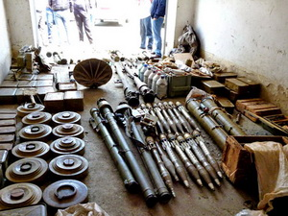

Arms Supplies
If the intercepted weapon consignment were intended to CE use in terrorist acts, the sophisticated type and quantities of these weapons reflects a CE adequately armed to engage in acts such armed assault. (please note above video) This is based on the assumption that similar type of weapons were/are successfully smuggled to the CE.

Coordinated Plan?
The video releases and Umalov statements, with specific reference to his call to fighters elsewhere in the Caucasus, implies that the CE does not have a coordinated plan, the call could evoke lone wolf or individual insurgency groups to act out of own accord, that will inevitable be associated with the CE.

Success May Mean in Proximity
A CE attack does not have to be at the Olympic sites as an act of terror in close proximity to the area of ​​the games, in adjacent parts of the North Caucasus, in major Russian cities, could be viewed as sufficient to disrupt the Games. With the Russian Government security services primarily focussed and deployed at the Sochi Olympic Games, other areas could be left vulnerable for CE acts of terror.

Mitigation
Overall, the probability of a CE attack at and or during the Games remains of significant concern. Taking into account the extend of security measures at the games, the primary threat to an act of terror at the games will be suicide bombings, where as more traditional strategies such as armed assaults and vehicle bombings are more likely during the event but in areas in close proximity to the Olympic site.

Discovery of Bombs and Corpses Rattles Tense Caucasus Region

Source: http://mobile.nytimes.com/2014/01/10/world/europe/caucasus-region.html?from=world

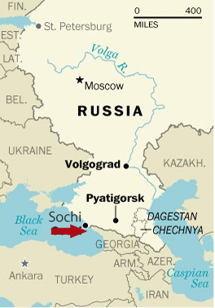
Jan 9, 2014 – The discovery of several improvised explosive devices and the bodies of six men shot dead put security forces on higher alert in the North Caucasus region of Russia on Thursday and added new concerns about violence ahead of the Olympic Games planned for the nearby resort city of Sochi next month.
The police found the bodies of the men on Wednesday in several abandoned cars near the city of Pyatigorsk in the Stavropol region, about 170 miles east of the site of the Games, and the explosives next to the cars, a law enforcement spokesman said. One of the devices detonated, and a bomb squad disarmed two others, he said.
No one was injured in the blast, the spokesman said, and it was not immediately clear whether the killings were intended as an act of terror or were connected to gangland-style violence.
The Stavropol region borders several turbulent North Caucasus republics, where Russia is struggling to quell an Islamist insurgency that has resulted in explosions and shootouts between gangs and local police forces almost daily.
Sochi has largely been quarantined ahead of the Games, closing its roads to vehicles from other parts of the country and mobilizing tens of thousands of government troops to ensure safety for visiting athletes and tourists.
The police said they were seeking three men from the neighboring Kabardino-Balkaria region in connection with the murders and “an attempt on the life of law enforcement officers,” the Interfax news service reported, but did not immediately link the case to terrorism.
State news media, citing anonymous sources, reported that two of the dead men were taxi drivers and a third worked as a furniture assembler. There was no official identification of the victims.
On Thursday evening, a Russian newspaper reported that law enforcement officers had detained a woman wearing a suicide belt on a bus in the Stavropol region.
The local police have not confirmed the report, and investigative officials could not immediately be reached for comment.

Iran maintains terrorist cells in Latin America
Source: http://infosurhoy.com/en_GB/articles/saii/features/main/2014/01/10/feature-01
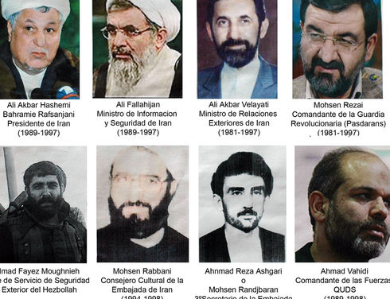
Argentine Judge Rodolfo Canicoba Corral issued an international arrest warrant in 2006 for Iranian ex-President Akbar Hashemi Rafsandjani and other top Iranian officials allegedly involved in the 1994 bombing of the Argentine-Israeli Mutual Association (AMIA) that killed 85 people. Imad Moughnieh was killed in Syria in 2008. (AFP)

Since the 1980s, Iran has been introducing intelligence cells into Latin America to recruit agents for terrorist attacks, according to security analysts and officials from the Argentine justice system.
This shadow army helped the Lebanese militia Hezbollah carry out the 1994 attack against the Argentine-Israeli Mutual Association (AMIA), which left 85 people dead.
In 2007, an Iranian cell in Guyana was planning to explode fuel tanks at John F. Kennedy Airport in New York, but they were stopped by U.S. security forces.
The data come from an investigation conducted by the prosecutor in the AMIA case Alberto Nisman, who accuses Iran of sponsoring and committing acts of terrorism in the region following the 1979 Islamic Revolution.
“The attack against the Jewish center in Buenos Aires was not an isolated incident,” Nisman said in a 502-page report filed with the court. “It exists in a larger context, developed as a result of a decision by the Iranian regime to ‘export the revolution,’ including through violence.”
In the report, which was released in May and was the result of nearly 10 years of investigations, Nisman states Iran has used mosques, embassies and cultural centers to carry out terrorism in Latin America.
The Iranian plan began in 1982, when a seminar was held in Tehran with about 380 clerics from 70 countries, according to the report.
Currently, Iran uses websites to recruit adherents, according to security analysts.
“Iran has installed websites in the region to propagate extremist messages,” said Luis Fleischman, a Uruguayan professor of political science at the Harriet L. Wilkes Honors College at Florida Atlantic University, in the United States. “The troubling part is not that common people read these websites, but that the local Arab population, which has lived in peace with the Jewish community for more than a century, may become radicalized.”

Argentina: The Mohsen Rabbani network
The leader of the Iranian intelligence cell in the Southern Cone was the Shia cleric Mohsen Rabbani, who supplied logistical support for the Hezbollah attack against the AMIA, according to the report.
Rabbani entered Argentina in 1983 as a tourist and obtained permanent residency the following year. He claimed to be a representative of the Ministry of Agriculture of Iran, but he was, in fact, a member of the Ayatollah Khomeini’s Intelligence Bureau, the report states.
Within months, Rabbani controlled three Shiite mosques in Argentina: At-Tauhíd, in the neighborhood of Floresta on the south side of Buenos Aires; Al-Iman, in Cañuelas, in the province of Buenos Aires; and El Mártir, in San Miguel de Tucumán.
Witnesses in the case said Rabbani manipulated students, placing them in situations of economic dependence to infringe upon their intellectual independence.
“Each student who came to the mosque was entitled to $1,000 pesos (US$ 1,000 at that time, US$151.41 today) a month for their studies, and Rabbani gave them only $100 pesos (US$ 100 at that time, $15.14 today), keeping the rest,” witness Eduardo Lescano said.
“Young recruits were sent to religious centers in Iran, where they ‘received military training and political indoctrination from the Pasdaran (the Iranian Revolutionary Guard),’” the report states.
Those who did not accept the radicalization were segregated from the rest of the group. This happened with Lescano, who said he “stopped attending the At-Tauhíd mosque in 1990 or 1991 due to ideological differences” before he was denied entry.
Rabbani used newspapers and radio stations to attract followers. The intelligence outfit also relied on front companies, such as the Government Trading Corporation of Iran (GTC), which inspected meat slaughtered under Islamic precepts, and Imanco (registered as an import/export company), as well as radicalized members of the local Muslim community, known as “antennas.”
Rabbani’s activities extended to Islamic centers in Chile, Colombia and Uruguay, according to Nisman.
“The decision to attack the AMIA was made on Aug.14, 1993 during a meeting in the Iranian city of Mashad,” the report states.
Rabbani was in charge of buying the van that was packed with the explosives used in the attack. Four months before the attack, he was appointed cultural counselor of the Iranian embassy, ensuring diplomatic immunity, according to the report.
Nisman found that Rabbani exchanged several phone calls with Colombian citizen Samuel Salman El Reda, who coordinated the work of the terrorists from the Brazilian city of Foz do Iguaçu, in the Triple Border Area.
An international arrest warrant has been issued for Rabbani, but he lives in Iran and is protected by the Islamic regime, Nisman said.

Guyana: The Abdul Kadir network
While Rabbani was operating in the Southern Cone, one of his disciples – Guyanese engineer and former politician Aubrey Michael Seaforth, known as Abdul Kadir – built a similar intelligence network in the Caribbean.
Kadir recruited followers in Guyana and neighboring countries beginning in 1983, according to the report.
His collaborators included Latif Alí (president of the Pioneer Shia Association of Guyana); Ismail Muhammad (leader of the Shiite mosque in Paramaribo and owner of a mailbox registered under the name “Hezbollah Surinam”); and Sheik Kareem Ibrahim, of Trinidad and Tobago.
Documents seized from Kadir’s home by U.S. authorities as part of the investigation into the plan to attack the John F. Kennedy Airport in New York show that he was sending intelligence reports to Morteza Tavasoli, the Iranian ambassador in Caracas.
Nisman’s report states Kadir’s students took part “knowingly or, perhaps, unknowingly” in actions carried out by the group planning to attack JFK airport.
This was the case with Abdul Raheem, who, in May 2007, picked up terrorists at the airport in Trinidad and helped them find a place to stay.
Kadir was arrested in June 2007 in Trinidad and Tobago, on board a plane scheduled to travel to Iran. He was extradited to the United States and sentenced to life in prison, along with other members of his group, for conspiring to attack New York’s JFK airport.

Brazil: The Tabatabaei Einaki network
In 1984, Iranian citizen Mohamed Taghi Tabatabaei Einaki arrived in Foz do Iguaçu to expand Rabbani and Kadir’s clandestine network in Brazil, according to the report.
Einaki left Brazil shortly thereafter, accused by the ambassadors of Saudi Arabia and Iraq of attempting to form terrorist cells. Yet, the Brazilian network continued to operate.
“Through another cleric, Taleb Hussein Khazraji, the strategic alliance between Iran and Hezbollah reached the city of São Paulo,” the report states.
Nisman has stated that at least another ten members of the Iranian network are in Brazil, including Farouk Omairi, who raised funds for Hezbollah from Foz do Iguaçú and was arrested in Brazil in 2007 on drug trafficking charges.

►Read also this interesting (Dec 2013) article:

Iron Triangle of Terror: Iran, Hezbollah, and Los Zetas?

Source: http://analysisintelligence.com/intelligence-analysis/iron-triangle-of-terror-iran-hezbollah-and-los-zetas/

What would the ultimate border security nightmare look like? Might it involve drug cartels, rogue Special Forces soldiers, or transnational terrorists? How about all three? This scenario sounds like something out of a Hollywood movie. The problem is that for the United States this nightmare may have come true.
On December 15th, 2013 it was revealed in an indictment that Hezbollah has a substantial drug connection to the Mexican drug cartel Los Zetas. The Lebanese druglord Ayman Joumaa was indicted in absentia for, “conspiring to smuggle over 90,000 tons of cocaine into America and laundering over $250 million for the cartels”. The druglord has close ties to Hezbollah and functioned as a middle man between the terrorist organization and the cartels. In terms of raw numbers, the amount of cocaine that he tried to smuggle was equivalent to a cargo of 2,250 eighteen wheelers. The sheer volume of this transaction is cause for concern, but the fact that Hezbollah and Los Zetas are working together is far worse.
………………………………………
Conclusion
Are Hezbollah and Los Zetas actively coordinating to undermine US interests in the Americas? There is good reason to believe that the groups are coordinating on narcotics activities. Both stand to gain substantially from money laundering and drug trafficking. The December 15th indictment appears to clearly establish these links and the report has not been questioned as much as the FBI report on the Iranian plot.The data on drug activity between Hezbollah and Los Zetas is more convincing than the plotting charges.
The Iranian plot may have been true and if so it is particularly disturbing for US security. If these two groups are indeed plotting together then an attack at the border may be an imminent threat. Despite this there are no conclusive links to show an iron triangle between Iran, Hezbollah, and Los Zetas. The three may be casually linked to one another in plotting terrorist attacks, but at present this coordination does not seem to be widespread.

Selected Dissertations and Theses on Terrorism, Counterterrorism and Political Violence, 1980 – 2013
(available in full Text)
Selected by Eric Price

Source: http://www.terrorismanalysts.com/pt/index.php/pot

Eric Price is a Professional Information Specialist who, after a career with the International Atomic Energy Agency (IAEA), joined Perspectives of Terrorism as Editorial Assistant.
“Counterterrorism Bookshelf” – 20 Important Books on Terrorism & Counterterrorism Related Subjects
By Joshua Sinai
Source: http://www.terrorismanalysts.com/pt/index.php/pot/article/view/319/html

This review column is the first in a series of columns that will provide a selective listing of important books by leading publishers on terrorism and counterterrorism-related subjects. The listings of publishers and their books are arranged in alphabetical order by publishers’ names, with their imprints included in their particular section. Within each section, the books are listed in alphabetical order, according to the lead author’s last name. Although most of the reviewed books are current, a few were published within the last several years, but are still considered to be important. Future columns will review books by publishers such as CRC Press, Hurst, Oxford University Press, Routledge, Stanford University Press, Springer, and University of Chicago Press.

Dr. Joshua Sinai is the Book Reviews Editor of ‘Perspectives on Terrorism’.

Simultaneous Attacks by Terrorist Organisations
By Kathleen Deloughery
Source: http://www.terrorismanalysts.com/pt/index.php/pot/article/view/312/html

While terror attacks that are a part of a coordinated effort receive attention in the popular media, they have not received much attention in the academic literature. The decision to carry out simultaneous attacks should be examined as one of the choices a terrorist organisation makes about the method of attack. Determining the impact of simultaneous attacks vis-à-vis a single attack can explain why groups would use this method. Up to one quarter of all attacks coded in two major databases, GTD and ITERATE, may be part of a simultaneous campaign. Empirical analysis shows simultaneous attacks are more likely to be successful and cause more fatalities, though not in a one-to-one fashion. These results underline the importance of considering simultaneous attacks in empirical analysis.

Introduction
Why do some terrorist organisations group their attacks close together, while others spread them out? For instance, Al-Qaeda is well known for carrying out simultaneous attacks—that is, having different terror cells hit more than one location at approximately the same time. It is accepted in the literature that terrorist organisations choose the method and location of their attack in order to achieve political or economic destabilization of the targeted government and to garner media attention for their cause. To carry out a single attack versus a simultaneous campaign is a decision for terrorists to consider, yet researchers have not examined these decisions closely. This article will examine why groups would carry out simultaneous campaigns over single attacks: what are the benefits?
In two of the largest terrorism datasets, International Terrorism: Attributes of Terrorist Events (ITERATE) [1] and the Global Terrorism Database (GTD) [2], attacks are coded as single events, even when they are carried out as part of a coordinated campaign.[3] Unfortunately, neither dataset specifically denotes whether or not attacks are coordinated. In order to complete any analysis, this project will first determine which attacks formed part of a coordinated campaign.
Since the most commonly used datasets disaggregate simultaneous attacks, the empirical literature on terrorism has a dearth of academic studies on this type of attack. Theoretical papers have examined the scale of terrorist attacks. Past research shows that the scale of a terrorist attack can help the targeted government to estimate the size of the organisation’s resources.[4] Coordinated attacks are by definition of a larger scale. The terror attacks of September 11, 2001 (a simultaneous attack with four component attacks), was of a scale not seen before.[5] Economic impact models of terror attacks have shown that simultaneous attacks can magnify the impact of a terror attack.[6] This article will differentiate between simultaneous attacks and single attacks using empirical analysis. In the past, empirical investigations of terrorism have largely ignored the presence of simultaneous attacks in the ITERATE and the GTD datasets. Not recognising that these attacks can be very different from single attacks may have biased the results of many past studies.
Potentially biased studies fall into two main categories: examining the level of terrorism or examining the impact of terrorism. In the former, terrorism is the dependent variable, while in the latter it is the independent variable. When a researcher is predicting the level of terrorism in a country/region/year given certain attributes, each attack, even if part of a coordinated effort, is coded separately. This coding is potentially problematic since attacks that are part of a coordinated effort are made under the same decision making process. For instance, terrorist organisations consider military expenditures when choosing a country to attack; that decision should only matter one time for a coordinated campaign. If all attacks are thought to be single attacks, then the terrorist organisation would be making that decision every time they carried out an attack. Therefore, the dependent variable would be systematically higher than the true value when coordinated attacks are present in the system. Such a measurement of the dependent variable is problematic, but only detrimental to the predictions of the past models if the measurement error is correlated with the independent variables, thus biasing the parameter estimates. It is highly likely that simultaneous attacks, the source of the measurement error, are correlated with some of the variables that factor into the resulting level of terrorism.
Potentially more problematic are the implications for studies assessing the impact of terrorism. For instance, there have been studies looking into the impact of terrorism on tourism [7], urban development [8], public opinion [9], and industry.[10] In these studies, terrorism is used as an independent variable to explain another phenomenon. Therefore, if any of the attacks coded are part of a coordinated effort, then that independent variable will be measured with error, i.e. the measure of terrorism will be overestimated. This counting system assumes that the individual attacks within a simultaneous effort have a one-to-one additive effect, which may not be true. For instance, if a coordinated attack consists of two attacks, then this counting system implies that each of the two attacks have the same impact as a different single attack. If an independent variable is measured with such an error then this can lead to biased estimates of the parameters. Therefore, the impact of terrorism that these empirical studies are obtaining may not be the true parameter estimates.
Given the potential for bias in results ignoring simultaneous attacks, it is worthwhile to explore how common this type of attack is in terrorism datasets. First, the theoretical arguments surrounding simultaneous campaigns and impact of attacks are discussed. Second, the data used in the analysis will be presented. Third, follows an examination of the methodology and results from the empirical analysis. Finally, suggestions will be offered for future research and analysis on simultaneous attacks.

Theoretical Arguments
Which is better for the terrorist organisation, carrying out many individual attacks throughout the year or concentrating on one large simultaneous set of attacks? To make an assessment of this, we must start from the assumption that terrorist organisations are choosing their optimal number of attacks given their budget constraints and the role that attacks play in their main goals: destabilization, media attention, and recruiting new members.[11] Due to budget and training constraints, organisations must decide whether to apply their resources to single attacks spread out over time or devote time and energy to a smaller number of coordinated attacks.
Coordinated attacks are likely to kill more people than single attacks. First, since these attacks usually take place in two or more separate locations, there tends to be an increase in the total number of potential victims. Additionally, individuals with greater skills and capabilities are assigned to harder terrorist attacks and these individuals tend to be both more successful and kill more people on average.[12] Simultaneous attacks require more planning and coordination; everything else being equal, they are harder to execute than single attacks, thus individuals with more advanced abilities will be assigned to these tasks. As a result, coordinated attacks should cause more deaths than single attacks.
Similarly, coordinated attacks could be more successful than single attacks. There are two ways to calculate the success of simultaneous attacks. First, one can use the maximum success of all attacks within the campaign. Only one portion of the attack needs be successful in order to incite fear and create direct victims. Second, the average of the success of each attack within the coordinated effort can be used to accurately measure the effectiveness of the campaign. Simultaneous attacks should be more successful than single attacks for two reasons. If a single attack that is part of a coordinated effort is unsuccessful, the campaign can still be a success if one of the other parts of the effort is successful. Additionally, more able individuals are assigned to harder tasks [13]. Therefore, due to planning and coordination issues, more able individuals should be assigned to coordinated terrorist efforts, thus leading to more successful simultaneous attacks.
If simultaneous attacks tend to produce more fatalities and are more successful, these attacks should receive more media coverage. A single unsuccessful attack may not receive media attention, but a coordinated campaign with one unsuccessful component is likely to be reported. Additionally, the higher the number of casualties, the greater amount of media attention the attack is likely to receive.[14] Therefore, if coordinated attacks do generate more fatalities, then simultaneous attacks in developed countries are more likely to garner media attention than single attacks. This increased news coverage can have the effect of bringing the motives of the terrorist organisation to the forefront, thus satisfying one of their main goals. In fact, the coordinated attacks on September 11th had a permanent effect of increasing the number of news stories on terrorism.[15]
Based on these reflections, two hypotheses concerning the impact of simultaneous attacks will be tested in the empirical section:
H1: Simultaneous campaigns tend to kill more people than single attacks.
H2: Simultaneous campaigns tend to have higher success rates than unsuccessful campaigns.

Data
Data for this project were derived from three main sources. Data on terrorist attacks come mostly from the University of Maryland’s Global Terrorism Database (GTD). The GTD is a comprehensive dataset covering both domestic and transnational terrorist events from 1970 until 2007 and beyond to the present day. It is one of the very few datasets with a worldwide coverage that also contains information on domestic terror events. Therefore, by using the GTD, we are able to obtain a fuller picture of the total amount of terrorism occurring in the world.[16]

Figure 1. Number of terrorism attacks per year

However, this dataset is not without its shortcomings. First, the information in the GTD was collected entirely from open sources. Therefore, bias could be introduced to the model if attacks are not reported in public sources. Attacks that are stopped in the planning stages and not reported to the media are also not included. Additionally, the GTD does not contain full data for the year 1993. Finally, the GTD uses an operationalised definition of success, resulting in over 90 percent of attacks being coded as successes.
The ITERATE dataset, which was developed by Edward Mickolus, contains more granular information on the success of terror attacks. In ITERATE, success is coded on a 0-6 scale, with information on attacks stopped in the planning stages, attacks executed unsuccessfully, and attacks carried out as intended. For instance, the four attacks comprising the events of September 11th, 2001 are all coded as successes in the GTD. However, ITERATE codes the attacks on the World Trade Center and the Pentagon as successes, but the crash of United Flight 93 is coded as an attack that was executed, but unsuccessfully. This information provides a much sharper picture of the difference in success between different attacks than the information in the GTD. Therefore, the analysis on the success of simultaneous attacks vis-à-vis single attacks will be carried out using ITERATE.[17]
Since neither dataset separately denotes when attacks are a part of a coordinated event, the available data was used to construct which attacks are most likely to constitute simultaneous attacks. Several different definitions of coordinated events were considered; however, in order to not overstate the effects of simultaneous attacks in this article, the strictest definition of simultaneous attacks was chosen. In order for two or more attacks to be considered part of a simultaneous campaign, the attacks must be carried out on the same day, in the same country, by the same group, using the same method.
Under this definition, approximately 25 percent of the attacks coded in the GTD are part of a simultaneous campaign. The breakdown of simultaneous campaigns by year can be seen in Figure 1. This definition probably understates the proportion of simultaneous campaigns in the dataset. By definition, if the group perpetrating the attack is unknown, the attack cannot be part of a simultaneous campaign. Approximately 38 percent of all attacks in the dataset were carried out by unknown perpetrators. Relaxing the definition of simultaneous attacks to only consider the day, location, and method of attack shows approximately 30 percent of all attacks listed in the GTD as being part of simultaneous campaigns. Additionally, groups can carry out coordinated attacks in different countries. For example, in 1998 local members of the Egyptian Islamic Jihad (affiliated with the global Al-Qaeda network) carried out coordinated truck bombs in Kenya and Tanzania. Since these attacks took place in separate countries, they will not be coded as simultaneous attacks. However, relaxing the definition of simultaneous attacks to only consider the day, method, and group, shows 26 percent of all attacks listed in the GTD are part of simultaneous campaigns. Using the strictest definition may exclude some attacks that are part of coordinated efforts, but it should minimise the number of single attacks which are incorrectly classified as part of a simultaneous campaign.
When utilising the information from ITERATE, the same technique is used to define simultaneous attacks – the attacks must have taken place on the same day, location, method, and group. Approximately 13 percent of the total attacks in the ITERATE dataset are part of a coordinated campaign. This number is lower than the corresponding calculations in the GTD dataset. ITERATE only contains information on transnational terrorism, therefore suggesting that coordinated campaigns happen at higher rates in domestic attacks than in transnational attacks. However, this finding may be due to peculiarities of the data available. Transnational attacks can occur in many different countries, while domestic attacks must by definition take place in the same country where the group is located. Therefore, since the definition of a simultaneous attack in this article requires that the attacks occur in the same country, we may be undercounting the number of transnational simultaneous attacks. For this reason, the data from ITERATE will only be used when testing Hypothesis H2 – calculating the impact of simultaneous attacks on success or failure of attacks.
A third set of data is derived from the Big Allied and Dangerous (BAAD I) dataset.[18] This dataset codes information on terrorist group characteristics. The dataset contains a snapshot of each terrorist organisation at one point in time between 1998 and 2005. Information offering insight into group capability includes data on age, size, ideology, territorial holdings, and number of alliances. Information from BAAD will be used to control for the characteristics of terrorist organisations that may lead to more terror fatalities.

Results
First the number of fatalities will be examined. Since some terrorist organisations do not intend to kill individuals with their attacks, group characteristics from the BAAD dataset will be added to this analysis. Figure II shows the number of fatalities in single attacks and attacks that are part of a coordinated campaign. II.

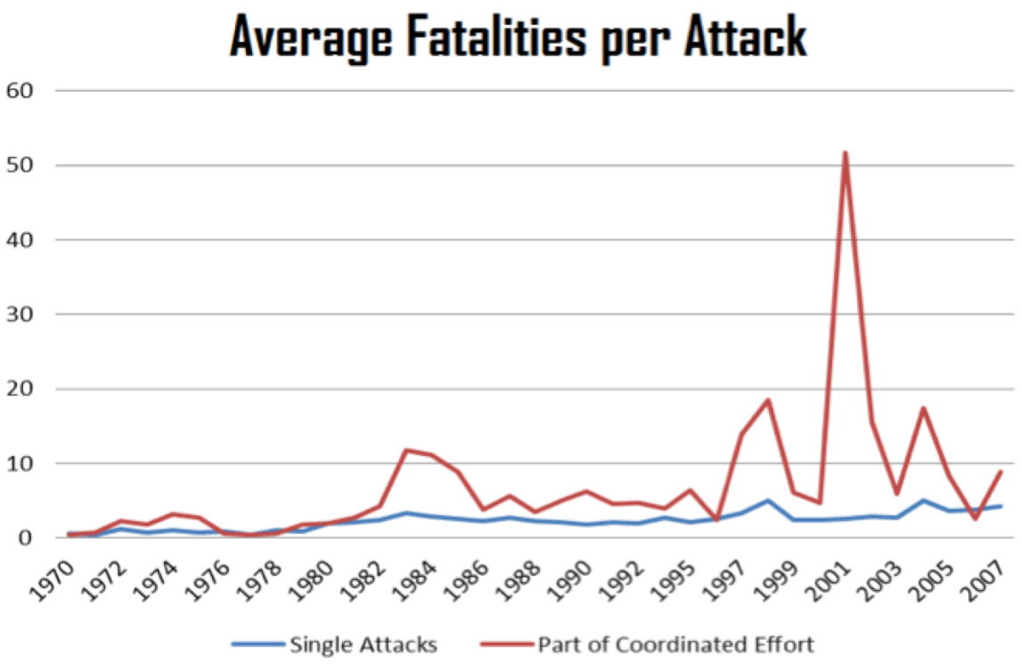
Figure II

Since the early 1980s, attacks as part of a coordinated effort have led to more fatalities. In order to verify this relationship, other characteristics that also determine the number of fatalities must be added to a regression equation. When information from the BAAD dataset is used in the regression analysis, only attacks carried out by perpetrators in the BAAD dataset between 1998 and 2005 are included, which further restricts the sample. While this sub-sample is non-random, the groups in the BAAD dataset were not selected based on whether or not they carried out simultaneous attacks. Therefore, it is plausible that the sub-sample is random on the known characteristics, and especially our characteristic of interest – simultaneous attacks. In Figure II, the time period from 1998-2005 records a larger divergence in fatalities from single attacks versus coordinated campaigns than earlier time periods. This divergence may indicate that coordinated campaigns are different in this time period than earlier. However, in Figure I, this time period experienced fewer attacks that were part of a coordinated effort. These issues need to be remembered when generalisations are made.
In this regression, the number of people killed in each attack will be a function of whether or not the attack was simultaneous, whether or not there were regional effects, year effects, attack type effects, group ideology, number of allies, and whether or not the attack was a suicide attack. The number of people killed is censored at 0 – meaning that many attacks result in no fatalities, so a Tobit model will be employed. The Tobit model allows the econometrician to account for different types of 0’s in the dependent variable.[19] In this case, the number of people killed may be 0 because the attack was unsuccessful in killing anyone or because the group never had any intention of causing casualties.
The results from the Tobit estimation can be seen in Table I. The coefficient of simultaneous is positive and significant, implying that attacks that are a part of simultaneous campaigns tend to kill more people. On average, 45 percent more fatalities occur in simultaneous campaigns than in single attacks, all else being held constant. Note that while the number of people killed increases with simultaneous attacks, the increase is not one-to-one with the scale of the attack. By definition, a simultaneous attack must have at least two attacks as components. However, the number of people killed in a coordinated effort less than doubles. This finding lends credence to the issues raised earlier, namely that using counts to measure the impact of terror attacks could lead to biased results when single and simultaneous accounts are treated the same way.

Table I: Number of Individuals Killed by Terror Attack 1998-2005

Next, how simultaneous attacks impact the success of terrorist attacks was examined using the ITERATE dataset. Since information on group characteristics are not used to explain success, the regression is no longer restricted to only the years where BAAD data is available. The impact of simultaneity on success is weaker, as can be seen in Table II, but provides evidence that simultaneous attacks are more successful than single attacks.
Three specifications of the model were run. For each specification, attacks that are part of a coordinated effort are combined to count as a single attack and denoted as “simultaneous”. Other variables in the regression that may characterize success include location of attack, method of attack, and year of attack.
Country and year fixed effects are included in this regression. The level of success by year varies from a low of 4.5 to a high of 5.8 on a six point scale. The average level of successful terror attacks in individual countries varies between 2.5 and 6.0 on a six point scale. Therefore, differences between different countries and years need to be taken into account in the regression model. One reason for these differences in success may be the level of deterrence by the targeted country; this should help determine success. Therefore, countries that spend more on deterrence should experience fewer successful attacks.
Table II. Success of terror attacks 1968-2004

The amount of money spent on deterrence depends on the country’s determination of the risk they may face. Controlling for the year of attack will control for differences in deterrence by year. However, deterrence spending is not the only factor that determines success. Method of attack also plays a role. For instance, suicide attacks may be harder to deter than other methods. ITERATE codes the method of attack into twenty-five broad categories including assassination, bombing, hostage taking, hijacking, and armed assault, etc. The average success by type of attack varies from 2.5 to 5.9 on ITERATE’s six point scale.
Three models, referring to three ways to operationalise success, are presented in Table 2. In Model 1, success of a coordinated campaign is assigned the value of its most successful component. In a coordinated campaign, only one component of the attack has to be successful in order for the public to view the attack as a success. Since the dependent variable is an ordinal variable between 0 and 6, an ordered logit estimation is run. In this model, simultaneous attacks are more successful than single attacks. Next, success of a coordinated campaign is assigned the value of the average success of each of its components. This definition of success is the most intuitive in operational terms, but it is more difficult to address empirically. The success variable is still between 0 and 6, but for simultaneous campaigns the variable is not necessarily an integer. In Model 2, a Tobit estimation is run on the average success variable. Tobit was used since there are many censored variables at both the upper and lower limits of the success scale. The results of this estimation model show no relationship between simultaneous attacks and success. In Model 3, the average success of each terrorist campaign is still used, but this number is rounded to its nearest integer value, allowing an ordered logit regression. Model 3 reveals a positive relationship between simultaneous attacks and success. Examining the odds ratio for Model 1 and Model 3 reveals that a coordinated campaign increases the probability of success by between 46 and 172 percent.
Both hypotheses, H1 and H2, were supported by the empirical analysis – simultaneous campaigns generate more fatalities and are more successful. However, the number of fatalities increases by only 45 percent, while the number of attacks involved at least doubles. The impact of the simultaneous attack is greater than the impact of a single attack, but in a smaller proportion to the increase in size. If the goal of the terrorist group is maximizing the number of deaths on a specific day, then it would make sense to use simultaneous attacks. If the goal of the group is to maximize the total number of fatalities in a year, single attacks may be more worthwhile. Hypothesis H2 is also supported, though results depend on how success for coordinated campaigns is defined. A terrorist group that is interested in successfully carrying out their planned attacks may be more interested in using simultaneous campaigns. Given the support for H1 and H2, considering each part of the campaign individually, as has been done by the past literature, may not be appropriate.

Conclusions
Simultaneous attacks have been largely ignored by the empirical literature on terrorism. In this article, several specifications are considered to classify which events are a part of simultaneous campaigns. The strictest definition - same day, group, location, and type of attack - is used in all analyses to protect against incorrectly classifying attacks as simultaneous. The goal of this article was to examine the impact of simultaneous attacks. The hypotheses stated that simultaneous attacks would be more successful and lethal. The empirical results suggest that simultaneous attacks have a higher probability of success. Additionally, simultaneous attacks generate more fatalities, but not on a “one-to-one” basis. This research has established that single attacks are different from attacks that are part of a coordinated effort, even though these two types of attacks are treated the same by the empirical quantitative literature. This difference should be considered in the future to ensure that results obtained from using terrorism counts are not biased. A closer look should also be given in future analyses with regard to the definition of “success”. An attack, or a set of attacks, might be “successful” in tactical terms but be a strategic failure. Beyond the “success” of individual or coordinated acts of terrorism, there is the issue of long-term effects. Terrorism as a mode of conflict waging has a poor record of achieving its ultimate objectives.[20]

►References are available at source’s URL.

Kathleen Deloughery is an Assistant Professor of Public Administration and Policy at the University at Albany, SUNY. She received her Ph.D. in Economics from The Ohio State University in 2009. Professor Deloughery’s main research interests include the economics of terrorism, radicalization, and political violence.

The 4 waves of Terrorism

Source: http://www.international.ucla.edu/cms/files/Rapoport-Four-Waves-of-Modern-Terrorism.pdf#!

First Wave: "Anarchist" – Time Period: 1880s-1920s

Second Wave: Anti-colonial – Time Period: 1920's-1960's

Third Wave: New Left Wing – Time Period: 1960's-1990's

Fourth Wave: "Religious Wave" – Time Period: Present Day

An interesting 2004 paper to read – the fourth wave of “Religious Terrorism” will end in 2025 following the wave patterns described by Prof Em David Rapoport, Department of Political Science, University of California at Los Angeles (UCLA).

U.S. Official: Afghanistan Could Become 'Narco-Criminal State'
Source: http://www.npr.org/blogs/thetwo-way/2014/01/15/262752712/u-s-official-afghanistan-could-become-narco-criminal-state

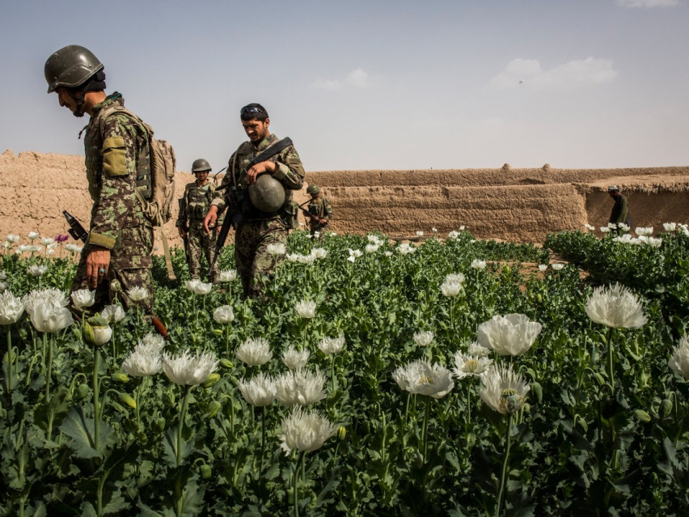
Despite a $7 billion effort to eradicate opium production in Afghanistan, poppy cultivation there is at its highest level since the U.S. invasion more than a decade ago, sparking corruption, criminal gangs and providing the insurgency with hard cash, says John Sopko, the special inspector general for Afghanistan reconstruction.
In testimony before the Senate Caucus on International Narcotics Control, he warns Wednesday that Afghanistan could degenerate into a narco-criminal state.
"The situation in Afghanistan is dire with little prospect for improvement in 2014 or beyond," Sopko says. "Afghan farmers are growing more opium poppies today than at any time in their modern history."
His assessment largely mirrors the fact that said about 209,000 hectares (515,000 acres) of land was being used to cultivate poppies last year — with the highest concentration in southern Helmand province. That compares with just 8,000 hectares in 2001 and 74,000 in 2002, when U.S.-led international forces toppled the Taliban.
As, many Afghan farmers in the province, who say they have few other options, see poppy cultivation as the lifeblood of an otherwise arid region.
"The narcotics trade is poisoning the Afghan financial sector and fueling a growing illicit economy," Sopko says. "This, in turn, is undermining the Afghan state's legitimacy by stoking corruption, nourishing criminal networks and providing significant financial support to the Taliban and other insurgent groups."
The value of the heroin produced is worth $3 billion annually, or roughly 15 percent of Afghanistan's gross domestic product. As much as 90 percent of the world's heroin is produced there, and some of it is now reaching the United States and Canada, Sopko says.
"It is widely thought that every drug organization supports or works with insurgents in Afghanistan," he says. "I have been told that these same groups are closely linked with corrupt government officials."
The special inspector general complains that counternarcotics have been a low priority for both the U.S. and Afghan governments and that robust law enforcement is needed.
He says that many U.S. and international donor officials and experts have advised him that "one of the greatest risks facing Afghanistan is that the narcotics traffickers and other criminal networks will expand their influence, filling a power vacuum in the areas where the Afghan government is weak."

EDITOR’S COMMENT: “Could Become” – another unfortunate article title… Why “could” as if now everything is OK and under control. It is not my intention to comment on the overall gain from invention to Afghanistan – simply because there is nothing solid to comment on! And this will become deadly obvious the day foreign troops will officially depart from the country. Afghanistan is already a narco-criminal state and it will grow in a similar way other Latin America states did. When invading a foreign country this should be based on a long term plan with visible and applicable goals. If plan is simply opportunistic (war against terrorism) then it should be done in a surgical way and withdrow on time. If not then the results are obvious even from “day one”. History provides lessons learned and a great opportunity to avoid future mistakes. Ancient Greeks used to quote: “Making the same mistake twice is not a wise man’s doing” (“To dis examartanin ouk andros sofou”) (see current situation in Iraq).

CounterTerrorism 2014 Calendar

Source: http://www.nctc.gov/site/

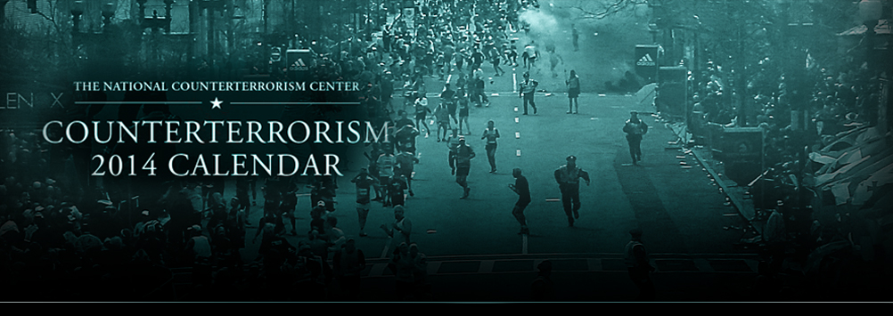
This online version features terrorism information, terrorist profiles, terrorist group details, as well as an interactive timeline and interactive map.

►You can download the calendar in .pdf format from the source URL.

Norway a target for more terror
Source: http://www.newsinenglish.no/2014/01/17/norway-vulnerable-to-more-terror/
The former security chief for Norwegian oil company Statoil is the latest anti-terror expert to warn that Norway is vulnerable to another terrorist attack, and possibly soon. Bernard Duncan Lyng, who’s also a former intelligence officer in the Norwegian military, notes that Norway “is an open and vulnerable country” to terrorists whose goal is to kill the highest numbers of civilians possible and create fear and anxiety.
Lyng told newspaper Dagsavisen on Friday, the day after Statoil marked the first anniversary of a terrorist attack on a gas facility it helps run in Algeria that he thinks there’s greater danger for terrorist attacks that target Norwegian interests abroad than for attacks within Norway. That’s because increasing numbers of companies like Statoil are operating and expanding in areas of conflict around the world. A facility run by Oslo-based oil company DNO was hit in the Middle East earlier this month, leaving several of its local workers dead. Five Norwegians were killed in the attack on Statoil’ Algerian facility last year.
At the same time, Lyng says Norway’s openness, its international community and valuable assets like offshore oil and gas installations can be terror targets as well. Anders G Romarheim, a researcher at Norway’s Institute for Defense Studies (Institutt for forsvarsstudier) agrees with Lyng that Norway is vulnerable despite its location in a relatively peaceful corner of the globe.
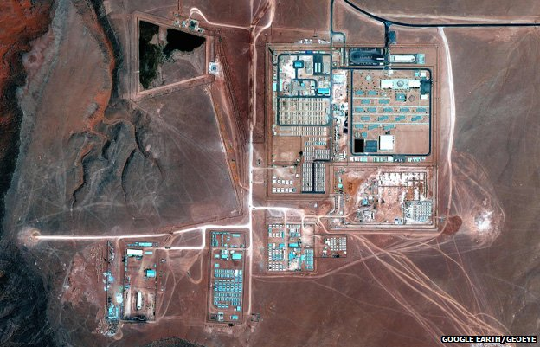
“It’s unfortunately naive to think that the terrorist attacks of July 22, 2011 (when a lone right-wing Norwegian gunman bombed government headquarters and killed 77 people) and at (Statoil’s) In Amenas plant (photo) were isolated events,” Romarheim told Dagsavisen. “If you read (police intelligence unit) PST’s threat evaluations year after year, you’ll see rising concerns for terrorism against Norway and Norwegian interests abroad.”
PST boss Benedicte Bjørnland has said that “we can never eliminate the terror threat,” and stressed that it’s here to stay. “We have to learn to live with it,” she told reporters last year.
Among the likely terror targets in Norway are the country’s offshore oil platforms, where anti-terror researchers have warned security is inadequate despite regular anti-terror exercises conducted by both Statoil, other oil companies, the Norwegian police and military. Still, others argue that land-based oil assets are under greater threat.
“Norway doesn’t accurately calculate the dimensions of the threat against offshore installations versus those on land,” Professor Tore Bjørgo of the state police academy told newspaper Dagens Næringsliv (DN) last autumn, when anti-terror troops were conducting a major exercise off Tananger on Norway’s west coast. “It’s much more probable that terrorists will attack on land, because it’s easier to escape than it would be from an oil platform.”
Even though the threat to offshore installations is high, Bjørgo thinks there’s too much focus on the threat to ships, platforms and other maritime installations and too little attention on refineries, gas plants and other industrial plants on the mainland. Others worry that Norway’s own Oil & Energy Ministry isn’t working hard enough to secure the country’s oil installations against spying, sabotage and terror both offshore and on land.
Magazine Teknisk Ukeblad reported last fall that the ministry wrote to Norway’s national security authority NSM (Nasjonal sikkerhetsmyndighet) last year claiming that no oil or gas installations needed extra protection from terrorism. NSM disagreed: “We question the ministry’s conclusion,” Carsten Rapp of NSM told Teknisk Ukeblad. “In our opinion, the country’s oil and gas installations are clearly part of vital national infrastructure that must be secured.”
Experts also see a need for more security around Norway’s popular fleet of coastal vessels in the Hurtigruten line, because they carry passengers from many countries who are visiting Norway, and would be highly visible targets that could get lots of publicity for terrorists.
Other targets include various top Norwegian officials (it’s only recently that the prime minister has been assigned a constant bodyguard), the Parliament building (Stortinget) in downtown Oslo, Norwegian universities, hospitals, airlines and trains.

EDITOR’S COMMENT: We rarely read or hear a loud outcry for security from this remote beautiful, peaceful and prospering country. It is these qualities that make Norway a target for now and the future. In Anders Behring Breivik manifest (2011) use "Find" function in your computer in order to locate areas of “CBRN” interest i.e. ricin, americium 241, polonium 210, sarin, botulinum, zyclon B, mustard etc. – you will be surprised about his plans and consequences. Read also carefully the last paragraph of this article: also one of the rare instances that “hospitals” are openly included in primary targets’ list. If you kill a hospital, you kill victims twice!

