Fukushima update
By Tatsujiro Suzuki
Source: http://thebulletin.org/suzukis-fukushima-updates

The Tokyo Electric Power Company (Tepco) acknowledged for the first time this week the probability that water was leaking from the reactor containment vessel in Unit 3 at the stricken Fukushima Daiichi Nuclear Power Station. The company announced in a press release that a robot had identified the leakage while removing debris from the first floor of Unit 3.
On January 18, 2014, a Tepco worker found that water was leaking to drainage in the vicinity of the unit's main steam isolation valve, according to the press release. The water seems to be flowing from the containment vessel and into the basement of the reactor building. Tepco also found that the water is contaminated (from cesium-134, 700 becquerel per cubic centimeter of water; from cesium-137, 1,700 becquerel per cubic centimeter of water; and from cobalt-60, 25 becquerels per cubic centimeter of water). The temperature of the water—20 degrees Celsius or 68 degrees Fahrenheit—is also warmer than the natural ground water, which measures 7 degrees Celsius or about 45 degrees Fahrenheit. Tepco reported that the water seems not to be leaking into the environment, as there has been no significant increase in radiation detection in the area. Also, the Unit 3 reactor continues to be steadily cooled, the company said.
The leakage is a significant finding; it could indicate that the Unit 3 containment vessel has significant damage and cooling water is leaking from it. Tepco said that it will continue to investigate the cause and location of the leak.
Tepco has also issued a new plan for victim compensation, recovery of Fukushima prefecture, and reorganization of the company itself. It calls for an establishment of a new company exclusively dedicated to decommissioning of Fukushima Daiichi nuclear power plant. It is expected to improve financial and technical capabilities.

Tatsujiro Suzuki is the vice chairman of the Japan Atomic Energy Commission (JAEC) and a member of the Pugwash Conferences on Science and World Affairs.

Chemical, physical traits of post-nuclear detonation fallout identified
Source: http://www.homelandsecuritynewswire.com/dr20140131-chemical-physical-traits-of-postnuclear -detonation-fallout-identified

Lawrence Livermore National Laboratory researchers have begun to develop a technique that provides a practical approach for looking into the complex physical and chemical processes that occur during fallout formation following a nuclear detonation.
Post-detonation nuclear forensics relies on advanced analytical techniques and an understanding of the physio-chemical processes associated with a nuclear detonation to identify the device type and the source of the nuclear material in the device.
An LLNL release reports that fallout is a material formed from a cooling fireball following a detonation, in which unburned fuel, structural material, and associated fission and activation products are incorporated with surrounding environmental material such as water, dust, and soil.
Fallout can record chemical, physical, and isotopic evidence showing the physical conditions and chemical environment associated with a detonation; however, despite years of studies, there is still a lack of understanding of what fallout characteristics tell about the underlying chemical and physical processes of its formation.
In a paper featured on the cover of the 28 November 2013 issue of the Journal of Applied Physics, Lab researchers Zurong Dai, Jonathan Crowhurst, Christian Grant, Kimberly Knight, Vincent Tang, Alexander Chernov, Edward Cook, Johann Lotscher and Ian Hutcheon report on a study of materials recovered from a laboratory-generated plasma that mimics conditions relevant to fallout formation.
“Our study begins to experimentally simulate and study the formation of debris subsequent to a detonation in which uranium-containing material interacts with the environment at high temperature,” Crowhurst said.
The experiments entail exposing simple combinations of materials to the conditions present in the cooling fireball, followed by a detailed examination of the recovered materials using primarily scanning and transmission electron microscopy.
The team used a small-scale electric arc apparatus to generate uranium-containing plasma in air. The design of this apparatus builds on a previous project, led by Lab scientist Jim McCarrick, which developed a highly repeatable arc source to study the kinetics of energetic materials during phenomena such as lightning and electrostatic discharge. For this work, the lifetime of the arc was extended to more closely approximate conditions relevant to fallout formation.
The images show a technique that Lawrence Livermore scientists have developed that provides a practical approach for looking into the complex physical and chemical processes that occur during fallout formation following a nuclear detonation. (a) A scanning transmission electron microscope image shows nano-crystals embedded into the top glass plate from (b) Corresponding selected-area electron diffraction pattern (c) and (d) X-ray EDS elemental maps of the nano-crystals.

The team found that the recovered solid debris was mostly in the form of spherules that had a wide range of sizes, chemical compositions and internal structures, implying that the debris was strongly affected by the environment where the heated material interacted.
Theoretical analysis indicates that a high temperature developed immediately after onset of the plasma, creating a momentary high pressure, which led to the plasma expanding as a shock wave through the narrow gaps between the sample and surrounding collection plates.
The release notes that the results, together with the compact scale and relatively low cost of the system, suggest that the technique will lead to a practical approach for investigating the complex physical and chemical processes that occur when actinide-containing material interacts with the environment at high temperature.
The work carried was out under a Strategic Initiative entitled “Nuclear Forensics: An Integrated Approach for Rapid Response”, led by Hutcheon.

— Read more in Z. R. Dai et al., “Exploring high temperature phenomena related to post-detonation using an electric arc,” Journal of Applied Physics 114 (28 November 2013)

Nuclear security systems and measures for major public events
Source: http://www-pub.iaea.org/MTCD/Publications/PDF/Pub1546_web.pdf

Terrorism remains a threat to international stability and security. High profile international and national major public events occur regularly, capturing great public interest and receiving intense media coverage. It is widely acknowledged that there is a substantial threat of a terrorist attack on major public events such as high profile political or economic summit meetings or major sporting contests.
The threat of nuclear and radiological terrorism remains on the international security agenda. Nevertheless, to reduce this risk, the international community has made great progress in securing nuclear and other radioactive material that could otherwise be used in a terrorist act. This progress is contingent on the efforts of all States to adopt strong nuclear security systems and measures.
There are large quantities of diverse radioactive material in existence, which are used in areas such as health, the environment, agriculture and industry.
The hazards of this material vary according to composition and intensity.
Additionally, the use of explosives in combination with this material can drastically enhance the impact of a criminal or terrorist act. If a criminal or terrorist group managed to detonate a so-called ‘dirty’ bomb in an urban area, the result could be mass panic, widespread radioactive contamination and major economic and social disruption.
Major public events are seldom held in the same State or at the same location or even at the same venue. At the national level, the hosting of major public events with proper nuclear security arrangements can provide a foundation on which to build an enduring national framework for nuclear security; one that can exist long after the event.
The organization of a major public event in which large numbers of people congregate presents complex security challenges for the State hosting such an event. Criminal or terrorist acts involving nuclear or other radioactive material at any major public event could result in severe consequences, depending upon the nature and quantity of the specific material involved, the mode of dispersal (violent or non-violent), the location and the population impacted. Implementing nuclear security systems and measures is, therefore, of paramount importance.
This Implementing Guide may be useful to the organizers of major public events. It represents a sound basis, drawn from experience, for raising awareness about nuclear security systems and the measures to be applied for such events.
This Implementing Guide was prepared with the support of experts from the Member States and their contributions in developing and reviewing it are gratefully acknowledged.

Operation Pure Cure tests bioterrorism response
Αρχή φόρμας

Source: http://www.dvidshub.net/news/120227/operation-pure-cure-tests-bioterrorism-response#.UvSH CPvz4yP

An employee goes rogue and sets off an explosion inside the urban headquarters of a large biotechnology company. A hazardous materials team from the company makes entry into the smoking building but must withdraw after detecting radioactivity. Local first responders that have arrived on the scene determine that it’s time to call in the experts.
The alert is sent out and the California National Guard’s 95th Civil Support Team (CST) is on the way.
The scenario was part of a multiagency bioterrorism exercise, called Operation Pure Cure, which took place Jan. 22 at the South San Francisco headquarters of Genentech, Inc.
The Hayward-based 95th CST organized the exercise. Participants included Genentech’s First Alert Team, the South San Francisco Fire Department, the Belmont Fire Department, the San Mateo County Hazmat Team, and the San Mateo County Office of Emergency Services.
The 95th CST conducts several exercises a year with civilian first responders to test their ability to work together during a chemical, biological, radiological or nuclear (CBRN) event.
Sgt. 1st Class Garrick Whitley, the exercise coordinator and the 95th CST’s CBRN noncommissioned officer in charge, said Operation Pure Cure was slightly different than most CST exercises because it involved a hazardous materials team from a private company, Genentech’s First Alert Team.
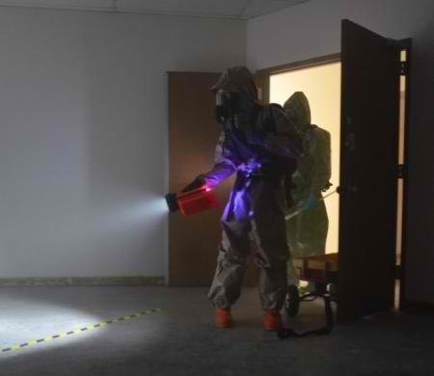
“The unique opportunity for this training was that we were able to use public, private and National Guard assets, and in the scenario the private asset was very capable with a hazmat response,” Whitley said. “Most companies don’t have a hazmat team to respond to incidents like this.”
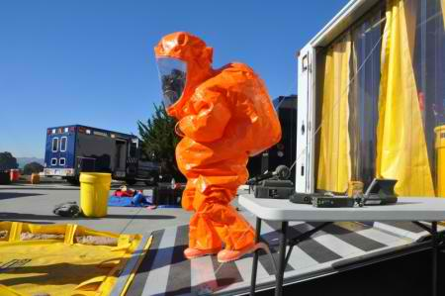
South San Francisco Fire Department Battalion Chief Jess Magallanes was the incident commander in charge of the agencies that had responded to the simulated attack.
Magallanes said the purpose of the exercise was to test the emergency response system during an incident that is a bit larger than what local agencies are used to handling.
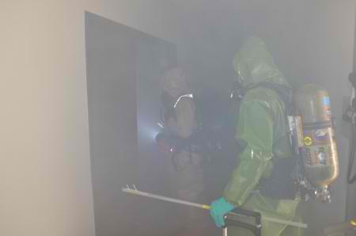
He said the 95th CST is a valuable resource that local agencies can call on for its specialized equipment and expertise should a CBRN incident occur.
“They’re able to basically scale everything up much bigger than my department with 70 sworn personnel can do,” he said.
Shortly after receiving the alert, the 95th CST’s blue trucks and trailers rolled out of the unit’s armory in Hayward, Calif. The team’s mobile science lab, communications truck, operations vehicle, command vehicle, decontamination truck, medical response vehicle and survey vehicle headed over the San Francisco Bay on the San Mateo Bridge toward the simulated disaster site.
The 95th CST is composed of 22 full-time soldiers and airmen. The team is operational 24 hours a day, seven days a week, on call to assist civilian authorities in the event of a CBRN incident.
The team’s area of responsibility is Northern California, while its counterpart, the 9th CST, is responsible for the southern part of the state.
The 95th CST soon arrived at the Genentech facility, staged its vehicles and prepared for action.
Maj. Christopher Angle, 95th CST Deputy Commander, was the officer in charge of the team for the exercise. He linked up with the incident commander and a Genentech official in charge of the company’s assets. They determined that entry teams should be sent into the building to find the source of the radioactivity.
CST entry team members Sgt. Michael Evans and Spc. Alyssa Quinn suited up in Level B hazmat suits and prepared to enter the smoke-filled Genentech building where the simulated blast had occurred.
The CST entry team and a two-man team from the San Mateo County Hazardous Materials Emergency Response Team then made a joint entry into the hot zone. The teams used specialized equipment to search the smoke-filled hallways and offices.
“Our primary mission was to locate and presumptively identify the strongest radiation source we could find, which was what initially had the Genentech team withdraw from their entry,” Evans said. “When I made entry, it was my job to relay back to the cold zone operations what the site looked like, to get eyes on.”
Sgt. Alex Zonio, the downrange entry team leader, supervised the CST entry team from the staging area outside. “They’re performing a reconnaissance mission, painting the picture for everyone else,” he said.
Evans and Quinn relayed what they were seeing to the team outside which was determining what the hazards were to people downrange.
The two entry teams entered a darkened room that was filled with thick smoke. They found a work bench surrounded by broken glass. Their sensors led them to a five-gallon bucket, inside of which they found the radioactive source—uranium-238.
After leaving the building, the two teams were scrubbed down and decontaminated in the CST’s decontamination trailer.
“It was a very successful mission,” Angle said. “We established a unified command. There was a joint interagency effort for the objective, combined entries, combined mission tracking. We attacked the incident commander’s objectives concurrently.”
Nick Gottuso, a district coordinator for the San Mateo County Sheriff’s Office of Emergency Services, was acting as the site access control leader during the exercise. He said this was his first time watching the 95th CST in action and that the exercise was a valuable test of interagency emergency operations.
“I think that the only way that we ever find out if all these emergency plans work is to exercise them in an event like this,” he said.

EDITOR’S COMMENT: I respect WMD-CSTs very much! I think they are the only entity available24/7/365 to do the job. In drills like the above most of the times I am in confusion of those not to like! Planners or defense “reporters”! Title indicates a “bioterrorism drill”. Target of drill is a “biotechnology company”. Hazard identified was “radioactivity”. Mission accomplished by identifying “U-238”. A bit confusing isn’t it? This time I will not comment on PPEs – another issue of confusion that we have to resolve one day for good – since one has to be present at the scene to see what was used and photos can sometimes be misleading. Neverthelless drills are good but planners should become better and spent some time wearing PPEs – this is a highly instructive lesson to learn.

Living Under The Threat Of Nuclear Terrorism
By Keshav Prasad Bhattarai
Source: http://www.eurasiareview.com/06022014-living-threat-nuclear-terrorism/

In a speech delivered at International Conference on Nuclear Security, Yukiya Amano – the Director General of International Atomic Energy Agency (IAEA), in Vienna in last July remarked that there are “over a hundred incidents of thefts and other unauthorised activities involving nuclear and radioactive material are reported to the IAEA every year.”
In his alarming speech, he warned the global community that terrorists and criminals were trying to exploit the vulnerability of global security system. He also reminded that they could even find states without nuclear materials as a transit point and make them their target with the nuclear weapon they developed. For example, if countries like Nepal – without any nuclear weapons and without any kind of regular or emergency nuclear safety and monitoring authority were chosen – for any strategic or tactical purposes, the consequences would turn into more chaos and devastation. In the speech, the IAEA chief explicitly presaged that “. . . The threat of nuclear terrorism is real and the global nuclear security system needs to be strengthened in order to counter that threat.”
Graham Allison, the Director of Belfer Center for Science and International Affairs at Harvard Kennedy School, has quoted US President Barrack Obama and his predecessor George W. Bush when they were asked “What is the single most serious threat to American national security?” Both replied – it was nuclear terrorism.
Similarly, when the only Defense Secretary serving both the Republican and Democrat Presidents – Robert M. Gates – was asked, “What keeps you awake at night?” Gates responded: “It’s the thought of a terrorist ending up with a weapon of mass destruction, especially nuclear.” The list sharing such grave threat goes longer.
Obviously, the global leaders may have differences over the strategies to combat nuclear terrorism; but they all, unambiguously have admitted that – Nuclear terrorism remains one of the greatest threats to global peace and security.
Understandably, in both Nuclear Security Summit held in 2010 and in 2012, World leaders agreed on the prospects of nuclear terrorism. Therefore, in these two summits held in Washington and Seoul and in other similar events almost all participants have unanimously endorsed that the potential nuclear terrorism could change the geopolitics around the world with far-reaching implications for global security – from short-term to long-term.
While, launching Nuclear Threat Initiative (NTI) – Nuclear Materials Security Index (2014), its Co-Chairman and former US Senator Sam Nunn claimed, “Today, nearly 2,000 metric tons of weapons-usable nuclear materials . . . are stored at hundreds of sites around the world”. Some of those materials, according to Nunn, are poorly secured and vulnerable to theft or sale on the black market. Terrorist organizations have plainly stated their desire to use nuclear weapons, and Nunn says that the terrorists need not go where there is the most material; they will go where the material is most vulnerable.
Tanya Ogilvie-White and David Santoroi, in a January 2014 special report they prepared for Australian Strategic Policy Institute (ASPI), have stated that there are three pathways to nuclear terrorism. The most worrying, according to them involves the theft or acquisition of a nuclear weapon from existing military stocks. The second, they say, “involves the theft and trafficking of radioactive or nuclear materials by terrorists, leading to the production and detonation of an improvised nuclear device (IND) or radiological dispersal device (RDD). The last one according to them is the terrorist attack or sabotage on a facility or on transportation, leading to a release of radioactive material.

Evidences and Ominous Possibilities
Ogilvie-White and Santoroi giving IAEA source have stated that only in 2012, 160 incidents involving the illegal trade and movement of nuclear or other radioactive material across national borders were recorded. Of those, 17 involved possession and related criminal activities, 24 involved theft or loss and 119 involved other unauthorized activities. Two incidents involved highly enriched uranium (HEU) in unauthorized activities and three others involved dangerous category of radioactive sources – two of which were thefts.
Since early 90s to 2012, there have been dozens of confirmed thefts or loss of weapons-usable nuclear material mostly from the countries of former Soviet Union and East European countries.
Some attempts were even made in Australia, France, and Germany. In June 2011, the Moldovan police broke up part of a smuggling ring attempting to sell highly enriched uranium usable in nuclear weapons. The smugglers were trying to sell for some $31 million to a serious buyer, reportedly of North African origin. Pierre Claude NOLIN- a Canadian politician and expert on Nuclear issue has stated that even in the United States – with the most stringent nuclear safety standards, research reactors are not immune from theft.
Kenneth C. Brill – former U.S. ambassador to the IAEA and Kenneth N. Luongo the president of the Partnership for Global Security have admitted that at least four terrorist groups, including Al Qaeda, have demonstrated interest in using a nuclear device. These groups operate in or near states with histories of questionable nuclear security practices. Both Brill and Luongo have stated that terrorists do not need to steal a nuclear weapon. It is quite possible to make an improvised nuclear device from highly enriched uranium or plutonium being used for civilian purposes. In addition, they say there is a black market in such material.
The earliest evidence that shows Al Qaeda’s attempts to acquire uranium to use in a nuclear device was in late 1993. The efforts continued and in 1998, according to Allison, Osama bin Laden issued a statement on “The Nuclear Bomb of Islam,” and declared, “It is the duty of Muslims to prepare as much force as possible to terrorize the enemies of God.”
According to the New York Times the militants, in past had made several attacks on bases that “are believed to be involved in the country’s nuclear program”.

Threat Zones for Nuclear Calamity
David E. Sanger and Eric Schmitt in the New York Times (January 26,2014) has raised a critical issue that after American troops complete withdrawal from Afghanistan – Al Qaeda and its affiliates may create trouble in both Pakistan and Afghanistan and it would be most complicated issue for the United States to respond a looming nuclear crisis in the region.
Sanger and Schmitt have further stated that in recent years, Pakistan has accelerated its drive to develop small tactical nuclear weapons aiming at India. They say it is similar to what the United States placed in Europe during the Cold War. However, such small weapons -instead of offering as a viable deterrent value to Pakistan, are more vulnerable to theft or being seized by a terrorist organization or a rogue commander. Therefore, American intelligence agencies have invested so heavily in monitoring the Pakistani arsenal.
With evidences and hard-facts, it cannot be rejected outright. For example, on August 15, 2012, Islamic militants attacked a major Pakistani Air Force Base in Kamra, some 40-kilometer North West of the capital Islamabad – where Pakistan is said to have stored its nuclear stockpile that includes at least some 100 warheads. Surprisingly, despite continued military operations in their tribal hideouts, the militants were able to attack in Pakistan’s most sensitive military installations; they destroyed one jet fighter, and killed several security personnel.
In October 2009, militants had even attempted the army headquarters of Pakistan located in the garrison city of Rawalpindi and controlled some parts of it.
Recently in January 20, while there were reports on the part of both Pak and Afghan governments that described their engagement with Taliban, the Pakistani Taliban made a bomb attack in a crowded market in Rawalpindi – near the army headquarter. Because of series of bomb blasts in Pakistan’s restive tribal region on the North East including Rawalpindi, Pakistan’s Prime Minister Nawaz Sharif cancelled his trip to the World Economic Forum in Davos, Switzerland.
Besides, scientific research institutes, and research bodies located at universities and campuses are considered vulnerable to thefts of nuclear and radiological materials. Fissile materials in such bodies are relatively open to the public or have many users and visitors, ASPI says. Nuclear research laboratories located on university campuses and operated by students, are considerably less secure and much more exposed to theft.
Similarly, the saboteurs and terrorists can crash an airplane into a nuclear power station or use car bomb or truck bomb into a nuclear reactor or mount cyber attacks controlling the activities of those reactors similar to“STUXNET” that was launched against Iranian nuclear facility in Natanz. (For detail please read, “Cyber Weapons- Are They the Deadliest Means of Modern Warfare?” Eurasia Review on September 27, 2012.)
It is also feared that during political crisis – countries such as Pakistan or North Korea, may lose control over nuclear weapons or fissile materials. Similarly, vast amount of weapon usable nuclear materials are available around the world and they have remained outside international security mechanisms. On this milieu, hundreds of questions have been raised on the possibilities of nuclear materials falling at the wrong hands and unfortunately, international community has not effectively developed any effective mechanism to protect the world from any such disaster.
Understandably, nuclear technology is about 70 years old. No nation or a group of nations has monopoly of the knowledge and ability to make a nuclear weapon. Various highly sophisticated simply non-nuclear mechanical instruments that are easily available in open market can be assembled to develop into an improvised nuclear weapon. Correspondingly, any small group of people, without any access to the classified literature, but with the knowledge available in the market, can hire some highly skilled scientists and build a crude nuclear explosive device. Therefore, a nuclear bomb at the hand of a terrorist is not an imagination – but a dire possibility.

But, Best Efforts can Bear Fruits
National and international watchdogs working for nuclear safety and security have expressed their concerns over series of threats as follows:
- Any well-resourced non-state actors and terrorist organization with some secured area to develop nuclear facilities might steal or illicitly purchase weapon grade uranium or plutonium and use them to make an improvised nuclear bomb.
- There are many non-state actors including terrorist organizations that are making hard attempts to obtain information, technology or expertise required to acquire or use nuclear materials for malicious purposes, or to disrupt information technology based control systems at nuclear facilities.
- Mainly, nuclear weapons or weapon grade nuclear materials can be stolen from countries without effective layers of its physical and legal security, but no country has foolproof security- even the United States.
- Terrorist organizations may find safe haven in states – with or without nuclear weapons, and lacking national capabilities to prevent, detect, respond, and prosecute illicit nuclear trafficking. Political instability and insurgency in nuclear power states may inspire terrorist organization seize those weapons.
For example, in 2003, it was revealed that A.Q. Khan the father of Pakistan’s nuclear bombs and his networks had illicitly sold critical nuclear technologies to North Korea and such practice can be extended up to terrorist organizations.
The first organization that can pose such threat is considered Al-Qaeda and its affiliates -decentralized now mainly from Pakistan to North Africa. US’s complete withdrawal from Afghanistan may inspire them to return to the Af-Pak border region and create a safe haven there.
Experts say that some 25 kilograms of (HEU) and 10 kilograms of plutonium is needed to make a nuclear bomb. However, the global stocks of weapons-usable nuclear materials are around some 2000 metric tons of HEU and almost 700 metric tons of weapon usable plutonium.
Indubitably, it becomes the responsibility of countries to ensure their safety and security of nuclear materials at their control. Undeniably, only a strong national and global public opinion coupled with stronger international security mechanism for the protection of such materials can bear best results.
Citing this year’s Nuclear Materials Security Index, The Hindu, one of India’s prominent national daily, has reported (January 9, 2014) that Pakistan has improved its nuclear security standards while India has ranked below to both of its nuclear neighbors – China and Pakistan.
The NTI Index says “Pakistan improved its score by three points compared with 2012, demonstrated the largest improvement of any nuclear-armed state.” This is a much encouraging development on the part of the world where many questions were raised regarding nuclear security amid some discussion at some circles even on a possible attack by the US or India in case Pakistan lose the control of its nuclear arsenal under some chaotic political development.
Pakistan has fared better. Iran has agreed to work with IAEA and let its inspectors monitor some of the nuclear facilities suspected for weapons development programs. If major global powers and other countries with nuclear facilities feel a special responsibility to protect the humanity from nuclear disaster and agree to constitute a global mechanism to make effective intervention in case there are adequate ground for such disaster – then the world will be more than a safe place. This ultimately, will be a great step in making the World free of nuclear weapons.
It is also said that HEU is possessed by both military and civil entities in more than 40 countries. There are some 140 civilian research reactors around the world and the US and IAEA have been doing a brilliant job in encouraging many countries in converting HEU reactors that produces weapon grade uranium to Low-Enriched Uranium (LEU) that only produces uranium for energy and medicinal purposes. Many countries like Indonesia, the Philippines, Thailand, and Vietnam have removed HEU and secured them effectively. Although the LEU reactors are still not free from danger. Terrorist are equally lured to target these reactors. Unsafe use, potential leaks, and damage to LEU reactors that causes dangerous air and water radiation, can always create nuclear nightmares, nevertheless the only solace they give is that they cannot be used to produce nuclear bombs. Therefore, HEU reactors replaced by LEU are a major step towards a world – free of nuclear weapons.

Keshav Prasad Bhattarai is the former President of Nepal Teachers’ Association,Teachers’ Union of Nepal and General Secretary of SAARC Teachers’ Federation. He writes for Eurasia Review. Earlier he worked as a columnist in an English language weekly from Nepal – ‘The Reporter’ and Rajdhani – a Nepali language daily. Before that as a freelancer, he wrote for different Nepali newspapers. For his long association with national and international trade union movement, he usually prepares concept papers on educational issues, economic development, trade union movement and democratic development for different organizations in Nepal from the perspective of teachers’ trade union but in a critical way. Keshav Prasad Bhattarai has also authored three books -- two of them are about Nepal's Relations with India and one on educational issues.

Nuclear convoy passes through Hamilton in the night
Source: http://www.dailyrecord.co.uk/news/local-news/nuclear-convoy-passes-through-hamilton-3120564

Anger has erupted after nuclear weapons were apparently transported along the M74 through Lanarkshire.
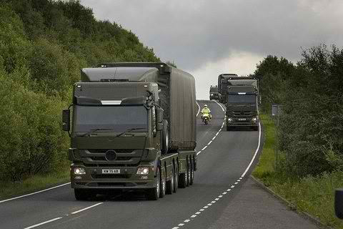
It is understood a 19-strong convoy of MoD lorries carrying weapons of mass destruction drove along the M74 in the early hours of last Wednesday (January 29) en route to Coulport on Loch Long.
Anti-nuclear campaigners say these weapons are seven-times more powerful than the bomb which destroyed Hiroshima.
Glasgow MSP Bill Kidd lodged a motion in the Scottish Parliament saying the idea of these weapons being transported through his community during the night was ‘chilling’.
His motion has been supported by Hamilton MSP Christina McKelvie and Clydesdale MSP Aileen Campbell.
Ms McKelvie said: “It is absolutely abhorrent that we continue to have nuclear weapons being transported through Scotland, especially past urban areas with dense populations. No information appears to be given to the local authorities of the areas that these weapons of mass destruction are taken through. And it beggars belief that these vehicles do not even carry radiation warning signs. There seems to be a complete lack of concern for the members of the public who may find themselves in the vicinity of these convoys. Awareness of these regular convoys can only strengthen the already strong opposition to these disgusting weapons being located in Scotland.”
Ms Campbell added: “This practice is deeply worrying and poses an unacceptable risk to the people of Clydesdale. The idea that weapons of mass destruction are being transported through our community while we sleep is absolutely chilling. I would urge all concerned to join with the Scottish Campaign for Nuclear Disarmament (CND) in supporting the motion in the Scottish Parliament condemning the practice, and make clear that our communities should not be put in danger like this.”
CND co-ordinator John Ainslie says normally these weapons are out of sight on submarines, but there are between 180 and 200 nuclear weapons in Scotland at the moment.
He added: “Each weapon has 100,000 tonnes of high explosives; they are seven times more powerful than the atom bomb which destroyed the city of Hiroshima.”
The MoD insist the transportation of weapons is done safely and that they provide the emergency services, local and health authorities with information on contingency arrangements for the transport of defence nuclear materials.
A spokesman for the MoD said: “We keep the number of nuclear convoys to a minimum, only transporting nuclear material to meet operational requirements.
“We do not comment on where material is moved for national security reasons. All routes used are subject to a rigorous selection process and appropriate measures are taken to ensure nuclear convoys operate safely, including working with the police.”

EDITOR’S COMMENT: I just love to read statements of “worrying” local authorities in issues of safety and security worldwide. Same for gestures like nuclear disarmament in a crazy world. It seems that been an “island” has strange consequences on the overall mentality of the people in high and low places. OK let us get rid of all nuclear weapons; let us stop the activities in all chemical plants – they also use M74 to transfer their highly dangerous goods all over the country; let us stop everything that put lives into imminent danger – i.e. wars or campaigns away from home. Let us all do that BUT let us do it simoultaneous and ALL together. Fake concern is just a news generator and a poor excuse for “we care; vote us again!”

Security of dirty bomb materials in U.S. inadequate
Source: http://www.homelandsecuritynewswire.com/dr20140210-security-of-dirty-bomb-materials-in-u-s-inadequate-experts

In December 2013 gunmen in Mexico hijacked a truck transporting a used radiation machined from a hospital to a disposal facility. The machine contained what scientists designate as category-1 radiation. These radiation sources may be used by terrorists in dirty bombs.
There are many devices and machines containing radioactive materials powerful enough to tempt terrorists. In a 2008 report, the National Research Council noted that there are more than 5,000 devices containing high-activity radiation sources in the United States, including 700 with category-1 sources.
The Bulletin of Atomic Scientists reports that the industry has taken various measures to secure these radiation sources while on location or in transport, but these security measures have been written with accident prevention in mind, not in order to thwart a deliberate, forcible effort by terrorists or criminals to gain control of the toxic material. If hapless truck-jackers can steal high-activity sources by accident, the Bulletin notes, a well-organized terrorist group could certainly do so in a planned operation.
Moreover, both security officials and the industry used to think that radioactive materials were “self-protecting,” because the powerful radiation should deter anyone thinking of tampering with these devices. The 9/11 attacks, and subsequent bomb-making feats by al-Qaeda bomb-makers, showed that terrorists may be more technologically-savvy than earlier thought, and, in any event, suicide bombers would not be deterred by the risk of radiation poisoning.
The Mexican authorities eventually found the capsule with the radioactive material still intact, but the incident is but the latest reminder of the vulnerability of radiation sources in civilian use to seizure by criminals or terrorists.
So far there have not been instances in the United States of category-1 radiation sources stolen, and security experts say that to maintain this record, facilities and institutions that operate, transport, or dismantled devices that contain radioactive contents must be better secured and monitored.
There have been improvements in securing radiation sources in civilian use. The Bulletin notes that one important improvement was the implementation of a national register for all U.S. category-1 and -2 sources. The NRC’s National Source Tracking System went online in 2009, and it contains information about who currently owns radiation sources (the “licensees”), and where their devices are kept.
Disposal of radiation sources can be expensive, so a government-funded program recovers high-level radiation sources declared as “unwanted” to keep the devices from waste dumps. The National Nuclear Security Administration (NNSA) operates its Global Threat Reduction Initiative (GTRI) in the United States to offer better security and training to facilities with radioactive sources. The program is voluntary, and since 2008, the NNSA has identified more than 2,900 American hospitals and industrial buildings that may need security upgrades.
The Bulletin notes, however, that these tracking and registration systems, unlike a safe in a bank, offer no physical protection. Over the past nine years the NRC has introduced various security regulations requiring physical barriers to prevent unauthorized access to sources, provisions for intruder detection, mandatory background checks for staff handing the materials, and security protocols to speed up response to an actual or attempted theft.Still, the Government Accountability Office (GAO) issued a sobering report in 2012. After its investigators visited several facilities where the new security measures to protect category-1 radiation source were implemented, the agency said that security conditions of hundreds of toxic radiation sources was deeply worrisome.
Security experts

The Bulletin makes several recommend-dations to make radiation sources, especially category-1 sources, more secure.
- Armed escorts should be required for category-1 transports, and a real-time location-tracking system should be mandatory not just for vehicles transporting category-1 sources, but also for those with category-2 sources. Drivers should be required, before beginning on their trip, to identify “safe havens” for rest stops for both category-1 and category-2 transports.
- All states should require armed escorts for category-1 transports, and this policy should be implemented now, even before the NRC to change its rules.
- Drivers of trucks carrying radiation sources must be trained to follow security protocols, avoid risky situations, and respond appropriately if they come under attack. The owners of transportation companies should equip their trucks with low-cost security systems — GPS tracking systems, duress buttons, or vehicle disabling devices — even when they are not legally required to do so.

Operations at a New Mexico nuclear waste repository suspended because of leaks
Source: http://www.homelandsecuritynewswire.com/dr20140219-operations-at-a-new-mexico-nuclear-waste-repository-suspended-because-of-leaks

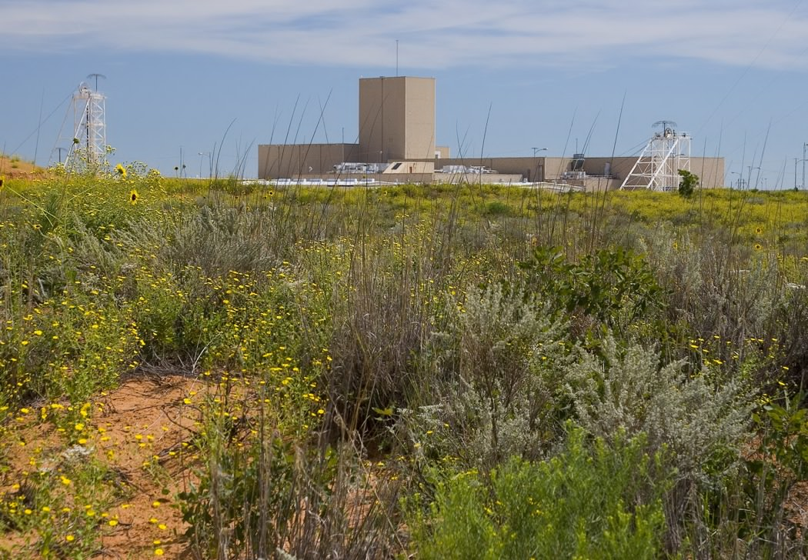
Operations at the Waste Isolation Pilot Plant, or WIPP, a New Mexico burial site for military nuclear waste, were suspended for the fourth day, the Department of Energy said, after sensors picked up radiation leaks inside salt tunnels where the radioactive material is entombed.
The Los Angeles Times reports that employees at the site, followed procedure by activating air filters and barring personnel from entering the 2,150-foot-deep waste repository.
Radiation sensors first picked up the leak at 11:30 p.m. Friday.
Officials said no radiation escaped to the surface.
“Officials at WIPP continue to monitor the situation,” spokeswoman Deb Gill said. “We are emphasizing there is no threat to human health and the environment.”
It is not immediately clear how long operations at the repository will be suspended.
The halting of operations at WIPP has already affected the handling of DoD nuclear waste. The Advanced Mixed Waste Treatment Project, a federal operation in eastern Idaho which is the primary user of WIPP, said Monday that it had suspended waste shipments to the New Mexico facility.
Gill noted that this is the second time this month the facility had to suspend operations. Earlier this month operations were halted after a truck caught fire in an underground tunnel.
The Times notes that a lengthy shutdown would create a backup in the nation’s nuclear waste disposal system. For example, in 2012, the dozen or so sites handling DoD nuclear materials made 846 shipments to WIPP, or about two a day. These facilities will now store waste on site, but storage capacity is limited.
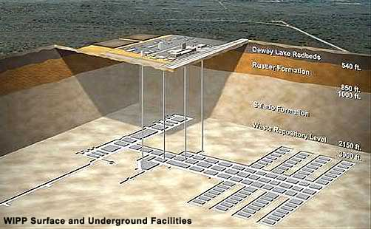
Edwin Lyman, a senior scientist at the Union of Concerned Scientists, told the Times he believed the cause most likely involved radioactive material on the outside of a container that was not properly decontaminated. Waste is typically packaged into sealed containers. Any contamination on the outside of the containers normally would be cleaned, Lyman said.
He added that a less probable cause was a radiological process inside a container that forced material out. WIPP has acceptance criteria for the waste that is supposed to prevent such an accident.
Lyman said that the intensity and range of contamination in the underground tunnels will dictate the extent of the cleanup operation necessary to get the repository back in operation. “It could be a mess,” Lyman said. “If there is airborne contamination and it involves plutonium, they are going to need to decontaminate surfaces. If it is in the ventilation system, it could have spread to other areas.”
The Times notes that WIPP is the repository for what is called transuranic waste, which includes plutonium and other artificial elements heavier than uranium. The various facilities around the country take the waste, which may include contaminated clothing, tools, wood, and put it in 55-gallon drums, and the drums are then crushed into 4-inch “pucks.” The pucks are placed into massive, lead-lined shipping containers designed to withstand highway crashes.
When the puck arrive at WIPP, they placed inside shafts within an ancient salt bed, which is supposed to collapse around the waste in the future and seal it. The operation began in March 1999 (for a detailed report on WIPP operations, see Matthew L. Wald, “Nuclear Waste Solution Seen in Desert Salt Beds,” New York Times [9 February 2014]).
For more than two decades, Congress had allocated funds to building a nuclear waste national repository in Nevada’s Yucca Mountain. Pressure from Nevada politicians and questions about the safety and capacity of the Nevada project led the Obama administration to end the Yucca Mountain project.
The nuclear waste being buried at WIPP is far less radioactive than the spent fuel from nuclear weapons which was to be buried in Nevada, but federal officials had hoped that a smooth, accident-free record of operation at WIPP would go a long way to generate support for a more ambitious, high-level repository which would offer an alternative to the Yucca Mountain repository.
“It hasn’t been a good month for WIPP,” Lyman told the Times.

Radiation detected above ground near WIPP site east of Carlsbad
Source: http://www.currentargus.com/ci_25179328/lab-radiation-detected-above-ground-near-wipp-site

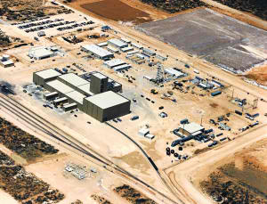
Feb 19 – Traces of radiation have been found approximately half a mile northwest of the Waste Isolation Pilot Plant, a federal nuclear waste repository approximately 26 miles east of Carlsbad.
Tests by the Carlsbad Environmental Monitoring and Research Center, a division of the College of Engineering at New Mexico State University, showed evidence of trace amounts of americium and plutonium on an air filter Wednesday afternoon at a sampling station off the WIPP Access Road.
"The levels detected during this time period are higher than the normal background levels of radioactivity from transuranic elements commonly found at this sampling station, thus their presence during this specific time frame appears to indicate a small release of radioactive particles from the WIPP underground exhaust shaft in the brief moments following when the radiation event occurred and when the WIPP ventilation system shifted to the filtration mode," said Russell Hardy, the director for the Carlsbad Environmental Monitoring and Research Center, in a news release. Analysis of the filter found trace amounts of americium and plutonium.
Hardy said even though small amounts of radiation were detected between Tuesday, Feb. 11, and Sunday, Feb. 16, it's important to note that radiation levels have been "very low and are well below any level of public and environmental hazard."
"At this time there is no concern," said John Heaton, the chairman of the Carlsbad Nuclear Task Force. "We definitely know that the amounts are miniscule. I think the risks are extremely low and I certainly have no worries about it personally."
Heaton and Hardy both agree that the americium and plutonium isotopes are so heavy, that they won't travel far from the original source. Only a large wind gust or human-caused incident could cause a spread of the radiation from where it currently lies, according to Hardy.
A second air sampling station located approximately 11.8 miles southeast of the WIPP facility on Highway 128 showed no detection of radioactive particles according to CEMRC. Scientists were able to collect a third sample near the WIPP exhaust shaft on Tuesday and results will be released as soon as the analysis on the air filter has been completed.
Heaton cautioned the public to not jump to any rash conclusions.
"Until we really know, it's all speculation," he said. "Even though it's very discouraging that there was a release, it's strictly speculation about what caused that. You have to realize that all the containers are closed and sealed (underground in WIPP). Until they are able to go back down and examine the waste, we could find out it's something even different than we think."
Continuous air monitors, or CAMs, first detected airborne radiation in the salt mines underground at WIPP on Feb. 14 at 11:30 p.m. and the air ventilation system immediately stopped the flow of outside air, according to the Department of Energy. The radiation was present downwind of Panel 7, Room 7, where current transuranic waste had been disposed.
Operations at WIPP have been halted since the morning of Feb. 5, when a vehicle used to haul salt underground in the north mine caught on fire, causing immediate evacuations of all personnel to the surface.
"We don't believe there is a connection between the earlier salt hauler truck event and this event," said Roger Nelson, acting DOE spokesman, on Saturday when WIPP released information of the radiation leak. The statement was later retracted by DOE spokeswoman Deb Gill on Monday who said that the agency would not speculate on any potential causes for either incident or any potential linkage of the two events.
WIPP will celebrate its 15th anniversary on March 26 of processing and disposing of TRU waste from federally owned cleanup sites around the country.

China concerned at Japan holding weapons-grade plutonium
Source: http://www.japantoday.com/category/national/view/china-concerned-at-japan-holding-weapons-grade-plutonium

China said on Monday (Feb 17) it was “extremely concerned” by a report that Japan has resisted returning to the United States more than 300 kilograms of mostly weapons-grade plutonium, the latest dispute between the two Asian neighbors.
Japan’s Kyodo news agency said that Washington had pressed Japan to give back the nuclear material which could be used to make up to 50 nuclear bombs. Japan had resisted, but finally given in to U.S. demands, it added.
The material was bought for research purposes during the 1960s and the two governments will likely reach an official agreement on its return at the Nuclear Security Summit at The Hague in March, an official at Japan’s Education Ministry said.
China is involved in a bitter territorial dispute with Japan and has warned Japan is trying to re-arm.
“China believes that Japan, as a signatory to the Non-Proliferation Treaty, ought to rigorously respect its international commitments to nuclear safety and non-proliferation,” Chinese Foreign Ministry spokeswoman Hua Chunying told a daily news briefing.
“For a long time, Japan has not returned the stored nuclear materials to the relevant country, which has caused concern in the international community. China is of course very concerned.”
Japan, the world’s only victim of nuclear attacks in the final stages of World War Two, does not have nuclear weapons, unlike China, and it is the government’s stance that it will not obtain them.
Deteriorating relations between Beijing and Tokyo have been fueled by a row over a chain of uninhabited islands in the East China Sea. Ships from both countries frequently shadow each other around the islets, raising fears of a clash.
Ties have worsened further since China’s creation of an air defense identification zone over the East China Sea and Japanese Prime Minister Shinzo Abe’s visit to the controversial Yasukuni Shrine honoring war criminals among Japan’s war dead.

Volgograd Terror Attack Highlights Need for Rail Security
Source: http://i-hls.com/2014/01/report-volgograd-terror-attack-highlights-need-for-rail-security/

The recent train station bombing in Volgograd Russia has focused renewed attention on the vulnerabilities of rail infrastructure, notes the IHS market research firm.
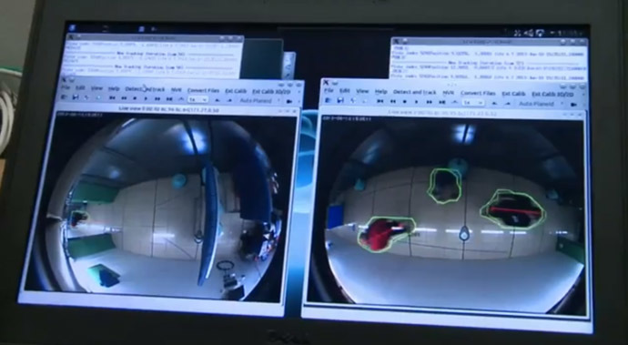
According to the recently published IHS report, purchases of explosives, weapons and contraband (EWC) detection equipment at rail stations worldwide is expected to increase by 3.3 percent in 2014, and 8.8 percent in 2015. A large amount of this growth is expected to come from Asia where rail expansion projects are ongoing. As these rail projects near completion, IHS expects to see an increase in purchases of explosives detection equipment.
Rail travel varies greatly by city, country and region, giving way to varying degrees of security. Unlike air travel, where all passengers and baggage are scanned for EWC, rail travel is not well suited to the same type of security measures.
First, many passengers use rail services as their primary mode of transportation and depend on the easy access and convenience that rail transportation offers, says IHS. Second, many rail stations have higher passenger volumes than airports. For example, in 2013 Atlanta’s Hartsfield Jackson International Airport had 71.1 million passengers, whereas Tokyo’s Shinjuku Station had 1.26 billion passengers.
According to a report in Government Security News these factors have led to the development of new standoff detection technology to detect explosives in crowded areas. Ahead of the 2014 Winter Olympics, NATO and Russia started work on the Stand-Off Detection of Explosives (STANDEX) system (photo from video). STANDEX was tested at several European rail stations and is expected to be deployed during the 2014 Winter Olympics.
Worldwide rail stations continue utilize a combination of trace, advanced imagery, explosives detection canines and explosives trace portals to detect explosives.
Overall, the use of explosives detection equipment remains limited at rail stations; however, this is beginning to change as attacks on rail infrastructure continue. The developments of new technologies that meet the unique security needs of the rail industry are expected to drive future growth in the market, says IHS.

Rodents Can Find Landmines, TB, Disaster Victims
Source: http://www.laboratoryequipment.com/news/2014/01/rodents-can-find-landmines-tb-disaster-victims?goback=.gde_3711808_member_5832535260486737924#!

When it comes to thinking about disease, rats are usually thought of as vermin that carry plague and pestilence. But what about rats being used to sniff out diseases such as tuberculosis in people’s saliva, or salmonella bacteria in contaminated food? Or what about “camerats” – back-packed with miniature cameras and wireless transmitters to find people trapped after disasters?
Researchers have been exploring all of these. Rats trained to detect TB have already been deployed in Tanzania and Mozambique, with further potential in African countries that have seen an increase in cases since the advent of HIV. Accurate and efficient TB diagnosis is one of the most pressing health problems in many African countries, and it is something researchers have found rats are able to do particularly well. In Tanzania, about 26,000 saliva specimens of TB patients are now screened by rats annually in the capital Dar es Salaam.
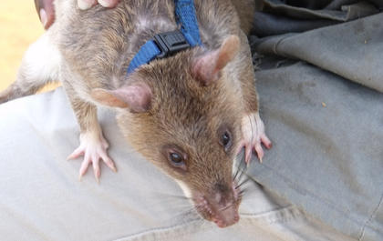
African Giant Pouched Rats, or Cricetomys gambianus, are widely distributed in tropical Africa. In 2000, researchers began training these rats at Sokoine University to detect landmines. The sensitivity of rats is many times greater than that of dogs. And they are able to detect levels of TNT (used in landmines) which are much lower than could be detected by a machine.

Pavlov’s rat
Whether it is for TB diagnosis, salmonella or landmine detection, the training of a rat as biosensor works on a very basic principle, very similar to the Pavlovian response or classical conditioning: a rat is given a deactivated culture of Mycobacterium tuberculosis to sniff, for example, before being given a reward for finding a TB-positive specimen from a series arranged on a test board. Much as sniffer dogs do when they’re trained to find traces of drugs or missing people.
The rats are being used in Mozambique, which was left heavily laid with landmines following years of civil war, and at any given time the scientists usually have between 15-20 animals in the field. The rats are now being used in Angola, and soon to be in Thailand and Cambodia. It is relatively safe for the rats and they are well cared for and get the attention of vets. They are replaced when they die naturally or due to unknown causes.

Seven sniffs a minute
Since they proved so successful in sniffing out mines, scientist wondered about what else they could do. So, they began training them to diagnose Mycobacterium tuberculosis, the causative agent of TB in humans, using saliva samples.
Rats are very accurate and specific when doing this and are phenomenally fast at diagnosis. The researchers found that rats are able to identify the TB bacterium with more than 90 percent accuracy and are able to pick up 44 percent more positive cases than microscopy.
Initially, the medical community was skeptical about this technology, but backed by various scientific studies that rats can do this with a high level of accuracy the idea has caught on.
It takes about six months for a rat to complete the training and to be accredited for TB diagnosis. And a single accredited rat is able to diagnose 140-150 specimens in 20-25 minutes (which equates to six to seven specimens per minute). To give a sense of this speed, a laboratory technician using microscopy will work on about 40 specimens in an eight-hour working day.
However, the idea is to use the rats to compliment the work technicians, in particular because sometimes technicians report positive specimens as negative. Negative samples can be double-checked by the rats.
They can also be deployed in more routine diagnoses where speed and accuracy can save lives. And in emergencies, for example when hundreds of thousands of people face a TB epidemic in refugee camps, the rats can be the only quick solution to identify patients of TB. At any given time the scientists have a stock of trained rats ready for this purpose. Deploying them in this way would involve collecting saliva samples and getting them to the rats in the lab.
The number of patients being screened in this way is likely to increase in future as more and more health centers submit requests to use this biosensor technology. In addition to the rats at Sokoine, Apopo, a Belgian NGO that supports the work, has also built a special TB diagnosis laboratory at the Eduardo Mondlane Univ. in Mozambique, which started operations in June last year.

Send in the camerats
What is the potential of using the rats in other disease situations? The Sokoine team currently training them to detect Salmonella bacteria that causes diarrhea, fever and vomiting when an individual consumes contaminated food. The training is quite advanced – there are several strains of Salmonella and at the moment they have been training the rats to detect four common strains with good progress – but they are still at the lab stage.
Another idea is to use the rats for rescue services in man-made or natural disasters. This is where “camerats" – again using African Giant Pouched Rats – come in. The idea is that using their equipped backpacks, they will be able to send images back of victims they find trapped in debris. Their small size will allow them to penetrate places where dogs cannot reach in the search for victims.
The Sokoine team is currently at simulation stage where they simulate a collapsed building with individuals trapped in it. What they need to establish is whether the rats are actively searching for individuals or if they are just finding them at random.
They are several advantages for using rats: they are low cost in maintenance, people don’t have the same emotional attachment as they do with dogs (and they have more sensitive smell), and their small size and faster growth mean they can start training much earlier.

Boot Soles Save Lives By Detecting Land Mines
Source: http://news.discovery.com/tech/gear-and-gadgets/boot-soles-save-lives-by-detecting-land-mines-140128.htm
Due to Colombia’s longtime guerrilla war with anti-government rebel groups like the Revolutionary Armed Forces of Colombia (FARC) and drug cartels, its jungles and fields are littered with active landmines. Since 1990, mines have injured more than 10,000 people, 2,000 of whom were killed. Only Afghanistan ranks higher in terms of such victims.
While programs exist to locate and destroy the mines, a Bogota-based design firm has a new solution. Lemur Studio created a shoe or boot insert that alerts wearers if they come within 6.5 feet of a landmine. Dubbed SaveOneLife, the mine-detectors are designed for soldiers, farmers and those tasked with destroying illegal crops.
The boot insole includes a planar coil printed on thin conductive material that acts as a metal detector. Along with a microprocessor and a radio transmitter, this detects the presence of other electromagnetic fields, produced by, say, a large metal object like a landmine. If a mine is detected, a signal is sent to a wristband interface that alerts the wearer and illustrates the location of the mine.
“The device was created with the goal of saving a life, hence the name, first by the families of the victims and second for the cost effects of military forces by the loss of his men in combat,” Ivan Perez, Lemur’s creative director, told Fast Company. Perez is currently pitching the idea to the military with the hope that they’ll fund the project.
In the meantime, SaveOneLife is up for the World Design Impact Prize which will be announced in November.

Triage for Treasures After a Bomb Blast
Source: http://mobile.nytimes.com/2014/02/01/arts/design/sorting-through-the-rubble-of-museum-of-islamic-art-in-cairo.html?_r=0&referrer=

A man in a white lab coat sat alone among piles of blown-off ceiling mangled metal and splintered wood here on Thursday inside the Museum of Islamic Art — home to a world-renowned collection that covers centuries of art from countries across the Islamic world. He carefully separated ochre-tinted pieces of old glass from the clear shards of modern showcases.
The precious glass came from exquisite medieval lamps — or meshkawat — from some of Cairo’s most important mosques. They were among the biggest material losses from a truck bomb blast on Jan. 24 that tore through this 111-year-old museum, blowing out windows and sending metal and glass flying through its halls. The bombing, which was aimed at Cairo’s police headquarters across the street, killed four people and injured 76. It occurred a day before the third anniversary of the revolution that overthrew Hosni Mubarak. The museum’s staff was struggling to cope with the devastation wrought on this collection of artifacts, many of them from Islam’s Golden Era and representing Islamic history from the Umayyads in the seventh century to the Ottoman period in the 19th.
“The explosion caused so much damage,” said Ahmed Sharaf, director of the Antiquities Ministry’s museum division. “So many pieces have been destroyed, ceramics, glass, wood.”
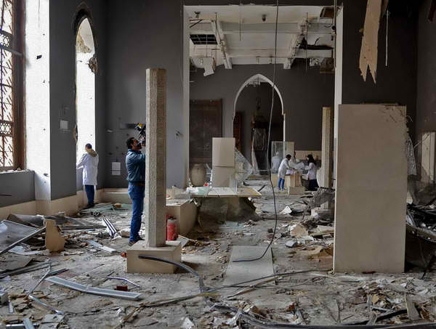
Egypt’s minister of antiquities, Mohamed Ibrahim, said on Friday that 74 precious artifacts had been destroyed and that 90 were damaged, but repairable. The museum had nearly 1,471 artifacts on display in 25 galleries and 96,000 objects in storage. Situated near Islamic Cairo, the museum building, with its impressive neo-Mameluke facade, had recently undergone a six-year, $10 million renovation. The complex includes Egypt’s National Library on the second floor, where several rare manuscripts and papyri were also damaged.
Egypt’s tumultuous post-revolution period has taken a disastrous toll on the country’s cultural heritage, as upheaval following the Arab spring — as well as conflicts in Iraq and Syria — have damaged the entire region’s artistic patrimony. In Egypt, museums and monuments have suffered from the spillover of street violence. More alarmingly, with a huge security vacuum since the 2011 revolution, looting has become rampant.
Looters have dug a honeycomb of holes around the famous Black Pyramid of Dahshour, in Giza. They have stolen an entire minbar, or pulpit, from a Mameluke mosque near Cairo’s Citadel, as well as beautiful brass details, marble plaques and wood inlays from some of the city’s most splendid mosques. Last August mobs attacked the Mallawi museum in Minya, 190 miles south of Cairo, stealing 1,050 of the 1,089 artifacts on display, including Pharaonic statues and jewelry and Greco-Roman coins.
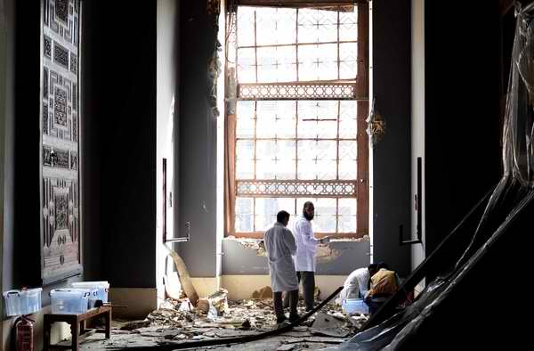
Almost immediately after the bomb blast, UNESCO said it would donate $100,000 to help with the eventual restoration of the museum and provided a team of experts to inspect the damage and assist with repairs. The United States has also pledged around $140,000. The Egyptian government says it needs $14 million to repair the museum and bring it to international standards with sophisticated security systems, bombproof glass and other protective measures. The blast also burst a pipe in the fire-prevention system, causing water from the library to pour into the museum galleries below.
“It could take years,” Mr. Ibrahim said. “We need funds. With financing we can do anything.”
Government specialists have been painstakingly collecting the pieces of damaged items, sifting through the piled debris, counting, categorizing and assessing what’s intact, what’s repairable and what’s lost forever.
Upstairs in the museum’s third-floor restoration labs, specialists stood hunched over slabs from an ornate wooden mihrab, or prayer niche, of intricate lattice, trying to fit dozens of tiny pieces of wood together in the same way medieval craftsmen worked, creating exquisite pieces of woodwork that stayed together simply because the pieces fit so perfectly.
Amid the rumbling of heavy machinery clearing out the police headquarters across the street, other restorers diligently pieced together another badly damaged wooden mihrab, dating to the Fatimid era of the 10th to 12th centuries; a Fatimid chair of ornate inlaid ivory and ebony; and a Quran box of painted wood from the 13th-to-16th-century Mameluke era.
The Islamic Museum’s collection also includes fanciful wooden friezes of Fatimid court life, the only remaining pieces from two palaces that flanked an impressive processional ground in the center of the caliphates’ forbidden city, the area between Bab al-Futuh and Bab Zuweila in the heart of Islamic Cairo today. The friezes survived. There’s also gold Mameluke jewelry, Ottoman-era ceramics, Persian carpets, marblework, stonework and mosaics.
“Not only are there beautiful artifacts,” the Islamic art historian Shahira Mehrez said of the collection, “but there’s also the first manifestation of the arabesque design, the first dated lusterware, the first geometric star pattern. These objects are invaluable not just for their unique artistic value, but as a documentary of artistic development of the Islamic world.”
While Egypt has always had its share of antiquity theft, now it’s more frequent, more efficient and more outrageous. Thieves have struck Pharaonic, Greco-Roman and ancient Christian sites from Abu Rawash north of Cairo to Luxor in the south. And they’re selling these treasures faster than ever, sometimes within hours.
“The last three years, there’s been a drastic situation, where you see at every archaeological site excavating without permission,” said Saleh Lamei Moustafa, a conservator of Islamic architecture. “They’re even bringing loaders. There are only 300 in the antiquities police, armed with pistols, and they’re fighting people with heavy weaponry.”
In October, Mr. Ibrahim, the antiquities minister, asked the United States for help in an op-ed article in The Washington Post, noting that Egypt’s antiquities are flooding international markets.
“Imagine a world in which the stories of King Tut, Cleopatra, Ramesses and others were absent from the collective consciousness,” he wrote. “And with much of our history still waiting to be discovered under the sand, the potential losses are staggering.”
These threats to Egypt’s heritage have inspired some to act. People rushed to help after the bombing near the Islamic museum.
“I couldn’t get inside, so I ran around buying supplies,” said Yasmine El Dorghamy, the publisher of Al Rawi, a magazine about Egypt’s heritage and history, who brought surgical gloves, foam to cover artifacts — and helmets, because of falling debris.
Ms. Dorghamy said she was part of a group of restorers, historians and activists who rush to endangered sites. “When there’s a firebomb or an attack, we’re the first ones there,” she said.
Abdel-Hamid El Sharif, who founded the nonprofit group Egyptian Heritage Rescue soon after the revolution to train volunteers in artifact rescue management, was also on the scene. His team got to work, wrapping up the most vulnerable artifacts and packing them in storage. “They called me the Disaster Man,” said Mr. Abdul Hamid, who pays Egyptian Heritage Rescue expenses out of pocket.
Members of the Islamic Museum’s advisory board warned the government after demonstrators began attacking police stations in 2011 that the museum was in grave danger because of its location near the police headquarters. Some argued that nothing could have saved the museum from the enormous bomb.
“It was 500 kilograms of TNT,” Mr. Ibrahim said, “just 25 meters from the museum.”

Suicide Bomb Trainer in Iraq Accidentally Blows Up His Class
Source: http://www.nytimes.com/2014/02/11/world/middleeast/suicide-bomb-instructor-accidentally-kills-iraqi-pupils.html?ref=world

If there were such a thing, it would probably be rule No. 1 in the teaching manual for instructors of aspiring suicide bombers: Don’t give lessons with live explosives.
In what represented a cautionary tale for terrorist teachers, and a cause of dark humor for ordinary Iraqis, a commander at a secluded terrorist training camp north of Baghdad unwittingly used a belt packed with explosives while conducting a demonstration early Monday for a group of militants, killing himself and 21 other members of the Islamic State of Iraq and Syria, army and police officials said.
Iraqi citizens have long been accustomed to daily attacks on public markets, mosques, funerals and even children’s soccer games, so they saw the story of the fumbling militants as a dark — and delicious — kind of poetic justice, especially coming amid a protracted surge of violence led by the terrorist group, including a rise in suicide bombings.
Just last week a suicide bomber struck a popular falafel shop near the Ministry of Foreign Affairs here, killing several people. On Monday evening Raad Hashim, working the counter at a liquor store near the site of the attack, burst out laughing when he heard the news.
“This is so funny,” Mr. Hashim said. “It shows how stupid they are, those dogs and sons of dogs.”
More seriously, he said, “it also gives me pain, as I remember all the innocent people that were killed here.”
“This is God showing justice,” Mr. Hashim continued. “This is God sending a message to the bad people and the criminals in the world, to tell them to stop the injustice and to bring peace. Evil will not win in the end. It’s always life that wins over death.”
Another resident of the area, who lives near the ministry building that was targeted last week, said: “I heard this today when my friend rang me in the afternoon to tell me about it. He was so happy as if he was getting married.
“Which made me happy as well,” the resident said. “I hope that their graves burn and all the rest of them burn as well. I was not happy with the number killed, though: I wanted more of them to die, as I remember my friend who was killed by a suicide bomber in 2007.”
Iraq is facing its worst violence in more than five years, with nearly 9,000 people killed last year and almost 1,000 people killed last month. On Monday, a roadside bomb in Mosul, in northern Iraq, targeted the speaker of Parliament, Osama al-Nujaifi, a Sunni, security officials said. Six of his guards were wounded, but Mr. Nujaifi was unharmed, they said.
The Islamic State of Iraq and Syria evolved from its previous incarnation as Al Qaeda in Iraq, but recently Al Qaeda’s central leadership disavowed the group, which has taken on an increasingly important role in the fighting in Syria, as well as in Iraq.
Along with the increase in attacks on Iraqi civilians in Baghdad and elsewhere, the Islamic State of Iraq and Syria and other Sunni extremist groups have captured territory in western Anbar Province, and for weeks they have controlled the city of Falluja and parts of Ramadi, the provincial capital. Other areas of the country have also become strongholds of the Islamic State and of Al Qaeda.
Terrorist training camps have been set up in the mountainous areas of Diyala Province. Northern Nineveh Province has become a gateway for jihadis traveling from Iraq to Syria. Mosul, Nineveh’s capital, has become a center of financing for militant groups estimated by one Iraqi official at millions of dollars a month, generated by extortion and other schemes.
Suicide attacks make up an increasing share of the operations financed by this money stream. At a congressional hearing last week, Brett McGurk, a senior State Department official, said 50 suicide attacks occurred in Iraq in November, compared with three in November 2012. “The suicide bomber phenomenon, it is complete insanity,” Mr. McGurk said.
In addition to the 22 militants who were killed, 15 others were wounded in the explosion on Monday at the militant compound, in a rural area of northeastern Salahuddin Province, according to police and army officials. Stores of other explosives, including explosives packed in at least 10 vehicles, ready for operations, were found at the camp, as well as heavy weapons, the officials said.
Eight militants were arrested when they tried to escape, the officials said. The militant commander who was conducting the training was not identified by name, but an Iraqi Army officer described him as a prolific recruiter who was “able to kill the bad guys for once.”
Referring to the recruiting pitch that martyrdom is a sure ticket to heaven and the virgins that await there, the officer added, “Maybe this suicide bomber will really get to heaven as they say.”
Back at the liquor store in Baghdad on Monday evening, Mr. Hashim, in almost a celebratory mood, passed four bottles of Corona to a customer and took his money.
“What happened today was not death, but it was life to us,” Mr. Hashim said. “Those 22 who were killed today might have killed hundreds of Iraqis, hundreds of innocent souls. May they burn in hell.”

Bomb sent to army careers office in Reading
Source: http://www.bbc.co.uk/news/uk-england-26143774

A bomb has been discovered at an armed forces careers office in Berkshire.
The package arrived in the post at the premises in St Mary's Butts, Reading, during the afternoon.
Another package was received at the Army and RAF Careers Office at Dock Road in Chatham, Kent, Thames Valley Police said. That has not been confirmed as a bomb.
The South East Counter Terrorism Unit is investigating whether there is a link between the two.
An MoD bomb disposal team was called to the office in Reading at about 14:00 GMT and the area around it was sealed off.
Officers on the scene confirmed it was a small but viable explosive device, which had been received in the post and had been made safe.
Kent Police said officers were called to the Chatham office at 10:45 GMT following a report of a suspicious package.
In a statement they said: "After the envelope that had been delivered to the building had been made safe the scene was stood down at about 5pm.

Anti-terrorism officers believe there is a link between two letter bombs.

UPDATE (Feb 13): Packages have been found at army careers offices in Oxford, Slough and Brighton, the South East Counter Terrorism Unit said. Another suspect package was found in a vehicle which was stopped and searched near RAF Mildenhall in Suffolk, Sky sources have confirmed.

Physical Barriers: Sometimes Low Tech is the Answer
Source: http://i-hls.com/2014/02/physical-barriers-sometimes-low-tech-answer/

Advanced technology rules the day in modern warfare – yet one very real threat to the U.S. Navy comes from a simple but deadly enemy strategy: small speed boats laden with explosives ramming into ships in harbor. Now a new maritime security barrier, developed with support from the Office of Naval Research (ONR), could provide a quantum leap in existing sea-port protection.
An ONR release reports that the new system is called the Halo Barrier, named after Newton, New Hampshire-based Halo Maritime Defense Systems, the company behind the new barrier development. Navy sources say these barriers offer far greater stopping capacity against speeding attack vessels, require less manpower to operate and could show significant cost avoidances over time compared to existing systems.
In many ports used by Navy vessels, experts say, there is not a lot of space between the existing barriers and ships, due to limited water space and the movement of commercial and private vessels.
According to HLS News Wire in one test of the current barriers, an attack craft was “caught” by the barrier lines but still got dangerously close to the target ship itself.
The Halo barrier, by contrast, can be deployed closer to ships while providing increased protection capability. In a series of dramatic tests late last year, speeding attack craft were stopped instantly, remaining at a safe distance from the ships.
“The effort to create an advanced port security barrier has been positively heroic, from folks well aware of the dangers posed by small attack craft in ports,” said Craig Hughes, deputy director of research at ONR. “This project represents a leap ahead in applied technology to create an advanced capability that addresses a critical fleet need to balance security and cost.”
The cost avoidances from using the Halo barrier come from reduced man-hours needed, and lower maintenance costs. It can be operated by only one or two people, versus the current systems that require large teams, long hours and armed protection to open and close barriers for incoming vessels.

15 dead in "terrorist attack" in China's Xinjiang
Source: http://www.channelnewsasia.com/news/asiapacific/15-dead-in-terrorist/998148.html

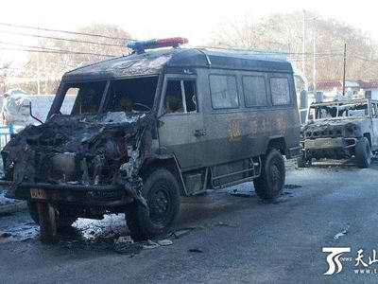
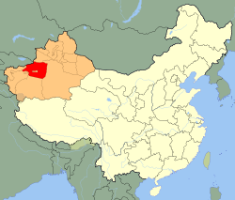
A total of 15 people died in an "attack" in China's Xinjiang region on Friday, with eight "terrorists" shot dead by police and three blowing themselves up, having killed four people, authorities said.
The incident in Aksu prefecture (red in the map) is the latest violence in the restive region home to mostly Muslim ethnic Uighurs.
"Eight terrorists were killed by police and three by their own suicide bomb during a terrorist attack Friday afternoon," the Xinhua official news agency said, citing police.
Riding motorbikes and cars carrying LNG cylinders, the group approached police officers near a park in Wushi county as they prepared to go on patrol, it said.
The Tianshan web portal, which is run by the Xinjiang government, said that as well as the 11 attackers, two police and two passersby were killed, and one assailant detained. Photos posted on the site showed a charred police van and jeep.
Xinjiang police and information officers reached by phone declined to comment to AFP. Wushi government and police officials could not be reached.
Aksu, in the far west of Xinjiang near the border with Kyrgyzstan, was the scene of triple explosions in late January that killed at least three people, according to Tianshan. Police shot dead six people soon afterwards.
Xinhua, citing a police investigation, described those blasts as "organised, premeditated terrorist attacks".
The vast and resource-rich region of Xinjiang has for years been hit by occasional unrest carried out by Uighurs, which rights groups say is driven by cultural oppression, intrusive security measures and immigration by Han Chinese.
Authorities routinely attribute such incidents to "terrorists", and argue that China faces a violent separatist movement in the area motivated by religious extremism and linked to foreign terrorist groups.
"Terrorist attacks" totalled 190 in 2012, "increasing by a significant margin from 2011", Xinhua said, citing regional authorities.
But experts question the strength of any resistance movement, and information in the area is hard to independently verify.
A spokesman for the overseas World Uyghur Congress, Dilshat Rexit, blamed the latest incident on what he called China's violent policies.
"Chinese armed officers' violent rooting out and provocation are the reason for Uighur resistance," he said in an emailed statement.
"The so-called terrorism is China's political excuse of directly shooting dead those who take a stand."
The most serious recent incident took place in Turpan last June, leaving at least 35 people dead.
In October, three family members from Xinjiang died when they drove a car into crowds of tourists in Tiananmen Square in Beijing, the symbolic heart of the Chinese state, killing two, before the vehicle burst into flames, according to authorities.
China's top security official Meng Jianzhu said days later that the attackers had "behind-the-scenes supporters" belonging to the East Turkestan Islamic Movement (ETIM) based outside the country.
The United States and the United Nations both categorised ETIM as a terrorist organisation in 2002, during a period of increased US-Chinese cooperation following the 9/11 attacks.
But the group's strength and links to global terrorism are murky, and some experts say China exaggerates its threat to justify tough security measures in Xinjiang.
Last month, police arrested the prominent Beijing-based Uighur scholar Ilham Tohti, a rare outspoken critic of the government's policies towards the ethnic group, accusing him of being involved in separatist activities.
Xinjiang -- which covers a sixth of China's territory -- contains 30 per cent of China's onshore oil and gas deposits and 40 percent of its coal, according to the official website china.org.
As of 2011, Uighurs made up 47 per cent of the population and Han Chinese 38 per cent, according to official Xinjiang figures. In 1949 by contrast, Han, China's dominant majority, accounted for six per cent.
The region has seen tremendous economic growth, but critics argue that the development mainly benefits the influx of Han Chinese.
Clashes involving Uighurs and Han in the region's capital of Urumqi in 2009 left around 200 people dead.

DHS warns airlines of renewed shoe-bomb risk
Source: http://edition.cnn.com/2014/02/19/us/airline-security-threats/

DHS has alerted airlines flying to the United States to the possibility that terrorists might try to bring explosives n board in their shoes. The airlines were told that there were no specific plots, and that the information was based on information collected in the United States and abroad that bomb makers affiliated with terrorist groups were working on a shoe-bomb design.
An airline industry source said the DHS warning listed 25 to 30 cities overseas, all with nonstop flights to the United States. Johannesburg, Paris, London, and Cairo, as well as some cities in the Middle East, were on the list.
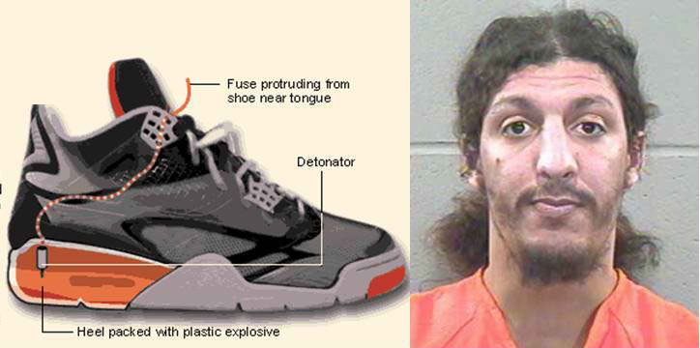
The alerts advised carriers that there would be increased scrutiny of people who appear on the TSA’s “selectee list,” which includes people deemed suspicious who could require additional screening, as well as randomly picked passengers.
CNN reports that a separate intelligence official stressed that the warning was issued out of a sense of heightened caution.
“This threat is not specific or credible enough to require a specific response. DHS often issues these alerts out of an abundance of caution, but this does not necessarily rise to the level of facilitating a response,” the intelligence official said.
Another official told CNN that there is no specific threat and said there is already some puzzlement about why DHS issued the warning.
Yet another intelligence source said the DHS warming to the airlines went beyond a concern about explosives in shoes to include cosmetics and liquids.
This official noted that the new alert is not related to recent warnings, issued on the eve of the opening of the Winter Olympics, about explosives hidden in toothpaste and cosmetic tubes on flights to Russia.
Hiding explosives in shoes is not new. In December 2001, passengers aboard an American Airlines flight from Paris to Miami prevented a U.K. citizen, Richard Reid, from detonating explosives hidden in his sneakers. Reid is serving a life sentence.
CNN notes TSA already X-rays shoes, but that travelers may notice additional searches, including swabs to detect explosives.
One official told the network that there are “seen and unseen” measures TSA can take for security and additional scrutiny.

2014 Cyber Predictions

Source:http://www.net-security.org/secworld.php?id=16234&goback=.gde_2324899_member_ 5831652687430565890#!

The advent of new technologies, the widespread implementation of mobile and wireless communication and the increase in mobile adoption will open up new opportunities for cyber-criminals.

With 2014 now in full swing, Catalin Cosoi, Chief Security Strategist at Bitdefender, draws on his expertise to predict the key security threats on the horizon:

Digital trust is gone: Malware signed with stolen digital certificates has been around for a while, but last year’s ‘next big thing’ was malware signed with digital certificates expressly purchased for this purpose. We expect this trend to continue throughout 2014, especially for grey-area software such as aggressive adware or spyware.

‘The Internet of Things’ to expand: By 2015, the number of interconnected devices in the world will reach 25 billion and that number will double by 2020. These devices include: livestock monitors; medical gear; automotive on-board computers and emergency signalling; buoys and household items, each with their own security implementations. ‘The Internet of Things’ is likely to become the main focus of cyber-criminals due to the sheer number of devices and poor security implementations.

Cyber-criminals to target Android users: Android currently holds about 70 per cent of the mobile OS market share, which makes it incredibly relevant to cyber-criminals. Adding to that is the fact that mobile devices are a payment mechanism by themselves (via premium-rate SMS, as well as the newly introduced NFC payments), cyber-criminals will increase their focus on developing malware for Android. The emergence of BYOD will also allow cyber-criminals to target companies as well as home-users.

E-mail spam is decreasing; long live social network targeted advertising: Spam has been around since the dawn of electronic communications and has gained serious traction during the botnet era. While spam volumes will continue to pump in 2014, cyber-criminals will put a greater focus on social networks, where they can target victims more effectively.

With Facebook already surpassing one billion active users, social networks will also be used by cyber-criminals to harvest willingly-shared information for spear-phishing, and for the dissemination for new threats. Blind spam attacks will, of course, still be used by cyber-criminals in conjunction with malicious attachments to add computers to botnets.

Old technologies will still be popular: The upcoming support termination for Windows XP – that will reach its end of life in April 2014 – will likely let cyber-criminals go after users of an operating system that is no longer patched. With no security updates to be delivered, Windows XP users, especially those in enterprise environments, will become increasingly vulnerable after April 2014.

Wearable technology may be targeted by hackers: Wearable devices, such as health-monitoring bracelets, are becoming increasingly popular with users all around the world and they are also becoming ever more interconnected with the internet.

Their minimal size and focus on battery life leaves little to no room for security, which may put them into the crossfire of hackers crossfire in the near future, although not necessarily in 2014.

Medical devices could also be at risk: Just like wearable technology, medical devices are becoming more and more interconnected. Their wireless communication capabilities allow doctors to monitor the health status of the patient and the device’s performance, but could also allow unauthorised third parties to tamper with the equipment and cause immediate death.

Malware growing bigger and more insidious: Botnets are still the backbone of any cyber-criminal operation, ranging from DDoS attacks to sending spam or illegaly mining Bitcoins at the expense of the victim. Cyber-criminals will focus on exploiting unpatched software bugs to join machines to botnets.

Some of the larger botnets will likely switch to peer-to-peer communication models to prevent takedown, while smaller ones will use social networks as a backup communication mechanism with their C&C servers.
Malware will surpass 250 million unique samples throughout 2014 because of server-side polymorphism features that are present in nearly all major crimepacks on the underground market.

An increasing number of targeted attacks against the energy sector

Source: http://securityaffairs.co/wordpress/21235/security/increasing-number-targeted-attacks-energy-sector.html?goback=.gde_4709642_member_5831085785775906817#!

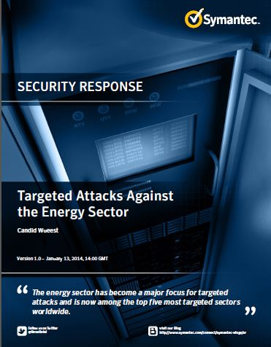
Companies and industries belonging in the energy sector are waiting most targeted sectors on a global scale, Symantec has issued a very interesting report titled “Targeted Attacks Against the Energy Sector” that provide an overview of malicious event that hit the energy world.
The number of cyber attacks is increasing every year, in the first half of 2013, the energy sector was the fifth most targeted sector worldwide, suffering 7.6% of all cyberattacks.
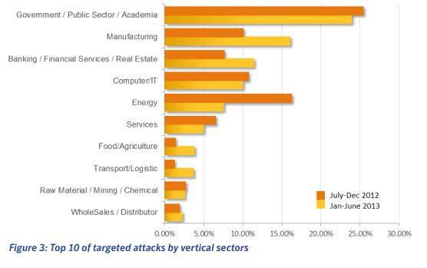
“During the monitoring period from July 2012 to June 2013, we observed an average of 74 targeted attacks per day globally. Of these, nine attacks per day targeted the energy sector. Accounting for 16.3 percent of all attacks, the energy sector was the second most targeted vertical in the last six months of 2012, with only the government/public sector exceeding it with 25.4 percent of all attacks.” revealed Symantec.
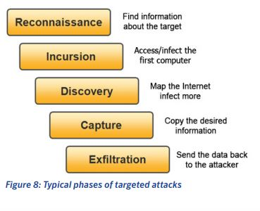
Security experts, private companies and government are aware of the cyber threat and fear a major incident could happen in the next months causing serious consequences. In April 2013, the US Department of Homeland Security alerted energy companies on ongoing spear-phishing campaign and of a rising tide of attacks aimed at sabotaging industrial processes.
The common sense of security is changed after the discovery of malware such as Stuxnet and Shamoon, experts in the energy sector have matured the sensitiveness that a cyber weapon could effects more dangerous that a bomb. Governments are spending a lot of effort in the improvement of cyber capabilities; this effort is transforming the cyber space in a warfare domain.
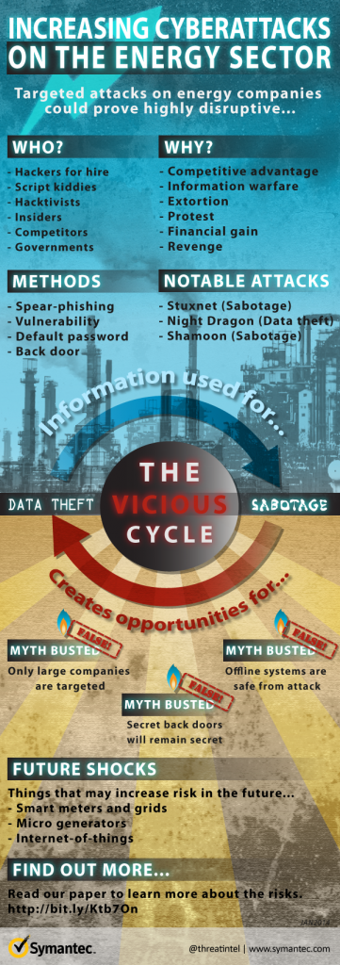
Hackers who target the energy sector operate mainly to steal intellectual properties, but an attack could cause an intentional or unintentional incidents that could cause human losses.
Intellectual property theft requires a long-term strategy of the attackers who modify their operational mode over the time to adapt the offensive to countermeasures adopted by the victims. The information stolen could be used to reduce the competitive gap with targeted industries, but it could be used also to perform further disruptive actions.
The scenarios hyphotized by Symantec experts are different, cybercrime, state-sponsored hackers, hacktivists and cyber terrorists merge into a single entity capable of moving hostile attacks with the catastrophic consequences.
“A competitor may commission actions against energy companies to gain an unfair advantage. There are “hackers for hire” groups such as the Hidden Lynx group, who are more than willing to engage in this type of activity. State-sponsored hackers could target energy firms in an attempt to disable critical infrastructure. Hacktivist groups may also victimize companies to further their own political goals. Symantec researchers know these threats can originate from all over the world and sometimes from within company walls. Insiders who are familiar with the systems can carry out attacks for extortion, bribery or revenge. And disruptions can simply happen by accident such as a misconfiguration or a system glitch. For example, in May 2013, the Austrian power grid nearly had a blackout due to a configuration issue.” states a post by Symantec.
The energy sector is adopting systems even more complex, there are numerous supervisory controls and data acquisition (SCADA) or industrial control systems (ICS) that are exposed online and that needs to be specifically protected. The high penetration level of technology has found critical infrastructure vulnerable to cyber attacks, the majority of smart grid and water facilities all over the world needs a more efficient security.
The technological offer is also complicated by the diffusion of new paradigms like the Internet of Things, which represent a business opportunity for the cybercrime industry.
Another factor that influences the overall security of the energy sector is it opens to open the energy market in which small contributors to the electric power grid (e.g. Private water power plants, wind turbines or solar collectors) become part of the entire infrastructure enlarging surface of attack.
“While these smaller sites make up only a small portion of the grid, the decentralized power input feeds can be a challenge to manage with limited IT resources and need to be carefully monitored to avoid small outages that could create a domino effect throughout the larger grid.” reports Symantec.
Companies in the energy sector will face a growing risk of suffering cyber attacks, new developments; including further extensions of smart grids and smart metering expose the more infrastructures to the Internet.
Be aware, also devices not connected to the Internet are at risk, there have already been a number of successful attacks against isolated systems!

►If you want to go deeper … read the report at:
http://www.symantec.com/content/en/us/enterprise/media/security_response/whitepapers/targeted_attacks_against_the_energy_sector.pdf

CrowdStrike Takes On Chinese, Russian Attack Groups in Threat Report
By Fahmida Y. Rashid
Source: http://www.securityweek.com/crowdstrike-takes-chinese-russian-attack-groups-threat-report? goback=.gde_4709642_member_5831774040066392064#!

Russian attackers targeted energy sector targets and a Chinese nexus intrusion group infected foreign embassies with malware using watering hole tactics in 2013, CrowdStrike researchers found in its first-ever Global Threat Report.
CrowdStrike's Intelligence Team tracked more than 50 different threat actor groups believed to be behind the majority of sophisticated threats against enterprises in 2013. These groups operated out of China, Iran, India, North Korea, and Russia. In its Global Threat Report, CrowdStrike identified many of the tactics, techniques, and procedures used by these groups to craft and launch sophisticated attacks against major targets around the world. CrowdStrike outlined details of how these groups carried out their attacks and what tools were used in the report, released Wednesday.
Attackers are human, which means “they make mistakes, and they have habits,” said Adam Meyers, vice-president of Intelligence at CrowdStrike, a firm focused detection and mitigation of targeted attacks. Attack tools, no matter how sophisticated, have specific “marks” that can be used to track back to the humans who created them, he said. The marks can be something like password reuse, a certain string that appears frequently in code, or even the name of the registrar hosting the domain name. These marks cannot be obfuscated and CrowdStrike researchers rely on these clues to connect different attacks and campaigns to each other.

Strategic Web Compromises
The report found that Strategic Web Compromises (SWC), where attackers infect strategic Websites as part of a watering hole attack to target a specific group of users, was a favorite attack method for groups operating out of Russia and China. The attack against the Council of Foreign Relations website in early 2013, which also compromised Capstone Turbine and Napteh Engineering & Development Co., involved three different adversaries using multiple types of malware, the report found. In March 2013, one of the attack groups compromised a Harvard University site targeting people who were concerned with military, international relations, and human rights issues in the Far East.
The Chinese group Emissary Panda carried out its own watering hole attack against foreign embassies a few months after the attack against the Department of Labor website, the report found. The group hosted a booby-trapped Microsoft Word document on the Website of a Spain-based defense manufacturer. Another watering-hole-attack affected the website for the Russian Federation's embassy in the United States. CrowdStrike observed multiple additional SWC operations by Emissary Panda using a number of compromised sites, the report found.
Attackers may prefer using SWC over spear phishing because users are getting better about identifying malicious emails and email filters make it harder for these messages to reach the user's inbox in the first place, CrowdStrike said. In contrast, the only way to avoid being hit with SWC is to have “technical countermeasures in place to detect the SWC or prevent exploitation,” the researchers wrote.
“Spear phishing is still the most common delivery mechanism for targeted intrusion operations; however, the frequency of SWC operations is increasing. CrowdStrike believes that this tactic will remain popular among targeted intrusion adversaries, and its use will likely continue to increase in frequency,” the report said.

Energy Sector Attacks
Energetic Bear, an adversary group out of the Russian Federation, have conducted intelligence collection operations against the energy sector since at least August 2012, the report said. There were hints that watering hole attacks were this group's “preferred delivery vector,” although there were other attacks based on booby-trapped PDF files targeted Adobe Reader. This group used two primary remote access tools, HavexRAT and SysMain RAT, which share code and have several techniques in common, CrowdStrike said.
While the energy sector was the primary target, CrowdStrike found that Energetic Bear had compromised hosts in 23 countries including the European government, defense contractors, energy providers, and IT providers. Other impacted groups included European, U.S., and Asian academia, European, U.S., and Middle Eastern manufacturing and construction industries, U.S. healthcare providers, non-European precision machinery tool manufacturers, and research institutes.
“Observed indicators obtained from monitoring this adversary’s activity suggest that Energetic Bear is operating out of Russia, or at least on behalf of Russia-based interests, and it is possible that their operations are carried out with the sponsorship or knowledge of the Russian state,” CrowdStrike said in its report.

Changing Tactics
CrowdStrike also included details about the various operations conducted by Deadeye Jackal, also known as the Syrian Electronic Army, including the attacks against Twitter accounts for multiple media outlets, the theft of TrueCaller.com's database and others, and compromising DNS records for various websites including The New York Times and The Washington Post. One important thing about Deadeye Jackal was the fact that the group changed its attack methods several times over the course of the year, the report found. For example the group used spear phishing tactics to collect login credentials towards the end of the year.
“Given the observed development of Deadeye Jackal since May 2011, from Facebook spamming to account takeover to data exfiltration and then to more efficient targeting against third-party service providers of victims, it is quite plausible that this adversary would use the infrastructure of their previously compromised victims as a resource to support ongoing campaigns,” the report found.

Understanding Tactics, Adversaries
CrowdStrike expects that cyber-targeting will increase in 2014, and that special events, such as the World Cup, the G20 summit, the Winter Olympic Games in Sochi, Russia, and the withdrawal of U.S. Forces from Afghanistan will be of special interest to attackers.
CrowdStrike believes organizations have an “adversary problem, not a malware problem,” Meyers said. The best way to understand the types of threats the organization is facing is to focus on the tactics and tools used by the adversaries instead of getting bogged down trying to detect and identify every type of malware the group may use. Criminal groups “diverse and difficult to track, but they, too, leave human toolmarks in the binaries and tools they leverage to steal information and criminalize the Internet,” the report said.
For example, attack groups often use the same registrar. Organizations can be proactive and look for what other domains are associated with the registrar to narrow down where the attack may come from, Meyers said. The fact that Microsoft will end-of-life Windows XP in April means these adversary groups have another potential attack vector. Organizations can take steps now to proactively close off that avenue of attack, Meyers said.

►The full report from Crowdstrike is available at:
http://www.crowdstrike.com/sites/all/themes/crowdstrike2/css/imgs/platform/CrowdStrike_Global_Threat_Report_2013.pdf

Fahmida Y. Rashid is a contributing writer for SecurityWeek. She has experience writing and reviewing security, core Internet infrastructure, open source, networking, and storage. Before setting out her journalism shingle, she spent nine years as a help-desk technician, software and Web application developer, network administrator, and technology consultant.

'Biggest' global hacking network busted
Source: http://www.terrorismwatch.org/2014/01/global-hacking-network-busted-pune-man.html

In what is being termed as the biggest international hacking scandal, possibly involving corporates, associations and big individuals, coordinated raids were conducted by investigative agencies in India, China and Romania, on the basis of intelligence from Federal Bureau of Investigation about the "organised hacking" happening in three countries and others. In India, the Central Bureau of Investigation conducted raids at four places including Mumbai, Pune and Ghaziabad and arrested the alleged mastermind hacker in India - Amit Vikram Tiwari (31), son of a former army colonel, said sources.
Interestingly, the controversial cricket league - Indian Premier League - is back in news again with the hacking scandal. According to highly placed sources, people connected to the IPL had approached Tiwari for hacking into the some accounts but they reportedly had a dispute over money after which work was not reportedly completed. CBI is investigating the IPL connection with the hacking. Officials refused to divulge details but hinted that some people associated with the tournament wanted high-level hacking done.
The primary investigations have revealed that corporates, individuals and even companies - "the clients" - had approached the hackers either for marriage disputes related issues or commercial purposes, which sources described as "corporate rivalry".
It is suspected that Amit Vikram Tiwari is main hacker in India but he was in touch with people abroad and master-hackers are based somewhere else. Sources also said that most of clients who approached Tiwari for hacking into email accounts and websites were foreigners. All possibilities -- national security, corporate hacking, financial fraud and hacking into government departments and secret units, are being probed by CBI in coordination with FBI.
Officials say that 900 email accounts were hacked between February 2011 and February 2013 by international hackers including Tiwari and 171 accounts out of these belonged to Indians. "It has been alleged that a number of internet websites advertised that the website operators could get access to e-mail account in exchange for a fee varying from $250 to $500. Customers desirous to get unauthorized access, submitted e-mail accounts to these websites. Upon receipt of the order, as well as the e-mail addresses, the website operators gained access to such e-mail accounts and sent a proof of such access to the customers. On receipt of payment from Customers these website operators shared the password with the customers," said CBI Spokesperson Kanchan Prasad. CBI has booked Tiwari and unknown hackers for criminal conspiracy, theft of information and Section 66 of Information Technology Act.
Sources say that payments were being received by hackers through western union money transfer and web-payment portal paypal.com.
What has baffled investigators is that FBI tracking the scandal. It is being suspected that some accounts related to United States government and big corporates there were also hacked after which FBI tracked the hosting sites, used for hacking, in India, China and Romania. In India, Tiwari and his fellow hackers were using two primary websites - and from Pune.
CBI Director Ranjit Sinha said that this was part of an international law enforcement operation and CBI had registered two FIRs against suspect operators of hacking websites. "The operation is product of an international investigation coordinated by Federal Bureau of Investigation, Department of Combating Organised Crime (DCCO) of Romania, CBI and the Ministry of Public Security (MPS) of China and raids in three countries were carried out simultaneously," said Sinha.
The FBI officials had been reportedly having regular meetings with CBI in New Delhi over past few months and a preliminary enquiry was registered last month itself and it was decided that coordinated raids would be conducted in all the countries. FBI has launched major operation against hackers located globally last year as part of which Romanian authorities have arrested a hacker known as 'Guccifer' on Thursday who was infamous for hacking into accounts of powerful leaders. It is alleged that Guccifer leaked online Colin Powell's personal emails, an unreleased script of Downton Abbey, and the paintings of George W Bush.
CBI sources say they had no information about arrests made in Romania and China as it was the domain of authorities in those countries and it was only concerned with the probe in India.
CBI officials, after arresting Tiwari from Pune, were bringing him to Delhi for interrogation. He has initially given some inputs about his clients and people whose accounts were hacked. Agency has recovered his computers, laptop and hard-drives for retrieving the data.
Sources say that Tiwari, who had reportedly done his engineering from Pune, had been arrested in 2003 as well for trying to defraud a Mumbai based credit card processing company. Mumbai Police had arrested him for the scandal.

Cyber Risks at the Sochi Olympics
Source: http://i-hls.com/2014/02/cyber-risks-sochi-olympics/

People interested in attending the 2014 Winter Olympic Games in Sochi are advised to take extra precautions to protect themselves from cyber attacks during the events, according to Lysa Myers, a cybersecurity expert.
“The most important thing is that the people behind the Olympics are already well aware of the risks, but the attendees are not necessarily aware of all of the risks that they are being exposed to,” she explains.
Government Security News reports that Myers is a security analyst at ESET, an anti-virus company based in Slovakia that provides anti-malware and anti-phishing software solutions for mobile devices, desktops, and laptops. ESET is one of the leading providers of anti-virus software throughout Western Europe; it also has locations across North America, Latin America, and Asia.
“There was actually a denial of service attack that hit the Olympics website during the 2012 London Olympics and cybercriminals threatened to turn off the lights during the opening event,” Lisa explains.
According to a report from the Department of Homeland Security (DHS), a denial of service attack is designed to prevent a user from being able to access a service or information on a website by flooding the server with too many network requests at once.
A July 2013 article in the Washington Times reveals that there was a significant cybersecurity threat during the 2012 London Olympic Games. “There was a credible [threat of] attack on the electricity infrastructure supporting the Games,” said Oliver Hoare, head of Olympic cybersecurity.
In an October 2012 article published by Computer Weekly, Gerry Pennell, the CIO of the 2012 London Olympics, stated, “we were attacked every day.” He explained, “we prepared for this well in advance so it didn’t cause us any problems.”
Myers explains that “This is a very contentious situation due to its location in Russia and authorities are planning to protect themselves from cyber attacks.” The reason why the location of the 2014 Olympic Games makes it an even greater potential target is because “there are few opportunities for gainful employment for many technology workers located across Eastern Europe and when crime pays more, there tends to be more of it.”

EDITOR’S COMMENT: Even if this does not happen in Sochi it is a good candidate for Rio2016…

Chemical, defense companies subject to Chinese Nitro attacks
Source: http://www.homelandsecuritynewswire.com/dr20140204-chemical-defense-companies-subject-to-chinese-nitro-attacks

Chemical and defense companies are increasingly becoming the targets of hackers who engage in industrial espionage to collect intellectual property for competitive advantage.
Dubbed “Nitro attacks,” the malware infections are part of a series of high-level cyber attacks that security experts attribute to government-backed hackers. The Times of India reports that in late 2011, about forty-eight chemical and defense firms were attacked by a Chinese hacker via his virtual private server (VPS) in the United States, according to a report from Symantec Corp. Computers belonging to the firms which were attacked were infected with malicious software known as PoisonIvy, a Remote Access Tool (RAT) installed on computer systems to steal information.
According to Symantec researchers, Nitro-hackers “typically obtain domain administrator credentials and/or gain access to a system storing intellectual property…While the behavior of the attackers differs slightly in each compromise, generally once the attackers have identified the desired intellectual property, they copy the content to archives on internal systems they use as internal staging servers. This content is then uploaded to a remote site outside of the compromised organization completing the attack.”
The majority of the computers infected belong to firms in the United States, Bangladesh, and the United Kingdom.
“The latest emerging threat in cyberspace is the deadly Nitro attack targeting chemical and defense companies to steal information,” said Pendyala Krishna Sastry, fraud management and digital forensics head of Tata Consultancy Services (TCS). Sastry spoke at India’s national workshop on “Digital Forensics and Incident Response Management,” organized by the computer science and engineering department of Gitam University.
According to Sastry, Nitro attacks are targeting critical infrastructure such as nuclear plants, industrial research data, and chemical industrial systems. The Times notes that India’s Central Bureau of Investigation, along with other law enforcement agencies, has created units for handling cybercrimes.

Report: 4 in 10 Government Security Breaches Go Undetected
Source: http://freebeacon.com/report-4-in-10-government-security-breaches-go-undetected/?goback= gde_1528217_member_5837199362941284355

A new report by Sen. Tom Coburn (R., Okla.) details widespread cybersecurity breaches in the federal government, despite billions in spending to secure the nation’s most sensitive information.
The report, released on Tuesday, found that approximately 40 percent of breaches go undetected, and highlighted “serious vulnerabilities in the government’s efforts to protect its own civilian computers and networks.”
“In the past few years, we have seen significant breaches in cybersecurity which could affect critical U.S. infrastructure,” the report said. “Data on the nation’s weakest dams, including those which could kill Americans if they failed, were stolen by a malicious intruder. Nuclear plants’ confidential cybersecurity plans have been left unprotected. Blueprints for the technology undergirding the New York Stock Exchange were exposed to hackers.”
Nearly every agency has been attacked, including the Departments of Homeland Security, Justice, Defense, State, Labor, Energy, and Commerce. NASA, the EPA, the FDA, the U.S. Copyright Office, and the National Weather Service have also been hacked or had personal information stolen.
In one example, hackers breached the national Emergency Broadcast System in February 2013 to broadcast “zombie attack warnings” in several midwestern states.
“Civil authorities in your area have reported that the bodies of the dead are rising from their graves and attacking the living,” the message said. “Do not attempt to approach or apprehend these bodies as they are considered extremely dangerous.”
“These are just hacks whose details became known to the public, often because the hackers themselves announced their exploits,” the report said. “Largely invisible to the public and policymakers are over 48,000 other cyber ‘incidents’ involving government systems which agencies detected and reported to DHS in FY 2012.”
Even worse, nearly four in 10 intrusions into major civilian agencies go undetected, according to the report.
“Weaknesses in the federal government’s own cybersecurity have put at risk the electrical grid, our financial markets, our emergency response systems, and our citizens’ personal information,” Coburn, ranking member of the Homeland Security and Governmental Affairs Committee, said in a statement. “While politicians like to propose complex new regulations, massive new programs, and billions in new spending to improve cybersecurity, there are very basic—and critically important—precautions that could protect our infrastructure and our citizens’ private information that we simply aren’t doing.”
The report places much of the blame on basic “lapses by the federal government,” including failures to address routine security, such as changing passwords and installing anti-virus software.
Based on more than 40 audits by agency watchdogs, the report takes a closer look at the worst offenders, including the departments of Homeland Security, Energy, Education, the Securities and Exchange Commission, and the IRS.
Each year the Government Accountability Office (GAO) identifies roughly 100 cybersecurity weaknesses within the IRS, whose computers “hold more sensitive data on more Americans than those of perhaps any other federal component.”
IRS computers had over 7,000 “potential vulnerabilities” as of March 2012, due to the failure to install “critical” security software, a problem the agency said would be fixed within 72 hours. Instead, it took an average of 55 days to install the patches.
Vulnerabilities at the agency leave vast amounts of personal information at risk, since the IRS collects Americans’ “credit card transactions, eBay activities, Facebook posts, and other online behavior,” according to the report.
DHS, which was put in charge of government cybersecurity in July 2010, also has hundreds of security flaws, including “failures to update basic software like Microsoft applications, Adobe Acrobat, and Java, the sort of basic security measure just about any American with a computer has performed.”
Only 72 percent of DHS Internet traffic passes through Trusted Internet Connections (TICs), and the agency has failed to install security patches on servers that contain intelligence from the U.S. Secret Service.
The Nuclear Regulatory Commission, which contains volumes of information on the nation’s nuclear facilities, “regularly experiences unauthorized disclosures of sensitive information,” according to the report.
The agency has “no official process for reporting” breaches, cannot keep track of how many laptops it has, and kept information on its own cybersecurity programs, and its commissioner’s “passport photo, credit card image, home address, and phone number,” on an unsecure shared drive.
The Department of Education is also a concern since it manages $948 billion in student loans made to more than 30 million borrowers. The agency’s computers contain “volumes of information on those borrowers,” including loan applications, credit checks, and repayment records.
The department’s Federal Student Aid (FSA) office reported 819 compromised accounts in 2011 and 2012, and the agency only reviewed 17 percent of those accounts to determine if malicious activity occurred.
The report notes that federal efforts have failed to improve the government’s cybersecurity. The Federal Information Security Management Act of 2002 requires agencies to implement security safeguards, and the government has spent $65 billion on IT security since 2006, though breaches remain widespread.
“More than a decade ago, Congress passed a law making the White House responsible for securing agency systems,” Coburn said. “It’s still not happening.”
“They need to step up to the job, and Congress needs to hold the White House and its agencies accountable,” he said.

The “Mask": Kaspersky Lab discovers advanced global cyber-espionage operation
Source: http://www.homelandsecuritynewswire.com/dr20140212-the-mask-kaspersky-lab-discovers-advanced-global-cyberespionage-operation

Kaspersky Lab’s security researchers have announced the discovery of the Mask (aka Careto), an advanced Spanish-language speaking threat actor that has been involved in global cyber-espionage operations since at least 2007. What makes the Mask special is the complexity of the toolset used by the attackers. This includes a sophisticated malware, a rootkit, a bootkit, Mac OS X and Linux versions, and possibly versions for Android and iOS (iPad/iPhone).
The primary targets are government institutions, diplomatic offices and embassies, energy, oil, and gas companies, research organizations and activists. Victims of this targeted attack have been found in thirty-one countries around the world — from the Middle East and Europe to Africa and the Americas.
The main objective of the attackers is to gather sensitive data from the infected systems. These include office documents, but also various encryption keys, VPN configurations, SSH keys (serving as a means of identifying a user to an SSH server), and RDP files (used by the Remote Desktop Client to automatically open a connection to the reserved computer).
“Several reasons make us believe this could be a nation-state sponsored campaign. First of all, we observed a very high degree of professionalism in the operational procedures of the group behind this attack. From infrastructure management, shutdown of the operation, avoiding curious eyes through access rules to using wiping instead of deletion of log files. These combine to put this APT ahead of Duqu in terms of sophistication, making it one of the most advanced threats at the moment,” said Costin Raiu, Director of the Global Research and Analysis Team (GReAT) at Kaspersky Lab. “This level of operational security is not normal for cyber-criminal groups.”
Kaspersky Lab researchers initially became aware of Careto last year when they observed attempts to exploit a vulnerability in the company’s products which was fixed five years ago. The exploit provided the malware the capability to avoid detection. This situation raised their interest and this is how the investigation started.
For the victims, an infection with Careto can be disastrous. Careto intercepts all communication channels and collects the most vital information from the victim’s machine. Detection is extremely difficult because of stealth rootkit capabilities, built-in functionalities and additional cyber-espionage modules.

Main findings:
- The authors appear to be native in the Spanish language, which has been observed very rarely in APT attacks.
- The campaign was active for at least five years until January 2014 (some Careto samples were compiled in 2007). During the course of Kaspersky Lab’s investigations, the command-and-control (C&C) servers were shut down.
- Kaspersky researchers counted over 380 unique victims between 1000+ IPs. Infections have been observed in: Algeria, Argentina, Belgium, Bolivia, Brazil, China, Colombia, Costa Rica, Cuba, Egypt, France, Germany, Gibraltar, Guatemala, Iran, Iraq, Libya, Malaysia, Mexico, Morocco, Norway, Pakistan, Poland, South Africa, Spain, Switzerland, Tunisia, Turkey, United Kingdom, United States, and Venezuela.
- The complexity and universality of the toolset used by the attackers makes this cyber-espionage operation very special. This includes leveraging high-end exploits, an extremely sophisticated piece of malware, a rootkit, a bootkit, Mac OS X, and Linux versions and possibly versions for Android and iPad/iPhone (iOS). The Mask also used a customised attack against Kaspersky Lab’s products.
- Among the attack’s vectors, at least one Adobe Flash Player exploit (CVE-2012-0773) was used. It was designed for Flash Player versions prior to 10.3 and 11.2. This exploit was originally discovered by VUPEN and was used in 2012 to escape the Google Chrome sandbox to win the CanSecWest Pwn2Own contest.

Infection methods and functionality
According to Kaspersky Lab’s analysis report, the Mask campaign relies on spear-phishing e-mails with links to a malicious website. The malicious website contains a number of exploits designed to infect the visitor, depending on system configuration. Upon successful infection, the malicious website redirects the user to the benign website referenced in the e-mail, which can be a YouTube movie or a news portal.
It is important to note the exploit websites do not automatically infect visitors; instead, the attackers host the exploits at specific folders on the website, which are not directly referenced anywhere, except in malicious e-mails. Sometimes, the attackers use subdomains on the exploit websites, to make them seem more real. These subdomains simulate subsections of the main newspapers in Spain plus some international ones for instance, the Guardian and the Washington Post.
The malware intercepts all the communication channels and collects the most vital information from the infected system. Detection is extremely difficult because of stealth rootkit capabilities.
Careto is a highly modular system; it supports plugins and configuration files, which allow it to perform a large number of functions. In addition to built-in functionalities, the operators of Careto could upload additional modules that could perform any malicious task.
Kaspersky Lab says its products detect and remove all known versions of the Mask/Careto malware.

►You can read full report at::
http://www.securelist.com/en/downloads/vlpdfs/unveilingthemask_v1.0.pdf

Hackers used previously unknown Internet Explorer flaw in new attacks
Source: http://www.terrorismwatch.org/2014/02/hackers-used-previously-unknown.html

A previously unknown flaw in a recent version of Microsoft Corp's Internet Explorer web browser is being used to attack Internet users, including some visitors to a major site for U.S. military veterans, researchers said Thursday.
Security firm FireEye Inc discovered the attacks against IE 10 this week, saying that hundreds or thousands of machines have been infected. It said the culprits broke into the website of U.S. Veterans of Foreign Wars and inserted a link that redirected visitors to a malicious web page that contained the infectious code in Adobe Systems Inc's Flash software.
FireEye researcher Darien Kindlund said that the attackers were probably seeking information from the machines of former and current military personnel and that the campaign shared some infrastructure and techniques previously attributed to groups in mainland China.
He said planting backdoors on the machines of VFW members and site visitors to collect military intelligence was a possible goal.
A VFW spokeswoman didn't immediately respond to requests for comment.
A Microsoft spokesman said the company was aware of the "targeted" attacks and was investigating. "We will take action to help protect customers," said spokesman Scott Whiteaker.
The latest version of the browser is IE 11, which is unaffected, and a Microsoft security tool called the Enhanced Mitigation Experience Toolkit also protects users who have installed that.
Previously unknown flaws in popular software are a key weapon for hackers and are sold by the researchers who discover them for $50,000 or more, brokers say.
They are most often bought by defense contractors and intelligence agencies in multiple countries, but some of the best-funded criminal groups buy them as well.

The cyberwar threat from North Korea
Source: http://www.foxnews.com/tech/2014/02/14/cyberwar-experts-question-north-korea-cyber-capabilities/

North Korea’s effort to build a cyberarmy that can conduct a string of attacks on neighboring states has experts asking some key questions:
- Is Pyongyang gearing up for a cyberassault on the United States?
- Does it have the capability?
“They do have the capability, obviously,” says Alexandre Mansourov, a visiting scholar at the U.S.-Korea Institute at the Johns Hopkins School of Advanced International Studies. “But I don’t think they have the intention.”
But not everyone is so unsure. Like the Cold War in the 1950s and ’60s, cyberwarfare is becoming an arms race. Many nations, including the United States, are building up their offensive and defensive capabilities amid an increase of espionage and a proliferation of attacks on public and private computer networks.
Experts say the number of attacks on South Korea over the last five years looks more like a coordinated war than the work of random hackers. This has some officials in the U.S. girding for a broader fight.
“We should never underestimate Pyongyang's willingness to engage in dangerous and provocative behavior to extract more aid and concessions from the international community,” Rep. Mike Rogers (R-Mich.), chairman of the House Select Committee on Intelligence, said in a statement to FoxNews.com.
“North Korea is certainly not the most capable nation-state threat actor today, but even relatively minor cyberplayers can sometimes find vulnerabilities in complicated civilian architectures and cause significant disruptions."
While no one knows exactly what North Korea has up its sleeve, a number of hackers who have defected, as well as the increasingly sophisticated attacks on South Korea, suggest that its leader, Kim Jong-un, isn’t limiting his muscle-flexing to nuclear tests in the Pacific.

A history of cyber-violence
According to reports beginning in 2010, North Korea has been training thousands of top computer science students to be sophisticated cyberwarriors. Some experts, like Professor Lee Dong-hoon of the Korea University Graduate School of Information Security, estimate that Pyongyang has been pouring money into cyberwarfare since the 1980s.
The proof is in the attacks, of course, though it is difficult to pin down the responsible parties:
- A wave of “distributed denial of service (DDoS)” attacks in 2009 struck both U.S. government and South Korean websites. A virus launched from unknown sources (South Korean officials accused Pyongyang) through a series of “zombie” computers sent waves of Internet traffic to a number of websites in the two countries. The U.S. Treasury and Federal Trade Commission sites were shut down for a weekend, but the action crippled a number of government sites and media outlets in South Korea.
- A DDoS attack on South Korean banks in March 2011 left 30 million people without ATM access for days. At the time, Dmitri Alperovitch, vice president of threat research for McAfee Labs, said the attacks had the mark of a North Korean “cyberwar drill” and theorized that Pyongyang had built an army of zombie computers, or “botnets,” to unleash malicious software. He guessed that the 2009 attack had been a similar operation.
- An attack in March 2013 was the biggest one yet, infecting and wiping clean the critical master boot records of 48,000 computers and servers associated with South Korean banks and media outlets, using their own networks. Experts traced the “cyberweapon” back through more than 1,000 IP addresses used on different continents, but South Korean officials accused North Korea of directing the attack. Systems were crippled for days.
Gen. James Thurman, commander of U.S. forces in South Korea, told Congress in 2012 that "the newest addition to the North Korean asymmetric arsenal is a growing cyberwarfare capability,” in which North Korea “employs sophisticated computer hackers trained to launch cyberinfiltration and cyberattacks" against South Korea and the U.S.
Observers say the alleged North Korean attacks are launched from servers all over the world in order to avoid detection.
“It’s all untraceable,” Mansourov said. “But there is a presumption of guilt -- I think it's a valid presumption.”
Jarno Limnéll, director of cybersecurity at Finland-based Stonesoft Corp. (part of the McAfee cybersecurity company), said that while it is “hard to know what cyber-capabilities your enemies or even your friends have, [this is] something [North Korea] has taken very seriously … and what they are saying quite publicly is they have several thousand men and women working on a daily basis on cyber. They want to give a very clear impression that they are a strong player in this field.”

Accusations fly worldwide
For its part, Pyongyang has accused South Korea and the U.S. of launching similar attacks against North Korea. Last March, around the time of the attacks on banks and broadcasters in Seoul, North Korean offices said an online attack took down the servers at Loxley Pacific Co., the broadband provider for the North.
Mansourov said there is a “Cold War situation going on,” a tit-for-tat between the North and South. And it’s not limited to the Korean Peninsula:
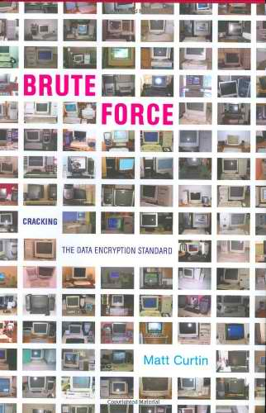
China has accused the U.S. of cybersnooping, and the U.S. has accused China not only of spying, but of launching expensive cyberattacks against public and private networks in the U.S.
Meanwhile, Israel and the U.S. were widely fingered for launching the Stuxnet virus that crippled Iran's nuclear program in 2010.
“It’s effectively an arms race,” said C. Matthew Curtin, founder of the computer security consulting firm Interhack and author of Brute Force: Cracking the Data Encryption Standard.
“We need to assume that hostile nation states -- even non-state actors like al Qaeda -- have offensive cyber-capabilities, and we need to be in a position to render their capabilities moot."
He said the best way to confront cyberthreats is to secure domestic networks and force other countries to spend more money to get to us. “Then it becomes like the [Cold War-era] Soviet Union, where they will eventually have nothing left to spend,” he said.
Rogers still hopes to see the Cyber Intelligence Sharing and Protection Act (CISPA), which the House passed in April, succeed in the Senate and be signed into law by President Obama. It would allow greater information sharing between the government and private companies to prevent and respond to cyberattacks. But critics say it will give the government greater ability to monitor citizens’ Internet communications.
“It’s not a black-and-white issue,” said Curtin, who noted that “nothing is free” and that breaking down these “barriers” of information will require ordinary citizens to give up some privacy.
But the threat is real, he said, whether it comes from North Korea or Iran.
"If someone was trying to shut down our power grid when there is a huge polar vortex blowing through the country, that would have a serious impact on us,” he said.

The cyber-security capital of the world
By Viva Sarah Press
Source: http://israel21c.org/technology/the-cyber-security-capital-of-the-world/

It’s no secret that the newest cyber-security and cyber-defense software is being coded in Israel.
In fact, in early 2014, multinational players IBM, Cisco, EMC, Lockheed Martin RSA and Deutsche Telekom all announced plans to set up cyber-research facilities in CyberSpark, Israel’s new cyber-security technology park in Beersheva.
Prime Minister Benjamin Netanyahu revealed the establishment of the new national cyber complex in the Negev city at the Cybertech conference in Tel Aviv – where some 450 heads of industry and cyber-security agencies from across the globe came to see an expo of Israeli security companies and startups.
Two years after the founding of the Israel National Cyber Bureau (INCB), Netanyahu predicted that Beersheva would “not only be the cyber capital of Israel but one of the most important places in the cyber security field in the world.”
“Just looking at the innovation that Israel has generated over the past several years especially in cyber security, it’s a growing area of focus and we want to be part of that,” Verizon infrastructure protection executive Sean Paul McGurk tells ISRAEL21c, explaining why he made the trip to Tel Aviv..
The number of Israeli cyber-defense companies has ballooned from a few dozen to some 220 in the last few years, according to the Tel Aviv-based IVC Research Center. That’s about five to 10 percent of the global $60 billion to $80 billion annual cyber-security market, says INCB Director Eviatar Matania.
Two other noteworthy facts: 78 Israeli cyber-security companies have raised $400 million since 2010; and about 20 multinational companies now operate online-security development centers in Israel (half of which were established since 2011).
“Cyber is the big engine for the Israeli market,” Theta-Ray VP R&D Ronen Lago tells ISRAEL21c. “We have the creativity to find out the new technologies.”

Futuristic solutions
“The most interesting thing happening right now is not sharing of historical information of attacks but actually coming up with technology that predicts the new type of attack according to proactive security,” Gadi Tirosh, a general manager at Jerusalem Venture Partners (JVP), tells ISRAEL21c. “It’s not just defending attacks of the past but actually predicting the attacks of the future.”
A look around at the conference gave a sense of that activity in action. There were over 75 startups showing off the next must-have technologies.
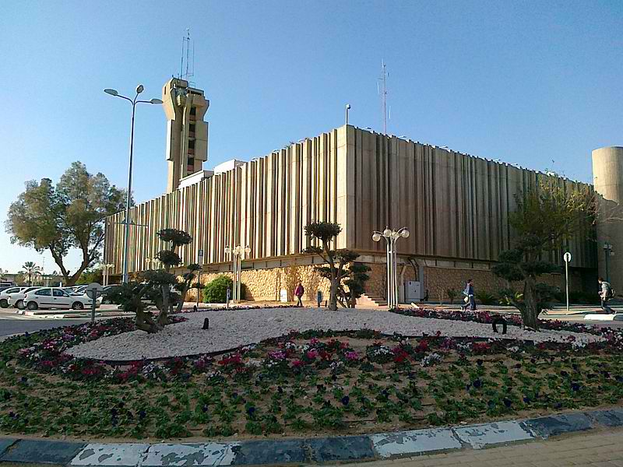
“What we’re seeing in the cyber-security market over the last two to three years is a shift of a completely new set of attacks. It’s not carpet-bombing attacks that we’ve seen in the past, but missile attacks, tailor-made attacks that are made to hit a particular organization, group or in some cases individuals. To deal with this kind of attack, you need a completely new set of technologies, and that’s what all these startups are striving [for],” Tirosh says.

Beersheba City Hall

“One of the best parts of the conference was the innovation center of the new startup companies, because you’re seeing a lot of technology being brought to market in rapid fashion,” says McGurk, who discovered Israel’s “incredibly innovative” cyber-security approaches when he was at the US Department of Homeland Security before joining Verizon.
“Israel is a crucible for creating that capability, and it’s something we want to be part of.”

Global players in Israeli cyber security
With hack attacks aimed at Israeli institutions every day, the country has had no choice but to step up to the plate and revolutionize the field of cyber security.
As Netanyahu told conference attendees in Tel Aviv in January: “The combination of military or security requirements, research institutions, small space, culture and the survival imperative have produced this special mix that makes Israel an outstanding society that produces outstanding capabilities in the field of cyber.”
Netanyahu and INCB’s Matania encouraged outsiders to collaborate with, and invest in, the country’s growing cyber-defense industry.
“Cyber doesn’t carry a passport,” McGurk says. “So you can be anywhere in the world and have an impact in a cyber domain. It’s really important to work collaboratively — not only governments but also industries across the board to reach solutions necessary to protect the networks.”

IBM in the Negev and Tel Aviv
IBM is working with Ben-Gurion University of the Negev to establish a Center of Excellence for Security and Protection of Infrastructure and Assets.
“Our ongoing investments and rich history of patent leadership is helping our clients secure and protect their infrastructure and data in today’s new era of big data and cloud computing,” said Steve Mills, senior vice present and group executive, IBM Software & Systems. “Our partnership with Ben-Gurion University will help extend innovation not only in Israel but around the world.”
In 2013, IBM acquired Israeli cybersecurity firm Trusteer and inaugurated the IBM Cybersecurity Software Lab in Tel Aviv. Here, more than 200 Trusteer and IBM researchers and developers focus on mobile and application security, advanced threat and malware, counter-fraud and financial crimes.
Similarly, Cisco Systems — one of the most active multinational tech companies in Israel — will invest $60 million in Israeli venture capital fund JVP’s $120 million cyber security fund.
“Cisco CEO John Chambers is personally committed to making Israel the first digital country. We are working closely with the government and we are very excited about the work we are doing across education and health and cyber,” Bryan Palma, Cisco senior vice president of security services, told Haaretz.
In his interview with the Israeli daily, Palma said IBM is hiring talented Israeli security consultants and is working with the government and startups to create a cyber-security technology lab through a strategic investment made with JVP.
JVP’s Tirosh tells ISRAEL21c that foreign companies “are putting money into Israel because they recognize the talent here and they recognize that this is where cyber innovation is happening. The Cyber Tech conference itself was amazing evidence of how much interest this country is drawing for cyber security and cyber defense.”

Viva Sarah Press is an associate editor and writer at ISRAEL21c. She has extensive experience in reporting/editing in the print, online and broadcast fields. She has jumped out of a plane, ducked rockets and been attacked by a baboon all in the name of a good story. Her work has been published by international media outlets including Israel Television, CNN, Reuters, The Jerusalem Post and Time Out.

Healthcare organizations under siege from cyberattacks, study says
Source: http://www.latimes.com/business/technology/la-fi-tn-study-epidemic-of-cyberattacks-have-com-promised-healthcare-orgs-20140218,0,4761289.story#axzz2tiW03nec

Add this to the list of things to freak you out: Healthcare organizations of all kinds are being routinely attacked and compromised by increasingly sophisticated cyberattacks.
A new study set to be officially released Wednesday found that networks and Internet-connected devices in places such as hospitals, insurance companies and pharmaceutical companies are under siege and in many cases have been infiltrated without their knowledge.
The study was conducted by Norse, a Silicon Valley cybersecurity firm, and SANS, a security research institute. In the report, the groups found from September 2012 to October 2013 that 375 healthcare organizations in the U.S. had been compromised, and in many cases are still compromised because they have not yet detected the attacks.
In addition to getting access to patient files and information, the attackers managed to infiltrate devices such as radiology imaging software, conferencing systems, printers, firewalls, Web cameras and mail servers.
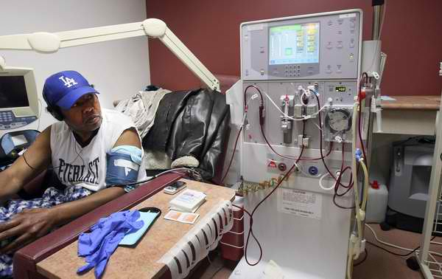
"What's concerning to us is the sheer lack of basic blocking and tackling within these organizations," said Sam Glines, chief executive of Norse. "Firewalls were on default settings. They used very simple passwords for devices. In some cases, an organization used the same password for everything.
"A decent percentage of these firms could have been eliminated from the data set if basic network and security protocol had been followed," he added.
The surge in attacks comes as hospitals and doctors across the country are using more and more medical devices that are connected to the Internet in some fashion. It's part of the broader trend known as the "Internet of Things" in which a growing range of devices are being fitted with sensors and Internet connections.
In addition, more patient information is being placed online, in part through the growing network of federal and state health insurance exchanges.
"The pace at which technology has allowed our devices to be connected for ease of use has allowed for a larger attack surface," Glines said. "More vigilance is required."
But as the report found, there are often not enough security measures taken to protect these connected devices.
As a result, patient information and privacy can be compromised.
But another troubling aspect is that once attackers gain access to these devices, they can use them to launch attacks on other devices.
Indeed, the report tracked the origin of some of the malicious traffic coming out of medical sites that had been hacked:
"The findings of this study indicate that 7% of traffic was coming from radiology imaging software, another 7% of malicious traffic originated from video conferencing systems, and another 3% came from digital video systems that are most likely used for consults and remote procedures."
In following the trails of this malicious traffic, Norse found detailed information about the layouts of hospitals and specifications of various lifesaving equipment.
Glines said the vulnerability can be addressed in many cases. But still, he's worried that healthcare providers may not move quickly enough.
"It's going to accelerate as we have more and more connected devices," Glines said. "With more healthcare information coming online, it becomes more valuable and therefore a richer target. We expect to see an uptick of breaches related to healthcare. It’s sort of a perfect storm."

Cyber Attacks – The New WMDs?
Source: http://www.pymnts.com/briefing-room/security-and-risk/online-and-cyber-fraud/2014/cyber-attacks-the-new-wmds

"Cyberattacks are likely to eclipse terrorism as a domestic danger over the next decade. … That’s where the bad guys go. There are no safe neighborhoods. All of us are neighbors online.” – FBI Director James Comey, The Guardian

Here are the cold hard facts.
According to Kaspersky Lab, 91 percent of organizations suffered a cyberattack in 2013. That included half of the world’s securities exchanges.
Here in the U.S., we began 2013 with an attack on nine of our largest banks and ended it with a massive attack on one of its largest retailers, Target. In between, it was reported by ABC News that 140 banks were listed as potential targets in the potential cyber-attack campaign known as OpUSA.
Worrying about these kinds of attacks drove cyber security spending globally to a record-breaking $46 billion last year – not to mention the costs of shattering consumer confidence in the safety and soundness of our payments and financial systems.
These cyber mercenaries all have different objectives. Some just want to wreak havoc and create massive inconvenience. Others want to inflict far more damage by stealing consumer data and, ultimately, money and valuables.
No wonder Comey called cyber terrorism one of the world’s biggest threats.
What’s clear, though, is the need for a new roadmap, a new compass and a new approach to fighting the bad guys in our new 24/7 neighborhood. WE need one that we all move in and out of every day with ease, thanks to our connected devices and mobile phones and the cloud and new technologies.

Organizing Chaos: Hospital Evacuation During Hurricane Sandy
By Amesh A. Adalja, MD, FACP, FACEP
Source: http://www.upmc-cbn.org/

Abstract
From October 22 to 31, 2012, Hurricane Sandy affected 14 US states and Washington, DC, causing particularly severe damage in New York and New Jersey. It was the second costliest hurricane in US history and caused 43 deaths in New York City and tens of thousands of injuries. When Sandy hit New York City on October 29, 2012, the flooding and power outages led to the evacuation of residents, hospitals, nursing homes, and assisted living facilities. New York City hospitals and various government agencies evacuated approximately 6,300 patients from 37 healthcare facilities. . . . Despite robust preparedness efforts, the severity of Sandy caught New York City hospitals by surprise because major hospital evacuations were not anticipated. Widespread power outages forced hospitals to rely on backup generators, which subsequently failed because of flooding. When healthcare facilities evacuated, neighboring institutions received the displaced patients.¹

The above abstract summarizes a recently published study that my Center colleagues and I conducted to describe the effect of hospital evacuations on hospitals in New York City.
Sandy made landfall in October 2012, prompting evacuations of thousands of individuals from healthcare facilities. Some facilities in flood prone areas pre-evacuated, but 2 hospitals (Bellevue and NYU Langone) evacuated in the midst of the storm. We sought to understand how the evacuations that occurred during the storm affected the hospitals that took in displaced patients. We also examined how the months-long closure of these 2 facilities affected patient surge in Manhattan hospitals.
Notable findings include the following:
- Hospital emergency managers viewed themselves as part of a coalition and acted accordingly (ie, they turned to one another for help).
- Moving complex patients at tertiary centers required a lot of communication among physicians adept at managing those patients—such cases were not just simple transport decisions.
- Utilizing out-of-state ambulances (as was done when FEMA-contracted ambulances were brought in) posed logistical problems because of unfamiliarity with the city and its hospitals.
- Planning for special populations is crucial (eg, patients on dialysis, patients on methadone), as they presented to EDs after the storm in large numbers.
- Sustained surge required hospitals to remove slack in the system and convert open space into patient care areas.
- Credentialing of displaced physicians was challenging, but feasible.
- Pre-evacuation is much less daunting a task than real-time evacuation.
- Hurricane Irene, during which pre-evacuation was considered an over-response, conditioned the response to Sandy.

Optimizing Evacuation
As hospital evacuation is a core component of hospital emergency preparedness and leverages the power of healthcare coalitions, we hope this study will help inform how hospitals nationwide plan for evacuations and other catastrophic health events in the future. By learning from the experience of Sandy, a path may be cleared to making an unavoidably chaotic process a little smoother.

Reference
Adalja AA, Watson M, Bouri N, Minton K, Morhard RC, Toner ES. Absorbing citywide patient surge during Hurricane Sandy: a case study in accommodating multiple hospital evacuations. Ann Emerg Med 2014.

What It’s Like to Run a One-Person Department
Source: http://www.emergencymgmt.com/disaster/The-One-Person-Shop.html

From drawing up emergency plans and coordinating projects to establishing relationships with first responders, the tasks of preparing and educating a county population about what to do when disaster strikes can be overwhelming, even with the resources and staff to do it. But in most small jurisdictions in remote areas of the U.S., one person is commonly charged with doing all of that and with very few resources.
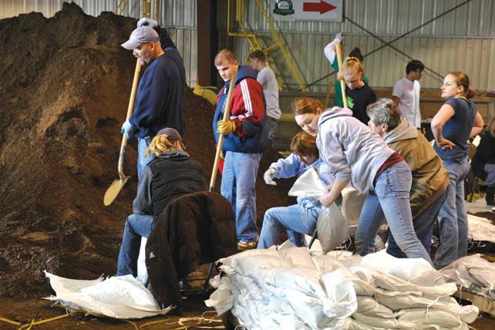
But these emergency managers survive and even thrive by embracing collaboration and taking the challenge of doing more with less in rural communities head-on. For example, in Wilkin County, Minn., which has a population of just under 6,600, Emergency Management Director Breanna Koval depends on her colleagues in surrounding counties for all facets of her job. She explained that because of her location in west central Minnesota, almost all the counties are one-person shops and they stay in constant contact with one another.
“On a daily basis we’re always asking one another questions on how we do things,” Koval said. “What agencies we’re talking to, contacts for agencies, how things were accomplished.”
That sense of togetherness seems to echo throughout many of the one-person emergency management offices in remote areas. The general sentiment among emergency managers in those situations is one of resolve to get the job done and lean on one another for support.
Dave Rogness, emergency services coordinator of Cass County, N.D., called his job “all about relationships.” He’s responsible for emergency plans and response activities for 27 incorporated cities and 52 townships in Cass County. The only city not in Rogness’ purview is Fargo, which has its own emergency manager. The two operate under a joint powers agreement, so when one person is out of town, the other is on call.
Rogness coordinates with 17 fire departments, along with a variety of ambulance units and law enforcement personnel.
“We try to involve as many of those entities as we can, because frankly, I have no staff,” Rogness said. “It’s me and a secretary that I share with some other folks, and I really have no resources either. I have no equipment to be able to train or respond or do any of those kinds of things.”

Establishing Priorities
Resource-challenged emergency managers must find alternative means to get projects done. From establishing volunteer groups to prioritizing the workload, many said it’s a balancing act to keep a location as prepared for a disaster as it should be.
Tricia Kriel, emergency manager of Ransom County, N.D., which has a population of approximately 5,400, keeps it simple. What she works on during a week depends on what’s the most pressing need at the time. If there’s a flood, everything else gets pushed to the side until the entire emergency period is over. Her approach is mimicked by many of her colleagues in one-person shops.
Doug McGillivray, former emergency manager of Yamhill County, Ore., took an organized but basic approach to his job. He kept a simple white board in his office listing all the projects he was working on in one column, and all the activities he wanted to be involved in, in another column.
McGillivray said people would be amazed by how many items from each column switched places during a year. He retired last October, but called his old job a “tap dance” regarding priorities. Koval agreed with that assessment and said that like McGillivray, she’s big on lists. At any given time, she has a checklist of tasks she’s identified as her priorities for a week, month or quarter, and works off of it.
“What’s a priority this afternoon may not be tomorrow morning — things change,” McGillivray said. “The important [projects] get done, those of less importance, they languish, but we pay attention to them as we can.”

Outreach Activities
Community engagement is a critical factor for preparedness in small jurisdictions. From coordinating volunteer groups to connecting with the public online through social media, getting people to sit up and take notice about what needs to be done in their neighborhoods could make a big difference in the event of a disaster.
Rickey Jaggers, director of the Pontotoc County Emergency Management Agency in Mississippi, (population of nearly 30,000) drawsheavily on volunteers throughout his jurisdiction. While Jaggers is responsible for drafting all the emergency management plans for the municipalities and schools in the county, when an emergency happens, people are ready to pitch in and help.
The county operates off 15 specific functions to staff its EOC, and Jaggers has volunteers for all of them. He’s currently training new people to be backups, so that the county is two-deep for every position.
McGillivray has found enormous success with volunteers as well. When he took the job with Yamhill County in December 2008, he placed a priority on building up the county’s Community Emergency Response Team. It now has more than 400 members, including 25 volunteers that are licensed amateur radio operators.
According to Rogness, one of the advantages when working in a small or remote county is citizens realize that during an emergency, everyone is expected to lend a helping hand. He said his biggest priorities are behind-the-scenes tasks and networking to make sure everyone is on the same page about what to do during a disaster.
From business owners to schools and nonprofit organizations, Rogness said all entities have a role to play. While it’s still primarily a volunteer-based system, it works and helps Rogness get his job done before, during and after an emergency.
For example, during flooding, the county’s universities, high schools and junior high schools are activated to fill and place sandbags. That stems from Rogness’ relationships with school superintendents. The schools provide the students, transportation and staff members to assist and coordinate the groups.
Outreach also can extend in the opposite direction. Jaggers recalled when an F3 tornado ripped through parts of Mississippi and Alabama a few years ago, he jumped in his own vehicle as a citizen and went to Tuscaloosa to help the area. Jaggers said it was a way to “pay it back” when others come up to assist him, and he believes most emergency managers in smaller areas would do the same.
“We go and help one another,” he added. “We don’t really care about the money.”
Technology also plays a part in prepping a community for a disaster. Kriel and Koval use social media to spread the word to residents about preparedness activities and important news regarding emergency planning. Both managers primarily use social media to remind people about severe weather expected in their respective counties. But it helps let people know what they should be doing, particularly if there’s going to be a flood.
In addition, old-fashioned newspaper advertisements and mailings have also been helpful, particularly for Koval during National Preparedness Month in September.
“We’ll send something to the paper, or I send packets of information to day cares, schools and group homes to target those more at-risk populations,” Koval said. “I try to be present at larger events like National Night Out or some of the senior events in town where they have information fairs.”

Challenges
Like many public-sector offices, money is always a difficult obstacle. Most of the one-person emergency management departments operate on small budgets that are significantly supplemented by funding from FEMA’s Emergency Management Performance Grants (EMPG) program.
While Yamhill and Cass counties have budgets of approximately $300,000 and $200,000, respectively, much of that comes from EMPG. By way of comparison, Ransom, Wilkin and Pontotoc counties are all well under $100,000. Most of those budgets are used to pay the emergency manager’s salary, administrative staff costs and program implementation. There isn’t a lot left over for extensive marketing campaigns or training. “EMPG is vital for my department because it pays to have me here,” Koval said. “But it doesn’t pay all of it. We get a small allocation, so it means I can only use so much. It pays a portion of my salary and that’s about it. The county is responsible for covering the rest.”
Jaggers is in a similar boat. His fiscal 2013 budget was $63,000, which covers his salary, costs to operate the office and half the salary of an administrative assistant he shares with another department. Jaggers said if EMPG funding disappears, his job would end because the county can’t afford to keep him full time.
Koval is most concerned with a lack of equipment and responders. EMPG funding is based on population, and because Wilkin County is small, there just isn’t enough money to adequately stock up resources in case of an emergency. If something happens, she’ll pull in equipment from the state or ask another county, but the lag time could result in loss of life or further property damage.
Another concern is the increasing frequency of school shootings. The risk of a shooter infiltrating an educational institution is real, and emergency managers are concerned.
From a lack of time to not having the authority, preparing a community for this threat can be difficult, particularly since not every county government is responsible for the emergency plans in educational facilities.
For example, Kriel said that although the schools in Ransom County are responsible for their own emergency details, she’s still in the midst of planning an “active shooter” exercise using some contractors — just so she and colleagues from other counties are prepared.
McGillivray thought that minimally, emergency management should be a presence in schools twice a year and that general preparedness information should be institutionalized in Yamhill County academic institutions.
“I don’t have time to do all this, and I’ve been squawking about it for 15 years,” McGillivray said.

Qatar – A ‘green wave’ for emergency vehicles
Source: http://www.gulf-times.com/Mobile/Qatar/178/details/381619/A-%E2%80%98green-wave%E2% 80%99-for--emergency-vehicles

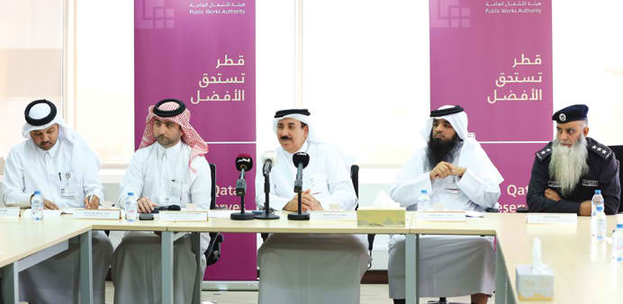
The newly-installed Emergency Vehicle Pre-emption Systems (EVPS) at 30 major intersections across Doha and its immediate neighbourhoods are expected to ensure smooth movement of ambulances and Civil Defence vehicles through the traffic signals in the event of emergency operations.
Senior officials of Ashghal and Ministry of Interior’s Department of Transport yesterday said more of such equipment is to be installed across the country in the coming months as part of the government’s commitment to improve the country’s traffic infrastructure.
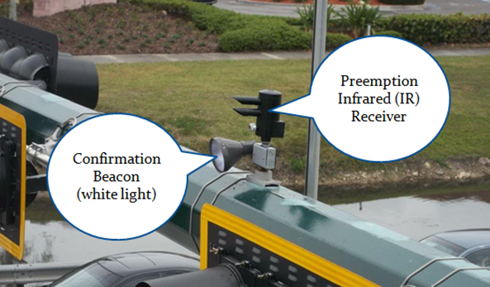
The new equipment will allow traffic lights at intersections to recognise Civil Defence vehicles and ambulances as they approach the signals and ensure their uninterrupted movement by switching on the green signal automatically if the red light is on. The whole programme of installation and maintenance for 24 months cost roughly QR3mn.
The EVPS equipment is installed mainly on some of the main roads in Doha and neighbouring areas, including Rayyan and the Industrial Area. The equipment consists of devices installed on emergency vehicles and at the intersections besides master software at Ashghal’s traffic control room in West Bay.
While explaining the features of the EVPS, Ashghal’s senior engineer and director of asset affairs, Hamad al-Tamimi (center in the photo above), said the advance system included GPS devices, supported by sensors which detect the signals from the Civil Defence vehicles and ambulances.
Until now, 15 ambulances and 10 Civil Defence cars are equipped with remote controls capable of sending signals to the traffic lights located more than 100m away.
Ashghal’s manager of road operations and maintenance Yousef al-Emadi hoped the EVPS would cut down significantly the response time of emergency and Civil Defence vehicles and reduce risks of accidents.
“This is because the ambulances or Civil Defence vehicle drivers press a button on the remote control in their vehicles to open the traffic light and ease the traffic flow in front of them,” he said.
Abdul Azeez al-Sada, the head of safety and traffic control at Ashghal, said the new devices would help streamline traffic on busy roads while ambulances and Civil Defence vehicles are involved in emergency operations.
“The safety of traffic flow is taken into account as other traffic signals at the intersections turn red before sensors mounted on the Civil Defence cars and ambulances and traffic lights open their path.”
The Ashghal official said the vehicles installed with the new equipment would soon be distributed to several locations taking into consideration the impact on the response time to the emergencies.
The drivers of ambulances and Civil Defence cars are trained to use the new system which will not be used except in critical situations.
A committee consisting of the officials of Ashghal, the General Directorate of Civil Defence and Hamad Medical Corporation has been constituted to monitor and assess the new system and provide recommendations and suggestions for improving its performance in the coming months.

Qatar – HMC air ambulance service gets new helicopters
Source: http://www.gulf-times.com/Mobile/Qatar/178/details/381618/HMC-air-ambulance-service-gets-new-helicopters
HE al-Qahtani presenting a plaque of appreciation to a senior official while Dr al-Kuwari look on. One of the newly-launched LifeFlight helicopters is in the background

The air ambulance service at the Hamad Medical Corporation (HMC) yesterday (Feb 17) received a boost with three new helicopters joining its LifeFlight operations.
A ceremony to mark the occasion was held in the presence of HE the Minister of Public Health Abdullah bin Khalid al-Qahtani, Army Headquarters chief of staff Major General Ghanim bin Shaheen al-Ghanim and HMC managing director Dr Hanan al-Kuwari.
The introduction of the new Agusta Westland AW139 LifeFlight helicopters will increase access to safe and effective emergency healthcare while ensuring air ambulance coverage even in the remotest areas of the country.
Two of the new helicopters, which will be in operation round-the-clock, replace smaller ones previously in use. The third helicopter will be on standby as a back-up for the two in service.
The new helicopters are being primarily used to transport seriously injured persons as quickly as possible from the scene of an emergency to hospital.
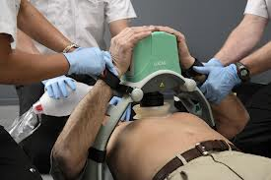
The helicopters are fitted with the most up-to-date medical equipment such as the LUCAS II chest compression device (photo) to enable chest compressions to continue for a patient while in transit.
According to Ambulance Service chief executive officer Dr Robert Owen, the new helicopters are larger and roomier than the old ones.
“These are pretty larger than the previous helicopters and can take two patients, treat them simultaneously and both patients have equipment as same as in the intensive care unit.”
The official said that during flight, patients could be monitored while defibrillator and infusion could also be done.
“The aircraft themselves are an excellent platform for air ambulance as they are very powerful and extremely fast. They have vibration dampening system in place, as helicopters make lot of vibrations while flying but the aircraft are largely soundproof,” the official said.
“Two pilots control each helicopter. On board the helicopter is a critical care flight paramedic and flight ambulance paramedic at all times to administer emergency medical care both at the scene of the incident and on flight to hospital. These are the most advanced air ambulances that you can find anywhere in the world,” the official said.
The pilots of the helicopters are from the Qatar Emiri Air Force (QEAF) and the launch of the air ambulances signified a new working relationship between HMC and QEAF.
“Because the ambulance are really sophisticated and fitted with advanced technology they will be based in Al Udeid Air Force base in order to get access to engineering maintenance that they will need,” Dr Owen said.
The air ambulance service is mainly for the Sealine area, Al Khor and other rural areas as well as abroad including Saudi Arabia and the UAE.
The helicopters complement a diverse fleet that has been planned and put together with Qatar’s specific needs in mind.
“These helicopters are an essential element of the fleet and they are most appropriate in cases where speed is of the essence. Of course this isn’t always the case, and the helicopter is not always the most appropriate transport to the hospital, but they are extremely necessary to the overall fleet and play an integral part in the HMC Ambulance Service, providing access to the safest and most effective care for the people of Qatar,” Dr Owen added.
Ambulance Service deputy medical director Dr Ibrahim M Fawzy Hassan pointed out that the helicopters could get emergency medical teams to the scene of a serious incident quickly.
“At the ambulance service, we are always looking for ways to get the best clinical care to patients as quickly as possible. This is how we can improve mortality rates and provide the people of Qatar with a top quality service. The launch of these LifeFlight helicopters marks a very important addition to the service and one that will greatly benefit our patients.”
Other vehicles include the fully equipped Mercedes Benz Sprinter ambulances, with a streamlined shape designed to cut through the Qatar traffic and the Toyota Landcruiser GX’s that enable paramedics to access patients in the desert.
There are presently now some 48 spokes and six hubs for easy ambulance distribution across Qatar.

EDITOR’S COMMENT:

I participated as an instructor at the “Training Course for First Responders Medical Personnel on “Response to Chemical Disasters” held by the National Committee for the Prohibition of Weapons (NCPW) in Doha (18-20 Feb 2014) and I had the opportunity to collaborate with medical colleagues from Qatar’s medical system (HMC). I was impressed by the new technologies incorporated into their response planning and their ambition for effective response in all terrains and all possible hazards! Well done Qatar!

Extreme weather wreaks havoc on global food crops
Source: http://www.yakimaherald.com/news/latestnews/1846779-8/extreme-weather-wreaks-havoc-on-global-food-crops

Volatile weather around the world is taking farmers on a wild ride.
Too much rain in northern China damaged crops in May, three years after too little rain turned the world’s second-biggest corn producer into a net importer of the grain. Dry weather in the U.S. will cut beef output from the world’s biggest producer to the lowest level since 1994, following 2013’s bumper corn crop, which pushed America’s inventory up 30 percent. British farmers couldn’t plant in muddy fields after the second-wettest year on record in 2012 dented the nation’s wheat production.
“Extreme weather events are a massive risk to agriculture,” said Peter Kendall, president of the British National Farmers Union, who raises 3,953 acres of grain crops in Bedfordshire, England. “Farmers can adapt to gradual temperature increases, but extreme weather events have the potential to completely undermine production. It could be drought, it could be too much rain, it could be extreme heat at the wrong time. It’s the extreme that does the damage.”
Farm ministers from around the world are gathered in Berlin in January to discuss climate change and food production at an annual agricultural forum, with a joint statement planned after the meeting.
Fast-changing weather patterns, such as the invasion of Arctic air that pushed the mercury in New York from an unseasonably warm 55 degrees Fahrenheit on Jan. 6 to a record low of 4 the next day, will only become more commonplace, according to the New York-based Insurance Information Institute. While the world produces enough to provide its 7 billion people with roughly 2,700 calories daily, and hunger across the globe is declining, one in eight people still don’t get enough to eat, some of which can be blamed on drought, the United Nations said.
“There’s no question, while there’s variability and volatility from year to year, the number and the cost of catastrophic weather events is on the rise, not just in the U.S., but on a global scale,” said Robert Hartwig, an economist and president of the insurance institute. “It’s all but certain that the size and the magnitude and the frequency of disaster losses in the future is going to be larger than what we see today.”
The number of weather events and earthquakes resulting in insured losses climbed last year to 880, 40 percent higher than the average of the last 30 years, according to Munich Re, the world’s largest reinsurer.
Research points to a culprit: an increase in greenhouse gases, generated by human activity, that are forcing global temperatures upward, said Thomas Peterson, principal scientist at the U.S. National Climatic Data Center in Asheville, N.C. The warmer the air, the more water it can hold, he said.
“What we’re finding worldwide is that heavy precipitation is increasing,” Peterson said.
Flood waters in Passau, Germany, in May and June reached the highest level since 1501, Munich Re said. That was the year Michelangelo first put a chisel to the block of marble that would become his sculpture of David. High water did $15.2 billion in damage in parts of Central and Eastern Europe, according to Munich Re.
A July hailstorm in Reutlingen, Germany, led to $3.7 billion in insured losses, according to Munich Re. Hailstones the size of babies’ fists cracked the windshield of Marco Kaschuba’s Peugeot.
“Two minutes before the storm started you could already hear a very loud noise,” said Kaschuba, a 33-year-old photographer. “That was from hailstones hitting the ground in the distance and coming closer.”
In 2012, Britain had its second-highest rainfall going back to 1910, according to Britain’s meteorology office. England and Wales had its third-wettest year since 1766.
December marked the worst blizzard since 1953 in Jerusalem, dumping 15 inches of snow on Israel’s capital, where more than 4,000 people were rescued from their vehicles, according to police.
“It was like a neutron bomb hit,” said Eilon Schwartz, 56, an environmental activist living in Tel Aviv who had taken his 11-year-old daughter to play in the snow with friends. “All these cars marooned in the snow and no people.”
December was also Norway’s wettest month in history, according to weather service YR.
Rainfall last year in the contiguous U.S. was 7 percent higher than the 20th century average, according to the National Oceanic and Atmospheric Administration. Yet it was difficult to draw broad conclusions because of regional variations. Michigan and North Dakota set records for wetness, while California set its own for lack of rain, NOAA said.
Other weather phenomena were similarly topsy-turvy. China shivered through its coldest winter in at least half a century in 2010. Three years later, Shanghai was suffocated by its hottest summer in 140 years, according to the city’s weather bureau.
Record flooding hit the Mississippi River in 2011. The next year, record-low water levels stranded barges, choking the flow of coal, chemicals and wheat.
Such fluctuations were reflected in food prices. In the past three years, orange juice, corn, wheat, soybean meal and sugar were five of the top eight most volatile commodities, according to data on 34 compiled by Bloomberg. Natural gas was No. 1.
While the percentage of the world’s people who go hungry has fallen to 12 percent last year from 19 percent in 1992, and food inflation is ebbing, farming is vulnerable to the extreme weather that comes with climate change, according to the United Nations.
Record harvests from India to Brazil to the U.S. expanded supply and sent corn, soybeans, wheat, sugar and coffee into markets where prices were falling. The Standard & Poor’s GSCI Agriculture Index of eight crops tumbled 22 percent last year, the biggest annual drop since 1981. The gauge is down 0.8 percent in 2014.
Yet higher food costs pushed 44 million people into poverty from June 2010 to February 2011, the World Bank estimated. The three years in the past two decades when global food costs were highest all occurred after 2007, according to the U.N. Historic drought on four continents over the last five years is partly to blame.
“A drought is really all-consuming,” said northeast Texas rancher Phil Sadler. “It doesn’t necessarily have to be on your place to feel the impact.”
The record Texas dry spell in 2011 was followed the next year by the most severe drought in the U.S. Midwest since the Dust Bowl of the 1930s. Texas cattle herds dwindled, driving the price of beef to a record in the U.S., the world’s biggest producer. As of the beginning of last year, ranchers in Texas had reduced their herds to the smallest since 1967, according to the Agriculture Department. The U.S. herd has shrunk for six straight years and last year was at its smallest since 1952, government data show.
“We had to liquidate our herd in order to be able to take care of what we had left,” Sadler said.
Even as rain returned to Texas in 2012, the problems weren’t over for ranchers such as Sadler. The Midwest drought boosted prices of corn and soybeans, used for feed, to all-time highs. The 2011 drought caused a record $7.62 billion in farm losses in Texas, including $3.23 billion for livestock producers, according to Texas A&M University’s AgriLife Extension Service in College Station.
Russia suffered its worst dry period in at least 50 years in 2010 and two years later lost about 25 percent of its grain harvest in another dry spell, according to the country’s Grain Producers Union.
Authorities declared a drought in 2013 across the entire North Island of New Zealand, the world’s biggest dairy exporter, as some areas were the driest in as many as 70 years, according to the government. That pushed the price of whole-milk powder to a record in April last year at Fonterra Cooperative Group Ltd’s GlobalDairyTrade auction.
In 2012, Spain had its driest winter and second-driest summer since at least 1947, cutting olive oil and wine volumes to the lowest in at least a decade.
A temperature of 110 degrees in Melbourne halted tennis matches last week at the Australian Open.
The violent ups and downs of the weather in the last few years have vexed agricultural producers, said Ross Burnett, who farms cotton in the northeastern Australian state of Queensland. A drought there, in the country’s biggest sugar- and beef-producing region, follows flooding in 2010 and 2011 so bad it stopped the steady rise of sea levels around the world, according to the U.S. National Center for Atmospheric Research.
“The variability is the most difficult part of it,” Burnett said. “It’s difficult given it can change overnight.”

Fire Consumes Villages in Norway
Source: http://abcnews.go.com/International/wireStory/fire-consumes-villages-northern-norway-22266 417

Jan 28 – Firefighters are struggling to control a blaze in central Norway that has destroyed most of two small villages and forced the evacuation of dozens of residents.
Strong winds spread the fire over a 6-square-mile (15-square-kilometer) area Tuesday, destroying 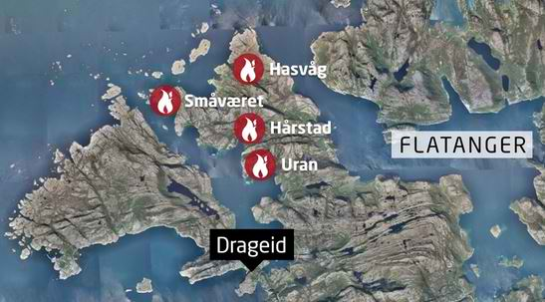around 90 buildings, including homes and holiday cabins, and preventing helicopters from the fire service and civil defense forces from tackling the blaze.
The fire started Monday night in Flatanger municipality, about 60 miles (100 kilometers) north of Trondheim. Officials say it probably began from sparks from power lines.
Local sheriff Nils Roger Duna says he hopes around 50 buildings in the two villages might be salvaged. There were no reports of any injuries.

EDITOR’S COMMENTS: Earlier Jan 2014, parts of a heritage village in Lærdal were gutted in a similar uncontrollable blaze, injuring some 50 people. It is a coincidence that all three “historic” villages are also common tourist destinations. Or perhaps it is not. Sparks from the electric grid sound a quite persuative cause in combination with unusual mild winter but is it the only cause? Just sharing some asymmetric thoughts outloud.

Protecting cities from floods cheaper than post-flood damage repairs
Source: http://www.homelandsecuritynewswire.com/dr20140205-protecting-cities-from-floods-cheaper-than-postflood-damage-repairs

Researches have concluded that it would be more cost effective for the economies of most coastal areas to employ flood prevention strategies rather than pay to clean up after flooding that occurs as a result of global warming. In a paper published in the Proceedings of the National Academy of Sciences, the researchers discuss likely flooding scenarios in the future as global warming cause ocean levels to rise, and the costs of building structures to prevent flood damage.
A PNAS release quotes the researchers to say that global warming is here to stay, and thus it is time to start making plans for dealing with the inevitable flooding which will occur as ocean levels rise as a result of warmer water and melting snow and ice. They note that approximately a billion people currently live in areas that are likely to be at risk — low-lying coastal areas. Since it is not likely that towns and cities will be moved farther inland, other measures need to be taken. The researchers say that flood prevention strategies are well established, for example, building levees, barrier islands, etc., so it is not difficult to draw up estimates for such schemes for individual areas. What is difficult is convincing cities and towns to spend billions of dollars on preventing floods which will not occur for many years.
The paper highlights the high financial toll which floods take, compared to the relatively small investment which would be required for flood prevention. They note, for example, that one developed coastal urban area could see damages from increased flooding reaching to nearly $20 trillion annually – which is more than the U.S. annual GDP of about $17 trillion. It would thus be cheaper to prevent the flooding in the first place.
The paper acknowledges that there would be significant differences in the costs of building flood control measures in different parts of the world, but say that even in areas where flood prevention measures would be the costliest, they will still be less expensive than remedial measures taken time and again in the wake of repeated flooding.
The paper notes, though, that having flood prevention system in place should not lead to a sense of security and complacency. Flood-control levees along the Mississippi River led people to believe that it would be safe to build in flood plains, but when the levees failed, the results were catastrophic.

— Read more in Jochen Hinkel et al., “Coastal flood damage and adaptation costs under 21st century sea-level rise,” Proceedings of the National Academy of Sciences (20 December 2013)

Attack on California power station heightens concerns about grid security
Source: http://www.homelandsecuritynewswire.com/dr20140207-attack-on-california-power-station-heightens-concerns-about-grid-security

Security experts are concerned that last year’s attack, which is yet to be solved, on an electrical-power substation in San Jose, California, is but a prologue to similar attacks which, if executed simultaneously and in a coordinated fashion against several such substations, could cripple the U.S. power grid.
The Wall Street Journal on Wednesday offered a detailed report on the 16 April 2013 incident at the Metcalf transmission station in San Jose.
The transformers at the substation, vital for regional power distribution, were shot at by several gunmen and disabled for twenty-seven days.
The Washington Post reports that the attack did not cause major power disruptions because officials were able to reroute electricity around the damaged substation.
What is especially worrisome, security exert note, is that the attack appeared to have been carried out by people with some training, although the FBI said the agency does not think it was the act of terrorists. The Journal notes that shell casings left at the scene had no fingerprints on them, and investigators notices piles of small rocks near the point from which the shooters fired their weapons, indicating that a scouting team may have watched the power station before that shooting.
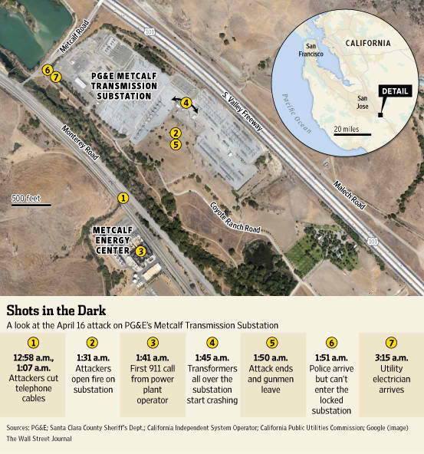
The attack began with at least one person entering an underground vault to cut telephone cables. The attackers then fired more than 100 shots, disabling seventeen transformers. The attack lasted fifty-two minutes, indicating that the shooters, based on their scouting of the area, knew they would not be noticed or disrupted.
“It’s still an ongoing investigation,” Brian Swanson, a spokesman for Pacific Gas and Electric (PG&E), which owns the substation, told the Post. “We’re not going to speculate as to the possible motive before the investigation is complete.”
The Journal’s account relied on analysis from Jon Wellinghoff, a former chairman of the Federal Energy Regulatory Commission (FERC). Wellinghoff, who now works for a San Francisco law firm, told the Journal that the attack was “the most significant incident of domestic terrorism involving the U.S. power grid that has ever occurred.”
Transformers such as those disabled in the attack are an essential and difficult-to-replace component of the national electrical grid.
The Post notes that in recent years, much of the concern about the safety of the electrical grid focused on cyberattacks, but the California attack was a demonstration that inflicting physical damage on a substation could be disruptive. An attack on any one substation may be compensated for by rerouting power, but the worry is about several such substations, especially if they are located in the same region, attacked at the same time, an event which would likely result in partial collapse of the grid and long blackout periods.
A 2012 report by the National Research Council found that high-voltage transformers “are the single most vulnerable component of the transmission and distribution system”.
“This has been the principal thing that has worried a lot of us, about vulnerability of the power system. Because transformers, especially the higher-voltage ones, tend to be very unique. They’re very hard to replace. And they’re very vulnerable,” M. Granger Morgan, a professor at Carnegie Mellon University who led the council’s study, told the Post said in a telephone interview.
“It’s probably a more serious issue than the cyber concerns,” Morgan said. “With cyber, it’s really hard to see that you could do much that caused long-term, serious damage. Whereas this is a strategy that could really mess up the power system not just for weeks, but for months at a time.”
Republican-led House Energy and Commerce Committee said Wednesday that lawmakers continue to follow the probe and that protecting the grid remains a top priority.
“We are aware of the attack and continue to monitor the investigation closely,” a committee spokeswoman told Fox News. “Committee staff has been briefed by agency officials and industry representatives. The security and reliability of the grid is a pressing concern, and we will continue our work to mitigate all emerging threats.”
At an industry gathering a few months ago, retired PG&E executive Mark Johnson said that he feared the attack was a dress rehearsal for a larger event.
Scott Aaronson, the Edison Electric Institute’s senior director of national security policy, said that “The industry takes its role as critical infrastructure providers very seriously…. Publicizing clearly sensitive information about critical infrastructure protection endangers the safety of the American people and the integrity of the grid.”

Coastal areas must adapt to sea-level rise and storm surges or suffer massive damage
Source: http://www.homelandsecuritynewswire.com/dr20140210-coastal-areas-must-adapt-to-sealevel-rise-and-storm-surges-or-suffer-massive-damage

According to the study published in the Proceedings of the National Academy of Sciences (PNAS), global average storm surge damages could increase from about $10-$40 billion per year today to up to $100,000 billion per year by the end of century, if no adaptation action is taken.
A University of Southampton release reports that the study, led by the Berlin-based think-tank Global Climate Forum (GCF) and involving the University of Southampton, presents, for the first time, comprehensive global simulation results on future flood damages to buildings and infrastructure in coastal flood plains. Drastic increases in these damages are expected due to both rising sea levels and population and economic growth in the coastal zone. Asia and Africa may be particularly hard hit because of their rapidly growing coastal mega-cities, such as Shanghai, Manila, and Lagos.
“If we ignore this problem, the consequences will be dramatic,” explains Jochen Hinkel from GCF and the study’s lead author. In 2100, up to 600 million people (around five per cent of the global population) could be affected by coastal flooding if no adaptation measures are put in place.
“Countries need to take action and invest in coastal protection measures, such as building or raising dikes, amongst other options,” urges Hinkel. With such protection measures, the projected damages could be reduced to below $80 billion per year during the twenty-first century. The researchers found that an investment level of $10 to $70 billion per year could achieve such a reduction. Prompt action is needed most in Asia and Africa where, today, large parts of the coastal population are already affected by storm surge flooding.
Investment, however, must also occur in Europe as shown by the recent coastal floods in South West England (see “Coastal flooding in Ireland offers warning of things to come,” HSNW, 21 January 2014). Professor Robert Nicholls from the University of Southampton, who is a co-author of the paper, says: “If we ignore sea-level rise, flood damages will progressively rise and presently good defenses will be degraded and ultimately overwhelmed. Hence we must start to adapt now, be that planning higher defenses, flood proofing buildings and strategically planning coastal land use.”
Meeting the challenge of adapting to rising sea levels will not be easy, explains Hinkel: “Poor countries and heavily impacted small-island states are not able to make the necessary investments alone, they need international support.” Adding to the challenge, international finance mechanisms have thus far proved sluggish in mobilizing funds for adapting to climate change, as the debate on adaptation funding at the recent climate conference in Warsaw once again confirmed.
“If we do not reduce greenhouse gases swiftly and substantially, some regions will have to seriously consider relocating significant numbers of people in the longer run,” adds Hinkel. Yet regardless of how much sea-level rise climate change brings, the researchers say careful long-term strategic planning can ensure that development in high-risk flood zones is appropriately designed or avoided.
Professor Nicholls says: “This long-term perspective is however a challenge to bring about, as coastal development tends to be dominated by short-term interests of, for example, real-estate and tourism companies, which prefer to build directly at the waterfront with little thought about the future.”

— Read more in Jochen Hinkel et al., “Coastal flood damage and adaptation costs under 21st century sea-level rise,” Proceedings of the National Academy of Sciences (20 December 2013)

U.K. facing flood crisis, as Prime Minister warns victims they are in for “long haul”
Source: http://www.homelandsecuritynewswire.com/dr20140211-u-k-facing-flood-crisis-as-prime-minister-warns-victims-they-are-in-for-long-haul

Thousands of British homeowners whose homes and communities have been inundated by flooding are in for a “long haul,” Prime Minister David Cameron said, warning that it will “take time before we get things back to normal.”
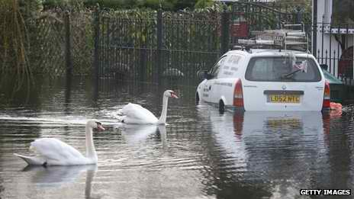
The prime minister, responding to a growing chorus of criticism of the government’s handling of the crisis, said he will “do everything” in his power to help residents amid.
“We have to recognize it’s going to take time before we get things back to normal,” Cameron said. “We’re in for a long haul, but the government will do everything we can to coordinate the nation’s resources.
“If money needs to be spent, it will be spent; if resources are required, we will provide them; if the military can help, they will be there. We must do everything, but it’s going to take time to put these things right.”
The Telegraph reports that the disorganized and ineffective response to the flooding has caused different cabinet ministers to point fingers at each other’s department as the chief culprit. The Environment Agency came in for the harshest criticism.
After Eric Pickles, the Communities Secretary, sharply attacked Lord Smith, the Environment Agency’s chairman, Nick Clegg, the Deputy Prime Minister and Owen Paterson, the Environment Secretary, criticized what they described as the “blame game” being played by members of the government.
When asked what message he had for the members of his cabinet, Cameron said: “A very simple message, which is everybody needs to get on with the vital work of bringing all of the nation’s resources to get our road and rail moving, to help people who have been flooded, to plan for the future and to learn all the lessons of the very difficult situation we’re in. That’s what everyone needs to do, that’s what’s going to happen in the days and weeks ahead.”
Defense Secretary Philip Hammond was embarrassed after he was berated, on live TV, by an angry volunteer who claimed that residents affected by the flooding have been abandoned.
Hammond insisted that the government has “a grip” on the situation, but the volunteer, for seven long minutes, offered detailed examples of how the government had failed to respond to the emergency.
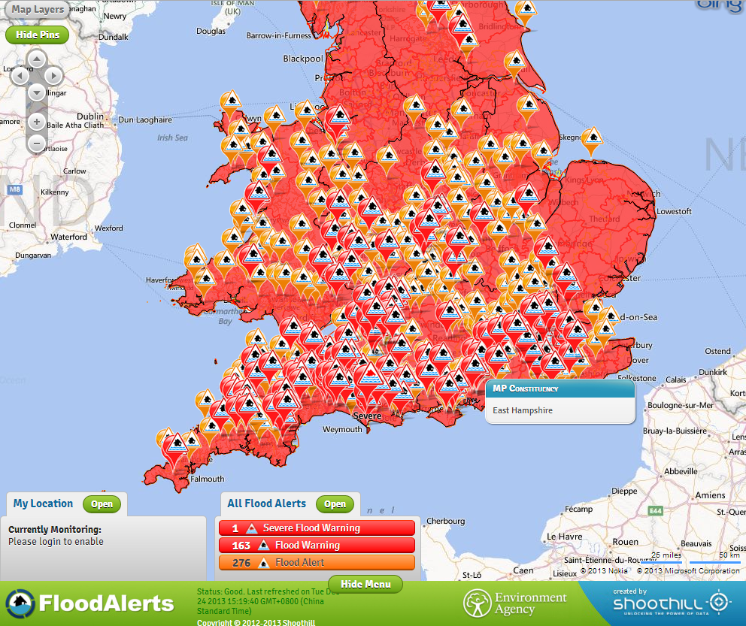
More than 1,000 people have been forced to evacuate their homes, with many more homeowners being told to prepare for evacuation in the coming days as weeks of heavy rainfall shows no signs of abating.
Hundreds of military personnel have been mobilized to help in the worst-affected areas of south west England and the Home Counties, as the government continues to fight not only the weather, but also the perception of lack of action.
The Telegraph notes that about 400 weather warnings remain in place across England, with forecasters predicting further heavy rainfall on already-saturated ground.
What heightened the anger at the government was the fact that in addition to lack of preparation and response – thus, there were many complaints that sandbags intended for the worst-hit areas being “hijacked” and unavailable to stem the rising water – homeowners complained that government agencies have not provided enough security after resident were ordered to evacuate, leading to looting of vacant homes.
As rains continue and rivers overrun their banks, politicians continue their fact-finding tours of deluged communities, declaring that the authorities are doing “everything possible” to repair damage and prevent further destruction.
Communities Secretary Eric Pickles told MPs that in addition to the River Thames, there was a high risk that the River Severn and River Wye would also break their banks, further stretching resources.
The Met Office’s Sarah Davies told a news briefing that strong winds forecast for the middle of the week could add to the problems facing the country, with snow reported today (Tuesday) in pockets of the Midlands.
The weather service says some 20-40 mm (0.75-1.5 inches) of rain is expected by Friday night across many southern and western areas. Some regions, including the already inundated south west of England, South Wales, western Scotland, and Northern Ireland, could have up to 70 mm (2.75 inches).
Davies warned that a storm expected Wednesday would likely fell trees and cause transport and power disruption, with winds in the South West potentially reaching 80 mph.
Cameron spent Tuesday morning in the Devon resort of Dawlish, where the floods destroyed the railway track, cutting off the rail link between Cornwall and the rest of the country.
He said it was “going to take time before we get things back to normal” but ministers would do everything possible.
“It is a huge challenge and we have had the wettest start to a year for 250 years, some of the most extreme weather we have seen in our country in decades,” he said.
Philip Hammond, after being criticized by residents in the Berkshire community of Wraysbury, told the BBC that the “Government has got a grip on this” but authorities cannot “prevent the course of nature.”
“We are dealing with an enormous force of nature here, vast quantities of water, an unprecedented weather pattern, and, while the authorities can and must do everything that is possible, there are some things I’m afraid that we just can’t do,” he said. “We cannot always intervene to prevent the course of nature.”
Hammond, who represents the constituency of Runnymede and Weybridge which has been affected by the flooding, told BBC: “Of course the Environment Agency — obviously under enormous pressure — is doing everything it can to manage this situation.
“Of course there will be longer-term questions about policy on the way flooding defenses are managed, on, for example, the policy of river dredging, and the time to discuss them is when the waters have gone down, when we’ve gone back to normal.”
Officials have predicted hundreds, if not thousands, more homes will be flooded over the coming days and said restoring the country’s damaged rail network could take months.
Pickles chaired the latest meeting of the government’s COBRA emergency committee yesterday as the prime minister visited south west England.
He warned: “Sadly, the worst of the bad weather is not over. But we are working tirelessly to deal with the situation on the ground and to prepare and protect vulnerable areas.”

Signs of New Russian Thinking About the Military and War
Source:http://www.jamestown.org/programs/edm/single/?tx_ttnews[tt_news]=41954&tx_ttnews[backPid]=27&cHash=134185b64418a1f38d0b50522b24b2ca#.Uvxw4vt5HcA

During peacetime, a key function of the General Staff, Ministry of Defense, and key components of them like the Academy of Military Sciences is to determine the nature of contemporary war and the ensuing responsibilities of the armed forces. To judge from the remarks given at the Academy’s annual meeting in late January, Russian thinking is once again in flux. Chief of Staff Valeriy Gerasimov observed on behalf of Defense Minister Sergei Shoigu that the “contradictory geopolitical situation” that has recently developed places “new heightened demands” on Russia’s defense (Interfax-AVN Online, January 27). It appears that those heightened demands encompass both military and non-military threats.
Gerasimov stressed that the crucial task of institutions like the Academy and of the General Staff is to predict and assess military and other threats to Russia and, on that basis, work out proposals for national defense. In particular, and with these non-military and military threats in mind, Gerasimov singled out the need for an “integral theory of non-direct and asymmetrical operations” that the federal authorities must implement under a single plan “in the interests of preventive neutralization” of the threats to Russian security. In this context he also noted that the General Staff’s duties are expanding (see EDM, February 11). Here he particularly singled out Russia’s theoretical response to threats emanating from Syria, Ukraine and the Arctic (Interfax, January 27). It should be noted that Syria is a potential power projection and stability operation, Ukraine could become a similar “stability- or “peace-creating” situation, and the Arctic is a pet project of President Vladimir Putin to defend against alleged threats to Russian energy (see EDM, December 16, 2013).
For Russian writers and officials, not only will contemporary and future war be a war of high-tech precision-strike complexes, it will also encompass a broad range of information warfare or even attempts at creating major economic disasters through conventional, non-nuclear, high-tech, precision strikes. This involves war from earth (or in the case of submarines underwater) to space to the digital realm. Indeed, Russia plans to create cyber warfare units by 2017 (RIA Novosti, January 30). Similarly Russia’s long-range aircraft will start using foreign airfields in 2014 to perform their missions (Interfax-AVN Online, January 22). Furthermore, writers like Konstantin Sivkov, First Vice President of the Academy of Geopolitical Problems, call for imitating the United States’ move to a global strike capability using non-nuclear missiles. This capability is ostensibly for use against terrorists, but clearly also encompasses major theater war (Voyenno-Promyshlennyi Kuryer Online, January 22). Colonel Sergei G. Chekinov (Reserve) and Lieutenant-General Sergei A. Bogdanov (Ret.), prominent writers on information operations, even argue that “non-traditional forms of armed struggle will be used to cause earthquakes, typhoons and heavy rainfall” that can damage not just the economy, but aggravate the overall socio-psychological climate in any targeted country (Military Thought, October–December 2013)
The emphasis on high-tech weapons and information operations, which may encompass broad, socio-psychological manipulation, does not make these writers outliers; rather, they are comfortably in the mainstream of Russian military thought. And their demands that the military be ready to play a more overtly “counter-revolutionary” and, perhaps increasingly, power-projection role have potentially profound repercussions. In particular, it means that future Russian combat operations may be expected to begin with a preventive information strike, not just to disable communications or infrastructure but also to incite mass socio-political upheaval through systematic propaganda. In addition, however, Putin is still calling for an emphasis on nuclear weapons and reconnaissance-communication systems, including space systems (kremlin.ru, January 22). These priorities are to be pursued on top of an already exceptionally ambitious and comprehensive modernization agenda focusing heavily on aerospace and naval systems capabilities. There is no sign that these priorities are being cut back even though it is palpably clear that the defense sector cannot meet the state’s demands (see EDM, December 10, 2013).
The huge military buildup has led, predictably, to naval demands for a fleet that can not only protect Russia but also advance Moscow’s interests in the world ocean through power projection capabilities, as in the case of the Mediterranean and Middle East regions (see EDM, February 4; Voyenno-Promyshlennyi Kuryer, January 16). But once again the gap between theory and ambition on the one hand and reality on the other is enormous. For example, although the Russian Navy claims it accepted 38 new ships for service in 2013, the actual figure is significantly lower—27 in total, including 7 combat ships, 5 auxiliaries and the rest being support vessels (Nezavisimaya Gazeta Online, January 17). Likewise, Defense Minister Shoigu had to admit to the Defense Collegium that the Russian arms industry still cannot meet government requirements, and Prosecutor-General Yuri Chayka recently reported on the continuing prevalence of widespread corruption and embezzlement throughout that sector (Ministry of Defense of the Russian Federation, January 29).
This gap between theory and ambition versus reality incentivizes the Russian Armed Forces’ continuing excessive reliance on nuclear weapons. But it also creates pressures, based on Moscow’s threat assessments of the situations in Ukraine and Syria if not the Arctic, that a systematic campaign of foreign-sponsored terrorism and/or revolution is being waged against Russia. To address these threats, Moscow believes it must react preemptively, even if only by informational means. Russian responses to Ukraine’s crisis may be illustrative of this trend. In short, military and strategic thinking in Moscow still cannot disenthrall itself from the Leninist paradigm of a Russian state under siege from its foreign interlocutors as well as those demanding reforms. Indeed, those enemies are still seen as being inextricably linked together, and as long as that remains the case, Russia will continue to see itself as threatened by a conflict with the West, if not other states.

Studying the 2011 Mississippi and Ohio rivers flood for better flood preparedness
Source: http://www.homelandsecuritynewswire.com/dr20140219-studying-the-2011-mississippi-and-ohio-rivers-flood-for-better-flood-preparedness

In May 2011, when the U.S. Army Corps of Engineers used explosives to breach a levee south of Cairo, Illinois, diverting the rising waters of the Mississippi and Ohio rivers to prevent flooding in the town, about 130,000 acres of Missouri farmland were inundated. It was the largest flood of the lower Mississippi ever recorded, and researchers from the University of Illinois at Urbana-Champaign took advantage of this “once-in-a-scientific-lifetime” occurrence to study the damage, funded by a National Science Foundation Rapid Response Grant. A UI Urbana-Champaign release reports that their results, published this week in the journal Environmental Science and Technology, demonstrate that landscape vulnerabilities can be mapped ahead of time to help communities prepare for extreme flooding.
“There is overwhelming scientific evidence that the characteristics of extreme rainfall under climate change are going to be different,” said Praveen Kumar, a professor of civil and environmental engineering (CEE) at Illinois and project leader on the study. “Forecasts of extremes of rainfall and flooding are not sufficient. The most urgent need is appropriate preparedness based on scientific assessment of landscape vulnerability.”
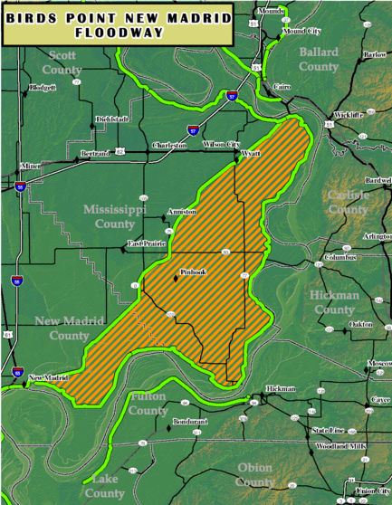
The 2011 activation of the Birds Point-New Madrid (BPNM) Floodway (photo) resulted in the diversion of floodwater for thirty-five miles before it was directed back to the Mississippi at New Madrid, Missouri. The Corps of Engineers also later opened the Bonnet Carré and Morganza spillways in Louisiana to ease pressure on the New Orleans levee system. The decision to inundate farmland was controversial because several hundred people live on the floodplain and the land is agriculturally valuable, said CEE Ph.D. student Allison Goodwell, lead author of the paper.
“The consensus with BPNM is that it worked really well,” Goodwell said. “It had a pretty immediate impact of lowering the levee stages all around the area.”
The release notes that the Illinois team included experts in hydrology, geography and geology, in collaboration with the U.S. Geological Service and the U.S. Army Corps of Engineers. Using a number of sensors they observed changes on the river and throughout the floodplain. They used a unique collection of data from high-resolution pre- and post-flood LIDAR mapping, an optical remote sensing technology, to analyze erosion and deposition from the flood. Using HydroSED 2D, a computer modeling system developed at the University of Illinois, they incorporated two-dimensional flow modeling, soil characteristics and information about vegetation to analyze the vulnerability of the landscape compared with observed impacts. They also compared sites that were heavily affected due to the flow with those that were not.
“You don’t get the chance to do these huge-scale experiments very often,” Goodwell said. “You could never do something like this in a lab. This was a chance to assess landscape impact and then back-predict that so before the next flood we have an idea of areas that might need protection. It can be broadly applied to areas along the Mississippi River basin or any area.”

— Read more in Allison E. Goodwell et al., “Assessment of floodplain vulnerability during extreme Mississippi River flood 2011,” Environmental Science and Technology, Article ASAP (10 February 2014)

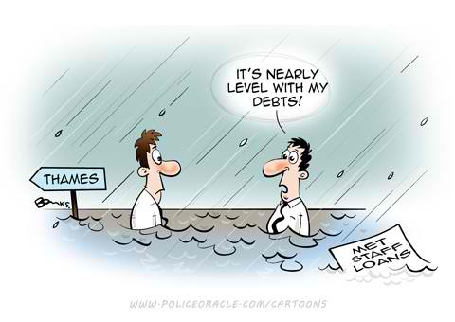

Aging grid cannot keep up with growing demand for electricity
Source: http://www.homelandsecuritynewswire.com/dr20140204-aging-grid-cannot-keep-up-with-growing-demand-for-electricity

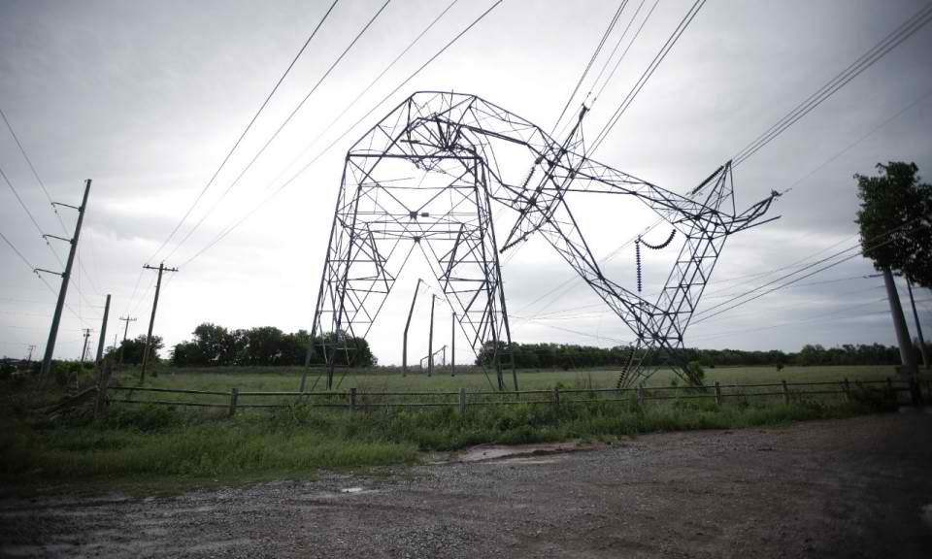
The U.S. power grid is in urgent need of innovation to keep up with the energy demands of the twenty-first century. The recent polar vortex, in which several Midwestern states reached temperatures twenty degrees below zero, left more than 27,000 homes and businesses in Illinois, Indiana, and Missouri without power. In response to the subzero temperatures, utility companies urged their customers to maintain low heat temperatures in their homes for fear of a grid overload.
Al Jazeera reports that nearly twenty-five million consumers in the United States were affected by blackouts in 2012, and economists estimate that such power outages can cost the country more than $70 billion in annual economic loss.
“It’s not for lack of effort or money, but rather because the American power industry deploys technology designed in the 1800s to manage a system of wires and wooden poles that is ill suited to the weather challenges of the 21st century,” wrote David Crane, president and chief executive officer of NRG Energy.
Al Jazeeranotes that the numbers reveal the growing problms the U.S. grid is facing:
- The demand for electricity increased by around 20 percent from 1999 to 2009, but transmission capacity only increased by around 7 percent in that time, according to a 2007 study by the University of Minnesota.
- Blackouts have been on the rise. From 2000 to 2004, there were 140 instances of power outages which each affected 50,000 or more consumers, according to analysis by Massoud Amin, director of the Technological Leadership Institute at the University of Minnesota. This number increased to 303 from 2005 to 2009. An annual blackout tracker report by power management company Eaton Corp. shows a steady rise in such blackouts. Between 2010 and 2012, there were 226 outages.
- The average age of a power plant is 30-years old, and around 75 percent of America’s power lines are 25-years old, according to a study by Hugh Byrd of Lincoln University in the U.K. and Steve Matthewman of Auckland University in New Zealand.
Despite the concerns of federal and private officials about the country’s energy infrastructure, the North American Electric Reliability Corporation (NERC) reported that from 2008 to 2012, dependability of the power grid was stable with high reliability of transmission lines. A lack of urgency discourages energy companies from investing in new technology. Regulation and the uncertainties that follow changes in regulations have also limited the amount of funds private firms have invested in the electric grid.
“The power sector, which is heavily regulated at the state level, is especially fragmented, but energy markets more generally may be slow to adopt innovation because of regulatory uncertainty, lack of information, and distortions introduced by past policies – including numerous existing subsidy programs,” noted a 2012 report by the Bipartisan Policy Center.
Experts say that to combat the slow implementation of innovation in America’s electricity sector, government and private entities must invest in research and development. The power industry spends less than 0.3 percent of annual sales, or about $600 million per year, on R&D. This is less than many industries in the country, yet all industries depend on reliable electricity. Government investment in energy does not yield immediate, short-term returns.
The White House is focused on innovating the electric grid. “In the face of an aging grid, investing in the grid’s infrastructure is crucial. Given this imperative, there is an opportunity to upgrade the grid’s efficiency and effectiveness through investments in smart grid technology,” read a 2011 framework to innovate the energy sector.
The immediate solution to the electricity crisis in the United States is the adoption of a smart grid, which will help consumers understand and measure their energy usage and will encourage energy companies to adopt renewable energy resources and better anticipate consumer usage habits. Smart grids offer more reliability and higher energy efficiency with a reliance on a diverse energy mix (wind, solar, and nuclear).
PG&E has adopted a smart grid concept labeled “demand response,” in which the supplier offers lower utility prices and in return, and customers agree to reduce usage when energy demand may potentially exceed supply.

Costs of extreme weather events multiply
Source: http://www.homelandsecuritynewswire.com/dr20140217-costs-of-extreme-weather-events-multiply

The United States sustained $1.15 trillion in economic loss in the past thirty years due to extreme weather, a trend that will continue if state and local governments do not prepare for future weather disasters, according to Munich Re, the world’s largest risk insurer.
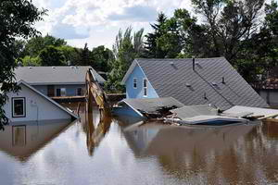
Department of Homeland Security’s (DHS) assistant secretary for policy David Heyman recently testified before the Senate Committee on Homeland Security and Governmental Affairsabout the cost of extreme weather events. In 2011, fourteen different natural disasters exceeded $1 billion each in damage caused, and there were ninety-eight presidentially declared disasters. “Without a concerted effort — national resilience effort, the trend is likely to continue,” Heyman warned.
CBS News reports that Heyman and Caitlin Durkovich, DHS assistant secretary for infrastructure protection, national protection and programs directorate, highlighted for the committee the importance of implementing a national preparedness system as a way to be better prepared for disasters. Heyman and Durkovich are creating Resilience STAR, a program similar to the Energy STAR program, which will designate structures which are built to withstand damage from certain disasters. “Our investments in resilience will pay significant dividends for the country. It is efficient and it is cost-effective,” Heyman said.
The ability for communities to respond swiftly to natural disasters is a matter of national security. “Just as terrorist attacks threaten our communities, extreme weather disrupts the security of our nation. Extreme weather strains our resources, diverts attention from counterterrorism efforts, serves as a threat-multiplier that aggravates stressors both at home and abroad, and destabilizes the lifeline sectors on which we rely,” Durkovich said.
Mark Gaffigan, the managing director of the U.S. Government Accountability Office’s (GAO) National Resources Environmental team, told the Senate committee that the federal government’s crop insurance program had increased four-fold since 2003, and the flood insurance program has a $24 billion debt. Gaffigan said that in addition to finding ways to reduce disaster risks, the federal government should begin fully budgeting for the response to weather disasters, which often comes from outside the normal budgeting process.
Senator Thomas Carper (D-Delaware), the committee’s chairman, says that the hearing was not focused on debating climate science, but “instead, it’s about trying to find common ground. And as our country debates how to address our changing climate and the extreme weather I believe it’s likely causing, our witnesses will deliver to us a clear message,” he said. “And that is, put simply, the increase in frequency and intensity of those extreme weather events are costing our country a boatload of money.”

