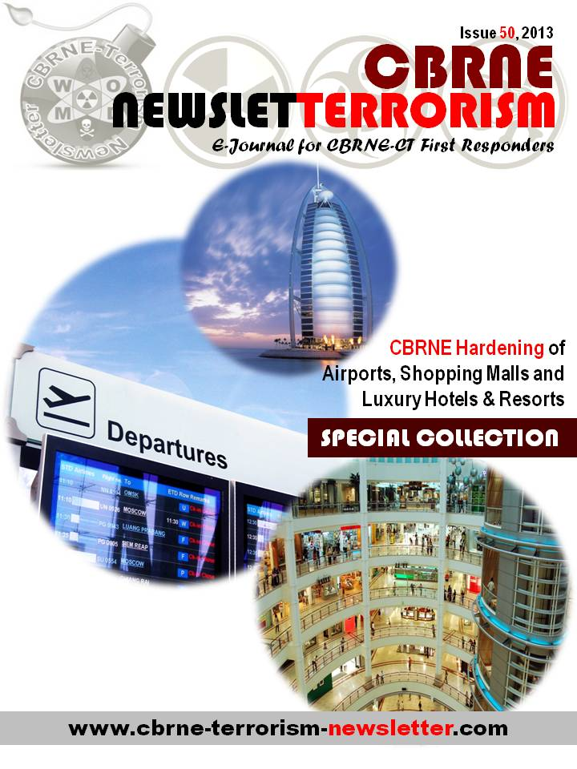

CBRNE hardening of Airports, Shopping Malls and Luxury Hotels & Resorts
By BG(ret’d) Galatas Ioannis, MD, MA, MC(Army)
Editor-in-Chief of CBRNE-Terrorism Newsletter

Introduction
When I was preparing this “Special Collection” dedicated to CBRNE hardening of airports, shopping malls and luxury hotels & resorts, I thought that it was a good idea to start with various articles focusing separately on each of the hree target-issues. In that respect I included the articles, events, opinions and initiatives related to security and counter-terrorism on these specific soft targets.

To my (expected) surprise I was not able to find related papers to the main title of the collection! I do understand that even on the Internet there are certain issues that are not uploaded due to the sensitive nature surrounding new emerging threats. But I was hoping to find one or two to present here. None (to my knowledge)! So I decided to write this document based on a recent presentation of mine (“Hotels’ CBRNE Preparedness”) presented during the CMCS World Congress on CBRNe Science and Consequence Management held in Cavtat-Dubrovnik, Croatia (13-19 April 2013). See also April-2013 “Special Collection” on “Hotel Terrorism”.

Luxury Hotels & Resorts

Hotels are symbolic targets of Western affluence and influence that attract precisely the kind of people the militants seek to eliminate – foreign diplomats, businesspeople, tourists, and local elites.

Luxury hotels, like restaurants, night clubs, shopping malls, and public transportation systems, are “soft targets” presenting few obstacles to determined terrorists since:

Are open environments with multiple points of entrance and egress and

Have a constant flow of traffic, including hotel guests and visitors, staff, merchants, and delivery people

Are easy for pre-attack reconnaissance, with floor plans, photos, and panoramic video clips of public areas often available over the Internet.

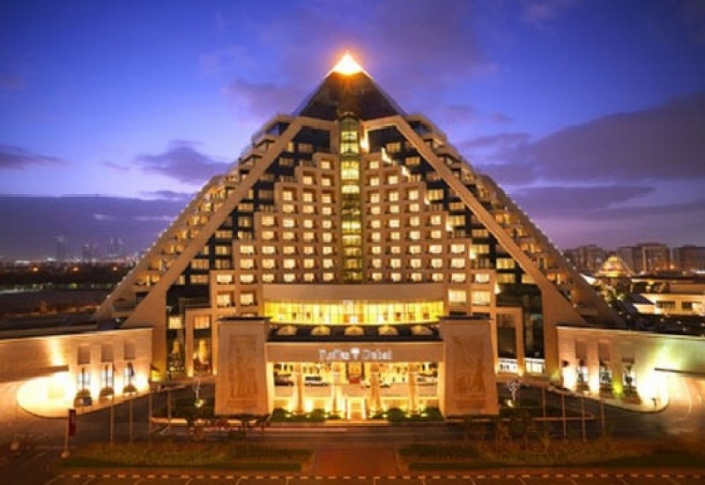
Terrorists have discovered that a successful attack on a 5-star property can yield rewards equivalent to an attack on an embassy, including scores of casualties, widespread panic, and extensive media attention – all of which are a boon to recruitment.

These actions do tend to cause both great harm to a country's collective psyche and economic disruption, and thereby support al Qaeda’s strategic aim of bankrupting the U.S. and its allies;

A fourth reason for the upsurge in hotel attacks is related to the changing organizational composition of the terrorist groups themselves: following the US-led coalition intervention in Afghanistan after 9/11, al Qaeda evolved from a highly centralized organization to a much flatter entity (LeT in Pakistan, Jemaah Islamiyah (JI) in Indonesia, Abu Sayaaf Group in the Philippines); these affiliated groups typically lack the resources and training to mount a successful attack on a Western embassy or airline, and so have turned their attention to easier targets – hotels.

Terrorist attacks on international hotels since 9/11

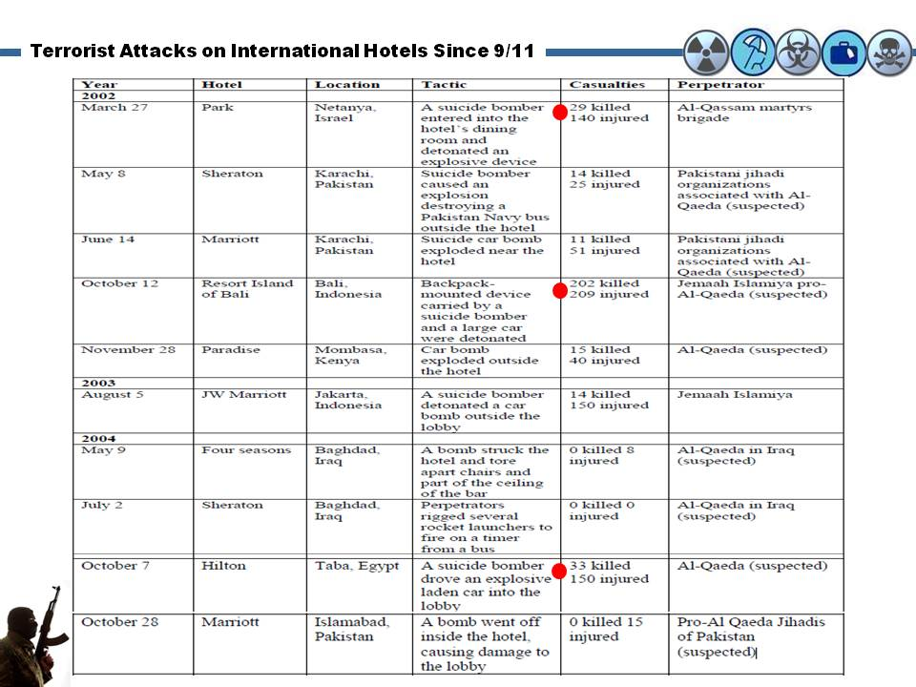
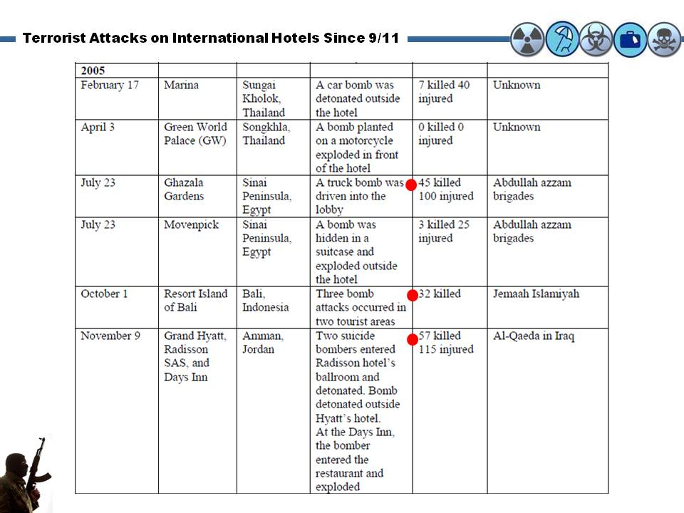
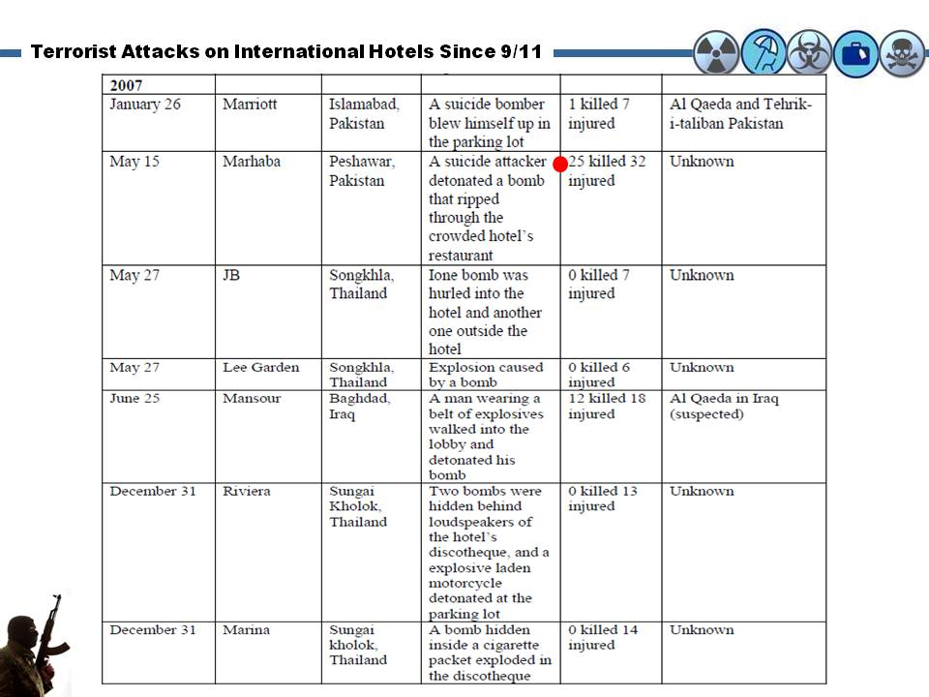
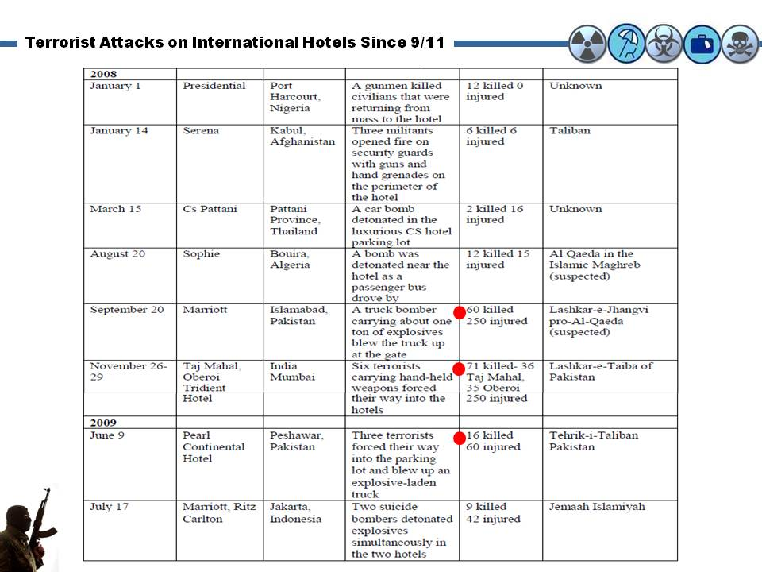

Between 9/11 and 2005
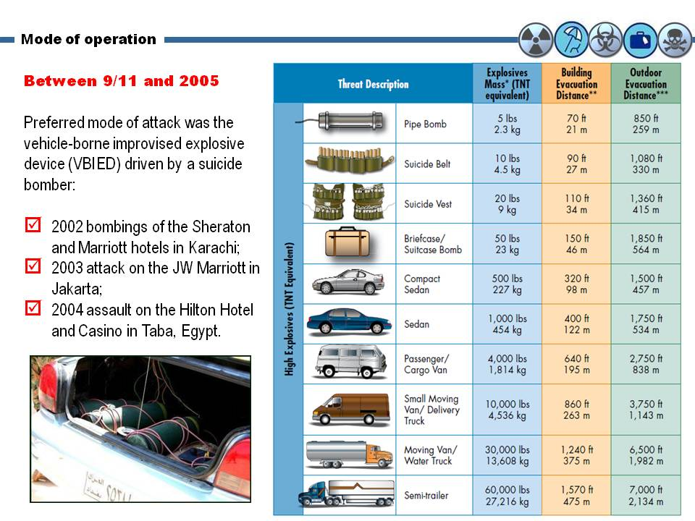
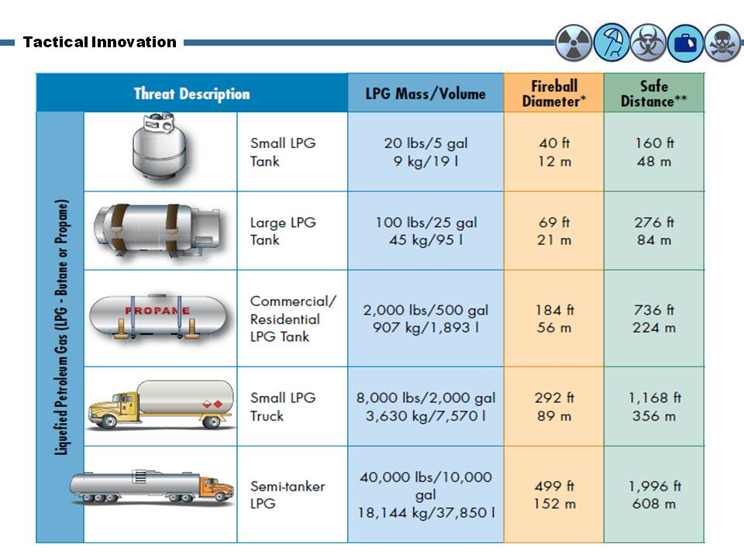

After 2005
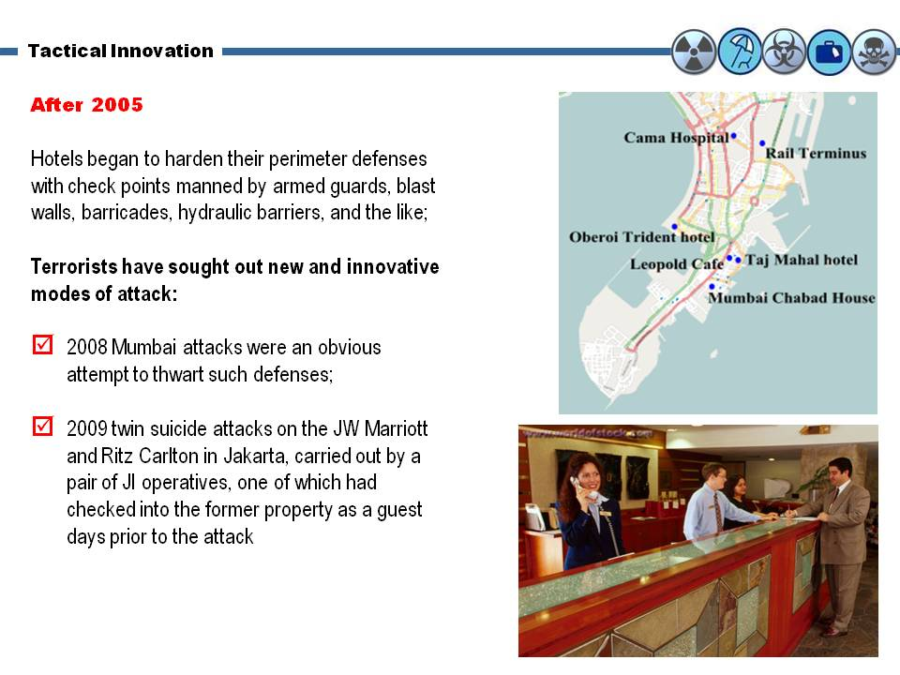

The threat is still real!
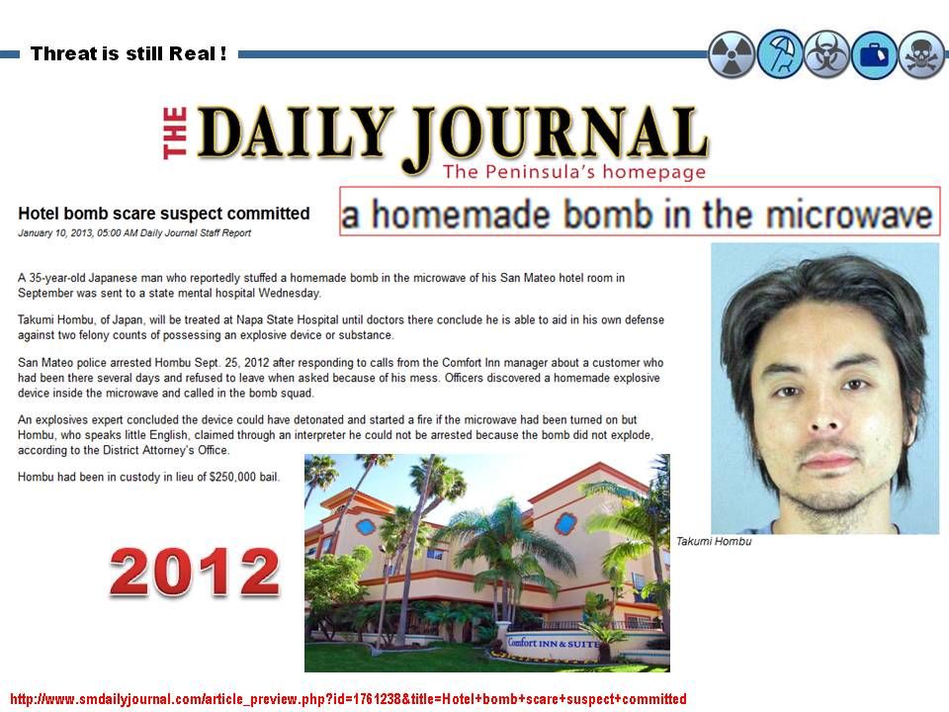

Impetus for enhanced security measures

Possible litigation brought by families of victims in the aftermath of a terrorist event that could have been foreseen or managed in a more effective manner has also forced hotel executives to concentrate on security.

The vulnerability of hotels to such litigation was aptly demonstrated by an act of industrial sabotage more than two decades ago: On New Year’s Eve in 1986, three disgruntled employees of the DuPont Plaza Hotel in San Juan, Puerto Rico decided to exact revenge on management for a labor dispute by setting a small fire in a ballroom to frighten guests and drive down occupancy rates. Tragically, the small fire turned into a raging inferno that led to 97 deaths and 150 injuries. The litigation that followed this incident produced nearly $2 billion in claims and remains one of the largest civil cases in history

Victims and relatives of those killed in the 2004 suicide attack on the Hilton Taba Hotel and Casino on Egypt’s Sinai Peninsula have filed a wrongful death lawsuit in Jerusalem against the Hilton Hotel chain for failing to thwart the suicide bomber who rammed his explosives-filled vehicle into the lobby, killing 33

The plaintiffs, who include over 100 survivors and relatives of victims, sued Hilton in 2006 in the U.S. District Court for the Southern District of New York, claiming that lax hotel security amounted to negligence, but in 2008 a U.S. District Judge ruled that Egypt or Israel would be a better forum for the case because the plaintiffs had no connection to the United States.

“It will not happen to us!” attitude

Should hotels far removed from the front lines of the War on Terror – i.e. in Seattle or Stockholm – require the same heightened level of security as those in Kabul or Karachi?

After all, terrorist attacks on hotels, while on the rise, remain a low risk threat, and guests are far less likely to fall prey to terrorism than to be robbed, assaulted, or injured in a fire.

Brian Jenkins (2009), for example, has observed that fewer than 500 hotel guests worldwide have been killed by terrorists over the past 40 years, out of a total global hotel guest population at any time of nearly 10 million.

The cost of counter-terrorism measures, whether covering windows with shatter-resistant film or deploying EVDs to screen vehicles, can be high.

Beyond costs, some executives worry that the presence of visible security measures – be they metal detectors, bomb-sniffing dogs, or gun-toting security guards – may undermine the welcoming ambiance that luxury hotels work hard to cultivate and drive away guests.

Marriott International experience

Under Marriott’s Threat Warning System, hotels can be assigned to one of three threat conditions: blue, yellow, or red.

Threat Condition Blue: hotel managers must verify guests’ identities upon check-in with a photo ID, increase security patrols around properties, and review bomb threat evacuation plans with staff, among other things.

Threat Condition Yellow, which could be triggered by a rise in terrorism or political upheaval in the area, requires hotels to check guests entering properties, restrict parking within close proximity to buildings, and halt luggage storage.

Threat Condition Red, which could result from intelligence indicating a specific threat against a property, hotels must inspect vehicles for explosives at checkpoints, examine luggage, and direct visitors through metal detectors at limited entry points.

Adherence to these procedures is ensured by twice yearly unscheduled visits from third party auditors and general managers found to be in non-compliance are subject to harsh disciplinary action.

The first step in meeting the evolving terrorist threat, is acknowledging that even the most robust countermeasures may not defeat an attack.

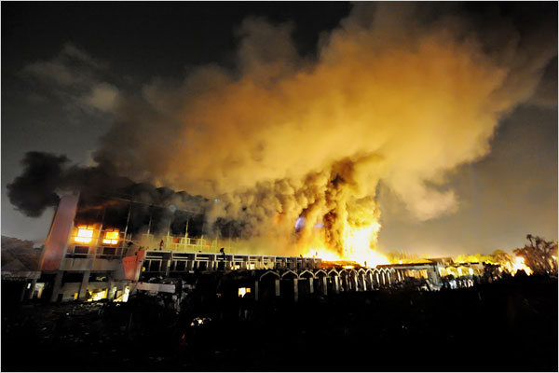
September 2008

Suicide truck bombing of the Marriott Hotel in Islamabad (“the world’s most protected hotel”) with formidable antiterrorism systems in place:

60 Security officers on duty;

Four bomb sniffing dogs

62 security cameras monitored by three security officers;

Under-vehicle cameras;

Walk-through metal detectors to screen everyone entering the building;

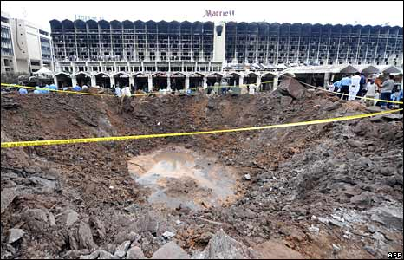
Entrance gate with Delta Barrier (drop-down & hydraulic barrier) – manned by shotgun-armed security officers;

Hotel was 132 feet from the vehicle inspection point

Notwithstanding these measures, 56 people died and 270 were injured when a suicide bomber detonated his charge after his vehicle slammed into the Delta Barrier. The blast from the powerful 1,320 pound bomb ripped a 25 foot deep by 60 foot wide crater in front of the hotel, destroyed most of the upper floor rooms of the property, and ignited a blaze that burned for two days.

Had the bomber achieved his goal of ramming the explosives-laden truck into the hotel lobby, the casualty count may have topped one thousand!

Target hardening

Preventing attacks like those carried out against Marriott in Islamabad and Jakarta is largely impossible once they have reached their operational stage.

Hotels need to focus attention on measures that discourage such attacks in the first place, and involve “target hardening”.

Although typically associated with visible security measures such as barricades and blast walls, target hardening also entails more subtle methods that often go undetected:

One of the best ways to harden a target, is to limit public disclosure of nonessential information about a property such as building diagrams;

Dispatching both plainclothes security officers and uniformed “greeters” to lobby areas to discreetly look for individuals casing buildings or taking suspicious photographs of entrances or security cameras is another;

Terrorists often seek employment at hotels as cover for conducting surveillance

conduct rigorous background checks of job candidates to weed out those with criminal

records questionable past associations, although, it is often impossible to determine

whether a candidate covertly subscribes to a violent political ideology.

Awareness training

Training employees to develop a heightened sense of awareness of the types of circumstances that could represent a threat to hotel guests and property – and immediately report them to security personnel – is another counter-terrorism imperative.

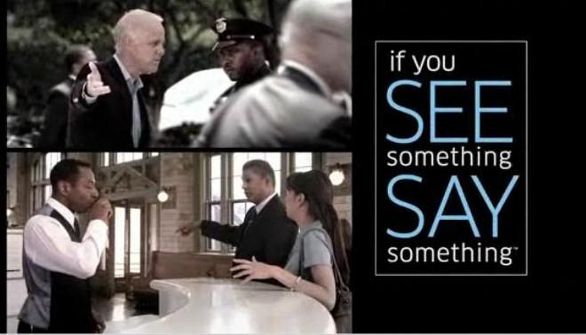To assist in this endeavor, Marriott has produced a series of colorful “See Something? Say Something!” security awareness posters that are hung in non-public areas of its hotels;

A poster titled “Back of the House” for example, encourages food service and maintenance crews to be watchful for individuals photographing the property’s service entrances, as well as for tampered locks and unattended packages;

Another titled “Guest Room and Guest Floor” instructs housekeeping staff to report the presence of weapons, hotel diagrams, and other suspicious items found in guest rooms.

Designing with security in mind

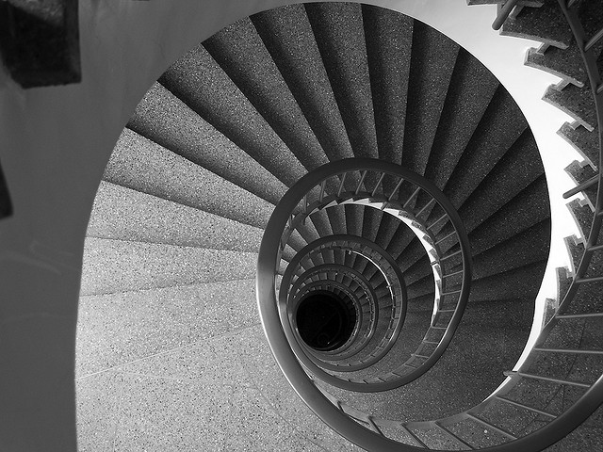
One of the biggest challenges hotel operators face in shielding their guests from possible terrorist attacks is that many existing properties were built with aesthetics, convenience, and cost uppermost in mind – not safety from suicide bombers and urban guerrillas.

As such they often have built-in features that make them vulnerable to Mumbai-style assaults including long hallways, spiral staircases, and towering atriums.

They may also be situated close to busy streets, giving terrorists easy access, or within close proximity to embassies or government buildings, leaving them vulnerable to collateral damage from attacks directed elsewhere.

Since retrofitting older buildings for enhanced security is both difficult and expensive, Marriott works with designers and architects at the inception of new projects to ensure that security is given prominence attention.
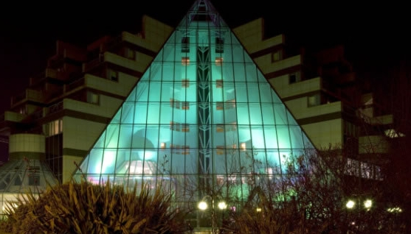 | 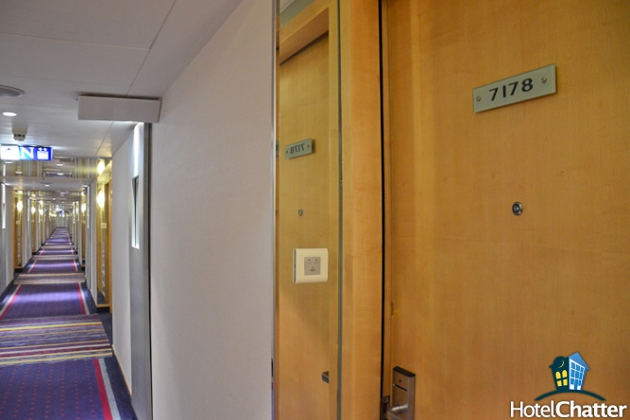

Requirements for hotels to be built in high threat locations include: shatter-resistant window film, walk-through metal detectors, exterior security cameras, bomb-sniffing dogs and hydraulic barriers.

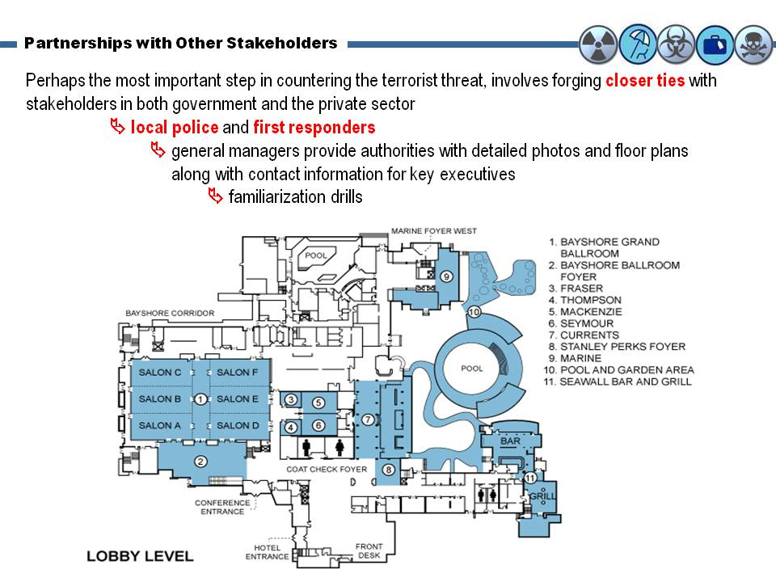
Partnerships with other stakeholders

Return on security investment?

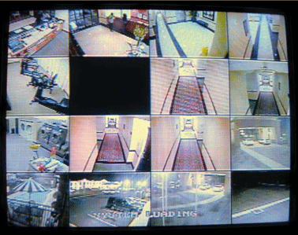
It is no secret that hospitality industry executives, like those in other sectors, have traditionally viewed security investments as sunk costs that detract from the bottom line, while adding little or nothing to the top.

Nonetheless, there appears to be growing recognition amongst hospitality executives that securing hotels against terrorism can also bring financial benefits.

Surveys indicate that guests rank security at the top of their list of priorities when choosing destinations, and are willing to pay a premium for it!

Few hotels currently call attention to the security features of their hotels let alone market them, this may change in the future – especially if attacks continue to increase in scope and intensity. But: “People visiting (high risk) environments aren’t looking for the softest beds now, or the best meeting space; they’re looking for the best security. If you invest in security, you’ll get the customers (Meyers, 2009).”

Implications for business travelers

Some private security consultants have begun advising their clients traveling to the Middle East and Southeast Asia to avoid Western five-star brands in favor of smaller, locally owned properties.

Stratfor, advised travelers to “avoid large chain hotels dominated by Western clientele” and choose smaller boutique hotels where they will be less conspicuous (Stratfor, 2009).

The notion that Western brands should be avoided is not universally-endorsed: Bruce McIndoe, president of Annapolis, Maryland-based iJET Intelligent Systems, emphasizes that: “Overall, it's best to stay in four or five star hotels, which cater to VIPs that demand higher security precautions”

Some risk reducing proposals:

hotels situated in walled compounds with robust perimeter security and at a considerable distance from public streets;

request rooms located away from lobby areas, parking lots and public-access roads, preferably between the second and sixth floors (to permit firefighter access);

limit time spent in public areas.

Business travel managers inquire terrorism-related issues before recommending specific properties, such as:

whether blueprints have been provided to security officials;

whether secondary communication systems exist for guests trapped inside rooms in the event of an attack;

whether hotel staff have been trained in evacuation techniques; and

what surveillance systems are in place to assist authorities in the event of an incident.

The way forward: Paradigm shift?

In the past, hotels and other soft targets have tended to adopt a “bunker mentality” when faced with a rising terrorist threat. While protecting the perimeter continues to be a key imperative, the latest round of suicide and guerrilla-style attacks throughout the Middle East and Asia suggest that it is no longer sufficient, as resourceful terrorists will often find ways to penetrate even the most robust defenses. In that respect luxury hotels – particularly if located in high threat locations – need to adopt a new mindset.

Experts believe that international hotels need to begin operating on the principle that terrorist attacks against their facilities are “inevitable” and take action to build resiliency. This involves embedding security into everything from architectural designs to hiring practices, while developing intelligent systems to thwart hostile surveillance, and crafting more effective emergency response plans that involve close government/private sector collaboration.

Adopting such an approach, will be neither easy nor cheap and is likely to be resisted by general managers who believe that luxury properties should focus exclusively on maximizing guest comfort and convenience and pursuing profits.

Nevertheless, unless there is a “paradigm shift” in the way hotels around the world conceive of and manage this new and rapidly evolving threat, the lives of their guests and employees, their reputations, and indeed their long-term economic viability will be at risk.

In conclusion: To succeed in this new environment, it is becoming abundantly clear that Hotel MNEs need to reach out to governments, other stakeholders and even competitors to form partnerships and alliances that may help them

understand the nature of the threat, analyze their specific vulnerabilities, and take action to thwart potential attacks.

MNEs must also build flexibility and resilience into their operations, so that if and when an attack does occur, systems are in place to manage the crisis, mitigate loss of life, and assist with the recovery process.

Hotel CBRNE preparedness

Old and New emerging threats

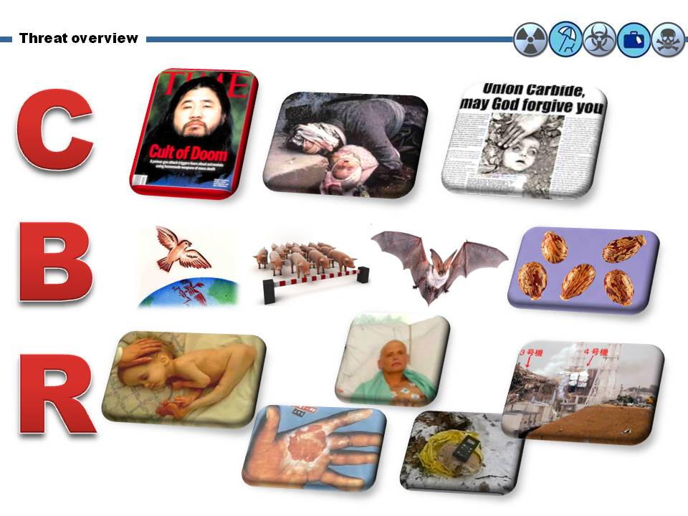
Our current knowledge regarding the consequences from CBRN release in urban/megapolis environment is very limited and it is based on past (and sometimes forgotten) experience on various incidents like the Tokyo metro sarin release, the Iraq-Iran chemical wars of the 1980s, the Bohpal’s accident in India, the various epidemics/pandemics (with most recent the MESR-COV originated in S Arabia in 2012), the anthrax and (recent) ricin letters, the Chernobyl and Fukushima accidents, the Polonium-210 incident in the UK and the only dirty-bomb threat in a recreational park in Moscow. Is this knowledge enough to alert us? Of course it is enough! But not enough to counter the universal inherent human attitude that “it will not happen to us!”

CBRNE Planning

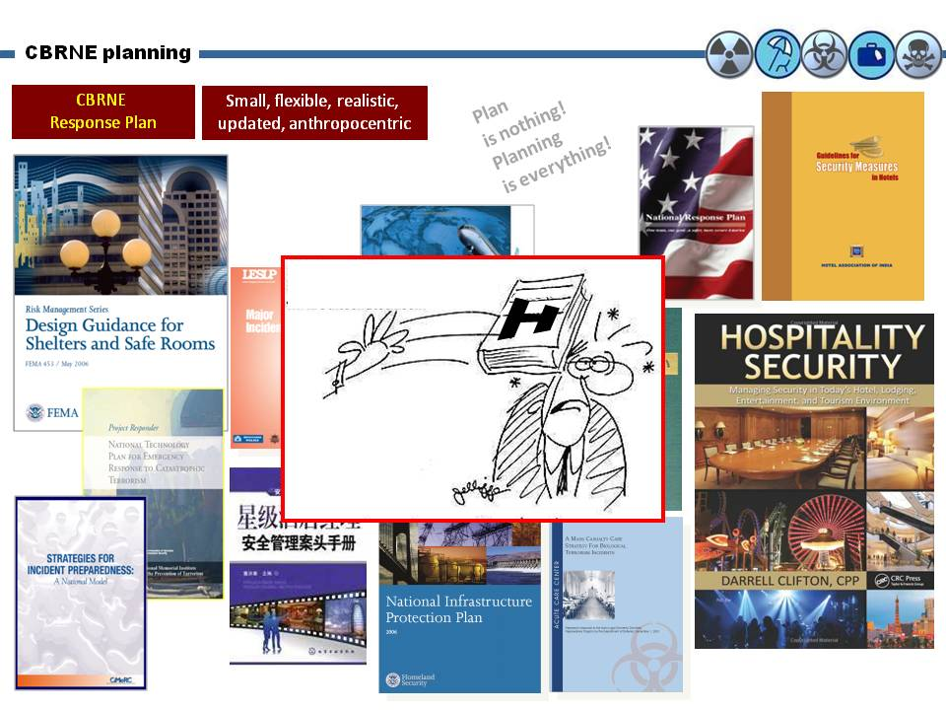
There are many plans and directives around the globe focusing on counter-terrorism defense of soft targets. I am not aware of specific “CBRNE plans” for hotels, shopping malls, airports and other places of mass gatherings. In principle, a “CBRNE plan” should be: “small, flexible, realistic, updated and anthropocentric”. Big plans are good when you through them to somebody and manage to hit the target!

CBR attacks

Like explosives’ threats, CBR threats may be delivered externally or internally to the building.

External ground-based threats may be released at a stand-off distance from the building or may be delivered directly through an air intake or other opening.

Interior threats may be delivered to accessible areas such as the lobby, mailroom, or loading dock, or they may be released into a secure area such as a primary egress route.

There may not be an official or obvious warning prior to a CBR event. Although official warnings should always be heeded, the best defense may be to be alert to signs of a release.

There are three potential methods of attacks in terms of CBR:

A large exterior release originating some distance away from the building (includes delivery by aircraft)

A small localized exterior release at an air intake or other opening in the exterior envelope of the building

A small interior release in a publicly accessible area, a major egress route, or other vulnerable area (e.g., elevator lobby, mail room, delivery, receiving and shipping, etc.)

Hotel scenarios

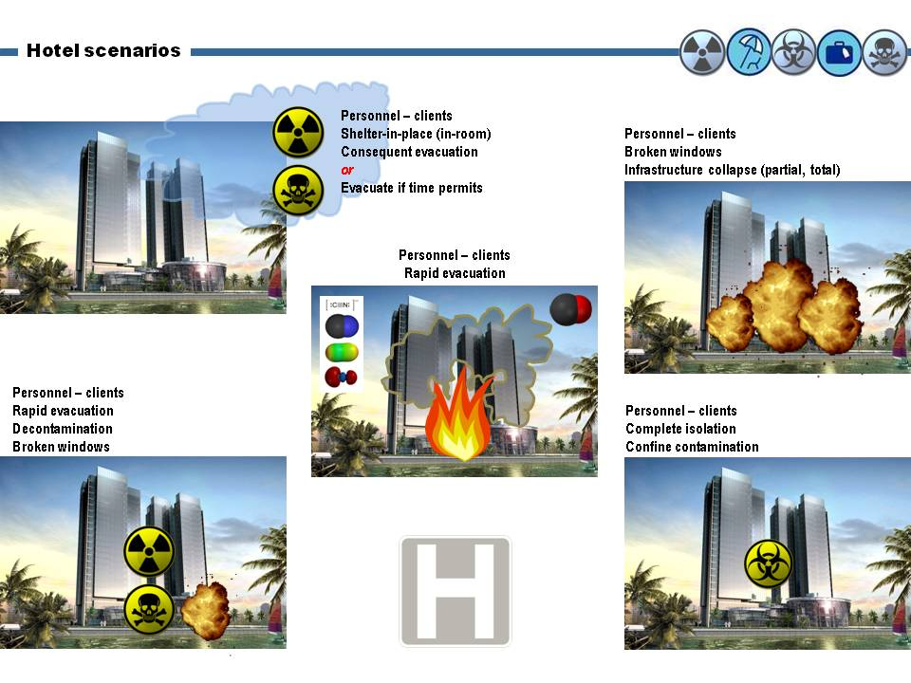
There are five scenarios that a hotel could be involved in a CBR release:

Scenario 1: The hotel is in the way of a progressing contaminated cloud – either chemical or radiological that might be the result of an accident or man-made action in a chemical or nuclear plant within the country, in a neighboring country or even far away. Winds are blowing towards the direction of the hotel and the cloud id traveling fast! What should we do in a facility of 1000 people (guests and staff).

Scenario 2: A deadly chemical is released or a dirty bomb is detonated inside the hotel. What should we do then?

Scenario 3: The hotel is on fire – fire means cyanide! What should we do then?

Scenario 4: Bomb detonation inside the hotel or in near proximity to the hotel? What should we do to protect guests and staff?

Scenario 5: A terrorist becomes very ill either accidentally or on purpose but during the previous couple days he moved around all facilities – restaurant, salad bar, casino, elevators, stairs, toilets, spa, fitness center, front desk, etc. What should we do to confine the spread of the highly infectious disease?

Scenario 6: A combination of scenarios 1-5 because in real life nothing is like as described in response plans and crisis management books – same like in medicine that only very seldom we face diseases in the way they are described in medicine books…

RDD/Explosives detonation

Example given in a luxury hotel in downtown Dubrovnik – it might happen in any urban environment in any country around the globe!
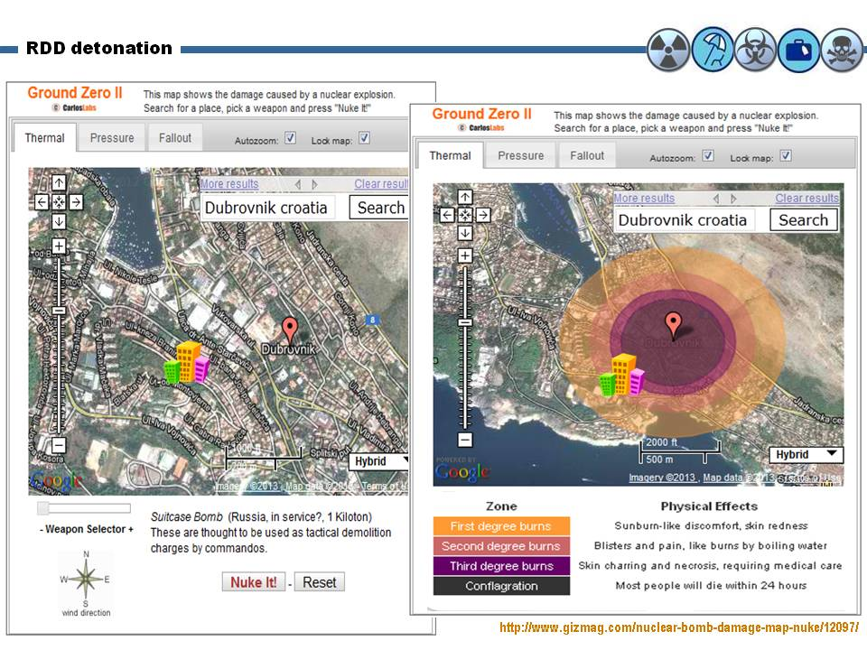
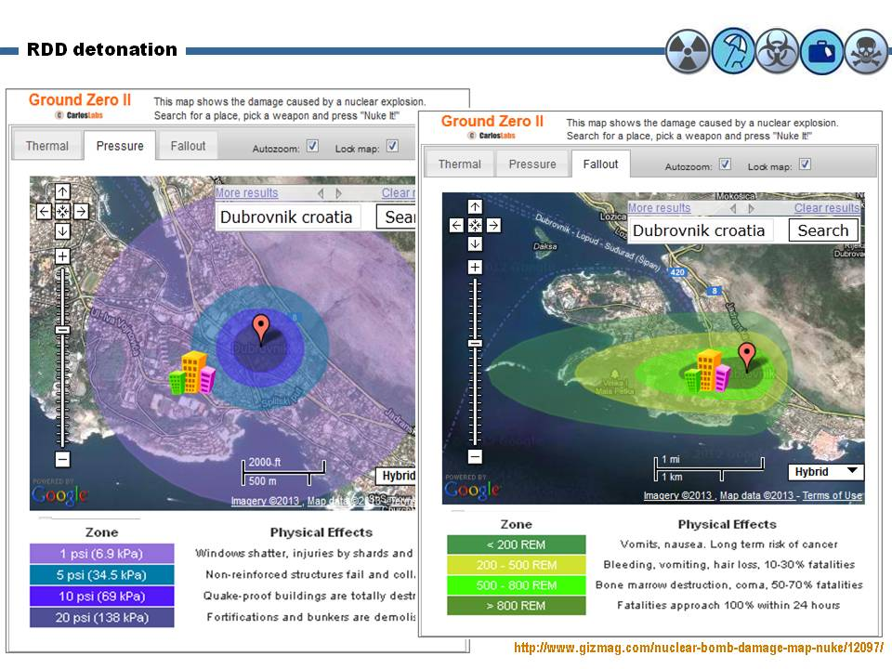

Apart the URL provided in the photo, below is another online bomb simulator that will help you test your defenses.

Source: http://meyerweb.com/eric/tools/gmap/hydesim.html

Overpressure Key
15 psi | Complete destruction of reinforced concrete structures, such as skyscrapers, will occur within this ring. Between 7 psi and 15 psi, there will be severe to total damage to these types of structures.
7 psi | Severe damage to complete destruction of reinforced concrete structures, such as skyscrapers, will occur within this ring.
5 psi | Complete destruction of ordinary houses, and moderate to severe damage to reinforced concrete structures, will occur within this ring.
2 psi | Severe damage to ordinary houses, and light to moderate damage to reinforced concrete structures, will occur within this ring.
1 psi | Light damage to all structures, and light to moderate damage to ordinary houses, will occur within this ring.
0.25 psi | Most glass surfaces, such as windows, will shatter within this ring, some with enough force to cause injury.

Shelter-in-a-Room

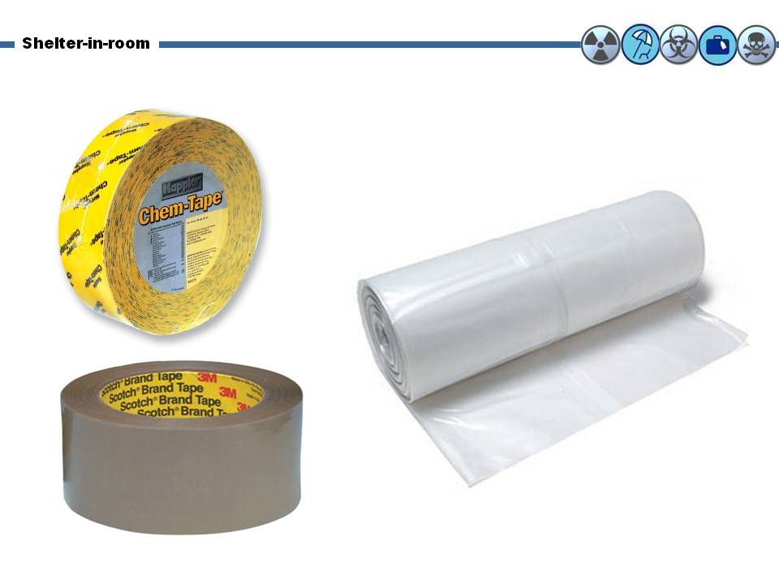
The contaminated cloud is coming towards your hotel. There is not time to evacuate premises, too many people, traffic jam all over etc. The only solution left is to shelter-in-place. But how can you do it now? Should it be done for each room? Do you gather guests and staff in big rooms – i.e. conference rooms and defend there? You prefer high or low floors? What about your VIPs that happen to be in your hotel at that unfortunate moment? What about basements and underground parking spaces? What exactly do you need to perform shelter-in-place?

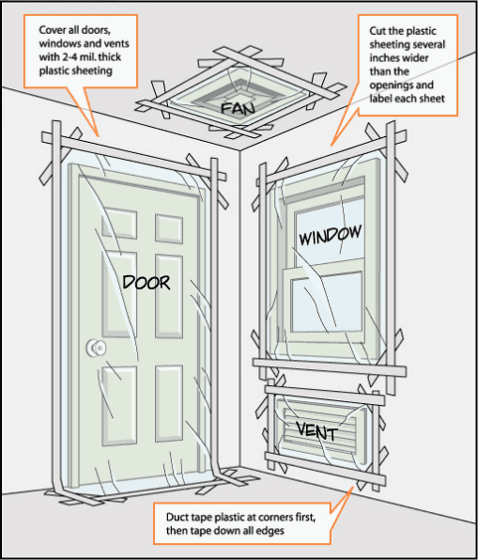
It is not rocket science! All you need is plastic sheets, sealing tape, cut the central air-conditioning and strategy. BUT YOU NEED THESE IN ADVANCE!!! It could be a survival kit for every room with visible directives on how to do it! It could be a collective shelter – there is no difference. The important thing is to survive the wave or minimize its effects on humans. Winds will do the rest! But then: when it is safe to exit shelters? Who is going to decide this? What is the next step? All these and many more are simple questions and have simple answers only if somebody spends some time to consider the problem and challenge the unexpected that always happens!

Shelter In Place And Seal The Room

Choose an interior room preferably without windows – i.e. bathroom;

Lock doors, close windows, air vents;

Turn off fans, air conditioning and forced air heating systems;

Take your emergency supply kit unless you have reason to believe it has been contaminated.

Seal all windows, doors and air vents with plastic sheeting and duct tape. Consider measuring and cutting the sheeting in advance to save time.

Be prepared to improvise and use what you have on hand to seal gaps so that you create a barrier between yourself and any contamination.

Local authorities may not immediately be able to provide information on what is happening and what you should do;

Leave TV open or listen to the radio or check the Internet on laptop often for official news and instructions as they become available.
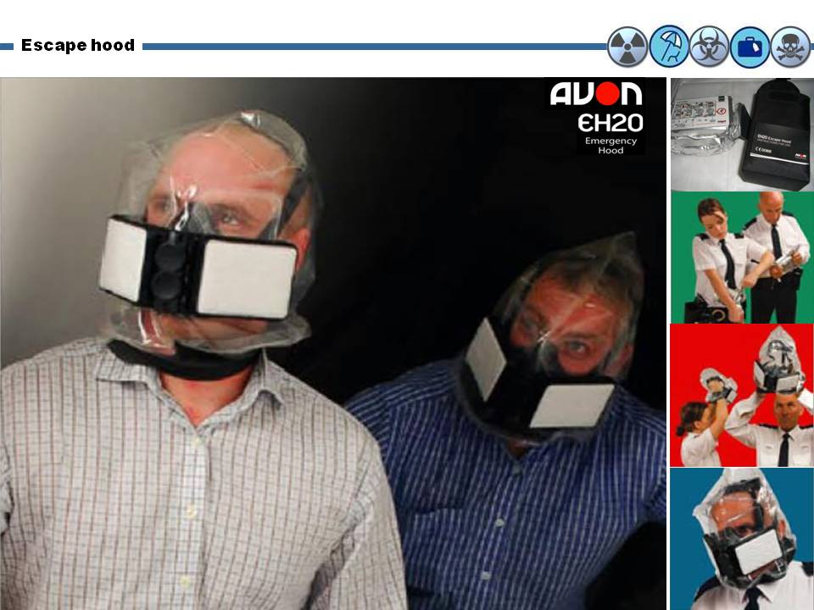

Escape hoods

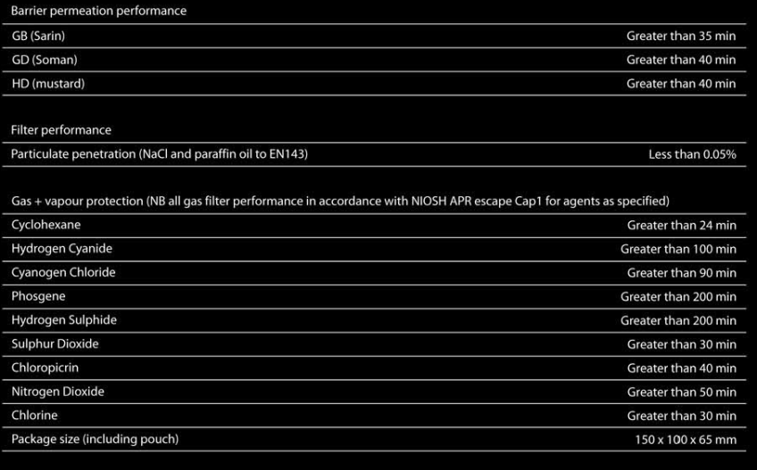
They are small, thin (you can put them in your back pocket of briefcase), inexpensive, last long (storage) and can save lives. One size fits all and provides protection against CBR agents and smoke for a limited period of time – but enough to escape safely or move to a safer environment. Enough products to select from – available on the Internet as well. Currently used by first responders and ambulance services around the globe – and they can make the difference between life and death! Data in chart below are for Avon’s EH20 Escape Hood currently employed by UK Ambulance Service.

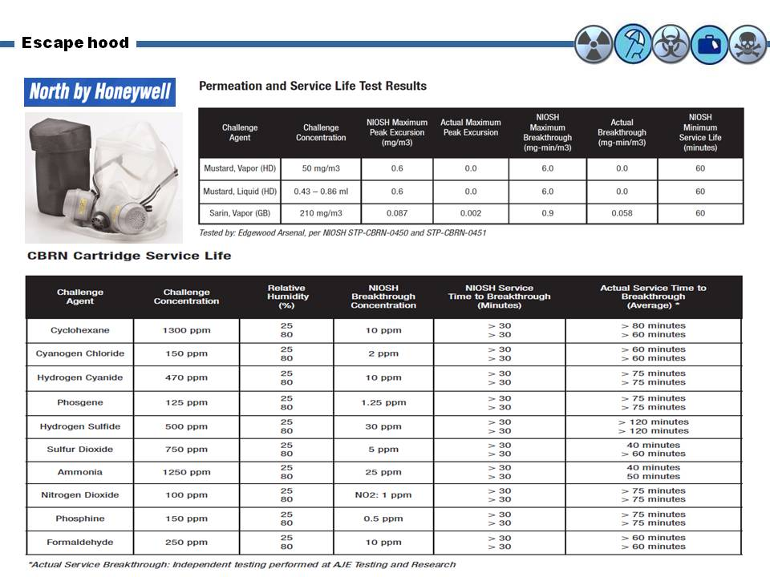
Another example of an escape hood:

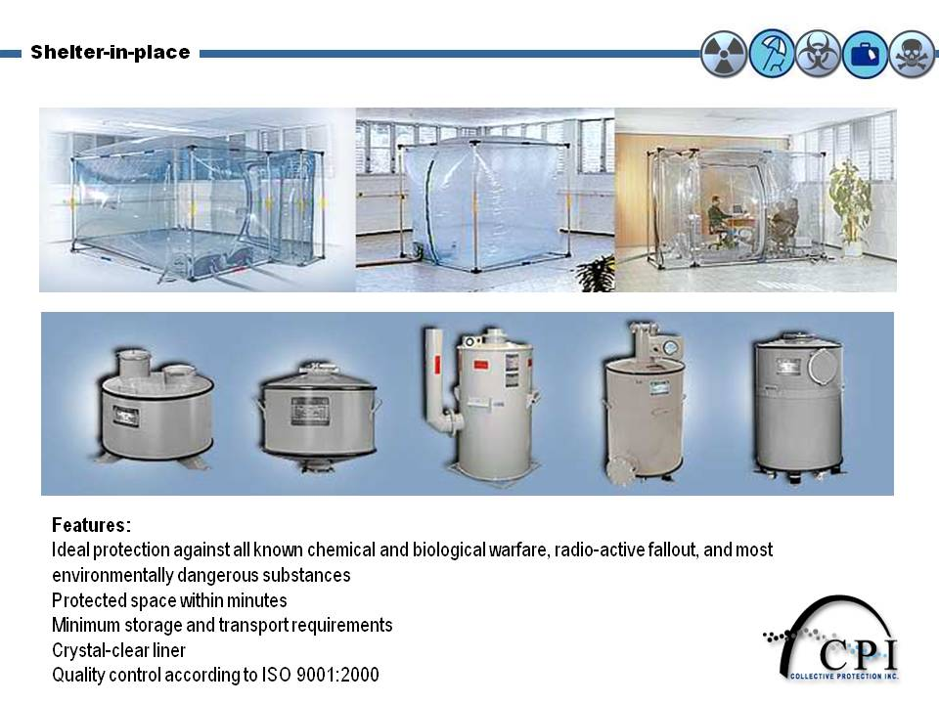
But also bigger systems can be installed in specific areas of the hotel – bigger capacity, more people to support!

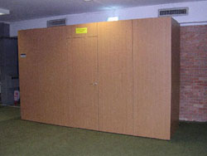
A very interesting solution that fit well within hotel’s environment is the Expandable Cabinet Shelter, which when closed looks just like a cupboard.

Within 8 seconds in the case of an emergency, simply open the door of the mass protection cabinet shelter, unlock the hooks and pull the front side of the cabinet out until the shelter is fully expanded.

Walk in, close the door, activate the filtration system and remain calm.

Mass protection shelter is impermeable to all war gases, bacterium and viruses.

It can be located in homes, offices, airports and any commercial areas, depending upon the model chosen will provide protection from between 6-35 occupants.

It can be supplied as a complete package including chemical toilet, liner protection carpet, TV/computer connections and survival rations and first aid kit.
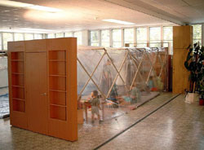

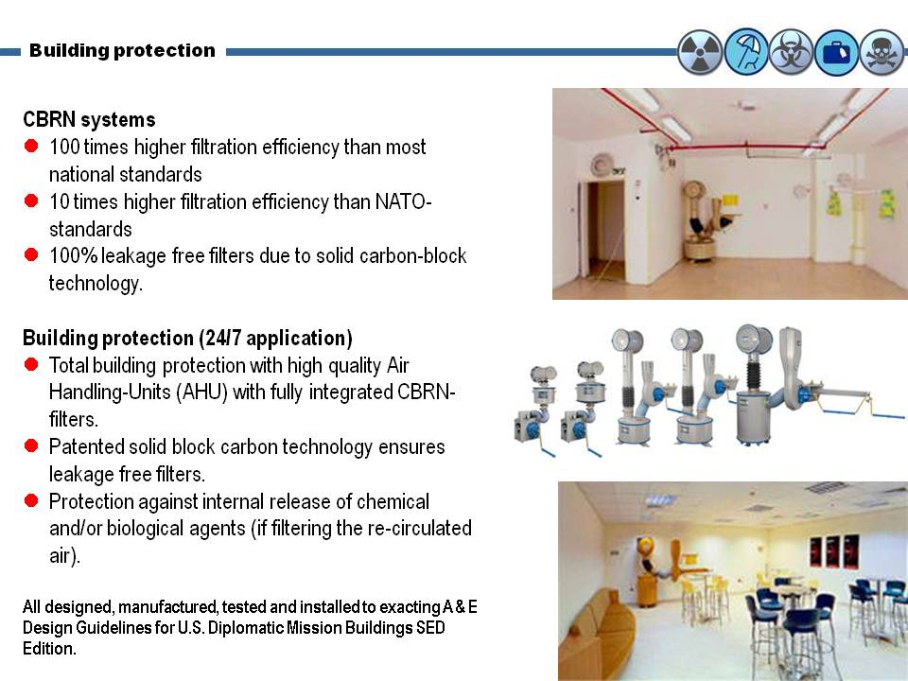
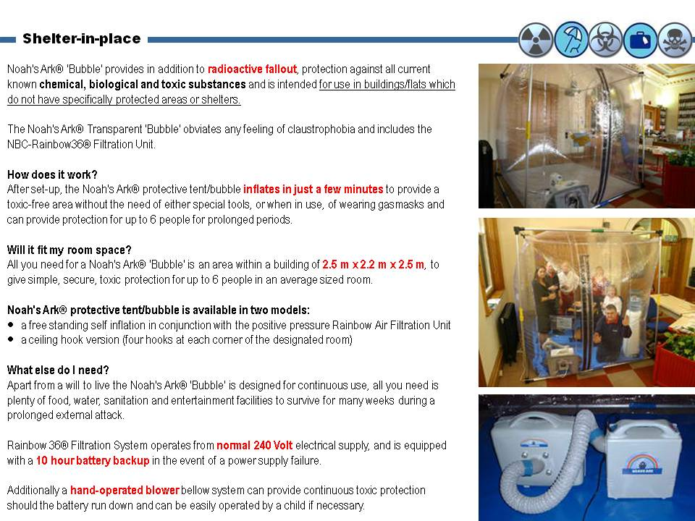
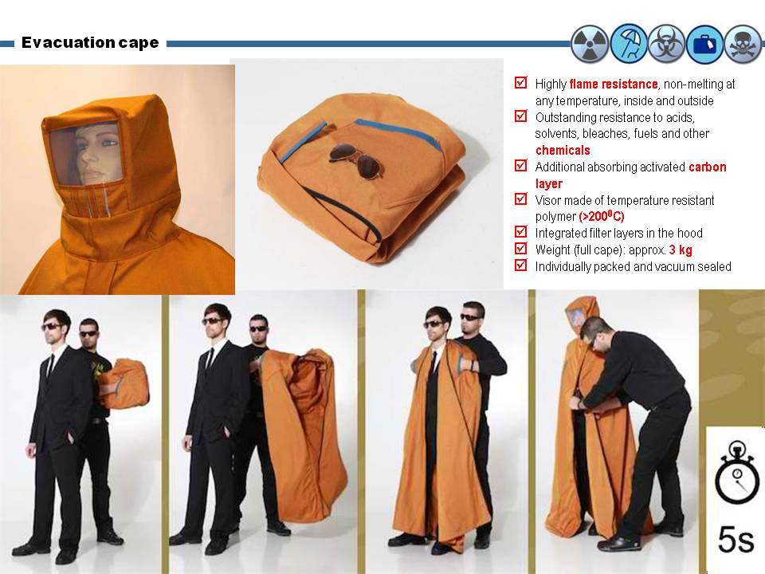

Isolation shelter

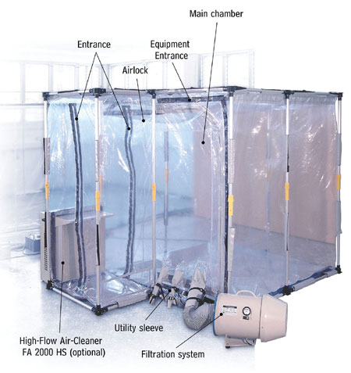
Isolation tent is made from a special crystal clear laminate which provides complete protection against any known biological diseases and viruses.

It consists of a main chamber and integrated airlock which is designed to the specific requirement of the particular application.

The negative pressure filtration system is fitted to the side walls of the Isolation tent to give the best available biological protection against infection and contamination threats.

Specially designed for hospitals dealing with highly infectious transmittable diseases such as SARS and will accommodate all normal hospital equipment including beds, tables and life support equipment.

System comprises 3 main packages of aluminum frame, the Isolation tent and a filtration system.

If required, an optional super clean high flow air cleaner FA 2000 HS can be integrated to improve the purging during entering and leaving the main chamber.

All components are packed so that they can be carried by a team of 2 people. It is manufactured according to ISO 9001 standards.

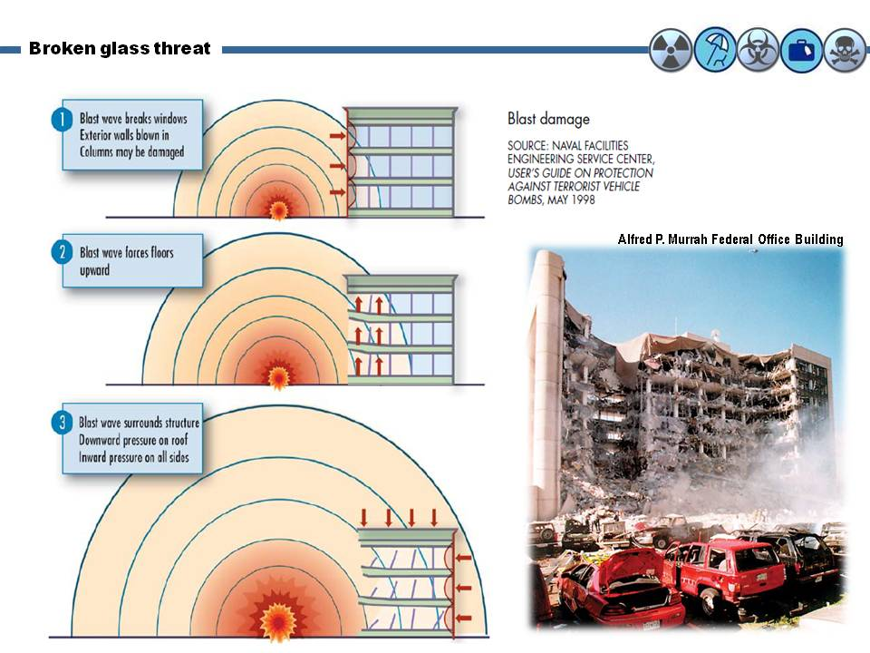
Broken glasses threat
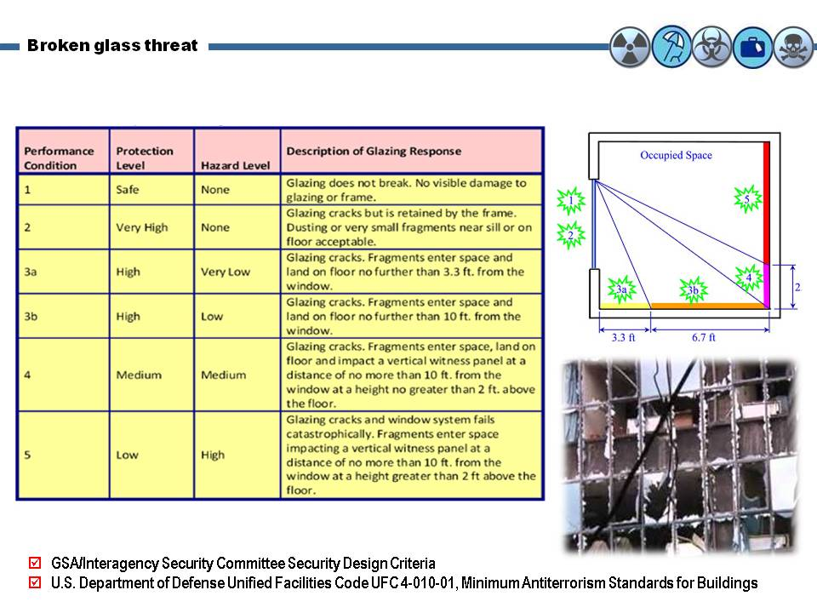

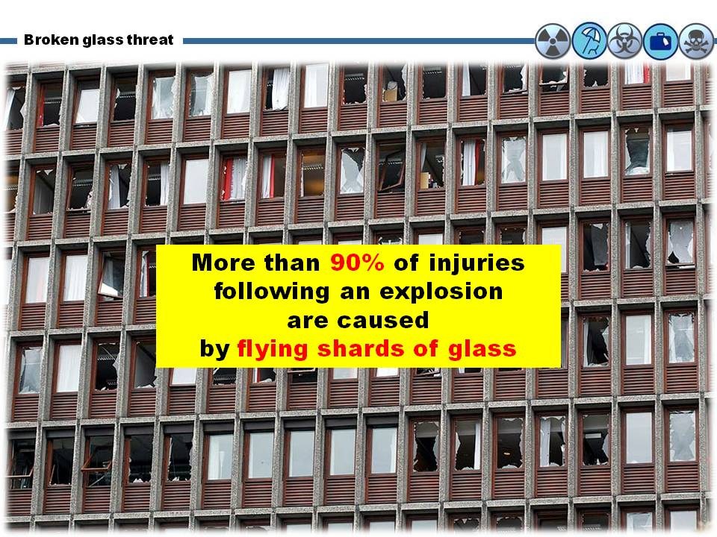
Bomb Blast Mitigation Film

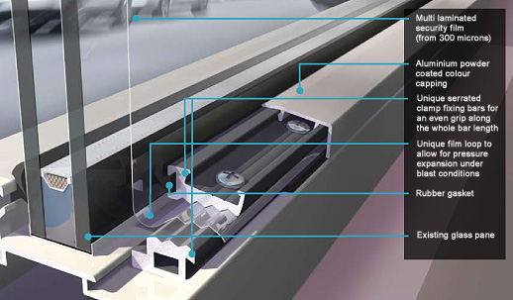
Provides protection for people and property in the event of a bomb blast or chemical explosion

Minimizes the risk of personal injury from broken glass

Ensures rapid recovery of business following window breakage, explosion or bomb blast.

Combined with edge retention systems for increased protection

Designed to provide outstanding security and blast protection, this unique and robust system clamps a high specification multi laminated security window film to a frame.

The system creates a defensive shield designed to hold glass in place after a blast or incident of vandalism - protecting your staff from flying glass injuries and securing your property from theft or damage.

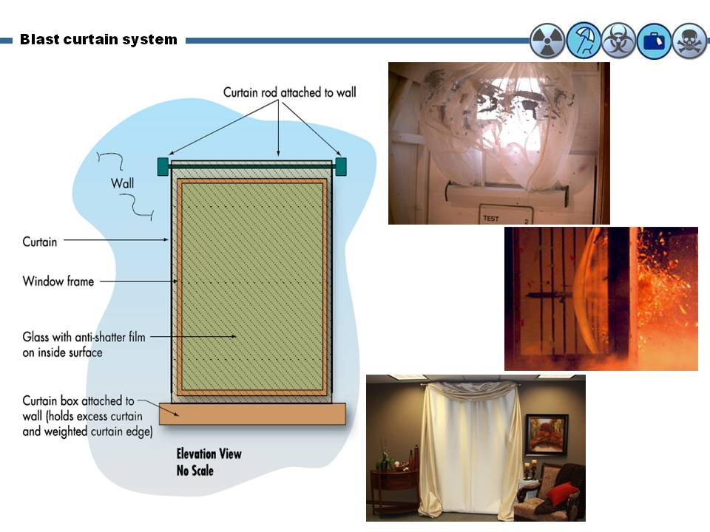
The system can be fitted to existing window frames and color matched for a cost-effective and attractive upgrade to glazing security.

Survival kits

GRAB Box™ Series is your first response to any CBRN, IED, VBIED, PBIED or WBIED incident and provide essential tools specifically designed for responding to crisis situations and terrorist incidents.

GRAB Box™ Series products are highly portable and simple to use and highly effective when deployed. The kits are blast proof and high visibility and the equipment has been put to the test on numerous occasions for responding to many different types of threats and actual incidents. Each kit contains:

Eye protection

Aide memoire & guidance kit

Breathing apparatus

High viz accessories

Washing equipment

Cutting & marking equipment

Scene illuminations

Antidotes

Many might say that having antidotes and medications for CB agents is beyond the scope of hotel services. This might be true in a general perspective BUT if the unexpected happens it would be a tremendous life saving assistance given the havoc of the “Golden Hour”. So it might be a good idea to retain a small stockpile of auto-injectable antidotes for nerve agents, cyanide poisoning and antibiotics.

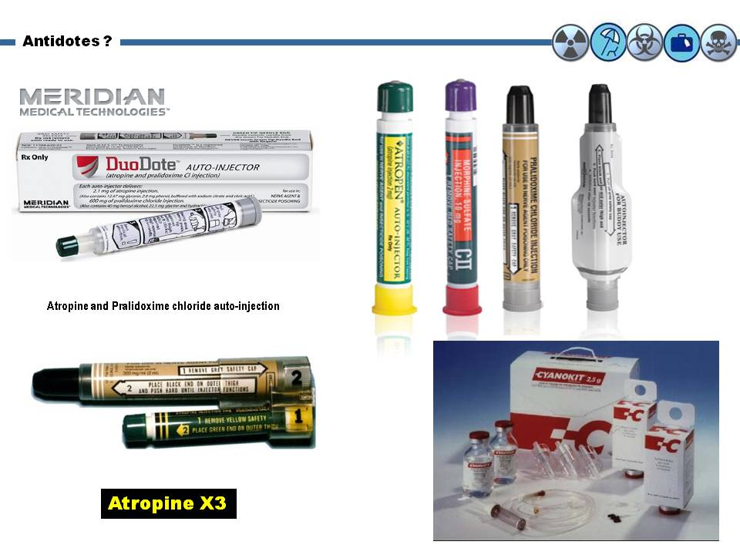

Food terrorism – poisoning

Rajneeshee bioterror attack (1984) was the food poisoning of 751 individuals in The Dalles, Oregon, United States, through the deliberate contamination of salad bars at ten local restaurants with salmonella. A leading group of followers of Bhagwan Shree Rajneesh (later known as Osho) had hoped to incapacitate the voting population of the city so that their own candidates would win the 1984 Wasco County elections. The incident was the first and single largest bioterrorist attack in United States history and one of only two confirmed terrorist uses of biological weapons to harm humans since 1945. As a final result 45 people hospitalized.

Food poisoning does not differ in methodology – only on intentions. It might happen anywhere in the world both in hotels and highly reputatable restaurants resulting in human casualties and even deaths depending of the pathogen involved. Below is a recent example in Europe.

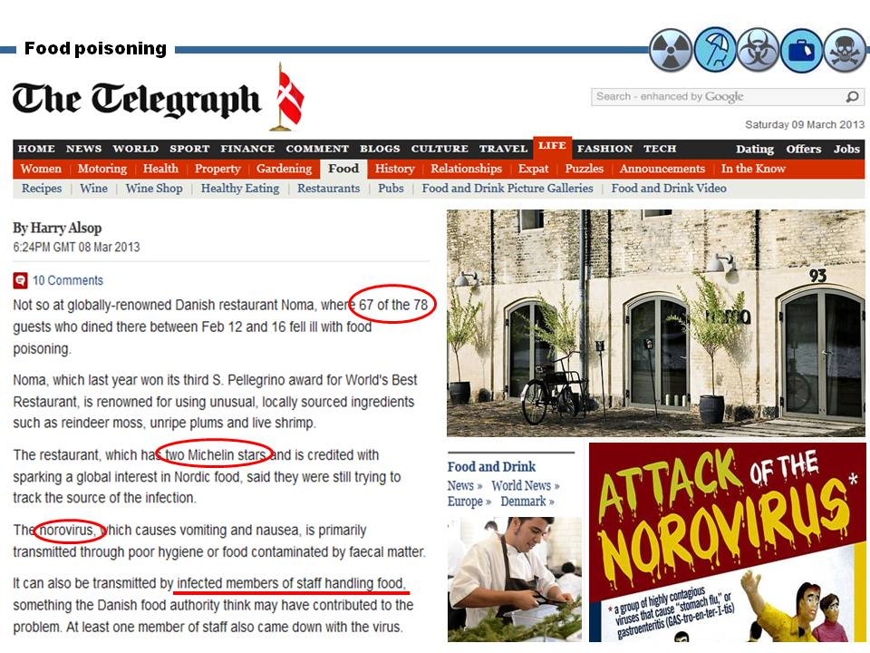

Water bio-terrorism contamination

Significant contamination of water supplies following attack with aerosolized toxins unlikely;

Dilution in reservoir or lake would result in nontoxic exposure;

Usual methods of water treatment (chlorination, filtration) effective vs. viruses, bacteria, most protozoa;

Potential risk: contamination near end-user – i.e. hotel guests

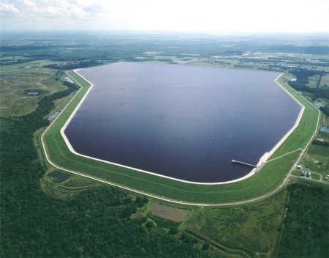

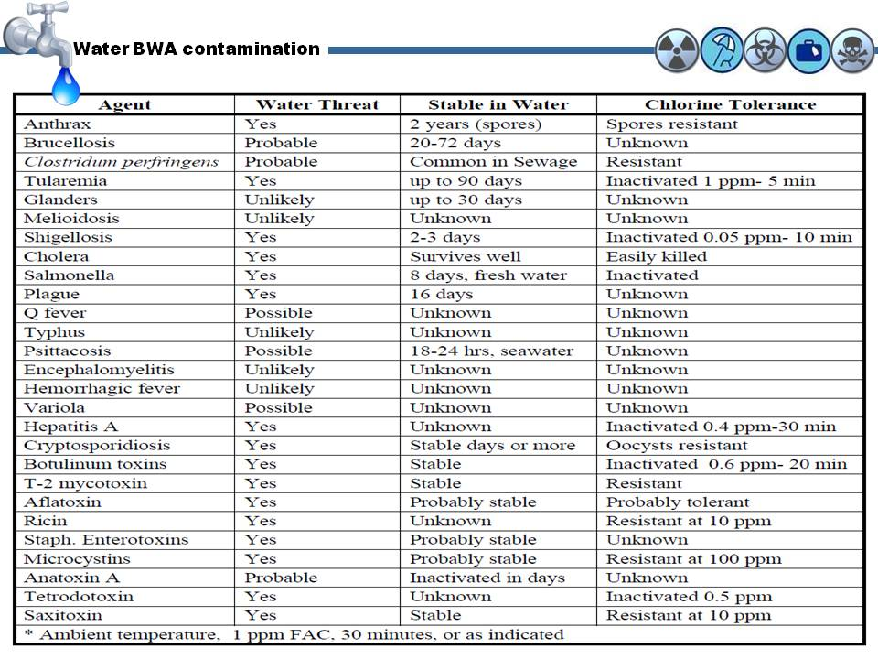
In the table below it is obvious that many bio-terror agents are quite stable in water and can survive chlorination process.

Improvisation

It is not everything about new expensive technology and innovations that threaten existing budgets for hardening processes. Improvisation might be act as an ally in potential life-threatening situation such as the release of chemical agents within hotel’s premises. Activate sprinkler firefighting system and transform it to a decontamination device. It will surely cause damages to infrastructure and cost money for restoration – but what is the cost of a single human life? If time permits this can be done at the basement parking lot but usually chemicals are heavier from air and tend to accumulate in lower empty spaces such as basements.

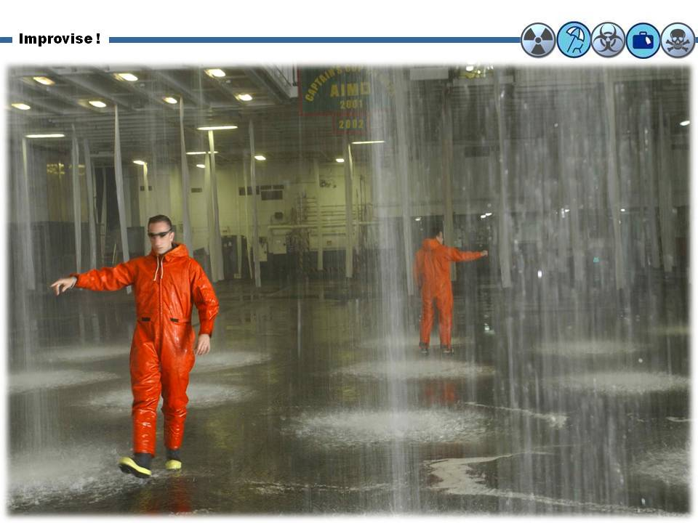

Human profiling/screening

This methodology originally started from Israeli airports where trained personnel in civilian clothing were moving around the airport premises observing human behavioral patterns. Retrospective studies in almost all terrorist attacks in urban environment concluded that a second surveillance perimeter would be beneficial for security purposes. Make an invisible perimeter around the hotel on 24/7 basis with security people critically observing behavior and patterns. Here lies a parallel problem. Having security personnel deployed it does not necessarily mean that they do know what to look for. And this leads to training! Terrorists exposed to B and C agents might have obvious clinical signs that can alert security personnel to act. Everything is a matter of training and dedication to the scope. Keep in mind than any deviation from SOPs leads to bloodshed. The statement of IRA spokesperson after the failed attempt to assassinate late former UK Prime Minister Margaret Thatcher is indicative of the terrorist most important modus operandi: “They have to be lucky all the time. We have to be lucky only once!”

A good example of human screeners is that recently employed by the Mall of America in United States (see photo below).

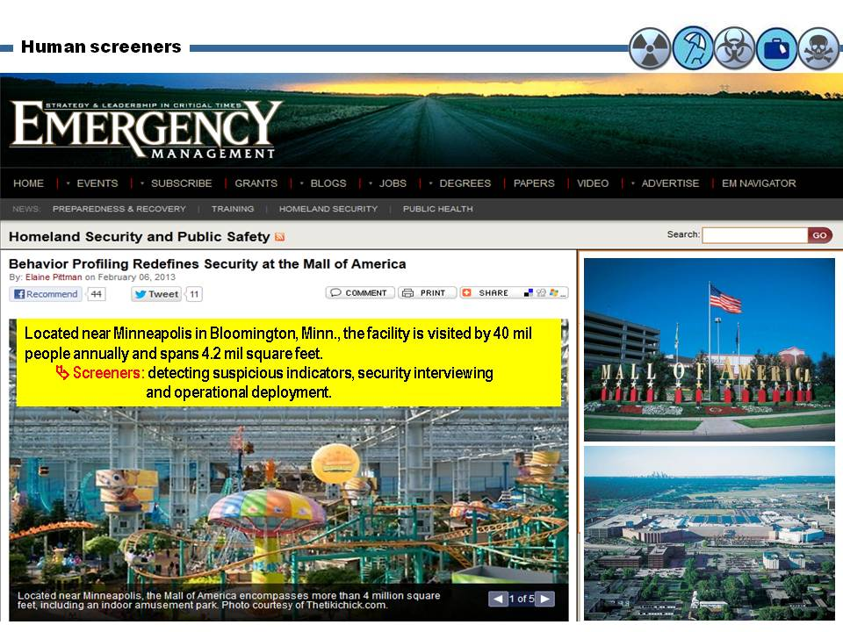

Is the threat real?

There is no doubt that the terrorist threat is real! The addition of CBR agents might be the next step!
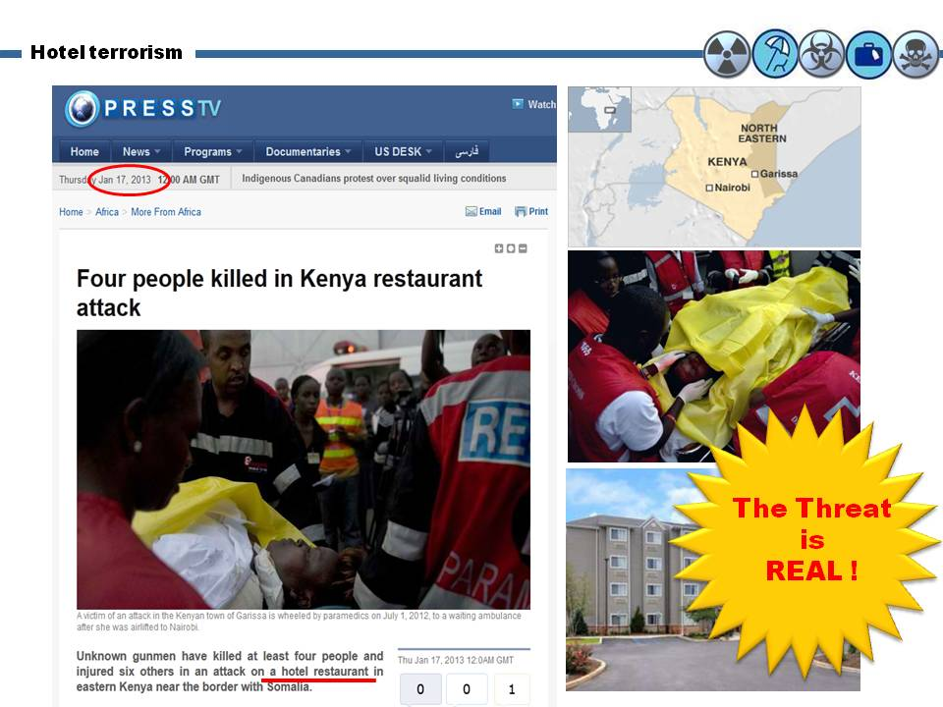

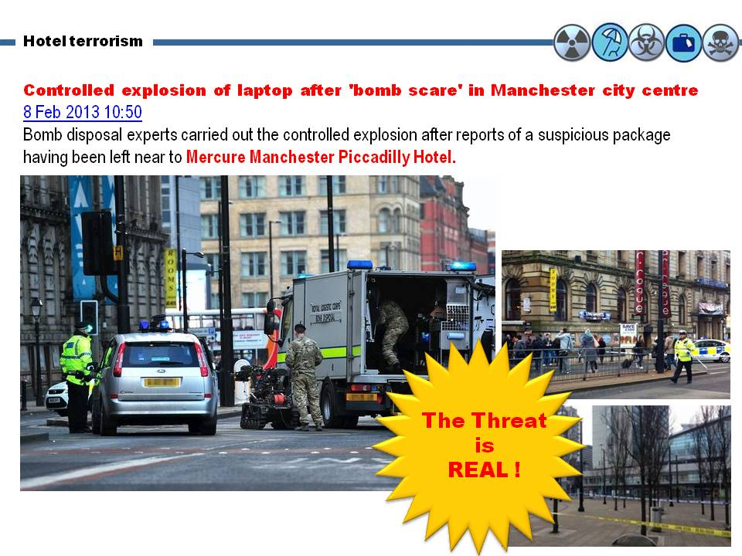

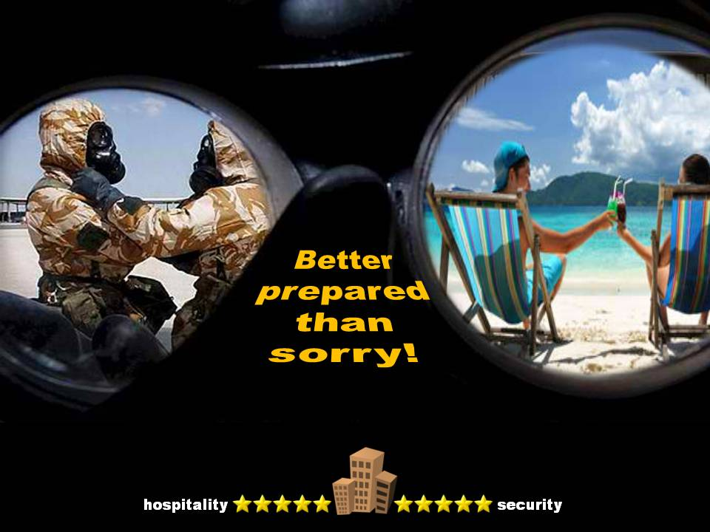
In conclusion

Shopping malls
Most of the directives proposals listed above are applicable also in shopping mall setting. From Wikipedia we read that a shopping mall, shopping center/centre, shopping arcade, shopping precinct, or simply mall is one or more buildings forming a complex of shops representing merchandisers, with interconnecting walkways enabling visitors to easily walk from unit to unit, along with a parking area – a modern, indoor version of the traditional marketplace. We also read that shopping malls can be categorized into various types (i.e. neighborhood center, community center, regional center, superregional center, fashion/specialty center, power center, theme/festival center and outlet center). Malls have various components such as food courts, department stores or stand-alone stores.

New trends
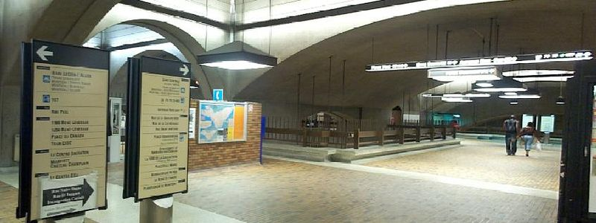
In parts of Canada, it is now rare for new shopping malls to be built. The Vaughan Mills Shopping Centre, opened in 2004, and Crossiron Mills, opened in 2009, are the only malls built in Canada since 1992. Outdoor outlet malls or big box shopping areas known as power centers are now favored, although the traditional enclosed shopping mall is still in demand by those seeking weather-protected, all-under-one-roof shopping. In addition, the enclosed interconnections between downtown multi story shopping malls continue to grow in the Underground city of Montreal (32 kilometres of passageway – photo above), the PATH system of Toronto (27 km (17 mi) of passageway) and the Plus15 system of Calgary (16 km (9.9 mi) of overhead passageway).
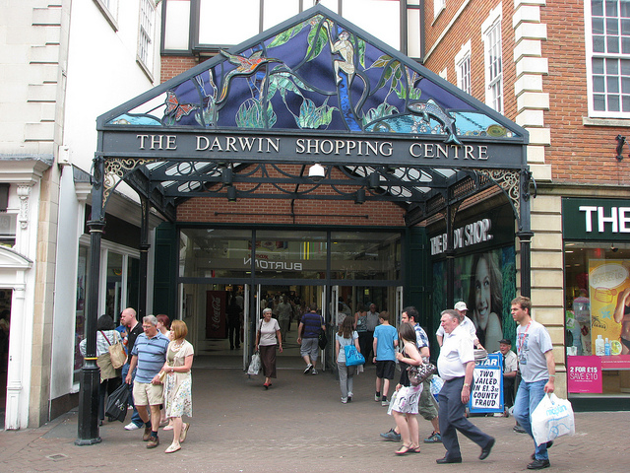
In Russia, on the other hand, as of 2013 a large number of new malls had been built near major cities, notably the MEGA malls such as Mega Belaya Dacha mall near Moscow. In large part they were financed by international investors and were popular with shoppers from the emerging middle class.

Vertical malls
High land prices in populous cities have led to the concept of the "vertical mall," in which space allocated to retail is configured over a number of stories accessible by elevators and/or escalators (usually both) linking the different levels of the mall. The challenge of this type of mall is to overcome the natural tendency of shoppers to move horizontally and encourage shoppers to move upwards and downwards. Vertical malls are common in densely populated conurbations such as Hong Kong and Bangkok. Times Square in Hong Kong is a principal example.
A vertical mall may also be built where the geography prevents building outward or there are other restrictions on construction, such as historical buildings or significant archeology. The Darwin Shopping Centre (photo) and associated malls in Shrewsbury, UK, are built on the side of a steep hill, around the former outer walls of the nearby medieval castle; consequently the shopping center is split over seven floors vertically – two locations horizontally – connected by elevators, escalators and bridge walkways. Some establishments incorporate such designs into their layout, such as Shrewsbury's McDonalds restaurant, split into four stories with multiple mezzanines which feature medieval castle vaults – complete with arrow-slits – in the basement dining rooms.

Note
Shopping mall (http://en.wikipedia.org/wiki/Shopping_mall)

Shopping malls as soft targets
The common denominator of all soft targets is mass gathering. And there are always big numbers of people in shopping malls during working hours that are quite extensive. A shopping mall is also the heart of the local or wider community and a symbol of financial prosperity. Not to mention that in many places around the globe the composition of shoppers visiting the mall is more international than national. In that respect smaller terrorism attacks can actually damage a community’s psyche just as much as something like 9/11, Middle East Forum Director Daniel Pipes argued referring to John Allen Muhammad, who earned the “Beltway sniper” moniker in 2002 when he killed 11 people in the Washington, DC, area during a three-week killing spree, putting the entire area in virtual lockdown during that time period. “You don’t need to pull off huge atrocities like 9/11 to be effective,” Pipes said. “Small Beltway ones can keep a whole city under siege.”
In such a confined (although big) space the release of CBR agents might be devastating. Why using them when conventional terrorism has a better cost to benefit ratio? But this is exactly the epitome of preventive thinking! Otherwise is like trying to answer the question “why al Qaeda haven’t used weapons of mass destruction in urban environment, yet?”

Note

The Local Mall Under Siege? Why Soft Targets are al Qaeda’s Next Move – Interview with Daniel Pipes.
(http://www.diplomaticourier.com/news/topics/security/1006-the-local-mall-under-siege-why-soft-targets-are-al-qaedas-next-move)

Shopping mall security environment
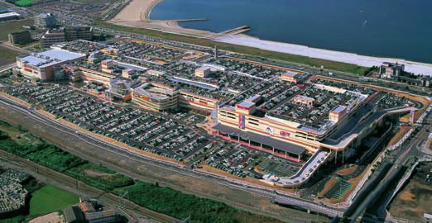
Shopping malls can be divided into the following security zones: (1) open parking space; (2) underground parking space; (3) multistory parking space: (4) main shopping area; (5) restaurants’ area; (6) multi-cinema area; (7) various activities areas – i.e. sports activities; and (8) engineering facilities areas. One of the biggest problems is the availability of blue-prints on the Internet – some generic; others quite detailed. Not to mention the ability to place the overall target on satellite image environment providing operational details such as police stations, fire stations, hospitals, distances but also real pictures not available in normal websites. In the above security environment, certain areas are better targets than others but in general the shopping mall should be surrounded by a second invisible defense circle composed of human screeners that will operated on both external and internal circles. The “see something, say something” approach can be very beneficial if conducted by trained security personnel. Unfortunately only some mega shopping malls adopted this strategy – i.e. Mall of America (see above on hotels’ issues). Another issue is the target selection: why choose a well guarded mall when there are thousands of smaller malls that can do the job? This is why human screening must become a nation-wide practice instead of the privilege of the very few. The impact on society and nation would be exactly the same!

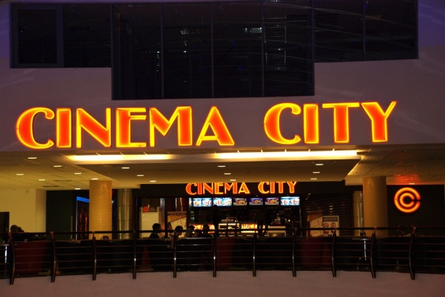
CBR attack
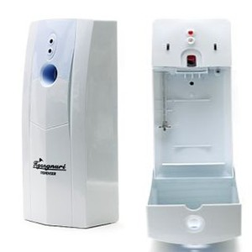
The biggest surveillance problem in shopping malls is the fact that almost all visitors carry one or more bags – small, bigger, boxes of all sizes and shapes, even bags with trailers. This make identification very difficult and complex compared with an equally crowded sports environment – i.e. stadium. Similar conditions are observed in the check-in areas of airports – delivered big baggage, carry-on small baggage and back-packs. In that respect anybody can carry virtually anything inside a shopping mall. This can change but it will cost both money and personnel!
Although a mall is a confined space, in reality it is a huge confined space and the concentrations of lethal agents can quickly dissolved into air. But there are certain areas that confined space is right enough to generate enough casualties to create havoc. For example toilets provide the right environment to release certain agents in various forms. If the canisters of automated space refreshers (photo) are replaced with poisonous content they can continue to spray every 5, 10, 15 or 30 minutes for a long period of time. This example gives enough time to the assaulting team to safely escape disguised as sanitation workers of an existing well-known company!
Food terrorism can be done rather easily by infiltration to existing personnel or as an overt/covert independent operation.
The weapon of choice is a dirty bomb. It will not kill many but radiation released – even in minimal levels – will do the rest and for a very long time. Pressure cookers with the addition of a small cylinder with a radioactive isotope suffice to create a powerful bomb.

Mall CBR defense
Due to construction issues, a shopping mall can have the detection alarm equipment available for other infrastructures. But certain measures in combination with improvising can be proved quite effective to counter the new emerging threats:
- Secure with a locked cage and a CCTV the outside air-conditioning/power units – rarely done;
- Immediately stop the air-conditioning system in case of an explosion or irregular reports of people falling down – so it BEFORE sending someone to see what it is all about!
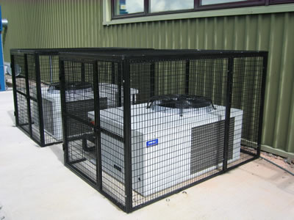
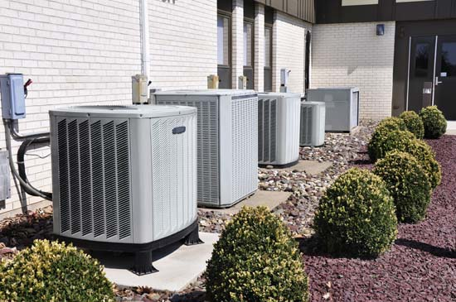
- Provide escape hoods to security personnel – easy to use and carry, low cost, long life and one size fits all! Victimization of internal first responders might be the game changer in a soft target attack.
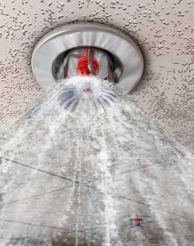
- Activate existing ceiling fire extinguishing system in all areas of shopping mall; thus providing a kind of mass decontamination.
- Open all exits on various levels in an effort to generate air currents that will dissolve high concentrations of the substances released.
- Have an emergency CBR plan and practice this plan with local responders – rarely done.
- Raise all parking lots’ bars to facilitate rapid evacuation of cars and visitors
- Deactivate escalators – some might fall but more will be heart if remain in operation and used by panicked people while in motion.

Airports
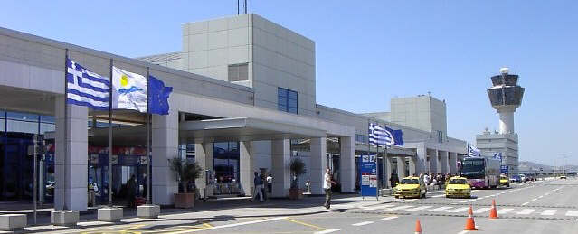
Airport security refers to the techniques and methods used in protecting passengers, staff and aircraft which use the airports from accidental/malicious harm, crime and other threats.
Large numbers of people pass through airports every day, this presents potential targets for terrorism and other forms of crime because of the number of people located in a particular location. Similarly, the high concentration of people on large airliners, the potential high death rate with attacks on aircraft, and the ability to use a hijacked airplane as a lethal weapon may provide an alluring target for terrorism, whether or not they succeed due their high profile nature following the various attacks and attempts around the globe in recent years.
Airport security attempts to prevent any threats or potentially dangerous situations from arising or entering the country. If airport security does succeed in this, then the chances of any dangerous situations, illegal items or threats entering into both aircraft, country or airport are greatly reduced. As such, airport security serves several purposes: To protect the airport and country from any threatening events, to reassure the traveling public that they are safe and to protect the country and their people.
Monte R. Belger of the U.S. Federal Aviation Administration notes "The goal of aviation security is to prevent harm to aircraft, passengers, and crew, as well as support national security and counter-terrorism policy.”

Note

Airport security (http://en.wikipedia.org/wiki/Airport_security)

Airport security environment

In almost all airports around the globe there are various zones with special interest to security: (1) the perimetric fencing; (2) the parking lot (open, underground, multistory); (3) underground metro station; (4) arrivals’ section; (5) departures’ section; (6) shopping section – open and for passengers’ only; (7) airfield and airplanes; (8) fuels’ section; (9) air control tower; (10) offices’ section; (11) baggage and cargo section.

Airports are guarded by police forces and private security companies while CCTVs are universal means of surveillance.

One of the biggest problems besides the accumulation of big numbers of people in confined spaces is that almost all of them carry baggage (big or small). Backpacks or personal bags are not inspected until the security control leading passengers to departure gates.

There are seasonal alterations in the numbers of people using airports (summer, holidays) – this is not the case for major airports that are busy all year round.

Check-in areas and arrivals are the areas with highest density of passengers and people connected to them (friends, relatives, tourism officials etc).

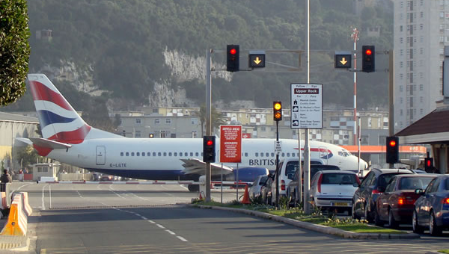
Finally airports are surrounded by an empty area – although cities tend to approach/cycle airports as time goes by. In a few instances it is difficult to identify which is what! (see Gibraltar airport in photos below)

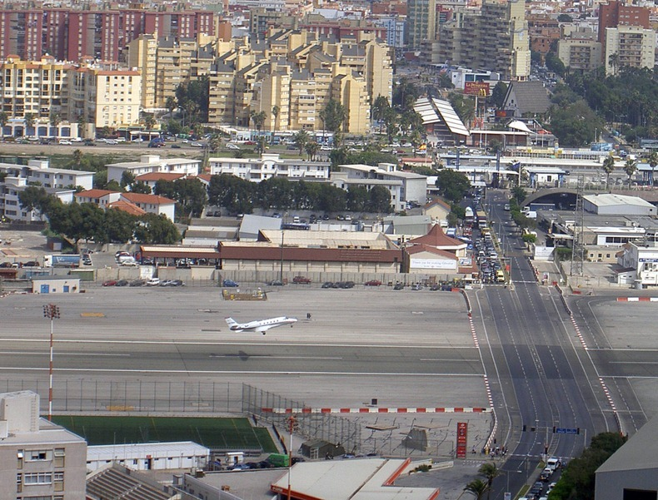
Fencing

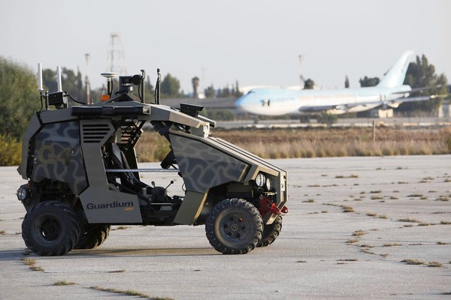
Usually it is a regular high fence sometimes with a security concertina razor barbed wire on top of it. Sometimes there is second inner fence of similar construction. CCTV may be present or not. Security personnel are not usually present unless there is a security alarm. Infiltration is easy. Unmanned security vehicles – like those in Tel Aviv’s Ben Gurion International Airport (photo) might be a good solution given the many capabilities they possess.

Parking lots

Usually supported by CCTVs but not always with security personnel. This is an area that a second perimetric human screen can be successfully applied.

Departures

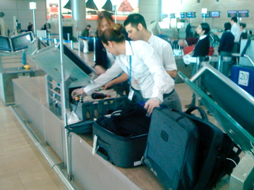
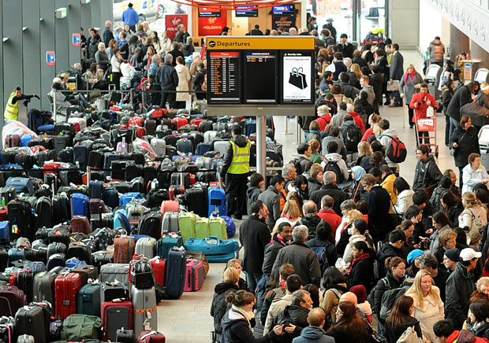
This is the biggest security problem of all! What is the universal setting? Passengers arrive at the departures’ section of the airport with their belongings (baggage, trolley-bags, backpacks) and accumulate before check-in booths. Passengers can be either alone or in groups. In certain periods or in certain times of the day there are hundreds of passengers in line. Despite efforts to isolate baggage inspection before final baggage drop-off (i.e. Ben Gurion Int Airport: baggage security inspection – electronically and physically before delivery) until now the problem remains unsolved due to the large volume of arriving passengers. Of course there is no problem without solution but we have to keep in mind that airports are money makers and not money spenders.

Departures’ is an area that needs to be inspected by human screeners mixed with crowd. In many instances human behavior reveals many secrets and intentions! It also an area that need to be re-designed and keep in pace of modern threats and capabilities of those who want to harm people in many ways.

Arrivals

Here the problem does not have to do with baggage but with the accumulation of people and the sometimes chaotic overall environment – a mixture of people, cars, buses and taxis (i.e. the nightmare of arriving at the old airport of N Delhi after midnight). At arrivals the presence of police is not as strong as in departures despite the fact that targeted (nationality based) terrorist activity might be attractive. There is also “understanding” from security officers on site regarding illegal short-term parking “to deliver the pregnant wife or the elderly arriving from abroad”! A VBIED cannot only harm people but also structural elements of the airport since arrivals are usually underground often connected with adjacent multistory parking lot.

Airfield/airplanes, baggage/cargo area, control tower, offices

Direct access to airfield and airplanes is rather difficult but not impossible. Here is where personnel background check is mandatory – should be regularly updated and investigated in depth.

Control tower is (or should be) an independent structure (power, ventilation, water) – this is both a strong and a weak aspect of security. It is widely visible from a distance and a good target for long range weapons. The tower format provides visibility of the airfields but modern technology might find solution to replace direct vision with electronic surveillance.

The MANPADS and laser problems

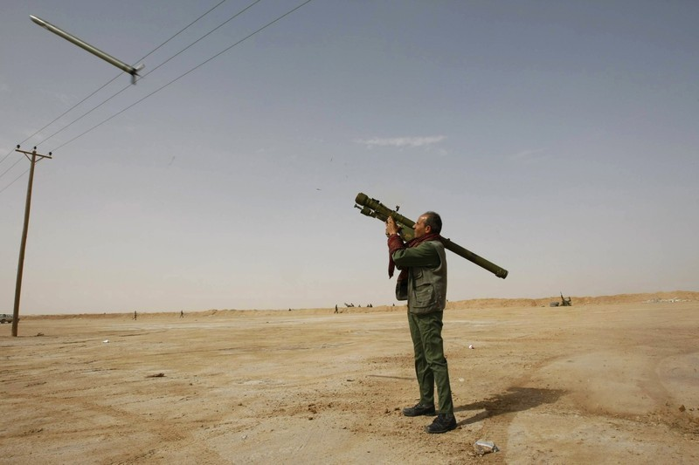
MANPADs always represent a problem to airplanes during their landing or take-off processes. In the long history of aviation terrorism there are quite many incidents recorded mainly in Africa but also elsewhere. What is worrying is the large numbers of missing MANPADs from armed forces’ storage facilities in Libya and their smuggling in neighboring countries and regions.

Although laser beams following airplanes started as immature behavior of the very few, modern handled laser can pose a serious threat to the pilot crew of commercial aircrafts.
There are four primary areas of concern. The first three are "visual effects" that temporarily distract or block pilots' vision. (For lasers, these effects are only of concern when the laser emits visible light.)
- Distraction and startle. An unexpected laser or bright light could distract the pilot during a nighttime landing or takeoff. A pilot might not know what was happening at first. They may be worried that a brighter light or other threat would be coming.
- Glare and disruption. As the light brightness increases, it starts to interfere with vision. Veiling glare would make it difficult to see out the windscreen. Night vision starts to deteriorate.
- Temporary flash blindness. This works exactly like a bright camera flash: there is no injury, but night vision is temporarily knocked out. There may be afterimages—again, exactly like a bright camera flash leaving temporary spots.
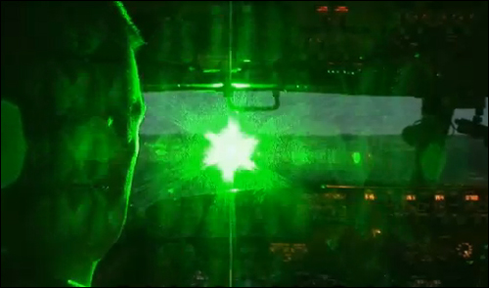
The three visual effects above are the primary concern for aviation experts. This is because they could happen with lower-powered lasers that are commonly available. The fourth concern, eye damage, is much less likely. It would take specialized equipment not readily available to the general public.
- Eye damage. Though it is unlikely, high power visible or invisible (infrared, ultraviolet) laser light could cause permanent eye injury. The injury could be relatively minor, such as spots only detectable by medical exam or on the periphery of vision. At higher power levels, the spots may be in the central vision, in the same area where the original light was viewed. Most unlikely of all is injury causing a complete and permanent loss of vision. To do this requires very specialized equipment and a desire to deliberately target aircraft.
It is extremely unlikely that any of the four elements above would cause loss of the aircraft, especially if the pilots react properly and work as a team.

Since both (MANPADS and lasers) are operated outside the perimeter of the airport a second line of defense should be 24/7 deployed covering this extreme aspect in urban environment.

Note

Lasers and aviation safety (http://en.wikipedia.org/wiki/Lasers_and_aviation_safety)

Man injured after explosion at Beijing Airport's Terminal three
15:13, Saturday, 20 July 2013
Source: http://www.rte.ie/news/2013/0720/463648-beijing-airport-explosion/

A man in a wheelchair detonated a home-made explosive in Beijing airport.
He injured himself and sent smoke billowing through the exit area of the international arrivals section of Terminal 3.
Individual Chinese unable to win redress for grievances have in the past resorted to extreme measures, including bombings.
Incidents like this are rare amid the tight security of airports, and the motive in this case is not yet known.
There were no other injuries and operations were normal after the blast.
State broadcaster China Central Television said the explosion took place just meters (feet) outside the door from which arriving international passengers depart after picking up their luggage.
It was not clear why the man was at the airport.
An airport spokeswoman declined to speculate about the man's motive, saying airport police were still investigating.
A Reuters witness said things had returned to normal about 90 minutes after the explosion and there were no signs of extra security.
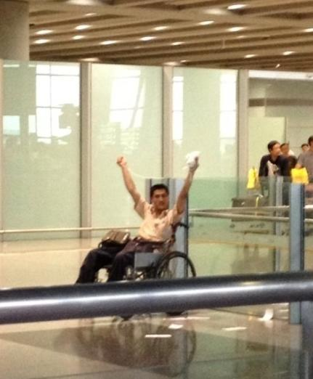
Explosives are relatively easy to obtain in China, home to the world's largest mining and fireworks industries.

CBR attack

Although airports and malls share some common CBR scenarios, an airport is not only a soft target but also a landmark. One can only imagine the consequences of a chemical, biological or radiological attack against an aviation hub! Let’s explore some scenarios:

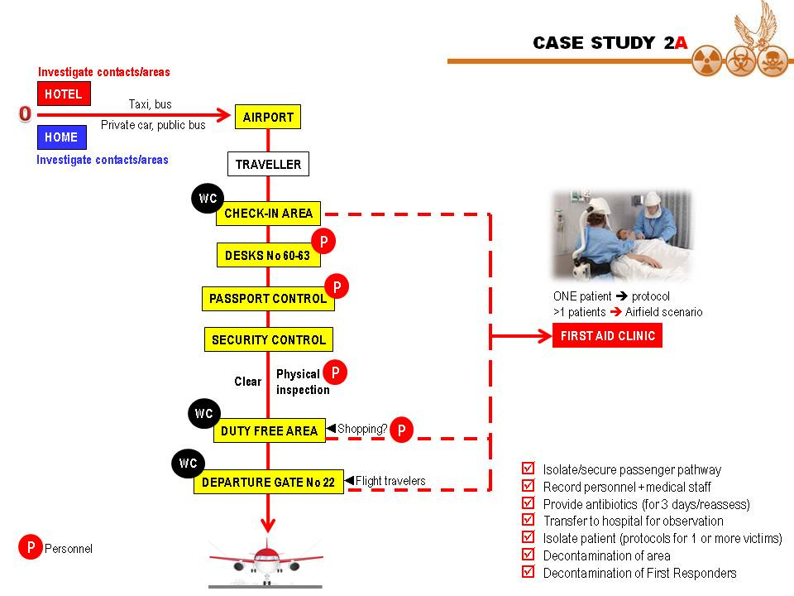
Scenario 1 – Bioterrorism on ground

A future terrorist self-infected with a highly contagious biological agent is leaving his house or hotel and arrives with a bus at the airport. There given the fact that he does not carry explosives or weapons he can easily pass all security controls and merge with hundreds of passengers flying to many different destinations but also to airport staff involved in security control. He can freely move around the airport for hours and depending on the incubation period of the pathogen involved to infect many people of all ages.

Finally he will be on board and travel to his next target. This might be a seasonal scenario executed during common flu season. In that respect he will not be the only one coughing or sneezing but one among many with similar symptoms. Is there a protocol checking these people in the airports? Can he be denied to travel because he has the flu? Can biological detectors detect the threat? No is the most probable answer to these questions.

Perhaps the same day or the days after, airport’s personnel will start experiencing symptoms; same for the hotel personnel he was living in or bus passengers he was travelling with towards airport? Will authorities be able to connect the dots on time for a proper alert and response? Perhaps – but this will be done after a few days. Is the medical personnel properly trained to identify bioterrorism agents’ symptoms and signs? Most probably not! – they haven’t been taught this lesson while in the medical school…!

Scenario 2 – Bioterrorism in flight

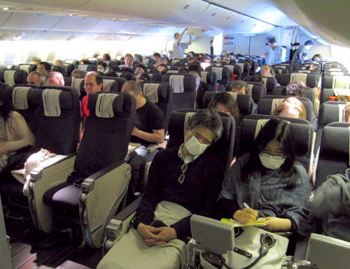
Finally the above bio-terrorist is on board but after takeoff his condition deteriorates fast and it is obvious that he is seriously ill. In cases like these most probably one or two physicians on board will advice captain and crew to land in the nearest airport to avoid putting his life in danger. Is the staff educated enough to identify certain key-signs that 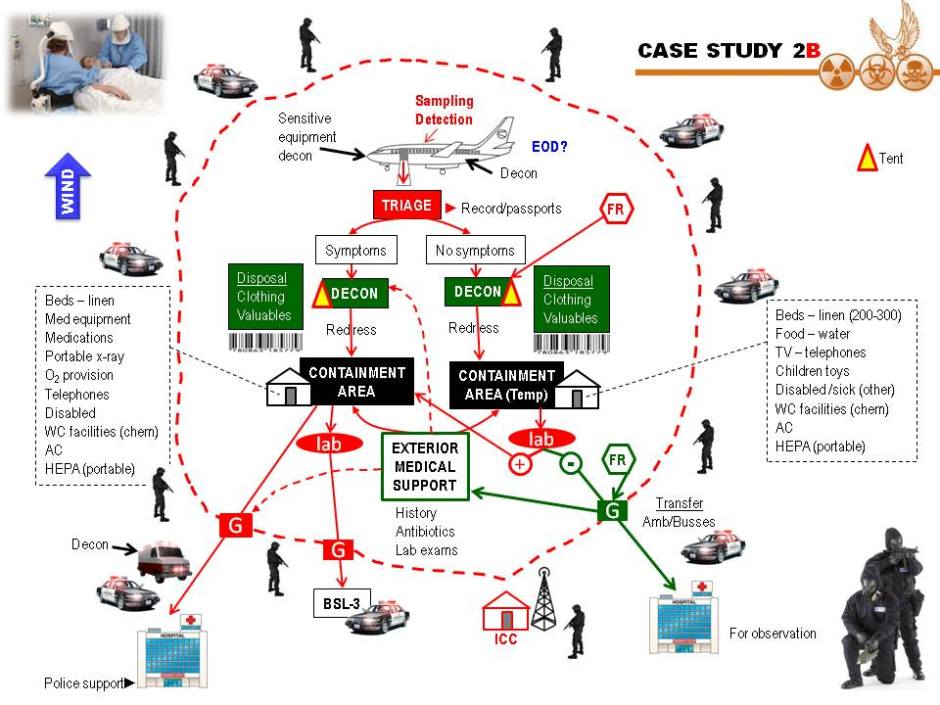might alert the medical staff of the airport to land to? Will the plane continue as scheduled? Who will order them not to fly? Who will put them into ground isolation or quarantine? Will this be done in the emergency landing airport or at the final destination where many of the patients will be presented with similar symptoms (long international flights lasting many hours)? What if the pilot – who usually personally inspects serious cases of sick people on board – becomes a victim himself? Are airport ground medical personnel ready to deploy before the arrival of the contaminated flight? Are state authorities equally prepared to respond?

Scenario 3 – Airport’s fuel facilities explosion (accident or man-made)

A contaminated plume is rapidly approaching the main airport building during very busy hours. Is there enough time to evacuate? Is there a possibility to shelter in place? Can authorities seal the building, deactivate central air conditioning or provide proper decontamination and first aids to those involved?

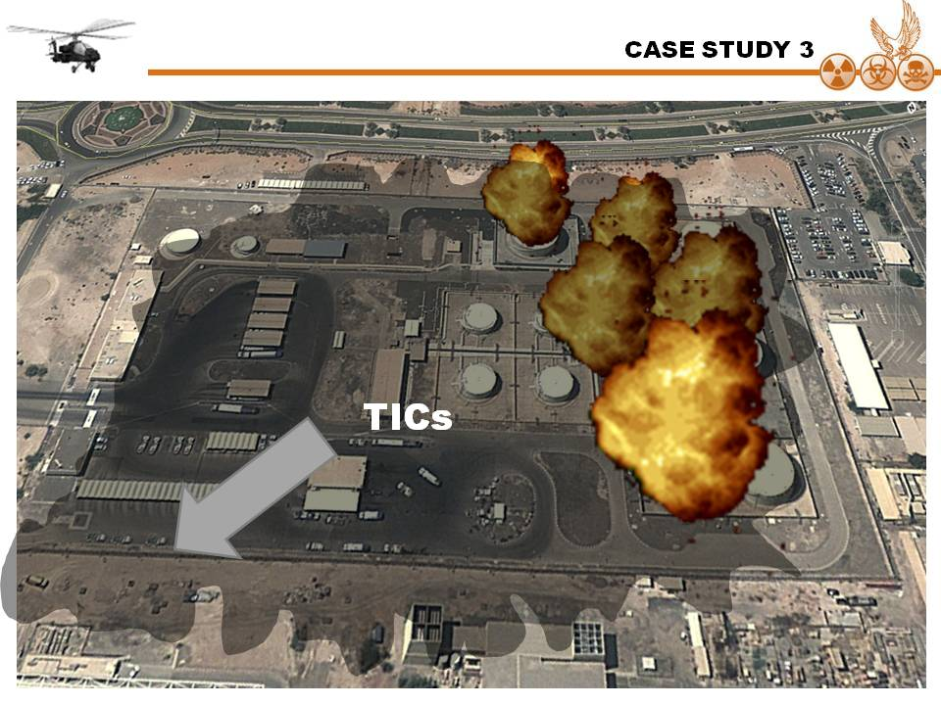

Scenario 4- Chemical attack

A direct attack with a chemical bomb is not a strong scenario although the impact will be high enough to cause both casualties and “hurt” the nation. But what if a lethal chemical is released through the miles long air providing network we see on the ceilings of almost all airports worldwide. Are outside outlets secured and regularly inspected? Will First Responders arrive on time against the traffic jam caused by people using their car to escape from the airport? Are the medical personnel ready, trained and prepared to deal with chemical terrorism? Same applies for police and fire fighting personnel already operating at the airport? Are there enough antidotes to inject? Are there chemical detectors to verify the threat in first place? Who and how will conduct decontamination of those been inside the airport and look for an escape out? The good thing is the civilians visiting the airport can enter or exit via certain doors – usually 5-7 in both arrivals and departures. This is an advantage that needs to be seriously considered when planning response in airport settings. Can airport’s authorities improvise and activate ceiling sprinkles to combat heavy contamination? Who will give the order to do this? Is he trained and aware of CBRN threats and consequences? Are airport designers and architects aware of the new threats and how can certain defenses could be incorporated into their final products?

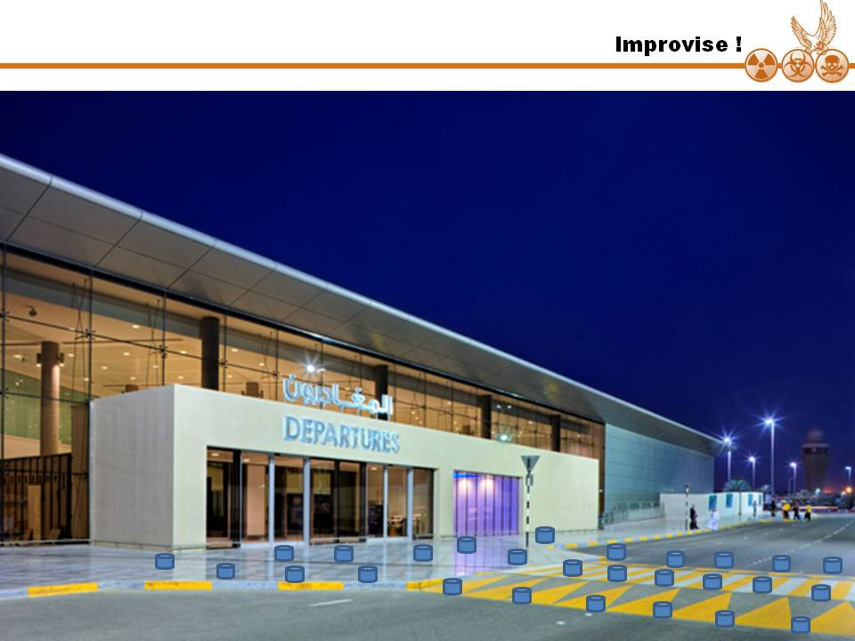
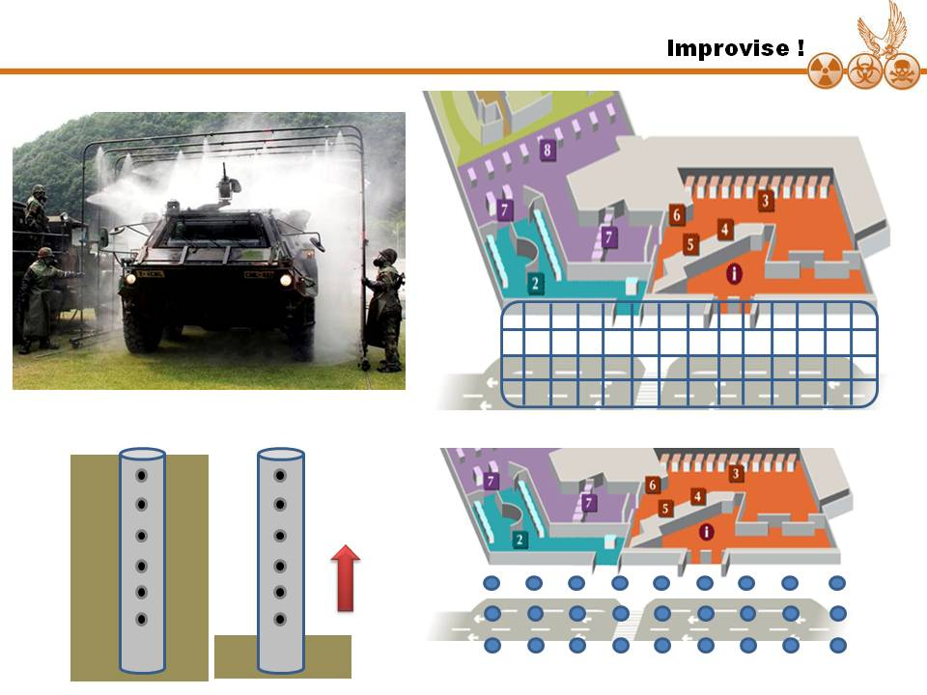
An automated decontamination system (ceiling – upper right or ground – bottom right) set outside arrivals and departures (Editor’s proposal).

Scenario 5 – Dirty bomb attack

What if the Beijing suicide bomber (read article above) was carrying a dirty bomb? Although casualties would be minimal (as in his case) what about the radio-contaminated smoke spread inside the airport? Are there CR detectors in operation? Stand alone or portable? Who would think to activate them the moment after an explosion will take place?

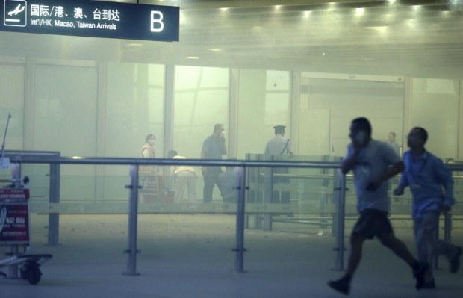 | 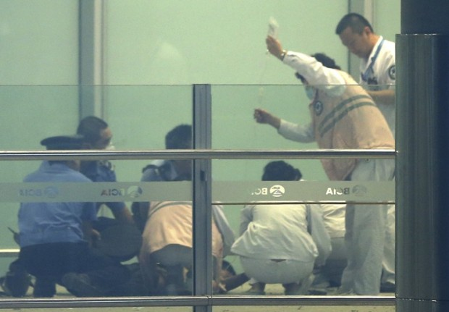
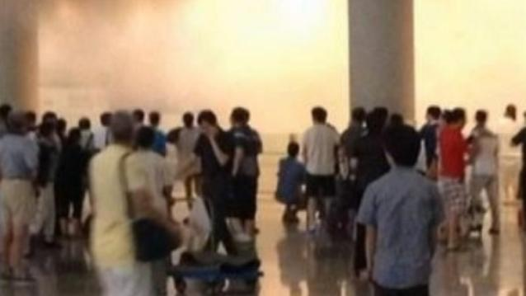

Conclusion

Based on the above – presented here in a generic form for obvious reasons – it is very easy to conclude that a CBR attack against soft targets as airports, shopping malls and hotels would be simply catastrophic! It is also obvious that plans and planners need to proceed to the next step – that of team working among experts and specialists of various backgrounds. Architects have no idea about CBRN. CBRN people have no idea about architecture. Civil engineers have no idea about IED/VBIED/INEDs. EOD/CBRN people have no idea about civil engineering. All the above have no idea about medical consequences and medical people have no idea about CBRN or explosives. But what if all these people belong to the same planning/designing team? What if all these experts start talking to each other and start solving problems in an efficient and combined way? I read about fabulous new projects constructed into various parts of the world. Huge hospitals, skyscrapers, underwater tunnels etc – are they prepared to deal with new emerging threats? Or are they based on the traditional way of state reaction and the inherent human belief that “it will not happen to them?”

Think about it next time you hear or read about the “biggest”, the “tallest” or the “most fantastic” structure humans erupt on Earth!

