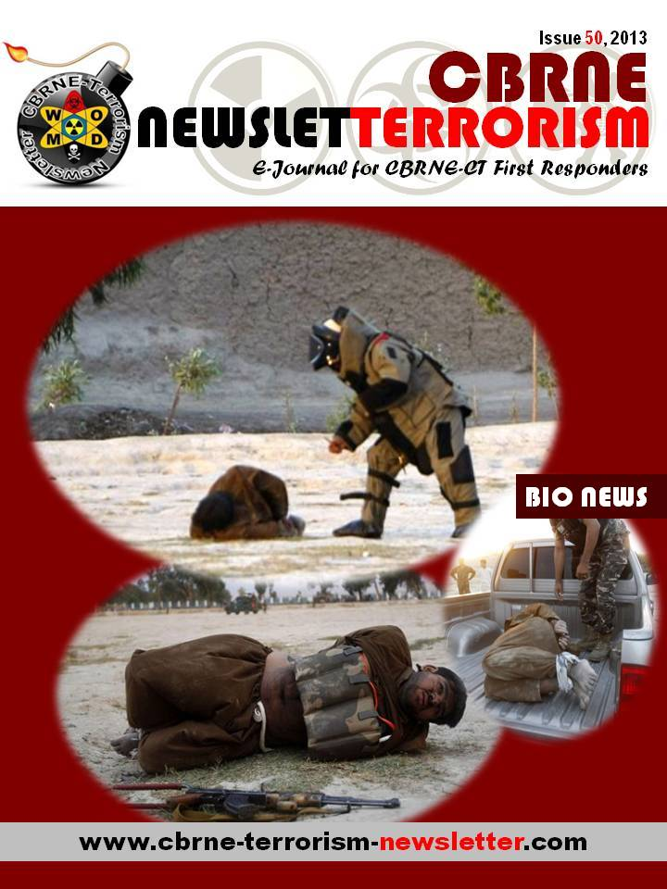



|  |  |
| --- | --- |
| Enterovirus meningitis confirmed with 45 children in sthrn Russian cities |  |

**June 16**

Source: http://www.itar-tass.com/c32/773260.html

Physicians in the southern Russian city of Rostov-on-Don have confirmed enterovirus meningitis with 45 people, a spokesperson for the federal Ministry of Healthcare said Sunday.

A total of 75 children are taking a course of hospital treatment in the aftermath of an outbreak of viral meningitis in the city with a population of about 1.1 million people. “All the patients /including the ones whose diagnosis has been confirmed - Itar-Tass/ are in a stable condition,” the spokesperson said.

As many as eight children have been released from hospitals since Saturday afternoon. All in all, the outbreak has affected 159 people.

Earlier reports said the physicians had confirmed the diagnosis of 38 children.

The Rostov region public health ministry also said four adult patients with manifestations of an acute viral respiratory infection were taking treatment at a city hospital and one of them was a kindergarten instructor.

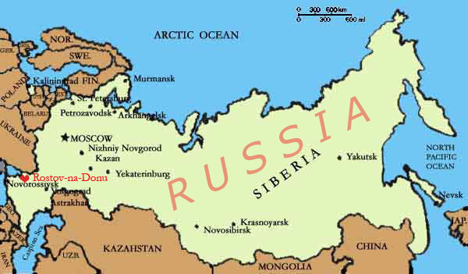An adult female patient is getting intensive therapy in the condition of an induced coma.

To prevent the emergence of new cases of the diseases, which is rarely lethal but which imposes debilitating impacts on its victims, the local medical authorities have launched a whole range of prophylactic measures like checkup rounds at apartment blocks.

As many as 4,249 children have been checked up to date.

The federal Healthcare Ministry expects an investigation report from the sanitary watchdog agency Rospotrebnadzor on the source of infection, as well as causes and mechanisms of its transmission to the children.

The list of aftereffects of enterovirus meningitis includes exhaustion, headaches, memory loss, anxiety, depression, balance problems, and hearing difficulties.

|  |
| --- |
| **Enteroviruses** are a genus of positive-sense single-stranded RNA viruses associated with several human and mammalian diseases. Serologic studies have distinguished 66 human enterovirus serotypes on the basis of antibody neutralization tests. Additional antigenic variants have been defined within several of the serotypes on the basis of reduced or nonreciprocal cross-neutralization between variant strains. On the basis of their pathogenesis in humans and animals, the enteroviruses were originally classified into four groups, polioviruses, Coxsackie A viruses (CA), Coxsackie B viruses (CB), and echoviruses, but it was quickly realized that there were significant overlaps in the biological properties of viruses in the different groups. Enteroviruses isolated more recently are named with a system of consecutive numbers: EV68, EV69, EV70, and EV71, etc. Enteroviruses affect millions of people worldwide each year, and are often found in the respiratory secretions (e.g., saliva, sputum, or nasal mucus) and stool of an infected person. Historically, poliomyelitis was the most significant disease caused by an enterovirus, poliovirus. There are 62 non-polio enteroviruses that can cause disease in humans: 23 Coxsackie A viruses, 6 Coxsackie B viruses, 28 echoviruses, and 5 other enteroviruses. Poliovirus, as well as coxsackie and echovirus are spread through the fecal-oral route. Infection can result in a wide variety of symptoms ranging from mild respiratory illness (common cold), hand, foot and mouth disease, acute hemorrhagic conjunctivitis, aseptic meningitis, myocarditis, severe neonatal sepsis-like disease, and acute flaccid paralysis. |

# Terror threats on the Pharmaceutical Industry

Source: http://i-hls.com/2013/06/terror-threats-on-the-pharmaceutical-industry/

**Over the last few months, my colleague, Dr. Miri Halperin Wernli (*Vice President, Deputy Head Global Clinical Development, Head of Global Business&Science Affairs at Actelion Pharmaceuticals, Switzerland*) and myself, undertook several research projects analyzing the risk of terrorism to the pharmaceutical industry. We have published various articles on the subject (including in a forthcoming issue of *Studies in Conflict and Terrorism)* and just completed a short documentary which aims at raising awareness on these dangerous recent developments. The result of our research has lead us to advice and brief governmental and non-governmental bodies; including the Israeli Ministry of Health and the Israeli National Security Council.**

The documentary presents unique data which demonstrates that **at least one terrorist organization – Hezbollah – is already involved in manufacturing and distributing counterfeit medications. Hezbollah is liable to use its production centers, international smuggling and distribution networks, and ties to international crime syndicates to insert deadly fake drugs into the pharmaceuticals market.**

This poses new and different challenges which need to be recognized and addressed by decision–makers, security agencies and the global pharmaceutical industry. By understanding the potential gaps and the associated risks, and by taking the recommended measures, the pharmaceutical industry can prevent or minimize the possibility of potentially severe consequences for the public and the industry.

**By Dr. Boaz Ganor**

Ronald Lauder Chair for Counter Terrorism,

Founder&Executive Director, ICT – The International Policy Institute for Counter-Terrorism,

Deputy Dean, Lauder School of Government, Herzliya, Israel,

The Interdisciplinary Center, Herzliya, Israel

|  |
| --- |
| The Vulnerability of the Pharmaceutical Industry to Terrorism Source: <http://www.chamber.org.il/images/Files/15659/%D7%A1%D7%99%D7%9B%D7%95%D7%A0%D7%99%20%D7%98%D7%A8%D7%95%D7%A8%20%D7%A2%D7%9C%20%D7%AA%D7%A2%D7%A9%D7%99%D7%99%D7%AA%20%D7%94%D7%A4%D7%90%D7%A8%D7%9E%D7%94.PDF> |

## New microfluidic chip useful in counterterrorism, water and food safety

Source: http://www.homelandsecuritynewswire.com/dr20130619-new-microfluidic-chip-useful-in-counter terrorism-water-and-food-safety

A new process for making a three-dimensional microstructure that can be used in the analysis of cells could prove useful in counterterrorism measures and in water and food safety concerns.

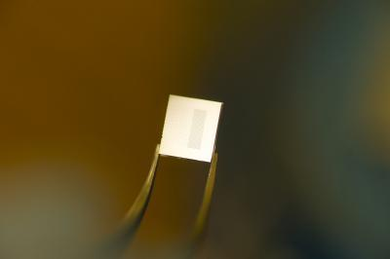The research, conducted by members of Virginia Tech’s Microelectromechanical Systems Laboratory (MEMS) in the Bradley Department of Electrical and Computer Engineering, is the focus of a recent article in the Institute of Electrical and Electronic Engineers’ Journal of Microelectomechanical Systems.

In their engineering laboratory, the researchers developed a new microfabrication technique to develop three-dimensional microfluidic devices in polymers. Microfluidics deals with the performance, control, and treatment of fluids that are constrained in some fashion, explained Masoud Agah , director of the laboratory.

A Virginia Tech release reports that as a result of this work, Agah, associate professor of the Bradley Department of Electrical and Computer Engineering and of the Virginia Tech–Wake Forest School of Biomedical Engineering and Sciences, and Amy Pruden, professor of civil and environmental engineering at Virginia Tech, have received a National Science Foundation (NSF) award of $353,091 to use the technology and develop new microchips named 3D-πDEP standing for “three-dimensional, passivated-electrode, insulator-based dielectrophoresis” for pathogen detection.

The NSF grant will allow them to focus on the isolation of waterborne pathogens that represent one of the “grand challenges to human health, costing the lives of about 2.5 million people worldwide each year,” Agah and Pruden said.

According to the World Health Organization (WHO), the isolation of pathogenic bacteria from the environment has not significantly changed since the 1960s, when methods for chemical treatment of samples to remove background organisms were first implemented.

In the past, Agah said, researchers have mainly used two-dimensional microfluidic structures since this type of fabrication is more simplistic. With the three-dimensional device developed by Agah and his collaborators, Yayha Hosseini and Phillip Zellner, both graduate students in the department, they are able to customize the shapes of the channels and cavities of the devices the fluids passed through.

The advantage of the fabrication process is that with a very economical technique it creates three-dimensional varying channels and cavities in a microfluidic structure with rounded corners as well as many other customized shapes.

These shapes are important because they resemble the living conditions as they occur naturally and this allows the use of the three-dimensional microfabrication technology beyond pathogen detection.

As an example, in human blood vessels, cells interact with each other and their surrounding environment inside circular channels. They have varying diameters, along with multiple branching and joints.

“Only under this type of condition can one truly study the biology of cells within a system in vitro as if it is occurring in vivo — our new microfluidic fabrication technology can resemble more realistically the structures of a cell’s true living conditions,” Agah said. It is the introduction of the three-dimensions that provides this distinctive environment.

The combination of Agah and Pruden’s expertise is important to the NSF-awarded work.

Pruden has a broad background in applied environmental microbiology, and has worked extensively in the detection and characterization of pathogens in various environmental systems. She is also leading other research efforts focused on the detection and monitoring of various pathogens and antibiotic resistant pathogens in drinking water and in wastewater.

The release notes that Agah is the recipient of a National Science Foundation CAREER Award for his work in three-dimensional micromachining and its use in microfluidics and chemical detection.

Prudent also has a CAREER award as well as a presidential Early Career Award in Science and Engineering.

By blending their proficiencies, with Agah’s group designing, modeling, and fabricating the chips, and Pruden’s group preparing the different bacterial cultures for characterizing their dielectrophoresis properties and benchmarking it against more acceptable yet costly methods, they believe they will be able to isolate different pathogenic and nonpathogenic bacteria.

To make their three-dimensional structure, the Virginia Tech researchers used the material polydimethylsixolane, known for its elastic properties similar to rubber. This material is already widely used because of its transparency, biocompatibility, and low-cost.

“Our work establishes a reliable and robust, yet low-cost technique for the fabrication of versatile 3-D structures in polydimethylsixolane,” Agad said.

Microfluidic devices can be used to trap and sort living organisms such as bacteria, viruses, and cells. With this new three-dimensional device that has a higher sensitivity and throughput than the two-dimensional version, according to Agah, he is able to make their predictions of applications ranging from water and food safety to fighting biological and chemical terrorism and to healthcare by fishing for abnormal cells in body fluids.

|  |
| --- |
| **New Information on MERS Highlights Need for Infection Control and Broad Case Definition** |

|  |  |
| --- | --- |
| **By Amesh A. Adalja, MD, FACP, and Eric Toner, MD**  Source: www.upmc-cbn.org | www.UPMCHealthSecurity.org |  |

|  |
| --- |
|  |
| Two major recent developments in the evolving scientific and clinical understanding of Middle East Respiratory Syndrome coronavirus (MERS-CoV) reinforce the fact that this highly lethal virus is capable of wide dissemination, especially within hospitals. As of today, the official WHO case count stands at 64, with 38 deaths.    **Retrospective Investigation of Hospital Cluster in Jordan**  In April 2012, a cluster (12 or more cases) of then unexplained respiratory illnesses occurred in a Jordanian hospital. After MERS-CoV was identified in September 2012 from cases in Saudi Arabia, retrospective PCR testing was performed on stored Jordanian specimens, and it revealed that 2 cases (both fatal) from the April outbreak in Jordan resulted from MERS-CoV. Because many more individuals in Jordan had been ill or exposed, 124 additional stored samples were tested using a recently developed serologic assay. As a result, 8 more cases of MERS were confirmed, bringing the total case count in Jordan to 10. Notably, the 8 additional cases are somewhat different from other MERS cases in that most did not have predisposing conditions, and one was an asymptomatic household contact.1 If the cases in Jordan cases are eventually added to the official case counts, the worldwide total will rise to 72 cases with 38 deaths.    **Saudi Hospital Cluster Resulted from Nosocomial Spread**  From April to May 2013, the eastern Saudi Arabian province of Al-Ahsa reported 23 cases of MERS, 15 of which were fatal, and 21 of which were contracted in a hospital's hemodialysis unit and ICU, both of which had open-ward designs. A description of the Saudi experience, just published in The New England Journal of Medicine, provides important data on the clinical presentation and the nosocomial spread of MERS. In particular, Assiri and colleagues note that most of the cases can be traced to the hospital's open-ward style hemodialysis unit before infection control measures were initiated or from the open ICU, where aerosolized medication, CPR, and mechanical ventilation were administered. Most of the hospital infections occurred among patients; only 2 healthcare workers had laboratory-confirmed infection with MERS-CoV.2 The outbreak ceased after introduction of basic infection control measures: standard-, contact-, and droplet-precautions; masks for patients; and exclusion of new suspected MERS patients from the units.  Regarding clinical presentation/characteristics, the authors report that fever and cough were present in most cases, and 35% presented with vomiting and/or diarrhea. As has been described in other reports, many case patients had underlying diseases such as renal failure and diabetes. Importantly, at presentation, 70% of patients had a normal oxygen saturation level (Sp02) when breathing room air and 13% had a normal chest x-ray.2    **Preparing for and Preventing Spread of MERS-CoV**  These new reports of large hospital-based outbreaks underscore the risk that MERS poses for unprepared healthcare facilities. Just as with SARS CoV--albeit on a smaller scale so far--MERS-CoV has demonstrated its ability to spread among hospitalized patients in the absence of adequate infection control. With its relatively long incubation period and serial interval (up to 2 weeks in some cases) combined with the realities of modern air travel, continued exportation of MERS to other parts of the world is a real concern. Moreover, it is entirely possible that some cases will be missed, given the possibility of mild or asymptomatic cases and a clinical presentation in which oxygen saturation and CXR may initially be normal in some patients. Testing might not be performed on mild or atypical (but possibly contagious) cases if only severe cases with typical presentations are recognized.  We caution clinicians and public health authorities to not be overly rigid in applying strict case definitions to possible MERS patients who meet some but not all the criteria. Clinicians should routinely ask about travel histories in patients with febrile, respiratory, or GI illnesses. If a patient has recently travelled to or been in contact with someone who has travelled to a region where MERS has been found, diagnostic testing should be considered. Furthermore, we strongly urge hospitals to pay better attention to existing guidelines for infection control. SARS and now apparently MERS can be controlled by strict application of basic infection control measures.    **References**   1. CDC expert reports some anomalies in Jordan MERS cases. CIDRAP. June 19, 2013. http://www.cidrap.umn.edu/cidrap/content/other/sars/news/jun1913jordan.html. Accessed June 20, 2013. 2. Assiri A, McGeer A, Perl TM, et al. Hospital outbreak of Middle East Respiratory Syndrome Coronavirus. N Engl J Med. 2013; http://www.nejm.org/doi/pdf/10.1056/NEJMoa1306742. Accessed June 20, 2013. |

## DHS wants to upgrade BioWatch, but admits the system addresses a receding threat

Source: http://www.homelandsecuritynewswire.com/dr20130621-dhs-wants-to-upgrade-biowatch-but-admits-the-system-addresses-a-receding-threat

The BioWatch program has cost more than $1 billion so far, and DHS wants billions more for upgrading it. The system is designed to detect large-scale bioterror attacks, but DHS, in its revised assessment of bioterror threats to the United States, said that rather than a massive release of germs in an American city – the kind of attack BioWatch sensors were aimed to detect – the more likely bioterror attacks are small-scale releases of anthrax or other pathogens. Such small-scale attack would likely not be picked up by BioWatch. Lawmakers want to know whether investing billions more in the system is worthwhile.

One of the fears the 9/11 terror attacks provoked was that terrorists, or a foreign power, would use unconventional means to attack the United States. The Bush administration launched the BioWatch program – pathogen release sensors deployed in thirty US. Cities — to defend the United States against biological weapons.

In a hearing on the Hill earlier this week, it became clear that DHS no longer believes that a biological attack on the United States is imminent, or even likely.

DHS officials told lawmakers that rather than a massive release of germs in an American city – the kind of attack BioWatch sensors were aimed to detect – the more likely bioterror attacks are small-scale releases of anthrax or other pathogens.

Such small-scale attack would likely not be picked up by BioWatch.

The Los Angeles Times reports that the only DHS official to testify at the hearing, BioWatch Program Manager Michael Walter, said efforts were underway to improve BioWatch’s performance, but that he was unable to address decisions or actions that occurred before he joined the department in 2009. Walter’s testimony did not sit well with the committee’s ranking Democrat, Rep. Henry Waxman (California).

“You’re the head of the program, you ought to know what happened,” Waxman said, indicating that as a manager of a program on which DHS has already spent more than $1 billion, and for which it is now asking for billions more for upgrades, Walter should be more informed.

The upgrade is called Generation 3, and it aims to automate the BioWatch system and allow it to sense germ releases both outdoors and indoors.

Representative Tim Murphy (R-Pennsylvania), the committee chairman, questioned the worthiness of the current system and Generation 3.

“After 10 years of operation, we still don’t know if the current BioWatch technology can detect an aerosolized bioterrorism agent in a real-world environment,” Murphy said.

Last July, the Times published detailed and critical reports about the BioWatch system’s effectiveness, leading to an examination of the system by the oversight and investigations arm of the House Energy and Commerce Committee.

Murphy said that spending billions on Generation 3 would be inconsistent with DHSt’s revised assumptions regarding the likelihood of a large-scale bioterror attack. The updated assumptions are outlined in the department’s bioterrorism risk assessments, which the department conducts every two years.

“This costly approach is unbalanced and misdirected,” Murphy said. “It makes no sense to expand outdoor monitoring for a less likely large-scale attack, while not addressing the declining number of public health responders who are needed in any kind of attack.”

## FDA-approved medications may stop deadly ebola

Source: http://www.homelandsecuritynewswire.com/dr20130626-fdaapproved-medications-may-stop-deadly-ebola

Ebola infections carry fatality rates of up to 90 percent. It strikes both humans and other primates, and there are fears it could be used as a biological weapon. There is no cure. New research suggests that a class of drugs that includes treatments for breast cancer and infertility appears able to inhibit the deadly, incurable Ebola virus.

A class of drugs that includes treatments for breast cancer and infertility appears able to inhibit the deadly, incurable Ebola virus, new research suggests.

A University of Virginia release reports that as part of a collaborative effort, researchers at the University of Virginia School of Medicine have shown that the drugs clomiphene, which is used to treat female infertility, and toremifene, used to treat breast cancer, can effectively block Ebola infections in mice. The drugs, and others with similar structures, appear to prevent the virus from delivering its RNA into the cytoplasm of cells.

Without the ability to deliver its genetic payload, the virus degrades quickly and is removed from the body.

“These are among the first FDA-approved compounds shown to be effective against Ebola in mouse models,” U.Va. researcher Judith M. White said. “With a virus this lethal, you want something to combat it.”

Ebola infections carry fatality rates of up to 90 percent. It strikes both humans and other primates, and there are fears it could be used as a biological weapon. There is no cure, so it is imperative that scientists find effective treatments. The new discovery eventually could lead to the repurposing of FDA-approved drugs, already available for prescription, to combat the virus.

The release notes that the findings are the result of an innovative partnership of academia, government, and private industry.

The drugs’ potential use against Ebola was first identified by investigators at biopharmaceutical company Zalicus and the U.S. Army Medical Research Institute of Infectious Diseases; they then turned to U.Va. for its expertise in figuring out how the drugs worked against the virus. U.Va. has developed an important assay that lets researchers analyze each step of the cellular infection process, allowing them to determine how the two drugs — and potentially other, similar drugs — undercut Ebola.

The U.Va. researchers concluded that the drugs were preventing the virus from fusing with membranes in targeted cells, essentially hemming in the viral RNA.

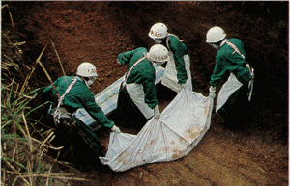“Ebola virus is in a race against the clock when it gets into the cell,” said Jason Shoemaker, a postdoctoral fellow who developed the assay as a graduate student in White’s lab. “We want to lock the door on it.”

The research could have important ramifications for understanding the Ebola infection process. “There is a lot about Ebola viruses that is very strange compared to other viruses,” Shoemaker said. “Any work that helps uncover more information about the viral entry pathway is helpful.”

The U.Va. research posed no health risk, as the researchers used what are known as “virus-like particles” that contain no genetic material.

In evaluating the drugs’ potential for stopping Ebola, U.Va. worked closely with both Zalicus and the Army Medical Research Institute, which handled the work involving live viruses.

White noted the unconventional process that led to the discovery of the drugs’ anti-Ebola properties. Instead of attempting to develop a drug starting at the molecular level, Zalicus began by looking for existing drugs that could inhibit Ebola.

“This whole approach is the reverse of how a molecular biologist might approach the problem,” White said. “If we’d gone with the molecular approach, we would never have looked at this class of drugs.”

The U.Va. researchers plan to continue their collaborative efforts and will look for drugs that may be even better at battling Ebola than clomiphene and toremifene.

“Our findings suggest we are not talking about one specific drug,” Shoemaker said. “It’s a whole family. One might be better.”

*— Read more in Lisa M. Johansen et al., “FDA-Approved Selective Estrogen Receptor Modulators Inhibit Ebola Virus Infection,”* Science Translational Medicine *5, no. 190 (19 June 2013)*

# BioFire Receives FDA Clearance for FilmArray® Blood Culture Identification Panel

Source: http://www.army-technology.com/contractors/nbc/idaho-technology/pressbiofire-receives-fda-clearance-for-filmarray-blood-culture-identification-panel.html?WT.mc_id=DN_PR

BioFire Diagnostics has announced the FDA clearance of its FilmArray Blood Culture Identification (BCID) panel. The 27-target panel is the most comprehensive test to be approved by the FDA to date.

The FilmArray BCID panel provides results from positive blood cultures, and can identify more than 100 blood pathogens known to cause sepsis. For each hour that severe sepsis goes untreated, the average mortality rate increases by 7.6%, making timely diagnosis and administration of appropriate therapy imperative for positive patient outcomes.

The BCID panel is designed to help hospitals identify bloodstream infection-causing organisms more rapidly than conventional identification methods. Rapid identification of pathogens in positive blood cultures has been shown to reduce mortality rates, shorten hospital stays and lower overall costs due to sepsis.

"We have made it a top priority this year to significantly reduce deaths caused by sepsis, and we plan to use diagnostic tools to help us achieve this goal," said Paul Schreckenberger, director of the Clinical Microbiology Laboratory at Loyola University Medical Center.

"The faster we get test results, the faster we will be able to apply an optimized treatment plan, thus improving overall patient outcomes including reduced deaths, costs and the length of patient hospital stays."

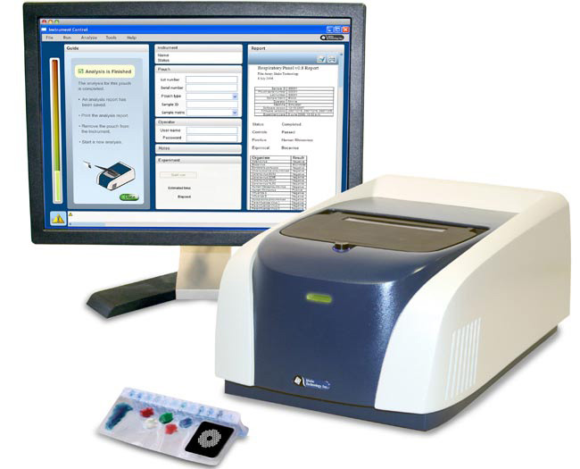With an easy procedure requiring only two minutes of hands-on time, the BCID panel can identify a pathogen in nine out of ten positive blood cultures in about an hour, and is the only test that provides results for gram-positive bacteria, gram-negative bacteria and yeast that cause bloodstream infections.

In addition, the panel includes the first FDA cleared diagnostic test for the blaKPC gene, which is linked to carbapenem resistance in Klebsiella pneumoniae, Acinetobacter spp and Carbapenem-resistant Enterobacteriaceae (CRE). Bloodstream infections with CREs are reported to kill up to 50% of infected patients.

The BCID panel also tests for common antimicrobial resistance genes associated with Methicillin-resistant Staphylococcus aureus (MRSA) and Vancomycin-resistant Enterococci (VRE).

"Customer feedback on the BCID panel has been extremely positive. There is a lot of excitement for this product among our clinical hospital laboratory customers and anticipation for the effect it will likely have on antibiotic stewardship, patient care and cost reduction," said Kirk Ririe, CEO of BioFire Diagnostics.

"We expect an immediate increase in revenues since existing FilmArray customers have indicated that they intend to adopt the BCID panel."

## Antibiotic from a marine microorganism is effective against anthrax

Source:http://www.homelandsecuritynewswire.com/dr20130703-antibiotic-from-a-marine-micro organism-is-effective-against-anthrax

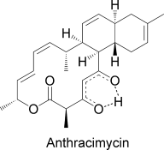A new potential drug from a marine microorganism is effective against anthrax and various other Gram-positive bacteria, as reported in the journal Angewandte Chemie International Edition. A chlorinated analogue kills off Gram-negative bacteria.

Anthrax is a dangerous infectious disease caused by the spore-forming bacterium Bacillus anthracis and transmitted by infected farm animals. For several years now, anthrax has also been feared as a biological weapon. Attacks with spore-containing letters caused five deaths in 2001.

Infection with anthrax usually requires tedious treatment with various antibiotics. Infections caught through the respiratory system are especially dangerous, often requiring continuous intravenous antibiotics. The search for effective antibiotics is thus correspondingly important.

A Wiley release reports that researchers working with William Fenical have now isolated a species of Streptomyces from near-shore sediments near Santa Barbara, California. The culture extracts demonstrate significant activity against anthrax. The team from the University of California, San Diego and Trius Therapeutics (San Diego) succeeded in isolating a molecule from this extract that kills off anthrax bacteria as well as other Gram-positive bacteria like staphylococci, enterococci, and streptococci. It is virtually useless, however, against Gram-negative bacteria.

By using a variety of methods of analysis, the researchers were able to determine the structure of this molecule, which they named **anthracimycin**. Anthracimycin contains an unusual system of rings, one with fourteen carbon atoms and two with six each. This is a macrolide whose biosynthesis very likely occurs by the polyketide pathway. X-ray crystallographic studies allowed the researchers to determine the absolute configurations of the seven asymmetric carbon centers in this compound, identifying the complete 3-dimensional structure.

This class of molecules is completely different from all known antibiotics. A similar carbon skeleton is found in chlorotonil, a metabolite from the terrestrial myxobacterium Sorangium cellulosum.

Chlorotonil differs, however, in its carbon skeleton, contains two chlorine atoms, and the stereochemistry of most of its asymmetric carbon centers differs from that of anthracimycin.

In order to examine the effects of the chlorine atoms in the close analogue chlorotonil, the scientists chlorinated anthracimycin. This chlorine-containing analogue proved to be only about half as effective against B. anthracis. Its activity against a number of Gram-negative pathogens, however, increased significantly. This finding is important because Gram-negative bacteria are often resistant to current antibiotics. Comprehensive studies of this new class of antibacterials could lead to the development of effective new drugs.

*— Read more in Kyoung Hwa Jang et al., “Anthracimycin, a Potent Anthrax Antibiotic from a Marine-Derived Actinomycete,”* Angewandte Chemie International Edition *(17 June 2013)*

|  |
| --- |
| Inhalational anthrax in a vaccinated soldierSource:http://erj.ersjournals.com/content/42/1/285.extract By Annemarie Sykes (Respiratory Medicine, Imperial College London, Norfolk Place, W2 1PG, UK), Tim Brooks (HPA Centre for Emergency Preparedness and Response, Rare and Imported Pathogens Laboratory, Porton Down), and Michael Dusmet, Andrew G. Nicholson, David M. Hansell & Robert Wilson (Royal Brompton and Hospitals NHS Foundation Trust, London)] *To the Editor:*We present a case of initially unrecognized, inhalational anthrax in a vaccinated member of the armed forces. A 38-year-old male presented with severe, sudden-onset central chest pain at rest, which was associated with nausea and dizziness. He denied shortness of breath. His past medical history included a "supraclavicular lymph node infection" at 18 years old. He was previously fit and well, apart from an undiagnosed painful right knee sustained in the previous year, which resolved with diclofenac. He had no respiratory problems and no family history of note, was married with one daughter, was a nonsmoker and drank less than 4 units alcohol per week. He was a member of the armed forces and had been deployed on operational tours in the Falklands, Kosovo, Germany, Croatia, Cyprus and, most recently, Iraq 4 years earlier. He had travelled to Disneyland in Florida, USA, 2 weeks before admission.On admission he developed haematemesis and an urgent oesophagogastroduodenoscopy (OGD) demonstrated 3 chronic gastric ulcers. Whilst recovering from the OGD he developed haemoptysis, fever and respiratory compromise and was admitted to the intensive therapy unit, where he was treated empirically with Tazocin and metronidazole. A chest radiograph demonstrated a markedly widened mediastinum and bilateral pleural effusions. A computed tomography (CT) pulmonary angiogram was negative for thromboembolic disease but demonstrated massively enlarged mediastinal lymph nodes, some of which were hyper-attenuating, bilateral consolidations and pleural effusions. He was anaemic, despite transfusion, with normal urea and electrolytes, liver function tests, clotting and immunoglobulins. C-reactive protein (CRP) was elevated at 96 and pneumococcal and Legionella antigens were negative, as was serology for cytomegalovirus and Epstein-Barr virus.He was transferred to the Royal Brompton Hospital, London, UK, where he underwent rigid bronchoscopy and mediastinoscopy with extensive resection of right paratracheal and subcarinal lymph nodes. These showed extensive haemorrhage and necrosis, confirmed on histology. Following the mediastinoscopy his temperature continued to spike at over 38 degrees C, he developed large bilateral pleural effusions which drained 3 L of haemorrhagic exudates and remained persistently culture negative from all sites. Further sampling of the subcarinal lymph nodes by endobronchial ultrasound-guided transbronchial needle aspiration confirmed haemorrhagic necrosis and the material obtained was again culture negative. His clinical condition improved with antibiotic treatment, his CRP and temperature settled and treatment was changed to oral co-amoxiclav.The combination of hyperattenuating (noncalcified) mediastinal lymph nodes on unenhanced CT reflecting a haemorrhagic component, haemorrhagic pleural effusions and histological confirmation of haemorrhagic lymphadenitis suggested the possibility of inhalational anthrax. Further inquiry identified that the patient had been administered anthrax vaccination on 4 occasions between 2002 and 2003, prior to posting in Iraq, followed by a booster in 2004.The Health Protection Agency was contacted for advice. The necrotic mediastinal tissue was examined, confirming that histology was highly suspicious for anthrax. Tissue toxin tests performed were negative. Serum antibody testing identified high PA and LF antibody levels. Acute and convalescent serology demonstrated rising levels of antibodies to both PA and LF antigens.Unenhanced computed tomography appearance demonstrated hyperattenuating mediastinal lymph nodes consistent with acute haemorrhagic lymphadenitis.A retrospective diagnosis of inhalational anthrax was made and thevpatient was treated for 4 months with co-amoxiclav. Despite exhaustive inquiry, no history of exposure to anthrax spores was identified. Follow-up radiographs 6 months after presentation demonstrated a normal mediastinal contour.This is the 1st case demonstrating survival of inhalational anthrax in a previously vaccinated member of the armed forces and highlights the difficulty associated with the diagnosis of inhalational anthrax in a rapidly deteriorating patient. Our patient had no exposure history and no contact with anthrax was ever identified.The diagnosis of inhalational anthrax was made in retrospect and would not have been possible had the patient not survived. Despite the suggestive clinical features of haemorrhagic thoracic lymphadenitis and bilateral pleural effusions, which were supported by histology, tissue toxin testing was negative and the diagnosis was made on convalescent antibody levels. The toxin test is sensitive and is positive when anthrax toxin is circulating or present in tissues. It rapidly becomes negative with antibiotic treatment and is cleared from the serum within a day, so would have disappeared by the time the samples in this case were taken.The histological features of the lymph nodes were highly suspicious of anthrax, and this was substantiated by the extremely high antibody response mounted in this patient. The PA antibody response was at the top of the ELISA scale used to perform the assay, with an optical density double that of recently vaccinated individuals. Given the interval of time since the patient's last vaccination, this rising level of PA antibody was unlikely to be due to vaccination alone. High LF antibodies, which are not usually detected in vaccinated individuals, were also detected and acute and convalescent serology demonstrated rising levels of antibodies to both PA and LF antigens. The anti-PA and anti-LF antibodies were measured using a validated ELISA test, which was also employed to study acute cases of anthrax in the concurrent outbreak in drug users. The optical densities of the patient's anti-PA and anti-LF tests were above the upper limit of the linear range of the assay at 3.9 and 3.6, respectively. As the sigmoidal curve of the ELISA (plotted as optical density against dilution of serum) at this point is asymptotic, an exact value cannot be given. This is higher than in any of the 50 positive acute cases of anthrax seen in the same time-frame and considerably higher than the optical densities of 1-2, which fell in the linear range, seen after the initial course of vaccination against anthrax.The patient developed a serious illness, but it followed a prolonged time-course and he survived. This may have been related to early appropriate empirical antibiotics (Tazocin and metronidazole followed by co-amoxiclav) and supportive treatment, but it is also likely that the previous vaccination provided a degree of protection that contributed to his survival. Although historically felt to be universally fatal, survival from inhalational anthrax has improved, especially since the advent of intensive care unit care [6]. Two survivors of bioterrorism-related inhalational anthrax reportedly demonstrated similar features and progress to our patient, including the typical features of mediastinal widening by marked lymphadenopathy (with nodes of increased attenuation due to acute haemorrhage), pleural effusions and air space consolidation [7].In summary, we have described survival of inhalational anthrax in a previously vaccinated member of the armed forces. The diagnosis was made by a multidisciplinary approach, highlighting the difficulties associated with diagnosing inhalational anthrax and the benefit of multidisciplinary review in complex cases. The patient's survival suggests that previous anthrax vaccination afforded some protection against inhalational anthrax in this case, even several years after vaccination. |

|  |
| --- |
| **Blastomycosis Cluster in Wisconsin** |

|  |  |
| --- | --- |
| **By Amesh A. Adalja, MD, FACP**, July 12, 2013  Source: http://cid.oxfordjournals.org/content/early/2013/06/03/cid.cit366.abstract |  |

|  |
| --- |
|  |
| Blastomycosis is a systemic infectious disease, with both pulmonary and extra-pulmonary manifestations, that is caused by infection with the fungus Blastomyces dermatidis. In the United States, the disease is restricted geographically primarily to regions in the Ohio and Mississippi River basins. In 2010, an unusual uptick in blastomycosis cases in Marathon County in north-central Wisconsin prompted an investigation. Wisconsin is 1 of 6 states where the infection is reportable. Results of the investigation were recently published in Clinical Infectious Diseases.1  Outbreak Case Characteristics  Using the Wisconsin Electronic Disease Surveillance System (WEDSS), investigators surveyed blastomycosis cases in Marathon County from 2000 until 2010. The outbreak began in September 2009 and ran through June 2010, during which time 55 cases were documented. The median age of cases was 31; 65% were male; 70% were hospitalized; and 5% experienced fatal infection. Remarkably, 45% of the cases were in people identified as Asian. The majority of patients reported camping, fishing, and backpacking activities. More than 50% of the cases (30) were associated with 5 residential clusters, defined as 3 or more cases in one neighborhood.1    Dramatically Increased Incidence in Asians   Although the investigators found an overall increase in incidence of blastomycosis in the county since 2005, this increase has disproportionately affected Asians--78% of whom are Hmong. Compared to non-Asians, Marathon County Asians have experienced a 586% increased incidence in this disease since 2005.  When outbreak patients were compared with historical cases, they were found to be less likely to smoke, more likely to be Asian, and less likely to have traveled prior to infection. Asian case patients were also found to be younger and less likely to report potential environmental exposures when compared with non-Asian cases. However, 21% of Asian patients reported another household member with blastomycosis compared to 2% of non-Asians. When analysis was confined to residential clusters, Hmong ethnicity yielded a 10.64 odds ratio for association with a cluster.1    Why an Increased Risk?   The most striking feature of this investigation is the dramatically increased incidence among Hmong residents in Marathon County. The report's authors indicate that this area in Wisconsin is home to the largest Hmong population in the state, the result of immigration after the Vietnam War.  As the authors note, the lack of natural immunity to Blastomyces in those from Vietnam cannot account for the increased incidence, as many of the case patients had been in the state for more than a decade, and some were born in Wisconsin. Instead, what seems most likely, in light of the fact that Hmong patients were less likely to engage in known risk-conferring behavior, is the presence of a genetic polymorphism that renders the Hmong more susceptible to symptomatic Blastomyces infection. This is similar to the increased vulnerability of Filipinos to the fungal disease cocciodiomycosis.  Understanding why the Hmong population was disproportionately affected by the outbreak will help elucidate the pathophysiology of the infection and, hopefully, refine treatment and prevention strategies.    Reference  Roy M, Benedict K, Deak E, et al. A large community outbreak of blastomycosis in Wisconsin with geographic and ethnic clustering. Clin Infect Dis 2013.  http://cid.oxfordjournals.org/content/early/2013/06/03/cid.cit366.abstract. Accessed June 16, 2013. |

Emergent BioSolutions Receives Paul-Ehrlich-Institut Approval to Market BioThrax in Germany

**July 1, 2013**

Source: http://216.70.91.55/?q=node/235&page=releasetxt&id=1834122&pubdate=01%20Jul,%202013

Emergent BioSolutions Inc. (NYSE:EBS) announced today that the Paul-Ehrlich-Institut (PEI) has approved Emergent’s marketing authorization application for BioThrax® (Anthrax Vaccine Adsorbed) in Germany. BioThrax is the only vaccine licensed by the U.S. Food and Drug Administration (FDA) for the prevention of anthrax disease.

“Emergent is pleased with this first marketing authorization of BioThrax within the European Union,” said Adam Havey, executive vice president and president of the biodefense division of Emergent BioSolutions. “Based on this regulatory approval we look forward to further expanding international registration of BioThrax within the EU to support member states’ efforts to protect their citizens against the threat of anthrax as a biological weapon.”

With this approval, BioThrax becomes the only anthrax vaccine approved by PEI for the prevention of anthrax disease. The marketing authorization approved by PEI provides for the administration of BioThrax in a three-dose schedule with boosters at three-year intervals recommended thereafter.

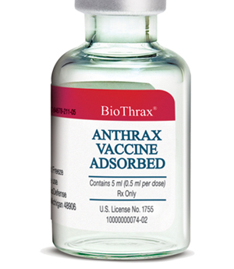**About BioThrax**

BioThrax is the only FDA-licensed vaccine for the prevention of anthrax disease. It is indicated for the active immunization of adults who are at high risk of exposure to anthrax. BioThrax is not licensed for use in a post-exposure setting. The safety and efficacy of BioThrax have not been established in pediatric or geriatric populations. Individuals are not considered protected until they have completed the three-dose primary immunization series. Vaccination with BioThrax may not protect all individuals.

BioThrax is manufactured from a culture filtrate, made from a non-virulent strain of *Bacillus anthracis.* To date, Emergent has delivered over 66 million doses of BioThrax to the U.S. government and continues to deliver additional doses under active procurement contracts. Since 1998, over 11 million doses have been administered to more than 2.9 million military personnel.

►**For full prescribing information, please visit:**

http://www.biothrax.com/prescribinginformation_biothrax_us.pdf.

# Local bioterrorism as a potential global threat

Source: http://www.northeastern.edu/news/2013/07/local-bioterrorism-as-a-potential-global-threat/

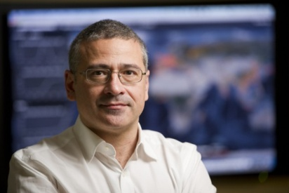According to a new com­puter mod­eling research study from North­eastern Uni­ver­sity net­work sci­en­tist **Alessandro Vespig­nani,** when it comes to bioter­rorist attacks, “dis­eases have no bor­ders.” Thus, an out­break of smallpox intended to harm a local pop­u­la­tion would ulti­mately affect the entire planet.

Vespig­nani, the Stern­berg Family Dis­tin­guished Pro­fessor of **Physics, Health Sci­ences,** and **Com­puter and Infor­ma­tion Sci­ence** at North­eastern, and his team mod­eled the spread of a hypo­thet­ical smallpox virus across the globe and found that even with the most con­ser­v­a­tive esti­mates, a small ini­tial attack in the city of London would likely spread to two or four coun­tries before the first cases were even diag­nosed, Vespig­nani said. The results were reported in a paper **pub­lished Wednesday** in the journal *Sci­en­tific Reports*.

Pre­vious research from other groups have claimed opti­mistic con­trol out­comes by imple­menting effec­tive con­tain­ment poli­cies and suf­fi­cient vac­cine stock­piles. While these con­di­tions may be real­istic for many western coun­tries, Vespig­nani said, the same is not true across all nations. “These papers con­sid­ered the local dimen­sion of a poten­tial attack,” Vespig­nani explained. He added that we are no longer lim­ited by local bound­aries. The modern trans­porta­tion system would allow unknow­ingly infected indi­vid­uals to travel across the globe well before any local con­tain­ment policy was con­sid­ered, he said.

The team rec­og­nized that some mem­bers of the global pop­u­la­tion might be immune to the pathogen if they received the smallpox vac­cine before it was erad­i­cated in 1977. But while accounting for immu­nity brings down the number of indi­vidual cases, the same number of coun­tries would be affected regard­less, according to the model.

Vespig­nani noted that the doc­trine of “mutu­ally assured destruc­tion” should deter even ter­rorist orga­ni­za­tions, which don’t want to bring dev­as­ta­tion to their own people. Nonethe­less, he warned, the world must still be pre­pared for such events. His team’s mod­eling exer­cise is a step in that direction.

Addi­tion­ally, with exper­i­ments on increas­ingly infec­tious pathogens like H5N1 cur­rently taking place in research lab­o­ra­to­ries, the model is also rel­e­vant in the case of an acci­dental out­break. The con­di­tions are slightly dif­ferent in these sce­narios, as diag­nosis would likely happen much sooner, but at least in the case of an acci­dental smallpox out­break, the problem reaches the inter­na­tional scale just as readily as with an intended outbreak.

Vespignani’s team is cur­rently adapting its model to look specif­i­cally at H5N1.

# Georgia rejects Russian accusation of biological warfare

Source: http://dfwatch.net/georgia-rejects-russian-accusation-of-biological-warfare-63483

**Georgian Food Safety Service responds to the Russian chief sanitary inspector, who said that Georgia was planning ‘bio-sabotage’ in Russia.**

Veriko Gulua, head of the Service’s press office told DF Watch that this statement is groundless and politically motivated.

Gennady Onishchenko, Russian Chief Sanitary Inspector of Rospotrebnadzor, claimed that the African swine fever epidemic spread to Russia from Georgia. Onishchenko told BBC and Interfax that the explosion of so-called African swine fever in Russia is a result of economic sabotage by Georgia.

“There is no suspicion that it really happened so. All this was implemented from Georgian territory and it was not a coincidence. This was a planned action, with a goal to destroy the Russian economy,” he told Interfax.

According to the Russian Minister of Agriculture, the loss suffered by the African swine fever epidemic since 2008 has been about USD 63 million. About 400 000 pigs were killed in this period, he said.

African swine fever has not been observed in Georgia since 2007, according to Georgia’s food safety service and the service therefore thinks Onishchenko’s statement is politically motivated.

In addition, Gulua told us there are plans to conduct a forensic testing of wild animals in order to determine how it is possible that this disease could spread from Georgia through wild animals on Russian territory, while it hasn’t been observed anywhere in Georgia.

# Bioterrorism: A Dirty Little Threat With Huge Potential Consequences

Source: http://www.forbes.com/sites/larrybell/2013/07/21/bioterrorism-a-dirty-little-threat-with-huge-potential-consequences/

All information for this article is taken from unclassified material. Most has been provided by a medical doctor and biomedical scientist who has an unconventional warfare background and prefers to be unnamed. He has conducted extensive research in tropical medicine, has served as overwinter physician for a 14-person Antarctic research team, and served as a WMD consultant to the National Medical Response Team (NMRT). He currently conducts jungle training for biomedical scientists, and has conducted extensive pathology investigations involving Ebola, Marburg and other deadly viruses. He also participated in the Asian Disaster Foundation medical response to Sri Lanka, and has authored and coauthored numerous related medical research papers.

In the early 1950s the evening of September 19th was simply another pleasant balmy night for the residents of San Francisco, California.  The year so far had been a tumulus one for the United States, with a Korean War that would have a final death toll of 33,629 American military casualties together with 1.5 million communists from Mao Zedong’s China and the military of the Korean peninsula.  Dwight D. Eisenhower was the President of the United States, in Europe the Cold War with the Soviet Union was heating up, and an uprising against the communist government of East Germany was developing.

A national polio epidemic was continuing, and Dr. Jonas Salk was developing the world’s first Polio vaccine that he would eventually administer to himself and his family.  On the lighter side of events, a charming young Queen Elizabeth II would be crowned Queen of England, and a humble New Zealand beekeeper named Edmund Hillary would perform the first successful ascent of Mount Everest. Texas Instruments had just invented the pocket-sized transistor radio, gasoline cost 20 cents a gallon, and the first color television sets would soon go on sale to the public for the princely sum of $1,175.

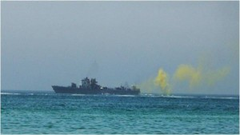Over in Oakland, John Renfield and his wife were preparing their two young daughters for bed. The children were both excited over their father’s just announced promise to take them to see Walt Disney’s new movie “Peter Pan” which was showing the next day at the local afternoon matinee. Consequently, it had taken the couple some coaxing to get their two youngsters quieted down and into bed.  After watching a half hour of the Jackie Gleason show the couple retired at 8:30, and were soon fast asleep.

As the Renfield family slept quietly and comfortably snug in their beds, a dark grey converted U.S. Navy minesweeper sailed a perpendicular course two miles off the coast of downtown San Francisco. The small vessel had been modified to pass one hundred and thirty gallons of a special homogenized liquid under pressure through a peculiar circular arrangement of specialized spray nozzles located at the very stern of the ship. As the liquid sprayed into the air, the minesweeper left a two-mile long trail of white vapor against the backdrop of the night.  Within a few minutes, the larger droplets in the long white cloud fell back into the ocean leaving only an invisible aerosol of microscopic droplets that were gradually blown over San Francisco by the prevailing onshore breeze.

By three AM, the invisible aerosol particles finally reached the Renfield house as well as the homes of all their neighbors, and as the aerosol passed through the neighborhood, some of the droplets seeped into the homes to equilibrate with the volume of air inside them.

The sleeping Renfield family inhaled thousands of bacterial spores of a harmless test microorganism deep into their lungs. Unknown to the Renfield family, they and most of the 800,000 other residents of San Francisco at the time, had just unknowingly participated in one of the most significant military experiments of the Cold War.

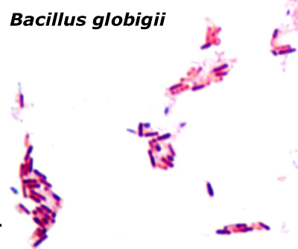The San Francisco test had its origins during World War II, when the American scientists at Camp (later Fort) Detrick and the English scientists at Porton Down began to perfect the military science of biological warfare in response to Japan’s use of biological agents in China. Using a series of aerosol dissemination tests at Area B in Maryland, the American scientists had developed a liquid spray system to disseminate lethal infections such as Anthrax, Tularemia, Psittacosis, and Brucellosis to kill and incapacitate enemy soldiers on the battlefield. Concerned over the possibility that Soviet submarines might one day surface off the coast of the U.S. and employ the same techniques, a series of large-scale open-air vulnerability tests were conducted on several American cities, as well as in the New York subway system.

The test on the City of San Francisco had been performed using the non-pathogenic biological warfare agent simulant called **Bacillus globegii**.  The microorganism caused no ill effects in humans or animals but its spores approximated those of deadly Bacillus anthrasis, the causative organism of Anthrax. By daybreak on September 20th, a handful of scientists from Fort Detrick began swarming over the San Francisco area where they were busy collecting hundreds of all-glass impinger air-samplers from the government offices and warehouses where they had been covertly installed before the test. The air samplers had faithfully monitored the dispersion and concentration of the simulated biological weapon aerosol.

When the sampling results were analyzed, the Detrick scientists were shocked to discover that **the simulated biological aerosol had traveled more than 10 miles from its release point offshore**. Had the disseminated agent actually been anthrax spores instead of harmless Bacillus globegii, then virtually the entire area population of San Francisco would have received an infective dose and would have died in a matter of a few days. Biological warfare had now progressed from being a battlefield weapon to a strategic weapon in the same category as the atomic bomb, capable of destroying entire cities.  In fear, the United States established the original Epidemic Intelligence Service designed to detect and provide early warning of a covert biological attack.

Over the next 25 years, new dry formulations of biological warfare munitions were developed and tested out in the vast expanse of the Dugway Proving Grounds in Utah. Small backpack generators were created to disseminate liquid biological agents for use in military special operations, and open air testing revealed the tremendous devastation that could be caused by even such simple but well-engineered devices. As biological munitions development continued, the vast acreage of Dugway proving grounds proved insufficient, and open air testing moved out to the H-bomb testing sites in the Pacific.

By the 1960’s, biological warfare had become a well-understood and terrifying new science. Using advanced aerial-delivered systems, it had been demonstrated on live rhesus monkeys. The latter revealed that **a single aircraft disseminating a properly formatted biological aerosol could cause infection and death of up to 30 percent of the inhabitants within a 2,400 square kilometer area**. During this time, Russian intelligence had a secret informer at Fort Detrick, and the Soviet Union responded by expanding their own biological weapons program and munitions.

It soon became clear that biological weapons were a genie that must never be let out of the bottle, and in 1969; President Nixon terminated all U.S. biological weapon research and production.  This was not the case for other nations. In response to the U.S. “Star Wars” program for ballistic missile defense, the Soviet Union began a massive program of offensive biological warfare, loading horrendous disease agents such as the Marburg virus and Smallpox into nose cones of some intercontinental missiles.

The Soviet program remained a complete secret to the Western intelligence agencies until three defectors from the program managed to escape from Russia. That program was eventually confirmed by Boris Yeltsin. Then, **as the former Soviet Union disintegrated, over 100 Soviet biological warfare scientists found their way to Iran** and other parts of the world. They brought with them their expertise in the design and manufacture of a variety of biological munitions, both simple and highly sophisticated. Some of these countries were known to be sponsors of international terrorism.

By the onset of the 21st Century, the concept of asymmetrical warfare and the use of terrorism had come into the foreground as large, well-funded, and state-sponsored terrorist groups sprang up throughout the world. In research published only a decade ago, the U.S. Centers for Disease Control and Prevention had estimated that the cost for managing a biological terrorist attack using anthrax spores would be 26.2 billion dollars per 100,000 actual infected cases.

Following the anthrax letter incidents in 2001 in the United States, a flurry of books, internet articles, and mostly clueless “talking heads” on international television, openly described the necessary characteristics of a successful biological aerosol, and one former FBI agent even went so far as to actually name one of the classified additives used for dry biological agent preparation. If the terrorists of the world did not previously know the potential of biological weapons for their cause before, the U.S. media made sure that now they would.

Although federal efforts involving numerous agencies to combat the threat of bioterrorism expanded rapidly following the 2011 anthrax letter attacks, which killed five people and infected 17 others, various congressional commissions, nongovernmental organizations, industry representatives and other experts have highlighted flaws in these activities. A 2008 report published by the congressionally-mandated Commission on the Prevention of WMD Proliferation and Terrorism concluded that “…unless the world community acts decisively and with great urgency, it is more likely than not that a weapon of mass destruction will be used in a terrorist attack in the world by the end of 2013.” It went on to say “**The Commission further believes that terrorists are more likely to be able to obtain and use a biological weapon than a nuclear weapon**.”

Making matters worse, unlike most other terrorist attacks, a biological attack could infect victims without their knowledge, and days could pass before victims develop deadly symptoms. To address this problem, the U.S. has been forced to implement air quality monitors throughout the country and stockpile antibiotics for emergency use.

A 2011 study conducted by the Congressional Research Service observes that: “Unfortunately, the nature of the bioterrorism threat, with its high consequences and low frequency, makes determining the bioterrorism risk difficult. Additionally, the presence of an intelligent adversary who can adapt to the presence of successful countermeasures complicates the use of standard assessment techniques.”

We should **never doubt** that terrorist adversaries are intelligent, have sophisticated and ever-advancing capabilities to inflict devastating casualties, or fully lack the will to do so. **To believe otherwise could potentially be a deadly mistake.**

**Sources:**

“U.S. Army Activities in the U.S. Biological Warfare Program”, Report to Congress, 1977

“Shoreline Diffusion Program, Oceanside, California, Vol. 1” ,TB Smith, BL Niemamm, Desert Test Center

Edward Regis, “The Biology of Doom: The History of America’s Secret Germ Warfare Project”, New York, Henry Holt and Company, 1999.

“Jane’s Chemical and Biological Handbook, 3rd Edition”, K. Alibeck, T. Dashiell, A. Dweyer, S. Lane, WC Patrick III, J. Richard, and F. Sidell

“U.S. Army Activities in the U.S. Biological Warfare Program, Report to Congress”, 1977

Dorothy L. Miller, “History of Air Force Participation in [the] Biological Warfare Program, 1944-1951, Historical Study No. 194”, Wright-Patterson AFB, September 1952

Dorothy L. Miller, “History of Air Force Participation in the Biological Warfare Program, 1951-1954, historical Study No. 313”, Vol. 1 and 2, Wright-Patterson AFB, 1957.

**“**Germs: Biological Weapons and America’s Secret War”, **J. Miller, W. Broad 2002.**

“Biohazard; The true story of the largest BW program in history”, K. Albeck, S. Handelman, April 11, 2000,

J. Miller and WJ Broad, New York Times, December 8, 1998

(Judith Miller has her own web site and she can give an accurate number of defecting scientists to Iran. She can also vouch for source’s credibility in this area.)

“The Economic impact of a Bioterrorist Attack: are prevention and post-attack intervention programs justifiable?”, A.F. Kaufman, M.I. Meltzer, G.P. Schmid.  Emerging Infectious Diseases, Vol. 3, number 2, June 1997,

“World at Risk: The Report of the “Federal Efforts to address the Threat of Bioterrorism”, December 2008, p. xv.

“Medical Aspects of Biological Warfare” (Textbooks of Military Medicine), by Walter Reed Army Medical Center Borden Institute (February 29, 2008).

“Federal Efforts to address the Threat of Bioterrorism: Selected Issues and Options for Congress”, Frank Gotton and Dana Shea, February 8, 2011, Congressional Research Service, <http://www.fas.org/sgp/crs/terror/R41123.pdf>

**Lessons from Select Public Health Events Having Relevance to Bioterrorism Preparedness**

**By Tamara R. Chapman** (Monterey Institute of International Studies) and **Raymond A. Zilinskas** (Monterey Institute of International Studies)

Source: http://www.nti.org/analysis/articles/lessons-select-public-health-events-having-relevance/

**Introduction**

The intent of this briefing paper is to examine the responses of the public health and health delivery systems of three cities that were challenged by extraordinary disease outbreaks and draw lessons useful to those who are involved in bioterrorism preparedness. We thus analyze the infectious disease outbreaks that occurred in The Dalles, Oregon, in 1984; Surat, India, in 1994; and Toronto, Canada, in 2003. In addition, we give a brief explanation why the so-called "anthrax letters" attacks of September-October 2001, are not addressed here. The brief concludes with a listing of lessons we have drawn from the case studies that could prove useful to bioterrorism preparedness planners in the United States.

**FOODBORNE SALMONELLA: THE DALLES, OREGON, UNITED STATES, 1984**

**Site and Effects of Outbreak**

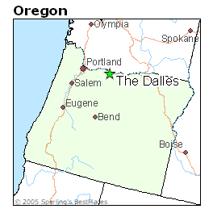The Dalles is located on the Columbia River in north-central Oregon, about 80 miles east of Portland. Its small population of about 11,000 in 1984, belies the large scale of economic activity in the city resulting from The Dalles being a major transportation hub between eastern and southern Oregon and Washington State.[1] The major east-west thoroughfare, Interstate 84, passes through The Dalles, so, on any given day, the city's population temporarily increases as travelers stop to rest and eat. For this reason, The Dalles is home to a disproportionately large number of restaurants; approximately 38 restaurants in 1984.[2] Such a large number of eating establishments and the transient nature of many of their customers made for a challenging epidemiological investigation when Salmonella typhimurium was discovered to be at the root of an outbreak of gastrointestinal illness in September 1984.

Salmonella bacteria typically are found in and transported by the feces of humans and other animals. In humans, these bacteria can cause gastrointestinal diseases, characterized by diarrhea, fever, and abdominal cramping. Salmonella infection (salmonellosis) does not usually require treatment beyond rest and oral rehydration; however, potentially life-threatening situation may occur when the infection strikes infants, children, and immunocompromised adults. When this occurs, treatment with antibiotics may be appropriate. Approximately 40,000 cases of salmonellosis are reported annually in the United States, with about 600 of the affected dying.[3]

On September 17, 1984, an individual who had gotten sick after eating at a local restaurant called the Wasco-Sherman County Health Department in The Dalles. Two days later, an additional 21 persons reported similar complaints and implicated two other restaurants. Within 48 hours of the first reported case, the clinical laboratory at the Mid-Columbia Medical Center, Wasco-Sherman County's only hospital, identified Salmonella in the patient's stool sample. The Oregon State Public Health Laboratory quickly confirmed this identification, and was able to further ascertain the species as typhimurium.[4]

Two weeks after the first case of salmonellosis, a classic epidemiological investigation carried out by the county health department established a link between salmonellosis victims and restaurants in The Dalles. All 38 restaurants in the city and its vicinity were asked to shut down their salad bars, which they did. Assistance from the U.S. Centers for Disease Control and Prevention (CDC) was sought.[5] Teams comprised of local and federal epidemiologists interviewed hundreds of victims and hundreds of restaurant customers who had not become sick to determine what they had eaten. They tracked down out-of-town visitors who had eaten at the restaurants. They also interviewed restaurant workers, inspected food handling practices at the restaurants, and examined farms, dairies, and water systems that supplied the restaurants.[6] In the end, the epidemiologists concluded that food handlers employing poor sanitary practices had contaminated restaurant salad bars with Salmonella typhimurium.[7] In the final tally, 751 cases, representing about 12% of the town's populations, of salmonellosis were confirmed. Ten of the county's restaurants were implicated as having been contaminated.[8]

In October, 1985, a bit over one year after the salmonellosis outbreak, the Bhagwan, the head of the Rajneesh cult, which had its U.S. headquarters in Wasco-Sherman County, during a television press conference alleged that some cult members had attempted to contaminate the water supply in The Dalles.[9] In response, state police, in collaboration with the FBI, obtained a warrant to search the Rajneeshees' compound, where they discovered a simple clinical laboratory that was equipped with an incubator and had supplies for growing cultures.[10] The searchers also found glass vials containing discs impregnated with Salmonella typhimurium.[11] Under questioning, cult members told the police that two women, Ma Anand Sheela and Ma Anand Puja, had ordered the laboratory technician to secure the Salmonella discs from a commercial supplier and to propagate a large quantity of the pathogen. Cult members then sprinkled the pathogenic "salsa" on lettuce and other fruits and vegetables and put Salmonella bacteria in restaurant coffee creamers and salad dressings.[12] Those who took part in this deliberate contamination were arrested and tried. The Bhagwan was deported to India, while Ma Anand Sheela and Ma Anand Puja were convicted and sentenced to multiple 20-year prison terms. Other cult members who took part in the dispersal of the pathogen were also convicted and received light jail sentences.[13]

**Social Consequences of Outbreak**

The Dalles salmonellosis outbreak stressed the small town's health infrastructure. The Mid-Columbia Medical Center had around 125 beds at the time. During the outbreak, the hospital surpassed its capacity for the first time in its history, forcing patients to receive care in the building's corridors. Angry about the capacity issue and no doubt worried about the large number of fellow victims suffering the same symptoms, patients grew hostile, allegedly throwing stool and urine samples at health care workers in some cases and making unreasonable demands for laboratory results. As the number of samples sent to the Mid-Columbia Medical Center's clinical laboratory increased 30- to 40-fold during the outbreak, it was overtaxed. At its most trying time, the laboratory actually ran out of culture media. The laboratory was able to increase the shipments of culture medium that it received during the outbreak, but it was still insufficient for the number of samples with which it was presented at the height of the outbreak.[14]

It is important to note that while the outbreak stressed the local public health and health delivery systems, there was no indication that either was anywhere near the point of collapse. Neither city, nor county officials asked the state of federal government for assistance beyond the request for certain types of experts and no mutual assistance agreements between the Wasco-Sherman County and neighboring counties were invoked.

**Economic Damages**

As far as we are aware, no economic analysis has been done on the consequences of The Dalles outbreak, so they cannot be determined with certainty. We can infer that the costs associated with the substantially increased patient load experienced by the Mid-Columbia Medical Center were borne largely by the inhabitants of the city and county, as were the salaries of health workers putting in overtime. Further, the epidemiological investigation into the origin of the outbreak, which involved public health officials checking the many possible sources of Salmonella, including local water systems, a local dairy, a tomato and cucumber farm, and others, probably incurred costs beyond the county health department's normal budget. As natural sources were found to be clean, it became apparent that restaurants were the origin. Health officials spent much effort on testing restaurant employees to identify possible carriers of Salmonella, which must have been a costly process. Further, once it became known that restaurants were the source of infection, this likely had a substantial adverse economic effect as consumers understandably would have grown leery of eating away from home; also, many employees who handled food in these establishments were sickened and probably were unable to work. The economic consequences of this Salmonella outbreak on the city and county almost certainly were even greater than losses suffered by the restaurant industry alone. These costs, however, cannot be documented.

**PLAGUE: SURAT, INDIA, 1994**

**Site and Effects of Outbreak**

Surat is a western Indian city that lies along the Tapti River in the state of Gujarat approximately 250 kilometers north of Mumbai (Bombay). The city has an estimated population of between 1.8 million[15] and 2.2 million[16], about 600,000 of whom are part-time residents[17]. A large number of Surat's inhabitants live in the city's wretched urban slums. Surat is the home to bustling diamond and textile industries. In 1994, Surat was challenged by a large outbreak of pneumonic plague.

The bacterium that causes plague, Yersinia pestis, is known to exist in natural reservoirs in India, including certain wild rodent populations.[18] From there the plague bacterium can be transmitted via 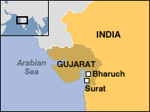insect vectors – most commonly the flea – to urban black rats (Ratus ratus), as well as the fleas that inhabit them. Y. pestis usually is transmitted to humans by the bite of an infected flea, which most often leads to the bubonic form of the disease. If the bubonic form of plague progresses to a systemic form, thus infecting the lungs, human-to-human spread via aerosolized droplets becomes possible.[19]

The origin of the disease outbreak in Surat and, indeed its diagnosis, has been the subject of much disagreement.[20],[21],[22] For our purpose, the retrospective questioning of the accuracy of the diagnosis (i.e., whether the outbreak was pneumonic plague or some other type of infectious disease) matters little since the disease was believed to be "plague" by both those who were directly affected, those who were not affected but took certain actions because they believed it was "plague," and observers who reported on the events as they unfolded in 1994.

**Social Consequences of Outbreak**

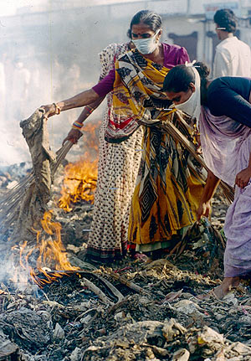In late September 1994, just after the yearly Hindu Ganesh Festival had brought an influx of visitors to Surat and just as the weather in India was becoming mild enough to usher in the annual tourist season, the first pneumonic patients appeared at the Surat Civil Hospital.[23] Local doctors quickly diagnosed them as suffering from plague. Within about one day, word of a mysterious fever spread by way of print and radio media, and panic enveloped Surat. Over the course of a few days, 400,000-600,000 people fled the city.[24] There was chaos at Surat's bus and rail stations, sometimes escalating to mob violence.[25] The Indian army's Rapid Action Force, which is specially trained in riot control, was called in to restore order and, most importantly, to prevent possible carriers of Y. pestis from leaving Surat.[26] Messages from the World Health Organization (WHO) to stay calm,[27] as well as reassurance from Indian Prime Minister Narasimha Rao that the situation was "well under control," went largely unheeded by Surat's inhabitants.[28]

The city's health delivery system was severely damaged as many of the city's health care workers absconded. In fact, a volunteer organization later filed criminal charges against 70 physicians, stating that they had abandoned the population in a time of great need.[29] Some offices of doctors who had left the city were torched.[30] However, it is not known how many health professionals remained and how many fled.[31] In addition to health workers fleeing, the antibiotic tetracycline, which is commonly used to treat plague, disappeared from pharmacies.[32] This drug was unregulated and thus available over the counter. Lacking proper guidance on how to effectively utilize the antibiotic, people—even those who were not presenting with disease symptoms—hoarded the drug. The resulting shortage of tetracycline led to the antibiotic being black-marketed, even among pharmacies.[33]

**Economic Damages**

Internationally, India's tourism and trade were heavily impacted. The Gulf states (Kuwait, Saudi Arabia, Qatar, Oman, and United Arab Emirates), followed by Pakistan and Sri Lanka, prohibited travel to and from India altogether.[34] Indian exports were also banned from entering these countries.[35] Even when a country did not place explicit travel restrictions on persons arriving from India, officials at many airports delayed travelers from India after they disembarked for inspections and other forms of scrutiny.[36]

On a local level, many workers failed to report to their work sites during late September, so commerce and productivity were negatively affected.[37] The reports of chaos in Surat led to a general trepidation among investors in the Indian stock market.[38] The Mumbai stock market suffered substantial losses after the announcement that trade between India and the Gulf state nations, which amounts to around $3 billion per year, would be suspended. Interestingly, the stock market dipped even further as India's Cabinet members held a meeting on September 29 to discuss the crisis in Surat,[39] perhaps demonstrating that the public interpreted the high-level meeting to be an indicator of a worsening situation in Surat.

Plague's impact on Surat, and India, were remarkable given that only about 100 people died from the disease.[40] Economically, the trade and tourism losses resulting from the plague outbreak have been estimated at about $1.3 billion. If one also factors in direct medical expenses and decline in production, that loss approaches $2 billion.[41] These numbers are staggering, especially when one considers that most of the financial losses came from worries that the stigmatized disease would spread and not from the actual physical harm associated with the outbreak.

It is of interest, and concern, that communications from high national and international leaders and agencies had few if any positive effects on how events unfolded in Surat. Reassurances from government officials that the situation was under control and messages from the WHO instructing residents not to panic were proved to be weak, possibly because they were so poorly communicated to the Surat population.

**SEVERE ACUTE RESPIRATORY SYNDROME (SARS): TORONTO, CANADA, 2003**

**Sites and Effects of Outbreak**

The first case of a virulent, atypical pneumonia materialized at a hospital in Foshan, Guangdong Province, in southeastern China on November 16, 2002, and then spread throughout the region. It is not our purpose to describe how this illness, named severe acute respiratory syndrome (SARS) by WHO on February 21, 2003,[42] spread in China and then internationally;[43] rather, we focus on how the causative virus arrived in Toronto, Canada.

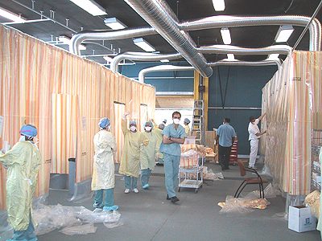SARS is caused by a coronavirus (SARS-CoV) and presents itself as a serious respiratory illness with high fever, bodyaches, headache; and pneumonia. SARS' fatality rate depends to a large extent on the victim's age; thus, under the age of 24 it is less than 1%, for ages 25-44 it is 6%, for ages 45-64 it is 15%, and for over the age of 65 it is higher than 50%.[44] SARS-CoV spreads human-to-human via infectious droplets released by coughs and sneezes or direct contact.[45] The virus is hardy, able to survive after drying on a surface for up to 48 hours and for four days in a stool sample. The average number of secondary infections generated per case (Ro) is estimated to be 2.7;[46] for comparison, the Ro for measles is 10-15, pertussis is 16-18, polio is 8-12, and seasonal influenza is 1.4-2.6 ( can go up as high as 21 in certain settings).[47] SARS-CoV is thus considered a moderately transmissible pathogen. (Under certain circumstances individuals infected with SARS-CoV have been demonstrated to be much more contagious than the average SARS sufferer, with a Ro of up to 90. These individuals are called super-spreaders. There appears to have been at least one super-spreader in Toronto.)

Toronto, the capital of Ontario Province, is the largest metropolis in Canada and the fifth largest city in North America.[48] According to 2003 data, Toronto's population was 2.5 million people, while the population of the Greater Toronto Area (GTA), which incorporates adjacent cities, was over 5 million.[49] The city is a major stopping point for both immigrants[50] and international travelers. Tens of thousands of travelers from Asia arrive every month at Toronto's Lester Pearson International Airport.[51]

Toronto's SARS index case was Mrs. Kwan Sui-chu (Mrs. K),[52] a 78 year old diabetic who in February 2003 stayed at the Hotel Metropole in Hong Kong. A severely ill physician who had arrived on February 21 from Guangdong Province stayed for just one night in a room adjacent to that of Mrs. K. Mrs. K is believed to have been infected by SARS-CoV on February 21 as she and her husband passed by "...an elderly Chinese man who was coughing severely and struggling to stay upright. He coughed several times in their general direction and when he looked up, they were struck by his angry, blood-shot eyes."[53] On February 23, Mrs. K flew to Toronto, her home city, and began to feel ill on February 25. Her primary care physician treated her with antibiotics on February 28, but she developed breathing problems and died at home on March 2. Retrospective epidemiological studies found that Mrs. K had infected her physician, who in turn started an epidemic among other health workers and their patients, as well as her 43 year old son and 38 year old daughter. The ill son sought help at the nearby Scarborough-Grace hospital on March 7, where he was kept in the emergency department for about 12 hours since no beds were available in the in-patient wards. During this time, he infected many health workers, out-patients, and visitors.[54] He died on March 13 of respiratory failure.

Toronto's SARS outbreak has been described in detail elsewhere;[55] here we review the highlights of the outbreak.[56] The outbreak had two phases, with phase 1 occurring between March 23 and April 19, and phase 2 between April 20 and July 2, when WHO designated Toronto as free of SARS. During this 3.5 month long period, 2,132 persons in Toronto were investigated as possible SARS victims; of these, 225 met WHO's case definition of SARS (it should be noted that an additional 133 persons living in municipalities adjoining Toronto contracted SARS). Of Toronto's SARS victims, 55 (24.4%) required intensive care and 38 (16.8%) died. There were 23,103 persons who had some sort of contact with actual or suspected SARS victims and therefore required quarantine; of these, 13,291 (57.5%) complied while the remainder either could not be reached or was reached after the quarantine period had expired. It therefore appears as if there was no case of outright refusal to comply with what was a voluntary quarantine imposed by city and provincial authorities. It is important to note that the site where by far most of those who were exposed to SARS-CoV (16,149 or 69.9%) was a hospital, while 2,148 (9.3%) was at a school, 2,150 (9.3%) at a doctor's office, 924 (4%) at a social setting, and 554 (2.4%) at the household of a sick person. Of the 19 acute care hospitals in the GTA, 11 became directly involved in the outbreak.

**Social Consequences**

We begin by noting what did not happen in Toronto; thus, there was no public disorder, no flight of inhabitants or health professionals, no run on drugs in pharmacies, nor any apparent restrictions on Canadian citizens or products by other countries. In fact, the social consequences for public health and health delivery tended to be so subtle as to become known only in retrospect.

In regard to public health, an analyst put it succinctly: Toronto suffered from "...a system under significant duress because of a 20-year erosion of investment in the public health system and because, as a consequence, many building blocks of an effective emergency response were not in place when SARS hit the city."[57] The "building blocks" included a weak and understaffed Toronto Public Health Department (TPH), a software program for reporting infectious diseases in Ontario that proved unworkable, and lack of expertise within TPH on communicable diseases and handling them. Further, when the TPH ordered the institution of a voluntary quarantine program to keep contacts at home (the quarantined persons were contacted by TPH twice per day by phone), there were a few serious break-downs of this system, such as a worker who asked his wife to cover for him when the TPH phoned while he went to work; he contracted a fatal case of SARS and infected a co-worker who also died.[58] On another level, public health officials at the federal, provincial, and city levels became incensed when WHO issued a global advisory against all non-essential travel to Toronto on April 23. However, by this time, the SARS outbreak was largely over and, furthermore, it was clear that by far most persons who had contracted the disease had done so in hospitals and doctors' offices, which meant that a visitor to Toronto stood a very, very small chance of becoming exposed to SARS-CoV. While the largest effect of 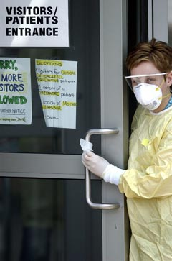the advisory was on the Canadian economy, it was demoralizing and embarrassing for the Canadian public health system to seemingly be put on the same level as the poverty-stricken Guangdong province in China.

The social impacts on the health delivery system were significant. One stemmed from an existing problem; Toronto's health delivery system had no surge capacity. This situation stemmed from the fact that many hospitals had been closed down during the 1990s for financial reasons, so the Toronto's hospitals were filled to 95% capacity when Mrs. K's son presented arrived at the Scarborough-Grace Hospital and therefore could not be accommodated in a closed ward.[59] As the outbreak grew, and as emergency departments, and even hospitals, were closed, a big problem arose regarding what to do with SARS victims. Eventually, a closed tuberculosis ward in one hospital was reactivated, and wards in other hospitals were converted overnight to contagious wards. The problem then became how to staff them (below), which remained an issue to the outbreak's end. Thus the problems created by the surge of severely sick SARS victims was largely solved, but it must be kept in mind that their number in GTA was just 358, and those cases arose over a 3.5 month period.[60]

However, one of the main impacts stemmed from the fact that so many doctors, nurses, and other health workers contracted SARS from patients; in all 46.3% of Toronto's SARS victims were health workers,[61] including many who everyone thought had taken careful precautions such as wearing gowns and masks, and practicing frequent hand washing. Many health workers came to fear working in environs where SARS patients were kept, so there developed a shortage of care-givers at temporary emergency facilities set up at various Toronto hospitals for the specific purpose of treating SARS victims. So, while health workers did not flee from Toronto, many of them declined to work with SARS patients, which resulted in those who did so becoming overworked and overstressed.

Further, all supplies of special equipment needed to treat SARS victims, such as assisted breathing devices, intubation kits, negative pressure rooms, etc., were quickly depleted in Toronto, causing shortages that negatively affected patient care.[62] Although shortages were soon rectified by bringing in supplies from stores elsewhere in Canada, it again must be kept in mind that "only" 358 SARS victims in GTA had such a profound affect on depleting the supply of all this type of special equipment in a major city and its environs in a highly industrialized country.

**Economic Damages**

There were three types of economic damages suffered by public and private sectors of Canada, Ontario, and GTA: (1) direct costs related to containing the outbreak and treating its victims; (2) indirect costs related to lost productivity, wages, health insurance premiums, and others; and (3) tourism revenue losses.

We do not have figures for the first two types, but believe it must have been at least one billion Canadian dollars. The estimated revenue loss for such spending categories as accommodation, food and beverage, transportation, recreation, and entertainment was 260.6 million Canadian dollars for the period March 2, 2003 through June 21, 2003.[63] Unemployment in the city rose to 7.7%, a full half-percent higher than the preceding month, with over 40% of job losses occurring in the hotel and restaurant sectors.[64] WHO's advisory likely contributed to these figures; however, tourism remained depressed even after the warnings were rescinded.[65] Because Toronto's economy contributes 20% of Canada's total economic activity, financial consequences of SARS had a national impact.[66] Even relatively early in the outbreak economists were predicting reductions in the national annualized growth figures,[67] but we have not been able to find a good estimate as to the total loss. Putting the economic impact of SARS on Toronto and Canada into perspective, some likened the consequences of this outbreak to the financial fallout that resulted from the events of September 11, 2001, in New York City and Washington, D.C.,[68] which certainly was more than a few billion dollars.

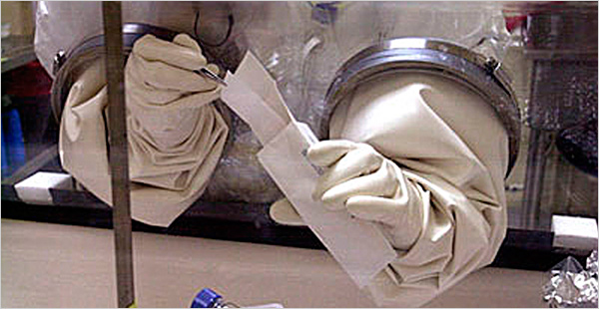**ANTHRAX ATTACKS IN SEPTEMBER/OCTOBER 2001**

The terrorist attacks in 2001 that utilized envelopes filled with Bacillus anthracis spores and sent through the U.S. Postal Service probably is one of the most prominent health events of that year, and one that undoubtedly remains in the minds of most adult Americans to this day. These attacks caused 22 cases of cutaneous and pneumonic anthrax in New York, New Jersey, Florida, Connecticut, and Washington, D.C.; of these, five died.[69] As of this writing, those responsible for these attacks have not been brought to justice. These attacks, and the casualties they caused, without a doubt shook public confidence in the government's ability to protect its constituents from a bioterror attack and respond effectively to accomplished attacks. However, the relatively small number of casualties they caused, as well as their wide geographic reach, makes them individually or collectively poorly suited for the purposes of this brief.

**Conclusion**

The three infectious disease outbreaks described and discussed here were caused by one non-communicable bacterial pathogen (Salmonella typhimurium), one communicable bacterial pathogen – Yersinia pestis (its communicability appeared to be of low order), and one moderately communicable virus (SARS-CoV). Many, many lessons can be learned from these outbreaks useful to both public health and health delivery professionals, but here we draw three.

First, without doubt the communicable pathogens caused many more problems to both the public health and health delivery communities. Thus, for public health the immediate issue had to do with containing the spread of disease, which entails the immediate imposing of public health measures ranging from frequent hand washing to the quarantine of entire communities. The longer it takes to impose these measures, the wider the scope of the outbreak and the more serious its intensity. Thus, communicating information to the public and its leaders about the causative pathogen, its mechanism of spread, and what the community needs to do to stop the spread becomes of the utmost importance. Conversely, if the outbreak is caused by a non-communicable pathogen, once public health professionals have identified from whence it originated, it usually is not so difficult to isolate and neutralize that pathogen's reservoir or source and thus stop the outbreak.

For health providers, communicable diseases also create difficult problems, in the first place having to do with protecting themselves and the public from contracting the contagious pathogen from infected individuals. As was demonstrated by SARS, if protection is not affected, the health providers and their institutions can act as amplifiers of the disease, thus becoming an important part of the problem rather than the solution. Therefore, although the quick identification of the pathogen is of high importance, it is paramount that health providers coming into contact for the first time with sick individuals displaying the usual signs of infection (e.g., elevated temperature, wheezing, coughing, high white blood cell count) immediately assume that they are dealing with a communicable disease and take appropriate personal and community protective actions.

The Surat and Toronto outbreaks both demonstrated that a dreaded contagious disease is likely to severely affect the availability of health workers willing to work with its victims. It is not hard to visualize that regardless of its site, were an outbreak to occur in the future that is caused by a highly contagious pathogen (SARS-CoV is moderately contagious and Y. pestis was probably even less contagious) and would last for some months or longer, the situation regarding availability of health workers to work with victims would deteriorate markedly and more or less rapidly, possibly leading to a deadly vicious circle where more and more inhabitants become sick and fewer and fewer health providers are available to provide help to them.

Second, it has become almost a truism among preparedness professionals that catastrophic health events are, first of all, local events, which means the response to them must in the first instance depend on locally made preparedness plans and resources available to local leaders and health professionals. As for preparedness planning, probably none had yet been made in either The Dalles or Surat (at least we have not found any sign of any plans at these cities being activated to deal with the exigencies of the outbreaks they faced). Of course, these events took place before September 11, 2001, which appears to be a turning point in regards to how community leaders view the need for preparedness planning; before 9/11, preparedness planning usually was limited to making ready for natural events, such as earthquakes, hurricanes, and others; after 9/11 there grew an awareness that communities also needed to plan for the possibility of catastrophes brought about by human actions.[70] Further, after the SARS pandemic in 2003, with additional stimuli provided by the ravages of avian influenza, community leaders have become better aware of the need for preparing for the occurrence of infectious diseases. However, such awareness seems not to have been present in The Dalles or Surat, and barely in Toronto, at the time of the outbreaks discussed here.

Returning to this issue of outbreaks being local events, each of the cases considered here occurred as isolated events; i.e., each outbreak affected a particular city and did not have wider spread.[71] Even so, each city had to quickly marshal its resources and address immediate challenges posed by the outbreak it faced. In particular, quick action was required in the cases of communicable diseases so they would not disperse and thus come to affect many persons. Eventually assistance did arrive to each city from higher levels of governance, but it took some days. The point we would like to make is that if a disease outbreak were to occur in the future that affected several or many communities in a country nearly simultaneously, the ability of higher authorities at the state/provincial and federal levels to assist each one of them would be limited and this limited assistance probably would take some time to arrive.

Third, in none of the cities we consider did officials immediately communicate information about the outbreaks they were experiences in an adequate manner. This did not matter so much in The Dalles, where the outbreak was localized and of relative short duration, and in Toronto the event communication situation improved markedly within a few days, but it could have made a large difference in Surat by preventing panic and the dislocation of the populace. This tells us that preparedness plans should included provisions for communicating event information accurately and in a timely fashion to the populace; in particular, political leaders must be in tune with leaders in the public health and health delivery systems so to make certain that they are all communicating the same messages. This would also help prepare the local health delivery community so its members maintain social responsibility and allow the public health system to institute public health measures, such as quarantine, vaccine campaigns, social distancing, and others without unduly alarming the public.

►**Notes**: available at source URL

# Cities Might Not Be as Prepared as They Think for a Bioterrorism Attack

**By John Metcalfe**

Source: http://www.theatlanticcities.com/jobs-and-economy/2013/07/cities-are-not-prepared-they-think-they-are-bioterrorism-attack/6286/

Imagine that a small group of terrorists deliberately infect themselves with smallpox and then walk around London, spreading it to the populace. How much could the terrible disease proliferate before the world realized something was amiss?

This unsettling question is at the heart of new computer model showing how a bioterrorism attack in one city could quickly become the world's problem. Scientists started off with the hypothetical release of smallpox in London, New York, Paris and other major cities, then simulated how travelers would carry the virus to a host of other countries. Their conclusion: **In the best-case scenario, smallpox could spread to two to four nations before doctors managed to diagnose it.** Still ahead would lie the monumental task of quarantining the infected, distributing vaccines and tracing the source of the outbreak.

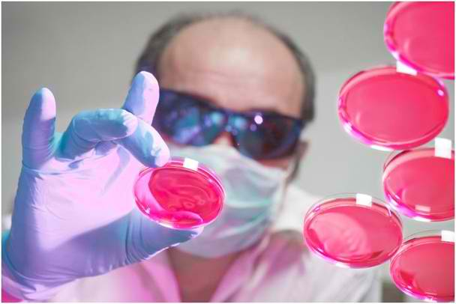 Previous research into bioterrorism have indicated that Western cities, with their protocols and vaccines, are pretty well prepared to handle a biological attack, says Alessandro Vespig­nani, a computer and health-sciences professor at Boston's Northeastern University. But in a paper in this month's Scientific Reports (don't worry, it was vetted for international-security issues), he and his fellow researchers argue that the assumption of local readiness is missing the big picture. "**The problem is that most of those studies don't consider the global dimensions of the event**," Vespig­nani says. "Before you even realize there is an outbreak, it might already be in other places. That changes the game."

One major danger: From London, the smallpox might spread to countries that don't have the health infrastructure of the Western world. In these places it could become potent pandemics that might wash over into still more nations. And that's not only possible for attacks in cities near the less-developed corners of the world. No matter what metropolis a bioterrorist targets for harm, the dispersion of disease unfolds more or less the same way, at least according to the computer model.

Vespig­nani says there are two big things that people should take away from these findings. The **first** is that governments and international health organizations, whether it be WHO, the CDC or whoever, need to develop contingency plans for a pandemic that originates from afar. "They need to think about sharing resources," he says.

The **second** is that wanna-be terrorists playing with pathogenic agents ought to consider that a biological attack is a double-edged sword. "They think they're going to affect only the area that they target. But quickly and easily, it will spread all over the world," perhaps even right back to their own motherland. "Using these kinds of weapons, there is no winner, for sure."

***John Metcalfe*** *is a staff writer at The Atlantic Cities.*

# Study reveals how a bioterrorism attack could spread to several continents before it's even detected

Source: http://www.dailymail.co.uk/news/article-2377452/Bioterrorism-Study-reveals-attack-spread-continents-detected.html

A bioterrorism attack could spread to several continents before it is even detected, according to a startling new scientific study.

The study found that if a small group of terrorists infected themselves with a disease such as smallpox and walked around London, then the pathogens could spread to up to four nations before doctors managed to diagnose it.

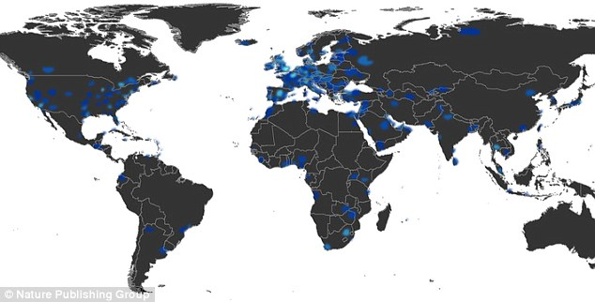'A deliberate smallpox release is likely to assume an international dimension even before the epidemic is identified,' the researchers wrote in the  study, which was published in this month's **Scientific Reports**, a trade publication.

In the case that a biological attack were released in London, this map shows the level of probability that certain areas would become immediately infected

'We show through large-scale individual-based simulations that biological targeted attacks on a single city can result in the presence of exposed individuals in several countries before the health system is aware of the release and the ensuing outbreak.'

Developed nations have contingency plans to contain biological attacks, but the study points out that the pathogens could rapidly overtake less developed nations that don't have the same resources.

'Some of the countries that could be affected may not have health infrastructures able to timely cope efficiently with the emergency dictated by a highly pathogenic virus outbreak,' the study notes.

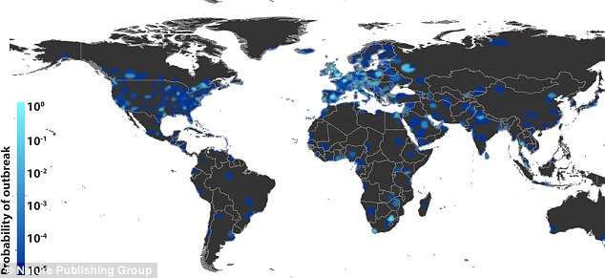The researchers who conducted the study recommend that international health organizations better prepare for the possibility of a biological attack that originates in a remote location.

This map shows the probability of infection globally two weeks after an attack originating in London

'They need to think about sharing resources,' one of the researchers, Alessandro Vespignani, told **Quartz**. Vespignani is a health sciences professor at Northeastern University.

Parts of the study were not published due to international security concerns.

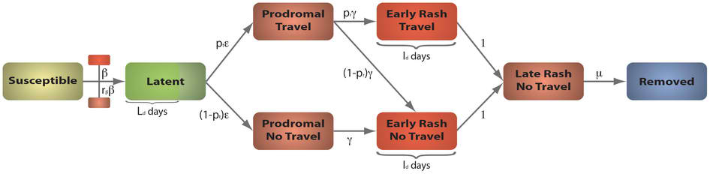'According to the comments of biosafety reviewers, we have removed quantitative data on risk probability and outbreak size in different scenarios,' the researchers wrote. 'Those additional outputs can be shared with government officials and biosecurity researchers upon request.'

Each susceptible individual in contact with an infectious case in Prodromal, Early Rash and Late Rash Stage, contracts the infection at rate *r*ββ, β and *r*ββ, respectively. Newly infected individuals enter a latency period during which they are not infectious yet and remain latent for a minimal duration of *Ld* days, after which they progress into the Prodromal Stage at per capita rate ε. Individuals in prodromal stage are divided between those who are able to travel, which occurs with probability *pt*, and those who are restricted from traveling. Prodromal Stage is characterized by reduced infection transmissibility *rβ*β and mean duration of γ−1 days. A proportion *pr* of individuals at the end of Prodromal Stage with traveling capability moves into Early Rash Stage to continue traveling while the rest – 1-*pr* – is withdrawn from traveling during this stage. Early Rash lasts for *Id* days and is characterized by the highest transmissibility β of the virus. After Early Rash, infectious individuals proceed to Late Rash Stage during which they are restricted from traveling and their transmissibility is reduced to *r*ββ. This last stage of infection is followed by permanent recovery at rate μ.

►**Read full study at:**

http://www.nature.com/srep/2013/130717/srep00810/full/srep00810.html

# How Ready Are We for Bioterrorism?

###### **By Wil S. Hylton**

###### Published: October 26, **2011**

Source:http://www.nytimes.com/2011/10/30/magazine/how-ready-are-we-for-bioterrorism.html?page wanted=all&_r=0

*A few days after 9/11, a retired Air Force colonel named Randall Larsen entered the northwest gate of the White House, crossed a courtyard to the Eisenhower Executive Office Building, stepped through the front door and stopped dead in his tracks.*

*In place of the usual security checkpoint, there was an elaborate upgrade that included not only metal detectors but also machines to sniff out radiation and explosives, elaborate pat-downs and a mandatory search of all personal belongings. It was the search that worried Larsen most.*

*After passing through a body scan, he stood quietly while a guard thumbed through the contents of his briefcase. It was mostly books and papers, but after a few seconds, the agent pulled out a respirator mask and shot Larsen a quizzical look. “That’s just for demonstration,” Larsen said quickly. “You saw Mayor Giuliani wear one at ground zero, right?” The agent turned the mask over a few times, then stuffed it back in the briefcase. Seconds later, Larsen was through.*

*Inside the building, he followed a long corridor to a room where Vice President Dick Cheney and members of the national-security staff soon joined him. Also in the room were Tara O’Toole, who is now the Obama administration’s top official for biodefense research at the Department of Homeland Security, and Thomas Inglesby, who runs the Center for Biosecurity. Three months earlier, Larsen, O’Toole and Inglesby collaborated on a national-security exercise to simulate the effects of a smallpox attack. Now, with the twin towers in ashes, they had come to brief the vice president on their findings.*

*As O’Toole began the presentation, Larsen studied Cheney’s expression. The vice president showed no reaction as O’Toole listed the officials who participated in the simulation, the complications they encountered as they tried to develop an emergency response and the arguments that broke out as they watched the disease spread beyond control. She concluded by telling the vice president that the country was unprepared for a biological attack.*

*Cheney nodded. “O.K.,” he said. “But what are we looking for? What does a biological weapon look like?”*

*At this, Larsen reached into his briefcase and pulled out a small test tube. “Mr. Vice President,” he said, “it looks like this.” Inside the tube was a weaponized powder of Bacillus globigii, almost genetically identical to anthrax. “And by the way,” Larsen said, “I just smuggled this into your office.”*

*At one of the most secure buildings in the world, in a moment of unprecedented alarm, the White House guards had searched Larsen’s briefcase — and never even saw the powder. “They were looking for the wrong things,” Larsen says now. “They still are.”*

**The specter of** a biological attack is difficult for almost anyone to imagine. It makes of the most mundane object, death: a doorknob, a handshake, a breath can become poison. Like a nuclear bomb, the biological weapon threatens such a spectacle of horror — skin boiling with smallpox pustules, eyes blackened with anthrax lesions, the rotting bodies of bubonic plagues — that it can seem the province of fantasy or nightmare or, worse, political manipulation. Yet biological weapons are as old as war itself. The ancient Hittites marched victims of plague into the cities of their enemies; Herodotus described archers’ firing arrows tipped with manure. By the 20th century, nearly every major nation developed, produced and in some cases used a panoply of biological weapons, including anthrax, plague, typhoid and glanders.

A decade after the 9/11 attacks, it is easy to forget the anthrax letters that sprang up just a few weeks later and to dismiss the fear that swept the country as a relic of a fragile moment that already belongs to history. But in the wake of those events, many national-security experts began to reconsider the risk of a biological attack — and reached some unsettling conclusions. Since the collapse of the Soviet Union, most scientists had assumed that the difficulty of building a bioweapon was far beyond the ability of a terror cell, but looking again in the early 21st century, many experts came to believe that advances in laboratory technology brought the science within reach. “What took me three weeks in a sophisticated laboratory in a top-tier medical school 20 years ago, with millions of dollars in equipment, can essentially be done by a relatively unsophisticated technician,” Brett Giroir, a former director at the Defense Advanced Research Projects Agency (Darpa), told me recently. “A person at a graduate-school level has all the tools and technologies to implement a sophisticated program to create a bioweapon.”

Even some nuclear experts began to wonder if the risk of a biological attack had eclipsed the nuclear threat. Graham Allison, the founding dean of Harvard’s John F. Kennedy School of Government and a leading expert on nuclear proliferation, told me: “Nuclear terrorism is a preventable catastrophe, and the reason it’s preventable is because the material to make a nuclear bomb can’t be made by terrorists. But in the bio case — oh, my God! Can I prevent terrorists from getting into their hands anthrax or other pathogens? No! Even our best efforts can’t do that. I think the amazing thing is that one hasn’t seen more bioterrorism, given the relative ease of making a bioweapon and the relative difficulty of defending.”

How a biological attack might unfold depends on a number of variables, including which biological agent is used, the extent of its weaponization, the amount released and the method of delivery. Some agents, like the smallpox virus, are highly contagious and could spread widely from a small release. Others, like the plague and tularemia bacteria, are not typically contagious but are relatively easy to make into wet slurry and disperse. Some of the most vivid descriptions of how such an attack might look come from the national-security exercises used to develop biodefense policy. The exercise briefed to Dick Cheney in 2001, for example, was known as Dark Winter and was coordinated by the Center for Strategic and International Studies and the Johns Hopkins Center for Civilian Biodefense Studies. It took place over two days at Andrews Air Force Base, with former Senator Sam Nunn playing the role of president, David Gergen acting as national-security adviser, the former C.I.A. director James Woolsey leading intelligence and the retired four-star general John Tilelli serving as chairman of the Joint Chiefs of Staff. As the smallpox virus began to appear, first in Oklahoma and then in pockets across the nation, the participants quickly discovered that the country had no standing response plan and only enough vaccine to protect 5 percent of the public. Within weeks, as many as a million people in the United States were estimated dead.

Not all experts are convinced that simulations like Dark Winter offer a realistic view. Milton Leitenberg, a prominent arms-control expert, has argued that the exercise relied on faulty premises to increase the death toll and “assure a disastrous outcome.” In particular, Leitenberg objects to the rate of secondary transmission assumed in the Dark Winter exercise. This is the figure to describe how many additional people each patient would infect, and it is highly contextual, depending on biological traits, like the genetic vulnerability of the target population; social habits, like the number of personal interactions by each victim; and meteorological conditions, like the weather and the time of year. Because the exercise was set in winter, which is favorable to smallpox, and because Americans are not routinely vaccinated, planners assumed a transmission rate of 10 new infections by each victim. Leitenberg says that number should be three. Other estimates vary. The Centers for Disease Control and Prevention uses a range of five to seven; the last comparable cases of smallpox to appear in Europe averaged between 9 and 17; and the authors of a 1999 article in Science magazine used the same figure as Dark Winter. But if Leitenberg is right, the death toll from the exercise would be much lower — most likely in the tens of thousands.

Whatever the transmission rate of smallpox, the more salient question for biodefense may be whether an attack will happen at all. On this, the expertise of microbiologists is limited, but there is surprisingly broad agreement among the officials in charge of national security over the past 10 years. Since 2001, senior members of both the Obama and Bush administrations, who have reviewed classified intelligence, have consistently placed biodefense at or near the top of the national-security agenda. In 2004, a report from the National Intelligence Council warned, “Our greatest concern is that terrorists might acquire biological agents.” Michael Chertoff, the secretary of Homeland Security between 2005 and 2009, told me, “In terms of catastrophic attacks, bio was at the top of the list.” In 2008, the director of national intelligence, Adm. Mike McConnell, described a biological attack as “my personal greatest worry.” In 2009, McConnell’s successor in the Obama administration, Dennis Blair, warned the Senate Select Committee on Intelligence that “the terrorist use of biological agents represents a growing threat.” In November 2009, the National Security Council estimated that a biological attack could place “hundreds of thousands of people” at risk of death and cost more than $1 trillion. Heidi Avery, a top biodefense official in the White House, told me recently that biological terrorism poses “the ultimate asymmetric threat; it should be considered in the same class as the nuclear threat.” And a report by the Congressional Commission on the Prevention of Weapons of Mass Destruction Proliferation and Terrorism, formed in 2007, concluded: “To date, the U.S. government has invested most of its nonproliferation efforts and diplomatic capital in preventing nuclear terrorism. The commission believes that it should make the more likely threat — bioterrorism — a higher priority.”

To heighten the nation’s biodefenses, the federal government has invested more than $60 billion since 2001, developing and distributing air sensors, educating doctors about the symptoms of bioterror pathogens and distributing medical supplies for biodefense to hospitals around the country. At the root of these efforts is a list of specific biological agents, known as “material threats,” that have been identified by the Department of Homeland Security as the most urgent pathogens to defend against. These include smallpox, anthrax, ebola, plague and a handful of lesser-known organisms.

Since 2004, the Department of Health and Human Services has overseen a program called Project BioShield to develop and stockpile vaccines and treatments, known collectively as “medical countermeasures,” to defend against the pathogens. After seven years, the achievements of BioShield are measurable. According to Robin Robinson, who directs the countermeasure program at Health and Human Services, there is currently enough smallpox vaccine in the stockpile to inoculate every United States citizen; enough anthrax vaccine to respond to a “three-city attack”; and a variety of therapeutic drugs to treat the infected. Yet many other goals of the program are incomplete and, in some cases, not even begun. After spending hundreds of millions of dollars, for example, to develop a new vaccine for anthrax that would replace the controversial formula developed 50 years ago by the Army — which is known to have serious side effects and has never been approved for children — there is still no new vaccine. There also are no new broad-spectrum antibacterial drugs in the stockpile and no new antivirals. “We don’t even have candidate products” for antivirals, Robinson told me.

Last year, two separate review boards evaluated the state of the country’s biodefense program, and each report came back scathing. The National Biodefense Science Board, a nonpartisan task force created in 2006 to oversee countermeasure development, delivered a 103-page report to the secretary of Health and Human Services, Kathleen Sebelius, describing “lack of urgency,” “lack of coherence,” “lack of prioritization” and “lack of synchronization.” The title of the report was “Where Are the Countermeasures?” And the commission created by Congress in 2007 to evaluate all defenses for chemical, biological, radiological and nuclear threats delivered its final report, offering letter grades in several categories. For attention to the safe storage of toxins, the government received an A. For openness and transparency, a B-minus. For biodefense, the grade was an F.

“The lack of U.S. capability to rapidly recognize, respond and recover from a biological attack is the most significant failure identified in this report card,” the commission wrote. “Especially troubling is the lack of priority given to the development of medical countermeasures — the vaccines and medicines that would be required to mitigate the consequences of an attack.”

Even within the biodefense community, there is a widespread sense that the countermeasure program is failing. Early this year, Sebelius described the effort as “full of leaks, choke points and dead ends,” and in more than 100 interviews with senior officials from each of the federal agencies related to countermeasure development — including past and current program heads at the White House, the Pentagon, the National Institutes of Health and the Departments of Homeland Security and Health and Human Services — I heard an endless series of grim diagnoses on the health of the nation’s biodefenses. As one senior official in the Obama administration put it: “We need a new model. This is never going to work.”

**Since the 1990s,** the United States’ approach to biodefense has been redesigned at least three times. Each time, the new approach was presented as a remedy; each time, the remedy failed to cure.

The story that circulates among officials is that the first modern president to focus on biodefense was Bill Clinton in 1998: after staying up all night reading “The Cobra Event,” by Richard Preston, a thriller about a terrorist strike with modified smallpox, Clinton called a high-level meeting of scientists, ordered the F.B.I. to review the plot and began pushing copies of the book on other politicians. By 1999, the White House and Congress had created a new division of the C.D.C., known as the National Pharmaceutical Stockpile, to store medicines for crises. But in the absence of an actual crisis, financing for the stockpile was fairly minimal. By summer 2001, it held only 15 million doses of smallpox vaccine and little else.

After the anthrax letters in October 2001, everything changed: by 2002, spending on biodefense rose to more than $4 billion, from $633 million, with an emphasis on expanding the stockpile. One of the program’s first priorities was to increase the supply of smallpox vaccine. Smallpox is regarded by biodefense experts as the most threatening biological weapon, because it can spread as easily as the flu and kills about one in three victims. To expand the stockpile, the Bush administration called in a legendary epidemiologist. In the 1960s and ’70s, D. A. Henderson led the World Health Organization’s program to eradicate smallpox in nature, chasing outbreaks through villages in Brazil, the mountains of Yugoslavia and the jungles of India before finally containing the last known cases in the Horn of Africa in 1977. Today, smallpox is the only human infectious disease ever eradicated by science.

Returning to public service in 2001, Henderson called in another legend of microbiology, Maj. Gen. Philip K. Russell, a former commander of the Army’s medical research program and a figure so revered that one commanding general was known to keep a bumper sticker on his wall that read, “What would General Russell do?” Between 2001 and 2004, Henderson and Russell, along with leaders at the National Institutes of Health and civilian research laboratories across the country, raced to develop new production techniques and expand the smallpox-vaccine supply. Today, the stockpile holds more than 300 million treatment courses.

Officials at Health and Human Services were also determined to produce and store a large supply of anthrax vaccine, but they were unsatisfied with the existing formula. Some veterans blamed the vaccine for gulf war syndrome, citing research at Tulane University, and after vaccination was made mandatory in 1998, hundreds of service members actually refused the shots. Some resigned from service in order to avoid it; a few were court-martialed for insubordination. In 2002, the most comprehensive study of the vaccine, by the Institute of Medicine at the National Academy of Sciences, concluded that while the vaccine was “reasonably safe,” a new vaccine was “urgently needed.”

Developing a new vaccine is vastly more complicated than increasing the supply of one that exists. In the pharmaceutical industry, the cost to develop a new drug or vaccine averages about $1 billion. To encourage companies into development, the Bush administration in 2003 announced the creation of a special fund within Project BioShield, filled with $5.6 billion for the purchase of countermeasures like a new anthrax vaccine, yet by the middle of 2004, not a single large pharmaceutical company had begun development. “The belief was: Fund it and they will come,” Senator Richard Burr, who is prominent in biodefense, told me. “Well, they didn’t come.” Anthony Fauci, the director of the National Institute of Allergy and Infectious Diseases (N.I.A.I.D.) at the National Institutes of Health, told me $5.6 billion was simply not enough money. “The Mercks and the GlaxoSmithKlines and others looked at it and said, ‘Forget it,’ ” he said.

Officials at Health and Human Services turned to smaller drug companies, instead. In November 2004, they offered the first major contract under BioShield to a young company called VaxGen, based in California. If VaxGen could develop and deliver a new anthrax vaccine, the government promised to purchase 75 million doses for $877 million.

From the outset, the choice of VaxGen proved controversial. The company had never produced a drug before, it had been delisted from Nasdaq a few months earlier for failure to file timely financial statements and it was embroiled in an ethical dispute in Thailand over human testing of another drug. But VaxGen did have certain advantages, not least that it had been working on a new anthrax vaccine for two years already, financed by $100 million from Fauci’s N.I.A.I.D.

To add another layer of confidence to the deal, officials at H.H.S. structured the VaxGen contract with unusually stringent terms. During the proposal process, VaxGen executives submitted a 1,000-point outline to show the approach they hoped to take. H.H.S. officials now made the outline binding: according to the former chief executive of VaxGen, Lance Gordon, officials notified the company two weeks before the deal became public that if VaxGen could not stick to the plan, the company risked breach of contract. In retrospect, Gordon told me, VaxGen never should have taken the terms. “It’s impossible,” he said. “In the history of mankind, nobody has been able to predict 1,000 tasks for hundreds of people over a five-year period. Life doesn’t work that way.”

Vaccines especially don’t work that way. Their development is notoriously complex and requires frequent adjustment as complications arise in the lab. Predictably, within months of signing the contract, VaxGen slipped off schedule and was technically in breach. At the same time, officials at H.H.S. were discovering that the VaxGen contract did not add to the countermeasure program’s appeal: by 2006, the third year of the contract, not one other major project was in development under BioShield.

It was time for a third overhaul. In the summer of 2006, Burr instructed his legislative staff to figure out what was wrong in the countermeasure program. He came to believe that the problem was institutional. If the early research at the N.I.H. was producing valuable leads for new drugs, and the money in Project BioShield offered an incentive at the end of development, then what was missing was an agency in between to help guide companies across what Burr’s staff called the Valley of Death. “What we saw,” Burr says now, “was that we had to become more than a procurer. We had to become a partner.” That July, Burr introduced a bill to establish a new agency at H.H.S., known as the Biomedical Advanced Research and Development Authority (Barda), with an annual budget of $1 billion, to finance the development of countermeasures and steer companies through the gantlet of clinical trials and F.D.A. approval. That December, the bill passed both houses of Congress unanimously — but even as executives at VaxGen watched to see how the new agency might help them, H.H.S. announced that the VaxGen contract would be canceled.

Five years later, the cancellation of that contract is still a matter of fierce debate in biodefense circles. Many experts say that the decision had less to do with science than politics. Scott Lilly, a senior fellow at the Center for American Progress, recently studied the role that lobbying may have played in VaxGen’s demise. Between 2004 and 2006, Lilly writes in a new study, the company that produced the old anthrax vaccine, which is now called Emergent BioSolutions, employed an army of lobbyists to undermine the VaxGen contract. “Each time VaxGen’s test results were less than had been hoped for,” the report says, “Emergent pounded VaxGen with a highly orchestrated campaign to overstate the problems and discourage government support of the effort.”

Executives at Emergent acknowledge the campaign against VaxGen but say it was not directed at the company so much as the structure of the BioShield contract. “Our issue was not with respect to VaxGen,” the president of Emergent, Daniel Abdun-Nabi, told me. “It was with respect to the approach of moving to a single supplier with an unproven technology. We thought it was premature. We thought it added risk to the country.” According to Abdun-Nabi, the company’s message to legislators was: “You shouldn’t put all your eggs in one basket. There’s a role for multiple suppliers.” The fact that this lobbying contributed to the implosion of VaxGen and another five years in which Emergent was the only supplier of anthrax vaccine, which has earned the company $1.5 billion, also troubles Abdun-Nabi, he said. “It puts us in a very difficult position to be the sole supplier. I mean, the whole nation is reliant on Emergent. And in one sense, we’re very honored to be in that position, but it’s a tremendous responsibility.”

General Russell, who led the early countermeasure program, told me: “It was Emergent lobbying that killed VaxGen. Period. Emergent bought the Congress. Congress killed VaxGen.” Several current officials share Russell’s view. When I asked one senior biodefense official about the lack of a new anthrax vaccine, the official nearly exploded: “Why don’t we have a second-generation anthrax vaccine? The reason is Emergent lobbying!” Even the director of Barda, Robin Robinson, acknowledged that politics played a role in the decision. “Should we have kept it? I think there’s a long debate,” he said. “They had brought in some really top-flight people in there, and Lance Gordon was really good at judging talent. Unfortunately, there was a lot of political pressure.”

Soon after the VaxGen contract failed, the company folded into another, and Emergent bought the rights to develop the new anthrax vaccine it had spent three years lobbying against. Abdun-Nabi told me his company was still trying to develop that vaccine, but critics question whether Emergent, which signed another contract this month to deliver $1.25 billion more of the old vaccine to the stockpile, is pursuing the replacement vaccine as enthusiastically as possible. “They bought the technology and buried it,” Russell says. “We are five or six years behind where we should be. We should be working on a third-generation vaccine.”

**If the pursuit** of a new anthrax vaccine has been halting, the pursuit of many other vaccines has halted altogether. In fact, other than the vaccines for anthrax and smallpox, there are no vaccines in the stockpile for any other agents on the material-threat list, nor are any of those vaccines in the advanced development program, nor will any of them enter the program any time soon.

Robin Robinson, the director of Barda, is a big, easy fellow, with a trim goatee and a light Southern drawl. The first I met him, two years ago, we sat at a long table with his new boss, Nicole Lurie, who had just been appointed by the Obama administration as the assistant secretary for countermeasure development. Lurie had an air of unpretentious surety and a sudden, piercing laugh, and she and Robinson wasted no time trying to hide the failings of their program. Although Barda was established in 2006 with an annual budget of $1 billion, it never actually received the money. In 2006, the agency received $54 million; in 2007, $104 million; in 2008, $102 million; and by the time I sat down with Robinson and Lurie in 2009, Barda had received in four years about half of what it was intended to receive in one. Lurie reminded me of the high cost required to develop drugs. “What does it take in the pharmaceutical industry?” she asked. “A billion dollars per product! The advanced development part of that might be about $350 million, so that’s the part that we should be funded for.”

“For each product!” Robinson said.

“For each product,” Lurie agreed. “So, we’re nowhere near it. We’re nowhere near the level that we need to be, to be able to protect the American public.”

In the two years since that conversation, financing for Barda has gone up, but with many of the goals still incomplete and criticism pouring in — two weeks ago, the Bipartisan W.M.D. Terrorism Research Center in Washington gave the agency a D for performance — the affinity between Robinson and Lurie is less apparent. Lurie, for example, has removed from Barda all contracting officers, instructing them to report to her instead of Robinson. This many seem minor, but companies working with Barda suggest that it has led to ballooning bureaucracy at an agency that was specifically created to attract business. “Now you really have two bosses,” Eric Richman, the C.E.O. of PharmAthene, which is one of four companies still working on a new anthrax vaccine, told me. “We actually spend as much time managing our contracts as we do developing our drugs. It’s a real burden.” Other C.E.O.’s echoed Richman’s concern, and friends of Robinson’s suggest that the move has compromised his ability to lead the program effectively. “This becomes very frustrating for him,” an H.H.S. official told me. “What does he tell the companies — ‘Now I have to go ask for permission’?”

But the gap between Robinson and Lurie also seems to extend to basic matters of policy and fact. Nowhere is the division in countermeasure development more apparent than on the question of vaccine development. Because a vaccine is only effective against a single pathogen, and because development is so expensive, Barda has focused much of its energy on therapeutic drugs — which may not offer protection to the healthy but can treat a broad range of diseases.

When I visited Barda recently to speak with Robinson and Lurie again, I heard two very different explanations for the move away from vaccines. Lurie described the decision as an unfortunate but necessary concession to the budget. “You’d like to have vaccines further along in the pipeline for all the threats we have, and you’d like to have a way to manufacture them quickly,” she told me. “But I don’t think there’s anywhere near enough money in the system.” Yet Robinson insisted that the move would have happened even if financing was not an issue. “There are only two biothreats — smallpox and anthrax — that we feel vaccination is the appropriate way to go,” he said. When I asked if that meant he would not even want a vaccine for other agents, like tularemia, he said: “I don’t think there’s a case to be made for that. What we’re doing is therapeutics.”

The debate over vaccine development is by no means limited to Robinson and Lurie. Ten years after the anthrax attacks, and with more than $16 billion committed to countermeasure development, there is still broad disagreement among officials over whether the stockpile should include other vaccines. When I asked Tara O’Toole, who leads the Science and Technology Directorate at the Department of Homeland Security (where the list of biological material threats is created and the countermeasure process begins) whether she believed the stockpile should include vaccines for other agents, she snapped: “Vaccines are essential. If there’s a bio attack, people are going to want their children vaccinated. It’s the only defense against reload.”

By “reload,” O’Toole was referring to a concept first developed by Richard Danzig, who is a former secretary of the Navy under Bill Clinton and one of the leading intellectuals in biodefense. Danzig currently serves as chairman of the board at the Center for a New American Security, sits on the Defense Policy Board at the Pentagon and is a member of the President’s Intelligence Advisory Board. The reload concept, he told me recently, describes a fundamental difference between biological weapons and all other weapon types. “When we talk about terrorists’ acquiring a nuclear weapon, we’re talking about just that — they’re acquiring a weapon,” Danzig said. “With biological weapons, we’re talking about acquiring the ability to produce weapons. So if you acquire the ability to produce 100 grams of anthrax, you can keep doing that. You really have to think about biology as potentially the subject of a campaign, where somebody keeps attacking, rather than a one-shot incident.” When I asked Danzig how the reload concept influences the debate over vaccines, he said: “You can reassure people that there will be antibiotics available for them, and you can keep producing ever greater numbers of antibiotics. But you can see that if you had the ability to vaccinate people and protect them, it would provide a larger degree of protection. So to the extent that these things come to pass, I think there will be more pressure to develop vaccines.”

Brett Giroir, who directed the Defense Sciences Office at Darpa and is now vice chancellor for strategic initiatives at Texas A&M University, shared Danzig and O’Toole’s belief that other vaccines should be developed. “Vaccines are critical components of a biodefense posture, and anybody who thinks they’re not isn’t thinking seriously about how we approach this,” Giroir told me. “If we got sprayed with tularemia in College Station and a biodefense sensor went off, that would be an ideal opportunity for vaccine.”

Tularemia is an especially difficult case. Found naturally in animals around the world, it can be transmitted during butchering and spread by ticks. Although it is highly infectious, it is seldom lethal. But during the 1950s and ’60s, Army researchers became interested in weaponizing tularemia.

It has been more than 40 years since the American bioweapons program shut down, and many of the details remain classified. Last fall, the final director of the program, William Patrick, died of cancer at 84, but in the final months of Patrick’s life, Robert Kadlec, the former biodefense chief in the second Bush White House, and Joel McCleary, a former aide to Jimmy Carter, spent hundreds of hours interviewing him on the history and accomplishments of the program. Over the past year, McCleary has delivered a presentation on the bioweapons program to members of Congress, the White House national-security staff and senior officials at the Departments of Defense, Homeland Security and Health and Human Services. One night this summer, I stopped by McCleary’s house to see the presentation myself.

Finding McCleary’s home in Georgetown was a bit like passing through the looking glass. I started down a cheery row of town houses, but as I approached the right number, I realized there was no house — just a gravel path that trailed away from the street with vines and shrubs surrounding it. I followed the path and came to a gate and, finding no bell or button, fiddled with an iron latch to enter a lush green courtyard shaded by a walnut tree. It was as if I made a wrong turn in Georgetown and wandered into the English countryside. In the center of the yard sat a small cottage, as wide as it was tall. I rang the buzzer a few times and rapped a brass knocker on the door, and after a few minutes, McCleary burst outside in a pair of bright red slippers. He is a large man, brimming with energy, and we stood in his yard admiring the flowers for a moment, then retreated inside to review the last known record of the American quest for a microbial army.

It was immediately apparent that the Army’s research on tularemia went far beyond what is commonly known. In hundreds of experiments, scientists weaponized the bacteria to extraordinary potency and then proceeded to mix the slurry with another agent, known as S.E.B., which multiplied the effects logarithmically, shattering the human immune system just as the tularemia plunged in. In several large outdoor tests, scientists drifted clouds of tularemia over cages of live monkeys to evaluate the infectivity. At high doses, the weaponized bacteria were determined to have an incubation period of just a few hours. If left untreated, the combination of tularemia and S.E.B. was projected to cause death within the same period. Patrick called these “killing winds.” In one video, he calmly warned, “Between 50 and 60 pounds of freeze-dried tularemia produced in our production facility would eliminate about 60 percent of the population of London, England.”

When I asked Robinson, who knew Patrick and has seen McCleary’s presentation, whether the extreme weaponization of tularemia suggests the limits of a therapeutic response and a role for vaccination, Robinson became circumspect. “I’ve got to be careful on this one,” he said, “because there is classified information.” Then he went on to explain that Barda is considering the possibility of such an attack but still hopes to respond by treating the sick, rather than by vaccinating the healthy. “What we’re doing,” he reiterated, “is therapeutics.”

To date, the United States has never developed an original vaccine for tularemia. Instead, for the past 50 years, scientists who study tularemia must be vaccinated with a weakened version of the bacterium, which was first obtained through mysterious means from the Soviet Union during the early days of the cold war and then modified. But today, supplies of the live vaccine are running thin. In fact, they are virtually gone. Although some lab workers still receive it, the official literature of the C.D.C. lists the tularemia vaccine as “not currently available,” and Karl Klose, who runs a tularemia lab at the University of Texas, San Antonio, told me that federal research into tularemia has dwindled over the past few years. “They’re basically just abandoning the effort,” he said. “It’s like the A.D.D. has kicked in.”

There is one vaccine candidate for tularemia currently in development. Although it is not a novel product and represents a different formulation of the old Soviet vaccine, it is currently in clinical trials at several locations around the country. Typically, the point at which a product becomes eligible for all the support and financing of the advanced development program at Barda is when the product enters Phase II testing. The new tularemia product entered Phase II this fall, but without interest from Barda, it has remained under the auspices of the early development program at N.I.A.I.D. If this seems organizationally confusing, it makes sense in at least one way. Since 2002, the financing for N.I.A.I.D. has outpaced that for advanced development by as much as 15 to 1. Partly, this is a result of N.I.A.I.D.’s being an older, established institution; partly it is a consequence of the institute’s powerful director, Fauci, who has led the agency since 1984 and is sometimes called the J. Edgar Hoover of biology. On the heels of the anthrax attacks in 2001, Fauci vigorously promoted N.I.A.I.D. as the best agency to lead countermeasure development and since 2003 has received about $1.6 billion each year for biodefense research. Some of that money goes into projects like the tularemia study, which would not be financed otherwise. Much more has gone into other kinds of projects entirely. A close look at Fauci’s budget last year shows that the director has steered about 70 percent of his biodefense funds toward research into natural disease, including AIDS, SARS and malaria — choosing to define “biodefense” however he likes.

**The offices of** N.I.A.I.D. lie within the sprawling N.I.H. campus in Bethesda, Md., just below the rim of the Washington Beltway. Among the stately grounds of the N.I.H., the N.I.A.I.D. building is mostly remarkable for how unremarkable it is: the exterior is smudged with mildew and laced with steel electrical conduit, and the corridors are dim and yellowing with age. One day recently, as I stood with Fauci in his seventh-floor office, he paused to admire the dishevelment around him. “Look at this!” he cried, running a hand over the dented surface of his desk. “I inherited this from my predecessor!” He pointed to an old sofa in the corner. “If there’s ever a Congressional investigation, I don’t want them to say I spent it all on myself!”

Fauci is a small, muscular man with an outsize manner. He is from New York in the most obvious ways. After three decades leading one of the most prestigious research programs on earth, he retains a booming Brooklyn patois that sounds, even when he is discussing matters of virulence and pathogenesis, as if he is shouting a pizza order to the back. As we sat together in his library, he explained that although he has overseen most federal spending on countermeasure development since 2002, he does not fully embrace the mission. The list of material threats, he said, reflects an outmoded way of thinking. “It’s less of a priority to say, ‘O.K., now here’s our menu for the Strategic National Stockpile,’ ” Fauci said. “We call that the military model.” He added, “Do we have this little thing in the stockpile or not? I don’t judge the safety of the country on that basis. To me, the idea of a naturally occurring threat is infinitely greater.”

Many agents on the list, Fauci said, were a product of the cold war, when the U.S. military kept a list of “Category A” pathogens being developed by the Soviet bioweapons program. “So when the decision was made to make an investment into developing countermeasures,” he told me, “that was essentially their matrix from the beginning: these are what we know the Soviets had. We know they have stockpiles. This is what we’re going to protect against.” He mentioned the bacterium glanders, which was reportedly used by Germany in World War I and by Japan in World War II but seemed to Fauci a comparatively minor threat today. “I think the unknown threat of a mutant microbe is infinitely greater than someone coming and dropping a glanders on us!” he said. “I mean, seriously! Get real about that!”

When I mentioned Fauci’s comments to O’Toole, who oversees the biological-threat list at the Department of Homeland Security, she said he was “completely wrong” to suggest that the list is rooted in cold-war thinking. “We use current intelligence as an integral part of every material-threat determination,” O’Toole said. “I’m surprised anyone in N.I.H. would think otherwise, particularly since the details of the material-threat determination process are briefed at the White House. It does raise a troubling question about how seriously N.I.H. is engaged in the biodefense mission.”

Whether or not Fauci is right about the origins of the material-threat list, his observation that a natural outbreak is more likely than a biological attack is difficult to dispute. Each year, seasonal flu leads to about 200,000 hospitalizations and several thousand deaths in the United States. Although a biological attack could be much larger, there is no certainty that such an attack will ever happen. How to balance the unlikely but catastrophic potential of bioterror with the steady advance of natural disease is one of the most puzzling challenges for biodefense policy going forward.

To some extent, this is also a question of framework. Fundamentally, the countermeasure program is a public-health project, yet with its reliance on classified intelligence and secret-threat assessments, it is more closely aligned in many respects with the methodology of other national-security projects. Where biodefense fits into government bureaucracy will have a profound impact on its financing. In public health, the $12 billion necessary to develop new vaccines for a dozen material-threat agents can seem a towering, even absurd, figure. Within the realm of national security, the same amount represents less than a quarter of the cost of the military’s experiment with the V-22 Osprey heli-plane, or about what the U.S. will spend in Afghanistan between now and Christmas.

“We spent trillions of dollars in the cold war preparing for a potential nuclear exchange that never occurred,” says Kenneth Bernard, who was the senior biodefense official in the Clinton White House from 1998 to 2001 and then again in the Bush White House from 2002 to 2005. “We’re not spending that kind of money to prevent a bio attack because the people who work on biology are not trained to think like that. They are much more interested in dealing with the three particular strains of influenza that are in the dish this year than they are in thinking about a plague attack in 2018.”

Even if the leadership and financing for biodefense were to shift toward a national-security framework, the task would still require complex coordination among agencies with expertise in disparate spheres. This challenge is not made easier by the personal hostility that has emerged among many current program heads — some of whom have close ties to the competing companies they oversee. In the course of several months of reporting, I heard senior officials from each of the major countermeasure agencies question the motives and professional credentials of the others, sometimes in a manner involving spittle. At times it seemed that the most virulent pathogen in biodefense was mutual hostility, and everybody had it.

Senior officials in the Obama administration say that the president is committed to improving coordination on biodefense and is entering a fourth major overhaul of the countermeasure enterprise. Last year, officials from the countermeasure agencies met weekly with the White House staff to discuss the merits and drawbacks of the current approach. Officials who attended those meetings say the administration hopes to develop a more “nimble, flexible” program, in which a single drug can treat multiple diseases and a single manufacturing plant can produce multiple drugs. If that plan, after 10 years and hundreds of millions of dollars trying to create a new anthrax vaccine that is still not ready, sounds optimistic, it is. Whether it is also realistic, only time will tell. Critics are quick to note that, three years after taking office, the administration is still holding meetings and announcing bold new plans.

A number of former and current officials also point out that no one in the Obama White House is focused exclusively on biodefense. In both the Clinton and Bush administrations, there was a biodefense director whose primary job was to coordinate the agencies. Today, there are four senior White House officials with partial responsibility for biodefense, but each of them is also responsible for a raft of other issues, like natural disasters, terrorism and large-scale accidents like the Deepwater Horizon oil spill. Whatever you think U.S. biodefense policy should be, it is difficult to imagine that it would not benefit from clear, central leadership. Kenneth Bernard, the biodefense czar in both the Clinton and Bush administrations, told me, “The only way that you can get all of those people in the room is to call them into the White House, and to have a coordinating group under a single person.” Robert Kadlec, who was the senior official for biodefense in the second Bush term, said, “Unless someone makes this a priority, it’s a priority for no one.”

Randall Larsen, who first smuggled a tube of weaponized powder into the meeting with Dick Cheney 10 years ago — and went on to become the executive director of the Congressional Commission on Weapons of Mass Destruction — said: “Today, there are more than two dozen Senate-confirmed individuals with some responsibility for biodefense. Not one person has it for a full-time job, and no one is in charge.”

***Wil S. Hylton*** *is a contributing writer for the magazine.*

|  |
| --- |
| Scientists discover fastest diagnostic test for Black Death to date thumbs up.jpg.pngSource: http://www.bioprepwatch.com/medical_countermeasures/scientists-discover-fastest-diagnostic-test-for-black-death-to-date/331570/  Director at the Max Planck Institute of Colloids and Interfaces and Professor at the Freie Universität Berlin Peter Seeberger and his team discovered the fastest diagnostic test yet for the Black Death using glycomic research technology.  Yersinia pestisThe team, using glycochemistry and glycobiology, found and synthesized an oligosaccharide structure on a bacterial surface and combined it with a protein. They then found antibodies against the surface glycan in blood of infected patients. Using the antigen they created, they then created antibodies which directly detected the presence of *Yersinia pestis*, the cause of Black Death, in infected samples.  The Black Death was an epidemic that took the lives of more than 200 million people during the medieval ages. Cases still occur today and are very dangerous, as each hour a person remains infected decreases the likelihood treatment will be effective. The plague can be treated by antibiotics if it is detected in time, and is considered one of the most deadly bioweapons.  Prior methods for detection included phenotyping or gene testing, both of which are expensive, slow and often times inaccurate. The new method of detection is quick and highly sensitive, making it quite possibly the most useful detection method for the plague today. |

## International partnership tries to preempt next global pandemic

Source: http://www.homelandsecuritynewswire.com/dr20130729-international-partnership-tries-to-preempt-next-global-pandemic

Researchers from **Australia, Singapore, and the United States** are joining forces, through a $20 million partnership, to help pre-empt and prepare the world for the next human pandemic.

Speaking in Canberra the other day, before a gathering of Australia’s leading biosecurity researchers, Dr. Gary Fitt, CSIRO Biosecurity Flagship director, said recent global events highlighted the need to ramp up research into viruses that spread from animals to humans.

“We now know that 70 percent of new diseases in people have originated in animals,” Fitt said.

“We are lucky to have a strong biosecurity system, backed by world-class science, but we live in an increasingly connected world with trade and people movements putting us at greater risk.”

A CSIRO release reports that recently a new SARS-like virus has emerged from the Middle East and has killed 45 of 82 people infected since September 2012.

Known as Middle East Respiratory Syndrome (MERS), it has spread from the Middle East to the United Kingdom, Germany, France, Italy, and Tunisia.

While in China there is a new strain of highly pathogenic bird flu, known as H7N9, which is spreading undetected, killing people instead of chickens. It is unknown how it spreads.

CSIRO and Duke-NUS (an alliance between Duke University in North Carolina and the National University of Singapore) have signed a relationship agreement with a view to forming the International Collaborative Center for One Health to assist in taking a new approach to tackling these deadly viruses.

Dr. Linfa Wang, CSIRO Science Leader and Director of the Program in Emerging Infectious Diseases at Duke-NUS, said that responding to these emerging threats needs a different approach to the past and must integrate medical, veterinary, ecological and environmental research.

“Bringing all of these disciplines together to develop a One Health approach rather than working independently is what our new international partnership is all about,” Wang said.

“We are combining CSIRO’s world-leading bat virology research with Duke-NUS medical expertise in the development of new and more effective methods for the discovery, treatment, prevention and control of new and emerging diseases in people.”

The release notes that research is already underway with the team at Duke-NUS working to develop new tests for early and rapid detection of emerging infectious diseases, such as Hendra virus and coronaviruses.

CSIRO scientists with expertise in bat virology will then test and validate these new platforms at the Australian Animal Health Laboratory, the world’s most advanced high containment facility, located in Geelong Victoria.

CSIRO says this work builds on the organization’s achievements in biosecurity research which have already had a profound impact on Australia’s biosecurity status including the delivery of a biological control for one of the world’s most invasive pests — the silverleaf whitefly — and the recent development of an equine Hendra virus vaccine.

### Bioweapons Country Report – Japan

**BioWeapons Monitor 2012**

Animesh Roul, Society for the Study of Peace and Conflict, New Delhi (India)

Excerpts, “Country Report: Japan”, pp. 51 – 64

**Editors, Gerald Walther and Simon Whitsby**

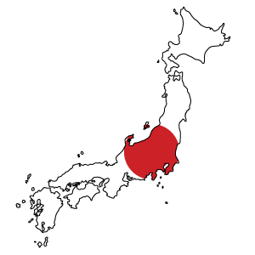Bradford Disarmament Research Centre, University of Bradford (UK)

Source: http://news.cbrnresourcenetwork.com/newsDetail.cfm?id=182

Japan has long supported the effort to strengthen the prohibition against biological and toxin weapons. Recently, in parallel with developments in the Inter-Sessional Process (ISP) of the BWC since 2003, Japan’s proactive engagement in counterterrorism and WMD (weapons of mass destruction) non-proliferation policies has been demonstrated in diverse international fora, such as the Australia Group, the Global Partnership (GP) programme of the Group of 8 (G8) and the Proliferation Security Initiative (PSI), as well as the UN Security Council Resolution 1540.(1)

Such commitment is due in part to the actual threats posed by the destructive use of science in Japan. The most prominent case of such misuse was the bioweapons development efforts of the religious group Aum Shinrikyo in the 1990s. at the Seventh Review Conference of the BWC in 2011, Japan emphasised that taking appropriate action to tackle biological threats ia an urgent issue in view of potentially heightened risks associated with biotechnology and biological agents, particularly with regards to their illicit use or misuse.(2)

Therefore, Japan urged that a comprehensive approach be taken to help mitigate potential biological threats.(3) Details of the approach were further elaborated in the series of working papers (WP) submitted by Japan to the Seventh Review Conference. Japan with Australia and New Zealand underlined the necessity for addressing compliance issues by looking at possible role of confidence building measures (CBM), Article V and VI of the Convention and relevant science and technology (S&T).(4) Japan with Australia also proposed the establishment of working groups on specific agenda items at the coming Inter-Sessional Process (ISP) between 2012 and 2015, including CBM, international cooperation (Article X) and annual review of S&T.(5) Notably at the Seventh Review Conference, Japan declared its CBM return will be made available to the public from 2012.6 S&T issue was further elaborated by WP No. 13, jointly submitted with Australia and New Zealand, proposing the establishment of “S&T Working Group Facilitator” who are appointed by the States Parties during the ISP and provide S&T report for the next Review Conference.(7) Finally, WP No.22 proposed the enhancement of the institutional aspect of the BWC by making the current CBM form user friendly and setting out “Matching Needs and Resources” mechanisms to help promote international cooperation between States Parties.(8)

**Status of the life sciences and biotechnology industry**

According to the BWPP’s 2011 global survey, Japan is one of the world’s leading countries in the field of the life sciences and biotechnology. Globally, Japan ranks second; in its geographical sub-region, East Asia, it ranks first. More specifically, globally, Japan ranks fourth in terms of publications and, together with the United States, first with regard to patents.(9) Japan is also home to some 5,000 companies engaged in the development, production and distribution of medical and health-care devices, equipment, instruments and materials.(10) There are more than 30 different types of academic life-science societies.(11) For example, the Molecular Biology Society of Japan has increased its membership to approximately 15,000 since 1978 and some 8,000 participants attend its annual conventions.(12) Around 200 universities have life-science degree courses and conduct biotechnology research projects, often in cooperation with relevant public and private research institutions.(13) Since 1942, the Japan Bioindustry Association (JBA) has organized the World Business Forum, which is the longest running international biotechnology event in Asia. In 2011, 20,606 participants attended 327 business exhibitions, leading to 1,643 business matching.(14)

**Biodefence activities and facilities**

Japan developed training exercises for responding to nuclear, biological and chemical (NBC) weapons in the 1970s as part of the operations of the Central NBC Weapons Defense Unit (CNBC) of the Japan Ground Self-Defense Force (JGSDF) and the emergency exercises of the Japan Maritime Self-Defense Force (JMSDF). However, substantial budgeting for NBC defence capacity-building started in 2000 following attempted biological attacks by Aum Shinrikyo in 1990–95.(15) Importantly, efforts to strengthen NBC counter-measures were further enhanced in light of increasing international attention to the threat of proliferation of bioweapons and their potential linkage with terrorism, including the anthrax attacks in the US in September 2001.

A number of relevant policy developments as part of NBC defence capacity-building occurred around 2000. In Fiscal Year 2000, the Government of Japan presented a budget plan for equipment for counterchemical and biological weapons that attempted to allocate unprecedented USD 65 million to the Ministry of Health, Labour and Welfare.(16) For the same Fiscal Year, USD 24 million was earmarked for the Ministry of Defense for its counter NBC project.(17) These policy developments were coordinated by relevant ministries and agencies, including the coastguard, commerce, defence, fire service, health/labour, police, and science/technology. In 2010, a 15-year summary of the development of CBRN (chemical, biological, radiological, nuclear) response measures after the Aum Shinrikyo Sarin gas attack on the Tokyo subway on 20 March 1995 pointed out that, while government efforts have led to clear advancements in CBRN capacity development within relevant agencies, ‘for better CBRN preparedness in Japan, more interdepartmental and interorganisational collaboration and co-operation should be enhanced to maximise the limited resources in this field’.(18) Table 1 summarises these policy developments, and Table 2 lists the relevant units and facilities.

Japan’s CBM Return of 2012 declared that Technical Research and Development Institute (TRDI) of the Ministry of Defense has conducted research on detection of biological agents and research on protective equipment in the Fiscal Year from April 2011 to March 2012 funded by the Ministry of Defense.(19) The financial and organizational details of this project is summarised in Table 3.

The other declared biodefence programme for the same FY was conducted by the JGSDF. This programme was approximately USD 35,000 (2,722,000 Japanese Yen) funded by the Ministry of Defense, including:

Research of molecular-biological diagnosis for biological agent casualties Research of aerobiology(20)

This programme did not include any private contractors. The facility, which conducted the programme, is a shared facility of the Military Medicine Research Unit, Test and Evaluation Command of the JGSDF with BSL2 laboratories (Approximately 42sqM). Scientific discipline of staff is Ph.D. of Medicine. There is no official publication policy at the facility and each programme is individually authorised for possible publication; no paper was published based on the biodefence programmes of the FY 2011-2012.(21)

**Maximum and high biological containment laboratories**

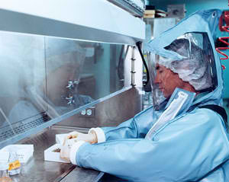Japan has two BSL4 facilities (see Table 4). Neither is operated at the Maximum containment level due to opposition from or an agreement with local residents; instead, they are operating as BSL 3 facilities without dealing with biological agents and research, which requires BSL 4 laboratories.(22) Table 5 shows the pathogens classified as BSL4 in Japan by the National Institute for Infectious Diseases (NIID). ‘BSL4 pathogens do not exist in nature in Japan, which currently has no equivalent physical containment facilities, but the possibility exists that they may be brought into the country unintentionally by those infected in endemic areas or intentionally by bioterrorists’.(23) With a view to making BSL4 facilities operational in Japan, discussions have taken place between academic and governmental experts.(24) In addition, a 2011 study of physical and social environmental conditions pointed out that communication with the public is far more developed than it was when BSL4 facilities were introduced in 1981, and there is improved public understanding about the necessity.(25) However, financial constraints remain an issue for local governments looking to sustain such facilities.(26)

The NIID’s research departments are engaged in the following research programmes: The Department of Virology I is focused on the quality control of vaccines and reference activities related to hemorrhagic fever viruses: arboviruses, Chlamydia, herpesviruses, neuroviruses, and Rickettsia.

Department II is focused on biological characterisation and the pathogenesis of the following viruses: diarrhoea viruses (such as Norwalk-like virus and rotavirus), enteroviruses, hepatitis viruses, poxviruses, tumour viruses (such as papillomaviruses and polyomaviruses). Department III is focused on the study of the measles virus as well as quality control of measles vaccines.(27)

The BWPP could not identify the exact number of BSL3 facilities in Japan. According to the National Institute of Health and Sciences (NIHS), however, there are approximately 200 BSL-3 facilities, 62 of which are located in institutes of health in local municipalities. The remaining BSL-3 facilities belong to hospitals, pharmaceutical industries and universities.(28)

Regarding possible dual-use research of concern in relation to the Fink Report of the US National Research Council, one of the widely debated H5N1 influenza research from 2011 to 2012 was conducted by a Japanese national (Dr. Yoshihiro Kawaoka from the University of Tokyo) while the researcher was conducting the research at the University of Wisconsin-Madison in the United States.(29) The series of international debates over this research also caught experts’ and media attention in Japan. A focused committee on dual-use issues under the Science Council of Japan was established on 16 November 2011, consisting of science, defence and legal experts, chaired by Dr. Hiroshi Yoshikura, an Emeritus Member, National Institute of Infectious Diseases in Japan, as well as the Adviser, Food Safety Division, Ministry of Health Labour and Welfare, Japan.(30) Currently, Dr. Kawaoka is also one of the members of the committee and the committee has been drafting a code of conduct on dual-use issues under the Council.(31)

**Vaccine production facilities**

Japan has a comparatively large number of vaccine production facilities (see Table 6).(32) Little information was found on production capacity; quantities of vaccine exports, listed in Table 7, though, illustrate the scale of vaccine production in Japan.(33)

**Disease outbreak data**

With regard to particularly dangerous diseases, the following record has been reported by the Infectious Disease Surveillance Center (IDSC). While the IDSC data is available from 25 February 2012, official disease statistics in formulated tables are only available for the years up to 2010—no formulated data in the tables could be found for 2011 and 2012.(34) Based on the available data it is evident that Japan has a low incidence of particularly dangerous diseases:

* Anthrax: none.
* Botulism: three cases in 2007 (one food borne, two is infant botulism); two cases in 2008 (one is infant botulism and the other is unknown); one case in 2010 (infant botulism).
* Lassa: none.
* Plague: none.
* Smallpox: none.
* Tularaemia: five cases in 2008.

**Relevant national laws, regulations and guidelines**

The most important piece of BWC legislation is the Law on Implementing the BWC of 1982, designed to criminalise and penalise production, possession, transfer and acquisition of biological and toxin weapons. The Law was enacted prior to Japan’s ratification of the BWC on 8 June 1982.(35) At the conclusion of the ‘International Convention for the Suppression of Terrorist Bombings’, Japan amended (in 2001) the Law to proscribe explicitly the ‘use’ of biological and toxin weapons.(36)

Various legal provisions as well as Cabinet Orders are in place to prohibit the use of biological/chemical weapons by non-state actors following the Aum Shinrikyo Sarin gas attack in March 1995 and the anthrax attacks in the US in September 2001. These include: the Law on the Prevention of Personal Injury by Sarin of 1995, which forbids the production, possession and emission of Sarin; and the Cabinet Order for the Enforcement of the BWC of 1995, which promotes the enhancement of the Law on Implementing the BWC.

In terms of measures, the Governmental Basic Directions for Addressing Bio-Chemical Terrorism of 2001 sets out more widely biosecurity initiatives, including improved public health preparedness, strengthened responses by the fire service, the JGSDF and the police, and the provision of appropriate information to the public in an emergency. The Foreign Exchange and Foreign Trade Law of 1949 was amended in 1997 to strengthen export controls, licensing legitimate financial and material transactions in the national interest. Finally, the Ministerial Notice on Laboratory Safeguards of 2001 advises research institutes to establish safeguard systems for dangerous pathogens.

**Codes of conduct, education and awareness-raising**

To help mitigate bioweapon threats, Japan has addressed—particularly in recent discussions concerning the BWC—some key aspects of awareness raising about the BWC among scientists. According to Japan, a lack of awareness among scientists is not to be taken as a sign of ‘the immorality of scientists’. ‘[T]he misconduct and failures of scientists are not caused by a lack of ethics but rather by ignorance’.(37)

The government’s particular emphasis on education led to the submission of WP No.20 and No.20-Rev.1 in conjunction with (Australia, Canada, New Zealand, Republic of Korea and Switzerland (on behalf of the “JACKSNNZ”), and Kenya, Sweden, Ukraine, the United Kingdom of Great Britain and Northern Ireland and the United States of America) to the Seventh Review Conference in 2011 with detailed reports and analyses of on-going education activities as part of national implementation of the BWC.(38,39)

Evidence from both recent official statements and academic research highlights nascent but advancing activities in the area of biosecurity education. A 2009 study surveyed 197 life-science degree courses at 62 universities in Japan by looking at different types of topics relevant to dual-use issues.(40) While life scientists lack education in the BWC, efforts have been made by the academic, professional and science communities to promote education in dual use issues as part of the life-science curricula (see Table 8).

In addition, the Japan Bioindustry Association (JBA) has underscored its mandatory professional rules and guidelines, stating that such standards are important in ensuring both ‘corporate compliance’ and social responsibility of the industrial sector.(41)

Notably, at the Seventh Review Conference, the Science Council of Japan announced that it set up a committee on dual-use issues in science and technology in order to balance the discussions on tackling dual-use concerns while maintaining the freedom of scientific research.(42) The committee has conducted a series of meeting in 2012 and aiming to establish a code of conduct for scientists on dual-use issues by September 2012.

**CBM participation**

Japan has submitted CBM declarations regularly since their establishment, except for 1987, 1989 and 1990.(43) It has made its CBM declarations available to the public since 2012.

**Participation in BWC Meetings**

Japan participates regularly in BWC-related meetings in Geneva, Switzerland. Since the Sixth BWC Review Conference in 2006, Japan has taken part in all relevant meetings (see Table 9).

**Past biological weapons activities and accusations**

Japan has neither conducted nor been accused of conducting a bioweapons programme since 1972. Japan’s bioweapons programme dates from the Second World War and is comparatively well documented.(44) In January 2007, the US National Archives declassified some 100,000 records including Select Documents on Japanese War Crimes and Japanese Biological Warfare, which contained a selection of around 1,400 documents pertaining to Japan’s Biowarfare Unit 731.(45)

With regard to the lawsuit brought against the Government of Japan by 180 Chinese citizens (survivors and families of victims), the Tokyo District Court stated on 27 August 2002 that ‘although . . . the suffering caused by this case of germ warfare was truly immense and the former Japanese military’s wartime actions were clearly inhumane . . . the decision whether to take certain [compensation] measures or if measures are taken what measures to take should be made in the Diet with a high level of discretion . . . the failure of the Diet to create laws for the relief of victims of this germ warfare cannot be conceived as illegal’.(46) The Tokyo District Court dismissed the demand of the plaintiffs (victims) for an official apology by the Government of Japan and YEN 10 million (approximately USD 130,430) in compensation for each plaintiff, as well as five per cent annual interest from 11 August 1997, the day the lawsuit was filed, to the day of completion of the compensation payment.(47)

The plaintiff appealed to the Tokyo High Court which dismissed the appeal in 2005; the receipt of a further appeal to the Supreme Court was refused and dismissed in 2007. At the time of the decision in the High Court in 2005, the government of Japan during the 162nd Diet, cited an official statement of 1995 noting that it believed there is no such right to claim in the case after the Japan-China Joint Communique of 1972 and that this is the shared view between the two governments.(48)

A more recent and prominent case is that of Aum Shinrikyo, which was able to accumulate hundreds of millions of dollars in assets and to recruit some 10,000 members in Japan, 30,000 in Russia, and to establish a presence in Australia, Germany, Sri Lanka, Taiwan, and the United States.(49) Aum Shinrikyo attempted several biological attacks using botulinum toxin and anthrax from 1990–95.(50) Bioterrorism by the group was unsuccessful due to a lack of technical expertise. Consequently, Aum Shinrikyo opted to use Sarin gas in its chemical attack on the Tokyo subway in March 1995, killing 13 people and injuring more than 6,000 others.

**►NOTE: Endnotes are available at source URL**

Russia: Preparing for biowarfare

Source: http://izvestia.ru/news/554429

*►Original text is in Russian – translated in English with Google Translate and refined by the Editor.*

By the end of 2014 the Russian military will be capable to neutralize deadly viruses and bacteria. The development of such a system has ordered by the Ministry of Defense to protect against biological threats and accidental or malicious spread of infectious agents. The tests will take place in military institutions, where in Soviet times were producing biological weapon-martial strains of plague, anthrax and other pathogens.

Total cost of this defense system, consisting of five components, is 284 million rubles. This money will help create a computer system capable to analyze the DNA of any bacteria or virus within an hour in order to develop a vaccine that could neutralize the infectious agent.

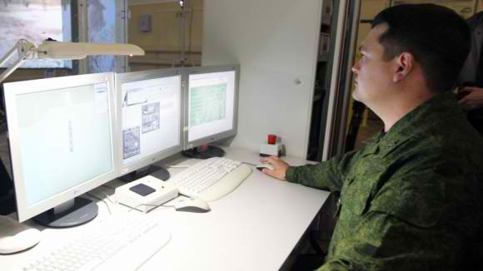The core of the system will be a decision supporting system for emergency response to biological hazards, which will be called "Golden Eagle 1" **(“Berkut-1”)** – similar to emergency prevention, command and control system, now operated by the Ministry of Defense.

The system will display on electronic maps data about infected territories, make mathematical prediction of the situation and indicate options for countering threats via available forces and means (NBC units, strategic reserves of gas masks, antidotes and disinfectants). For this purpose, the system will maintain a database of deadly viruses and bacteria, related drugs and hazard facilities throughout the country.

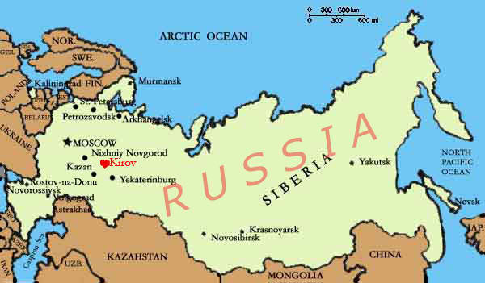Determination of the type of virus and bacteria will be based on a system called “Nightingale-1” (“Solovey-1”) capable to perform isolation of nucleic acids **(DNA and RNA) from pathogens under investigation that will be used to create a vaccine within one hour (4 analyses per hour).**

A second system called “Udod-1”, with the aid of genetic engineering, will insert pathogen’s DNA to reference cells in order to identify mechanisms of action and effective countermeasures (vaccines).

Specifically for smallpox (Orthopox virus) military labs are planning to manufacture a special vaccine under code-name "Bustard-1" (“Drofa-1”) in the form of tablets that can be stored for two years and will be issued not only to military but to civilians as well. Tablets are expected to help develop immunity against Orthopox viruses in 70% of cases.

The next element of the system will be an automated production control system specifically made for the immunotherapeutic agents (code: “Vyp-1”), that will automatically monitor every step in the developmental process of drugs. This information will enhance capabilities for rapid switching from one production line to another.

The system will be deployed in Kirov at the military Biological Institute (33 Central Scientific Research & Testing Institute – Military Unit 23527), Ministry of Defense, where during Soviet-era they studied viruses and bacteria along with countermeasures against plague, anthrax and other biological weapons.

This project is part of the federal program "National System of Chemical and Biological Security of the Russian Federation (2009-2014)."

|  |
| --- |
| “Saudi SARS” spreads globally thanks to mass religious gatherings in Middle East Source: http://i-hls.com/2013/08/saudi-sars-spreads-globally-thanks-to-mass-religious-gatherings-in-middle-east/?utm_source=activetrail&utm_medium=email&utm_campaign=English%20Newsletter% 207/8/2013  Researchers say that the life-threatening MERS coronavirus which recently emerged in the Middle East could spread faster and wider thanks to two international mass gatherings involving millions of people in the next few months – the Umrah pilgrimage and the Hajj. The researchers describe the most likely pathways of international spread based upon worldwide patterns of air travel.  A team of researchers led by Dr. Kamran Khan of St. Michael’s Hospital in Toronto, Canada, encouraged health care providers to learn from the experience of SARS by anticipating rather than reacting to the introduction of MERS in travelers returning from the Middle East. SARS, which was also caused by a previously unknown coronavirus, killed 800 people worldwide a decade ago, including forty-four in Toronto, and cost the Canadian economy an estimated $2 billion.  A St. Michael’s Hospital release reports that the MERS corona virus, which appears to have emerged in the Middle East in early 2012, has spread to several countries in Western Europe and North Africa where there have been localized clusters of cases. Worldwide about eighty cases have been confirmed, with a mortality rate of more than 50 percent.  Khan said there is potential for the virus to spread faster and wider during two annual events that draw millions of residential and foreign Muslims to Saudi Arabia. The first is Umrah, a pilgrimage that can be performed at any time of year but is considered particularly auspicious during the month of Ramadan, which began on July 9th and ends on August 7th. The second is the Hajj, a 5-day pilgrimage required of all physically and financially able Muslims at least once in their life. It takes place October 13-18 this year and is expected to draw more than three million people.  Khan’s team analyzed 2012 worldwide airline traffic and historic hajj data to predict population movements in and out of Saudi Arabia and the broader Middle East during these two mass gatherings to help countries assess their potential for MERS introduction via returning travelers and pilgrims. He also used World Bank economic and per capita health care expenditure data to help gauge individual countries’ abilities to detect imported MERS in a timely manner and mount an effective public health response. |

# http://syndicatednewsservices.com/wp-content/uploads/2013/06/mers.jpg

# warning.pngBird flu strain in China 'passed between humans'

Source: http://www.bbc.co.uk/news/health-23594392

Researchers have reported **the first case of human-to-human transmission of the new strain of bird flu that has emerged in China.**

The British Medical Journal said a 32-year-old woman was infected after caring for her father. Both later died.

Until now there had been no evidence of anyone catching the H7N9 virus other than after direct contact with birds.

But experts stressed it does not mean the virus has developed the ability to spread easily between humans.

**By 30 June there had been 133 cases of H7N9 bird flu reported in eastern China and 43 deaths.**

Most people had visited live poultry markets or had close contact with live poultry in the week or two before they became ill.

**Intensive care**

Yet researchers found that the 32-year-old woman had become infected in March after caring for her 60-year-old father in hospital.

Unlike her father - who had visited a poultry market in the week before falling ill - she had no known exposure to live poultry but fell ill six days after her last contact with him.

Both died in intensive care of multiple organ failure.

Tests on the virus taken from both patients showed the strains were almost genetically identical, which supports the theory that the daughter was infected directly from her father rather than another source.

Public health officials tested 43 close contacts of the patients but all tested negative for H7N9, suggesting the ability of the virus to spread was limited.

The researchers said that while there was no evidence to suggest the virus had gained the ability to spread from person to person efficiently, this was the first case of a "probable transmission" from human to human.

**'Strong warning sign'**

"Our findings reinforce that the novel virus possesses the potential for pandemic spread," they concluded.

Dr James Rudge, of the London School of Hygiene and Tropical Medicine, said that limited transmission between humans is not surprising and has been seen before in other bird flu viruses, such as H5N1.

He added: "It would be a worry if we start to see longer chains of transmission between people, when one person infects someone else, who in turn infects more people, and so on.

"And particularly if each infected case goes on to infect, on average, more than one other person, this would be a strong warning sign that we might be in the early stages of an epidemic."

An accompanying editorial in the BMJ, co-authored by Dr Rudge, concluded that while this study might not suggest that H7N9 is any closer to delivering the next pandemic, "it does provide a timely reminder of the need to remain extremely vigilant".

## Effective screening of airline passengers arriving from areas of infectious disease outbreaks

Source: http://www.homelandsecuritynewswire.com/dr20130809-effective-screening-of-airline-passengers-arriving-from-areas-of-infectious-disease-outbreaks

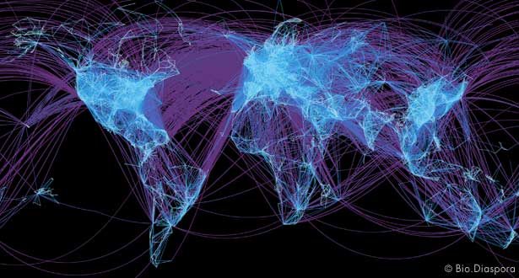New study shows that exit-screening at thirty-six airports would have assessed all air travelers at risk of transporting H1N1 out of Mexico at start of 2009 pandemic. Screening at 99 percent of the world’s international airports could have been forgone with negligible missed opportunities to prevent or delay the spread of disease. Screening at just eight airports worldwide would have led to the assessment of 90 percent of all at-risk air travelers.

Researchers have developed a simple new tool to help governments around the world decide whether to screen airplane passengers leaving or arriving from areas of infectious disease outbreaks.

The global airline transportation network visualized by the flight pathways of all commercial flights worldwide.

The tool was developed by examining all international airplane traffic in the initial stages of the 2009 H1N1 pandemic.

A St. Michael’s Hospital release reports that researchers led by Dr. Kamran Khan of St. Michael’s Hospital in Toronto found that that a focused and coordinated approach to screening airplane passengers would generate the greatest public health benefits.

Furthermore, they found that screening travelers as they leave an area where an infectious disease outbreak is under way is far more efficient than screening passengers when they land at their final destination.

It is also much less disruptive to international travel and the global economy, they wrote in the May issue of the Bulletin of the World Health Organization.

After the 2003 SARS outbreak, 194 countries agreed to the International Health Regulations, a global treaty designed to prevent, protect against and control the spread of infectious disease without putting unnecessary restrictions on international travel and trade. Until now, it’s been unclear how governments should balance those competing demands.

Dr. Khan, an infectious disease physician and founder of BioDiaspora, uses global air traffic patterns to predict the international spread of infectious disease. This web-based technology has been used by numerous international agencies, including the U.S. Centers for Disease Control and Prevention (CDC), the European Center for Disease Prevention and Control, and the World Health Organization (WHO) to evaluate emerging infectious disease threats, including those during global mass gatherings such as the Olympics or the annual Hajj pilgrimage in Saudi Arabia.

Dr. Khan used his experience analyzing air traffic patterns to review the flights of the nearly 600,000 people who flew out of Mexico in May 2009, the start of the H1N1 pandemic. He found that exit screening would have caused the least disruption to international air traffic.

In fact, all air travelers at risk of H1N1 infection could have been assessed as they left one of Mexico’s thirty-six international airports. Exit screening at just six airports in Mexico coupled with entry screening at two airports in Asia (Shanghai and Tokyo) would have allowed for screening of about 90 percent of the at-risk travelers worldwide.

Assessing those same passengers when they landed at their destinations on direct flights out of Mexico would have been much more complicated and expensive because it would have required screening at eighty-two international airports in twenty-six countries.

“One never waits for a fire to spread before putting it out,” said Dr. Khan. “It only makes sense to intervene as early as possible right at the source. The same principle applies to infectious disease outbreaks. To prevent or slow the spread of infectious disease, the most efficient strategy is to control an outbreak at it source, and if this cannot be achieved, to consider screening travelers as they depart the affected area for destinations around the globe.”

The researchers came up with a simple tool any city could use to make a timely, reliable decision about traveler screening during a future outbreak, regardless of where or when the outbreak might occur. Decisions from the tool are based on just three factors: (i) whether effective exit screening at the source of the outbreak is taking place, (ii) whether a city receives direct flights from the source of the outbreak, and (iii) the incubation period of the disease.

“If countries adopt this tool, it would help distinguish settings where traveler screening is reasonable from those where screening is clearly not warranted,” Dr. Khan said. “Taking a highly targeted approach to screening would efficiently produce public health returns while minimizing disruption to international travel, and consequently the world’s economy.”

Dr. Khan noted that screening people as they leave the site of an outbreak does place an additional burden on that country, especially if it’s a resource-poor country, and that it would be in other countries’ interest to provide resources to assist.

“While entry screening may offer the perception of being more closely aligned with the self-interests of a country, the reality is that it’s far more resource intensive and inefficient than exit screening in the source country,” Dr. Khan said. “Since entry-screening consumes valuable health and human resources that could be used more effectively elsewhere, it can actually be counterproductive from both a public health and an economic perspective.”

The reason entry screening is inefficient is that many travelers leaving the source of an outbreak may mingle with other travelers who have no connection to the outbreak. In the case of the H1N1 pandemic, screening all international travelers as they arrived in airports around the world would have been exceedingly inefficient: 116 travelers would have had to been screened for every traveler who may have been exposed to H1N1, or 67.3 million travelers at 1,111 international airports. Dr. Khan said that 90 percent of international trips 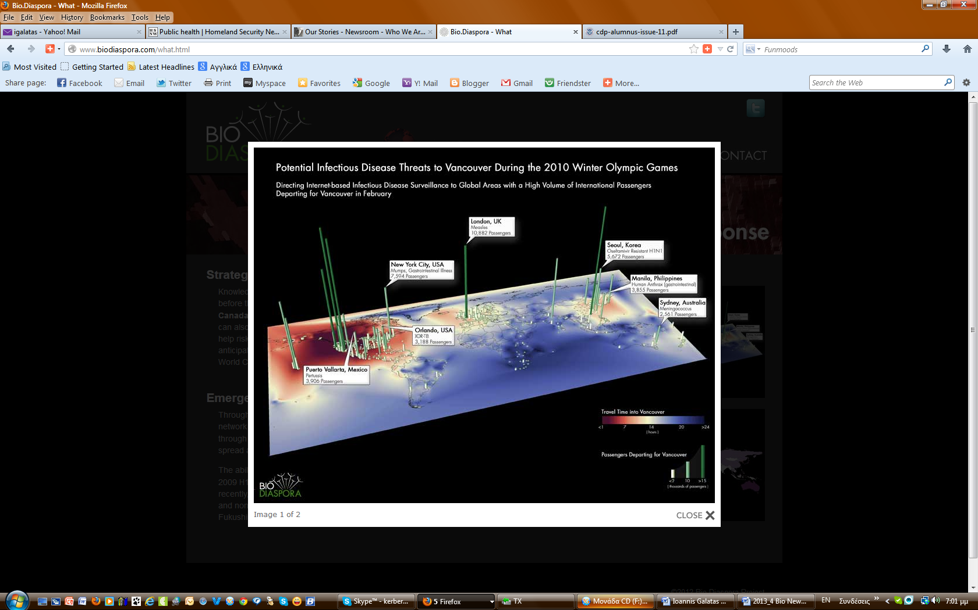by air last less than twelve hours, meaning it is unlikely that travelers incubating an infection will board a plane with no symptoms and develop the illness during the trip. The average incubation period for H1N1, for example, is about two days, but 78 and 91 percent of at-risk travelers who flew out of Mexico in May 2009 finished their air travel within six and 12 hours respectively. Even the longest direct flights — seventeen hours to Tokyo and twenty hours to Shanghai — would have taken less than one day.

Each year, more than 700 airlines transport more than 2.5 billion travelers between 4,000 airports. The chief of aviation medicine of the International Civil Aviation Organization said Dr. Khan’s paper “will be very helpful as we continue to determine how to utilize resources to best protect the health of travelers and populations, while minimizing travel disruptions.”

“Countries receiving travelers need to be confident that exit screening has been undertaken efficiently and it’s a great help if communication channels have been established in advance of a public health event. ICAO, the WHO and others have been working together since 2006 to provide just this type of multi-sector/multi-stakeholder network through the Collaborative Arrangement for the Prevention and Management of Public Health Events in Civil Aviation,” said Dr. Tony Evans.

The release notes that the paper does not recommend how passengers should be screened. Some airports, such as those in Hong Kong and Tokyo, routinely use thermal scanners to look for fever among all arriving travelers. In others, traveler questionnaires and direct visualization of travelers for signs of illness are used.

The views expressed by writers in the Bulletin do not necessarily represent the views of WHO.

Funding for the study was provided by the Canadian Institutes of Health Research.

*— Read more in Kamran Khan et al., “Entry and exit screening of airline travelers during the A(H1N1) 2009 pandemic: a retrospective evaluation,”* Bulletin of the World Health Organization *91, no. 5 (May 2013): 313-88*

## Controlling contagion by restricting mobility

Source: http://www.homelandsecuritynewswire.com/dr20130809-controlling-contagion-by-restricting-mobility

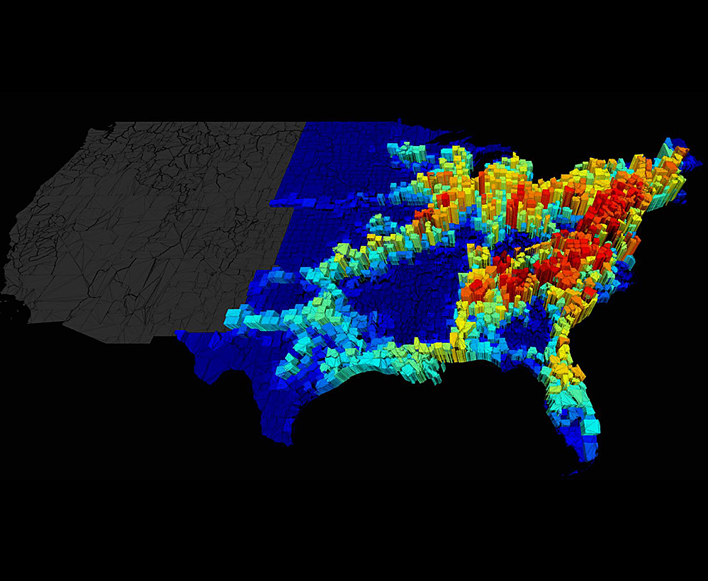In an epidemic or a bioterrorist attack, the response of government officials could range from a drastic restriction of mobility — imposed isolation or total lockdown of a city — to moderate travel restrictions in some areas or simple suggestions that people remain at home. Deciding to institute any measure would require officials to weigh the costs and benefits of action, but at present there is little data to guide them on the question of how disease spreads through transportation networks.

However, a new MIT study comparing contagion rates in two scenarios — with and without travel restrictions — shows that even moderate measures of mobility restriction would be effective in controlling contagion in densely populated areas with highly interconnected road and transit networks. The researchers called the difference between infection rates in the two scenarios the “price of anarchy,” a concept from game theory that’s frequently used as a metric in studies of the controlled use of transportation networks.

The study, published online 31 July in the Journal of the Royal Society Interface, is the first to link the concept of price of anarchy to the spread of contagion. It assumes that transmission of the news of the epidemic (which influences how people select travel routes) and the epidemic itself follow the same mobility network, and uses standard epidemiological models to simulate the flow of contagion.

MIT researchers have linked the game theory concept of "price of anarchy" to the spread of contagion. The price of anarchy measures the difference in the spread of a disease between selfish (uncoordinated) and policy-driven (coordinated) human mobility. In this graphic, warm colors indicate geographical areas (such as the I-95 commuting corridor) with a high price of anarchy.

The researchers — Ruben Juanes, the ARCO Associate Professor in Energy Studies in MIT’s Department of Civil and Environmental Engineering, graduate student Christos Nicolaides, and research associate Luis Cueto-Felgueroso — used data from the 2000 U.S. census to establish the aggregate daily flux of people commuting between counties.

Previous research had shown that when individuals become aware of an epidemic, they travel not by taking the shortest route, but by taking the shortest route that avoids infected areas — even if they’re already infected — a strategy that exposes people in uninfected areas to disease. Such “selfish behavior,” as it is called in game theory, is in direct opposition to the strategy of policymakers, who presumably would act in the benefit of the greater social good by routing infected individuals through areas where infection rates were already high.

The MIT study shows that the price of anarchy in some regions of the United States, such as along Interstate 95 in the Northeast, would be considerable. For a moderately contagious disease — one in which every infected person infects, on average, two others — restricting individuals to specific travel routes would decrease infection rates by as much as 50 percent.

“In an area with high connectivity, the outcome of action coordinated by officials is going to be better than selfish action, but the economic and social costs of disruption could sometimes be too high,” Juanes says. “In other cases, there would be an enormous benefit to having authorities impose travel restrictions. The price of anarchy is a quantitative measure that identifies areas where intervention might pay off.”

“Although the study is an idealized scenario, it does give insight to authorities about when and where it would be important to impose route restrictions on human mobility in the case of an emergent outbreak or in the extreme case of bioterrorism,” says Nicolaides, the paper’s first author, who was funded by a Vergottis Fellowship from the MIT School of Engineering. “But you have to take into account the structure of the underlying mobility network and its traffic properties. Imposing policy-initiated action in areas with low traffic would not render substantial benefits for the containment of an epidemic.”

In their models, the researchers tracked an infectious disease as it spread via commuting networks in the contiguous United States, and found that the price of anarchy for contagion varies depending on the proximity of a network to major commuting corridors.

“A commuting network may be very local, but some contagion is related to more distant travel networks,” Cueto-Felgueroso says. “That’s why we see a higher price of anarchy near major arteries, like Interstate 95 in the northeastern United States.”

The researchers had previously studied the spread of disease through the air transportation network and found that the interconnectivity and location of an airport in the network, not just the number of travelers moving through it, were key to its ability to spread disease.

Juanes says the next step in this work is to measure the price of anarchy for contagion in the world’s 7,000 airports.

“In my view the MIT paper could be a game-changer in the field of epidemic modeling,” says Dirk Brockmann, an associate professor of engineering sciences and applied mathematics at Northwestern University who was not involved in the research. “Including decision-making and game-theoretic components into models of disease dynamics is massively overdue and essential, as even the most sophisticated models do not account for this type of feedback. Since mobility is such a sensitive component in terms of shaping disease dynamics, the approach the researchers take is very plausible, and it identifies clearly the intriguing interplay of selfish action versus policy action in the context of epidemiology. This is going to be very important in the future.”

*— Read more in Christos Nicolaides et al., “The price of anarchy in mobility-driven contagion dynamics,”* Journal of the Royal Society Interface *10, no. 87 (31 July 2013)*

# Robotic intubation device seeks out patients' airways

**By Ben Coxworth**

Source: http://www.gizmag.com/guidein-tube-robotic-intubation/28637/

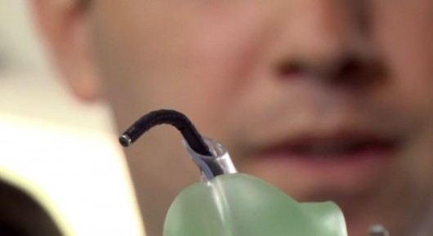When a patient is placed under general anesthesia or otherwise has difficulty breathing on their own, they typically have a plastic endotracheal tube inserted into their mouth and down their trachea. This process maintains a clear air passage to the lungs, and is known as intubation. In order to make it safer and easier, students from the Hebrew University of Jerusalem’s Biodesign program have created a robotic intubation device, that takes some of the guesswork out of the procedure.

Ordinarily, endotracheal tubes are inserted by physicians (sometimes with the help of machines) who must visually guide the tube into the trachea. If they mistakenly send it down the esophagus, the patient may not be able to breathe and could perish. It’s particularly possible that such a mistake could occur when performing chaotic battlefield intubations, or when dealing with patients that have blood or other liquids obscuring the view down their throats.

Known as the **GuideIN Tube**, the U Jerusalem device seeks out the trachea for itself. In order to help it do so, clinicians place an infrared light source against the skin on the outside of the patient’s trachea. Detectors at the end of the GuideIN Tube “see” that light shining through on the inside of the trachea, and direct the tube’s flexible probe-like guiding element (pictured above) to point in its direction. Forward momentum of the tube is provided by hand, but it steers itself.

The GuideIN Tube has already been successfully tested on cadavers, and it is hoped that clinical trials could begin next year.

***Ben Coxworth*** *is an experienced freelance writer, videographer and television producer, Ben's interest in all forms of innovation is particularly fanatical when it comes to human-powered transportation, film-making gear, environmentally-friendly technologies and anything that's designed to go underwater. He lives in Edmonton, Alberta.*

# Bioterrorism: How real is the threat?

Source: http://theboar.org/2013/08/12/bioterrorism-how-real-is-the-threat/#.UgqDfKzp_wM

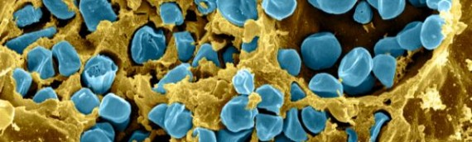**Despite the threat of terrorism always hanging over the nation’s head, it’s not often that we hear of bioterrorism. Is this simply due to bioweaponry being far less prevalent than the traditional bombs or firearms, or could it be that we are worryingly uninformed about the matter?**

The biological agents required for a bioterrorist attack are found naturally in the environment, and can be relatively easier to acquire than the agents needed for chemical or nuclear weapons. The bioterrorism risks of human and agricultural destruction are potentially threatening. These risks could be exacerbated by global terrorism, and also the ease with which biological agents can be acquired, weaponised and eventually used. Given the unpredictability of terrorism, should we question the commitments and costs to defence measures in the face of current governmental cuts? The threats posed by the use of bio-weaponry are not clearly understood by the general public and could potentially lead to fears of a bioterrorism attack.

In the history of biological warfare, no two nations have carried out such attacks on each other. Akin to the potential nuclear fallout between the United States and the Soviet Union during the Cold War, it was the possession of nuclear weapons more than their actual usage that carried any real significance. This is likely to remain so in the foreseeable future due to the fears of mutually assured destruction. As states have defined geographical territories, in addition to military and political establishments that enemies can physically retaliate against, it is often argued that any present-day threat of biological warfare would almost certainly involve the role of terrorists. Some suggest that the pursuance of bioterrorism is now inevitable – Is this the case?

**But just how easy is it?**

Because terrorists traditionally lack the logistical and technical sophistication required for biological warfare, bio-weaponry could continue to remain far from their reach.

Assuming success in acquiring the biological agents, the complexities of science could hinder the subsequent weaponisation of these agents. The cultivation and production of weapons-grade toxins or spores, and the successful aerosolization – converting a physical substance in to a gas – of these particles, would involve highly-specific laboratory conditions, knowledge and skills. For example, the bacteria *Francisella tularensis* is a potential agent of bioterrorism, and is extremely difficult to cultivate in laboratories. In addition to this, the accumulation of large quantities necessary for a bioterrorism event would prove difficult for terrorists with presumably less resources and expertise.

Biological agents are also living organisms. Unlike chemical or nuclear materials, the maintenance of viable stocks requires scientific expertise and years of experience. A series of attacks on several news media offices and U.S Senators occurred in 2001, where anthrax spores (the spores of a lethal disease) were contained in letters mailed to the victims, resulting in 5 deaths. The samples used in the 2001 Anthrax attacks were found to originate from state-sanctioned research conducted by Dr. Bruce E. Ivins; a leading figure in anthrax cultivation at the United States Army Medical Research Institute for Infectious Diseases (USAMRIID) with over 20 years of experience. The achievement of such high technical standards is likely to remain beyond an individual without sufficient expertise and laboratory resources.

Finally, the process of dissemination – the dispersion of the bio-weaponry – exposes biological agents to harsh environmental stresses, reducing its viability as infectious particles. Solar degradation, atmospheric dispersion and aerosolization stress can all affect the success of a bioterrorist attack.

Given the multitude of obstacles that stand in the way of bioterrorism, it is no secret that the use of firearms in the course of terrorism is considerably simpler, yet no less lethal.

While science may constitute the first layer of defence, many are concerned with the possibility of rogue scientists or the recruitment of scientifically qualified members by terror organizations. For example, at least three of the 9/11 hijackers were sent for flight training in preparation for their mission; an evidence of the commitment and determination some groups may possess.

Can we justify governmental spending to defend us against bioterrorism?  Whilst non-state actors may lack in scientific sophistication, even the most rudimentary or crude methods of weaponry may be sufficient for a ‘successful’ terrorist attack. Much of the above evidence contests the idea of bioterrorism being a legitimate threat, and most would hope to never have to reap the payouts of such investments, but it could be essential for the preservation of national security.

## Scientists develop safe method for research on deadly flu viruses

Source: http://www.homelandsecuritynewswire.com/dr20130813-scientists-develop-safe-method-for-research-on-deadly-flu-viruses

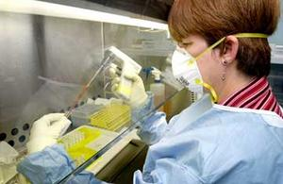In 2012, scientists around the world agreed to a worldwide, yearlong voluntary moratorium on research into the deadly H5N1 bird flu. The ban came after several scientific teams successfully altered the H5N1 viral genome to enable airborne transmission of the bird flu between ferrets — mammals considered a good research model for humans. The public health concern was that altered H5N1 could escape the lab, infect and spread among humans, producing a global pandemic. There was also concern that terrorists would use the altered H5N1 viral genome in large-scale bioterror attacks. Researchers have now been able to turn molecules in human lung cells into viral scissors that cut H5N1 bird flu and similar bugs into pieces. This dismantling of the viral genome in human lung cells will ensure safe research on deadly strains of influenza.

A new strategy that dismantles a viral genome in human lung cells will ensure safe research on deadly strains of influenza, say researchers from the Icahn School of Medicine at Mount Sinai.

Details of their “molecular biocontainment” approach, designed to prevent effective transmission of these viruses to humans, are published in Nature Biotechnology. The strategy they developed and tested will enable healthy molecules in human lung cells to latch on to these viruses and cut the bugs up before they have a chance to infect the human host.

A Mount Sinai Medical Center release reports that findings from the study, led by Benjamin tenOever and Adolfo Garcia-Sastre, both Fishberg Professors in the Department of Medicine and Department of Microbiology at Mount Sinai, should resolve concerns that led in 2012 to a worldwide, yearlong voluntary moratorium on research into the deadly H5N1 bird flu.

The ban came after several scientific teams successfully altered the H5N1 viral genome to enable airborne transmission of the bird flu between ferrets — mammals considered a good research model for humans.  The public health concern was that altered H5N1 could escape the lab, infect and spread among humans, producing a global pandemic.

“The question last year was whether the risk of altered bird flu escaping laboratories justified the science aimed at understanding the transmission of these viruses. With our method, the possibility of human transmission is no longer a concern,” says Dr. tenOever.

H5N1 normally spreads between poultry and wild birds. It can be transmitted from birds to humans, with difficulty, and has only rarely been passed between people. It is lethal to humans. Since 2003, it has killed 360 people out of 610 people infected.

The researchers say the approach they developed works for all influenza A viruses, which includes H5N1, and potentially with other highly pathogenic RNA viruses, including Ebola and SARS.

Dr. tenOever is known internationally for his work on using microRNAs (miRNAs) — small noncoding RNA molecules that help regulate gene expression — to help the body fight off viral pathogens. He has created a strategy that mimics the system plants use to destroy invading viruses.

“When a plant recognizes viral material, it creates a small inhibitory RNA (siRNA) that latches on to the virus and cleaves it,” says Dr. tenOever. Human cells also have small RNAs in the form of miRNAs, but they are used to maintain cell health — not to fight a virus. Drs. tenOever and Garcia-Sastre — along with scientists from the University of Maryland’s Department of Veterinary Medicine — discovered that if they alter a viral genome by adding a binding site for a miRNA found in human cells, that molecule morphs into a plant-like attacker. It latches on to the virus and destroys it in the same way plant siRNAs do.

The release notes that in this study, the scientists discovered a specific miRNA (miR-192) that is found in human and mouse lung cells, but not in the lungs of ferrets. They added multiple binding sites for miR-192 on to the H5N1 genome, and demonstrated in mice that, upon contact, lung cells destroyed the virus. They then demonstrated that H5N1 transmission between ferrets was not decreased when altered virus was used. The researchers also showed the approach works with other influenza A viruses.

“It is clear that we can apply this technology to any virus,” Dr. tenOever says. “The only requirements are that we need a miRNA that is present in humans, but not in the model system where we want to study the virus, such as in ferrets. We also need a viral genome that permits insertion of miRNA target sites.”

Once a virus is altered to contain the miRNA target sites, it can replicate ad infinitum for research in laboratories worldwide, Dr. tenOever says. “There is no need to continually go back to the drawing board,” he says.

In January, a handful of scientists in nine nations resumed their research on H5N1, using standard biocontainment procedures. Drs. tenOever and Garcia-Sastre believe that adding this molecular biocontainment strategy to their research should relieve any public concern pertaining to this research.

The study was predominantly funded by the Center for Research on Influenza Pathogenesis, a National Institute of Allergy and Infectious Diseases–funded Center of Excellence in Influenza Research and Surveillance.

# New Report Holds U.N. Responsible for Haitian Cholera Epidemic

Source: http://www.law.yale.edu/news/17237.htm

The United Nations inadvertently caused a deadly cholera epidemic in Haiti, and has legal and moral obligations to remedy this harm, according to new report released by researchers at Yale Law School and the Yale School of Public Health.

The 58-page report, “Peacekeeping without Accountability,” provides the first comprehensive analysis of the cause of 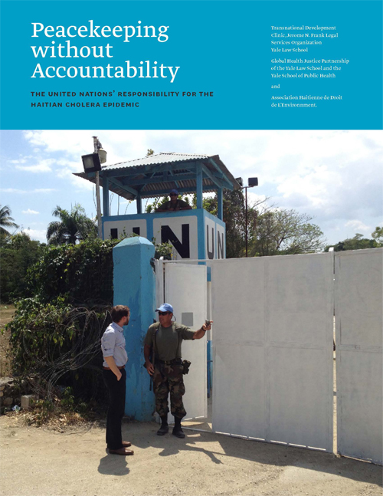the massive outbreak of cholera in Haiti—which has killed more than 8,000 people and sickened more than 600,000 since it began in 2010. The report examines the role the U.N. played in precipitating the crisis and the U.N.’s responsibilities to provide legal remedies to victims of the epidemic. It directly contradicts recent statements by the U.N. Secretary-General that the organization did not bring cholera to Haiti, and has no legal responsibilities for the epidemic or its consequences.

“Peacekeeping without Accountability” is issued by the Transnational Development Clinic at Yale Law School and the Global Health Justice Partnership at the Yale Law School and the Yale School of Public Health, in collaboration with the Haitian Environmental Law Association (Association Hatïenne de Droit de L’Environment).

“While the U.N. has played an important role in the Haitian post-earthquake recovery effort, it has also caused great harm to hundreds of thousands of Haitians,” said Tassity Johnson ’13, one of the authors of the report. To date, the U.N. has refused to consider the claims of approximately 5,000 Haitians seeking redress, invoking its immunity in concluding that the claims are “not receivable.”

“The U.N.’s ongoing unwillingness to hold itself accountable to victims violates its obligations under international law. Moreover, in failing to lead by example, the U.N. undercuts its very mission of promoting the rule of law, protecting human rights, and assisting in the further development of Haiti,” Johnson said.

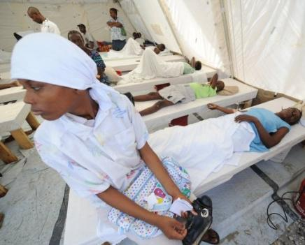“Peacekeeping without Accountability” is the result of more than a year of research into the key epidemiological and legal issues arising out of the introduction of cholera to Haiti. The report incorporates consultations with victims of the epidemic, human rights advocates, attorneys, journalists, aid workers, medical doctors, and government agency officials with first-hand knowledge of the epidemic.   
The report confirms prior accounts that U.N. peacekeepers inadvertently but negligently brought cholera into Haiti, causing one of the largest epidemics in recent history. As the report documents, in October 2010, peacekeeping troops belonging to the U.N.’s Haitian mission, MINUSTAH, unknowingly carried cholera into the country. Because of inadequate water and sanitation facilities at the MINUSTAH base in the Haitian town of Méyè, sewage from the base contaminated the Artibonite River, the largest river in Haiti and one the country’s main water sources. By July 2011, cholera spread through the country, infecting one new person per minute. The epidemic continues, and public health experts estimate it will take a decade or longer to eliminate cholera from Haiti. Prior to this outbreak, cholera had not existed in Haiti for more than a century.

“Peacekeeping without Accountability” provides a comprehensive set of recommendations outlining the steps the U.N. and other principal actors in Haiti should take to meaningfully address the cholera epidemic. The report calls for setting up a claims commission, as well as providing a public apology, direct aid to victims, infrastructural support, and adequate funding for the prevention and treatment of cholera. It also emphasizes that the prevention of similar harms in the future requires that the U.N. commit to reforming the waste management practices of its peacekeepers and complying with its contractual and international law obligations.

►**Read full report at:** http://www.law.yale.edu/documents/pdf/Clinics/Haiti_TDC_Final_Report.pdf

## Lawmakers, scientists question FBI’s investigation, conclusion in 2001 anthrax attacks

Source: http://www.homelandsecuritynewswire.com/dr20130814-lawmakers-scientists-question-fbi-s-investigation-conclusion-in-2001-anthrax-attacks

Twelve years after the fall 2001 anthrax attacks, and six years after the 2007 FBI’s determination that Bruce Ivins, a top government anthrax researcher at the U.S. Army Medical Research Institute of Infectious Diseases (USAMRIID), was the perpetrator of the attacks (Ivins died in 2008 of apparent suicide), lawmakers and USAMRIID scientists insist that the FBI’s conclusions are not supported by scientific evidence – indeed, that some basic scientific facts make the Bureau’s conclusions untenable.

Bruce Ivins was FBI's only suspect prior to and following his 2008 suicide // Source: zohur.net

After years of requests from lawmakers, the Government Accountability Office (GAO) has opened an investigation into the scientific methods used by the FBI to determine that researcher Bruce Ivins was the sole perpetrator of a 2001 series of anthrax attacks that killed five and injured seventeen.

Ivins, a top government anthrax researcher at the U.S. Army Medical Research Institute of Infectious Diseases (USAMRIID) since 1980, had been interviewed throughout the FBI investigation. He died in 2008 in an apparent suicide by acetominaphen overdose, as the FBI and Department of Justice were preparing to charge him in the attacks.

According to the Frederick News-Pott, U.S. Representative Rush Holt (D-New Jersey), whose district was the mailing point for the anthrax-laden letters, has been requesting the GAO to investigate the scientific methodology used by the FBI in concluding, since 2007, that Ivins was the perpetrator.

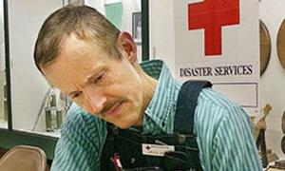Bolstering the efforts of Holt and other lawmakers is a 2011 report from a National Research Council (NRC) committee which determined that the conclusions reached by the FBI were not supported by science. At USAMRIID, three of Ivins’s coworkers raised issues that were never addressed by the FBI investigation.

Henry Heine, a friend of Ivins, said that USAMRIID did not have the equipment necessary to dry the number of spores that were sent. Heine’s estimate was that it would have taken Ivins months to grow the volume of anthrax spores that was mailed.

Heine pointed out that nearly thirty gallons of anthrax culture would be needed to produce the spores that were mailed, and USAMRIID did not have a fermenter that could handle such a large quantity. Additionally, the only fermenter the center did have was out of order at the time.

According to a separate Frederick News-Post report, Gerard Andrews and Jeffrey Adamovicz, both of whom served as Ivins’s supervisors, pointed out that there are several other problems with the FBI’s methodology, some of which involve ignoring crucial evidence.

Both pointed out that the FBI ignored the presence of silicone and tin in the samples gathered from the mailings, but not found in the samples provided by Ivins’s lab. This means that the anthrax samples may have been genetically similar, but not chemically similar.

Another bacteria, Bacillus subtilis, was not found in the Ivins-provided flask, but was found in the mailings to media outlets.

“Additionally, it was a genetically unique strain that was not worked on at USAMRIID, let alone Ivins’ lab,” said Andrews. He added that “that forensic marker is critical to exonerating USAMRIID and Bruce Ivins.”

Patrick Eddington, a senior policy advisor to Holt, said, “There needs to be an exhaustive explanation of how the FBI handles cases like this.” Pointing to several other Bureau blunders, Eddington added that the FBI is “still out of their depth when it comes to dealing with cases with this kind of science.”

For its part, the FBI has said that it relied on the totality of it investigation, not just on the science, that lead it to conclude Bruce Ivins’s culpability in the anthrax mailings.

## New understanding of key step in anthrax infection

Source: http://www.homelandsecuritynewswire.com/dr20130822-new-understanding-of-key-step-in-anthrax-infection

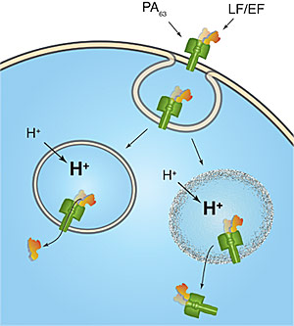A new hypothesis concerning a crucial step in the anthrax infection process has been advanced by scientists at the National Institute of Standards and Technology (NIST) and the U.S. Army Medical Research Institute for Infectious Diseases (USAMRIID) at Fort Detrick, Maryland.

The research teams have explored the behavior of the toxins that rapidly overwhelm the body as the often-fatal disease progresses. Their findings suggest a new possible mechanism by which anthrax bacteria deliver the protein molecules that poison victims. Anthrax is easily weaponized; the findings could help lead to a more effective cure.

###### Anthrax toxins are sequestered from the cell surface (top) in a bubble-like endosome. The toxins have been thought to escape the endosome by threading their way through a hole in the endosome (lower left), but a new hypothesis suggests they may rupture the endosome (lower right).

###### Credit: Robertson/NIST

A NIST release reports that anthrax bacteria kill by releasing three toxins that work in concert to destroy cells. One toxin, called PA, attaches to the cell membrane, where its surface serves as a sort of landing pad for the other two toxins, called LF and EF. Once several molecules of LF and EF have latched onto PA, the cell membrane tries to destroy these unwanted hangers-on by wrapping them up in an “endosome,” a small bubble of membrane that gets pinched off and moved into the cell’s interior. There, the cell attempts to destroy its contents by a process that includes making the interior of the endosome more acidic. But before the cell can fully carry out its plan, the LF and EF escape from the endosome and wreak havoc in the cell’s interior. The question is: how do these toxins escape?

“A recent hypothesis is that LF and EF completely unfold and then squeeze through the narrow hole that PA forms in the endosomal membrane,” says NIST physical scientist John Kasianowicz. “However, the studies used to support this concept make use of short segments of the toxins, not their native full-length versions. The results don’t show that the complete LF and EF are transported through the pore or whether they refold into functional enzymes once they reach the other side. So, we decided to look at other possible explanations.”

The NIST/USAMRIID team explored the behavior of full-length toxins using an artificial membrane that mimics a cell’s exterior. They put the toxins mixed in salt water on one side of this barrier and slowly rendered this fluid more acidic, resembling conditions within an endosome. The change in chemistry, however, apparently altered the physical characteristics of the LF and EF toxins, because it caused them to bind irreversibly to the PA pore, creating a “complex” of multiple toxins. This result alone suggested it would be difficult, if not impossible, for LF and EF to thread through the pore.

In addition, the team discovered that the bound toxins tend to rupture membranes. This finding led them to suggest that perhaps it is complexes of LF or EF bound to PA that gets into cells, and that these complexes are the active toxins inside cells.

Kasianowicz says this new hypothesis could explain previous experimental results, in which the complex was found in the blood of animals that died of anthrax. But he emphasizes that the matter is not yet settled.

“We don’t know enough to choose between these theories — and in fact it’s possible that the toxins escape the endosome by more than one mechanism,” he says. “But it’s important that we better understand this step in the process to thwart anthrax more effectively.”

*— Read more in B. J. Nablo et al., “Anthrax toxin-induced rupture of artificial lipid bilayer membranes,”* Journal of Chemical Physics *139, no. 6 (8 August 2013)*

# Mathematical model makes defensible estimates of how scenarios might play out if anthrax were released in a terrorist attack

Source: http://www.medicalnewstoday.com/releases/264944.php

If terrorists targeted the United States with an anthrax attack, health care providers and policy makers would need key information - such as knowing the likelihood of an individual becoming infected, how many cases to expect and in what pattern, and how long to give antibiotics - to protect people from the deadly bacteria.

Those questions gained urgency when anthrax-laced letters killed five people and infected 17 others in the wake of the terror attacks of September 2001. Now, using information from prior animal studies and data from a deadly anthrax exposure accident in Russia in the late 1970s, University of Utah and George E. Wahlen Department of Veterans Affairs Medical Center researchers have developed a mathematical model to help answer critical questions and guide the response to a large-scale anthrax exposure.

In a study in PLOS Pathogens online, the researchers use their model to estimate that for an individual to have a 50 percent chance of becoming infected with anthrax (known as ID50), he or she would have to inhale 11,000 spores of the bacteria. A 10 percent chance of being infected would require inhaling 1,700 spores and a 1 percent chance of infection would occur by inhaling 160 spores. The researchers also found that at ID50, the median time for anthrax symptoms to appear is 9.9 days and that the optimal time to take antibiotics is 60 days.

"Anthrax is a well-studied disease and experimental animal data exist, but there is no real good information on dose response for the disease in humans," says Adi V. Gundlapalli, M.D., Ph.D., an infectious diseases specialist and epidemiologist, associate professor of internal medicine at the U of U School of Medicine and staff physician at the Salt Lake City George E. Wahlen Department of Veterans Affairs Medical Center. "We don't want to be overly fearful, but we need to be prepared in the event of a bioterrorism attack with anthrax."

Although studies with animals at other institutions have looked at anthrax, the data are limited and usually involved vaccine testing and not exposure amounts for infection. Gleaning information from accidental exposures in isolated cases is difficult and not often helpful. So, Toth and Gundlapalli gathered what useful information from animal studies reported in the medical literature and then combined it with data from an accidental exposure at a Soviet Union bioterrorism plant that occurred in the city of Sverdlovsk, Russia, in 1979.

Gundlapalli, who as a postdoctoral fellow at the U of U helped build a bioterrorism surveillance system for the 2002 Winter Olympics in Salt Lake City, and Damon J.A. Toth, Ph.D., a mathematician and assistant professor of internal medicine at the U of U, are co-first authors on the study.

Anthrax is found on the skin of dead animals and its spores can live thousands of years. People can become infected when they are in close proximity to anthrax, such as a farmworker who might be exposed to a dead animal and inhales spores of the bacteria. But it also can be manufactured in laboratories and spread in other ways, such as when people opened letters containing anthrax or when the spores are put into an aerosol and dispersed over large areas by wind currents.

Previous studies at other institutions had provided widely varying estimates of the chance of becoming infected with anthrax with low dose exposure. For example, one model based on animal data estimated a 1 percent chance of becoming infected from inhaling one spore, while another study estimated that healthy humans would have virtually no chance of becoming infected after inhaling up to 600 spores. But analyzing the results from a better documented, non-human primate study at another institution, in combination with a carefully constructed mathematical model appropriate for humans, Toth estimated that the number of spores required for a 1 percent chance of infection is 160. These estimates were derived by developing and refining a competing-risks model in which the inhaled bacteria is trying to set up an infection in the lungs and the human body is trying to expel or control the bacteria. Toth then used available experimental animal data to optimize the working of the model to produce results that matched the timing of cases at Sverdlovsk.

"Our study, for the first time, takes all the best data and modeling techniques available on dose response and evaluates them critically," Toth says. "No one study satisfied all our criteria to be the best model, so we refined the available information to develop our model."

"When the Institute of Medicine was asked to look at the effectiveness and costs of different strategies to respond to an anthrax in 2012, the Committee identified a critical need for accurate information on the time from exposure until people became ill and how this would change depending on the dose," said Andrew Pavia, M.D., professor and chief of pediatric infectious diseases at the University of Utah and a member of the IOM committee that wrote the report, "Prepositioning antibiotics for Anthrax," and a consultant to CDC on anthrax. "The time between exposure and when symptoms develop is the most effective time to administer antibiotics to prevent illness. This study adds a thoughtful approach to using all of the available data to improve these estimates, but considerable uncertainty will remain." Pavia was not involved in the study

Along with existing animal studies, data gathered from the accident at Sverdlovsk proved invaluable. Up to 100 people died when a filter was accidently left off a piece of equipment at a plant that was developing anthrax as a bioterrorism weapon. Spores of the bacteria were released into the air near the town of Sverdlovsk. The Soviets eventually let outside experts in to study the accident. From publicly available accounts, despite limited records and a substantial delay before the investigation, it would appear that scientists were able to estimate when the release happened, plot where people were in the surrounding area when it occurred and then look at weather records to identify wind currents. With that information, they plotted how the spores were scattered in relation to people who became infected.

The timing and geographic pattern of the best documented cases from Sverdlovsk were consistent with both the shape of the dose-response curve and the distribution of incubation periods produced by the new model. The model also sheds light on how long antibiotics should be given after an exposure to decrease the chances of infection. The model's predictions match so well with publicly available Sverdlovsk data that Gundlapalli and Toth believe they can use the model to reasonably estimate how exposures to anthrax would unfold, especially at low doses of the bacteria.

"By combining the data from Sverdlovsk and prior studies, we can make defensible estimates on how scenarios might play out if anthrax were released in a terrorist attack," Gundlapalli says. "How many cases could we expect? When would be expect to see the cases? How long should we treat those exposed with preventive antibiotics? Our model provides real answers to help policy makers when they need that information."

## Risks of SARS, MERS spreading greater than thought

Source: http://www.homelandsecuritynewswire.com/dr20130819-risks-of-sars-mers-spreading-greater-than-thought-scientists

Outbreaks such as the severe acute respiratory syndrome (SARS) and Middle East respiratory syndrome coronavirus (MERS) have afflicted people around the world, yet many people think these trends are on the decline.

Quite the opposite is true.

The efforts to combat this epidemic are being spearheaded by a team of Lawrence Livermore National Laboratory (LLNL) scientists. Led by Monica Borucki of LLNL’s Biosciences and Biotechnology Division, the Lab researchers have made promising new discoveries that provide insight into the emergence of inter-species transmittable viruses.

A LLNL release reports that they discovered that the genetic diversity of a viral population within a host animal could allow a virus to adapt to certain conditions, which could help it reach a human host. This discovery advances the scientific understanding of how new viruses produced from animal reservoirs can infect people. An animal reservoir is an animal species that harbors an infectious agent, which then goes on to potentially infect humans or other species. Borucki’s team is investigating viruses related to SARS and MERS, but not the actual viruses themselves.

“The team’s findings are the first steps in developing methods for predicting which viral species are most likely to jump from animals to humans and potentially cause outbreaks of diseases,” Borucki said.

Borucki’s LLNL multidisciplinary research team includes Jonathan Allen, Tom Slezak, Clinton Torres, and Adam Zemla from the Computation Directorate; Haiyin Chen from the Engineering Directorate; and Pam Hullinger, Gilda Vanier, and Shalini Mabery from the Physical and Life Sciences Directorate.

Coronaviruses are one of the groups of viruses that most commonly jump to new host species as evidenced by SARS and MERS, according to Borucki. These viruses appear to have jumped from animals to humans and are capable of causing severe diseases in humans.

“Our discoveries indicate that the next generation of genetic sequencing technology, combined with advance computational analysis, can be used to characterize the dynamics of certain viral populations,” she said.

The team’s work on coronaviruses received funding from LLNL’s Laboratory Directed Research and Development (LDRD) program and the Defense Threat Reduction Agency (DTRA).

In June, a research paper published in the Journal of General Virology by other scientists cited the Borucki team’s findings as pioneering, and it recommended their methodology for studying viral evolution.

Borucki said her team’s research findings eventually could be used to influence how vaccines and antivirals are designed and tested.

“Deep Illumina sequencing (a type of genetic sequencing that involves sequencing reads in parallel) is already being used extensively to understand HIV and hepatitis C resistance to antivirals,” she said. “We plan to follow up our findings by examining how animal host traits such as nutritional status (being malnourished or obese) influence how viruses evolve.”

The release notes that this latest discovery is part of a string of achievements for Borucki’s team. In 2010, they secured a three-year, $1.4 million contract from DTRA to fund a research project to study how to better determine the origins of a virus.

*— Read more in Eili Huhtamo et al., “Isolation and full genomic characterization of Batai virus from mosquitoes, Italy 2009,”* Journal of General Virology *94 (June 2013): 1242-48*

## http://circuswagon.files.wordpress.com/2012/06/optimized-in-case-of-zombies.jpg?w=538