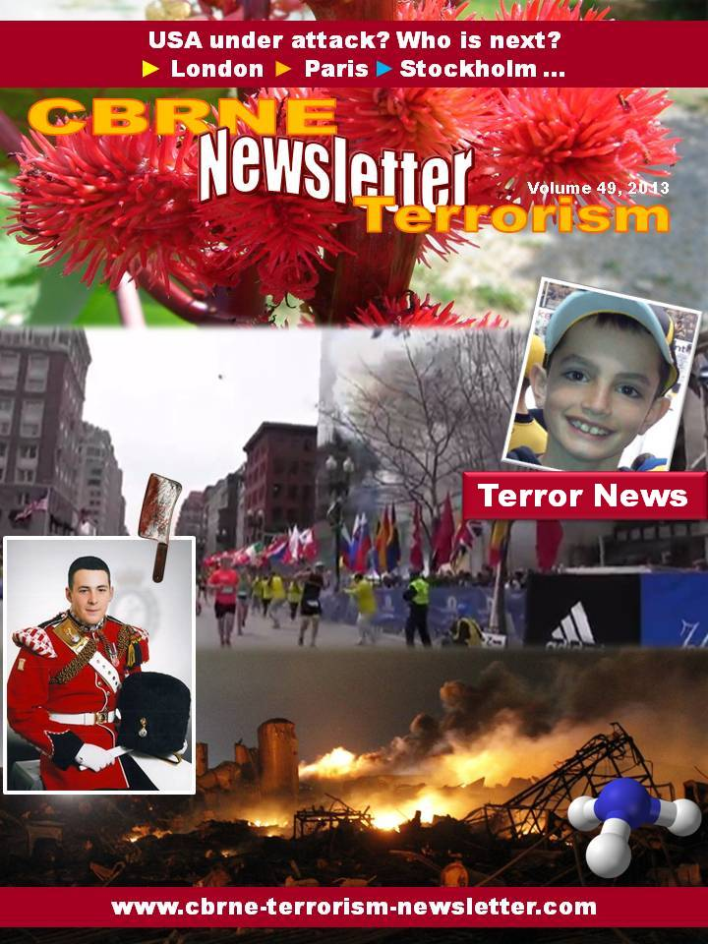

New terrorist alliance brings bomb maker out of retirement
By Tom Brady (Independent.ie Security Editor)
Source: http://www.independent.ie/irish-news/new-terrorist-alliance-brings-bomb-maker-out-of-retirement-29180071.html

The new terrorist alliance, which is posing a major challenge to security forces on both sides of the Border, has lured an experienced Provisional IRA bomb manufacturer out of retirement.
Anti-terrorist officers say the man's skills have given a major boost to the capacity of the New IRA alliance to mount mortar attacks.
He is being credited with the development of the mortars that were to have been used in an attack on a police station in Derry city last month.
The attack was foiled by the PSNI after a tip-off from the gardai resulted in a van carrying four primed mortars being intercepted as it was being driven into the city. The Citroen Berlingo van had a Dublin registration plate but had not been stolen and gardai believe it was purchased in the capital in the weeks leading up to the planned attack.
The alliance had previously used a recently purchased car from Dublin in the murder of Northern Ireland prison officer David Black near Lurgan last October.
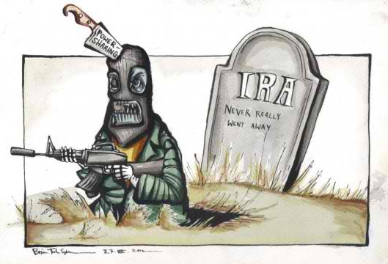
After the Provisional IRA ended its terror campaign, almost all of its top bomb makers faded into the shadows.
Several attempts were made by the dissident groups, the Real IRA and the Continuity IRA, to convince some of them to join their organisations.
But they remained in retirement until the formation of the New IRA last summer, merging members of the Real IRA, the Derry-based Republican Action Against Drugs – mainly comprised of Provisionals – and non-aligned groups operating in Belfast and east Tyrone.
Other former key Provisionals, including some based in Armagh, also joined the ranks and took control of the organisation, inflicting punishment on those they believed were holding on to some of the proceeds from "fund-raising" activities, which were meant to have been carried out on behalf of the dissidents.
Their involvement has been a major factor in attracting a handful of veteran bombers, who featured at the height of the violence in the North, back into terrorism despite the risks created by regular infiltration of dissident groups by the security forces.

The UK Counter-Terrorism Strategy: A Return on Investment
By Charlie Edwards
Source: http://www.rusi.org/analysis/commentary/ref:C5165370EE3D28/#.UWV3rzdLNGc

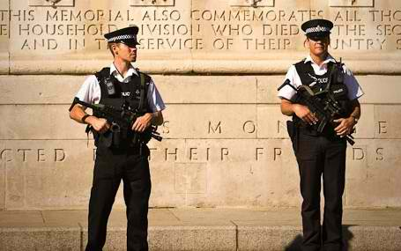
The 2012 annual report for the UK's Counter-Terrorism (CONTEST) Strategy highlights the return on investment made in providing security for the Olympic Games. But success accrued at home must now be re-configured to meet the threat abroad.

In 2012, the government presided over one of its most important security and safety operations in recent history: the Olympic and Paralympic Games. The planning and operation is described in detail in the government's annual counter-terrorism report. While most commentators have focused on the revised Prevent workstream of the CONTEST strategy, the other workstreams - Pursue, Protect and Prepare - warrant closer scrutiny.

A Dynamic and Diverse Threat
There were no successful terrorist attacks in Great Britain during the period of the annual report, an achievement given the current threat to the UK which was recently described by Deputy Assistant Commissioner, Stuart Osborne as comparable to 'one potential attack planned... similar to July 7 [2005]... every year'.
The annual report acknowledges that though the risk from terrorist attacks has reduced globally, the UK still faces a dynamic and diverse threat in the future. Pakistan and the Afghanistan-Pakistan border remain of the highest importance to UK national security - a concern reflected in recent UK investigations which revealed how young Britons were still seeking training from extremist groups there. Following the terrorist attack in Norway in 2011, a debate in European capitals ensued on the threat from extreme right-wing terrorism. European governments, including the British government, reassessed the threat from extreme right-wing terrorism. Politicians, academics and the wider public felt the threat from such groups had grown and in some cases presented a similar challenge to the UK as Islamist terrorist groups.

Terrorism in the UK 2012
• 245 terrorism-related arrests in Great Britain
• 45 people were charged with terrorism-related offences
• 18 convicted of terrorism related offences
• 25 people awaiting trial as of 18 January 2013
• 33 terrorist attacks in Northern Ireland. 246 people have been arrested and 88 charged. Source: CONTEST Annual Report 2012
The UK government's review of Prevent found the evidence did not support this assertion. Right-wing groups clearly pose a menace to communities - academic research provides evidence to support this claim. However the threat from extreme right-wing terrorism is not comparable to the threat from Islamist terrorism. According to the National Domestic Extremism Unit (NDEU) there were five arrests under terrorism legislation in relation to far right wing activity in 2012.
The threat from Islamist terrorist groups operating in north-west Africa has developed and groups have more freedom to manoeuvre than they did previously. The recent attack in Algeria demonstrates current intent and capability. However, the region of greatest concern to the British counter-terrorism community is Syria, identified by the British Foreign Secretary at RUSI as 'the number one destination for jihadists anywhere in the world today.'
Since 2008 over 150 foreign nationals have been kidnapped by Islamist terrorist groups (thirteen of whom were British nationals). It is now estimated that Al-Qa'ida-affiliates and other Islamist extremist groups have collected at least US $60 million (£39 million) in foreign national ransom payments since 2008. Kidnapping used to be reserved largely in the Sahel region. However, there has recently been an increase in targeting of foreigners for kidnap in northern Nigeria, with most ascribing blame to Boko Haram splinter group Ansaru, which has been identified in the report as having 'a more international agenda.'
This analysis focuses on three key issues, the Olympic legacy with regard to the UK's national security in the future, the nuts and bolts of CONTEST and the government's counter-terrorism work overseas.

The Olympic Legacy
The Home Secretary, Theresa May, has described the Olympics as the 'the largest peacetime security operation in this country's history
Of the £600 million the government had identified for additional policing and Games security, the expectation was that the event could be delivered for £475 million. In December 2012, the estimate for policing and wider Games security costs was £455 million. Separately, £553 million was provided to the London Organising Committee (LOCOG) for venue security, including infrastructure and personnel. In February 2013 the spending estimate was reduced to £451 million, reflecting the settlement reached between LOCOG and the private security company, G4S.
The London Olympics catalysed government spending and had a major impact on wider security and safety planning. For example, lessons from preparations for the Games have informed the programme of planning for high impact biological attacks. Emergency service communication capacity was increased on priority London Underground stations in the run up to the Games and from February 2012, armed British Transport Police patrols were introduced across the London transport network. But what does this investment mean for UK national security in the long term?
The counter-terrorism community has clearly benefited from the extra investment over the past seven years (since the Games were awarded to London in 2005). Increased capabilities for the police and Security and Intelligence agencies have been matched by wider developments in the counter-terrorism infrastructure across the UK through regional Counter-Terrorism Units (CTUs). But the threat from terrorism has changed as other risks to national security have evolved. So the question remains as to how 'UK national security' benefits from the Olympic security legacy, especially as priorities have expanded to include cyber security and fighting organised crime. Resources may need to be shifted to support other areas, while aspects of policing will increasingly need to be shared across policing priorities.

The Nuts and Bolts of CONTEST
Most commentators have focused on the revised Prevent workstream and the relative success of intervention programmes like Channel. However, the CONTEST strategy is made up of three other workstreams - Pursue, Protect and Prepare. These workstreams are the nut and bolts of UK counter-terrorism and are critical to the success of CONTEST. Without the necessary powers and capabilities the police, security and intelligence agencies will not be able to prevent terrorist attacks in the UK. So it is worth considering what progress, if any, has been made in these areas.
There have been some serious setbacks for the government within the Pursue workstream which have raised serious challenges to civil liberties and privacy and have pitted the two parties in the coalition government against each other. The draft Communications Data Bill was revised in the face of severe criticism from Parliamentary Committees; while the Justice and Security Bill has been condemned by parliamentarians across the House of Commons and civil liberty groups as disproportionate and unnecessary. One positive aspect of this Bill is that it will provide for greater oversight of the Intelligence Agencies by extending the Intelligence and Security Committee's remit. However, critics have rounded on the provision to introduce Closed Material Procedures to allow sensitive intelligence to be heard in court - claiming that the bill 'threatens greater corrosion of the rights of the individual in the UK, in the name of national security'.
Following a wide ranging review, the coalition government abolished Control Orders and replaced them with Terrorism Prevention and Investigation Measures (TPIMs). The annual report suggests that draft emergency legislation for 'enhanced' TPIMs has been prepared and subjected to pre-legislative scrutiny in case such exceptional circumstances should arise, suggesting that elements of the old Control Order regime may be reintroduced if necessary.
The Protect workstream has seen some important technical successes including the establishment of a new EU Inbound Cargo Regime which came into effect in early last year. However the government continues to engage with EU Member States on obtaining Advance Passenger Information (API) on flights to the UK from within the EU, while the Passenger Name Record (PNR) Directive is currently being considered by the European Parliament. It is at the border, however, that the government faces its most complex challenge. There have already been a number of changes to the border regime in the UK including the creation of a separate Border Force. As it was struggling under the volume of casework - which led to backlog running into the hundreds of thousands - the UK Border Agency was subsequently abolished in March and its functions subsumed into the Home Office, while two new organisations would focus on the visa system and on immigration law enforcement.
The Prepare workstream remains a serious concern for officials in government. The Joint Emergency Services Interoperability Programme is still a high priority given the lack of real progress by the three emergency services. For example a key finding of the London Assembly report into the 7/7 bombings published in June 2006 was that the emergency services could not communicate underground. This was not a novel finding - indeed it had been made 18 years earlier in the official inquiry into the King's Cross fire, published in 1988.
The emergency services play a critical role during a terrorist attack. And yet how well they operate together remains a cause for concern. The Interoperability programme will ensure that the three services have a detailed understanding of each others' roles and responsibilities at an incident scene, clear guidance on how to work together where appropriate, and that they share information quickly and effectively. All of this will be require a greater emphasis on joint training and exercising at all levels of command.[1]

Home and Away
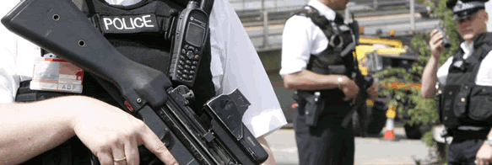
The annual report highlights the continuing gulf between the strategy to counter-terrorism in the UK versus the limited resources and comparable effort in place overseas. Recent successes in countering terrorism in the UK, coupled with a diversifying threat overseas and weak governments in priority countries in Asia, Africa and the Middle East suggest the British government will have to refocus some of its efforts abroad. Given the constraints on public spending in the UK, funding and supporting such programmes will likely be in concert with the European Union and EU member states. For example, the European Commission is already looking at ways it can fund counter violent extremism projects in the Horn of Africa and Pakistan.
In December last year the Prime Minister, David Cameron, announced that UK force levels in Afghanistan would be reduced to around 5,200 by the end of 2013.The drawdown is consistent with both UK military advice and the NATO strategy agreed at the Lisbon Summit in 2010, under which ISAF forces will continue to operate across the country. The annual report suggests that Pakistan and the Afghanistan-Pakistan border remain of the highest importance. So what effect will the drawdown have on UK National Security?
British security officials describe Al-Qa'ida-core as being 'hollowed out' and the group's training infrastructure is minimal, certainly compared with the dozens of fully fledged camps that were in use on the eve of the 9/11 attacks. Yet, individuals continue to travel to Pakistan where a range of groups (Al-Qa'ida, Tehrik-i-Taliban Pakistan and others) take a keen interest in UK nationals. The reduced presence of ISAF personnel in the 'N2KL' provinces (Nangarhar, Nuristan, Kunar and Laghman) for instance, could have real implications for the threat against Western countries in the future. The conflicts of the past have not ended, and as the annual report highlights, future areas of instability are still defining themselves within the broader threat picture.
The CONTEST strategy does highlight the importance of counter-terrorism overseas but it is clear that more needs to be done as the threat continues to diversify. Poor governance, limited capacity by national governments and a lack of counter-terrorism capabilities in high risk countries requires greater and more urgent attention. Marshalling the resources of the European Union, EU member states and the wider international community must be a priority.

Counter-terrorism in An Age of Austerity
The CONTEST Strategy annual report highlights the successes of British counter-terrorism efforts as well as the ongoing challenges facing the government. These challenges are likely to be felt more acutely by policymakers and practitioners in the coming years - not least with a reduction in public spending, but also as resources are inevitably shifted to other priority areas in Home Affairs including organised crime and cyber security.

Note
1. CONTEST Annual Report, HM Government, March 2013

Total cost of piracy: $5.7 billion to $6.1 billion
Source: http://marinelog.com/index.php?option=com_content&view=article&id=3863:total-cost-of-piracy-57-billion-to-61-billion&catid=1:latest-news&Itemid=195

Even though ransoms paid to Somali pirates fell to an estimated $31.75 million in 2012 – an 80.1 percent decline on the $159.62 million paid the previous year — maritime piracy cost the global economy between $5.7 billion and $6.1 billion in 2012. Though that is a staggering figure, it is a decline of around $850 million on 2012.
Those are some of the findings of ECoP 2012, the third annual assessment of the Economic Cost of Somali Piracy 2012 from Oceans Beyond Piracy (OBP), a project of the One Earth Future foundation.
The methodologies and the calculations used in the ECoP 2012 report have been reviewed by BIMCO which considers the study to be "an informed and constructive contribution to the anti-piracy debate."
The report says that while 2011 was characterized by a sharp drop in Somalia-based piracy attacks and hijackings at mid-year, 2012 was marked by the continuation of consistent policies to successfully repress piracy at sea. The costs associated with the naval presence were estimated to be similar to those incurred in the previous year.
The maritime industry's collective response to piracy was marked by a continuation of recommended practices in line with the fourth revision of the Best Management Practices (BMP4), which were adopted in August 2011. The High Risk Area associated with the latest version of BMP also remained consistent throughout the year, which reflected the assessment that the range of Somalia-based pirate attacks had finally reached a zenith.
A final factor leading to the drop in Somali piracy in 2012 was the increased presence of armed guards. In 2011, OBP estimated that around 30 percent of ships employed private armed security. In 2012 that percentage was revised upwards to 50 percent.
OBP says that analysis of Automatic Information System (AIS) data has caused it to revise its estimates of large-scale commercial shipping traffic in the Indian Ocean from 42,450 vessel transits to 66,612 transits per year.
OBP says there were several significant cost observations for 2012, as compared to those incurred during 2011:
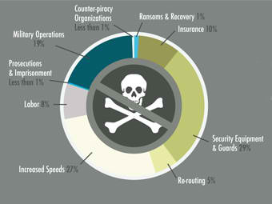
- Increased "per incident" costs: Between 2011 and 2012, the number of attempts and hijackings fell much more drastically than the cost of combatting piracy. This led to a substantial increase in the "per incident" cost of piracy. In 2011, $28.6 million was spent per pirate attack, and in 2012, that number rose 189.0 percent to $82.7 million.
- Increased cost of armed guards: The most pronounced increase in the cost of piracy came as a result of the increased number of armed guards used to protect merchant vessels transiting the HRA. Between $1.15 and $1.53 billion was spent on armed guards in 2012. In 2011, that figure was $530.6 million. The observed increase comes as the result of an increased proportion of ships employing armed guards (30 percent in 2011 and at least 50 percent in 2012) as well as a revised estimate of the number of commercial transits through the HRA each year. Controlling for that latter methodological factor, the cost of armed guards increased 79.7 percent in 2012.
- Decreased cost of increased speeds: The most drastic cost reduction seen in 2012 came from a decrease in the cost of fast steaming through the HRA. In 2011, an estimated $2.7 billion was spent on above optimal speeds, but that figure was down to $1.53 billion in 2012. The observed $1.17 billion dollar decrease comes from a decline in the proportion of ships steaming at above optimal speeds as well as a reduction in the amount by which the average "speeding" ship steamed above the economically optimal level. These estimates were made using Satellite AIS data, which was analyzed to calculate this year's cost and assess last year's figures.
- Consistent ratio of Recurring Costs vs. Investment: In 2011, it was estimated that approximately 99.5 percent of the total cost of piracy was spent on the recurring costs of vessel protection. This figure stood in stark contrast to the money invested in prosecutions and building regional and Somali capacity to reduce piracy. In spite of the success achieved at sea in reducing piracy attacks and hijackings, this ratio remains consistent with last year's figures. In 2012, 99.4 percent of all funds were spent on recurring suppression costs, with the remaining 0.6 percent invested in long-term prevention solutions.
This year's assessment, like the one before it, considered nine separate, first order cost categories:
- Ransoms and Recovery: In 2012, OBP estimates that $31.75 million dollars in ransoms were paid to Somali pirates. This represents an 80.1 percent decline in ransoms paid from 2011, when $159.62 million was paid. The reduction in ransoms is due to the lower number of vessels captured and released in 2012, as well as a lower average ransom than the previous year. In addition to the ransom payment itself, the logistical costs associated with paying ransoms and recovering the vessels – including the cost of delivering the ransom, damage caused to the vessel while it is held, and the cost of negotiators, consultants and attorneys' fees – were estimated at 100 percent of the value of the ransoms themselves, bringing the total cost attributable to the payment of ransoms and recovery of vessels to $63.5 million in 2012.
- Military Operations: The incremental cost of vessel deployments (including reconnaissance aircraft and Unmanned Aerial Vehicles), vessel protection detachments, the administrative budgets of naval operations, and SHADE (Shared Awareness and Deconfliction) meetings amounted to $1.09 billion in 2012. This figure represents a 14 percent decrease from the $1.27 billion reported in 2011. However, most of the decrease comes as a result of a more conservative methodology used to calculate the cost of UAV deployments. Operationally, the major change that took place between 2011 and 2012 is a decrease in naval assets deployed by the "big three" naval missions – EUNAVFOR's Operation Atalanta, NATO's Operation Ocean Shield, and the Combined Task Force's CTF-151 – alongside a corresponding increase in the assets provided by "independent deployers" including China, India, Japan, Russia, and South Korea.
- Security equipment and guards: The total cost of security equipment and guards in 2012 was estimated to fall within the range of $1.65 and $2.06 billion. The cost of security equipment fell a moderate 11 percent, from around $578.7 million in 2011 to $514.6 million in 2012. Because of a greater acceptance of armed guards by both Flag States and ship owners and operators, the cost of armed guards rose much more dramatically, up 79.7 percent from 2011 to 2012 when keeping the number of annual transits through the Indian Ocean constant. However, our revised estimate of annual transits resulted in a more dramatic increase, with between $1.15 and $1.53 billion spent on armed guards alone in 2012.
- Re-routing: Shipping companies spent $290.5 million re-routing along the Arabian Peninsula and Indian coast as opposed to taking a direct route through the HRA. While Best Management Practices still recommends that vessels re-route, it appears as though fewer ship owners and operators are actually doing so. The sum spent on re-routing is down 47.9 percent from the amount estimated in 2011. However, the proportion of ships transiting around the Horn of Africa that chose to re-route only dropped by 10 percent. The rest of the reduction is the result of a change in methodology, whereby fewer tankers and bulk carriers were considered to be candidates for re-routing.
- Increased speed: In 2012, OBP estimates that shipping companies spent an extra $1.53 billion on fuel costs associated with steaming at faster than optimal speeds in order to prevent pirate attacks. While there was no change in the industry's recommendations for increased speed through the HRA, the estimated cost of this practice dropped 43.3 percent from 2011, where the estimated additional cost was $2.7 billion. This $1.17 billion decrease is the largest in absolute terms of all nine cost sections considered, and is the result of a reduction in the proportion of ships going through the High Risk Area at increased speed and a drop in the average speed of those ships steaming at faster than optimal speeds. To calculate the cost of increased speed for 2012, and to confirm the drop in compliance, OBP utilized satellite Automatic Information System (AIS) data provided by ExactEarth™ and licensed to OBP for use in this report.
- Labor: The labor-related costs attributable to maritime piracy include the cost of hazard pay as well as the cost of paying seafarers while a vessel is being held hostage. Hazard pay is associated with theInternational Bargaining Forum agreement, which affords crews on participating vessels the right to double pay while transiting the High Risk Area. These costs totaled $471.6 million, up significantly from the $195.1 million estimated in 2011. This increase is the result of a revised estimate that 70 percent of seafarers transiting the HRA are entitled to hazard pay, based on IBF membership or similar arrangements, as opposed to the 30 percent assumed in 2011. This revised assumption came as the result of conversations with the Anglo-Eastern Group, a leading ship management company. Hazard pay is also affected by the revised estimate of annual transits in the Indian Ocean. Thus all of the observed labor cost increases come as a result of revised methodology as opposed to changes in labor practices.
- Prosecutions and imprisonment: In 2012, the cost of prosecution and imprisonment was $14.89 million, down 9.2 percent from the figure reported in 2011. Broken down further, the cost of prosecutions was $8.84 million, down 24 percent from 2011, while the cost of imprisonment increased 26.67 percent from 2011 to $6.04 million in 2012. The reduction in prosecution costs appears to be almost entirely due to a decrease in the number of suspects prosecuted, while the increase in the cost of imprisonment reflects the long term obligations associated with imprisoning a pirate. More new pirates were imprisoned in 2012 than were released.
- Insurance: The cost of insurance fell by 13.3 percent, from $634.9 million spent in 2011 to $550.7 million spent in 2012. This fall is attributable to the increased presence of private armed guards aboard merchant vessels and the resulting premium discount. Moreover, due to a higher number of expensive vessels transiting the Suez Canal in 2012, the costs associated with War Risk premiums rose slightly. Controlling for that change in the composition of the insured property, the cost of piracy-related insurance fell by 14.9 percent.
- Counter-piracy organizations: The cost of various counter-piracy organizations, ranging from United Nations agencies to independent NGOs, was $24.08 million in 2012. This figure represents a 13 percent increase from the $21.3 million reported in ECoP 2011.

►Read full report: http://oceansbeyondpiracy.org/sites/default/files/ecop2012final.pdf

Boston bombing may signal end to ten relatively terror-free years in U.S.
Source: http://www.homelandsecuritynewswire.com/dr20130417-boston-bombing-may-signal-end-to-ten-relatively-terrorfree-years-in-u-s
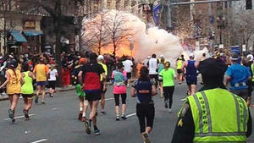

The bombing at the Boston Marathon on Monday may signal an end to more than ten years in which the United States was surprisingly free from terrorists attacks, largely as a result of aggressive law enforcement tactics which followed the 9/11 attacks.
The New York Times reports that the Global Terrorism Database, compiled by a terrorism research center at the University of Maryland, noted that the 9/11 attacks were an anomalous event during a period, which began in the mid-1970s, of gradual decline in the number of terrorist attacks in the United States. The only post-9/11 terrorist incident in which the number of deaths exceeded nine people was a shooting spree at Fort Hood in Texas in 2009. The number of casualties in the bombing in Boston – three deaths and 176 injured – far exceeds the highest casualty count in terrorist activities in recent American history.
Only four such acts — the 9/11 attacks, the 1993 World Trade Center Bombing, the 1995 Oklahoma City bombing, and the poisoning of restaurant salad bars with salmonella bacteria by religious cultists in Oregon in 1984 — exceed those numbers.
“I think people are actually surprised when they learn that there’s been a steady decline in terrorist attacks in the U.S. since 1970,” Gary LaFree, a University of Maryland criminologist and director of the National Consortium for the Study of Terrorism and Responses to Terrorism, told the Times.
During the 1970s 1,350 attacks were carried out by various radical groups, including extremists from the left and right, white supremacists, Puerto Ricans nationalists, black militants, and other groups.
The numbers declined during the 1980s as these groups were weakened by arrests and defections. This decline accelerated in the 1990s with the fall of the Soviet Union, which covertly supported some violent leftist groups, according to LaFree.
“As a result of 9/11, there’s been a revolution in the way law enforcement treats this problem,” LaFree said. “Police agencies led by the F.B.I. are far more proactive. They’re interrupting the plots before the attacker gets out the door.”
LaFree noted that not only law enforcement agencies have become more sophisticated, so have the terrorists: about half of the terrorist attacks worldwide since 9/11, and nearly a third of those in the United States, have never been solved.

Bombings at the 2013 Boston Marathon
Source:http://start.umd.edu/start/publications/br/STARTBackgroundReport_BostonMarathon2013.pdf

In light of the series of bombs that exploded near the finish line at the Boston Marathon on April 15, START has compiled data on the history of terrorism in Boston, Massachusetts, terrorist usage of coordinated attacks in the United States, and terrorist attacks at previous marathons around the world.
Terrorist activity in Boston
Attack | Year | Casualties
World Trade Center | 1993 | 1048 (including 6 deaths)
Murrah Federal Building, Oklahoma City | 1995 | 818 (including 168 deaths)
Salmonella poisoning in Oregon | 1984 | 751
Atlanta Olympics Bombing | 1996 | 111 (including 1 death)
Bombing at LaGuardia Airport, NY | 1974 | 85 (including 11 deaths)
Amtrak Rail Sabotage, Arizona | 1995 | 79 (including 1 death)
START’s Global Terrorism Database (GTD) records 16 terrorist attacks that have occurred in Boston since 1970, but only three since 1990. The most recent recorded terrorist attack occurred in November 1995 when an explosion occurred at the Boston-based headquarters of the Christian Science community. This 1995 bombing caused no fatalities.
According to the GTD, Boston has been the 14th most frequently targeted U.S. city by terrorists in the past 40+ years. Houston, Texas, has similarly experienced 16 attacks during this period. New York (430 attacks) is by far the most frequently targeted U.S. city, with Los Angeles (103 attacks) the second most common target.
The majority of Boston’s terrorist activity occurred in the 1970s, with Black nationalists responsible for five of the 12 attacks during that decade. Violent White supremacists and violent far-leftists were also active in Boston during this time.
There have been two fatal terrorist attacks in Boston since 1970, both classified as assassinations: In 1992, Iwao Matsuda—the president of a Japanese university—was assassinated in his hotel during a visit to Boston; in 1995, Paul McLaughlin—a prosecutor specializing in gang-related cases—was shot in his car in a parking lot in the city.
Mass-Casualty Terrorism in the United States
While catastrophic events like those of September 11, 2001, demonstrate how deadly terrorists can be, data shows that most terrorist attacks do not inflict a large number of casualties (injuries and fatalities). Historically, each U.S. terrorist attack has resulted in 3.3 casualties on average. Excluding the 9/11 attacks, the average number of casualties per U.S. attack drops to 1.4 casualties per attack. Mass-casualty terrorism is rare in the United States, but it does occur. (*Those average figures do not include 1993 data, for which START does not have a complete annual dataset.)
There have been 28 terrorist attacks in the United States since 1970 known to have resulted in more than 10 casualties. In addition to the attacks of September 11, 2001, mass-casualty terrorism in the United States includes:

*The Fort Hood attack was the fourth most lethal attack in terms of fatalities, with 13 dead and 32 wounded.

Coordinated attacks in the United States
Reports indicate that two bombs exploded near the finish line of the 2013 Boston Marathon. Early reports had indicated that additional devices in the area were defused prior to detonation, but those reports have been discredited.
Globally, 12 percent of the more than 100,000 terrorist attacks that have occurred since 1970 have been part of a coordinated attack, where the perpetrators have targeted multiple targets within a short period of time. The rate of such complex, coordinated attacks in the United States is consistent with the global average, with 300 of the 2,362 attacks in the United States between 1970 and 2011 qualifying as part of a “multiple” attack.
At different points in history, though, this tactic has been particularly popular among terrorists targeting the United States. The figure below presents trend data on the percentage of terrorist attacks each year that are categorized as such coordinated attacks (versus singular attacks). During the last 15 years, the percentage of such attacks in the United States has tended to exceed the global average. Given the complications that such attacks create for counterterrorism efforts as well as first responders, this could be an important trend to consider for the United States.

Incendiary Devices and Explosives in the US
The most common weapons used in the 207 terrorist attacks in the United States from 2001 to 2011 were incendiary devices and explosives. For the entire duration covered by START study, “Integrated United States Security Database (IUSSD): Data on the Terrorist Attacks in the United States Homeland, 1970 to 2011,” these two categories accounted for more than 81 percent of all the weapons used in the attacks.
Incendiary devices accounted for more than half of all weapons used over the last decade, representing a large increase in the use of such weapons compared with the norm for the 1970 to 2011 time period. However, from 2001 to 2011, the use of explosives such as dynamite, grenades and “car bombs,” is markedly lower, accounting for only 20 percent of all weapons used compared with 52 percent for the entire sample from 1970 to 2011.

Marathon-Related Attacks

April 2008: Colombo, Sri Lanka
On April 6, 2008, a Liberation Tigers of Tamil Eelam militant blew himself up, killing 14 civilians, including the minister of highway and road development, Jeyaraj Fernandopulle. The attack occurred as the minister was flagging the start of a road marathon. The attack injured 83 others in Weliweriaya, northeast of Colombo, Sri Lanka.

January 2006: Lahore, Pakistan
1. On Jan. 28, 2006, in a series of related incidents, protesters of a marathon in which women and men would participate together in Lahore, Pakistan, set at least two buses on fire with unspecified weapons. The protesters were supporters of the Mutahida Majlis-e-Amal, or the United Action Forum coalition. There were no casualties and no reported claims of responsibility.
2. In a related incident, on Jan. 27, 2006, marathon protesters threw stones at policemen and at public property, and set four buses on fire with unspecified weapons. The protesters were supporters of the Mutahida Majlis-e-Amal, or the United Action Forum coalition. At least four people were injured in the protests, two of them police officers.

May 2005: Gideon’s Green, Northern Ireland
On May 2, 2005, suspected Irish Republican Army members planted a pipe bomb at Gideon's Green, Newtownabbey in Belfast along the route of the Belfast Marathon. It was disabled before it could harm anyone, including the target of the attack, Chief Constable Hugh Orde. An unidentified perpetrator called in a warning about the bomb indicating that Hugh Orde was the intended target of the attack.

May 2003: Belfast, Northern Ireland
On May 5, 2003, a substantial bomb was left in a van by two masked men in Belfast, North Ireland, in front of the motor tax office a few hours before the annual Belfast marathon. The owner of the van called the police who defused the bomb before it exploded. Police suspected that the Real Irish Republican Army (RIRA) was responsible for the incident.

May 1998: Belfast, Northern Ireland
On May 3, 1998, suspected Irish Republican Army (IRA) militants fired two Mark 6 mortars at the Grosvenor Road Royal Ulster Constabulary (RUC) station in Belfast, Northern Ireland. The mortars, however, did not detonate and no injuries or damage were reported. The discovery of the mortars disrupted the Belfast Marathon, which was to be held the day after this incident.

November 1994: Manama, Bahrain
On November 25, 1994, protestors attacked participants of a marathon along the al-Budayyi’ Highway using a number of blunt objects, including sticks and rocks. Three marathon runners were injured, including a British national and a person from Saudi Arabia. While the specific motive for the attack is unknown, it is believed that the perpetrators were protesting the route of the marathon because of its proximity to a site believed to be the remains of a mosque. Protesters were also angered by the dress of female participants in the race.

London Marathon to go ahead despite Boston blasts
Source: http://www.bangkokpost.com/news/world/345623/london-marathon-reviews-security-after-boston-blasts

The London Marathon will go ahead this weekend (April 21, 2013) after security arrangements were reviewed in the wake of the bombings that caused carnage at the Boston Marathon, organisers and police said on Tuesday.
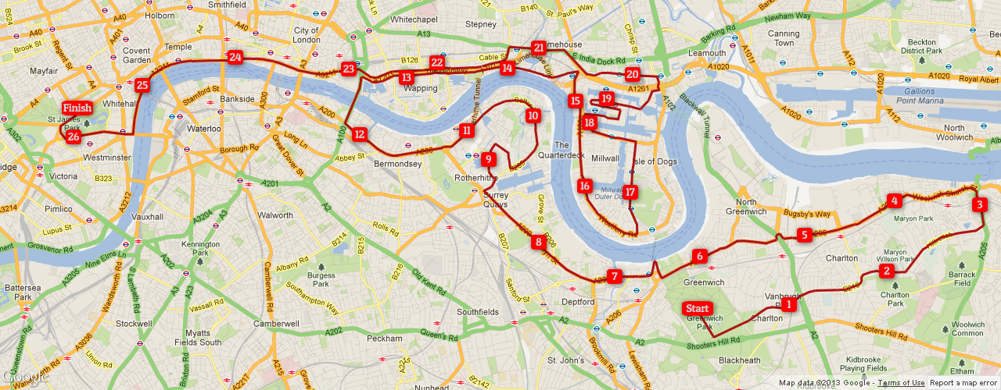
Three people were killed and more than 170 wounded, some with horrific injuries, in two explosions as runners approached the finish line in Boston on Monday.
The FBI vowed to go "to the ends of the Earth" to find those responsible for the worst attack in the United States since the September 11, 2001 atrocities.
The organisers of the London race said after talks with police and city officials that the race will take place as planned on Sunday.
London Marathon chief executive Nick Bitel said: "The support we have been offered by our stakeholders and the wider running community has been outstanding. We have the full support of the Metropolitan Police, the mayor's office and other authorities.
"We want to reassure our runners, spectators, volunteers and everyone connected with the event, that we are doing everything to ensure their safety and that the Virgin London Marathon 2013 is an outstanding success."
Organisers said a 30-second period of silence will be held before the start of the race in memory of the victims of the Boston attacks.
Commander Christine Jones from the Metropolitan Police said the force was working with the London organisers to make sure "we have all the tactics in place that we need".
The head of the force, Bernard Hogan-Howe, said it would be "professionally irresponsible" if it did not re-assess its security arrangements for the London Marathon in light of the Boston attacks.
But he said he had "no reason to think (that the people of London) are any less safe than they were before the terrible events in Boston yesterday."
It is an additional security headache for the London police, who are already deploying 4,000 officers for Wednesday's funeral of former British Prime Minister Margaret Thatcher.
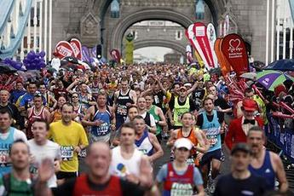
The London race, which is expected to attract 36,000 runners and half a million spectators, has long been considered a potential target for terrorists.
Centred around the River Thames, the course winds past several of London's most iconic landmarks, including Tower Bridge, the Houses of Parliament and Queen Elizabeth II's Buckingham Palace residence.
It also passes through Canary Wharf, one of the world's biggest business districts.
Bitel admitted earlier that the nature of the event made it difficult to secure the entire 26.2-mile (42.2-kilometre) route.
"When you have an event of any nature -- a marathon, parade -- it's only as safe as the city itself. If it's not held in a stadium, you can't do a lockdown like you may do in a building," he said.
Organisers must also consider security arrangements for third-in-line to the throne Prince Harry, after it was confirmed he still planned to attend the event to present medals to the winners.
Sports Minister Hugh Robertson, who oversaw security arrangements during last year's London Olympics, said the city had substantial experience of dealing with the risk of terror attacks.
"These are balance of judgements, but we are absolutely confident here that we can keep the event safe and secure," he told BBC radio.
British government officials including Home Secretary Theresa May met representatives from the security services to review the arrangements.
Mayor of London Boris Johnson said the bombings in Boston were "shocking, cowardly and horrific" and Londoners' thoughts were with the victims.
"We do have robust security measures in place for Sunday's London Marathon but, given events in Boston, it's only prudent for the police and the organisers of (the) race to re-examine those security arrangements," he said.
The London authorities will draw on their experience of hosting last year's Olympics, which attracted over half a million visitors to the city but passed off without any major security incidents.
As well as thousands of amateur runners, a world-class field is expected to line up for the London Marathon, including all three medal-winners from the men's race at the Olympics.
British star Mo Farah, who claimed the 5,000m and 10,000m double at the London Games, is also due to complete half the race, as he begins preparations to compete over the full distance.

Most Schools Are Ill-Prepared for an Active Shooter Scenario
By Jim McKay
Source: http://www.emergencymgmt.com/safety/Schools-Ill-Prepared-Active-Shooter.html

New Washington, Ohio, Chief of Police Scott Robertson talks with fourth grade students as they huddle in closet during a lockdown drill at the St. Bernard School. Photo courtesy of APimages.com/Craig Ruttle
It will take an all-hazards tactic, additional campus safety personnel and a new approach to building design for schools to become more hardened against the threat of an active shooter on campus.
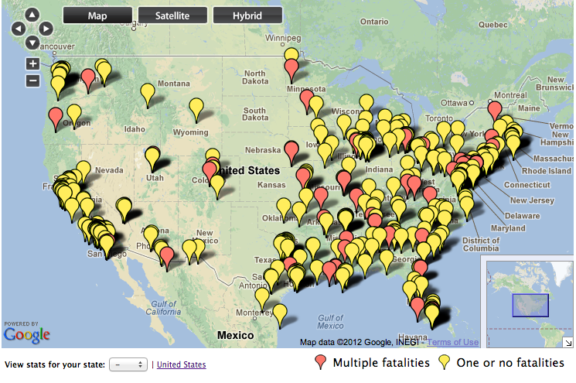
But before all of that happens, we will undoubtedly see more events like the one that shook the country on Dec. 14, 2012, when 20 kids and six staff members were shot to death at Sandy Hook Elementary School in Newtown, Conn.
“The chilling fact is, it’s happened before and it will happen again,” said Bo Mitchell of 911 Consulting. “One danger here is that we always prepare for the last crisis, so we are all preparing for Hurricane Sandy and the Newtown massacre. Both were devastating but employers have to prepare for all hazards — bomb threats, suspicious packages, bullying at work and bullying at school are examples.”
There are people planning the next attack now, according to Bill Lowe, associate professor of emergency management and terrorism at Jacksonville State University in Alabama. He said copy-cats often fantasize about killing large numbers of people, but some never go through with it. They may post a threat on Facebook or talk about it, but their actions don’t go beyond the planning stage. “The ones I’m concerned about are the ones who aren’t stupid enough to put it on Facebook. They’re doing it silently, and it’s happening right now.”
Lowe said at some point schools will have to be built more strategically to harden them against intruders. That would mean building a school where access could be controlled by having fewer entrances, Lowe said. “The goal is to deny access to the building and delay access to victims.”
Lowe advocates having an all-hazards security officer on campuses. The officer would be trained for many different scenarios and be armed. “If you can justify having a librarian in the school, then how do you justify not having someone responsible for intruder protection, fire protection — someone trained to deal with emergencies?” Lowe asked. “I see this person being sort of multi-capability officer.”
During a traditional school year, this multidimensional first responder could work for the school district for nine months and the police or sheriff’s department for three, Lowe said. “The sheriff’s or police department could pay a quarter of his or her salary, and the school district pays the rest,” he said. “If you have somebody who can fill multiple roles, then you’re amortizing that cost over many different things.”
In addressing whether teachers should carry firearms, Lowe said, “I don’t know that I embrace that.”
He said as children get older their propensity for violence increases and that makes colleges a likelier target of gun violence. The older children have more issues with mental health, access to drugs and firearms, and the capability to use them.
Many colleges and universities have a full-time police department and understand the risks, however, an active shooter situation is unknown until it happens. “If you were to ask any police chief or sheriff, ‘Is your community prepared for an active shooter event?’ all of them would say, ‘Absolutely,’” Lowe said. “That’s what they think, but they won’t be tested until it happens.”
An example is the Aurora, Colo., shooting where a gunman killed 12 people in a movie theater last July. The gunman began his rampage by releasing two canisters of pepper spray, which hampered police and emergency medical efforts. That was a new twist, Lowe said. “[Pepper spray] hangs around for a long time and once it’s on the victims, it affects them for a long time.”

Most Unprepared
In general, Mitchell said, schools and businesses can and should examine their emergency plans and how they would respond, not only during a shooting but also during various potential hazards.
Emergency plans should be for all hazards, not just for an active shooter situation and should include trainings that incorporate everyone associated with that school or business, according to Mitchell.
Mitchell said schools are employers first and most employers are not well prepared. “For every one organization that is well planned, trained and exercised, there are 10 that are not,” he said. “Every employee has a legal right to review their employer’s emergency plan. That’s federal law.”
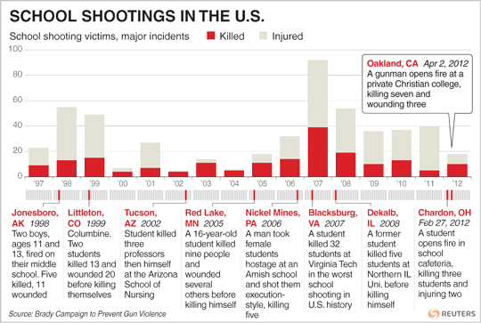
Schools and businesses all have the same problem: They think they are well prepared but they’re not. Mitchell said there is ample research done by the Government Accountability Office, the National Association of School Resource Officers and other national organizations that point to a lack of preparedness for K-12 schools and businesses.
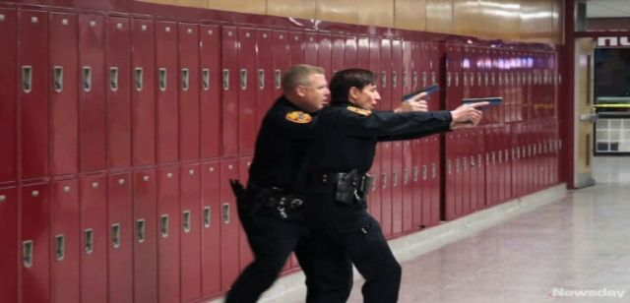
The research shows that most schools have paperwork they call a plan, but it’s not all hazards and they don’t train all of their employees as required by federal law. “They’ll train ‘the team,’ but they don’t train all employees, and for emergency purposes that’s the contractors, the cafeteria staff, the security people and grandma who volunteers in the gift shop,” Mitchell said.
“They should train coaches, temps, volunteers, everyone because when something goes wrong, all those people will be considered employees at court, even if they didn’t get a paycheck.”
Mitchell said research indicates that schools aren’t well prepared because they don’t exercise. “Table top exercises, full-scale exercises done with and without emergency services in concert — both are great and more is better, but they aren’t doing it,” he said. “Some of this is, ‘Oh, we’ll scare the children or we’ll scare the parents.’ That’s bull. Locking down a school is very difficult, but that doesn’t alleviate your responsibility to do that.”

The “Plan”
Every principal will answer in the affirmative when asked if his or her school has a disaster plan. But is that plan being exercised or is it “on the shelf?”
“A lot of it is on the shelf, a lot of it isn’t all hazards, a lot of it isn’t trained,” Mitchell said. “OSHA [Occupational Safety and Health Administration] says school is a workplace.
It says before you’re a school, you’re a workplace and every employee shall be trained in emergency planning, annually in a classroom. This is not happening on a wide spectrum from Maine to California.”
The reasons vary, from lack of education, to politics to denial and, of course, a lack of resources.
The feeling that “it won’t happen to us” is ubiquitous in the U.S., including schools and businesses. Couple that with the fact that school administrators aren’t emergency managers and that parents of students attending those schools may not know what questions to ask those administrators about emergency plans, which and it equals lack of preparation.
“Public schools tend to turn to their police chiefs and fire chiefs, which is all well and good but they’re busy people, and if all schools showed up at the police and fire departments, the system would collapse,” Mitchell said.
He also said politics play a role in that police officers and firefighters aren’t going to go to parents because they’d be going over the heads of boards of education. And boards of education are reluctant to turn to parents because they’re busy running schools and taking on security too is a daunting thought.
Mitchell said parents should ask school administrators if they have a plan, if it’s all hazards, if it conforms to the NFPA 1600 Standard on Disaster/Emergency Management and Business, have they trained it annually in a classroom and have enough people been trained, including the grandma volunteering in the gift shop.
Lowe said there are indications that Sandy Hook Elementary School personnel did some things that saved lives in the few minutes of chaos. “Keeping doors closed, turning off lights and keeping children quiet,” were smart things to do, he said. “It’s all about cover and concealment. How do you conceal yourself from the predator? Out of sight, out of mind and out of sound, out of mind. If the predator can hear people screaming and yelling out of fear, that just increases the prey drive.”

Jim McKay is the editor of Emergency Management magazine.

12 arrested as Turkish police foil bomb plot on U.S. Embassy
Source: http://www.washingtontimes.com/news/2013/apr/12/12-arrested-turkish-police-foil-bomb-plot-us-embas/

Τέλος φόρμας
Turkish police seized nearly 50 pounds of plastic explosives and arrested 12 in connection with what they believe was a bomb plot on the U.S. Embassy in Ankara.
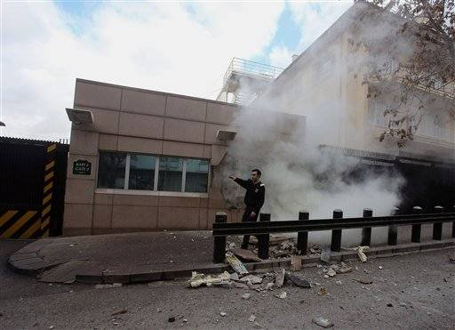
The arrests were part of raids in Istanbul and Tekirdag in February — but were only reported on Friday, United Press International said.
The bomb plot was allegedly the brainchild of an al-Qaeda cell operating in Turkey, police told UPI. The members trained in Afghanistan but hailed from Chechnya, Azerbaijan and Turkey.
In addition to the plastic explosives, police also grabbed 10 firearms and six laptop computers, UPI reported.
Police had alerted U.S. Embassy officials in February about a possible threat, and a travel warning was issued. But no details were given.
On Friday, Turkish officials still declined to comment, UPI said.

Boston Marathon Massacre – The killer (red) and the victim (blue) in the same photo!

Libya’s Sabha Oasis: Former Qaddafist Stronghold Becoming Regional Center of Insecurity
By Andrew McGregor
Source:http://www.jamestown.org/single/?no_cache=1&tx_ttnews[tt_news]=40751&tx_ttnews[backPid]=7&cHash=d0ee00320e8242cdc31b4c26719e205a

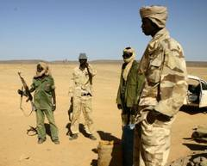
Tubu Militia (Source Libya Herald)

During the rule of the late Mu’ammar Qaddafi, Libya’s Sabha Oasis was an important regional security center, dominating Libya’s remote Fezzan region and the ancient trans-Saharan trade routes that connect sub-Saharan Africa to the Mediterranean coast. The Libyan airbase and garrison at Sabha gave Qaddafi a military presence in a region that contains most of Libya’s considerable oil wealth as well as a remote center for nuclear weapons development and rocket testing. The presence of many Qaddafist loyalists in Sabha (including members of Qaddafi’s own Qadhadhfa tribe) made it the last major center to be taken by rebel forces in the campaign to depose Qaddafi. Today, roughly a year-and-a-half after Qaddafi’s death, Sabha’s strategic importance has actually increased due to the insecurity that prevails in southwestern desert.
To cope with the rampant insecurity that allowed the deadly Islamist attack on Algeria’s In Aménas gas plant to be mounted from southwestern Libya, Sabha was one of several southern regions declared a closed military zone in December, 2012, with temporary closures to border crossings with Niger, Algeria, Chad and Sudan (see Terrorism Monitor, January 25).

Sabha – The Disputed Oasis
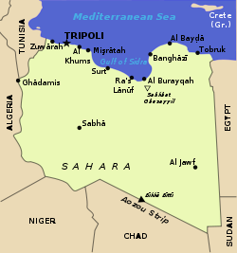
Located some 500 miles south of Tripoli, the town of Sabha, with a population of roughly 200,000, is dominated by a massive Italian-built fort (Fortezza Margherita, but now known as Fort Elena), a legacy of Italy’s brutal occupation of the Libyan interior in the early 20th century. Most residents belong to Arab or Arab-Berber tribes, but the Tayuri and al-Hijra neighborhoods belong to members of the Tubu, an indigenous Black African tribe following a semi-nomadic lifestyle in what is now southern Libya, northern Chad and northeastern Niger. Though famed for their traditional fighting skills, the Tubu of Sabha occupy cheap fire-blackened cinder block housing that provides witness to the bitter inter-communal battles that have plagued the oasis town since the Libyan revolution. The Tubu make up only 10 to 15 percent of Sabha’s population, which also includes a number of Tuareg and migrants from Sudan, Chad and Niger who were encouraged to fill jobs in Libya’s oil economy.
Stripped of citizenship by Qaddafi and denied basic services such as medical care and education by Libyan administrators ordered to treat all Tubu as undocumented aliens, the Tubu see an opportunity to normalize and legitimize their historic presence in southern Libya through specific inclusion in Libya’s new constitution. Earlier this month, the Tubu attempted to educate other Libyans and foreign delegates about the Tubu by holding the first-ever “Festival for Tubu Heritage and Culture” in Murzuk, southwest of Sabha. While the event was attended by a number of members of the GNC, official foreign representation was limited to the Turkish consul and a UN delegate (Libya Herald, April 8). For the Turkish consul, his arrival marked something of a symbolic return to the region: Ottoman troops were beginning to establish posts in the Tubu regions of the Sahara in the early 20th century prior to being withdrawn after the Italian invasion of Libya in 1912.
A group of Tubu fighters under the leadership of Niger-based militant chief Barka Wardougou (who became close to Tuareg rebel groups in Niger in the last decade) took Murzuk from its loyalist garrison in August, 2011 (Ennahar [Algiers], August 20, 2011). Wardougou and his militia remained in southwestern Libya after Qaddafi’s overthrow (Jeune Afrique, May 17, 2012).

Who Will Control the Borders?
Despite playing a leading role in the expulsion of Qaddafist forces from Libya’s southwest and the southeastern Kufra Oasis region, Libyan Tubus continue to be treated with the suspicion normally associated with pro-Qaddafists. When Sa’adi al-Qaddafi threatened to return from his Niger exile in February, 2012 to lead a new uprising in cooperation with elements of the Libyan military against the “gangs” who controlled Libya, attacks quickly began on Tubu residents of Kufra who were suspected (without evidence) of supporting Sa’adi’s plans for counter-revolution (Jeune Afrique, May 17, 2012; al-Arabiya, February 11, 2012; al-Sharq al-Awsat, February 15, 2012). For now, the Tubu continue to guard the border regions of the southwest, though partly out of self-interest – infiltration by Islamic extremists and narco-traffickers would challenge traditional Tubu control of local smuggling routes. The Tubu are already engaged in a struggle for control of these routes with their local rivals, the Awlad Sulayman Arabs. The Tubu and Awlad Sulayman fought a vicious battle using automatic weapons, rockets and mortars in Sabha in March 2012. The clashes left at least 50 dead and over 160 wounded (Libya Herald, March 28; Tripoli Post, March 29; for the battle, see Terrorism Monitor Brief, April 6, 2012).
In Sabha, incendiary rumors that the Tubu minority are about to take over the city often find a ready audience amongst the Awlad Sulayman and Awlad Abu Seif Arabs. Many Tubu are similarly convinced that the Awlad Sulayman intend to take control of the entire southwest region. Operating under the nominal direction of the Ministry of Defense, Tubu militias remain in control of several sensitive areas in southwestern Libya, including the southern al-Wigh airbase and parts of the Murzuk oil-fields. Calls from the militias for funding and equipment to control the borders have largely fallen on deaf ears. The Tubu not only know the physical terrain, they also know the location of unmarked minefields along the Libyan-Chadian border, deadly relics of the prolonged struggle between Chad and Qaddafi’s Libya for control of the uranium-rich Aouzou Strip.

Return of the Qaddafists
The continued presence of Sa’adi Qaddafi across the border in Niger also contributes to the destabilization of the region. A group of armed men attacked a Sabha police post on April 12, killing a police guard and two others before seizing vehicles and arms from the station. The next day, over 20 individuals described as supporters of the Qaddafi regime were arrested. According to the head of Sabha’s military council, Ahmad al-Atteibi, the men had confessed to having been infiltrated from abroad with the purpose of setting up a base in the south (SAPA, April 13; News24, April 14). Another police source claimed the assailants were veterans of the Libyan Army’s 32nd Mechanized Brigade, a well-trained, well-armed and highly loyal unit under the direct command of Khamis al-Qaddafi (a son of the Libyan leader who was killed in a NATO airstrike in late August, 2012 (Libya Herald, April 14). Two vehicles belonging to the attackers were later recovered by the Zawiya Martyrs’ Brigade, a militia hailing from the Berber-dominated Nafusa Mountains of western Libya. Libyan border police also reported arresting a group of Libyans entering the country from Egypt with a large quantity of pro-Qaddafi literature for distribution in Sabha (Libya Herald, April 13).
Libya has been applying intense pressure on Niger to extradite Sa’adi to Libya to face war crimes charges and it is expected that the former soccer player and Special Forces commander will join other members of the Qaddafi family in Oman rather than wait to be returned to an unhappy fate in Libya (al-Shabiba [Oman], March 26; Times of Oman, March 26).

Securing the South
The apparent inability of local security forces to resist attacks on their posts prompted a joint emergency meeting of Libya’s government and the ruling General National Congress (GNC). The meeting was attended by the highest levels of Libya’s administration and security services in an effort to find a solution to the ongoing challenges to government authority in the south (Libya Herald, April 14).
Security forces and militias from northern Libya dislike serving in the south, partly because there are no additional benefits offered to persuade them to serve there. Deployment orders from the Libyan Army command continue to be treated as requests by most of the Libyan militias. Most are unable to cope with the isolation and severe climate of the vast desert expanses south of Sabha, leaving the region largely in the hands of local tribal militias, smuggling bands and roving groups of extremists who may have already established bases in the deserts.
The smugglers, who specialize in arms, fuel, vehicles, subsidized food, narcotics and human trafficking, are usually at least as well-armed and organized as the security forces tasked with their elimination. With under-equipped local security forces often going unpaid for months at a time, it has become much easier to simply purchase free movement through Libya’s ungoverned southwest. Efforts to inhibit the smugglers’ operations can invite retaliation; on March 30, a well-armed smuggling group angered by attempts to restrict their activities attacked the Sabha headquarters of the southern military region command at the Sabha airbase, killing two officers and wounding three other soldiers (Libya Herald, March 30; PANA, April 2).
The Arab-Berber Qadhadhfa, who were regarded as Qaddafi loyalists during the rebellion, have also engaged in deadly clashes with the generally anti-Qaddafi Awlad Sulayman tribe, who experienced rough treatment from the former dictator after he suspected them of planning his overthrow. Libyan army Special Forces units under Colonel Wanis Bukhamada were deployed to stop these tribal battles in early 2012. Bukhamada has since survived assassination attempts in both Sabha and his hometown of Benghazi.

Conclusion
The task of securing southern Libya from Islamist militants, narco-traffickers and arms-traders depends greatly upon efforts to reform Libya’s security services, most notably the National Liberation Army. However, with most former rebels preferring to remain under arms with their rebellion-era militias, such efforts have been painfully slow in obtaining results. Northerners dislike military service in the south and enduring suspicion of Tubu motives prevents the GNA from supplying this group with the arms, funds and equipment they need to secure the borders. As clashes with their Arab neighbors continue, Tubu goodwill towards post-revolutionary Libya is rapidly diminishing, as is the potential for this group to assume security tasks in southern Libya that few others are qualified to carry out. The In Aménas attack is a potent reminder of the necessity of securing the strategic Sabha Oasis and the rest of southwestern Libya before well-armed Islamists fleeing the French-led intervention in Mali can set up new operational bases in the region.

Andrew McGregor is Director of Aberfoyle International Security, a Toronto-based agency specializing in security issues related to the Islamic world. He received a Ph.D. from the University of Toronto’s Dept. of Near and Middle Eastern Civilizations in 2000 and is a former Research Associate of the Canadian Institute of International Affairs. In October 2007 he took over as managing editor of the Jamestown Foundation’s Global Terrorism Analysis publications. He is the author of an archaeological history of Darfur published by Cambridge University in 2001 and publishes frequently on international security issues. His latest book is A Military History of Modern Egypt, published by Praeger Security International in 2006. Dr. McGregor provides commentary on military and security issues for newspapers (including the New York Times and Financial Times), as well as making frequent appearances on radio (BBC, CBC Radio, VOA, Radio Canada International) and television (CBC Newsworld, CTV Newsnet, and others).

Boston's Jihadi Terrorists & The Chechen Connection
Source: http://acdemocracy.org

Dzhokhar Tsarnaev has been taken alive in Watertown, Massachusetts, this evening.
It is now clear that the Boston Marathon bombing was carried out by Islamist jihadis. It has to been kept in mind that there are two kinds of Chechen terrorists: anti-Russian Chechen nationalists and Chechen Islamists. The terror in Boston was carried out by jihadis who were ethnically Chechen.
Although it will take a while for all the details to come out regarding the Tsarnaevs' exact connections and motives, it is also highly unlikely that that the brothers were completely independent operators.
Tamerlan Tsarnaev, the older brother, linked his YouTube page to another video entitled "The Emergence of Prophecy: The Black Flags From Khorasan." The video, which was translated by the SITE Intelligence Group, was reported in October 2011. It was sent by a terrorist group from the Afghan-Pakistan region, identified as the "Caucasus Mujahideen in Khorasan, to their 'brothers' in the Islamic Caucasus Emirate and their emir, Doku Umarov."
Khorasan plays an important role in the Islamic prophecies where Muslims led by a savior, the Mahdi, will defeat the last Dajjal--the false prophet--at the time of a war that will end all war. The Sunnis believe the Mahdi has not yet been born, while the Shia believe that the Twelfth Imam, Muhammad al-Mahdi, is alive now and hidden by God. However, the "happy end" for both is the same: "An army of black flags from Khurasan that will come to help Imam Mehdi to establish his Caliphate, in Kaaba (Mecca), Saudi Arabia and rule the world under 'the one true religion,' Islam."
Jihadist groups, such as the Taliban, the Islamic Jihad Union (IJU) in Pakistan, the Islamic Movement of Uzbekistan (IMU), al-Qaeda, Hamas and others have been using the "Black Flags from Khorasan," to rally their jihadi troops. Al Qaeda, for example, regularly puts out an online magazine titled "Vanguards of Khorasan."
Reportedly, the Tsarnaev brothers studied in Islamic schools in the Islamic Republic of Dagestan, where al Qaeda and other Salafi and Wahhabi Saudi funded terror groups have continued their suicide bombing since the 1990s. If they were not radicalized there, they may have been radicalized by Islamist elements in the U.S. playing upon their Chechen nationalist sympathies and Islamic education. As well as chatrooms on the Internet, and other theological edits online and in the Mosques they may have frequented.
The Tsarnaevs were known as 9/11 deniers. Dzhokhar, the younger brother, tweeted in Russian on April 21, 2012, 'I will perish young.' Last August, Dzhokhar posted on Facebook that the "Boston marathon isn't a good place to smoke tho'." Yet, none of their friends or family member thought this was unusual, or worrisome.
There's also evidence that Tamerlan championed the cause of Islamism in Chechnya against Moscow. While he said he was unhappy in the U.S., he preferred it to living in Russia.
We know that last year Tamerlan spent six months in Russia. But we don't know exactly where, and whether he continued to Pakistan to train with the IJU or other similar Islamic radical groups. We may learn more about this and more, and we may not.
Were the Tsarnaev brothers part of a Chechen al-Qaeda cell? If they were, then the statements made by Russia's puppet leader in Chechnya Ramzan Kadyrov could mean more than just protesting that his country had nothing to do with the bombers.
Kadyrov said that the Tsarnaevs, "grew up in the United States, their attitudes and beliefs were formed there. It is necessary to seek the roots of evil in America. From terrorism to fight the whole world." Peaceful Chechnya has nothing to do with this, he said.
Or, was Kadyrov trying to direct us away from a Moscow-ordered international provocation? A Chechen attack on the U.S. would surely bolster Putin's plans to clamp down, again, on suspect Chechens and others from southern Russian Islamic republics near Sochi, the site of the Olympic Winter Games in 2014.
On April 17, a day after the Boston bombing, Dagestan's parliament voted to forgo their right to elect their governor, choosing instead to allow Russian President Vladimir V. Putin to appoint whomever he saw fit. Was this an innocent co-incidence? Would other southern Russian Islamic republic follow? Should we worry about more Chechen Islamist terrorism in the U.S.?
In "How Chechnya Became a Breeding Ground for Terror," Lorenzo Vidino, explains: On September 1, 2004, a group of Chechen terrorists took hostage and two days later murdered at least 335 schoolchildren and parents in Beslan, a town in the Russian republic of North Ossetia. The atrocity focused world attention on Chechnya. The Russian government used the event to reiterate its arguments that Chechen terrorists and foreign jihadists supporting them have ideological, financial, and operational ties with Islamist terrorist organizations such as Al-Qaeda.[1]
Although President Vladimir Putin and top Russian security officials provided evidence of links between Chechen fighters and Al-Qaeda, European politicians and mainstream Western journalists focused instead upon the Russian army's brutality and dismissed Putin's claims as an attempt to gain sympathy in the West and deflect criticism of Russia's handling of a nationalist insurgency.
Putin may have been opportunistic, but he was also correct. A close examination of the evolution of the Chechen movement indicates that Islamists and followers of Al-Qaeda have increasingly sought to co-opt the Chechen movement as their own.

Al-Qaeda Adopts the Chechen Cause
Foreign fighters did not have a significant presence in the first Chechen war, which started soon after the 1991 collapse of the Soviet Union and ended with the November 1996 Russian retreat and the creation of an autonomous Chechen government led by the late Aslan Maskhadov.[2] The main Chechen rebel leader during the first war, Dzhokhar Dudayev, had a generally secular nationalist outlook. According to Alexander Iskanderyan, director of the Center for Caucasian Studies in Moscow, "the Chechen independence movement had no Islamic dimension at all."[3] But when the conflict began to attract media coverage, Islamic jihadis migrated to Chechnya.
Over the last decade, Islamist terrorists have co-opted the Chechen cause as part of a global jihad. Umar Ibn al-Khattab, a Saudi native who became the leader of the foreign mujahideen in Chechnya, said, "This case is not just a Chechen matter but an Islamic matter, like Afghanistan."[4]
Al-Qaeda's involvement in Chechnya has grown steadily. Drawn by media reports of the Chechen conflict, Ibn al-Khattab and a few aides joined the jihad in the Caucasus in 1995. The same year saw the death of Muhammad Zaki, an American who traveled to Chechnya for the same reason.[5] With expertise developed in Afghanistan during the 1980s and honed in Tajikistan early the following decade, Ibn al-Khattab made a qualitative contribution to the fight against the Russians. By the summer of 1996, Ibn al-Khattab and his band were involved in the fighting that culminated in the capture of the Chechen capital of Grozny.[6]
Chechen commanders perceived the foreign jihadists in different ways. Maskhadov, for example, hailed the contribution of "mujahideen from many Islamic states [who] fought by our side. They took up arms and defended our people ... These mujahideen were a great help and support to us."[7] Other Chechen leaders felt that the presence of the Afghan Arabs would become a problem: "We do not need them, they will give us a lot of trouble-but we won't be able to stop them," one said.[8]
Russian checkpoints, brutal winters, and the inability of most of the mujahideen to speak even basic Russian diverted many jihadists away from the Caucasus. In 1997, Khalid Sheikh Muhammad, mastermind of the 9-11 attacks on New York and Washington, attempted to join Ibn al-Khattab in Chechnya but was unable to traverse Azerbaijan.[9] Other 9-11 hijackers had also considered making Chechnya their destination. According to planner Ramzi Binalshibh, only a "chance meeting" on a train in Germany with a high-ranking Al-Qaeda operative caused 9-11 hijackers Muhammad Atta, Marwan al-Shehhi, Ziad Jarrah, and Binalshibh to travel to Afghanistan for training instead.[10]
In 1997, Ayman al-Zawahiri, Osama bin Laden's deputy, attempted to enter Chechnya but was arrested by Russian police in Dagestan carrying false documents. The Russian police-still unaware of how deep the international Islamist involvement had become-did not recognize him. They sentenced him to six months, which he served in a Dagestani prison.[11] He later argued that the Chechen conflict could become a strategic linchpin for the jihadist movement in his book, Fursan taht Rayat ar-Rasul (Knights under the Prophet's Banner):
The liberation of the Caucasus would constitute a hotbed of jihad (or fundamentalism as the United States describes it) and that region would become the shelter of thousands of Muslim mujahideen from various parts of the Islamic world, particularly Arab parts. This poses a direct threat to the United States, represented by the growing support for the jihadist movement everywhere in the Islamic world.
If the Chechens and other Caucasian mujahideen reach the shores of the oil-rich Caspian Sea, the only thing that will separate them from Afghanistan will be the neutral state of Turkmenistan. This will form a mujahid Islamic belt to the south of Russia that will be connected in the east to Pakistan, which is brimming with mujahideen movements in Kashmir. The belt will be linked to the south with Iran and Turkey that are sympathetic to the Muslims of Central Asia. This will break the cordon that is struck around the Muslim Caucasus and allow it to communicate with the Islamic world in general. Furthermore the liberation of the Muslim Caucasus will lead to the fragmentation of the Russian Federation and will help escalate the jihad movements that already exist in the republics of Uzbekistan and Tajikistan, whose governments get Russian backing against those jihadist movements.
The fragmentation of the Russian Federation on the rock of the fundamentalist movement and at the hands of the Muslims of the Caucasus and Central Asia will topple a basic ally of the United States in its battle against the Islamic jihadist reawakening.[12]
Most Chechens do not share Zawahiri's strategic vision; they want only independence from Russia. The majority of the Chechen population embraces moderate Sufi traditions and shuns the strict religious interpretation and expansionist political goals that Arab jihadists promote.[13] Nevertheless, several prominent Chechen commanders have teamed up with the foreign mujahideen. While some Chechen commanders have been radicalized by years of war, many others have embraced the jihadi ideology only to become the beneficiaries of the funding from wealthy Persian Gulf patrons, much as separatists during the Cold War claimed to be communist in order to obtain Soviet support.
As radical Islamists convert Chechens from their indigenous Sufi practices toward extremist Salafi or Wahhabi doctrine, increasing numbers of Chechens are embracing Ibn al-Khattab's views, encouraged by fatwas endorsing him issued by Al-Qaeda-linked Saudi clerics.[14] "They [the Wahhabis] went to the market and they paid with dollars. There was no power here; there was disorder everywhere, and their influence was very strong," said a Chechen administrator exemplifying the Wahhabis' modus operandi in Chechnya. "The poor Chechen people were already suffering so much, and our young guys simply couldn't think. They were ready to accept any ideas."[15]
The cycle was self-reinforcing. As Islamism supplanted nationalism as the motivating factor of the Chechen cause, hundreds of Muslim youths from the Middle East and Europe flocked to Chechnya. Aukai Collins, a Hawaiian convert to Islam, published an account of fighting in Chechnya.[16] Turkey and Jordan, both home to large ethnic Chechen populations, saw an intense movement of fighters.[17]
Ibn al-Khattab remained the key figure in the spread of international jihad to Chechnya, though. Knowledge of his past is the key to understanding the depth of Al-Qaeda's involvement in Chechnya. While in Afghanistan, his trainer and guide was Hassan as-Sarehi,[18] a prominent commander who, with Osama bin Laden, had led the Arab fighters in the Lion's Den operation against Soviet forces, a legendary battle in which foreign mujahideen say they defeated a much larger force.[19] Regardless of the veracity of their claims, the account has served as the basis for the myth of bin Laden. During this period, Ibn al-Khattab reportedly met both bin Laden, whom Ibn al-Khattab described as "a good man,"[20] and also Al-Qaeda's spiritual leader, Abdullah Azzam. Such contacts would empower Ibn al-Khattab as he expanded his jihad.
Ibn al-Khattab and his followers remained in Chechnya even after Moscow recognized Chechnya's autonomy.[21] In a 1998 interview, Ibn al-Khattab said, "We were asked by the civil and military leadership and the president to train the people because nobody was convinced the Russians would completely withdraw."[22] The Chechen government formed upon the 1996 Russian withdrawal welcomed Ibn al-Khattab's continued presence, even reportedly bestowing a medal on him for heroism in the battle for Grozny.[23]

Catalyzing Chechen Terrorism
Ibn al-Khattab's contribution to the Chechen campaign went beyond his 1995 and 1996 military contribution. He emphasized the value of propaganda and released dozens of tapes both to frame the Chechen fight as part of a global jihad and to describe the plights of the Chechens and the endeavors of the mujahideen. These tapes were distributed throughout a network of mosques and constituted an unparalleled recruiting tool. Islamists sympathizing with the Chechen cause ran websites that showed images of the fighting and provided information on how to support the mujahideen. Two of the best known sites[24] were operated by Babar Ahmad, a British national arrested in London in August 2004 on a U.S. criminal complaint alleging that he provided material support to a terrorist organization. Among the disclosures in the filing were e-mails linked to the October 23, 2002 seizure of Moscow's Dubrovka Theater, which led to the deaths of 160 men, women, and children.[25]
Russian intelligence reports and Islamist propaganda videos, many of which are still available in bookstores in Europe and the Middle East, suggested that Ibn al-Khattab established several military training and religious indoctrination camps. In the three years of calm before the outbreak of renewed conflict in Chechnya, Ibn al-Khattab tightened his relation with key Chechen commanders such as Shamil Basayev,[26] with whom he set up a training camp in the village of Serzhen-Yurt.[27] In 1998, Ibn al-Khattab and Basayev created the Islamic International Peacekeeping Brigade, which consisted of Chechens, Arabs, and other foreign fighters. The Islamic International Peacekeeping Brigade is one of the three Chechen groups that the U.S. State Department lists as terrorist organizations for its involvement in the Dubrovka theater siege.[28]
The mujahideen used the pause in hostilities to prepare for the next attack on Russian forces. In September 1999, suspected Chechen and Dagestani terrorists blew up apartment buildings in Moscow and in the southern Russian city of Volgodonsk, killing 217 people.[29] While Ibn al-Khattab denied responsibility for the theater attack,[30] an armed Chechen incursion into the neighboring Russian republic of Dagestan proved to be the last straw. Moscow, already agitated by mujahideen attempts to impose Islamic law in several Dagestani villages,[31] interpreted the attack as an invasion of Russian territory.
Russian troops poured into Chechnya, launching the second Chechen war, characterized on one hand by indiscriminate Russian attacks and, on the other hand, by terrorist tactics introduced by the foreign jihadists. For example, while no suicide attack took place in Chechnya before 2000,[32] Chechen suicide bombers have struck repeatedly in more recent years. "Black widows," as female Chechen suicide bombers are called, attacked a Moscow rock concert in July 2003,[33] a Moscow subway station the following month,[34] and downed two Russian civilian airliners in September 2004.[35]
Ibn al-Khattab was killed in March 2002, perhaps by a poisoned letter sent by Russian intelligence.[36] His successor was Abu Walid al-Ghamdi, a Saudi who had been in Chechnya since the late 1990s.[37] Abu Walid emphasized terrorism in Russia rather than guerilla warfare in Chechnya. Russia's domestic security agency, the Federalnaya Slozhba Biezopasnosty (FSB) blamed Abu Walid for planning almost all recent suicide bombings in Russia, including the February 2004 Moscow subway bombing that killed more than forty commuters.[38] In April 2004, Russian forces reportedly killed Abu Walid although the circumstances of his death remain unclear.[39]
While the identity of Abu Walid's successor is unclear, foreign jihadists remain active in the region. In April 2003, Colonel Ilya Shabalkin, a spokesman for Russian forces in Chechnya, estimated Arabs to be about one-fifth of Chechnya's roughly 1,000 active fighters, but they comprise the skilled communications core and provide most of the expertise in mine laying.[40]
The migration of jihadists was not one-way. Just as Afghan Arabs traveled to the Caucasus, some Chechens made the opposite trek, traveling to Afghanistan. According to one report, in March 1994, Basayev toured terrorist training camps in the Afghan province of Khost, returning to Chechnya two months later. According to the State Department, several hundred Chechens trained in Al-Qaeda camps in Afghanistan, some fighting there in Al-Qaeda's select military 055 Brigade. In October 1999, emissaries of Basayev and Ibn al-Khattab traveled to Kandahar where bin Laden agreed to provide fighters, equipment, and money to conduct terrorism and aid the fight against Russia. Later that year, bin Laden reportedly sent substantial sums of money to Basayev, Ibn al-Khattab, and Chechen commander Arbi Barayev to train gunmen, recruit mercenaries, and buy ammunition.[41]

Chechnya's International Islamic Support Network
Ibn al-Khattab built a wide network based upon generous funding. Evidence collected by Russian and U.S. authorities suggests that the same sources that financed Al-Qaeda in Afghanistan also supported Ibn al-Khattab and other Chechen commanders. The FSB has identified Islamic charities operating in Chechnya and elsewhere in the region. Al-Haramain, for example, a Saudi-based charity whose assets in the United States have been frozen by the U.S. Treasury Department,[42] operated for years in Russia and Chechnya, pumping US$50 million into mujahideen coffers according to Russian intelligence.[43]
In 1997, for example, Al-Haramain financed Dagestani extremist formations "of Wahhabist orientation," whose objective was to overthrow the "constitutional order existing in the republic" and create an Islamic state in the territory of Dagestan and Chechnya. The FSB also reported that Al-Haramain sponsored the Foundation for Chechnya, which served as a mechanism to supply the mujahideen.[44] Al-Haramain derived a portion of its funds for Chechen operations from American sources. In February 2005, a federal grand jury indicted the Ashland, Oregon branch of the charity and two top Al-Haramain officers for various money-laundering offences after a lengthy U.S. Internal Revenue Service investigation that uncovered an alleged scheme by officers of the charity to funnel money in support of Chechen jihadists.[45]
The Benevolence International Foundation, a Chicago-based charity, also pumped money to Chechen Islamists. According to a U.S. government affidavit filed in a Chicago court: In 1995, Madani al-Tayyib (then in the Sudan serving as Al-Qaida's chief financial officer) asked an Al-Qaida member to travel to Chechnya through Baku, Azerbaijan, to join with Al-Qaida in the fighting in Chechnya. The Al-Qaida member ... was told that he would be joining up with Ibn al-Khattab, a mujahideen leader who had worked in Afghanistan with bin Laden. At about this time, a website used by Chechen mujahideen indicated that Ibn al-Khattab led the Arab contingent of fighters in Chechnya. BIF [Benevolence International Foundation] had been identified on the Internet website as conduits for financial support to those fighters.[46]
The U.S. prosecutor's filing detailed how, in the mid-1990s, the Benevolence International Foundation opened an office in Chechnya and worked closely with Sheik Fathi, a Jordanian of Chechen descent, who had fought in Afghanistan. In 1998, Al-Qaeda military commander Saif al-Islam served as the Benevolence International Foundation officer in Chechnya. The organization's office in Baku kept close contact with the Al-Qaeda cell in Kenya that bombed the U.S. embassy in Nairobi in August 1998.[47] Until its November 2002 U.S. Treasury designation as a terrorism financier,[48] the foundation lent material support to Chechen mujahideen in the form of cash and military equipment. An internal memo written by a foundation employee reveals that Vice Prime Minister of the Cabinet of Ministers Khasan Khazutev "assured to become an effective conduit to pass on the proposed aid, cash ... to the mujahideen."[49]
Front organizations are just one of the means used by terrorists to smuggle cash into Chechnya. Despite their efforts to stop the money coming from abroad, the Russian domestic security agency reports that up to $1 million a month in remittances from Islamists and the Chechen diaspora reaches Chechnya, delivered by couriers who travel through Georgia.[50] Donations are often sent to Chechnya through hawala, a system used in the Middle East to transfer money informally through a network of couriers and acquaintances, and are, therefore, particularly hard to trace.[51]

Breeding Ground for International Terror
With the loss of their Afghan safe haven, Al-Qaeda operatives scattered. With the help of Islamist charities, many traveled to the Pankisi Gorge,[52] a mountainous area in northern Georgia. In December 2003, for example, an Azeri military court convicted the leaders of Revival of Islamic Heritage, a Kuwaiti humanitarian organization, for sending Azeri recruits to the Pankisi Gorge on their way to fight in Chechnya.[53]
According to Georgian officials, in early 2002, some sixty Arab computer, communications, and financial specialists, military trainers, chemists, and bomb-makers settled in the gorge. The group used sophisticated satellite and encrypted communications to support both Ibn al-Khattab's operations in Chechnya and terrorists planning attacks against Western targets. The "Pankisi Arabs" later tried to buy explosives for what Georgian security officials believe was to have been a major attack on U.S. or other Western installations in Russia.[54]
A 2003 plot involving ricin, a virulent and deadly toxin, demonstrated the Islamist co-option of the Chechen nationalist conflict and its transformation into a global jihadist training ground. According to U.S. intelligence sources cited in the Italian indictment, Abu Mussab al-Zarqawi, the Jordanian terrorist alleged to mastermind much of the Iraqi insurgency, dispatched Adnan Muhammad Sadiq (Abu Atiya), a former Al-Qaeda instructor at a Herat, Afghanistan training camp, to Pankisi. In the gorge, Abu Atiya, a Palestinian who had lost a leg during the Chechen war, trained terrorists in the use of toxic gases.[55] He also was behind a 2002 scheme to stage biological and chemical attacks against Russian or American interests in Turkey.[56]
Undeterred by his compromised Turkey plot, in autumn 2002, he tasked a number of Islamist cells from North Africa to travel to Europe to conduct poison and explosive attacks.[57] In December 2002, French authorities arrested four terrorists planning to blow up the Russian embassy in Paris. According to the French Interior Ministry, three of the individuals arrested-Merouane Benahmed, Menad Benchellali, and Noureddine Merabet-had fought alongside Chechen mujahideen and had received training in toxic substances from "high-ranking Al-Qaeda operatives" in the Pankisi camps. The terrorists said they wanted to attack the Russian embassy to avenge Ibn al-Khattab's death.[58]
Information extracted from the detainees in France led investigators to another cell in north London, which possessed a stock of ricin.[59] The ensuing investigation led to raids on London's Finsbury Park mosque,[60] a raid in Manchester during which an Algerian terrorist fatally stabbed a British police officer,[61] and arrests in Spain.[62]
The global reach of Al-Qaeda's Chechen cells was demonstrated by the fact that the ricin's manufacture was consistent with descriptions in Al-Qaeda manuals and in a notebook found by Russian Special Forces during a raid of a Chechen rebel base.[63] According to the Kremlin's spokesman for Chechen issues, Sergei Yastrzhembsky, the ricin investigation showed that Chechnya had become part of a "network of international terrorist organizations."[64]
In April 2002, the U.S. Defense Department created the "Georgia Train and Equip Program" as part of which U.S. Special Forces trained Georgian troops to "enhance ... counterterrorism capabilities and address the situation in the Pankisi Gorge."[65] The program officially ended in April 2004 with its success unclear. While there have been important arrests of Arab jihadists,[66] the February 2003 declaration of the Georgian State Security Ministry that Al-Qaeda had fled the Pankisi Gorge,[67] was premature. In May 2003, Russian deputy prosecutor general Sergei Fridinsky said that about 700 terrorists still operated in the Pankisi Gorge.[68]
In December 2004, despite sustained operations carried out by Georgian Special Forces, Russian authorities claimed that about 200 Chechen and foreign fighters remained in the Pankisi Gorge and even threatened a preemptive strike inside Georgian territory.[69] The Russian claims, which the Georgian government described as "strange and irresponsible,"[70] appear to be motivated by both genuine concern about the presence of guerrilla fighters on Georgian territory and by Moscow's desire to assert authority over Georgia. While small groups of fighters cross between Chechnya and Georgia, it appears that the Georgian government has been sincere in its efforts to end a massive and constant presence of armed guerrillas on its territory.
The Georgians claim that Moscow is using the Pankisi Gorge to threaten them.[71] Such a perception is reinforced by the Russian government's refusal to extend the Organization for Security and Cooperation in Europe's renewal of the Georgia Border Monitoring Operation,[72] which, since December 1999, had stationed neutral observers along the porous border.[73] Unfortunately, Moscow's tendency to conflate corollary geopolitical concerns with its war on terrorism has allowed its detractors to ignore legitimate grievances with regard to Islamist infiltration of Chechen fighters.

Conclusions
Terrorist groups have not limited their actions to Chechnya and Georgia. According to the State Department, Ibn al-Khattab, with Al-Qaeda's financial support, also mobilized mujahideen from Azerbaijan and the Russian republics of Dagestan, Ingushetia, and Ossetia.[74] Moscow is correct in asserting that the Chechen question cannot be contained to the borders of Chechyna. With external financing and subsidized mosques and Islamic schools spreading extremism in areas bordering Chechnya, the spread of Islamism is a real threat.[75] Ibn al-Khattab stated that his goal was "the removal of all Russian presence from the land of Caucasus,"[76] implying that he saw Chechnya as a launching pad for a much wider war. The FSB sees the Chechen fighters "not [as] nationalists or independence-seekers, [but rather as] disciplined international terrorists, united by a single aim: to seize power and bring in a new world order based on Shari'a (Islamic) law."[77] The March 2005 death of Aslan Maskhadov, the circumstances of which are still murky, will probably exacerbate the conflict. With Maskhadov's nationalism out of the way, it will be easier for Baseyev and his followers to put a Wahhabi-influenced Islamist stamp on the conflict.
U.S. and European officials are slowly realizing the repercussions of hundreds of battle-hardened jihadis just three hours by plane from Western Europe. In the era of global jihad, terrorists operating in the remote mountains of the Caucasus pose the same threat as a cell operating in the heart of any Western European city. Jean Louis Bruguière, the French magistrate that conducted the investigation on the Chechnya-trained cell that planned to bomb the Russian embassy in Paris, said after the perpetrators' arrests, "We have some information that the Caucasus at the present time will play a very major role and could be a new Afghanistan."[78] Western authorities should heed Bruguière's warning. Chechnya may appear a diplomatic and military quagmire as once did Afghanistan. But the cost of leaving the problem unaddressed can be high. Chechnya may seem half a world away, but distance is no longer a guarantee of immunity from terror.

Resources
[1] The New York Times, Sept. 12, 2004.
[2] Anatol Lieven, Chechnya, Tombstone of Russian Power (New Haven and London: Yale University Press, 1998), p. 144.
[3] The Christian Science Monitor, Feb. 26, 2002.
[4] Life and Times of Ibn ul Khattab, a documentary released by Ansaar News Agency, London, 2002, containing footage of Khattab between 1992 and 2002.
[5] U.S. News & World Report, June 10, 2002.
[6] Paul J. Murphy, The Wolves of Islam. Russia and the Faces of Chechen Terrorism (Washington: Brassey's Inc., 2004), p. 37.
[7] Yossef Bodansky, "Chechnya Fighting to Resume?" Defense and Foreign Affairs' Strategic Policy, Nov./Dec. 1996, p. 6.
[8] Interview with an unnamed Chechen leader, The Washington Post, Oct. 10, 1999.
[9] The 9-11 Commission Report (New York: W.W. Norton Co, 2004), p. 149.
[10] Ibid., p. 165.
[11] Lawrence Wright, "The Man behind bin Laden," The New Yorker, Sept. 16, 2002.
[12] Ayman al-Zawahiri, Knights under the Prophet's Banner, excerpts in Asharq al-Awsat (London), Dec. 2, 2001, in Foreign Broadcast Information Service, Daily Report, Near East South Asia, Jan. 10, 2002.
[13] Matthew Evangelista, The Chechen Wars. Will Russia Go the Way of the Soviet Union? (Washington, D.C.: The Brookings Institution, 2002), pp. 71-3.
[14] Federalnaya Slozhba Biezopasnosty Rossiyy Raspologayet Dostoviernoy Informatziey o Putiakh y Sposobakh Finansovoy Podderszhky Voruzhiennikh Formirovanyy Miezhdunarodnikh Terroristov, Voyuyushikh na Territoryy Chechenskoy Respubliky, report by the Russian Federal Security Service (hereafter, FSB report), n.d., p. 36.
[15] Evangelista, The Chechen Wars, p. 73.
[16] Aukai Collins, My Jihad: One American's Journey through the World of Usama bin Laden-as a Covert Operative for the American Government (New York: Pocket Books, 2002).
[17] Author's interview with a former Russian official, Toronto, Apr. 2004.
[18] For reproduction of the document, see: "H-Net* Jihad in Chechnya-Profile of Ibn-ul-Khattab (Untuk Tatapan), A. Razak, 26 Jan 2000," Yahoo Groups, accessed Apr. 1, 2005. This document was accessed in its original from azzam.com, an Islamist website removed after 9-11.
[19] Sheik Abdullah Azzam, The Lofty Mountain (London: Azzam Publications, 2003), pp. 42-8.
[20] "Terrorist Designation under Executive Order 13224 Islamic International Brigade, Special Purpose Islamic Regiment, and Riyadus-Salikhin Reconnaissance and Sabotage Battalion of Chechen Martyrs," U.S. Department of State, Feb. 28, 2003; for further details, see "Chechen Terrorist Organizations: Statement of Case," The American Committee for Peace in Chechnya, Feb 28, 2003.
[21] Evangelista, The Chechen Wars, pp. 44-5.
[22] Life and Times of Ibn ul Khattab.
[23] Asharq al-Awsat, May 2, 2002; Murphy, The Wolves of Islam, p. 37.
[24] http://www.azzam.com and http://www.qoqaz.net These websites have been taken down following the 9-11 terrorist attacks.
[25] United States Attorney's Office District of Connecticut, news release, Aug. 6,

Lorenzo Vidino, Senior Fellow, Center for Security Studies, ETH Zurich
The arrest of second Boston Marathon bomber

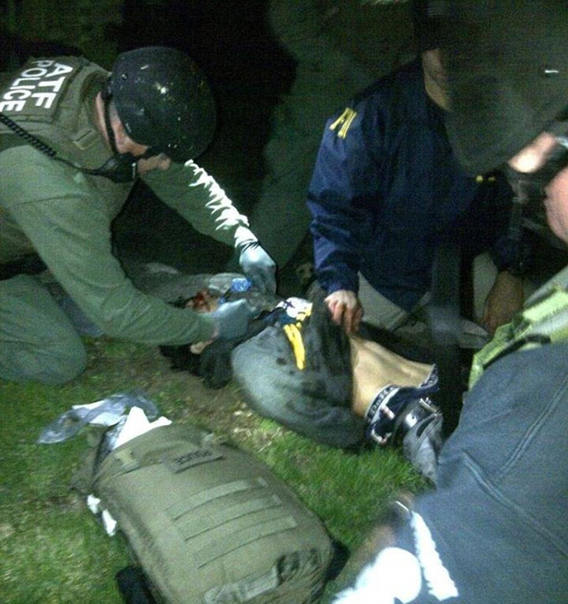
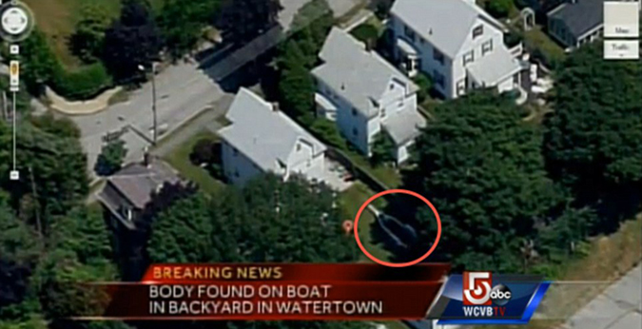

“Contractors” at Boston Marathon Stood Near Bomb, Left Before Detonation
Source: http://www.globalresearch.ca/contractors-at-boston-marathon-stood-near-bomb-left-before-detonation/5332069

(Photos) Seen across street after blasts, talking with FBI bomb squad. Who were they? What were they and the FBI doing?
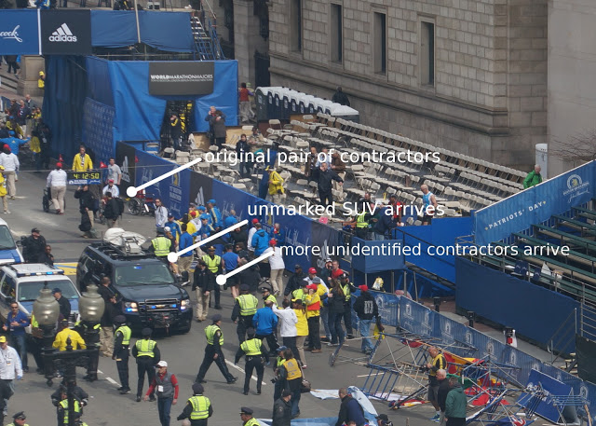
►Editor’s Comment: Article was not set in full due to the original source contains photos in full screen mode for better observation.

The Tsarnaev brothers were double agents who decoyed US into terror trap
Source: http://www.debka.com/article/22914/The-Tsarnaev-brothers-were-double-agents-who-decoyed-US-into-terror-trap

TTamerlan Tsarnaev killed. His brother Dzhokhar captured

The big questions buzzing over Boston Bombers Tamerlan and Dzhokhar Tsarnaev have a single answer: It emerged in the 102 tense hours between the twin Boston Marathon bombings Monday, April 15 – which left three dead, 180 injured and a police officer killed at MIT - and Dzohkhar’s capture Friday, April 19 in Watertown.
The conclusion reached by debkafile’s counterterrorism and intelligence sources is that the brothers were double agents, hired by US and Saudi intelligence to penetrate the Wahhabi jihadist networks which, helped by Saudi financial institutions, had spread across the restive Russian Caucasian.
Instead, the two former Chechens betrayed their mission and went secretly over to the radical Islamist networks.
By this tortuous path, the brothers earned the dubious distinction of being the first terrorist operatives to import al Qaeda terror to the United States through a winding route outside the Middle East – the Caucasus.
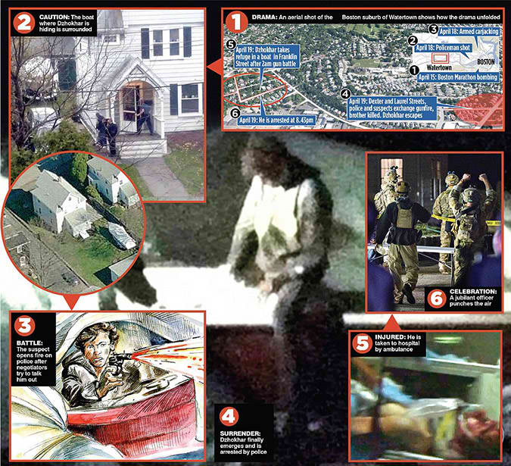
This broad region encompasses the autonomous or semi-autonomous Muslim republics of Dagestan, Ingushetia, Kabardino-Balkaria, Chechnya, North Ossetia and Karachyevo-Cherkesiya, most of which the West has never heard of.
Moscow however keeps these republics on a tight military and intelligence leash, constantly putting down violent resistance by the Wahhabist cells, which draw support from certain Saudi sources and funds from the Riyadh government for building Wahhabist mosques and schools to disseminate the state religion of Saudi Arabia.
The Saudis feared that their convoluted involvement in the Caucasus would come embarrassingly to light when a Saudi student was questioned about his involvement in the bombng attacks while in a Boston hospital with badly burned hands.
They were concerned to enough to send Saudi Foreign Minister Prince Saudi al-Faisal to Washington Wednesday, April 17, in the middle of the Boston Marathon bombing crisis, for a private conversation with President Barack Obama and his national security adviser Tom Donilon on how to handle the Saudi angle of the bombing attack.
That day too, official Saudi domestic media launched an extraordinary three-day campaign. National and religious figures stood up and maintained that authentic Saudi Wahhabism does not espouse any form of terrorism or suicide jihadism and the national Saudi religion had nothing to do with the violence in Boston. “No matter what the nationality and religious of the perpetrators, they are terrorists and deviants who represent no one but themselves.”
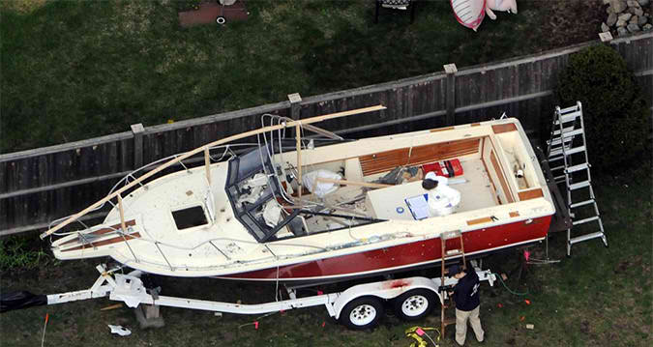
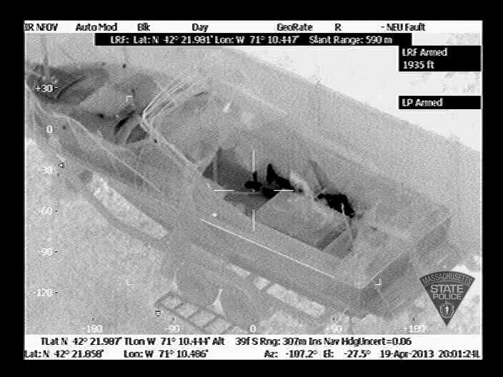
Prince Saud was on a mission to clear the 30,000 Saudi students in America of suspicion of engaging in terrorism for their country or religion, a taint which still lingers twelve years after 9/11. He was concerned that exposure of the Tsarnaev brothers’ connections with Wahhabist groups in the Caucasus would revive the stigma.
The Tsarnaevs' recruitment by US intelligence as penetration agents against terrorist networks in southern Russia explains some otherwise baffling features of the event:
1. An elite American college in Cambridge admitted younger brother Dzhokhar and granted him a $2,500 scholarship, without subjecting him to the exceptionally stiff standard conditions of admission. This may be explained by his older brother Tamerlan demanding this privilege for his kid brother in part payment for recruitment.
2. When in 2011, a “foreign government” (Russian intelligence) asked the FBI to screen Tamerlan for suspected ties to Caucasian Wahhabist cells during a period in which they had begun pledging allegiance to al Qaeda, the agency, it was officially revealed, found nothing incriminating against him and let him go after a short interview.
He was not placed under surveillance. Neither was there any attempt to hide the fact that he paid a long visit to Russia last year and on his return began promoting radical Islam on social media.
Yet even after the Boston marathon bombings, when law enforcement agencies, heavily reinforced by federal and state personnel, desperately hunted the perpetrators, Tamerlan Tsarnaev was never mentioned as a possible suspect
3. Friday, four days after the twin explosions at the marathon finishing line, the FBI released footage of Suspect No. 1 in a black hat and Suspect No. 2 in a white hat walking briskly away from the crime scene, and appealed to the public to help the authorities identify the pair.
We now know this was a charade. The authorities knew exactly who they were. Suddenly, during the police pursuit of their getaway car from the MIT campus on Friday, they were fully identified. The brother who was killed in the chase was named Tamerlan, aged 26, and the one who escaped, only to be hunted down Saturday night hiding in a boat, was 19-year old Dzhokhar.
Our intelligence sources say that we may never know more than we do today about the Boston terrorist outrage which shook America – and most strikingly, Washington - this week. We may not have the full story of when and how the Chechen brothers were recruited by US intelligence as penetration agents – any more than we have got to the bottom of tales of other American double agents who turned coat and bit their recruiters.
Here is just a short list of some of the Chechen brothers’ two-faced predecessors:
In the 1980s, an Egyptian called Ali Abdul Saoud Mohamed offered his services as a spy to the CIA residence in Cairo. He was hired, even though he was at the time the official interpreter of Ayman al-Zuwahiri, then Osama bin Laden’s senior lieutenant and currently his successor.
He accounted for this by posing as a defector. But then, he turned out to be feeding al Qaeda US military secrets. Later, he was charged with Al Qaeda’s 1998 bombings of US embassies in Nairobi and Dar es-Salaam.
On Dec. 30, 2009, the Jordanian physician Humam Khalil al-Balawi, having gained the trust of US intelligence in Afghanistan as an agent capable of penetrating al Qaeda’s top ranks, detonated a bomb at a prearranged rendezvous in Kost, killing the four top CIA agents in the country.
Then, there was the French Muslim Mohamed Merah. He was recruited by French intelligence to penetrate Islamist terror cells in at least eight countries, including the Caucasus. At the end of last year, he revealed his true spots in deadly attacks on a Jewish school in Toulouse and a group of French military commandoes.
The debate has begun over the interrogation of the captured Boston bomber Dzhokhar Tsarmayev when he is fit for questioning after surgery for two bullet wounds and loss of blood. The first was inflicted during the police chase in which his brother Tamerlan was killed.
An ordinary suspect would be read his rights (Miranda) and be permitted a lawyer. In his case, the “public safety exemption” option may be invoked, permitting him to be questioned without those rights, provided the interrogation is restricted to immediate public safety concerns. President Barack Obama is also entitled to rule him an “enemy combatant” and so refer him to a military tribunal and unrestricted grilling.
According to debkafile’s counter terror sources, four questions should top the interrogators' agenda:
a) At what date did the Tsarnaev brothers turn coat and decide to work for Caucasian Wahhabi networks?
b) Did they round up recruits for those networks in the United States - particularly, among the Caucasian and Saudi communities?
c) What was the exact purpose of the Boston Marathon bombings and their aftermath at MIT in Watertown?
d) Are any more terrorist attacks in the works in other American cities?

Two Are Accused in Canada of Plotting Train Derailment
Source: http://www.nytimes.com/2013/04/23/world/americas/2-arrested-in-plot-to-attack-passenger-train-canada-says.html?_r=0

The Royal Canadian Mounted Police on Monday announced the arrest of two men who are accused of planning to derail a passenger train in an Al Qaeda-linked plot.
The police, saying the investigation was continuing, offered little in the way of details or evidence at a news conference in Toronto. Canadian politicians and government officials were similarly reticent.
Assistant Commissioner James Malizia said that the two suspects had received “direction and guidance” from “Al Qaeda elements living in Iran,” but that there was no evidence that the effort had been sponsored by the government of Iran.
He declined to explain how the link to Al Qaeda had been made.
The suspects were identified as Chiheb Esseghaier, 35, who has been living in Montreal, and Raed Jaser, 30, of Toronto. The police said the men were not Canadian citizens, but declined to identify their nationalities or to describe their immigration status in Canada.
Chief Superintendent Jennifer Strachan said the two men had studied train movements and rail lines in and around Toronto, and had been plotting to attack a train operated by Via Rail Canada, the government-owned rail system, within Canada.
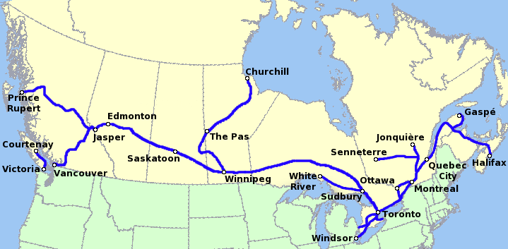
The police declined to identify what train or train line the men had planned to target or to describe how the derailment was to have occurred. Via Rail, in conjunction with Amtrak, runs a train from Toronto to New York’s Penn Station.
The police emphasized that the public had never been in “imminent danger.” Officials said that the suspects had been under constant observation and that contingency plans had been made.
Little is known about the men. The Canadian Press news agency reported that Mr. Esseghaier studied at the University of Sherbrooke in Quebec in 2008 and 2009, and had recently been doing graduate work in biology at the Institut National de la Recherche Scientifique in Montreal.
Both the police and David Jacobson, the United States ambassador to Canada, indicated that the F.B.I. and other American law enforcement and intelligence agencies were involved in the investigation. No one, however, offered any specifics about that involvement or indicated if the plot had a cross-border element.
“These arrests were the result of extensive cross-border cooperation, which is the hallmark of our relationship,” Mr. Jacobson said in a statement. “Dedicated professionals on both sides of the border brought these arrests to fruition.”
During the news conference, senior officers of the Mounted Police were asked repeatedly about the link to Iran, which seemed unusual. Iran is dominated by Shiites while Al Qaeda is a Sunni organization. But the United States has accused Iran of aiding Al Qaeda in the past.
The arrests were made shortly before Canada’s House of Commons began a debate on legislation that would expand the powers of police and intelligence agencies in suspected terrorism cases.
Early this month, the Mounted Police said two young Canadians from London, Ontario, had died in January while participating in an attack on a gas plant in Algeria. In 2006, the police arrested 18 people in and around Toronto who they said were part of a Qaeda-affiliated group that planned attacks in Canada. Eleven were convicted or pleaded guilty while charges against the remainder of the suspects were dropped.

The Northern Caucasus region a breeding ground for terrorists
Source: http://www.homelandsecuritynewswire.com/seworld20130422-the-northern-caucasus-region-a-breeding-ground-for-terrorists

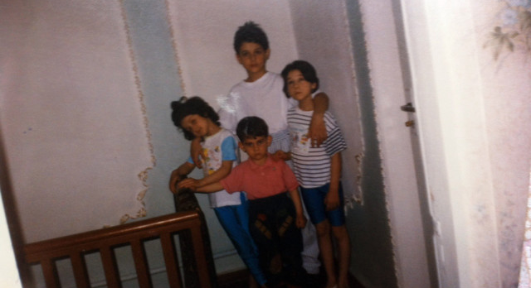
For more than 150 years, the Northern Caucasus region of Russia has seen a restive population chafing under Russian – and, later, Soviet – rule. When the Soviet Union disintegrated in 1991, the separatist forces in Chechnya tried to negotiate independence from the Russian Federation, but failed. The separatists launched a campaign against the Russian rule in Chechnya, and in response, the Russian military invaded the territory, brutally suppressing the rebellion. Following their defeat in the 1994-95 war, the originally secular separatist movement turned toward Islamic radicalism: the seizure of power in Afghanistan by the Taliban, the creation of al Qaeda, and the support Islamic movements – and governments — offered fellow co-religionists in Bosnia-Herzegovina and, later, in Kosovo, persuaded Chechen separatist leaders that aligning their movement with the broader Islamic cause was the best path to secure support from the Muslim world in the form of money and fighters. This affiliation with the global Jihadi movement became even stronger after the second round of Russian military intervention in Chechnya, in 1999-2000.
An undated file photo released to Bloomberg by a family aunt shows Tamerlan Tsarnaev, top center, and Dzhokar Tsarnaev, bottom center, posing with their sisters at an undisclosed location. Source: Family photo via Bloomberg

More than 200,000 have so far been killed in Chechnya, nearly all of them Chechen civilians killed by the Russian army, and hundreds of thousands more have been turned into refugees. Russia has been roundly criticized for its military tactics in the two rounds of war, tactics which included carpet-bombing of cities — including the flattening of the capital city of Grozny — and indiscriminate artillery shelling and missile attacks on civilian neighborhoods.

Why the Boston Bombers Succeeded
By Scott Stewart (Vice President of Analysis – Stratfor)
Source:http://www.stratfor.com/weekly/why-boston-bombers-succeeded?utm_source=freelist-f&utm_ medium=email&utm_campaign=20130423&utm_term=sweekly&utm_content=readmore&elq=91aa0e582e634a338ea133917c59a52c

When seeking to place an attack like the April 15 Boston Marathon bombing into context, it is helpful to classify the actors responsible, if possible. Such a classification can help us understand how an attack fits into the analytical narrative of what is happening and what is likely to come. These classifications will consider factors such as ideology, state sponsorship and perhaps most important, the kind of operative involved.
In a case where we are dealing with an apparent jihadist operative, before we can classify him or her we must first have a clear taxonomy of the jihadist movement. At Stratfor, we generally consider the jihadist movement to be divided into three basic elements: the al Qaeda core organization, the regional jihadist franchises, such as al Qaeda in the Arabian Peninsula, and grassroots operatives who are radicalized, inspired and perhaps equipped by the other two tiers but who are not members of either.
Within the three-tier jihadist movement there exist two distinct types of operatives. One of these is the professional terrorist operative, a person who is a member of the al Qaeda core or of one of the regional franchises. These individuals swear loyalty to the leader and then follow orders from the organization's hierarchy. Second, there are amateur operatives who never join a group and whose actions are not guided by the specific orders of a hierarchical group. They follow a bottom-up or grassroots organizational model rather than a hierarchical or top-down approach.
There is a great deal of variety among professional terrorists, especially if we break them down according to the functions they perform within an organization, roles including that of planners, finance and logistics specialists, couriers, surveillance operatives, bombmakers, et cetera. There is also a great deal of variety within the ranks of grassroots operatives, although it is broken down more by their interaction with formal groups rather than their function. At one end of the grassroots spectrum are the lone wolf operatives, or phantom cells. These are individuals or small groups who become radicalized by jihadist ideology, but who do not have any contact with the organization. In theory, the lone wolf/phantom cell model is very secure from an operational security standpoint, but as we've discussed, it takes a very disciplined and driven individual to be a true lone wolf or phantom cell leader, and consequently, we see very few of them.
At the other end of the grassroots spectrum are individuals who have had close interaction with a jihadist group but who never actually joined the organization. Many of them have even attended militant training camps, but they didn't become part of the hierarchical group to the point of swearing an oath of allegiance to the group's leaders and taking orders from the organization. They are not funded and directed by the group.
Indeed, al Qaeda trained tens of thousands of men in its training camps in Afghanistan, Sudan and Pakistan but very few of the men they trained actually ended up joining al Qaeda. Most of the men the group instructed received basic military training in things like using small arms, hand-to-hand combat and basic fire and maneuver. Only the very best from those basic combat training courses were selected to receive advanced training in terrorist tradecraft techniques, such as bombmaking, surveillance, clandestine communications and document forgery. But even of the students who received advanced training in terrorist tradecraft, only a few were ever invited to join the al Qaeda core, which remained a relatively small vanguard organization.
Many of the men who received basic training traveled to fight jihad in Afghanistan, Bosnia and Chechnya or returned home to join insurgent or militant groups. Others would eventually end up joining al Qaeda franchise groups in places like Yemen, Iraq, Libya and Algeria. Still others received some basic training but then returned home and never really put their new skills into practice.
Most grassroots jihadists fall along a continuum that stretches between the lone wolf and someone who received advanced terrorist training but never joined al Qaeda or another formal militant group.
Whether the two men suspected of carrying out the April 15 Boston Marathon attack knowingly followed al Qaeda's blueprint for simple attacks by grassroots actors, their actions were fairly consistent with what we have come to expect from such operatives. Certainly based upon what we have seen of this case so far, the Tsarnaev brothers did not appear to possess sophisticated terrorist tradecraft.
For example, regarding the bombs employed in the attack and during the police chase, everything we have seen still points to very simple devices, such as pipe bombs and pressure cooker devices. From a bombmaking tradecraft standpoint, we have yet to see anything that could not be fabricated by reading Inspire magazine, spending a little bit of time on YouTube and conducting some experimentation. As a comparison, consider the far larger and more complex improvised explosive device Anders Behring Breivik, the Oslo bomber, constructed. We know from Breivik's detailed journal that he was a self-taught bombmaker using directions he obtained on the Internet. He was also a lone wolf. And yet he was able to construct a very large improvised explosive device. Also, although the Tsarnaev brothers did not hold up a convenience store as initially reported, they did conduct an express kidnapping that caused them to have extended contact with their victim while they visited automatic teller machines. They told the victim that they were the bombers and then allowed the victim to live. Such behavior is hardly typical of professional terrorist operatives.

Grassroots Theory
As it has become more difficult for professional terrorists to travel to the United States and the West in general, it has become more difficult for jihadist organizations to conduct attacks in these places. Indeed, this difficulty prompted groups like al Qaeda in the Arabian Peninsula to attempt to attack the United States by dispatching an operative with an underwear bomb and to use printer cartridge bombs to attack cargo aircraft. In response to this difficulty, al Qaeda in the Arabian Peninsula began to adopt the grassroots into their operational doctrine. They first began promoting this approach in 2009 in their Arabic-language magazine Sada al-Malahim. The al Qaeda core organization embraced this approach in May 2010 in an English-language video featuring Adam Gadahn.
In July 2010, al Qaeda in the Arabian Peninsula launched an English-language magazine called Inspire dedicated to radicalizing and equipping grassroots jihadists. Despite the losses that al Qaeda in the Arabian Peninsula has experienced on the battlefield, it has continued to devote a great deal of its limited resources toward propagating this concept. It has continued to publish Inspire even after the magazine's founder and editor, Samir Khan, was killed in an American missile strike in Yemen.
The grassroots strategy was perhaps most clearly articulated in the third edition of Inspire magazine, which was published in November 2010 following the failed October 29, 2010, printer bomb operation. In a letter from the editor in which Khan explained what he referred to as "Operation Hemorrhage," he wrote:
"However, to bring down America we do not need to strike big. In such an environment of security phobia that is sweeping America, it is more feasible to stage smaller attacks that involve fewer players and less time to launch and thus we may circumvent the security barriers America has worked so hard to erect. This strategy of attacking the enemy with smaller, but more frequent operations is what some may refer to the strategy of a thousand cuts. The aim is to bleed the enemy to death."
In Adam Gadahn's May 2010 message entitled "A Call to Arms," Gadahn counsels lone wolf jihadists to follow a three-pronged target selection process. They should choose a target with which they are well acquainted, a target that is feasible to hit and a target that, when struck, will have a major impact. The Tsarnaev brothers did all three in Boston.

Implications
Yet despite this clearly articulated theory, it has proved very difficult for jihadist ideologues to convince grassroots operatives to conduct simple attacks using readily available items like in the "build a bomb in the kitchen of your mom" approach, which they have advocated for so long.
This is because most grassroots jihadists have sought to conduct huge, spectacular attacks -- attacks that are outside of their capabilities. This has meant that they have had to search for help to conduct their plans. And that search for help has resulted in their arrest, just as Adam Gadahn warned they would be in his May 2010 message.
There were many plots disrupted in 2012 in which grassroots operatives tried to act beyond their capabilities. These include:
- On Nov. 29, 2012, two brothers from Florida, Raees Alam Qazi and Sheheryar Alam Qazi, were arrested and charged with plotting attacks in New York.
- On Oct. 17, 2012, Bangladeshi national Quazi Nafis was arrested as part of an FBI sting operation after he attempted to detonate a vehicle bomb outside New York's Federal Reserve Bank.
- On Sept. 15, 2012, Adel Daoud was arrested after he parked a Jeep Cherokee outside a Chicago bar and attempted to detonate the bomb he thought it contained. This was also an FBI sting operation.
But the carnage and terrorist theater caused by the Boston attack have shown how following the simple attack model can be highly effective. This will certainly be pointed out in future editions of Inspire magazine, and grassroots operatives will be urged to follow the model established by the Tsarnaev brothers. Unlike operatives like Faisal Shahzad who attempted to go big themselves and failed, the brothers followed the blueprint for a simple attack and the model worked.
It is quite possible that the success of the Boston bombing will help jihadist ideologues finally convince grassroots operatives to get past their grandiose plans and begin to follow the simple attack model in earnest. If this happens, it will obviously have a big impact on law enforcement and intelligence officials who have developed very effective programs of identifying grassroots operatives and drawing them into sting operations. They will now have to adjust their operations.
While these grassroots actors do not have the capability of professional terrorist operatives and do not pose as severe a threat, they pose a much broader, amorphous threat. Law enforcement and intelligence agencies generally do not deal well with ambiguity.
There are simply too many soft targets to protect and some of these simple attacks will inevitably succeed. This means that this low-level broad threat will persist and perhaps even intensify in the immediate future.
As we've previously discussed, the best defense against the grassroots threat are grassroots defenders. These include the police and alert citizens who report suspicious activity -- like people testing bomb designs -- a frequent occurrence before actual bomb attacks. The slogan "If you see something, say something," has been mocked as overly simplistic, but it is nonetheless a necessity in an environment where the broad, ambiguous threat of grassroots terrorism far outstrips the ability of the authorities to see everything. Taking a proactive approach to personal and collective security also beats the alternative of living in terror and apprehensively waiting for the next simple attack.
It is also very important for people to maintain the proper perspective on terrorism. Like car crashes and cancer and natural disasters, terrorism is part of the human condition. People should take prudent, measured actions to prepare for such contingencies and avoid becoming victims (vicarious or otherwise). It is the resilience of the population and its perseverance that will ultimately determine how much a terrorist attack is allowed to terrorize. By separating terror from terrorism, citizens can deny the practitioners of terror the ability to magnify their reach and power.

Quiz: How much do you know about terrorism?
Source: http://www.csmonitor.com/World/Global-Issues/2012/0719/Quiz-How-much-do-you-know-about-terrorism/Question-1?goback=.gde_1528217_member_234319612

►Some very interesting questions that will test your knowledge – and even make you wonder!

Pictures That Prove Double Amputee Was An Actor at Boston Bombings
Source: http://beforeitsnews.com/alternative/2013/04/pictures-that-prove-double-amputee-was-an-actor-at-boston-bombings-2626684.html
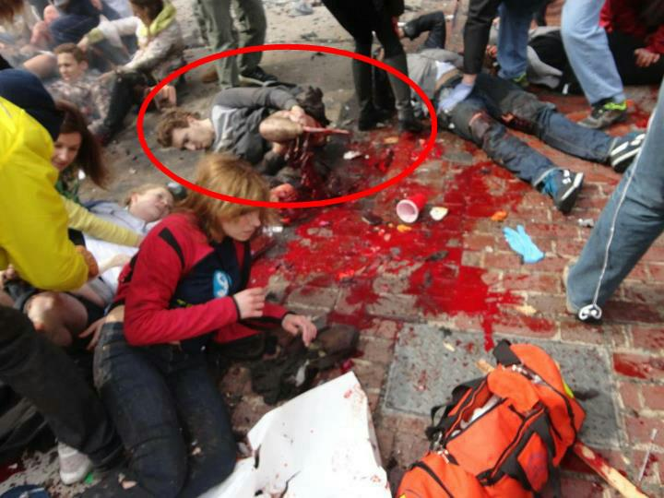

Kahane Chai
Source:http://www.start.umd.edu/start/data_collections/tops/terrorist_organization_profile.asp?id=3750
Mothertongue Name: | n/a
Aliases: | Kach
Bases of Operation: | Israel, West Bank/Gaza
Date Formed: | December, 1990
Strength: | Less than 100 members
Classifications: | Nationalist/Separatist, Racist, Religious
Financial Sources: | Donations from supporters in U.S. and Europe
Founding Philosophy: | Kahane Chai is an offshoot of Kach, the religious extremist group formed by Rabbi Meir Kahane. Following Kahane's assassination in 1990, his son Binyamin Kahane formed Kahane Chai (which means Kahane lives). Although Kahane Chai and Kach are designated separately, Kahane Chai is essentially an alias for Kach as the two groups have a shared core leadership and are referred to interchangeably in the media. The differences between Kach and Kahane Chai centered around personal squabbles between Binyamin Kahane and the leaders of Kach, but such differences have disappeared since Binyamin Kahane was killed in 2000.  Kahane Chai, along with Kach, was banned from politics in Israel in 1994 following Dr. Baruch Goldstein's killing of 29 Muslims in the Cave of the Patriarchs. Goldstein was a member of Kach and statements in support of his actions by Kach and Kahane Chai led to their ban. Despite this ban, Kahane Chai is still very active in Israeli society and its leaders openly recruit new members and criticize government policy.  Kahane Chai is a violent group that aims to reinstate the ancient Biblical kingdom in Israel. It aims for expulsion of Arabs from Israeli territory and the creation of a Jewish theocracy. The group has been linked to a bombing attempt at the schoolyard of an Arab all-girls school and has been designated as a terrorist group by many foreign governments due to its constant intimidation of Arabs throughout Israel. The group has in recent years refrained from major terrorist activity as it is attempting to convince the Israeli government to lift the ban on Kahane Chai.
Current Goals: | Kahane Chai increased its level of activity in protest of Ariel Sharon's plan to dismantle settlements in the Gaza Strip and West Bank. Viewing such a step as a violation of the principle that Jews deserve control of the holy land, the group issued many ominous warnings. The most serious threats leveled by Kahane Chai involved threats on the lives of politicians who supported the disengagement plan as well as an announcement of plans to derail train tracks in protest of the new policy. In any case, although opposition to disengagement was widespread, it was rarely violent, and Kahane Chai did not carry out any terrorist attacks.

Key Leaders
- Ben-Gvir, Itamir
- Federman, Noam
- Kahane, Binyamin Ze'ev
- Marzel, Baruch

Related Groups
- EYAL (Fighting Jewish Organization) -- Other Affiliation
- Kach -- Founding Group

U.S. Government Designations
Foreign Terrorist Organization (FTO): | No
Terrorist Exclusion List (TEL): | No

Other Governments' Designations
UK Proscribed Group: | No
Australia Specified Group: | No
Canada Specified Group: | Yes
EU Specified Group: | Yes
Russia Specified Group: | No

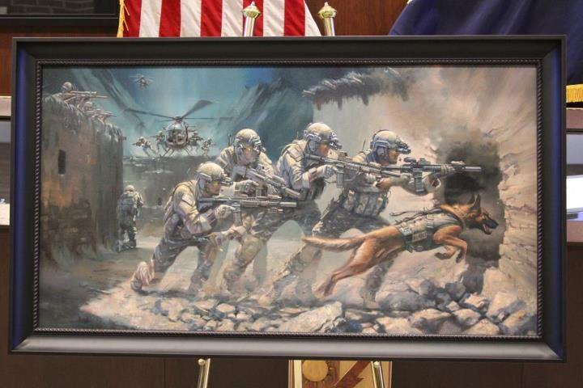

Two women arrested for 'plotting' attack on F1
Source: http://www.gulf-daily-news.com/NewsDetails.aspx?storyid=352015

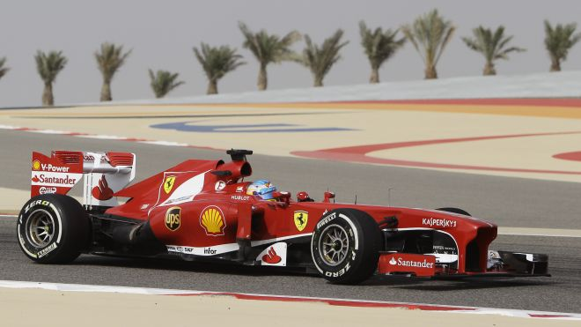
Two Bahraini women have been arrested for allegedly plotting to attack the Formula One race held in the country last weekend.
They have been transferred to the Public Prosecution after officers stopped them at a police checkpoint stationed on the highway towards the Bahrain International Circuit (BIC).
Public Security chief Major-General Tariq Al Hassan said the Interior Ministry was successful in ensuring law and order across the country during the Gulf Air Bahrain Grand Prix because of increased police presence in different locations.
"On the second day of the Grand Prix, police assigned to the Bahrain International Circuit's gate stopped two girls who were acting suspiciously," he was quoted in a comprehensive report about security incidents, plans and investigations.
"After searching them it was found that one of them was wearing a pillow stuffed under her clothes. The girl told police she was testing security procedures as part of a primary step for a terror act."
Maj-Gen Al Hassan said police seized more than 1,000 ready-to-use Molotov cocktails, a large quantity of empty bottles used to make firebombs, 19 fake bombs, three ready-to-use explosives, planted in different areas, over 130 tyres, a number of petrol tanks, iron rods and 72 homemade fire extinguisher guns.
He said police also discovered an ammunition warehouse on April 20 in Duraz which contained homemade weapons and bullets.
Tear gas canisters and fire extinguishers that were reconfigured to shoot iron rods were also found. The same day, officers uncovered an illegal makeshift clinic in A'ali that was used to treat rioters.
Maj-Gen Al Hassan also refuted online reports that police made arbitrary arrests.
He said 27 people have been arrested between November 7 and April 21 on different charges including detonating homemade bombs, arson attack on an ATM machine, attacking police patrols, blocking major highways with rubbish bins, damaging a private car during a Molotov cocktail attack, and attacking a woman in her car.

Shattering the al-Qaeda-Chechen Myth
Source:http://app.bronto.com/public/?q=preview_message&fn=Link&t=1&ssid=500&id=2hpc43mz1larh4nfb3zlqjbkzu0xe&id2=6b3ku8zh4ljss5vm1dm2injzlutow&subscriber_id=bhuhzevrvpcumonhxrajjsgucxtabkd&messageversion_id=bqlxszppfbuaskuyoswinrsurestbje&delivery_id=avtyiglartpmbjuearqesaxssvqmbkn&tid=3.AfQ.T44Z.CqSL.ARyIug..AoabKg.b..l.AxTh.b.UXc6Bg.UXc6Bg.e5jBOw

EDITOR’S COMMENT: The Jamestown Foundation presents two in-depth pieces of analysis, written by Brian Glyn Williams in 2003, which resolutely dissect and reject the notion of a direct connection between the al-Qaeda terrorist network and the Chechen insurgency fighting against the Russian Federation. Dr. Brian Glyn Williams is assistant professor of Islamic History at the University of Massachusetts-Dartmouth.

Boston Bombers Had Links to al Qaeda Terrorist Cells
Source: http://www.debka.com/article/22922/Boston-Bombers-Had-Links-to-al-Qaeda-Terrorist-Cells

The surviving Boston bomber Dzhokhar Tsarnaev has every incentive for insisting that he and his brother acted alone and out of “ideological” motives in the Boston Marathon bombings of April 15.
That was predictable.
What is surprising is the acceptance of this claim by his federal interrogators.
He can’t speak because of a wound to the throat. But did they really expect him to write down the names and addresses of his and his brother Tamerlan’s fellow terrorists and associates?
Dzhokhar was formally charged Monday, April 22, with using and conspiring to use a weapon of mass destruction. The charge related to the twin bombings of the Boston Marathon causing the deaths of three people including an 8-year old boy and injuring 180 others.
One way or another, the 19-year old Dzhokhtar is condemned to die – whether under a federal court sentence or from his injuries.
If he sticks to his story that they brothers acted alone in the cause of Islam, he dies a “a glorious martyr” to the sacred cause, celebrated across the radical Islamic world as a shining inspiration for more terrorist cells to go forth bearing his name.
Politicians are not the only ones who care about their legacies. To achieve this he must refrain from spilling the beans and lead the FBI inquiry up a blind alley.
DEBKA’s counter-terrorism sources say the investigation’s best bet would be to finally follow up on the treasure trove the Federal Security Service of the Russian Federation – the FBS - relayed to Washington in 2011. They not only fingered Tamerlan, who died in a shootout with the Boston police, as a “suspect Islamist terrorist” but revealed that he had toured radical Islamic mosques in Dagestan and Chechnya in search of contacts in jihadist terror groups. The Russians also appended a whole list of terrorist suspects of Caucasian descent in the Boston area.
Also worth following up is Barack Obama’s call to Russian President Vladimir Putin on April 19 to thank him for Moscow’s cooperation n the marathon bombing investigation
What was that about? What made Russian assistance valuable enough for the two presidents to agree on better cooperation between the FBI and the FBS?
And the content of a second conversation that took place at the height of the search for the Boston bombers would be highly relevant too. On April 17, Saudi Foreign Minister Prince Saud al-Faisal arrived unannounced at the White House and was immediately received by President Obama. Our sources report that he too handed a high-value dossier from confidential files in Riyadh containing data on clandestine Saudi terrorist cells in the Boston area.
By digging into an unsolved two-year old triple murder, the Boston Globe lifted a corner of the veil on the Tsarnaev brothers’ violent past in the service of radical Islam. The Boston police consequently reopened the case this week and are looking at Tamerlan for the murder of three young Jews found with slashed throats in a Waltham, Massachusetts apartment on Sept. 11, 2011. Brendan Mess was Tamerlan’s close friend, Erik Weissman, a Brandeis University graduate and Raphael Teken a devout Jew.

Look again at the date: The murders took place on the 10th anniversary of 9/11.

A Sketch of Jemal Oukacha: The New Commander of AQIM in the Sahel and Sahara

Source: http://mlm.jamestown.org

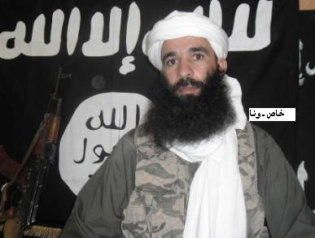
Jemal Oukacha (a.k.a. “Yahya Abu al-Hammam”) is a new commander of al-Qaeda in the Islamic Maghreb (AQIM). As the “Emir of the Sahara,” Oukacha has control over a brigade of AQIM fighters responsible for an area stretching from the Azawad region of northern Mali to the region of Ghardaia in southern Algeria (Ennahar TV [Algiers], March 24). He is a high value target for Western and West African security services, with a long history of participation in the transnational West African jihadist movement, including the planning and execution of attacks against embassies and military buildings as well as the kidnapping and killing of civilians (France 24 [Paris], September 23, 2010). The Department of State designated Oukacha as a terrorist under U.S. Executive Order 13224 in February (U.S. Department of the Treasury, February 14).
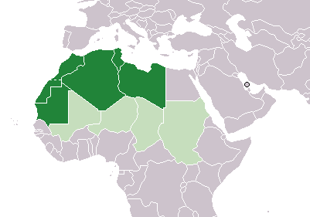
He was born in 1978 in the village of Reghaia, east of Algiers (Reuters, October 5, 2012). Oukacha is reported to have been a member of the Algerian militant organization the Salafist Group for Preaching and Combat (GSPC) at its founding in 1997, during which time he is believed to have built his relationship with Abu Musab Abd al-Wadoud (Jeune Afrique [Paris], April 9). He was arrested by Algerian authorities in 1998 and was released in 2000 after an alleged amnesty agreement between the GSPC and the Algerian government. Oukacha subsequently returned to fighting with the GSPC (Algerie1 [Paris], February 14).
Following his time in prison, Oukacha was reportedly an active GSPC fighter in northern Algeria in the region of Algiers and to have fought in southern Algeria and northern Mali until 2004-2005, when he was placed under the command of Mokhtar Belmokhtar, an important AQIM leader based at the time in Mauritania (Jeune Afrique [Paris], April 9). Under the command of Belmokhtar, Oukacha allegedly participated in an attack against the northern Mauritanian military base of Lemgheity that killed 17 Mauritanian soldiers (Ennahar [Algiers], September 22, 2010). Oukacha is also reported to have planned and executed an October 2007 attack on the Mauritanian military base of El Ghallaouiya near the central city of Oudane that killed three Mauritanian soldiers (Le Combat [Bamako], October 8, 2012).
While in Mauritania, Oukacha eventually transferred to fight under the nominal command of Abdelhamid Abou Zeid, who was reputed to be one of the most ruthless of AQIM’s leaders. As an important sub-commander in Abou Zeid’s Tariq Ibn Ziyad Brigades, Oukacha led the al-Fourqan Brigade and was believed to have been involved in the planning of a number of operations conducted against local and Western targets in Mauritania (Terrorism Monitor, March 20, 2013). These attacks included the suicide bombing assassination at the French embassy in Nouakchott in August 2009 of Chris Leggett, an American humanitarian worker who was accused of proselytizing Christianity (Ennahar [Algiers], September 22, 2010).

Maghreb (dark green) – Sahel (light green)

In 2012, Oukacha emerged as one of the most important figures amongst the jihadist movement in northern Mali. The al-Fourqan Brigade, under the command of Oukacha, joined several other AQIM cadres that entered Mali and was encamped to the east of Timbuktu (Le Matin [Algiers], November 24, 2012). Following the capture of the central-northern Malian city of Timbuktu by the militant Salafist, ethnic Tuareg organization Ansar al-Din in April 2012, Oukacha was named the “Governor” of Timbuktu by Ansar al-Din’s leader Iyad ag Ghali (Magharebia [Nouakchott], April 16, 2012). The appointment occurred after ag Ghali had invited Oukacha, Abu Zeid and Belmokhtar to Timbuktu as AQIM’s representatives and advisers, on how to implement Shari’a law in the city (Agence France Presse, April 3, 2012). Perhaps realizing the growing importance of Oukacha to the jihadist movement in Mali and the wider Sahel region, the al-Furqan Brigade was reportedly the target of a drone strike which killed six jihadist fighters moving in a convoy near Timbuktu in June 2012 (Magharebia [Nouakchott], June 22, 2012).
Oukacha was later appointed the Emir of the Sahara in October 2012 following the death of the former Emir, Nabil Makhloufi (a.k.a. “Abu al-Kama), in a car accident in northern Mali. The Emir of the Sahara is an important position within AQIM and is reportedly responsible for Zone 9 of the Southern Region of the group’s “Islamic Empire of the Desert” (al-Akhbar [Nouakchott], June 16, 2012). It is stated that Abu Musab Abd al-Wadoud (a.k.a. “Abd al-Malik Droukdel”), Oukacha’s mentor and the Algerian-born overall commander of AQIM, directly intervened in his selection as Emir of the Sahara (Reuters, October 5, 2012; see also Terrorism Monitor, October 18, 2012). As Emir, Jemal Oukacha is believed to command multiple brigades of jihadist fighters from several West African countries, including Tunisia, Algeria, Mauritania, Morocco and Libya (Le Combat [Bamako], May 17, 2012). Shortly after assuming the title of Emir, Oukacha relinquished leadership of the al-Furqan Brigade to his long-time Mauritian subordinate Mohammad Lemine Ould Hacen (Le Matin [Algiers], November 24, 2012).
Since the threat and eventual intervention of French, African Union and Economic Community of West African States (ECOWAS) military forces against jihadist groups in northern Mali in January, Oukacha has been outspoken in his threats of retaliation and defeat for the invading armies. In October 2012, he stated that a potential French and ECOWAS invasion of Mali would be a “proxy war after the failure of direct intervention in Afghanistan,” and that six French hostages seized by AQIM in the Sahel region would be killed in the event of Mauritanian participation in an invasion of northern Mali (Agence Nouakchott d’Information, October 20, 2012; see also Terrorism Monitor December 14, 2012). Following the military intervention of French and African forces in northern Mali, Oukacha stated that jihadist fighters would engage in prolonged, mobile, guerilla warfare to bleed its enemies in Mali and expand its range of operations against French and its African allies’ interests throughout the Sahel region (al-Jazeera, January 27).
Oukacha is considered to be a well-respected and talented fighter with strong tactical combat leadership and a serious commitment to Islamic piety (Jeune Afrique [Paris], April 9). He is reportedly one of the few AQIM leaders to have earned wide respect amongst the jihadist groups fighting in Mali, including the remnants of Ansar al-Din and the Movement for Oneness and Jihad in West Africa (MUJWA), which have been on tense terms since the establishment of a large jihadist presence in northern Mali (Le Combat [Bamako], October 8, 2012; see also Terrorism Monitor, October 18, 2012). French authorities regard Oukacha as the mastermind of the logistical network supplying the jihadists seeking to defeat allied forces through a war of attrition in the Ifoghas Massif in northeastern Mali (Le Monde [Paris], March 4, 2013). As a result of his experience, the loyalty he commands and stated strategy of engaging in a “long war” with French and regional forces, Oukacha is emerging as the most dynamic and dangerous, jihadist commander in the Sahel and Maghreb region.

The North Korean spy who blew up a plane
Source: http://www.bbc.co.uk/news/world-asia-22244337

Kim Hyun-hui certainly doesn't look like a mass murderer. The 51-year-old mother of two has a gentle smile and soft voice.
Today she lives in quiet seclusion somewhere in South Korea; she won't say where. The day we meet she is, as always, accompanied by a group of hired heavies in ill-fitting suits.
She fears the North Korean government still wants to kill her, and with good reason.
Kim Hyun-hui was once an agent of the North Korean regime. Twenty-five years ago, on Pyongyang's orders, she blew up a South Korean airliner.
Sitting in a Seoul hotel room she describes to me how, at the age of 19, she was recruited from an elite Pyongyang University where she was studying Japanese.
She trained for six years. For three of them she was paired with a young Japanese woman, Yaeko Taguchi, who had been kidnapped from her home in northern Japan. She says Mrs Taguchi taught her to speak and act like a Japanese.
Then came her fateful mission.
It was 1987 and South Korea was preparing to host the Olympic Games in Seoul. North Korea's leader Kim Il-sung and his son Kim Jong-il were determined to stop it.
"I was told by a senior officer that before the Seoul Olympics we would take down a South Korean airliner," Kim Hyun-hui tells me.
"He said it would create chaos and confusion in South Korea. The mission would strike a severe blow for the revolution."

Direct orders
Kim and an older accomplice boarded the Korean Airlines plane in Baghdad. She placed the suitcase bomb in an overhead locker.
During a stopover in Abu Dhabi, the two North Korean agents got off and made their escape.
Kim Hyun-hui: "I am sad to have been born in North Korea" | Kim Hyun-hui was sentenced to death, but later received a presidential pardon

Hours later over the Andaman Sea, the bomb blew up. All 115 on board were killed.
But then their plan went wrong. The two agents were tracked to Bahrain and caught.
Her accomplice killed himself with a cyanide-laced cigarette, but Kim Hyun-hui failed. She was instead flown to Seoul and paraded before the international media.
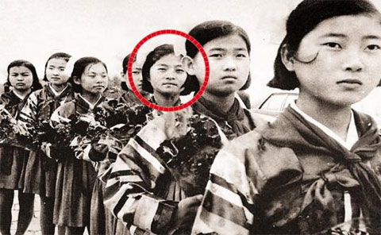
"When I came down the steps of that aircraft, I didn't see anything," she says. "I just looked at the ground. They had taped my mouth shut. I thought I was entering the den of the lion. I was sure they were going to kill me."
Instead they took her to an underground bunker where the interrogations began.
At first she says she tried to keep up the pretence she was Japanese. But finally she broke.
"When I confessed, I did so reluctantly. I thought my family in North Korea would be in danger; it was a big decision to confess. But I began to realise it would be the right thing to do for the victims, for them to be able to understand the truth."
In her confession, Kim made it clear that the orders to bomb the plane had come directly from Kim Il-sung or his son and heir-apparent, Kim Jong-il.
/Courtesy of the National Intelligence Service

God-like figure
"In North Korea everything was about the Kingdom of Kim Il-sung and his son Kim Jong-il," she says.
"Without their sanction nothing could happen. We were told our orders were 'ratified'. They only used that word when the orders came from the top.
"Kim Il-sung was a god-like figure. Anything that was ordered by him could be justified. Any order would be carried out with extreme loyalty. You were ready to sacrifice your life."
From what she tells me, it is clear Kim Hyun-hui has gone from one-time true believer in the Kim cult to an ardent hatred of the regime and a deep sense of personal victimhood.
"There is no other country like North Korea," she says. "People outside can't understand. The whole country is set up to show loyalty to the Kim royal family. It's like a religion.
"People are so indoctrinated. There are no human rights, no freedoms.
"When I look back it makes me feel sad. Why did I have to be born in North Korea? Look at what it did to me."
She also believes, perhaps wishfully, that the days of the Kim dynasty are numbered.
With the founders of the dynasty - Kim Il-sung and Kim Jong-il - now dead, their impoverished kingdom has been handed down to the 30-year-old Kim Jong-un.
"North Korea is in a desperate situation," she says. "Discontent with Kim Jong-un is so high; he has to put a lid on it.
"The only thing he has is nuclear weapons. That's why he has created this sense of war, to try to rally the population. He's doing business with his nuclear weapons."
In 1989 a South Korean court sentenced Kim Hyun-hui to death, but President Roe Tae-Woo gave her a pardon.
She later married a South Korean intelligence officer with whom she has two children.
Some might say she got off lightly considering what she did. But she says she still carries a heavy burden of guilt.
She says she has found solace in Christianity, and in meeting and being forgiven by the families of those she killed.
"Eventually when I met the victim's families," she says, "we were all in tears hugging and crying."
During our hour-long meeting, there is only one moment when her emotions break through. It is right at the end, when I ask her about her family in North Korea. With tears welling up in her eyes, she shakes her head.
"I don't know what happened to them," she says. "I have heard that they were seen being taken away from Pyongyang to a labour camp."

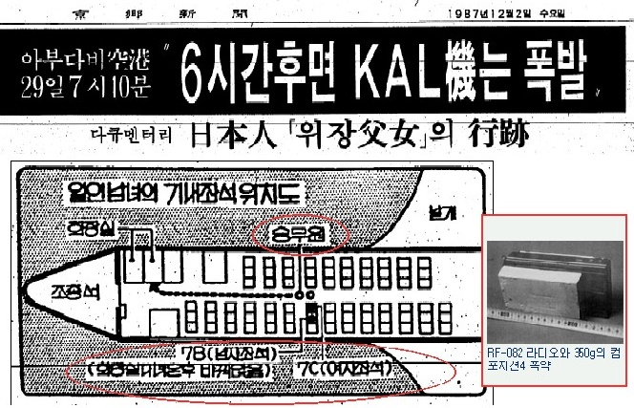

Dzhokhar Tsarnaev had no firearms, explosives with him when captured (25 April 2013)
Source: http://www.homelandsecuritynewswire.com/dr20130425-dzhokhar-tsarnaev-had-no-firearms-explosives-with-him-when-captured

More details have emerged to shed light on the last few hours before 19-year old Dzhokhar Tsarnaev was captured hiding on a boat in Watertown, Massachusetts. Tsarnaev had no weapons or explosives with him in the boat where he was hiding. Boston police officers say that the heavy fire directed at the boat was probably the result of chaos of the moment. In a tense and charged atmosphere, one accidental shot could have caused what police call “contagious fire.” Tsarnaev sustained severe injuries, some of them to his neck and lower jaw, preventing him from talking. This led to rumors in the press that he tried to take his own life, but failed. We now know that he could not have tried to take his life because he had no firearms with him on the boat.
- There was no firefight in the backyard of the house where the boat was parked – or, more precisely, it was a one-sided fire: Tsarnaev did not respond to the heavy fire directed at the boat by police officers because he was unarmed. The police kept firing at the boat, on and off, for about half an hour, but in the tension and confusion which surrounded the siege it appears that they did not realize that nobody was firing back at them.
- The Washington Post reports that the FBI, whose agents were among those surrounding the boat, would not comment specifically on the events, but an FBI spokesman, Paul Bresson, said: “Law enforcement was placed in an extraordinarily dangerous situation…. They were dealing with an individual who is alleged to have been involved in the bombings at the Boston Marathon. As if that’s not enough, there were indications of a carjacking, gunfire, an ambushed police officer and bombs thrown earlier. In spite of these extraordinary factors, they were able to capture this individual alive with no further harm to law enforcement. It was a tremendously effective outcome under dire circumstances.”
- Boston police sources say that the heavy fire directed toward the boat was probably the result of chaos of the moment. Some police officers present believed Tsarnaev had fired a weapon at them, and that he was about to detonate explosives. One police officer described the situation as “the fog of war,” and said that in a tense and charged atmosphere, one accidental shot could have caused what police call “contagious fire.”
- “They probably didn’t know whether he had a gun,” one law enforcement official told the Post. “Hours earlier he and his brother had killed a police officer, shot another officer and thrown explosives out of their cars as the police were chasing them. They couldn’t assume that he did not have a gun and more explosives.”
- Tsarnaev sustained severe injuries, some of them to his neck and lower jaw, preventing him from talking. This led to rumors in the press that he tried to take his own life, but failed. We now know that he could not have tried to take his life because he had no firearms with him on the boat.
- Police are now certain that Tsarnaev sustains all his injuries during a firefight with the police during the early hours of Friday. A transit police officer was wounded in the exchange, in which the Tsarnaev brothers fired more than 200 rounds and lobbed homemade explosives at police. Both Tamerlan and Dzhokhar stepped out of the car to engage the police officers approaching them.
- Tamerlan was shot and fell to the ground. Dzhokhar climbed back in a Mercedes SUV the two had carjacked earlier. He drove the SUV at the police officers, and in the process drove over his brother, who was still alive. Tamerlan’s cloths were caught by the SUV’s undercarriage, and he was dragged, still alive, for quite a distance. Sources in Boston say that his life probably could have been saved had he not been driven over by the SUV and then dragged on the pavement at high speed.
- Dzhorkhar accelerated away toward Watertown, abandoned the car, and made it on foot to the tarp-covered boat.

FOR IMMEDIATE RELEASE April 26, 2013
Contact: Matthew Czekaj
pubs@jamestown.org
202.483.8888

JAMESTOWN FOUNDATION RESPONDS
TO FALSE IZVESTIA ARTICLE

The Jamestown Foundation categorically rejects the content and premise of the April 24 report by the Russian newspaper Izvestia, which suggested that Jamestown was in any way tied to Tamarlan Tsarnaev. The story presented in the Izvestia article is entirely false and groundless. Our organization has never had any contact with the Tsarnaev brothers, and we have no record or knowledge of either of them ever attending any Jamestown event in Washington, DC, or elsewhere. Furthermore, Jamestown has never hosted any seminars to train terrorists or subversive agents.
On Thursday, April 25, the Georgian government officially denounced the Izvestia report and the Ministry of the Interior pointed out that Georgian Col. Grigor Chanturia, on whom Izvestia’s reporting is supposedly based, does not even exist. According to the Georgian Interior Ministry spokesperson, “First of all, I would like to note that Grigor Chanturia—such an employee was never registered at the Ministry of Internal Affairs, and this is not trustworthy information by any means. Regarding Tsaranev and the information spread about him—such a person has never been in Georgia.”

Please see reports here: http://www.georgiatoday.ge/article_details.php?id=11057
and (in Georgian) here:
http://www.radiotavisupleba.ge/content/bostonis-teraktshi-echvmitanilebi/24967445.html

Wednesday’s article suggesting Jamestown was in some way complicit in training Tsarnaev is but the latest example of the unfounded rumors and falsehoods regularly featured in Izvestia’s pages. Among other instances, this Russian paper has published reports that the well-known Russian blogger Rustem Agdamov was interrogated in Norway for an alleged rape case. Norway police subsequently denied that they had any criminal proceedings in place.

See (in Russian): http://www.rusnovosti.ru/news/243570/

Additionally, the Organization Beslan Mothers has accused Izvestia of a “dirty campaign” against the victims of the 2004 terrorist attack.

See (in Russian):
http://www.presscouncil.ru/index.php?option=com_content&task=view&id=272&Itemid=&limit=1&limitstart=1

Finally, Jamestown wishes to clarify an incorrect point made in an April 25 article on the Foreign Policy blog “Passport” (see here:
http://passport.foreignpolicy.com/posts/2013/04/25/russian_paper_tries_to_tie_tsarnaevs_to_georgia_and_zbigniew_brzezinski). Dr. Zbigniew Brzezinski is no longer a member of Jamestown’s Board of Directors, and has not been for many years.

The Jamestown Foundation’s mission is to inform and educate policy makers and the broader community about events and trends in those societies that are strategically or tactically important to the United States and which frequently restrict access to such information. Utilizing indigenous and primary sources, Jamestown’s material is delivered without political bias, filter or agenda. It is often the only source of information which should be, but is not always, available through official or intelligence channels, especially in regard to Eurasia and terrorism.
Founded in 1984, The Jamestown Foundation is an independent, non-partisan research institution dedicated to providing timely information concerning critical political and strategic developments in China, Russia, Eurasia and the world of terrorism. Jamestown produces three periodic publications: Eurasia Daily Monitor, Terrorism Monitor and China Brief. Jamestown research and analysis is available to the public free-of-charge via Jamestown’s website, www.jamestown.org

U.S. Attitudes toward Terrorism and Counterterrorism
Report to the Resilient Systems Division, Science and Technology Directorate, U.S Department of Homeland Security
March 2013
Source:http://www.start.umd.edu/start/publications/START_USAttitudesTowardTerrorismandCounterterrorism_March2013.pdf

Existing survey data do not provide comprehensive baseline information about US beliefs and attitudes on terrorism and counterterrorism. Improved understanding of public attitudes can inform programs and tools related to managing public risk perception, increasing effectiveness of pre- and post- event communication by Federal, state, and local officials, and building and supporting more resilient social networks within and across communities.
In this project, we collected systematic survey data from a sample of Americans in response to a range of newly developed survey questions.
The survey was developed by two leading survey methodologists, following consultations with a research team of experts who study the dynamics of terrorism, counterterrorism, and community resilience, as well as with practitioners and officials from throughout the homeland security community.
The questions were administered to members of a web panel by the on-line survey firm Knowledge Networks, and a second wave of the survey will be issued approximately six months after the first wave to allow for analysis of attitudes over time.
The first wave of the questionnaire was completed, from September 28, 2012 to October 12, 2012, by 1,576 individuals 18 years of age and older.
The first section of the questionnaire assessed the salience of terrorism by asking respondents whether they had thought about terrorism in the preceding week, how likely they thought a terrorist attack in the United States was in the next year, and whether they had done anything differently in the past year because of the possibility of such an attack.
About 15 percent of the sample said they had thought about the prospect of terrorism in the preceding week, significantly more than the fraction who said they had thought about hospitalization (10 percent) and violent crime victimization (10 percent), but about the same fraction as those who said they had thought about job loss (16 percent).
The second section of the questionnaire posed questions about how likely respondents would be to call the police in response to various actions potentially related to terrorism and how concerned respondents felt the government should be about these actions.
Respondents who said they had thought about a terrorist attack in the last week were more likely than other respondents to say they were likely to call the police in response to the various situations described to them.
The survey then assessed respondents’ awareness and evaluation of government efforts related to terrorism in the United States.
A large majority of the respondents said that the U.S. government has been very effective (33 percent) or somewhat effective (54 percent) at preventing terrorism; less than 13 percent characterized the government as not too effective or not effective at all.
In a final section of the survey, we asked respondents about two specific programs focused on increasing communication between members of the public and the government on topics related to terrorism.
The first was the “If You See Something, Say Something” campaign. Most respondents (more than 56 percent) said they had not heard anything about this campaign, and a substantial number (more than 20 percent) were not sure whether they had heard anything about it. Of those who had heard something about the campaign, most thought it would be very (18 percent) or somewhat (67 percent) effective.
We also considered responses to a question about whether individuals would be willing to meet with local police or with people from the Department of Homeland Security (DHS) to talk about terrorism.
Clear majorities of respondents said they would be willing to meet with people from DHS (57 percent) and with local police (58 percent) to talk about terrorism. Most people (88 percent) gave the same answer to the two questions.
People who saw the government as very or somewhat effective in preventing terrorism were more likely to say they were willing to attend such meetings than those who saw the government as not too effective or not effective at all to prevent terrorism.

Italy gunman 'targeted politicians' in Rome shooting
Source: http://www.bbc.co.uk/news/world-europe-22330952

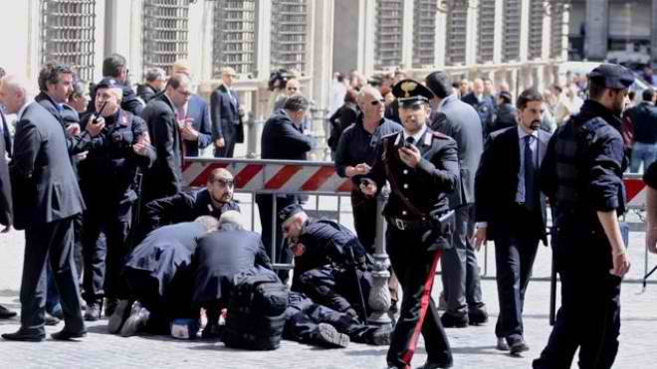
A gunman who shot and seriously injured two policemen outside the Italian PM's office in Rome was acting out of anger at politicians, prosecutors allege.
A suspect named as 49-year-old Luigi Preiti was arrested at the scene.
Analysis
David Willey BBC News, Rome

A new wave of political optimism reigns, after dire predictions of the possible institutional and economic collapse of the eurozone's third largest economy.
With their backs to the wall, the seriously fractured Democratic Party, and Silvio Berlusconi's People of Freedom Party decided to bury their ideological differences and will now try to co-operate in a last-ditch attempt to remedy a social and economic crisis that threatened to get out of hand after an indecisive February election.
The history of the very few "grand coalition" experiments in Italy since World War II does not inspire hope for long-term success.
But Italy's former ruling parties, which monopolised power in Rome for many decades after the end of WWII, have long since disappeared.

Rome prosecutor, Pierfilippo Laviani, said the gunman had hoped to target politicians but as he was unable to, he shot the police officers instead.
The attack came as a new government was sworn in across the city at the Quirinale Palace.
Democratic Party Deputy Leader (PD), Enrico Letta, 46, becomes prime minister at the head of a "grand coalition" including Silvio Berlusconi's People of Freedom party (PDL).
'Isolated act'
Mr Preiti was reported to be an unemployed man from the southern region of Calabria with no criminal record.
The Ansa news agency said the gunman, dressed in a dark business suit, fired several shots outside the Chigi palace, about a kilometre (mile) away from the Quirinale and had acted alone.
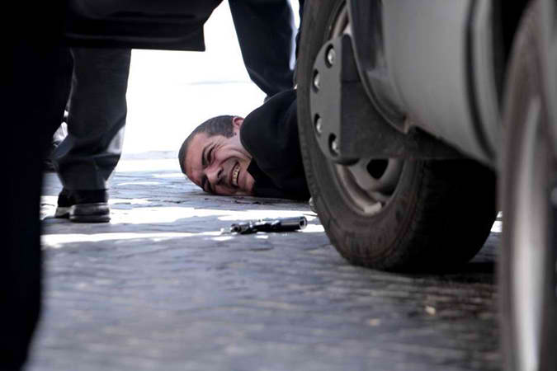
There had been earlier reports that the gunman may have suffered mental problems.
Ansa quoted Mr Preiti's brother as saying that Mr Preiti suffered no such disorders and that the family was shocked at what had happened.
The agency reported that Mr Preiti had separated from his wife, with whom he has a son.
Prosecutor Pierfilippo Laviani said Mr Preiti had "lost his job, he had lost everything".
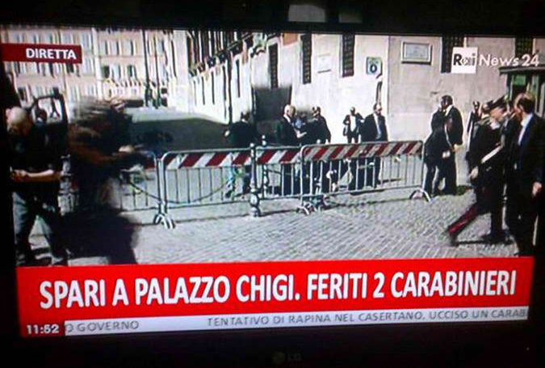
"He has confessed everything. He doesn't seem to be a deranged individual," Mr Laviani said.
The new Interior Minister Angelino Alfano said it appeared the shooting was an "isolated act" and that there were no concerns for "the general situation of public order in the country".
The most seriously hurt police officer was named as Giuseppe Giangrande, who suffered neck or spinal injuries and is being treated at the Policlinico Umberto.
The second officer was also seriously hurt, with a leg wound, while a pregnant woman who was passing by was slightly injured.
Mr Preiti was being treated at a separate hospital.
Rome Mayor Gianni Alemanno said shortly after the shooting: "It's not an act of terrorism but certainly the [political] climate of the past few months has not helped."
Italy had been in political deadlock since February's general election. A new government was agreed on Saturday.
Correspondents say the new "grand coalition" between Italy's current main right- and left-wing parties is unprecedented, and will probably prove an uneasy alliance.
Mr Berlusconi will not be a minister but Mr Alfano, the PDL secretary and one of Mr Berlusconi's closest political allies, is the deputy PM as well as interior minister.
Bank of Italy director general Fabrizio Saccomanni heads the powerful economy ministry and Emma Bonino is foreign minister.
The third strongest force to emerge from the Italian election, the Five Star movement led by former comedian, Beppe Grillo, has refused to take part in a coalition.
The country is still plagued by economic woes after becoming one of the first eurozone victims of the global financial crisis of 2008.

EDITOR’S COMMENT: If not a terrorism act, then what? The beginning of a social uprise? And which society is next to follow? Greece? If we do not include finance and economy in the aetiology of terrorism, many similar events and bloodshed with follow. Terrorism is not about killing many people. It is about showing to all of us that we are next. A condition that we all suffer and evident – at least in Southern Europe – during the last 3 years. Logic governance is the andidote and those in high places need to realize that they govern people and souls; not interests and ephemeral political games of power and profit!

BOOK REVIEW – Africa: Al-Shabaab in Somalia: the History and Ideology of a Militant Islamist Group, 2005 - 2012
By Magnus Taylor
Source: http://allafrica.com/stories/201304260179.html?viewall=1

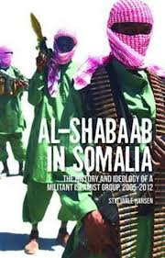
Stig Jarle Hansen has written what is undoubtedly the best book on Al-Shabaab - a militant islamist group based in Somalia - currently available. It has received high praise from international Africa commentators as Gerard Prunier, J.Peter Pham and Christopher Coker.
Hansen, a Professor in International Relations based in Norway, clearly had unprecedented access to the movement over years of conducting research in Somalia. The attendant dangers of associated with a westerner seeking to carry out such work in one of the world's most dangers country's makes this study all the more remarkable.
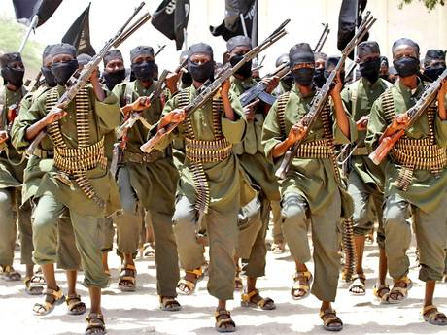
The author himself clearly has little time for "desk-based" commentators, stating that many suffer from the "Nairobi reality problem" - getting most of their information from sources in the Kenyan capital.
In brief, the book examines the development of Al-Shabaab chronologically, in 4 main periods:
2005 - 06: initial formation and development under the Union of Islamic Courts (UIC) which had taken control of the capital, Mogadishu, after years of warlord-led violence.
2007 - 08: The insurgency against Ethiopian occupiers who had taken invaded the country following fears about the nature of the new islamist regime in Mogadishu.
2009 - 10: The Golden Age of Shabaab - following the defeat of the Ethiopian-imposed Transitional Federal Government (TFG) and subsequent territorial control of Southern Somalia.
2010 - the present: The era of troubles - the movement sustains severe territorial losses, but is not eradicated after concerted regional (and international) action including the African Union forces (AMISOM) in Mogadishu and invasions by Kenya/Ethiopia.
One of Hansen's core arguments is that the group cannot be properly understood by focusing on local currents alone "it was very much a product of global currents interacting with local conditions". He neatly sums this up with his description of the Al-Shabaab rank and file which consisted of unemployed Somali youths, "with some nebulous ideas about the global oppression of Islam, but with more important and largely correct ideas about the Sharia Courts and Islam bringing an end to warlords, injustice and terror."
It is a book packed full of detail, which will be of interest particularly to those who follow broad developments in Somali politics. For example, I was particularly surprised to learn that 'Afghan vets' played a significant role in the development of Al-Shabaab. Although not great in number, figures such as Muktar Robow, a former spokesperson for the movement (said to have met with Osama Bin Laden in 2008), were key in developing the ideology and core operational capacity of al-Shabaab, and remain important in this regard.
Another interesting theme is the extent to which Shabaab managed to win support, at least tacit, from the Somali population. The political fragmentation of Mogadishu under warlord rule in the 1990s meant that its citizens and, in particular, the business community, were willing to support any movement that could provide a semblance of law and order in the city. To this end, Shabaab developed relatively successful law enforcement and justice 'division'.
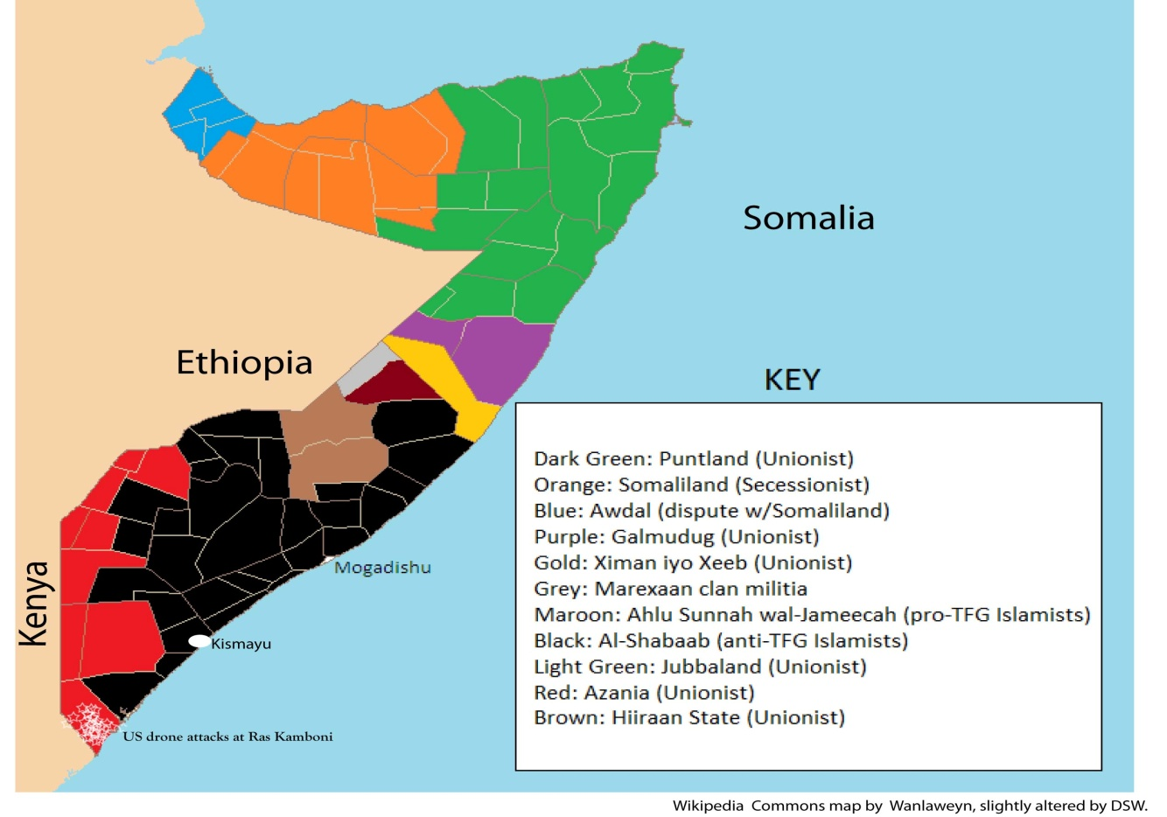
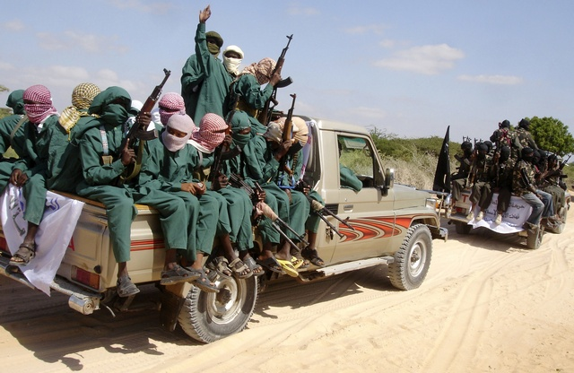
Hansen attributes this ongoing capacity to communicate its core concerns, along with a surprising resilience to latter day defeats, to the fact that the movement's leaders operated around a consistent ideology and had "[well] developed problem solving mechanisms". This has made it "probably made it the most unified actor in southern Somalia" - at least up until 2008/09 - "a factor that was neglected by most observers, except for the Somalis themselves."
Tax was also collected and I found it striking that Hansen was able to list the rates applying to livestock in Kismayo in 2010 (camel - 180,000 shillings, cow - 90,000, goat - 50,000). Other such details of Al-Shabaab's financial operations are also impressive. For example, the author tells us that during the Ethiopian occupation, Shabaab's militias were paid $20 for a hand grenade attack, $30 for killing a soldier and $100 for a road bomb or mortar attack. He notes that this was in a period when the TFG police and army were not paid at all.
Shabaab also developed a sophisticated PR operation, particularly focusing on online media aimed at recruiting Somalis from around the world. However, as Hansen states, the movement's global rhetoric was paradoxical. Local recruitment, by far the most important source of members, was largely from unemployed Somali youth, "hostile to the Ethiopian intervention and with a nationalist/clannist motivation for joining the organisation." Some Somali from the diaspora have joined al-Shabaab, motivated both by "the sense of humiliation driven by Ethiopian human rights violation", but also due to a "a larger ideological framework, seeing the Somali struggle as part of a wider 'Clash of Civilisations' between Islam and the rest".
Whilst Al-Shabaab could not be relied upon to deliver the full benefits of an effective, centralised state, it has given a measure of law and order/justice in areas where there rule was not contested (particularly in the South). It also became the only (self proclaimed) al-Qaeda ally controlling large areas of territory anywhere in the world. It has exported jihadists within Africa (Nigeria, Kenya, Uganda) and as Hansen states, "contributed to an African momentum for jihad" perhaps now most evident in Nigeria and Mali.
Predictions of Al Shabaab's collapse have occurred frequently since 2008 but, despite notable set-backs, it has survived - its leaders "tied together by old memories and ideological perceptions". Stig Hansen's book is an essential tool for those wishing to understand what the future might hold for "one of Somalia's most efficient political organisations of the last 20 years."

Magnus Taylor is editor of Africa Arguments Online.

Al Qaeda's £168million cocaine smugglers: terror group flooding Britain with drugs
Source: http://www.mirror.co.uk/news/uk-news/al-qaedas-168million-cocaine-smugglers-1857934

Al Qaeda has teamed up with other terror groups to smuggle cocaine to Britain, the Sunday People has discovered.
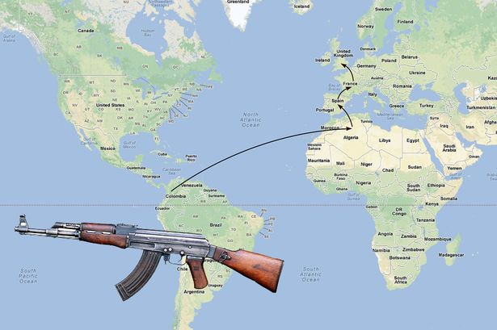
One plot involved a staggering four tons of the illegal drug with a street value of £168million.
Al Qaeda, led by 9/11 mastermind Osama bin Laden until his death in May 2011, is using profits to fund terror plots in the UK and western Europe.
And they have paid for the cocaine with weapons looted in Libya during the mayhem following the death of Colonel Gaddafi in 2011.
Spooks from MI6 and the UK’s criminal intelligence agency SOCA have joined forces to investigate al Qaeda’s links to drug cartels and terrorist groups in Africa and South America.
Two Colombians – one a member of left-wing terror movement FARC – were arrested after a probe by the US Drugs Enforcement Agency.
It is understood the South American group, now a major cocaine cartel, sold a large quantity of the drug to bin Laden’s North African branch, al Qaeda of the Islamic Maghreb.
They paid using cash and also weapons looted in Libya.
The drug was shipped to North Africa and moved across the Mediterranean into southern France where it is believed to have been distributed to other European countries, including the UK.
A second operation carried out by secret intelligence groups led to the arrest of the former head of the navy in West Africa’s Guinea-Bissau, now classed as a “narco-state” because of its reliance on the cocaine trade.
Admiral Jose Americo Bubo Na Tchuto and six others have now been flown to New York and charged with drugs trafficking. Four also face terrorism charges.
They were caught in a sting operation in which they believed they were talking to members of FARC. They agreed to supply ground-to-air missiles and a quantity of AK-47 assault rifles and grenade launchers in exchange for four tons of cocaine with a street value of £168million.
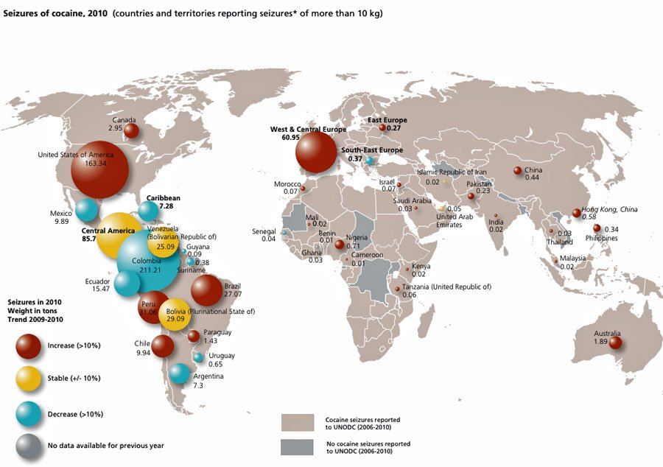
Al Qaeda of the Islamic Maghreb has long been involved with cocaine traffickers, receiving large payments to ensure drug runners could safely cross the Algerian Sahara with multi-million-pound consignments.
But spies say this is the first time evidence has emerged suggesting the organisation are themselves trafficking cocaine into Europe.
A highly placed crime intelligence source in London said: “It is a very worrying development and both MI6 and SOCA will be working together to find out as much as they can.
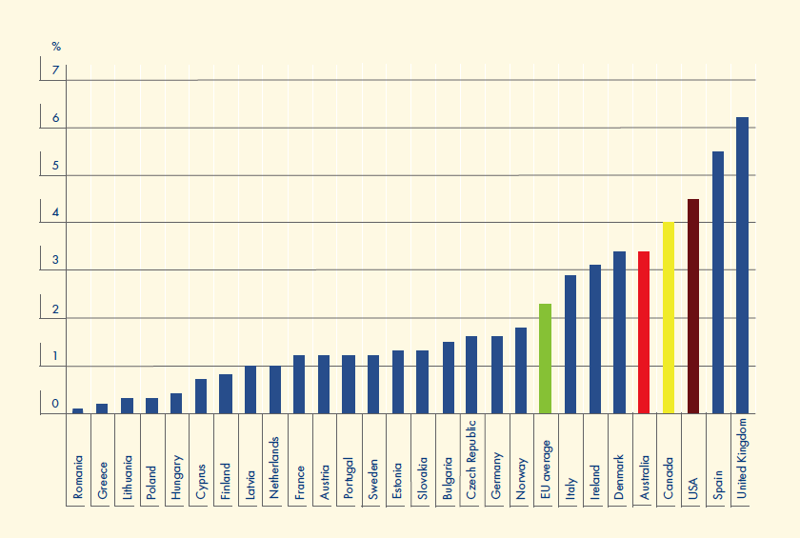
“When there is an overlap between straightforward crime and security matters, the two agencies work together. There will be a lot of interaction with security forces from several countries.
“France will be particularly involved given the Algerian connection and the fact that France seems to be the main entry point for the al Qaeda shipments. There will also be strong American interest.’’
In January 2009 Briton Edwin Dyer, 60, was kidnapped by al Qaeda of the Islamic Maghreb while holidaying in Niger.

2010 prevalence of cocaine use among young adults (aged 15–34) in Europe, Australia, Canada and the USA*
He was held hostage for five months before being beheaded in neighbouring Mali, where his captors have vowed to set up “an Afghanistan in Africa” despite a French military operation to kick them out.
Meanwhile in Afghanistan the Taliban announced the start of their spring offensive. Almost 500 people, including 217 insurgents, have already been killed there this month.

* Source: http://www.emcdda.europa.eu/online/annual-report/2010/library/fig7

Petter Nesser. Jihad in Europe. Patterns in Islamist terrorist cell formation and behaviour, 1995-2010. Oslo: University of Oslo PhD Thesis, 2011.
Reviewed by Alex P. Schmid
Source: http://www.terrorismanalysts.com/pt/index.php/pot/article/view/260/html

Scandinavia is not only home of some of the world’s leading centers for the study of armed conflict but has, in the Norwegian Defence Research Establishment (FFI), also one of the best terrorism research institutes. Under the supervision of its research director, Brynjar Lia, Petter Nesser wrote a remarkable doctoral dissertation, based mainly on in-depth, inductive analyses of case studies. 15 jihadist cases were selected from 28 serious plots, 44 seemingly serious but less documented ones and 23 vague plots registered in Europe. The jihadist plotting cells varied, with two exceptions, from 2 to 10 core members. In 13 out of the 15 cases the foreign ties with the European jihadists were strong or probably strong. At least 5 of the 15 cases were clear-cut suicide operations and in only three cases the perpetrators planned to escape. Their operatives came, in declining frequency, mainly from Algeria, Pakistan, Morocco, Jordan, Turkey, Iraqi and India and were between 18 and 32 years old. In all plots studied, at least one core member had spent time in a foreign-based terrorist training camp. The role of the Internet as a virtual training camp, Nesser found, was, at least for the period he investigated, still minor. He discovered that “real-life cases rarely agree with simplified models” (p.499) and concluded that “the dismissal of an al-Qaeda recruitment apparatus in Sageman (2004) appears too categorical, and is probably wrong” (p.519).
The author distinguished various types of cell members: terrorist entrepreneurs and their protégés on the one hand, and the more numerous foot soldiers who tend to be misfits and drifters, on the other hand. Each type joined the jihad for somewhat different reasons. This differentiation, linked to different motivational drivers (religions-ideological, political and social) has important implications for inducing members to dis-engage from terrorism and, on the counter-radicalisation side, for preventing disenfranchised and under-employed Muslim youth in Europe from joining jihadist groups to begin with. However, Dr. Nesser also stresses the importance of conflict resolution efforts in countries of origin (e.g., Pakistan) of Muslim radicals in European diasporas as a way of reducing terrorism. Based on a wide range of open sources, sharp thinking and nuanced judgment, this study breaks new theoretical and empirical ground. One can only hope that its commercial publication is not further delayed or that an electronic version is made available to the research community in the near future. The same is true for many other worthy dissertations but this one, in particular, stands out head and shoulders for its clear thinking and counterterrorism policy implications.

About the reviewer: Alex P. Schmid is editor-in-chief of ‘Perspectives’ on Terrorism and Visiting Research Fellow of the International Centre for Counter-Terrorism (ICCT)

Analysis of Al-Qaeda Terrorist Attacks to Investigate Rational Action
By Daniel P. Hepworth
Source: http://www.terrorismanalysts.com/pt/index.php/pot/article/view/253/html

Abstract
Many studies have been conducted to demonstrate the collective rationality of traditional terrorist groups; this study seeks to expand this and apply collective rationality to Islamic terrorist groups. A series of statistical analyses were conducted on terrorist attacks carried out by Al-Qaeda and affiliated terrorist organization; these were then compared to two more conventional terrorist groups: the Euskadi Ta Askatasuna (ETA) and the Liberation Tigers of Tamil Eelam (LTTE). When viewed through the context of the groups’ various motivations and objectives, the results of these analyses demonstrates collective rationality for those terrorist groups examined.

Introduction
After 9/11, many people in the West believed that anyone who would commit an act of terrorism, especially suicide terrorism, must be deranged; research has shown this not to be the case. [1] Most research indicates that terrorists are not insane, and some research indicates that many of them are generally neither poor nor uneducated, although these debates are certainly not settled. [2] Most terrorist groups do not attack indiscriminately. As Brian M. Jenkins said, “terrorists want a lot of people watching [...] not a lot of people dead.” [3] Some groups will even issue public apologies if an attack kills too many, especially civilians. [4] Many terrorist groups dissolve not because of military might but because the group either attains (some of) its goal(s) or after continued failure, its members abandon the tactic of terrorism. [5] Each of these choices indicates the rationality of terrorists groups. [6]
However, some thirty years after his initial statement, Brian Jenkins’ more recent statement that some terrorist groups want many people watching and many people dead [7] is consistent with the growth of mass casualty terrorist attacks and the fact that Osama bin Laden sought nuclear weapons to use against the Western world. [8] James Piazza [9] found that terrorist groups motivated by religious and/or millenarian goals (especially those which are Islamic) are much more dangerous than more traditional terrorist organisations.
This article examines terrorist attacks carried out by Al-Qaeda and affiliated Islamic, religiously motivated terrorist groups (hereafter referred to as the Al-Qaeda network, AQN), and seeks to establish that the AQN operates in a rational fashion. In order to clearly demonstrate the rationality of the AQN in the context of its character as a religiously motivated terrorist organisation, their operations are compared to those of the Basque Euskadi Ta Askatasuna (ETA) and the Liberation Tigers of Tamil Eelam (LTTE), both more conventional terrorist groups.

Defining (Suicide) Terrorism
The most cursory examination of the literature will show that there is no universally accepted definition terrorism. However, after examining a wide range of definitions and drawing upon commonly occurring elements, one has been constructed for the purpose of this article. [10]:
Terrorism is a violent act (or threat of one) carried out by a sub-state individual or group against a civilian population (including police, other governmental workers and non-combat-ready military personnel) for the purpose of striking fear in the surviving population in order to bring about political change.
The other important term on which a definition needs to be settled is suicide terrorism. Crenshaw defines suicide terrorism as “acts of terrorism that require the death of the perpetrator for successful implementation.” [11] Upon examination of the literature, it is clear that while use of this definition is not unanimous, [12] it is by far the most accepted and as such, used for this research. [13]

Rational Action Theory
At present, one popular theoretical approach to explain collective terrorist behavior is rational action theory. [14] A good deal of research has found that terrorist groups act in a “collectively rational” manner, learning from failure and from one another. [15] They apply cost-benefit concepts to examine the risks and rewards of their potential choices , taking what is seen as the most efficient route to reach their goals. [16] Rationality theorists refer to this type of instrumental rationality, as “an instrumental relationship between ends and means.” [17] This approach has been successfully applied to terrorist hijackings and kidnappings, [18] the operational strategies of terrorists in Chechnya [19], Palestinian terrorists in Israel, [20] and suicide terrorism in general. [22]
Two caveats should be noted in the discussion of the application of rational action theory to terrorist organisations. First, as with any theoretical explanation for a phenomenon, research exists that raises questions about the applicability of this particular theory that should be considered. [23] Gregory Miller makes a very valid case for questioning not only the rationality of terrorist organisations, but also the value of applying rationality theories. [24] He points out that different people within an organisation have different goals (perhaps different from those of the organisation itself) and that “rational” behavior can be rooted in either hedonistic self-interest or socially conscious morality, which means that almost any behavior may be explained as “rational.”
Second, no theory should be construed as a catchall explanation for all behavior. As applied to terrorist organisations, rational action theory is used to explain, at least in part, the behavior of the group as sanctioned by its leaders. However, decisions may be made at any level of the organisation and each of these decision-makers may be aware of different information, leading to different “rational” decisions. Additionally, not all decisions are made rationally, especially when made by those who are reactive and/or emotionally compromised. These concerns must be kept in mind when considering this and other research on the rationality of any organisation.

Terrorist Groups
The present study focuses on the unique nature of Al-Qaeda and related groups. Al-Qaeda has the general, short-term goal of repulsing the Western influence allegedly assaulting the Muslim world while its long-term goal is the complete restoration of the caliphate and the establishment of a worldwide Muslim community. [25] These goals set the Al-Qaeda Network (AQN) apart from traditional terrorist groups, which are typically motivated by more tangible objectives, such as national separation from an existing state. [26] The nature of these objectives and other factors tend to force conventional terrorist groups to limit the number of casualties they inflict, especially on civilians lest they risk alienating their support-base. In this sense, the traditional terrorist group is almost like a politician who cannot take too many unfavorable actions for fear of alienating voters.
Al-Qaeda members have no compunction against mass killings. Sheikh bin Laden made it clear that God wants them to slay the infidels and that God will reward this behaviour on earth and in the hereafter. This assumed obligation to serve the will of God combined with His command to slay nonbelievers [27] distinguishes this religious Islamist terrorist group and its affiliates from most other terrorist groups.
ETA (Euskadi ta Askatasuna – Basque Fatherland and Freedom) and the LTTE (Liberation Tigers of Tamil Eelam in Sri Lanka) are/were traditional non-religiously motivated terrorist organisations, seeking a separate homeland for their respective peoples. Both groups were relatively active during most of the time under consideration, making them sound choices as comparison groups. The LTTE was also specifically selected because it is one of the few examples of a more conventional terrorist organisation, which utilised suicide bombings. [28]

Study Hypotheses
As an indication of collective rationality on the part of the AQN, it is hypothesised that due to the group’s goals and methods of achieving those objectives, bombings conducted by the AQN will, on average, result in significantly more fatalities than those carried out by the comparison groups. It is also surmised that the AQN will attack civilian targets at a rate higher than other target types and that attacks on these targets will, on average, result in the highest number of fatalities. Due to their size, prevalence, and lack of direct governmental strategic value, civilian targets are not only ripe with victims but security protection is most often minimal at best, making them easier targets for the AQN. It is expected that bombings conducted by the comparison groups will, in contrast, focus more on governmental targets in both frequency and severity, given their more traditional motivation of creating terror and demonstrating governmental weakness while creating a relatively low number of casualties.
Additionally, it is hypothesised that both groups which utilize suicide bombings, the AQN and LTTE, will conduct them primarily against specific target types: the AQN against civilian targets in order to create maximum damage and the LTTE against military targets, applying the presumably most effective method against the hardest and most valuable target type. It can be assumed that any terrorist group (especially one steeped into a particular version of Islam, given its condemnation of suicide) would not use such a tactic unless it was effective. Thus, according to rational action theory, this technique, would not be used unless it granted large dividends, primarily in the form of casualties.

Data
Data for this study was taken from the Global Terrorism Database (GTD), maintained by the National Consortium for the Study of Terrorism and Responses to Terrorism (START) at the University of Maryland (http://www.start.umd.edu/gtd/). The GTD defines terrorism as “the threatened or actual use of illegal force and violence by a non- state actor to attain a political, economic, religious, or social goal through fear, coercion, or intimidation”. [29]
The present study examines more terrorist groups than just Al-Qaeda proper. The GTD contains a series of Terrorist Organisation Profiles (TOPs), which were used to compile a list of 18 Al-Qaeda-associated organisations, [30] which was utilized by this study. These organisations make up what is referred to here as the aforementioned Al-Qaeda Network (see Appendix A for a list of its members).
A number of factors were used to screen out certain attacks. Only attacks that have been classified as “unambiguous” by the GTD were used. Second, only attacks carried out by the AQN between the beginning of 2002 and the end of 2007 were used. There were few Al-Qaeda attacks before 11 September 2001, with a sharp increase in the period that followed. At the time this study began, GTD data ran through 2007, making that the cut-off point. Third, only bombings were examined in order to ensure a level of consistency across all attacks, as the number of victims was a primary factor in this study.
In order to allow for comparisons of the attacks carried out by the AQN, similar data was recorded for ETA and LTTE attacks. The data covering ETA and LTTE attacks differed slightly from those of the AQN. First, in order to obtain a sufficient sample size, ETA data was collected between 1996 and 2007. Also, due to statistical reasons, attacks carried out by the LTTE were limited to the years of 2005 – 2007. There is nothing inherently important about the 2002 – 2007 timeframe of AQN attacks; this is merely when they became the most active, thus minimising concern over the differing attacks dates for the comparison groups.

Variables and Coding
For attacks carried out by each terrorist group, the year of the attack was recorded. Attacks were coded as successful or not (e.g. the bomb did or did not detonate), and suicide or not. The GTD defines a suicide attack as an attack “where there is evidence that the perpetrator did not intend to escape the attack alive.” [31] This definition does not fit exactly with the preferred definition of suicide terrorism, which requires the death of the attacker, but it works here all the same, especially as this study will only consider bombings. This definition is deemed acceptable here because in most situations, it is incredibly difficult to determine whether or not the terrorists intended to die; thus the best that can be done is to look to the evidence surrounding the attack and make an educated guess.
The classification of the victim type was recorded for each attack as military, police, other government, and civilian. For the AQN data only, the country in which the attack occurred was recorded as was the determination of whether or not the United States was a target. For the ETA and LTTE data, all attacks occurred in one country only (Spain and Sri Lanka, respectively) and neither group ever attacked an American target. The number of victims from an attack was coded in two ways: fatalities and injuries.

Data Issues and Transformations
After variable analysis, the fatalities variable was used to determine the severity of the attack (in most analyses) due to the number of cases in which the number of injuries was unknown (in the AQN data 30 of 405 cases, or 7.41%, were missing for injuries compared to four of 405, 0.99%, for fatalities). A z-score analysis was run on the fatalities variable to test for outliers. The maximum z-score for the AQN data was high at 7.677, however, because of the nature of the data, the nature of the hypotheses, and the presumed accuracy of the data, these scores were left in place for the analysis. This must be kept in mind when reading the analyses and results. Also, the AQN fatalities variable had a skewness score of 4.147, due in large part to the high number of cases in which zero fatalities were reported, which dictated the use of negative binomial regression. The same issues with the fatalities variable occurred with the LTTE data and the same solution was applied.
In order to run regression analyses, two variables, target type and country, were recoded. The initial target type coding was compressed into a dichotomous variable for the regression analyses. As military, police, and other government classifications are all government targets and considering that multiple hypotheses look specifically at civilian targets, this variable was recoded into the binary categories of all government and civilian. [32]
The country in which AQN attacks occurred was used strictly as a control variable. This variable was divided into two categories: countries with ten or more attacks and countries with less than ten, which were grouped together as an “other” category. This allowed for a solid separation of countries with a practically significant number of attacks and those with only a few. Afghanistan, Indonesia, Iraq, Pakistan, and the Philippines fell into the former category and were dummy coded (with Afghanistan used as the reference point). [33] The remaining “other countries” response was also added to the dummy coding.
One issue with the ETA data was that of the 203 attacks analyzed, only 19 resulted in any fatalities, with a maximum number in any attack of three. Thus, the fatalities variable was dichotomized into either no fatalities or fatalities (i.e. 0 = no fatalities, 1 = fatalities). The injuries variable was also recoded (and used in one analysis, as explained later) into an ordinal level variable with four values of no injuries (0), few injuries (defined as 1-5), a medium number of injuries (defined as 6-25), and many injuries (defined as 26 and up, with a maximum score of 95).

Results
Descriptive Statistics
There were 405 recorded, categorized bombings carried out by the AQN in 17 countries between 2002 and 2007. Over half (216, 53.33%) took place in Afghanistan, followed by Iraq (70, 17.28%). Most were successful (388, 95.80%) and one-third (135, 33.33%) were suicide bombings. Almost half (191, 47.16%) were targeted at civilians (see Table I). The United States was targeted less than five percent of the time (18, 4.44%), none of the AQN attacks occurred within the borders of the United States during that time.
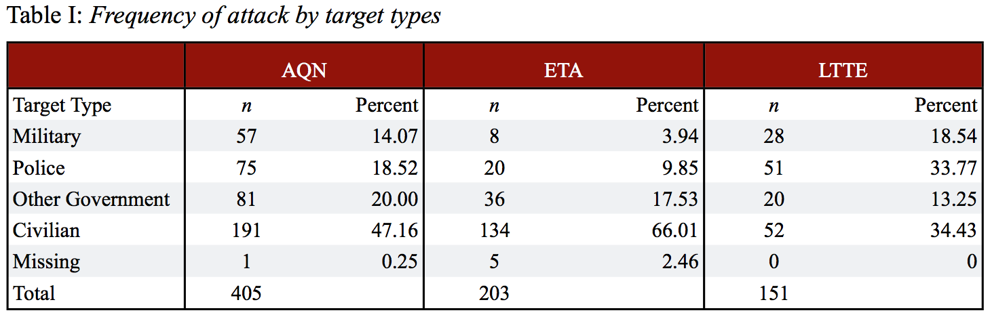
The ETA attacked civilian targets most often at 134 times (66.01%). Of the 203 attacks, 160 (78.82%) were successful. Fifty-two (34.43%) of 151 LTTE attacks were carried out against civilian targets and almost all attacks (142, 94.04%) were successful. While the LTTE did employ suicide attacks, it did so at a very low rate (7 of 151, 4.64%).

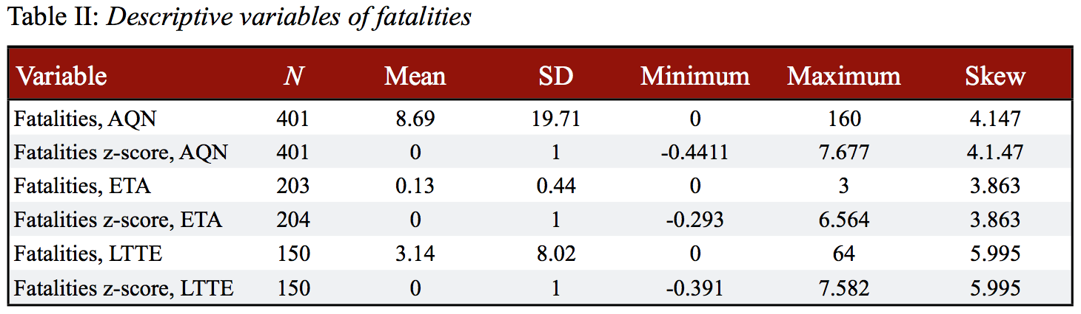
As expected, attacks carried out by all groups produced far more injuries than fatalities on average. Al-Qaeda network attacks produced the most fatalities on average, followed by the LTTE, and ETA (see Table II).

Chi-Square Analyses
Nonparametric chi-square analyses were conducted on the target type variable for each terrorist group. Significance was found in all tests (AQN, χ2(3, 404) = 110.020, p < 0.001; ETA χ2(3, 198) = 200.303, p < 0.001; and LTTE χ2(3, 151) = 20.894, p < 0.001). Standard two-variable chi-square analyses were conducted to test the relationship between suicide and target type for AQN and LTTE attacks. A statistically significant relationship was found for AQN attacks (χ2(3, 404) = 13.554, p = 0.004) with military targets attacked by suicide bombers at the highest percentage (28/57, 49.12%) and civilian targets were struck by this tactic at the smallest percentage (48/190, 25.26%). The same test with LTTE data also yielded significance (χ2(3, 151) = 10.544, p = 0.014) with military and other government targets each attacked by suicide bombers three times, civilians once, and police never (see Table III).

Negative Binomial Regression Analysis of AQN Attacks
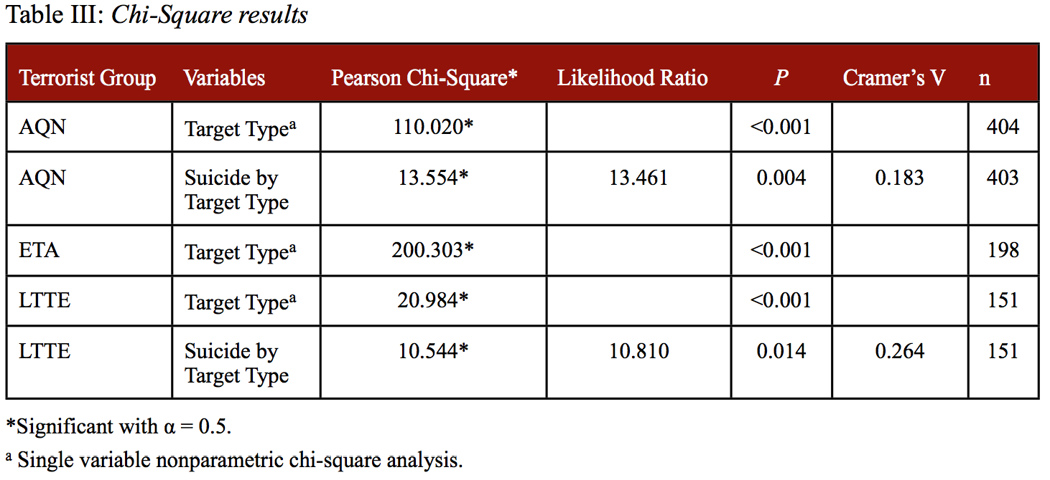
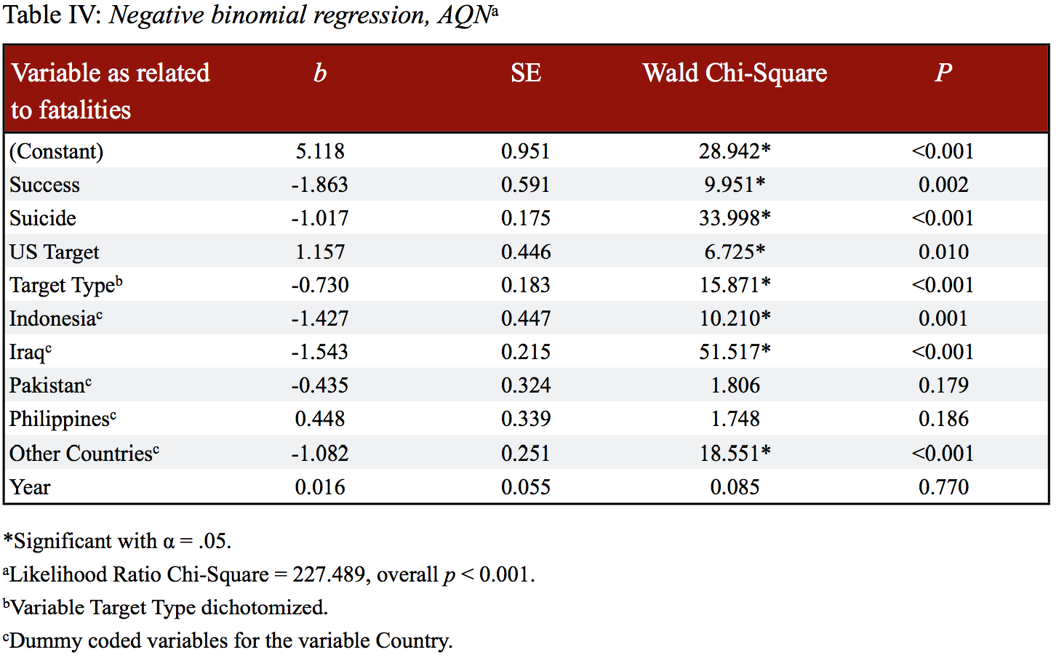
A negative binomial regression analysis was conducted to test the lethality of AQN attacks (fatalities) against suicide and target type. Control variables included the year of the attack, the country in which the attack occurred, whether or not the United States was the intended target of an attack, and success. After verifying that the data passed the necessary statistical assumptions, [34] overall significance was found (likelihood ratio chi-square = 227.489, overall p < 0.001). Both suicide and target type were found to be statistically significant (b = -1.017, Wald chi-square = 33.998, p < 0.001 and b = -0.730, Wald chi-square = 15.871, p < 0.001, respectively). [35] These results indicate that, controlling for the other factors, suicide attacks carried out by the AQN produced more fatalities than non-suicide attacks and that AQN attacks on civilian targets generated a significantly higher number of fatalities than those against other targets. The negative value of the predictor coefficient, b, as seen in this analysis and the regression of LTTE attacks (as seen in Tables IV and VI, respectively) for variables, such as success, suicide, and target type, indicate positive correlation of the variables due to the logarithmic transformation of the dependent variable inherent in negative binomial regression. Other variables that were found to be significant contributors to the number of fatalities included success, whether or not the United States was the target of the attack, [36] and various countries (but not all of them) (see Table IV).

Multivariate Regression Analyses of ETA Attacks
A binary logistic regression analysis was conducted on ETA attacks with the dichotomized fatalities variable serving as the dependent variable (DV), the dichotomized target type variable the Independent Variable (IV), and the year of the attack and success as control variables. However, the standard error was 5962.537, due to the extreme number of zeroes in the data set. The error-ridden results of this test will not be reported; instead, it will simply be said that it is clear that most ETA attacks did not produce any fatalities.
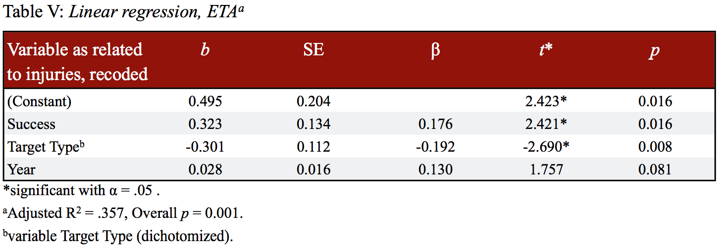
Due to the limitations of the fatalities variable in this data set, a second multivariate regression analysis was conducted to better understand how severely the ETA attacked each target type. This linear regression was conducted with the same independent and control variables as the previous regression, but with the recoded injuries variable (as described above) as the DV. Changing the DV in this fashion is clearly not ideal because it cannot be used to serve as a direct comparison between the ETA and AQN. Those killed in a terrorist bombing are often specifically targeted either as individuals or as members of a group, where many of those who are injured are often simply in the wrong place at the wrong time. The same could be said of additional fatalities from an attack, but this is more common among those wounded but not killed. That said, given the limitations of the data, this analysis does allow for a better understanding of ETA tactics. After verifying that the DV passed the necessary assumptions and requirements, [37] the regression was run and overall significance was found, R2 = 0.077, F (3, 198) = 5.349, p = 0.001. Significance was also found with the IV, β = -0.192, t (198) = -2.690, p = 0.008. This analysis indicates that governmental targets suffered significantly more injuries than civilian targets (see Table V).

Negative Binomial Regression Analysis of LTTE Attacks
A final negative binomial regression analysis was conducted on the LTTE data testing similar variables (DV = fatalities, IV = dichotomized target type and suicide, control variables = success and a dummy coded year variable). Statistical assumptions were verified and the overall model was found significant (likelihood ratio chi-square = 85.716, overall p < 0.001). Suicide and target type were significant (b = -1.206, Wald chi-square = 7.769, p = 0.005 and b = -1.225, Wald chi-square = 33.138, p < 0.001, respectively). [38] Suicide attacks were again more lethal and attacks against civilian targets begot the most fatalities (see Table VI).
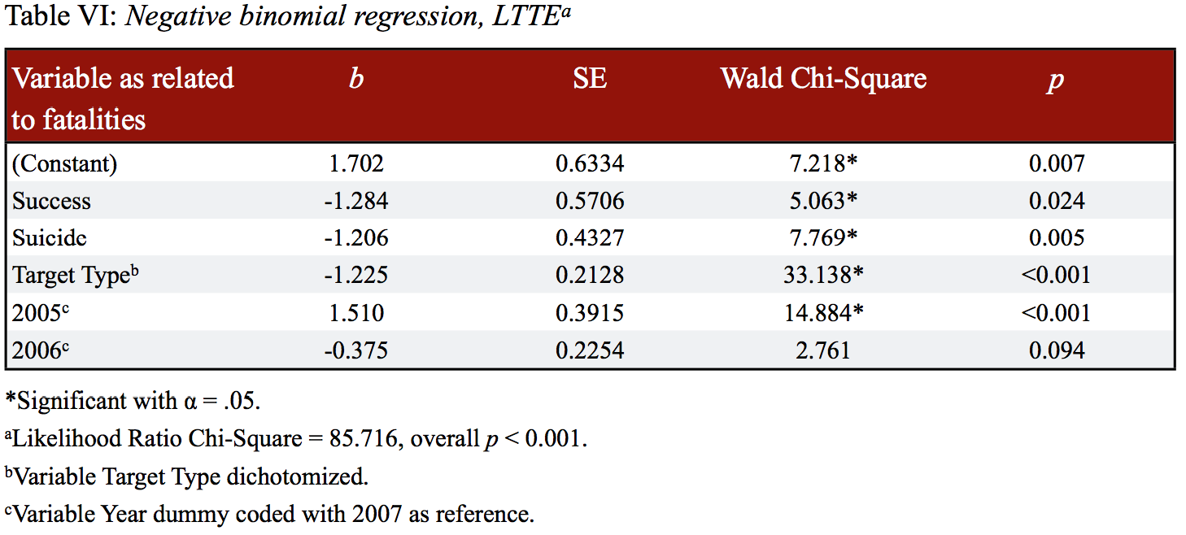
Discussion
While several studies have found that terrorists groups differ significantly in their operations by their classifications, [39] our research supports the notion of rationality of the AQN. [40] This terrorist organisation, in order to wreak maximum havoc, used suicide bombings far more often and in doing so, created far more fatalities than other groups, even the LTTE. It was expected that the more traditional ETA would not use this tactic and that the LTTE, while certainly an anomaly insofar as this non-religious group used suicide bombings, utilized it at much lower rate as neither group sought to cause too many fatalities.
Attacks carried out by the Islamic religious AQN were far more deadly than those attacks carried out by either secular, conventional group. The regression analyses indicate that, all else being equal, attacks conducted against civilian created an especially high number of fatalities and, while the AQN attacked civilian targets at a lower rate than the ETA, the AQN did attack civilians more often than any other single target type. Once again, these results indicate rational action on the part of the AQN as the death of as many unbelievers as possible is required in order to attain both short- and long-term goals. Not only did the AQN kill far more individuals than conventional terrorist groups, but the most lucrative targets were attacked more often than any other.
One unexpected result was that the AQN utilised suicide bombings against military targets at the highest rate (49.12%) and civilian at the lowest (25.26%). One possible explanation for this comes from Daniel Byman [41] who noted the value of striking targets that demonstrate the weakness of the target government, namely highly secure areas. If suicide bombings are more successful (this study failed to confirm or deny this due to the low number of recorded unsuccessful attacks), then Byman’s point may explain this finding. If the group believes a successful attack on a hardened military target is valuable enough, it would use a tactic deemed to have the best chance of success. This may also be explained by the fact that the AQN may view suicide attacks against civilian targets as less necessary as these targets are softer and of lower risk.

Policy Implications
When combined with research of how terrorist groups have been successfully defeated in the past, this research suggests that counterterrorism policy applied to the AQN must be primarily designed in a combat-oriented fashion. [42] Diplomatic negotiations with religious terrorist groups have been historically unsuccessful and this research indicates that this trend will continue. When terrorists’ goals are nothing short of global dominance, no amount of negotiation will appease them. Instead, coalition forces must continue to operate as they have with a combined effort to both destroy and contain the terrorists militarily and to remove, as much as possible, their support within local populations.
Next, civilian targets must be hardened. The AQN is targeting civilians at an alarming rate and with potentially devastating effect. Dynamic steps must be taken to protect valuable civilian locations, especially those that terrorists have struck in the past (e.g. airports, centers of economic activity).
Finally, this research suggests that Al-Qaeda’s leadership truly aims at mass casualty attacks. And while bin Laden is dead, it would be foolish to believe the drive for obtaining weapons of mass destruction died with him. And while it is true that it is very difficult to obtain and use such weapons, [43] Al-Qaeda leadership is seeking them and this research strongly suggests that if they obtain even one such a device, it may be used. That stated, it is also possible that possession of such a weapon may cause the organisation to shift tactics, perhaps using it for deterrence or blackmail, such as the removal of Western troops from the region. It goes without saying that even though the odds against such an attack may be very small, if one were deployed against the United States the damage and number of casualties would likely reduce the 11 September 2011 attacks to a historical footnote.

►Bibliography is available at the source link

Daniel P. Hepworth (PhD, University of Illinois at Chicago) is a professor of Criminal Justice at Murray State University. His research is primarily focused on a better understanding terrorist behavior and the effectiveness of counterterrorism policies in North Africa, South Asia, and the Middle East.

The Role of Foreign Influences in Early Terrorism: Examples and Implications for Understanding Modern Terrorism
By James M. Lutz and Brenda J. Lutz
Source: http://www.terrorismanalysts.com/pt/index.php/pot/article/view/252/html

Abstract
Globalisation has been linked with outbreaks of political violence and terrorism in the modern world. An analysis of Judean revolts against Rome and the Seleucid Greeks, individual suicide attacks in South and Southeast Asia in the 17th century to the early 20th century, and the Boxer Rebellion in China suggest that the intrusion of foreign influences had similar effects in the past.

Introduction
Analysts of insurgency and terrorism have proposed a variety of explanations for outbreaks of such violence. One of the purported causes for such outbreaks has been the intrusion of foreign economic and/or cultural influences that disrupt local structures and systems. Local groups can react to the intrusion of these outside influences in a number of ways, including all types of political violence. While modern examples have been analyzed, it is possible that there were occurrences in less recent times that represented violent reactions to the impact of foreign influences. More specifically, the occurrence of various kinds of political violence in past eras will be considered. Two thousand years ago, on the Mediterranean littoral, Judea experienced numerous revolts during the periods of Greek and Roman dominance that reflected a reaction against economic and cultural changes occurring in the region. The appearance of Western traders and then conquerors in South and Southeast Asia in early modern times eventually led to Muslim suicide attacks in South and Southeast Asia as a response to the intrusion of Westerners. Finally, at the beginning of the twentieth century, the Boxer Rebellion in China will be considered as an example of a violent reaction to foreign influences.
In the post-Cold War modern era it has been suggested that negative reactions to globalisation have increased. Globalisation is a complex process that has been defined in a variety of ways. There is some general agreement on components, including that in the economic sphere it is “the widening, deepening, and speeding up of international connectedness” [1]. Globalisation, however, goes beyond increased economic interactions. It has cultural, military, political, and social dimensions as well as the economic ones [2]. The possibility of such major effects from foreign influences being present and resulting in violent reactions has obviously been much greater with the increased speed of transportation and communication in the modern world. While such effects would have been more muted in the past, it is quite possible that they were present, and the examination of the Judean revolts, Muslim suicides, and the Boxer Rebellion can indicate linkages between the appearance of foreign influences and violence. These examples can also have implications for understanding the effects of contemporary globalisation.

Maccabee Revolt in Judea
The Maccabee revolt against the Greek Seleucid Empire started in 166 BCE. Judea had been part of one of the Greek successor states to the empire of Alexander the Great since 300 BCE. Initially there were no recorded problems in Judea, but with the passage of time tensions between some Jews and the Greeks began to increase. The trigger for the outbreak of outright rebellion was the decision of Antiochus IV to violate the tradition of religious toleration that had previously existed; in addition, there were efforts to restrict Jewish religious practices as part of a policy of the subsequent Seleucid emperors who attempted to create more cultural uniformity among subject populations, including those in Judea [3]. There was, moreover, an existing current of unrest in Judea that resulted from the fact that many Jews had adopted Greek practices and beliefs. The resort to religious repression that was linked to the actual revolt was actually part of an ongoing effort by the Seleucids to deal with the existing violence that was already challenging the state [4]. The conflict between Jews and Greeks was further exacerbated when Antiochus IV stripped the temple of gold and other wealth in order to build up the imperial treasury. While the desecration of the temple was an important event, much of the wealth of the temple had been promised to Antiochus by the new High Priest as part of his bribe to be confirmed in this religious position with elements of local political leadership [5]. (Such payments had come to be commonplace in Judea under the Seleucids with the post usually going to the highest bidder.) This set of events triggered an open revolt that was led in succession by Mattahias and then by his sons (collectively known as the Maccabees). The rebels relied on guerrilla warfare tactics and terrorist attacks as part of a broader arsenal of strategies to confront the Greeks and their collaborators in Judea [6]. Eventually, the Judean rebels were able to raise field armies and to engage Seleucid troops in conventional battles and managed to emerge as victors.
Clashing religious views were a definite source of contention between the Jewish dissidents and the pantheistic Seleucid state. The conflict also reflected differences within the Jewish community between those who had adopted Greek cultures and those who had not. The upper strata of Jewish society, including some priestly elements were attracted to the Greek culture [7]. The pro-Greek Jews in the ruling circles even welcomed the Seleucid emperor when he briefly conquered Jerusalem [8]. Prior to the rebellion of the Maccabees there were riots in the streets of Jerusalem, which had become the center of Greek culture. The violent confrontations involved street battles between those who had adapted to the Greek culture , and the more traditional religious elements who opposed the outside contamination [9]. In fact, the early attacks by the dissidents were mainly directed against Hellenised Jews who had assimilated into the dominant Greek culture and focused on population centers such as Jerusalem that had been strongly influenced by Greek culture [10]. The actions of Antiochus IV in seizing the wealth of the temple occurred in an already very volatile situation in Judea but did not create the unrest in the province. His violation of the temple, however, did greatly increase the volatility.
When the actual rebellion began, most of the Jewish elite continued to collaborate with the Seleucids, while other sections of the urban population remained opposed to the rebellion or were unwilling to actively participate on the dissident side. The Jewish collaborators included many members of the upper classes and others who benefited from an early form of globalisation (in this case Hellenisation). By supporting the Greek state, they were attempting to preserve their advantageous positions. The rebels thus attacked not only the Greek officials but started “a campaign terrorizing the Jews of the area who were willing to bow the knee before the Greek authority, and saw nothing amiss in integrating their religion and culture with that of their pagan neighbors” [11]. The rebels under the leadership of the Maccabees had the support of different groups in Jewish society. The very orthodox believers opposed to the pro-Greek leadership in Jerusalem provided early support for the rebellion [12]. Mattahias Maccabee was himself a priest who was at odds with the urban elite and the religious establishment. Other members of priestly groups that had lost status due to changes in the administration of the temple also joined the rebellion [13]. The violent opposition to the Seleucids and their local backers also had support among local villagers and peasants who were faring poorly in economic terms in competition with the Greeks who had penetrated Judean society [14]. All of these groups had already faced status loss or economic decline or were about to face such losses from the intrusion of the Greek social and economic systems. The cultural conflict between Greeks and Jews raged not only in Judea but spread into surrounding areas of the Seleucid Empire. Jews who sympathized with the traditionalists in Judea became targets for persecution and violent attacks by local Greeks in these neighboring provinces [15].
The Jewish revolt against the Seleucids clearly reflected the effects of foreign influences in this part of the world. The incorporation of Judea into Alexander’s empire after the defeat of the Persians introduced new ideas and a different culture directly into the area. Persian culture, like that of Babylonia or Egypt, had presented fewer challenges to Jewish society. Hellenisation, however, brought new cultural and economic influences into the region. The inclusion of Judea into the successor states of Alexander’s empire increased economic links with outside regions. The Greek influence was “more marked in economic life” where the presence of Greek merchants transformed commercial centers [16]. The Greeks established trade fairs as part of an effort to enhance commercial activity and promote local economic activity [17]. The Seleucids, in fact, became great merchants in this era [18]. Their trading efforts extended well beyond the borders of the empire; they developed maritime trading links across the Indian Ocean to South Asia and indirect links to China and the Far East [19].
Trade and the accompanying Greek culture brought advantages and opportunities to some of the inhabitants, but it was threatening the economic livelihood of others. While polytheistic religions in the Fertile Crescent and Egypt could easily adapt to the Greek pantheon of gods, monotheistic Judaism faced greater challenges. There were connections between the economic and societal pressures that came with increasing integration into a wider world. One consequence of the integration into the Greek world was the beginning of the migration of Jewish merchants and others to areas outside Judea. The strong Jewish community that inhabited Alexandria, a uniquely Greek city in Egypt founded by Alexander the Great, dates back to the 6th century BCE. This integration, however, generated opposition. There were rabbis who would not allow local Jews to participate in the trade fairs that came with the Greeks because of the pagan religious ceremonies that were celebrated and the potential for contamination by these foreign religious practices [20]. This fear had a basis in fact since for the Greeks there was a profitable symbiotic relationship between commercial activities and temples and religion [21]. All of these changes that were occurring in the region stimulated tensions that contributed to the outbreak of the revolt. Those in Judea who felt threatened by the foreign religious pressure and economic changes that came with globalisation and Hellenisation reacted violently, beginning with terrorist and guerrilla attacks. The rebels that began with tactics of the weak were ultimately successful in defeating the Seleucids in conventional battles in 141 BCE, creating an independent state.

Rome and the Judean Revolts
The independent Jewish state created by the Maccabees, however, lasted less than a century. Then Judea became part of the Roman Empire—first as a client kingdom and then as a province of the empire. The Roman period re-introduced outside influences into Jewish society since the province was once again exposed to greater external cultural and economic influences. The cultural influences remained predominately Greek in the eastern part of the empire. Thus, the victory of 141 BCE over the Seleucids did not survive in a cultural sense with the reappearance of Greek influences that entered Judea with the Romans. Economically and politically Judea was once again absorbed into an imperial state. While the Roman presence was initially accepted, tensions steadily increased as many of these same external influences once again penetrated into Jewish society, leading to three revolts. The initial attacks actually occurred as early as 6 CE (AD) [22]. The first open rebellion was the Great Revolt of 66 CE, the second occurred in 115 CE and was centered in Cyrene, Cyprus, and Egypt, and the third took place again in Judea in 132 CE. All three were put down by Roman troops, but only with some difficulty. All three rebellions, as was the case with the Maccabees, relied on terrorism and guerrilla tactics, as well as conventional field battles.
The Great Revolt itself was preceded by a major campaign of terrorism and guerrilla attacks. The Jewish rebellion included a number of different dissident organisations, but they all assassinated Roman officials and Jewish collaborators, spreading terror in Jerusalem and throughout Judea [23]. The Zealots, one of the dissident groups, targeted the Roman authorities in an effort to provoke violent responses from the state and to drive a wedge between Romans and Jews [24]. The rebels developed what is often seen as a modern technique, namely the kidnapping of individuals to exchange them for their own group members who had been captured and imprisoned. At one point they managed to capture the son of the High Priest and arranged to trade him for some of their imprisoned comrades [25]. These attacks, including a campaign of assassinations, helped to prepare the way for the full-fledged rebellion. An observer on the scene at the time, noted: “More terrible than the crimes themselves was the fear they aroused” [26]. The pro-Roman elements in Judea were effectively neutralized as it became extremely dangerous to oppose the dissident groups who wanted to separate from Rome. The small Roman garrison in the province could not cope with the unrest, and a relief force sent from Syria was defeated before it reached Jerusalem. It took major military campaigns to re-conquer the province and end the revolt in 70 CE.
Foreign influences increased with the incorporation of Judea into the Roman Empire. Economic interactions in particular rose. Rome dominated the Mediterranean Sea and facilitated commerce by the suppression of piracy. The empire provided for enhanced economic integration and greater commercial opportunities for those inside its borders than had previously existed [27]. The empire by its very presence and structure directly stimulated trade, and both the infrastructure of the imperial state necessary for political control and the imposition of taxation led to increased commerce [28]. Commercial ties outside the empire rose as well. Trade links with India and indirectly with the Far East, inherited from the Greek period, were expanded [29]. The volume of goods transported in these maritime trade routes is generally considered to have peaked in the first century CE. Rome had in fact become the central node in an economy that linked southern Europe, North Africa and parts of Asia [30]. It was in the context of increasing contacts with other parts of the world that the Great Revolt began.
The lines of division within the Jewish community suggest that the dissidents were reacting to the intrusion of foreign influences and some of the negative effects that accompanied them. The Zealots and other dissidents were opposed by collaborators, who included merchants that benefited from the inclusion of Judea in the Roman Empire [31]. The moderate Jews who had accepted inclusion in the empire also counted amongst themselves many priests and others members of the elite [32]. It was not surprising, therefore, that the Jewish elite took a dim view of the militants who threatened their position and status [33]. The established priesthood also benefited from the empire. Members of these groups became the targets for the campaign of assassinations. There is some evidence that the attacks in Jerusalem convinced many in Judea—and even wealthy Jews living elsewhere in the Empire—to provide funds for the rebels in order to avoid becoming targets for assignation themselves [34].
The rebels, in contrast to pro-Roman elements, enjoyed the support of the lower classes that provided many of the recruits for the militant groups [35]. The dissidents even attacked and destroyed archival records, including loan documents that detailed the debts that the poor owed the rich, as a means of gaining the support of working class Jews who were burdened with heavy debts [36]. The anti-elite nature of the dissidents appeared in other ways. One of the dissident groups primarily attacked the local Jewish aristocracy, although all the competing groups joined forces to defend Jerusalem during the Roman siege [37]. Like the Maccabees before them, many of the rebels also included religious extremists opposed to Greek culture and the secularization of Judea; they wanted to reestablish a Jewish theocratic state led by the High Priest [38]. Rabbis continued to oppose the trade fairs that had continued to be held under the Romans [39]. The Zealots and other militants groups thus drew upon both economic and religious discontent in their revolt against inclusion in the Roman Empire.
The second Jewish revolt began in Cyrene (Cyrenica, northeast Libya) and spread to Egypt and Cyprus, lasting from 114 to 117 CE. While the sources on the causes of this rebellion are more obscure than those for the Great Revolt, it does appear to have been linked to tensions between Jews and the Greek culture in this part of the Roman Empire [40]. The dissidents eventually raised field armies to battle the Romans. Some of the participants in this revolt shared the views of the dissidents who had been involved in the Great Revolt in Judea [41]. There is less information available on the violent techniques used in the initial stages of the outbreak, so the relative importance of guerrilla tactics, terrorism, and conventional military tactics is not clear. The Romans had to mobilize additional troops to deal with the revolt, indicating that the dissidents were able to raise significant conventional military forces. During the earlier revolt in Judea the rebels had attacked Greeks and Greek temples, and during this insurrection the rebels also destroyed Greek temples and slaughtered Greeks when cities were captured [42]. It is noteworthy that the Jewish rebels did not attack other groups or their religious sites [43]. This focus on attacking the dominant Greek culture in this rebellion clearly suggests that foreign cultural influences were important in motivating individuals to join this revolt. This sizeable Jewish community was obviously opposed to the dominant Greek culture, and it is possible that they may also have fallen on economic hard times.
The third and final Jewish revolt was led by Bar Kokba and lasted from 132 to 135 CE.He claimed to be the messiah who had come to reestablish the Jewish religion and the Jewish state. The rebels once again mounted a significant campaign against the Romans and were even able to gain control of Jerusalem for a period of time. It took a major military effort, led by the Emperor Hadrian in person, to defeat the rebels [44]. The end result of this Roman military victory was the dispersion of the Jewish population to other parts of the empire as part of an effort designed to limit the danger of future uprisings. There may have been some economic issues behind this revolt. The Jewish elite, who had once again become attached to the Greek and Roman ways, opposed this rebellion as they had opposed the Great Revolt [45]. The elite obviously continued to be the economic beneficiaries of the imperial connection. The primary impetus for the revolt, however, appears to have been religious. There was some fear that Rome was going to secularize Judea by officially establishing the Roman pantheon of gods in place of Judaism [46]. There is evidence that the Romans did in fact interfere with the practice of Judaism in this period [47]. While suggestions that the Romans intended to interfere with the local religion may have been exaggerated, the fear of the religious elements in the local population that their beliefs were going to be challenged was all that was needed to raise a rebellion. Perceptions, whether correct or incorrect, can drive political actions. There is no doubt that the Greek and Roman religious practices did constitute a threat to Judaism, given the willingness of many Jews to assimilate to these practices.
All three of these revolts as well as the Maccabee revolt indicated that there were high levels of tension between the Jewish religion and culture on the one hand and the Greek and Roman culture and its pantheon of gods on the other. The intrusion of the Greek influences into the area generated a great deal of local antagonism. In the case of the Great Revolt and the Bar Kokba revolt, there were also obvious economic issues, many of which would have been related to the economic changes that had come with the empire. These economic issues contributed to the tension. The three revolts included a variety of violent techniques, often including terrorist tactics. The case of the Zealots in the prelude to the Great Revolt provides one early, very clear example of a terrorist campaign that for a while successfully neutralised those elements of the population who were loyal to Rome and opposed to a rebellion.

Pagsabil—Individual Muslim Suicide Attacks in Asia
The spread of European merchants and soldiers to South and Southeast Asia and the creation of Portuguese, Dutch, British, and Spanish empires generated protests and anti-colonial violence. There was one form of violence that appeared in the Muslim communities in India and Southeast Asia that began in the 17th century and continued through the early 20th century. It was a somewhat unique form of terrorism in that it largely involved efforts by individuals after local Muslim armies had already been defeated by the Europeans. Conventional military campaigns and even guerrilla warfare had failed to prevent the continuing European encroachment and conquest. Along with European political control came efforts by Christian missionaries to convert local populations. In reaction to these events, individual Muslims would then practice a form of suicidal attack called pagsabil (juramentado in Spanish in the Philippines). An individual would arm himself and attack any Europeans or their local Christian allies or other collaborators that he could find until he was killed. In a few cases two or three individuals would attack as a group. These attacks occurred in Malabar on the Indian coast—against the Portuguese, then the Dutch, and finally the British. These attacks also occurred in Aceh in the Dutch East Indies and in the southern Philippines against the Spanish [48]. The attackers clearly expected to die in their assaults on symbols of alien rule and culture. The individuals involved in these attacks were apparently seeking to defend the integrity of the local community with its religious and cultural values by intimidating the colonisers The resulting fear that they inspired in colonial authorities and other Europeans frequently did lead to better treatment of local Muslims and kept the colonial authorities from interfering too much in local Islamic communities [49]. The same techniques used against the Europeans were also later used as well by individual Muslim peasants in the Malabar Coast to obtain better treatment for Muslim tenants from Hindu landlords [50]. Local religious authorities or other leaders often blessed these ‘lone wolf’ attacks, but there was no formal organisation involved in the violence.
The suicide attacks were launched in a cultural context that recognized that this kind of resistance was a defense of the community against the outsiders—the attackers were often considered heroes and martyrs by local populations. These suicide attackers saw themselves as defending local Muslim communities from the non-Muslim occupiers [51]. In the Philippines local Christians often became targets in the defense of the Muslim community since they were seen as collaborating with the Spanish [52]. The response by the local authorities to these attacks was often fairer treatment of local Muslims and the modification of objectionable policies. Since there was turnover among colonial bureaucrats, merchants, and other representatives of the European colonial society, periodic outbreaks of pagsabil were frequently necessary to emphasize the need to respect local religious sensibilities. While the attacks were somewhat unusual when compared to others kinds of political violence that might have been attempted, they were ostensibly effective.
The confrontation of different civilizations and the associated value clash of cultures (in this case colonialism) help to explain this type of violence. The suicide attacks were reactions to the encroachment of new ideas that came with the arrival of the Europeans, first as explorers and traders and then as conquerors. The Europeans, beginning with the Portuguese clearly disrupted the existing political and commercial situations in South Asia and Southeast Asia. Much of the trading activities were in the hands of Muslim merchants, and the Europeans (especially the Portuguese and Spanish) sought to eliminate such middlemen for religious as well as economic reasons [53]. The suicide attacks were a manifestation of the confrontation between the local population and the colonizing Western powers [54]. The violent interaction in these cases provides an example of a clash between different civilizations. The arrival of the Europeans was a direct consequence of the expansion of the global economy. It was the spices and other goods of the Far East that attracted the explorers and the merchants in the first place. While the appearance of the Europeans initially disrupted regional trade, it eventually led to an increase in commercial links in the region. As the European dominance became more firmly established, overall trade increased. By the 1800s the increased Asian trade consisted primarily of the exchange of raw materials for manufactured goods [55]. Even though the Dutch attempted to dismantle the local trading networks in their area of control (today’s Indonesia) and replace them with Dutch merchants, local traders, however, managed to establish new networks that then co-existed with the Dutch [56]. As the Europeans became more firmly established in the region, the level of exports from the Dutch Indies to Europe increased significantly [57]. Trade between the Dutch territories and India also rose during this period [58].
The Europeans were in the process of creating a new economic system that meant that many local producers and merchants in Asia were losing economic opportunities, wealth, and status. Political conquest obviously changed local patterns of rule. European commercial interests were able to displace local economic activity. European trade with India, for example, contributed to the eventual deindustrialization of India [59]. The arrival of Christian clergy and missionaries from the European countries exacerbated the effects of other changes by increasing cultural tensions between the Europeans and the indigenous populations. Not only was the political independence and economic well-being of parts of the local populations threatened by the expanding global reach of the Europeans, the foreign religion also threatened their religious and social systems. The cultural importance of these attacks was obvious since they persisted into the early 20th century, although occurrences were more rare as time went by [60]. The importance of the religious element in the attacks was obvious because when the United States took over the Philippines from Spain, these kinds of attacks ended once the inhabitants realized that efforts at conversion to Christianity had ceased [61]. Many of the local inhabitants were not specifically opposed to foreign political rule; they were, however, more determined to resist the attempts to convert them.

The Boxer Rebellion
China was also affected by the European expansion and imperialism that unsettled populations in South Asia and Southeast Asia, although the effects were felt somewhat later in China. Distance postponed the arrival of Western influences, and China in this period was also withdrawing into itself. Eventually China was pulled into greater interactions with outside powers, and local producers saw European goods displacing those from China [62]. China was required to enter the international economic system through the treaty ports that were forced to be open to European trade. The first Sino-Japanese War over Korea (1894-95) demonstrated Chinese vulnerability, and the German takeover of Tsingao in the Shantung Peninsula (1898) accelerated the pressure on China. As China faced losses in territory, the United States in conjunction with Great Britain worked to maintain the Open Door Policy with regards to maintaining Chinese openness to imports from all foreign producers [62]. The Open Door Policy was designed to permit all countries, including European colonial possessions, to have access to continued trade with China, increasing China’s interactions with the rest of the world.
Almost every aspect of Chinese society was under assault from Western influences during this period. The Chinese economy was disrupted by the arrival of Western merchants and goods, and by the late 19th century advanced Western military technology. The disruption went beyond economic changes. Social status was threatened by the presence of Europeans. Perhaps the most obvious symbol of the political, social, and economic assault on traditional Chinese society were the extraterritoriality provisions of treaties which required that in criminal or civil cases involving a European (or Japanese) and a Chinese, the case would be tried in a European court of law rather than a Chinese court. This extraterritorial principle indicated that the Chinese legal system was considered inferior and could not provide a fair trial for Europeans. These provisions provided almost daily and demeaning reminders of the position of Chinese in their own country.
One consequence of this forced integration of China into the Western economic and political system was the Boxer Rebellion. Anti-colonial opposition to integration into Western economies did not rely on suicide attacks as had for a long time been the case in South and Southeast Asia. The Boxer Rebellion initially relied on conventional terrorist tactics and eventually on military attacks as part of an effort to drive out European influences that were perceived as undermining Chinese society. The Boxers (the Society of the Righteous Harmonious Fists) originated as a secret society in China. Such secret societies have had a long history in China, but proliferated since the late eighteenth century in response to increased threats to Chinese identity [64]. These secret societies were often willing to use political violence to maintain their position, gain economic advantage, and bring about political change.
The Boxer Rebellion broke out at the end of the nineteenth century. The Boxers were intent on driving all foreign influences out of China. They were able to draw upon the increasing discontent with the foreign presence in China that appeared in the 1890s. In the earlier years there had been riots that targeted foreigners and Chinese Christians [65]. These attacks were supported by both local officials and secret societies as they shared the same antipathy towards Western influences [66]. The Chinese regarded Christian missionaries as the vanguard of a movement to attack Chinese culture. Chinese Christians came to be seen as part of this attack, and in point of fact missionaries and converts were used by European powers as a means of gaining greater influence in areas of possible colonial expansion [67]. The Christians, as a consequence, were attacked for cultural rather than religious reasons.
The actions of the Boxers were a continuation of previous actions protesting the intrusion of Western products and values into Chinese society. It is worth noting that the Boxers originated in the Shantung area where Germany had recently established a sphere of influence and founded a small colony [68]. The Boxers, like earlier groups, attacked the foreigners and Western inventions such as railroads and the telegraph. Chinese Christians continued to be targets[69]. The Boxers eventually escalated the violence and attacked the foreign diplomats in the capital of Peking [70]. These attacks led to the intervention of a multinational military force from the European countries, Japan, and the United States. These modern Western forces were able to defeat the Boxers and the Chinese military units that joined them with the encouragement of the Chinese monarchy. When the Western forces reached the Chinese capital and raised the siege of the foreign legations, the Chinese government was forced to pay reparations for the damages done. This violent response to Western penetration had failed.
The Boxer Rebellion clearly represented a clash of cultures or civilizations just as the suicide attacks by Muslims in the earlier example did. The Boxer uprising was a spontaneous uprising of those Chinese to the increasing Western presence in China, and it had strong support from the Chinese who had been displaced by the modern technology that came with ‘globalisation’ in the form of imperialism [71]. The involvement of the Chinese displaced by Western technology in earlier violence and the Boxer Rebellion itself was a direct consequence of economic penetration. While the Boxer Rebellion has often been portrayed as a unique episode in Chinese history, in fact, it was just one episode among many violent responses to the intrusion of foreign influences [72]. The involvement of court officials and elements of the military who later joined the rebellion reflected a “last desperate attempt to preserve the integrity of Chinese civilization” [73]. The failure of the Boxer Rebellion started the process that led to the end of the Chinese monarchy.

Implications for Understanding the Links between Globalisation and Modern Terrorism
The above examples from earlier times can be related to the effects that foreign influences and globalisation can have on outbreaks of contemporary terrorism. Today an increasingly integrated global economy has meant that countries are now more connected to each other. Economic globalisation has led to increased prosperity in general, but the resulting gains have not been equally or equitably distributed [74]. The spread of market capitalism that often accompanied globalisation has modified and in some cases almost destroyed the structure of local economies [75]. Further, there are indications that globalisation in the 20th century has led to greater inequality among countries and within countries [76]. Globalisation can have the most negative impacts for lower classes as well as for poorer states since they are least able to take advantage of the opportunities that come with greater interactions [77]. Clearly the inclusion of Judea in the Greek and Roman empires resulted in gains for some and losses for others. The economic networks that expanded under Roman auspices, in fact, “might properly be seen as a classical form of globalization” [78]. The intrusion of European traders and conquerors in South and Southeast Asia and China also resulted in major disruptions.
Globalisation has generated stress on local societies in other ways. Socially dissimilar groups come into closer physical proximity to each other [79]. Increased proximity can generate tensions between groups that would not otherwise exist. The interactions of Greeks with Jews generated major animosities that appeared in the Judean revolts, and social and cultural conflicts were underlying the pagsabil attacks and the Boxer Rebellion. Regions that are already more integrated into the modern global system may have increased stability, but those countries first undergoing the process of integration will be likely to suffer greater disruption and difficulties [80]. The societal and economic stress that comes with globalisation can generate new opposition from groups in society at the same time that the process has weakened local government [81]. In the historical cases above, the process of integration involved major disruptions of local societies, but the dissidents were often facing powerful governments.
In the modern world globalisation has resulted in changes that have been linked with outbreaks of political unrest, including terrorist violence, from a variety of groups. Left-wing terrorist groups which were prevalent in the second half of the twentieth century focused on the evils that accompanied the spread of global capitalism [82]. They attacked multinational corporations that were increasingly viewed as symbolic of economic (capitalist) globalisation, similar to the economic disruptions. Groups with right-wing ideologies have also reacted to what they see as the negative effects of globalisation. They have opposed the migration of workers from culturally and religiously dissimilar areas. Current immigration debates in the United States and Europe reflect these concerns, and some of the more extreme groups in these industrialized regions have adopted terrorism as one response [83]. Ethnic terrorism can be a reaction to globalisation. Smaller ethnic communities can see their cultures in danger of being overwhelmed or absorbed by the homogenizing trends that are associated with globalisation, and they sometimes react violently [84]. In the historical cases there were clearly violent reactions to the appearance of other ethnic groups.
Both early and contemporary globalisation has also generated opposition from various religious groups. The intrusion of foreign ideas and beliefs has been seen as undermining traditional religious values in many traditions [85]. Capitalism that has been associated with contemporary globalisation has undermined spiritual and moral frameworks [86]. Muslim groups have focused on the threats that globalisation presents to their interpretation of Islam [87]. Clearly the pagsabil attacks reflected such a response to external threats. Islam, however, is not the only religion to see external threats from globalisation. Militant Hindus in India have attempted to drive out foreign religious influences [88]. Christian groups in the United States have negatively reacted to the supposed evils of secular humanism that has spread throughout much of the world, challenging their own values. Jewish extremist groups in Israel have not only targeted Palestinians; there have also been occasional isolated attacks against other Israeli citizens who are considered to be too secular [89]. The Aum Shinryko cult in Japan was concerned about cultural and religious deterioration that was attributed to globalisation [90].

Conclusions
The above case analyses have indicated that foreign influences had a number of obvious negative impacts on societies and economies in the past and contributed to outbreaks of violence, including terrorism. The foreign influences almost always went beyond economic effects, to include significant cultural and social effects as well. The penetration of external cultural forces and economic activities were important sources of political discontent and the resulting violence. The various Judean revolts, the pagsabil suicide attacks, and the Boxer Rebellion all clearly represented reactions to both economic and cultural threats that came with globalisation, but the greater threat appears to have been cultural in these cases. The Boxer Rebellion had a similar trajectory in terms of cultural conflict and the clash of civilizations that reinforced the economic dislocations and threats to the well-being of important indigenous groups. The individual Muslim suicide attacks in India, Indonesia, and the Philippines reflected a clear clash between different civilizations. There is, however, also some evidence about economic deprivation as a contributing factor of this violence. In the case of Malabar in India, the fact that Hindu landlords became targets would suggest that economic concerns were of greater relevance.
The spread of foreign influences has obviously had negative effects on a number of political systems in past centuries. Yet the ways in which the intrusive activity created problems has varied. It is apparently not so much the absolute level of these influences that would be important as the relative level of change that occurred. In periods of active foreign penetration or globalisation, small changes would not trigger larger effects had these not come on top of previous changes. Small changes, however, could have a greater impact when there have been relatively fewer external influences as was the case in the past. In the above examples, the changes were large in relative terms and sometimes in absolute terms as Judea, South and Southeast Asia, and China were drawn into increased interactions with outside areas. When the effects from foreign events or linkages are new, the economic displacement or the creation of disadvantages for some important groups in various societies is more likely. At least some of these groups may then respond violently.
What the above analysis could not answer is why foreign influences or in current parlance, globalisation, leads to outbreaks of terrorism in some cases but not in others. What are the other factors that contribute? What are the roles of religious differences and the clash of cultures? It does appear from the above cases that political violence and terrorism occur when there are religious, and associated cultural, differences involved (Jewish versus Greek; Muslim versus Christian; Chinese Confucianism versus Christian). Factors other than foreign influences, however, can be important in such outbreaks. Economic disruption reinforced by such religious/cultural differences or religious/cultural disruptions reinforced by economic disruption appears to constitute an important confluence of factors that frequently led to such outbreaks in the past, and suggest that such a confluence could also contribute to contemporary as well as future political violence.

►Notes are available at the source link

Dr. James M. Lutz is a Professor of Political Science at Indiana University-Purdue University at Fort Wayne

Dr. Brenda J. Lutz is a Research Associate at the Decision Sciences and Research Institute at Indiana University. They have collaborated in researching various aspects of terrorism.

100 Core and Periphery Journals for Terrorism Research
Compiled and selected by Judith Tinnes
Source: http://www.terrorismanalysts.com/pt/index.php/pot/article/view/258

Abstract
This resource collection lists journals that are deemed to be most helpful for serious researchers. It contains both subscription-based and open-access journals, most of them peer-reviewed. These journals were identified by a variety of techniques, including citation analyses, to optimize results.

Judith Tinnes, Ph.D., studied Information Science and New German Literature and Linguistics at the Saarland University (Germany). Her doctoral thesis dealt with Internet usage of Islamist terrorists and insurgents. While working for several research support organisations, she has gained expertise in information retrieval, librarianship and electronic publishing. Currently she works in the Research & Development department of the Leibniz Institute for Psychology Information (ZPID) (http://www.zpid.de) for the open-access publishing project PsychOpen (http://www.psychopen.eu). In her spare time, she works as an Editorial Assistant for ‘Perspectives on Terrorism’.

Prominent Online Jihadi Urges Muslims To Kill Americans, Target U.S. Interests Worldwide
Source: http://www.memrijttm.org/content/en/blog_personal.htm?id=6659&param=GJN
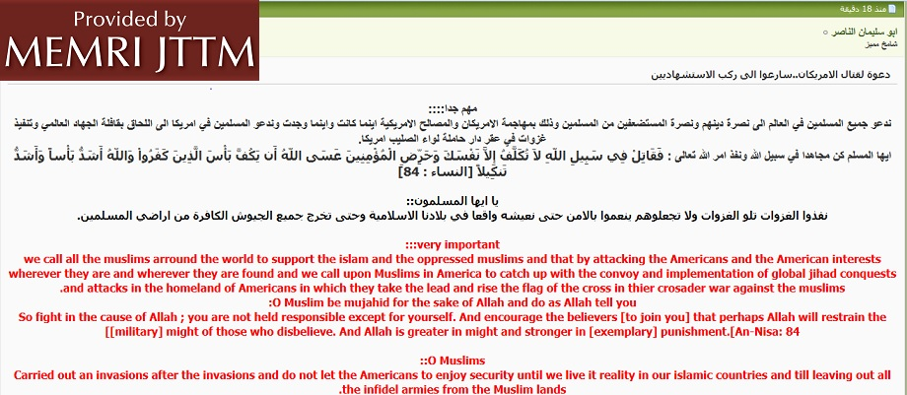
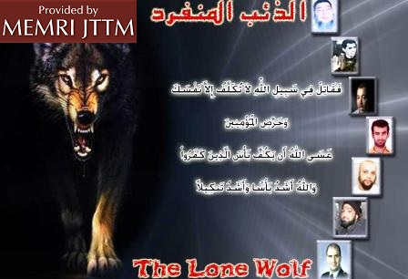
On April 20, 2013 Abu Suleiman Al-Nasser, a prominent writer on the Shumoukh Al-Islam jihadi forum, posted a message he labeled "Very Important," in which he called on Muslims around the world to kill Americans and target U.S. interests everywhere. In his post, which is titled "Call to fight [against] Americans... Hurry up and join the Martyrs," Al-Nasser urged Muslims to carry out operations in America. "O Muslims," he wrote, "carry out invasion after invasion and do not let them [the Americans] live in peace until we [Muslims] experience living peacefully in our Islamic countries and until all infidel armies leave Muslim lands." The post also includes images of a Wolf and a number of terrorists including Fort Hood Shooter Major Nidal Hassan.

Al-Nasser has posted similar posts and delivered audio messages calling for similar attacks in the past. For example, in May 2011, Al-Nasser released an audio recording calling for immediate attacks against Americans and U.S. and NATO targets.[i]
Endnotes:
[i] See Jttm Report Abu Suleiman Al-Nasser Releases Audio Recording Calling for Jihad Supporters Worldwide to Enlist for Attacks against U.S. May 4, 2011
►Posted at: April 20, 2013

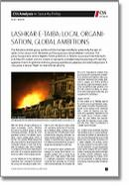
Center for Security Studies (CSS)

Lashkar-e-Taiba: Local Organisation, Global Ambitions
Author(s): Prem Mahadevan
Editor(s): Daniel Trachsler
Series: CSS Analysis in Security Policy
Issue: 132
Publisher(s): Center for Security Studies (CSS), ETH Zurich
Publication Year: 2013
Source: http://www.css.ethz.ch/publications/DetailansichtPubDB_EN?rec_id=2479

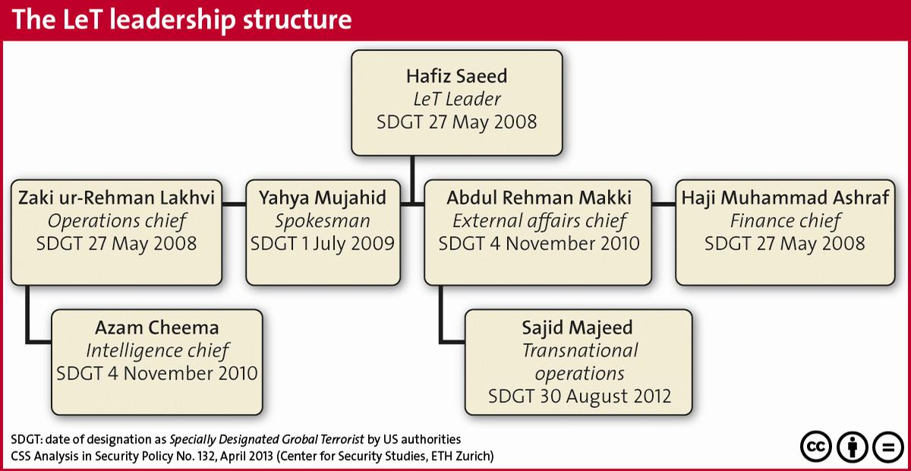
The Pakistani jihadist group Lashkar-e-Taiba has been labelled as potentially the next al- Qaida. It has shown both the desire and the capacity to attack Western nationals. The group has gained a certain degree of state protection in Pakistan by compartmentalising its activities into violent and non-violent components, and selectively cooperating with security agencies. Due to its global ambitions, growing operational presence, and internal dynamics, it now poses a serious threat to international security.

►Download the report from source link

Six admit planning to bomb English Defence League rally

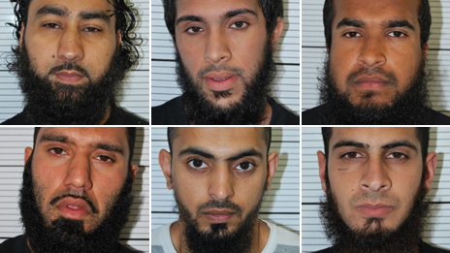
Source: http://www.bbc.co.uk/news/uk-22344054
Omar Khan, Zohaib Ahmed, Jewel Uddin, Mohammed Saud, Mohammed Hasseen and Anzal Hussain, (clockwise from top left)

Analysis
Dominic Casciani
(BBC Home affairs correspondent)

Jewel Uddin was under surveillance because of his links to other identified extremists. But he wasn't being watched around the clock because 24-hour coverage only occurs when a suspect is thought to be planning an attack and is in the closing stages of their preparations.
The British police and MI5 don't have the manpower that the East German Stasi once had, so counter-terrorism investigators deal everyday with competing requests for resources for covert operations. Uddin was, in the jargon, a person of interest whom investigators wanted to better understand.
But given what they knew of his connections, did they make the right call? The case has inevitable echoes of 2004 when MI5 had come across a man from West Yorkshire on the periphery of another investigation. They never got to the bottom of who he was until he led the 2005 suicide attacks on London.
Six men from the West Midlands have pleaded guilty to planning to bomb an English Defence League rally.
Omar Mohammed Khan, Mohammed Hasseen, Anzal Hussain, Mohammed Saud, Zohaib Ahmed and Jewel Uddin admitted preparing an act of terrorism. All six will be sentenced on 6 June.
Five of them took a homemade bomb to an EDL rally in Dewsbury, West Yorkshire, last June but arrived after it ended.
They were caught after their car was stopped and found to have no insurance.
Police and security services had no intelligence about the planned attack, although one of the would-be killers, Jewel Uddin, was under surveillance in relation to another terror plan.
After the hearing at Woolwich Crown Court, Assistant Chief Constable of West Midlands Police Marcus Beale said: "Their capability was clear.
"They created devices that would have certainly maimed and possibly killed people depending on how close they were.
"Their intent was very, very clear. In my view they were very dangerous."
Tommy Robinson, aka Stephen Lennon, leader of the EDL, said he welcomed the convictions.
'Female devil'
On 30 June 2012, the EDL, an anti-Islamic group that says it supports peaceful protest, held a rally in Dewsbury, despite attempts by the Muslim community in the town to have it stopped.
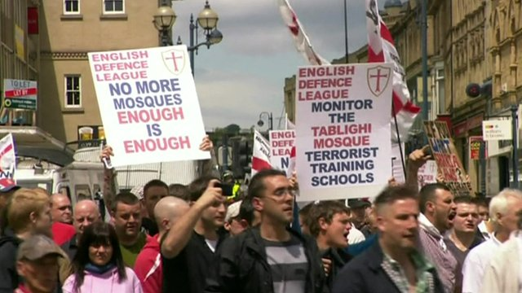
Police estimated there could have been as many as 750 EDL supporters in attendance, as well as dozens of police officers and passers-by.
As the rally was taking place, the five men travelled there in two cars, one of which was carrying a homemade bomb constructed out of a modified firework and containing 359 nails and 93 ball bearings.
They also had two sawn-off shot guns, parts of other explosive devices, knives and a long printed message, dated the same day, describing their motivation and calling the Queen a "female devil".
It said: "To the EDL (English Drunkards League). O enemies of Allah! We have heard and seen you openly insulting the final Messenger of Allah... you should know that for every action there is a reaction.

The BBC's June Kelly reports on the background to the case
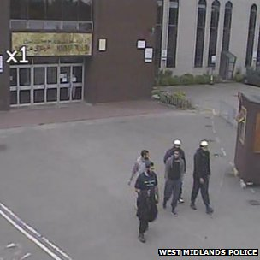
"Today is a day of retaliation (especially) for your blasphemy of Allah and his Messenger Muhammad. We love death more than you love life. The penalty for blasphemy of Allah and his Messenger Muhammad is death."
However, the men arrived after the EDL rally had broken up because the right-wing group had insufficient speakers to carry on later into the afternoon.
The would-be attackers left the town but were stopped by a traffic police officer on the M1 motorway for having no car insurance.
Days later, when the impounded vehicle was searched, the weapons were found - sparking a manhunt across Birmingham.

Under surveillance
Following their arrests, it emerged that Uddin was already known to the police and MI5.

Five of the men were caught on CCTV in Dewsbury shortly after the rally had disbanded
He was an associate of another group of Islamist terrorists, also based in Birmingham, who were jailed last week for planning an attack to rival the 7 July and 9/11 atrocities.
Uddin was under partial counter-terrorism surveillance, and five days before the aborted EDL attack, a West Midlands surveillance officer watched him and another man go to a homewares shop near his home in the Sparkhill area of Birmingham.
Police later established that the man accompanying Uddin was fellow plotter Omar Khan - and that the pair had bought some of the knives eventually found in the car boot.
A second member of the group, Ahmed, had been separately charged with possession of jihadist magazines that included bomb-making instructions. He was on bail at the time of the failed bombing.
Responding to suggestions police could have arrested Uddin earlier, ACC Beale said: "We didn't fail to join the dots.
"We were doing what was right and proportionate at the time."
Five of the men were from Birmingham - Uddin, 27, and Khan, 28, both from Sparkhill, Ahmed, 22 from Saltley, Hasseen, 23 from Tyseley, and Hussain, 24, from Moseley - and one, Saud, 22, was from Smethwick.
All changed their pleas from not guilty on Tuesday via videolink, admitting preparing an act of terrorism between 1 May and 4 July 2012.
Mr Robinson told the BBC he believed the plot was targeted at him personally.
The EDL leader said he had intended to travel to Dewsbury to be part of the rally but had been unable to go at the last minute for family reasons.
A statement from the Birmingham Coalition of Muslim Organisations and Mosques, which says it represents most of the city's 230,000 Muslims, said: "The Muslim community in Birmingham wishes to make one thing absolutely clear: These acts are not carried out in our name."

Who funds terrorism and why?
Source: http://english.pravda.ru/world/americas/29-04-2013/124448-terrorism-0/

Nearly every day in one or another country explosions are heard and innocent blood is shed. Global terrorism has become a major problem of the early 21st century. Attempts to deal with it have not produced any results. Terrorism is a well-organized structure. Who are the main sponsors of terrorist acts? Who is financing terrorists and why?
The U.S. financial intelligence unveiled its new list of the countries suspected of involvement in terrorism financing and money laundering. According to its estimates, the situation in Iran and North Korea is so serious that it requires immediate defensive "counter-measures." The Americans advised to practice "enhanced precautions" in relation to 13 countries - Vietnam, Indonesia, Yemen, Kenya, Pakistan, Nigeria, Myanmar, Sao Tome and Principe, Ecuador, Turkey, Tanzania, Syria and Yemen.
Another two dozen countries, including Kyrgyzstan and Tajikistan, have been named countries with "strategic deficiencies" who expressed willingness to deal with them. The relations between the United States, Iran and North Korea are quite complicated. These countries are virtually on the verge of a war, and ominous calls were heard from one party or another more than once. This is precisely why the United States included them in the list of the most dangerous countries helping terrorists.
The Americans generally like to change their opinions, calling the enemies those who are not beneficial at the time and justifying real devils. Last year the U.S. called Saudi Arabia the primary sponsor of terrorists. The Americans stated that the Saudis were active in all areas of international terrorism; they were planning attacks and engaged in financing the activities of criminal gangs.
The report submitted on 10 July 2012 by the Pentagon's leading analyst firm "Rand Corporation" stated that in the event of a failure to do away with this activity it was advisable to freeze all financial assets of the kingdom and strike at the Saudi oil fields.
It would be wrong to say that a struggle with terrorism can be won through the destruction of its combat units, as they are only an advanced echelon of the enormous extremist structure that wants to change the existing world order through violence. The second, basic tier includes Pakistan, Iraq, Iran, Syria, Sudan, Yemen, Lebanon and other countries.
Headquarters, training centers and arsenals of terrorists are located on the territory of these countries. The authorities in these countries provide terrorists the opportunity to use public infrastructure for communication and command. They also supply bandits with weapons, documents, intelligence and information support.
Financial institutions through which terrorists get money to implement the most sophisticated and bloody actions are also located on their territory. But the core jihad countries are usually economically weak communities. With fairly limited resources, they allocated a great deal of money for the maintenance of their own armed forces.
But a significant part goes directly to terrorists. Who delivers these funds? They are provided by countries of the third tier that consist mainly of oil emirates of the Persian Gulf. It is usually absolute monarchies whose main sources of income are production and sale of oil and gas.
The populations of these countries almost without exception are of Muslim Wahhabi orientation, the most reactionary Muslim faith aimed at achieving global domination of Islam. Finally, these countries are located on the coast of the Persian Gulf, which allows them to consolidate their own efforts and respond quickly to any changes. The third tier of jihad today includes 5 countries: Saudi Arabia, UAE, Qatar, Oman and Bahrain.
Saudi Arabia is a huge country whose territory is four times larger than the area of ​​France. The country has a population of just over 20 million people, and its main religion is Wahhabi Islam, whose canons are fully integrated in the daily life of the country. Saudi Arabia is the informal head of the Islamic world, because Mecca and the Kaaba are located on its territory.
The clan at power conducts a consistent policy of Wahhabi doctrine statements, and not only in their own country. The essence of this doctrine is set out in the Tauhid manifesto that says that true Muslims must fight with the infidels everywhere and continuously, with word, arms and money. Saudi Arabia learned the last message well and finances terrorism.
For example, Saudi Arabia's military budget is $18.7 billion, which is one of the highest in the world. At the same time, the Saudi Army has only 200,000 soldiers and officers. In comparison, China spends $17 billion dollars on its military, while the armed forces of this country exceed 2.4 million people.
Where do those billions actually go? Today it is clear that they are spent on funding the countries and organizations on the frontlines of the war with the civilized world. According to intelligence of U.S., Israel and Russia, the money to finance Pakistan's nuclear and missile programs as well as creation of the "Taliban" and its activities in Afghanistan was sent precisely from the military budget of Saudi Arabia.
Over five years the money has been paying for the activities of Chechen military units. In addition, the citizens of Saudi Arabia take part in the most bloody and cynical crimes in all regions of the world more actively than other Arabs. Thousands of them were concentrated in the "dormant" terrorist units of Islamic diaspora in Europe and America. They are driven not only by religious fanaticism. Saudi petrodollars have not been canceled.
Everybody knows that the rebel troops in Syria are funded by the West. The United States wants to take control of the country with huge resources of oil and gas. The Americans must restore order in their own country before blaming other countries in supporting terrorism. After all, it is the U.S. that created Al-Qaeda as the opposition to the Soviet forces in Afghanistan, the U.S. has grown Bin Laden, etc.
The American neo-conservatives openly support terrorists in the Caucasus. Terrorism in the Caucasus region of Russia is a cynical organization created by the U.S. intelligence to manipulate and destroy the Russian Federation. A complex network of terrorist organizations operating under the banner of "independence" and "separatism" for the Caucasus region for over two decades has been trying to destabilize the situation in Russia.
With the money of the U.S. State Department and the Foreign Ministry of Finland "Kavkaz-Center" was created and launched. It is a propaganda mouthpiece of Doku Umarov. Any terrorist attack is characterized as a heroic act. Another sponsor organization is "The American Committee for Peace in the Caucasus." According to the report of the Institute of Political Studies, the committee was founded in 1999 by Freedom House - a neo-conservative organization that cooperates with the U.S. government.
This fund receives money from the National Fund for Democracy. "The American Committee for Peace in the Caucasus" finances the activities of terrorists trying to destroy Russia from within. Former foreign minister of Ichkeria Ilyas Akhmadov was given the status of a "political refugee" by this organization. It is this committee that provided him with funding sponsored by the American taxpayers. Therefore, the U.S., blaming everyone in support of terrorism, in many ways is the founder and a main sponsor of this phenomenon. Unfortunately, innocent people suffer from these political games.

Sergei Vasilenkov (Pravda.Ru)

Europol: EU sees sharp rise terror attacks, deaths in 2012
Source: http://www.securityinfowatch.com/news/10930290/europol-eu-sees-sharp-rise-terror-attacks-deaths-in-2012

The annual terrorism report published by Europe's crime-fighting agency, coming less than two weeks after the bombings in Boston, identified 219 completed or failed attacks in 2012 in EU-member states, the majority in France and Spain.
That was a rise of 26 percent over 2011, when 174 such attacks were reported.
Europol defines a "terrorist" offence as an intentional act which may seriously damage a country or international organisation when committed to intimidate a population, compel a government to act, or destabilise political, economic or social structures.
"The threat from terrorism ... remains strong in Europe. It also continues to evolve from structured groups and networks to smaller EU-based groups and solo terrorists or lone actors," the EU Terrorism Situation and Trend Report found.
Seventeen people died last year in such incidents, the deadliest being a series of three attacks by a lone gunman in and a bombing at Bulgaria's Burgas airport, each of which killed seven.
Only two people died in such attacks in 2011.
As in years past, the majority of the attacks came from separatist groups in and Spain. Basque separatist group ETA carried out none, having declared a ceasefire in October 2011.
But the threat from religiously-inspired lone actors is strong, the report found. France's Mohamed Merah, a 23-year-old of French-Algerian origin, shot three soldiers, three Jewish children and a Jewish teacher in March 2012 before being killed by police.
The report found a continued reliance on the Internet for smaller groups and lone actors who use it to collaborate with like-minded individuals and plan attacks.
In 2012, more EU citizens travelled to conflict zones around the world, such as Syria and the Sahel, to engage in fighting.
"Syria emerged as the destination of choice for foreign fighters in 2012," the report found, citing the risk of EU citizens, upon their return, using their new training and knowledge for activities in Europe.
EU citizens have also been detected in Somalia, where they are believed to be affiliated with al Qaeda, and northern Mali, where France has been striving to drive out insurgents linked to al Qaeda since January.
"The developments in the Sahel region are of major interest to the security situation of the EU," wrote Europol Director Rob Wainwright.
Representing less of a threat last year were left-wing and anarchist groups, which committed 18 reported attacks compared with 37 last year and 45 in 2010. The number of such attacks increased in Italy in 2012, however.
Following the killing of 77 people in Norway in 2011 by right-wing extremist Anders Behring Breivik, EU governments stepped up their surveillance of right-wing groups. Such groups staged two attacks in 2012, in Bulgaria and Poland.

Jihadists show little interest in Switzerland
Source:http://www.swissinfo.ch/eng/swiss_news/Jihadists_show_little_interest_in_Switzerland.html?cid=35678896

Switzerland is still not a priority target for jihadists according to the Federal Intelligence Service (FIS), although it cannot rule out that these organisations could recruit potential terrorists or find support for their activities.
In its annual report presented on Tuesday, the FIS said that while several hundred people have travelled from Europe to join jihad or terrorist movements over the past decade, less than 20 known journeys have been made from Switzerland.
One third have actually been confirmed as such trips, while the others could have also been related to language courses.
A number of these travellers are known by European security services to participate in acts of war or provide logistical support to jihad organisations. Others have also undergone training to commit acts of terror where they are or elsewhere, including in the West.
The FIS states that particular attention is given to persons returning who have attended a training camp in a jihad area or participated in combat, given the risk of them carrying out potential attacks in Europe or serving as role models for others.
For the intelligence service, the case of the Toulouse shootings in March last year is the perfect example of what can go wrong. However, there have been no confirmed cases of returnees to Switzerland so far.

Typical destinations
According to the FIS, Somalia is the most frequent destination for Swiss jihad sympathisers, while there is only one confirmed case of travel to the Afghanistan-Pakistan region. That person – a former asylum seeker who evaded a prison sentence for supporting a criminal organisation – was reportedly killed in a drone attack last year.
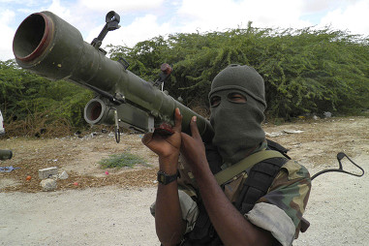
The report warned that Syria is also becoming a destination for jihadists, mainly because getting there is simpler than getting to many other countries. A number of individuals could have travelled from Switzerland for this purpose, although they are still unconfirmed.

A number of Swiss residents travelled to Somalia, where there is an Islamist insurrection (Keystone)

The FIS believes that unimpeded travel from Switzerland could damage the country’s reputation. It could also cause Switzerland to serve as a preparation and recruitment area for terrorists and increase the risk that Swiss residents or people with a direct relationship to Switzerland be involved in terrorist acts.
To counter these potential threats, the intelligence service says that it currently calls on the resources it is legally allowed to use to identify potentially dangerous networks and individuals.

Local threats
At home, right- and left-wing extremists are not considered a major threat by the FIS, even if there is some potential for violence. Arrests and sentencing have helped reduce the activities of left-wing extremists, while the behaviour of their right-wing counterparts has become more clandestine, making it harder to assess.
Of bigger concern to the authorities are illegal intelligence operations still carried out in Switzerland, notably those using computer resources to access sensitive information. With information and communications facilities increasingly interconnected, cyberattacks are more likely.
Traditional spying is still taking place, however. Georgian intelligence, for example, conducted illegal surveillance of their country’s opposition in Zurich, and there are signs that other states are carrying out similar operations.
Foreign spies are also believed to be keeping a close eye on Switzerland’s research and financial sectors as well as the many international organisations that call the country home.

POLL: Boston Bombings And Threat Of Terrorism
Source: http://www.kionrightnow.com/story/22123928/poll-boston-bombings-and-threat-of-terrorism

A CBS News/New York Times Poll is out on the Boston bombings and the threat of terrorism.
According to the poll:
41% of Americans think U.S. Intelligence agencies had information that could have prevented the bombings at the Boston Marathon, but 45% do not.
53% think the Boston bombing suspects were connected to a larger terrorist group, while 32% think they acted alone. The poll was conducted before reports that female DNA was found on one of the bomb fragments.
In the wake of these attacks, fears of another terrorist attack in the U.S. have risen sharply. 66% now think an attack is at least somewhat likely to happen in the next few months, up from 37% last April.

►Read full report at: http://ftpcontent.worldnow.com/kion/news/CBSNYPoll.pdf

The US's Narrow-Minded Anti-Terrorism Strategy: Blowback and the Cycle of Violence
By Melvin A Goodman
Source: http://truth-out.org/news/item/16087-the-uss-narrow-minded-anti-terrorism-strategy-blowback-and-the-cycle-of-violence

The United States and the Central Intelligence Agency have never acknowledged the potential for “blowback,” or negative fallout, from their military and covert actions. The Watergate burglary by the veterans of the Bay of Pigs was an obvious example of blowback. CIA’s support for the anti-Soviet mujahideen in the 1980s proved particularly damaging, because the mujahideen provided weaponry to fuel conflicts in the Balkans and the Sudan and trained the terrorists who would attack us at home, including the bombing of the World Trade Center in 1993.
Former CIA director Robert Gates may believe that support to the mujahideen was the CIA’s “greatest success,” but don’t tell that to U.S. soldiers and Marines in Afghanistan who have had to deal with former mujahideen forces, such as the Haqqani and Hekmatyar networks, for the past decade. The United States inadvertently created, trained, and sustained an infrastructure of terror that exported terror wrapped in the language of religious war.
Now we are dealing with an updated version of “blowback,” a series of terrorist attacks in the United States where perpetrators claim their inspiration is the U.S. “war on Islam.” They cite the use of U.S. military power and CIA operations in Muslim countries. The surviving Boston Marathon bomber, who contends that he acted to counter U.S. policies in Iraq and Afghanistan, is the latest example.
But he is one of many. Osama bin Laden claimed that he targeted the United States because of the “occupation” of Saudi Arabia and its holy places by the U.S. military. Faisal Shahzad, a Pakistani immigrant who went to college in Connecticut, said he left a S.U.V. packed with explosives in Times Square because of U.S. drone strikes in Pakistan. Major Nidal Malik Hasan killed 13 people at Fort Hood, Texas in 2009 because of U.S. military strikes in the Middle East and the Persian Gulf. Najibullah Zazi, an Afghan-American, planned a suicide attack on New York City’s subway system because of the U.S. role in Afghanistan.
The attack on the Benghazi consulate last year focused on the U.S. intelligence platform in eastern Libya. The groups claiming responsibility for the Benghazi attack had been targeted by U.S. intelligence throughout Southwest Asia and North Africa. Any U.S. intelligence component is a likely target of the wrath of militant and terrorist organizations because of the CIA’s key role in the war on terror and the increasingly widespread use of drone aircraft.
The United States has been single-minded and narrow-minded in dealing with terrorism, believing that a unilateral use of military power would provide the best protection for its interests. We have used unwieldy military instruments, such as armed drones, to counter the threat. There is increased evidence that the militarization of U.S. foreign policy and the increased operational tempo of the U.S. military itself is creating many more terrorists and insurgents than it is destroying. Secretary of Defense Donald Rumsfeld acknowledged this fact ten years ago, and more recently the former commander of U.S. forces in Afghanistan, General Stanley McChrystal, did the same. A Yemeni activist told a subcommittee of the Senate Judiciary Committee on April 23, 2013, that a single drone strike creates a greater hatred of the United States than the actions of Yemeni insurgents.
Just as a bipartisan panel in the 1950s, the Doolittle Committee, declared that there were “no rules” in the global competition with the Soviet Union and that “hitherto acceptable norms of human conduct do not apply,” which led to the misuse of the CIA and a series of misbegotten covert actions from the 1950s to the early 1970s, the War on Terror became the justification for another surge in illegal CIA activities, including the use of torture and abuse, secret prisons, and extraordinary renditions. These tactics raise important moral and humanitarian questions and compromise the strategic quest for international stability.
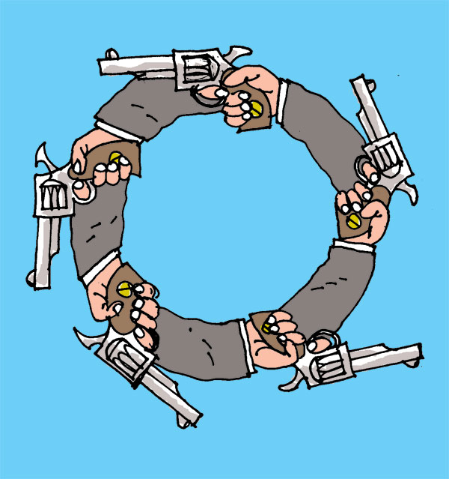
The “creativity” of the United States in using the CIA as a military weapon has not been matched by the use of diplomacy in the international arena. At the outset of his first term, President Barack Obama sent strong signals regarding the need for diplomacy and conciliation as opposed to President Bush’s emphasis on military force and covert action. President Obama even named three so-called tsars for diplomatic dealings with the Middle East (George Mitchell), Iran (Dennis Roth), and Afghanistan-Pakistan (Richard Holbrooke). It was soon obvious that the tsars were isolated and ignored within Hillary Clinton’s Department of State and General James Jones’ National Security Council. The example of Holbrook was particularly revealing because, unlike his colleagues, Holbrook had actual ideas about using a prisoner exchange to get the Taliban to talks similar to the Dayton talks for Bosnia or Rambouillet for Kosovo in the 1990s. But the Pentagon–backed by congressional conservatives–opposed any prisoner release that would possibly lead to putting Taliban fighters back on the battlefield. The Pentagon is even dragging its heels in implementing further withdrawal of forces from Afghanistan.
The end of the Cold War dramatically widened the area of diplomacy and conciliation in U.S. foreign policy, but three presidents over a twenty-year period chose to ignore the opportunity. President Bill Clinton ignored signs of conciliation from Iran, and instead of “anchoring” Russia to the Western security architecture, he enlarged the North Atlantic Treaty Organization. President George W. Bush abrogated the Anti-Ballistic Missile Treaty, the core of strategic deterrence, in order to deploy a national missile defense that does not work, and then manipulated specious intelligence to lead the country into an unnecessary and immoral war against Iraq.
President Obama ignored a credible signal from North Korea for the start of a diplomatic dialogue, and has relied on sanctions and coercion in dealing with Iran’s nuclear program. His administration has ignored fundamental questions of law and morality in the war on terror. At home, the Obama administration has endorsed a National Defense Authorization Act that permits indefinite detention of U.S. citizens; prosecutes whistleblowers; refuses to close Guantanamo; and allowed solitary confinement for Bradley Manning.
After the Pentagon was attacked on 9/11, Secretary of Defense Donald Rumsfeld told his closest advisors to “go massive–sweep it all up, things related and not.” Going massive has meant the use of an even blunter military instrument to stabilize a lawless tribal region in Southwest Asia that has been causing trouble for the past 150 years. Pakistan has used U.S. money and support to fund the regrouping of the Afghan Taliban, thus assuring defeat in any counter-insurgency. The U.S. policy of extraordinary renditions created a virtual global network for torture and abuse that involved dozens of countries in Europe, Asia, the Middle East, and Africa.
Military tools will not solve the myriad problems that include India vs. Pakistan; Afghanistan vs. Pakistan; Iran vs. Afghanistan; and the powder kegs that exist in Central Asia. The long-term commitment of military forces and money has further destabilized the region, and contributed to the violence aimed at U.S. forces and even the United States itself. We cannot occupy the entire world. The sooner we close certain doors and turn the keys over to key regional actors, the better off we will be.

Melvin A. Goodman is national security and intelligence columnist for Truthout. His 42-year government career included service with the CIA, the State Department, the Defense Department and the US Army. His latest book was "Failure of Intelligence: The Decline and Fall of the CIA"; he is the author of the forthcoming "National Insecurity: The Threat of American Militarism" (City Lights Publisher, 2012).

Answers to Why People Become Terrorists
By Bruce Hoffman
Source:http://www.thedailybeast.com/articles/2013/04/27/answers-to-why-people-become-terrorists.html?goback=.gde_1528217_member_236214263

From the bombers of 9/11 to the Tsarnaev brothers, everyone asks the question: why? Why would these men kill? Why would these men aim for such destruction? We know there is no one path to radicalization. The reasons why someone picks up a gun or blows themselves up are ineluctably personal, born variously of grievance and frustration; religious piety or the desire for systemic socio-economic change; irredentist conviction or commitment to revolution. And yet, though there is no universal terrorist personality, nor has a single, broadly applicable profile ever been produced, there are things we do know. Terrorists are generally motivated by a profound sense of (albeit, misguided) altruism; deep feelings of self-defense; and, if they are religiously observant or devout, an abiding, even unswerving, commitment to their faith and the conviction that their violence is not only theologically justified, but divinely commanded.
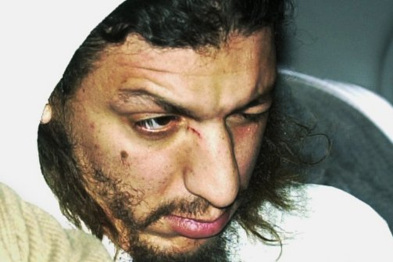
Richard Reid, the so-called “shoe bomber,” who attempted to blow up an American Airlines flight en route from Paris to Miami in December 2001 was a career criminal who dropped out of high school and converted to Islam while in prison before he was recruited to al Qaeda. (AP)

All terrorists fundamentally see themselves as altruists: incontestably believing that they are serving a “good” cause designed to achieve a greater good for a wider constituency—whether real or imagined—which the terrorist and his organization or cell purport to represent. Indeed, it is precisely this sense of self-righteous commitment and self-sacrifice that that draws people into terrorist groups. It all helps them justify the violence they commit. It gives them collective meaning. It gives them cumulative power. The terrorist virtually always sees himself as a reluctant warrior: cast perpetually on the defensive and forced to take up arms to protect himself and his community. They see themselves as driven by desperation——and lacking any viable alternative—to violence against a repressive state, a predatory rival ethnic or nationalist group, or an unresponsive international order.
Religion only serves as one more justification—particularly in the case of suicide terrorism. Theological arguments are invoked both by the organizations responsible for the attacks and by the communities from which the terrorists are recruited. In the case of Muslims, although the Quran forbids both suicide and the infliction of wanton violence, pronouncements have also been made by radical Muslim clerics, and in some instances have been promulgated as fatwas (Islamic religious edicts), affirming the legitimacy of violence in defense of defenseless peoples and to resist the invasion of Muslim lands. Among the most prominent was the declaration by the Ayatollah Khomeini who once declared (in the context of the Shi’a interpretation of Islam) that he knew of no command “more binding to the Muslim than the command to sacrifice life and property to defend and bolster Islam.” Radical Islamist terrorist movements have thus created a recruitment and support mechanism of compelling theological incentives that sustains their violent campaigns.
But individuals will always be attracted to violence in different ways. Just look at the people who have gravitated towards terrorism in the United States in recent years. We have seen terrorists of South Asian and North as well as East African descent as well as those hailing both from the Middle East and Caribbean.
Now we have the Tsarnaev brothers products of centuries-long conflict between Russia and Chechnya. We have seen life-long devout Muslims as well as recent converts—including one Philadelphia suburban housewife who touted her petite stature and blonde hair and blue eyes as being so atypical of the stereotypical terrorist so as to defy any efforts at profiling. Radicalized over the Internet, she sought to use her self-described ability to avoid detection to assassinate a Swedish artist who drew a cartoon of the Prophet Muhammad. They come from every walk of life, from marginalized people working in menial jobs, some with long criminal records or histories of juvenile delinquency, to people from solidly middle and upper-middle class backgrounds with university and perhaps even graduate degrees and prior passions for cars, sports, rock music and other completely secular, material interests.
The spectrum of British jihadis over the past decade illustrates the panoply of individuals attracted to terrorism. Richard Reid, the so-called “shoe bomber,” who attempted to blow up an American Airlines flight en route from Paris to Miami in December 2001 was a career criminal who dropped out of high school and converted to Islam while in prison before he was recruited to al Qaeda. By comparison, Omar Khyam, the mastermind behind a 2004 bombing plot of a shopping mall outside London, was the son of a wealthy businessman and grew up in a comfortable, upper-middle-class environment. Similarly, Ahmed Omar Saeed Sheikh, the al Qaeda operative responsible for the kidnapping of Wall Street Journal reporter Daniel Pearl in 2002, attended an exclusive (e.g., expensive) private school. He later was admitted to the world-renowned London School of Economics (LSE), where he studied applied mathematics statistical theory, economics, and social psychological. Described as “handsome, tall and muscular, very bright and charming,” his parents expected he would be knighted some day and not languishing in prison awaiting execution for his role in Pearl’s execution.
And, as we have also seen, relationships formed at work, at school, on sports teams, and other recreational and religious activities as well as over the Internet can prey upon the already susceptible. In some instances, first generation sons and daughters of immigrants embrace an interpretation of their religion and heritage that is more political, more extreme and more austere—and thereby demands greater personal sacrifices—than that practiced by their parents. The violence inflicted on Muslims in general and Muslim women and children especially around the world have been cited by many homegrown terrorists as a salient motivating factor in their politicization and radicalization and may explain why the American invasions of Iraq and Afghanistan were cited by Dzhogar Tsarev as the reasons behind his and his older brother’s bombing of the Boston Marathon.
Indeed, the common element in the radicalization process reflects these individuals’ deep commitment to their faith—often recently re-discovered; their admiration of terrorist movements or leading terrorist figures who they see as having struck a cathartic blow for their creed’s enemies wherever they are and whomever they might be; hatred of their adopted homes, especially if in the United States and the West; and, a profoundly shared sense of alienation from their host countries.
At the start of the war on terrorism a dozen years ago the enemy was clear and plainly in sight. It was a large terrorist organization, situated mostly in one geographic location, and it was led by an identifiable leader. Today, when the borders between domestic and international terrorism have blurred, when our adversaries are not only identifiable organizations but enigmatic individuals, a complete re-thinking of our counterterrorism policies and architecture is needed. We built an effective defense against the previous threat. Our challenge today is to develop new defenses against this more amorphous, diffuse and individualized one.

Professor Bruce Hoffman has been studying terrorism and insurgency for more than 30 years. He is currently Director of the Center for Security Studies, Director of the Security Studies Program, and a tenured professor at Georgetown University’s Edmund A. Walsh School of Foreign Service, in Washington, D.C.

Al Qaeda branches strengthen as center weakens
Source: http://www.dw.de/al-qaeda-branches-strengthen-as-center-weakens/a-16780261

Osama bin Laden, the founder and long-time leader of the Islamist terrorist organization al Qaeda, was killed two years ago by US soldiers. His worldwide terrorist network has changed a lot since then.
The name al Qaeda is synonymous with a number of terrorist attacks, both in the West and in the Arab world. The destruction of the World Trade Center in New York in 2001 brought the group to the world's attention. Around 3,000 people were killed. The former head of the Islamist terror network, Osama Bin Laden, was hunted down in Pakistan and shot dead by US soldiers.
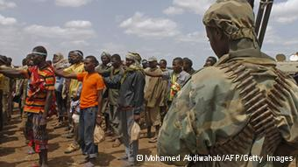
Al Shabab is very active Somalia

Now the group is split. Several Islamist groups in North Africa, the Middle East, and on the Arabian Peninsula occasionally use the name al Qaeda, but pursue their own aims.
Al Qaeda's headquarters are thought to be in Afghanistan and Pakistan, but experts believe the strength of this core has been reduced considerably.
Estimates hold that only 300-400 people make up the ideological center of al Qaeda. However, the groups outside of al Qaeda's center are thought to have gotten stronger.

Leadership weakened
Islamism researcher Guido Steinberg of the German Institute for International and Security Affairs (SWP) believes that the death of Bin Laden has significantly weakened al-Qaeda, depriving it of a charismatic leader who stands above the arguments between individual factions. "The current leader, the Egyptian Ayman al Zawahiri, has always been controversial among many non-Egyptians within the organization."
But Zawahiri remains the supreme commander of the terrorist organization. The leaders of different branches of al-Qaeda are bound to him by oath. Zawahiri has also cultivated a small group of long-serving comrades, says journalist and al Qaeda expert Yassin Musharbash. "They present the image of al Qaeda to the world through videos and speeches," he told DW. "That sets the ideological direction."

Branches and allies
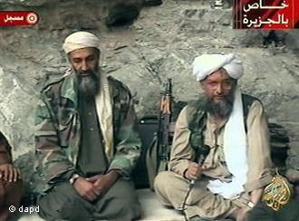
Apart from the headquarters in Pakistan, there are also official al Qaeda groups and movements in other countries, says Musharbash. "There are branches in Iraq, in North Africa, and on the Arab Peninsula. The al Shabab militia, which has made itself subject to al Qaeda, is very active in Somalia. But it is not the same as al Qaeda."

Ayman al-Zawahiri has emerged as the network's new leader

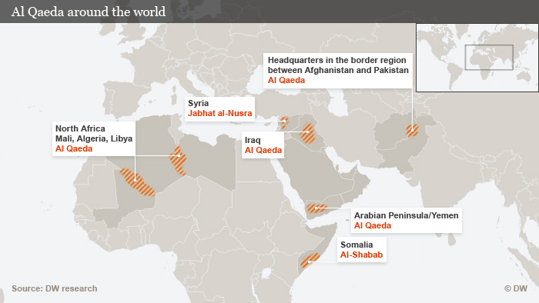
The terrorist group now led by Zawahiri is particularly well represented in Algeria, Mali, and Libya. And terrorist activity is increasing in Iraq, where there are thought to be 1,000 al Qaeda followers. Similarly, the Islamists have strengthened their position among the various rebel groups in Syria, fighting against the regime of President Bashar al Assad, says Musharbash. "In Syria, there is the al Nusra Front, probably the most important jihadist group at the moment."
But, as yet, the group's presence in Syria does not represent any threat to the outside world, the terrorism expert adds, though he warns that that could change if the Assad regime collapses. If that happens, Musharbash says the al Nusra Front could make good on its threat to install a mini-Emirate and attack Israel. "The group has publicly declared this aim several times."

Few members, many supporters
There are only vague estimates as to the total number of al Qaeda supporters in the world. Musharbash thinks that "there can't be more than 10,000 people in the world who would describe themselves as members of al-Qaeda." He puts the number as closer to 5,000.
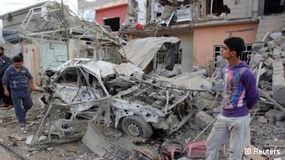
But on top of that there is a large number of supporters and sympathetic groups willing to lend help. "There are al Qaeda supporters who are not members, but still militant," he says. "We see that in Libya, Tunisia, on the Sinai peninsula, and in Yemen - a kind of second ring around al Qaeda. They are groups who emphasize their local origin and stay independent."

More Muslims are killed by al Qaeda than non-Muslims

Guido Steinberg of SWP believes that all of the al Qaeda groups decide on their strategy independently. But at the same time, actions are often planned by the al Qaeda headquarters, the Islam scholar says. "In 2010, a big, programmatic video was distributed in which almost all al Qaeda leaders with a rank and name appeared," Steinberg explains. "They said: you don't have to come to Pakistan anymore, you don't have to join the organization anymore. You can look in your own country to see how you can organize terrorist activity there."
Still dangerous
More Muslims are killed by al Qaeda than non-Muslims
The number of al Qaeda attacks in western countries has gone down significantly thanks to the success of the US' anti-terror operations. That has led to the assumption that the danger of al Qaeda has been reduced. But in truth the opposite is likely the case.
"Al-Qaeda is hundreds of times more active in the Islamic world than outside it," Mushabarash says. "There are studies that say al Qaeda kills eight-and-a-half times more Muslims than non-Muslims." The terrorist network has experienced something of a second wind because of the ever more complicated Arab Spring.
"One shouldn't underestimate al Qaeda," said Musharbash. "At decisive points, al Qaeda has always found ways to re-invent itself. And at the moment we are seeing that again."

Return of terror shatters US sense of calm
By George N. Tzogopoulos
Source: http://www.globaltimes.cn/content/778636.shtml#.UYKQ20qsnQ4

For many years the specter of terror had been largely absent from the US. Domestic life had returned to normalcy after the period of instability and uncertainty following the September 11 attacks. In parallel with this, terrorism was no longer considered a priority for US citizens more worried about the economy and unemployment.
A few shocking seconds on April 15 in Boston, however, have changed the calm routine. The families of victims will experience the pain for their remaining life. Words are useless to portray the drama. And whatever punishment is inflicted on the surviving terrorist, it will be little relief.
Along with the lives lost and injuries inflicted, the blasts in Boston raise important questions regarding similar attacks in future. The interception of a letter addressed to US President Barack Obama, apparently containing ricin, multiplies fears for a drastic return of terrorism. The explosions in the town of West, Texas stirred worries of another attack, but proved to be a safety failure rather than a security one.
In any case, the main challenge for the US is that it needs to reconcentrate on an issue which had been relatively marginalized in its agenda.
Perspectives for the future before the Boston attacks seemed rather positive. The report Global Trends 2030, published by the US National Intelligence Council, stated that "the current phase of Islamic terrorism might end by 2030," and asserted that terrorists would possibly "focus less on causing mass casualties and more on creating widespread economic and financial disruptions."
Is this a setback for Washington? Although it is too early to draw safe conclusions, the challenges for the Obama administration in his second term will certainly be harder.
The international profile of the country has been mild and cooperative since 2009, in comparison to the George W. Bush era. In the case of Libya, for instance, the US preferred to transfer the leading role to its European allies. Even in the cases of Iran and Syria, the possibility of a military intervention is not highly endorsed by the White House. But this did not prevent the success of terrorists on the soil of the US itself.
The final results of investigations on the Boston bombings will be critical for the US response at both the domestic and international levels. The debate about Chechnya, jihad and the region's alleged ties with Al Qaeda reflects the way global terrorism may be framed in the following months in the West. This is naturally fueled by the origin of the arrested perpetrators.
It is particularly interesting to explore why the US has been targeted by radicals who support the Chechen cause. In the view of experts in terrorism, Al Qaeda places this struggle within the framework of the war between Islam and its enemies. Jihadists find a common denominator in the actions of Washington against the Taliban and of Moscow against the Chechens. They feel they are threatened by countries which have different geographical locations but that share the same goal, in their eyes, of extinguishing Islam.
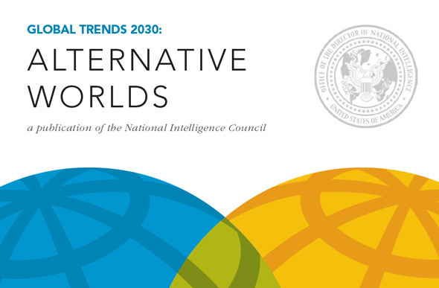
Such a narrative can offer a useful tool for an understanding of the recent bombings. Beyond this, the lessons learned are also of high significance. International cooperation has to further expand in order to assist counterterrorist efforts and intelligence services.
Terrorists do not distinguish victims according to nationality or religion. The tragic death of the Chinese student Lü Lingzi during the Boston attacks confirms their sweeping logic. The commitment of the US and Russia to increase their collaboration is a positive development but more practical steps need to be taken including more countries and alliances.
At the same time, in spite of the necessity of prevention, it is evident that the imagination and insane instincts of terrorists can go beyond measures taken by civilized countries.
There is a degree of asymmetry in the fight against terror. Incidents such as the Boston attacks do not necessarily reveal flaws and imperfections, especially in the aftermath of the September 11 atrocities.
Resilience is required as the history of the US openly suggests. Washington needs to go on, overcome the shock and be prepared to mitigate potential risks and threats in the future.

George N. Tzogopoulos is a research fellow at the Hellenic Foundation for European and Foreign Policy.

New Most Wanted Terrorist
Source:http://www.fbi.gov/news/news_blog/new-most-wanted-terrorist?utm_campaign=email-Immediate&utm_medium=email&utm_source=extras&utm_content=220887

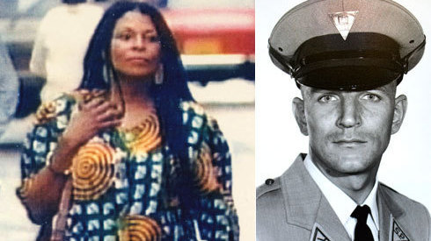
On the 40th anniversary of the cold-blooded murder of a New Jersey state trooper, the fugitive convicted of the killing, Joanne Chesimard, has been named a Most Wanted Terrorist by the FBI—the first woman ever and only the second domestic terrorist to make the list.
Officials from the FBI and the New Jersey State Police made the announcement this morning during a press conference, noting that the FBI is offering a reward of up to $1 million for information leading to the apprehension of Chesimard, who is believed to be living in Cuba under political asylum. Additionally, the state of New Jersey is offering an independent reward of up to $1 million, bringing the total maximum reward to $2 million.

U.S. steps up hunt for editor of al-Qaeda online magazine after details emerged Boston bombers followed the digital publication's bomb-making recipes
Source: http://www.dailymail.co.uk/news/article-2316940/U-S-steps-hunt-editor-al-Qaeda-online-magazine-details-emerged-Boston-bombers-followed-digital-publications-bomb-making-recipes.html

The hunt is on.
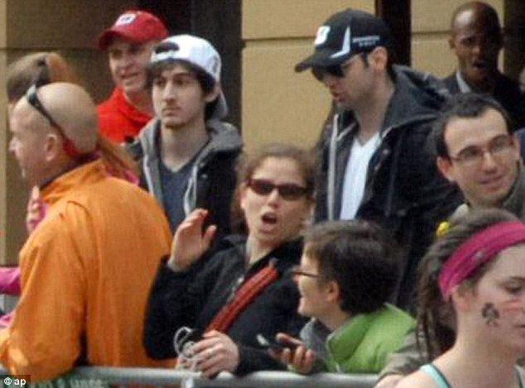
U.S. authorities are stepping up their efforts to track down the editor of a digital magazine published by Al Qaeda after details emerged that the surviving Boston bomber told investigators he and his brother learned how to build explosives by reading the online publication.
The CIA is believed to be spearheading the effort to find Yahya Ibrahim, a jihadist who has edited ‘Inspire’ since its founding editor-in-chief was killed by a U.S. drone strike in Yemen in 2011, the Daily Telegraph in London reports.
Fodder: U.S. officials say 'Inspire' has served as a viable resource for Dzhokhar Tsarnaev, his late brother Tamerlan, and other terrorists before them
U.S. officials say that ‘Inspire’ has served as a viable resource for Dzhokhar Tsarnaev, his late brother Tamerlan, and other terrorists before them.
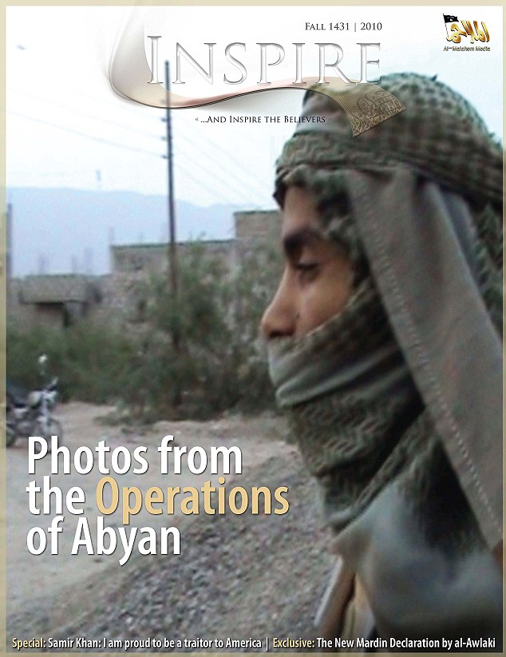
‘Inspire clearly is a powerful propaganda tool,’ an unnamed CIA source told the Telegraph saying that officials were concerned about the online magazine’s ability to push ‘potential jihadists to conduct violent action.’
Ibrahim, who publishes his articles and editorial letters in English, is believed to be a war-themed pen name for a propagandist tied to the Yemen-based Al-Qaeda in the Arabian Peninsula, according to the Telegraph.

Propagandist: Ibrahim, who publishes his articles and editorial letters in English, is believed to be a war-themed pen name for a propagandist tied to the Yemen-based Al-Qaeda in the Arabian Peninsula

Scott Stewart, a former State Department special agent who now works for the global intelligence company Stratfor, told the newspaper that he suspects Ibrahim may have similar fundamentalist roots to the digital publication’s founder Samir Khan.
Khan was killed in the same drone attack that took out radical American and Yemini cleric Anwar al-Awlaki in September 2011.
‘Yahya Ibrahim is a distinct individual,’ Stewart, who has analysed ‘Inspire’, said. ‘His presence has been there since issue one, and he speaks in a distinct voice. He is obviously very proficient in English, and it would not be surprising if he were someone, like Khan, from an immigrant family to the U.S.’
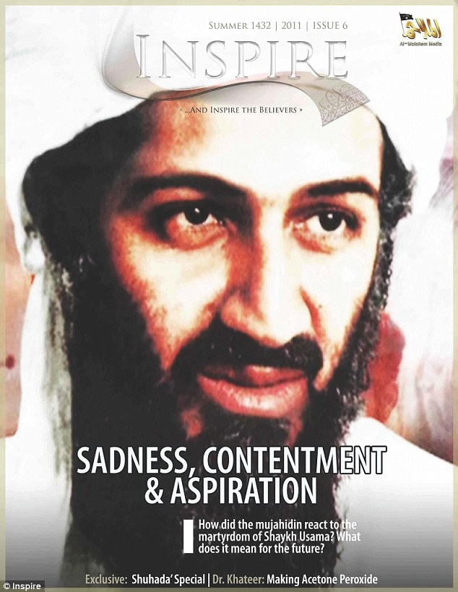
Michael Leiter, a former National Counterterrorism Center director, said that U.S. officials will consider prosecuting Ibrahim and other editors for giving material support to terrorists.
Food for hatred: Michael Leiter, a former National Counterterrorism Centre director, said that U.S. officials will consider prosecuting Ibrahim and other editors for giving material support to terrorists.

Terror watch list grows to 875,000
Source: http://www.washingtontimes.com/news/2013/may/3/terror-watch-list-grows-875000/print/

The number of names in a secret U.S. database of suspected terrorists has swollen to 875,000 from 540,000 only five years ago, in part because of rule changes introduced after al Qaeda's failed underwear bomb plot in 2009.
The new figures were released Friday by the U.S. National Counter-Terrorism Center, which manages the database, the Terrorist Identities Datamart Environment, or TIDE. A senior intelligence official explained the changes to The Washington Times.
"It's absolutely not unwieldy," the official insisted. He was seeking to rebut charges that the growing size of such a database actually makes harder the work of finding real terrorists -- what critics call the "larger haystack, same number of needles" problem.
U.S. intelligence and law enforcement agencies have software tools for sorting through the data to find what they need, the official said, "They use the database every day and get the results they desire."
As of December 2012, a factsheet from the center states, TIDE contained over 875,000 entries. Each one represents a known or suspected terrorist and includes all their known aliases and spelling variations on their name, the official said.
Less than one percent, or fewer than 9,000, were Americans, including both citizens and legal permanent residents, he said, adding the center does not release exact numbers.
The official said the larger number of entries in recent years was due in part to changes to the rules about who gets into the database. The changes were introduced in the wake of the botched Christmas 2009 attack on a Detroit-bound airliner by al Qaeda "underpants bomber" Umar Farouk Abdulmutallab.
After Abdulmutallab's bomb -- which he had successfully smuggled aboard in his underwear -- failed to go off, lawmakers honed in on the way TIDE was managed and how names were added.
In response, the National Counter-Terrorism Center changed the rules.
"There's a lower standard," for who gets into TIDE, the official said, meaning "less specific derogatory information" about a suspect is needed before they are entered.
TIDE is not in itself a watchlist, but it is the prime source for the nation's post-Sept. 11 unified terrorist watchlist for law enforcement, intelligence and other agencies, the Terrorist Screening Database, or TSDB.
The difference is vital because TSDB -- which is used by state and local police, and multiple federal entities including customs and border agencies and the Transportation Security Administration -- has to be unclassified. It is managed by the FBI-run Terrorism Screening Center.
TSDB is used by U.S. agencies, including several within the Department of Homeland Security, to populate their own watchlists, like the TSA's "no-fly" list, CLASS, the State Department's database for checking visa applications, and TECS, the customs and border watchlist.
TIDE, on the other hand, is classified at the "secret" level and is managed by the National Counter-Terrorism Center, which is an intelligence agency.
"TSDB is an unclassified subset of TIDE," said the official, purged of derogatory information and instead just indicating what sort of a threat the individual might pose and what action law enforcement or other officials in contact with them should take.
Also excluded are entries in TIDE that are not specific enough to be useful for watchlisting purposes.
This complex and sprawling U.S. machinery for collecting, assessing and watchlisting information about suspected terrorists, established in the wake of the Sept. 11 terror attacks, has come under new scrutiny following the Boston Marathon bombing last month.
Accused Chechen-American bomber Tamerlan Tsarnaev was interviewed by the FBI in 2011, after Russian authorities said they were concerned he might be radicalizing and preparing to come to Russia to join Islamic extremist terror groups in the volatile Muslim-majority North Caucasus.
The FBI, who also interviewed relatives and trawled through Mr. Tsarnaev's electronic communications, found no derogatory information and -- after repeatedly requesting more details from the Russians and getting no response -- closed their file, the bureau said last month.
While they were investigating him, the FBI listed him in TECS. But not as a terrorist, the senior intelligence official said.
The FBI determination at that time was that there was not sufficient derogatory information to consider Mr. Tsarnaev, a green card holder in the process of becoming a citizen, an "appropriately known or suspected terrorist," the official said.
"They put him in TECS because they wanted to look at his travel history, not because" they thought he was a threat, the official said. He noted that law enforcement agencies can flag people for scrutiny when they travel abroad for a variety of non-terror related reasons, for example if they are suspected of involvement in drug or people smuggling, or they are believed to be a target or an operative of a foreign intelligence service.
The TECS listing caused what became "the ping heard 'round the world."
Homeland Security Secretary Janet Napolitano told Congress the week after the bombing that Mr. Tsarnaev had "pinged" in the DHS' watchlist system when he left for Russia on a mysterious six-month visit which investigators believe may be crucial to understanding his motivation and capabilities for the bombing.
By the time he returned six months later, she said, the listing had lapsed because the FBI assessment had been closed.
The remarks prompted charges from lawmakers that U.S. intelligence agencies had once again failed to "connect the dots," and thwart a terror plot in the making.
But last week, it emerged that both Mr. Tsarnaev and his mother Zubeidat Tsarnaeva, were entered into TIDE anyway, after the FBI had closed their investigation.
"After the FBI went back to the Russians for the second time, the Russians sent the same memo [that they had originally passed to the FBI] to the CIA," the official said.
"The CIA knew the FBI had done a review, but out of an abundance of caution, they nominated him and his mother [to TIDE] anyway. Under the post-Abdulmutallab rules they were pushed to the TSDB," he added.
Experts say the difference in the behavior of the two agencies is a classic example of how U.S. intelligence and law enforcement agencies -- though they now work much more closely together on counter-terrorism -- continue to have rather different approaches to the issue.
Phillip Mudd, a career counter-terrorism official who held senior posts with both the FBI and the CIA, said there were proper limits on what domestic agencies like the FBI should do to track terror threats, if Americans' rights are to be protected and an open society maintained.
Speaking recently about the Boston case to a Washington think tank, Mr. Mudd said watchlisting every person ever flagged up as a potential jihadist, especially by a foreign intelligence service, would be beyond the nation's resources, contrary to its constitution -- and ineffective.
"How do you boil down the 10,000 other cases to that one guy" who is actually going to carry out an attack? "And what do you do about the false positives?" he asked -- innocent people wrongly suspected, arrested or even charged?
Those who argue for greater vigilance "never talk about the false positives," he averred.
Mr. Tsarnaev, 26, the elder of the two brothers accused of staging the Boston Marathon attack, died in a shootout with police in the days following the bombing. His younger brother Dzhokhar, 19, was captured the following day and is now facing charges.

Shaun Waterman is an award-winning reporter for The Washington Times, covering foreign affairs, defense and cybersecurity. He was a senior editor and correspondent for United Press International for nearly a decade, and has covered the Department of Homeland Security since 2003. His reporting on the Sept. 11 Commission and the tortuous process by which some of its recommendations finally became law in the 2004 Intelligence Reform and Terrorism Prevention Act earned him a "Dateline Washington" award from the Society of Professional Journalists. Prior to joining UPI, Waterman worked as a senior producer for the British Broadcasting Corporation's flagship evening radio news program, The World Tonight. Waterman joined the BBC in 1992 as a news trainee, and worked in local TV and radio news for three years before joining TWT team. In 1999, he was appointed to run the BBC's American radio news desk in Washington, providing round-the-clock news from all over both American continents for the corporation's six radio networks. Before joining the BBC, Waterman worked as a freelance journalist and parliamentary aide, writing for numerous publications including the investigative magazine Private Eye and doing press and research work for a number of members of the British Parliament. Waterman, who is British, has a master's degree in social and political sciences from King’s College, Cambridge. He lives in Washington, D.C., and has an American son, Miles.

Why Such Secrecy About Private Military Contractor’s Men Working the Event?
Source: http://www.nationofchange.org/why-such-secrecy-about-private-military-contractor-s-men-working-event-1366983083

Speaking as an investigative reporter with almost 40 years’s experience, I can say that when government officials won’t talk, they’re generally hiding something embarrassing or worse.
I tried, and nobody will talk about those Craft International Services private security personnel who were widely observed and photographed near the finish line of the Boston Marathon, wearing security ear-pieces, hats and T-shirts bearing the company’s skull logo, and all wearing the same dark coats, khaki pants and combat boots, some carrying what appear to have been radiation detectors. (I got no hard answers, though there were some inadvertent hints given.)
I first contacted a man identifying himself as Jack Fleming, a public affairs person with the Boston Athletic Assn., sponsor of the marathon. Fleming advised me that “If you want to ask about that you should contact the Commonwealth (of Massachusetts) Executive Office of Public Safety.”
I called that agency and spoke with the public information office there, a man named Terrell. He first said, "Did you call the Marathon organizers?" When I replied that I had, and that they had said to call his office, he replied, "They did?" Then he said, “You should call the City of Boston Police Department. They released a security plan to some media organizations.”
Indeed they had released that plan to the Boston Globe. Based upon the information it got from the police the article the Globe ran, did report that the Police had deployed “air patrols, K9 units, and more than 1,000 uniformed officers and soldiers along the 26-mile course and the finish line,” but it made no mention of the private contracting of soldiers-for-hire, which is what Craft International does. News agency Reuters reported, meanwhile, that a top official for the Massachusetts state Homeland Security Department, Undersecretary Kurt Schwartz, told a group at Harvard U. that his agency had “planned” for a possible bombing attack on the marathon, even running a “table-top” exercise about such an event a week before the race.
I called the Boston Police to ask if they had hired the Craft International personnel who were observed at the scene just before and after the bombing, and was told by the public affairs office there that “Anything having to do with the investigation of the bombing would have to be referred to the FBI Boston Division office.” When I pointed out that I wasn’t asking anything about the investigation, but was simply asking who had hired the security personnel from Craft International, the answer was simply repeated: “You’ll have to ask the FBI.”
So I called the FBI, and got a public affairs person there named Amanda Cox. Her initial response to my question was, “I do not have any information on that,” then said I had been referred to her by the Boston Police Department, and said that photos of the scene after the bombing had shown Craft International personnel conversing with FBI agents. She then put down the phone, and I could hear her turn to a supervisor and ask, her voice muffled, “This guy’s asking about the Craft Security Consultants -- who hired them and what they were doing.”
I next overheard the muffled voice of another woman to whom she had been speaking reply, “I think you could safely say, ‘I do know we worked with a lot of people who worked on security at the marathon...’” After that I couldn’t make out what was being said.
Cox later returned to the phone, and instead told me, “I’d refer you to the company on any information about who hired them.” (Taken together the overheard conversation and the official answer from Cox would at least seem to confirm that Craft's people were hired for the event, and that the FBI knows a lot more than it is willing to say about them.)
Next I called Craft International. The company has no phone number listed on its website -- just a general email address of info@thecraft.com (to which I wrote to asking for information, but which elicited no response)--but I found one listed for their headquarters office at 2101 Cedar Springs Rd., Suite 1400, Dallas, TX, in a listing on the company published in a directory in Bloomberg Businessweek, This entry noted that the company, in addition to “providing security, defense, and combat weapons training services for military, police, corporate and civilian clients in the US and internationally,” also “offers corporate and private and civilian training services...” The number, published in a business magazine, was clearly meant as a contact for potential customers to call.
A woman answered the phone brightly with the company's name. However, when I identified myself as a reporter, and said I was wondering if someone could tell me who had hired personnel from the firm to work at the Boston Marathon, she responded with a flummoxed: “Um, I um, don’t really have any information on that. I’m just an answering service.”
I replied, “Look, the number I called is listed as the number of the company’s corporate headquarters at 2101 Cedar Springs Road. You’re not an answering service.”
At that point she said, “Let me see who I can transfer you to.”
However, after a long pause, she was back, and said, “The answer I’ve been given is that you should go to the website, where there’s an email address you can write to with your question.”
I had already done that, I told her. She then said she couldn’t help me and hung up.
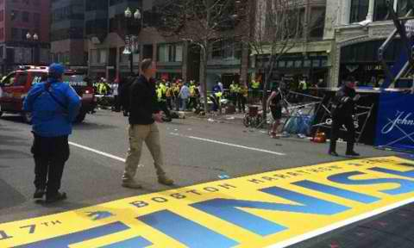
I also called the US Department of Homeland Security, but a woman named Angela who answered the press office number for this public government agency (she refused to provide her last name despite being the public information office) said the DHS media office was “only taking inquiries sent in by email.” I sent in an inquiry asking if any unit of the DHS had hired Craft International to provide security at the Boston Marathon, but so far have received no response.
As things stand, since it's highly unlikely that Craft International, a private for-profit enterprise founded by the late ace Navy Seal sniper Chris Kyle, would have "hired" itself to police the Marathon gratis, it seems pretty clear that we had rent-a-special forces-soldier people, hired by some agency, at the scene of the bombing ahead of the bombing.
And we have no reporting on this in the mainstream corporate media.
Why? I have no answer to that.
I did write to Andrea Estes, the lead writer of the Globe’s piece on police security planning mentioned above, who is described in her bio on the Globe’s website staff page as an “investigative reporter specializing in government accountability.”
I called and left a message on her phone, and sent her an email, asking if she had looked into the Craft Security personnel, to see who hired them, what they were doing at the race finish line, and why they appeared be carrying radiation detectors. She has so far not responded to my request for information and assistance concerning anything she had done or learned about this, or whether she had looked into it at all.
Certainly there is a big accountability question. A bunch of them actually. Here are a few:
- If Craft International people were hired, who hired them and why?
- If it was the Boston Police or the FBI that hired them, why won’t they just say so? Simply hiring outside security help should not be a secret, and could in no way affect the investigation into the bombing and the captured suspect, Dzhokhar Tsarnaev, so why the secrecy about that? Given all the police presence, and the size of the FBI's Boston division, why did they need those extra guys from a private rent-a-soldier firm?
- If it was not the Boston Police or the FBI, what agency did hire the company, and why?
- If it was the state’s Homeland Security Dept. or or the state Executive Office of Public Safety, or perhaps more likely, the US Department of Homeland Security, did they notify the FBI that they had done so, and tell the agency what had prompted them to do this?
- The big overarching question when it comes to who hired Craft International is, what possible gain in security could have been achieved by adding what appears to be seven guys (or perhaps a few more who didn’t appear in photos) from a private security firm when the Boston Police had in place over 1000 armed security people from their office and the National Guard, and when, as became evident immediately after the bombs went off, a large number of FBI personnel were also on hand?
Unless, of course, the Craft Security people were aware of something that we, the public, including the race participants and spectators, and perhaps even the police and FBI, were not aware of.
Transparency is critical to accountability. At this point, it is clear that we have had a massive failure of the national security state. Despite the fact that the FBI was aware of concerns about Tarmelan Tsarnaev, and the fact that the CIA had him on a watch list, he appears to have been able to work on line to learn how to build a powerful homemade bomb, to obtain the materials, including a substantial quantity of black powder, to build a number of them, and, allegedly with the help of his younger brother Dzhokhar, to place them near the finish line and detonate two of them, killing three people and injuring as many as 200. That’s a huge intelligence fail.
It would be an even bigger fail if it turns out that some agency had awareness of a credible threat and that it hired Craft International personnel to prevent it. We clearly need to know, and have a right to demand to know, who hired those men and why. After all, at a minimum, on the face of things, they did an abysmal job of preventing a bombing right in front of their supposedly well-trained noses.
And of course, as I wrote earlier, there is also another question, which is really disturbing: The image of the exploded backpack released by the FBI and identified as the remains of the pack that was carrying one of the two pressure-cooker bombs, prominently displays a white square on a black background. This is not a doctored photograph; it’s the photograph that was released by the FBI. There are also at least two photos depicting one of the Craft International men who is wearing a black backpack identical to several of the other Craft International personnel. The same white square is also visible on the top of his pack.
There does not appear to be any such white marking -- square or otherwise -- on the top of the black backpack worn by Tarmelan Tsarnaev, as observed in several security photos taken of him (Dzhokhar Tsarnaev was shown carrying a smaller white or light-colored pack, slung over one shoulder). Check out the images below of Tarmelan, the exploded bag and the Craft International character:
I am not drawing any conclusions from any of this, but I will say that when government agencies at all levels and a private contracting firm are all this obtuse and secretive (and in some cases even deceptive) about what should be a simple question -- who hired these men? -- my suspicions are aroused.
Somebody’s clearly hiding something.
And by the way, why aren't the mainstream media asking about this? Are corporate media journalists so intimidated about being labeled “conspiracy nuts” that they can't do their jobs? At a minimum, this goes to the question of accountability. It also goes to the question of inter-agency communication or lack of it. And given what we know about how many times the FBI has been an active encourager and enabler of terror plots which it later thwarts and claims credit for preventing, there’s the question, too of potential official culpability. Furthermore, when an horrific incident like this is used to justify such new threats to our Constitutional freedom as an unprecedented martial law-style lockdown of an entire 1-million-person metropolitan area and a precedent-setting deliberately Miranda-free, attorney-free interrogation of a hospitalized, gravely wounded and sedated suspect, it is critical that the whole story be told, not just the official one.

A Profile of Mahmud Mansur Nidal: The Alleged Dagestani Connection to Boston Bomber Tamerlan Tsarnaev
By Mairbek Vatchagaev
Source:http://www.jamestown.org/single/?no_cache=1&tx_ttnews[tt_news]=40828&tx_ttnews[backPid]=13&cHash=7691d825f782ccfb95f137870da514bb

In connection with the tragic events in Boston, some Western journalists have started pursuing sensational angles to the story concerning the purported ties between the alleged elder Boston Marathon bomber, Tamerlan Tsnarnaev, and a Dagestani militant who went by the name of Mahmud Mansur Nidal (see ABC News, April 30). Nidal’s name recently surfaced in connection to Tamerlan, who visited Dagestan in 2012 and reportedly made contact with this deceased Dagestani militant.
Nidal was born in the Dagestani city of Buinaksk in 1992 (http://polit.ru/news/2012/05/20/insurgent/). The Russian newspaper Novaya Gazeta first broke the story about Nidal’s ties to Tamerlane, which argued that the Dagestani militant was a key contact of the elder Tsarnaev brother during his 2012 visit to the mountainous Russian republic of Dagestan. While some newspapers and Western media have incorrectly reported that Nidal is an ethnic Chechen, he is actually from Dagestan and is half ethnic Kumyk and half Palestinian (www.novayagazeta.ru/inquests/57925.html). The Kumyks—the third largest ethnic group in the republic of Dagestan—are a Turkic speaking people who are of Mongol descent.
Whatever ties existed between Tamerlan and Nidal, they did not last long. Mahmud Mansur Nidal was 19 years old when he was killed in a police operation in Makhachkala on May 19, 2012 (http://lenta.ru/news/2012/05/19/end/). He put up his last fight at his home, located on 1b, Yubileinaya Street in Makhachkala, which the Dagestani police surrounded on the evening of May 18. Apart from Nidal, also present in the domicile were Mansur’s mother, Zarina, Mansur’s spouse, Maryam (a.k.a. Anzhela) Dolgatova, with their two-month-old infant, along with their guests, Fatima Nurmagomedova and her husband, Abdurakhman Magomedov.
Following many hours of negotiations, the women and children were allowed to leave the house. Abdurakhman Magomedov also surrendered to the authorities. However, Mansur Nidal refused to surrender and fought the police forces and was subsequently killed by the security services as they stormed the building (http://moidagestan.ru/news/antiterror/16933).
According to Dagestani police reports, by December 2011, Mansur Nidal was accused of being a member of the Shamilkala (a.k.a. Makhachkala) Jamaat. The police suspected Nidal of participating in several killings, bomb attacks and assaults on government forces, including an attack on a police checkpoint in Makhachakala on May 3, 2012. In that specific terrorist attack, which was carried out by suicide bombers, 13 people died and over a hundred were injured (www.gazeta.ru/news/seealso/2326593.shtml). Mansur Nidal denied his involvement in this attack to the police in the midst of their siege of his home, stating that he had been out of town that day.
Unofficial sources allege that during the special operation at Nidal’s home, a crowd of 150–200 young people attempted to prevent the police from storming the building (http://ummanews.com/news/kavkaz/6972-2012-05-20-11-22-33.html). The protesters blocked the street where the police operation was taking place. This type of behavior by civilians is quite unusual for Makhachkala.
A prominent journalist from the Russian paper Novaya Gazeta earlier this week attempted to connect Nidal to Tamerlan Tsarnaev, the elder of the two brothers accused of setting off bombs at the Boston Marathon on April 15, 2013. It is difficult to imagine that an American who had no friends in Makhachkala, who knew no one locally except his relatives in the city, could simply meet someone like the suspected militant Nidal without arousing the suspicions of the Russian security services. Even a native Russian visitor from Moscow would be under total surveillance by the local security services while visiting Makhachkala—not to mention a visitor from the United States.
Furthermore, the claim that Mansur Nidal joined the insurgency at the age of 19, implies that he must have gone underground before Tamerlan Tsarnaev had even arrived in Makhachkala. The suggestion that a person can simply and casually stroll the streets of Makhachkala and befriend a militant is absurd.
Having joined the ranks of the jamaat, it is highly improbable that Mahmud Mansur Nidal would have allowed himself to risk all his contacts for the sake of some newcomer from the United States, such as Tamerlan Tsarnaev. Members of the underground jamaats in the North Caucasus simply do not scurry around and recruit new people in the open. They instead rely on underground recruitment networks where potential militants are thoroughly vetted before being approached, particularly in Dagestan where the Russian intelligence services have an extensive network of agents and informants.
Basic recruitment tasks by the jammats in the North Caucasus are normally assigned to very different individuals who determine whether the person is fit to become the jamaat’s member. Members of the jamaat in Dagestan rely on the narrow circle of their close friends and associates in order to move from one location to another. Even though the Dagestani jamaat is called “the forest brothers,” its members primarily reside within urban areas, unlike the Chechen rebels who operate in the safety of mountainous retreats and Chechnya’s numerous forests. In fact, that is why nearly 99 out of 100 police operations in Dagestan are normally carried out in Dagestani cities or villages rather than in mountainous areas.
An analogous though separate hypothesis that Tamerlan Tsarnaev met 22-year-old William Plotnikov is also highly dubious. William Plotnikov was born in the Tyumen region of Russia and then moved to Toronto, Canada. Being an ethnic Russian, he converted to Islam, went to Dagestan to participate in jihad and was killed in July 2012 (www.ntv.ru/novosti/312762/). Plotnikov would also have been underground by the time Tamerlan Tsarnaev arrived in Dagestan, which makes the probability of the two meeting in Makhachkala close to zero because of the high risk of being detected by the Russian intelligence services.
The Moscow papers’ stories about Tamerlan Tsarnaev’s visit to Georgia (http://izvestia.ru/news/549252), about his contacts with Mansur Mahmud Nidal (www.novayagazeta.ru/inquests/57925.html), or even his possible contacts with the Canadian William Plotnikov (http://www.mk.ru/social/article/2013/05/01/849704-amerikanskoe-sledstvie-izuchaet-kontaktyi-tamerlana-tsarnaeva-na-severnom-kavkaze-s-kanadskim-dzhihadistom.html) are nothing more than attempts to deflect attention from what Tamerlan Tsarnaev was really doing on his last visit to Russia.

Dr. Mairbek Vatchagaev is a noted Chechen historian and political analyst on the North Caucasus and a former senior ranking official in the Chechen government of Aslan Maskhadov. A native of Chechnya, Dr. Vatchagaev is currently a Non-Resident Senior Fellow at The Jamestown Foundation and a regular contributor to the Jamestown publication Eurasia Daily Monitor where he writes about developments in the North Caucasus. He has published 56 articles on the history of Chechnya and Sufism in the North-Caucasus; 285 articles related to political science on the North Caucasus and Russia; including five books on the history and religion in Chechnya and the North Caucasus. In 1997 he published a book on the first 100 days in office of the first ever democratically elected President of Chechnya—Aslan Maskhadov. He is also the author of the book, “Chechnya in the 19th Century Caucasian Wars.”

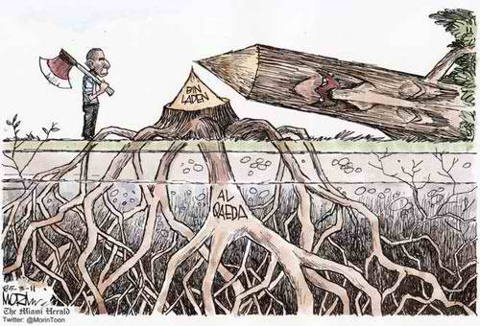

The invisible women who hunt terrorists
By Susan Hasler
Source: http://edition.cnn.com/2013/05/03/opinion/hasler-women-intelligence-analysts/

Editor's note: Susan Hasler spent 21 years at the CIA in many roles, including counterterrorism analyst, and is the author of "Intelligence: A novel of the CIA." She is among the analysts featured in a new HBO documentary, "Manhunt," based on the book by Peter Bergen about the hunt for Osama bin Laden. It will be shown on CNN May 10.

The first time I viewed an al Qaeda recruitment video, I squinted at a scratchy black blob shimmying across the screen. It took a moment to recognize this was an amateur effort to obliterate the image of a woman from a clip of a politician's visit to Saudi Arabia. The blob was evidently his wife. I wondered at the time it must have taken to erase her from every frame. Of all the rapid-fire images of death and destruction in the video, I found this one the most chilling.
That same feeling surfaced in the days after Seal Team Six killed Osama bin Laden two years ago. I watched talking heads on every network hold forth on the takedown. Almost without exception, they were men. I felt like my female colleagues had been erased from the picture.
In the 1990s it was largely women who tracked the threat from bin Laden, who pieced together slivers of data to form a surprisingly accurate picture of an international terror network that had yet to announce its existence to the world.
When Greg Barker interviewed me for the documentary "Manhunt," he asked what it was that made women so good at tracking terrorists. I felt a moment of panic at being led into the minefield of gender stereotypes. I worried about discounting the efforts of some excellent male counterterrorism analysts I had known. Then I thought to myself, "Yes, women do have a special genius for the job."
To step firmly into the stereotype minefield, is it because terrorism is all about relationships? Perhaps. Using the Boston bombing as an example, let's look at the mother and how she may have influenced the older son who in turn could have influenced the younger one. At this moment analysts are following that circle of relationships outward, looking at other friends and family members. Analysts are trying to suppress their own egos and put themselves into the minds of the suspected terrorists. What do I need to carry out this attack and to whom do I turn for help?
Suppressing one's ego is an important part of being a good counterterrorism analyst. First, you have to be willing to admit up front what you don't know. The amount of data is so large that no one individual can look at all of it. A good analyst acknowledges her blind spots and networks with other analysts to fill them.
When it comes to ego suppression, women are just better at it than men. They've had more practice. I ran across one man who never admitted to any gaps in knowledge. Whenever someone would try to tell him something, he would blithely say, "I knew that." He didn't last long as a counterterrorism analyst.
Another characteristic of the women who tracked bin Laden is that they didn't have their egos so caught up in their "careers" that they let it affect their jobs.
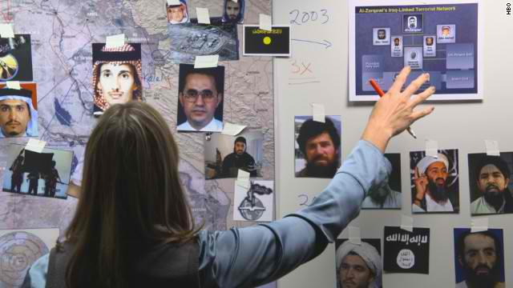
For an analyst, the path to career advancement lies through a "hot account," which means a subject that attracts policymaker interest. Al Qaeda was not a hot account in the 1990s. Some managers resented the amount of time the women spent on it.
On career appraisals, one report written for the policymaker often counted for more than months spent sifting through data and working with counterparts on the clandestine side of the house. Their careers suffered because the women were so focused on the job of tracking al Qaeda.
These women had the intellectual discipline and honesty to allow their conclusions to arise from the data, rather than taking the shortcut of cherry-picking the data to fit preconceived notions. For whatever reason, women are particularly good at perceiving patterns in a nonstop stream of seemingly random data.
Terrorism analysis requires persistence, tenacity, patience and dedication. The women who tracked bin Laden had those characteristics in spades. In the days after 911, one analyst was working 18-hour days despite severe back pain. When she finally took the time to go to a doctor, she found out she had a broken vertebra. Then she went back to the office and continued to work the long hours.
These women broke down in tears, struggled with guilt, depression and the physical impact of stress. They juggled the job with the demands of motherhood, eldercare and other personal issues that don't disappear after a terrorist attack. Through it all they continued to do their jobs, because, by God, they weren't going to let that bastard bin Laden win.
I have one urgent request for the CIA, FBI and other relevant agencies. After the next attack, could you please send a woman to talk to the press? You have lots of them and, trust me, they know what they're talking about. Please do it to improve the morale of your female officers and give their daughters a better understanding of their options in life. The women are tired of being invisible.

Intelligence alert over terror attack on US consulate in Mumbai
Source: http://articles.timesofindia.indiatimes.com/2013-05-06/india/39064019_1_intelligence-agencies-us-consulate-terror-alert

The Western Naval command headquarters has alerted the city police about the threat of a bomb attack on the US consulate here on July 21. The intelligence was shared with reference to an anonymous letter received by the consulate-general and American Centre in Kolkata, threatening to attack both places.
A copy of the single-page letter was passed on by Sanjay Kumar, command intelligence officer, western naval command. The letter has 'Al-Jihad' written on top, much like a logo or the name of an organization. It said US consulate officials are the targets and told the Americans to vacate the consulates. It also said, "We shall carry out blasts in public places and railway stations of Hyderabad, Bangalore and Mumbai in July this year."
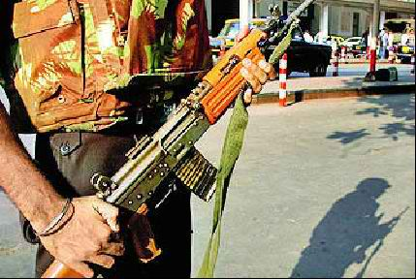
It was unclear when the US consulate received the letter and why July 21 was chosen. Al-Jihad is not known to intelligence agencies but they are taking the threat seriously as terror outfits are known to hide under various names. The input has been shared with the Intelligence Bureau headquarters and its wings in Hyderabad, Kolkata, Bangalore and Mumbai.
The state anti-terrorism squad (ATS) also issued a terror alert, saying the Indian Mujahideen (IM) could target several places to avenge the conviction of and death penalty for its operative, Himayat Mirza Baig, in the German Bakery bomb blast case.
Amitesh Kumar, deputy inspector general of police, ATS, in a two-page alert stated, "In view of the death penalty to Himayat Baig in the German Bakery bomb blast case and the recent blast in Bangalore, retaliation cannot be ruled out. IM can possibly launch a fresh terror strike."
Kumar said of the likely targets that need special attention are the ones that have already been reconnoitered by terrorists, as revealed during interrogation of the CIA spy-turned-Lashakar-e-Taiba loyalist, David Headley. A National Investigation Agency team had interrogated Headley in the US.
The places mentioned in the hit list of terrorists include the Nashik police academy, Deolali army cantonment, the Osho ashram, ABC Farm, Hard Rock Cafe, Oakwood Hotel, Koregaon Park Plaza, J M Road, North Main Road in Pune, Gold Adlabs, Hinjewadi, and the RSS headquarters in Nagpur.
A police officer said all the locations have been provided additional security. However, while security and intelligence agencies have been sending out terror alerts often, their credibility is in doubt. Many senior officers say they don't even read the alerts. While intelligence agencies claim it's their job to pass on information, several city police officers contend that the information given is often difficult to establish or act on.

New Jihadi magazine
Source: http://www.jhuf.net/showthread.php?17892-Good-News-New-Jihadi-magazine-in-English-quot-AAZAN-quot
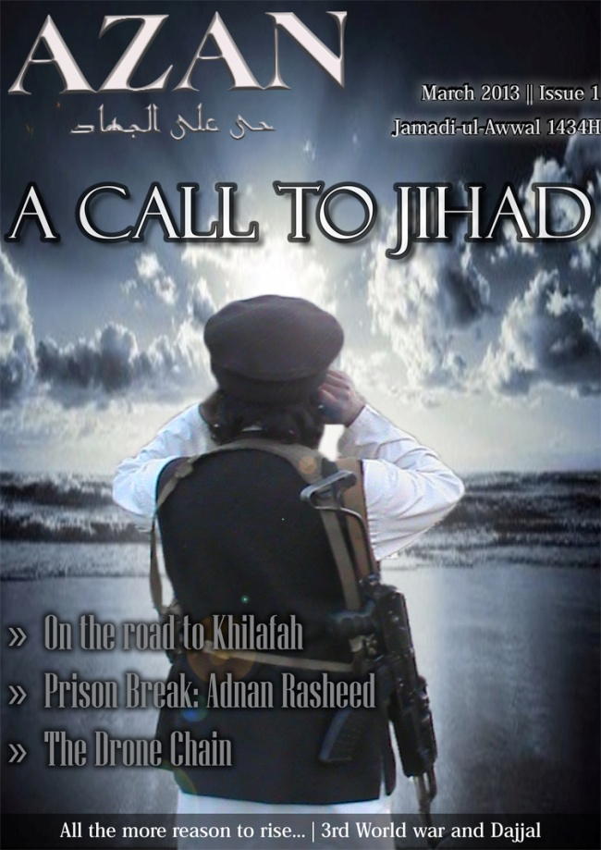

►Available at: http://ia801703.us.archive.org/34/items/jhuf-azan1/azaan1.pdf

East Africa anti-terror intelligence fusion cell opens in Nairobi
Source:http://www.defenceweb.co.za/index.php?option=com_content&view=article&id=30418:east-africa-anti-terror-intelligence-fusion-cell-opens-in-nairobi&catid=49:National%20Security&Itemid=115

The Kenya Police Services has commissioned a new state of-the-art anti-terrorism nerve centre, which will also act as a regional intelligence fusion centre to monitor the threat posed by terrorist groups throughout East Africa.
The centre was built with the help of the British government, which also donated one Rigid Inflatable Boat (RIB) for use by the marine police on coastal patrols around the port of Lamu, X-ray and scanner equipment to screen visitors entering and leaving the country through the Nairobi International Airport, and maritime surveillance equipment to monitor piracy.
The centre, which is known as the Kenya Police Operations Centre (KPOC), features advanced technology-driven investigation systems which include a forensic laboratory, detection equipment and state of the art interrogation and holding cells for terror suspects.
Officiating at the commissioning ceremony in Nairobi last week, British High Commissioner to Kenya Christian Turner said the opening of the centre proves that his government remains committed to helping Kenya and the East Africa in upgrading the regional capacity to fight transnational crime and terrorism.
"The UK's support for this centre is a further indication of the commitment that the UK has to working with Kenya. This centre will help both countries deepen our partnership in fighting terrorism," Turner was quoted by local media as saying.
Further, he said the centre will serve as the main intelligence gathering, co-ordination and operations cell in all matters relating to terrorism in East Africa. As part of the security assistance package, the British government also trained Kenyan police officers from the Anti-Terrorism Unit (ATU) on how to use the new equipment. British instructors also provided their Kenyan counterparts with human rights education.
The Kenyan Police Service police anti-terror unit welcomed the launch of the centre saying it comes at a time when the country is facing new security threats from home-grown and transnational terror groups and maritime crime syndicates. Internally, the Kenyan police are fighting a low-level guerilla war against the Mombasa Republican Council (MRC), an armed group which wants the Muslim majority coastal areas to secede from Kenya and form a republic in which Mombasa will be the capital city.
Last week, a Kenyan magistrate sentenced Iranians Ahmad Mohammed and Sayed Mousavi to life in prison after finding them guilty of plotting bomb attacks in Nairobi and Mombasa. They were arrested in Mombasa in June last year after being found in possession of 15 kg of the military-grade explosive RDX. The arrest was immediately followed by Israeli Prime Mininster Benjamin Netanyahu's announcement that his security services had information that the two were part of a wider terrorist plot to attack Israeli-related interests and businesses in Kenya.
Although both men and the Iranian government denied any complicity to a terror plot, Judge Kiarie Waweru ruled that there was enough evidence for each man to be sentences to life in prison. Kenya has been hit by a number of terrorist attacks since August 1998 when Al Qaeda operatives led by Fazul Abdul Mohammed conducted simultaneous truck-bomb attacks which blew up US embassies in Nairobi and Dar es Salaam in Tanzania within a short period.
Since then, Kenya has been hit by terror attacks. On 28 November 2002, an all-terrain vehicle crashed through a security checkpoint outside the Israeli-owned Paradise Hotel and blew up, killing 15 people and injuring 80 others, most of whom were Israelis. At exactly the same time, two shoulder-launched Strela 2 (SAM-7) surface-to-air missiles were fired at an Israeli-chartered Boeing 757 as it took off from Mombasa but they both missed the target.
Following its military intervention in support of the Somali government, Kenya now faces an immediate threat from Al Shabaab after routing the insurgents out of southern, coastal and central Somalia. Since then, the Somali insurgents have been blamed for a surge of kidnappings and grenade attacks in Nairobi and various small towns along the border with Somalia between October 2011 and 2012.
Among its key regional targets, the anti-terror nerve centre in Nairobi will also monitor suspected terrorist activity along the border with Tanzania. This week, Tanzanian security services arrested eight men - among them four Tanzanians and four Saudi Arabians - in connection with a fresh terror attack in which a Catholic church parish near the coastal city of Aruscha was bombed while the Vatican ambassador Archbishop Francisco Montecillo Padilla was visiting on Sunday.
Two people were killed and 60 others were wounded in the incident. The Saudi nationals had entered the country through a small airport near the city of Arusha on Saturday and were arrested on Sunday as they tried to cross the border into Kenya. Kenyan and Tanzanian security services say there is evidence that both countries are targets and recruiting centres for international Islamist-inspired terror groups.

“Red Light” in Western Africa – The rising Terror Risks Energy Infrastructures and Threatens Economy
By Meir Gershuni
Source: http://i-hls.com/2013/05/red-light-in-western-africa-the-rising-terror-in-africa-risks-energy-infrastructures-and-threatens-economy/

The continent of Africa, and in particular the countries south of Sahara, are center of wide scale activity for Israeli companies who have been acting at the area since the end of 50`s. The activity was first led by the Foreign Office, who in a very short time established tens of Israeli representation offices in African countries, and in this way laid the foundations for activity in the fields of agriculture, security and infrastructure development. Later on, more and more private companies from Israel entered Africa, and performed impressive projects in various areas. During the years the business relations had their ups and downs that were influenced by political moves and events like the Six Day War and Yom Kippur War. Nevertheless, along the entire period a massive Israeli business presence was established in Africa in various fields. The present deterioration in the level of terror threat and crime at the continent of Africa is a blinking red light considering the substantial risk requiring security arrangement against it. However, and since this is the situation, this is also an opportunity for Israeli security companies specializing in management of risks of this type, to provide security solutions for each foreign organization intending to act in these countries, in order to protect the well being of its personnel and safeguard its assets.
An impressive show of force of the radical Islamic organizations in Northern Africa took place last January, when 41 foreign hostages (citizens of USA, UK, Japan, Norway, Philippines, France, Malaysia and Romania) were kidnapped by Islamic extremists at the Amenas gas field near the Algiers-Libya border. This event demonstrates the freedom of action that the terror organizations enjoy at the arena, as the result of lack of organized government and security systems, with an emphasis on countries like Mali and Libya. Also in apparently more stable countries there is a growing trend towards terror activity. Such is happening each day in Nigeria.
More than 230 foreign citizens have been kidnapped at the Delta area in Nigeria since January 2007. In the recent years there is an ever worsening trend, for execution of kidnapping and bombing attacks using a variety of operational methods, focusing at the energy facilities (oil and gas). In addition to the repeating damages to the oil pipelines, also the ships used by the maritime oil production facilities and oil rigs placed opposite the Delta are a prominent target for terror acts.
Since January 2007 till June 2012 there were no less than 79 terror acts and bombing attempts at the Sahel arena only. Nigeria is the greatest oil producer at the African continent, and it is also a model for a security problem and the high level of threats against the energy facilities located in the country.
But the main problem is not just the deteriorating security in Nigeria, but the absence of stability in Western Africa in general. Africa serves at the recent years as a safe haven and operation base for activists who were trained in fighting at the tribal areas in Pakistan. As a result of the massive pressure on Al Qaeda in Afganistan-Pakistan, the substantial threats are not coming anymore from the “original” Al Qaeda, but from organizations identified with Al Qaeda and in particular the ones operating in Africa, such as the Islamic Maghreb Al Qaeda (AQIM), El Shabaab in Somalia and the Nigerian organization El Bioko Haram, who have become a real threat at the African continent in general and at the Sahel area in particular. The “production line” for the continent`s terror factors at the continent has been focused recently in Mali, that has become a “safe haven” for terror activists, and it was not by chance that the French government decided on the Seval operation, aiming to crack down on the Al Qaeda nests in the country.
No country has felt the impact of the fall of Gadafi regime more substantially than Mali, which experienced already in the past lack of stability, coups d’état acts, revolts of the Tuareg population and the influences of terror and crime organizations. But during the recent year Mali experienced all the problems simultaneously.

Focusing of the threat on oil and gas sector at the Sahel area
In the last decade a number of terror acts took place in various places worldwide against oil and gas industry. A representative sample:
- In February 2002, a hell boat loaded with explosives crashes against the wall of the giant French oil container ship MV Limburg next to Yemen shores. As a result of the explosion one crewman was killed, others were wounded and 90’000barrels of oil were spilled into the sea. The Ql Qaida organization took responsibility for the operation.
- In February 2004, Osama Bin Laden encourages his soldiers to “concentrate actions against the oil facilities and in particular in Iraq and the Persian Gulf”. Trying to justify such a move, he explained that the US is using the energy resources of the Arab countries for a ridiculous price.
- In 2006, Al Qaeda tried to blow up a car bomb in Abqaiq, Saudi Arabia, One of the largest refineries in the world. The bombing attempt failed at the breaking in stages into the well protected site.
In the recent years the terror has spread against oil infrastructures, and it is no more limited to the Gulf area and the Middle East. In 2007, Al Qaeda published a press message on its intention to attack interests and energy facilities of United States in other countries: “The oil facilities that the United States is enjoying, will be attacked in all areas [of the world], and not only in the Middle East”. The above implies Al Qaeda intention for attacking targets in Northern Africa and the Sahel area, where, since 2006, the organization enjoys local support of Islamic Maghreb (AQIM). Before the establishment of this group, the GSPC organization was operating in this area, focusing on actions again Algerian oil facilities as the preferred target. The organization executed a series of terror acts against workers and facilities of the oil companies Sonelgaz, Sonatrach and ENTP, operating in the south of Algeria. Tens of people were killed in these terror acts and extensive damage was caused to the oil producing facilities. However, none of these terror actions was similar to the spectacular terror bombing executed on January 16th, 2013 in the natural gas facility in Amenas, in eastern Algeria. At least 4o terrorists who entered Algeria from Libya and the north of Mali, attacked two buses transporting workers from the natural gas field , and in parallel attacked and took control – actually quite easily, in the absence of a reasonable security force – on the gas facility, while taking hundreds of workers as hostages. After futile and unprofessional attempts to negotiate with the kidnappers, two actions of taking control and rescuing were executed by an elite unit of the Algerian army. The disastrous results of the operation were followed by much western criticism. At least 39 hostages were killed and many others were wounded. The Algerian army killed most of the terrorists and caught 3 of them. According to a declaration of the involved organizations, the action was executed as an act of revenge against the French intervention on Mali.
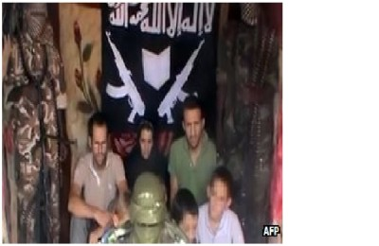
Also in Nigeria, the greatest oil producing country in Africa, The terror threat has grown substantially since the beginning of French intervention in Mali, following support of the French military steps by the Abuja government.

The French family in captivity of Boko Haram

The French intervention against Islamic groups in north of Mali – the area where the Islamic groups are strongly linked, ideologically and operationally, with Boko Haram - accelerates the extension of the terror threat to the countries in the south, where most of the western oil facilities are located. In this context, I have to note the possibility that the Nigerian Islamist terror organizations may try to “market” their terror actions (kidnapping and acts against infrastructures) to local organizations located in the south, like the MEND (Movement for the Emancipation of the Niger Delta). Even though there is no concrete evidence of such an operative cooperation between the south and the north, western organizations and companies acting in the region should take this into account.
Five terror groups are threatening at present the oil companies acting in Sahel and Western Africa : Al Quaeda in Islamic Maghreb (AQIM), The Movement for Oneness and Jihad in Western Africa (MUJAO), the Nigerian Boko Haram and its separatist section Ansaru, and MEND (Movement for the Emancipation of the Niger Delta). Leaders of all these groups have declared on their intention to harm western interests in the area, and in particular the workers and energy infrastructures of the oil companies, which are their main and preferred target.
In 6th of April 2013 the MEND organization attacked a police ship sailing at the Delta. Twelve policemen were killed in the terror act. The Movement for the Emancipation of the Niger Delta (MEND) took responsibility for the terror act, and threatened to continue its violence against the Nigeria government and the oil companies (mostly foreign) in the area.
The threat by MEND came as a reaction on the jailing of its leader, Okah, by a court South Africa, for 24 years. The organization`s spokesman published a press announcement, according to which “All the oil companies and the public are asked to ignore the false feeling of security that the government is trying to sell…”
These terror attacks are causing critical disruptions to the oil industry, as expressed recently by shutting down the Bonny oil pipeline, that was leading over 150,000 barrels per day !!, following repeating sabotage actions on the pipeline . At the end of 2013’ also Shell company announced on its intention to close the main Nigerian pipeline, Nembe Creek Trunkline, for an unlimited period, following sabotage actions and oil stealing in unprecedented rates last year.
The leader of the organization was sentenced to 24 years of imprisonment in South Africa, following execution of two car bombings in the Nigerian capital Abuja and killing of 10 persons. The organization was almost inactive following an agreement with the government that the leaders and many of the organization`s members will be granted amnesty (this is the reason the leader was sentenced in South Africa and not in Nigeria) and even generous payments in order to keep an “industrial peace” (in both meanings). In spite of the agreement, the organization admitted responsibility for sabotage action on the crude oil pipeline owned by the Italian national gas and oil company, ENI, last year.
The rising rate of sabotage and terror action is undoubtedly a major problem for the international organizations acting in Nigeria who are already forced to cope with oil theft on an industrial scale – one fifth of the daily oil production – 2,000,000 barrels – is being stolen, worth about 1 billion dollars per month (!), according to the government estimates.
Although Nigeria “leads” in scope and severity of the terror acts, other African countries are influenced by the terror acts of the terror organizations and Islamic groups in the Sahel.
It is known that most of the activity of the above groups is to establish local infrastructure in the neighboring countries and even more distant countries (see South Africa). This includes countries like Burkina Faso, Ivory Coast, Guinea Conakry and Senegal, where AQIM and MUJAO are acting quite intensively. Senegal, whose population is 90% Moslem, and in which the path to establishing dormant terror cells is quite short, is a prominent example.
Except for the concrete threat accompanying the daily activity of the energy companies at the arena, the oil and gas companies in the area are expected to become more and more exposed to harassment in the field of Cyber. The threat in this field is higher than in other business area, since most, if not all, of all the operational systems of the energy facilities are controlled remotely by computerized .(Please refer to the Cyber attack executed at the end of 2012 on the Saudi oil company Aramco).
This subject is worth a separate dedicated discussion.

In Summary
Western companies and in particular the companies active in the energy field, operating oil infrastructures (workers, production facilities, refineries, distribution points, maritime platforms, service ships etc.) from Mauritania to Chad, Algeria and Nigeria, are all exposed to growing terror threats, that for quite a long time are not limited only to the lawless Sahara area, but are in a process of accelerated expansion to the west and center of the African continent.
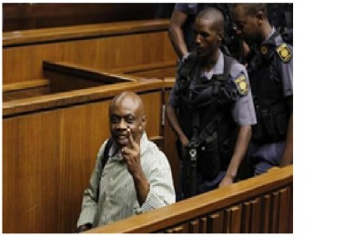
MEND leader on trial in South Arfica

Kidnapping of the French family in 19th of February 2013 at the border of Nigeria with Cameroon demonstrates the severity of the threat also in countries where till now there was a relatively quiet situation. By the way, the family was released at the end of the week 20/4.
The decision of the giant oil producing companies to cancel or postpone business activity, such as BP announcement immediately after the Amenas terror act on immediate stop of their drilling operations in Libya’ as well as the decision by Shell to stop the flow of oil in the main oil transport pipeline in Nigeria, are a sign of the companies` recognition of the size of threat on their workers and facilities, implying also that they don`t have an adequate security answer to the present threats.
It can be assumed with a high degree of certainty that already in the near future the companies working in the area, and in particular the oil and gas companies, will be asked to increase their insurance and secondary insurance payments for energy projects, to pay higher bonus payments for foreign workers employed in dangerous areas and in parallel to improve the safety and security means, standards and procedures in the various oil sites.
The increased terror and crime threats create a new economic and social reality, influencing the availability of resources abundant in Africa and needed by the whole world. As stated, this is a blinking red light indicating the threat on foreign factors wishing to operate in this area. Relieving these threats depends on the existence of effective intelligence and security arrangements that will be able to deter opponents, thwart attempts of impairing human life and causing damage, while providing an effective answer on emergency situations. There is a particular identity of interests in joining together these two points. On one hand this an existential threat for companies and business organizations operating on the continent, and on the other hand it is a business opportunity for security companies, specializing in risk management, providing consulting services and guidance in establishment of suitable security arrangements.

Meir Gershuni is a former Head of Division at the ISA, and at present Senior Vice President of the MAYDEX AG specializing in energy infrastructure security planning and a Senior Lecturer in the School of Security and Emergency Management at the Wingate Academic College.

Is There A Third Boston Marathon Bomber?
Source:http://www.westernjournalism.com/is-there-a-third-boston-marathon-bomber/?utm_source= Western+Journalism&utm_campaign=ab1cb5b7c2-RSS_EMAIL_CAMPAIGN&utm_medium=email& utm_term=0_4e00ceee98-ab1cb5b7c2-254528313
Saudi national Abdul Rahman Ali Alharbi ?

The Chechen Black Widows—Female Terrorists in al Qaeda and the Tsarnaev Brothers
By Anne Speckhard, Ph.D
Source: http://blog.annespeckhard.com/2013/05/07/the-chechen-black-widows-female-terrorists-in-al-qaeda-and-the-tsarnaev-brothers-3/?goback=.gde_1528217_member_238961714

As Tamerlan Tsarnaev’s body awaits a burial place and Dzhokar Tsarnaev a trial for charges of using weapons of mass destruction, the spotlight has temporarily been turned to the elder brother Tamerlan’s wife, Katherine Russell, whose computer has been found to have al Qaeda materials downloaded to it and whose kitchen and bathroom show traces of explosive materials indicating the brothers’ bombs were likely assembled in her home. Katherine Russell, an all American girl who converted to Islam after falling in love with Tamerlan was married to him in June of 2010 and together they had a small child.
Russell claims that she knew nothing about her husband’s intentions and has, according to FBI informal reports, been working closely with them. The possibility that Russell could also be a terrorist alongside her husband raises questions for many about the involvement of the female “Black Widows” –suicide operatives in the Chechen terrorist groups that following the fall of the Soviet Union in 1991, hijacked that republic’s secular independence movement turning it into a Chechen “jihad”.
During the early nineties when the Chechen secular rebel movement was met with a firm Russian response culminating in the first Chechen war of independence, the Chechen freedom fighters looked to the west for support. Except for westerners decrying human rights violations, the Chechen freedom fighters didn’t find the support they hoped for. But they did find—between the two wars of independence with Russia—an influx of foreign fighters coming victorious from the Afghan jihad—militants still euphoric over defeating the former USSR. These foreign fighters were confident that they could declare and win a “jihad” in Chechnya as well.
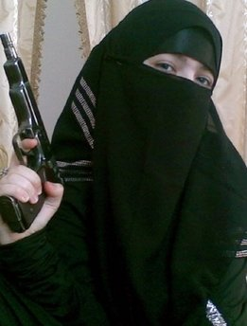
Most notable among them was Saudi foreign fighter Khattab, who brought the nascent al Qaeda ideology along with the methods of “martyrdom” or suicide missions into the Chechen battle for independence. He successfully convinced then rebel leader Shamil Basaeyev to change methods. Khattab and other foreign fighters brought the ideology, themselves as trainers and funneled funds into the “Chechen jihad” changing it completely. And as a result starting in 2000, a long terrorist campaign grew up out of the Chechen rebel movement in which over thirty suicide missions were carried out involving over one hundred and twelve “martyrs” half of whom were women operatives who blew themselves up in subways, on airplanes, at checkpoints and most infamously who took over a Moscow theater of over eight hundred theater goers and the Beslan school, taking over twelve hundred hostages—mostly women and children.
And what was perhaps most chilling about the Chechen terrorists was that they used women from the start. The first Chechen suicide bombers were two young women who drove an explosive laden truck into their target. Half of the hostage takers in Moscow were women dressed in long black Salafi style robes with bomb belts strapped to their waists—they were seen by journalist as women in mourning clothes when in fact they were dressed in conservative Islamic dress common to their extremist groups and they were wrongly dubbed the “Black Widows”.
All the Chechen suicide bombers that we conducted psychological autopsies on (over half of the total) had lost a family member traumatically to the two wars but the women had lost not only husbands, but brothers and fathers as well—so many were widows, but some were simply traumatically bereaved and seeking revenge. For Chechens this was the first time that women had been involved in revenge seeking behaviors – a domain in Chechen culture usually reserved only for the men.
As Chechens joined the militant jihadi ideology we found that they were instructed by their Middle Eastern teachers that they should fulfill their life duties before going on suicide missions—by marrying and having children—something that Tamerlan also did. Likewise women were presented in their world view as useful for childbearing but the best “love” was presented as “brotherly” or homosexual lovemaking and women were presented as needing to be respected, but as unclean. Basaeyev as well as other terrorist leaders also chose their wives strategically from among various areas and clans so as to guarantee protection when needed from their extended families.
The Chechen case gave us one of the first insights into how women carry out their roles in militant jihadi groups. Thus far al-Qaeda central has been slow to use women—although two Belgian women were recruited into their ranks and one—a European descent white convert—Muriel Degauque carried out a suicide mission in Iraq. Al Qaeda in Iraq also began to use female bombers toward the end when males could no longer pass the checkpoints and we have now seen them in Afghanistan as well. But unlike in Chechnya where women joined the fighters in the forest and were suicide bombers from the beginning, al Qaeda has kept women in the roles of money carriers, instigators—some in Europe even offering themselves as a prize in marriage to potential “martyrs”, as translators of militant jihadi texts into the local languages and in some rare cases even as suicide operatives and trainers. Women have yet to be fully activated in al Qaeda central.
And although women joined right from the start in the Chechen case, we did not find them in leadership roles—men still call the shots when it comes to terrorism. Indeed in the Moscow theater hostage taking the women terrorists inside the theater (mercifully) did not detonate their bombs without an order from the men who were outside the theater proper—engaged in battle with Russian Special Forces. Although the women could have blown the theater and all those held there to bits, had they felt the initiative to act on their own.
With Katherine Russell, we still wait to learn more. She was a hardworking mother supporting her family—working seventy to eighty hours a week outside her home. She may have been just like the many Palestinian family members I interviewed who were in complete shock upon learning their son or daughter had blown themselves up—and she may have failed to notice how radicalized and serious her husband had become about his extremist views. Lack of knowledge and denial of the horrific is often a common attribute among close family members of terrorists.
Her case does however bring up a chilling parallel of the 7-7 London metro bomber, Germaine Lindsay’s widow—Samantha Lewthwaite—who also claimed innocence after her husband’s terrorist act, calling it “abhorrent”. Lewthwaite, also the mother of her “martyred” husband’s two children later turned up in Kenya leading and carrying out terrorist attacks against western targets. Lewthwaite according to a UK police officer’s comments reported in the Telegraph to have written in her diary that the devoted wife of a mujahid (holy warrior) must realize that her “life in the hereafter promised to be sweeter because of her husband’s “sacrifice” and that a wife must be “discrete”, “obedient” and must understand that her husband’s calling meant that she and her husband would be cut off from their families.
Let’s hope the story of a terrorist’s wife and mother to his child doesn’t follow those same lines in the case of Katherine Russell who in any case must be suffering from a great deal of sadness and loss over her husband’s sudden heinous death. And let’s hope that al Qaeda continues to be reluctant to use women operatives as time has proven they are the best at passing security checkpoints and lulling us into a false sense of safety.

Anne Speckhard, Ph.D. is Adjunct Associate Professor of Psychiatry in the Georgetown University Medical School and author of Talking to Terrorists: Understanding the Psycho-Social Motivations of Militant Jihadi Terrorists, Mass Hostage Takers, Suicide Bombers & “Martyrs” In the last decade she interviewed over four hundred terrorists, suicide bombers, terrorist supporters, family members, close associates and hostages. She also conducted psychological autopsies with a Chechen colleague on over half of the 112 Chechen suicide bombers investigating what put them on the terrorist trajectory and what motivated them to explode themselves.

Researcher Creates A Database Of Global Terrorist Groups
Source: http://www.wunc.org/post/researcher-creates-database-global-terrorist-groups

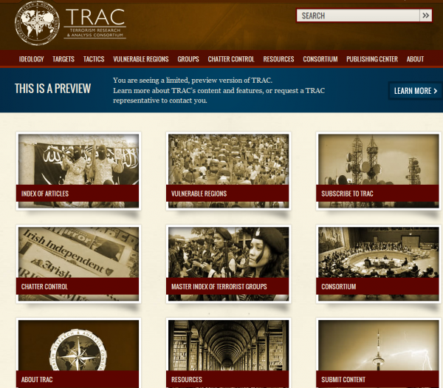
Veryan Khan has devoted the last decade to researching terrorist groups across the globe. Trackingterrorism.org is a database created by Khan, to curate information about different terrorist groups.

Veryan Khan is the editorial director of tracterrorism.org and an associate publisher of Beacham Publishing.

NEW REPORT – Council on American-Islamic Relations: Compedium on American-Islamic Relations
By Citizens for National Security

This analysis and compendium represent a comprehensive view into the origin, purpose, and operational activities of the Council on American-Islamic Relations (CAIR) as it is constituted in both the United States and Canada. The study includes almost 150 documented cases of frivolous lawsuits, extortion, intimidation and subversion undertaken by it, all aimed at silencing its critics and advancing its agenda.
CAIR has long misrepresented itself as a Muslim civil rights organization, but it is far from this false image it tries to project. In reality, CAIR is a seditious and subversive organization operating within the United States and Canada as a direct operational extension of the radical Islamist Muslim Brotherhood. It is deeply associated with numerous terrorist organizations and sponsors, and is itself an instrumental facet of the radical and violent Islamist movement. Through its thirty-three chapters it operates as a network of loosely affiliated organizations with shared goals, strategies, and patterns of conduct. The chapters often work together in launching closely coordinated campaigns aimed at subverting and challenging traditional constitutional principles and traditions.
Though CAIR engages in some seemingly legitimate activities such as filing EEOC complaints in cases of actual discrimination, this appears to be a cover for its more politically motivated activities. Inferring CAIR’s intent by its conduct, it seems clear that CAIR’s mission is to stifle all criticism of Islam, to blind the American and Canadian people, their politicians, law enforcement and intelligence organizations to the threats to their societies posed by radical Islam, to dismantle their national security procedures, and to Islamize corporate America. In effect, CAIR has been waging a form of “Lawfare” against the American people, institutions, and constitutional freedoms. Unfortunately, they have had significant success in each of these areas.

About CITIZENS FOR NATIONAL SECURITY
Citizens For National Security (CFNS) is a nonprofit, nonpartisan, 501(c)(3) public charity committed to calling attention to, and providing objective and unbiased information on, the full range of national security threats to the United States from Islamists, other extremist ideologies and rogue nations. Unlike other writers, speakers or organizations active on the issue of national security, CFNS draws on the extensive and unmatched experience of its founders and its well-honed research capability to develop, assemble and present only accurate, reliable and objective data about the goals, activities and supporters of anti-U.S. movements. Free of any partisan affiliation, sponsorship or agenda, CFNS focuses on providing the credible information that ordinary citizens can use in deciding for themselves how best to enhance our national security. To learn more about CFNS, please visit www.CFNS.US.

►Read full report at Newsletter’s website (link: “CBRNE-CT Papers”)

U.S. terror suspect studied chemical engineering at Quebec University

Source:http://www.cbc.ca/news/canada/story/2013/05/10/canada-via-plot-suspect-quebec-student.html? cmp=rss

A man arrested in a U.S. terror plot in New York April 22 was a graduate student studying chemical engineering at Laval University in Quebec City, CBC News has learned.
Ahmed Abassi's major is "particularly chilling" in conjunction with other evidence presented against him by the FBI, said CBC's Greg Weston.
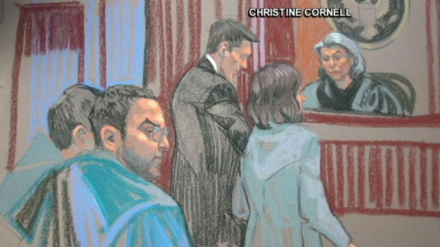
The FBI alleges Abassi was plotting to kill upwards of 100,000 people by contaminating the air or water supply in a major U.S. city. However, the plan did not materialize any further than discussions.
Abassi is also being linked to Chiheb Esseghaier, one of two Canadian residents recently arrested in Canada in connection with an alleged plot to derail a Via passenger train.
The RCMP said it worked closely with the FBI during the RCMP's investigation into Esseghaier and his co-accused, Raed Jaser. The FBI's parallel investigation led to the charges against Abassi.
"Through our efforts, we assured that at no time did this individual pose an imminent threat to public safety in Canada," said Sgt. Greg Cox.

Unclear how Abassi entered U.S.
American investigators have accused Abassi, 26, of fraudulently applying for a visa to stay in the United States to "facilitate an act of international terrorism."
"Abassi had an evil purpose for seeking to remain in the United States — to commit acts of terror and develop a network of terrorists here, and to use this country as a base to support the efforts of terrorists internationally," U.S. Attorney Preet Bharara said in a statement.
Abassi travelled to the U.S. in March, said Weston. However, he did not enter the country directly from Canada.
CBC News has learned Abassi left Canada for Tunisia before Dec. 25, 2012. Abassi never returned to Canada, Weston reported.
Abassi had trouble obtaining a visa to return to Canada, Immigration Minister Jason Kenney said when answering a question at a news conference.
Kenney said immigration officials became aware of security concerns while he was in Tunisia and he believes officials did not renew Abassi's study permit.
Canadian law enforcement sources say Abassi had been under surveillance by RCMP and CSIS agents for months before he left for Tunisia and subsequently resurfaced in New York.
But a senior government official told CBC News that Abbasi's student visa did not allow him to leave the country during his studies without re-applying for an entry permit to Canada.
The official said it was Abassi's subsequent application for a re-entry permit to Canada that raised red flags on his file with visa officers at the Canadian consulate in Tunisia, and the permit was denied.
It's unclear how he entered the U.S.
Weston said Abassi's route is important, because of an American perception that Canada is a breeding ground for alleged terrorists.

May have radicalized 2 Canadians
Abassi allegedly played a key role in radicalizing at least one of the two Canadian residents arrested last month in an alleged plot to derail a Via rail train.
U.S. investigators say that while they were monitoring Abassi, he met with Esseghaier, 30, in New York City.
Officials noted in the statement that Esseghaier was "previously radicalized by Abassi."
In New York City, Abassi, Esseghaier and an undercover agent discussed their plans. The statement says Abassi "discussed his desire to engage in terrorist acts against targets in the United States and other countries, and his intention to provide support and funding to organizations engaged in terrorist activity."
In an interview with law enforcement officers, Abassi acknowledged that he "may have radicalized" Esseghaier, and said the two "discussed plots to poison a water system and to derail a passenger train," U.S. prosecutors said in a letter filed by U.S. prosecutors with a New York court.
The indictment charges Abassi with two counts of knowingly making false statements to immigration authorities to facilitate an act of international terrorism. Abassi may face further undisclosed charges at a later date, according to the letter.
Canadian authorities arrested Esseghaier, 30, and Toronto-area resident Jaser, 35, last month for allegedly planning to carry out an attack against a passenger train travelling between the U.S. and Canada.
Authorities arrested the trio on the same day, but the FBI kept Abassi's detainment quiet until Thursday.

Can India clamp down on terror?
Source: http://www.hindustantimes.com/India-news/NewDelhi/Can-India-clamp-down-on-terror/Article1-1058831.aspx

A team of investigators waited impatiently for a forensic report early last month. The report was important for it could establish the identity of the bomber who had been caught on CCTV in Hyderabad’s Dilsukhnagar area where serial blasts killed 17 in February this year.
The face in the footage was not clear and investigators were hopeful that a forensic expansion of the image would establish their suspicion – that the attack had been carried out by IM’s nimble-footed Yasin Bhatkal.
The forensics didn’t help and so the Hyderabad attack stays unsolved as does the one in Bangalore last month, where a bomb placed on a motorcycle outside the BJP office left 16 injured. While the investigators know who bought the second-hand motorcycle, the bomber still remains at large.
The Hyderabad and Bangalore attacks sum up the reasons for why India continues to be a soft target. Crucially, the attacks also exemplify what’s wrong with India’s counter-terrorism grid.
Most security experts point out that India’s counter terrorism strategy is flawed because it lacks a security mindset, unlike America, which believes first in pre-empting attacks and then “in going to the end of the world” to get them, as articulated by President Barack Obama after the Boston bombings.
In contrast, India had not pursued near-perfect intelligence as was evident from the Hyderabad instance. The areas in which the Hyderabad bombers struck were the exact areas which had been recced by operatives of the IM who were later arrested by the Delhi Police.
But the bombers managed to trigger blasts despite the Hyderabad police having interrogated the operatives at length in Delhi.
“Countering terrorism is a constant cat and mouse game in which you cannot afford to be outsmarted,’’ says a senior home ministry official, adding, “we are far behind in this game. We were still using landlines when the terrorists moved online.
By the time we woke up to that, they’d switched to superior techniques like voice-over internet protocol (VOIP), which is difficult to monitor.”
Imran Khan, one of the operatives who had recced Dilsukhnagar in Hyderabad told his NIA interrogators that he’d conveyed the details to his boss and founder of IM, Riyaz Bhatkal, over yahoo messenger.
And here once again, is what’s wrong with India’s counter-terror infrastructure: for the nearly five years since 26/11, India has been pushing the US, to provide details of Mumbai conspirator David Headley’s email details and then of Abu Jindal (who was extradited from Saudi Arabia), but all its got in answer is, “the privacy laws don’t allow us to share the information.”
Despite 26/11 and despite the technological advances made by terror groups, India — unlike China — hasn’t been able to push internet providers to shift their servers here.
There are other flaws. India continues to remain vulnerable despite the brazen attacks in Mumbai, because of its defensive posture. Despite terror being exported from Pakistan by the LeT, India has not increased the costs of war through hot pursuit.
Nor — and this is alarming — has the government devoted enough resources, both at the Centre and in the states.
The Intelligence Bureau, which lies at the heart of the counter terror grid has 30% vacancies. The anti terror squads in states, including Mumbai which has been hit several times, is short of men and material.
Also, the police-population ratio stands at 137, when by international standards it should be 220 per 100,000 people and that too during peace time.
According to Ajai Sahni, Director, Institute for Conflict Management, “It is a long haul, even if we start doing the right thing now."
Former RAW Additional Secretary, B Raman also warns of increasing alienation and radicalisation. Clearly, there is more wrong than right as 26/11 showed in 2008 and Hyderabad did more recently.

The myth of Islamic terrorism in America
By Ali Shihabi
Source: http://english.alarabiya.net/en/views/news/middle-east/2013/05/11/The-Myth-of-Islamic-terrorism-in-America-.html?goback=.gde_4657639_member_240087837

After the planes hit on 9/11, a myth-making industry was born.
“Why do they hate us?” was the first thought to cross horrified American minds.

Israel’s lobby, worried that she would be seen as having sowed the seeds of anti-American sentiment in the Islamic world, quickly came up with an alternative explanation: “They hate us for our freedoms—our way of life,” screamed the headlines. Promoted by friendly journalists, politicians, and academics, these slogans quickly drowned out all other competing theories and were eagerly picked up and trumpeted by right-wing pundits like Rush Limbaugh, and Islamophobes like Daniel Pipes, who went on to claim that Islamists want to impose sharia law on America.
Hollywood, not to be left out of all the fun, quickly jumped on the bandwagon with a slew of entertaining programs like 24; Sleeper Cell; Homeland; and others that amplified and capitalized on this paranoia.
Bin Laden, in fact, had no interest in changing the “American way of life.” He wanted instead to topple the Saudi monarchy and saw 9/11 as a way to permanently rupture the Saudi–U.S. alliance, a goal he very nearly succeeded in accomplishing.
Islamists actually could not care less about imposing sharia law in the U.S. They want control of Arabia, its oil and its holy places, and any other Muslim-majority state they can get their hands on in the meantime. Their target, their obsession, was the Muslim world not America. Islamophobes, however, striving to keep Americans on edge, claimed to spot “homegrown” radical Islam lurking behind every tree.

A battle zone
In fact, a careful review of events since 9/11 proves, without a shadow of a doubt, that the claim that militant Islam has gained any traction among the Muslims of America is farcical.
Had militant Islam actually taken hold in America, this country would have become a battle zone. After all, with millions of Muslims in the U.S., the successful spread of any such ideology among them would have resulted in thousands of recruits, hooked on jihadist websites, eagerly building bombs, and champing at the bit to commit acts of terrorism. Such numbers could have turned a city like New York into another Baghdad. Instead, the number of terror attacks in the U.S. involving Muslims, over the course of more than a decade, is fewer than the fingers of one hand. The numbers here just do not add up to justify any credible claim of an Islamist war of terror on American soil.
Manufacturing local Islamic terrorism, either through FBI sting operations or through rebranding criminal acts by Muslims as acts of Islamic terrorism, does the United States no service.
In fact, the two major events since 9/11—first, Major Hasan’s shooting of fellow soldiers at an army base, and second, the recent Boston bombing—are little more than horrible criminal acts carried out by disturbed, maladjusted individuals, very similar to the Columbine and Newtown school shootings. The perpetrators’ motives and actions are better explained by psychologists than by those so-called “terrorism experts” who have sprung up in abundance in recent years to feed on and perpetuate this narrative. These so-called “Islamic terrorists” had no organization behind them, no training, and nothing but some superficial exposure to jihadi websites. Had they had any meaningful support, then these criminals would not have carried out their atrocities in the amateurish way that they did and gotten caught so easily.
As Philip Mudd, former deputy director of the CIA’s Counterterrorism Center, told Charlie Rose in a recent interview about the Boston bombers, “I don’t necessarily think these are real jihadi terrorists. I think they are angry kids. … They may have some vague religious notions,” he added, but, “psychologically, this has characteristics of Columbine as much as characteristics of al-Qaeda.”
The problem here is that criminal acts, however outrageous, are no match for Islamic terrorism in the excitement department. People are used to crime, but Islamic terrorism still gets the adrenaline pumping and television ratings shooting up.
Manufacturing local Islamic terrorism, either through FBI sting operations or through rebranding criminal acts by Muslims as acts of Islamic terrorism, does the United States no service and causes public confusion, unnecessary anxiety, and a misallocation of valuable government resources.
This brings me to a final tidbit for those eager conspiracy theorists among us. This Islamic terrorism phenomenon is tailor-made for “false flag” operations. Any intelligence agency or covert organization worth its salt can set up an “imam” to dupe some fools into committing terrorist acts, with virtually no possibility that anyone will be able to trace this action back to the source. Barriers to entry in the jihadi imam recruiting department are very low, and the characters duped into this sordid business are hardly going to be the brightest blades on the block. Identifying malcontented, disturbed individuals to target is no difficult task, either. In fact, the older Tsarneyev brother’s recent visit to Russia is certainly worthy of extreme scrutiny, if such a thing is at all possible.
Can any such incidents be false flag operations? We may never know, or at least not until Oliver Stone comes along and figures this out for us in a new blockbuster movie.

Ali Shihabi is a writer on Middle Eastern politics. He is a Saudi citizen who is a graduate of Harvard and Princeton and the founder of an investment bank.

Islamic terrorists may target Russian long range ballistic missiles
Source:http://i-hls.com/2013/05/islamic-terrorists-may-target-russian-long-range-ballistic-missiles/?goback=.gde_1528217_member_240251655

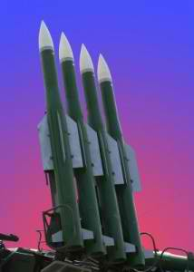
Russia has completed the upgrade of the security systems at its intercontinental ballistic missile (ICBM) bases, especially against the threat from Islamic terrorists. This program has been reported first in Strategy Page.
Russia currently has 120 ICBMs in silos and 190 moved about on 16 wheel 17.4 meter (54 foot) long TELs (Transporter Erector Launchers). Naturally the Russians are not giving out details of the upgrades.
But it was revealed that all components of multilayer systems of sensors, as well as power control and fire suppression systems are being refurbished or improved. Security personnel, all of them carefully selected, are to be given additional training and new (apparently more deadly) rules of engagement.
The Russians said little about improvements in the security of their mobile ICBMs. These travel around roads inside large rural military bases. That makes these mobile systems the most vulnerable to terrorist attack. There have probably been major improvements in how these mobile ICBMs are monitored and protected.
In the meantime Russia is developing new ICBM’s. Two kinds of new strategic missiles, which Russian experts develop, should become a response to the deployment of the U.S. missile defense system in Europe. It goes about a heavy liquid-fuel ICBM weighing 100 tons. The new missile will surpass the most powerful missile in the world RS-20B Voyevoda (Satan). The second type is a solid-fuel ICBM, which is said to replace fifth-generation Yars and Topol-M complexes. The news was revealed Friday by the Commander of Strategic Missile Forces of Russia, Colonel General Sergei Karakayev.

Canada deports convicted terrorist after 26 years
Source: http://www.huffingtonpost.com/huff-wires/20130513/cn-canada-terror-deportation/

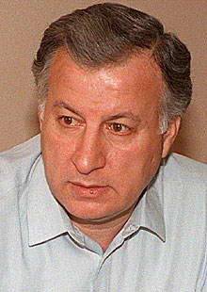
A Palestinian man convicted of hijacking an airliner in Greece in 1968 has been deported from Canada 26 years after entering the country using an alias, the immigration minister said Monday.
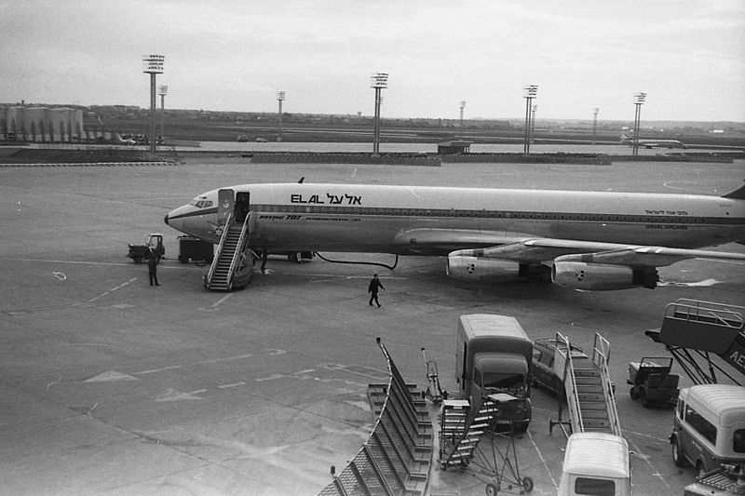
Immigration Minister Jason Kenney said the case "made a mockery of Canada's generosity and our fair immigration system for two and a half decades."
Kenney said Mahmoud Mohammad Issa Mohammad made a false refugee claim in 1987. The government learned a year later that he was a member of the Popular Front for the Liberation of Palestine, and had participated in a terrorist attack on an El Al Israeli plane in which an Israeli citizen was killed. Kenney said Mohammad and another man stormed a plane and threw grenades and fired live rounds at civilians.
Mohammad was convicted in Greece in 1970 of manslaughter and sentenced to 17 years in prison, but he was freed before completing his sentence as part of a deal to resolve another hijacking.
Kenney said Mohammad, 70, was deported to Lebanon on Saturday after living in southern Ontario since 1987. Kenney said Mohammad was deported to Lebanon because his wife is Lebanese and he has residence there.
Kenney called the case a "comedy of errors" and said Canada "will no longer be treated like suckers by terrorists."
He said under new immigration laws enacted by his Conservative government he would have never been allowed to stay in Canada for so long. Mohammad was able to use 12 or more appeals and loopholes under old laws to remain in Canada, he said.
"There were 26 years of considerations given to Mr. Mohammad and finally our legal system decided that he could be deported," Kenney said.
The Canadian government chartered a plane and a medical team went with Mohammad so he could not claim he was suffering from something like heart trouble and have the plane turn around, Kenney said. Mohammad has undisclosed health issues.

Hezbollah’s Criminal Network Expanding in Size, Scope and Savvy
Source: http://www.worldpoliticsreview.com/trend-lines/12918/global-insider-hezbollah-s-criminal-network-expanding-in-size-scope-and-savvy?goback=.gde_1528217_member_237314677

In late-April, the Obama administration blacklisted two Lebanese money exchanges for allegedly facilitating Hezbollah’s use of narcotics trafficking profits to fund terrorist activities. In an email interview, Matthew Levitt, director of the Stein program on counterterrorism and intelligence at the Washington Institute for Near East Policy and author of the forthcoming “Hezbollah: The Global Footprint of Lebanon's Party of God,” explained the broad range of Hezbollah’s illicit activities and the growing savvy of its criminal network.
WPR: What are Hezbollah's main illicit business activities, and where is it most active?
Matthew Levitt: Hezbollah is engaged in an amazingly broad array of illicit activities, from counterfeiting currencies, documents and goods to credit card fraud, money laundering, arms smuggling and narcotics trafficking. Hezbollah, one investigator quipped, is like the “Gambinos on steroids.” In 2002, Hezbollah operatives in North Carolina were convicted for smuggling cigarettes across state lines and sending some of their profits back to their commanders in Lebanon. In 2009, 10 individuals in Philadelphia were charged with conspiring to provide material support for Hezbollah through trafficking stolen laptop computers, passports, Sony PlayStation 2 systems and automobiles. In October 2011, a group of businessmen pled guilty to attempting to ship electronics to a shopping center in South America that the U.S. Treasury Department had designated as a Hezbollah front.
Authorities have tracked similar illicit activities to places as disparate as Benin and Venezuela, in addition to the United States. An extensive 2011 Drug Enforcement Agency investigation traced $200 million a month from cocaine sales in Europe and the Middle East to Hezbollah-linked operations located in Colombia, Lebanon, Panama and West Africa. However, most of Hezbollah’s illicit operations take place in the loosely regulated triborder area where Argentina, Brazil and Paraguay meet. Ties between Hezbollah and drug cartels along the U.S.-Mexico border have also grown in recent years.
WPR: How important are those businesses as a source of funding for the group?
Levitt: Hezbollah's criminal network has grown in size, scope and savvy. Wary of the instability plaguing its patrons in Tehran since the Green Movement uprising in 2009, Hezbollah has expanded its illicit activities to gain greater financial independence -- an expansion that is sure to continue in the wake of the uprising in Syria, Hezbollah's other major benefactor. The organization has developed a sophisticated, organized and global crime network that brings in tens of millions of dollars in profit each year. The organization views its illicit income as critical for providing social services to an expanding swath of the Lebanese electorate, paying the families of its fighters and investing in its growing arsenal of rockets and other advanced weapons.
WPR: How effective is the U.S. campaign against these activities?
Levitt: The U.S. has made strong efforts to counter Hezbollah activity both at home and abroad. Domestically, investigators have targeted Hezbollah’s abuse of charities and criminal enterprises. Internationally, diplomats have been pressing European and other countries to take more concerted action against Hezbollah’s terrorist and criminal activities. Over the past few years, Washington has also ramped up efforts to “highlight the group’s moral bankruptcy” by exposing Hezbollah’s narcotics trafficking and money laundering networks and imposing sanctions on banks and exchange houses that facilitate Hezbollah’s illicit financial dealings. While there is always more to be done, the combination of law enforcement, intelligence, diplomacy and financial tools amounts to a more holistic approach to countering Hezbollah’s criminal activity than ever before. Washington counters Hezbollah organized crime as best it can with limited help from Europe; to date, only Britain and the Netherlands have designated the group or its "wings" as terrorist organizations. Measures against Hezbollah fundraising would have much greater impact if taken by all industrial countries rather than in a piecemeal fashion.

EUROPOL TE-SAT 2013 Report
Source:https://www.europol.europa.eu/content/te-sat-2013-eu-terrorism-situation-and-trend-report

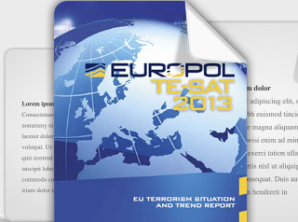
The fight against terrorism remains a top priority for the European Union and for Europol. The TE-SAT is one of Europol’s most significant strategic analysis products. It offers law enforcement officials, policymakers and the general public facts and figures regarding terrorism in the EU while, at the same time, seeking to identify developing trends in this phenomenon. It is a public document produced annually and is based on information provided and verified by the competent authorities of the EU Member States.

►Read full report at the source above

Benghazi tied to Boston bombings?
By Aaron Klein
Source: http://www.wnd.com/2013/05/bengazi-tied-to-boston-bombing/

There is a common threat that links the Sept. 11, 2012, Benghazi attack to both the Boston Marathon bombings and the terror assault on the In Amenas gas facility in southern Algeria in January.
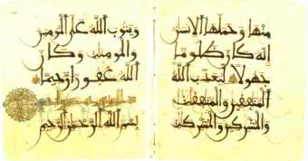
The thread runs through al-Qaida in the Arabian Peninsula, or AQAP, one of the most deadly members of the al-Qaida conglomerate. AQAP previously attempted several major attacks within the U.S.
The group was the first al-Qaida member to comment on the Benghazi attack, releasing a statement arguing the assaults on the U.S. mission and nearby CIA annex were revenge for the death of Abu Yahya al-Libi, one of the most senior al-Qaida operatives.
AQAP did not directly claim responsibility for the Benghazi attacks.
Al-Libi, of Libyan descent, was believed to have been killed in Pakistan in June 2012.
Lost in the news media coverage about the U.S. response to the Libya attacks was that one day before the assaults, on Sept. 10, 2012, al-Qaida leader Ayman al-Zawahiri released a video calling for attacks on Americans in Libya to avenge the death of al-Libi.
The 42-minute video announced the death of al-Libi. Released on a jihadi online forum less than 18 hours before the Benghazi attack, Zawahiri urged jihadists, and particularly those in Libya, to avenge the killing of al- Libi.
“His blood urges you and incites you to fight and kill the crusaders,” he said.
Last week, CNN quoted sources disclosing several Yemeni men belonging to AQAP took part in the Benghazi attacks.
One senior U.S. law enforcement official told CNN that “three or four members of al-Qaida in the Arabian Peninsula” took part in the attack.
Another source quoted by CNN as being briefed on the Benghazi investigation said Western intelligence services “suspect the men may have been sent by the group specifically to carry out the attack.”
“But it’s not been ruled out that they were already in the city and participated as the opportunity arose,” continued the CNN report.
CNN further quoted one source revealing counter-terrorism officials learned the identity of the three men and later traced them to northern Mali, where they are believed to have connected with the jihad organization led by Moktar Belmoktar.
Belmoktar, an Algerian, is a senior leader of the Islamic Maghreb. He claimed responsibility for the Algeria gas facility attack in January in which 38 people were killed during a three-day siege.
Another intelligence source told CNN that Belmoktar had received a call in the aftermath of the Benghazi attack from someone in or close to the city.
The person on the other end of the call stated, “Mabruk, Mabruk!” meaning “congratulations” in Arabic, according to the source.

Boston bombing link
Meanwhile, AQAP has also been tied to the Boston bombing.
AQAP is behind Inspire magazine, the periodical thought to have provided bomb-building instructions for Tamerlan and Dzhokhar Tsarnaev, the accused Boston Marathon terrorists.
AQAP previously attempted attacks on U.S. soil. One such attempt was the 2009 Christmas Day plot by a Nigerian recruited by the group to blow up a plane flying into Detroit. That attack failed when the suspect’s device malfunctioned.
In October 2010, AQAP reportedly attempted to blow up planes destined for the U.S. using printer bombs disguised as air cargo. The plan was thwarted after a tip from Saudi intelligence.
In April 2012 it was reported that a British informant working for Saudi counter-terrorism thwarted an AQAP plot to bomb a U.S-bound airliner.

Aaron Klein is WND's senior staff reporter and Jerusalem bureau chief. He also hosts "Aaron Klein Investigative Radio" on New York's WABC Radio.

Police on alert after school massacre threat
Source: http://www.thelocal.fr/20130517/french-police-on-alert-after-school-massacre-threat#.UZY6B0q 9bPo

Around 750 police have been stationed at schools across the French city of Strasbourg after an anonymous person, believed to be a teenager, posted a message online threatening to commit suicide and kill several pupils at a school on Friday.
The menacing message was posted in on the gaming forum jeuxvideo.com earlier this week.
In it the anonymous poster, writing under the pseudonym "dead man" said he would write “the last chapter of his life” and that he intended to commit a massacre in a school using his uncle’s gun.
“I live in a certain city, where there is a certain high school, and on Friday I leave my mark in history. My life and the lives of many other people will finish on this day [Friday]” the message read.
The message was posted in an internet café in the city of Strasbourg.
Police have released this photo of the teenager who is suspected of having posted the threat in the hope the public can help track him down.
The threat, which comes a day after a 51-year-old burst into a school in Paris before shooting himself in the head in front of terrified school children, is being taken seriously by police.
Officers have been stationed at several schools across the city on Friday in the case that the anonymous poster carries out his threat.
Around 255 policemen are working around the clock to try to identify the person behind the message.
Police are appealing for witnesses and are asking anyone with information to call 03 90 23 13 05.
Thursday’s shocking incident, which saw a man with a history of family problems commit suicide in front of a dozen young children in the hall of a Catholic primary school in Paris, sparked a debate about security at French schools.
The man, who was not affiliated with the school, forced his way into the La Rochefoucauld primary in central Paris at 11:30 am, pushing aside two adults who tried to stop him, Francois Weil, the city's top educational official said.
On Friday France's Interior Minister Manuel Valls poured cold water on the idea of installing metal detectors at schools across the country, saying it would be "difficult" due to the high number of institutions.
"Can we really stop a desperate man who has decided to end his days in this way? It seems difficult to me, " Valls said.
The Minister said it would not be right to simply react to the public emotion caused by the incident and station, police and metal detectors in all schools.
"That is the case in the United States in particular and look what situation they are in there," Valls said, in reference to the number of school shootings in the America.

EDITOR’S COMMENT: A new form of (virtual?) terrorism???

We live in a strange-strange world!
Source: http://imgur.com/a/Nx8EU#ZdLUN2i

South Africa Becoming Terrorist Haven
Source: http://muslimsinafrica.wordpress.com/2013/05/15/south-africa-becoming-terrorist-haven-professor-hussein-solomon/

This has not been a good week for the South African intelligence community. Two back to back media reports raise more questions regarding the capacity of South Africa’s intelligence community and the will of their political mandarins to robustly respond to the scourge of international terrorism.
Following a year-long investigation, the Daily Maverick’s De Wet Potgieter exposed the existence of secret Islamist military training camps in South Africa – one at Vlakplaas, outside Pretoria and the other in the mountains of the Klein Karoo[i]. Whilst the existence of militant Islamist training camps in South Africa is not a new phenomenon – going back to at least the 1990s – the information on the South African government’s own responses makes for fascinating reading.
According to Potgieter, following the 9/11 terror attacks in Washington and New York, the South African police launched an operation to investigate militant Islamist activities in South Africa named Operation Kanu. However in 2010 intelligence personnel were recalled from the operational sites and laptops, cameras and situation reports were all taken away from these operatives. All surveillance was ceased on the orders, it would seem, from their political masters. Even more puzzling was the fact that despite incriminating evidence found by these operatives, no arrests followed Operation Kanu.
This raises several more questions. Why would such an operation lasting several years and with the expenditure of so many resources be suddenly called off? Who had the authority to terminate such an operation which proved to be so promising given the incriminating evidence and subversive activities that De Wet Potgieter alludes to? Why would these training camps not be regarded as a threat to South Africa’s own national security, not to mention the country’s own international legal obligations to eradicate terrorism? Was there any significance that all surveillance ended and intelligence operatives called off in 2010 – the year that South Africa hosted the Soccer World Cup and where there was credible evidence of a terrorist threat posed to this World Cup?
These questions, it would seem, is also being asked by London and Washington whose intelligence services are frustrated with the inaction on the part of the South African government to effectively respond to the terror threat emanating from within its borders.
The following day (14 May 2013), a report appeared in the Daily Mail and focused on British-born Samantha Lewthwaite who was married to the London 7 July 2005 Kings Cross bomber, Germaine Lindsay[ii]. British intelligence sources believe her to be an integral member of both Al Shabaab and Al Qaeda. With her growing seniority in jihadi circles her role has expanded from moving funds raised in the United Kingdom to terror cells in Somalia to commanding her own all-female terror squad. She is also alleged to be associated with Habib Ghani, an experienced Al Qaeda bomb maker who was trained in Pakistan.
So what is the significance of Samatha Lewthwaite for South Africa? Well, she just happened to spend two years in South Africa under an assumed name building up a terror network that spans the United Kingdom, South Africa and Pakistan.
The first media report by De Wet Potgieter was fundamentally a story of a lack of political will on the part of the political mandarins in this country to decisively deal with the terror threat posed. The second story was fundamentally about the incapacity (dare I say incompetence?) on the part of the South African intelligence community to detect the presence of Samantha Lewthwaite in the country for two solid years. Neither was she the first to use South Africa not only as a safe house, but also to build terror networks in this country.
These twin issues of a dearth of political will and incapacity will need to be fixed as a matter of urgency if we are to ensure the security of all South African citizens and for South Africa to play its part in eradicating the scourge of international terrorism.

Notes
[i] De Wet Pogieter, “Al Qaeda: Alive and well in South Africa,” The Daily Maverick. 13 May 2013. Internet: http://www.dailymaverick.co.za. Date Accessed: 14 May 2013.
[ii] “Now White Widow is connected to British-born Al Qaeda bomb maker: Fugitive wife of 7/7 terrorist was key link, The Daily Mail, 14May 2013. Internet:
http:://hiiraan.com/news4/2013/May/29348/now_white_widow_is_connected_to_british. Date Accessed: 15 May 2013.

Dr. Hussein Solomon holds a D.Litt et Phil (Political Science) from the University of South Africa. Currently he is Senior Professor in the Department of Political Science, University of Free State. His previous appointments include being Executive Director of the International Institute of Islamic Studies (2009-2010); Professor and Director of the Centre for International Political Studies, University of Pretoria (2000-2010), Research Manager at the African Centre for the Constructive Resolution of Disputes (1998-2000), Senior Researcher: Institute for Security Studies (1996-1998) and Research Fellow: Centre for Southern African Studies, University of the Western Cape (1993-1995). In 2011, he was Visiting Professor at the Osaka School for International Public Policy (OSIPP). In 2007 and 2010 he was Visiting Professor at the Global Collaboration Centre at Osaka University in Japan and in 2008 he was Nelson Mandela Chair of African Studies at Jawahrlal Nehru University in New Delhi, India. In 1994, he was Senior Visiting Fellow at the Department of War Studies, King’s College, University of London. Currently he is Visiting Fellow at the MacKinder Programme for the Study of Long-Wave Events at the London School of Economics and Political Science in the United Kingdom.

Ordinary Citizens: The Last Line of Defense Against Terrorism
Source: http://www.stratfor.com/sample/weekly/ordinary-citizens-last-line-defense-against-terrorism

The April 15 Boston Marathon bombing has rekindled interest in the topic of grassroots terrorism, specifically the kind conducted by grassroots jihadists. We define grassroots jihadists as individuals who have been inspired by the al Qaeda core or franchise groups but who are not members of these groups.
Some grassroots operatives, such as Najibullah Zazi, who pleaded guilty to charges related to a New York City Subway bomb plot in 2009, travel to places, such as Pakistan, Somalia or Yemen, where they receive training from jihadist franchise groups. Other grassroots jihadists, such as accused Fort Hood shooter Maj. Nidal Malik Hasan, communicate but have no physical interaction with members of a franchise group. Some grassroots militants have no direct contact with other jihadist elements. Lastly, some would-be grassroots militants seek out other jihadist elements but accidentally make contact with government informants. In recent years, such cases have been occurring more frequently, resulting in sting operations and arrests.
Stratfor first began discussing the threat posed by grassroots jihadists in 2005, when we described how the al Qaeda threat was devolving from one based on the core al Qaeda group to a wider movement. But in the big picture, grassroots actors are not just a jihadist phenomenon. We've also extensively discussed the move to leaderless resistance operational models by both left- and right-wing extremists.
Grassroots operatives are a very big problem for government counterterrorism efforts. Indeed, that is why militant ideologues promote the leaderless resistance model. That doesn't mean that such operatives cannot be stopped, but in order to stop them, citizens must think differently about counterterrorism. In the face of a growing grassroots threat there is a growing need for what Stratfor calls "grassroots defenders."

Grassroots Threats
In recent decades, governments have become fairly efficient at identifying and gathering intelligence on known groups that could conduct violent attacks. This is especially true in the realm of technical intelligence, where dramatic improvements have been made in the ability to capture and process huge amounts of data from landline, cellphone and Internet communications. Governments have also become quite adept at penetrating known groups and recruiting informants. Even before 9/11, government successes against militant groups had led white supremacist and militant animal rights and environmentalist groups to adopt a leaderless resistance model for their violent and illegal activities.
In the post-9/11 world, intelligence and security services dramatically increased the resources dedicated to counterterrorism, and the efforts of these services have proved very effective when focused on known organizations and individuals. In fact, because of these successes we have seen jihadist groups, such as al Qaeda in the Arabian Peninsula and the al Qaeda core, since 2009 encourage aspiring militants to undertake lone wolf and small-cell activities rather than travel to places like Pakistan and Yemen to link up with the groups and receive training in terrorist tradecraft.
We see no sign that this trend toward leaderless resistance will reverse in the near future, and our forecast is that the grassroots threat will continue to grow, not only from the jihadist realm but also from far-right and far-left actors.

Stretched Thin
As noted above, most counterterrorism intelligence efforts have been designed to identify and track people with links to known militant groups, and in that regard such efforts are fairly effective. By contrast, counterterrorism efforts have been largely ineffective in identifying those grassroots militants who do not contact known terrorist entities. The focus on identifying and monitoring the activities of someone connected to an established militant group is understandable given that operatives belonging to groups such as Hezbollah or al Qaeda have access to much better training and far greater resources than their grassroots counterparts. Simply put, counterterrorism agencies focus more of their attention on the more potent threat.
However, grassroots operatives can and do kill people. Although they tend to focus on softer targets than operatives connected to larger groups, some grassroots attacks have been quite deadly. For example, the July 2005 London bombings killed 52 people, and Anders Behring Breivik was able to kill 77 in his July 2011 twin attacks in Norway. While the Boston Marathon bombing killed only three, it wounded hundreds.
One problem for most counterterrorism agencies is that counterterrorism is not their sole mission -- or in some cases even their primary mission. Often, as is the case with MI5 in the United Kingdom, the primary counterterrorism agency also has substantial foreign counterintelligence responsibilities. In the case of the FBI, it has not only counter-terrorism and foreign counter-intelligence missions but also a host of other responsibilities, such as investigating bank robberies, kidnappings, white-collar crime, online crime and public corruption. Also, while counterterrorism was the primary focus of almost every law enforcement and intelligence agency immediately after 9/11, as time has passed, the emphasis on counterterrorism has lessened.
The resources of the primary counterterrorism agencies are also quite finite. For example, the FBI has fewer than 14,000 special agents to fulfill its many responsibilities, and while counterterrorism has become its top mission in the post-9/11 era, only a portion of its agents (estimated to be between 2,500 and 3,000) are assigned to counterterrorism investigations at any time. Some FBI contacts also tell us that counterterrorism assignments are not viewed as career enhancing, and thus many billets remain vacant.
Counterterrorism investigations can also be very labor intensive. Even in a case in which a subject is under electronic surveillance, it takes a great deal of manpower to file all the paperwork required for the court orders, monitor the surveillance equipment and, if necessary, translate conversations and run down or task out additional investigative leads developed during the monitoring. Seemingly little things like conducting a "trash cover" on the subject (sifting through a subject's trash for evidence and intelligence) can add hours of investigative effort every week. If full, 24/7 physical and electronic surveillance is put in place on a subject, it can tie up as many as 100 special agents, surveillance operatives, technicians, photographers, analysts, interpreters, lawyers and supervisors.
It is also important to recognize that the bar is set pretty high for the FBI to investigate people. The FBI cannot just open an investigation on someone on a whim. It needs an identifiable objective and purpose in order to open a preliminary inquiry into a potential suspect, what is referred to as an "assessment." The FBI can't open a case based on activity protected by the First Amendment or on a subject's race, ethnicity, religion or national origin. Even once an assessment is launched, it can't become a full field investigation unless it finds some indication that there is a potential criminal violation. Assessments also have a limited time frame and must be closed unless an indication of a criminal violation is found.
Again, given the potential threat posed by known or suspected al Qaeda, Hezbollah or domestic terrorist suspects, it is understandable that most of the counter-terrorism resources would be devoted to investigating and neutralizing that threat. However, the problem with the focus on known actors is that it leaves very little resources for proactive counterterrorism tasks such as looking for signs of potential operational activities, including pre-operational surveillance and weapons acquisition, conducted by previously unknown individuals. Such efforts are a huge undertaking for agencies with limited resources.
Furthermore, in the case of a lone wolf or small cell, there simply may not be any clear-cut chain of command, a specific building to target or a communication network to compromise -- the specialties of Western intelligence agencies. The leaderless resistance organization is, by design, nebulous and hard to map and quantify. This lack of structure and communication poses a problem for Western counterterrorism agencies. Also, since the grassroots threat can emanate from a variety of actors, it is impossible to profile potential militants based on race, religion or ethnicity. Instead, their actions must be scrutinized for indicators of radicalization and attack planning.
Law enforcement has thwarted many grassroots plots, but in those plots the suspects have either planned an attack that was beyond their means, leading them to seek assistance from someone who turned out to be a government informant, or they have contacted a known militant actor and, in doing so, come to the attention of the authorities. Grassroots actors who do not seek assistance and who do not get caught communicating with known terrorist entities can often launch their attacks undetected. In those cases, the attack will either fail, like the 2010 Times Square bombing, or succeed, like the Boston Marathon bombing.

Grassroots Defenders
All grassroots militants engage in activities that make their plots vulnerable to detection. Due to the limited number of dedicated counterterrorism practitioners, these indicators (and sometimes blatant mistakes) are far more likely to be witnessed by someone other than an FBI or MI5 agent. This fact highlights the importance of what we call grassroots defenders -- that is, a decentralized network of people practicing situational awareness who notice and report possible indications of terrorist behavior such as acquiring weapons, building bombs and conducting preoperational surveillance.
It is important to note that grassroots defenders are not vigilantes, and this is not a call to institute the type of paranoid informant network that existed in East Germany. It is also not a call to Islamophobia -- the Muslim community is an important component of grassroots defense, and many plots have been thwarted based upon tips from the Muslim community. Grassroots defenders are citizens who take responsibility for their own security and for the security of society and who report possible terrorist behavior to the authorities.
The most important pool of grassroots defenders is police officers on patrol. While there are fewer than 14,000 FBI agents in the entire United States, there are some 34,000 officers in the New York City Police Department alone and an estimated 800,000 local and state police officers across the United States. While the vast majority of these officers are not assigned primarily to investigate terrorism, they often encounter grassroots militants who make operational security errors or who are in the process of committing crimes in advance of an attack, such as document fraud, illegally obtaining weapons or illegally raising funds for an attack.
For example, in July 2005, police in Torrance, Calif., thwarted a grassroots plot that was uncovered during the investigation of a string of armed robberies. After arresting one suspect, Levar Haney Washington, police searching his apartment uncovered material indicating that Washington was part of a small jihadist cell that was planning to attack a number of targets. Hezbollah's multimillion-dollar cigarette smuggling network was uncovered when a sharp North Carolina sheriff's deputy found the group's activities suspicious and tipped off the Bureau of Alcohol, Tobacco, Firearms and Explosives, launching the massive Operation Smokescreen investigation.
Traffic stops by regular cops also have identified several potential grassroots jihadists. In August 2007, two Middle Eastern men stopped by a sheriff's deputy for speeding near Goose Creek, S.C., were charged with possession of a destructive device. Likewise, a traffic stop in September 2001 in Alexandria, Va., led to an investigation that uncovered the so-called Virginia Jihad Network. In fact, at the time of the 9/11 attacks, the operation's leader, Mohamed Atta, was the subject of an outstanding bench warrant for failing to appear in court after being stopped for driving without a license.
But police are not the only grassroots defenders. Other people, such as neighbors, store clerks, landlords and motel managers, can also notice operational planning activities. Such activities can include purchasing bombmaking components and firearms, creating improvised explosive mixtures and conducting pre-operational surveillance.
On July 27, 2011, an alert gun store clerk in Killeen, Texas, called the local police after a man who came into the store to buy smokeless powder exhibited an unusual demeanor. They located the individual and, after questioning him, learned he was planning to detonate an improvised explosive device and conduct an armed assault at a local Killeen restaurant popular with soldiers from nearby Fort Hood. The clerk's situational awareness and decision to call the police likely saved many lives. There are reports that just last week authorities in Montevideo, Minn., arrested a man who was reportedly preparing to conduct an attack. Concerned neighbors alerted authorities of his suspicious behavior. The man, a convicted felon, was reportedly affiliated with a militia group. Authorities allegedly found an AK-style rifle, Molotov cocktails and pipe bombs during a search of his home.
Ordinary citizens exercising situational awareness can and have saved lives. This reality has been the driving force behind programs like the New York Police Department's "If You See Something, Say Something" campaign, a program subsequently adopted by the U.S. Department of Homeland Security as a means of encouraging citizens to report potential terrorist behavior.
It is unrealistic to expect the government to uncover and thwart every plot. There are too many potential actors and too many vulnerable targets. Individuals need to assume some responsibility for their own security and the security of their communities. This does not mean living in fear and paranoia, but rather living with a relaxed level of situational awareness, being cognizant of potential dangers and alert to indicators of them. People who accept this responsibility and who practice this awareness are the true grassroots defenders.

Ordinary Citizens: The Last Line of Defense Against Terrorism is republished with permission of Stratfor."

What happened to Somalia’s pirates?
Source: http://www.economist.com/blogs/economist-explains/2013/05/economist-explains-11

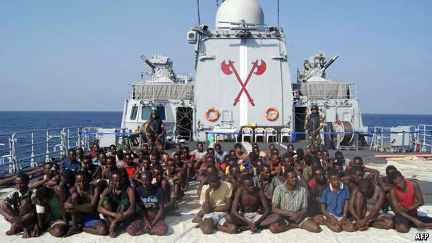
On May 10th pirate-busters celebrated the fact that one year had passed since a ship was successfully seized by Somali hijackers. Pirates have been attacking vessels passing the Horn of Africa since at least 2005, when they received a $315,000 ransom for Feisty Gas, a ship owned by a company in Hong Kong. Since then, payments have risen continuously, reaching a high last year of $9.5m for the Smyrni, a Greek tanker, and her crew of 26. But since its capture on May 10th 2012, the pirates have not hijacked any more vessels. Why are the pirates at bay?
Though the spoils are rising, pirate attacks have been falling off. Just 75 attacks took place in the Gulf of Aden and off the coast of Somalia in 2012, down from more than 200 in 2011. Currently, 71 sailors are being held hostage by pirates, according to the International Maritime Bureau, a body that monitors crime at sea; in early 2011, the figure was 758. Estimates for how much Somali piracy has cost the world economy range from $7 billion to $18 billion, the latest estimate by the World Bank. One theory is that the pirates have spent the past few months stock-taking, clearing their stock of hostages and ships before restarting their campaign. Another possibility is that their business model is shifting towards kidnapping foreign aid-workers and tourists on land.
But the main reason for the drop in maritime hijackings seems to be that ships are now far better defended against attacks. Armed guards, now carried by more than 60% of vessels, have been essential in discouraging them. Pirates are playing it safe by first scouting for guards, whereas previously they opened fire to intimidate crews; seeing arms on board is a big deterrent. Higher cruising speeds in pirate-infested zones and rerouting also have helped, as have razor wire, high-pressure hoses and citadels—secure spaces on ships from which crews can call for reinforcements. (This makes it easier to come to the aid of ships under attack, because pirates can no longer use seafarers as human shields.) Navies patrolling the area, from EU task-forces to private motherships, are also co-operating better and acting more aggressively.
All these gains are “fragile and reversible”, says Jon Huggins, director of Oceans Beyond Piracy, an American NGO. The EU and NATO navy mandates expire at the end of 2014. Defensive measures, particularly higher speeds and armed guards, are expensive. Suppression at sea needs to be combined with better onshore government and deterrence, both sorely lacking. Kenya and the Seychelles have worked hard to drive pirates out or into prisons; yet war-torn Somalia is still an ideal cover. Mr Huggins warns that the pirate gangs are still intact and are waiting for their next opportunity. Their activities usually wane from May to September during the rough seas of the monsoon season, but they could still stage an autumn comeback.

But…

Saudi ship owner paid $2.6 million ransom to Somali pirates
Source:http://digitaljournal.com/article/350171?goback=.gde_4962526_member_242170533#ixzz2TjmnhuTR

The Saudi owner of an Algerian ship hijacked by Somali pirates in 2011 has admitted paying a ransom of $2.6 million. The crew was released after 10 months when the cash ransom was parachuted to the pirates.
Arab News reported the Saudi Arabian owner of the Algerian cargo ship MV Blida (photo) has confirmed a ransom was paid to free the crew in November 2011. Algeria operates a strict policy of non-negotiation with hostage-takers.
Ghaith Rashad Feraoun said his only concern was freeing the sailors from captivity. Feraoun said he withdrew cash from Lebanon and it was dropped to the ship from a small plane.
The crew comprised 17 Algerians, six Ukrainians, two Filipinos, one Jordanian and one Indonesian. Following their release the crew spoke of their harrowing ordeal at the hands of the pirates. AFP reported the kidnappers threatened to leave the crew in the El Ramla desert "where it is impossible to survive" if no ransom was paid.
The pirates initially demanded a ransom of $8 million. According to Somali Report pirate Mohamed Ahmed explained the venture had left the pirates out of pocket as the ransom received was not enough to "repay all their investors and suppliers who supported the operation for nearly a year."

Somalia: A Terrorist-Piracy Nexus?

By Sigurd Neubauer and Joseph Szyliowicz
Source: http://www.huffingtonpost.com/sigurd-neubauer/somalia-piracy_b_3320406.html

Piracy, like terrorism has been a scourge of mankind for centuries and, though its practitioners, real (Blackbeard, Anne Bonny and Henry Morgan) and mythical (Captain Jack Sparrow in the Pirates of the Caribean movie stories) have achieved heroic stature in popular culture, its contemporary manifestations represent a major threat to the global economy and to national security.
Significant strides have been made in recent years towards combating piracy, especially off the coast of Somalia, but a robust international grand strategy is urgently needed in order to forestall an ever more dangerous global threat as pirates develop ever more sophisticated organizational structures, many of which are already linked to criminal gangs and even, in some cases to terrorist groups.
Their activities already impose heavy financial and human costs not only on the maritime industry but also on the countries from which they operate. Heretofore, the area around Somalia has been the most dangerous area but significant progress has been made in reducing piracy there. Last year, pirates succeeded in capturing 13 vessels, compared to 49 in 2010 and 28 in 2011, according to the International Maritime Organization (IMO). Part of that success can at least be partially explained by the European Union's heavy naval presence around the Horn of Africa, in the Gulf of Aden while improving intelligence sharing with NATO, the Combined Maritime Forces (CMF), the UK Maritime Trade Operations (UKMTO), and the International Maritime Bureau (IMB) Piracy Reporting Center. Additional measures implemented by shipping companies such as providing more armed security aboard merchant vessels while securing the ship's perimeter with razor or barbed wire have also led to the significant decrease in the number of piracy attacks. Equally important, however, was the 2009 implementation of the Djibouti Code of Conduct, a code concerning the repression of piracy and armed robbery against ships. Under the code, aside from committing themselves to abiding by various counter-piracy United Nations Security Council Resolutions, the signatories also pledged to overhaul their domestic counter-piracy legislation. As a result, a record number of pirates were sentenced by local courts around the world last year.
The significance of these developments should not, however, be overstated. First, the cost remains enormous -- in 2011, it is estimated that Somali piracy cost the global economy an estimated 7 billion USD through higher insurance premiums, security enhancements, and business disruption and earned the pirates some 160 million USD in ransoms. These figures do not include the psychological burdens borne by the captives or the costs imposed on Somalia. And, the actual costs are probably even higher due to widespread underreporting. Second, while piracy off the coast of Somalia has decreased, pirates are gradually focusing their efforts where patrols are not available for protection, now operating in the wider Indian Ocean. As pirates are extending their reach from Oman to the Maldives, they have also proven to be excellent entrepreneurs, building large well-financed organizations that are able to execute ever more sophisticated attacks such as hijacking oil tankers off the coast of Nigeria and stealing the valuable cargo. Moreover, pirate groups are becoming increasingly international and are extending their reach from national bases to neighbors -- from Nigeria, for example to Benin and the Ivory Coast, usually in cooperation with powerful local elements.
Economically speaking, piracy already presents an enormous challenge and it is conceivable that as pirates face stiffer resistance on the high seas by an increasingly stronger international naval presence, their political and ideological motivations could radicalize over time. Currently, terrorist groups already cooperate with criminal gangs to raise funds and piracy could potentially become a lucrative source of income for radical groups. A second plausible scenario is that as pirates struggle to capture more ships, pirates could resort to attacking shipping directly as criminal motivations could subside to radical ideology propagated by al Qaeda and its splinter groups.
Hence, it is easy to envision a nightmare scenario wherein terrorists, supported by a pirate group, hijack an oil tanker not just to steal the oil or collect the ransom but to blow it up in a major port with devastating economic consequences across the globe. A separate threat scenario that should not be underestimated entails terrorists capturing a liqueﬁed natural gas carrier that can be used as a ﬂoating bomb, which can either be detonated at a major port or near a flotilla of ships in the open seas. Piracy and terrorism can also be used as means to exert economic warfare against the United States and the international community as maritime attacks oﬀer terrorists an alternate means of causing mass economic destabilization. After all, terrorists have already attacked ships -- al Qaeda, the USS Cole (2000), Abu Sayyaf a ferryboat in the Philippines (2004) and the Mumbai attacks (2008).
Although only limited evidence exists at present for such a prospect, the piracy issue must be viewed as more than an economic problem.
This is particularly relevant for the Somalia case where the Al Shabaab terrorist group is known to have links to al Qaeda. Although, at present, such factors as clan differences and the pirates' business orientation have precluded any cooperation with Al Shabaab, a scenarios where Al Shabaab mounts a transnational attack by sea can easily be imagined.
Hence, though significant strides have been made towards quelling piracy in recent years, a broad approach that focuses on defeating piracy networks on land as well as on the seas is urgently needed. Such a strategy should be carried out in conjunction with international security cooperation that places greater emphasis on socio-economic development in order to deal with the underlying political and economic factors. The cost of neglecting a robust development strategy for Somalia could potentially be devastating for East Africa and beyond; failure to do so could also undermine the region's trading ability, at the expense of radical groups potentially seeking to capitalize on economic devastation brought by piracy.
As a first step in that strategy, we propose that Somalia be strengthened through soft policies that allow for stronger institutions, which include building a capable coast guard, and training local forces to take responsibility for their own security. In such an effort, initiatives spearheaded by the U.S. and such organizations as the African Union and Arab League and regional partners such as Kenya and Ethiopia are sorely needed. Efforts should be made to promote economic development by building a well-functioning central government beyond Mogadishu's premises. Diplomatically speaking, the Somali government also needs to be boosted. Moreover, drawing upon the Arab states' close geographical proximity and deep historical ties to Somalia, members of the Gulf Cooperation Council and the Islamic Development Bank could play a lead role in funding urgently needed development initiatives while at the same time strengthening partnerships with tribal leaders across Somalia.
Failure to implement stabilizing measures for Somalia could also significantly hurt U.S. economic interests as it is estimated that nearly 20 percent of all international seaborne freight in any given year end up in the United States. By implementing a comprehensive strategy for Somalia, Washington will inevitably protect its economic interests by helping to secure the world's oceanic environment. It is therefore a welcoming sign that Washington is considering re-establishing a formal U.S. diplomatic presence in Somalia. However, this is only a first step; the U.S. should exercise stronger leadership in combating piracy throughout the world.

Sigurd Neubauer is defense and foreign affairs specialist and he works for a northern Virginia based defense and aerospace consulting firm.

Joseph Szyliowicz is professor at the Josef Korbel School of International Studies, University of Denver.

Mathematics to detect terror
Source:http://i-hls.com/2013/05/mathematics-to-detect-terror/?goback=.gde_1528217_member_ 242432386

Can math models of gaming strategies be used to detect terrorism networks? The answer is yes, according to a paper in the SIAM Journal on Discrete Mathematics.
In a paper published in the journal last month, authors Anthony Bonato, Dieter Mitsche, and Pawel Pralat describe a mathematical model to disrupt the flow of information in a complex real-world network, such as a terrorist organization, using minimal resources.
According to Homeland Security News wire a SIAM release reports that terror networks are comparable in their structure of hierarchical organization in companies and certain online social networks, where information flows in one direction from a source, which produces the information or data, downwards to sinks, which consume it. Such networks are called hierarchical social networks.
“In such networks, the flow of information is often one way,” explains author Pawel Pralat. “For example, a celebrity such as Justin Bieber sends out a tweet, which is sent to millions of his followers. These followers send out their own retweets, and so on. We may therefore view hierarchical social networks as directed networks without cycles, or directed acyclic graphs (DAGs).”
Here, there is no requirement for reciprocity (the celebrity does not necessarily follow his or her followers). Similarly, in a terrorist network, the leaders pass plans down to the foot soldiers, and usually only one messenger needs to receive the message for the plan to be executed.
Disruption of the flow of information would correspond to halting the spread of news in an online social network or intercepting messages on a terror network.
The authors propose a generalized stochastic model for the flow and disruption of information based on a two-player outdoor game called “Seepage,” where players who depict agents attempt to block the movement of another player, an intruder, from a source node to a sink. “The game – motivated by the 1973 eruption of the Eldfell volcano in Iceland – displays some similarities to an approach used in mathematical counterterrorism, where special kinds of DAGs are used to model the disruption of terrorist cells,” says Pralat.
The motivating eruption caused a major crisis at the time, as lava flow threatened to close off the harbor, the island’s main source of income. In the game, inhabitants attempt to protect the harbor by pouring water on the volcanic lava to halt its progress. A mathematical model of the game puts two opponents against each other – the sludge, or intruder, against the greens, or agents – forming.

Fibbing About Terrorism & Badgering Muslims.
Source: http://blogs.ottawacitizen.com/2013/05/24/fibbing-about-terrorism-badgering-muslims/

Alan Johnson is quite right, of course. It shouldn’t take a couple of deranged yobs howling Allahu Akbar and hacking to death the 25-year-old Royal Fusilier Lee Rigby in broad daylight on Wednesday in the South London borough of Woolwich to make it obvious. “We need to discuss the elephant in the room – the radical and sectarian, often violent, and sometimes fascistic political ideology and global movement of Islamism. Why? Because we are fighting against a religiously inspired ideology, jihadism, but we don’t want to talk about religion.”
This reluctance to get serious about that conversation is the source of so much fuzziness and reticence and timidity about the intimately related matter of “terrorism.” I’ve been banging on about this dangerous incoherence for quite some time and I touched on the subject again only a couple of weeks ago in the Ottawa Citizen. Just for starters, in Canada’s case, Section 83.01(1)(b) of the Criminal Code fails to distinguish between acts of violence that are unambiguously intended for terrorist mayhem and legitimate acts of revolutionary violence necessary to the purpose of regime change in state-terrorist tyrannies like that of Syria’s Bashar al-Assad. There is a difference.
Ever since September 11 there has been a legitimate argument about which is more destructive to open societies: the menace of Johnson’s “often violent and sometimes fascistic political ideology” that usually goes by the name terrorism, or the craven and supine apologetics for Islamist crackpotism that form such central motifs of liberal establishment opinion about it.
In my Ottawa Citizen column today I notice how moral illiteracy defines the way such reliably creepy arbiters of hip opinion as the Guardian’s Glenn Greenwald and the American celebrity bullshit artist Michael Moore are responding to the Woolwich atrocity. Michael Moore tries to get a laugh out of his Twitter followers about it, in his usual cheap and vulgar way, but it is only the fuzzy timidities around the definition and the common use of the term “terrorism” that allow Greenwald to so easily and completely normalize what he presents as perfectly understandable Muslim revenge violence.
The “causation” that Greenwald slips in without having the courage to make the case for it, the root cause, indeed the proximate cause of Wednesday’s atrocity, is “western violence against Muslims.” There it is. Wednesday’s outage was retaliation. It’s “our” fault, because “we” have been so mean to “them.” Can you imagine some Etobicoke imam getting away with saying something like that? Of course you can’t. He’d be run out of town on a bus by the good Muslims of Etobicoke.
I’m not so certain that occasional security lapses with tragic consequences are really the greater threat to our civil liberties and our sovereignty than demands for our outright capitulation all trussed up to look cool and sophisticated, as in this 2010 Haroon Siddiqui homily under the helpfully brazen headline To tackle domestic terrorism, end foreign wars. I’ve always thought it strange that the Toronto Star will shout and yell about the privatization of government services, but subcontracting Canada’s foreign policy to the Toronto 18? Hey, we’re cool with that.
My case is that it’s not “the Muslims” who have any explaining to do about the commonplace trope that the so-called West is at war with the so-called Muslim World, and that anytime some depraved and bloodthirsty lunatic who fancies himself as an aggrieved Muslim goes on a rampage in any one of the NATO countries we should take it as understandable, which is to say rational, behaviour. It is mainly that caste of moral illiterates among the celebrity opinion-arbiters of popular culture that has established this imbecility as, like, central to the discourse, man. It’s that lot that has some explaining to do. We might badger them for a change and give our innocently devout Muslim neighbours a rest for once, is my point.
Alan Johnson is quite right. It’s just that the question isn’t about Islam so much as it is about Islamism, which almost always takes on some form of terrorism. It’s not about “us” versus some Muslim “them.”
Johnson: “One of the fruits of globalisation is that the walls separating what concerns “us” from what concerns “them” have tumbled down. We are all “us”, now. The global is local. Woolwich made plain that the fear and the violence and the grieving that has spilled over from what the Muslim political scientist Bassam Tibi calls “Islam’s predicament with modernity” are now also ours to bear, and they will borne also by our children and our grandchildren. No more changing the subject.”
And no more excuse-making for wanton barbarism, either.

Talking to terrorists
By Dimitris Giannakopoulos

Source:http://www.moderndiplomacy.eu/index.php?option=com_k2&view=item&id=147:talking-to-terrorists&Itemid=487

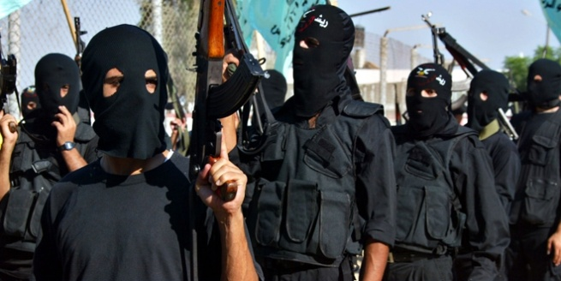
An interview with Anne Speckhard
"This is an account, spanning over a decade, of what happens when you do just that. Traveling through the West Bank and Gaza, into the U.S. Department of Defense prisons in Camp Bucca and Camp Victory, down the alleyways of the Casablanca slums, inside Chechnya, in the radicalized neighborhoods of Belgium, the UK, France and the Netherlands and sitting with the hostages of Beslan and Nord Ost, Dr. Speckhard gives us an account of what puts vulnerable individuals on the terrorist trajectory and what might also take them back off it.
One of the only experts to have such a breadth of experience – having interviewed over four hundred terrorists, their friends, family members and hostages – having visited, and even stayed overnight at times in the intimate spaces of terrorists’ homes, interviewing them in their stark prison cells and meeting them in the streets of their shanty towns, Dr. Speckhard gives us a rare glimpse of terrorists within their own contexts"

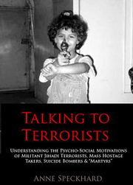
What isyour definition of Terrorism and what is the critical difference from National Liberation Movements?
There is no one definition of terrorism that has gained universal acceptance" in fact in a recent handbook of terrorism put out by Alex Schmid identifies hundreds of definitions! My own definition relies in good part on that of the U.S. FBI and State Department - I would define it as - terrorism consists of politically motivated attacks upon civilian targets by non state actors in order to instill terror and influence a wider witnessing audience. National liberation movements or so called freedom fighters who primarily and intentionally attack civilians for the purpose of influencing the political process and influencing the wider witnessing audience are terrorists by this definition and they can be distinguished from actual freedom fighters or guerrilla insurgents who fight the military and do not intentionally attack civilian targets.

What do you think are the main causes of radicalization and to what degree do you think they are really connected to religion?
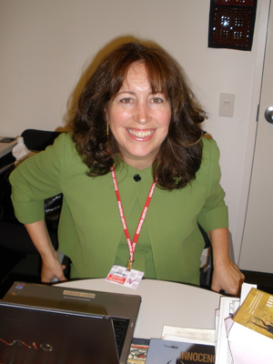
I just attended a day long conference at the Hague convening some of the top experts in Europe to discuss this issue and it was difficult to come to a consensus. First of all we have to decide what is radicalization. If it is simply becoming "radical" in the sense of believing that society needs to change and trying to change the status quo it may be a good thing. If it is radicalization to violent extremism and fanaticism it is obviously not a good thing. Group dynamics, ideology, social support and individual vulnerabilities interact and all play a part in the mix for radicalizing to extremist violence. In Europe those who radicalize into extremist and terrorist movement often feel disenfranchised, marginalized have frustrated aspirations, happen upon and make strong bonds of friendship even marriage into groups that espouse violent answers, come to believe an extremist ideology, may begin to take on the traumas of others in other parts of the world and identify with them believing they are fighting for their cause. Religion is not necessary but is a strong force to identify "them" and us, to give justification for certain acts, to give courage to fight and die, to bind groups together, etc. but many ideologies can provide the same functions.

Based on your research, what are the most common events, strong enough to transform a normal citizen to a suicide bomber?
Usually a group is involved and a recruiter to encourage a person to take this role and to equip him to carry it out and to help him to reach his target. A degree of social support that exists also is very important for the person to believe it is the right thing to do. On the individual level, there must be some vulnerability to being attracted to a group that uses suicide bombing.
A group must find vulnerable individuals who can be activated into believing it and carrying it out - those who are in deep psychic pain are the most likely recruits. Violent events and trauma greatly contribute to a willingness to give one's life for the cause. In my experience a highly traumatized and bereaved individual is a great target to recruit as a suicide bomber because he or she is in enough "psychic pain" to want to exit life and may believe that in dying he or she will be reunited with those who have died before. If the group's ideology is "martyrdom" then there are many rewards for participating most importantly believing that one will gain instant entrance to paradise along with other rewards. If her group also glorifies dying that way and will make a hero of her or him it becomes even more powerful. The fact that a group and its ideology is important in the mix can be demonstrated by looking at many areas of the world where there is a lot of trauma but no terrorism and no suicide bombers. It takes a group to organize it and an ideology to believe its a good thing. Without either of these many vulnerable individuals will never go and become suicide bombers.

What are the main differences between male and female suicide bombers?
In the main they are much the same. Female bombers can cross security perimeters more easily because they can hide explosives on their bodies more easily and protest invasive body searches and they are usually expected to be innocent. Females are rarely leaders, although most suicide bombers - male or female are not leaders. The Chechens used females from the beginning - half and half with the men. There are fewer female suicide bombers in conservative Islamic middle eastern countries because the groups were afraid to use them as there were issues about getting them to the target and dressing them while still preserving their modesty and issues about arrest and imprisonment if they fail.

We are talking about political and religious motives. What about “guns for hire” and terrorism as business?
Illicit drugs and money laundering are often involved in terrorism particularly to fund the terrorist operations. If a group is hiring thugs to carry out it's acts it is still terrorism if the group is politically motivated, aiming at civilians etc.

You have talked with many terrorists. What’s your stance on so-called "enhanced interrogation methods"?
Some argue for the "ticking bomb" method of interrogation -- that if one is believed to hold intel that can save innocent lives then it's okay to torture. I think it's a mistake. First of all how do you know your inmate is holding such information? The best intelligence is gained from creating real rapport with a prisoner and that should always be attempted before all else. In many cases it won't work initially or ever. Then intelligence may be gained by surveillance, recording conversations etc, sending in another "fake" prisoner to create rapport etc. Oftentimes that works. We should know that prison in itself is a very tough thing for most people to deal with and under circumstances of isolation and boredom some will open up and begin to talk. Others won't. I don't see the point of using violence or fear to get someone to talk as we cannot trust what one gets from a person in pain or terrorized is necessarily reliable and it also often cannot be used in court to get a conviction so it is problematic in that sense as well. And I find it morally repugnant to engage in such activities - even if we do gain by it. The truth is sometimes we do get good intel this way but we must ask ourselves do we want to be on the same level as our enemies? Likewise when our enemies gain evidence of us acting in this way they can use it against us to recruit more to their cause. We saw this when pictures of Abu Ghraib were leaked and now I think we may see it again from the graphic portrayals of violent interrogations now being depicted in Zero Dark Thirty. That's a pity.
When I worked with detainees in Iraq many were completely amazed that they were not tortured by the Americans and it created a profound positive reaction in them. Yet one could argue that if indeed innocent lives could be saved torture of any type is worth it. I don't personally agree but I do see the credence of such arguments. My own view is that to engage in any type of soft or hard torture is not worth it - it changes us so fundamentally and we can gain a lot of intel without resorting to these methods.

Why were the terrorists willing to talk to you? Do you have a powerful moment to remember?
I don't know why they trusted me but I was very gratified that they did and I learned a lot. I have asked myself many times why they talked to me? I think I won their trust by being honest -- saying openly what I was studying and why (an academic study), being interested in their whole lives and the context of their lives - they living circumstances, traveling to them and taking risks to do so, being empathetic and sincere and nonthreatening, and being a psychologist who could help them to untangle parts of their own lives. Not many people get to spend an hour or two talking to a psychologist who is nonjudgmental, kind and interested in their lives. I think many got interested in themselves as they talked and opened up a lot because of that. I have many, many powerful moments to remember - for instance when at a Gaza safe house the militants there asked if I'd considered that they could take me hostage -- to which I replied that I had relied on their honor not to. Alan Johnston from the BBC was taken and held hostage some months later which chills me to this day... I saw and listened to many things that moved me a lot. All of these stories are in my book which is written more like a novel than an academic treatise - although the theory is woven throughout.

Will you continue this project? Are you interested to talk with western terrorists too? Jailed members of “November 17” in Greece for example?
I would love to continue the project but I haven't funding for it at present. I did talk to western extremists in Europe as well - some in Belgium, France and Netherlands and UK. During the time I was in Greece I consciously decided to leave Greece out of the mix since my husband was serving there as U.S. Ambassador and I thought it best to keep a low profile on such work... to leave it for another day. Yes I'd love to speak with jailed Nov 17th and the violent extremists’ active in the Greek society even now. Many of their arguments about social injustices have validity but their endorsement and use of violence does not. And their ideology is so different from that of the militant jihadis so it would be an interesting contrast. By the way we all loved living in Greece. You have a most beautiful country, lovely culture, great food, great wine, unbelievable sea, sunshine, mountains and islands and very kind and good people! I'll never forget my time there and I hope to return again and again!

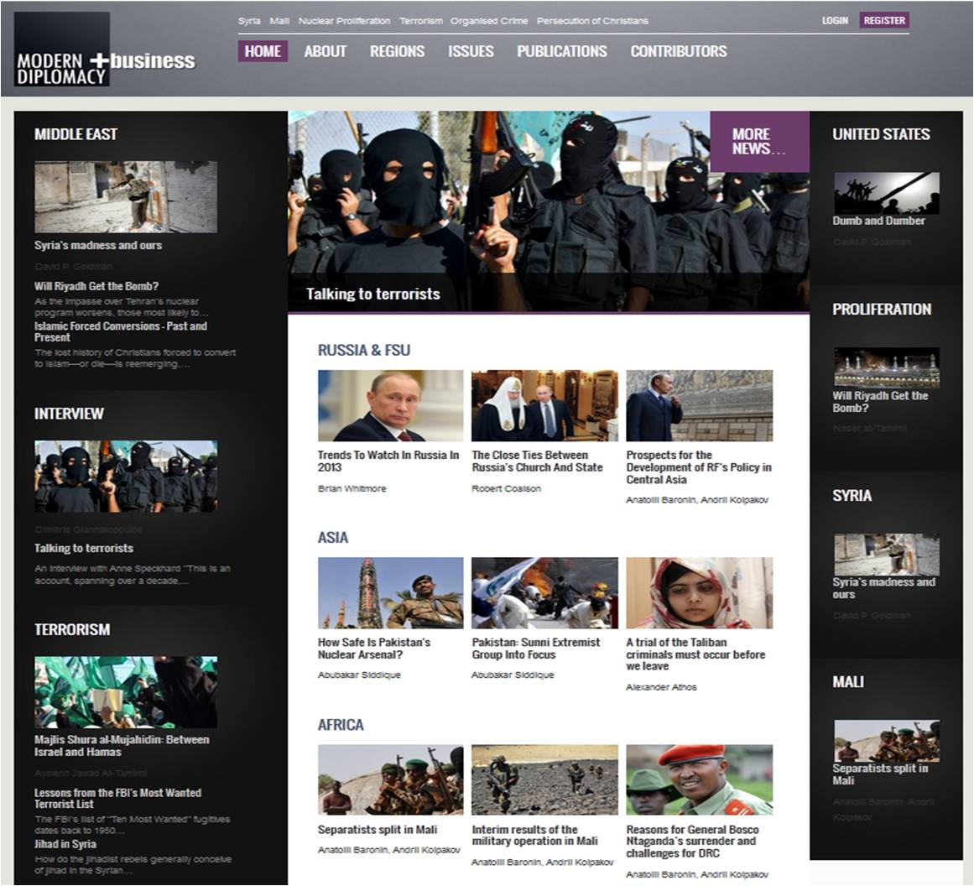
Dimitris Giannakopoulos is an experienced journalist and project manager with 15 years in Print and online Information. From 1996 to 2004, he worked as a reporter and columnist for many Greek newspapers and magazines, ranging from local politics to international affairs, specialized in Middle East, Greece, Russia& FSU, Terrorism and Security issues. Since 2004 is the owner and editor of the Presscode magazine and Director of Presscode Network (www.presscode.gr) He is also member of numerous think-tanks, Institutes, clubs and groups worldwide.

Rising extremism in Europe causes concerns in the Balkans
By Linda Karadaku (Southeast European Times in Pristina)
Source:http://www.setimes.com/cocoon/setimes/xhtml/en_GB/features/setimes/features/2013/05/24/feature-03

The rise of extremism in Europe and its possible threat to the region concerns Balkan analysts, who said the solution is in close political, security and judicial co-operation.
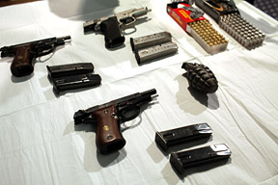
In 2012, 537 people were arrested for terrorism-related offences in 17 EU member states, according to the latest Europol report. [AFP]

"The Balkans was always one of the most risky terrorist threat areas. It's the only part of Europe [excluding former Soviet Union] that had brutal wars at the close of the 20th century," Dragan Popovic, executive director of the Belgrade Policy Centre, told SETimes.
He said the key element in fighting terrorism is regional co-operation.
"It is impossible to deal with such a threat without strong and substantial co-operation within the Balkans, including close co-operation on political, security and judicial levels," he said.
Popovic also emphasised NATO's role in the regional anti-terrorist fight.
"The Balkans should use the most effective anti-terrorist umbrella in the world, NATO. Even in countries like Serbia, though far from NATO membership, regional co-operation is crucial in the fight against terrorists' threats," Popovic said.
Rising extremism in Europe causes concern in regional countries with a large diaspora, such as Kosovo.

Mentor Vrajolli, a security analyst at the Pristina Centre for Security Studies, said the diaspora is exposed to the same terrorist threats as other Europeans.
"Thus far, our institutions can do nothing about this threat, because Kosovo hasn't been a country of origin or destination of terrorism," Vrajolli told SETimes.
He said that Kosovo institutions should increase preventive anti-terrorist measures, including enhancing communication between Kosovo institutions with Kosovo immigrants in the west.
The increase in recruitment of individuals willing to commit to terrorism is the main concern in Bosnia and Herzegovina (BiH).
"In the last year, there's a noticeable increase in recruitment of individuals willing to carry out terrorist attacks. They are a real threat to the security of the country, and the entire continent," Dzevad Galijasevic, director of the Southeast Europe Expert Team for the Fight Against Terrorism and Organised Crime, told SETimes.
Galijasevic said the increasing danger from terrorism and extremism in BiH stems from poor social and economic conditions.
According to the BiH secret service agency, about 3,000 Islamic extremists live in the country.
The latest terrorism case was connected to Mevlid Jasarevic, who fired more than 100 bullets from an automatic rifle at the US embassy in Sarajevo in October 2011. The Court of BiH, which qualified Jasarevic's actions as "terrorist," sentenced him to 18 years in prison in December last year.
According to the 2012 Europol report, terrorist attacks in Europe marked a significant increase. In 2012, there were 219 terrorist attacks recorded in seven EU member states. Most of the attacks were attached to separatist terrorism.
In 2012, a total of 537 people were arrested for terrorism-related offences in 17 EU member states, an increase from 484 arrests in 2011.
Terrorism manifests in a variety of ways, and can be driven by diverse motivations, including religion and strong ethno-nationalist sentiments that lead to separatist terrorism, the report said.
"Europol is carrying out a 'travelling in connection to terrorist activities' project on the agendas of current and upcoming EU presidencies. The purpose is to scope current best practices within the EU law enforcement and intelligence communities," Soren Pedersen, a Europol communication officer, told SETimes.
Popovic said it is important not to overestimate terrorist threats, but preserve the level of human rights and freedoms.
"All Balkan governments could easily use real or imagined terrorist threats to diminish the level of human rights or rule of law in the Balkans. This could be more dangerous for the Balkan peoples than terrorist threats," Popovic told SETimes.

Correspondent Drazen Remikovic in Sarajevo contributed to this report.

Terrorism... Again: Old Threats, Alternative Solutions
By Edit Schlaffer
Source:http://www.huffingtonpost.com/edit-schlaffer/terrorism-again-old-threa_b_3333776.html?utm_ hp_ref=world

Terrorism just got a new haunting image; a Muslim man with bloody hands stands in the streets of London holding a meat cleaver that he used to butcher a Royal infantry soldier only moments earlier. This fateful incident connects two young men from very different walks of life. The attacker Michael Adebolajo (photo), apologized to the women nearby for the gruesome sight, declaring that women in their lands "have to see the same" and explaining that "The only reason we have done this is because Muslims are dying by British soldiers every day."
At this point we should take a step back to reflect on whether we are in danger of stumbling into the stereotyping trap. Some will be quick to judge, that the two perpetrators actually represent the people in the far lands that one of them was referring to.
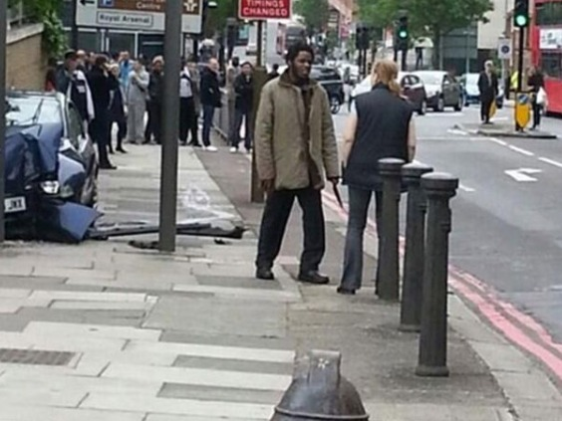
In the course of my recent work in the most volatile regions affected by terrorism, I had the enlightening experience of listening to the voices of fathers and mothers of suicide bombers who had lost everything that was dear to them; their children and their dignity. Yet instead of calling for revenge, they express an entirely different sentiment: "You may not use our country as an excuse to spread terror, death, fear, and bloodshed." This message undermines and discredits the typical narratives spread by recruiters, who refer particularly to Palestine as a source of grievance and justification for engaging in violent extremism.
The Palestinian mothers whom I met want to get this message out to the Western youth: "This is our fight, not yours." We have to respect this idea, for they are front-runners and are taking high risks within their society. Indeed, Nabila, a mother from Ramallah, told me that when she heard the news of her son's martyrdom, she fell to her knees and praised God. Soon after she reassessed he initial reaction: "What am I doing? I am thanking God, but instead I should be asking for his forgiveness." So she stood up and demanded for the women around her to stop their celebratory cheering. Even while this shocked her husband, she bravely faced the assembled group and challenged the local male culture of bravery. Reflecting on the aftermath she says, "We are still where we are, but just without him. He was my eldest, my strength and my protection." Now she wakes up every night, begging him in her thoughts: "Please come home, just one more time, my darling."
When I learned about the drama that unfolded on that London street, another mother came to mind: Ingrid Loyau-Kennett, a scout leader and former teacher. She engaged one perpetrator in a very personal way, asking him what he wants, managing to calm him down. Maybe this was a rare moment, when someone asked him to spell out his fragmented thoughts. This is a remarkable approach that starkly contrasts the "hard power" methods that are more commonly used. Such new "soft power" applications could act as the basis of an effective alternative in counter terrorism strategy.
The consequences of this assault immediately affected the delicate community cohesion, so that Muslim citizens again feel under attack and threatened. Shelina Zahra Janmohamed, a London-based blogger, voiced her sense of personal unease when leaving her home after the Woolwich attacks: "I felt scared, fearful of how I was perceived and what people would be thinking. I'm worried for my safety, for the security of my family."
Western anti-Muslim sentiment needs to be balanced by Muslims voicing their determination to confront the Islamist threat and expose the abuses of Islam by a small minority of extremists.
These voices are indeed widespread, even within Pakistan, a country closely associated with terrorism. I was very impressed by a group of women from the SWAT Valley -- a hotbed of extremism -- all of whom have a son or husband who was forcibly recruited by the Taliban or arrested by the army for Taliban involvement. Yet what do we actually know about these people and their stories? In some cases the villagers had witnessed symbolic public executions in front of their houses to scare those who wanted to resist joining the militant forces. The village women, recognizing how "Jihad" brought violence and misery to their families, are keen to voice their opposition, even in light of the well-known potential, brutal consequences. Madeeha, one of my interview partners, insists: 'If the recruiters come back and the men in our village cannot stop hem, then we women will join forces against them.'
Aisha Al-Wafi is the mother of Zacarius Moussaoui, who was the only person ever to be tried in a US court for being involved in the 9/11 attacks. In a conversation with me, Al-Wafi passionately exclaimed, "Strangers come and give orders to my son not to respect me? What's that about?... The extremists -- I hate them, because they don't love Islam, because The Prophet says, 'your mother, your mother, your mother'... And the extremists say, 'don't listen to your mother?' That's Islam? No, that's not Islam." She is calling out for tolerance and respect for others: "We (Muslims) need to respect, so that we'll be respected."
Talking about community cohesion makes me contemplate the countless missed bridge-building opportunities that could have materialized on a global level. A workshop with a group of women, family members of victims of the 9/11 attacks, showed me that more than ten years following the attacks there was still a need to come to terms with the aftermath of the attacks. The most remarkable feature of this meeting was the complete absence of hatred or desire for revenge towards Muslims at home or abroad. These women do not fuel any toxic anti-Islam rhetoric. Rather they highlight the commonalities between themselves and families living in regions of the world within which terrorism constitutes a daily and very real threat. These women of the Tuesday's Children group set an admirable example, and sent out a joint declaration that they refuse to hate.
What we see here is fascinating: new female approaches that challenge the mainstream scenario, namely Jihadists' claim that they are acting with the support of Muslim communities. Ultimately, we all have to find a way to live together, and we need therefore to be actively engaged in making the ambitious project of peaceful co-existence work. We have to realize that there are alternatives and powerful new players: women, co-shaping the security arena.

Dr. Edit Schlaffer is a social scientist, activist, and founder of Women Without Borders in Vienna, Austria. Schlaffer created the global SAVE (Sisters Against Violent Extremism) campaign. Women's eNews included her as one of the '21 Leaders for the 21st Century' in 2010, and she was named one of Newsweeks' 150 Movers and Shakers in 2011.

Watch Philadelphia for terror attack
Source:http://www.terrorismwatch.org/2013/05/analysts-watch-philadelphia-for-terror.html?utm_source =feedburner&utm_medium=email&utm_campaign=Feed%3A+terrorismwatch%2FJTvK+%28Terrorism+Watch%29&utm_content=Yahoo!+Mail

Some analysts are suggesting Philadelphia, the historic city of “Brotherly Love,” is where the nation’s next terrorism attack will happen.
Middle East Forum terror analyst Hillel Zaremba said one reason is that the city’s mosques – one website lists 24 in the metropolitan area – are tied to a larger network. “Many of them have ties to Islamist organizations. They have had, I use had, because they’ve gotten smarter and have scrubbed a lot of their websites of the references,” Zaremba said. “But there are very troubling indications of the kinds of things they believe in and the causes they support – that would lead one to believe that they are from a hardline, Islamic worldview.”
Zaremba points out that what goes on in the mosque has a lot to do with the radicalization process.
“You can say a lot of things about the training. You can say a lot of things about infidels, you can say a lot of things about the whole Israel-Palestine, the Palestinian nexus,” Zaremba said. “You can have ‘Reliance of the Traveler.’ You can have a copy of that in your mosque and it’s certainly helping to develop an atmosphere, in my mind, an attitude that contributes to someone going over and becoming violent,” Zaremba said.
John Guandolo is a former FBI counterterrorism specialist and terrorism analyst. He’s also president of Guandolo and Associates, and has said, “‘Reliance of the Traveler’ is the single most authoritative book on Islamic law.”
Dave Gaubatz, co-author of “Muslim Mafia,” said that he’s researched Philadelphia mosques and confirms that the city’s locations present a very real danger. “They rated very high for the likelihood for future terrorist attacks,” Gaubatz said. Zaremba adds that recent events provide further evidence for the direction the city’s Muslim community is taking. “We know that from time to time there have been arrests of troubling individuals, of people who have been deported. There have been arrests of people who were involved in terror plots that didn’t quite get off the ground,” Zaremba said. Zaremba lists one specific. “The so-called Fort Dix group did pray at a local mosque (in Philadelphia),” Zaremba said of the Islamists who were convicted of conspiracy after being caught allegedly planning an attack at Fort Dix, N.J.
Zaremba said when an arrest is announced, the local imams swing into damage control. “They go around and say they could never have gotten that from us. They say they don’t know who radicalized them,” Zaremba said. “I guess it was just by osmosis that these people picked that up.” An indication of how radical some of Philadelphia’s mosques may be is the existence of an Islamic youth program that has been described as a Muslim version of the Boy Scouts. Zaremba says the mosques call them “Jawala Scouts.” The group was incorporated in 2005 by the United Muslim Movement. UMM recruits young boys as young as the age of seven. Zaremba says the boys have been
photographed doing military drills and wearing camouflage. “If you just type in Jawala Scouts
Philadelphia, you can find pictures of kids going out camping with paintball guns,” Zaremba said. “What does that mean? My brother belonged to the Boy Scouts. They went out camping. Did they take guns with them? I don’t think so. “Why are you drilling kids in camouflage and training them to use guns?”
Zaremba emphasizes that paintball alone may not be that significant. However, it’s the picture that emerges when you put together the pieces. “People can ask why we’re making a big deal out of this. Why, because they’re training with guns and because they’re Muslim?” Zaremba said. “Yes, as a matter of fact.” Zaremba’s assessment also involves the preaching and teaching in the mosques. He cited one website in particular. “One of the websites had an FAQ section and it asked about jihad.
The site said they reject the use of violence except in cases where holy sites and places are threatened,” Zaremba said. He explains that the statement is important because the uniformity in Islamic teaching and how Islam defines the word “holy place” and “threatened” whether it’s overseas or in the United States. “Those are code words. What do they mean? If you’re in Israel, that could mean the Al-Aqsa mosque in Jerusalem and that is a provocation to Muslims because they’re not in Muslim hands,” Zaremba said. “Forget about Jerusalem. As far as Hamas is concerned, the entire nation of Israel needs to be eliminated and restored to Muslim control. “This mosque in Philadelphia was giving a kind of a ‘carve out’ for violence because they believe that any Muslim site they believe is threatened qualifies,” Zaremba said. The website Muslim Philly Ads lists a mosque that is affiliated with the United Muslim Movement, the group that sponsors the Jawala Scouts. The list on the site also says one of Philadelphia’s mosques is affiliated with the Muslim Brotherhood and another is a Salafist mosque.
International Christian Concern’s Middle East Specialist Aidan Clay says the Salafists are pro-jihad and among the most radical of the Islamic sects. He says that if you want to see Salafists in action, simply follow what’s taking place in Egypt. “Salafis are very militant. They pledged to stay out of Egyptian politics prior to the revolution, but since [then they have] won one-fourth of the seats in Egypt’s November 28, 2011 parliamentary elections,” Clay said. ” Salafis have been responsible for at least two major attacks against Christians in Egypt since the revolution. They take Islamic texts very literally and would prefer to bring the Muslim world back to the dark ages, living as Muhammad did,” Clay said. “Many Salafis justify the murder of non-Muslims that do not offer complete submission, including the payment of a special tax called jizya,” Clay said.

Most British firms “unprepared” for terror attacks’
Source: http://www.guardian.co.uk/business/2013/may/29/cybercrime-internet

A large majority of companies are ill-prepared for a terrorist attack, according to a poll of more than 600 British business leaders published .
A YouGov survey suggests a majority of British businesses could be failing to implement even basic security practice. More than half of decision-makers said their business did not regularly check whether sensitive corporate information had been leaked, and more than 40% never conducted a risk assessment of the threats to their companies.
The poll was analysed by Actis – Applied Counter-Terrorism, Terrorism, Intelligence & Security Studies, a branch of SMC (Swiss Management Center) University, which offers education, consultancy and research in counter-intelligence and security.
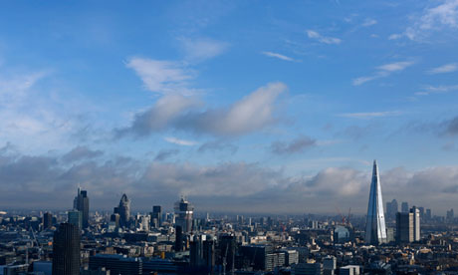
More than 80% of British businesses would fail a simple counter-terrorism test, according to the Actis analysis, with 54% of respondents saying their businesses had either never or not recently checked whether any sensitive information about their organisation was publicly available.
In 2009, more than 10,000 confidential client memos sent through Bloomberg's private messaging system were published online by a former employee, Actis said. Sensitive conversations, including messages from traders at more than a dozen of the world's largest banks, remained openly available through a simple Google search until earlier this year, it added.
Companies had not prepared a list of potential risks to their business in 40% of cases and just over a third said their companies do not enforce any sort of computer password policy.

US says PKK deadliest terrorist organization in Europe
Source: http://www.todayszaman.com/news-316992-us-says-pkk-deadliest-terrorist-organization-in-europe.html

The US State Department has branded the Kurdistan Workers' Party (PKK) as the deadliest terrorist organization in Europe and said it had continued its violent campaign throughout the year in 2012.
In its annual report on trends in political violence, the State Department said the long-active PKK in Turkey continued its campaigns of violence last year and that there were 226 terrorist incidents reported through to November of last year.
The State Department's "Country Reports on Terrorism 2012" covers events in 2012 and does not include such developments as the settlement process between the Turkish state and the PKK and the significant decrease in violent incidents of the past five months..
The report praised Turkey for being a “long-standing counterterrorism partner” of the US. It added that Ankara co-chairs the Global Counterterrorism Forum (GCTF) with its ally the US and received US assistance to address the terrorist threat posed by the PKK in 2012.
The report noted that Turkey faced a significant internal terrorist threat in 2012 and has taken strong action in response. Most prominent among terrorist groups in Turkey is the PKK, it said. The report stated that the PKK continued to demonstrate its nationwide reach with typical tactics and techniques that included ambushes of military patrols in the countryside, improvised explosive devices (IEDs) along known military or police routes and bombings of both security and civilian targets in urban areas. According to the NATO Centre of Excellence-Defense Against Terrorism in Ankara, there were 226 terrorist incidents reported through November.
The report said that as a result of last year's military operations targeting PKK members, 494 terrorists were killed, 21 injured and 44 arrested, while 155 surrendered to the authorities during the first 10 months of the year. Counterterrorism law enforcement efforts in Turkey remained focused on the domestic threat posed by several terrorist groups, including the PKK. Turkey's methodology and legislation are geared towards confronting this internal threat.
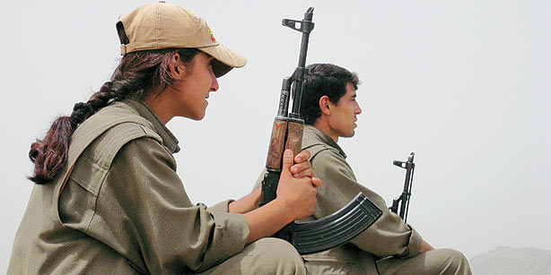
The report also criticized the anti-terrorism law and said the limited definition of terrorism under Turkish law, restricted to activities targeting the Turkish state and its citizens, represented an impediment to effective action by Turkey against global terrorist networks.
The report also listed other prominent terrorist groups such as the Revolutionary People's Liberation Party/Front (DHKP-C), a militant Marxist-Leninist group with anti-US and anti-NATO views that seeks the violent overthrow of the Turkish state. The report also included Turkish Hizbullah (unrelated to Lebanon's Hezbollah) as a terrorist organization, a radical religious organization founded to fight the PKK.

Terror watch lists: Can you keep tabs on every suspect?
By Ruth Alexander (BBC News)
Source: http://www.bbc.co.uk/news/magazine-22718000

After the Boston Marathon bombing and the killing of a British soldier on the streets of Woolwich in London, it emerged that suspects were known to the security services - prompting concern from critics. But how feasible is it for the spies to monitor everyone on their watch list?
Michael Adebolajo and Michael Adebowale's names have become well known since they became key suspects in the killing of Drummer Lee Rigby in a street attack in Woolwich on 22 May.
But it has transpired that they were already familiar names to the British domestic intelligence service, MI5. The UK Parliament's Intelligence and Security Committee is to investigate the agency's actions in relation to the case.
Boston bomb suspect Tamerlan Tsarnaev, meanwhile, was questioned in 2011 by the FBI amid claims he had adopted radical Islam.
But is it practical - or even possible - to keep close tabs on every person who comes to the attention of the security services?
No, according to Dame Stella Rimington, former head of the of MI5. To see that, she says, you just have to look at the numbers.
It's not known how many people are on the terrorism watch list in the UK. But it has been said to be around 2,000.
To keep a constant watch on just one of those people, you would need a team of at least six surveillance operatives, Dame Stella says. But of course they couldn't work 24 hours a day, so you would need three teams of six.
And those operatives couldn't just sit outside a suspect's house. So, you'd need an additional person to, say, sit in a nearby house, and alert the team of six when the suspect left the house.
Then there's the control centre, where staff receive information from the mobile operatives and give them directions. And finally, there's a desk officer in charge of the case.
"Doing that 24 hours a day, seven days a week - well, you do the sums, it's an awful lot of people," Dame Stella says.
And if 2,000 people were to be followed like that, we'd be talking about 50,000 full-time spies doing nothing but following suspected terrorists. That's more than 10 times the number of people employed by MI5. The numbers don't add up.
As a matter of simple economics, then, it's not possible to follow every suspicious character around the clock. Surveillance technology offers an alternative - but it also presents mathematical problems of a different kind.
Imagine that the intelligence services had unlimited resources and could monitor everyone's phone lines.
Imagine they could detect would-be terrorists within the first three words they utter on the phone with a 99% degree of accuracy.
There would just be one small problem, according to Howard Wainer, a professor of statistics at the Wharton School of the University of Pennyslvannia in the United States.
Suppose there are 3,000 terrorists in the United States, he says. If the software is 99% accurate, you would be able to pick up almost all of them - 99% of them. However if you were listening to everybody - all 300 million US citizens - 1% of the general population are going to be picked up by mistake.
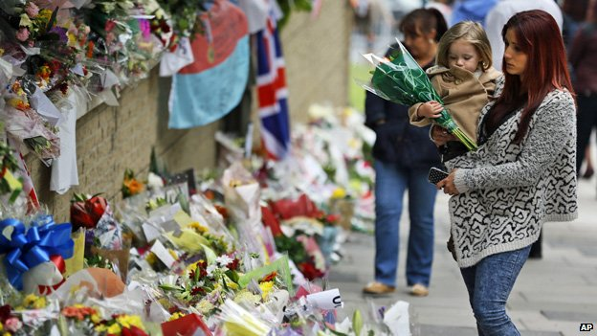
"So mixed in with the 3,000 true terrorists that you've identified are going to be the three million completely innocent people, who are now being sent off to Guantanamo Bay," Wainer says.
That is, for every terrorist you would have 999 innocent, but very angry people.
In reality, Wainer says, your terrorist detector would be nowhere near 99% effective. But, on the other hand, the security services do not in fact monitor everyone.
Still, if you narrow your target population to the point that there is one actual terrorist per 100 people wiretapped, and assume a 90% effective test, the chance of a false positive remains high. Even when someone triggers an arrest, Howard Wainer says, the odds are 11 to one that they're not a terrorist.
It's hard to predict who will become radicalised, and who will go on to commit an act of violence, according to Nigel Inkster, who used to work for MI6, the UK's secret intelligence service abroad and is now employed by the International Institute of Strategic Studies, a London think tank.
"With the wisdom of hindsight, everything always looks clear, but when you are looking at the situations as they unfold, you are operating in a climate of considerable uncertainty," he says.
Technological advances mean intelligence services can use computers to sort through lots of information to help target the right people.
Algorithms are used to search social media for key words, or to spot suspicious patterns in airline travel records, for example.
But these techniques may be of limited use, according to Louise Amoore, a professor at Durham University specialising in data and security.
"You may already begin to think about how the algorithms used to detect possible risky connections might be adapting," she says.
"For example, post-Boston there may be more attention in the US to travel to particular parts of the world, perhaps including Chechnya and Dagestan. We could imagine, post-Woolwich, that there might be greater attention in the refining of algorithms to think about patterns of travel and links to deportation.
"But of course, it's using data from past events. Our research is suggesting that the tuning of the algorithm reflects almost always past events."
In other words, the algorithms are always fighting the last war.
And, as for the useful information that can be gleaned from the data, there is a risk it can be lost in the noise.
Big data is one of the challenges that security and intelligence organisations around the world now face, according to Nigel Inkster.
"You're able to amass large quantities of data, beyond what is possible for one individual or group of individuals quickly to analyse and assimilate," he says. "Algorithmic approaches are being adopted to try and triage this information, but I don't think you are ever going to be able to develop algorithms which can substitute for or improve upon human judgement."
Dame Stella points out that this is a well-known problem - it happened to the East German Stasi. They "overdosed" on information, she says.
"Intelligence services can strangle themselves if they have too much information, because they can't sort out from it what they need to know and what they don't need to know. So in this entire search for information you've got to be pretty focused and targeted."

He is only 12 years old – for God’s Shake!!!

Source: http://www.ajuaa.com/lookme/play.php?vid=153

Porous borders, graft expose Uganda to terrorist attacks-US
Source: http://www.monitor.co.ug/News/National/Porous-borders--graft-expose-Uganda-to-terrorist-attacks-US/-/688334/1870446/-/mlty1g/-/index.html
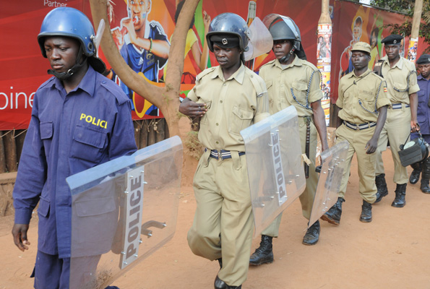
Anti-terrorism police at Lugogo in July 2010, shortly after suspected Al-Shabaab terrorists killed at least 70 people in Kampala. PHOTO BY JOSEPH KIGGUNDU

The United States has warned that a plethora of corruption, porous borders and limited resources make Uganda vulnerable to terrorist attacks in spite of the country’s plausible lead role in ensuring regional security.
The grim assessment is contained in the Country Reports on Terrorism 2012 report, which the US Department of State’s Bureau of Counter-terrorism prepares annually to appraise Congress on global trends of extremism. It was released last week.
“Although Uganda significantly improved its ability to investigate terrorist acts, additional training and resources are needed,” the report notes, citing disturbing domestic loopholes in tracking shady financial transactions.
The report adds: “Uganda’s financial sector remained vulnerable to money laundering, terrorist financing, and other illicit financial transactions; Uganda has not criminalised money laundering.
“Legal and law enforcement measures to combat terrorist financing, based on the Anti-Terrorist Act of 2002 and the Financial Institutions Act of 2004, are inadequate and do not meet international standards.”
Uganda’s Anti-money Laundering Bill, designed to bolster regulatory checks of cash flow in and out of the country, criminalising the offence of money laundering and imposing harsher penalties on perpetrators besides providing for sharing of related information with international community, is stuck in Parliament since its tabling last year.
Majority lawmakers in September last year derided the draft legislation as “politically-motivated” and claimed it would threaten direct foreign investment.
Bank of Uganda’s legal counsel Titus Mulindwa warned then that inaction would aid criminals to “take-over” local commercial banks by concealing or disguising the nature, source, interest or movement of their massive proceeds from criminal activities.
If enacted, the Anti-money Laundering law would establish a Money Laundering Intelligence Unit within the central bank alongside an inter-agency taskforce bringing together insurers, bankers, police, businesspeople and bureaucrats to monitor financial crime.
It is the lack of such legislation which has Washington frightened that money for terrorism financing could be passing through Uganda undetected, especially that the country has neither the capacity required to effectively monitor and regulate alternative remittance services nor wire transfer data.
“The Bank of Uganda asks local (commercial) banks to report suspicious transactions, but there is no clear implementation mechanism for enforcing this or investigating potentially suspicious activity, the report notes.
Senior police commissioner George Amur Chombe, who is the acting Counter-Terrorism director, was unavailable for comment yesterday, and neither were spokespersons for the Force that leads other security agencies on the anti-terrorism fight.
In July 2010, suspected al-Shabaab terrorists killed at least 70 people in Kampala with twin bomb attacks at Lugogo Rugby Club and the Ethiopian Restaurant in Kabalagala, a city outskirt.
The government, which has issued several terror alerts since then, has undertaken institutional reforms, provided more financing, trained additional experts and acquired modern equipment to detect and or thwart unending threats by terrorists.
The American evaluation is based on legislation, law enforcement and border security, countering terrorist finance; regional and international cooperation and countering radicalisation.
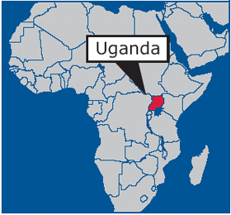
How neighboring countries fare
South Sudan: The government’s ability to enact preventive measures and conduct counterterrorism operations was extremely limited. The Lord’s Resistance Army remained a threat. South Sudan has very limited monetary and human resource capacity to provide effective law enforcement.
Tanzania: The National Counterterrorism Center …sees itself as a means of preventing terrorist attacks rather than responding to them. Tanzania lacks sufficient resources to adequately patrol borders. Officers manning border posts are often underequipped and under-trained. Some border posts do not have access to electricity, so computerised systems are not always an option.
Rwanda: In April, cooperation between Rwanda and the DRC ended over the M23 rebel group. The Rwandan government, including Rwandan Defense Forces (RDF), provided assistance to M23 during the year…The poor security situation in the eastern DRC put pressure on Rwanda’s western borders.
DR Congo: There was no credible evidence to indicate a significant presence of terrorists. The government lacked complete control over some areas of its territory, especially in the east where numerous armed groups operated with impunity and had very limited capacity to monitor.
Kenya: Despite Somali refugee issues, preparation for 2013 national elections, the threat of al-Shabaab and ethnic, political, and economic tensions, the government demonstrated persistent political will to secure its borders, apprehend terrorists.

U.S. Department of State Issues Latest Country Reports on Terrorism

June 6, 2013
Source: http://www.homelandsecurity.org/node/880

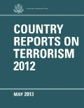
On 30 May 2013, the Department of State submitted the latest version of its annual Country Reports of Terrorism to the U.S. Congress as required by law. The report provides the Department of State’s annual assessment of trends and events in international terrorism that occurred from 01 January to 31 December 2012. It includes a strategic assessment, country-by-country breakdowns of counterterrorism efforts, and sections on state sponsors of terrorism, terrorist safe havens, and foreign terrorist organizations.
Among the key developments in 2012 were:
- A marked resurgence of Iran’s state sponsorship of terrorism, through its Islamic Revolutionary Guard Corps-Qods Force (IRGC-QF), its Ministry of Intelligence and Security, and Tehran’s ally Hizballah, was noted.
- The al-Qa’ida (AQ) core in Pakistan continued to weaken.
- Tumultuous events in the Middle East and North Africa have complicated the counterterrorism picture.
- Leadership losses have driven AQ affiliates to become more independent.
- We are facing a more decentralized and geographically dispersed terrorist threat.

►Read the full report at: http://www.state.gov/documents/organization/210204.pdf

Peru to Build this Year 10 New Counter-Terrorism Bases in VRAEM
Source: http://www.peruviantimes.com/08/peru-to-build-this-year-10-new-counter-terrorism-bases-in-vraem/19398/

Peru’s government plans to build an additional 10 counter-terrorism bases in a remote jungle region that is rife with remnants of Shining Path rebels, state news agency Andina reported.
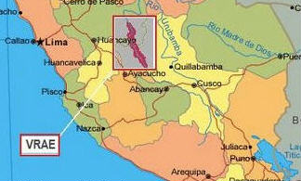
Defense Minister Pedro Cateriano said that the bases are to be set up this year.
“This year we are planning to construct 10 more counter-terrorism bases and we are evaluating the possibility through government to government mechanisms, to acquire bases from Canada, with modern equipment that allows them to be transported easily,” Cateriano said.
The bases will be built in the Apurimac, Ene and Mantaro river valleys, a dense, mountainous jungle region that includes districts in the south-central regions of Cuzco, Ayacucho, Junin and Huancavelica. The VRAEM, as the area is known for strategic purposes, is where the last remaining Shining Path rebels have built a network providing protection to illicit coca growers and drug traffickers.
Cateriano also said that the government will revamp the few existing military bases in the area, which are known to be underfunded, and, in at least one small town, housed in local community buildings or schools. “President Ollanta Humala’s administration is taking steps to improve the conditions of all the bases,” he said.
The VRAEM is the biggest coca-growing region in the country. Coca leaves have many traditional uses in the Andes, including as a digestive tea, but the larger number of illicit crops are turned into coca paste and cocaine. Peru is the world’s biggest cocaine producer, along with Colombia.
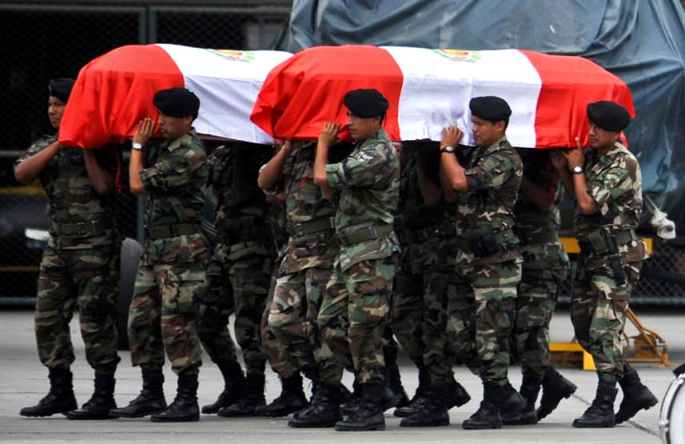
At its peak in the late 1980s and early 1990s, the Shining Path terrorized Peru with a violent Maoist ideology, aiming to overthrow the established government order in a campaign of bombings, assassinations and massacres. Following the arrest of Abimael Guzman in 1992, the organization fell apart, and a few of the rebels fled to montane forest regions, where they have been contained by the police and military since then.
The Shining Path today, however, bears no relation to its previous organization, in ideology or mission. In the VRAEM the remaining rebels have been able to survive and even prosper, but thanks entirely to profits from the cocaine trade and the lack of state authority for many years in the area. In 2012, the Shining Path killed 10 soldiers and police officers that were sent into the region to rescue some 40 hostages taken by the rebels. The father of one of the killed soldiers went into the area on his own to retrieve his son’s body, abandoned by the police. More recently, the rebels have downed cell phone towers to block police communications.
The building of the new military bases is part of the government’s plan to root out the rebels by increasing the military’s presence in the region. The plan also includes building infrastructure, such as roads and telecommunications, providing alternative development programs for coca farmers and for the first time ever, eradicating coca crops in the VRAEM.
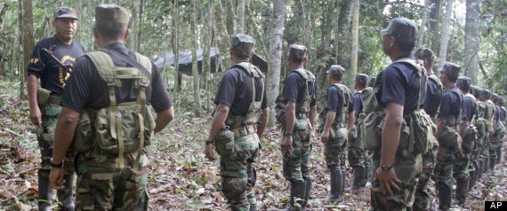
The policy has been criticized by some analysts, including the former chief of Peru’s anti-drug agency, Ricardo Soberon, over concerns that the local population could find themselves stuck in the middle of a conflict between the state and the rebels, similar to that of the 1980-2000 years of conflict, when military and police response was poorly focused and often violent against the civilian population.
The recent shooting by soldiers of a public transport van operating between villages near Kepashiato, injuring nine passengers, is an example of the nervous reaction of the military who are unfamiliar with the area.

“Red Light” in Western Africa – The rising Terror Risks Energy Infrastructures and Threatens Economy
By Meir Gershuni
Source: http://i-hls.com/2013/05/red-light-in-western-africa-the-rising-terror-in-africa-risks-energy-infrastructures-and-threatens-economy/?utm_source=MANPADS+and+Rising+Terror+Risks+in+ Western+Africa&utm _campaign=ACD%2FEWI+BLOG&utm_medium=email

The continent of Africa, and in particular the countries south of Sahara, are center of wide scale activity for Israeli companies who have been acting at the area since the end of 50`s. The activity was first led by the Foreign Office, who in a very short time established tens of Israeli representation offices in African countries, and in this way laid the foundations for activity in the fields of agriculture, security and infrastructure development. Later on, more and more private companies from Israel entered Africa, and performed impressive projects in various areas. During the years the business relations had their ups and downs that were influenced by political moves and events like the Six Day War and Yom Kippur War. Nevertheless, along the entire period a massive Israeli business presence was established in Africa in various fields. The present deterioration in the level of terror threat and crime at the continent of Africa is a blinking red light considering the substantial risk requiring security arrangement against it. However, and since this is the situation, this is also an opportunity for Israeli security companies specializing in management of risks of this type, to provide security solutions for each foreign organization intending to act in these countries, in order to protect the well being of its personnel and safeguard its assets.
An impressive show of force of the radical Islamic organizations in Northern Africa took place last January, when 41 foreign hostages (citizens of USA, UK, Japan, Norway, Philippines, France, Malaysia and Romania) were kidnapped by Islamic extremists at the Amenas gas field near the Algiers-Libya border. This event demonstrates the freedom of action that the terror organizations enjoy at the arena, as the result of lack of organized government and security systems, with an emphasis on countries like Mali and Libya. Also in apparently more stable countries there is a growing trend towards terror activity. Such is happening each day in Nigeria.
More than 230 foreign citizens have been kidnapped at the Delta area in Nigeria since January 2007. In the recent years there is an ever worsening trend, for execution of kidnapping and bombing attacks using a variety of operational methods, focusing at the Energy facilities (oil and gas). In addition to the repeating damages to the oil pipelines, also the ships used by the maritime oil production facilities and oil rigs placed opposite the Delta are a prominent target for terror acts.
Since January 2007 till June 2012 there were no less than 79 terror acts and bombing attempts at the Sahel arena only. Nigeria is the greatest oil producer at the African continent, and it is also a model for a security problem and the high level of threats against the Energy facilities located in the country.
But the main problem is not just the deteriorating security in Nigeria, but the absence of stability in Western Africa in general. Africa serves at the recent years as a safe haven and operation base for activists who were trained in fighting at the tribal areas in Pakistan. As a result of the massive pressure on Al Qaeda in Afganistan-Pakistan, the substantial threats are not coming anymore from the “original” Al Qaeda, but from organizations identified with Al Qaeda and in particular the ones operating in Africa, such as the Islamic Maghreb Al Qaeda (AQIM), El Shabaab in Somalia and the Nigerian organization El Bioko Haram, who have become a real threat at the African continent in general and at the Sahel area in particular. The “production line” for the continent`s terror factors at the continent has been focused recently in Mali, that has become a “safe haven” for terror activists, and it was not by chance that the French government decided on the Seval operation, aiming to crack down on the Al Qaeda nests in the country.
No country has felt the impact of the fall of Gadafi regime more substantially than Mali, which experienced already in the past lack of stability, coups d’état acts, revolts of the Tuareg population and the influences of terror and crime organizations. But during the recent year Mali experienced all the problems simultaneously.

Focusing of the threat on oil and gas sector at the Sahel area
In the last decade a number of terror acts took place in various places worldwide against oil and gas industry. A representative sample:
- In February 2002, a hell boat loaded with explosives crashes against the wall of the giant French oil container ship MV Limburg next to Yemen shores. As a result of the explosion one crewman was killed, others were wounded and 90’000barrels of oil were spilled into the sea. The Ql Qaida organization took responsibility for the operation.
- In February 2004, Osama Bin Laden encourages his soldiers to “concentrate actions against the oil facilities and in particular in Iraq and the Persian Gulf”. Trying to justify such a move, he explained that the US is using the Energy resources of the Arab countries for a ridiculous price.
- In 2006, Al Qaeda tried to blow up a car bomb in Abqaiq, Saudi Arabia, One of the largest refineries in the world. The bombing attempt failed at the breaking in stages into the well protected site.
In the recent years the terror has spread against oil infrastructures, and it is no more limited to the Gulf area and the Middle East. In 2007, Al Qaeda published a press message on its intention to attack interests and Energy facilities of United States in other countries: “The oil facilities that the United States is enjoying, will be attacked in all areas [of the world], and not only in the Middle East”. The above implies Al Qaeda intention for attacking targets in Northern Africa and the Sahel area, where, since 2006, the organization enjoys local support of Islamic Maghreb (AQIM). Before the establishment of this group, the GSPC organization was operating in this area, focusing on actions again Algerian oil facilities as the preferred target. The organization executed a series of terror acts against workers and facilities of the oil companies Sonelgaz, Sonatrach and ENTP, operating in the south of Algeria. Tens of people were killed in these terror acts and extensive damage was caused to the oil producing facilities. However, none of these terror actions was similar to the spectacular terror bombing executed on January 16th, 2013 in the natural gas facility in Amenas, in eastern Algeria. At least 4o terrorists who entered Algeria from Libya and the north of Mali, attacked two buses transporting workers from the natural gas field , and in parallel attacked and took control – actually quite easily, in the absence of a reasonable security force – on the gas facility, while taking hundreds of workers as hostages. After futile and unprofessional attempts to negotiate with the kidnappers, two actions of taking control and rescuing were executed by an elite unit of the Algerian army. The disastrous results of the operation were followed by much western criticism. At least 39 hostages were killed and many others were wounded. The Algerian army killed most of the terrorists and caught 3 of them. According to a declaration of the involved organizations, the action was executed as an act of revenge against the French intervention on Mali.
Also in Nigeria, the greatest oil producing country in Africa, The terror threat has grown substantially since the beginning of French intervention in Mali, following support of the French military steps by the Abuja government.

The French family in captivity of Boko Haram
The French intervention against Islamic groups in north of Mali – the area where the Islamic groups are strongly linked, ideologically and operationally, with Boko Haram - accelerates the extension of the terror threat to the countries in the south, where most of the western oil facilities are located. In this context, I have to note the possibility that the Nigerian Islamist terror organizations may try to “market” their terror actions (kidnapping and acts against infrastructures) to local organizations located in the south, like the MEND (Movement for the Emancipation of the Niger Delta). Even though there is no concrete evidence of such an operative cooperation between the south and the north, western organizations and companies acting in the region should take this into account.
Five terror groups are threatening at present the oil companies acting in Sahel and Western Africa : Al Quaeda in Islamic Maghreb (AQIM), The Movement for Oneness and Jihad in Western Africa (MUJAO), the Nigerian Boko Haram and its separatist section Ansaru, and MEND (Movement for the Emancipation of the Niger Delta). Leaders of all these groups have declared on their intention to harm western interests in the area, and in particular the workers and Energy infrastructures of the oil companies, which are their main and preferred target.
In 6th of April 2013 the MEND organization attacked a police ship sailing at the Delta. Twelve policemen were killed in the terror act. The Movement for the Emancipation of the Niger Delta (MEND) took responsibility for the terror act, and threatened to continue its violence against the Nigeria government and the oil companies (mostly foreign) in the area.
The threat by MEND came as a reaction on the jailing of its leader, Okah, by a court South Africa, for 24 years. The organization`s spokesman published a press announcement, according to which “All the oil companies and the public are asked to ignore the false feeling of security that the government is trying to sell…”
These terror attacks are causing critical disruptions to the oil industry, as expressed recently by shutting down the Bonny oil pipeline, that was leading over 150,000 barrels per day !!, following repeating sabotage actions on the pipeline . At the end of 2013’ also Shell company announced on its intention to close the main Nigerian pipeline, Nembe Creek Trunkline, for an unlimited period, following sabotage actions and oil stealing in unprecedented rates last year.
The leader of the organization was sentenced to 24 years of imprisonment in South Africa, following execution of two car bombings in the Nigerian capital Abuja and killing of 10 persons. The organization was almost inactive following an agreement with the government that the leaders and many of the organization`s members will be granted amnesty (this is the reason the leader was sentenced in South Africa and not in Nigeria) and even generous payments in order to keep an “industrial peace” (in both meanings). In spite of the agreement, the organization admitted responsibility for sabotage action on the crude oil pipeline owned by the Italian national gas and oil company, ENI, last year.

MEND leader on trial in South Africa

The rising rate of sabotage and terror action is undoubtedly a major problem for the international organizations acting in Nigeria who are already forced to cope with oil theft on an industrial scale – one fifth of the daily oil production – 2,000,000 barrels – is being stolen, worth about 1 billion dollars per month (!), according to the government estimates.
Although Nigeria “leads” in scope and severity of the terror acts, other African countries are influenced by the terror acts of the terror organizations and Islamic groups in the Sahel.
It is known that most of the activity of the above groups is to establish local infrastructure in the neighboring countries and even more distant countries (see South Africa). This includes countries like Burkina Faso, Ivory Coast, Guinea Conakry and Senegal, where AQIM and MUJAO are acting quite intensively. Senegal, whose population is 90% Moslem, and in which the path to establishing dormant terror cells is quite short, is a prominent example.
Except for the concrete threat accompanying the daily activity of the Energy companies at the arena, the oil and gas companies in the area are expected to become more and more exposed to harassment in the field of Cyber. The threat in this field is higher than in other business area, since most, if not all, of all the operational systems of the Energy facilities are controlled remotely by computerized .(Please refer to the Cyber attack executed at the end of 2012 on the Saudi oil company Aramco).
This subject is worth a separate dedicated discussion.

In Summary, Western companies and in particular the companies active in the Energy field, operating oil infrastructures (workers, production facilities, refineries, distribution points, maritime platforms, service ships etc.) from Mauritania to Chad, Algeria and Nigeria, are all exposed to growing terror threats, that for quite a long time are not limited only to the lawless Sahara area, but are in a process of accelerated expansion to the west and center of the African continent.
Kidnapping of the French family in 19th of February 2013 at the border of Nigeria with Cameroon demonstrates the severity of the threat also in countries where till now there was a relatively quiet situation. By the way, the family was released at the end of the week 20/4.
The decision of the giant oil producing companies to cancel or postpone business activity, such as BP announcement immediately after the Amenas terror act on immediate stop of their drilling operations in Libya’ as well as the decision by Shell to stop the flow of oil in the main oil transport pipeline in Nigeria, are a sign of the companies` recognition of the size of threat on their workers and facilities, implying also that they don`t have an adequate security answer to the present threats.
It can be assumed with a high degree of certainty that already in the near future the companies working in the area, and in particular the oil and gas companies, will be asked to increase their insurance and secondary insurance payments for Energy projects, to pay higher bonus payments for foreign workers employed in dangerous areas and in parallel to improve the safety and security means, standards and procedures in the various oil sites.
The increased terror and crime threats create a new economic and social reality, influencing the availability of resources abundant in Africa and needed by the whole world. As stated, this is a blinking red light indicating the threat on foreign factors wishing to operate in this area. Relieving these threats depends on the existence of effective intelligence and security arrangements that will be able to deter opponents, thwart attempts of impairing human life and causing damage, while providing an effective answer on emergency situations. There is a particular identity of interests in joining together these two points. On one hand this an existential threat for companies and business organizations operating on the continent, and on the other hand it is a business opportunity for security companies, specializing in risk management, providing consulting services and guidance in establishment of suitable security arrangements.

Meir Gershuni is a former Head of Division at the ISA, and at present Senior Vice President of the MAYDEX AG specializing in Energy infrastructure security planning and a Senior Lecturer in the School of Security and Emergency Management at the Wingate Academic College.

Al Qaeda has feared weapon

Source: http://www.cbsnews.com/8301-202_162-57588775/al-qaeda-has-feared-weapon-mali-documents-suggest/?utm_source=MANPADS+and+Rising+Terror+Risks+in+Western+Africa&utm _campaign=ACD%2FEWI+BLOG&utm_medium=email

The photocopies of the manual lay in heaps on the floor, in stacks that scaled one wall, like Xeroxed, stapled handouts for a class.
Except that the students in this case were al Qaeda fighters in Mali. And the manual was a detailed guide, with diagrams and photographs, on how to use a weapon that particularly concerns the United States: A surface-to-air missile capable of taking down a commercial airplane.
The 26-page document in Arabic, recovered by The Associated Press in a building that had been occupied by al Qaeda in the Islamic Maghreb in Timbuktu, strongly suggests the group now possesses the SA-7 surface-to-air missile, known to the Pentagon as the Grail, according to terrorism specialists. And it confirms that the al Qaeda cell is actively training its fighters to use these weapons, also called man-portable air-defense systems, or MANPADS, which likely came from the arms depots of ex-Libyan strongman Col. Moammar Gadhafi.
"The existence of what apparently constitutes a `Dummies Guide to MANPADS' is strong circumstantial evidence of al Qaeda in the Islamic Maghreb having the missiles," said Atlantic Council analyst Peter Pham, a former adviser to the United States' military command in Africa and an instructor to U.S. Special Forces. "Why else bother to write the guide if you don't have the weapons? ... If AQIM not only has the MANPADS, but also fighters who know how to use them effectively," he added, "then the impact is significant, not only on the current conflict, but on security throughout North and West Africa, and possibly beyond."
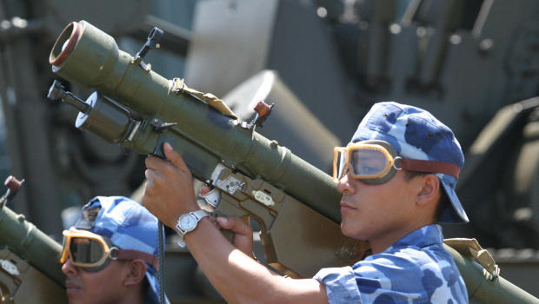
The United States was so worried about this particular weapon ending up in the hands of terrorists that the State Department set up a task force to track and destroy it as far back as 2006. In the spring of 2011, before the fighting in Tripoli had even stopped, a U.S. team flew to Libya to secure Gadhafi's stockpile of thousands of heat-seeking, shoulder-fired missiles.
By the time they got there, many had already been looted.
"The MANPADS were specifically being sought out," said Peter Bouckaert, emergencies director for Human Rights Watch, who catalogued missing weapons at dozens of munitions depots and often found nothing in the boxes labeled with the code for surface-to-air missiles.
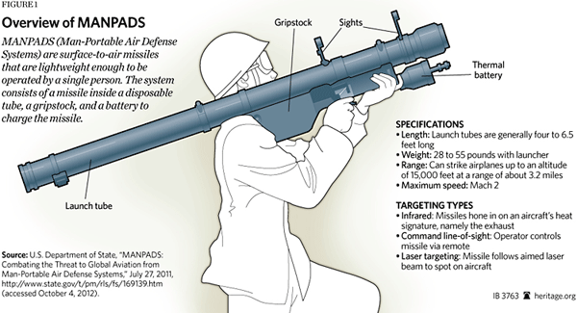
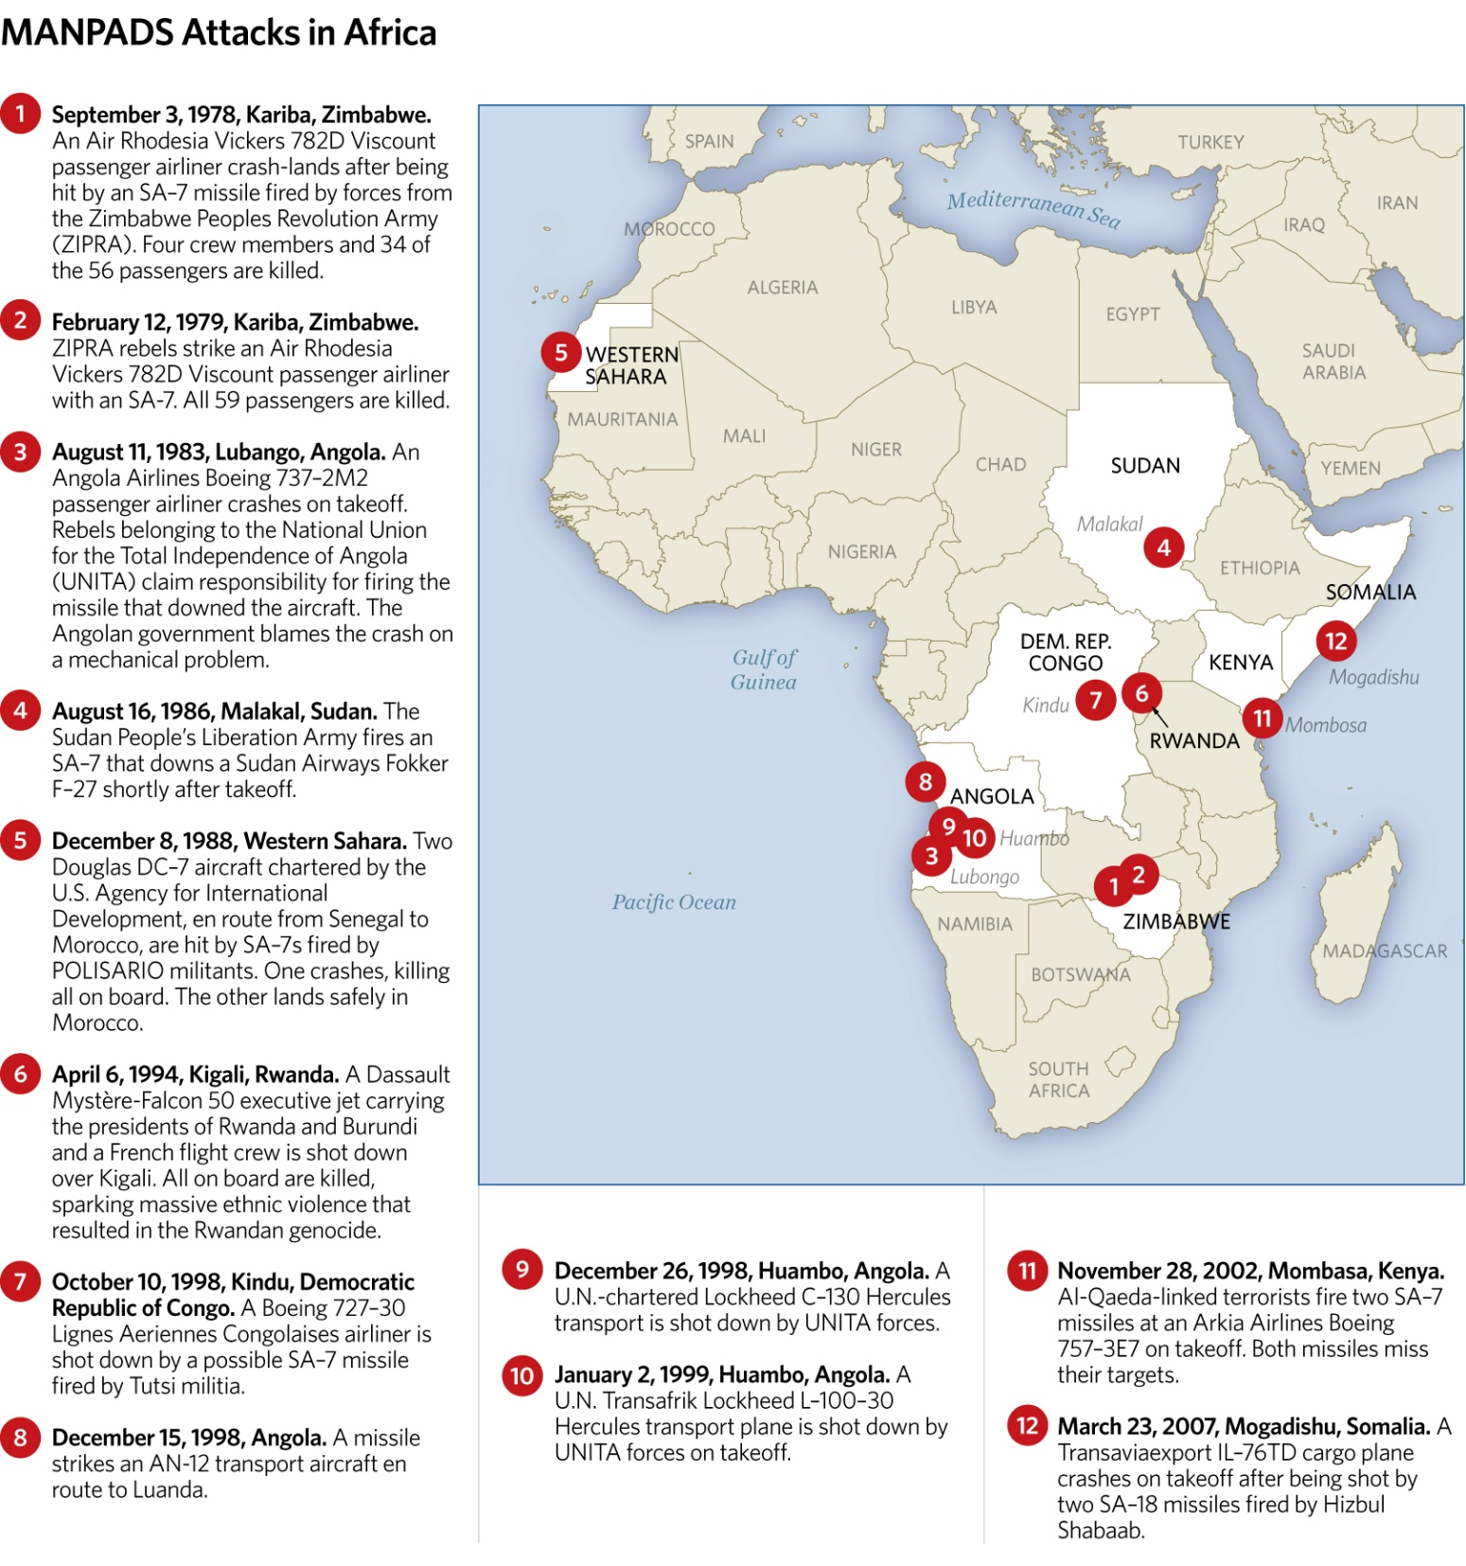
The manual is believed to be an excerpt from a terrorist encyclopedia edited by Osama bin Laden. It adds to evidence for the weapon found by French forces during their land assault in Mali earlier this year, including the discovery of the SA-7's battery pack and launch tube, according to military statements and an aviation official who spoke on condition of anonymity because he wasn't authorized to comment.
The knowledge that the terrorists have the weapon has already changed the way the French are carrying out their five-month-old offensive in Mali. They are using more fighter jets rather than helicopters to fly above its range of 1.4 miles (2.3 kilometers) from the ground, even though that makes it harder to attack the jihadists. They are also making cargo planes land and take off more steeply to limit how long they are exposed, in line with similar practices in Iraq after an SA-14 hit the wing of a DHL cargo plane in 2003.
And they have added their own surveillance at Mali's international airport in Bamako, according to two French aviation officials and an officer in the Operation Serval force. All three spoke on condition of anonymity because they were not authorized to comment.
"There are patrols every day," said the French officer. "It's one of the things we have not entrusted to the Malians, because the stakes are too high."
First introduced in the 1960s in the Soviet Union, the SA-7 was designed to be portable. Not much larger than a poster tube, it can be packed into a duffel bag and easily carried. It's also affordable, with some SA-7s selling for as little as $5,000.
Since 1975, at least 40 civilian aircraft have been hit by different types of MANPADS, causing about 28 crashes and more than 800 deaths around the world, according to the U.S. Department of State.
The SA-7 is an old generation model, which means most military planes now come equipped with a built-in protection mechanism against it. But that's not the case for commercial planes, and the threat is greatest to civilian aviation.
In Kenya in 2002, suspected Islamic extremists fired two SA-7s at a Boeing 757 carrying 271 vacationers back to Israel, but missed. Insurgents in Iraq used the weapons, and YouTube videos abound purporting to show Syrian rebels using the SA-7 to shoot down regime planes.
An SA-7 tracks a plane by directing itself toward the source of the heat, the engine. It takes time and practice, however, to fire it within range. The failure of the jihadists in Mali so far to hit a plane could mean that they cannot position themselves near airports with commercial flights, or that they are not yet fully trained to use the missile.
"This is not a `Fire and forget' weapon," said Bruce Hoffman, director of the Center for Security Studies at Georgetown University. "There's a paradox here. One the one hand it's not easy to use, but against any commercial aircraft there would be no defenses against them. It's impossible to protect against it. ... If terrorists start training and learn how to use them, we'll be in a lot of trouble."
In Timbuktu, SA-7 training was likely part of the curriculum at the `Jihad Academy' housed in a former police station, said Jean-Paul Rouiller, director of the Geneva Center for Training and Analysis of Terrorism, one of three experts who reviewed the manual for AP. It's located less than 3 miles (5 kilometers) from the Ministry of Finance's Budget Division building where the manual was found.
Neighbors say they saw foreign fighters running laps each day, carrying out target practice and inhaling and holding their breath with a pipe-like object on their shoulder. The drill is standard practice for shoulder-held missiles, including the SA-7.

Islamic extremism on the rise in Germany

Source:http://www.thecommentator.com/article/3762/islamic_extremism_on_the_rise_in_germany
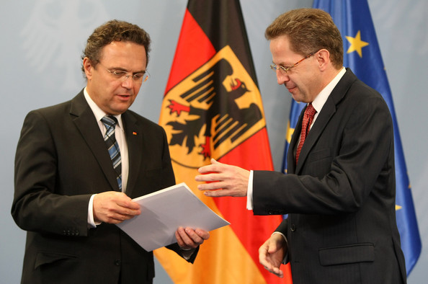
German authorities have noted a distinct rise in the number of Islamic extremists operating in Germany, many of which may be prepared to carry out violent attacks.
According to a new Associated Press report, Germany's interior ministry claims that the number of Salafis in the country rose from 3,800 in 2011 to 4,500 in 2012.
The total number of people of concern to Germany's security services now numbers around 42,550, which includes those involved with 'other forms' of extremist Islamist ideology. An estimate made in 2009 calculated that there are 4.3 million Muslims in Germany in total.
Hans-Georg Maassen, the head of Germany’s domestic intelligence service, says about 1,000 people are of serious concern to authorities and 130 are under round-the-clock surveillance.
Maassen told reporters in Berlin on Tuesday that about 60 people have traveled from Germany to Syria this year to join jihadi groups seeking to topple President Bashar Assad.

