New Bioterrorism Vaccine Gets First Test In Humans
Source: http://www.fiercevaccines.com/press-releases/new-bioterrorism-vaccine-gets-first-test-humans

Integrated BioTherapeutics (IBT) announces the initiation of a Phase 1 clinical trial testing the safety and immunogenicity of its staphylococcal enterotoxin B vaccine "STEBVAX" in healthy adults.
This trial, marking the first time a superantigen vaccine has been administered to humans, is designed to enroll 28 individuals. STEBVax is a proprietary, rationally designed and attenuated form of Staphylococcal Enterotoxin B (SEB), a member of a group of toxins called superantigens due to the ability to cause a massive inflammatory response leading to toxic shock.
"SEB is a biowarfare threat to the US and the superantigens can be critical factors affecting the outcome of Staphylococcus aureus infections," said Dr. M. Javad Aman , IBT President and Chief Scientific Officer. "This clinical study advances our vaccine programs designed to protect military and civilian populations against the threat of SEB and our long-term goal of developing vaccines and therapeutics for Staphylococcus aureus."
The National Institute of Allergy and Infectious Diseases (NIAID), part of the National Institutes of Health (NIH), have sponsored the clinical trial. The trial is being conducted at the Center for Vaccine Development at the University of Maryland in Baltimore, which is one of NIAID's Vaccine and Treatment Evaluation Units (VTEUs).
"We are extremely pleased to see a decade-long research and development effort, which was heavily supported by the government, reach this critical milestone," Aman said. "Safety evaluation of STEBVax is significant as it is the first time a vaccine for such a potent toxin is being tested in humans."
IBT, a biotechnology company developing medical countermeasures for biodefense and emerging infectious diseases, is dedicated to the development of vaccines, immune-therapeutics and discovery of small molecules targeting emerging infectious agents. IBT was named Outstanding Company of 2011 by the Maryland Technology Development Corporation (TEDCO), recognizing the company's tremendous growth in funding and personnel, and its strong relationships with the U.S. Government and industry partners.

About Integrated BioTherapeutics Inc:
Integrated BioTherapeutics Inc (IBT) is an emerging research-based company dedicated to development of vaccines, immune-therapeutics, and discovery of small molecules targeting emerging infectious agents. IBT has a portfolio of proprietary recombinant technologies for development of vaccines and immune-therapeutics against major biodefense and emerging infectious agents, with an emphasis on staphylococcal, and streptococcal infections, as well as viral hemorrhagic fevers. IBT has experience with many U.S. government agencies including the U.S. Army Medical Research Institute of Infectious Diseases, National Cancer Institute, National Institute of Health, and the Department of Defense. IBT has established cooperative relationships with pharmaceutical and biotechnology companies for development of joint products for prevention and treatment of staphylococcal infections and viral hemorrhagic fevers. IBT is funded through government grants, contracts and revenue from its CRO division, IBT Bioservices.

About Staphylococcal Enterotoxin B:
The Staphylococcus aureus and Streptococcus pyogenes bacteria release superantigens during an infection. SEB is one of the most potent superantigens. When purified, SEB is a potential bioweapon and was pursued by the US and USSR prior to an international ban on offensive biological and chemical weapons. STEBVax is considered a stand-alone vaccine for biodefense applications but is also a component of IBT's multivalent vaccine for prevention and treatment of staphylococcal infections in civilian life, a pressing public health problem in light of growing antibiotic resistance. The prospective multivalent vaccine will contain additional toxoids including other attenuated superantigens and pore-forming toxins currently in pre-clinical development at IBT.

America Is Not Prepared For A Pandemic Or Bioterrorism Disaster [Report]
Source:http://www.inquisitr.com/542916/america-is-not-prepared-for-a-pandemic-or-bioterrorism

A new pandemic study maintains that the majority of schools and businesses in the United States are not prepared for such a disaster. The St. Louis University study addressed both response preparedness for bioterrorism attacks and pandemics spurred by infectious disease.
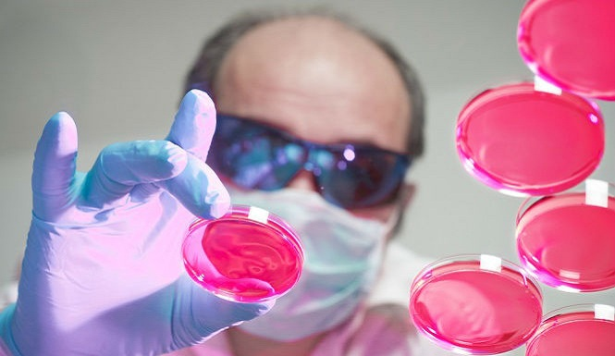
The pandemic preparedness study was considered extremely timely due to the recent influenza outbreak and ongoing controversy about airborne bird flu research. The St. Louis University study was headed by professor Terri Rebmann from the College for Public Health and Social Justice, Newswire reports.
The pandemic and bioterrorism study found that American schools and businesses need to improve their biological disaster plans to minimize the impact should such a tragedy occur, Science Daily notes. An excerpt from the St. Louis University study reads:
“One of the key findings from the study was that about 60 percent businesses reported they have a policy that encourages their ill staff to stay home, but about 40 percent responded that the business has a culture that encourages staff to work when they are sick. There’s a disconnect between written policies versus what the business culture encourages. This can contribute to disease spread in the business setting, especially among healthcare agencies.”
St. Louis University researchers also concluded that only 48 percent of schools address pandemic preparedness. A total of only 40 percent of schools have reportedly updated their pandemic and bioterrorism plans since in the past four years. The study sites the 2009 H1N1 pandemic which spread the virus to more than 214 countries worldwide.
Influenza reportedly spread quickly in the school environment due to how closely students and staff interact. The St. Louis University pandemic and bioterrorism study was published in the American Journal of Infection Control.

Flu breakthrough: New drug developed to combat flu pandemic
Source: http://www.csiro.au/Portals/Media/Flu-breakthrough---New-drug-developed-to-combat-flu-pandemic.aspx

CSIRO scientists have helped to design a new drug to safeguard against epidemic and pandemic flu strains – as published in Science today.
The new drug has been proven to be effective in preventing the spread of different strains of influenza in laboratory models – including resistant strains of the virus.
The breakthrough is the result of a global collaboration between scientists from CSIRO, the University of British Columbia and the University of Bath.
In order to infect cells, flu viruses bind onto sugars on the cell surface. To be able to spread they need to remove these sugars. The new drug works by preventing the virus from removing sugars and blocking the virus from infecting more cells. It is hoped the drug will also be effective against future strains of the virus.
According to the World Health Organization, influenza kills approximately 500,000 people each year, with up to 2500 of those deaths occurring in Australia. Costs to the Australian health care system are estimated to be more than A$85M, with more than 1.5 million work days lost annually.
CSIRO scientist Dr Jenny McKimm-Breschkin, a researcher in the team that developed the first flu drug Relenza, said that understanding exactly how flu viruses become resistant to drugs has helped them to design a better flu drug.
"CSIRO researchers have shown that flu viruses continually mutate and some have become resistant to available treatments," Dr Jenny McKimm-Breschkin said.
"The new drug is effective against these resistant strains. As the site where the drug binds is found in all flu strains, the new drug is expected to be effective even against future flu strains.
"With millions of poultry currently infected with 'bird flu' globally, there are still concerns about its adaptation and potential to spread among humans, causing the next pandemic," she added.
Professor Steve Withers, University of British Columbia, has led the research team for the past seven years and said that although further studies are required to determine efficacy against a broader range of flu strains, the findings are extremely positive.
"Despite recent improvements in vaccine production, when a new strain of flu emerges it can take several months before vaccines are available to the public," Professor Steve Withers said.
"This antiviral drug would play an important role as the first line of defense in modulating disease severity and in controlling a pandemic while vaccines are prepared," he added.
Details of the research have been published in a paper titled: 'Mechanism-based Covalent Neuraminidase Inhibitors with Broad Spectrum Influenza Antiviral Activity'. Researchers estimate it will take up to seven years before the drug is released.

CDC bioterror labs cited for security flaws in audits
Source: http://www.usatoday.com/story/news/nation/2013/02/25/cdc-bioterror-labs-cited-for-security-failures-in-audits/1945933/

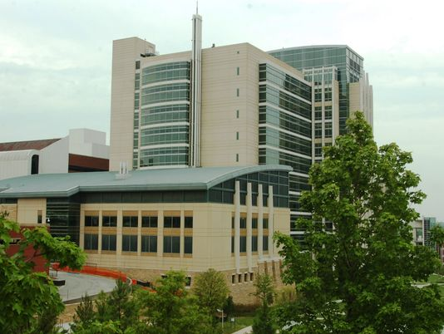
Laboratories at the Centers for Disease Control and Prevention have been repeatedly cited in private government audits for failing to properly secure potential bioterror agents such as anthrax and plague, and not training employees who work with them, according to "restricted" government watchdog reports obtained by USA TODAY.
"These weaknesses could have compromised [CDC's] ability to safeguard select agents from accidental or intentional loss and to ensure the safety of individuals," according to a 2010 report by the Department of Health and Human Services' inspector general.
The IG probed federal lab security after a scientist at an Army lab was implicated in the anthrax attacks in 2001. The IG also noted problems with CDC lab security in reports from 2009 and 2008.
The reports — which are prompting concern among some key members of Congress — offer a rare window into the CDC's performance on safety and security issues when working with the world's most dangerous pathogens.
The CDC is the main federal agency that oversees government and private bioterror lab safety involving agents dangerous to people, but it refuses to release copies of its lab inspection reports. The IG's office released its reports to USA TODAY in response to a Freedom of Information Act request.
CDC officials said nobody was endangered because their labs have redundant layers of safety and security to protect employees and the public. When issues arise, they are fixed immediately, said Joseph Henderson, director of the CDC's Office of Safety, Security and Asset Management. "We always take it seriously," he said. "We strive for perfection."
The issues cited in the IG reports are "troubling," said U.S. Rep. Fred Upton, chairman of the House Committee on Energy and Commerce. His committee has been examining federal regulation of bioterror labs in the wake of USA TODAY reports last summer about incidents at CDC labs in Atlanta of security doors left unlocked and issues with airflow systems that help prevent the release of infectious agents. The newspaper's earlier reports, which involved incidents in 2009-2012, were based on leaked internal e-mails and other records.
The IG reports were heavily redacted by government officials because they contain "restricted, sensitive information." Still Upton, R-Mich., said they "show the need for better scrutiny over the handling of select agents ... and we intend to immediately look into the issues raised."
The reports also concerned U.S. Rep. Henry Waxman of California, the ranking Democrat on the committee. He said, "There appears to be long-standing and recurring problems at CDC's labs which underscore the need to increase oversight and to ensure that appropriate action is taken to correct these problems permanently."
The issues cited in the IG's audits include:
- Failing to ensure the physical security of bioterror agents or restrict access to approved individuals. The 2009 report cites coding on electronic cards that allowed overly broad access to approved workers, allowing them wide access to all bioterror research areas, rather than just the specific areas or specimen freezers for their projects. Most of the details in the 2010 report were redacted.
- Failing to ensure that those working with and around potential bioterror agents have received required training. The 2010 report says auditors couldn't verify that 10 of 30 employees sampled had the required training. The 2009 report says the labs "did not provide biosafety and security training to 88 of 168 approved individuals" before they were given access to work areas for bioterror agents.
- Not ensuring that only approved individuals accepted packages containing potential bioterror agents arriving from other outside labs. The 2010 audit identified six unapproved people — five from a delivery contractor and one security guard — who received and signed for the packages. The 2008 report, which focused on security of arriving packages, also identified issues.
In 2008, the FBI implicated a microbiologist working at an Army biodefense lab as being responsible for the anthrax letter attacks, which killed five and sickened 17. The scientist, Bruce Ivins, took a fatal overdose of Tylenol while under scrutiny.
It is not clear which germs or toxins, known as "select agents" in federal regulations, were involved in the CDC incidents that occurred from 2005 to 2009. Select agents are all dangerous pathogens and include the ebola virus, monkeypox virus, the toxin that causes botulism and ricin, a deadly poison that made headlines in 2003 after a potential London terror attack was foiled.
Although the locations of the CDC labs examined by the IG's auditors were redacted from the reports, Henderson said the 2010 and 2008 audits involved labs on the CDC's main campus in Atlanta, and the 2009 audit was of the agency's labs in Fort Collins, Colo.
Rutgers university biosafety expert Richard Ebright, who reviewed the IG reports at USA TODAY's request, said the issues cited are significant and repeated. "There is no evidence of improvement. Some of the same kinds of violations occurred repeatedly over the three-year review period," he said. "It is ironic that the institution that sets U.S. standards for safety and security of work with human pathogens fails to meet its own standards."
In the wake of USA TODAY's reports last June and concerns about the CDC policing itself, the CDC agreed last August to have its labs inspected by bioterror lab experts from the U.S. Department of Agriculture. The USDA has inspected CDC labs twice, said CDC spokesman Tom Skinner, and inspections will occur every 12 to 18 months.
The CDC would not share copies of its most recent inspection reports, saying it is agency policy not to release them for security reasons. Yet to document that CDC had corrected airflow issues at its Emerging Infectious Diseases Laboratory in Atlanta, the agency on Friday provided USA TODAY a copy of an external lab safety review done at the CDC's request by biosafety experts from Canada's public health agency. The Canadian review at the $214 million 11-story lab complex known as Building 18, says it found no issues of "non-compliance" that pose health and safety risks.
The CDC has not responded to USA TODAY's FOIA requests filed eight months ago for copies of its inspection reports for Building 18's labs, nor has it responded to requests for documents about the building's lab security and airflow incidents.

Marburg drug shows promise
Source: http://www.homelandsecuritynewswire.com/dr20130307-marburg-drug-shows-promise

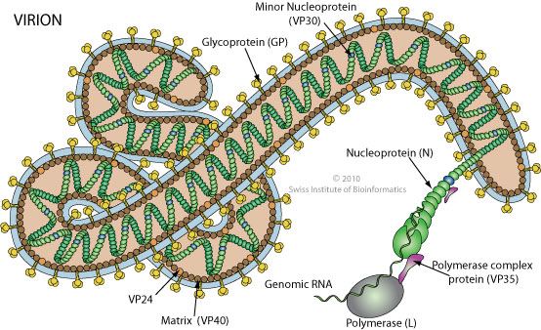
Sarepta Therapeutics, a developer of RNA-based therapeutics, the other day announced positive results from a non-human primate study of AVI-7288, the company’s lead drug candidate for the treatment of Marburg virus infection. The data showed that intramuscular administration of AVI-7288 resulted in survival rates up to 100 percent in treated subjects, similar to efficacy observed in previous studies that evaluated the drug when administered by intravenous injection.
Marburg hemorrhagic fever is a severe and highly lethal disease with no effective treatments, and it has been classified as a Category A bioterrorism agent by the Centers for Disease Control and Prevention (CDC).
“These data reinforce the strong efficacy of AVI-7288, while showing that the drug can be delivered via a convenient intramuscular injection,” said Chris Garabedian, president and chief executive officer of Sarepta Therapeutics. “This alternative delivery method to the intravenous route has the potential to greatly enhance the practical utility of AVI-7288 in a mass casualty situation and also serves as a model for delivery of our rapidly adaptable platform for other therapeutic applications.”
Sarepta is developing AVI-7288 under a U.S. Department of Defense (DoD) contract managed by the Joint Project Manager Transformational Medical Technologies (JPM-TMT) Project Management Office, a component of the Joint Program Executive Office for Chemical and Biological Defense (JPEO-CBD). Under the contract, Sarepta initiated the study in non-human primates to evaluate the tolerability, pharmacokinetics, and efficacy of AVI-7288 through intramuscular administration. The study included four cohorts in which subjects received daily treatments of AVI-7288 ranging from 7.5 to 30 mg/kg or a placebo after exposure to the virus.
In the study, intramuscular injections of AVI-7288 were well tolerated. Efficacy results showed a high degree of survival between 83 and 100 percent in each of the three treatment groups. No subjects survived in the placebo-treated control group.
Sarepta says that under a separate contract with JPM-TMT, it is developing an intravenous formulation of AVI-7288, which has demonstrated similar survival rates even when the drug is administered up to four days after exposure to the Marburg virus.
The work is a collaborative effort between Sarepta and scientists at the U.S. Army Medical Research Institute of Infectious Diseases (USAMRIID), the DoD’s leading medical research laboratory for biological defense, which has the DoD’s only maximum containment, or Biosafety Level 4, capability.

About Marburg virus
Marburg hemorrhagic fever is a severe and potentially fatal disease in humans first recognized in 1967. It is caused by an RNA virus of the Filoviridae family and is understood to be endemic to Africa. The Marburg virus is classified as a Category A bioterrorism agent by the Centers for Disease Control and Prevention, or CDC, and is a material threat to national security and public health as determined by the Secretary of Homeland Security in 2006. Onset of the disease is often sudden, and the symptoms include fever, chills, nausea, vomiting, chest pain, and diarrhea. Increasingly severe symptoms may also include massive hemorrhaging and multiple organ dysfunctions. There are currently no treatments for Marburg virus infection beyond supportive care.

Bioterrorism and the Pandemic Potential
By Rebecca Keller
Source:http://www.stratfor.com/weekly/bioterrorism-and-pandemic-potential?utm_source=twitter&utm_ medium=official&utm_campaign=link

Periodic media reports of bird flu, a new SARS-like virus and a case of drug-resistant tuberculosis have kept the world informed, but they have also contributed to a distorted perception of the true threat such contagions pose. Perhaps the greatest value of the media coverage is the opportunity it provides to discuss the uncertainties and the best ways to prepare for biological threats, both natural and man-made.
It is important to remember that the risk of biological attack is very low and that, partly because viruses can mutate easily, the potential for natural outbreaks is unpredictable. The key is having the right tools in case of an outbreak, epidemic or pandemic, and these include a plan for containment, open channels of communication, scientific research and knowledge sharing. In most cases involving a potential pathogen, the news can appear far worse than the actual threat.

Infectious Disease Propagation
Since the beginning of February there have been occurrences of H5N1 (bird flu) in Cambodia, H1N1 (swine flu) in India and a new, or novel, coronavirus (a member of the same virus family as SARS) in the United Kingdom. In the past week, a man from Nepal traveled through several countries and eventually ended up in the United States, where it was discovered he had a drug-resistant form of tuberculosis, and the Centers for Disease Control and Prevention released a report stating that antibiotic-resistant infections in hospitals are on the rise. In addition, the United States is experiencing a worse-than-normal flu season, bringing more attention to the influenza virus and other infectious diseases.
The potential for a disease to spread is measured by its effective reproduction number, or R-value, a numerical score that indicates whether a disease will propagate or die out. When the disease first occurs and no preventive measures are in place, the reproductive potential of the disease is referred to as R₀, the basic reproduction rate. The numerical value is the number of cases a single case can cause on average during its infectious period. An R₀ above 1 means the disease will likely spread (many influenza viruses have an R₀ between 2 and 3, while measles had an R₀ value of between 12 and 18), while an R-value of less than 1 indicates a disease will likely die out. Factors contributing to the spread of the disease include the length of time people are contagious, how mobile they are when they are contagious, how the disease spreads (through the air or bodily fluids) and how susceptible the population is. The initial R₀, which assumes no inherent immunity, can be decreased through control measures that bring the value either near or below 1, stopping the further spread of the disease.
Both the coronavirus family and the influenza virus are RNA viruses, meaning they replicate using only RNA (which can be thought of as a single-stranded version of DNA, the more commonly known double helix containing genetic makeup). The rapid RNA replication used by many viruses is very susceptible to mutations, which are simply errors in the replication process. Some mutations can alter the behavior of a virus, including the severity of infection and how the virus is transmitted. The combination of two different strains of a virus, through a process known as antigenic shift, can result in what is essentially a new virus. Influenza, because it infects multiple species, is the hallmark example of this kind of evolution.
Mutations can make the virus unfamiliar to the body's immune system. The lack of established immunity within a population enables a disease to spread more rapidly because the population is less equipped to battle the disease. The trajectory of a mutated virus (or any other infectious disease) can reach three basic levels of magnitude. An outbreak is a small, localized occurrence of a pathogen. An epidemic indicates a more widespread infection that is still regional, while a pandemic indicates that the disease has spread to a global level.
Virologists are able to track mutations by deciphering the genetic sequence of new infections. It is this technology that helped scientists to determine last year that a smattering of respiratory infections discovered in the Middle East was actually a novel coronavirus. And it is possible that through a series of mutations a virus like H5N1 could change in such a way to become easily transmitted between humans.

Lessons Learned
There have been several influenza pandemics throughout history. The 1918 Spanish Flu pandemic is often cited as a worst-case scenario, since it infected between 20 and 40 percent of the world's population, killing roughly 2 percent of those infected. In more recent history, smaller incidents, including an epidemic of the SARS virus in 2003 and what was technically defined as a pandemic of the swine flu (H1N1) in 2009, caused fear of another pandemic like the 1918 occurrence. The spread of these two diseases was contained before reaching catastrophic levels, although the economic impact from fear of the diseases reached beyond the infected areas.
Previous pandemics have underscored the importance of preparation, which is essential to effective disease management. The World Health Organization lays out a set of guidelines for pandemic prevention and containment. The general principles of preparedness include stockpiling vaccines, which is done by both the United States and the European Union (although the possibility exists that the vaccines may not be effective against a new virus). In the event of an outbreak, the guidelines call for developed nations to share vaccines with developing nations. Containment strategies beyond vaccines include quarantine of exposed individuals, limited travel and additional screenings at places where the virus could easily spread, such as airports. Further measures include the closing of businesses, schools and borders.
Individual measures can also be taken to guard against infection. These involve general hygienic measures -- avoiding mass gatherings, thoroughly washing hands and even wearing masks in specific, high-risk situations. However, airborne viruses such as influenza are still the most difficult to contain because of the method of transmission. Diseases like noroviruses, HIV or cholera are more serious but have to be transmitted by blood, other bodily fluids or fecal matter. The threat of a rapid pandemic is thereby slowed because it is easier to identify potential contaminates and either avoid or sterilize them.
Research is another important aspect of overall preparedness. Knowledge gained from studying the viruses and the ready availability of information can be instrumental in tracking diseases. For example, the genomic sequence of the novel coronavirus was made available, helping scientists and doctors in different countries to readily identify the infection in limited cases and implement quarantine procedures as necessary. There have been only 13 documented cases of the novel coronavirus, so much is unknown regarding the disease. Recent cases in the United Kingdom indicate possible human-to-human transmission. Further sharing of information relating to the novel coronavirus can aid in both treatment and containment.
Ongoing research into viruses can also help make future vaccines more efficient against possible mutations, though this type of research is not without controversy. A case in point is research on the H5N1 virus.
H5N1 first appeared in humans in 1997. Of the more than 600 cases that have appeared since then, more than half have resulted in death. However, the virus is not easily transmitted because it must cross from bird to human. Human-to-human transmission of H5N1 is very rare, with only a few suspected incidents in the known history of the disease. While there is an H5N1 vaccine, it is possible that a new variation of the vaccine would be needed were the virus to mutate into a form that was transmittable between humans. Vaccines can take months or even years to develop, but preliminary research on the virus, before an outbreak, can help speed up development.
In December 2011, two separate research labs, one in the United States and one in the Netherlands, sought to publish their research on the H5N1 virus. Over the course of their research, these labs had created mutations in the virus that allowed for airborne transmission between ferrets. These mutations also caused other changes, including a decrease in the virus's lethality and robustness (the ability to survive outside the carrier). Publication of the research was delayed due to concerns that the results could increase the risk of accidental release of the virus by encouraging further research, or that the information could be used by terrorist organizations to conduct a biological attack. Eventually, publication of papers by both labs was allowed.
However, the scientific community imposed a voluntary moratorium in order to allow the community and regulatory bodies to determine the best practices moving forward. This voluntary ban was lifted for much of the world on Jan. 24, 2013. On Feb. 21, the National Institutes of Health in the United States issued proposed guidelines for federally funded labs working with H5N1. Once standards are set, decisions will likely be made on a case-by-case basis to allow research to continue.
Fear of a pandemic resulting from research on H5N1 continues even after the moratorium was lifted. Opponents of the research cite the possibility that the virus will be accidentally released or intentionally used as a bioweapon, since information in scientific publications would be considered readily available.

The Risk-Reward Equation
The risk of an accidental release of H5N1 is similar to that of other infectious pathogens currently being studied. Proper safety standards are key, of course, and experts in the field have had a year to determine the best way to proceed, balancing safety and research benefits. Previous work with the virus was conducted at biosafety level three out of four, which requires researchers wearing respirators and disposable gowns to work in pairs in a negative pressure environment. While many of these labs are part of universities, access is controlled either through keyed entry or even palm scanners. There are roughly 40 labs that submitted to the voluntary ban. Those wishing to resume work after the ban was lifted must comply with guidelines requiring strict national oversight and close communication and collaboration with national authorities. The risk of release either through accident or theft cannot be completely eliminated, but given the established parameters the risk is minimal.
The use of the pathogen as a biological weapon requires an assessment of whether a non-state actor would have the capabilities to isolate the virulent strain, then weaponize and distribute it. Stratfor has long held the position that while terrorist organizations may have rudimentary capabilities regarding biological weapons, the likelihood of a successful attack is very low.
Given that the laboratory version of H5N1 -- or any influenza virus, for that matter -- is a contagious pathogen, there would be two possible modes that a non-state actor would have to instigate an attack. The virus could be refined and then aerosolized and released into a populated area, or an individual could be infected with the virus and sent to freely circulate within a population.
There are severe constraints that make success using either of these methods unlikely. The technology needed to refine and aerosolize a pathogen for a biological attack is beyond the capability of most non-state actors. Even if they were able to develop a weapon, other factors such as wind patterns and humidity can render an attack ineffective. Using a human carrier is a less expensive method, but it requires that the biological agent be a contagion. Additionally, in order to infect the large number of people necessary to start an outbreak, the infected carrier must be mobile while contagious, something that is doubtful with a serious disease like small pox. The carrier also cannot be visibly ill because that would limit the necessary human contact.
As far as continued research is concerned, there is a risk-reward equation to consider. The threat of a terrorist attack using biological weapons is very low. And while it is impossible to predict viral outbreaks, it is important to be able to recognize a new strain of virus that could result in an epidemic or even a pandemic, enabling countries to respond more effectively. All of this hinges on the level of preparedness of developed nations and their ability to rapidly exchange information, conduct research and promote individual awareness of the threat.

►"Bioterrorism and the Pandemic Potential” is republished with permission of Stratfor.

Researchers find cicada wing structure able to kill bacteria on contact
Source: http://phys.org/news/2013-03-cicada-wing-bacteria-contact-video.html
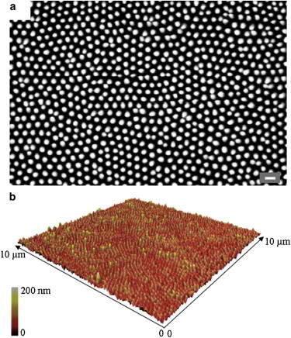

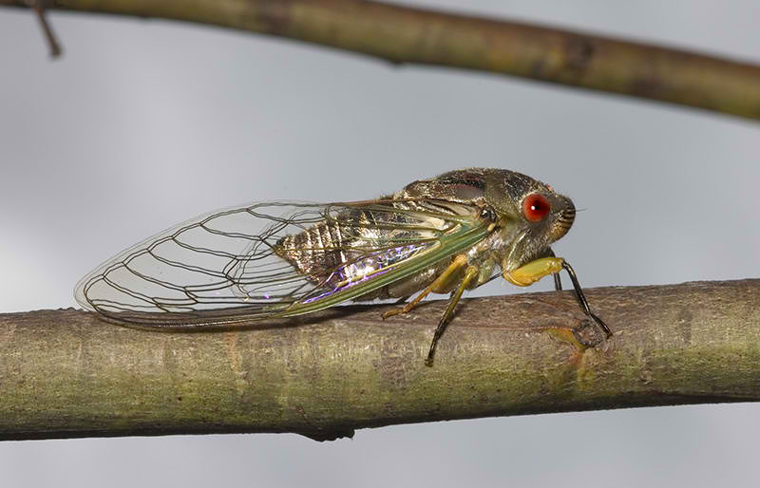
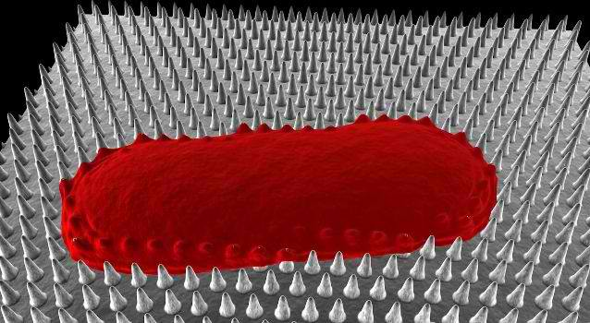
A combined team of researchers from Spain and Australia has discovered what they claim is the first known instance of a biomaterial that can kill bacteria on contact based only its physical surface structure. In their paper published in Biophysical Journal, the team describes how they found that clanger cicadas have nanoscale sized pillars on their wings that trap and slowly kill bacteria by pulling their cells apart. Under a microscope, the team reports, the wings of the clanger cicada show a landscape hostile to bacteria—vast arrays of blunted spikes. When bacteria land on the spikes, they don't pop, as might be expected, instead, they stick and are slowly torn apart as their cell skin descends to the wing surface between the spikes. It works because at least some bacteria have elastic skin. It's similar to a water balloon landing on a bed of blunt nails. The nails aren't sharp enough to pierce the balloon's skin, but over time, as the weight of the water inside the balloon pushes the skin between the spikes, causing it to stretch, tears eventually develop, causing the balloon to deflate, or in the case of the bacteria on the cicada's wing, death. To make sure they understood what was actually going on with the cicada's wings and the bacteria that landed on them, the researchers cooked some bacteria in a microwave to cause different degrees of elasticity in their skin. Those specimens were then dropped onto a cicada wing surface to see what would happen—unsurprisingly, those that were more elastic were torn apart, while those that were more rigid, were not. It's the first time anyone's seen a living organism fend off bacteria using nothing more than the shape of their biomaterial. Such a finding is of course exciting to those that study infectious microorganisms, and perhaps to everyone else as it may lead to the development of materials that could be used to perform the same action for us, though not as an extension of our own bodies of course. Coverings could be made for countertops, doorknobs or hand rails, etc., to kill bacteria and/or viruses on contact without having to resort to polluting bioagents.

Abstract
The nanopattern on the surface of Clanger cicada (Psaltoda claripennis) wings represents the first example of a new class of biomaterials that can kill bacteria on contact based solely on their physical surface structure. The wings provide a model for the development of novel functional surfaces that possess an increased resistance to bacterial contamination and infection. We propose a biophysical model of the interactions between bacterial cells and cicada wing surface structures, and show that mechanical properties, in particular cell rigidity, are key factors in determining bacterial resistance/sensitivity to the bactericidal nature of the wing surface. We confirmed this experimentally by decreasing the rigidity of surface-resistant strains through microwave irradiation of the cells, which renders them susceptible to the wing effects. Our findings demonstrate the potential benefits of incorporating cicada wing nanopatterns into the design of antibacterial nanomaterials.
Biophysical Model of Bacterial Cell Interactions with Nanopatterned Cicada Wing Surfaces, Biophysical Journal, Volume 104, Issue 4, 835-840, 19 February 2013

The GIDEON web application
Source: http://www.gideononline.com/about/gideon/

GIDEON is the world’s premier global infectious disease knowledge management tool. GIDEON (Global Infectious Diseases and Epidemiology Online Network) is an easy to use, interactive and comprehensive web based tool that helps you overcome information overload while saving you time through quick access to a vast knowledge database. GIDEON is used for diagnosis and reference in the fields of tropical and infectious diseases, epidemiology, microbiology and antimicrobial chemotherapy. It complements the GIDEON ebook series.

Content
GIDEON consists of three modules, which are continually updated: Infectious Diseases, Microbiology and Occupational Toxicology. The Infectious Diseases module encompasses over 340 infectious diseases, 231 countries, over 500 anti-infective drugs and vaccines. Microbiology includes more than 1,500 microbial taxa (bacteria, mycobacteria, yeasts); and Toxicology over 3,000 toxic agents.
GIDEON’s worldwide data sources essentially include the entire world’s literature and adhere to the standards of Evidence Based Medicine. Over 19,000 notes with three million words of text outline the status of specific infections within each country. Also featured are over 5,000 images, 30,000 graphs, 347 interactive maps and more than 150,000 linked references.

Users
GIDEON is used in hospitals, universities (colleges and medical schools), private practice, public health departments and military installations – by physicians (emergency room, internal medicine, pediatrics, hospitalists), teachers, clinical microbiologists and health professionals. It is an ideal teaching tool for biology, public health and medical students, residents and fellows.

Accuracy
In a blinded multi-center field trial of 495 patients, the correct diagnosis was displayed in over 94% of cases, and was listed first in over 75%. GIDEON has been reviewed in numerous journals and is continually updated to maintain accuracy.

Requirements
GIDEON web requirements:
- Latest version of browser, including Mobile devices
GIDEON is supported through subscriptions and does not accept advertising.

Antimicrobial resistance poses “catastrophic threat” to mankind
Source: http://www.homelandsecuritynewswire.com/dr20130312-antimicrobial-resistance-poses-catastrophic-threat-to-mankind?page=0,1

The U.K. Department of Health says that global action is needed to tackle the catastrophic threat of antimicrobial resistance, which in twenty years could see any one of us dying following minor surgery, England’s Chief Medical Officer Professor Dame Sally Davies said yesterday.
This stark warning comes as the second volume of the Chief Medical Officer’s annual report is published, providing a comprehensive overview of the threat of antimicrobial resistance and infectious diseases.
Calling for politicians to treat the threat as seriously as MRSA, the report highlights a “discovery void” with few new antibiotics developed in the past two decades. It highlights that, while a new infectious disease has been discovered nearly every year over the past thirty years, there have been very few new antibiotics developed leaving our armory nearly empty as diseases evolve and become resistant to existing drugs.
A U.K. Department of Health release reports that in addition to encouraging development of new drugs, the report highlights that looking after the current arsenal of antibiotics is equally important. This means using better hygiene measures to prevent infections, prescribing fewer antibiotics and making sure they are only prescribed when needed.
The Chief Medical Officer also states that more action is needed to tackle the next generation of healthcare associated infections, including new strains of pneumonia-causing klebsiella, which will be harder to treat.
Some seventeen recommendations are made as part of the report, including:
- A call for antimicrobial resistance to be put on the national risk register and taken seriously by politicians at an international level, including the G8 and World Health Organization
- Better surveillance data across the NHS and world-wide to monitor the developing situation
- More work carried out between the healthcare and pharmaceutical industries to preserve existing drugs and encourage the development of new antibiotics to fill the “discovery void” of the last twenty years
- Building on the success of the NHS in cutting MRSA rates, which have fallen by 80 percent since a peak in cases in 2003 through better hygiene measures, which should be used when treating the next generation of healthcare associated infections such as new strains of harder-to-treat klebsiella.
Professor Dame Sally Davies said:
Antimicrobial resistance poses a catastrophic threat. If we don’t act now, any one of us could go into hospital in twenty years for minor surgery and die because of an ordinary infection that can’t be treated by antibiotics. And routine operations like hip replacements or organ transplants could be deadly because of the risk of infection.
That’s why governments and organizations across the world, including the World Health Organization and G8, need to take this seriously.
This is not just about government action. We need to encourage more innovation in the development of antibiotics — over the past two decades there has been a discovery void around antibiotics, meaning diseases have evolved faster than the drugs to treat them.
In some areas, like cutting rates of drug resistant MRSA, the NHS is already making good progress so it’s important that we use that knowledge across the system and I hope my recommendations will prompt people to do that.
The Department of Health will soon publish the U.K. Antimicrobial Resistance Strategy setting out how it will meet the challenge that the Chief Medical Officer has outlined (see a British Medical Journal preview of the plan).
The five-year U.K. Antimicrobial Resistance Strategy and Action Plan will:
- Champion the responsible use of antibiotics — by ensuring NHS staff have the skills, knowledge and training to prescribe and administer antibiotics appropriately. Part of this will include reviewing and updating the curricula for medical undergraduates
- Strengthen surveillance — by improving the recording of data on the numbers of antibiotics prescribed and trends in antibiotic resistance, this information can used by clinicians to change patterns of prescribing. This will help reduce the level of resistance and help ensure patients respond to treatments
- Encourage the development of new diagnostics, therapeutics and antibiotics, for example by continuing to support the Innovative Medicines Initiative (IMI) and other initiatives that encourage scientific research.
The Chief Medical Officer’s wide-ranging report makes several further recommendations on tackling antimicrobial resistance, including:
- New infection control measures should go beyond hospitals and be applied to home and community care settings
- The national approach to tackling antimicrobial resistance should not just focus on humans and the risk of antimicrobial resistance in animals should be managed closely by the Department for Food, Environment and Rural Affairs
- Public Health England should work closely with the NHS Commissioning Board to make sure that advanced testing facilities are available to treat infections brought into the country from abroad
- Further promotion of the benefits of vaccination and encouragement of vaccine uptake during pregnancy to prevent diseases such as flu and whooping cough should be undertaken
- Directors of Public Health should work with schools to ensure the school nursing system is well-placed to deliver new immunization programs
Note that the U.S. Centers for Disease Control and Prevention (CDC) last Tuesday also sounded the alarm about the growing threat of antibiotic-resistant superbugs. Addressing the cost implications of the antibiotic-resistant superbug threat, Richard Smith and Joanna Coast write in Monday’s British Medical Journal:
…The costs of resistance could be much higher than (existing) estimates (of $55 billion per year in the US) suggest. As an example we estimated the consequences of having no antibiotics for patients having a total hip replacement. Because antibiotics have been used as prophylaxis and treatment for hospital-acquired infection since hip replacements were first performed, we looked at information relating to limb amputation, as a proxy for what infection rates might have been with and without antimicrobials.
…Currently, prophylaxis is standard practice, and infection rates are about 0.5-2%, so most patients recover without infection, and those who get an infection have it successfully treated. We estimate that without antimicrobials, the rate of postoperative infection is 40-50% and about 30% of those with an infection will die. Thus, removal of antibiotics would increase postoperative infection by 1-50% and deaths by 0-30%.

— Read more in U.K. Department of Health, Annual Report of the Chief Medical Officer, vol. 2, Infections and the rise of antimicrobial resistance; Anthony S. Kessel and Mike Sharland, “The new UK antimicrobial resistance strategy and action plan: A major societal, political, clinical, and research challenge,” British Medical Journal (11 March 2013) (doi: 10.1136/bmj.f1601);and Richard Smith and Joanna Coast, “The true cost of antimicrobial resistance,” British Medical Journal (11 March 2013)

Wary of Attack With Smallpox, U.S. Buys Up a Costly Drug
Source: http://www.nytimes.com/2013/03/13/health/us-stockpiles-smallpox-drug-in-case-of-bioterror-attack.html?pagewanted=all&_r=0

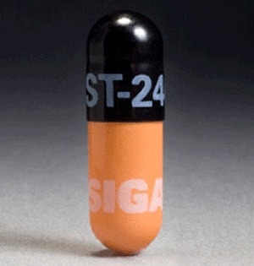
The United States government is buying enough of a new smallpox medicine to treat two million people in the event of a bioterrorism attack, and took delivery of the first shipment of it last week. But the purchase has set off a debate about the lucrative contract, with some experts saying the government is buying too much of the drug at too high a price.
A small company, Siga Technologies, developed the drug in recent years. Whether the $463 million order is a boondoggle or a bargain depends on which expert is talking. The deal will transform the finances of Siga, which is controlled by Ronald O. Perelman, a billionaire financier, philanthropist and takeover specialist.
Smallpox was eradicated by 1980, and the only known remaining virus is in government laboratories in the United States and Russia. But there have long been rumors of renegade stocks that could be sprayed in airports or sports stadiums. Experts say the virus could also be re-engineered into existence in a sophisticated genetics lab.
As part of its efforts to prepare for a possible bioterrorism attack, the government is paying more than $200 for each course of treatment.
Siga argues that the price is a fair return on years of investment. And Robin Robinson, director of the Biomedical Advanced Research and Development Authority, part of the Department of Health and Human Services, the overseer of the contract for the drug, Arestvyr, defended the size of the order and the price paid. He said that two million doses was the amount analysts predicted would be needed to contain a smallpox outbreak in a large city and that the whole country would require 12 million, along with vaccines.
The price, he said, was arrived at through federal purchasing guidelines and was “fair and reasonable” compared with the price of other commercial antiviral drugs, which he said ranged from $108 to $7,364.
But when stockpiling a smallpox drug was first proposed in 2001 after the Sept. 11 and anthrax attacks, it was expected to cost only $5 to $10 per course, said Dr. Donald A. Henderson, who led a government advisory panel on biodefense in the wake of those attacks. Dr. Henderson was a leader in the eradication of smallpox in the 1960s and is now at the Center for Biosecurity at the University of Pittsburgh Medical Center.
Dr. Richard H. Ebright, a bioweapons expert at Rutgers University, said there was little need for so much Arestvyr since the country has raised its stockpile of smallpox vaccine to 300 million doses now, up from only 15 million in 2001.
“Is it appropriate to stockpile it? Absolutely,” he said. “Is it appropriate to stockpile two million doses? Absolutely not. Twenty thousand seems like the right number.”
Vaccines are normally given before an infection to prevent a disease, while antivirals like Arestvyr are given after virus infections, to treat them. Smallpox has such a long incubation period that the vaccine can prevent disease even if it is given as late as three days after infection. Arestvyr may also prevent infection if given early enough, but that has not been proven.
Dr. Eric A. Rose, the president of Siga and a vice president of Mr. Perelman’s holding company, MacAndrews & Forbes, acknowledged that the drug cost little to make, but said the price being charged for a patented drug was a bargain compared with AIDS antiretrovirals that cost $20,000 a year and cancer drugs that cost more than $100,000 a year.
Asked about the size of the purchase, he compared it with a flu drug. “There are 80 million courses of Tamiflu in the strategic national stockpile,” he said. “Smallpox is just as contagious and has 30 times the mortality. By measures like that, I’d say 2 million is on the low end.”
He also said that Mr. Perelman had invested $80 million in the company through years of research with no sales. Without a profit potential, no company would take up smallpox, Ebola and other lethal but very rare diseases, he said.
And Dr. Isaac B. Weisfuse, who was formerly head of pandemic planning for the New York City health department and is now Siga’s medical policy director, said that plans calling for tens of million Americans to be vaccinated within days of a major smallpox outbreak were unrealistic and that Arestvyr could save lives.
Arestvyr — which until November was known as ST-246 or tecovirimat — prevents the virus from forming the double outer envelope that lets it break out of the first cells it infects and spread throughout the body. A 14-day course can be taken in combination with smallpox vaccine, offering double protection, which Dr. Henderson called “quite amazing.”
Arestvyr is not approved by the Food and Drug Administration except for use in emergencies.
It has never been tested on smallpox in humans because the disease was eradicated. However, it has prevented death in dozens of monkeys injected with what would normally have been lethal doses of smallpox or a related virus, monkey pox.
It also appears to have helped several humans suffering from potentially lethal reactions to smallpox vaccine, which is itself a live smallpox-related virus but is normally harmless. They included a child near death after catching his father’s vaccination virus, a soldier vaccinated just before discovering he had leukemia, and a woman whose immune system was suppressed by steroids and who was infected by touching bait meant for raccoons that contained a combined rabies/smallpox vaccine.
However, those patients were also given immune globulin, other drugs and hospital care, so it is hard to know exactly what worked.
Bioterrorism experts say the need for Arestvyr has declined since the United States increased its stockpile of smallpox vaccine, which was once given to people routinely before the disease was brought under control, including a less potent but less risky backup vaccine for those who cannot tolerate the standard one.
The word “smallpox” still strikes fear. John Grabenstein, a retired colonel and a top biodefense adviser to the Defense Department after the 2001 attacks, recalled reports of refrigerated Soviet warheads loaded with the virus that could, in theory, aerosolize it over large areas. Others have envisioned a few infected terrorists mingling in crowds.
Left untreated, smallpox kills a third of victims. But prominent experts say the danger is overblown. Because it can take up to two weeks before an infected person becomes seriously ill, and up to five more days before he or she begins to infect others, there is time to respond, they said.
Also, they said, by the time smallpox victims reach the infectious stage, when their pox are erupting, they are too sick to wander around. That is why outbreaks in schools or factories were nearly unheard of.
Smallpox was eradicated by “ring vaccination” — finding each case and vaccinating just the 50 to 200 people closest to it.
If there were a lage-scale bioterrorism attack using smallpox, health officials could move quickly, some experts say.
“If we had to, we could vaccinate the entire country in three days,” said Dr. William H. Foege, another leader of the smallpox eradication effort who now advises the Bill & Melinda Gates Foundation. This vaccine does not use a syringe, but a forked pin that Dr. Foege said he could “train anyone to use in 10 minutes.” In a true emergency, he argued, schoolteachers, police officers, firefighters and others would all be vaccinators.
Other experts think that is overoptimistic, since an attack would cause panic.
Also, Dr. Rose of Siga pointed out, there are only an estimated 700 million doses of smallpox vaccine in a world of 7 billion people, so the United States might use its vaccine and Arestvyr stockpile to help other countries. (Only the United States, Japan and Israel are believed to have enough doses for their entire populations, experts said.)
Dr. Henderson and Dr. Philip Russell, who formerly headed the Walter Reed Army Institute of Research and served on the advisory panel with him, said they expected the government to pay much less for an antiviral drug since they cost little to make and the alternative, vaccines, cost the government $3 a dose. “If they’re talking $250 a course, they’re a bunch of thieves,” Dr. Russell said.
Other experts, like Dr. Grabenstein, said that since the drugs have no other use, they are like aircraft carriers: to entice companies to make them, the government has to pay all the costs plus guarantee the producer a profit — and that it might be prudent to have extras on hand.
Mr. Perelman’s company, MacAndrews & Forbes, has spent more than $1 million lobbying each year since 2008, according to the Center for Responsive Politics, a watchdog group. A spokeswoman for the company, Christine Taylor, said it had done “absolutely no lobbying” for the Siga contract.

Yale researchers trick bacteria to deliver a safer vaccine
Source: http://news.yale.edu/2013/03/12/yale-researchers-trick-bacteria-deliver-safer-vaccine

Vaccines that employ weakened but live pathogens to trigger immune responses have inherent safety issues but Yale researchers have developed a new trick to circumvent the problem — using bacteria’s own cellular mistakes to deliver a safe vaccine.
The findings, published online March 12 in Nature Communications, suggest new ways to create novel vaccines that effectively combat disease but can be tolerated by children, the elderly, and the immune-compromised who might be harmed by live vaccines.

This rendering is of the molecular machine that helps bacteria infect cells. Yale researchers have learned how to use it to trigger immune responses.

“We have managed to assemble a functional protein-injection machine within bacterial mini-cells, and the amazing thing is that it works,” said Jorge Galan, senior author of the paper and the Lucille P. Markey Professor of Microbial Pathogenesis and chair of the Section of Microbial Pathogenesis at Yale.
Galan’s team has assembled the molecular machine used by Salmonella to cause food poisoning or typhoid fever. Scientists have been successful in modifying this protein injection machine to trigger a protective immune response against a variety of infectious diseases. However, it has been necessary to use modified or virulence-attenuated bacteria that carry this machine.
The new trick exploits a mutation that causes bacteria to create “mini-cells” when they improperly divide. Mini-cells contain no DNA and, therefore, are not pathogenic and extremely safe. Galan’s team was able to assemble the protein-injection machines within these bacterial cells, which when administered to mice, deliver antigens that trigger an immune response without causing an infection.
The system could be used to combat cancer as well as a wide variety of infectious diseases, Galan said.
Heather A. Carleton is lead author of the paper. Other Yale authors include Maria Lara-Tejero and Xiaoyun Liu.
The research was funded by the National Institutes of Health.

Engineering the type III secretion system in non-replicating bacterial minicells for antigen delivery
Source: http://www.nature.com/ncomms/journal/v4/n3/full/ncomms2594.html

Abstract
Type III protein secretion systems are being considered for vaccine development as virtually any protein antigen can be engineered for delivery by these nanomachines into the class I antigen presentation pathway to stimulate antigen-specific CD8⁺ T cells. A limitation in the use of this system is that it requires live virulence-attenuated bacteria, which may preclude its use in certain populations such as children and the immunocompromised. Here we report the engineering of the Salmonella Typhimurium type III secretion system in achromosomal, non-replicating nanoparticles derived from bacterial minicells. The engineered system is shown to be functional and capable of delivering heterologous antigens to the class I antigen presentation pathway stimulating immune responses both in vitro and in vivo. This antigen delivery platform offers a novel approach for vaccine development and cellular immunotherapy.
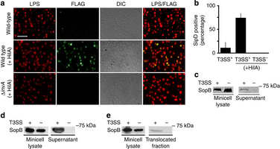
(a,b) Detection of the needle complex tip protein SipD on the surface of purified minicells. Minicells were isolated from wild-type or T3SS-defective (ΔinvA) S. Typhimurium strains expressing SipD-FLAG and carrying a plasmid expressing the…

Nature Communications 4, Article number: 1590

NIH Study Sheds Light on Role of Climate in Influenza Transmission
Source:http://www.domesticpreparedness.com/Government/Government_Updates/NIH_Study_Sheds_Light_on_Role_of_Climate_in_Influenza_Transmission/

Two types of environmental conditions — cold-dry and humid-rainy — are associated with seasonal influenza epidemics, according to an epidemiological study led by researchers at the National Institutes of Health’s Fogarty International Center. The paper, published in PLoS Pathogens, presents a simple climate-based model that maps influenza activity globally and accounts for the diverse range of seasonal patterns observed across temperate, subtropical and tropical regions.
The findings could be used to improve existing current influenza transmission models, and could help target surveillance efforts and optimize the timing of seasonal vaccine delivery, according to Fogarty researcher Cecile Viboud, Ph.D., who headed the study. “The model could have a broader application, encouraging researchers to analyze the association between climatic patterns and infectious disease across a wide range of diseases and latitudes,” said Viboud.
Human influenza infections exhibit a strong seasonal cycle in temperate regions, and laboratory experiments suggest that low specific humidity facilitates the airborne survival and transmission of the virus in temperate regions. Specific humidity is the ratio of water vapor to dry air in a particular body of air while relative humidity — commonly used in weather forecasts — the amount of water vapor in the air relative to its capacity to hold water vapor, and is primarily a function of temperature.
Data from animal studies indicate low temperature and humidity increase the duration of the virus’s reproduction and expulsion in infected organisms and virus stability in the environment, increasing the probability of transmission through coughing, sneezing or breathing. In contrast, high temperature seems to block airborne transmission.
According to James Tamerius, Ph.D., a geographer at Columbia University, New York City, and the first author of the study, the effect of low specific humidity on influenza could cause annual winter epidemics in temperate areas. “However, this relationship is unlikely to account for the epidemiology of influenza in tropical and subtropical regions where epidemics often occur during the rainy season or transmit year-round without a well-defined season,” he said.
After assessing the role of local climatic variables on virus seasonality in a global sample of study sites, Viboud and her colleagues found that temperature and specific humidity were the best individual predictors of the months of maximum influenza activity, known as influenza peaks. The team discovered that in temperate regions, influenza was more common one month after periods of minimum specific humidity. These periods happen to coincide with months of lowest temperature. In contrast, sites that maintained high levels of specific humidity and temperature were generally characterized by influenza epidemics during the most humid and rainy months of the year. “The models we used predicted the timing of peak influenza activity with 75 to 87 percent accuracy,” said Viboud.
"Anecdotal evidence suggests that colder climates have winter flu while warmer climates that experience major fluctuations in precipitation have flu epidemics during the rainy season, and the current study fits that pattern,” said Viboud. “In contrast, the seasonality of influenza is less well-defined in locations with little variation in temperature and precipitation, and is a pattern that remains poorly understood. One hypothesis that is often used to explain tropical influenza activity is that people congregate indoors more frequently during the rainy season, increasing contact rates and disease transmission. There is little data to confirm this, however, and it’s an interesting area for future research."
To reach these conclusions, the researchers used a recently developed global database that provides information on influenza peaks from 1975-2008 for 78 sites worldwide. The study spanned a range of latitude that was between 1 and 60 degrees, with 39 percent of the sites located in the tropics. Additionally, epidemiological data from nine countries participating in FluNet, the World Health Organization’s global influenza surveillance program, was used to ensure independent validation. The nine countries—including Spain, Tunisia, Senegal, Philippines, Vietnam, Colombia, Paraguay, South Africa and Argentina— were not represented in the original 78-location database and were chosen because each country provided several years of data.
“We’ve shown the importance of thresholds in humidity and temperature which are predictive of whether influenza activity occurs during winter months, the rainy season or throughout the year,” said Viboud. “The predictions of our climate-based models compared favorably to epidemiological information collected independently of the dataset used for the model-building exercise.”
Though the study offers researchers a new tool in the global effort to track the spread of influenza, climate is only one of several potential drivers of influenza seasonality. “Further work should focus on examining the role of population travel and other factors in influenza transmission,” notes Mark Miller, M.D., director of Fogarty’s Division of International Epidemiology and Population Studies. ”
More broadly, additional analysis of the link between climate and infectious diseases is needed— particularly for respiratory and intestinal pathogens that display marked seasonality.” The authors conclude, “A better understanding of the environmental, demographic and social drivers of infectious disease seasonality is crucial for improving transmission models and optimizing interventions.”

Unearthed after seven centuries the 'Black Death' pit skeletons that could unravel the mystery of what caused the plague
Source: http://www.independent.co.uk/news/uk/home-news/unearthed-after-seven-centuries-the-black-death-pit-skeletons-that-could-unravel-the-mystery-of-what-caused-the-plague-8535591.html

For seven centuries they have lain beneath the feet of commuters in one of the busiest parts of central London.
Thirteen skeletons, lying in two neat rows, 2.4m beneath a road in Farringdon, have been unearthed by excavations for London's Crossrail project.
The remains, which were found in a 5.5m-wide shaft at the edge of Charterhouse Square in Farringdon, are thought to be victims of The Black Death.
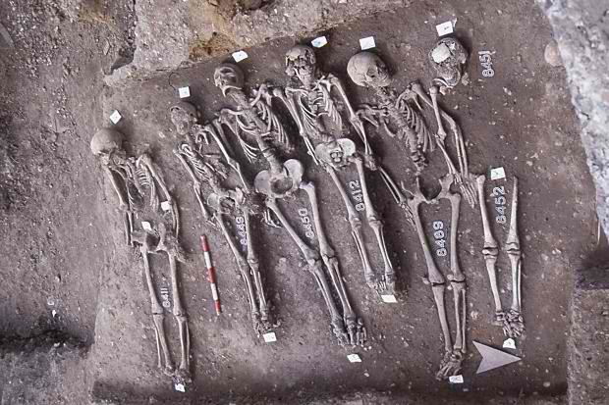
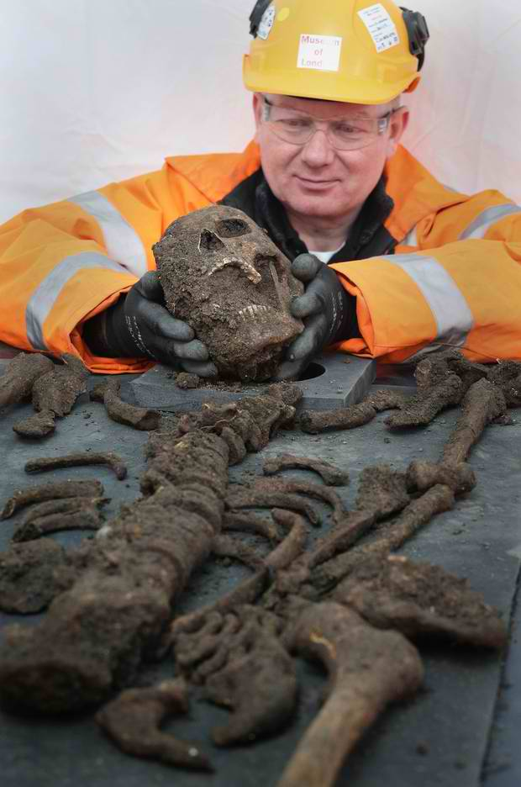
Builders working on the £15bn Crossrail project uncovered the bodies alongside pottery dating from the mid-14th Century.
Experts believe that the skeletons' arrangement in two neat rows suggests they date from the earlier period of the plague, before it became a pandemic and before bodies were thrown randomly into mass graves.
Scientists now hope that analysis could shed some light on the virus or bacterium that led to the Black Death.
The skeletons were discovered in an area of London where experts believe many more bodies were buried.
John Stow, the 16th century historian, wrote in his 1598 Survey of London that 50,000 bodies were buried in what was then "no man's land".
Although that number is now widely believed to have been an exaggeration, the discovery of further remains has not been ruled out.
Nick Elsden from Museum of London Archaeology (MOLA) says that further discoveries are likely.
"The short answer is we don't know just how many skeletons are out there," he said.
Tests will be carried out on the skeletons but experts are linking the discovery with the Black Death as it is known that a burial ground for plague victims was opened in the Farringdon area.
A similar skeleton formation was found in a Black Death burial site in nearby east Smithfield in the 1980s. The skeletons are being carefully excavated and taken to MOLA for testing.
But Mr Elsden was quick to reassure the public that there was no longer any health risk from the plague which killed over a quarter of the British population in 1348.
"It's not something that stays in the soil. You have to actually meet someone who has it in order to catch it."
The bodies are not the first to have been uncovered by the Crossrail excavations.
Archaeologists have already uncovered more than 300 skeletons near Liverpool Street station.
Up to 4,000 skeletons dating from the 17th-19th centuries are expected to be found in the Bethlem "Bedlam" hospital burial ground, which is the site of of Liverpool Street's new stations.
At a Canary Wharf site builders also discovered 68,000-year-old mammoth bones.
The discovery of so many skeletons has led the Museum of London to admit that storage is becoming a problem.
Crossrail lead archaeologist Jay Carver said: "This is a highly significant discovery and at the moment we are left with many questions that we hope to answer.
"We will be undertaking scientific tests on the skeletons over the coming months to establish their cause of death, whether they were plague victims from the 14th century or later residents, how old they were and perhaps evidence of who they were.
"However, at this early stage... all points towards this being part of the 14th century emergency burial ground."
He added: "The general assumption about human exhumation is that they should stay in the ground. There is normally no justification for digging up skeletons except for important research like this, but we now have our sample."
Scientists are hoping to map the DNA signature of the plague virus and possibly contribute to the discussion regarding what virus caused the Black Death.
It is also hoped that the research could help combat modern day diseases.
"Many biologists are researching ancient diseases in the hope of better understanding the modern ones," said Mr Carver.
Around 75 million people globally, and up to 60% of the European population, perished during the Black Death which was one of the most devastating pandemics in human history.
It lasted between 1348 and 1350 and killed around 1.5 million Britons.

2012 Combat Casualty Care
Source: http://www.cs.amedd.army.mil/borden/book/ccc/CCCFull.pdf

Preface
To enhance combat casualty care (CCC) pre-deployment education for all healthcare providers, this contemporary educational program was developed through the Small Business Innovative Research Program in partnership with civilian industry and the Office of the Secretary of Defense for Health Affairs.
This military medicine textbook is designed to deliver CCC information that will facilitate transition from a continental United States (CONUS) or civilian practice to the combat care environment. Establishment of the Joint Theater Trauma System (JTTS) and the Joint Theater Trauma Registry (JTTR), coupled with the efforts of the authors, has resulted in the creation of the most comprehensive, evidence-based depiction of the latest advances in CCC.
Lessons learned in Operation Enduring Freedom (OEF) and Operation Iraqi Freedom (OIF) have been fortified with evidence-based recommendations with the intent of improving casualty care. The chapters specifically discuss differences between CCC and civilian sector care, particularly in the scheme of “echelonized” care. Overall, the educational curriculum was designed to address the leading causes of preventable death and disability in OEF and OIF. Specifically, the generalist CCC provider is presented requisite information for optimal care of US combat casualties in the first 72 to 96 hours after injury.
The specialist CCC provider is afforded similar information, which is supplemented by lessons learned for definitive care of host nation patients.
These thirteen peer-reviewed and well-referenced chapters were authored by military subject matter experts with extensive hands-on experience providing CCC during the course of OEF and OIF, and were edited by an experienced team of physicians and research methodologists. Together they will provide readers with a solid understanding of the latest advances in OEF and OIF CCC. This information provides an excellent supplement to pre-deployment CCC training and education. Ideally, readers will aptly apply the newly acquired knowledge toward improving CCC.

Eric Savitsky, MD
UCLA Professor of Emergency Medicine/Pediatric Emergency Medicine Executive Director, UCLA Center for International Medicine
Director, UCLA EMC Trauma Services and Education Los Angeles, CA
June 2011

Mankind is still at risk of the plague
Source: http://www.homelandsecuritynewswire.com/dr20130318-mankind-is-still-at-risk-of-the-plague

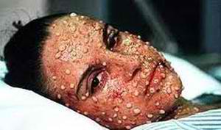
The plague has affected global population levels, with around seventy-five million people perishing during the fourteenth century’s Black Death. A new study finds that a number of factors show we are still at risk of plague today. The study also provides lessons for how best to control the plague.
The other day archaeologists unearthed a Black Death grave in London, containing more than a dozen skeletons of people suspected to have died from the plague. The victims are thought to have died during the fourteenth century and archaeologists anticipate finding many more as they excavate the site.
The Plague is by definition a re-emerging infectious disease which affects the lungs and is highly contagious, leading to mass outbreaks across populations. An Elsevier release reports that history shows us that population levels suffered globally due to the plague, with around seventy-five million people globally perishing during the fourteenth century Black Death.
This study, published in Infection, Genetics and Evolution, analyzed the Great Plague of Marseille, which caused 100,000 deaths between 1720 and 1723. The researchers aimed to highlight issues we are facing with infectious diseases today, identify the best ways to respond to epidemics, and whether we are still at risk of the plague re-emerging again.
Results show that a number of factors show we are still at risk of plague today. This is largely due to transport trade and novel threats in developing countries where multi-drug resistant pathogens are currently emerging and spreading rapidly. This genetic change has also contributed to a development in the way the bacteria infect new hosts meaning they can now live in mammalian blood.
The study also highlighted the need for effective management of epidemics in future. Fear of in infection can have a negative impact on a population’s economic situation due to a significant loss of tourism, and widespread panic. History has shown us that providing the necessary information about diseases and improving the management of epidemics are vital steps for avoiding panic and containing diseases.

— Read more in Christian A. Devaux, “Small oversights that led to the Great Plague of Marseille (1720-1723): Lessons from the past,” Infection, Genetics and Evolution 14 (March 2013): 169-85

Abstract
In recent decades, the issue of emerging and re-emerging infectious diseases has become an increasingly important area of concern in public health. Today, like centuries ago, infectious diseases confront us with the fear of death and have heavily influenced social behaviors and policy decisions at local, national and international levels.
Remarkably, an infectious disease such as plague, which is disseminated from one country to another mainly by commercial transportation, remains today, as it was in the distant past, a threat for human societies. Throughout history, plague outbreaks prevailed on numerous occasions in Mediterranean harbors, including Marseille in the south of France. A few months ago, the municipal authorities of the city of Marseille, announced the archaeological discovery of the last remnants of a “lazaretto” or “lazaret” (, March 3th, 2012), a place equipped with an infirmary and destined to isolate ship passengers quarantined for health reasons. More recently, on September 16th, 2012, the anchor of the ship “Grand Saint Antoine” responsible for bringing the plague to Marseille in 1720, was recovered and it will be restored before being presented to the public in 2013 ().
In the light of these recent archaeological discoveries, it is quite instructive to revisit the sequence of events and decisions that led to the outbreak of the Great Plague of Marseille between 1720 and 1723. It comes to the evidence that although the threat was known and health surveillance existed with quite effective preventive measures such as quarantine, the accumulation of small negligence led to one of the worst epidemics in the city (about 30% of casualties among the inhabitants). This is an excellent model to illustrate the issues we are facing with emerging and re-emerging infectious diseases today and to define how to improve bio-surveillance and response tomorrow. Importantly, the risk of plague dissemination by transport trade is negligible between developed countries; however, this risk still persists in developing countries. In addition, the emergence of antibiotic resistant strains of Yersinia pestis, the infectious agent of plague, is raising serious concerns for public health.

New, drug-resistant pandemic swine flu may go global
Source: http://www.homelandsecuritynewswire.com/dr20130319-new-drugresistant-pandemic-swine-flu-may-go-global
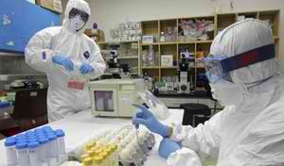

Health experts in Australia have expressed concerned about the threat of a new type of drug-resistant pandemic flu which is circulating in the population at large.
These experts say that the new strain of swine flu has learned how to dodge the antiviral Tamiflu and while rare, is now spreading outside of hospitals.
The BBC reports that the research team which examined the virus say it is “fitter” than other drug-resistant strains, and thus more dangerous.
The BBC notes that U.K. experts have also said the have come across a few similar cases.
The UK’s Health Protection Agency said it would be closely monitoring the situation.
The research team presented its findings at the Annual Scientific Meeting of the Australasian Society for Infectious Diseases. The researchers described how the H1N1pdm09 swine flu virus is still sensitive to another antiviral drug Relenza (zanamivir) – b thatut Tamiflu (oseltamivir) is now powerless against the strain.
The researchers noted that the virus was found in people in the community rather than sick patients, especially people with serious underlying conditions and weak immune systems.
Lead investigator Dr. Aeron Hurt, from the World Health Organization Collaborating Center for Reference and Research on Influenza in Melbourne, said: “The greatest concern is that these resistant viruses could spread globally, similar to that seen in 2008 when the former seasonal H1N1 virus developed oseltamivir resistance and spread worldwide in less than 12 months.”
Another worrisome aspect of the new strain is that it was found to emerge among people who have never been treated with Tamiflu, which suggests it is very good at spreading from person to person.
The Tamiflu-resistant strain is relatively rare still, but Dr. Hurt is concerned that it has the potential to turn global.
“The widespread transmission and circulation of oseltamivir-resistant H1N1pdm09 viruses remains a risk in the future.
“Close monitoring of resistant viruses in both treated and community patients remain important.”
The U.K.’s HPA has recorded eight cases of oseltamivir-resistant H1N1pdm09 in the community setting.
The HPA’s head of flu surveillance Dr. Richard Pebody said: “While the frequency of oseltamivir resistance in community settings has increased slightly since the 2009-10 pandemic from 1-2% in the 2012/13 flu season, rates of detection remain low.”

Bioethics Panel Warns Against Anthrax Vaccine Testing On Kids
By Rob Stein
Source: http://www.northcountrypublicradio.org/news/npr/174550155/bioethics-panel-warns-against-anthrax-vaccine-testing-on-kids

Anthrax has long been considered one of the most likely weapons a bioterrorist might use. Some researchers think the vaccine should be tested on children to find out if it would be safe to use in an attack. But a presidential bioethics commission says that first, researchers will have to show that children would face no more than "minimal risk."
A controversial government proposal to test the anthrax vaccine in children would be unethical without first conducting much more research, a presidential commission concluded Tuesday.
"The federal government would have to take multiple steps before anthrax vaccine trials with children could be ethically considered," Amy Gutmann, who chairs the Presidential Commission for the Study of Bioethical Issues, tells Shots. "It would not be ethical to do it today."
Health and Human Services Secretary Kathleen Sebelius asked the 13-member commission to review the possible medical experiment after critics raised questions about whether it would be ethical. They questioned whether the risks of the testing were necessary given that an anthrax attack may never happen.
"This assignment was one of the most difficult that any bioethics commission has been given," Gutmann says.
Anthrax has long been considered one of the most likely weapons a bioterrorist might use. It's relatively easy to make and spew over a large area. And the toxins produced by anthrax spores can be deadly, especially if inhaled.
"We want to make sure we're taking care of the kids," says Daniel Fagbuyi of the Children's National Medical Center, who chaired a federal panel that started the push to study the anthrax vaccine in kids.
The vaccine's been given to more than 1 million adults in the military, but no one knows how well it would work in children.
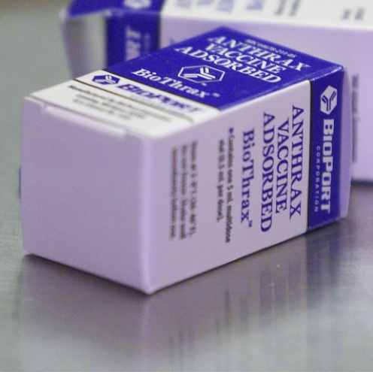
"We want to know what we're doing to them. Does this really work? And how does it work? What's the body's immune response to it? Those are the types of things that we need to glean," Fagbuyi says.
But other experts are skeptical. They wonder whether it's worth exposing kids to the vaccine for a theoretical risk, which means they won't directly benefit. So Sebelius asked the commission to vet the proposal.
"There is something to be gained by going ahead with research on children. There is a common good to be gained in being prepared," Gutmann says.
But Gutmann says that has to be weighed against an important principle.
"We have a long-standing ethical requirement in this country that children not be used merely as means for the public good," Gutmann says.
So after holding hearings and picking apart the scientific and ethical nuances, the commission outlined a series of steps researchers would have to take before any testing on children would be ethical.
Those steps would have to include research to convincingly show that children would face no more than "minimal risk." Gutmann defines that as the "level that a child routinely encounters in daily life for a medical check-up that poses absolutely no substantial risk or threat to the child."
In addition to modeling and testing in animals, the commission said researchers should first try testing the vaccine in younger adults. If that goes OK, they might try studying the vaccine on the oldest kids and work their way down very slowly to the youngest.
Other experts praised the commission's conclusions.
"We can overreact to the threat of bioterrorism and other terrorist attacks," says Lawrence Gostin of Georgetown University. "When we really don't know whether, when or if we will get any kind of an attack, it seems to me that we really do need to have very rigorous ethical safeguards," Gostin says.
But those pushing for the testing, like Fagbuyi, are disappointed. He's worried what might happen if there's an attack while we're waiting. Parents will be frantic but doctors won't know what to tell them about how well the vaccine works or whether it's safe.
"During a time of an emergency when there's enough chaos going on and discord, is that the time we really want to be explaining that, 'Well, we don't have all the evidence at this time, and we could have done this earlier, and we did not'?"
The Department of Health and Human Services, which will make the final decision about whether to move forward with the testing, issued a statement saying officials would review the commission's report.

Rob Stein is a correspondent and senior editor on NPR's science desk. In his reporting, Stein focuses on the intersection of science, health, politics, social trends, ethics, and federal science policy. He tracks genetics, stem cells, cancer research, the obesity epidemic, and other science, medical, and health policy news. Before NPR, Stein served as The Washington Post's science editor and national health reporter for 16 years, editing and then covering stories nationally and internationally. Earlier in his career, Stein spent about four years at NPR's science desk. Before that, he served as a science reporter for United Press International in Boston and the science editor of the international wire service in Washington. Stein is a graduate of the University of Massachusetts in Amherst. He completed a journalism fellowship at the Harvard School of Public Health, a program in science and religion at the University of Cambridge, and a summer science writer's workshop at the Marine Biological Laboratory in Woods Hole, Mass.

Winnipeg’s National Microbiology Laboratory prepares for next big outbreak
By Jennifer Yang
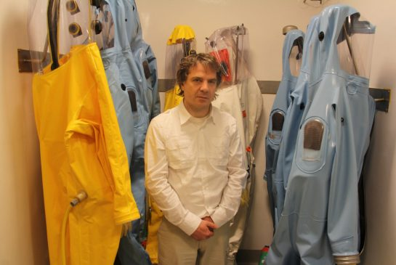
Source:http://www.thestar.com/news/insight/2013/03/22/winnipegs_national_microbiology_laboratory_prepares_for_next_big_outbreak.html

Jennifer Yang / Toronto Star (Dr. Gary Kobinger stands in front of biosafety suits that he wears on a regular basis. Kobinger works with some of the world's deadliest known pathogens, including Ebola, which he is currently developing a vaccine for)

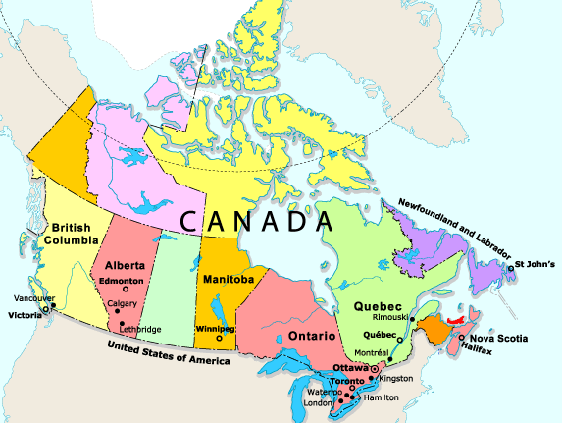
In late November, a strange envelope turned up at the Canadian embassy in Lebanon. Its suspicious contents — wood shavings, according to local reports — sparked alarm: did it contain dangerous pathogens? Could this be a bioterrorist attack? The building was closed until the package could be investigated.
In snowy Winnipeg, 9,600 kilometres away, Dr. Cindi Corbett received the call: she was going to Beirut. In the hours before sunrise on Nov. 30, Corbett and her team drove to a nondescript warehouse and grabbed four black bags — inside were the components of a mobile laboratory, capable of handling some of the world’s deadliest pathogens.
The team was soon en route to Lebanon. Within hours of arriving at the embassy, they had set up their lab, investigated the package and deemed it to be harmless.
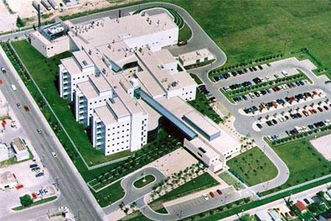
The episode drew little attention, both at home and in Lebanon, and nowhere on Google will you find any mention of Corbett in Beirut. For the mother of two, it was just another day on the job as one of Canada’s top bioterrorism scientists. For the National Microbiology Laboratory where Corbett works, the Beirut incident was just another example of how Public Health Agency of Canada scientists work behind the scenes to protect people from microscopic dangers.
Public-health practitioners sometimes mutter that people only notice them when things go wrong. Canadians may remember reading about the National Microbiology Laboratory during SARS, the 2009 H1N1 flu pandemic or the recent XL Foods E. coli outbreak.
But even in the long, quiet stretches between crises, the lab is working every day to keep pathogens at bay. The Next Big One is always simmering; whether it boils over depends on a mixture of chance and preparedness.
Ten years after SARS, considered by some to be the first pandemic of the 21st century, the Toronto Star travelled to Winnipeg to meet the people whose job it is to keep pathogens from gaining the upper hand.
A former acting director once described the NML as Canada’s “Supreme Court of clinical microbiology” — as a reference laboratory, it has an inventory of cultures and cutting-edge diagnostics to support labs across the country.
The building’s architects envisioned more of a “cathedral of science,” however, designing a clean white exterior, a vaulted atrium and plenty of glass for sunlight to stream in.
But the NML, which employs about 400 people, feels more like an elite university campus. The vibe is serious but casual; at lunch, the cafeteria fills with co-op students from the University of Manitoba.
If the NML were a university, then the dean would be Dr. Frank Plummer. On a recent March day, the white-bearded Plummer is relaxed; dressed in blue jeans and brown leather shoes, he strolls through the lab with the leisurely pace of a beachfront vacationer.
But Plummer, a widely respected scientist known for his groundbreaking HIV research, is probably the “busiest person I know,” says one staffer. Three pins on his jacket lapel hint at a career brimming with accomplishments: Order of Canada, Order of Manitoba, Royal Society of Canada fellowship.
And there is no reason Plummer shouldn’t be relaxed. This is “peacetime” after all — no ongoing outbreaks — and he has confidence in the lab he has cultured since becoming scientific director general in 2000.
After $172 million, and about a decade of planning and construction, the NML opened in 1999 — a feat in itself, some might argue. After all, the building contains Canada’s only “biosafety level-four lab” (or BSL-4 in scientist shorthand), meaning it contains the world’s deadliest incurable pathogens — think Ebola, Marburg, Nipah virus. In other words, level-four labs tend to make their neighbors uneasy.
In Ontario, two attempts to open BSL-4 labs have failed spectacularly. In 1995, a $5.8-million lab in Etobicoke was mothballed after fervent community backlash; in the ’80s, a completed $2-million lab at Toronto General Hospital never opened due to “bureaucratic ass covering,” a former hospital president complained to the CBC.
But the NML opened with minimal fuss on the site of a former asphalt plant, in a hardscrabble Winnipeg neighborhood of low-income homes and the occasional auto shop. It shares a building with the Canadian Food Inspection Agency’s centre for foreign animal disease — a common-sense arrangement, seeing as some 400 new infectious diseases have emerged in the past seven decades and more than 60 per cent came from animals.
The building’s security is muscular. The foundation is embedded into the Canadian shield and there are backup systems for backup systems; a chemical storage facility is designed to ensure accidental explosions blast away from the main building. The level-four lab is a concrete box inside another concrete box — and the concrete sat and “cured” for a year; it was then x-rayed for cracks and slathered with thick sealant to prevent microbes from escaping.
Getting into the NML is also difficult. Mail is x-rayed and contract workers — everyone from the cafeteria lady to the garbage collectors — must have “secret level-two” clearance, meaning they’ve been subjected to background checks and have a neighbor who will vouch for them. Visiting reporters are restricted from writing about camera locations, security features — even the views outside the windows.
But the NML, as with any organization, is not immune to error. In 2009, a former employee smuggled 22 vials out of the lab, including ones containing non-infectious Ebola material (he was caught at the U.S. border and arrested). Incident reports also document occasional fluctuations in air pressure and, in one instance, an employee accidentally poked with a needle handling non-infectious material (the lab takes a proactive approach to reporting incidents and meets with a community oversight group four times a year).
On Plummer’s third year as scientific director general, he was confronted with the SARS coronavirus, his first time dealing with a major outbreak. He admits people were caught off guard. “We sort of muddled through SARS.”
Ten years later, SARS is gone but the microbial threats continue to loom: Lyme disease is creeping into Canada, deadly bacteria strains are developing drug resistance and a new coronavirus is popping up in the Middle East.
But the lab has come a long way since SARS, Plummer says.
“We’re ready,” he says, when asked about the next big outbreak. “And we’re always improving on the readiness.”
Technology has improved by leaps and bounds over the past decade and the NML has kept pace. Now included in the lab’s lineup: several machines that can quickly sequence entire genomes (because the staff likes to name the machines after dead rock stars, “Kurt Cobain” is now working at the NML) and a newly acquired robotic machine (nicknamed Wall-E), which can generate more than 100 cell cultures at a time — giving the lab a major advantage the next time scientists need to quickly identify a mysterious new outbreak.
Part of being ready is also the existence of the lab’s emergency operations centre, built shortly after SARS. It is the lab’s Situation Room: TV screens encircle the room, the windows go opaque with the touch of a button and a digital world map covers one wall. Taped to the desks are sheets of paper that read “Bomb Threat Checklist.”
Ten years ago, Plummer and his people were writing the emergency playbook as SARS unfolded; communication was haphazard. Now, there are protocols that click into place when an outbreak emerges, with everything flowing through the operations centre.
The centre also supports NML scientists deployed overseas — as was the case last fall, when a small team went to the Democratic Republic of Congo to assist with an outbreak of Ebola, one of the world’s most feared viruses, which can kill up to 90 per cent of its victims.
Corbett, who runs the lab’s microbiological emergency response team, accompanied the DRC group and brought the same “lab-in-a-box” she took to Beirut. But her team also has larger mobile labs at its disposal, including a Freightliner truck that can handle level-three pathogens like anthrax (Torontonians may have noticed the truck at the G20 summit in 2010).
Officially, Corbett’s title is “chief of bioforensics assay development and diagnostics” — or chief of BADD, she jokes. Overseas deployments are only a small fraction of her job, however; day-to-day, she is more likely to be researching the latest in microbial forensics (law enforcement agencies often ask Corbett for help with criminal investigations involving biological specimens) or developing tests to diagnose agents that could be used as bioweapons. Corbett also trains law enforcement on everything from handling dangerous materials to spotting clandestine labs (apparently, slow cookers can incubate more than just pot roasts).
Although Corbett attended the DRC trip, she is not the lab’s Ebola expert — that title belongs to Dr. Gary Kobinger, who led the deployment.
Kobinger is the kind of scientist who works in a lab with bulletproof glass and wears a pressurized containment suit, familiar to anyone who has ever watched a Hollywood pandemic movie. As the lab’s head of special pathogens, he is a rare specimen: an Ebola expert from Quebec living in the Canadian prairies.
Recently, the National Geographic Channel featured Kobinger as part of a one-hour special on modern-day exploration. “Join Dr. Gary Kobinger as he battles the world’s deadliest viruses,” the promo read. In November, Kobinger published a study that found pigs were capable of transmitting Ebola virus to monkeys through air droplets — a revelation that had Kobinger and his people wrestling pigs in the DRC so they could sample their blood for Ebola antibodies.
Kobinger has also developed an Ebola vaccine that works in monkeys; his next goal is to test it in humans (something that likely won’t take place for at least another year, he says).
“It’s really exciting,” he says. “It’s a dream come true, in seeing a treatment moving forward to the clinic.”
In Kobinger’s BSL-4 lab, his team of about 25 people are regularly working with everything from Hantavirus to the deadliest flu strains. They also diagnose samples taken from Canadian tourists — perhaps recently returned from some exotic locale with some microbial hitchhiker in tow.
Reference laboratories such as the NML need to be prepared for anything — in today’s borderless world, any infectious disease is just a plane ride away.
Polio, for instance, has long been eradicated from Canada but the NML continues to maintain a lab, and the expertise, to test for it. The world is inching closer to polio eradication — it now circulates in just Pakistan, Nigeria and Afghanistan — but that means it is more critical than ever to ensure against the virus’s return, said Dr. Tim Booth, director of viral diseases.
When it comes to outbreak prevention, however, one of the NML’s most important roles is surveillance. In Booth’s viral diseases division, the influenza department tests thousands of flu samples every season to detect which strains are circulating — this information also helps shape next year’s flu vaccine.
Scientists at the lab also monitor hospital outbreaks, drug-resistant bacteria and food-borne diseases. In the enteric diseases division, Dr. Celine Nadon is tracking E. coli and Listeria outbreaks using molecular fingerprinting and a continental laboratory network called PulseNet, which can detect outbreaks before they spread beyond as few as two people.
For Plummer, this means his calm is unlikely to be disturbed anytime soon — even when the Next Big One hits.
“We’re like the fire department — when something happens, you don’t go ‘Oh boy, it’s a fire!’” he says. “This is what we’re here for. You just sort of click into high gear.”

Jennifer Yang is the Toronto Star’s global health reporter and has won one National Newspaper Award with the Star.

EDITOR’S COMMENT: Would it be better and more effective if Canadian Embassies around the globe (or specifically in hot spots) to be manned with a CBRN specialist equipped with proper portable detection equipment. Especially when comes to bio-threats, time is life and distance from Canada requires long lasting traveling. This in combination with modern telemedicine systems and audio material transfer in real-time might lead to faster decisions that might save lives in case of a real bioterrorism event.

Cangene's botulism antitoxin receives FDA approval
Source: http://www.examiner.com/article/cangene-s-botulism-antitoxin-receives-fda-approval

The US Food and Drug Administration (FDA) announced the approval of Botulism Antitoxin Heptavalent manufactured by Winnipeg, Canada immune therapeutic company, Cangene Corporation, for the treatment of botulism due to exposure of botulinum neurotoxin, according to a FDA news release March 22.
The approved antitoxin, is the first that neutralizes all seven known botulinum nerve toxin serotypes (A, B, C, D, E, F, G).
“This product approval meets an urgent unmet medical need for the treatment of sporadic cases of life-threatening botulism and provides a medical countermeasure should botulinum nerve toxins be used in a terrorism event,” said Karen Midthun, M.D., director of the FDA’s Center for Biologics Evaluation and Research.
The efficacy of this product was approved under the FDA's Animal Rule, because it was not feasible or ethical to conduct efficacy studies in humans.
The results provided substantial evidence that the antitoxin is reasonably likely to benefit humans with botulism, according to the FDA.
In addition, the health agency reports the safety of the product was tested in 40 healthy human volunteers and also monitored in 228 patients who received the antitoxin experimentally under a botulism treatment program administered by the Centers for Disease Control and Prevention (CDC).
The most commonly observed side effects were headache, fever, chills, rash, itching and nausea. Since the product is manufactured from horse plasma it may cause allergic reactions and a delayed hypersensitivity reaction (serum sickness) in people sensitive to horse proteins.
Botulinum neurotoxins, causative agents of botulism in humans, are produced by Clostridium botulinum, an anaerobic spore-former Gram positive bacillus. Botulinum neurotoxin poses a major bioweapon threat because of its extreme potency and lethality; its ease of production, transport, and misuse; and the need for prolonged intensive care among affected persons. A single gram of crystalline toxin, evenly dispersed and inhaled, can kill more than one million people, according to a study publish in the Indian Journal of Medical Research.
The Botulism Antitoxin Heptavalent will be maintained in the Strategic National Stockpile and distributed through the CDC’s Drug Service.

Predicting disease outbreaks to protect soldiers -- and civilians
Source:http://www.homelandsecuritynewswire.com/dr20130325-predicting-disease-outbreaks-to-protect-soldiers-and-civilians

Researchers from Johns Hopkins University and the Pentagon develop a new method to predict dengue fever outbreaks several weeks before they occur. The method extracts relationships between clinical, meteorological, climatic, and socio-political data. It can be used in any geographical region and extended to other environmentally influenced infections affecting public health and military forces worldwide. DoD is currently evaluating the method for use in mitigating the effects of infectious disease in various operational settings.
A team of scientists from the Johns Hopkins University Applied Physics Laboratory (APL) has developed a novel method accurately to predict dengue fever outbreaks several weeks before they occur.
The new method, known as PRedicting Infectious Disease Scalable Model (PRISM), extracts relationships between clinical, meteorological, climatic, and socio-political data in Peru and in the Philippines. It can be used in any geographical region and extended to other environmentally influenced infections affecting public health and military forces worldwide.
A Johns Hopkins University release reports that PRISM is aimed at helping decision-makers and planners assess the future risk of a disease occurring in a specific geographic area at a specific time. Developed by APL’s Anna Buczak and a team of researchers for the Department of Defense (DoD), PRISM predicts the severity of a given disease at a specific time and place with quantifiable accuracy, using original analytical and statistical methods. “By predicting disease outbreaks when no disease is present, PRISM has the potential to save lives by allowing early public health intervention and decreasing the impact of an outbreak,” says Sheri Lewis, APL’s Global Disease Surveillance Program manager. DoD is currently evaluating PRISM for use in mitigating the effects of infectious disease in various operational settings.
PRISM’s distinctive prediction method utilizes Fuzzy Association Rule Mining (FARM) to extract relationships between multiple variables in a data set. These relationships form rules, and when the best set of rules is automatically chosen, a classifier is formed. The classifier is then used to predict future incidence of the disease — in this case dengue fever, the second most common mosquito-borne disease, which puts more than one-third of the world’s population at risk.
“PRISM is designed to help public health leaders make informed decisions, mitigate threats and more effectively protect their populations,” says Lewis. “Ideally, decision-makers want to learn about a disease outbreak before it spreads, and PRISM will provide them with highly accurate information to protect our military forces deployed in at-risk areas.”
While PRISM’s pilot predictive analysis was the study of dengue fever in Peru, APL scientists have extended the method to predicting dengue in the Philippines and are working to fine-tune the model and expand its capabilities to include other infectious diseases. “Dengue was the starting point for our work because the data were readily available, but eventually we want to apply the methodology to other diseases, such as malaria and influenza,” says Lewis.
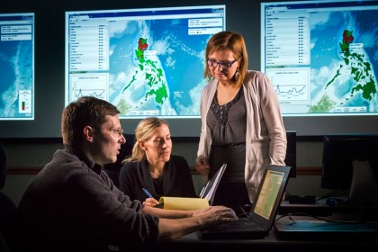
Once fully operational, PRISM will aid in the earliest possible detection of illness within a community by complementing electronic disease surveillance systems such as the APL-developed Electronic Surveillance System for the Early Notification of Community-based Epidemics (ESSENCE) and the Suite of Automated Global Electronic bioSurveillance (SAGES).
ESSENCE collects, processes, and analyzes non-traditional data sources to identify disease activity in a community, allowing data to be queried, analyzed and visualized by the end user. SAGES is a collection of freely available software, including open source versions of ESSENCE, for electronic surveillance in countries with little funding for public health initiatives. SAGES can be used alone or with existing surveillance applications providing governments with the flexibility to develop inexpensive and customized systems to collect and track information about the spread of diseases.

— Read more in Anna L. Buczak et al., “A data-driven epidemiological prediction method for dengue outbreaks using local and remote sensing data,” BMC Medical Informatics and Decision Making 12: 124 (5 November 2012)

Biological attacks 'getting easier for terrorists'
By James Kirkup
Source:http://www.telegraph.co.uk/news/uknews/terrorism-in-the-uk/9955007/Biological-attacks-getting-easier-for-terrorists.html?fb&goback=.gde_3711808_member_226608064

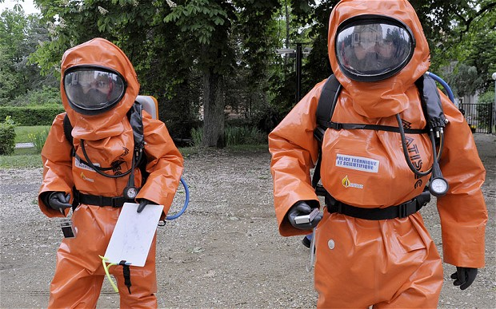
Charles Farr, the Director of the Office for Security and Counter-Terrorism, said that extremists have ever greater access to the information and technology required to create and spread germ agents or other biological weapons.
He spoke as an official assessment suggested that countering the threat to the UK from international terrorism is becoming harder and more expensive.
The Home Office has published an annual report on its Contest counter-terrorism strategy, which warned that Islamic terrorist threats are now spread more widely across the world, requiring “very significant resources” to combat.
The report showed that security officials and intelligence agencies believe that a priority for Britain is improving its ability to detect biological attacks, treat victims and decontaminate attack sites.
“Biological will get easier from a terrorist point of view,” Mr Farr said.
Factors facilitating such attacks include the availability of formulae and other information on the internet; increasing teaching of biological sciences at universities, and “greater availability of technology,” he said.
Mr Farr, a former MI6 officer, declined to give further details of the threat, but the Home Office report hints at a range of new precautions.
Last year, the Home Office began enforcing a new list of controlled biological agents to “ensure that dangerous pathogens and toxins that are required in important medical and scientific research are used and held securely.”
Lessons learned from the security operations for the London Olympic Games have “informed the wider programme of planning for high impact biological attacks,” the report said.
The Home Office report also said that British authorities continue to plan for a Mumbai-style attack by terrorist gunmen.
In particular, the emergency services have been working on plans to treat and extract casualties from an attack scene even while violence continues.
Details are secret, but it is believed that special teams of armed police officers and volunteer paramedics have been trained to operate under fire.
Mr Farr also revealed that even as officials prepare for such attacks, the counter-terrorism budget is coming under pressure to make cuts.
Security and intelligence agencies are having to “find savings” to fund the battle against al-Qaeda, he said. In some cases, that means reducing manpower.
The warnings about the money available for counter-terrorism come as ministers discuss a Spending Review that is likely to impose more cuts on the Home Office budget after the next general election.
Danny Alexander, the Chief Secretary to the Treasury, told the Daily Telegraph last week that the Home Office could not be spared cuts in the 2015/16 round.
The Home Office report on British counter-terrorism warned that the UK faces a more complicated and widespread threat, which is more costly to address.
“The terrorist threats we face are now more diverse than before, dispersed across a wider geographical areas, and often in countries without effective governance,” it said.
“This poses significant challenges to our national security and to the security and intelligence agencies and departments working on counter-terrorism: operating in these areas is difficult and dangerous, requires very significant resources and is complicated and at times made impossible by the breakdown of governance and law and order.”
Mr Farr said that the changing nature of the threat puts new financial pressure on the Home Office and other agencies.
“It takes more to do the same amount of counter-terrorism work,” he said. “We have to find savings.”
He added: “Across the whole of the CT budget, which is in the region of £1 billion, you would expect to find some efficiency savings. Technology means that in some areas, you can do the same with fewer people.”
The Home Office report also warned that British Muslims fighting in Syria’s civil war could return home to carry out terrorist attacks.

James Kirkup is Deputy Political Editor for the Telegraph. Based at Westminster, he has been a lobby journalist since 2001 and has a particular interest in subjects including economics and defence. Before joining the Telegraph he was Political Editor of the Scotsman, covered European politics and economics for Bloomberg, and reported from countries including Iran, Zimbabwe and the USA.

UAE: Keep calm, experts say after Emirati dies from coronavirus infection
Source:http://www.thenational.ae/news/uae-news/health/keep-calm-experts-say-after-emirati-dies-from-coronavirus-infection

Health experts urged calm yesterday after an Emirati man died in a hospital in Germany after contracting a Sars-like virus.
The man, who was 73, had been transferred by air ambulance to Munich from a hospital in Abu Dhabi on March 19.
German doctors diagnosed a novel coronavirus (NCoV) infection and the man was pronounced dead on Tuesday. It is not known where he contracted the virus, although he had recently visited Saudi Arabia, where most cases have originated. He is the 11th person to die out of 17 cases reported to the World Health Organisation.
"The difficulty is finding the reservoir of this virus - where it comes from," said Dr Mansour Al Zarouni, a consultant molecular microbiologist in Dubai.
"The suggestion is only that it comes from the Arabian Peninsula but there is nothing solid. We don't know where this virus lives. You can prevent it easier if you know the source."
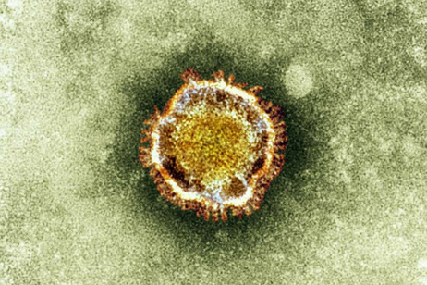
Hugh Pennington, emeritus professor of bacteriology at the University of Aberdeen in Scotland, said it was important to find the source of the virus.
"That way you can understand the spread of it and take measures to prevent any further cases," he said. "It's obviously cause for concern - any new virus that kills this many people is something we don't wish to have. But, on the other hand, the number of cases is still small and everyone is keeping a very close eye on it to ensure it doesn't develop into a major public health problem."
Prof Pennington, who has chaired inquiries into E. coli outbreaks in Scotland and South Wales, said scientists were desperate to find out more about this virus: "There is an international network of people dedicated to working out what the virus is and giving advice as well."
Dubai Health Authority has been monitoring the situation for some time, a spokeswoman said yesterday.
"In this particular case, the patient was 73 years old and the immunity in this age group is lower. Dubai Health Authority is in contact with international health organisations and is following the necessary protocol," she said.
The Emirati who died was receiving cancer treatment in Germany, the state news agency Wam said. Health authorities in the UAE say there are no suspected cases of the virus in this country.
The World Health Organisation has been monitoring the spread of the novel coronavirus since it was first detected in humans last year.
It said Sars, a virus that claimed the lives of 755 people in 2003, and nCoV are distantly related and "both capable of causing severe disease".
Doctor Zarouni said the incident underlined the need for greater preparedness for all virus outbreaks.
"All the other GCC countries have their own virology centres to conduct testing but the UAE does not - it has one in Sharjah but it is not up and running," he said.
He called for centres to be set up where samples could be sent for testing, not just for this virus but for others too. "The number one priority is for the Government to establish centres to handle this so that we do not panic or create chaos - the problem is that, today, when you hear clinicians or GPs talking about a virus like this, any patient going to casualty with a fever will think they have the virus, when that is not the case. People should remain calm."
Saudi Arabia is well prepared for this type of outbreak, he said.
"Saudi has experiences handling the Haj, where they receive a great many people to the country and they have more experience in dealing with Sars and influenza."
In 2009, Arab health ministers agreed to discourage elderly and other high-risk groups from making the Haj pilgrimage amid the H1N1 swine flu outbreak. Pilgrims from the UAE were required to show proof of vaccination.

New foot-and-mouth vaccine shows promise
Source: http://www.homelandsecuritynewswire.com/dr20130329-new-footandmouth-vaccine-shows-promise

The 2001 foot and mouth outbreak in Britain was devastating and cost the economy billions of pounds in control measures and compensation. One recommendation in a Royal Society report following the epidemic recommended the development of new approaches to control the virus. Scientists have used a new method to produce a vaccine which does not rely on inactivating the live, infectious virus which causes the disease — and is therefore much safer to produce.
A new vaccine against foot-and-mouth disease which is safer to produce and easier to store has been developed by scientists from the University of Oxford and the Pirbright Institute.
They have used a new method to produce a vaccine which does not rely on inactivating the live, infectious virus which causes the disease — and is therefore much safer to produce.
A University of Oxford release reports that instead the vaccine consists of empty virus shells that have been produced synthetically, and are designed to produce an immune response that protects against the disease.
Furthermore, the empty shells have been engineered to be more stable, making the vaccine much easier to store because the need for the vaccine to be refrigerated is reduced.
The 2001 foot and mouth outbreak in Britain was devastating and cost the economy billions of pounds in control measures and compensation. One recommendation in a Royal Society report following the epidemic recommended the development of new approaches to control the virus.
An improved vaccine against the disease would also be important in countries where the disease is endemic, which are often in the developing world.
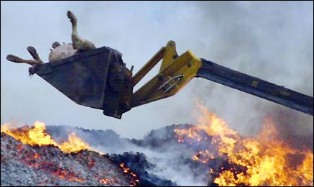
The research was led by Professor David Stuart, professor of structural biology at the University of Oxford and life science director at Diamond Light Source, and Dr. Bryan Charleston of the Pirbright Institute. The findings are published in the journal PLOS Pathogens.
“What we have achieved here is close to the holy grail of foot-and-mouth vaccines. Unlike the traditional vaccines, there is no chance that the empty shell vaccine could revert to an infectious form,” says Stuart.
Charleston adds: “The ability to produce a vaccine outside of high containment and that does not require a cold storage chain should greatly increase production capacity and reduce costs. Globally there is an undersupply of the vaccine due to the high cost of production and this new development could solve this problem and significantly control foot-and-mouth disease worldwide.”
Early clinical trials of the new vaccine in cattle have shown it is as effective as current vaccines. While a commercial product is still several years away, the team hopes that the technology can be transferred as quickly as possible to make it available to a global market.
One of the problems of existing vaccines against foot and mouth disease is identifying which animals have been vaccinated and which haven’t.
Charleston says: “The complete absence of some viral proteins from this new vaccine will also allow companion diagnostic tests to be further refined to demonstrate the absence of infection in vaccinated animals with greater confidence.”
The work on the structure of the virus shells and identification of mutations to improve their stability was carried out by Stuart and his team at Oxford University using Diamond Light Source, the U.K.’s national synchrotron facility.
Charleston at Pirbright Institute and Professor Ian Jones at Reading University and their teams incorporated the mutations into the empty virus shells and showed they stimulate protective immunity in cattle.
Together the three groups have developed a system for the production of empty protein shells in commercially viable amounts.
Richard Seabrook, Head of Business Development at the Wellcome Trust, which part-funded the work, says: “This vaccine still has some way to go before it will be available to farmers but these early results are very encouraging.”
Nigel Gibbens, the U.K.’s Chief Veterinary Officer, comments: “There are many more years of work and research to be done to get this vaccine ready for use, but this is undoubtedly an exciting leap forward. Once available, vaccines of this type would have clear advantages over current technology as a possible option to help control the disease should we ever have another foot and mouth disease outbreak.
“This vaccine has been developed using some truly groundbreaking techniques which are a credit to the quality of British scientists working in the field of animal health.”
The release notes that the scientists involved believe this new approach to making and stabilizing a vaccine may also work with other viruses from the same family, including viruses that infect humans such as polio.
“This work will have a broad and enduring impact on vaccine development, and the technology should be transferable to other viruses from the same family, such as poliovirus and hand foot and mouth disease, a human virus which is currently endemic in south-east Asia,” says Stuart.
The work was principally funded by the Department for Environment, Food and Rural Affairs (DEFRA) and the Wellcome Trust.

— Read more in Claudine Porta et al., “Rational Engineering of Recombinant Picornavirus Capsids to Produce Safe, Protective Vaccine Antigen,” PLOS Pathogens 9, no. 3 (27 March 2013): e1003255

Professor studies biological warfare pathogen
Source: http://www.wvpubcast.org/newsarticle.aspx?id=29365

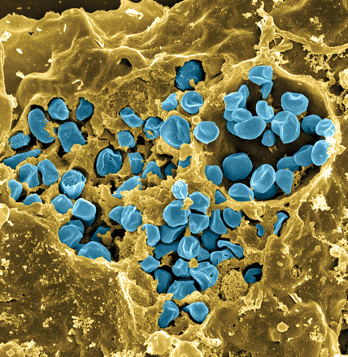
Francisella tularensis: the Centers for Disease Control and Prevention has classified it as a biodefense agent because of its possible use in bioterrorism. One professor and some students at West Liberty University are working to create a vaccine.
“At Pitt I studied Francisella tularensis, and that is a biological warfare pathogen,” says West Liberty University Biology Professor Dr. Joseph Horzempa. “It’s a very infectious bacteria.”
Horzempa received half a million dollars in grants to study this bacterium. Half of that award came from the National Institutes of Health, and the other half from WV-Idea Network of Biomedical Research Excellence.
“Francisella looks like a teeny tiny jelly bean,” he says.
But it’s a deadly jelly bean. Horzempa explains that in order to be classified as a Category A biodefense agent by the Center for Disease Control, a bacterium has to meet certain criteria.
“Some bacteria, you need to have a million bacteria, like Salmonella or E. coli, in order for an infection to be established. So you would have to inject a whole lot of those bacteria in order to get some kind of disease that comes with it. Francisella you only need a single bacterium. So it’s just about the most infectious thing on the planet. That’s one criterion.”
“The second criterion is that it’s able to be aerosolized and easily spread. And the third criterion would be that the infection in quite lethal or serious enough that it can cause a lot of problems.”
Horzempa is quick to explain that the bacteria he and his students are working with in his lab at West Liberty are weakened and therefore pose no imminent threat should they somehow become airborne or sneak into a tick’s gut, which is one of the other ways these particular bacteria can be transmitted to humans—through a tick bite.
The resulting disease is called tularemia. The bacterium that causes it was first isolated in 1911 from ground squirrels found dying of a plague-like illness in Tulare County, CA.
“There are different forms depending on the route of infection. Inhalational tularemia is when you breathe in the organism and it gets in the lungs. That’s a pulmonary infection. So you get pneumonia, develop a high fever, general malaise, and after a while you can slip into a coma.”
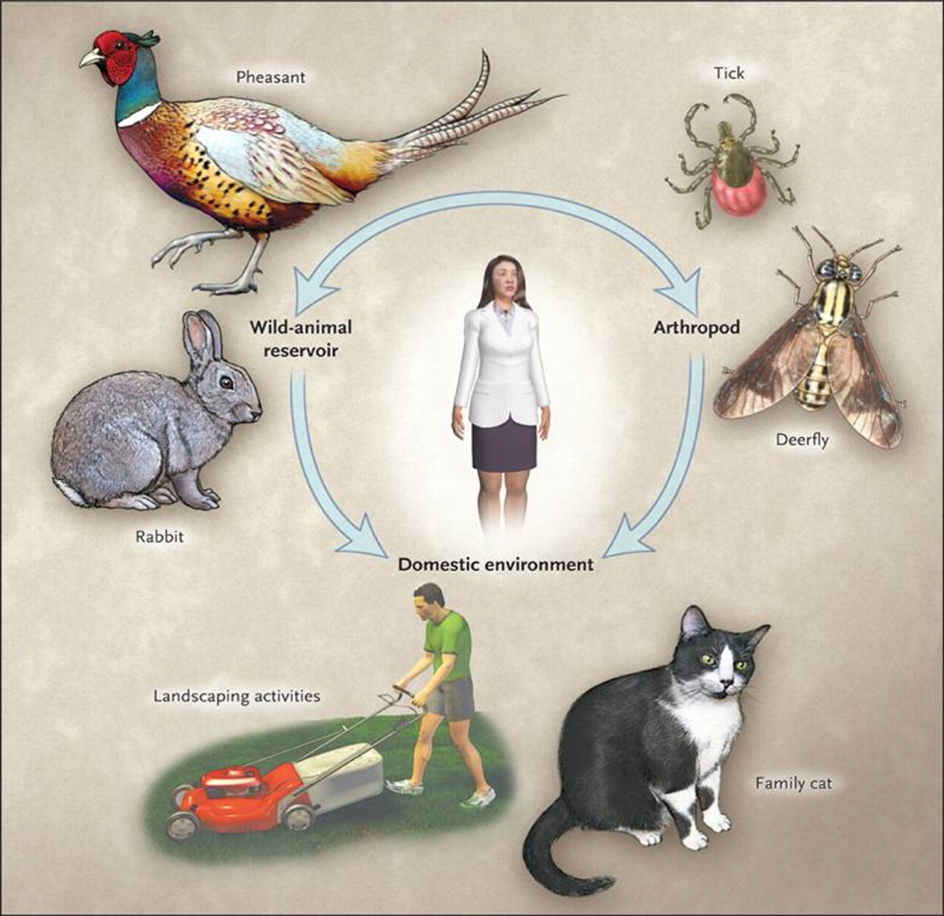
Horzempa says the other form of the disease is ulceroglandular tularemia which is spread through ticks or deerflies and manifests in the lymph nodes throughout the body. The symptoms are skin ulcers, swollen and painful lymph glands, fever, and coma.
Horzempa says treatments are available, but there’s always the threat of an antibiotic-resistant strain being developed.
“That’s why we constantly want to do research and find new therapies and different molecular mechanisms of the bacterium that we can target, versus the conventional antibiotics.”
Hozempa’s interest in Francisella began when he worked at Pitt University with the most virulent form of the bacterium during a time when the government was showing a renewed interest in funding bioterrorism defense research.
“I thought that Francisella was kind of a cool organism. Its biology is intriguing. It actually replicates and grows inside of your host cells that are suppose to kill bacteria—these white blood cells called macrophages. Anytime you get a bacterial infection, macrophages go to the site of the infection and they eat and kill the bacteria.
"But Francisella wants to get inside the macrophage and then it resists all the killing mechanisms of the macrophage and can actually grow in the cell. So I thought it was really cool to figure out what was going on there and try to throw my hat in the field of Francisella research.”
While at Pitt, Horzempa discovered that Francisella invades red blood cells. Now at West Liberty he and his research team are working to determine ways to inhibit that invasion, or to create vaccines.

College student invents gel that halts bleeding
Source: http://www.mnn.com/green-tech/research-innovations/stories/college-student-invents-gel-that-halts-bleeding

Joe Landolina may have invented a cure for bleeding. He claims that his creation, a substance called Veti-Gel, jump-starts the clotting and healing process so quickly that even wounds to internal organs or major arteries are able to close up instantaneously. And Joe has accomplished all this by his third year of college at NYU.
"It instantly tells the body, 'OK, stop the bleeding,' but also it starts the healing process," said Landolina.
Veti-Gel (also sometimes called Medi-Gel) is a synthetic form of the extracellular matrix, or ECM, the substance that forms a kind of scaffolding in the body that holds cells together and also triggers the clotting process if there is an injury. In tests on rats, Landolina was able to close up a slice into the liver and a puncture of the carotid artery. (He plans to publish the results in about two months.)
A bit less gruesome than those tests is a simulation video that Landolina and colleagues at startup Suneris produced. The 26-second clip begins with the team making about a 3-inch slice into a raw pork loin that's been pumped full of pig's blood. That blood immediately pours out as if from a spigot. They then squeeze a layer of Veti-Gel over the cut, and the flow stops immediately. "I have seen [Veti-Gel] close any size wound that it is applied to," said Landolina. "As long as you can cover it, it can close it."
Plants naturally produce a material similar to the human extracellular matrix, but Landolina improves the process by using genetically modified plants to create Veti-Gel. Other wound treatments, such as collagen, come from animals, he said. And some rival treatments require refrigeration. Veti-Gel can be kept in packets or tubes at any temperature from 33 degrees to about 90 degrees Fahrenheit (1 degree to 32 degrees Celsius).
Landolina has been developing and testing Veti-Gel at Englewood Hospital in New Jersey. Dr. Herbert Dardik, who oversees Landolina's work at the hospital, told TechNewsDaily by email, "The material has promise… but the work is in its early stages and we need to carry out confirmatory tests. I am optimistic for the future."
Veti-Gel could also serve as a treatment for severe burns, Landolina said. "One of my other colleagues … he went to a bonfire. One of his friends fell into the fire and got second-degree burns. He put the gel on, and the next day it was healed," Landolina said.
That scenario recalls a scene from the movie "The Hunger Games," in which the heroine applies a sci-fi cream to a burn that quickly heals. Landolina knows it well.
Veti-Gel does three things in particular, depending on what part of the wound it comes in contact with. It can stimulate the creation of a blood-clotting substance, activate platelet cells to further plug the hole or cover and compress the wound.
When any part of the body is wounded, the damaged extracellular matrix helps trigger a cascade of chemical reactions in the blood that ends in fibrin — fibers that join togehter to start blood clots.
If Veti-Gel reaches the blood's platelet cells, it helps signal them to change shape and stick together to further help plug the hole in a blood vessel.
And when Veti-Gel comes into contact with the extracellular matrix in the wounded tissue, it binds to it, forming a kind of cover over the area. That eliminates the need to even apply pressure to the wound. "It looks like, feels like, and acts like skin," said Landolina.
If Veti-Gel works as well as claimed, it could rival other products designed to close wounds. The U.S. military typically uses QuikClot, gauze soaked in kaolin, a material that activates platelets to form a clot. But it requires several minutes of applying pressure. Hospitals typically use Floseal, a bovine gelatin containing human thrombin, the enzyme that produces fibrin for clotting.
Landolina is currently designing tests to compare Veti-Gel to those rival treatments and is looking for an independent researcher to perform the evaluation. He hopes to have the results this summer. Landolina is also looking to start testing Veti-Gel with veterinarians.
"We are eager to see the results," said Marisa Tricarico, who evaluates medical investments for the NYU Innovation Venture Fund. "He has impressed a lot of people," she said of Landolina (that includes assessments from medical experts).
Landolina has applied for a patent and is beginning the FDA approval process. He also plans to apply for a grant from the Department of Defense, which he hopes will some day be a client. (He plans to market a version for the military called Medi-Gel.)
With all the success he's already had, Landolina may feel it's time to have a drink and celebrate. But he'll have to wait a bit longer — he doesn't turn 21 until next January

.

Novel bird flu kills two in China
Source: http://www.nature.com/news/novel-bird-flu-kills-two-in-china-1.12728

A technician holds test reagents for H7N9 bird flu virus at the Center for Disease Control and Prevention in Beijing (Li Wen/Xinhua Press/Corbis)

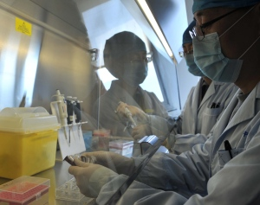
Scientists and public health officials worldwide are on alert after China announced on 31 March that two people had died and a third had been seriously sickened from infections with a new avian flu virus, H7N9, that has never been seen before in humans.
The emerging, if preliminary, analyses of the viruses' genomes point to the possible spectre of a pathogen that might spread silently in poultry without causing serious disease. That would make the virus difficult to monitor even as it causes serious disease in humans. Should the virus become established in birds, regular human infections might then occur — providing opportunities for it to adapt better to humans, and ultimately spread between them, potentially sparking a pandemic.
Scientists stress that it is far too early to make a full risk assessment of the potential pandemic threat. But the initial analysis of viral sequences is "worrisome“ because they show several features suggestive of adaptation to humans, says Masato Tashiro, a virologist at the Influenza Virus Research Center in Tokyo, the World Health Organisation (WHO)’s influenza reference centre in Japan.
The epidemiological picture is troubling too, says Malik Peiris, a flu virologist at Hong Kong University. "Any time an animal influenza virus crosses to humans it is a cause for concern, and with three severe cases [of disease] over a short period of time, we certainly have to take it seriously," he says. "There's no obvious indication of human to human spread, so we should not overreact, but neither should we be complacent."
The first case of the novel H7N9 was an 87-year-old man in Shanghai who became ill on 19 February and died on 4 March. A 27-year-old man in the same city fell ill on 27 February and died on 10 March. A 35-year-old woman in Chuzhou City in Anhui province, several hundred kilometres west of Shanghai, fell ill on 9 March and remains seriously ill. All three developed flu-like symptoms before developing severe pneumonia. The cases were announced on 31 March by China's health ministry, the China Health and Family Planning Commission, which informed the WHO on the same day.
So far, there appears to be no sustained spread between people. Chinese authorities tracked dozens of contacts of the three cases and reported that none showed relevant symptoms or tested positive for the virus. Some uncertainty hangs over whether family members of the first case — who were hospitalized with severe pneumonia just before their father — might have passed on the virus to the elderly, housebound man. Though the family members reportedly tested negative for the virus, these might have been false negatives. Still, for the moment, experts say, if any human spread is occurring, it is not happening easily.

Sequences yields first clues
Chinese researchers have moved swiftly to decipher the new virus. The WHO Chinese National Influenza Center in Beijing has sequenced isolates from each of the three cases and on 31 March published them on the GISAID flu sequence database. Researchers around the world have since been racing to discover what clues the genome might hold as to the source of the virus, and to its pathogenicity and potential to infect, and spread between, humans.
Analyses suggests the virus is a new one that has been generated by reassortment — which occurs when different virus strains infect a host at the same time and swap genes with each other.
Flu virus have eight genes, including two that carry codes for the haemagglutinin (H) and neuraminidase (N) proteins that stud the surface of the virus, and six that code for internal proteins. Analyses so far suggest that in the new human cases, the genes coding for the internal proteins appear to come from H9N2 viruses — a class that is endemic in birds, including poultry, in Asia and elsewhere. More specifically, the sequences appear similar to recent H9N2 viruses found in China and South Korea.
The gene for the N protein, says Tashiro, appears similar to avian H11N9 viruses that were found in the South Korea in 2011; in Hongze, Jiangsu, in 2010; and the Czech Republic in 2005. The gene for the H protein — especially critical, because this protein allows the virus to bind to host cells — seems to belong to a Eurasian group of H7 avian flu viruses.
The new virus, in other words, seems to stem from reassortment of three virus strains that purely infect birds — in contrast with the 2009 H1N1 pandemic virus, which was a mix of viruses that infect birds, pig and humans. Most of the genetic analyses are still being carried out confidentially within WHO's global flu research networks. But some researchers, such as a team at the University of Edinburgh, have also started posting their preliminary analyses online.
A striking feature of the novel virus is that its H protein is structurally similar to that of viruses that don’t cause severe sickness in birds, and different from those that do, such as the H5N1 virus that has been ravaging poultry flocks in Asia since late 2002. Flu viruses that don’t sicken birds can, however, cause severe disease in humans simply because we lack any immunity to them. They also may be more lethal in people depending on how they bind to receptors in the human airways.
Though analysis is in early days, scientists say it seems clear from the sequence that the novel virus has acquired key mutations that permit the H protein to latch onto receptors on mammalian cells in the airways instead of avian receptors. The virus also contains several other genetic variations that are known from past studies in mice and other animals to cause severe disease.
Initial data suggest, too, that the virus is affecting cells deep in the lung, which would fit with a picture of a virus — much like that of the novel coronavirus — that can cause severe disease. But it may also indicate a virus that doesn’t spread as easily as one that affects the nose and throat and can thus be coughed and sneezed out more readily. Still, the full pattern of receptor binding has yet to be worked out, cautions Peiris.

Silent spreader?
The fact that the virus appears not to sicken birds has potential epidemiological, and possibly public health, implications, Peiris adds. It could be spreading in poultry undetected — and thus could create a reservoir of infection that would lead to frequent sporadic human infections that crop up without warning.
A highly pathogenic virus like H5N1 is easy to spot as it wipes out flocks — and can then be controlled by extended culling. But it might be next to impossible to control a virus in birds that offers few visible symptoms, says Peiris. "That really would be quite a problem,” he says. "The question is whether it's already too late to stamp out or not."
Indeed, China has not reported any recent H7 flu infections in birds, perhaps because such infections would not show up as serious disease, or maybe because of shortcomings in surveillance or reporting. A key need now, Peiris says, is to track down which birds or animals the affected humans caught the virus from.
Though H7 viruses are common in wild birds, but much less so in poultry, it seems highly unlikely that three human cases in such a short space of time could result from contact with wild birds, he says. Domestic fowl are the most likely alternative. But given that the virus has mutations that are adapted to infection of mammals, a source might also be pigs, says Tashiro.
Flu experts say that other urgent needs include testing any human cases of serious pneumonia for traces of the virus and tracking down contacts of any new human cases. Among researchers and public health officials, says Peiris, "It's not an atmosphere of alarm, but an atmosphere of concern."

Nanobiotechnology kills listeria, other food-borne pathogens, dead
Source: http://www.homelandsecuritynewswire.com/dr20130402-nanobiotechnology-kills-listeria-other-foodborne-pathogens-dead

Engineering researchers at Rensselaer Polytechnic Institute have developed a new method to kill deadly pathogenic bacteria, including listeria, in food handling and packaging. This innovation represents an alternative to the use of antibiotics or chemical decontamination in food supply systems.
A Rensselaer Institute release reports that the researchers, using nature as their inspiration, successfully attached cell lytic enzymes to food-safe silica nanoparticles, and created a coating with the demonstrated ability to selectively kill listeria — a dangerous foodborne bacteria that causes an estimated 500 deaths every year in the United States. The coating kills listeria on contact, even at high concentrations, within a few minutes without affecting other bacteria. The lytic enzymes can also be attached to starch nanoparticles commonly used in food packaging.
This new method is modular, and by using different lytic enzymes, could be engineered to create surfaces that selectively target other deadly bacteria such as anthrax, said Jonathan Dordick, vice president for research and the Howard P. Isermann Professor at Rensselaer, who helped lead the study.
This research, which combined the expertise of chemical engineers and material scientists, took place in the Rensselaer Center for Biotechnology and Interdisciplinary Studies and the Rensselaer Nanoscale Science and Engineering Center for the Directed Assembly of Nanostructures. Collaborating with Dordick were Rensselaer colleagues Ravi Kane, the P. K. Lashmet Professor of Chemical and Biological Engineering, and Linda Schadler, the Russell Sage Professor and associate dean for academic affairs for the Rensselaer School of Engineering.
“In this study, we have identified a new strategy for selectively killing specific types of bacteria. Stable enzyme-based coatings or sprays could be used in food supply infrastructure — from picking equipment to packaging to preparation — to kill listeria before anyone has a chance to get sick from it,” Kane said.
“What’s most exciting is that we can adapt this technology for all different kinds of harmful or deadly bacteria.”
Results of the study are detailed in a paper published yesterday in the journal Scientific Reports from the Nature Publishing Group.
The release notes that this most recent study builds upon the research team’s success in 2010 of creating a coating for killing methicillin resistant Staphylococcus aureus (MRSA), the bacteria responsible for antibiotic resistant infections. While the previous coating was intended for use on surgical equipment and hospital walls, the development of a listeria-killing coating had the extra challenge of needing to be food-safe.
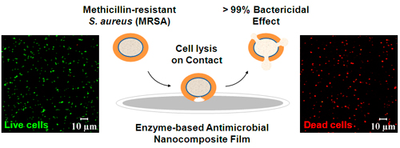
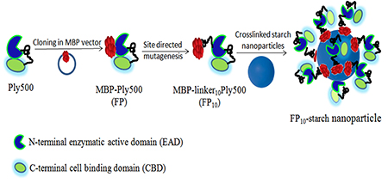
Dordick and the research team found their answer in lytic enzymes. Viruses that affect bacteria, called phages, inject their genetic material into healthy cells. The phage takes over a healthy cell, and in effect transforms the host cell into a little factory that creates more phages. Near the end of its life cycle, the original phage creates and releases lytic enzymes, which break down and make holes in cell walls of the infected bacteria. The manufactured phages escape through these holes and go on to infect other healthy cells.
Nature used lytic enzymes to break out of bacterial cells, Dordick said, and the researchers worked for years to exploit the same lytic enzymes to break into bacteria such as MRSA and listeria.
To stabilize the listeria-killing lytic enzymes, called Ply500, the researchers attached them to U.S. Food and Drug Administration-approved silica nanoparticles to create an ultra-thin film. The researchers also used maltose binding protein to attach Ply500 to edible starch nanoparticles commonly used in food packaging. Both Ply500 formulations were effective in killing within 24 hours all listeria at concentrations as high as 100,000 bacteria per milliliter — a significantly higher concentration than normally found in food contamination situations.
“Starch is an inexpensive, edible material often sprayed into the packaging as a powder layer on meat product. We took advantage of the natural affinity of a maltose binding protein fused to Ply500, and biologically bound Ply500 to starch as a non-antibiotic, non-chemical agent for reducing the threat of listeria to our food supply,” Schadler said.
Looking forward, the research team plans to continue investigating new methods for harnessing the power of lytic enzymes to selectively kill harmful bacteria.
This research was supported with funding from Sealed Air Corporation.

— Read more in Kusum Solanki et al., “Enzyme-Based Listericidal Nanocomposites,” Scientific Reports 3, article no. 1584 (2 April 2013)

Ground-breaking technology quickly detects biothreats
Source: http://www.bioprepwatch.com/weapons_of_bioterrorism/ground-breaking-technology-quickly-detects-biothreats/328891/?goback=.gde_3711808_member_229693508

Researchers at Sandia National Laboratories are working on a medical device that will be able to quickly detect numerous biothreat agents, including anthrax, ricin, botulinum, shiga and SEB toxin.
The device will first need to be approved by the FDA. It will then be used in emergency rooms in event of a bioterrorism attack.
“This is an unmet need for the nation’s biodefense program,” Anup Singh, senior manager for Sandia’s biological science and technology group, said. “A point-of-care device does not exist.”
Sandia’s project is funded by a recent grant for almost $4 million by the National Institute of Allergy and Infectious Diseases, a part of the National Institutes of Health. With the funding, Sandia’s work on biosciences and microfluidics have continued to grow.
“This will take things to the next level,” Singh said.
The need for diagnostic devices is a growing market, Singh said, since there are always new diseases that are troublesome to detect.
“Plus, we want dual-use devices that combat both man-made and nature-made problems,” Singh said. “We’re not just going to wait for the next anthrax letter incident to happen for our devices to be used and tested; we want them to be useful for other things as well, like infectious diseases.”
Singh emphasized that expanding into these areas will keep Sandia’s bioresearch efforts going for years to come.

Handbook of Applied Biosecurity for Life Science Laboratories, Farsi translation

Authors: Peter Clevestig and Ali Karami
Source: http://books.sipri.org/product_info?c_product_id=438#

Biosecurity covers a broad spectrum of potential risks and threats ranging from criminal activities to bioterrorism and espionage. This handbook focuses on the laboratory related activities and basic components of applied biosecurity that are relevant to all laboratory employees. The role played by laboratory managers and principal investigators in safeguarding laboratory assets and the employees under their supervision is also highlighted.
This handbook provides guidance for personnel who work with infectious pathogens and toxins that may affect the health of humans, animals and plants. It aims to engage scientists, laboratory employees and students in laboratory biosecurity, and to provide practical advice that will ensure the secure handling and storage of biological materials.
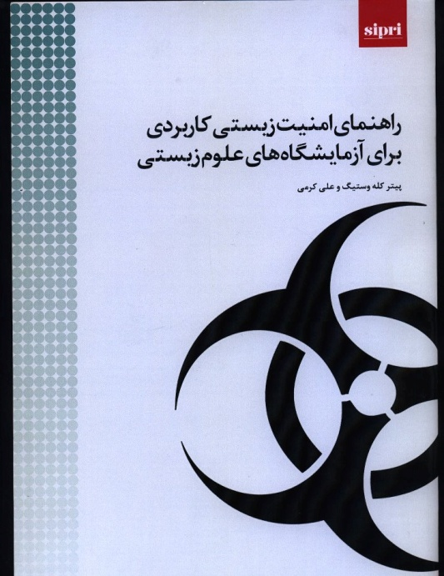
Acknowledging biosecurity risks and the important role of the employee in maintaining biosecurity is crucial to keeping the workplace safe and secure. Safeguarding infectious agents is also a national legal obligation under the 1972 Biological and Toxin Weapons Convention and United Nations Security Council Resolution 1540.

Contents
1. The purpose of this handbook
2. The components of applied biosecurity
2.1. What is applied biosecurity?
2.2. Biosecurity risk assessment
2.3. Applied biosecurity in practice
3. Supervision of applied biosecurity
3.1. Biosecurity concerns for the laboratory manager and the principal investigator
3.2. Managing applied biosecurity
3.3. Biosecurity emergencies
3.4. Training and evaluation
Glossary

About the authors
Peter Clevestig (Sweden) is a Senior Researcher with the Chemical and Biological Security Project of the SIPRI Arms Control and Non-proliferation Programme. He is a virologist by training and, before joining SIPRI, conducted research at the Department of Microbiology, Tumor and Cell Biology of Karolinska Institute (KI), Stockholm. He also served as the administrator of the KI Biosafety Committee. He is an active member of the Nordic Biosafety Network and the European Biosafety Association (EBSA). He has authored or co-authored several scientific publications, primarily in the field of virology, and regularly lectures on biosecurity issues at European scientific research facilities.

Ali Karami (Iran) is Associate Professor of Medical Biotechnology at the Baqiyatallah University of Medical Science.

