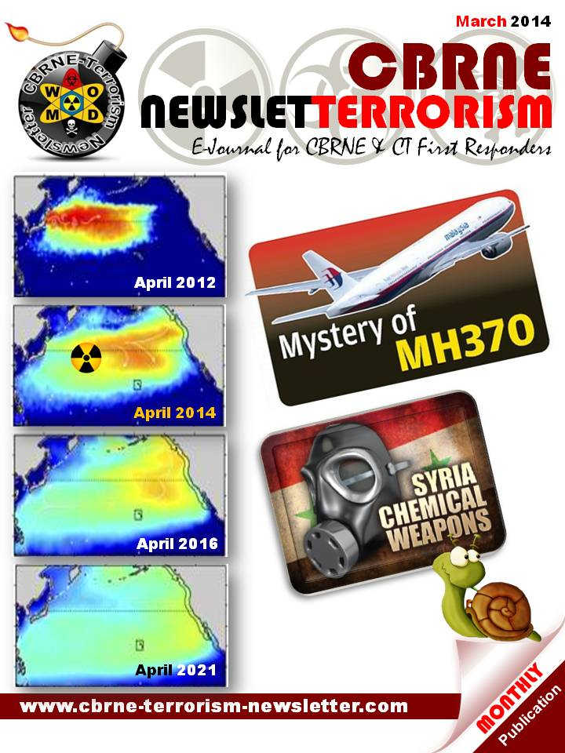
Warns against greater terror threat towards Norway
Source: http://www.norwaypost.no/index.php/news/latest-news/29570-warns-against-greater-terror-threat-towards-norway

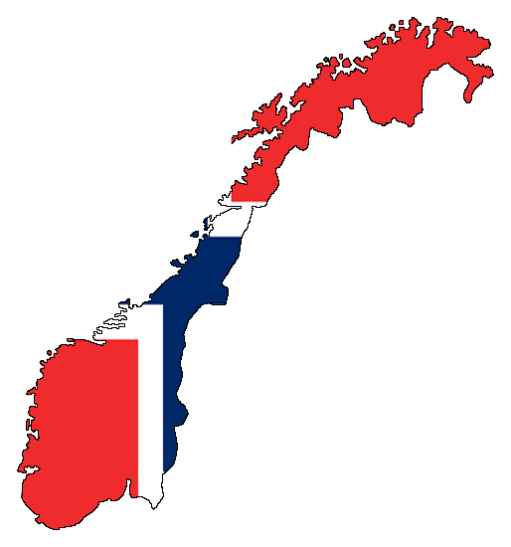
The most significant terror threat against Norway in 2014 is militant extremists who have been trained in Syria, and are returning to Norway, according to a new Intelligence report.
On Monday, Lieutenant General Kjetil Grandhagen (photo) presented the Intelligence Services' (E-tjenesten) annual report on the threat level that Norway is facing in 2014.
The report highlights three main areas: The development in the Northern areas, Norwegians who travel to Syria and receive training from groups tied to Al Qaida, and the digital attacks on Norway, which are increasing.
According to the Intelligence Services there is no race towards the resources in the Arctic. However, "Russia's goal, the leading Arctic power, is to remain the most important premise provider for future development and activity," the report says, according to Aftenposten.
The report also describes that several other countries outside the Arctic region shows a considerable interest in the Arctic, including China. More activity increased the presence of Russian civil, paramilitary and military presence, according to the Intelligence Service.
The report also raises the issue of international terrorism, threats in cyberspace and the geographical areas Russia, Asia, China, North-Africa and the Middle-East.
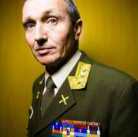
However, the biggest terror threat against Norway in 2014 is in the Middle East.
"The terror threat against Norway and Norwegian interests abroad will increase in 2014. This is mainly due to the development in Syria, where certain areas constitute "free areas" for militant Islamists that are used to plan attacks against targets in Europe," the report concludes.
The Security Police (PST) has also raised concerns about the number of Norwegians who have travelled to Syria, seek militant Islamist groups, receive military training and are radicalized. When these individuals return to Norway they pose a significant terror threat.
"What we are most worried about at this point are organizations who operate in Syria. Al Nusra and ISIL, who both have ties to Al Qaida and whose ambition is to practice jihad in Syria and extend their efforts to the West," Grandhagen explains. The Lieutenant General tells Aftenposten that there are currently between 40 and 50 Norwegians who have been in Syria as jihadists.

EDITOR’S COMMENT: It is good to read about the concerns of European countries about the extremists coming back home from Syria. What we have not yet read is what they are going to do about it. If there is anything pre-active to do…

Low-Tech Terrorism
By Bruce Hoffman
Source: http://nationalinterest.org/print/article/low-tech-terrorism-9935

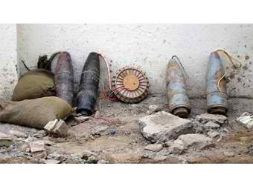
Among the more prescient analyses of the terrorist threats that the United States would face in the twenty-first century was a report published in September 1999 by the U.S. Commission on National Security/21st Century, better known as the Hart-Rudman commission. Named after its cochairs, former senators Gary Hart and Warren Rudman, and evocatively titled New World Coming, it correctly predicted that mass-casualty terrorism would emerge as one of America’s preeminent security concerns in the next century. “Already,” the report’s first page lamented, “the traditional functions of law, police work, and military power have begun to blur before our eyes as new threats arise.” It added, “Notable among these new threats is the prospect of an attack on U.S. cities by independent or state-supported terrorists using weapons of mass destruction.”
Although hijacked commercial aircraft deliberately flown into high-rise buildings were not the weapons of mass destruction that the commission had in mind, the catastrophic effects that this tactic achieved—obliterating New York City’s World Trade Center, slicing through several of the Pentagon’s concentric rings and killing nearly three thousand people—indisputably captured the gist of that prophetic assertion.
The report was also remarkably accurate in anticipating the terrorist organizational structures that would come to dominate the first dozen or so years of the new century. “Future terrorists will probably be even less hierarchically organized, and yet better net-worked, than they are today. Their diffuse nature will make them more anonymous, yet their ability to coordinate mass effects on a global basis will increase,” the commission argued. Its vision of the motivations that would animate and subsequently fuel this violence was similarly revelatory. “The growing resentment against Western culture and values in some parts of the world,” along with “the fact that others often perceive the United States as exercising its power with arrogance and self-absorption,” was already “breeding a backlash” that would both continue and likely evolve into new and more insidious forms, the report asserted.
Some of the commission’s other visionary conclusions now read like a retrospective summary of the past decade. “The United States will be called upon frequently to intervene militarily in a time of uncertain alliances,” says one, while another disconsolately warns that “even excellent intelligence will not prevent all surprises.” Today’s tragic events in Syria were also anticipated by one statement that addressed the growing likelihood of foreign crises “replete with atrocities and the deliberate terrorizing of civilian populations.”
Fortunately, the report’s most breathless prediction concerning the likelihood of terrorist use of weapons of mass destruction (WMD) has not come to pass. But this is not for want of terrorists trying to obtain such capabilities. Indeed, prior to the October 2001 U.S.-led invasion of Afghanistan, Al Qaeda had embarked upon an ambitious quest to acquire and develop an array of such weapons that, had it been successful, would have altered to an unimaginable extent our most basic conceptions about national security and rendered moot debates over whether terrorism posed a potentially existential threat.
But just how effective have terrorist efforts to acquire and use weapons of mass destruction actually been? The September 11, 2001, attacks were widely noted for their reliance on relatively low-tech weaponry—the conversion, in effect, of airplanes into missiles by using raw physical muscle and box cutters to hijack them. Since then, efforts to gain access to WMD have been unceasing. But examining those efforts results in some surprising conclusions. While there is no cause for complacency, they do suggest that terrorists face some inherent constraints that will be difficult for them to overcome. It is easier to proclaim the threat of mass terror than to perpetrate it.
The terrorist attacks on September 11 completely recast global perceptions of threat and vulnerability. Long-standing assumptions that terrorists were more interested in publicity than in killing were dramatically swept aside in the rising crescendo of death and destruction. The butcher’s bill that morning was without parallel in the annals of modern terrorism. Throughout the entirety of the twentieth century no more than fourteen terrorist incidents had killed more than a hundred people, and until September 11 no terrorist operation had ever killed more than five hundred people in a single attack. Viewed from another perspective, more than twice as many Americans perished within those excruciating 102 minutes than had been killed by terrorists since 1968—the year widely accepted as marking the advent of modern, international terrorism.
So massive and consequential a terrorist onslaught naturally gave rise to fears that a profound threshold in terrorist constraint and lethality had been crossed. Renewed fears and concerns were in turn generated that terrorists would now embrace an array of deadly nonconventional weapons in order to inflict even greater levels of death and destruction than had occurred that day. Attention focused specifically on terrorist use of WMD, and the so-called Cheney Doctrine emerged to shape America’s national-security strategy. The doctrine derived from former vice president Dick Cheney’s reported statement that “if there’s a one percent chance that Pakistani scientists are helping Al Qaeda build or develop a nuclear weapon, we have to treat it as a certainty in terms of our response.” What the “one percent doctrine” meant in practice, according to one observer, was that “even if there’s just a one percent chance of the unimaginable coming due, act as if it’s a certainty.” Countering the threat of nonconventional-weapons proliferation—whether by rogue states arrayed in an “axis of evil” or by terrorists who might acquire such weapons from those same states or otherwise develop them on their own—thus became one of the central pillars of the Bush administration’s time in office.
In the case of Al Qaeda, at least, these fears were more than amply justified. That group’s interest in acquiring a nuclear weapon reportedly commenced as long ago as 1992—a mere four years after its creation. An attempt by an Al Qaeda agent to purchase uranium from South Africa was made either late the following year or early in 1994 without success. Osama bin Laden’s efforts to obtain nuclear material nonetheless continued, as evidenced by the arrest in Germany in 1998 of a trusted senior aide named Mamdouh Mahmud Salim, who was attempting to purchase enriched uranium. And that same year, the Al Qaeda leader issued a proclamation in the name of the “International Islamic Front for Fighting the Jews and Crusaders.” Titled “The Nuclear Bomb of Islam,” the proclamation declared that “it is the duty of Muslims to prepare as much force as possible to terrorize the enemies of God.” When asked several months later by a Pakistani journalist whether Al Qaeda was “in a position to develop chemical weapons and try to purchase nuclear material for weapons,” bin Laden replied: “I would say that acquiring weapons for the defense of Muslims is a religious duty.”
Bin Laden’s continued interest in nuclear weaponry was also on display at the time of the September 11 attacks. Two Pakistani nuclear scientists named Sultan Bashiruddin Mahmood and Abdul Majeed spent three days that August at a secret Al Qaeda facility outside Kabul. Although their discussions with bin Laden, his deputy Ayman al-Zawahiri and other senior Al Qaeda officials also focused on the development and employment of chemical and biological weapons, Mahmood—the former director for nuclear power at Pakistan’s Atomic Energy Commission—claimed that bin Laden’s foremost interest was in developing a nuclear weapon.
The movement’s efforts in the biological-warfare realm, however, were far more advanced and appear to have begun in earnest with a memo written by al-Zawahiri on April 15, 1999, to Muhammad Atef, then deputy commander of Al Qaeda’s military committee. Citing articles published in Science, the Journal of Immunology and the New England Journal of Medicine, as well as information gleaned from authoritative books such as Tomorrow’s Weapons, Peace or Pestilence and Chemical Warfare, al-Zawahiri outlined in detail his thoughts on the priority to be given to developing a biological-weapons capability.
One of the specialists recruited for this purpose was a U.S.-trained Malaysian microbiologist named Yazid Sufaat. A former captain in the Malaysian army, Sufaat graduated from the California State University in 1987 with a degree in biological sciences. He later joined Al Gamaa al-Islamiyya (the “Islamic Group”), an Al Qaeda affiliate operating in Southeast Asia, and worked closely with its military operations chief, Riduan Isamuddin, better known as Hambali, and with Hambali’s own Al Qaeda handler, Khalid Sheikh Mohammed—the infamous KSM, architect of the September 11 attacks.
In January 2000, Sufaat played host to two of the 9/11 hijackers, Khalid al-Midhar and Nawaf Alhazmi, who stayed in his Kuala Lumpur condominium. Later that year, Zacarias Moussaoui, the alleged “twentieth hijacker,” who was sentenced in 2006 to life imprisonment by a federal district court in Alexandria, Virginia, also stayed with Sufaat. Under KSM’s direction, Hambali and Sufaat set up shop at an Al Qaeda camp in Kandahar, Afghanistan, where their efforts focused on the weaponization of anthrax. Although the two made some progress, biowarfare experts believe that on the eve of September 11 Al Qaeda was still at least two to three years away from producing a sufficient quantity of anthrax to use as a weapon.
Meanwhile, a separate team of Al Qaeda operatives was engaged in a parallel research-and-development project to produce ricin and chemical-warfare agents at the movement’s Derunta camp, near the eastern Afghan city of Jalalabad. As one senior U.S. intelligence officer who prefers to remain anonymous explained, “Al Qaeda’s WMD efforts weren’t part of a single program but rather multiple compartmentalized projects involving multiple scientists in multiple locations.”
The Derunta facility reportedly included laboratories and a school that trained handpicked terrorists in the use of chemical and biological weapons. Among this select group was Kamal Bourgass, an Algerian Al Qaeda operative who was convicted in British courts in 2004 and 2005 for the murder of a British police officer and of “conspiracy to commit a public nuisance by the use of poisons or explosives.” The school’s director was an Egyptian named Midhat Mursi—better known by his Al Qaeda nom de guerre, Abu Kebab—and among its instructors were a Pakistani microbiologist and Sufaat. When U.S. military forces overran the camp in 2001, evidence of the progress achieved in developing chemical weapons as diverse as hydrogen cyanide, chlorine and phosgene was discovered. Mursi himself was killed in 2008 by a missile fired from a U.S. Predator drone.
Mursi’s death dealt another significant blow to Al Qaeda’s efforts to develop nonconventional weapons—but it did not end them. In fact, as the aforementioned senior U.S. intelligence officer recently commented, “Al Qaeda’s ongoing procurement efforts have been well-established for awhile now . . . They haven’t been highlighted in the U.S. media, but that isn’t the same as it not happening.” In 2010, for instance, credible intelligence surfaced that Al Qaeda in the Arabian Peninsula—widely considered the movement’s most dangerous and capable affiliate—was deeply involved in the development of ricin, a bioweapon made from castor beans that the FBI has termed the third most toxic substance known, behind only plutonium and botulism.
Then, in May 2013, Turkish authorities seized two kilograms of sarin nerve gas—the same weapon used in the 1995 attack on the Tokyo subway system—and arrested twelve men linked to Al Qaeda’s Syrian affiliate, Al Nusra Front. Days later, another set of sarin-related arrests was made in Iraq of Al Qaeda operatives based in that country who were separately overseeing the production of sarin and mustard blistering agents at two or more locations.
Finally, Israel admitted in November 2013 that for the past three years it had been holding a senior Al Qaeda operative whose expertise was in biological warfare. “The revelations over his alleged biological weapons links,” one account noted of the operative’s detention, “come amid concerns that Al Qaeda affiliates in Syria are attempting to procure bioweapons—and may already have done so.”
Indeed, Syria’s ongoing civil war and the prominent position of two key Al Qaeda affiliates—Al Nusra Front and the Islamic State of Iraq and the Levant—along with other sympathetic jihadi entities in that epic struggle, coupled with the potential access afforded to Bashar al-Assad’s chemical-weapons stockpiles, suggest that we have likely not heard the last of Al Qaeda’s ambitions to obtain nerve agents, poison gas and other harmful toxins for use as mass-casualty weapons.
Nonetheless, a fundamental paradox appears to exist so far as terrorist capabilities involving chemical, biological and nuclear weapons are concerned. As mesmerizingly attractive as these nonconventional weapons remain to Al Qaeda and other terrorist organizations, they have also mostly proven frustratingly disappointing to whoever has tried to use them. Despite the extensive use of poison gas during World War I, for instance, this weapon accounted for only 5 percent of all casualties in that conflict. Reportedly, it required some sixty pounds of mustard gas to produce even a single casualty. Even in more recent times, chemical weapons claimed the lives of less than 1 percent (five thousand) of the six hundred thousand Iranians who died in the Iran-Iraq war. The Japanese cult Aum Shinrikyo succeeded in killing no more than thirteen people in its attack on the Tokyo underground in 1995. And, five years earlier, no fatalities resulted from a Tamil Tigers assault on a Sri Lankan armed forces base in East Kiran that employed chlorine gas. In fact, the wind changed and blew the gas back into the Tigers’ lines, thus aborting the attack.
Biological weapons have proven similarly difficult to deploy effectively. Before and during World War II, the Imperial Japanese Army carried out nearly a dozen attacks using a variety of germ agents—including cholera, dysentery, bubonic plague, anthrax and paratyphoid, disseminated through both air and water—against Chinese forces. Not once did these weapons decisively affect the outcome of a battle. And, in the 1942 assault on Chekiang, ten thousand Japanese soldiers themselves became ill, and nearly two thousand died, from exposure to these agents. “The Japanese program’s principal defect, a problem to all efforts so far,” the American terrorism expert David Rapoport concluded, was “an ineffective delivery system.”
The challenges inherent in using germs as weapons are borne out by the research conducted for more than a decade by Seth Carus, a researcher at the National Defense University. Carus has assembled perhaps the most comprehensive database of the use of biological agents by a wide variety of adversaries, including terrorists, government operatives, ordinary criminals and the mentally unstable. His exhaustive research reveals that no more than a total of ten people were killed and less than a thousand were made ill as a result of about two hundred incidents of bioterrorism or biocrime. Most of which, moreover, entailed the individual poisoning of specific people rather than widespread, indiscriminate attacks.
The formidable challenges of obtaining the material needed to construct a nuclear bomb, along with the fabrication and dissemination difficulties involving the use of noxious gases and biological agents, perhaps account for the operational conservatism long observed in terrorist tactics and weaponry. As politically radical or religiously fanatical as terrorists may be, they nonetheless to date have overwhelmingly seemed to prefer the tactical assurance of the comparatively modest effects achieved by the conventional weapons with which they are familiar, as opposed to the risk of failure inherent in the use of more exotic means of death and destruction. Terrorists, as Brian Jenkins famously observed in 1985, thus continue to “appear to be more imitative than innovative.” Accordingly, what innovation does occur tends to take place in the realm of the clever adaptation or modification of existing tactics—such as turning hijacked passenger airliners into cruise missiles—or in the means and methods used to fabricate and detonate explosive devices, rather than in the use of some new or dramatically novel weapon.
The terrorists have thus functioned mostly in a technological vacuum: either aloof or averse to the profound changes that have fundamentally altered the nature of modern warfare. Whereas technological progress has produced successively more complex, lethally effective and destructively accurate weapons systems that are deployed from a variety of air, land, sea—and space—platforms, terrorists continue to rely, as they have for more than a century, on the same two basic “weapons systems”: the gun and the bomb. Admittedly, the guns used by terrorists today have larger ammunition capacities and more rapid rates of fire than the simple revolver the Russian revolutionary Vera Zasulich used in 1878 to assassinate the governor-general of St. Petersburg. Similarly, bombs today require smaller amounts of explosives that are exponentially more powerful and more easily concealed than the sticks of TNT with which the Fenian dynamiters terrorized London more than a century ago. But the fact remains that the vast majority of terrorist incidents continue to utilize the same two attack modes.
Why is this? There are perhaps two obvious explanations: ease and cost. Indeed, as Leonardo da Vinci is said to have observed in a completely different era and context, “Simplicity is the ultimate sophistication.” The same can be said about most terrorist—and insurgent—weapons and tactics today.
Improvised explosive devices (IED) and bombs constructed of commercially available, readily accessible homemade materials now account for the lion’s share of terrorist—and insurgent—attacks. The use of two crude bombs packed in ordinary pressure cookers that killed three people and injured nearly three hundred others at last April’s Boston Marathon is among the more recent cases in point. Others include the succession of peroxide-based bombs that featured in the July 2005 suicide attacks on London transport, the 2006 plot to blow up seven American and Canadian airliners while in flight from Heathrow Airport to various destinations in North America, and the 2009 attempt to replicate the London transport bombings on the New York City subway system.
The account of the construction of the bombs intended for the New York City attack presented in the book Enemies Within vividly illustrates this point. Written by two Pulitzer Prize–winning journalists, Matt Apuzzo and Adam Goldman, the book describes how the would-be bomber, an Afghanistan-born, permanent U.S. resident named Najibullah Zazi, easily purchased the ingredients needed for the device’s construction and then, following the instructions given to him by his Al Qaeda handlers in Pakistan, created a crude but potentially devastatingly lethal weapon:
For weeks he’d been visiting beauty supply stores, filling his carts with hydrogen peroxide and nail polish remover. At the Beauty Supply Warehouse, among the rows of wigs, braids, and extensions, the manager knew him as Jerry. He said his girlfriend owned hair salons. There was no reason to doubt him.
On pharmacy shelves, in the little brown plastic bottles, hydrogen peroxide is a disinfectant, a sting-free way to clean scrapes. Beauty salons use a more concentrated version to bleach hair or activate hair dyes. At even higher concentrations, it burns the skin. It is not flammable on its own, but when it reacts with other chemicals, it quickly releases oxygen, creating an environment ripe for explosions. . . . Even with a cheap stove, it’s easy to simmer water out of hydrogen peroxide, leaving behind something more potent. It takes time, and he had plenty of that.
Preparing the explosive initiator was only slightly more complicated, but considerably more dangerous. Hence, Zazi had to be especially careful. “He added the muriatic acid and watched as the chemicals crystallized,” the account continues:
The crystals are known as triacetone triperoxide, or TATP. A spark, electrical current, even a bit of friction can set off an explosion. . . .
The white crystal compound had been popular among Palestinian terrorists. It was cheap and powerful, but its instability earned it the nickname “Mother of Satan”. . . .
When he was done mixing, he rinsed the crystals with baking soda and water to make his creation more stable. He placed the finished product in a wide-rimmed glass jar about the size of a coffee tin and inspected his work. There would be enough for three detonators. Three detonators inside three backpacks filled with a flammable mixture and ball bearings—the same type of weapon that left 52 dead in London in 2005. . . .
He was ready for New York.
These types of improvised weapons are not only devastatingly effective but also remarkably inexpensive, further accounting for their popularity. For example, the House of Commons Intelligence and Security Committee, which investigated the 2005 London transport attacks, concluded that the entire operation cost less than £8,000 to execute. This sum included the cost of a trip to Pakistan so that the cell leader and an accomplice could acquire the requisite bomb-making skills at a secret Al Qaeda training camp in that country’s North-West Frontier Province; the purchase of all the needed equipment and ingredients once they were back in Britain; the rental of an apartment in Leeds that they turned into a bomb factory; car rentals and the purchase of cell phones; and other incidentals.
The cost-effectiveness of such homemade devices—and their appeal to terrorists—is of course not new. Decades ago, the Provisional Irish Republican Army (PIRA) demonstrated the disproportionate effects and enormous damage that crude, inexpensive homemade explosive devices could achieve. In what was described as “the most powerful explosion in London since World War II,” a PIRA fertilizer bomb made with urea nitrate and diesel fuel exploded outside the Baltic Exchange in April 1992, killing three people, wounding ninety others, leaving a twelve-foot-wide crater—and causing $1.25 billion in damage. Exactly a year later, a similar bomb devastated the nearby Bishops Gate, killing one person and injuring more than forty others. Estimates put the damage of that blast at $1.5 billion.
Long a staple of PIRA operations, in the early 1990s fertilizer had cost the group on average 1 percent of a comparable amount of plastic explosive. Although after adulteration fertilizer is admittedly far less powerful than plastic explosives, it also tends to cause more damage than plastic explosives because the energy of the blast is more sustained and less controlled.
Similarly, the homemade bomb used in the first attack on New York’s World Trade Center in 1993—consisting of urea nitrate derived from fertilizer but enhanced by three canisters of hydrogen gas to create a more powerful fuel-air explosion—produced a similarly impressive return on the terrorists’ investment. The device cost less than $400 to construct. Yet, it not only killed six people, injured more than a thousand others and gouged a 180-foot-wide crater six stories deep, but also caused an estimated $550 million in damages and lost revenue to the businesses housed there. The seaborne suicide-bomb attack seven years later on the USS Cole, a U.S. Navy destroyer anchored in Aden, Yemen, reportedly cost Al Qaeda no more than $10,000 to execute. But, in addition to claiming the lives of seventeen American sailors and wounding thirty-nine others, it cost the U.S. Navy $250 million to repair the damage caused to the vessel.
This trend toward the increased use of IEDs has had its most consequential and pernicious effects in Iraq and Afghanistan during our prolonged deployments there. As Andrew Bacevich, a retired U.S. Army officer and current Boston University professor, has written, “No matter how badly battered and beaten, the ‘terrorists’” on these and other recent battlefields were not “intimidated, remained unrepentant, and kept coming back for more, devising tactics against which forces optimized for conventional combat did not have a ready response.” He adds, “The term invented for this was ‘asymmetric conflict,’ loosely translated as war against adversaries who won’t fight the way we want them to.”
In Iraq and Afghanistan, both terrorists and insurgents alike have waged low-risk wars of attrition against American, British, allied and host military forces using a variety of IEDs with triggering devices as simple as garage-door openers, cordless phones and car key fobs to confound, if not hobble, among the most technologically advanced militaries in the history of mankind. “The richest, most-trained army got beat by dudes in manjammies and A.K.’s,” an American soldier observed to a New York Times reporter of one such bloody engagement in Afghanistan five years ago.
Indeed, terrorists and insurgents in both Afghanistan and Iraq have demonstrated the effectiveness of even poorly or modestly armed nonstate adversaries in confronting superior, conventional military forces and waging a deadly war of attrition designed in part to undermine popular support and resolve back home for these prolonged deployments. Equally worrisome, these battle environments have become spawning grounds for continued and future violence: real-life training camps for jihadis and hands-on laboratories for the research and development of new and ever more deadly terrorist and insurgent tactics and techniques. “How do you stop foes who kill with devices built for the price of a pizza?” was the question posed by a Newsweek cover story about IEDs in 2007. “Maybe the question is,” it continued, “can you stop them?”
At one point, IEDs were responsible for nearly two-thirds of military fatalities caused by terrorists and insurgents in Iraq and a quarter of the military fatalities in Afghanistan. According to one authoritative account, there was an IED incident every fifteen minutes in Iraq during 2006. And, after the number of IED attacks had doubled in Afghanistan during 2009, this tactic accounted for three-quarters of military casualties in some areas.
These explosive devices often were constructed using either scavenged artillery or mortar shells, with military or commercial ordnance, or from entirely homemade ingredients. They were then buried beneath roadways, concealed among roadside refuse, hidden in animal carcasses or telephone poles, camouflaged into curbsides or secreted along the guard rails on the shoulders of roadways, put in boxes, or disguised as rocks or bricks strewn by the side of the road. As military vehicle armor improved, the bomb makers adapted and adjusted to these new force-protection measures and began to design and place IEDs in elevated positions, attaching them to road signs or trees, in order to impact the vehicles’ unarmored upper structure.
The method of detonation has also varied as U.S., allied and host forces have adapted to insurgent tactics. Command-wire detonators were replaced by radio-signal triggering devices such as cell phones and garage-door openers. These devices were remote wired up to one hundred meters from the IED detonator to obviate jamming measures. More recently, infrared lasers have been used as explosive initiators. One or more artillery shells rigged with blasting caps and improvised shrapnel (consisting of bits of concrete, nuts, bolts, screws, tacks, ball bearings, etc.) have been the most commonly used, but the makeshift devices have also gradually become larger as multinational forces added more armor to their vehicles, with evidence from insurgent propaganda videos of aviation bombs of 500 lb. being used as IEDs. In some cases, these improvised devices are detonated serially—in “daisy chain” explosions—designed to mow down quick-reaction forces converging on the scene following the initial blast and first wave of casualties.
By 2011, the U.S. Defense Department had spent nearly $20 billion on IED countermeasures—including new technologies, programs, and enhanced and constantly updated training. A “massive new military bureaucracy” had to be created to oversee this effort and itself was forced to create “unconventional processes for introducing new programs,” as a 2010 New America Foundation report put it. Yet, as the British Army found in its war against Jewish terrorists in Palestine seventy years ago, there is no easy or lasting solution to this threat. IED attacks had in fact become so pervasive in Palestine that in December 1946 British Army headquarters in Jerusalem issued a meticulously detailed thirty-five-page pamphlet, complete with photographs and diagrams, describing these weapons, their emplacement and their lethal effects. Even so, as military commanders and civilian authorities alike acknowledged at the time, IEDs were then as now virtually impossible to defend against completely.
Perhaps the most novel and innovative use of IEDs, however, has been when they have been paired with toxic chemicals. Much as the Iraq conflict has served as a proving ground for other terrorist weapons and tactics, it has also served this purpose with chemical weapons. Between 2007 and 2010, more than a dozen major truck-bomb attacks occurred in Iraq involving conventional explosions paired with chlorine gas.
The most serious incident, however, was one that was foiled by Jordanian authorities in April 2004. It involved the toxic release of chemicals into a crowded urban environment and was orchestrated by the late Abu Musab al-Zarqawi, the founder and leader of Al Qaeda in Iraq. The Amman plot entailed the use of some twenty tons of chemicals and explosives to target simultaneously the prime minister’s office, the General Intelligence Department’s headquarters and the U.S. embassy. Although the main purpose of the coordinated operations was to conduct forced-entry attacks by suicide bombers against these three heavily protected, high-value targets, an ancillary intention is believed to have been the infliction of mass casualties on the surrounding areas by the noxious chemical agents deliberately released in the blasts. An estimated eighty thousand people, Jordanian authorities claim, would have been killed or seriously injured in the operation.
The above attacks in Iraq and the foiled incident in Amman all underscore the potential for terrorists to attack a domestic industrial chemical facility with a truck bomb or other large explosive device, with the purpose of triggering the release of toxic chemicals. In this respect, the effects of prior industrial accidents involving chemicals may exert a profound influence over terrorists. In 2005, for instance, a train crash and derailment in South Carolina released some sixty tons of liquefied chlorine into the air, killing nine people and injuring 250 others. Considerably more tragic, of course, was the 1984 disaster at a Union Carbide chemical facility in Bhopal, India. Some forty tons of methyl isocyanate were accidentally released into the environment and killed nearly four thousand people living around the plant. Methyl isocyanate is one of the more toxic chemicals used in industry, with a toxicity that is only a few percent less than that of sarin.
The war on terrorism today generates little interest and even less enthusiasm. A decade of prolonged military deployments to Iraq and Afghanistan has drained both the treasuries and willpower of the United States, Great Britain and many other countries, as well as the ardor and commitment that attended the commencement of this global struggle over a dozen years ago. The killings of leading Al Qaeda figures such as bin Laden and Anwar al-Awlaki—along with some forty other senior commanders and hundreds of the group’s fighters—have sufficiently diminished the threat of terrorism to our war-weary, economically preoccupied nations.
But before we simply conclude that the threat from either Al Qaeda or terrorism has disappeared, it would be prudent to pause and reflect on the expansive dimensions of Al Qaeda’s WMD research-and-development efforts—and also to consider the continuing developments on the opposite end of the technological spectrum that have likewise transformed the threat against conventionally superior militaries and even against superpowers. Like it or not, the war on terrorism continues, abetted by the technological advances of our adversaries and thus far mercifully countered by our own technological prowess—and all the more so by our unyielding vigilance.

Bruce Hoffman is a contributing editor to The National Interest, a senior fellow at the U.S. Military Academy’s Combating Terrorism Center, and a professor and director of the Center for Security Studies at Georgetown University.

Egypt’s tourism – Old sores lie at the heart of Sinai’s spike in violence
By Sharif Nashashibi
Source: http://www.thenational.ae/thenationalconversation/comment/old-sores-lie-at-the-heart-of-sinais-spike-in-violence?utm_source=Sailthru&utm_medium=email&utm_term=*Mideast%20Brief&utm_ campaign=Mideast%20Brief%202-24-14#full

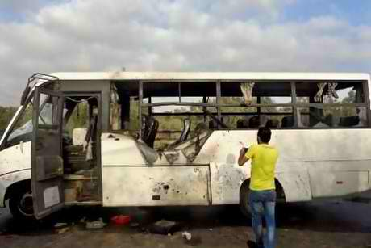
Egypt’s tourism industry has suffered badly during three years of turmoil. With rising extremism, it was only a matter of time before tourists became victims, and on February 16, three tourists and their driver were killed in an attack on a bus in the northern Sinai region.
Two days later, the Islamist group Ansar Beit Al-Maqdis, which claimed responsibility, warned tourists to leave Egypt “before it’s too late”.
The strategy was clear: target an industry that is vital to the faltering national economy and thereby destabilise the authorities. Ansar Beit Al-Maqdis said it was waging “economic war” against the government. The same logic applies to attacks against Egypt’s gas pipelines – there have been four so far this year.
Tourism revenue plummeted 41 per cent last year to $5.9 billion. This new attack has added to the industry’s woes, with tour operators and hotels reporting cancellations and fewer bookings.
Despite this, there are major misconceptions regarding insecurity in the Sinai. The first is that the problem began after the removal of former president Mohammed Morsi last year. While the situation has escalated since then, this was in fact a major problem during Hosni Mubarak’s decades-long rule.
For example, bombings at tourist sites in Taba in 2004, Sharm el-Sheikh in 2005 and Dahab in 2006 killed more than 140 civilians. Similarly, gas-pipeline attacks occurred long before the current authorities took power.
Sinai was presented as a major challenge at the outset of Mr Morsi’s presidency. Numerous incidents during his year in office resulted in the death of soldiers, militants and civilians. Mr Morsi fired his intelligence chief and other top security officials, as well as the governor of North Sinai, after 16 soldiers were killed in August 2012. The attack resulted in a crackdown dubbed Operation Sinai.
The use of the air force “marked a sharp escalation in Egypt’s fight against the militants, who have become increasingly active in the mountainous terrain,” the Associated Press reported at the time. The US expressed its support for “the Egyptian government’s ongoing efforts to protect its people and others in the region from terrorism and growing lawlessness in the Sinai.”
This has been largely forgotten. It suits the authorities because they can blame supporters of Mr Morsi and the Muslim Brotherhood for the militancy (despite the Brotherhood’s condemnation of the recent tourist attack and other violence since he was removed).
It also suits those opposed to Mr Morsi’s removal because they can blame his successors for the worsening security situation, and for creating a problem that supposedly did not previously exist. The truth is that all of Egypt’s leaders, from Mr Mubarak onwards, have contributed to Sinai’s deterioration by viewing it primarily as a security issue, and thus responding with force. As an Egyptian intelligence officer told The Economist in 2011: “We’re not in the business of legitimising smugglers, terrorists, drug barons and outlaws.”
The motives of militants in the region have been dangerously over-simplified and misunderstood. The authorities are portraying violence there as part of their war against Islamist terror that was unleashed by Mr Morsi’s supporters. Conveniently, this label fosters support from a frightened public.
However, Sinai residents’ grievances are long-running, and many have little to do with Mr Morsi or Islam, though both factors play a part, particularly in recent months. The grievances include demands for greater autonomy, the selling and resettlement of their land under Mr Mubarak, and economic, political and social marginalisation.
A statement released after the latest tourist attack by Ansar Beit Al-Maqdis referred to the government “killing innocent people, imprisoning women, demolishing their houses, looting their properties” and “displacing their owners.”
Half of Sinai’s native Bedouin population, which has an identity distinct from the rest of Egypt, “live in poverty, with few employment opportunities,” wrote Fawaz Gerges, professor of international relations at the London School of Economics. “For their survival, they depend on an underground economy.”
However, all Egyptian governments have, to a greater or lesser extent, worked with Israel in the maintenance and tightening of the blockade on the Palestinian territory of Gaza since it began in 2007. This has considerably restricted Bedouin revenues.
Even Mr Morsi, who often expressed sympathy with the plight of Gazans, was guilty of this.
His flooding of smuggling tunnels into the territory was condemned by the governing Hamas movement (another fact conveniently forgotten by both sides in Egypt). The current authorities are eagerly clamping down as well.
There is also the issue of identity. “A substantial minority” of Sinai’s 400,000 residents “is of Palestinian extraction, even if often Egyptian-born,” according to a report by the International Crisis Group.
“The Palestinian element is extremely conscious of its identity and ties to the populations of Gaza and the West Bank.” The Bedouin, who largely comprise the rest of the Sinai population, belong to tribes that “often have extensive branches” in Israel and Palestine.
As such, there is considerable resentment regarding Egypt’s participation in the Gaza blockade, and of Cairo’s ties with Israel in general. Ansar Beit Al-Maqdis’s statement following its tourist attack described Israel as the “Zionist enemy,” and condemned the Egyptian government’s desire “to please their Jewish masters and protect their alleged borders.” Earlier this month, the group carried out a rocket attack on the Israeli city of Eilat.
As long as the violence and lawlessness in Sinai are seen purely as a result of radical religious militancy, rather than of long-standing grievances against the state, the situation will continue to fester, to the detriment of the entire country. Meanwhile, political factions across the spectrum point fingers while ignoring their collective responsibility.

Sharif Nashashibi is a journalist and analyst on Arab affairs.

Forecasts of terrorist apocalypse? Never mind
By Peter Bergen
Source: http://edition.cnn.com/2014/02/26/opinion/bergen-sochi-terrorism-predictions/?hpt=us_mid

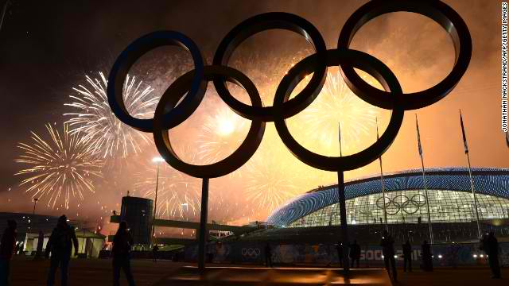
"It's tough to make predictions, especially about the future" is an aphorism attributed to the great baseball player Yogi Berra.
But one topic where pundits, politicians and prognosticators of every persuasion don't have any problem about making pessimistic predictions is terrorism.
The Winter Olympics in Sochi, Russia, was an Olympic-level example of this. In the lead-up to the Games, the airwaves were filled with glum predictions that Sochi would be the 1972 Munich Olympics on steroids.
Rep. Michael McCaul, R-Texas, chairman of the U.S. House Homeland Security Committee, told Fox News, "There's a high degree of probability that something will detonate, something will go off. ... But I do think it's probably, most likely going to happen outside the 'ring of steel' at the Olympic Village."
Similarly, Michael G. Grimm, co-chair of the House Russian Caucus, issued a press release headlined, "Sochi Olympics Cannot Become a Benghazi Nightmare." The New York Republican warned, "We cannot sweep these threats under the rug, like we did with Benghazi or the warnings from Russia on the Tsarnaev brother behind the Boston Marathon bombing. Each time we fail to recognize these threats, we not only risk the lives of innocent Americans, but appear weaker and vulnerable in the eyes of the enemy."
Bill Rathburn, who directed security for the 1996 Summer Olympics in Atlanta, in an interview with Yahoo News predicted of Sochi, "It's not a matter of whether there will be some incident, it's just a matter of how bad it's going to be."
No wonder that two days before the Sochi Olympics, more than half of Americans believed a terrorist attack on the Games was likely, according to a CNN/ORC poll.
Now cue up the swarms of "black widows" descending on Sochi to kill themselves along with many Olympic spectators.
And then the Games were held and ... nothing happened
It turned out that the most terrifying image from Sochi was the look of disgust on the face of American figure skater Ashley Wagner when she learned of her lower-than-expected score.
Sochi is only the most recent example of the hyperventilating hyperbole of the doomsday terrorism prognosticators. Because so many folks were caught flat-footed by 9/11, some seem to overcompensate by keeping up a steady drumbeat of dire terror warnings.
In November, House Intelligence Committee Chairman Mike Rogers, R-Michigan, told CNN that al Qaeda "poses a bigger threat to attack inside the U.S. right now than it did before 9/11."
Rogers' statement defies common sense.
Before 9/11, al Qaeda had an entire county, Afghanistan, as a safe haven; its training camps there churned out thousands of militants every year; it had access to funding substantial enough so that it could spend several hundred thousand dollars on the 9/11 plot. It was a formidable enemy.
Now al Qaeda's safe haven is long gone; the group hasn't mounted any successful attack in the States since 9/11 or, for that matter, anywhere in the West since the London transportation system bombings in 2005.
On 9/11, the United States had never used armed drones in combat. Since then, the CIA has launched 370 drone strikes at suspected militant targets in Pakistan. During President Barack Obama's tenure alone, those drone strikes have killed more than 30 of al Qaeda's leaders in Pakistan.
Not only that: The United States is a much harder target than it was on 9/11. Then there were 16 people on the U.S. "no fly" list.
Today there are more than 20,000. In 2001, there were 32 Joint Terrorism Task Force "fusion centers," where multiple law enforcement agencies worked together to chase down leads and build terrorism cases. Now there are 103.
The U.S. intelligence budget also grew dramatically after 9/11. In 2010, the United States spent more than $80 billion on intelligence collection and other covert activities, much of it directed at terrorist groups -- more than three times what the country spent in 1998.
At the time of the 9/11 attacks, the U.S. Department of Homeland Security, the National Counterterrorism Center and the Transportation Security Administration all didn't exist. All these new post-9/11 institutions make it much harder for terrorists to operate in the United States.
The gloom and doom about terrorism becomes much worse when the specter of terrorists deploying chemical, biological, radiological or nuclear weapons is added to the mix.
Graham Allison, the respected political scientist and founding dean of Harvard's Kennedy School of Government, published a book in 2004 titled "Nuclear Terrorism, which garnered considerable attention with its prediction that "on the current path, a nuclear terrorist attack on America in the decade ahead is more likely than not."
Of course, now we are a decade later, and nothing of the sort has happened.
Indeed, a striking finding of a database of every jihadist terrorism case in the United States since 9/11 maintained by the New America Foundation is that not one of the more than 200 individuals who were indicted or convicted of a jihadist terrorism crime acquired, manufactured or deployed chemical, biological or radiological weapons, let alone a nuclear device.
It's relatively easy to say the sky is always falling. Indeed, given the human capacity for evil, bad things are, indeed, going to happen. But when the sky doesn't fall, which is much of the time when it comes to terrorism, the doomsday prognosticators are rarely held to account. In any event, they are too busy warning of the next catastrophe.

Peter Bergen is CNN's national security analyst, a director at the New America Foundation and the author of "Manhunt: The Ten-Year Search for bin Laden -- From 9/11 to Abbottabad."

EDITOR’S COMMENT: To a certain degree I liked this posting – especially the last paragraph stating that “doomsday prognosticators are rarely held to account”. On the other hand, security analysts have to prognose things. But we must keep in mind that prognosis (Greek: pro + gnosis = before + knowledge = know before you know it) is like the non existing “crystal ball” – you presume that something might happen but you do not know it for sure! Imagine if we do not practice prognosis in diseases – millions of people would have died in a complete surprise. If analysts are not making prognosis then equally bad surprises would follow. If we constrict them to make only post-events ananlysis they have to change occupation because anybody can do that (although we cannot do even than in the best possible way – see “lessons learned” that usually remain “problems identified”). I think that the real problem in prognosis is the financial element that favors defense companies providing all that surveillance equipment, weaponry, software systems and related applications. Along with those supporting such a connection. If prognosis remains strictly confidential and if intelligence sharing was a reality then the human brain-computer might come to more accurate conclusions in the field of international security. During my career I faced this problem many times: in the medical field there was always a question on why the patient had to do all that (expensive) lab test to see how his body was behaving in relation to his clinical symptomatology; in the security field many times my prognosis was also questioned on the grounds that “what you say is impossible to happen”! People forget that a prognosis is made in a given time window. Tomorrow a given prognosis might be wrong. But yesterday the same prognosis was right and valid. If we stop trying to prognose bad things ahead then it is for sure that the unexpected will happen (as always) and public surprise and bloodshed would not justify our concervatism off mind and the way we think about tomorrow.

Attacks planned on gas installations
Source: http://tribune.com.pk/story/676132/terrorism-attacks-planned-on-gas-installations/

LAHORE – An intelligence agency has reported the involvement of the Baloch Republican Army in targeted attacks on gas pipelines, trains and railways tracks. Three of the group’s members have been arrested, and two remote control devices and explosives recovered.
Muhammad Zaman, Muhammad Hussain and Jalil Ahmed have been apprehended and handed over to the police. Sources familiar with the matter said they had planted explosives on a rail track near Kot Mithan railway station in Rajanpur. The 12kg bomb was defused on time.
The report states that the BRA has planned to carry out sabotage activities targeting exposed pipelines, sale metre stations and SNGPL Town border stations. They have carried out reconnaissance at various gas installations and pipelines in seven districts. The report says Baloch insurgents frequently use OGDCL and SNGPL vehicles to transport explosives and saboteurs. The report has been shared with the government.

Islamist Terror Enclave Discovered in Texas
Source: http://www.clarionproject.org/analysis/exclusive-clarion-project-discovers-texas-terror-enclave

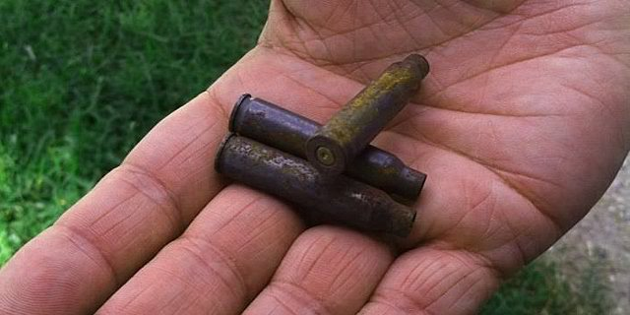
Shells found in the area of the Muslims of the Americas' 'Mahmoudberg' enclave in Texas.

A Clarion Project investigation has discovered a jihadist enclave in Texas where a deadly shooting took place in 2002. Declassified FBI documents obtained by Clarion confirm the find and show the U.S. government’s concern about its links to terrorism. The investigation was completed with help from ACT! For America Houston.
The enclave belongs to the network of Muslims of the Americas, a radical group linked to a Pakistani militant group called Jamaat ul-Fuqra. Its members are devoted followers of Sheikh Mubarak Ali Gilani, an extremist cleric in Pakistan.

Muslims of the Americas
The organization says it has a network of 22 “villages” around the U.S., with Islamberg as its main headquarters in New York. The Clarion Project obtained secret MOA footage showing female members receiving paramilitary training at Islamberg. It was featured on the Kelly File on FOX News Channel in October. A second MOA tape released by Clarion shows its spokesman declaring the U.S. to be a Muslim-majority country.
A 2007 FBI record states that MOA members have been involved in at least 10 murders, one disappearance, three firebombings, one attempted firebombing, two explosive bombings and one attempted bombing. It states:
“The documented propensity for violence by this organization supports the belief the leadership of the MOA extols membership to pursue a policy of jihad or holy war against individuals or groups it considers enemies of Islam, which includes the U.S. Government. Members of the MOA are encouraged to travel to Pakistan to receive religious and military/terrorist training from Sheikh Gilani.”
The document also says that, "The MOA is now an autonomous organization which possesses an infrastructure capable of planning and mounting terrorist campaigns overseas and within the U.S."
Other FBI reports describe the MOA in similar ways, with a 2003 file stating, “Investigation of the Muslims of the Americas is based on specific and articulate facts giving justification to believe they are engaged in international terrorism…”
MOA members believe the holiest Islamic site in the country is located at their Islamville commune in South Carolina. Other MOA entities include the International Quranic Open University, United Muslim Christian Forum, Islamic Post, Muslim Veterans of America and American Muslim Medical Relief Team.

Terror Enclave: “Mahmoudberg, Texas”
The MOA compound in Texas, described by the FBI as an “enclave” and “communal living site,” is in Brazoria county along County Road 3 near Sweeny. It was discovered by the FBI due to a tip from an informant in New York.
The MOA referred to its Texas commune as “Mahmoudberg” in online instructions for a parade in New York in 2010. A posting on an Islamic message board in 2005 advertised a speaking engagement in Houston by someone from Mahmoudberg.
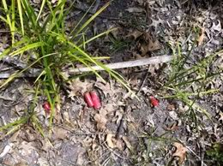
According to the reports, the commune is seven to 10 acres large, is in an “extremely wooded area” and two or three trailer homes moved there in December 2001. However, ACT members visited the area as part of Clarion’s investigation and interviewed one nearby local who confidently said it is closer to 25 acres in size and spoke of a presence dating back to the late 1980s.
“The area is so rural it is quite common for residents to shoot firearms for target practice or hunting on private property without interference from law enforcement,” one FBI report states.
Locals told the ACT members that they haveShells found in the area of MOA's 'Mahmoudberg' enclave in Texas heard gunfire coming from the commune.

Pictures of shells from the area are posted to the right:

The FBI reported in 2007 that one commune resident used to be a leader at the MOA commune in Badger, California. The site was called "Baladullah." In March 2001, one of the Baladullah members was arrested for transporting guns between New York and South Carolina. Another was charged with murdering a police deputy that caught him breaking and entering a home.
Interviewed residents all agreed that the MOA members are private, yet when the ACT members were spotted in the area, they were immediately and repeatedly approached. At one point, a commune resident gave them a final warning to leave, despite the fact that they were not trespassing or harassing MOA members.
“It was definitely very threatening and menacing,” an ACT member told me.
Multiple sources confirmed that one resident of the commune is a police officer. According to a nearby neighbor, one of the MOA members used to drive trucks for the U.S. Army in Kuwait.
The commune is also linked to a non-profit called the Muslim Model Community of Texas. Members travel to Houston to worship at the MOA Dawah Center that is linked to another organization called First Muslims of Texas.

States where Muslims of the Americas enclaves are located
The 2002 Shooting Incident
One of the MOA members was shot and killed by another member on February 7, 2002 between 11-11:30 p.m. according to the FBI documents and a police report.
The victim was Salminma Dawood, also known as Terrance C. Davis III. His death was reportedly an accident, having been shot by another MOA member who “returned gunfire to unknown individuals who were harassing the MOA commune.”
Law enforcement reported encountering about a dozen African-American males at the scene, approximately five of whom lived at the commune. The investigators saw an estimated seven women and children who also resided there.
The police were denied access to the trailer homes and were not allowed to directly interview the women, who covered their faces in their presence. Communication with the women had to be done by passing notes through a male intermediary.
Locals told the ACT members that government investigators had visited the area a few times and the commune residents refused to talk to them. According to one local, two ambulances were denied entry earlier this year until the police intervened. A search of the Brazoria county criminal records shows that two residents of Mahmoudberg were arrested in April 2013 and charged with “interference with public duties.” The trial is pending.

More MOA Activity in Texas
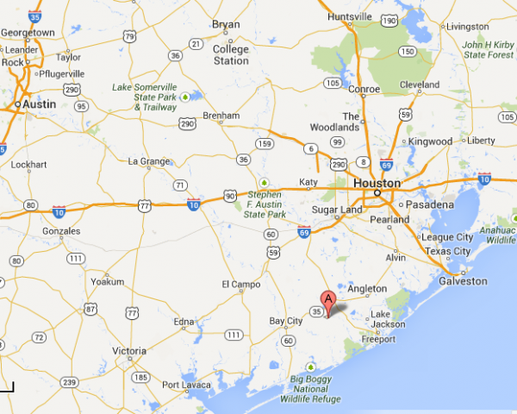
The MOA presence in Texas is not limited to the Mahmoudberg commune near Sweeny. As mentioned, the MOA utilizes a dawah (outreach) center in Houston for activities. The declassified FBI documents show that the extremist group has been in Texas since the 1980s.
On October 11, 1991, a federal search warrant for three suspects was issued after a MOA/Jamaat-ul-Fuqra bomb plot in Toronto was foiled. A nearly 45-acre “compound” about 70 miles south of Dallas was raided. The location may have been near Corsicana, as another FBI document mentions that about seven MOA members purchased property in that area.
The suspects managed to flee on October 5-6 before the raid took place. Their children also suddenly disappeared from school. The feds found four mobile homes, three military, general-purpose tents and six vehicles. Loose ammunition, books on counter-terrorism techniques and weaponry and various items with “Jamaat Fuqra Land” written on them were discovered.
They also found surveillance photos of a post office building and the Greenhead Station in Los Angeles, leading authorities to suspect that attacks on these sites were planned.
MOA activities in Texas continued after the October 1991 raid. Two FBI documents from 1992 mention that MOA members in the state were using false aliases, social security numbers and birth certificates.

Why is MOA Allowed to Operate?
The FBI documents obtained by the Clarion Project clearly identify MOA as a terrorist organization. The Department of Homeland Security privately agreed in 2005, listing Jamaat ul-Fuqra (and specifically MOA) as a possible sponsor of a terrorist attack on the U.S.
So why is MOA/JUF allowed to operate in the country?
The answer is that the State Department has not designated MOA/Jamaat ul-Fuqra as a Foreign Terrorist Organization. The group is thus permitted to organize in the U.S. until that happens. Yet, the State Department has also recognized the group’s terroristic agenda.
In 1998, the State Department’s Patterns of Global Terrorism report described Jamaat ul-Fuqra as an “Islamic sect that seeks to purify Islam through violence.” It said that Fuqra members engaged in assassinations and bombings in the U.S. in the 1980s and still live in “isolated rural compounds” in the country.
A State Department spokesperson was asked in January 2002 about why MOA stopped appearing in the Department’s annual terrorism reports. The answer was as follows:
“Jamaat ul-Fuqra has never been designated as a Foreign Terrorist Organization. It was included in several recent annual terrorism reports under ‘other terrorist groups,’ i.e., groups that had carried out acts of terrorism but that were not formally designated by the Secretary of State. However, because of the group's inactivity during 2000, it was not included in the most recent terrorism report covering that calendar year.”
It has not appeared since. Yet, here we have FBI documents from as late as 2007 discussing the terrorist threat posed by MOA.
It’s long past due that the State Department be forced to address this obvious threat. The State Department must designate Jamaat ul-Fuqra as a Foreign Terrorist Organization before it’s too late.

Analysing Terrorism from a Systems Thinking Perspective
By Lukas Schoenenberger, Andrea Schenker-Wicki and Mathias Beck
Source: http://www.terrorismanalysts.com/pt/index.php/pot/article/view/323/html

Given the complexity of terrorism, solutions based on single factors are destined to fail. Systems thinking offer various tools for helping researchers and policy makers comprehend terrorism in its entirety. We have developed a semi-quantitative systems thinking approach for characterising relationships between variables critical to terrorism and their impact on the system as a whole. For a better understanding of the mechanisms underlying terrorism, we present a 16-variable model (photo below) characterising the critical components of terrorism and perform a series of highly focused analyses. We show how to determine which variables are best suited for government intervention, describing in detail their effects on the key variable—the political influence of a terrorist network. We also offer insights into how to elicit variables that destabilise and ultimately break down these networks. Because we clarify our novel approach with fictional data, the primary importance of this paper lies in the new framework for reasoning that it provides.
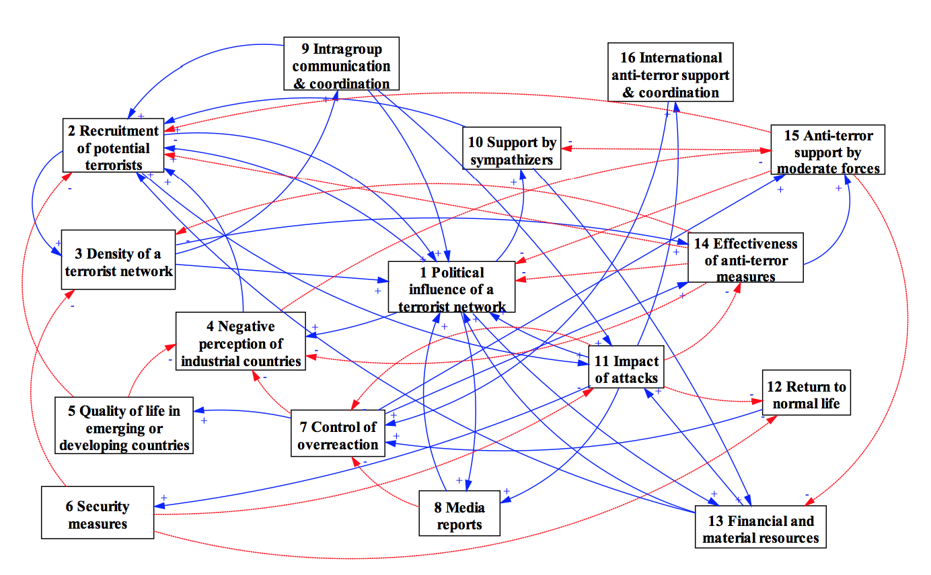
Lukas Schoenenberger is a PhD student at the Institute of Business Administration at the University of Zurich (Switzerland). His research focus is on linking purely quantitative with more qualitative approaches within the field of systems theory. In particular, he combines concepts from graph theory, System Dynamics and stakeholder-oriented approaches to analyse systems.
Dr. Andrea Schenker-Wicki is a Professor of Business Administration at the University of Zurich.
Mathias Beck is also a PhD at the Institute of Business Administration at the University of Zurich.

►Read this very interesting research paper at source’s URL.

A Primer to the Sunni-Shia Conflict
By Philipp Holtmann
Source: http://www.terrorismanalysts.com/pt/index.php/pot/article/view/330/html

Which dispute is so resilient that it continues nearly 1,400 years after the original quarrel? It is the Sunni-Shiite dispute over the question who should succeed the Prophet Mohammed. The original struggle turns around the question if religio-political leadership should be passed on by bloodline (the Shiite imamate) or election (the Sunni caliphate). Today, this has become among some factions a fight over the monopoly to sacrifice and martyrdom, and it takes the form of a competition for political predominance in the Middle East between Saudi Arabia and Iran.
How did it all begin? In 657 AD the Ummayad governor Mu’awiyya contested the reign of the fourth caliph Ali, son-in-law of the Prophet Muhammad, starting the first civil war among Muslims (fitna) that lasted until 661. Ever since, the Muslim community has been split into two major factions: Sunnis [1], who believe that there should have been an egalitarian right of any capable Muslim to head the caliphate, provided he has been chosen by consensus (ijma'). In reality, however, Mu’awiyya confined the inheritance of leadership strictly to members of his own family after he had usurped power, as did Abbaside caliphs and Ottoman sultans in later centuries. Shiites [2], on the other hand, consider it the exclusive right of male members of the family of Muhammad (ahl al-bayt) to head the imamate. The strongest and most influential of Shiite groups are the Twelver Shiites, named after their belief in the twelfth Imam, who allegedly went into hiding in 873; since 1979 this group rules in Iran.
The quarrel over succession continues today between many Shiites and Sunnis - the latter comprising around 85-90% of the world’s Muslim population (which is estimated to be roughly 1,6 billion [3]). Both Sunni and Shia religious leaders, influenced by hardships endured by their communities over the course of history, have developed eschatologies full of apocalyptic doomsday visions and are obsessed with the hereafter. And yet, worldly matters are just as important, with leaders arguing that it is a divine obligation to install an Islamic political, economic and social system on Earth.
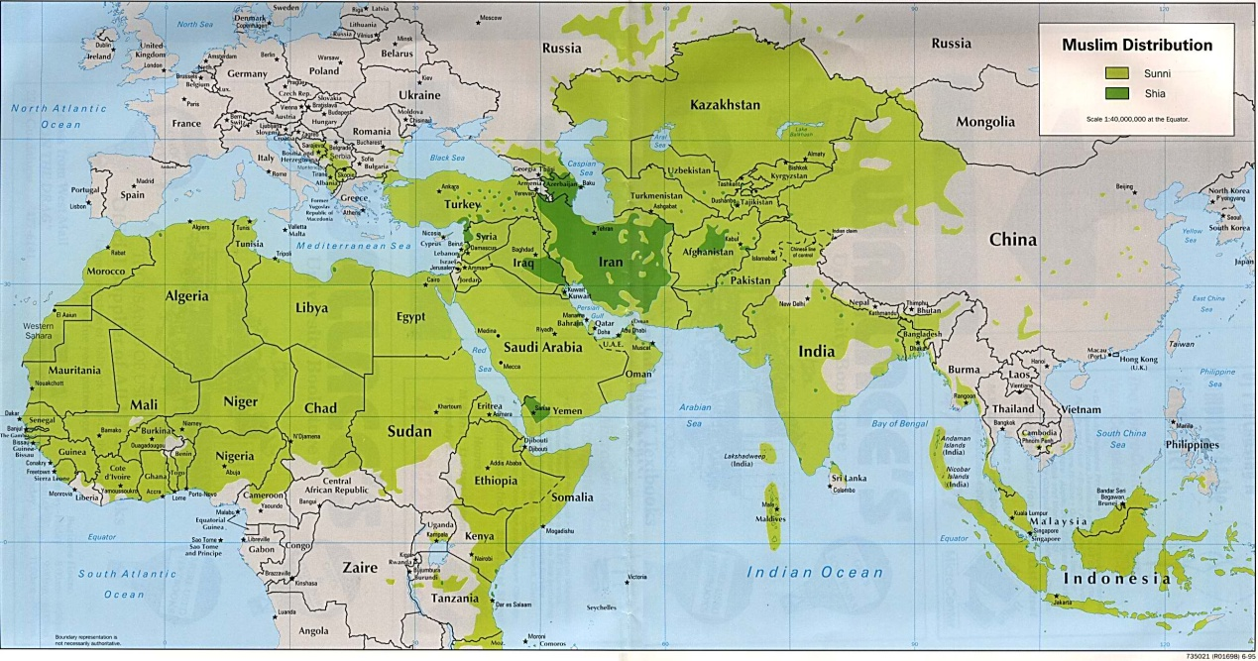
To understand the complex dynamics of the contemporary Sunni-Shiite conflict, one needs to understand both the historical and doctrinal context. This can shed some light on the kaleidoscopic nature of intra-Muslim conflict which plagues the Middle East today: A prominent current within Sunni Islam is Salafism, which is a puritan, purifying, fractionated and almost uncontrollable current that bases its doctrine on a literalist interpretation of the Quran and the life of the first three generations of Muslims (al-salaf al-salih). There are intra-Salafi conflicts as well as severe conflicts between Salafis and modern ‘cultural’ Muslims. Moreover, there is a particularly severe quarrel between Salafis and Shiites. On the other hand, there are currently no serious conflicts among Shiites. Their split into three major doctrinaire groups—the Zaidis (Hasan’s and Hussein’s line accepted leaders), Imamites (Hussein’s line accepted leaders) and Ghulat (“exaggerators” who venerate some imams as quasi-gods)—does not stand in the way of coalition building among them - as exemplified in Iranian support for Yemenite Huthi-Rebels.
The historic Sunni-Shiite split originally led to the emergence of three factions. The Khawarij (“those who leave”) regarded the faction of Mu’awiyya as infidel, because it had dared to challenge the authority of Caliph Ali. Moreover, they excommunicated Caliph Ali, son in law of Muhammad, for consenting to arbitration with the insurgents instead of battling them. Ali and his followers would later become known as the Shiites, while Mu’awiyya and the Ummayad Caliphate would become the first representatives of the Sunni majority faction. The Khawarij would follow neither of them and even denounce the sahaba (the followers of Muhammad), declaring them infidels and combating them by means of assassinations and guerrilla-type warfare. This introduced the doctrine of takfir into Islam (pronouncing someone as kafir [unbeliever] and excommunicating him), for which, according to competing legal interpretations, either the accused or the accuser is punishable by death.[4]. Today the doctrine is commonly used by Sunnis against opponents. Khawarij are often compared to today’s Jihadi Takfiris, who form a sub-group of the militant Salafi-Jihad trend, who in turn are a sub-group of Salafi fundamentalists. For modern Takfiris (who declare other Muslims ‘unbelievers’ by judging their allegedly infidel actions as kufr akbar – “greater unbelief”) it is only a small step from the concept of spiritual purification of society to its physical cleansing. The takfir doctrine has become a type of ideological virus that threatens to tear apart Sunni Islam. Sunni-Muslim state clergy and quietist-evolutionary Salafis put the Khawarij-label frequently on political-oppositional Salafis and on Salafi-Jihadis. The latter throw the accusation back at them, claiming that the former are betraying all true Muslims.[5] Among Sunnis is it common practice to declare Shiites as infidels per definition—most do not even bother with the takfir accusation. For Salafis, like the internationally influential Bahraini sheikh Abu Sufyan as-Sulami, the ruling Alawites in Syria (who belong to the Shiite-Nusayriyya sect) are even “more infidel than the Jews and the Christians.”
Yet by isolating Shiites and labeling them infidels, Sunnis have actually helped their rivals to develop an identity on their own in the course of Islamic history. Ever since the fourth caliph Ali was assassinated and his son Hussein was murdered, Shiites have spiritually connected to the plight of these victims of sectarian strife and integrated the re-experience of their martyrdom into their belief practice (especially during the annual Ashura festival on the tenth day of the Islamic month of Muharram, which commemorates the murder of Hussein in 680 AD in Kerbala, located in today’s Iraq). As a persecuted minority, Shiites in many countries have had to revert to practices of secrecy and became accustomed to suffering and discrimination when living in Sunni majority environments. [While Shiite communities can be found worldwide, most Shiites live in just four countries: Iran, Pakistan, India and Iraq.] At the same time, this adversity has helped Shiites to consolidate a common sense of identity and to find relative doctrinal and social cohesion.
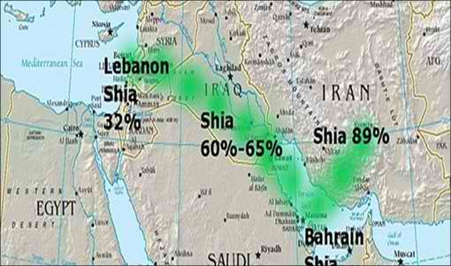
In contrast, certain religious and political doctrines put forth by Sunni extremists since the 1960s have caused divisions and mayhem in their own ranks. The Sunni quest for identity started in the early 20th century with the abolishment of the caliphate by Turkey in 1924. It was intensified by Western colonialism, by failed experiments with state formation in parts of the Arab world and by five humiliating Arab military defeats against Israel. As a consequence of a long series of setbacks on several levels, Salafist fundamentalism has become a strong ideological alternative for many Sunni Muslims since the 1970s. In the course of the radicalisation and popularisation of Salafist concepts—which include a new sense of isolation, victimisation and martyrdom—some Sunnis are fostering doctrines which are similar to those of Shiites: they believe in hiding their true doctrine (taqiya) in order to protect themselves; they apply independent Islamic legal reasoning (ijtihad), although this leads to a jurisprudential anarchy (fauda fiqhiyya); they cherish martyrdom (istishhad); and they believe in miracles (karamat), especially with regard to slain martyrs. Paradoxically, the widespread use of suicide attacks today, and the saint-like veneration of martyrs by Sunni extremists were initially introduced into the Middle East by the Shiite Hezbollah in 1981.
Thus, while the 20th century witnessed the disintegration of Ottoman Sunni power and the emergence of new, disunited Sunni ideological currents, it also saw the strengthening and consolidation of Shiite power. Particular milestones in this process were (i) the establishment of a modern theological Shiite state (the Islamic Republic of Iran, founded in 1979), (ii) the creation of a formidable military sub-state force (Hezbollah), which by the mid-1990s controlled most of Lebanon and in 2006 slapped the allegedly invincible Israeli Defence Forces right in the face, (iii) a strong Shiite segregation movement in northern Yemen, (iv) Shiites in top political and military positions in Pakistan, and (v) a Shiite parliamentary majority government in Iraq since 2005. With their centralised and more effective leadership styles in military, religious and political affairs, modern Shiites are well-positioned to become the winners in the region’s Sunni-Shiite conflict unless Sunnis find a common religious agenda and political platform. Even if they do, Western and local military junta interventions in past Sunni attempts to build Islamist governments (see Algeria, Gaza and Egypt, among others) have proven that there are many obstacles on the way. On a tactical level, Shiite powers may lose some battles in the ongoing conflicts in Lebanon, Syria, Iraq, Saudi Arabia, Bahrain and Northern Yemen. Yet Sunnis seem incapable of re-establishing anything that resembles the lost caliphate. All that remains are hot pockets of resistance and insurgency, where the highest chains of command are those of Sheikhs who also battle each other about differences in doctrine and strategy. These battles produce ever more Sunni dissenters, who, out of frustration, often declare those surrounding them ‘infidels’, whether they are Sunnis or Shiites.
This takfir problem is especially severe among Sunni-Salafis, whose different branches maintain large transnational propaganda networks. The messages emanating from these networks often contain dangerous simplifications and lead to further radicalisation of doctrines. The Salafi cleric Hassan Dabbagh, who preaches via Pal Talk as well as in a mosque in Leipzig (Germany), complained recently that many Muslim youngsters in the European diaspora only believe in “takfir and Kalashnikov”– an interpretation that is fostered by the Internet-propaganda of Salafi clerics like Muhammad Mahmud, an extremist Austrian preacher of Egyptian origin. For Shiites, intra-Sunni disunity and hate campaigns are not a problem as long as these help to foster their own cohesion. For Sunnis, however, these internal splits are anathema to a common united front.
Sunni rebel groups are busy battling each other in northern Syria, in some instances with financial support and weapons from Saudi Arabia and Qatar. Meanwhile, Shiite powers are demonstrating united military and diplomatic fronts in Syria and Lebanon, and are gathering behind Iranian president Hassan Rouhani’s diplomatic initiative for a rapprochement with the West. Part of Rouhani’s initiative is to focus on stronger inter-Shiite relations, in order to present a unified base of support. Iran might even drop its long-term Sunni ally Hamas, whose leader was recently prohibited from visiting Tehran. It is not even inconceivable that Iran might prefer closer ties with the United States over maintaining its longstanding alliance with the Assad dynasty. [6] Peace in Syria and a new government that shares central strategic interests, such as the containment of the Sunni-Jihadi threat, are on top of the Shiite agenda. Shiites, it would appear, are making good progress on their very own political highway.

Notes
[1] Lit. Ahl al-Sunnahwa-l-Jama'a = “People who follow the tradition of Muhammad and the consensus of the Muslim community.”
[2] Lit. shi'at 'Ali = “The Party of Ali.”
[3] According to the Pew Research Center, “World’s Population more Widespread than you might think” (June 7, 2013) Online at: http://www.pewresearch.org/fact-tank/2013/06/07/worlds-muslim-population-more-widespread-than-you-might-think/
[4] Ever since, there has been a doctrinaire battle in Islam, whether or not an infidel action is enough to excommunicate a Muslim or whether unbelief of the heart needs to be proven. The practice of the Khawarij was revived in different Islamic periods for political purposes. For example, some Sunni legal scholars in the 12th and 13th centuries used it as a label against Mongol Muslim converts, who attacked the Abbaside Caliphate at that time, and declared the Mongols infidels. The doctrine was also revived under the purist Wahhabi sect in the 18th century, which coalesced with the Sa’ud clan in their power struggle with other tribes over control of the Arabian peninsula.
[5] Among Sunni-Salafi sects the takfir-doctrine has been revived since the 1970s, and has been quoted as justification, for example, in the assassination of the Egyptian cleric Muhammad al-Dhahabi in 1977, the occupation of the Grand Mosque in Mecca in 1979, and the assassination of Egyptian president Anwar al-Sadat in 1981. In the Algerian, Iraqi and Syrian civil wars, the doctrine has played a decisive role as underpinning for the murder of tens of thousands of Muslim civilians. Also Saddam Hussein’s brutal slaughter of Shiites in the Iran-Iraq war, in which the dictator mercilessly applied nerve agents, can be partly explained by it.
[6] “Nasser Hadian: Reasons Iran Wants Peace in Syria,” United States Institute of Peace, February 4, 2014, accessed February 9, 2014, http://iranprimer.usip.org/blog/2014/feb/04/nasser-hadian-reasons-iran-wants-peace-syria.

Dr. Philipp Holtmann is an analyst specializing in the Middle East, where he has lived and worked in several countries. He conducts in-depth research on jihadist media as well as on Muslim conflicts and reconciliation issues and is a Research Associate with the Terrorism Research Initiative. His publications include ‘Abu Mus’ab al-Suri’s Jihad Concept’ (2009), ‘Virtual Leadership: How Jihadis Guide Each Other in Cyberspace’ (2012), ‘The Symbols of Online Jihad’ (2013), ‘The Use and Genre of Huda’ (encouraging battle songs) versus Anashid (praiseful hymns) in Jihadi Propaganda’ (2013), and ‘Countering Al-Qaeda’s Single Narrative’ (2013).

Boko Haram's International Reach
By Ely Karmon
Source: http://www.terrorismanalysts.com/pt/index.php/pot/article/view/326/html

Although most of Boko Haram’s terrorist activity is focused, for the moment, on Nigerian territory, this Research Note argues that it is already an important international jihadist organisation. The watershed that marks Boko Haram’s passage from a purely Nigerian phenomenon to an international jihadist actor is its attack on the United Nations Headquarters in Abuja, Nigeria’s capital, on August 26, 2011. The bulk of BH’s membership, the indiscriminate and cruel characteristic of its attacks, the complexity of the Nigerian religious and ethnic context, the sheer weight of the Nigerian state in an instable neighborhood - Cameroun, Niger, Chad, Mali - and its proximity to the jihadist battle front in the Sahel convert it into an immediate and infectious regional threat.

Jama`at Ahl al-Sunna li al-Da`wa wa al-Jihad, popularly known as Boko Haram (BH), rose to international prominence in 2010 and 2011 when it carried out a series of deadly attacks against the Nigerian government and detonated a car bomb at a United Nations building in Abuja, the capital.
The year 2013 saw a major increase in the indiscriminate terror attacks by BH, which killed and injured thousands of innocent civilians, police and military officers, public officials and group members. Attacks between January 2012 – August 2013 included not only 50 churches and Nigerian Christians but also clerics or senior Islamic figures critical of Boko Haram and “un-Islamic” institutions or persons engaged in “un-Islamic” behaviour.[1] According to a UN humanitarian agency, attacks between May and mid-December 2013 killed more than 1,200 people, a figure that does not include insurgents killed during targeted military operations.[2] Boko Haram targets include police stations, government buildings, churches, politicians, newspapers, banks, and schools. Tactics include drive-by shootings on motorcycles, the use of improvised explosive devices, and starting in 2010, suicide bombings.
This Research Note will focus on the international dimensions of Boko Haram and the threat it represents to the international community. It will not deal with its history, the social, political and economic factors which led to its formation and its transformation into the most dangerous Nigerian salafist/jihadist organisation.
Although there is already some in-depth academic literature on BH, by Nigerian and Western scholars [3] the point of departure of this discussion will be Emilie Oftedal’s report "Boko Haram – an overview," for the prestigious Norwegian Defence Research Establishment (FFI).[4] Oftedal’s conclusion is that “Boko Haram has focused mainly on national grievances and targets” and she warns against “exaggerating Boko Haram’s connections with foreign militants and considers the likelihood of Boko Haram becoming a major international terrorist threat in the near future to be relatively low.” However, the report also raises the possibility that BH or one of its factions—mainly the splinter group Ansaru—may become more internationally oriented and mount further attacks outside Nigeria. It claims that Ansaru “has conducted several attacks against Westerners and targeted soldiers going to Mali, and appears more globally oriented than the ‘core’ BH movement led by Abukakar Shekau.”[5] In contrast, the Jamestown Foundation’s Boko Haram expert Jacob Zenn has a different take than Oftedal concerning Ansaru. In his view Ansaru was created by al-Qaida in the Islamic Magrheb (AQIM) and has a close operational relationship with BH: “In many ways Ansaru is the internationalist component of Boko Haram; although, it may not exist as a distinct entity from Boko Haram, since the French intervention in Mali in January led to the two group’s integration when Ansaru lost contacts with a retreating AQIM.” [6]
Another perspective, as argued in this Research Note, is that BH is already an important international jihadist organisation although most of its terrorist activity is focused, for the moment, on Nigerian territory. In fact, Oftedal also wrote a M.A. thesis about the transnational aspects of Boko Haram, where she analyses their significance for the group’s capabilities and reach. In her discussion she refers mainly to the states bordering Nigeria that are threatened by the BH terrorist activities, namely Niger, Chad, Cameroon and Benin. [7] As described later in this analysis, the growing regional dimension of the Boko Haram threat represents a form of internationalization which, if remained unchecked, will have dire consequences in the years to come.
In August 2009, about a week after the death of its then-leader Muhammed Yusuf, Sanni Umaru, the interim head of the organisation, published an ideological declaration regarding its goals and methods of operation. This can be seen as a milestone in the organisation's move to the second phase, evolution toward an international orientation: “In fact, we are spread across all the 36 states in Nigeria, and Boko Haram is just a version of Al-Qaeda, which we align with and respect. We support Osama bin Laden, we shall carry out his command in Nigeria until the country is completely converted to Islam, which is according to the wish of Allah.” [8] Several years later, documents seized at Osama bin Laden's compound in Abbottabad in Pakistan showed that top level BH leaders had been in touch with Al-Qaeda “within the past 18 months.” [9]
In early 2010, Abdelmalik Droukdel, the leader of AQIM, publicly offered Boko Haram assistance in early 2010. [10] Then in early July 2010, Abubakar Shekau, Muhammed Yusuf’s deputy, who was thought to have been killed by police in 2009, appeared in a video and claimed leadership of the group. He said he was ready to launch attacks on western influences in Nigeria. On July 13, Shekau issued another statement expressing solidarity with Al-Qaeda and threatened the United States. [11] In October 2010, AQIM’s media arm published a statement by Shekau, the first time AQIM disseminated an official message from another group. AQIM and BH officials have referenced growing ties in public statements. [12] According to Jacob Zenn, Shekau is excellent in classical Arabic and well versed in Islamic scholarship. His sermons show a synthesis of local salafist preaching with calls for international jihadism and for breaking down the Western and U.S.-led world order. [13]
While these statements reflect various forms of international intentions, the watershed that marks Boko Haram’s passage from a purely Nigerian phenomenon to an international jihadist actor is its attack on the United Nations Headquarters in Abuja, Nigeria’s capital. On August 26, 2011, a suicide bomber drove a vehicle with an improvised explosive device to the U.N. headquarters in Abuja, killing 23 people and injuring more than 80 others. BH took responsibility for the attack, the first time it had targeted an international, non-Nigerian entity .The Nigerian State Security Service (SSS) named the alleged bombing mastermind as Mamman Nur, “a notorious Boko Haram element with Al-Qaeda links who returned recently from Somalia.” [14]
The SSS’ claim fits with a June 2011 statement by BH that some of its members had gone for training in Somalia: “We want to make it known that our Jihadists have arrived [in] Nigeria from Somalia where they got serious training on warfare from our brethren who made the country ungovernable and forced the interim government to relocate to Kenya… despite the armoured carriers that they are boasting of, they are no match with the kind of training we acquired in Somalia.”[15]
Two videos later emerged purporting to show members of BH preparing for suicide attacks, including Mohammed Abul Barra, the suicide bomber of the U.N. building, launching a vague warning to “Obama and other infidels”. The voice said to be Shekau’s calls the U.N. headquarters a “forum of all the global evil” while also offering praise for Osama bin Laden. [16]
The scale and method of the attack suggested that BH had adopted the tactics of AQIM, which took responsibility for a similar attack on United Nations offices in Algeria on December 11, 2007. The suicide attacks became AQIM’s signature and represented a combination of local and global terror. [17] By calling the Algerian U.N. headquarters a “Green Zone,” and labeling its staff a “den of international infidels,” AQIM itself symbolically relived the August 2003 attack by Al-Qaeda in Iraq on the U.N.’s mission in Baghdad, which killed Chief of Mission Sergio Vieira de Mello and caused the U.N. to depart from Iraq. [18]
According to Oftedal, Ansaru claimed responsibility for the December 2012 kidnapping of a French engineer from his residence in Katsina state, presented as retaliation for France’s ban on the Islamic veil and its role in the military intervention in northern Mali. In January 2013, Ansaru attacked a convoy of troops in Kogi State en route to deployment with West African forces in Mali trying to stop Nigerian troops joining Western powers. Meanwhile, she also gives examples that support the view of BH as an international jihadist actor. Like other researchers, she cites Malian security officials saying Boko Haram fighters were in the majority in the attack on the Algerian consulate in Gao in April 2011; Niger’s president Mahamadou Issoufou June 2012 statement that Niger had evidence that BH was running training camps in Gao, Mali; the Nigerian Air Chief Marshal, Oluseyi Petinrin, claim in June 2012 that BH had ties to AQIM, the first time a Nigerian top security official made such links in public. In July 2012, Gen. Carter Ham, head of the US military’s Africa Command, said there were signs that BH, al-Shabaab and AQIM were increasingly coordinating their activities.
Shekau’s November 2012 video, unlike his five other statements issued in 2012, was in Arabic and was posted on online jihadist forums, an indication that he was seeking to appeal to both the wider jihadist community and to Al-Qaeda's leaders. Shekau refers to the fighters in the jihadist theaters as his "brothers" and addresses "the soldiers of the Islamic State in Mali ... our brothers and sheikhs in beloved Somalia ... our brothers and sheikhs in Libya ... our brothers and sheikhs in oppressed Afghanistan ... our brothers and sheikhs in wounded Iraq ... our brothers and sheikhs in Pakistan ... our brothers and sheikhs in blessed Yemen ... our brothers and sheikhs in usurped Palestine, and other places where our brothers are doing jihad in the Cause of Allah." Shekau warns "Britain, America, Israel, and Nigeria" that the killing of jihadist leaders will not defeat the groups. Shekau says that BH is "with our mujahideen brothers" in their fight against "the Jews and the Crusader Christians." According to Bill Roggio, an American commentator on military affairs, Shekau's videotape is very similar to tapes issued by Somalia’s Al-Shabaab in 2008, when the group was making overtures to join al Qaeda. [19]
The December 2013 nighttime attack launched by hundreds of BH fighters on a Nigerian Air Force base in the city of Maiduguri, in which a number of security personnel were killed and several aircraft destroyed, is reminiscent of attacks by Al- Qaeda’s associates on important military bases in other theaters of war: the Pakistani Taliban’s attack on Pakistani Naval Station Mehran in Karachi in May 2011 and the Afghan Taliban’s assault on Camp Bastion in Helmand in September 2012.[20]
Speaking in Arabic, Hausa and Kanuri in a video disseminated on the Internet, Shekau took responsibility for the raid on the Maiduguri air base and claimed “the whole world” feared him - U.S. President Barack Obama, French President Francois Hollande, Israeli Prime Minister Benjamin Netanyahu and even the late British premier Margaret Thatcher. He singled out in particular the U.S.: “You are boasting you are going to join forces with Nigeria to crush us. Bloody liars,” he said, adding: “By Allah, we will never stop. Don’t think we will stop in Maiduguri. “Tomorrow you will see us in America itself. Our operation is not confined to Nigeria. It is for the whole world.”[21]
The arrest of key figures of the group proved that its links with AQIM opened it up to funding from groups in Saudi Arabia such as the Islamic World Society and some prominent local businessmen. From the trial of Kabiru Umar, suspected mastermind of the Christmas Day bombing of St. Theresa’s Catholic Church, in Madalla on 25 December 2011, it appeared that funding came also from an Islamic group, Musilimi Yaa'maa, based in Algeria. [22]

The Regional Threat
The regional aspect of BH’s “internationalism” can be seen as the most immediate and infectious threat. It is of note that most of BH’s activities take place within the boundaries of the 19th century Bornu Empire which cover northeastern Nigeria, the northern tip of Cameroon, southwestern Chad and northeastern Niger. After the 2009 rising in Maiduguri documents found on the bodies of dead militants indicated that many of them had come from Niger and Chad. [23]
Leaders of neighboring countries such as President Biya of Cameroon and President Debi of Chad as well as leading diplomats of Niger who are devising regional mechanisms to attack BH, recognised it has increasingly become a regional issue. [24]
The ability of BH fighters to escape into other countries has greatly frustrated Nigeria. A Borno state official accused Cameroonian authorities of refusing to arrest or chase BH militants fleeing across the border after carrying out attacks in Nigeria. Some Nigerian security sources complain that Cameroon has shown little interest in the problem, while Niger and Chad do not have adequate resources to help. [25]

Cameroon
One of the main difficulties for the Nigerian security forces in patrolling the border with Cameroon is a lack of infrastructure, which allows BH to set up bases and training camps in the desert or forested areas of the northern Nigerian-Cameroon border region. Shekau has repeatedly appeared in video messages sent from his hideout, allegedly located somewhere in northern Cameroon, and BH has consistently used Cameroon as a rear base for carrying out attacks in Nigeria. For example, in February 2013 Boko Haram kidnapped a family of seven Frenchmen in Cameroon, near the Nigerian border, the first major incident by the group outside Nigeria. In the statement claiming responsibility for the attack the group made reference to the French-led intervention in Mali: “Let the French president know that he has launched war against Islam and we are fighting him everywhere. Let him know that we are spread everywhere to save our brothers.”
A missionary has been killed and several churches set ablaze in attacks by BH in Cameroon. The Nigerian missionary, David Dina Mataware, with the Christian Missionary Foundation (CMF), was killed on November 13, 2013 in a village which straddles the Nigeria-Cameroon border. He was murdered on the same day as the kidnapping of a French priest, but the death was not reported by the media even though both incidents happened in the same area. [26] BH claimed in a statement that it “coordinated” the kidnapping of French priest Father Georges Vandenbeusch with Ansaru. He was liberated at the end of December 2013. [27]
Most recently, on December 19, 2013, a convoy of BH militants crossed the border from Cameroon into Banki, Nigeria, and attacked the military Kur Mohammed Barracks in Bama. The attack was particularly traumatic because it came only days after Boko Haram destroyed parts of the Maiduguri air base.
Nigeria recently negotiated a security agreement with Cameroon to grant its troops access to BH settlements which has become the new haven for its fighters. The agreement ensures Nigeria is not accused of violating the sovereignty of Cameroon when troops launch air or ground assaults against BH hideouts across the border. [28]
The Cameroonian authorities have set up tighter border controls in the Far North region to guard against infiltration by BH fighters. A rapid response military unit has been deployed and some tourist hotels now have armed guards. However, the authorities admit that it is impossible to completely secure Cameroon’s longest border. The two countries have agreed to conduct separate but coordinated border patrols. [29]

Niger
Authorities in Niger arrested 15 suspected BH members in Diffa in February 2012 and seized home-made explosives and grenades. Suspected BH members were arrested in the Zinder region in September 2012. [30] In May 2013, BH inmates in a prison near the Nigerien capital of Niamey, with support from comrades in Nigeria and Niger launched an attack on their prison guards. In October 2012, Niger and Nigeria signed an agreement on joint border patrols, with the aim of restricting movement of illicit arms and militants across the borders.

Chad
Chad President Idris Deby has warned of the insecurity in the Lake Chad region based on what he describes as “the permanent threat” posed by BH and AQIM, and has called for the creation of a joint deterrence force comprised of military forces from Nigeria, Chad, Niger, Cameroon and the Central African Republic. In January 2012, the Nigerian government ordered the temporary closure of its borders with Cameroon, Chad and Niger to prevent cross-border activities of BH militants and roving bands of Chadian deserters and former rebels who have made the region south of Chad their base of operations. [31]

Mali and beyond
BH fighters traveled to Mali in 2012, when the militant Salafist groups AQIM, MUJAO (Movement for Oneness and Jihad in West Africa), and Ansar al-Dine controlled the northern part of the country and established closer relations with these groups. [32]
The pattern of attacks that has occurred since then indicates the insurgents may have to a large degree scattered into more remote areas of the region. Dumba is located near Lake Chad and close to Nigeria’s borders with Cameroon, Chad and Niger.
In August 2012 the imam of the Grand Mosque in Bignona, southern Senegal, claimed that Boko Haram was recruiting local youths. [33] There are indications that BH has recruited some militants from neighboring countries. Mamman Nur—believed to be second in command to Shekau—is from Chad, while Abubakar Kilakam and Ali Jalingo, responsible for major attacks in the northeastern Borno State, are said to be from Niger. [34] Interestingly, although there are large Nigerian communities in Europe and the United States there is no information about “foreign fighters” from Western countries traveling to Nigeria to join Boko Haram, as Oftedal notes.

The International Context
The French Intervention in Mali
The French military and African Union states’ forces intervention in Mali since January 2013 has provided new opportunities for the internationalisation of Boko Haram’s activity and has brought it closer to other jihadist groups fighting in the Sahel: AQIM, The Movement for Oneness and Jihad in West Africa (MOJWA) and Ansar al-Dine. At the same time it presented the group with possibilities for training, combat experience and operational cooperation with these organisations.

United States Policy
A November 2011 report by the U.S. House of Representatives Committee on Homeland Security, Subcommittee on Counterterrorism and Intelligence, concluded that “Boko Haram has the intent and may be developing the capability to coordinate on a rhetorical and operational level with al-Qaeda in the lands of the Islamic Maghreb (AQIM) and Somalian Al Shabaab.” The committee called for designating both BH, and its splinter group, Ansaru, as foreign terrorist organisations. The committee advised that BH "intent and capability to attack the U.S. homeland" be not discounted, warning the U.S. intelligence community to avoid repeating mistakes made with Tehrik-e-Taliban Pakistan and Al-Qaida in the Arab Peninsula – both groups were underestimated until they attempted to launch attacks on American soil. [35]
Already in June 2012 the U.S. had labelled BH commanders Abubakar Shekau, Khalid al-Barnawi and Abubakar Adam Kambar “Specially Designated Global Terrorists.” According to the U.S. State Department Khalid al-Barnawi has “ties to BH” and “close links to AQIM.” According to a source cited by AFP, Barnawi is believed to have run a militant training camp in the Algerian desert and was involved in the kidnapping of French nationals in Niger in 2011 and a Briton and an Italian in Nigeria in 2012.
Since June 2013, the U.S. government has been offering $23 million worth of rewards for information on key leaders of terrorist organisations in West Africa. BH’s leader, Abubakar Shekau, heads the list with a reward of $7 million for information leading to his location, some $2 million higher than Mokhtar Belmokhtar, a veteran jihadi leader in the Sahel. This suggested a shift in U.S. thinking regarding threats emanating from BH. [36]
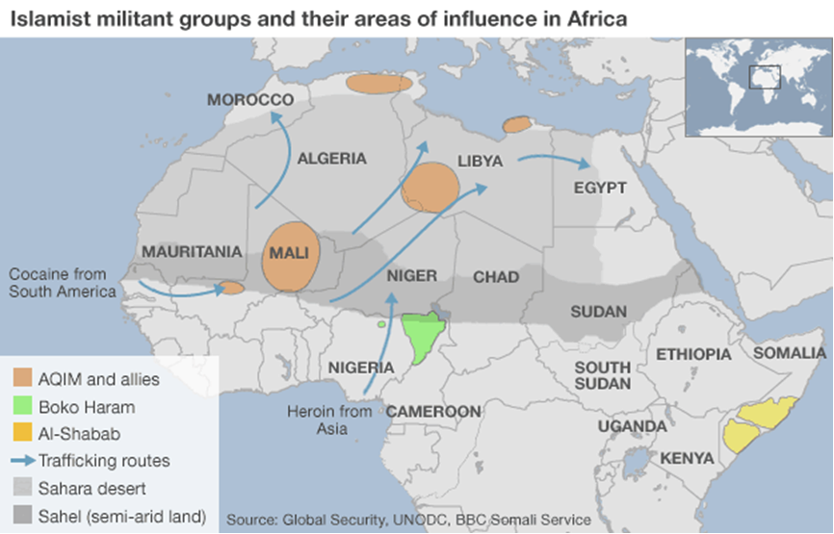
Opponents of the Foreign Terrorist Organisation (FTO) designation, like Rep. Patrick Meehan, perceived BH as “little more than a grassroots insurrection with no defined leader or structure.” Some believe that the FTO designation could have negative implications for the U.S. and Nigerian partnership. John Campbell, Senior Fellow for Africa Policy at the Council on Foreign Relations, and former US Ambassador to Nigeria, suggests that BH “could acquire a jihadist character if the United States is seen as supportive of Nigerian security approaches.”[37]
On November 13, 2013 the U.S. State Department finally decided to designate Boko Haram and Ansaru as Foreign Terrorist Organisations (FTOs) and as Specially Designated Global Terrorists (SDGTs), thus assisting U.S. Justice and Treasury Departments in collaborating with counter-terrorism partners to investigate and prosecute terrorist suspects or supporters in the United States, including charitable organisations providing material support to these terrorists groups.
The groups operate locally, but have international connections and resources. As the U.S. government views Nigeria as an important economic partner, Nigeria’s security and stability has added importance to the U.S. Notably, Nigeria is the second largest African destination for U.S. foreign direct investment, and provides approximately eight percent of U.S. oil imports. Nigeria has also been a major stabilising force in Africa through its major contribution of UN peacekeeping forces. [38]
Nnamdi Obasi, a Nigeria analyst with the International Crisis Group (ICG) asserts that the move will encourage BH to aggressively target U.S. interests in Nigeria and further radicalise the movement and push it to strengthen international linkages with other Islamist groups. "Some Nigerians are also concerned that it could embolden the US military to launch military operations in the country unilaterally, much like they've been doing in Pakistan," he claims. [39]
At the end of December 2013, Canada joined the United States in designating BH as a terrorist organisation under its Criminal Code. By virtue of the listing, the assets of the groups and anyone associated with them in Canada will be “seized and forfeited.”

Conclusion
Jonathan Hill, from the Defence Studies Department, King's College London, rightly compares the path of Boko Haram towards a bloody jihadist group with the Algerian model. The extreme violence and indiscriminate character of its attacks (burning or throat cutting of dozens of students) are re-enacting what has already happened in Algeria. The extreme forms of terrorism and cruel guerrilla tactics of the Armed Islamic Group (GIA) leading to the factionalism of its direct forbears, the Salafist Group for Preaching and Combat (GSPC) and finally the AQIM under the influence of Ayman al-Zawahiri could tie more closely BH to the Algerian jihadi group. [40]
Because Nigeria is Africa's largest oil producer and most populous state, the internal instability provoked by the expanding violence of Boko Haram could have major regional and global implications.
The bulk of BH’s membership, the indiscriminate and cruel characteristic of its attacks, the complexity of the Nigerian religious and ethnic context, the sheer weight of the Nigerian state in an instable neighborhood (Cameroon, Niger, Chad, Mali) and its proximity to the jihadist battle front in the Sahel play in this direction.
However, on the background of the forthcoming important presidential and legislative elections in Nigeria in February 2015, it is possible Boko Haram will make a special effort to expand its terrorist campaign to southern Nigerian Christian states in the hope of provoking a religious war and present itself as the defender of Nigeria’s Muslims.
Paradoxically, if the Nigerian army and security forces succeed in curtailing BH’s terrorist and guerrilla activities in the North and seriously weaken the organisation, the result could be enhanced activities outside Nigerian territory, fractionalisation and closer cooperation with foreign “brother” groups, as happened in the past to the GIA/GSPC in Algeria, leading to the Sahel-based AQIM, or the Chechen insurgents driven south to Dagestan, Kabardino-Balkaria and Ingushetia to form the so-called Islamic Caucasus Emirate.

Ely Karmon, PhD, is Senior Research Scholar at the International Institute for Counter-Terrorism (ICT) and the Institute for Policy and Strategy (IPS) at the Interdisciplinary Center (IDC) in Herzliya, Israel. He lectures on International Terrorism and CBRN terrorism at the M.A. Counterterrorism Studies at IDC. His fields of research include political violence, international terrorism, CBRN terrorism, and the strategic influence of terrorism and subversion in the Middle East and worldwide.

►You can read the “notes” of this paper at source’s URL.

“Counterterrorism Bookshelf” – 23 Books on Terrorism & Counter-terrorism Related Subjects
By Joshua Sinai
Source: http://www.terrorismanalysts.com/pt/index.php/pot/article/view/329/html

Dr. Joshua Sinai is the Book Reviews Editor of ‘Perspectives on Terrorism’.

Literature on Terrorism Research
Compiled and selected by Judith Tinnes
Source: http://www.terrorismanalysts.com/pt/index.php/pot/article/view/328/html

This bibliography contains journal articles, book chapters, books, edited volumes, theses, grey literature, bibliographies and other resources on the field of Terrorism Research, its sub-disciplines (such as Critical Terrorism Studies), central approaches and methods. Though focusing on recent literature, the bibliography is not restricted to a particular time period and covers publications up to mid of January 2014. The literature has been retrieved by manually browsing more than 200 core and periphery sources in the field of Terrorism Studies.

Judith Tinnes, Ph.D., studied Information Science and New German Literature and Linguistics at the Saarland University (Germany). Her doctoral thesis dealt with Internet usage of Islamist terrorists and insurgents. Currently she works in the research & development department of the Leibniz Institute for Psychology Information (ZPID). She also serves as Editorial Assistant for ‘Perspectives on Terrorism’.
Active Shooter After Action Reports Analyzed in FEMA Lessons Learned ‘Trend Analysis’
Source: http://www.hstoday.us/single-article/active-shooter-after-action-reports-analyzed-in-fema-lessons-learned-trend-analysis/78512b6bdcb87764272ee77a6cd90297.html

A new Federal Emergency Management Agency (FEMA) Lessons Learned Information Sharing (LLIS.gov) analysis of 30 active shooter After Action Reports (AARs) highlighted “the importance of inter-agency coordination on the ability of emergency medical services (EMS) personnel to respond” to an active shooter incident.
“Trends also emerged with regard to the management of on-site logistics,” the FEMA LLIS “Trend Analysis” report stated.
To assist with both exercise and response planning for an active shooter incident, FEMA’s LLIS.gov team included response recommendations and considerations that first responders can adopt.
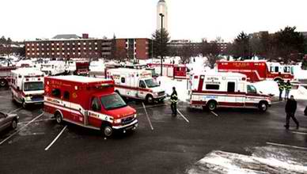
LLIS.gov describes a trend analysis as “an analysis comparing similar events, activities, capacities, or capabilities over a predetermined time period to detect patterns or relationships between factors or variables.”
FEMA's LLIS analysis of the 30 AARs said “Proactive law enforcement response with the intent to use force to stop the attacker, such as the response to the Virginia Tech shooting, ensures that the gunman, if still alive when law enforcement arrives, is unable to continue inflicting harm on potential victims. While the main priority for active shooter response efforts is minimizing the number of casualties, an equally pressing priority is getting emergency medical care to victims of the shooting in a timely manner.”
FEMA’s LLIS analysis of the AARs also “found several trends related to the deployment of emergency medical services during an active shooter incident.”
The key findings are:
- EMS active shooter incident protocols should consider a plan that takes into consideration the pressing medical needs of the wounded and the operational risk involved; and
- Management of on-scene logistics, when responding to an active shooter incident, has a significant impact on the efficiency of response and on personnel safety.
With regard to on-scene logistics management, the LLIS analysis of the 30 after action reports determined that “On-scene activities during response to an active shooter incident will be fast-paced and, often times, hectic. In order to minimize the impact of this on operations, EMS should consider placing priority on logistics management -- which affects the speed at which EMS can conduct triage operations, provide pre-hospital treatment and expedite the transport of victims to healthcare facilities.”
“Good logistics management is dependent on proper incident command and an effective staging area for resources,” LLIS said, adding that “Interagency coordination is crucial once EMS is deployed on scene.”
FEMA’s LLIS team said “EMS assets will benefit from a unified command structure that communicates the location of the staging area, the security status of the scene, the approximate number of victims and the time when they can access the scene. In order to ensure this exchange of information occurs, agencies must have well-developed relationships with one another.”
When on scene logistics is managed through interagency coordination, FEMA's LLIS.gov team said it “ensures that personnel remain safe throughout the response effort [and] prevents EMS from unknowingly deploying within the hot zone of an incident where they may be at risk and could become casualties themselves. In order to keep EMS personnel safe, unified command should keep EMS informed of the situation as it unfolds and establish an operations perimeter to manage response operations.”
The following recommendations were made in AARs on logistics management:
- “It is critical to have fire/EMS assets staged away from the incident until force protection can be well coordinated through a unified command;” and
- “Establish a perimeter to secure the area for fire/EMS victim triage. This will reduce the amount of officers needed for force protection.”
“Logistics is also important during triage operations,” FEMA’s LLIS analysis of the 30 active shooter AARs said. “Proper triage operations ensure that victims quickly move through the different phases of care, starting with patient stabilization through to hospital care. Efficient and effective triage entails the proper identification of a victim’s injuries and general condition by EMS personnel. This will ensure that victims receive the best possible care on the scene, during transport, and at the hospital once they arrive. To expedite the application of pre-hospital treatment, responding agencies should also consider different ways to move patients to a secure location for treatment while the scene is being cleared of all threats."
The following triage and pre-hospital treatment recommendations came from the AARs analyzed:
- “[Law enforcement should] work with EMS personnel on smaller incidents to reinforce the learned behaviors of briefing, determining evacuation corridors, and evacuation of patients so that the behaviors become second nature and the response can be scaled to the event;”
- “Continue to assess best practices for triage set-up and logistics;”
- “Triage tarps should be set further apart from one another to decrease confusion and possible cross-over of patients;” and
- “Triage tags, patient care reports, or standardized Incident Command System forms must be completed accurately and retained after a multi-casualty incident.”
The FEMA LLIS analysis further determined that “The management of assets, through the establishment of a staging area and a scene perimeter, meant logistics improved the efficiency and effectiveness of the response effort. The familiarity between agencies, primarily fire/EMS and university police as a result of previous exercise drills and working planned events, was stated as a main reason why they were able to easily carry out incident command protocols and procedures during this incident.”
With regard to personnel safety and security, the analysis of the 30 after action reports found that because victims of a shooting often suffer gunshot wounds that leave them in critical condition, EMS is charged with providing medical care to victims to stabilize them long enough to be transported to a definitive-care facility.
“However, in the immediate aftermath of an active shooter incident, threat levels can remain high due to the potential existence of secondary hazards (e.g. secondary shooter, placement of improvised explosive devices), resulting in operational and tactical delays of EMS delivering significant life-saving care to the wounded,” FEMA’s LLIS analysis said.
“Although personnel safety needs to be maintained throughout the response, this can inadvertently cause a delay in providing medical care to a victim, decreasing the chances of survival in some cases,” the analysis continued. “Consequently, EMS should take these two considerations -- medical needs of the wounded and personnel safety -- into account during the response to an active shooter incident.”
To ensure that both medical attention and operational risks are managed properly, FEMA’s LLIS team said that “responding EMS personnel need to collaborate closely with law enforcement on scene [and that] the analysis of the AARs demonstrated several ways in which EMS personnel coordinate with law enforcement during response.”
The following recommendations from the AARs include:
- “EMS units must take their direction from the on-scene [Incident Command] IC or[Unified Command] UC. [Regional Communication Centers] do not have … a visual understanding of the incident to the point where they can give tactical direction to emergency assets at the scene of an emergency or disaster;”
- “Outside entities are not familiar with buildings; law enforcement should guide EMSto the scene or area to respond;” and
- “Conduct joint [law enforcement] LE/Fire/EMS tabletop and functional exercises towork through active shooter tactical incidents.”
FEMA's LLIS analysis also noted that “Several real-world and exercise AARs discussed the use of force protection, where law enforcement escorts EMS through the incident site, to facilitate a more aggressive and rapid medical response. This model allows EMS to deploy to the ‘warm zone’ of an incident to start saving lives before the all clear is given, which could range from minutes or hours before being announced.”
In order to carry out this tactical, interagency operation, the FEMA LLIS analysis said “law enforcement works with EMS personnel to provide a protective escort through the incident site so that EMS can provide trauma care to the wounded,” and that “a major emphasis is placed on treating patients who are likely to perish from sustaining one of the three most common fatal injuries from ballistics.”
Agencies that wish to explore the feasibility of establishing plans and procedures to incorporate force protection in their active shooter response protocols should consider the following AAR recommendations:
- “Establish a unified command rapidly with representatives from all disciplines to apply better communications and coordination of law enforcement and fire/EMS assets;”
- “Provide force protection training to all first responders, unified command staff, and private ambulance companies to save lives;”
- “Develop a ‘regional force protection policy’ and establish a [on-scene] perimeter to secure the area for fire/EMS victim triage;”
- “[Exercises should] evaluate the ability to safely and efficiently remove and treat large numbers of injured and uninjured, from a hot zone to a secured location, effectively providing for their safety and wellbeing;” and
- “Further explore the feasibility of patient/victim extraction by providing joint training and exercise opportunities to law and fire first responders.”

EDITOR’S QUESTION: Is piracy targeting changing?

Now they’re after oil and have no interest in the vessel or the crew, who are held hostage only long enough to siphon cargo from the ship. The ideal is no one gets killed, which keeps reprisals down.
Even more interesting is where that oil goes, because this requires a massively organized transnational criminal network that necessarily extends to officialdom in some regions. The stolen cargo has to be stored somewhere before it is disbursed on the black market, or repackaged and camouflaged by legitimate petroleum products.

Stabbing Attack Kills Dozens at China Train Station
Source:http://online.wsj.com/news/articles/SB10001424052702304071004579414243691552578?mg=reno64-wsj&url=http%3A%2F%2Fonline.wsj.com%2Farticle%2FSB1000142405270230407100457 9414243691552578.html

More than 10 people armed with knives rampaged through a train station in southwestern China, leaving 33 people dead and injuring 130 others in what state media called a terrorist attack by separatists from the Xinjiang region.
The government news agency Xinhua said the train station in the center of Kunming city was crowded with travelers and migrant workers when the attackers began stabbing people around 9:20 p.m. Saturday. It quoted witnesses saying the attackers wore black and carried long knives.
In addition to 29 people killed in the attack, police shot dead at least four suspected attackers, captured one and continued to hunt for others, Xinhua said.
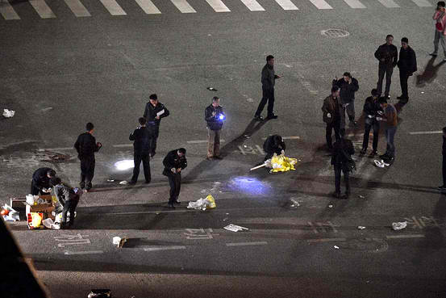
Police officers investigate the scene outside a railway station in southwestern China. Associated Press
Xinhua, citing unnamed government officials in Kunming, identified the assailants as separatists from Xinjiang, China's northwestern region where some members of a mainly Muslim ethnic group, the Uighurs, have rebelled against Chinese rule.
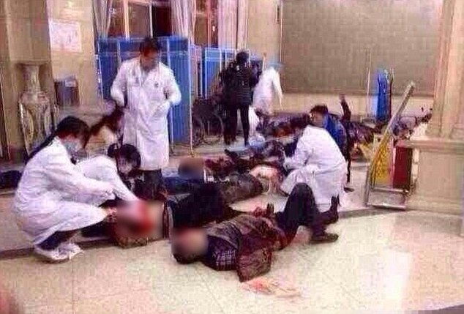
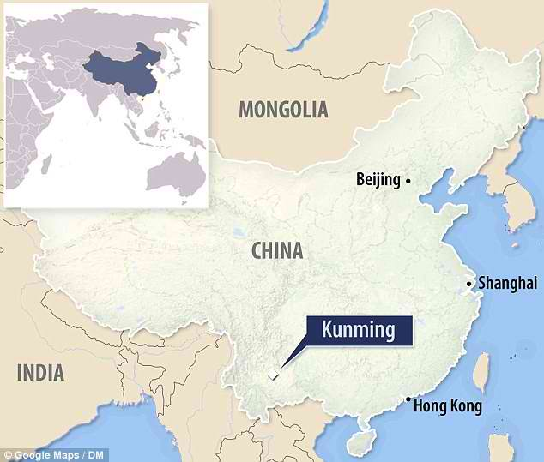
If confirmed, the attack would be one of the deadliest by Uighur separatists in the decadeslong, sometimes violent campaign and would mark a departure in tactics. Targets in the past have usually been police, paramilitary barracks and other symbols of Chinese government authority, and attacks have mainly been staged inside Xinjiang.
President Xi Jinping, in remarks carried by state media, didn't say where the attackers came from but called on law enforcement to solve the case, "severely punish the terrorists in accordance with the law and firmly strike down this aggression." China's top security official, Politburo member Meng Jianzhu, went to Kunming to lead the investigation and was shown on state television meeting with injured in the hospital.
The attack comes just ahead of this week's opening of the annual session of China's national legislature and a concurrent meeting of a government advisory body—events that always bring higher levels of security.
Some local governments appeared to notch up security further. In the Sichuanese capital of Chengdu, 400 miles (650 kilometers) north of Kunming, police said they were launching an emergency contingency plan, and stepping up armed patrols by police at train stations, airports, shopping malls and elsewhere.
Social media posts mixed anger and sadness. Lin Zhibo, an official at the Communist Party's People's Daily newspaper in Gansu province, said on his verified account on the Sina Weibo social media platform that the victims must be mourned and attackers harshly dealt with. "The crime of betraying the country deserves death," he wrote.
Reports and posts about the attack appeared to be strictly controlled, with many newspapers republishing the official Xinhua version of events. On Chinese social media, users posted photos purporting to be from the Kunming railway station, showing bodies lying on the station's floors, with blood pooling underneath them. Some photos were later deleted.
Separatist violence has ticked up in recent years in Xinjiang, which abuts Central Asia and has important oil and gas reserves. Chinese authorities and experts on the region say that some separatists have become radicalized by the more militant strains of Islam found in neighboring Pakistan and the Middle East. Exiled Uighurs and rights groups say increasingly intrusive police measures and restrictions on religious practices have incited a backlash by some Uighurs.
The violence poses security and political problems for the Chinese leadership. Tensions between Uighurs and the majority Han Chinese have run high in Xinjiang for years. Ethnic rioting between them in Xinjiang's capital, Urumqi, in 2009 left nearly 200 people dead.
Xinhua said that before Saturday's railway station assault, the deadliest attack on civilians occurred in Xinjiang's Lukqun township in June in which at least 24 people were killed. What happened in Lukqun remains unclear. At the time Xinhua reported that Uighurs brandished long knives and killed civilians as they charged government offices. Overseas-based Uighur groups dispute that account.
In one of the few incidents outside Xinjiang, China blamed the separatist East Turkestan Islamic Movement for crashing a sport-utility vehicle into a pillar near the Tiananmen gate in central Beijing in October. Two tourists were killed in addition to the three people—members of a Uighur family—in the vehicle.

407 killed in 192 terrorist incidents in February 2014
Source: http://www.pakistantoday.com.pk/2014/03/01/national/407-killed-in-192-terrorist-incidents-in-february/

Around 407 people lost their lives in 192 terrorist incidents during February 2014, a report of Conflict Monitoring Centre said on Saturday.
This includes deaths of 68 security forces personnel, nine razakars, 194 terrorists and 136 civilians. 516 others were injured, including 133 security personnel, 4 razakars, 49 terrorists and 330 civilians.
Security forces arrested 143 suspected terrorists while 24 people have been kidnapped during February 2014. Balochistan witnessed highest number of incidents (83) but number of deaths in FATA outnumbered other provinces/ administrative units.
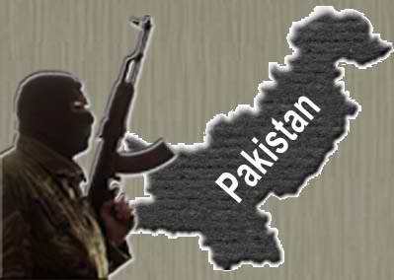
In 49 violent incidents in FATA, 175 people died, including 24 security officials, one razakar, 132 terrorists and 18 civilians while 59 others were injured including 24 security officials, four razakars, 27 terrorists and four civilians, 44 suspected terrorists were arrested while one person was kidnapped.
In terms of number of human losses, KP followed suit where 98 violent incidents caused 109 deaths including 14 security personnel, seven razakars, 27 terrorists and 61 civilians while 180 others were injured including 11 security officials, 15 terrorists and 154 civilians. Injuries to civilians in KP outnumbered other provinces/regions.
In KP, security forces also arrested 24 suspected militants while 6 people were kidnapped. In only incident in Islamabad Capital Territory (ICT), two people were arrested while no casualty or injury was reported. In 83 violent incidents in Balochistan, 68 people were killed, including seven security personnel, 1 razakar, 30 militants and 30 civilians while 72 others were wounded, including 31 security personnel, five terrorists and 36 civilians.
14 people were arrested but number of kidnapping stood tall in Balochistan with kidnapping of 17 persons. 45 violent activities were reported in Sindh in which 50 people were killed including 20 security personnel, four terrorists and 26 civilians while 191 people were injured including 58 security officials and 133 civilians.
Security forces claimed to have arrested 29 suspected terrorists. In 16 violent incidents in Punjab, 5 people were killed including three security officials, one terrorist and one civilian while 14 others were wounded, including nine security officials, two terrorists and three civilians. Security forces also arrested 30 suspected terrorists in various operations in Punjab.
Among 292 violent incidents, 194 were terrorist activities and 98 actions were conducted by security forces. In 192 terrorist attacks, 256 people lost their lives, including 68 security officials, 9 razakars, 44 terrorists and 30 civilians while 478 suffered injuries, including 132 security officials, four razakars, 18 terrorists and 324 civilians. Three terrorists were arrested while 24 people were kidnapped. Among these 194 violent activities, six were suicide bombing in which 25 people were killed including six security personnel, six terrorists and 13 civilians while 75 others were injured, including 11 security personnel and 64 civilians.
Three suicide attacks were recorded in KP while one each in Balochistan, Punjab, and Sindh. In 36 attacks, terrorists used grenades, mortar shells and rockets, killing 30 people and injuring 104 others. 27 activities were of kidnapping, target killing or kidnap and killing in which 45 people lost their lives including 29 security officials, one terrorist and 15 civilians.
Violent activities by the terrorists (194) in February were marginally higher than the previous month (189 in January). Loss of security personnel has been recorded considerably lower; 68 as compared to 100 in corresponding period last month.

Ukraine nationalist leader calls on 'most wanted' terrorist Umarov 'to act against Russia'
Source: http://rt.com/news/yarosh-nationalist-address-umarov-380/

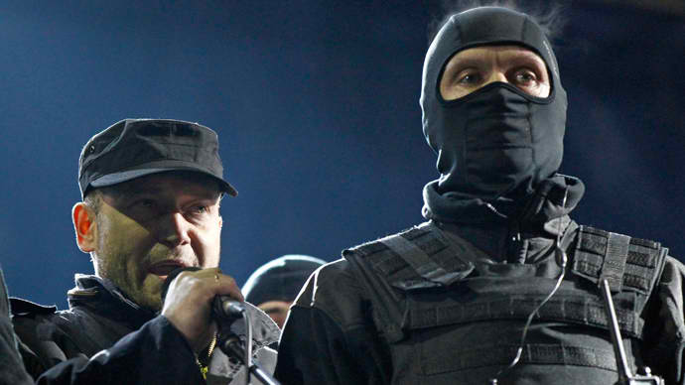
Dmytro Yarosh (L), a leader of the Right Sector movement, addresses during a rally in central Independence Square in Kiev February 21, 2014 (Reuters / David Mdzinarishvili)

A leader of the Ukrainian radical group Pravy Sektor (Right Sector), Dmitry Yarosh, has called on Russia’s most wanted terrorist Doku Umarov to act against Russia in an address posted on Right Sector’s page in VKontakte social network.
The statement points out that “many Ukrainians with arms in the hands” supported Chechen militants in their fight against Russians and “it is time to support Ukraine now.”
The message, signed “leader of Right Sector Dmitry Yarosh” then calls on Umarov “to activate his fight” and “take a unique chance to win” over Russia.
Yarosh, who is a self-proclaimed deputy secretary of the National Security and Defense Council of Ukraine, leads the far-right militant Right Sector group. He used to be a leader of radical nationalist group Trident, which became the core of the Right Sector.
Yarosh attended the February 21st political gathering at the renamed Independence Square shortly after the signing of the deal that returned the country to the 2004 constitution. He shared the stage with virtually all of Ukraine’s prominent opposition politicians, including former superstar boxer and leader of the Democratic Alliance for Reform, Vitaliy Klitschko. In the following video, surrounded by masked units from his far-right following, he declares victory and vows to continue fighting, as the crowd cheers in a military fashion.
The radical leader has been consistently anti-Russian in his statements, calling for the destruction and division of the “Moscow Empire” and openly supporting Chechen militants and Georgian aggression. Yarosh believes Russia is Ukraine’s “eternal foe” and has said that war between the two countries is “inevitable.”
Aside from his beliefs on Russia, the Right Sector leader believes Ukraine should be “careful” with its future EU membership, as the “bureaucratic monster of Brussels” is “doing everything to bring to naught the national identity” of EU member countries.
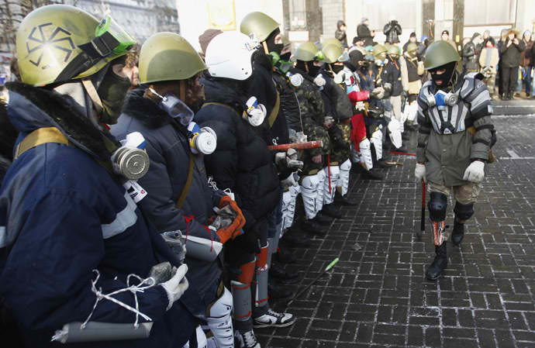
Far-right group "Right Sector" train in Independence Square in central Kiev, January 25, 2014. (Reuters/David Mdzinarishvili)

Yarosh’s outrageous plea to terrorist Doku Umarov exhibits the “guts of the so-called new Ukrainian authorities,”Chairman of the Presidium of the Russian Congress of Peoples of the Caucasus told Itar-Tass.
“Extremists, nationalists of all stripes, flooded the peaceful republic threatening it with chaos and violence,” Aliy Totorkulov said.
Even the fact of Yarosh’s address, whose “hands are stained with blood” shows that the Ukraine’s extreme right“Maidan sponsors” and the forces supporting the instability in Caucasus come from a “single-center” of extremism, Totorkulov stressed.
“We strongly support the deployment of Russian troops to resolve the situation in Crimea as well as provide assistance to other Ukrainian regions, where the population rejects nationalism and asks [Russia] for help and protection.”
During the recent riots in Ukraine, Yarosh rejected any negotiations with the Ukrainian government, calling on his supporters to defy the truces and agreements of the government and the opposition.
The Right Sector has been referred to as the most active, the most radical and the best organized group in the Ukrainian unrest. Well-equipped masked rioters from Right Sector often used clubs, petrol bombs and firearms against the Ukrainian police. Some notorious members of the radical movement have continued to use rifles and pistols to intimidate local authorities, which they believe should be “afraid” of the people.
Although the violent acts of the group have been well-documented by media and placed on YouTube, Western powers have largely ignored its actions and persisted with describing the protests in Ukraine as “peaceful.” After meeting with Ukrainian protesters, including Right Sector members, in late January, Western representatives went as far as saying that they were “convinced that these people posed no threat.”
The Russian Foreign Ministry’s commissioner for human rights Konstantin Dolgov said that Moscow awaits the West’s reaction to Yarosh’s appeal to Umarov.
“The Ukrainian neo-fascist Yarosh has appealed to terrorist Umarov,” Dolgov wrote on Twitter. “Does the West place their stake on such Ukrainian ‘democrats’? Will they react to this?”
Umarov, who commanded groups of militants in both Chechen wars and organized several large terror acts, is the most wanted terrorist in Russia. Umarov has claimed responsibility for several attacks on Russian civilians, including the 2010 Moscow Metro bombings and the 2011 Domodedovo International Airport bombing, which killed dozens of people and injured hundreds.
In March 2011, Umarov was put on the UN Security Council’s Al-Qaeda and Taliban Sanctions Committee list of individuals. The US government has also announced a $5 million reward for information leading to the terrorist leader’s capture.
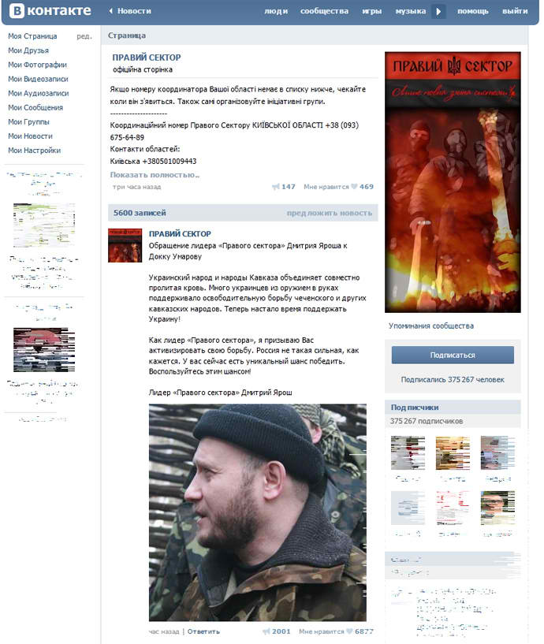
The self-proclaimed ‘Emir of the Caucasus Emirate’ routinely recorded video addresses, in which he incited terror attacks against Russian government forces and civilians. He last appeared alive in a video posted on the internet in summer 2013, calling to step up terrorist activities and thwart the 2014 Sochi Winter Olympics. Umarov’s long absence led rumors of his death to spread, but so far this has not been officially confirmed.
Meanwhile the social media page of the Right Sector group, where the message has been posted, was taken down as it has violated company’s policies by posting ◄prohibited content. The VKontakte page now states that the "community has been blocked at the request of Roskomnadzor as it has been added to the register of prohibited content."
The Right Sector social media VKontakte page had over 375,000 followers and was used for coordinating the actions of the movement's cells across Ukraine.
After the outrageous message caught the attention of world media, a Right Sector representative has claimed that the movement has nothing to do with the posting and that one of their administrator's accounts was "hacked."

Turkey Financing Top Global Terror Groups
Source: http://www.terrorismwatch.org/2014/03/report-turkey-financing-top-global.html

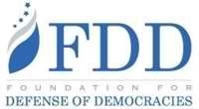
Turkey has become a principal financial hub for terrorists under the leadership of Prime Minister Recep Tayyip Erdogan, whose government has helped Iran skirt sanctions, supported jihadi groups in Syria, and provided financial backing to Hamas, according to a new report by the Foundation for Defense of Democracies (FDD).
Turkey, a key U.S. ally, “has turned a blind eye” to terror financing and is potentially on the verge of crossing the line to becoming an official state sponsor of terrorism, according to the Friday report, which cites the Erdogan government’s close ties to some of the world’s top terror organizations and operatives.
The report comes just a day after 84 U.S. lawmakers and former government officials urged President Barack Obama to confront Erdogan over his harsh repression of political opponents.
As Turkey’s support for terrorism expands, the Obama administration has remained silent out of fear of offending Erdogan, whom the White House considers a strategic asset, according to the report authored by FDD’s Jonathan Schanzer, a former terrorism finance analyst at the U.S. Treasury Department.
The Obama administration “has remained on the sidelines, expressing relatively mild concern about the crackdowns on law enforcement officials and the jailing of journalists, while electing not to mention terrorism finance issues publicly,” the report states.
“Washington’s silence stems from fears of a fall-out with Turkey, which has been a crucial ally over the years, and is situated strategically at the intersection of Europe and the Middle East,” according to the report. “But Turkey’s actions constitute a direct challenge to Washington’s sanctions regime.”
The report catalogues in detail Turkey’s cozy relationship with jihadi groups, terrorist operatives, and the Iranian regime.
Last year, “Turkey was involved in a massive sanctions-busting scheme with Tehran,” according to the report. “Now known as ‘gas-for-gold,’ the scheme helped the Iranian regime gain some $13 billion” despite international sanctions meant to stop such deals.
Additionally, over 2,000 Iranian companies are reportedly registered in Turkey, where pro-Erdogan political elites have been accused of facilitating large cash transfers with Tehran.
Turkey’s top intelligence agency is also believed to be working with Iran in a bid to “scuttle intelligence operations” aimed at stopping Iran’s nuke program, according to the report.
Erdogan has also gone to great lengths to bolster extremist rebel groups in Syria, according to the report, which cites “mounting evidence suggests that Turkey has been directly or indirectly arming, training, and even financing Sunni jihadi groups” in the country.
Turkey reportedly sent 47 tons of weapons to Syrian rebels during a six-month period in 2013, according to the report.
There are “few questions that it has been Turkish policy to provide support to a range of rebel factions,” the report states. “Turkey now appears to allow a broad spectrum of anti-Assad forces, including those with radical ideologies, to operate on Turkish territory.”
“Jihadi personnel and finances” have been identified as flowing from Turkey to Syria.
Israeli military officials have additionally claimed that “Syrian al Qaeda groups were training in three separate bases in the Turkish provinces.”
Erdogan has also been exposed for having a close friendship with Yasin al-Qadi, a Saudi Arabian businessman who has faced sanctions for his financial ties to al Qaeda, Osama bin Laden, and other terrorist fronts.
Hamas has become another ally of the Erdogan government, which has held meetings with the terror group’s senior leadership and allows one of its key operative to work in Turkey.
Senior Hamas leader Saleh al-Aruri has been living in Turkey, “where he has been allegedly involved in the financing and logistics of Hamas operations,” according to the report, which states that “al-Aruri may be raising funds on Turkish soil that go to support terrorism.”
This coincides with “broader Turkish support” for Hamas, including political cover and financial backing.
Turkey has even inked a $4 billion deal with a Chinese missile firm that has been sanctioned “multiple times by the U.S. for selling prohibited missile technology to Iran,” according to the report.
Turkey’s deal with the controversial China Precision Machinery Import and Export Corp appears “to be a direct attempt to undermine the U.S.-led sanctions against Iran,” the report states.
The Turkish government’s growing ties to terror have come amid a corruption scandal that has rocked Erdogan’s AKP political party, which has “purged the investigators, prosecutors, and journalists involved” in exposing the corruption.
FDD’s Schanzer warned that left unchecked by the United States and the rest of the international community, “Turkey’s terrorism finance problems could fester further.”
“These problems have already raised questions about whether Turkey currently serves as a barrier to extremism from the Middle East,” Schanzer said.

Anatomy of militant groups reveals Iraq's different challenges
By Aymenn Jawad Al-Tamimi
Source: http://www.meforum.org/3783/iraq-militant-groups

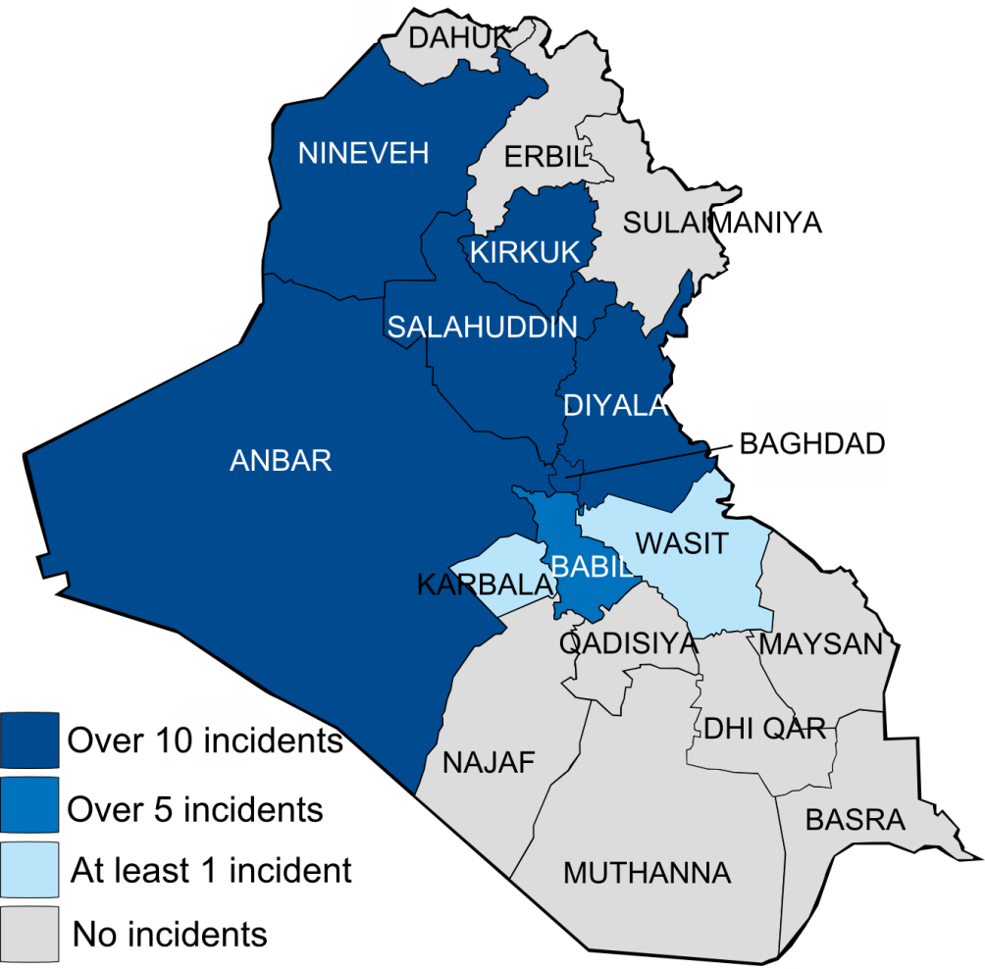
The most influential militant group is the Al Qaeda-offshoot Islamic State of Iraq and Levant (Isil), the successor to the Islamic State of Iraq that was formed at the end of 2006. Isil is strongest in Anbar – where it runs training camps in the desert – and retains at least partial presence in Ramadi, Fallujah and Nineveh. In Mosul, Isil functions as the mafia in the city, extorting millions of dollars every month from local businesses.
On account of its vast financial clout, as well as boosts in manpower following the US troops' withdrawal and Baghdad prison breaks in July last year that saw hundreds of prisoners escape, responsibility for the frequent coordinated bomb attacks targeting civilians in Baghdad and elsewhere can be reliably traced to Isil. The group is also the only one among the active insurgent groups capable of targeting points south of Baghdad on an occasional basis, including Kut, Wasit and Nasiriyah governorates. This also applies to the autonomous Kurdish region, which is now dealing with a "blowback" from Iraqi Kurdish recruits to Isil who have headed to Syria.
Isil in Iraq is more openly advertising its operations in Anbar, Nineveh, Salah ad-Din and Diyala provinces on social media. Isil is also attempting to demonstrate institutions of proto-state building in Fallujah, most notably issuing a statement on the establishment of an Islamic virtue and vice committee in the town.
Ideologically, the closest group to Isil is Jamaat Ansar al-Islam (JAI), a 2007 offshoot of the defunct Iraqi Kurdistan Al Qaeda-affiliated Ansar Al Islam. JAI primarily operates in Nineveh, Kirkuk and Salah ad-Din provinces, with occasional operations in Baghdad. But the frequency of operations conducted by JAI nowhere nears that of Isil. While Isil can carry out well over 100 operations in Nineveh in a single month, JAI nationwide manages only a couple or few dozen at most.
Although both groups support the establishment of a caliphate, engage in takfir (accusing Muslims of apostasy) and target Shia civilians, JAI is actually the most notable among the other insurgent groups for its deep rivalry with Isil. This has led to multiple clashes in Kirkuk and Nineveh. One JAI supporter in Mosul told me that Isil had killed 40 JAI members between April and December. In February 2013,* JAI appealed to Al Qaeda chief Ayman Al Zawahiri to restrain Isil's conduct.
JAI's key grievance against Isil is that Isil does not consider itself a mere group or faction like others – an important complaint echoed in Syria. Indeed, on jihadi forums, JAI members and supporters were the first to popularise references to Isil as a jamaat, or "group", which is now a standard part of Syrian rebel discourse in refusing to accept Isil' claims to being a state (in turn, JAI circles also now use the Arabic acronym "Daesh", used as a derogatory term, to refer to Isil). This has infuriated Isil circles, who denounce JAI for supposedly not supporting the project of a caliphate and deride JAI's members as criminals.
Apart from these two groups, the most generic term used for the insurgency is "revolutionaries of the tribes". This has entailed the declaration of a number of tribal "military councils", beginning in Anbar and spreading out elsewhere.
The general Anbar tribal military council is the most prominent. It likely comprises a variety of nationalist insurgents from old groups that generally ceased to be active after 2008 or once the US occupation ended, such as the 1920 Revolution Brigades and the Salafi-leaning Islamic Army of Iraq, which following the US withdrawal set up an activist wing called the Sunni Popular Movement which participated in the 2012 protests.
Outside of Anbar, however, it is apparent that a number of these tribal military councils are simply fronts for the Baathist Naqshbandi Army, which distinguishes itself from the other groups in engaging in occasional cross-sectarian messaging. This Naqshbandi influence is most apparent in the social media output released via Intifada Ahrar Al Iraq, the Naqshbandi's activist wing, purporting to show Shia tribal military councils against the government in areas like Karbala.
Besides these so-called tribal military councils, there are also other new generic banners around which insurgents have gathered, most notably the Jaysh Al Izza wa Al Karama ("Army of Pride and Dignity"), reflecting the name of the protest sit-in sites in various areas in which Sunni Arabs gathered last year.
The relations of the other groups with Isil, besides JAI, are complex. One can find evidence of insurgents deriding Isil as Daesh, while Isil circles themselves ultimately distrust the other groups, particularly the Naqshbandi, for supporting supposedly un-Islamic agendas, despite apparent cooperation recently between Isil and the Naqshbandi in seizing three localities in Salah ad-Din province.
On the whole, it seems unlikely that the Iraqi government will be able to revive a widespread "Sahwa" movement, the popular anti-insurgency Awakening Councils in 2005, against Isil for the time being. Meanwhile, killing will likely continue. None of these groups has the strength to dislodge the central government from power, but the government is similarly unable to decisively defeat them. Isil poses the most serious terrorist and military threat, while the other groups primarily constitute a problem for the government to assert control in Sunni Arab areas.

Aymenn Jawad Al-Tamimi is a student at Brasenose College, Oxford University, and a Shillman-Ginsburg Fellow at the Middle East Forum.

Counterterrorism or Neo-Colonialism? The French Army in Africa
Source:http://www.jamestown.org/single/?tx_ttnews[tt_news]=42051&tx_ttnews[backPid]=7&cHash=a1093c20018e501db578a3eb82cffdce#.Uxlkac5uTi1

France has sent troops in the past year to two former African colonies, Mali and the Central African Republic (CAR). In Mali, the concern was an Islamist terrorist assault on the government, while in the Central African Republic there were fears that religious clashes between the country’s Muslim and Christian populations could descend into genocide. France will maintain a presence in both nations for the foreseeable future, but French interventions in Africa date back over five decades. The major difference between then and now is that France is now working in cooperation with African Union troops and has received U.S. air support in Mali’s Operation Serval.

The Past as Prologue
At its height, France’s African empire included most of the Sahara and Sahel region, large parts of West Africa (including several important ports), the Island of Madagascar and the strategic port of Djibouti at the southern entrance to the Red Sea.
The conclusion of World War II was the beginning of the end for most European colonial empires, as the conflict lethally weakened both the governments’ political fortitude and their military capacities to withstand rising post-war Third World nationalist independence movements, many supported by the Communist bloc as “wars of liberation.”
The watershed year for African independence was 1960, when 17 sub-Saharan nations, including 14 former French colonies, gained independence. However, Algeria, with its status as a department of France, had to endure a brutal guerrilla war against its French occupiers before finally gaining independence in July 1962. The last French colony in Africa, Djibouti, only gained independence in June 1877.

France – Still Influential in African Ex-Colonies
Despite the independence of its former African colonies, France still wields a high degree of influence in sub-Saharan Africa. Economic considerations remain a major driver of French foreign policy in Africa. Over the past decade, France's share of African trade plummeted from 10 to 4.7 percent, while China’s African market share soared to over 16 percent in 2011. [1] Reviving France’s African trade is a key foreign policy element of the French government.
During African crises, France remains a prime source of diplomatic, financial and military support for African francophone nations. From 1960 to 2005, France launched 46 military operations in its former African colonies. [2] French military interventionism in its former African colonies has been a relatively consistent policy for 54 years and is supported by an extensive network of bilateral Franco-African defense and military assistance treaties. French military protection was extended to the francophone former Belgian colonies of Zaire (now the Democratic Republic of the Congo), Rwanda and Burundi in the mid-1970s. While many of the operations were portrayed as missions to protect French citizens or support legitimate governments against rebellions, Paris often sent military assistance contingent on a “legitimate” African leader’s willingness to support French interests.

The 1994 Genocide in Rwanda – A Turning Point
In 1993, Rwandan rebels rose against the government and France sent 600 troops in Operation Noroît to protect foreigners, though these troops were withdrawn by the end of the year. On April 8, 1994, in view of the deteriorating situation, France launched Operation Amaryllis in order to protect the evacuation of 1,500 residents, primarily Westerners. France's subsequent Operation Turquoise saved an estimated 10,000 to 17,000 lives, but it also helped Rwandans suspected of genocide flee the country, resulting in harsh media criticism and parliamentary inquiries, especially as France did not use its U.N. Security Council position to stop the killings while it was still possible. [3] The French embassy in London stated that “France acted not only in order to prevent the tragedy, but also to mobilize the international community to come to the aid of the genocide victims.” [4] The allegations of inaction contributing to the Rwandan slaughter increased French determination not to allow similar events in former French and Belgian colonies in the future.

French Peacekeeping Operations
Roughly 12,000 French troops are currently engaged in 15 United Nations peacekeeping operations around the world, sanctioned by the Security Council. [5] According to the French Ministry of Defense, nearly half of these are deployed in Africa in both military and advisory capacities, increasingly on short-term emergency deployments in order to stabilize regions under France’s traditional influence. [6]

France’s African Military Presence Becomes Permanent
There are three main French military bases in Africa. Djibouti is the largest, with smaller forces at Dakar in Senegal and Libreville in Gabon. Their purpose is to promote regional security, though the base in Djibouti on the Red Sea allows France to exercise a measure of military influence in the Middle East as well. According to the French Ministry of Defense, the missions of the “prepositioned forces” are assisting armed forces of the African Union (AU); fulfilling the commitments of France to host countries, European and UN frameworks, including peacekeeping; crisis prevention, support of free trade and the protection and possible evacuation of French nationals. [7]
France is in Djibouti under a 1977 bilateral defense protocol covering “Les forces françaises stationnées à Djibouti” (FFDj). The French Ministry of Defense numbers FFDj forces at about 1,900 soldiers, including 1,400 permanently based prepositioned troops, with the FFDj “numerically the most important French contingent in Africa.” [8]
The “Éléments français au Sénégal” (EFS) deploys about 450 soldiers, mostly in Dakar; in 2014, the EFS is slated to run at least 120 training exercises and train about 5,000 African military personnel from neighboring Sahel countries, including Niger, Mali and Mauritania, along with providing assistance to French troops in Mali. [9]
France has deployed armed forces in Gabon since independence under defense agreements signed in August 1960. “Les forces françaises au Gabon” (FFG) currently number about 900 soldiers, including 450 permanently based in Gabon, one of three French reservoirs of prepositioned forces in Africa, with the FFG on alert to support operations in Western and Central Africa. [10]
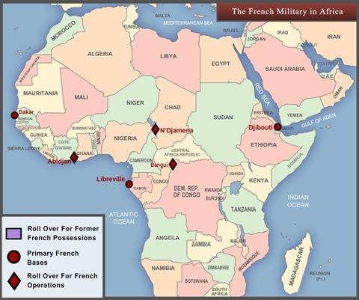
The ongoing Operation Épervier (“Sparrowhawk”) deployment of French troops in Chad began in February 1986 at the request of the Hissène Habré government to contain a Libyan invasion that was threatening the Chadian capital of N’djamena. The 950 French troops still stationed there contribute to both Chad’s stability and that of the surrounding region. [11]
Force Licorne, the deployment of 450 French troops in Côte d'Ivoire, dates back to September 2002, when they were dispatched to protect French nationals after an attempted coup. [12]

Mali 2013 – Operation Serval (“Wildcat”)
In 2013, France undertook two interventions, one in Mali and another in the CAR. On January 11 2013, Malian authorities requested French assistance in halting armed terrorist groups believed to be advancing towards the capital Bamako. Utilizing its prepositioned forces, France launched a major air and land intervention a few hours later in support of the Malian armed forces. West African and Chadian troops backed by a pro-Bamako Tuareg militia joined them in the second half of January. Eight NATO air forces plus Sweden and the UAE provided non-combat assistance with air transport, aerial refueling and reconnaissance. Within six weeks, French-led forces recaptured all of the towns in northern Mali that had been seized by the Islamists in 2012. [13] French forces now work alongside the United Nations’ peacekeeping Mission multidimensionnelle intégrée des Nations unies pour la stabilisation au Mali, (MINUSMA), established by UN Security Council Resolution 2100 to stabilize Mali after the 2012 Tuareg rebellion and Islamist occupation.
About 2,500 French soldiers with armor and attack helicopters are currently serving in Operation Serval in Mali alongside four battalions of AU troops, though further reductions of the size of the French force are underway. [14]

Central African Republic - Operation Sangaris
France has deployed forces to the CAR seven times in just over 30 years, including on three occasions in 1996.
In March 2013, Séléka rebel leader Michel Djotodia seized power, unseating elected president François Bozize and became the second Muslim leader of the predominantly Christian oil-rich country (former CAR president Jean-Bédel Bokassa briefly converted to Islam for three months in 1976 at the urging of Libyan leader Mu’ammar Qaddafi). Some Muslim guerrillas ignored Djotodia’s order to disband and went on a rampage, prompting Christians to form anti-balaka (“anti-machete”) vigilante groups in response.
Accordingly, on December 5, 2013, French President François Hollande announced his decision to reinforce French troops in the CAR to prevent a humanitarian disaster, telling reporters: “The Security Council has adopted a resolution, unanimously, which mandates an African force to provide security, to restore stability in the CAR and to protect the population. France will support this operation… Already, 600 French soldiers are on the spot. This number will double in the next few days, if not hours.” [15]
But France is now moving beyond unilateral intervention. On December 6-7, 2013, France hosted the Elysée Summit for Peace and Security in Africa, with 53 African delegations and France participating, along with UN, AU, EU, IMF, World Bank and African Development Bank representatives. Participants reiterated their commitment to collective security in Africa and to encouraging peace and promoting human rights. Vice Admiral Marin Gillier, director of the Security and Defense Cooperation Directorate of the Ministère des affaires étrangères (MAE) stated in the wake of the summit’s Final Declaration that Directorate priorities are set according to three criteria set by the Elysée, the MAE and the Ministries of Defense and the Interior. The first priority is geographical, centering on the Sahara-Sahel region. The second is to oppose cross-border trafficking in drugs, human beings and armaments. The third and final priority is to preserve the influence of France. Far from constricting French behavior, the Final Declaration is being interpreted in Paris as a mandate to expand French African operations, including deploying a maritime safety system in the Gulf of Guinea. [16]
On January 10, Djotodia resigned under intense international pressure after failing to end the violence. He was succeeded by former Bangui mayor Catherine Samba Panza as interim president. Panza immediately urged Christian and Muslim militias to cease fighting.

Conclusion
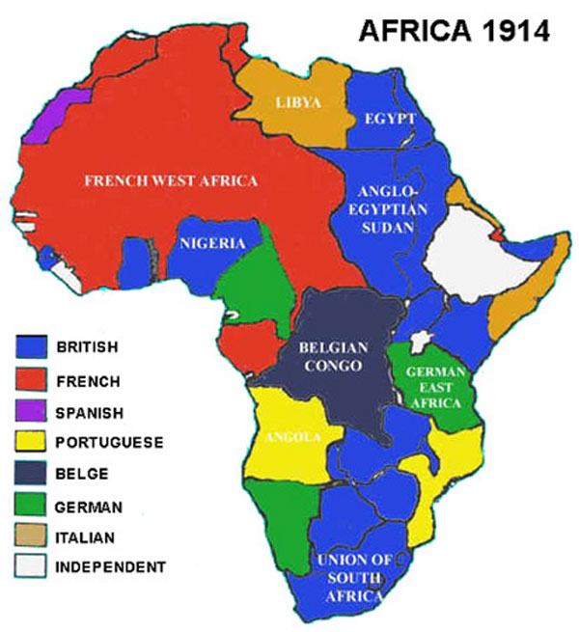
For decades, France viewed much of post-colonial Africa as pré carré, an exclusive sphere of influence. The results of its military footprint in Africa have been mixed. A year after Operation Serval began, Mali’s government has reasserted itself through nationwide polls that saw former premier Ibrahim Boubacar Keïta elected president and parliament reopened. Challenges for Mali remain a peaceful settlement with its Tuareg separatists, quashing the remnants of its Islamist insurgency and improving the dire state of the economy.
The picture is cloudier in the CAR. The bloodshed continues, albeit at a reduced rate, and the interim political structure is at best fragile. A number of analysts have described the CAR as a failed state in permanent crisis. Furthermore, the country is surrounded by other poverty wracked, unstable states, including Chad, the Democratic Republic of the Congo, Sudan, South Sudan and Cameroon.
On February 25, the National Assembly approved extending France’s 2,000-strong CAR deployment beyond April by a vote of 428 for and 14 against. The same day, French Prime Minister Jean-Marc Ayrault warned his compatriots: “Our action in the CAR is not finished but our efforts have begun to bear fruit,” adding that “difficulties are considerable.” [17]
France is now encountering increased economic competition for African resource riches from new players in Africa, including China, India, Canada, the United States, Israel, Iran, Brazil, the Gulf States, Turkey, South Africa and Malaysia. Such competition will only intensify in the short and long term. Paris, in the meantime, is prepared to protect its economic assets, ordering Special Forces troops to protect its uranium facilities in Niger.
Multilateral deployments seem to be the way of the future, with France coordinating its activities with such allies as the EU and the United States. For the moment, however, France’s prepositioned troops are likely to be the advance units for the foreseeable future of any peacekeeping forces sent into France’s former African colonies.

►You can access sources sited at article’s URL.

Dr. John C. K. Daly is a Eurasian foreign affairs and defense policy expert for The Jamestown Foundation and a non-resident fellow at the Central Asia-Caucasus Institute in Washington DC.

Hezbollah in the streets of Caracas?
By Roger Noriega
Source: http://www.aei-ideas.org/2014/02/hezbollah-in-the-streets-of-caracas/

A man whom the US Treasury Department has designated as an operative of the terrorist organization Hezbollah has relocated from the Syria war zone to Venezuela in recent days, apparently in support the government’s violent crackdown against student demonstrators. Ghazi Atef Nassereddine was sanctioned by the US government in 2008 for providing logistical and financial support to Hezbollah.
Sources and documents substantiate Nassereddine’s role as Hezbollah’s principal representative to the Venezuelan regime and a close collaborator of President Nicolás Maduro. In recent years, his official cover has been as a diplomat assigned to Venezuela’s embassy in Damascus, where he has used his position to facilitate travel for many persons from the Middle East to Venezuela. From that post, he had extraordinary access to senior Syrian security officials who have waged war on opponents of the Assad regime.
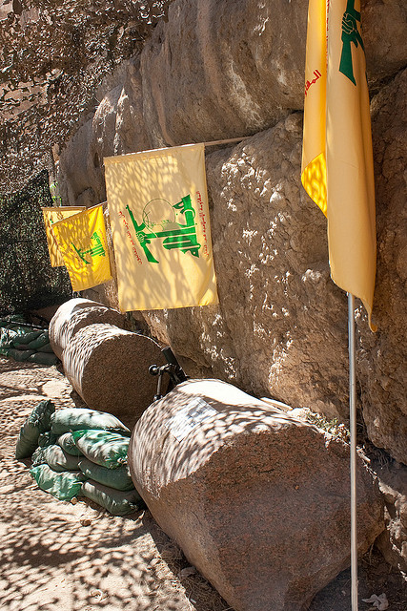
Two witnesses also have told me that Nassereddine worked personally to obtain Maduro’s approval of Hezbollah money laundering schemes using Venezuelan entities. One plan involved the transfer of Syrian oil through a Venezuelan-operated refinery in the Caribbean to evade international sanctions. These deals would produce enormous profits for corrupt representatives of the Maduro regime as well as Hezbollah.
As part of the late Hugo Chávez’s radical, anti-US agenda, the Venezuelan regime has promoted and even funded the presence and activities of Iran and Hezbollah in the Western Hemisphere. Now that regime is turning to these allies as it faces a meltdown fueled by its virtual bankruptcy, shocking rates of violent crime, spiraling inflation, widespread shortages of food and medicine, and more recently, student demonstrations against Maduro’s regime in the country’s principal cities.
One very dangerous operative who has answered this call is Ghazi Nassereddine, who was born in 1971 in the Lebanese town of Bint Jbeil, which the Israeli’s have dubbed, “The capital of Hezbollah.” Ghazi parents emigrated to Venezuela, where he acquired citizenship soon after Chávez took power. As I stated in my testimony before the Subcommittee on Counterterrorism and Intelligence Committee on Homeland Security on July 2011, “[Ghazi Nassereddine], along with at least two of his brothers, manages a network that raises and launders money and recruits and trains operatives to expand Hezbollah’s influence in Venezuela and throughout Latin America.” His brother, Oday, is a long-time activist in the so-called “Bolivarian Circles,” one of the activist groups that has received paramilitary training to defend Chavismo.
Ghazi Nassereddine appears to have returned to Venezuela to help the regime in its fight to hold to power and silence protesters against Nicolás Maduro’s criminal regime. He tweeted from Caracas on February 19 that he “supports the actions taken by the government [against the opposition]” and labeled the government’s actions against the opposition as “humanitarian and patient.”
Nassereddine’s return to Venezuela shows that the regime knows that it is in fight for survival and prepared to use violence. Already thuggish paramilitary have been videotaped beating and shooting pistols indiscriminately into crowds of student demonstrators. It is remarkable that a Hezbollah operative of Nassereddine’s prominence would be part of that repressive campaign.
In recent years, numerous policymakers and experts in the region have documented the presence of Iran’s terrorist proxy in the Hemisphere – although the State Department continues to minimize this threat. That Hezbollah operatives could be among those committing acts of terror and violence against Venezuelan demonstrators would be a dramatic demonstration of that group’s operational capability and brazenness in the Americas.
The State Department is reportedly “considering” what measures to take in response to the acts of violence and the expulsion this week of three US diplomats from Caracas. Beyond whatever diplomatic action it might be mulling over while violence rages in Venezuela, US national security agencies should direct additional resources to verify and counter the involvement of Hezbollah terrorists committing acts of violence on the streets of Venezuela.

Roger F. Noriega is a former assistant secretary of state for Western Hemisphere affairs (Canada, Latin America, and the Caribbean) and a former U.S. ambassador to the Organization of American States. He coordinates AEI's program on Latin America and writes for the Institute's Latin American Outlook series.

Saudi Arabia declares Muslim Brotherhood 'terrorist group'

Source: http://www.terrorismwatch.org/2014/03/saudi-arabia-declares-muslim.html

March 7 – Saudi Arabia has formally designated the Muslim Brotherhood a terrorist organisation.
An interior ministry statement also described two jihadist groups fighting with the Syrian rebels - the Nusra Front and the Islamic State in Iraq and the Levant - as terrorist groups.
The statement gave Saudis fighting in Syria 15 days to return.
A royal decree issued last month said any citizen found guilty of fighting in conflicts abroad faced a jail sentence.
Hundreds of Saudis are believed to be fighting in Syria, and correspondents say Riyadh fears they could pose a security risk when they return home.
Although the kingdom has supported the Sunni-led rebels fighting to overthrow Syrian President Bashar al-Assad, it has long feared a backlash from radical jihadist groups.
Last month, King Abdullah decreed jail terms of up to 20 years for anyone belonging to "terrorist groups" or fighting abroad. The new law also promised tough sanctions for anyone backing the incriminated organisations.
However, rights group Amnesty International has criticised the legislation, saying it could be used to suppress peaceful political dissent.
Earlier this week, Saudi Arabia joined the United Arab Emirates and Bahrain in withdrawing its ambassadors from Qatar, which it sees as an important supporter of the Brotherhood.
The Muslim Brotherhood is already banned in Saudi Arabia, which has long viewed its ideology of populist Islam as a threat.
Analysts say the Brotherhood's conservative Sunni doctrines are seen as a challenge to the Saudi principle of dynastic rule.
In Egypt, the Brotherhood has been driven underground since the army deposed President Mohammed Morsi, a longtime member of the group.
The military-backed government in Cairo designated the Brotherhood a terrorist group in December.

Analysis
Sebastian Usher BBC Arab affairs editor

This is the strongest warning so far to Saudis fighting with extremist groups in Syria. The Saudis clearly now fear similar blowback from having encouraged jihadist rebels there as they faced a decade ago when militants returning home attacked domestic targets. The statement also bans an exhaustive list of activities - including meetings, funding and online communication - that could be seen as supporting such groups. But it goes further, encompassing any activism seen as seditious. The message goes wider too - coming as it does in the midst of a diplomatic offensive against Qatar. Saudi Arabia, the UAE and Bahrain have all withdrawn their ambassadors from Doha in an unprecedentedly public dispute over Qatar's perceived support for the Muslim Brotherhood.

Ex-CIA Pilot Gives Sworn Testimony That No Planes Hit The Twin Towers

US Will Have To Rebut Or Accept Statement As Truth
Source1: http://neonnettle.com/news/211-ex-cia-pilot-gives-sworn-testimony-that-no-planes-hit-the-twin-towers
Source2: http://www.activistpost.com/2012/03/911-affidavit-by-john-lear-son-of.html

March 7 – A former CIA and civilian pilot has sworn an affidavit, stating that no planes flew into the Twin Towers as it would have been physically impossible.
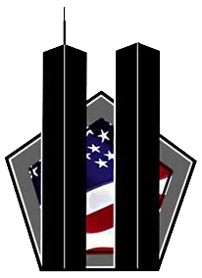
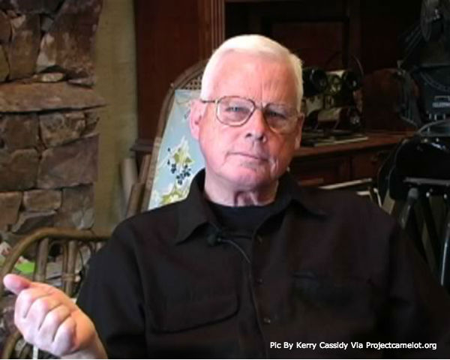
John Lear, the son of Learjet inventor, Bill Lear, has given his expert evidence that it would have been physically impossible for Boeing 767s, like Flights AA11 and UA175 to have hit the Twin Towers on 9/11, particularly when flown by inexperienced pilots:
‘No Boeing 767 airliners hit the Twin Towers as fraudulently alleged by the government, media, NIST and its contractors’, he stated in the affidavit.
‘Such crashes did not occur because they are physically impossible as depicted, for the following reasons: in the case of UAL 175 going into the south tower, a real Boeing 767 would have begun 'telescoping' when the nose hit the 14 inch steel columns which are 39 inches on center.
The vertical and horizontal tail would have instantaneously separated from the aircraft, hit the steel box columns and fallen to the ground.
‘The engines when impacting the steel columns would havemaintained their general shape and either fallen to the ground or been recovered in the debris of the collapsed building.
‘No Boeing 767 could attain a speed of 540 mph at 1000 feet above sea level ‘parasite drag doubles with velocity’ and ‘parasite power’ cubes with velocity.
The fan portion of the engine is not designed to accept the volume of dense air at that altitude and speed.
- The piece of alleged external fuselage containing 3 or 4 window cutouts is inconsistent with an airplane that hit 14 inch steel box columns, placed at over 500 mph. It would have crumpled.
- No significant part of the Boeing 767 or engine could have penetrated the 14 inch steel columns and 37 feet beyond the massive core of the tower without part of it falling to the ground.
‘The debris of the collapse should have contained massive sections of the Boeing 767, including 3 engine cores weighing approximately 9000 pounds apiece which could not have been hidden. Yet there is no evidence of any of these massive structural components from either 767 at the WTC. Such complete disappearance of 767s is impossible.
The affidavit, dated 28th January 2014 is part of a law suit being pursued by Morgan Reynolds in the United States District Court, Southern District, New York.
In March 2007, Reynolds, a former chief economist under the George W Bush administration filed a Request For Correction with the US National Institute of Science and Technology citing his belief that real commercial jets (Boeings) did not hit the WTC towers.
Although the 9/11 Truth movement initially rejected the ‘no-planes’ theory as too outlandish, after scientific and rational analysis, it has become a widely accepted explanation of the evidence collected.
Unlike any other form of statement, an affidavit becomes truth in law, if it is not rebutted. It will now be up to critics of the theory to present their evidence and analysis to rebut the statement point by point. If they do not – or cannot – then the US government will be obliged to admit that the account given by the 9/11 Commission is wrong.
The 65 year old retired airline captain and former CIA pilot – who has over 19,000 hours of flight time -- also drew attention to the inexperience of the pilots who allegedly flew the planes:
‘The alleged 'controlled' descent into New York on a relatively straight course by a novice pilot in unlikely in the extreme because of the difficulty of controlling heading, descent rate and descent speed within the parameters of 'controlled' flight.
‘It takes a highly skilled pilot to interpret the "EFIS" (Electronic Flight Instrument Display) display, with which none of the hijacker pilots would have been familiar or received training on, and use his controls, including the ailerons, rudder, elevators, spoilers and throttles to effect, control and maintain a descent.
Lear has, according to his sworn statement, flown over 100 different types of planes during his 40 years of flying and holds more FAA airman certificates than any other FAA certificated airman. He flew secret missions for the CIA in Southeast Asia, Eastern Europe, the Middle East and Africa between 1967 and 1983 then spent 17 years working for several passenger and cargo airlines as Captain, Check Airman and Instructor.
He is a member of Pilotsfor911truth.org, which has consistently shown that it was impossible for jet airliners to have hit the Twin Towers in the way the 9/11 Commission has suggested.
The Commission did not take evidence from experts or pilots when it conducted its enquiry into the attacks from 2002 to 2004.

RAND – Terrorism Risk Insurance Act Contributes to Improved Security
Source: http://www.hstoday.us/single-article/terrorism-risk-insurance-act-contributes-to-improved-security-rand-study-says/de7d4524987621fcac79b6942390420c.html

The Terrorism Risk Insurance Act (TRIA) is key to ensuring the availability and affordability of the terrorism coverage that not only undergirds the US economy, but substantively contributes to the nation's security, said the Coalition to Insure Against Terrorism (CIAT) about a new RAND study of the national security benefits of the law.
Performed by RAND's Center for Catastrophic Risk Management and Compensation, the "study makes it clear that TRIA enables the smooth functioning of the terrorism risk insurance marketplace, which is critical to commercial insurance consumers representing a broad range of industries, from real estate, to public utilities, to major entertainment venues,” said CIAT spokesperson Martin DePoy.
CIAT represents business insurance policyholders.
TRIA originally was passed in 2002 “when reinsurers withdrew from the terrorism risk insurance marketplace, causing primary insurers to withdraw, as well,” CIAT said. “The lack of availability of this coverage stalled economic activity, including lending for new construction, contributing to massive job losses.”

TRIA restored terrorism risk coverage to the market and was reauthorized in 2005 and 2007.
“For more than a decade,” TRIA “has made it possible for businesses to purchase the terrorism risk coverage they need through the private market at almost no cost to the taxpayer,” CIAT said in a statement in response to the new RAND report.
However, TRIA is set to expire at the end of the year unless it’s reauthorized by Congress.
The RAND study “reaffirmed the fact that insurers continue to be unable to effectively price catastrophic terrorism risk -- a key to providing terrorism coverage -- because risk from such attacks, unlike risk from natural disasters, is man-made, designed to overcome loss-mitigation efforts and inherently unpredictable,” CIAT said.
“Terrorism risk models cannot predict exposure to catastrophic terrorism,” the RAND report concluded, noting that “While history does tell us how bad such attacks could be, it doesn’t tell us how likely such events will be because both intentions and capabilities of terrorist groups are evolving in response to a dynamic terrorism security environment.”
The RAND study also determined that, “To the extent insurance is available without TRIA before the [terrorist] event, prices and availability of markets after terrorism events may become further unstable as firms seek to understand whether recent events signal significant changes in future terrorism risk.”
CIAT said “RAND’s analysis additionally pointed out the significant contribution TRIA makes to national security by enabling more rapid rebuilding after an attack and supporting economic growth.
“The primary influences of TRIA on national security,” the study said, “are likely through improvements in resilience and recovery. To the extent TRIA leads to greater access to insurance, this could improve both the pace and effectiveness of recovery efforts and in turn makes communities more resilient to future terrorism events … To the extent that terrorism insurance is more available with TRIA than without it, renewing the legislation contributes to improved national security.”
“The RAND study underscores the fact that TRIA continues to be the factor that makes possible the wide availability of terrorism risk coverage today,” DePoy said. “This legislation is a shield against the potentially devastating economic impact of terrorism and a major component of our national security policy. CIAT strongly advocates that TRIA be reauthorized.”
“Our study finds that if the act expires and the take-up rate for terrorism insurance falls, then our country would be less resilient to future terrorist attacks,” said Henry Willis, lead author of the RAND study and director of the Homeland Security and Defense Center at RAND, a nonprofit research organization.
The RAND study found that terrorism remains a real -- albeit uncertain -- national security threat, with the most likely scenarios involving arson or explosives being used to damage property or conventional explosives or firearms used to kill and injure civilians. Terrorism has occurred persistently in the US since 2001, yet complex terrorist attacks have not occurred.
"However," a RAND announcement said, "there are active terrorist groups who do aspire to conduct more complex attacks on US targets, and the possibility remains that sometime in the future, one of these groups may succeed."
Continuing, RAND said "An examination of past attacks is only of limited use for accurately predicting the probability of future attacks or losses from attacks different than those that have occurred, Willis said. For that reason, there are limits to how terrorism risk models can be used to understand future terrorism risks."
RAND said "The current terrorism risk insurance program has a $27.5 billion threshold for aggregate losses that are paid by the insurance industry and commercial policyholders before the government program begins paying."
"The threshold ensures that the insurance industry, rather than the taxpayer, is ultimately responsible for paying for those incidents that are within the range of the industry’s modeling capability," RAND said. "At the same time, that threshold permits insurance companies and policyholders to manage risks from incidents that involve deep uncertainty that cannot be adequately quantified using modeling.
DePoy said he could stress strong enough the need for lawmakers to reauthorize TRIA “at the earliest possible date.”
“In both 2005 and 2007, our members saw policy renewals that included “springing exclusions,” which would have voided terrorism coverage upon the expiration of TRIA,” DePoy said. And “This year, we already have been told by members that carriers have advised them to again expect springing exclusions on the renewal of policies that extend past December 31, 2014.”
Consequently, DePoy said “We urge Congress to act as soon as possible to eliminate the possibility of gaps in coverage, which would produce severe financial disruption.”
CIAT said the RAND study on the national security impacts of TRIA is the first of three studies being conducted by the think tank on the effects of the legislation.

China’s Jihadists
By Rachel Ehrenfeld
Source: http://acdemocracy.org/chinas-jihad/#sthash.thWWWHu6.dpbs

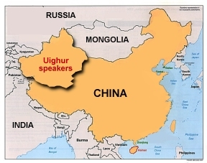
On March 2, 2014, a train station in Kunming, in western China’s Yunnan province, witnessed a horrific slashing attack by black-clad Uighurs wielding large knives and machetes. The attack left 29 dead and 143 wounded.At least 9 Uighurs,members of the East Turkestan [separatists] Islamic Movement (ETIM), which have committed more than 200 terrorist attacks over the past 12 months, were identified as the attackers.
The Uighurs are Turkic-speaking Muslim minority from the country’s northwestern region Xinjang that borders Afghanistan, India, Kazakhstan, Kyrgyzstan, Laos, Mongolia, Pakistan, Russia and Tajikistan. Xinjiang is also known as East Turkestan.
It is unlikely that the machete-wielding Uighurs, who traveled 900 miles away from home, could have planed the massacre without help from a few of the very small number of Kuming’s Uighur residents.
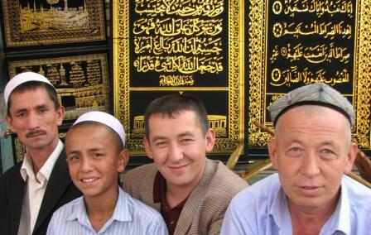
The Chinese authorities blame inflammatory videos and social media sites that have managed to evade China’s Internet censorship as the instigators of the Uighur jihad movement. They also blame outside support from Sunni radicals from the 5 post-Soviet Central Asian states for growing terrorist attacks. Others claim the attack was orchestrated by al Qaeda in Xinjang.
An interesting theory has been voiced by Radio Free Asia (RFA): The assailants may have been fugitives from Xinjiang and in Kunming as a stop on their way to Laos where they hoped to set up a sanctuary (if there wasn’t already one there). RFA reports that, last September, at least 30 Uighurs were apprehended on the Laos-China border at Mohan, which is in Yunnan’s Mengla county.
China’s oppression of its Uighur population is a recipe for violence. To change the ethnic and religious character of Xinjiang, the government moved Han Chinese into the region. The government’s strict policies on Catholics and evangelical Christians applies also to the Muslim Uighurs. They can only use religious texts that have been approved by the state (including the Koran), their mosques are managed by the government, and only beardless Uighur men and women without headscarves are employed by the government. These restrictions, however, will do little to slow the propagation of radical Sunni ideology among XinjiangUighers.
In recent years, China’s relations with major countries in the Islamic world have become increasingly complex and problematic. This is especially true of China’s ties with Turkey, where a sizeable Uyghur minority resides, and where historical, linguistic, religious and cultural links have conditioned the fortunes of what Yitzhak Shichor has called the “ethno-diplomacy in Sino–Uyghur relations.”1
Of late, Turkey, Saudi Arabia, neighboring Kazakhstan, and other Muslim countries have openly been displaying sympathy for their coreligionists in Xinjiang [the Xinjiang Uyghur Autonomous Region]. That has precipitated Chinese discontent, which could lead to an overhaul of, and a deterioration in, its carefully cultivated relations with the Islamic world. Teyyip Erdogan, the fiery prime minister of Turkey, who in Davos in early 2009 accused Israel’s president, Shimon Peres, of “genocide” against the Palestinians in Gaza2 and then callously stalked out of the panel, had another “temper tantrum,” this time venting his rage against the Chinese. He accused them of genocide for the killing of 200 people, most of them Han, during riots in June and July 2009, insisting that there was “no point of interpreting this otherwise.”3 For Erdogan, who carries the terrible moral burden of the genocide of 1.5 million Armenians by Turkey during World War I, hurling the same accusation against others, despite the staggering numerical disproportion, may perhaps alleviate his own guilt. Much like Holocaust deniers who accuse Israel of having become the “Nazis” of our time or of committing genocide against the Palestinians, Erdogan’s rhetoric can perhaps be dismissed as displaced aggression. This is to compensate for the failings of his own country, which continues to launch attacks against the Kurds in both Turkish and Iraqi territory and to deny them their civil rights and independence.
In its harsh condemnation, Turkey stood out as an exception, certainly compared to other governments, including Washington, which responded cautiously and did not rush to censure the Chinese as would have been expected. Under the heading “Turkey, another Axis of Evil?” a Chinese writer lashed out at Turkey for its harsh position on China. He cited Erdogan’s talk to a group of foreign ministers from the Gulf area visiting Istanbul, in which the prime minister said, “We have always looked to our Uyghur brothers, with whom we have historical and cultural ties.” He noted that Erdogan promised that as a member of the UN Security Council for 2009–11, his country would raise the issue there. Foreign Minister Ahmet Davutoglu emphasized that Turkey had concerns about developments in the Uyghur Autonomous Region, and “cannot remain silent in the face of what is happening there,” echoing what Erdogan had said about Gaza half a year earlier.
Turkey’s trade unions and business associations went even further—urging a countrywide boycott of Chinese products, an escalation that would transform the row from a diplomatic struggle to a commercial one, echoing what other Islamic countries had done to Denmark during the “Cartoon Crisis” in 2005. Consequently, an atmosphere was created in which Ankara permitted (and even encouraged) anti-Chinese demonstrations by Uyghur groups dwelling in Turkey. This, in spite of earlier demonstrations of Chinese support for Turkey, as in 2003, when Beijing roundly condemned the acts of terror that had rocked Turkey. This time, Turkey was taken to task for supporting the “separatist and terrorist thugs of Xinjiang, thus raising Chinese indignation.”4
The Xinjiang Conundrum
Ever since the annexation of the Xinjiang province to China in the 1880s as the “new border,” that vast area has been growing increasingly important on the level of strategy, energy, minority issues, security and international policy levels in the purview of China. Geographically, the entire area is known as East Turkestan, namely, the country of the Turks. Under the late Qing Dynasty, Xinjiang became one of the Republic’s provinces, though it was granted some degree of cultural autonomy, unlike the five Muslim republics of the Soviet Union. Thus, while the fall of the USSR precipitated the independence of Kazakhstan, Kyrgyzstan, Uzbekistan, Tajikistan and Turkmenistan, Xinjiang, with its Uyghur Muslim population, remained part of China. Moreover, in Xinjiang, a calculated plan to settle Han Chinese (the predominant ethnic group in China) in order to strengthen the Chinese foothold of the state has brought the Han–Uyghur demographic balance to parity, thus engendering the bitterness of the indigenous Muslim population, which feels uprooted and discarded.
The combination of this complicated political situation, involving foreign relations with neighboring countries and the rise of Islam worldwide, the transformation of Xinjiang into a strategic area for the Chinese nuclear and space program, Xinjiang’s common border with Russia, and the potential development of petroleum and gas fields there, has turned this province into a most crucial one for the People’s Republic of China (PRC). The recent eruptions of violence between Han and Uyghur in Urumqi, the province’s capital, are but the tip of the iceberg of the usually well-concealed malaise that brews under the surface, under the guise of harmony between the peoples of China.
Historically, Chinese Islam has been prone to unrest whenever Chinese pressure grew untenable, or the promise of secession/autonomy loomed on the horizon. In connection with the Afghan War, Muslims in Baren5 advocating a “free East Turkestan” staged a fierce five-day revolt in April 1990. Chinese authorities later discovered that the mujahideen of Afghanistan had supplied the Baren rebels with arms.6
In November 1993, turmoil broke out in twelve counties and cities of Xinjiang. There were attempts to take over government offices or sack them. In some instances, homemade incendiary bombs were thrown, and gunmen shot government troops who were attempting to thwart rebel attacks against government stores. This was a clear escalation of the Xinjiang unrest, and demonstrated that the level of acrimony against the central government had by far transcended a mere local channeling of bitterness or frustration into social disturbance. The PRC’s policy of openness to the Islamic world may have contributed to Islamic separatist aspirations, due to the fact that the twelve Muslim ethnic groups of Xinjiang regard Turkey, not China, as their spiritual home.7 The Chinese were placed in a situation of having to choose between placating their Muslim citizens and Islamic countries or losing control of their minority population. This so alarmed the Chinese that Prime Minister Li Peng himself delivered a warning against “foreigners and divisive forces that infiltrate by hoisting national banners and donning religious garments.”8
China claims that al-Qa’ida has trained members of the East Turkestan Islamic Movement, which is classified as a terrorist group by the US and the UN. The group took its name from the short-lived Republic of East Turkestan that was declared in Xinjiang at the end of World War II, then crushed by the PRC in 1949. Moreover, China has persuaded Pakistan and Kazakhstan to hand over captured militants, a policy that may have fueled the Taliban fundamentalist rage now gripping Pakistan. The Chinese security apparatus has also created a pervasive system of informers and has deployed new units of anti-terrorist police to patrol mosques and markets in the trouble-prone cities of Xinjiang.9 But the iron-fisted security policy has apparently backfired. Western journalists have exposed a society segregated by religion and ethnicity, divided by reciprocal distrust and living in separate sections of tightly policed cities, notably Urumqi.
Again in 2007, there was evidence that while the severe oppression did crush opposition, it failed to win the loyalty of the Uyghur population. Beijing’s aim was to prevent Muslims from slipping away to join militants in Saudi Arabia, Pakistan and Afghanistan. Consequently, Chinese anti-terrorist units attacked a training camp in the mountains around Kashgar, where the Silk Route winds into the Karakoram and Pakistan, killing eighteen men. The clash was hailed by the state media, which called it a “blow to the East Turkestan Islamic Movement.”
The escalation of violence in Kashgar came despite economic efforts by the government to increase the Uyghurs’ standard of living, which the Uyghurs sensed they were paying for with the loss of their identity. Their children must undergo compulsory Chinese education, while their own fabled literature, poetry and music are fading into the folkloristic background. China is pouring billions into modernizing Kashgaria, even while importing thousands of Han to populate the area.
Because of efforts to develop relations with Muslim oil-producing countries, Beijing has been very careful not to appear to be oppressing its Muslim minorities. In July 2009, another incident, involving rumors of the rape of two Han women, precipitated rioting, resulting in hundreds of dead and thousands of lives derailed. President Hu Jintao was forced to return from the G-8 Summit in L’Aquila in an attempt to quash the unrest. Chinese authorities, in the perilous situation of facing an impending general outburst, tried to maintain order between Han and Uyghur, regardless of who was to blame for the incitement. As the Uyghur protest escalated, the riots turned violent, and the event reverberated throughout the world as “breaking news.” Paradoxically, although more Han were killed than Uyghurs, the latter were depicted as the oppressed underdogs and were treated as such by the media.
The Uyghurs feel that the survival of their culture is threatened by the Chinese, as Beijing announced that it would tear down the old city of Kashgar—the Uyghur cultural hub—and replace it with a new city. They are also concerned about the limits imposed on the use of the Uyghur language in schools and the fact that Muslim state officials are being encouraged to abandon the Ramadan fast. These measures are construed in Uyghur eyes as governmental oppression and as methods of erasing Muslim culture from their midst.
China does not seem to understand the dynamics of how the “affirmative action” they pursue in Xinjiang, with its huge economic investment meant to enhance the welfare of the minorities, can engender what they may regard as ungrateful, rebellious conduct on their part. This will not change as long as the majority– minority relationship between the main actors persists. Either the regime is strictly uncompromising and unforgiving, or, when it begins to compromise, it triggers a process that brings about its own demise. This is how the Soviet Union and the regimes of the Eastern Bloc collapsed. Deng Xiaoping’s reforms and the pleasures of a rising standard of living are set off by the ethnic tensions between Han and Uyghur.
The importance of Xinjiang, together with the fact that it shares sensitive borders with four countries, obviously make that remote heartland a focus of world interest; therefore, it is difficult for the world to regard that province and its affairs as a domestic Chinese problem, and China is unfavorably judged for its behavior and castigated for its policies. Those that presume to “understand” China’s positions jump to the conclusion that “China’s fears are no excuse for its punitive and often violent suppression of the Uyghurs,”10 as if they would be better able to handle the same situation were they faced with it. In that respect, it is much like the ongoing conflict in the Middle East. To be sure, when the USA, Britain, Russia, Turkey and others are confronted with similar situations, they behave no better than China.
Uyghurs are not interested in their homeland’s importance to China. For them, the government’s discriminatory policies, which do not permit them to cultivate their separate identity, are the key issues. After 9/11 and the worldwide scare of Muslim terrorism, the repression of Uyghurs intensified; many of their leaders were jailed, accused of having connections with foreign Muslim terrorists. Draconian sentences have been meted out to any group or individual convicted of terrorism, religious radicalism, or separatism. Nevertheless, no muftis in the Islamic world have yet found the time to issue any fatwa against China.11
Turkish attitudes to China have been especially affected by the unrest in Xinjiang. Turkey once had an open-door policy toward its Uyghur brethren, the Turkic ethnic minority, members of which began arriving in waves from China in the late 1930s. In 1952, for instance, when several thousand Uyghurs fled China’s Communist regime for Pakistan, the Turkish government stepped in and brought 1,850 people overland to Turkey. The new arrivals were settled in specially built housing—in a district called the New Quarter—in the city of Kayseri in central Anatolia, and were given jobs and citizenship. Such a welcome, however, is unimaginable today. Even though public sympathy still runs deep for the long- suffering Uyghur population of what many Turks refer to as East Turkestan, Ankara has become increasingly wary of antagonizing Beijing. Just recently, President Abdullah Gül visited China and oversaw the signing of $1.5 billion in Turkey–China business contracts. After the recent violence in Urumqi, one Turkish minister called for a boycott of Chinese goods, but that was quickly retracted; Prime Minister Erdogan, who, in a characteristic outburst of anger labeled events there “tantamount to genocide,” has had to control his temper. The row was soon smoothed over by apologetic foreign ministry officials.12
China’s plight in the face of the danger of increasing international Muslim protest was dramatized by its apologetic response to the Maghribi al-Qa’ida (AQIM) threat to take revenge on China for the death of forty-six Muslim Uyghurs in Urumqi during the Xinjiang riots. Of course, no mention was made in that threat, as in its threats against Israel or the US, of the deaths it had caused (in this case 136 Han Chinese who perished in those riots, according to the official report) or of the outrages perpetrated by the Muslims that brought about those deaths. Threats were also made of retaliation against the large numbers of Chinese who are employed in Saudi Arabia and other parts of the Middle East and North Africa.13 The Muslims were urged “to chop off their heads in their work places or in their homes, to tell them that the time of enslaving Muslims has gone.” This was the first time that any al-Qa’ida group had threatened China and its interests so directly and so boldly. In fact, in June 2009, an al-Qa’ida branch in North Africa was reported to have ambushed an Algerian security team that protected a Chinese construction project. In that attack, as many as twenty-four guards were killed. Increased communication on the internet among active jihadists indicates that information is being sought about Chinese interests in the Muslim world in order to target them, thus avenging the perceived injustices in Xinjiang.14
In Yemen, where al-Qa’ida is seeking to topple President Saleh, Chinese interests are also threatened, though no direct and significant link has been detected between the Uyghurs and bin Laden or his organization. That is perhaps why, in spite of the vows of revenge against Beijing, no full-scale jihad has been urged against China. AQIM, which supports a Muslim state in Algeria, resents the highly centralized and absolute control of the Uyghur population of China by a government of “unbelievers,” hence its harsh reaction and threats directed at Beijing. AQIM is presumed to be buoyed by the Muslim fighters returning from Iraq who are seeking new jihadi frontlines. But it should be noted that even in moderate Indonesia, with the largest Muslim population in the world, some Muslim groups called for a jihad against China, clashing with police outside the Chinese embassy in Jakarta. The anti-Chinese sentiment in the Muslim world has been spreading, hence the absolute necessity for the Hu government to quell the unrest as rapidly as possible.15
The Islamic Party of Turkestan (IPT), an illegal organization headquartered in the heart of Xinjiang, but operating clandestinely and in concert with Muslims from outside the area, has released an audio statement in the Uyghur language in response to the riots. The recorded voice is that of Sayf Allah [the Sword of Allah], a military commander in the group.16 He was last seen in a video released in early 2009, entitled “Steadfastness and Preparation for Jihad for the Sake of Allah.” The recording, with a still photo in the background, and the statement were posted on jihadist forums in July 2009, the communiqué itself being dated July 7. The communiqué was released by the Islamic Army of Turkestan, formerly known as the Islamic Army of East Turkestan, a small jihadist Uyghur group, believed to be based, just like the beleaguered al-Qa’ida, in the tribal regions of Western Pakistan. The group threatened China for having quashed the Xinjiang riots, stating that “Allah’s cavalry will soon fall upon you… Oh brave mujahideen…, kill the Communist Chinese wherever you find them.”17 The wording is strikingly similar, with local adaptations, to al-Qa’ida and Hamas statements about Israel and the West.
Just how far the Uyghur issue reverberates throughout the Islamic world and affects its foreign relations (but also how selective Muslims in the world can be about their outbursts) was demonstrated in a German courtroom in early July, with the murder of a Muslim woman. In that incident, the victim, a thirty-one- year-old pregnant Egyptian, was stabbed to death in a Dresden court by a man she was scheduled to testify against for allegedly calling her a terrorist. When her husband tried to protect her, he was also stabbed by the attacker and then shot by the court’s security guard, who had mistaken him for the assailant. This incident sparked outrage throughout the Muslim world and fueled demands for a formal apology from Germany. But while the Muslim world raged about the “headscarf martyr,” Marwa al-Sherbini, holding her up as a symbol of persecution, the far more widespread and lethal plight of Chinese Muslims has generally provoked a more moderate reaction. That issue has not generated much interest in the Arab and Muslim worlds, and the news media have given it only sporadic coverage. Even those Muslim writers who were prolific in defending the headscarf martyr had very little to say about Chinese Muslims. However, the Saudi Arab Times compared the Uyghur struggle to that of the Palestinians and the Han Chinese to the Jews. It was only when events escalated in Urumqi that the editorial of the Egyptian state-run Al-Ahram weekly urged the international community (not the Muslim world) to pay attention to the crackdown. But calls on Muslim leaders to condemn that repression remained conspicuously absent.18
This disparity in coverage of Muslim oppression might seem surprising. But one must remember that to some Arab regimes, the bloody clashes of police with demonstrators are sadly reminiscent of what is happening in their own country. An Egyptian Muslim opposition leader observed, “In both cases they make the same systematic separation of opponents, of Islamic groups, of opposition groups and they arrest many and they kill many… How could they criticize the Chinese? They are in the same boat…” Conversely, he believes that the harsh Turkish criticism of China is possible because Turkey has a democratic system. The US- funded al-Hurra network reported that in Jordan, too, there were some signs of protest, as forty Jordanian MPs submitted a letter to the speaker of the Jordanian Parliament, calling on the government to condemn the events in Xinjiang. The Islamic party there asked the government to take a stance on the “practices against Muslims in Germany and China.” But no formal statement by the government was forthcoming. This remarkable omission can be attributed to the economic and commercial interests that accrue from China’s strong presence in the Muslim world.
For many years now, China has been the major trading partner of Iran and Sudan and an important source of imports to most of the other countries in the region. Iran, which itself was busy quelling dissenters after the controversial presidential elections at exactly the same time as the riots in Xinjiang, also remained relatively quiet. But individual clerics and representatives of Islamic movements have voiced protest.19 Notably, Iran has been the most vocal Islamic country in criticizing Germany in the wake of the murder of the headscarf martyr. Some 1,500 Iranian women gathered in front of the German embassy in Tehran, chanting “death to the enemies of hijab.” Iranian judiciary chief Ayatollah Mahmud Shahoudi called for the German court officials present during the attack to be sued, and the Iranian ambassador to UNESCO complained to that organization’s director about what he called the “desecration of Islamic values in European countries.” President Ahmadinejad called the event “absolute proof of the brutality of the German government.”
However, in other cases, Iran’s reaction to affronts against Muslims has been somewhat subdued. For example, in contrast to Erdogan’s severe reaction to the situation in China, in which he angrily accused the Chinese of “genocide,” Iran’s reaction to events in China was mild—limited to a telephone call by the Iranian foreign minister, Manouchehr Mottaki, to his Chinese counterpart. The Iranian denounced the “foreign meddling” aimed at “undermining China’s stability”— thus, implicitly blaming the West for the Xinjiang unrest.20 Iran’s interpretation of these events was certainly calculated to justify its own muted reaction, by shifting the blame from China to the West. But its commercial ties with China do not provide the entire explanation if one takes into account the fact that Germany is Iran’s largest trade partner in Europe, exporting technology and chemicals that may be contributing directly to Iran’s nuclear program.
Part of the explanation is that Iran was busy employing its own baton-wielding basij [paramilitary milita] to quell the demonstrators who questioned the results of the rigged presidential elections. Twenty of the protesters died. Tehran could not react harshly against Chinese police repression while its own security forces were acting in similarly draconian fashion. Some Iranian analysts claimed that in denouncing Germany so vocally, Tehran sought to divert domestic and international attention following the elections. Germany, after all, has been one of the harshest critics of the oppression of Iranian protesters, while China has remained silent on the legality of the elections. This quid pro quo had to be expected, for it not only constituted a response to Germany’s criticism, but also portrayed the Western world as “enemies of Islam,” and drummed up support for the regime in its own time of crisis. Add to that China’s cordial relations with Iran, and the fact that it blocked resolutions at the Security Council to tighten sanctions against it, and a plausible interpretation emerges for the double standard in the way China and Germany were treated by Iran.
The wise old man of China, Deng Xiaoping, who in post-Mao China sounded like a latter-day Confucius, is cited as having said that he was not afraid of the masses speaking up, but of ten thousand horses standing mute. He was referring to the revolutionary sound inherent in the silence of the oppressed millions. Present-day Chinese leaders, who were raised on a strict diet of Deng’s wisdom, also understand the danger inherent in the misleadingly silent waves of the oppressed people of Xinjiang and Tibet. The Chinese hope that by devoting vast resources to economic development and buying more silence, they can postpone unrest until after they pass the baton to the next generation.
If so, are we witnessing a major change in the Han–Uyghur relationship, as the old patterns of repression and its zealous concealment are beginning to crack? Contrary to its longstanding practice, the Chinese government quickly publicized the Urumqi riots of 2009, perhaps believing that the images of the rebellion and rampage would arouse massive Han solidarity with its leadership. Consequently, rather than easing the situation, government actions seem to have encouraged anti-Uyghur stereotypes. (Uyghurs were characterized as terrorists, rapists, thugs and thieves.) If this latest eruption of riots is indicative of anything, it is that Beijing is learning that despite preferential treatment and heavy investment in the economy of the region, the Muslims of Xinjiang are not about to be appeased. Quite the contrary, the continuous settlement of the Han Chinese in Xinjiang only raises tensions and fans the fires of discontent, which are apparently even more intense than in Tibet or Mongolia.22
Today, many claim that among the fifty-six nationalities in China, the Tibetans and Uyghurs, far from being discriminated against, are actually “privileged and overindulged.” For example, those groups are exempt from the one-child policy, and benefit from educational and social welfare programs. Paradoxically, these programs did not improve the lot of the minorities but actually stirred the Han to rebel. In an essay published in April 2009, Ma Rong, a professor of sociology at Beijing University, fumed against the current minority policy. He argued that while European and even Imperial Chinese ethnic concepts of nationhood encompassed many ethnic groups within one citizenship, the PRC adopted Soviet laws on this matter, which gave the minorities, in accordance with Leninist ideology, many privileges that ultimately brought about the collapse of the Soviet Union. Autonomy, like that accorded to the Uyghurs, has politicized group identity and created dissent and separatism, and ultimately barred integration of the minorities into China. Ma Rong proposes a multicultural China with equality for all, perhaps unaware of the dismal failure of multiculturalism in Europe when attempted with the Muslim immigrant minority there.23
Under strict Communist rule in Beijing, the government exercised control over information, kept its citizens in the dark and prevented the rise of any consciousness about civil rights or any links between its citizens and the outside world. Internet, fax, mobile phones, the abundant flow of information and the relaxation of civil liberties domestically have given minorities, notably the Tibetans and the Uyghurs, the motivation, means, constituency and global support needed to make their words of protest heard across the world, and have accordingly constrained the ability of the Chinese central government to ignore world public opinion and to react to events not to its liking with brute force. Thus, dissidents are demonstrating more spontaneously, knowing that violent repression will stoke further unrest and that the authorities fear world opinion. The instantaneous transmission by the media of any local incident, such as the one in the toy factory in Guangdong that triggered the Urumqi riots in Xinjiang renders the containment of such incidents virtually impossible. They can then become causes célèbres within moments. Today, all of China and the rest of the world are aware of the Xinjiang trauma, while in the nineteenth century, the ruling hierarchy and certainly anyone outside the country were hardly aware of the great Muslim rebellions that were taking place.24
Since the resurgence of ethnicity and ethnic nationalism in China in the 1970s, in the post-Cultural Revolution era,25 the government of China has adopted the policy of “two less and one lenient.” This means that in handling Chinese minority criminals, the police should capture less, kill less and be more lenient than toward the Han majority. Under this policy, many complain, the Uyghur can commit crimes with impunity. Many Chinese have witnessed Uyghur thieves beating up Hans in large cities such as Beijing and Shanghai, while the police stand by, not daring to do anything because of the aforementioned policy. As a result, Hans and Uyghurs have a different perception of the law. The Uyghurs, it is claimed, know that they can maltreat members of the Han Chinese majority without fear of recrimination. If they kill a Han, they will not be sentenced to death. The state is there not only to protect them from the tyranny of the majority, but also to defend them from its punishment. If they commit a crime for which they deserve punishment, they always consider that punishment “persecution,” “racism” or “discrimination.” This would perhaps help explain the larger numbers of Han casualties in the 2009 Xinjiang eruption, and the likely increase in Uyghur criminality. For when no punishment is feared, there is no deterrent to violence.
Consequently, in October 2009, in order to maintain appearances and especially to satisfy the Han who have been complaining about too much leniency, eight Uyghur rioters were sentenced to death with more trials to follow.
In the immediate aftermath of the riots, a mythology is being woven around them, which assures the longevity of their transmission in the future and the perpetuation of their effect on the minds of the growing generations of Uyghurs. It has been claimed by the exiled US-based head of the World Uyghur Congress, Rebiya Kadeer, that 10,000 of her people were killed or detained in the month of July in the ethnic unrest in Urumqi. She appealed to the United Nations to investigate their disappearance and said she was “perplexed” by the muted US response to the violence. (On a visit to Japan, she emphasized that almost 10,000 people “disappeared” in one night on July 5 when authorities cracked down on the unrest in the mainly Muslim region of Xinjiang.) “Where did those people go?” she asked dramatically? “If they died, where did they go?” She said Chinese police opened machine-gun fire on Uyghur people after dark, once the electricity was turned off, and that the following morning large numbers of Uyghur men had gone missing. She cried out in public:
“Uyghur people who were there must have been either killed or taken away next morning, the streets were cleaned and the bodies of ethnic Han (Chinese) were left in the streets. I want to urge the international community to dispatch an independent, third-party investigation mission to investigate what happened…If China can confidently say that the Uyghur people are at fault, then open up the area, tell the third-party commission what really happened.”
But Beijing continues to insist that its version of events is correct. Beijing escalates its accusations against Kadeer of being a “criminal” and a “separatist” who instigated the unrest—which the government said left 197 people dead, most of them Han Chinese killed by angry Uyghur mobs. China has said police opened fire to prevent further bloodshed, killing twelve “mobsters,” according to state media reports, and that more than 1,400 people were detained for their involvement in the unrest. Kadeer said she was not involved in fomenting the riots, which came only after Uyghur protests over violent clashes at a factory in southern China, which triggered the June 2009 crisis in the first place. China summoned the Japanese ambassador in Beijing to protest Kadeer’s visit, but the protest was politely rejected, and she traveled to Japan as well as to Australia, which also rejected protests from Beijing.
Who will win this struggle over memory and history? The continued controversy about fact and myth will ensure that the wound will continue to fester. Wang Lequan, the hard-line party secretary of Xinjiang, who is also a member of the Politburo, said that the erupting violence there had been a “profound lesson learned in blood,” and he vowed to implement “the most resolute and strongest measures to deal with the enemies’ latest attempt at sabotage.”27 If that statement does, indeed, herald another period of repression, then the future for Xinjiang and its Uyghurs is a bleak one indeed.

►Read article’s “Notes” at source’s URL.

Raphael Israeli is a professor of Islamic, Middle Eastern, and Chinese history at the Hebrew University of Jerusalem. He is the author of over twenty books and some one hundred scholarly articles on Islamic, Chinese and Middle Eastern affairs. Among his latest books are The Islamic Challenge in Europe (2008) and Islam in China: Religion, Ethnicity, Culture, and Politics (2007).

Saudi chameleon: What next, jihad in Crimea?
By Pepe Escobar
Source: http://rt.com/op-edge/crimea-terrorism-saudi-tatars-050/
​

The House of Saud may be up to something in Crimea. Let’s pivot back to the desert to see how that could possibly be accomplished.
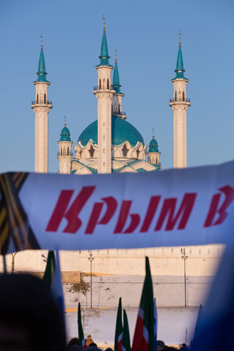
A week ago, Minister of Information and Culture Abdelaziz Khoja proclaimed that the House of Saud “renews its firm position condemning terrorism in all its forms.” That was the preamble to ask all Saudi nationals, jihadists or otherwise, to abandon Syria. They were committing a crime, Saudi King Abdullah, ever closer to meeting his maker, decreed.
Then, Saudi Arabia, the United Arab Emirates (UAE) and Bahrain all called their ambassadors from Qatar, under the pretext that Doha continues to support “hostile media,” as in Al Jazeera.
Finally Saudi Arabia officially declared the Muslim Brotherhood, Al-Nusra Front (Al-Qaeda’s official Syrian branch) and the Islamic State of Iraq and the Levant (ISIL) - the rogue jihadists fighting both the Assad government in Syria and the Maliki government in Iraq - as terrorist organizations. Any Saudi member of any of these outfits not back to the Kingdom in 15 days would be thrown in jail for up to 30 years.
By decree, the Saudi Interior Ministry (just in case) also branded as terrorists the Shiite Huthi rebels in northern Yemen, as well as an obscure, Saudi-based outfit called ‘Hezbollah Inside the Kingdom’. None of the above can so much as have a Facebook account.

Petromonarchy implosion
It’s easy to laugh this off as the epic implosion of that prime collection of what the West calls ‘our’ bastards – the petromonarchies of the Gulf Cooperation Council (GCC), also known as Gulf Counter-Revolution Cub.
And yes, soon the whole thing degenerated into a trademark, vicious inter-Arab catfight. For Qataris, for instance - accused by the Saudis of “meddling” - the meddlers are in fact the Saudis, who supported the August 2013 military coup in Egypt and are responsible for the giant mess among fighting outfits in Syria. Predictably, reams of Saudi and Emirati journalists quit assorted Qatari media jobs, many following a ‘polite’ request by the Saudi Ministry of Culture and Information.
Yet it's more complicated. The Saudi royal decree follows an ultra-hardline counterterrorism law which targets any sort of criticism of the House of Saud. So this is not only about the House of Saud being terrified of blowback from assorted hardcore jihadists, after they hone their skills in the Levant. They are terrified of anything that moves in and around Saudi Arabia. Imagine their feelings about the world at large.
They are terrified of young, Westernized Saudis with ‘revolutionary’ ideas. They are terrified of jihad freelancers. They are terrified of Muslim Brothers supported by their cousins in Qatar – which the West, laughably, praises as practicing a ‘more moderate’ brand of medieval Wahhabism. The old Emir Hamad al Thani – who recently deposed himself to the benefit of his son Tamim – had skillfully manipulated the Brotherhood as the key lever of Doha’s wide Middle-Eastern ambitions.
To spice up the Saudi-Qatari melee, there was only one Saudi prince among the royals who was in favor of some accommodation, following the orders of his American exceptionalist masters. Yet Saudi heir apparent Prince Nayef, a perennial Minister of Interior from 1975 to 2012, is now dead.
And now it’s wide in the open that Riyadh and Doha virtually come to blows on about everything – from Palestine and Egypt to Syria. After all, every grain of sand in Southwest Asian deserts always knew that the House of Saud is in favor of Salafis while Doha’s state policy was always to support the Ikhwan.
Now it’s easy; you’re either with us or you’re a terrorist. Well, the Bush-Cheney regime in the US had thought about this one first. The difference is that with so many freelancers, Jihad Inc. was handed a monster PR problem, and the usual Gulf financiers, mostly Saudi and Emirati, lost control of the pack.
Now, following the new order, any commando, mercenary, suicide bomber or beheader must abide by the strict American-Saudi playbook; otherwise he won’t be fully weaponized, or worse, will become a candidate for incineration by one of Obama’s choice Hellfire missiles. The Empire needs you, boys, but you gotta behave.

A shuttle to Simferopol?
And that brings us, not accidentally, to Crimea. I was told by a very good Saudi source to keep a close eye on the House of Saud’s machinations in Ukraine; they seem to be immensely interested in what’s going on. This follows the destitution of too volatile Bandar bin Sultan, aka Bandar Bush, from his perch as top intelligence commander of the war on Syria (US Secretary of State John Kerry was crucial in his downfall); Bandar’s replacement by Interior Minister Prince Mohammed bin Nayef, who is quite popular in Washington; and the ‘recall’ of Saudi fighters in the Levant.
The Tatars in Crimea are Muslims. They are about to ‘celebrate’ the 70th anniversary of their mass deportation by Stalin. They were back to Crimea by the end of the 1980s, and now number roughly 250,000 in Crimea; 13 percent of a largely Russian population, with an unemployment rate of at least 50 percent.
Refat Chubarov, the president of the Majlis, the National Assembly of Crimean Tatars, considers the Crimean referendum on March 16 a “threat” to the Ukraine. He is not promoting a jihad, but as many Tatar representatives, already forecasts “serious consequences” if Crimea’s statute is changed. There is certified Tatar backing to the neo-Nazis/fascists of the Svoboda and Right Sector kind in Kiev. From this ‘alliance’ to jihad, it’s just a suicide bombing away.
Whatever happens in Crimea, the House of Saud is up to something. Bandar Bush had boasted to President Putin that he controlled Caucasus jihadists and could turn them on and off at will. His successor might as well be tempted to turn them on not in the Caucasus, but in establishing a shuttle from the Syrian desert to Simferopol. What a spectacular favor to his American masters. The emperor, after all, is soon to visit Riyadh.

Pepe Escobar is the roving correspondent for Asia Times/Hong Kong, an analyst for RT and TomDispatch, and a frequent contributor to websites and radio shows ranging from the US to East Asia.

Costs of securing airports far outweigh the benefits
Source: http://www.homelandsecuritynewswire.com/dr20140321-costs-of-securing-airports-far-out weigh-the-benefits-study

A recently published research paper concludes that the funds allocated to secure the world’s major airports far outweigh the benefits.
Mark Stewart, an engineer at the University of Newcastle in Australia and an expert in risk-modeling, and John Mueller, a professor of political science at Ohio State University, have both written other studies in which they argue that Americans overestimate the risk of and impact from terrorist attacks, allowing this exaggerated fear to distort their lives.
Their recent study, published in the Journal of Air Transport Management, performs the same cost-benefit analysis used by engineers, insurers, and policymakers, and then applies it to airport security.
“This kind of analysis is pretty standard for other hazards,” Mueller says. “For example, if you’re planning to build some underground shelters for tornadoes in Alabama, the questions are exactly the same: How many lives do you save? How much does it cost? What is the likelihood of tornadoes?”
Businessweek reports that Stewart and Mueller calculated the costs associated with traditional airport security initiatives and compared them against the risk of an airport attack, the cost of damage from an attack in lives and property ( for the purpose of the calculation, a human life was valued at $7 million), and the effectiveness of particular security initiatives in preventing an attack.
The authors concluded that “many of the assessed security measures would only begin to be cost-effective if the current rate of attack at airports in the U.S., Europe, and the Asia-Pacific increases by a factor of 10-20.”
Stewart and Mueller also considered the cost of measures proposed to strengthen airport security including vehicle-search checkpoints, hiring more skycaps to monitor vehicles, and deploying more bomb-sniffing dogs.
The report does not take into account security initiatives that are meant to protect airplanes, such asTSA scanners, body searches, ID checks, air marshals, but it does calculate the cost associated with protecting air terminals — police patrols and blast barriers, among other measures. The authors acknowledged the need to protect airplanes, but they found no reason that justify the high cost of airport security. “Although there may be special reasons to protect airplanes, however it is not all clear that there are any special reasons to protect airports.”
The paper claims that compared with many other places of congregation, people are more dispersed in airports, therefore a terrorist attack is likely to kill far fewer people than if a crowded sports stadium was targeted.
The paper used the cost and risk reduction figures for Los Angeles International Airport, but the research was conducted before the shooting at the airport last fall, which resulted in the death of TSA agent Gerardo Hernandez and several others wounded.

— Read more in Mark G. Stewart and John Mueller, “Cost-benefit analysis of airport security: Are airports too safe?” Journal of Air Transport Management 35 (March 2014): 19-28 ►(http://politicalscience.osu.edu/faculty/jmueller/JATMfin.pdf)

"We're Lucky" LAX Shooting Didn't Take More Lives: Mayor
Source: http://www.nbclosangeles.com/news/local/after-action-report-lax-shooting-response-2508040 21.html

A report on the emergency response to a shooting last year at Los Angeles International Airport, which left a security screener dead, cites serious shortcomings in communication between agencies that left major commanders in the dark and a long lag in establishing a coordinated response.
The lengthy report cites the "heroism" of officers who shot and took suspect Paul Ciancia into custody after he'd killed a Transportation Security Administration officer and injured three people on Nov. 1.
But it details lapses in coordination and technology between police and fire departments, which set up multiple command posts at different locations that didn't unify for 45 minutes. The first meeting among commanders didn't occur until more than 1 1/2 hours after the shooting began.
"We're lucky that shooting didn't take more lives," Los Angeles Mayor Eric Garcetti said during a press conference.
The report says police and fire officials were hindered by incompatible radio systems that prevented airport police from communicating. Meanwhile, senior police and fire commanders arriving on scene had no idea where to go or what the others were doing. There was nearly no communication between the command post officials and those in the airport's emergency operations center, which the report described as being staffed by untrained mid-level managers.
The airport spent $5.4 million in 2011 on a new high-tech radio system, which often proved useless in communicating with the more than 20 agencies that responded.
Fire officials worried by how close the incident command post was to the initial shooting site originally set up their own command post, which hampered the ability to coordinate with law enforcement and to get victims out of the terminal. Airport police had to send two teams of marksmen on top of parking structures to protect the command post amid initial worries of additional shooters.
Authorities say Ciancia, 24, targeted TSA officers in his attack. The Pennsville, N.J., native who moved to Los Angeles two years earlier has pleaded not guilty to 11 federal charges, including murder of a federal officer.
The report cites a number of lessons learned, including some 50 recommen-dations, and ominously warns: "Had the attacker not been highly selective in his targets, and/or had there been multiple attackers with weapons of greater lethality, the outcome might have been far different."
Much of the review confirms earlier reports by the AP, including that a TSA supervisor picked up a red phone immediately after the first shots were fired and the gunman hastily fled. The report says the airport police dispatcher "only heard the sounds of shouting and gunshots. With no caller identification for a call from a Red Phone, and no one on the other end of the line, it was not initially known from where the call originated."
Technical malfunctions were discovered at the Terminal 3 checkpoint and an airport-wide audit of red phones and panic buttons found some of those devices weren't working properly. The report calls for updates to the airport's emergency red phones and improvements to how airport police receive 911 calls as well as to security cameras.
The broad review of the emergency response conducted by airport staff and an outside contractor included interviews with airport staff, law enforcement and first responders, reviews of camera footage, dispatch logs and 911 calls.
There is no mention of the two airport police officers assigned to Terminal 3 who were out of position without notifying dispatchers as required when the shooting erupted.
The report recommends that airport police test their random security deployments to uncover flaws after it was determined that Ciancia may have passed through an airport police checkpoint but evidently wasn't deterred or stopped.
A flood of responders made it difficult to track resources and organize their deployment. And the responders left their vehicles in airport roadways, requiring them to be towed.
Because officers from other jurisdictions working LAX perimeter checkpoints had not been given directions, they turned away many responders who had to find an escort in, including members of the Department of Disabilities, the Red Cross, TSA security officers, pilots and flight attendants, aircraft mechanics, ground crews, service workers. Even the airport executive director and head of media relations weren't allowed in for a time.
Recommendations include improving the public announcement system and increased training for the entire airport community and other agencies involved in responding to such emergencies. The report also calls for training airport police in tactical medicine so they can help the injured before paramedics arrive.
Los Angeles World Airports, which operates LAX and two other airports, spends $125 million on security annually, according to the report.
It is highly critical of the Los Angeles World Airports' emergency management program, which it says is "not well-defined or widely understood across the agency, or perhaps even respected by the stakeholders it must be engaged with and from whom it must win support and cooperation."
It adds that the airport operator's emergency management division "does not appear to be appropriately organized, sufficiently staffed, or adequately resourced."
The airport prepared an active shooter draft plan in March 2013, but officials on the airport's emergency management committee couldn't reach a consensus on it.
The airport has hired an outside contractor to work on an emergency plan and program since early 2012; that process is ongoing.

EDITOR’S COMMENT: “Luck” and “surprise” – the two basic elements of post-incident reactions worldwide. Millions spend on security and high tech communications but the scenario was so simple: You drive your car at Terminal 3, take out your ammo, walk through the corridor and start shoot people! Even planners should have played this scenario and take pre-active measures. Not to mention the proximity of air traffic control tower to the multistory parking at the entrance of the airport that makes it a suitable target for a VBIED attack. Elementary Mr Watson, elementary!

Shebab says latest suicide bomber was 60-year-old from Norway
Source: http://www.terrorismwatch.org/2014/03/shebab-says-latest-suicide-bomber-was.html

Somalia's Al-Qaeda-linked Shebab rebels on Wednesday identified a suicide car bomber who struck a town recently captured by African Union troops as a 60-year-old Somali man who held Norwegian citizenship.
The attack in Buulo Burde in the south of the country on Tuesday targeted a hotel crowded with army officers and was followed by an assault by Shebab gunmen, leaving several dead, officials said.
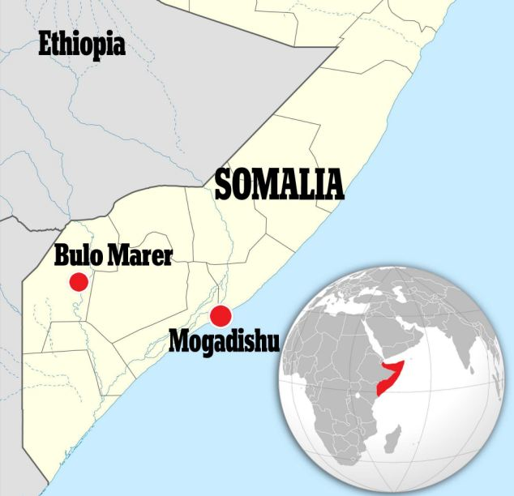
"The attacker of Buulo Burde was a 60-year-old man who came from Norway to fight the enemies of Allah," Shebab military spokesman Sheikh Abdul Aziz Abu Musab told AFP, naming the attacker as Abdullahi Ahmed Abdulle, a Norwegian national of Somali origin.
"He paid the sacrifice in order to be close to Allah by killing his enemies. The event is showing us that there is no age limit for jihad," the spokesman said.
The attack is the latest by the Shebab, launched in apparent retaliation for a new offensive to root them out of areas of the war-torn country still under their control.
African Union soldiers, who are fighting the Shebab alongside Somali government troops, captured the small town from the Islamists last week.
The UN-backed AU force this month launched a fresh offensive against Shebab bases, with the gunmen largely fleeing ahead of the assault, only to later stage guerrilla attacks.
Shebab fighters once controlled most of southern and central Somalia but withdrew from fixed positions in Mogadishu two years ago.
Recent Shebab attacks have targeted key areas of government or the security forces, in an apparent bid to discredit claims by the authorities that they are winning the war.

Al Qaeda calls for car bombs in US cities, other 'crusader' countries
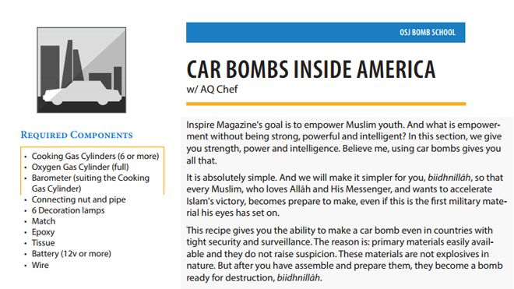
Source: http://www.foxnews.com/us/2014/03/19/al-qaeda-calls-for-car-bombs-in-us-cities-other-crusader-countries/
The spring 2014 edition of Inspire magazine, seen above, urges jihadists to target specific U.S. locations using car bombs. Detailed instructions and simple diagrams on every step are provided.

Al Qaeda is calling on terrorist affiliates to detonate car bombs in major U.S. cities, including New York, Washington, D.C., and Los Angeles, in the latest edition of its Inspire magazine.
The issue comes nearly a year after the Boston Marathon bombing, and as the city readies new security measures for this year's race, being held next month. Inspire is the same magazine that included instructions for how to make pressure cooker bombs, which were used in last year's Boston attack.
The magazine’s Spring 2014 issue urges jihadists to target heavily populated events such as political rallies and sporting events, both in the United States and abroad -- including in Great Britain, France and other “crusading” countries.
“Choosing the place and time is a crucial factor to success in any operation,” the magazine reads. “Choose targets in your own country. You know the enemy better, you are within … The important thing is that you target people and not buildings.”
Would-be bombers also are urged to consider launching attacks during “election seasons” and between Christmas and New Year’s Eve. Specific targets are also cited, including Chicago’s "Sears Tower" (now called the Willis Tower), military bases in northern Virginia and soccer stadiums in Great Britain, particularly during Premier League matches.
“Disguise yourself during the operation, appear fat (add some clothes on you), change your complexion, be a 'clone', use any mask (believe me embarrassment is the last thing you will think about), wear a mask suitable for the festival, white beards on 25th Dec,” it reads. “All in all, be creative brother. The most important part to hide is your eyes and around.”
The issue also contains extremely detailed, “absolutely simple” instructions on how to build such a bomb.
“My Muslim brother, before you start reading the instructions, remember that this type of operation, if prepared well and an appropriate target is chosen, and Allah decrees success for you, history will never forget it,” the magazine reads. “It will be recorded as a crushing defeat on the enemies of Islam.”

8,000 foreign Shi'ite fighters in Syria fighting for Assad
Source: http://www.jpost.com/Middle-East/8000-foreign-Shiite-fighters-in-Syria-fighting-for-Assad-new-study-says-345769

A new report released Tuesday on the presence of foreign Shi’ite fighters entering Syria to fight on behalf of the Assad regime has put their numbers at 7,000 to 8,000.
The study was released by the Tel Aviv-based Meir Amit Intelligence and Terrorism Information Center, a part of the Israeli Intelligence and Heritage Commemoration Center. The Center was founded in the 1980s by leading members of the Israeli intelligence community.
“In our assessment, Iran might profit from the involvement of Shi’ite foreign fighters in Syria when they return to their countries of origin, especially Iraq.
Their return is liable to create for the Iranians, especially the Quds Force, ready-made networks of trained, battle-experienced fighters that can be leveraged by Iran for its terrorism and subversive activities,” the report said.
Speaking to The Jerusalem Post, Reuven Erlich, head of the Intelligence and Terrorism Information Center, said the Shi’ite fighters could easily become “Iranian agents, with motivation and military experience,” which could spread out across the region.
“Their numbers are increasing, and in our assessment today there are at least 7,000-8,000, including several thousand Hezbollah fighters (whose numbers change from time to time),” the report said discussing the amount of Shi’ite militia volunteers in Syria.
That estimate included several thousand Shi’ite Iraqis organized into military units, the most prominent of which is the Abu al-Fadhel al-Abbas Brigade. “In addition to the hard core of Hezbollah and Iraqi Shi’ite fighters, there are several hundred Shi’ite foreign fighters from the Shi’ite communities in Arab and Muslim countries such as Bahrain, Yemen (Houthi rebels), Kuwait, Saudi Arabia, Pakistan and Afghanistan,” the report continued.
The arrival of Shi’ite volunteers from the Arab-Muslim world is being orchestrated by Iran, it said.
“Iran supports them not only by providing religious justification, but money and equipment as well. In addition, in our assessment Iran is involved in operating the Shi’ite military units in collaboration and close coordination with the Syrian army and the Assad regime’s security forces.
Handling Hezbollah, and the other Shi’ite foreign fighters in Syria, follows Iran’s strategy of supporting the Syrian regime through proxies, limiting its own direct military intervention in the fighting,” the report’s authors said.
Iran itself has sent several hundred soldiers to Syria, most of them members of Quds Force, a part of the Iranian Islamic Revolutionary Guards Corps (IRGC), according to the research.
The Quds Force (which was also behind the recent attempt to smuggle Syrian arms to Gaza) has established militia units comprised of Shi’ites and Alawites across Syria. The units are nourished with weapons, military advice, guidance and training, funds and propaganda, the study said.
“The Quds Force, which has strong contacts with the Hezbollah and Iraqi Shi’ite militias, recruits and handles Shi’ite foreign fighters in Iraq, Lebanon and other countries. Thus Iran’s extensive support (alongside Russia’s) is a strategic prop, enabling the Syrian regime to survive in the civil war whose end is not in sight and whose outcome is not clear,” it said.
Hezbollah’s highly trained military units in Syria are fighting in close collaboration with Syrian security forces, and have played a vital role in strategic battles, such as the recapture of Al-Qusayr in 2013.
“Over the past few months Hezbollah operatives have been integrated into the supporting units of the Syrian army’s campaigns in the rural areas east of Damascus, the areas around Aleppo and the ongoing campaign along the Syria- Lebanon border [the Al-Qalamoun mountains, especially the city of Yabrud], which, according to the media, is about to be taken over by the Syrian forces with Hezbollah backup,” the authors said.
Many Iraqi foreign fighters come with rich experience in guerilla warfare, the report said, but “in our assessment they are less proficient as fighters than Hezbollah.
However, the Shi’ite foreign fighters play an important role in defending the religious sites sacred to Shi’a, especially the grave of Al-Set Zaynab, south of Damascus.”
To a certain extent, the Shi’ite forces balance the involvement of foreign Sunni jihadists in Syria, and at the same time greatly complicate the civil war and intensify its religious-sectarian nature, the study found.
Hezbollah’s involvement in Syria provoked a counter-response in the form of al-Qaida attacks in Lebanon, a development that threatens “to undermine Lebanon’s already fragile internal stability and possibly eroding Hezbollah’s status. It might also aggravate the Arab-Muslim Sunni- Shi’ite rift.”
The Meir Amit Intelligence and Terrorism Information Center released a series of detailed studies on the Syrian civil wars, which are available on its website.
In January, it released a report estimating that some 6,000 to 7000 foreign Sunni fighters arrived in Syria to fight with the rebels, with the big majority of them joining jihadi organizations, foremost among them, the Al-Nusra Front.
The two central jihadi organizations in Syria, the Al Nusra Front, headed by al-Qaida’s central leader, Ayman al-Zawahiri, and its competitor, the Islamic State in Iraq and Greater Syria, have a combined membership of 9,000 members, of which an estimated 6,000 are foreign volunteers, according to the study.

EDITOR’S COMMENT: Apart from the high level “chess” geopolitical games we only now began to understand, do we really know what is happening is Syria? Do we really know what Syrian citizens – the real victims of this bloodshed – are suffering and what they really want regarding the future of their own country? Do we really know about their needs in healthcare, education, elementary daily needs and many other important issues for survival? Are we sure that armed forces do exist in a structural mode or has been replaced by foreign fighters and security forces loyal to the regime? Are we sure that chemical weapons will be finally given for destruction – all of them? Can we understand why Muslims kill Muslims or why Muslims kill Christians? Are we clever enough to realize what will all foreign fighters will do when they will “retire” from the conflict zone and return back to their “civilized” societies? Are we really satisfied with the actions taken by UN or EU or other structured bodies to stop the massacre in country that does not deserve this? Perhaps it is time to stop eating all that multilevel propaganda and proceed to solutions that will stabilize the area and give people the possibility to have a normal life. We only live – an average – about 70 yrs. Remember?

Al-Qa’ida, the Second Act: Why the Global 'War on Terror' Went Wrong
Source: http://www.unz.com/pcockburn/al-qaida-the-second-act-why-the-global-war-on-terror-went-wrong/

It is now 12-and-a-half years since the September 11 attacks that put al-Qa’ida firmly on the map of global terrorism. The US has spent billions of dollars on its ‘war on terror’ to counter the threat and succeeded in killing Osama bin Laden three years ago. And yet al-Qa’ida-type groups are arguably stronger than ever now, especially in Syria and Iraq where they control an area the size of Britain, but also in Libya, Lebanon, Egypt and beyond.
In a groundbreaking five-part series, The Independent’s award-winning foreign correspondent, Patrick Cockburn, investigates the resurgence of the terrorist organisation. Today, he asks: why did the ‘war on terror’ go wrong?

Al-Qa’ida-type organisations, with beliefs and methods of operating similar to those who carried out the 9/11 attacks, have become a lethally powerful force from the Tigris to the Mediterranean in the past three years. Since the start of 2014, they have held Fallujah, 40 miles west of Baghdad, much of the upper Euphrates valley, and exert increasing control over the Sunni heartlands of northern Iraq. In Syria, their fighters occupy villages and towns from the outskirts of Damascus to the border with Turkey, including the oilfields in the north-east of the country. Overall, they are now the most powerful military force in an area the size of Britain.
The spectacular resurgence of al-Qa’ida and its offshoots has happened despite the huge expansion of American and British intelligence services and their budgets after 9/11. Since then, the US, closely followed by Britain, has fought wars in Afghanistan and Iraq, and adopted procedures formerly associated with police states, such as imprisonment without trial, rendition, torture and domestic espionage. Governments justify this as necessary to wage the “war on terror”, claiming that the rights of individual citizens must be sacrificed to secure the safety of all.
Despite these controversial security measures, the movements against which they are aimed have not only not been defeated but have grown stronger. At the time of 9/11, al-Qa’ida was a very small organisation, but in 2014 al-Qa’ida-type groups are numerous and powerful. In other words, the “war on terror”, the waging of which determined the politics of so much of the world since 2001, has demonstrably failed.
How this failure happened is perhaps the most extraordinary development of the 21st century. Politicians were happy to use the threat of al-Qa’ida to persuade people that their civil liberties should be restricted and state power expanded, but they spent surprisingly little time calculating the most effective practical means to combat the movement. They have been able to get away with this by giving a misleading definition of al-Qa’ida, which varied according to what was politically convenient at the time.
Jihadi groups ideologically identical to al-Qa’ida are relabelled as moderate if their actions are deemed supportive of US policy aims. In Syria, the US is backing a plan by Saudi Arabia to build up a “Southern Front” based in Jordan against the Assad government in Damascus, but also hostile to al-Qa’ida-type rebels in the north and east. The powerful but supposedly “moderate” Yarmouk Brigade, which is reportedly to receive anti-aircraft missiles from Saudi Arabia, will be the leading element in this new formation. But numerous videos show that the Yarmouk Brigade has frequently fought in collaboration with Jabhat al-Nusra (JAN), the official al-Qa’ida affiliate. Since it is likely that, in the midst of battle, these two groups will share their munitions, Washington will be permitting advanced weaponry to be handed over to its deadliest enemy.
This episode helps explain why al-Qa’ida and its offshoots have been able to survive and flourish. The “war on terror” has failed because it did not target the jihadi movement as a whole and, above all, was not aimed at Saudi Arabia and Pakistan, the two countries that had fostered jihadism as a creed and a movement. The US did not do so because they were important American allies whom it did not want to offend. Saudi Arabia is an enormous market for American arms, and the Saudis have cultivated and, on occasion bought up, influential members of the American political establishment.
A measure of the seriousness of the present situation is that, in recent weeks, Saudi Arabia has for the first time been urgently seeking to stop jihadi fighters, whom it previously allowed to join the war in Syria, from returning home and turning their weapons against the rulers of the Saudi kingdom. This is an abrupt reversal of previous Saudi policy, which tolerated or privately encouraged Saudi citizens going to Syria to take part in a holy war to overthrow President Bashar al-Assad and combat Shia Muslims on behalf of Sunni Islam.
In recent weeks, Saudi Arabia has called on all foreign fighters to leave Syria, and King Abdullah has decreed it a crime for Saudis to fight in foreign conflicts. The Saudi intelligence chief, Prince Bandar bin Sultan, who had been in charge of organising, funding and supplying jihadi groups fighting in Syria, has been unexpectedly removed from overseeing Saudi policy towards Syria, and replaced by a prince who has led a security clampdown against al-Qa’ida inside Saudi Arabia.
The US is increasingly fearful that support for the Syrian rebels by the West and the Sunni monarchies of the Gulf has created a similar situation to that in Afghanistan in the 1980s, when indiscriminate backing for insurgents ultimately produced al-Qa’ida, the Taliban and jihadi warlords. The US Under-Secretary for Terrorism and Financial Intelligence, David Cohen, warned this month that “terrorist” movements, such as JAN and the Islamic State of Iraq and the Levant (Isis), were not only destabilising Syria but “these well-funded and well-equipped groups may soon turn their attention to attacks outside of Syria, particularly as scores of newly radicalised and freshly trained foreign recruits return from Syria to their home countries”. The number of foreign fighters that Mr Cohen gives is a significant underestimate, since the head of US intelligence, James Clapper, estimates foreign fighters in Syria to number about 7,000, mostly from the Arab world, but also from countries such as Chechnya, France and Britain.
Al-Qa’ida has always been a convenient enemy. In Iraq, in 2003 and 2004, as armed Iraqi opposition to the American and British-led occupation mounted, US spokesmen attributed most attacks to al-Qa’ida, though many were carried out by nationalist and Baathist groups. According to a poll by the Pew Group, this persuaded 57 per cent of US voters before the Iraq invasion to believe that there was a connection between Saddam Hussein and those responsible for 9/11, despite a complete absence of evidence for this. In Iraq itself, indeed the whole Muslim world, these accusations benefited al-Qa’ida by exaggerating its role in the resistance to the US and British occupation.
Precisely the opposite PR tactics were employed by Western governments in 2011 in Libya, where they played down any similarity between al-Qa’ida and the Nato-backed rebels fighting to overthrow the Libyan leader, Muammar Gaddafi. This was done by describing as dangerous only those jihadis who had a direct operational link to the al-Qa’ida “core” of Osama bin Laden. The falsity of the pretence that the anti-Gaddafi jihadis in Libya were less threatening than those in contact with al-Qa’ida was forcefully, if tragically, exposed when US ambassador Chris Stevens was killed by jihadi fighters in Benghazi in September 2012. These were the same fighters lauded by governments and media for their role in the anti-Gaddafi uprising.
Al-Qa’ida is an idea rather than an organisation, and this has long been so. For a five-year period after 1996, it did have cadres, resources and camps in Afghanistan, but these were eliminated after the overthrow of the Taliban in 2001. Subsequently, al-Qa’ida’s name was a rallying cry, a set of Islamic beliefs such as the creation of an Islamic state, the imposition of sharia, a return to Islamic customs, the subjugation of women and waging holy war against other Muslims, notably the Shia, as heretics worthy of death. At the centre of this doctrine for making war is an emphasis on self-sacrifice and martyrdom as a symbol of religious faith and commitment. This has turned out to be a way of using untrained but fanatical believers to devastating effect as suicide bombers.
It has always been in the interests of the US and other governments that al-Qa’ida should be viewed as having a command-and-control structure like a mini-Pentagon, or the Mafia in America as shown in the Godfather films. This is a comforting image for the public because organised groups, however demonic, can be tracked down and eliminated through imprisonment or death. More alarming is the reality of a movement whose adherents are self-recruited and may spring up anywhere.
Osama bin Laden’s gathering of militants, which he did not call al-Qa’ida until after 9/11, was just one of many jihadi groups 12 years ago. But today its ideas and methods are predominant among jihadis because of the prestige and publicity it gained through the destruction of the twin towers, the war in Iraq and its demonisation by Washington as the source of all anti-American evil. These days, there is a decreasing difference in the beliefs of jihadis, regardless of whether or not they are formally linked to al-Qa’ida central, now headed by Ayman al-Zawahiri. An observer in southern Turkey discussing 9/11 with a range of Syrian jihadi rebels earlier this year found that “without exception they all expressed enthusiasm for the 9/11 attacks and hoped the same thing would happen in Europe as well as the US”.
Unsurprisingly, governments prefer the fantasy picture of al-Qa’ida because it enables them to claim a series of victories by killing its better-known members and allies. Often, those eliminated are given quasi-military ranks, such as “head of operations”, to enhance the significance of their demise. The culmination of this most publicised but largely irrelevant aspect of the “war on terror” was the killing of Bin Laden in Abbottabad in Pakistan in 2011. This enabled President Obama to grandstand before the American public as the man who had presided over the hunting down of al-Qa’ida’s leader. In practice, his death had no impact on al-Qa’ida-type jihadi groups, whose greatest expansion has been since 2011.
The resurgence of these jihadis is most striking on the ground in Iraq and Syria, but is evident in Afghanistan, Libya, Somalia and, in recent months, Lebanon and Egypt. In Iraq, it was a final humiliation for the US, after losing 4,500 soldiers, that al-Qa’ida’s black flag should once again fly in Fallujah, captured with much self-congratulatory rhetoric by US Marines in 2004. Aside from Fallujah, Isis, the premier jihadi movement in the country, has rapidly expanded its influence in all parts of Sunni Iraq in the past three years. It levies local taxes and protection money in Mosul, Iraq’s third largest city, estimated to bring in $8m (£4.8m) a month.
It has been able to capitalise on two factors: the Sunni revolt in Syria and the alienation of the Iraqi Sunni by a Shia-led government. Peaceful protests by Sunni started in December 2012, but a lack of concessions by Prime Minister Nouri al-Maliki and a massacre at a peace camp at Hawijah last April is transmuting peaceful protest into armed resistance.
Last summer, Isis freed hundreds of its leaders and experienced militants in a spectacular raid on Abu Ghraib prison. Its stepped-up bombing campaign killed 9,500 people, mostly Shia civilians, in the course of last year, the heaviest casualties since 2008. But there is a crucial difference between then and now. Even at the previous peak of its influence in 2004-06, al-Qa’ida in Iraq did not enjoy as strong a position in the Sunni armed opposition as it does today.
Jessica D Lewis, of the Institute for the Study of War, commented in a study of the movement at the end of 2013 that al-Qa’ida in Iraq “is an extremely vigorous, resilient and capable organisation that can operate from Basra to coastal Syria”.
In Syria, Isis was the original founder in early 2012 of JAN, sending it money, arms and experienced fighters. A year later, it tried to reassert its authority over JAN by folding it into a broader organisation covering both Syria and Iraq. The two are now involved in a complicated intra-jihadi civil war that began at the start of the year, pitting Isis, notorious for its cruelty and determination to monopolise power, against the other jihadi groups. The more secular Free Syrian Army (FSA), once designated along with its political wing by the West as the next rulers of Syria, has collapsed and been marginalised.
The armed opposition is now dominated by jihadis who wish to establish an Islamic state, accept foreign fighters, and have a vicious record of massacring Syria’s minorities, notably the Alawites and the Christians. The Islamic Front, for instance, a newly established and powerful alliance of opposition brigades backed by Turkey and Qatar, is fighting Isis. But that does not mean that it is not complicit in sectarian killings, and it insists on strict imposition of sharia, including the public flogging of those who do not attend Friday prayers. The Syrian jihadis rule most of north-east Syria aside from that part of it held by the Kurds. The government clings to a few outposts in this vast area, but does not have the forces to recapture it.
The decisions that enabled al-Qa’ida to avoid elimination, and later to expand, were made in the hours immediately after 9/11. Almost every significant element in the project to crash planes into the twin towers and other iconic American buildings led back to Saudi Arabia. Bin laden was a member of the Saudi elite, whose father had been a close associate of the Saudi monarch. Of the 19 hijackers on 9/11, 15 were Saudi nationals. Citing a CIA report of 2002, the official 9/11 report says that al-Qa’ida relied for its financing on “a variety of donors and fundraisers, primarily in the Gulf countries and particularly in Saudi Arabia”. The report’s investigators repeatedly found their access limited or denied when seeking information in Saudi Arabia. Yet President George W Bush never considered holding the Saudis in any way responsible for what had happened. The exit of senior Saudis, including Bin Laden relatives, from the US was facilitated by the government in the days after 9/11. Most significantly, 28 pages of the 9/11 Commission Report about the relationship between the attackers and Saudi Arabia was cut and never published – despite a promise by President Obama to do so – on the grounds of national security.
Nothing much changed in Saudi Arabia until recent months. In 2009, eight years after 9/11, a cable from the US Secretary of State, Hillary Clinton, revealed by WikiLeaks, complains that “donors in Saudi Arabia constitute the most significant source of funding to Sunni terrorist groups worldwide”.
Moreover, the US and the west Europeans showed themselves indifferent to Saudi preachers, their message spread to millions by satellite TV, YouTube and Twitter, calling for the killing of Shia as heretics. These calls came as al-Qa’ida bombs were slaughtering people in Shia neighbourhoods in Iraq. A sub-headline in another State Department cable in the same year reads: “Saudi Arabia: Anti-Shi’ism As Foreign Policy?” Five years later, Saudi-supported groups have a record of extreme sectarianism against non-Sunni Muslims.
Pakistan, or rather Pakistani military intelligence in the shape of the Inter-Services Intelligence (ISI), was the other parent of al-Qa’ida, the Taliban and jihadi movements in general. When the Taliban was disintegrating under the weight of US bombing in 2001, its forces in northern Afghanistan were trapped by anti-Taliban forces. Before they surrendered, hundreds of ISI members, military trainers and advisers were hastily evacuated by air. Despite the clearest evidence of ISI’s sponsorship of the Taliban and jihadis in general, Washington refused to confront Pakistan, and thereby opened the way for the resurgence of the Taliban after 2003, which neither the US nor Nato has been able to reverse.
Al-Qa’ida, the Taliban and other jihadi groups are the offspring of America’s strange alliance with Saudi Arabia, a theocratic absolute monarchy, and Pakistani military intelligence. If this alliance had not existed, then 9/11 would not have happened. And because the US, with Britain never far behind, refused to break with these two Sunni powers, jihadism survived and prospered after 9/11.
Following a brief retreat, it took advantage of the turmoil created by wars in Iraq and Afghanistan and, later, by the Arab uprisings of 2011, to expand explosively. Twelve years after the “war on terror” was launched it has visibly failed and al-Qa’ida-type jihadis, once confined to a few camps in Afghanistan, today rule whole provinces in the heart of the Middle East.

The Maternal Drama of the Chechen Jihadi
By Nancy Hartevelt Kobrin Ph.D. (Author)
Source:http://freepsychotherapybooks.org/?utm_source=Maternal+Drama&utm_campaign=maternal+drama&utm_medium=email

The volcanic iceberg mentality of the Jihadi is a psychotic adaptation, a result of children having been treated as objects when they were infants. Underneath the frozen, cold image lies a seething cauldron of rage ready to explode. In this type of society children learn to repress their feelings. As a consequence, internal rage boils within the personality. On the one hand the mother is idealized as a powerful object, and on the other her power is perceived as toxic and must be destroyed.

►You can freely download this book from source’s URL.

What makes us feel vulnerable to terrorism?
Source: http://www.medicalnewstoday.com/releases/273679.php

How do we perceive our vulnerability to terrorism? Is it through our sense of place, such as urban neighbourhoods where we live or offices where we work (as evidence has previously suggested); or is it actually through mobility, when we are travelling between places, the contradictory notion of 'placelessness'? Recent research published in Urban Geography addresses this very question.
Focussing his research on people's perceptions of their vulnerability to terrorism, Kevin Keenan conducted interviews with householders in Boston, US in 2008, and encouraged them to define terrorism and talk about their feelings towards it.
According to this study, it is transportation systems that make us feel more at risk to terrorism rather than the sense of 'placelessness' itself. It is not so much the destination of our journey, but rather the journey itself that influences our perceived vulnerability to terrorism.
Despite this, Keenan's study also reveals that "the poor are quite aware of their vulnerability and relative immobility", suggesting that our personal wealth can amplify or attenuate our sense of vulnerability. This highlights a policy need to increase mobility options for the poor, which may help to increase the chances of effective evacuation in the event of a terrorist incident.
Whether it is our sense place, or 'placelessness' that makes us feel most at risk of terrorism, this study remind us of the importance of being aware of our surroundings when we are on the move, to help us feel more secure in our everyday lives.

What Pakistan Knew About Bin Laden
Source: http://www.terrorismwatch.org/2014/03/what-pakistan-knew-about-bin-laden.html

Shortly after the Sept. 11 attacks, I went to live and report for The New York Times in Afghanistan. I would spend most of the next 12 years there, following the overthrow of the Taliban, feeling the excitement of the freedom and prosperity that was promised in its wake and then watching the gradual dissolution of that hope. A new Constitution and two rounds of elections did not improve the lives of ordinary Afghans; the Taliban regrouped and found increasing numbers of supporters for their guerrilla actions; by 2006, as they mounted an ambitious offensive to retake southern Afghanistan and unleashed more than a hundred suicide bombers, it was clear that a deadly and determined opponent was growing in strength, not losing it. As I toured the bomb sites and battlegrounds of the Taliban resurgence, Afghans kept telling me the same thing: The organizers of the insurgency were in Pakistan, specifically in the western district of Quetta. Police investigators were finding that many of the bombers, too, were coming from Pakistan.
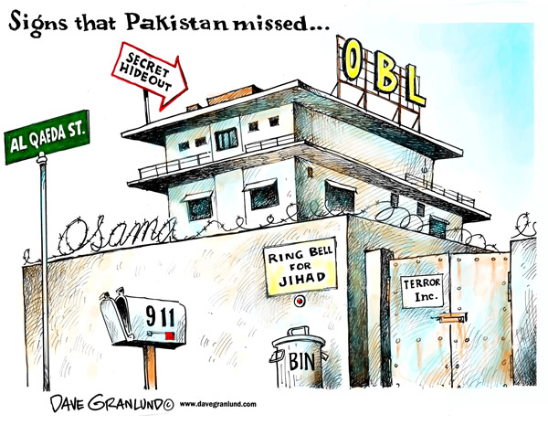
In December 2006, I flew to Quetta, where I met with several Pakistani reporters and a photographer. Together we found families who were grappling with the realization that their sons had blown themselves up in Afghanistan. Some were not even sure whether to believe the news, relayed in anonymous phone calls or secondhand through someone in the community. All of them were scared to say how their sons died and who recruited them, fearing trouble from members of the ISI, Pakistan’s main intelligence service.
After our first day of reporting in Quetta, we noticed that an intelligence agent on a motorbike was following us, and everyone we interviewed was visited afterward by ISI agents. We visited a neighborhood called Pashtunabad, “town of the Pashtuns,” a close-knit community of narrow alleys inhabited largely by Afghan refugees who over the years spread up the hillside, building one-story houses from mud and straw. The people are working class: laborers, bus drivers and shopkeepers. The neighborhood is also home to several members of the Taliban, who live in larger houses behind high walls, often next to the mosques and madrasas they run.
The small, untidy entrance on the street to one of those madrasas, the Jamiya Islamiya, conceals the size of the establishment. Inside, a brick-and-concrete building three stories high surrounds a courtyard, and classrooms can accommodate 280 students. At least three of the suicide bombers we were tracing had been students here, and there were reports of more. Senior figures from Pakistani religious parties and provincial-government officials were frequent visitors, and Taliban members would often visit under the cover of darkness in fleets of S.U.V.s.

One of many madrasas in Quetta in 2008
Alex Majoli / Magnum
We requested an interview and were told that a female journalist would not be permitted inside, so I passed some questions to the Pakistani reporter with me, and he and the photographer went in. The deputy head of the madrasa denied that there was any militant training there or any forced recruitment for jihad. “We are educating the students in the Quran, and in the Quran it is written that it is every Muslim’s obligation to wage jihad,” he said. “All we are telling them is what is in the Quran. Then it is up to them to go to jihad.” He ended the conversation. Classes were breaking up, and I could hear a clamor rising as students burst out of their classrooms. Boys poured out of the gates onto the street. They looked spindly, in flapping clothes and prayer caps, as they darted off on their bikes and on foot, chasing one another down the street.
The reporter and the photographer joined me outside. They told me that words of praise were painted across the wall of the inner courtyard for the madrasa’s political patron, a Pakistani religious-party leader, and the Taliban leader Mullah Muhammad Omar. This madrasa, like so many in Pakistan, was a source of the Taliban resurgence that President Hamid Karzai and other Afghan leaders had long been warning about. In this nondescript madrasa in a poor neighborhood of Quetta, one of hundreds throughout the border region, the Taliban and Pakistan’s religious parties were working together to raise an army of militants.
“The madrasas are a cover, a camouflage,” a Pashtun legislator from the area told me. Behind the curtain, hidden in the shadows, lurked the ISI.
The Pakistani government, under President Pervez Musharraf and his intelligence chief, Lt. Gen. Ashfaq Parvez Kayani, was maintaining and protecting the Taliban, both to control the many groups of militants now lodged in the country and to use them as a proxy force to gain leverage over and eventually dominate Afghanistan. The dynamic has played out in ways that can be hard to grasp from the outside, but the strategy that has evolved in Pakistan has been to make a show of cooperation with the American fight against terrorism while covertly abetting and even coordinating Taliban, Kashmiri and foreign Qaeda-linked militants. The linchpin in this two-pronged and at times apparently oppositional strategy is the ISI. It’s through that agency that Pakistan’s true relationship to militant extremism can be discerned — a fact that the United States was slow to appreciate, and later refused to face directly, for fear of setting off a greater confrontation with a powerful Muslim nation.

Footsteps of the insurgency
On our fifth and last day in Quetta, four plainclothes agents detained my photographer colleague at his hotel. They seized his computer and photo equipment and brought him to the parking lot of the hotel where I was staying. There they made him call and ask me to come down to talk to them. “I’m in trouble here,” he told me. It was after dark. I did not want to go down to the parking lot, but I told my colleague I would get help. I alerted my editor in New York and then tried to call Pakistani officials.
Before I could reach them, the agents broke through the door of my hotel room. The lintel splintered, and they burst in in a rush, snatching my laptop from my hands. There was an English-speaking officer wearing a smart new khaki-colored fleece. The other three, one of whom had the photographer in tow, were the muscle.
They went through my clothes and seized my notebooks and a cellphone. When one of the men grabbed my handbag, I protested. He punched me twice, hard, in the face and temple, and I fell back onto the coffee table, grabbing at the officer’s fleece to break my fall and smashing some cups when I landed. For a moment it was funny. I remember thinking it was just like a hotel-room bust-up in the movies.
Then I flew into a rage, berating them for barging into a woman’s bedroom and using physical violence. The officer told me that I was not permitted to visit the neighborhood of Pashtunabad and that it was forbidden to interview members of the Taliban. As they were leaving, I said the photographer had to stay with me. “He is Pakistani,” the officer said. “We can do with him whatever we want.” I knew they were capable of torture and murder, especially in Quetta, where the security services were a law unto themselves. The story they didn’t want out in the open was the government’s covert support for the militant groups that were propagating terrorism in Afghanistan and beyond.

A mosque in Quetta in 2008
Alex Majoli / Magnum
Six months later, Pakistan blew up. In the spring of 2007 in Islamabad, female students from a madrasa attached to the Red Mosque were staging a sit-in to protest the demolition of several illegal mosques in the city. The Red Mosque stood at the center of Pakistan’s support for jihad in Afghanistan and throughout the Muslim world. It was founded by a famed jihadi preacher, Maulana Muhammad Abdullah, who was assassinated in 1998, not long after he visited Osama bin Laden in Afghanistan. Al Qaeda blamed the killing on the Pakistani government at the time.
Abdullah’s sons inherited the mosque and continued its extremist teachings. The eldest, Maulana Abdul Aziz, delivered fiery Friday sermons excoriating Musharraf for his public stance on the fight against terrorism and his dealings with the American government. Despite an earlier reputation as a nonreligious bureaucrat, the younger brother, Abdul Rashid Ghazi, spoke of undergoing a conversion after his father’s death and a meeting with Bin Laden, and by 2007 he would not leave the Red Mosque compound for fear of arrest. He warned that ranks of suicide bombers would retaliate if the government moved against the student protesters.
With such leaders behind them, the students began staging vigilante actions in the streets. They were radical and obsessive, vowing to die rather than give up their protest. The government’s inaction only encouraged them. Several months after the protest began, a group of students made a midnight raid on a massage parlor and abducted several Chinese women.
Remonstrations from China, Pakistan’s most important regional ally, pushed Musharraf to take action. Pakistani Army rangers occupied a school across the street, and police officers and soldiers moved in to surround the mosque on July 3. Armed fighters appeared from the mosque, carrying rockets and assault rifles and taking up sandbagged positions on the mosque walls. Loudspeakers told the students that this was the time for bravery. A female student took over the microphone. “Allah, where is your help?” she asked in a quavering voice. “Destroy the enemies. Tear their hearts apart. Throw fireballs on them.”
Islamabad is a green, tranquil home for civil servants and diplomats, but for several days it resounded with gunfire and explosions. Crowds of worried parents arrived from all over the country to try to retrieve their children. The Red Mosque leaders tried to make the students stay. “They said if the women and others die, the people will take their side,” one father told me, and I realized then how premeditated this all was, how the girls were pawns in their plan to spark a revolution.
A week after the siege began, there was a ferocious battle. Elite Pakistani commandos rappelled from helicopters into the mosque and were raked with machine-gun fire. Perched in the mosque’s minarets and throughout its 75 rooms, the militants fought for 10 hours. They hurled grenades from bunkers and basements, and suicide bombers threw themselves at their attackers. The commandos found female students hiding in a bricked-up space beneath the stairs and led 50 women and girls to safety. Ghazi retreated to a basement in the compound. He died there as the last surviving fighters battled around him.
More than 100 people were killed in the siege, including 10 commandos. The ISI — despite having a long relationship with the mosque and its leaders, as well as two informers inside providing intelligence — played a strangely ineffective role. In a cabinet meeting after the siege, ministers questioned a senior ISI official about the intelligence service’s failure to prevent the militant action. “Who I meet in the evening and what I discuss is on your desk the next morning,” one minister told the official. “How come you did not know what was happening a hundred meters from the ISI headquarters?” The official sat in silence as ministers thumped their desks in a gesture of agreement.
“One hundred percent they knew what was happening,” a former cabinet minister who attended the meeting told me. The ISI allowed the militants to do what they wanted out of sympathy, he said. “The state is not as incompetent as people believe.”
The Pakistani military faced an immediate and vicious backlash. In the months that followed, there were strikes against convoys of soldiers in the northwest and a wave of suicide bombings against government, military and civilian targets throughout the country, including the army’s headquarters and the main ISI compound in Rawalpindi. After years of nurturing jihadists to fight its proxy wars, Pakistan was now experiencing the repercussions. “We could not control them,” a former senior intelligence official told a colleague and me six months after the Red Mosque siege.
Yet even as the militants were turning against their masters, Pakistan’s generals still sought to use them for their own purpose, most notoriously targeting Pakistan’s first female prime minister, Benazir Bhutto, who was preparing to fly home from nearly a decade in exile in the fall of 2007. Bhutto had forged a deal with Musharraf that would allow him to resign as army chief but run for another term as president, while clearing the way for her to serve as prime minister. Elections were scheduled for early 2008.
Bhutto had spoken out more than any other Pakistani politician about the dangers of militant extremism. She blamed foreign militants for annexing part of Pakistan’s territory and called for military operations into Waziristan. She declared suicide bombing un-Islamic and seemed to be challenging those who might target her. “I do not believe that any true Muslim will make an attack on me because Islam forbids attacks on women, and Muslims know that if they attack a woman, they will burn in hell,” she said on the eve of her return.
She also promised greater cooperation with Afghanistan and the United States in combating terrorism and even suggested in an interview that she would give Western officials access to the man behind Pakistan’s program of nuclear proliferation, A. Q. Khan.
President Karzai of Afghanistan warned Bhutto that his intelligence service had learned of threats against her life. Informers had told the Afghans of a meeting of army commanders — Musharraf and his 10 most-powerful generals — in which they discussed a militant plot to have Bhutto killed.
On Oct. 18, 2007, Bhutto flew into Karachi. I was one of a crowd of journalists traveling with her. She wore religious amulets and offered prayers as she stepped onto Pakistani soil. Hours later, as she rode in an open-top bus through streets of chanting supporters, two huge bombs exploded, tearing police vans, bodyguards and party followers into shreds. Bhutto survived the blast, but some 150 people died, and 400 were injured.
Bhutto claimed that Musharraf had threatened her directly, and Karzai again urged her to take more precautions, asking his intelligence service to arrange an armored vehicle for her equipped with jammers to block the signals of cellphones, which are often used to detonate bombs. In the meantime, Bhutto pressed on with her campaign, insisting on greeting crowds of supporters from the open top of her vehicle.
In late December, a group of militants, including two teenage boys trained and primed to commit suicide bombings, arrived at the Haqqania madrasa in the northwestern town of Akora Khattak. The madrasa is a notorious establishment, housing 3,000 students in large, whitewashed residence blocks. Ninety-five percent of the Taliban fighting in Afghanistan have passed through its classrooms, a spokesman for the madrasa proudly told me. Its most famous graduate is Jalaluddin Haqqani, a veteran Afghan mujahedeen commander whose network has become the main instrument for ISI-directed attacks in Kabul and eastern Afghanistan.
The two young visitors who stopped for a night at the madrasa were escorted the next day to Rawalpindi, where Bhutto would be speaking at a rally on Dec. 27. As her motorcade left the rally, it slowed so she could greet supporters in the street. One of the two teenagers fired a pistol at her and then detonated his vest of explosives. Bhutto was standing in the roof opening of an armored S.U.V. She ducked into the vehicle at the sound of the gunfire, but the explosion threw the S.U.V. forward, slamming the edge of the roof hatch into the back of her head with lethal force. Bhutto slumped down into the vehicle, mortally wounded, and fell into the lap of her confidante and constant chaperone, Naheed Khan.
As Bhutto had long warned, a conglomeration of opponents wanted her dead and were all linked in some way. They were the same forces behind the insurgency in Afghanistan: Taliban and Pakistani militant groups and Al Qaeda, as well as the Pakistani military establishment, which included the top generals, Musharraf and Kayani. A United Nations Commission of Inquiry into the circumstances of Bhutto’s death found that each group had a motive and merited investigation.
Pakistani prosecutors later indicted Musharraf on charges of being part of a wider conspiracy to remove Bhutto from the political scene. There was “overwhelming circumstantial evidence” that he did not provide her with adequate security because he wanted to ensure her death in an inevitable assassination attempt, the chief state prosecutor in her murder trial, Chaudhry Zulfiqar Ali, told me. (Musharraf denied the accusations.) A hard-working, hard-charging man, Ali succeeded in having Musharraf arrested and was pushing to speed up the trial when he was shot to death on his way to work in May 2013.
Ali had no doubts that the mastermind of the plot to kill Bhutto was Al Qaeda. “It was because she was pro-American, because she was a strong leader and a nationalist,” he told me. A Pakistani security official who interviewed some of the suspects in the Bhutto case and other militants detained in Pakistan’s prisons came to the same conclusion. The decision to assassinate Bhutto was made at a meeting of the top council of Al Qaeda, the official said.
It took more than three years before the depth of Pakistan’s relationship with Al Qaeda was thrust into the open and the world learned where Bin Laden had been hiding, just a few hundred yards from Pakistan’s top military academy. In May 2011, I drove with a Pakistani colleague down a road in Abbottabad until we were stopped by the Pakistani military. We left our car and walked down a side street, past several walled houses and then along a dirt path until there it was: Osama bin Laden’s house, a three-story concrete building, mostly concealed behind concrete walls as high as 18 feet, topped with rusting strands of barbed wire. This was where Bin Laden hid for nearly six years, and where, 30 hours earlier, Navy SEAL commandos shot him dead in a top-floor bedroom.
After a decade of reporting in Afghanistan and Pakistan and tracking Bin Laden, I was fascinated to see where and how he hid. He had dispensed with the large entourage that surrounded him in Afghanistan. For nearly eight years, he relied on just two trusted Pakistanis, whom American investigators described as a courier and his brother.
People knew that the house was strange, and one local rumor had it that it was a place where wounded Taliban from Waziristan recuperated. I was told this by Musharraf’s former civilian intelligence chief, who had himself been accused of having a hand in hiding Bin Laden in Abbottabad. He denied any involvement, but he did not absolve local intelligence agents, who would have checked the house. All over the country, Pakistan’s various intelligence agencies — the ISI, the Intelligence Bureau and Military Intelligence — keep safe houses for undercover operations. They use residential houses, often in quiet, secure neighborhoods, where they lodge people for interrogation or simply enforced seclusion. Detainees have been questioned by American interrogators in such places and sometimes held for months. Leaders of banned militant groups are often placed in protective custody in this way. Others, including Taliban leaders who took refuge in Pakistan after their fall in Afghanistan in 2001, lived under a looser arrangement, with their own guards but also known to their Pakistani handlers, former Pakistani officials told me. Because of Pakistan’s long practice of covertly supporting militant groups, police officers — who have been warned off or even demoted for getting in the way of ISI operations — have learned to leave such safe houses alone.
The split over how to handle militants is not just between the ISI and the local police; the intelligence service itself is compartmentalized. In 2007, a former senior intelligence official who worked on tracking members of Al Qaeda after Sept. 11 told me that while one part of the ISI was engaged in hunting down militants, another part continued to work with them.
Soon after the Navy SEAL raid on Bin Laden’s house, a Pakistani official told me that the United States had direct evidence that the ISI chief, Lt. Gen. Ahmed Shuja Pasha, knew of Bin Laden’s presence in Abbottabad. The information came from a senior United States official, and I guessed that the Americans had intercepted a phone call of Pasha’s or one about him in the days after the raid. “He knew of Osama’s whereabouts, yes,” the Pakistani official told me. The official was surprised to learn this and said the Americans were even more so. Pasha had been an energetic opponent of the Taliban and an open and cooperative counterpart for the Americans at the ISI. “Pasha was always their blue-eyed boy,” the official said. But in the weeks and months after the raid, Pasha and the ISI press office strenuously denied that they had any knowledge of Bin Laden’s presence in Abbottabad.
Colleagues at The Times began questioning officials in Washington about which high-ranking officials in Pakistan might also have been aware of Bin Laden’s whereabouts, but everyone suddenly clammed up. It was as if a decision had been made to contain the damage to the relationship between the two governments. “There’s no smoking gun,” officials in the Obama administration began to say.
The haul of handwritten notes, letters, computer files and other information collected from Bin Laden’s house during the raid suggested otherwise, however. It revealed regular correspondence between Bin Laden and a string of militant leaders who must have known he was living in Pakistan, including Hafiz Muhammad Saeed, the founder of Lashkar-e-Taiba, a pro-Kashmiri group that has also been active in Afghanistan, and Mullah Omar of the Taliban. Saeed and Omar are two of the ISI’s most important and loyal militant leaders. Both are protected by the agency. Both cooperate closely with it, restraining their followers from attacking the Pakistani state and coordinating with Pakistan’s greater strategic plans. Any correspondence the two men had with Bin Laden would probably have been known to their ISI handlers.
Bin Laden did not rely only on correspondence. He occasionally traveled to meet aides and fellow militants, one Pakistani security official told me. “Osama was moving around,” he said, adding that he heard so from jihadi sources. “You cannot run a movement without contact with people.” Bin Laden traveled in plain sight, his convoys always knowingly waved through any security checkpoints.
In 2009, Bin Laden reportedly traveled to Pakistan’s tribal areas to meet with the militant leader Qari Saifullah Akhtar. Informally referred to as the “father of jihad,” Akhtar is considered one of the ISI’s most valuable assets. According to a Pakistani intelligence source, he was the commander accused of trying to kill Bhutto on her return in 2007, and he is credited with driving Mullah Omar out of Afghanistan on the back of a motorbike in 2001 and moving Bin Laden out of harm’s way just minutes before American missile strikes on his camp in 1998. After the Sept. 11 attacks, he was detained several times in Pakistan. Yet he was never prosecuted and was quietly released each time by the ISI.
At his meeting with Bin Laden in August 2009, Akhtar is reported to have requested Al Qaeda’s help in mounting an attack on the Pakistani army headquarters in Rawalpindi. Intelligence officials learned about the meeting later that year from interrogations of men involved in the attack. Information on the meeting was compiled in a report seen by all of the civilian and military intelligence agencies, security officials at the Interior Ministry and American counterterrorism officials.
At the meeting, Bin Laden rejected Akhtar’s request for help and urged him and other militant groups not to fight Pakistan but to serve the greater cause — the jihad against America. He warned against fighting inside Pakistan because it would destroy their home base: “If you make a hole in the ship, the whole ship will go down,” he said.
He wanted Akhtar and the Taliban to accelerate the recruitment and training of fighters so they could trap United States forces in Afghanistan with a well-organized guerrilla war. Bin Laden said that Afghanistan, Pakistan, Somalia and the Indian Ocean region would be Al Qaeda’s main battlefields in the coming years, and that he needed more fighters from those areas. He even offered naval training for militants, saying that the United States would soon exit Afghanistan and that the next war would be waged on the seas.
Akhtar, in his mid-50s, remains at large in Pakistan. He is still active in jihadi circles and in running madrasas — an example of a militant commander whom the ISI has struggled to control yet is too valuable for them to lock up or eliminate.
In trying to prove that the ISI knew of Bin Laden’s whereabouts and protected him, I struggled for more than two years to piece together something other than circumstantial evidence and suppositions from sources with no direct knowledge. Only one man, a former ISI chief and retired general, Ziauddin Butt, told me that he thought Musharraf had arranged to hide Bin Laden in Abbottabad. But he had no proof and, under pressure, claimed in the Pakistani press that he’d been misunderstood. Finally, on a winter evening in 2012, I got the confirmation I was looking for. According to one inside source, the ISI actually ran a special desk assigned to handle Bin Laden. It was operated independently, led by an officer who made his own decisions and did not report to a superior. He handled only one person: Bin Laden. I was sitting at an outdoor cafe when I learned this, and I remember gasping, though quietly so as not to draw attention. (Two former senior American officials later told me that the information was consistent with their own conclusions.) This was what Afghans knew, and Taliban fighters had told me, but finally someone on the inside was admitting it. The desk was wholly deniable by virtually everyone at the ISI — such is how supersecret intelligence units operate — but the top military bosses knew about it, I was told.
America’s failure to fully understand and actively confront Pakistan on its support and export of terrorism is one of the primary reasons President Karzai has become so disillusioned with the United States. As American and NATO troops prepare to withdraw from Afghanistan by the end of this year, the Pakistani military and its Taliban proxy forces lie in wait, as much a threat as any that existed in 2001.
In January 2013, I visited the Haqqania madrasa to speak with senior clerics about the graduates they were dispatching to Afghanistan. They agreed to let me interview them and gave the usual patter about it being each person’s individual choice to wage jihad. But there was also continuing fanatical support for the Taliban. “Those who are against the Taliban, they are the liberals, and they only represent 5 percent of Afghans,” the spokesman for the madrasa told me. He and his fellow clerics were set on a military victory for the Taliban in Afghanistan. Moreover, he said, “it is a political fact that one day the Taliban will take power. The white flag of the Taliban will fly again over Kabul, inshallah.”
Pakistani security officials, political analysts, journalists and legislators warned of the same thing. The Pakistani military was still set on dominating Afghanistan and was still determined to use the Taliban to exert influence now that the United States was pulling out.
Kathy Gannon of The Associated Press reported in September that militants from Punjab, Pakistan’s most populous province, were massing in the tribal areas to join the Taliban and train for an anticipated offensive into Afghanistan this year. In Punjab, mainstream religious parties and banned militant groups were openly recruiting hundreds of students for jihad, and groups of young men were being dispatched to Syria to wage jihad there. “They are the same jihadi groups; they are not 100 percent under control,” a former Pakistani legislator told me. “But still the military protects them.”
The United States was neither speaking out against Pakistan nor changing its policy toward a government that was exporting terrorism, the legislator lamented. “How many people have to die before they get it? They are standing by a military that protects, aids and abets people who are going against the U.S. and Western mission in Afghanistan, in Syria, everywhere.”
When I remember the beleaguered state of Afghanistan in 2001, I marvel at the changes the American intervention has fostered: the rebuilding, the modernity, the bright graduates in every office. Yet after 13 years, more than a trillion dollars spent, 120,000 foreign troops deployed at the height of the war and tens of thousands of lives lost, Afghanistan’s predicament has not changed: It remains a weak state, prey to the ambitions of its neighbors and extremist Islamists. This is perhaps an unpopular opinion, but to pull out now is, undeniably, to leave with the job only half-done.
Meanwhile, the real enemy remains at large.

This article is adapted from “The Wrong Enemy: America in Afghanistan, 2001-2014,” to be published next month by Houghton Mifflin Harcourt. Carlotta Gall is the North Africa correspondent for The New York Times. She covered Afghanistan and Pakistan for the paper from 2001 to 2013. Editor: Joel Lovell.

Could Our Food Supply Be A Target For Terrorists?

Source: http://www.terrorismwatch.org/2014/03/could-our-food-supply-be-target-for.html

It sounds like the plot of a Hollywood blockbuster: Villains bent on chaos set their sights on a food company — an easy target — with plans to lace its products with a chemical or pathogen. The hero finds out in time to save the day.
Sound far-fetched? Not according to U.S. regulators who have been pondering such scenarios.
Under new proposed rules from the Food and Drug Administration, food processors and manufacturers — both domestic and companies abroad that ship food to the U.S. — would need to take steps to mitigate a potential terrorist attack.
Few documented incidents of malicious food contamination exist, though, which raises the question: Is food terrorism fact or fiction?
In the aftermath of Sept. 11, the U.S. government spent years, and billions of dollars, fortifying various industries against possible terrorist attacks. And since then, the United States has seen its fair share of terrorist attacks, including the April 2013 Boston Marathon bombing.
While the food system has remained relatively untouched, "we've certainly studied it since 9/11 to assess what the potential impacts might be," says Don Kraemer, deputy director of the FDA's Center for Food Safety and Applied Nutrition. "And they can be catastrophic," he says.
The FDA rules focus on weak links in food processing and manufacturing in an attempt to ferret out where the vulnerabilities exist.
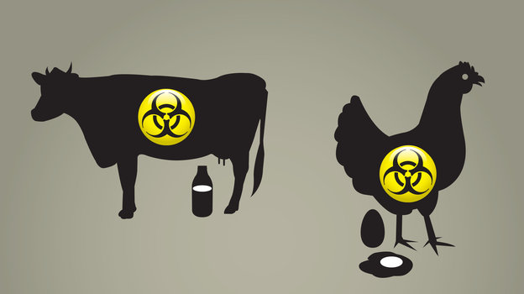
The rules mostly apply to facilities in charge of bulk storage or handling of liquids for human consumption — think dairy plants where milk is stored in big vats. Another area of concern? Facilities like large, industrial bakeries where lots of ingredients are mixed together.
"A lot of food processing manufacturers don't practice rigid biosecurity," says Peter Chalk, a terrorism analyst with the Rand Corp., a policy think tank.
Many food companies fail to take even the most basic precaution, he says. Owners don't padlock warehouses or engage in sufficient surveillance. Or they hire a lot of transient workers without performing background checks.
"So actually, introducing a contaminant — salmonella, botulism, mercury — into the food chain would not be particularly difficult," Chalk says.
The weak links, though, haven't really been tested. The last big bioterrorist attack in the U.S. happened in 1984 in The Dalles, Ore. That's when members of a cult infected salad bars with salmonella; more than 700 people were sickened. Since then, the American food system has grappled more with unintentional outbreaks, like the listeria-laden cantaloupe that killed 33 people in 2011.
Would the FDA's proposed rules keep us safe? Chalk says the vulnerabilities go well beyond what's covered in the proposal.
Producers could be at risk as well, he says. It would be relatively easy to deal a devastating blow to the country's livestock industry with a virus in a vial. An act of agroterrorism like that keeps some food experts up at night.
If a terrorist wanted to deal a devastating economic blow to the U.S., all it would take is a calculated release of foot-and-mouth disease on the nation's livestock. Unintentional outbreaks in Europe and South America have haunted economies there, as trade is shut down and whole herds are culled to quarantine the disease.
The impact of a deliberate outbreak in the U.S. could be huge. One risk assessment from the Department of Homeland Security found that if a pathogen like foot-and-mouth disease were let loose among Great Plains ranchers, total damages could exceed $50 billion. Exports and trade could be cut off, and consumer demand would very likely take a huge hit.
When U.S. troops raided an al-Qaida storehouse in Afghanistan in 2002, they found documents detailing ways to attack American agriculture to deal a blow to the U.S. economy. Still, no attack has materialized in the 12 years since.
"Agriculture is critical infrastructure in a country," says Keith Roehr, Colorado's state veterinarian. "How would we eradicate the disease? We don't know. ... We know there would be steps we would take. Do we know exactly what these would be? No, we don't."
Yet few livestock owners consider their operations targets of terrorism, Roehr says. And that mindset could leave them vulnerable.
Experts suspect that the bigger reason the U.S. has avoided a large-scale attack on food and farms is that an attack like that doesn't carry the same weight as a suicide bombing or mass shooting.
"It lacks a visible point for the media to latch on to, [except for] the possible images of burning cows," Chalk says. "Really, it doesn't have the same blood lust appeal of carrying out a suicide attack in a shopping mall."
Still, it's a risk that government regulators want the food industry to consider more seriously, in case what seems like a grisly fiction turns into reality.

