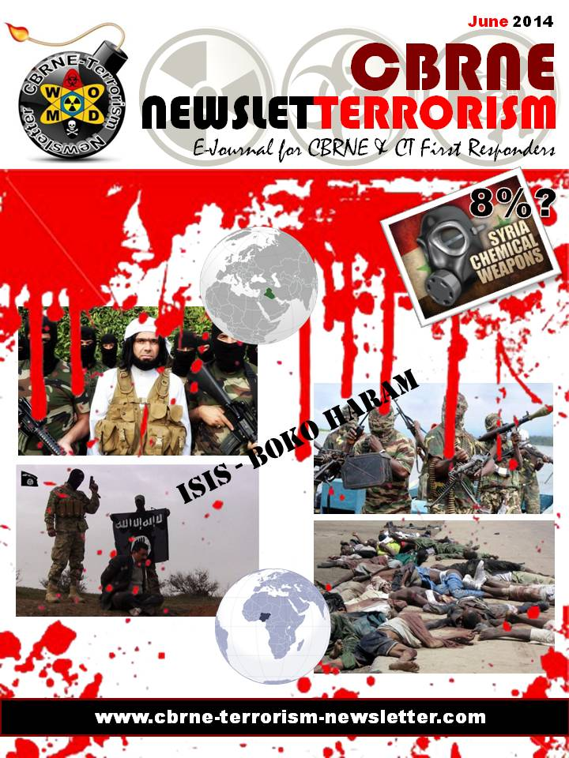
CBRNE-Terrorism Newsletter – 2014©
June 2014

Website: www.cbrne-terrorism-newsletter.com

Editor-in-Chief
BG (ret) Ioannis Galatas MD, MA, MC
PhD cand
Consultant in Allergy & Clinical Immunology
Medical/Hospital CBRNE Planner
Senior Asymmetric Threats Analyst
CBRN Scientific Coordinator @ RIEAS
Athens, Greece

Contact e-mail: igalatas@yahoo.com

Assistant Editor
Panagiotis Stavrakakis MEng, PhD, MBA, MSc
Hellenic Navy Capt (ret)
Athens, Greece

Co-Editors/Text Supervisors
- Steve Photiou, MD, MSc (Italy)
- Dr. Sarafis Pavlos, Captain RN(ret’d), PhD, MSc (Greece)
- Kiourktsoglou George, BSc, Dipl, MSc, MBA, PhD (cand) (UK)

Advertise with us! (New price list)
CBRNE-Terrorism Newsletter is published on-line monthly and distributed free of charge. Starting from 2014 issue all advertisements will be charged as following:
Full page (A4) 100€
Double pages (A4X2) 200€

EDITOR
Mendor Editions S.A.
3 Selinountos Street
14231 Nea Ionia
Athens, Greece
Tel: +30 210 2723094/-5
Fax: +30 210 2723698

Contact e-mail: Valia Kalantzi info@mendor.gr

DISCLAIMER: The CBRNE-Terrorism Newsletter® is a free online publication for the fellow civilian/military First Responders worldwide. The Newsletter is a collection of papers related to the stated thematology, relevant sources are provided and all info provided herein is from open Internet sources. Opinions and comments from the Editorial group or the authors publishing in the Newsletter do not necessarily represent those of the Publisher.
CBRNE-Terrorism Newsletter is:

- Read by First Responders in more than 80 countries around the globe (below right: top-20 countries);

- Distributed to more than 700 institutions, organizations, state agencies, think tanks, defense companies, institutions and universities.
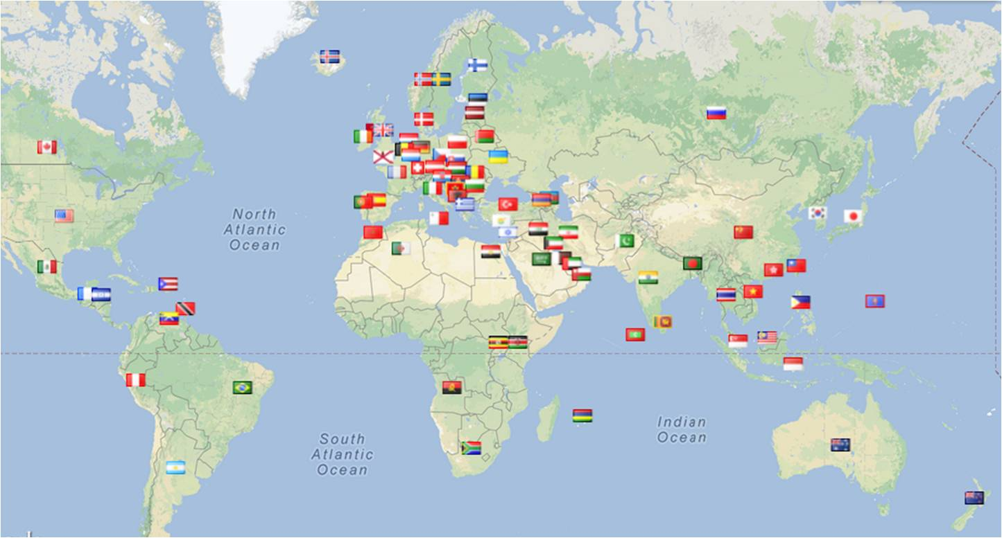
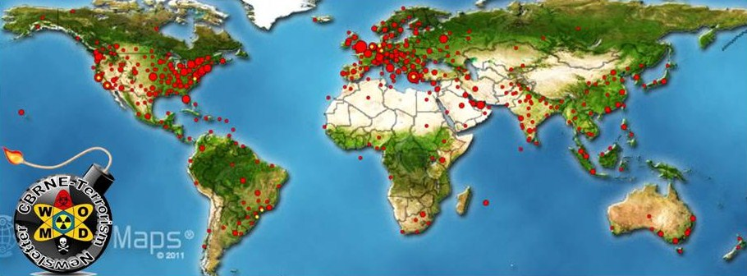

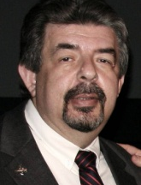
Editorial
Brig Gen (ret’d) Ioannis Galatas, MD, MA, MC

Editor-in-Chief
CBRNE-Terrorism Newsletter

Dear Colleagues,

In many aspects June was an interesting month! Many things happened – not pleasant ones (as always)!
Starting with 2014 FIFA World Cup, it became obvious that we have to re-evaluate mega events and their contribution to overall society. When basic needs of societies are not adequately covered at national level then it is highly hypocretic to organize multibillion events just for fun and with the ridiculous excuse that they contribute to the athletic spirit. Riots are in the daily agenda of all soccer venues along with arrests, riot control agents and social disruption. Olympic Games will follow soon (only two years left) and things might go out of control if corrective measures are not taken yesterday. It seems that international organizers should stop thinking about their pockets and start applying the principles they are supposed to represent. World can still continue to spin around even without their presence!
Situation in Syria remains the same – stably fragile. It seems that the evolution of ISIS is pointing Assad regime as the only stabilizing factor in the wider geopolitical area. It is not that opposers started liking him or that they now realized that they bet on the wrong horse. It is the nature of the geopolitical chess that directs constant changes of support or opposition. The remaining 8% of the chemical weapons’ arsenal is still in Syria and now all support the idea that its delivery delay is not accidental due to the overall turmoil in this country. By they way: since we do have the 92% at hand, why don’t we have no idea yet about its destruction process? Hope there is nothing “fishy” in that as well!
ISIS made the big surprise in June! Even bigger that the disclosure of Team UK from the World Cup! They came out in the open and started marching towards Bagdad applying the “shock and awe” (technically known as rapid dominance) military protocol enriched with decapitations, murders, setting fires in Christian churches, destroying monuments etc. They even got their hands on a major refinery (temporary) and an old inactive (???) chemical weapons plant. What was also impressive was the statement made by John Kerry: "The United States of America is not responsible for what happened in Libya, nor is it responsible for what is happening in Iraq today," said Kerry at a press conference in Cairo after a short visit to Egypt for talks with its newly elected President Abdel Fattah al-Sisi as part of his Middle East tour. I am starting to wonder if I am personally responsible for this! Perhaps when ISIS occupies Bagdad the international community will react and correct (?) imbalances in the area…
Ukraine crisis is also active and despite empty rhetorics nobody seems to be interested to be actually involved there. When a Grand Master is sitting on the other side of the table there is no time to start intensive chess lessons – you just try not to lost the game with a painful shah mat leading to roi mat even before moving your pieces!
Another important incident was the attack of Taliban (Tehrik-e-Taliban Pakistan) against the international airport in Karachi, Pakistan. The deadly assault shows the growing sophistication of the Pakistani Taliban, which has an increasing presence in the country’s largest city and appears, poised to inflict further damage despite a split in its ranks. What if they now attempt to take over one of the nuclear facilities? What if the airport attack was just a drill before they materialize their major objective? (…and would not be the first time)
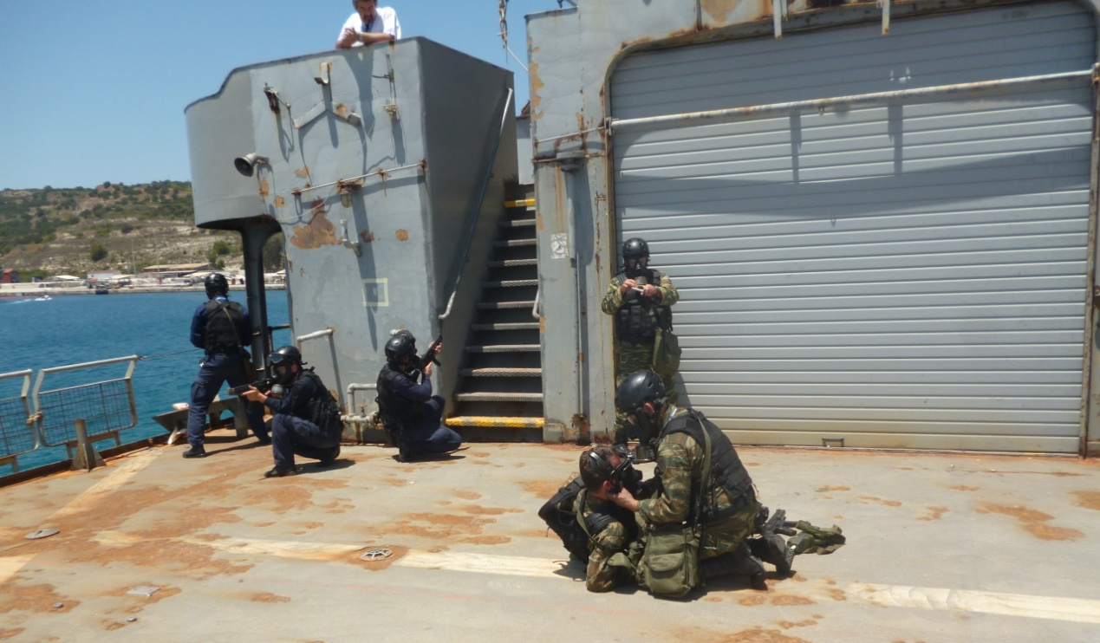
Despite the above life goes on and I participated as invitedf lecturer in two very important courses: the first one was held at the NATO Maritime Interdiction Operational Training Centre (NMIOTC) in Chania, Island of Crete, Greece and the second at the NATO School in Oberammergau (NSO), Germany. What was interesting in NMIOTC was the fact that in cooperation with the Joint CBRN Plattoon of Hellenic National Defense General Staff we offered for the first time a pilot training for CBRN Boarding Teams operations (Editor in white watches the demo process). This is a very interesting project that will soon lead to appropriate SOPs for boarding teams operating on “suspicious” vessels.
During the time in NSO an important question was set to the students: “Do we negotiate with terrorists?” I will not reveal the answers given – basically negative, but then comes a real life situation that changes existing rules.
To hear the White House spin it, the release of five terrorists in Qatar to gain the release of Bowe Bergdahl poses only minor risks to the U.S. But a new intelligence report suggests just how foolish that belief is. As the Islamic State of Iraq and Syria, or ISIS, rapidly dismembers what remains of Iraq, policy-makers and pundits have been left spluttering, "Who are those guys?" But we know the answer. The U.S. released the terrorist leader of ISIS, Abu Bakr al-Baghdadi, from Camp Bucca in Iraq back in 2009. It did so as part of the Obama administration's Iraq drawdown of U.S. presence there. Today, al-Baghdadi and his cohorts are gleefully slitting throats, murdering infidels and imposing Shariah law on Iraq — setting up a de facto Islamic caliphate across much of Syria and Iraq. Why bring up al-Baghdadi? Because it's possible the five we let go for Bergdahl deal will be as bad or worse. A secret assessment by U.S. intelligence suggests that four of the five detainees will return to fight for the Taliban, two of them in senior positions. Analysts agree. "They will almost certainly play an important strategic role for the Taliban going forward," Seth Jones, a Rand Corp. analyst, told the Wall Street Journal. In short, thanks to our own stupidity, it's back to terrorism and the never-ending war against the U.S. That we let them go is bad enough. But one of the released prisoners, former Taliban deputy defense minister Mohammad Fazl, also has the odious distinction of having played a key role in the 9/11 plot. According to Thomas Joscelyn, a senior fellow at the Foundation for Defense of Democracies, Fazl helped "coordinate a military offensive against the enemies of the Taliban and al-Qaida in Afghanistan the day before" the 9/11 attacks. Fazl's offensive was viewed as "an essential part of al-Qaida's 9/11 plot," Joscelyn adds. The White House portrayed the 5-for-1 deal as a harmless, one-time swap as the War on Terror winds down. In fact, the deal only increased the threat of terrorism. President Obama might think the War on Terror is "over," but the terrorists apparently have other ideas.
It is boring (and painful) to write again about the situation in Greece…Let’s say that it is like the situation in Syria – stably fragile! The moment that current political system will start thinking about citizens and homeland instead of who will politically prevail, I will let you know!
Finally the brutality of Boko Haram in Nigeria and extremists in China’s XinJang territory wrote a new chapter in terrorists’ modus operandi and the definition of terrorism itself. Is the international society willing to take measures? Are they going to say “enough” of bloodshed or they will be consumed in useless rhetoric (as usual)? (copy and paste para from May’s issue…)
The Editorial Team is wishing you a great summer time and suggests Greece as your tourism destination!

The Editor-in-Chief

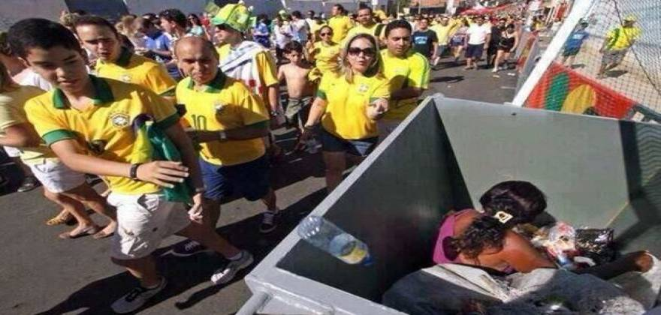
World Cup 2014 – They had a good time watching their favorite soccer team. She is trying to survive…

Brazil’s Dance with the Devil: Dave Zirin Examines the Victims of the 2014 World Cup
By David Caruso
Source: http://thesoccerdesk.com/brazils-dance-with-the-devil-dave-zirin-examines-the-victims-of-the-2014-world-cup/

Poverty makes for a lousy photo-op—a fact FIFA and the International Olympic Committee know all too well. What viewers won’t see this summer at the World Cup or during the 2016 summer Olympics are the poor homes along the hillsides that feature prominently in the landscapes of Rio and other cities and towns across Brazil.

Bulldozers and wrecking balls don’t alleviate poverty. But they do remove the homes where the poor live from the sightlines of what the rest of the world sees when they visit Brazil and tune in on television. Not on the screen will be the thousands forcibly removed from their beloved, cared-for homes and communities to make way for what FIFA and the IOC regard as a better backdrop to their games.
However, Dave Zirin is among the journalists who comprise a demolition unit of their own, destroying the façade put on by Brazil, FIFA and the IOC by revealing to the world the destruction caused by the games.
Zirin provides the reader with the necessary history of Brazil, its people, history and politics along with the politics of the World Cup and the Olympics to both appreciate and understand the dilemma facing the poor (and, to varying degrees, all non-super rich) of Brazil today.
His brief yet comprehensive history allows the story of present day Brazil to be better understood as the invasion of the world’s two largest mega-sports events hit its shores. But it is the present that his book is about. As intricate as Brazil’s history is, the problem is simple as Zirin documents by talking to the people the games affect.
“Just tell them that we’re here,” one man facing forced evacuation tells Zirin, “And that we don’t want to leave.” Therein, lies the story. Brazil’s Dance with the Devil tells the tale of Brazilians living in favelas, hillside homes that are built by the community and maintained by families often for generations. The problem, though, is that the occupants are poor and their poverty sits too close to the sites of the game. Since the television cameras can’t remove them from view FIFA and the IOC demands cause the Brazilian government to send in the bulldozers in to do the work.
Why the Brazilian government would be so quick to ruin the lives of its poor to please FIFA and the IOC raises a question that past Olympics and World Cups raised and answered. It isn’t just to please the producer of the mega-events. Instead, FIFA and the IOC give the Brazilian government an excuse to do what they have long wanted to do: please the wealthy class.
The favelas, often described as slums, are actually an impressive coming together of poor people who help one another build homes, share utilities and provide a safe environment to live a productive and dignified life. The favelas also often lie in close proximity to wealthy areas. Moreover, in an inversion of the “mansion on the hill,” with the favelas it is the poor who live among the steep and sweeping views of the city and ocean while the rich dwell at sea level. Many developers have a lot to gain by the demolition of the favelas.
Children enjoying a game of soccer among the homes of a favela. (Photo courtesy of Buda Mendes–Getty Images.)

Unable to bring in the bulldozers at the whim of the well-to-do in their incessant strive to do better, the government jumped on the chance to come to the call of FIFA in the guise of doing it for the games.
With estimates of over 200,000 people potentially being displaced under forced eviction with their homes and communities demolished, Zirin rightfully links this displacement for profit to ethnic cleansing. While ethnicity plays a role in Brazil’s poverty, in this case, it is poverty cleansing. If you’re poor, you’re out.
Brazilians love and identify themselves with soccer. It is fitting that soccer’s biggest match be held in arguably soccer’s best-known stadium: Rio’s Maracana. Sadly, the Maracana itself serves as a fitting symbol for the transforming cityscapes in Rio and Brazil’s other hosting cities.
Once a stadium capable of seating over 180,000 soccer fans, the Maracana has been reduced to holding 75,000. Like the hills surrounding it, the stadium once held space for the poorer fans of soccer in its upper levels. Now, where soccer fans once cheered on their favorite teams and players, luxury seats have taken over to satisfy the rich. Poorer fans, displaced in the city, are displaced from the stadium as well.
Though the demolition that changed the Maracana from a stadium for soccer fans to a mega-event location for the rich took place while it was uninhabited, no fans were forced to leave at gunpoint or at the sound of an approaching bulldozer, it doesn’t take much imagination to wonder what the fans who cheered Pele there when he scored his 1000th goal would have said, “Just tell them that we’re here and that we don’t want to leave.”
There’s always room for soccer. (Photo courtesy of Lalo de Almeida.)

Zirin explains the particular insatiable greed wrecking the landscape and lives of Brazil’s poor (while exploiting the tax-paying working class) as neoliberalism—a term applied to economic liberalism gone wild that includes free trade, privatization and deregulations that results in a blurred border as to where corporate capitalism ends and government begins. As Zirin might ask, sound familiar?
The problem for those few at the top reaping the benefits from neoliberalism is how to get a nation to go along with the program. The answer lies in nationalism and, when a war isn’t handy, there’s nothing like a mega-sports event like the Olympics or the World Cup to prepare for that allows a government to do as it pleases in the guise of doing what’s best for the country.
Zirin gives examples of government exploits of the Olympics and World Cups of the 20th and 21st centuries. The Olympic opening ceremonies that we watch with our friends and loved ones as the proud athletes of country after country parade into the stadium as the torch is lit are both prominent sporting memories of our lives as well as the thoughtfully conceived construct of Adolf Hitler as he prepared to show the world the prowess of Germany. We don’t like to think of it as carrying on a Nazi legacy but it is a Nazi legacy and we are carrying it on as we watch the opening ceremonies of each passing Olympic Game.
Zip ahead to the 2012 London games and you have a nation pouring billions into a post 9/11 security industry. Zirin acknowledges the importance of security and that London has suffered from terrorism. The problem, however, is allowing the Olympics to become the catalyst that transforms London from a democratic capital city that tries to protect its citizens from terrorism among its other duties to a full-fledged police-state that emerged with the passing of the 2006 “London Olympic Games Act” that allowed a 48,000 strong security force to deal with broadly defined security issues that included the life-saving measure of making sure properly licensed vendors sold only officially approved items.
The World Cup, though smaller in scale than the Olympics, can have a larger reach as it is held in multiple cities throughout a nation. Zirin sites where South Africa suffered from what they thought would be a beneficial relationship with FIFA in hosting the Cup. The South African government poured money into now near-empty stadiums. So much care was put into constructing the stadiums and maintaining the health of the pitch beneath the African sun that one rally cry was that the health of the grass received more attention and money than the health of the people. Most tragic to South Africa was that the World Cup revealed that the hard-fought for end to apartheid had become nothing more than a switch from racial apartheid to economic apartheid.
Zirin points out that the Olympics and the World Cup act as a Trojan horse that allows neoliberal capitalism and police-state “democracy” to go unhindered. It is the poor, though they have little to begin with, who pay the heaviest price.
They haven’t kept quiet. Refusing to concede to the slogans of FIFA, such as the need for public spending to produce “FIFA quality stadiums,” Zirin documents how the people of Brazil have in turn demanded from their government FIFA quality schools and FIFA quality hospitals. They haven’t gotten them, but as Zirin reports, the demonstrations have had positive outcomes. Some neighborhoods have been saved. With each saved neighborhood come saved jobs, saved educations and saved dignity.
From anger to art: a mural in a Rio favela shows a crying boy and the words, “Destroying our community for the World Cup” and “FIFA go home.” (Photo courtesy of the UK magazine Metro.)

Soccer is not the problem, as Zirin points out. Nor is the World Cup. But that the poor should be worse off because of the World Cup is a travesty. The rose colored glasses that FIFA handed out to the citizens of Brazil when they awarded the country the World Cup have been replaced with tear-gas withstanding goggles as the people take to the streets against the government of Brazil, against FIFA and against the 157,000 strong security force secured by Brazil to keep a nation safe from itself.
Zirin quotes Eduardo Galeano throughout the book, which is no surprise as both love the beautiful game and loathe what greed and big money have done to it. Galeano laments the trajectory of “beauty to duty” in Soccer in Sun and Shadow. Zirin cites a quote from another of Galeano’s work, Open Veins of Latin America, that exposes the crux of the Brazilian poor’s current World Cup dilemma: “Where opulence is most opulent . . . misery is most miserable.”
For FIFA and the IOC, the World Cup and the Olympics might be huge money grabs while the host nation looks the other way—towards their dream police state and the deepening pockets of their political friends. But as protests mount, the Trojan horse could crumble like a statue made of matchsticks. When it’s all over, the poor of Brazil will resemble less a people showered with the joys of a world class mega-event than those who found themselves homeless following the earthquake in Haiti or the tsunami in Fukushima.
Beyond Zirin’s link of the forced evictions to the manmade catastrophe ethnic cleansing, the devastation can also be likened to a natural disaster. Manmade or natural, the 200,000 or more Brazilians who will lose their homes because of the World Cup and the Olympics are devastated and will be in need because of the games for years. It’s a scenario in which the Stings and Paul Simons of the world could be called upon for a benefit concert—the Concert to Help the Victims of the 2014 World Cup and 2016 Olympic Games.
There may not have been a 2011 Fukashima Olympic Games but the games might as well have been played on the killer wave that destroyed the communities. A similar wave hits Rio in 2016. The 2010 Haitian World Cup never happened, but the bulldozers destroying homes in Brazil shake the ground like the earthquake in Haiti that destroyed homes, towns and lives. As soccer fans recognize the similarities, and see host countries not benefiting from the games but suffering from them, they will demand a more restrained and sensible World Cup. With the Qatar games eight years away and reports coming out of slavery, forced labor, inhumane living conditions for workers and multiple deaths already, the world biggest sport may find itself with a disgusted audience—if one at all.
While the pen is mightier than the sword, Zirin joins the people of Brazil in a battle against a tougher opponent than any weapon: the almighty dollar. Brazil’s Dance with the Devil is a FIFA quality book that exposes the burden FIFA, the IOC and the Brazilian government have poured onto the poor of Brazil. While the poor suffer the most, the government’s waste of tax dollars and eagerness to delve into corporate corruption has negatively affected all but the nation’s richest.
Over a million Brazilians across the country—that’s MILLION—protested against the government’s handing of the upcoming World Cup and Olympic games during last June’s Confederation Cup. While the world tunes in to see soccer’s best, Brazil may be putting on another show, a protest of support by the people, for the people, that not even a FIFA quality cover-up can keep from being exposed to the eyes of the world.

(Brazil’s Dance with the Devil: The World Cup, the Olympics, and the Struggle for Democracy by Dave Zirin is published by Haymarket Books is available at bookstores online and in person.)

David Caruso is a local poet as well as a local soccer-dad, Son of Ben and transportation company manager. He lives in Haddonfield, New Jersey with his wife Maggy, and their three children.
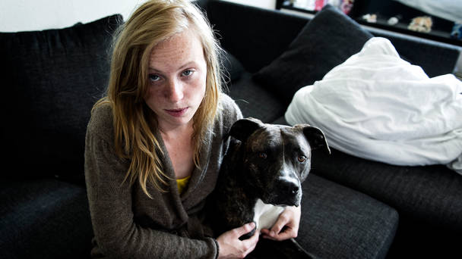
Denmark – 23yo girl punched, kicked, stoned and thrown into the lake - With her dog!
Source: http://www.liveleak.com/view?i=f7a_1400689364
Stone throws, punches, kicks and then thrown into the lake.
Thus ended Illum Sara Lund-Jensen walk with her dog in Odense, Denmark Tuesday night.
The 23- year-old woman says she was out walking her five year old dog by a lake near Granparken when four muslims looked mad at the dog and owner .
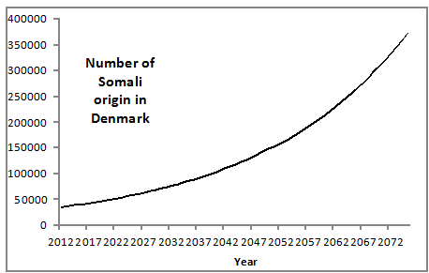
First the muslims asked questions about the dogs race and age, but suddenly it changed to anger.
- One began to kick my dog , which made me really mad. Then one of them threw a stone at us , which touched my dog, says Sara Illum Lund -Jensen.
She says that she tried to protect her dog against the aggressive boys. This brought herself in the firing line .
- They knocked me to the ground and started kicking me and roll me into the lake. I was lying there along with my dog, while they threw several stones at us.
The four teens left the place, and then a elderly woman helped her out of the water. It was both soaked and deeply shaken says Sara Illum Lund –Jensen. The 1.49 minutes long video was uploaded to her Facebook profile.

New generation of aerial robots for high-risk missions
Source: http://www.homelandsecuritynewswire.com/dr20140612-new-generation-of-aerial-robots-for-highrisk-missions

The need for robots able to carry out high-risk service tasks, such as the inspection of power plants and the cleaning of skyscrapers, is growing. Robots which actively interact with the environment without being constrained on the ground are well suited to such tasks.
A University of Twente release reports that doctoral candidate Abeje Yenehun Mersha designed novel human-in-the-loop control architectures for this new and advanced generation of aerial service robots. Mersha is affiliated with the CTIT research institute of the University of Twente. He is due to obtain his doctoral degree today (Friday, 13 June).
Mersha’s research focuses mainly on the teleoperation of aerial service robots. These types of robots are poised to be fundamental parts of tomorrow’s service applications for their low-cost, safety, and efficiency. These robots support humans in performing various tasks that require the ability actively to interact with remote environments while staying airborne.
An extension of the operator
Mersha developed different teleoperation control architectures that allow an operator to remotely supervise an aerial service robot while performing a complex service task. Mersha explains: “The human operator does not need be a trained pilot to operate the aerial robot, but an expert in the required service task. The aerial robot can be seen as an extension of the operator’s own hand, which is being remotely controlled in a cluttered environment by using a haptic device.” He continues: “The overall teleoperation control architecture should guarantee a stable behavior both during the free-flight of the aerial robot and during the interaction with the remote environment, while guaranteeing a good level of transparency even in the presence of time-delays and other network-induced imperfections.”
Multi-modal haptic feedback
Control strategies that rely upon a cooperative and adaptive interaction between the on-board automatic control of the aerial robot and the human operator, are essential for the accomplishment of service tasks. In the case of traditional aerial robots, the operator becomes aware of the states of the autonomous aerial robot through camera images (visual feedback). Due to the complexity of the service tasks, however, this form of feedback alone might not be adequate. Through a haptic device, used to bilaterally interact with the remotely controlled aerial robot, operators are now able to actually feel how the task is progressing.
So, for example, if the robot interacts with the environment and is no longer able to move forward, the operator feels a resistance in the form of an opposing force via the haptic interface. As such, the operator feels like he is actually interacting with the remote environment directly. Moreover, having received this force feedback, together with other feedbacks, such as vision and vibro-tactile information, the awareness of the operator significantly increases. This helps the operator to make a better decision in order to accomplish the task effectively and efficiently.

Time delay
Mersha carried out a variety of simulations and experiments in order to test the theory in practice. Among others, he carried out the longest intercontinental haptic teleoperation of aerial robots in cooperation with the Australian National University to assess his solution for dealing with time delays and other network-induced imperfections. The experiment involved an operator located in Enschede, The Netherlands, flying an aerial service robot in Canberra, Australia, that performs a maneuvering task in cluttered environment while avoiding obstacles.

Improved terahertz technology to benefit passenger screening, food inspection, MRIs
Source: http://www.homelandsecuritynewswire.com/improved-terahertz-technology-benefit-passenger-screening-food-inspection-mris-3

Researchers at Sandia National Laboratories, along with collaborators from Rice Universityand the Tokyo Institute of Technology, are developing new terahertz detectors based on carbon nanotubes that could lead to significant improvements in medical imaging, airport passenger screening, food inspection and other applications.
A paper in Nano Letters describes a technique that uses carbon nanotubes to detect light in the terahertz frequency range without cooling.
A Sandi Lab release reports that historically, the terahertz frequency range — which falls between the more conventional ranges used for electronics on one end and optics on another — has presented great promise along with vexing challenges for researchers, said Sandia’s François Léonard, one of the authors.
“The photonic energy in the terahertz range is much smaller than for visible light, and we simply don’t have a lot of materials to absorb that light efficiently and convert it into an electronic signal,” said Léonard. “So we need to look for other approaches.”

Terahertz technology offers hope in medicine and other applications
Researchers need to solve this technical problem to take advantage of the many beneficial applications for terahertz radiation, said co-author Junichiro Kono of Rice University.
Terahertz waves, for example, can easily penetrate fabric and other materials and could provide less intrusive ways for security screenings of people and cargo. Terahertz imaging could also be used in food inspection without adversely impacting food quality.
Perhaps the most exciting application offered by terahertz technology, said Kono, is as a potential replacement for magnetic resonance imaging (MRI) technology in screening for cancer and other diseases.
“The potential improvements in size, ease, cost and mobility of a terahertz-based detector are phenomenal,” he said. “With this technology, you could conceivably design a hand-held terahertz detection camera that images tumors in real-time, with pinpoint accuracy. And it could be done without the intimidating nature of MRI technology.”

Carbon nanotubes may help bridge the technical gap
Sandia, its collaborators and Léonard, in particular, have been studying carbon nanotubes and related nanomaterials for years. In 2008, Léonard authored The Physics of Carbon Nanotube Devices, which looks at the experimental and theoretical aspects of carbon nanotube devices.
Carbon nanotubes are long, thin cylinders composed entirely of carbon atoms. While their diameters are in the 1- to 10-nanometer range, they can be up to several centimeters long. The carbon-carbon bond is very strong, so it resists any kind of deformation.
The scientific community has long been interested in the terahertz properties of carbon nanotubes, said Léonard, but virtually all of the research to date has been theoretical or computer-model based. A handful of papers have investigated terahertz sensing using carbon nanotubes, but those have focused mainly on the use of a single or single bundle of nanotubes.
The problem, Léonard said, is that terahertz radiation typically requires an antenna to achieve coupling into a single nanotube due to the relatively large size of terahertz waves.
The Sandia, Rice University, and Tokyo Institute of Technology research team, however, found a way to create a small but visible-to-the-naked eye detector, developed by Rice researcher Robert Hauge and graduate student XiaoweiHe, that uses carbon nanotube thin films without requiring an antenna. The technique is thus amenable to simple fabrication and represents one of the team’s most important achievements, Léonard said.
“Carbon nanotube thin films are extremely good absorbers of electromagnetic light,” he explained. In the terahertz range, it turns out that thin films of these nanotubes will soak up all of the incoming terahertz radiation. Nanotube films have even been called “the blackest material” for their ability to absorb light effectively.
The researchers were able to wrap together several nanoscopic-sized tubes to create a macroscopic thin film that contains a mix of metallic and semiconducting carbon nanotubes.
“Trying to do that with a different kind of material would be nearly impossible, since a semiconductor and a metal couldn’t coexist at the nanoscale at high density,” explained Kono.
“But that’s what we’ve achieved with the carbon nanotubes.”
The technique is key, he said, because it combines the superb terahertz absorption properties of the metallic nanotubes and the unique electronic properties of the semiconducting carbon nanotubes. This allows researchers to achieve a photodetector that does not require power to operate, with performance comparable to existing technology.

A clear path to performance improvement
The next step for researchers, Léonard said, is to improve the design, engineering and performance of the terahertz detector.
For instance, they need to integrate an independent terahertz radiation source with the detector for applications that require a source, Léonard said. The team also needs to incorporate electronics into the system and to further improve properties of the carbon nanotube material.
“We have some very clear ideas about how we can achieve these technical goals,” said Léonard, adding that new collaborations with industry or government agencies are welcome.
“Our technical accomplishments open up a new path for terahertz technology, and I am particularly proud of the multidisciplinary and collaborative nature of this work across three institutions,” he said.
The release notes that in addition to Sandia, Rice, and the Tokyo Tech, the project received contributions from researchers taking part in NanoJapan, a 12-week summer program that enables freshman and sophomore physics and engineering students from U.S. universities to complete nanoscience research internships in Japan focused on terahertz nanoscience.

— Read more in Xiaowei He et al., “Carbon Nanotube Terahertz Detector,” Nano Letters, Article ASAP (29 May 2014)

Could devastating floods help Bosnians heal their war wounds?
By Damir Mitric
Source: http://www.homelandsecuritynewswire.com/dr20140612-could-devastating-floods-help-bosnians-heal-their-war-wounds

The heaviest rainfalls ever recorded in the Balkans have led to catastrophic flooding in Bosnia and Herzegovina.
Swelled by weeks of rain, the devastating floodwaters swamped more than 60 percent of the country last month, killing twenty-four people, destroying more than 100,000 homes, and displacing around 950,000 citizens. The floods also damaged vital infrastructure, destroyed industrial assets, and killed livestock. The European Bank for Reconstruction and Development’s preliminary estimate put the damage bill at about 1.3 billion euros.
The emotional cost is harder to calculate. The violent breakup of Yugoslavia in the 1990s and the subsequent war in Bosnia between 1992 and 1995 took the lives of more than 100,000 Bosnians and left two million homeless. Two decades later those survivors have been forced once again to abandon their homes — this time by floodwaters rather than bullets.
Adding to the misery of ordinary Bosnians, the murky floodwaters have washed up old military hardware such as hand grenades and landmines. More disturbingly, they appear to have unearthed the skeletal remains of some of the thousands of people who went missing during the four-year conflict.
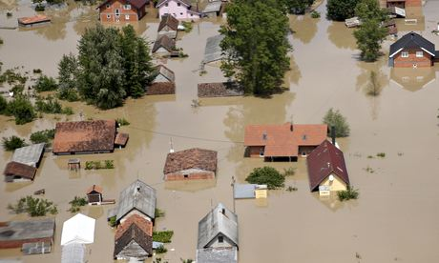
The floods have clearly reawakened the trauma experienced by survivors of the conflict among Bosnians at home and members of the large diaspora around the globe. Yet they also appear to have re-united communities which had been divided on ethnic and religious lines since the war.

Unity of people re-emerges
Over the past weeks media outlets have been flooded with stories and images of bravery, camaraderie, and community spirit where ethnicity suddenly became irrelevant. “Serbs”, “Bosniaks,” and “Croats” have become “people.” The appearance of volunteer brigades, particularly those made up of students, which travelled across the Inter-Entity Boundary Line, also seemed reminiscent of the old Yugoslav doctrine of “brotherhood and unity.”
While brotherhood in post-conflict Bosnia is a nostalgic illusion, the term unity has recently made a new appearance in public discourse. Many people affected by the floods over the past fortnight have been forced into inter-ethnic contact, either accepting help or offering it to those in life-threatening situations.
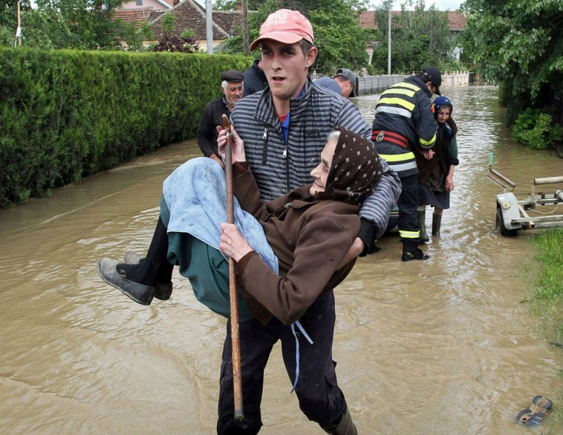
Merisa Krivdić, who helped to send a relief truck to Bosnia from the Bosnian Cultural Centre in Aachen, Germany, described how a local man claimed that the floods had opened his eyes. The man from the town of Prijedor said: “I did not realize that I don’t hate my neighbor until I actually spoke to him.”

Ethnicity as political capital
The recent spirit of unity presents a threat to Bosnia’s nationalist political elites. Political leaders have fostered and relied on the myth of ancient ethnic hatred to stay in power since the end of the war. Critics claim persuasively that the politicians use division as political capital to distract the population from issues such as corruption, which many allege was and continues to be particularly widespread during the selling of state-owned companies and assets.
The political elites have also had to face recent protest movements. In February 2014, a number of demonstrations and riots spread through Bosnian towns and cities. The marchers demanded the resignation of a corrupt government they feel has betrayed, abandoned and humiliated them over the last two decades.
In a country where the official unemployment rate sits at 44 percent, the slogan of the day was “I am hungry in three languages.” This came to symbolize the beginning of a unification process by the impoverished people of Bosnia in their struggle against divisive political leaders.

Floods as a catalyst for change
Analysts and ordinary Bosnians now say the floods have the potential to speed up that process.
Sudbin Musić, the secretary of the Association of Concentration Camp Survivors “Prijedor 92,” says he actually wishes the floods came sooner. Unlike Krivdić, Musić returned to his birthplace in Prijedor in 1998, after fleeing Bosnia in 1992 to avoid the violent forces of ethnic cleansing.
Prijedor was one of the most violent towns during the war. It housed the infamous Omarska, Karaterm, and Trnopolje concentrations camps set up by the local Serb authorities in 1992 to imprison the Bosniak and Croat population. Musić’s father was murdered in the town outside the Musić family home.
Yet despite the past and being unsure of how he will afford to renovate his flood-damaged home, Musić believes the floods have brought unity:
I am going to be blunt and say that I wish that these floods happened earlier. We needed this and I needed this feeling of unity and I needed these thousands of examples of human solidarity of Serbs, Bosniaks, Croats and all others.
It remains to be seen how this feeling — shared by many others — can be harvested to mobilize the people of Bosnia ahead of the general elections in October. Such a movement would have the potential to force corrupted political elites into the corner by draining them of their political capital.
At the same time, this would create an opening for a frank and honest dialogue about Bosnia’s bloody past — including perpetrators, bystanders, victims and all those in between. This would be the only solid foundation that could secure the future of the state of Bosnia and Herzegovina.

Damir Mitric is Adjunct Research Fellow at Swinburne University of Technology.

ISIS vision of a global caliphate
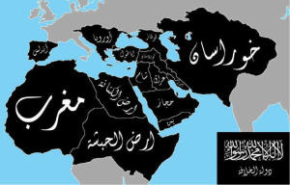
Source: http://springtimeofnations.blogspot.gr/2014/01/middle-east-update-al-sham-islamic.html
EDITOR’S COMMENT: I see that Greece is included in the map. Barbars might want to give it a try – just to teach them some history! I only wonder why UK or France are not in the map!

An 'Islamic State' Is Born
By Jonathan Spyer
Source: http://www.meforum.org/4724/an-islamic-state-is-born

In a stunning and deeply significant development, the fighters of the Islamic State in Iraq and Syria (ISIS) organization this week captured the city of Mosul. They then moved on to take Tikrit unopposed and according to reports yesterday were headed toward the capital, Baghdad.
Five-hundred thousand people have fled Mosul in the wake of its conquest by the jihadis. The city, which has an Arab majority population along with large Kurdish and Turkmen minorities, is Iraq's second largest. Its capture was the latest and most significant success in an offensive launched by the ISIS jihadis a week ago.
It also represents a calamitous defeat for the US-trained security forces of Prime Minister Nouri al-Maliki.
ISIS is the most brutal and best-organized of the jihadi elements that have emerged in Iraq and Syria over the last decade. It now controls a contiguous area of territory stretching from deep into western Iraq and including the cities of Mosul and Falluja, across the border into Syria, taking in the province of Raqqa, including its capital Raqqa City, and continuing until the border with Turkey. The movement has a presence as far as the southern suburbs of Baghdad.
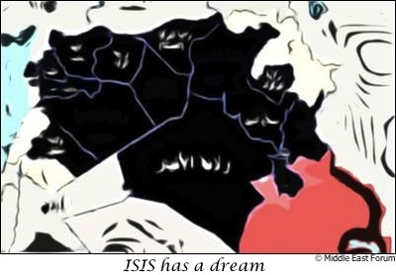
The ISIS offensive into Iraq was well-planned, and its execution shows the extent to which ISIS sees its activities in Iraq and Syria as part of a single conflict.
The movement withdrew forces from outlying parts of Syria's Idlib and Aleppo provinces in January.
At the time, this was presented by Syrian rebels as a defeat they had inflicted on ISIS, but eyewitnesses confirmed that hardly any fighting took place.
The offensive operations against the Kurdish YPG militia in the Kobani (Ayn al-Arab) area also tailed off.
The reason is now clear: ISIS was withdrawing forces and consolidating the western border of its "Islamic state," in order to focus on expanding the eastern border deep inside Iraq.
The "Syrian" civil war long ago burst its borders, to become a sectarian conflict taking in the territory of Syria, Iraq and Lebanon. ISIS's tactical offensive has cast this fact into bold relief.
It is also, by necessity, bringing about cross-border cooperation between those elements targeted by ISIS.
The area to the north of ISIS's "Islamic state" is controlled by the Kurds. But relations between the Kurdish Regional Government (KRG) of Massoud Barzani in northern Iraq and the (PKK)-associated PYD's three areas of control in northern Syria have worsened in recent months. Intra-Kurdish violence has not occurred, but the KRG has kept the border between the two areas tightly sealed – leading to PYD accusations that the KRG's close strategic relations with Turkey were causing it to support the Turkish position against Syria's Kurds.
The ISIS offensive appears to have repaired relations between the two Kurdish areas.
The latest gains by the movement in Mosul bring it within a few kilometers of the first checkpoints of Barzani's Peshmerga forces. Thus, there is a common ISIS-Kurdish border stretching across PYD and KRG-controlled areas.
The result: YPG and Peshmerga commanders have conducted meetings at the border crossings over the last few days, to coordinate their defensive actions against ISIS. The Samalka border crossing, closed for three months, was opened this week to allow refugees to travel back to Syrian Kurdistan, according to Wladimir van Wilgenburg, a Dutch journalist and researcher at the Jamestown Foundation, currently reporting in Iraq and Iraqi Kurdistan.
So the cross-border Islamist entity is facing a renewed Kurdish alliance to its north. But what of the Baghdad government? Maliki's armed forces may have performed atrociously in recent days, but he remains part of the Middle East's single most powerful functioning alliance – the Iran-led regional bloc.
The emerging reality in western Iraq creates difficulties for the Iranians. Their client in Damascus, the Assad regime, has largely recovered its fortunes in recent months. Aided by Iran's Revolutionary Guards Corps and Hezbollah, Syrian regime forces are close to encircling rebel-controlled eastern Aleppo.
This little-reported process is causing deep alarm among supporters of the rebellion. Should Syrian President Bashar Assad succeed in besieging and starving out Aleppo, this will definitively end the long stalemate between the regime and the Sunni rebels, possibly paving the way for a regime attempt to roll up the remainder of rebel-controlled Syria.
But even as one Iranian client triumphs, another – Maliki – has lost large portions of his territory to a jihadi force, in the opening moves of what could be a renewed sectarian war on the soil of Iraq. And while the Syrian rebels may be disunited and poorly organized, this is not true of ISIS – a disciplined, determined and savage force.
This means that the Iranians may in the weeks and months ahead be forced to increase support and attention to their beleaguered client in Baghdad, even as he struggles to form a new government following the parliamentary elections in April.
Maliki's declaration of a general mobilization is more likely to produce a Shi'ite sectarian military response, and hence continued sectarian fighting against a background of political paralysis.
Therefore, the key point is that the "Islamic State in Iraq and al-Sham" is no longer the name of a movement, or the expression of an aspiration. As of now, it is a descriptive term applying to a de facto sovereign space, taking in a large swath of western Iraq and eastern and northern Syria.
The powerful Iran-led Shi'ite alliance will in the period ahead undoubtedly seek to destroy this state.
The Kurdish entities to the north will seek to defend themselves against both sides.
The result of all this cannot be known. The reality is one of sectarian war over the ruins of Iraq and Syria.

Jonathan Spyer is a senior research fellow at the Global Research in International Affairs (GLORIA) Center and a fellow at the Middle East Forum.

World Cup security teams focus more on crime, protests – less on terrorism
Source: http://www.homelandsecuritynewswire.com/dr20140616-world-cup-security-teams-focus-more-on-crime-protests-less-on-terrorism

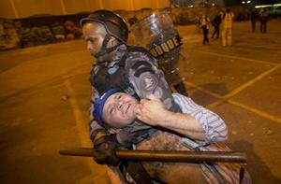
During the 2014 FIFA World Cup, currently being held across twelve different venues across Brazil, security teams have extensively prepared for measures to be taken against crime and protest related to heated political unrest.
As NBC News reports, American bomb-busting robots, Israeli surveillance drones, and German anti-aircraft tanks — an international assortment of security officials and measures – are just some of the pieces of the greater security apparatus protecting both players and fans.
Due to the hundreds of thousands of fans — including up to 90,000 Americans — which have descended on cities such as Sao Paulo and Rio de Janeiro, the country’s typical problems with protesters, thieves, and drug-traffickers will only be heightened.
Liliana Ayalde, the U.S. ambassador to Brazil, told the network, “This is crunch time. It’s busy. We’re preparing very carefully and trying to predict as much as we can so that we can be ready for our main responsibility, which is all the fans that are coming down from the States.”
The Brazilian government itself has spent an estimated $855 million to maintain order at the games. Manpower includes undercover police officials throughout various protest groups and soccer hooligan contingents, as well as teams of bomb-sniffing and detection groups and a highly wired and technologically developed intelligence apparatus.
Surprisingly, much of this comes in the wake of a U.S. State Department report which confirmed that “Brazil is a non-aligned country with no significant enemies and is not targeted by any known radical groups.” All the focus has been trained on the civilian population.
Such maneuvering comes in the wake of tensions that escalated in events such as 2013’s Confederations Cup in Brazil, in which roughly one million protesters fought in the streets with police. Eight people were killed. Other sports-related attacks such as the 2010 suicide bombings in Kampala, Uganda during the 2010 World Cup and an attack at the UEFA Champions League Final in Nigeria, both loom in the mind of security and government officials who are preparing for the worst.
The games are scheduled to continue until 13 July.

Italy warns Mediterranean migrant rescues may end
Source: http://www.bbc.com/news/world-europe-27878346?utm_source=Sailthru&utm_medium= email &utm_term=*Morning%20Brief&utm_campaign=2014_MorningBrief6.17.2014

Italian Interior Minister Angelino Alfano has warned that a naval operation to rescue migrants in the Mediterranean Sea may have to come to an end without EU intervention.
Speaking in Sicily, he said Italy would not allow people to die but could not continue to patrol Libya's coast.
Shortly after he spoke, a Kuwaiti oil tanker arrived in Sicily carrying another 356 migrants.
The body of a Syrian who had died on the journey was reportedly on board.
At least 39 people drowned some 65 km (40 miles) off Libya at the weekend after an overloaded, inflatable boat capsized while trying to cross to the Italian island of Lampedusa.
The Italian navy rescued another 39 people but there are fears the number of people who died is far higher.
Last October, 360 people died when a boat sank off Lampedusa.
We set sail, heading south, to the new front in Italy's immigration crisis.
They called the operation "Mare Nostrum" - Our Sea.
It's taking a toll on the country's finances, and on its immigration centres, which are filling up at an alarming rate.
It's also putting pressure on other European countries to share the burden, but there's increasing political pressure within many of those countries to limit immigration.
Mr Alfano was speaking in the Sicilian port of Pozzallo, where many of the migrants have been brought in recent months by the Italian navy.
The migrants picked up by the Kuwaiti-registered tanker, al-Salmi, were from Syria, Libya, Egypt, Somalia and Morocco, Italian media reported.
Another 200 migrants were rescued by the Italian navy elsewhere.
The cost of the naval operation and the logistics of tackling a daily influx of refugees have put political pressure on the Italian government.
Malta has also called on the EU to help shoulder the burden.
Prime Minister Joseph Muscat said sometimes more than 20 boats filled with refugees were making the trip from North Africa, posing humanitarian and logistical problems.

EDITOR’S COMMENT: Italinas felt guilty for the Lampedusa case and started the Mare Nostrum operation mainly to satisfy the rest of the EU member states of the north that know only to criticize but never participate or take actions. Since then they have rescued thousands of illegal immigrants from North Africa. If they stop they will be criticized again. If they continue they will not be able to handle and control the problem. A problem that is composite and multilevel but is not our problem – and we have many more important problems to solve. It will not be a total surprise if rules of engagement changes in the (near) future. Europe cannot solve the situation others created in neighboring continent. Europe should start caring of their own before attempting care for others. Simple as that… unfortunately!

Brazil on Strike: Class Struggle and the World Cup
By Sabrina Fernandes
Source: http://www.globalresearch.ca/brazil-on-strike-class-struggle-and-the-world-cup/5386758

Many labour unions are either in the process of negotiating with their respective employers (mostly municipal, state, or federal governments) in Brazil, while others are actively on strike. These include federal workers from the government bureaucracy, school teachers, city staff, and university staff and faculty. In this piece, I would like to highlight how unions in the transportation sector are highly represented in these labour struggles.

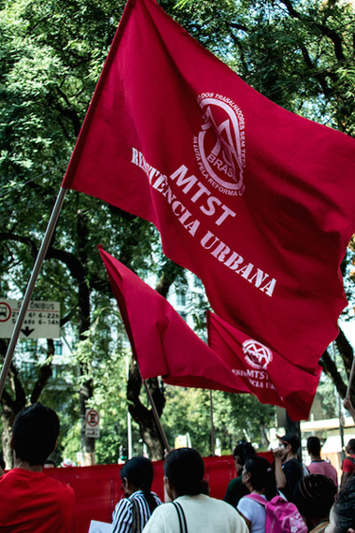
The Metro Workers Union of São Paulo is one of them and as of Monday, the 9th of June, it faces its fifth day of strike amidst layoff threats and a repressive state military police. Shortly before, the bus drivers of the city of São Paulo, represented by two unions, were also on strike. In both cases, the judiciary found the strikes to be ‘abusive’ and fined the unions hundreds of thousands of reais after ordering the workers back to their posts. The Metro Workers decided to continue the strike, with the support of a variety of social movements (including the Free Fare Movement – MPL, and the Homeless Workers’ Movement – MTST), political parties from the radical Left, and other labour unions. The judicial decision is being challenged for many reasons, but primarily for the fact that it is fuelled by illegalities committed on behalf of the employer that lead to the disavowal of the right to strike.[1]
A unified act in support of the metro workers was announced after the assembly for early Monday in the metro station Ana Rosa. The act was immediately interrupted by the arrival of the riot police squad. They advanced on the picketing metro workers, arresting some of them, and attempted to disperse the protesters who stood in solidarity with pepper spray, tear gas bombs, and raised weapons. Although some protesters attempted to kick the bombs back at the squad, the damage was done and even bystanders on their way to work were affected. A militant from the student movement and the PSTU was arrested, beaten, and humiliated by the police during an act of solidarity.[2] After recovering from the tear gas, the protesters assembled again at the metro station and, from there, they walked toward Praça da Sé in São Paulo, where they were joined by more social movements and political party representatives before marching again.

Major Victory for the Homeless
The MTST was heavily present, joining the others from its occupation in the east side of the city named “Cup of the Peoples” in response the crisis of living standards and access to housing exacerbated by the 2014 FIFA World Cup in host cities. The MTST struggle with the city and the federal government for the occupied lot resulted in a major victory on Monday night: the government committed to developing popular housing on the land and expanding the participation of organized social movements/institutions in the allocation of future housing by the government programme. Guilherme Boulos, from the MTST national coordination, happily announced that their current demands had been met and reiterated that the victory was a result of the strong mobilizations on the streets.[3]
Metro workers: The people are with you

The metro workers could not announce a similar victory late Monday night and decided to temporarily suspend the strike until a new assembly on Wednesday, June 11th, where they will vote on whether to resume the strike on the first day of the World Cup. At the time of writing, the strike will likely be resumed as the union fights to have the workers who were fired on Monday immediately reinstated.
The role of labour is paramount to the solidarity on the streets at this moment, which differentiates it from the large street protests of June 2013. Political parties from the radical left have also been directly involved in this struggle, and militants from the parties PSOL, PSTU, and PCB are working with leftist collectives on the possibility of a general strike. Further, matters related to the right to the city are evident in the joint struggle by the MTST, labour unions, and other social movements fighting for social justice in the urban environment. The urban social and geographical transformations caused by the World Cup have highlighted linkages between these struggles, as the process related to the mega event contributed to the history of dispossession and inequality in the big urban environments of Brazil.
The crisis of the urban transportation sector is to be noted here, since the sector is known for its overcrowding and inefficiency. Public transportation is often privately run and it is a space shared by the working class (the poor and the lower middle-class) as well as students. The tax cuts for automobile purchases promoted by the Lula government a few years ago, and still maintained by the current Workers’ Party administration, have led to more cars on the streets and added to already bad gridlocks in cities whose urban road networks lack the capacity to handle so many vehicles. At the same time, it further discouraged those who can afford to pay for transit to use transit, as the system is devalued and considered the realm of the working class, especially those workers who commute for hours everyday in crowded buses and trains. A year ago, protesters mobilized by the Free Fare Movement were being violently attacked by the military police in the struggle for affordable (and hopefully free) public transportation in Brazilian cities. This and other groups and movements that mobilized the population last year have joined the Metro Workers of São Paulo in a way that the labour struggle is understood together with access to public transportation in the city and the quality of this access for the users. In fact, the Metro Workers Union challenged the governor of São Paulo directly in these terms: “instead of striking, we will work for free for a day if access is free.” Suffice to say that the proposal, understood as “catraca livre” (literally, a free turnstile), was not even entertained by the governor and the metro company.
Instead, the partnership between state and the mainstream media, especially the Globo network, has focused on vilifying the metro workers for inconveniencing the people of São Paulo as if the only alternative is the end of the strike. Also worrisome is the fact that the metro company has enlisted untrained administrative personnel to run some of the trains in the meantime, putting the users at a great risk.
City transportation workers in Rio de Janeiro and Natal, two other World Cup host cities, are also on the brink of a strike. In the Federal District, the bus drivers successfully negotiated a 20 per cent salary increase before the games begin, as Brasília, Brazil’s national capital, is also a key World Cup host city.
The Significance of the World Cup
The World Cup officially begins this Thursday and is considered a site of struggle for the Brazilian Left, both the autonomous and the organized, as the mega event has helped to highlight the state of inequality and social injustice in many Brazilian cities. The negative legacy of the World Cup ranges from large sums of public money spent on the event and some of its lavish structures to urban property speculation, gentrification, forceful removals, unjust labour trends, and even deaths related to the stadium renovations. It also provides a new kind of leverage, as the Brazilian government works to build up the spirits of the population with patriotism and the love for soccer. Such patriotism attempts to downplay the questions generated by the articulations of “There won’t be a World Cup,” “World Cup for whom?” and “At the World Cup, there will be struggle” that permeate the chants and demands of the groups mobilizing around the World Cup issue. The Brazilian government will be under international scrutiny for a month, and there is pressure for the host cities (and their respective airports) to run as smoothly as possible in face of the construction delays, budget scandals, and the growing antagonism toward FIFA that surround the games.
Those most interested in the success of the event have also attempted to undermine the strength of the movement. In the words of the next president of the Brazilian Soccer Confederation, Marco Polo del Nero: “These protests have from 500 to 1000 people. São Paulo has 14 million inhabitants. It’s little, next to these 14 million. The proof is that all the tickets for the World Cup and the Brazilian team exhibition games were sold. The protest is by a minority.”[4]

“At the World Cup, there will be struggle”
The articulation “There won’t be a World Cup” (Não vai ter copa) was especially popular earlier in the year, and it targeted the World Cup spending and abuses. While the concept was powerful at first, it soon became evident that the World Cup was quickly approaching and it would happen – to the point that even president Dilma Rousseff boasted that “there will be a World Cup” on social media. The concept was then rearranged around the idea that the World Cup that will happen would not be the one the state and FIFA wanted, since the discontent would eclipse the festivities and the attempt to conceal the social problems in Brazil. It is true that enthusiasm around the event and supporting Brazil’s national soccer team seems subdued and World Cup decorations are not as widespread as before; however, a portion of the population is still looking forward to the event and will be present at the stadiums – primarily those who can afford to do so.
Another popular articulation is the question “World Cup for whom?” and it is central to the work of the Popular Committees of the World Cup, which focus on exposing the negative impacts of the games and mobilizing opposition against the way the government and FIFA have managed them. The question is interesting, as it helps to unveil the structures that make such a profitable event possible, especially as the government’s argument that this World Cup is for the Brazilian people has fallen apart and cannot be justified based on the love for the national sport. The answer, the committees show, is a World Cup for big capital, large construction companies, property owners, and the elites who can access the games and get perks that middle-class attendees cannot afford. It is primarily a World Cup for FIFA, a private institution whose World Cup dealings have been slowly exposed.[5]
Mega events are normally promoted as a big tourism opportunity for the host country, and they are said to leave a legacy of improved infrastructure and national image. In the Brazilian case (and no doubt, to some extent, everywhere else where such events are held), the legacy is broken promises of improvement, capital and property speculation, dispossession, and the promotion of a constructed image of Brazilian culture that highlights the exotic and the stereotypical while it actively erases the social processes that make up the daily lives of Brazilians. Let us take the example of the favelas. Their alleged pacification, that is, the takeover of the favelas by the Pacifying Police Units (UPPs) in an effort to drive drug dealers away and make them safer, is a myth. The UPPs are known by favela inhabitants as repressive, racist, and violent. The disappearance of a man called Amarildo last year at a Rio de Janeiro favela after being taken for questioning by the police led to anger and protests. Amarildo has been joined by numerous others, such as Douglas (known as DG), and Cláudia. The three were parents and hard workers, and their murders are linked to criminal activities by the military police of Rio de Janeiro.[6] Despite these stories and many others, the favela pacification is part of an effort by the city to promote them as lively communities where samba, carnaval, soccer, and feijoada thrive. The favelas are transformed into an exotic object in the unequal space of the city, one that can be exploited by tourism and conceals social injustice through a racist and commodified idea of cultural diversity.
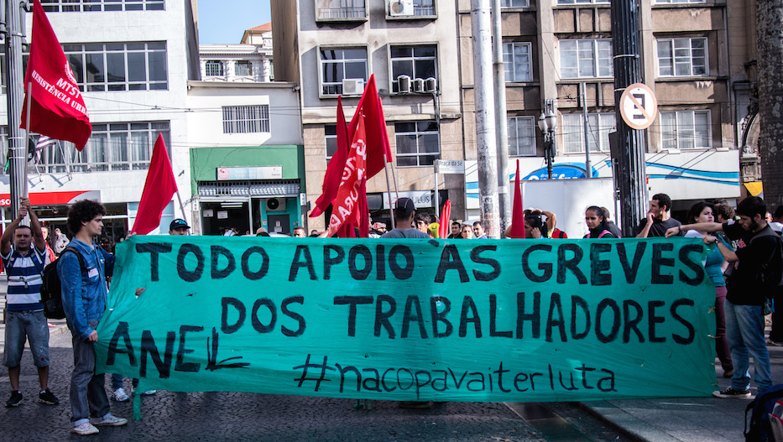
“Thus, it brings to the forefront the idea of a more permanent struggle that is energized by the dialogue and solidarity that arises when many groups, social movements, and parties join forces to expose, denounce, oppose, and resist together. ”
All support for the workers’ strike. #attheworldcup there will be struggle.

This is why the notion of “At the World Cup, there will be struggle” (Na copa vai ter luta) is so important. Promoted mainly by organized actors, such as radical left parties and central unions, it is not meant to say struggle was absent before and will be present during the event. Actually, it provides the social struggles in the city with a useful frame of contestation of capital and the neoliberal actions of the state. It is also a tool for politicization, as it demonstrates that popular discontent during the games is not limited to the oppression related to the FIFA interests, but to a larger system that permits such events to take on such a scale of exploitation for profit. Thus, it brings to the forefront the idea of a more permanent struggle that is energized by the dialogue and solidarity that arises when many groups, social movements, and parties join forces to expose, denounce, oppose, and resist together. Ultimately, these joint struggles should aim to continue the work of mobilizing their membership base, which is fundamental to promoting class consciousness, as well as to politicize others into the struggle of building alternatives and a political project.
It is not only a matter of what we are struggling against, but also what we are struggling for. The lessons of the past year in Brazil, which have moved toward a renewed focus on the organized struggle of the people, need to be taken seriously. The victories that have resulted must be used to draw the movement toward questions of where to go after the World Cup moment is gone. Finally, the apparent losses of today as capital continues to threaten the movement through political and police repression must fuel our intransigence, as Gramsci argued, so that the eventual victories can be understood for what they ought to be in the socialist struggle: an offensive against capital that puts us closer to an alternative, rather than momentary collaboration with the state and bourgeois power.

References are available at source’s URL.

Sabrina Fernandes is a Ph.D. candidate in Sociology at Carleton University. Her research focuses on contemporary Left articulations in Brazil by political parties, social movements, and mass mobilizations. She is currently in Brazil following the organized struggle around the World Cup.

Brazil’s Olympics and World Cup: Mega-Events and the Threat to Public Welfare
Olympic Capitalism: Bread and Circuses Without the Bread
By David Swanson
Source: http://www.globalresearch.ca/brazils-olympics-and-world-cup-mega-events-and-the-threat-to-public-welfare/5380063

The author of Brazil’s Dance With the Devil, Dave Zirin, must love sports, as I do, as billions of us do, or he wouldn’t keep writing about where sports have gone wrong. But, wow, have they gone wrong!

Brazil is set to host the World Cup this year and the Olympics in 2016. In preparation Brazil is evicting 200,000 people from their homes, eliminating poor neighborhoods, defunding public services, investing in a militarized police and surveillance state, using slave and prison labor to build outrageous stadiums unlikely to be filled more than once, and “improving” a famous old stadium (the world’s largest for 50 years) by removing over half the capacity in favor of luxury seats. Meanwhile, popular protests and graffiti carry the message: “We want ‘FIFA standard’ hospitals and schools!”
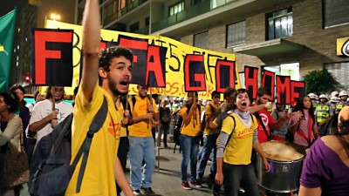
Brazil is just the latest in a string of nations that have chosen the glory of hosting mega sports events like the Olympics and World Cup despite the drawbacks. And Zirin makes a case that nations’ governments don’t see the drawbacks as drawbacks at all, that in fact they are the actual motivation. “Countries don’t want these mega-events in spite of the threats to public welfare, addled construction projects, and repression they bring, but because of them.” Just as a storm or a war can be used as an excuse to strip away rights and concentrate wealth, so can the storm of sporting events that, coincidentally or not, have their origins in the preparation of nations for warmaking.
Zirin notes that the modern Olympics were launched by a group of European aristocrats and generals who favored nationalism and war — led by Pierre de Coubertin who believed sport was “an indirect preparation for war.” “In sports,” he said, “all the same qualities flourish which serve for warfare: indifference toward one’s well being, courage, readiness for the unforeseen.” The trappings of the Olympic celebration as we know it, however — the opening ceremonies, marching athletes, Olympic torch run, etc., — were created by the Nazis’ propaganda office for the 1936 games. The World Cup, on the other hand, began in 1934 in Mussolini’s Italy with a tournament rigged to guarantee an Italian win.
More worrisome than what sports prepare athletes for is what they may prepare fans for. There are great similarities between rooting for a sports team, especially a national sports team, and rooting for a national military. “As soon as the question of prestige arises,” wrote George Orwell, whom Zirin quotes, “as soon as you feel that you and some larger unit will be disgraced if you lose, the most savage combative instincts are aroused.” And there is prestige not just in “your” team winning, but in “your” nation hosting the grand event. Zirin spoke with people in Brazil who were of mixed minds, opposing the injustices the Olympics bring but still glad the Olympics was coming to Brazil. Zirin also quotes Brazilian politicians who seem to share the goal of national prestige.
At some point the prestige and the profits and the corruption and the commercialism seem to take over the athletics. “[T]he Olympics aren’t about sport any more than the Iraq war was about democracy,” Zirin writes. “The Olympics are not about athletes. And they’re definitely not about bringing together the ‘community of nations.’ They are a neoliberal Trojan horse aimed at bringing in business and rolling back the most basic civil liberties.”
And yet … And yet … the damn thing still is about sports, no matter what else it’s about, no matter what alternative venues for sports are possible or imaginable. The fact remains that there are great athletes engaged in great sporting activities in the Olympics and the World Cup. The attraction of the circus is still real, even when we know it’s at the expense of bread, rather than accompanying bread. And dangerous as the circus may be for the patriotic and militarist minded — just as a sip of beer might be dangerous to an alcoholic — one has the darndest time trying to find anything wrong with one’s own appreciation for sports; at least I do.
The Olympics are also decidedly less militaristic — or at least overtly militaristic — than U.S. sports like football, baseball, and basketball, with their endless glorification of the U.S. military. “Thank you to our service men and women watching in 175 countries and keeping us safe.” The Olympics is also one of the few times that people in the U.S. see people from other countries on their televisions without wars being involved.
Zirin’s portrait of Brazil leaves me with similarly mixed sentiments. His research is impressive. He describes a rich and complex history. Despite all the corruption and cruelty, I can’t help being attracted to a nation that won its independence without a war, abolished slavery without a war, reduces poverty by giving poor people money, denounces U.S. drone murders at the U.N., joins with Turkey to propose an agreement between the United States and Iran, joins with Russia, India, and China to resist U.S. imperialism; and on the same day this year that the U.S. Federal Communications Commission proposed ending the open internet, Brazil created the world’s first internet bill of rights. For a deeply flawed place, there’s a lot to like.
It’s also hard to resist a group of people that pushes back against the outrages being imposed on it. When a bunch of houses in a poor Brazilian neighborhood were slated for demolition, an artist took photos of the residents, blew them up, and pasted them on the walls of the houses, finally shaming the government into letting the houses stand. That approach to injustice, much like the Pakistani artists’ recent placement of an enormous photo of a drone victim in a field for U.S. drone pilots to see, has huge potential.
Now, the question is how to display the Olympics’ victims to enough Olympics fans around the world so that no new nation will be able to accept this monster on the terms it has been imposing.

The Lack of Major Wars May Be Hurting Economic Growth
Source: http://www.nytimes.com/2014/06/14/upshot/the-lack-of-major-wars-may-be-hurting-economic-growth.html?_r=0

The continuing slowness of economic growth in high-income economies has prompted soul-searching among economists. They have looked to weak demand, rising inequality, Chinese competition, over-regulation, inadequate infrastructure and an exhaustion of new technological ideas as possible culprits.
An additional explanation of slow growth is now receiving attention, however. It is the persistence and expectation of peace.
The world just hasn’t had that much warfare lately, at least not by historical standards. Some of the recent headlines about Iraq or South Sudan make our world sound like a very bloody place, but today’s casualties pale in light of the tens of millions of people killed in the two world wars in the first half of the 20th century. Even the Vietnam War had many more deaths than any recent war involving an affluent country.
Counterintuitive though it may sound, the greater peacefulness of the world may make the attainment of higher rates of economic growth less urgent and thus less likely. This view does not claim that fighting wars improves economies, as of course the actual conflict brings death and destruction. The claim is also distinct from the Keynesian argument that preparing for war lifts government spending and puts people to work. Rather, the very possibility of war focuses the attention of governments on getting some basic decisions right — whether investing in science or simply liberalizing the economy. Such focus ends up improving a nation’s longer-run prospects.

A Safer World
The number of people who have died in wars has declined sharply since the 20th century.
It may seem repugnant to find a positive side to war in this regard, but a look at American history suggests we cannot dismiss the idea so easily. Fundamental innovations such as nuclear power, the computer and the modern aircraft were all pushed along by an American government eager to defeat the Axis powers or, later, to win the Cold War. The Internet was initially designed to help this country withstand a nuclear exchange, and Silicon Valley had its origins with military contracting, not today’s entrepreneurial social media start-ups. The Soviet launch of the Sputnik satellite spurred American interest in science and technology, to the benefit of later economic growth.
War brings an urgency that governments otherwise fail to summon. For instance, the Manhattan Project took six years to produce a working atomic bomb, starting from virtually nothing, and at its peak consumed 0.4 percent of American economic output. It is hard to imagine a comparably speedy and decisive achievement these days.
As a teenager in the 1970s, I heard talk about the desirability of rebuilding the Tappan Zee Bridge. Now, a replacement is scheduled to open no earlier than 2017, at least — provided that concerns about an endangered sturgeon can be addressed. Kennedy Airport remains dysfunctional, and La Guardia is hardly cutting edge, hobbling air transit in and out of New York. The $800 billion stimulus bill, in response to the recession, has not changed this basic situation.
Today the major slow-growing Western European nations have very little fear of being taken over militarily, and thus their politicians don’t face extreme penalties for continuing stagnation. Instead, losing office often means a boost in income from speaking or consulting fees or a comfortable retirement in a pleasant vacation spot. Japan, by comparison, is faced with territorial and geopolitical pressures from China, and in response it is attempting a national revitalization through the economic policies of Prime Minister Shinzo Abe.
Ian Morris, a professor of classics and history at Stanford, has revived the hypothesis that war is a significant factor behind economic growth in his recent book, “War! What Is it Good For? Conflict and the Progress of Civilization From Primates to Robots.” Morris considers a wide variety of cases, including the Roman Empire, the European state during its Renaissance rise and the contemporary United States. In each case there is good evidence that the desire to prepare for war spurred technological invention and also brought a higher degree of internal social order.
Another new book, Kwasi Kwarteng’s “War and Gold: A 500-Year History of Empires, Adventures, and Debt,” makes a similar argument but focuses on capital markets. Mr. Kwarteng, a Conservative member of British Parliament, argues that the need to finance wars led governments to help develop monetary and financial institutions, enabling the rise of the West. He does worry, however, that today many governments are abusing these institutions and using them to take on too much debt. (Both Mr. Kwarteng and Mr. Morris are extending themes from Azar Gat’s 820-page magnum opus, “War in Human Civilization,” published in 2006.)
Yet another investigation of the hypothesis appears in a recent working paper by the economists Chiu Yu Ko, Mark Koyama and Tuan-Hwee Sng. The paper argues that Europe evolved as more politically fragmented than China because China's risk of conquest from its western flank led it toward political centralization for purposes of defense. This centralization was useful at first but eventually held China back. The European countries invested more in technology and modernization, precisely because they were afraid of being taken over by their nearby rivals.
But here is the catch: Whatever the economic benefits of potential conflict might have been, the calculus is different today. Technologies have become much more destructive, and so a large-scale war would be a bigger disaster than before. That makes many wars less likely, which is a good thing, but it also makes economic stagnation easier to countenance.
There is a more optimistic read to all this than may first appear. Arguably the contemporary world is trading some growth in material living standards for peace — a relative paucity of war deaths and injuries, even with a kind of associated laziness.
We can prefer higher rates of economic growth and progress, even while recognizing that recent G.D.P. figures do not adequately measure all of the gains we have been enjoying. In addition to more peace, we also have a cleaner environment (along most but not all dimensions), more leisure time and a higher degree of social tolerance for minorities and formerly persecuted groups. Our more peaceful and — yes — more slacker-oriented world is in fact better than our economic measures acknowledge.
Living in a largely peaceful world with 2 percent G.D.P. growth has some big advantages that you don’t get with 4 percent growth and many more war deaths. Economic stasis may not feel very impressive, but it’s something our ancestors never quite managed to pull off. The real questions are whether we can do any better, and whether the recent prevalence of peace is a mere temporary bubble just waiting to be burst.

EDITOR’S COMMENT: This article from NYTimes is important and highly worrysome. This newspaper is considered as a “serious” one to doubt its content. This means that we have to take it seriously. There are some nuts in high places that spread the word that Russia’s nuclear system is not valid and that they could destroy Russia without consequences for the United States! Then as “winners” they believe that they could justify this “crime” to global community with the aid of their controlled mass media. We really worry about those who rule this planer and those who think that our lives worth less than a fly while they believe that they are “immortal”…

Syrian chemical weapons deadline passes with 92 percent of materials removed
Source: http://www.upi.com/Top_News/World-News/2014/04/28/Syrian-chemical-weapons-deadline-passes-with-92-percent-of-materials-removed/9291398692362/

As of the April 27 deadline, "The Syrian Arab Republic has now removed from its territory or destroyed in-country more than 92% of its declared stockpile of chemical weapons material."
Sigrid Kaag, Special Coordinator of the OPCW-UN Joint Mission in Damascus, said that while "This is a significant achievement ... nearly 8% of Syria's declared weapons material remains on its territory."
Kaag expressed optimism that the Syrian government, "having come this close to meeting the target date for the removal of chemical weapons material ... will take the final step very soon."
Syria should strive to complete the removal "in the shortest possible timeframe," the OPCW-UN Joint Mission special coordinator said, while acknowledging the difficult security conditions.
"Should this material be removed soon, the Syrian Arab Republic will have successfully carried out a major obligation that is a focus of much international attention."
UN Security Council Resolution 2118 for the "Scheduled Destruction of Syria's Chemical Weapons" was adopted on September 27, 2013.

EDITOR’S COMMENT: It is most possible that Assad will keep the remaining 8% until the June 3 elections as a safeguard of his trembling authority. Elections results will define the completion of the destruction of Syria’s chemical arsenal. On the other hand I was always wondering if all countries that destroyed their chemical weapons (i.e. Albania, Libya) did that in a 100% manner or kept a few barrels just for “scientific research”… Of course if you did it once you can do it again even if the country is under strict international surveillance. Not to mention that perhaps West now starts to like Assad again due to the ISIL situation in Iraq…

Mimetic Human Skin to Protect Responders from Chemical Agents
Source: http://globalbiodefense.com/2014/04/25/mimetic-human-skin-to-protect-responders-from-chemcial-agents/

New basic research on how to mimic human skin could produce better ways to protect warfighters and first responders against contaminants.
Sponsored by the Defense Threat Reduction Agency Chemical and Biological Technologies Directorate (DTRA CB/JSTO), the project managed by DTRA’s Dr. Brian Pate is using prominent dermatologists Drs. Xiaoying Hui and Howard Maibach from the University of California, San Francisco.
The research focuses on a novel multi-step system based on isolated human stratum corneum (SC) as a surrogate to rapidly define the relative roles of SC proteins and lipids in dermal penetration of chemical agents, prevention of their penetration (barriers), and decontamination after exposure.
Refinement of the role of each SC component will be accomplished by partitioning the roles of individual lipids and proteins, using standard lipid and protein chemistry methods coupled with various state of the art imaging technologies to quantitatively determine the molecular distribution for agent simulants within the stratum conreum.
This project, named “Human Stratum Corneum Protein and Lipid Domains: Their Roles in Skin Decontamination Intervention Strategy Development,” was funded via a DTRA Broad Agency Announcement.
Clothing Infused with Nanotubes to Protect Against Chemical Weapons
Source: http://globalbiodefense.com/2014/05/12/clothing-infused-with-nanotubes-to-protect-against-chemical-weapons/

Scientists at the National Institute of Standards and Technology (NIST) have demonstrated a way to engineer carbon nanotubes to dismantle the molecules of organophosphate nerve agents. In principle, the nanotubes could be woven into clothing that destroys the chemicals on contact before they reach the skin.
The team’s experiments show that nanotubes can be combined with a copper-based catalyst able to break apart a key chemical bond in organophosphates, such as Sarin. A small amount of catalyst can break this bond in a large number of molecules, potentially rendering a nerve agent far less harmful.
Single-walled carbon nanotubes, represented by the gray cylinders, can be combined with a catalyst (purple ribbons) that is capable of breaking down Sarin and related toxins into less dangerous components. The idea might one day be used to create clothing for increased protection against nerve agents.

While organophosphates are harmful if inhaled, they also are dangerous if absorbed through the skin, and can be even be re-released from clothing if not thoroughly decontaminated. Many organophosphates are classified as weapons of mass destruction.
To protect themselves during research, the team did not work with actual nerve agents, but instead used a “mimic molecule” that contains a chemical bond identical to the one found in organophosphates. Breaking this bond splits the molecule into pieces that are far less dangerous.
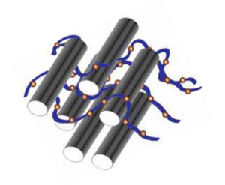
The team developed a way to attach the catalyst molecule to the nanotubes and then tested the effectiveness of the tube-catalyst complex to break the bonds. To perform the test, the complex was deposited onto a small sheet of paper and put into a solution containing the mimic molecule. For comparison, the catalyst without nanotubes was tested simultaneously in a different solution. Then it was a simple matter of stirring and watching chemistry in action.
“The solution was initially transparent, almost like water,” says the team’s John Heddleston, “but as soon as we added the paper, the solution started to turn yellow as the breakdown product accumulated. Measuring this color change over time told us the amount and rate of catalysis. We began to see a noticeable difference within an hour, and the longer we left it, the more yellow it became.” The catalyst-nanotube complex far outperformed the catalyst alone.
Principal investigator Angela Hight Walker says that several questions will need to be addressed before catalytic nanotubes start showing up in clothing, such as whether it is better to add the catalyst to the nanotubes before or after they are woven into the fabric.
“We’d also like to find ways to make the catalytic reaction go faster, which is always better,” Hight Walker says. “But our research group has been focusing on the fundamental science of nanoparticles for years, so we are in a good position to answer these questions.”

Read more at: http://www.thenanoresearch.com/upload/justPDF/0405.pdf
Chem-Bio Coatings: More Than Just a Fresh Coat of Paint
Source: http://globalbiodefense.com/2014/06/12/chem-bio-coatings-just-fresh-coat-paint/

Today’s coatings used on military aircraft, tanks and transport vehicles meet all the services’ requirements of durability, stealth and performance. However, when it comes to chemical and biological threats, they sometimes soak up these agents like a sponge, potentially exposing military personnel to deadly hazards.
That’s why the scientists at the Defense Threat Reduction Agency’s Chemical and Biological Technologies Department (DTRA CB) are looking at establishing new standards to meet both emerging and established threats.
“Although our current crops of coating materials meet the current criteria, we feel that a new standard needs to be established,” explained Dr. Revell Phillips, manager, DTRA CB’s Coatings Program at Ft. Belvoir, Va. Phillips recently gathered approximately 40 to 50 government, academic and industry representatives from various backgrounds and disciplines in a coatings colloquium to talk about what the new standards should be. “This gave us a great opportunity to brainstorm and collaborate to come up with real-world solutions,” he said.

CARC – Chemical Agent Resistant Coatings
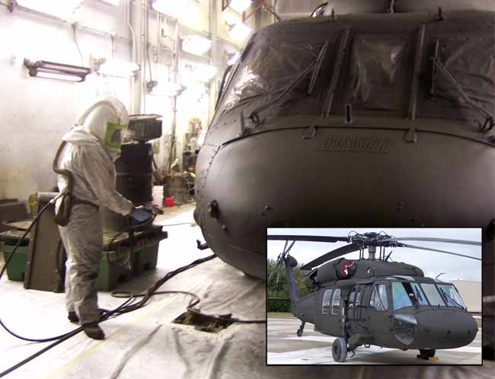
The chemical resistance standards for the Department of Defense’s Chemical Agent Resistant Coatings, or CARC, for tactical vehicles have been developed and used for the past 40 years. While the standards for many of CARCs characteristics have evolved over the years, those for decontamination and resistance have remain unchanged. Phillips hopes his research will deliver the required results to start implementing incremental changes to the standard within the next year. He points out that raising the bar incrementally for manufacturers makes the transition to a new crop of protective coatings more feasible and likely to succeed.
A similar approach was used to great success in reducing the amount of volatile organic compounds the coatings release while curing. He also pointed out that determining the correct tests to use is critical to getting the best results. Gathering the scientists together, as they did in the recent coatings colloquium, helped guarantee success. Incremental implementation will leverage the expertise of the coating industry by encouraging the individual coating manufacturers to use technology advances and internal research and expertise to improve the chemical agent resistance and the ability of chemical agents to be removed from military coatings. DTRA CB wants to protect the warfighter and stay ahead of emerging threats that the current standard of CARC typically absorbs.

HaMMER and Nanocomposite Coatings
To protect the warfighter, in addition to evolving the agent resistance standards for coatings, scientists working for DTRA CB are also conducting several programs, such as the Hazard Mitigation, Material, and Equipment Restoration (HaMMER) Advanced Technology Demonstration (ATD), omniphobic fluid repellent coatings, and nanocomposite coatings to protect warfighters from chemical and biological threats from certain agents.
HaMMER, a DTRA CB-funded program that has been demonstrated by soldiers on actual vehicles in field conditions, takes a tailored, all-hazards approach to mitigate current and emerging chemical and biological threats. Using a family-of-systems approach, HaMMER demonstrated the synergistic effects of a three-phased system utilizing strippable coatings, agent disclosure products and new decontaminants. HaMMER operational demonstrations began with applying an Akzo Nobel strippable coating to vehicles prior to entering the battlefield. During decontamination operations, a newly developed agent disclosure spray, that readily changes colors in the presence of agent, was applied to the coating to quickly locate areas of contamination. Crew members were then able to rapidly peel off the coating and/or apply decontaminants only to the contaminated areas without having to scrub the entire vehicle, significantly reducing labor, time and resources. The results were some of the lowest post-decontamination levels seen to date.
For omniphobic fluid repellent coatings, researchers are looking at a number of options from hardening the coatings with improved crosslinking, a process to build up a three-dimensional network at a molecular level to give the coating better structure, to using resistant additives much like a beefed up version of “scotch-guarding” a material. Working at the nanoparticle level, DTRA CB-funded research is now looking coating additives that would sequester and deactivate harmful agents.
“We believe that through these research efforts and the evolution of the agent resistance standard in collaboration with industry will help us get to coatings that are more easily and completely decontaminated, protecting warfighters faster, better and sooner,” said Phillips.

UAE Armed Forces take part in chemical attack rescue exercises
Source: http://www.thenational.ae/uae/in-pictures-uae-armed-forces-take-part-in-chemical-attack-rescue -exercises#image-1
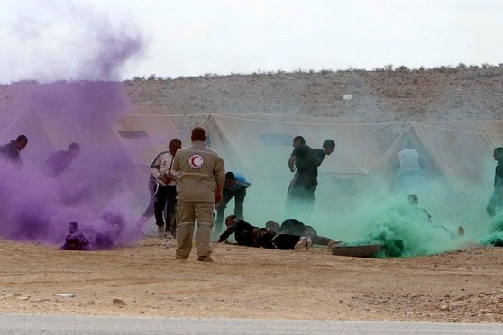
Jordanian and UAE Armed Forces take part in chemical attack exercises at Prince Hashem ibn Abdullah special operations training centre, in Zarqa, 30km east of Amman, Jordan. Trainees were monitored by forces from USA during the Eager Lion military exercises. About 12,500 participants from 20 countries took part in the exercise.
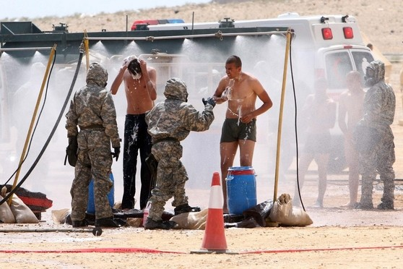
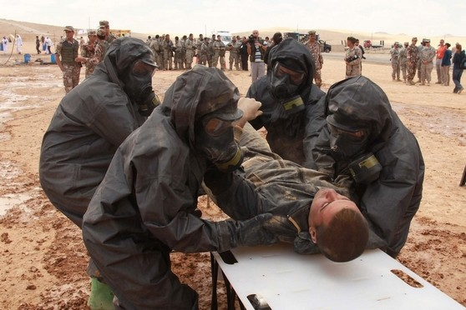
EDITOR’S COMMENT: Chem drill are always helpful to verify training. But they should be done the right way. Looks like that the two soldiers performing decontamination are not waterproof while a third one and those in line for decontamination are in the way of the contaminated water spray. Not to mention about the secontady contamination of the ground. If you cannot do it right during drill do not expect to do it right in a real life situation. Simple operational mathematics…

Brazil World Cup 2014: Security Costs Five Times as Much as South Africa
Source: http://www.ibtimes.co.uk/brazil-world-cup-2014-security-costs-five-times-much-south-africa-1452064

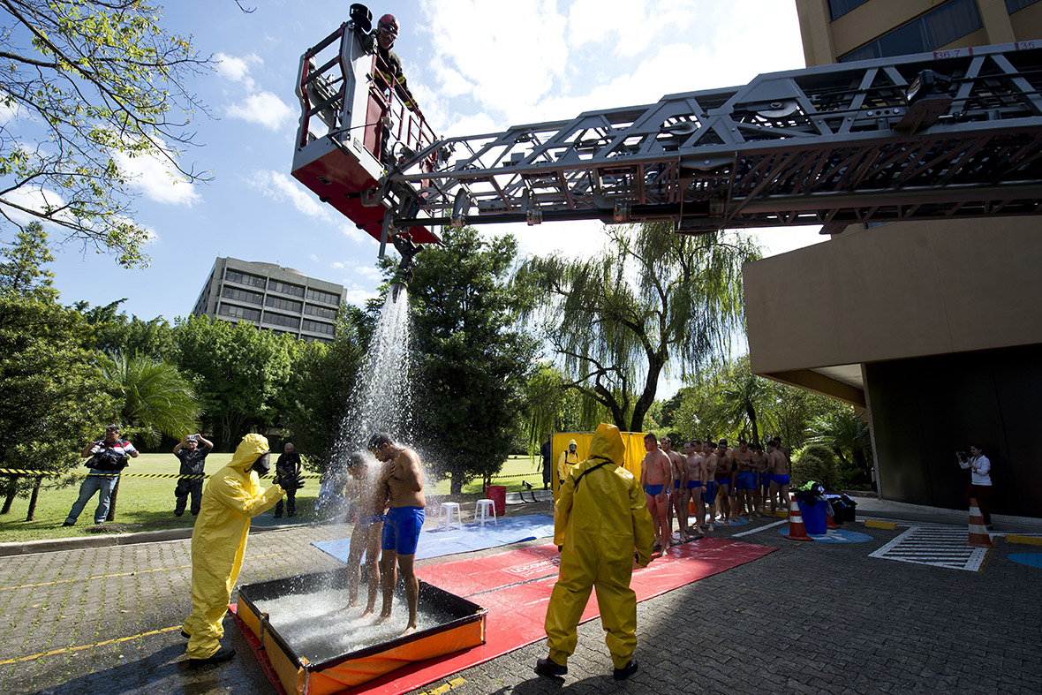
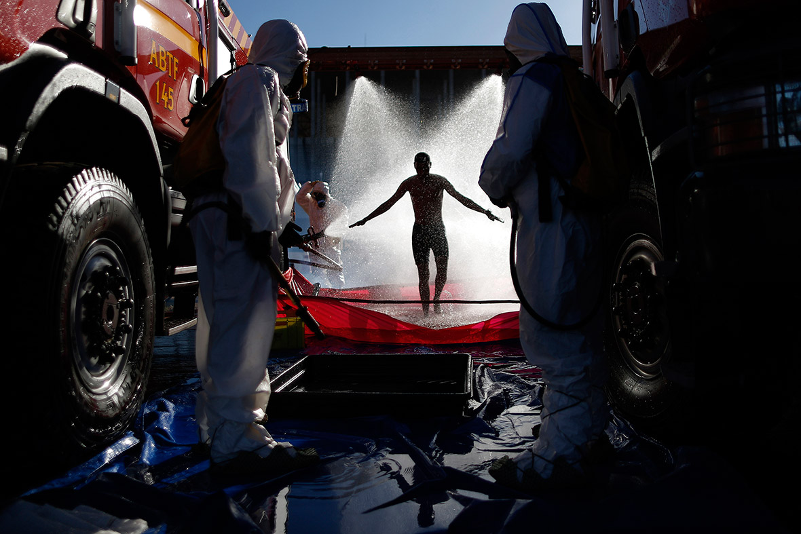
Brazil has spent £498m on security for the 2014 World Cup – more than five times the amount South Africa spent on security for the last World Cup. Over 170,000 security officers will be available to patrol the 12 stadiums hosting World Cup. Helicopters, drones, and surveillance equipment will also be used.
The Brazilian government is promising that "the World Cup in Brazil will be the safest ever" despite continuing protests.

EDITOR’S COMMENT: Interesting pictures, good settings. Water curtains still remain the best solution for mass CR decontamination. But the problem is not on how to contuct decontamination. The problem is mass casualties’ management. And this means “hospitals CR preparedness” – an issue that is not shown in most (if not all) drills that stop the moment victims are inside ambulances. Although no CBRN incident is expected during World Cup what really worries the international secutiry community is how well prepared Brasil is to deal with such events during the coming 2016 Olympic Games. And as far as I know there is a huge gap in this sector. Many might say they will fix it because they have time. But time passes by fast in mega events and there is no indication that responsible planners realize how things work and how people behave in related incidents. All hospitals in cities hosting Olympic events should be prepared to manage contaminated casualties and worried well and this is not done so far. Let us hope that the inherent belief that “it will not happen to us” will prevail to life’s conclusion that “the unexpected always happens!” The military have certain capabilities and some experience (from the Goiania incident) but is it enough without the support of the civilian response sector?

The promise of the Syrian chemical weapons plan
By Kingston Reif
Source: http://thebulletin.org/promise-syrian-chemical-weapons-plan7237

Last summer, as a Moscow-brokered deal to disarm Syria of chemical weapons took shape, a headline in Foreign Policy blared, “There's Almost No Chance Russia's Plan for Syria's Chemical Weapons Will Work.” The accompanying story was typical of many at the time suggesting that the emerging plan was a fool’s errand, that it distracted attention from the deadly battles Syrian President Bashar al-Assad was waging with conventional weapons, and that US participation signaled weakness and lack of resolve in Washington.
In the wake of the Syrian government’s large-scale use of the nerve agent sarin against unprotected civilians last August, the United States and Russia concluded a last-ditch diplomatic agreement forcing Damascus to join the Chemical Weapons Convention (CWC) and verifiably eliminate or remove all chemical weapons material and equipment by June 30. With that deadline approaching, now is a good time to judge the deal’s effectiveness. Is the doom and gloom that characterized (and continues to characterize) much of the commentary on the agreement still warranted? The answer is “no”—with disclaimers. It’s true that Syria has yet to ship out all of its chemicals, that questions remain about whether Damascus is hiding additional prohibited materials, and that the civil war continues to rage with no end in sight. And yet: Progress in implementing the deal has been extraordinary given the circumstances, and the unprecedented international effort has more effectively reduced the threat from Syria’s chemical weapons than the alternative Washington considered—punitive cruise missile strikes.
So far, 92.5 percent of Syria’s declared chemical weapons (a total of 1,290 metric tons) has been destroyed or shipped to the port of Latakia for transport out of the country. In addition, the Organisation for the Prohibition of Chemical Weapons (OPCW)—the implementing agency for the CWC—has verified the destruction of Syria’s chemical-weapons-making equipment.
But the plan is behind schedule. The regime has missed multiple deadlines to remove all of its chemicals, which in turn will make it impossible to destroy the arsenal by June 30 as mandated by the deal. Some argue that Assad is holding on to his last batch of chemicals as bargaining chips. Syria’s failure to destroy or ship out 100 percent of the declared stockpile would constitute a clear violation of the agreement and justify strong international condemnation and UN Security Council action under Chapter VII of the UN Charter.
Further complicating matters are questions about whether Syria declared all of its chemical weapons facilities, equipment, and materials to the OPCW. The United States and other Western governments have raised concerns about the completeness of Syria’s declaration, and OPCW officials have visited Damascus in recent weeks in an attempt to clear up alleged omissions and discrepancies. The United States has also accused Syria of stalling on destroying its chemical weapons production sites, though it has disabled the equipment that mixes sarin and mustard precursor ingredients and fills munitions with poison gas. Moreover, allegations of additional chemical attacks inside Syria raise questions as to whether Assad is truly committed to ending his use of the weapons. Recent reports allege that the Assad regime has targeted the opposition with chlorine gas, a chemical not covered by the CWC given its numerous commercial and industrial uses, including pool chlorination. While chlorine is not a banned substance, using it as a weapon is a violation of the CWC—though rockets and missiles armed with sarin warheads are far more deadly than rudimentary chlorine barrel bombs.
These setbacks and concerns are serious and can't be ignored. On balance, however, what has been achieved so far—the near elimination of one of the two largest operational chemical weapons arsenals in the world, in the midst of the chaos of a civil war no less—is remarkable.
Despite repeated and largely unjustifiable Syrian foot-dragging, it seems more likely than not that the remaining 100 metric tons of declared chemicals—which have been packed in containers and are ready for shipment—will be removed in the coming weeks or months. A key reason is that Russia, which appears to have taken the threatened US cruise missile strikes seriously, is invested in the success of the deal. Though the United States and Russia are at odds over Moscow’s aggression in Ukraine and continued support for Assad, Russia has put pressure on Syria to remove its chemicals. Bilateral diplomatic cooperation between Washington and Moscow remains an important tool for reducing WMD threats.
The deal has also significantly reduced the chemical weapons threat to US allies in the region. Just ask Israeli Prime Minister Benjamin Netanyahu, who hasn’t exactly been a supporter of President Obama’s Middle East policy. In a recent interview with Bloomberg News reporter Jeffrey Goldberg, he said:
I think this is the one ray of light in a very dark region. It’s not complete yet. We are concerned that they may not have declared all of their capacity. But what has been removed has been removed. We’re talking about 90 percent. We appreciate the effort that has been made and the results that have been achieved.
The neutralization of Syria’s chemical weapons would be a major step toward a Middle East free of WMD. As Mideast nations continue to bicker over the agenda for a long-postponed conference to discuss banning chemical, biological, and nuclear weapons, the successful elimination of the Syrian arsenal would help demonstrate that a ban is possible. Furthermore, it could be used as leverage to pressure holdouts Egypt and Israel to ratify the CWC.
By ridding Syria of nearly all of its chemical weapons, the US-Russia deal has been more effective and less risky than airstrikes likely would have been in reducing the Syrian chemical threat. As US National Security Advisor Susan Rice said in May, “there are no number of airstrikes that might have been contemplated that would have done what has been accomplished, which is [that] now 92.5 percent of the declared chemical weapons are out of the country.” In addition, airstrikes might have backfired by causing Assad to launch additional chemical attacks, including against Israel, or retaliate using terrorist proxies such as Hezbollah. Strikes could have also led to greater US involvement in the civil war and threatened negotiations with Syria’s close ally Iran over curtailing the latter’s nuclear program.
Some observers continue to argue that the deal has made it easier for Assad to continue his war against the Syrian opposition using conventional weapons. But the purpose of the contemplated US airstrikes was not to stop the civil war but to punish Assad for using chemical weapons and degrade and deter his ability to launch future attacks. Nonetheless, might airstrikes have boosted the morale of the rebels and hastened the downfall of Assad? Maybe, but it seems unlikely that the small and limited airstrikes that were being proposed at the time would have dramatically altered the course of the conflict.
The continued slaughter in Syria does raise an important question about why the use of chemical weapons should be viewed differently than brutality perpetrated via other means. There isn’t an easy answer to this question, but the international norms that have been established against particularly heinous weapons are worth upholding, even if they only make a small dent in the odious face of war. Sigrid Kaag, the incredible woman overseeing the destruction of Syria’s chemical weapons, put it this way: “We can never be happy knowing people are dying… I feel only relief knowing that we are, in some way, helping.”
The most oft-repeated criticism of the US response is that in allowing Assad to cross the “red line” that President Obama drew against chemical weapons use, Washington’s credibility and resolve to make good on threats is now in question. This charge is unconvincing. It ignores the fact that Israel, the closest US ally in the region, strongly supports the deal. Meanwhile, Iran, the biggest US adversary in the region, has agreed to verifiably constrain its nuclear program despite the alleged display of American weakness in Syria. While some US allies in East Asia have expressed concern about US steadfastness, Syria is not an accurate bellwether for the American commitment to them, since Washington is obliged by treaty to come to the assistance of countries such as Japan and South Korea if they are attacked. Indeed, the Obama administration has taken many tangible steps recently to assure allies in Asia of the American commitment to their security.
The removal and destruction of Syria’s chemical weapons is far from over. Formidable obstacles remain, including ensuring that Assad is not hiding undeclared materials. But we shouldn’t lose sight of what has been achieved or forget that we are another torturous step closer to eliminating the scourge of chemical weapons.

Kingston Reif is the director of nuclear nonproliferation at the Center for Arms Control and Non-Proliferation. A recipient of a Marshall Scholarship, he was awarded a prestigious Scoville Peace Fellowship in 2008. He blogs about nuclear weapons policy at Nukes of Hazard.

Want to know about chemicals stored near you? Don’t expect Texas to tell you anymore.
Source: http://watchdogblog.dallasnews.com/2014/06/want-to-know-about-chemicals-stored-near-you-dont-expect-texas-to-tell-you-anymore.html/

Obtaining information like the kind we used to build this map just got a lot more difficult. The state agency in charge has stopped releasing the information to the public.
The state agency that collects and maintains information on large chemical supplies across Texas has stopped sharing it with the public.
That was the type of information The Dallas Morning News used after last year’s deadly West explosion to identify dozens of other locations with ammonium nitrate fertilizer near homes and schools.
The Department of State Health Services released its database of chemical inventories, as reported by businesses across the state, after The News and other news media made public-information requests following the West disaster.
But the department changed course starting March 1. It began asking the Attorney General’s Office whether it had to withhold the information because of a 2003 state statute involving homeland security.
The AG’s Office, which rules on open-records matters, said the department did have to keep the information from the public, according to a May 22 letter. WFAA-TV (Channel 8) first reported on the ruling Thursday night.
As a result, the state health department will no longer release its inventory reports unless told otherwise by the AG, a spokeswoman told The News Friday.
The department’s change in disclosure, combined with the AG’s ruling, means the public has no easy way to obtain years of inventory records for multiple chemical-using businesses. Instead, the public can only ask an individual business for a copy of its most recent inventory — far less information than the state could release if it chose to.
A spokesman for AG Greg Abbott noted Friday that the state’s health and safety code still affords the public access by making records requests to businesses.
But there are no mandatory penalties for businesses that refuse to release the information. Violators are punished at the discretion of the state health department’s director.
Information about chemical stockpiles was made public as part of the 1986 Emergency Planning and Community Right-to-Know Act. The federal law requires businesses each year to report large stores of chemicals. The information, recorded in so-called Tier II reports, is made available to first responders at all levels and the public.
Congress passed the law to help the public plan against toxic releases like the one in 1984 that killed thousands in Bhopal, India.
The state health department’s website says the mission of the Tier II program “is to protect the public health and environment by providing current and accurate information about hazardous chemicals and their health effects.”
Just last week, a federal task force called for greater information-sharing and public awareness about chemical dangers in a report to President Barack Obama. He created the task force to overhaul U.S. chemical safety after 15 people died in the West disaster.
The state health department will continue sharing with emergency planners and first responders, spokeswoman Carrie Williams said. But the change in disclosure policy for everyone else was prompted by AG rulings on similar requests filed with other agencies for ammonium nitrate and chemical inventory information.
The state security statute cited by the department was a post-Sept. 11 creation. Added in 2003, it makes confidential information that is “more than likely to assist in the construction or assembly of an explosive weapon or a chemical, biological, radiological, or nuclear weapon of mass destruction” or that specifies the location of “a chemical, biological agent, toxin, or radioactive material that is more than likely to be used in the construction or assembly of such a weapon.”
Joseph Larsen, an expert on public records and attorney for The News, said Friday that the AG’s office has “almost uniformly” granted state agencies the right to withhold records under that security statute.
The Office of Texas State Chemist, for example, was allowed last year to keep secret key details of its facility inspection records for fertilizer businesses.
The News was among the news organizations requesting the documents after West. The newspaper argued that ammonium nitrate was more likely to be used as a fertilizer rather than an explosive device or weapon.
“Further, claiming this statute as a basis for withholding is richly ironic given the public safety disaster that has resulted from failure to make the public aware of the presence of the massive quantities of fertilizer at the West plant in the first place,” Larsen, on behalf of The News, wrote to the AG’s office.
But the AG ruled that some of the information in the records was confidential. What the chemist released to The News was heavily redacted. Details left out included names of the businesses and their addresses, making it difficult to know which ones passed or failed inspections.

Interactive map at: http://www.dallasnews.com/news/local-news/20130503-map-ammonium-nitrate-storage-facilities-in-texas.ece

AHLS Provider Manual, 4th edition
AHLS announces the publication of the 4th edition of the Advanced Hazmat Life Support Provider Manual with updated material, photos, illustrations and data.
The updated AHLS Provider Manual, edited by Frank G. Walter, MD, includes
- Beautiful color palette, photos
- Images and tables throughout
- Closely follows the PowerPoint slide presentation
- Common graphics for Primary Survey and Resuscitation; Poisoning Treatment Paradigm™
The 503-page manual lays flat when open, whether at the beginning, middle or end of the book.
Each antidote chapter includes a new heading, “Populations with Functional Needs,” which addresses the specific needs of pregnant and nursing women, pediatric and geriatric patients, or those with renal insufficiency.
The AHLS Provider Course and its accompanying Provider Manual is part of a two day, 16 hour course that prepares healthcare professionals in the medical management of patients exposed to hazardous materials. AHLS has trained over 15,000 health care professionals, representing 64 countries, around the world.
Purchase a copy for $175 plus shipping through the AHLS website, www.ahls.org

Italy seized 'weapons of mass destruction' parts
Source: http://www.thelocal.it/20140617/weapons-materials-founds-in-la-spezia

June 17 – Customs officers in the northern Italian port of La Spezia have identified a shipment from China found last autumn as materials that could be used to make weapons of mass destruction.
The materials, addressed to a non-existent Lebanese company, were found in nine containers on a merchant ship from China and were destined for use in Syria, the Italian news agency ANSA reported on Tuesday.
The shipment, valued at several million euros, contained steel parts that are usually used to make heavy weapons, the agency said. They were due to be transported overland to Syria via Libya.

Skunk Riot Control Copter
Source: http://www.desert-wolf.com/dw/products/unmanned-aerial-systems/skunk-riot-control-copter.html

The Skunk is equipped with 4 high-capacity paint ball barrels releasing at up to 20 paint balls per second each, with 80 Pepper balls per second stopping any crowd in its tracks.
The current hopper capacity of 4000 balls and with a High Pressure Carbon Fiber Air system it allows for real stopping power. Bright strobe lights, blinding Lasers and with on-board speakers enables communication and warnings to the crowd.
Equipped with a FLIR Thermal camera, full HD video colour camera, on board recording, full telemetry data link and long range control link, this unit is unique.
The powerful Octa copters can also be operated in formation by a single operator. The Desert Wolf Pangolin ground control station is used for system management. What makes the Pangolin unique is the operator and his team are also under full video and audio surveillance. Every move, every decision, every command is recorded.
The lifting capability of the Skunk is 45 Kg due to the eight powerful electric motors with 16 Inch props.
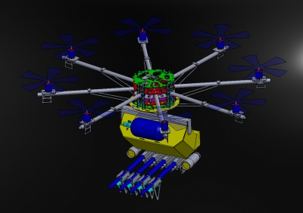
The operator has full control over each marker. He can select the RED paint marker and mark the protester who carries dangerous weapons, he can select the BLUE marker to mark the vandalising protestors and if needed the Pepper balls to stop the advancing crowd before they get into a "Life threatening situation"
He can also set the releasing frequency of each marker from as low as 1 ball per second up to 20 balls per second. If all markers releases at maximum rate, the you disperse 80 balls per second. This high frequency will only be used in an extreme "Life threatening situation".
The system also has a number of safety systems and features. Desert Wolf will continue to improve the design and ensure a safe and reliable product. Our aim is to assist in preventing another Marikana, we were there and it should never happen again.

Iraqi rebels seize chemical weapon factory
Source: http://www.3news.co.nz/Iraqi-rebels-seize-chemical-weapon-factory/tabid/417/articleID/349490/ Default.aspx
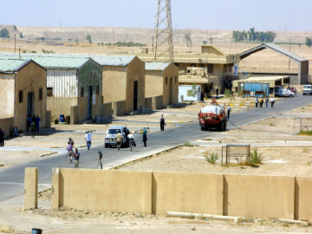
June 20 – Sunni radicals in Iraq, who have overrun a swathe of territory north of Baghdad in a lightning offensive, have taken control of one of Saddam Hussein's former chemical weapons factories, a US official says.
"We are aware the that the ISIS has occupied the Al Muthanna complex," State Department spokeswoman Jen Psaki said in a statement.
But she said she didn't think the Islamic State of Iraq and the Levant (ISIS) militants would be able to produce usable chemical weapons there, because any materials remaining are old and unwieldy.
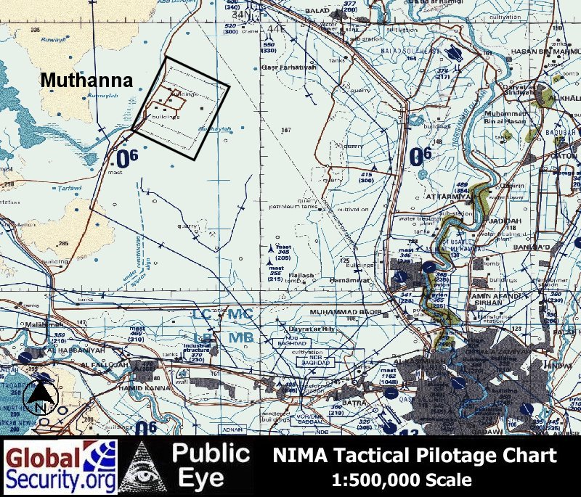
The complex, located just 72 kilometres northwest of Baghdad, began producing mustard gas and other nerve agents, including Sarin, in the early 1980s soon after Hussein took power, according to a CIA factsheet.
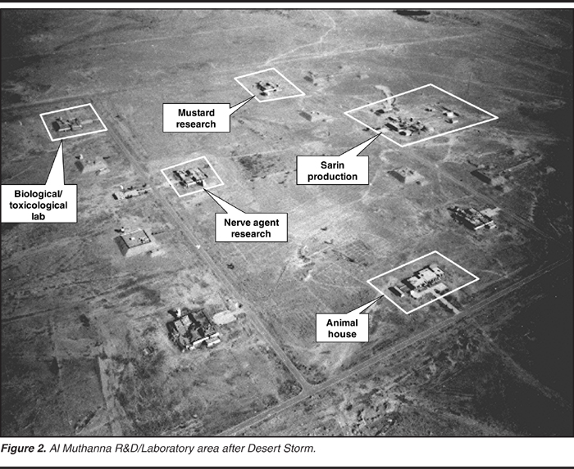
The program expanded to its height during the Iran-Iraq war later that decade, and produced 209 and 394 tons of Sarin in 1987 and 1988 respectively.
But the CIA writes that the facility shut down after the first Gulf war, when UN resolutions "proscribed Iraq's ability to produce chemical weapons."
In the early 1990s, the site was used to oversee efforts to destroy Iraq's chemical weapons stockpile.
Psaki said "We remain concerned about the seizure of any military site by the ISIS."
However, she said, "we do not believe that the complex contains [chemical weapons] materials of military value and it would be very difficult, if not impossible to safely move the materials."

CBRN Treatment Guide for Militia CBRN Response Units
Source: http://uscrow.org/2013/04/02/cbrn-treatment-guide-for-militia-cbrn-response-units/
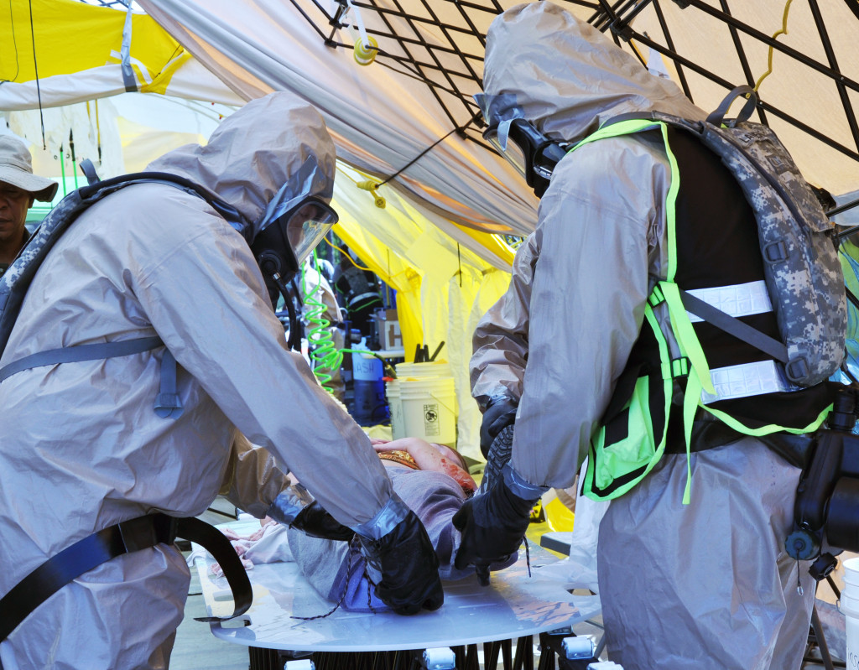
CBRN Treatment requires the members of your survival group or militia to be properly trained in basic medical skills to advanced medical skills like CBRN treatment. This guide will describe SOP for CBRN medical personnel in the event of post-attack contamination requiring medical treatment. When evacuating contaminated victims’ psychological stress reactions will cause erratic behavior. Casualty care issues should be addressed at all times.

CBRN Response Unit Responsibilities
When operating within a medical capacity to CBRN response, your unit will be asked to be mentally prepared to carry out your responsibilities in a moral and ethical fashion, while addressing the prevention of further contamination among personnel. CBRN response units should be trained in the following standards;
- MOPP (Mission Oriented Protective Posture) Training Standards – Click to view MOPP Standards
- Coordinate and monitor NBC defense training. Ensure the integration of NBC defense training in all aspects of training.
- Assist in establishing and receiving unit-level mission-essential task list. Provide guidelines to ensure tasks can be performed under NBC conditions.
- Evaluate individual and collective NBC training. Determine training needs and recommend training required to correct deficiencies.
- Project NBC training ammunition requirements, based on current threat conditions and operational data.
- Instruct all personnel on basic decontamination procedures.
- Assign medically trained personnel key treatment roles and training parameters.
CBRN Medical Response Unit Guidelines
Medical response units will be tasked with the supervision of patient decontamination, while supporting units will be required to assist in decontamination and perform lifting and washing. Non-medical personnel should be included in the CBRN treatment planning parameters when mass casualties are expected as a part of the decontamination effort. The standard for CBRN MRUs unit structure require a minimum of fifteen operators that include, medical personnel, decontamination personnel, containment personnel, assisting personnel to handle likely CBRN incidents. As a patriot group, or militia, common armed forces standards for CBRN troop size are unrealistic. This calls for several more operators.
The role of CBRN response units composed of civilian/militia personnel should be clearly defined per incident by unit commanders, unit commanders must outline a clear decontamination strategy and response plan before committing personnel to the incident.
CBRN response units are equally susceptible to contamination; this requires individual responsibility. CBRN personnel must take immediate steps to prevent themselves from becoming a casualty to include but are not limited to;
- Skin decontamination should be immediately performed by contaminated personnel and/or assisting medical personnel.
- Assisting personnel known as ‘buddy-aid’ consists of emergency actions to maintain vital body functions in a casualty who cannot self-administer. These responsibilities include; decontaminating casualty, immediately don uncontaminated/decontaminated personal protective equipment to prevent further absorption through the skin, and evacuating casualties as soon as possible.
  - Full wipe downs within 10 minutes should be performed to remove contaminated materials. Use RADIAC on all surfaces. In addition, responders can utilize CDS (Civil Defense Simultest Sets) that will detect alcohol, methanol, aliphatic hydrocarbons, n-hexane, armoatics, touene, chlorinated hydrocarbons, perchloroethylene, ketones, acetone, and hydrochloric acid in as little as 5 minutes.
  - There is no such thing as ‘too much caution’ during CBRN incidents. Contaminated units must establish the following principles;
    - DED – Detailed Equipment Decontamination
    - DAD – Detailed Aircraft Decontamination (including civilian operated aircrafts)
    - DTD – Detailed Troop Decontamination (i.e. personnel)
    - Personnel should be prepared and sufficiently trained in self-treatments.
CBRN Medical Response Unit Assisting Personnel
CBRN medical support should be trained in; decontamination standard procedures, knowledge of operation specific equipment, basic patient treatment and evacuation standards, containment and defensive protocols. When CBRN incidents require extended durations, assisting personnel can assist in the development of sleep rotation planning. However, post SHTF CBRN attacks will not likely accommodate for extended stays, meaning operations should be completed within 24 hours to prevent further casualties.

CBRN Medical Personnel Triage Guidelines
Triage guidelines for civilian operators and militia members differ from military standards, primarily due to the lack of equipment available to civilians. Military personnel operating in the capacity of a militia are more likely to be better equipped to acquire the required items and applying triage guidelines.
The CBRN START protocol means simple triage and rapid treatment. The START protocol is SOP for providing primary triage efforts in a CBRN incident. The method employs the use tagging patients by medical personnel in the following method;
- Immediate (critical) [Red Tag] ventilation present after positioning the airway or ventilation are over 30 per minute or capillary refill greater than 2 seconds or no radial pulse or cannot follow simple command.
- Delayed (urgent) [Yellow Tag] Any patient not in the immediate or minor categories. These patients are generally non-ambulatory.
- Minor (ambulatory) [Green Tag] Any patient requiring medical attention who is not immediate or delayed and who is able to walk.
- Deceased (expired) [Black Tag] No ventilation present after the airway is opened.

CBRN response unit personnel are not required to follow the START protocol during secondary and subsequent triage. Knowledge of the medical consequences of various injuries (e.g., burn, blast, or crush injuries or exposure to chemical, biological, or nuclear weapons) is critical when considering the following triage guidelines.
- Immediate Treatment – to include those requiring immediate life or limb saving surgery, while ensuring treatment is not time-consuming and those treated have a high chance for survival.
- Delayed Treatment – Those in need of time-consuming surgery and/or resuscitation but whose general condition permits a delay in treatment. Such examples would include major bone fracture, uncomplicated major burns, and respirator effects of CBRN agents. When treating delayed treatment patients antibiotics should be administered, in addition to; catheterizations, gastric decompressions, administration of intravenous fluids, splinting, pain relief and respiratory/pharmalogical support of CBRN effects.
- Minimal Treatment – Relatively minor injuries such as minor lacerations, abrasions, fractures and non-incapacitating effects of CBRN agents.
- Expectant Treatment – represents casualties who’ve received multiple serious injuries and whose treatment would be time-consuming with a low chance of survival. Such patients would include those patients exhibiting severe burns, severe and multiple effects of CBRN agents described in the usCrow Introduction into CBRNE, and intractable CNS (central nervous system) respiratory effects of CBRN agents.
- For more information on triage in a CBRN environment, refer to Emergency War Surgery and The Textbook of Military Medicine, Medical Aspects of Chemical and Biological Warfare.
- In CBRN mass casualty incident, the site should be divided into zones/sectors and, in addition to the appointment of an overall triage officer, triage officers should be appointed for eachidentified zone. Field medical triage must be conducted at three levels; on-site triage, medical triage, evacuation triage.

CBRN assisting Personnel basic medical Treatment Guidelines
Site and personal safety is of paramount concern for the responder. Site Safety “standard practices” shall include baring entry into the Hot Zone without proper precautions, proper protective clothing based on the risk, and knowledge and permission of the Incident Commander. Treatment can begin when it is safe to do so this would include but not limited to Basic Life support procedures. Patients should be evaluated for contamination and decontaminated accordingly. Assisting personnel should follow standard CBRN medical response guidelines when treating expectant casualties;
- Secure Airway
- Avoid body fluids and protect against secondary contamination
- Avoid further contamination due to burping or emesis
- Supplement oxygen while recording vitals
- Obtain patient history
- Report findings to CBRN response unit medical personnel

CBRN Radiological Treatment Guidelines
RDDs (radiological dispersion devices), also known as dirty bombs can cause mass casualties from extreme heat, explosion, debris, and radiological dust. RDDs consist of radioactive material attached to improvised munitions and explosive devices. Fatalities and future radiation levels should be assessed after detonation.
The RTR system (radiation specific triage, treatment and transport sites) is a role assumed by medical response unit assisting personnel, characterizing the organized and efficient deployment of material and personnel assets. The RTR system is not a triage system for each patient but for overall mission effectiveness while preserving personnel safety. RTR sites should be determined by mission commanders accommodating for such environment, residual, and infrastructure factors.

CBRN Enemy Combatants and Threats to Personnel
Certain casualties and patients who pose a risk to other casualties and personnel are to be retained and segregated. Typically EPWs (enemy prisoners of war) i.e. detainees are treated identically to non-combatants personnel. However, civilian CBRN operations may not permit such operations risks. Commanders of CBRN units should ascertain operational security procedures for the intake and/or elimination of enemy combatants organically throughout the mission, weighing the advantages and disadvantages of the situation.

CBRN Mass Casualties
The expectation of mass casualties should be developed at an early stage in training to prevent medical personal from suffering traumatic disorders (everyone is different). In the event of mass casualty due to a bio-terrorist attack they are likely to exceed local capabilities, this is a fact.
CBRN mass casualty incidents are often brought down to saving limbs and lives with a martial minded triage effort. CBRN victims should be completely decontaminated before providing medical treatment to contaminated victims and performed in cold zones (uncontaminated area).
This CBRN guide is to be used in conjunction with the following downloadable PDF guides issued by various HazMat/CBRN Organizations:
- HAZMAT Medical Protocols Part I
- HAZMAT Medical Protocol Second Edition
- The International CBRN Training Curriculum

SCENARIO: Chemical (Sarin Release)
Source: http://www.orau.gov/cdcynergy/erc/content/activeinformation/scenario-1_content_print.htm

This scenario takes place at a glass-enclosed entertainment and shopping center with over 350 retail stores in the heart of uptown Houston, Texas. The upscale promenade shopping area also contains an ice-skating rink, two hotel towers, and four office towers. More than 6,000 workers are currently employed in the office towers alone. Restaurants line the first floor of the promenade area, with outdoor cafes lining one whole section. At lunchtime, over 20,000 customers and employees frequent the area.
In this scenario, a terrorist group has obtained eight gallons of Sarin nerve agent and puts this liquid nerve agent into four two-gallon pressurized metal containers with aerosol release valves. The mall ventilation system carries the agent throughout the mall and to surrounding parking lots where it will not survive for very long. The release has the potential to affect everyone within the mall and a large number of people in the surrounding area.
The effects of an aerosol Sarin release are instantaneous. They include blurred vision, breathing difficulty, gastrointestinal distress (after severe exposure), skeletal muscle paralysis, seizures, loss of consciousness, and death. Persons exposed to very small amounts of the nerve agent show limited symptoms, and they can be successfully treated if the symptoms are noted in time and the proper antidotes (especially atropine) are available. One should expect, however, countless individuals exhibiting symptoms based on stress and hysteria, rather than actual exposure.
The four Sarin containers are placed inside open-top trash cans inside the mall. The containers are simultaneously released during the height of the lunch hour when the mall experiences its peak daily occupancy. The terrorists placed the containers in the outer perimeter hallways of the first floor of the mall, effectively blocking ground-level entrances. The release disperses the Sarin contained in each container into the atmosphere, directly contaminating many people.
In this scenario, it should be apparent that a nerve agent is involved. However, responders cannot identify the type of agent released. The medics responding to the scene have Occupational Safety and Health Administration (OSHA) training and should recognize some of the symptoms. If not, the sequence of events and the massive number of casualties should indicate that a gaseous release occurred.
Vehicular access to the mall is complicated by the fact that the release spawns general panic leading to spontaneous evacuation of the surrounding area. Unaware of the presence of gas upon arrival, many of the first responders are exposed to the Sarin.

Ask Yourself:
- Although the situation is just now unfolding and most likely you would not even be aware of it at this point, do you have a plan that addresses your organization's role, lines of responsibility, and resources needed in the event of a crisis or emergency?
- How does your organization prepare (in advance) its communication team to respond quickly to crises and emergencies?

STEP 1 – Verify situation
Houston, Texas - Thursday, October 24. The weather forecast predicts a warm, calm, overcast day. At midday, the temperature is 78° Fahrenheit.
At 12:15 p.m., the mall is filled with lunch-hour shoppers and the surrounding parking areas are congested.
At 12:30 p.m., a 911 dispatcher receives a call from the mall security manager. He reports that hundreds of customers inside the mall are gasping for air and convulsing. Hundreds more are collapsing. He is evacuating the mall and needs help. First responders are immediately dispatched to the scene. Within minutes, other callers report seeing people collapsed outside the mall.

Ask Yourself:
- What are your priorities at this point?
- What sources could be contacted to verify the situation?
- What subject-matter experts do you have on hand, or can contact, for clarification?
- If the event described in this scenario happened in your community, how would you verify it? List the verification steps you would take.

STEP 2 – Conduct notifications
After dispatching emergency units to the site, the 911 center notifies the municipal switchboard. Reports of casualties at the mall follow. Fire and police squads and Medical Emergency Units arrive on site and initiate emergency response operations. The mayor is notified that a crisis of potentially major proportions is unfolding

Ask Yourself:
- What are your priorities at this point?
- What other organizations, if any, besides those noted here should be notified of this event?
- What are the internal and external communications requirements for this response?
- If the event described in this scenario happened in your community, how would you verify it? List the verification steps you would take

STEP 3 – Assess level of crisis
Major highways and access roads are congested with traffic and scattered traffic accidents caused by individuals fleeing the mall.
People inside the mall and in the parking lots near the building exits and vents appear to have been exposed to an unidentified substance and are convulsing and asphyxiating. Some are shaking uncontrollably and sweating profusely. Many appear dead and others who are severely incapacitated require immediate medical assistance. Victims are transported to area hospitals.
Many first responders at the response site exhibit similar symptoms and need immediate medical attention. Residential areas in the surrounding areas appear unaffected.
At 1:45 p.m., the State Emergency Operations Center (EOC) in Austin is activated. At 2:15 p.m., a representative from the local television station contacts city officials to report that an unidentified caller claims to have released a nerve agent at the mall this afternoon as part of a coordinated terrorist attack against the United States. The caller makes it clear this is the first of other planned releases. The television station goes live with the story moments later.
By 3:30 p.m., the emergency rooms at two local hospitals report that some of their personnel exhibit the same symptoms as patients from the mall. One of the hospitals reports that its emergency room is operating at full capacity, it has activated its mass casualty disaster plan, and it is unable to care for additional victims. Designated trauma centers request technical information regarding the agent used in the terrorist attack. Another local hospital reports that tissue and blood samples from several of the victims were packaged as extreme biohazards. The samples were sent to the University of Texas Health Science Center in Houston by special courier.
National television broadcasts, linking with local affiliates, show live pictures of the incapacitated and the dead being removed from the mall. Reporters request information regarding the city's response to and preparedness for this type of incident. A major cable news network requests an interview with a representative from the city.
Residents within two miles of the affected mall spontaneously evacuate their homes, frightened by the images on television. Traffic bottlenecks form on all major city transportation arteries, including Interstate 610, further complicating response activities. The combination of spontaneous evacuees and above-normal traffic result in virtual grid lock throughout the area.
At 4:30 p.m., both the George Bush Intercontinental and William Hobby Airports are shut down by the Director of Aviation following the imposition of a widespread "no-fly" area over the city by the Federal Aviation Administration (FAA). The airport will remain closed until further notice.
A preliminary situation report indicates that 400 people are dead and the unidentified hazardous material affected 2,000 at the mall and surrounding area. Residents in the vicinity request directions to shelters as they evacuate. There is mounting concern and fear over the potential for additional chemical agent releases in other areas of the country. Media reports include rumors of widespread panic.
Hospitals in the area report increasing cases of medical personnel exhibiting symptoms of exposure. Medical teams are unsuccessful in identifying a chemical nerve agent, though they are certain that symptoms are caused by organophosphate poisoning. Due to symptoms manifested by its medical personnel, one local hospital closes its ER and discourages people from coming to its facility. Another local hospital director calls the city requesting assistance in evacuating unexposed hospital patients to another medical facility.
Area morgues are overwhelmed. Requests are made for additional resources to manage the number of bodies removed from the incident locations. The Houston EOC requests chemical decontamination assistance from the State and FEMA. Concerned relatives call, desperate for information regarding the fate of their loved ones, and cause the local telephone exchange to overload and fail.
The laboratory at the local university's Health Science Center calls the Texas Emergency Management Agency (EMA) and the city identifying the chemical agent as Sarin, the same substance used by Japanese cult members in their attack on the Tokyo subway.
The number of bodies collected overwhelms the city and surrounding morgues. Shelters are activated and provide emergency services to evacuees and displaced people. Hospitals report a noticeable drop in the number of additional victims arriving at these facilities; however, hysterical patients and asymptomatic victims continue to arrive. Mutual aid from across the country continues, increasing the need for coordination of resource allocation. National FEMA and FBI representatives are on the scene.
Concerned residents overload the phone emergency switchboard with requests for information regarding the whereabouts of family members. Media representatives transmit live interviews from Houston. Residents are reluctant to return to their homes in spite of assurances that designated areas are safe for re-entry. National attention is focused on Houston. The incident sends shock waves through the country. People nationwide avoid public places.
Local business people raise the specter of an economic slowdown because of concerns that their inability to resume normal operations will have a negative impact on their business activity, especially in light of the generalized searches being conducted.

Ask Yourself:
- What are your priorities at this point?
- Based on the information given, what is the level of crisis for this event?
- What hours of operation/schedule would you put the communication team on for this event?
- What resources and other tools are needed to ensure an effective communication response?
- Based on the information presented, what staffing levels do you foresee your organization contributing to the response effort? What problems do you anticipate?
- If the event described in this scenario happened in your community, how would you verify it? List the verification steps you would take.

STEP 4 – Organize and give assignments
Responders continue to assess protective measures. "Hot spots" are identified inside the mall's ventilation system and other confined spaces. Responders evaluate containment and decontamination strategies at these hot spots and ask if "forced ventilation" is an option. Evacuation of selected areas continues. Other public protective measures are evaluated. Hazardous Materials Team ( HAZMAT) responders debate declaring up-wind areas around the release sites safe for re-entry and they believe vapor or inhalation risk is a threat only in a limited area. Designated shelter locations request food, medicine, and dwelling resources and information on containment actions to prevent the spread of the chemical agent contamination to clean areas.
A FEMA Region VI representative requests that the Texas EMA identify potential locations for the Disaster Field Office (DFO). The DFO coordinates the overall response in accordance with the Federal Response Plan (FRP). The Texas EMA coordinates with the Houston EOC to determine the best sites for DFO establishment. An Emergency Response Team-Advanced (ERT-A) is on its way from the FEMA headquarters in Washington, D.C.
A FBI terrorism team is dispatched to Houston to direct crisis management operations. The team director is scheduled to meet with the Houston EOC and the Texas EMA directors upon arrival. The area FBI representative arrives onsite and takes control of the investigation. FBI officials suspect a terrorist group may be responsible for the incident in Houston.
The FBI directs that general, deliberate bomb searches be conducted for all major public gathering places. While there have been no further calls from the terrorist organization, the FBI remembers the statement that the attack "is the first part of a coordinated terrorist attack against the United States" and takes it seriously.
Planning for site decontamination, remediation, and clean-up is initiated. Coordination of response efforts over the next 48 hours continues. Medical surveillance of response team members and the population at large, the decision to authorize population re-entry, public security issues, long-term medical support services, and implementation of recovery plans are all open for discussion

Ask Yourself:
- What are your priorities at this point?
- What immediate public relations and media concerns must be anticipated? How will these concerns be addressed? Who will serve as your organization's spokesperson in this incident?
- What portion(s) of your communications response team would you activate at this point?
- Would your functional team(s) know their roles and immediate tasks? To whom would they report and take direction?
- How will your organization's actions be coordinated with the actions of other agencies? What conflicts could arise from the need to simultaneously conduct extensive criminal investigation and response functions? What conflicts may be anticipated between the overlapping federal/State/local jurisdictions?
- If the event described in this scenario happened in your community, how would you verify it? List the verification steps you would take.

STEP 5 – Prepare information and obtain approvals
At 5 p.m., the governor declares a state of emergency and formally requests a Presidential declaration of a major disaster. Pending the President's decision on whether or not to declare a disaster, the governor asks for Section 403(C) of the Stafford Act. The White House is briefed on the incident. Federal officials are notified and agency regional representatives are directed to Galveston, Texas.
The two Houston airports will re-open in the morning, but many scheduled flights into the area during the next few days are cancelled. It is anticipated that the mall and the immediate vicinity will remain closed until it is declared safe for public use (at least one week).

Ask Yourself:
- What are your priorities at this point?
- With federal, state and local agencies involved, how will media inquiries be handled?
- What, if any, are the critical health communication messages that need to be released to the public?
- How would you develop these messages and get them cleared efficiently?
- Who in your organization is responsible for authoring media releases?
- What audience(s) group(s) would you target and what concerns would you address?
- How would your organization display empathy and caring to the public about this event?
- What questions would you anticipate the media to ask about this event?
- If the event described in this scenario happened in your community, how would you verify it? List the verification steps you would take.

STEP 6 – Release information to the public
At 8 p.m., media groups interview emergency response experts. Some theorize that the level of sophistication in the attack is an indication of international assistance.
At 10 p.m., the President issues a major disaster declaration granting the FEMA authority to provide emergency response support to Houston and to conduct consequence management activities. The President, in a special statement carried on all networks, condemns the vile act of terrorism and vows to punish the culprits. The DFO, with its additional Federal resources, will not be fully operational for another 24 hours.

Ask Yourself:
- What are your priorities at this point?
- What types of training does your organization need to more effectively manage the communications response to situations of this type?
- List the policies and procedures included in the Emergency Operations Plan (EOP), standard operating procedures (SOP), and checklists that you think should be further reviewed, supplemented, or developed for your organization to handle the communication response to an event similar to this. Which are priorities?
- In what ways would your organization monitor an event such as this after the initial release of information?
- How would your organization determine when it would be appropriate to move into the "post-event" phase for an event similar to this?
- If the event described in this scenario happened in your community, how would you verify it? List the verification steps you would take

UW-Madison scientist creates new flu virus in lab
Source: http://host.madison.com/news/local/health_med_fit/uw-madison-scientist-creates-new-flu-virus-in-lab/article_4cedeb40-efdc-5d2e-a02d-ffb301a84b53.html

Yoshihiro Kawaoka, the UW-Madison scientist whose bird flu research sparked international controversy and a moratorium two years ago, has created another potentially deadly flu virus in his lab at University Research Park.
Kawaoka used genes from several bird flu viruses to construct a virus similar to the 1918 pandemic flu virus that killed up to 50 million people worldwide. He tweaked the new virus so it spread efficiently in ferrets, an animal model for human flu.
Dissension over such work continues. Harvard and Yale researchers criticized such studies last month, saying the viruses could escape from labs and spread disease. Safer approaches could be more effective, they said.
Kawaoka, who reports on his new work Wednesday in the journal Cell Host and Microbe, said his research helps efforts to identify problematic viruses and develop drugs and vaccines against them.
“The work we do provides scientific data so there can be an informed risk assessment of viruses circulating in nature,” he said in an email. “The more we learn, the better prepared we will be for the next pandemic.”
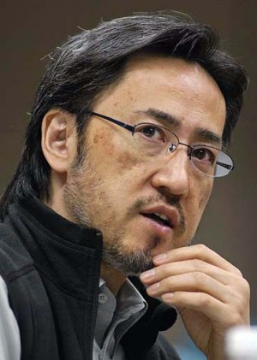
His previous creation of an altered H5N1 bird flu virus, along with similar H5N1 work by Dutch researcher Ron Fouchier, prompted a year-long moratorium on the projects in 2012 and months of delay before the results were allowed to be published.
Some scientists said the viruses might not only be accidentally released from the labs but potentially replicated by terrorists.
The moratorium ended last year. Kawaoka said he resumed his H5N1 research this May, after approval by federal officials.
The research on the 1918-like virus was done during the moratorium, which covered only the altered H5N1 virus work, Kawaoka said. UW-Madison approved the 1918-like virus research, and the National Institutes of Health reviewed the new report on the findings, university officials said.
Both projects were carried out at UW-Madison’s Institute for Influenza Virus Research at University Research Park on Madison’s West Side. The lab is classified as Biosafety Level 3-Agriculture, the highest biosafety level at the university and half a notch below the top level anywhere of BSL4.
In the new research, Kawaoka and his colleagues searched public databases of information on various flu viruses isolated from wild birds from 1990 to 2011. The researchers identified eight genes nearly identical to the genes that made up the 1918 pandemic flu virus.
Using that information, they created a virus that differed from the 1918 virus by only 3 percent of the amino acids that make virus proteins. That virus was more pathogenic in mice and ferrets than regular bird flu viruses, but it wasn’t as harmful as the 1918 virus and didn’t spread among ferrets.
They made various substitutions to the virus and found that just seven mutations enabled it to spread among ferrets as efficiently as the 1918 virus. The new virus didn’t kill the ferrets, however, Kawaoka said.
“These viruses could evolve in nature and pose a risk to humans,” he said. “In a sense, it demonstrates that influenza viruses that don’t normally arouse alarm should be monitored.”
Marc Lipsitch, an epidemiologist at Harvard University, and Alison Galvani, an epidemiologist at Yale University, said in a paper in PLOS Medicine last month that such experiments pose “a significant risk to public health, arguably the highest level of risk posed by any biomedical research.”
If 10 labs did such bird flu experiments for a decade, with similar precautions, there would be a 20 percent chance of a lab-acquired infection, which would have a 10 percent chance of spreading widely to others, they said.
Flu studies using lab dishes, computer analysis, virus components or seasonal flu viruses would be safer and “more scientifically informative and more straightforward to translate into improved public health,” Lipsitch and Galvani wrote.
Kawaoka said potential pandemic viruses replicate quickly and act differently than seasonal flu, so relying on lab dishes and seasonal flu strains “can be highly misleading and, in fact, can be harmful.”
The work he and Fouchier did on the altered H5N1 flu virus helped authorities realize they need to keep stockpiling H5N1 vaccines, he said.
“Thus, human populations have already benefitted from the H5N1 ferret transmission experiments,” Kawaoka said.

Anatomical Pathologist Reveals Actual Cause of Mad Cow Disease
Source: http://insurancenewsnet.com/oarticle/2014/06/11/anatomical-pathologist-reveals-actual-cause-of-mad-cow-disease-a-516402.html#.U5nmCEBpfgI

What is scarier than disease? Mass cover-up of the cause.
Dr. William Croft has successfully identified illness utilizing anatomic pathology for over 38 years, including diagnosing toxic mold, arsenic, petroleum, asbestos, and Chronic Wasting Disease in humans.
Croft's latest discovery involves serious controversy: Man-made prions were used in the 1980s as a disguised disease to explain mad cow disease, chronic wasting disease and other ailments and deaths, which were actually caused by pesticide poisoning.
Croft's research and discoveries about this bioterrorism conspiracy and insurance company cover up are found in his new thrilling story, Operation Synapse, a well-documented book that lifts the veil that has been covering the public's eyes since the late 1980s.
"This was a great fraud placed on the people of the world; pharmaceutical and insurance companies side stepped their responsibilities due to greed," Croft says. "The public will be very interested in how these institutions have broken the common trust."
Determined to inform the United States and other countries around the world that pesticides are the actual cause of mad cow disease and chronic wasting disease, Operation Synapse is an eye-opening story about a major conspiracy that has been taking place for the past 27 years.

William Croft earned a bachelor's degree in physiology from the University of Wisconsin and a doctorate in veterinary medicine from the University of Minnesota. He later earned a Ph.D. in medical pathology from the University of Wisconsin, which gave him the tools to study the cause and effect relationship of human and animal illnesses. Employed as an anatomical pathologist on the UW-Madison faculty he obtained over $900,000 in grant resources to study human disease regarding early detection, diagnosis, mechanism of action, and possible therapeutic methods. Croft also investigated environmental medical health emergencies related to pesticides, solvents, petroleum, heavy metals, phenol, asbestos and toxic mold found in sick buildings. The opportunity to study Chronic Wasting disease in the whitetail deer population in Montana revealed the poisoning that had been hidden for over 27 years. Croft shares this exciting and important discovery in his new fiction based on well-documented fact, "Operation Synapse."

Ebola outbreak highlights need for global surveillance strategies
Source: http://www.homelandsecuritynewswire.com/dr20140418-ebola-outbreak-highlights-need-for-global-surveillance-strategies

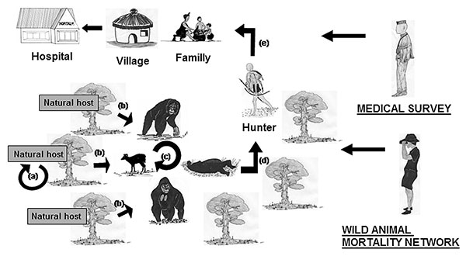
According to the World Health Organization (WHO), the deadly Ebola virus can cause mortality rates up to 90 percent of those individuals who contract the disease. No cure or vaccine exists for Ebola hemorrhagic fever and public health officials are concerned about further spread of the virus in the region. A comprehensive review was published yesterday examining the current state of knowledge of the deadly Ebola and Marburg virus. The review calls for improved global surveillance strategies to combat the emergence of infectious diseases such as the recent outbreak of Ebola in West Africa that has claimed the lives of 122 people in the countries of Guinea and Liberia.
EcoHealth Alliance, a nonprofit organization that focuses on conservation and global public health issues, published a comprehensive review yesterday examining the current state of knowledge of the deadly Ebola and Marburg virus. The review calls for improved global surveillance strategies to combat the emergence of infectious diseases such as the recent outbreak of Ebola in West Africa that has claimed the lives of 122 people in the countries of Guinea and Liberia. According to the World Health Organization (WHO), the deadly Ebola virus can cause mortality rates up to 90 percent of those individuals who contract the disease. No cure or vaccine exists for Ebola hemorrhagic fever and public health officials are concerned about further spread of the virus in the region.
An EcoHealth Alliance release reports that the virus is transmitted from person to person through contact with infected blood or bodily fluids, but the origin of each outbreak is ultimately linked to wildlife. The consumption of bushmeat in Guinea may possibly serve as the transmission point from wildlife to human populations for the disease. Guinea has forbidden the sale and consumption of bats, which serve as natural reservoirs of the virus, and warned against eating rats and monkeys in its effort to keep the illness from spreading.
Since the late 1970s, Ebola outbreaks have sporadically erupted in various parts of Africa, and experts report this is the worst outbreak in the past seven years. Historically, Ebola outbreaks have been contained through quarantine and public health measures, but where and when the next outbreak will emerge still remains a mystery. “Our scientists have developed a strategy to predict where the next new viruses from wildlife will emerge and affect people. These zoonotic viruses cause significant loss in life, create panic and disrupt the economics of an entire region,” said Dr. Peter Daszak, Disease Ecologist and President of EcoHealth Alliance. “Our research shows that focusing surveillance on viruses in bats, rodents and non-human primates (a “SMART surveillance approach), and understanding what’s disrupting these species’ ecology is the best strategy to predict and prevent local outbreaks and pandemic disease,” Daszak continued.
The study, published by EcoHealth Alliance’s Dr. Kevin Olival and Dr. David Hayman from Massey University, reviewed all of the current literature on filoviruses — the class of viruses that include both Ebola and Marburg virus — and took a critical look at the ecological and virological methods needed to understand these viruses to protect human health. As part of the study, EcoHealth Alliance’s modeling team mapped the geographic distribution of all known bat hosts for these viruses, and found that Guinea and Liberia lie within the expected range of Zaire Ebola — the strain responsible for the current outbreak. The team highlighted the need for more unified and improved global surveillance strategies to monitor outbreak events around the globe in wildlife. “We are in the beginning stages of developing early warning systems to identify disease “spillover” events from wildlife to humans before they occur, but much work remains to be done. It’s an exciting time where ecology, disease surveillance, mathematical modeling, and policy are all critically converging towards the goal of pandemic prevention,” said Dr. Kevin Olival, Senior Research Scientist at EcoHealth Alliance. “Our work on bat ecology is specifically important since we know that they are reservoirs for a number of viruses, including Ebola and Marburg. Bat species are critical to the health of ecosystems and disease studies must be conducted with conservation as a integral component,” he continued.
The release notes that it is estimated that fifteen million people die from infectious disease each year with more than half of those afflicted being children. For that reason, EcoHealth Alliance’s research to find the reservoirs of potentially deadly diseases in wildlife and its research to discover how disease spillovers occur make it crucially important conservation-focused work.

Read more at: http://www.mdpi.com/1999-4915/6/4/1759

— Read more in Kevin J. Olival and David T. S. Hayman, “Filoviruses in Bats: Current Knowledge and Future Directions,” Viruses 6, no. 4 (17 April 2014)

Bioterrorism as a voter fraud mechanism
Source: http://www.homelandsecuritynewswire.com/dr20140612-bioterrorism-as-a-voter-fraud-mechanism

Claims of voter fraud, especially on a large scale, are typically more the stuff of urban legend than factual findings, but individual anecdotes do exist. One example is the case of Nevada Republican Roxanne Rubin, who tried to vote twice in the 2012 presidential election but was arrested just minutes after her second attempt, but it can be argued that this is a testament to the reliability of voter fraud prevention measures put in place by municipalities across the country. Rubin later explained that her attempt to vote twice was an experiment to test the voting system.
There are more extreme cases proving the reliability of voter fraud prevention measures. One such instance occurred in the early 1980s, when a guru named Bhagwan Shree Rajneesh and his hundreds of followers, called Rajneeshees, relocated from India to a 64,000-acre ranch in Wasco County, Oregon, a rural area of roughly 21,000 people at the time. Rajneesh’s plan to build more houses on the ranch to accommodate his followers was met with disapproval from county officials, who held the construction permits. Residents of Wasco County shared concerns about the sect’s intentions and its growing power. In 1982, Rajneeshees voted in nearby Antelope’s (population: 50) local elections to win a majority of the town’s council seats, then renamed the town to “Rajneesh,” raised property taxes to extract funds from local residents, and then renamed the local recycling center the “Adolf Hitler Recycling Center.”
Though the Rajneeshees continued to gain legislative power, they accounted for less than 10 percent of the county’s population, and so were unable to convince the Wasco County Commission to issue construction permits. To unseat at least two of the three sitting county commissioners in the upcoming election, the Rajneeshees decided to suppress non-Rajneeshees voters by poisoning thousands of residents with Salmonella prior to election day, and then recruit thousands of homeless people from nearby cities and offering them food and shelter if they voted for Rajneeshees-backed candidates.
The Atlantic reports that when two of the three county commissioners visited the Rajneeshees compound, both men got sick after drinking glasses of water infected with Salmonella, but became well following treatment at a local hospital. The commissioners blamed their illness on the Rajneeshees and continued to deny the group construction permits. To proceed with their plan, the Rajneeshees poured Salmonella-tainted liquid on food items in ten restaurants throughout the county, poisoning 751 people in what would become the largest bioterrorism attack in American history. No one was killed in the attack, so the Rajneeshees contemplated poisoning the county’s water supply and crashing a plane loaded with bombs into the county courthouse, but neither plan came to fruition.
Phase two of the Rajneeshees’s plan to win two commissioner seats by getting homeless individuals in their care to vote for Rajneeshees-backed candidates was made difficult when Oregon Secretary of State Norma Paulus required anyone registering to vote in the county to personally appear at a local eligibility hearing and prove that he or she satisfied Oregon’s twenty-day residency requirement to vote.
The Rajneeshees were left with few options, and after being charged for both the Salmonella poisoning and the homeless-voter vote fraud, Rajneesh was fined $400,000 and three of his deputies were sent to prison before being deported.
Attempts at voter fraud by individuals like Rubin or financially-backed groups like the Rajneeshees have proven over time to be difficult thanks to the voter fraud prevention measures put in place.

Risk Assessment Mission to Determine MERS Threat
Source: http://www.hstoday.us/single-article/risk-assessment-mission-to-determine-mers-threat/24a 5150ab11dd93637f94343cc819805.html

A team from the World Health Organization (WHO) and technical partners from the Global Outbreak Alert and Response Network (GOARN), a collaboration of existing institutions and networks who pool human and technical resources for the rapid identification, confirmation and response to outbreaks of international importance, concluded a five day mission in the United Arab Emirates (UAE) to assess the risk posed by the Middle East Respiratory Syndrome Coronavirus (MERS-CoV).
Health authorities in the UAE invited WHO to review the current situation after an upsurge in MERS- infections in April. The team consisted of six experts in coordination, epidemiology, infection prevention and control, food safety and the human-animal interface and risk communication.
MERS was first reported in Saudi Arabia in 2012. Most infected individuals with confirmed MERS infection develop severe acute respiratory illness with symptoms including fever, cough and shortness of breath. The fatality rate of those infected with MERS is 30 percent. Globally, as of June 4, 681 laboratory-confirmed cases of infection with MERS have officially been reported to WHO, including 204 deaths.
While MERS is predominantly found in countries in or close to the Arabian Peninsula, on May 2, the first US imported case of MERS was confirmed in a traveler from Saudi Arabia to the United States. On May 11, a second US case of MERS was confirmed in a traveler whose point of origin was also from Saudi Arabia. Experts believe the two US cases are not linked.
During the recent WHO and GOARN mission, the team had extensive meetings with experts from the Health Authority of Abu Dhabi, Dubai Health Authority and the Abu Dhabi Food Control Authority as well as the Minister of Health. The team visited the hospital to which two-thirds of the country’s cases can be traced in order to review the epidemiological investigation and assess the infection prevention and control measures that have already been applied. The WHO team evaluated the work done on investigating possible exposure routes, transmission patterns and the clinical situation.
The preliminary findings of WHO indicated the cases in UAE do not show evidence of sustained human to human infection. The recent upsurge of cases in Abu Dhabi appear to have been caused by a combination of factors, including a breach in infection prevention and control measures in health care settings, active surveillance and an increase in community acquired cases.
"We are impressed by the amount of data and information generated during the investigation of MERS cases by UAE to help better understand MERS- CoV,” said Peter Ben Embarek, WHO team leader. “This knowledge is of utmost importance to the rest of the world to better discover the source of the virus and the routes of transmissions from animals to humans.”
“The UAE health authorities have been following up diligently on the MERS-CoV cases, including repeated laboratory testing to check when cases have been cleared of the virus. This data will make an important contribution to the risk assessment and to guide the health response internationally," Embarek concluded.
WHO recommended UAE health authorities continue to investigate MERS, including the source of infection, and share new information as it becomes available. There is an ongoing need to share experiences and knowledge from all countries that have cases of MERS to better understand this emerging disease, including the role of animals in its spread.
WHO stressed the importance of participating in multi-country case control studies from both the human health and animal health perspective. There are opportunities for joint analysis of samples from infected camels and the infected humans around them. These studies will help understand the role of camels in the disease - particularly how human infection happens. This information will help inform people who are in close contact with camels to gain a realistic picture of the risk, and the level of precaution needed.

Bio-attack – how vulnerable are we? [2002 interview]
Source: http://www.wnd.com/2002/01/12482/

Editor’s Note: Dr. Ken Alibek, author of “Biohazard: The Chilling True Story of the Largest Covert Biological Weapons Program in the World – Told from the Inside by the Man Who Ran It,” defected to the United States in 1992 after leaving his job as a top scientist in the Soviet Union’s biological weapons program. In his book, Alibek describes putting anthrax on a warhead and targeting a city on the other side of the world. Alibek sat down with WorldNetDaily’s talk-radio host Geoff Metcalf for a chilling interview on the mechanics of and defense against biological weapons, as well as treatment options for victims.

Q: Dr. Alibek, at various times, the Soviet Union tried to deny their involvement in biological and chemical warfare. What was it that you actually did for the Soviets in the field of biological weapons?
A: It would be a long story, but to make a long story short, I would tell you the Soviet Union had a very huge, a very sophisticated, very powerful biological weapons program. It was established many years ago – in my opinion, in the late ’20s. It continued to the beginning of the ’90s, and nobody knows whether or not it continues. But this program was to research and develop very sophisticated biological weapons, including many bacterial weapons based on anthrax, plague and many other bacterial agents.
Q: It wasn’t just the things kids study in college, but you guys were actually creating, for lack of a better description, biological weapon cocktails.
A: The general idea was not just to create cocktails, but according to the Soviet Union’s military biological doctrine, in future wars the Soviet Union would be using many different biological weapons.
Q: Such as?
A: Including many viral weapons, bacterial weapons, fungi weapons. In this case, of course, we can talk about possible “cocktails,” if, for example, one large metropolitan area is attacked by several different biological weapons.
Q: In the wake of the Sept. 11 attack, the big follow-up flap was the anthrax scare. However, frankly, when you look at the numbers, it was almost insignificant. Are you familiar with the exercise we ran in June called “Dark Winter”?
A: I’ve heard about the exercise, but personally I didn’t take part.
Q: But you are familiar with the results from the after-action report?
A: Yes. I know something about it, because it was quite a discouraging report.
Q: One of the many depressing things is when you take a look at the anthrax flap and the actual people affected and fatalities, statistically – now I know that to the individuals involved it is tragic – but statistically, it is insignificant. But God forbid something like smallpox were to be introduced as a biological weapon; it would be catastrophic, wouldn’t it?
A: Yes, you are right. Smallpox is a completely different weapon. It is contagious. It requires a very low infectious dose. And if somebody deploys smallpox, we would see completely different consequences.
Q: There was an Australian guy, Dr. Ron Jackson, and he had a partner. They kind of accidentally created some kind of mousepox, didn’t they?
A: Yes. There was a study, and in my opinion, they did quite the wrong thing publishing this data.
Q: We have been told, and we still get told, you don’t have to worry about smallpox because the only people that have it are some lab samples in the U.S. and Russia. How significant is the threat of some kind of a smallpox biological weapon being released?
A: In my opinion, it is a very significant mistake when we believe that just Russia and the United States have this virus. A decision was made in the early ’80s that smallpox was eradicated. Then the decision was made just to have two repositories – one in the United States and one in the Soviet Union, now Russia. But at the same time, there was not any kind of obligatory requirement to destroy all national stocks. It was a recommendation. But there was no identification or notification process; nobody knows actually what countries or who else has a strain of the smallpox virus. In my opinion, there are some countries that have not destroyed this virus; in my opinion, we are quite na?ve believing nobody else but the United States and Russia have the virus.
Q: I don’t recall the details, but you may, about one specific incident. Gorbachev got in a diplomatic pickle at one point over biologicals. The U.S. held his feet to the fire, and Gorby instructed officials to basically hide a whole bunch of biological weapons on some island not too far from Afghanistan.
A: It was not smallpox; it was anthrax. But, generally, if we talk about the Gorbachev role in smallpox, it started when they came to Moscow in 1987. As the leader of this program, I saw a top secret decree signed by Gorbachev to intensify research and development work in the field of smallpox. He ordered the development of new types of smallpox biological weapons. He ordered the development of new strains, genetically engineered strains, of smallpox. It was the late ’80s, the beginning of the ’90s. To believe that everything was ended a long time ago, it would not be true.
Q: Gorbachev ordered subordinates to “get rid of this! Hide it!” So they took it and buried it on this island and then just left it there?
A: You know, you are absolutely right. There is an island, an island located in the Aral Sea …
Q: Yeah, that’s it!
A: The name of the island is Vozrozhdeniye. In English, I would translate it like “renaissance” island. Yes, in the late ’80s, a decision was made just to transfer all anthrax stocks from one of the major stockpiling facilities to Vozrozhdeniye Island. Now we know this island is quite contaminated with anthrax.
Q: Actually, before Sept. 11, I think there was some long-term plan to actually try to decontaminate the island. What I found shocking and amazing was that once the Soviets stuck that stuff on the island, they basically just buried it in a shallow grave and walked away.
A: Yes, you are right. They tried to decontaminate it, but when you deal with anthrax, it’s actually impossible to decontaminate the entire island.
Q: When you defected from the Soviet Union, your debriefing took a long time, didn’t it?
A: Yes. It took about one year.
Q: I recall the U.S. was surprised when you told us that the Russians were continuing to produce smallpox by the ton.
A: Yes. By the time I came, they were not producing smallpox by the ton, but this work was being done during the beginning of the ’80s, and they knew it.
Q: Ken, if the Soviets had that much, where is it?
A: With biological weapons, it’s a little bit easier than with chemical weapons, because it is very difficult to destroy chemical weapons. Biological weapons have been destroyed using some specific techniques. It’s not a very big problem.
Q: What do you do – throw a bottle of Clorox in it?
A: Not Clorox – high-temperature steam. For example, about 120 degrees Celsius. And you can kill the smallpox virus.
Q: You were involved in an accident with, what was it, Tularemia? Some plague like agent.
A: Yes, Tularemia, that’s right. It’s a plague-like disease, but it’s not contagious.
Q: But you were sloshing around in puddles of the stuff, right?
A: Yes. There was an accident.
Q: Recently, there was an Ebola outbreak. A lot of people are asking, if a biological weapon were to be used by some potential bad guy, they probably wouldn’t use anthrax, would they?
A: It is difficult to say. In many cases, it depends on the availability of one or another biological agents. We don’t consider this anthrax case “effective,” because there were just five deaths. And you’re right, it is a tragic event.
Q: But statistically, it is really insignificant.
A: Yes, but at the same time, what we need to pay attention to, in my opinion, is we remember how we felt in that time – October and November – the feeling of being scared, the feeling of anxiety. People were afraid to open letters. During that time, we suffered a huge economic damage from a very small amount of anthrax. In this case, what’s important for us to understand is it’s not just a matter of biological attack as a biological attack …
Q: But as a psychological attack.
A: It’s the psychological impact, the economic impact. Even two to five grams of anthrax could cause such significant damage, you can imagine what kind of problem we are going to have. In addition to anthrax, it is plague, it’s smallpox, it’s Ebola. Unfortunately, it has been developed already.
Q: The problem with this stuff is the symptoms. Our medical infrastructure is not prepared to diagnose cases of Ebola, anthrax, smallpox or whatever. If somebody comes in with flu-like symptoms, they are probably going to call it flu.
A: Yes. This is one of the biggest problems, and we know this. We have been discussing this issue many times, but even now we can say that our medical community is not fully prepared to just do defensive diagnosis between smallpox and flu, especially in the beginning of the infectious process.
Q: Why?
A: Because we see no signs of smallpox. We call them flu-like symptoms. Anthrax, smallpox, some other infectious disease could be misdiagnosed, and we can miss the real picture. And when we get to what is really going on, it could be quite late.
Q: The catch-22 is that when a microbe is inhaled, it doesn’t immediately shoot right to the bloodstream. It could take hours or days, right?
A: Yes. We call this the incubation period. The incubation period is the period when we don’t see any significant symptoms of infection. It is the period when the virus or bacterium is developing and accumulating in the body in the lymphatic system, the bloodstream. And then we see a second stage we call the prodromal stage, or some people call it a period of flu-like symptoms. It means after infection, we could have two to seven to 17 days of incubation period, depending on the pathogen. Then some period of three, four, five days of so-called flu-like symptoms period. In this case, you can imagine how many people would be already infected.
Q: You were raised in the Soviet Union and inculcated with all the Soviet propaganda. At what point did Ken Alibek have his epiphany and come to the conclusion that something is very, very wrong?
A: Nothing came within a couple of days. It was a long process of thinking, of analyzing what was going on in the Soviet Union in the field, what we knew about the United States’ activity. The final decision I made was when I came to the United States in 1991 to inspect the United States’ biological weapons facilities. When I found all those facilities abandoned, all the equipment rusted – and of course, no activity whatsoever – I decided it was enough. I quit the program. I left the army. I was, at the time, a colonel in the Russian Army. I decided to go back to my native motherland, because I am not native Russian. I’m from Kazakhstan, central Asia. I decided to go to Kazakhstan, and when I came there, I was offered the same work to help Kazakhstan do something in this field. Of course, it was too much, and I decided to escape. I came to the United States in 1992.
Q: You became a doctor in 1975. You spent all that time working in the bioweapons development and technology program. I can’t imagine the Soviets were all that anxious to lose a resource like you.
A: It’s a long story. Nobody would let me go away, and when they found out I decided to quit, it created all kinds of problems. All my phones were tapped, and there were a lot of talks with KGB officials, and some scary things were happening. But the decision was made.
Q: I dug up the testimony you had before Reps. Hunter and Weldon in their subcommittee. Probably one of the best instructive things you can do for our readers is to explain for them, as you did to Congress, what are biological weapons. Because one of the things you touched on were the things that could be developed that aren’t apparently around yet, like agents that could corrode equipment and so forth. So, what is a biological weapon?
A: It is a very interesting question, because not many people know about biological weapons. Biological weapons are weapons based on bacteria, viruses and various pathogens. Bacterial agents – for example we know anthrax, we know plague, we know tularemia – viral agents like smallpox, Ebola, Malberg and hemorrhagic fever viruses. But these viruses themselves are not weapons yet. In order to make weapons, they developed special technologies – techniques to manufacture agents in large amounts, large quantities. The process starts from a single vial, and then there are several stages of manufacture and using different nutrient media, different types of equipment. Then the process of concentration, the process of drying – meaning filling in specific bombs, warheads. And at this stage, it could be said a specific biological weapon is ready for use.
Q: Prior to that, would they attempt to manipulate or genetically alter the biological agent so that it is more resistant to, or impervious to any kind of vaccine?
A: You know, Geoff, there are different types of biological weapons. Some of them could be based on so-called natural strains. For example, this recent anthrax scare is a natural strain; it is not a genetically manipulated strain. But some sophisticated weapons could be based on genetically engineered strains. Some of them could be antibiotic-resistant biological weapons.
Q: You said in your congressional testimony that, theoretically, it is possible that new types of biological weapons could be produced to damage equipment by corrosion, degrade plastics that are used in computers and so forth, and even render fuels useless. Are they just “maybes” and “what ifs,” or has someone actually developed those things?
A: In the Soviet Union, there was some study about whether or not it was feasible to develop such weapons. It was known there are some microorganisms with the capability to destroy fuel, to destroy plastic and so on. In this case, you’re talking about the possibility and the feasibility, and it is possible. At the time I was working for the Soviet program, there was no actual weapon of such that was developed.
Q: What about delivery systems? Beyond the mail with the anthrax scare, I know most of these nasty bugs are delivered by mosquitoes or fleas you put it in the water supply, or somehow it is ingested. It is unlikely with a terrorist threat that some big bomber is going to come in and disseminate it that way. How do they deliver the biological weapon?
A: We need to divide two different deployment methods or techniques: military deployment and terror deployment. When we talk about military deployment, we can talk about special containers.
Q: Missiles?
A: No, just containers which have infected vectors like fleas, mosquitoes and so on. It is quite an old technique but one which can still be used even now by some countries. Then a more sophisticated delivery technique is missiles, aviation bombs with special bombletts that would contain dry or liquid types of biological weapons. It is a more sophisticated technique. There is a so-called diversion-type biological weapon that could be used for contamination of water sources or food sources. But the last one could be used by terrorist groups to contaminate water supplies and food supplies.
Q: What about the various water purification systems we have? Would it eradicate the normal type of biological weapon that might be introduced?
A: It depends on the type of purification system For example, if we talk about a large city with a very big, powerful water purification system, that would be a big problem for would-be terrorists. There is the dilutional issue, because to contaminate and infect the entire big reservoir, it would be very, very difficult because it would require a very huge amount of biological agent.
Q: I have also had occasion to talk with Stanislov Lunev. He was the GRU defector, and he was talking about nuclear suitcase bombs he claims were pre-deployed – already in the continental United States someplace waiting for some sleeper to activate. Was there ever the intent or a plan or policy under the bioweapons program of the Soviet Union to pre-place biologicals in the event someone wanted to deploy them at some later date?
A: Because I was working for strictly a military program, and it was intended to deploy biological weapons just in one case – in case of war and in using what I would say are regular delivery systems such as missiles, strategic bombers or medium range bombers – we didn’t develop anything such as you suggest. But I have no idea if something was developed by the KGB. It wasn’t our responsibility to develop this type of terrorist weapon.
Q: The stuff you were working on was pretty sophisticated, high-tech scientific stuff, and hopefully the prospect that that kind of stuff – and I don’t want to be Pollyanna-ish about this – but the prospect that these genetically manipulated agents might end up in the hands of a terrorist hopefully would be less likely than a nation-state. But what is the primary biological threat that Americans should be aware of that arguably our country doesn’t want to warn us about yet? Is it smallpox?
A: I wouldn’t say smallpox. Smallpox is a possible biological terrorism agent. I would include here anthrax, smallpox, plague, some other viral agents – Ebola, Marburg …
Q: What is Marburg infection?
A: Marburg infection is a close relative to Ebola. It is from the same family of viruses. It has effectively the same effects as the Ebola virus.
Q: Are there any natural pre-warning things? Are birds going to start falling out of the air or cattle dropping over to give us a heads-up that something bad is happening?
A: Unfortunately, we wouldn’t see anything like this. What we could see are some attempts to deploy biological agents in highly populated areas.
Q: So bad guys would target New York, L.A., Chicago, Detroit. …
A: Yes, unfortunately. Unfortunately, it could be New York, it could be Los Angeles, or Chicago or Washington, D.C. Because a major idea of terrorism – terrorism could be translated as “horror” – is just to scare people, to terrify people. That’s why they would try to use it at some locations where you can cause the highest damage, the highest disruption of vital activity.
Q: The Soviet Union and the United States were not the only ones playing with this stuff. Japan had a group working on biologicals, Osama bin Laden has wanted this stuff, Saddam Hussein has been seeking any and all kinds of weapons of mass destruction.
A: True.
Q: Fiction author Tom Clancy has a few scenarios – one in “Rainbow Six,” where he talks about Ebola being used as a biological weapon. How realistic is that?
A: Unfortunately, science moves very fast. Now we know that theoretically it is possible to genetically engineer the Ebola virus. Some work has been done in this field, and now many scientists working in that area understand how that virus can be engineered.
Q: Unfortunately, if science can do it, science probably will do it. Is Ebola less fragile now? Can it be aerosolized and airborne?
A: For regular natural Ebola virus, it could be aerosolized. The study has been done. I don’t envision any problem for someone to aerosolize genetically engineered Ebola virus. It’s not going to happen soon, but we need to understand that theoretically it could happen.
Q: Now that you are helping us in finding countermeasures and so forth, the big question is, are we up-to-speed on this challenge or have we been sleeping at the switch?
A: In my opinion, we try to accelerate our speed, but at the same time, we have lost much time. We could have started much earlier. But you know, there was a time nobody actually believed a biological-weapons threat would be a real threat. Now we know it is not science fiction; we have already seen something. Even in this case, in my opinion, we move quite slow. It’s not just a matter of being slow. Unfortunately, as a country we still have no well-defined national scientific concept of biological-weapons defense. We still need to rectify our understanding of biological weapons.
Q: In the wake of the recent anthrax scare – and we both grudgingly admit that statistically, although that had a devastating psychological impact, not a lot of people died from that – but if Iran, Iraq, whoever, anybody that is playing with this stuff decides they want to do something bigtime, did Don Rumsfeld pick up a phone and kick somebody in the ass and say, “Hey, we need something next week. Make it so!”?
A: If you say we need something next week, we’ve got the answer of, “Yes, we’ve got antibiotics to treat anthrax.” Then they can get an answer: “Yes, we’ve got an investigational vaccine.” At the same time, what we need to understand is two important things. First, vaccines would never be feasible to use in case of virus attacks.
Q: Starting with the fact you don’t know what our enemies are going to use.
A: And because you don’t know when you need to use it, because this threat comes without warning. In this case, when we see the first cases of anthrax, it is already too late to use vaccines. But when we talk about antibiotics, antibiotics are able to treat cutaneous form of anthrax and inhalation anthrax at the early stages. If we misdiagnose anthrax and we see people in late stage anthrax and we did – remember all those people who died were in late stages of anthrax – unfortunately, we have nothing to treat those people.
Q: There was a recent Congo Ebola epidemic. Do you think it is natural?
A: In my opinion, when we talk about African cases, in the great majority of cases these are natural outbreaks. But if we see something in Europe like Ebola or Marburg, of course it would be very difficult to imagine this infection could appear in Europe.
Q: Even though we have al-Qaida playing down around Yemen and Sudan and so forth, you don’t think man precipitated the Congo Ebola?
A: You know, to say something for sure, you need to have much more information.
Q: I know that. I’m just asking for your professional opinion.
A: In my opinion, these cases were natural cases.
Q: Some of the countries playing in this arena, like Iraq, Iran, Syria, in the case of Iraq the conventional wisdom is that if or when Saddam gets his hands on a deployable weapon of mass destruction, he is going to use it.
A: Yes. In my opinion, you are absolutely right. It’s a tough problem now. We talk about a necessity to force Iraq to just open its facilities for inspection. We know that Iraq is not going to do this. In this case, it seems to me in the future we are not going to have any option but to start bombing Iraq. But you know, there is another side of this problem. If we start doing this, and this guy – he is a crazy guy – he understands he has no choice, because we will be hunting for Saddam Hussein as we do for Osama bin Laden. In this case, knowing he has no chance, he would try to deploy biological weapons to kill as many people as possible. That’s my biggest concern.
Q: Are we better off now than we were 10 years ago? And what do we need to do that we are not doing?
A: Yes, you are absolutely right. We are much better off. If you compare what we knew about biological-weapons threat and biological-weapons defense 10 years ago and what we know now, it is a huge step ahead. But at the same time, what we need to understand, the American nation, the American people, could do much just to force the government to do some very important steps.
Q: Such as?
A: First, we still have no real national concept of biological-weapons defense. We still have no full understanding of what biological-weapons threat is. Without this understanding and without this concept, we wouldn’t be able to develop an appropriate defense for our country. That is absolutely essential, and that must be done.

Dr. Ken Alibek’s book, “Biohazard: The Chilling True Story of the Largest Covert Biological Weapons Program in the World – Told from the Inside by the Man Who Ran It,” is available for purchase at the WorldNetDaily store.

Misconceptions and the Spread of Infectious Disease
By Brittany Linkous
Source: http://fas.org/pir-pubs/misconceptions-spread-infectious-disease/

New and improved medical treatments for infectious diseases are vital to improving global health security; however, public education is equally important. Myths and misperceptions regarding infectious diseases have detrimental effects on global health when a disease outbreak occurs. While it may seem that this problem is isolated to remote regions of the developing world, neither infectious diseases nor misconceptions regarding them are explicitly confined to certain areas.
Outbreaks can be highly disruptive to the movement of people and goods, often leading to increased regulations and restrictions on travel and trade to reduce the potential for further spread of disease. ¹⁾ The Severe Acute Respiratory Syndrome (SARS) epidemic in 2003 ²⁾ was but one of the numerous examples in which international travel was disrupted. The disease quickly infected thousands of people around the world and disrupted national economies. ³⁾ Due to the rapid transmissibility of SARS, the World Health Organization (WHO) issued a travel advisory in effort to reduce the international public threat. ⁴⁾ In 2001, the United Kingdom experienced a detrimental hit to the agricultural sector as foot-and-mouth disease spread throughout livestock. ⁵⁾ Because of the highly transmissible nature of the disease (which affected cattle, pigs, sheep, and goats), the government banned all exports of live animals, meat, and dairy products in an effort to mitigate the spread of the disease and on February 24, mass slaughtering of pigs and cattle began. ⁶⁾ Later that same year, the tourist industry estimated that businesses lost nearly £250 million ($421 million U.S. dollars). ⁷⁾
In the developing world, pneumonia, diarrhea, malaria, measles, and HIV/AIDS ⁸⁾ are some of the primary causes of death, especially among children. This is in part attributable to socioeconomic factors that prevent people from having access to routine health services and immunizations. Poor nutrition and unsanitary living conditions also place people at-risk. In Africa, the death rate among children from measles, a viral respiratory disease, has reached an average rate of one per minute. ⁹⁾ Measles weakens the child’s immune system, rendering them susceptible to further fatal complications such as diarrhea, pneumonia, and malnutrition. ¹⁰⁾ Yet, in the developed regions of the world, measles is commonly treated through immunizations.
Tetanus, an infection caused by the bacteria Clostridium tetani (which is ubiquitous in the soil), ¹¹⁾ is common in developing areas that continue to practice unsanitary medical techniques during procedures such as child birth, circumcision, and use of contaminated medical bandages during such procedures. ¹²⁾ ¹³⁾ While proper sanitary resources are scarce in these regions, it is evident that the lack of supplies is not the only cause of disease transmission as proper sanitation techniques could have mitigated transmission. Due to the lack of education and misinformation regarding public health, sanitation, and the mechanisms of disease transmission, the spread of infectious diseases like tetanus continues.
Developed countries are also susceptible to infectious disease outbreaks despite modern medical advances and technology. Disease outbreaks in developed regions have been due in part to the misconceptions of vaccines and anti-bacterial drugs that have been used to deter the spread of infectious diseases. While some individuals have the perception that antibiotics are a “cure-all” drug, their effectiveness is only on infections caused by bacteria, not viruses. When improperly used (for example- taking when they are not needed, ingesting the wrong type of antibiotic or one that is not of the proper dose), the bacterial cells that survive can result in reinfection or the emergence of an antibiotic-resistant strain of the bacteria. ¹⁴⁾ ¹⁵⁾ This was evident in the recent reemergence of pertussis, also known as “Whooping Cough,” in the mid-1970s when Great Britain, Sweden and Japan reduced their usage of the pertussis vaccine as there was a common fear of vaccinations. The effect was immediate and drastic- there were over 100,000 cases and 36 deaths in Great Britain, 13,000 cases and 41 deaths in Japan, and 3,200 cases in Sweden. ¹⁶⁾ The United States witnessed a similar outbreak in the northwest region of the country in 2012, when over 17,000 cases emerged shortly after an increased rate of vaccine refusals for pertussis. ¹⁷⁾ While no vaccine is 100% effective, it is evident that popular misconceptions regarding infectious diseases and their spread can have detrimental repercussions on the populace and need to be addressed head-on.
Education, early detection, and access to are all essential in containing and preventing the spread of disease in a globalized society. Myths and misconceptions have hindered the effectiveness of vaccinations, as individuals have become skeptical of their effectiveness. However, vaccinations can drastically reduce the chances of contracting many diseases. ¹⁸⁾ Additionally, developing and utilizing programs that educate the public regarding the implications of infectious diseases and treatments pertaining to them, the spread of disease is likely to be significantly reduced.
Infectious disease outbreaks are a significant threat to global health security and thus have the potential to impact nearly every facet of daily life. Even in an era of medical advancements, increased sanitary practices, and knowledge of microbes, infectious diseases are still prevalent throughout the world. While having better medical practices and medicines available is beneficial in combating the transmission of infectious diseases, there is no substitute for better public health education.

Brittany Linkous is a graduate of King University with a double major in Cellular and Molecular Biology and Political Science and History, and a minor in Security and Intelligence Studies. While at King, she served as Executive Officer of the King Security and Intelligence Studies Group and Executive Editor of the Security and Intelligence Studies Journal. She also interned in Washington, DC, at the William J. Perry Center for Hemispheric Defense Studies at the National Defense University, and the Federation of American Scientists. In the fall of 2014, Brittany will be entering the Biodefense Program at George Mason University.

Drug-resistant pathogens spread in Florida hospitals
Source: http://www.homelandsecuritynewswire.com/dr20140617-drugresistant-pathogens-spread-in-florida-hospitals

Drug-resistant germs kill more than 40 percent of individuals with serious infections, and they tend to have a higher kill-rate among patients with weaker immune systems, including the elderly and young children. In Florida, several hospitals handled antibiotic-resistant germ outbreaks without alerting the public. Since 2008, twelve outbreaks have affected at least 490 people statewide, but the Florida Department of Health (FDH) did little to inform the public.
Antibiotic-resistant germs continue to plague hospitals across the United States. In Florida, several hospitals handled antibiotic-resistant germ outbreaks without alerting the public. A Palm Beach Post investigation found that since 2008, twelve outbreaks have affected at least 490 people statewide, and the Florida Department of Health (FDH) did little to inform the public.
The Centers for Disease Control and Prevention (CDC) estimates that drug-resistant germs kill more than 40 percent of individuals with serious infections, and they tend to have a higher kill-rate among patients with weaker immune systems, including the elderly and young children.
In 2008, FDH found that a drug-resistant bacteria had infected ten people in Broward County in a single month, leaving seven of them at one long-term care hospital. The bacteria, now referred to as CRE (Carbapenem-resistant Enterobacteriaceae), had a mortality rate of 69 percent. Officials warned that healthcare professionals must take safety measures to limit the spread of germs from hospitals and nursing homes to the general community. “The speed at which the epidemic…is spreading in our healthcare system mandates urgent action,” said top control experts in a scientific journal.
Five years later, on 4 June 2014, Florida health officials are requiring laboratories to report cases of CRE. CDC director Dr. Tom Frieden has said of CRE, “it can resist all antibiotics, kill a high proportion of people it infects, and spread from person-to-person and bacteria-to-bacteria readily.” Pharmaceutical firms have not invested in a drug to prevent the spread of CRE, so healthcare officials are relying on coordinated prevention measures among area hospitals. “Prevention is the only real option with these germs,” said epidemiologist Dr. L. Silvia Munoz-Price of Jackson Medical Center in Miami. Officials now recommend healthcare workers to practice regular hand-washing, and disinfection of shared medical devices, both of which are standard protocols.
FDH has not released the name of hospitals involved in the twelve CRE outbreaks, and state lawyers have denied public disclosure requests, pointing to an exemption in the open-records law for epidemiological investigations. Hospitals themselves are not motivated to publish that they have highly resistant germs in their facilities, and the state law which requires outbreaks of any germ to be reported have been enforced loosely. In the past five years, Florida’s Agency for Healthcare Administration, which licenses and inspects hospitals, has cited only one hospital for failing to report an outbreak, said agency spokeswoman Shelisha Coleman.
State officials are unaware of how widespread drug-resistant germs are, but a 2011 Duval County Health Department survey found that eight of ten hospitals within the county received reports of 113 CRE cases. Other drug-resistant germs are spreading in Florida’s hospitals, and until now lack of compliance with infection control protocols has made it difficult to reduce the spread.

Effects of experimental exclusion of scavengers from anthrax-infected herbivore carcasses on Bacillus anthracis sporulation, survival and distribution
By Steve E. Bellan1, Peter C.B. Turnbull2, Wolfgang Beyer3 and Wayne M. Getz4,5
¹Center for Computational Biology and Bioinformatics, University of Texas at Austin, Austin, Texas, USA
²Salisbury, UK
³Universität Hohenheim, Institut für Umwelt-und Tierhygiene, Stuttgart, Germany
⁴Department of Environmental Science, Policy & Management, University of California, Berkeley, California, USA
⁵School of Mathematical Sciences, University of KwaZulu-Natal, Durban, South Africa
Source: http://aem.asm.org/content/early/2013/04/08/AEM.00181-13.abstract

Abstract
Scavenging of anthrax carcasses has long been hypothesized to play a critical role in the production of the infectious spore-stage of Bacillus anthracis after host death, though empirical studies assessing this are lacking. We compared B. anthracis spore production, distribution and survival at naturally occurring anthrax herbivore carcasses that were either experimentally caged to exclude vertebrate scavengers or unmanipulated. We found no significant effect of scavengers on soil spore density (p > .05). Soil stained by terminally hemorrhaged blood and by non-hemorrhagic fluids exhibited high levels of B. anthracis spore contamination (ranging from 10³–10⁸ spores per gram) even in the absence of vertebrate scavengers. At the majority of carcass sites, we also found that spore density in samples taken from hemorrhagic-fluid stained soil continued to increase for longer than 4 days after host death. We conclude that scavenging by vertebrates is not a critical factor in the life cycle of B. anthracis and that anthrax control measures relying on deterrence or exclusion of vertebrate scavengers to prevent sporulation are unlikely to be effective.

Read the full paper at: http://aem.asm.org/content/79/12/3756.full.pdf+html

Some comments from promedmail.org:
Firstly, not all infected species are equicompetent at shedding/leaking infected body fluids. In this study, they tried with a springbok carcass but rejected it when no spores were found in its soil samples. Over the years, we have had a very similar experience with white tailed deer anthrax carcasses; I have sampled the soil under some 10 deer carcasses and never had a positive recovery; others have had identical experiences. On the other hand, I have never seen such a gross leakage as this study described with zebras. With cattle carcasses, I frequently see a bovine shaped spread of grease under the carcass and maybe blood at where the nose and anus would have been, and only there viable spores might be found. Thus, zebras and springboks/white tails are the alpha and omega of carcass leakers.
As white tails are the major affected deer species in west Texas -- the ranch we do most of our research on has over 800 deer and only some 3 dozen aodads -- so _B. anthracis_ must find some way of
supporting new deer outbreaks most years. Deaths are not reported in their aodads. The ranch soil is a typical alkaline steppe soil.
The paper does not mention which scavenger species fed on the carcasses, though it lists possibles. In my experience, vultures or turkey buzzards will find a carcass within minutes, and a gang of them will quickly and efficiently eviscerate it. African vultures are well described doing the same, and in doing so, they efficiently and significantly reduce the risk and extent of any soil contamination; passage through their intestines kills any and all vegetative _B. anthracis_ cells; one year, we had a deer outbreak with some 2 dozen deaths, and the buzzards fed on the carcasses, and when I sampled their faeces under their roost, there was not one positive faecal sample in the 20 cultured. Vulture faeces will be positive if they feed on an old carcass where sporulation has already occurred. And beyond a threshold number of deaths, the vultures are replete, and then ignore the new dead deer.
If you are going to have soil contamination from scavengers, it must depend on how they attack the carcass. Maximal soil contamination would logically be from a fresh anthrax carcass with maximum bloody fluid, e.g., ascites, spillage. Lions having ripped the carcass open dine together. Foxes, whether in northern Canada or Argentina, tunnel in. Wolves are very untidy feeders, from what I have seen about wood bison carcasses. Hyaenas come late and drag off pieces and limbs, as do coyotes. Feral hogs and mountain lions are carcass draggers.
In an area with frequent zebra anthrax cases, one might expect to see a genomic shift in the pathogen to maximize the volume of fluids, bloody and otherwise, shed from a zebra carcass. And late fluids even
if with no viable organisms might act as nutrients for the early 1st deposited soil-cycling anthrax organisms’ later if not immediately. Plus they would fertilise the forage to attract grazing animals back
to this contaminated site at a later date.
What I am trying to say is that this is not a simple situation. It is one overdue for analysis and investigation, as we have a triad of factors: host species and potentials for postmortem fluid leakage or
not; scavenger species and feeding habits; and pathogen factors. In addition, confirmation is needed on what happens within the typical target species not just in the 1st 4 days but up to 8 to 10 days
postmortem in relation to, for example, numbers of surviving viable organisms within the carcass, pH, and the internal aerobic-anaerobic status. It is possibly not as simple as tradition would have it,
though probably not widely different. It needs recalibration.
One last point, when sampling soil repetitively, flag each sample site. It is all too easy to revisit old, previously sampled sites, ignore other parts, and get distorted results. I speak from
experience. - Mod.MHJ

As many as 75 CDC scientists exposed to anthrax after violation of handling procedure
Source: http://www.homelandsecuritynewswire.com/dr20140619-as-many-as-75-cdc-scientists-exposed-to-anthrax-after-violation-of-handling-procedure

June 19 – The Centers for Disease Control and Prevention (CDC) said earlier today (Thursday) that as many as seventy-five scientists working in CDC laboratories in Atlanta, Georgia may have been exposed to live anthrax bacteria after researchers deviated from established pathogen handling procedures.
The scientists are now being treated to prevent infection. The New York Times reports that so far none of the scientists has exhibited any symptoms.
The exposure occurred after researchers working in a high-level biosecurity laboratory located at the CDC’s Atlanta campus failed to follow proper procedures to inactivate the bacteria. They compounded this initial error by moving the samples, which may have included live bacteria, to lower-security CDC labs not equipped to handle live anthrax. Scientists working in the lower security lab do not wear the protective gear necessary when handling live anthrax bacteria.
Thomas Skinner, CDC spokesman, said that “the likelihood that anyone was actually exposed is very small.”
Dr. Paul Meechan, director of the environmental health and safety compliance office at the CDC, was quoted by the Guardian to say that the CDC discovered the potential exposure on the evening of Friday, 13 June, and immediately began contacting individuals who worked in the labs who may have handled live anthrax bacteria.
“No employee has shown any symptoms of anthrax illness,” Meechan said.
Meechan added that the normal incubation period can take up to five to seven days, though in some cases the incubation period may be as long as sixty days.
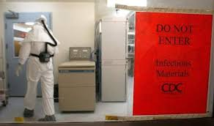
Meechan said that it was likely that only seven researchers may have directly handled the live anthrax, but the agency is casting as wide a net as possible to make sure all employees at the agency who may have walked into any of the labs at risk are being offered treatment.
He said that around seventy-five individuals are being offered a 60-day course of treatment with the antibiotic ciprofloxacin, as well as an injection with an anthrax vaccine.
Meechan told the Guardian it is too early to determine whether the transfer was accidental or intentional.
He said that all employees who were doing procedures to inactivate the bacteria were working in a highly secure biolab and were “tier one select agent approved,” meaning that they had undergone a security reliability review and deemed to be “stable, trustworthy individuals.”
Meechan added that the CDC is conducting an internal investigation to discover how the exposure occurred and said disciplinary measures would be taken if warranted.
“This should not have happened,” he said. For those exposed, he said, “We’re taking care of it. We will not let our people be at risk.”

EDITOR’S COMMENT: Perhaps this is the second incident worldwide after the Sverdlovsk anthrax leak in 1979.

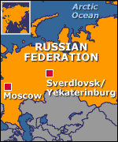
Sverdlovsk anthrax leak
Source: http://en.wikipedia.org/wiki/Sverdlovsk_anthrax_leak

The Sverdlovsk anthrax leak was an incident in which spores of anthrax were accidentally released from a military facility in the city of Sverdlovsk (formerly, and now again, Yekaterinburg) 1450 km east of Moscow on April 2, 1979. This accident is sometimes called "biological Chernobyl".The ensuing outbreak of the disease resulted in approximately 100 deaths, although the exact number of victims remains unknown. The cause of the outbreak had for years been denied by the Soviet Union, which blamed the deaths on intestinal exposure due to the consumption of tainted meat from the area, and subcutaneous exposure due to butchers handling the tainted meat. All medical records of the victims had been removed in order to avoid revelations of serious violations of the Biological Weapons Convention.

Background
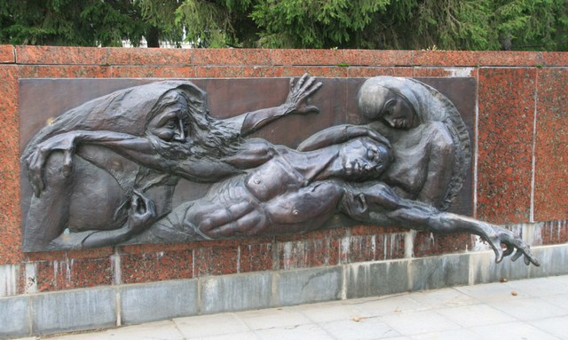
The closed city of Sverdlovsk had been a major production center of the Soviet military-industrial complex since World War II. It produced tanks, nuclear rockets and other armaments. A major nuclear accident happened in this region in 1957, when a nuclear waste facility exploded (known as the Kyshtym disaster), resulting in the spread of radioactive dust over a thousand square kilometers. The biological weapons facility in Sverdlovsk was built after World War II, using documentation captured in Manchuria from the Japanese germ warfare program.
The strain of anthrax produced in Military Compound 19 near Sverdlovsk was the most powerful in the Soviet arsenal ("Anthrax 836"). It had been isolated as a result of another anthrax leak accident that happened in 1953 in the city of Kirov. A leak from a bacteriological facility contaminated the city sewer system. In 1956, biologist Vladimir Sizov found a more virulent strain in rodents captured in this area. This strain was planned to be used to arm warheads for the SS-18 ICBM, which would target American cities, among other targets.

The accident
The produced anthrax culture had to be dried to produce a fine powder for use as an aerosol. Large filters over the exhaust pipes were the only barriers between the anthrax dust and the outside environment. On the last Friday of March 1979, a technician removed a clogged filter while drying machines were temporarily turned off. He left a written notice, but his supervisor did not write this down in the logbook as he was supposed to do. The supervisor of the next shift did not find anything unusual in the logbook, and turned the machines on. In a few hours, someone found that the filter was missing and reinstalled it. The incident was reported to military command, but local and city officials were not immediately informed. Boris Yeltsin, a local Communist Party boss at this time, helped cover up the accident.
All workers of a ceramic plant across the street fell ill during the next few days. Almost all of them died in a week. The death toll was at least 105, but the exact number is unknown as all hospital records and other evidence were destroyed by the KGB, according to former Biopreparat deputy director Ken Alibek.

The investigation
In the 1980s, there was vigorous international debate and speculation as to whether the outbreak was natural or an accidental exposure. If accidental, there was discussion of whether it represented violation of the 1972 Biological Weapons Convention. A number of small investigations launched by Russian scientists in the years immediately following the dissolution of the Soviet Union re-opened the case in a number of newspaper articles.
A team of Western inspectors led by Professor Matthew Meselson of Harvard finally gained access to the region in 1992, and determined that all of the victims had been living directly downwind at the time of the release of the spores via aerosol. Livestock in the area were also affected. It was revealed around this time that the accident was caused by the non-replacement of a filter on an exhaust at the facility, and though the problem was quickly rectified it was too late to prevent a release. Had the winds been blowing in the direction of the city at that time, it could have resulted in the pathogen being spread to hundreds of thousands of people. The military facility remains closed to inspection. Professor Meselson's original contention for many years had been that the outbreak was a natural one and that the Soviet authorities were not lying when they disclaimed having an active offensive bio-warfare program, but the information uncovered in the investigation left no room for doubt. Meselson's wife, Jeanne Guillemin (who had participated in the investigation), detailed the events in a 1999 book.

Aftermath
Russian Prime Minister Egor Gaidar issued a decree to begin demilitarization of Compound 19 in 1992. However, the facility continued its work. Not a single journalist has been allowed onto the premises since 1992. About 200 soldiers with Rottweiler dogs still patrol the complex. Classified activities were moved underground, and several new laboratories have been constructed and equipped to work with highly dangerous pathogens. One of their current subjects is reportedly Bacillus anthracis strain H-4. Its virulence and antibiotic resistance have been dramatically increased using genetic engineering.

Read also:

New anthrax-killing virus could offer new ways to detect, treat, and decontaminate anthrax bacillus
Published 29 January 2014
Source: http://www.homelandsecuritynewswire.com/dr20140129-new-anthraxkilling-virus-could-offer-new-ways-to-detect-treat-and-decontaminate-anthrax-bacillus
From a zebra carcass on the plains of Namibia in Southern Africa, researchers have discovered a new, unusually large virus (or bacteriophage) which infects the bacterium that causes anthrax. The novel bacteriophage could eventually open up new ways to detect, treat, or decontaminate the anthrax bacillus and its relatives that cause food poisoning. Bacteriophages are often highly specific to a particular strain of bacteria, and when they were first discovered in the early twentieth century there was strong interest in them as antimicrobial agents. The discovery of penicillin and other antibiotics, however, eclipsed phage treatments in the West, although research continued in the Soviet Union.

Faster anthrax detection could speed bioterror response
Published 28 February 2014
Source: http://www.homelandsecuritynewswire.com/dr20140228-faster-anthrax-detection-could-speed-bioterror-response

The fall 2011 anthrax attacks cost $3.2 million in cleanup and decontamination. At the time, no testing system was in place that officials could use to screen the letters. Currently, first responders have tests that can provide a screen for dangerous materials in about 24-48 hours. Now, researchers have developed a new method for anthrax detection that can identify anthrax in only a few hours.
Using a virus known as a “bioluminescent reporter phage,” Stewart and graduate student, Krista Spreng, tested the phage at the MU Laboratory for Infectious Disease Research. The phage, developed by David Schofield at Guild BioSciences, a biotech company in Charleston, South Carolina, is injected in the sample causing anthrax to glow if present. The team also found that the method can detect low levels of anthrax bacteria and rule out false positives. The added benefit to this reporting system is its ability to show if anthrax is present and whether or not the spores are alive, Stewart said.

Scientists urge U.S. to do more to detect, prevent use of bioweapons
Published 29 May 2014
Source: http://www.homelandsecuritynewswire.com/dr20140529-scientists-urge-u-s-to-do-more-to-detect-prevent-use-of-bioweapons

Carefully targeted biological weapons could be as dangerous as nuclear weapons, so the United States should invest more resources in developing technologies to detect them, scientists say. What is especially worrisome is that “The advent of modern molecular genetic technologies is making it increasingly feasible to engineer bioweapons,” says one expert. “It’s making people with even moderate skills able to create threats they couldn’t before.” There is another worry: “A high-tech bioweapon could cost only $1 million to build,” the expert adds. “That’s thousands of times cheaper than going nuclear. Iran’s centrifuges alone cost them billions.”

Researchers discover Achilles’ heel in antibiotic-resistant bacteria
Source: http://www.homelandsecuritynewswire.com/dr20140620-researchers-discover-achilles-heel-in-antibioticresistant-bacteria

Scientists at the University of East Anglia have made a breakthrough in the race to solve antibiotic resistance. New research published today in the journal Nature reveals an Achilles’ heel in the defensive barrier which surrounds drug-resistant bacterial cells.
The findings pave the way for a new wave of drugs that kill superbugs by bringing down their defensive walls rather than attacking the bacteria itself. It means that in future, bacteria may not develop drug-resistance at all.
A UEA release reports that the discovery does not come a moment too soon. The World Health Organization has warned that antibiotic-resistance in bacteria is spreading globally, causing severe consequences. Even common infections which have been treatable for decades can once again kill.
Researchers investigated a class of bacteria called “Gram-negative bacteria’ which is particularly resistant to antibiotics because of its cells” impermeable lipid-based outer membrane.
This outer membrane acts as a defensive barrier against attacks from the human immune system and antibiotic drugs. It allows the pathogenic bacteria to survive, but removing this barrier causes the bacteria to become more vulnerable and die.
Until now little has been known about exactly how the defensive barrier is built. The new findings reveal how bacterial cells transport the barrier building blocks (called lipopolysaccharides) to the outer surface.
Group leader Prof. Changjiang Dong, from UEA’s Norwich Medical School, said: “We have identified the path and gate used by the bacteria to transport the barrier building blocks to the outer surface. Importantly, we have demonstrated that the bacteria would die if the gate is locked.”
“This is really important because drug-resistant bacteria is a global health problem. Many current antibiotics are becoming useless, causing hundreds of thousands of deaths each year.
“The number of super-bugs are increasing at an unexpected rate. This research provides the platform for urgently-needed new generation drugs.”
Lead author Ph.D. student Haohao Dong said: “The really exciting thing about this research is that new drugs will specifically target the protective barrier around the bacteria, rather than the bacteria itself.
“Because new drugs will not need to enter the bacteria itself, we hope that the bacteria will not be able to develop drug resistance in future.”

— Read more in “Structural basis for outer membrane lipopolysaccharide insertion,” Nature (18 June 2014)

Pigs and Birds form terror cell and unleash biological warfare on unsuspecting North Americans
Source:http://www.democraticunderground.com/discuss/duboard.php?az=view_all&address=389x5533318

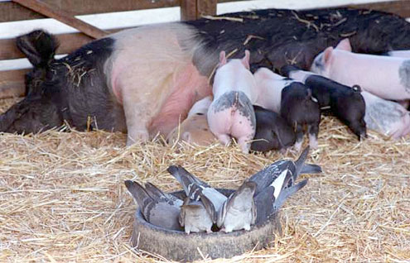
The CIA has issued the following photo:

