Guards at U.K. nuclear weapons facility slept on the job, skipped routine patrols
Source: http://www.homelandsecuritynewswire.com/dr20131217-guards-at-u-k-nuclear-weapons-facility-slept-on-the-job-skipped-routine-patrols

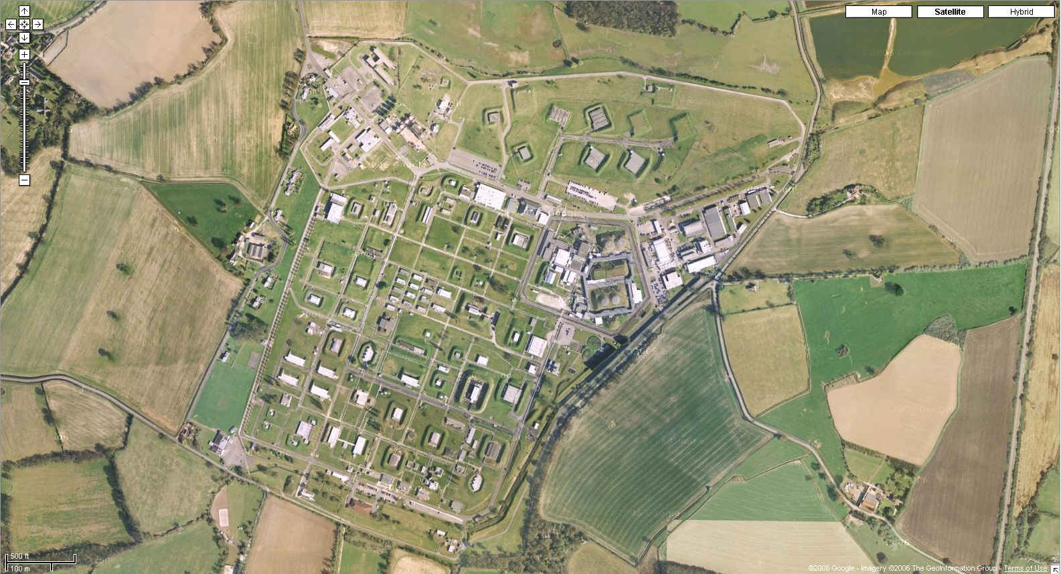
Police officers of the U.K. Ministry of Defense police, assigned to guard Britain’s nuclear weapons, are under investigation after it has been reported that they had slept on the job and failed to complete routine patrols at a nuclear weapons facility.
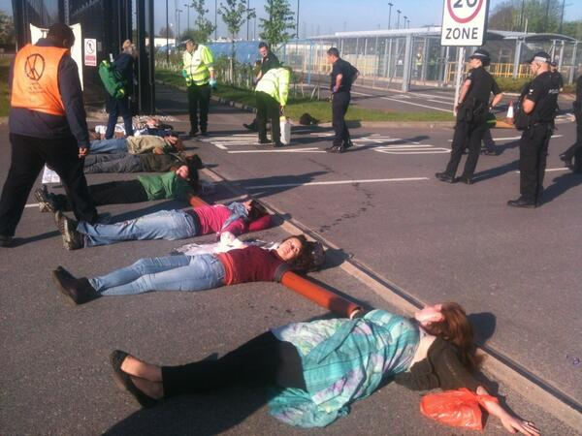
The Guardian reports that seven officers at the Atomic Weapons Establishment (AWE) in Burghfield, Berkshire, have already resigned without facing disciplinary charges.
AWE is the location of the complex final assembly of nuclear weapons, and also where the U.K. nuclear warheads are maintained and decommissioned. The Ministry of Defense has created a 2,700-strong police unit specifically for guarding the AWE facility.
An MoD spokesman said that disciplinary action was initiated immediately after the infractions were discovered, and that several officers had been removed from the site and reassigned to other duties pending the conclusion of investigations.
The MoD insists, though, that there had been no threat to the security of the facility or the safety of the nuclear warhead stored there.
A spokesman said: “We can confirm a number of officers are under investigation for failing to complete their full patrols at the Atomic Weapons Establishment.
“The investigation is ongoing and the Independent Police Complaints Commission has been notified. It would be inappropriate to comment further while the case is ongoing, however we can be clear that at no point was the security of the site or its nuclear assets compromised.”
Peter Burt of the Nuclear Information Service, an organization campaigning for nuclear safety, told the Daily Mirror: “The sheer scale of these claims is astonishing, especially given the highly sensitive nature of the complex. It handles radioactive materials, explosives and hazardous chemicals.
“The government never misses an opportunity to tell us how sites like this are at constant risk from terrorists. It’s clear there have been problems with security and supervision at a high level.”

Are Jordan's nuclear ambitions a mirage?
By Chen Kane
Source: http://thebulletin.org/are-jordans-nuclear-ambitions-mirage

In October 2013, Jordan announced it had chosen Russia to build its first two nuclear-power reactors. Historically, Jordan has lacked access to energy resources. It depends on imports for more than 96 percent of power consumption. This means that a whopping 20 to 25 percent of Jordan’s national expenditures go to importing energy. That is a massive outflow of capital for a country of only 6.5 million people. Jordan’s decision to turn to nuclear power, however, doesn’t mean that the kingdom is about to sail smoothly into the club of nations that produce their own nuclear energy. While Jordan is in great need of a less costly and more reliable energy source, it won’t get there unless it can overcome some major challenges.

High demand. Jordan’s pursuit of nuclear energy is motivated by two factors. The first is a desire to expand, secure, and diversify its energy sources. The kingdom estimates that its electricity consumption will more than double by 2030, reaching 6,000 megawatts per year.
Jordanians have long experienced wild energy price fluctuations and repeated blackouts due to sudden shortages. For example, the pipeline that runs from Egypt to Jordan—and supplies Jordan with more than 80 percent of its natural gas—has been bombed more than 15 times since 2011 as a result of the volatile security situation. Since July 2013 the gas supply from Egypt has been completely suspended, costing Jordan’s fragile economy more than $2 billion. For these reasons, the kingdom understandably looks with hope to nuclear energy as a source of electricity for households, water desalination plants, and industry.
Jordan’s second motive for pursuing nuclear power is to reduce the economic toll that imported energy takes. Many in Amman believe that given the country’s vast uranium reserves, once it starts mining, it will be able to export both energy and the raw material, making the program a significant source of new income. Jordan plans to export part of the uranium and use the rest as a strategic stockpile for its own nuclear program. (It should be noted that French nuclear giant Areva and Jordan Phosphate Mines Company have said that the uranium is not commercially viable.) With more than 15 neighboring countries having announced plans to pursue nuclear energy, Jordan sees an opportunity to become a leading uranium provider.

Pressing problems. While Jordan has made impressive progress in pursuing nuclear energy, many urgent challenges still need to be addressed. It possesses none of the required technology, skilled staff, or infrastructure necessary for a nuclear program. The country has no experience in operating nuclear reactors or fuel and waste facilities. And it has chosen a Russian nuclear reactor design—the AES92—that has been built only in India, where it is currently due to start up after being under construction for 10 years, even though it has not been reviewed by an open and experienced regulatory body.
As worrisome as all that may seem, there are other issues that are even more pressing.

Dealing with public opposition. Domestic critics have, not surprisingly, raised safety and environmental concerns since the spectacle of a disastrous accident at Japan’s Fukushima Daiichi Nuclear Power Station in 2011. Meanwhile the Arab Spring stoked public unrest in Jordan and emboldened anti-nuclear demonstrators to take to the streets. Those who oppose the nuclear program question the accuracy of data presented by the government regarding its cost and economic effectiveness. Said Ayoub Abu Dayyeh, the head of the prominent Jordanian nonprofit organization the Society of Energy Saving and Sustainable Environment, summarized the basis for the public’s skepticism: “In Jordan we have witnessed fraudulent elections, a fraudulent Parliament; it is not out of the realm of possibility that at the end of the day we will receive fraudulent studies.” Domestic critics also question whether there really are large, commercially viable uranium reserves in the kingdom, and whether their country can provide the quality and volume of water needed for mining and cooling reactors.

Going further on non-proliferation. Amman must bolster its non-proliferation credentials. They are, to be sure, already impressive. Jordan has signed and ratified all the central agreements, and the International Atomic Energy Agency (IAEA) has found the country to be in full compliance with treaty obligations. Jordan was also the first country in the Middle East to adopt the Additional Protocol that endows the IAEA with extra inspection privileges to verify that no undeclared nuclear activities are taking place. It can and should go further, though, by signing on to the revised Small Quantities Protocol, a set of rules aimed at monitoring states with little or no nuclear material. Since the Jordanian government has not adopted changes to the protocol, in practice the IAEA does not conduct verification activities in the country. Another proliferation-related issue for Jordan to address will be negotiating an arrangement under which Russia takes back spent nuclear fuel—a fissile material that could theoretically be diverted to use in nuclear weapons.

Agreeing on a bilateral deal. Jordan and the United States need to finalize the bilateral nuclear cooperation agreement they have been working toward. Jordanian officials have repeatedly said that they are not prepared to forgo uranium enrichment, maintaining that any such restriction might unfairly limit their rights under the Nuclear Non-Proliferation Treaty. They say, too, that a ban on enrichment would prevent Jordan from fulfilling its hope of becoming a major uranium and nuclear fuel supplier. The United States, though, hopes to prevent the spread of enrichment and reprocessing technologies—which are required to produce nuclear weapons—to new countries.
Whether Jordan does or does not accept a ban on enrichment will have important regional implications. On the one hand, if Amman decides to forgo the right, more states will likely commit to the idea that enrichment and reprocessing capabilities are not required in order to enjoy nuclear energy. On the other hand, should Jordan retain the right to enrichment under its agreement with the United States, it is hard to see why other Middle Eastern countries would agree to do otherwise in future bilateral negotiations.

Passing stronger laws. Jordan must see through the process of adopting export controls governing nuclear technology and material. Strong legislation, as well as robust implementation and enforcement capabilities, are vital; Jordan is a key link in the global movement of goods between East and West. Specifically, Jordanian leaders should set criteria for determining to what nations, companies, and individuals Amman may sell its natural and enriched uranium.

Where’s the money? Jordan will have to figure out how to finance its nuclear reactors. Its decision last month to go with Russia as a partner was motivated by financial constrains. Moscow agreed to take on 49 per cent of the plants’ $10 billion price tag while the two countries are still negotiating a financing scheme. They may choose the build-operate-own (BOO) model, under which Russia would recoup its investment from guaranteed electricity sales without receiving any other financial commitments from Amman. The BOO model has been used only once before to finance nuclear power infrastructure, in Russia’s contract to construct four plants in Turkey. Even before breaking ground, that project is already falling behind schedule.
A cash-strapped Jordanian government agreed to finance the remaining 51 percent of the cost of construction and operation. However, given the state of the country’s economy, a nuclear program will be prohibitively expensive. As Amman seeks to build up an expensive new industry with limited funds, safety could be compromised, and weak regulations on staffing and exports would mean that nuclear materials could escape supervision. One way to secure a steady cash flow for the nuclear program over the long term would be to allocate part of the proceeds from uranium sales to a fund that would invest back into Jordan’s energy and water desalination sectors. Such a fund could also reduce volatility and function as an energy-shock absorber.

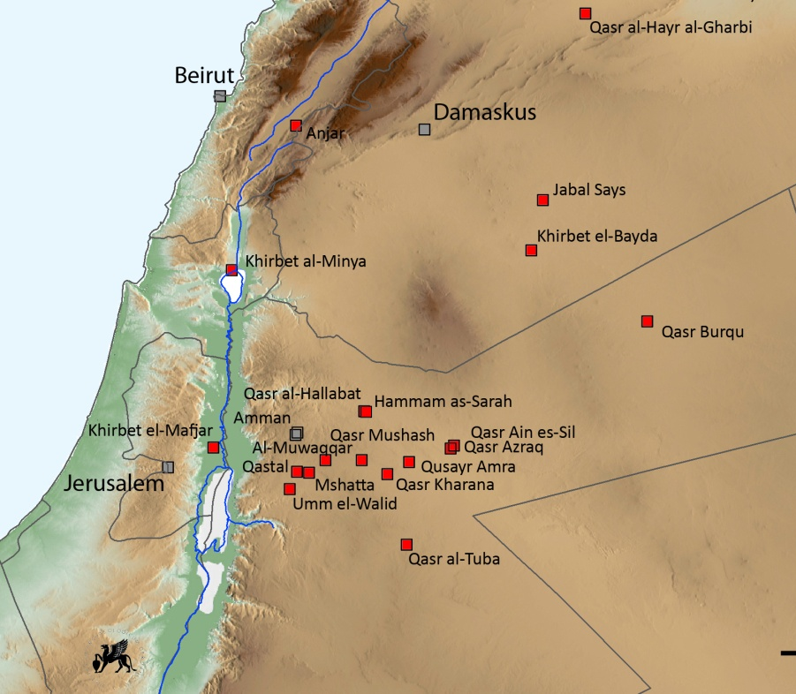
Location, location, location. Finally, there have also been problems finding a site for the first reactor. In October 2013 Jordan announced a third relocation, to Qusayr Amra, 60 kilometers northeast of Amman on the edge of the northern desert. But the kingdom has yet to resolve hurdles such as access to cooling water in the area and active resistance from local tribes. Member of Parliament Hind Fayez, who belongs to the influential Beni Sakher tribe living around Qusayr Amra, has said, “I will not allow the construction of the nuclear reactor, not even over my dead body.”
Jordan is at a crossroads. If it fails to address the aforementioned challenges, the adverse implications for its political stability, public safety, economic health, and regional standing could be irreversible. If, however, the kingdom's proposed nuclear energy program is successful, pursuing it could turn out to have been a pivotal strategic move, going a long way to solving the country's very real energy and economic crisis. And if Jordan agrees to forego enriching its own uranium—which many observers assess as a commercial pipe dream—the country could serve as a stellar regional example, showing that it's possible to embrace non-proliferation while also embracing nuclear energy.

Mrs. Chen Kane is the Middle East projects manager at the James Martin Center for Nonproliferation Studies and co-editor of the website Arms Control and Regional Security for the Middle East.

EDITOR’S COMMENT: Israel has nuclear weapons already. Iran is pursuing them. S Arabia is very interesting and ready to proceed if Iran finally got them. So as one of the commenter of this article wrote: “What gives you confidence that a Russian take-back scheme provides protection against breakout from safeguards? 5 years of spent fuel in a cooling pond of a single 1 GWe reactor contains something like 100 weapons worth of weapons-usable Pu. If Jordan expels the IAEA inspectors, no one can prevent it from doing what it likes with that Pu.”

The Mexican radiation accident
Source: http://blogs.fas.org/sciencewonk/2013/12/mexican-radiation-accident-ii/

A highly respected colleague and friend of mine say he no longer refers to “lessons learned” but, rather, to “lessons recognized” because he has noticed that we don’t always learn our lessons. It’s not too early to recognize some lessons from the Mexican accident of the other week, but the fact that this accident happened at all suggests that we have failed to learn from past accidents. In this posting I’d like to go over some past radiation accidents (as opposed to nuclear accidents) and the lessons that we should have learned from them, as well as devoting a few paragraphs to the issue of radioactive materials security.
Goiania Brazil, 1987
Goiania Brazil is a big city that had over a million inhabitants in 1987. Most large cities make extensive use of radioactivity and radiation in medicine and Goiania was no exception. But things were a little lax in the 1980s, and when a cancer therapy clinic closed in 1987 the radioactive therapy source was simply abandoned instead of being transferred to a disposal facility. Thus, when scrap metal scavengers broke into the clinic they were able to walk out with a radiation therapy unit, including a high-activity (almost 1500 curies) Cs-137 source. Not knowing what they had found the scavengers opened the irradiator head and the source itself. Impressed with the pretty blue talcum powder-like filling, they took it home with them to show to family and friends. When all was said and done, four people had died of radiation sickness and over a hundred were exposed to enough radiation or contamination to require medical attention.
Like in Mexico, the thieves in Goiania were unaware of what they had stolen and, also like the Mexican theft, an underlying problem was a relative paucity of good security. We can also infer scanty regulatory controls in both cases, to permit the Brazilian source to be abandoned and the Mexican source to be transported without properly packaging or securing the source during shipping. Unlike the recent incident, the Goiania source was filled with easily dispersible Cs-137 as opposed to Co-60, which is typically found as a solid chunk of metal; this contributed to the wide spread contamination in Goiania compared to the relatively “clean” Mexican incident. The health toll of the Mexican accident is not yet known, although it seems likely that whoever removed the sources from the irradiator head would have received enough radiation to cause severe radiation sickness or death.

New Delhi, India, 2010
In 2010 the University of Delhi became aware of a cobalt irradiator that had been in storage for over a quarter century. Cobalt-60 has a half-life of only 5.27 years; after 5 half-lives the amount of radioactivity had decayed to only about 3% of the original activity. But 3% of a large number can still be significant – when the university decided to simply sell the entire irradiator off as scrap metal there were still about 20 curies of activity remaining; enough to be deadly under the right circumstances.
In this case, over 100 pieces of radioactivity were scattered through a number of scrap metal yards in the Delhi area and other pieces were given to eight workers at the scrap metal yard. One worker received a dose of over 300 rem and died of radiation sickness; two other workers developed radiation sickness but eventually recovered. After being informed of the incident the Indian government scoured the scrap metal yards, recovering (they think) all of the radioactivity. Interestingly, though, a few years later some contaminated metal products made of Indian stainless steel showed up in the US. This suggests that either additional pieces remained at large or that there was the loss of another Indian Co-60 source that was not reported. Either way, this is another incident in which radioactive materials were disposed of improperly and without adequate checks (not to mention without proper radioactive materials security).

Lessons recognized
There are more. A source was lost in Mexico in 1984 that ended up melted with scrap metal – it was found when a load of contaminated metal was picked up in the US. In Bolivia an industrial radiographer was unable to retract a source into its shield and, instead of measuring radiation levels to confirm the location of the source, he simply bundled everything up and put it in the cargo area of a bus, exposing the passengers to (luckily) low doses of radiation. And other radiation incidents happened in every continent for the last half-century and more. But there are some common threads woven through most of these incidents that are worth trying to tease out to see if we can recognize the lessons.
One of these is that most of the lost sources were not properly secured. Had the Mexican source, for example, been properly guarded the truck might not have been stolen; had it been shipped in an appropriate container it could not have been opened by the thieves and there would have been no exposure. Similarly, the Goiania source was simply left behind in an abandoned building, making it easy pickings for the scrap metal scavengers. Proper attention to securing radioactive sources would have saved lives.
Another common theme is that many sources were being used by personnel who neglected to perform proper radiation surveys. This might not have made a difference in Mexico earlier this month, but a simple radiation survey would have shown the people at the Delhi University that the cobalt in its irradiator had not yet decayed to stability – this would have saved at least one life and would have spared the remaining victims their radiation sickness. Radiation surveys would also have shown that sources had become unshielded in accidents that occurred in Iran, Bolivia, Turkey, and elsewhere. Part of the problem here is that many of those tasked with using or safeguarding these sources were not radiation safety professionals, who would have understood the risks posed by high-activity sources and would almost certainly have performed surveys that would most likely have averted these tragedies.
The final commonality among the incidents noted here and others that have taken place is the relative paucity of effective regulatory oversight. While a great many nations adhere (on paper) to standards developed by the International Atomic Energy Agency, they may lack the ability or the trained personnel to enforce their regulations. In fact, I have visited some nations in which radioactive materials users had never seen a government inspection; even some nations in which the users were unaware that their nations had radiation regulations at all (in one case, I visited an industrial radiographer who was using an aged copy of our own American regulations, being unaware that his nation had adopted IAEA standards). In spite of my own disagreements with regulators from time to time these accidents and my own experiences have convinced me that regulatory oversight is essential, if only to keep licensees on their toes. The lack of such oversight makes it all too easy for minor errors to turn into something potentially (or actually) life-threatening.
One of the things I found in the Navy is that most accidents are the result of multiple failures and that the process leading up to an accident can be interrupted at any of these steps. In the most recent accident, the use of a proper shipping container, proper security procedures, and appropriate regulatory oversight were all lacking – attend to any one of these factors appropriately and the accident would not have occurred. In a safe system a single failure should not put lives or health at risk. At this point it’s too late to help the people who were presumably exposed in Mexico, and too late to help the others exposed in India, Brazil, Iran, and so many other nations. But one can hope that other nations in which potentially dangerous radioactive sources are in use (virtually every nation on Earth) will not only recognize these lessons, but will learn from them as well. We have over a century of experience in working with radiation and we know how to do so safely – how to manage the risks so that nobody need be harmed. It would be a shame if others in coming years were to be harmed by something that is relatively easily controlled, simply because the lessons of past mistakes were recognized – but not learned

►Read also:

Known and less known radiological accidents

Source: http://www-pub.iaea.org/books/IAEABooks/Publications_on_Accident_Response

- Nueva Aldea  - Bialystok  - Samut Prakarn  - Yanango  - Nesvizh  - San Salvador | - Cochabamba  - Gilan  - Sarov  - Istanbul  - Hanoi | - Lilo  - Tomsk  - Tammiku  - San Jose  - Soreq  - Goiania

IAEA Books on: Accident response @

http://www-pub.iaea.org/books/IAEABooks/Subject_Areas/0610/Accident-response

Train carrying nuclear waste derails near Paris

Source: http://www.presstv.ir/detail/2013/12/23/341577/french-nuclear-waste-train-derails/
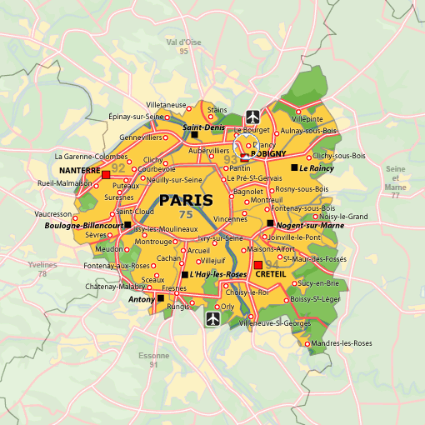

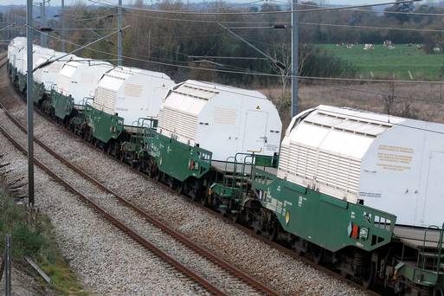
A freight train carrying nuclear waste has derailed near the French capital Paris, but no leaks, casualties or other problems have been reported so far.
The train overturned at a depot in the town of Drancy, three kilometers (two miles) northeast of Paris on Monday, Jean-Christophe Lagarde, the mayor of the town, said.
"Today at 1605 (1505 GMT), a freight car transporting radioactive material derailed in Drancy station," Lagarde said.
He added that some 4,000 cargo wagons transporting radioactive or chemical waste pass through the station annually while describing the Monday’s incident as “intolerable”.
Experts performed radiological tests after the event and found no leaks, an unnamed French official with the national fire service said.
The official added that the train was moving slowly and went about 50 centimeters off the rails.
France's "Europe Ecologie Les Verts" (EELV) Green Party asked for the termination of radioactive waste transfer through residential areas and busy stations.
“The slightest accident can have catastrophic effects,” the EELV Party said in a statement. “All (nuclear waste) transport is risky and exposes populations to unnecessary danger.”
Lagarde also voiced concern about the security of the nuclear and chemical cargoes passing frequently through the town.

French police investigate sabotage in nuclear train crash
Source: http://www.english.rfi.fr/europe/20130719-french-police-investigate-sabotage-nuclear-train-crash
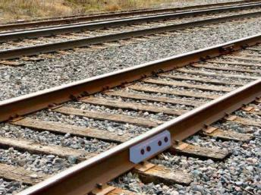
A fishplate, similar to one that may have caused the accident at Brétigny-sur-Orge station.

French police are investigating an apparent act of sabotage to the derailment of a train transporting nuclear waste on the same day as last week’s deadly rail crash south of Paris. Although the same part malfunctioned in both cases, no evidence of a connection has yet been found.
The state-owned rail company, SNCF, has made a legal complaint and police have opened an inquiry into the incident, which took place on 12 July, the same day as the crash that cost six lives at Brétigny-sur-Orge.
A previously unknown anti-nuclear group claimed responsibility for it in a statement sent to the regional newspaper, the Populaire du Centre.
The crash took place in the morning on a stretch of track used exclusively by nuclear giant Areva to transport nuclear waste near Bessines-sur-Gartempe, in central France.
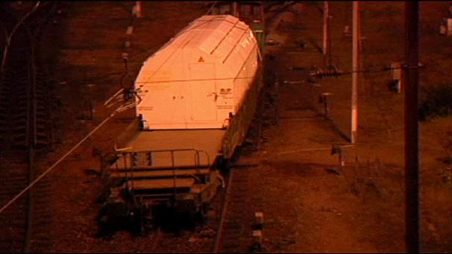
An Areva convoy came of the rails and carried on for 100 metres, reportedly because a fishplate joining two rails had been removed and a rail disconnected.
Two railworkers aboard were not hurt but have filed a complaint for endangering their safety and wilful damage.
A fishplate also came loose at Brétigny-sur-Orge, causing a train to career off the track in the evening of the same day.
Although investigators are unclear how all the bolts holding it in place came loose at the same moment, they have found no evidence of sabotage and the site is clearly visible from a signal box opposite.

BP, Chevron Accused of Illegally Dumping Toxic Radioactive Drilling Waste Into Louisiana Water
Source: http://readersupportednews.org/news-section2/312-16/21076-bp-chevron-accused-of-illegally-dumping-toxic-radioactive-drilling-waste-into-louisiana-water

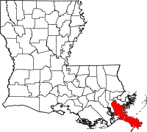
The Louisiana parish of Plaquemines (red area in the map) is taking on a group of oil and gas giants including BP and Chevron for allegedly dumping toxic waste - some of it radioactive - from their drilling operations into its coastal waters, according to a lawsuit removed to federal court on Thursday (Dec 21, 29013).
Plaquemines Parish is claiming the companies violated the Louisiana State and Local Coastal Resources Management Act of 1978 by discharging oil field waste directly into the water "without limitation." Worse, the companies allegedly failed to clear, revegetate, detoxify or restore any of the areas they polluted, as required by state law. The oil and gas companies' pollution, along with their alleged failure to adequately maintain their oilfields, has caused significant coastal erosion and contaminated groundwater, the lawsuit said.
"I think the oil companies have an obligation to self-report, I think the oil companies are to blame and I think the oil companies took advantage of the state," John Carmouche, one of the lead attorneys for the parish, said in November when the suit originally came out in state court. The lawsuit is just one of nearly 30 that were filed in November by both Plaquemines and Jefferson parishes, targeting dozens of energy companies and their contractors they claim helped destroy and pollute coastal areas.
Plaquemines' suit says BP and Chevron should have known that the oilfield wastes, referred to as "brine," contained "unacceptable and inherently dangerous" levels of radioactive materials called Radium 226 and Radium 228. According to the Nuclear Regulatory Commission, small amounts of Radium 226 were once used as an additive in toothpaste, hair creams, and even food items due to supposed beneficial health properties. Those products soon "fell out of vogue," however, after it was discovered that the health effects were exactly the opposite of beneficial.
Long-term exposure to radium also increases the risk of developing several diseases, including lymphoma, bone cancer, leukemia and aplastic anemia, according to the EPA.
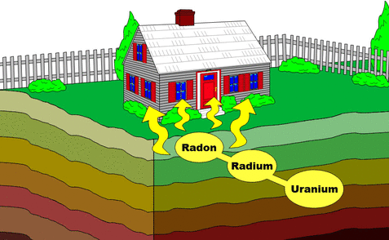
Radium emits both alpha and gamma radiation, the former of which is detrimental if taken into the body through inhalation or ingestion - a real concern considering the alleged water contamination. According to the Environmental Protection Agency, about 80 percent of the radium that is swallowed will promptly leaves the body through feces, while the other 20 percent enters the bloodstream and accumulates preferentially in the bones. Some of that radium will remain in the bones throughout the person's lifetime, the EPA said.
Another aspect of the lawsuit against BP and Chevron targets their construction of "unlined earthen waste pits," which the lawsuit describes as "simply holes, ponds or excavations" that are dug into either the ground or a marsh. Many of those pits were never properly closed, the suit says, adding that BP and Chevron did not even attempt to obtain permits to close them. The lawsuit also alleges that BP has been illegally dredging canals throughout the region for their oil and gas activities, without the necessary permits.
"These suits are more of the same," Louisiana Oil and Gas Association President Don Briggs said in an email to The Advocate in November. "Extort as much money from the oil and gas industry as possible, thus lining the pockets of a small group of trial lawyers."

EDITOR’S COMMENT: (1) Why BP is allowed to drill in the US but not off-shore UK? (2) There are so many dangerous staff around us, that we people, have no idea about because we think that there is someone out there – the gov – that is taking care of it for our own good. So stupid - us! (3) Is there a building legislation regarding protection from basements’ radon protection? (4) A universal ”copy & paste” last paragraph when a quite (big or small) abscess opens and the pus coming out becomes visible. Offensive approach without any reasonable explanation depending/counting on the long lasting judicial process and the poor memory of populace. In the meantime beware of the holes!

December 30, 2013: Open Letter on the Threat from the Gulf of Mexico
By Ambassador Henry F. Cooper
Source: http://highfrontier.org/december-30-2013-open-letter-on-the-threat-from-the-gulf-of-mexico/# sthash.XDUXZHNp.dpbs?utm_source=The+Threat+from+the+Gulf+of+Mexico+-+Amb.+Henry+F. +Cooper&utm_campaign=ACD+BLOG&utm_medium=email

If you live near the Gulf of Mexico, you are the front line to an emerging existential threat to all Americans. The electromagnetic pulse (EMP) from a nuclear weapon exploded a hundred miles above the U.S. could kill 60-90 percent of all Americans. Though efforts in 2013 made progress in gaining awareness of this key problem, much remains to be done to get the powers that be to address this well-known threat that could be launched by Iran or Terrorists from a ship in the Gulf.
I’m updating my last year’s related message to keep everyone informed about an emerging existential threat—particularly to those who live near the Gulf of Mexico. But this is actually an existential threat to all Americans. It is well known, and should be addressed urgently—but alas the powers that be continue collectively to ignore it, although there are signs of a slow awakening.
It is a fact that the EMP created by a single nuclear weapon exploded a hundred miles above the United States could lead to the death of several hundred million Americans.
And this kind of attack could be delivered by Iran or terrorists.
The congressionally-mandated nonpartisan EMP Commission reported these findings almost a decade ago. Yet neither Republican nor Democrat administrations, nor congress, have seriously addressed this all too real threat, which could and now should be addressed, especially in view of the events of the past year. So, we have decided to focus our efforts on informing grass roots America and local and state authorities about this urgent threat and what can be done about it.
Why? Let me connect a few dots—hopefully in layman’s terms.

First, we know EMP effects are real—and potentially catastrophic.
The U.S. first observed them on atmospheric nuclear tests in the early 1960s. For example, a U.S. high altitude nuclear test (Starfish Prime) in the South Pacific turned out lights in Hawaii, almost a thousand miles away.
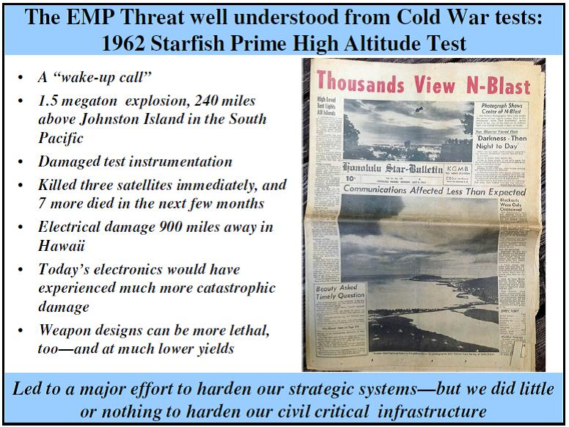
Today, the effects would be much more damaging because modern electronics are much more vulnerable to EMP than were the electronics of the early 1960s. Indeed, a burst over the continental U.S. could bring our entire “just in time” economy to an indefinite standstill—we could lose for many months the electric power grid and our communications, transportation, banking and other critical infrastructure systems upon which we depend for survival.
The effects of even a single high altitude nuclear burst today would impose an indefinitely long return to the 19th century, but without the agrarian society that supported everyone during those days. Now, without those essentials, most Americans would perish for lack of food and other necessities. For example, diabetics without Insulin would die, as would others without critically needed prescriptions filled. How long would it be before civil order would break down if those in our cities were without the benefits of our globally dependent, just-in-time economy? And then what?
Dr. William R. Graham, President Reagan’s science advisor, an expert on EMP effects and as Chairman of the nonpartisan EMP Commission, testified to congress that up to two thirds of all Americans could die within the next 12 months. Others think the percentage could be higher.

Second, these EMP effects are well known, including to rogue states and terrorists who wish to kill us.
Of course, the Russians understand EMP effects, perhaps better than we, from the Soviets more extensive high altitude testing in the 1960s. We hardened our strategic forces to counter their attack plans during the Cold War so that we could retaliate if the Soviets attacked us or our allies. We depended on that threat to deter them from attacking in the first place. And so we relied upon deterrence rather than hardening our critical civil infrastructure against EMP.
Others who may not be deterred by threats of retaliation, also understand the EMP threat—and at least some appear to have learned from the Russians how to build advanced nuclear weapons of lower yield to maximize the EMP effects. And technology for ballistic missile delivery systems has proliferated widely. For example, the EMP Commission concluded that Iran well understood EMP and over a decade ago actually tested some of its ballistic missiles in ways that are consistent with carrying out such a high-altitude EMP attack with ballistic missiles launched from vessels off our coasts. This past year, Iranian officials explicitly stated in conjunction with impressive operational exercises that they could attack us from off our coasts, including from the Gulf of Mexico..
Additional information can be found on our webpage: www.highfrontier.com including more recent examples of the growing instability in the Middle East, in particular as Iran continues its steady pace toward gaining nuclear weapons—now perhaps only months away as ill-advised diplomatic efforts seem destined to fail.

Third, our current missile defenses, if appropriately deployed, could defend against such attack—but our deployment strategy needs improvement.
Most notably the Navy’s Standard Missile now at sea on about 30 (growing to about 35 by 2015) of our Aegis ships have demonstrated this inherent capability. Some of these ships are usually operating near our east and west coasts, and could shoot down such attacking missiles from vessels off our coasts if launched within their striking radius. On a random day during 2012, there were 4-6 Aegis ships along our eastern seaboard or in east coast ports—from which they could defend against off-coast attacks if they were prepared to do so. Thus, improved readiness of our missile defense capable Aegis ships operating near our coasts could improve the defense against ballistic missiles launched from nearby vessels. Actually, if inter-netted with a TYP-2 radar deployed in Maine, they could also defend against Iranian intercontinental ballistic missiles (ICBMs) launched over the North Pole to attack the U.S.
But of greater importance for those of you near the Gulf of Mexico is the fact that our Aegis ships don’t operate in the Gulf. So we are completely vulnerable to attacks from the south—from ships off our southern coasts, or from Venezuela which Iran is helping to develop ballistic missiles. Last year, Panama stopped a North Korean ship in the canal carrying from Cuba two hidden (happily unarmed) nuclear capable SA-2 ballistic missiles. This illustrates a major concern.
Some good news is that the recently signed National Defense Authorization Act for 2014 directs the Secretary of Defense to recommend how our Homeland Defenses can be improved. Specifically, it directs that ballistic missile threats from vessels off our coasts, including from the Gulf of Mexico, be included—as well as other threats from the South.
High Frontier helped inform the powers that be of the key vulnerabilities and possible defense options to aid their deliberations about homeland defense issues—our next objeccive is to be sure that they consider our views of how best to follow through.

Fourth, we can easily afford an effective defense against this threat—indeed, in my opinion and for reasons summarized below, we cannot afford not to defend against it.
We can adapt an on-going program that is now developing defenses to protect our European allies against exactly the same kind of threat from Iran. This program, called “Aegis Ashore,” is composed of the Standard Missile carried on our Aegis ships, and its associated radar and command and control systems, deployed as a modular unit on land—initially in Romania (by 2015) and then in Poland (by 2018). Work has begun on the site in Romania and preliminary steps have been agreed in Poland.
The first U.S. Aegis Ashore site became operational for testing purposes in Hawaii in December, reportedly built for $400 million. We could easily afford build effective Aegis Ashore sites at several military bases in states around the Gulf of Mexico, on the same time frame as is formally planned for the sites in Romania and Poland.
All development costs are funded by the existing program—with the exception of Environmental Impact Statements required before such U.S. sites are formally selected. Deployment and operations costs may be more than in Hawaii but should be less than in Europe.
Fifth, time is running out for us to provide these needed defenses against Iran and its agents.
In 2012, Iran’s President, Mahmoud Ahmadinejad, said that Israel has no roots in the Middle East and would be “eliminated” . . . echoing his previous claims that Israel is a “tumor” to be “wiped off the map.” In his speech to the U.N. General Assembly on one of Judaism’s holiest days— Yom Kippur, he referred to Israelis as “uncivilized Zionists” and railed against the U.S. and European Union as having “entrusted themselves to the devil.”
Iran’s threats to “Little Satan” Israel cannot be separated from its threat to “Great Satan” America, as Brigadier General Amir Ali Hajizadeh, commander of Iran’s Revolutionary Guards missile section, clarified just before those same U.N. sessions. On Iran’s Arab-language network, he said, that if Israel and Iran engage militarily, “nothing is predictable… and it will turn into World War III.” And further, “In circumstances in which they [the Israelis] have prepared everything for an attack, it is possible that we will make a pre-emptive attack. Any Israeli strike would be presumed to be authorized by the U.S. Therefore, we will definitely attack U.S. bases in Bahrain, Qatar and Afghanistan.”
Iran has expanded its defensive and offensive capabilities with help from China, Russia, North Korea and other nations amid demands—to little or no avail—by the U.N. and Western nations that it cease its program for making a bomb in violation of its international agreements. Iranian leaders have flouted the fact that sanctions had not worked—though they apparently did well enough to bring Iran to the negotiating table—after Hassan Rouhani replaced Ahmadinejad as Iran’s President last August, and the world applauded his U.N. charm offensive in September.
Ali Khamenei is still Iran’s Supreme Leader dedicated to the same goals as when Ahmadinejad was President—so nothing really changed. However, Rouhani’s softer diplomatic approach apparently gained relief from sanctions that had squeezed Iran’s economy. U.S. diplomats, led by Secretary of State John Kerry, last November foolishly agreed to relieve the sanctions, while in effect only hoping that Iran would slow down (but not stop) their obvious efforts to process uranium and plutonium for nuclear weapons.
At best, Iran’s development program to reach a “breakout capability” was delayed a few months—if it doesn’t already exist. Israeli Prime Minister Benjamin Netanyahu said the agreement was a “historic mistake,” and even at least 13 U.S. Democratic Senators apparently agreed, parted company with the President and are joining a number of Republicans to sponsor legislation to restore even more sanctions if there is no progress in the next several months. Stay tuned.
If (many would say “when”) Iran gets nuclear weapons and mates them to their extensive supply of ballistic missiles of all ranges, they will have a major capability to launch these missiles against Israel and the United States. As we have previously discussed, Iran can use ballistic missiles to strike the U.S. with nuclear weapons, using: 1) short or medium range ballistic missiles launched from vessels off our coasts, 2) ICBMs launched over the North Pole, and/or 3) nuclear armed satellites that approach the U.S. from over the South Pole. If we take measures immediately, we can quickly counter the first two threats, but will have only limited near-term capability to respond to the third. All three could deliver an EMP attack on the U.S.
If any or all of these options were used to attack us, Iran would no doubt precede any such attack with operations intended to distract and confuse us. For example, Iran could employ the impressive ballistic missile capability they demonstrated in 2012 comprehensive exercises. Iran’s high-flying ballistic missiles could overwhelm U.S. missile defenses in the Persian Gulf, where much of the world’s oil passes. Its fast-attack boats could swarm a battleship and possibly sink it—remember the USS Cole destroyer that was almost sunk in the Yemen port of Aden by al-Qaeda using a single high speed boat on October 12, 2000 (killing 17 American sailors and wounding 39 others)? And Iran’s submarine fleet carries torpedoes that can threaten our ships.
The Iranian navy could hit us at least one time at sea or on shore, after which we would probably destroy their navy and most of their land-based missile capability. But they may not act alone—and not only in the Persian Gulf. And meanwhile they could be preparing for the main attraction, perhaps phased, to attack Israel and then the U.S. in one or more of the above scenarios.
In the midst of this confusion, sympathetic Islamic riots also could and probably would go global. Why should we believe that, if Iran goes to war in the Middle East, such on-demand demonstrations and riots will not also happen in the U.S.—as well as direct attacks on the international commerce upon which our “just in time” markets depend? In my view we must prepare for that eventuality. And time may be running out.
Sixth, Washington’s counters to this growing threat seem too little, too late.
President Obama and his administration seem to be trying to separate the U.S. plight from that of Israel. In spite of his claims to support Israel, his policies seem more consistent with preparing to live with an Iran armed with nuclear weapons rather than Israel’s insistence on stopping Iran from getting them. This may well turn out to be a “fool’s errand” that leads to Iranian nuclear attacks on both the “Little Satan” Israel and the “Great Satan” America.
While Israel is doing all it can to deal with this threat, U.S. lethargic policies continue to leave us vulnerable to any number of threat scenarios that could involve an existential EMP attack on the U.S. before we can build operational defenses against such an attack. Among the most worrisome scenarios are attacks from vessels off our coasts, particularly from the Gulf of Mexico, and attacks from nuclear-armed satellites that approach the U.S. from over the South Pole. Even terrorist surrogates can perform the former in ways Iran practiced over a decade ago and Iran last year tested satellites launched over the South Polar region in ways that could execute the latter.
We can counter the EMP threat by shooting down Iranian ballistic missiles, if we prepare to do so—our problem is persuading the powers that be to make the needed preparations—both to provide effective defenses and to harden U.S. critical infrastructure to EMP effects.
For the third congress in a row, proposed legislation to empower the Federal Energy Regulatory Commission with authority and resources to harden key elements of our electric power grid remains bottled up in congressional inaction. Yet it is obviously important to assure the survival/rapid revival of the power that underpins our critical infrastructure without which many millions of Americans would perish, as discussed above. The currently proposed Shield Act has overwhelming bipartisan support in the House and Senate, but currently is being blocked in the House Energy and Commerce Committee.

Seventh, I believe that our best hope for ending the above discussed apathy is to educate the grass roots about the threat and help them with a bottoms-up effort to demand that Washington powers that be live up to their oath to provide for the common defense.
My bottom line conclusions in last year’s message have been reinforced and expanded by our studies over the past year (See www.highfrontier.org):
- The U.S. cannot avoid involvement in a war between Iran and Israel, regardless of who starts it.
- If such a war begins, it will likely spread globally like wildfire, fanned by Islamist terrorists . . . including within the United States.
- Today, we cannot assure that Iran cannot launch ballistic missiles from vessels off our coasts and, if mated with a nuclear weapon, detonate it high above the U.S. creating an EMP—causing no physical damage, but ultimately leading to the death of several hundred million Americans.
- We are currently unprepared to defend against such an attack or to provide for the survival of millions of Americans if it were to occur—especially from the Gulf of Mexico.
- We are also vulnerable to nuclear armed satellites launched over the South Polar region to attack the U.S. from the South.
- An affordable near-term defense against the former is clearly possible, with enlightened leadership. Countering the latter threat is more difficult but there are ways to start and long-term solutions.

Finally, last year’s activities give me confidence that we can achieve grass roots support.
In 2012, I lectured at the University of Mississippi on the threat and how a key Aegis Ashore site in Pascagoula (where our Aegis ships are built) could help defend against ballistic missiles launched from vessels in the Gulf of Mexico. After our positive exchanges with faculty and students of Ole Miss’ College of Engineering, we met with the Jackson County Board of Supervisors, who must support such a deployment if it is to be politically viable—and they responded very positively. Then we met with Mississippi’s Secretary of State and Governor, who also were very receptive. My subsequent discussions with Mississippi’s senior Senator, Thad Cochran, were also very positive. However, Congress passed only a Continuing Resolution that did not permit any new activity to deal with this critically important issue.
As noted above, Congress recently passed and the President signed into law the National Defense Authorization Act of 2014 that includes clear guidance to the Department of Defense to report on how our homeland missile defenses can be improved—with clear instructions to consider threats from vessels off our coasts, including from the Gulf of Mexico, and other threats from the South that should include nuclear-armed satellites such as those previously tested by Iran.
Furthermore, I lectured at University of West Florida in the Florida panhandle last year, about the fact that we could be facing a crisis reminiscent of the Cuban Missile Crisis of a half century ago.
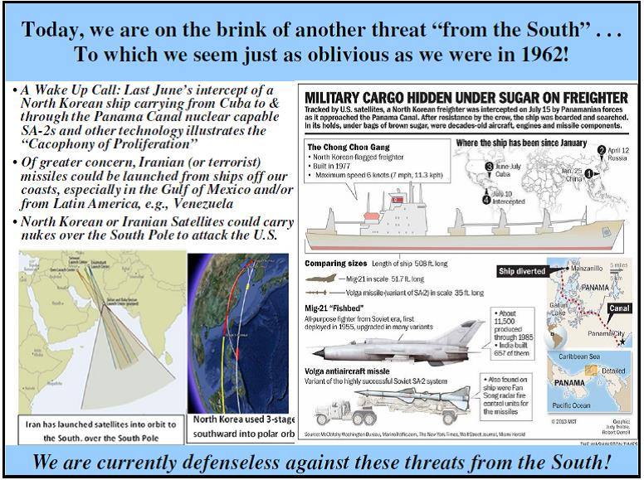
Following our discussions with the faculty and students in Pensacola, Dr. Daniel Fine (An Independent Working Group colleague) and I met with key state authorities and others in the Panama City area—and concluded that Tyndall AFB should be the Florida panhandle site for basing Aegis Ashore. We also concluded that Homestead AFB could be a second Aegis Ashore site near the tip of the Florida Peninsula. Thus, the stars are aligned from the bottom up in Mississippi and Florida—and I hope we can turn this positive support into a serious acquisition program in 2014, when we anticipate additional follow-up meetings. Next year, I also hope to explore possibilities in Texas for another site—at this time with a focus on Corpus Christi Naval Air Station.
As a complement to these activities focused on deploying missile defenses to counter an EMP attack, I always seek to emphasize the EMP threat, of which most people are unaware. And as we have emphasized in our email messages, such a threat can be manmade, such as with a ballistic missile attack, or natural, in particular produced by infrequent but certain to occur solar storms that launch electric particles that interact with the earth’s geomagnetic field and produce at least one of the most damaging EMP effects that alone can bring down the currently unhardened electric power grid.
As I wrote last week, I have joined a number of grass roots initiatives to address the natural and manmade EMP threat. Many of these developments were reviewed at the December 6, 2013 DuPont Summit in Washington, DC (cosponsored by the Policy Studies Organization and the InfraGard National EMP Special Interest Group). Videos of the proceedings should be on the web in the next week or so, and I will provide links to them in my future email messages.
I often applaud Maine State Representative Andrea Boland (D-Sanford) for her advocacy which, in only six months, led to landmark legislation to begin dealing with the vulnerability of Maine’s electric power grid. The Maine House and Senate passed almost unanimously this model legislation. Hopefully, the Maine Public Utilities Commission (MPUC) will take effective remedial actions. If so, Maine could lead the nation in hardening the national grid. And I am working with others to engage other states and their key officials, hoping that they will indeed follow suit.
So there are reasons to be encouraged and no doubt more positive things I could write—but it also should be clear that we will continue to confront major problems before we can rest easy about the existential EMP threat.
As you consider your year-end giving, I hope you will make a tax deductible gift to High Frontier, as indicated below. We urgently need your support to help defray our expenses for a full court press to defend the states around the Gulf of Mexico—and the rest of America, before it may be needed to secure the survival of all we hold dear.
God bless you and yours—and may you have a happy and prosperous new year . . . Let freedom ring!
For America,
Henry F. Cooper
Chairman, High Frontier

High Frontier is a 501c(3) nonprofit organization dedicated to building truly effective missile defenses. Our Founder, Lt. Gen. Danny Graham was a close advisor to President Ronald Reagan in initiating the Strategic Defense Initiative. As High Frontier’s Chairman and President Reagan’s Chief Negotiator with the Soviet Union in defending the SDI program, which helped to end the Cold War, and then SDI’s Director, I am seeking to finish the work Danny began. I hope you will help me do so with the best tax deductible gift you can afford.

Towards Sochi 2014 – Remember these incidents?

Source: http://www.pbs.org/wgbh/nova/dirtybomb/chrono.html

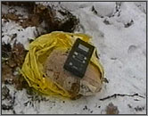
November 1995

Moscow, Russia — In the first-ever attempt at radiological terror, a group of Chechen rebels contacts a Russian television station and boasts of its ability to construct a radioactive bomb. The rebels alert the press that they have buried a cache of radiological materials in Moscow's Ismailovsky Park. In the very spot where the rebels indicated it would be, authorities find a partially buried container of cesium. Neither the Chechens who planted it there nor the original source of the cesium is ever identified.

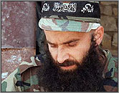
December 1998

Argun, Chechnya — The head of the Russian-backed Chechen Security Service, Ibragim Khultygov, announces that a Security Service team has found a container filled with radioactive materials and attached to an explosive mine hidden near a railway line. They safely defuse the bomb but do not identify the radioactive substances involved. The location of the discovery—in a suburban area 10 miles east of the Chechen capital of Grozny, where a Chechen rebel group is known to operate an explosives workshop—leads nuclear specialists to suspect Chechen rebels' involvement in the incident. Shamil Basayev, the rebel leader who phoned in the dirty-bomb threat in Moscow three years earlier, is the known chief of the explosives workshop near Argun.

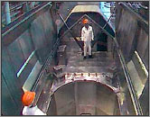
September 1999

Grozny, Chechnya — Unidentified thieves attempt to steal a container of radioactive materials from the Radon Special Combine chemical factory. Half an hour after being exposed to the container, one of the suspects dies and the other collapses, even though each held the container for only a few minutes while trying to carry it out of the factory. The surviving suspect is hospitalized in critical condition, but he recovers and is placed under arrest. Chechen officials do not discuss his case publicly, nor do they identify the type of radioactivity involved in the incident, saying only that the container held 200 grams of "radioactive elements."

June 2001

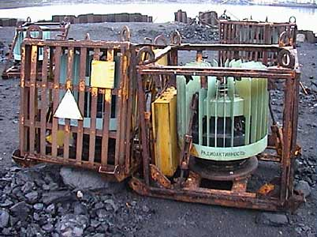
Kandalaksha, Russia — Two people in Russia's Murmansk region receive powerful doses of radioactivity and are hospitalized after plundering a nuclear-powered lighthouse, one of 132 such lighthouses located along Russia's northern coast. The scavengers say they were trying to extract lead from the lighthouse for sale as scrap metal and were unaware of its dangerous strontium power source. Inspectors later detect elevated radiation levels for hundreds of feet on the route along which the two carried a leaking lead container before abandoning it. Though Russia's Soviet-era nuclear lighthouses were originally designed to withstand earthquakes and even planes crashing into them, after years of neglect these unguarded and uninspected structures are easily dismantled by thieves. In January 2003, the U.S. government announces a plan to aid Russia in safely replacing the energy sources of all of its nuclear lighthouses.

December 2001

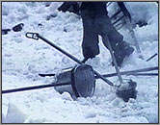
Lja, Georgia — Three woodcutters discover two heat-emanating containers near their campsite in the remote Abkhazia region of the Caucasus. Hoping to use the containers as a heat source, the men drag them back to their tents. Within hours they become ill with nausea, vomiting, and dizziness, and leave the site to seek treatment at a local hospital. Later, the men develop severe radiation burns on their backs. The International Atomic Energy Agency (IAEA) dispatches a team to recover the containers, but severe weather prevents them for more than a month from reaching the campsite and securing the materials. When the IAEA team finally reaches the containers in February 2002, they discover that each one, previously used in Soviet-era radiothermal generators, contains 40,000 curies of strontium, an amount of radiation equivalent to that released immediately after the accident at Chernobyl.

November 2002

Moscow, Russia — Head of Russia's nuclear regulatory agency, Yuri Vishnyevsky, announces that small amounts—a few grams here and there—of weapons-grade and reactor-grade nuclear materials are missing from the country's atomic facilities. Vishnyevsky does not provide details on when and how the materials disappeared, but he indicates that the material involved is uranium. According to experts, a few grams of weapons-grade uranium would not be sufficient to make an effective nuclear bomb, but it could provide material adequate for a dirty bomb. Moreover, small amounts of reactor-grade uranium can be enriched to weapons-grade through a process that some rogue nations possess, including Iraq. With Russia's nuclear security in severe decline due to financial troubles and disorganization, Vishnyevsky's announcement underscores a major source of concern about unsecured radioactive materials in Russia.

►Read also: “Organized crime and the trafficking of radiological materials” @:
http://cns.miis.edu/npr/pdfs/npr_17-2_kupatadze.pdf

EDITOR’S COMMENT: Terrorism and mega sport events such as Olympic Games (both Summer and Winter) are always a deadly combination. Incidents can happen before (CR or conventional – i.e. recent multiple Volgograd bombings [2013]), during (CBR or conventional) and after (B-consequences) the Games. Incidents might happen in a given Olympic City but also any city in the country will do the job (and with less effort)! Given the fact of previous “experience” of terrorist groups involved in 2013 attacks it will be NO surprise if a RDD attack is attempted or executed in the coming two months (Jan-Feb 2014). The question is: “are we ready to cope with the consequences?”

Al-Qaeda’s attempt to acquire Russian made nuclear weapons confirmed by former CIA Director Tenet
Source: http://groundreport.com/al-qaeda-attempted-to-acquire-russian-made-nuclear-weapons-confirmed-by-former-cia-director-tenet/

In his book “At The Center of the Storm – My years at the CIA”, by George Tenet, a former Director of CIA (from 1997-2004), who served under two presidents (Bill Clinton and George W. Bush) talks about al-Qaeda’s attempt to purchase nuclear weapons on the black market.
In one incident he mentions the fact that in May 2003, the Saudi’s had captured several top level al-Qaeda operatives and sympathizers, including a man by the name of Shaykh Nasir bin Hamin al-Fahd. Al-Fahd was a man who published a white paper which sought to justify the use of nuclear weapons.
His paper was called “A Treatise on the Legal Status of Using Weapons of Mass Destruction Against Infidels”.
While in custody, he confirmed that al-Qaeda had been negotiating for the purchase of Russian devices (meaning nuclear weapons), he claimed ignorance regarding the nature of these devices (pg 274).
Tenent said that “Our inability to determine the fate of the Russian devices presented great concern, not only for me but for the White House” (pg 275).
He apparently shared that information during a presidential briefing at the White House attended by former president Bush.
After the meeting “She (Condi Rice) recommended that I call Defense Minister Ivanov, explain the president’s concerns and obtain Ivanov’s assurances that our respective intelligence agencies would intensify their work to resolve the WMD threats” (pg 275).
“Defense Minister Ivanov was receptive to our concerns and agreed immediately to receive CIA representatives in Moscow and coordinate meetings with Russian Intelligence” (pg 275).
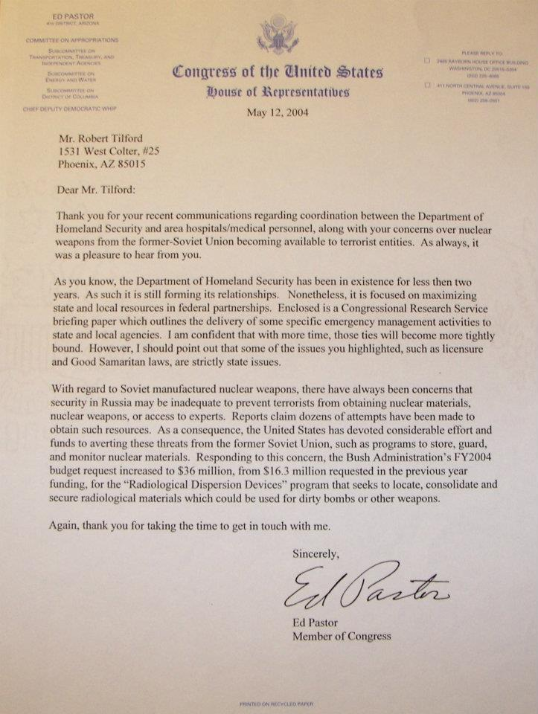
“As expected the Russian took copious notes and asked penetrating questions regarding the information we had come to share. But the conversation became awkward as we began asking questions. The Russian could not shed light on reports we had received of missing material from the former Soviet Union. They did not recognize the names of former Soviet scientists who reportedly collaborated with al-Qaeda. They refused to delve into any matters relating to the security of their nuclear facilities and nuclear weapons, including reports sourced to Russian officials concerning possible theft of Russian suitcase nukes” (pg 276).
A suitcase nuke is a tactical nuclear weapon which uses, or is portable enough that it could use a suitcase as its delivery method.
The highest-ranking GRU defector Stanislav Lunev claimed that such Russian-made devices do exist and described them in more detail.
These devices, “identified as RA-115s (or RA-115-01s for submersible weapons)” weigh from fifty to sixty pounds. They can last for many years if wired to an electric source. In case there is a loss of power, there is a battery backup. If the battery runs low, the weapon has a transmitter that sends a coded message—either by satellite or directly to a GRU post at a Russian embassy or consulate” (source: Stanislav Lunev. Through the Eyes of the Enemy: The Autobiography of Stanislav Lunev. Regnery Publishing, Inc., 1998. ISBN 0-89526-390-4.).
“A “suitcase” bomb is a very compact and portable nuclear weapon and could have the dimensions of 60 x 40 x 20 centimeters or 24 x 16 x 8 inches. The smallest possible bomb-like object would be a single critical mass of plutonium (or U-233) at maximum density under normal conditions. The Pu-239 weighs 10.5 kg and is 10.1 cm across. It doesn’t take much more than a single critical mass to cause significant explosions ranging from 10-20 tons” (source: Suitcase nukes http://www.tonyrogers. com/news/suitcase_nukes.htm).
The CIA never found or accounted for these missing Russian weapons.
Tenent later commented on this unresolved threat:
“Of all al-Qaeda’s efforts to obtain other forms of WMD (Weapons of Mass Destruction), the main threat is the nuclear one. I am convinced that this is where UBL (Osama bin Laden) and his operatives desperately wanted to go. They understand that bombings by cars, trucks, trains and planes will get them some headlines, to be sure. But if they manage to set off a mushroom cloud, they will make history – such an event would place al-Qaeda on par with the superpowers and make good Bin Laden’s threat to destroy our economy and bring death into every American household” (pg 279).
“We have learned that it is not beyond the realm of possibility for a terrorist group to obtain a nuclear weapon. I have often wondered why this is such a hard reality for so many people to accept”, said the former CIA Director Tenet (pg 279).

“One mushroom cloud would change history. My deepest fear is that this is exactly what they (al-Qaeda) intend” (pg 280).

Surveillance network built to spot secret nuclear tests yields surprise scientific boon
Source: http://www.washingtonpost.com/world/national-security/surveillance-network-built-to-spot-secret-nuclear-tests-yields-surprise-scientific-boon/2014/01/01/ea9c126e-6f3a-11e3-b405-7e360f7e9fd2_story.html

The engineers who designed the world’s first truly planetary surveillance network two decades ago envisioned it as a way to detect illegal nuclear weapons tests. Today, the nearly completed International Monitoring System is proving adept at tasks its inventors never imagined. The system’s scores of listening stations continuously eavesdrop on Earth itself, offering clues about man-made and natural disasters as well as a window into some of nature’s most mysterious processes.
The Obama administration hopes the network’s capabilities will persuade a reluctant Senate to approve a nuclear test-ban treaty that stalled in Congress more than a decade ago. Meanwhile, without the treaty and wholly without fanfare, new stations come on line almost every month.
“We can pick up whale sounds, and ice sheets cracking,” said Thomas Muetzelburg, a spokesman for the Comprehensive Nuclear Test-Ban Treaty Organization (CTBTO), the Vienna-based group that operates the network. More importantly, he said, “we can reliably detect nuclear tests.”
The monitoring system is a latticework of sensors — including radiation detectors and machines that measure seismic activity or low-frequency sound waves — spread out across 89 countries as well as the oceans and polar regions. Like a giant stethoscope, it listens for irregularities in Earth’s natural rhythms, collecting and transmitting terabytes of data to a small office in the Austrian capital.
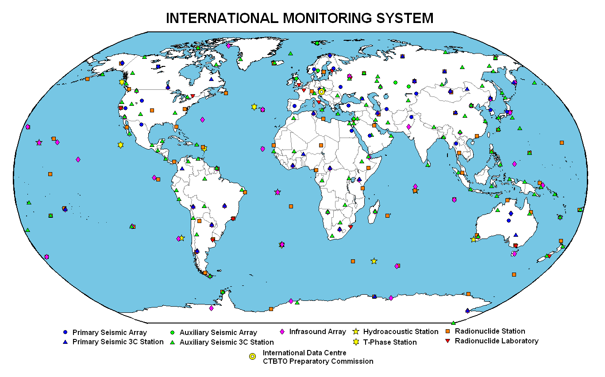
The network was designed to help enforce the 1996 Comprehensive Nuclear Test-Ban Treaty, which outlawed explosive testing of nuclear weapons. But while the treaty has never entered into force — the United States and seven other countries have declined to ratify it, in part because of concerns over verification — the monitoring network has steadily grown over the years, from a handful of stations in 2003 to more than 270.
The network has emerged as one of the most compelling arguments for the treaty, advocates say. Arms-control officials in the Obama administration have cited the network’s advances in arguing for a new push for Senate ratification of the nuclear test ban, despite opposition from prominent Republicans who argue that the pact undermines U.S. interests.
“There has been a growing realization, especially after Fukushima, that the International Monitoring System has improved to an impressive level,” Rose Gottemoeller, the State Department’s assistant secretary for arms control, verification and compliance, said in an interview. “It became clear that the time is right to go out and talk about these accomplishments and what the treaty can do for U.S. national security.”
The test-ban treaty has not come up for a vote in the Senate since 1999, when it was soundly defeated. The vote embarrassed the Clinton administration and drew criticism from countries around the world, including Russia, which is among the pact’s 161 signatories.
At the time, the United States had already halted testing of its nuclear weapons under an undeclared moratorium that began in 1992. Still, most Republicans and many Democrats opposed the treaty on the grounds that it offered false security; at the time, there was no global system in place that could reliably detect cheating.
The International Monitoring System was designed to address those concerns. Construction began on the first listening stations in 2000, and dozens were operating by 2006, when the network experienced its first major test — an underground detonation that signaled North Korea’s emergence as a nuclear weapons power. The country’s communist government would conduct two additional nuclear tests, in 2009 and last February.
“We detected the announced 2006 test even though only 60 percent of the network was in place,” said Muetzelburg, the CTBTO official. He said 21 of the system’s stations registered that event, compared with 94 seismology stations detecting North Korea’s test in 2013.
As it turned out, the network’s listening posts did more than simply pick up the tests’ underground shock waves. Numerous stations also picked up trace amounts of radioactive xenon, a gas emitted in nuclear explosions. From studying the xenon plume, scientists could even calculate how long North Korea waited to open the sealed entrances to its underground test chambers.
Arms-control experts say the North Korean tests show that the monitoring system is up to the challenge for which it was designed — deterring secret nuclear weapons tests. While today’s advanced computers can conduct simulations of a nuclear explosion, few countries would seek to field a nuclear arsenal — or modernize an existing one — without testing whether the technology works, according to a senior European diplomat involved in arms-control negotiations.
“This actually works in the favor of the United States, because it effectively freezes its nuclear advantages in place while inhibiting other countries from developing nuclear weapons,” said the official, who insisted on anonymity because he was not authorized to discuss the matter.
Arms-control advocates worry that a failure to approve the treaty will eventually result in increased competition among countries seeking to acquire nuclear weapons or upgrade their arsenals. If all hope for passage dies, support for the monitoring network — which costs more than $120 million annually in member-state dues to maintain — will probably dry up as well, proponents say, leading to the loss of a scientific asset with benefits to the entire planet.
In the past two years alone, advocates note, the network has contributed to scientists’ understanding of a variety of natural disturbances. When a deadly tsunami damaged Japan’s Fukushima nuclear reactor, the network’s sensors tracked the spread of airborne radioactive contamination across the Pacific Ocean to North America and beyond. And last year, when an asteroid exploded over Russia’s Chelyabinsk province, the system’s monitors were able to track the trajectory and size of the space rock as it plummeted toward Earth.
Current and former U.S. officials who have followed the network’s evolution say its capabilities are impressive, but they acknowledge that it may not be enough to sway doubters in Congress. While President Obama has promised to push for ratification of the test-ban treaty, former lawmakers say the public support necessary to win passage has not materialized.
“It looks pretty far away at this moment,” said former senator Richard G. Lugar (R-Ind.), a champion of arms control during his three decades in Congress who opposed the test-ban treaty in 1999, in part because of concerns over verification. “Just getting the START treaty across the finish line was such a struggle, and it was relatively modest.”
Gottemoeller, the State Department official, noted that support for the 1960s ban on aboveground nuclear tests was prompted by a global concern about radioactive contaminants in milk. “The Limited Test Ban Treaty grew out of a mother’s movement,” she said. “We need to generate that kind of public support.”

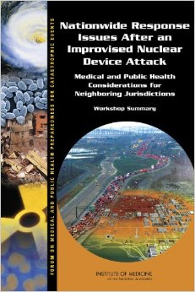
Nationwide Response Issues After an Improvised Nuclear Device Attack: Medical and Public Health Considerations for Neighboring Jurisdictions: Workshop Summary Paperback – January 23, 2014
By Forum on Medical and Public Health Preparedness for Catastrophic Events (Author) , Board on Health Sciences Policy (Author) , Institute of Medicine (Author) , Miriam Davis (Editor) , Megan Reeve (Editor) , Bruce Altevogt (Editor)
Source: http://www.nap.edu/openbook.php?record_id=18347&page=R13

►Available to read online at source’s URL.

The Mystery Plume Rising Over Fukushima’s Reactor 3
By Oliver Tickell
Source: http://www.counterpunch.org/2014/01/01/the-mystery-plume-rising-over-fukushimas-reactor-3/#!

Fukushima’s Reactor Building 3 exploded on 13th March 2011 as a result of a hydrogen buildup, breaching the building’s containment and emitting a huge plume of radiation. The reactor itself is in meltdown.
And now fresh plumes of steam have been seen coming out the structure. These have now been confirmed by Tepco, the owner of the nuclear plant, from 19th December onwards. The company believes the steam is coming from the fifth floor of the building.
However it does not know the cause of the steam. Lethal levels of radiation and the physical damage to the structure have so far made entry and inspection impossible.

Possibility 1: a meltdown is taking place
The Reactor 3 fuel storage pond still houses an estimated 89 tonnes of the plutonium-based MOX nuclear fuel employed by the reactor, composed of 514 fuel rods.
Ever since the explosion Tepco has been concerned that if the spent fuel storage pond dries out, the intensely radioactive spent fuel rods would melt down and produce further significant radioactive emissions.
One possibility is that this process may now be taking place. In the event of water loss from the pond, the water would begin to overheat and produce clouds of steam, prior to a complete meltdown. If this is the case then a second major nuclear disaster at Fukushima is in the making.
Earth Wind Map (interactive – see source at the end of this article)

This explanation appears to be relatively improbable, however, and no official warnings have been released on either side of the Pacific.

Possibility 2: ‘corium’ has reached groundwater
Reactor 3 itself contained 566 fuel rods, and has experienced a complete meltdown. The location of the molten fuel, known as ‘corium’, is unknown, but it may have burnt its way through the reactor base and entered the underlying soil.
This would also produce steam as the hot corium came into contact with groundwater, while also releasing radioactive contamination to make its way into the Pacific Ocean.

Possibility 3: rainwater on stray fuel elements / Reactor
An alternative explanation is that the steam plumes could be caused by stray fuel pellets and reactor rod fragments – which themselves produce significant amounts of heat – coming into contact with rainwater percolating through the damaged and roofless structure.
And of course the same water could be reaching the hot reactor vessel. According to a Fairewinds Energy Education posting on Facebook, the reactor is currently producing about 1 MW of heat, equivalent to 1,000 1KW electric fires, so enough to produce plenty of steam.
This would provide the least worrying explanation for the steam, in that as the radioactivity continues decline so will the heat production and the volume of steam produced. If this explanation is correct, there is no reason expect any catastrophic outcome.
However the steam is carrying considerable amounts of radiation into the atmosphere and represents an ongoing radiation hazard.

Oliver Tickell edits the Ecologist

Earth Wind Map:

http://earth.nullschool.net/?goback=.gde_3711808_member_5824547654893346817#current/wind/isobaric/500hPa/equirectangular=-162.45,4.74,241

Fukushima, a Global Conspiracy of Denial
Does anyone in authority anywhere tell the truth about Fukushima?
By William Boardman
Source: http://readersupportednews.org/opinion2/271-38/21308-fukushima-a-global-conspiracy-of-denial

If there is any government or non-government authority in the world that is addressing the disaster at Fukushima openly, directly, honestly, and effectively, it's not apparent to the outside observer what entity that might be.
There is instead an apparent global conspiracy of authorities of all sorts to deny to the public reliably accurate, comprehensible, independently verifiable (where possible), and comprehensive information about not only the condition of the Fukushima power plant itself and its surrounding communities, but about the unceasing, uncontrolled release of radioactive debris into the air and water, creating a constantly increasing risk of growing harm to the global community.
While the risk may still be miniscule in most places, the range of risk rises to lethal in Fukushima itself. With the radioactive waste of four nuclear reactors (three of them in meltdown) under uncertain control for almost three years now, the risk of lethal exposure is very real for plant workers, and may decrease with distance from the plant, but may be calculable for anyone on the planet. No one seems to know. No one seems to have done the calculation. No one with access to the necessary information (assuming it exists) seems to want to do the calculation.
There is no moral excuse for this international collusion. The excuses are political or economic or social, but none of them excuses any authority for withholding or lying about information that has potentially universal and destructive impact on everyone alive today and everyone to be born for some unknown generations.
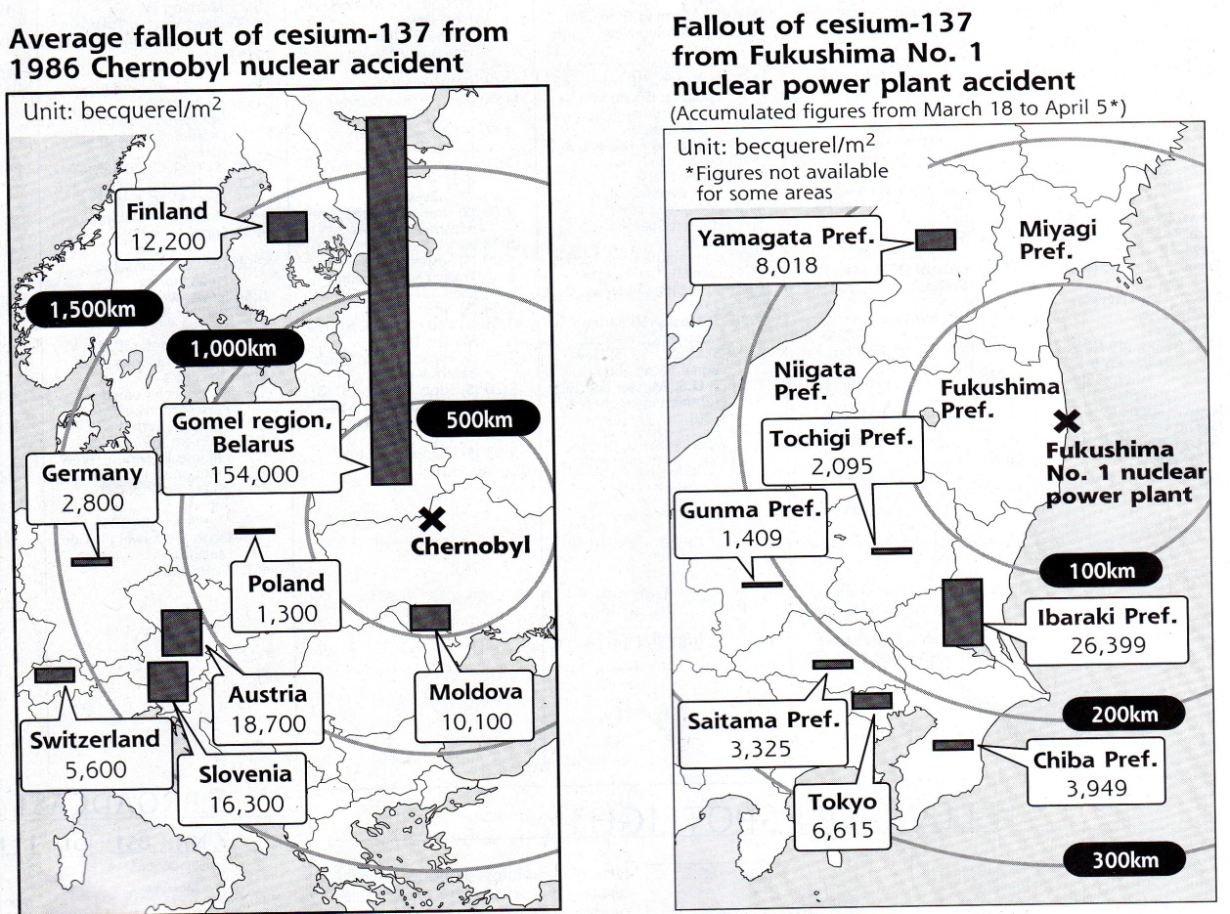
Japanese authorities may be the worst current offenders against the truth, as well as the health and safety of their people. Now the Japanese government has passed a harsh state secrets law that threatens to reduce or eliminate reliable information about Fukushima. The U.S. government officially applauded this heightened secrecy, while continuing its own tight control on nuclear information. Japanese authorities are already attacking their own people in defense of nuclear power: not only under-measuring and ignoring varieties of radioactive threat, but even withholding the iodine pills in 2011 that might have mitigated the growing epidemic of thyroid issues today. Failing to confront Fukushima honestly, the Japanese are laying the basis for what could amount to a radiological sneak attack on the rest of the world.
Just because no one seems to know what to do about Fukushima is no excuse to go on lying about and/or denying the dimensions of reality, whatever they might be. There are hundreds, probably thousands of people with little or no authority who have long struggled to create a realistic, rational perspective on nuclear threats. The fundamental barrier to knowing the scale of the Fukushima disaster is just that: the scale of the Fukushima disaster.

Chernobyl 1986 and Fukushima 2011 are not really comparable
Chernobyl is the closest precedent to Fukushima, and it's not very close. Chernobyl at the time of the 1986 electric failure and explosion had four operating reactors and two more under construction. The Chernobyl accident involved one reactor meltdown. Other reactors kept operating for some time after the accident. The rector meltdown was eventually entombed, containing the meltdown and reducing the risk. Until Fukushima, Chernobyl was considered the worst nuclear power accident in history, and it is still far from over (albeit largely contained for the time being). The Chernobyl Exclusion Zone of roughly 1,000 square miles remains one of the most radioactive areas in the world and the clean-up is not even expected to be complete before 2065.
At the time of the March 11, 2011, earthquake and tsunami, the Fukushima plant had six operating reactors. Three of them went into meltdown and a fourth was left with a heavily laden fuel pool teetering a hundred feet above the ground. Two other reactors were undamaged and have been shut down. Radiation levels remain lethal in each of the melted-down reactors, where the meltdowns appear to be held in check by water that is pumped into the reactors to keep them cool. In the process, the water gets irradiated and that which is not collected on site in leaking tanks flows steadily into the Pacific Ocean. Within the first two weeks, Fukushima radiation was comparable to Chernobyl's and while the levels have gone down, they remain elevated.
The plant's corporate owner, Tokyo Electric Power Company (TEPCO), in turn effectively owned by the Japanese government after a 2012 nationalization, began removing more than 1,500 fuel rod assemblies from the teetering fuel pool in November, a delicate process expected to take a year or more. There are additional fuel pools attached to each of the melted down reactors and a much larger general fuel pool, all of which contain nuclear fuel rod assemblies that are secure only as long as TEPCO continues to cool them. The Fukushima Exclusion Zone, a 12-mile radius around the nuclear plant, is about 500 square miles (much of it ocean); little specific information about the exclusion zone is easily available, but media coverage in the form of disaster tourism is plentiful, including a Google Street View interactive display.
Despite their significant differences as disasters, Chernobyl and Fukushima are both rated at 7 – a "major accident" on the International Nuclear Event Scale designed in 1990 by the International Atomic Energy Agency (IAEA). That is the highest rating on the scale, a reflection of the inherent denial that colors most official nuclear thinking. Designed by nuclear "experts" after Chernobyl, the scale can't imagine a worse accident than Chernobyl which, for all its intensity, was effectively over as an accident in a relatively short period of time. At Fukushima, by contrast, the initial set of events was less acute than Chernobyl, but almost three years later they continue without any resolution likely soon. Additionally Fukushima has three reactor meltdowns and thousands of precarious fuel rod assemblies in uncertain pools, any of which could produce a new crisis that would put Fukushima clearly off the scale.
And then there's groundwater. Groundwater was not a problem at Chernobyl. Groundwater is a huge problem at the Fukushima plant that was built at the seashore, on a former riverbed, over an active aquifer. In a short video, nuclear engineer Arnie Gunderson makes clear why groundwater makes Fukushima so hard to clean up, and why radiation levels there will likely remain dangerous for another hundred years.

Fukushima Unit #3 activity led to some panic-driven reporting in 2013
The Japanese government and nuclear power industry have a history of not telling the truth about nuclear accidents dating back at least to 1995, as reported by New Scientist and Rachel Maddow, among others. Despite Japan's history of nuclear dishonesty, Japanese authorities remain in total control of the Fukushima site and most of the information about it, without significant objection from most of the world's governments, media, and other power brokers, whose reputation for honesty in nuclear matters is almost as bad as Japan's. In such a context of no context, the public is vulnerable to reports like this from the Turner Radio Network (TRN) on December 28:
** NEWS FLASH – URGENT ** STEAM SUDDENLY EMANATING FROM FUKUSHIMA REACTOR # 3 – WEST COAST OF NORTH AMERICA SHOULD BEGIN PREPARATIONS FOR POSSIBLE RADIATION CLOUD WITHIN 3 TO 5 DAYS
Five days after this story was posted, the "radiation cloud" had not developed despite the story's assertion that: "Experts say this could be the beginning of a 'spent fuel pool criticality (meltdown)' involving up to 89 TONS of nuclear fuel burning up into the atmosphere and heading to North America." The story named no "experts" and provided links only to TEPCO announcements in Japanese. The bulk of the story reads like an infomercial for "protective" gear of various sorts that TRN makes a point of saying it does NOT sell. Despite such obvious warning signs, others – such as The Ecologist and Gizmodo – reported the threat of "another meltdown" at Fukushima Unit #3 as imminent.
Clarification and reassurance quickly started chasing the "new meltdown" rumor around the Internet. ENENEWS (Energy News) promptly posted the TEPCO reports in English, demonstrating that there was nothing "sudden" about the steam releases, they've been happening more or less daily since 2011, but condensation caused by cold weather makes them visible. At FAIREWINDS (Energy Education), Arnie Gunderson posted on January 1:
"… the Internet has been flooded with conjecture claiming that Fukushima Daiichi Unit 3 is ready to explode…. Our research, and discussions with other scientists, confirms that what we are seeing is a phenomenon that has been occurring at the Daiichi site since the March 2011 accident…. While the plants are shutdown in nuke speak, there is no method of achieving cold shut down in any nuclear reactor. While the reactor can stop generating the actual nuclear chain reaction, the atoms left over from the original nuclear chain reaction continue to give off heat that is called the decay of the radioactive rubble (fission products)…. constantly releasing moisture (steam) and radioactive products into the environment." [emphasis added]
In other words, Fukushima Unit #3 continues to leak radioactivity into both air and water, as Units #1 and #2 presumably do as well. But as Gunderson explains, the level of radioactivity has declined sharply without becoming benign:
"When Unit 3 was operating, it was producing more than 2,000 megawatts of heat from the nuclear fission process (chain reaction in the reactor). Immediately after the earthquake and tsunami, it shut down and the chain reaction stopped, but Unit 3 was still producing about 160 megawatts of decay heat. Now, 30 months later, it is still producing slightly less than 1 megawatt (one million watts) of decay heat…. 1 megawatt of decay heat is a lot of heat even today, and it is creating radioactive steam, but it is not a new phenomenon."

Reassurances about Fukushima are as misleading as scare stories
The reassuring aspects of the condition of Unit #3 – radioactive releases are not new, they're less intense than they once were, the nuclear waste is cooling – while true enough, provide only a false sense of comfort. Also true: radiation is released almost continuously, the releases are uncontrolled, no one seems to be measuring the releases, no one seems to be tracking the releases, no one is assessing accumulation of the releases. And while it's true that the waste is cooling and decaying, it's also true that a loss of coolant could lead to another uncontrolled chain reaction. ("Fukushima Daiichi Unit 3 is not going to explode," says Gunderson in a headline, but he can't know that with certainty.)
For the near future, what all that means, in effect, is that the world has to accept chronic radiation releases from Fukushima as the price for avoiding another catastrophic release. And even then, it's not a sure thing.
But there's another aspect of Fukushima Unit #3 that's even less reassuring. Unit #3 is the one Fukushima reactor that was running on Mixed oxide fuel, or MOX fuel, in its fuel rods. MOX fuel typically uses Plutonium mixed with one or more forms of Uranium. Using Plutonium in fuel rods adds to their toxicity in the event of a meltdown. In part because Plutonium-239 has a half-life of 240,000 years and can be used to make nuclear weapons of "dirty bombs," its use in commercial reactors remains both limited and controversial. Because it contains Plutonium, MOX fuel is more toxic than other nuclear fuel and will burn at lower temperatures. As Natural Resources News reported in 2011:
"The mixed oxide fuel rods used in the compromised number three reactor at the Fukushima Daiichi complex contain enough plutonium to threaten public health with the possibility of inhalation of airborne plutonium particles…. Plutonium is at its most dangerous when it is inhaled and gets into the lungs. The effect on the human body is to vastly increase the chance of developing fatal cancers."
Reportedly, TEPCO plans don't call for the removal of the MOX fuel in Unit #3 for another decade or more. Fuel removal from Units #1, #2, and #3 is complicated by lethal radiation levels at all three reactors, as well as TEPCO's inability so far to locate the three melted cores with any precision.
There is ample reason to hope that Fukushima, despite the complex of uncontrollable and deteriorating factors, will not get worse, because even the Japanese don't want that. But there is little reason to expect anything but worsening conditions, slowly or suddenly, for years and years to come. And there is even less reason to expect anyone in authority anywhere to be more than minimally and belatedly truthful about an industry they continue to protect, no matter how many people it damages or kills.
The perfect paradigm of that ruthlessly cynical nuclear mentality is the current Japanese practice of recruiting homeless people to work at Fukushima in high level radiation areas where someone with something to lose might not be willing to go for minimum wage.

William M. Boardman has over 40 years experience in theatre, radio, TV, print journalism, and non-fiction, including 20 years in the Vermont judiciary. He has received honors from Writers Guild of America, Corporation for Public Broadcasting, Vermont Life magazine, and an Emmy Award nomination from the Academy of Television Arts and Sciences.

What's worse than an Iranian bomb?

An Iranian almost-bomb
By Gary C. Gambill
Source: http://www.meforum.org/3712/iranian-bomb

For all of their sharp disagreements over the particulars of foreign policy, everyone in Washington seems to agree on one thing — that the overarching objective of American policy toward Iran should be, as President Barack Obama frequently intones, to "prevent Iran from building a nuclear weapon."
They've got it wrong. The primary objective of American policy must be a sweeping degradation of Iran's nuclear industrial infrastructure, preferably by diplomatic means, even if the resolute pursuit of this goal provokes Iran into rashly attempting the construction of a bomb — indeed, especially if it does so.
Bear in mind that Iran hasn't been rushing to build a bomb. Rather, it has been working steadily to increase its breakout capacity — the ability to successfully produce a nuclear weapon on short notice, if it made a mad dash to do so. According to the latest report of the International Atomic Energy Agency (IAEA), Iran has accumulated 7,154 kg of under-5% low-enriched uranium (LEU) and 196 kg of near-20% medium enriched uranium (MEU), altogether enough to build six or seven bombs if enriched further to weapons grade (i.e., about 90%). With over 18,000 centrifuges installed at the Natanz and Fordow facilities, Iran's breakout time is currently four to six weeks — which is to say, that is how long it would take to produce a sufficient quantity of weapons grade uranium (WGU) for its first bomb, according to an October 24 report by the Institute for Science and International Security (ISIS), plus whatever extra time is needed to construct a serviceable explosive device.
Iran's paramount goal is to inch as close as possible to the finish line without triggering a military response, then reach a permanent settlement with the P5+1 (the five permanent members of the UN Security Council, plus Germany) that preserves as much of its breakout capacity as possible in exchange for an end to sanctions that have hobbled its economy.
Achieving an internationally-legitimized nuclear threshold status has immense strategic advantages for the Islamic Republic, above and beyond the ability to rapidly weaponize at a few months' notice: Fear of provoking Tehran to cross this final threshold likely will discourage the international community from slapping on future sanctions for sponsoring terrorism, bloody proxy interventions in the region (including Syria), human rights violations, and Iran's various other rogue-state activities. And Iranian threshold status is just as bad as a bomb in instigating a regional nuclear arms race.
Phase one of this strategy had largely run its course by the time Iran began secretly negotiating with Obama administration officials in 2013, and Iran's enrichment efforts had slowed considerably. Moving substantially closer to the nuclear goal line (e.g., by accumulating sufficient MEU to build a bomb without having to enrich LEU all the way up to weapons grade) would have resulted in even more damaging sanctions and risked provoking a war. The Iranians now are ready to stop pushing the envelope because they already are in the position they want.
The Joint Plan of Action (JPA) — the name of the November, 2013 accord that would temporarily freeze Iran's nuclear program — effectively rewards Iran for doing something that was already in its interests. Slightly reducing enriched uranium stockpiles and accepting modestly expanded inspections to verify its "voluntary measures" enable Tehran to park its nuclear progress, eliminate the perceived threat of an imminent breakout, and thereby immunize itself from the threat of Israeli attack while negotiation of a final status agreement drags on, all while enjoying limited sanctions relief and an upfront P5+1 promise to allow a "mutually defined enrichment program."
U.S. Secretary of State John Kerry's frequent admonitions that, absent the JPA, Iran would "rush towards a nuclear weapon" are absurd. Iran won't seriously consider a breakout unless or until its leaders are prepared to absorb Israeli, and possibly American, air strikes and live with a far more debilitating sanctions regime — or until one or both of these threats fade away. Thankfully, we're not there yet.
But if a firm and unyielding international commitment to reduce Iran's breakout capacity happens to increase the possibility of a breakout attempt in the short-term, so be it. We should all be so lucky if Iranian Supreme Leader Ali Khamenei is foolhardy enough to launch a breakout prematurely and unite the world against his regime. Even if he manages to squeeze a weapon's worth of fissile material out of what's left of Iran's smoldering enrichment facilities, I like the international community's chances of ensuring that it is destroyed or relinquished once the ayatollahs have shown their true colors.
But five years from now, if the JPA forms the basis of a permanent accord, all bets are off. The nightmare scenario isn't that the Iranians rush to weaponize; it is that they are allowed to perch on or near the precipice of doing so until a day when the sanctions are lifted and Western desire for Iranian co-operation in Syria, Lebanon, and the Palestinian territories is at a premium.
So enough talk about preventing Iran from building a bomb, a phrase that too easily conjures to mind hypothetical scenarios in which Tehran accepts an enrichment freeze and omniscient inspections regime, while keeping most of its present nuclear infrastructure intact. Averting the construction of a nuke, at the expense of doing little to roll back the threat of a nuclear Iran, virtually guarantees that the mullahs will eventually cross the finish line in force.

Gary Gambill is a Shillman-Ginsburg Fellow at the Middle East Forum.

Japan's energy pact with Turkey raises nuclear weapons concerns
Source: http://ajw.asahi.com/article/behind_news/AJ201401070060

A pact required for Japan’s first nuclear plant export after the Fukushima disaster faces opposition over concerns about a possible proliferation of nuclear weapons.
Debate over the issue is expected when the government seeks Diet approval for the nuclear energy agreement with Turkey during a session that convenes this month.
Japan and Turkey agreed to conclude the nuclear energy pact, a precondition for exporting nuclear technology, in May. It requires the recipient country to use technology, as well as equipment and materials, only for peaceful purposes.
However, the pact includes a provision allowing Turkey to enrich uranium and extract plutonium, a potential material for nuclear weapons, from spent fuel if the two countries agree in writing. A senior Foreign Ministry official said the clause was added at the request of Turkey.
The agreement would also pave the way for exporting Japan’s enrichment and spent nuclear fuel reprocessing technologies if revisions are made.
The provision has sparked criticism that it contradicts Japan’s stance against nuclear weapons.
“There is a risk that (the government) accepts unreasonable demands in relation to projects sponsored by a prime minister,” Shigeaki Koga, a former industry ministry bureaucrat, said.
A consortium that includes Mitsubishi Heavy Industries Ltd. won a contract to build four nuclear reactors in the Black Sea city of Sinop with strong backing from Prime Minister Shinzo Abe, who is pushing nuclear plant exports as part of his growth strategy.
Abe and his Turkish counterpart, Recep Tayyip Erdogan, met in Tokyo on Jan. 7. The two leaders discussed the project and overall atomic energy cooperation when Abe visited Turkey in May and October.
The Sinop project will be Japan’s first nuclear plant export after the triple meltdown at the Fukushima No. 1 nuclear power plant triggered by the March 2011 Great East Japan Earthquake and tsunami.
The senior Foreign Ministry official stressed the need to swiftly conclude the pact with Turkey.
“(The agreement) will not be in time for the first reactor scheduled to start operations in 2023 unless it is approved by the Diet soon,” the official said.
Although the opposition Democratic Party of Japan promoted nuclear plant exports when it was in power, some of its lawmakers, including those from areas affected by the Fukushima nuclear accident, are against the pact.
The Japan Restoration Party, another opposition party, has decided to oppose the agreement.
Even the foreign affairs division of Abe’s ruling Liberal Democratic Party withheld its approval in October because some members said the provision on uranium enrichment and plutonium extraction will run counter to nuclear nonproliferation.
The LDP division gave its approval only after Foreign Minister Fumio Kishida offered reassurances in the Diet that Japan will not allow spent fuel reprocessing in Turkey.
Japan placed restrictions on enrichment and reprocessing in its nuclear energy agreements with Vietnam, South Korea, Jordan and Russia, which took effect in 2012.
The agreements with Vietnam and Jordan, as well as the pact with the United Arab Emirates, which has yet to be approved by the Diet, basically say enrichment and reprocessing will not be conducted in those countries.
Yuki Tanabe of the Japan Center for a Sustainable Environment and Society, a nonprofit organization, also pointed out a seismic risk in Turkey, where more than 17,000 people died in a major earthquake in 1999.
“Even if Japanese nuclear reactors are highly resistant to earthquakes, an accident could occur when facilities around them are damaged,” Tanabe said.
Erdogan is trying to acquire nuclear and other technologies from abroad to promote economic growth, which has underpinned his more than 10-year-long administration.
It is important for Turkey, which aims to eventually build nuclear plants on its own, to win support from Japan not only on nuclear technology but also on human resources development.
Japan promised to set up a science and technology university in Turkey when Abe visited in May.
Turkey is also discussing a project with Japan to establish a joint venture between a local company and MHI to produce engines for tanks used by its military.

EDITOR’S COMMENT: The addition of this term is expected to cause reactions in Japan as it comes in contrast with the policy of Non-Proliferation Treaty adopted by the country (due to come shortly for approval by the Japanese parliament ), but the money is a lot and R.T. Erdogan was clear: If there was this term would not sign the contract .
What does the acquisition of nuclear weapons from Turkey implies for the surrounding geographic area, it more than obvious!
Ankara had tried, in the case of Russian-built nuclear power plant in Akkuyu of Mersin, to obtain enriched nuclear fuel, but Russia did not "bite" the lure of the $ 20 billion contract.
The Russian-built nuclear power plant was about four reactors of 1200MW each (probably of VVER-1200 pressurized water type).
But the Russians refused Turks to have the ability to burn many types of fuel or have the possibility of recharge fuel pluggable conditions necessary to make extraction of fuel and "other" uses. At the same time Turkey would be committed to use Russian imported fuel.
This has not happened in the case of the Japanese contract.
The systematic attempt to obtain nuclear weapons from Turkey started in the mid 1990s. At that time Turkey tried to buy a CANDU type nuclear power plant from Canada that would allow her to feed the reactor with natural uranium or MOX (Mixed Oxide Fuel) which is a mixture of natural uranium and plutonium from that recovered from nuclear bombs destroyed under international treaties or because of age. Turkey would also be able to use Th/U233 (Thorium / Uranium -233) fuel.
Since the fuel used in the CANDU is natural uranium, Turkey would not be under the control of nuclear states regarding the flow of enriched uranium that would be supplied if different reactor technology was used.
Since fuel supply and removal of plutonium-rich waste does not requires shutting down of the reactor, Turkey would possess the ideal facilities to produce plutonium without being liable to the international community.
Also the ability of CANDU to use MOX containing plutonium recovered from nuclear weapons was given Turkey the theoretical possibility for allegedly importing NOX fuel, to use natural uranium from its stockpile and from the imported NOX to 'steal' plutonium to build atomic weapons.
That tricky methodology could quickly store sufficient quantities of plutonium to build several atomic bombs.
A stack of NOX contains 232g of plutonium, which means that 26 of them can produce 6kg of plutonium - enough to produce a nuclear bomb similar to that dropped in Nagasaki. In the case of advanced NOX (374g), 16 bundles would be enough. A nuclear reactor needs 61 bundles.
The agreement with Canada was not materialized because everyone in the West understood Turkey’s nuclear ambitions.
At that time Turkey was not ready for such increments since it was not the country it is today: A country projecting as a regional superpower, with high economic growth (participating in G20) and huge defense industry that provides the ability to build missile-carrying nuclear warheads.
A "Nuclear Turkey” is forwarded by the Turkish side as an acceptable solution to prevent an uncontrolled dispersion of nuclearization of less “democratic” countries as Egypt and S. Arabia and as a "response" to a “Nuclear Iran”.
The Turkish Center for International Relations and Strategic Analysis (TURKSAM) in its report entitled: "Turkey becomes a nuclear power" states: "In the near future, Turkey announced that it will become a nuclear power, as it has the technology to produce nuclear weapons. During the last decade Turkey invests in long-range missile technology. However, the international community, which is more interested in nuclear and less on missile technology, keeps an open eye on Turkey."
Watching Ankara’s strategy in science, technology and defense, it is obvious that Turks are vehemently interested in investing in many long-range missile systems.
A secure evidence of the intention of developing nuclear weapons, are the large construction projects related to medium-range ballistic missiles, because missiles with conventional warheads in these caliber spectrums have limited military value compared to the cost of development and construction.
Today, Turkey appears to be in possession of forty B61 nuclear warheads (airplane drop), while additional fifty are stored at the Incirlik Airbase – NATO representative confirmed that “nuclear weapons belong to member-states.”
This unclear control status of nuclear warheads’ possession governing the 40 warheads is of concern to Greek political and military leadership - especially if the information that they have been transferred west in the Balikesir Airbase (HQ of the 9th Main Jet Airbase) and Akinci Airbase (HQ of the 4th Main Jet Airbase), is confirmed. These two bases accommodate six specific Weapons Storage Vaults (WSVs) within fortified shelters and are integrated into the US operational planning for launching nuclear weapons by Turkish warplanes.
The possession of nuclear weapons by the unique (military) opponent of Greece should be avoided or in case of failure of preventive diplomacy, immediate actions should be undertaken.
However, it is not clear if the US has tacitly consented to the acquisition of nuclear weapons from Turkey. So we must not be so sure that US will be on Greek side and its efforts to postpone Tuskish nculear ambitions in South East Mediterranean. It would be very interesting to read how Russia validates this Turkish-Japanese agreement and what actions is willing to route.

On the other hand there is always the possibility to copy and paste Operations “Opera” or “Orchid”. For example: four Μirage 2000-5 armed with Scalp-EG (targeting reactors), supported by F-16 Advanced (with special fuel tanks [CFTs] and ΑΜRAAM/IRIS-T) and one ΕΜΒ-145Η (in the triangle Rhodes Island, Crete Island and Cyprus) would do the the job. What will happen after this mission? It depends on who is with whom…

Stavroula Tsolakidou (13yo) Crowned Chess
World Champion

Perhaps this is a good opportunity for Greece to revaluate friends and enemies and put new strategies on the “chessboard”. If you haven’t realized this so far – Yes! Even small countries like Greece, do play chess! Because chess in not just a game but an ancient gene component in lethargy!

If the Boston Marathon attack had involved dirty bombs
By George M. Moore
Source: http://thebulletin.org/if-boston-marathon-attack-had-involved-dirty-bombs

Boston Marathon bombing was horrific enough without getting into ways in which it could have been worse. But in fact there is one avenue of speculation worth exploring, because doing so could help keep cities safe in the future: What if the explosive devices allegedly used by the Tsarnaev brothers had contained radioactive material? What would be the effect of such a so-called dirty bomb?

To date, attempts or threats to use radioactive materials as weapons have surfaced only a few times. (Chechen separatists have been prominent among the perpetrators.) However, it's common for radioactive materials to go missing: the International Atomic Energy Agency's Incident Trafficking Database receives a new report of radioactive material that is out of regulatory control about every other day. Many experts believe it's only a matter of time before a dirty bomb or another type of radioactive dispersal device is used, with some expressing surprise that it hasn't happened already.
Although the Boston attackers did not use dirty bombs, with a little effort and planning they likely could have stolen radioactive materials from commercial or medical users, or from university research facilities. To be sure, the radioactive material they could have obtained likely would not have been the most dangerous kind. Plus, it's not clear how effective their pressure cooker bombs would have been at dispersing it. Many experts have noted that the most frequently-stolen types of radioactive materials -- such as the type found in the moisture-density gauges used in construction (read more on next article) – are unlikely to cause deaths by exposure to radiation.
That doesn't mean, though, that the impact of a dirty bomb attack won't be significant. The initial physical injuries due to the Boston explosives might have been essentially the same if dirty bombs were used, but the presence of radiation would have affected the response at every level.
Within seconds of the Boston blasts, the police and others were working to render aid to the victims. Some of the first responders probably carried simple "radiation pagers," devices that can detect the presence of some kinds of radiation. If the pagers had gone off, it could have hampered immediate assistance to victims. Police and firefighters would have been concerned not only with their own safety, but with that of others rushing to assist.
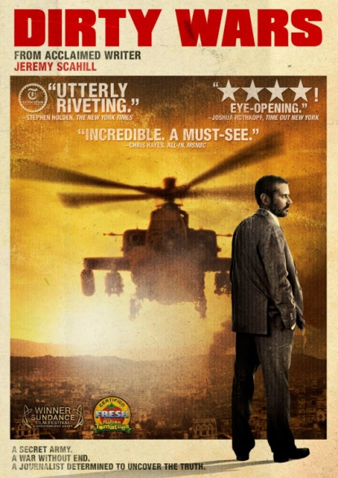
Had the Boston bombs been dirty bombs, a full-blown radiation response would have been required. The response planners would have had to deal with the fact that people not showing visible physical injuries could have ingested or inhaled radioactive material and been contaminated, or could have been exposed without being contaminated. Could Boston have established timely triage and contamination zones to prevent the movement of contaminated people and material out of the area -- or would the situation have resembled the chaos in the 2004 movie Dirty Wars, a fictional account of a dirty bomb attack in London?

Health hazards. If the Boston marathon had been attacked with dirty bombs, hospitals would have received contaminated victims and patients with radioactive material embedded in them. Protocols for dealing with these problems could have led to delays and further loss of life.
Even if no victims were killed by radiation, there would be long-term medical repercussions. Public health officials would have to determine the radiation doses both to the people who were contaminated and to those who were merely exposed. The history of the few large-scale radiation exposure accidents, such as the 1987 incident involving a medical radiation source in Goiania, Brazil, indicates that the public's fear of all things involving radioactivity might greatly expand the medical response required. Medical personnel would need to deal with people who have not been exposed to radiation, but fear they have been.
Most of the radiation exposure from a dirty bomb would likely have no immediately observable effects, but could lead to stochastic effects, primarily radiation-induced cancers, in numbers that would be difficult to distinguish from normal cancer rates. However, the potential victims would probably demand to be tracked with programs that could last for many decades.
The victims of the Boston bombings and their families may suffer lifelong mental impacts in addition to injuries from the blasts. While the physical injuries from dirty bombs would be about the same, they could lead to a wider range of physical and mental effects. There would be a group of potential long-term victims left to wonder about their status for decades, uncertain as to whether the exposure they received would cause medical problems.

Legal reaction. The forensic response would also have to have been handled differently if radioactive material had been used. With the crime scene contaminated, it would have been more difficult to acquire and process all the photos and videos that turned out to be instrumental in tracking down the Tsarnaev brothers. Items that technicians were able to examine relatively quickly, such as parts of pressure cookers and circuit boards, might not have been available in the same time frame. Normal police forensic labs are not generally equipped to analyze radioactively contaminated items, and experts in nuclear forensics are few and far between. The work that the public observed done so quickly and efficiently in Boston would have required significant outside assistance. The effects could have delayed identification of the bombers, and perhaps allowed them to carry out more attacks.
Had radioactive materials been used, public officials would also have had to consider what level of cleanup Boston required. Contaminated material would have to have been removed and treated as radioactive waste, at great cost. The Environmental Protection Agency has standard decontamination guidelines, but the public might have demanded even more cautious ones.
Finally, any dirty bomb incident could have major political and legal ramifications. Modern tragedies of all types have generated calls for laws to ensure that whatever happened cannot occur again. Some of these new regulations end up well thought out, while others that initially appear helpful are counter-productive. Some, however logical, cannot survive the political process. The reaction to a dirty bomb would probably be just as messy.
It's not pleasant to think through worst-case scenarios, but in this case it's essential. The media, citizens, and all levels of government should undertake a thorough exploration of how to respond to a dirty bomb, so that they are prepared when one is actually used.

George Moore is a scientist in residence at the James Martin Center for Nonproliferation Studies of the Monterey Institute of International Studies. From 2007 to 2012 he was a senior analyst in the Office of Nuclear Security at the International Atomic Energy Agency (IAEA).

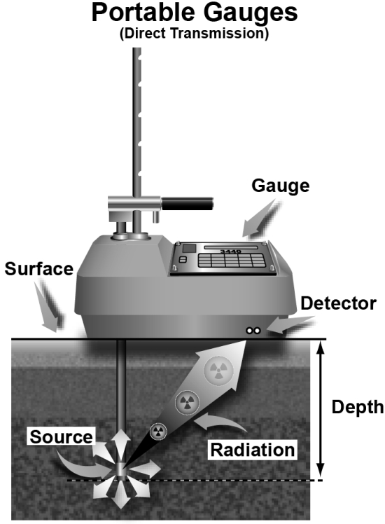
Moisture and Density "Nuclear" Gauges Used in Road Construction
Source: http://www.epa.gov/radtown/gauges.html

Quality control is an important aspect of any construction project. Building roads is no exception, and the moisture content and density of the materials used are very important. Gauges containing radioactive sources are used for determining the density of asphalt, soil, aggregate (usually gravel or crushed rock), and concrete as well as the moisture content of the soil or aggregate.
These gauges work by measuring either the "backscatter" or the "direct transmission" of radiation directed at a material. "Backscatter" is the amount of radiation that is deflected by the material and is measured by placing the gauge on the surface of the material. "Direct transmission" is the amount of radiation that passes through the material and is measured by drilling a hole in the material and inserting the gauge.
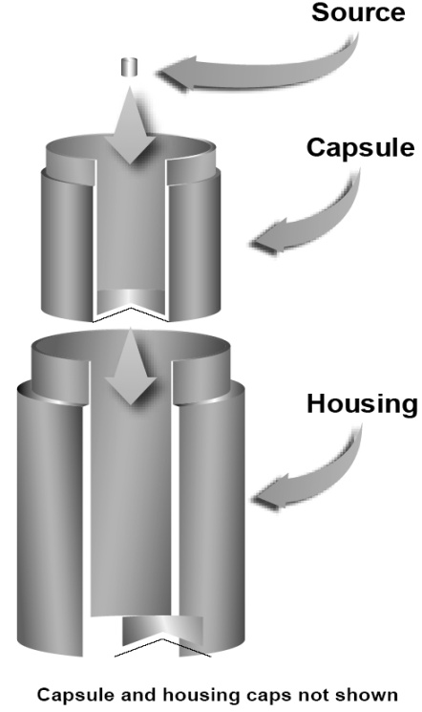
Various kinds of sources are used in moisture and density gauges, and each gives off specific types of radiation. One source often used is cesium-137, which emits both beta and gamma radiation. Another is a compound of americium-241 and beryllium, which emits neutron radiation. (Although americium-241 emits alpha radiation, when mixed with beryllium (a non-radioactive metal), the mixture emits neutrons.)
The radioactive sources in the gauge are surrounded by shielding. It is only when the gauge is mishandled or damaged that it becomes a significant radiological hazard to the operator. Extensive experience with these gauges over many years indicates that radiation exposure to workers is generally low and that accidents involving the gauges are infrequent. When these gauges are used properly, radiation exposure of the general public is not an issue.
Nuclear gauges containing licensed radioactive sources must be disposed of properly. They must not be treated as ordinary trash, recycled as scrap metal, or abandoned. Contact the manufacturer or your state radiation control program for disposal instructions. Some manufacturers also accept gauges for disposal.

Increased Security for Nuclear Materials

Source: http://mobile.nytimes.com/2014/01/11/opinion/increased-security-for-nuclear-materials.html? _r=0&referrer=

There is some rare good news on the issue of securing and containing deadly nuclear materials. In the last two years, seven countries have forsaken their uranium and plutonium stockpiles, bringing the number of nations still possessing appreciable quantities of nuclear fuel usable for bomb-making down to 25. In 1991, the number was 52.
The data comes from the Nuclear Threat Initiative (NTI), a private advocacy group that promotes the safekeeping of nuclear materials. Following up on its first report in 2012, the group surveyed the precautions each country had in place and ranked nations based on their security practices. The report issued on Wednesday covered factors like national laws, regulations, participation in international treaties and physical security, including whether a state has armed guards protecting its facilities.
The countries deserving special praise — Austria, the Czech Republic, Hungary, Mexico, Sweden, Ukraine and Vietnam — effectively gave up their bomb-making capability and now have less than one kilogram (2.2 pounds) of material that can fuel nuclear weapons.
Of the countries that still have weapons-usable nuclear material, Australia placed first on the security ranking, because it reduced its supply of nuclear materials and ratified a treaty that commits countries to criminalize acts of nuclear terrorism and bring nuclear criminals to justice. The United States fell to 11th in part because it failed to ratify two nuclear accords.
Despite progress, the challenges ahead are daunting. At the bottom of the security rankings were North Korea (25), which is continuing to expand its nuclear weapons program, and Iran (24), which is in negotiations with the United States and other world powers on an agreement to freeze and roll back its program.
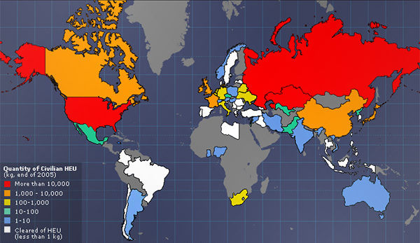
Pakistan’s rank rose to 22, up slightly from two years ago and ahead of India (23), because the Pakistani government took steps to update its nuclear security regulations. Still, both countries are nuclear-armed, have weak safety and security ratings, and are still increasing their nuclear fuel stockpiles for military and civilian purposes.
The world is already awash in 2,000 metric tons of weapons-usable nuclear material spread across hundreds of sites around the globe. According to the International Atomic Energy Agency, 100 incidents of theft and other unauthorized activities involving nuclear and radioactive material are reported to the organization every year.
There are many steps the international community can take to prevent nuclear fuel from falling into terrorists’ hands, including developing a system of global standards for securing the material and persuading nations to ratify nuclear security treaties. World leaders should push this agenda forward when they meet in The Hague for their third nuclear summit meeting this March.

►Visit NTI’s website at: http://www.nti.org/

Interim nuclear agreement with Iran goes into effect 20 January
Source: http://www.homelandsecuritynewswire.com/dr20140113-interim-nuclear-agreement-with-iran-goes-into-effect-20-january

The United States and the EU announced Sunday that on 20 January Iran will start implementing November’s “comprehensive agreement.” One of the main clauses in the agreement calls for Iran to begin eliminating its stockpile of highly enriched uranium – that is, uranium enriched to 20 percent or higher — in eight days’ time from the start date. In addition to eliminating its stockpile of 20 percent enriched uranium before the end of January, Iran will also freeze other aspects of its nuclear program, accept more rigorous inspections of its nuclear facilities, and disable the cascade that produces 20 percent-enriched uranium. In exchange, Iran would receive some the relief from the sanctions, providing a $7 billion boost to the Iranian economy. The bulk of relief is in the shape of $4.2 billion in restricted Iranian assets which will be repatriated to Tehran in regular instalments throughout the six months until the deal concludes in July.

US nuclear forces, 2014
Source: http://bos.sagepub.com/content/70/1/85.full

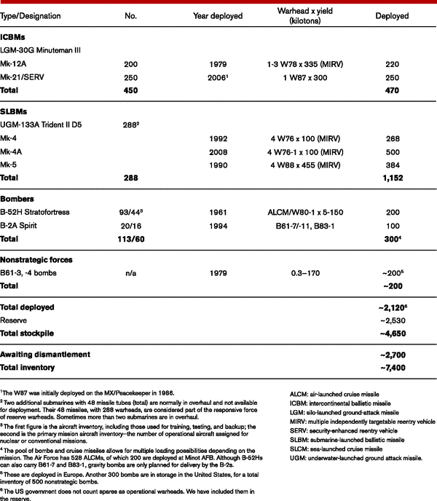
The United States has an estimated 4,650 nuclear warheads available for delivery by more than 800 ballistic missiles and aircraft. Approximately 2,700 retired but still intact warheads await dismantlement, for a total inventory of roughly 7,400 warheads. The stockpile includes an estimated 2,130 operational warheads, about 1,150 on submarine-launched ballistic missiles and 470 on intercontinental ballistic missiles. Roughly 300 strategic warheads are located at bomber bases in the United States, and nearly 200 nonstrategic warheads are deployed in Europe. Another 2,530 warheads are in storage. To comply with New START, the United States is expected to eliminate land-based missile silos, reduce the number of launch tubes on its missile submarines, and limit its inventory of nuclear-capable bombers in coming years. Coinciding with a revised nuclear weapons strategy, the Obama administration is also planning an upgrade of all nuclear weapons systems. The three-decade-long plan would cost more than $200 billion in the first decade alone.

►Read more at source’s URL.
Mathematician drafts urban nuclear shelter guide
Source: http://phys.org/news/2014-01-mathematician-urban-nuclear.html

A scientist published a guide Wednesday (Jan 15) to help authorities limit deaths from fallout after a city is hit by a nuclear bomb.
Taking cover in existing buildings is widely accepted as a critical first action after a nuclear blast in a major city.
But how long people should stay there before moving to better shelter is a more complex question.
Buildings that are lightweight or lack a basement are more easily penetrated by radioactive dust.
Writing in a British scientific journal, Michael Dillon of the Lawrence Livermore National Laboratory in California, has now come up with a mathematical model for the "optimal shelter exit time" to minimise radiation risk.
Based on his calculations, if adequate shelter is 15 minutes away, individuals should remain in their initial, poor-quality shelter no longer than 30 minutes after detonation.
If, however, the better shelter is only five minutes away, individuals should move there immediately and forego the closer but unsafe buildings altogether, he wrote.
Reaching adequate shelter rapidly could save between 10,000 and 100,000 individuals from fatal exposure in the event of a single, low-yield detonation, said the study published in Proceedings of the Royal Society A.
"These methods are intended to assist emergency planning officials in the development of an optimal low-yield nuclear detonation response strategy," wrote Dillon.
A low-yield blast is described as 0.1-10 kilotons.
One kiloton (kT) is an explosive force equivalent to that of 1,000 metric tons of TNT. The US bomb that killed more than 200,000 people in Hiroshima, Japan, in 1945 was about 15 kT.
More than a fifth of American households lack basements or are considered too lightweight to offer shelter in the fallout phase of the emergency, the study said.

Iraqi Policeman Throws Himself on Suicide Bomber to Save Others
Source: http://world.time.com/2013/12/19/iraqi-policeman-saves-pilgrims/?goback=.gde_4962526_ member_5819373458475229188#!
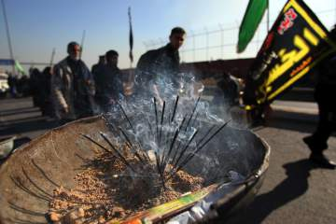
Ali al-Saadi / AFP / Getty Images
Incense burning as Iraqi Shi‘ite Muslim pilgrims walk along the main highway that links the Iraqi capital, Baghdad, with the holy city of Karbala on Dec. 18, 2013, to take part in the Arbaeen religious festival that marks the 40th day after Ashura

A heroic Iraqi police officer, Ayyub Khalaf, gave his own life on Wednesday as he threw his arms around a suicide bomber moments before detonation in the middle of a procession of Iraqi pilgrims.
The 34-year-old policeman’s sacrifice almost certainly helped keep the death toll down to five, with 10 wounded, Agence France-Presse reports.
“Ayyub was martyred while defending pilgrims,” said his friend Saad Naim. “His name will be an eternal symbol because he saved the lives of dozens of innocents.”
The attack, which took place in Khales, northeast of Baghdad, is the latest in a string of strikes against Shi‘ite pilgrims. Violence in Iraq has hit a level this year not experienced since 2008.
Khalaf is survived by a wife and two children, 6 and 9 years old.

Car bomb explodes at hotel in Sadao district of Songkhla province in Thailand
Source: http://www.news.com.au/world/car-bomb-explodes-at-hotel-in-sadao-district-of-songkhla-province-in-thailand/story-fndir2ev-1226788615250

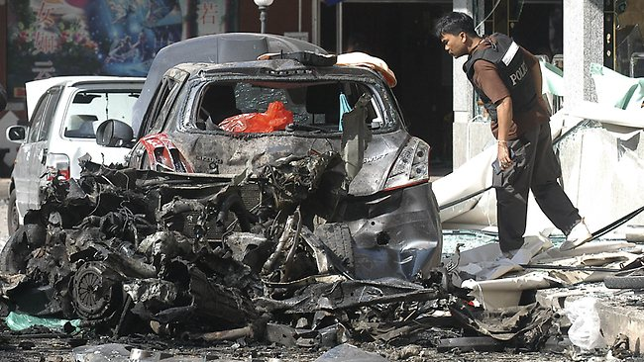
More than 20 people have been wounded - four seriously - when a car bomb went off near a hotel in the far south of Thailand, a local governor says.
The blast occurred in front of a hotel in the Sadao district of Songkhla province, an area rarely targeted by insurgents fighting for a level of autonomy for Thailand's southernmost provinces which have a Malay Muslim majority.
Television footage showed a smoke-choked road and charred cars outside the hotel.
Two other bombs attached to parked motorcycles struck a police checkpoint and a police station elsewhere in the province without causing injury, according to Songkhla governor Kritsada Boonrat.
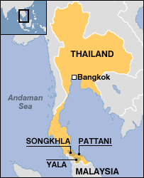
"Something like this has never happened in Sadao district before... this area is a border trade area (with Malaysia)," Ms Kritsada said, adding security will be stepped up.
He said police were checking CCTV footage and forensic teams were investigating the three bomb sites, but did not say who he believed was responsible.
The southernmost provinces are in the grip of a near-decade-long insurgency which has cost thousands of lives - the majority of them civilians.
'Unprecedented'... "Something like this has never happened in Sadao district before," the region's governor said.
The violence occurs on a near-daily basis in Pattani, Yala and Narathiwat, and occasionally extends to several districts in Songkhla.
Tentative peace talks between the Thai state and representatives of the major rebel group have stalled.
Another round of talks scheduled for December has been postponed as the crisis-hit Thai government handles massive street protests in Bangkok aimed at toppling Prime Minister Yingluck Shinawatra.
National Security Council chief Paradorn Pattanatabut said the culprits may have been linked to the Thai rebellion in the south, and could have been expressing anger that peace talks have faltered while the government concentrates on political turmoil in Bangkok.
"A second theory is it was related to the domestic political situation - to discredit the government," he added.
Sources close to the talks have raised doubt over whether the peace talks will continue given the political unrest in Bangkok.

Passengers evacuated 'just in time' before Israel bus bomb
Source: http://edition.cnn.com/2013/12/22/world/meast/israel-bus-bomb-explosion/

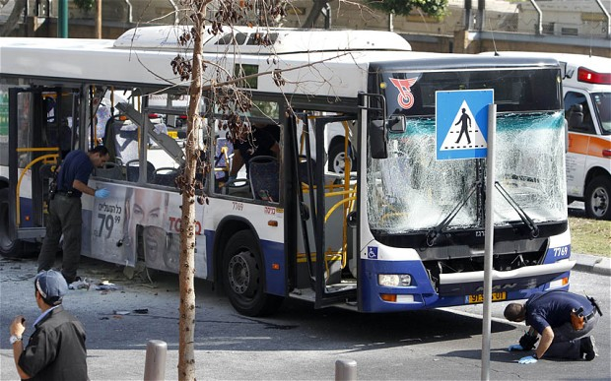
A bomb exploded on a public bus in Israel on Sunday (Dec 22, 2013), moments after passengers evacuated.
Someone spotted a suspicious bag and reported it to the driver, police spokesman Micky Rosenfeld said.
"The passengers were immediately taken off the bus," he said, and made it out safely "just in time."
The bomb detonated while an expert was examining the bag. He was shaken, Rosenfeld said, but not injured seriously.

EDITOR’S COMMENT: Any connection with Kenya’s bus bombings or a new terrorist modus operandi/trend? (Dec 25, 2013 ►Explosion hits bus in Cairo, Egypt; wounds five; Dec 30, 2013 ►Volgograd bus incident).

The Growing U.S. “Bomb Library”
Source: http://i-hls.com/2013/12/the-growing-u-s-bomb-library/
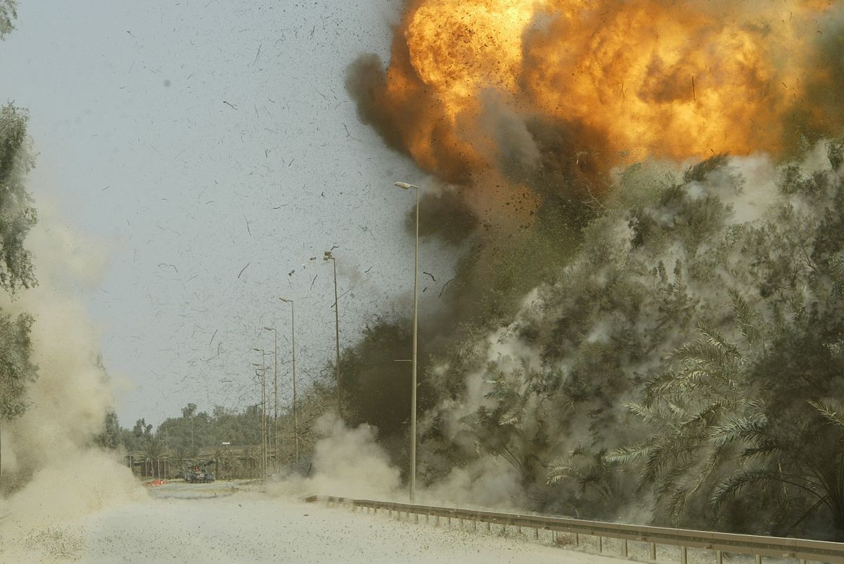
Iraq, 2007: Controlled IED expliostion (Wikimedia Commons)

It has been ten years since the FBI established the Terrorist Explosive Device Analytical Center (TEDAC), and since that time the multi-agency operation — sometimes referred to as America’s bomb library — has become an important tool in the nation’s fight against terrorism.
According to HLS News Wire before TEDAC, no single government entity was responsible for analyzing and exploiting evidence and intelligence related to the improvised explosive devices (IEDs) used by international and domestic terrorists. The FBI say that today, TEDAC coordinates all those efforts.
Located at the FBI Laboratory in Quantico, Virginia, “TEDAC is the government’s single repository for IEDs,” said Special Agent Greg Carl, TEDAC director. “The evidence and intelligence we gather from these explosives is used by law enforcement, the military, the intelligence community, and by our political decision-makers. There is no question that the work we have done — and continue to do — has helped to save American lives.”
Whether bombs come from the battlefields of Afghanistan or from homegrown terrorists within U.S. borders, TEDAC’s thirteen government agency partners and seventeen external partners collect the devices and send them to TEDAC to be analyzed and catalogued.
Since its creation in 2003, TEDAC has examined more than 100,000 IEDs from around the world and currently receives submissions at the rate of 800 per month. Two million items have been processed for latent prints — half of them this year alone. “Just from the sheer volume,” Carl said, “we have a lot of experience identifying IED components and blast damage.” As a result, he added, “we have identified over 1,000 individuals with potential ties to terrorism.”
Also based on TEDAC analysis, more than 100 people have been added to the U.S. government’s Terrorist Watchlist, a database that identifies subjects known or reasonably suspected of being involved in terrorist activity. “Putting individuals on the list prevents them from entering the country,” Carl said.
The agency notes that TEDAC is capable of much more than evidence collection for criminal prosecution, though. “Since we also partner with the military and the intelligence community, our work is utilized by many different sources,” Carl said. The military, for example, uses TEDAC intelligence for force protection and to disrupt terror networks. Decision-makers can count on TEDAC’s intelligence — based on forensic science — to help them form policy.

►More on TEDAC at:

http://www.fbi.gov/about-us/lab/terrorist-explosive-device-analytical-center-tedac/tedac

Dolphins inspire new radar system to detect hidden surveillance and explosive devices
Source: http://www.southampton.ac.uk/mediacentre/news/2013/oct/13_188.shtml

Inspired by the way dolphins hunt using bubble nets, scientists at the University of Southampton, in collaboration with University College London and Cobham Technical Services, have developed a new kind of radar that can detect hidden surveillance equipment and explosives.
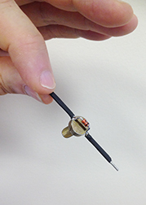
The TWIPR diode

The twin inverted pulse radar (TWIPR) is able to distinguish true ‘targets’, such as certain types of electronic circuits that may be used in explosive or espionage devices, from ‘clutter’ (other metallic items like pipes, drinks cans, nails for example) that may be mistaken for a genuine target by traditional radar and metal detectors.
The new system has been developed by a team led by Professor Tim Leighton from the University’s Institute of Sound and Vibration Research and is based on his unique sonar concept called twin inverted pulse sonar (TWIPS). TWIPS exploits the natural abilities of dolphins to process their sonar signals to distinguish between targets and clutter in bubbly water. Some dolphins have been observed to blow ‘bubble nets’ around schools of fish, which force the fish to cluster together, and their sonar would not work if they could not distinguish the fish from the bubbles.
The technique uses a signal consisting of two pulses in quick succession, one identical to the other, but phase inverted. Professor Leighton, along with Professor Paul White and students Dan Finfer and Gim Hwa Chua, showed that TWIPS could enhance linear scatter from the target, while simultaneously suppressing nonlinear scattering from oceanic bubbles.
Professor Leighton’s team proposed that the TWIPS method could be applied to electromagnetic waves and that the same technique would work with radar. They teamed up with Professor Hugh Griffiths and Dr Kenneth Tong of University College London and Dr David Daniels of Cobham Technical Services to test the proposal, by applying TWIPR radar pulses to a ‘target’ (a dipole antenna with a diode across its feedpoint - typical of circuitry in devices associated with covert communications, espionage or explosives) to distinguish it from ‘clutter’ (represented by an aluminium plate and a rusty bench clamp). In the test, the tiny target showed up 100,000 times more powerfully than the clutter signal from an aluminium plate measuring 34 cm by 40 cm.
The study, ‘Radar clutter suppression and target discrimination using twin inverted pulses’ is published in the journal Proceedings of the Royal Society A.
Professor Leighton says: “As with TWIPS, the TWIPR method distinguishes linear scatterers from nonlinear ones. However, in scenarios for which TWIPS was designed, the clutter scatters nonlinearly and the target linearly - while in situations using TWIPR, these properties are reversed.
“For instance, certain electronic components can scatter radar signals nonlinearly if driven by a sufficiently strong radar signal, in contrast to naturally occurring objects which tend to scatter linearly.”
Given that the diode target measured 6 cm in length, weighed 2.8 g, costs less than one Euro and requires no batteries, it allows the manufacture of small, lightweight and inexpensive location and identification tags for animals, infrastructure (pipelines, conduits for example) and for humans entering hazardous areas, particularly where they might be underground or buried. These tags can easily be tuned to scatter-specific resonances to provide a unique identifier to a TWIPR pulse, what Professor Leighton calls ‘the TWIPR fingerprint’.
Buried catastrophe victims not carrying such tags might still be located by TWIPR, as it can carry the bandwidth to search for mobile phone resonances, offering the possibility of locating victims from their mobile phones, even when the phones are turned off or the batteries have no charge remaining.
Professor Leighton adds: “In addition to the applications discussed above, such technology could be extended to other radiations, such as magnetic resonance imaging (MRI) and light detection and ranging (LIDAR), which, for example, scatters nonlinearly from combustion products, offering the possibility of early fire detection systems.”

Deadly blast hits Russian train station
Source: http://www.aljazeera.com/news/europe/2013/12/deadly-blast-at-russian-train-station-2013122 993711404374.html

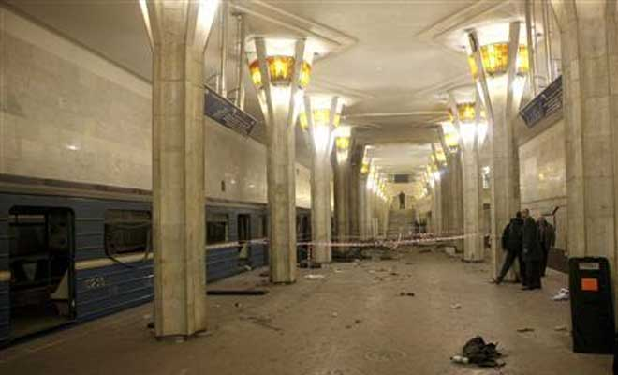
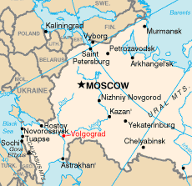
A female suicide bomber has set off a blast in a train station in the southern Russian city of Volgograd killing at least 15 people and injuring at least 34, news reports and officials said.
Regional Interior Ministry spokeswoman Svetlana Smolyaninova told the ITAR-TASS news agency on Sunday that the blast occurred inside the city's main train station at around 12:45pm (Dec 29, 2013).
Vladimir Markin, the spokesman for the nation's top investigative agency, the Investigative Committee, said the suicide bomber detonated her explosives in front of a metal detector.
"When the suicide bomber saw a policeman near a metal detector, she became nervous and set off her explosive device," Markin said in a statement.
He added that the bomb contained about 10 kilograms of TNT explosives, and was rigged with shrapnel.
Markin said that security controls prevented a far greater number of casualties at the station, which was packed with people at a time when several trains were delayed.
Sergei Bozhenov, Volgograd's regional governor, said 15 died. Russia's Health Ministry said at least 34 people were injured.
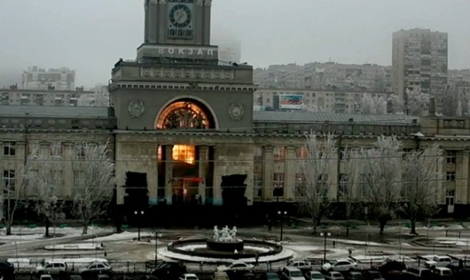
Al Jazeera's Peter Sharp, reporting from Moscow, said one of those injured was a nine-year old girl, who was shielded by her mother, who died in the explosion.

'Black widows'
The city of Volgograd, known as Stalingrad in the Soviet era, was attacked in October 2013 by a female suicide bomber (30 yo Naida Asiyalova, wife of Dmitry Sokolov, a militant from Makhachkala, Dagestan's capital city) with links to groups fighting federal forces in Russia's volatile North Caucasus.
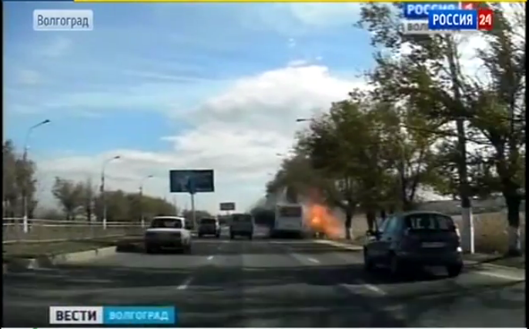
The October 21 strike killed six people aboard a crowded bus (photo below) and immediately raised security fears ahead of the February 4-23 Winter Games in Sochi.
The Black Sea city that will host the Olympics lies 690km southwest of Volgograd and in direct proximity of the violence ravaging North Caucasus regions such as Dagestan and Chechnya on a daily basis.
"It is almost certain that Vladimir Putin will be meeting people in the Kremlin to revise and go over the security operation that's already in place," Al Jazeera's Sharp said.
More than 30,000 troops and security personnel have been drafted in the Sochi region ahead of the games, our correspondent said.
Fighters are said to be seeking to impose an Islamist state throughout Russia's North Caucasus.
Their leader Doku Umarov has ordered his foot soldiers to target civilians outside the region and disrupt the Olympic Games.
Female suicide bombers are often referred to in Russia as "black widows", women who seek to avenge the deaths of their family members in North Caucasus fighting by targeting Russian civilians.
Female suicide bombers set off blasts at two Moscow metro stations in March 2010 that killed more than 35 people.
They were also responsible for taking down two passenger jets that took off from a Moscow airport within minutes of each other in 2004, killing about 90 people.

Volgograd suicide bomber's identity confirmed
Source: http://voiceofrussia.com/news/2013_12_29/Photos-of-female-suicide-bomber-that-killed-dozens -in-Russias-south-now-public-1600/

The suicide bomber who set off a 10kg TNT charge today in the southern Russian city of Volgograd had been officially identified as Oksana Aslanova, a 26-year-old Tabasaran national from Turkmenistan, the Voice of Russia's source reports.
An explosion rocked the railway station in Volgograd at 12:45 Moscow Time on Sunday, December 29th . According to the latest reports, 14 people were killed and dozens injured. According to one of the existing versions, the terrorist attack was carried out by Oksana Aslanova from Daghestan but information needs to be confirmed,” the source said.
The woman was married to one of the militant warlords who was killed during a special operation recently. She was married several times. Investigators are searching for the relatives of the participants of the Dagestani bandits who are suspected of masterminding terrorist attacks in Central Russia.
The work to establish the whereabouts of Oksana Aslanova has been in progress in Daghestan since June of 2012.
Oksana Aslanova was reportedly born June 16, 1987 in Turkmenistan. She later moved to live in Russia’s North Caucasian Republic of Dagestan. She settled down in the city of Derbent at 15/41, Rasulbekov Street and studied at the Dagestan State Pedagogic University.
She married to Mansur Velibekov, a Chechen radical and member of the Southern (Yuzhnaya) criminal ring, who was wiped in 2008. Upon her death, Velibekov’s widow became a so-called “Sharia wife” of the gang’s leader, Gasan Abdulayev.
Another report suggests that Aslanova was also married to a terrorist Israpil Validzhanov, who went under the nickname of Amir Hasan. That criminal got eliminated on March 18, 2011 near the Dagestani village of Tashkapur.
There is no information about her since March 8, 2012. Possibly, the so-called "black widow", who outlived all her husbands, underwent training as a suicide bomber.
Her ID data was reported as follows: passport series 6706 No 719598, issued on Aug. 25, 2007 by the Federal Migration Service in the Khanty-Mansi Autonomous Region. She was registered at the address: 12/34, 1 Mikrorayon, city of Raduzhny in Nizhnevartovsk district in the Region of Tyumen.
Another theory has it that the Volgograd bombing was carried out by a male terrorist who carried explosives in a backpack, a police source told Russia's Interfax news agency.
“We’ve discovered that the suicide bomber was in fact a man who brought the IED to the railway station in a rucksack. His identity has been determined.”
The source did not name the alleged attacker, but added investigators had found an unexploded hand-grenade and a pistol at the scene, which presumably belonged to the terrorist.
Yet another police source in the North Caucasus region told Interfax the railway station’s CCTV footage also showed a man who might have been behind the bombing. “Videos from the building’s cameras suggest that the terror attack was apparently carried out by a man, although this information needs to be confirmed.”

Volgograd blasts: New deadly explosion hits Russian city
Source: http://www.bbc.co.uk/news/world-europe-25546477

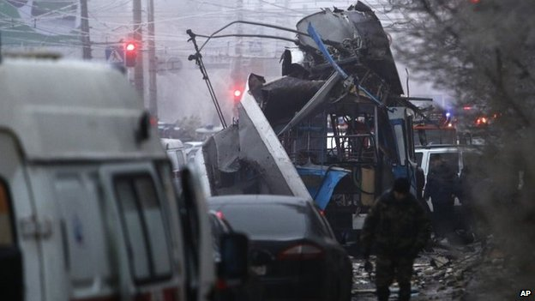
At least 15 people have been killed and 23 others hurt in a suspected suicide bombing on a trolleybus in the Russian city of Volgograd, officials say.
The blast comes a day after 17 people died in another suicide attack at the central station in the city.
Security has been tightened at railway stations and airports across Russia.
Moscow is concerned militant groups could be ramping up violence in the run-up to the 2014 winter Olympic Games in the city of Sochi.
The Olympic venue is close to Russia's volatile north Caucasus region.
Volgograd lies about 900km (560 miles) south of Moscow, 650km north of the North Caucasus and 700km north-east of Sochi.

Busy market
A spokesman for Russia's Investigative Committee said both explosions were now being treated as acts of terrorism.
The latest explosion took place near a busy market in the city's Dzerzhinsky district during Monday morning rush hour.
A one-year-old child is reported to have been among those injured.
The area has been cordoned off, and police and emergency services are at the scene.
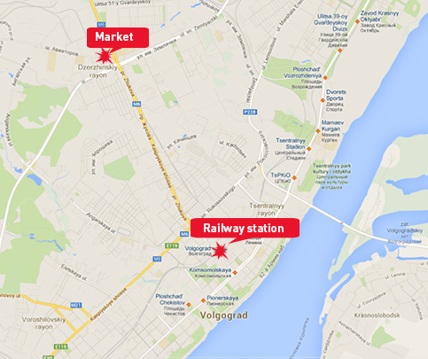
Images posted on social media websites showed the burned-out shell of the trolleybus and bodies scattered around.
Sunday's blast rocked Volgograd-1 station at around 12:45 (08:45 GMT) at a time of year when millions of Russians are travelling to celebrate the New Year.
A nearby security camera facing the station caught the moment of the blast, showing a bright orange flash behind the station's main doors.
The explosion shattered windows and sent debris and plumes of smoke from the station entrance.
No group has yet said it was behind the blast.
An Islamist insurgency in the North Caucasus region has led to many attacks there in recent years. Insurgents have also attacked major Russian towns.
The attacks show that the bombers do not need to attack Sochi directly to attract international attention - any target in Russia will do, says the BBC's Daniel Sandford in Moscow.

The suicide bomber behind the bombing of the Volgograd railway station may be Pavel Pechenkin, a security source told Interfax. He was born in the city of Volzhsk in Mari El republic in central Russia. In spring 2012, he joined a Dagestan-based militant gang after converting to Islam and changing his name to Ansar ar-Rusi, the source said. The information was not officially confirmed. (http://www.rt.com/news/volgograd-bus-blast-updates-958/). Confirmed now!

Russian terrorist attacks since 1991: what's changed?
Source: http://www.theguardian.com/world/2013/dec/30/russian-terrorist-attacks-since-1991-whats-changed?CMP=twt_gu

Two bomb attacks today in Volgograd are thought to be the work of terrorists. Using a database of terrorism we look at how the frequency and type of attack has changed
Since 2001, researchers at the University of Maryland have been compiling the world's largest database of terrorist events. By systematically cataloguing the date, location, target, tactic and number of injuries involved in events since 1970, the researchers have been able to document the changing nature of terrorism worldwide.
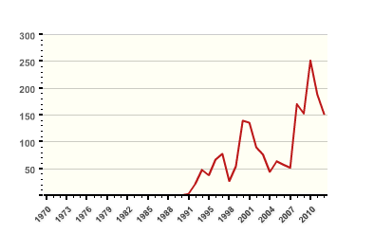
Unlike other countries, no incidents are recorded between 1970 and 1991 in Russia because of the lack of reliable statistics prior to the fall of the Soviet Union. In the decades since the 1990s, the number of terrorist incidents has risen six-fold, although the yearly totals have fluctuated considerably.
Terrorism in Russia Photograph: /Global Terrorism Database

Location of incidents
The majority of attacks have been targeted at the border between Georgia and Azerbaijan. Unsurprisingly, the capital Moscow has also been a focus for several incidents.

Casualties
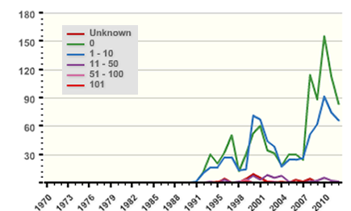
Most terrorist attacks do not result in casualties and those that do rarely injure more than 10 individuals. Despite that, the rise in the number of attacks has still resulted in a rise in the number of injured and fatally wounded victims.
Fatalities terrorism in Russia Photograph: /Global Terrorism Database

Russia's deadliest terrorist incident occurred on 1st September 2004 when a group of armed Chechen Rebels seized a school in Beslan, North Ossetia. 1,200 children, parents, and teachers were taken hostage in the school gym during a siege which left 727 people injured and approximately 344 dead.

Changing tactics
As the use of terrorism has grown in Russia, the specific tactics used have changed slightly over time. The use of explosives such as bombs and dynamite has grown rapidly since 2007 - as has the use of firearms as a weapon.
The police have also overtaken government, the military and business to become the most common target of terrorists. Since 2006, there have been 337 attacks against the police, accounting for 1 in 3 of all terrorist incidents. Transportation was targeted in 66 cases, while harming religious figures and institutions was the aim of 55 attacks during that time.

Defining terrorism
Aware that the database is an attempt to quantify a highly politicised phenomenon, the researchers have attempted to be transparent about their definition of terrorism. To be included in the global terrorism database (GTD), the incident must:
- be intentional
- entail some level (or threat of) violence
- be perpetrated by subnational actors
In addition, the event has to satisfy at least two extra criteria out of the following three:
- The act must be aimed at attaining a political, economic, religious, or social goal
- There must be evidence of an intention to coerce, intimidate, or convey some other message to a larger audience (or audiences) than the immediate victims
- The act must be outside the parameters permitted by international humanitarian law (particularly the prohibition against deliberately targeting civilians or non‐combatants)

Field Forensics Explosives Detection
Source: http://www.fieldforensics.com/news-ffi.html

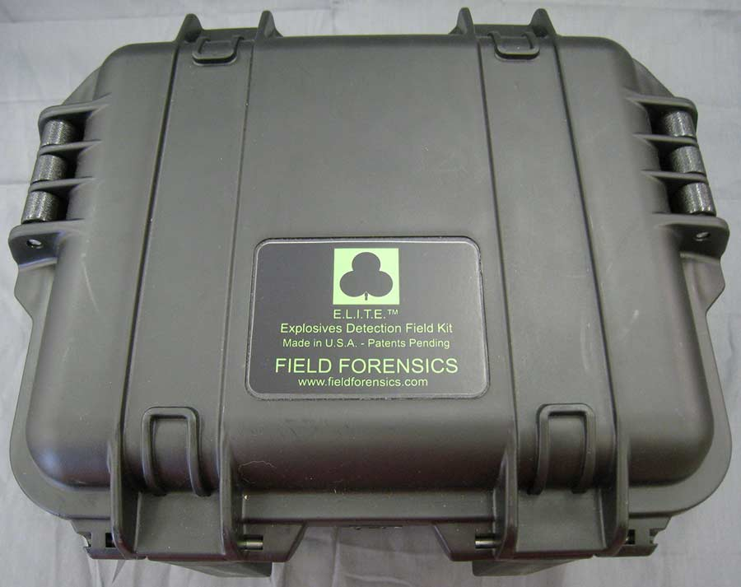
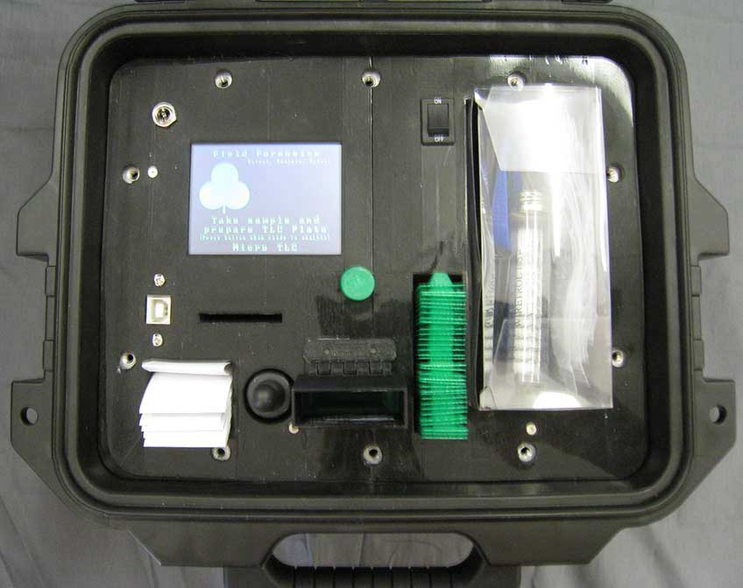
Field Forensics announces the availability of microTLCTM, a portable, fast and easy to use solution for the separation and identification of drugs and explosive mixtures. In addition to achieving package miniaturization using only one thin layer chromatography (TLC) plate, the microTLC has other innovations including an integrated ultra-violet light source, digital video camera for plate analysis and record management, extended battery operation, together with easy menu-driven operations. TLC is an established laboratory procedure that identifies compounds belonging to the same general chemical class. Now the microTLC enables both laboratory and field analysis to be performed by first responders and forensics scientists.
The lightweight microTLC provides a streamlined sampling and testing protocol that allows rapid, reproducible, separation and identification of the real-world drugs and cutting agents, explosives and precursors, with extended use to a wide range of hazardous materials. The miniaturized kit employs the use of commercially available plates as the separation medium and a colorimetric identification scheme that provides confirmation of the identity of the analyte under analysis. Pre-spotted plates can be used with drugs and explosives standard materials. Total analysis times can be less than three minutes. Limits of detectability are typically at nanogram levels. Picogram levels are possible.
With the microTLC, the elution solvent can be changed to develop a different separation pattern. This provides a method to confirm the identity of a suspected drug or explosive without physically changing the type of TLC plate. This is important when there may be a non-drug or non-explosive material that has the same retention factor as one of the standard drug or explosive compounds.
To meet the fast growing law enforcement case work challenges created by the increasing availability of cocaine and heroin mixtures together with new classes of synthetic drugs, the microTLC provides rapid identification of compounds of seized drugs including isomers and analogs. The microTLC is a category B instrument for presumptive testing under the SWGDRUG guidelines.
The microTLC is available now and can be delivered within four weeks after receiving customer orders. Pricing for one unit is less than US$5,000.

Quick and Easy - In the lab or in the field:
- Reagents are all pre-measured
- Integrated UV light means neither safety glasses nor developing reagents are needed.
- Plates are pre-marked for sample application and standards have been pre-applied
- No need to calculate Rf values
- Built in camera to capture an image of developed plate

Specifications and Features:
- Fully contained; 11.8” x 9.8” x 7.7”; 8 lb. (3.6 kg)
- Rechargeable battery operates 12 hours
- Data acquisition and storage capabilities
- Fast - test is complete within 3 minutes
- Easy step by step on-screen instructions
- Separates components of a mixture while determining analyte(s) of interest
- Pre-spotted TLC plates have a 1-year shelf life
- Nanogram (ng) detection limits; picogram (pg) possible

Palestinian ambassador to Czech Republic killed in explosion
Source: http://www.homelandsecuritynewswire.com/dr20140102-palestinian-ambassador-to-czech-republic-killed-in-explosion

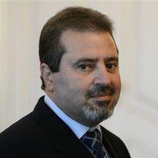
Jamal al-Jamal, the Palestinian ambassador to the Czech Republic, was killed yesterday (Jan 1, 2014) in a blast at his home in Suchdol, an upscale suburb north of Prague. The blast is believed to have been caused by explosives stored in a safe. When he opened the safe, the explosives went off.
The Czech police say that its initial investigation has not found any signs of an attack on the ambassador residence, but that the police is still interested in finding out why such a large quantity of explosives was kept in the residence, which also housed the offices of the Palestinian diplomatic mission in Prague.
The Guardian reports that Riad al-Maliki, the Palestinian foreign minister, said that the safe had not been opened in at least thirty years. The ambassador moved to the new – or rather, renovated — building in October, and workers moved the safe, unopened, from the old offices of the Prague Palestinian mission to the new one at that time.
“The ambassador decided to open it. After he opened it, apparently something happened inside and [the safe] went off,” Maliki said.
Jamal, 56, was rushed to a Prague military hospital in serious condition, and died a few hours later without gaining consciousness.

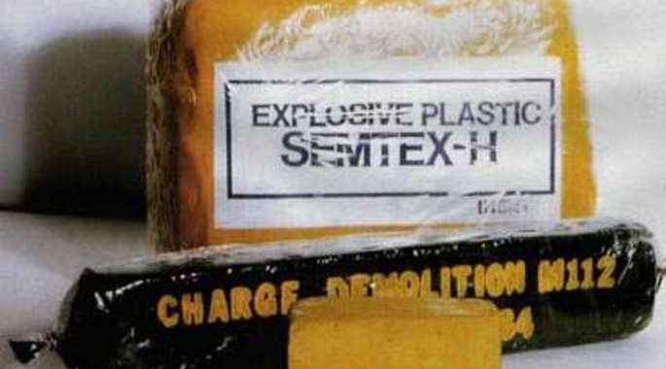
The bomb in the Palestinian ambassador's safe could go back to the old days when communist Czechoslovakia supplied terrorists with Semtex, a well known and highly effective Czech-made explosive.
Bank safe explosion illustration

An embassy spokesman, Nabil el-Fahel, told Czech Radio the ambassador’s entire family had been at the two-story residence when the blast occurred.
A Palestinian official in Ramallah said: “This explosion happened at his house. He recently moved there. He was taken to hospital. An investigation is under way.”
A second Palestinian source told the Guardian: “He moved an old case with him to the new house from the old house. And when he opened it, the explosion happened.”
The Palestinian foreign ministry said it would send a delegation to Prague to help with the investigation.
Jamal had been ambassador to the Czech Republic since October.
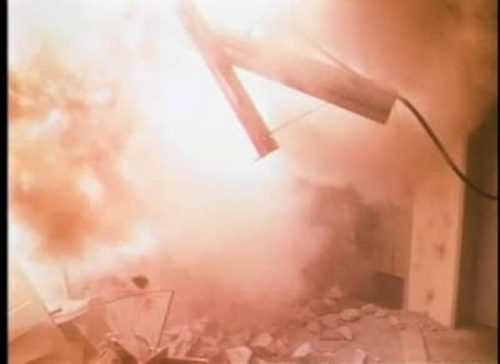
Analysts note that the reference by al-Maliki, the Palestinian foreign minister, to the fact that the safe had not been opened in thirty years may offer an explanation of the explosion. Until the late 1980s, the Palestinians used the offices of the PLO missions in foreign capitals to store explosives and weapons which were used in attacks on Israeli and Jewish targets in those cities. That practice ended as the PLO abandoned terrorism and turned to diplomacy to achieve the Palestinian national goals, a process which culminated in the 1992 Oslo Agreement between Israel and the PLO.
It may well be the case that the safe was used to store explosives in that early, terrorist phase of the PLO. The current generation of Palestinians serving in diplomatic posts – and the ambassador was a member of this new generation — probably never imagined that an old, dusty safe which workers moved from the old PLO offices to the new Palestinian embassy would contain explosives —and would, in all likelihood, also be booby-trapped.

►UPDATE (Jan 2): Twelve (12) unregistered weapons (enough for a group of 10) found in the home of the Palestinian envoy.

►UPDATE 2 (Jan 16): A second IED was found disgized in a book in a crypt.

TRICKY QUESTION!

Who said (?): “I can give you a guarantee to protect the Sochi Winter Olympics next year. The Chechen groups that threaten the security of the games are controlled by us.”

►Answer: http://english.farsnews.com/newstext.aspx?nn=13921011000510

EDITOR’S COMMENT: Chess is a strategy game. Strategy is not a game! Sometimes (often) I wonder about the level of sanity of world leaders playing deadly games as if they were playing chess!
Implant Sciences' Trace Detection Equipment to Protect 2014 Sochi Games
Source: http://www.hstoday.us/single-article/implant-sciences-trace-detection-equipment-to-protect-2014-sochi-games/5f9864e6da6ee8c0697cd4d10d14a19b.html

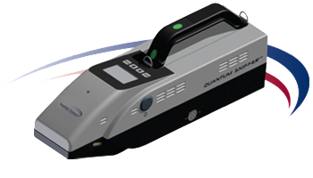
Implant Sciences Corporation (otcqb:IMSC), a high technology supplier of systems and sensors for homeland security and defense markets, announced it has shipped eight QS-H150 handheld explosives trace detectors for deployment at the media center during the upcoming Sochi games.
The Sochi Media Center will open its doors during the Winter Games in 2014. During that time, ninety-eight events in fifteen winter sports will be held. The Sochi Media Center (inclusive of the International Broadcast Center), which will serve as the primary media venue for accredited media representatives for the Sochi games, is equipped to host multimedia events in several formats and will provide round-the-clock assistance to members of the media.
"The QS-H150 will be deployed as part of a comprehensive security package at the Sochi Media Center," stated Natalya Hall, general manager for Russia and the CIS countries at Implant Sciences. "During the Games, the Center is expected to welcome 12,000 media representatives - including over 10,000 broadcasters representing about 100 companies from all around the world, so security is an extremely important consideration."
"Re-establishing our presence in the Russian market has been a priority for us," stated Implant Sciences' Vice President of Sales and Marketing, Darryl Jones. "This order demonstrates measurable progress against this goal. We are continuing to expand our sales presence in Russia and the CIS countries and look forward to more orders in the near future."
The QS-H150 utilizes Ion Mobility Spectrometry (IMS) technology, providing fast, accurate detection of trace amounts of a wide variety of military, commercial, and homemade explosives. Built with no radioactive materials and featuring a low-maintenance, self-calibrating, and self-clearing design, the QS-H150 provides very high levels of operational availability. The QS-H150 has been proven to perform well in a wide variety of temperatures and challenging environments, from humid jungles to dry, sand swept deserts.

Man arrested after WMD's found in Caldwell Co. home
Source: http://www.wbtv.com/story/24376062/report-man-arrested-after-wmds-found-in-caldwell-co-home

A Lenoir man was arrested after police said at least two weapons of mass destruction were found in his home.
The incident began just after 9:15 a.m. when the Lenoir Police Department got a call about a bomb being inside a home on Cedar Place, which is off of Hibriten Drive SW.
At the home, officers found materials they say "appeared to be consistent with materials used to construct a weapon of mass destruction."
The weapons, officials said, were a "Molotov cocktail" and a second, unidentifiable incendiary device. Both devices were collected and secured by STAT Environmental Services of Lenoir.
Police arrested 22-year-old Joseph Scott Bolick, Jr., at the home and charged him with manufacture/possess nuclear/biological/chemical weapon and possession of drug paraphernalia.
Bolick was taken to the Caldwell County Jail and placed under a $50,000 secured bond.

EDITOR’S COMMENT: I read the title of the article and I was eager to read about sarin, soman, VX or toxins or RIEDs and alike. Instead I read about ONE Molotov bomb and an incendiary device. And he was arrested for possession of WMDs!!!! In Greece we have so many Molotovs that we could easily start the First WMD World War! Perhaps it is time to advocate US legislation at home! On the other hand, despite my bitter comment I think that we must all understand that “mass” in WMD does not necesseraly mean ecatombs of victims. A burned police officer will do… Modern violence desensitization will pay back and then we will all complain about lack of security and alike. Perhaps Lenoir police spread a loud message and we must have our ears unplugged to understand the future potentials of apathy.

Greek M-collection

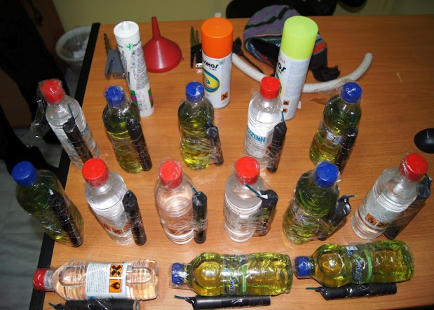 | 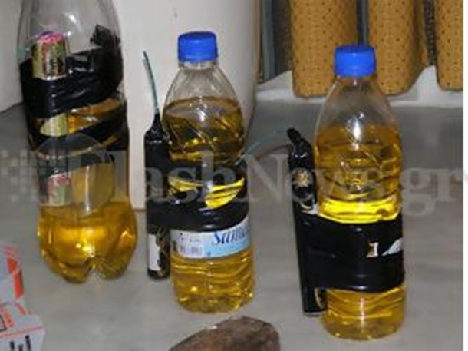
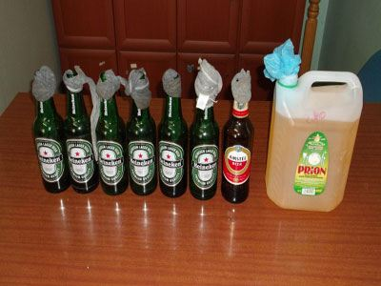 | 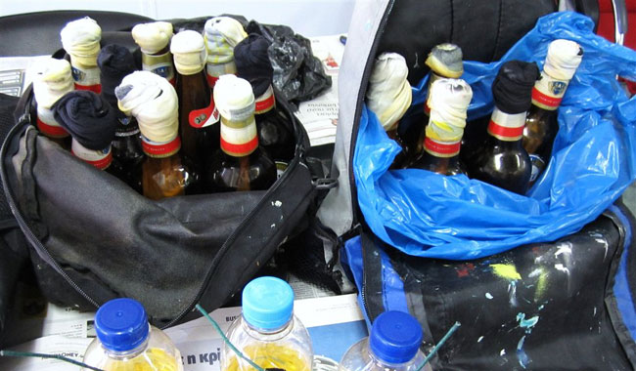
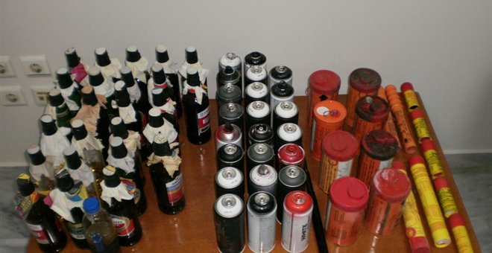

UK – About nine’ WW2 bombs washed on to Westcliff beach
Source: http://www.marsecreview.com/2014/01/about-nine-ww2-bombs-washed-on-to-westcliff-beach/ ?goback=.gde_4709642_member_5826350792721862660#!

“About nine” World War Two explosives have been washed up on a beach in Essex following recent storms, Thames Coastguard have said.
Experts from the Royal Navy carried out controlled explosions on the anti-aircraft shells at Westcliff-on-Sea (red dot on map), at about 09:45 GMT.
They were called in by coastguards, after a man walking on the beach on Sunday morning spotted the explosives.
They were identified as anti-aircraft shells by the navy experts.
Thames Coastguard said the shells, which were corroded but still live, were found at low water at Ray Gut channel, about half a mile (800m) away from Westcliff seafront.

Aitzaz Hasan: Tributes to Pakistan teenager killed when he stopped a bomber
Source: http://www.bbc.co.uk/news/world-asia-25663992

Tributes have been pouring in for a Pakistani teenager who was killed on Monday when he tackled a suicide bomber targeting his school in the Hangu area.
Aitzaz Hasan, 15, was with friends outside school when they spotted a man wearing a suicide vest.
Despite the pleas of his fellow students, he decided to confront and capture the bomber who then detonated his vest, his cousin told the BBC.
Aitzaz is being hailed as a hero in an outpouring of praise on social media.
There have even been calls for him to receive the army's highest honour awarded to those who have sacrificed their life for their country, though it is unclear if he would be qualified to receive it as a civilian.
"We the citizens believe that State of Pk must award Nishan-i-Haider to Pk's brave son Shaheed Aitezaz," journalist Nasim Zehra tweeted on Thursday.
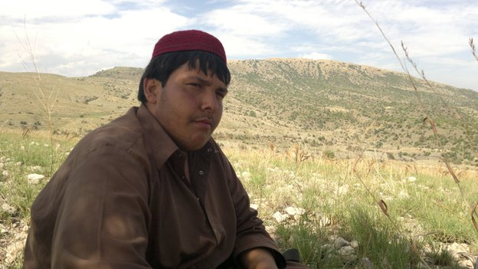
The incident took place on Monday in Ibrahimzai, a Shia-dominated region of Hangu, in north-western Pakistan. There were almost 2,000 students in attendance at the time of the attack, media reports say.
"My cousin sacrificed his life saving his school and hundreds of students and school fellows," his cousin Mudassar Hassan Bangish told the BBC's Aleem Maqbool.
"The suicide bomber wanted to destroy the school and school students. It was my cousin who stopped him from this...destruction."
He then described the sequence of events as related to him by witnesses at the school.
Aitzaz's friends had urged him not to confront the suicide bomber but he ignored their pleas and decided to confront the man with the intention of halting him.
"So he told them 'I'm going to stop him. He is going to school to kill my friends'. He wanted to capture this suicide bomber. He wanted to stop [him]. Meanwhile the suicide bomber blasted himself which resulted in the death of my cousin," Mr Bangish said.
He described Aitzaz as "brave" and a good student. "He always used to say 'I am always ready for my country'."
His family insists that rather than focus on the sorrow brought about by his death, they want to focus on their pride in his actions.
"He is a shahid [martyr]. A shahid of his whole nation," he said.
"My son made his mother cry, but saved hundreds of mothers from crying for their children," Mujahid Ali, Aitzaz's father is quoted as saying.

2010 Times Square Bombing Attempt

Source: http://www.theepochtimes.com/n2/united-states/shahzad-confesses-to-times-square-bombing-attempt-say-officials-update-34704.html

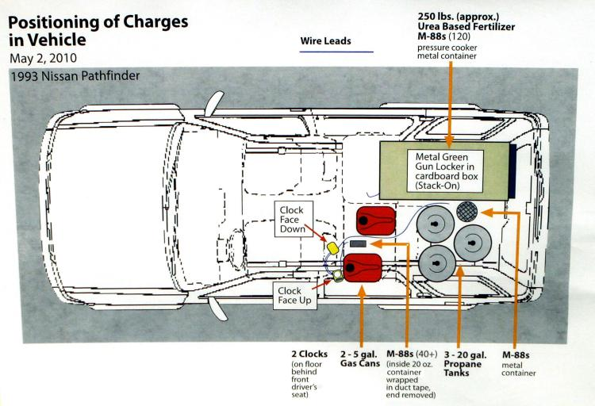
In this handout from the U.S. Department of Justice (DOJ), a graphic showing the positioning of charges in the Nissan Pathfinder allegedly driven by Faisal Shahzad and left in Times Square. Shahzad, 30, a naturalized U.S. citizen from Pakistan was arrested in connection with the case while on board a flight leaving the country. (Photo by U.S. Department of Justice via Getty Images).

CATSA Invests $60 Million in Explosives Detection
Source: http://www.hstoday.us/single-article/catsa-invests-60-million-in-explosives-detection/500fbd3b 7930307208d4391bb17dcdc2.html

The Canadian Air Transport Security Authority (CATSA) contracted L-3 Security & Detection Systems to supply its high-speed eXaminer XLB explosives detection systems.
The total value of the contract, including service, is approximately $60 million.
L-3’s eXaminer XLB is the first certified dual-energy EDS specifically for screening checked baggage in high-throughput airport environments. Capable of scanning over 1,200 bags per hour in-line, it is designed to keep baggage moving continuously through a meter-wide scanner.
The eXaminer XLB generates high-resolution 3D image data for explosives detection by combining helical computed tomography (CT) with dual-energy imaging. Using 3D continuous flow CT technology, the system generates high-resolution, medical-quality images in real time. Features include 360-degree rotational views of entire bags and individual threat objects.
More than 1,000 eXaminer systems have been deployed at airports domestically and internationally.

The new VBIED?

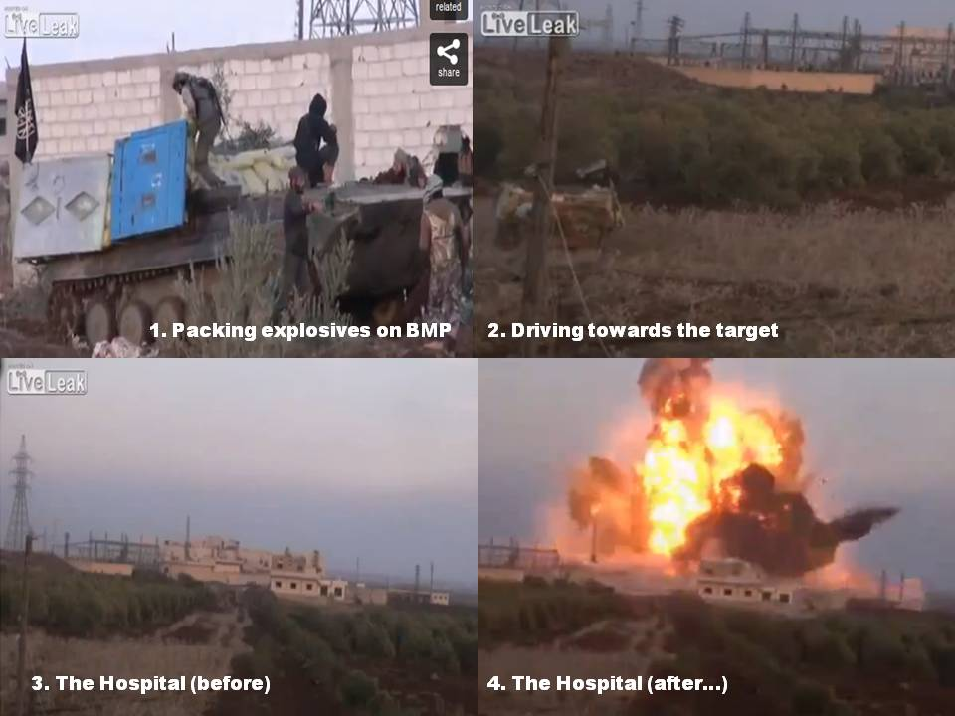
ISIS – Al-Nursa suicide bomber in BMP packed with TNT explosives against Jassim Hospital, Syria.

IMF, UN officials among 21 killed in Kabul suicide attack
Source: http://www.reuters.com/article/2014/01/18/us-afghanistan-explosion-idUSBREA0G12P20140 118

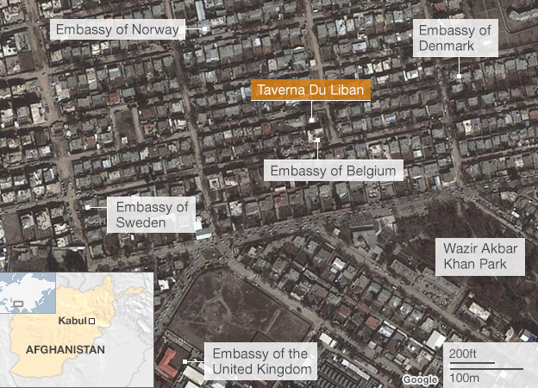
A Taliban suicide bomber and gunmen attacked a restaurant popular with foreigners in the heart of the Afghan capital Kabul, killing 21 people including three United Nations staff and the International Monetary Fund's top representative in Afghanistan.
Gunmen burst into the Lebanese restaurant spraying diners with bullets after the bomber blew himself up near the entrance around 7:30 p.m. local time on Friday, just as people had sat down for dinner.
Thirteen foreigners were among those killed, according to police, and details about the victims began to trickle through on Saturday.
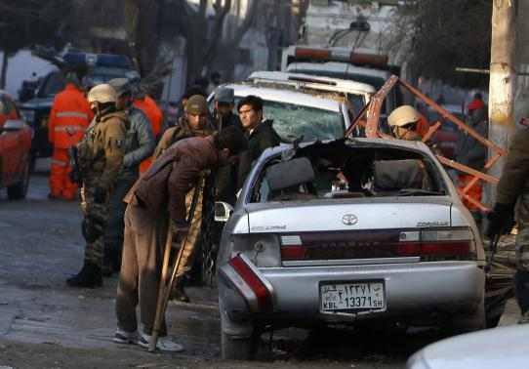
The U.S. State Department said three U.S. private citizens were killed. Britain and Canada confirmed they each lost two nationals and Denmark said one of its citizens also died.
The American University of Afghanistan said two of its U.S. employees died in the attack on La Taverna du Liban, a popular dining spot whose charismatic owner, Kamal Hamade, was also killed.
"We are devastated by the news," Michael Smith, president of AUAF, said in a statement.
After the initial blast, sporadic bursts of gunfire were heard over the next hour. The two gunmen inside the Lebanese restaurant, located in Kabul's diplomatic enclave, were shot dead by police, an Afghan official said.
Most foreign forces are preparing to leave Afghanistan this year after more than a decade of war. Afghanistan watchers fear the Taliban will intensify attacks in the run-up to an election in April to find a successor to President Hamid Karzai.
At odds with Washington over the terms of the bilateral security pact that governs the withdrawal, Karzai is still deliberating whether to allow some U.S. troops to stay on.
If no agreement is reached, Afghan forces could be left to fight the insurgents on their own.
The Taliban claimed responsibility for Friday's attack, calling it revenge for a U.S. air strike earlier this week that had also drawn condemnation from Karzai as eight civilians were killed.
The White House condemned the violence.
"There is no possible justification for this attack, which has killed innocent civilians, including Americans, working every day to help the Afghan people achieve a better future with higher education and economic assistance at the American University, United Nations, International Monetary Fund and other organizations," it said in a statement.

Favorite haunt
Several kitchen staff survived by fleeing to the roof, where they hid until they were rescued by police.
"When I was in the kitchen, I heard an explosion outside. Then all the guys escaped up and I went to the roof and stayed with my back to the chimney for two or three hours," said Suleiman, a cook at the Lebanese restaurant.
By midnight, the operation to clear the area was still under way, with police nervously flashing lasers at passing cars and people on the dark, dusty streets.
The restaurant had been running for several years, and was a favourite haunt for foreigners, including diplomats, contractors, journalists and aid workers.
A couple of armed guards were usually on duty at the front entrance, which led to a courtyard in front of the main ground floor dining room.
The suicide bomb attack took place at that entrance, but accounts differed over where the gunmen had entered from.
"The target of the attack was a restaurant frequented by high-ranking foreigners ... where the invaders used to dine with booze and liquor in the plenty," Taliban spokesman Zabihullah Mujahid said in an e-mailed statement, written in English.
Karzai issued a statement on Saturday condemning the attack, using the opportunity to swipe at the United States for not doing enough to fight "terrorism."

Alexander Petersen, 29 years old with Greek, Danish and American citizenships was among those killed in the bombing. He was a LSE graduate and a lecturer at the American University in Afghanistan.

"If NATO forces led by the United States of America want to be united and partner with the Afghan people, they have to target terrorism," he said in a statement. Karzai believes Washington could do more to persuade the Taliban to begin direct peace talks with his government.

UN Peace seeker killed
The IMF's representative in Afghanistan, 60-year-old Lebanese national Wabel Abdallah, was one of the diners killed. He had led the fund's office in Kabul since 2008.
"This is tragic news, and we at the fund are all devastated," Managing Director Christine Lagarde said in a statement. "Our hearts go out to Wabel's family and friends, as well as the other victims of this attack."
The United Nations initially said four staff were killed, counting the IMF's representative in the total. The other three included a Russian, an American and a Pakistani.
The Russian was a senior U.N. political officer trying to negotiate a start to peace talks with the Taliban.
"You can imagine the effect it has had on staff members here," U.N. spokesman Ari Gaitanis told Reuters.
A British Foreign Office spokeswoman said two Britons were killed in the attack. Del Singh, a British opposition Labour Party candidate for the European Parliament, was one of British victims, and the other was serving with the EU Police Mission in Afghanistan. A Dane serving with the mission also died.
Canadian Foreign Affairs Minister John Baird said two Canadians were killed, but it was unclear which organisation they worked for.
Foreign casualties were taken to a military base in Kabul. At a hospital morgue near the attack, Afghans screamed and cried as they mourned attack victims, some pressing scarves to their faces to stifle sobs. One young man, grieving for his dead father, kicked a wall and howled.
"One of the restaurant's cooks was wounded," said a doctor, Abdul Bashir. "Two dead bodies have been taken to the morgue."
While the south and southeast of Afghanistan have been the main theatres of action in a war that has dragged on for more than a decade, Kabul has suffered regular attacks.
Taliban fighters mounted several attacks in the capital during the summer months last year, but the assault on Friday inflicted far higher casualties.

13,000 High School Boys Just Graduated "Suicide Bomber" School in Gaza
By Onan Coca
Source: http://eaglerising.com/4184/13000-high-school-boys-just-graduated-suicide-bomber-school-gaza/

Radical Islam is pure, unadulterated evil. Here's proof. 13,000 boys just graduated from "suicide bombing" school in Gaza. Yep, they have a school for that.
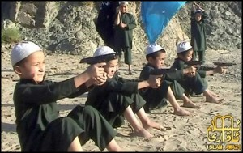
It's because of stories like these I feel like we are fighting in an almost unwinnable war.
Radical Islam is not a foe that can be beaten with traditional methods. This isn’t like us storming the beaches of Europe to begin beating back the Nazi threat. The War on Terror will be fought in corners, crevices and shadows all over the world… and as we’ve already seen, even when we think we have the upper hand, things can turn very quickly. (Remember 9-11-2012 in Benghazi?)
I’m not a pessimist. I’m not a defeatist. I’m not for rolling over against the Islamist threat. I think we should stand and fight against tyranny whenever and wherever it threatens us.
However, I think we should enter into these fights with the full knowledge of what we are about to undertake. Do you want to know what the war on terror will continue to be like? It’s scary and you may rather continue with your day without this knowledge.
Here is what the war on terror will continue to look like.
The Hamas government in Gaza celebrated the graduation on Monday of paramilitary camps geared at training high-school children “to follow in the footsteps of the suicide martyrs.”
The camps, titled “the pioneers of liberation,” are run by Hamas’s ministries of education and interior. Some 13,000 students in grades 10-12 participated in the one-week training camps this year, compared to 5,000 last year when the program was launched, Israeli sources with knowledge of the program said.
Hamas Prime Minister Ismail Haniyeh, Interior Minister Fathi Hammad and Education Minister Usama Mzeini attended the graduation ceremony on Monday, each delivering fiery speeches stressing the importance of military training in developing a new generation of Palestinian combatants.
“Beware this generation,” Haniyeh said, addressing Israel. “This is a generation which knows no fear. It is the generation of the missile, the tunnel and the suicide operations.”
The Hamas prime minister added that female trainers are also on staff “to oversee the training of the young women to follow in the footsteps of the female suicide operatives.”
Hammad, the interior minister, said the training was in preparation for the coming war with Israel.
“This generation is a sapling from God on earth. It will harvest the enemies of God and be the pride of all nations,” he said.
Do you hear them? Do you truly understand the lengths that these people will go to to win a war against people they see as an “enemy” to their god? Folks, this is just me being honest… we don’t have that kind of will to fight. We are not on some holy crusade to rid the world of Islam. They had 13,000 children training to be suicide bombers! And this is just in one little section of Israel (or to be PC, Palestine).
I’m not saying we can’t win – I’m saying we may need to develop a different tactic and try to “fight” this war in a different manner. Al-Qaeda seems to be proof – every time we kill their leaders, new ones simply stand up in their place.
To win, we need to change tactics.
Another story was reported on this past week again showing the depths to which these monsters would go to defeat us.
A young girl, age 10, was forced by her brother to wear a suicide vest and set it off at a security checkpoint. She wore the vest because she was forced to, but when she was confronted by security, she told them everything. They tried to return her to her family, but she refused and so was sent to live under government care in the local capitol.
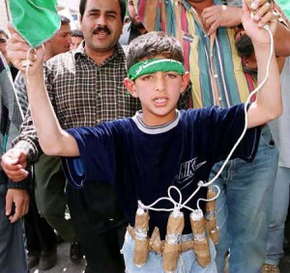
It was late evening, the mullah was calling for prayers and my brother took me outside and told me to put on this vest. He showed me how to operate it, and I said: "I can't - what if it doesn't work?" And he said: 'It will, don't worry.'
I was scared and he took the vest back from me and he hit me hard, and I felt scared. Then [he gave me back the vest and] left me near the checkpoint where he said I had to operate it.
I realised it was a suicide vest because it was heavier than a normal one.
He said: "If you operate this on the people at the checkpoint, they will die - you will not die." But I knew it was a suicide vest and I would die too. Then he went back home - the checkpoint is just near our house.
After my brother left me… I slept in the desert and didn't see anyone that night.
This is the level of resolve in our enemies. If we are seriously planning a long and drawn out fight, we need to truly understand what it will take to win.
Do we have it in us to defeat the growing and horrifying enemy that is radical Islam?
I believe we do - but i'm not all that confident in the leaders we have in Washington.

Onan Coca is a graduate of Liberty University (2003) and earned his M.Ed. at Western Governors University in 2012. Onan lives in the Atlanta area with his wife, Leah. They have three children and enjoy the hectic pace of life in a young family. Onan and Leah are members of the Journey Church in Hiram, GA.

EDITOR’S CORNER: You might wonder: Her brother asked her to do this??? You have to read this book in order to understand the “brother” mentality and the mentality of a parallel universe: Nancy Hartevelt Kobrin – “Penetrating the Terrorist Psyche”.

TOP 10 Cyber Predictions 2014

Source: http://www.cdans.org/media/7675/16335.pdf

Cyber criminals experiment with new exploit kits after arrest of developer; activity likely to remain constant
Source: http://news.csarn.org/2013/12/cyber-criminals-experiment-with-new-exploit-kits-after-arrest-of-developer-activity-likely-to-remain.html

In this period we have continued to observe the development of malware and tactics on the part of international cyber criminals. Recent security research has indicated that criminal groups have begun to migrate from the previously popular ‘BlackHole’ exploit kit after the arrest in Russia of its developer, known only by his online name of ‘Paunch’. Crime groups are reported to have begun small scale experiments with a new malware exploit kit dubbed ‘Magnitude’. Criminals have however continued to use the Cutwail botnet (network of compromised computers) to send phishing emails with the intent of gaining access to online banking accounts and recruiting further computers to the botnet.......
This shift is significant as it underlines the importance of malware developers in ongoing cyber crime campaigns. Exploit kits such as Blackhole and Magnitude are frequently updated by their developers, who often enter into financial arrangements with criminal groups for the use of their malware. While the arrest of ‘Paunch’ has been a notable success for Russian law enforcement, the size and resilience of the Eastern European malware development community is such that it will lead to little if any reduction in the overall threat from cyber crime. Individuals are as always advised to treat any email purporting to be from a financial institution with caution, and to contact their institution if they have any doubts about its authenticity.

Ports – A soft target
Source: http://www.portstrategy.com/news101/port-operations/safety-and-security/A-soft-target?goback =.gde_1528217_member_5819732373335474178#!

Ports increasingly need to focus on cyber as well as physical security needs reports Stevie Knight
Antwerp’s recent security breach and massive eight-tonne cocaine haul has raised questions: not just about how much of this stuff is getting through, but how many targeted ports simply remain unaware they are under cyber attack?
“It’s a certainty” that some port’s container stacks are being infiltrated without anyone noticing, says consultant Henk van Unnik, previously chair of Rotterdam’s Port Security Development Board and president of the International Association of Airport and Seaport Police. He adds: “A few years ago drug smuggling tended to hinge on bribery or extortion, but a port’s software is a much easier target.”
So, to get at the cases of drugs that have made their journey stashed inside legitimate containers all a criminal gang needs to do is access a port’s IT system and make a few tweaks. “The port or terminal may well not even know it’s been hit and worse, might not understand the implications even if it does realise something has happened, laying itself open to further exploitation,” explains Dan Solomon of security firm Optimal Risk.
Mr van Unnik adds: “It’s not unknown for a crime ring to change a reachstacker’s orders and get a box with its hidden suitcases of smuggled drugs to move from a restricted quarter to a more relaxed yard area.” The container still has to be opened, but the reachstacker has obligingly tucked it away behind some tall stacks. “It’s closed up again with a duplicate seal so all is apparently as before,” he says.
Interestingly, he points out a second method the gangs use is hacking in to change the truck and driver details to one of their stooges who goes in to pick up the box. It’s an effective switch, as Antwerp knows to its cost.

Hardware built into a power box containing wifi components sending all captured data to the criminal organisation. Photo: APCS

Covert operations
But while Antwerp was alerted by ‘disappearing’ containers, it’s not always that obvious explains Mr van Unnik; some gangs will simply close the container up again with the appropriate seal, even delivering it to the right address. “It just looks like a normal load, similar to thousands of others. No-one is any the wiser.”
The reason for such subterfuge is simply to keep the route open for as long as possible: while terrorists quite often want their actions to be noticed, international usually gangs don’t.
At this point it’s worthwhile asking, how big is the actual problem – and why should a port worry? Firstly, Mr van Unnik’s draws on experience: “In my time as chief of the port police in Rotterdam, we intercepted up to 10 or 12 tonnes of cocaine, annually. But even huge hauls didn’t affect the street price, so you can only imagine how much is getting through.”
Secondly, it’s a bit like any nasty infection – don’t treat it and it will grow. Mr Solomon explains while terrorism grabs the headlines, even organised crime can have a devastating effect if you get to the point where it has undermined confidence in the system. “The minute there’s no trust in the paperwork, the minute you admit don’t know what’s in the containers, everything stops. Until you can prove you have a system that works, frankly, you have a severe problem...”
Despite this, Mr van Unnik adds that the fight is tough and not one the ports can win all the time. Still, “doing nothing is not an option” he says. “You have to do your utmost to keep the integrity of the business climate. It’s a matter of trust.”

Varied approaches
However, different areas have different pressures. Mr van Unnik admits that while some regions have a fairly low cyber security base and just need to upgrade their processes, others that may have very sophisticated systems are undermined by attitude. “There are places that plainly accept corruption as part of their culture, so security issues are that much harder to address,” he concludes.
Further, some regions may simply be looking in another direction. “African or Middle Eastern ports are usually going to be more worried about physical security... the budgets they do have will be focused on what they see as the high-probability issues. But that doesn’t mean that other threats go away,” says Mr Solomon.
On top of this, the drive for volume has played a part in ports’ vulnerability to cybercrime. “There’s been a lot of focus on efficiency but to an extent, this is a trade off against security,” he adds. “You only have to look at the way the systems are layered; as the software that controls it all usually lives on the same server as everything else, once hackers are in, they are in.”
Not only is the battle against international organised crime particularly tough, it’s made more difficult by the complexity of seaport environments which, unlike airports, can’t be isolated.
As Mr Solomon points out, there tends to be a fault line where the two sides, physical and cybersecurity, converge: “You don’t need a very sophisticated hack to get hold of the passwords,” he says. “If you can access key facilities, a discrete data logger can be easily planted to ‘capture’ key strokes.”

Open for business
However, John Kerkhof of Antwerp Port Community Systems says that the biggest issue in the fight against cybercrime has been caused by the ubiquitous nature of the internet.
He explains that hackers install malware on shipping lines’ computer systems using information culled from social networking sites. The recipient would get an apparently innocent email from a friend which quietly generated screen shots, delivering data about the pick-up codes to the criminal gang.
The reality is that fighting it is only going to get harder; he points out: “These gangs have time and money.” Unlike many ports.
Despite this, information-sharing gives ports and terminals “their most effective weapon” in the fight back, says Mr Kerkhof. Antwerp is building a security working group which is learning best practice from other professional security regimes, and it’s also getting round the table with its stakeholders.
“Further, as the gangs’ modus operandii become known, ports can check with each other and organisations like Europol and take appropriate measures.” Standards can also help, as Authorised Economic Operator or equivalent shows that logistics companies have been audited for checks and controls “which means inspections can be focused on the less secure ones”, he concludes.
But technology can be used to fight technology. As Mr Kerkhof explains: “If you can’t make a house safe, you have to make sure there is nothing in the house to take.”
So, APCS has developed a platform that leaves the pin code generation till the last moment: “The pin code is the final element in the chain, only being created when the driver requests it so there is nothing for the criminal gang to find sitting on the system.”
He adds after being trialled by Antwerp’s MSC terminal and drivers for a year the platform is about to be rolled out to other facilities, giving less for the cyber gangs to get their teeth into.

9 Notorious Hackers Of 2013
Source: http://www.informationweek.com/security/attacks-and-breaches/9-notorious-hackers-of-2013/d/ d-id/1113140?

If recent years are any guide, crime-committing hacktivists should loom large. In 2011, LulzSec stormed on to the scene, pulling off 50 days of hacks that mixed technical savvy with PR acumen. But by 2012, the leaders of LulzSec had been arrested, as had many participants in high-profile Anonymous operations, thanks to a concerted effort by the FBI and its counterparts overseas. By the end of 2013, some of the best-known domestic hackers with political aims either were in jail or, in the case of some people arrested in Britain, had already served time and were on parole.
Policing hacks launched from non-allied countries has always been a different story, given the Department of Justice's inability to arrest, extradite, or sometimes even identify suspects operating from certain countries. For example, many crimeware toolkit-driven campaigns that use bots to steal personal financial details and then remove millions of dollars from banks are run from Russia or former Soviet satellites that have no extradition treaty with the United States.
Foreign attackers who hold a political grudge against the United States likewise remain tough to stop. Last year, a group of foreign attackers -- backed by the Iranian government, US government officials have alleged -- launched Operation Ababil, a series of distributed denial-of-service (DDoS) attacks against US banks. Those attacks continued into their fourth wave in 2013, making them the longest-running series of online attacks in history. Despite the timing and the targets being revealed in advance, targeted banks often had difficulty blunting the DDoS attacks.
Also on the overseas tip, US officials increased their denunciation of state-sponsored Chinese hackers in 2013. Though China had long been suspected of hacking businesses and government agencies, government officials began publicly pointing the hack-attack finger after the security firm Mandiant published evidence of what it said was an elite PLA military online hacking team, which it had linked to the theft of intellectual property from US businesses, as well as the theft of US military secrets.
Hacking has long been defined -- loosely, anyway -- in terms of white, black, and gray hats, referring to hackers who pursue ethical computer security research (white hats), people who hack solely for their own gain or at the expense of others (black hats), and people who fall somewhere in the middle (gray hats). Clearly, Chinese APT attacks, crimeware toolkits, bank DDoS exploits, and other leading hack attacks were evidence of black-hat behavior.
But the world turned a lot more gray beginning in the middle of 2013, after Edward Snowden, a National Security Agency contractor, fled to China and began leaking 1.7 million secret NSA documents. Those disclosures, which are ongoing, have begun to pull back the curtain on America's massive online surveillance apparatus. For example, we've learned that the agency hacked into tens of thousands of PCs abroad, as well as hacking into Internet backbone communications or technology giants' datacenters directly, to allow the agency to eavesdrop on foreign and domestic communications.
Who are the good guys and bad guys now?

Anonymous hacking collective
Is there any group of hackers more outspoken online than Anonymous? The group started the year with a legal bang by backing a White House "We the People" petition arguing that DDoS attacks should be protected as a form of free speech, so that they could be used to protest injustice. However, that attempt to hack the Constitution failed to garner the number of signatures required for a White House response.
But that didn't stop the collective from protesting perceived injustices. Its Operation Last Resort included hacking the US Sentencing Commission website -- which establishes sentencing policies and practices for the federal courts -- to include a game of Asteroids, to protest federal prosecutors having threatened Reddit co-founder Aaron Swartz with a 35-year prison sentence for downloading millions of documents from the JSTOR archive, which helped drive Swartz to commit suicide. The group also defaced a Massachusetts Institute of Technology website to denounce the institution's failure to protest Swartz's prosecution.
As the year progressed, the campaigns continued, with Anonymous channeling mass anger over the 2008 economic crash -- as well as the fact that no Wall Street executives were ever charged with crimes related to it -- by leaking what it said were passwords for 4,000 financial executives. Rebranded as Operation Wall Street, the effort continued, with the hacktivist collective calling on the public to dox (release sensitive documents on) bank executives.
Anonymous continued with attacks against North Korean websites after the country's leadership threatened to restart a nuclear reactor; OpIsrae" attacks against Israeli websites -- taking sides in the Israeli-Palestinian conflict -- that reportedly fizzled; an OpUSA attack against banks and government agencies that likewise fizzled; and a threatened Guantanamo Bay Naval Base attack that led authorities there to deactivate WiFi and social media.
Meanwhile, Anonymous earned widespread praise in October when its members launched Operation Maryville to highlight the case of two Missouri girls, ages 13 and 14, who were both allegedly raped last year, only to see prosecutors drop charges against one of the girl's alleged attackers. The outcry helped draw attention to the case, leading the state's lieutenant governor to demand that a grand jury investigate.

Stratfor hacker Jeremy Hammond
Anonymous-allied Jeremy Hammond hacked into the private intelligence contractor Strategic Forecasting (known as Stratfor) in late 2011 and then posted the stolen files to a server that now appears to have been owned by the FBI. He also distributed the stolen information to WikiLeaks, which published it as part of its Global Intelligence Files program.
Hammond was indicted in 2012. In May 2013, he pleaded guilty to one count of conspiracy to engage in computer hacking. He admitted to masterminding the Stratfor hack, compromising account information for approximately 860,000 Stratfor users, and publishing stolen data pertaining to 60,000 credit cards. Anonymous later used the cards to make $700,000 in unauthorized donations to nonprofit groups. In addition, Hammond admitted to hacking numerous other organizations, ranging from the FBI's Virtual Academy and the Arizona Department of Public Safety to the Jefferson County Sheriff's Office in Alabama and the Boston Police Patrolmen's Association. Thanks to the hacking count, Hammond faced up to 10 years in prison and up to $2.5 million in restitution.
After Hammond pleaded guilty, but before Judge Loretta Preska sentenced him in November, Hammond's supporters launched a letter-writing campaign in pursuit of leniency, arguing in part that Hammond had been entrapped by the former LulzSec leader Sabu, who'd become an FBI informant six months before Hammond hacked Stratfor, and who was being monitored around the clock by handlers at the bureau.
At the sentencing hearing, Hammond read a statement saying that Sabu had provided him with passwords and root access information for 2,000 different websites. "These intrusions, all of which were suggested by Sabu while cooperating with the FBI, affected thousands of domain names and consisted largely of foreign government websites, including those of Turkey, Iran..." Hammond said, before being cut off by the judge, who told him that the list of target names was to be redacted.
Preska sentenced Hammond to 10 years in prison, to be followed by three years of supervised release.

Ex-LulzSec leader Sabu
Looming over Hammond's trial was the specter of Sabu (real name: Hector Xavier Monsegur), the former Anonymous participant and ex-leader of LulzSec, who was quietly arrested by the FBI on June 7, 2011. Monsegur immediately turned informant and has apparently been helping the bureau ever since. That assistance has included gathering evidence -- and in some cases entrapping -- members of Anonymous and LulzSec, as well as helping the FBI identify system vulnerabilities and exploits.
But Monsegur hasn't been seen in public since. Despite pleading guilty in August 2011 to all the charges filed against him -- 10 counts of hacking, one of identify theft, and one of bank fraud -- with a maximum potential prison term of 124 years, he has yet to be sentenced. His sentencing has repeatedly been delayed by Department of Justice prosecutors, "in light of the defendant's ongoing cooperation," according to court documents.
All the men who were arrested for hacking by the FBI, using evidence gathered in part by Monsegur, have pleaded guilty to one or more of the charges filed against them. As a result, none of their cases have gone to trial, and none have called Monsegur to testify.
In a statement released this year, Hammond suggested that the FBI didn't want to see Monsegur take the stand. "It is widely known that Sabu was used to build cases against a number of hackers, including myself. What many do not know is that Sabu was also used by his handlers to facilitate the hacking of targets of the government's choosing -- including numerous websites belonging to foreign governments."
Hammond added: "What the United States could not accomplish legally, it used Sabu, and by extension, me and my co-defendants, to accomplish illegally." But because he pleaded guilty and his case never went to trial, those allegations have yet to be proven or disproven in a court of law.
Monsegur's sentencing is currently scheduled for Jan. 13, 2014. But, of course, it could be postponed yet again.

Chinese APT1 attack crew
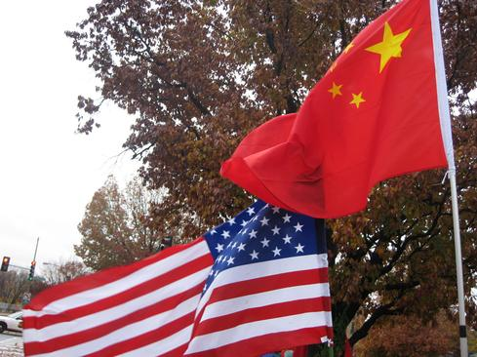
That alert was sounded in February when the security firm Mandiant published a report into a group operating from China it called APT1 (also known as the Comment Crew), which it said had used spear phishing attacks to compromise 141 businesses in 20 different industries. Rather than being contract or state-sponsored hackers, Mandiant said, APT1 was actually part of the People's Liberation Army Unit 61398, which it characterized as an elite military hacking unit.
Was China really behind the attacks? Officials there issued denials, but many US information security experts concurred, though opinions varied as to what should be done in response. Some legislators wanted to authorize businesses to strike back and retrieve stolen intellectual property. Some security experts said businesses (especially defense contractors) should stop blaming China and spend more time securing their systems, so that the Chinese or anyone else couldn't launch low-cost APT attacks and easily comprise their systems.

Syrian Electronic Army
The Syrian Electronic Army (SEA) is another band of state-affiliated -- if not state-sponsored -- attackers. This one is allied with Syrian President Bashar al-Assad. Syria, of course, is in the midst of a bloody civil war. Estimates of the number of people killed during the conflict exceed 100,000, and millions of people have been left homeless.
Serving as an online propaganda wing for Assad, the SEA hacked a number of sites in 2013 -- ranging from National Public Radio and Reuters to the BBC and the Onion -- to protest perceived reporting accuracies or slights against Assad. In April, the group hacked an Associated Press Twitter feed and issued a hoax tweet to 1.9 million followers: "Breaking: Two Explosions in the White House and Barack Obama is injured." Cue stock market panic, with the value of US stock markets briefly plunging by $200 billion.
Twitter faced criticism for lacking any type of two-factor authentication system that might have helped prevent the AP account from being taken over. It quickly added one.
Another one of the SEA's most brazen hacks involved its disruption of the domain name system (DNS) settings for The New York Times and Twitter websites. Twitter quickly restored service, but the NYT website was still inaccessible from many parts of the world 48 hours later.
Many information security experts, while decrying the attacks, also said they were quite technically sophisticated, in part by virtue of their simplicity. "They exposed some world-class exposures in some world-class environments," said Carl Herberger, vice president of security solutions at Radware. "To take down The New York Times website? Pretty impressive. To expose some security problems in Twitter, even if the rest of the world didn't know they were there? Very impressive."

Blackhole founder Paunch
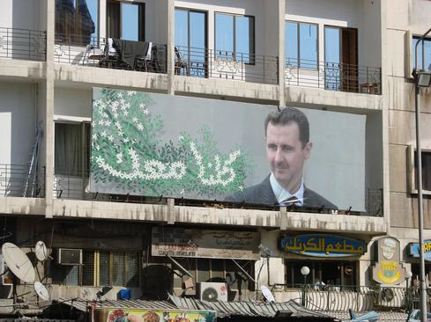
There's an unwritten rule for black-hat hackers operating from inside Russia: If you don't attack other Russians, and do occasionally lend a hand to the country's security services, then authorities will likely turn a blind eye to your cybercrime activities.
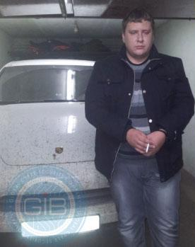
Cue the case of 27-year-old Paunch, identified in news reports as Dmitry Fedotov (pictured), who was arrested by police in the Russian city of Togliatti in October, together with 12 of his alleged cohorts. They've been charged with building and operating -- and in Paunch's case, masterminding -- the notorious Blackhole crimeware toolkit, which first appeared in the summer of 2010. It was so successful at launching financial malware attacks that in October 2012, the Blackhole gang began offering a new, zero-day-vulnerability-targeting exploit pack called the Cool Exploit Kit for $10,000 per month. Together, those two exploit kits reportedly accounted for 40% of all exploit-kit-driven infections in the world.
The toolkits offered crimeware syndicates value for their money. "Blackhole Exploit Kit is rented on the seller's server for $500 per month. The price of renting the software itself for installation on your own server was $700 for three months," according to a statement released by the cybersecurity firm Group-IB, which said it helped Russian authorities investigate the case. "At present, there are reports that Blackhole kingpin, 'Paunch' has more than a thousand customers. It is known that 'Paunch' was earning $50,000 per month from his illegal activity."
Of course, Blackhole users could earn much more. According to Russian authorities, the Blackhole financial malware Trojan -- which specializes in procuring people's usernames, passwords, bank account numbers, and other banking credentials -- was used to steal $2.1 million from Russian banks. Meanwhile, it has reportedly been used to steal an estimated $866 million from banks outside Russia.

US bank DDoS attackers
Remember Operation Ababil? The series of DDoS attacks against US financial institutions was launched in September 2012 by a group calling itself the Cyber Fighters of Izz ad-Din al-Qassam. Those attacks have continued, with the group announcing the fourth wave of attacks in July 2013.
At the end of 2013, the attacks against Wall Street websites remain ongoing, which has earned the hacking group an accolade of sorts. "It's the longest ever continuously run cyberattack in history," Radware's Herberger, told us. "It's still on its fourth wave," though the volume of related attacks seems to have vastly diminished. "It's kind of like an Iraq situation. The main fighting is over, but there's still residual stuff out there."
Those attacks began as a supposed protest against the posting to YouTube of a clip from Innocence of Muslims, a film that mocks the founder of Islam. But US government officials, speaking on background, have long asserted that the attack campaign was being sponsored and run by the Iranian government and likely launched in reprisal for Stuxnet, which was reportedly created by a joint US-Israeli cyberweapons program.

Federal Bureau of Investigation
When it comes to hacking prowess, it would be tough not to rate the FBI's cracking of the Tor onion-routing system this summer, as part of a year-long investigation into a child pornography distribution ring.
The anonymizing Tor network is beloved by privacy aficionados and activists, because it can be used to hide not only data flowing over the Internet, but also who's communicating with whom. In addition, Tor's hidden services -- denoted by a dot-onion (.onion) domain name that's always randomly generated -- can make a website reachable only via the Tor network.
But those services can also be abused. The FBI has accused Eric Eoin Marques, who was arrested in Dublin in August 2013, of child pornography distribution through his operation of Freedom Hosting. An FBI agent told an Irish court that Freedom Hosting, which offered Tor hidden services -- but which wasn't affiliated with the Tor Project, which develops the Tor software -- was hosting more than 100 child porn Tor sites, which collectively counted "thousands of members" who posted "millions of images" that involved the abuse of children.
To identify Marques, the bureau reportedly hacked into the Freedom Hosting site in July and used the site to distribute a simple piece of malware that infected anyone using the Tor Browser Bundle (TBB), a version of Firefox customized by the Tor project to use the anonymizing Tor network. The FBI's malware was simple. It was designed to record the Mac address or Windows hostname of the computer it had infected and then send that data via HTTP to the FBI. Using that information, the bureau could unmask and track any individual Tor user.
The TBB browser vulnerability was patched by the Tor Project on June 26.

National Security Agency
Who were the most notorious hackers of all in 2013? It would be tough not to give that award to the NSA. According to documents leaked by Snowden, the agency's Tailored Access Operations division (responsible for offensive hacking operations) had used malware to hack into 50,000 PCs for surveillance purposes by 2012.
According to those documents, the agency's Special Source Operations division has been hacking into Internet backbones as part of the digital dragnet. The surveillance operation appears to have been built to record massive quantities of information flowing across the Internet. That includes the Prism program, which captures the metadata (tracking information) associated with every mobile phone call made in the United States. The underlying thinking appears to be that, if the agency technically can grab a copy of those communications, why not go ahead and do so, in case they're ever of interest in future terrorism investigations?
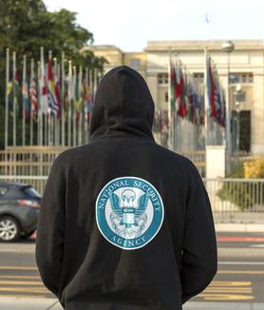
Cue privacy, legal, and constitutional questions, not least over revelations that, if the NSA surveillance apparatus turns up any signs of criminal activity, agency analysts are authorized to share that information with law enforcement agencies.
In 2014, might the NSA's hacking and other information-grabbing operations be curtailed? That's not clear, though a presidential commission submitted a related list of recommendations this month to President Obama. The commission recommended that the NSA get a civilian -- not military -- leader for the first time in its history. Obama reportedly plans to detail next month how the government's intelligence gathering and surveillance operations will be restructured.
The NSA's activities face continuing scrutiny from legislators and judges. On Dec. 16, in the case of Klayman v. Obama, Judge Richard Leon found that the NSA's bulk metadata collection program was "almost Orwellian" in its scope and violated the Fourth Amendment. He ruled that the NSA must cease collecting data -- and destroy all collected data -- related to the two people who had filed the lawsuit. "However, in light of the significant national security interests at stake in this case and the novelty of the constitutional issues, I will stay my order pending appeal" by the government. In other words, stay tuned.

Algorithms are changing the face of situational awareness and online security
By Phrantceena Halres
Source: http://www.securityinfowatch.com/article/11288329/where-human-technical-tasks-may-need-several-minutes-to-be-performed-an-algorithm-may-only-need-a-few-seconds?goback=.gde_1528217_ member_5824668769326243842#!

There's no doubt that the age of online information has created new national security threats, which have made it a priority for enterprise and governments to ensure the security of their network and IT infrastructure. The use of anthropological techniques presents an alternative perspective for researchers whose intent is to develop intuitive and multi-tiered security as it relates to cyberspace.
A focal point of this research is what’s called ‘tacit knowledge’, or knowledge of something that is implicit rather than formal knowledge that characterizes the duties and tasks performed by security institutions. One way to illustrate this kind of knowledge is the content of folk songs. We are all familiar with the sayings and implications of the lyrics of folk songs in our own culture, yet those of other cultures are foreign to outsiders. You have to live it to understand it.
Primary to security analysts' concern is the fact that open-source and commercially developed tools lack the intrinsic understanding of security analysis, leaving the tools used by many analysts inadequate. This subsequently results in labor-intensive resolutions to problems, such as exactly what data has been compromised, and how did an attacker penetrate the system.
Where human technical tasks may need several minutes to be performed, an algorithm may only need a few seconds, freeing up intelligent minds to concentrate on problems of greater complexity. Frequently, network attacks are automated by software scripts called net bots. Network defenses would be at a disadvantage when analysts on the other side don’t possess streamlined processes to repel such attacks or minimize the damage that it incurs. With more sophisticated tool support, researchers hope to automate standard tasks that are traditionally performed by human beings.

Eradicating human error may improving the nation’s defense apparatus
Because a good number of cyber-attacks are automated, automation is central to cyber security. However, professional analysts usually require a lot of time to locate the system that has been breached by a virus or malware. When we add in the element of human error, valuable time finding a resolution and its deployment is lost, thus leaving even more data at risk. Humans are prone to mistakes. While algorithms, are not entirely mistake free, they can include quality control instructions that a human analyst may fail to carry out because of fatigue or other reasons.
As a result, what we have is a numbers game when attempting to identify a breach, but an automated attack has inherent advantages not including time in its favor. If some defense mechanisms are automated, including matrix processing, error-correction and other statistical techniques, the potential for a faster problem resolution, along with a sharp reduction in human error, can be accomplished.

Greater central standards and algorithms trigger mechanisms to combat threat scenarios
Algorithms translate processes that are performed by humans into instructions that can be understood by computer systems on a sophisticated level. At its core, an algorithm can ‘understand’ a problem, and based on the available data and instructions produce a desirable result. Well-designed algorithms are able to get at the heart of a process and produce output on a computational level for a very large number of scenarios. Defense mechanisms must gather and process large amounts of data from a wide net, which presents difficulties for humans. But with the aid of automation based on a framework, quicker deployment of an appropriate response can be achieved. Macro components such as communication and power are constantly under attack, and while system redundancy is one means of protection, threats are advancing in their complexity and damage potential.

Algorithms could predict attacks and improve situational awareness
There are at least seven aspects related to situational awareness (SA) which can impact the quality of cyber defense measures. It is most critical to have a firm grasp of the current situation, or perception. This involves recognition and identification, such as the type of the attack, the people or organizations involved, and so on. This aspect, however, involves more than merely detecting that an intrusion has taken place, but also precisely the event that is occurring.
Implications and the impact of the attack must be ascertained so that the defense mechanisms in place can focus efforts where they are needed and respond appropriately. There are two components of primary concern here: damage assessment and the future implications of the attack. It follows that the analysts must have a keen awareness of how such situations evolve, through an analysis of how the situation came to fruition.
At this point, questions begin to arise as to why such a situation has arisen. This is where the detective work begins and is concentrated on tracing the steps leading up to the attack, which will ultimately identify vulnerabilities. Though a lesser priority, another crucial aspect is the quality of the data collected on the previous events. Here we are concerned with the soundness of the data that has been collected, its validity and how recently it has been gathered.
From here, we can begin to make assessments of the plausibility or likelihood of future attacks. The newly assessed information may provide us a picture of the attackers, their capabilities and then help to filter all possible scenarios to those that are likely to occur again. Arriving at a plausible profile comes down to knowing the adversaries, as well as the vulnerabilities in the defense systems that are in place.

Automation fosters better training, education and time to focus on unique threats
Directives that are concerned with security are manifested in defense policy, standards and procedures, and the training needed to support those initiatives. Training, though a critical necessity, is fraught with possible stumbling blocks, monopolizing valuable resources such as instructors and trainees. It is critical that the focus be on the cutting edge training and techniques.
For some of the reasons mentioned in the preceding sections, analysts are typically tasked with processing data that potentially can be performed with the support of automated tool-sets. These tool-sets must not only cover standard operational control methods, such as process control and critical path analysis, but can also be applied to a defense posture that evolves and quickly understands the nature of cyber threats. These tools and the underlying algorithms should reflect the nature of the data being processed, and must also take into consideration various cultural and environmental components.
Training should involve a comprehensive approach, where procedures having to do with situational awareness are automated, and analysts and consultant efforts are focused on broader and more specific threats. Additionally, awareness training should have a group focus, emphasizing the capabilities of individuals. In this way, analysts and consultants are best equipped to handle their specific responsibilities.
The cumulative effect of cyber security training should be a layered approach that allows algorithms to take on a larger role in the identification and recognition of a breach, the actors involved and the defense measures that may be appropriate. Vulnerabilities and post-mortem risk assessment should also be a focus of both awareness training and one of the aspects of an automated tool-set.

Conclusion
Algorithms are seen by many as a key component to the technological advancement of humanity and society. Effective cyber security is a primary means of maintaining stability, the first line of which is a sound defense against cyber attacks. Algorithms that are applied to cyber networks will perform operations on ever larger data sets, employing highly advanced knowledge discovery and forecasting/prediction techniques.
The future importance of algorithms revolves around our converting mathematical and logical statements into process instructions that increasingly understand the environmental and evolving situational aspects of our defense networks, and the threats to its effectiveness and stability.

Phrantceena Halres is founder, chairman and CEO of Total Protection Services Global, a certified security services company focused exclusively on high threat/close proximity safety and security services for the protection of critical infrastructure assets in the corporate, government, nuclear, energy and personal protection sectors.

Cloud-based security to grow 50 percent by 2015
By Nick Clunn
Source: http://techpageone.dell.com/technology/cloud-based-security-grow-50-percent-2015/?goback= .gde_4709642_member_5825223539271168003#!

Technology analysts at Gartner are predicting the cloud-based security services market to expand by nearly 50 percent over the next two years to $3.1 billion as more organizations look to purchase encryption solutions.
The report announced Thursday identified email security, web security and identity and access management as the services that will become the most popular. The highest growth, however, will buoy lesser-used solutions, including:
- Cloud-based tokenization*
- Security information and event management
- Vulnerability assessment
- Web application firewalls

Trust issues
The benefits offered by cloud-based security — particularly encryption — are making the category increasingly popular, said Kelly Kavanagh, principal research analyst at Gartner. But many potential customers will have trust concerns that providers and brokers will need to address, she said.
Linda Musthaler, a principal analyst with the Essential Solutions Corporation, summed up the challenges this way in an October piece for NetworkWorld: “For one thing, a third party having access to data in the clear is a violation of regulations such as PCI-DSS, HIPAA, GLBA and others. Also, customers have lost trust in cloud-platform or SaaS (software-as-a-service) providers to protect their data. There have been high-profile data breaches that make end-users nervous. What’s more, customers fear the U.S. government will subpoena access to their data without their knowledge or permission. For companies outside the U.S. that choose to use a U.S.-hosted cloud or app, there are data privacy and residency concerns.”

Warming up
But Gartner expects these trust issues to thaw as organizations gain more experience with SaaS and more employees introduce personal devices into the workplace. SaaS applications have gained a strong foothold in the enterprise with more than 55 percent of users polled in a recent Softchoice survey reporting that they run SaaS apps on corporate devices.
Ruggero Contu, research director at Gartner, predicted that the cloud-based security market will soon include several different kinds of players, giving organizations a buffet of options in the coming years.
“The strongest interest is in encryption products from cloud-security brokers, thanks to their relative ease of deployment and their options for on-premise encryption management,” he said. “Nevertheless, Gartner expects cloud-hosting providers and IaaS (infrastructure-as-a-service) providers to show an increased interest in cloud-based encryption capabilities.”

* Tokenization is the process of replacing sensitive data with unique identification symbols that retain all the essential information about the data without compromising its security. Tokenization, which seeks to minimize the amount of data a business needs to keep on hand, has become a popular way for small and mid-sized businesses to bolster the security of credit card and e-commerce transactions while minimizing the cost and complexity of compliance with industry standards and government regulations.

Nick Clunn is a journalist covering the tech beat and an adjunct professor at Montclair State University. He lives in New Jersey, where he had worked as a staff writer for several leading daily newspapers and websites.

Internet security

Check these online solutions – one of them might be good for you!

- GNU MediaGoblin  - ownCloud  - I2P: The Darknet  - Diaspora | - Etherpad  - Jitsi (Skype analogous)  - Cryptocat  - Bitmessage

2013 Cyber Summary: More Attacks, More Sophistication
Source: http://i-hls.com/2014/01/2013-cyber-summary-more-attacks-more-sophistication/

The volume of cyber attacks keeps growing: 91% of organizations worldwide suffered at least one cyber attack in 2013, with 9% being the victim of many focused, well planned attacks aimed at infecting their network infrastructure. This according to an annual Kaspersky Lab report.
One of the major findings was the emergence of “cyber mercenaries”. These are groups of hackers who target a wide variety of organizations. Their usual pattern: Staying inside the infected networks for just a few weeks, stealing every piece of information they can get their hands on. The longer they stay the harder it becomes to remain undetected. Cyber mercenaries usually operate in a “hit and run” fashion, researching their target, striking with precision and then vanishing. These are organized groups of people conducting cyber-attack operations for money.
Other findings in the Kaspersky 2013 report:
- Malware-based attacks against several governments were detected
- Most cyber crime events involved stealing information
- There was a noticeable trend of attacking subcontractors instead of going after the big organizations
- Many net attacks were based on sabotage, meaning using malware to delete information or to block infrastructure
- Researchers identified hackers capable of stealing money through online banking systems
- Mass spreading of malicious code might affect any company, leading to loss of income and assets
- Cyber criminals continuously improve their malicious codes, using them in unforeseen and unconventional ways

All Fortune 500 companies have been hacked: 97% know it, the other 3% don’t
Source: http://tech.fortune.cnn.com/2014/01/06/cybersecurity-and-cyberwar/

“Ninety-seven percent of Fortune 500 companies have been hacked,” says Peter Singer, “and likely the other 3 percent have too, they just don’t know it.” Singer, director of the Brookings Institution’s Center for 21st Century Security and Intelligence, and author of the 2009 bestseller Wired for Warpaints, and co-author Allan Friedman paint a gloomy picture in the opening pages of their new book Cybersecurity and Cyberwar: What Everyone Needs to Know (Oxford University Press). Following a year of massive data breaches within both the U.S. government and private industry, an honest assessment of the cybersecurity landscape is only appropriate. “This is now a very real problem, one that we have to recognize, that we have to manage,” Singer says in a conversation with Fortune. “Stop looking for others to solve it for you, stop looking for silver bullet solutions, and stop ignoring it.”

►Read more on source’s URL.

Anonymous hacker group for Caucasus threaten cyber war against Russian gov unless they stop Sochi Olympics

Source: http://themuslimissue.wordpress.com/2013/12/31/anonymous-hacker-group-for-caucasus-threaten-cyber-war-against-russian-gov-unless-they-stop-sochi-olympics/

On December 27, 2013, the website Kavkazcenter posted a video titled “Appeal by the Anonymous Caucasus #OpPayBackForSotchi2014.” The “Anonymous Caucasus” describes itself as the “electronic army of the Caucasus Emirate” and has a website and accounts on Twitter and Facebook. In this video it warns the Russian government to stop its “activities” in Sochi (presumably the preparations for the Winter Olympics), otherwise the group will launch a cyber war against it in retaliation for the “Circassian genocide” of 1864.[i]
The video, 2.31 minutes in duration, shows still images of signs in English that read: “Putin, don’t build your credibility on Circassian graves”; “Sochi 2014 – the hidden genocide”; “You’ll be skiing on the mass graves”; “2014 Sochi Olympic winter games – Circassian genocide 150 anniversary”.

The message is delivered by an unseen announcer. The following are excerpts:
“Our message is addressed to the government of the Russian Federation and to all the supporters of the [Winter] Olympics in Sochi. You are spending millions of dollars to organize these games on the land of the Circassians, on the land where their entire people was cruelly annihilated, on the land of the 1864 genocide… 150 years have passed, but Russia has not recognized the genocide of the Circassian people, and continues to ignore the people who live on this land. But now Anonymous Caucasus has decided to carry out a new operation called “Pay Back For Sochi.” We will launch the largest cyber war [that ever was] against the Russian government. You will pay for [the genocide]. You crossed the line of inhumanity by wanting to hold your games on the land of our ancestors. Our army is now stronger than it was yesterday and [even] a minute ago, and our activity will increase. We support all the peoples of the Caucasus [in the struggle] against our enemy and enemy of Islam – [namely] Russia. Stop your activities in the Sochi region and we will stop ours… [If you don't], we will attack you, we will destroy you. We will get our own way and you will not stop us. We are the Anonymous Caucasus. We neither forgive nor forget…”

Cyber Attacks against Middle East Embassies
Source: http://i-hls.com/2014/01/report-cyber-attacks-against-middle-east-embassies/

Microsoft, in late November 2013, reported zero-day attacks against Windows XP based systems and Server 2003 servers. Investigation revealed that the attackers used advanced backdoor techniques.
According to the Trend Micro blog post the attacks targeted 28 embassies in a certain Middle Eastern capital city. The attacks were conducted using malware attached to targeted e-mail messages. The subject of these messages was the Syrian civil war, in an attempt to fool the targets into opening the attached files.
Company researchers added that in addition to the targeted attacks and the use of anti-analysis techniques there was no other unusual activity. The backdoor technique was identified was BKDR_TAVDIG.GUD, meant to hide it from bug-detection software and make it harder for analysts to identify it.
In addition, according to the list of targets, the high motivation and the capabilities needed to conduct a complex operation, the resources of the attackers are well beyond those of regular hackers. The results of the attack – which embassies were damaged and how severely – couldn’t be verified. Researchers are also not sure if there were any additional targets.

U-M researchers estimate best time to launch a cyber attack
Source: http://ns.umich.edu/new/releases/21899-u-m-researchers-estimate-best-time-to-launch-a-cyber -attack

University of Michigan researchers have developed new ways to analyze Internet security risks by creating a mathematical model that can predict when a cyber attack may be launched.
Robert Axelrod, professor of political science and public policy at U-M's Ford School, and Rumen Iliev, postdoctoral research fellow at the school, created the model to help develop a basis for understanding the strategic implications of cyber technology.
Focusing on the timing of cyber conflict, their model analyzes when an attacker is most motivated to exploit vulnerabilities in a target's computer system for espionage or disruption.
"One of our major contributions is to develop some concepts to deal with this new realm of cyber conflict," Axelrod said. "It took 15 years in the nuclear world for people to understand the implications of nuclear technology. It is our hope that it won't take that long to understand the strategic capabilities of cyber technology."
They developed two concepts. One is stealth, which is the ability of a resource to exploit vulnerability in a target's computer system to stay undiscovered if it is used. The other is persistence, which is to keep the vulnerability undiscovered if it isn't used.
"A good resource should have both stealth and persistence," Iliev said. "The less persistent a resource is, the sooner (it should be used) lest the vulnerability is fixed before (there's) a chance to exploit it."
They illustrate their model using four case studies, including the Stuxnet attack on Iran's nuclear program and the Iranian cyber attack on the energy firm Saudi Aramco.
"We also hope this will encourage other efforts to study these things in a rigorous way," Axelrod said. "There's a lot of discussion about cyber problems, but it's so new that the language isn't established. People use the word attack to mean anything from stealing a credit card number to sabotage of an industrial system."

— Read more in Robert Axelrod and Rumen Iliev, “Timing of cyber conflict,” Proceedings of the National Academy of Sciences (6 December 2013)

Healthcare industry to conduct cyberattack drill in March
Source: http://www.nextgov.com/cybersecurity/2014/01/health-care-sector-test-reflexes-cyber-attack/ 76676/?oref=nextgov_today_nl

The American health care industry, in partnership with the federal government, will in March conduct simulated cyberattacks targeting industry networks and resources in an effort to test the industry’s vulnerability to cyberattacks.
Nextgov reports that this will be the first time insurers, hospitals, pharmaceutical manufacturers, and the Department of Health and Human Services (HHS) will run coordinated drills. Healthcare is one of seventeen critical infrastructure sectors which, if attacked, could have damaging consequences for the country.

HHS Chief Information Security Officer Kevin Charest said in a statement, “Our goal for the exercises is to identify additional ways that we can help the industry be better prepared for and better able to respond to cyberattacks. This exercise will generate valuable information we can use to improve our joint preparedness.”
The event will be coordinated by the Health Information Trust Alliance, a medical information technology advocacy group.
A 2012 Ponemon Institute study revealed that 94 percent of health care organizations experienced at least one form of cyberattack during the previous two years. The simulated cyberattacks planned for March, titled CyberRX, will help participants identify weak points within their digital infrastructure.
NextGovnotes that HITRUST has established an incident response center that shares intelligence on threats among industry members, including HHS and officials at the Department of Homeland Security (DHS). The exercise in March will determine the efficiency of the response center model.
“As cyber threats continue to increase and the number of attacks targeted at healthcare organizations rise, industry organizations are seeking useful and actionable information with guidance that augments their existing information security programs without duplication or complication,” HITRUST Chief Executive Officer Daniel Nutkis said in a statement. “CyberRX will undoubtedly provide invaluable information that can be used by organizations to refine their information protection programs.”
Other industries have conducted coordinated attacks to measure the strength of their digital infrastructure. In November 2013, 10,000 electrical engineers, cybersecurity specialists, utility executives, and FBI agents in California spent two days testing their cyber vulnerabilities. The financial sector also ran its second simulated test, Quantum Dawn 2, in October 2013. The six-hour exercise included more than 500 people and more than fifty organizations.
Participants in the March exercise include Children’s Medical Center Dallas, CVS Caremark and Express Scripts, as well as several insurance providers such as Health Care Service Corp., Humana, UnitedHealth Group, and WellPoint. It is uncertain whether HealthCare.gov, the federal online health insurance exchange, will participate. A second exercise is planned for this summer.

►Read the Ponemon Institute study at:
http://lpa.idexpertscorp.com/acton/attachment/6200/f-0033/1/-/-/-/-/file.pdf

For The First Time, Hackers Have Used A Refrigerator To Attack Businesses
Source: http://www.businessinsider.com/hackers-use-a-refridgerator-to-attack-businesses-2014-1?go back=.gde_4962526_member_5829859108890640388#!

Security researchers at Proofpoint have uncovered the very first wide-scale hack that involved television sets and at least one refrigerator.
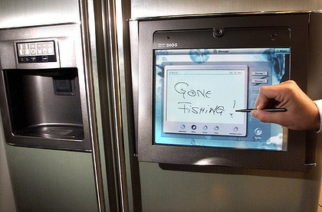
Yes, a fridge.
This is being hailed as the first home appliance "botnet" and the first cyberattack from the Internet of Things.
A botnet is a series of computers that seem to be ordinary computers functioning in people's homes and businesses, but are really secretly controlled by hackers. The Internet of Things, is a new term in the tech industry that refers to a concept where every device in your house gets its own computer chip, software, and connection to the Internet: your fridge, thermostat, smart water meter, door locks, etc.
To a hacker, they all become computers that can be hacked and controlled.
In this case, hackers broke into more than 100,000 everyday consumer gadgets, such as home-networking routers, connected multi-media centers, televisions, and at least one refrigerator, Proofpoint says. They then used those objects to send more than 750,000 malicious emails to enterprises and individuals worldwide.

In the press release, Proofpoint explains:
- The hack happened between December 23, 2013 and January 6, 2014, and featured waves of malicious email, typically sent in bursts of 100,000, three times per day, targeting enterprises and individuals worldwide.
- About three-quarters of the emails were sent by regular computers, but the rest, slightly more than one-quarter, were sent by hacked home appliances.
- Hackers didn't have to be amazingly smart when breaking into home appliances. Many times they gained access because the home owners didn't set them up correctly, or used the default password that came with the device.
Most homes are not yet a part of the Internet of Things, and looks like hackers will already be there to greet them when they arrive.

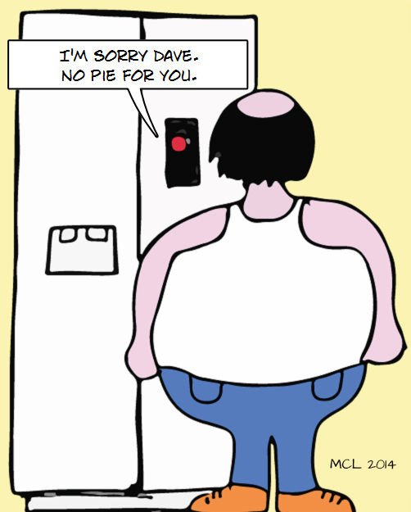

Global map predicts giant earthquakes
Source: http://www.homelandsecuritynewswire.com/dr20131213-global-map-predicts-giant-earthquakes

A team of international researchers, led by Monash University’s Associate Professor Wouter Schellart, have developed a new global map of subduction zones, illustrating which ones are predicted to be capable of generating giant earthquakes and which ones are not.
The new research, published in the journal Physics of the Earth and Planetary Interiors, comes nine years after the giant earthquake and tsunami in Sumatra in December 2004, which devastated the region and many other areas surrounding the Indian Ocean, and killed more than 200,000 people.
A Monash University release reports that since then two other giant earthquakes have occurred at subduction zones, one in Chile in February 2010 and one in Japan in March 2011, which both caused massive destruction, killed many thousands of people and resulted in billions of dollars of damage.
Most earthquakes occur at the boundaries between tectonic plates that cover the Earth’s surface. The largest earthquakes on Earth only occur at subduction zones, plate boundaries where one plate sinks (subducts) below the other into the Earth’s interior. So far, seismologists have recorded giant earthquakes for only a limited number of subduction zone segments. Accurate seismological records, however, go back to only ~1900, and the recurrence time of giant earthquakes can be many hundreds of years.
“The main question is, are all subduction segments capable of generating giant earthquakes, or only some of them? And if only a limited number of them, then how can we identify these,” Dr. Schellart said.
Schellart, of the School of Geosciences, and Professor Nick Rawlinson from the University of Aberdeen in Scotland used earthquake data going back to 1900 and data from subduction zones to map the main characteristics of all active subduction zones on Earth. They investigated if those subduction segments that have experienced a giant earthquake share commonalities in their physical, geometrical and geological properties.
They found that the main indicators include the style of deformation in the plate overlying the subduction zone, the level of stress at the subduction zone, the dip angle of the subduction zone, as well as the curvature of the subduction zone plate boundary and the rate at which it moves.
Through these findings Dr Schellart has identified several subduction zone regions capable of generating giant earthquakes, including the Lesser Antilles, Mexico-Central America, Greece, the Makran, Sunda, North Sulawesi and Hikurangi.
“For the Australian region subduction zones of particular significance are the Sunda subduction zone, running from the Andaman Islands along Sumatra and Java to Sumba, and the Hikurangi subduction segment offshore the east coast of the North Island of New Zealand. Our research predicts that these zones are capable of producing giant earthquakes,” Schellart said.
“Our work also predicts that several other subduction segments that surround eastern Australia (New Britain, San Cristobal, New Hebrides, Tonga, Puysegur), are not capable of producing giant earthquakes.”

— Read more in W. P. Schellart and N. Rawlinson, “Global correlations between maximum magnitudes of subduction zone interface thrust earthquakes and physical parameters of subduction zones,” Physics of the Earth and Planetary Interiors 225 (December 2013): 41-67

The Identification of Hazardous Industrial Sites in Publicly-Available UK Disaster Risk Assessments
By Mark Leigh
Source:http://www.epcollege.com/EPC/media/MediaLibrary/Knowledge%20Hub%20Documents/J%20Thinkpieces/Occ-8-Risk-Sites.pdf

One of the issues with UK Community Risk Registers is the area they cover: each one spans at least one whole county and sometimes more than one. Some of the risks they warn and inform the people about are more-or-less evenly distributed across these regions, but many are specific to particular locations, like certain hazardous industrial sites. However, the location of these sites is never given in these registers. So, how do you (as a member of the public) know if a given published risk is close enough to where you live, work or travel to concern you? It seems that the public is being made aware of certain risks, but is at the same time being denied the information that would help them make sense of them – in terms of their actual vulnerability at the individual and local community level. That doesn’t seem very coherent from the public risk communication perspective, or very balanced in terms of warning and informing. It compromises the utility of Community Risk Registers and reduces their value in terms of promoting community resilience.
This paper argues that the locations and identities of site-specific risks should, in principle, be given in the UK’s Community Risk Registers. It examines the arguments for and against, before effectively proving that this information (and more!) is so easily obtainable from other public sources that local policies of withholding it from Community Risk Registers are at least open to challenge. There should be a serious debate about this among those responsible for civil protection risk registers, and this paper should inform it.

It’s the third in a series on UK Community Risk Registers by Mark Leigh: see also:
- Leigh, MJ (2012); Communicating With the Public About Risk: Making Community Risk Registers Work (click here)
- Leigh, MJ (2013); Assessing the Risk of Civil Protection Hazards in the UK: Getting the Methodology Right (click here)

Mark Leigh is Director of the Faculty of Civil Protection, Emergency Planning College

EDITOR’S COMMENT: A paper you have to read! It is one of the rare occasions that someone says things by their names regarding the highly important issue of populace awareness on issues of security concern. Read “The Experiment” in p.7 – a solid proof supporting author’s arguments!

►You can read the full paper at source’s URL.

Could Chemical Signals Replace Radio in Extreme Environments?
Source: http://www.emergencymgmt.com/safety/Chemical-Signals-Replace-Radio.html

In the U.K., researchers are studying how to communicate like animals do -- by sending messages with chemicals (along the lines of pheromones).
Developed by Weisi Guo of the University of Warwick in the U.K, and Professor Andrew Eckford and Ph.D. student Nariman Farsad of York University in Toronto, the first message transmitted using an airborne alcohol spray was “10101100111000101011110110,” decoded as “O CANADA” using the researchers’ binary coding scheme (the International Telegraph Alphabet No. 2).
With a data rate of one bit every three seconds, chemicals won’t be used for video streaming any time soon, but if adopted, this technology could begin replacing radio in many emergency response scenarios within the next two years.
The technology works in much the same fashion as smoke signals or Morse code. In the experiments, a chemical, in this case alcohol, was emitted from a sprayer. A spray represents 1 and a pause represents 0. An Arduino-based receiver was built to interpret and decode the spray signal, which was received from distances of two, three and four meters. The "O CANADA" output was displayed on a small screen. Researchers concluded that the method was highly reliable at short distances.
The data rate of such chemical communication is slow, but still fast enough for many practical applications of inter-robot communication, Eckford said – it’s basically like getting an answer to a yes or no question every three seconds, which is comparable to human interaction. For instance: “Is it safe to go this way?” “Yes.”
Arduino is an open-source electronics prototyping platform based on flexible, easy-to-use hardware and software. It's intended for artists, designers, hobbyists and anyone interested in creating interactive objects or environments.

The applications they’re looking at now, Eckford said, are environments where radio doesn’t work well, such as in sewers where there’s a lot of water and tight spaces, collapsed buildings with debris that radio has trouble passing through, shipwrecks or caves where water and objects prevent the effective use of radio, and burning buildings where smoke and other obstructions prevent traditional forms of communication.
“When you inspect a sewer system today it’s a big deal,” Eckford said. “You have to put down a special robot, it needs a tether because it can’t send radio signals back. You can’t send down autonomous devices. What we’re thinking about is something like having automated robots constantly going through the sewer system, mapping it out, seeing if there’s anything wrong and sending information to each other."
And if there’s any kind of emergency, they could surface at a manhole and then send a video signal, he said.
A robot traveling down a sewer that came to a branch in the tunnel could ask another robot which way it should go. In a matter of seconds, the robot would know which branch needs help exploring and which branch has already been mapped, much as cells or bacteria communicate on a microscopic level -- which is actually how Eckford and his colleagues first began thinking about this research.
Development for the nanoscale is the long-term goal of this research, Eckford said, and such developments could completely change how medicine is administered. This was the goal when this research was first conceived, he said. But nanoscale research is expensive and they lacked the necessary funding, so they decided to start at the macro level.
Since starting this research, Eckford and his colleagues realized that their macrolevel research had practical applications too. In fact, Eckford said, the technology is ready and there’s no reason it couldn’t find its way into new products in the next year or two.
One environment considered in their macrolevel research was inside a jet turbine – finding a way to transmit telemetry data from inside a very hot, ionized environment where electronic transmission would be difficult. This problem is very similar to the environments faced by firefighters, Eckford pointed out.
Other researchers have also recognized the burning building communication problem, going so far as to develop hologram and laser technology to overcome high temperatures, smoke and unanticipated physical barriers. In extreme environments, traditional communication often doesn't function.
In many search and rescue missions, robots are used alongside humans, and the ultimate goal for many scientists is to take humans completely out of danger’s way in such scenarios.
“We’re suggesting maybe you could actually use robots that communicate and cooperate at very low speed using this chemical link, but that should be [fast] enough to help them coordinate their efforts and search safely without having to risk a human,” Eckford said.

Food security and self-provision of major cities
Source: http://www.homelandsecuritynewswire.com/dr20131213-food-security-and-selfprovision-of-major-cities

Wealthy capital cities vary greatly in their dependence on the global food market. The Australian capital Canberra produces the majority of its most common food in its regional hinterland, while Tokyo primarily ensures its food security through import. The Copenhagen hinterland produces less than half of the consumption of the most common foods. For the first time, researchers have mapped the food systems of capital cities, an essential insight for future food security if population growth, climate change, and political instability will affect the open market. A University of Copenhagen release reports that several partners in the International Alliance of Research Universities (IARU) are behind the study.
“The three major cities in our study achieve food security by different degrees of self-provision and national and global market trade. It is important to understand such food flows in order to relate it to the energy challenge and the risk of national political unrest caused by food shortages and its effect on the open food trade,” says Professor Dr. John R. Porter from the University of Copenhagen, who is leading author on the study recently published online in the journal Global Food Security.
Porter is also the main lead author of the forthcoming report from the IPCC Working Group 2 on food production systems and food security, which will be released following governments’ review, in March 2014.
Higher farmland yields have influenced the cities self-provisioning over the past forty years, but overall the ability of cities to feed themselves is unlikely to keep pace with increasing population, the research shows.

Self-provisioning does not increase in line with population growth
Particularly in the capitals of Australia and Japan, where the population has increased tremendously over the past forty years, the self-provision has declined; in Canberra from 150 to 90 percent and in Tokyo from 41 to 27 percent.
This is despite the increase in yield of agricultural land per hectare. Copenhagen on the other hand, has increased its self-provision slightly from 34 to 45 percent because its population has remained fairly constant.
“When the local capacity to supply a city declines, it becomes more dependent on the global market. As an example, Japan imported wheat from 600,000 hectares of foreign farmland to meet the demand of their capital and surrounding region in 2005. This means that large cities should now start to invest in urban agriculture especially if climate change has large effects on food production and other parts of the food chain in the future,” says Porter.
The study has exclusively focused on the historical and current production and not considered whether changes in land management practices can increase productivity further or whether consumers are willing to limit their intake to local seasonally available goods. It did not include citizen-based production from allotments, urban gardens etc.

Scientific debate on food security and urbanization
More than half the human population lives in or near cities. That has increased global food transportation which makes up 15 percent of the global greenhouse gas emissions.
Both food security and urbanization is on the program for next year’s major international conference on sustainability hosted by the IARU partnership. John Porter is organizing the session on global challenges and sustainable solutions related to food security.
“The congress will be an important event to discuss new insight in global food security and the different challenges faced by rural and urban populations. Also, we get a unique chance to stimulate the discussion with input from expertise of other disciplines, such as economy, biodiversity and health.”

Scrapping sea level protection puts Australian homes at risk
Source: http://www.homelandsecuritynewswire.com/dr20131216-scrapping-sea-level-protection-puts-australian-homes-at-risk

As the science on the coastal impacts of climate change gets stronger, the protections for Australia’s coastal communities are getting weaker. If that continues, everyone will pay.
Along the eastern seaboard of Australia, where most Australians live, state governments are relaxing their policies and largely leaving it to local councils to decide if homes can be built in low-lying areas.
The Queensland government confirmed this week that sea level rise will be removed from its State Planning Policy, just as it was in New South Wales a year ago, while Victoria has also relaxed its sea level rules.
Yet nearly 39,000 homes are already located within 110 meters of soft, erodible shorelines, according to the Australian Department of Environment, which states exposure to the effects of sea level rise “will increase as Australia’s population grows”.
With 85 percent of Australians living in coastal areas, and billions of dollars of buildings and roads at stake, if we don’t get coastal planning right we risk facing huge human and economic costs.
The Local Government Association of Queensland has warned that councils could be sent broke by the state policy change, particularly because of the legal liability they could face if they approve coastal developments that are subsequently hit by future storm damage or flooding.
And as we saw with the devastating Queensland floods of 2011 and other major disasters, when individual homeowners were not insured and needed help, or when individual councils can’t afford to fix damaged roads and infrastructure, who ends up footing much of the repair bill? All Australian taxpayers.
So this is not just a problem for the lucky few with homes by the beach: we all have something at stake in getting coastal protections right.

EDITOR’S COMMENT: Climate change although visible on daily basis it is ignored by state authorities who refuse to believe that in the near future coastal areas will be under immediate danger. It is like thinking: “We will not be alive then, why spending money on prevention?” Climate change, desertification and mass population movement are asymmetric threats that one day will require urgent management but it would be too late.

Japan tsunami exacerbated by landslide
Source: http://www.homelandsecuritynewswire.com/dr20131219-japan-tsunami-exacerbated-by-landslide
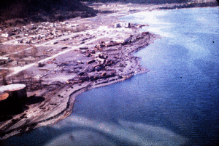
'Scalloped' shoreline indicates undersea landslides // Source: usgs.gov

The 2011 Japan tsunami, which killed up to 20,000 people and caused the partial meltdown of the Fukushima nuclear plant, was made worse by an underwater landslide, according to scientists.
Until now, the lethal waves have been blamed solely on the magnitude-nine earthquake which struck at sea, forty-three miles east of the country’s northern Tohoku peninsula.
An international team, led by Professor Dave Tappin of the Natural Environment Research Council’s (NERC) British Geological Survey, says the earthquake cannot explain the full extent of the waves.
“The earthquake alone cannot explain the height of the waves along the Sanriku coast of northern Honshu Island,” says Tappin. “They were generated by a sub-marine landslide.”
According to Tappin, the research raises a “big problem” for early-warning systems. Where the risk of landslides goes unrecognized, tsunamis generated by similar earthquakes could be badly underestimated.
It is well known that landslides can generate tsunamis on their own, and research on the Papua New Guinea event of 1998 showed that landsides triggered by small earthquakes could also produce devastating tsunamis.
This research, however, presented at last week’s Fall Meeting of the American Geophysical Union, is the first to recognize the significant contribution that underwater landslides can make to tsunamis generated by giant quakes.
“With the Japan tsunami, for the first time we had offshore wave data recorded at GPS buoys,” says Tappin. “This allowed us to identify the most likely location of the landslide.
“Using maps of the seabed, we identified a landslide that was 40 kilometers wide, 20 kilometers long and 2 kilometers thick. That makes it 500 cubic kilometers, so it’s pretty big.
“We then used computer models to simulate the tsunami from a dual source; the earthquake and the landslide, and this gave us the high water levels along the north Honshu coast.
“An additional check on the landslide source was from an analysis of the wave frequency at the buoys, which showed a high-frequency component that could only be from the landslide.”
Tappin says the landslide also explains helicopter video footage of the tsunami which appears to show two separate wave trains, around 20-30 minutes apart.
The earthquake hit on the afternoon of 11 March 2011. It was the most powerful ever known to have struck Japan, and was strong enough to shift the Earth slightly on its axis.
The sheer scale of the tsunami took Japan by surprise. The Japanese Meteorological Agency had predicted a tsunami of just six meters. When the waves arrived, however, they reached heights of up to twelve meters, overtopping seawalls and sweeping away entire towns behind them.
The Sanriku coastline was particularly hard-hit. In Minamisanriku, a town of 17,000 people, over 95 percent of the buildings were destroyed, and more than 800 people lost their lives.

EDITOR’S COMMENT: Giant submarine landslide? Driven by angry Nature or perhaps a huge explosion? No, I am not a conspirionist freak – just thinking asymmetric and nasty. (but try this combination in Google while observing photos from that era were building were not so much affected by the huge earthquake!)

Space Debris: A Growing Threat
Source: http://i-hls.com/2013/12/space-debris-a-growing-threat/

The U.S wants improved tools to track space debris. The current efforts are aimed at tracking orbital debris that could endanger satellites, the Defense Advanced Research Projects Agency (Darpa) is seeking methods for the uncued detection of objects in low-inclined low Earth orbit (LILO).
According to Aviation Week the LILO project is part of Darpa’s OrbitOutlook (O2) program to bolster the U.S. Space Surveillance Network (SSN) with new sensor, database and validation capabilities. The SSN is tasked with observing and tracking space objects.
Low-inclined LEO objects are defined as those orbiting at an altitude of less than 1,000 km and an orbital inclination of 0±20-deg. (prograde, or orbiting with the rotation of the Earth) or 180±20-deg. (retrograde), Darpa says in a new solicitation.
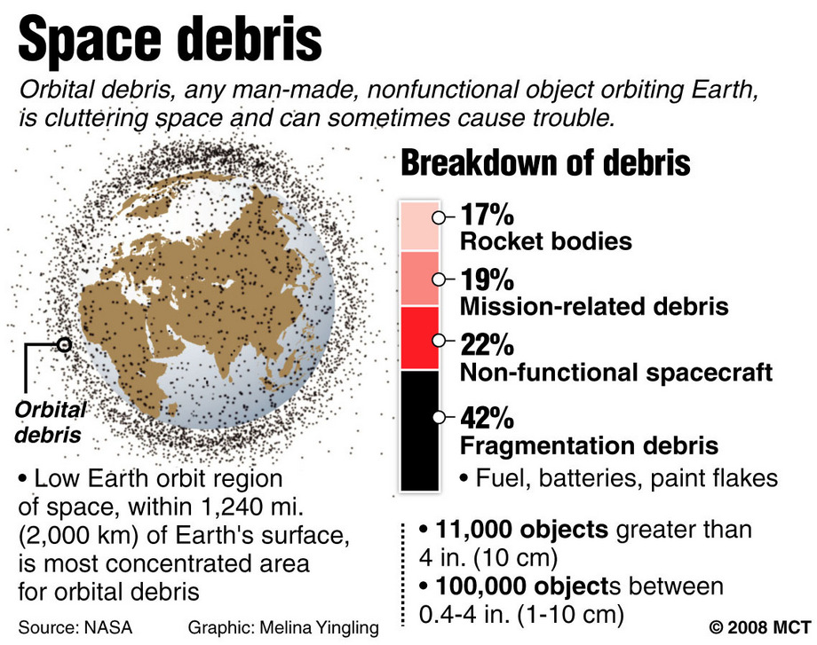
The agency is seeking proposals for new or modified sensors that can be deployed within 12 months of contract award. They are to be capable of detecting objects 10 cm or larger at 1,000 km, without prior knowledge of their location or trajectory, with an astrometric precision of better than 6 arcsec. and a timing accuracy of less than 10 millisec.
The LILO system is required to provide at least three independent detections of an orbit within a 10-min. window. Darpa says solutions may include passive optical or radio-frequency sensors or active radar, but says it is not interested in systems that use active illumination.
A goal of the LILO project is to demonstrate the ability to integrate new or modified sensors rapidly to supplement the SSN. The schedule calls for performers to deliver observation data to Darpa within 12 months of contract award, and ideally within six months.
The 12-month first phase is planned to begin in the third quarter of 2014 and include a technical demonstration period of up to three months. Darpa will have to option to buy data collected during a follow-on 12-month operational phase.

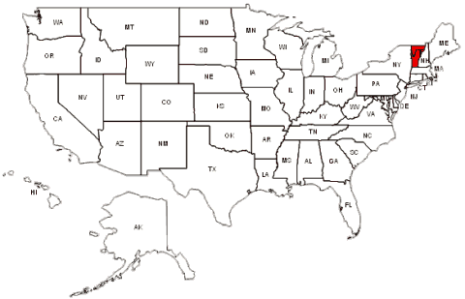
Vermont preparing for climate-driven disasters
Source: http://rutlandherald.com/article/20131217/NEWS03/712179920

The State of Vermont and a host of partners unveiled a range of recommendations Monday intended to help the state and local communities limit damage from natural disasters, which officials believe will become more frequent in coming years as a result of climate change. The state is focusing on preparing for more major weather events and preventing widespread damage such as the effects of flooding from Tropical Storm Irene.

The August 2011 storm caused hundreds of millions of dollars in damage to roads, bridges, homes and businesses.

►Read more at source’s URL

Freshwater loss compounds climate change’s detrimental effects on agriculture
Source: http://ci.uchicago.edu/press-release/lost-freshwater-may-double-climate-change-effects-agriculture

A warmer world is expected to have severe consequences for global agriculture and food supply, reducing yields of major crops even as population and demand increases. Agricultural models estimate that given the present trajectory of greenhouse gas emissions, climate change will directly reduce food production from maize, soybeans, wheat, and rice by as much as 43 percent by the end of the twenty-first century. Now, a new analysis combining climate, agricultural, and hydrological models finds that shortages of freshwater used for irrigation could double the detrimental effects of climate change on agriculturedue to the reversion of twenty to sixty million hectares of currently irrigated fields back to rain-fed crops.

►Read more at source’s URL

World's shrinking groundwater sources in urgent need of better governance
Source: http://www.homelandsecuritynewswire.com/dr20131231-worlds-shrinking-groundwater-sources -in-urgent-need-of-better-governance

An eminent Australian water scientist has urged the world to take better care of its groundwater resources — or risk dangerous scarcities, economic impacts, and potential conflicts in coming decades.
Professor Craig Simmons, the director of Australia’s National Centre for Groundwater Research and Training (NGCRT) says that governments around the world need to get behind the UNESCO plan to develop a Global Framework for Action on groundwater governance, due for release shortly.
“Groundwater governance may sound like a dry argument to some people – but it’s a life-and-death issue for millions. It also affects the ability of countries like China and India to continue to grow their economies and to feed three billion people. And, since water scarcity is sometimes a trigger for conflict, it also holds the key to a more peaceful world.”
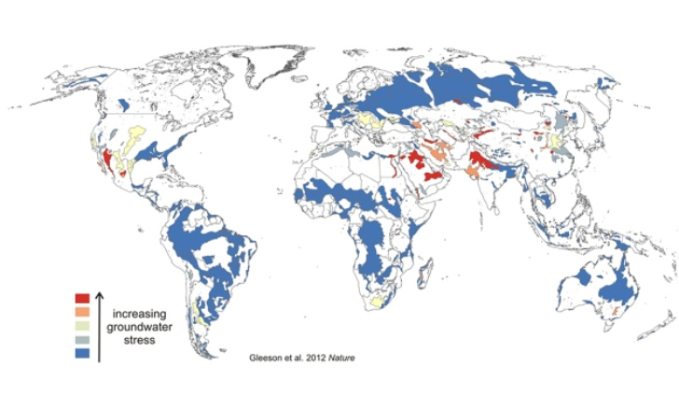
An NGCRT release reports that groundwater makes up 97 per cent of the world’s available fresh water. Total global use is estimated by scientists at around 1,000 cubic kilometers a year, with the largest users being India, China, and the United States. Since 1900, the world has drawn down its groundwater reserves by an estimated 4,500 cubic kilometers — and demand continues to increase, especially in arid countries, which are rapidly running short of water that can be affordably extracted.
“A significant part of the world’s food supply depends on groundwater — which is already starting to run short in critical regions such as the western USA, Mexico, northwestern Sahara, Indus Basin, and North China Plain,” Professor Simmons says. “This is something every consumer should be concerned about, as it affects global food prices.”
“Australia has been a significant contributor to the UNESCO discussions on developing a global action plan to protect this imperiled resource. Furthermore, with the work done to cap bores in the Great Artesian Basin, we are one of the very few countries in the world to have launched a successful bid to reverse a decline in a major groundwater resource.”
Professor Simmons says that groundwater supplies around 30 percent of all the freshwater used in Asia — and if it runs short, could threaten food security, economic growth and many huge cities.
“The countries where this is happening are keenly aware of the risks — but this is not a simple issue to resolve: you can’t just turn off the tap.”
Hence, he says, the need for better governance of groundwater — and the rapid global sharing of best practices, good laws and regulations, effective policy options, ideas, advanced technologies and greater public awareness.
“Asia — especially south Asia — and the nations of the Pacific South Asia face major challenges to meet their growing demand for water, at a time when the resource itself is under increasing stress. The unplanned and massive use of groundwater in the last thirty years has resulted in serious and growing problems of depletion through over abstraction and groundwater pollution, from man-made chemicals, arsenic or salinity.
“Also, in a region subject to a growing impact from natural disasters, groundwater represents a vital reserve of fresh water which is essential for post-disaster recovery.
“Much economic and population growth is generated in coastal and flood-prone areas of the Asia-Pacific and many small island states are especially vulnerable, as rising sea levels threaten their freshwater aquifers.”
“All round the world, especially beneath the great cities, groundwater faces a sustained deterioration in quality due to human activities which use ever-increasing amounts of toxic chemicals, many of which leach from landfills and industrial sites into aquifers used by city people for drinking water. UNESCO has warned that, because groundwater usually moves very slowly, groundwater pollution is almost irreversible, or at least, very persistent.”
Professor Simmons says Australia has a great deal to contribute towards improving the world’s groundwater governance. “In the Great Artesian basin we have demonstrated one of the rare cases of conserving and improving water resources in a massive groundwater basin by capping uncapped free-flowing bores to restore water pressure in the basin and protect the health of important groundwater-dependent ecosystems and springs.
“Similarly, in the Murray Darling Basin we have established one of the world’s most effective water management systems for a large river basin – where one of the big issues is managing water across different boundaries and jurisdictions. And we have demonstrated the practicality of managed aquifer recharge — or water banking – to replenish groundwater during wet times.
“Among our most important contribution to world groundwater science is the work we are now doing in modelling and predicting the behavior of aquifers under varying conditions and developing state of the art methods for measuring, modelling and monitoring groundwater. This is an absolutely essential platform for any form of effective governance. You have to know what you’ve got and be able to forecast future changes - especially under climate change - in order to manage it well.”

Flood-hit UK must prepare for more extreme weather, says climate adviser
Source: http://www.theguardian.com/environment/2014/jan/05/uk-prepare-extreme-weather-floods

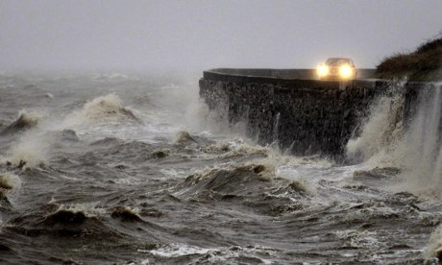
Strong winds and high tides batter the coastal road close to Newtownards, Northern Ireland. Photograph: Peter Morrison/AP

Britain needs to face up to a radical change in weather conditions that could be the result of global warming, and spend much more on flood defences, Sir David King, the government's special envoy on climate change, has said.
Amid the worst floods for decades, King said the UK must do more to manage the problem, potentially doubling spending to £1bn a year by 2020, as extreme weather events are likely to become more frequent.
The former chief scientific adviser spoke out as the UK braced itself for further disruption from wind and storms, with 84 flood warnings in England and Wales, and a further 220 areas on alert.
The storms and floods have claimed three lives, including that of a man thought to have drowned after his mobility scooter fell into the river Thames at Osney in Oxford on Saturday night. A teenager remains missing in Devon.
Strong winds, persistent rain and tidal surges are predicted for the UK for at least another two days, mostly in the south and Wales, as emergency services attempt to cope with the trail of devastation already caused by the severe weather.
On Sunday, the Met Office issued yellow weather warnings of ice and rain, predicting river and surface flooding as well as travel disruption, mainly in south Wales, the south-west and south-east of England, Northern Ireland and Scotland. Up to 40mm of rain could fall on higher ground.
Coastal areas – particularly in southern England – are most vulnerable on Monday because of unusually high tides and the arrival of a strong Atlantic storm. The Thames barrier will remain closed to protect land near the river.
Inland rainfall is expected to put pressure on rivers, endangering nearby communities including those along the river Medway in Kent, the Severn estuary in Gloucestershire and the Thames in Oxford.
King raised the possibility that the storms are linked to climate change and said "priority should be given to much more funding to create a better situation so we can face up to flooding in a proper manner on the British Isles.
"The important thing to get across is the simple notion that storms and severe weather conditions that we might have expected to occur once in 100 years, say, in the past may now be happening more frequently," he told BBC Radio 5 Live.
"And the reason is – as predicted by scientists – that the climate is changing and as the climate changes we can anticipate quite a radical change in weather conditions."
King said a report he wrote in 2004 predicted that a sea-level rise, increased storm surges and increased intensity of rainfall would penetrate further inland, affecting cities and causing billions of pounds a year of economic damage. The Environment Agency estimated then that for every pound invested in flood defences the country would save about £7 or £8 in flood damage, he added. But a boost in funding for defences did not survive the recession.
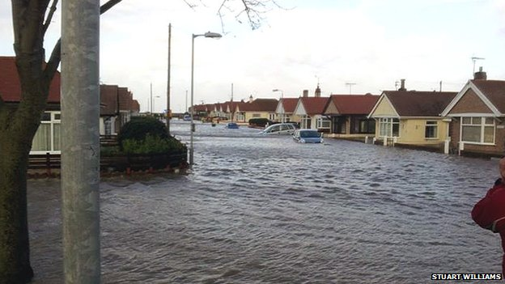
"If we really want to manage this problem, and I'm sure that all of us do, we will have to do two things," he said. "One, get back to the higher investment level in flood defences and, two, push hard on the rest of the world in terms of mitigating the impacts of climate change and of course this is a big target for getting an international agreement."
Thousands of people have lost power and about 200 have seen their homes flooded over the past few weeks, putting David Cameron under pressure over cuts to the Environment Agency's budget.
On Sunday the prime minister insisted the UK would see record levels of spending on flood defences "guaranteed right out into 2020 so [the Environment Agency] can really plan for the future".
However, Labour accused Owen Paterson, the Conservative environment secretary of ignoring the increased risk of flooding because he is sceptical about climate change science.
Maria Eagle, the shadow environment secretary, said Paterson had questions to answer about why he was allowing cuts at the Environment Agency that could affect Britain's ability to deal with severe weather incidents.
Paterson chaired another meeting of the government's emergency committee "to ensure everything is being done on the ground to prepare for bad weather ahead".
Matt Dobson, a forecaster for MeteoGroup, said the rain "simply has nowhere to go" because weeks of severe weather had left the ground waterlogged and rivers rising over their banks.
"It's very unusual to have so many powerful storms come in one after the other in such a short space of time; we haven't seen anything like this since about 1991," he said.

Massachusetts takes steps to withstand climate change impacts
Source: http://www.seattlepi.com/news/science/article/Mass-Gov-to-unveil-climate-change-prep-plan-5140486.php

Governor Deval Patrick of Massachusetts earlier this week unveiled a $50 million plan to help prepare Massachusetts for the challenges climate change poses to energy supplies, public health, transportation, and basic infrastructure in his state. A $40 million grant from the state’s Department of Energy Resources will help cities and towns develop protections around energy services, and $10 million will go toward shoring up critical coastal infrastructure and dam repair.

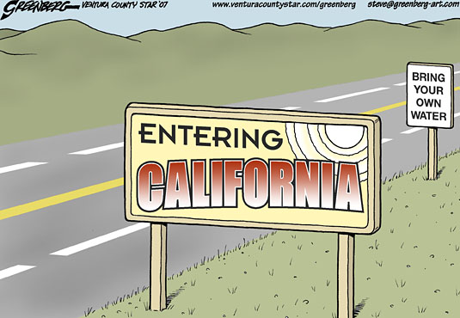

2013 Disasters Cost Insurers $44 Billion
By Kelly Sheridan
Source: http://www.insurancetech.com/claims/2013-disasters-cost-insurers-44-billion/240164860

Global reinsurer Swiss Re has released preliminary sigma estimates for the global cost of man-made and natural disasters in 2013. Insurers lost $44 billion this past year in catastrophes that caused global economic losses of $130 billion.
The $44 billion cost to insurers is a major decrease from the $81 billion lost in 2012. In 2013, insured losses totaled at least $38 billion and man-made disasters generated $6 billion. The overall economic loss is also a decrease, down from $196 billion in 2012.
Flooding was a primary factor in insurance claims around the world. In June 2013, floods throughout central and eastern Europe cost $4 billion to insurers and $18 billion overall, making it the second most expensive fresh water flood on sigma records. June flooding in Alberta, Canada totaled $2 billion for insurers, the largest disaster cost ever recorded for a single country.
Other severe weather in Europe contributed to global insurance losses. July 2013 brought Hailstorm Andreas to Germany and France, which cost $4 billion. Windstorms Christian and Xavier later hit central and northern Europe; each cost insurers around $1 billion.
Typhoon Haiyan, which brought heavy rains, storm surges, and record-high winds to the Philippines, claimed 7,000 of the 25,000 lives lost in last year’s disasters. Though this was the highest loss of life from a single event in 2013, insurance costs are expected to be modest as insurance penetration is low in the country.
“In many parts of the world, insurance penetration remains low,” says Kurt Karl, chief economist at Swiss Re. “Together with preventative measures, insurance can lessen the destructive impact and financial burden that large catastrophic events can have on people’s lives.”

KellySheridan is an associate editor for Insurance & Technology. Prior to joining InformationWeek Financial Services, she was a staff writer for InformationWeek and InformationWeek Education. Kelly has also written for trade publication Promo Marketing and a number of lifestyle blogs. She recently received her B.A. in English from Villanova University.

Becoming Resilient: The Definitive Guide to ISO 22301 Implementation
Source: http://www.iso27001standard.com/en/books/becoming-resilient-the-definitive-guide-to-iso-22301-implementation?utm_source=drj&utm_medium=website&utm_campaign=book

Author and experienced business continuity consultant Dejan Kosutic has written this book with one goal in mind: to give you the knowledge and practical step-by-step process you need to successfully implement ISO 22301. Without any stress, hassle or headaches!
✓ Learn how to start an implementation project
✓ Get a simple explanation of the ISO 22301 standard
✓ Learn how to structure the required documentation
✓ Learn the certification process and the criteria of certification bodies
✓ And get all this (and much more) in language you’ll understand

Why you’re going to love this book!
- Think like a consultant – And avoid hiring one! Author and experienced ISO 22301 consultant Dejan Kosutic shares all his knowledge and practical wisdom with you in one invaluable book.
- Implementation becomes clear – This books keeps you from feeling overwhelmed with your project, instead making everything clear in your mind.
- Save time and money – Without the right guidance, implementation of ISO 22301 can be costly, time consuming and ineffective. This book will prevent you from making these mistakes, providing you with an easy, stress-free method.
- Written in plain English – Leaving the technical jargon to the geeks, Becoming Resilient is written for normal people in plain, simple language – meaning you can focus on getting the job done.
- Practical examples – Learn how to organize your project, write a business continuity policy, perform risk assessment, write and perform a Business Impact Analysis and much more.

How to Prepare Your Organizations for Emergencies? Drills, Drills and More Drills
Source: http://i-hls.com/2013/12/how-to-prepare-your-organizations-for-emergencies-drills-drills-and-more-drills/

Earthquakes, natural disasters, floods or snow storms, fires, cyber attacks, damaged databases. All these could happen to any organization, and it’s no secret that this type of events seriously damage business and operational continuity.
There’s isn’t any wonder cure to handle these incidents, except one: Being prepared, very well prepared. And an important part of these preparations are drills, in which various scenarios are simulated so that personnel will know how to act during emergencies.
Comsec, an IT security and risk management consulting firm, advises hundreds of organizations in Israel and around the world. Its clients include banks, financial institutions and technological organizations. Ami Braun, VP of Cyber Solutions, explained the significance of events which disrupt business continuity: “They cause damage to the system. It becomes much more difficult to serve customers, leading in turn to loss of revenue and reputation. Managing emergencies requires the formation of emergency procedures, and the best tool for that are drills and simulations. When the organization plans drills during routine operations personnel are calm and relaxed. They can suggest and prioritize responses, probable scenarios and even extreme scenarios. In this way organizations can prepare for unexpected emergencies, which are usually local or national events: Natural disasters, sabotage or cyber attacks.”
An important part of any drill is simulation, defined as imitating real-world processes over time. This gives the ability to simulate what might happen during emergencies, how to respond and how to cope.
Comsec offers a unique product, the Com Simulator, a system designed to aid organizations in practicing real-time decision making and work processes, in addition to virtual-reality business continuity and cyber attack challenges. The simulation is a multi-participant role playing game based in a dynamic and flexible environment, which allows for simulating cyber- and business continuity emergencies and later analyzing of the events. Simulations are prepared, deep and rich in detail, in order to create dynamic relations between participants.
Ami Braun added: “The goals of the simulation are to review, to make sure and to question whether various elements in the organization are indeed prepared to handle threats to business continuity, to reach new insights and to draw a proper response plan. Additional goals are: Preparing and training these elements to act and respond to events; to identify, map and define new expected events by simulating extreme situations.”
The drills themselves are similar to military drills: There’s a blue team and there’s a red team; there’s a command center and there are judges; and there are, of course, guides and participants. Who are the players in the simulation? Anyone who is close to the organization – suppliers, subsidiaries, relevant government offices, regulators, competitors, customers, the public and the media. Senior decision makers are also players, directors of finances, sales and marketing, for example.
Drills have four stages:
- Preparations
- Drill
- Initial debrief on the day of the drill
- Extensive inquiry, drill summary
Ami Braun: “Our system of drills has its benefits, but it also has its flaws. The most significant benefits are real time control and monitoring, in addition to advanced processing and analysis capabilities. This is a platform capable of simulating dynamic events and organizational dilemmas, in addition to facilitating interaction between the players. The main flaw is long prep times. The drill itself lasts for an entire day, and may even last for up to three days. This requires a significant investment. Still, it has been proven that the benefits outweigh the flaws. The preparation, drilling and inquiry stages are the best tools we have at our disposal in order to prepare organizations for rainy days, when business and operational continuity are at risk.”

Drills vs. reality
By the Editor-in-Chief

Drills, drills and more drills – the title conclusion of the above article. This is correct and logical! We test our plans with drills. We also test our personnel’s reactions with drills. Totally agree with drills! So why comment on drills?
Because my main objection is about drills’ realism! There are two types of drills. Those during the preparatory phase when we build or harden our defenses and those during the response phase. The first type recuires step-by-step planning aiming to identify gaps and fix things. Usually they are conducted in a controlled environment and in a pre-set date. This gives the time to prepare well and perform within expectations. The bad thing is that in these drills, the result is almost always pre-defined. Success! And usually authorities are satisfied and make related announcements in fabulous press-conferences that spread the message “we are ready”! Mostly to the populace – the major client!; but also to themselves! And (usually) that is all!
The second type is the main problem! Because they are conducted with the same mentality as the first type! Response drills are totally different because they have to face reality. Reality is not pre-defined both in mode and time. It happens, this very morning whether it is Monday or Saturday; day or night; single episode or multiple combined; conventional or asymmetric; with or without electricity; from the list of threats or facing new threats. The main purpose is to simulate reality in response. And this is when real problems arose since we seldom proceed to this kind of drills.
Take for example a CBRNE drill. Usually the drill stops the moment that casualties are clean and nice inside ambulances. Surpise personnel and ask ambulances to deliver casualties in the near by hospital. Surprise vs. chaos! All gaps will march in front of your eyes within seconds after the call announcing the delivery of contaminated casualties at the EMS of the given hospital. But in real life this is how it is! Terrorists do not choose to attack in an area full of big trauma hospitals and experienced personnel (as it happened during Boston bombing)! Combine a conventional underground metro attack with a notice that high levels of radiation was counted on site and many victims with multiple wounds experience inner radio-contamination as well! Go to an EMS department and say to the doctor in charge: “Hi! As from this moment your hospital is in a chemical drill!” Step back and observe!
This is how we test our “we are ready” quota! It would be really nice to have a preliminaty announcement that in a given time terrorists will commence a dirty bomb attack but this is not what happens in real life. Even during conventional bombining that we do have these preliminary calls asking to evacuate a building in the next 30 min, something might go wrong and booom!
In conclusion: drills, drills and more drills! YES but also REALISTIC drills and MORE REALISTIC drills!!!
►And always remember: No plan stands in front of the real enemy!

Cryptolocker: Menace of 2013
Source: http://www.zdnet.com/cryptolocker-menace-of-2013-7000024299/

Security software company Symantec named Cryptolocker the “Menace of the Year”.
Bitdefender logged over 12,000 victims in a week last month. That's not huge on a global scale but it should be a big enough number to make businesses pay attention.
While relatively few have been affected so far, many of those that have succumbed experienced a world of pain, as the victim stories below will attest.
Backup is the key to recovering from a Cryptolocker lockout.
For anyone who hasn’t been paying attention, Cryptolocker is a variant of ransomware that unlike its predecessors does not work by locking a computer. Instead, it encrypts all data and demands a ransom in Bitcoins for the user to regain access.
It is usually distributed as an executable attachment disguised as a Zipped document and presented as an invoice or report or similar via a spam campaign.
All of that would be frightening enough for individual users, but Cryptolocker more than most trojans is a threat to businesses too. that's because it not only attacks data on the PC on which the executable was opened, but also on devices and drives connected to that PC.
So, what’s it like being on the receiving end?
One business in Australia that was shut down for five days with staff sent home on leave. Every network share’s business data was encrypted, over 64,000 files, after a staff member clicked on an attachment, despite telltale suspicious signs.
The firewall failed to detect and stop the infection as did antivirus software.
After the download, multiple files executed from a website and downloaded more malicious code to boot at startup via the registry.
Backup is key. It allows companies to enter their own personal Tardis and, like Dr Who, wind the clock back.
In this case it failed. The server had made room for the latest revised data by deleting all the old backups.
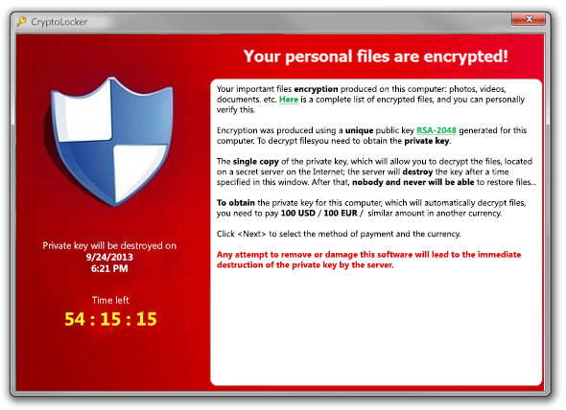
“The receptionist could not wait for the backup to complete on the last known backup date, and pulled out the USB drive early.”
This forced the IT fixers to restore from an older backup, losing many proposals and quotes. The system was recovered “but at great expense and emotional cost”.
Contrast that with a New Zealand law firm where, through good management and a bit of luck, backup was effective.
“Only 45 minutes of work was lost and as this all happened at around midday a lot of staff were at lunch so there was not much activity in regards to the data.”
The most famous victim to date is the Police department of Swansea, Massachusetts. Infected in November, the department decided to pay the ransom demand of two bitcoins, around US$750 at the time, and recovered its data.
In the process it not only revealed its vulnerability, but also drew heat for rewarding the criminals.
Cryptolocker is not entirely new. It emerged in September, but similar malware families date back as far as 2005.
Symantec says due to the publicity around ransomware, there are fewer uninformed potential victims and that had lowered the effectiveness of the tactic and its profitability.
Cryptolocker is their response.
“Due to this increased public awareness, in the last quarter of 2014 [sic] we have seen cybercriminals reorganize around a new type of extortion: Cryptolocker. This threat is pervasive and preys on a victim's biggest fear: losing their valuable data…
“If files are encrypted by Cryptolocker and you do not have a backup of the file, it is likely that the file is lost.”
There is no way to retrieve locked files without the attacker's private key. There can also be a time limit, usually 72 hours, in which to pay the ransom.
Almost comically, the criminals were making so much coin from a surging bitcoin value, they later reduced the ransom.

►Users are being advised to take the following precautions:
- Backup all files regularly and off the network
- Lock down directories
- Make sure you have a business grade unified threat management (UTM) firewall with current subscriptions
- Keep all virus protection software up to date
- Make sure all employees are aware of this danger, trained in response and know to not open attachments without first talking to the IT department.

