CBRNE-Terrorism Newsletter – 2014©
February 2014

Website: www.cbrne-terrorism-newsletter.com

Editor-in-Chief
BG (ret) Ioannis Galatas MD, MA, MC
PhD cand
Consultant in Allergy & Clinical Immunology
Medical/Hospital CBRNE Planner
Senior Asymmetric Threats Analyst
CBRN Scientific Coordinator @ RIEAS
Athens, Greece

Contact e-mail: igalatas@yahoo.com

Assistant Editor
Panagiotis Stavrakakis MEng, PhD, MBA, MSc
Hellenic Navy Capt (ret)
Athens, Greece

Co-Editors/Text Supervisors
- Steve Photiou, MD, MSc (Italy)
- Dr. Sarafis Pavlos, Captain RN(ret’d), PhD, MSc (Greece)
- Kiourktsoglou George, BSc, Dipl, MSc, MBA, PhD (cand) (UK)

Advertise with us! (New price list)
CBRNE-Terrorism Newsletter is published on-line monthly and distributed free of charge. Starting from 2014 issue all advertisements will be charged as following:
Full page (A4) 100€
Double pages (A4X2) 200€

EDITOR
Mendor Editions S.A.
3 Selinountos Street
14231 Nea Ionia
Athens, Greece
Tel: +30 210 2723094/-5
Fax: +30 210 2723698

Contact e-mail: Valia Kalantzi info@mendor.gr

DISCLAIMER: The CBRNE-Terrorism Newsletter® is a free online publication for the fellow civilian/military First Responders worldwide. The Newsletter is a collection of papers related to the stated thematology, relevant sources are provided and all info provided herein is from open Internet sources. Opinions and comments from the Editorial group or the authors publishing in the Newsletter do not necessarily represent those of the Publisher.

CBRNE-Terrorism Newsletter is:

- Read by First Responders in more than 80 countries around the globe (below right: top-20 countries);

- Distributed to more than 700 institutions, organizations, state agencies, think tanks, defense companies, institutions and universities.

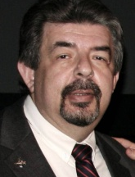
Editorial
BG (ret’d) Ioannis Galatas, MD, MA, MC

Editor-in-Chief
CBRNE-Terrorism Newsletter

Dear Colleagues,

February was overall a very interesting month!

First, the comments for the Monthly publication was very encouraging and towards the right direction. Very few were annoyed by some of my comments. Mainly because they personalize them – not my purpose – instead of reading behind the lines. I think it is our duty and obligation to say things by their names if we do not agree with them; but at the same time to propose ideas and solutions. Just saying “no” or “I do not like it” deletes the contribution of commending. Perhaps by now you have noticed two things about me: my great affection to animals and my strong objection to current status of Olympic Games. I have good reasoning for both as a human being and a Greek. This is for those commenting about the presence of animal news in “my corner” and my radical proposal for the permanent organization of Olympic Games in Greece – where all started some centuries ago.

In the Newsletter important info in articles is marked red and more comments are added at the end of articles. It is advised to visit sources since many links included in articles are omitted for technical reasons. In addition pictures, tables, maps and other graphics are added in order to give a more comprehensive understanding of the info provided. Three new “chapters” were added as well: Emergency Management; Asymmetric Threats and Business Continuity. Finally the website hosting the Newsletter underwent update and stylistic improvement in an effort to provide a better overall outcome. We hope that you will like these modifications and enjoy the Newsletter.

Destruction of Syrian chemical weapons is progressing slowly and this is well understood from a technical perspective. Although It is a very complex operation, scarcity of accurate and detailed information sometimes generates disputes with a touch of political overdose regarding the management of the final CWA/precursors’ products disposal. I am sure that OPCW and involved parties will understand this and take corrective actions to avoid misunderstandings. Let us all hope that everything goes according to the plan and that the unexpected will not happen this time!

Socchi Winter Olympics are over and no terrorist attack (conventional or asymmetric) has been recorded in the area or other parts of the host country. It seems that the Russian “umbrella” was as effective as expected. Of course this will not ensure that peace will follow in the region or that local ambissions have forgotten or changed. One might provokatly say that if it did not happen in Sochi then most probably it will not happen anywhere in the near future. But it is in our nature as security analysts to hypothesize threats everywhere and try to analyse odds and possibilities. In that respect, Brasil is our new focus of interest. Although CBRNE threats will always be on the top list, there the problem lays in lay people and conventional terrorism. I will continue to ask myself about the security criteria employed in the selection if this great nation to deliver the 2016 Olympic Games. Absence of legislation on terrorism; a vast country to defend; highest criminality worldwide; a bounch of megapolis directly involved in the Games; slow progress in CBRNE preparedness (especially in the health sector); terrorist organizations’ infiltration in the Tri-Border area; loose mentality for the unexpected provide a prosperous environment for disturbing terrorist events that may greatly affect the Games and the country itself in case something real (big or small) happens before or during this mega event.

Nature is pissed again – snow storms and floods stormed both US and UK causing loss of lives and billions for restoring chaos produced. The UK case is of interest since it was the first time that this country faced such catastrophes. One might commend that the phenomena were too much to handle. I would agree but I would also add that this is why we have something called planning. And in planning we always deal with worst case out-of-the-box scenarios. If certain movie producers can use these scenarios for their movies, it is within the responsibility of response forces to share similar mentality and act accordingly. Even if they have to propose the construction of new or connecting rivers to control flooding; change or improve building regulations or impose hardening interventions to existing infrastructure. Sand bags could not be the solution next time a similar or worse catastrophe will storm the country – or any country.

In Greece overall situation is the same. We have a new game now called Euro-elections! And (as usual) we all play that game as if everything else have already fixed or moving towards the end of the tunnel in source for the stolen light. Perhaps because Greeks were given by Creator the “double gene” of excellence and abyss! Nothing really happened with the “Coca-Cola” poisoning (HCl) but to be honest the suspicion was plant into our minds – at least mine! We all know that terrorism is not about killing people. It is to show us that we are next!

Personally February and first days of March was very interesting due to my participation as an instructor in the first course organized in Doha by the Qatari National Committee for the Prohibition of Weapons (NCPW) addressing HAZMAT/CBRN issues for medical first responders and as lecturer in the Fire Safety Technology Forum (Abu Dhabi, UAE) addressing “C₂BRNE threats and resilience strategies” on the occasion of the World Civil Defense Day. It was very interesting to meet colleagues know from the past, meet new ones and interact with medical counterparts on issues of mutual interest. Participation in similar events, besides the role as my personal psychotherapy (CBRN passion) might come up with a more solid proposal and opportunity to continue doing what I love most. Time will show!

I hope March will be equally interesting and intriguing and that the Newsletter will continue to provide you all the info related to CBRNE/CT issues. I also hope to like my new proposal for the abbreviation of threats as C₂BRNE (Cyber-Chemical-Biological-Nuclear-Explosives) instead of the “old” one that slowly is turing to “Cannot Bother Right Now” forgetting the these threats “Can Be Really Nasty”!

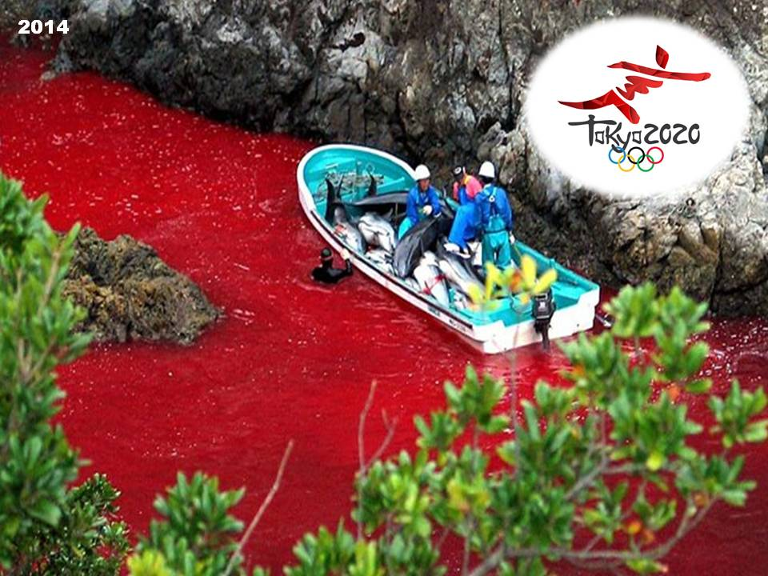
The Editor-in-Chief

No comments…

BOOK REVIEW – The Prisoner
Author: Omar Shahid Hamid
Publisher: Pan Macmillan (2013) Pages: 352
Reviewer: Afrah Jamal
Source: http://www.dailytimes.com.pk/opinion/26-Jan-2014/take-no-prisoners

“When you gaze long into an abyss, the abyss gazes back.”
The plaque reads: ‘Deputy Director Counter Intelligence Terrorism — Police Intelligence Bureau (IB), Senior Superintendent (SSP) CT and Anti Extremism Cell (CID) (2011)’. The resume is equally moving. It belongs to a man who has been in the crosshairs of extremists, banned outfits of different denominations and local mafia men who may or may not have political backing. Since he knows where the ‘boris’ (sacks) are buried, the impact of Omar Shahid Hamid’s revelations will be explosive. However, cops do not read so, as a rule, he thinks he will be okay.
Though The Prisoner resides unobtrusively in the fiction section, its outlines are expertly crafted from those off-camera moments and unacknowledged victories. A kidnapped US journalist comes into play early in the game, giving the requisite urgency and, while parallels to the Daniel Pearl case are inevitably drawn, the events depicted here follow a different trajectory. The lead positions are taken by an ever-cheerful Akbar, the maverick and Constantine often referred to as “Consendine”, a Christian who joins Dr Death, Colonel Tarkeen, Major Rommel in the deadly waltz. Our beloved army, agencies and “Kaley gate wale” (black gate wallahs) await and a party called the “United Front” rises with its “goonda politics”, with a Don in self-imposed exile in tow.
When Omar Shahid Hamid sallies forth into a crime-ridden battlefield determined to revisit the darkness he encountered in the line of duty, he hauls his 12 years of experience with him. But The Prisoner trades insider’s knowledge not just to enlighten, which is noble and exhumes skeletons, which is bold, but also to entertain and pay tribute to unsung heroes.
The curtain is pulled back to reveal a motley crew out to serve and protect, profit and survive. Hit squads lurk nearby. Finding the American is a priority but it is also a gateway to sift through the political debris, tour the underbelly and discover Karachi’s changing skyline. It is where the law confronts the wards, “crews of young men supposed to create party structure at basic neighbourhood level” who created a parallel government instead, usurping “power of taxation...punishment”, with a monopoly over “life and death”. But, though the writer resurrects past controversies, and boldly goes where few have dared to tread, The Prisoner is not a takedown.
Not really. Nor does it plunge into the abyss to admire the moral compasses spinning out of alignment. What we know of the Karachi police comes from experience (unpleasant), headlines (unsavoury) and reputation (shady times 10). Omar concedes the police is corrupt but also shows the “challenges they face, the pressures upon them, the hazardous environment they must operate in”, and what happens when they fall in the line of duty or get on the wrong side of ruling factions for that matter. When he casually mentions a city of millions twisted into submission, forcing a ruthless right hand man described as “the high priest of murder, chief enforcer of reign of terror” to take the stand and calls upon a line-up of unsavoury characters (Shashlik Khan), it is to set the stage. When he remarks that real power that lies with a “ward” and not the “thana” (jail), it is to poke at its gory core.
Both the 1990s and 2000 come into play and the overlapping timelines provide a snapshot of Karachi’s troubling past. It is an immersive experience and, though the players are masked, in most cases it is not that hard to discover their identities. One learns a bit about the prison system “crawling with informers and turncoats where men came out a bigger, better more dedicated criminal”, the mushrooming madrassas (seminaries) that do not necessarily have sinister agendas but abject poverty and hopelessness end up making places like Orangi “a rich recruiting ground”. Towering above all stands the familiar “Haji Camp” designed as a virtual fortress, with its “massive arms dump, living quarters, torture chambers in the basement that no SHO has dared raid”. Within these pages our heroes can vent: “Either we survive or they do.” Later, the character observes, “he has never seen anyone slaughter policemen like they do”.
In real life, the number of their fallen may exceed 460 in 10 years; other nations are reportedly taken aback by these shocking statistics, which rival that of “Mumbai, NY, London or Sao Paolo”. One day before the launch of his book, Omar was at a colleague’s funeral. A week later, his partner and most likely the inspiration for the central character, was taken out by the TTP. For that reason it is a world bleached of colour, masterfully crafted from Karachi’s moody fits and broken dreams that is, by turns, dramatic, funny and dark.
His debut novel is a searing suspense thriller, which not only serves Karachi’s ruling underworld on a platter but also vindicates the defenders. There is a negative perception about civil servants and, for the most part, it is accurate, says an ex-civil servant. Omar has been described as an exception by former commissioner Ziaul Islam, who was also the moderator at the book launch. One day, he came upon Omar serving as a magistrate, and who quietly continued with his job as magistrates/judges are supposed to, unlike the misguided majority busy bowing to protocol. Zia, seen raving about his honesty, integrity, intellectual prowess (Omar is a BA Law, Masters in Law, University of London, Masters in Criminal Justice Policy from LSE), is convinced that Omar Shahid Hamid is well equipped to be a police officer, “but maybe not here,” he adds ruefully.
Zia, who was commissioner and recognised some of the operations detailed in the book, shared an ominous extract written sometime in 1995/96: “Gradually but surely Karachi is being carved into crime syndicates, organised crime is coming to the city in a big way. The present turmoil and violence is only the tip of the iceberg — the first sign of imminent surrender of state power to mafias and militias...” and most saw this coming he says, adding that, “we let it happen”. There are mafias in Tokyo, he admitted, but they do not interrupt daily life. Our underworld is above ground and visible, has political support and flourishes below and above and, though crime affects major cities, it remains in control. Not here.
The Prisoner is an action packed adventure that offers valuable insight into the rarefied world of the Karachi police department now on the frontlines and can be used to piece together Karachi’s chequered history. It is rated R for language and G for some gruesome imagery.
Among thugs that represent a “grave threat to national security”, the hydra of jihadis rising from the rubble of 9/11 and the spectre of terrorism, a few good men striving to take back the streets of Karachi stand their ground. This is their story.

“When policemen break the law, then there isn’t any law — just a fight for survival” --- Billy Jack (1971).

Mrs. Afrah Jamal is a freelance journalist.

Iraq: 935 Lies, a Tyrant and Weapons of Mass Destruction
By Felicity Arbuthnot
Source: http://dissidentvoice.org/2014/02/iraq-935-lies-a-tyrant-and-weapons-of-mass-destruction/

The greatest crime since World War II has been U.S. foreign policy.
— Former US Attorney General, Ramsey Clark, 1927 – Present

On February 10th, 2003, German Green MP Joschka Fischer, then Foreign Minister and Vice Chancellor, stunned an international security conference that was discussing the proposed invasion of Iraq in Munich’s opulent 19th century Bayerischer Hof hotel, by banging on the table, switching to English to guarantee Donald Rumsfeld understood, and shouted of the US arguments for war: “… I am not convinced.” As he spoke, he gazed at the then US Defence Secretary over his silver, half framed spectacles, concluding: “That is my problem, I cannot go to the public and say, ‘these are the reasons’, because I don’t believe in them.”
A stony faced Rumsfeld was described as ”gazing at Mr Fischer through a tropical plant …he looked like a tiger in the jungle, ready to pounce.”
The astute Herr Fischer recognized a pack of lies when he heard them and saved Germany from enjoining a war of aggression — Nuremberg’s “supreme international crime” — against a country which posed no threat and had no way of defending itself against the world’s most devastating and destructive weapons, whose poisonous residual pollution will continue to maim and kill generations to come for all time.
Both Tony “I’d do it again” Blair and George W. Bush face a citizen’s arrest whenever they appear in public, with Blair also reiterating with others responsible for bombing Iraq back to a pre-industrial age (again) that the country is a better place without Saddam, “a tyrant who killed his own people.” In fact, the Western trumpeted mass graves found in Iraq were from the 1991 war and the subsequent US encouraged uprising and its predictably violent suppression.
In Kurdistan, where the people in the Iran border were terribly caught in the crossfire from the weapons used by both devastated sides (and sold to both sides by the US) Saddam Hussein was firmly in the firing line for the terrible deaths at Halabja. However, a meticulous 1990 US War College Report threw doubt on the facts of even that horror, stating:
Iraq was blamed for the Halabja attack, even though it was subsequently brought out that Iran too had used chemicals in this operation, and it seemed likely that it was the Iranian bombardment that had actually killed the Kurds.
Further, according to a 2008 study George W. Bush “and seven top officials, including Vice President Dick Cheney, former Secretary of State Colin Powell and then National Security Adviser Condoleezza Rice, made 935 false statements about Iraq” during the two years following September 11th, 2001.
However, the US and UK are seemingly remarkably selective when it comes to tyrants who “kill their own people”, and not only have failed to censure their tyrannical Iraqi puppet, Nuri al-Maliki, but are arming him to the teeth with the same weapons which are linked to the horrific birth defects, and cancers throughout Iraq, which he is now using on “his own people.” Moreover, if allegations from very well informed sources that he holds an Iranian passport are correct, to say that US-UK’s despot of choice appears in a whole new political light would be to massively understate.
To facilitate Al-Maliki’s assault on Iraq’s citizens, the US “rushed” 75 Hellfire missiles to Baghdad in mid-December. On January 23rd Iraq requested a further 500 Hellfires, costing $82 million — small change compared to the $14 Billion in weapons provided by America since 2005.
The AGM-114R Hellfire II, nauseatingly named “Romeo”, clocked in at $94,000 each – in 2012. Such spending on weaponry in a country where electricity, clean water, education and health services have all but collapsed since the fall of Saddam Hussein.
Last week an “American cargo jet loaded with weapons” including 2,400 rockets to arm Iraqi attack helicopters also arrived in Baghdad. This week a contract was agreed to sell a further 24 AH-64E attack helicopters to Iraq “along with spare parts and maintenance, in a massive $6.2 Billion deal.” With them comes the reinvasion of Iraq, with: “hundreds of Americans” to be shipped out “to oversee the training and fielding of equipment”, some are “US government employees”, read military, plus a plethora of “contractors”, read mercenaries.
According to Jane’s Defence Weekly, on November 15th, 2013 Iraq also took delivery of “its first shipment of highly advanced Mi-35 attack helicopters as part of a $4.3 Billion arms purchase from Russia”, of an order of “about 40 Mi-35 and 40 Mi-28 Havoc attack helicopters.”
The all to “attack his own people” in the guise of defeating “Al Qaida” in Anbar province and elsewhere where the people have been peacefully protesting a near one man regime of torture, sectarianism, kangaroo courts which sentence victims who have also had confessions extracted under torture.
The chilling death penalty regime led the UN Commissioner for Human Rights, Navi Pillay, to comment, with considerable understatement: “Weaknesses in the criminal justice system means that the death sentence is often handed down under questionable circumstances in Iraq.”
On January 22nd it was reported that 38 people had been executed in the previous four days. In 2013 Iraq had the third highest executions in the world, according to Amnesty International.
So now Al-Maliki is to unleash weapons of mass destruction on any who oppose his reign of terror. Hellfire missiles, also used by the US forces in Fallujah, are described as “Thermobaric Hellfire Missiles”. Their effective performance in Fallujah led to major production contracts in 2005.
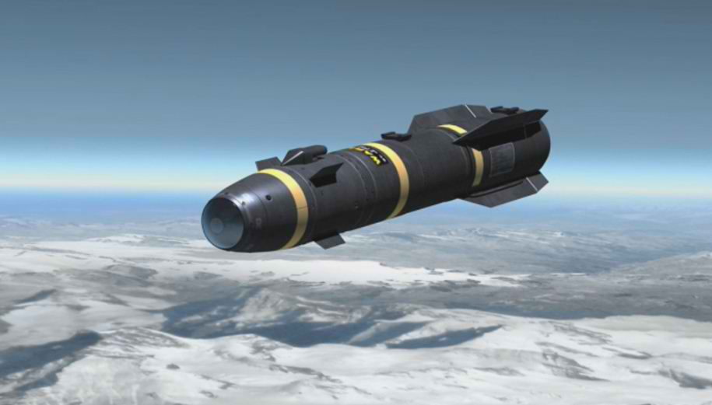
Thermobaric weapons use high temperature/high pressure explosives as anti-personnel incendiary weapons. They char or vaporise victims in the immediate target location, or suffocate and collapse internal organs with their extended blast/vacuum effects.
These weapons use a new generation of reactive metal explosives, some of which are suspected of using Uranium for the high temperature and increased kinetic blast effects. If Uranium enhanced warheads were used in Fallujah these may have contained between ten and one hundred kgs of Uranium per warhead, depending on weapon type. (Ongoing.)
They also contain a fuel air explosive (fae) of which “The (blast) kill mechanism against living targets is unique and unpleasant … What kills is the pressure wave, and more importantly, the subsequent rarefaction (vacuum) which ruptures the lungs … If the fuel deflagrates but does not detonate, victims will be severely burned and will probably also inhale the burning fuel. Since the most common fae fuels, ethylene oxide and propylene oxide, are highly toxic, undetonated fae should prove as lethal to personnel caught within the cloud as most chemical agents”, according to the US Defence Intelligence Agency. Syria watchers please note. (Emphasis mine[author])
The temperature within the detonation can reach 4,500 to 5,400 °F (2,500 to 3,000 °C). Outside the cloud, the blast wave travels at over two miles per second (3.2 km/s) – 7200 mph.
There are also reports of white phosphorous or napalm having being used by Maliki’s forces in Fallujah. Certainly if a one two-minute video is authentic, as it appears to be, a tell tale inflammatory weapon which cannot be extinquished, is well apparent (in Arabic, but the visual speaks for itself).
On January 28th World Bulletin recorded: “Some 650 people have been killed or injured and 140,000 displaced by indiscriminate army shelling in Iraq’s western city of Fallujah” according to Iraqi Parliament Speaker Osama Nujaifi.
The people of Samarra, whose eye wateringly beautiful, golden domed Al-Askari Mosque was blown up in 2006, offered their homes and hospitality to the people fleeing Fallujah and Anbar province, but Maliki’s security warned Samarra residents not to accept any displaced Fallujah and Anbar families. They were given 24 hours to leave Samarra, writes a friend in Iraq, adding: “Can you believe such criminality? Forcing the kicking out the refugees who left their houses due to heavy bombing by Maliki’s criminal forces?”
On Thursday January 30th a source with contacts in Fallujah gave the names behind the statistics of just a few of the injured arriving at Fallujah General Hospital:
- Iman Mohammed Abdul Razzaq 40 years old (female)
- Isaac Saleh Mohammed 4 years (Male)
- Abeer Mohammed Saleh 18 years old (female)
- Shorooq Borhan Ali 7 years (female)
- Ashoaq Mohammed Jassim, 25 years old (female)
- Sarah Mohammed Odeh, 13 years old (female)
- Fatima Mohammed Odeh, 15 years old (female)
- Saleh Mohammed Abdul Razzaq 45 years old (male)
Nobel Peace Laureate Obama and Prime Minister David Cameron’s regimes are as culpable for their continuing support and facilitating of Al-Maliki’s crimes against humanity as were Bush and Blair in the lies that delivered Iraq’s ongoing death and destruction.
But they would do well to note that the escalation of the unrest in Fallujah began on the December 30th, the anniversary of Saddam Hussein’s execution — by a man who was also called Al-Maliki.
The puppet Iraqi Prime Minister further enraged a justifiably angry population last week with a speech on TV talking of the interference of other countries and their support for terrorist groups. The response was to point out his apparent amnesia over the fact that he entered Iraq on the back of the American tanks in an illegal invasion -– and there is still the question of that alleged Iranian passport.
Given the Iraqi’s record of running out of patience with imposed despots, he should watch out. The last imposed Prime Minister called Nuri (al-Said) who ignored, as Wiki puts it: “poverty and social injustice, became a symbol of a regime that failed to address these issues, choosing a course of repression, to protect the privileged”, met a very unpleasant end.
As mentioned before, Iraq’s history repeats in uncanny ways.

Felicity Arbuthnot is a journalist with special knowledge of Iraq. Author, with Nikki van der Gaag, of Baghdad in the Great City series for World Almanac books, she has also been Senior Researcher for two Award winning documentaries on Iraq, John Pilger's Paying the Price: Killing the Children of Iraq and Denis Halliday Returns for RTE (Ireland.)

►Read also:

Uranium and other contaminants in hair from the parents of children with congenital anomalies in Fallujah, Iraq

Source: http://www.conflictandhealth.com/content/5/1/15

Recent reports have drawn attention to increases in congenital birth anomalies and cancer in Fallujah Iraq blamed on teratogenic, genetic and genomic stress thought to result from depleted Uranium contamination following the battles in the town in 2004. Contamination of the parents of the children and of the environment by Uranium and other elements was investigated using Inductively Coupled Plasma Mass Spectrometry. Hair samples from 25 fathers and mothers of children diagnosed with congenital anomalies were analysed for Uranium and 51 other elements. Mean ages of the parents was: fathers 29.6 (SD 6.2); mothers: 27.3 (SD 6.8). For a sub-group of 6 women, long locks of hair were analysed for Uranium along the length of the hair to obtain information about historic exposures. Samples of soil and water were also analysed and Uranium isotope ratios determined.

Results
Levels of Ca, Mg, Co, Fe, Mn, V, Zn, Sr, Al, Ba, Bi, Ga, Pb, Hg, Pd and U (for mothers only) were significantly higher than published mean levels in an uncontaminated population in Sweden. In high excess were Ca, Mg, Sr, Al, Bi and Hg. Of these only Hg can be considered as a possible cause of congenital anomaly. Mean levels for Uranium were 0.16 ppm (SD: 0.11) range 0.02 to 0.4, higher in mothers (0.18 ppm SD 0.09) than fathers (0.11 ppm; SD 0.13). The highly unusual non-normal Fallujah distribution mean was significantly higher than literature results for a control population Southern Israel (0.062 ppm) and a non-parametric test (Mann Whitney-Wilcoxon) gave p = 0.016 for this comparison of the distribution. Mean levels in Fallujah were also much higher than the mean of measurements reported from Japan, Brazil, Sweden and Slovenia (0.04 ppm SD 0.02). Soil samples show low concentrations with a mean of 0.76 ppm (SD 0.42) and range 0.1-1.5 ppm; (N = 18). However it may be consistent with levels in drinking water (2.28 μgL⁻¹) which had similar levels to water from wells (2.72 μgL⁻¹) and the river Euphrates (2.24 μgL⁻¹). In a separate study of a sub group of mothers with long hair to investigate historic Uranium excretion the results suggested that levels were much higher in the past. Uranium traces detected in the soil samples and the hair showed slightly enriched isotopic signatures for hair U238/U235 = (135.16 SD 1.45) compared with the natural ratio of 137.88. Soil sample Uranium isotope ratios were determined after extraction and concentration of the Uranium by ion exchange. Results showed statistically significant presence of enriched Uranium with a mean of 129 with SD5.9 (for this determination, the natural Uranium 95% CI was 132.1 < Ratio < 144.1).

Conclusions
Whilst caution must be exercised about ruling out other possibilities, because none of the elements found in excess are reported to cause congenital diseases and cancer except Uranium, these findings suggest the enriched Uranium exposure is either a primary cause or related to the cause of the congenital anomaly and cancer increases. Questions are thus raised about the characteristics and composition of weapons now being deployed in modern battlefields

Moscow school shooting: Student held after killing two
Source: http://www.bbc.co.uk/news/world-europe-26014836

An armed student who entered a school in Moscow and shot dead two adults before taking more than 20 teenagers hostage has been arrested.
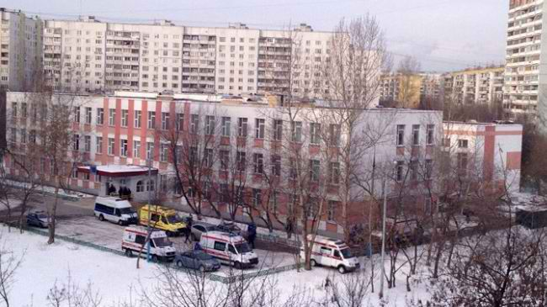
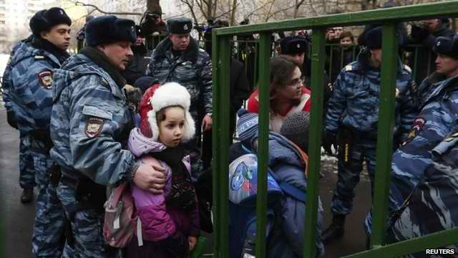
Police said the student had killed one officer and a teacher. Another policeman was shot and injured.
The hostages were freed after the student's father went in to the school.
Russian President Vladimir Putin has described the incident as "tragic", while Moscow's mayor called for a review of school security.
In comments at a meeting with theatre workers in the city of Pskov, Mr Putin suggested improved arts education could help prevent such incidents.
"A new generation of spectators with good artistic taste should be brought up - capable of understanding and appreciating theatrical, dramatic and musical arts," he said.
"Had we been doing this properly, maybe there would have been no tragedies similar to today's tragedy in Moscow."
The gunman was a pupil at School No 263 on the northern outskirts of Moscow.
Russian investigators named him as Sergei Gordeyev, and said he was an excellent student who appeared to have had an "emotional breakdown".
He was armed with two rifles legally owned by his father.
Vladimir Markin, a spokesman for Russia's main investigative agency, said a school security guard had been unable to stop Gordeyev from entering the school when he arrived carrying the weapons.
But the guard did manage to hit an alarm before following the student to his classroom, he said.
Gordeyev shot dead a geography teacher before locking more than 20 10th grade students - aged about 15 - inside a classroom.
He then fired at least 11 shots at police officers who had responded to the alarm, wounding one and killing another, Mr Markin said, in the statement quoted by Russian news agencies.
The stand-off was resolved when the student's father was called to the school; wearing a bullet-proof vest, he went into the building to speak to his son.
The hostages were freed unharmed and all children and teachers were evacuated from the school.
Soon after, the student was disarmed and taken into custody.
Moscow's Mayor Sergei Sobyanin said he had "made a decision to conduct a complete review of how our school security system is working, and to take additional steps".
The BBC's Steve Rosenberg in Moscow says school shootings are incredibly rare in Russia.
In the worst ever such incident, Chechen separatists took over a school in Beslan, North Ossetia, holding more than 1,000 people hostage. More than 300 people, mostly children, were killed as security forces stormed the school to end the siege.

EDITOR’S COMMENT: Moscow's Mayor Sergei Sobyanin said he had "made a decision to conduct a complete review of how our school security system is working, and to take additional steps".
Same as his US counterparts and always post-active we review another bloody surprise. Extra security was applied due to coming Sochi Olympics – I cannot imagine the situation before this “extra” security. If a young student infiltrated the school so easily, imagine what some dedicated terrorists could do either in the capital or in any other city in the vast country. Or in a European school, university or nursery school. Always post-active; never pro-active!

Who is Who of foreign fighters against Assad regime in Syria

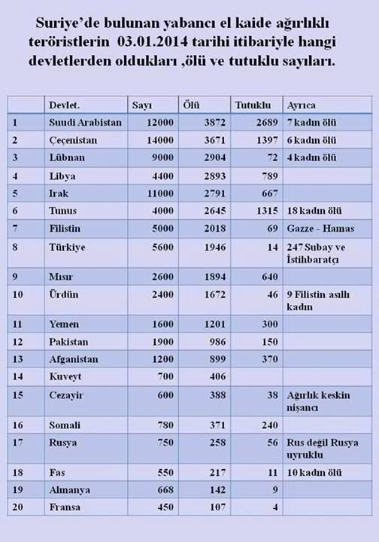
Source: Facebook post of Turkish Opposition congressman (CHP)

Title Line: State Number Killed Arrested Additionally;

Kadin=woman; Fistine=Palestine; Misir=Egypt; Urdun=Jordan; Cezayir=Algeria; Fas=Moroco.

The rise and fall of “eco-terrorist” Rebecca Rubin

Source:http://www.thestar.com/news/insight/2014/02/02/the_rise_and_fall_of_ecoterrorist_rebecca_rubin.html

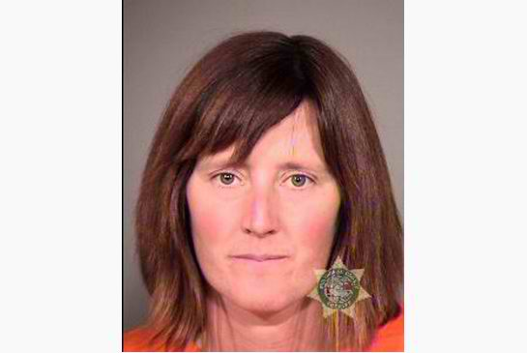
Canadian Rebecca Rubin sits in a Portland jail cell, her extremist past behind her and five years of prison time to count down. She is shaken but relieved.
“She was pleased with the outcome of the sentencing,” says her mother, Sandy Rubin, noting that on Monday U.S. District Court Judge Ann Aiken gave her the least prison time possible under a plea-bargained deal.
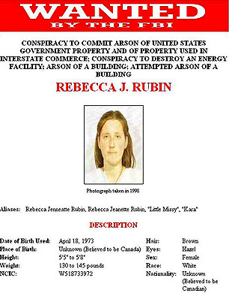
Aiken accepted that Rubin, at 40, is not the same woman who ran with a notorious cell of eco-arsonists when she was in her 20s. Her professed redemption, Aiken concluded, is sincere.
The former Vancouver resident surrendered to the FBI in November 2012 after seven years as a fugitive in B.C. She pleaded guilty to participating in what the FBI calls “the largest eco-terrorism case in United States history.”
By the time the cell disbanded in 2001, it had committed 20 arsons in five western U.S. states causing $40 million (U.S.) in damage. The targets included everything from horsemeat processing plants to SUV dealerships.
“Little Missy,” as Rubin was known in the group, participated in five missions.
“I accept full responsibility for my mistakes,” she wrote in a letter to the court in Portland, Ore. “Although I have changed significantly in the years since I committed these offences, in my twenties I was wilful, driven and stubborn to a fault.
“The years I had spent leafletting, trail building, working in animal sanctuaries, peacefully protesting, blockading, hunger striking, canvassing and letter writing, all seemed to have accomplished nothing,” she added.
She let frustration overcome her, she told the court, and “failed to seriously consider the negative consequences of my actions.”
A deep love of animals had become a story about the rise and fall of an eco-saboteur.
She was born in Nelson, B.C., on April 18, 1973. Her parents divorced when she was 2. When she was 8, her mother moved to London, Ont., to study nursing. Rebecca and her brother, Joel, lived two years with their American father in rural Pennsylvania before rejoining their mother.
Her affinity for animals was evident at an early age. As a child her favourite books were Charlotte’s Web and Beautiful Joe, both of which concern threatened or abused creatures. She dreamed of being a veterinarian but changed her mind when she discovered the training involved “cruelty to animals,” as she put it.
She always had pets — cats, dogs, a rabbit — went camping with the family and spent summers at her grandparents’ lakeside cottage in B.C.
At 16 she became a vegetarian; at 18 a vegan. In court documents, her lawyer, Richard Troberman, says Rubin swore off meat after watching a video of animals “confined under terrible conditions and being slaughtered.
“She was sickened by what she saw,” he writes. “It was this experience that eventually led her into ever-escalating protests against animal abuse.”
To her mother, nothing else about her stood out.
“She was a normal teenage kid without a driving passion for anything in particular,” she said in a phone interview from Vancouver.
The family moved to Vancouver after a decade in London. Rebecca enrolled at Simon Fraser University and studied geography. It was during this period that she became involved with groups aimed at protecting wildlife and the natural world. As a member of Friends of the Wolf, for example, she went on a hunger strike to protect the animal.
In 1996, Rubin went backpacking with a girlfriend for nine months through East Africa and visited a gorilla reserve in Rwanda.
“The fact that the (gorrilla) population is being decimated was heart wrenching for her,” her mother says. “A lot of things happened in Africa to make her really sickened by what was going on in the world with respect to animals.”
In March, 1997, Rubin was living with her mother when their home was raided by the RCMP. Police were investigating the mailing of pipe bombs and razor blades to several companies, including people working in the fur trade and other individuals, including Holocaust denier and former Toronto resident Ernst Zundel.
Shortly after, Rubin moved in with David Barbarash, an animal-rights activist she had met in 1994 while protesting a proposed development of the Burns peat bog near Vancouver. The former Toronto resident had served a sentence for releasing cats from a lab at the University of Alberta and causing $50,000 in property damage.
In 1998, the RCMP charged Barbarash and fellow activist Darren Thurston with 27 counts of mailing dangerous material with intent to harm. Thurston had served time with Barbarash in the cat-release case. For her part, Rubin was charged with possessing material for an explosive device.
Barbarash described the charges as outrageous and accused the RCMP of a dirty-tricks campaign. In 2000, all charges were stayed after the RCMP defied a court order to disclose certain documents on grounds that it would jeopardize future investigations.
By this time, Rubin was active in the U.S. cell that would eventually land her in prison.

Eco-radicalism
Eco-radicalism took root in the U.S. in the early 1970s. It was influenced by such books as The Monkey Wrench Gang, based on the true story of four high school students who vandalized thousands of newly built Arizona homes to protest urban sprawl.
By the late 1980s, the Animal Liberation Front, created in England by fox-hunt saboteur Ronnie Lee, was well-established on both sides of the Atlantic. Also on the scene in Britain, the U.S. and Canada by the mid-1990s was the Earth Liberation Front, initially formed by former members of the Earth First! movement.
All embraced “direct action” by small autonomous cells, justifying destruction of property when less aggressive protest fails.
These views were stoked in the summer of 1995 when a group of determined environmentalists and eco-anarchists descended on a piece of the Willamette National Forest known as Warner Creek, near Eugene, Ore. The U.S. Forest Service wanted logging on a swath of old-growth forest. Activists blocked the access road, camped and bonded in the forest for 11 months.
Among the self-proclaimed Cascadia Forest Defenders were Kevin Tubbs, Jacob Ferguson, Chelsea Gerlach, William Rodgers and Kendall Tankersley. They would form the eco-arsonist cell that Rubin and others joined.
During its six-year lifespan, the cell involved 19 mostly middle class young people who proclaimed themselves members of the ALF and ELF. An arson never involved more than eight people. They called themselves “the elves” and named the fuel mixture used for firebombs “vegan Jell-O.”
Along with their ideology, some shared frustration.
“Everything we were doing was not working and we felt we were failing,” Tankersley said in an interview with the Star. “I would give everything I had to protect a place only to see it destroyed. It was heartbreaking.”
Then she met Ferguson, a heroin addict with dreadlocks and a pentagram tattooed on his forehead. He convinced her that property damage is as American as the Boston Tea Party.
Tankersley became his girlfriend and took part in three attacks before concluding, she says, that he was a twisted pyromaniac. She left the cell after six months.
“It’s not what I wanted my legacy to be,” she says. When she was arrested years later, she was preparing for medical school. She served three years and now, at 36, co-owns a homemade ice cream shop in Colorado.
Romantic relationships played a key role in the cell’s bonding and recruitment. But Tubbs rejects the cell name “The Family,” used by prosecutors, journalists and academic researchers.
“I never heard the name ‘The Family’ in reference to our group until long after my arrest,” he wrote in an email exchange with the Star from the Arizona prison where he is serving a 12½-year sentence.
John Ferreira, the lead FBI agent on the case for a decade in Oregon, never heard the name either. Tubbs speculates the label was the government’s attempt to portray them as murderous Mafia thugs.
The cell’s first attack was a solo job by Tubbs in December 1995. He placed plastic bottles filled with flammable liquid on three trucks at the Dutch Girl Dairy company in Eugene, according to prosecution documents. He spray-painted “ALF,” “Go Vegan,” and “Dairy=Death.” Then he lit the fuse.
Tubbs was eventually convicted for his role in 14 arsons.
He grew up on an Air Force base in Bellevue, Neb., in what he describes as a “happy, stable, Brady-Bunch-like middle-class family with two very loving and caring parents” — and nine dogs.
A defining moment came during his freshman year at college, where he studied fine arts and theatre. He saw a video about the Amazon rainforest being cleared for cattle grazing. It seemed an outrageous example of profit-obsessed, suicidal economics.
He joined People for the Ethical Treatment of Animals (PETA) and took part in confrontational protests. He later joined the ALF/ELF arson cell and was with Rubin for all the arsons she committed.
Rubin’s initiation in direct action came in 1997, according to court documents filed by U.S. prosecutors, when she helped Barbarash and Thurston plan a release of dogs from a medical research lab in California. She carried out this plan two years later.
(Barbarash denied radicalizing Rubin in an interview with Maclean’slast year. He did not take part in the dog release or in any of the arsons the cell committed. Thurston declined to be interviewed for this story.)
In 1997 she also met Tubbs in Canada. She travelled with him and Ferguson to Idaho for a mink release but that mission was aborted.
Her first arson was on Nov. 30. By then the cell had struck four targets, including the dairy company, two U.S. Forest Services ranger stations in the Willamette forest and a horsemeat-processing plant.
She assembled firebombs for the U.S. Bureau of Land Management wild-horse facility in Burns, Ore., where some horses were destined for slaughter. The crew had two-way radios and a police scanner.
She opened the gates to release the horses while others set the devices. Then they dug a hole in the ground, threw in their clothes and shoes, doused them with acid and covered them with dirt. Finally, they issued an ALF/ELF communiqué accusing the bureau of “hypocrisy and genocide against the horse nation.” The fire destroyed the facility.
Rubin was back in action a year later at another government horse facility in Rock Springs, Wyo. But the gang spotted police and aborted the mission. They buried the firebombs nearby and left.
The next target was the Vail ski resort in Colorado, which the cell believed was encroaching on lynx habitat. A crew of seven, including Rubin, lugged backpacks filled with fuel containers up a steep snow-covered mountain. Deciding the cold made the detonators unreliable, they hid the fuel in snow wells and left.
On Oct. 11, they returned to the horse corral in Wyoming and dug up the firebombs. Rubin freed the horses before the devices could be placed.
“Horses being horses, they go where the food is, so they ran into town,” says Stephen Peifer, the U.S. prosecutor, laughing. “Of course that alerted law enforcement and all of a sudden they’re scurrying to get the hell out of there. So that had to be aborted too.”
Eight days later, Rodgers and Gerlach made their way back to the Vail ski resort. Rodgers dug out the hidden fuel and torched the place. Damage and loss of revenue amounted to $24.5 million. Though Rubin wasn’t present for the fire, she pleaded guilty to the arson nonetheless.
In late December 1998, after started a relationship with Tubbs that lasted two years, Rubin helped place firebombs at a forest-products company in southern Oregon. Days later Ferguson noticed they had not exploded, so he and Tankersley returned to make it happen.
The attacks become the talk of the environmental and animal-rights movements. “There was a lot of energy and excitement and support for it,” says Leslie James Pickering, then the ELF spokesperson. “People really felt like, ‘If we don’t like what’s going on and we ask (government and companies) to stop politely and they don’t, we have another recourse.’ ”
Finally, in October 2001, Rubin and Thurston crossed the border illegally to take part in an attack against another government wild-horse corral in California. They wore gloves, dressed in black and covered their shoes with socks. The fire destroyed a barn.
It was the cell’s last arson.

Operation Backfire
To catch the arsonists, the FBI and state police forces set up a task force called Operation Backfire, a project that was hampered by jurisdictional infighting and difficulty amassing sufficient evidence against cell members.
“They kicked our butts,” says Ferreira, the former FBI investigator. “We had no idea who they were.”
No DNA or fingerprints were left at the crime scenes. Cell members vowed never to speak of an arson, even to one another. No one cell member knew the names of all the others. Most went by what Ferreira calls their “earth names” — Tubbs was “Dog,” Rodgers was “Avalon,” Rubin was “Little Missy” (and later “Kara”).
Many attended so-called “book club” meetings held in five states, where they learned firebomb making, reconnaissance, lock picking and secret communications.
“Our only hope was to get somebody to flip,” says Ferreira, who retired from the FBI in 2006 and opened a sports memorabilia store in Eugene.
By 2004, federal officers presented Ferguson with evidence that he had lied to them while under subpoena years earlier, an offence that carries a five-year prison term. He agreed to wear a wire. In return, the FBI paid for his methadone treatment and guaranteed he wouldn’t do time for the 14 arsons he had committed.
“We had to make a pact with the devil,” Ferreira says. “We had no choice.”
Ferguson secretly recorded eight former cell members across the country, including Tubbs, Rodgers and Thurston. He returned with a treasure trove of incriminating evidence.
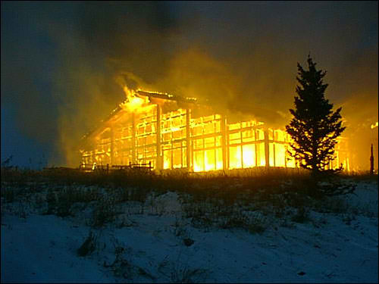
“Ferguson was associated with the anarchist, anti-capitalist punk scene,” says Lauren Regan, a Eugene civil-rights lawyer who defended four of the cell members. “He was the last person anyone thought would work with the feds.”
In December 2005, police began making arrests.
In Rodgers’ Arizona home, police found timing devices and child porn on his computer, as well as details of the arson manuals he wrote. He was a ringleader: he recruited six cell members and founded the “book club.” He funded his activities by growing and selling marijuana.
While in custody days later, he wrapped a plastic bag over his head and killed himself.
Faced with long prison terms, many did what they vowed never to do — they snitched, guaranteeing them infamy on militant websites.
Sixteen have so far pleaded guilty, receiving sentences ranging from three to 13 years. All but one got extra time under a formula reserved for terrorists, even though none was charged as a terrorist and the arsons did not injure a single person.
Lawyer Regan, executive director of Eugene’s Civil Liberties Defense Center, says the sentences were meted out during post-9/11 “hysteria.” Labelling “bunny huggers as terrorists” was the government’s attempt to compensate for its failure to prevent 9/11, she says.

The fugitive
In court documents, U.S. prosecutor Stephen Peifer describes Rebecca Rubin as a “dedicated member” of the cell. But FBI agent Jane Quimby, who spent years hunting her, calls Rubin “more of a follower.”
Certainly, Rubin had a deep concern for animals, but might never have committed crimes if not for the influence of others, Quimby says.
Whichever it was, Rubin had come to realize by the time of the cell’s last arson in 2001 that the attacks were counterproductive, Troberman, her lawyer, told the court.
She took an online course on bird biology with the Cornell Lab of Ornithology, worked on a public information program aimed at keeping bears off private property, attended wildlife rehab workshops in the U.S., and worked at several agencies that help injured animals.
In 2003, she lived in a small cabin with a wood stove and an outhouse in B.C.’s Slocan Valley. While working at the Island Wildlife Natural Care Centre on B.C.’s Saltspring Island, she came across a bantam chicken with a bizarre problem — it couldn’t keep its head straight. Rubin wouldn’t accept a mercy killing. She built a splinter for the chicken’s neck and took it home.
“She made a little place for the chicken to live in her cabin,” says Sandy Rubin. “And after months and months of wearing this little device, the chicken recovered.”
Rubin wanted to open her own wildlife rehab centre one day. In 2004 she took a six-month internship at the Ventana Wildlife Society in California and helped introduce condors to the wild.
She entered the U.S. so often she probably thought her past was behind her.
But in January 2006, U.S. Attorney General Alberto Gonzales and FBI Director Robert Mueller announced a 65-count indictment against 11 former members of the arson cell, flatly calling them terrorists. Rubin’s name was among them.
“I was terrified to be compared to Osama bin Laden in the media,” she told the court. She panicked and fled, leaving her mother a cryptic message: “Check the Internet, I’m going away.”
“I lost everything and everybody when I left home, ashamed and in fear of my life,” Rubin says in her letter. “My entire world fell away.”
“I spent months crying myself to sleep,” she adds. “I felt like a ghost: unmoored and completely alone.”
Quimby tracked Rubin to the condor centre. She learned there that Rubin had adopted an abandoned dog from the local humane society, whose records led her to Sandy Rubin’s North Vancouver home.
When Quimby visited, no one was home but she spotted the dog through the window. When she met Rubin later that day, the dog was no longer at the house.
“We were pretty convinced that either Rebecca had left the dog with mom or that she was somewhere in the neighbourhood, or maybe even living there,” Quimby says.
The agent made an FBI “wanted” poster with the dog’s picture, planning to show it to vets within a 160-kilometre radius of Sandy’s home. But Canadian authorities balked, so Quimby dropped the idea.
Years passed. Quimby makes it clear that Canadian police did less surveillance of Sandy Rubin’s home and neighbourhood than the FBI would have liked.
“The reality is, we had a pretty good idea of where she was and we were not able to make things happen,” she says.
Quimby hunted Rebecca Rubin from 2002 until she retired from the FBI in 2010: “People would say, ‘What do you want for Christmas?’ And I’d say, ‘I want Rebecca Rubin to turn herself in.’ ”
Rubin first tried to do so through her lawyer in 2009. But when California prosecutors told her they would insist on a 30-year sentence, she stayed underground.
She worked odd jobs while living in fear of being recognized. She missed her family and friends.
In 2012, she tried again for a deal. This time, the U.S. Justice Department approved a plea bargain that set her sentence at between 60 and 90 months and wouldn’t require her to snitch on others.
She showed up at her mother’s home in late September 2012. “She looked great,” her mother says. “She looked healthy, she looked strong.”
The plan was for Rubin to be held by Canadian authorities and taken to the border once arrangements were made. But they refused to arrest her.
“It’s odd,” Troberman says. “I mean, this woman was reputed to be the most wanted eco-terrorist, then she tries to turn herself in and it’s, ‘thanks, but no thanks.’ ”
There was no arrest warrant for Rubin in Canada. The “provisional” warrant needed was never issued because it required an address for the fugitive.
“It was a catch-22,” says Stephen Peifer, who prosecuted the case in the District of Oregon. He adds that a provisional warrant request when Rubin was surrendering would have triggered a lengthy extradition process, which everyone wanted to avoid.
In short, Peifer says that in all Rubin’s years as a fugitive, she was hiding from police forces that could not have arrested her even if she had been spotted in downtown Vancouver.
During this uncertain period, Rubin spent two months catching up with her family. She renewed bonds with her 95-year-old grandfather and her older brother. She and her mother went to movies, dinners and long hikes on Cypress and Seymour mountains near Vancouver.
Finally, on Nov. 29, the Rubins agreed to the only option that seemed available: mother and daughter drove to the border in Blaine, Wash., and into the arms of the FBI.
“Had we not agreed to do that, God knows she could still be sitting here waiting,” Sandy Rubin says.

Decline of eco-terrorism
Broadly defined, there were 172 incidents of eco-terrorism in the U.S. between 1970 and 2010, according to a report to the Department of Homeland Security, citing statistics from the global terrorism database at the University of Maryland.
The incidents peaked when the arson cell was active in the late 1990s and have since declined to less than a handful a year.
The decline partly reflects the reasons Peifer gives for the cell’s breakup: frustration that facilities were simply rebuilt after they were attacked; activists growing up; and the fallout from the 9/11 attacks, where anything that smacks of terrorism is publicly abhorrent.
Pickering, the former ELF spokesperson, warns that extremism may re-emerge as concern for the environment becomes more urgent. Economic sabotage is already a widely used tactic — for example, costly disruptions to the building of oil pipelines.
“As things get worse,” says Regan, the civil-rights lawyer, “people’s perception of the word radical is going to change, as it has throughout history.”
As part of her sentence, Judge Aiken ordered Rubin to read a couple of books, including Nature’s Trust: Environmental Law for a New Ecological Age, by University of Oregon law professor Mary Wood. It argues governments have become the servants of private interests plundering the environment.
Wood also lays out the legal argument behind “atmospheric trust litigation” occurring in virtually every U.S. state: that the environment is a public asset held in trust by governments, which have a duty to protect it.
“It’s a bold call to (democratic) action for citizens,” Wood says of her book in an interview. “We must not let this time slip by because our officials are mismanaging our trust assets so much that they’re putting our life systems in danger.”
Rebecca Rubin is a changed person. But even the judge who locked her up apparently doesn’t want her to lose the passion that her younger self misdirected.

How A Simple New Invention Seals A Gunshot Wound In 15 Seconds
Source: http://www.popsci.com/article/technology/how-simple-new-invention-seals-gunshot-wound-15-seconds
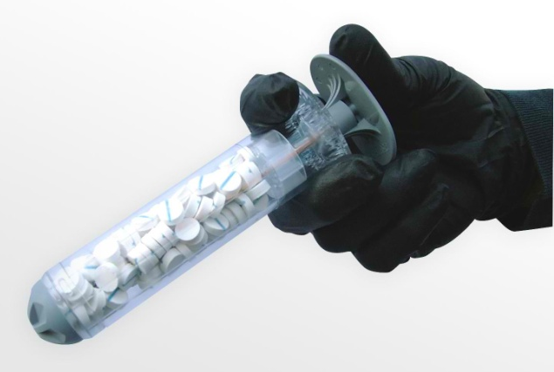

When a soldier is shot on the battlefield, the emergency treatment can seem as brutal as the injury itself. A medic must pack gauze directly into the wound cavity, sometimes as deep as 5 inches into the body, to stop bleeding from an artery. It’s an agonizing process that doesn't always work--if bleeding hasn't stopped after three minutes of applying direct pressure, the medic must pull out all the gauze and start over again. It’s so painful, “you take the guy’s gun away first,” says former U.S. Army Special Operations medic John Steinbaugh.
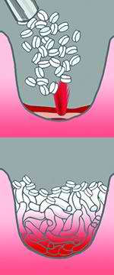
Even with this emergency treatment, many soldiers still bleed to death; hemorrhage is a leading cause of death on the battlefield. "Gauze bandages just don't work for anything serious," says Steinbaugh, who tended to injured soldiers during more than a dozen deployments to Iraq and Afghanistan. When Steinbaugh retired in April 2012 after a head injury, he joined an Oregon-based startup called RevMedx, a small group of veterans, scientists, and engineers who were working on a better way to stop bleeding.

XStat, before and after
RevMedx

RevMedx recently asked the FDA to approve a pocket-size invention: a modified syringe that injects specially coated sponges into wounds. Called XStat, the device could boost survival and spare injured soldiers from additional pain by plugging wounds faster and more efficiently than gauze.
The team’s early efforts were inspired by Fix-a-Flat foam for repairing tires. “That’s what we pictured as the perfect solution: something you could spray in, it would expand, and bleeding stops,” says Steinbaugh. “But we found that blood pressure is so high, blood would wash the foam right out.”
So the team tried a new idea: sponges. They bought some ordinary sponges from a hardware store and cut them into 1-centimeter circles, a size and shape they chose on a whim but later would discover were ideal for filling wounds. Then, they injected the bits of sponge into an animal injury. “The bleeding stopped,” says Steinbaugh. “Our eyes lit up. We knew we were onto something.” After seeing early prototypes, the U.S. Army gave the team $5 million to develop a finished product.
But kitchen sponges aren’t exactly safe to inject into the body. The final material would need to be sterile, biocompatible, and fast-expanding. The team settled on a sponge made from wood pulp and coated with chitosan, a blood-clotting, antimicrobial substance that comes from shrimp shells. To ensure that no sponges would be left inside the body accidentally, they added X-shaped markers that make each sponge visible on an x-ray image.
The sponges work fast: In just 15 seconds, they expand to fill the entire wound cavity, creating enough pressure to stop heavy bleeding. And because the sponges cling to moist surfaces, they aren’t pushed back out of the body by gushing blood. “By the time you even put a bandage over the wound, the bleeding has already stopped,” Steinbaugh says.
Getting the sponges into a wound, however, proved to be tricky. On the battlefield, medics must carry all their gear with them, along with heavy body armor. RevMedx needed a lightweight, compact way to get the sponges deep into an injury. The team worked with Portland-based design firm Ziba to create a 30 millimeter-diameter, polycarbonate syringe that stores with the handle inside to save space. To use the applicator, a medic pulls out the handle, inserts the cylinder into the wound, and then pushes the plunger back down to inject the sponges as close to the artery as possible.
Three single-use XStat applicators would replace five bulky rolls of gauze in a medic’s kit. RevMedx also designed a smaller version of the applicator, with a diameter of 12 millimeters, for narrower injuries. Each XStat will likely cost about $100, Steinbaugh says, but the price may go down as RevMedx boosts manufacturing.
If the FDA approves XStat, it will be the first battlefield dressing created specifically for deep, narrow wounds. Gauze, the standard treatment for gunshot and shrapnel injuries, is only approved by the FDA for external use, but “everyone knows that if you get shot, you have to pack gauze into the wound,” says Steinbaugh. When RevMedx submitted its application to the FDA, the U.S. Army attached a cover letter requesting expedited approval. According to Steinbaugh, RevMedx and the military are now in final discussions with the FDA.
Last summer, RevMedx and Oregon Health and Science University won a seed grant, sponsored by The Bill & Melinda Gates Foundation, to develop a version of XStat to stop postpartum bleeding. In the future, RevMedx hopes to create biodegradable sponges that don’t have to be removed from the body. To cover large injuries, like those caused by land mines, the team is working on an expanding gauze made of the same material as XStat sponges.
“I spent the whole war on terror in the Middle East, so I know what a medic needs when someone has been shot, ” Steinbaugh says. “I’ve treated lots of guys who would have benefitted from this product. That’s what drives me.”

QUIZ
Find the country where:
A quarter of adults think Superman is a Biblical hero – testament to a shocking lack of religious education. A third believes Harry Potter is based on a religious tale. Yet the same number does not know where the story of Adam and Eve is told.

►Answer: At the end of Part C of the Newsletter…

Iran Delivers Surprise, Money, to Jewish Hospital
Source: http://www.nytimes.com/2014/02/07/world/middleeast/iran-delivers-surprise-money-to-jewish-hospital.html?goback=.gde_1528217_member_5837570795894771715&_r=0

The brother of Iran’s president walked into Tehran’s only Jewish hospital on Thursday, delivering a surprise donation along with the message that the Health Ministry would give more attention to hospitals that traditionally serve Christian and Jewish Iranians.
“We are very happy,” a nurse there said by telephone. “This is a good sign.”
The hospital, the Dr. Sapir Hospital and Charity Center, received $400,000 from the government of President Hassan Rouhani, the semiofficial Mehr News Agency reported. Another Iranian source, the semiofficial website Tabnak, said that the amount was $200,000, but that a second installment in the same amount would be coming.
The leader’s brother, Hossein Fereydoon, who goes by Mr. Rouhani’s original family name, was quoted by Tabnak as saying, “Our government intends to unite all ethnic groups and religions, so we decided to assist you.”
Since taking office in August, Mr. Rouhani has embarked on a campaign to engage the world after years of isolation under his predecessor, Mahmoud Ahmadinejad, who never missed an opportunity to denigrate Israel and deny that six million Jews had died in the Holocaust.
Mr. Rouhani’s approach toward Jews and the care he takes when mentioning Israel form a central part of his effort to undo some of the damage — international censures and sanctions — from Mr. Ahmadinejad’s two terms.
The gift to the hospital comes after the president’s social media team wished Jews around the world a happy Rosh Hashana, in September. In stark contrast to Mr. Ahmadinejad, Mr. Rouhani rarely mentions Israel and avoids talking about the Holocaust.
While the Islamic republic’s ideology prescribes that Israel — “the Zionist regime,” as it is referred to here — is a mortal enemy, never to be recognized, Iran is also home to the largest population of Jews in the Middle East after Israel, though that number is dwindling. Jews are an officially recognized minority, with a population of about 9,000.
“We can clearly see that Mr. Rouhani is trying to take distance from Mr. Ahmadinejad’s Holocaust-denial policies,” said Farshad Ghorbanpour, a political analyst close to the government.
Some are interpreting Mr. Rouhani’s gentler approach toward Israel as a policy change, pointing to several Middle Eastern meetings to which both countries sent representatives, even though Iran does not officially recognize Israel.
During the Munich Security Conference last Saturday, the Iranian foreign minister, Mohammad Javad Zarif, gave an interview in which he was reported to have said that Iran could consider recognizing Israel someday.
“After the problem with the Palestinians is resolved, the conditions that will enable recognition of the State of Israel will be established,” he was quoted as telling a German television station, Phoenix.
In a separate speech at the conference, Mr. Zarif said the Holocaust was “tragically cruel and should not happen again.”
On Thursday, Mr. Zarif denied the comments attributed to him during the interview, saying his words were distorted. He did not deny his comments about the Holocaust.
Meir Javedanfar, an Iranian-Israeli who teaches Iranian politics at the Interdisciplinary Center in Herzliya, Israel, said Mr. Rouhani’s gestures were “rare for recent years,” and described Mr. Zarif’s remarks about an Iranian decision regarding relations with Israel in the event it finalizes a peace deal with the Palestinians as “a first in itself.”
“They may or may not decide to recognize Israel,” Mr. Javedanfar said in a telephone interview, “but to say that they will decide on it is unprecedented.”

Homophobia as extremism: the cost to freedom of choice

By Amos N. Guior
Source: http://www.terrorismwatch.org/2014/02/homophobia-as-extremism-cost-to-freedom.html

As has been repeatedly and thoroughly documented, Russian President Vladimir Putin is, for lack of a better word, a homophobe. Putin’s incessant drum-beating targeting homosexuals and lesbians led President Obama, Chancellor Merkel, and President Hollande to publicly announce that they will not attend next month’s Winter Olympics in Sochi.
Boycotts are tricky, raising legitimate concern regarding effectiveness and consequences. The Carter Administration’s decision to boycott the 1980 Moscow Games in response to the Soviet Union’s invasion of Afghanistan failed to gather widespread international support, and the Soviet led boycott of the 1984 Los Angeles Games seemingly served to only punish spectators and Eastern bloc athletes who had trained for years.
However, the Sochi Games address a profoundly distinct paradigm: the decision by Obama, Merkel, and Hollande is directly related to Putin’s disturbingly homophobic statements, policies, and actions. Putin’s words have the potential to cause harm. That is very different from the motivations of previous boycotts.
The decision to send two openly gay American athletes, retired tennis star, Billie Jean King, and hockey player Caitlin Cahow, as members of the US delegation is an important message to Putin, the LBGT community, and the world regarding the essentiality of tolerance. However, it still begs the larger and more important issue.
Legislative and judicial decisions in the United States regarding same sex marriage, the banning of gay marriage in Nigeria, and the outlawing of homosexuality in many countries suggest fear of the “other” is pervasive. Differences in values, principles and lifestyles are the essence of vibrant and robust societies; the responsibility of leadership is to ensure the safety and security of those who, seemingly, are outside what may be perceived as the traditional mainstream of society. However, the true test of leaders, opinion-makers, and the public is the degree to which alternative lifestyles will be at least accepted, if not embraced.
President Putin’s aggressive and offensive comments regarding homosexuals manifest intolerance of the “other” with the obvious potential to endanger those whose lifestyle he finds objectionable. Differences of opinion are legitimate; stigmatizing and castigating with the intent to delegitimize the “other” is playing with fire.
In many ways, the question revolves around the freedom of speech, for there is extraordinary tension between words spoken and their consequences, intended or unintended. Much of the discussion regarding free speech/hate speech and what limits, if any, should be placed depend on the relationship between the speaker and the audience. In analyzing the harm in hate speech Professor Jeremy Waldron makes the following cogent observation:
Hate speech undermines this public good, or it makes the task of sustaining it much more difficult than it would otherwise be. It does this not only by intimating discrimination and violence, but by reawakening living nightmares of what this society was like—or what other societies have been like—-in the past. In doing so, it creates something like an environmental threat to social peace, a sort of slow-acting poison, accumulating here and there, word by word, so that eventually it becomes harder and less natural for even the good-hearted members of society to play their part in maintaining this public good.
In advocating for restrictions on hate speech Waldron writes:
I want to develop an affirmative characterization of hate speech laws that shows them in a favorable light—a characterization that makes good and interesting sense of the evils that might be averted by such laws and the values and principles that might plausibly motivate them. (The Harm in Hate Speech, Jeremy Waldron, Harvard University Press, 2012)
Waldron is right to highlight both the need to engage in conversation regarding limiting speech and its inherent difficulty and controversy. However, given the power of speech the discussion is essential. The adage “words kill” is not an ephemeral concept devoid of content and history. Quite the opposite; examples of the harm caused by words are bountiful and tragic. The harm is not only to specific individuals targeted by extremists or individuals who belong to particular ethnic and religious communities but to larger society which tolerates hate speech in the name of free speech.
Is Putin an extremist? Perhaps. Do Putin’s words have the potential to cause great harm? Absolutely. Does the decision by Obama, Merkel, and Hollande send a sufficiently powerful message to Putin and others who lash out at homosexuals? Perhaps, perhaps not. Can Putin’s words be legislatively restricted or banned? Realistically, no. However, that limitation need not be applied to others who incite, explicitly and implicitly, against homosexuals. That, perhaps, more than anything else should be our “takeaway” from the hate-filled language that characterizes the Russian President.
These lines are written on Martin Luther King, Jr. Day. His words at his Nobel Peace Prize acceptance speech in 1964 serve as powerful reminder of both the danger of extremism and the power of the human spirit:
I accept the Nobel Prize for Peace at a moment when 22 million Negroes of the United States of America are engaged in a creative battle to end the long night of racial injustice, I accept this award on behalf of a civil rights movement, which is moving with determination and a majestic scorn for risk and danger to establish a reign of freedom and a rule of justice… I am mindful that only yesterday in Birmingham, Alabama, our children, crying out for brotherhood, were answered with fire hoses, snarling dogs and even death. I am mindful that only yesterday in Philadelphia, Mississippi, young people seeking to secure the right to vote were brutalized and murdered. And only yesterday more than 40 houses of worship in the State of Mississippi alone were bombed or burned because they offered a sanctuary to those who would not accept segregation. I am mindful that debilitating and grinding poverty afflicts my people and chains them to the lowest rung of the economic ladder.
It is, then, to the “at risk” that we owe a duty and it is for their protection that we must seriously consider limiting the free speech of those directly responsible for the harm and danger in which they live. Western society’s obligation to protect the vulnerable is no less sacred than Western society’s obligation to ensure freedom of speech.

Amos Guiora is Professor of Law and Co-Director of the Center for Global Justice at the S.J. Quinney College of Law, the University of Utah, where he teaches Criminal Procedure, International Law, Global Perspectives on Counterterrorism, and Religion and Terrorism. He is the author of Tolerating Intolerance: The Price of Protecting Extremism, Legitimate Target: Criteria-Based Approach to Targeted Killing, Freedom from Religion: Rights and National Security,and Constitutional Limits on Coercive Interrogation.

EDITOR’S COMMENT: What is all that global hubbub with homosexuality? What is the real (if any) motivation behind LBGT community (to use the new abbreviation in our lives)? What is the reasoning for this “straight-non straight war”? I understand that politicians take side for their own reasons (as always). Religious leaders the same. Racists the same. But what about all of us? Nobody knows the cause behind this phenomenon despite all the theories said and published for decades. But this is a “problem” that is happening behind closed doors and windows. Same doors and windows “straight” people are enjoying their private lives with their partners. Do I like a man and a woman playing erotic games in public? No! Do I enjoy seeing male Marines getting married? No! Do I enjoy male Minster with his husband representing a fine nation? No! Did the Greek team at Sochi Olympiad asked ME or US to get permission to parade with “raibow” gloves at the ceremony? No! Why should they feel the need to be self characterized in all aspects of public life? Why don’t we all respect each other and behave accordingly in our daily interactions? Why do they feel suppressed and need to demonstrate their differences? And why the dear Prof of this article compares Mertin Luther King who fought against slavery and human life of the “non-white” with modern movement on how certain groupts make love? You cannot hide the color of your skin but you can hide your sexual preferences – especially in a world that does not really care about people! By the way: we spend billions for “Olympic Security Games” but we have forgotten (I think since Bijing 2008) the “Olympic Truce” that goes TOGETHER with “Olympic Games”. Perhaps the next step would be to forget the prefix “Olympic” as well! What is the need to cover a box with a precious wrapper when the box is empty?

Turkish Hospitals Traffick Injured Syrian Citizens’ Organs
By Les Blough
Source: http://axisoflogic.com/artman/publish/Article_66384.shtml

Were it not for the well-documented terrorism and atrocities that we know are being committed by Turkey's Erdogan government in Syria, we might pass over as political fiction the hand-me-down news report (below) about injured Syrians being robbed of their organs when taken to Turkey's public hospitals for treatment. But in the context of Turkey's role in supporting and arming the terrorists to overthrow the Assad government in Syria and its history with trafficking human organs, there's reason enough to take the report seriously.
The Turkish public health sector has a history of operating in international human organ smuggling for money. In 2010 The Guardian reported the theft of human organs by Yusuf Ercin Sonmez, a Turkish surgeon who was sought by Interpol in an international manhunt at the time. Sonmez has been indicted for illegally taking human organs for sale from patients in Kosovo and accused of the same in Azerbaijian and of being involved in an organ theft ring in Ecuador. In Kosovo, Sonmez was indicted for taking organs from Serb soldiers, captured in the 1998-1999 US war on Serbia and leaving them to die. Linked to Hashim Thaci, the US-backed Prime Minister of Kosovo, Sonmez had been repeatedly arrested for these crimes in Turkey but later released. According to The Guardian,
"Yilman Altun, 23, was the desperate young Turk who said he was promised a rich reward for his organ by a broker in Istanbul. Alongside him lay Bezalel Shafran, a 74-year-old Israeli who had paid £76,400 for the black-market kidney he hoped would prolong his life...
"According to an indictment released this week, the surgeon transferring the kidney between these strangers in the Medicus clinic in a deprived suburb near the Kosovan capital, Pristina, was Yusuf Ercin Sonmez, a 53-year-old medic...
"But it is Sonmez who prosecutors believe has been the central figure in the trafficking. The Turk has been repeatedly arrested for organ transplants in his native country, where colleagues describe him as an accomplished but rebellious surgeon. In 1998, Turkish TV, whose reporters posed as donors, found seven patients, mostly from Israel. Sonmez was later banned from working in Turkey's public health sector...
"Since then he has been linked to clinics operating on donors and recipients from across the world. He has admitted to doing thousands of transplants, but says that his donors sign disclaimer forms declaring they are giving their organs for humanitarian purposes...
"Patients from Canada, Germany, Poland and Israel had received organ transplants at the clinic. But despite promises of payment of up to €20,000 ($33,000), the donors had left empty-handed."
Arrested and Released
If the reports cited below sound confusing, perhaps some of the original publishers meant them to be so. Many of the news stories in western media tell only parts of the story, omit key elements or simply do not followup on the arrests. But when the reports by various news agencies are examined closely and integrated certain things become clear. For one, when the corporate media reports that a person has been "arrested" it doesn't necessarily mean that he has been prosecuted or imprisoned or even detained.
Yusef Sonmez was working with Moshe Harel, an Israeli, at the time of his "surgical attacks" in Medicus, a medical clinic owned by Lutfi Dervishiin in Kosovo where Sonmez and other doctors worked. Sonmez was the primary surgeon and Moshe Harel was known as "the fixer" for the organ theft&sell ring, recruiting or finding 'donors' and recipients for organ removal and transplant by Sonmez and a few other surgeons working for them.
Dr. Yusef Sonmez (L) and Moshe Harel
In 2008, Moshe Harel was arrested in Pristina but fled Kosovo "after he was released from detention." Subsequently, Kosovo authorities issued an international arrest warrant for both, Sonmez and Harel which stated that at least 30 illegal kidney removals and transplants were carried out in the Pristina clinic in 2008. The police raided Medicus that year "after a Turkish man collapsed at Pristina airport waiting for a flight back to Istanbul after having a kidney removed." Haaretz later reported,
"In 2008 investigators closed down the private health clinic where the doctors worked as part of the initial investigation. Kosovo police launched a raid triggered by suspicions that a Turkish man had sold his kidney to an Israeli recipient after he appeared fatigued at Pristina airport trying to board a flight to Turkey."
On November 12, 2010 Haaretz followed an AP report stating that Interpol had issued an arrest warrant for Harel and Sonmez adding, "Two other doctors, Israeli national Zaki Shapira and Turkish national Kenan Demirkol are identified in the 46-page document as unindicted co-conspirators."
On December 20, 2010 Haaretz reported that Moshe Harel was "on the run" and:
"Moshe Harel, an Israeli of Turkish descent, is known as "the fixer" of the alleged organ ring, for his suspected role in matching potential donors recruited in Turkey with recipients, many if not all of whom had connections with Israel."
On January 12, 2011 Yusef Sonmez appeared again in Turkey. The BBC reported that Somnez was "arrested and bailed," (i.e. released on bail by Turkish authorities in Istanbul) adding "The [organ] donors, said to have come from Moldova, Kazakhstan, Russia and Turkey and to have lived in 'extreme poverty or acute financial distress', were allegedly transported to Pristina Airport." It's noteworthy that the BBC said 8 others were charged a year earlier but made no mention of Moshe Harel in their report.
CNN also reported that Yusef Sonmez was arrested in Istanbul on January 12, 2011 on the Interpol warrant but that "Sonmez was then released by the court pending trial."
On February 10, 2011 the New York Times ran an article in defense of Sonmez (excerpts):
"ISTANBUL — For a surgeon wanted by Interpol and suspected of harvesting human organs for an international black-market trafficking ring, Dr. Yusuf Sonmez was remarkably relaxed as he sipped Turkish red wine in a bustling kebab restaurant facing the wind-whipped Sea of Marmara.
"Dr. Sonmez, refreshed from a ski trip to Austria, spoke last month while on a break from business trips to Israel and operations on cancer patients here.
"He boasts about the results of his kidney transplant operations, more than 2,400 by his count. He keeps friends (and, incidentally, investigators) up to date on his life via a blog and Web site.
"And in his seaside villa on the Asian side of Istanbul, he treasures a framed copy of a signed letter in 2003 from the Ministry of Health in Israel commending him for his life-saving aid to “hundreds of Israeli patients who are suffering from kidney diseases and awaiting transplants'.
"Of his surgical skills, he added, wryly, “I am the best in the world as long as my fingers aren’t broken.”
On May 25, 2012 Reuters reported that Moshe Harel was finally arrested in Israel on the Interpol warrant.
"Moshe Harel was arrested along with several other people in connection with a parallel investigation in Israel, said the mission, known as EULEX.
"Harel is a key suspect in a separate, but parallel, investigation regarding the Medicus indictment, filed in June 2011, charging him with the criminal offences of trafficking in persons and organized crime,"
Reuters said the indictment stated Harel is, "An Israeli citizen [involved] in 'identifying, recruiting and transporting victims ... ensuring the delivery of cash payments by electronic bank transfer" prior to surgery."
"Police in Kosovo accuse Israeli Harel of seeking out people in need of kidney transplants and luring donors to Kosovo from Turkey and the poorer countries of the former Soviet Union with the promise of 15,000 euros ($20,000) in payment. It is not known whether they received the money. The organs were then sold on for between 80,000 and 100,000 euros ($100,000-$125,000)."
On the same day, AFP reported:
"Pristina - The suspected mastermind behind an organ trafficking network, sought for years by Kosovo authorities, has been arrested in Israel an EU prosecutor said on Thursday. 'We have received information that Moshe Harel has been arrested in Israel on organ trafficking and other related offences,' EU special prosecutor Jonathan Ratel said. 'We are seeking confirmation with the Israeli authorities,' he added."
Also on May 25, 2012 Press TV, reported on the story of Somnez & Harel and discussed broader findings of organ trafficking in Israel:
"Reports earlier this week by Ha’aretz, indicate that at least 10 Israeli citizens were arrested for being members of an organ trafficking gang. The Italian New Generation Foundation for Human Rights and the Everyone Group has presented evidence indicating that Sinai locals harvest the organs of the people they transfer to Israel. In this connection, a number of mass graves have been found containing the corpses of Africans missing some of their organs."
The Trial
The trial in Kosovo took place in April, 2013, 5 years after the organ trafficking crimes were committed in Kosovo. Jonathan Ratel is a Canadian lawyer who serves as head of the European Union’s Special Prosecution Office in Kosovo. He began his investigation in March 2010 and the trial began in September 2011 before three international judges. Ratel pieced together the complex case covering countries that ran through Kosovo, Turkey, Europe, Canada, US and Israel. The trial included testimony from 80 witnesses and Ratel's closing arguments included 250 PowerPoint slides and lasted six-and-a-half hours.
On April 19, 2013 The Star (Canada) conducted a telephone interview with Ratel when he called this dark web of trafficking human organs, "the cruel harvest of the poor" and added, “The single motivating factor behind this enterprise was the opportunity for obscene profits available in the black market organ trade.”
On April 29, 2013 the New York Times published this:
"Five people were convicted Monday in Pristina, the capital of Kosovo, in connection with an elaborate organ-trafficking network that lured poor people to the country to sell their kidneys and other organs to wealthy transplant recipients from Israel, the United States, Canada and Germany. Organs sold for as much as $130,000 each.
"The defendants, all Kosovars, were tried before a panel of two European Union judges and one Kosovar judge. A special prosecutor for the union, Jonathan Ratel, called the case a landmark because doctors had been convicted.
"Dr. Lutfi Dervishi, a urologist and the director of the clinic at the center of the trafficking ring, was sentenced to eight years in prison. His son Arban Dervishi was sentenced to seven years and three months, and Dr. Sokol Hajdini, the clinic’s chief anesthesiologist, to three years. Two other defendants received one-year suspended sentences.
"Mr. Ratel said the Dervishis were aided by Dr. Yusuf Sonmez, whom he called a notorious international organ trafficker. Dr. Sonmez is a fugitive and may be in South Africa, Mr. Ratel said."
On the Lam
On April 29, 2013, The Star stated that Dr. Yusuf Sonmez and Moshe Harel, "remain at large, wanted under an Interpol 'Red Notice'.”
On August 10, 2013, Friends of Kosovo reported, "Two foreign suspects in the case – Turkish doctor Yusuf Sonmez and Moshe Harel, an Israeli citizen – are still listed as wanted by Interpol but remain at large."
December 16, 2013 - According to Balkan Transitional Justice, defendants Sonmez and Harel cannot be tried in their absence and their prosecution depends on their extradition:
"Turkish doctor Yusuf Sonmez and Israeli citizen Moshe Harel, both accused of people trafficking and organised crime, are listed as fugitives wanted by Interpol and have been on the run since the indictment in the case was raised in June 2011.
"But EULEX judge Malcolm Simmons said that he was 'worried that little or almost nothing has happened since then'.”
'We can do little until the defendants are arrested,' Simmons said at a hearing in Pristina that was held to give an update on the organ-trafficking case.
EULEX prosecutor Allen Cansick, said the EU mission believes that 'Harel is still in Israel,' while 'the mission has information that Sonmez is travelling around the world.'
But Cansick expressed hope that the men might be apprehended, saying that '“there are however possibilities they might be brought to Kosovo some time later.'
Where have these two cretins gone? Where have they been in hiding and who is hiding them - since the time they walked from prosecution in Kosovo? Are either or both being given secret asylum in Israel as in the past? Are they continuing their ghoulish work in Turkey, protected by the Erdogan government, robbing organs from injured Syrian civilian and military who've been sent there for treatment and from Syrian soldiers who have been captured by the terrorists? The latter would certainly fit with their work in Kosovo where they robbed captured Serb soldiers of their organs before Kosovo's "freedom fighters" killed them. The following report from Fars News Agency tells of how the organ theft business is thriving in Turkey.
February 5, 2014
Fars News Agency
Turkish Hospitals Traffick Injured Syrian Citizens’ Organs
According to a report by the Lebanese al-Safir daily, trafficking the injured Syrian people’s body organs is a phenomenon which has intensified in Turkish governmental hospitals.
Ahmad Abdulkarim Muhammad, a 19-year-old young Syrian, is one of the victims of this phenomenon. He was injured in Syria in January and was transferred to Antakya hospital in Southern Turkey and died after a few days.
Despite being transferred to the hospital for head injuries, a video released after his death shows that his abdomen has gone under surgery operations which indicates stealing of his vital organs, including kidneys, liver, etc.
Earlier reports also said that Turkish authorities are engaged in trafficking body organs of injured Syrians that are taken to Turkey for treatment.
The Lebanese newspaper al-Diyar reported [May, 2013] that Turkish authorities transfer young injured Syrians to certain hospitals in the Turkish cities of Antakya and Iskenderun.
The report added that the Turks leave the injured Syrians alone to die after their body organs are removed in the hospitals. The dead are later sent to the Syrian border region to be buried.
Turkish doctors have confirmed that out of 62,000 injured Syrian civilian and military people who were transported into Turkey, body organs of over 15,600 of them were excised and their bodies were sent back into Syria to be buried, al-Diyar stated.
Turkish officials have made no comments over the issue so far.
The Lebanese newspaper also states that the body organs, including livers, kidneys and hearts are given to people waiting for treatment in Turkey.
Al-Diyar said European scientific websites acknowledged that body organ transplantation operations had increased in Turkey over the past two years, since the beginning of the crisis in Syria.

Les Blough is the Editor at Axis of Logic.

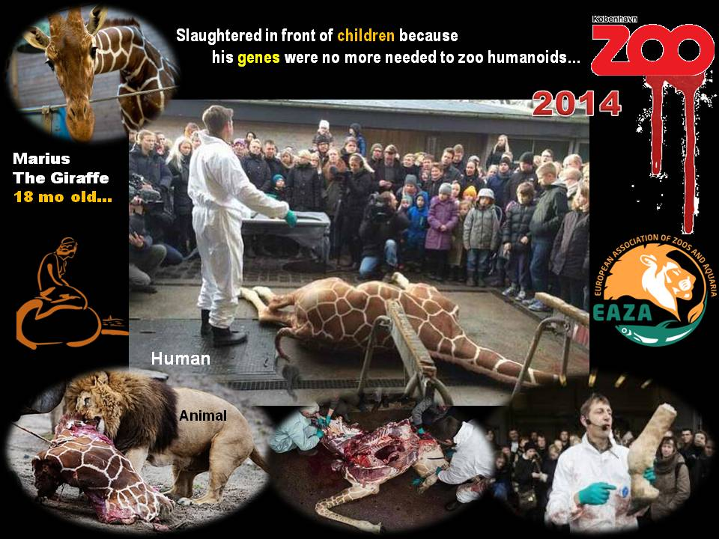

No comments…

Feb 12, 2014 – Second giraffe named Marius at risk of being put down in Denmark
Jyllands Park zoo says it may kill male giraffe to make way for female, days after death at Copenhagen zoo sparked outcry. Why? Because they have two male giraffes and they want to buy a female one… Shame on you Denmark!!!

Should the U.S. intervene in Syria? What Iraq can't teach us
Source: http://www.haaretz.com/mobile/.premium-1.573417

“Why do we [Americans] feel compelled that we have to go in and be in the middle of a fight between people who are murdering each other?” asked Republican Congressman Dana Rohrabacher (Cal.) last week. “Thousands of people are losing their lives to this insanity. Why does the United States feel that we need to become part of this insanity?... Let them kill each other."

►The full text is available for Haaretz subscribers.

EDITOR’S COMMENT: I am not a subscriber and I have no access to full text and in that respect my comment might be totally wrong. Perhaps before this comment, Honorable Congressman might have made other statements/comments on who brought Syria in current chaotic status and why – or something like this. Perhaps he also questioned previous case studies resulted in almost identical bloodshed. If someone has the full article I would like very much to read it and prove myself wrong and injustice!

The Olympic Games JOKE…

Switzerland votes to restrict immigration
Source: http://www.theguardian.com

Anti-immigrant movements across Europe were boosted Sunday when Switzerland, by a narrow margin, voted to impose quotas on newcomers to the country – including newcomers from neighboring EU countries. The vote is likely to complicate the country’s relations with the EU. In a referendum which saw broad mobilization by far-right populists demanding caps on immigration in a country where about a quarter of the population of eight million is made up of recent immigrants, 50.4 percent of voters supported the measure, in a relatively high turnout of 56 percent. The vote saw a clear split between east to west Switzerland, with the francophone west voting against the quotas and the German-speaking east backing the restrictions.

EDITOR’S COMMENT: Remember the old saying that “majority rules”? Remember that majority equals “democracy”? Remember why we vote in national elections – our own “one minute democracy”? If you have forgotten, Swiss “people” just reminded us some forgotten messages. Just Swiss people – not left, right, up, down, black, white, yellow, green or red! Same people that soon will vote again about the type of military airfighter they would like to buy with their money. Europe or EU cares about future business (as usual). Swiss care about their country. Does that make them less Europeans than the rest of us? Or what is left of us…

The Swiss Virus: Europe Gripped by Immigration Worries
Source: http://www.spiegel.de/international/europe/right-wing-populists-stand-to-benefit-from-eu-im-migration-concerns-a-953897.html#ref=nl-international

The Swiss aren't the only ones in Europe deeply concerned about immigration. Many across the Continent would also like to see limits placed on newcomers from elsewhere in the EU. Europe must remain firm, but right-wing populists stand to benefit.
The man who sent all of Europe into a flurry of agitation is battling a persistent cough. But Christoph Blocher is in the best of moods nonetheless. He is enjoying his victory in the five-star Hotel Ermitage near Gstaad at an altitude of 1,231 meters (4,038 feet) with the snow-covered Alpine peaks of the Berner Oberland as a backdrop.
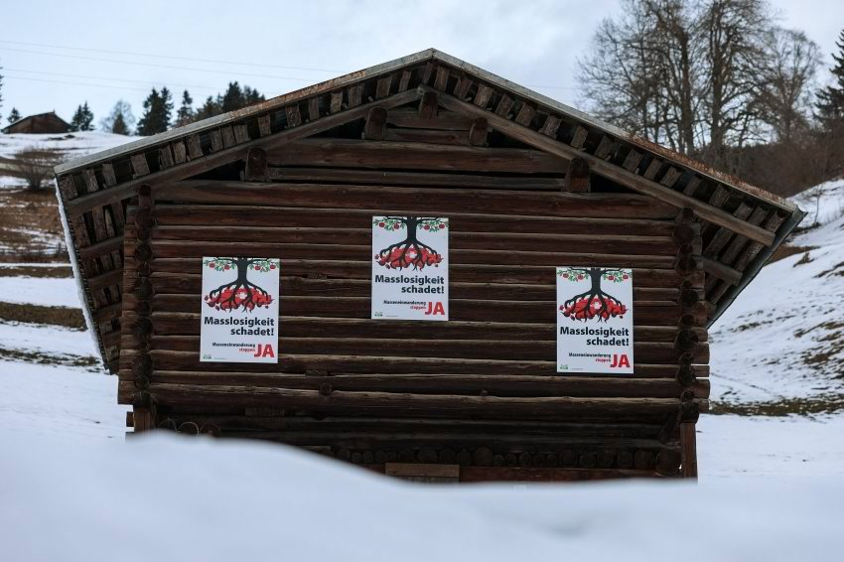
Blocher is wearing brown pants and a plaid shirt stretched over his ample belly. The sun is shining, the sky is blue, the receptionists are wearing traditional folk costumes and paintings of happy-looking cows decorate the walls. It is how he likes his country of Switzerland.
Blocher is recovering here from his strenuous campaign against "mass immigration," which he led together with his Swiss People's Party. Without Blocher, the referendum never would have come to pass -- and it certainly would not have achieved its unexpected success, which saw a razor-thin majority of 50.3 percent of voters approving quotas for immigration from European Union countries. It is a result that strikes at the core of united Europe. And once again, Blocher showed them all, particularly the Swiss government in Bern and EU headquarters in Brussels.
It is his most significant triumph since 1992, when he also used a referendum to prevent Switzerland from joining the European Economic Area, a result which put a stop to the country's courtship with EU membership.
A satisfied Blocher is sitting at a wooden table in the hotel restaurant and holds forth for two hours. "Switzerland didn't resolve to prevent all foreigners from coming," he said, wagging his finger. "Those who are needed can still come. The others can't."
That the EU has reacted with such a fuss is hardly surprising, he says grinning. The result has led to desperation among the other half of Switzerland's population and sent the country's government into a state of silent despondency. Swiss business owners are concerned about countermeasures from Brussels. More than anything, though, the Swiss referendum has sent shock waves through Europe.
Few paid the vote much mind before it took place, but the referendum's result last week made it onto the front pages of newspapers across Europe. Politicians from London to Berlin, from Brussels to Rome released statements. And it quickly became clear that the Swiss once again shined the spotlight on an issue that people across the continent are concerned about.

A Wedge in Europe
It was a similar story in 2013 when the Swiss voted to put caps on manager salaries in the country. But this time, with just three months to go before European Parliament elections in May, the stakes are even higher. Survey numbers for right-wing populist parties in several European countries have hit record highs, an indication that the forces unleashed by the crisis have not dissipated. European citizens, of course, have never been particularly infatuated with EU institutions, but before they at least believed that the bloc was good for the economy and quality of life. But with the crisis seemingly unwilling to let go, increasing numbers of people have come to believe that Europe actually threatens their prosperity.
Greeks, Italians and French blame economic policy from Brussels for their difficulties. At the same time, Germans and other Northern Europeans are afraid they will ultimately be forced to cough up for EU countries to the south. What some call "reform" and others call "austerity" is driving a wedge between Europeans. And now, the issue of free movement across the EU is being thrown into the discussion because many are concerned they could lose out on the employment market. But questioning the EU principle allowing people to choose where they wish to live and work is akin to questioning the entire European project.
Switzerland, of course, is not a member of the European Union, but it is closely bound to the bloc by a number of bilateral pacts. The fact that one of the most prosperous countries in the world is seeking to distance itself from the union shows just how great the resentment has become -- and it shows what might be in store for Brussels in the not-too-distant future. German Finance Minister Wolfgang Schäuble, European Parliament President Martin Schulz and European Commission President José Manuel Barroso were quick to emphasize that the right to free movement within the bloc was not up for debate. But they also said that they respect the voters' desires as expressed in the Swiss referendum.
One reason for the mostly cautious reactions from European politicians is that it remains unclear exactly what the concrete results of the referendum will look like; Bern must first determine how high the quotas for immigrants from the EU will be. But more importantly, European politicians are clearly wary of fueling the debate. Few, after all, can be certain that citizens in their own country wouldn't have voted the same way, given the opportunity.
Indeed, it wasn't just right-wing populist politicians -- such as Heinz-Christian Strache from the FPÖ in Austria, Geert Wilders from Holland or Marine Le Pen from the Front National in France -- who rushed to congratulate the Swiss and demand immigration quotas for their own countries. Even politicians with reputations as moderates, such as former French Prime Minister François Fillon, likewise demanded quotas. In Germany, a survey found that 48 percent would support a similar policy.

Delighted by the Result
In particular, however, Brussels is concerned that the Swiss virus could infect Great Britain. Hate for the EU there is so great that a conservative politician even blamed Brussels indirectly for the recent flooding in the country. Many in Britain are delighted by the result of the Swiss referendum -- and no one is as vocal about it as Nigel Farage. "Fantastic," he yells into the telephone. Farage is head of the UKIP party, which favors Britain's withdrawal from the EU and is currently polling at 20 percent in pre-election surveys. "The result of the referendum is very encouraging," he says. "Finally, common sense is winning out."
British Prime Minister David Cameron, facing the prospect of a strong UKIP, has himself demanded that some EU treaties be renegotiated in Brussels. He would also like to see immigration quotas like those approved by the Swiss, but his demands have thus far not been met. Last week, Cameron's spokesman said that the referendum reflects a "growing concern" when it comes to freedom of movement within the EU. For Britain, Switzerland is a test to see how susceptible the EU is to coercion.
Conservative MP Andrea Leadsom can now approach the coming months with equanimity. In 2011, she co-founded the initiative Fresh Start, which demands that the UK's relationship with the EU be re-imagined. Last week, she was sitting in the atrium of the London House of Commons explaining her 30 demands: Great Britain should opt out of EU police and criminal justice measures; it should withdraw from the Charter of Fundamental Rights; each member state should be able to decide for itself who is allowed access to welfare benefits; the British parliament should be allowed the ability to block European Commission proposals it doesn't agree with. Essentially, Leadsom wants structures that allow the UK to pick and choose the regulations it finds most advantageous.
In recent months, MPs associated with Fresh Start have been traveling through Europe promoting their "menu," as they call it. They were in Berlin, Paris, Copenhagen, Amsterdam and a half-dozen other European capitals. "It is a poker game," Leadsom says. Their joker is the fact that they have a threat in hand that would be a horror scenario for many in Europe: the withdrawal of Britain from the EU. In 2017, the country is planning to hold a referendum on whether to remain in the bloc; if they decide to go, it would likely trigger a difficult crisis in the EU.
The EU must find a response. It has to become more flexible and less bureaucratic in order to take the wind out of its opponents' sails. At the same time, it can't allow itself to be blackmailed. But the current success of the right-wing populists is increasing pressure on the EU Commission. Brussels must find a reaction to the fact that many Europeans no longer welcome the Continent's open borders -- rather, they see them as a real threat.

Simply Unacceptable
In Madrid last Thursday, European Commissioner Michel Barnier was waiting for his flight back to Brussels. The Frenchman is responsible for the EU's internal market and for banking regulation. In many ways, he is a typical Eurocrat: hardly anyone knows who he is but almost all are affected by the decisions he takes. He has ambitions of becoming European Commission President once Barroso's term expires this autumn and had just had a meeting with the Spanish prime minister in an effort to gain his support.
Barnier says that he respects the Swiss referendum, but he is of course unhappy with the result. Immigration quotas for EU citizens, he says, are simply "unacceptable."
He is a convinced European. In the early 1990s, he was one of the few from his party -- the conservative Union for a Popular Movement -- to vote for the Maastricht Treaty, the agreement that paved the way for the common currency. Now, he is seeing many UMP members showing sympathy for the xenophobic slogans being bandied about by the right-wing Front National. Even French Interior Minister Arnaud Montebourg, a member of President François Hollande's Socialist Party, has criticized EU competition rules. France's relationship to the EU is at a low point.
Barnier is trying not to let it bother him. "The crisis is to blame," he says, adding that once the economy gets going again, normality will return. But no one can really say when, or even whether, the EU will once again see substantial growth. As such, Barnier is interested in calming the debate by appeasing the British: One should look into what issues could be better regulated on a national basis, he recently said.
As a parliamentarian and regional president, Barnier served the Savoyen region for more than 20 years. He says: "175,000 people there drive to work across the Swiss border each day." These engineers, researchers and doctors, he said, contribute to Switzerland's prosperity -- a situation which is beneficial to all. On the other side of the border, in the canton of Geneva, the majority agrees. Voters there rejected the referendum.
But proximity to the border does not necessarily result in a pro-European attitude. A couple hundred kilometers to the southeast, another border canton overwhelmingly supported the initiative: Tessin. Some 60,000 people from the Italian region of Lombardy work in Tessin; well before dawn, the traffic jam in Viggiù, an Italian border town of 5,000, begins. Brake lights line up for kilometers as commuters slowly make their way from the EU into Switzerland.
The right-wing populist party Lega Nord is powerful in Viggiù -- the same party which for decades has been demanding the creation of an independent state called "Padania" in Italy's prosperous north. It is also opposed to immigration. "If I were Swiss, I would have voted the same way," says Sandra Cane, mayor of Viggiù. "Who are we to interfere in their affairs? I also don't like the lecturing tone adopted by the EU, this idea of 'now we are going to punish Switzerland by shutting off the electricity.'"
Such comments coming from Sandra Cane are astounding for two reasons. First, despite being the only dark-skinned mayor in all of Italy, she is a member of Lega Nord, a party notorious for its racism. Second, almost half of Viggiù's working population commutes to Switzerland. "It is true that, if the Swiss slam the door shut, we are dead. But we should learn from them and hold a similar referendum in Italy," Cane says. "Everyone is coming to us, from Lampedusa they head north. And yet, we have enough people here already with nothing to eat."
The gap in prosperity between Switzerland and Italy led Cane and other mayors in Lombardy to seriously campaign to be recognized as the 27th Swiss canton. The project failed, but the envious looks across the border have remained.
As such, it is hardly surprising that demands are increasing for the Swiss example to be followed. Roberto Maroni, head of Lega Nord and president of Lombardy, says "sovereignty lies with the people, not with Ms. Merkel or in Brussels."
Italian politicians are fond of complaining about Europe, which is much easier than owning up to their own failures. When European Commissioner for Economic and Monetary Affairs Olli Rehn was in Rome last September, he was roundly criticized. Rehn is a "Mr. Nobody who comes to Italy and acts like the senior supervisor," said one Senate vice president. Rehn acts "as though we were a colony," said the chair of the foreign relations committee. Many Italians blame Brussels for the economic troubles their country is currently facing. Just as so-called "benefit tourism" has generated hostility for the EU among northern member states, austerity has angered those in the south.

On the Other Side
In Bargen, a village of 291, located directly on the Swiss border with Germany in the canton of Schaffhausen, it would be difficult to claim that Europe had destroyed any lives. It is a well-off little town. Yet 79.7 percent of the voters there opted in favor of a cap on immigration from the EU, higher than anywhere else in Switzerland. Bargen apparently wants the border back, even though the village is little more than a trio of gas stations on the highway -- gas stations that make their money off of Germans who fill up here because fuel is cheaper than on the other side of the border.
Erich Graf, the municipality's president, smokes a cigarette and looks out over his village. He said he thought long and hard about the referendum before he ultimately voted in favor of immigration caps. He came to the conclusion that something had to change. Graf is a heavy-set man with a friendly, ruddy face and gray hair. Prior to Switzerland joining the Schengen area and when the border still functioned as such, he worked for the border patrol.
"In referenda, our village tends to be more to the right than to the left," he says. In Bargen, foreigners make up 23 percent of the population, almost exactly Switzerland's nationwide average. Three-quarters of the foreigners are Germans. It is difficult to say where the rejection comes from, Graf says, yet he tries nonetheless. "Twenty-five years ago, everyone knew everyone here." People chatted on the street, there were local clubs and events -- village life. Now it has become much more anonymous, he says. His comments are infused with a feeling of loss.
When it came to the referendum, Bargen was not focused on the big picture. Just like elsewhere in Switzerland, voters here didn't reject the EU because they are doing poorly. Rather, they think that their economy is perhaps growing too rapidly and the country is changing too quickly. Because they feel their home is threatened.

Picking Up the Pieces
Switzerland is doing better than ever before with prosperity at an all-time high, almost full employment and an economy that grew by 2 percent last year. "How can we explain to people from abroad that we have a problem?" Such is the question asked by Valentin Vogt, president of the Swiss employers' association and, to some extent, the loser of the referendum. But Vogt is trying to be a good loser. "It happens to be the case that we have this system of direct democracy, the best political system in the world, even if there are sometimes outliers where one wonders …" He stops speaking in mid-sentence, the smile fades from his lips.
Vogt is chairman of the board at a metal engineering company which employs 1,200 people. He is also an advisor to the Swiss National Bank and acts as the voice of Swiss business. Now, he has been placed in the difficult position of explaining his curious, intractable homeland and defending it from external criticism even if he himself was bitterly disappointed by the result of the referendum. Until the very end, he thought that a majority of voters saw things as he did. He traveled throughout the country trying to convince people to back his position. "You know, it is very easy to blame foreigners for all problems," he would say. Now, he hopes that the government will find a solution that is acceptable for the EU.
But Brussels has already postponed talks with Switzerland on a cross-border electricity deal and has also put the brakes on a research and educational pact which could mean that Swiss students are denied access to the Erasmus educational exchange program. If more consequences are coming -- were the EU really to make good on its threats of a harsh response to Switzerland's renouncement of freedom of movement -- then all the applause the country is receiving from people across Europe would be of little use.
Whereas Blocher, the victor, basks in his success in the mountains, Vogt is forced to pick up the pieces down in the city.

Managing the deficit
By Dan Kaszeta
Source: CBRNe World; October 2013; pp.31-35

A technical paper on Ghouta (Syria) sarin incident you must read. Based on existing operational data on using chemical weapons in the field author questions the number of casualties caused, the quantities of sarin used and the delivery methods (rockets) employed. Read it and make your own conclusions. It fits well with CBRNe World Editor’s (Gwyn Winfield) paper entitled “Truth, lies and taking sides” (pp. 22-26).

Dan Kaszeta is Managing Director of Strongpoint Security (UK) and author of the book “CBRN and Hazmat Incidents at Major Public Events: Planning and Response (2012).

U.S. analysis of Syrian chemical weapons attack is under fire
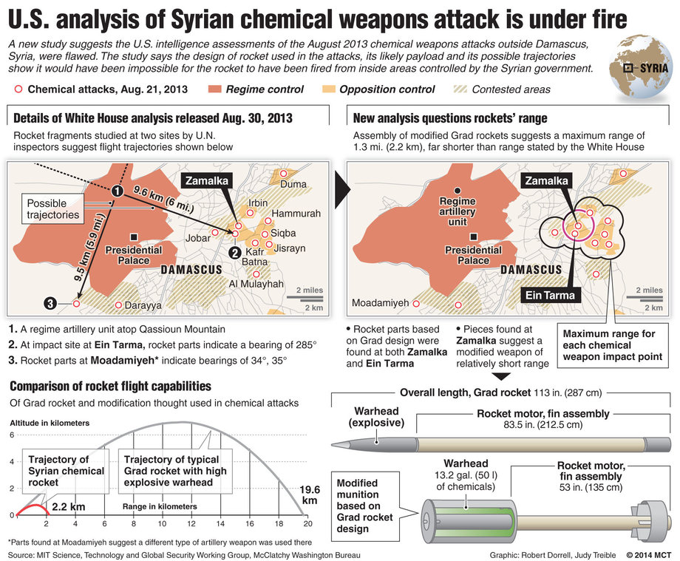
Source: http://www.mcclatchydc.com/2014/01/15/214656/new-analysis-of-rocket-used-in.html
A new study suggests the U.S. intelligence assessments of the August 2013 chemical weapons attack outside Damascus, Syria, were flawed. The study says the design of rocket used in the attack, its likely payload and its possible trajectories show that it would have been impossible for the rocket to have been fired from inside areas controlled by the Syrian government.

►Read more at source’s URL.

Five big questions about the massive chemical spill in West Virginia

By Brad Plumer
Source: http://www.washingtonpost.com/blogs/wonkblog/wp/2014/01/21/five-big-questions-about-the-massive-chemical-spill-in-west-virginia/

A big chemical spill that contaminated the water supply of some 300,000 West Virginia residents earlier this month has raised plenty of questions about the way the United States regulates industrial compounds.
Some background (read also Jan 2014 issue): There are more than 84,000 chemicals in the United States — and we don't know all that much about many of them. The current U.S. law on chemical safety is 37 years old, riddled with exceptions, and widely seen as ineffective. The federal government has required testing for only 200 chemicals in the past 37 years — and banned just five substances deemed dangerous (the last was asbestos in 1991).
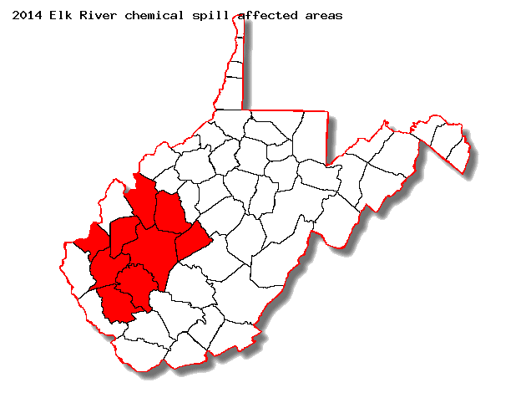
That blind spot became an issue in the West Virginia spill, when thousands of gallons of crude MCHM leaked into the water supply near Charleston. Early on, the Centers for Disease Control and Prevention said that the chemical was safe at very low levels (less than 1 part per million). But, last week, the CDC suggested that pregnant women shouldn't drink the water at all until the chemical was undetectable. In part, that's because there's not a ton of information about MCHM or its health effects.
Meanwhile, the rules surrounding chemical facilities and spills the themselves are often patchy and incomplete. And what rules do exist are often incompletely enforced in states like West Virginia. Below is a broad overview of the issues here:

What exactly happened in West Virginia? On Jan. 9, 2014, a steel storage tank near Charleston, W.Va., containing crude 4-methylcyclohexane methanol (MCHM) began leaking through a one-inch hole. The chemical was soon seeping into the Elk River, just 1.5 miles upstream of a water-treatment center.
Residents in the area quickly noticed a strange licorice-like odor, and some 300,000 people in nine counties were advised not to drink the water (see map). Hundreds of people in the area have sought medical treatment so far, with symptoms ranging from nausea to rashes, although it's still unclear how many of those cases are related to the water contamination.*
As the days went by, things got more confusing. On Jan. 13, West Virginia regulators began lifting the ban on drinking the water (but asked people to flush their pipes first). Yet some uncertainty remained: The CDC initially said that the water would be safe if it had less than 1 part per million of crude MCHM. Then regulators said pregnant women should not drink the water until officials declare it free of any trace of the chemical. Some doctors are still warning that children should avoid the water. More people are still seeking medical treatment. No one knows the full extent of the damage.
As for the facility itself: The leaky storage tank in question was owned by Freedom Industries, which had acquired six decade-old storage tanks on Dec. 31 and, shortly after the Charleston spill, declared bankruptcy. (My colleague Steven Mufson has much more on the company.) The Charleston site did have a brick-and-concrete containment dike as a last resort against spills, but that dike reportedly had structural problems and was slated for repairs. Freedom Industries is also investigating whether freezing water from a leaky municipal pipe may have punctured its storage tank.
(Update: On Tuesday, Freedom Industries told federal investigators that was another previously unidentified chemical in the tank, a product known as "PPH." State water officials say they "likely" would have removed that chemical from the drinking water during treatment, but they're now conducting tests to make sure.)

What is MCHM, and why do we know so little about it? MCHM is a chemical compound used at coal-processing plants to separate fine particles of coal from the surrounding rock in a process called "froth flotation." It is mainly used to process coking coal for metallurgy rather than steam coal for power plants.
Information is murky about its health effects. The U.S. government doesn't require any testing for the chemical: MCHM was one of 62,000 industrial compounds that were grandfathered in with the Toxic Substances Control Act of 1976. (The chemicals were grandfathered, in part because they'd been around for awhile and were assumed to be safe.)
What we do know about MCHM came from independent tests carried out in the late 1990s by Eastman Chemical, the sole U.S. manufacturer of the compound. The company was ramping up production of MCHM and decided to conduct some toxicity tests on rats — even though this wasn't required by law. Wired's Deborah Blum has a nice overview of these studies: For instance, the Eastman researchers fed MCHM to rats and found that the chemical was roughly poisonous at around 200 to 800 parts per million. They concluded that a dose one-fourth as big wouldn't be toxic (although tests showed that even smaller doses weren't entirely benign). From this, the CDC extrapolated and conservatively set a safe level for humans at 1 part per million.**
But that still adds up to fairly limited information. In its reports, Eastman says it had "no data available" for things like repeated dose toxicity, or carcinogenicity, or reproductive toxicity. This helps, in part, explain why many of the health warnings have been confused and uncertain.

Could chemicals be more tightly regulated and tested? That's possible, in theory. Current regulations require little testing for new industrial compounds and none for the 62,000 chemicals that were grandfathered in back in 1976. There are two big reform bills on offer here, one favored by industry and one favored by environmentalists:
1) The Chemical Safety Improvement Act of 2013: This bill was crafted last year by Sen. David Vitter (R-La.) and the late Sen. Frank Lautenberg (D-N.J.), and it has the support of the American Chemistry Council, which represents chemical manufacturers like Dow and Dupont.
Here's how it works: Under current law, the Environmental Protection Agency can only call for testing of a chemical if evidence surfaces that the substance is dangerous. Under the Vitter-Lautenberg bill, the EPA would review all actively used chemicals and label them as either “high” or “low” priority based on their potential risk to human health and the environment. The agency would then subject high-priority chemicals to further review. The EPA would also have greater flexibility to request data from companies and take action on chemicals deemed unsafe, from labeling requirements to outright bans.
That said, it's unclear if this bill would have made much difference in West Virginia. The EPA would likely have considered MCHM a "low-priority" chemical and exempted it from further review, said Rep. Henry A. Waxman (Calif.). Indeed, some environmental groups have called the Vitter-Lautenberg bill too weak, saying it could pre-empt stricter state laws and marks a compromise from earlier health-testing proposals.
2) The Safe Chemicals Act: This is the stricter bill favored by many environmental and consumer-protection groups and was sponsored by Lautenberg and Kirsten Gillibrand (D-N.Y.). It would require manufacturers to prove that chemicals are safe before they can be sold. That could include MCHM and other chemicals grandfathered in under the 1976 law.
This is clearly a much stricter testing regime—and it doesn't prioritize some chemicals over others. For industry groups, it's far too strict: The American Chemistry Council has argued that this bill could set an "unachievable" safety standard. It says the Vitter-Lautenberg bill sets a better balance between safety and permitting innovation.

How often do chemical leaks like this happen? In West Virginia, it's hardly unknown. The Elk River spill is the third big chemical accident in the last five years.
We can also look more broadly: The AP recently examined spills from the coal industry as a whole: "For decades, chemicals and waste from the coal industry have tainted hundreds of waterways and groundwater supplies, spoiling private wells, shutting down fishing and rendering streams virtually lifeless, according to an Associated Press analysis of federal environmental data."
Some of this waste is a side effect of stricter air-pollution rules that have induced coal plants to scrub and capture various pollutants. A recent EPA analysis found 132 cases where coal plant waste contaminated rivers, streams and lakes, and 123 where it spilled into underground water sources. That includes chemicals to remove air pollutants such as sulfur dioxide and "fly ash" that is now captured rather than released into the air.
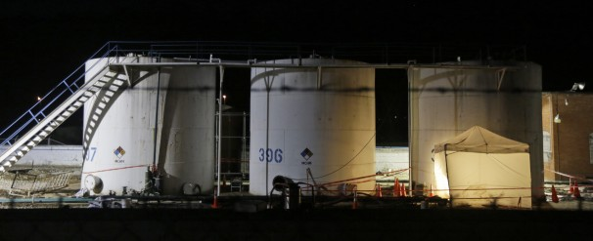
Many of these discharges are perfectly legal: To date, the EPA has put few limits on chemicals released by power plants (although last year the agency proposed the first major limits on a few compounds since 1982). What's more, some coal-mining practices, such as mountaintop-removal, create their own water pollution. In the past few years, the EPA has imposed tighter oversight on permits for this type of mining.
The chemical storage tanks owned by Freedom Industries in Charleston, W.Va. (Steve Helber/Associated Press)

Are there regulations around the chemical leaks themselves? It depends on the state. In West Virginia, for instance, chemicals that are stored underground are subject to environmental regulations and inspections. But tanks stored above ground, such as the one owned by Freedom Industries, aren't regulated as strictly. The last inspection at the Charleston site was back in 2001. And MCHM wasn't deemed dangerous enough for additional regulations — so, given limited manpower, the site was deemed a lower priority and the problems with the containment dike were never discovered.
Ever since the spill, politicians have been pushing to change that. West Virginia Gov. Earl Ray Tomblin has proposed a bill to require yearly inspections of above-ground chemical tanks in West Virginia. The bill would also require water systems to draft plans to prepare for spills.
In the Senate, Joe Manchin (D-W.Va.) is pushing a bill that would ask the federal government to set standards for state-run regulatory efforts. Under this bill, states would have to inspect chemical facilities that could threaten water supplies every three years. The bill would also make the locations and contents of chemical storage sites public.
Of course, new rules are only as stringent as the enforcement. And there's reason to be skeptical of how well regulators will follow through: One 2009 investigation by The New York Times found that companies in West Virginia that violate state clean water laws rarely get fined. Also, back in 2011, the U.S. Chemical Safety Board outlined a plan for West Virginia companies to submit to regular audits of their chemical safety plans. This came in the wake of a 2008 fire and explosion at a Bayer chemical plant. As Mike Elk details here, that plan was largely ignored.

* Update: Added more current numbers on those seeking medical attention.
** Fixed the wording here.

Brad Plumer covers energy and environmental issues, which ends up including just about everything from climate change to agriculture to urban policy and transportation.

Airport Security’s Greatest Nightmare: Chemical Terror Attacks
Source: http://i-hls.com/2014/01/airport-securitys-greatest-nightmare-chemical-terror-attacks/

The greatest nightmare imaginable to airport security personnel: It’s Christmas Eve. Plenty of passengers! Thousands of people crowd the L.A. Airport. An elegantly dressed woman, holding an expensive handbag, joins the line at a crowded check-in counter.
Suddenly she screams “Allahu Ackbar,” grabs a glass vial containing a clear liquid and spills the liquid on the floor. She then draws a pistol and opens fire. Security reacts immediately, shouting for people to lie down, shoot the woman and kill her. Meanwhile several breathless people are lying on the ground, some dead, victims of toxic gas. No one understand what’s happening, hundreds die within minutes. That’s one possible chemical attack scenario in an airport terminal.
This nightmarish fictional event was described by Brig. Gen. (Res.) Abraham Bachar, former director of emergency response in various defense establishment organizations and today CEO of Israteam, as part of the IPRED 3 medical emergency response conference.

Bachar described some of the changes in the U.S. after 9/11: The establishment of the DHS, upgraded airport security, identification and detection systems for people and cargo, anti-hijacking precautions aboard airplanes and more.
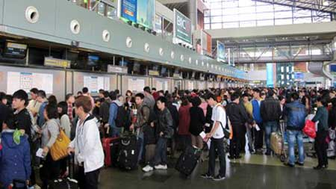
“One weak link was left untouched: The passenger terminals,” said Bachar. “Countries invested a lot of money in preventing hijackings but neglected the passenger terminals. These are usually wide open, swarming with people – passengers and others – which no one checks. Someone can easily carry an explosive or a chemical agent into the terminal and cause a mega-terror event.”
According to Bachar current security procedures for terminal attacks will only lead to panic and more deaths, as the first to fall would be the security officers: They are trained to get into close range of their targets as quickly as possible – the wrong tactic in case of a chemical attack.
So how can airport security prepare itself? According to Bachar the most important thing is speed. Toxins kill within minutes and the response must be immediate: Give evacuation instructions to passengers, direct security personnel, evacuate casualties to nearby hospitals – all within those few minutes. Other means of preparation include frequent drills, acquiring protective equipment, establishing a command and control network within the airport itself, and more.
According to Bachar the Israeli Airport Authority has already established a special response center for chemical attacks. Other airports around the world, concluded Bachar, can adapt the Israeli system for their own needs.

EDITOR’S COMMENT: When such warnings come from a highly experienced person as Gen Avi Bachar – one of our instructors during a disaster management course given a decade ago during preparation for the Athens Olympics – should be seriously taken into consideration. Even without the chemical element this scenario is applicable worldwide. Airport security should be re-evaluated and updated to avoid materialization of such scenarios in the near future. Check-in and Arrivals are most vurnerable; same applies for a second perimetric surveillance zone to avoid long-range attacks against airplanes and infrastructure.

Detecting Chemicals, Measuring Strain with a Pencil and Paper
Source: http://www.mccormick.northwestern.edu/news/articles/2014/01/detecting-chemicals-measuring-strain-with-a-pencil-and-paper.html

Sometimes solving a problem doesn’t require a high-tech solution. Sometimes, you have to look no farther than your desktop.
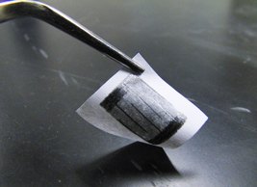
Three students from Northwestern University’s McCormick School of Engineering —an undergraduate, a master’s student, and their teaching assistant — have proven that pencils and regular office paper can be used to create functional devices that can measure strain and detect hazardous chemical vapors.
A paper describing their findings, “Pencil Drawn Strain Gauges and Chemiresistors on Paper,” was published January 22 in Scientific Reports, an open-access journal from the Nature Publishing Group.
The project originated in fall 2011 in McCormick’s Introduction to Conducting Polymers course (MSE 337) during a discussion about the conductive properties of graphene, a one-atom thick layer of carbon that can be parsed from regular pencil lead. (A misnomer, pencil “lead” actually comprises graphite in a clay binder.)
“When you draw a line on a piece of paper, the graphite may shed numerous graphene sheets,” said Jiaxing Huang, associate professor of materials science and engineering. “A student asked, ‘Can we use that graphene for something?’ That started an exploration of what pencil traces can do.”
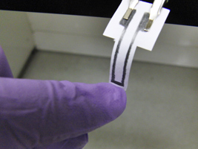
One team of students — including lead authors Cheng-Wei Lin (MS materials science ’13) and Zhibo Zhao (BS materials science ’13) — started by measuring the conductivity of a pencil trace on paper, then used the traces to create a rudimentary electrode. They learned that curling the paper in one direction increased the trace’s conductivity by compressing the conductive graphene particles. Curling the paper in the other direction loosened the graphene network and decreased conductivity.
When the chemical is present, the polymer binder absorbs the vapors and expands, pushing the graphene network apart and decreasing conductivity. The conductivity decreased the most in the presence of vapors that are more readily absorbed by the polymer binder.
These types of chemical sensor — also called “chemiresistors” — are key elements in “electronic noses” for detecting toxic chemical vapors. In creating chemiresistors, researchers often use more expensive materials, such as networks of carbon nanotubes or metal nanoparticles, and need to disperse them in polymer matrix to form a network.
Other applications of the pencil-and-paper technology could be more unconventional. “It could help to inspire some new form of art,” Huang said. “Perhaps one can make ‘smart’ and interactive drawings, in which the art itself is the circuitry and can respond to the environment.”
In addition to Lin, Zhao, and Huang, Jaemyung Kim (PhD materials science ’13), who served as teaching assistant for the course, co-authored the paper.

— Read more in Cheng-Wei Lin et al., “Pencil Drawn Strain Gauges and Chemiresistors on Paper,” Scientific Reports 4, Article number: 3812 (22 January 2014)

Diplomat's son reportedly arrested by terror police in London raid
Source: http://www.independent.co.uk/news/uk/crime/diplomats-son-reportedly-arrested-by-terror-police -in-london-raid-9091435.html

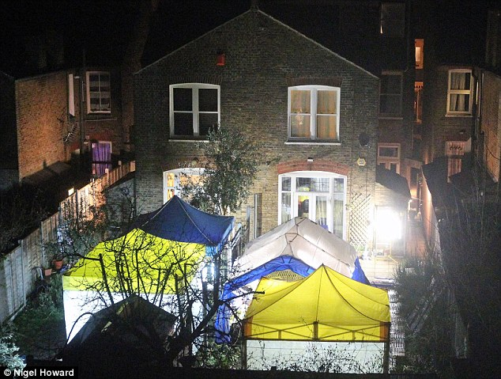
A son of a British diplomat has been arrested under anti-terror laws following a police investigation into an alleged toxic chemical terror threat, it has been reported.
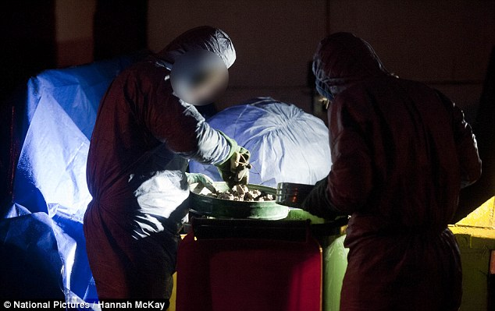
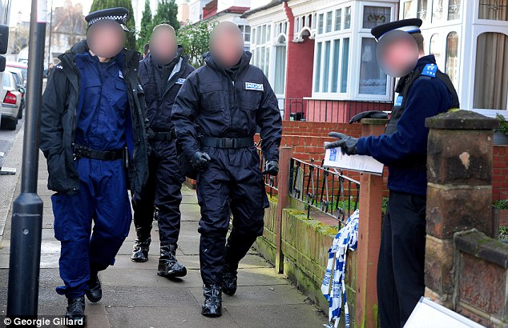
It is believed that one of the 19-year-old twin sons of Foreign Office First Secretary Nicholas Sutcliffe was questioned by specialist police officers, and has since been released on bail until April.
The reportedly £650,000 house in Streatham, south London, is being investigated by weapons experts following a raid at 8am on Saturday morning.
Officers have put up floodlights and tents in the gardens of neighbouring houses in Wyatt Park Road, where the teenager was reportedly arrested.
Neighbours told the Daily Mail that a ‘motorcade’ of more than 30 officers closed off the road in Streatham Hill, and had dug up the garden of the house.
They said officers were wearing protective clothing and carrying breathing equipment, which police said was a precautionary measure.
The teenager is thought to be one of Nicholas and Carole Sutcliffe’s four children.
Nicholas Sutcliffe has represented the UK as First Secretary since 2001 at embassies in Brazil and Cuba.
A 36-year-old woman, who was also arrested in connection with the investigation in Stratford on Monday, remains in police custody at an east London police station.
The police said in a statement: “Public safety is a priority and at this stage there is nothing to suggest members of the public in the immediate area are at risk.”
The Anti-Terrorism, Crime and Security Act 2001 allow the Home Secretary to indefinitely detain, without charge or trial, foreign nationals who are suspected of terrorism.
It also covers aiding or abetting the overseas use or development of chemical or biological weapons.

EDITOR’S COMMENT: Judging from photos released what is for sure is that they were not looking for conventional weapons or explosives since PPE, tents or communication vans are not SOPs. Perhaps chemicals or a garage bio-culture (as a school project…).

An Army of One: Assessing CBRN Pursuit and Use by Lone Wolves and Autonomous Cells
By Gary A. Ackerman & Lauren E. Pinson
Pages 226-245
Source:http://www.tandfonline.com/doi/abs/10.1080/09546553.2014.849945?utm_source=START+Announce&utm_campaign=57481fbfb4-START_Newsletter_September9_26_2013&utm_medium= email&utm_term=0_a60ca8c769-57481fbfb4-14081393&#.UuqNJfvz4yO
Abstract
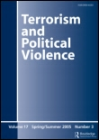
In recent years, much of the literature on terrorist pursuits and use of unconventional weapons has focused on al-Qaeda and other Islamic extremist groups. Some scholars posit lone actors may differ from organizations when it comes to the observation that larger organizations are more likely to engage in chemical, biological, radiological, and nuclear (CBRN) activity, but leave this as an open question because of a prior lack of data on lone actors. Furthermore, new technologies and expanding networks may also spawn more deleterious lone actors, including what have been referred to as “super-empowered individuals.” This article utilizes the Profiles of Incidents Involving CBRN by Non-State Actors Dataset and the Radiological and Nuclear Non-State Actors Database to illustrate the characteristics of CBRN pursuit by lone wolves and autonomous cells over time. Initial findings confirm the general perceptions that, historically, lone actors have engaged in cruder, smaller scale, and less frequent CBRN plots and attacks than their formal terrorist organization counterparts, but suggest that such actors do present a genuine threat, at least in terms of the potential for mass disruption. Additionally, while they share several similarities with more formal organizations, lone actors and autonomous cells tend to be motivated less by collective religious or ethno-nationalist concerns than larger organizations, focusing more on narrow or solipsistic drivers. Lone actors and autonomous cells also appear to largely calibrate their CBRN ambitions to their capabilities and their CBRN actions tend to receive better media coverage than formal terrorist organizations.

Gary A. Ackerman is the Director of the Special Projects Division at the National Consortium for the Study of Terrorism and Responses to Terrorism (START), University of Maryland.
Lauren E. Pinson is a Senior Research/Project Manager at START and a PhD student at Yale University.
Modern Warfare
Source:http://www.cbrneworld.com/_uploads/download_magazines/Sellstrom_Feb_2014_v2.pdf
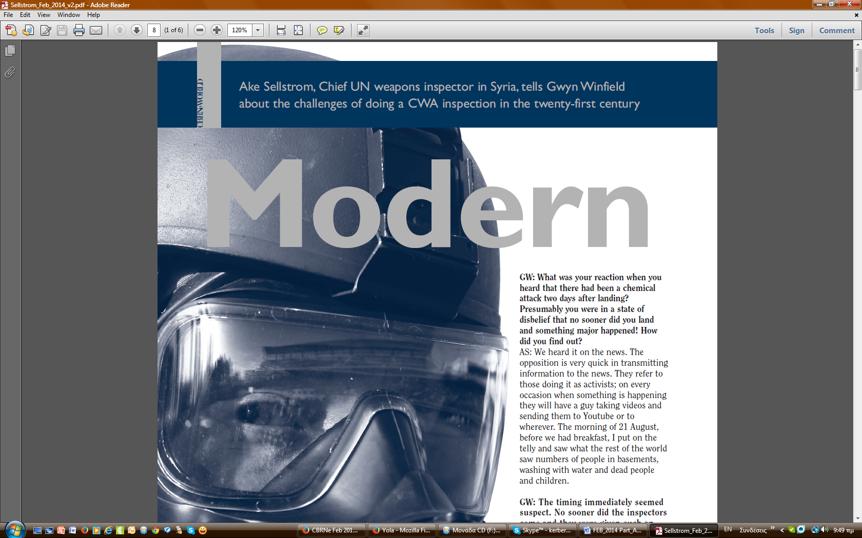
Ake Sellstrom, Chief UN weapons inspector in Syria, tells Gwyn Winfield (Editor of CBRNe World) about the challenges of doing a CWA inspection in the twenty-first century.

Syria has shipped out less than 5 percent of chemical weapons
Source: http://www.reuters.com/article/2014/01/29/us-syria-crisis-chemical-idUSBREA0S19720140129

Jan 29 – Syria has given up less than 5 percent of its chemical weapons arsenal and will miss next week's deadline to send all toxic agents abroad for destruction, sources familiar with the matter said on Wednesday.
The deliveries, in two shipments this month to the northern Syrian port of Latakia, totaled 4.1 percent of the roughly 1,300 tonnes of toxic agents reported by Damascus to the Organisation for the Prohibition of Chemical Weapons (OPCW), said the sources, who spoke on condition of anonymity.
"It's not enough and there is no sign of more," one source briefed on the situation said.
The internationally backed operation, overseen by a joint OPCW-United Nations mission, is now 6-8 weeks behind schedule. Damascus needs to show it is still serious about relinquishing its chemical weapons, the sources told Reuters.
Failure to eliminate its chemical weapons could expose Syria to sanctions, although these would have to be supported in the U.N. Security Council by Russia and China, which have so far refused to back such measures against President Bashar al-Assad.
The deal under which Syria undertook to eliminate its chemical arsenal stopped the United States and its allies from launching bombing raids to punish Assad for a chemical attack last August and made clear the limits to international action against him.
U.N. Secretary-General Ban Ki-moon suggested in a report to the Security Council this week that shipments had been unnecessarily delayed and urged the Syrian government to speed up the process.

Message to Syria
That is the message that will be given to Syria's representative to the OPCW during its executive council meeting on Thursday in The Hague, where the Nobel Peace Prize-winning organisation is located, the sources said.
A senior Western diplomat, speaking on condition of anonymity, said that the U.N. Security Council will be briefed on the issue by mission head Sigrid Kaag next week.
"All the indications are, and the secretary-general's report makes clear, that actually the regime has been sort of stalling on the implementation of the agreement," the diplomat said.
"It will be important what Sigrid Kaag says about whether she thinks these delays are deliberately politically motivated and why or whether there's any truth in the weather, the security and those more technical aspects," he said.
Another senior Western diplomat said the Syrian government is "teasing us" by dragging its heels but doing enough to avoid being declared in non-compliance with its obligation to destroy its chemical weapons program.
The second diplomat added that Russia would never permit the U.N. Security Council to declare Assad's government in non-compliance with its duty to eliminate its poison gas program.
"The Russians will never accept it," the second diplomat said, adding that Western powers were also reluctant to do anything that could be seen as undermining the Geneva peace talks between Assad's government and the opposition.
"Our impression is that they (Assad's government) are managing this issue in parallel with the Geneva discussion," he said. "Everything is blocked so they are blocking on the chemical weapons to remind us" of their power on this issue.
Syria, where civil war has killed well over 100,000 people and forced millions to flee, has blamed delays on security obstacles. It said the mission could not be safely carried out unless it received armored vehicles and communications equipment.
A source briefed on the situation said: "Yes, it's true there is a war, but have you ever heard of a civil war without security issues? They have all the necessary means they need for transportation. Now they need to start shipping the chemicals out."
Under a deal agreed by Russia and the United States after the August 21 sarin gas attack, Syria vowed to give up its entire stockpile by mid-2014. The rocket attacks in the outskirts of Damascus killed hundreds, including women and children.
Eradicating Syria's chemical weapons stockpile, including sarin, mustard gas and VX, requires massive foreign funding and logistical support.
The bulk of the most toxic substances are to be destroyed on the Cape Ray, a U.S. cargo ship now en route to the Mediterranean that will be loaded with the chemicals at an Italian port. The remainder will go to several commercial waste processing facilities, including in Britain and Germany.

North Korea’s Chemical Warfare Capabilities
By Joseph S. Bermudez Jr.
Source: http://38north.org/2013/10/jbermudez101013/

The recent revelations of chemical agent usage in Syria’s long civil war not only reveals the tragic levels that this conflict has descended to but has also unexpectedly raised interest in the chemical warfare capabilities of the Democratic People’s Republic of Korea (DPRK), which has reportedly provided chemical warfare assistance to the regime of Bashar al-Assad.[1][2]
The available body of evidence reveals that the DPRK produces and possesses the capability to effectively employ throughout the Korean peninsula, significant quantities and varieties of chemical weapons. It also has, to a lesser extent, the ability to employ these weapons worldwide using unconventional methods of delivery. Just as ominous as these chemical weapons production and delivery capabilities is a growing body of evidence that indicates a DPRK history of proliferation of chemical capabilities to nations such as Syria, Iran and others.

Organization[3]
Chemical weapons research, development and production within the DPRK are the responsibility of organizations subordinate to the Korean Workers’ Party (KWP) Munitions Industry Department—more specifically the Second Academy of Natural Sciences and the Second Economic Committee’s Fifth Machine Industry Bureau. Both organizations receive co-operation and assistance from the Academy of Sciences and the Korean People’s Army (KPA). The Fifth Machine Industry Bureau, with the assistance of the KPA’s Nuclear Chemical Defense Bureau, controls all facilities, or sub-facilities, that manufacture chemical weapons. The academy’s Third Machine Industry (artillery shells), Fourth Machine Industry (missile warheads) and Seventh Machine Industry (air delivered weapons) Bureaus provide additional assistance. At present, there are at least 18 facilities that have been associated with chemical precursor or agent production.[4]

Chemical Warfare Agents
Chemical agents currently reported to be in the KPA inventory include, but are not necessarily limited to: adamsite (DM), chloroacetophenone (CN), chlorobenzyliidene malononitrile (CS), chlorine (CL), cyanogen chloride (CK), hydrogen cyanide (AC), mustard-family (H, HD or HL), phosgene (CG and CX), sarin (GB), soman (GD), tabun (GA) and V-agents (VM and VX).[5] It is important to note that, according to KPA defectors, the DPRK produces a total of 20 different chemical agents for use in weapons. It is believed that the KPA has concentrated upon sulfur mustard, chlorine, phosgene, sarin and the V-agents.
To date, there have been no public indications that the DPRK produces binary chemical agents. However, given the benefits of such weapons (such as safety and a longer shelf-life), it is likely that some binary agents are in production.

Reported Human Testing[6]
Intermittent reports from defectors state that the DPRK has conducted testing of chemical agents on political prisoners. For example Kwon Hyok [pseudonym], a security official at Detention Camp 22, has described incidents where healthy prisoners were placed inside glass chambers into which was inserted “gas” while technicians observed their deaths.[7] Im Chun Yong, a former special operations forces member, states that similar experiments took place on an island in the Yellow Sea. These reports are extremely difficult to confirm.[8] Taken as a whole, and within the context of what is currently known about the treatment of political prisoners within the DPRK, such reports suggest a long-standing DPRK policy of low-level lethal testing of chemical agents on unwilling human subjects.

Chemical Agent Production Capacities and Inventory
The DPRK is almost certainly self-sufficient in the production of all necessary precursor chemicals for first generation chemical agents, including nerve agents. DPRK publications suggest that among the precursors it is capable of producing are, ethylene chlorohydrin, hypochlorous acid, phosgene, phosphorous trichloride, sulfur dichloride, sulfur monochloride, thiodiglycol and thionyl chloride.
The best estimates available credit the DPRK with an annual production potential of 4,500 tons of chemical agents in peacetime and 12,000 tons in wartime. Estimates of chemical weapons inventory have varied considerably over the past 20 years. In 1989, the inventory was estimated to be “180 to 250 tons of chemical weapons of several kinds.”[9] During October 2008, the ROK minister of defense stated that the DPRK possessed 5,000 tons of chemical agents.[10] Current estimates suggest an inventory of 2,500-5,000 metric tons of agents, the majority of which were believed to be in the form of mustard, phosgene, sarin and V-agents.[11] It is further believed that this inventory includes as many as 150 warheads for ballistic missiles. The KPA may also possess limited numbers of binary (GB, GF or VX for example) chemical munitions.

Chemical Protection Equipment Production[12]
The production of chemical defense and decontamination equipment is known to occur at the No. 279 Factory (a.k.a. Research Center 279). While research and development into the “…decontamination of people, equipment, clothing, and water against nuclear, biological, and chemical weapons” is conducted by the No. 398 Institute (Research Center No. 398). Both facilities are located in Pyongwon-gun, Pyongan-namdo. Like the Kanggye and Sakchu Chemical Weapons Factories, these facilities are subordinate to the Equipment Department of the Nuclear-Chemical Defense Bureau. Products from No 279 Factory are shipped to the “Maram Materials Corporation” and “Chiha-ri Chemical Corporation.” According to DPRK defectors, the Hamhung University of Chemical Engineering provides many of the researchers employed at the No. 398 Institute.
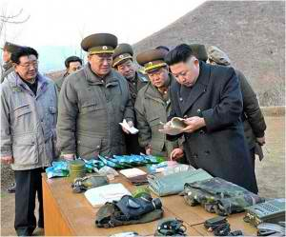
February 21, 2013, Kim Jong Un inspects the equipment of the KPA Unit 323, including what appears to be a DPRK manufactured gas mask—presumed to be manufactured by the No. 279 Factory. (Photo: KCNA)
DPRK manufactured gas mask seized by the Greek government en route to Syria in November 2009—compare with image above. (Photo: UN Panel of Experts)

DPRK civilian and military scientists and researchers maintain active research programs directly applicable to chemical defense. For example, in 2008, scientists at Kim Il Sung University were engaged in studying various methods of sulfur mustard decontamination. Other scientists worked on the synthesis of diethyl phosphite which has known commercial uses, but can also be used as a precursor chemical for the G-series of nerve agents.

Proliferation
Since the 1990s there have been repeated reports that the DPRK has provided chemical weapons, agents or technology to Egypt, Iran, Libya and Syria. Most of these reports center around the sales of defensive equipment, manufacturing technology, assistance in developing chemical warheads for Scud class ballistic missiles and development of chemical warfare production infrastructure.
With regards to DPRK-Syria chemical weapons-related activity, reports originating in the Middle East indicate that there was an acceleration of such efforts beginning in early 2007. These reports identify the city of Aleppo as the center of this activity. It was near Aleppo that a chemical-related accident allegedly occurred in July 2007 in which both Syrian and DPRK personnel were killed when a missile with a chemical warhead exploded prematurely. These reports, while numerous, remain unconfirmed.[13]
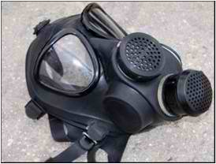
On September 22, 2009 the ROK Coast Guard intercepted the Panamanian registered container ship MSC Rachele that, having stopped previously in Nampo (DPRK), was sailing from Dalian (China). The vessel was subsequently brought into the port of Busan where its cargo was inspected and compared with the ship’s manifest. The inspection identified four shipping containers that contained DPRK-origin chemical protective suits destined for Syria.[14]
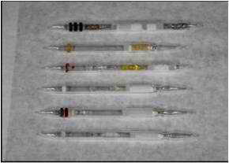
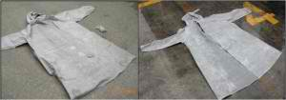
The following month, November 2009, the Greek government detained a merchant vessel under suspicions that it might be carrying cargo violating UN sanctions and conducted an inspection. The cargo was of interest because it had originated in Nampo (DPRK), was trans-shipped through the port of Dalian (China), transited through Jeddah (Saudi Arabia) and other ports, and was en route the Syrian port of Al Lādhiqīyah (Latakia). The inspection resulted in the identification and seizure of four shipping containers that contained 13,000 chemical protective suits, 23,600 gas indicator ampoules to detect specific chemical substances and other items—all manufactured in the DPRK. The intended recipient of the goods was the Syrian Environmental Study Center. In March 2012, the Syrian Government stated that this shipment of chemical protective suits and ampoules was for agricultural and laboratory use. The Environmental Study Center appears to be linked with the Higher Institute of Applied Sciences and Technology, an educational institution that provides training to the Scientific Studies and Research Center (CERS), which has been previously implicated in Syria’s weapons of mass destruction programs.[15]

DPRK-origin chemical protective coats seized in October 2009 (left) and November 2009 (right). (Photo: UN Panel of Experts)

DPRK manufactured gas indicator ampules seized by the Greek Government in November 2009. (Photo: UN Panel of Experts)

In December 2012, a defecting Syrian Army major who had reportedly served in the chemical branch stated that Iranian and KPA experts in treatment and usage of chemical weapons were assisting the Syrian Army.[16]
Most recently, on April 3, 2013, the Liberian flagged merchant vessel El Entisar [Victory] was detained by Turkish authorities as it passed through the Dardanelles Straits. Acting upon information provided by the United States, the authorities conducted an inspection of the vessel and identified and seized an estimated 1,400 rifles and pistols, approximately 30,000 rounds of ammunition and an unstated number of gas masks—all manufactured in the DPRK. According to a statement by the ship’s captain, the shipment originated in the DPRK. It is believed that the shipment was being transported to Syria via a circuitous route in hopes of avoiding interception.[17]

Notes
[1] This paper draws heavily upon the author’s interviews with defectors and officials around the world over the past 25 years. Almost all of these interviews were understandably granted under the provisions of anonymity for the interviewees and will unfortunately not be cited in detail here. A longer, but somewhat dated, discussion of KPA chemical warfare capabilities can be found in Chapter 8 of the author’s Shield of the Great Leader: The Armed Forces of North Korea, (Sydney: Allen & Unwin, and London: I.B. Taurus), 2001.
[2] Haggard, Stephan and Noland, Marcus. “Chemical Weapons: The North Korean Angle,” Peterson Institute for International Economics, September 3, 2013; and Yori, Yanover. “The Syrian army has already used a small amount of chemical weapons in a battle near Baba Amr,” Jewish Press, December 9, 2012.
[3] “N. Korea Deploys 10 More Subs,” Korea Times, October 12, 1999; Defense White Paper 1998-2010, (Seoul: ROK Ministry of National Defense); and Bermudez Jr., Joseph S. “Inside North Korea’s CW Infrastructure,” Jane’s Intelligence Review, Volume 8, Number 8, August 1996, pp. 378–382.
[4] Yi Chung Kuk, a KPA defector, has also identified Wonsan as being the site of chemical agent production, however, no details of this have become available. “Nuclear, Chemical, Biological Warfare Research Detailed,” Naewoe Tongsin, No. 903, June 9, 1994; “North Korea Major Producer of Biochemical Weapons,” Vantage Point, November 1992, Vol. XV, No. 11, pp. 23-25; and “DPRK’s Advanced Weapons Analyzed,” Korea Times, February 8, 1991, p. 8.
[5] Lieutenant General Michael D. Maples, U.S. Army Director, Defense Intelligence Agency, Statement for the Record, Senate Select Committee on Intelligence Committee, January 11, 2007, p. 13‎; “Nuclear, Chemical, Biological Warfare Research Detailed;” and North Korean People’s Army Operations, FC 100-2-99, (Fort Leavenworth: U.S. Army), December 5, 1986, p. 11-4.
[6] “N.K. experiments on disabled children: rights group,” Korea Herald, June 30, 2013.
[7] Frenkiel, Olenka. “Human guinea pigs,” BBC, July 28, 2004; Greimel, Hans. “NKorea-Gassing Allegations,” Associated Press, February 3, 2004; and Barnett, Antony. “Revealed: the gas chamber horror of North Korea’s gulag,” The Observer, January 31, 2004.
[8] “NKorea ‘Tests Weapons on Children’,” Chicago Tribune, July 24, 2009; and “Defector warns of N Korea chemical threat,” al-Jazeera, July 24, 2009.
[9] “Daily Says North Stockpiling Biochemical Weapons,” Yonhap, June 23, 1990; and “N. Korea is Mass Producing Chemical Weapons: U.S. Report,” FPI International, June 8, 1986, p. 4.
[10] “N. Korea Deploys 10 More Subs;” “Military Estimates DPRK Chemical Arms Stocks,” Seoul Sinmun, April 15, 1995; “North Said To Own 1,000 Tons of Chemical Weapons,” Yonhap, March 21, 1995; and “Defense Minister Interviewed 16 Aug,” Korea Herald, August 17, 1991, pp. 1, 3.
[11] Military and Security Developments Involving the Democratic People’s Republic of Korea 2012, (Washington, D.C.: Office of the Secretary of Defense), p. 17; Defense White Paper 2010, (Seoul: ROK Ministry of National Defense), p. 35; Kwon Yang Joo, “Critical Need to Devise Measures to Terminate North Korea’s Chemical Weapons which are as Detrimental as the Nuclear Weapons,” Korea Institute for Defense Analysis, October 7, 2010, www.kida.re.kr; and Lieutenant General Michael D. Maples, U.S. Army Director, Defense Intelligence Agency, Statement for the Record, Senate Select Committee on Intelligence Committee, January 11, 2007‎.
[12] “Nuclear, Chemical, Biological Warfare Research Detailed;” and Yi Chung Kuk. Kin Seinichi no Kaku to Guntai [Kim Chong-il’s Nuclear Weapons and Army], (Tokyo: Kodansha), 1994, pp. 101-110.
[13] Gordon, Michael and Schmitt, Eric. “Syria Uses Scud Missiles in New Effort to Push Back Rebels,” New York Times, December 12, 2012; Yori, Yanover. “The Syrian army has already used a small amount of chemical weapons in a battle near Baba Amr,” Jewish Press, December 9, 2012; and Eshel, David. “Syria’s Chemical Weapons Proliferation Hydra,” Defense Update, September 23, 2007.
[14] UN Panel of Experts. Note by the President of the Security Council, United Nations Security Council, S/2013/337, June 11, 2013, p. 28; Military and Security Developments Involving the Democratic People’s Republic of Korea 2012, (Washington, D.C.: Office of the Secretary of Defense), p. 17; Japan: Recent Security Developments, Committee on Armed Services, House of Representatives, Hearing Held on July 27, 2010, (Washington, D.C.: Government Printing Office), 2010, p. 67; and “Gov’t Report on Seized NK Containers Presented to UNSC,” Donga Ilbo, December 16, 2009.
[15] Demick, Barbara. “North Korea tried to ship gas masks to Syria, report says,” Los Angeles Times, August 27, 2013; UN Panel of Experts. Note by the President of the Security Council, United Nations Security Council, S/2013/337, June 11, 2013, p. 28; “Greece Seizes N. Korea Chemical Weapons Suits: Diplomats,” Agence France Presse, November 17, 2011; and Michinobu Yanagisawa. “N. Korea tried to ship WMD reagent in 2009,” Yomiuri Shimbun, January 6, 2012.
[16] Yori, Yanover. “The Syrian army has already used a small amount of chemical weapons in a battle near Baba Amr,” Jewish Press, December 9, 2012.
[17] Demick, Barbara. “North Korea tried to ship gas masks to Syria, report says,” Los Angeles Times, August 27, 2013; and “N.Korea ‘Exporting Chemical Weapons Parts to Syria’,” Chosun Ilbo, June 17, 2013.

Joseph S. Bermudez Jr. is an internationally recognized analyst, author and lecturer on DPRK defense and intelligence affairs and ballistic missile development in the Third World.

Detecting Underwater Weapons of Mass Destruction
Source: http://science.dodlive.mil/2014/01/31/detecting-underwater-weapons-of-mass-destruction/

Scientists at the U.S. Naval Research Laboratory (NRL) are conducting research to improve the detection of weapons of mass destruction in maritime environments.
In recognition of their efforts, they recently received a Best Paper Award at the 2013 IEEE Conference on Technologies for Homeland Security.
The authors are Anthony Hutcheson, Bernard Phlips, Eric Wulf, Lee Mitchell, Neil Johnson, from NRL’s Space Science Division, High Energy Space Environment Branch, and Byron Leas, SRA International, Inc. Their paper, “Maritime Detection of Radiological/Nuclear Threats with Hybrid Imaging System,” won the Best Paper Award in the Land and Maritime Border Security Track at the IEEE conference.
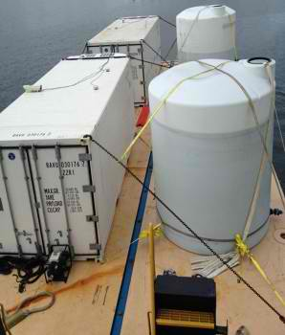
Five Best Paper Awards were presented — one for each track — Cyber Security; Biometrics and Forensics; Land and Maritime Border Security; Attack and Disaster Preparation, Recovery and Response, along with one overall best paper.
The Best Papers will be published in “Homeland Security Affairs,” the peer-reviewed online journal of the Naval Postgraduate School Center for Homeland Defense and Security.
Scientists know that the remote detection of special nuclear materials is difficult because the materials are not very radioactive, the radiation signatures decrease rapidly with distance, and faint sources of radiation can be obscured by naturally occurring and man-made radioactive sources.

The SuperMISTI system is shown here mounted on a 48-foot trailer for testing prior to deployment to the Manta technology demonstration. (Photo: U.S. Naval Research Laboratory)

The award-winning paper tells how the NRL team has developed the SuperMISTI stand-off detection system for maritime environments as part of the Office of Naval Research’s (ONR’s) Maritime Weapons of Mass Destruction Detection program. The instrument was deployed at Norfolk Naval Station in July 2012 as part of the ONR’s Manta technology demonstration to determine the on-water performance of the system.
SuperMISTI is a hybrid detection, identification, and imaging system for sources of gamma-ray radiation at stand-off distances.
NRL researchers designed and built SuperMISTI based on the Mobile Imaging and Spectroscopic Threat Identification (MISTI) system that they designed for the Department of Homeland Security Domestic Nuclear Detection Office Stand-Off Radiation Detection System program.
The SuperMISTI system uses the high-resolution spectra of high-purity germanium (HPGe) detectors to detect and identify gamma-ray sources, as well as coded aperture technology and lower-cost sodium iodide (NaI) detectors to image and localize the detected sources.
With its modular design, SuperMISTI allows the detection/identification and the imaging/localization portions to be used separately or together depending on the situation.
The complete SuperMISTI system is shown here on a 60-foot barge. The water ballast tanks used to maintain a level barge are shown on the right. (Photo: U.S. Naval Research Laboratory)
Dr. Hutcheson reports that NRL’s SuperMISTI hybrid system has successfully detected, identified, and localized gamma and neutron sources in a maritime environment at operationally relevant distances.
Since the completion of the Manta demonstration in 2012, NRL scientists have increased the number of HPGe detectors in the detection/identification subsystem from 24 to 48. This modification significantly enhances the gamma detection/identification capabilities of the system.
The NRL team plans for further performance enhancements, including the use of a large-area BF3 detector array to increase neutron detection capabilities and the implementation of better localization algorithms for neutron sources.

Parachuting Canister Detects Chemical Weapons
Source: http://www.popsci.com/technology/article/2013-03/heres-chemical-weapon-sensor-built-cell-phone-innovation

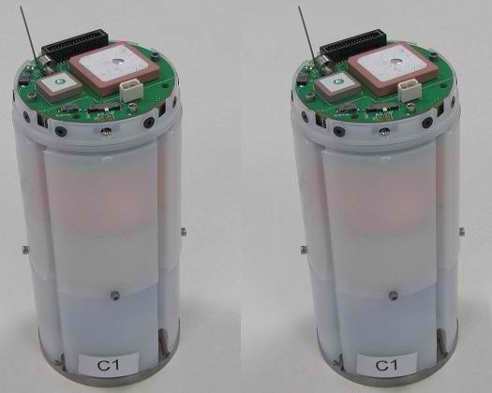
Army researchers at the Edgewood Chemical Biological Center (ECBC) are developing new technology that could help U.S. troops battle chemical warfare. The technology, a canister about the size of a soda can, can sniff out dangerous chemicals and relay information about potential hazards back to troops.
The canister could be especially useful in Syria.
Often odorless and invisible, chemical agents act fast and can rapidly lead to paralysis or death. ECBC's technology--still under development--is designed to help soldiers avoid those dangerous situations. Built around the handheld Joint Chemcial Agent Detector, these sensor-equipped canisters can be dropped from an airplane, parachute to the ground and then relay via satellite any information on chemical agents they pick up. The canisters have seismic sensors, and the ability to detect other airborne chemical agents, including Sarin, Mustard gas, Lewisite, and Cyanogen Chloride, among others. There's also a GPS antenna to help soldiers pinpoint its location. The prototype cans have a battery life of up to six hours, which the researchers hope to increase to several days.
This sensor cans are officially known as Global Strike Near Real-Time Battle Data Assessment (NRT-BDA) and as the name implies the goal is to provide a broad, instantaneous picture of unseen threats in a battle field. Because of their indiscriminate nature, chemical threats are usually launched long-range, so detecting a chemical attack also means figuring out a place the enemy probably isn't. The speed is especially important for informing advancing troops about areas that are safe versus those that aren't. If a chemical attack is detected further than 500 feet from troops that gives troops enough time for them to put on protective equipment. That is a tremendous advantage over the handheld device on which they are based, and would prove invaluable to any troops moving on the ground against a regime with chemical weapon stockpiles.

Libya’s Cache of Toxic Arms All Destroyed
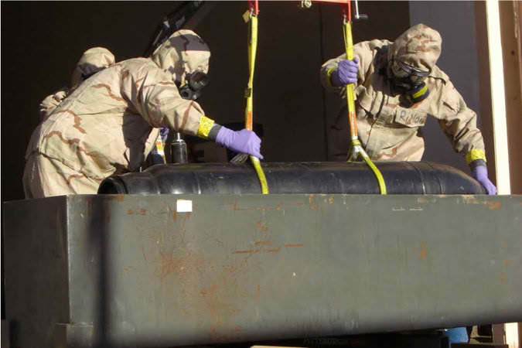
Source: http://www.nytimes.com/2014/02/03/world/africa/libyas-cache-of-toxic-arms-all-destroyed.html? ref=world&utm_source=Sailthru&utm_medium=email&utm_term=*Morning%20Brief&utm_campaign=MB%2002.03.14&_r=0
In an image from the Pentagon, a bomb was moved from a bunker in Libya to be later drained of its chemical agent.

Even as the international effort to destroy Syria’s vast chemical weapons stockpile lags behind schedule, a similar American-backed campaign carried out under a cloak of secrecy ended successfully last week in another strife-torn country, Libya.
The United States and Libya in the past three months have discreetly destroyed what both sides say were the last remnants of Col. Muammar al-Qaddafi’s lethal arsenal of chemical arms. They used a transportable oven technology to destroy hundreds of bombs and artillery rounds filled with deadly mustard agent, which American officials had feared could fall into the hands of terrorists. The effort also helped inspire the use of the technology in the much bigger disposal plan in Syria.
Since November, Libyan contractors trained in Germany and Sweden have worked in bulky hazmat suits at a tightly guarded site in a remote corner of the Libyan desert, 400 miles southeast of Tripoli, racing to destroy the weapons in a region where extremists linked to Al Qaeda are gaining greater influence. The last artillery shell was destroyed on Jan. 26, officials said.
As Libya’s weak central government grapples with turmoil and unrest, and as kidnappings and assassinations of military and police officers accelerate in the country’s east, American and international weapons specialists hailed the destruction of the Libyan stockpile as a bright spot in an otherwise gloomy security environment.
“It’s a big breakthrough,” said Paul F. Walker, an arms control expert with the environmental group Green Cross International who has helped in efforts to demilitarize the American and Russian chemical weapons stockpiles since the 1990s. “Even though Libya’s chemical stockpile was relatively small, the effort to destroy it was very difficult because of weather, geography and because it’s a dangerous area with warring tribes, increasing the risks of theft and diversion,” he said.
Libya’s last two tons of chemical weapons were dwarfed by the 1,300 tons that Syria has agreed to destroy. But American and international arms experts say the need for easily transportable and efficient technology to wipe out the Libyan arms became a model for the Syria program now underway.
For Libya’s fragile transitional government, such collaboration with the West on security matters is a delicate issue. It gives the country’s leaders desperately needed assistance to defuse internal threats, but also risks accusations of compromising national sovereignty.
Asked about the American efforts to destroy the chemical weapons, Libyan security officials in Tripoli initially issued sweeping denials. One later briefly acknowledged the operation on the condition of anonymity, and then officials stopped returning phone calls.
On Sunday, the White House said that it would ensure that the Syrian government complied with an accord to give up its chemical arsenal despite missed deadlines and delays in carrying out the deal.
The White House chief of staff, Denis McDonough, said on the CBS News program “Face the Nation” that the deal was “not falling apart, but we would like to see it proceed much more quickly than it is.”
The disposal of the last of Libya’s chemical weapons closes a chapter that Colonel Qaddafi began in early 2004, when his government turned over a vast cache of nuclear technology and chemical stockpiles to the United States, Britain and international nuclear inspectors.
At that time, Libya declared for destruction 24.7 metric tons of sulfur mustard, a syrupy liquid that when loaded into bombs or artillery shells and exploded creates a toxic mist that penetrates clothing, burns and blisters exposed skin, and can kill with large doses or if left untreated. The chemical was used extensively in World War I.
Libya had destroyed about half of these stocks when civil war broke out in 2011. Western spy agencies closely monitored the destruction site in the Libyan desert to ensure the stockpiles were not pilfered by insurgents.
When the new government took control in Tripoli that fall, it signaled its intent to finish the job. Libyan officials also surprised Western inspectors by announcing the discovery in November 2011 and February 2012 of two hidden caches of mustard, or nearly two tons, that had not been declared by Colonel Qaddafi’s government. That brought the total declared amount of chemical to 26.3 tons.
Unlike the majority of Libya’s mustard agents, which were stored in large, bulky containers, the new caches were already armed and loaded into 517 artillery shells, 45 plastic sleeves for rocket launchings and eight 500-pound bombs.
The new stockpiles immediately posed huge challenges for the fledgling Libyan government, which had no ability to destroy the combat-ready chemical weapons, as well as for its American and European allies called upon to help.
The disposal site is deep in the desert, in an area where Islamist militants hostile to the West wield growing influence. It also sits on the front line of the struggle between Libya’s eastern and western provinces over political power and oil revenue. A defining issue in post-Qaddafi politics, the regional rivalry has often spilled out into armed blockades of the national highways and crucial oil-export terminals as well.
Using $45 million from the Nunn-Lugar Cooperative Threat Reduction program, which has helped rid the former Soviet Union of thousands of nuclear weapons since the end of the Cold War, the Pentagon and its Defense Threat Reduction Agency tapped the Parsons Corporation, a construction firm based in Pasadena, Calif., to work with Libya to oversee the rebuilding and safeguarding of the Libyan disposal site, which had been ransacked during the civil war.
Remarkably, the mustard agents stored in bulk containers at the site were untouched and their inspection seals unbroken, American and international officials said. These have all been destroyed, too.
Canada donated $6 million to help restore water, sewage service and electricity to the site, and to build living quarters for Western and Libyan contractors. Germany agreed to fly international inspectors to the site.
The project has relied on a custom-built device from Dynasafe, a Swedish company, to destroy the weapons. It is essentially a giant, high-tech oven called SDC (static-detonation chamber – photo). The munitions were fed through an automated loading system into a gas-tight chamber, where the toxic materials were vaporized at temperatures between 750 and 1,000 degrees Fahrenheit. Gases created in the process were scrubbed by special filters.
“The destruction of these munitions was a major undertaking in arduous, technically challenging circumstances,” Ahmet Uzumcu, the director general of the Organization for the Prohibition of Chemical Weapons, whose inspectors supervised the destruction of the chemical weapons, said in a written statement.
Although American officials acknowledge that Libya is awash with conventional arms, they expressed confidence that the vast Libyan desert holds no other secret caches of unconventional arms for jihadis to exploit.
Andrew C. Weber, assistant secretary of defense for nuclear, chemical and biological defense programs, said, “This is the culmination of a major international effort to eliminate weapons of mass destruction from Libya and to ensure that they never fall into the hands of terrorists.”

►Watch a video on SDC plant at: http://www.youtube.com/watch?v=8VOmlST_oGE

Beth-El will Provide WoMD Protection for the "Watercat M18"
Source: http://www.israeldefense.com/?CategoryID=483&ArticleID=2742

The Israeli company Beth-El will shield the advanced Combat Support Service Vessels of the Finnish Navy against Weapon of Mass Destruction attacks. So was settled between Beth-El and Marin Alutech of Finland, which builds the vessels.
Beth-El is engaged in WoMD protection solutions integrated with air conditioning for structures and weapons platforms for land and sea warfare.
The cooperation is part of a project for the supply of 12 “Watercat M18” vessels for the Finnish Navy. The Watercat M18 armored modular craft (AMC), is a new landing craft which is designed to fulfill all modern requirements for future combat support vessels. The advanced vessels will be powered by two 660kW Scania diesel engines and feature Rolls-Royce waterjet propulsion. It is 19 meters long, capable of sailing at up to 35 knot and make a sharp turn almost on the spot.
The vessels is suitable for troop transportation, medical and evacuation tasks, landing operations, patrolling and escort tasks, as well as combat and battle support scenarios. It has been specially designed for archipelagic, coastal and offshore conditions with an effective heating and air-conditioning system allowing heat and extreme cold, arid or humid climates.
It has been recently announced that Marine Alutech will deliver 12 pieces of these Watercat M18 AMC multipurpose high-speed landing crafts to Finnish Navy during 2014-2016. The Israeli company Beth-El has already been integrated in the project.

Chemical weapons watchdog picks Ekokem, Veolia to destroy Syria's stockpile
Source: http://uk.reuters.com/article/2014/02/14/syria-crisis-chemical-idUKL5N0LJ18I20140214

Feb 14 – Ekokem AB of Finland and Veolia of France have won contracts to destroy part of Syria's chemical weapons stockpile, the global watchdog OPCW said on Friday. The Hague-based Organisation for the Prohibition of Chemical Weapons, which is overseeing the destruction process, has earmarked up to 40 million euros ($55 million) for the commercial processing of 500 tonnes of industrial chemicals and millions of litres of toxic waste.

Syria’s Chemical Weapons Stockpiles to be Transferred to the Italian Mafia?
Source: http://www.globalresearch.ca/syrias-chemical-weapons-stockpiles-to-be-transferred-to-the-italian-mafia/5369399

Does the disposal of Syria’s chemical weapons by the two selected waste disposal companies, namely Finland’s Ekokem and France’s Veolia require a contractual arrangement (or “agreement”) with Italy’s most powerful criminal syndicate on behalf of the Nobel Peace Prize winning Organisation for the Prohibition of Chemical Weapons (OPCW)?
Read down. Its a long saga…

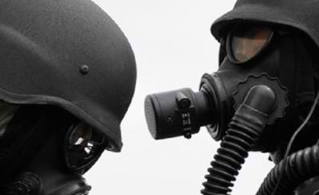
On September 12, last year, Syria’s President al-Assad committed to surrender Syria’s chemical weapons, with the caveats that the United States must stop threatening his country and supplying weapons to the terrorists. He has been as good as his word. The same cannot be said for the US and its boot licking allies.
Three days earlier US Secretary of State John Kerry – who had been killing Vietnamese in the US onslaught on Vietnam as American ‘planes rained down 388,000 tons of chemical weapons on the Vietnamese people (i) – had threatened Syria with a military strike if the weapons stocks were not surrendered within a week, stating that President Assad: “isn’t about to do it and it can’t be done.”
The ever trigger-happy Kerry was right on the second count, it can’t be done for two reasons, extracting dangerous chemicals from a war zone is, to massively understate, a foolhardy and hazardous business. Additionally it seems having received Syria’s agreement, the “international community” and the Nobel Peace Prize winning Organisation for the Prohibition of Chemical Weapons (OPCW) had no disposal plan in place and had not a clue what to do with them, whilst at every turn Syria is blamed.
As ever double standards and hypocrisy rule. According to CNN (10thOctober 2013):
“The United States estimates it will be at least another decade before it completes destruction of the remaining 10% of its chemical weapons, estimated at more than 3,100 tons.”
And Syria? “U.S. intelligence and other estimates put its chemical weapons stockpile at about 1,000 tons.” they are believed to be “stored in dozens of sites”, in the circumstances a logistical nightmare and a massive danger to the public and those driving them to be insisting on transporting them anywhere.
CNN also quotes Wade Mathews who had worked on “the U.S. project to destroy its chemical stockpile” who doubted that Syria could meet the deadlines. The US operation, he said: “took billions of dollars, the cooperation of many levels of government – including the military – and a safe environment to make sure the destruction was done safely.”
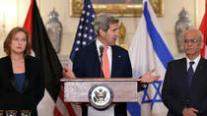
“We had a coordinated effort, we had a government that insisted that it be done safely and that the community was protected … I don’t think those things are in place in Syria.”

Shopping Around for a Country to Destroy the Weapons
Having received Syria’s compliance, the OPCW started shopping around for a country -any country it seems – to destroy the weapons. Norway, approached by the US, was first choice. They declined, since the country had no experience in dealing with chemical weapons, the Foreign Ministry website stating: “… Norway is not the most suitable location for this destruction.”

Norway Says No: What About Albania?
The second country approached was Albania, a request which the country’s Prime Minister Edi Rama said also came direct from the United States.
According to the Berlin-based Regional Anti-Corruption Initiative, Albania is one of the most corrupt countries in Europe and the most corrupt in the Balkans, plummeting from a woeful 95 out of the 176 countries monitored in 2011, to 113 in 2012 and 116 in 2013, on their Corruption Perception Index.
In their end of year Report, the Initiative quotes Transparency International:
“In Albania corruption is registering a new physiognomy in a favorable political environment, with characteristics like a new systems for money laundering, financing of political parties from illegal activities, the capture of the state through the control of procurement and privatization, human and narcotics trafficking and the impunity of high State officials before the justice system and the law.”(ii)
Protestors against the weapons destruction took to the streets in thousands, some wearing gas masks and protective clothing, protests also took place in neighbouring Macedonia, with rallying outside the Albanian Embassy.

Albania Says Sorry, We Cannot do It
Albania finally rejected with Rana apologetically grovelling to Washington: “Without the United States, Albanians would never have been free and independent in two countries that they are today”, he said referring to Albania and Kosova and the massive March 24th 1999 – June 10th 1999 NATO and US assault on the former Yugoslavia with depleted uranium weapons which are, of course, both chemical and radioactive. A Science Applications International Report explains re the residue from the weapons:
“Soluble forms present chemical hazards, primarily to the kidneys, while insoluble forms present hazards to the lungs from ionizing radiation … short term effects of high doses can result in death, while long term effects of low doses have been implicated in cancer.”
In addition to concerns regarding corruption in Albania -terrorist groups would undoubtedly offer high sums for such weapons – safety might surely have been a consideration. In 2008 an explosion at an ammunition storage depot near Albania’s capitol Tirana, killed twenty six people, wounded three hundred and damaged or destroyed five thousand five hundred homes. The disaster was said by investigators to be caused by a burning cigarette – in a depository for 1,400 tons of explosives.
Worse, when Albania was pressured to destroy its own chemical weapons stocks, some tons left over from the Cold War:
“The U.S. offered to pay for their destruction and later hired some private company which destroyed the weapon capability of the chemicals but otherwise left a horrendous mess.”
Hazardous waste was left in containers, on a concrete pad, inevitably they started to leak.
“In late 2007-early 2008, the US hired an environmental remediation firm, Savant Environmental, who determined the problem was worse than originally thought. Many of the containers were leaking salts of heavy metals, primarily arsenic, lead and mercury.”
Moreover, the conexes – large, steel-reinforced shipping containers – were not waterproof, thus lethally contaminated condensation and water leakage dissolved some of the contaminants which leaked onto the ground.
“Savant Environmental repackaged the waste and placed it in twenty shipping containers. There it sits, visible from space”, on the concrete pad – in the open.(iii)
All in all, why was Albania considered?
It is surely coincidence that on 3rd October last year, Tony “dodgy Iraq dossier” Blair, also an enthusiastic backer of Washington and NATO in their Balkans blitz, was appointed as advisor to the Albanian government to advise the impoverished country how to get in to the EU. Heaven forbid he might have advised that taking on lethal weapons no one else was prepared to touch, might tick quite a big approval box and made a call to someone somewhere in Washington. This is of course, entirely speculation.
However, as Pravda TV opined at the time, apart from the sorely needed financial boost: “It will increase the status and prestige of a poor country in Europe, Albania is in Europe’s backyard, in this case it will be going foreground.”(iv)

Belgium and France also Decline: “There Remain very few Candidates” for the Task; “the Hunt Continues”
Belgium and France also declined an invitation to dispose of Syria’s weapons, with Ralph Trapp, a consultant in disarming chemical weapons quoted as saying that “there remain very few candidates” for the task; “the hunt continues” commented The Telegraph (18th November 2013.)
The trail goes cold as to how many other governments may have been frantically begged to accept cargo loads of poisoned chalices as the US imposed clock ticked, but Italy caved in allowing around sixty containers to be transferred from a Danish cargo ship to a US ship in the Italian port of Giola Tauro, in Calabria, with further consignments also expected to arrive.
The permission caused widespread demonstrations in Southern Italy, the government accused of secrecy and one demonstrator summing up the prevailing mood:
“They are telling us that the material carried is not dangerous, but in fact nobody knows what is inside those containers.”
Not dangerous eh? Does any government, anywhere ever tell the truth?

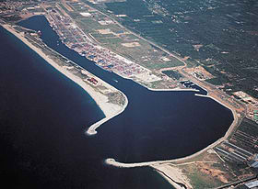
Italy Says Yes. Not Dangerous. Send the WMD to Calabria. It will Help the Local Economy, but Watch out for the Calabrese Mafia
The Giola Tauro port (right), which accounts for half the Calabria region’s economy “has been in crisis since 2011”, with four hundred workers on temporary redundancies – out of a total workforce of thirteen hundred. Not too hard to arm twist, the cynic might think.
The port also suffers from allegations of being a:
“ major hub for cocaine shipments to Europe by the Calabria-based ‘Ndrangheta mafia.” However, Domenico Bagala, head of the Medcenter/Contship terminal where the operation is planned countered with: “Since Gioia Tauro handles around a third of the containers arriving in Italy, it is normal that it has more containers that are seized”, adding: “We operate in a difficult territory but we have hi-tech security measures in place.”
Calabria is, in fact, plagued by corruption and organized crime. A classified cable from J. Patrick Truhn, US Consul General in Naples (2nd February 2008) obtained by Wikileaks stated:
“If it were not part of Italy, Calabria would be a failed state. The ‘Ndrangheta organized crime syndicate controls vast portions of its territory and economy, and accounts for at least three percent of Italy’s GDP (probably much more) through drug trafficking, extortion and usury.” Further: “During a November 17-20 visit to all five provinces, virtually every interlocutor painted a picture of a region …throttled by the iron grip of Western Europe’s largest and most powerful organized crime syndicate, the ‘Ndrangheta.”(v)
Moreover: “The ‘Ndrangheta is the most powerful criminal organization in the world with a revenue that stands at around fifty three billion Euros (seventy two billion U.S. dollars – forty four billion British pounds)” records Wikipedia, noting operations in nine countries, on four continents. Arguably, a less ideal transit point than Calabria for a stockpile of chemical weapons would be hard to find.
Of special concern to Carmelo Cozza of the SUL trade union is the port’s neighbouring village of San Ferdinando which has protested the operation: “The schools are right next door!”(vi)
However, when it comes to dodgy dealings, organized crime could seemingly learn a thing or two from the EU. Large amounts of Syria’s financial assets, frozen by the European Union, have simply been spirited from accounts, in what the Syrian Foreign Ministry slams as: “a flagrant violation of law.”
Last week the EU endorsed the raiding of Syria’s financial assets frozen across Europe and the the transfer of funds to
“ … the Organization for the Prohibition of Chemical Weapons (OPCW) … a flagrant violation of the international law and the UN Charter and understandings reached by the executive board of the OPCW”, commented a Foreign Ministry source, adding: “the European step violates the resolution of the OPCW executive board adopted on 15thNovember 2013 which acknowledged Syria’s stance which was conveyed to the Organization, officially stating the inability to shoulder the financial costs of destroying the chemical weapons.”
The theft of Syria’s moneys was condemned as a: “swindle policy practiced by some influential countries inside the EU at a time when they reject to release frozen assets to fund purchase of food and medicine which is considered the priority of the Syrian state … (meanwhile) the EU allowed its members to arm the terrorist groups which are responsible for bloodshed in Syria …” the source added.”(vi) It is hard to disagree.
The EU/UN/OPCW has apparently learned well from the UN weapons inspectors and other UN benefits from the Iraq embargo, which bled the country dry from “frozen” assets, to which they helped themselves, as the children died at an average of six thousand a month year after year, from “embargo related causes.” As the UN spent Iraq’s moneys, Iraq’s water became a biological weapon, the lights went off and medical and educational facilities largely collapsed. Are UN embargoes the UN’s shameful new money spinner?
So, can things get worse in the black farce which is the chaotic, dangerous, disorganised disposal attempts of Syria’s chemical materials? You bet they can.
The companies selected to destroy the chemicals are Finland’s Ekokem and the US subsidiary of the French giant Veolia.
“The most dangerous materials are to be neutralized at sea by the Cape Ray, an American naval vessel specially outfitted for that purpose, which departed its Norfolk, Va., home port on Jan. 27 for the Mediterranean.”(New York Times, 14th February 2014.)
A method which has never been tried before, an experiment seemingly to take place in the Mediterranean, not in US territorial waters. “It’s Not Just a Job, It’s An Adventure”, was a US Navy recruiting slogan. Doubt the population of the countries bordering the near enclosed Mediterranean feel quite the same, from Europe to Anatolia, North Africa to the Levant.
Additionally, the inclusion of Veolia as a suitable partner in the whole dodgy venture is in a class of its own. The company has long been involved in waste management and vast transport projects in the illegal settlements in Israel.
In November 2012 Professor Richard Falk, wrote, on UN note paper, to the (UK) North London Waste Authority who were considering awarding £4.7 billion worth of contracts to Veolia. His letter (viii) quoted in part below, detailing his concerns regarding the company’s compliance with international legal norms, speaks for itself:
“I am writing to you in my capacity as the United Nations Special Rapporteur on the situation of human rights in the Palestinian territories occupied since 1967 to urge you not to select Veolia for public contracts due to its active involvement in Israel’s grave violations of international law.
“Due to its deep and ongoing complicity with Israeli violations of international law and the strength of concern of Palestinian, European and Israeli civil society about the role played by Veolia, I decided to select Veolia as one of the case studies to include in my report. I have attached the report for your consideration.
“Veolia is a signatory to the UN Global Compact, a set of principles regarding business conduct. Yet its wide ranging and active involvement in Israel’s settlement regime and persistent failure to exercise due diligence show utter disregard for the human rights related principles of the Global Compact.
“It is my view that Veolia’s violations of the UN Global Compact principles and its deep and protracted complicity with grave breaches of international law make it an inappropriate partner for any public institution, especially as a provider of public services.”
Professor Falk concludes:
“I urge you to follow the example set by public authorities and European banks that have chosen to disassociate themselves from Veolia and take the just and principled decision not to award Veolia any public service contracts. Such a measure would contribute to upholding the rule of law and advancing peace based on justice.”
So a company in breach of international law is being awarded a contract to a UN body (the OPCW) in spite of being condemned by a distinguished UN legal expert and Special Rapporteur.

The Calabrese Ndrangheta Mafia: Specialized in Toxic Waste Disposal

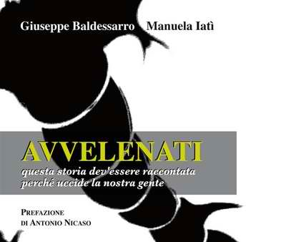
What the press reports fail to mention is that the Ndrangheta mafia operating out of The Giola Tauro port has for several years been involved in the lucrative trade of toxic waste disposal in Calabria. It’s a multibillion dollar business.
Giuseppe Baldessarro and Manuela Iati are the authors of a 2010 book entitled “Avvenelati” (“Poisoned”) which carefully documents the trade and disposal of toxic waste including chemicals and radioactive materials by the Calabrese Ndrangheta mafia.
According to the authors, the truth regarding Ndrangheta’s insidious role “has been poisoned” ["la vérité a été "empoisonnée"]. The Italian State protects the Ndrangheta mafia:
“Each time there is a police investigation, unusual things happen, the investigators land up dead … The secret services intervene, it’s chaotic. There’s big money involved.” ( quoted by Delphine Saubaber, “Découvrir la vérité sur la ‘Ndrangheta provoquerait un séisme politique”, L’Express, 20 July 2010, translated from French by GR)
Cancer deaths in Calabria are extremely high, according to Baldessarro and Iati. “There are places in Calabria where one person in 10 has cancer indicating that toxic waste has contaminated the soil and water.” (Ibid)

Italy’s Plan B: The Important Unanswered Question
Does the disposal of Syria’s chemical weapons by the two selected waste disposal companies, namely Finland’s Ekokem and France’s Veolia require a contractual arrangement (or “agreement”) with Italy’s most powerful criminal syndicate on behalf of the Nobel Peace Prize winning Organisation for the Prohibition of Chemical Weapons (OPCW)?

Collateral Achievement. Israel’s Middle East Monopoly over a Second Weapon of Mass Destruction: Chemical Weapons
With regard to Middle East geopolitics, another anomaly, as Bob Rigg -former UN weapons inspector in Iraq, and former senior editor for the OCPW and former Chair of the New Zealand National Consultative Committee on Disarmament- points out:
“At present, Israel has a monopoly on nuclear weapons in the Middle East. Once the destruction of Syria’s chemical weapons is complete, Israel will enjoy a near regional monopoly over a second weapon of mass destruction -chemical weapons. In addition to Israel, Egypt is the only regional power with a chemical-weapons capability. “
At all levels, law breakers rule supreme.

►Visit references at source’s URL.

USAF to Enhance CBRN Training with Argon’s PlumeSIM
Source: http://www.hstoday.us/single-article/usaf-to-enhance-cbrn-training-with-argons-plumesim/e97 df5d01c1a339b1a9eb846df05d475.html

Argon Electronics has been contracted by the United States Air Force through the Air Force Civil Engineer Center to deliver their PlumeSIM CBRN training system to enhance CBRN exercises during the Silver Flag Exercise Site at Tyndall Air Force Base, Florida.
PlumeSIM will be used with Argon’s M4 JCAD simulators to create highly realistic CBRN and HazMat exercises, implemented in both virtual and live training environments, according to Argon.
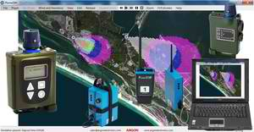
“The system will permit challenging exercises involving Chemical Warfare Agents and Toxic Industrial materials in a wide range of scenarios to be implemented with ease,” Argon said in a statement. “The highly flexible PlumeSIM architecture will enable the system to be expanded to support any future potential CBRN/HazMat simulation requirements the USAF may have.”
The PlumeSIM provides Air Force Emergency Management “with a realistic way to demonstrate their equipment proficiency and knowledge in a CBRN environment during field training exercises without the risk of personnel injury and damage to the environment or operational equipment,” the firm said, adding that “The realistic scenarios and After Action Review capability within PlumeSIM will help ensure Emergency Management response teams maintain the highest standards of readiness, while also providing a valuable means to verify student performance.”
“We are absolutely delighted to be delivering PlumeSIM to one of the foremost CBRN training facilities in the world,” said Argon Managing Director Steven Pike. “The Air Force has been an important and long standing customer of Argon. This contract further demonstrates the importance the US government places on the need to maintain CBRN skills to ensure an effective response capability.”

Not much is known about long-term health effects of chemical leaked in W.Va.
Source: http://www.homelandsecuritynewswire.com/dr20140224-not-much-is-known-about-longterm-health-effects-of-chemical-leaked-in-w-va

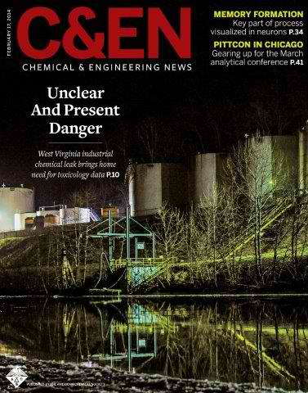
In January, 10,000 gallons an obscure chemical called 4-methylcyclohexane-methanol, or MCHM, used in processing coal, leaked from storage tanks into the nearby Elk River in the Charleston, West Virginia area, contaminating the water of more than 300,000 residents for days. To what degree MCHM affects long-term human and fetal health is a major concern for residents because of the lack of complete toxicology and other studies on the chemical.
The chemical leak which contaminated drinking water in the Charleston, West Virginia area last month put in sharp relief the shortcomings of the policies and research that apply to thousands of chemicals in use today. An article in Chemical & Engineering News (C&EN), the weekly magazine of the American Chemical Society (ACS), delves into the details of the accident that forced 300,000 residents to live on bottled water for days.
An ACS release reports that a team of C&EN reporters and editors note that the main chemical that leaked into the water supply is an obscure one called 4-methylcyclohexane-methanol, or MCHM, which has a black licorice scent. Freedom Industries, the company that owned the leaking tank, used it to process coal. Freedom hypothesizes that the ground beneath the tank froze and caused it to rupture. As a result, an estimated 10,000 gallons of crude MCHM and associated material flowed into the nearby Elk River. Soon after, residents reported a licorice smell in their water, with some also experiencing rashes, mild burns, and stomach upset.
To what degree MCHM affects long-term human and fetal health is a major concern for residents because of the lack of complete toxicology and other studies on the chemical. This gap of information goes back to the timing of the chemical’s commercialization and subsequent scaling-up that largely allowed it to slip through regulatory holes. The tests that have been done suggest that MCHM is a skin and eye irritant. The lack of information has spurred more research and discussion on how to improve the handling of such accidents in the future.

— Read more in Alexander H. Tullo et al., “Obscure Chemical Taints Water Supply: Chemical contamination of West Virginia drinking water system raises scientific, policy shortcoming,” Chemical & Engineering News 92, no. 7 (17 February 2014): 10-15

After failing 5 February deadline, Syria wants 100-day extension to remove chemicals
Source: http://www.homelandsecuritynewswire.com/dr20140224-after-failing-5-february-deadline-syria-wants-100day-extension-to-remove-chemicals

After missing the 5 February deadline to have all its chemical weapons removed from its territory, Syria has submitted a new 100-day plan for their removal. The international group monitoring the operation says the completion of the removal can be accomplished in less time than that.
The Organization for the Prohibition of Chemical Weapons (OPCW) executive committee met on Friday in The Hague to discuss the joint OPCW and UN mission at a time when there is a growing international frustration with Syria over its failure to live up to its commitments.
Arutz Sheva reports that the Syrian government failed to meet the 5 February OPCW deadline to move all of its declared chemical substances and precursors out of the country.
The OPCW deadline for all of Syria’s declared chemical materials to be destroyed is 30 June.
“The Syrian 100 day plan for removal of the chemicals, on which we have been briefed, is not adequate,” Philip Hall, head of the British Foreign Office Counter Proliferation Department, told the OPCW, according to a copy of his statement.
“We now urge the Syrian authorities to accept the proposals submitted by the Operational Planning Group that provide for removal in a much shorter time frame, without compromising on security,” he said.
A senior UN diplomat, briefing reporters on condition of anonymity, said the OPCW believes the operation can be carried out before the end of March, adding that Syria’s proposed end-May deadline would not leave enough time for the chemicals to be destroyed before the end of June.
Specialists say that the MV Cape Ray, a U.S. ship equipped with special equipment to neutralize the most toxic of Syria’s chemicals at sea, will require ninety days to complete the destruction.
“The international community has put into place everything that is necessary for transport and destruction of these chemicals. Sufficient equipment and material has been provided to Syria. The ships to carry the chemicals away from Syria are waiting,” said Robert Mikulak, U.S. ambassador to the OPCW.
“The U.S. ship to destroy CW agent and precursors is now in the region and waiting. Commercial facilities to destroy other chemicals have been selected and contracts awarded; they are waiting. And yet Syria continues to drag its feet,” he said.
Syria had 1,300 tons of declared chemicals, Mikulak said, and 95.5 percent of the worst toxins and 81.1 percent of priority two chemicals remained in the country. The worst chemicals are supposed to be destroyed by the end of March and the rest of the arsenal by the end of June.
“Syria should revise its 100-day transport schedule to embrace the recommendations developed by the OPCW, the UN … to expedite removal,” said Mikulak.
Sigrid Kaag, head of the international inspection mission in Syria, said a few days ago that she did not believe Syria was intentionally delaying the removal of its chemical arsenal, but that accelerated cooperation was vital to meet the mid-year deadline.
“Intermediate milestones ideally should have been met, they have not been met, there are delays,” she said. “Delays are not insurmountable. Delays have a reason, there’s a rationale, there’s a context.”

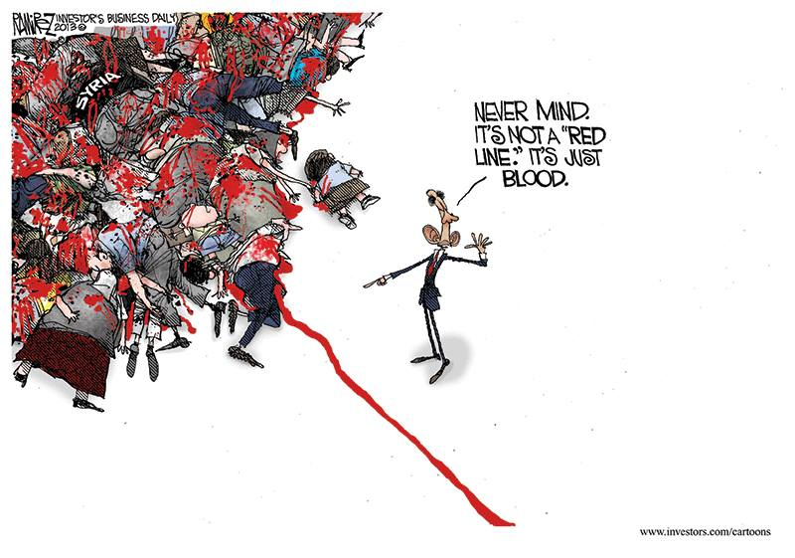

Are you aware of these names?

Source: http://adventure.howstuffworks.com/top-5-poisonous-plants1.htm#page=1

- Manchineel  - Jimsonweed  - Aconite  - White Snakeroot  - English Yew | - Castor Bean  - Deadly Nightshade  - Rosary Pea  - Water Hemlock  - Oleander

Manchineel
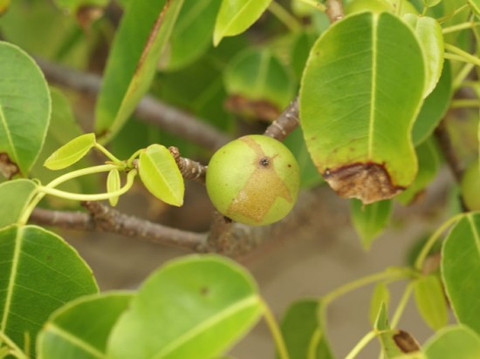
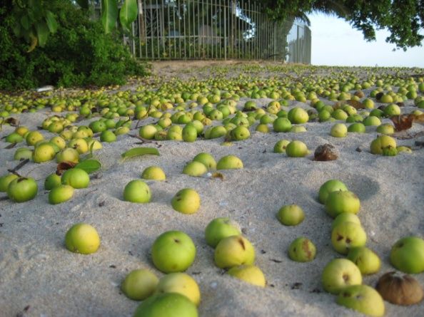
Would you believe that there's a tree so poisonous that you don't actually have to touch it to be harmed? It's called the manchineel tree (Hippomane mancinella), found throughout the Florida Everglades, Central America and the Caribbean. Inhaling sawdust or smoke from the 30-foot (9.1-meter) tall tree may result in a variety of uncomfortable side effects, including coughing, laryngitis and bronchitis. Some reports suggest that simply standing beneath the tree during a rainstorm and being splashed by runoff may result in rashes and itching. Your car isn't even safe from this toxic tree: Park under its low branches, and dripping sap can seriously damage the paint.
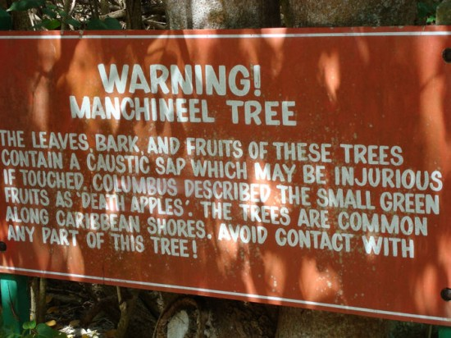
Direct contact with the manchineel tree is far more hazardous. Its milky sap can squirt from the tree when twigs are snapped off, painfully irritating the skin and eyes. Ingestion of the deceptively sweet, crabapple-like fruits is known to blister the mouth and cause the throat to swell shut, and then inflict severe gastrointestinal problems. These harmful effects result from the toxin hippomane A and B, which are present in every part of the tree.

The manchineel tree sometimes grows near the beach, giving it another of its common names, "beach apple." Hapless tourists vacationing on the warm coasts of Central America and the Caribbean often encounter its poisonous boughs with unfortunate consequences.

Oleander
The oleander, or Nerium oleander, is considered by many to be the most poisonous plant in the world. All parts of the beautiful oleander contain poison -- several types of poison. Two of the most potent are oleandrin and neriine, known for their powerful effect on the heart. An oleander's poison is so strong, in fact, that it can poison a person who simply eats the honey made by bees that have digested oleander nectar.
The oleander is an attractive plant, and despite its deadly reputation is often planted for decorative purposes. Although native to the Far East and the Mediterranean areas, oleander has been introduced in the United States, where it grows easily. It's tolerant of poor quality soil and dry weather. The plant grows as a dense shrub, and is typically 6 to 18 feet (1.8 to 5.4 meters) tall at maturity. It has thick, dark green leaves, and the flowers, which grow in clusters, can be yellow, red, pink or white.
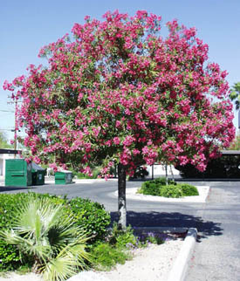
Even in barren areas, the oleander produces lovely flowers and fragrance. Animals instinctively avoid the plant, and it grows rapidly, so it's often used for highway barriers and other areas that require screening from noise and pollution. Its rapid growth also makes it a popular choice around new construction zones, as it prevents erosion.
Unlike some toxic plants, the oleander is poisonous to most animals as well as humans. A single ingested oleander leaf can kill a child. Ingestion of oleander results in diarrhea, vomiting, intense stomach pain, drowsiness, dizziness, an irregular heartbeat, and often, death. If the victim survives the initial 24 hours after ingestion, his or her odds of surviving increase dramatically. For successful treatment, the patient is induced to vomit, his or her stomach may be pumped, or he or she may be fed activated charcoal to absorb as much of the poison as possible.

EDITOR’S COMMENT: You can read more in the source’s URL. Reasoning behind this post: Some might consider “castor beans” as old fashion and thus explore new ways to deliver threat signals or use nature to intentionally kill people. Knowledge is power and preparedness the best medication.

Pakistan's Polio Crisis Poses Wider Threat
Source:http://online.wsj.com/news/articles/SB10001424052702304027204579334142274363428?mg=reno64-wsj&mg=reno64-wsj&url=http%3A%2F%2Fonline.wsj.com%2Farticle%2FSB100014240527 02304027204579334142274363428.html%3Fmg%3Dreno64-wsj

The country's polio crisis is threatening to spread the virus across the world, health officials said, as Islamist militants target vaccination teams, killing three health workers in the latest such attack on Tuesday.
The world's largest polio reservoir is here in the city of Peshawar, on the doorstep of Taliban-controlled tribal areas, World Health Organization officials said.
The dreaded virus has been almost wiped out in recent years, but the Pakistani strain of polio was found in Syria in recent months, possibly carried by militants joining the civil war there.
Pakistanis could face travel restrictions this year when health experts convene at the WHO to consider how to deal with the disease's outbreak, said Sana Bari, a spokeswoman for the WHO in Geneva.
Last week, the WHO said India had gone three years without a polio case. There are now just two other nations where health experts classify polio as "endemic": Afghanistan and Nigeria.
A major cause of the worsening crisis is connected with the U.S., Pakistani officials say. The Central Intelligence Agency used a fake vaccination campaign as cover for its hunt for Osama bin Laden in northern Pakistan in 2011. Pakistani health workers across the country are now suspected of being spies, and targeted by the militants. U.S. officials haven't commented on the Pakistani allegations, and the CIA defended its tactics at the time, insisting the vaccination campaign was genuine.
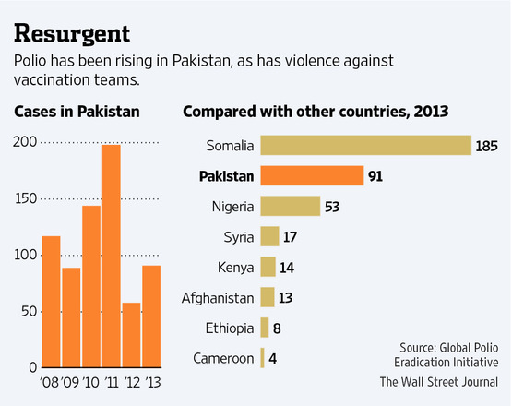
In the latest such attack on Tuesday, in a central district of Pakistan's biggest city, Karachi, gunmen on motorbikes shot and killed three members of a vaccination team—two of them women—and injured two others.
Hard-line clerics have long opposed the polio drops, but the CIA's use of a vaccinator have confirmed their worst suspicions. The Pakistani Taliban's main umbrella group, known as Tehreek-e-Taliban Pakistan, hasn't claimed responsibility for the killings of vaccinators. Security experts say they believe, however, that it is the work of the TTP and allied militant groups.
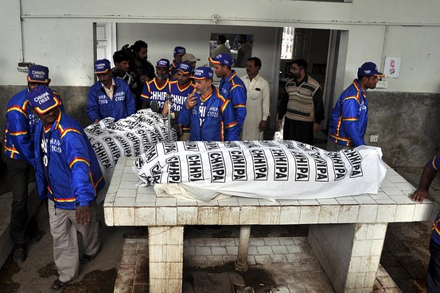
"We are against these polio vaccinations," said Ehsanullah Ehsan, a TTP spokesman. "It is against Islam and our traditions. These foreign nongovernmental organizations can easily use polio as cover for spying."

Pakistani rescue workers stand beside the bodies of polio vaccination workers at a hospital in Karachi. European Pressphoto Agency

Peshawar, the main city in the country's troubled northwest, has become home to the world's largest reservoir of the polio virus, the WHO warned last week.
In Peshawar, 10-month-old Baseerat has been diagnosed with polio, which has already crippled her right foot. In her case, health workers say they suspect that last year's suspension of the polio campaign in her area of Peshawar after a female polio worker was killed could have meant she missed some rounds of drops.
Najibullah, the girl's uncle, a laborer who took Baseerat's family into his three-room house after her father committed suicide, said: "I have my own children to look after, too. Only God is keeping us going now."
In mid-2012, as Pakistan was close to eliminating the disease, militants banned the vaccinations in tribal areas they control and unleashed a campaign of assassinations against the health workers, who go door to door to administer polio drops.
Many of the vaccinators are women. Their trade union, the Lady Health Workers Association, said it would go on strike to protest the lack of security. Polio workers are paid 250 rupees a day, or less than $2.50, for what has become one of the most dangerous jobs in Pakistan.
Since mid-2012, 32 polio health workers have been killed, according to Unicef, the United Nations children's organization helping lead the vaccination effort in Pakistan.
At the crowded bus stands in Peshawar, a good place for health workers to reach children, the impact of the militant attacks is obvious. The polio workers don't wear identifying clothing or badges. They gingerly approach families with children, offering the drops, which are carried in ordinary plastic shopping bags. Most parents readily agree.
However, at the main bus stop serving North Waziristan on the city's Kohat Road, the situation is different. As many as 80% of parents going to Miranshah, the main town in North Waziristan, refused the drops, said Ateeq ur Rehman, who supervises 10 polio workers at the Kohat Road bus stand, which serves all parts of the tribal areas.
"They won't give their reasons for refusing," said Mr. Rehman. "We try to reason with these parents but they get angry."
While Nigeria and Afghanistan cut the number of polio cases in 2013, the number of children paralyzed by the disease in Pakistan almost doubled and was more than the other two countries combined.
"As long as any country is endemic, it represents a threat to all countries in the world," said Ms. Bari.
With some 300,000 children unreachable because of the militants' ban on vaccinations in the North and South Waziristan tribal areas, and the violence elsewhere, a major outbreak of the disease is now feared.
The CIA had recruited a Pakistani doctor, Shakil Afridi, who ran a fake door-to-door vaccination campaign in 2011 in Abbottabad, a town in north Pakistan, in an attempt to get DNA samples from the house where it was suspected the al Qaeda leader lived.
Although Dr. Afridi, who is in jail in Pakistan after a conviction on an unrelated case that his lawyers insist is trumped up, was providing vaccinations for hepatitis B, not polio, the CIA's use of a doctor for spying has cast suspicion on all health workers, said Pakistani officials and international aid professionals.
"It is because of Shakil Afridi that militants have taken up this issue," said Zaheer ul Islam, a senior Peshawar city administration official. "The whole polio-vaccination program has been sabotaged by this Shakil Afridi."
Washington has been pressing for the release of Dr. Afridi. Congress decided last week to hold back $33 million of aid in protest—$1 million for every year of his prison sentence.
Defending the jailing of Dr. Afridi, Pakistan's Ministry of Foreign Affairs said Monday: "His action also caused immense damage to the polio campaign in the country."
Pakistan diagnosed 91 children who had been paralyzed by the polio virus in 2013, up from 58 cases in the previous year, said health officials. For every paralyzed child, 200 more are estimated to have contracted the infection. Foreign donors largely fund the vaccination drive.
Peshawar, the tribal areas, and Karachi are the three main pockets left of the disease, health officials said.
"The government of Pakistan is trying its best," said Safdar Rana, a senior health official in Islamabad dealing with polio. "But we need to be supported by all means possible."

EDITOR’S COMMENT: What is missing of this alarming article is the implication of mass illegal immigration in other countries. For example in Greece significant proportion of illegal immigrants are originating from Pakistan – including small children (2012: 11,136; 2013: 3,744*). Same vaccination policy is enforced also in Afghanistan (2012: 16,584; 2013: 5,960). Also do not forget the rising polio problem in Syria (2013:7,665). There will be no surprise if old extincted diseases reappear in the Western (sleeping) world!

* Data from official Greek Police website:
http://www.astynomia.gr/index.php?option=ozo_content&perform=view&id=24727&Itemid=73&lang=

Turkeys inspire smartphone-capable early warning system for toxins
Source: http://newscenter.berkeley.edu/2014/01/21/turkey-inspired-chemical-sensors/

Some may think of turkeys as good for just lunch meat and holiday meals, but bioengineers at UC Berkeley saw inspiration in the big birds for a new type of biosensor that changes color when exposed to chemical vapors. This feature makes the sensors valuable detectors of toxins or airborne pathogens.
Researchers took inspiration from the way turkey skin color is altered to create a new sensor that can change color when exposed to volatile chemicals. (Photos by Valerie Burtchett)
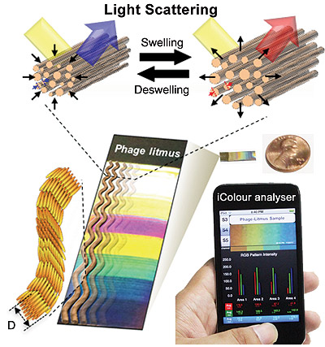
Turkey skin, it turns out, can shift from red to blue to white, thanks to bundles of collagen that are interspersed with a dense array of blood vessels. It is this color-shifting characteristic that gives turkeys the name “seven-faced birds” in Japanese and Korean.
The researchers say that spacing between the collagen fibers changes when the blood vessels swell or contract, depending upon whether the bird is excited or angry. The amount of swelling changes the way light waves are scattered and, in turn, alters the colors we see on the bird’s head.
Seung-Wuk Lee, UC Berkeley associate professor of bioengineering, led a research team in mimicking this color-changing ability to create biosensors that can detect volatile chemicals.
“In our lab, we study how light is generated and changes in nature, and then we use what we learn to engineer novel devices,” said Lee, who is also a faculty scientist at the Lawrence Berkeley National Laboratory.
The researchers created a mobile app, the iColour Analyser, to show that a smartphone photo of the sensor’s color bands could be used to help identify chemicals of interest, such as vapor of the explosive TNT. They described their experiments in a study published today (Tuesday, Jan. 21) in the journal Nature Communications.
Sensors that give off color readings are easier to use and read than conventional biosensors. However, the major color-based sensors in development elsewhere can only detect a limited range of chemicals and, according to the researchers, they can be very difficult to manufacture.
“Our system is convenient, and it is cheap to make,” said Lee. “We also showed that this technology can be adapted so that smartphones can help analyze the color fingerprint of the target chemical. In the future, we could potentially use this same technology to create a breath test to detect cancer and other diseases.”
Bio-inspired sensors are made from bacteriophages that mimic the collagen fibers in turkey skin. When exposed to target chemicals, the collagen-like bundles expand or contract, generating different colors. The researchers also created a mobile app to be used with smartphones to help analyze the sensor’s color bands. (Schematic courtesy of the Seung-Wuk Lee Laboratory)
In copying this turkey-skin design, Lee and his team employed a technique they pioneered to mimic nanostructures like collagen fibers. The researchers found a way to get M13 bacteriophages, benign viruses with a shape that closely resembles collagen fibers, to self-assemble into patterns that could be easily fine-tuned.
The researchers found that, like collagen fibers, these phage-bundled nanostructures expanded and contracted, resulting in color changes. The exact mechanism behind the shrinking or expanding phage bundles is still unclear, but it’s possible that the small amount of water in the phage is reacting to the chemical vapors, the researchers said.
The turkey-inspired biosensors were exposed to a range of volatile organic compounds, including hexane, isopropyl alcohol and methanol, as well as TNT, at concentrations of 300 parts per billion. The researchers found that the viruses swelled rapidly, resulting in specific color patterns that served as “fingerprints” to distinguish the different chemicals tested.
The researchers showed that the biosensor’s specificity to a target chemical could be increased by genetically engineering the DNA in the M13 bacteriophage to bind with sites specific to TNT. The biosensor was then exposed to two additional chemicals, DNT and MNT, which have similar molecular structures to TNT. The engineered biosensor successfully distinguished TNT from the other chemicals with distinct color bands.
The biosensors were also able to signal changes in relative humidity, ranging from 20 percent to 90 percent, becoming redder with moister air and bluer with drier air.
The study lead author is Jin-Woo Oh, a former postdoctoral researcher in Lee’s lab and now an assistant professor in the Department of Nanomaterial Engineering at Pusan National University in South Korea.
The National Science Foundation, the Defense Acquisition Program Administration and Agency for Defense Development in South Korea, Korea’s Ministry of Education, Science and Technology, and Samsung helped support this work.

— Read more in Jin-Woo Oh et al., “Biomimetic virus-based colourimetric sensors,” Nature Communications 5, Article number: 3043 (21 January 2014)

Substitute for conventional antibiotics: Researchers discover a protein that kills bacteria
Source: http://www.homelandsecuritynewswire.com/dr20140123-substitute-for-conventional-antibiotics-researchers-discover-a-protein-that-kills-bacteria

In the arms race between bacteria and modern medicine, bacteria have gained an edge. In recent decades, bacterial resistance to antibiotics has developed faster than the production of new antibiotics, making bacterial infections increasingly difficult to treat. Scientists worry that a particularly virulent and deadly “superbug” could one day join the ranks of existing untreatable bacteria, causing a public health catastrophe comparable with the Black Death.
Now, a Tel Aviv University release reports, research led by Dr. Udi Qimron of Tel Aviv University’s Department of Clinical Microbiology and Immunology at the Sackler Faculty of Medicine has discovered a protein that kills bacteria. The isolation of this protein, produced by a virus that attacks bacteria, is a major step toward developing a substitute for conventional antibiotics. “To stay ahead of bacterial resistance, we have to keep developing new antibiotics,” said Dr. Qimron. “What we found is a small protein that could serve as a powerful antibiotic in the future.”
Dr. Ido Yosef, Ruth Kiro, and Shahar Molshanski-Mor of TAU’s Sackler Faculty of Medicine, and Dr. Sara Milam and Prof. Harold Erickson of Duke University, contributed to the research, published in the Proceedings of the National Academy of Sciences.

Teaming up with a killer
Bacterial resistance is a natural process. Over the past sixty years or so, however, the misuse and overuse of antibiotics has pushed more and more bacteria to become more and more resistant, undermining one of the pillars of modern health care. Recently, the World Health Organization named growing antibiotic resistance one of the three greatest threats to public health.
Bacteriophages, often referred to as “phages,” are viruses that infect and replicate in bacteria. Because they coevolved with bacteria, they are optimized to kill them. As proof of their endurance, phages are the most common life form on earth, outnumbering bacteria ten to one. In places like the former Soviet Union, phages have been used to treat bacterial infections for the past hundred years.
Harmless to humans, they inject their DNA into bacteria and rapidly replicate, killing their hosts.
“Ever since the discovery of bacteriophages in the early twentieth century, scientists have understood that, on the principle of the ‘enemy of my enemy is my friend,’ medical use could be made of phages to fight viruses,” said Dr. Qimron.

Breaking out the little guns
Dr. Qimron and his colleagues set out to understand how all fifty-six proteins found in T7, a particularly virulent phage that infects Escherichia coli bacteria, contribute to its functioning. They discovered that one of the proteins, called 0.4, impedes cell division in E. coli, causing the cells of the bacteria to elongate and then die. The protein is common to many bacteria and a similar process occurs in all bacteria, so the finding may have wide application.
No bacteriophage preparation has been approved in Western medicine for treating systemic bacterial infections. One reason is their inability to penetrate body tissues effectively. They are filtered effectively from the bloodstream by the spleen and liver, and occasionally neutralized by antibodies. The 0.4 protein, however, is much smaller than a whole phage, and so should be able to penetrate tissue better, getting to the bacteria to do its deadly work.
The major challenge for pharmaceutical companies will be figuring out how exactly to deliver the protein as a drug, said Dr. Qimron. In the meantime, he continues to hunt for other proteins that kill bacteria.

— Read more in Ruth Kiro et al., “Gene product 0.4 increases bacteriophage T7 competitiveness by inhibiting host cell division,” Proceedings of the National Academy of Sciences 110, no. 48 (26 November 2013)

Florida teenager faces bioterrorism charges
Source: http://www.homelandsecuritynewswire.com/dr20140124-florida-teenager-faces-bioterrorism-charges

Jesse Korff, 19, of Labelle, Florida is facing federal charges in New Jersey for selling poison through a black marketplace on the underground Internet.
Law enforcement says from November 2013 through 15 January this year, Korff produced, stockpiled, and sold abrin for use as a weapon.
The Center for Disease Control and Prevention (CDC) considers abrin, which is extracted from the seeds of the rosary pea plant, a subset of biological agents and toxins posing a threat to public health and safety. Small doses of abrin are potentially lethal to humans if ingested, inhaled, or injected.
“The criminal complaint alleges Jesse Korff was willing to sell a potentially deadly toxin to a stranger over the Internet,” U.S. Attorney Paul Fishman said in a statement. “He allegedly peddled the poison on a virtual black market of illegal and dangerous goods, hidden in the shadow of a secretive computer network favored by cybercriminals.”
“We’re talking basically a biohazard type situation,” Special Agent Dave Couvertier, with the FBI’s Tampa office, said. “Potentially a weapon of mass destruction, depending on how you utilize it.”
News-Press reports that Korff allegedly sold abrin through anonymous marketplace Black Market Reloaded, a site only accessible on the Tor network, and where purchases can be made using decentralized electronic currency Bitcoin. A DHS undercover agent in Newark created a BMR user account and reached out to Korff with questions about the toxin.
On 23 December Korff allegedly wrote the agent back, saying that abrin was “not a pill” but “comes in a liquid to put in a drink or in food like the bun of a cheeseburger.” The complaint says that four days later Korff told the undercover agent he would conceal the toxin in a hollowed-out candle with wax poured on top. The complaint says that Korff cautioned the agent that the drink designated to be poisoned “should be somewhat dark,” suggesting either coke or a shot of brown liquor. “Actually alcohol would probably be the best because you know they will drink all of it,” Korff allegedly wrote. “And they will start to feel flu like symptoms in 48 hours, then it will progressively get worse until they die by the forth [sic] day.”
Court documents show that on 31 December the agent sent Korff a message agreeing to send $1,500 in Bitcoin in exchange for one dose of abrin. He asked Korff what the death of his intended victim would
Court documents show that on 31 December the agent sent Korff a message agreeing to send $1,500 in Bitcoin in exchange for one dose of abrin. He asked Korff what the death of his intended victim would look like to a doctor, to which Korff, on 1 January, replied, “a really bad case of the flu” and that “no doctor will suspect foul play so there will most likely be no autopsy.”
On 5 January Korff messaged the gent with a Bitcoin address for the payment and with the location of a Florida rest stop where Korff would leave the abrin for the agent to pick up. The complaint says that agent in several messages indicated to Korff he would be driving down from Canada to pick up the toxin and take it back to his home country.
On 13 January Korff allegedly answered some of the undercover agent’s concerns by saying, “I guarantee it will work … if you drop the abrin in someone’s drink Wednesday he will be dead Friday and there is no way to trace it after 24 hours of ingestion.” Korff then offered to sell the undercover a second dose of abrin for a discounted price of $1,000, court documents show.
On 14 January officials set surveillance of the rest stop, and later that day saw the driver of a Buick inspecting areas of land near the road. Investigators were able to trace the Buick back to Korff and also began monitoring the man’s home.
The same day Korff allegedly sent the agent photographs of the proposed drop-off point and said he would put the abrin-containing candles in a McDonald’s bag behind a No Trespassing sign. Korff was arrested after agents saw him leave his home, go into a McDonald’s near the rest stop, and leave the food bag in the location shown in the photos.
News-Press notes that a lab test found the toxin to contain “a detectable amount of abrin.”
Korff was charged with one count each of possession and transfer of a toxin for use as a weapon and smuggling goods out of the United States. Korff will make a bail hearing before a federal court in Fort Myers, Florida, later today (Friday). He will then be taken to New Jersey to appear in Newark federal court.
“Had this been an actual sale to a real customer, the consequences could have been tragic,” Fishman said. “Fortunately, an undercover law enforcement officer posing as a buyer was able to get a dangerous chemical weapon and its alleged seller off our streets.”
Korff faces up to life in prison and a $250,000 fine for the charge of possession and transfer of a toxin for use as a weapon. He faces up to ten years in prison and a $250,000 fine for the charge of smuggling goods from the United States.

EDITOR’S COMMENT: When I included the first article in this Chapter it was like I knew that sooner or later someone would try to take advantage of Nature’s poisons. And he was on 19 years old…

►This plant may sound pious, but it's actually deadly. Rosary peas got their name from their traditional use as ornamental beads for rosaries.

They are used in jewelry around the world. Many jewelry makers have died after pricking a finger while handling rosary peas.

Sudan's connection to Syria's WMDs
By Jill Bellamy
Source: http://www.israelhayom.com/site/newsletter_opinion.php?id=7121

As international attention focuses on the destruction of Syria's long-denied chemical weapons program, its biological weapons program, although acknowledged in 2012 by then-Foreign Ministry spokesman Jihad Makdissi, remains in the shadows.
For decades, as President Bashar Assad quietly built his chemical arsenal from trading with partners such as Germany and the Netherlands, these activities and the sale in chemical precursors, which are illegal under the U.N. Chemical Weapons Convention, slid under the radar and caused no real concern. For the most part, the sale of chemical precursors to states like Iraq, Iran and Syria were largely ignored or, in some instances, denied by nonproliferation parties who were more inclined to criticize the United States for their engagement in Iraq and failing to support the Biological and Toxin Weapons Convention, Verification Protocol. The protocol would have allowed inspectors drawn from countries like Iran to enter the U.S.'s most classified defense laboratories. As Syria quietly amassed a huge chemical weapons arsenal, nonproliferation and arms control nongovernmental organizations and even several state signatories to the Chemical Weapons Convention looked the other way.
Today, as Syria's chemical weapons stockpiles are destroyed at sea, their biological weapons program is willfully being ignored, just as their chemical weapons program was for decades. The focus on its chemical weapons destruction is a highlight for nonproliferation experts who will likely try to claim victory over something they denied was happening for two decades. Syria has a developed biological weapons program that currently continues to be treated in the same circles with high skepticism, denial, ignorance, in much the same way that its chemical weapons programs were until these weapons were deployed on the streets of Damascus. At that point, little room was left for the disbelievers to pretend that Assad had no chemical weapons repositories and or no-intent to use this as a strategic weapon.
Even with the use of chemical weapons in Damascus, there has been no major outcry for Assad to hand over his biological weapons program just as there was no outcry, particularly from nations who collected extensive intelligence on this, over his chemical weapons stockpile. It was only until the use of sarin and only after some 10 other chemical deployments (of between 14 and 16 in total), efforts had to be taken in order for the nonproliferation community to appear to be at the helm. While weapons experts and inspectors for the most part acknowledge that Assad's chemical and biological weapons programs have existed for decades, the nonproliferation community remains largely willing to look the other way or deny biological weapons programs exist at the Scientific Studies and Research Center in Damascus.
Ake Sellstrom, who headed the U.N. inspection team, issued a report on Sept. 16 that, as reported by AP, "concluded that evidence collected in the Ghouta area of Damascus following an attack on August 21 provided 'clear and convincing evidence that surface-to-surface rockets containing the nerve agent sarin were used.' Thursday's report said evidence indicated chemical weapons were probably used in Khan al Assal outside Aleppo, Jobar in the eastern suburbs of Damascus, Saraqueb near Idlib in the northwest, and Ashrafiah Sahnaya in the countryside outside Damascus."
While the Chemical Weapons Convention inspection regime, the Organization for the Prohibition of Chemical Weapons, has already announced it will run out of funding to destroy current stockpiles, of additional concern is the transfer of chemical and biological weapons to Hezbollah in Lebanon. The idea that chemical and possibly biological weapons were already transferred to Lebanon over a year ago is met with general denial by arms control and nonproliferation advocates alike. Khaled Daher, a member of Lebanon's parliament, stated that "Iran's Revolutionary Guards constructed underground bunkers and storerooms in Lebanon to house long-range missiles capable of carrying chemical warheads that Hezbollah received from Syria."
When Israel dares to raise the subject of biological or other unconventional weapons, or provide its "allies" with evidence of almost any class of weapon acquired by Hezbollah, Iran, Syria, Sudan or any other terrorist organization, it is usually swiftly rebuked and generally treated with skepticism, marginalized, and in some circles, treated with hostility just for providing such intelligence. Until chemical weapons were used on Syrian civilians, Israeli intelligence was dismissed.
Even when it is accepted that a state has programs to develop weapons of mass destruction, those who oppose dealing with this reality will often formulate arguments on "intent." Until sarin was deployed in Damascus and other sites, most WMD experts cautioned that Assad did not have the intent even if he had the capability and that Syria's programs were for deterrence. It is thus time to take a sober look at Assad's biological weapons programs and "intent," before they too are used.
In an article that appeared recently in The Times of Israel, the staff writer noted:
"In an unclassified report in April, U.S. Director of National Intelligence James Clapper assessed that Syria could be capable of producing limited biological weapons. 'Based on the duration of Syria's long-standing biological warfare program, we judge that some elements of the program may have advanced beyond the research and development stage and may be capable of limited agent production,' Clapper wrote. 'Syria is not known to have successfully weaponized biological agents in an effective delivery system, but it possesses conventional and chemical weapon systems that could be modified for biological agent delivery.'"
The Times of Israel article continued with a statement by Anthony Cordesman from a 2008 report on Syrian weapons of mass destruction. Cordesman went further, citing Israeli sources. According to Israel, he wrote, "Syria weaponized botulinum and ricin toxins in the early 1990s, and probably anthrax." He noted "reports of one underground facility and one near the coast," cited a "possible production capability for anthrax and botulism, and possibly other agents," and mentioned "limited indications [Syria] may be developing or testing biological variations on ZAB-incendiary bombs and PTAB-500 cluster bombs and Scud warheads."
The Cordesman report noted that "using advanced agents -- such as the most lethal forms of anthrax -- can have the effectiveness of small theater nuclear weapons. It is difficult to design adequate missile warheads to disseminate such agents, but this is not beyond Syrian capabilities -- particularly since much of the technology needed to make effective cluster munitions and bomblets for VX gas can be adapted to the delivery of biological weapons."
Today in Damascus, Assad runs a significant biological weapons program. That program poses more of a direct threat to international health security than his chemical arsenal ever posed. Syria's biological weapons programs run mainly out of the Scientific Studies and Research Center pose an existential threat to Israel if not the international community as a whole. The pattern of denial that emerged as a hallmark of nonproliferation advocates over Assad's chemical stockpiles is of great concern. In Geneva, when discussions on Syria's biological weapons programs arise, it is treated as a non-issue, almost a myth, so abstract that it does not bear discussing in too much depth. When it did come up, it was quickly dismissed as posing no more of a danger than a natural outbreak any disease may present. Generally Syria's biological weapons programs were dismissed and denied by nonproliferation advocates and any expert who brought up the matter was dismissed or rumored to work for the U.S. State Department, with the intent to marginalize biological defense specialists by an overriding nonproliferation advocacy.
While natural outbreaks of pandemic disease, even avian flu and genetically modified versions of this or other pathogenic agents, could potentially pose catastrophic mortality rates, nothing compares to a well-orchestrated, multi-state release of highly pathogenic agents, most probably genetically modified, created in a military weapons laboratory and deployed by trained military or terrorist personnel such as Hezbollah. Natural outbreaks of disease do not compare to offensive biological weapons deployment by a state.
If this isn't worrying enough, part of the training on deployment for this weapon class has apparently been conducted with the consent of the Khartoum government in Sudan. While South Sudan spirals into tribal war, it is not unimaginable that Iran's Islamic Revolutionary Guard Corps may well have provided not only training in conventional weapons but biological and chemical weapons deployment as well. It is likely that training was conducted by Iran's Quds Force, responsible for extraterritorial operations, a primary component of which is training Islamic fundamentalist terrorist organizations. Currently, the Quds Force conducts training activities in Iran and Sudan. As noted by Katherine Zimmerman in an American Enterprise Institute report:
"The United States sanctioned Sudan as a state sponsor of terrorism in 1993 for harboring international terrorist groups, including Hamas, Palestinian Islamic Jihad, Lebanese Hezbollah, and Egypt's al Gama'a al Islamiyya. At least 10 paramilitary training camps in Sudan provided training to Hamas and other terrorist groups at the time. Over the years, both the U.S. and Israel have periodically hit targets in Sudan for facilitating terrorism and weapons transshipment. American cruise missiles hit a pharmaceutical company in Khartoum in 1998 that had alleged links to Osama bin Laden, and Israeli planes hit an arms convoy in January 2009. The Yarmouk Military Industrial Complex in Khartoum, struck in 2012, was allegedly linked to Iran's Islamic Revolutionary Guards Corps, exploded on October 23."
Sadly, unlike chemical weapons, it doesn't matter where biological warfare agents are released or which lab they come from. As biological weapons are living organisms, it is the pace, not the space that is uniquely characteristic. As we have witnessed with the outbreak of polio virus type 1 in Syria, which the World Health Organization has typed back to Pakistan and which was likely introduced into Syria by foreign fighters, namely al-Qaida, when biological agents are released either in Syria or Sudan where fighters have been trained on it for the last several years, the global community is immediately at risk.
This is not like a chemical munition that detonates and is contained and dissipates. Biological weapons in Sudan and the training of Hezbollah's forces at camps in the north are a serious and real-time danger to international health and security. War-torn countries such as Syria and Sudan pose significant risks in terms of command and control over WMD arsenals. While we might applaud the nonproliferation groups for finally begrudgingly acknowledging that Syria had a chemical weapons program, which forced the disposal of Assad's chemical arsenal, Assad has managed to keep his far more valuable biological weapons complex intact.

Dr. Jill Bellamy is an international expert and former consultant to NATO on biological warfare and threat reduction.

EDITOR’S COMMENT: This article answers my question posted in p.54 of Jan 2014 issue (Part A) regarding shifting to BWAs following destruction of CWAs. Let as hope that suspicions will not become true…

300 sickened on Royal Caribbean cruise ship
Source: http://www.nbcnews.com/health/300-sickened-royal-caribbean-cruise-ship-2D11996578

U.S. health officials are investigating a possible norovirus outbreak that has sickened more than 300 passengers and crew members on the Royal Caribbean's Explorer of the Seas ship, shown below.
U.S. health officials are expected to board a Royal Caribbean cruise ship in the Virgin Islands on Sunday to investigate a possible outbreak of highly contagious norovirus that has sickened more than 300 passengers and crew members.
The Explorer of the Seas ship stopped part way through a 10-day cruise from Cape Liberty, N.J., to the Caribbean island of St. Maarten after reports of vomiting and diarrhea, according to the cruise line and the Centers for Disease Control and Prevention.
Some 281 of the 3,050 passengers and 22 of the 1,165 crew members showed symptoms of the fast-spreading infection, according to the CDC’s Vessel Sanitation Program, which monitors cruise ships.
“During its sailing, Explorer of the Seas has experienced an elevated number of persons with a gastrointestinal illness,” cruise line officials said in a statement. “Those affected by the short-lived illness have responded well to over-the-counter medication being administered on board the ship.
There’s no known cause of the outbreak and cruise officials stopped the ship in San Juan, Puerto Rico, for an “extensive and thorough sanitizing” regimen known to "kill norovirus," officials said.
A CDC Vessel Sanitation Program officer and an epidemiologist planned to board the ship in St. Thomas, U.S. Virgin Islands on Sunday to conduct an investigation and evaluate the outbreak and the response.
“We sincerely apologize for this disruption to our guests’ cruise vacation,” Royal Caribbean officials said.
Norovirus is a fast-moving gut bug typically spread by infected people or contaminated food or water. Norovirus is the most common cause of acute gastroenteritis in the U.S., resulting in about 21 million illnesses, between 56,000 and 71,000 hospitalizations and as many as 800 deaths, the CDC says.
The virus lingers on surfaces and spreads very easily. Thorough handwashing with hot water and soap and meticulous environmental cleaning can help stop the spread.
It’s not yet clear whether the outbreak on Explorer of the Seas has been linked to a nasty new type of norovirus known as the GII 4 Sydney strain. That was the bug blamed for an outbreak last year on the Queen Mary 2. During a voyage from Dec. 22, 2012 to Jan. 3, 2013, 204 passengers and 16 crew members developed norovirus, the CDC reported.

►Update (Feb 27): Number of infected rose significantly – 595 out of 3,050 passengers and 50 out of 1,165 crew members!

New strategy for controlling epidemics in big cities
Source: http://www.homelandsecuritynewswire.com/dr20140127-new-strategy-for-controlling-epidemics -in-big-cities

Researchers in the Network Dynamics and Simulation Science Laboratory at the Virginia Bioinformatics Institute are the first to model in detail how transient populations impact the spread of an illness, and how outbreaks such as influenza can be curbed by encouraging healthy behaviors in high-traffic tourist destinations.
A Virginia Tech release reports that influenza places a huge burden upon society, both physically and economically. It is estimated that influenza costs the United States economy over $87 billion annually.
In a large city like Washington, D.C., with about 50,000 visitors on any given day who stay for just a few days, there is a constant influx of new people who are susceptible to infections. Further, they visit highly populated tourist destinations, where they come into contact with other visitors as well as residents. Disease can spread quickly.
“We built a detailed synthetic population model of Washington, D.C., including transient populations: tourists, business travelers,” said Samarth Swarup, an applied computer scientist at the institute. “Our computational model shows that an influenza epidemic can be much worse when we take the impact of transients into account.”
Researchers used EpiSimdemics, an interaction-based, high-performance computing simulation software program to simulate the spread of a flu-like disease in the Washington, D.C., metro area.
The release notes that the Network Dynamics and Simulation Science Laboratory integrates analytical and computational research across diverse domains to develop synthetic information systems and analytical methods to understand very large, complex systems. Investigators perform basic research and develop informatics technology.
The simulations determined whether closing the area’s main museums for varying durations would affect the spread of the illness, and also whether the spread of the illness was slowed if healthy behaviors, such as covering coughs and using hand sanitizers, were encouraged at these main tourist destinations.
They also analyzed the spread of the epidemic and derived the average number of contacts per day, per individual, and the average duration per contact.
Their studies revealed that by encouraging healthy behaviors at locations of high mixing, such as the museums of the Smithsonian Institution, the outbreak size could be significantly reduced, and the peak of the epidemic could be significantly reduced and delayed. It turns out that this is much better than simply closing the museums for a few days a kind of “social distancing” intervention, which seems to have no effect on the epidemic.
Researchers say the findings, which appeared in November in the journal Scientific Reports, can be used for policy recommendations, such as promoting the use of hand sanitizers in museums.
“That in turn would offer the opportunity to conduct a field experiment to validate our model against actual epidemic and intervention data,” Swarup said.
The research was supported in part by Defense Threat Reduction Agency, the National Institutes of Health and National Institute of General Medical Sciences Models of Infectious Disease Agent Study, and the National Science Foundation.

— Read more in Nidhi Parikh et al., “Modeling the effect of transient populations on epidemics in Washington DC,” Scientific Reports 3, Article number: 3152 (6 November 2013)

Scientists decode genome of plague that struck 800 years before Black Death
Source: http://www2.canada.com/calgaryherald/iphone/news/latest/story.html?id=9436653

It's not nearly as well-known as the Black Death, but the sixth-century Justinian plague was just as deadly, wiping out an estimated 30 million to 50 million people in only two years as it spread across Asia, North Africa, Arabia and Europe.
Now an international team of researchers, including Canadian disease detectives, have determined the two pandemics resulted from distinct strains of the bacterium that causes plague.
Using tiny fragments of DNA extracted from the 1,500-year-old teeth of two Justinian plague victims buried in Germany, the scientists were able to reconstruct the genome of the strain of Yersinia pestis that caused the AD 541-543 pandemic - making it the oldest pathogen genome decoded to date.
While the Justinian strain flared up periodically over the next hundred years to cause subsequent outbreaks, it eventually died out, said Hendrik Poinar, an evolutionary geneticist who directs the Ancient DNA Centre at McMaster University.
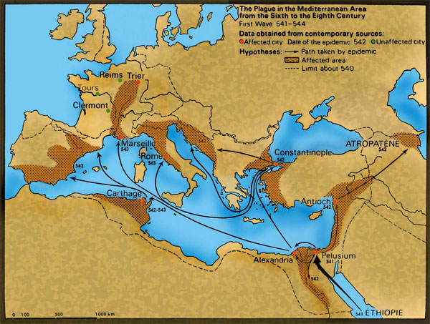
The strain that caused the Black Death, ravaging half the population of Europe eight centuries later, was a distinct form, which re-emerged in the late 1800s and spread worldwide, he said.
"The Justinian looks like it came, it flared up, it killed its people and then there were no more suitable hosts or it didn't survive underground and did not re-emerge in that form," Poinar said. "So the Black Death is actually a completely novel emergence of Yersinia pestis 800 years later."
The findings, published Monday in the journal Lancet Infectious Diseases, suggest a new strain of plague could emerge again in humans in the future.
"We know the bacterium Y. pestis has jumped from rodents into humans throughout history and rodent reservoirs of plague still exist today in many parts of the world," said Dave Wagner of the Center for Microbial Genetics and Genomics at Northern Arizona University, one of the study's co-authors.
"If the Justinian plague could erupt in the human population, cause a massive pandemic and then die out, it suggests it could happen again," Wagner said in a release. "Fortunately, we now have antibiotics that could be used to effectively treat plague, which lessens the chances of another large-scale human pandemic."
The DNA samples used in the research were taken from two victims of the Plague of Justinian -named after the Roman emperor of the time - who were buried in gravesites in an early medieval cemetery in Aschheim, Germany, near Munich.
Based on carbon-dating and grave goods found with the skeletal remains, scientists believe the victims died in the latter stages of the epidemic when it had reached southern Bavaria, sometime between 541 and 543.
German scientists first identified possible Yersinia pestis in some of the buried victims, then passed their findings to experts at the University of Arizona for comparison to modern-day plague strains. Those groups then contacted Poinar's lab, which specializes in ancient DNA and had reconstructed the genome of the Black Death strain in 2011.
"We are the ones that took the teeth, extracted the DNA and basically pulled the little fragments out," said Poinar, adding that over time, the breakdown of matter in burial pits produces an intermingled "soup" of DNA from humans, plants, insects, bacteria and fungus.
"And deep, deep, deep, buried in that mess, were these tiny fragments of Yersinia," he said. "Basically what we do is we design very sensitive, selective 'fishing rods' that can pick out Yersinia like tuna or maybe more like Chilean sea bass from the Pacific waters, something that's infrequent."
Poinar's lab determined that the strain responsible for the Justinian outbreak was an evolutionary "dead-end" and distinct from strains involved later in the Black Death and other plague pandemics that would follow.
The third pandemic, which spread from Hong Kong around the world in the 1800s, is likely a descendant of the Black Death strain and thus much more successful than the one responsible for the Justinian plague.
"We really have built this time machine to go back into deep time and really look at co-infections and host-pathogen evolution, and I think that's critical to understanding infectious disease dynamics," said Poinar. "Without understanding, you can't really predict epidemics or prepare for them."
While relatively rare, cases of plague still occur today in certain areas of the world, including the western United States, transmitted to humans from rodents infected with the bacteria, typically by fleas.
In 2012, Oregon welder Paul Gaylord was bitten by his cat, which had been infected by a plague-carrying mouse. He survived after being on life-support for a month, but later had to have all of his blackened and withered fingers and toes amputated.
"I think this is a good reminder that plague is an ever-present bug," said Poinar. "As climate changes and these rodents move because their ecology changes, because of food or aridity or whatever it might be, they come into contact with rodents that are susceptible to plague and you can have a new epidemic that begins.
"So being consciously aware of where Yersinia pestis is, which particular strains are present in a rodent population at a certain point in time and how those rodents are moving according to climate change is critical for understanding or being prepared for a possible re-emergence down the road."

New anthrax-killing virus could offer new ways to detect, treat, and decontaminate anthrax bacillus
Source: http://www.homelandsecuritynewswire.com/dr20140129-new-anthraxkilling-virus-could-offer-new-ways-to-detect-treat-and-decontaminate-anthrax-bacillus

From a zebra carcass on the plains of Namibia in Southern Africa, an international team of researchers has discovered a new, unusually large virus (or bacteriophage) which infects the bacterium that causes anthrax. The novel bacteriophage could eventually open up new ways to detect, treat, or decontaminate the anthrax bacillus and its relatives that cause food poisoning. The work is published 27 January in the journal PLoSOne.
A UC Davis release reports that the virus was isolated from samples collected from carcasses of zebras which died of anthrax in Etosha National Park, Namibia. The anthrax bacterium, Bacillus anthracis, forms spores that survive in soil for long periods. Zebras are infected when they pick up the spores while grazing; the bacteria multiply and when the animal dies, they form spores that return to the soil as the carcass decomposes.
While anthrax is caused by a bacterium that invades and kills its animal host, bacteriophages, literally “bacteria eaters,” are viruses that invade and kill bacterial hosts.
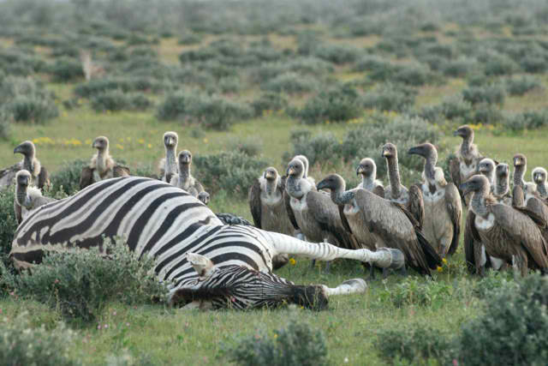
The first thing the team noticed was that the virus was a voracious predator of the anthrax bacterium, said Holly Ganz, a research scientist at the UC Davis Genome Center and first author on the paper.
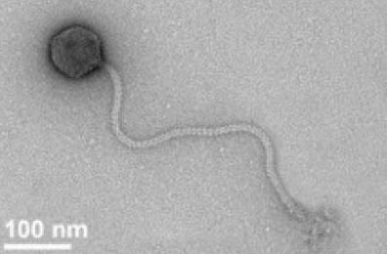
They also noticed that the new virus, named Bacillus phage Tsamsa (photo), is unusually large, with a giant head, a long tail and a large genome, placing it among the largest known bacteriophages.
Tsamsa infects not only B. anthracis but also some closely related bacteria, including strains of Bacillus cereus, which can cause food poisoning. Sequencing the genome allowed researchers to identify the gene for lysin, an enzyme that the virus uses to kill bacterial cells, that has potential use as an antibiotic or disinfecting agent.
The release notes that bacteriophages are often highly specific to a particular strain of bacteria, and when they were first discovered in the early twentieth century there was strong interest in them as antimicrobial agents. The discovery of penicillin and other antibiotics, however, eclipsed phage treatments in the West, although research continued in the Soviet Union.
“With growing concerns about antibiotic resistance and superbugs, people are coming back to look at phages,” said Ganz said.
One advantage of bacteriophages is that because they tend to be very specific, they can potentially target only “bad” bacteria while leaving beneficial bacteria unharmed. Also, phages evolve with the host and have the potential to overcome bacterial resistance, said coauthor Jochen Klumpp of the Institute of Food, Nutrition and Health, ETH Zurich.
Ganz began the work as a postdoctoral scientist on a team led by Wayne Getz, Professor of Environmental Science, Policy and Management at UC Berkeley and at the University of KwaZulu-Natal, South Africa. Sequencing of the phage genome was conducted at UC Davis after Ganz joined the laboratory of Professor Jonathan Eisen.
Ganz said that she hoped the publication of the phage’s sequence information would enable other researchers to investigate further and potentially develop applications for the phage and its proteins.
“You might use it to detect the anthrax bacillus or B. cereus; use it as an alternative to antibiotics or as part of a decontaminant,” she said.

— Read more in Holly H. Ganz et al., “Novel Giant Siphovirus from Bacillus anthracis Features Unusual Genome Characteristics,” PLoSOne (27 January 2014).

Anthrax Anti-toxin Said Effective; Disinfection System Gets Patent
Source: http://www.hstoday.us/single-article/anthrax-anti-toxin-said-effective-disinfection-system-gets-patent/7f1fa8c6fd0f095d6de665e6d243c380.html

Elusys Therapeutics, Inc., a biopharma-ceutical company developing antibody therapies to treat infectious disease, presented data demonstrating that its ETI-204 anti-toxin for the treatment of inhalational anthrax was 100 percent effective in protecting monkeys from death due to anthrax when administered via intramuscular (IM) injection up to 72 hours prior to anthrax exposure.
ETI-204 is completing phase III development and is a candidate for future inclusion into the Strategic National Stockpile, the US government’s repository of critical medical supplies for biothreat and other emergency preparedness.
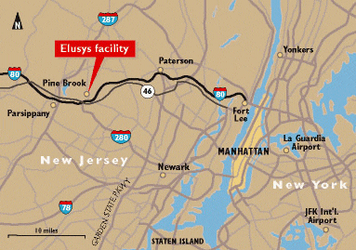
The company’s study results were discussed this week at the ASM Biodefense and Emerging Diseases Research meeting in Washington, DC.
"Achieving 100 percent survival with ETI-204 administered as a prophylactic, with no disease re-emergence and all survivors observed to be spore-free at day 56 post-challenge is highly encouraging," said Elizabeth Posillico, PhD, president and chief executive officer of Elusys.
Data demonstrated “that ETI-204, both alone or in combination with antibiotics, can significantly improve survival compared to control and suggest that ETI-204 has no direct effect on CNS toxicity," Posillico said in a statement.
“ETI-204 is formulated as a solution and is the only anthrax anti-toxin in advanced stages of development that is being investigated for IV treatment and IM prophylaxis administration,” the company said. “A product that can be given via IM injection is highly desirable because it could provide the capability to more rapidly administer product to people outside of a hospital setting or when IV administration is not feasible.”
Anthrax is a life-threatening infectious disease caused by the bacterium Bacillus anthracis and remains one of the nation’s top bioterror threats. Much of the morbidity and mortality of anthrax can be attributed to anthrax toxins. Inhaled anthrax is often fatal, despite treatment with antibiotics. In the 2001 anthrax letter attacks, inhalational anthrax had a fatality rate of approximately 50 percent in humans infected even when victims were given antibiotics and supportive hospital care.
ETI-204 is currently undergoing three double blind, randomized, placebo-controlled safety and tolerability studies with nearly 400 adult volunteers. Three studies assessing pharmacokinetics and safety of IV administration of ETI-204 in humans have already been completed. The more common adverse events related to ETI-204 administration across the three studies included upper respiratory tract infection, nausea, headache, nasal congestion and erythema.

Disinfecting a weaponized biological attack
Meanwhile, patent protection has been given to Medizone International, Inc. for AsepticSure, which is designed to remediate buildings following a weaponized biological attack using Anthrax.
The company announced this week that it had been granted its fourth patent by the United States Patent and Trademark Office for its revolutionary enclosed space room disinfection system, AsepticSure.
“Following on the heels of patent protection being established for its health care related patent applications,” Medizone said it “has now been awarded a patent for its government variant of AsepticSure intended for use by defense agencies as a response to a biological attack on critical buildings, infrastructure and resources."
"At our Innovation Park, Queens University laboratories, we have been successful in completely eliminating Bacillus atropheus and Bacillus subtilis, both internationally recognized study surrogates for Anthrax, one of the most difficult weaponized pathogens to kill,” said Medizone International President Dr. Michael E. Shannon. “Being able to eliminate these surrogates for Anthrax with our technology almost assures we now have the ability to remediate critical public infrastructure following a biological attack and restore it to service without damaging important and expensive equipment including communications systems. Militaries have struggled with this problem for decades and, until now, this simply has not been possible."
"To now have patent protection granted for this system should allow the company protected access to a potentially lucrative government market due to the unique capability of AsepticSure's government variant,” said Medizone CEO Edwin Marshall.

AsepticSure

Source: http://www.medizoneint.com/asepticsure/

The AsepticSure® hospital sterilization system is a portable, affordable, easily operated system that can be used by trained maintenance staff. It is placed in the center of the room to be cleaned. Vents and doors are then sealed with an easily and cleanly removable 3M-tape product.
The system is turned on from outside of the room through a remote wireless computer interface. The room is filled with a unique and patented gas formula that is ozone-based to specific humidity and charge strength.
Following the charge period, the sterilization process is remotely turned off and a separate technology is employed that restores the atmosphere inside the room to EPA standards. The end result leaves the treated room sterile of pathogens with a sweet, fresh oxygen-charged atmosphere very similar to what you experience after a thunderstorm.
From an operational perspective, the turnaround time for re-use of rooms up to 4,000 cubic feet in size is 80 to 90 minutes. This includes the decontamination of carpets, drapes and medical equipment, all to the 6 log standard - the Gold Standard benchmark by which all disinfection technologies are measured.

►Read more at source’s URL.

Experience: I caught the plague from my cat
Source: http://www.theguardian.com/lifeandstyle/2014/jan/31/i-caught-plague-from-my-cat

Paul Gaylord: 'I was in a coma for 27 days, during which my hands and feet swelled up and began to turn black.' Photograph: Patrick Kehoe for the Guardian

It began with Charlie going missing. He was a beautiful, smoky-grey, short-haired cat and he'd been gone for a couple of days. He could have gone anywhere: we live in a very rural area, at the foot of the Cascade Mountains, 12 miles from the town of Prineville, Oregon.
It was a Saturday night when Charlie showed up on the porch, but something was wrong: he couldn't walk, his face was swollen and he seemed to be choking on something. When I looked, it was a mouse stuck in his mouth. When I tried to pull it out, Charlie accidentally bit my finger, then ran under the porch. When he came out the next day, he was clearly suffering. It was as if the mouse had died in his mouth and was rotting, and I was worried about bacteria. I called a friend over to put him down, then we buried him.
On the Monday I went to my job as usual, as a welder, but by mid-morning I started to feel very sick. It came on all of a sudden and I developed a high fever. At the emergency care clinic, they gave me a dose of antibiotics for cat-scratch fever. I quickly developed flu-like symptoms. I turned grey and my skin hurt. A few days later I was delirious and my wife took me back to the clinic. I was taken by ambulance to the nearest hospital and put in intensive care.
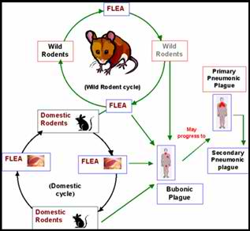
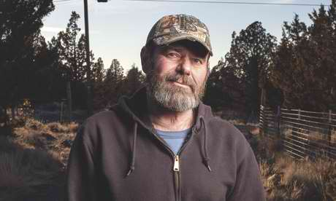
That evening a doctor told me he thought I had developed bubonic plague: I had glands under my arms the size of lemons and that's one of the symptoms. I knew rodents could carry the disease, but I didn't realise I could get it from my cat. I was told it originally came over on steamships from China in the 1900s, carried by the fleas on rats.
At 6am the next morning, I was put on a ventilator and taken by ambulance to another hospital. The last thing I remember is riding in that ambulance. I went downhill quickly and was put on full life support. Hooked up to a dialysis machine, I had collapsed lungs and at one point my heart stopped.
I was in a coma for 27 days, during which my hands and feet swelled up and began to turn black. When I finally woke up, I just remember feeling incredibly thirsty. My doctor told me I had developed all three stages of the plague: bubonic (the least lethal form, which infects the lymphatic system), pneumonic (which infects the lungs) and septicaemic (the bloodstream). Some people have survived bubonic plague, but not all three, apparently. Technically, I shouldn't be here.
The doctor said I'd probably lose my feet and hands, but all I could think about was how thirsty I was. They didn't let me drink anything for days because I had a tracheotomy and was being fed intravenously.
Eventually I understood the seriousness of what had happened: the day before I woke up from my coma, doctors had been talking about turning off my life support. My recovery shocked everybody. I'd been told I'd be on dialysis for the rest of my life, but I had one treatment and I recovered. Everything in my body did, except my hands and feet.
After a month in hospital, I went home. I had to live for six weeks with the dead fingers and toes, so doctors could work out which parts were going to heal before they performed the amputations. They wanted to take off my hands and feet at the wrists and ankles, but I didn't want that. Instead, they removed my fingers; I still have my hands and part of my thumbs. They took off all the toes on my left foot, and about a third of my right foot is gone.
The Centres for Disease Control and the health department came to look all around the house, but they found no dead rodents and no sign of the plague. They dug up the cat and sent his body off to a lab in North Carolina. He was infected with it, but it's hard to say where he picked it up. The disease is carried by a certain type of flea that lives on burrowing rodents such as mice and squirrels. A cat can cover a lot of ground in two days.
It's hard to believe it happened to me, but rather than feel depressed, I've always felt positive and happy to be alive. I was working 15 hours a day until I got sick. After my illness, I retired, but I'm still able to make hunting knives in my workshop as a hobby. I think it's just a fluke that I caught this. Now I hope to make people aware of the illness. If you know the symptoms and what to look for, you stand a much better chance of surviving.

Genes of Gypsies show traces of convergent evolution in response to Black Death
Source: http://www.homelandsecuritynewswire.com/dr20140205-genes-of-gypsies-show-traces-of-convergent-evolution-in-response-to-black-death

The Black Death once exterminated up to 30-50 percent of Europeans. Researchers have identified immune system genes in Europeans and Gypsies that likely underwent convergent evolution during Europe’s deadly epidemics. Immune system genes evolve under the influence of infectious diseases, but few studies have attempted genome-wide assessments of infection-driven evolution.
Researchers have identified immune system genes in Europeans and Gypsies that likely underwent convergent evolution during Europe’s deadly epidemics. Immune system genes evolve under the influence of infectious diseases, but few studies have attempted genome-wide assessments of infection-driven evolution. A PNAS release reports that to investigate the effects of epidemics on immune system evolution, Mihai Netea and colleagues exploited the fact that two ancestrally distinct populations — Romanians, of European ancestry, and Gypsies, of North Indian ancestry — have cohabited Romania during the last millennium, exposed to epidemics such as the Black Death, which once exterminated up to 30-50 percent of Europeans.
The authors used microarrays to assay 196,524 genetic variants called single nucleotide polymorphisms, or SNPs, in the genomes of three groups, namely 100 people of Romanian descent, 100 people of Gypsy ethnic background, thought to have descended from Northwest Indians who immigrated to Europe about a millennium ago, and, for comparison, 500 present-day Northwest Indians.
The authors report that a gene cluster called TLR1/TLR6/TLR10, which encodes immune receptors, adaptively evolved in Romanians and Gypsies but not in present-day Northwest Indians, suggesting an effect of selection pressure specific to Europe. When the authors exposed peripheral blood mononuclear cells from 101 present-day Europeans to Yersinia pestis, the plague bacterium, and Y. pseudotuberculosis, a precursor of the plague bacteria, SNPs in the TLR1/TLR6/TLR10 cluster — but not in a different receptor called TLR4 — appeared to influence immune responses against both bacteria.
According to the authors, the findings might help uncover the origin of differences in the susceptibility of Europeans and other populations to some modern diseases.

— Read more in Hafid Laayouni et al.,”Convergent evolution in European and Rroma populations reveals pressure exerted by plague on Toll-like receptors,” Proceedings of the National Academy of Sciences (3 February 2014)

Sarepta's bioterrorism drug found safe in humans
Source: http://www.bizjournals.com/boston/blog/bioflash/2014/02/sareptas-bioterrorism-drug-found-safe.html

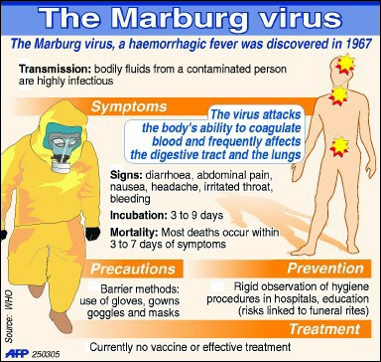
While most attention on Sarepta Therapeutics has concerned its drugs for Duchenne’s muscular dystrophy, today the Cambridge biotech reported data from an early-stage trial of its potential drug for the bio-terrorism infection known as the Marburg virus.
Marburg is a deadly infection disease first recognized in 1967 and endemic to Africa. Its sudden onset causes fever, chills, nausea, vomiting, chest pain and diarrhea, and eventually massive hemorrhaging and multiple organ dysfunctions. The Marburg virus was determined to be a threat to national security in 2006. Sarepta has been developing AVI-7288 under a contract from the Department of Defense. For the first nine months of 2013, Sarepta earned $11.6 million in contract revenue, and company spokesman Jim Baker said that $9.9 million of that came from its work to develop AVI-7288.
Today, Sarepta (Nasdaq: SRPT) reported that among 40 healthy volunteers in a Phase 1 study who all took different dosage levels of AVI-7288 for two weeks, the drug appeared safe and well-tolerated through the highest dose tested — 16 milligrams per kilogram of body weight.
According to federal filings, work on the first phase of the contract for AVI-7288 was completed last year, and further development is at the discretion of the DoD. If the agency authorizes continued development, Baker said it would be under the rarely-used "animal rule," reserved for diseases in which human tests would be unsafe or unethical. Sarepta stands to make a total of $84 million if the DoD authorizes it to develop AVI-7288 through approval.
The revenue from the company’s work on AVI-7288 helps out in its more well-known focus on drugs to treat Duchenne’s. Today, the company said that the data from the Phase 1 study not only supports continued development of the Marburg drug, but provides additional evidence in supporting of its so-called phosphorodiamidate morpholino oligomer, or PMO, technology, which is designed to make drugs based on affecting the body’s RNA more effective.
“The new data for AVI-7288 add to a growing body of evidence supporting the safety and activity of Sarepta’s PMO-based chemistries,” said Art Krieg, senior vice president and chief scientific officer of Sarepta, in a statement. “Our proprietary RNA technologies offer a versatile drug development platform with broad potential utility across a spectrum of therapeutic areas.”

Floods caused lead poisoning in U.K. cattle
Source: http://www.homelandsecuritynewswire.com/dr20140213-floods-caused-lead-poisoning-in-u-k-cattle

Massive floods in England and Wales have forced thousands to evacuate their homes and destroyed railways and roads. Scientists say the U.K. floods of recent years carry yet another danger with them: lead poisoning. Silage cut from fields soon after they were inundated in the 2012 floods and then fed to cattle raised the lead levels in the animals, killing some of them. Blood samples taken from cattle showed that all of them had lead levels beyond the safe limit for human consumption. An autopsy carried out on one of the casualty animals found lead concentrations 79 times the safe level in its kidney. The contaminated material is thought to originate from historical metal mining in the area. Scientists say a number of river catchments throughout England and Wales face a similar risk.

— Read more in S. A. Foulds et al., “Flood-related contamination in catchments affected by historical metal mining: An unexpected and emerging hazard of climate change,” Science of The Total Environment 476–477 (1 April 2014): 165–80.

A very interesting bio-decon project

Bio-response Operational Testing and Evaluation (BOTE) Project
Source:http://cfpub.epa.gov/si/si_public_record_report.cfm?address=nhsrc/&dirEntryId=240984

Objectives
- Conduct and evaluate field-level application of three decontamination technologies/protocols for the cleanup of a building contaminated with Bacillus anthracis (Ba) spores, the causative agent for anthrax. Simulants of Ba spores were used.
- Utilize newly developed biological sampling and analysis methods for characterization of the anthrax simulant contamination (concentration and location) and determination of decontamination efficacy.
- Collect and analyze results and operational information from the decontamination operation.
- Perform a cost analysis of the complete remediation process.
- Determine the exposure to spores associated with reentry into the building following cleanup.
Effectiveness
Full-facility fumigation using VHP® Technology
- Conditions not sufficient for effective decontamination
- No observed damage to facility or contents
- Low relative waste generation

Decontamination process using removal and disposal of contaminated porous materials and pH-adjusted bleach spraying of non porous materials
- Effective process, few post-decontamination samples positive with very low CFU
- Damage to some surfaces, such as swelling of laminated floor
- High relative waste generation

Full-facility fumigation with ClO₂
- Effective process, few post-decontamination samples positive with very low CFU
- No damage to surfaces; observed corrosion of equipment connections
- Low relative waste generation

►You can download technical brief report from source’s URL.

Anthrax Guidelines Address Nonpregnant, Pregnant Adults
Source: http://www.medscape.com/viewarticle/819274

Updated guidelines from the Centers for Disease Control and Prevention (CDC), published online January 15 in Emerging Infectious Diseases, address anthrax postexposure prophylaxis (PEP) and treatment in nonpregnant and pregnant adults.
"Anthrax has been recognized as an infectious disease of animals and humans for millennia," write Katherine A. Hendricks, MD, MPH, from the CDC, Atlanta, Georgia, and other members of the Workgroup on Anthrax Clinical Guidelines. "Within the United States, animal anthrax is reported in most years, but naturally occurring human anthrax is rare.... Biodefense experts often place Bacillus anthracis at or near the top of the list for potential threat agents."
Reasons that B anthracis is a potential threat include its availability and ease of dissemination and the high mortality of systemic anthrax infections. Therefore, anthrax has been a high-priority threat and a major focus of national emergency preparedness planning since the 2001 anthrax attack.

Guidelines for Anthrax Management in Nonpregnant Adults
In 2011-2012, the CDC convened panels of civilian and military anthrax experts and clinicians who had treated patients with anthrax, representing the fields of internal medicine, pediatrics, obstetrics, infectious disease, emergency medicine, critical care, pulmonology, hematology, and nephrology. Their mandate was to review and update guidelines for PEP and for treatment of anthrax in nonpregnant adults.
They considered use of antibiotics and antitoxins, clinical management, and future research priorities. These include development of tests to identify and treat anthrax earlier in its course, as well as animal models to facilitate assessment of currently recommended treatments.
The evidence underlying the updated guidelines includes recent case reports of patients with systemic anthrax; reviews of published, unpublished, and proprietary data concerning antimicrobial drugs and anthrax antitoxins; and critical care interventions that may help patients with anthrax.

Specific topics covered in the newly published guidelines include:
- updated recommendations for antimicrobial PEP, which should ideally start as soon as possible after exposure;
- currently available antimicrobial and antitoxin treatment options, considering toxin production, potential for antimicrobial drug resistance, frequent occurrence of meningitis, and presence of latent spores;
- potentially beneficial critical care measures for persons with anthrax, including clinical procedures for infected nonpregnant adults;
- expanded discussion, compared with previous guidelines, of critical care and clinical procedures and of additional antimicrobial choices, including preferred antimicrobial drug treatment for possible anthrax meningitis.

Specific recommendations include the following:
- Regardless of vaccination status, everyone exposed to aerosolized B anthracis spores should receive a full 60 days of PEP antimicrobial drugs.
- Antimicrobial combination therapy is more likely to be curative than monotherapy, and there is a theoretical benefit for combined use of bactericidal and protein synthesis inhibitor agents.
- The US Food and Drug Administration has approved ciprofloxacin, levofloxacin, and doxycycline for PEP for inhalation anthrax in adults aged 18 years or older. Because no safety data are available for levofloxacin use beyond 30 days, oral ciprofloxacin and doxycycline are first-line antimicrobial drugs for PEP.
- When anthrax meningitis is suspected, treatment should include at least 3 antimicrobial drugs with activity against B anthracis. All should have good central nervous system penetration, at least 1 should have bactericidal activity, and at least 1 should be a protein synthesis inhibitor. Intravenous combination treatment should continue for at least 2 to 3 weeks.
- For any patient with a high level of clinical suspicion for systemic anthrax, the potential benefit achieved by adding antitoxin to combination antimicrobial drug treatment outweighs the potential risk. There are no major considerations clearly favoring use of one antitoxin over another.
- A single oral fluoroquinolone may successfully treat uncomplicated cutaneous anthrax. Ciprofloxacin, levofloxacin, moxifloxacin, and doxycycline are equivalent first-line agents.

Guidelines for Anthrax Management in Pregnant Women
"As part of a comprehensive plan for anthrax readiness, it is important to plan for the needs of pregnant, postpartum, and lactating (P/PP/L) women because of their unique immunology and physiology and the complexities of balancing maternal and fetal risks," Dana Meaney-Delman, MD, MPH, from the CDC, and colleagues write in a second guideline.
"The purpose of this meeting summary is to provide updated clinical information to health care providers and public health professionals caring for P/PP/L women in the setting of a bioterrorist event involving anthrax."
The CDC and the Association of Maternal and Child Health Programs convened a meeting of national experts in August 2012 to review important interventions regarding anthrax prevention and treatment in P/PP/L women. Participants included infectious disease, obstetrics, maternal-fetal medicine, neonatology, pediatrics, and pharmacy experts, as well as representatives from professional organizations and national, federal, state, and local agencies.
Topics included overall prevention and treatment strategies in P/PP/L women, vaccination, antimicrobial prophylaxis and treatment, clinical considerations and critical care issues, use of antitoxin, delivery issues, infection control measures, and communication.
"Antimicrobial drug use in pregnant women in the setting of anthrax must be viewed in the context of the high mortality risk and the benefits of treatment for the mother and fetus, as well as possible effects on the fetus resulting from the infection or from administration of antimicrobial drugs to the mother," the authors write. "Although safety and pharmacokinetic data for pregnant women are limited, antimicrobial drugs used for anthrax PEP and treatment for P/PP/L women are generally the same as those for nonpregnant adults."
It is unclear whether clinical signs and symptoms of anthrax differ because of the physiologic changes that accompany pregnancy. Clinical indicators of infection may be less reliable in pregnant women
No direct evidence is available to evaluate the safety and efficacy of anthrax immune globulin and raxibacumab in pregnant women and their babies.
"Pharmacokinetic studies designed to determine dosing and to elucidate transplacental passage of antibiotics and antitoxins during pregnancy represent the highest priority research gap," Dr. Meaney-Delman and colleagues conclude

Nazis planned to use malaria-infected mosquitoes as biological weapons
Source: http://www.telegraph.co.uk/history/world-war-two/10640420/Nazis-planned-to-use-malaria-infected-mosquitoes-as-biological-weapons.html

Hitler’s scientists planned to use malaria-infected mosquitoes as biological weapons by sending them behind enemy lines in the Second World War, according to research.
SS leader Heinrich Himmler ordered secret research into how insects infected with the disease could be kept alive long enough to be used against the allies, German academic Dr Klaus Reinhardt has claimed.
In January 1942, the SS chief created a special laboratory at Dachau concentration camp with the official aim of finding new remedies against diseases transmitted by lice and other insects, as well as the typhoid that plagued German troops.
But in the journal Endeavour, Reinhardt said records kept by Dachau Entomological Institute revealed its scientists also pursued research into biological warfare.
They tested the life spans of different mosquito breeds to try and find one that would remain alive long enough to be dropped into enemy territory.
At the end of the trials in 1944 a breed of anopheles mosquito, particularly effective in transmitting malaria to humans, was recommended by the director of the institute, according to Reinhardt, from Germany's Tuebingen University.
It is not known whether there was a connection between the work of the Entomological Institute and the chilling experiments carried out by Dr Claus Schilling who used prisoners as human guinea pigs deliberately infecting them with malaria.
Schilling was sentenced to death by hanging after the war.
The mosquito research had to remain secret because Germany, alongside the allied nations, had signed up to the 1925 Geneva protocol banning the use of biological and chemical weapons.
But Reinhardt dismissed the project as "a bizarre mix of Himmler's smattering of scientific knowledge, personal paranoia, an esoteric world view, and genuine concerns about his SS troops" which proved of no use to Hitler’s war effort.

EDITOR’S COMMENT: It comes as no surprise since their close alies in the East has a similar BWA unit – the notorious Unit 731. Only difference was that Japanese preferred plague infected fleas!
.
Unit 731 and the Japanese Imperial Army’s Biological Warfare Program
By Tsuneishi Keiichi
Translated by John Junkerman
Source: http://www.japanfocus.org/-Tsuneishi-Keiichi/2194

[Japan's Unit 731 remains central to the fiercely contested China-Japan controversy over war crimes and war memory, and to the international debate on science and ethics. With a staff of more than 10,000, including many of Japan’s top medical scientists, 731 and its affiliated units conducted human experiments, including vivisection, on Chinese and other victims in Manchukuo and throughout China between 1933 and 1945. The experiments tested, among other things, the lethality of biological weapons and sought to determine the ability of the human body to survive in the face of various pathogens and in conditions such as extreme cold.
Tsuneishi Keiichi is Japan's leading specialist on biowarfare. His voluminous studies conducted over thirty years in Japan, China, the United States and Europe, have provided core material for all writing hitherto on the Ishii Network. In the following careful resumé essay, he concentrates on organization and function, omitting much of the horrific detail covered elsewhere. Drawing on Japanese military records, this study documents the deaths of 850 victims in the years up to 1943, the largest number infected with plague, cholera, and epidemic hemorrhagic fever. It also makes use of American records and interviews.
Unit 731 not only conducted tests but also led the way in waging biological warfare on numerous occasions throughout the war, the best documented being attacks on Ningbo and throughout Zhejiang province. As in the case of the Nanjing Massacre and the “comfort women,” casualty figures remain contested. The figure of 3,000 persons exterminated at Pingfan, the major experiment site of the Ishii Network, is widely accepted among specialists for the period ending in 1945. The post-surrender destruction by the Japanese authorities both of the research sites and the military documents, has made precise casualty estimates difficult.
As Tsuneishi documents, attacks in Zhejiang resulted in more than 10,000 Japanese military casualties including the death of 1,700 Japanese soldiers, revealing the difficulty of waging effective biowarfare. No estimate is provided here of Chinese deaths. a reminder of contemporary practice in providing only American body counts in Iraq, but also of the difficulty of establishing Chinese casualties.
Japan’s grim experiment with biowarfare pales in comparison with the estimated 10-30 million Chinese who died as a result of war and associated conditions of famine in the years 1931-45. But the findings of Ishii and his colleagues were important enough for American authorities to grant immunity from prosecution in exchange for evidence of the research findings of Unit 731. The 731 scientists, who were evacuated to Japan prior to the defeat, continued their careers as eminent figures in the postwar medical and scientific establishment.
The Ishii Network
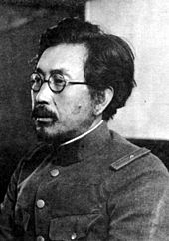
Unit 731 was the common name of a secret unit of Japan’s Manchuria-based Kwantung Army whose official name was the Epidemic Prevention and Water Supply Department. [1] The leader of the unit was Ishii Shiro, who held the rank of lieutenant general at the end of World War II (photo). The unit epitomized the extensive organization for the development of biological weapons within the imperial army, which was referred to, beginning in the late 1930s, as the Ishii Network.
The network itself was based at the Epidemic Prevention Research Laboratory, established in 1932 at the Japanese Army Military Medical School in Tokyo. Unit 731 was the first of several secret, detached units created as extensions of the research lab; the units served as field laboratories and test sites for developing biological weapons, culminating in the experimental use of biological weapons on Chinese cities. The trial use of these weapons on urban populations was a direct violation of the 1925 Geneva Protocol, which outlawed the use of biological and chemical weapons in war. It was also understood by those involved that the use of human subjects in laboratory and test site experiments was inhumane. This was why it was deemed necessary to establish Unit 731 and the other secret units.
The Epidemic Prevention Research Laboratory was created under the initiative of Ishii Shiro after he returned from two years of field study of American and European research facilities. It was set up, with the approval of top-level army authorities, as a facility to develop biological weapons. It is said that Ishii first became convinced of the need to develop biological weapons with the signing of the Geneva Protocol in 1925.
The biological weapons Ishii sought to develop had humans as their target, and Unit 731 was established with this goal in mind. In order to produce biological weapons as quickly as possible, Ishii considered it essential to have a human experimentation site at the disposal of his research laboratory. Japan had occupied northeastern China and in 1932 the puppet state of Manchukuo was established. Within this “safe zone,” Ishii set up what was called the Togo Unit, based in the village of Beiyinhe, about 100 kilometers south of Harbin. Human experimentation began there in the fall of 1933. The Togo Unit was a secret unit under the vice chief of staff of the Kwantung Army. It was set up to determine whether it was possible to conduct human experiments in northeastern China, and if it was possible, whether the experiments would produce useful results. The launching of this feasibility study reflects the deliberate nature of Ishii as the organizer of the research, and you could say it was marked with his character. All of those involved in this research and development were military doctors, but they all used false names. At this stage, the scale of the project involved about ten doctors, along with a staff of about one hundred.
The Inauguration of Unit 731
Unit 731 was officially established in 1936. Its establishment is reflected in a memo dated April 23, 1936, entitled “Opinion Regarding the Reinforcement of Military Forces in Manchuria,” from the chief of staff of the Kwantung Army to the vice minister of the Ministry of War (contained in the Ministry of War Journal for the army in Manchuria, Rikuman Mitsu-dainikki). Under the heading “Establishment and Expansion of the Kwantung Army Epidemic Prevention Department,” the memo states that the department will be “newly established” in 1936 and “one part of the department will be expanded in fiscal 1938.” This is the oldest official document concerning Unit 731 that has been found to date.
In addition to inaugurating Unit 731, this memo also laid the foundation for establishing two other units. It called for the establishment of an additional biological weapons development unit, independent of Ishii’s unit, which was called the Kwantung Army Military Horse Epidemic Prevention Workshop (later referred to as Manchuria Unit 100), and for preparations to set up a chemical weapons development unit called the Kwantung Army Technical Testing Department (later referred to as Manchuria Unit 516).
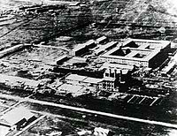
Several months later, the memo’s recommendations were approved by Emperor Hirohito, the two units were established, and preparations began for creating the Testing Department. The Ministry of War Journal for May 21, 1936 recorded this development under the heading. “Imperial Hearing on Military Force Improvement Consequent upon Budget Approval.” The journal noted: “Units concerned with epidemic prevention: One unit each is established for epidemic prevention among humans and horses.”
Having been officially established, Unit 731 moved its facilities from Beiyinhe to a newly established laboratory at a hospital in Harbin. This laboratory served as a front-line headquarters while the unit’s permanent facilities were being built in Pingfan, outside of the city of Harbin. These facilities were completed and capable of conducting research in the fall of 1939, after the hostilities at Nomonhan (on the border between Manchuria and Mongolia) had ended.
With the construction of the Pingfan facilities, the primary research staff changed in composition from the military doctors of the Togo Unit to private-sector medical researchers affiliated with universities and other institutions. The first group to be posted to the unit was a team of eight assistant professors and instructors from Kyoto Imperial University in the spring of 1938. The group consisted of two bacteriologists, three pathologists, two physiologists, and one researcher specializing in experiments using animals. Within a year, a second group had arrived at the facility, and the research staff had expanded considerably. The prominence of researchers in pathology and physiology in the development of biological weapons reflected the need for specialized judgment in assessing the results of human experimentation.
With the expansion of the war front throughout China after 1937, sister units affiliated with Unit 731 were established in major Chinese cities. These units were also called Epidemic Prevention and Water Supply Departments. (Unit 1855 was established in Beijing on February 9, 1938; Unit 1644 in Nanjing on April 18, 1939; and Unit 8604 in Guangzhou on April 8, 1939). Later, after Japan occupied Singapore a similar unit (Unit 9420) was established there on March 26, 1942. These affiliates comprised the scope of the Ishii network through the end of the war. As of the end of 1939 (that is, before the establishment of the Singapore unit), the network had a total staff of 10,045, of which 4,898 were assigned to the core units in Tokyo and Pingfan.
Human Experimentation
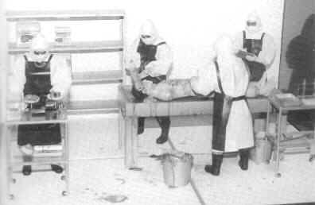
Human experimentation took place at all of the units of the Ishii network, but it was conducted systematically by Unit 731 and Unit 1644. Of these two, there are extant reports from a US Army survey of human experimentation by Unit 731, so the general outline of its program is known.
The following table was compiled from two sources: a report to US occupation authorities dated December 12, 1947 by Edwin Hill and Joseph Victor, concerning human experimentation by Unit 731 and related facilities; and a list of specimens brought back to Japan by a Unit 731 pathologist in July 1943. Aside from Ishii and another unit leader, Kitano Masaji, the names of individual researchers do not appear; they are identified as military personnel (M, primarily military doctors), (C) civilian technicians conducting research within the military, and (PT) part-time researchers working outside of the military.
The number of specimens reflects the number of subjects who died as a result of human experimentation as of July 1943. Consequently, the total number of victims of human experimentation at the time of Japan’s surrender two years later would be higher than these figures. The figures also do not include victims of germ bomb tests at the Anda field test site or from other experiments.

Subject Researcher Total Specimens Medically Usable Specimens
anthrax M 3631
botulinus Ishii 20
brucellosis Ishii, M, C, M 31
CO poisoning 10
cholera C, C 13550
dysentery M, M, PT, PT, M 2112
glanders Ishii, C 2220
meningitis Ishii, C 51
mustard gas 1616
plague Ishii, C, M, C 18042
plague (from the Shinkyo [Changchun] epidemic) 6664
poison 20
salmonella M, C 1411
Songo (epidemic hemorrhagic fever) C, Kitano, C 10152
smallpox Ishii, C 42
streptococcus 31
suicide 3011
tetanus Ishii, PT, C 3214
tick encephalitis C, Kitano 21
tsutsugamushi (scrub typhus) C 20
tuberculosis C, Ishii 8241
typhoid C, C 6322
typhus C, M, C, Kitano, C 269
vaccine 22
Total 850403
Technicians who were civilian employees of the army were treated as officers. The status of civilian employees ranged from infantry-class to general-class, but technicians were treated as lieutenants and above. Ranking below the technicians were operators, clerks, and staff. For the most part, the Ishii network took on university researchers as technicians. The part-time researchers were part-time employees of the Military Medical School Epidemic Prevention Research Laboratory; they were professors at Tokyo and Kyoto imperial universities who were contracted to perform research in their own laboratories. In short, a large number of civilian researchers were mobilized.
Biological Warfare Trials
For the most part, the use of the biological weapons developed by the Ishii network amounted to field trials.
The first of these trials took place during the Nomonhan Incident in 1939. In August, toward the end of the hostilities, pathogens that cause gastrointestinal disease were placed in the Holsten River, a tributary of the Halha River that the Soviet Army used as its source of water. It is not clear how many Soviet soldiers suffered from this attack, but it is thought that casualties were not widespread. This was because the typhoid bacillus and the other pathogens that were used lose their infectivity when placed in water. This fact was known to Ishii’s group. It is thought that they nonetheless carried out the attack because they wanted to conduct a field test of biological weapons in combat. While there were likely few Soviet casualties, at least one Japanese soldier became infected when he spilled liquid from a drum filled with contaminated water while dumping it into the river. He died of typhoid fever at an army hospital in Hailar.
During the following year, 1940, larger scale field trials were conducted in central China, using biological weapons dropped from airplanes. The pathogens were cultivated by Unit 731 and shipped to Unit 1644 in Nanjing, which served as the forward base for the attacks, which continued until 1942. During the first two years, these attacks were carried out in cities along the Chang River. Of these, the large-scale attack on the city of Ningbo on October 27, 1940 is well documented and has also been thoroughly investigated by the Chinese.
The attack took place at 7 a.m. from heavy bombers flying a low-altitude run at 200 meters. The bombers dropped fleas, grain, and strips of cotton on the streets in the center of the city. The fleas were infected with the plague. They had ingested blood from plague-infected rats and were called “plague fleas.” The plague bacteria were not dissipated directly, as it was considered more effective to infect the carrier fleas and release them, in order to target a specific area with a focused attack. It was also expected that the bacteria would live longer in the bodies of the fleas. The fleas were dropped with grain and cotton to ensure that they reached the target area, and it was also thought that the cotton would absorb some of the shock of impact on the ground.
The first death was recorded on the fourth day, October 30, and casualties increased rapidly in the days that followed. By November 2, it was clear that the disease was an epidemic, and the area was sealed off as disease-contaminated. The next day, it was determined that the disease was the plague. By then 37 deaths had been reported. The quarantine imposed on the area slowed the spread of the epidemic.
The plague epidemic ended on December 2 with the death of the last two victims. Deaths totaled 106 people. These figures were reported in a survey, conducted by two Ningbo researchers and published in March 1994 by Dongnan University Press. This historical account of the epidemic tracked down all of the victims and listed them by name, and it is thus a very valuable document.
This attack, killing more than one hundred people, was the most lethal in this series of attacks on Chinese cities. However, when one considers that the attack was carried out by heavy bombers on a risky low-altitude run, these results have to be considered a military failure.
There were two primary reasons for this failure. First, the bacteria used was so infectious that it immediately set off alarms among its victims. Second, the effort suffered from exaggerated expectations of the ability to artificially spark an epidemic. In February 1941 Ishii reported to his superior officer, Lt. Gen. Kajitsuka Ryuji, chief of the medical department of the Kwantung Army: “It is not as easy as some people think, and as I once thought, to deliberately spread infectious disease. While infectious disease spreads readily in natural circumstances, numerous obstacles are encountered when artificially spreading infection, and sometimes great pains must be taken to overcome these.” [2] It was expected that pathogens dropped in a densely populated area like Ningbo would quickly spread person to person, but these expectations were betrayed.
Great Failures
In November 1940, the month after the attack on Ningbo, the Chinese began to take countermeasures in response to biological warfare attacks on urban populations. On November 28, the central Chinese city of Jinhua suffered an attack. The result was a failure. According to a Chinese Ministry of Health document, “At the time that the plague epidemics were continuing in Ningbo and its vicinity, three Japanese airplanes flew over Jinhua and dropped a large number of small granules the size of small shrimp eggs. These strange objects were gathered and examined at a local hospital. . . . They showed the physical characteristics of the bacteria that cause the plague. In any case, the plague did not break out in Jinhua and as far as this town was concerned the Japanese experiment in germ warfare ended in failure.”
No effort was made to collect the material dropped from the airplanes on Ningbo, but one month later the objects dropped on Junhua were gathered and analyzed. There had been rapid progress in securing evidence in response to the attacks. It is also likely that townspeople were warned to stay inside their houses. As a result, the Japanese experiment was deemed a failure.
Biological weapons are not only useful as potent means of war; their use can also be accompanied by an important element of strategic disinformation, if it is claimed that the enemy itself used them, or if it is implied that they were used in retaliation. In this sense, when biological weapons are used, one tactic is to cause confusion as to whether they were used or not, but if the enemy deems the trial uses a failure, the tactic itself fails decisively.
Nonetheless, the trial use of biological weapons on central Chinese cities continued in the fall of 1941. One of the targets was the city of Changde, about 1000 kilometers east of Shanghai in the Chinese interior. The Chinese applied the lessons they learned the previous year and were able to keep casualties in the single digits. Thus the results of the trials through the end of 1941 indicated that dropping plague fleas from airplanes as a means of attacking urban areas was quite ineffective.
Beginning in 1942, Japan began dropping pathogens from airplanes into battlefield zones, on a scale that amounted to a combat operation. In April, Japan launched the Zhejiang campaign. In this campaign, Ishii and company carried out massive biological weapons attacks. Cholera bacteria was the main pathogen employed, and the attacks resulted in more than 10,000 casualties. It has also been reported that some victims contracted dysentery and the plague. More than 1700 soldiers died, mostly from cholera. This would have been considered a great success for the Ishii group, but for the fact that all of the victims were Japanese soldiers.
A Japanese medic captured by American forces at the end of 1944 described the casualties among the Japanese army during his interrogation: “When Japanese troops overran an area in which a [biological weapons] attack had been made during the Chekiang [Zhejiang] campaign in 1942, casualties upward from 10,000 resulted within a very brief period of time. Diseases were particularly cholera, but also dysentery and pest [bubonic plague]. Victims were usually rushed to hospitals in rear. … Statistics which POW saw at Water Supply and Purification Dept Hq at Nanking showed more than 1,700 dead, chiefly from cholera; POW believes that actual deaths were considerably higher, ‘it being a common practice to pare down unpleasant figures.’” [3]
A New Type of Bomb
After the 1942 failure, the Japanese army general staff lost all confidence in the efficacy of biological weapons. The pressure was on to find a new approach that would ensure the safety of friendly troops and deliver a more reliable, more devastating blow to the enemy.
The new approach developed was to pack the pathogens in bombs or shells, which would be dropped from airplanes or delivered by artillery. This would satisfy both of the requirements, to deliver massive carnage while maintaining the safety of the attacking troops. At the same time, the only way to prevent disasters like that of the Zhejiang campaign was to improve communication among the troops.
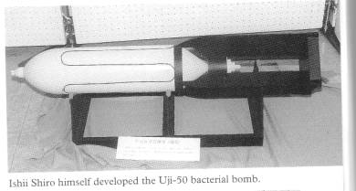
Two hurdles confronted the effort to load bombs with pathogens. The first was the need to keep the pathogens alive for long periods of time. The second was the need to develop a bomb made of materials that would break apart upon impact using little or no explosives; this would prevent the pathogen from being destroyed by heat. Alternatively, if a bombshell could not be made of fragile material, a pathogen that could withstand the heat of an explosion would have to be selected. When a bomb or a shell lands, people do not immediately gather at the point of impact, so it was necessary to convey the pathogen from that spot to wherever people were. Again a live host like a plague flea that would physically carry the pathogen and infect people was considered the best solution to this problem.
A bacteria bomb using the plague bacteria was developed to satisfy most of these requirements. The bomb used plague fleas packed in a shell casing of unglazed pottery made from diatomaceous earth (a soft, sedimentary rock containing the shells of microscopic algae). This same material was used in a water filter that Ishii had developed and patented. As this bomb would break apart using minimal explosive, it was expected that the plague fleas inside would survive the heat and scatter in all directions, to bite people and spread the disease. This bomb, called the Ishii bacterial bomb, was perfected by the end of 1944. In the beginning of 1945, the collection of rats went into high gear, and Unit 731 went to work cultivating fleas to be infected with the plague.
Japan’s Defeat
The main force of Unit 731 left the unit headquarters by train soon after the Japanese surrender and returned to Japan between the end of August and early September 1945. Some members of the unit and officers of the Kwantung Army were captured by the Soviet military. Twelve of these POWs were tried by the Soviet Union at a war crimes trial in Khabarovsk in December 1949. In addition to members of Unit 731, officers of the Kwantung Army and the army’s chief medical officer were also charged as responsible parties. All of those charged were given prison sentences ranging from two to twenty-five years, but aside from one man who committed suicide just before returning to Japan, all had been repatriated by 1956. The record of the Khabarovsk trial was published in 1950 as Materials on the Trial of Former Servicemen of the Japanese Army Charged with Manufacturing and Employing Bacteriological Weapons (Foreign Languages Publishing House, Moscow).
On the other hand, not one of the members of Unit 731 who returned to Japan was tried as a war criminal. Instead, the American military began investigating the unit in September 1945, and unit officers were asked to provide information about their wartime research, not as evidence of war crimes, but for the purpose of scientific data gathering. In other words, they were granted immunity from prosecution in exchange for supplying their research data. The American investigation continued through the end of 1947 and resulted in four separate reports. The investigation took place in two phases.
The first phase resulted in the Sanders Report (dated November 1, 1945) and the Thompson Report (dated May 31, 1946). These two reports contained information on the unit’s bacteria bombs, but did not address the subject of human experimentation or the trial use of biological weapons. Kitano Masaji, who was in Shanghai at the time of Japan’s surrender, was interrogated in January 1946, but he was instructed by Lt. Gen. Arisue Seizo, the Japanese chief of intelligence, that he should not talk about “human experimentation and biological weapons trials,” Kitano later told this writer. In other words, until that time, these two subjects had been effectively concealed.
Body disposal at Unit 731
However, at the end of 1946, American authorities received notice from the Soviets that they intended to try cases involving human experimentation and biological warfare. Ishii and others were interrogated again, and they confirmed the general content of the Soviet claims. The American investigation began anew, headed by new investigators. Two additional reports were produced: the Fell Report (dated June 20, 1947) and the Hill and Victor Report (dated December 12, 1947). These documents described the human experiments conducted by Unit 731 and its related units, based primarily on the interrogation of researchers involved in the experiments.
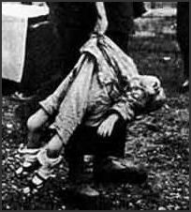
The Hill and Victor Report concludes with the following evaluation: “Evidence gathered in this investigation has greatly supplemented and amplified previous aspects of this field. It represents data which have been obtained by Japanese scientists at the expenditure of many millions of dollars and years of work. Information had accrued with respect to human susceptibility to those diseases as indicated by specific infectious doses of bacteria. Such information could not be obtained in our own laboratories because of scruples attached to human experimentation.”
The above account makes clear the nature of the crimes committed by the Ishii Unit. At the same, it is necessary to question the responsibility of the American forces who provided immunity from prosecution in exchange for the product of these crimes.
This essay was written by Tsuneishi Keiichi for publication in Sekai senso hanzai jiten (Encyclopedia of world war crimes) (Bungei Shunju, 2002), edited by Hata Ikuhiko, Sase Masamori, and Tsuneishi.
Tsuneishi Keiichi is a Kanagawa University professor specializing in the history of science, and Japan’s leading specialist on biological warfare and Unit 731.
Translated by John Junkerman, a documentary filmmaker living in Tokyo. His most recent film, “Japan’s Peace Constitution,” will be distributed in North America by First Run Icarus Films. He is a Japan Focus Associate. Posted at Japan Focus November 20, 2005.

Gaining better understanding of tularemia, aka “rabbit fever”
Source: http://www.homelandsecuritynewswire.com/dr20140218-gaining-better-understanding-of-tularemia-aka-rabbit-fever

Tularemia, aka “rabbit fever,” is endemic in the northeastern United States, and is considered to be a significant risk to biosecurity — much like anthrax or smallpox — because it has already been weaponized in various regions of the world.
At the 58th Annual Biophysical Society Meeting, which is taking place this week (15-14 February 2014) in San Francisco, California, Geoffrey K. Feld, a postdoctoral researcher in the Physical & Life Sciences Directorate at Lawrence Livermore National Laboratory (LLNL), described his work to uncover the secrets of the bacterium Francisella tularensis, which causes tularemia.
“Despite its importance for both public health and biodefense, F. tularensis pathogenesis isn’t entirely understood, nor do we fully understand how the organism persists in the environment,” explained Feld.
An AIP release reports that previous efforts, funded by both the National Institutes of Health (NIH) and LLNL, demonstrated that amoebae may serve as a potential reservoir for the bacteria in nature. “Specifically, we demonstrated that amoebae exposed to fully virulent F. tularensis rapidly form cysts — dormant, metabolically inactive cells — that allow the amoebae to survive unfavorable conditions,” said Amy Rasley, the research team leader.
This encystment phenotype was rapidly induced by F. tularensis in the laboratory and was required for the long-term survival of the bacteria. Further exploration led to the identification of secreted F. tularensis proteins, which are responsible for induction of the rapid encystment phenotype (REP) observed in amoebae.
In the new work, Feld and colleagues characterized two of these REP proteins — called REP24 and REP34 — and began to describe their functions based on their three-dimensional crystal structures.
A big surprise finding was that these proteins resembled “proteases,” which are proteins that cut other proteins in a specific manner. “Our preliminary data indicate that F. tularensis bacteria lacking these proteins are diminished in their ability to infect or survive in human immune cells, which indicates that these proteins may also contribute to F. tularensis virulence,” Feld said.
Rasley and colleagues believe that careful characterization of these two novel F. tularensis proteins may shed light on how this organism persists in the environment and causes disease.
“Ultimately, this type of research could inform efforts to combat the disease, although there is much work to do. Currently, we don’t know the protein targets in the host — amoeba, human, etc. — that the REP proteins act on, nor do we know the mechanism by which the proteins could help F. tularensis survive in the environment or cause disease,” Feld said.
“Once these questions are elucidated, a broader understanding of environmental persistence and pathogenesis might lead to better diagnostics and/or novel countermeasures to combat tularemia,” he added.

— Read more in Geoffrey K. Feld, “Structure and Function of Two Putative Virulence Factors from Francisella tularensis” (paper presented at the 58th annual meeting of the Biophysical Society, San Fancisco, California, 16 February 2014)

The U.S.-Mexico Border Infectious Disease Surveillance Project: Establishing Binational Border Surveillance
Source:http://wwwnc.cdc.gov/eid/article/9/1/02-0047_article.htm
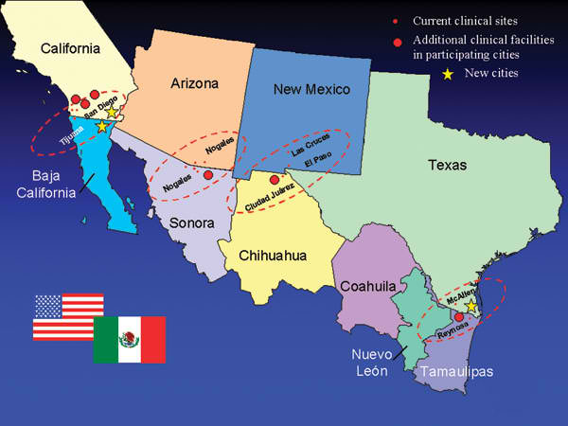
Border Infectious Disease Surveillance project sentinel sites in sister cities along U.S.-Mexico border: Tiajuana–San Diego, Nogales-Nogales, Las Cruces–Cuidad Juarez–El Paso, and Reynosa-McAllen. The new cities are Mexicali-Imperial (the sister city pair near Tijuana–San Diego) and Brownsville (near McAllen).

In 1997, the Centers for Disease Control and Prevention, the Mexican Secretariat of Health, and border health officials began the development of the Border Infectious Disease Surveillance (BIDS) project, a surveillance system for infectious diseases along the U.S.-Mexico border. During a 3-year period, a binational team implemented an active, sentinel surveillance system for hepatitis and febrile exanthems at 13 clinical sites. The network developed surveillance protocols, trained nine surveillance coordinators, established serologic testing at four Mexican border laboratories, and created agreements for data sharing and notification of selected diseases and outbreaks. BIDS facilitated investigations of dengue fever in Texas-Tamaulipas and measles in California–Baja California. BIDS demonstrates that a binational effort with local, state, and federal participation can create a regional surveillance system that crosses an international border. Reducing administrative, infrastructure, and political barriers to cross-border public health collaboration will enhance the effectiveness of disease prevention projects such as BIDS.

►Read more at source’s URL.

How do you weaponize a rabbit?
Source: http://theweek.com/article/index/256780/how-do-you-weaponize-a-rabbit

There are four major infectious agents that officials fear terrorists will turn into potent bioweapons. The first three you know — smallpox, anthrax, and the plague. The fourth? An itty bitty bacterium that wikes to wive in bunny wabbits.
Don't let its host of choice fool you — tularemia is a serious disease. Humans can contract the nastiness through the bites of ticks and flies or handling the corpses of infected bunnies. Failure to cook said bunnies thoroughly will also make you sick. And that's not all. Back in 2000, 15 residents of Martha's Vineyard came down with "rabbit fever" in a single season — an outbreak thought to have started when someone ran over an infected rabbit with a lawnmower.
Obviously, if an errant brush hog can transmit the disease, a terrorist with an aerosol device could wreak some serious havoc. This isn't merely the plot of a Tom Clancy novel. The United States, Russia, and Japan all experimented with tularemia's use as a bioweapon during World War II. That's why researchers at the Lawrence Livermore National Laboratory (LLNL) are peering into the bacterium's inner workings to learn how we might fight such an outbreak. And they're finding tularemia to be a rather sneaky microbe.
In humans and rabbits, tularemia evades the immune system by hiding out in white blood cells — the very sentries we rely upon to hunt invaders. Common signs of the disease include ulcers at the site of insect bites, swollen lymph nodes, and flu-like symptoms such as fever, muscle aches, and fatigue. If left untreated, rabbit fever can kill, as it did with one of the cases in the Martha's Vineyard outbreak.
But as potentially dangerous as tularemia is, there's still a great deal we don't know about it. For instance, until Amy Rasley and her team at LLNL started studying the bacteria, we had no clue how it survived in the environment — i.e., outside of humans, bunnies, and ticks. But Rasley's research has shown that when tularemia is in a bind, it can seek refuge in an amoeba, which are surprisingly similar physiologically to our white blood cells. Once inside, the bacterium becomes encapsulated in dormant cysts where it can remain until better opportunities arise.
Oh, but that's not nearly all. One of Rasley's colleagues, Geoffrey Feld, has been using x-ray crystallography to unravel the secrets of tularemia's survival trick. (Feld discussed the LLNL team's findings last weekend at an annual meeting of the Biophysical Society.) It seems tularemia is capable of secreting special proteins that might actually trigger the amoeba's cyst-making response. In other words, the bacterium does its best Frank Underwood impression and tricks the amoeba into giving it an office.
"If we're able to better characterize these proteins," said Feld in an interview, "then maybe we can start thinking about new countermeasures against tularemia based on how they work."
More research will be needed, of course, but the findings are promising — and welcome, given how little we know about the bacteria. Though the Centers For Disease Control and Prevention reports an average of just 130 human cases of tularemia each year, the agency takes the potential for its use in bioterrorism very seriously.
As an epidemiologist with the CDC's Division of Vector-Borne Diseases, Kiersten Kugeler says tularemia is a cause for concern because it's both highly infectious and widely available in nature. "CDC operates a national program for bioterrorism preparedness and response which includes stockpiling antibiotics to treat infected persons," she said. And just last week the CDC announced a cooperative effort with other federal agencies, international organizations, and foreign governments to launch the Global Health Security Agenda, which Kugeler said is designed to "standardize and unify response to disease outbreaks and close gaps in surveillance and response."
In other words, the CDC's got your back when it comes to a doomsday scenario involving tularemia. Furthermore, Kugeler says terrorists would require technology of "substantial sophistication" to weaponize rabbit fever on a large scale.
Then again, sometimes the simplest methods work best. There's some evidence to suggest that the Hittites used rabbit fever against their enemies over 3,300 years ago — making it the first known instance of bioterrorism. The Hittites' method? Leaving infected rams along the roads traveled by their enemies. After all, who can resist a free ram?

Austin Biotech Firm Tasks Human Protein To Thwart Bioterrorism
Source: http://bionews-tx.com/news/2014/02/24/austin-biotech-firm-tasks-human-protein-to-thwart-bioterrorism/

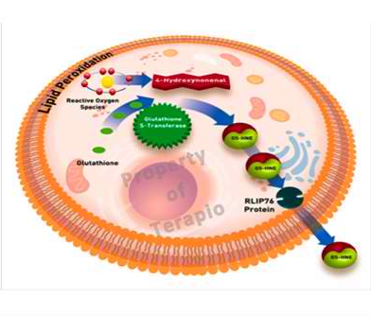
Austin based biopharmaceutical company Terapio Corporation’s research efforts are focused on developing therapeutics based on the protein RLIP76. Initial applications include developing the RLIP76 protein as a medical countermeasure for radiation exposure and chemical threats to civilian, military, and first responder populations. Terapio is also developing the protein to aid patients in recovery from traumatic brain injury and stroke.

RLIP76 protein pathway under normal conditions

The RLIP76 protein primarily works though the oxidative stress pathway and provides benefit as both a prophylactic and post exposure treatment. Terapio’s key innovation was the discovery that RLIP76 protein could be administered exogenously when encapsulated in liposomes and reach many of the body’s organs quickly, increasing the transport capacity of the cells of those organs and allowing them to deal with toxins associated with oxidative stress, which has found to be prevalent in the recovery phase of traumatic brain injury and stroke patients.
Terapio (which means “treatment” in Esperanto) notes that many of the damaging effects of radiation, chemical toxins and genetic disorders are due to the action of free radicals produced in the body’s cells by oxidation of cellular components such as lipids, proteins and DNA. These oxidation pathways culminate in the generation of reactive alkenals such as 4-hydroxynonenal (4HNE) that, if allowed to build up in cells, lead to cell death.
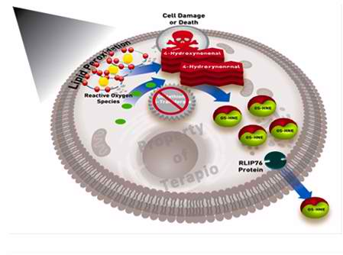
Normally, cells only have to deal with low levels of oxidative stress by binding alkenals such as 4HNE to glutathione, which is then removed from the cell by the transport action of RLIP76. However, if this mechanism becomes overwhelmed, as in the case of the examples noted in the preceding paragraph, 4HNE levels will quickly become lethal. Terapio’s key innovation was the discovery that RLIP76 protein could be externally administered when encapsulated in liposomes (TPO-7630) and reach many of the body’s organs quickly, increasing the transport capacity of the cells of those organs and allowing them to deal with increased oxidative stress. All of Terapio’s current applications directly leverage this finding.

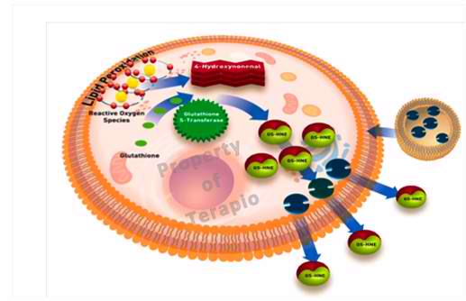
Exposure to insults increases 4HNE levels, leading to cell death.
The addition of RLIP76 protein reduces 4HNE levels by effluxing GS-HNE from the cell and promoting cell survival.

Acute Radiation Syndrome (ARS) or radiation sickness is an acute illness caused by exposure of all or part of the body to a high dose of penetrating radiation in a very short period of time. The dose and length of exposure determines the extent of organ systems affected and ultimately, the potential lethality threat to the patient. The hematopoietic (bone marrow) syndrome of ARS will occur at lower radiation doses and while some cases will recover, there is a greater risk of death without treatment as the radiation dose level increases. The primary cause of death is the destruction of the bone marrow and hemorrhage. Higher doses result in damage to the gastrointestinal tract and Central Nervous System, and mortality is almost always 100% in these cases.

Texas scientists find easy test for detecting deadly Ebola virus
Source: http://bionews-tx.com/news/2013/04/06/texas-scientists-find-easy-test-for-detecting-deadly-ebola-virus/

The Texas Biomedical Research Institute has had a breakthrough when it comes to being able to identify cases of the Ebola virus in order to prevent potential outbreaks. San Antonio scientists have been able to locate a unique component to the Ebola virus that makes it possible for a simple test to be administered which would allow them to know whether they are dealing with a true Ebola infection, or something else.
Typically it is very difficult to make a conclusive judgement when it comes to identifying viruses. One looks much like another, and symptoms can easily be misread. This can either lead to an unfounded panic from an incorrect diagnosis of a deadly virus like Ebola, or it can allow a single infected patient turn into a full-blown outbreak. Using this new method, scientists are confident they can create a way for doctor’s to know determinately whether or not they are dealing with the virus.
During a screening process performed by Texas Biomed virologist Andrew Hayhurst, Ph.D. And his assistant Laura Jo Sherwood, they found that hiding within Ebola is a polymer called nucleoprotein (NP).
Using llama antibodies – which are precisely what they sound like: antibodies taken from the animal – they discovered that they could easily find the NP polymer. Meaning that if NP was present, they knew they were dealing with Ebola. If it wasn’t, they could be almost certain they were not.
“Ebola NP is rather like a cob of corn displaying hundreds of kernels linked in a repetitive polymer, giving us the perfect molecular magnet to attract llama antibodies that can be assembled into highly avid assays based on a single antibody,” said Dr. Hayhurst.
The project is still in it’s infancy, but could mean another diagnostic tool for the medical community. Ebola is one of the terrifying viral demons that, were it ever to be weaponized, could be very difficult to contain or combat. It could be turned into one of the most deadly, and destructive biological weapons on the planet. By being able to allow first responders and doctors in emergency rooms to be able to determine whether or not they are dealing with Ebola could alert the global community to bioterrorism attacks. Or prevent unnecessary panic.
Even without the frightening overtones of biological warfare, the ability to allow principle physicians a way to rule Ebola out during the diagnostic process would avoid misdiagnoses and limit the possibility of a dangerous contagion being exposed to the populace at large.

