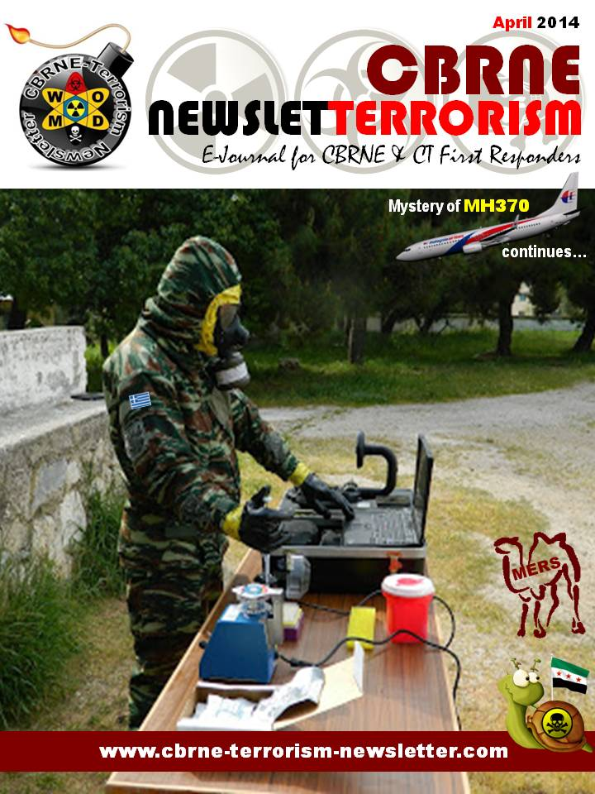
Turkish intel expert sheds light on 3 years investigation into Iranian regime terrorism
Source: http://www.ncr-iran.org/en/news/terrorism-fundamentalism/16211-turkish-intel-expert-sheds-light-on-3-years-investigation-into-iranian-regime-terrorism

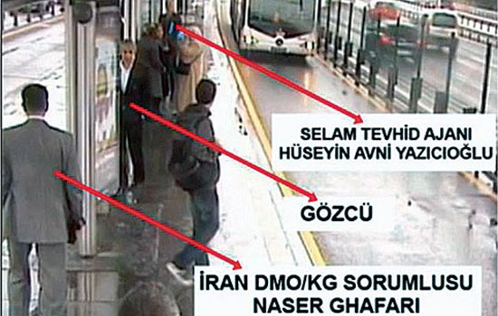
Former İstanbul Police Department intelligence bureau chief Ali Fuat Yılmazer has said Iran-linked notorious terrorist organization Tawhid-Salam is “the stealthiest and the mos t dangerous terrorist organization of recent times” Turkey has ever faced. He lamented that a painstakingly difficult three-year-long investigation into Iran-backed terrorist organization Tawhid-Salam has been foiled and ridiculed by some government officials, leading most suspects to flee the country.
Yılmazer, who has specialized in fundamentalist and extremist religious terror groups, said it was very difficult to expose this clandestine terror network that has access to top officials in Turkey, yet the police have done a solid and careful investigation to expose the wider network of Iranian agents that has been set up in Turkey and discovered connections to senior government officials.
“The Salam terror investigation included very important details,” Yılmazer said in a live TV interview on Tuesday night.
The veteran intelligence expert underlined that Tawhid-Salam is a very important terrorist organization that is backed by Iran.
He also lashed out at Justice Minister Bekir Bozdağ, who ridiculed the investigation, saying: “A group of people say hello with ‘Salam alaikum' [Peace be upon you] and others reciprocate with ‘Alaikum salam' [Also upon you]. On some people's say-so, a terrorist organization was supposedly founded, which is called Tawhid Salam. It is ridiculous.” Turkish Prime Minister Recep Tayyip Erdoğan also adopted a cynical stance about the existence of the terrorist group, raising questions of a cover-up in the government just as Erdoğan tried to do for the corruption scandal that was exposed on Dec. 17.
Former intelligence chief said this is a terrorist organization that was responsible for the assassination of several journalists and academics in the 1990s, including Uğur Mumcu, Bahriye Üçok, Ahmet Taner Kışlalı and several other intellectuals. The organization is also noted for killing US, Saudi Arabian and Israeli diplomats, as well as Iranian dissidents who took refuge in Turkey.
He said the organization stayed dormant for a while until it was reactivated several years ago and started committing bombing attacks and surveillance activities on sensitive targets in İstanbul. Yılmazer said the investigation cannot be hushed up despite government efforts to keep the investigation from going to court.
Information recently released online related to the terrorist activities of the Tawhid-Salam (also known as Jerusalem Army), which was first identified in 1996, has revealed that pro-government dailies Star and Yeni Şafak sought to discredit a secret probe of the group that would implicate senior government officials working on behalf of Iran by claiming that up to 7,000 people with no connection to one another were wiretapped in an investigation of what was supposedly a fake terrorist organization.
However, Yılmazer said only 234 people were wiretapped in three years during the investigation and the original tip about the reactivated Iranian-linked cells was made on Aug. 8, 2010, when an individual came forward in Bursa city.
Some of the details of the investigation have recently come out when Twitter user @ACEMUSAKLARI started uploading documents, photographs and video footage from what seems to be from the original investigation file onto online portals.
According to video footage posted on YouTube, Kamile Yazıcıoğlu, a 49-year-old woman who had fled from her abusive husband, Hüseyin Avni Yazıcıoğlu, reported anti-terror units to the Bursa police, saying that her husband had been working for Iranian intelligence and provided documents as evidence to back up her claims. She later repeated her testimony to İstanbul anti-terror units in depositions given in March and April 2011. The allegations triggered a secret three-year investigation into Yazıcıoğlu and his accomplices and contacts, both among Turkish officials and Iranian intelligence agents. Prosecutors in İstanbul launched an investigation on April 8, 2011, case file 2011/762.

Growing questions about TSA’s behavioral detection program
Source: http://www.homelandsecuritynewswire.com/dr20140327-growing-questions-about-tsa-s-behavioral-detection-program

TSA has spent roughly $1 billion training thousands of “behavior detection officers” as part of theScreening of Passengers by Observation Techniques (SPOT) program. The purpose of SPOT is to identify facial and body expressions that signals terrorist activity. The results have not been impressive: less than 1 percent of the more than 30,000 passengers a year who are identified as suspicious end up being arrested, and the offenses have not been linked to terrorism.
A November 2013 report by the Government Accountability Office (GAO) recommended that the TSA should reduce future funding for the agency’s behavioral detection program because there is little evidence of the program’s effectiveness. According to the GAO, “available evidence does not support whether behavioral indicators, which are used in the Transportation Security Administration’s (TSA) Screening of Passengers by Observation Techniques (SPOT) program, can be used to identify persons who may pose a risk to aviation security.”
The recommendation was supported by a survey in which psychologists Charles Bond and Bella DePaulo analyzed more than 200 studies in which participants correctly identified 47 percent of lies as deceptive and 61 percent of truths as nondeceptive, resulting in an average of 54 percent — only 4 percent better than chance. Accuracy rates were lower in experiments when judgment had to be made relying solely on body language.
“The common-sense notion that liars betray themselves through body language appears to be little more than a cultural fiction,” says Maria Hartwig, a psychologist at John Jay College of Criminal Justice in New York City.
The New York Times reports that TSA administrator, John Pistole has defended the SPOT program, saying it identified “high-risk passengers at a significantly higher rate than random screening.” The GAO report challenged the methodology behind Pistole’s conclusion and questioned the cost-effectiveness of the program.
Researchers have found that the best clues to recognizing liars are verbal clues. Dr. Nicholas Epley, a professor of behavioral science at the University of Chicago, has found that people over-rely on reading facial expressions. “Reading people’s expressions can give you a little information, but you get so much more just by talking to them,” he says. “The mind comes through the mouth.”
Epley explains why people believe they can read body language in his book on the topic, Mindwise: How We Understand What Others Think, Believe, Feel, and Want. “When you’re lying or cheating, you know it and feel guilty, and it feels to you as if your emotions must be leaking out through your body language,” he says. “You have an illusion that your emotions are more transparent than they actually are, and so you assume others are more transparent than they actually are, too.”

— Read more in Aviation Security: TSA Should Limit Future Funding for Behavior Detection Activities (GAO, November 2013); Charles F. Bond, Jr. and Bella M. DePaulo, “Accuracy of Deception Judgments,” Personality and Social Psychology Review 10, no. 3 (2006): 214-34; Bella M. DePaulo et al., “Cues to Deception,” Psychological Bulletin 129, no. 1 (2003): 74-118; Richard Wiseman et al., “The Eyes Don’t Have It: Lie Detection and Neuro-Linguistic Programming,” PLoSOne (11 July 2012) (DOI: 10.1371/journal.pone.0040259); Julia Shaw et al., “Catching liars: training mental health and legal professionals to detect high-stakes lies,” Journal of Forensic Psychiatry & Psychology 24, no. 2 (17 January 2013): 145-59 (DOI: 10.1080/14789949.2012.752025)

Mindwise
By Dr Nicholas Epley (Author)

You are a mind reader, born with an extraordinary ability to understand what others think, feel, believe, want, and know. It’s a sixth sense you use every day, in every personal and professional relationship you have. At its best, this ability allows you to achieve the most important goal in almost any life: connecting, deeply and intimately and honestly, to other human beings. At its worst, it is a source of misunderstanding and unnecessary conflict, leading to damaged relationships and broken dreams.
How good are you at knowing the minds of others? How well can you guess what others think of you, know who really likes you, or tell when others are lying? How well do you really understand the minds of those closest to you, from your spouse to your kids to your closest friends? Do you really know what your coworkers, employees, competitors, or clients want?
In this illuminating exploration of one of the great mysteries of the human mind, University of Chicago psychologist Nicholas Epley introduces what scientists have learned about our abilities to understand the most complicated puzzle on the planet—other people—and the surprising mistakes we so routinely make. Why are we sometimes blind to the minds of others, treating them like objects or animals instead? Why do we sometimes talk to our cars, or the stars, as if there is a mind that can hear us? Why do we so routinely believe that others think, feel, and want what we do when, in fact, they do not? And why we do we believe we understand our spouses, family, and friends so much better than we actually do? Mindwise will not turn others into open books, but it will give you the wisdom to revolutionize how you think about them—and yourself.

Praise for Mindwise:
- “Mindwise is a brilliant and beautiful exploration of the mystery of other minds—and how we fail to solve it. Insightful and important, Mindwise is one of the best books of this or any other decade.”
—Daniel Gilbert, Edgar Pierce Professor of Psychology, Harvard University, New York Times bestselling author of Stumbling on Happiness

- “What is it like to be someone else? How can we get into other people’s heads? These questions have challenged the greatest thinkers in Western philosophy, and they obsess every one of us as we try to deal with our family, lovers, friends, enemies, colleagues, and allies. In Mindwise, the distinguished social psychologist Nicholas Epley offers a lively and fascinating tour of the latest science on how we figure out (and all too often fail to figure out) what everyone else is thinking.”
—Steven Pinker, Johnstone Professor of Psychology, Harvard University, author of How the Mind Works and The Stuff of Thought

- “‘Know thyself,’ commanded the Oracle at Delphi. Mindwise shows us why that’s so hard to do, yet so vital as the starting point for understanding others. Epley writes with scientific authority, grace, and deep humanity. You’ll come away from this book understanding the African concept of Ubuntu: A person is a person through other people.”
—Jonathan Haidt, Thomas Cooley Professor of Ethical Leadership, NYU Stern School of Business, author of The Righteous Mind

- “Why are we often so terribly bad at figuring out what other people are thinking? Nicholas Epley is one of the smartest and most creative social psychologists alive, and in his extraordinary new book, he explores the powers and the limits of our capacity for ‘mindreading.’ Epley is a clear and engaging writer, and Mindwise is replete with fascinating insights into human nature.”
—Paul Bloom, Brooks and Suzanne Ragen Professor of Psychology, Yale University, author of Just Babies

- One of the smartest and most entertaining books I have read in years. At a time when there are dozens of popular social science books to choose from -- Epley's masterpiece stands out as the cream of the crop.
—Steven Levitt, William B. Ogden Distinguished Service Professor of Economics, University of Chicago, New York Times bestselling author of Freakonomics

- “Too much of life's misery comes from misunderstanding what others are thinking, and from assuming that those we love must know what is (obviously!) on our mind. Mindwise is a highly enjoyable and informative book by one of psychology's rising stars that will make you spend less time in pointless arguments and more time in rewarding relationships. Gaining some wisdom about the minds of others will be painless and priceless.”
—Richard H. Thaler, Ralph and Dorothy Keller Distinguished Service Professor of Economics and Behavioral Science, University of Chicago Booth School of Business, author of Nudge

- “Since Malcolm Gladwell’s Tipping Point and Freakonomics there has been a vast output of books on behavioural science. Many have been quite poor — formulaic books supporting obvious conclusions at unnecessary length. Mindwise stands out from the crowd. It is surprising, intelligent and convincing. It continues to make worthwhile points in every chapter (after about chapter two most books of this kind are repeating themselves) and the author tells you things you don’t know without straining for effect. You emerge from reading it understanding both yourself and others better, which is not a bad dividend from reading fewer than 200 pages.”
—Daniel Finkelstein, The Times

- ““Mindwise” is good reading for negotiators, the makers of public policy, heck, for anyone who interacts with other people, and that should be all of us. Mr. Epley is a genial, informative host in this tour of some of the most interesting findings in the social psychology of understanding one another, which he calls "mind-reading." His examples are drawn from the headlines as well as the peer-reviewed literature, and he keeps things going at a quick pace without dumbing-down the science.”
—Daniel J. Levitin, The Wall Street Journal

- “Epley lays out his argument alternately as thesis and antithesis in clear, engaging prose. He cites plenty of research, but illustrates his examples from everyday life and popular culture. This makes for enjoyable reading.”
—Richard Cytowic, New York Journal of Books

- "Psychologist Nicholas Epley’s Mind-wise provides a guide to understanding the minds of others. His engrossing book outlines the strategies that we use: projecting from our own minds, using stereotypes, and inferring from others’ actions… Epley is a lucid and magnetic host, and his book ... is crammed with evidence-based research."
—Leyla Sanai, The Independent

CNN producers busted trying to get into WTC site
Source: http://nypost.com/2014/03/25/cnn-employees-busted-trying-to-skirt-wtc-security/

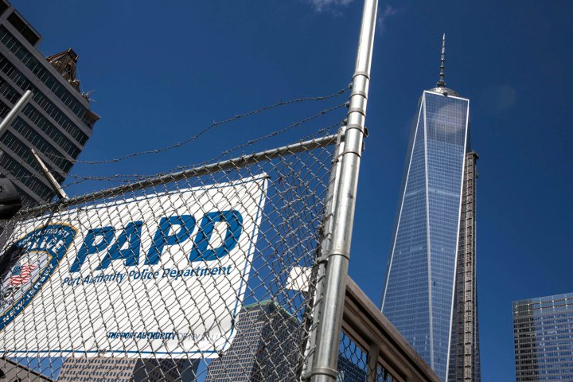
Two CNN producers were arrested Tuesday for trying to sneak into the World Trade Center site to test its security — after The Post reported that a teen made it all the way to the spire of the world’s top terror target.
Connor Boals, 26 (bottom), and Yon Pomrenze, 35 (top), made multiple attempts to get onto Ground Zero before being arrested shortly after 2 p.m., law enforcement sources said.
The pair initially tried to get through a gate at Vesey and Washington streets, with a source saying they told the cop who stopped them that “if a 16-year-old could get on the site, they should be able to get in.”
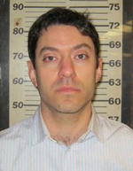
Next, they headed east, with Boals twice being spotted trying to climb a fence and getting stopped by cops, a source said.
They finally tried to push their way through a gate at Vesey and Church streets, where they were arrested.
Sources said the men were trying to test security at the site.
“They were trying to prove a point. I guess they thought anybody could get in,” one source said.
Both were charged with trespassing, obstructing governmental administration and disorderly conduct.
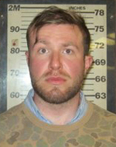
Cops also seized a miniature GoPro video camera, a full-size video camera and a tripod, sources said.
Last week, Justin Casquejo, 16 (right), of Weehawken, NJ, was busted for entering the site and making it all the way to the top of the Freedom Tower. On Monday, three men, including a former ironworker at the site, were charged with parachuting from the building.
Mayor Bill de Blasio on Tuesday said “both City Hall and 1 Police Plaza are concerned about this situation.”
A CNN spokesperson said Boals and Pomrenze “were not asked to sneak onto the World Trade Center site.”

EDITOR’S COMMENT: Anything for publicity… Including stupidity!

Boston Survivor!
Sydney Corcoran

Key events in the monitoring of Tamerlan Tsarnaev
Source: http://www.bostonglobe.com/news/nation/2014/03/27/key-events-monitoring-tamerlan-tsarnaev/ Zghz8YhSFRE0P5lPeoEuTI/story.html

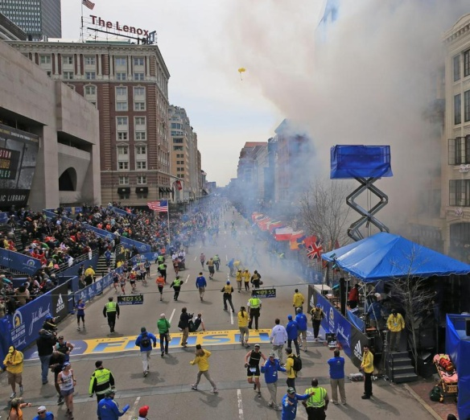
March 27 – The House Committee on Homeland Security report identifies a lack of coordination between agencies and multiple failures to identify warning signs about Tamerlan Tsarnaev. Some examples:

Early 2011 FBI receives letter from Russian intelligence officials expressing concern that Tsarnaev had become radicalized.
Early 2011 FBI Joint Terrorism Task Force in Boston initiates assessment of Tsarnaev.
March 22, 2011 FBI case agent enters Tsarnaev on a government TECS database to alert officials to scrutinize any international travel.
June 24, 2011 FBI closes assessment case on Tsarnaev, finding no links to terrorism.
Summer 2011 FBI notifies Russian authorities it has found no terrorism link to Tsarnaev.
Late September 2011 Unredacted portions of the House committee report do not say so, but Russians sent a letter expressing concerns about Tsarnaev to the CIA.
Oct. 20, 2011 A second TECS database alert is entered into the system, but his name is misspelled as “Tsarnayev’’ and it indicates the wrong birthday. Advisory says “detain is mandatory’’ for screening if Tsarnaev is detected departing or arriving on international travel.
Nov. 6, 2011 Tsarnaev purchases ticket to fly to Russia via JFK airport.
Jan. 18, 2012 TECS database alert system notifies a Customs and Border Patrol officer at Boston Joint Terrorism Task Force of his pending flight. It is unclear if this officer notifies other officials in task force.
Jan. 22, 2012 Tsarnaev departs for Russia. Customs does not detain and interview him, despite the “unequivocal’’ instructions in the TECS database that he be screened.
June 22, 2012 Tsarnaev books travel to depart Russia, bound for United States, triggering another TECS database alert to the Joint Terrorism Task Force in Boston. It is unknown if information is shared within the task force.
July 17, 2012 Tsarnaev departs Russia for the United States but once again is not detained and interviewed by officials.

April 15, 2013 Two bombs explode at the finish line of the Boston Marathon.

EDITOR’S COMMENT: “Connectig the dots” is not a suitable game for US intelligence agencies. Same for (geopolitical) “chess”…

Why Somalia isn’t the real piracy threat
Source:http://www.thestar.com/news/world/2014/03/27/why_somalia_isnt_the_real_piracy_threat.html

Maybe God has a soft spot for pirates. That would explain the Strait of Malacca, a natural paradise for seafaring bandits.
Imagine an aquatic highway flowing between two marshy coasts. One shoreline belongs to Malaysia, the other to Indonesia. Each offers a maze of jungly hideaways: inlets and coves that favour pirates’ stealth vessels over slow, hulking ships.
It’s a narrow route running 885 kilometres, roughly the distance between Miami and Jamaica. This bottleneck is plied by one-third of the world’s shipping trade. That’s 50,000 ships per year — ferrying everything from iPads to Reeboks to half the planet’s oil exports.
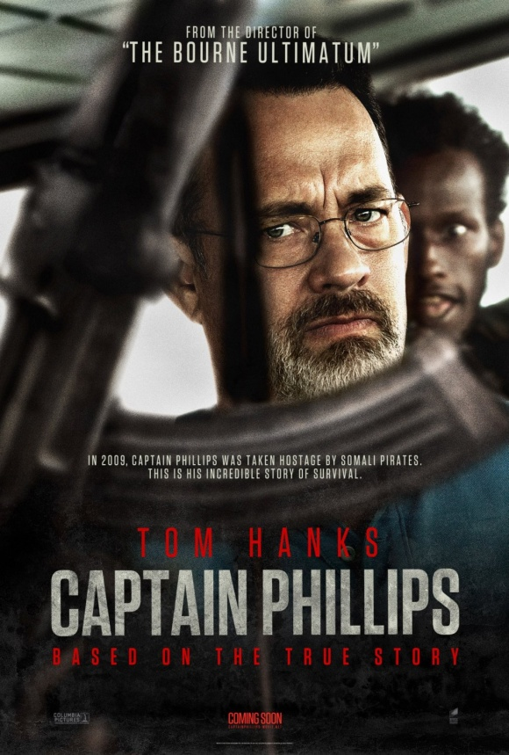
The world’s fascination with neo-piracy now centres on Somalia. Thanks to the 2013 thriller Captain Phillips, in which Tom Hanks plays a cargo ship captain abducted by Somalis, even teenagers know the anarchy-prone African state is a breeding ground for pirates.
At least it was. In truth, Hollywood stumbled onto Somalia’s piracy phenomenon rather late. In the last three years, pirate strikes in Somali waters have plummeted 95 per cent to a meagre seven incidents in 2013; none were successful.
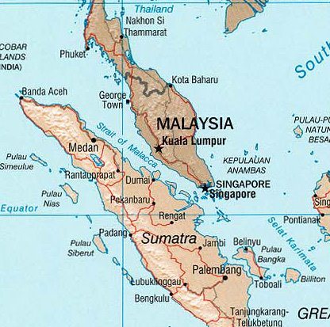
Piracy in Southeast Asia, meanwhile, is accelerating. Attacks and attempted attacks in the waters of Indonesia — which controls much of the Malacca Strait and its environs — totalled 107 last year. That’s a 700 per cent increase in just five years.
The German insurance firm Allianz, which released these figures in a new report, is now sounding a warning: Southeast Asian piracy must be reined in before it’s too late.
The attacks mostly amount to “opportunistic thefts carried out by small bands,” according to Allianz, but these syndicates could potentially “escalate into a more organized piracy model.”
Modern-day captains plying risky waters look to a guide called the BMP. Based on intel from Western navies and shipping firms, it offers tactics on avoiding pirates and — if that doesn’t work — fending them off and surviving abduction.
The guide’s best advice? Go really fast. No pirates have ever boarded a ship pushing 18 knots, or nearly 34 kilometres per hour, the guide says.
But that’s practically impossible in the Strait of Malacca.
The channel is simply too crowded and too shallow. Gigantic vessels are instead forced to churn through at slow speeds that invite pirates in fast-moving skiffs. (To save fuel, today’s cargo ships often travel at about 22 kilometres per hour.)
Indonesian pirates typically have different tactics from their Somali counterparts, who’ve made headlines by invading vessels and demanding multimillion-dollar ransoms.
In the Malacca Strait, pirates like to get in and get out. Their “modus operandi isn’t to kidnap,” according to Tim Donney, an Allianz marine risk consultant. “These pirates just want the cash aboard the vessel or to rob the crew of any valuables.”
Indonesia isn’t nearly as lawless as Somalia. But both are coastal nations where poverty is rife and police are ill-equipped. Both also happen to be situated on routes trafficked by wealthy nations’ trade vessels.
“Most piracy takes place in areas where people are poor. Their livelihood has been taken from them by globalization, civil unrest or war,” writes Nigel Cawthorne, author of the book Pirates of the 21st Century.
Somalia’s turnaround is owed to several factors: NATO- and EU-backed naval patrols, ships hiring on-board riflemen and, perhaps most importantly, a new Somali government working to stabilize its lawless coast.
Somali pirates also forced the shipping industry to get creative. They’ve come up with effective pirate-proofing techniques that could be applied to more ships entering the Malacca Strait.
The BMP recommends blasting approaching pirates with hot water, ringing ships with razor wire and even installing electric fencing. Discharging foam, according to the manual, is “effective as it is disorientating and very slippery.”
Piracy along the Malacca Strait route should be easier to fight than in Somalia. All of the nations patrolling the strait have functioning governments, committed to fighting the problem, and are financially incentivized to maintain a bandit-free trade route.
Piracy poses no existential threat to the shipping industry. Considering the volume of international trade, losses from piracy “amount to little more than a rounding error,” according to piracy analyst Martin N. Murphy. But the “sense of disorder” created by piracy, he writes, “may be hard to calculate in dollars.”

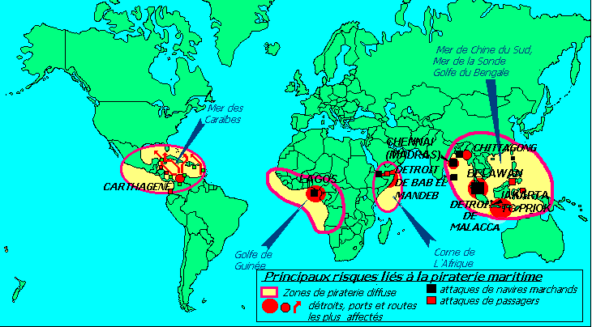
World piracy heavens

Terrorism in Portugal “worrying in the mid-term”
Source: http://www.theportugalnews.com/news/terrorism-in-portugal-worrying-in-the-mid-term/31121

This year’s Annual Internal Security Report (RASI), released this week, has warned that Portuguese nationals are joining the Jihad in countries such as Syria and Mali, where there is a strong Al-Qaeda presence and are the locations where many European combatants linked to the terrorist network gather.
According to the RASI report for 2013 “what attracted attention was the movement of national citizens to Jihad areas, particularly those whose destinations were regions where Al-Qaeda and its affiliates look to reinforce their position, with emphasis on Syria, or in the direction of regions under the influence of Al-Qaeda in the Islamic Maghreb and of regional terrorist groups, such as Mali.”
Speaking to Expresso newspaper, a spokesperson for the Observatory for Security, Organised Crime and Terrorism (OSCOT), José Manuel Alves, addressing the findings in the RASI 2013, said that the situation in Portugal “is not as worrying as in Spain or France” but there are “radical fringe [groups] in Portugal, especially in peripheral mosques.”
The 417-page report revealed that “certain phenomena were noted that underpinned and boosted terrorist activity” and that, similar to recent years, “detecting evidence that reveals, mediately or immediately, the involvement of national citizens or of structures based in national territory, in the activism, propaganda, logistical support or financing of international terrorist networks, remains a central issue.”
It further stressed that there also “is a risk of possible connections to our country of old elements from operational structures of separatist or revolutionary terrorist networks, albeit deactivated, namely by using Portugal as a place of retreat for sleeping cells.”
On its Foreign Travel Advice website the British Government warns that there is an “underlying threat from terrorism” in Portugal.
“Attacks, although unlikely, could be indiscriminate, including in places frequented by expatriates and foreign travellers”, it reads.
José Manuel Alves meanwhile told Público that the situation is “worrying”, but “at least for now we can breathe.
“I am more concerned with the mid-term”, he said.
Activity relating to separatist terrorist groups such as the Basque nationalist and separatist organisation ETA and the Irish Real IRA has been detected on various occasions in Portugal in recent years.
In January last year two men were sentenced by Olhão court (Algarve) to four years and ten months in prison for charges relating to the attempted trafficking of weapons to supply the dissident faction of the IRA, RIRA.
Defendants Conor Sheehan, who was born in Northern Ireland, and Portuguese national Paulo Guerreiro, both received a prison term of four years and ten months for their roles in the buying of guns in the Algarve.
Two other men, James Rice, who was enlisted to transport the guns to Ireland, and fourth defendant Portuguese national António Mestre, had their sentences of three years and nine months and three years and five months, respectively, suspended.
The reading of the verdict took place under a massive armed police presence, indicative of the sensitive nature of the case.
It is not the first time RIRA activity has been exposed in the Algarve.
In 2009 two men believed to belong to the Real IRA were found to be using a restaurant in the small fishing village of Alvor as a main European base.
It was at the Panda Grill on the outskirts of the village that Paul Anthony McCaugherty and Michael Gregory allegedly negotiated the buying and selling of weapons for the Real IRA, between 2005 and 2006.”They are also believed to have done business in the Algarve, including a property transaction, to the sum of €46,000, to finance RIRA terrorist activity.” McCaugherty was described as the dissident group’s number two man. He is also believed to have had a hand in the cold-blooded killing of two British soldiers on 7 March 2009, at a military base in County Antrim, Northern Ireland.
The Real IRA is described as a rebellious breakaway arm of the IRA (Irish Republican Army) which refuses to accept a cease-fire and peace in Ireland. Its main objective is to end British sovereignty in Northern Ireland through force.
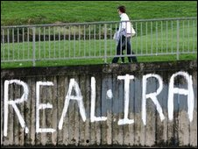
It is designated as a terrorist organisation in the United Kingdom and the United States.
In January 2012 a panel of judges at a court in Caldas da Rainha sentenced an alleged Basque terrorist Andoni Zengotitabengoa Fernandez to a total of 12 years in prison.
The suspected ETA terrorist was found guilty of belonging to a terrorist organisation, possession of explosives to commit terrorism, three counts of forgery, grand theft auto and resisting arrest, when he attempted to run over a police officer during a stop and search operation.
The Chief Judge Paulo Coelho said the possession of explosives was the most serious crime “due to where the explosives were kept (…) which could have had disastrous consequences”. Fernandez lived in a house in Obidos, close to Caldas da Rainha where 1,500 kilos of explosives were found by police officers.
Zengotitabengoa was first arrested by Portuguese police at Lisbon Airport in March 2010 as he tried to flee the country on a flight to Venezuela using a fake Mexican passport.
Also in 2010 a Portuguese judge ordered the extradition of a Spanish couple arrested in Portugal on suspicion of belonging to the Basque separatist organisation.

Fury as fanatic who trained 7/7 bomber sets up Islamic PRIMARY SCHOOL in Britain
Source: http://www.dailymail.co.uk/news/article-2592441/Fury-fanatic-trained-7-7-bomber-sets-Islamic-PRIMARY-SCHOOL-Britain.html

A terror suspect who trained the ringleader of the 7/7 terrorist bombings in London has been allowed to set up an Islamic primary school, teaching children as young as three, The Mail on Sunday can reveal.
As a member of a banned extremist group, Sajeel Shahid, 38, called for violence against British troops and ran a training camp in Pakistan where known terrorists learned how to make bombs and fire rocket- propelled grenades.
One of his ‘graduates’ was Mohammed Siddique Khan, who led the gang of four suicide bombers on the deadliest terrorist attack ever committed in Britain, killing 52 people on the London Underground and a bus on July 7, 2005.
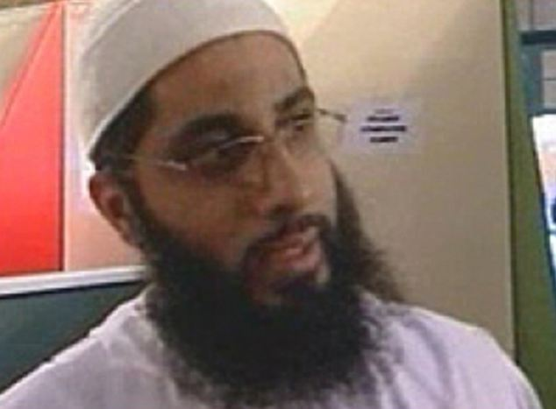
Boss: Ad-Deen school founder Sajeel Sahid, 38, called for violence against British troops and ran a training camp in Pakistan where known terrorists learned how to make bombs and fire rocket- propelled grenades

Shahid also allegedly trained four convicted terrorists who tried to blow up the Bluewater Shopping Centre in Kent and London’s Ministry of Sound nightclub in a foiled plot.
The jihadist – who was raised in Britain but spent years in Pakistan after the 9/11 attacks – was detained for three months in 2005 by the Pakistani security forces over his suspected links to Al Qaeda.
He had been running the Pakistan branch of the banned British extremist group Al-Muhajiroun. After his detention he was expelled from the country.
But despite being known to British security services, on his return to the UK he was given permission to set up an independent primary school, where he taught lessons and employed his brother – who also has a history of extremism – as head of IT.
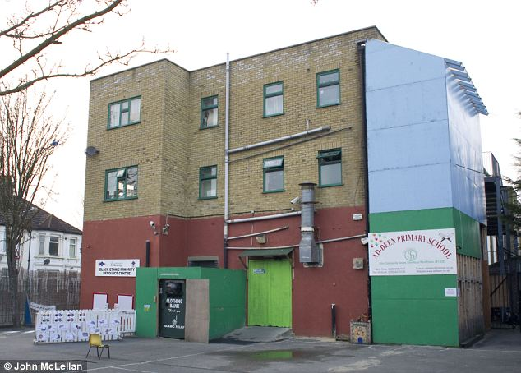
Independent school: Documents seen by The Mail on Sunday show Shahid was registered as director and proprietor of the Ad-Deen Primary School in Ilford, Essex, which teaches 54 pupils aged three to 11

The Department for Education said last night it was ‘urgently’ looking into Shahid’s case, which critics said exposed the lack of checks on potentially dangerous individuals who set up schools in the UK.
Lord Carlile, the Government’s former adviser on counter-terrorism, said: ‘It is a matter of real concern that somebody should be able to slip through the net and run a school where there has been substantial concern about his activities in the past.
'People who have been involved in terrorist activity anywhere in the world should not be allowed to run schools, unless there is the clearest evidence they have rejected the views that made them turn towards terrorism.’
Keith Vaz, chairman of the Home Affairs Committee which is investigating terrorism, including extremism in schools, said: ‘It’s extremely worrying a person with such a history, which should be of concern to the relevant authorities, should be in such a position. The DfE needs to look into this urgently.’
Documents seen by The Mail on Sunday show Shahid was registered as director and proprietor of the Ad-Deen Primary School in Ilford, Essex, which teaches 54 pupils aged three to 11. He is thought to have founded the £2,000-a-year school in 2009, where, using the pseudonym Abu Ibrahim, he taught children to recite the Koran.
He was able to operate his school for five years, despite the DfE launching a Due Diligence and Counter-Extremism Unit in 2010 to prevent individuals with a history of extremist beliefs running schools.
A cursory internet check on Shahid reveals his past as a terror suspect, as he even has a profile on Wikipedia stating his involvement with Al-Muhajiroun, the group founded by Omar Bakri Mohammed.
In 2001, Bakri sent Shahid and his elder brother Adeel, 39, also a member of Al-Muhajiroun, to Pakistan to set up a branch of the group there.
In December 2001, Shahid gave an interview to a British newspaper. He said: ‘We say the Pakistan army, navy and air-force should be fighting US and British forces which are killing our Islamic brothers and sisters in Afghanistan. We see the US and British governments as the biggest terrorists in the world.’
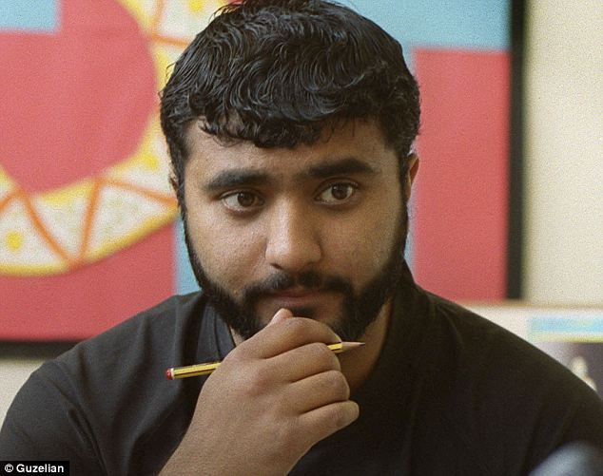
He also called on Muslims to rise up and ‘throw out their rulers implementing kufr [infidel] laws to be replaced by the Islamic law and order,’ adding, ‘jihad was the only solution for Muslim lands under occupation.’

Bomber: Mohammed Sidique Khan, 30, working as a teaching mentor in a classroom at a school in the Beeston area of Leeds before leading the gang of four extremists who carried out Britain's worst-ever terror attack

More details of Shahid’s activities in Pakistan emerged at the Old Bailey trial of seven terrorists who plotted to blow up the Bluewater Centre and the Ministry of Sound with half a ton of fertiliser.
The court heard evidence from Muhammed Junaid Babar, 39, a US terrorist who became an FBI supergrass on Al Qaeda, who had met Shahid and his brother in Pakistan in 2001.
Babar revealed they accommodated British jihadists in safe houses in Lahore, before they left for Afghanistan to fight the Americans.
According to transcripts obtained by the MoS, Babar told the court that in 2003 he and Shahid and two others travelled to a region near the Afghan border and set up a terrorist training camp in Malakand.
Babar told the jury that in August 2003, the would-be ringleader of the 7/7 attacks, Mohammed Siddique Khan, 30, trained at the Malakand camp with Mohammed Shakil, 37, a friend from Leeds. He was jailed in 2009 for seven years for attending the camp.
Khan, who was known at the camp as Ibrahim, and Shakil, known as Zubair, were joined by four other Brits, who were led by Omar Khyam, 34, who was later convicted as the ringleader of the Bluewater plot.
In 2005, the Shahid brothers were arrested by security forces in Pakistan on suspicion of supporting and having links with Al Qaeda and were detained for three months.
Security sources told The Mail on Sunday that Sajeel Shahid was ‘on MI5’s radar’ after he was expelled from Pakistan and returned to the UK, but slipped towards the bottom of their priority list as he was not deemed a national security threat. He has never been charged with any terrorism offences.
But last night, questions were asked as to how Shahid’s past was not uncovered by the DfE despite background vetting, which include enhanced criminal records checks.
Electronic records sent to Companies House indicate that Shahid resigned from Ad-Deen early this month, although a staff member said that he ‘still goes in and out’ and can be reached at the school. He did not respond to our calls.
Ofsted inspected the school in 2011 and 2012 without apparently discovering Shahid’s past, concluding it met ‘all regulatory requirements’.
Last night, Ofsted refused to answer any questions on what checks it made on the background of Ad-Deen’s staff and proprietor.
The DfE spokesman said: ‘We will investigate any evidence put to us.’

Is 'secret immunity' for IRA suspects really to blame for new N. Ireland controversy?

Source: http://www.terrorismwatch.org/2014/03/is-immunity-for-ira-suspects-really-to.html

Testing the assumptions behind the headlines.
Northern Irish politics has again been thrown into turmoil, after the bombing trial of an alleged Irish Republican Army militant collapsed in London when it transpired the suspect had been given official assurances that he would not be tried.
But while both British Prime Minister David Cameron and Northern Ireland First Minister Peter Robinson have decried the letter – one of many sent by the British government to IRA suspects since the 1998 Good Fridaypeace agreement – is the existence of these letters really a surprise to Mr. Cameron and Mr. Robinson?
Or rather, is it another instance of contemporary Northern Ireland touching the third rail of its historical politics: the unsolved violent crimes of the "Troubles," and the near impossibility of addressing them to the satisfaction of both republicans and unionists?

The Downey letter
The case against John Downey, a man accused of killing four soldiers in the 1982 IRA bombing of London’s Hyde Park, collapsed Wednesday when it was revealed that he had been supplied with a letter stating that he would not face trial. The letter informed him that “There are no warrants in existence, nor are you wanted in Northern Ireland for arrest, questioning or charging by police. The Police Service of Northern Ireland are not aware of any interest in you by any other police force.”
It later came to light that 187 suspected letters had been sent to “on the runs,” IRA suspects who had avoided trial by absconding from British jurisdiction. The letters allowed suspects to return to Northern Ireland, giving them assurances there were no open investigations into their alleged past activities.
Speaking on BBC television, British Secretary of State for Northern Ireland Teresa Villiers said the letters are not a "get out of jail free" card, but rather indicated a disinclination to pursue historical cases where new evidence was not available. “If new evidence emerges, those letters do not constitute immunity from prosecution,” she said.
Mr. Cameron has been embarrassed by the deal. Speaking alongside German Chancellor Angela Merkel during her visit to Britain, Mr. Cameron said he wanted to “get to the bottom” of the issue.
Thirty-eight letters were sent by Cameron’s Conservative government, the rest under the previous Labour administrations of Tony Blair and Gordon Brown.

Unionist anger
But unionist politicians have responded to the collapsed trial with dismay, arguing the deal was a secret one done by the then British government of Tony Blair and Irish republican party Sinn Féin.
First Minister Robinson, who leads the Democratic Unionist Party, a hardline pro-British group, threatened to resign from his post. Mr. Robinson later rescinded his threat when the British government announced a “judge-led inquiry” into the matter. The inquiry will not be a full-blown judicial inquiry and will not be able to investigate the role of former British Prime Minister Tony Blair in the deal.
At an emergency sitting today of the Northern Ireland Assembly, the powersharing body set up under the 1998 “Good Friday Accord,” Mr. Robinson restated he had been unaware of the scheme do deal with “on the runs,” describing the deal as an “invisible” one.
But political commentator Mick Fealty says studied ignorance may be at work in the kerfuffle: “There are things that political parties didn’t want to know. Robinson didn’t want to know anything about this. It’s all routed through the [British government’s] Northern Ireland Office.”

Time to close the door on the past?
The past may be a foreign country, but in Northern Ireland it remains a hostile one. Northern Ireland’s attorney general came under fire in November 2013 when he suggested there should be an end to prosecutions for killings that occurred during the 30-year conflict, arguing that the evidence trail was too cold to endure safe convictions.
The proposal was roundly rejected, but may take on new life in light of recent events. “I think that’s where we’re headed. I don’t think it means an amnesty, though. These are not letters of immunity, they’re letters of comfort. It’s a confidence-building exercise,” says Mr. Fealty.
But what is sauce for the goose is sauce for the gander, and any attempt to cease prosecutions of IRA members would also mean an end to prosecutions of pro-British loyalist terrorists and British army soldiers.
“Sinn Féin has effectively argued that bringing septuagenarians to trial is not the way forward. What this may mean is that victims of loyalist groups and British government actions will not get what they’re looking for [either]. [Sinn Féin leader] Gerry Adams is saying ‘You don’t want to prosecute old [IRA] soldiers,’ and that means these things should not be pursued,” Fealty says.
Since the Downey trial collapsed, others have called for an end to prosecutions. Billy McQuiston, a senior member in the loyalist terrorist group the Ulster Defence Association, today said the Police Service of Northern Ireland’s Historical Enquiries Team (HET) should be shut down. Loyalist perception that the HET was focused almost exclusively on the actions of loyalists fueled rioting on the streets of Belfast in recent years.

Prisons for pirates could breed new security risks
By Jill Keenan
Source: http://www.terrorismwatch.org/2014/03/prisons-for-pirates-could-breed-new.html

Mowlid Ahmad Abidoon stands quietly in the small prison cell where he has lived for nearly two years. Slot windows on one wall let in only a little sunlight, leaving his face almost entirely obscured in darkness. Yet there are splashes of colour all around: The room’s bunk beds are covered in sheets with bright floral and geometric patterns, over which hang canopies of blue mosquito nets — cells within the cell.
Clad in a striped polo shirt and prison-uniform pants, Mowlid estimates that he is about 20 years old; the last traces of baby fat still cling to his cheeks. He insists that he shouldn’t be behind bars. “I’m a fisherman, not a pirate,” he says flatly, as though he has delivered this speech a hundred times before.
Court documents from Seychelles say otherwise. On December 6, 2009, Mowlid and a band of fellow Somali pirates used firearms and explosives to attack the Topaz, a Seychelles Coast Guard patrol vessel. (Seychelles, an island nation, is about 825 miles southeast of Mogadishu, Somalia’s coastal capital.) They were arrested, convicted and sentenced to 24 years in prison.
That’s how Mowlid ended up in Hargeisa Central Prison, home to 29 Somali pirates. The prison was born of necessity. Pirates are often tried in countries like Seychelles and Mauritius, in whose waters they are caught, but those states don’t want to keep the convicted in their jails. The Somali government can’t reasonably take them, given its extreme volatility. Yet one place has been eager to house pirates: Somaliland, a self-declared independent (but internationally unrecognised) republic in northern Somalia that wants to prove its state-like qualities and relative security in the tumultuous Horn of Africa.
So the United Nations invested millions of dollars to build a prison in Hargeisa, Somaliland’s capital. Opened in 2010 and run by local authorities, it was the first new prison in the region in 30 years.
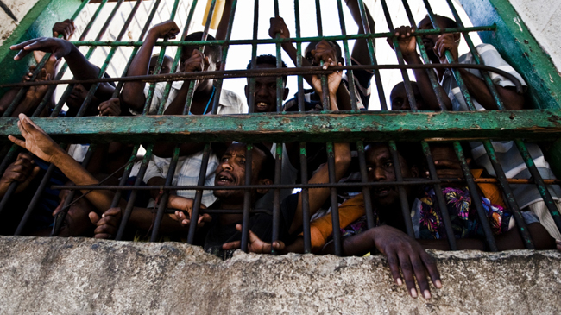
Today, outside the prison’s main entrance, a sign warns visitors what they cannot bring with them: hand grenades, knives, assault rifles. Inside, inmates compete against guards in basketball, while feral kittens roam the dusty grounds. In the prison’s open kitchen, a huge pot of stew bubbles over a fire. Aside from spirals of barbed wire and armed guards atop open towers, there isn’t much obvious security.
Beneath the veneer of calm, however, the prison is nearing capacity. The facility can hold 506 prisoners, and it already has 480. (Pirates are housed alongside other criminals.) Mowlid, like many inmates, shares his cell with nine other men. Meanwhile, some 1,350 pirates currently incarcerated abroad await repatriation to Somalia. It’s clear that neither Hargeisa nor Somaliland generally will be able — or even willing — to take them all.
The solution, according to the international community, lies in another autonomous region in Somalia: Puntland, which encompasses the country’s northeastern coastline. The UN provided funding to upgrade and expand a prison in the port city of Bosaso, and, another UN-backed facility was to be opened in Garowe, Puntland’s capital, this year. But Puntland isn’t Somaliland. It is a less stable and more corrupt place. Perhaps most worrying, however, is that it’s also considered the heart of Somalia’s pirate culture.
“Puntland is pirate land,”explains Michael Frodl, the founder of C-Level Maritime Risks, a Washington-based consultancy. “If I were a Somali pirate, I’d do everything I could to get sent to Garowe.”
Piracy began spreading rapidly in the waters off Somalia in the early 21st century because of civil war and poverty — offering a chance to make money amid an economic wasteland of opportunity.
In a typical operation, pirates armed with guns and other weapons approach commercial ships in skiffs, hijack them, and demand a ransom, a chunk of which they often pay to wily financiers. But even if Somali pirates can be considered products of circumstance, some have also become torturers and murderers: Freed hostages have reported pirates hanging captives by their feet, submerging them at sea, staging mock executions, and locking them in freezers.
Reports of appalling violence, along with hundreds of millions of dollars in losses to shipping companies, have prompted the international community to focus on repressing, arresting, and prosecuting Somali pirates.
In 2008, the UN Security Council adopted a resolution calling on countries with ships in the region to use military force against pirates. Nato and the European Union (among others) police the Indian Ocean, and private, foreign-funded security operations have also joined the fight. Meanwhile, shipping companies have fortified their vessels to repel attacks, using everything from armed guards to razor wire.
Their efforts have worked. There were only 15 reported attacks in 2013, according to the International Chamber of Commerce, down sharply from a peak of 237 in 2011. Analysts around the world have touted the drop as a huge success.
But while the most visible manifestations of piracy have diminished, the root causes of the phenomenon remain unaddressed back on dry land. Amid continuing political and economic instability, organised gangs of pirates still exist, looking for susceptible targets, and a new generation of young men like Mowlid could easily turn to a life of maritime crime.
Indeed, according to a 2013 World Bank report, “Current and proposed onshore or offshore policies for curbing Somali piracy are either ineffective or unsustainable.” As a result, the report states, “whether they [pirate attacks] will continue to be suppressed is a major question.” Similarly, Jon Huggins of the nonprofit Oceans Beyond Piracy, has called the recent gains against pirates “fragile and reversible” and has warned against “emphasis[ing] too much the declining numbers of attacks.”
The prisons in Somaliland and Puntland, in other words, are part of a security solution to a problem that is, at its heart, economic and political - a worrying mismatch. Ending piracy once and for all will require more than military might on the high seas and the threat of incarceration.
According to the World Bank, it will require incentivising — through both law enforcement and development initiatives — the local leaders enabling piracy to change their tune. Then there is the matter of jobs. “Ultimately, we need to get these Somali men, often youth, quality employment,” says Michael Shank, an adjunct professor and Somalia expert at George Mason University’s School for Conflict Analysis and Resolution. The UN Development Programme has pegged the unemployment rate for Somali youth between the ages of 14 and 29 at 67 per cent — one of the world’s highest.
Pirate prisons alone certainly cannot address this problem. Although inmates can complete training programs in trades like construction, metalworking, and plumbing in the Hargeisa and Bosaso facilities, it’s unlikely they will be able to use their newfound skills upon release. Even fishing jobs are largely out of reach. Shank explains that, in addition to “ransom pirates,” there are “resource pirates.” The latter, however, aren’t Somalis.
They are foreign fleets that threaten East Africa’s waters with overfishing and toxic-waste dumping, making it impossible for many Somali men to make money the way their fathers and grandfathers did.
“To put the problem of piracy in perspective, ransom pirates made $60 million (Dh220 million) in their most lucrative year, while commercial-resource pirates illegally harvest up to $450 million in fish annually,” says Shank. “Any sustainable solution for this problem, then, must address this exploitation.”
Ironically, pirate prisons may also be generating new security risks. Pirates in Hargeisa and Bosaso are held in the same facilities as members of Al Shabab, the Somali group with ties to Al Qaida, and juveniles are housed alongside adults. That means there’s a very real risk that impressionable, disillusioned young men could be radicalised — young men like Mowlid, who, if his estimated age is correct, was only about 16 when he and his friends attacked the Topaz. “I don’t see any future,” Mowlid says of his life.
John Wilcox, a prison adviser for Somaliland with the United Nations Office on Drugs and Crime (UNODC), says roughly 12 of the Hargeisa prison’s inmates are members of Al Shabab. There is a covert prison intelligence programme in place to ward off radicalisation, but Wilcox still worries that the facility could become a breeding ground for extremists.
“A lot of these guys don’t have father figures,” he says, alluding to another socioeconomic problem in Somalia: the disintegration of clan and family structures because of conflict and hardship. “And with Al Shabab in here, we certainly don’t want this to be the place where they find one.”
Radicalisation might be less of a concern if prison inmates were certain to remain behind bars. But in November 2013, Bosaso’s prison was attacked by Al Shabab militants carrying at least one rocket-propelled grenade; they killed three people as they sought to liberate fellow extremists from their cells.
The UNODC was quick to point out that, had it not been for its recent investments in Bosaso, the attack could have been worse. “However, we cannot close our eyes to possible attacks,” says Manuel de Almeida Pereira, a programme coordinator with the UNODC in Garowe. “We remain, of course, worried.”
It’s not just Al Shabab that threatens the prisons’ security: Puntland has a reputation for tolerating and even enabling piracy. Although Puntland’s former president, Abdul Rahman Farole — in office from 2009 until January 2014 —made repeated public pledges and some concrete efforts to undermine, arrest, and convict pirates, a 2012 report by the UN Monitoring Group on Somalia and Eritrea called into question “the authenticity of the Puntland authority’s commitment to fighting piracy.”
Gangs have reportedly paid off local communities in order to dock hijacked ships in Puntland’s coastal cities during ransom negotiations, and Puntland government officials have been known to receive pirate money in exchange for protection agreements and information about the location of foreign ships.
A 2012 Chatham House study also found that ransom money contributes heavily to the region’s economic development, particularly in provincial capitals. “Puntland’s political elites are therefore unlikely to move decisively against piracy,” the report concluded.
The decision to invest in greater detention capacity in Puntland — like Somaliland before it — was due largely to a lack of alternatives. (It didn’t help that, due to an ongoing border dispute, Somaliland has refused to imprison pirates born in Puntland, saying it must deal with its own problems.) But the large-scale transfer of pirate prisoners from abroad hardly seems like a safe solution.
Pirates have had success bribing their way out of custody throughout Somalia. The UN is working to ensure that prisoners are not unlawfully released from the facilities it funds, but some experts are worried that pirates may still slip through the cracks in Puntland.
“Pirates are basically being sheltered by the regime in exchange for protection money,” Frodl, the maritime risk consultant, says. “Those jails might hold a few foot soldiers, but if you tried to incarcerate any high-level pirates in Puntland, they’d buy their way out in a week.”
Mowlid, who grew up in the town of Barawe, south of Mogadishu, perks up slightly when asked about the Puntland prisons. Puntland might be better, he agrees. In Somaliland, he has never been able to have a visitor, and he misses his family. Puntland would be closer to home. A few of his fellow inmates nod. A transfer might be nice.
But that’s not what they really want to talk about. As the minutes pass, they shift in their seats, ignoring the bottles of fruit juice and water a prison guard has passed around.
“How can you help us?” demands Ares Isse Karshe, a 40-year-old pirate who was captured with Mowlid. He has a thin, ragged beard with hints of gray. When I explain that I can’t help him, he leans back in his chair and says nothing.
Across the room, Mowlid is willing to speak — but only a little. He claims once more that he is innocent and that his right to a fair trial was violated.
“Please leave us alone,” Mowlid says finally, looking down. “We give up the sea. It belongs to you now.” His fingers have curled into fists.

Jill Keenan is a New York-based journalist who writes for the Washington Post.

Terrorists Using Virtual Currencies – a Growing Threat
Source: http://i-hls.com/2014/03/terrorists-using-virtual-currencies-growing-threat/

Virtual currencies have the potential for widespread use by terrorists, but so far the limited scale of their real world adoption means it remains unrealized, said a senior anti-money laundering Treasury Department official. This according top Fierce Homeland Security.
The crux of oversight by the Treasury’s Financial Crimes Enforcement Network unit into virtual currencies is the point at which they’re exchanged into legal currencies such as dollars, acknowledged David Cohen, Treasury undersecretary of terrorism and financial intelligence. He spoke at the New York City headquarters of financial newswire Bloomberg News.
These days, illicit actors such as terrorists or those evading official sanctions can’t operate in the real world with a digital-only currency. They need real-world currencies to pay salaries, for travel and safehouses, Cohen said. The volatility of digital currencies’ value against legal currencies is also a limiting factor.
The future could easily see greater adoption among terrorist organizations, especially should virtual currencies become pervasive enough that illicit actors wouldn’t need to convert them back into legal tender – and that would likely trigger greater degrees of oversight.
He also warned virtual currency exchanges not registered with FinCEN that they carry the risks of civil and criminal penalties for failing to do so.

New study evaluates English-language jihadist magazine
Source: http://www.start.umd.edu/news/new-study-evaluates-english-language-jihadist-magazine?utm_ source=START%20Announce&utm_campaign=e14be0d181-START_Newsletter_September9_26_ 2013&utm_medium=email&utm_term=0_a60ca8c769-e14be0d181-14081393

In a recent in-depth analysis of Inspire magazine, START researchers applied the information, motivation, and behavioral skills model (IMB) of behavior change, an empirically tested and widely applied model, and found that the online English-language jihadist publication created in Yemen used religious arguments, terroristic propaganda and quotes from prominent American figures as tools to radicalize and recruit Western terrorists and promote a do-it-yourself approach to terrorism.
As al-Qaida Central’s media node, as-Sahab Media recently announced that it will release a new English-language jihadist publication called Resurgence, this new study also provides an analytical template against which this new publication can be compared and contrasted to al-Qaida in the Arabian Peninsula’s Inspire magazine.
Researchers found that Inspire also focused on “creative” terrorism to mobilize individuals. That is, using easily found objects and turning them into weapons of mass destruction. Case in point, the magazine featured articles such as “Make a Bomb in the Kitchen of Your Mom.”
“One of the things that appears to make Inspire a significant addition to the online communication landscape is its ability to pull together so many elements that provide both the influence -- information, attitudinal and normative components -- and the skills -- behavioral skills and technical abilities -- for a do-it-yourself jihadist to plan and execute a successful attack,” said START Investigator Anthony Lemieux, associate professor of communication at Georgia State University.
Additionally, the researchers noted that Inspire encourages extremists to work alone.
“Throughout the magazine, there is a focus on mobilizing, but the central themes are more about allowing readers to feel a sense of identity and connectedness and then take action,” said Lemieux, the lead researcher of Georgia State’s Transcultural Conflict and Violence Program. “And that action can be taken at an individual level.”
Developed with significant editorial input by Samir Khan and Anwar al-Awlaki, both U.S. citizens, Inspire has been implicated in several terrorist plots in the United States, including in the Boston Marathon Bombings. Dzhokhar Tsarnaev admitted to using the magazine’s information on bombs to help build a pressure cooker bomb. Additional copies of the magazine were found on Tamerlan Tsarnev’s wife’s computer.
Lemieux, along with fellow START Investigator Jarret Brachman and researchers Jason Levitt and Jay Wood, evaluated 11 editions of the magazine. Specifically, the research team assessed how Inspire’s editors presented information, how the editors motivated audience members to act and the frequency of proposed terrorism plots advertised in the magazine.
Despite the findings that jihadist magazines support terroristic activities, the researchers warn against exaggerating the influence of publications such as Inspire.
“Magazines alone do not push extremists. Propaganda and communication in all its forms, especially online chatrooms, discussion forums, and YouTube videos carry significance as well,” according to the researchers.

Is Asia facing a new wave of religious extremism?
By Maha Hosain Aziz
Source: http://globalpublicsquare.blogs.cnn.com/2014/03/28/is-asia-facing-a-new-wave-of-religious-extremism/

Asked to name organizations tied to extremism, most people would likely list the usual suspects – Islamist militant groups like al Qaeda and the Taliban. But a spate of recent attacks has highlighted a growing problem that is threatening to destabilize parts of Asia, and it hails from what might seem to many a surprising source – a militant strain of Buddhism.
In Sri Lanka, for example, reports surfaced in January that eight Buddhist monks were involved in an attack on two churches in the southern town of Hikkaduwa. Another group, the Buddhist Power Force, is said to have been targeting Muslim minorities, and has pushed to ban headscarves, halal foods and other Muslim businesses. In July 2013, Buddhist mobs reportedly attacked a mosque in the north-central town of Dambulla; in August that year, a mosque was attacked in Colombo, sparking clashes between Buddhists and Muslims that left at least a dozen people injured. Sadly, the response from the Sri Lankan government, distracted as it is by the ongoing fallout since the end of the civil war with the Tamil Tigers, has been muted at best.
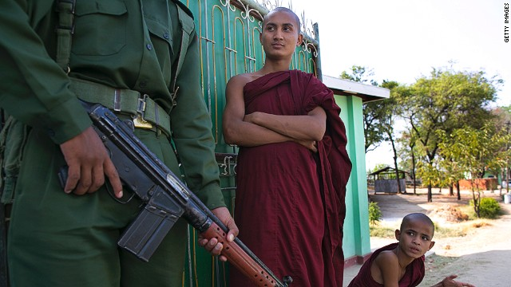
Meanwhile, since 2012, Myanmar's Buddhist militants have become more aggressive in targeting Muslim minority religious groups, engaging in hate speech, boycotting their businesses, destroying shrines and in a number of cases killing non-Buddhists. Last March, for example, Human Rights Watch noted a “mob of 200 Buddhist nationalists torched a Muslim school in Meiktila, Myanmar.” It added that students were clubbed and set on fire in the attack, which claimed the lives of 32 students and four teachers. In January, the United Nations reported that at least 40 Rohingya Muslim men, women and children were killed in Rakhine as Buddhist-led rioters burned down Muslim-owned houses and shops.
Thankfully, the response from Myanmar’s government was more vigorous than that of Sri Lanka’s, and the government imposed a state of emergency at certain points. In addition, President Thein Sein publicly expressed his “concern” over Buddhist-led protests against Muslim speakers at a local literary event.
Unfortunately, this stance risks being undermined by claims in February that the government has been complicit in restricting “basic freedoms” of Rohingya Muslims in Rakhine State.
NGO Fortify Rights said in a recent report that documents it had obtained in Myanmar “detail restrictions on movement, marriage, childbirth, home repairs and construction of houses of worship, and other aspects of everyday life”. It added that: “Confidential enforcement guidelines empower security forces to use abusive methods to implement these ‘population control’ measures.” And just this week, the U.S. Department of State warned of "the continued lack of adequate security forces and rule of law on the ground in Sittwe," the capital of the western state of Rakhine, following reports of Buddhist mobs attacking foreign aid groups in the region.
True, Buddhist-led violence is not unique to the past few years – think of the militant Buddhist movement that engaged in anti-government mob violence in South Vietnam in 1963-65. And in some cases, violent acts could be seen simply as a sign of pure desperation – earlier this month in China, a former Buddhist monk set himself alight in Sichuan Province in protest against Chinese rule in Tibet, the 129th such self-immolation since 2009. But attacks on schools and mob violence against Muslim bystanders suggest a new and combustible ingredient is being added to an already volatile and tense part of the world.

How should such extremism be tackled?
The crucial first step is obvious – local governments must acknowledge the problem actually exists, and that it is serious. This is something that simply isn’t happening in either Sri Lanka or Myanmar, where Buddhist-dominated governments seem largely incapable of acknowledging the term “Buddhist militancy.”
This is shortsighted, because the reality is that growing Buddhist militancy will only weaken already strained relations between different communities within these countries, threatening to undermine democratic and economic development in the process.
But a potentially bigger and destabilizing problem exists down the road – Muslim extremists from outside the region getting drawn into a conflict with Buddhist extremists. In the past two years, Islamist militant groups from Indonesia, Pakistan and Afghanistan have publicly noted the plight of their Muslim counterparts in Myanmar and promised jihad against Myanmar’s Buddhist population. Sri Lanka might find itself not far behind.
Will the future of extremism be a battle between Islamist and Buddhist militants? Right now, as the world’s attention is focused on the rehashing of Cold War-style tensions in Ukraine, the possibility seems remote. But the seeds for an extremist conflict in parts of Asia have already been planted. If governments in the region want to ensure long term stability, they would do well to take seriously the growing tensions within their own borders.

Maha Hosain Aziz is a professor of politics (adjunct) in NYU's Graduate School of Arts & Sciences, a senior analyst at geopolitical consultancy Wikistrat and advisory board chairwoman of Afghanistan’s first university e-mentoring program (New Silk Road Generation). The views expressed are her own.

Hundreds of Britons are terror-training in Syria, making attack on U.K. “inevitable”
Source: http://www.homelandsecuritynewswire.com/dr20140407-hundreds-of-britons-are-terrortraining-in-syria-making-attack-on-u-k-inevitable

Thousands of foreign fighters, including hundreds of Britons, are now in Syria, fighting with rebel forces against the regime of Bashar al-Assad. Security experts say that the danger faced by Britain and other countries from jihadist fighters returning from Syria is “unprecedented,” and that a terror attack on British soil by one or more British Muslims returning from Syria is “inevitable.”
Gilles de Kerchove, the EU’s counterterrorism coordinator, informed the relevant agencies of EU countries that these jihadi supporters are gaining “combat experience and forging connections with extremists.” As a result they could “return radicalized” and “seek to carry out attacks against the West.”
The Independent reports that these warnings were included in written evidence to a Home Affairs Select Committee inquiry on counterterrorism.
“All the reports I have seen suggest that it is becoming increasingly acute,” de Kerchove added. “National budgets devoted to counter-terrorism are declining across the EU. Yet the threat that we face is becoming more diverse, more diffuse, and more unpredictable.”
The problem is not confined to Syria. Africa is now a “particular” concern, since “the terrorism threat is growing and becoming a major obstacle to development”, de Kerchove warned.
He is calling for “concerted and coordinated action” by European countries to “avoid destabilization … and the establishment of terrorist safe havens”. He added: “We should be investing a lot more in counter-terrorism work, including externally, if we are to prevent or mitigate future terrorist attacks.”
More needed to be done to “counteract more effectively the use of the internet and social media for radicalization and recruitment purposes” and to “identify and detect” foreign fighters, he said.
The EU counterterror chief commends Britain for having developed “one of the best communication campaigns, which not only raises awareness of the phenomenon and the possible risks related to it, but also offers an alternative to those who want to go to Syria for humanitarian reasons.”
Countries need to share intelligence because “it is not inconceivable that a foreign fighter could return to his home country with the intention of joining former comrades for an attack in another.”
The Independent notes that terror experts agree with de Kerchove’s analysis and warnings, as they prepare for a talk on foreign fighters to be hosted by the Chatham House think-tank on Thursday (“Foreign Fighters in Syria: A Threat at Home and Abroad?”).
The number of fighters means they are “almost impossible to monitor,” Richard Barrett, the former head of counterterrorism at MI6, told the Independent on Sunday. Many will return and not be a problem, but some will come back “radicalized and a real danger to society,” he said.
He noted that simply arresting people returning from Syria was a “knee-jerk reaction” and that such heavy-handed treatment by the police risked radicalizing people.
“I was a bit horrified to see a few weeks back some chief constable was saying all these guys should be locked up, and I think already 16 people have been arrested who have come back from Syria. Maybe there was good reason for that. But how you treat people is really important. There is a balance to be struck, where you do not mistreat people on the one hand, but do not overlook people who are a threat [either].”
Raffaello Pantucci, senior research fellow at the Royal United Services Institute (RUSI), said: “It seems almost inevitable that some sort of a threat back to the U.K. will come off the battlefield in Syria, something supported by the fact that security services in the U.K. believe they have already disrupted at least one plot with links to Syria.”
A Home Office spokesman said in a statement that “The U.K. advises against all travel to Syria. Even people travelling for well-intentioned humanitarian reasons are exposing themselves to serious risk, including being targeted for recruitment by terrorist groups.”
He added: “The police and security services are actively working to detect and disrupt any terrorist threat from Syria and individuals who travel there.
“People thinking about travelling to Syria to engage in terrorist activity should be in no doubt that we will take the strongest possible action to protect our national security.”

690 attacks recorded during elections day in Afghanistan
Source: http://www.khaama.com/690-attacks-recorded-during-elections-day-in-afghanistan-2971

Defense ministry spokesman, Gen. Zahir Azimi said Saturday that the attacks by militants included direct fire, rocket attacks, improvised explosive device (IED) attacks and suicide attacks.
Gen. Azimi further added that 162 insurgents movements were recorded in 201 Silab Corps zone, 241 movements were recorded in Shaheen Corps zone, 20 in Thunder Corps zone, 39 movements in Atal Corps zone, 39 movements in Zafar Corps zone, 76 insurgents movements were recorded with Shaheen Corpse, 50 movements were recorded with Maiwand Corps and 82 attacks were recorded with 111 Corps zone.
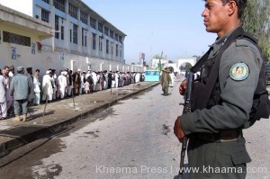
Azimi also added that 164 militants were killed and 82 others were injured during the attacks while Afghan army soldiers seized various types of weapons belonging to the assailant militants.
He said at least 7 Afghan national army soldiers were martyred and 45 others were injured during these attacks.
Despite the security threats, the participation of the voters was higher and over 7 million voters participated in presidential and provincial council elections.
The IEC officials in a press conference said Saturday that the turnout of the elections surpassed most expectations despite security threats.
65 percent male and 35 female voters participated in Saturday’s elections, which is twice higher as compared to voters’ participation in 2009 presidential election.
Only 211 polling stations remained close due to security threats while 6,212 polling stations were open across the country.

Al-Qaeda in Iraq Moves Into Abu Ghraib With Eyes on Baghdad
Source: http://news.antiwar.com/2014/04/06/al-qaeda-in-iraq-moves-into-abu-ghraib-with-eyes-on-baghdad/

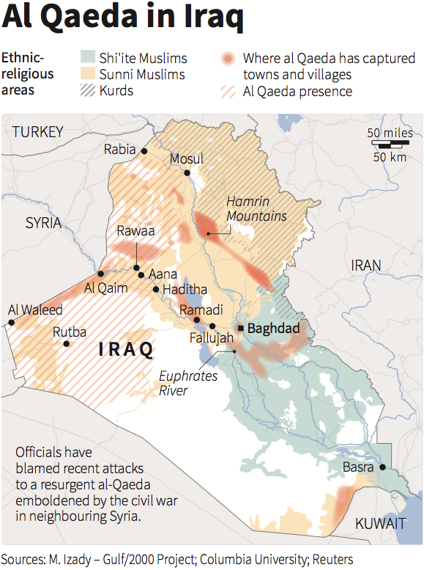
Al-Qaeda in Iraq (AQI) has held the major Iraqi city of Fallujah for three solid months now, and despite a heavy offensive from the nation’s military seems no closer to ceding it back to the central government.
Rather, AQI looks to be going on the offensive once again, with their fighters seizing Abu Ghraib, a key city on the edge of the Anbar Province, leading to the Baghdad governate.
The Army sees the move into Abu Ghraib, a city of nearly 200,000 itself, as an effort to split the offensive and “ease the pressure imposed on them in Fallujah.” That may be just part of the problem.
AQI’s reach continues to spread both in Anbar and elsewhere, and the capture of Abu Ghraib puts a large chunk of their fighters just a stone’s throw away from the capital city itself, with Fallujah and Abu Ghraib giving them effective control over the highway leading to Baghdad from the west.
Iraq’s military has warned in the past that AQI, awash with weapons from the Syrian Civil War, has enough armament to take Baghdad itself if not confronted. Now, it seems like even the military’s offensives are just slowing that push.

EDITOR’S COMMENT (on both articles above): Two short articles representing the past and the future following foreign invasions in that part of the world… History is a river that cannot be stopped!

Djibouti: China Planning Military Base, Increased Co-operation
Source: http://www.aafonline.co.za/news/djibouti-china-planning-military-base-increased-co-operation

Djibouti is a small, impoverished country with little in the way of natural resources. It is not able to be self-sufficient in food production and it is one of the least developed countries in the world. However, the country is situated in the Horn of Africa, a strategic position that makes it very important for a number of countries.
Djibouti is located in a key area on the west coast of the Gulf of Aden, with its northern part facing the Mandab Strait where the Red Sea enters the Indian Ocean. Djibouti is also a good natural harbour with calm and deep water. Most importantly, unlike Somali, Djibouti has a secure and stable government that has had only two presidents since it gained independence from France in 1977. The Somali and the Afar, the two largest ethnic groups in Djibouti, together make up almost 90 percent of the country’s population, and they get along in harmony.
France, the former colonial master, was the first to build a military base here and French forces have been conducting desert training in Djibouti for many years. France and Djibouti have signed a defence agreement and France continues to operate several military bases in the country. According to Djiboutian observer, France recognizes the importance of its bases in Djibouti now more than ever following its deployment of troops to Mali, and is now preparing to increase its troops and investment in Djibouti.
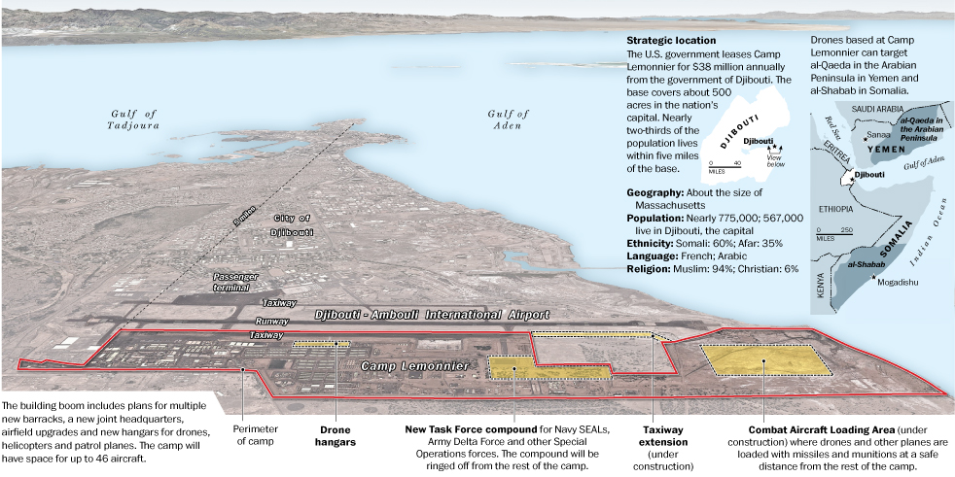
The US saw the strategic value of Djibouti after 9-11, when it was gearing up for the War on Terror. It established the only US military base in Africa here, Camp Lemonnier, and it is spending hundreds of millions of dollars in developing and expanding it. The When the US was in the process of setting up its Africa Command (Africom, based in Germany) Djibouti actively invited the US to consider setting up the headquarters in Djibouti. The military base in Djibouti not only allowed the US to have a foothold in East Africa and manage its participation in the anti-piracy operations in the Gulf Aden and the Indian Ocean, but also plays an important role in the US attack on Somalia’s Al-Shabaab militants and US military operations to protect and extract diplomatic personnel in the region, as it was used recently as staging area for a small force that evacuated US embassy personnel from Juba, South Sudan. Several years ago (2011), Japan also established its first overseas naval military base in Djibouti as part of its participation in anti-piracy operations.
Besides hosting the military bases of these countries, Djibouti is also important as a maintenance and resupply base for many countries’ escort ships. The berths in the country’s harbour are full of ships, and arrangements for ships that want to dock in them must be made well in advance. In the past four years, the ships in China’s escort fleet have docked in Djibouti more than 50 times.
The port of Djibouti is the country’s economic lifeline, and the fees that it collects from military bases are another important source of income. According to local sources France pays about €30 million (US$39.06 million) per year in fees for the right to maintain military bases in the country, while the US pays US$30 million and Japan pays a similar sum for its naval facilities. Japan and Djibouti has also signed an agreement in which Japan donated two patrol boats to Djibouti. These funds mean a lot in a country that has a population of only 820 000. As a result, Djibouti pursues a policy of balanced diplomacy in which “everyone who visits is treated as a guest and care is taken not to offend anyone.”
Djibouti also has close relations with China. On 25 February Djiboutian Minister of Defence Hassan Darar Houffaneh and his Chinese counterpart General Chang Wanquan signed a security and defence strategic partnership agreement at the Cheikh Osman military camp. Under the partnership, Djibouti has offered military facilities such as a home port to the Chinese navy. Djibouti wants China to assist it in enhancing the operational capacities of the Djiboutian armed forces in order to safeguard security in the country and help to consolidate peace and security in the sub-region. Djibouti wants to build the capacity of the navy, which lacks patrol boats, and building the air force, which will soon acquire Chinese aircraft.
Djibouti has also asked China for "assistance with surveillance, including radar, and more training through the provision of additional places at China's military training centres and colleges in the aviation, maritime, armaments, logistics and engineering sectors", according to the minister.
However, the US is not very happy about these developments and during her recent meeting with President Guelleh, American National Security Advisor Susan Rice expressed concerns about the Chinese plan for a military base in Djibouti. According to reports the US is offering Djibouti a number of economic incentives to try and persuade President Guelleh not to accept the Chinese offer.
It is not clear what President Guelleh will decide, but in light of the Djibouti government’s efforts to remain absolutely neutral in such a strategic geographical area, it is likely that Camp Lemonnier would see some Chinese neighbours sometime in the future.

EDITOR’S COMMENT: France, USA, Japan, now China… Why so much interest for naval bases in Djibouti? Isn’t piracy declining in the area or not?

Intelligence Services Thwarted Terror Attacks during Sochi Olympics
Source:http://www.novinite.com/articles/159679/Intelligence+Services+Thwarted+Terror+Attacks+during+Sochi+Olympics

Russian and international intelligence services thwarted planned terror attacks during the Sochi Olympics, according to the Director of the Russian Federal Security Service (FSB).
Aleksandr Bortnikov, as cited by RIA Novosti, announced that the terror attacks had been prevented thanks to the joint efforts of the FSB and partnering intelligence services from the United States, Austria, France, Germany and Georgia.
He informed that the security of the Sochi Winter Olympics had been guaranteed by a total of 93 representatives of 42 international entities, special services and the law enforcement authorities of 32 countries, according to reports of the Bulgarian National Radio (BNR).
Bortnikov also made clear that Russia was reviewing its legislation in the sphere in a bid to make the fight against terrorism more successful.

Saudi opens luxury rehab centre for Al-Qaeda militants
Source: http://www.yourmiddleeast.com/news/saudi-opens-luxury-rehab-centre-for-alqaeda-militants _14480

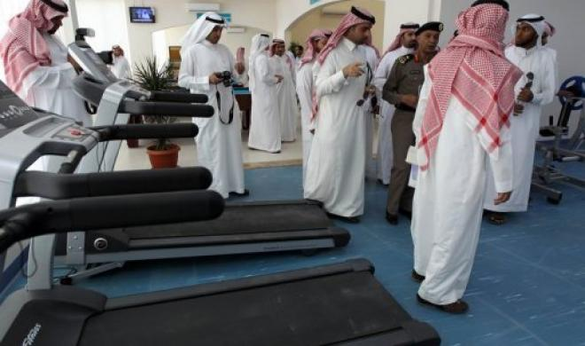
Saudi Arabia is hoping to wean jailed Al-Qaeda militants off religious extremism with counselling, spa treatments and plenty of exercise at a luxury rehabilitation centre in Riyadh.
In between sessions with counsellors and talks on religion, prisoners will be able to relax in the centre's facilities which include an Olympic-size indoor swimming pool, a sauna, a gym and a television hall.
The new complex is the work of the Prince Mohammed bin Nayef Centre for Counselling and Care, a body set up seven years ago to rehabilitate extremists jailed during a Saudi crackdown on the local branch of Al-Qaeda.
"Just under 3,000 (Islamist prisoners) will have to go through one of these centres before they can be released," interior ministry spokesman General Mansur al-Turki told AFP during a tour of the new centre.
Another centre has already opened in the western port city of Jeddah, and three more are planned for the north, east and south of the desert kingdom.
The new facility in Riyadh, however, is the first to offer inmates a taste of luxury as an incentive to moderate their beliefs.
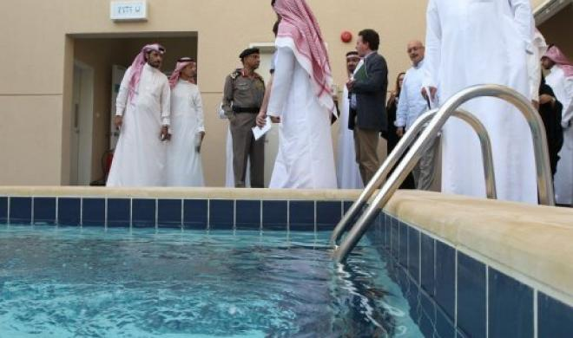
The centres bear the name of the current interior minister, who spearheaded the government's crackdown on Al-Qaeda following deadly attacks by the group between 2003 and 2006 in which more than 150 Saudis and foreigners were killed.
Al-Qaeda jihadists, many of them trained in Afghanistan, had targeted Saudi Arabia for allowing US troops to set up bases in the kingdom during the Gulf War and to stay on afterwards, until they eventually withdrew in 2003.
During the crackdown, many militants fled from Saudi into Yemen's lawless southern and southeastern regions where the network formed Al-Qaeda in the Arabian Peninsula in January 2009 -- classified by the United States as the jihadists' deadliest branch.
Prince Mohammed himself survived a suicide attack by a jihadist in August 2009 when a bomber managed to infiltrate the prince's security. The prince suffered only superficial injuries.
The Riyadh centre spreads over an area equivalent to around 10 football pitches and is designed to accommodate 228 prisoners from the "deviant group," the term used by Saudi authorities to refer to Al-Qaeda.
Each of the 12 buildings at the flagship facility will host 19 prisoners, who will have access to special suites where they can spend time with visiting family members.
Good behaviour could earn them a two-day break with their wives.
During the day, the prisoners will attend seminars on religious affairs, aimed at steering them away from thoughts of jihad.
"In order to fight terrorism, we must give them an intellectual and psychological balance... through dialogue and persuasion," said the director of the rehabilitation centres, Said al-Bishi.
He said a total of 2,336 Al-Qaeda prisoners have now been through Saudi rehabilitation schemes.
"The percentage of those who rejoin the deviant minority does not exceed 10 percent," Bishi said, a proportion he described as "encouraging".
AFP tried to speak to several former Al-Qaeda prisoners who had been released after going through rehabilitation but they declined to be interviewed about their experiences.
Not everyone is convinced, however. There have been some high-profile returns to the ranks of the jihad, such as Saeed al-Shehri, who became deputy leader of Al-Qaeda in the Arabian Peninsula after supposedly being rehabilitated.
Liberals are particularly critical of the religious content of the programme which they say draws on an ultra-conservative version of Islam not so different from Al-Qaeda's own.
"We cannot know if the programme will succeed in eradicating terrorism and extremism," social scientist Khaled al-Dakheel told AFP.
"To treat the problem at its root, one should challenge jihadist thought with an enlightened philosophy, not just with other Salafist ideas that are only slightly less extreme," he said.
"There must be pluralism and an acknowledgement of the rights of others to be different."

The Caucasus Emirate: From Anti-Colonialist Roots to Salafi-Jihad
By Derek Henry Flood
Source: http://www.isn.ethz.ch/Digital-Library/Articles/Detail/?lng=en&id=178401

On October 21, 2013, a lone suicide bomber from Dagestan boarded a bus in Volgograd, Russia, and detonated an explosive device that killed six people.[1] Media outlets quickly noted that the attack occurred both outside the restive North Caucasus and before the Winter Olympic Games in February 2014. Less than two months later, on December 29, 2013, a suicide bomber entered Volgograd’s principal railway terminal and blew himself up, and the following day another suicide bomber in Volgograd detonated explosives on a trolleybus. The consecutive bombings killed a total of 34 people and created further apprehension regarding security in not just Sochi, but across southern Russia.[2]
Notably, none of the suspected attackers were ethnic Chechens.[3] On January 18, 2014, Vilayet Dagestan, a constituent militant group of the Salafist-oriented Caucasus Emirate,[4] released a 49-minute video claiming responsibility for December’s double bombings in Volgograd.[5] The statement by Vilayat Dagestan,[6] which was believed to have been nominally under the control of Doku Umarov at the time of its release, concerned itself with global jihadist grievances rather than narrower local issues traditionally emphasized by Islamic militant groups in the North Caucasus. Dagestan today is arguably much more of a hotbed of insurgency than Chechnya itself, and the ascendency of Dagestani Salafist fighters may indicate a play for primacy within the Caucasus rebel umbrella faction.
On July 2, 2013, Doku Umarov, the Caucasus Emirate’s late amir, issued a video statement threatening the Sochi Olympics, adding that he approved of attacks on civilians.[7] Although the 2014 Winter Olympic Games came and went without incident, they were under threat throughout their duration. Russian President Vladimir Putin pledged that the most expensive Olympics the world had ever seen—taking place on the fringe of a war zone—would be thoroughly protected by an impenetrable “ring of steel” comprised of Sochi’s inherent physical geography combined with an estimated 60,000-man security force and majority Orthodox Christian populace.[8]
This article examines the causal factors that led to the rise of the Caucasus Emirate, how the fight for an independent, post-Soviet Chechnya morphed into a much wider struggle for an Islamic emirate governed by Shari`a across the North Caucasus, and how the conflict in the Caucasus has awkwardly intersected with the ongoing internecine jihadist battles in Syria in ways that its original leadership never intended. The article finds that while for many years militancy in the North Caucasus was centered on an anti-colonial rebellion rejecting Russian rule with varying degrees of Islamist characteristics, Caucasian Salafism has supplanted any one particular brand of ethnic nationalism as the chief ideological current among fighters. With Caucasian fighters from Jaysh al-Muhajirin wa-al-Ansar displaying the Caucasus Emirate logo in Syria,[9] geography no longer entirely defines pan-Caucasian Salafi-jihadism, nor are those of Chechen origin necessarily driving this movement.

How Separatism Turned to Emirate Building
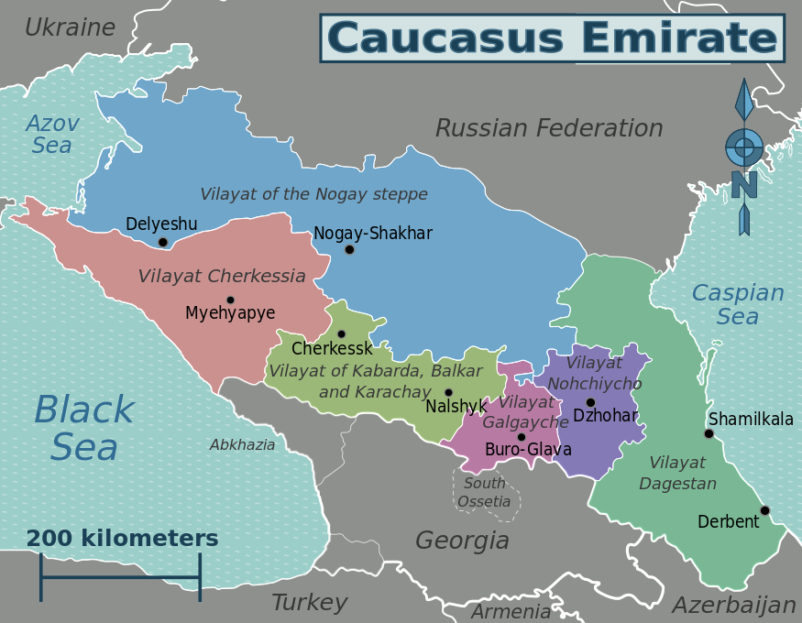
The Caucasus Emirate is an ideologically Salafist outfit inhabiting what has been historically a haven of Sufi orders in the North Caucasus.[10] It emerged from the failed insurrections that Chechens launched against Russian federal forces in two distinct conflicts beginning in late 1994.
Chechen separatism gained momentum in the immediate aftermath of the chaotic Soviet collapse. In March 1992, the Republic of Chechnya refused to sign the proposed federative treaty put forth by then-President Boris Yeltsin.[11] Chechen rebel leaders subsequently declared independence from Moscow—the only one of Russia’s 89 republics and regions to make a genuine attempt at formal secession.
The Chechen forces during the first Russo-Chechen war in 1994 were led by former Soviet Air Force General Dzhokhar Dudayev, who was initially a secular nationalist. The second war in 1999 was principally helmed by President Aslan Maskhadov, a moderate Sufi who fought under a primarily ethno- nationalist hue somewhat reluctantly imbued with localized Islamism as a way to frame Chechen separatism in part to satisfy his Islamist peers.[12] Maskhadov had to contend with the very real ascendancy of Salafism (often referred to as “Wahhabism”) because the schism between nationalists and Salafists had grown ever wider in the wake of Russia’s killing of Dudayev on April 21, 1996.[13]
As Russian forces successively eliminated these original nationalist leaders, the insurgency began to take on a distinctly Salafist tone embodied by increasingly erratic men like Shamil Basaev. Basaev was much more apt to work alongside transnational Arab jihadists like the notorious Saudi commander Umar ibn al-Khattab who led foreign fighters in Chechnya in ambushes against Russian military columns and their local proxies.[14]
As hopes for a separate Chechen state began to fade, the nationalist movement wilted away in all but name with many of its most prominent surviving members fleeing for the safety of the West and swapping fatigues for suits and ties.[15]
Although the conflict was relatively obscure to Western audiences in the 1990s, Chechnya was a key node of global jihad in the pre-9/11 era. Before eventually ending up in Afghanistan, several of the 9/11 hijackers and plotters were drawn into the operational side of violent global jihad in hopes of joining the battle for Chechnya, which was portrayed as a righteous fight between oppressed Muslim believers and infidel Russian troops.[16] Vitriolic audio sermons and video propaganda tailored for Arabic-speaking audiences portraying the war against Russian forces in Chechnya as analogous to the 1980s jihad in Afghanistan circulated in the Persian Gulf region in late 1999 and the early 2000s.[17] As early as mid-1996, Usama bin Ladin cited the war in Chechnya three times in a list of grievances of the global Islamic community. Although the first war was largely nationalist in tone, it began to attract roving Arab Salafist fighters such as Ibn al-Khattab. Al-Khattab’s infamy gained from fighting Russian troops in Chechnya helped to establish links between the jihad in the North Caucasus and Saudi Arabia. As Russian forces killed both nationalist and Islamist rebel actors throughout the early 2000s, the Islamists—who were far less likely than the nationalists to negotiate with the Kremlin—would come to helm the rebellion and eventually steer it away from Chechen nationalism and toward Islamism.[18]
When Doku Umarov—a nationalist who later cloaked himself in Salafism—took control of the unrecognized Chechen Republic of Ichkeria (ChRI) in June 2006, the fight for Chechnya was gradually subsumed into a broader struggle. Umarov began reaching out to militant groups in other parts of the North Caucasus. In October 2007, he declared the establishment of the Caucasus Emirate[19] comprised of six “vilayats” (provinces) which were subdivided into “jama`ats” (communities) representing insurgents from the republics spanning across the bulk of what is now the North Caucasus Federal District[20] from the shores of the Caspian Sea in coastal Dagestan to Sochi on the Black Sea. Umarov was an adept survivor, transforming himself from a member of the nationalist camp to a longstanding amir of the Islamist one.
During the evolution of the Caucasus Emirate, the locus of jihad, however, moved from Chechnya to Dagestan[21] and somewhat lesser so to the republics of Ingushetia and Kabardino-Balkaria. During the second war in Chechnya, Moscow escalated its “Chechenization” policy by co-opting former Chechen nationalist rebels—chief among them Akhmad Kadyrov, Chechen President Ramzan Kadyrov’s late father—which exploited fissures within the insurgency in an effort to regain control of Chechnya through local clients, in lieu of directly negotiating with rebel leaders.[22] The Putin government later infused large sums of capital to help rebuild Grozny, which was shattered by well over a decade of war.[23] Chechnya, under the repressive grip of the Kremlin- appointed President Kadyrov, has undergone a significant transformation in recent years, particularly evident in the once Stalingrad-like republican capital of Grozny, which now maintains the architectural air of a nouveau riche oil center. As Ramzan Kadyrov consolidated his rule over Grozny and its environs, and as Salafism spread on the Chechen republic’s eastern and western flanks, militancy in the North Caucasus became far less concentrated, with a host of different militant actors asserting their credentials.
Moreover, the struggle for the North Caucasus long predates the largely nationalist-hued Chechen wars of the 1990s. Chechens, Avars, Circassians and other ethno-linguistic groups firmly resisted Russian expansionism during the czarist period until at least 1864 when the Russians declared victory in the Caucasian wars.[24] Led most notably by Imam Shamil, a dynamic Avar from the village of Gimry in present-day central Dagestan,[25] North Caucasian Sufis waged a 25-year-long holy war against Russian forces that is still invoked to the present day.[26] In the 19th century rebellion against the Russian conquest of the Caucasus, the perception of religious difference between invading Orthodox Russians and indigenous Muslim Caucasian groups was a rallying cry among different ethnic groups who shared Islam as a binding factor across mountains and valleys. Today, the symbolically significant Gimry is an area of Salafist influence in Dagestan located at a strategic crossroads between Makhachkala and the mountainous border with Chechnya where Russian federal forces began a crackdown in the lead up to the Olympics.[27]
Non-Chechens, such as Vilayat Dagestan, have had the most dire effect on Russian security as of late. By executing the Volgograd bombings, Dagestani jihadists threatened events in Sochi asymmetrically by attacking civilian targets outside their historical areas of operation. The bulk of North Caucasian militants’ attacks in recent history have occurred in the republics adjacent to Chechnya or the occasional mass casualty attack on symbolic locales in Moscow.
Part of what the Volgograd incidents indicate is that although a Chechen had remained at least the titular head of this increasingly decentralized insurgency, militants from other disenfranchised republics and regions are increasingly the ones carrying out attacks. The 2010 Moscow metro attacks were carried out by a pair of Dagestani women,[28] and the Domodedovo attack was executed by a young Ingush man.[29] Chechens are no longer necessarily the key players in a conflict that arose from the ashes of their own national liberation struggle. The October 21, 2013, attack in Volgograd was allegedly carried out by Naida Asiyalova from Gunib, Dagestan, whose husband was an ethnic Russian convert to Islam,[30] while the December 29 and 30 attacks were launched by a pair of young Dagestani men named Asker Samedov and Suleiman Magomedov.[31] Moreover, after acknowledging Umarov’s death on March 18, 2014,[32] the Caucasus Emirate announced his successor as Aliaskhab Kebekov (also known as Ali Abu Muhammad), an ethnic Avar from Dagestan.[33] Kebekov became the first non-Chechen rebel to lead the widening insurgency in the North Caucasus.

From Chechnya to Dagestan and Beyond
While the Caucasus Emirate has steeped itself in the language of transnational Salafi-jihadism for several years, the appearance of the “Imarat Kavkaz”—as the endonym of the Caucasus Emirate is known among jihadists—brand in Syria may mean that rhetoric has become reality among the freelance diaspora militants. The presence of ethnic Chechen fighters and commanders along with other Caucasian militants in Syria was probably not the result of a top-down hierarchical decision-making process made in the mountains of southern Chechnya or western Dagestan, but of jihadists who went to Syria partly out of its free-for-all opportunistic jihadist environment.[34]
For the first time in the post-9/11 period, there is incontrovertible evidence that Chechens and other Caucasian ethnicities are joining and even heading foreign fighter contingents in a non-contiguous war theater far from their contested homeland.[35] Until recently, Chechen violence was focused almost exclusively on symbols of the Russian state and, to a somewhat lesser extent, Russian civilians. Despite Umarov’s infusion of boilerplate jihadist rhetoric into some of his public statements since the formation of the Caucasus Emirate in 2007, the liberation of Chechnya remained one of his central aims, rather than fighting conflicts outside the region. Yet Syria has been a sea change for the Caucasus Emirate, which has belatedly endorsed freelance participation of fighters in the war.[36]
Several prominent “Chechen” Salafi-jihadis fighting in northern Syria—most notably Omar al-Shishani,[37] a military leader of the Islamic State of Iraq and the Levant’s (ISIL) northern sector—are in fact Georgian nationals known as Kists. Georgia’s small community of Kists migrated south from Chechnya and Ingushetia and settled along the Alazani River in northeastern Georgia’s Pankisi Gorge beginning in the 1830s.[38] Starting in late 1999, the Kists began to host Chechen refugees fleeing the war in southern Chechnya’s Itum-Kale district.
Indeed, the presence of Chechen and other Caucasian fighters in Syria has been ideologically problematic for their peers in the North Caucasus and led to division among emigrant jihadists on the ground in Syria. Omar al-Shishani pledged bay`a (loyalty) to the ISIL, which is led by the Iraqi jihadist commander Abu Bakr al-Baghdadi, in November 2013.[39] Another Georgian Kist jihadist leader named Salah al-Din al-Shishani disagreed with Omar al-Shishani. Salah al-Din had pledged bay`a to the Caucasus Emirate under the leadership of Umarov in order to keep the Jaysh al-Muhajirin wa-al-Ansar faction operating financially and politically independent within Syria, while also trying to avoid fitna (sedition).[40] Omar al-Shishani has taken up a highly visible role that has won him adulation within the ISIL while it has been battling both regime forces and comparatively less extreme Salafist and other rebel groups in northern Syria.[41]
Although a minute figure in absolute numbers estimated to be in the hundreds, Chechens and other Caucasians from across the diaspora as well as the Russian Federation continue to trickle into Syria via the porous borderlands of Turkey’s southern provinces.[42] Chechen and other Caucasian participation in the Syrian jihad represents a major shift in the Islamist currents in the North Caucasus itself. Chechens from outside the North Caucasus can opportunistically slip across the Turkish-Syrian border to wage jihad and gain valuable battlefield experience. Russia has tightened its grip on Chechnya, and the Kadyrov regime has consolidated its rule on Grozny and its environs, making Syria an attractive destination for now.[43]
Doku Umarov wavered on his position vis-à-vis Syria, which created space for an influx of fighters into the northern Levant. Perhaps out of sheer pragmatism, Umarov came around to endorsing Chechen fighters flowing into Syria in a bid to remain relevant among his followers.[44] Although Umarov and his aides never altogether abandoned their evolved form of Chechen nationalism now branded in Salafist speak, as militancy has ramped up in Dagestan and Kabardino-Balkaria the localized jihad in the North Caucasus is far less Chechen-centric and increasingly globalized Islamist in tone, although this is not evident in terms of operational capacity thus far.
The Russian president has publicly raised his concern about the possibility of veteran jihadists returning to the southern tier of the Russian Federation from Syria’s front lines, stating: “they will not vanish into thin air.”[45] The Syria effect is one that worries a host of governments aside from just Moscow. The scenario of fighters returning from the Syrian battlefield is a concern not only for the Russian Federation, but also for the South Caucasus region and EU states that host Chechen refugee diasporas with direct connections to the 1990s anti-Russian insurgency. Georgia in particular has a two-fold problem—its own Kist population has had a few commanders depart its territory to wage jihad in Syria while it still hosts refugees who trekked to Georgia in late 1999 and who may be vulnerable to radicalization.[46]
In addition, a small number of Sunni Azeris from Azerbaijan have also been traveling to northern Syria via Georgia and Turkey—both of which have visa-free regimes for Azerbaijani nationals.[47] On a recent visit to Azerbaijan, Turkish Foreign Minister Ahmet Davutoglu stated that Ankara is struggling to control its 566-mile border with Syria and will not be monitoring Azeris unless intelligence on specific suspects is provided in advance by the Azeri government.[48]

Conclusion
Although Russian and local authorities have made gains in securing Chechnya after years of all out war, religio-political violence has not only continued unabated in neighboring republics, but has in fact escalated in recent years. Russian counterinsurgency strategy lacks a significant hearts-and-minds component aimed at deradicalization. The Russian leadership relies instead on relentless hard power kinetics paired with some economic incentives parceled out to local power brokers. This has made Grozny relatively safe but has done nothing to resolve the longstanding question of who or what power should rightfully rule the North Caucasus in the minds of its diverse, indigenous peoples.
While militants from the Caucasus Emirate did not manage to breach the heavy security detail surrounding the Sochi Olympic Games, that does not mean that the threat to overall Russian security is diminished, as evinced by the attacks in Volgograd. The cycle of violence emanating from the North Caucasus is likely to continue as Salafism rises in popularity coupled with the heavy-handed tactics of the Kremlin’s security apparatus. The Caucasus as a whole, along with the wider Russian Federation, will still have to contend with the likelihood of jihadists returning from Syria and perhaps Iraq.
Unexpectedly, Umarov’s initial hesitance notwithstanding, the Caucasus Emirate is currently officially present in Syria at least in terms of a visual brand, although its fighters are more so functionally under the banner of Jaysh al-Muhajirin wa-al-Ansar. In his final years as the amir of the Caucasus Emirate, Doku Umarov was increasingly viewed as a figurehead,[49] devoid of much charisma, or a spokesman, rather than a genuinely effective operational leader. The vilayets that comprise the Caucasus Emirate appear to be increasingly autonomous in nature. In this context, it is conceivable that the fight for the violence-plagued republics of the North Caucasus will no longer necessarily be dominated by Chechen leadership nor Chechen aims.
Umarov had proclaimed that the Caucasus Emirate is but one part of a larger worldwide jihadist realm. At present, the center of gravity for many aspiring Caucasian jihadists has shifted to northern Syria. Within the North Caucasus, the epicenter of jihad has long since shifted away from war-weary Chechnya, with more aggressive Dagestani jama`ats now taking the lead. The appointment of Aliaskhab Kebekov as the new amir of the Caucasus jihad—to replace the late Umarov—demonstrates the final transition from a once Chechen-centered rebellion to genuine Salafi-jihad in the North Caucasus.

►Endnotes are available at source’s URL.
Derek Henry Flood is an independent security analyst with an emphasis on MENA, Central Asia and South Asia. Mr. Flood is a contributor to IHS Jane’s Islamic Affairs Analyst and guest commentator for BBC Arabic, His past work has appeared online with CNN, the Christian Science Monitor and numerous other publications.

Peace? Philippines Signs Deal with Separatists
Source: http://www.cbn.com/cbnnews/world/2014/April/Peace-Philippines-Signs-Deal-with-Separatists/

April 12 – After more than 17 years of negotiations, the Philippine government has finally signed a peace agreement with a militant Islamic separatist group.
The historic peace agreement was signed by members of the Philippine government and the Moro Islamic Liberation Front (MILF).
The document is officially known as a the Comprehensive Agreement on the Bangsamoro.
Bangsamoro means the land of the Moros, which is the ethnic name of the Muslims.
It gives the Bansamoro the right to wealth and power sharing and the right to self determination, but under federal control.
"The role of the MILF may be likened to a gatekeeper for the transition. It's not the government of the MILF but the government of the Bangsamoro," MILF Chairman Al Haj Murad Ebrahim said.
During the course of negotiations several groups opposed the peace pact.
In September of last year, some members of the Moro National Liberation Front (MNLF) sieged the southern city of Zamboanga, leaving some 200 dead and displacing thousands of residents.
The uprising was the result of its leader Nur Misuari's dismay over the peace agreement because he claims this has bypassed a peace treaty that the government made with his MNLF group in 1996.
The MILF, which represents Muslims in the present peace agreement, is the biggest breakaway group of the MNLF.
Paramanan Hajul was one of the victims of the war in Zamboanga.
"Our house was just 100 meters away from the fighting between the MNLF and government soldiers. It was very traumatic for my family and that is why I am so happy that the peace agreement was finalized," he said.
"I believe that there is always an intelligent and peaceful solution to a conflict instead of using violence," he said.
There are other Muslim rebel groups to reckon with before this peace process can be successfully implemented.
But the government, the MILF, and other stakeholders, including churches, are believing the agreement is a key to the lasting peace and progess in the predominantly Muslim region of Mindanao.
Bishop Efraim Tendero of the Phillippines Council of Evangelical Churches said Christian involvement for finding peaceful solutions for the decade-old conflict in Mindanao helped end the insurgency that left an estimated 150,000 people dead since 1970s.
"They consulted with us and in that consultation, we had a no-holds-barred discussion. There will be freedom of religion, freedom of worship, freedom of expression. That will be guaranteed," Bishop Tenderp said.
"Then the Muslim leader said can you pray for us. Can you imagine a Muslim leader asking a Christian bishop to pray," Tenderp continued.
The country's congressional leaders must approve the peace plan before it can become law.
Philippine President Benigno Aquino III fully supports the plan and gave a warning to anyone who attempts to derail it.
"I will not let peace be snatched from my people again. Not now, when we have already undertaken the most difficult and most significant steps to achieve it," President Aquino lll warned.
The Comprehensive Peace Agreement has the support of the president and perhaps Congress, but because of the opposition from the different Islamic groups, it may still be a long and tough journey before peace in Southern Philippines will become a reality.

Peace in the Philippines, but what next for the MILF?

By Alexandra Phelan

Source: http://theconversation.com/peace-in-the-philippines-but-what-next-for-the-milf-24964

Late last month, the Moro Islamic Liberation Front (MILF) insurgency and the Philippines government signed a landmark peace settlement, signalling the end of a decades-old conflict. After 17 years of on-and-off negotiations, the two parties finally signed a settlement based on the Framework Agreement developed in 2012.
The new “Bangsamoro” autonomous region will replace the now-defunct Autonomous Region in Muslim Mindanao (ARMM). The ARMM was originally established in accordance with the 1976 Tripoli Agreement, signed between the government and the MILF’s rival, the Moro National Liberation Front (MNLF).
While the agreement is a significant political achievement for Philippines president Benigno Aquino as it essentially marks the end of combat between the insurgency and government forces, a challenging road lies ahead in achieving overall peace in the Philippines.

Background to the MILF
The MILF was officially established in 1984 by Salamat Hashim. A former leader within the MNLF who became disenchanted with the decision to sign the 1976 Tripoli Agreement, Salamat split from the MNLF and advocated more radical action in establishing an independent Islamic state in the southern Philippines.
The MILF’s initial hostility towards the Philippines government commenced when the MNLF accepted the offer of semi-autonomy in 1987. Although a general cessation of hostilities between the MILF and the government was signed in 1997, it was abolished under president Joseph Estrada in 2000. The MILF then declared “jihad” against the government.
While the MILF is primarily an insurgency, it has been alleged that they have engaged in terrorist tactics, such as the 2003 Davao City bombings. The organisation is also alleged to have had ties to both the Abu Sayyaf Group (the ASG) and Indonesia’s Jemaah Islamiyah. These links have been consistently denied by the MILF.

The other challenges to peace
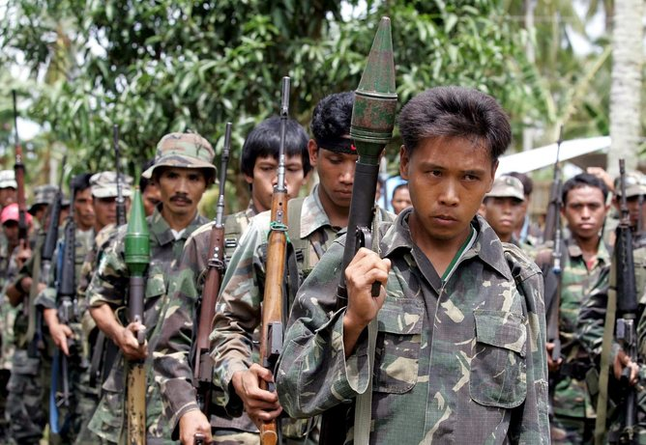
While the Philippines government has re-opened the door for negotiations with the country’s communist insurgency in the north, within Mindanao there are other actors that can obstruct the successful implementation of the peace plan.
Unsurprisingly, Nur Misuari, the founder and former leader of the MNLF, has been unsupportive of the peace process. Based on arguments that are partly political and partly personal, he has expressed discontent with the fact that the MNLF has been sidelined in the deal.
Misuari has already been accused of playing a role in two recent incidents that were allegedly intended to hamper the negotiations. The first was a strange attempt by the “Sultan of Sulu”, Jamalul Kiram III, to reclaim land in Borneo in February 2013. Later, in September, Misuari is alleged to have facilitated a three-week stand-off in which 200 individuals were taken hostage in Zamboanga City in Mindanao.
Misuari has been in hiding since the Zamboanga incident. Although MNLF chairman Abul Khayr Alonto is supportive of the peace process, Misuari retains a loyal group of supporters.
Also, the government still needs to contend with the ASG and the Bangsamoro Islamic Freedom Fighters (BIFF). Although these groups are notably smaller than both the MILF and MNLF, they are significantly more radical and ruthless.
The BIFF broke away from the MILF in disagreement with the peace talks in 2008, and has been accused of carrying out various attacks, including an attack on the military HQ in Maguindanao in February.
Meanwhile, the notorious ASG is listed as a terrorist organisation by many western countries (including Australia). It is considered the most violent Islamist group in the southern Philippines due to its tactics of taking hostages and occasionally beheading them.
The MILF has vowed to turn in the weapons of between 10,000 and 15,000 fighters. EPA/STR

The MILF’s disarmament
As part of the MILF’s disarmament, the insurgency has vowed to turn in the weapons of between 10,000 and 15,000 fighters. The Annex of Normalisation within the Framework Agreement stipulates that the MILF will undergo a graduated program of decommissioning, with a third party overseeing this process related to both weapons and MILF forces.
A concern is that it is unclear how much arsenal the MILF holds. Its “forces” not only include MILF combatants, but also private armies that operate within the region.
With claims there are already defections from the MILF to the MNLF, the disengagement and reintegration of former combatants will be the next challenge. This is particularly the case as many of these combatants have been fighting since the insurgency’s inception.
For success in the long term, measures must be implemented to assist combatants in returning to civilian life – including employment. A challenge also seen within many other conflict environments is that often these individuals lack marketable skills or experience of seeking work. Given the organisations still active in Mindanao, there is no lack of opportunities for the fighters to redirect their combatant experience elsewhere.
It is positive that a final peace arrangement has been signed and the importance of a Bangsamoro political entity has been recognised. But the same steely determination on behalf of both the MILF and Philippines government needs to be maintained to bring stability to the troubled region.

Alexandra Phelan is Teaching Associate/PhD Candidate at School of Social Sciences at Monash University

Hezbollah develops new tactics in Syrian civil war
Source: http://www.haaretz.com/news/middle-east/1.585372

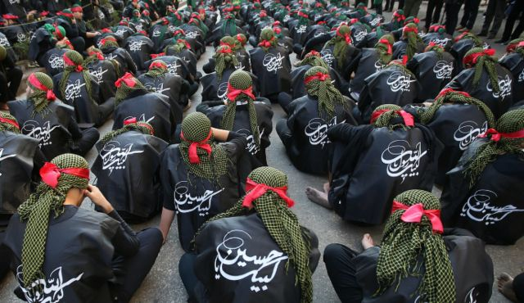
The commandos infiltrated Syrian rebel-held territory near the Lebanese border, watching rebel fighters come and go from a two-story villa before slipping inside to plant a powerful bomb. The next morning, they detonated it as three rebel explosive experts and four assistants met inside, turning the villa to rubble in seconds.
The operation late last month in Syria's western Qalamoun region was carried out by fighters from Lebanon's militant Hezbollah group, several Lebanese officials close to the militants have told The Associated Press. The Shi'ite group has sent hundreds of its fighters into Syria to shore up President Bashar Assad's overstretched troops, helping them gain ground around the capital, Damascus, and near the Lebanese border.
But with its own casualties mounting in a civil war that activists say has killed more than 150,000 people in three years, officials say Hezbollah has turned to a variety of new tactics — including complicated commando operations — to hunt down rebels and opposition commanders.
The aim of the new strategy, that includes hit-and-run attacks as well as reconnaissance missions, is to help Assad hold onto power, limit Hezbollah casualties and attack groups that want to launch attacks inside Lebanon itself.
"Hezbollah is also well aware of its comparatively limited manpower capacity," said Charles Lister, an analyst with the Brookings Doha Center. "So exploiting an ability to inflict damage on the enemy without expending significant resources ... is a natural strategic development."
Hezbollah has a long history of guerrilla attacks. It fought Israel in the wake of its occupation of south Lebanon until it pulled out in 2000, relying on hit-and-run assaults to combat Israel's army.
In Syria, the turning point in Hezbollah's strategy came after the group helped secure the Syrian border town of Qusair last June, said the Lebanese officials, who spoke on condition of anonymity to discuss Hezbollah military tactics. After that battle, they say rebels ambushed and killed four elite Hezbollah fighters after Syrian troops told them the area was secure.
Now, Hezbollah sends small groups of fighters to observe areas before entering, the officials say. One official said Hezbollah also has linked Syrian territories where it is present to its bases in Lebanon via a secure, hard-wired telecommunication network it has been using back home for years. The fighters avoid using mobile phones or other equipment easy to monitor, the official said.
The attack on the villa in Qalamoun also showcases the turn to commando-style fighting. Syrian state media said Syrian troops carried out the attack. However, Lebanese daily newspaper Al-Akhbar that is sympathetic to Assad, said both Syrian troops and Hezbollah special forces carried out the attack.
Observers of the group and experts say the Qalamoun attack was consistent with similar operations carried out by Hezbollah in the past.
"Covert and targeted Hezbollah operations further into Syria's interior or into 'enemy territory' is not such a surprising development," Lister said. "After all, Hezbollah training incorporates all the capabilities necessary for such operations, and there is a precedent for similar tactical evolutions, particularly against Israel."
Lister added that the attack "opens its forces up to being able to expand their operational capacity to include covert qualitative attacks on enemy infrastructure and senior leadership."
An opposition activist in Qalamoun who uses the name Amer al-Qalamouni told the AP that the three men, part of an engineering unit, were killed while preparing a bomb and did not die in an operation carried out by Syrian troops or Hezbollah.
"Had the bomb been detonated by the army or Hezbollah we would have said that but they did not," al-Qalamouni said by telephone from Syria. "They (Hezbollah and army) want to take credit that they killed them." He did not elaborate.
A spokesman for largely secretive Hezbollah declined to comment when asked if its commandos carried out the Qalamoun attack, saying he had no information about it. The group's television station Al-Manar, however, hailed the "qualitative operation" and aired black-and-white photographs of the villa before and after the attack.
Al-Manar said the operation was carried 11 kilometers (7 miles) deep inside rebel territories near the area of Hawsh Arab.
The station also reported that the three bomb experts killed were behind suicide attacks that targeted Lebanon. That also offers further motivation for Hezbollah to carry out such an attack. Syrian rebel groups and those supporting them increasingly carry out suicide attacks and other assaults in Shiite neighborhoods in Lebanon as revenge for Hezbollah's support of Assad. Dozens have been killed in recent months, the bulk of whom are usually civilians.
Lebanon itself remains deeply split over Syria's increasingly sectarian civil war. Assad comes from a Shiite offshoot sect and the rebels fighting him are dominated by Sunnis. Stopping the attacks in Lebanon could ease those tensions and help Hezbollah's own image at home.
Meanwhile, Syrian troops continue to reap the benefits of Hezbollah's experience.
"Since the crisis started until now there has been major development in the performance of Syrian forces," said Qassim Qassir, a Hezbollah expert who writes for the Lebanese daily newspaper As-Safir.
One of the deadliest operations against rebels in Syria occurred in February when forces loyal to Assad killed 175 rebels, many of them al-Qaida-linked fighters, in an ambush near Damascus. The attack — filmed and broadcast exclusively by Al-Manar — was described as one of the deadliest attacks by government forces against fighters near the capital since the crisis began in March 2011. Many believe Hezbollah orchestrated the assault because of Al-Manar having access and due to the fact the group's fighters are active in the region.
The Lebanese officials close to Hezbollah said the group's fighters spearhead operations near the Lebanon border, where they pound areas with artillery, multiple rocket launchers and mortars before storming it. Once they get an area under control, they hand it over to Syrian troops or pro-government Syrian militiamen known as the National Defense Forces.
"They don't trust anyone," an official said. "They were ambushed several times and lost a number of elite fighters."

Three killed in attacks on two Jewish centers in Kansas City
Source: http://www.homelandsecuritynewswire.com/dr20140414-three-killed-in-attacks-on-two-jewish-centers-in-kansas-city

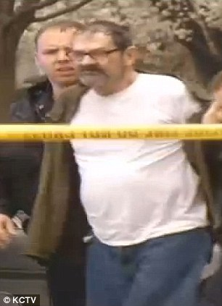
A man shouting “Heil Hitler” and uttering other neo-Nazi slogans killed at least three people at two separate Jewish centers in Kansas City. Police arrested the man Sunday afternoon at an empty elementary school, located near the scene of the second shooting.
One of the attacks occurred at the Jewish Community Center of Greater Kansas City where teenagers were auditioning for KC Superstar, a state-wide competition, at the Lewis and Shirley White Theatre located on the premises.

The shooter, later identified as Frazier Glenn Cross, is taken away from the scene after being apprehended in an elementary school in Kansas City on Sunday afternoon

One of the dead is a 14-year-old boy.
Witnesses say the attacker appeared to be a man in his early 70s. As he was walking through the JCC and the theater, he asked people whether they were Jewish before shooting them.
The Daily Mail reports that the first shooting was reported at 1 p.m. on Sunday at the Jewish Community Center of Greater Kansas City, and the second shooting was reported at Village Shalom, which is an assisted living center at 5500 West 123rd St. Village Shalom is located a few blocks away from the JCC.
KPTV reports that the police said the screaming suspect was taken into custody at the Valley View Park Elementary School, which is a mile away from Village Shalom.
The police said several people are in medical care, and that two people were undergoing emergency surgery at Overland Park Regional Medical Center.
The Mail reports that Mike Metcalf, one of the witnesses, recalled the frightening scene at the Jewish Community Center.
“My son and I were walking into the Jewish Community Center this afternoon for an umpire clinic, around the westside and all of the sudden we heard a gunshot, a pretty loud gunshot,” said Metcalf.
“I turned to look to my right and I can see a man standing outside a car with a shotgun, what to me looked like a shotgun, and there was somebody laying on the ground.”
Metcalf said he yelled at his son to run as fast as he could.
April 15, 2014
New York: The Washington Post and The Guardian won the Pulitzer Prize in public service for revealing the US government’s sweeping surveillance programmes in a blockbuster series of stories based on secret documents supplied by National Security Agency (NSA) leaker Edward Snowden.
The Pulitzer for breaking news was awarded to The Boston Globe for its “exhaustive and empathetic” coverage of the Boston Marathon bombing and the manhunt that followed.

EDITOR’S COMMENT: The Guardian won the prize but Snowden is facing life imprisonment? What a strange world we are living in!

Missile Threats Against Civil Aviation
Source: http://i-hls.com/2014/03/shoulder-launched-missiles-threats-defenses/

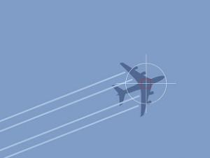
The nature of terror and guerilla warfare requires using mobile, easily concealable weapons; shoulder-launched missiles fit the description perfectly. More than 700,000 missiles were manufactured since the 1970s, mostly in the U.S. and the Soviet Union but also in other countries such as China and Sweden. Reports indicate that shoulder-launched missiles are very common among various militant groups.
The reasons terrorists and guerrillas use shoulder-launched missiles are:
- Lethality – a missile hit on a passenger plane is usually lethal. Civilian planes are not protected against missiles. According to a 2003 report civilian planes have been attacked by these missiles 35 times within the last 26 years. 24 went down, with more than 500 fatalities.
- Mobility, compactness – shoulder-launched missiles are relatively small and light. A Stinger missile, for example, is 1.52 meters long weighs 10.1 kgs, with the launcher itself weighing another 15.2 kgs. They can be mobilized and concealed very easily.
- Low cost – Older models are sold on the black market for hundreds of dollars, while newer models cost tens of thousands. Affordable prices as far as terrorists are concerned.
- Ease of use – using the missile launchers does require training, but the system’s homing capabilities make using it relatively simple.
- Vulnerable targets – military aircraft have defense systems – which do not provide a total immunity. Civilian planes, however, lack any defenses at all, making them relatively vulnerable.
Terrorists use these missiles against civilian or military targets.

Military targets – one of the main advantages of countries and armies against terrorist organizations is aerial superiority: Bombing targets, watching the enemy’s every move and mobilizing forces with helicopters. The weaker side will do anything to minimize this advantage. One of the main weapons used against the Soviets in Afghanistan were Stinger missiles supplied by the U.S. They destroyed and damaged hundreds of helicopters and planes and severely limited the Soviet’s aerial superiority. One of nightmares of the U.S.-led coalition in Afghanistan was the reappearance of the Stingers. Hamas and Hezbollah, not surprisingly, aim to base their air defense system on this type of weapon, challenging Israeli air superiority in the area. The topic of military defenses against missiles is too wide to be discussed here.

Civilian targets – commercial planes are a favorite terrorist target, shoulder-launched missiles being just one of their methods of attack. Israelis are familiar with the attack on the Arkia plane in November 2002, in Mombasa, Kenya, using SE-7 missiles. There have been many other attempts, some successful, over the last few decades. The financial damage caused by shutting down airports, even for very short periods of time, is enormous.
Dealing with shoulder-launched missiles is costly and complex. The following defense methods all have to be used in combination:
- Offensive operations – against terrorist organizations in general, more specifically against those likely to use these missiles.
- Blocking missile distribution and acquisition by potential attackers – the lesson from the Afghan militants and their Stinger missiles – distribution has to be limited. This is why the U.S. doesn’t transfer missiles to Syrian rebels. A number of treaties and agreements are aimed at preventing distribution of missiles, while additional resources are invested in collecting missiles already in the field: Taking over, or purchasing, missiles from non-functioning states. Libyan missiles, for example, have spread across Africa and elsewhere. Another method is installing technological systems that prevent missile use by non-sanctioned elements.
- Disrupting smuggling routes – offensive, intelligence, legal, financial and other actions aimed at preventing smuggling and weakening smugglers and missile sales.
- Preventing missile fire by improving airport security – modern shoulder-launched missiles require relatively large secure areas – up to hundreds of kilometers – around airports, but securing the immediate vicinity can prevent the launch of older missiles, including anti-tank weapons.
- Adapting aerial transportation processes and techniques – changing flight paths and altitudes, changing takeoff and landing routes and collecting intelligence in order to prepare for potential attacks.
- Countermeasures – Elbit, for example, developed a missile defense system for planes, to be installed aboard Israeli commercial aircraft. These systems are very expensive, however, and only a few countries would be capable of enforcing their use. The system’s efficiency against missiles from various technological generations, or missiles using different targeting methods, isn’t constant and requires ongoing upgrades and adaptations.
- Improving aircraft survivability – adding redundant systems and protection for fuel tanks, for example.
Shoulder-launched missiles are an efficient weapon, used by militants and terrorists to overcome the aerial superiority of the enemy. Military aircraft are equipped with defense systems and countermeasures. Protecting civilian aviation against these missiles is complex and costly, but the missile threat itself is equally severe. Utilizing the methods described above may prevent missile launches, lower lethality, prevent damage and save lives.

New in Ben Gurion Airport: Automatic Exit Screening
Source: http://i-hls.com/2014/03/new-ben-gurion-airport-automatic-exit-screening/

All the suitcases belonging to exiting passengers in the Ben Gurion Airport are already checked by the airport’s new security system. The initial results have been positive: Few incidents requiring manual inspection of baggage, almost no mistakes and malfunctions.
Top Airport Authority officials told iHLS that from a security standpoint, the HBS (Hold Baggage Screening) system is working perfectly, and that it is still being adapted to work better with the luggage conveyor system. The main HBS components are new, very advanced screening machines.
Using the new procedures, passengers will arrive at the airport already holding a boarding card, after checking in from their homes, hotels, internet or at check-in counters soon to be installed in the airport. The passengers will present their travel documents to the security guards, who will mark their luggage and send it to the automatic security screening system, where the screening process will be conducted without the passengers being present. The passenger hall in terminal 3 will no longer feature screening machines.
The HBS screening is automatic, although if a suspicious material is detected in a suitcase it is transferred for a thorough manual check. For this reason passengers will be asked to arrive at the airport with the luggage unlocked, so that human security officials can check them without breaking the locks.
Airport Authority management stated that everything is being done so that the new systems begin work during Passover, when there’s a much higher demand for flights.
The benefit from using the system is double: Saving time and conducting non-biased screening. Manual checks can take up to an hour. With the new system’s aid security officials can quicly pinpoint the locations of forbidden materials. Since the system checks the luggage of all passengers, it’s also non-biased. Around 70 million dollars were invested in the system. It was manufactured in the U.S. and developed in accordance with FAA security standards.

Report details first-response lessons from Boston Marathon bombing
Source: http://www.homelandsecuritynewswire.com/dr20140417-report-details-firstresponse-lessons-from-boston-marathon-bombing

In April, DHS released a 19-page report titled “Boston One Year Later: DHS’s Lessons Learned,” detailing three topics which were a focus of attention in the aftermath of the Boston Marathon bombing. The report discussed the “importance of partnerships,” the “need for effective and reliable communications,” and the need to further boost anti-radicalization efforts.
ABC News reports that immediately after the bombing, U.S. Customs and Border Protection’s (CBP) National Targeting Center “re-vetted” all flights that departed earlier in the day from Boston, New York, and Newark airports to identify potential suspects. A review of DHS’s “name-matching capabilities” found a misspelling of “Tamerlan Tsarnaev,” the older of the accused Boston bombers, allowing him to return unnoticed to the United States after a trip to Russia despite previous alerts from Russian intelligence. DHS has now improved its ability to detect variations of names derived from a wide range of languages.
Boston police chief Ed Davis said he was not notified about Tsarnaev before the attacks despite previous FBI investigations of Tsarnaev, but now DHS has improved its system of sharing information with local officials about potential threats.
Since 2002, Massachusetts has received roughly $1 billion from twenty-two DHS grant programs, including $370 million for the Boston urban area. DHS grants issued to local law enforcement helped prepare for a quick response to the bombing and identification of the suspects. According to the report, “DHS grants, training and workshops as well as drills and exercises throughout the Northeast region, and specifically in Boston and the Commonwealth of Massachusetts, built preparedness capabilities to enhance responses to complex, catastrophic attacks. Participants credited these investments for the coordinated and effective response to the bombings by law enforcement, medical, and other public safety personnel.”
The DHS report notes that Secret Service and U.S. Immigration and Customs Enforcement (ICE) agents reported difficulties in transmitting messages via radio to local law enforcement. “The wireless network status immediately after the bombings was congested for four hours, but neither damaged nor shutdown,” the report said.
Emergency responders, traditionally instructed to wait until a scene is safe and secure before approaching to treat victims, attended to victims immediately following the bombings because emergency medical services (EMS) staffers were pre-staged and on scene for the Marathon. The EMS success after the bombing has led the first responder community to rethink “the utility of securing a perimeter before EMS can enter and instead move to a system in which they can begin treating victims immediately.”

►The complete DHS report may be viewed at:
http://abcnews.go.com/images/Blotter/DHS%20After%20Action%20Review%20-%20FINAL.PDF

Hezbollah planned attack on Israeli tourists in Bangkok
Source: http://en.trend.az/regions/met/arabicr/2264894.html

One of the men suspected of belonging to Shiite Lebanese movement Hezbollah has admitted to planning an attack on Israeli tourists in Bangkok, a Thai newspaper reported on Friday (April 17).
Bangkok Post, citing a source involved in the investigation, reported that the men have been identified as French-Lebanese Daoud Farhat and Lebanese-Filipino Youssef Ayad, Al Arabiya reported.
The newspaper said Farhat and Ayad arrived days before the start of a festival called Songkran on April 13, but were arrested on suspicion of links to Hezbollah.
Both were born in Lebanon but authorities have to confirm if their travel documents are genuine.
Assistant national police Chief Winai Thongsong told the newspaper that the two were arrested at different locations in Bangkok after Thai police received intelligence from Israel about a planned plot targeting Israeli tourists.
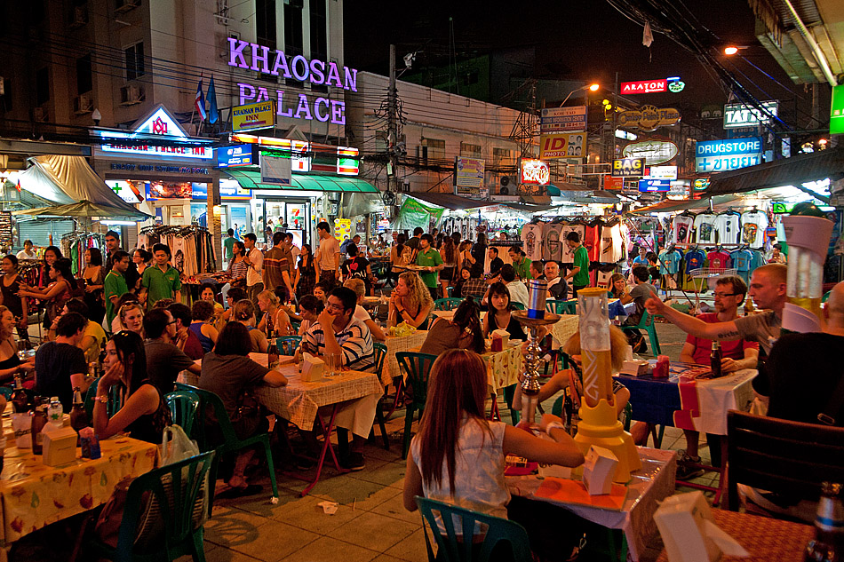
The source said Ayad has admitted that Hezbollah entered Thailand to carry out a bomb attack against Israeli tourists and other Israeli groups on Khao San Road (photo) during Songkran.
"Now we can seize materials, such as nails and bolts, used in making bombs from their homes in Bangkok," the source said, adding "we are taking the holder of the Philippines passport to Rayong province to search for more bomb-making material kept there."
The source also said that authorities are trying to track down Hezbollah operatives in Thailand.
"If we had been unable to arrest the men during Songkran, a bomb attack would certainly have taken place somewhere on Khao San Road," said the source, according to the newspaper.

