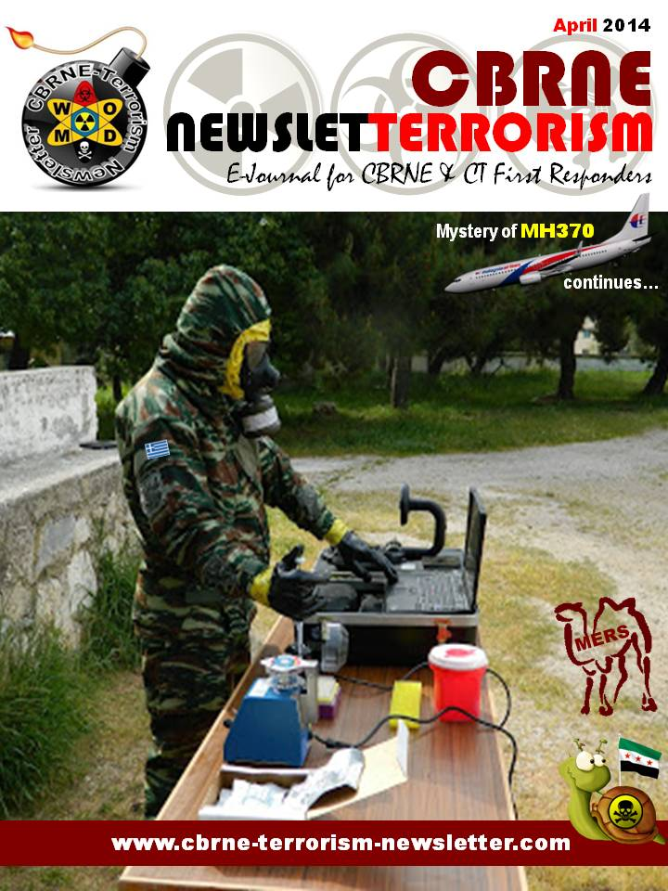
CBRNE-Terrorism Newsletter – 2014©
April 2014

Website: www.cbrne-terrorism-newsletter.com

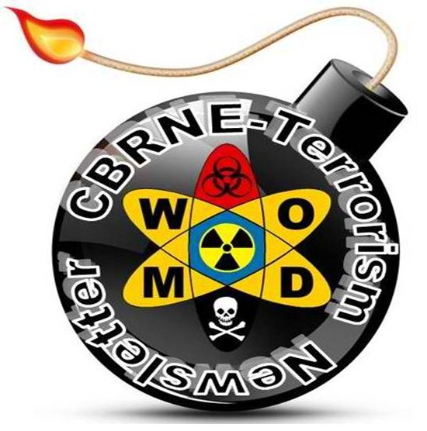
Editor-in-Chief
BG (ret) Ioannis Galatas MD, MA, MC
PhD cand
Consultant in Allergy & Clinical Immunology
Medical/Hospital CBRNE Planner
Senior Asymmetric Threats Analyst
CBRN Scientific Coordinator @ RIEAS
Athens, Greece

Contact e-mail: igalatas@yahoo.com

Assistant Editor
Panagiotis Stavrakakis MEng, PhD, MBA, MSc
Hellenic Navy Capt (ret)
Athens, Greece

Co-Editors/Text Supervisors
- Steve Photiou, MD, MSc (Italy)
- Dr. Sarafis Pavlos, Captain RN(ret’d), PhD, MSc (Greece)
- Kiourktsoglou George, BSc, Dipl, MSc, MBA, PhD (cand) (UK)

Advertise with us! (New price list)
CBRNE-Terrorism Newsletter is published on-line monthly and distributed free of charge. Starting from 2014 issue all advertisements will be charged as following:
Full page (A4) 100€
Double pages (A4X2) 200€

EDITOR
Mendor Editions S.A.
3 Selinountos Street
14231 Nea Ionia
Athens, Greece
Tel: +30 210 2723094/-5
Fax: +30 210 2723698

Contact e-mail: Valia Kalantzi info@mendor.gr

Cover photo: Bio-detection; Joint CBRN Platoon, Hellenic Armed Forces

DISCLAIMER: The CBRNE-Terrorism Newsletter® is a free online publication for the fellow civilian/military First Responders worldwide. The Newsletter is a collection of papers related to the stated thematology, relevant sources are provided and all info provided herein is from open Internet sources. Opinions and comments from the Editorial group or the authors publishing in the Newsletter do not necessarily represent those of the Publisher.

CBRNE-Terrorism Newsletter is:

- Read by First Responders in more than 80 countries around the globe (below right: top-20 countries);

- Distributed to more than 700 institutions, organizations, state agencies, think tanks, defense companies, institutions and universities.

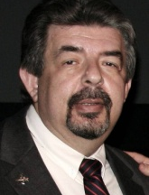
Editorial
BG (ret’d) Ioannis Galatas, MD, MA, MC

Editor-in-Chief
CBRNE-Terrorism Newsletter

Dear Colleagues,

Although spring is here in many parts of our world winter remains strong…
Two main incidents were inherited from March: the missing MH370 flight and the destruction of Syria’s chemical weapons. It seems that the destiny of the aircraft and its passengers will remain a mystery for long. Extreme scenarios were heard – from Israel to Garcia Base and Afghanistan! What is for sure is that there is something fishy out there. And it smells BAD!!! As for the CWAs destruction process it is supposed to progress according to plans. It would be highly appreciated if more clarity is added to the overall process since there is nothing to hide. Unless there is something to hide… (?)
Then we have the World Cup. What is really going on in Brazil? And the most important of all: why Brazil was chosen for this mega event. Soccer love is enough to assign an event in a country facing so many social/security problems? What if these problems hit the sky during the games? Should we blame somebody else besides local organizers? And what about Rio2016? Is preparedness progressing according to plan? CBRN related issues worries me a lot – especially in the health/medical/hospital section. The good thing is that the new anti-terrorism legislation will be in place on time. But is this enough? Underlying problems will be also visible after 2yrs since there is no intention to solve them. What will change after two years? Pracically nothing!
Together with the April’s issue there are two very interesting articles: one for Syria’s chemical weapons and the other on the 2011 E.coli outbreak in Germany. The latter offers an interesting perspective of a man-made cause of the outbreak. It took a lot of time for this paper to be accepted for publication - I just wonder why?
Newsletter’s circulation is satisfactory. If I could have some web specific software It would have been much better; but we stick to our mission to provide info without all the nice environments modern journals provide. Not that we do not envy them! We had many invitations for media partnership and many more comments of readers’ satisfaction. The latter is our moving power and we highly appreciate all the comments and suggestion that reach our email.
As for Greece I just copy and paste March’s last paragraph: “Situation in Greece is fragilly stable… Our new toy is the coming elections and which part or party will prevail over others. The word “progress” is still absent from politicians’ vocabulary and the depression status of populace progressed from subclinical to clinical.”

The Editor-in-Chief

Danish zoo that killed Marius the giraffe puts down four lions
Source: http://www.theguardian.com/world/2014/mar/25/danish-copenhagen-zoo-kills-four-lions-marius-giraffe

A Danish zoo that prompted international outrage by putting down a healthy giraffe and dissecting it in public has killed two lions and their two cubs to make way for a new male.
"Because of the pride of lions' natural structure and behaviour, the zoo has had to euthanise the two old lions and two young lions who were not old enough to fend for themselves," Copenhagen zoo said.
Lions eating the remains of Marius the giraffe at Copenhagen zoo last month.

The 10-month-old lions would have been killed by the new male lion "as soon as he got the chance", it said.
The four lions were put down on Monday after the zoo failed to find a new home for them, a spokesman said. All four were from the same family.
He said there would be no public dissection of the animals since "not all our animals are dissected in front of an audience".
Within a few days the new male will be introduced to the zoo's two female lions, who have reached breeding age.
The zoo's chief executive, Steffen Straede, said: "The zoo is recognised worldwide for our work with lions, and I am proud that one of the zoo's own brood now forms the centre of a new pride of lions."
Last month the zoo's scientific director, Bengt Holst, received death threats over the decision to kill an 18-month-old giraffe, Marius, who was put down with a bolt gun before children were allowed to watch his body being chopped up, dissected and fed to lions.
The move shocked thousands of animal lovers around the world who had signed an online petition to save him. The zoo said on its website it had no choice but to prevent the animal attaining adulthood since under European Association of Zoos and Aquaria rules inbreeding between giraffes is to be avoided.
Many Danes were surprised and even angered by the international reaction to the event, with a leading expert on the ethics of the treatment of animals decrying the "Disneyfication" of zoo creatures.

Answer to question set in previous issue:

Busy Launch Week Features Two Missions to ISS
Source: http://www.parabolicarc.com/2014/03/23/busy-launch-week-features-mission-iss/
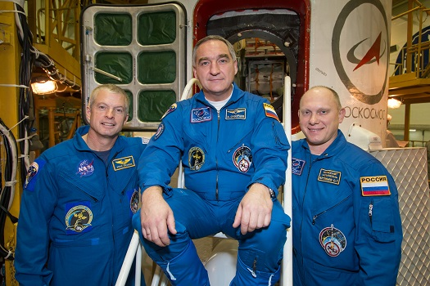
NASA astronaut Steve Swanson (left) and Russian cosmonauts Alexander Skvortsov (center) and Oleg Artemyev of Expedition 39. (Credit: NASA/Victor Zelentsov)

Russia will send a new new three-man crew to the International Space Station on Tuesday in one of five launches scheduled worldwide this week. SpaceX will follow up the crew launch on Sunday, March 30 by sending a Dragon freighter to the orbital outpost.
NASA astronaut Steve Swanson and Russian cosmonauts Alexander Skvortsov and Oleg Artemyev are scheduled to lift off from Baikonur at 5:17 p.m. EDT Tuesday (March 25).

NASA releases stunning image of lightning strike from space as part of new 'lightning lab'
Source: http://www.independent.co.uk/news/science/nasa-releases-stunning-image-of-lightning-strike-from-space-as-part-of-new-lightning-lab-9214118.html

NASA has released a stunning photo of a lightning strike as seen by an astronaut aboard the International Space Station (ISS) as part of the launch of Firestation, a new instrument on the station dedicated to tracking lightning.
The image shows a cloudy outlook over the Arabian Peninsula with a pale purple glow indicating where the lightning has struck. The mass of orange at the bottom edge of the photo is Kuwait City, while the smaller cluster of lights towards the top of the picture is the city of Hafar Al Batin in Saudi Arabia.
The photo was taken last December but has only just been released as a part of the new Nasa initiative. Images like this one might be rare but lightning bolts themselves are extremely common, crackling across Earth’s atmosphere at a rate of roughly 50 times a second.
All this activity adds up to 4.3 million strikes every day or 1.5 billion a year, says Nasa. However, the space agency is only really interested in one type of lightning: the comparatively rare strikes that emit gamma rays, a type of radiation usually only created by exploding stars and during nuclear fusion.
Lightning strikes of this sort are known as TGFs or terrestrial gamma-ray flashes, and they’re so powerful that they actually create antimatter in the Earth’s atmosphere for fractions of a second.

Do we have to worry about the future?
Two movies you have to see and wonder…

The Libyan Oil Crisis: Social Fragmentation in an Unstable State
By Dario Cristiani
Source:http://www.jamestown.org/programs/tm/single/?tx_ttnews[tt_news]=42184&tx_ttnews[backPid]=26&cHash=0abf8d55418a0a431ad401796e3b6519#.U0A70KJpKGd

In early March, the North-Korean flagged tanker MT Morning Glory reached the eastern port of Es-Sider, one of the three oil ports seized by Ibrahim al-Jadhran’s Cyrenaica Defense Forces. [1] Jadhran’s forces tried to sell oil independently of Tripoli’s control, something that they had threatened to do in the past. The tanker was reportedly loaded with about 234,000 barrels of crude and was able to slip through Libyan naval patrols. Shortly afterwards, U.S. Special Forces boarded and seized the tanker off of Cyprus before returning it to Libya (Reuters, March 23). The inability of the Libyan government to manage this situation created a major political crisis, with Prime Minister Ali Zeidan fleeing the country on a private jet for Germany after being sacked by the General National Congress (GNC) (Guardian [London], March 13; al-Jazeera, March 22; AFP, March 23). The crisis was not an isolated event, but instead represented the peak of a wider situation pitting the central government in Tripoli against armed groups (especially in the east) that has brought Libyan oil output to a standstill. Given the importance of oil for Libya, and of Libya for the global oil market, these developments have a wider significance beyond their economic impact.

The Roots of the Current Crisis
The end of the 42-year-long Qaddafi regime triggered a series of political fragmentations that are somehow natural in the history of Libya. A rather challenging and inhospitable geophysical environment has fostered the dominance of local groups – and a local and narrow definition of interests and solidarity – rather than allowing the emergence of a unified and more inclusive national society. Like other nations in the region, Libya’s national borders were more the product of European colonialism and the introduction of the concept of nation-states than the product of a local historical process. Unlike other countries – Egypt, for instance – which had a nationalist sensibility and narratives to support it, the presence of a unified and inclusive nationalist narrative in Libya has always been particularly weak and the establishment of modern national borders has failed to produce a sense of nationalist coherence or solidarity.
The three regions that compose modern Libya – Cyrenaica, Tripolitania and Fezzan - have always maintained their own particular identity. Within them, local communities, tribal links and towns have historically represented the focal points through which Libyans have organized their interests and represent the primary units of social and political reference. These tendencies were well displayed in the fight against Italian colonialism, when resistance was organized around powerful local families and urban settlements.
The dominance of localism was not challenged by the establishment of Libya as a nation-state in 1951 and the 1969 revolution led by Muammar Qaddafi did not change this situation significantly. A few years after the revolution, Qaddafi gave up his original ambition to downplay the influence of tribal solidarity and used a select few tribes to prop up his regime and boost stability. His divide and conquer strategies and the exclusive nature of his regime nurtured a desire for revenge that clearly emerged once the Libyan revolution started in 2011. Moreover, the deliberate lack of civil institutions within the Jamahiriya (the Republic of the Masses) and the spread of informal mechanisms to manage power did not produce a new, inclusive national identity, but rather created a political context in which fragmentation and narrower, local-based and largely selfish visions of interest became dominant.
Revolutionary units, militias and brigades were organized around cities and local power-brokers, and once the regime collapsed, they also became the key actors in post-Qaddafi Libya. The weak central authority tried to appease and contain these militias rather than challenge them directly. Some militias were able to guarantee a minimum level of stability in their areas, while in other places the presence of multiple rival militias created an informal “balance of power” that was able to again guarantee a minimum level of security.
This situation was short-lived, however, and now many of these militias are directly challenging the authority of Tripoli, especially groups in the east, where the situation is exacerbated by the presence of most of the oil facilities, disagreements over defining the borders of some oil fields lying at the meeting point of Tripolitania and Cyrenaica bids by some political movements to gain greater access to oil revenues. The attempt to sell Libyan oil has changed the intensity of the struggle, bringing it to a different and more challenging level.

Libyan Oil Trends
Shortly before the revolution, Libyan oil output reached 1.77 million barrels per day (bpd) of crude oil in 2010, equivalent to 2% of global output according to IMF figures. [2] Following 9/11, Qaddafi, who had earlier nationalized the Libyan oil industry, seized the opportunity to reduce his international isolation by cooperating with the West, reducing his foreign policy adventurism and giving up Libya’s WMD program. This allowed international oil companies to return to Libya at a time when the national oil sector was particularly in need of new investment. This trend stopped in 2011, when the eruption of the Libyan Civil War brought oil production to a standstill. The IMF calculated that Libyan oil production for 2011 stood at 0.5 million bpd, with the lowest point in August 2011 when production was almost zero as the Qaddafi regime collapsed and rebels took control of Tripoli. [3] After that, production gradually resumed and quickly returned to its pre-war level, hitting 1.7 million bpd in September 2012.
A rising wave of strikes and protests led to a sharp reduction in oil output in 2013, however. In mid-October 2013, former prime minister Ali Zeidan announced that Libya was producing between 600,000 to 700,000 bpd thanks to the return online of more than one-third of its oil production. This assertion was false. In September 2013, production was 150,000 bpd. In the second half of 2013, Libya produced only an average of around 250,000 bpd. In January 2014, production recovered as the government announced that Libya produced about 582,000 bpd in the week ending January 18 (Libya Herald, February 6). That was just a temporary development, as production collapsed again, with the National Oil Corporation (NOC) announcing that production stood at 155,000 bpd at the end of March (Reuters, March 28).

More than the Blockade
The blockades by rebel militias of the oil and gas facilities have the potential to harm Libyan energy operations for decades to come. Paolo Scaroni, the head of Italian ENI (one of the most important companies operating in Libya), noted that: “Opening and closing gas and oil fields is not like switching a light on and off. It risks damaging the geology of the field” (Libya Herald, March 24). The blockades and the consequential sharp decline in oil output are not the sole problems that Libya and its oil sector have to face, with the energy sector burdened by a series of structural problems that may have a serious impact on medium- and long-term operations.
Despite the importance of this sector’s revenues to Libya, its governance is engulfed by political instability. On January 21, Oil Minister Abd al-Bari al-Arousi and four other members of the Justice and Construction Party (JCP), the political arm of the Libyan Muslim Brotherhood, resigned from the government after failing in an attempt to censure Prime Minister Ali Zeidan (Libya Herald, January 22). Moreover, the execution-style killing of British oil worker Mark de Salis and girlfriend Lynn Howie on a Libyan beach heightened the risk perception of foreign companies operating in Libya (Guardian [London], January 4). Although this is not a decisive factor in pushing companies away from Libya, it nevertheless may raise concerns. Other factors that could discourage foreign investment and a more active commitment from oil companies to the country include:
- Continuing security volatility;
- The risk to personnel in Libya;
- The targeting of energy facilities for occupation by political activists and militants;
- Some recent and disappointing drilling results;
- The psychological burden to the industry in the wider North African region following the attack at Algeria’s In Aménas gas facility in January 2013.
The sector is also facing legal and regulative problems in Libya; the Libyan Exploration and Production Sharing Agreements (EPSA) IV terms on contracts are considered by international companies to be among the most restrictive and penalizing in the global oil market (Oil & Gas Journal, April 18, 2005). In this legal framework, contract winners are generally determined by how high a share of production a company is willing to offer to the NOC (WorldFinance.com, September 13, 2013). Funds for exploration work must be provided entirely by the private companies, who must also pay for 100 percent of all costs faced for a minimum time period of five years while the NOC maintains exclusive ownership. Moreover, the management structure of Libyan joint venture companies gives the NOC a “golden share” (allowing the holder to outvote all other shareholders in specific circumstances) and the final word on all decisions. After the revolution, Libyan authorities stated they were keen on announcing EPSA V terms by the end of 2013. However, in September 2013, NOC Chairman Nuri Berruie announced that the new EPSA would not be produced before mid-2014, asserting that the GNC did not have the constitutional authority to launch a new EPSA bidding round (Libya Herald, September 18, 2013).

The Importance of Oil for Libya
Libya is a paradigmatic example of a “rentier state,” one that relies almost entirely on the “rent” of its natural resources to external clients for its national revenues. Libya remains one of the most hydrocarbon-dependent countries in the world, with a poorly-diversified export sector.
The hydrocarbon sector currently composes around 70 percent of GDP and about 98 percent of exports (AFP, February 19). Oil revenues remain the most important budgetary source for Libya, composing about 90 percent of government revenues. [4] Libya holds the largest proven oil reserves in Africa; according to the latest BP Statistical Review of World Energy, Libya has 48 billion barrels of proven reserves (2.9 percent share of the world total). [5]
A rather important element of the Libyan oil industry is that it is a major contributor to the global supply of light and sweet crude. Light crude is generally considered to have an API gravity (American Petroleum Institute gravity is used to compare the relative densities of petroleum liquids) higher than 31.1 degrees (though this may vary) and only the oil produced at the al-Bouri field stands below this threshold, with an API of 26. Sweet crude has a low sulfur content, particularly important for producers facing tighter environmental regulations. This important element explains why Libyan oil is particularly interesting for oil companies, as it is easier to refine and produces higher percentages of gasoline and diesel fuel when converted. Moreover, the geographical position of Libya makes it a rather important supplier of oil for Europe, and the fact that Libyan oil supplies are not dependent on the situation in the Suez Canal and the Persian Gulf made it historically a major target of interest for international oil companies, particularly in Europe.
Although the energy sector only employs around 2 percent of the Libyan workforce, it is nevertheless fundamental in supporting employment in the public sector, where an estimated 1.3 million workers form roughly 80 percent of Libya’s labor force. [6] The pattern of Libyan public spending suggests that the oil sector is also a fundamental element of social stability. In 2012, wages and salaries represented the largest component of public expenditure, accounting for about 36 percent of the total. Subsidies and transfers (29 percent) also had a significant share, while goods and services accounted only for 25 percent. [7] This means that about 65 percent of Libya’s public expenditure has an immediate and direct impact on the living standards of the population.

Conclusion: Implications for Libya and for the World
Libya’s dependence on oil makes the current crisis one of the toughest challenges faced by the already weak government in Tripoli. Over the past three years, Libya has been able to partially contain the impact of increasing fragmentation using public money. Despite this, Libya has been unable to control the proliferation of militias and local groups claiming a bigger slice of the “oil pie.” Libya’s inability to leverage public money to cool social tensions in the wake of the ongoing financial crisis is a major element of concern, since it could lead to further radicalization. This is a significant challenge and its outcomes will determine the future path of Libya as a nation state. This challenge, however, goes well beyond Libyan borders. Given the importance of Libya to global oil production, prolonged political instability and a lasting blockade of its oil facilities may combine to keep global oil prices high. Apart from the classic supply and demand dynamic (as Libyan problems reduce the global supply of oil), the energy market is also particularly sensitive to geopolitical factors; security concerns in Iraq, Nigeria, Venezuela and the former Soviet space may also play a role in putting upward pressure on prices.
A Libya on the brink of complete chaos, without significant changes in the legal and regulatory framework of its oil sector, may push foreign firms to rethink their strategies. The ongoing shale revolution may push many companies to search for less risky environments in which to operate, potentially abandoning a country that, despite enormous potential in terms of reserves and the high quality of its oil, will likely experience at least several more years of chaos. Moreover, the blockades may damage the oil infrastructure and delay routine maintenance work, in turn reducing Libya’s ability to achieve the oil production targets that authorities claim they should be meeting in normal conditions, generally 1.7 to 1.8 million bpd. This will, of course, have an impact on the overall stability of the country; at the moment, the struggle between local groups to get a bigger slice of revenues that were for decades in the hands of Qaddafi and his circle is pitting groups – above all from the east – against the government and also against themselves. If such revenues diminish, competition will increase and cause further radicalization, in turn advancing the already significant trend to fragmentation that characterizes Libya. This is the reason why oil remains key to the success of post-revolutionary Libya.

►Notes available at source’s URL.

Dario Cristiani is a PhD Candidate in Middle East and Mediterranean Studies at King’s College London. Previously, he has been a teaching fellow in Political Science and Comparative Politics at the University of Naples "L’Orientale" and a political analyst with the Power and Interest News Report (PINR).

Anti-immigrants backlash in Europe intensifies
Source: http://www.homelandsecuritynewswire.com/dr20140403-antiimmigrants-backlash-in-europe-intensifies

Anti-immigration groups and parties are enjoying a surge in many European countries, including Britain, France, and Austria, as many European economies face high unemployment and declining wages. The open-border policies of the European Union (EU), which allow citizens of EU member states to work and receive social welfare anywhere within the EU, have led many citizens to call for immigration limits and quotas.
Analysts say immigrants are a convenient scapegoat for the economic problems in some countries, but many right-wing political parties have used the anti-immigrant sentiment to gain legislative and political victories. Earlier this year, Swiss voters approved an initiative to tighten immigration quotas despite threats of penalties by the EU. Nigel Farage, leader of Britain’s U.K. Independence Party, said that British voters would make the same decision, “but by a landslide,” if they were allowed to vote on a referendum like the Swiss.
Those who oppose the EU open-border policy say the inflow of immigrants puts a strain on public services, and may harm cultural identify. “We are full, this is the thing, it is simple — we are on course to reach 70 million people in our population and we cannot take any more people,” said John Mills, a golf course marshal from Sussex.
USA Today reports that the British government’s recent attempt to limit welfare benefits to immigrants is now facing legal action by the European Commission. Germany has organized a panel to find ways to reduce “benefit tourism” in cities which are overwhelmed by unemployed East Europeans migrating not for work, but to take advantage of Germany’s health care, schools, and welfare. “The number of immigrants from Bulgaria and Romania and the social problems linked to some of them can be managed nationally but in certain regions it is alarming, and the rise in numbers is alarming,” Interior Minister Thomas de Maiziere told Reuters. “So we must take measures to avoid this becoming a problem.”
Business leaders, on the other hand, say that the current levels of immigration are good for the European economy because they expose local companies to more workers and skills. “With the aging population, we are desperately in need of immigration,” said Ben Tonra, the head of the University College Dublin School of Politics and International Relations. “Also, the reality is, jobs need to be filled, particularly in service sectors, particularly in low-wage sectors, which immigrants are willing to take up, which local people are unwilling or unable to take up for whatever reason.”
While many Europeans call for anti-immigration policies, it is uncertain whether immigrants are the reason for the slow economy in many EU member states. Bulgarians and Romanians won the right to work across all EU countries in January, and while groups and countries, including the United Kingdom, try to discourage them from migrating, Karin Boettger, deputy director of the Berlin-based Institute for European Politics, said that based on the statistics, “Romanians and Bulgarians pay more into the social security system than they use. Most of the people who come here actually contribute to the economic wealth of the country, and are not, as some suggest, here to live off welfare.”

France's new approach to preventing French Muslims from going to fight in Syria
Source: http://www.homelandsecuritynewswire.com/dr20140402-frances-new-approach-to-preventing-french-muslims-from-going-to-fight-in-syria

France will soon adopt preventative measures, currently practiced in Britain, Denmark, and the Netherlands, to stop minority youths from pursuing jihad in Syria. There is a concern that radicals who travel to Syria could return to France with the skills and determination to carry out terror attacks. Last week authorities reported the discovery of three soda cans packed with nails, bolts, and explosives along with bomb-making instructions at the apartment of a 23-year-old man who had recently visited Syria.
NPR reports that in the past, France relied on prosecuting confirmed extremists as a way to discourage homegrown terrorists, but several government officials saidthat a new approach will be adopted. “We are working upstream,” said one high-ranking security official. “That’s new in France.” Another government official said France is “not on the forefront when it comes to the prevention of radicalization.”
France has consulted with British authorities to learn from similar preventative efforts.
The new approach will encourage local law enforcement, schools, and community leaders to help identify at-risk youths before radicalization begins and advances, then introduce the youths to local prevention centers.
Terrorism expert Magnus Ranstorp of the Swedish National Defense Collegesays that “from a security point of view, it doesn’t make sense to rely on the repressive approach alone.” Security should not be “the first and only recourse …. there will always be fires breaking out,” said Ranstorp. “The preventative approach is the only way forward.”
Nicholas Bons, a French convert to islam, killed in Syria
French authorities reported in January 2014 that roughly 700 French residents had traveled to Syria to join in the fight against Syrian forces. The travel of French pro-jihadists to Syria exceeds the number of Europeans who left to fight in Iraq and Afghanistan.
Some officials say the West’s harsh stance against Syrian president Bashar al-Assad may provide some legitimacy for vulnerable youths who see fighting in Syria against Assad as a just cause. NPRnotes that among the 700 French who traveled to Syria to fight with the rebels were teens as young as 15 year old, leading the French government to consider restricting minors from leaving France, though details on how that approach would be enforced have not been released. Authorities also want to improve cooperation with security counterparts in Turkey, a popular route into Syria for fighters.
Louis Capriolo, a former French counterterrorism official, doubts that prevention efforts will help in the short term. “We are in a demarche that will take years. Radicalization no longer takes place inside the town, which you can control, inside mosques, which you can control,” he said, referring to the radicalization that may occur via the Internet. “We are in a dimension that no one masters anymore at all.” Many parents “don’t know what a tweet is, what a chat is.” According to Capriolo, as long as Syria is a battlefield, the “jihad phenomenon will continue.”

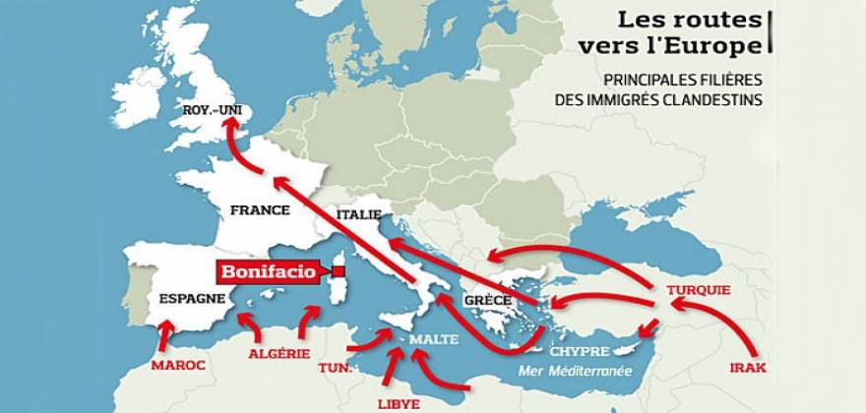
EDITOR’S COMMENT (on both articles above): I will start with the statement (from Italian Minister of Interior Angelino Alfano) that approximately 300,000 to 600,000 illegal immigrants are waiting in North Africa for better traveling conditions (summer time) to invade Europe. It is a mistake to confuse mass illegal immigration with policy and politics. Since modern “developed” societies failed to spread “prosperity” to the rest of the world it is now time to defend their own homes. Even if economies were strong enough to absorb the incoming laborforce the problem would the same give or take. Change of mentality is much more important that unemployment. For example in Greece, locals became lazy and turned to urban centers for easier prosperity instead of working in the fields surrended to cheap new coming “slaves” that would do anything to survive. Even today that we suffer from current financial (?) turmoil it is very difficult to find a Greek worker for field work. This overall mentality affected also many aspects of social web such as education, healthcare and potentially homeland security. The combination of lack of indegration with inability to support a new nation within the nation resulted in a fragile environment that might explode unexpectingly. It would be ideal if there was a real European Union that would address the issue globally and not based on own policies and advantages. But such unity is absent and it is up to gate keepers to keep the gates closed while home owners of central and north Europe are playing fools. And how can one do that peacefully? Can we modify with a click Syria, Iraq, Albania, Afghanistan, Libya, Somalia or Pakistan to stop “producing” immigrants? No we cannot solve their problems; we have enough of our own. So the only way to defend a country is to record all the people currently in the country and make the best out of them. But also to deny access to all potential newcomers. The latter defines measures and actions that are neither humanitarian nor ethical. But in a war situation ethics are not the norm. Survival of people and nations prevail. And those who from a safe distance accuse others for brutality or inhumanity should for once profuce less missiles and aircrafts, should stop interfering to other nations, should stop killing the environment and should start appreciate human life more than numbers, oils or dominance. Then perhaps one day the global equilibrium will retain its balance and life in this planet would be a normal one. Until then our home defense would continue to be our first priority. If we do not do that either alone or in close cooperation with others then there will be no tomorrow. At least the “tomorrow” we are all looking for and strive for…

Amazing Police Cars!!!
Blue-Light Phones a Mainstay of Campus Security
Source: http://www.emergencymgmt.com/safety/Blue-Light-Phones-Campus-Security.html

Spend any time on a college campus, and you can't miss that emergency phone with the blue light on it.
These phones are built to withstand vandals, blackouts and bad weather.
There's one more hazard the blue-light emergency phones have managed to survive:
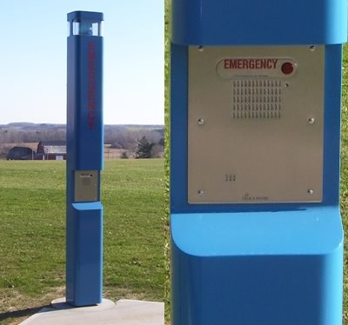
The cell phone.
Though nearly everyone carries mobile phones these days, the blue-light phones have managed to hang on. University of North Carolina at Greensboro (UNCG) and Guilford Technical Community College (GTCC) are both adding them to new areas of campus as they grow, and campus police officials say their visibility and reliability enhance campus safety.
"They're a reliable form of communication, and we all know that cell phones don't always work," UNCG Police Maj. Paul Lester said. "You can always run to these phones and push the button and get the help you need."
But in the cell phone era, campus emergency phones don't get a lot of use. UNCG police got nearly 10,500 calls for service in 2013. But only 90 came from the emergency phones.
That campus has 130 emergency phones, including 78 in standalone blue-light towers. N.C. A&T has about 40 emergency phones. There are 281 emergency phones at UNC-Chapel Hill and another 400 at N.C. State, the state's largest university. GTCC has 25 blue-light phone towers.
The phones themselves cost about $500 each and can be hung on walls of dorms, academic buildings and parking decks. All of them have a button that connects a caller directly to campus police. Police say maintenance costs are minimal.
Some emergency phones hang from steel towers planted in parking lots, quads and other outdoor areas. They stand about 9 feet tall, cost about $2,000 and come in different colors — blue at UNCG and N.C. A&T, black at UNC-CH, white at N.C. State.
They're called blue-light phones because most are topped with a blue strobe light that goes off when someone uses it. Campus police officials say the light alerts passers-by of a potential problem and helps officers find a person calling for help.
Some campuses have given up on the phones. The University of California, Davis, removed more than 100 outdated emergency phones in 2011 after installing a wireless 911 system on campus.
But in 2012, Florida State University police credited a blue-light phone with helping officers catch a suspected rapist who attacked a student.
So why do the blue-light phones hang on?
— They're reliable.
Cell phones run out of charge, get left in dorm rooms and can't always get a signal.
Police can't always pinpoint the location of someone calling from a mobile phone. Calling 911 sometimes connects to the local police, not campus police. And who can remember the seven-digit campus emergency number?
"During an emergency, the stress of it all can rattle folks so much that they aren't able to dial a three- or seven-digit number. Just being able to push one button helps with that," said Robin Hattersley Gray, editor of Campus Safety Magazine, which covers security issues at schools, colleges and hospitals.
"Also, cell networks tend to not work during large-scale disasters because everyone is calling their loved ones to check on them," she added. "The network gets clogged and calls don't go through."
— They have handy special features.
Some of the newer models come with public address systems so police can make announcements in an emergency. Some police departments mount cameras atop the towers.
— They're not mobile apps.
Some universities offer mobile applications that let cell phone users connect directly to campus police via text message or photo.
But a campus safety mobile app cost several dollars per student per year, and not all students download it.
"That's a significant check they're writing every semester for that app," said David Fleming, marketing and design director for Code Blue, a Michigan company that has made blue-light phones for the past 25 years.
GTCC plans to add three new blue-light towers to its Cameron Campus and three more to its aviation building near Piedmont Triad International Airport. Both facilities are scheduled to open later this year.
"Not everyone has a cell phone," GTCC Police Chief Dawn Tevepaugh said. "For us (the blue-light phones) are a much faster system to reach a real person."

EDITOR’S COMMENT: Perhaps in addition to existing call button some specialized buttons could be added such as: “rape”, “shooting”, “explosion”, “car accident”. Police will then know the location (via GPS) and will intervene prepared accordingly. Type of incident might now allow time to give vocal details and info. A “press and run” button might elicit a faster response and we all know that in serious incidents time equals lives.

Strategic Trends 2014

Key Developments in Global Affairs

Author(s): Michael Haas, Jonas Grätz, Prem Mahadevan, Lisa Watanabe, Martin Zapfe
Editor(s): Oliver Thränert, Martin Zapfe
Series Editor(s): Andreas Wenger
Series: Strategic Trends
Publisher(s): Center for Security Studies (CSS), ETH Zurich
Publication Year: 2014
Publication Place: Zurich

The chapters of “Strategic Trends 2014” all describe aspects of the long expected shift in the geopolitical balance. This shift is different and far more evolved and complex than the well-established narrative of surging emerging nations, especially in Asia, gradually replacing Western influence in regions, markets, and policy issues. Beyond a mere decline of Western influence, the chapters of this volume reflect a basic insecurity over the future direction of these geopolitical shifts. Long expected developments – the US increasingly disengaging at least from Europe, Europe itself struggling to live up to its geostrategic aspirations – that could provide a secure framework to interpret global events, face new developments. Taken together, the five chapters in this volume of CSS Strategic Trends highlight elements of a world in which the West is losing ground. As a result, the global order faces not necessarily decreasing stability, but increasing strategic insecurity.

►You can download it from:
http://www.css.ethz.ch/publications/DetailansichtPubDB_EN?rec_id=2919

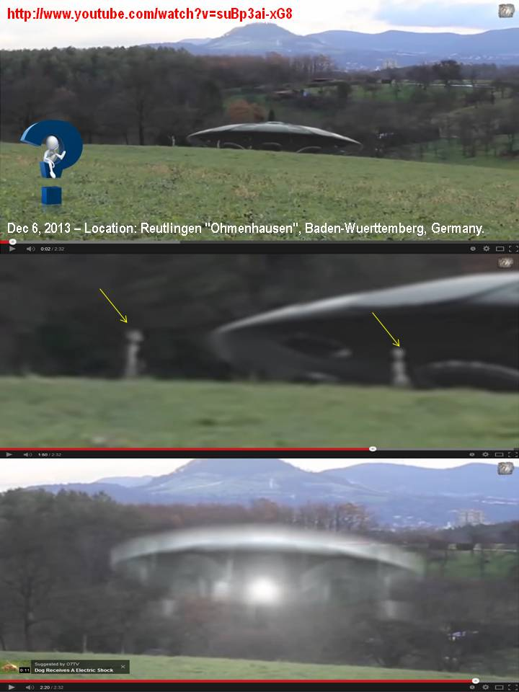

UAE most popular country to live in, Arab Youth Survey reveals
Source: http://www.thenational.ae/uae/government/20140407/uae-most-popular-country-to-live-in-arab-youth-survey-reveals

April 7 – Arab youths have named the UAE as the country they would most like to live in – for a second successive year.
They also, for the second year, picked the UAE as the nation they would like their home country to emulate.
The UAE was ahead of 20 other countries, including the United States, Germany and Britain, as young people’s top country to live in.
In this year’s Arab Youth Survey 39 per cent chose the UAE, up from 31 per cent last year. The US was second with 21 per cent. Saudi Arabia had 14 per cent, followed by France and Qatar at 13 per cent each.
Young people in Qatar were the most favourable towards the UAE, with 42 per cent favouring the Emirates.
Experts believe the UAE’s popularity is based on a strong economic outlook, moderate government, ease of conducting business here and its reputation as a safe haven in a region of political unrest.
Emiratis were also upbeat about the way ahead, with seven in 10 young people agreeing with the statement: “I feel optimistic about what the future holds for my country.”
The survey showed that young Emiratis were the most confident about their prospects with 50 per cent believing they had more opportunities now than a year ago, compared with the overall Arab figure of 40 per cent.
This pushed the UAE to the top of the 16 countries polled in terms of hope for the future.
The banning of the veil and a weakening economy were the reasons for France slipping from second position last year to the fourth slot this year, experts said.
“It is not surprising that Europe is not a place that Arab youth most want to live in. It is to do with the banning of the veil by France and the drop in the economic prospects,” said Jeremy Galbraith, chief executive of Burson-Marsteller Europe Middle East and Africa.
Turkey, which occupied the fourth spot last year, is no longer in the world’s top-five ranked countries that Arab youth chose to live in.
The US was the only non-Arab country that showed a rise in favourable perception – increasing to 25 per cent from 16 per cent last year.
Fewer Arab youths lean towards non-Arab countries, with just 14 per cent naming France as the country they would like their nation to follow – down from 17 per cent last year.
About 10 per cent expressed a preference for Turkey, down from 16 per cent last year, and 7 per cent favoured China, which slipped from 13 per cent in 2013.
The survey did not include Syria due to the unrest in the country.
“The region has been through a tumultuous time economically, politically and socially, but what inspires me is that the young people show resilience and optimism,” said Joseph Ghossoub, chairman of the communications conglomerate the Menacom Group.
“This feels me with pride because optimism remains despite the uncertainty the region is faced with.”
The survey results echo the United Nations-commissioned 2013 World Happiness Report that ranked the UAE as the happiest Arab country and the 17th happiest in the world.

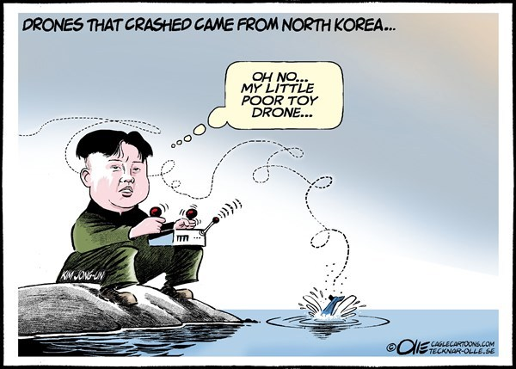

The Less Americans Know About Ukraine, the More They Want to Get Involved
Source: http://www.thewire.com/global/2014/04/americans-dont-know-where-ukraine-is-still-want-to-intervene/360287/

Only one out of six Americans polled in a recent survey was able to correctly identify Ukraine on a map, so naturally those are same Americans who are also the most supportive of U.S. military intervention in the crisis.
The poll, conducted by political scientists Kyle Dropp, Joshua D. Kertzer and Thomas Zeitzoff, asked a national sample of 2,066 Americans to say what action they believe the U.S. should take in Ukraine and, in a separate round of questioning, to point out Ukraine on a map. The authors explain in a Washington Post blog post:
In addition to measuring standard demographic characteristics and general foreign policy attitudes, we also asked our survey respondents to locate Ukraine on a map as part of a larger, ongoing project to study foreign policy knowledge. We wanted to see where Americans think Ukraine is and to learn if this knowledge (or lack thereof) is related to their foreign policy views.
The researchers constructed a heat map representing where respondents thought Ukraine was, and found that people who thought Ukraine was further away from where it actually is were more likely to think the U.S. should take military action in the region.
According to Dropp, Kertzer and Zeitzoff, most people have a pretty skewed idea of where Ukraine is:
Most thought that Ukraine was located somewhere in Europe or Asia, but the median respondent was about 1,800 miles off — roughly the distance from Chicago to Los Angeles — locating Ukraine somewhere in an area bordered by Portugal on the west, Sudan on the south, Kazakhstan on the east, and Finland on the north.
Still, it seems Americans are generally opposed to intervening in Ukraine. According to this poll, respondents are more on board with passive aggressive censure – like Washington boycotting the Russia-hosted G8 summit — than actual military aggression. Last month, CBS noted that 61 percent of respondents to a poll on the subject said they don't think the U.S. has a responsibility to intervene. About 32 percent felt the opposite way.

One in three Brits think Everest is in Europe as survey reveals poor geographical knowledge
Source: http://www.theguardian.com/uk/2007/nov/14/uknews4.mainsection

2007 – The most visited local "landmark" for many British adults is their nearby DIY store, according to a survey published today, which suggests we are a nation of reluctant explorers, with little sense of adventure and a poor understanding of geography. A third of those who took part in the survey thought Mount Everest is in Europe, while only half were aware that the Nile is the world's longest river.
The research warns that most people are failing to make the most of their local area and have little knowledge of important geographical facts.
The survey was carried out to mark National Geographic's geography awareness week and also today's so-called "GIS Day", which aims to encourage young people to understand the extent to which geographic information - and increasingly the opportunity to use technology such as digital mapping - underpins our daily lives.
The UK is among more than 80 countries which will participate by holding local events such as workshops and school assemblies.
Asked how many countries there were in the world, only a third were correct in choosing 193. A third of people thought Mount Everest was either in the Alps or the UK - it is in Nepal - and only half of respondents knew that the Nile was the world's longest river.
Asked which facility had been visited the most during the past month, the DIY superstore came top with 39%. The local museum was bottom with only 9%. Almost a third said they had never visited their local museum or church and a quarter had never been to their leisure centre.
Respondents were also asked about what they remembered most about geography lessons at school from a list of eight topics. Maps came top with 24%, rocks/erosion and "don't know" were in joint second place with 16%, and farming in last with 5%.
The findings follow a separate survey carried out earlier this week by the British Council, which showed that UK children aged 11 to 16 have the lowest international awareness among their age group in 10 countries.
David Lambert, professor of geography education and chief executive of the Geographical Association, said: "Geography helps us make sense of the world and face vital issues such as climate change, energy, food production, the 'war on terror', water and poverty. It also touches all our lives every day, from businesses to schools, government to hospitals.
"Essential to a rounded education, young people should learn geography because it introduces them to relationships between the human activity within our physical world. This is key to gaining an improved understanding of the environment we live in today and in the future."

After 6 years…

Brits who holiday here can’t pinpoint Cyprus on a map
Source: http://cyprus-mail.com/2013/08/22/brits-who-holiday-here-cant-pinpoint-cyprus-on-a-map/

2013 – More than half of British holidaymakers visiting Cyprus confused the island with Greece, revealed a study by British Airways on the geographic awareness of the former colonial power’s subjects.
According to an article in the Daily Mail, despite Britain having a long and tumultuous relationship with its former colony, the majority of holidaymakers coming to Cyprus don’t really know where it is.
When shown a map, 53 per cent of Britons booked to go to Cyprus thought it was part of mainland Greece while just under a half thought Turkey was in the Ukraine.
Almost a quarter of those heading to Spain thought it was geographically located in France while 14 per cent of people looking for French resorts pointed towards Belgium.
The same figure confused Italy with Belarus while 24 per cent of those visiting Ireland thought it was in Spain.
Overall, a third of respondents admitted they found it difficult to pinpoint where they went on holiday.
Claire Bentley, representing British Airways Holidays, which conducted the survey, told the Daily Mail: “It is surprising to think that people are prepared to spend their hard earned wages on a holiday, without researching something as important as its location.”
The key factor in booking a holiday appeared to be the temperature for 65 per cent of Britons, while local attractions came a close second (61 per cent).
Just over half of respondents said accommodation is an important factor when booking a holiday, while 48 per cent were attracted to a hotel’s facilities.
Around 47 per cent were concerned about the currency used at their holiday destination, while 24 per cent wanted a decent swimming pool, 34 per cent wanted easy access to a beach, and 10 per cent wanted a decent pub.
Four in ten people admitted they often travelled to a holiday destination not knowing much about where they are going, not researching cultural differences, or bothering to locate their intended destination on a map.
Seven in ten people realised they should be more knowledgeable about their holiday destinations in the future, said the Daily Mail

3D Printed UAS – A Reality
Source: http://i-hls.com/2014/04/3d-printed-uas-reality/

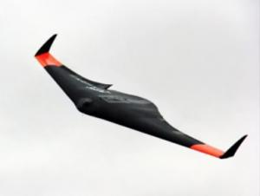
Engineers at the Advanced Manufacturing Research Centre (AMRC) at the University of Sheffield have successfully printed a 1.5m-wide prototype unmanned aerial vehicle (UAV) for a research project looking at 3D printing of complex designs.
According to sUAS the engineers said the polymer craft could form the basis of cheap and potentially disposable UAVs that could be built and deployed in remote situations potentially within as little as 24 hours.
Earlier versions required significant amounts of support material around component parts to prevent the airframe structures from deforming during the build process. Using support material adds a direct material cost, and significantly increases build time, in some cases by an order of magnitude. This is a result of the machine having to change between build and support structure heads after each printed layer.
New 3D printing techniques, such as the fused deposition modelling (FDM) used to make the UAV at Sheffield, could soon be used in the creation of products without the need for complex and expensive tooling and the time required in traditional manufacturing.
The UAV has already completed a test flight as a glider. Researchers are developing an electric ducted fan propulsion system that will be incorporated into the airframe’s central spine. They plan to develop the craft for guidance by GPS or camera technology, controlled by an operator wearing first person-view goggles.
The Sheffield UAV comprises nine parts that can be snapped together. It weighs less than 2kg and is made from thermoplastic. The engineers are currently evaluating the potential of nylon as a printing material that would make the UAV 60 per cent stronger with no increase in weight.

New Fire Fighting Simulator
Source: http://i-hls.com/2014/04/israel-new-fire-fighting-simulator/

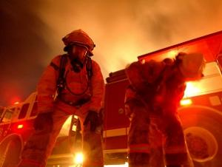
Cadets at the Israeli Fire Fighting and Rescue Academy used to train using combustible materials such as wood, hay, tires and so on. Now the cadets have moved on, training with a true fire simulator. The new device, placed inside a shipping container, was upgraded and modified by the instructors to allow for fire drills taking place inside closed structures.
The simulator requires cooking gas and simulates home or industrial fire scenarios. The available scenarios include: Electric engine fires, fires involving electric wiring and boards, fires ignited inside hazardous material containers and more. The simulator has been connected to several systems in order to increase the numbers of options available for the simulations:
- An audio system, recording and playing audio from incidents involving fires or collapsing buildings
- Powerful, environmentally-friendly smoke generator
- Fireproof-glass window into the container, used by drill instructors
- Doors used to simulate breaking into structures
The simulations have been designed to be as realistic as possible, aimed at training fire fighters and other cadets in the academy. It incorporates extensive safety procedures. The operators have complete control over the intensity of the fire and smoke, allowing them to stop simulations with the press of a button.
This week the simulator has been presented to Internal Security Minister Yitzhak Aharonovich, who visited the facilities. According to the Fire Fighting and Rescue Authority, a new academy structure – along with a more advanced simulator – are planned for the future.

Italy rescues 4,000 migrants in 48 hours in escalating crisis
Source: http://www.todayszaman.com/news-344216-italy-rescues-4000-migrants-in-48-hours-in-escalating-crisis.html

April 9 – Better sea conditions and turmoil in Libya, grappling with chaos and rampant militias three years after the ousting of Muammar Gaddafi, have increased the numbers risking the perilous sea journey from North Africa to try to reach Europe.
“The emergency is getting worse and there is no halt to the boats arriving,” Interior Minister Angelino Alfano told state-owned RAI radio. “This issue is serious and Europe must take it in hand, immediately, because this is not a Mediterranean border but a European border.”
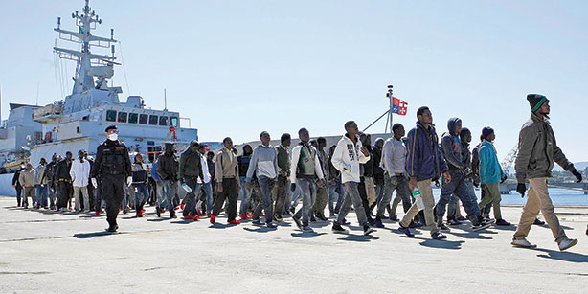
Rome has repeatedly urged the European Union to take a greater role in policing the seas as two-thirds of migrants who reach Italy travel onwards to other countries in the region. The interior minister said 15,000 migrants had arrived in Italy by sea since the start of 2014.
Rescues over the past two days included one group of 1,049 migrants containing 91 women and three babies, who were spotted by a navy helicopter and a drone as their boats ran into difficulty. They were rescued by ships and brought to ports on the island of Sicily.
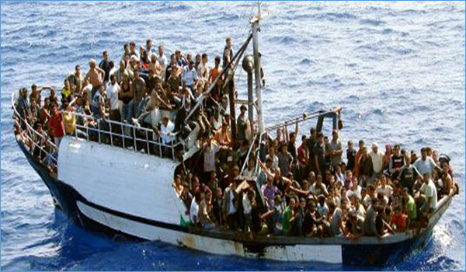
Alfano said that on Wednesday two commercial vessels alerted by Italian forces were aiding 661 people in distress and that at least one migrant on the boats had died during the journey.
“As we speak, there are people smugglers, merchants of death, earning and profiting from human beings, from the death of other men, and even from our timely sea rescues because it makes their trips shorter, therefore more profitable and less risky,” he said.
Italy is a mayor gateway into Europe for migrants who cross the Mediterranean, often in overcrowded and flimsy vessels.
Two shipwrecks last October, one in which 366 Eritreans drowned and another in which 200 mostly Syrians died, prompted the Italian government to put its navy on permanent patrol in the waters between Sicily and North Africa.

EDITOR’S COMMENT: In continuation to my comment in p.14 it would be extremely interesting if we could change with a “magic stick” the geography of Europe and place Germany or Netherlands or Denmark or Austria where Italy or Greece are. It would be interesting to see what their immigration policies would be and how they would cope with this invasion. It is nice to speak about mass immigration when you have other countries filtering and absorbing the wave but reality is totally different you know!

Homeland Security Education Guide

Fall 2013

Source: http://www.nxtbook.com/nxtbooks/kmd/hst_201311_v2/#/0

A guide for those seeking higher education in homeland security.

Annual Fire Fighting Report: Less Casualties, More Arson
Source: http://i-hls.com/2014/04/annual-fire-fighting-report-less-casualties-arson/

Less casualties in fire incidents, more calls to the fire fighting services emergency centers and more fires raging in open areas.
These are the main issues mentioned in the Israeli Fire Fighting and Rescue Authority’s annual report, published recently. The report explains that terrorists and arsonists are responsible for fires aimed at damaging forested areas, although some incidents are caused by careless travelers or the weather.
During 2013 18 people were killed in fires, compared to 23 in 2012. Among those 18, 12 were killed in fires caused by flaming mattresses or by using faulty heating appliances.
Haim Tamam, Chief Safety and Investigations Officer for the Fire Fighting Authority, explained that the most common causes of fires are: Arson – 37% of cases; electric failures – 23%; negligence – 5%. In addition, the annual report explains that there’s been a rise of 6% in the number of cases the authority dealt with: In 2013 there were 94,920 incidents, compared to 89,585 in 2012. There were, however, less incidents of building fires.

The report summarizes the main activities of the Fire Fighting and Rescue Authority, some based on lesson learned in previous years: Increased fire fighting power, more fire fighters, much more extensive training and more airborne fire fighting activities.

Nekoma Pyramid

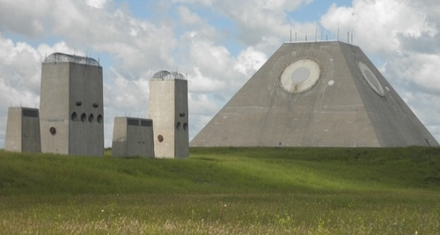
Giant Pyramid near Nekoma, North Dakota USA - part of the Antiballistic Missile system constructed over eight years for approximately $6 Billion and operational for not more than three days. Upon closure, the giant tunnels beneath were flooded with water.

The Safeguard Program was developed in the 1960s to shoot down incoming Russian intercontinental ballistic missiles. Built at a cost of 6 billion dollars in Nekoma, North Dakota, the site was a massive complex of missile silos, a giant pyramid-shaped radar system, and dozens of launching silos for surface-to-air missiles tipped with thermonuclear warheads.
However, due to its expense, and concern over both its effectiveness and the danger of detonating defensive nuclear warheads over friendly territory, the program was shut down. Today it is a military-industrial shell in the middle of nowhere, or in the words of one writer, "a monument to man's fear and ignorance."

Greece – Robotics

The World is safer with RoboRockers

Source: http://greekroborockers.wordpress.com/

On 8-9 March 2014 in the first FLL-Greece final, our team reached the top!! We lived an amazing weekend that we will never forget! Rushing, performing, encouraging, laughing, struggling, hugging, dancing, becoming friends… and most of all, HAVING FUN!!
All the members of our team, from the youngest George, 10, to the eldest Ilias, 16, (hugging in the photo above) cooperated so perfectly well with each other, helped the other teams by encouraging them and even lending equipment, and struggled so hard to do their best, that our team was nominated for 9 out of the 10 awards of the competition!
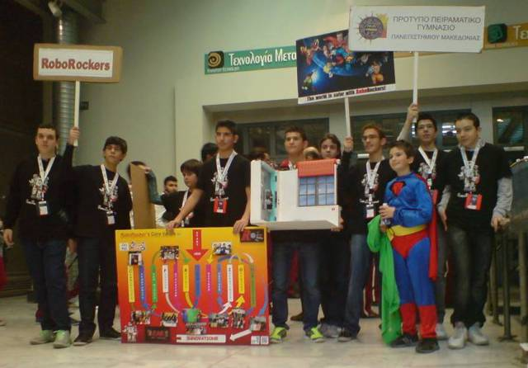
The award we finally won, was the Robot Strategy and Innovation Award, because just a few days before the competition, two of our team members (that were not even on the Robot Game and Design subteam!) had the marvellous idea to construct a completely new one-motor extension to our original construction, so that our robot could finish the Nature’s Fury missions by passing the obstacles and at the same time bringing all people and supplies at the safe area.
And then came the moment of announcing the Champions Award! We knew that our work was excellent in all levels and that we had worked very hard, but since there were many teams with outstanding performance, we didn’t expect that we would be the ones! So, when our team’s name was announced as the big FLL-Greece 2013 Champion, we just couldn’t believe in our ears!! The moments that followed, we will remember for the rest of our lives!
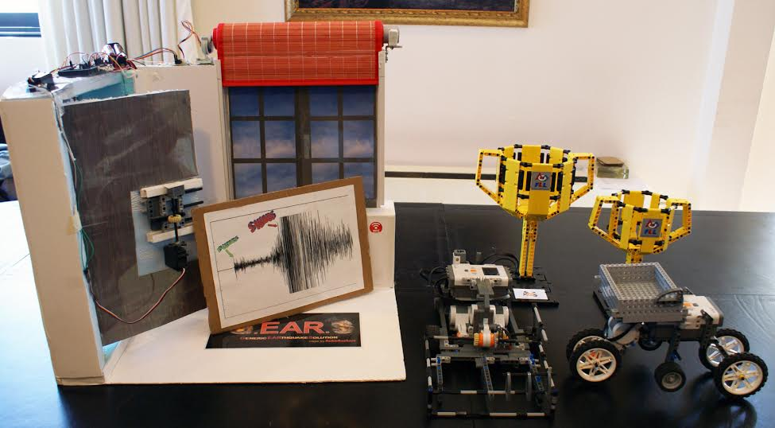

G.E.A.R.S. (Generic EARthquake Solution)
Our invention is named G.EAR.S, which stands for Generic EARthquake Solution. Our solution is called Generic because it can solve two different problems created by Earthquakes. First problem: broken glass fallen from windows of high buildings can kill people on the streets. Second problem: Locked house doors can get jammed in an earthquake and prevent people from getting out in time. So, our invention can save lives!
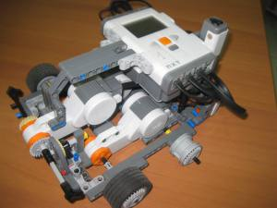
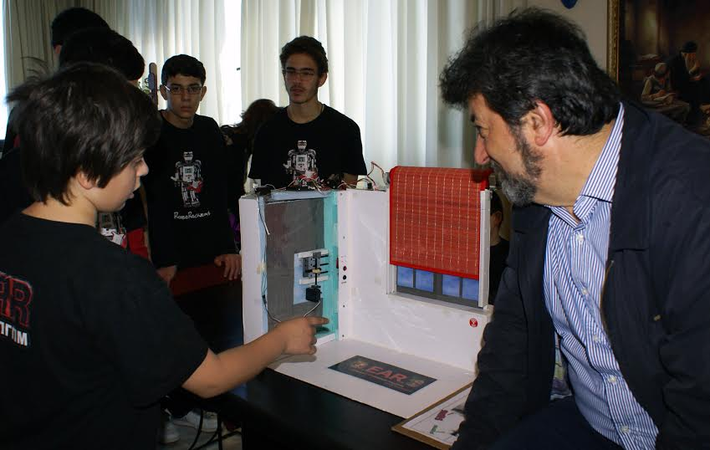
Our idea is based on the function of an accelerometer. It can detect with high accuracy the first small amplitude waves that arrive in an earthquake and are called P-Waves. When an earthquake starts, the accelerometer detects it immediately and an alarm sounds, so that we can wake up. The house door unlocks and opens by itself, so that we can get out of the house with ease. The door remains open with no possibility to close accidentally, until we decide to close it. The window shutter also closes automatically so that, if there is any fallen glass, it stays within the shutter. The shutter can be positioned either in the inside or in the outside of the house, to prevent glasses falling on the street.
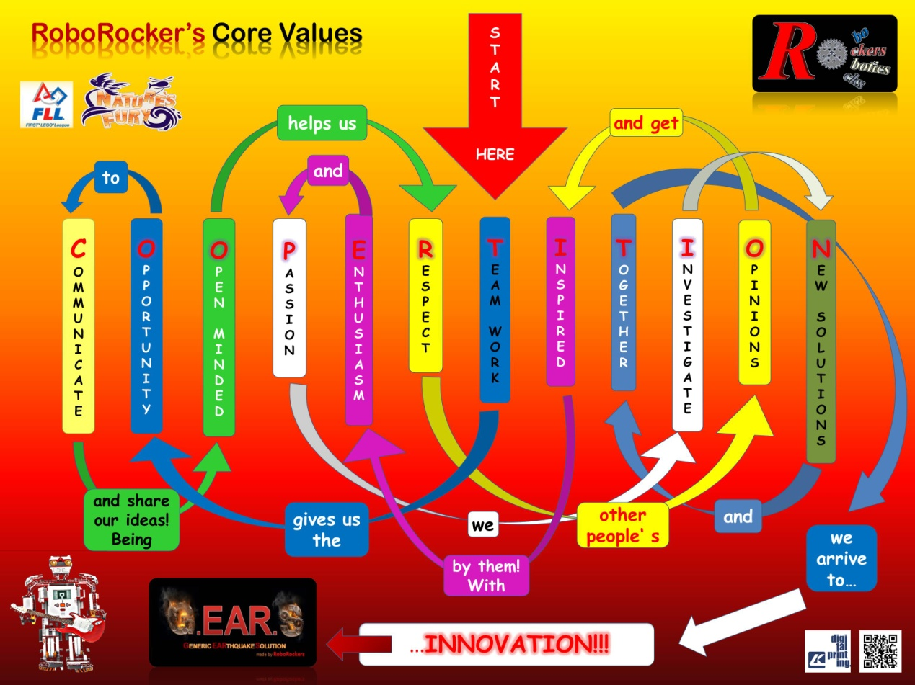

Our values
We strongly believe in Team Work! Each member of the team inspires the others and by working hard all together we can do miracles! A sample of the miracles we can do is our FLL poster which is a word labyrinth that explains our values. The first letters of our values keywords form the FLL core value: COOPERTITION!

US Army examining next-gen augmented reality "live synthetic" simulations
Source: http://www.gizmag.com/army-live-synthetic-future-combat-simulation/31312/

Modern warfare is sometimes compared to a video game, but within ten years combat training may become the most realistic video game imaginable. The US Army’s Future Holistic Training Environment Live Synthetic program is a new approach to combat training that integrates various simulations into a single, remotely accessible system. Used on bases across the country, its goal is to provide the Pentagon with a cheaper, more effective way of training soldiers for future military operations.
The year is 2025 and you see a field full of infantry running about, shouting at one another, ducking at nothing,and generally looking like a load of overgrown children at play in a peaceful meadow. But to the soldiers, thanks to special goggles, earphones, and other technology, it’s a full-blown firefight of exploding mortars, the smell of cordite, the scream of shells, and the roar for jets blasting overhead in a haze of smoke. Meanwhile, thousands of miles away, the pilots of those planes sit in a room where the battle is just as realistic, as do the officers commanding the battle from their control center.
Is this some elaborate new immersive computer game? In a way, but it’s a game with a deadly purpose, which is to train soldiers for the wars of the future.
Many people think that they main purpose of the armed forces is to fight wars, but ask a soldier and you’ll probably be told that it’s to train, and train, and train some more. In fact, the main reason why major military powers like the United States do so well in the field isn’t their array of weapons, but the fact that men and women are relentlessly trained in using them and all the other combat and logistical systems. You can have the finest military technology in the world, but if the people operating them aren't properly trained, you might as well be throwing rocks.
Training goes back to the Greeks and the Romans, with the latter striving to make drills into bloodless wars and wars in to bloody drills. It’s been around ever since armies started practicing instead of just showing up on the day. For centuries, soldiers would drill with weighted dummy weapons against opponents made of wood and canvas. In the past two hundred years, drills have become more and more elaborate with flight simulators, mock command bridges, and even whole towns set up complete with actors to help train troops.
With the US involvement in Afghanistan winding down, training becomes more important than ever if skills are to be retained. The problem is how to make training realistic, cost effective, and just plain effective. Training is never completely safe. It can even be as dangerous as actual combat, such as during the training for the D-day landings in 1944 that saw hundreds dead when things went pear shaped. It’s also expensive. Running a tank or a jet or a submarine costs a staggering amount of money, and its often hard for civilians to understand why so much has to be spent so a battalion can run up and down a mountainside.

Four pieces of the puzzle
Future Holistic Training Environment Live Synthetic works by taking the four main areas of simulation training and turning them into one system. The US Army refers to the first of these as Live simulation (LS), which is defined as real people operating real systems in the field. It’s basically good, old-fashioned training. It’s the sort of thing you see when Marines rush ashore in a training exercise carrying assault rifles that fire harmless lasers and wear vests that tell referees how many times they've been hit.
This form of simulation has advanced to the point where US marines at camp Pendleton use computer generated images of people or animals and the hope is that in the future this will expand to soldiers in augmented reality glasses and earpieces to provide sound.
The second form of simulation is virtual simulation (VS). This is real people operating simulated systems. "Like your child driving the racing car at the video arcade,” says Col. John Janiszewski, director of the National Simulation Center (NSC), US Army Combined Arms Center, Fort Leavenworth, Kansasi. “The child believes he's in a real vehicle with steering, gas, brakes and a display." It’s basically flight simulators, tank simulators, and similar set-ups like something out of any incredibly upmarket games arcade.
According to the Army, this hasn't really changed that much in recent years and the real need is to integrate these simulators into other systems.
Then there’s constructive simulation (CS), which is simulated people and equipment operating in a simulated environment. This is a bit like those strategy games where you move people and other assets around on a digital map as you try to build castles or conquer Europe. As these have grown more sophisticated, they’ve become a major component of military training, especially at the officer level for dealing with large-scale operations.
The newest area and one of the fastest advancing is gaming simulation (GS), which is similar to CS, but where the simulated world looks real to the participant, like in a game of Halo or Call of Duty. It’s so new that the Army still hasn’t worked it into the Live, Virtual, Constructive-Integrative Architecture (LVC-IA) acronym. GS has the advantage of being much more realistic, intuitive, and engaging than other simulators, and it can operate using conventional computers rather than specialized equipment.
The advantages of such simulations are that they are much safer than training under live fire and much cheaper. According to the Army, it costs US$3,500 to operate an attack helicopter for one hour, while a simulation only costs $500. Furthermore, simulations are more readily available and open up the possibility of even simulated instructors or robots being available in the future. So instead of bringing the soldiers to the simulators, it may be possible to bring the simulation to the soldiers.

Bringing it all together
The tricky thing about these simulations is that they’re currently designed to operate independently of one another. In other words, the pilot in a flight simulator gets his training without interacting with a soldier training in a simulated attack exercise on the ground. The US army hopes to change this with Future Holistic Training Environment Live Synthetic. As outlined by Janiszewski in a report by the Army News Service, the plan is to create a “live synthetic” system that fuses the main areas of simulation into one whole that will allow the participants to be scattered across various centers, yet still be able to fully participate in training exercises in real time.
Toward that end, the NSC is discussing the problems faced in creating such a system with industry experts and academics. The system in its development stages is currently being tested at Fort Hood, Texas and is being rolled out to other bases as development proceeds, with 15 more bases on the delivery list. According to the Army, this is still a long way from “live fusion,” but it is setting the basis for its eventual operation.The plan is to define the requirements for live synthetic by next year with field trials by 2022 and full deployment by 2025.

Implant to protect police dogs from overheating
Source: http://www.gizmag.com/blueforce-dog-temperature-monitor/31377/

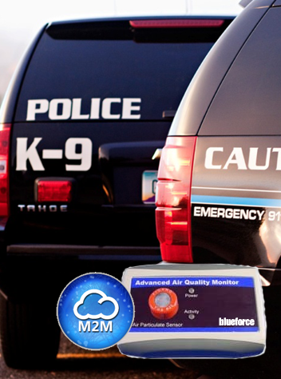
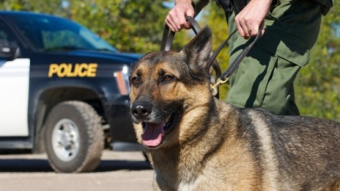
Police dogs serve many purposes for law enforcement agencies. Often times they are used for their superior sense of smell, but they are also used to apprehend suspects. As such, these animals face many risks. One, though, is not necessarily the first that comes to mind, and that is being left to overheat in police cruisers. A company called Blueforce Development aims to fix this problem with a sensor that alerts police when a K-9's temperature reaches dangerous levels.
According to the Pennsylvania K9 Assistance Foundation, an equal number of K-9's die in heat-related situations as gunshots when on duty. Blueforce Development believes that its K9 Life Safety Bundle can prevent these deaths from occurring.
The system includes a sensor that is surgically implanted in the dog that sends data on the animal's internal body temperature to a small receiver attached to the animal’s protective gear. If the dog's temperature falls below or exceeds a value set by the dog's handler, the data is transmitted using any in-car Wi-Fi, 3G, 4G or LTE connection inside the squad car to Blueforce's cloud servers. From there, a notification is sent to the iOS or Android device of anyone subscribed via Blueforce's system to the dog in question. These notifications take the form of audible tones, vibrations, text messages, or emails.
The company did announce that the package will include five sensors that monitor temperature, humidity, and volatile organic compounds. Pricing: $4,753.50.

Brazil’s new anti-corruption law: risk and compliance in Latin America’s biggest economy
Source: http://www.legalisglobal.com/item/225-brazil-s-new-anti-corruption-law-risk-and-compliance-in-latin-america-s-biggest-economy

Brazil’s anti-corruption enforcement record has to date been poor. Indeed, in Transparency International’s 2013 Progress Report on assessing the enforcement of the OECD Convention on Combating Foreign Bribery, Brazil was ranked in the “little or no enforcement” category. Recent events, however, indicate that this is likely to change.
With its rise in the rankings of the world’s largest economies and its imminent hosting of the 2014 World Cup and 2016 Olympics, the pressure to improve its record has been evident. Domestic pressure has also increased. Widespread civil unrest during the summer of 2013 was significantly influenced by popular condemnation of corruption in the country.
The effects have been clear. The Brazilian Supreme Court’s recent ruling that the majority of the politicians and businessmen convicted in the “Mensalão case” (involving the embezzlement of public monies to pay coalition parties for political support) must begin their prison terms is considered a landmark ruling in showcasing the government’s efforts in tackling corruption. Further, in its report, Transparency International lists four investigations into foreign bribery by Brazilian companies that are currently underway, and all are said to have commenced in 2012.
The unrest also resulted in Brazil’s new anti-corruption law (the Anti- Corruption Law) being rushed through the Brazilian Senate, despite being originally proposed in 2010. Both external and internal pressures indicate that the Brazilian authorities are likely to prioritize investigation and prosecution of corruption.

The Clean Company Law
Otherwise known as “the Clean Company Law”, the Anti-Corruption Law (Federal Statute No 12,846/13) was signed by Brazil’s President Rousseff on Aug. 1, 2013 and came into force on Jan. 29, 2014. In summary, the key provisions of the new law are:
Public officials The Anti-Corruption Law prohibits companies and individuals from engaging in direct and indirect acts of bribery or attempted bribery, of both foreign and Brazilian public officials. Whilst the definition of a public official is not entirely clear, it is envisaged that it will cover any individual who holds a position in any public agency or entity. It remains to be seen whether the definition also encompasses individuals in companies owned or controlled directly or indirectly by governments. In contrast to the FCPA, facilitation payments are prohibited.
Application The Anti-Corruption Law applies to Brazilian companies with respect to domestic and foreign bribery. It also applies to Brazilian subsidiaries of foreign parent companies, as well as to non-Brazilian companies that have representations in Brazil (e.g. through an office or branch) for bribery occurring in Brazil.
Corporate liability for employees and third parties Companies will now be responsible for the unlawful acts of their employees and agents.
Successor liability The Anti-Corruption Law imposes successor liability in the context of mergers and acquisition transactions so that an acquiring entity may be liable for any acts of corruption committed by the acquired entity.
Strict liability offense Unlike the FCPA, no corrupt intent is required. It is sufficient to demonstrate that one or more offenses were committed in a legal-entity’s interest or to its benefit.
Other offenses While, unlike the UK Bribery Act, the Anti-Corruption Law does not cover commercial bribery, the new law does extend to fraud or manipulation in a public bidding process and tampering or interfering with government investigations.
Penalties Significant administrative and judicial penalties may be imposed on corporations that infringe the Anti- Corruption Law, including:
- Fines of up to 20 percent of the company’s gross turnover for the previous fiscal year, but no less than the benefit obtained by the company.
- Disgorgement of benefits attained through the unlawful act.
- Debarment of the entity from participating in future public procurement.
- Banned receipt of subsidies, donations, grants or loans from public bodies for a period ranging from one to five years.
- Dissolution of the entity.
Mitigation Fines can be mitigated if companies demonstrate that they maintain effective anti-corruption compliance programs, if they self-report violations to the authorities and if they co-operate in the relevant investigations.

Cultural shift
Companies with interests in Brazil must therefore take note. Indeed, Brazil is not a jurisdiction unfamiliar with corruption. Although being one of the world’s largest economies, including being South America’s leading economic power, Brazil is currently ranked 72nd out of 177 countries in Transparency International’s Corruption Perceptions Index, with the incidence of corruption being prevalent in both the public and private sectors. Moreover, Brazil’s key industries — mining, oil, petrochemicals and infrastructure — are traditionally susceptible to corruption, but the compliance frameworks of Brazilian businesses are largely underdeveloped.
Crucially, the shift in the law will have to contend with traditional business practices that do not prioritize transparency over efficiency. This will require both cultural transformation and effective compliance programs. With respect to the latter, in the absence of comprehensive direction from the Brazilian government, companies should rely on international best practice standards, such as the World Bank Integrity Guidelines, as well as guidelines in relation to the UK Bribery Act from the Ministry of Justice, and the FCPA from the US Department of Justice and Securities and Exchange Commission.
In addition, companies should consider the following points, which are of particular relevance to the Brazilian market:
Global strategy The new Anti-Corruption Law exists within a growing matrix of laws in various jurisdictions, and it may offer Brazilian and other regulators, such as the UK’s Serious Fraud Office or the U.S. Department of Justice, a footing for joint enforcement. A company’s anti-corruption compliance program must therefore be guided by a global strategy.
Investor due diligence Investment in Brazil – whether directly or in companies with a Brazilian presence — will need to be subject to robust risk-based anti-corruption due diligence, tailored to the specific industry in which such entities operate and the corresponding risk factors they exhibit.
Ethical culture Anti-corruption compliance has not traditionally been an element of many Brazilian companies’ legal risk management strategy. Accordingly, embedding an anti-corruption compliance program that transforms the culture of the organization is key. Mere procedures alone will not affect the required cultural change.
Regulatory interaction Businesses in Brazil generally have a high-level of interaction with the public sector, increasing the risk of bribery. Companies must ensure their engagement with regulators is carefully monitored and controlled.
Third-party liability Third-party relationships will have to be managed closely. Businesses must have an in-depth understanding of their business partners and conduct sufficient due diligence, not only prior to engagement, but also throughout their relationship to ensure such partners do not commit corruption offenses on their behalf. This will be of distinct importance to companies involved in the 2014 World Cup and 2016 Olympics, owing to the complexity and large contracts that those events entail.
Internal investigations Companies must have established procedures for conducting effective internal investigations, as they will need to act promptly should allegations of improper conduct be made. The results of internal investigations are likely to be central to a company’s ability to decide on whether to make a voluntary disclosure to the authorities, which will be of particular importance considering the possibility of benefitting from leniency under the Anti-Corruption Law.

Conclusion
The Anti-Corruption Law imposes significant penalties on companies and highlights the Brazilian government’s increasing focus on tackling corruption. While attention to the particular imperatives of compliance and risk under the Anti-Corruption Law should be of particular note to companies with Brazilian interests, all multinational companies should take the new law as a signal of the increasing importance and complexity of anti-corruption regulation around the world and need for a responsive global strategy.

Disgraced Havelange played "important role developing Olympic Movement" claim Rio 2016
Source: http://www.insidethegames.biz/olympics/summer-olympics/2016/1014023-exclusive-disgraced-havelange-played-important-role-developing-olympic-movement-claim-rio-2016
Rio 2016 have claimed that they have no control over whether one of the mains stadium to be used during the Olympics and Paralympics will continue to be named in honour of disgraced former FIFA President João Havelange.
The 96-year-old Brazilian was yesterday officially named in a report published by FIFA's Ethics Committee into the scandal involving collapsed marketing partners ISL which descirbed his behaviour as "morally and ethically reproachable".
The report revealed that Havelange and his former son-in-law Ricardo Teixeira may have received up to $22 million (£14.5m/€17 million) in "commissions", which the report said were actually bribes.
He has now resigned as Honorary President of FIFA, having stood down as the longest serving member of the International Olympic Committee (IOC) in December 2011 on the eve of an Executive Board meeting where he faced expulsion for his involvement in the ISL scandal.
The Estadio Olimpico João Havelange, built in 2007 for the Pan American Games, is due to host athletics during Rio 2016, and possibly rugby sevens, meaning that the organisers and IOC face the embarrassment of his name being broadcast around the world on a daily basis to a television audience of hundredsof millions.
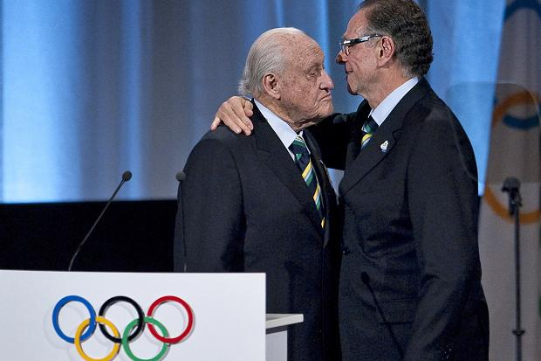
"Existing venue names are the property of the venue owners, which in this particular case is the City of Rio de Janeiro," a spokesman for Rio 2016 told insidethegames.

João Havelange is embraced by Rio 2016 President Carlos Nuzman during the IOC Session at Copenhagen in 2009 where the Brazilian city was awarded the Olympics and Paralympics
Senior Rio 2016 officials, however, have refused to condemn the behaviour of Havelange, who was an influential member of their successful bid team when they were awarded the Olympics by the IOC at its Session in Copenhagen four years ago.
"João Havelange has played an important role in developing football and the Olympic Movement, in Brazil and across the world," the spokesman told insidethegames.
"It is a fact that he was part of our winning bid team but it is not for us to comment on issues relative to his other activities in sport.
"The Rio 2016 project and the bid victory were a collective effort by the Brazilian society.
"It was the quality of the project that ultimately led the IOC to award the Games to Rio de Janeiro."

EDITOR’S COMMENT: I have already expressed my concerns about the Brazilian mega events’ security issues. Articles like the above might shed a beam of light in the way these big athletic corporations (i.e. IOC, FIFA) are functioning. If you ask a security analyst “Was Brazil a good choice for mega events?” he/she would surely reply “Of course NOT!” given the known and unknown problems this great country faces. So why it was chosen? Politics of course (as usual)! And profit of course (as usual)! These are not athletic events; they are Games! Profitable games for the stakeholders involved – both local and international. But what if the escalating (as you will notice in the special link of Newsletter’s website) social-crime wave turns to a tsunami during the Games (WC2014, Rio2016)? What if multiple fronts simultaneously evolve in different parts of Brazil? And I am not referring to the possibility of terrorist involvement based in the Tri-Border area or the Amazon forests. Just people demonstrating for better living conditions and criminals doing what they do best for the last decades. What will happen then? I want to believe that some high officials do not sleep at night!

And then I found this NEW book…

Omertà! Sepp Blatter's FIFA Organised Crime Family

By Andrew Jennings (Author)

Source: http://www.amazon.co.uk/Omert%C3%A0-Blatters-Organised-Crime-Family-ebook/dp/B00JN73 JDQ/ref=sr_1_9?ie=UTF8&qid=1397323087&sr=8-9&keywords=omerta+book

‘In Omertà I show that the leadership of FIFA, under Brazil’s João Havelange and now Sepp Blatter, tick all the boxes defining an Organised Crime Syndicate,’ says Andrew Jennings.

‘My investigations took me from confronting the Mafia in Palermo, to FIFA’s glass and marble palace in Zurich, then to the gang wars in Rio, following the trail of briefcases stuffed with gold bars.

‘I had wonderful help and encouragement in Brazil from activists, reporters, fans, academics, police, prosecutors, a brave woman judge, honest politicians – and one of Brazil’s greatest ever footballers.

‘The 2014 FIFA World Cup will be played against a backdrop of the rage of more than half of Brazil’s football-loving population. If demonstrators are killed by the out-of-control riot police, the responsibility rests with Sepp Blatter who years ago endorsed the corruption now engulfing the tournament.

‘In the 1990s I investigated the International Olympic Committee, police corruption and Organised Crime. During breaks I reported from wars in Beirut, Chechnya and Central America. Then it was time to investigate Sepp Blatter’s FIFA, grown fat from bountiful World Cup TV and marketing revenues and not scrutinised by the sports media.

‘At the beginning I thought there would be only a few crooks to expose at FIFA. Then terrific sources from inside the organisation made contact, giving me boxes of FIFA’s confidential internal financial records. I realised that the magnitude of the corruption — and the cover-ups — was breath-taking. It was not a few crooks. As an institution, FIFA was mobbed up!

‘With other reporters I have exposed the organised corruption at the top of FIFA. The scandals of recent years have been marked by the silence of FIFA’s leadership. Like a true gangland boss, Blatter refuses to condemn any of his colleagues forced out for wrongdoing. The global brands that fund FIFA are equally silent. Omertà is their rule.

‘Some of the heaviest punishments inflicted on football officials by Blatter during the last four years of scandals have not been for corruption. They have been for talking to undercover reporters – for breaking the vow of Omertà.

‘Some of Blatter’s Executive Committee are proved to be outright crooks. Others, enjoying fabulous salaries, fees and bonuses, access to World Cup tickets and unaudited development grants look the other way, mouths and eyes glued closed, upholding Omertà. Football’s money is the grease lubricating the FIFA machine and keeping Sepp Blatter in power.

‘Omertà reveals that ‘Blatter’s ‘reform process’ is bogus. He has changed FIFA’s rules to protect himself, rigged the evidence against him and hired expensive investigators to exonerate him

It has cost FIFA millions of dollars to make him the sports world’s Great Untouchable.’

►Omertà’s Foreword is by former football star, Romario, now a Congressman in Brasilia.
►The cover illustration is by Olé Anderson. In 2013 Blatter persuaded a court to ban Olé’s cartoons in Switzerland.

►Contents: http://www.transparencybooks.com/uploads/9/8/8/1/9881717/the-chapters.pdf

Andrew Jennings presents investigation films for BBC-TV, has written five books on corruption and thousands of articles for newspapers, magazines and academic journals. Foul! — his first investigation of FIFA corruption has been published in 16 languages since 2006. Blatter went to court in Switzerland to have it banned – and failed! Andrew has won numerous awards for his journalism and lectures world-wide on corruption and investigation techniques. Sepp Blatter banned him from FIFA press conferences in 2003 when Andrew disclosed that football’s President pays himself a huge secret bonus every year.

Will superhuman powers give us superhuman problems?
Source: http://www.gizmag.com/human-enhancement-issues/31743/?utm_source=Gizmag+Subscribers &utm_campaign=141712c3ba-UA-2235360-4&utm_medium=email&utm_term=0_65b67362bd-141712c3ba-90124985

Any mention of cyborgs or superpowers evokes fantastical images from the realms of science fiction and comic books. Our visions of humans with enhanced capabilities are borne of our imaginations and the stories we tell. In reality, though, enhanced humans already exist ... and they don't look like Marvel characters. As different human enhancement technologies advance at different rates, they bleed into society gradually and without fanfare. What's more, they will increasingly necessitate discussion about areas that are often overlooked – what are the logistics and ethics of being superhuman? Gizmag spoke to a number of experts to find out.
Our natural tendency is to focus on the functionality of enhanced humans. Abilities like super-strength, flight or telepathy seem so far removed from that of which we're capable and so desirable that it's understandable for us to focus on these possibilities. The individual, social and ethical consequences of enhanced humans are considered far less in popular culture, however.
"People tend to imagine the current state of human enhancement as either much more advanced or retarded than it really is," Steve Fuller, Auguste Comte Chair in Social Epistemology in the Department of Sociology at the University of Warwick, tells Gizmag. "I realize that this sounds paradoxical, but generally speaking it helps to explain the curious blend of impatience and disappointment that surrounds the topic. This simply reflects the fact that people know more about human enhancement from its own hype and science-fictional representations – which can be positive or negative – than from what's actually available on the ground."
Professor Andy Miah, director of the Creative Futures Institute at the University of the West of Scotland, has spent much of his career looking at the potential for human enhancement and what it might mean for us. Speaking to Gizmag, he explains that enhancement is not a new phenomenon, but that, increasingly, we have important decisions that will have to be made.
Miah argues that as society becomes more advanced, more and more difficult decisions surrounding human enhancement will be thrust upon us. "I thinks it's inevitable that we will have to make these decisions," he says, explaining that the only other option would be to halt human progress with an archetypal head-in-the-sand scenario.

Trade-offs
The issues that society will have to consider range from straightforward personal issues to highly complex and abstract social issues. Beginning with the more personal considerations, Miah uses the example of super-strength. "In order for that, you are going to need added muscle mass, which will likely compromise your potential for speed and agility," he says. It's a simple proposition used to show that any enhancement is likely to have side-effects.
Kevin Warwick, Professor of Cybernetics at the University of Reading, tells Gizmag that it will be important for people to consider what they are getting themselves into and what exactly they want to achieve. "The nature of the enhancement will take on dramatically different forms," he explains. "Has anyone done it before? It could be dangerous; could go wrong. There could be side effects that we know little or nothing about."
Another example is provided by social psychologist Bertolt Meyer in a recent Wired article. Meyer, who was born without his lower left arm, asks whether people would have a limb amputated to replace it with a prosthesis that was to some extent better. Even now, though, he notes a potential trade-off. "Augmented bodies that contain connected technology give the word hacking a new meaning," he says in the article. "My i-limb connects to my iPhone, but my iPhone is connected to the internet. Technically, a part of my body has become hackable."
Fuller agrees that such unintended consequences are the main consideration required when thinking about enhancement. "If, say, your memory is successfully enhanced, consider how else this might change your way of living and your relationship with people." Warwick reiterates this point by asking, "With superintelligence, what would the enhanced folk do with the stupid unenhanced?".

Social impacts
This application of practicality places the idea of human enhancement under a whole new light compared to its presentation in popular culture. It provides an instant recognition that being bestowed with a "super-power" is unlikely to come without its costs. Furthermore, it only complicates matters when considered on a larger scale.
Miah poses the question of what impact life-extension will have on society. We are already living longer and, already, there is a strain being placed on society. Care, pensions and housing are all impacted by aging populations. So what if we had the option of living to 200? 500? 1000? Trying to conceive how this might impact society requires a huge speculative leap, says Miah.
The issues aren't limited to the present time or to immediate consequences, however. Society also has to consider the potential consequences for future generations of modifying humans today. "If we find out how to remove a specific gene to cure a disease, we may find that in 200 years time that gene is hugely important for another reason," Miah explains.
Similarly, he poses another lateral ethical dilemma. "If we develop the ability to improve our own intelligence," he asks, "do we have a responsibility to do so for animals too? That would completely change our view of animals and animal rights." Although radical, this concept is not that far-fetched. India recently gave dolphins "non-human person" status, recognizing their high intelligence and providing them with specific rights.

Considerations
The main social considerations for enhancement technology, Fuller suggests, are ensuring their equitable distribution, so that priority is given to those for whom enhancement serves to reduce already existing inequalities rather than increasing them, and the extent to which we will tolerate personal enhancement.
"We are effectively encouraging people to experiment with all sorts of modes of being – involving transgenic and prosthetic implants – that could easily result in a diversity of capacities previously unseen in human history," says Fuller, "some of which are likely to incorporate some measure of what we now call disability."
Almost counter-intuitively, Fuller also points out that we would have to consider the place of people who, for religious or other reasons, refuse to be enhanced, however legal or safe. Is it fair to leave people behind or put them at a disadvantage simply because they opt-out of a post-human world?

Future enhancement
Fuller says he agrees with the transhumanist idea that we need to take greater risks with our bodies and our environments in order to flourish in the long term, but believes that we must have legal, social, political and economic safeguards in place. He is keen for state and international agencies to become actively involved to ensure that the enhancement market is appropriately regulated and doesn't exacerbate the social problems we already have. While he points out that such intervention can't always be relied upon, Fuller suggests that advancement of the technology is likely to happen regardless.
"Generally speaking, even if states end up being either very laissez-faire or prohibitive in their approach to these new technologies, they will happen by other means, i.e. outside the jurisdiction of the state," predicts Fuller. "A good case in point is seasteading.org, a floating vessel outside of territorial waters that is designed to house research for doing challenging science that is currently not allowed by over-restrictive ethics panels at universities."
Warwick suggests that, despite the minefield of ethical dilemmas to be navigated and potential for individuals with increasingly varied capabilities, the market is likely to develop much like any other. "[The future of human enhancement probably involves] initially exciting, pioneering experimentation over the next few years," he predicts. "Then lots of commercial opportunities opening up."

U.S. Still Cleaning up Chemical Weapons from World War II…in 40 States
Source: http://www.allgov.com/news/top-stories/us-still-cleaning-up-chemical-weapons-from-world-war-iiin-40-states-140326?news=852772

Bring us your nerve gases, your blister agents, your horrible weapons of warfare, your wretched refuse of World War II…

This about sums up the decision of leaders in Washington after World War II when it came time for the American military to dispose of its arsenal of chemical weapons and those belonging to both the countries it fought against and alongside.
After the war’s conclusion, the U.S. government buried thousands of munitions loaded with chemical agents all across the country. These weapons of mass destruction were part of the U.S. arsenal as well as those belonging to ally Britain and enemies Germany and Japan.
The bombs and containers were simply dumped in the ground and buried, without concern for long-term environmental and health consequences.
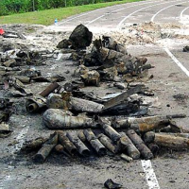
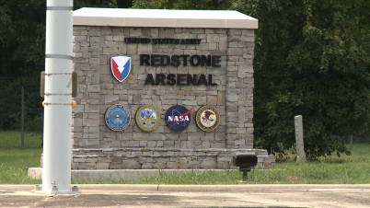
Alabama is home to the largest of 249 such sites that are located in 40 states. Redstone Arsenal, a longtime U.S. Army base, sits atop miles of hidden trenches containing blister agents, choking agents, blood agents and more.
The 38,000-acre base is surrounded by homes, schools, churches and shopping centers—a city of 200,000 people. It was reported that few residents are aware of the toxic danger lurking nearby.
A disposal team has been working at Redstone since the 1970s trying to locate all of the chemical weaponry that is buried beneath 17 six-mile-long trenches. Once those trenches have all been located, the next step—scheduled to begin in 2019—is to remove the bombs and containers with great care, due to the uncertainty of the weapons’ condition after being held deep underground for decades. No more than six munitions can be safely removed each day.
“Even if we tried to do this as fast as anybody could ever get it done, we’re talking decades and decades,” James Watson, a disposal team member, told the Los Angeles Times. “This stuff is very dangerous to dig up. It’ll hurt you. It will blister you up. If you get that nerve agent on you, it will kill you.”
Redstone’s cleanup is expected to take until at least 2042. The quantity of weapons: 388,000. Between 20,000 and 25,000 of these are intact and, once disturbed, may be volatile.
Alabama has a second site, at former Camp Sibert near Huntsville, with at least 13 stockpiles of mustard and phosgene gas.
Another of these sites is located in Spring Valley, Virginia, not far from the White House. Its arsenal features even older chemical munitions—possibly including mustard and arsenic—manufactured during World War I.
Several years ago, a vast supply of munitions from World War II (photo) was discovered beneath the grounds of Odyssey Middle School in Orlando, Florida. One of the weapons ignited into flames, but didn’t explode, injuring an Army Corps of Engineers contractor attempting to remove it. More than 200 potentially volatile explosives were found, most under the school and some near homes in the surrounding neighborhood. Home values, which were originally in the $600,000 range, plunged by at least 30%, while banks told homeowners their residents were worthless to lend against.
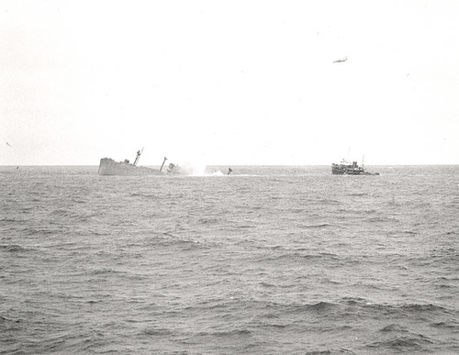
The U.S. military also dumped a huge volume of chemical weapons off both the Atlantic and Pacific coasts. There are no plans to clean up those sites, although Congress has authorized studies to look into it.
In 1958, about a hundred miles offshore of California, the SS William Ralston (left) — loaded with more than 300,000 mustard gas bombs and 1,500 one-ton containers of Lewisite, a blistering agent — was scuttled by the U.S military. To this day it sits beneath nearly 14,000 feet of water just outside of San Francisco.
Ralston believes the U.S. task of removing 1,300 tons of secured chemical weapons from Syria for destruction at sea will be something of a breeze compared to the job here at home. “In Syria, you know where the weapons are and what they are, and they can move them with a forklift,” Watson told the Times. “Here, we don’t know. We have to go out there and dig them out of the ground … The sheer mass of this stuff is overwhelming.”

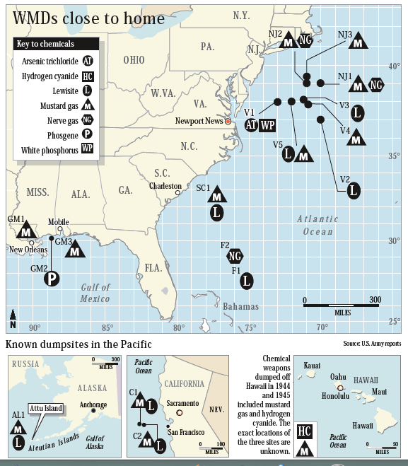
Environics USA will continue to Support the ChemRAE

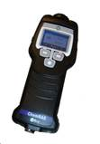
RAE Systems (a Honeywell company) has ceased taking orders for the ChemRAE as of February 28, 2014. Environics has always made the ChemRAE for RAE Systems and will continue support of the ChemRAE. The ChemRAE allows users to share its alarm data over the RAE Systems AreaRAE network.
The ChemPro100i will now have the option of adding the two ChemRAE libraries to it allowing it to use these two libraries to communicate on an AreaRAE network. This can be done when purchased new or as an upgrade for ChemPro100is that have been previously fielded. ChemPro100i users that purchase the upgraded library will still need to purchase the RAE Link 3 modem, connection cable and any required software license(s) separately from RAE Systems in order for the ChemPro100i with the upgraded libraries to work on an AreaRAE network. The ChemPro100i platform can detect, classify and identify many more chemicals than the older ChemPro100v2/ChemRAE can. The ChemPro100i features an improved user interface allowing operators easy access to commonly used features like the Trend or “Sniffer” screen, changing libraries and re-zeroing the ChemPro100i. The ChemPro100i has 12 different libraries that give it usefulness in many more applications including routine HazMat, Clan Lab interdictions, firefighting Overhaul activities and responses to irritants. We continue to improve the ChemPro100i and its libraries with FREE upgrades released approximately once a year. The ChemRAE’s two libraries largely limit it to the detection of Chemical Warfare Agents (CWAs). Because of the fortunate lack of CWA events both the CWA detector and the responder skills can get “dusty.” The versatility of the ChemPro100i in routine HazMat response keeps it from becoming a dust collector. If the “BIG ONE” does happen, both the user skills and the ChemPro100i are ready for the job.

For additional information please contact:
Christopher Wrenn
Sr. Director of Sales & Marketing
Corporate phone: 410-612-1250
Corporate fax: 410-612-1251
chris.wrenn@EnvironicsUSA.com

West Virginia chemical spill degrades air, water quality
Source: http://www.homelandsecuritynewswire.com/dr20140327-west-virginia-chemical-spill-degrades-air-water-quality

In the more than two months since the 9 January chemical spill into West Virginia’s Elk River, new findings reveal the nature of the chemicals that were released into the water and then into the air in residents’ houses.
“Based on our increasing understanding of the chemicals involved in the water crisis, the complexities and implications of the spill keep growing,” said Andrea Dietrich, professor of civil and environmental engineering at Virginia Tech. “People are still afraid to drink the water; odors persist in schools, residences, and businesses; data are still lacking for the properties of the mixture of chemicals in the crude MCHM that spilled.”
A Virginia Tech release reports that the lack of data motivated Dietrich and her research team to take on essential odor-related research that went beyond their National Science Foundation Rapid Response Research grant to better understand the properties of the chemical mixture called crude 4-methylcyclohexane methanol, the major component in the crude mix of the spilled chemicals into the Elk River [see “NSF rapid response research grants to fund study of West Virginia chemical spill,” HSNW, 10 February 2014; and “Determining long-term effects of West Virginia chemical spill,” HSNW, 11 March 2014]. It is used in the separation and cleaning of coal products.
Rapid Response grants are the agency’s funding mechanism when a severe urgency exists in terms of the availability of data.
When Dietrich’s team first started, their goal was to conduct detailed scientific investigations to determine the long-term fate of the chemicals in the drinking water distribution system and in the environment. The spill had occurred upstream from the West Virginia America Water intake, treatment, and distribution center. Some 300,000 residents were affected, losing their access to potable water. The continued plight of West Virginia living day-to-day with the contaminant’s licorice odor resulted in Dietrich’s team unraveling the odor threshold problem.
As the ban was lifted on drinking water use, Virginia Tech researchers gathered their data and they realized that West Virginians were still complaining of an odor in their homes and in the environment.
“Like for many contaminants in water, chemicals leave the water and enter the breathing air, so that inhalation becomes a route for human exposure as well as drinking the water,” stated Daniel Gallagher, also a faculty member in Virginia Tech’s Via Department of Civil and Environmental Engineering and a member of the research team.
The Virginia Tech researchers were able to pinpoint the concentrations of contaminants in the air that residents can detect because they have specialized equipment, uniquely available in the College of Engineering, but more commonly used in the food, beverage, and fragrance industries. Called olfactory gas chromatography, it allows the investigators to independently measure the concentrations and odors of the two isomers found in the 4-methylcyclo-hexane methanol.
This specific cyclohexane “consists of two isomers, a cis- and a trans- methylcyclo-hexane methanol. The isomers have the same chemical formula but a very slight shape difference that for many isomers, can have enormous effects on the physical, chemical, and biological properties. Only the trans isomer has the characteristic licorice-like odor. The cis isomer is significantly less odorous and has different descriptors,” Dietrich explained.
Dietrich added that they determined the odor threshold concentration of the trans-isomer to be “exceedingly low”, measured at 350 parts per trillion by volume in the air. This air odor threshold can be combined with a Henry’s Law Constant that relates the concentration in air to estimate the corresponding concentration in water. Based on an estimated Henry’s Law Constant from TOXNET, this odor threshold in water concentration is about seven parts per billion-water.
This is more than a hundred times lower than the one part per million health guideline recommended by the Center for Disease Control. Thus, the odor of MCHM is readily detectable even when the water concentration water meets the health guideline level.
This relationship now needs to be further understood through additional data collection and research.
An “important implication of the findings,” Dietrich said “is the critical need to independently measure the concentrations of the cis and the trans isomers, as was done in this study and is being done at the Virginia Tech labs. “The licorice odor will be proportional to the amount of the trans isomer, not the total amount of methylcyclohexane methanol. While there may be a tendency to measure ‘total methylcyclohexane methanol’, this could lead to misleading interpretations.”
“The cutting edge research instrumentation and support available for student and faculty research is extensive,” said lead graduate student Katherine Phetxumphou, of Woodbridge, Virginia, who is supported on a Virginia Tech Graduate school fellowship and is a member of Virginia Tech’s Water INTERface Interdisciplinary Graduate Education Program.
“After our research protocol for human subjects received approval in February, we logged hundreds of hours of research that all boiled down to one number — the odor threshold for trans methylcyclohexane methanol. It is amazing we accomplished so much so fast; we were committed to do this for the people of West Virginia and the research community,” Dietrich said.
Of all the human senses, odor has been the most difficult to scientifically explain. The release notes that just ten years ago, Linda Buck and Richard Axel were awarded the Nobel Prize in Medicine for being the first to decipher the genes that determine the sense of smell.

Wireless Sensing Device Detects Chemical Vapors Remotely
Source: http://www.hstoday.us/single-article/wireless-sensing-device-detects-chemical-vapors-remotely/ 23f99c78e93081f76d6e7ac16ff8b167.html

Researchers at the Georgia Tech Research Institute (GTRI) have developed a small electronic sensing device that can alert users wirelessly to the presence of chemical vapors in the atmosphere.
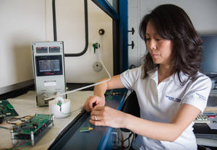
According to an announcement by GTRI, the technology -- which could be manufactured using familiar aerosol-jet printing techniques -- is aimed at myriad applications in military, commercial, environmental, healthcare and other areas.
“The current design integrates nanotechnology and radio-frequency identification (RFID) capabilities into a small working prototype,” GTRI said, explaining that “An array of sensors uses carbon nanotubes and other nanomaterials to detect specific chemicals, while an RFID integrated circuit informs users about the presence and concentrations of those vapors at a safe distance wirelessly.”
Because the sensing device is based on programmable digital technology, the RFID component can provide greater security, reliability and range -- and much smaller size -- than earlier sensor designs based on non-programmable analog technology. The present GTRI prototype is 10 centimeters square, but GTRI said “further designs are expected to squeeze a multiple-sensor array and an RFID chip into a one-millimeter-square device printable on paper or on flexible, durable substrates such as liquid crystal polymer.”
“Production of these devices promises to become so inexpensive that they could be used by the thousands in the field to look for telltale chemicals such as ammonia, which is associated with explosives," said Xiaojuan Song, a GTRI senior research scientist and principal investigator on the project. "This remote capability would inform soldiers or first responders about numerous hazards before they encountered them."
GTRI said “wireless sensors could also be valuable for identifying and understanding air pollution, she said. Inexpensive sensors that detect ammonia and nitrogen oxides (NOx) could be fielded in large numbers, giving scientists increased knowledge of the location and intensity of pollutants.”
The prototype “contains three sensors along with an RFID chip. Future devices for field use might contain a much larger number of sensors based on various nanomaterials -- including carbon nanotubes, graphene and molybdenum disulfide -- depending on the types of chemicals to be detected,” GTRI said.
"In general, having an extensive sensing array is the best approach," Song said. "For real-world applications, a variety of sensors offers better functionality, because they can work together to produce a more detailed and reliable picture of the chemical environment."
The RFID component uses the 5.8 gigahertz (GHz) radio frequency and is believed to be the first RFID system that exploits this frequency.
“The advantage of 5.8 GHz technology is that it will let RFID tags be made extremely small – in the area of one centimeter square, said Christopher Valenta, a GTRI research engineer who is co-principal investigator on the project.
Valenta explained that the digital transmission of data from RFID-based sensors does a much better job than earlier analog techniques based on interpretation of radio-frequency waveforms.
Specifically, digital signaling with 5.8 GHz RFID offers:
- Greater security due to digital techniques that prevent unauthorized access to the wireless data stream;
- Increased resistance to interference from materials such as metals that can cause false readings;
- Digital-logic readings of chemical concentrations that are more precise and easier to interpret than analog approaches; and
- Longer-range communication capability.
The GTRI team is currently gearing up to design a very small, 5.8 GHz RFID component. After fabrication and testing, the chip could be inexpensively manufactured in large numbers.
"It might take $400,000 to design and fabricate that first RFID chip, but all the subsequent copies might cost only a few pennies," said Valenta, who is a Ph.D. candidate in the School of Electrical and Computer Engineering.
GTRI said its “team successfully tested its prototype sensing system in a demonstration designed to resemble an airport checkpoint,” and that the “sensor array detected the targeted chemical despite emersion in a complex chemical environment, and the RFID component was able to transmit the sensors' readings.”
The present GTRI prototype is semi-passive, so it requires power from an incoming signal beam in order to send data back to a remote reading device, the technical institute said. Future sensing devices might exploit ambient energy from solar or vibrational sources that would let them work at longer ranges with greater sensitivity, GTRI said.
GTRI’s team also “is continuing to work on the important task of developing pattern recognition software that will support effective functioning of the sensor array.”
"The prototype 5.8 GHz wireless sensing system promises to be flexible and highly scalable," Valenta said. "An advanced design might include an array of 10 or more different sensors, with electronics that could utilize those sensors to perform 25 different jobs, and yet still be tiny, robust and inexpensive."

CBRN & Hazmat Incidents Decontamination Equipment Market Will Grow from $5.8b in 2013 to $8.3b in 2020

Source: http://www.digitaljournal.com/pr/1825371

This need was demonstrated only too recently with the August 2013 Sarin chemical attack in the suburbs of Damascus resulting in at least 281 to 1,729 fatalities, with over 90% of them civilians. With Syria relinquishing by March 2014 only 50% of Bashar Assad's chemical weapons arsenal, nearly 700 tons still remain vulnerable to falling into the wrong hands.
According to the Decontamination Equipment of CBRN & Hazmat Incidents: Industry, Technologies and Global Market - 2014-2020 report, following the accident at the Fukushima nuclear power plants and the BP oil spill in the Gulf of Mexico (total liability could amount to as much as US $100 billion), new governmental legislation and funding of post CBRN attack and Hazmat accidents are only two of the many factors driving the decontamination equipment and reagents market growth
Homeland Security Research Corp.'s new report is the most comprehensive analysis of the multibillion global decontamination incidents market published to date. Government-sponsored decontamination research and development will be directed at developing next generation decontamination techniques. As such, RDT&E projects receive considerable funding.
The report reveals 30 business opportunities induced by two main market drivers:
- Policy makers' increased recognition of the growing threat presented by Hazmat accidents and CBRN terrorism.
- The environmentally conscious public would not tolerate slow & sloppy decontamination of Hazmat/CBRN events.
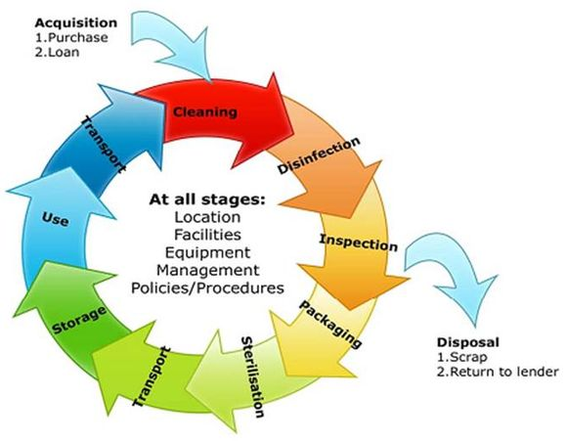
Meeting both of these challenges has sparked a host of new and pipeline technologies that have the decontamination markets poised for considerable growth.
The report, segmented into 48 submarkets, offers for each submarket 2011-2013 market size data and assessments, as well as 2014-2020 forecasts and analysis. In 288 pages, 178 tables and figures, the report analyzes and projects the 2014-2020 market and technologies from several perspectives, including:
- Market and technology forecast by modality: contamination detection systems; equipment, buildings and infrastructure decontamination systems and people decontamination equipment
- Regional and national markets: e.g., USA, Europe, China, Japan, Middle East, Latin America, Asia-Pacific.
- Equipment sales and post warranty service & upgrade business
- Guidelines for decontamination equipment procurement
- Product comparison tables: hundreds of decontamination products including detailed product pricing and performance information
- Competitive environment: 93 vendors and their products
- Industry environment: e.g., competitive analysis, SWOT analysis
- Current and pipeline decontamination technologies
- Business opportunities and challenges

►Explore more Homeland Security and Public Safety Reports at:
http://www.homelandsecurityresearch.com.

Research identifies most likely non-state chem-bio threats
Source: http://www.start.umd.edu/news/research-identifies-most-likely-non-state-chem-bio-threats? utm_source=START%20Announce&utm_campaign=e14be0d181-START_Newsletter_September9_26 _2013&utm_medium=email&utm_term=0_a60ca8c769-e14be0d181-14081393

Among violent non-state actors, the threat of chemical or biological (CB) weapons pursuit and use lies heavily with violent jihadists of all stripes, according to a new START Research Brief. Jihadist actors occupied seven of the top 10 spots in a qualitative analysis; Nine of the top 10 in a quantitative analysis, and half of the top 10 in an elicitation analysis.
“The possibility that violent non-state actors, including terrorists and criminals, might employ chemical or biological weapons has understandably attracted much attention in both policy and government circles,” said Gary Ackerman, Director of Special Projects at START. “This is primarily a result of credible evidence of terrorist interest in these weapons and demonstrated terrorist willingness and capability, albeit thus far via conventional means, to inflict mass casualties.”
The project, Anatomizing Chemical and Biological Non-State Adversaries, aims to improve understanding of, and more effectively identify, perpetrators and potential perpetrators of attacks employing CB agents.
The goal of the project is to enhance the capability of defense practitioners to protect the United States by including more detailed specifications of the threat component in risk assessment calculations, in addition to the already well-developed vulnerability and consequence elements.
Although the project’s focus was on ideologically motivated violence, the research also provides some insight into criminal use of CB materials, which can significantly impact public security.
The project is led by START Investigators Gary Ackerman, Victor Asal and Amanda White.

►Read the Research Brief at: http://www.start.umd.edu/pubs/STARTResearchBrief_Anatomizing.pdf

Israel: Assad used chemical weapons on 27 March in a Damascus neighborhood
Source: http://www.homelandsecuritynewswire.com/dr20140408-israel-assad-used-chemical-weapons-on-27-march-in-a-damascus-neighborhood

President Bashar Assad’s military used chemical weapons two weeks ago in a neighborhood east of Damascus against opposition forces, a senior Israeli defense official said yesterday (April 7).
Syrian rebels reported of two instances in which Assad’s forces used chemical weapons recently, both about two weeks ago and both in Damascus neighborhoods. Haaretz reports that the Israeli confirmation was the first information provided by outside intelligence sources to back up the rebels’ claims.
The first attack took place on 27 March, and Haaretz says Israeli sources say Israel has concrete evidence of such use of chemical weapons in the Harsata neighborhood of eastern Damascus. The sources noted that the chemicals used by the Syrian military on 27 March were not lethal, but rather are incapacitating agents typically used to neutralize people for a few of hours. Israeli officials say they cannot confirm the use of chemicals in the second case, which occurred in the same neighborhood.
Israeli defense minister Moshe Ya’alon on Monday said that the Syrian regime has destroyed its entire production line for manufacturing chemical weapons, and it appears to have destroyed most of the ammunition used to deliver the chemical weapons. About 60 percent of the chemical materials have already been taken out of Syria for destruction.
“In recent weeks the process of removing the material from Syria has quickened, after a short break, via a Danish or Norwegian ship n Latakia and from there to an American site where the material will be destroyed,” said Ya’alon.
Ya’alon also said the situation in Syria has reached an impasse. “Today Assad controls a bit less than 40 percent of [Syrian] territory,” he said. Recently Assad has received political support because of the process to destroy the chemical weapons, said Ya’alon.

Cutting edge, animatronic mannequin to test CB protective suits, equipment
Source: http://www.homelandsecuritynewswire.com/dr20140408-cutting-edge-animatronic-mannequin-to-test-cb-protective-suits-equipment

TheDefenseScienceandTechnologyLaboratory (DSTL) has taken delivery of a new robotic mannequin which will be used totest chemical and biological (CB) protective suits and equipment for the U.K.’s Armed Forces.
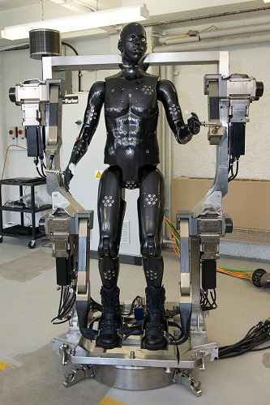
The “Porton Man” uses state of the art technology and is able to walk, march, run, sit, kneel and even lift its arms as if to sight a weapon just like an infantry soldier. It means new equipment such as chemical and biological suits can be thoroughly tested in a realistic but secure environment. More than a hundred sensor sall over the body are able to record data during tests and scientists are even able to carry out real-time analysis.
DSTL says it has used mannequins in the past, but this animatronic version is a unique capability that puts the United Kingdom at thefore front of testing.Designed by Osier Way, Buckingham-based i-bodi Technology Ltd.,the robot is built accurately to represent the military user.
DSTLin Porton Down, Wiltshire is the only place in the world that that can use chemical warfare agents to assess the effectiveness of complete clothing systems. Previous test results helped influence the final design of the chemical, biological, and radiological (CBR) suits used by U.K. Armed Forces and the updated technology in the new mannequin will help design the next generation of protection.
Jaime Cummins of DSTL’sChemical and Biological Physica lProtection group said: “Significant advances inanimatronics, material design and sensing technologies have all been incorporated into this new Porton Man mannequin. As a result, we will be able to assess and characterize protective clothing in ways which were not previously possible. We areimmensely proud to have this mannequin as part of our capability to protect against the threat posed by chemical and biological agents.”
Jez Gibson-Harris,CEO,i-bodiTechnology,said: “Our brief was to produce a light-weight robotic mannequin that had a wide range of movement, fitted the anthropometric data and was easy to handle. Of course there were a number of challenges associated with this and one way we looked to tackle these challenges was through the use of Formula One technology. Using the same concepts as those used in racing cars, we were able to produce very light but highly durable carbon composite body parts for the mannequin.”
Minister for Defense Equipment, Support and Technology, Philip Dunne, said: “This technology, designed by a British company is enabling the U.K.to lead the way in this important testing. Increased investment in science and technology by the MoDis not only enabling battle winnin gand life saving equipment tobe developed but also helping innovative companies like i-bodiTechnology to develop cutting edge capability.”

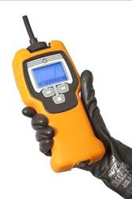
New ChemPro100i upgrade allows it to characterize more chemicals with greater sensitivity and easier use

April 9 – The ChemPro100i allows one to sniff for more unknown gases and vapors than any other sniffing product and it can classify and identify many gases and vapors including Chemical Warfare Agents (CWAs) and common Toxic Industrial Chemicals (TICs) including ammonia and chlorine. The ChemPro100i has the versatility to be used for a wide variety of gas/vapor detection applications including: HazMat, Clan Lab interdictions, firefighting Overhaul activities and responses to irritants like mace and pepper spray. The ChemPro100i offers a number of use specific “libraries” providing it with the specificities unique to each one of these applications. Roughly once a year Environics USA releases an upgrade to the ChemPro100i libraries. As part of our 5-year extended warranty we provide library upgrades FREE OF CHARGE to ChemPro100i customers. Our newly released library demonstrates how Environics USA is constantly improving the ChemPro100i without additional cost to our customers. The current improvements to the ChemPro100i include:
- Characterize more vapors: the “Irritant” library adds the ability to detect CN (Mace/Tear gas) and CS (o-chlorobenzylidene)
- Increased sensitivity: the limits of identification for common chemicals like ammonia and chlorine have decreased to make the ChemPro100i much more responsive to these chemicals
- “Automatic Gear Shift” meaning less need to shift between libraries, making the ChemPro100i easier to use

For additional information please contact:
Christopher Wrenn
Sr. Director of Sales & Marketing
Environics USA
1308 Continental Drive, Suite J, Abingdon, MD 21009
- Corporate phone: 410-612-1250
- Corporate fax: 410-612-1251
- chris.wrenn@EnvironicsUSA.com

Remote Control REALITY
Source:http://www.omagdigital.com/publication/?i=204533&ver=html5&p=18#{%22page%22:18,%22issue_id%22:204533}

For industrial responders, the closest thing to fighting a real fire is a live-fire training exercise using a full-scale mockup of a plant or refinery unit. But what do those same responders do for reality when the training is about hazardous materials?
Safely shutting off the flames is as simple as turning a valve. The same cannot be said for toxic or flammable vapors. And without using the real thing the hand-held meters that responders depend on have nothing to activate a reading. The only substitute is having someone shout out fictional readings from the sidelines, an exercise as realistic as a free lunch.
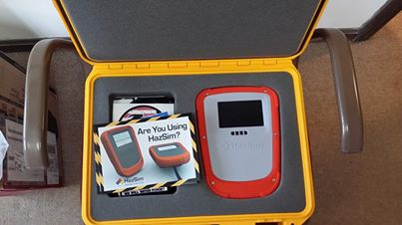
The BP North American Research Center in Naperville, IL, provides its hazmat responders an extra degree of authenticity by means of an innovative computer simulation known as HazSim, a training tool invented by an active duty first responder, said BP Life Safety Specialist Daniel Graunke.
"It's a computer-based system that allows you to walk around with a device that is similar to a monitor," he said. "The device provides the same readouts as our hand-held detectors. Using signals from a computer which is remotely controlling the HazSim training device, the instructor running the training exercise can change those readouts accordingly, truly simulating what could easily be a real situation."
If the training scenario involves a low oxygen environment, the instructor can adjust the readings that the responders are working from to indicate low oxygen. Likewise, the hand-held monitor can issue real time information indicating a high concentration of carbon monoxide, hydrogen sulfide or any number of other threats.
BP's Naperville responders were introduced to the HazSim system last June by instructor Greg Lauf of All Risk Training and Safety, Inc. By November, the research center purchased HazSim to use as a full-time training tool of its own.
HazSim allows responders to train with equipment that is very close to what would be used in real life without risking exposure to dangerous agents, Graunke said.
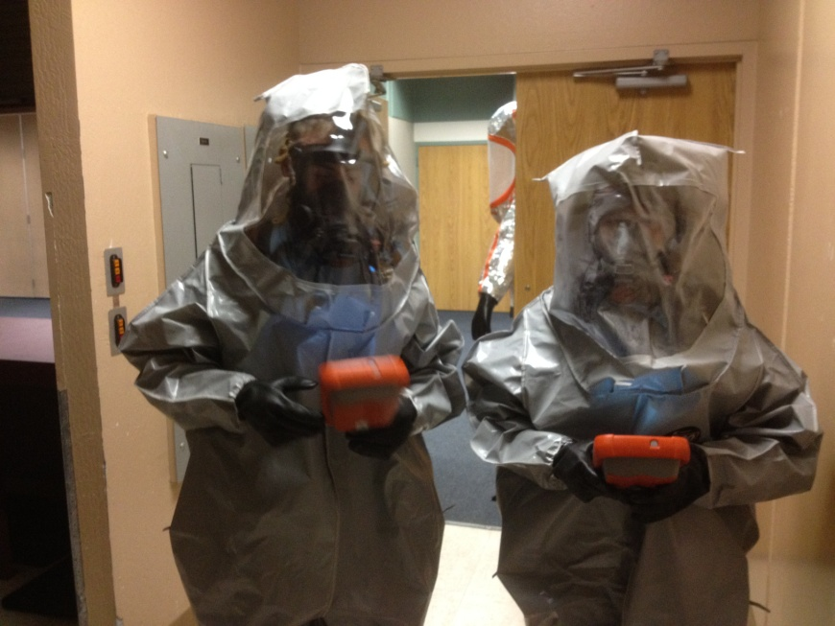
"It's a very good system to give proper instruction on the use of metering equipment," he said. "It's difficult to use the real metering equipment and actually perform an exercise or drill without using the actual products that you're looking for."
Lauf said HazSim gives an instructor the ability to fine tune a training scenario to simulate any situation.
"I control the exercise from a tablet computer," Lauf said.
"As the participants move down range, I can manipulate the readings by means of a Local Area Network. If they go too far, I can simulate readings to indicate they are walking past the threat. Or, if the vapor density is low to the ground and they're not monitoring correctly, I can simulate that as well."
Lauf remains close enough to control the situation but far enough away to not directly interfere with the responders' tactics or interpretations. The number of training scenarios possible is endless, he said.
"The meter has about 20 different configurations," Lauf said. "It can be used as a single gas meter for something like chlorine or expanded to a standard four gas meter. I can even make it into a radiation detector. It can be customized to just about any meter configuration possible."
Before HazSim, Lauf was forced to post the readings on sheets of papers along the course of the simulation. Being that close to the action made it difficult not to coach the responders.
"I would be in the hot zone with them, which is not realistic," Lauf said. "They would be looking at the meter in their hand that said zero and the sign that said '5 ppm H2S."'
Likewise, when attempting to train using a real meter that registers a safe oxygen content of 21 percent when the training scenario involves oxygen deprivation is a far step from authenticity and easily distracts the trainees.
"Your brain is not clicking right because you're seeing one thing and being told another," Lauf said.
As a substitute for direct intervention, the instructor can send questions to the responders via the HazSim device itself.
Having a HazSim system permanently available for use in Naperville is a vast improvement in training, Lauf said. Otherwise, the availability of the system would be limited to twice a year.
"Graunke sees a real value in HazSim as a training tool," Lauf said. "Having it on hand year round makes it available to their manufacturing personnel as well." IFW Spring 2014.

April 11, 2014 – Syrian government, rebels report chemical attack
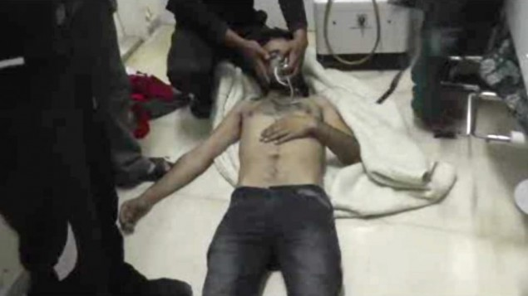
Source: http://www.timesofisrael.com/syrian-government-rebels-report-chemical-attack/
In this Friday, April 11, 2014 image made from amateur video, provided by Shams News Network, a loosely organized anti-Assad group based in and out of Syria that claim not to have any connection to Syrian opposition parties or any other states, and is consistent with independent AP reporting, shows a man as he lies on the floor with an oxygen mask at a hospital room in Kfar Zeita, some 200 kilometers (125 miles) north of Damascus, Syria. (photo credit: AP/Shams News Network)

Syrian government media and rebel forces said Saturday that poison gas had been used in a central village, blaming each other for an attack that reportedly injured scores of people.
Details of the attack Friday in Kfar Zeita, a village in Hama province some 200 kilometers (125 miles) north of Damascus, remained sketchy Saturday night.
But online videos posted by rebel activists showed pale-faced men, women and children gasping for breath at a field hospital, suggesting an affliction by some kind of poison in a conflict that’s seen hundreds killed by chemical weapons.
The main Western-backed opposition group, the Syrian National Coalition, said the poison gas attack hurt dozens of people, though it did not identify the gas used.
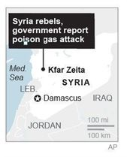
The Britain-based Syrian Observatory for Human Rights, an activist group that relies on a network of on-the-ground volunteers, said the gas attack happened during air raids that left heavy smoke over the area. It reported that people suffered from suffocation and breathing problems after the attack, but gave no further details.
State-run Syrian television blamed members of the al-Qaida-linked Nusra Front rebel group for using what it described as chlorine gas in an attack it said killed two people and injuring more than 100. The TV report claimed the Nusra Front is preparing for another chemical attack against the Wadi Deif area in the northern province of Idlib, as well as another area in Hama. The government station did not explain how it knew the Nusra Front’s plans.
Activists in the village could not be reached Saturday.
An activist from Hama who is currently in Turkey and is in contact with residents told The Associated Press that the attack occurred around sunset Friday. The man, who goes with the name Amir al-Basha, said the air raids on the rebel-held village came as nearby areas including Morek and Khan Sheikhoun have witnessed intense clashes between troops and opposition fighters.
An amateur video posted online by opposition activists showed a hospital room in Kfar Zeita that was packed with men and children, some of whom breathing through oxygen masks. On one bed, the video showed six children, some appearing to have difficulty breathing while others cried.
The video appeared genuine and corresponded to other AP reporting of the attack.
Chemical weapons have been used before in Syria’s 3-year-old conflict, a war which activists say has killed more than 150,000 people. In August, a chemical attack near the capital, Damascus, killed hundreds of people. The U.S. and its allies blamed the Syrian government for that attack, which nearly sparked Western airstrikes against President Bashar Assad’s forces. Damascus denied the charges and blamed rebels of staging the incident.
Before the August attack, there have been several incidents of toxic gases being used. Britain, France and the U.S. have spoken about chemical weapons use in the central city of Homs, Damascus and elsewhere.
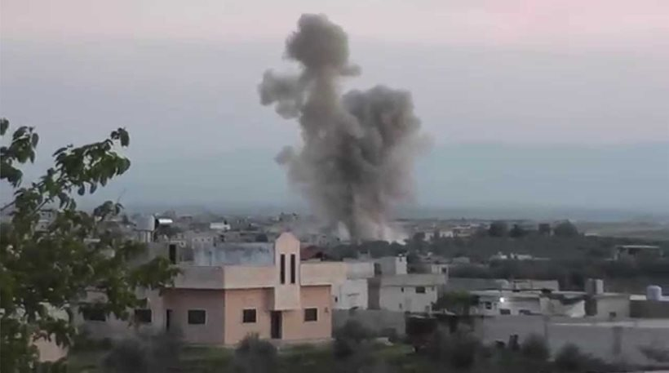
A United Nations weapons inspectors’ report released in December identified four locations where chemical weapons likely had been used in 2013: Khan al Assal outside Aleppo, Jobar in Damascus’ eastern suburbs, Saraqueb near Idlib in the northwest and Ashrafiah Sahnaya in the Damascus countryside. In two cases, inspectors reportedly found “signatures of sarin,” a nerve agent.
The Syrian National Coalition called on the U.N. to conduct a “quick investigation into the developments related to the use of poisonous gas against civilians in Syria.” The coalition also claimed that another chemical weapons attack Friday struck the Damascus suburb of Harasta, though state media did not report on it.
The chemical weapons attack in August caused an international outcry. A coalition formed to eliminate the weapons and now aims to remove and destroy 1,300 metric tons of chemicals held by the Assad government by June 30. Syria’s government missed a Dec. 31 deadline to remove the most dangerous chemicals in its stockpile and a Feb. 5 deadline to give up its entire stockpile of chemical weapons. Assad’s government cited security concerns and the lack of some equipment but has repeated that it remains fully committed to the process.
Meanwhile, violence continued Saturday elsewhere in Syria. In the northern city of Aleppo, Syria’s largest and one-time commercial center, the Observatory and state television reported intense clashes, mostly near a main intelligence office in the city’s contested neighborhood of Zahra.
Syrian state news agency SANA reported earlier Saturday that several mortar shells hit the government-held neighborhoods of Hamidiyeh and Khaldiyeh, killing at least six people and wounding 15.
Aleppo became a key front in the country’s civil war after rebels launched an offensive there in July 2012.

Industrial Chemicals as Weapons: Chlorine
By Benjamin Brodsky (Monterey Institute of International Studies - 2007)
Source: http://www.nti.org/analysis/articles/industrial-chemicals-weapons-chlorine/

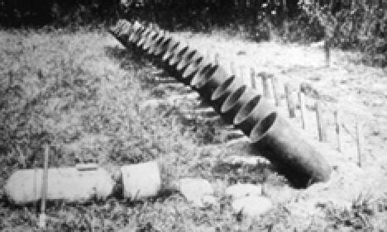
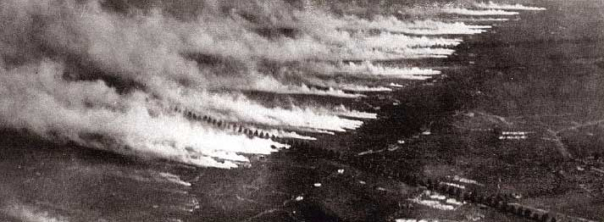
Certain recent events in Iraq have elevated long-standing fears that terrorist groups may use poisonous chemicals, especially elemental chlorine, as toxic weapons against vulnerable populations. These concerns rest on a solid factual basis: many chemicals produced for industrial purposes are inherently dangerous due to their possession of one or more of the following properties: reactivity, flammability, explosiveness, toxicity, or carcinogenicity. In particular, the toxic industrial gases anhydrous ammonia, hydrogen fluoride, and elemental chlorine (often referred to as toxic inhalation hazards, or TIH) are of utmost concern from both safety and security standpoints. Any of these chemicals when released in the course of an accident or a deliberate attack can form a toxic gaseous plume that when carried by wind is capable of inflicting potentially catastrophic loss of life on the population in its path. The worst industrial accident in history is illustrative: 40 metric tons of methyl isocyanate was released from a Union Carbide pesticide plant in Bhopal, India, on December 3, 1984. The resulting plume killed at least 3,000 people downwind and injured more than 100,000. A sufficiently large release of elemental chlorine may be capable of exacting a comparable toll, particularly if it were to be discharged in a highly populated civilian area.
This issue brief describes the properties, hazards, and the legitimate applications of chlorine, as well as its use for weapons purposes during World War I and currently in Iraq. The vulnerability of America's chemical infrastructure to deliberate attack (including the facilities that produce, consume, and transport chlorine), as well as efforts currently underway to achieve infrastructure security, are also examined. The brief concludes with an evaluation of alternative approaches to mitigating the potential threat posed by a deliberate chlorine release.

Properties of Chlorine
Chlorine (Cl[2]) is a highly reactive, pale green gas produced industrially by the electrolysis of readily available aqueous sodium chloride (table salt). Worldwide, the annual production of chlorine totals approximately 55 million metric tons.[1] In 2006, the American chemical industry produced 12.2 million metric tons of chlorine, making it one of the ten most produced chemicals in the United States by weight.[2] Chlorine and its derivative chemicals serve myriad functions in modern society. The most important use of chlorine itself is as a disinfectant; for example, chlorine is employed worldwide in drinking water treatment facilities. In addition, chlorine derivatives (materials containing chlorine atoms chemically bound to other elements) are used as bleaching agents, construction materials (especially polyvinyl chloride, or PVC), high purity silicon precursors (e.g. trichlorosilane) for use in computer chip manufacture, pharmaceutical compounds (including "blockbuster" drugs such as Singulair, Plavix, and Norvasc), and many other functional materials.[3]
The high toxicity of chlorine gas tempers the many beneficial uses of the chemical.[4] Chlorine gas is heavier than air, and therefore will disperse slowly into the atmosphere after release. Because chlorine is water soluble, exposure to the gas irritates the mucous membranes and eyes at concentrations (in air) of under 3 parts per million (ppm).[5],[6] Moderate irritation of the upper respiratory tract occurs at 5-15 ppm, followed by chest pain, vomiting, and dyspnea at 30 ppm. Above 50 ppm, lung inflammation and pulmonary edema occurs. Chlorine is deadly at concentrations of several hundred ppm or higher. According to the National Institute for Occupational Safety and Health, a chlorine concentration of 10 ppm is considered to be immediately dangerous to life or health.[7]

Military and Terrorist Use of Chlorine
In what many consider to be the dawn of modern chemical warfare, chlorine was first employed as a "choking agent" in the early days of World War I. On April 22, 1915, during the second battle of Ypres, the German military released approximately 168 metric tons of chlorine from 5,730 buried gas cylinders.[8] The heavy green plume was carried by prevailing winds to the Allied lines, where French and French Algerian soldiers, not suspecting a chemical attack, were taken by surprise and quickly overwhelmed by the chlorine. The attack claimed the lives of at least 800 soldiers, and injured thousands more. While this incident underscores the potential lethality of chlorine, both sides soon realized that chlorine is not a militarily effective chemical weapon against a prepared adversary. In particular, chlorine possesses both a visible color and a strong odor, which alerts people of its presence and enables avoidance. Moreover, the effects of chlorine exposure may be completely or somewhat mitigated using simple countermeasures, such as wearing a gas mask or even covering the nasal passages with a wet cloth. Therefore, chlorine was quickly abandoned in favor of more fearsome chemical agents (e.g. phosgene and mustard gas). Despite its nefarious usage, its widespread manufacture and distribution for industrial and sanitary purposes has continued.
In Iraq, militias or terrorists have detonated bombs rigged to cylinders containing chlorine that originally were intended for water treatment and other industrial uses, with the intention of dispersing the gas over their targets (primarily Iraqi police and civilians). The US military believes that terrorist groups affiliated with Al Qaeda are primarily responsible for these types of attacks.[9] According to the United Nations Monitoring, Inspection, and Verification Commission (UNMOVIC), at least 10 attacks involving chlorine have occurred in Iraq up to June 1, 2007, resulting in dozens of civilian deaths and an unknown number of injuries.[10] An attack on June 3, 2007 targeted a United States military forward operating base and resulted in making 65 US service members ill from chlorine exposure. The perpetrators have used relatively small, easily transportable quantities of chlorine in the attacks, no more than several tons. Deaths have been attributed primarily to the effects of the explosives themselves, not the chlorine.[11] It is reasonable to assume that the efficacy of these attacks will increase as terrorists modify their methods of chlorine dispersion based on past experience.
The attacks in Iraq utilizing chlorine have re-raised simmering questions in the United States: Is the country's chemical infrastructure, especially the sub-sector that makes and stores elemental chlorine, vulnerable to attacks by terrorist elements that would result in the large-scale release of TIH chemicals over population centers? Would facilities where chlorine is stored be attractive to those who seek to harm civilians?
Chlorine presents both disadvantages and some advantages to domestic terrorists. On the one hand, chlorine is not nearly as potent a toxin as other chemical weapons used in terrorist attacks, such as the fluoroorganophosphate nerve agent sarin released on the Tokyo subway on March 20, 1995 by the religious cult Aum Shinrikyo, killing 12. However, nerve agents require substantial finances, advanced equipment, appropriate chemical precursors, and personnel with specialized training in synthetic organic chemistry to prepare. Even then, nerve agent synthesis and dispersion is non-trivial. For example, Aum Shinrikyo used impure sarin coupled with a crude and relatively ineffective delivery system for the subway attack, despite mustering all the resources mentioned above.[12] On the other hand, chlorine does not need to be chemically synthesized (given its abundance), and as a gas does not require active aerosolization for efficient dispersal. Most importantly, a large release of chlorine may inflict mass casualties on unprepared civilians. According to a 2004 report by the Homeland Security Council, a deliberate release of 60,000 gallons of liquefied chlorine from an industrial facility in a highly populated area may result in 17,500 civilian deaths, while the Department of Homeland Security (DHS) estimates that a "worst-case" chemical release would result in fewer than 10,000 deaths.[13][14]

Chemical Facility Security
According to the Environmental Protection Agency (EPA), in the United States there are approximately 15,000 facilities, including about 2,000 water systems, which store more than the threshold quantities of hazardous chemicals necessary to trigger EPA regulation. A "worst-case" chemical release from any one of 123 such facilities could expose more than 1,000,000 people to toxic gases.[15] In the aftermath of September 11th, the chemical industry has recognized its potential vulnerability and moved rapidly to enhance facility security. In 2002, the American Chemistry Council (ACC), a chemical industry association whose members control approximately 2,000 facilities, established the Responsible Care[®] Security Code, a mandatory private security initiative.[16] The Security Code requires member facilities to complete vulnerability assessments, perform physical security enhancements, invite an independent, third party audit of these enhancements, conduct employee training and drills, and perform periodic security self-audits. These requirements apply to members of the Chlorine Institute, a trade association and Responsible Care[®] partner whose membership includes 98% of chlorine producers and 100% of chlorine packagers in the United States.[17] According to the ACC, its companies have invested about $3 billion in security improvements since September 11th, and all member facilities have completed security upgrades and subsequent independent audits.[18]
Although private security initiatives have garnered justifiable praise, they are also widely viewed as inadequate. Investigative journalists have easily penetrated dozens of chemical facilities nationwide, including many housing chlorine, over the past several years. For example, in 2003, a reporter was able to approach storage tanks holding approximately 1,000 tons of chlorine gas at the Sony Technology Center in Westmoreland County, Pennsylvania.[19] In 2005, reporters from the New York Times were able to approach and loiter near chlorine storage tanks on an industrial site in densely populated Northern New Jersey, only miles from New York City.[20] In addition to the gaps in physical security, facility employees and emergency response personnel are often inadequately prepared to handle a deliberate chemical release.[21] Clearly, comprehensive chemical security requires, in addition to private initiatives, the participation of the public sector in order to safeguard the public most effectively.
At the federal level of government, DHS is responsible for chemical sector security. Until very recently, however, DHS had not received a Congressional mandate to implement and enforce industry-wide security measures.[22] The situation changed in October 2006, when President Bush signed the Homeland Security Appropriations Act, H.R. 5441, which gave DHS interim (3 year) authority to regulate security at chemical facilities. On April 2, 2007, DHS issued the interim final rule regulating chemical facility security, known as the Chemical Facility Anti-Terrorism Standards.[23] The rule requires facilities possessing a threshold quantity of one or more of 342 chemicals of interest, including chlorine, to file a report known as a "top screen" with DHS. For chlorine, this threshold level currently is 1,875 lbs or more.[24] Using this data, DHS will perform a risk assessment and categorize "at risk" facilities according to a tiered system, with Tier 1 facilities considered the highest risk and Tier 4 facilities the lowest. A number of factors are considered in the assessment, including the type and amount of chemical(s) stored as well as the layout and location of the facility. DHS currently estimates that 5,000-8,000 facilities will be assigned a ranking in the tier system, with fewer than 1,000 assigned to Tiers 1 & 2.[25] The facilities assigned to a risk tier will be required to submit vulnerability assessments and site security plans, subject to DHS verification, with failure to comply resulting in daily fines and/or shutdown of the facility in violation. Chemical manufacturers have embraced the new rule's risk-based approach, although others, including environmental groups, have highlighted several apparent weaknesses.[26],[27] For example, the rule contains no timetable for compliance, no whistleblower protections, and may preempt more stringent state and local regulations. Furthermore, the rule is not applicable to water and waste treatment facilities that utilize chlorine for disinfection, and does not require these or other chemical facilities to consider replacing chlorine with safer alternatives (see below). Recent thefts of chlorine cylinders from a California water treatment facility have served to underscore the final point.[28]

Security of Chlorine Rail Shipments
Industrial chemicals, like all commodities, must be transported from production facilities to various consumers. For TIH chemicals such as chlorine, freight railroad offers the most viable transportation option for large-scale shipment. Of the approximately 12 million tons of chlorine produced annually in the United States, almost 3 million tons are shipped by rail, usually in 90 ton pressurized tank cars.6 Rail shipment of hazardous materials (hazmat) is very reliable; 99.997% of the ca. 1.8 million annual hazmat shipments in the United States arrive without incident.[29] Although rail accidents involving chlorine are exceedingly rare, when chlorine tank cars are breached, the consequences often are fatal. On June 28, 2004, near San Antonio, Texas, a head-on collision of two trains resulted in a chlorine tank car breach. Two people died of chlorine inhalation, and 50 more were hospitalized for exposure. On January 6, 2005, in Graniteville, South Carolina, another head-on collision resulted in the derailment of three cars containing chlorine. The resultant chlorine plume killed 8 people, injured 240 more, and led to the evacuation of 5400 people from the spill area.[30]
The railroad infrastructure (including trains, tracks, stations, etc.) is vast and relatively accessible, a necessity for rapid and inexpensive exchange of people and goods. The US rail system is comprised of approximately 171,000 miles of track and covers an area of 3,200 square miles.[31] The open nature of rail systems renders them particularly prone to attacks by terrorists and other groups, as no feasible security plan can possibly protect the entire infrastructure simultaneously and at all times. The RAND Corporation estimates that 181 terrorist attacks against railroads worldwide occurred in the period between 1998 and 2003.[32] Most attacks were directed against transit systems, as exemplified by the more recent bombings of the Madrid, London, and Mumbai commuter rail systems. The US freight rail system is as vulnerable as the European rail systems, and many lines pass through densely populated, high threat urban areas (HTUA's), most notably in the Northeastern corridor. Given the large quantities of chlorine shipped by rail, as well as the potentially catastrophic consequences of a large chlorine release, chlorine-containing tanker cars may represent an attractive target for terrorists.
Freight rail security, especially hazmat and TIH chemical transport, has attracted concern since September 11th and, even more so, after the Graniteville, S.C. chlorine accident in 2005. The freight rail industry, through programs initiated by the Association of American Railroads (AAR), has taken a more proactive stance on security issues since September 11th. The Terrorism Risk Analysis and Security Management Plan designed by AAR forms the basis for post-9/11 freight rail security. The plan includes over 50 security enhancements, addressing a number of general issues such as physical security, risk assessment, communications, and enhanced employee security training.[33] The railroads also, through the Transportation Community Awareness and Emergency Response Program (TRANSCAER) and the ACC's Chemical Transportation Emergency Center (Chemtrec), train and inform emergency responders to help them deal with hazmat emergencies. With respect to chlorine and other TIH chemicals, the Union Pacific railroad recently signed a memorandum of understanding with Dow Chemical to upgrade the TIH railcar fleet and procedures for TIH transport. The memorandum calls for the installation of global positioning satellite units on all TIH tank cars, the design of a new, more robust tank car for TIH chemicals, as well as a reduction in the time that TIH tank cars lay idle in urban areas.[34]
There has existed considerable variation in the approaches of local and federal governments to the threat of chlorine rail shipments. Many local governments, particularly HTUA's, are examining the possibility of banning chlorine rail shipments in proximity to highly populated areas. Citing the threat of chlorine, the Washington, D.C. city council voted on February 1, 2005 to ban all hazmat shipments within 2.2 miles of the Capitol, thus forcing rail companies to reroute shipments of chlorine around the city center.[35] CSX Transportation challenged the law in court and received an injunction, which remains in effect as of this writing. The railroad industry argues that: (1) rerouting increases the risk of accidental of deliberate hazmat exposure, due to increased mileage, (2) rerouting simply shifts exposure risk to other populations, and (3) regulatory variations at each locality would impose significant cost and time burdens on the industry. The federal government, represented by the Department of Justice, supported the railroad industry position in this case, arguing that the regulation of interstate commerce is its Constitutional responsibility.[36] The federal agency responsible for freight rail security, the Transportation Security Administration (TSA), has not yet sought to force railroads to reroute chlorine and other TIH chemicals around HTUA's, as it currently is not currently required to do so by law. Rather, TSA and the Department of Transportation (DOT) have issued voluntary security action items to guide private railroad efforts to secure chlorine and other TIH railcars.[37] TSA is also engaged in formulating rules and pilot programs in cooperation with the railroad industry, aimed at reducing the potential for attack on chlorine tankers. In conjunction with other federal, state, and local government agencies, TSA is currently conducting comprehensive reviews of rail corridor security, with a focus on HTUA rail corridors.[38] However, many have perceived federal funding for surface transportation security, including rail security, to be inadequate. The American Public Transportation Association noted in early 2007 that the federal government has allocated $549 million for rail transit security (including both passenger and freight rail security) since September 11, 2001, in contrast to over $24 billion for aviation security.[39]
Although prior security efforts have no doubt made a positive impact on rail security, freight railroads, and the chlorine transported on them, remain poorly protected. Publicly disclosed reports and media investigations over the past five years have identified gaping vulnerabilities in freight rail security. For example, a 2006 report published by the Citizens for Rail Safety (a public interest group) concluded that rail facilities are not sufficiently secure: cars containing hazmat, including TIH such as chlorine, often sit idle and unprotected, rail workers are poorly trained with respect to security, and emergency responders and citizens are ill-prepared for a hazmat emergency.[40] In early 2007, a reporter from the Pittsburgh Tribune-Review published an article describing how he gained access to a number of hazmat-containing (including chlorine) railcars throughout the country.[41] The reporter was not stopped by employees or rail police, and found hazmat-containing railcars unprotected on rails controlled by 12 railroads. These reports followed the publication in 2005 of two Teamsters Rail Conference surveys of rail workers, which reported significant physical security lapses and a notable lack of security training for workers.[42],[43]
Partially in response to the problems cited above, the US Congress passed new homeland security legislation (H.R. 1: Improving America's Security Act of 2007) on July 27, 2007.[44] President Bush has indicated that he will sign the bill into law in August 2007. The legislation will provide significant enhancements in TIH rail transportation security.[45] Provisions in the legislation call for significantly enhanced funding for freight rail safety and security, including hazmat transportation security, infrastructure improvement, and research and development aimed at secure rail car technologies. Specifically, language in the bill encourages the adoption of wireless communications to track the positions of TIH railcars and monitor their status in real-time. Furthermore, DHS and the DOT must require rail carriers shipping TIH chemicals to develop and submit risk mitigation plans to be enacted when the Homeland Security Advisory System threat levels are high or severe. These plans are to include rerouting of TIH chemical shipments away from high consequence targets, including densely populated areas, landmarks, and other important national resources, as designated by DHS. The legislation also calls for the establishment of a "rail worker security training program" and introduces federal whistleblower protections to protect rail employees who report rail security lapses and violations. This legislation promises to mitigate some of the problems currently facing rail security, but the ongoing evolution of public and private measures must continue.

Inherently Safer Technologies
An alternate approach to mitigating the risk posed by chlorine may be to reduce levels of chlorine consumption by replacing chlorine with inherently safer technologies (ISTs). As noted in a 2006 study by the National Academy of Sciences, "The most desirable solution to preventing chemical releases is to reduce or eliminate the hazard where possible, not to control it."[46] The adoption of ISTs to replace TIH chemicals is strongly supported by a number of interested parties, including environmental groups and the railroad industry. Depending on the industrial application, chlorine may in fact be readily replaced with cost-effective alternatives. According to a 2006 study by the Center for American Progress, 207 waste treatment plants and drinking water facilities have replaced chlorine gas with safer disinfectants such as sodium hypochlorite (chlorine bleach) and ultraviolet light since 1999.[47] Adoption of ISTs not only eliminates the TIH risk of chlorine at the chemical facility, but also reduces the risk of chlorine release in transit. For example, since 1999, 25 water facilities in the United States that previously received chlorine shipments by freight rail have switched to ISTs, and six others plan to do so.[48] Despite this progress, over 2,000 water treatment facilities continue to use chlorine gas, with 37 continuing to receive freight rail shipments. These facilities should be encouraged to adopt ISTs, especially in light of the current situation in Iraq and the thefts of chlorine in California in 2007 (see above).
However, chlorine cannot be easily replaced with IST in totality due to its chemical versatility. Notably, water treatment accounts for only about 5% of chlorine consumption. Chlorine remains a central ingredient in the manufacture of other chemicals and materials, most notably plastics, and a cost-effective replacement may not be apparent in many cases. In addition, a main byproduct of chlorine manufacture, sodium hydroxide (caustic soda), is itself an important industrial chemical (the chlorine production process is known as the Chlor-Alkali process for this reason). Eight million metric tons of sodium hydroxide was produced in the United States in 2006. Thus, an analysis of chlorine replacement by IST must explore the economic impact of lowered chlorine and sodium hydroxide production. The replacement of chlorine by IST is a worthy pursuit, but it will be a long-term endeavor.

Conclusion
It is indisputable that should a large chlorine release such as the Graniteville accident take place in the future, it would pose a substantial danger to the public. Moreover, recent studies demonstrate convincingly that chlorine-containing facilities, whether they are chemical plants or railroad infrastructure, may be infiltrated with ease and regularity by trespassers. It may be argued that there exist more readily accessible targets for terrorist attack, including even smaller quantities of chlorine transported by truck. However, given the toll that a large-scale chlorine release could inflict on a population, facilities and railcars containing multi-ton quantities of chlorine warrant increased attention. The DHS and TSA have both worked well with industry to create voluntary chemical security guidelines, yet to date neither agency has imposed stringent regulations governing chlorine security. The establishment of a coherent national policy (which adequately addresses the concerns of individual localities) regarding the issue of TIH railcar rerouting around HTUA's is particularly vital. The recently approved federal legislation addresses rerouting of TIH shipments in times of elevated threat, but a permanent, satisfactory solution for a non-threat environment will also be required. Further, the new Chemical Facility Anti-Terrorism Standards issued by DHS do not require the chemical industry to examine adopting ISTs to replace chlorine and other TIH chemicals. While chlorine replacement with an IST should not necessarily be mandatory, incentives should be considered to persuade the chemical industry to adopt safer practices. The federal government should also consider an increase in funding for research aimed at the development of ISTs. If a viable, cost effective IST exists for a given chemical process, it is in the best interest of the chemical industry to adopt it of their own accord in order to safeguard employees, facilities, and the surrounding communities. Increased funding for fundamental research and development of ISTs will hasten this progression. Finally, perhaps the best countermeasure against a large attack using chlorine or other TIH chemicals is public awareness and education. Militarily, it has been known for 80 years that the deleterious effects of chlorine may be attenuated using simple methods. Both private industry and governments at all levels, especially those with chlorine facilities in their jurisdictions, should enhance education and outreach efforts to the public regarding appropriate courses of action (e.g. shelter in place protocols) in the case of a chlorine release incident.

►References are available at source’s URL.

Identifying the most likely non-state chem-bio threats
Source 1: http://www.homelandsecuritynewswire.com/dr20140414-identifying-the-most-likely-nonstate-chembio-threats
Source 2: http://www.start.umd.edu/pubs/STARTResearchBrief_Anatomizing.pdf

New research finds that Jihadists pose the most likely chem-bio threat, but other actors also featured as top threats. Jihadist actors occupied seven of the top 10 spots in a qualitative analysis; nine of the top 10 in a quantitative analysis; and half of the top 10 in an elicitation analysis.
Among violent non-state actors, the threat of chemical or biological (CB) weapons pursuit and use lies heavily with violent jihadists of all stripes, according to a new START Research Brief. Jihadist actors occupied seven of the top 10 spots in a qualitative analysis; nine of the top 10 in a quantitative analysis; and half of the top 10 in an elicitation analysis.
“The possibility that violent non-state actors, including terrorists and criminals, might employ chemical or biological weapons has understandably attracted much attention in both policy and government circles,” said Gary Ackerman, director of Special Projects at START.
“This is primarily a result of credible evidence of terrorist interest in these weapons and demonstrated terrorist willingness and capability, albeit thus far via conventional means, to inflict mass casualties.”
A START release reports that the project, Anatomizing Chemical and Biological Non-State Adversaries, aims to improve understanding of, and more effectively identify, perpetrators and potential perpetrators of attacks employing CB agents.
The goal of the project is to enhance the capability of defense practitioners to protect the United States by including more detailed specifications of the threat component in risk assessment calculations, in addition to the already well-developed vulnerability and consequence elements.
The project’s focus was on ideologically motivated violence, but the research also provides some insight into criminal use of CB materials, which can significantly impact public security.

Terror in Brazil, but it's only a drill... Police run through chemical-attack scenario ahead of World Cup
Source: http://www.dailymail.co.uk/sport/worldcup2014/article-2589955/Terror-Brazil-drill-Police-run-chemical-attack-scenario-ahead-World-Cup.html

Armed police seize a suspected terrorist, others officers wear protective clothing to help victims of the chemical attack while the injured are airlifted to safety.
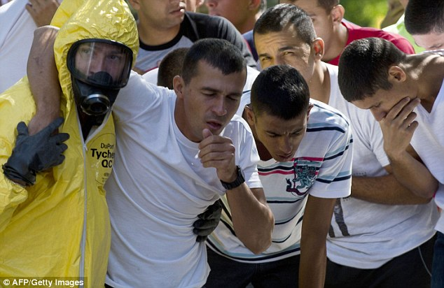
That is the scenario which unfolded as PM paramilitary policemen ran through a terror drill in preparation for this summer’s World Cup.
Photo 1

The opening match of the tournament between Brazil and Croatia will kick off in Sao Paolo on hursday, June 12 and that is the city the authorities chose to play out the attack.
Images show ‘victims’ being hosed down and decontaminated, while bomb disposal experts are also used during the exercise.
They are all part of the measures being taken to ensure that the emergency services are prepared for all possible scenarios with 600,000 visitors set to descend on the South American country during the finals.
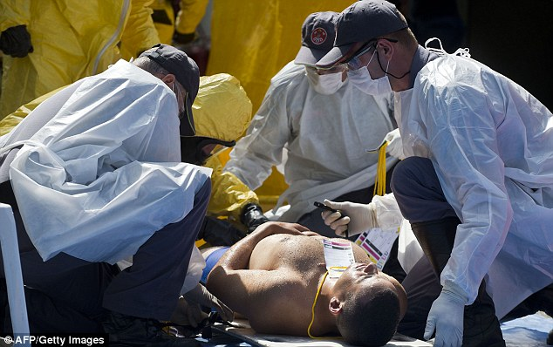  Photo 2 | 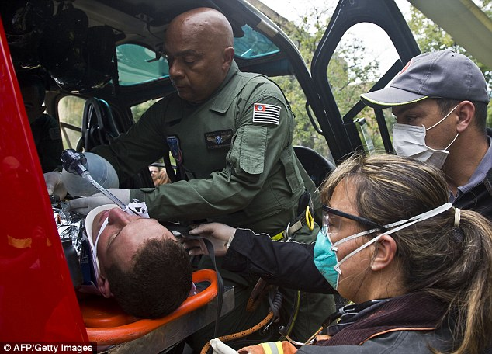  Photo 3

EDITOR’S COMMENT: I will repeat myself by saying that you can get many conclusions from pictures! Also that if you cannot do it right during the drills then the same will happen in a real incident!

Photo 1: Notice the zipper on responders gear!
Photo 2: Is the victim contaminated or not? If he is, then the medics are wearing the wrong PPE. If he is not, then what the responder in full PPE doing in the cold zone?
Photo 3: Always helicopters medevacuating victims! Press love it! But how many helicopters they have for (supposingly) mass casualties?

Brazil’s counter-terrorism personnel train for World Cup
Source: http://infosurhoy.com/en_GB/articles/saii/photo_essay/2014/04/15/photo_essay

Brazilian firefighters remove victims from a contaminated area during an exercise in São Paulo at the end of March to prepare them in the event of an emergency at the World Cup. (Courtesy of Rodrigo Paneghine/Public Safety Secretariat of the State of São Paulo)
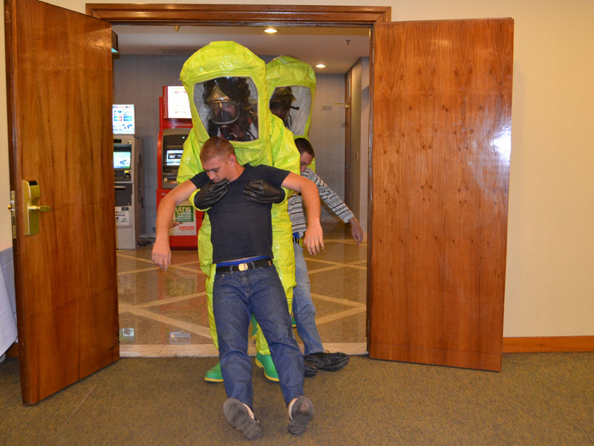
EDITOR’S COMMENT: Most probably from the same exercise (above). Just another unbelievable photo! Responders in Level-A gear carrying unconscious victims from supposed hot zone! Just another proof that planners designed this drill have never been in PPE ever in their life! Seriously now: time allocated between donning and doffing (including decontamination process) does not exceed 30-40 minutes. During that time these “poor” colleagues have to: walk and enter the scene, look for secondary IEDs, initiate detection sequence, take samples, make an initial assessment and report to HQ. During exactly the same time an experienced chef is able to prepare a ham and cheese omelet, some toasts, a cappuccino and serve some fresh orange juice! Come on people! First Responders in Level-A are not your home maids doing everything requested! They “suffer” in totally encapsulated gear, they loose liters of water threatening their own integrity, they carry lots of equipment and they operate in a hostile and potentially lethal environment! Do not treat them that way because you never had the curiocity to see how life is inside personal protective equipment. Besides: if these two men were unconscious most probably they would not make it. So it is not their first priority against those who have a chance to survive. If drills are not realistic or if those participating are not doing things the right way what is the reasoning behind all these fiestas? Just to impress the media and indirectly pass the message to the populace that “we are ready”? Readiness is a very serious case to be taken so lightly? And in that particular drill did victims were transported to the nearest hospital’s ED to be taken care of or everybody assumed that we doctors know what to do in case the “real thing” happens?
US Produced Sarin Gas Used in Syria
Source: http://english.farsnews.com/newstext.aspx?nn=13930125000262

April 14 – American Journalist and Researcher Jeffrey Silverman said that chemical weapons used by rebels in Syria were transferred by sea from Georgia's US-controlled Laboratory, in a new revelation that proves chemical attacks in Syria are committed by foreign-backed militants.
Jeffrey Silverman said in an interview with Veterans Today website that US Department of Defense operates a network of labs in Georgia and that they have an offensive capacity.
On August 27, 2013 the famous American political investigator and principal editor of the ex-US State Department and intelligence service publication Veterans Today, Gordon Duff, published an article entitled "US Contractors Cited for Syrian Chemical Attacks," and a video entitled "Syrian Gas Attack Proof Syrian Army Has No Involvement."
The commentary to the video states, "The video which you are watching right now was filmed in Syria and shows the chemical weapons which were sent from Georgia. The US is standing behind all this. Former US Senator Richard Lugar is the person whose assistance made it possible to transport weapons from Georgia via Turkey into Syria, with the support of the United States and Turkey… A US chemical weapons program supplies the Syrian rebels with weapons of mass destruction. A team of investigators has determined that chemical weapons were supplied from this region, which is under US control. They followed the trail of these chemical weapons to the Georgian Republic. Turkish Army subdivisions transported them to Al-Qaeda terrorists operating in Syrian territory.
Journalists Jeffrey Silverman and Lika Moshiashvili are credited with having discovered the secret and illegal operations taking place in the US-controlled Central Reference Laboratory (CPHRL) in the Tbilisi suburb the Alekseevka Settlement."
In another context Silverman said, "The truth will soon be exposed as to why so much money (was spent) on this lab, 300 million dollars in total, and how the US, Turkey and Saudi Arabia have used Georgia to supply chemical and conventional weapons to terrorists … basically that Al-Qaeda is America’s best friend. Turkey is even the main subcontractor to the construction of the bio lab here in Tbilisi. That is not a happenstance!"
Silverman said that Gordon Duff provided him with the information that prove chemical weapons were transported into Syria from Georgia, and added that this information also confirmed by his own sources. "He stated, Based on reliable sources, that chemical weapons were being transferred by sea from Georgia to Syria. They have human intelligence sources who find and track such materials…"
"This is a team of American veterans who found out that the supply of chemical weapons in Syria was performed from outside, via Turkey," Silverman added.

Nigeria: Benue Suspects Chemical Attack in 200 Deaths
Source: http://allafrica.com/stories/201403290077.html

The recent series of attack on Benue Communities by Fulani Herdsmen is beginning to take its toll on displaced persons due to the crises even as the Commissioner for Information, Justine Amase disclosed that over 200 people were killed with substance suspected to be chemical weapons
According to him, some bodies of those killed were taken for medical examination and it was discovered that there was no gun shot or harm to the bodies.
"This led us to suspect that some chemicals were used and to compound the issue the bodies of some of the victim were set on fire to destroy any evidence", he said.
According to him, the Commissioner for health has taken up the issue and has sent sample of some of the victim to a world class laboratory for further investigation.
Investigations by THISDAY revealed that despite the effort of the Benue State Emergency Management Agency (BSEMA) and the National Emergency Management Agency (NAMA) to provide relief materials for those displaced in camps, life is turning out to be unbearable for them as child illness like malaria measles and diarrhoea have continued to ravage the camps.
Another worrisome development in the camps is said to be the issue of open defecation due to lack of adequate toilet facilities for the inmates who has exposed the IDPs to air and water borne diseases.
One of the displaced persons, who gave her name as Mrs. Elizabeth Terngu said she lost her three months old baby two days ago after the baby suddenly developed constant stooling and vomiting.
She said, "I had my baby just five days before the Fulanis sacked us from our homes, one week after getting here, I noticed she started stooling and vomiting. I started giving her drugs but days later she died.
"Apart from my baby, about ten other children and babies have also died in the last few days within this our area", she wept. At the LGEA primary school, North Bank and LGEA primary school Ichwa, several illnesses were discovered to be affecting the displaced persons.
According to one John Ternenwge "In the last one week, we have lost over 5 children and elderly people in this camp, in fact four days ago, some persons died here at Ichwa on the same day. We also heard that we have lost several of our relatives at the LGEA primary school", he said.
Meantime, two days ago, the Chairman of the Benue Network of Non Governmental Organisations, BENGONET, Mr. James Gbagir, lamented on state radio that the condition in the camps were fast deteriorating.
Gbagir said, "apart from the poor condition and the overpopulated camps, the security of the camps also leaves much to be desired."
Speaking on the development, Amase debunked reports that people were dying in the camps.
He said, "I know that the Commissioner of Health and his team have taken it upon themselves to ensure that medical and other services were rendered to the displaced persons in the camps; though I would not say nobody died but the truth is that some of the deaths may not be connected to poor condition in the camps."

The Psychological Considerations of Chemical and Biological Weapons
By Keith Pounds
Source: http://www.theprepperjournal.com/2014/03/07/psychological-considerations-of-chemical-and-biological-weapons/

Both civilian and military researchers have well-studied the psychological effects of natural disasters on civilians and the effects of combat on soldiers. Yet, little attention has been given to the psychological effects of the deployment of chemical or biological weapons on the general public or first responders.
While first responders and search and rescue personnel would likely be overwhelmed with treating the actual physical casualties of biological and/or chemical weapons, past experience has shown that the presence of those who would experience adverse psychological reactions is extreme and could seriously disrupt the treatment of those actually suffering life-threatening injuries.
This paper offers an examination of human behavior in such crises as well as recommendations for the treatment of the so-called “walking worried,” who suffer from the uninformed and irrational psychological consequences of such attacks. It also shows that the success of chemical and biological weapons for military use has been insignificant, and is likely a reason why their use by terrorists to date has been minimal to non-existent.
However, the combination of technological advances now available to terrorists and the very real concerns over the psychological effects resulting from chemical or biological weapon exposure pose a moderate to severe threat to civilian populations and emergency planners.
As such, the implementation of strategies for emergency planners to address the psychological considerations of chemical and biological weapons among civilians and first responders is critical.
Fear is contagious. While it is said that terrorism may kill individuals, it intimidates thousands. Though panic may be the immediate result of a chemical or biological attack, prolonged anxiety among individuals and society as a whole can be crippling.

THE ANATOMY OF CHEMICAL AND BIOLOGICAL WARFARE
Chemical weapons are predominantly man-made and can generate effects in victims within hours or days. They are said to be good for use as terrorist weapons because many of the symptoms created by chemical exposure (e.g. hyperventilation, heart palpitation) can be misdiagnosed as “anxiety and fear” by medical providers. This can slow down the detection of the use of chemical weapons. Such misdiagnoses can create increased anxiety and fear among the general public.
With biological weapons, only a small amount is required to infect an individual as the pathogens typically “grow” inside the body. From the time a person is actually infected until the time the pathogen “grows” inside the body and causes the person to be become symptomatic is called the “incubation period.”
It is this incubation period that makes the mass use of biological weapons particularly fearful. It can often be several days or weeks before victims begin to show signs of exposure. Not only could it be several more weeks before medical providers are able to acquire sufficient prophylactic medications for infected persons – and vaccines for the non-infected – many of the infections from biological weapons can travel from person to person, or through contaminated food.
We can easily see how this would not only create fear and panic among the general population, it could disrupt and overwhelm the medical community. Keep in mind too that in the several days or weeks that it may take for authorities to discover that there has actually been a biological event, the terrorists would be long gone, avoiding detection and arrest.
Surprising to most, history has shown that biological agents are very ineffective as military weapons and chemical weapons have only limited use. However, we have seen that chemical and biological weapons can be very effective weapons of terror against civilians, “by inducing fear, confusion and uncertainty in everyday life”.
Mathewson (2014) categorizes terrorist attacks into three phases: (1) the Pre-attack Phase, (2) the Acute Event Phase and (3) the Consequence Management and Reconstruction Phase.
The Pre-attack Phase is the period prior to an actual attack. It is during this phase that organizations (military, communities, schools, etc.) should conduct ongoing assessments and judge their vulnerabilities. While the military and law enforcement most often do well to prepare during this phase, many local community leaders and even individual citizens do not.
The Acute Event Phase consists of immediate response to an actual terrorist event and strategies learned in the Pre-attack Phase are implemented. These strategies will include fire suppression, search and rescue and emergency medical efforts. Obviously, planning during the Pre-attack Phase helps mitigate damage during the Acute Event Phase.
The final Consequence Management Phase is the actual time for reconstruction. It is during this phase that communities, health care providers and individual families will confront those suffering from frustration, anxiety, grief and mourning, as well as sleep disorders, memory problems and varying degrees of depression.
Even anxiety experienced in the Pre-attack Phase can result in some psychological response, but it is the trauma experienced during the Acute Event Phase of a chemical and/or biological event that can lead to an array of psychological responses during the Consequence Management Phase.
It is estimated that between nine and 35 percent of persons directly exposed to all traumatic events develop significant post-traumatic psychological distress and perhaps even post-traumatic stress disorder (PTSD).
Studies show that human-made disasters can be even more psychologically impairing than natural disasters. Terrorism may be the most pathogenic due to its unpredictable and unrestrained nature (Mathewson, 2014).
Perhaps even more profound, the discovery of an actual chemical or biological attack “could generate a disproportionate public response because of a broad public perception that their use is akin to poisoning”.
While panic may be the immediate result of a terrorist attack, prolonged anxiety among individuals and society as a whole can be crippling.

BRIEF HISTORY OF BIOLOGICAL AND CHEMICAL WARFARE
During the Trojan War in 431 BC, the Greeks used mixtures of sulfur and pitch resin to produce suffocating fumes against the Trojans. Since then, chemical and biological weapons have been used in a number of conflicts.
At the Battle of Ypres, Belgium in April 1915, the Germans used chlorine gas against the French, killing 5,000 and injuring 15,000. Throughout World War 1, chemical agent sulfur mustard (mustard gas) caused some 400,000 casualties, more than any other chemical agent. All total, during World War II, an estimated 124,000 tons of chemicals were used by all parties.
From 1978 to 1980, Rhodesian and South African forces poisoned waterways with Anthrax, infecting thousands of cattle, causing a critical food shortage in the area. Over 10,000 people contracted the disease, resulting in 182 deaths.
In 1979, in Sverdlovsk, Russia, 94 people became sick with gastrointestinal anthrax – resulting in 64 deaths – from what the Russian government blamed on contaminated meat. It was later discovered that the outbreak was related to a faulty exhaust filter at a nearby military facility.
During the Iran-Iraq war (1980-1988), Saddam Hussein used chemical weapons on Iraqi civilians and Iranian soldiers. Although, of the 600,000 Iranians killed during that war, less than one percent (5,000) died from chemical weapons.
In the mid-1990s, the Aum Shinrikyo cult in Japan made several unsuccessful attempts to release anthrax in Tokyo. While local residents reported foul smells, brown steam and pet deaths, the strain of anthrax deployed was a weak vaccine strain and caused no human deaths.
Surprising to most, history has shown that biological and chemical weapons have actually limited or no effective use as military weapons. As for chemical weapons specifically, Harigel (2001) wrote, “it is difficult to see why they are around in the first place.”
We have seen though that they can be very effective weapons of terror against civilians.

“THE WALKING WORRIED”
We can classify several types of traumatic events, including: (1) natural disasters, like earthquakes, hurricanes and floods, (2) accidental disasters, like vehicle and airplane accidents, and (3) deliberately man-made disasters, including school shootings, arson and terrorist activities.
In the aftermath of disasters, we find that communities can – at least temporarily – become more cohesive, with neighbors acquiring a more firm sense of “community” and “helping out” other neighbors.
Still, studies show that mass violence – such as terrorist attacks – can be psychologically more severe than others types of disasters, resulting in as many as 67% of those exposed suffering from some degree of psychological impairment. The medical community has come to call this group of psychological casualties “the walking worried,” as they only “think” they are suffering from the effects of possible chemical or biological attacks.
Studies show that these “walking worried” can overwhelm medical resources, further complicating local efforts to deal with scarce resources in times of disaster.
On March 28, 1979, in Pennsylvania, residents dealt with a series of problems at the Three Mile Island (TMI) nuclear reactor, Studies show that those who lived near the reactor reported increased anxiety and psycho-physiological problems up to five years after the containment and cleanup of TMI with symptoms “characterized as chronic stress syndromes.”
While this was a technological disaster – rather than one involving terrorists’ use of chemical or biological weapons – it shows the uniqueness of how humans deal with “exposure” to foreign materials.
In June 1987 – during the 1980-1988 Iran-Iraq War, Saddam Hussein deployed mustard gas against the Iranians and some 4,500 of the 12,000 civilian residents of Sardasht were exposed. While most received mild exposure and were treated as outpatients, some 1,500 developed moderate to severe symptoms requiring hospitalization. Years after the attack, residents still held that the deaths from the chemical attacks were more horrific than deaths from conventional weapons. Those under the age of 19 at the time of the attacks suffered more severe psychological effects.
When Saddam Hussein deployed SCUD missiles against Israeli civilians during the first Gulf War, there was clearly a “threat” of chemical or biological attack, but there were no actual reports or evidence of these agents being used. Still, 27% of Israeli civilians admitted to hospitals during the attacks had mistakenly injected themselves with Atropine antidotes and 43% were diagnosed as “psychological casualties” Palmer notes that “about 75% of the casualties resulted from inappropriate actions or reactions on the part of victims.”
One study found a 250% increase in the risk for clinical depression among Israeli civilians during the period of the SCUD attacks. It was noted that those at the greatest risk were middle-aged women as well as the less educated.
On March 20, 1995, terrorists placed several bags of the neurotoxin sarin on different trains on Tokyo’s subway system. While only 13 died from the exposure and 1,051 people had medical symptoms indicative of sarin exposure, over 4,500 were treated as “psychological casualties” of the attack. One report showed that as many as 50% of those initially involved still reported physical or mental disability over three years later.
Even further, because it was several hours before officials realized there had been a nerve agent attack, there were no coordinated decontamination efforts. As a result, “135 firefighters and EMS personnel (10% of the responders) suffered secondary contamination and 20% of receiving hospital staff suffered effects from secondary exposure” (Beaton & Murphy, 2014; Shea, 2004). Today, 18% of people in Japan still experience “flashbacks” from the attack (Mathewson, 2014).
Another example is the Oklahoma City terrorist bombing, which resulted in 168 fatalities, but 8,898 individuals pursued counseling crisis intervention or support groups; a ratio of 1:53. Among adult survivors, 45% experienced post-event psychiatric disorders and 34% suffered from post traumatic stress disorder (PTSD).
Of the surviving first responders to the World Trade Center, studies show that 52% still suffer from both mental health issues and respiratory problems (Mathewson, 2014). Of some 10,000 New York firefighters who have “visited” the site of the 9/11 attacks, about 4,000 have reported respiratory difficulties, leading to what has become known as “World Trade Center Syndrome”.
Between 1996 and 2000, there were only 180 anthrax inquiries in the United States. Surprisingly though, from September to October in 2001 – in the immediate aftermath of the 9/11 attacks – there were a staggering 7,000 reports regarding anthrax. The existence of such a dramatic shift in anthrax reporting can be directly contributed to the psychological effects of the anthrax mailings which occurred in the weeks after the 9/11 attacks. Such a drastic reaction of the public should be a significant consideration for medical personnel, first responders and emergency planners.

PSYCHOLOGICAL EFFECTS, FIRST RESPONDERS
While first responders are certainly susceptible to the same psychological responses to chemical and biological weapons as the general population, there is some evidence that their training can serve as a buffer (of sorts) leaving them better prepared to cope.
Fear of chemical and biological weapons (or other tragic, fearful events and weapons) may itself be associated with several epidemics of medically unexplained illnesses. Among our military troops, we have seen several chronic phenomena relevant to exposure and related symptoms, including Atomic Veterans Syndrome, Agent Orange Syndrome, and Gulf War Illness. Although, in many cases, we can see that media hype and misinformation have distorted even these syndromes.
Agent Orange has been said to cause increased risk of cancer among veterans and birth defects in the children of veterans exposed to this agent in Vietnam. Studies by the Centers for Disease Control (CDC) found no evidence of this to be true. However, this group does suffer from increased rates of anxiety, alcohol abuse and PTSD.
For emergency medical department personnel, radiological weapons and even “dirty bombs” will be easier to deal with than chemical or biological weapons because radioactivity can be measured more readily than nerve agents or vesicants. Emergency medical personnel may be contaminated by chemical or biological agents as they arrive on scene of an event, or as contaminated patients arrive in emergency rooms. Once it is discovered that one of these agents has been deployed, emergency personnel would likely then be overwhelmed with the “walking worried”.
First responders can be very reluctant to ask for help, increasing their risk of later exacerbating any psychological injury. This is why first responder personnel should be on the lookout for stress indicators among their co-workers.
All of these factors increase our anxiety, fear and uncertainty over chemical and biological weapons. Shea adds that “the wide array of potential symptoms from chemical, biological and toxin weapons make identification of the causal agent difficult and complicates treatment.”

RECOMMENDATIONS
Uncertainty is the primary driver of fear in the event of chemical or biological weapons. This makes the use of these weapons a concern for government officials, an attractive weapon for terrorists and front page news for the media.
As the media headline these attacks, associated hysteria can easily translate to communities not directly affected. It is important that media-types provide clear, reliable information in a timely manner and – during the Emergency Management Phase of an attack – be sure to differentiate opinion from reporting.
Another factor related to these kinds of attacks involves false alarms. In the Gulf War there were some 4,500 false alarms and some 2,300 false anthrax alarms during the first two weeks of the anthrax mailings.
Lack of trust in both the government and media could heighten reaction to these attacks. After these types of attacks, the public can blame authorities for their being unable to protect the citizens.
During a chemical or biological attack, the psychological casualties will almost always outnumber the physical casualties. The “walking wounded” could overwhelm medical personnel and local emergency planners, further complicating emergency efforts, leading to increased public hysteria.
Today’s military medical personnel use morbidity reports and statistics dating from as early as World War II to assess the possibility of battle fatigue and combat stress syndrome on soldiers. They can estimate how many psychological casualties or “walking worried” they will have depending on the number of actual “physical casualties” in any given conflict or engagement. For example, if a combat unit receives 10 physical casualties, we can use a ratio of 1:10 to predict that we will likely receive 100 psychological casualties (although the ratio could be 1:5, 1:15, etc.). Local, civilian emergency planners would do well to use this same type of planning.
Planners should remember that – after a chemical or biological attack – there is no time sheet to anticipate when psychological symptoms will begin to appear, or to what extent they will appear in any given person. An individual’s past experience with traumatic events could help or hinder recovery. Individual strengths or weaknesses will be a determining factor, as well as the degree to which that person has suffered personal loss as a result of the attack.
Emergency planners should consider that large scale panic is actually not very common in human beings, even when in groups. Of course, this applies until an individual or group perceives immediate threat of death or grave bodily injury. History has shown that – even during times of war or raid – the vast majority of people were able to cope well. Many communities even experienced heightened concern for their fellow man.
First responders and medical planners should remember that – especially following disasters – women experience anxiety, depression and even PTSD at twice the rate of men. After a traumatic event, about eight percent of men and 20 percent of women will develop PTSD. However, men in general and first responders are more likely to deny symptoms, or that they need help. Lastly, fire fighters and rescue workers have higher rates of alcoholism and their alcohol intake tends to increase under extreme stress.
After a chemical or biological attack, medical personnel should remember that it will be difficult to separate those suffering actual exposure symptoms from those exhibiting unexplained medical illnesses as a result of “perceived” exposure. These “walking worried” will complicate medical response, especially if there is government effort to quarantine individuals, which will further heighten public anxiety.
For emergency planners, realistic training is a must. Unfortunately, while many local services provide training on emergency response and the treatment of physical casualties, the treatment of psychological casualties is seldom addressed.

Keith Pounds is a former hospital corpsman (medic) having served in the U.S. Navy and with the Marines. He holds an MBA with a concentration in organizational psychology and is the president and CEO of Countercon, a Columbia, S.C.-based counterterrorism consulting company. In 2012, he was designated as an Honorary Green Beret by the S.C. Chapter of the Special Forces Association.

Syria submits more 'detailed' list of chemical weapons
Source: http://www.reuters.com/article/2014/04/17/us-syria-crisis-chemicalweapons-idUSBREA3G1 C920140417

April 17 – Syria has submitted a "more specific" list of its chemical weapons to the global regulator overseeing the destruction of its stockpile after discrepancies were reported by inspectors on the ground, officials said.
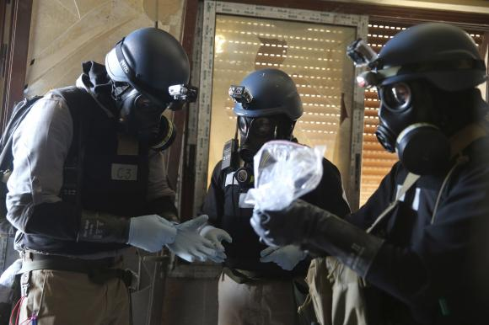
Damascus agreed to give up its chemical arsenal after Washington threatened military action following the death of hundreds of Syrians in a sarin gas attack on the outskirts of Damascus during Syria's civil war last August. But Damascus is several weeks behind schedule in handing over its lethal toxins.
A diplomat said questions had been raised by member states at the Organisation for the Prohibition of Chemical Weapons (OPCW) about the details of its chemical arsenal submitted by President Bashar al-Assad's government last year.
The officials said the original list had been based on estimates, not exact amounts of toxic agents found in storage and production facilities across Syria.
The joint U.N./OPCW mission in Syria found "discrepancies between what they found, and what was on the original declaration", one diplomat told Reuters.
OPCW spokesman Michael Luhan confirmed a revised list had been submitted. "For some of the stockpile, ranges of quantities had been provided. Now they are being replaced with specific amounts," he said.
The exact amounts came to light after inspectors visited the sites, took inventory, and packaged the chemicals for transport to the port town of Latakia, he said. Official could not provide specific details about the discrepancies.
Syria initially reported to the OPCW having roughly 1,300 metric tons of toxic chemicals, including precursors for poison gas and nerve agents. Luhan said no new chemicals were added in the revised list.
As part of a deal reached with the United States and Russia last year, the Assad government agreed to abandon the weapons of mass destruction and destroy all chemicals in its possession by June 30.

Over 500 metric tones of toxins
Syria did not make public the exact list of chemicals, but officials have said it includes more than 500 metric tons of highly toxic chemical weapons, such as sulfur mustard and precursors for the poisonous gas sarin, as well as more than 700 metric tons of bulk industrial chemicals.
They are being loaded onto Norwegian and Danish ships in the Syrian port town of Latakia as part of a multi-million-dollar operation involving at least 10 countries.
The chemical weapons will be neutralized at sea on a specially-equipped U.S. ship, the MV Cape Ray, while the bulk chemicals will be sent to commercial waste facilities in Finland, Britain and Germany.
But Syria has fallen several weeks behind schedule in handing over the chemicals, having shipped out nearly two thirds of the stockpile for destruction abroad.
After missing several deadlines, Syria submitted a revised plan to the OPCW, saying it would hand everything over by April 27, or within 10 days.
An official at the OPCW, who spoke on condition of anonymity, confirmed a new list had been submitted, but said it was part of a routine reporting process.
"Sometimes information is not complete, or not in a format we require. It's not extraordinary," the official said. "But what they have submitted needs to be seen to come to any conclusions and I better not speculate about what's in there."

EDITOR’S COMMENT: Just another round of “bla, bla, bla” from both sides! What is most interesting are the surgical gloves worn over rubber gloves during sampling process (photo in article).

CBRN Mapping
Source: http://cbrn.netseven.it/?page_id=92

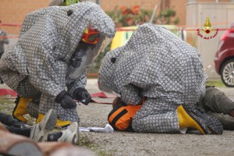
WP2, “Preparatory and Mapping Activities”, is led by the Sant’Anna School of Advanced Studies of Pisa and involves other two partners: the Italian National Fire-Fighters Corp – Fire Department of Pisa (CNVVF) and University of Rome “Tor Vergata”. WP2 aims at identifying and analysing the Italian and – in a comparative perspective – other 10 EU Member States’ Institutional and legal framework governing the response to CBRN incidents. It also aims to map and examine the technical-operational procedures and practices adopted by law enforcement authorities, incident commanders and other first responders in dealing with these incidents. Overall goal of the investigation is to identify the similarities and differences between the institutional, legal and, above all, technical-operational approach to CBRN events of the countries surveyed, as well as to recognise gaps and the best practices. Since the national framework dealing with response to CBRN events in the surveyed States, or specific norms and procedures it consists of, have been established according to international obligations, WP2 deals also with these obligations and examine how they have been implemented at domestic level.
The “Mapping Report” identifies and analyses the Italian and – in a comparative perspective – other 10 EU Member States’ Institutional and legal framework governing the response to CBRN emergencies or crises affecting their territory. To a minor extent, it also maps the technical-operational procedures and practices adopted by national law enforcement authorities, incident commanders and other first responders in dealing with these emergencies or crises.

►You can download the 212 pages Report from:
http://cbrn.netseven.it/?post_type=document&p=522

EDITOR’S COMMENT: High Italian fashion in Level-A gear as well!

One in ten American schoolchildren in school near risky chemical facility
Source: http://www.homelandsecuritynewswire.com/dr20140423-one-in-ten-american-schoolchildren-in-school-near-risky-chemical-facility

One year after the fertilizer facility explosion in West, Texas, which destroyed and severely damaged nearby schools, an analysis by the Center for Effective Government finds that nearly one in ten American schoolchildren live and study within one mile of a potentially dangerous chemical facility.
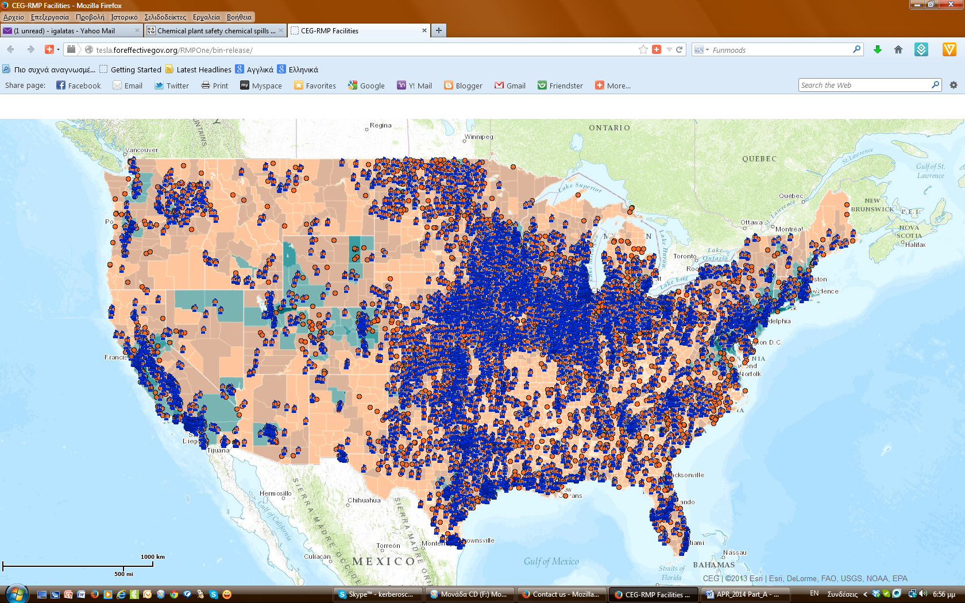
The analysis, displayed through an online interactive map, shows that 4.6 million children at nearly 10,000 schools across the country are within a mile of a facility which reports to the U.S. Environmental Protection Agency’s (EPA) Risk Management Program. A Center release notes that factories, refineries, and other facilities that report to the program produce, use, or store significant quantities of certain hazardous chemicals identified by EPA as particularly risky to human health or the environment if they are spilled, released into the air, or are involved in an explosion or fire.
“The number of children who are potentially in harm’s way is deeply troubling,” said Katherine McFate, president and CEO of the Center for Effective Government. “Minority and low-income kids bear the greatest risks, but no one is immune from this danger.”
The Center’s analysis found that California, Texas, and Illinois have the largest numbers of children at risk from dangerous chemicals. But the percentage of children at risk in other states like North Dakota, Iowa, and Nebraska is alarming: about a third of children in these three states attend a school within a mile of a facility with known chemical hazards.
Sean Moulton, director of open government policy at the Center for Effective Government, noted, “In the year since the West, Texas disaster, we’ve seen workers killed, drinking water poisoned, and entire towns evacuated. In state after state, town after town, people have been hurt or worse because of inadequate oversight, aging public and private infrastructure, and chemical industry battles against stronger standards and safeguards.”
To make children safer in communities across the country, the Center and more than 100 other groups have called for stronger chemical information disclosure standards, better reporting to oversight agencies like the EPA and DHS, and more robust emergency response plans that are vetted with surrounding communities. But most importantly, the federal government must require that all facilities switch to inherently safer chemicals and processes whenever possible.

►Check the Map at: http://tesla.foreffectivegov.org/RMPOne/bin-release/

\

No-refrigeration, spray vaccine could curb diseases in remote areas
Source: http://www.acs.org/content/acs/en/pressroom/newsreleases/2014/march/no-refrigeration-spray-vaccine-could-curb-diseases-in-remote-areas.html

March 19 – A new kind of single-dose vaccine that comes in a nasal spray and doesn’t require refrigeration could dramatically alter the public health landscape — get more people vaccinated around the world and address the looming threats of emerging and re-emerging diseases. Researchers presented the latest design and testing of these “nanovaccines” at the 247th National Meeting & Exposition of the American Chemical Society (ACS), the world’s largest scientific society.
Their talk was one of more than 10,000 presentations at the meeting, being held here through Thursday at the Dallas Convention Center and area hotels.
“Our nanovaccine approach could be instrumental for containing future outbreaks of recently emerged and re-emerging diseases, such as SARS, new flu strains and multi-drug resistant tuberculosis,” said Balaji Narasimhan, Ph.D., the project’s lead researcher.
He noted that most of today’s vaccines require needles, boosters and refrigeration, all of which pose challenges for doctors and patients. Other than the pain factor, which can lower the chances that someone will seek out a vaccine, follow-up shots and refrigeration further reduce the reach of these vitally important preventive treatments. In some places with limited resources, refrigeration simply isn’t available. Thus, many people who need vaccinations the most aren’t getting them at all. The good news is that the vaccines Narasimhan’s team is developing don’t need to be kept cold and are easy to administer.
“Our nanovaccines can be stored at room temperature for as long as six to 10 months and still work,” said Narasimhan, who’s at Iowa State University. “Also, we’re designing them so they get delivered in one dose through a nasal spray, which could potentially allow patients to give the vaccine to themselves.”
Another major limitation of traditional vaccines is the way they work, he said. Most current vaccines help a person develop disease immunity by introducing part of a virus or bacteria and triggering the body’s humoral response — the part of the immune system that produces antibodies to fight off a harmful pathogen. Later, if the person gets infected by that microbe, the body immediately knows how to respond.
But increasingly, evidence is emerging that the other component of the body’s immune system, what’s called the cell-mediated arm, also plays an important part in some emerging and re-emerging diseases, such as whooping cough. This side of the immune system depends on a group of cells called T cells, rather than antibodies, to fight viruses and bacteria.
Part of the elegance of these nanovaccines is their simplicity and versatility, Narasimhan explained. They are made of only two components: bits of proteins from a virus or bacteria packed into nontoxic, biodegradable polymers that can be custom-designed.
When administered through the nose or by a shot, these tiny packages enter the body and flag the immune system. Sentinels called antigen-presenting cells that keep watch in the body for foreign invaders gobble up the nanovaccine particles, chop up the polymers and pathogen proteins, and appropriately put pieces of the proteins on their surfaces. Depending on the chemistry of the nanovaccine, this triggers the body’s cell-mediated or humoral immune response and trains it to recognize the pathogen and attack it quickly in case of future infections.
“We have exciting results that attest to the ability of the nanovaccine formulations to do a very good job of activating cell-mediated immunity,” said Narasimhan. “We’ve shown that it works with rodents, and we’re moving forward to show that in larger animals, as well.”

Preparedness & Progress for Emerging Pathogenic Threats
By Robert C. Hutchinso
Source: http://www.domesticpreparedness.com/pub/docs/DPJMar14.pdf

With the world’s many evolving and emerging threats, infectious pathogens continue to be an important area for domestic and international identification and monitoring. It is an international concern that requires continuous domestic focus, evaluation, and collaboration.
The Middle Eastern Respiratory Syndrome (MERS) and H7N9 virus continue to expand their presence in animals and humans, requiring a high level of planning and preparedness. The evolution, resistance, and expansion that many virus strains have shown over the past few years have become a considerable challenge for planners and their operational partners:
- Reuters reported on 10 December 2013 that the H7N9 virus has a mutation that is resistant to Tamiflu, one of the few first-line treatment drugs;
- The University of Minnesota’s Center for Infectious Disease Research and Policy (CIDRAP) reported on 17 December 2013 that the H5N1 avian influenza has resulted in a mortality rate of 59 percent;
- Rarely encountered viruses, such as the H10N8, H5N2, H9N2, and H6N1 influenzas, are diagnosed in humans causing illness and sometimes death; and
- In December 2013, Caribbean public health officials discovered the first locally acquired case of the exotic African and Asian mosquito-borne virus Chikungunya, which was especially significant as the peak tourist season had just begun.
Only time will tell if these pathogens are emerging threats that are occurring more often, or if the nation is becoming more efficient at epidemiological surveillance, identification, and subsequent information sharing. Either way, robust and thoughtful preparedness must remain a priority.

Goals, Challenges & Findings
For those in the public health and homeland security planning and preparedness fields, it is difficult to estimate or forecast the next emerging or re-emerging epidemic or pandemic threat. However, it may be even more difficult to generate and maintain interest in these pathogenic threats when diverse and conflicting priorities exist. With so many other homeland security challenges confronting the nation each day, these distant, low-probability public health threats may not be a preparedness priority for some public health and homeland security professionals. However, there still are many achievements, lessons learned, and identified areas for improvement that these professionals can review and evaluate to assess preparedness levels and priorities.
A U.S. Department of Health and Human Services (HHS) Office of the Inspector General issued a report in 2009 that identified three findings for local pandemic preparedness regarding vaccine and antiviral drug distribution and dispensing:
- Selected localities had not addressed in their planning documents most of the vaccine and antiviral drug distribution and dispensing components and preparedness items identified in HHS pandemic influenza guidance.
- All selected localities conducted exercises related to vaccine and antiviral drug distribution and dispensing; however, most did not create after-action reports and improvement plans for these exercises.
- All selected localities collaborated with community partners to develop and exercise their plans to distribute and dispense vaccines and antiviral drugs during an influenza pandemic.
Through HHS, the Public Health Emergency Medical Countermeasures Enterprise (PHEMCE) is the coordinating body for federal agencies in charge of protecting the civilian population from potential adverse health impacts using medical countermeasures and coordination with its state, local, and tribal partners.
Since the release of the 2007 PHEMCE Strategy and Implementation Plan, the nation has progressed in the development and stockpiling of medical countermeasures for emergency use. The updated 2012 PHEMCE Strategy established the following national strategic goals for the next five years:
- Create, develop, manufacture, and procure critical medical countermeasures;
- Establish and communicate clear regulatory pathways to facilitate medical countermeasure development and use;
- Develop logistics and operational plans for optimized se of medical countermeasures at all levels of
- response; and
- Address medical countermeasure gaps for all sectors of the U.S. civilian population.
In addition to these examples of governmental guidance and assessments, private organizations also have recently conducted informative preparedness studies. A 2013 report by the Trust for America’s Health and Robert Wood Johnson Foundation found that the national ability to prevent and control infectious diseases was hampered by limited resources and outdated systems. The report provided recommendations to address gaps in areas such as infection control and emerging global illnesses. Many of these recommendations and issues are not new, but continue to require review and contemplation.

Preparedness, Planning & Progress
Of course, not all of the preparedness studies and reports are negative. The Center for Infectious Disease Research and Policy at the University of Minnesota reported progress in public health preparedness in late 2013. After a two-year effort to gather and analyze existing state-level data from a wide range of sources, a consortium of 25 public and private public health organizations awarded the nation an overall health-security preparedness score of 7.2 on a scale of 10, using 128 variables or measures. The study found strengths in health surveillance, incident and information management, and countermeasure management, in addition to areas for improvement, such as surge management and community planning and engagement.
The level of planning and preparedness for a potential novel viral public health threat or pandemic varies from report to report, but the most important consideration may be how truly prepared the nation would be for an actual large-scale incident. An exercise or assessment using current strategies, plans, and policies is based on the existing framework or recent past experiences – after-action reports and lessons learned. Difficult and probing queries stemming from the above listed pathogenic developments may identify weaknesses within current plans and exercises, which will strengthen subsequent strategic plans and discourse.
From the information listed above, HHS and surveyed jurisdictions have plans and procedures for establishing points of distribution for medical countermeasures from the Strategic National Stockpile and other established sources. This preplanning is shrewd and crucial, but it may not be deep enough for the unexpected challenges and consequences. A more-detailed assessment of security plans and procedures for safeguarding supplies and personnel during each response stage may require additional consideration and exercising by planners and responders.

Law Enforcement, Identification & Prevention
One example may be the guidance and training for law enforcement and public health officials to control access and use force, which may be necessary during times of noncompliance. Although this is a specific point, existing plans and procedures may not adequately consider the realistic loss of security and law enforcement resources – due to the worried-well, illness, or other absenteeism – for quarantine enforcement or distribution of medical countermeasures.
Plans and exercises also may not fully account for the enforcement actions during screening or medical countermeasures distribution, which may require existing personnel to execute other exigent duties and assignments – for example, expanded security, arrest processing, injured personnel, crowd control, or other defensive measures – to maintain control of the process and resources. These unanticipated duties can quickly exhaust limited personnel and require the deployment of precious resources from other assignments.
Controlling access to stores during Black Friday holiday sales can result in the loss of simple civil behavior. However, controlling access to limited and valuable medical supplies during a public health scare, when information may be inconsistent or conflicting, would likely present a greater challenge.
The Severe Acute Respiratory Syndrome (SARS) outbreak of 2003 in North America demonstrated that a domestic medical facility or laboratory – rather than an international border screening inspection – may identify and interdict an emerging public health concern. The interior identification of a public health threat greatly expands the number of jurisdictions that need to seriously and continually assess their intentions and capabilities. The unpredictability of a public health threat may greatly constrict the preparation and notification timeframe. Commonly agreed upon and well-understood plans, procedures, and training will need to evolve – with the potential threats – over time.
On 16 December 2013, the Centers for Disease Control and Prevention included the top five threats for 2014.
Two of those threats – emergence and spread of new microbes, and globalization of travel – are major causes for spreading illnesses. With regular reports of common and unique pathogens evolving, emerging, or re-emerging around the world, there may not be time to adequately prepare for a threat once it expands or explodes. A previously successful tabletop exercise or comprehensive plan may not be enough to effectively oversee or support the distribution of medical countermeasures or other critical actions if a serious illness outbreak were to occur next week. Many public and private organizations have demonstrated impressive progress in recent years, but so have many of the pathogenic threats.
The opinions expressed herein are solely those of the author in his individual capacity, and do not necessarily represent the views of his agency, department or the U.S. government.
Robert C. Hutchinson is a supervisory special agent (SSA) with the U.S. Department of Homeland Security, U.S. Immigration and Customs Enforcement’s Homeland Security Investigations. He was previously the deputy director and acting director for the agency’s national emergency preparedness division. SSA Hutchinson also served at the assistant director of policy and programs for the agency’s firearms and tactical
The Severe Acute Respiratory Syndrome (SARS) outbreak of 2003 in North America demonstrated that a domestic medical facility or laboratory – rather than an international border screening inspection – ay identify and interdict an emerging public health concern. The interior identification of a public health threat greatly expands the number of jurisdictions that need to seriously and continually assess their intentions and capabilities. The unpredictability of a public health threat may greatly constrict the preparation and notification timeframe. Commonly agreed upon and well-understood plans, procedures, and training will need to evolve – with the potential threats – over time.
On 16 December 2013, the Centers for Disease Control and Prevention included the top five threats for 2014.
Two of those threats – emergence and spread of new microbes, and globalization of travel – are major causes for spreading illnesses. With regular reports of common and unique pathogens evolving, emerging, or re-emerging around the world, there may not be time to adequately prepare for a threat once it expands or explodes. A previously successful tabletop exercise or comprehensive plan may not be enough to effectively oversee or support the distribution of medical countermeasures or other critical actions if a serious illness outbreak were to occur next week. Many public and private organizations have demonstrated impressive progress in recent years, but so have many of the pathogenic threats.

The opinions expressed herein are solely those of the author in his individual capacity, and do not necessarily represent the views of his agency, department or the U.S. government.

Robert C. Hutchinson is a supervisory special agent (SSA) with the U.S. Department of Homeland Security, U.S. Immigration and Customs Enforcement’s Homeland Security Investigations. He was previously the deputy director and acting director for the agency’s national emergency preparedness division. SSA Hutchinson also served at the assistant director of policy and programs for the agency’s firearms and tactical training division. He completed his graduate degrees at the University of Delaware in public administration and Naval Postgraduate School in homeland security studies.

Positive results reported from single dose anthrax vaccine studies
Source: http://www.homelandsecuritynewswire.com/dr20140402-positive-results-reported-from-single-dose-anthrax-vaccine-studies

Immunovaccine Inc. and Pfenex Inc. announced positive results from anthrax challenge studies in rabbits using Pfenex’s mutant recombinant Protective Antigen (mrPA) formulated with Immunovaccine’s DepoVax delivery system. The studies showed that animals administered a vaccine containing mrPA formulated in DepoVax were protected against a lethal anthrax challenge at a range of antigen doses.
DepoVax containing between 0.1 and 9 micrograms of mrPA was tested as a single dose in rabbits to determine the level of neutralizing antibodies produced by the vaccine and its ability to protect against a lethal dose of the anthrax causing bacteria (B. anthracis). All animals vaccinated with a single dose of mrPA-DepoVax (photo) containing as little as one third of a microgram of antigen were protected from anthrax infection. Four out of five animals vaccinated with mrPA-DepoVax containing one tenth of a microgram of antigen were also protected.
A dose response was observed in the first twenty-eight days following vaccination with higher amounts of mrPA formulated in DepoVax producing higher levels of neutralizing antibodies during this period. In rabbits immunized with a DepoVax vaccine, antibody titers generally plateaued within twenty-eight days and persisted until at least day 70 when animals were exposed to the disease agent. The neutralizing titers measured on day 28 suggest that animals may be protected within one month of a single immunization.
The companies said that further studies will be designed to continue to evaluate the potential of DepoVax-based vaccines to offer rapid protection with a single dose.
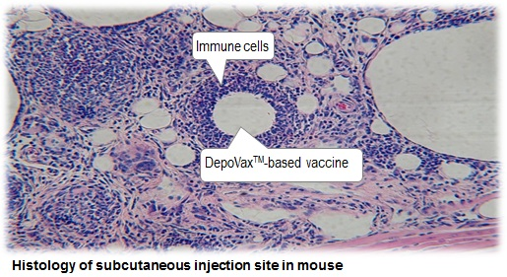
“The positive data from this latest study highlight the potential for the DepoVax platform to enable rapid response vaccines to combat bioterrorism,” stated Dr. Marc Mansour, chief operating officer of Immunovaccine. “The ability to decrease the antigen content and still produce lasting protective antibody titers that protect from anthrax challenge following one vaccination potentially demonstrates the immune enhancing characteristics of DepoVax.”
“Pfenex is excited to be collaborating with Immunovaccine in pursuit of a stable, fast acting, dose sparing and antigen sparing vaccine candidate that will meet the needs of the U.S. Federal Government,” stated Dr. Bert Liang, chief executive officer of Pfenex.
Previously reported rabbit and non-human primate studies suggested that DepoVax may enable a single dose rPA anthrax vaccine. It is now confirmed that a single dose of mrPA formulated in DepoVax is protective in the rabbit model. These studies, conducted under the National Institute of Allergy and Infectious Diseases’ (NIAID’s) preclinical services program, are intended to evaluate Immunovaccine’s DepoVax adjuvanting technology and advance the development of next generation bio-defense vaccines.

Food-related disease outbreaks can teach us about the consequence of food terrorism
Source: http://www.homelandsecuritynewswire.com/dr20140404-foodrelated-disease-outbreaks-can-teach-us-about-the-consequence-of-food-terrorism

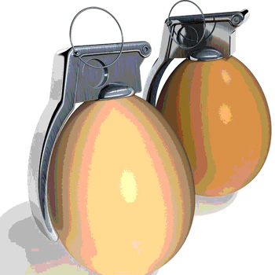
Since unintentional food-related outbreaks have become so common, policy makers could use data from unintended foodborne disease outbreaks to estimate the effects of intended foodborne disease outbreaks. The impact on trade and economies is the primary motive for food terrorism, according to the World Health Organization (WHO), but beyond the financial loss, such intended foodborne disease outbreaks may even impact political stability.
The 1993 Jack in the Box Escherichia coli (E. coli) outbreak and the 9/11 terror attack both have similarities in that both events changed how America viewed safety and security, both represented risks to financial and economic stability, and both incidents resulted in new industries in areas of public health and homeland security.
In 2002, the World Health Assembly, the decision-making body of the World Health Organization (WHO), adopted a resolution detailing concerns about threats against civilian populations by the use of agents distributed via food. WHO also published Terrorist Threats to Food — a document advising government policy makers on the threats to global health security through food safety.
Focusing on food as food ingredients and water-in the forms of food ingredients and bottled water, WHO defines the threat to food safety or food terrorism as “an act or threat of deliberate contamination of food for human consumption with biological, chemical, and physical agents or radionuclear materials for the purpose of causing injury or death to civilian populations and/or disrupting social, economic or political stability.”
According to Food Safety Magazine, a 2013 report released by the Centers for Disease Control and Prevention (CDC) notes that E. Coli and other foodborne pathogen outbreaks have not decreased over the last twenty years. The study notes 67,752 reported illnesses connected to 13,405 food-related outbreaks reported between 1998 and 2008. Since unintentional food-related outbreaks have become so common, are government agencies prepared to prevent intentional food-related outbreaks? Policy makers could use data from unintended foodborne disease outbreaks to estimate the effects of intended foodborne disease outbreaks.
The WHO’s document relies on data from unintended foodborne disease outbreaks to outline the potential effects of food terrorism. Past recalls in American markets of foreign fruits have resulted in the bankruptcy of international growers and shippers. The WHO details specific events in recent history when individual U.S. recalls on domestic ground beef contaminated with E. coli and lunch meats with contaminated Listeria resulted in the loss of millions of pounds of each affected products. Both recalls also resulted in an estimated loss of $44 million and $61 million, respectively. The impact on trade and economies is the primary motive for food terrorism, according to the WHO, but beyond the financial loss, such intended foodborne disease outbreaks may even impact political stability. Better understanding of the global food industry’s failures will be critical in preventing intentional violations of the food system.

Black Death skeletons reveal pitiful life of 14th-century Londoners
Source: http://www.theguardian.com/science/2014/mar/29/black-death-not-spread-rat-fleas-london-plague

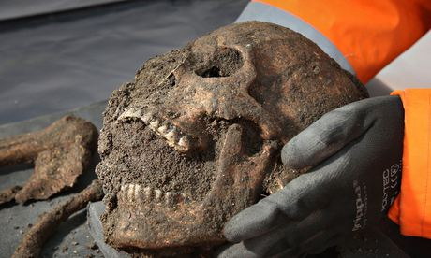
The 25 skeletons unearthed in the Clerkenwell area of London a year ago may hold the key to the truth about the nature of the Black Death that ravaged Britain and Europe in the mid-14th century.
A Channel 4 documentary on Sunday will claim that analysis of the bodies and of wills registered in London at the time has cast doubt on "facts" that every schoolchild has learned for decades: that the epidemic was caused by a highly contagious strain spread by the fleas on rats.
Evidence taken from the human remains found in Charterhouse Square, to the north of the City of London, during excavations carried out as part of the construction of the Crossrail train line, may support a theory held by some scientists that only an airborne infection could have spread so fast and killed so quickly.
The Black Death arrived in Britain from central Asia in the autumn of 1348 and by late spring the following year it had killed six out of every 10 people in London. Such a rate of destruction would kill five million now. By extracting the DNA of the disease bacterium, Yersinia pestis, from the largest teeth in some of the skulls retrieved from the square, the scientists were able to compare the strain of bubonic plague preserved there with that which was recently responsible for killing 60 people in Madagascar. To their surprise, the 14th-century strain, the cause of the most lethal catastrophe in recorded history, was no more virulent than today's disease. The DNA codes were an almost perfect match.
According to scientists working at Public Health England in Porton Down, for any plague to spread at such a pace it must have got into the lungs of victims who were malnourished and then been spread by coughs and sneezes. It was therefore a pneumonic plague rather than a bubonic plague. Infection was spread human to human, rather than by rat fleas that bit a sick person and then bit another victim. "As an explanation [rat fleas] for the Black Death in its own right, it simply isn't good enough. It cannot spread fast enough from one household to the next to cause the huge number of cases that we saw during the Black Death epidemics," said Dr Tim Brooks, a scientist from Porton Down, who was not part of the Crossrail team, will put forward his theory in a Channel 4 documentary, Secret History: The Return of the Black Death,on Sunday.
To support his argument, Brooks, who has yet to examine the Crossrail evidence, has looked at what happened in Suffolk in 1906 when plague killed a family and then spread to a neighbour who had come to help. The culprit there was pneumonic plague, which had settled in the lungs of the victims and was spread through infected breath.
The skeletons at Charterhouse Square reveal that the population of London was also in generally poor health when the disease struck. Crossrail's archaeology contractor, Don Walker, and Jelena Bekvalacs of the Museum of London found evidence of rickets, anaemia, bad teeth and childhood malnutrition.
In support of the case that this was a fast-acting, direct contagion, archaeologist Dr Barney Sloane found that in the medieval City of London all wills had to be registered at the Court of Hustings. These led him to believe that 60% of Londoners were wiped out.
Antibiotics can today prevent the disease from becoming pneumonic. In the spring of 1349, the death rate did not ease until Pentecost on 31 May.

DARPA launches Biological Technologies Office
Source: http://www.homelandsecuritynewswire.com/dr20140407-darpa-launches-biological-techno logies-office

“Biology is nature’s ultimate innovator, and any agency that hangs its hat on innovation would be foolish not to look to this master of networked complexity for inspiration and solutions,” DARPA director Arati Prabhakar said in his Testimony to Subcommittee on Intelligence, Emerging Threats and Capabilities, U.S. House of Representatives, on 26 March 26, 2014.
Technology, like biology, constantly evolves. DARPA said that it is the agency’s mission to stay ahead of the shifting technology curve by making critical, early investments in areas that cut across fields of research and enable revolutionary new capabilities for U.S. national security. Now DARPA is poised to give what it describes as unprecedented prominence to a field of research that can no longer be considered peripheral to technology’s evolving nature. Starting last week, biology takes its place among the core sciences that represent the future of defense technology.
DARPA has created a new division, the Biological Technologies Office (BTO), to explore the increasingly dynamic intersection of biology and the physical sciences. Its goals are to harness the power of biological systems by applying the rigorous tools of engineering and related disciplines, and to design next-generation technologies that are inspired by insights gained from the life sciences. DARAP says that BTO’s programs will operate across a wide range of spatial and temporal scales — from individual cells to humans and other organisms and the communities in which they operate, and from the time it takes for a nerve to fire to the time it may take a new virus to spread around the world one sneeze at a time. “All told, BTO will explore the intricate and highly adapted mechanisms of natural processes and demonstrate how they can be applied to the mission of national defense,” DARPA says.
BTO expands on the work undertaken by DARPA’s Defense Sciences (DSO) and Microsystems Technology (MTO) Offices. Recent progress in such diverse disciplines as neuroscience, sensor design, microsystems, computer science, and other longstanding areas of DARPA investment has begun to converge, revealing newly emergent potential ready to be realized.
“The Biological Technologies Office will advance and expand on a number of earlier DARPA programs that made preliminary inroads into the bio-technological frontier,” said Geoff Ling, named by DARPA director Arati Prabhakar to be the first director of BTO. “We’ve been developing the technological building blocks, we’ve been analyzing our results, and now we’re saying publicly to the research and development community, ‘We are ready to start turning the resulting knowledge into practical tools and capabilities.’”
The initial BTO portfolio includes programs transferred from DSO and MTO, but will also include new opportunities, beginning with the recently announced Hand Proprioception & Touch Interfaces (HAPTIX) program (left photom previous page) that expands on the work of DARPA’s Revolutionizing Prosthetics and Reliable Neural-Interface Technology programs (right photo, previous page). In keeping with DARPA tradition, future programs will be created from ideas brought to the agency by program managers and through conversations with the research community.
“Before BTO, DARPA had a handful of biologists, neuroscientists, engineers, and the like, interested in synthesizing their work but distributed across different offices,” Ling said. “Now we’re under one roof, so to speak, and looking to attract a new community of scholars, who will bring a host of new ideas at the intersection of traditional and emerging disciplines.”

Three research focus areas reflect the scale and scope of BTO’s mission.
- Restore and maintain warfighter abilities: Because military readiness depends on the health and wellbeing of service members, a critical focus is on cultivating new discoveries that help maintain peak warfighter abilities and restoring those abilities as quickly and fully as possible when they are degraded — including through the development of advanced prosthetics and neural interfaces. BTO will seek to develop new techniques and therapeutic strategies for addressing current and emerging threats, but its work will extend beyond medical applications to include exploration of complex biological issues that can affect a warfighter’s ability to operate and interact in the biological and physical world.
  - DARPA’s Systems-Based Neurotechnology for Emerging Therapies (SUBNETS) program is an example of work to restore lost function. It pursues advanced therapies to reduce the burden and severity of neuropsychological illness in afflicted troops and veterans.
  - The Autonomous Diagnostics to Enable Prevention and Therapeutics (ADEPT) program, which seeks novel ways to identify and protect against infectious disease, is an example of work to mitigate or neutralize biological threats.
- Harness biological systems: The highly evolved functional and synthetic capabilities of biological systems can be harnessed to develop new products and systems in support of national security with advantages over what even the most advanced conventional chemistry and manufacturing technologies can achieve. BTO seeks to establish a fundamental understanding of natural processes and the underlying design rules that govern the behavior of biological systems, and apply that knowledge to forward-engineer new systems and products with novel functionality.
  - DARPA’s Living Foundries program, for example, is focused in part on creating a biologically based manufacturing platform to provide rapid, scalable access to new materials with novel properties that can enable a new generation of mechanical, electrical, and optical products.
  - The Chronicle of Lineage Indicative of Origins (CLIO) program, meanwhile, aims to make biological engineering safer by establishing enduring control elements that protect against intentionally harmful genetic engineering, prevent illegal acquisition or misuse of proprietary strains, provide novel forensic tools to assist in the investigation of biological incidents, and allow responsible investigators to document compliance with safe biological manipulation practices
- Apply biological complexity at scale: Biological systems operate over an enormous range of spatial, physical, and temporal scales. Some organisms thrive as individual cells but most depend on dynamic interactions with other species; humans, for example, are colonized by communities of foreign cells that greatly outnumber their own and have potentially significant but still largely mysterious impacts on metabolism, psychological state, performance, and health. A better understanding of the interactions between mammalian and non-mammalian species and micro- and macro-organisms could foster new approaches to enhancing mental and physical health in routine and threatening situations. Similarly, disease vectors migrate around the globe slowly and stealthily at times, and at other times in devastating waves of breathtaking speed — reflecting poorly understood dynamics that can undermine national security. Because they are so difficult to parse from larger biological and ecological phenomena, population-level effects of relevance to agriculture and food security remain largely unplumbed. BTO is looking into pursuing new insights derived from biological complexity and living-system dynamics with the goal of developing applications to enhance global-scale stability and human wellbeing.
  - The Biochronicity program studies the role of time in biological functions. By looking for temporal instructions, or “clock signatures,” in biological organisms, the program aims to make it possible to manage the effects of time on human physiology.
DARPA notes that because BTO programs push the leading edge of science, they will sometimes be society’s first encounter with the ethical, legal, or social dilemmas that can be raised by new biological technologies. For that reason, DARPA periodically convenes scholars with expertise in these issues to discuss relevant ethical, legal, and social issues.

Abu Dhabi confirms new Mers-Coronavirus case
Source: http://www.thenational.ae/uae/health/abu-dhabi-confirms-new-mers-coronavirus-case
April 8 – A 59-year-old resident of Abu Dhabi, who suffers from diabetes and final-stage renal failure, was diagnosed with Mers coronavirus, the Health Authority - Abu Dhabi confirmed.
The man, currently on dialysis, complained of respiratory symptoms and was admitted to hospital, where he was diagnosed with the illness, the state news agency, Wam, reported.
Last month, the World Health Organisation (WHO) reported two new cases of the Middle East respiratory syndrome coronavirus in the UAE.
The Ministry of Health said that globally, detected cases continue to be very low compared to other types of flu-like illness. It is monitoring the situation.
The authority said it is coordinating with the Ministry of Health and other authorities and has taken all necessary measures as per international standards and recommendations from the WHO.
Up to April 1, the WHO reported there were 207 laboratory-confirmed cases of infection with Mers worldwide, including 87 deaths.
The WHO is urging all of its member nations to remain vigilant and report any new cases to it as soon as possible. Cases of Mers, which can cause coughing, fever, pneumonia and kidney failure, have been confirmed in the Middle East, Britain, France, Germany, Italy and Tunisia.

Rapid, broad countermeasures sought against mystery infections
Source: http://medicalxpress.com/news/2014-04-rapid-broad-countermeasures-sought-mystery.html

A group of University of Washington scientists is seeking broad, versatile countermeasures effective against several different kinds of viruses and other pathogens. The investigators are part of a national push for faster responses to unexpected infectious agents. These include newly emerging, unknown pathogens, forgotten ones, those expanding beyond their usual geographic range, or dangerous new strains of old enemies like influenza.
"Emerging viruses are a major threat to global public health, especially because few antivirals are available to treat patients," noted Michael Katze, UW professor of microbiology who is heading the UW contributions to this effort. "There is a significant need for methods to rapidly identify newly emergent pathogens, but also to g uide medical treatments and to quickly contain outbreaks."
The UW is one of seven institutions across the country recently chosen as part of the Center for Research in Diagnostic and Discovery program, under the auspices of the National Institute of Allergy and Infectious Diseases Centers of Excellence for Translational Research. The Center brings together experts from across the country in microbial ecology, human and microbe genetics, engineering, public health and many other fields.
In concert, the Center investigators will devise new ways to prevent, detect, track, diagnose and treat emerging and re-emerging infectious diseases and counter bioterrorism. W. Ian Lipkin of the Mailman School of Public Health at Columbia University is leading the $31 million effort. Over the next five years, the University of Washington is expected to receive approximately $5 million of this grant from NIAID, part of the National Institutes of Health.
The project extends the Katze lab's inventive, basic research to potential clinical applications against new viral pathogens, such as those behind Ebola hemorrhagic fever, Middle East Respiratory Syndrome, Severe Acute Respiratory Syndrome, also known as SARS, avian influenza, and others, according to Angela Rasmussen, a UW research scientist and project manager for the new UW research center.
She added that the new Center will allow the Katze lab to leverage its extensive experience with genomics and systems biology to develop new diagnostic tools and prognostic assays.
The lab, she noted, also wants to identify drugs that can be repurposed for timely responses to epidemics and biodefense threats.
The National Institute of Allergy and Infectious Diseases reports that it has shifted its strategy away from "one-bug-one-drug" toward building a more flexible, broad-spectrum arsenal against multiple pathogens.
Newly emerging pathogens vary in the degree of illness they cause. Some people can be infected with an unheard-of virus and have no symptoms. Other times, viruses that have never struck a human population before can have lethal manifestations, such as blood loss, brain swelling, or extreme difficulty breathing.
The Katze lab will analyze how infected organisms, their genes, cells and immune systems, and their viral attackers interact with each other. They will use machine-learning computer modeling, profiles of gene transcriptions and other measures of genome-wide activity, as well as non-linear geometric and other mathematical methods, to discover ways to measure infectious disease severity. These measurements point out distinctive signatures in the hosts' reaction to infection.
The signatures might assist in diagnosing illness, predicting disease outcome, and finding new ways of modulating the host response to ward off or tame pathogens.
The researchers will also mine drug databases to uncover existing therapies to repurpose. Their host signature method complements traditional emerging infectious disease or bioterrorism research, which often depends on locating, cultivating and identifying the virus or other causative agent.
In their proposal, the researchers indicated that they hope the combination of approaches will reduce "the difficulties in responding to contain and treat previously unknown or uncharacterized pathogens."
Research for this project will also take place in the high-containment laboratory at National Institute of Allergy and Infectious Diseases' Rocky Mountain Laboratories in Montana. Funding for this project is from the National Institute of Allergy and Infectious Diseases (U19 AI109761).

How coughs and sneezes float much farther than you think
Source: http://www.sciencedaily.com/releases/2014/04/140408112111.htm

The next time you feel a sneeze coming on, raise your elbow to cover up that multiphase turbulent buoyant cloud you're about to expel.
That's right: A novel study by MIT researchers shows that coughs and sneezes have associated gas clouds that keep their potentially infectious droplets aloft over much greater distances than previously realized.
"When you cough or sneeze, you see the droplets, or feel them if someone sneezes on you," says John Bush, a professor of applied mathematics at MIT, and co-author of a new paper on the subject. "But you don't see the cloud, the invisible gas phase. The influence of this gas cloud is to extend the range of the individual droplets, particularly the small ones."
Indeed, the study finds the smaller droplets that emerge in a cough or sneeze may travel five to 200 times further than they would if those droplets simply moved as groups of unconnected particles -- which is what previous estimates had assumed. The tendency of these droplets to stay airborne, resuspended by gas clouds, means that ventilation systems may be more prone to transmitting potentially infectious particles than had been suspected.
With this in mind, architects and engineers may want to re-examine the design of workplaces and hospitals, or air circulation on airplanes, to reduce the chances of airborne pathogens being transmitted among people.
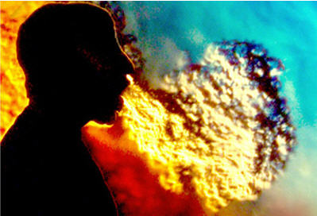
"You can have ventilation contamination in a much more direct way than we would have expected originally," says Lydia Bourouiba, an assistant professor in MIT's Department of Civil and Environmental Engineering, and another co-author of the study.
The paper, "Violent expiratory events: on coughing and sneezing," was published in the Journal of Fluid Mechanics. It is co-written by Bourouiba, Bush, and Eline Dehandschoewercker, a graduate student at ESPCI ParisTech, a French technical university, who previously was a visiting summer student at MIT, supported by the MIT-France program.

Smaller drops, longer distances
The researchers used high-speed imaging of coughs and sneezes, as well as laboratory simulations and mathematical modeling, to produce a new analysis of coughs and sneezes from a fluid-mechanics perspective. Their conclusions upend some prior thinking on the subject. For instance: Researchers had previously assumed that larger mucus droplets fly farther than smaller ones, because they have more momentum, classically defined as mass times velocity.
That would be true if the trajectory of each droplet were unconnected to those around it. But close observations show this is not the case; the interactions of the droplets with the gas cloud make all the difference in their trajectories. Indeed, the cough or sneeze resembles, say, a puff emerging from a smokestack.
"If you ignored the presence of the gas cloud, your first guess would be that larger drops go farther than the smaller ones, and travel at most a couple of meters," Bush says. "But by elucidating the dynamics of the gas cloud, we have shown that there's a circulation within the cloud ï¿½ the smaller drops can be swept around and resuspended by the eddies within a cloud, and so settle more slowly. Basically, small drops can be carried a great distance by this gas cloud while the larger drops fall out. So you have a reversal in the dependence of range on size."
Specifically, the study finds that droplets 100 micrometers in diameter travel five times farther than previously estimated, while droplets 10 micrometers in diameter travel 200 times farther. Droplets less than 50 micrometers in size can frequently remain airborne long enough to reach ceiling ventilation units.
A cough or sneeze is a "multiphase turbulent buoyant cloud," as the researchers term it in the paper, because the cloud mixes with surrounding air before its payload of liquid droplets falls out, evaporates into solid residues, or both.
"The cloud entrains ambient air into it and continues to grow and mix," Bourouiba says. "But as the cloud grows, it slows down, and so is less able to suspend the droplets within it. You thus cannot model this as isolated droplets moving ballistically."

Ready for a close-up
The MIT researchers are now developing additional tools and studies to extend our knowledge of the subject. For instance, given air conditions in any setting, researchers can better estimate the reach of a given expelled pathogen.
"An important feature to characterize is the pathogen footprint," Bush says. "Where does the pathogen actually go? The answer has changed dramatically as a result of our revised physical picture."
Bourouiba's continuing research focuses on the fluid dynamics of fragmentation, or fluid breakup, which governs the formation of the pathogen-bearing droplets responsible for indoor transmission of respiratory and other infectious diseases. Her aim is to better understand the mechanisms underlying the epidemic patterns that occur in populations.
"We're trying to rationalize the droplet size distribution resulting from the fluid breakup in the respiratory tract and exit of the mouth," she says. "That requires zooming in close to see precisely how these droplets are formed and ejected."

Saudi Arabia reports 2 more deaths from MERS
Source: http://www.cbc.ca/news/health/saudi-arabia-reports-2-more-deaths-from-mers-1.2604046?cmp =rss

Saudi health authorities said Wednesday that 11 people in the western city of Jeddah have contracted the Middle East respiratory syndrome, resulting in two recent deaths and prompting officials to temporarily shutter the emergency unit at one of the city's biggest hospitals.
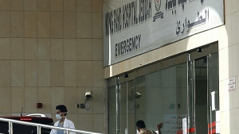
Among those who tested positive for MERS was an employee at Jeddah's King Fahd hospital (photo). The potentially fatal disease is related to SARS and was first identified in 2012 in the Middle East, where most cases since have been diagnosed.
Officials at King Fahd hospital began referring incoming patients to other medical facilities on Tuesday so the emergency ward could be thoroughly cleaned and disinfected, according to the kingdom's health ministry. Authorities said they expected to reopen the emergency ward at the hospital within 24 hours.
A nurse at another hospital in the city had also earlier contracted the virus.
The official Saudi Press agency reported on Wednesday that three people who tested positive for the disease remain hospitalized, and that two others had contracted it had died in Jeddah province.
The deaths bring to at least 66 the number of people who died in the kingdom, which is at the centre of the MERS outbreak.

Risk of dengue fever epidemic in Europe
Source:http://www.sciencedaily.com/releases/2014/04/140407090531.htm?utm_source=feedburner&utm_medium=feed&utm_campaign=Feed%3A+sciencedaily+%28Latest+Science+News+--+ScienceDaily%29

April 7 – The risk of dengue fever beginning to spread in Europe is imminent. According to researchers from Umeå University, this is no longer just an issue for the scientific community but also for politicians and policy makers, who need to be prepared and develop preventive measures.
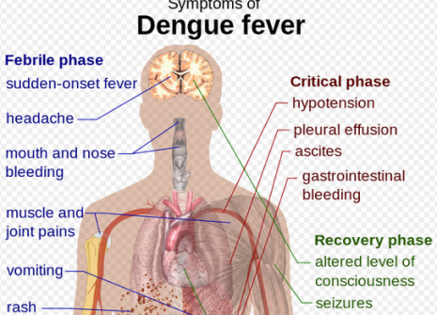
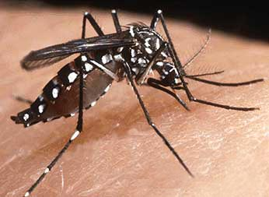
With a changing climate and rising temperatures in Europe, the incidence of the Aedes aegypti mosquito has also increased. The mosquito is the main vector of dengue that can cause haemorrhagic fever. Although no outbreak of the disease has not yet occurred in Europe, researchers at the Epidemiology and Global Health unit at Umeå University claim that there is now good living conditions for the mosquito in Europe and that it is therefore only a matter of time before we see an epidemic here. The Aedes albopictus mosquito has already established itself in large parts of Europe. Even though it is not as competent a vector as Aedes aegypti, several domestic cases of the disease have been observed in countries such as France and Croatia.
"The last outbreak of dengue in Portuguese Madeira when several thousand became ill, shows that it is no longer a theoretical possibility that the disease can take hold in Europe. It is a reality that can strike at any time," says Raman Preet, researcher and scientific project manager of the Dengue Tools project at the Department of Epidemiology and Global Health, Umeå University. "When the disease shows up in Europe it has probably accompanied travelers in areas in the world where the disease is established. Then it will be spread with the help of the Aedes mosquito."
The risk for Swedish travelers to be infected by dengue is highest when going to Sri Lanka and Bangladesh, while most cases in Sweden stems from trips to Thailand. There is currently no vaccine that can protect against dengue, nor is there any treatment when the illness strikes. Symptoms are similar to those of severe cold with fever, headache, muscle and joint pain, or upset stomach. The disease can be life threatening when it affects children, the elderly and chronically ill. In severe cases it can develop into a hemorrhagic fever.
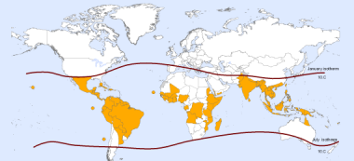
The previous models used to study the spread of dengue and especially the living conditions for the Aedes mosquito has taken up the average temperature in different areas. Jing Helmersson, PhD student within the EU-funded DT project at Umeå University, demonstrates in her studies that it is not enough. These calculations must also include the diurnal temperature distribution in different areas, and temporal trends when assessing the potential for an epidemic caused by dengue. Therefore, Jing Helmersson has developed a climate model with historical data from 1901 to the present day, whose projections extends to 2099. The results show a strong link between climate change and increased ability for mosquitoes to spread the disease in Europe.
"In our analyses, we can see that climate change, including the extreme weather with large daily temperature fluctuations in different areas of Europe, causes a large relative increase in the potential for epidemic spread of dengue fever," says Jing Helmersson. "It mainly concerns areas in southern and central Europe where the potential for proliferation previously has been small. At the same time we see that the spread potential will decrease in warm areas of the world, because the temperatures get too high."
Following the results of the research project, Jing Helmersson believes that it is important to continue with the mapping of future risks of dengue infection, especially in temperate regions of the Northern Hemisphere. Increased globalization and the influx of viruses carried by flight passengers further heightens the risks.
"Perhaps the most important of these studies is that they give us a better understanding of the risks of a future epidemic of dengue fever," says Jing Helmersson. "This type of modelling where we use weather and climate data makes it possible to forewarn the authorities in countries that are at risk of dengue epidemics, so that they in turn can prepare and start to act."

Top experts suggest bolstering smallpox vaccine stockpiles
Source: http://www.cidrap.umn.edu/news-perspective/2014/04/news-scan-apr-09-2014

Although global experts have spent considerable time debating whether or not to destroy the remaining stocks of smallpox virus in WHO labs, not nearly enough resources are being spent on preparing for a potential terror-related outbreak of the eradicated disease, two leading experts said in a commentary today.
Writing in Biosecurity and Bioterrorism yesterday, two former directors of the WHO's smallpox eradication program, D. A. Henderson, MD, MPH, and Isao Arita, MD, PhD, suggest stockpiling traditional smallpox vaccine sufficient to cover 10% of the world's population, with 300 million additional doses in a WHO stockpile.
Henderson is a distinguished scholar at the UPMC Center for Health Security in Baltimore, and Arita is director emeritus of the Kumamoto Medical Center in Japan. Henderson is also co-editor-in-chief of the journal.
"Regrettably, there are few countries that have been sufficiently concerned so as to possess an emergency vaccine stockpile or to make other preparations to respond to an outbreak should it occur," the experts write.
They provide a summary of developments toward antiviral agents and a better smallpox vaccine but conclude, "It makes little sense to continue to invest in new vaccines or antiviral agents when there is so little interest in purchasing well-tested, available vaccines to provide at least minimal protection."
The two cite the example of Imvamune, a new and reputedly safer vaccine developed by Bavarian Nordic, of which the United States has stockpiled 20 million doses—enough to immunize 10 million people—for $505 million, or about $25 per dose.
Rather than pursuing a "perfect" smallpox vaccine at great cost, Henderson and Arita recommend that resources would be better spent on stockpiling traditional vaccines. "There are now available 2 excellent replicating strains of freeze-dried vaccine virus that are highly protective, whose shelf life is 10 years or more, and whose cost is about $3 per dose," they write, suggesting that nations stockpile these vaccines in large quantities.
And on the topic of destroying the remaining lab stocks of smallpox virus? "Given our knowledge of recombinant biology, retention of live variola virus is scientifically unnecessary," they say, and propose two specific approaches to virus destruction.

Salmonella outbreak tied to Foster Farms chicken tops 500 cases
Source: http://www.cidrap.umn.edu/news-perspective/2014/04/news-scan-apr-09-2014

April 9 – A multistate outbreak linked to Foster Farms chicken contaminated with Salmonella Heidelberg has grown to 524 cases, up from 481 cases on Mar 4, the Centers for Disease Control and Prevention (CDC) said today.
The 43 new cases are in California (34), Oregon (3), Arizona (2), Texas (2), Michigan (1), and Washington (1). Cases are from 25 states and Puerto Rico. No new states have been affected. The vast majority of cases (399) have been in California (see CDC map below).
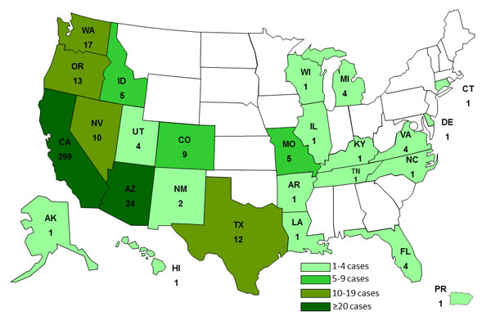
Of the 437 case-patients with available information, 162 (37%) have been hospitalized. Illness-onset dates ranged from Mar 1, 2013, to Mar 18, 2014.
Thirteen percent of patients have developed blood infections. That number is typically 5% with Salmonella infections, the CDC said. Of 61 isolates of the outbreak strains tested to date, 38 (62%) showed resistance to one or more antibiotics, a factor that may raise hospitalization rates, the agency said.
Foster Farms is located in Livingston, Calif. The US Department of Agriculture (USDA) announced in October that it was allowing three Foster Farms facilities linked to the outbreak to continue operating after they made changes in their slaughter and processing methods. One of the plants, however, was temporarily closed by the USDA on Jan 8 because of "egregious insanitary conditions."

Seven students taken to hospital and school evacuated after habanero chili peppers are found in playground
Source: http://www.dailymail.co.uk/news/article-2599967/Habanero-peppers-school-playground.html

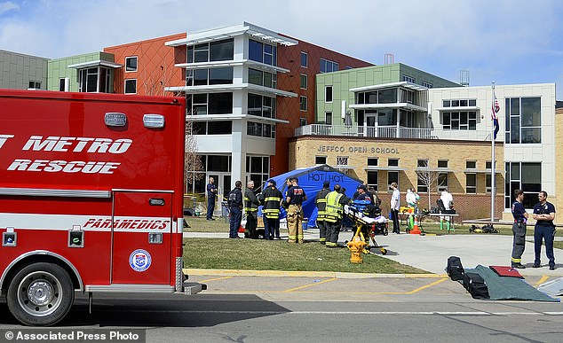
Seven students were rushed to hospital and the Colorado school they attend had to be evacuated on Monday after habanero chili peppers were found in the playground.
About two dozen students and a teacher's aide had to be hosed off in the school yard after also coming into contact with the chili peppers, which had been scattered around play equipment.
Habaneros are so hot they need to be handled with gloves, and can cause a long-lasting burning sensation if they come into contact with skin or eyes.
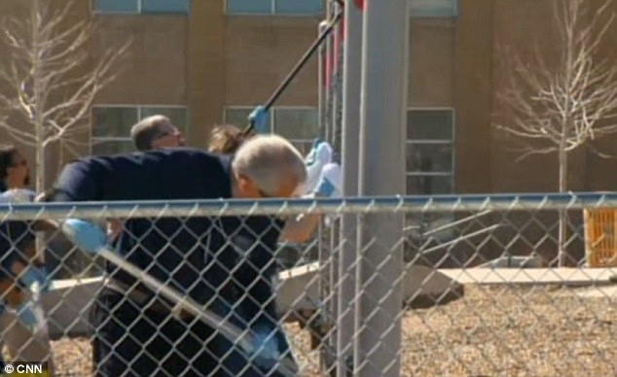
Hazmat crews doused those suffering with symptoms caused by the chili peppers in water in the school yard, and students who didn't need to go to hospital were taken to a nearby church to wait for their parents.
To prevent further problems, Jefferson County Open School in Lakewood, which has about 500 students from kindergarten to grade 12, closed on Tuesday so the yard could be scrubbed clean.
Play equipment was power-washed and the wood chip in the yard was removed in an attempt to clear any trace of the painfully hot peppers.
School spokeswoman Lynn Setzer said no one knows how the peppers came to be in the school yard, but coming into contact with the oil from them would have caused the symptoms being seen.
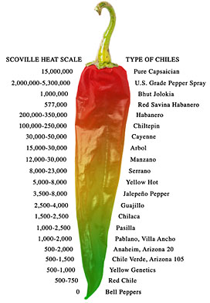
The hot chili peppers were discovered when students came back in after break, complaining of a burning sensation.
Heat from habaneros is released when the skin is broken, which is what happened as the children unwittingly stood on the discarded peppers while playing.
Principal Scott Bain said: 'They were mixed in so just traffic and what have you kind of crunched them up a little bit within the woodchips.'
The ages of the children have not yet been released, but all of the students treated in hospital were released the same day and are said to be doing well.
A Jefferson County fire department spokesman said: 'It isn’t known at this time how or when the peppers got on the playground.'
Habaneros score between 100,000 and 350,000 units on the Scoville scale, which measures chili pepper hotness.
Those handling them are warned to wear gloves and avoid any direct contact with the peppers which causes skin to become red and burn.
'As a person who grows some painful peppers, I have learned the hard way to take heed when handling them,' CNN Eatocracy editor Kat Kinsman said. 'It's all fun and games until you get some pepper juice in your eye, and then it's as if the sun is exploding.'
The school reopened today and the woodchip in the school yard is being replaced.

The Smallpox Threat: A Time to Reconsider Global Policy
Source: http://online.liebertpub.com/doi/full/10.1089/bsp.2014.1509.comm

In May of this year, the 67th World Health Assembly will again debate the question of when the remaining specimens of smallpox virus should be destroyed. Over the past 18 years, this has been on the agenda of 5 previous Assemblies, the last being in 2011. At that time, the delegates “affirmed strongly the decisions of previous Health Assemblies that the remaining stocks of variola virus should be destroyed.”¹ They asked that the date be decided by the 2014 Assembly.
Inordinate amounts of time, effort, and resources have been spent in endeavoring to reach consensus on this one component of a smallpox threat strategy: whether to destroy or not destroy smallpox virus strains now being retained in the 2 World Health Organization (WHO) Collaborating Laboratories (in the United States and Russia). In both, the virus is being held under secure conditions. This year, a WHO-appointed group of international scientists concurred that there is no justification for retaining live smallpox virus. In any case, as others have pointed out, advances in genomic biology would now permit strains of virus to be replicated should someone wish to do so.² Logic dictates an early date for destruction of the last laboratory strains.
Meanwhile, countries and committees have substantially ignored the far more important initiatives that the global community and individual nations should take in order to be prepared to deal with smallpox outbreaks should they occur. Few have stockpiles of vaccine; not more than 8 to 10 countries have sufficient vaccine to cope with an outbreak. A WHO global emergency reserve, recommended 10 years ago, is steadily shrinking. Strategic plans for outbreak containment have been little discussed. At the same time, 2 initiatives have received special attention and resources: one to develop a vaccine that would protect without adverse reactions, and one to perfect antiviral drugs to treat cases should they occur. Both have failed to meet expectations.
In writing this commentary, we have jointly drawn on our own half-century of experience with smallpox to offer a brief historic context for a better comprehension of current efforts and to critique the contemporary status of preparedness and response in coping with the unlikely return of smallpox, which has played such a dominant role throughout mankind's history.

Αρχή φόρμας
Τέλος φόρμας

A Brief History of Deliberations about Virus Destruction
From the time of the occurrence of the last smallpox case in 1978, many countries and scientists have argued for the destruction of all known specimens of variola virus. Many fear, realistically, the increasing potential for a global catastrophe should smallpox be introduced into a now largely unvaccinated world, either accidentally by escape from a laboratory or deliberately by a terrorist. As an initial step to diminish that risk, all virus laboratories, beginning in 1975, were asked by WHO to destroy such specimens of variola virus as they might have or to transfer them to 1 of 2 WHO Collaborating Smallpox Laboratories (the US Centers for Disease Control and Prevention, Atlanta, GA, or the State Research Center for Virology, Novosibirsk, Russia).³ By 1983, all countries had provided written notice of their compliance. Research using live variola virus is now believed to be restricted to these 2 laboratories. Both function under continuing international oversight of approved biological security practices and approved research protocols.
Following the 1980 declaration of eradication, a WHO Committee on Orthopoxvirus Infections was established to deal with issues pertaining to smallpox in the posteradication era.⁴ Variola virus destruction was a priority concern for countries that most recently had been infected and for whom memories of the disease were most vivid. They contended that destruction of the 2 known stocks of virus would reduce the risk of an accidental release and emphasized to all that possession of smallpox virus was unconscionable and unacceptable to the international community. Moreover, as they pointed out, the decision to undertake eradication had been by a majority vote of World Health Assembly delegates. Thus, it seemed appropriate for virus destruction to be decided in a similar manner. Favoring retention, however, were a number of scientists who believed that, in principle, it would be wrong to destroy an organism that conceivably might play a role, as yet unforeseen, in contributing to basic scientific insights in virology.
Between 1985 and 1995, the WHO Committee on Orthopoxvirus Infections consulted many virologists and public health leaders about activities that should be undertaken before destruction of the virus.⁵ It encouraged special laboratory initiatives intended to characterize the essential nature of the existing virus strains, including their genetic structure. It also sought professional judgments from scientists in many countries.
The final report of the WHO Committee was delivered to the Director General for presentation to the 1996 World Health Assembly. It recommended that all existing stocks of variola virus be destroyed. This decision had the written support of 5 international microbiological organizations. However, a proposed presentation and discussion at the World Health Assembly was deferred pending further deliberations. Subsequent assemblies debated the question but continued to postpone setting a date for virus destruction until specified studies were completed. Two principal goals for research were identified: the development of a new smallpox vaccine that would provide full protection without adverse reactions, and 2 antiviral compounds suitable for treatment of smallpox infections.
Three years ago, Tucker published a detailed history of the deliberations. He characterized the issue of smallpox virus destruction as constituting “one of the longest and most contentious policy debates in the field of international health.”^{5(p55)} He added: “Unless a compromise formula can be worked out …, the result could be a diplomatic train wreck.”^{5(p55)}

Αρχή φόρμας
Τέλος φόρμας

Expert Advisory Committee Deliberations, 2011, 2014
Continuing interest in reaching a decisive conclusion resulted in the scheduling of a major comprehensive review of the issues and research activities so that final decisions could be reached at the 2011 World Health Assembly. In preparation, special meetings of 2 WHO committees were convened prior to the Assembly to review the smallpox research program and to provide their advice. One committee was the long-standing WHO Advisory Committee on Variola Virus Research (ACVVR),⁶ which was composed largely of virologists, many of whom were engaged in smallpox research and policy. The advice of a second committee was also sought: the Advisory Group of Independent Experts (AGIES),⁷ a group of distinguished scientists who had not been engaged in smallpox research or the eradication program. Available to both committees was a specially developed comprehensive scientific review of all variola virus research spanning the period 1999 to 2010.⁸ After considerable discussion, the 2 committees reached a general agreement on most but not all of the major issues pertaining to the retention of smallpox virus. The Assembly deferred making a specific decision and requested that the subject be addressed again at the 2014 World Health Assembly.
The 2 committees held additional meetings in 2013. The majority in each committee agreed that there was no need to retain live variola virus for the development of further diagnostic tests, sequencing the genomes of additional isolates, use in animal models, or further development of smallpox vaccines. The AGIES also felt there was no need to retain variola virus for further development of antiviral agents; a majority of the ACVVR members, however, concluded that this objective justified its retention.

Αρχή φόρμας
Τέλος φόρμας

The Threat of an Outbreak of Smallpox
One question is key in all decisions: What is the likelihood that smallpox outbreaks will ever again recur? There is agreement that outbreaks are highly unlikely but that the probability is not zero. Thirty-five years have elapsed since the last case of smallpox. Over the years, many rumors of cases have been investigated; none has proved to be valid. Efforts have been made to isolate virus from bodies exhumed from various burial sites, including in the frozen tundra, but these have failed. Many pox lesions occurring in animals have been cultured. The viruses found were specific to various animal species. Thus, it is essentially certain that there is no natural reservoir of live smallpox virus.
A concern that cannot be allayed is the possibility of release of virus from unknown specimens in a laboratory. In the mid-1990s, information became widely available about a long-secret industrial-scale biological weapons program in the former Soviet Union.⁹ Variola virus had been the organism preferred above all others. The program is reported to have terminated during the 1990s. After this time, some of its scientists emigrated to other countries, bearing with them relevant knowledge and perhaps specimens. To date, however, there has been no evidence to confirm that clandestine activities with smallpox virus have been resumed in any laboratory or country. So far as is known, the only known specimens of variola virus are in the 2 designated WHO Collaborating Laboratories. However, there is no way to be certain that there are no others. Were the virus to be released, there is every reason to believe that it would be as lethal today as it was prior to the interruption of smallpox virus transmission.
Thus, there are valid reasons to ensure that adequate vaccine is available to counter any smallpox threat. Without vaccine, other procedures, such as isolation measures, quarantines, or supportive therapy, would be of little avail. A catastrophic pandemic could ensue.

Αρχή φόρμας
Τέλος φόρμας

Vaccines for an Emergency Response
The potential chaos and disruption of a terrorist event were dramatically emphasized by the September 2001 attack on the World Trade Center in New York City and the subsequent dissemination of anthrax organisms in letters. About that time there were intelligence intercepts that suggested there would be yet another biological attack. Anthrax was a threat, but smallpox was particularly to be feared.
The US was not then well prepared to deal with smallpox. At that time, the US had only 15 million doses of a traditional calf lymph smallpox vaccine; it had been in storage for more than 20 years. It was decided that smallpox vaccine sufficient to vaccinate all citizens should be obtained urgently and stockpiled. However, there were no vaccine producers in the US or in other countries that were capable of producing more than a few million doses per year. A new tissue cell culture production method was needed. Senior US staff, working closely with the Acambis company, in a temporarily available Austrian laboratory, succeeded in producing more than 200 million doses of a new tissue cell culture vaccine called ACAM2000 in 18 months. The strain was a plaque-purified virus derived from the long-used New York City Board of Health strain. The vaccine was freeze-dried and is expected to have a shelf life of 10 years or more. The vaccine is now fully licensed.
Progress in other countries in developing emergency stockpiles of vaccine has been disappointing. In 2004 the WHO Committee on Orthopoxviruses was convened to discuss the global needs for smallpox vaccine.¹⁰ The committee recommended the establishment of a special WHO emergency vaccine reserve, to be activated as needed. Proposed was a 200 million dose emergency stockpile to be donated by member countries. It was recommended that 5 million doses be kept in Geneva for immediate dispatch. It was also recommended that there be a “virtual” stockpile of 195 million doses, donated by individual countries but retained in national stockpiles ready for immediate shipment. In making the recommendation, the committee cautioned that this quantity of vaccine might well be inadequate even for dealing with a few moderate-sized outbreaks. However, they recognized that to propose a larger stockpile was unrealistic given the scarcity of national resources.
The committee recognized that there would be a serious problem in obtaining more vaccine if needed. There were at that time only a few national vaccine manufacturers. Most produced the traditional calf-lymph vaccine and had a production capacity of no more than a few million doses. Each would require at least 4 to 5 months to augment production. To develop new facilities capable of producing a tissue culture vaccine was thought to require at least 3 to 4 years. Thus, the committee recommended that there be at least 2 national laboratories that, in an emergency, would be capable of producing large quantities of vaccine in tissue cell culture.¹⁰ At this time, one is under construction and nearing completion. It is being constructed by Sanofi-Pasteur (which purchased Acambis). This is intended to have an annual production capability of at least 50 million doses. Meanwhile, a Japanese manufacturer (Kaketsukan) has built in Kumamoto, Japan, the only other laboratory capable of large-scale production of tissue cell culture smallpox vaccine (80 million doses per year). This vaccine uses a new, more attenuated strain (called LC16m8) derived from the once widely use Lister Institute vaccine strain and is licensed in Japan.¹¹ The vaccine, like ACAM2000, is freeze-dried and is administered with a bifurcated needle.

Αρχή φόρμας
Τέλος φόρμας

10 Years Later
Ten years have elapsed since the WHO Committee on Vaccines met. The WHO emergency stockpile in Geneva is now 3 million doses rather than the recommended 5 million. WHO's virtual emergency vaccine supply held in national stores is now 30 million doses—not 195 million doses. Moreover, it is believed that there are not more than 7 or 8 countries that have sufficient vaccine to vaccinate as many as 20% of their populations should emergency containment measures be needed.
Which vaccines should be available for emergency use? The WHO Scientific Advisory Group of Experts (SAGE) met in November 2013 to provide advice to member countries as to which smallpox vaccines should be included in a stockpile and how they should be used in case of an outbreak.¹² SAGE recommended that the vaccines should be lyophilized (to maximize shelf-life of stockpiles), they should be capable of being administered by bifurcated needles (to allow reduction of the dose needed for traditional scratch vaccination), and they should produce a visible major cutaneous reaction as a correlate of protection. Only the 2 licensed vaccines, ACAM2000 and LC16m8, meet these stipulations. SAGE recommended that if neither of these vaccines was available, countries should use locally produced vaccines like those used during eradication, which met WHO standards of potency, purity, and stability.
SAGE observed, in passing, that a recently developed vaccine, Imvamune (known as Imvanex in Europe), is not recommended until more information is available regarding its efficacy and safety and until it is produced as a lyophilized product.

Αρχή φόρμας
Τέλος φόρμας

Vaccine Use Policies
Vaccine utilization requirements necessarily must take into account that the occurrence of smallpox anywhere in the world is a global threat in a now largely unprotected population. Smallpox has the potential to spread from person to person in any climate and in any season. With the rapidity and extent of international travel, an outbreak in one country has implications for national responses throughout the world. Thus, following an outbreak anywhere, a number of countries, whether infected or not, will very likely seek vaccine for protection of high-risk staff and officials. Given the limited quantities of vaccine available, response planning must opt for strategies that use the least possible number of vaccine doses. The WHO emergency stockpile itself is so small that it would be of value only in limited circumstances; most countries have no national stocks, and those that do are certain to be cautious in offering vaccine to others. With so few sources of vaccine, there is a potential for serious conflict between countries with vaccine and those without.
The overall quantities of vaccine needed will vary greatly depending on a number of factors. An initial attack could affect a few people or thousands. The rapidity with which cases are discovered and isolated and their contacts vaccinated would govern the extent of spread. Much would depend on the degree of prior planning and training at local, national, and international levels. To date, such activities have been modest to negligible in most countries. In the past, an instinctive reaction of government officials has been simply to recommend obtaining enough vaccine to permit mass vaccination over large areas or perhaps nationwide. Given the limited amounts of vaccine available or able to be produced in an emergency, such policies would rapidly exhaust current stockpiles. SAGE specifically recommended against use of mass vaccination.¹²
It is important for all countries to have action plans and training for a targeted response. What is required is early detection of cases and vaccination of the few people who have been in face-to-face contact with each patient since he or she became ill. Typically, patients have 2 to 3 days of high fever and are so ill that they usually remain bedridden. Contacts are usually few in number. Vaccination is effective even when given 3 to 4 days after infection. Diagnosis of smallpox cases is comparatively easy and, in an outbreak, does not require laboratory confirmation for most cases. The disease spreads slowly because of a 10- to 12-day interval between successive generations of cases. Thus, large quantities of vaccine are not required to effect control. However, without adequate education and preparedness of the public and medical community, even small, readily contained outbreaks could result in serious civil disorder and a clamor for mass vaccination campaigns.

Αρχή φόρμας
Τέλος φόρμας

A New Vaccine and a New Antiviral Agent
Throughout the debates regarding destruction of smallpox virus, a principal argument for retaining live smallpox virus was to achieve 2 goals. The first was to have a smallpox vaccine that would provide full protection against smallpox without causing adverse reactions; the second was to have 2 antiviral compounds suitable for treatment of smallpox infections.
Creating new vaccines and drugs is well recognized to be difficult, time-consuming, and costly, but funds have been provided for several efforts.² Progress has been difficult, however, in part because of a lack of suitable animal models and the fact that there are no human cases. Other mammalian orthopoxviruses have been helpful in research, but all exhibit significantly different responses. None behaves like the natural smallpox virus does in humans. Thus, after more than a decade of research in highly capable laboratories, there is only 1 vaccine and 1 antiviral product that have progressed sufficiently to warrant a limited purchase for the US emergency stockpile. Neither fulfills the objectives originally envisaged. How they might be incorporated into a response plan has not been elaborated.
Several prospective antiviral drugs, intended for treatment of clinical cases, have been in development. One, tecovirimat (Arestvyr, or originally ST-246),¹³ has been purchased to date for the US stockpile: 1.3 million courses of treatment at a cost of $175 million. What is needed is a drug that would be effective in treating patients exhibiting the typical pustular rash. It is notable that in human smallpox, the pustular rash does not appear until some 2 weeks after the patient has been infected with the virus. Most animal studies, however, have begun treatment immediately after infecting the animals. What remains to be shown is that monkeys, for example, infected by aerosol can be successfully treated many days later after pustules have begun to develop. Studies to date have not been encouraging. The drug is not licensed for use.
Considerable effort has been invested in developing a safe, protective vaccine for individuals with eczema or immune-deficiency diseases, who are at a greater risk of complications should they receive 1 of the 2 replicating vaccines (ie, ACAM2000 or LC16m8). For this purpose, a new vaccine, Imvamune (originally modified vaccinia Ankara or MVA), a nonreplicating vaccine, has been developed by the Bavarian Nordic Company. To date, 20 million doses (enough for 10 million people) have been purchased by the United States for its stockpile at a cost of $505 million. In 2013, the European Union granted marketing authorization for this product subject to an annual reassessment.¹⁴ It is not licensed in the United States.
The new vaccine, however, is substantially more expensive and requires the administration of 2 doses of vaccine by syringe and needle. Full protection is not obtained until 14 days after the second dose.¹⁵ The vaccine is stable for only 2 years at –20°C. More concerning is the fact that fewer than 7,000 people have been vaccinated. Reported adverse reactions are few, but, even so, incomplete studies indicate possible risks of myocardial effects.¹⁵ There is no apparent programmatic use for the vaccine at this time.

Αρχή φόρμας
Τέλος φόρμας

Summing Up
The perceptible threat of a smallpox release is little different today than it was 35 years ago; the implications of a smallpox outbreak in an increasingly susceptible world are more dire. Regrettably, there are few countries that have been sufficiently concerned so as to possess an emergency vaccine stockpile or to make other preparations to respond to an outbreak should it occur. It makes little sense to continue to invest in new vaccines or antiviral agents when there is so little interest in purchasing well-tested, available vaccines to provide at least minimal protection.
Rather than pursuing dreams of a perfect vaccine or a drug to treat a preventable disease, it would seem more rational to invest available energy and time in the development of smallpox vaccine stockpiles (national, regional, or global) and operational plans for isolation of patients, vaccination of contacts, and protection of high-risk medical and health personnel. There are now available 2 excellent replicating strains of freeze-dried vaccine virus that are highly protective, whose shelf life is 10 years or more, and whose cost is about $3 per dose. We suggest, as a reasonable goal, to have aggregate stockpiles of vaccine amounting to perhaps 10% of the global population, with another 300 million doses in a WHO stockpile. One licensed vaccine production facility is in operation, and a second is due to come on line by the end of the year.
Should the current stocks of live smallpox virus be destroyed? Given our knowledge of recombinant biology, retention of live variola virus is scientifically unnecessary. The virus, after all, could be recreated by a skilled microbiologist. Thus, at this time, we would propose 2 alternatives: (1) an internationally witnessed destruction of virus in each of the 2 Collaborating Laboratories, and (2) creation of an international lockbox for the virus strains to retain the genetic diversity of the isolates should they ever be needed for uses unforeseen.

Αρχή φόρμας
Τέλος φόρμας

References
1. World Health Organization. Smallpox Eradication: Destruction of Variola Virus Stocks. WHA document 64.11. Geneva: World Health Organization; 2011.
2. DA Henderson. Smallpox virus destruction and the implications of a new vaccine. Biosecur Bioterror 2011;9(2):163-168.
3. I Arita. The Smallpox Eradication Saga. Hyderabad, India: Orient Blackswan; 2010:16-20.
4. World Health Organization. Final Report of the Global Commission for the Certification of Smallpox Eradication. Geneva: World Health Organization; 1980.
5. JB Tucker. Breaking the deadlock over destruction of the smallpox virus stocks. Biosecur Bioterror 2011;9:1-13.
6. World Health Organization. Advisory Committee on Variola Virus Research. Report of the Twelfth Meeting. Geneva: World Health Organization; 2013.
7. World Health Organization. Advisory Group of Independent Experts to Review the Smallpox Research Programme (AGIES). Geneva: World Health Organization; 2013.
8. World Health Organization. Scientific Review of Variola Virus Research 1999-2010. Geneva: World Health Organization; 2010.
9. K Alibek, S Handelman. Biohazard: The Chilling True Story of the Largest Covert Biological Weapons Program in the World. New York: Random House; 1999.
10. World Health Organization. Working Document: Mechanisms for Acquisition and Release of Smallpox Vaccine by WHO. Geneva: World Health Organization; 2004.
11. JS Kennedy, M Gurwith, CL Dekker, et al. Safety and immunogenicity of LC16m8, an attenuated smallpox vaccine in vaccinia-naïve adults. J Infect Dis 2011;204:1395-1402.
12. World Health Organization. Meeting of the Strategic Advisory Group of Experts on Immunization 2013. Conclusions and Recommendations. Wkly Epidemiol Rec 2014;89:1-2.
13. R Ruepp. European Medicines Agency Activities on Smallpox. Paper prepared for the WHO Advisory Committee on Variola Virus Research, September 2013.
14. European Medicines Agency, Committee for Medicinal Products for Human Use. Assessment Report: IMVANEX. Procedure No. EMEA/H?C/002596. London: European Medicines Agency; 2013.
15. GJ Hatch, VA Graham, KR Bewley, et al. Assessment of the protective effect of Imvamune and Acam2000 vaccines against aerosolized monkeypox virus in cynomolgus macaques. J Virol 2013;87:7805-7815.

D. A. Henderson, MD, MPH, is Distinguished Scholar, UPMC Center for Health Security, Baltimore, Maryland, and Coeditor-in-Chief of the Journal.
Isao Arita, MD, PhD, is Director Emeritus of the Kumamoto Medical Center, National Hospital Organization, Kumamoto, Japan. Both served as Directors of the World Health Organization Global Smallpox Eradication Program.

2014 edition of updated first responder biodetection technology guide available
Source: http://www.homelandsecuritynewswire.com/dr20140411-2014-edition-of-updated-first-respon der-biodetection-technology-guide-available

A 2014 update to a detailed product guide listing biodetection technologies and sampling products is now available. The updated digest provides a comprehensive compilation of commercially available detection devices and products published to help first responders when purchasing equipment and supplies needed to rapidly assess biological threats.
DHS’s Science and Technology Directorate and the Department of Energy’s Pacific Northwest National Laboratory (PNNL) just made the revised report — Biodetection Technologies for First Responders: 2014 — available free of charge. A PNNL release reports that the technology summaries in the new version of the report provide web links, equipment specifications, pricing, and annotated references from peer-reviewed publications for about thirty detection technologies and twenty-five sampling products from nearly two dozen companies (PNNL notes that it does not sell or endorse any of these products).
This report updates the previous edition, which was downloaded more than 5,500 times.
“We believe first responders and purchasing specialists will find the updated report a valuable product-buying guide,” said Cindy Bruckner-Lea, PNNL principal investigator. “With dozens of companies, technologies and sampling products listed, the report provides a convenient and useful resource to fire fighters, law enforcement and hazardous materials response teams.”
More than 69,000 publicly reported suspicious powder incidents have occurred in the United States since the 2001 anthrax attacks. The events continue across the nation at a rate of about five per day, including several incidents involving ricin in 2013.
“Rapid biodetection is essential to the first responder community,” said Seattle Fire Department Assistant Chief, A.D. Vickery. “These professionals are on the front lines everyday ensuring public health and safety is protected and preserved.”
In addition to the report, PNNL is nearing completion of its first round of independent biodetection technology performance evaluations. The initial focus of the product appraisals will be on the ability of the products to detect anthrax and various forms of ricin, as well as the impact of a wide range of commonly encountered hoax powder materials. PNNL intends to provide its initial results of this independent analysis at the International Association of Fire Chiefs conference later this year.
PNNL team members and other first responder hosts will be sponsoring a 90-minute session at the IAFC International Hazardous Materials Response Teams Conference, to be held 29May-1 June in Baltimore, Maryland. The 30 May session will include brief presentations on technology testing results as well as use and instrument limitations. The session’s primary focus, however, will involve interactive discussions on the needs, gaps, priorities and useful tools that can assist first responders in making informed choices when facing a potential bioevent.

►Download the report at: http://biodetectionresource.pnnl.gov/

Results of surveillance for infections with Shiga toxin-producing Escherichia coli (STEC) of serotype O104:H4 after the large outbreak in Germany, July to December 2011
By C Frank, A Milde-Busch and D Werber
Department for Infectious Disease Epidemiology, Robert Koch Institute, Berlin, Germany
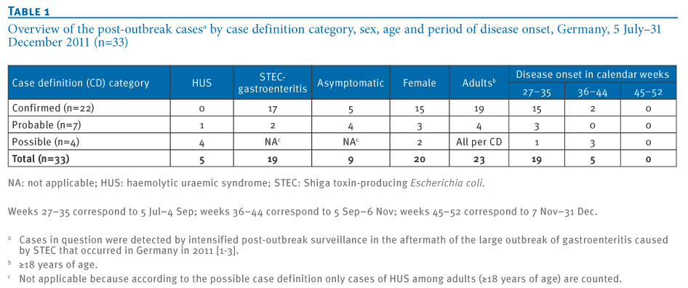
Source: http://www.eurosurveillance.org/ViewArticle.aspx?ArticleId=20760

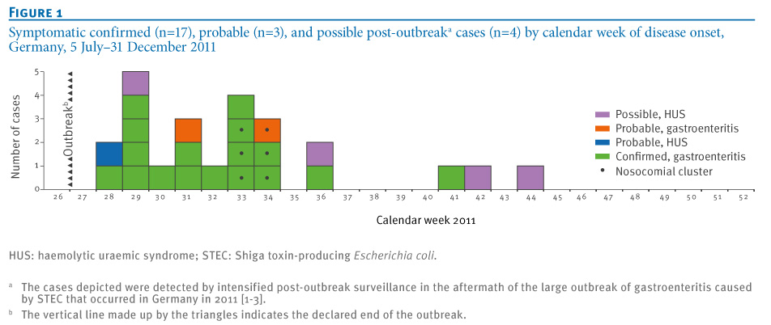
After the massive outbreak of infections with Shiga toxin-producing Escherichia coli (STEC) of serotype O104:H4 in Germany in the summer of 2011, post-outbreak surveillance for further infections with this type of STEC was maintained until the end of 2011. This surveillance was based on national mandatory reporting of STEC infections and the associated complication of haemolytic uraemic syndrome (HUS), as well as on data obtained from a questionnaire. Between the outbreak’s end (5 July) and 31 December 2011, a total of 33 post-outbreak cases were recorded. Post-outbreak cases occurred with diminishing frequency towards the year’s end and resembled the outbreak cases in many respects; however the proportion of HUS among all post-outbreak cases was smaller than during the outbreak. Two thirds of the post-outbreak cases were likely infected by contact with known outbreak cases. Both laboratory and nosocomial spread was noted in this period. No post-outbreak case recalled sprout consumption as a potential source of infection. The scarcity of information conveyed by the nonculture tests routinely used in Germany to diagnose STEC made linkage of post-outbreak cases to the outbreak difficult. Though post-outbreak surveillance demonstrated the outbreak strain’s potential for lengthy chains of transmission aided by prolonged shedding, our results and continued routine surveillance until the end of 2013 do not support the notion, that the outbreak strain has been able to establish itself in the German environment.

►Read full paper at source’s URL.

A different approach on the same topic

Teen Sent Romantic Rival Ricin-laced Birthday Card
Source: http://www.huffingtonpost.com/2014/03/21/nicholas-helman_n_5009996.html

A man sent a birthday card laced with the deadly poison ricin to a romantic rival in hopes of winning back his ex-girlfriend, authorities said.
Nicholas Helman, 19, was arrested at his home in Hatboro, outside Philadelphia, Wednesday on an attempted murder charge and other counts, authorities in Bucks County said.
Helman told a Target store co-worker earlier this month that he sent the toxic card to his ex-girlfriend's current boyfriend, investigators said. The co-worker notified police, who called the recipient's home and spoke to his mother, who said her daughter was outside getting the mail at that moment. Authorities then went to the home to confiscate the card.
Helman was questioned March 7 and told investigators only that he had coated the card with a substance that resembled anthrax, authorities said in an affidavit of probable cause. He said he intended to scare his ex-girlfriend in hopes of reconciling with her, police said. He initially was charged with terroristic threats and harassment and spent four days behind bars before making bail.
Authorities said Helman had ingredients for making ricin, a poison that occurs naturally in castor beans, but that initial tests didn't turn up the toxin itself. Authorities then sent the card away for more lab tests, and prosecutors were told Tuesday that traces of ricin had been confirmed on the card, the district attorney's office said. Police accompanied by hazardous materials teams and the FBI then arrested Helman.
Bucks County District Attorney David Heckler told The Philadelphia Inquirer that the toxin was "very potent."
"He made ricin, and if you lick that card, you're dead," he said.
Court documents don't list an attorney for Helman, who was jailed without bail after his arraignment Wednesday night. He has a March 27 preliminary hearing.
His father, Douglas, told The (Doylestown) Intelligencer that he knew nothing about the charges. He said his son had been good at science and math in school and made Eagle Scout last year.

Hope in the Battle with Ebola
Source: http://www.smallcapnetwork.com/BioCryst-Pharmaceuticals-BCRX-BCX4430-a-Hope-in-the-Battle-with-Ebola-Dejour-Energy-DEJ-Black-Gold-Knocks-at-the-Door/s/via/26106/article/view/p/mid/1/id/184/

Since its inception in 1969, the U.S. Army Medical Research Institute of Infectious Diseases (USAMRIID) has spearheaded research to develop medical solutions—vaccines, drugs, diagnostics, and information—to protect the U.S.' military service members from biological threats. Its specialized capabilities include Biosafety Level 3 and Level 4 laboratories, world-class expertise in the generation of biological aerosols for testing candidate vaccines and therapeutics, and fully accredited animal research facilities.
As the United States continues a new era of civilian biodefense research, it is also clear that USAMRIID plays a critical role in the status of the U.S.' preparedness for biological terrorism and biological warfare. While USAMRIID's primary mission is to protect the warfighter, its research benefits civilians as well.
Filoviruses, such as Ebola virus and Marburg virus, are extremely virulent. These pathogens are classified as Category A Bioterrorism Agents by the Centers for Disease Control and Prevention. Marburg virus is a member of the family Filoviridae, along with Ravn virus, Ebola virus, Sudan virus and Bundibugyo virus, all of which cause severe viral hemorrhagic fevers in humans.
Ebola virus disease, formerly known as Ebola haemorrhagic fever, is a severe, often fatal illness in humans, characterized by the sudden onset of fever, intense weakness, muscle pain, headache and sore throat. This is followed by vomiting, diarrhoea, rash, impaired kidney and liver function, and in some cases, both internal and external bleeding. Laboratory findings include low white blood cell and platelet counts and elevated liver enzymes.
Ebola is introduced into the human population through close contact with the blood, secretions, organs or other bodily fluids of infected animals. Ebola then spreads in the community through human-to-human transmission, with infection resulting from direct contact (through broken skin or mucous membranes) with the blood, secretions, organs or other bodily fluids of infected people, and indirect contact with environments contaminated with such fluids.
More than 120 people have died from the latest Ebola outbreak in West Africa. With no cure or vaccine, it is one of the most deadly of viruses, killing between 60% to 90% of those infected.
Health officials do not expect the virus to go global and stress that Ebola is not easy to catch, requiring direct contact with an infected victim’s bodily fluids.
BCRX recently reported the online publication in the journal Nature of extensive laboratory and nonclinical characterizations of BCX4430, including efficacy results in animal models of infection with Marburg virus and Ebola virus, two highly virulent pathogens responsible for viral hemorrhagic fever diseases.
The Nature online publication, "Protection against filovirus diseases by a novel broad-spectrum nucleoside analogue BCX4430," (http://www.nature.com/nature/journal/vaop/ncurrent/full/nature13027.html) represents the first report of protection of non-human primates from filovirus disease by a small molecule drug, and describes efficacy results generated from an ongoing collaboration between scientists at the U.S. Army Medical Research Institute of Infectious Diseases (USAMRIID) and BCRX.
Developed by BCRX, BCX4430 has demonstrated antiviral activity in testing conducted at BCRX Utah State University/NIAID and USAMRIID. BCX4430 has been shown to be active against more than 20 RNA viruses in nine different families, including filoviruses, togaviruses, bunyaviruses, arenaviruses, paramyxoviruses, coronaviruses and flaviviruses.
In tests conducted at USAMRIID, BCX4430 protected animals against parenteral exposures to Marburg, Ebola and Rift Valley Fever viruses and from exposures to aerosolized Marburg virus, an experimental condition designed to mimic an exposure scenario that could result during a bioterrorist attack.
BCX4430, a viral RNA-dependent RNA polymerase (RdRp) inhibitor, is being developed as a countermeasure against human filovirus diseases and other viral diseases representing major public health threats. In September 2013, the National Institute of Allergy and Infectious Diseases (NIAID) contracted with BCRX for the development of BCX4430 as a treatment for Marburg virus disease. In 2013, NIAID awarded funding of $7.5 million to BCRX, and total funding of up to $22.0 million, if all contract options are exercised. The goals of this contract are to file investigational new drug (IND) applications for intravenous and intramuscular BCX4430 for the treatment of Marburg virus disease, and to conduct Phase 1 human clinical trials.

New MRSA Superbug Emerges In Brazilian Patient
Source: http://www.huffingtonpost.com/2014/04/18/mrsa-superbug-brazil-vancomycin_n_5173629.html

A new, highly drug-resistant type of the superbug methicillin-resistant Staphylo-coccus aureus (MRSA) recently caused a fatal blood infection in a Brazilian patient, according to a new report.
The 35-year-old man, who was in poor health and had been in the hospital for a long time, was infected with a strain of MRSA that developed resistance — during his hospital stay — to the powerful antibiotic vancomycin, which is widely used to treat this infection.
Researchers found that unlike previous superbugs that were associated with hospitals, this vancomycin-resistant staph bacteria (VRSA) is genetically related to a MRSA strain that has been circulating in the United States and northern South America, according to the study, published today (April 17) in the New England Journal of Medicine.
"This particular bug is genetically different from all the others that have been described before, and belongs to a clone that has been described before to cause infections in the community, and not in the hospital," said study researcher Dr. Cesar Arias, an infectious diseases scientist and an associate professor of medicine at the University of Texas.
These findings in the Brazilian patient's case "raise concerns that this particularly resistant contaminant can actually disseminate now much more easily than previously thought," Arias told Live Science.

Why the case was unique
MRSA is one of the most common causes of infections worldwide. It can cause a variety of infections, ranging from a simple skin boil to a nasty flesh-eating infection that can be fatal. Studies show that about one in three people carry staph bacteria in their nose, but it usually doesn't cause any illness. Two in 100 people carry MRSA, according to the Centers for Disease Control and Prevention.
The cheapest and most commonly used drug to treat an MRSA infection is the antibiotic vancomycin. However, in 2002, a staph infection that was resistant to vancomycin was reported, and about 10 more cases were documented since, mostly in the United States.
But all of these reported cases were skin infections; the Brazilian man's infection was much more serious.
"The difference with this bug is that this is the first time the bug has been shown to be causing a bloodstream, aggressive infection in a patient," showing that acquiring resistance to vancomycin doesn't make the bacteria any less capable of invading the blood, Arias said.

How did it happen?
Researchers found that in the Brazilian patient, MRSA likely became vancomycin-resistant during the time the patient was being treated in the hospital with antibiotics, suggesting he didn't get this fully resistant bacteria from outside.
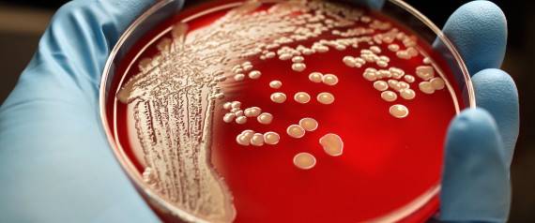
To become resistant to vancomycin, staph bacteria need a new piece of DNA transferred to them from another type of bacteria that is already resistant. Previous studies have found the vancomycin-resistance genes come from another bacterium called Enterococcus, which usually affects very sick people. These genes can be transferred between bacteria very easily both in the laboratory and in the patient's body.
"Bacteria have these pieces of DNA that can move from one to another — it's basically bacterial sex, and they do it a lot. They are very promiscuous," Arias said.
Researchers said there likely was an exchange of genes between some Enterococci and some staph bacteria within the man when he was infected with both bacteria. This exchange made the staph bugs resistant to vancomycin.
Moreover, in the lab studies, researchers found that when the gene was transferred, it could be passed easily from one staph bacterium to another.
"So, there is a strain of staph that has shown before that it can disseminate easily in the community, and has a genetic element that can also be transferred very easily, setting the stage for a breakout," he said.

Nowhere is too far
There's not enough data for scientists to know exactly how commonly MRSA is found in the Brazilian population, or whether other instances of vancomycin-resistance have happened. "This bug could sit happily in people who are perfectly healthy; we don't know if it's already out or not," Arias said.
But if the vancomycin-resistant superbug were to break out, it wouldn't stay confined to one region or country.
"Bugs don't have passports. They don't respect borders. They can travel very easily," Arias said. "And, in fact, this has been shown for MRSA."
There are other drugs available to treat MRSA that have become resistant to vancomycin. However, all of the alternatives are much more expensive than vancomycin, and haven't been around as long, so less is known about them.
"Treating vancomycin-resistant staph would be much more complicated and much more expensive," Arias said. "If it happens in a developing country, it would break the health system."

Pocket-sized anthrax detector aids global agriculture
Source: https://share.sandia.gov/news/resources/news_releases/badx/#.U1Fop6JpKGc

A credit-card-sized anthrax detection cartridge developed at Sandia National Laboratories and recently licensed to a small business makes testing safer, easier, faster and cheaper.
Bacillus anthracis, the bacteria that causes anthrax, is commonly found in soils all over the world and can cause serious, and often fatal, illness in both humans and animals. The bacteria can survive in harsh conditions for decades. In humans, exposure to B. anthracis may occur through skin contact, inhalation of spores or eating contaminated meat.
Melissa Finley’s research in Sandia’s International Biological Threat Reduction Program inspired the detector, which currently is named BaD_{x} (Bacillus anthracis Diagnostic). Finley works with veterinary labs in less-developed countries, helping them improve safety, security and efficiency at diagnosing infectious diseases.

Making labs efficient, safer and more secure
“Working with dangerous samples like B. anthracis spores places laboratory staff at risk. Concentrating many positive test samples in a lab could also tempt someone to steal positive anthrax samples for nefarious uses,” Finley said.
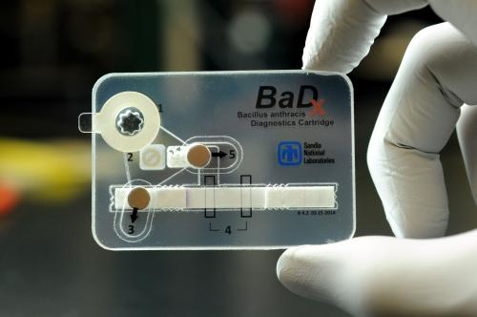
Currently, samples must be propagated in a laboratory that uses specialized tools requiring a consistent power supply not always available in the developing world, Finley said.
But another big barrier is cost.
“Farmers in many developing countries don’t make a lot of money, so they don’t pay for diagnostic testing often. When they do, they can’t afford to pay a lot for it,” said Finley.
The most common diagnostic test for anthrax costs around $30, which is out of the reach of many farmers, perhaps discouraging them from testing animals they suspect as infected, Finley said. The new device, which is more like a pocket-sized laboratory, could cost around $5-7 and does not require specialized tools to use.
The consequences of not testing animals suspected of having anthrax are life-and-death.
“Because B. anthracis forms spores when exposed to oxygen, slaughtering or opening the carcass of an infected animal places many people at risk,” Finley said.

Complex and sensitive, but simple to operate
The device requires no battery or electric power to operate. It’s hardy against wide temperature variation and can detect very small numbers of B. anthracis spores. That could make it especially useful in parts of the world where anthrax is prevalent, but refrigeration and lab facilities are lacking.
The device can be used by a trained technician in the field. The technician would put a sample swab into the amplification chamber, which contains selective growth media. The device then uses a lateral flow assay, similar to a common pregnancy test, to detect the B. anthracis. Magnetically operated valves allow the sample to advance from stage to stage to complete the testing process. A colored line will appear on the device several hours later, if the test is positive for the bacteria.
After testing, the technician can initiate a chemical process that sterilizes the device, which avoids the risk of positive samples accumulating and falling into the wrong hands. In addition to the sterilization process, the device is sealed closed, making extraction of live bacteria difficult.
“The device amplifies the B. anthracis so it can detect as few as 100 spores instead of the typical 1-10 million required for detection,” says device engineer Jason Harper.
Harper and engineer Thayne Edwards developed the microfluidics platform with the patent pending magnetic valves that move the sample through the testing process.
Lead bioscientist Bryan Carson, with technologists Jackie Murton and Bryce Ricken, developed the selective media, and worked on building and testing the device, as well as helping to develop the decontamination strategy.
Nanotechnology researchers George Bachand and Amanda Carroll-Portillo are working on improved strips for the lateral flow assay.
Bill Arndt a researcher in the International Biological Threat Reduction Program, who regularly works in the developing world, provided guidance on device design.
The device was tested by Julie Lovchik of the Department of Internal Medicine at the University of New Mexico, using virulent strains of B. anthracis. Testing at Sandia was done using nondisease-causing strains of the bacteria.
Sandia has licensed BaD_{x} to Aquila, a New Mexico small business that specializes in the design and manufacture of technologies and services for nuclear security and international safeguards.
“We see a lot of potential for government customers and nongovernmental organizations as well as commercial markets,” said Markku Koskelo, chief scientist for Aquila.
The team hopes to use the basic device design to develop tests for other types of disease-carrying bacteria such as salmonella and group A streptococcus, which causes strep throat. Future devices could be created to detect infectious diseases in humans and stem the spread of infectious diseases during epidemics.

‘Level 4’ disease research can be safe, belongs in America’s medical capital
Source: http://www.bostonglobe.com/opinion/editorials/2014/04/13/level-disease-research-can-safe-belongs-america-medical-capital/sShOiraz03EUmSRX9JCueO/story.html

April 13 – Few disaster scenarios capture the anxieties of our age like the sudden emergence of a deadly, invisible disease in a vulnerable population. In the anthrax attacks after 9/11, which were never conclusively solved, a biological agent took the lives of victims who had the misfortune of being exposed to the wrong pieces of mail. Films such as “Outbreak” and “Contagion” contemplate the consequences of deadly microbes proliferating with the help of air travel and the health care system itself. These are precisely the kind of events that Boston University’s National Emerging Infectious Diseases Laboratories facility will prevent, but only if it is allowed to do the kind of research for which it was painstakingly designed and constructed.
Next week, a Boston City Council committee will hold a hearing on Councilor Charles Yancey’s proposed ordinance to ban level 4 research at the biolab. To pass such a measure would be to overestimate any danger that the biolab poses to nearby residents — and to retreat from the singular role that Boston plays as the world’s greatest repository of life-saving expertise.
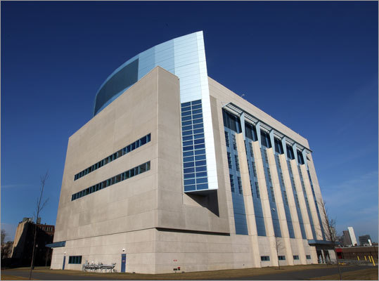
The very existence of the $200 million BU biolab, built mostly with funding from the National Institutes of Health, recognizes that scientific knowledge is humanity’s greatest safeguard against infectious disease. But understanding how to counter so-called level 4 pathogens, which are harmful or deadly to humans and in nearly every case are untreatable, requires working with them. The need to transport such pathogens to a laboratory in an urban setting, along with their continued presence in the building, raises legitimate safety concerns: What happens if a vehicle carrying a level 4 pathogen gets into an accident? What if an act of terrorism or an act of nature breaches the building? What if an employee accidentally — or, worse yet, intentionally — carries a lethal microbe out into the wider world?
These are legitimate questions, and biolab planners have gone to elaborate lengths to address all of them.
That level 4 pathogens are extraordinarily dangerous to infected individuals doesn’t mean they spread easily or quickly. (Smallpox, which is highly contagious, is held by international agreement in only two facilities in the world, and will not be used at the BU biolab.) Regardless, the security protocol for transporting pathogens to the lab is more rigorous than what federal transportation rules require; a tiny vial of pathogen would be surrounded in multiple layers of protective materials and then a hard plastic case, then strapped in the center of a vehicle away from its walls, then transported by two specially trained, background-checked drivers, so that the sample never goes unattended.
As for the biolab facility itself, it’s secure in a variety of ways: Among many other precautions, the perimeter fencing and the structure itself would resist truck bombs; auxiliary generators are housed on the roof in case of flooding; scientists who work in level 4 biohazard areas would clean up after themselves and would be expected to assist with medical emergencies that occur in biohazard areas; elaborate biometric security systems in high-level biohazard areas would require the presence of two scientists, reducing the possibility that one scientist working alone with pathogens could spirit a vial outside.
Recognizing that scientists at BU and the National Institutes of Health could make appropriate provision for all these dangers, former mayor Tom Menino allowed the biolab project to go forward. The controversy has been renewed since his departure; during last fall’s race to elect his successor, most of the candidates, including eventual winner Marty Walsh, expressed trepidation about level 4 research. Yancey, who’s been invited more than once to tour the lab but hasn’t yet done so, depicts his ordinance to ban level 4 research as proper precaution in light of the possibility that safeguards might fail. “I am not convinced,” he says in an interview, “we really need to invite that possibility to the City of Boston.”
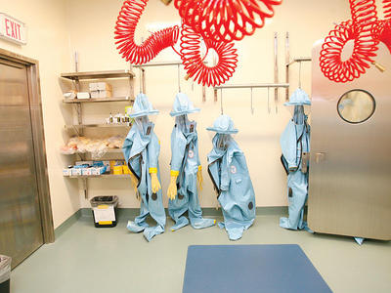
City councilors shouldn’t kid themselves: Shutting down level 4 research will reduce the usefulness of the biolab and its ability to attract top-level scientists. Beyond that, it would hamper the advance of scientific knowledge about infectious disease. The BU facility is equipped with sophisticated equipment absent at many other facilities; some of the research projects that would otherwise occur at the Boston biolab might go to other facilities; but some wouldn’t occur at all.
Besides, most advances in science occur through collaborative effort — from scientists who can confirm, refute, and learn from one another’s work. It’s understandable why critics of the biolab might prefer that the research take place in an isolated facility far from any population center. But banishing this research from Boston, the world’s densest concentration of medical brainpower, would impede scientists’ ability to learn from one another.
Even though auto accidents killed 33,600 people in the United States in 2012, Americans accept that risk because immobility carries enormous costs as well. Day in and day out, residential areas north of Albany Street are at far greater risk from commonplace threats — speeding vehicles, gas leaks, faulty wiring — than from any research at the biolab. City councilors should not simply ignore the extensive safety precautions BU has taken, and they must not shoo aside a major health research facility out of broad cinematic fears. Medical advancement isn’t just one of the Boston area’s core economic engines, but also its greatest gift to the world.

Fears Rise Over MERS Outbreak While Saudis Fumble
Source: http://time.com/72112/mers-virus-saudi-arabia/

The sudden spike in cases of Middle East respiratory syndrome, or MERS, in Saudi Arabia came soon after camel-racing events at the Jenadriyah Festival in Riyadh. That suggested the surge in the incurable coronavirus, which resembles pneumonia but is fatal to 1 in 3 who contract it, confirmed what scientists already knew of the disease: that camels seem to be reservoirs for the virus, and transmit it to humans more easily than humans do to one another.
But with the number of cases picking up, there are worries that may be changing. And if the virus has mutated to increased person-to-person contagion, it has potentially catastrophic implications for another annual festival: the yearly pilgrimage to Mecca and Medina known as hajj. More than a million Muslims from around the globe gather in the western Saudi cities during the first week of October, then return to their home countries, which last year numbered 188. In an age when international travel has dramatically exacerbated the spread of new viruses like SARS, virologists say the mounting concern is only too clear.
The worries are aggravated by the performance of the Saudi government, which has failed to confirm whether the virus is, in fact, mutating. The Saudis have either not performed tests that would reveal the changes, or have not shared them with international authorities, virologists complain. On Monday, Health Minister Abdullah al-Rabiah was fired amid mounting criticism of the kingdom’s handling of the budding crisis.
“It’s frustrating,” says Ian Mackay, an associate professor at the Australian Infectious Diseases Research Centre at the University of Queensland, who compared the Saudi handling of MERS with China’s response to the 2013 outbreak of bird flu. “With the H7N9 virus, China provided almost too much information. You worried about the privacy of some of the patients, given the level of detail that China was providing.
“But we’re seeing the complete opposite extreme in Saudi Arabia, where you can’t even get the sex of the patient in some cases,” Mackay tells TIME. “And the WHO doesn’t seem to be getting that information either.”
Indeed, the World Health Organization as good as confirmed it did not have the latest information from Riyadh in declining to comment on the outbreak on Tuesday afternoon. “Kindly be advised that we cannot comment on latest MERS figures since we do not have the latest case count,” the WHO’s media office says in an emailed reply to questions from TIME. “And we can only communicate and comment on the cases that we have been officially notified of by a member state, namely Saudi Arabia.”
Concerns that the virus may have mutated are focused on two clusters of cases among health care workers: one cluster is in Jeddah, the western Saudi city through which pilgrims pass en route to nearby Mecca. The other cluster is among paramedics in Abu Dhabi, in the United Arab Emirates.
Mackay, who noted the clusters in his blog, says he can see two possible explanations: “One is a fairly bad but widespread breakdown of infection control and prevention protocols” among the health care workers — that is, nurses or doctors failing to use gloves, surgical masks or other standard measures designed to prevent infection while working with a MERS patient. Such a breakdown would be possible even in a well-equipped and prosperous Gulf nation, Mackay noted, but for both outbreaks to take place at the same time “would be fairly coincidental.”
The other, more alarming possibility? “The other avenue is the virus has changed and become more easily transmitted between humans,” Mackay said.
That is cause for concern way beyond the Middle East. “When humans readily transmit to humans, that’s what will cause a worldwide outbreak,” Michael Osterholm, director of the Center for Infectious Disease Research and Policy at the University of Minnesota, told National Public Radio. “We are very concerned that … with what we’ve seen over the last two weeks … we may be at that point now.”
Whether the virus has, in fact, mutated dangerously cannot be known until the Saudis examine the genome of the latest samples of the virus and share the results. The WHO has said it is “working closely” with the kingdom, but has not issued any conclusions. Another way to find out if the virus has mutated would be if the number of cases were to skyrocket. But with only 344 cases worldwide so far — a decade ago, SARS infected at least 8,000, and killed 775 — the count remains low, and awareness is growing.
In 2013, concerns over MERS kept many as a million people away from hajj, an obligation that the Koran imposes upon any Muslim who can afford the trip. Saudi authorities discouraged attendance by the very young, the elderly, pregnant women, and people already suffering from chronic illness, a major risk factor for the virus. Still, more than 3 million people circulated at the holy sites for five days, at close quarters. With the risk of mass contagion in the air this year, the world may be hoping for a better reaction from Saudi Arabia than it has got so far.

PathSensors introduces portable pathogen identifier system
Source: http://www.homelandsecuritynewswire.com/dr20140424-pathsensors-introduces-portable-pathogen-identifier-system

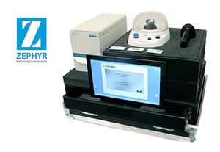
Baltimore, Maryland-based PathSensors, Inc., an environmental testing bioscience company, has introduced the portable Zephyr Pathogen Identifier system. The company says it delivers rapid, reliable detection of bacteria, virus, and toxins in powder and liquid samples in minutes.
The Zephyr Identifier uses CANARY (Cellular Analysis and Notification of Antigen Risks and Yields) technology, which is licensed from the MIT-Lincoln Laboratory. With CANARY biosensors, the rapid kinetics and signal amplification of cell-based signaling enables pathogen detection at sensitivities down to 50 cfu/pfu within five minutes.
Zephyr detects foodborne pathogens such as salmonella, e.coli, listeria, and campylobacter in dry foods, meats, and on food preparation surfaces; something which is significant issues for food producers. The company say that currently it isengaged in programs with the USDA and FDA to identify pathogens in poultry and plant materials.
“The portable Zephyr is as an easy-to-use, field deployable pathogen identification system, typically requiring less than a half hour of operator training,” explains Ted Olsen, president of PathSensors. “The user interface walks the operator through each assay step, making the system extremely user-friendly.”
PathSensors is currently working with other government organizations, including first responders, to deploy the portable Zephyr system in the field to provide detection of biological risks. “Typically, field samples are transported to regional laboratories for identification testing which can take critical hours,” Olsen explains. “Zephyr technology enables quick testing onsite in minutes.”
The comoany notes that at launch, it is offering reagents for rapid identification of the most common bio-threat agents. Initially, these pathogens include anthrax, ricin, botulinium toxin, smallpox, the plague, and tularemia.
The new Zephyr system expands PathSensors’ line of instrumentation which includes the BioFlash-AF Identifier for aerosol collection and identification of airborne pathogens in the ag-poultry environment, using a single sample.
PathSensors says it now offers a complete line of instrumentation that can identify biological agents in any sample matrix: powder, liquid, or aerosol. The instruments can be used as standalone or as part of an integrated biological detection system.
The existing product line also includes the BioFlash-E Biological Identifier, a high-volume aerosol sampler for building, event, and mailroom applications.

