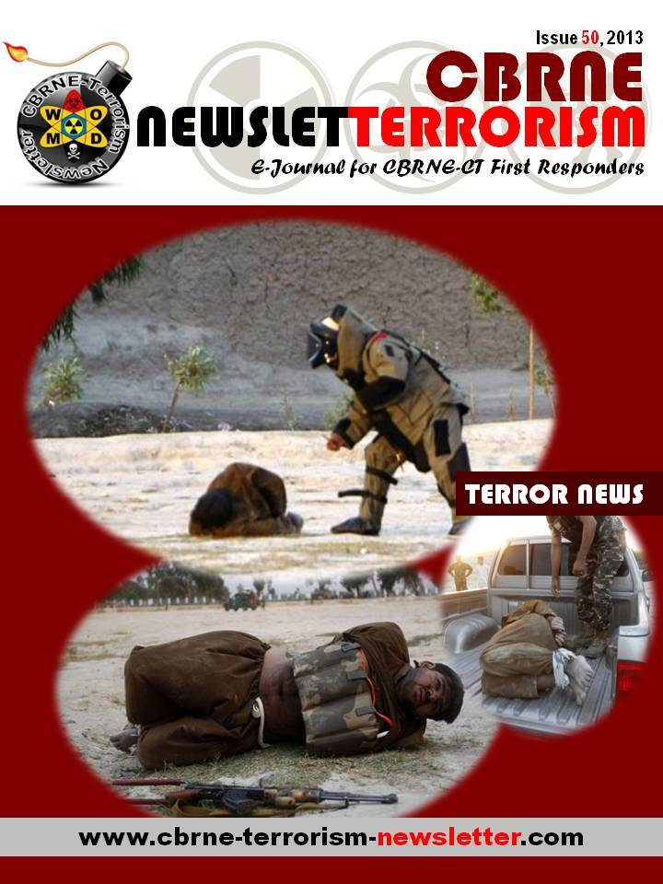

New breed of terror in N. Ireland
Source:http://www.terrorismwatch.org/2013/06/opinion-new-breed-of-terror-in-n-ireland.html?utm_ source=feedburner&utm_medium=email&utm_campaign=Feed%3A+terrorismwatch%2FJTvK+%28Terrorism+Watch%29&utm_content=Yahoo!+Mail

On June 17 and 18, the political world's focus will be on Northern Ireland, where the Group of Eight summit will take place.
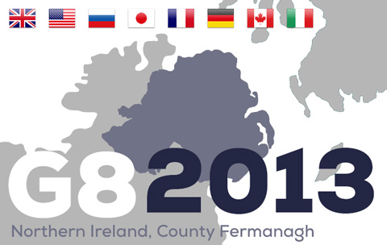
Although this is a region defined by its violent history, the summit is already proving to be one of the most complex and wide-ranging security operations Northern Ireland has ever seen. Thousands of additional police officers are being brought in from England, Wales and the Republic of Ireland to assist.
During the 2005 event, which took place in Scotland and was the last G8 summit in the UK, four al Qaeda-inspired men detonated bombs on the London transport network, killing 52 people and themselves.
Although any kind of incident at or around the summit venue itself remains unlikely, there is the risk of a terrorist attack timed to distract from the event. But this year, unlike the 2005 attack, the focus is on a very different kind of group.
If you thought Northern Ireland's troubles were a thing of the past, you'd be forgiven. A brutal terrorist campaign over 35 years that saw almost 4,000 deaths came to an end thanks to a hard-fought political process. What that took should not be underestimated. Years of painstaking mediation and negotiation, risky moves by brave politicians on all sides and the crucial involvement of the U.S. saw hope prevail, despite the occasional setback that threatened destabilization.
Communities on both sides of the social and political divide cautiously welcomed the peace process and its negotiated settlements. The "Troubles" seemed finally to be over. Former paramilitaries agreed to lay down their arms, and once-sworn enemies eventually learned to share power.
Yet, peace in Northern Ireland is still described by many as fragile. In recent times, riots, gunfire and petrol bombs have returned to the streets. The "flag protests," which defined the end of 2012 and the beginning of 2013, have again highlighted the inherent divisions in Northern Irish society. The Union flag, flown proudly over Belfast City Hall for so long, was lowered after a vote by the City Council. Some among Northern Ireland's Unionist community were outraged. Protests escalated.
But it is not the rioters and flag protesters who pose the most persistent threat to this fragile peace. Another group watches from the sidelines. They are the "dissident" Republicans, splinter groups that have grown in size and impact since the peace process saw the end of the Provisional IRA as we once knew it.
The dissidents are responsible for a growing wave of low-level bombings, shootings and threats across the region. They insist that only armed resistance can force Britain's withdrawal from Northern Ireland and lead to a united Ireland. While most people in Northern Ireland view the peace process as having brought stability, the dissidents reject it.
Though tactically proficient, the dissidents lack strategic acumen. On the surface, they are united by the idea of "Brits out," with aspirations to achieve a united Ireland through violence and their disdain for the Sinn Fein leadership and the peace process that it has embraced.
Traditionally, dissidents have been split by local differences, ideological divergences, petty jealousies and competitive personalities. "Dissident Republican" came to describe a range of groups. One calls itself the Real IRA. Then there's the Continuity IRA and Óglaigh na hÉireann, Gaelic for Irish Volunteers.
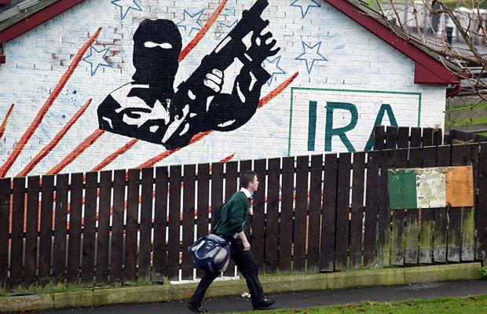
There has been talk of a merger to unite the disparate factions. In July, the "New IRA" was announced: a merger of the Real IRA, the Derry-based Republican Action Against Drugs and other previously non-aligned Republicans. But the Continuity IRA stayed aloof from the alliance.
The new group's members and supporters may number in the few hundreds, but it seems their ranks are growing. They have killed soldiers, police officers and most recently a prison officer. They continue to target Northern Irish police stations, with weaponry of growing sophistication. They shoot suspected inner-city drug dealers north and south of the Irish border to help embed themselves in their communities while simultaneously undermining the police.
These dissident factions are capable of causing sometimes extensive disruption with actual or hoax improvised explosive devices. Just last year, police in Northern Ireland recovered an armor-piercing rocket that included the plastic explosive Semtex in the city of Londonderry.
We have monitored the dissidents' steady rise, logging thousands of events and documents in the process.
What does it all add up to?
In short, the threat posed by dissident Republican groups is evolving, and probably for the worse. Their activity has increased. Their recruitment efforts continue to expand. Many of these new recruits belong to a different generation from their forerunners. They weren't even born at the time of the 1994 Provisional IRA cease-fire, and some of the older members are senior ex-IRA members who bring much needed political acumen, as well as expertise in bomb-making, recruitment, training and targeting.
Their activities span the country, north and south, with mostly urban concentrations in Belfast, Derry, Dublin and Limerick. There is increasing evidence of training and recruitment in the Irish Republic, with evidence for some logistical support appearing in England.
True, they don't have the kind of support once enjoyed by the Provisional IRA. But the dissidents don't just acknowledge their lack of popular support. They embrace it. They revel in their "noble isolation."
Terrorism analysts have come to associate this particularly dangerous kind of thinking with Islamist terrorist groups, not Irish Republicans. Yet Ireland's newest dissidents are a different breed and pose new threats.
In responding to recent dissident activity, Northern Ireland's politicians have been vocal. We hear, time and again, "Nobody wants a return to the old days," "They have no mandate" and "They will never win." Those same clichéd responses never deterred the Provisional IRA. In defiance, and in an appeal for support, the dissidents claim the ability to bring their "struggle to a successful conclusion through military operations."
The 100th anniversary of the Easter Rising, when the progenitors of Irish Republicanism were executed by occupying British forces, is in 2016. Just like their IRA predecessors, the dissidents draw their inspiration and legitimacy from an unyielding view of the past yet find a steady stream of eager recruits in the present.
In the years leading up to 2016, it is likely that the dissidents will try to strengthen their support and perceived legitimacy through a proliferation of attacks. They will promote themselves as the true heirs of the 1916 Republicans, heirs who can finally bring about a united Ireland through one last campaign of force.
The IRA itself was once just a ragtag bunch of self-appointed guardians of an age-old mission that found relevance in contemporary events. A remorseless logic in what the dissidents say reveals why they are unpredictable, dangerous and ambitious.
We have become dangerously complacent about the dissident Irish Republicans. We hope we are wrong, and the G8 summit in County Fermanagh does not become a platform on which they can bring international attention to their campaign.

Mogadishu’s Dilemma: Who’s in Control?
By Muhyadin Ahmed Roble
Source: http://www.jamestown.org

Over the past two years, Somalia’s fragile security has improved slightly following the retreat of the al-Qaeda-associated insurgent group al-Shabaab from the Somali capital of Mogadishu and other urban areas of south and central Somalia.
Because of the pressure coming from the African Union Mission in Somalia (AMISOM) and Somalia’s national army, al-Shabaab has chosen to switch to a guerrilla-style warfare that is better suited to the movement’s strengths than attempts to seize and hold territory at a time when the movement is experiencing a military decline and growing divisions in its leadership.
Though Somali government officials heralded the group’s withdrawal from Mogadishu as the end of an era, the reality remains different. Al-Shabaab has evacuated its known military bases but continues to maintain a presence there. Control of the city is divided between two shifts in which government soldiers and al-Shabaab alternate as the dominant force according to the time of day.
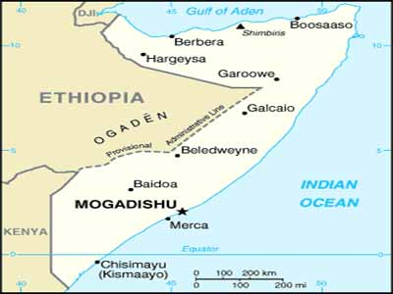
Speaking to a pro-Shabaab radio station in Somalia on May 9, senior al-Shabaab leader Shaykh Abdulkadir Ali Mumin mocked the Somali government’s calls for foreign investment and the return of diaspora Somalis, both based on the government’s alleged control of the capital. Shaykh Mumin claimed that his group still controls Mogadishu’s southern districts of Huriwaa, Yaqshid and Dayniile during the night (Somaliweyn.org, May 9). This is not just a claim; it is a fact that residents in these areas will affirm. When the sun goes down, government soldiers in these districts rush to their bases to avoid taking casualties in the dark from al-Shabaab’s fighters.
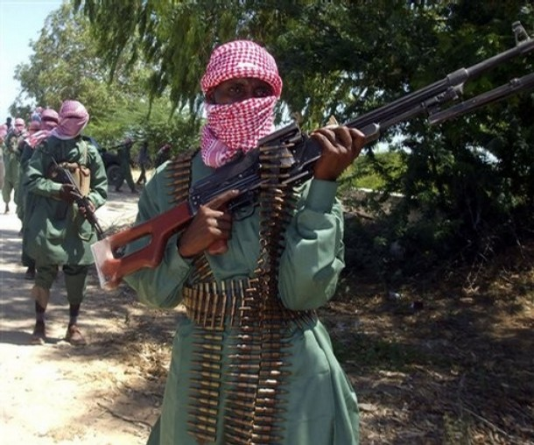
During al-Shabaab’s “nightshift,” members of the group who were present in the streets of these districts as ordinary people during the day punish those who assisted government soldiers during the “government’s shift.” For instance, Somali president Hassan Shaykh Muhammad’s May 5 visit to the southern district of Dayniile only increased the number of people who were punished by al-Shabaab during the night. Two days after the president’s visit, al-Shabaab fighters attacked the house and took the life of a traditional elder who was among the people who welcomed the president. His body was recovered in the morning (Somaliweyn.org, May 9).
The Dayniile district is a home turf of al-Shabaab spokesman Shaykh Ali Muhammad Raage and remains one of the group’s strongholds in the capital. A number of people, including government soldiers and young residents thought to be members of al-Shabaab, have been killed in the district since the militants’ withdrawal from Mogadishu. District chief Muhammad Abdi Yusuf confirms al-Shabaab’s presence in Dayniile and their intention to use the district as a base from which to plan suicide attacks and bombings in the capital (warqabad24.com, December 18, 2012).
There are clear indications that al-Shabaab is still capable of destabilizing Mogadishu and providing a significant challenge to the government’s efforts to restore security in the capital. In April, al-Shabaab fighters seized the country’s Supreme Court complex in Mogadishu for several hours in a surprise attack before blowing themselves up, killing more than 35 people, mostly civilians (Hiraan.com, April 14). The attack happened just days after British intelligence agencies warned of a possible terror attack in the capital, but Somalia’s government downplayed the warnings through its minister of information, Abdullahi Hersi Elmoge, who said the Somali security forces had not identified any threats out of the ordinary (Africa Review [Nairobi], April 7).
In another attack, eight people were killed on May 5 when an al-Shabaab suicide bomber crashed into a government convoy transporting a Qatari aid delegation on Mogadishu’s busiest road, the KM4 leading to the airport. One of the vehicles belonged to Somali Interior Minister Abdikarim Hussein, though the minister was not in his car at the time. The attack happened one day after the city’s main roads were reopened after a four-day closure by government soldiers due to a high level security alert (Garowe Online, May 5).
The recent attacks have raised questions regarding the government’s ability to provide security, a task the Somali president said was his government’s “first, second and third priority” during his inauguration last year (Hiraan.com, September 16).
The Somali government is now planning to launch a special military operation in the capital’s southern parts, where the militants are believed to have hideouts. According to military sources, a recently trained 1,000-strong elite force is expected to deploy in the capital this month in 120 distinctively colored military vehicles equipped with advanced radio and alarm equipment (Sabahi Online, April 18; May 2). Efforts have been made to ensure that the new Somali army is free of tobacco use, alcohol use and the use of drugs, particularly qat, a chewable plant popularly used as a stimulant in Somalia, Yemen and parts of the Horn of Africa.
Addressing the army at their base in southern Mogadishu on April 18, President Mohamud urged the troops to defeat al-Shabaab, saying the future of the nation is in their hands. There is, however, another foe that must be defeated first – the continuing indiscipline of the Somali armed forces. The former militiamen, who often go unpaid for months, routinely take to the estates and streets of Mogadishu to rob the people and city they are supposed to protect, thus becoming yet another element of Somalia’s security challenges.
Some members of the army have gone so far as to construct illegal roadblocks in Mogadishu to extort vehicles moving through the capital. Just last year, there were more than 60 illegal roadblocks in and around Mogadishu run by government soldiers, pro-government clan militias and freelance militias. A few months after being dismantled, some of these checkpoints are now back in place. In November, the president himself noticed that most rape cases in Mogadishu involve government soldiers who often kill their victims and witnesses to their crimes (Hiiraan.com, November 25, 2012; Daily Nation [Nairobi], February 22).
The indiscipline of Somalia’s security forces may be one reason that some residents of Mogadishu prefer al-Shabaab fighters over government soldiers. Under al-Shabaab control, residents might only feel insecure if they had links with the government or disobeyed the militants’ orders, but in the government controlled areas there are hundreds of reasons to be insecure, including fear of being caught in an exchange of bullets between factions of the government army. As long as government troops remain undisciplined, al-Shabaab will remain a preferred choice for some people. What matters most now is not necessarily the numbers and tactics of the military, but rather the government’s ability to impose discipline over the security forces and provide salaries in a timely fashion that would help discourage alternative and illegal methods of obtaining funds needed to survive

.
Muhyadin Ahmed Roble is a Nairobi-based analyst for the Jamestown Foundation’s Terrorism Monitor publication.

The Mobile Threat: Multiple Battlefields Ensure Instability in the Sahel/Sahara Region
By Andrew McGregor
Source: http://www.jamestown.org

There are signs that the scattered remnants of the Islamist coalition that occupied northern Mali for nine months are beginning to use their financial resources and pre-planned alternative bases to regroup in the Sahel/Sahara region in order to carry out new operations against their targets – the “apostate” governments of the region, local security infrastructure and the considerable French economic interests and personnel found in the region. Though the Islamists took heavy losses in the French-led intervention that drove them from northern Mali, the extremist groups were not trapped and destroyed in the hastily conceived operation. Rather, they have been relieved of a strategic disadvantage, the fixed occupation of certain territories, and regained their number one tactical asset – mobility.
An examination of the regional and international aspects of the ongoing struggle in the Sahel/Sahara helps shed some light on the direction the battle between the Islamists and African states is taking at the half-way point of 2013.

Southern Libya: A Hub for Terrorism?
Southern Libya remains in turmoil, with frequent clashes between African Tubu nomads and Arab tribes preventing effective security measures from being implemented. According to Jouma Koussiya, a Tubu activist, one of the main problems is the government’s reliance on northern militias and northern commanders to provide security in the region, a policy that is actually weakening government control in southern Libya: “They know nothing about the region and they ultimately fail. Now tribes are working together to form a unified military council in order to secure the region, instead of the government” (AP, June 3).
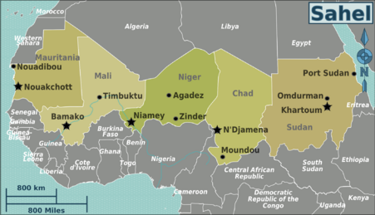
There are also unforeseen dangers to be encountered; on Libya’s southern border with Chad, five members of the Martyr Sulayman Bu-Matara Battalion doing border patrols were recently abducted during a prolonged firefight by gunmen believed to be from Chad (al-Hurra [Benghazi], June 2; al-Tadamus [Benghazi], June 1; May 30). One of the main problems in securing the south remains the unwillingness of northern troops and militia members to serve in the harsh and unfamiliar conditions prevailing in the Libyan Desert. To remedy this, Prime Minister Ali Zeidan has announced that bonuses of $1,200 will be paid out to soldiers and militia members willing to work in the region. The announcement is part of a new government strategy to secure the towns and cities of the region first before beginning a second phase of operations to secure and monitor the vast border regions of the south (AFP, June 2).
Libyan Prime Minister Ali Zeidan insists claims that the attackers who struck a military barracks in the Nigérien city of Agadiz and a French uranium facility near the Nigérien town of Arlit on May 23 came from southern Libya are “without basis,” saying that the export of terrorism was a practice of the Qaddafi regime but would not be tolerated in “the new Libya” (AFP, May 28). Defense Minister Muhammad al-Barghathi also denies that there is any security crisis in Libya, suggesting the situation is “stable,” asserting that the militias are doing important work under the control of the Defense Ministry and refuting reports that French security services are tracking al-Qaeda in the Islamic Maghreb (AQIM) elements in southern Libya by claiming that “the al-Qaeda organization does not exist in Libya” (al-Jadidah [Tripoli], May 28; June 2).
Prime Minister Zeidan’s “no problems here” approach to the security crisis in southern Libya has been strongly criticized by some observers within Libya who maintain terrorists have created bases in southern Libya (al-Watan [Tripoli], May 28). Usama al-Juili, the defense minister in the Libyan Transitional National Council that preceded the current General National Congress (GNC) government, has expressed a different view of the security situation in the Libyan south:
The terrorists who had been moving from Libya toward Mali are currently reversing course. Which is to say that they are now heading from Mali toward Libya. So I am not astonished that southern Libya has been turned into a new sanctuary for the terrorists fleeing north Mali. Algeria was right when the country spoke out against the war in Mali. It knew the consequences of it. Algeria, though, has the resources to cope with a new geographic reconfiguration of terrorism after the military offensive in north Mali. As for Libya, it does not have these resources... Closing borders is something useless (Le Temps d’Algerie, June 13).
The disarray in the Libyan security structure prevents effective measures from being taken to secure the south, with the anomalous inclusion of largely independent militias within the security structure creating confusion and insecurity throughout Libya.
Libyan army chief-of-staff General Yusuf al-Mangush, generally viewed as a supporter of the militias, resigned under popular, military and governmental pressure following the June 8 massacre of protesters calling for the disarmament of the Libyan Shield militia that left 31 killed (including four members of the army’s Thunderbolt Special Forces unit who arrived to quell the violence) and 60 wounded. The new acting chief-of-staff, General Salim al-Qnaidy, has warned that “patience is running out with the militias” as he attempts to implement a GNC decision to “end the presence of all brigades and illegal armed formations in Libya even if the use of military force is required” (Quryna al-Jadidah [Benghazi], June 12; Libya News Network, June 9). The Libyan Shield-1 headquarters in Benghazi has since been occupied by government troops belonging to the al-Sa’iqah Special Forces and their heavy weapons seized (al-Watan [Tripoli], June 9). The Libyan Shield-1 commander, Wissam bin Hamid, has taken to the airwaves to denounce the protesters as Qaddafi loyalists and traitors to Libya even as other Libyan Shield bases are scheduled to be occupied by units of the national army (al-Tadamun [Benghazi], June 9; al-Watan [Tripoli], June 9).
The approach of the Libyan political leadership reflects the difficulty of the new Libyan government in asserting its writ in that nation – acknowledging that the government is incapable of controlling its own security situation is to admit the government does not have sovereignty over Libya and is in need of foreign intervention.

A French Role in Libya?
French foreign minister Laurent Fabius indicated two weeks ago that France must “make a special effort on southern Libya,” presumably in excess of the modest Libyan requests for advice and training and equipment for border guards (Libya Herald, June 2). Despite Libyan signals that it intends to grapple with its deteriorating security situation by itself, French Defense Minister Jean-Yves Le Drian appeared to hold out the possibility that French forces could be available for a mission in southern Libya if Tripoli desired it: "Libya is a sovereign country that is responsible for its own borders. It has to decide whether it wants extended support from the French or any other European country to secure its borders" (AFP, June 2). Rumors in Libya of an imminent French military intervention in the south prompted a denial from French President François Hollande, who cited the absence of a UN mandate or a request from Libyan authorities for military assistance (AFP, May 31).
President Hollande, who is struggling to gain control of a French African foreign policy that has traditionally been in the hands of a select group of military and business interests, has described a new three-track policy in Africa that will include military training and support, environmental preservation and an emphasis on development that could involve opening European markets to African exporters (Fraternite Matin [Abidjan], June 6). Hollande has also signaled French willingness to provide military assistance at the request of regional governments.
However, a growing military commitment in Africa does not necessarily fit with new cuts to the French military budget that will see a reduction in the number of troops, reduced helicopter capability and a cut in the number of armored vehicles amongst other measures. General Jean-Philippe Margueron, the army second-in-command, has warned that a planned reduction in training raises the possibility of mission failure and the production of “cannon fodder” rather than combat-capable troops (Le Monde [Paris], June 11).
France is now looking to purchase 12 MQ-9 Reaper drones from the United States, with two of these to be permanently deployed in Africa to replace the aging Harfang drone systems currently based alongside U.S. drones in Niamey (AFP, June 11). While the Reapers are the choice of the French Air Force, the defense ministry has said Israel will be looked at as an alternative provider if a deal cannot be made with the United States. France is certain to seek weaponized versions of the Reapers, though Washington has so far been reluctant to provide armed drones to any purchasers, including its NATO allies (Defense Industry Daily, May 31).

Niger – The Latest Target
According to Nigérien President Mahamadou Issoufou, there is little doubt that the suicide bombers that struck a military base in Agadez and a French uranium plant in Arlit on May 23 came from southern Libya: “For Niger in particular, the main threat has moved from the Malian border to the Libyan border. I confirm in effect that the enemy who attacked us... comes from the (Libyan) south, where another attack is being prepared against Chad” (AFP, May 28; RFI, May 27). [1] The Libyan Ministry of Foreign Affairs responded to Issoufou’s statement by saying it “did not serve the interests of the two countries” and there was “no evidence of the participation of Libyan elements” (al-Manara, May 27).
Malian security officers say the attacks may actually have been planned by radical Islamists in Tarkint, a town in the remote Tilemsi Valley, which has served as a stronghold for the extremists (RFI, May 31). However, there are also reports from sources in Niger that the May 23 attacks were planned in Derna, a Cyrenaïcan Islamist stronghold on the Mediterranean coast (Jeune Afrique, June 9). The Nigérien intelligence service claims that the jihadists who escaped from Mali are now concentrated in the Ubari and Sabha Oases region of southwest Libya (Jeune Afrique, June 9; for the situation in Sabha, see Terrorism Monitor, April 19).
Rhissa ag Boula, formerly a leading Tuareg rebel in northern Niger and now a special adviser to the Nigérien president, says that: “The south of Libya, where anarchy reigns, has become a safe haven for the terrorists hunted in Mali” (AFP, June 1). Another veteran Tuareg rebel leader and current MNLA spokesman Hama ag Sid’Ahmad confirmed the Malian and Libyan origin of the attackers, who belonged to the AQIM-related Movement for Unity and Justice in West Africa (MUJWA) and operated under the coordination of Mokhtar Belmokhtar’s al-Mua'qi'un Biddam Brigade (“Those Who Sign in Blood”):
The terrorist groups got to that region through the Malian and Libyan borders. It’s not complicated; the borders are real sieves. Since [Mokhtar] Belmokhtar is the main organizer, without his presence and that of certain drug barons, MUJWA would not exist… Even if the terrorist leaders no longer have major military resources and they are having mobility difficulties, they have money. They are quietly trying to reorganize, forget the leaders' quarrels, and unite in order to fight together. It's the presence of the French Special Forces that is preventing them from reorganizing quickly… (Le Temps.d’Algerie, May 27).
So long as Niger refuses to meet Libyan demands for the extradition of Mu’ammar Qaddafi’s son Sa’adi (who lives under house arrest in Niamey) and several other ex-members of the Qaddafi regime, little can be expected in the way of security cooperation between the two nations. Tripoli has indicated its unhappiness with the Nigérien approach by repatriating thousands of Nigériens working in Libya whose remittances helped support many citizens of this deeply impoverished nation. With nothing in the way of employment waiting for them in Niger, these returnees may eventually pose a new security threat in Niger.
Niger is also having trouble hanging on to terrorists it has under detention; on June 1, 22 prisoners, including several convicted terrorists, were freed from a high-security prison in Niamey by three gunmen. One of those who escaped was Alassane Ould Muhammad "Cheibani," a Gao region Arab with a history of prison escapes. Cheibani was serving a 20-year sentence for the December, 2000 assassination of William Bultemeier, a U.S. Embassy defense official in Niamey and the 2009 murder of four Saudi Arabians in northern Niger. Cheibani is also a prime suspect in the 2008 kidnappings of Canadian diplomats Robert Fowler and Louis Guay (RFI Online, June 4). [2]

Mali – Between Stabilization or a New War
In northern Mali’s Kidal region there is still no resolution to the differences between the Tuareg rebels of the Mouvement National de Libération de l’Azawad (MNLA – a secular separatist movement) and the central government in Bamako. The situation is growing critical as Malian troops continue their slow progress towards Kidal, which they have announced they are determined to enter despite the MNLA’s promise to oppose their entry. Mahamadou Djeri Maiga, the vice-president of the MNLA’s political wing, has promised that: “If we are attacked, it will be the end of negotiations and we will fight to the end” (AFP, June 4).
With the Malian army looking for revenge against the MNLA and their supporters for the January 2012 massacre of Malian troops taken prisoner in Aguel Hoc, there are signs that renewed clashes are inevitable. Most notable of these indications was the heavy fighting between MNLA rebels and Malian government troops that took place near the village of Anefis on June 5. This time, the MNLA withdrew, but once they are pinned up against the Algerian border in Kidal they will have to choose between further resistance or the abandonment of their cause (and the consequences that will follow). The Malian troops, under the command of two of Mai’s most capable officers, Colonel Didier Dacko and Colonel Hajj ag Gamou, were accompanied by roughly 100 French troops, though it was uncertain whether they were there to aid the Malian army or to impede the outright defeat of the MNLA, which worked closely with French forces in finding and destroying Islamist elements hiding in the Idar des Ifoghas mountains.
A Malian government spokesman denounced what he described as “ethnic cleansing” in Kidal on June 4, promising that Malian troops would enter Kidal soon (L’Essor [Bamako], June 4). The charge of “ethnic cleansing” was in response to the MNLA’s arrest of dozens of Black Malians (mostly Peul/Fulani and Songhai) in Kidal during a hunt for “infiltrators” sent to the city by Malian military intelligence (RFI , June 3; AFP, June 3). Tensions in the city were reflected in a suicide bomber’s attempted assassination on June 4 of an MNLA colonel believed to have close ties to the French military (AFP, June 4).
The MNLA and the Malian government are once more at the negotiating table in Ougadougou, with Bamako working from the position presented in a UN Security Council resolution that the MNLA must lay down its arms and allow the Malian military to enter Kidal in return for negotiations by the next president regarding the status of Azawad. The MNLA believes it has already made sufficient concessions by abandoning its demand for independence and accepting the July elections (RFI, June 8). There is internal pressure in Bamako to press the administration to carry on the return of the Malian army to Kidal. Malian members of parliament declared in early June that they would not participate in the July elections if the Malian army was not present in Kidal (Info Matin [Bamako], June 4). The High Council for the Unity of Azawad (HCUA), founded in Kidal on May 19, largely from former members of rebel groups, has joined the MNLA in presenting a single position in the Ouagadougou negotiations.
Tuareg negotiators have indicated they are ready to sign a document advanced by the Burkina Faso mediators that would allow Malian troops to enter Kidal in advance of the planned July elections, but Bamako’s representatives have indicated they have reservations about the agreement, which would see rebels be confined to cantonments with their weapons in return for a “special status” for Azawad (northern Mali – a term Bamako does not wish to see in the document). Bamako is seeking complete disarmament and the pursuit of the arrest warrants issued for many Tuareg rebel leaders accused of various crimes before and during the Islamist occupation of northern Mali (AFP, June 13).
The African troops currently deployed in Mali are expected to be absorbed in several months by the United Nations Multidimensional Integrated Stabilization Mission in Mali (MINUSMA), a 2,600 man force under the command of General Jean-Bosco Kazura of Rwanda, with a second-in-command from Niger and a French chief-of-staff. Though Chad was looking to take command of the mission, a poor interview by the Chadian candidate for command appears to have precluded this possibility and with it, the possible participation of Chadian forces (RFI, June 11). Additional troops may come from China, Bangladesh, Burundi, Honduras, Norway and Sweden, with a 1,000 man French rapid reaction force (Jeune Afrique, June 13).

Conclusion
Chadian president Idriss Déby has warned of the threat posed by terrorist groups now based in southern Libya, not only to his own country, but also to Europe, and has called for an international intervention to enable Libya to form a secure and functioning state that is not a threat to its neighbors. There is a danger of seeing this struggle as consisting of several different theaters defined by national boundaries, when this is contrary to the jihadist conception of this conflict, which is essentially borderless. AQIM, which was once largely restricted to activities within northern Algeria, has expanded into a number of related movements with operatives in Mauritania, Mali, Niger, and Libya and the potential to ally with other groups such as Boko Haram and Ansar al-Shari’a. With their mobility restored, the Islamist Jihadists of the Sahel/Sahara will continue to take advantage of regional political rivalries, underequipped militaries and fears of neo-colonialism to rebuild their movement. Libya’s inability to secure its restless south and its readiness at the highest levels of government to ignore terrorist infiltration present the most immediate and most important challenges in restricting jihadist operations. Unless real international security cooperation can be established, the Islamist extremist groups may soon emerge with the upper hand in the struggle for the vast territories of northern Africa.

Notes
1. For the attacks in Arlit and Agadez, see Andrew McGregor, “Niger: New Battleground for North Africa’s Islamist Militants?, Jamestown Foundation Hot Issue, May 29, 2013, http://www.jamestown.org/programs/hotissues/single-hot-issues/?tx_ttnews[tt_news]=40932&tx_ttnews[backPid]=61&cHash=7c12e2e7bda14085101f67dc09adf5fa
2. U.S. Embassy Bamako Cable 09BAMAKO106, February 23, 2009.

Andrew McGregor is the Senior Editor of Global Terrorism Analysis and the Director of Aberfoyle International Security, a Toronto-based agency specializing in security issues related to the Islamic world.

The Rise of Narco Submarines
Source:http://www.marsecreview.com/2013/06/the-rise-of-terror-groups-narco-submarines/?goback=. gde_1878638_member_248315525

An international drug trafficking ring that for two years smuggled cocaine into Europe inside crates of frozen fish has been smashed, Brazilian police announced on Tuesday.
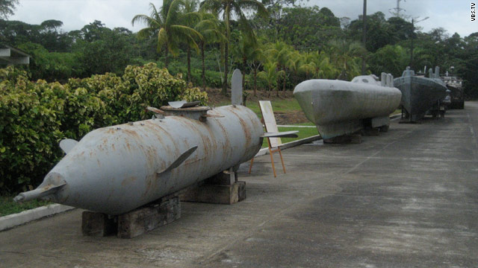
With the help of the U.S. Drug Enforcement Administration, forces from five different countries arrested a Colombian, two Portuguese, three Spaniards and five Brazilians.
Federal police inspector Paulo Teles said the cocaine, which came from Colombia and Bolivia, was hidden inside bags of ice used to pack the fish in southern Brazil and then flown to Portugal. Assets belonging to the gang worth $5 million have been seized.
The case illustrates the increasingly inventive methods that drug interdiction authorities have to deal with in the continuing war on narco-terrorism.
In the Caribbean, U.S. authorities have in the past year found that semi-submersible and fully submersible vessels are the narco-terrorists’ transportation method of choice.
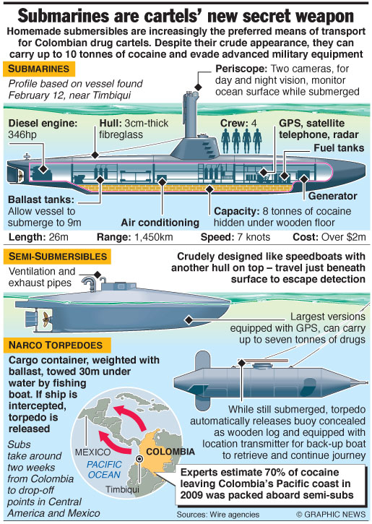
The submarines, or narco subs, typically tend to be low-slung, diesel-propelled vessels, usually painted a dark shade to blend with the water.
They are often built by independent contractors who are willing to sell the vessels to any group offering the right price.
The shifting trends in contraband distribution will be discussed at IDGA’s Counter Narco-Terrorism and Drug Interdiction event in September.
In the last year, the U.S. Coast Guard has come across at least three models of a new and sophisticated drug-trafficking submarine capable of traveling completely underwater from South America to the coast of the United States.
The fully submersible vessels can hold up to 10 tons of cocaine and, in an effort to avoid detection, surface at night to charge their batteries off the onboard diesel engine.
For the USCG, the narco subs represent a radical departure from the traditional speed boats and high-powered fishing and leisure boats that are much easier to spot.
From the subs, the drugs are unloaded in shallow waters or transported to shore by small boats.
Cmdr. Mark J. Fedor of the Coast Guard described, in an interview with the New York Times, the new breed of narco subs as “the Super Bowl of counter-narcotics.”
He said: “When you hear one is moving, you say: ‘Wow. Game on’.
“These vessels are seaworthy enough that I have no doubt in my mind that if they had enough fuel, they could easily sail into a port in the United States.”
Working within the constraints of budget restrictions, the new counter narco-terrorism push is part of a larger shift to new areas of focus for the nation’s security and intelligence agencies after years in Iraq and the oncoming withdrawal fromAfghanistan.
Aside from USCG ships, drones and aircraft combing the waters, a sophisticated command center has been established that combines intelligence from various U.S. agencies and from other nations in the region, which are increasingly cooperating to battle cocaine trafficking.
The enemy is usually Colombia’s FARC group which uses cocaine to fund its operations, plus the various Mexican drug cartels.
The command center, in Key West, is officially known as the Joint Interagency Task Force-South. It has a staff of 600 with the Departments of Homeland Security, Justice, State and Defense all being represented.

IDGA’s Counter Narco-Terrorism and Drug Interdiction summit is being held in Miami from September 16-18. For full details, go to www.CounterTerrorismEvent.com

Fire Wars: June 2013
Source: http://econwarfare.org/

The fire raging in Colorado Springs forced William (Bill) Scott and his wife Linda to evacuate their home. Last we spoke, Bill didn't know if they'll have a home to return to.
As of Saturday afternoon, June 15, the apparent arson that set Colorado's Black Forest on fire last Tuesday killed at least two people and destroyed and damged more than 388 homes. The fire that burned 15,500 acres led to the evacuation of 38,000 people. The six-hour delay of federal air tankers to help extinguish the fast spreading fire didn't help. All the while, local law enforcement and firefighters have been collecting whatever evidence they can find to identify the arsonist(s).
Bill Scott, who's a senior fellow at ACD, warned about such a scenario last July, speaking at the ACD/EWI Economic Threats briefing on Capital Hill. An expert on aerial firefighting, he presented a sobering analysis of the devastating Waldo Canyon Fire, pointing out that the striking rise Western U.S. wildfires may be caused by elements other than nature.
He noted that in spring 2012, al-Qaeda's English-language online magazine, Inspire, published an article called "It Is of Your Freedom to Ignite a Firebomb," which featured instructions on how to build an incendiary bomb to light forests on fire.
A few months later, Russia's security (FSB) chief, Aleksandr Bortnikov warned, "al-Qaeda was complicit in recent forest fires in Europe" as part of the terrorists' "strategy of a thousand cuts."
Bortnikov spoke of "extremist sites [that] contained detailed instructions of waging the 'forest jihad' and stressed that such a method had proved itself effective as it inflicted both physical and moral damage, needed little training or investment and it was extremely hard for police to find and apprehend the arsonists."
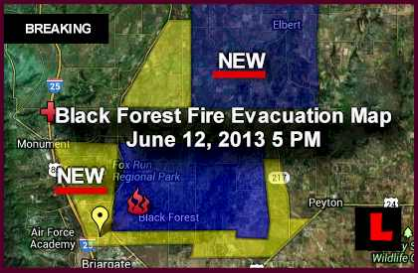
Since then, more fatwas advocating that "Fire is cheap, easy and effective tool for economic warfare" have been issued. They've included detailed instructions for constructing remote- controlled "ember bombs, and how to set fires without leaving a trace."
Fire wars are not limited to Europe and the U.S. Palestinan jihadists have been setting fire to Israel's modest forests for many years. However, political correctness seems to override Israeli and Russian warnings of that jihadist modus operandi. How many Tzarnaevs are hiding in Colorado's woods?
While many of the fires that have scorched millions of acres and destroyed thousands of homes in Arizona, California, Colorado, New Mexico, Utah and other states have been identified as arson, none have been publicly attributed to criminal or terrorist groups, despite the presence of Mexican gangs and large number of other illegals in our Western states
Bill Scott's "Fire Wars" presentation on YouTube led several Colorado legislators to propose a bill to allow the formation of Colorado's Firefighting Air Corps. "In military terms, Colorado is a target-rich environment - an arsonist's dream-come-true, and the U.S. Forest Service's worst nightmare," as Scott said while giving a riveting testimony before the state Senate a few months ago. He went on to say that
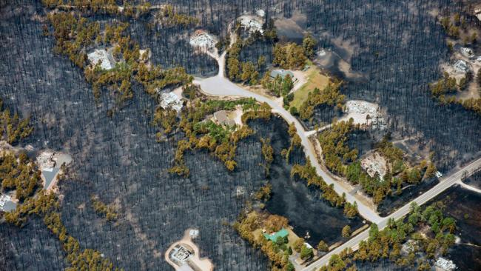
"Colorado wildfires took six lives, destroyed 647 homes and consumed $48 million in fire suppression costs. And we are one match or lightning strike away from a disaster that will make 2012 look like a GOOD year.
"Consider this scenario: A hot day with humidity levels below 10 percent. High winds, blowing into a dead-end valley, toward a picture-perfect town on the shore of a large mountain lake. Also watching the weather, an Islamic jihadist decides, 'Today's the day.' He takes off in a rented Cessna 172 and flies across the mouth of that valley, pitching lighted road flares from the airplane. In a matter of minutes, a wall of fire with flames topping 200 feet roars up that valley, trapping hundreds of tourists and citizens.
"The local U.S. Forest Service district ranger issues a top-priority emergency call for fire-fighting air tankers, noting that lives and property are in imminent danger. A harried federal dispatcher responds with this chilling truth: 'We're out of air resources. We're fighting fires all over the nation, and all federal assets are committed. You folks are on your own.'
"Within hours, the small Colorado town burns to the ground and hundreds of trapped people die horrific deaths. After-action reviews conclude that the deadly fire was ignited by an al Qaeda terrorist - who was never caught - and all fatalities were attributable to 'insufficient firefighting resources.' If large air tankers had been deployed in a timely manner, a protective corridor through the conflagration could have been created, providing an escape route.
"Some will scoff and dismiss that scenario as mere fiction, noting that Colorado has never suffered such a disastrous fire. True, but we're in a new era, facing a perfect storm of unprecedented elements: Drought; tinder-dry beetle-kill trees blanketing millions of acres; a real-and-present terrorist threat; and a cash-strapped, dysfunctional federal land-management agency that has less than a dozen large air tankers to serve the entire nation."
Indeed, a state firefighting airforce would make Colorado independent of the cash-strapped, dysfunctional federal land-management agency, reducing the response time from six hours to 20 minutes. Colorado's Senate Bill 245 was reluctantly approved last April by the Democratic majority; however, it refused to allocate the funds necessary to buy the air tankers. It was signed into law last week by Colorado's Governor John Hickenlooper.
Ironically, Bill and his wife had to evacuate exactly one week after the unfunded bill was signed into law, and the worst fire in Colorado history was raging, endangering the state's citizens, its forests and economy.
In California alone, during the first two weeks of June, wild land fires have already surpassed the total cost of the last two years of firefigthing in rural areas.
Most U.S. state economies seem to be rebounding this year. However, recovery from anticipated natural disasters could easily deplete their treasuries. There is little that can be done to prevent huricane destruction. However, states, as well as the federal government, could and should more to do to minimize the effects of man-made forest fires.

Morsi Appoints Member of Terrorist Group Governor of Province They Terrorized
Source: http://www.nationalreview.com/corner/351270/morsi-appoints-member-terrorist-group-governor-province-they-terrorized-patrick

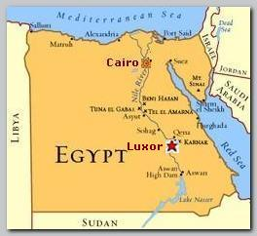
Egyptian president Mohamed Morsi recently appointed 17 new local governors this weekend, seven of them from his party, and one from a decidedly problematic one: The new governor of Luxor belongs to the political wing of Gamaa al-Islamiyya, which is not only a terrorist group but the organization that perpetrated one of the worst terrorist attacks in Egyptian history in Luxor, where they slaughtered four Egyptians and 58 foreign tourists in 1997. (The Blind Sheikh, who orchestrated the 1993 World Trade Center bombing, was a member of the terrorist group, too.)
Gamaa al-Islamiyya now has a radically Islamist political party associated with it that, while it’s renounced terror and violence, still wants to turn Egypt into a theocratic state — which would, among other things, mean destroying all the “pagan” monuments that pay the bills in Egypt, banning alcohol, etc.
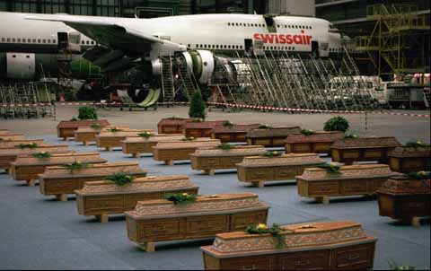
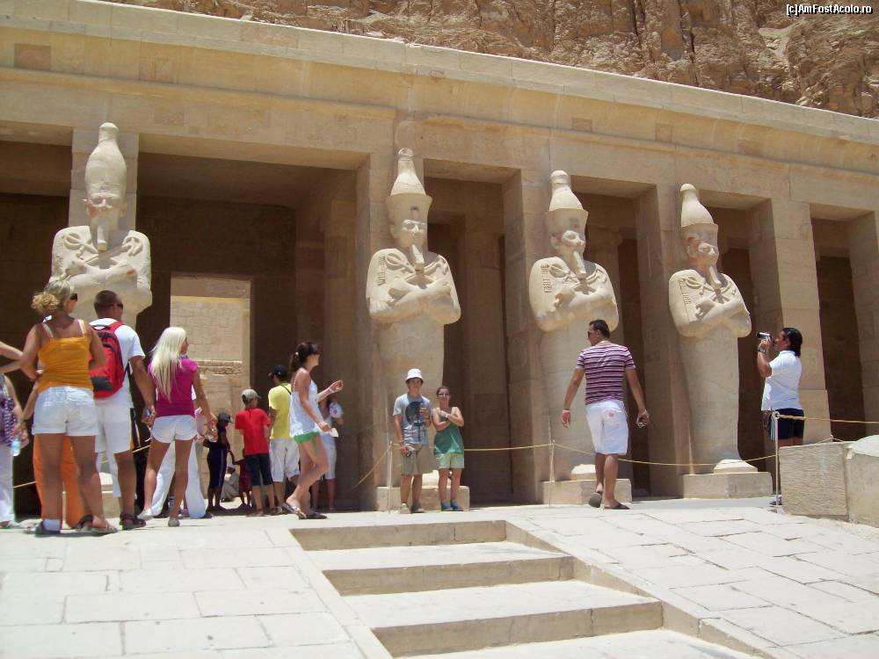
Morsi’s appointments were distributed in a way that seems intended to shore up his position and play down concerns that he’s consolidating a Muslim Brotherhood dictatorship — he picked a number of military officers and members of other political parties. His selecting a member of Gamaa al-Islamiyaa’s party to represent Luxor, then, is offensive and stupid, but also represents Morsi’s efforts to deal with the fact that there are a lot of ultra-Islamist Egyptians who supported the idea of overthrowing the Egyptian state and replacing it with an Islamic one, and basically still do. Witness the fruits of Muslim (quasi-)democracy.
Gamaa al-Islamiyya and other groups’ campaign of Islamist terror in Egypt in the 1980s and 1990s was more than just deadly — at times it pretty much crippled the Egyptian economy, too, because the country relies so heavily on tourism. Mubarak’s government made fighting these groups a priority and eventually broke the back of this Islamist insurgency; that made the place a good deal safer for tourists (whether the AK-armed “Tourist Police” that blanket popular sites are security theater or not is sort of unclear), though the attacks haven’t stopped entirely. Unrest in the Sinai since the Muslim Brotherhood government took over has raised concerns over how willing and capable Morsi’s government is with regards to fighting terrorism, and their decision to appease one such group with a governorship doesn’t seem like a good sign.

W African piracy outstrips Somalia
Source: http://www.iol.co.za/news/africa/w-african-piracy-outstrips-somalia-1.1533951#.UcHUmNi9bPo
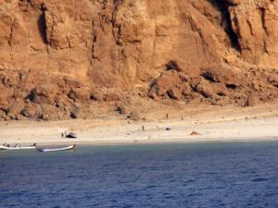
File image - An aerial view taken from a NATO military helicopter shows boats at a beach said to be frequented by pirates near Somalia's northern port town of Bossaso. REUTERS/NATO/Handout

Dakar, Senegal - A new report says piracy affected more ships and sailors off West Africa than off Somalia's coast last year.
The report drawing on data from the International Maritime Bureau said nearly 1 000 seafarers and fishermen were attacked by pirates armed with guns or knives in the Gulf of Guinea. More than 200 people were taken hostage.
The report said attacks on commercial ships in West Africa have become more frequent and are now occurring across a broader geographic area. Pirates in the region are aided by weak navies and coast guards, as well as a lack of awareness about the threats they pose.
The cost of piracy in West Africa totaled up to $950 million last year, the report said.

Should Brazil Be Concerned About Terrorism at the Olympics, World Cup?
Source: http://www.theworld.org/2013/06/should-brazil-be-concerned-about-terrorism-at-the-olympics-world-cup/
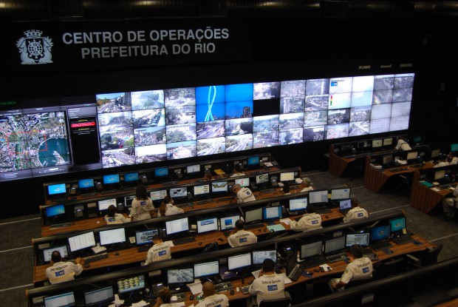
The Rio Operations Center has more than 400 cameras watching the city. Built to monitor traffic and weather, it will offer security help for the Olympics and World Cup. (Photo: Jason Margolis)

As Brazil gets ready to host the Olympics 2016 and World Cup next year, the country won’t just be dealing with threats from civil unrest. There’s also the threat of terrorism.
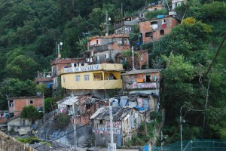
I spoke with a lot of people in Rio de Janeiro and asked, could something like the Boston Marathon bombings happen here? Here’s how most everybody answered.
“We don’t have these kinds of problems. We have other problems, not these kinds of problems,” said Renato Cosentino, with the human rights organization Global Justice.
He, and many Brazilians, often talk about crime concerns, but terrorism is something that happens in far off places. The Boston Marathon bombings did rattle some nerves though, said Tim Vickery, World Soccer Magazine’s South American correspondent.
“It was front page news here on the kind of weekly news magazines: Are we prepared?”
The group responsible for planning the Olympics, Rio 2016, has emphasized that security is a top priority, and has expressed full confidence in hosting a safe event, a point echoed by government officials at various levels.
That vote of confidence is largely justified, said Vickery, because authorities here have lots of experience dealing with mass events, such as Rio’s Carnival every year.
Rio’s security planning for the World Cup and Olympics has been squarely aimed at “pacifying” the city’s favelas. (Photo: Jason Margolis)

“They know the vulnerable points in their city, it’s a huge show of strength on the streets. But the level of sophistication needed to combat a terrorist threat, that’s something that they’re not particularly used to,” said Vickery.
For that, the Brazilians are looking to outside help, people like Jim McGee with The Soufan Group, a security consulting firm headquartered in New York. McGee spent two decades with the FBI working a lot of big sporting events, Super Bowls, the World Cup, and the Olympic Games.
McGee said terrorism may seem like an exotic threat to most Brazilians, but there is reason for concern.
“When you invite the world to your country, you invite not only all of the sporting teams and the fans, but you invite most of the problems that are occurring globally as well.”
McGee compares the situation in Brazil today to Greece, which hosted the Summer Olympics nine years ago.
“In 2004, we brought over, and when I say we I mean the FBI, we brought over subject-matter experts that we were able to embed right with their counterparts, within the Greek Hellenic National Police, the Greek Coast Guard, etc., the first responder agencies, their fire department,” said McGee. “So that they had our experts right there in an advisory role in the event of an incident or a crisis.”
McGee said he hopes the FBI – along with British, Australian, and Israeli security experts – will be in Brazil as well.
Rio state police officers are already working with the FBI and Spanish police, exchanging information about things like anti-terrorism tactics and chemical threats.
In Rio, the city government recently opened a new command and control center, a facility spurred by the upcoming Olympics. The room has 70 operators, in shifts, that monitor the city’s operation with more than 400 cameras installed at strategic points in the city. The room contains the largest screen in Latin America.
I took a tour of the control center with Victor De Martino, who works for the city of Rio as an international communications adviser. We stood on a balcony overlooking about 30 people monitoring the TV’s.
“These guys are responsible for the cameras, they can zoom in and zoom out the cameras, they can turn (them) around,” said De Martino, motioning at the people working below.
This room was designed primarily to monitor traffic and weather incidents, such as threats from mudslides. The state government just opened up its own control center nearby, solely dedicated to security. But it’s all integrated said De Martino.
“One of these guys might see, well there’s something weird there. Then he’s going to call the guy on the left, who is the guy from the police in the gray suit, ‘Look, there’s something weird there.’ And then they can use this information.”
De Martino adds, there will be many more cameras trained on Olympic facilities.
Security expert Jim McGee said these eyes all around are critical for mega sporting events. In Boston, for example, surveillance cameras helped identify the alleged Marathon bombers.
“In London, you can’t go anywhere where you’re not under the view of a camera. And that contributed to why the London Olympics went so well without an incident,” said McGee.
McGee said so far, overall, Brazil is taking the necessary steps to meet the security challenges posed from outside threats. That’s reassuring, but it is coming at a steep cost.
Street protesters in Brazil this week have been railing against the tens of billions of dollars being spent on preparations for the upcoming World Cup and Olympics.
Precise spending figures are fungible, as is the specific security budget. Anyway you add it though, Tim Vickery said for many Brazilians, all this hassle and cost just isn’t worth it.
“We were quite happy in our little backwater, in our little tropical backwater, not having any enemies. So there is a downside to hosting the world.”
Of course, there’s an upside too. If the World Cup and Olympics go off without a hitch, billions of people will see Brazil at its finest. Then maybe some of the costs and preparations won’t seem so severe.

TWA Flight 800 Crash: Documentary Will Prompt New Probe Into Deadly Plane Explosion
Source:http://main.aol.com/2013/06/19/twa-flight-800-crash-docu_n_3464822.html?1371646819&icid= maing-grid7|htmlws-sb-bb|dl9|sec1_lnk3%26pLid%3D331970

Former investigators are pushing to reopen the probe into the 1996 crash of TWA Flight 800 off the coast of New York, saying new evidence points to the often-discounted theory that a missile strike may have downed the jumbo jet.
The New York-to-Paris flight crashed July 17, 1996, just minutes after the jetliner took off from John F. Kennedy Airport, killing all 230 people aboard.
The effort to reopen the probe is being made in tandem with the release next month of a documentary that features the testimony of former investigators who raise doubts about the National Transportation Safety Board's conclusion that the crash was caused by a center fuel tank explosion, probably caused by a spark from a short-circuit in the wiring.
"We don't know who fired the missile," said Jim Speer, an accident investigator for the Air Line Pilots Association, one of those seeking a new review of the probe. "But we have a lot more confidence that it was a missile."
In a petition filed Wednesday seeking to reopen the probe, they say they have "reviewed the FAA radar evidence along with new evidence not available to the NTSB during the official investigation and contend that the NTSB's probable cause determination is erroneous and should be reconsidered and modified accordingly."
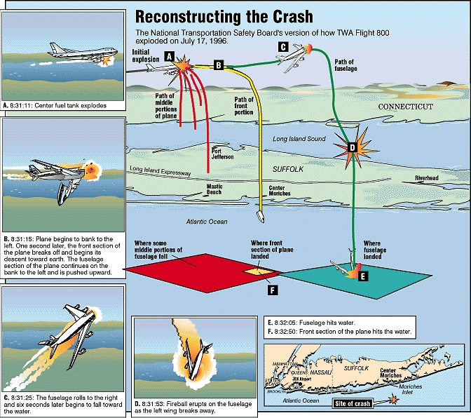
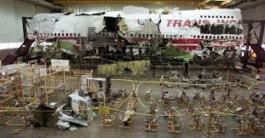
Those calling for a review of the investigation include former NTSB accident investigator Hank Hughes and Bob Young, a former senior accident investigator for the now-defunct TWA. Tom Stalcup, a physicist and co-founder of a group called Flight 800 Independent Researchers Organization, also questions the NTSB's original findings and is featured prominently in the documentary, which is slated to air on the 17th anniversary of the crash next month.
The NTSB issued a statement Wednesday morning saying it is aware of the upcoming documentary.
"All petitions for reconsideration are thoroughly reviewed, and a determination is usually made within about 60 days," spokeswoman Kelly Nantel said. "While the NTSB rarely re-investigates issues that have already been examined, our investigations are never closed and we can review any new information not previously considered by the board."
She noted the TWA Flight 800 investigation lasted four years.
"Investigators took great care reviewing, documenting and analyzing facts and data and held a five-day hearing to gather additional facts before determining the probable cause of the accident during a two-day board meeting."
Robert Francis, the former vice chairman of the NTSB who headed the investigation, declined to comment.
The former investigators calling for a new probe say new evidence that a missile may have taken down the jet includes analysis of radar of the jetliner.
Speculation of a missile strike began almost immediately after the crash. Theories that an errant missile may have been fired from a U.S. military vessel were widely refuted, but conjecture about a shoulder-fired missile launched by terrorists in a small boat has never completely gone away.
The petitioners contend that the testimony of more than 200 witnesses who reported seeing streaks of light headed toward the plane should be reconsidered. The NTSB said after the first investigation that it found no evidence of a missile strike. It explained that what witnesses likely saw was the jetliner pitching upward in the first few moments after the explosion, but some witnesses still maintain that the streak of light they saw emanated from the waterline and zoomed upward toward the plane.
The petition filed with the NTSB to reopen the probe claims "new analyses of the FAA radar evidence demonstrate that the explosion that caused the crash did not result from a low-velocity fuel-air explosion as the NTSB has determined. Rather, it was caused by a detonation or high-velocity explosion."
John Seaman, the longtime leader of an organization of TWA 800 victims' families, noted there have been several attempts over the years to reopen the investigation.
"Unless something was to develop that would be very clear and compelling, then a lot of these interested parties are not really helpful," said Seaman, whose niece died on the flight. He spoke to The Associated Press in a telephone interview from upstate New York on Tuesday, ahead of the formal filing of the petition.
"They reopen wounds," he said of the petitioners. "Personally I can't keep going over it again and again. I think most families feel that way."
The documentary airs on the EPIX premium television channel. An EPIX spokeswoman declined to say how much the filmmakers were paid for the documentary.

The Book That Killed Terrorism
By Qasim Rashid
Source: http://www.huffingtonpost.com/qasim-rashid/the-wrong-kind-of-muslim_b_3446002.html
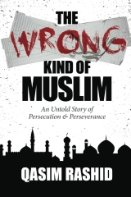

The Wrong Kind of Muslim: An Untold Story of Persecution & Perseverance (Print and Kindle e-Book) launches on June 19th and begins with this Rage Against The Machine lyric: "Now renegades are the people, with their own philosophy, they change the course of history, everyday people like you and me." This is because some 20 million members of faith minorities in Pakistan are dying to introduce themselves to every day people like you and me -- pun intended.
Since 9/11, terrorists in Pakistan have killed over 40,000 people -- and counting. The Wrong Kind of Muslim is the true story of the journey into the heart of that terrorism to unearth the untold story of those faith minorities silenced by Taliban suicide bombings, secret police torture, and state sponsored religious persecution. It is the horrifying truth about growing radicalism in Pakistan and its impact on Western security. But most importantly, it is the inspiring, untold, and finally uncensored story of the millions fighting back -- and winning.
This book comes after too many have paid an irreplaceable price. Over 125 Ahmadi Muslims have been martyred in cold blood in just the past three years alone. The government and vigilantes have championed every form of discrimination against Ahmadi Muslims, even exhuming deceased Ahmadi Muslims -- only because of their faith. And most horrifically, the persecution of Ahmadi Muslims is just the beginning.
As The Wrong Kind of Muslim reveals, this terrorism is not limited to just the Ahmadiyya Muslim community. The body of a murdered eleven-year-old Christian boy in Faisalabad is uncovered -- lips and nose sliced, and stomach removed. Every day, another Hindu woman is raped, "converted" to Islam, and forcibly married. Shia genocide shows no sign of ending. And as far as atheists in Pakistan are concerned, I've been advised they "don't exist."
These are our fellow human beings.
This is where The Wrong Kind of Muslim fights back and says enough is enough. This book is a call to unite those of all faiths and of no faith to conquer the common enemy that is oppression of conscience -- to conquer terrorism. This is not just a story of what has gone wrong in Pakistan; it is also the story of what is going right in the world; a revolution to free the billions oppressed worldwide, a revolution to end terrorism.
And sure, I could tell you to read The Wrong Kind of Muslim because U.S. Senator Tim Kaine's back cover endorsement reads, "Rashid's heartfelt story compels admiration for him..." Or because leading American scholar of Christianity and Islam, Butler University Professor Dr. Philip Jenkins, calls it "A significant and alarming book that demands attention as a passionate call for peace and toleration." Or because former Harvard human rights fellow Beena Sarwar describes it as a "must-read for anyone who cares about human rights in Pakistan and worldwide." I am even privileged to have Princeton University Professor Dr. Atif Mian write the foreword (he describes me as "A bigot's worst nightmare.")
But as privileged and grateful as I am to have these, and other, gracious endorsements -- they are not the primary reason you should read The Wrong Kind of Muslim.
You should read The Wrong Kind of Muslim because there are millions in Pakistan and billions worldwide who need their stories heard -- who are dying to introduce themselves to you. And unless we listen to and act upon these countless (previously censored) voices, we risk condemning not only their future -- but also our own.
For this is not a story of just them. This is the story of us all. And in the global village we call Earth, our only hope at survival is to work together against the universal problem that is oppression of conscience. Some 5.25 billion people worldwide live under some form of oppression of conscience. That means that in 2013, only the minority enjoys true freedom of conscience.
Thus, The Wrong Kind of Muslim sets out to make today's minority tomorrow's majority. We can do this. But first we must be renegades with the philosophy that we will change the course of history. And we shall do it through ordinary people like you and me. Together we will end terrorism. So when anyone asks you why you read The Wrong Kind of Muslim, it really is simple.
Because countless suffering people needed someone to hear their voice, and unlike billions worldwide -- you had the unique freedom to listen.

Qasim Rashid is an award winning member of the Muslim Writers Guild of America, having co-authored and co-edited two books, (Towards a Greater Jihad and By the Dawn's Early Light). He is a National Spokesperson for the Ahmadiyya Muslim Community and serves as a Muslim Chaplain for Virginia State Prisons. Qasim is currently completing his third book, a non-fiction, The Wrong Kind of Muslim: An Untold Story of Persecution, set to be released later this year. He received his Bachelors of Science degree in Marketing from the University of Illinois at Chicago, and his JD at the University of Richmond School Of Law. At Richmond Law, Qasim founded the Muslim Law Student Association. He is a vocal human rights activist, prolific writer and a frequent lecturer on American-Islamic issues across a wide range of media.

Counter-Agroterrorism 101
By Patrick Rose
Source: http://www.domesticpreparedness.com/Infrastructure/CIP-R/Counter-Agroterrorism_101/

An “all-hazards approach” to disaster preparedness includes manmade disasters, which in large part are attempts of various forms of aggressors – for example, state-sponsored or non-state actors – to violently destroy life and property. The malicious intent of any aggressor is to undermine a sense of security, destabilize a government’s ability to function, and severely disrupt the economy. All of which is the reason why the protection of critical infrastructure and key resources (CIKR) has been a major focus in the nation’s efforts to prevent aggressors from: (a) successfully executing an attack; and (b) meeting their objectives. The primary focus of current CIKR plans and policies, though, seems to be on securing the nation’s transportation and energy infrastructure – and, by doing so, sometimes neglecting food security (i.e., animal and agriculture).
The U.S. food supply represents a high-risk vulnerability for the entire nation. What is officially referred to as the Food and Agriculture Sector of the U.S. economy – and, therefore, the nation’s food industry as a whole – contributes upward of $1 trillion to the U.S. Gross Domestic Product. In fact, as Agriculture Secretary Thomas Vilsack pointed out in a press release on 1 February 2013, U.S. agricultural exports alone accounted for $478 billion from 2009 through 2012, largely because the United States is one of the dominant producers of the world’s grain supplies.
In addition, as the American Farm Bureau Federation notes on its website, an estimated 15 percent or so of the total U.S. workforce is employed in the food industry, in jobs ranging from animal and agriculture stewardship and processing to selling food products at local markets.

Food – An Easy & Desirable Target
These statistics demonstrate not only how integral and important the Food and Agriculture Sector is to the nation’s overall economy, but also how attractive the food industries may be as potential targets for terrorist attack. Perhaps less attention has been given to preventing terrorist attacks against the Food and Agricultural Sector because the potential death toll following an attack on any link in the food chain – production, processing, supply, and distribution – would be much less than, for example, a deliberate biological weapons attack in a large metropolitan city. Nonetheless, a successful attack on the nation’s food supply could lead to disastrous economic losses and raise understandable doubt about the nation’s ability to secure its own food supply.
Today, unfortunately, that sector has several exploitable vulnerabilities that make securing the food at each stage an almost impossible task. Production facilities – farms, for example – are widely scattered throughout the nation, are easily accessible by would-be terrorists, and usually have little if any security. In addition, each step within the food production pipeline – from maintaining to processing livestock and/or distributing the food – is highly concentrated, making a large-scale and surreptitious contamination attack much easier to carry out.
During the last quarter of 2012, the U.S. Food and Drug Administration (FDA) recorded on average up to six recalls of food products per day. Most of the recalls were because of unintentional food contamination. Moreover, according to the U.S. Centers for Disease Control and Prevention’s website, an estimated 48 million Americans suffer annually from various foodborne illnesses, 128,000 of that number are hospitalized, and 3,000 die.
There have been numerous prominent examples of mass poisonings, both planned or accidental, in recent years – for example, according to the U.S. Centers for Disease Control and Prevention, the salmonella contamination of peanut butter in 2009 infected 714 people nationwide – that not only illustrate how vulnerable the nation’s Food and Agriculture Sector really is but also give potential aggressors optimism that intentional attacks would have a high likelihood of success.
Compounding these obviously exploitable vulnerabilities is the widely accessible arsenal of biological agents now available to would-be terrorists. The plant and animal pathogens that could be used as biological weapons are much easier to acquire than deadly human pathogens are – or probably ever will be. Moreover, because most plant and animal pathogens do not put the people who handle them at risk during the mass production or release stages of an attack, they are much more desirable weapons than are human pathogens that could harm or kill the aggressors themselves.
In addition to the ease of acquiring plant and animal pathogens, the delivery mechanisms of introducing these same biological agents are relatively simple to use – or misuse. In most cases, the pathogens are highly contagious and could rapidly spread through crops or animal populations dispersed over fairly large geographic areas. A major related problem is that any medical countermeasures used are rather limited when it comes to protecting plants and animals. That deficiency means in turn that the rapid spread of a biological weapon introduced against a plant or animal can often be stopped only after the susceptible crops or livestock are destroyed.

The Role of the U.S. Private Sector
In developing a plan of action to protect the Food and Agriculture Sector, the burden cannot fall entirely on state and local law enforcement agencies – primarily because of the many strategic challenges they would face in carrying out this mission by themselves. Efforts certainly have been made to develop effective strategies for protecting the sector – at the federal level, for example, beginning with Homeland Security Presidential Directive 9 (i.e., Defense of United States Agriculture and Food) issued in 2004.
Nonetheless, several federal agencies, such as the U.S. Department of Agriculture (USDA) and the Food and Drug Administration, have been struggling, with limited resources, to effectively secure the nation’s food and agriculture on their own. However, even as many federal, state, and local agencies have been stressing the importance of a truly integrated engagement, with the private sector heavily involved, to expand and improve the nation’s all-hazards preparedness capabilities, it also has become apparent that the private sector itself can play a critical role in the overall protection of the nation’s food supply.
It is equally important that members of the private sector also understand the risks and consequences of unintentional contamination as well as the connection between food safety and their businesses’ bottom lines. Paralleling the governmental efforts to integrate food-safety mechanisms will help the private sector contribute to a larger, significantly enhanced, and more effective nationwide food defense strategy. Moreover, although federal resources are limited, there have been several actions taken to expand and facilitate the private sector’s engagement in food defense. For example, the U.S. Department of Agriculture already supplies tools to assist the private sector in developing its own plans and strategies.
In addition, a recent effort by the U.S. Food and Drug Administration – creation of a new software program (Food Defense Plan Builder) – also assists the private sector in developing a customized food defense plan. The new software allows private industry to review current gaps and areas for improvement, as well as to make changes needed to provide greater protection against the threats posed by the intentional release of any biological agent.
Of course, the success of such efforts will continue to be dependent on the intended audience applying the cautionary steps needed. For a nationwide food defense system to be truly comprehensive, affordable, and capable of mitigating threats that could put the entire nation at risk, the private sector must work more closely and more effectively with local, state, and federal agencies to coordinate their combined efforts and close the vulnerability gaps still threatening the entire nation.

Patrick Rose, a Senior Analyst at Gryphon Scientific, holds a Ph.D. in Microbiology and Immunology from Oregon Health and Science University. Prior to joining Gryphon Scientific, he was a senior policy analyst at the Center for Health and Homeland Security. He managed numerous projects through the Homeland Security Exercise and Evaluation Program and was an instructor for the Senior Crisis Management Training Program at the U.S. Department of State Office of Anti-Terrorism Assistance. His tenure includes positions at the National Institutes of Health and the Los Alamos National Laboratories. In addition, he was a National Research Service Award postdoctoral fellow at the University of Pennsylvania. In the spring of 2011, he was recognized for his research as one of the top 100 International Academics worldwide by the German Scholars Organization and the President of Germany. He also is an alumnus of the Emerging Leaders in Biosecurity Initiative through the Center for Biosecurity at the University of Pittsburgh Medical Center.

Emperor’s new clothes – Terrorism
Source: http://buckssecurity.wordpress.com/2013/06/22/emperors-new-clothes-terrorism/
Editor’s Comment: This paper was posted at the blog site of Bucks New University Security. Parts in red are comments by Prof Phil Wood, Head of the Department of Security and Resilience at Buckinghamshire New University.

I came across a short article today in Insurance Journal concerning 'The Many Faces of Terrorism' that is a classic case of stating the blindingly, staringly obvious, badly. I have had to read through it several times to try to identify anything that is convincing or correct. With this kind of expertise out there, you can be sure that the future of insurance and risk estimation remains bright! My bold below:
“The recent attacks in London, Paris and the Boston marathon bombing are evidence that terrorists are resorting to simpler tactics,” said Mark Lynch, the head of Political Risk Model Development at Aon Benfield’s Impact Forecasting. “They have more opportunities and can use household products [knives in London and Paris, easily available chemicals in a pressure cooker in Boston]. It’s difficult to stop.” Terrorism per se is difficult to stop; the size of the assailant group, once committed to and engaged in an attack is relevant only in the amount of damage they can cause. Much more relevant and important during preparation phases when contact between individuals and groups makes them vulnerable to interception. The fact that terrorists can use household products is nothing new; and their tactics have always been simple; the complexity of their weapon of choice is variable. 9/11: box cutters used as the trigger for the delivery of the main weapon, the aircraft and the shock effect.
The threat to society from lone individuals and organized groups, dedicated to committing violent acts to express their grievances, has been a fact of life for a very long time. In the past the main targets were public officials, most prominently the assassination of Archduke Duke Franz Ferdinand in 1914, which set off the First World War. Since the dawn of time in fact. Most prominent? JFK/Bobby Kennedy; Hariri; Margaret Thatcher (Brighton); Benazir Bhutto; Pope John Paul II...
More recently, however, terrorists have greatly expanded their targets, planting bombs in public places, hijacking airplanes, kidnapping or holding hostage workers and business people [the recent siege of a gas plant in Algeria] and committing other random acts of violence. Protracted mayhem now occurs almost on a daily basis in many countries, notably Syria, Iraq, Afghanistan, Somalia and Pakistan, which are, or are close to becoming, war zones. That is because they are either war zones or there is organised activity. Terrorists have been doing the majority of the things listed here for many years. Organisations like the IRA did not spring up in the 1970s.
While western and more developed nations aren’t in that category, they are nonetheless exposed to the threat of terrorism. The U.S., the UK, Spain, Germany, Lebanon and elsewhere have all been hit by terrorist attacks over the last 40 years that have cost thousands of lives and billions of dollars. What a non-sequitur: the fact that there is war or bipartisan activity in one country does not necessarily initiate terrorism in another - political involvement and activity or the actions of a nation-state may also expose it to terrorism. Richard Bingley's discussion on Lebanon in this blog posted earlier in the week provides an example of linkages and exacerbating factors.
Why has the terrorist presence remained so prominent? “It continues to be employed because it works,” Lynch said. “They are sometimes successful and they get publicity.” Wow! He cited the kidnapping and murder of the Israeli Olympic team in Munich in 1972 as an early example. It significantly increased the world’s awareness of the grievances embedded in Palestinians by Israel’s occupation and seizure of what they considered their lands. The bombing of the U.S. Marine barracks in Lebanon in 1983 forced the U.S. to end its military presence in the country. I am not sure that it 'forced the US' to leave Lebanon and if that is the basis of the theorem that 'it works' lets go back to 9/11. A spectacular attack that caused outrage and a vigorous response that has led to AQ being disrupted - is it a trigger for anything else? The reason that we have more 'lone wolves' is that the organised AQ is not in existence as it was - that was a result of 9/11. Munich 1972 did not change Israel's view. Terrorism often entrenches determination to respond by nations ; certainly in equal measure to its success in achieving its publicity or political aims; although the UK in Northern Ireland and Spain following the Madrid bombings may be exceptions. See START's article here for a simplistic discussion on resilience: http://www.start.umd.edu/start/announcements/announcement.asp?id=545
“Terrorist groups seek to maintain their exposure, and to get their message across,” said Lynch. Their high profile acts also “attract new recruits and increase the status of their members within their peer group.” If one attack is successful, it spawns “copycat” attacks. A British soldier is stabbed to death in London; a day later a French soldier is stabbed in Paris. That is two then - hardly a surge of global impact. The other effect of this, certainly following the murder of Lee Rigby, has been to cause division and expose prejudice and to some extent, increased targeting and victimisation of muslims. That is an effect of terrorism - division and hardening of attitudes, leading to further action on all sides.
Of all the western countries the UK probably has more experience with terrorism than any other, due in large part to the 700 year conflict over the occupation of Ireland and the settlement reached in 1922 that split the island into two countries – Northern Ireland remaining British.
After relative quiescence, the conflict broke out anew in 1968 with demonstrations in Derry (UK-Londonderry) over the heavy handed actions of the local government. For the next 30 years Northern Ireland, the Irish Republic and the UK experienced a wave of bombings, targeted killings, riots and other violence, until the “Good Friday Agreement,” concluded on April 10, 1998, finally established a new working relationship and brought a measure of peace.
The reaction to the “Troubles” ranged from brutal to benign, but it also had consequences for the insurance industry. Following the Bishopsgate bombing in London’s financial district, which caused huge property losses, along with one death and many injuries, the UK established Pool Re to take on terrorist risks that would otherwise have been uninsurable. That is because the IRA realised, correctly, that killing large numbers of civilians achieved little in terms of political effect and caused significant opposition even among its passive support. However, hitting the financial centre of the City of London was astute.
It also created a need for more accurate information on how to predict terrorist threats and what the results of an attack might be. In short the insurance industry was called upon to model terrorist risks, as it models natural disaster risks. Lynch and his colleagues at Aon Benfield have been doing just that, and have produced the first models covering the UK and Germany. From there they will analyze France and other European countries before turning to the U.S. and Latin America.
The blueprint they have produced notes that “while terrorism modeling is a relatively new field in catastrophe modeling, it has grown more prominent in the wake of a number of large market losses stemming from terrorism.” As a result it requires a “completely different approach to address the risk, compared to natural hazards.” There is “greater emphasis on the validity of expert input, flexibility and qualitative analysis.” Thanks for the expert help, insurers! Perhaps the type of modeling that is suggested here is not so new. START has been in existence since 2005 doing just that and there are long-established analysis outputs for businesses that need them; governments, academic and thought leaders such as Wilton Park and RUSI amongst others have been doing this for a while.
The blueprint features maps with each potential target across “key areas” identified. The sites selected are “of strategic importance and represent military, political or ‘emotive’ value.” The maps can correlate the distance between a given potential target and the property for which coverage may be sought. The targets are “configured with help from local security consultants and government agencies.” They lay out “damage curves” that have been extrapolated from “over 20 different attack types,” including actual blast tests.” The model can “encapsulate the risk” to property, business interruption, life, accident and health lines. Or maybe go to FEMA
http://www.fema.gov/library/viewRecord.do?fromSearch=fromsearch&id=1559 or CPNI http://www.cpni.gov.uk/ and get the information that you need...
A number of the targets are “symbolic,” Lynch said. They include “airports, train stations and other transport sites.” The 20 different types of attacks range from a lone individual with a knife or other weapon, which Lynch pointed out “is almost impossible to predict,” to an attack with a nuclear device and to a lesser extent chemical and biological weapons.
He explained that although the nuclear scenario is the most drastic, it’s also one of the least likely to occur. “An attack with a nuclear device needs state sponsorship. You also have to transport it across borders, and to detonate it is very difficult, requiring real expertise.” The “majority of our consultants” see the possibility of a nuclear attack as extremely remote. I would be listening to 'the minority' of your consultants. Moving across borders illegally and developing expertise are not linked to state sponsorship at all.
He also downplayed the potential threat from biological and chemical weapons, as they are deadly at close range, but they disperse quite rapidly and can be analyzed quickly. Irrelevant: a concentration of people in an enclosed space is a prime target - analysis will assist in casualty recovery but has no influence on effect. As an example he cited the attack on the Tokyo subway with sarin. The cult that perpetrated the attacks aimed “to kill thousands,” but comparatively few people were actually killed or injured. One attack and one outcome is not really the basis for downplaying this threat.
“The real threat comes from lower grade conventional weapons, especially suicide bombs. Planting a bomb in a crowded area – as in the London and Madrid bombings and the Boston Marathon bombing – causes significant loss of life and serious property damage. Lynch pointed out that suicide bombers are especially deadly because they can choose when and where they will detonate their explosives, thereby seeking to create the maximum amount of death, injury and damage. Mumbai was quite deadly...
Terrorists exist in most countries, but their nature varies depending on what they are seeking and how they are organized. While many attackers claim a connection with Al Qaida, “they are usually smaller self-organized groups or cells,” Lynch said. “Al Qaida has become more like a franchise. They use the name to attach importance to their message and to get more publicity.” This is a little out of date now, whilst AQ related and inspired organised groups are active and operating; the 'franchise' is less prominent - the threat has moved on.
It is actually the individuals and small cells that are the hardest to model and predict, as well as to identify. “A knife attack is almost impossible to prevent,” Lynch said. The only way to do so is increased “surveillance, but we have finite resources.” He estimated, however, that the security services do a pretty good job, managing to prevent around 80 percent of potential terrorist attacks, “but it’s impossible to stop them all.”
Of necessity models for terrorism deal with the microcosm, the individual threat level to any given potential target. But there’s also the macrocosm, the ongoing wars, revolutions and extended conflicts that provide fodder, both for the commission of terrorist acts and the people who are led to commit them. A litany of the world’s trouble spots includes most of North Africa, practically all of the Middle East, Chechnya, parts of Asia and Latin America, many countries in Sub Saharan Africa, and, prominently Afghanistan and Pakistan.
Lynch explained that in the near term these conflicts actually reduce the threats of terrorist attacks in other countries, as many committed individuals join one side or another. France estimates that about 50 of its citizens are fighting in Syria, the UK estimates around 100. Statistically flawed, that leaves about 40 million adults each in the UK and France who aren't. There are plenty left behind to conduct operations.
However, the experience these individuals gain increases the threat they pose over the long term. Many return from these conflicts as battle hardened guerrilla fighters with extensive knowledge of how to construct and place bombs, or carry out armed attacks. They may also have an established base from which to operate and a supply of weapons and explosive materials.
Trying to create an accurate model for terrorism may not be an impossible job, but it is certainly a difficult one, especially, as Lynch pointed out, “the threat from terrorism changes significantly over time.” Nonetheless, Aon Benfield has targeted 2015 as the year when it will have completed the models for terrorist risks in most countries. That will be a significant step forward in identifying the threats those countries face.'

I feel that this is slightly misinformed and under-researched, but it could just be me. I'll ponder it further as the inevitable downstream costs from insurance premiums begins to bite...

Could terrorists remotely crash your car?
Source: http://www.usatoday.com/story/driveon/2013/06/23/terrorists-crash-car/2446151/

Could a 14-year-old computer hacker in Indonesia remotely take over control of your car as you drive down the Interstate, cause the car to dangerously accelerate and and kill you by crashing it?
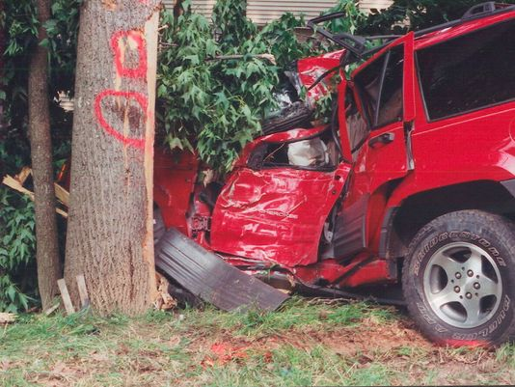
That's the scenario raised and explained by AOL Autos in a story about the threat of terrorists and cars -- and one that drew a fairly
quick rebuke from auto site Jalopnik as unwarranted "fearmongering."
The government is taking threats of carhacking seriously enough that the National Highway Traffic Safety Administration opened up a "cyber terrorism department" to sort out software issues that could make cars vulnerable to attack, AOL Autos says.
When Sen. Jay Rockefeller, D-W.V., raised the issue of cyber car terrorism at a Senate Commerce Committee hearing, he was told that university researcher had succeeded in hacking into car's electronics systems and were able to perform stunts like turning the engine on and off.
Jalopnik, however, in its typically unvarnished way, calls the findings into question.
"While technically some of what's described in the article is certainly true, the fear-mongering tone, calculated to terrify the rapidly aging AOL dial-up readership, is uncalled for at this point," its post says.
Yes, cars are packed with computers, but few can be accessed wirelessly from outside the car. It noted that researchers said they probably would need an additional attachment to car's computer brains to really take it over. Plus, some of the kinds of systems that might make a car vulnerable aren't really deployed yet.
Nissan, for instance, is one of the first with drive-by-wire steering, and so far, it's is limited to one luxury model, the Infiniti Q50.
There are also backup safety systems and the software is written in a way that emphasizes safety and redundancy.
But it's getting easier to see why people care about far-fetched possibilities of computer hacking. The film Fast and Furious 6 includes a chase scene in which the bad guys remotely control pursuing cars' computer systems to make them crash at high speed.
The solution? The good guys switch to old-school cars that don't have computers.

Former general says independence will raise threat of terrorism
Source: http://www.express.co.uk/news/uk/409830/Former-general-says-independence-will-raise-threat-of-terrorism

Major-General Andrew Mackay fears Scottish independece will bring very serious risks
Major-General Andrew Mackay, who led British forces in Afghanistan and commanded the Army in Scotland, said that independence would bring “very real risks”.
A new report has suggested that Scotland would be left with a limited defence force which would struggle to recruit and retain personnel and jobs and economic growth would suffer.
Independent think tank the Scotland Institute claimed that a separate Scotland would face difficulties in setting up its own intelligence services, leaving it vulnerable to terrorists and computer hackers.
The panel of experts behind the report, chaired by Maj-Gen Mackay, is comprised of senior armed forces personnel, defence academics, former secretaries of defence and senior officials from Nato, the UK’s Ministry of Defence and the EU.
Maj-Gen Mackay, from Elgin, Morayshire, left the army in 2009 after 27 years of service. He has previously been critical of the Ministry of Defence’s strategy in Afghanistan.
He said that the report raises serious concerns about the implications of a ‘yes’ vote in next year’s referendum.
In its foreword, he writes: “I cannot see how slicing up a competent and well-established military will aid either the UK or an independent Scotland. Indeed I see very real risks to the people of Scotland.”
He cited “the loss of jobs and the local economic impact that the inevitable removal of the Faslane naval base would bring”.
In addition, there would “the huge costs necessary to start building the armed forces from afresh, the loss of access to sensitive intelligence materials and the inevitable dilution in the quality and number of the armed forces of this small island, which to date have had such a profound effect upon the course of world events”.
Dr Azeem Ibraham, executive chair of the Scotland Institute, added: “An independent Scotland would find it difficult to maintain an air force of any consequence and would possess a truncated navy, stripped of submarine forces.”
He added: “It would also be at some disadvantage in the gathering of intelligence and in meeting cyber security challenges.”
The report also concludes that the defence industry would be downsized, threatening jobs.
It echoes a Westminster report which concluded that Scotland would lose its share of Britain’s existing defence export industry.
A Scottish Government spokesman said: “An independent Scotland will have first-class conventional forces which will play a full role in defending the country and cooperating with international partners.
“But we will not waste billions of pounds on Trident nuclear weapons.”

China's 'War on Terror': September 11 and Uighur Separatism
By Chien-peng Chung
Source:http://www.terrorismwatch.org/2013/06/chinas-war-on-terror-september-11-and.html?utm_ source=feedburner&utm_medium=email&utm_campaign=Feed%3A+terrorismwatch%2FJTvK+%28Terrorism+Watch%29&utm_content=Yahoo!+Mail

In the wake of the September 11 attacks on the United States, China has launched its own "war on terror." Beijing now labels as terrorists those who are fighting for an independent state in the northwestern province of Xinjiang, which the separatists call "Eastern Turkestan." The government considers these activists part of a network of international Islamic terror, with funding from the Middle East, training in Pakistan, and combat experience in Chechnya and Afghanistan.
In fact, separatist violence in Xinjiang is neither new nor driven primarily by outsiders. The region's Uighurs, most of whom practice Sufi Islam and speak a Turkic language, have long had their national ambitions frustrated by Beijing. The latest wave of Uighur separatism has been inspired not by Osama bin Laden but by the unraveling of the Soviet Union, as militants seek to emulate the independence gained by some Muslim communities in Central Asia. For a decade now, Xinjiang has been rocked by demonstrations, bombings, and political assassinations. According to a recent government report, Uighur separatists were responsible for 200 attacks between 1990 and 2001, causing 162 deaths and injuring more than 440 people. In the largest single incident, in 1997, as many as 100 people may have been killed during a pro-independence uprising in the town of Ili, with the government and the separatists blaming each other for the fatalities. These incidents have occurred despite the best efforts of the Chinese authorities to suppress them. As part of their continuing "strike hard" campaign against crime, for example, Chinese police recently reported the arrest of 166 separatist "terrorists" and other "major criminals" in a series of raids carried out in Urumqi, Xinjiang's capital.
The separatists have accused the regime of resorting to arbitrary arrest, torture, detention without public trial, and summary execution. The Chinese government, meanwhile, has alleged that members of a shadowy "Eastern Turkestan Islamic Movement" have obtained funds and training from al Qaeda. As the security environment in Xinjiang grows increasingly tense, the conflict shows just how complicated such struggles can be, and how inadequate purely repressive approaches are in dealing with them.

Beg to differ
China's Qing dynasty completed its annexation of what is now Xinjiang in 1759, and the region's first demand for independence can be traced to an uprising by a local chieftain named Yakub Beg in 1865. He fought fierce battles against the armies of the Chinese court and even managed to secure, in return for trade concessions, diplomatic recognition from tsarist Russia and the United Kingdom. Although finally defeated in 1877, Beg's campaign set a precedent by calling for Uighur independence based on appeals to religion and ethnicity.
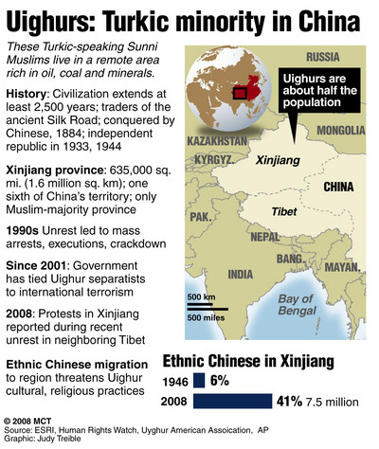
With the end of China's imperial era, the Uighurs (in combination with other local Muslim groups) twice briefly achieved statehood. From 1931 to 1934, and again from 1944 to 1949, separate regimes calling themselves the Eastern Turkestan Republic were set up in Xinjiang. The first, which started in the city of Hami, was crushed by a local warlord representing the government of the erstwhile Republic of China. The second, which centered on the districts of Ili, Altai, and Chugachak, was pressured into integrating with the People's Republic of China shortly after the latter's formation. For the next four decades, Xinjiang's Communist rulers kept the lid on ethnic separatism in the region through iron-fisted control. But for many Uighurs the aspiration for a country of their own never went away.
Today the million-strong Uighur emigre community provides support for several separatist political organizations. Located across the globe, these organizations are not all radical; indeed, many do not advocate violence at all. The Washington, D.C.-based Eastern Turkestan National Freedom Center, for instance, lobbies members of Congress on behalf of the Uighur cause and publishes books and tapes on pan-Turkic nationalism for circulation inside Xinjiang. Meanwhile, the leader of the Europe-based Eastern Turkestan Union, Erkin Alptekin, prefers to organize conferences and work with Tibetan emigre groups seeking autonomy for their own homeland. In truth, whether or not they support the use of violent methods, the Xinjiang separatist groups both at home and abroad are too small, dispersed, and faceless to constitute a threat to Chinese control over the region. Beijing fears them nevertheless, because the mere possibility that they may cause disruption creates an impression of social instability in Xinjiang and dampens foreign investment.
The Chinese government has alleged that "more than a thousand" Xinjiang separatists have received terrorist training in Afghanistan and claims to have arrested a hundred foreign-trained terrorists who have made their way back to Xinjiang. But only one Uighur separatist organization, the Eastern Turkestan Islamic Party of Allah, appears conclusively to have operated in Afghanistan. Its identity was exposed when its putative leader, Alerkan Abula, was executed by the Chinese authorities in January 2001. Other groups, such as the East Turkestan Opposition Party, the Revolutionary Front of Eastern Turkestan, the Organization for Turkestan Freedom, and the Organization for the Liberation of Uighurstan, have links to small guerrilla cells based in the oasis towns of Xinjiang's Taklimakan Desert. The guerrillas have raided government laboratories and warehouses for explosive materials and manufactured various types of bombs. The Turkey-based Organization for Turkestan Freedom, for example, claimed responsibility for the bombing of a bus in Beijing on March 7, 1997, injuring 30 people. The Chinese government also suspects this organization of attacks on the Chinese embassy in Ankara and the Chinese consulate in Istanbul that same year.
Despite the separatists' efforts, China is unlikely to relinquish control of the province. With 18 million people, Xinjiang produces one-third of China's cotton, and explorations in the Tarim Basin have revealed the country's largest oil and gas reserves. The region borders Mongolia, Russia, several Central Asian republics, Pakistan, and India, making it a useful springboard for projecting Chinese influence abroad. And Beijing realizes that acquiescing to Uighur demands will only embolden separatists in Tibet and Taiwan.
The government has also invested a great deal in the region. As part of a grand scheme to develop China's western areas, Beijing plans to spend more than 100 billion yuan ($12 billion) on 70 major projects in Xinjiang over the next five years, mostly to improve infrastructure. The government has recently completed a railway linking the remote western city of Kashgar to the rest of Xinjiang. And the regime is considering proposals for using foreign investment to build oil and gas pipelines from Central Asia across the Taklimakan Desert.

Defining moment
The U.S. action in Afghanistan presented a dilemma for the Uighurs. On the streets of Urumqi, Kashgar, and other cities in Xinjiang, opinions both for and against the U.S. antiterrorist effort could be heard. Many Uighurs expressed sympathy for their Taliban friends and fellow Muslims across the border in Afghanistan, who had provided sanctuary, arms, and training to Xinjiang separatist fighters over the years. Yet the Uighurs also had positive feelings toward the United States, which had occasionally spoken out against Beijing's violations of their rights.
The September 11 attacks and the subsequent crisis also created a dilemma for China. They offered an opportunity for the government to reframe its battle with the Uighur separatists as part of a larger international struggle against terrorism. But the Afghan campaign raised other, less comfortable issues as well. As a result the Chinese response to the U.S. war on terror has been muted. China supported two UN Security Council resolutions that condemned global terrorism in general terms, but since then Beijing has remained notably silent, a reflection of its ambivalence.
On the one hand, China sees the U.S. fight against al Qaeda as helping to safeguard the authority and effectiveness of national governments. On the other, it worries about the legal and diplomatic repercussions of sanctioning such a clear violation of state sovereignty as the invasion of Afghanistan. It was fortunate for China that no UN resolution seeking to ratify the legality of the U.S.-led military campaign was introduced. A vote against such a resolution would have been seen by Washington as an unfriendly gesture, but a vote for could have set a precedent legitimizing the sort of intrusive foreign military interventions that China has generally opposed. And abstaining would have made the Chinese government look weak and indecisive in the fight against global terrorism.
The Chinese government has tried to equate America's fight against Osama bin Laden and al Qaeda with its own battle against the separatists of Xinjiang. Beijing is signaling to Washington that it wants a free hand in dealing with what it perceives to be foreign-sponsored terrorists on its soil, just as the United States is doing at home and abroad. The Bush administration, however, has been reluctant to equate the fight against "terrorists with global reach" with domestic crackdowns against separatists in China and elsewhere. Rather, Washington has made it clear to the Chinese that nonviolent separatist activities cannot be classified as terrorism.
The problem is that some of the Xinjiang activists do in fact use violence to achieve their goals. Distinguishing between genuine counterterrorism and the repression of minority rights can thus be difficult, as can be determining which acts of terrorism are "international" and which are purely domestic. Foreign-backed militant separatism, a not uncommon phenomenon of which Uighur activism is an example, poses intellectual and legal problems as well as practical ones. Clear guidelines are needed to determine when political refugees can be extradited or punished for supporting separatism from beyond a country's borders, for example, or when international law justifies the use of force against citizens who receive weapons, funding, and training from abroad. Otherwise, precedents might accumulate suggesting it is acceptable for some governments to go after foreign sources of terrorism, but not for others.

Whither the Uighurs?
What Beijing needs to recognize is that its own policies are the root causes of Uighur resentment. Rather than trying to stamp out the problem through force and repression alone, the Chinese government should instead do what it can to improve the conditions that fuel separatist feelings.
The government's call to develop the west has accelerated migration by Han Chinese into Xinjiang, thereby exacerbating tensions. In 1949, the region was almost 90 percent Uighur; today, that figure has dropped to 45-50 percent. Many Uighurs do not speak Mandarin Chinese, which is usually the prerequisite for any good-paying job or government position, and few are as well educated as the immigrants. As a result, the Han dominate commerce in Xinjiang's urban areas and are frequently seen by the locals as having the region's best jobs in the government, the Communist Party, and the military. The Han also usually live in newer neighborhoods and go to informally segregated schools.
Rather than allowing the flow of immigration into Xinjiang to remain unchecked, the Chinese regime should regulate it so that immigrants do not compete unnecessarily with the locals for jobs, schools, or state services. Beijing should encourage public-sector corporations, oil companies, and government agencies to increase their hiring of ethnic minorities. Quotas for Uighur admission into colleges and government positions should also be expanded and enforced. The government must also allocate funds fairly among Han and Uighur neighborhoods. Cleaning up the area around China's nuclear test site at Lop Nor in the Taklimakan Desert, where soil and groundwater pollution are causing birth defects and health problems among the local inhabitants, would be another important step.
Furthermore, as guaranteed in the Chinese constitution, the government must uphold religious freedom. Muslim Uighurs who openly practice their faith complain of harassment by the authorities. The regime must respect Muslim customs and allow the free functioning of mosques and religious schools, interfering only if they are found to be educating or harboring militants. Political changes are required as well: less gerrymandering in favor of Han Chinese among Xinjiang's administrative units, more proportionate ethnic representation in party and government structures, and more devolution of power from Beijing to the region.
Hunting down terrorists is only a partial solution to the violence in Xinjiang. Unless China listens to the Uighurs and treats them better, its troubled western region is unlikely to be calmed any time soon.

Chien-peng Chung is Assistant Professor at the Institute of Defence and Strategic Studies in Singapore.

INTERVIEW: ‘Islamic Extremists Want My Downfall, That’s Why They Put Me On The Cover’
Source:http://www.terrorismwatch.org/2013/06/islamic-extremists-want-my-downfall.html?utm_source= feedburner&utm_medium=email&utm_campaign=Feed%3A+terrorismwatch%2FJTvK+%28Terrorism+Watch%29&utm_content=Yahoo!+Mail

In recent months, anti-Muslim violence has rocked many parts of Burma and has left dozens of people killed and thousands displaced, while thousands of homes were destroyed. Ultra-nationalist monk U Wirathu, 46, has been accused of stirring up this unrest through his nationwide ‘969’ campaign, which calls on Buddhists to shun Muslim-owned businesses and to “think in a nationalist way.”
The 969 symbol has also been found painted on the walls of destroyed Muslim-owned buildings, suggesting that Buddhist rioters were motivated by his words.
His controversial campaign has attracted widespread media attention. Last week, Time magazine Asia ran a cover story on the movement and placed a photo of U Wirathu on their July issue, which labeled the monk “The Face of Buddhist Terror”.
The Irrawaddy first interviewed U Wirathu about his role on the anti-Muslim violence on April 2. In another Q&A at his Masoeyein Monastery in Mandalay this weekend, the radical monk reacts to Time magazine’s cover story.
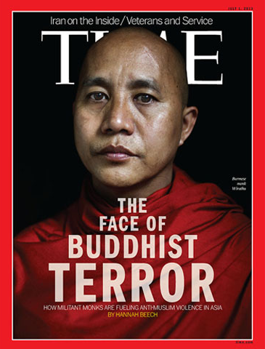
Radical nationalist monk U Wirathu was portrayed on the July cover of Time magazine as “The Face of Buddhist Terror.” (Image: www.time.com)

QUESTION:How do you feel about being portrayed on the cover of Time magazine as “The Face of Buddhist Terror”?
ANSWER: I think this article is targeting me, but not Buddhism as a whole. This is being done because the Islamic extremists want my downfall. It is like during British colonial times, when the British thought that seizing the Burmese kingdom would be easier if the Kanaung Mintha Prince, who was trying to build modern royal army, died. [The crown prince is revered in Burma for his attempts to modernize the country. He was killed by other princes in 1866.]
If I fall down, it will be very easy for the extremist who wants to overwhelm Burma with their extreme beliefs. They want me to be arrested, or killed. That’s why, they put me on the [Time] cover, I think. … Extremists are trying to turn Burma into an Islamic country. There is financial, technological, human resources support for this, even media support. I’ve observed these things and because I’m speaking out to show these things to the world, I have become their number 1 enemy, so they are targeting me. Actually, Times magazine is not targeting me — the group who want to fight against me is behind this [cover].

Q: There are many who say that you are an extremist and preach hate speech in your sermons. Do you have a reaction to those views?
A: Who wants to fight me will fight until I stop my sermons. I do not preach hate or against someone or something. I do not insult in my sermons either. I just preach to protect my people. You can call it a national protection sermon, or a nationalist sermon, or a national security sermon. For example, when a child is abused, does he have to stay silent? Or, will you accuse him of misusing his rights by asking help from his parents? Will you blame him if he spreads hate between his parents and the person who abuses him? We have the right to say when we were beaten, the right to cry and report a problem. For that same reason, I give national protection sermons.

Q:But, there have been complaints and reports that anti-Muslim violence occurred in areas where you have been preaching for the 969 campaign. What do you say to those accusations?
A: The areas where I gave my sermons never experienced any problems. I was in Muse [in Shan State] on May 18 and 19. The violence erupted in Lashio on May 28. If this happened in Muse right after my sermons, I am the responsible one and will accept such accusations. But I’ve never been to Lashio, I was just passing by. I don’t even know if I passed through Lashio because I fall asleep on the car. So, I couldn’t have anything to do with what has happened in a town that I was just passing by.
And in Meikhtila, I went there in October. The violence happened in March. So, if someone alleges that this occurred because of my sermons, how I should respond? It’s been four months. Also, if nothing had happened at the gold shop, would that shop have been destroyed? [An argument between a Buddhist customer and Muslim gold shop owner sparked the Meikthila riots.] If the Buddhist monk named Thawbita was not murdered there, would Meikhtila have experienced the violence? And the problems were not started by Burmese Buddhists. The Burmese are the ones who were insulted. So, what can I say if someone blames me for this?
Muslim extremist groups are also creating these [inter-communal] problems. They have two reasons. One is that they want to carry out jihad in Burma. And what was done in Meikhtila, they want to do in the whole country. If the same thing happens again, the international Muslim extremists will bring jihad to the country. That’s why they created the violence in Lashio.
Another reason is that they want to have me arrested. That’s why they are sacrificing their own mosques, shops and homes, and then they put the blame for these events on my sermons. …
With regards to the Burmese groups [who were involved in the unrest]. I’ve learned that no one is behind them. We can say they are just thugs, jobless, lazy-boned people who make use of an opportunity during these uncontrollable situations of violence, so that they can loot things from markets and shops.

Q: There has been a lot of criticism of a law you drafted that would put restrictions on marriages between Buddhist women and Muslim men. Activists say that it would constitute a violation of basic human rights. What is your reaction to this criticism?
A: Actually, the draft law [that was circulated on June 13] will not go to Parliament. The draft law which will be submitted to Parliament will be released only on June 27. The initial draft that we released was just meant to get an idea of how people felt about such a law.
What’s more, this draft law does not abuse the rights of women. It is to protect women from having their rights abused. Even though we are a Buddhist country, our women have no freedom of religion. So, we will completely follow human rights [principles] in writing this law. We want our Burmese women to have complete women’s rights. Christian ladies, Buddhist ladies who marry Muslim men are not getting freedom of religion nor women’s rights. They have to stay at their homes like prisoners of war. I want to give freedom to them. I do not want future generations of women to suffer like that. … Current laws [in Burma] cannot effectively protect women’s rights or their religious freedom.

Q:You have said that the number 969 symbolizes Buddhist values and teachings. But when people who carry out anti-Muslim violence they use it to justify their actions and paint 969 on destroyed Muslim-owned buildings. So, then it becomes the symbol of Buddhist rioters. What do you think of that situation?
A: Things like that can happen. That’s why the monks’ conference was held in Hmawbi Township, Rangoon. There, the Sayardaws produced a statement saying not to use 969, which is a symbol of peace, in any way for violence or as a means of defaming another religion.
You can’t say that the 969 [campaign] is a violent gang just because a group of men misuse it. You cannot tell us that there are words that say “kill the people who have different religion or ethnicity” is included in the meaning of 969. The rules of 969 are not like that. It is not violent and doesn’t say you should respond with violence even if you’re being abused, instead you should follow only the law. So, claiming that 969 is violent is nonsense.

Time magazine 'Buddhist Terror' headline irks this country
Source: http://www.ndtv.com/article/world/time-magazine-buddhist-terror-headline-irks-this-country-383530

Myanmar has reacted angrily to a Time magazine cover story on a prominent radical monk accused of fuelling anti-Muslim violence, accompanied by the headline "The Face of Buddhist Terror".
Social media users in the former junta-ruled nation also voiced dismay at the US magazine's July front page, which shows a photograph of controversial Mandalay monk Wirathu, whose anti-Muslim remarks have come under scrutiny following a wave of deadly religious violence.
The Time report "creates a misunderstanding of Buddhism which has existed for thousands of years and is the religion of the majority of our citizens," said a statement posted on the presidential office website late on Sunday.
"The government is currently striving with religious leaders, political parties, media and the people to rid Myanmar of unwanted conflicts," it said, adding that the issue of religion should be handled respectfully by the media.
In a sign of the strength of feeling, one online petition started over the weekend to condemn the magazine had collected almost 40,000 names by today.
The use of the words "Buddhist" and "Terror" upset all followers of the faith, which is peaceful "and not for terrorists," a message accompanying the petition said.
Eye-witnesses to violence which flared in March in central Myanmar said people dressed in monks' robes were involved in the unrest, which left scores dead, mainly Muslims.
Radical monks have led a campaign to shun shops owned by Muslims. Wirathu has also called for a law to restrict marriages between Buddhist women and men of other faiths.
Senior monks, however, have accused foreign media of one-sided reporting of the Buddhist-Muslim conflict.
Facebook users accused Time of deepening divisions and defaming Myanmar's main religion.
"Insulting the monk Wirathu, a son of Buddha, is the same as insulting Buddhism," said one post by Wai Phyo.
"What Wirathu is doing now is to protect our own nationality and religion," the Facebook user wrote, urging the magazine to apologise.
"Obviously this writer doesn't understand Myanmar and Buddhism well," another post said.
Several episodes of religious fighting have exposed deep rifts in the Buddhist-majority country and cast a shadow over widely praised political reforms since military rule ended two years ago.
In March at least 44 people were killed in sectarian strife in central Myanmar with thousands of homes set ablaze.
Communal unrest last year in the western state of Rakhine left about 200 people dead and up to 140,000 displaced, mainly Rohingya Muslims.

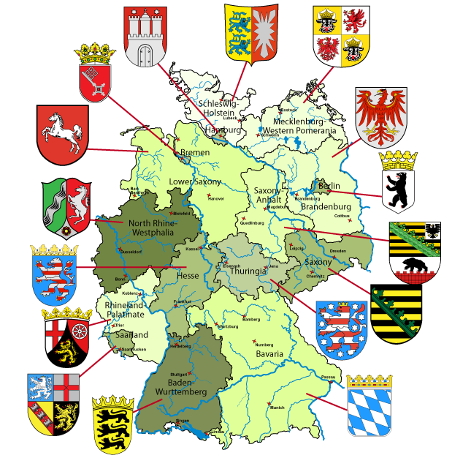

German police reported to have raided Islamist network
Source: http://www.bbc.co.uk/news/world-europe-23045561

German police are reported to have carried out a series of raids against a suspected Islamist militant network.
Reports suggest the police targeted a money-laundering operation which financed terrorist activity, and people planning to use model aircraft to carry out an attack.
Flats and other premises were raided in the early hours of Tuesday (June 25) in Bavaria and Baden-Wuerttemberg in the south of Germany and Saxony in the east.
No arrests have been announced so far.
The police investigation centres on men of Tunisian origin, according to German media, several of them studying flight and space technology at Stuttgart University.
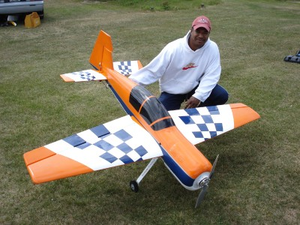
Police say documents and technical equipment were seized as part of the investigation into plans to use two remote-controlled model planes to launch a terrorist attack.
A parallel investigation is looking into suspicious money transfers thought to be used to finance a "Holy War".
Flats were searched in Stuttgart and Munich, and the town of Dachau in Bavaria.
An internet provider in Saxony was also targeted.
Armed anti-terror police were used in the raids in Munich and Stuttgart as they expected to encounter weapons.

A new breed of terror in Northern Ireland
By John Horgan and John F. Morrison
Source: http://edition.cnn.com/2013/06/14/opinion/horgan-g8-northern-ireland/index.html

On June 17 and 18, the political world's focus will be on Northern Ireland, where the Group of Eight summit will take place.
Although this is a region defined by its violent history, the summit is already proving to be one of the most complex and wide-ranging security operations Northern Ireland has ever seen. Thousands of additional police officers are being brought in from England, Wales and the Republic of Ireland to assist.
During the 2005 event, which took place in Scotland and was the last G8 summit in the UK, four al Qaeda-inspired men detonated bombs on the London transport network, killing 52 people and themselves.
Although any kind of incident at or around the summit venue itself remains unlikely, there is the risk of a terrorist attack timed to distract from the event. But this year, unlike the 2005 attack, the focus is on a very different kind of group.
The town of Enniskillen, Northern Ireland, will host the G8 Summit next week.

If you thought Northern Ireland's troubles were a thing of the past, you'd be forgiven. A brutal terrorist campaign over 35 years that saw almost 4,000 deaths came to an end thanks to a hard-fought political process. What that took should not be underestimated. Years of painstaking mediation and negotiation, risky moves by brave politicians on all sides and the crucial involvement of the U.S. saw hope prevail, despite the occasional setback that threatened destabilization.
Communities on both sides of the social and political divide cautiously welcomed the peace process and its negotiated settlements. The "Troubles" seemed finally to be over. Former paramilitaries agreed to lay down their arms, and once-sworn enemies eventually learned to share power.
Yet, peace in Northern Ireland is still described by many as fragile. In recent times, riots, gunfire and petrol bombs have returned to the streets. The "flag protests," which defined the end of 2012 and the beginning of 2013, have again highlighted the inherent divisions in Northern Irish society. The Union flag, flown proudly over Belfast City Hall for so long, was lowered after a vote by the City Council. Some among Northern Ireland's Unionist community were outraged. Protests escalated.
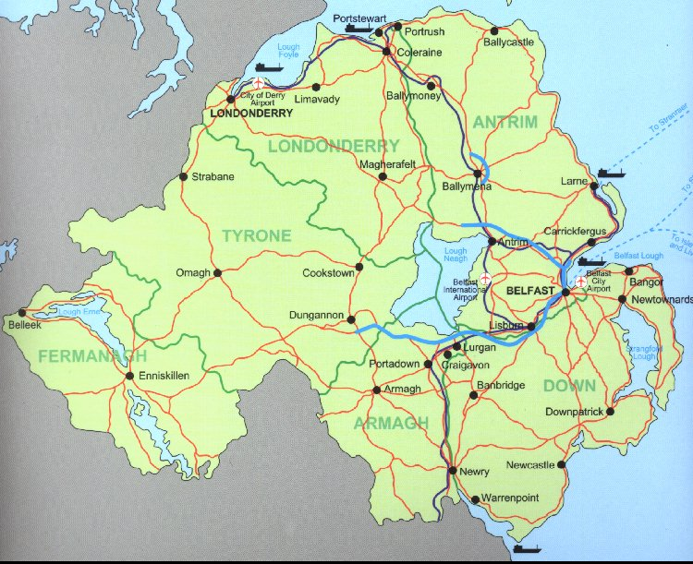
But it is not the rioters and flag protesters who pose the most persistent threat to this fragile peace. Another group watches from the sidelines. They are the "dissident" Republicans, splinter groups that have grown in size and impact since the peace process saw the end of the Provisional IRA as we once knew it.
The dissidents are responsible for a growing wave of low-level bombings, shootings and threats across the region. They insist that only armed resistance can force Britain's withdrawal from Northern Ireland and lead to a united Ireland. While most people in Northern Ireland view the peace process as having brought stability, the dissidents reject it.
Though tactically proficient, the dissidents lack strategic acumen. On the surface, they are united by the idea of "Brits out," with aspirations to achieve a united Ireland through violence and their disdain for the Sinn Fein leadership and the peace process that it has embraced.
Traditionally, dissidents have been split by local differences, ideological divergences, petty jealousies and competitive personalities. "Dissident Republican" came to describe a range of groups. One calls itself the Real IRA. Then there's the Continuity IRA and Óglaigh na hÉireann, Gaelic for Irish Volunteers.
There has been talk of a merger to unite the disparate factions. In July, the "New IRA" was announced: a merger of the Real IRA, the Derry-based Republican Action Against Drugs and other previously non-aligned Republicans. But the Continuity IRA stayed aloof from the alliance.
The new group's members and supporters may number in the few hundreds, but it seems their ranks are growing. They have killed soldiers, police officers and most recently a prison officer. They continue to target Northern Irish police stations, with weaponry of growing sophistication. They shoot suspected inner-city drug dealers north and south of the Irish border to help embed themselves in their communities while simultaneously undermining the police.
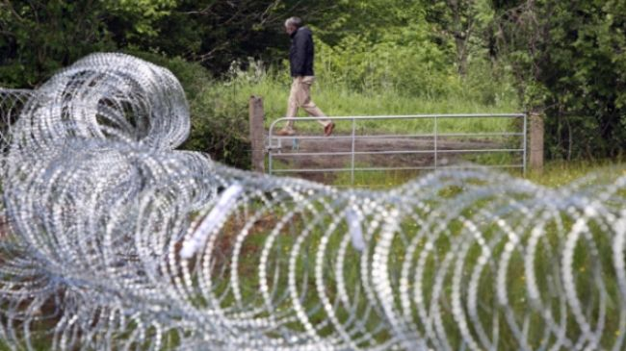
These dissident factions are capable of causing sometimes extensive disruption with actual or hoax improvised explosive devices. Just last year, police in Northern Ireland recovered an armor-piercing rocket that included the plastic explosive Semtex in the city of Londonderry.
We have monitored the dissidents' steady rise, logging thousands of events and documents in the process.

What does it all add up to?
In short, the threat posed by dissident Republican groups is evolving, and probably for the worse. Their activity has increased. Their recruitment efforts continue to expand. Many of these new recruits belong to a different generation from their forerunners. They weren't even born at the time of the 1994 Provisional IRA cease-fire, and some of the older members are senior ex-IRA members who bring much needed political acumen, as well as expertise in bomb-making, recruitment, training and targeting.
Their activities span the country, north and south, with mostly urban concentrations in Belfast, Derry, Dublin and Limerick. There is increasing evidence of training and recruitment in the Irish Republic, with evidence for some logistical support appearing in England.
True, they don't have the kind of support once enjoyed by the Provisional IRA. But the dissidents don't just acknowledge their lack of popular support. They embrace it. They revel in their "noble isolation."
Terrorism analysts have come to associate this particularly dangerous kind of thinking with Islamist terrorist groups, not Irish Republicans. Yet Ireland's newest dissidents are a different breed and pose new threats.
In responding to recent dissident activity, Northern Ireland's politicians have been vocal. We hear, time and again, "Nobody wants a return to the old days," "They have no mandate" and "They will never win." Those same clichéd responses never deterred the Provisional IRA. In defiance, and in an appeal for support, the dissidents claim the ability to bring their "struggle to a successful conclusion through military operations."
The 100th anniversary of the Easter Rising, when the progenitors of Irish Republicanism were executed by occupying British forces, is in 2016. Just like their IRA predecessors, the dissidents draw their inspiration and legitimacy from an unyielding view of the past yet find a steady stream of eager recruits in the present.
In the years leading up to 2016, it is likely that the dissidents will try to strengthen their support and perceived legitimacy through a proliferation of attacks. They will promote themselves as the true heirs of the 1916 Republicans, heirs who can finally bring about a united Ireland through one last campaign of force.
The IRA itself was once just a ragtag bunch of self-appointed guardians of an age-old mission that found relevance in contemporary events. A remorseless logic in what the dissidents say reveals why they are unpredictable, dangerous and ambitious.
We have become dangerously complacent about the dissident Irish Republicans. We hope we are wrong, and the G8 summit in County Fermanagh does not become a platform on which they can bring international attention to their campaign

.
John Horgan will be a professor of security studies at University of Massachusetts-Lowell starting July 1.
John F. Morrison is senior lecturer in criminology and criminal justice at the University of East London.

Did NSA leaks help al Qaeda?
By Paul Cruickshank
Source: http://security.blogs.cnn.com/2013/06/25/did-nsa-leaks-help-al-qaeda/

Obama administration officials and congressional lawmakers over the past two weeks have condemned Edward Snowden for admittedly leaking classified information on national security surveillance programs.
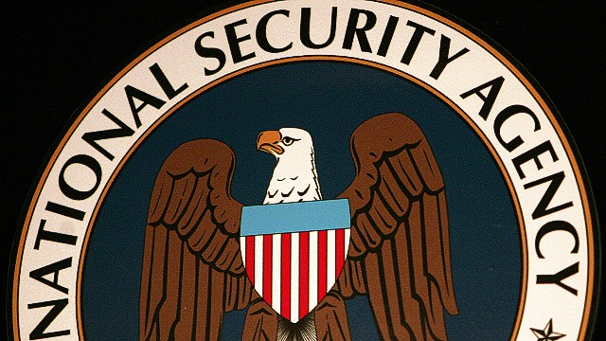
Mike Rogers, the chairman of the House Intelligence Committee, spoke of "changes we can already see being made by the folks who wish to do us harm, and our allies harm."
He added the disclosures of surveillance programs may also "make it harder to track bad guys trying to harm U.S. citizens in the United States."
FBI Director Robert Mueller last week testified "these disclosures have caused significant harm to our nation and to our safety."
How should these claims be weighed?
There is little doubt the leaks were damaging to some degree. It is axiomatic that disclosures on the scope of NSA surveillance can be helpful to terrorist groups.
Al Qaeda and its affiliates do pay attention to such things because nothing is more important to terrorist groups than operational security.
However, some analysts also rightly point out that al Qaeda and like-minded groups were already aware of the enormous capabilities of the NSA to snoop on their communications, and had already taken measures to try to evade detection.
Al Qaeda can hardly have failed to notice that U.S. intelligence intercepts helped thwart a significant number of its plots since 9/11. This was well documented long before Snowden's leaks this month to the Guardian and the Washington Post.
Some of these plots included the 2009 Najibullah Zazi plan to bomb New York subway system; a potential plot in Belgium in 2008; a plot by al Qaeda affiliated militants to bomb U.S. soldiers in Germany in 2007; and the 2006 plot to bomb nine airliners bound for North America simultaneously above the Atlantic (by far the most serious plot since 9/11).
Al Qaeda and its affiliates responded to the string of plots thwarted by the NSA by being more careful in the way they communicated.
By 2008, al Qaeda had banned electronic communications inside the tribal areas of Pakistan, instead requiring messages be exchanged through couriers, according to the testimony of Western al Qaeda recruits.
Militants sympathetic to al Qaeda developed encryption software to help it mask its communications with operatives overseas.
A group of German militants recruited into an al Qaeda plot to attack Europe in 2010 were provided hands-on instruction in encrypting their communications using a program called Mujahideen Secrets in the tribal areas of Pakistan by Younes al Mauretani, a senior al Qaeda operative, according to German intelligence officials.
An internal al Qaeda strategy document called "Future Works" authored in 2009, which was subsequently recovered by German authorities from an al Qaeda operative in Berlin, spoke of the need to instruct Western recruits in ways to secretly communicate with their handlers.
German intelligence officials told CNN that militants in Germany had by 2011 developed ways to communicate in secret over the Internet with terrorist operatives in Pakistan.
The most prominent adopter of the Mujahideen Secrets software was Anwar al Awlaki, an American-Yemeni cleric who orchestrated several plots against the United States for al Qaeda's affiliate in Yemen before his death in a U.S drone strike in September 2011.
In 2009, Awlaki personally instructed at least one European militant in Yemen how to use the software so they could communicate without their e-mails being intercepted. CNN has seen copies of the encrypted emails.
By the following year al Awlaki had developed a sophisticated multi-layered method to encrypt communications with operatives overseas.
Significant detail about it was revealed in the 2011 trial of Rajib Karim a British-Bangladeshi-British terrorist operative who had communicated with Awlaki the previous year.
The court heard how in early 2010 Karim, then working in a British Airways call center in Newcastle, communicated in coded phrases from the UK with Awlaki in Yemen through deeply-encrypted word documents that were stealthily digitally compressed and then uploaded to pages of Web hosting sites with addresses only known to the parties in question.
The messages appear not to have been intercepted by the NSA or any other Western intelligence agency.
Even after finding the communications, it took British investigators significant time to decipher the communications, only succeeding after they found the cipher codes and passwords in a file on his the computer, it was revealed at trial. This illustrated how difficult it would be to track such messages in real time.
It was not just al Qaeda that was able to evade detection by the NSA.
On May 1 2010, Faisal Shahzad, an American recruited by the Pakistani Taliban, tried but failed to blow up a car bomb at New York's Times Square.
Court documents revealed that rather than stay off the grid, Shahzad had been in regular touch over the Internet with his handler in Pakistan to get bomb-making guidance in the run up to the attack.
"Using software programs that were installed on his laptop while he was in Pakistan, Shahzad and the Pakistani Taliban were able to exchange information about the bomb he was building," court documents stated.
These communications were obviously not detected by the NSA, otherwise Shahzad would have been arrested before trying to carry out an attack.

The Abu Dhabi mercenaries unit
Source: http://i-hls.com/2013/06/the-abu-dhabi-mercenaries-unit/

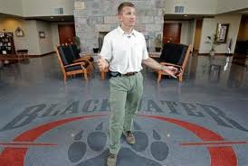
Colombia’s defense ministry is alarmed about an exodus of top soldiers to the United Arab Emirates to join a highly paid U.S.-led mercenary force organized by Erik Prince, billionaire founder of the security firm Blackwater. Prince, who sold Blackwater in 2010 after it was involved in scandals in Iraq, went to Abu Dhabi, capital of the Persian Gulf federation, in 2011.
He signed on to form an 800-man battalion of mercenaries for what emirati officials termed “anti-terrorism operations” inside and outside the country.
According to UPI it’s widely believed in Gulf security circles the force, being assembled under considerable secrecy by Prince’s Reflex Responses registered in the emirates, will be used for undisclosed special operations for the seven desert emirates that make up the federation.
That’s expected to include putting down “internal unrest” that might challenge the ruling families, as happened in Egypt, Libya, Tunisia and Yemen, and which is growing in Kuwait and Bahrain.
The Reflex Responses force, which is officially described in a contract leaked to the New York Times in 2011 as “independent of formal command and support structures throughout the United Arab Emirates,” will have its own air wing, with fixed wing aircraft and helicopters, plus its own private navy.
The naval wing’s tasks will primarily be “small boat operations … maritime interdiction operations and securing oil delivery platforms.”
The mercenaries have a custom-built high-security base in the desert where troops live and train.
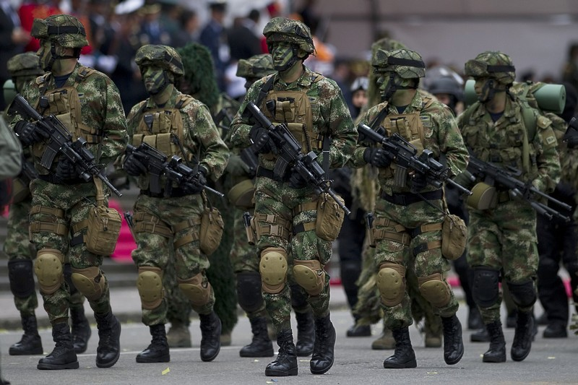
U.S. military analyst Spencer Ackerman says Prince’s new project “might run afoul of U.S. laws prohibiting citizens from training foreign militaries,” which requires a government license. The State Department has not said whether Reflex Responses has one.
But it’s unlikely that Prince, who sold off Blackwater amid a blizzard of adverse publicity over his men’s excesses in Iraq where the company was accused of wantonly killing civilians, would embark on this new project without making sure he wasn’t open to legal action, particularly if he found himself having to send troops to fight Muslims seeking sweeping democratic reform from rulers who are U.S. allies.
The Sunni Muslim Arab monarchies of the gulf are increasingly concerned about their future amid the political upheaval and conflict sweeping the Arab world, fueled, they claim, by Shiite Iran.
The emirates currently are trying 94 citizens for sedition and seeking to overthrow the political system. The defendants, including two prominent human rights lawyers, face a possible 15 years in prison.
But the over-riding security threat is widely perceived to be Iran, 100 miles across the gulf and which occupies several islands claimed by the Emirates.
Prince’s mercenary force is made up largely of Colombian soldiers, including senior officers and men with a Special Forces background
There are also many veterans of Executive Outcomes, a South African security firm that became notorious in the 1990s for suppressing rebellions in mineral-rich African dictatorships and staging coups to gain control of such assets.
EO personnel included many veterans of Britain’s Special Air Service and special operations units in South Africa’s apartheid-era military.
Prince, an ex-U.S. Navy SEAL, is setting up his new force under a reputed $529 million contract with the royal family of oil-rich Abu Dhabi, the emirates’ leader and economic powerhouse. The contract expires in 2015.
Analysts say soldiers from Colombia’s 450,000-strong U.S.-trained military are held in high regard in the emirates and other gulf states because of their combat experience fighting leftist guerrillas and because they’re not as expensive as Western veterans.
Colombian officials estimate 500 soldiers, including pilots of Black Hawk helicopters widely used in special operations, have gone to join Prince’s force, where they earn $3,000 a month against $600 back home.
Bogota has complained to Abu Dhabi to stop hiring its best soldiers, so far without any apparent result.
“These are soldiers with a lot of experience, and it took a great effort to train them,” Jorge Bedoya,Colombia’s deputy defense minister, told The Financial Times.
The gulf monarchies are used to paying foreigners to do their dirty work. They have traditionally hired foreigners, mainly Pakistanis and Baluchis, to stiffen their armed forces.

Al-Qaida said to be changing its ways after leaks
Source:http://www.terrorismwatch.org/2013/06/al-qaida-said-to-be-changing-its-ways.html?utm_source =feedburner&utm_medium=email&utm_campaign=Feed%3A+terrorismwatch%2FJTvK+%28Terrorism+Watch%29&utm_content=Yahoo!+Mail

U.S. intelligence agencies are scrambling to salvage their surveillance of al-Qaida and other terrorists who are working frantically to change how they communicate after a National Security Agency contractor leaked details of two NSA spying programs. It's an electronic game of cat-and-mouse that could have deadly consequences if a plot is missed or a terrorist operative manages to drop out of sight.
Two U.S. intelligence officials say members of virtually every terrorist group, including core al-Qaida, are attempting to change how they communicate, based on what they are reading in the media, to hide from U.S. surveillance — the first time intelligence officials have described which groups are reacting to the leaks. The officials spoke anonymously because they were not authorized to speak about the intelligence matters publicly.
The officials wouldn't go into details on how they know this, whether it's terrorists switching email accounts or cellphone providers or adopting new encryption techniques, but a lawmaker briefed on the matter said al-Qaida's Yemeni offshoot, al-Qaida in the Arabian Peninsula, has been among the first to alter how it reaches out to its operatives.
The lawmaker spoke anonymously because he would not discuss the confidential briefing by name.
Shortly after Edward Snowden leaked documents about the secret NSA surveillance programs, chat rooms and websites used by like-minded extremists and would-be recruits advised users how to avoid NSA detection, from telling them not to use their real phone numbers to recommending specific online software programs to keep spies from tracking their computers' physical locations.
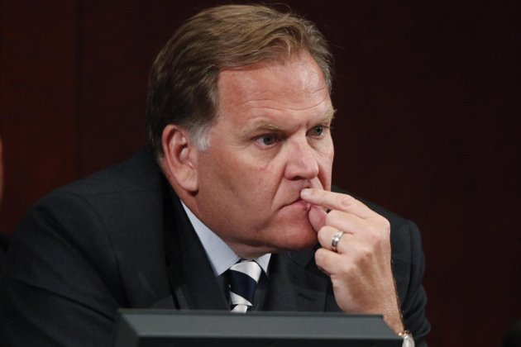
House Intelligence Committee Chairman Mike Rogers, R-Mich., said there are "changes we can already see being made by the folks who wish to do us harm, and our allies harm."
Sen. Angus King, I-Maine, said Tuesday that Snowden "has basically alerted people who are enemies of this country ... (like) al-Qaida, about what techniques we have been using to monitor their activities and foil plots, and compromised those efforts, and it's very conceivable that people will die as a result."
At the same time, NSA and other counterterrorist analysts have been focusing their attention on the terrorists, watching their electronic communications and logging all changes, including following which Internet sites the terrorist suspects visit, trying to determine what system they might choose to avoid future detection, according to a former senior intelligence official speaking anonymously as a condition of discussing the intelligence operations.
"It's frustrating. You have to start all over again to track the target," said M.E. "Spike" Bowman, a former intelligence officer and deputy general counsel of the FBI, now a fellow at the University of Virginia's Center for National Security Law. But the NSA will catch up eventually, he predicted, because there are only so many ways a terrorist can communicate. "I have every confidence in their ability to regain access."
Terror groups switching to encrypted communication may slow the NSA, but encryption also flags the communication as something the U.S. agency considers worth listening to, according to a new batch of secret and top-secret NSA documents published last week by The Guardian, a British newspaper. They show that the NSA considers any encrypted communication between a foreigner they are watching and a U.S.-based person as fair game to gather and keep, for as long as it takes to break the code and examine it.
Documents released last week also show measures the NSA takes to gather foreign intelligence overseas, highlighting the possible fallout of the disclosures on more traditional spying. Many foreign diplomats use email systems like Hotmail for their personal correspondence. Two foreign diplomats reached this week who use U.S. email systems that the NSA monitors overseas say they plan no changes, because both diplomats said they already assumed the U.S. was able to read that type of correspondence. They spoke on condition of anonymity because they were not authorized to discuss their methods of communication publicly.
The changing terrorist behavior is part of the fallout of the release of dozens of top-secret documents to the news media by Snowden, 30, a former systems analyst on contract to the NSA.
The Office of the Director for National Intelligence and the NSA declined to comment on the fallout, but the NSA's director, Gen. Keith Alexander, told lawmakers that the leaks have caused "irreversible and significant damage to this nation."
"I believe it will hurt us and our allies," Alexander said.
The leaks revealed that the NSA was scanning the worldwide use of nine U.S.-based Internet service providers, including Google, Yahoo, Skype and YouTube.
"After the leak, jihadists posted Arabic news articles about it ... and recommended fellow jihadists to be very cautious, not to give their real phone number and other such information when registering for a website," said Adam Raisman of the SITE Intelligence Group, a private analysis firm. They also gave out specific advice, recommending jihadists use privacy-protecting email systems like TOR, also called The Onion Router, to hide their computer's IP address, and to use encrypted links to access jihadi forums, Raisman said. While TOR originally was designed to help dissidents communicate in countries where the Internet is censored, it is facing legal difficulties because criminals allegedly have used it as well.
"Criminals are doing well without things like TOR," said Karen Reilly, a spokeswoman for TOR. "If TOR disappeared tomorrow they would still have secure, anonymous access to the Internet. ... Their victims would not."
Other analysts predicted a two-track evolution away from the now-exposed methods of communication: A terrorist who was using Skype to plan an attack might stop using that immediately so as not to expose the imminent operation, said Ben Venzke of the private analysis firm IntelCenter.
But if the jihadi group uses a now-exposed system like YouTube to disseminate information and recruit more followers, they'll make a gradual switch to something else that wasn't revealed by Snowden's leaks — moving slowly in part because they'll be trying to determine whether new systems they are considering aren't also compromised, and they'll have to reach their followers and signal the change. That will take time.
"Overall, for terrorist organizations and other hostile actors, leaks of this nature serve as a wake-up call to look more closely at how they're operating and improve their security," Venzke said. "If the CIA or the FBI was to learn tomorrow that its communications are being monitored, do you think it would be business as usual or do you think they would implement a series of changes over time?"
The disclosure that intelligence agencies were listening to Osama bin Laden drove him to drop the use of all electronic communications.
"When it leaked that bin Laden was using a Thuraya cellphone, he switched to couriers," said Jane Harman, former member of the House Intelligence Committee and now director of the Woodrow Wilson International Center. "The more they know, the clearer the road map is for them."
It took more than a decade to track bin Laden down to his hiding place in Abbottabad, Pakistan, by following one of those couriers.

A short history of terrorist attacks involving Canada
Source: http://www.calgaryherald.com/touch/story.html?id=8278841

Canadians have been the targets – and sometimes the perpetrators – of terrorist attacks in the modern era. Here’s a brief look at some major events:

1985
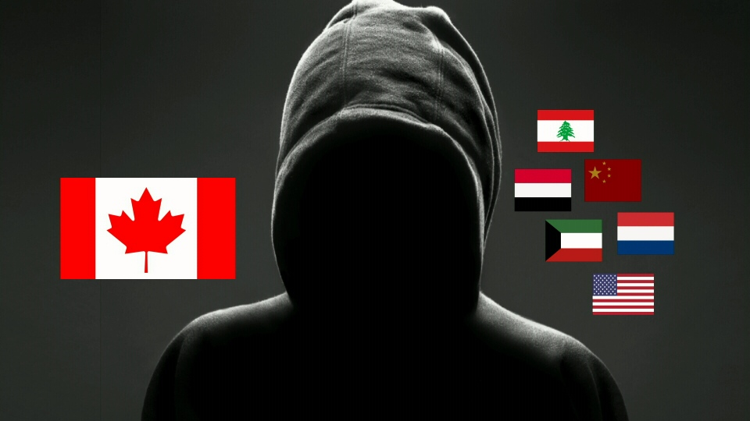
June: Air India flight 182 is blown up off the coast of Ireland, killing 331 people, mostly Canadians. One person, Inderjit Singh Reyat, a militant Sikh nationalist, is convicted for manslaughter related to the attack.

2001
September: 24 Canadians are killed in the 9/11 attacks against the World Trade Center in New York and the hijacked airliner that crashed in a field in Pennsylvania.

2004
March: Ottawa software engineer Momin Khawaja is arrested and charged with participating in an international plot to bomb locations in London, England on behalf of Islamic extcalremists. He is convicted in 2008 and given a life sentence.

2006
August: Eighteen men from the Toronto area are arrested and charged with various terrorist offences including attempting to assassinate the prime minister, blow up the Peace Tower and bomb the Toronto Stock Exchange. The group is linked to al-Qaeda. Eleven are eventually convicted of a number of crimes with sentences ranging from two-and-a-half years to life.

2009
October: Pakistani-Canadian Tahawwur Rana is arrested in Chicago by the FBI and charged with providing material support to the Pakistan militant group Lashkar-e-Taiba. He is convicted in 2011 and in January, 2103, sentenced to 14 years in prison.

2010
August: Two Ottawa men, Hiva Mohammad Alizadeh and Misbhuddin Ahmed, and one man from London, Ont., Dr. Khurram Sher, are arrested and charged with participating in a terrorist group and conspiring to participate in acts of terror. The attacks were supposedly planned for Canada, Iran, Afghanistan and Pakistan.

2013
April: Ali Medlej and Xristos Katsiroubas, from the same high school in London, Ont., are identified as two insurgents who were killed in January during a terror attack on a gas plan in Algeria. A third friend, Aaron Yoon, is in jail in Mauritania serving a two-year sentence for terror-related offences. A fourth man from London, Mujahid Enderi, is also sought by police.
April 22: News reports indicate two people, one from Toronto and one from Montreal, have been arrested by the RCMP for a plot in the Toronto area targeting a Via Rail passenger train. The RCMP says they are not Canadian citizens.

Counterterrorism Bookshelf
By Joshua Sinai
Source: http://www.terrorismanalysts.com/pt/index.php/pot/article/view/272/html
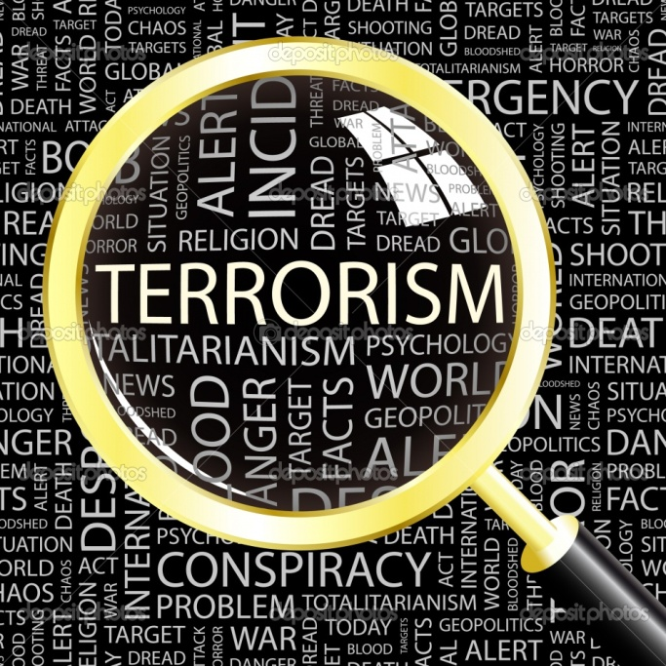
The following are capsule reviews of important books recently published on terrorism and counterterrorism-related topics.

Peter Bergen, editor (with Katherine Tiedemann), Talibanistan: Negotiating the Borders Between Terror, Politics, and Religion (New York: Oxford University Press, 2013), 528 pages, $24.95. ISBN: 978-0-19-989309-6 [paperback].
The contributors to this edited volume examine in a comprehensive manner all aspects of the Taliban’s insurgency in Afghanistan, including those related to Pakistan's Northwest Frontier Province and Federally Administered Tribal Areas. They examine issues such as the distinctions between the Taliban and Al-Qaeda, as well as the fractures within each organization; how the Taliban recruits and moves its fighters into Afghanistan; the effectiveness of the United States-led counterinsurgency campaigns against the Taliban (including the impact of the drone strikes against Taliban operatives), as well as the tensions (but also, at times, cooperation) between the Pakistani security services and the Taliban. Also discussed are the political and religious forces shaping the Taliban’s insurgency in the Northwest Frontier Province.

Anat Berko, The Smarter Bomb: Women and Children as Suicide Bombers (Lanham, MD: Rowman & Littlefield Publishers, Inc., 2012), 212 pages, $42.00. ISBN: 978-1-4422-1952-6 [hardcover].
A highly insightful discussion of the motivations of primarily Palestinian suicide bombers, especially women and children, and the male operatives who recruit and dispatch them on their martyrdom operations against Israel. The author, an Israeli criminologist and retired Lt. Colonel in the Israeli military, has spent many years interviewing Palestinian security prisoners at their jails, including the operatives whose suicide missions had failed, resulting in their long prison sentences. Fluent in Arabic and Arab culture, she was able to gain their trust and speak with them intimately. Their identities, as a result, are disguised (a disappointment for those who wish to follow up on these cases) – but readers will nevertheless benefit from the wealth of personal and operational details that are revealed by such first-hand field work.

Raphael Bossong, The Evolution of EU Counter-Terrorism: European Security Policy After 9/11 (New York, NY: Routledge, 2013), 194 pages, $135.00. ISBN: 978-0-415-68857-4 [hardcover].
An account of the evolution of the European Union’s (EU) counter measures against terrorism from the late 1970s until the end of the first decade after 9/11. Case studies discuss the EU’s responses to international terrorism in 9/11 in New York and Washington, the attacks in Madrid in March 2004 and London in July 2005; the nature of the EU’s member-states’ security and counter-terrorism cooperation in light of the new directions in counterterrorism policies produced by these attacks. The concluding chapter assesses the effectiveness of the EU’s counterterrorism measures and suggests avenues for further theoretical and empirical research.

Vahid Brown and Don Rassler, Fountainhead of Jihad: The Haqqani Nexus, 1973-2012 (London, UK: Hurst & Company/New York, NY: Oxford University Press, 2013), 320 pages, $35.00. ISBN 978-1-83904-207-9 [hardcover].
Drawing upon primary sources, the authors analyze the origin and evolution of the Haqqani network, the powerful guerrilla organization that fights alongside the Taliban and Al-Qaeda in Afghanistan and Pakistan, where it is based in the Waziristan tribal frontier. The authors provide extensive details about its role in the establishment of the global jihadi movement and Al-Qaeda in the early 1990s, detail how the network is organized (for example, like a traditional Pashtun clan, it is led by its founder, Maulvi Jalaluddin Haqqani, and his son Sirajuddin Haqqani), how it raises funds to mount its insurgency, and also focuses on its links with the Pakistani intelligence service. Although densely written and overly academic in tone, and not as critical as one would wish in discussing an insurgent organization that ruthlessly pursues an agenda of anti-modernism and religious intolerance, this book is recommended for its comprehensive account of the Haqqani network.

Dolnik, Adam, Editor, Conducting Terrorism Field Research: A Guide (New York, NY: Routledge, 2013), 280 pages, $42.95. ISBN: 978-0-415-60931-2 [paperback].
The contributors to this important volume provide a detailed “how to” guide to conducting fieldwork in terrorism studies. As opposed to library research, field research entails numerous challenges, including ethical questions involved in interviewing former and (if possible) current terrorists (including those serving prison sentences) and traveling to dangerous conflict zones where terrorist groups operate. For academics, in particular, a major challenge is obtaining approval from their university review boards to ensure that their subjects will be protected from any future harm arising from the research. A further challenge, once a researcher is in the field, is whether to coordinate such research with local governments and their security services that may be monitoring them, including sharing the results of one’s findings with them. To answer these and other questions, the editor has brought together top experts in the field who explain how to utilize different disciplines and methodological approaches, as well as the crucial regional specializations that are necessary to conduct such field research. The volume is well organized, with each contributor providing a road-map to their own research, describing planning and preparation phases, the formalities involved in getting into conflict zones and gaining access to sources. Providing such a practical guide makes this volume essential for all those involved in conducting research on terrorism.

Duncan, Gillian, Orla Lynch, Gilbert Ramsay and Alison M.S. Watson, Editors, State Terrorism and Human Rights: International Responses since the End of the Cold War (New York, NY: Routledge, 2013), 200 pages, $42.95. ISBN: 978-0-415-62907-2 [paperback].
The contributors to this innovative volume discuss the use of terror by states since the end of the Cold War. Case studies include Saddam Hussein’s campaign against the Kurds, Indonesian terror against East Timor, and terror in Rwanda in 1994, as well as the nature of the international responses to these campaigns. The concluding chapter discusses how the late Paul Wilkinson’s books on these issues, such as Terrorism versus Democracy, apply to advancing current thinking on these issues.

Dyson, William E., Terrorism: An Investigator’s Handbook [Fourth edition] (Boston, MA: Anderson Publishing, 2012), 528 pages, $59.95. ISBN: 978-1-4377-3487-4 [paperback].
This is one of the finest and most important handbooks written on the discipline of terrorism investigations. It discusses what investigators need to know about terrorism in terms of how terrorism is defined from an investigator’s perspective, the different categories of terrorist groups, including religiously-based terrorism, how terrorists operate and how they differ from other types of criminals, what terrorists attempt to know about law enforcement (for instance, by reading security-related manuals about them), effective interrogation techniques to be used against those who are apprehended, how to create and maintain databases on terrorist suspects to aid in investigations, conducting undercover surveillance of suspects, using informants, managing terrorist incidents once they occur, including collecting physical evidence at such sites, and how to prepare prosecutable cases against terrorist suspects. The author is a former FBI agent who conducted numerous terrorist investigations, so readers will greatly benefit from his extensive practitioner knowledge of counterterrorism.

Forest, James J.F., The Terrorism Lectures: A Comprehensive Collection for Students of Terrorism, Counterterrorism, and National Security (Santa Ana, CA: Nortia Press, 2012), $25.00, 424 pages. ISBN: 978-0-9842252-9-3 [paperback].
The author is an associate professor at the University of Massachusetts, Lowell, and co-editor of “Perspectives on Terrorism.” In this volume, he has assembled his class lectures to comprehensively discuss and explain the history of terrorism, its root causes, how terrorist groups organize, as well as the frameworks that analysts use to determine the scope of a terrorist threat. Divided into four parts, the chapters cover topics such as definitions, the history of terrorism, underlying contexts that motivate and facilitate terrorism, such as grievances, the process of radicalisation and recruitment into terrorism, terrorism and the internet, financial and criminal dimensions, different categories of terrorist groups, tactics and weapons, and the components of effective counterterrorism.

Forest, James J.F., Editor, Intersections of Crime and Terror (New York, NY: Routledge, 2013), 200 pages, $145.00. ISBN: 978-0-415-63961-3 [hardcover].
This is a comprehensive examination by leading academic experts of the conducive environments and interactions between international organised criminal and terrorist networks. A majority of such interactions take the form of temporary organisational alliances (what is termed “customer-supplier relationships”) over a specific type of transaction, such as document fraud or smuggling humans, drugs or weapons across a particular border. In the process, the contributors point out, organized criminal and terrorist networks collaborate, share knowledge and learn from each other which serve to expand and upgrade their operational capabilities. The book contains broad conceptual articles, historical analyses as well as case studies that highlight different facets of the intersection between crime and terrorism. Understanding the variety of these relationships’ dynamics at the individual, organisational, and contextual levels sheds light on understanding the magnitude and types of security threats posed by the interactions between terrorists and criminal networks and how to respond to such threats more effectively.

James J.F. Forest, Russell D. Howard, and Joanne C. Moore, Editors, Homeland Security and Terrorism: Readings and Interpretations [Second Edition] (New York, NY: McGraw Hill, 2013), 609 pages, $72.49. ISBN: 978-0-07-802629-4 [paperback].
A collection of articles by experts in homeland security, terrorism and counterterrorism studies (including a chapter by this reviewer). Chapters cover topics such as defining the terrorist threat, the nature of homeland security, responding to the threat through organisational resilience at the federal, state, and local levels, the relationship between public security and civil liberties, and challenges in homeland security, such as lessons from other countries in preventing natural catastrophes and terrorism.

Roger Griffin, Terrorist’s Creed: Fanatical Violence and the Human Need for Meaning (New York, NY: Palgrave Macmillan, 2012), 280 pages, $40.00. ISBN: 978-0-230-24129-9 [hardcover].
A study of the origins and motivations underlying terrorism, which are not assumed to be merely “metaphysical creeds.” The author explores terrorism as a form of “zealotry” throughout history, explains how terrorism is presented in fiction, the “metapolitics" of radicalization into terrorism, the “hybrid metapolitics” of religious terrorism, and Islamism as a “mazeway resynthesis.” The concluding chapter presents the author’s “rethinking” of the nature of terrorism. This is a well-written and interesting analysis, although one has to get used to the author’s terminology.

Jussi M. Hanhimaki and Bernhard Blumenau, Editors, An International History of Terrorism: Western and Non-Western Experiences (New York, NY: Routledge, 2013), $160.00, $47.95 ISBN: 978-0-415-63541-7 [paperback]
The contributors to this interesting and important volume discuss the evolution of terrorism and counterterrorism since the first historical wave of modern terrorism in the 1880s (although the first chapter by Richard Bach Jensen argues that the first wave actually started in 1905 and ended in 1914 – a point that is not addressed by the editors in their introduction). The chapters, which are written by prominent experts, cover terrorism conflicts and government responses in cases such as West Germany in the 1970s, France from 1968 to 1974, Italy in the 1970s and 1980s, Bengal, Mozambique, Chad and Libya. Also covered are Al-Qaeda’s terrorism campaigns and the United States response to terrorism. In such a selection of case studies, however, one wishes that other important cases would have been covered as well, such as Britain in Northern Ireland, Israel and the Palestinians and Sri Lanka and the Tamils. This would have shed important light on lessons learned in formulating effective counterterrorism campaigns. The concluding chapter by David Rapoport is of special interest for its discussion of his notion of the four historical waves of modern terrorism – although, disappointingly, it does not refer to the volume’s other case studies.

Stig Jarle Hansen, Al-Shabaab in Somalia: The History and Ideology of a Militant Islamist Group, 2005-2012 (New York, NY: Columbia University Press, 2013), 208 pages, $33.75. ISBN: 978-0-231-70398-7 [hardcover].
This is a comprehensive and detailed examination of al Shabaab, the preeminent terrorist organisation in Somalia. The author, a Norwegian academic who has conducted extensive field work in Somalia, discusses how al Shabaab began as an offshoot of the Islamic Courts Union and became an Al-Qaeda affiliate. Al Shabaab’s organizational success, the author writes, is due to its close links to local clan structures, to Somali clans in Kenya, and to diaspora Somali clans in Europe and America, from whom it recruits its “foreign fighters.” The book would have benefited from a chapter on the counter-measures by the Somali government (however weak) against it, as well as the measures by Western governments to monitor the activities of diaspora Somalis who travel to Somalia to fight for al Shabaab.

Jennifer L Hesterman, The Terrorist-Criminal Nexus: An Alliance of International Drug Cartels, Organized Crime, and Terror Groups (Boca Raton, FL: CRC Press, 2013), 351 pages, $69.95. ISBN: 978-1-4665-5761-1 [hardcover].
In this important study of the convergence between terrorist and criminal organizations, the author demonstrates how these organisations operate with a sophistication that is usually associated with multinational corporations, although, unlike legitimate businesses, their operations are clandestine and criminal in nature. The author, a retired U.S. Air Force Colonel, and an expert on national security, is well placed to examine how these issues intersect through the case studies of Al-Qaeda, Hezbollah, FARC, drug cartels, violent gangs, as well as domestic U.S. groups such as the Sovereign Citizens.
Johnson, Daryl, Right-Wing Resurgence: How a Domestic Terrorist Threat is Being Ignored (Lanham, MD: Rowman & Littlefield, 2012), 422 pages, $45.00. ISBN: 978-1-4422-1896-3 [hardcover].
The author, a former senior domestic terrorism analyst at the Department of Homeland Security, Office of Intelligence & Analysis (I&A), presents a critical account DHS’ coverage of the threats posed by far-right terrorist and extremist groups in the United States.

Lankford, Adam, The Myth of Martyrdom: What Really Drives Suicide Bombers, Rampage Shooters, and Other Self-Destructive Killers (Palgrave Macmillan, 2013), 272 pages, $27.00 ISBN: 978-0-230-34213-2 [hardcover].
An examination of the underlying causes that drive individuals to become suicide terrorist bombers and rampage shooters (i.e., active shooters). The author finds that, based on their suicide notes, love letters, diary entries, and martyrdom videos, such mass killers are driven to carry out their suicidal acts for reasons such as depression, anxiety, marital strife, or professional failure. Of special interest is the author’s typology of the four types of suicide terrorists: conventional, coerced, escapist, and indirect (when operatives, often unknowingly, will be detonated remotely by their dispatchers). Also of interest is the concluding chapter on how to prevent suicide terrorism.

Roel Meijer and Edwin Bakker, Editors, The Muslim Brotherhood in Europe (New York: NY: Columbia University Press, 2012), 288 pages, $45.00, ISBN: 978-0-231-70290-4 [hardcover].
The contributors to this important edited volume discuss the activities of the Egyptian-based Muslim Brotherhood’s affiliates in Europe, where its missionary programs have gained considerable influence among the continent’s Muslim communities. Case studies examine the evolution of the relationship between the Muslim Brotherhood in Europe and the Middle East, the attempt by European Islamists to give the organisation a ‘European’ orientation, and the organisation’s activities in Britain, France, the Netherlands, Spain, and Germany. While one might not agree with some of the contributors’ assertions that the European Muslim Brotherhood has incorporated “democratization and secularisation” into its religious ideology, this is nevertheless a valuable collection of chapters about how this organization has managed to become a central force in European Muslim society.

Lyubov Grigorova Mincheva and Ted Robert Gurr, Crime-Terror Alliances and the State: Ethnonationalist and Islamist Challenges to Regional Security (New York, NY: Routledge, 2013), 252 pages, $135.00. ISBN: 978-0-415-50648-9 [hardcover].
An examination of the trans-border connections between ethno-nationalist and Islamist terrorist and criminal networks and the largely dysfunctional states in which they operate. Case studies include the PKK in Turkey, the civil war in Bosnia, militant nationalism and the “criminalized” state in Serbia in the 1990s, Islamist terrorism in Algeria in the 1990s, and the state and crime syndicates in Bulgaria. Lyubov Grigorova Mincheva is Associate Professor of Political Science at the University of Sofia, Bulgaria, and Ted Robert Gurr is University Professor, Emeritus, at the University of Maryland, and author of the classic book “Why Men Rebel.”

Lambert, Robert, Countering Al-Qaeda in London: Police and Muslims in Partnership (New York, NY: Columbia University Press, 2013), 412 pages, $50.00. ISBN: 978-0-231-70276-8 [hardcover].
The author is a retired officer in the Metropolitan Police Service in London, who had served in its Special Branch as head of the Muslim Contact Unit. Now, as an academic lecturer and researcher, he is in a position to write his inside account of the projects he had established to reduce Al-Qaeda-inspired extremism and terrorism in London by partnering Muslim community groups with police forces. These projects were so successful that they empowered the local Muslims to exile the Egyptian Sunni extremist preacher Abu Hamza and his violent supporters from Finsbury Park Mosque in North London and diminished the influence of the extremist clerics Abu Qatada and Abdullah el Faisal. This pioneering and innovative book is highly recommended as an important case study for counterterrorism and countering extremism practitioners.

Michael, George, Lone Wolf Terror and the Rise of Leaderless Resistance (Nashville, TN: Vanderbilt University Press, 2012), 264 pages, $34.95. ISBN: 978-0-8265-1855-2 [hardcover].
Homegrown “lone wolf”-type terrorism has become a pervasive form of terrorist low-intensity warfare in Europe and North America, because it is difficult for organized terrorist groups to operate due to the effectiveness of governments’ counterterrorism measures. The author is a professor at the Air War College, and specializes in writing about “lone wolf” terrorism. In this authoritative study he discusses the spectrum of “lone wolf” terrorism together with “leaderless resistance,” another aspect of such warfare, in which small cells operate without the need for leadership by an outside organization. To explain this phenomena, the author discusses the evolution and strategy of such warfare, which are applied to the case studies of extremist far-right groups in America and Europe, including the Norwegian Anders Breivik, environmental and animal rights extremists, Islamist “lone wolves” such as Major Nidal Hasan, and the likelihood of such cells and individuals to obtain weapons of mass destruction.

Philip Mudd, Takedown: Inside the Hunt for Al Qaeda (Philadelphia, PA: University of Pennsylvania Press, 2013), 224 pages, $28.95. ISBN: 978-0-8122-4496 [hardcover].
An authoritative and informative “insider” account by a former high-level official at the CIA and FBI about how both agencies substantially upgraded their counterterrorism capabilities following the U.S. government’s failure to prevent Al-Qaeda’s catastrophic attacks on 9/11. It is a highly informative primer on the components that constitute effective counterterrorism. Mr. Mudd explains that a measure of success in counterterrorism is not merely “who [is] captured or killed…but whether operations [break up] plots and destroyed the networks that could sustain long-term training and planning resulting in another strategic strike.” Successful counterterrorism requires not only effective intelligence and military operations against terrorist networks, but solid analytical products to guide the nation’s top decision makers. As an “insider”, Mr. Mudd provides a revealing portrait of how the “threat matrix” – a snapshot summary of the threats facing the country on a daily basis – is produced, the difficulty of piecing together fragments of disparate intelligence information about terrorist cells and their operatives, how intelligence analysts attempt to be careful about prioritizing threats, since lots of unfounded rumors invariably make their way as “raw intelligence” – but all of which need to be considered, given the difficulty of penetrating terrorist organizations such as Al-Qaeda to uncover their imminent plots. With governments’ attention focused on understanding how the “homegrown” Tsarnaev brothers were radicalized into bombing the Boston Marathon, Mr. Mudd’s book also provides important insight on how the agencies examine the activities of individuals who are suspected of possible future involvement in terrorism. While a majority of those who are radicalized are clusters of “angry young men” who “think about doing something,” but never take action, the key to determining their proclivity to becoming terrorists, he writes, is to “Find the key players; find how they communicate; find their overseas contacts; determine their access to weapons, explosives, training; find who radicalized them, and who they’d radicalized.” Mr. Mudd’s “Takedown: Inside the Hunt for Al Qaeda” is one of those very few insightful books about counterterrorism that only a veteran practitioner could write, making it essential reading for those with an interest in this field.

Frank Shanty, Editor, Counterterrorism: From the Cold War to the War on Terror [Volume I: Combating Modern Terrorism (1968-2011)], [Volume II: 21st Century Global Counterterrorism Measures] (Santa Barbara, CA: Praeger, 2012), 994 pages, $131.00. ISBN-13: 978-1598845440 [hardcover].
This two-volume reference set is a comprehensive compilation of entries (to which this reviewer contributed three entries) on some of the primary issues involved in combating terrorism. The first volume covers issues such as defining terrorism and insurgency, case studies on significant counterterrorism campaigns around the world, and key issues affecting counterterrorism strategies, such as the psychology of those who become terrorists, countering radicalisation and recruitment into terrorism, curtailing terrorists’ funding, and intelligence, law enforcement and military countermeasures. The second volume presents overviews of the world’s top counterterrorism forces, chronologies of major counterterrorism operations, and profiles of major terrorist organisations and prominent terrorists.
Simcox, Robin and Emily Dyer, Al-Qaeda in the United States: A Complete Analysis of Terrorism Offenses (London, UK: The Henry Jackson Society, 2013), 728 pages, $77.83. ISBN: 978-1-909035-05-8 [paperback]. An abridged report can be downloaded at http://henryjacksonsociety.org/wp-content/uploads/2013/02/Al-Qaeda-in-the-USAbridged-version-LOWRES-Final.pdf.
An important and first-of-its-kind comprehensive and detailed account of how Al-Qaeda’s threat within the United States has evolved, by profiling all Al-Qaeda and Al-Qaeda-inspired terrorists who were convicted in U.S. courts (federal and military) or who participated in suicide attacks against the U.S. homeland between 1997 and 2011. The authors profile 171 individuals by providing statistical analysis on their background (such as age, nationality, occupation, education and whether they were religious converts); data relating to types of offenses, type of charge and their subsequent sentence. Also discussed are individual connections to other known terrorists or designated terrorist organizations. In addition it studies those individuals who had received terrorist training or had combat experience.

Simon, Jeffrey D., Lone Wolf Terrorism (Amherst, NY: Prometheus Books, 2013), 335 pages, $26.00. ISBN: 978-1-61614-646-7 [hardcover].
This is an important contribution to the study of “lone wolf” terrorism, which has become a significant threat in the United States and Western Europe because of the difficulty organised terrorist groups face operating in these well-defended societies. Despite these hurdles, however, the author points out that the pervasiveness of the Internet is providing an ideal “breeding ground” for such isolated individuals with terrorist proclivities to be radicalized into “going operational” on behalf of violent extremist causes. It is important to note that these “lone wolves” are not just Islamist extremists, but are found among the spectrum of political and religious ideologies. Although few women have turned to “lone wolf” terrorism, the author suggests that this is likely to change in the coming years. Finally, although it is generally believed that little can be done to identify “lone wolves” prior to their attacks, the author finds that innovative strategies and policies, such as tracking their activities on the Internet, can be developed to prevent this type of non-organized group terrorism.

Andrew Staniforth, (Edited by Fraser Sampson), The Routledge Companion to UK Counter-Terrorism (New York, NY: Routledge, 2013), 374 pages, $205.00. ISBN: 978-0-415-68585-6 [hardcover].
With the United Kingdom confronted by various types of terrorism for more than a century, its government has developed an extensive counterterrorism capability to counter such threats. This volume examines the evolution of these counter-terrorism measures through case studies on the threat posed by Northern Ireland (primarily the Provisional Irish Republican Army) and Al- Qaeda-inspired terrorist operatives and through personal insider accounts by leading counter-terrorism policy makers, prosecutors and practitioners. The volume’s primary author, Andrew Staniforth, is a former Special Branch detective, and its editor, Fraser Sampson, is Chief Executive and Solicitor for the West Yorkshire Police Authority, and a widely published author on these issues.

Guido W Steinberg, German Jihad: On the Internationalization of Islamist Terrorism (New York, NY: Columbia University Press, 2013), 304 pages, $37.50. ISBN: 978-0231159920 [hardcover].
Germany has been threatened by terrorism since the 1970s, but in its formative period it was primarily the target of far-leftist militant groups. Beginning in the 1990s, however, as Germany’s Muslim population expanded, Muslim extremism began to take root in the country, exemplified by the Hamburg cell which played a major role in 9/11’s attacks against America. Since then, the militant Islamist threat has escalated, with German jihadists becoming, in the author’s words, “Europe’s most dynamic,” with many of them traveling to Turkey, Chechnya, Pakistan, and Afghanistan to join Al-Qaeda-affiliated forces. The author, a researcher at the German Institute for International and Security Affairs, is considered one of his country’s leading experts on terrorism.

Jacob L Stump and Priya Dixit, Critical Terrorism Studies: An Introduction to Research Methods (New York, NY: Routledge, 2013), 208 pages, $42.95. ISBN: 978-0-415-62047-5 [paperback].
A textbook of how to systematically conduct academic research in terrorism studies through selected theoretical, methodological, and empirical approaches. This volume is part of a series of what are called “Critical Terrorism Studies” (CTS) - an approach that seeks to distinguish itself from more traditional “Terrorism Studies” (TS) by being more “critical” than the rest. Chapters include one on “Postcolonial and Feminist Approaches to Terrorism” and another on the “Ethnography of the Terrorist Subject.” The chapter on “Discourse Analysis” includes a discussion on “Critical and Poststructural/Foucauldian.” Despite the authors’ extensive use of jargon, the alternative analysis that is presented here is worth considering.

Taylor, Max and P.M. Currie, editors, Terrorism and Affordance [New Directions in Terrorism Studies] (New York, NY: Continuum, 2012), 196 pages, $130.00. ISBN: 978-1-4411-3381-6 [hardcover].
In this edited volume, the contributors explore the utility of what is termed the concept of “affordance” to analyze the underpinnings of terrorist-type political violence. This concept refers to “how the quality of an environment or object allows an individual to perform a specific action,” which in this case refers primarily to terrorist criminal behavior. Although the discussion is highly theoretical, the methodologies presented by its academic contributors are highly useful for those involved in counterterrorism studies.

Max Taylor, P.M. Currie, and Donald Holbrook, Editors, Extreme Right-Wing Political Violence and Terrorism (New York, NY: Bloomsbury, 2012) 208 pages, $34.95. ISBN: 978-1-4411-5162-9 [paperback].
In this edited volume, the contributors examine far-right extremist terrorism in America and Europe, beginning with the nature of the threat, their ideologies, how adherents become radicalised into extremist violence, and how some of the members of such groups can be influenced to disengage from violent activities. Case studies cover far-right extremists in America, England and Northern Ireland, the Netherlands, France, Germany, and Anders Breivik’s attacks in Norway. A separate chapter compares far-right extremism with Jihadi violence. A concluding chapter places the European experience within the larger framework of the Arab Spring’s protest movements.

About the Reviewer: Dr. Joshua Sinai is the Book Reviews Editor of ‘Perspectives on Terrorism’.

Controversies of Conversions: The Potential Terrorist Threat of European Converts to Islam
By Monika G. Bartoszewicz
Source: http://www.terrorismanalysts.com/pt/index.php/pot/article/view/265/html

Abstract
This article summarising some findings from a doctoral dissertation discusses European converts to Islam. It explores the conditions under which conversion leads to radicalisation and terrorist violence; it analyses recrudescent concomitances of causal mechanisms of this phenomenon. Furthermore, it explores possible pathways existing between conversion, radicalisation and terrorist violence; identifies key variables pertaining to causal pathways and processes; provides hypotheses regarding the radicalisation pathways, and establishes a typology that can serve as a basis for further studies. By dispelling stereotypes on European New Muslims (ENM) this research note offers a new, contextual approach to the issue under consideration. In doing so it invites the reader to reconsider the concepts of “convert”, “radicalisation” and “potential”- concepts crucial for questioning the widely expressed assumptions that European converts to Islam are a homogenous “risk group” and a security threat.

Introduction
Conventional wisdom regarding European converts to Islam and branding them as a security threat is based on the premise that the majority lack the necessary religious knowledge and are therefore unable to discern between the various interpretations of Islam - thereby constituting easy prey for radicals.[1] Moreover, the idea of “convert’s zeal” contributes to the belief that being ready to prove their dedication to the new faith and community, converts are prepared and willing do to anything, including perpetrating the most atrocious acts of political violence.[2] There are two prevailing pictures of European converts to Islam taken from a security perspective. One presents converts as operational assets for the jihadist circles, whereby the instrumental value of European New Muslims (ENM) is underlined not only in terms of proselytising, logistics or support, but also for planning and carrying out terrorist attacks.[3] Official reports and analyses indicate that radical groups recruited converts because of their ability to cross borders with greater ease or serve as front men for renting accommodation or for providing other logistical support. There is also the notion that many recent converts are women; a factor further complicating establishing a standard profile.[4] The second picture, prevalent in the media, presents converts as disaffected and often troubled young people, who perceive the current wave of Islamic terrorism as the new revolution and join an idealist fight against the evils of the world, against the rich, the powerful, and the unjust.[5] From this perspective, the Quran appears as the new Das Kapital.
This partially explains why, in spite of the small numbers of converts attracted to terrorism, security services are stubbornly focusing on converts, perceiving them as a serious and growing terrorist threat. From such an angle, the supposed road from convert to jihadist is remarkably short and simple and the terrorist potential is immense. It is also suggested that someone new to Islam does not have the cultural bearings or a sound religious grounding to resist radical interpretations of Islam. Such conceptual errors can lead to a false and misleading perception of the causality between European converts to Islam and terrorism.

The Study
In view of such problems and perceptions, I undertook a study aimed at examining which factors determine converts’ non-violent (ideological) and violent (with subsequent engagement in terrorism) radicalisation. Consequently, the research explored what the radicalisation mechanisms are that may lead to such an activity, to determine possible regularities and to analyse viable implications pertaining to countering them. Providing a precise assessment of the potential threat of European New Muslims and a thorough analysis of their conversion processes as well as a typology that can help counter their radicalisation is timely as converts are now viewed by many policy makers, as well as representatives of academia, think-tanks and society at large as remaining at the heart of the terrorist threat which looms over Europe.
The methodology of the research developed over the course of study. It started with a deductive approach based on the available academic literature on European converts to Islam. A majority of experts treats converts as a homogenous group; broad generalisations are conducted whereby converts are presented as gullible individuals, easy to influence and prone to fall into an outbidding spiral when trying to prove their worth to their new brethren. Thus, for the purposes of the research, the working hypothesis assumed an “outbidding spiral” with converts wanting to prove their true “Muslimness” and show without any doubts that in spite of being newcomers to religion they truly belong to the community of believers.[6] The working hypothesis stipulated that converts want to prove that they left behind everything that in their view the West stands for: moral emptiness, hedonism, secularism, shallow consumerism and even a perception of a Western conspiracy against Muslims. During the field work, this claim proved to be erroneous and thus a deductive approach was abandoned in favour of the inductive one. Consequently, the cases were examined to uncover what causal pathways might operate in them and what radicalisation processes are triggered under what conditions. Such combination of cross-case (through a comparative case study) and within case (through process tracing) analysis reduced to a high degree the risk of inferential errors that can arise from using a single method. The typology, on the other hand, sought to group the various kinds of causal mechanisms and pathways that link the independent variables of each type with its outcome. The ultimate aim was therefore to develop a comprehensive typology through a series of case studies and process tracing methods.[7]
Due to my desire to avoid prior assumptions about what constitutes “radical Islam” and a willingness to circumvent the heated debate on the nature of fundamentalist religious ideology and practices as well as due to the nature of the research, radicalisation needed to be conceptualised in the broadest of possible terms. While the criminal nature of terrorism is widely accepted, it is very difficult to find a consensus as to what kind of extremist views should be outlawed and which ones should still be permissible under the premises of the free speech. In other words: being a terrorist is a crime, being a radical is most definitely not. On the other hand, just because some people decide to take things into their own hands and perpetrate terrorist acts, this does not mean that they are more radical in their beliefs than those whose choice of method was different. One’s radicalism cannot be measured in one’s proneness to violent action.[8] Hence, radicalism as an advocacy of, and commitment to, bringing about a sweeping social, political or religious change and a total, political and social transformation is not necessarily violent. In terms of means used, radicalism can be a perfectly legitimate challenge to the established norms or policies. It does not by itself constitute a terrorist threat and does not necessitate violence. Thus, I understand radicalisation as a process of turning away from mainstream society and a rejection of its norms and values through advocating a way of life that challenges the status quo and rejecting the core fundamentals of liberal democracy with a possible but not necessary engagement in illegal and/or violent activities. Being radical can be described as a desire to have the monopoly over the way life should be lived and society organized. The ultimate marker of deepening radicalisation is not the inclination towards the use of violence but progressing totalism whereby the individual moves from everybody “can”, through “should” to “must” live my way of life. Terrorist violence is understood in the study as an active engagement in the implementation of a terrorist act or the planning of such an act (even it foiled by the interception of the plot preparation or execution by law-enforcement agencies).

Data
Since my research relied entirely on causal stories, which rest on different chains of complex causal relations, I argue that small-n analysis has much higher efficacy for the purposes of the study. It can discover regularities through qualitative analysis and juxtaposition of similar cases. This facilitates addressing the question of causal processes as well as the pathways within each case. The indispensable data reflects the qualitative nature of the research and consisted of four main pillars. The first one was academic literature on various forms of radicalisation and on European converts to Islam. The second group consisted of materials acquired through sustained and systematic archival work with open sources: magazines, newspapers, and Internet websites. This allowed for a surprisingly comprehensive documentation of converts’ background, biographical data, and individual characteristics, including statements and narratives of those converts who were inaccessible for direct interviews. Thirdly, given the nature of the research, primary sources are extremely difficult to acquire and sometimes simply impossible to obtain. As a consequence, official policy reports published by governments, think tanks, research centres and other publicly available governmental analyses were the best source of information for those cases where a direct interview was not possible due to the demise of an individual under investigation and/or due to national security concerns. The final tier were fieldwork notes from participant observation sessions, reflective diary, and in-depth interviews with European converts residing in the UK, the Netherlands and Poland. These were collected between May 2009 and April 2011. In this respect, the research moved between the theoretical avenues of academia to state documents (reflecting the official discourse on terrorism), and from media accounts to individuals’ own statements.[9]
The study consisted of thirty in-depth, oral interviews, following a flexible but comparable set of open-ended questions. These offered the respondents a certain flexibility that allowed digressions, yet kept them within the perimeter of the study’s interests. Nevertheless, an effort was made to retain maximum consistency across the cases to provide a profound understanding of particular contexts and trajectories of conversion. In addition to interviews, participant observation sessions were conducted for a year in the New To Islam community in Glasgow which in this study served as a representative microcosm of a broader panoply of New Muslims communities. I also attended an assortment of activities in which converts participated: public events like demonstrations, charity dinners or fashion shows but also religious meetings, sermons, lectures, talks, shopping trips and shahadas (Muslim profession of faith, i.e. declaration of the oneness of God and acceptance of Muhammad as God’s prophet). A research diary was kept throughout this phase in order to record and systematise the research materials. The methodology described above allowed for specifying the pathways through which particular types of conversions related to radicalisation. Each pathway was characterized in terms of variables by identifying the conjunctive effects of underlying causal mechanisms operating within specified conditions. This allowed generalisations about possible future instances of radicalised converts who fit the same type of “ideal archetypes”.

Findings
The findings of the study confirmed that “becoming to be,” i.e. conversion to Islam, has an immense impact on the subsequent “being a Muslim”. Therefore, in an attempt to investigate converts’ radicalisation, one needs to look at the conversion stories. These are not mutually exclusive but balance each other and are to be read as complementary parts of a whole. These two elements of ian ndividual’s life are connected and work in concert. For this reason, a consistency approach is put forward; one that considers the issue of the potential terrorist threat of European converts to Islam from a pre-conversion vantage point and that proposes a concurrent, highly contextualised framework linking the converting trajectories with their subsequent influence of post-conversion period in converts’ lives. Thus, the proposed approach answers to conceptual weaknesses and offers an alternative that deeply affects our conceptions and presumptions about converts.
While carefully distinguishing European converts to Islam from other converting groups, the study weaves together decades of religious conversion research and offers a useful synthesis acknowledging that each conversion process incorporates active, passive, individual, collective, material and spiritual elements. Simultaneously, my proposition is more distinct in terms of research direction while, at the same time as it is more holistic, it avoids overlap and repetition of some of the flaws and biases of earlier models.[10] The main concern of my model is to take into consideration the contextual specificity of a carefully defined social group. I also wanted to portray the full range of the phenomenon of religious conversion indicated by other models, transcending their limitations by incorporating the aforementioned factors into a single model of conversion that can be applied to European converts to Islam.
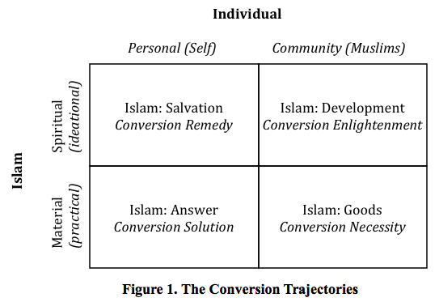
The framework of the study underpins empirical investigations and it incorporates subjective utilities, recognising the diversity of conversion experiences as well as partially conflicting rationales and goals of changing one’s religious denomination which may range from spiritual to ideological and from social to instrumental. Since conversion is the meeting point between an individual and religion, the model thus takes the human aspect in its actual behaviour either involving the individual self or other social actors open to external social forces on the one hand and the approach to the religious element on the other. This approach casts an invaluable light upon the dynamic relationship between social conditions and religious orientation in the identity transformation called religious conversion. These two crucial factors are complementary, not antagonistic, and stretching the analysis fully between the two poles of individual versus collective aspects of conversion captures the multiplicity of the facets of the conversion experience without creating a faulty impression that it is either one or the other aspect, but rather a dynamically interacting and interwoven whole.
The above meta-theoretical matrix is a viable alternative to existing theories; a meeting point between the two modes of thinking about conversion, between the individual approach focusing on a single person and looking for the ideal type of convert and the collective approach analysing structural factors and trying to capture the ideal mechanism of conversion. It shows unequivocally that converts cannot be treated uniformly as a security risk group. The question arises, however, if there is no ideal convert/conversion model: how can the variance be determined and the potential for violent (or non-violent) radicalisation be assessed?
Assessing the impact of conversion on later life is an extremely challenging and daunting task. In the first place, the conversion narrative is not always available. Secondly, the difficulties of establishing the conversion trajectory notwithstanding, we need to remember that “becoming to be” only shapes “being New Muslim”. The acceptance of Islam as religion by taking shahada is merely a first, albeit the most important, step in being a Muslim. However, the richness of the conversion experience is not limited to this simple act. The shape and dynamics of mechanisms operating throughout the conversion process do not determine its consequences. Yet they undeniably inform the further development and provide the impetus and stimulus for the first stages of the New Muslim life. In other words, the ways of Becoming suggest the possibilities of Being.
Converts are not a uniform monolith and the very name designating them as a group is but another social construct with constantly changing boundaries. Nonetheless, amidst the disparity that can be noted when comparing different converts, a common denominator emerges, namely their identity as European New Muslims, which appears to be a unifying factor that overcomes the divisions and discrepancies. It is crucial to analyse the possible ways of living a New Muslim life and establish what factors have a key impact on the ideational change and how these interact. With the aim to refine the current conceptualisation of a potential terrorist threat we need to identify not only the types of ascertaining conversion but also the ways of living conversion. If shahada brings converts together and their identity as New Muslims sets them apart, the key to understanding the potential terrorist threat of European converts to Islam lies in the identity spectrum of understanding of what it means to be Muslim and to delineate the normative space of belonging. Thus, the ideational dimension renders the impartial knowledge about the factors crucial for security implications.
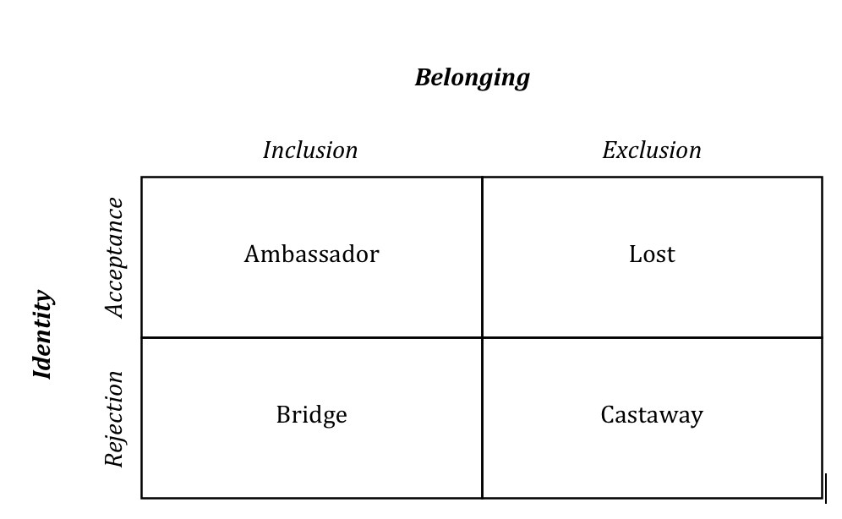
My proposition of the identity-belonging nexus and its influence on individual’s actions is presented in the following matrix, being an amended version of Sandra Wallman’s four-part social boundary matrix. Wallman’s [11] original proposition does not provide answers to the enriched “me” versus the changed “me” dilemma: Is conversion a putting on of a new layer of clothing or putting on a new garment altogether? Similarly, it leaves unexplained the question of conquering the border: Does conversion enlarge the space or is it a simple crossing where what once was “us” now becomes “them”? The main signifier is the nexus of identity and belonging: is the new self built on a rejection of the old or an acceptance of the new and what is the attitude towards “them” in relation to new “us”? Therefore, the study proposes a highly contextualised typology that allows for capturing the full texture and the dynamic nature of conversion, offering an analytic tool that reflect the nature of the problem and also has the potential to inform policy making. The matrix also develops the understanding of the relationship between the discursive and normative constituents of being a New Muslim and their role in the relationship between the individual and the group. Rejection and exclusion, as well as acceptance and inclusion always take place at the intersection of an enabling environment and a personal trajectory. My own research approach, while sympathetic to psychological pursuits, is oriented more towards a social self that is partially contingent on underlying psychological structures. At the crossroads of personal history and the conducive environment, the interplay of factors within the identity–belonging nexus can trigger radicalisation in varying degrees. Simultaneously, the use of violence is only one of the possible avenues of radicalisation.

Figure 2.The Typology of European Converts to Islam
The identity of a convert, the “New Muslim” identity, is understood here as a part of an individual’s self-concept. The degree to which it permeates life and organises other self-identities varies: It can be subjugated to the fact of being Scottish or Dutch or, conversely, it can overpower the notion of being a woman. Regardless of how rich and complex the importance of group membership is, its impact upon the individual behaviour will depend on positive or negative attitudes towards social identity categorization (what I am vs. what I am not). These are crucial in reference to the way we react towards “the other”.
Belonging, on the other hand, is seen as an emotional attachment, feeling safe and “at home” as defined by Nira Yuval-Davis.[12] In my proposition, belonging, as an act of self-identification, is considered from the cognitive perspective of the dynamics between inclusion-exclusion duality, which reflects the isomorphic nature of the border. Again, the notion of who is incorporated and who remains left out is crucial for determining the direction and intensity of interactions as every boundary must be viewed in a wider societal and political context showing the intricate connection between identity and belonging and the importance of borders. Naturally, one cannot attain a typology without making some sweeping generalisations. It is not the intention of this study to argue that the above convert archetypes are set in stone, i.e. that a person displaying one set of features characteristic for a given ideal type cannot and/or will not move into another quadrant. Furthermore, it needs to be remembered that ideal archetypes identified within the proposed theoretical framework remain ideal, i.e. while capturing the mechanisms and dynamics of social reality, by their nature offer only simplified versions of the real world.
On the individual level the study explored whether the two identities, the national and the Islamic, are conflicted or competing and whether the indigenous cultural element vanishes after crossing the religious border. The framework shows how individuals feeling at ease with their hitherto prevailing identity and who embrace Islam not as the essence of “the other” but as something that completes the wholeness of their personality (acceptance) are far less inclined to proceed to activities that aim at destroying the culture in which they were brought up as opposed to those who, in order to embrace Islam, feel the need to discard in an act of rejection all that they were before the shahada. This framework also indicates that when someone not so much embraces Islam, but rejects the West and everything it represents, by excluding the whole sphere of belonging they make themselves more vulnerable towards radicalisation. The first case resembles a situation where a church building is no longer in use for Christian services but can still serve the community as a museum or an art gallery or a mosque. In the second instance the building itself is deemed undesirable and unfit to become a mosque, so it is destroyed to give space for new structures.

Four Archetypes
By looking at the converts’ own narratives, the study illustrated the dynamic interplay of the factors crucial during a convert’s life after the shahada. Each of the elements shaping the way Islam is lived by European New Muslims was analysed through the proposed conceptual framework in order to reflect upon the complex reality of the converts’ lived lives within the identity-belonging nexus. In this light, particular consideration was given to rejection, acceptance, exclusion and inclusion factors. The Ambassadors narratives show how acceptance and inclusion are instruments for internalising the differences and enhancing the pluralism of ideas countering radicalisation. One respondent called Anna showed how the Ambassador archetype represents individuals for whom conversion is based upon acceptance and inclusion, the reconciliation of the old with the new, with all elements working in unison. “No, it is not important that people know that I am a Muslim. I hope that they will see about my behaviour that I am a Muslim [rather] than I have a label here [pointing to her forehead]. I want to find the similarities. That is what I want to find, because that is what gives us a bond.”[13] As the analysis revealed, Ambassadors are not tussled between contending perspectives. Ambassadors offer a registry of solutions to potential conflicts and represent some sense of a middle path between the other archetypes that stand divided on ideas central to the lives of European converts to Islam and the issue of them being a security issue.
The Lost archetype counters the theories arguing that only the young, socially alienated and economically marginalised individuals convert. It also challenges the unidirectional dynamics of radicalisation and shows how a convert can practice with all the zeal of a new believer, then slowly diminish in his fervour being on the verge of abandoning religion altogether until a proper balance is found in the spiritual and material elements of life. It presents the most ephemeral and contradictory of the four archetypes where embracing Islam as the new religion based on an acceptance of the new incessantly clashes with the exclusion of the old sense of belonging in their social, cultural and behavioural dimensions. The study argues that the Lost archetype is the most common and at the same time the least stable of the four archetypes. Simultaneously, it can be claimed that it is a conundrum of so many factors that one can hardly refer to the plethora of circumstances and responses as a cohesive archetype as it encompasses such a multitude of idiosyncratic behavioural traits. It is difficult therefore to describe an ideal individual since the variety within the type is based on an overabundance of highly personalised factors. At the same time, it is the ubiquitous archetype and the main challenge it poses from the security perspective is that it can easily lead a convert into any of the other three archetypes depending on which of the push and pull factors prevail in the identity-belonging dynamic. During the interviews a respondent called Asa brilliantly summarised the perils of a lost convert: “As a new Muslim, if you ain’t got no knowledge you are going to do wild stuff...let’s say at that time I became a new Muslim, and I do not know nothing about Islam and I have…no sort of a mentor, someone to guide me in the right path, I could of easily fallen into um, um, extremism, you know? Because I think, I think, that is how they [radicals] target people....”[14]Thus, while what is Lost can sometimes be found and mature as an Ambassador, the Lost archetype can occasionally also become a Bridge archetype and even entirely vanish in the vortex of the new-self and resurface as a Castaway.
The Bridge archetype emerges when one’s identity is created on the foundation of rejection and at the same time, instead of limiting the normative spaces of belonging, be opened towards conquering new territories and include new communities into one’s existential sphere. It often necessitates making hard choices like explained by a respondent called Liliana: “I knew I was going to become a Muslim and I knew the consequences of my choice: that I will not be able to stay at home because it would be hard and that my studies will not help me in anything, in life I mean. I also knew that I would have to leave because most of the [Muslim] guys live abroad, those with whom I would like to be.” [15]Thus, in a sense acting as a Bridge requires both cultural and social bi-location which only is intensified by the interplay between the factors of rejection and inclusion, a prevalent feature of this archetype. The investigation exposes that Bridges are people of concrete deeds and swift actions. The Bridge, although grounded quite firmly in culture, binds the two banks of his religious identity. Simultaneously, however, the Bridge indicates a certain migratory tendency: one does not enter the bridge to remain there forever, a bridge leads somewhere and hence those who can be ascribed to the Bridge archetype are always on the move, never rooted in one place, never fully settled. Symptomatically, even though the Bridges professes a world without barriers, by acting as an intermediary between two communities whom they clearly distinguish from each other, they in fact replicate the divisions. To quote one of them, Laura: “In contrast to Europe where we have stereotyping of Muslims, in the Arab world they are stereotyping Europe, yes they are! And a lot of our Muslims [female converts] have problems just because they are European. They are rejected…So these are two different worlds, based on their cultures I would say, and converts are just a group in between.”[16]
The Castaway archetype draws upon the stories of individuals whose lives constitute a unique coalescence of rejection and exclusion. That provides favourable conditions for a totality of belief which has the potential of resulting in susceptibility towards terrorist violence. The Castaway archetype is the one that has become emblematic, often being taken as representative of the whole convert community. To define this archetype in one sentence, one could say that instead of living Islam in Europe, the Castaways live Islam instead of Europe. Eric Breininger’s memoires “Mein Weg nach Jannah”[My Road to Paradise] perfectly exemplifies these tendencies: “I knew that I had to take measures against the crusaders who were humiliating our brothers and sisters. Also every Muslim should stand up for a life according to the law of Allah and for that reason that we must build an Islamic state.”[17] The study concluded that the tandem of rejection and exclusion trigger dynamics whereby a desire for a borderless world results in perpetual reaffirmations of existing divisions. It argued that the Castaway is but a minority in the converts’ community and hence the matrix proposed in the doctoral thesis (of which this article forms a partial summary) might help develop policies to target radicalisation vulnerabilities. It invites policy makers to re-think and re-structure current policy approaches to European converts to Islam.

Conclusions
The study’s conclusions amount to an invitation to reconsider the concept of “the convert”. In addition to redefining “the convert”, it also calls for redefining the concept of “the potential”. It stipulates that the lack of understanding of converts’ drives, and the very nature of the process of radicalisation culminates in, an ignorance of the fact that the convert community, en masse, vehemently opposes being labelled a security threat. In particular it is claimed that the potential of the convert community as first and foremost allies in countering terrorist threats, is ignored. This, in turn, raises profound concerns in terms of the efficacy of anti-radicalisation and anti-terrorist policies. Secondly, the more flexible perspective offered in the thesis highlights the interplay of factors indicated in the meta-theoretical matrix and the typology. The research conducted opens up alternative avenues that could be used on the policy-making level in order to inhibit and disrupt processes of converts’ radicalisation. The theoretical framework proposed in the dissertation allows not only for a more flexible perspective and a fuller and more appropriate understanding of potential terrorist threats posed by European converts to Islam, but also shows how these can be translated into concrete security policies. The negative approach aimed at eliminating Castaways should be replaced by a positive one resulting in strengthening and facilitating the Ambassador archetype. The research conducted strongly advocates a nuanced, more accurate understanding of the potential terrorist threat of European converts to Islam. Such an approach could be more successful than a rigid essentialised approach of a “risk group” that is far too generic to be functional at the policy level.

Notes
[1] O. Roy (2008). Al-Qaeda: A True Global Movement. In R. Coolsaet (Ed.), Jihadi Terrorism and the Radicalisation Challenge in Europe. Aldershot: Ashgate, p. 106.
[2] J. Cesari (2008). Muslims in Europe and the Risk of Radicalisation. In R. Coolsaet (Ed.), Jihadi Terrorism and the Radicalisation Challenge in Europe. Aldershot: Ashgate, p. 103.
[3] C. Whitlock. Converts to Islam Move Up in Cells: Arrests in Europe Illuminate Shift. The Washington Post, September 15, 2007. http://www.washingtonpost.com/wp-dyn/content/article/2007/09/14/AR2007091402265.html (accessed September 15, 2007); Benjamin, D. The Convert's Zeal: Why Are So Many Jihadists Converts to Islam? The Brookings Institute.http://www.brookings.edu/articles/2007/0907terrorism_benjamin.aspx?rssid=benjamind (accessed November 18, 2008).
[4] M. Bloom. (2007). Female Suicide Bombers: a Global Trend, Daedalus, 136:1, p. 36.
[5] Cf.:[-]. Essex Boys Sign Up for 'Holy War'. The Observer. February, 2002; [-]. Whites Being Lured Into Islamic Terror. The Telegraph, July 02, 2006; [-].Al-Qaeda's White Army of Terror. Scotland on Sunday. January 13, 2008; [-].Exeter Bombing Suspect Was 'Brainwashed', Friends Insist. The Independent. May 24, 2008.
[6] Cf.: M. Bloom. (2005).Dying to Kill: The Allure of Suicide Terrorism. New York: Columbia University Press; and A.H. Kydd. & B.F. Walter (2006). The Strategies of Terrorism. International Security, 31:1, pp. 49-80.
[7] A.L. George. & A. Bennett (2004). Case Studies and Theory Development in the Social Sciences. Cambridge: MIT Press.
[8] L. Clutterbuck (2010). An Overview of Violent Jihad in the UK. In M. Ranstorp (Ed.), Understanding Violent Radicalisation, London: Routlege, p. 156.
[9] A.P. Schmid (1993). Defining Terrorism: The Response Problem as a Definition Problem. In A. P. Schmid & R. Crelinsten (Eds.), Western Responses to Terrorism. London: Frank Cass, p. 7.
[10] R.A. Straus (1979). Religious Conversion as a Personal and Collective Accomplishment. Sociological Analysis, 40:2, pp. 158-165; D. Snow & R. Machalek (1983).The Convert as a Social Type. In: R. Collins (Ed.), Sociological Theory. San Francisco: Jossey-Bass, pp. 259-89; H. Gooren (2007). Reassessing Conventional Approaches to Conversion: Toward a New Synthesis. Journal for the Scientific Study of Religion,46:3, pp. 337-353; J.T. Richardson. (1985). The Active vs. Passive Convert: Paradigm Conflict in Conversion/Recruitment Research. Journal for the Scientific Study of Religion, 24, pp. 119-236; B. Kilbourne & J. T. Richardson (1989). Paradigm Conflict, Types of Conversion, and Conversion Theories. Sociological Analysis, 50:1, pp. 1-21; J. Lofland & R. Stark (1965).Becoming a World-saver: A Theory of Religious Conversion. American Sociological Review, 30, pp. 862-874; L. R. Rambo (1993). Understanding Religious Conversion. New Haven, CT: Yale University Press.
[11] S. Wallman. (1978). The boundaries of “Race”: Processes of Ethnicity in England. MAN, New Series, 13:2, p. 207.
[12] N. Yuval-Davis. (2006). Belonging and the Politics of Belonging. Patterns of Prejudice, 40: 3, p. 199.
[13]Anna. Interview by author. Tape recording. Assen, the Netherlands. August 08, 2009.
[14] Asa. Interview by author. Tape recording. London, UK. March 16, 2011.
[15] Liliana. Interview by author. Tape recording. Reading, UK. February 18, 2010.
[16] Laura. Interview by author. Tape recording. Czeladź, Poland. December 29, 2009.
[17] A.G. El-Almani (aka Eric Breininger), (2010). Mein Weg nach Jannah (My Path to Jenna). Elif Medya, p. 53. Breininger died on 30 April 2010 in the Waziristan in a confrontation with Pakistani security forces.

Dr Monika Gabriela Bartoszewicz is a Karol Wojtyła Fellow at the Centre for Thought of John Paul II (Warsaw, Poland) specialising in religion in politics.

230 Websites and Blogs for Terrorism Research
Compiled and selected by Judith Tinnes
Source: http://www.terrorismanalysts.com/pt/index.php/pot/article/view/270/html

Abstract
This resource collection lists 230 websites and blogs which are deemed to be valuable information sources for serious researchers in the field of (counter-) terrorism studies. The first part lists websites run by academic, governmental, non-governmental, and private institutes, organisations, companies, as well as individual experts. The second part of the collection comprises blogs, many of them containing analyses of primary source materials as well as up-to-date news.

The following resource collection lists 230 websites and blogs that are likely to be useful for students, researchers, and professionals in the field of terrorism and counter-terrorism. It is update as of end of May 2013. The first part comprises websites run by a broad spectrum of actors in the field, including academic, governmental, and private institutes, organisations, companies, and individual experts. Many of the sites contain so-called “Grey Literature”, i.e., non-conventional publications such as reports, working papers, or research briefs. Generally, grey literature is often harder to locate than conventional literature (such as journal articles or books) because it is “neglected by most library catalogs and databases”[1]. It encompasses a broad range and variety of materials. Many of the publications are original, covering topics in a thorough, in-depth fashion – often surpassing in length conventional journal articles. To find publications at a particular website, researchers are advised to search for the relevant section (often entitled “Publications”), which can be retrieved either by browsing or via the site map. A Google search with the site operator (e.g.: publications site :ctc.usma.edu) may also deliver satisfactory results.
The second part of this resource collection covers blogs maintained by terrorism experts. In the dynamic field of terrorism research, blogs are an invaluable information source as they provide users topical and thematic information. Many terrorism research blogs publish well-founded analyses of primary source materials (e.g., statements, video, and audio publications by terrorist organisations), point to news sources or expert literature and also provide links to additional relevant websites (so-called “Blogroll”). Several bloggers in the field run accompanying Twitter accounts where they tweet news headlines and information on newly released publications by terrorist and counter-terrorist organisations, enabling readers to track events in nearly real-time.
The resources assembled here were identified by scanning a variety of information sources such as bibliographies, institutional resource guides and expert blogs. Like every hand-searched resource collection, this one reflects subjective choices. Since the information requirements of researchers differ, the present resource list should not be used as single source for website and blog retrieval in the wide interdisciplinary field of terrorism studies. Especially for disciplinary sub-topics, researchers are advised to look out for additional online resources tailored to their specific needs. Readers should also keep in mind that this list focuses mainly on English-language resources. However, there is a growing amount of Internet resources available in other languages for those who have the necessary language skills.

About the Compiler: Judith Tinnes, Ph.D., studied Information Science and New German Literature and Linguistics at the Saarland University (Germany). Her doctoral thesis dealt with Internet usage of Islamist terrorists and insurgents. Currently she works in the research & development department of the Leibniz Institute for Psychology Information (ZPID) (http://www.zpid.de). She also serves as Editorial Assistant for 'Perspectives on Terrorism'.
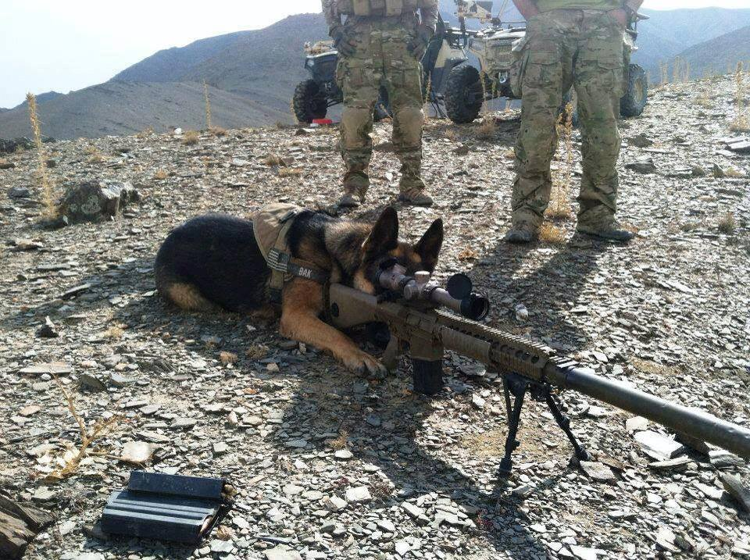

West Africa piracy overtakes Somali ship attacks
Source: http://www.bbc.co.uk/news/world-22944460

Piracy off the coast of West Africa has now overtaken Somali piracy, a report by the International Maritime Bureau (IMB) and other seafarers' groups says.
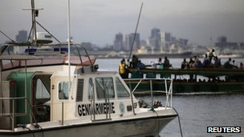
It says 966 sailors were attacked in West Africa in 2012, compared with 851 off the Somali coast.
West African pirates mostly steal fuel cargo and the crews' possessions, often resorting to extreme violence.
Five of the 206 hostages seized last year off West Africa have been killed, the document says.
'Sadistic methods'
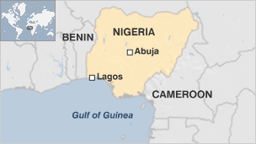
The report, entitled The Human Cost of Maritime Piracy 2012, was released by the International Maritime Bureau (IMB), the Oceans Beyond Piracy (OBP) project and the Maritime Piracy Humanitarian Response Programme (MPHRP).
It says that despite the growing number of pirate attacks in West Africa's Gulf of Guinea region "the area has not received the attention that was brought to Somalia".
Pirates typically target fuel cargo, selling it on the lucrative black market.
"In Nigeria, money moves quite quickly, unlike in Somalia," one seafarer is quoted as saying in the document.
"In Somalia, it would take months. In Nigeria, the pirates take our (oil) cargo and the money of the (shipping) company. It would take only weeks, it is quite fast."
The highest risk area for pirate activity in West Africa is off the coast of Nigeria, by far the biggest country, and oil producer, in the region.
Because successive governments there have failed to develop sufficient domestic oil refining capacity, Nigerian waters are full of tankers exporting crude oil and importing refined petroleum that are vulnerable to attack, says BBC international development correspondent Mark Doyle.
Corruption and, until recently, armed rebellion in the oil producing areas, have led to the development of an entire, well-organised industry for stealing - or "bunkering", as it is known in Nigeria - oil products, he says.
That industry has become almost institutionalised by a national government subsidy on petrol, our correspondent adds.
The report released on Tuesday says tackling piracy in both West Africa and Somalia requires "co-operation between efforts at sea and those on land to build maritime security and provide job opportunities to potential pirates".
At the same time, the findings show a 78% drop in piracy off Somalia last year compared with 2011.
The report says this is due to better practices by ship's captains and crews and the increasing use of armed guards aboard vessels in the region.
But it adds that at least 78 hostages are still being held captive by Somali pirates. Some sailors have been already held for more two years.
Many Somali pirates have used cruel and sadistic methods to extort ransom payments, it says.

Analysis

Frank Gardner BBC security correspondent

Maritime piracy off West Africa differs from that off Somalia and may eventually prove harder to deal with.
In the Somali Basin there is a large concentration of patrolling warships - from the US Navy 5th Fleet, Nato, the EU and others - as well as reconnaissance aircraft, all acting in coordination. But in the Gulf of Guinea there is not one but several national coastlines to patrol with no single unified policing body.
Somali pirates generally aim to capture a ship with minimum casualties then hold the vessel, its crew and cargo to ransom for millions of dollars, sometimes for as long as two years. West African pirates tend to be land-based criminals, mostly from Nigeria, who look to steal the cargo and any valuables they can find in a quick grab-and-dash operation, often staying onboard for less than a week.
International efforts to tackle piracy off West Africa have been slow to take effect.

Tourism and terrorism in Jammu and Kashmir
By Dr Shabir Choudhry
Source: http://www.international.to/index.php?option=com_content&view=article&id=8813:tourism-and-terrorism-in-jammu-and-kashmir&catid=48:dr-shabir-choudhry&Itemid=79#comments

29 June 2013. For many countries in the world tourism is the main source of their national income. Nearly all countries make great efforts to encourage tourism and provide appropriate facilities that more and more people come and spend money in their countries to boost the national economy.
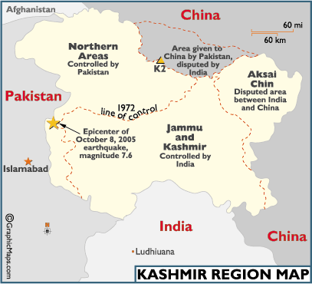
Recently I visited Istanbul, Turkey, and saw tens of thousands of tourists from various countries. These people were not only impressed what Istanbul had to offer to the tourists, but they also spent millions of dollars that provided jobs to the local people. All tourists eat, drink, use transport, stay in hotels and pay visa fees and entrance fees etc.; and that provides employment to the local people and boost economy.
However, that is not what happens in the divided State of Jammu and Kashmir. It is sad that some forces with vested interest not only discourage tourism in the State of Jammu and Kashmir; but they also make special efforts to commit acts of violence and terrorism to frighten tourists and prospective tourists.
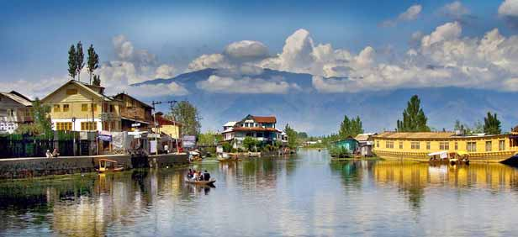
The government of India makes serious efforts to encourage tourism in the part of Jammu and Kashmir under their control. They do this not only to support the local economy; but also to give this message to the world that the worst is over in Kashmir and normalcy is returning. To counter that, the Pakistani government, their agencies and proxies make sincere and concerted endeavours to discourage, frustrate and frighten tourists in all parts of Jammu and Kashmir State.
People may remember that Pakistani backed religious fanatics systematically targeted tourists, killed them, harassed them; and in some cases kidnapped them. Idea was that non Kashmiris must stay away from Jammu and Kashmir; and that people of Jammu and Kashmir must not benefit from fruits of tourism. These fanatics did all these non - Islamic acts in name of religion. Islam does not allow acts of violence and terrorism, promotion of religious hatred, or killing of innocent people. Islam commands to respect guests and visitors and these fanatics killed them and harassed them in name of Islam.
Islam says no compulsion in religion and strictly demands that religious minorities must be protected; and that there must be no interference in their religious matters. These fanatics, in name of religion, declared to stop Amar Nath Yatra and persecuted religious minorities. They closed beauty parlours and in some cases threw acid on faces of women who went to these beauty parlours. It is strange that these fanatics did not ask their mentors to close beauty parlours in Pakistan, from where they were getting training, arms and directions, but felt appropriate to implement their orders in Jammu and Kashmir.
A few years ago I met a man in Rawalpindi, Pakistan. During conversation with me he explained his experience of a visit to Neelam Valley, situated in Pakistani Administered Kashmir. He lived in Lahore and went to the Neelam Valley with his family for a holiday. He said police check posts on the way to the Neelam Valley and the attitude of the security men was harassing and intimidating. He said wherever they went they were followed by two motor bikes all the time. He had his wife, sister and children with him. They felt so insecure that after two days they cut short their holiday and went back to Lahore.
The authorities in Islamabad DONOT like people to visit areas of the Jammu and Kashmir State under their control, especially areas adjacent to the LOC and Gilgit Baltistan. People of these areas live behind ‘Iron Curtain’; and the authorities don’t like even the Pakistanis know what actually goes on in these areas. Apart from that they know tourism will promote the local economy, and will give people economic independence which will ultimately reduce their reliance on those who control and plunder these areas.
Furthermore, interaction with the outside world, even with well off and liberal minded Pakistani is not tolerated, as that could jeopardise their game plan and loosen their grip. People have to see the recent barbarous and inhuman attack on the Mountain climbers in Gilgit in the light of the mind-set explained above. I agree, there might be some other motives too, but the fact remains that authorities do not even like people of so called Azad Kashmir visiting Gilgit Baltistan and interact with each other.
The unprovoked killing of the Mountain Climbers, who came from various countries, were our guests. All civilised people respect visitors. Their presence there was not threat to any state secrets or defence installations. They were spending their hard earned money there, which was helping the local people. Why kill them? It is crystal clear that the local people will never kill them.
Killers were not ordinary people. They were highly trained individuals who could not have reached that area without some ‘official’ support. The attack was well planned, and they were appropriately equipped with arms. The camp was at the height of 4,200 Meters; and the attackers knew exactly where to find them and what to do. One commentator said, “It takes two to three days to reach (the camp). The body needs to acclimatise for climbing up. How they went undetected is a big question."
It is a known fact that extremist groups in Pakistan get some official support. They were set up, trained, armed and financed to advance a certain policy that the men in uniform could not officially do. It is widely believed that different extremist groups have official patronage in Pakistan; and Western reputable writers and Think Tanks have extensively written on this subject. Mark Bowden, a famous author of many books related to South Asia and terrorism wrote:
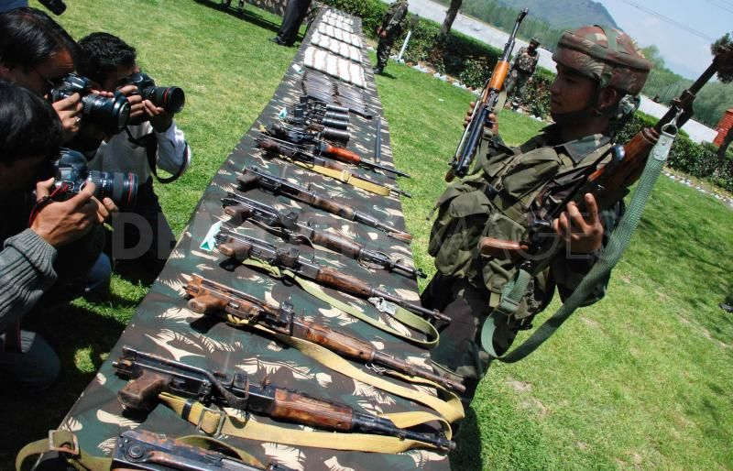
‘But the issue of Pakistan was delicate. That unstable nation was critical to the war efforts in Afghanistan. It was a nuclear power in one of the world’s most volatile regions, and yet elements of its government, particularly its powerful intelligence agency, the Inter – Services Intelligence (ISI), were known to be in bed with all manner of Islamist radicals. Pakistan’s President Musharraf had been walking a narrow thin line with the Bush administration, providing enough cooperation to avoid being branded an enemy but falling well short of routing extremists hold in Pakistan’s lawless northwest.’ Source: The Killing of Osama Bin Laden, page 79-80
It was because of Pakistan’s hobnobbing with the extremist groups that many experts on terrorism said ‘Pakistan was part of the problem’ and ‘not part of the solution’ in fighting terrorism. The American intelligence sources believed that ‘Pakistan had become the new safe haven for the terror groups after the fall of Taliban’. As the result of this double play America also got frustrated, and due to lack of distrust, President Obama had to say: “If we have actionable intelligence about high – value terrorist targets and if President Musharraf won’t act, we will.” It was as a result of this policy that America unilaterally conducted a secret operation in Abbottabad to kill Osama Bin Ladin. Despite the fact that Pakistani sovereignty was violated, Pakistani government congratulated America for this success.
The brutal killing of mountain climbers has further tarnished Pakistan’s image at the international level. The fanatic killers were wearing police uniform. This was the worst attack on foreign nationals for many years; and it will have very serious impact on tourism in this region. Naik Nam Karim, General Secretary of the Pakistan Association of Tour Operators said:
‘The killings were a "disaster" for Gilgit-Baltistan, where tourism is the main source of income. "It will destroy tourism in our area," he told AFP, saying that he had already received a slew of cancellations by email and telephone’. "We used to be able to convince foreign tourists that there was peace in Gilgit-Baltistan but this incident has ruined everything."

Foreign tourists were of two kinds: climbers and trekkers – those who wanted to see stunning natural beauty of the region. On average non-trekking tourists used to spend $3,000; and trekkers used to spend between $8-10,000 because they stayed here longer.
It must be pointed out that before the war on terrorism more than twenty thousand foreign tourists visited Gilgit Baltistan each year, which greatly helped the local people run their kitchens. The number of visitors has dropped dramatically to around 5,000 a year now. After this tragic incident who would like to risk their lives and go there; and it will hurt the local people immensely.
If the authorities in Islamabad are serious in combatting and eradicating terrorism and encouraging tourism, then they will have to take some bold steps which may not be popular in certain quarters. However, if they continue with their old policy, then I am afraid these fanatics will lead Pakistan to a disaster.

Dr Shabir Choudhryis a political analyst and author of many books and booklets. Also he is Director Institute of Kashmir Affairs.

Rebels kill policeman, injure 14 others in Chechnya
Source:http://www.reuters.com/article/2013/06/29/us-russia-chechnya-clash-idUSBRE95S04H20 130629

Rebels have killed a Russian policeman and injured 14 others in Chechnya, police said on Saturday, a rare clash in the now mostly calm North Caucasus republic which lies near to the venue for the 2014 Winter Olympics.
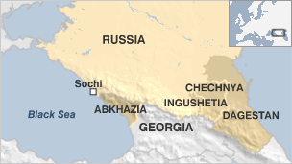
Moscow waged two wars against separatist rebels in mainly Muslim Chechnya in the 1990s but the province has been fairly peaceful in recent years as Islamist insurgents have turned their focus to the nearby regions of Dagestan and Ingushetia.
This month, President Vladimir Putin put Russia's security forces on high alert to safeguard the Games due to take place next year in the Black Sea resort of Sochi.
A police spokesman said by telephone from the Chechen capital Grozny that a police patrol had run i nto a band of rebels in the southern Shatoi district.
"They (the rebels) were ordered to put down their weapons, but instead they opened fire," he said, adding that he could not say how many insurgents had been involved.
Russia's interior ministry said security forces were pursuing the rebels in a mountainous forest region.
Human rights activists say Russia's Islamist insurgency is fuelled by a combination of religion, official corruption and strong arm tactics against suspected militants by local leaders.

The 'Sex Jihad'
By Raymond Ibrahim
Source: http://www.meforum.org/3542/sex-jihad

News emerged a few weeks ago in Arabic media that yet another fatwa had called on practicing Muslim women to travel to Syria and offer their sexual services to the jihadis fighting to overthrow the secularist Assad government and install Islamic law. Reports attribute the fatwa to Saudi sheikh Muhammad al-'Arifi, who, along with other Muslim clerics earlier permitted jihadis to rape Syrian women.
Muslim women prostituting themselves in this case is being considered a legitimate jihad because such women are making sacrifices—their chastity, their dignity—in order to help apparently sexually-frustrated jihadis better focus on the war to empower Islam in Syria.
And it is prostitution—for they are promised payment, albeit in the afterlife. The Koran declares that "Allah has purchased of the believers their persons [their bodies] and their goods; for theirs (in return) is the garden (of Paradise): they fight in His cause, and slay and are slain (Yusuf Ali trans. 9:111).
On the basis of this fatwa, several young Tunisian Muslim girls traveled to Syria to be "sex-jihadis." Video interviews of distraught parents bemoaning their daughters' fates are on the Internet, including one of a father and mother holding a picture of their daughter: "She's only 16—she's only 16! They brainwashed her!" pleads the father.
Most recently, the Egyptian-based news service Masrawy published a video interview with "Aisha," one of the Tunisian Muslim girls who went sex-jihading in Syria, only to regret her actions. While in Tunisia, Aisha said she met a Muslim woman who began talking to her about the importance of piety, including wearing the hijab; she then went on to talk about traveling to Syria to help the jihadis "fight and kill infidels" and make Allah's word supreme, adding that "women who die would do so in the way of Allah and become martyrs and enter paradise." (According to mainstream Islamic teaching, dying in jihad is the only guaranteed way to avoid hell.)
Aisha eventually came to the conclusion that she was being exploited in the name of religion and left.
While news that Muslim girls in hijabs are prostituting themselves in the name of Islam may surprise some, Islamic clerics regularly issue fatwas permitting forbidden things—so long as they help the jihad. For instance, not only did the original "underwear bomber" Abdullah Hassan al-Asiri hide explosives in his rectum to assassinate Saudi Prince Muhammad bin Nayef—they met in 2009 after the 22-year-old Asiri "feigned repentance for his jihadi views"—but, according to Shi'ite talk-show host Abdullah Al-Khallaf, he had fellow jihadis sodomize him to "widen" his anus to fit more explosives.
Al-Khallaf read the fatwa that purportedly justified such actions during a 2012 Fadak TV episode.
After praising Allah and declaring that sodomy is forbidden in Islam, the fatwa asserted:
However, jihad comes first, for it is the pinnacle of Islam, and if the pinnacle of Islam can only be achieved through sodomy, then there is no wrong in it. For the overarching rule of [Islamic] jurisprudence asserts that "necessity makes permissible the prohibited." And if obligatory matters can only be achieved by performing the prohibited, then it becomes obligatory to perform the prohibited, and there is no greater duty than jihad. After he sodomizes you, you must ask Allah for forgiveness and praise him all the more. And know that Allah will reward the jihadis on the Day of Resurrection, according to their intentions—and your intention, Allah willing, is for the victory of Islam, and we ask that Allah accept it of you.
While all these sex-fatwas may seem bizarre, they highlight two important (though little known in the West) points. First, that jihad is the "pinnacle" of Islam—for it makes Islam supreme; and second, the idea that "necessity makes permissible the prohibited." Because making Islam supreme through jihad is the greatest priority, anything and everything that is otherwise banned becomes permissible. All that comes to matter is one's intention, or niyya (see Sheikh Yusuf al-Qaradawi's discussion along these lines).
As for the intersection between sex and violence (jihad), it was once explored by the Arabic satellite program Daring Question, which aired various clips of young jihadis giddily singing about their forthcoming deaths and subsequent sexual escapades in heaven. After documenting various anecdotes indicative of jihadi obsession with sex, Egyptian human rights activist Magdi Khalil concluded that "absolutely everything [jihad, suicide operations, etc.] revolves around sex in paradise," adding, "if you look at the whole of Islamic history, you come up with two words: sex and violence."
Indeed, Islam's prophet Muhammad maintained that death during jihad not only blots out all sins—including sexual ones—but it actually gratifies them:
The martyr is special to Allah. He is forgiven [of all sins] from the first drop of blood [that he sheds]. He sees his throne in paradise, where he will be adorned in ornaments of faith. He will wed the 'Aynhour [a.k.a. "voluptuous women"] and will not know the torments of the grave, and safeguards against the greater terror [hell]. … And he will copulate with 72 'Aynhour (see The Al Qaeda Reader, p. 143).
This goes to one of the many seeming contradictions in Islam: Muslim women must chastely be covered head-to-toe—yet, in the service of jihad, they are allowed to prostitute themselves. Lying is forbidden—but permissible to empower Islam. Intentionally killing women and children is forbidden—but permissible during the jihad. Suicide is forbidden—but permissible during the jihad—when it is called "martyrdom."
One may therefore expect anything from would-be jihadis, regardless of how un-Islamic the means may otherwise seem.
Even so, this uncompromising mentality, which is prevalent throughout the Islamic world, especially along the frontlines of the jihad, is the same mentality that many Western leaders and politicians think can be appeased with just a bit more respect, well-wishing, and concessions from the West.
Such are the great, and disastrous, disconnects of our time.

Raymond Ibrahim is author of the new book, Crucified Again: Exposing Islam's New War on Christias (published by Regnery in cooperation with Gatestone Institute, 2013). A Middle East and Islam expert, he is a Shillman Fellow at the David Horowitz Freedom Center and associate fellow at the Middle East Forum.

Hollywood’s Islam-Free Terrorism
Source:http://frontpagemag.com/2013/mark-tapson/hollywoods-islam-free-terrorism/?utm_source= rss&utm_medium=rss&utm_campaign=hollywoods-islam-free-terrorism

The Los Angeles Times reported Friday that terrorism is making a comeback in Hollywood films after a dozen post-9/11 years in which they shied away from dealing with a topic that studios deemed too sensitive. The report credits this new trend to filmmakers attempting to bring to their fictional films some “real-world relevance.” There’s just one problem: Hollywood’s terrorism is still devoid of real-world terrorists.
The Times article points out that the filmmakers of several of the summer’s blockbusters feel safe again to depict acts of terrorism: “collapsing skyscrapers, spaceships flying into densely populated cities and bombers run amok… With the terror attacks more than a decade in the past, they say they no longer have to worry about alienating audiences.”
First of all, terror attacks are not “more than a decade in the past.” Sure, they aren’t on the scale of 9/11, but America has continued to endure attempted and successful terror attacks since then, all the way up to the recent Boston bombing. As for alienating audiences, did it ever occur to those filmmakers that movies in which America proudly and unapologetically kicked Islamic terrorist butt might provide audiences with that tremendous collective catharsis that Aristotle noted was the aim of good drama? That movies which affirmed our freedoms and our superior cultural values – that’s right, I said superior –might have united, inspired and empowered those audiences? That such movies might have sent a message to the world that we are unbowed by barbarism?
Instead, when Hollywood did address the clash of civilizations in those post-9/11 years, it pumped out movies disapproving of the CIA and/or the wars in Iraq and Afghanistan. Every one of them reeked with the message of moral equivalence that we’re no better than the terrorists. Every one depicted our soldiers as PTSD-ravaged. Every one condemned our presence in Iraq as a Bush lie. And every one of those films about our clash of civilizations bombed, if you’ll pardon the pun, including Syriana, The Green Zone, Stop-Loss, In the Valley of Elah, Redacted, Brothers, Lions for Lambs, Rendition, The Kingdom, Body of Lies, and more. Why did they bomb? Because Americans don’t want to see movies loaded with those defeatist, self-flagellating messages. So Hollywood ended up alienating those audiences anyway.
“[Y]ou write about the times you live in,” said James Vanderbilt, screenwriter of White House Down, about an aspiring Secret Service agent protecting the president when the White House is taken over by – wait for it – domestic terrorists. “I was always fascinated with the idea of how you could take over the country — who would be able to do that,” said Vanderbilt.
I have a suggestion: if he wants to write about the times we live in, why not address credible, real-world enemies like Iran, Hezbollah, or al Qaeda and “its affiliates” (as President Obama calls them)? If he wants to imagine who could take over the White House, how about the Muslim Brotherhood, who traffic in and out of the White House now like it’s Grand Central Station? But he won’t because the truth is, too many in Hollywood are multiculturalist cowards who have already chosen to submit to Islam.
The latest Star Trek sequel is “about terrorism,” says the actor who plays Capt. Kirk, “about issues we as human beings in 2013 deal with every day, about the exploitation of fear to take advantage of a population, about physical violence and destruction but also psychological manipulation.” And yet the actor doesn’t explicitly make the obvious connection to those threats from Islamic fundamentalists. (In fact, nowhere in the Times article do the words “Islam” and “Muslim” appear in any form.)
Nor does Shane Black, director and co-writer of Iron Man 3, whose “ultimate terrorist” called “The Mandarin” “has this driving hatred for America which fuels his rhetoric with which he recruits these legions of followers.” Sounds like a clear stand-in for bin Laden or any number of Islamic terrorist leaders. And yet Black takes the safe route and makes his ultimate villain a vague fantasy figure.
In the new Superman reboot Man of Steel, director Zack Snyder said he was trying to evoke the 9/11 attacks “in a mythological rather than literal sense, using Superman as something like a therapist,” as the Times reporter puts it. “[Superheroes are] helping us understand the weird psychological and big horrible events that happen all the time,” Snyder said. “These guys deal with them in a dream-like way that makes it OK. A modern problem — a city getting destroyed — a superhero can help you understand that.”
Are we children who need to be coddled, who need help “understanding” “big horrible events”? During World War II Americans didn’t have to wrestle with the concept of Nazism or of Japanese imperialism in metaphorical terms. We didn’t have to undergo therapy to overcome our murky inner fears to confront those ideologies. We simply recognized them as evil and set out to eradicate them by laying waste to our enemies and their war-making capabilities.
As quoted in the Times article, Michael Taylor, chair of film and television production at USC’s School of Cinematic Arts, wishes filmmakers would use their platforms to explore “the root causes of terrorism” and its consequences. “Maybe there is a missed opportunity — where they can include an issue of positive social change in the narrative,” said Taylor, who also founded USC’s Media Institute for Social Change. “What can we be doing about terrorism, and how do we feel about it?”
How do we feel about it? This is typical touchy-feely nonsense from the left, whose first response to a terrorist threat is to blame America for it, then to organize a white privilege workshop or a gender-neutral drum circle to work out their deep-seated cultural guilt. Meanwhile Islamic terrorists – not Tea Partiers, not “anti-government types,” not angry vets, not anyone that Homeland Security considers a primary terrorist threat – continue blowing up children on our own soil.
Hollywood movies during WWII reflected an unconflicted confidence in our values and in the rightness of our purpose. Today, thanks in no small part to Hollywood’s deeply subversive cultural influence, it is our Islamic enemies who have that confidence, while America is paralyzed by navel-gazing, hand-wringing, moral confusion – and filmmakers who see their work as collective therapy rather than an inspirational call to arms.

Two held in British Columbia 'Canada Day bomb plot'
Source: http://www.bbc.co.uk/news/world-us-canada-23155029

Two people have been arrested in British Columbia accused of plotting to plant a bomb outside the provincial legislature on Canada Day, police say.
John Stewart Nuttall and Amanda Marie Korody were self-radicalised and inspired by al-Qaeda, the Royal Canadian Mounted Police said.
The two Canadians from Surrey, British Columbia, were arrested on Monday, which was Canada's national day.
They are not believed to have been in contact with other militant groups.
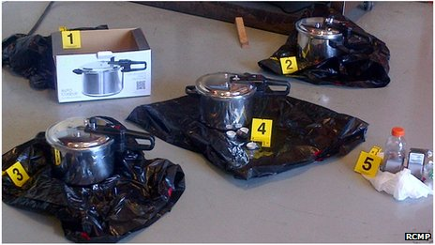
"Our investigation demonstrated that this was a domestic threat, without international linkages," said Royal Canadian Mounted Police (RCMP) Assistant Commissioner James Malizia.
The pair were arrested in the town of Abbotsford and are in custody in Surrey, police said. They are due in court later on Tuesday.
'Committed to violence'
At a press briefing on Tuesday, RCMP officials said the pair had been charged with conspiring to place an explosive in a public place with the intent of causing death or serious injury and with possessing a device to cause an explosion.
They also face one count of knowingly facilitating a terrorist activity.
Authorities displayed images of pressure cookers, which they said were to be used to make bombs similar to those detonated at the Boston marathon bombing in April.
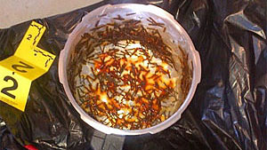
The RCMP said that inside the pressure cookers were nuts, bolts, nails, washers and other material that could kill or injure people.
The arrests are the result of a probe launched in February under an operation known as Project Souvenir, authorities said.
"The suspects were committed to acts of violence and discussed a wide variety of targets and techniques," said Assistant Commissioner Wayne Rideout.
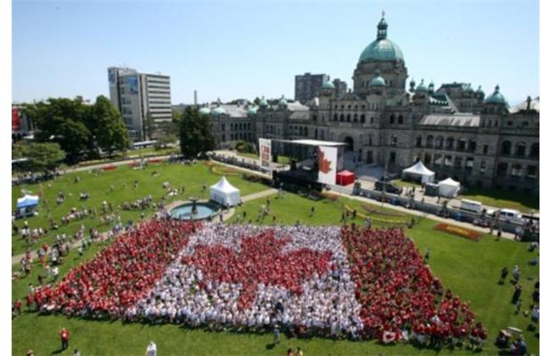
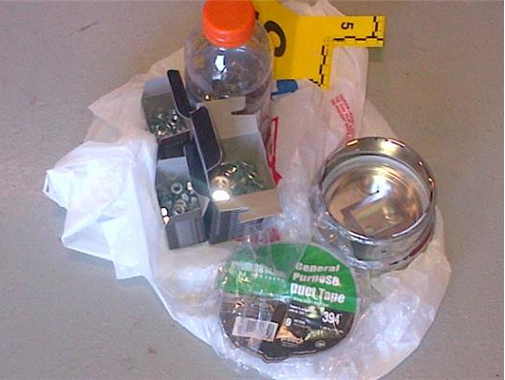
He added that there had not been a threat to public safety and that authorities had intervened to make sure the devices were not dangerous.
"These devices were completely under our control, they were inert, and at no time represented a threat to public safety," the assistant commissioner added.

Letter bomb ignites in Greek post sorting centre
Source: http://www.tinyg.info

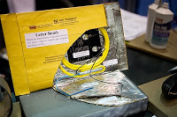
A letter bomb believed to have been sent by Italian radical anarchists ignited in a Greek post sorting centre on Wednesday without causing any injuries, police said.
The police said the envelope from Italy contained a makeshift explosive device and was addressed to a senior Greek police officer.
The bomb apparently went off by accident after the envelope was dropped by staff at a post sorting centre north of Athens, the police said.
Similar devices had been sent by the Italian Informal Anarchist Federation (FAI) to the then justice minister and the warden of Greece’s top security prison in 2011.
FAI has expressed solidarity to jailed members of Greek militant outfit Conspiracy of Fire Nuclei, which had sent parcel bombs to European leaders and embassies and carried out arson and bomb attacks some three years ago.

EDITOR’S COMMENT: Outer envelope was yellow in color, A3 size, containing a brown dossier (32X38 cm) sealed with Velcro tape. Recipient of the “letter” was the former Head of the Counter-terrorism Service (Gen Demitrios Chorianopoulos).

Chechen jihad leader vows to commit jihad mass murder at 2014 Winter Olympics in Russia
Source: http://www.jihadwatch.org/2013/07/chechen-jihad-leader-vows-to-commit-jihad-mass-murder-at-2014-winter-olympics-in-russia.html

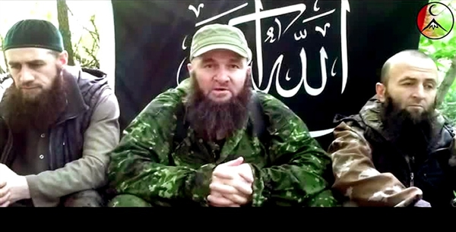
Question for our moral superiors: is resisting jihad terror "racism" if the jihad terrorists are...Caucasians?
"Chechen militant Umarov threatens to attack Sochi Olympics – video," from EuroNews, July 3 (thanks to Lookmann):
Chechen Islamist militant leader Doku Umarov has urged his followers to prevent the 2014 Winter Olympics in Russia – according to a video posted online, which cannot be independently verified.
The footage appeared to show Umarov saying: “They (Russia) plan to hold the Olympics on the bones of our ancestors, on the bones of many, many dead Muslims – buried on the territory of our land on the Black Sea, and we as mujahideen are obliged not to permit that, using any methods allowed us by the almighty Allah.”
You'd almost get the idea that this guy is a Muslim. Naaah, couldn't be -- it's a Religion of Peace. He must be a greasy Islamophobe.
Russian President Vladimir Putin has promised high security for the games, scheduled for next February in the Black Sea resort of Sochi.
Umarov’s group, Caucasus Emirate, aims to carve out an autonomous Islamist state in Southern Russia. It claimed responsibility for a bombing at a Moscow airport in 2010 that killed 37 people.

Shipping Containers & Hidden Dangers
By Richard Schoeberl
Source:http://www.domesticpreparedness.com/Infrastructure/Transportation/Shipping_Containers_&_Hidden_Dangers/

American seaports are not only the maritime doorway to the nation but also a crucial link in the U.S. two-way trade with other nations. Today, billions of dollars’ worth of unchecked goods move in and out of U.S. international seaports every month, making ports vulnerable to disruption from both terrorist attacks and natural disasters. In the United States, the Customs and Border Patrol (CBP), the U.S. Coast Guard, the Department of Agriculture, port authorities’ own police forces, and many other local, state, and federal government agencies diligently work together to protect the nation’s seaports from myriad threats. Nuclear proliferation is a viable threat and the possibility of a terrorist attack on a U.S. seaport is certainly plausible – both with the potential to cause immediate devastation to the local community and to cripple the already delicate global economy.

Busy Ports
The United States currently is served by more than 360 commercial ports – which, according to the U.S. Coast Guard, provide nearly 3,200 handling facilities for both cargo and passengers. Additionally, U.S. seaports process more than 2 billion tons of import/export freight per annum. In 2009 alone, according to the U.S. Department of Transportation, nearly 10 million ocean-borne cargo containers entered the United States through its seaports.
Los Angeles and Long Beach, California, are unequivocally the busiest North American container ports, trailed by the Port of New York and New Jersey. In 2011, the Port of Long Beach handled more than 6 million containers and the Port of New York and New Jersey handled 5.5 million – both container totals are measured in TEUs (20-foot equivalent units).
Cargo containers are an important component of the global supply chain – the flow of goods from manufacturers to retailers. Unfortunately, the mass influx of containers provides innumerable opportunities for would-be terrorists to smuggle and detonate a weapon of mass destruction (WMD) on U.S. soil. Although terrorism remains a critical security focus at seaports, it is actually rated by U.S. Customs as a lower risk than other threats – e.g., drug smuggling, human trafficking, weapons trafficking, and trade and import safety violations – that have the potential to compromise the nation’s supply chain.

Consequences of an Attack
Apart from the potential human costs that may result from a lack of port security, the economic costs of a maritime attack can be overwhelming. During a time when workforces face layoffs, impending unemployment extensions, and foreclosures, any political or economic factor that impedes the flow of trade would not only affect the seaports themselves but also interrupt the supply of goods. The widespread effect would be felt throughout the country, and in many other nations as well.
Rear Admiral Paul Zukunft, the Coast Guard’s Assistant Commandant for Maritime Security, told the House Subcommittee on Border and Maritime Security last year that, “Considering that high concentrations of our population live in and around port areas, and 95 percent of our international trade is done via the sea, the consequences of any attack or disruption on our maritime transportation system are potentially severe.”
Section 1701 of the 9/11 Commission Act of 2007 requires that all maritime cargo containers bound for the United States must, as of 12 July 2012, be scanned by non-intrusive imaging equipment and radiation detection technology before being loaded on ships. Reinforcing efforts to counter the looming terrorist threat at U.S. ports is the fact that then-candidate Barack Obama promised during his 2008 presidential campaign to “Develop technology that can detect radiation and work with the maritime transportation industry to deploy this technology to maximize security without causing economic disruption.”

The Benefits & Pitfalls of 100-Percent Screening
Unfortunately, the practicality of fully implementing the “100-percent screening” mandate is questionable – so much so that today, nearly six years since the 9/11 Commission Law was enacted, the U.S. Department of Homeland Security (DHS) has failed to implement the mandate ordered by Congress.
Given the complexity and magnitude of the global supply chain, as well as the massive number of containers transported to and from the United States each year, U.S. seaports remain susceptible to a broad spectrum of threats that domestic as well as international terrorists may be able to exploit. Although the U.S. intelligence community has long suggested the possibility of terrorists smuggling a WMD into the United States inside a shipping container is relatively low, the vulnerability to such an attack is theoretically very high.
According to the CBP, in fact, agency officials scanned only 473,380 – about 4.1 percent of the approximately 11.5 million containers shipped into U.S. ports in 2012 – with X-ray or gamma-ray machines, and some shipments getting only a cursory paperwork review. The low percentage of scanned cargo is officially rationalized as a “layered risk-based approach” to cargo scanning and focuses primarily on specific cargo considered to be “high risk” – how that term is defined and bestowed is not always clear.
Detecting radioactive materials or any other harmful matter at U.S. ports clearly remains a challenge for federal officials. However, U.S. Representative Candice Miller, a Michigan Republican who chairs the House Subcommittee on Border and Maritime Security, accepts the current approach. In a statement before the subcommittee on 7 February 2012, she acknowledged that, “We all recognize it [the current process] may be optimal but perhaps not realistic from a cost perspective.” She also reiterated a statement from DHS Secretary Janet Napolitano that, “The 9/11 Act’s mandate to scan 100% of maritime cargo containers is not achievable, does not necessarily make sense, and is not in line with the current risk-based approach.”
At the same hearing, though, former Rep. Laura Richardson (D-Calif.) said that a successful terrorist attack “on one of our ports, such as the Port of Los Angeles or the Port of Long Beach, would have a devastating economic impact and severely impact the global supply chain. The cost of one terrorist attack in our ports,” she continued, “would far surpass the costs of instituting the 100 percent container scanning that is required by law and was recommended by the 9/11 Commission. We have been extremely fortunate that an attack has not yet occurred in our ports.”

A Recipe for Disaster – Funding Cuts & Dense Populations
The Megaports Initiative – a collaborative effort between DHS, the U.S. Department of State, and their counterparts in U.S. international partners – is also facing severe spending cuts. The U.S. government has spent roughly $850 million on 42 different maritime security projects in 31 other nations to carry out such tasks as: (a) providing the seaports of other nations with radiation recognition equipment; (b) training foreign inspectors; and (c) providing other assistance to the employees of foreign governments who operate the ports.
Whether that funding stream will continue at the same level seems doubtful. According to a GAO statement in November 2012, “The administration’s fiscal year 2013 budget proposal would reduce the Initiative’s budget by about 85 percent, and NNSA [National Nuclear Security Administration] plans to shift the Initiative’s focus from establishing new Megaports to sustaining existing ones.”
It is important to note that a number of America’s seaports can be found in or near highly populated areas and, therefore, are attractive targets for a terrorist organization. The New York region, for example, is home to approximately 19 million people. The consequences of a WMD or nuclear attack at the Port of New York and New Jersey could be cataclysmic.
According to 2006 estimates by the RAND Corporation and a 2005 report from the Congressional Research Service, an attack on a U.S. seaport could cause thousands of deaths and severely impair international trade, with damages ranging from a “low” of $45 billion to more than $1 trillion. In order for the 100-percent screening mandate to be fully realized, regardless of costs associated with the mandate, DHS must safeguard the movement of cargo at each and every link of the supply chain, beginning at the port of origin, continuing during the entire time the cargo is in passage, and not ending until such time as the cargo reaches its port of destination in the United States. In short, simply inspecting the cargo manifest – the rather porous “inspection process” often used – is no longer sufficient.
In summary, the costs associated with scanning all maritime cargo containers before they arrive in this country are great, but the consequences of not doing so could be much greater. Securing the nation will become increasingly more difficult as budgets continue to decrease, screening and security measures are delayed until after containers reach their U.S. destination, and only a small percentage of the scanning required is actually carried out – on random containers.
In a worst-case situation, a nuclear weapon concealed inside a cargo container can be triggered from a distance. If a WMD does in fact happen to be detected at random by radiation portal monitors – in New York or Long Beach, perhaps – it may still be too late to stop or even mitigate the damage and to save the lives of tens of thousands of people living within the port area targeted.

Richard Schoeberl has more than 17 years of counterintelligence, counterterrorism, and security management experience, most of it developed during his career with the Federal Bureau of Investigation, where his duties ranged from service as a field agent to leadership responsibilities in executive positions both at FBI Headquarters and at the U.S. National Counterterrorism Center. During most of his FBI career he served in the Bureau’s Counterterrorism Division, providing oversight to the agency’s international counterterrorism effort. He also was assigned numerous collateral duties during his FBI tour – serving, for example, as a Certified Instructor and as a member of the agency’s SWAT program. He also has extensive lecture experience worldwide and is currently a terrorism and law-enforcement media contributor to Fox News, Sky News, al-Jazeera Television, and al-Arabiya.

Al-Qaeda's Jihad on Anti-Morsi Egyptians
By Raymond Ibrahim
Source: http://www.meforum.org/3548/al-qaeda-jihad-morsi-egypt

Now that the Egyptian military appears to have granted the nation's wish—to be rid of Morsi and the Muslim Brotherhood, as millions have been chanting, "Irhal" ["Leave office"]—al-Qaeda appears to have stepped in.
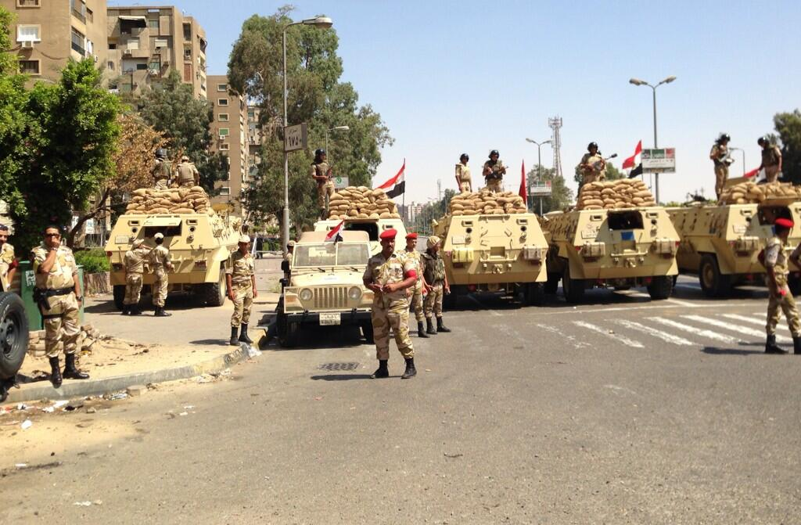
Hours before Egyptian President Muhammad Morsi was sidelined by the military council, Muhammad al-Zawahiri, Egypt's al-Qaeda leader, declared that the terrorist organization would wage a jihad to save Morsi and his Islamist agenda for Egypt. (They would not be the first Islamic terrorists to come to his aid; Hamas members were earlier arrested from inside Muslim Brotherhood headquarters, where they opened fire on protesters.)
According to a July 2 Veto Gate report, "al-Qaeda, under the leadership of Muhammad Zawahiri, is currently planning reprisal operations by which to attack the army and the Morsi-opposition all around the Republic [of Egypt]." The report adds that, hours before this information was ascertained, Zawahiri had been arrested and was being interrogated—only to be ordered released by a presidential order. He has since fled to the Sinai, where al-Qaeda is stationed—not to mention where Morsi had reportedly earlier summoned thousands of foreign jihadis to come to his aid whenever necessary, and where he may even have smuggled Muhammad Zawahiri's brother, Ayman Zawahiri—al-Qaeda's supreme leader.
In another report, Muhammad Zawahiri "offered joy to our Muslim Brothers in Egypt, for in all circumstances, we will not lose, Allah willing—quite the contrary." He added that "if matters reach a confrontation, then to be sure, that is in our favor—for we have nothing to lose. And at all times and places where chaos reigns, it's often to the jihad's advantage." Zawahiri concluded by saying that even if many and important jihadis and Islamists are arrested, it matters not, "for we sold our souls to Allah"—a reference to Koranic verses like 9:111—"and welcome the opportunity to fight to the death."
In the context of all these threats, many Egyptians are understandably worried. Right before the military intervened, a Tahrir TV host frantically and repeatedly called Morsi a "murderer," and the Brotherhood a "gang of murderers," adding, "Oh Minister of Defense—move! Move! Move and save the country! There is no time!" This may also explain why so many leading Islamists—along with Morsi himself—have been arrested and held by the military, on the charge of inciting Muslims against anti-Morsi demonstrators, by portraying them as "apostates" who must be fought and killed for are trying to resist the implementation of the Sharia of Allah.
They may also be being held as hostages to dissuade al-Qaeda from waging an all-out jihad, as many of those arrested—Safwat Hegazy, Hazim Abu Ismail, Tarek al-Zomor, Khaled Abdullah—are open friends of Muhammad Zawahiri.
On the other hand, although the Brotherhood has been portrayed in the U.S. as "just another" political party—or, in the mystifying words of James Clapper, Obama's director of national intelligence, "largely secular," which is the last thing it is—it is folly to think that Morsi, the Brotherhood, and all their Islamist and jihadi allies are going to go peacefully.
Now that the Islamists have tasted power— Salafis, Muslim Brotherhood, or al-Qaeda—it is unlikely that they will quietly give it up without a fight. History has proven that many jihadis never give up—unless they are in prison or dead. And as Egyptian al-Qaeda leader Muhammad Zawahiri pointed out, not only have they long been inured to sufferings and deprivations—they have nothing to lose.

Raymond Ibrahim is author of the new book, Crucified Again: Exposing Islam's New War on Christians (published by Regnery in cooperation with Gatestone Institute, 2013). A Middle East and Islam expert, he is a Shillman Fellow at the David Horowitz Freedom Center, associate fellow at the Middle East Forum, and author of The Al Qaeda Reader.

Model planes as weapons of terror
Source: http://security.blogs.cnn.com/2011/09/29/analysis-model-planes-as-weapons-of-terror/

The F-86 Sabre was a fighter jet that played a pivotal role in the Korean War. And it was a model of that plane – packed with high explosive – that Rezwan Ferdaus allegedly planned to use to launch his own war against iconic targets in Washington D.C.
Miniature versions of the plane – 5 feet 6 inches long – can easily be acquired for less than $200 from websites serving model plane enthusiasts.
"Provides authoritative rudder control so you can execute point rolls and knife-edge flight with precision," reads the promotion material for the model on one website.
According to the affidavit in the case against Ferdaus, one of these F-86 models was delivered in August to a storage facility in Framingham, Massachusetts that he had rented under a false name to build his attack planes and maintain all his equipment.
Ferdaus was arrested in Ashland, a small town just to the west of Boston "in connection with his plot to damage or destroy the Pentagon and U.S. Capitol, using large remote controlled aircraft filled with C-4 plastic explosives," according to a press statement from the Massachusetts U.S. District Attorney's Office.
The idea of using model planes and similar devices in terror attacks is unusual but not unprecedented.
Christopher Paul, a Columbus Ohio resident pleaded guilty in 2008 to planning terrorist attacks in the United States and Europe. According to the indictment in that case, Paul conducted research from 2006 on a variety of remote-controlled models, including a boat and a 5-foot long helicopter. Paul was accused of joining al Qaeda in the early 1990s.
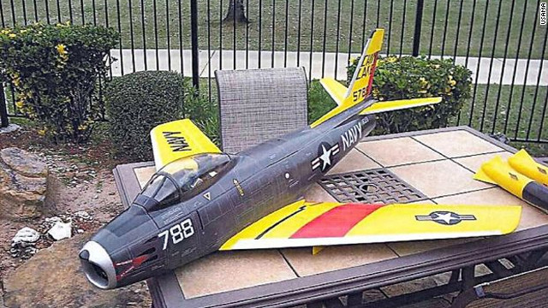
Ferdaus allegedly planned to fill three remote controlled aircraft - which he referred to as "small drone airplanes" - with explosives, launch them from the east Potomac park, and guide them by GPS into their targets.
In some ways, the idea echoes – albeit in primitive fashion – the growing use by the United States and other governments of unmanned drones for surveillance and missile strikes against terrorist targets. The use of drones has had a dramatic impact in the campaign against al Qaeda and other terror groups in Pakistan – and is now being expanded to the Horn of Africa.
Hezbollah, the Shiite militia in Lebanon, reportedly carried out an armed drone attack on an Israeli naval vessel during the 2006 Lebanon war. The Haaretz newspaper reported at the time that the ship was attacked by an explosives-laden drone, which would have been undetected by radar. Four Israeli sailors were killed.
The notion that terrorists could use their own crude versions of pilotless drones might seem fantastical to some – a scenario dreamt up and posted on blogs by radio-controlled aircraft hobbyists in their darker moments.
But advances in remote-control technology mean that there are now a wide variety of easily purchased machines that terrorists might contemplate using for strikes in the United States.
One remote-controlled helicopter that retails online for $10,000 in the U.S. is described as capable of lifting a payload of at least 20 lbs. (9 kg.) It can be accessorized with a built-in camera providing real-time video transmitted back to the controller, a feature which would be of obvious help to terrorists seeking to home in on a target – and record a propaganda video of the attack at the same time.
In 2006, a Maryland teacher, Ali Asad Chandia, was convicted of trying to acquire an electronic automatic pilot system for a model aircraft on behalf of the Pakistani terror group Lashkar e Tayiba. The system contains a stability and control computer that can be programmed to fly a plane with a 10-12 foot wingspan using GPS co-ordinates and can be programmed to turn a video camera on and off when the plane reaches certain locations.
Such advances, combined with precise mapping services like Google Earth, may also provide terrorist operatives with opportunities to strike targets several miles away. However, remote detonation of C4, a very stable explosive insensitive to most physical shocks, carried on a model plane would be a challenge.
As long ago as 2007, Senator Charles Schumer D-New York said of model planes: "They present a real danger. The difficulty is figuring out how to regulate them."
Rep. John Mica R -Florida has also expressed concern in the past, saying in 2006: "They can carry explosives...even of more concern would be carrying small amounts of chemical or biological material."
Ferdaus, a Northeastern University graduate with a degree in physics, is alleged to have planned a simultaneous ground assault involving six gunmen. Unbeknown to him as he developed the plan was that "accomplices" he was in touch with were FBI undercover agents.
"I just can't stop; there is no other choice for me," he confided to one of them as he prepared the attack, according to the press statement. The agents handed over explosives and weapons just before they arrested him.
The threat from remote-controlled aircraft needs to be put in some perspective. Even 20 pounds of high explosive might not inflict devastating structural damage on a building – especially if it were reinforced like the Pentagon. By comparison, the devastating 1995 Oklahoma City bomb involved 2.5 tons of explosive packed into the back of a truck – although much of that was a more basic form of ammonium nitrate and fuel oil.
Even so, the force of a few pounds of C4 in a confined and crowded space such as a sports stadium or outdoor concert venue could produce mass casualties.
There is also the psychological impact of using remote-controlled aircraft against high-profile targets.
According to U.S. authorities, Ferdaus anticipated that the model planes would have a large "psychological" impact by killing Americans, including women and children, whom he referred to as "enemies of Allah."

►Source: http://idsa.in/system/files/jds_3_3_alele_amishra.pdf

Wg. Cdr. Ajey Lele and Archana Mishr are Research Fellow at the Institute for Defence Studies and Analyses, New Delhi and Doctoral Candidate at the Jawaharlal Nehru University, New Delhi, respectively.

Terror Financing – Tracking the Money Trails
Source: http://www.fbi.gov/news/stories/2013/july/terror-financing-tracking-the-money-trails/terror-financing-tracking-the-money-trails?utm_campaign=email-Immediate&utm_medium=email&utm_source =fbi-top-stories &utm_content=238423

The U.S.-born radical cleric Anwar al-Awlaki once wrote an essay called “44 Ways to Support Jihad.” Five of his top 10 strategies focused on the same topic—money.
It’s not surprising. Money fuels the operations of terrorists. It’s needed to communicate, buy supplies, fund planning, and carry out acts of destruction.
But there’s a flip side to this proverbial coin. In the shadowy, secretive world of terrorists, this spending leaves a trail—a trail that we can follow to help expose extremists and their network of supporters…sometimes before they can strike.
That’s why shortly after 9/11, we established the Terrorist Financing Operations Section (TFOS). Within the FBI, TFOS is responsible for following the money, providing financial expertise on our terrorism investigations, and centralizing efforts to identity extremists and shut down terrorism financing in specific cases. More recently, TFOS has adopted a broader strategy to identity, disrupt, and dismantle all terrorist-related financial and fundraising activities. A key element is using financial intelligence to help identify previously unknown terrorist cells, recognize potential terrorist activity/planning, and develop a comprehensive threat picture.
It’s challenging work. The dollar amounts can be small—for example, the Oklahoma City bombing cost a little over $4,000 to carry out, the attack on the USS Cole about $10,000, and the London subway bombings around $14,000. At the same time, terror groups can obtain funding from seemingly legitimate sources— like donations, community solicitations, and other fundraising activities. They can also generate money from criminal activities such as kidnappings, extortion, smuggling, and fraud. And their financial networks—their methods and means of moving money—use both formal systems (i.e., banks, licensed money remitters, and the Internet) and informal systems (i.e., unlicensed money remitters and money couriers).
But TFOS and investigators from our 103 Joint Terrorism Task Forces around the country are able to apply certain financial investigative techniques—like credit history checks, reviews of banking activity, and government database inquiries—to counterterrorism cases to help track terror money trails. These techniques generate a treasure trove of intelligence: personal information like citizenship, date of birth, and phone numbers; non-terrorism-related criminal activity; previously known business and personal associations; travel patterns; communication patterns; and suspicious purchases.
These techniques can also help link previously unrelated cases, create historical timelines, and generate additional leads that allow investigators to use more sophisticated techniques like court-authorized electronic surveillance.
In addition to working with FBI field offices, the men and women of TFOS—experienced agents, intelligence analysts, forensic accountants, and other professionals—handle critical outreach duties. They coordinate efforts with the U.S. intelligence community and—through FBI legal attachés—our global intelligence and law enforcement partners. They work jointly with domestic law enforcement and regulatory communities. And, in conjunction with the Treasury Department’s Financial Crimes Enforcement Network (FINCEN), they conduct liaison with the financial services sector.
TFOS chief Jane Rhodes-Wolfe believes that the combined efforts of the financial industry, international partners, and federal, state, and local agencies have “established an increasingly difficult environment for terrorist financiers to operate in undetected…and ensure an ongoing and coordinated approach to terrorist financing to help prevent future terrorist attacks against the U.S.”

Lee Rigby: Military funeral for killed soldier

http://www.bbc.co.uk/news/uk-england-23263754

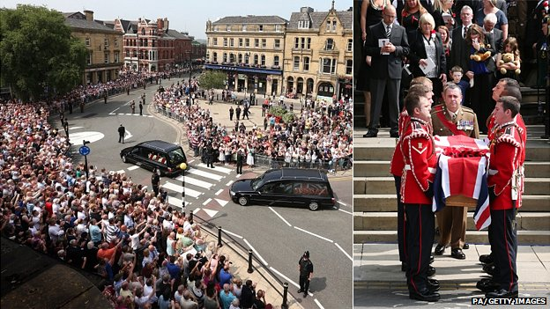
The prime minister and thousands of mourners have attended the military funeral of Fusilier Lee Rigby at Bury Parish Church in Greater Manchester.
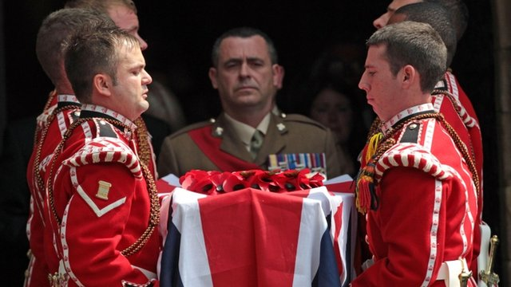
The 25-year-old soldier, from Middleton, was killed in Woolwich, south-east London, in May.
His commanding officer Lt Col Jim Taylor said in a eulogy Lee had been "a true regimental character".
After the service his body was driven along roads lined by mourners for a private burial at Middleton Cemetery.
'Good people'
The soldier's family were greeted by applause as they arrived with his son wearing a T-shirt showing the words 'My Daddy My Hero'.
They have thanked people "across the world" for their "overwhelming support".
Fusilier Rigby's wife Rebecca said: "There are so many kind and generous people out there.
"It's just horrible that it takes something such as this to make you see how many good people there are."
Fusilier Rigby's body was guarded overnight during a vigil at the church by 32 members of the Royal Regiment of Fusiliers.
The funeral service, which was relayed to those gathered outside, began with a silent tribute from the crowds in the streets around the church at about 11:00 BST.
Among those gathered were hundreds of serving and former soldiers in their regimental ties, blazers and caps, wearing their campaign medals.
They applauded the arrival of David Cameron who was accompanied by London Mayor Boris Johnson.

'Lighten the mood'
Inside the church, Fusilier Rigby was described as a "fantastic soldier" by his commanding officer.
Lt Col Jim Taylor of the 2nd Battalion Royal Regiment of Fusiliers said Lee was "larger than life [and] was always at the centre of fun and mischief, but he was a true regimental character with real charisma and everybody fell under his spell".
"To be with Lee was to be where it was most fun - the centre of good times and much mischief," he said.
"People fell quickly under his spell. Whether it was in work or off duty, at a ceremonial engagement or on operations, Lee just knew how to lighten the mood.
"He could brighten a room within moments and, by all accounts, clear a dancefloor in seconds if a Whitney Houston track was playing."
He added Fusilier Rigby had "a natural swagger and the confidence of someone truly comfortable in their own skin".
"He was always happy. His smile was infectious, as was his enthusiasm for soldiering and his passion for life."
He also spoke of Fusilier Rigby's military service and said he had "proved himself to be dedicated, professional and incredibly brave".
"His courage was tested every day. He was not found wanting."
The eulogy was met with applause inside and outside the church.
Military chaplain the Reverend Clare Callanan spoke of the impact of the soldier's death on the "hearts and minds of family, of friends and of a nation".
She said it was an event which had caused "outrage, horror, anger" but had also shown "the courage of individuals" and brought faiths together.

'Happy memories'
Asked before the funeral about how Fusilier Rigby would like to be remembered, Mrs Rigby said: "Lee always wanted his service to be a time that people would remember him and shed the tears, but then he always said a remembrance of his life.
"He wanted people to enjoy that and sit and talk about happy days and happy memories they have got of Lee and the things he used to do and say because he was always so full of life."
Stepfather Ian Rigby said: "I think today should be a celebration of Lee's life, what he has meant to us.
"Lee was a fun-loving lad and that is how he should be remembered."
As the funeral began, soldiers gathered outside Woolwich Barracks where Fusilier Rigby was killed and the Last Post, a call traditionally performed at military funerals, was played by a bugler.
The regular morning summer train service between Fort William and Mallaig, hauled by the steam loco 45407 The Lancashire Fusilier, also paused for two minutes on the Glenfinnan Viaduct as a mark of respect.
The engine is owned and run by Ian Riley, whose engineering works are on the East Lancs Railway in Bury.
Members of the public lined the route from Bury to Middleton on police and council-designated "suitable roads".
Michael Adebolajo, 28, from Romford, east London, and Michael Adebowale, 22, from Greenwich, south-east London, are accused of Fusilier Rigby's murder.
Mr Adebolajo is also accused of the attempted murder of two police officers and possession of a firearm with intent to cause others to believe that violence would be used.

Turkey’s Counterterrorism Response to the Syrian Crisis
By Jennifer Lang
Source:http://www.jamestown.org/single/?no_cache=1&tx_ttnews[tt_news]=41114&tx_ttnews[backPid]=7&cHash=38aa0ad4bceccda260f81d1ea0325a8b#.UeDmEKz7CF9

Turkey has faced a relatively limited but consistent threat from jihadist militants linked to al-Qaeda dating back to the 1980s/90s, particularly following the return of Turkish fighters from Afghanistan (Hurriyet, October, 2001). The 2003 Istanbul bombings that resulted in over 60 fatalities triggered a major crackdown on suspected jihadists that led to the official conclusion that “the main body of the terrorist organization [al-Qaeda in Turkey] has been dismantled.” [1]
The numerous foiled plots and raids connected to al-Qaeda cells in Turkey signal the considerable capacity of Turkish security forces seasoned in countering terrorism. The ongoing conflict in Syria, however, adds an unexpected element to Turkish (in)security and the types of threats authorities will have to counter in coming years.
Al-Qaeda does not consider Turkey a priority target and will therefore continue to focus efforts on Syria via Jabhat al-Nusrah (JaN). However, Turkey’s border provinces present an increasingly complex environment in which Turkish authorities may struggle to maintain control. The border runs for 560 miles and remains easy to traverse despite additional security at border points.
The presence in this region of Syrian opposition forces, refugees, local jihadist and Salafist groups, al-Qaeda-associated groups such as JaN, Kurdish nationalists and Turkey’s Alawite and Alevi populations all contribute to a situation that is volatile and has the potential to significantly deteriorate as the conflict in Syria drags on. The establishment of long-term jihadist networks in the border region presents a serious concern, although is outweighed by the potential for widespread sectarian conflict spilling over into Turkey.
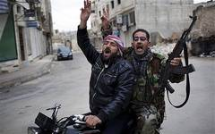
Turkish nationals who fought in both Iraq and Afghanistan later returned to Turkey establishing cells focused primarily on support activities such as recruitment and fundraising. In October 2012, the U.S. State Department asserted that al-Qaeda elements in Iran, led by the financier Muhsin al-Fadhli, were moving fighters and funds through Turkey to Syria (Today’s Zaman, October 19, 2012). Turkey’s geographical position made it a key transit state for jihadists travelling to Afghanistan and Iraq, a factor that now also extends to its southern neighbor, Syria.
Meanwhile, Ayman al-Zawahiri has directly referenced Turkey in official messaging, noting the cooperation of the ruling Adalet ve Kalk?nma Partisi (AKP - Justice and Development Party) with Israel as well as its alleged fight “against Islam and Shari’a” as points of contention. [2] According to intercepted courier communications, discussions between Osama bin Laden and Habib Akdas, the leader and founder of al-Qaeda in Turkey, similarly referenced such issues as justification for the 2003 Istanbul attacks. [3]
Over the past ten years, plots involving jihadists with varying degrees of affiliation to al-Qaeda have included:
- A 2004 plot to attack the NATO Summit in Istanbul;
- A 2005 plot to attack an Israeli cruise ship in Antalya;
- A 2008 attack on the U.S. Consulate in Istanbul that resulted in three fatalities;
- A 2011 plot to attack the Incirlik Air Base (used by the United States to send supplies to Iraq and Afghanistan);
- Plots in 2011 and 2013 to attack the U.S. Embassy in Ankara.
Turkey’s support for the Syrian opposition appears to have been based initially on humanitarian concerns as well as the underlying assumption that Syrian president Bashar al-Assad will not remain in power. This has further extended to lending support to the force it believes has the best shot at maintaining Syria’s territorial integrity and as an extension, the most likely to be able to stem the growing tide of sectarian tension. The jihadist threat to Turkey vis-à-vis Syria comes in the form of local groups; al-Qaeda affiliated Syrian groups (namely JaN); and foreign jihadists.
Support for local jihadist and Salafist groups somewhat fits within Turkey’s wider strategy, particularly as some maintain links to the Free Syrian Army (FSA) and the Syrian Islamic Front. Such groups include Ghorba’a al-Sham and Ahrar al-Sham. Ghorba’a al-Sham is a local jihadist group which often aligns with the JaN and consists mainly of Turks; Ahrar al-Sham is not a jihadist group but is considered a hardline Salafist group. Turkey has agreed to funnel all military aid through the opposition’s Supreme Joint Military Command; however, this agreement is in an early stage and the reality is that many informal funding routes still exist. [4] Although these fighters do not necessarily share al-Qaeda’s desire to establish a global Islamic caliphate, support for hardline groups nonetheless feeds into wider sectarian tensions in the area and could contribute to the formation of long-term jihadist networks.
Clashes in the border areas between opposition forces and Kurdish nationalists, including members of the Partiya Yekîtiya Demokrat (PYD - Democratic Union Party), Syria’s largest Kurdish organization, have prompted claims that Turkish support for local jihadist groups is based on its desire to squash Kurdish influence in northern Syria amid fears of a breakaway Kurdish state. Fierce battles in Ras al-Ayn (Syria’s northernmost city, close to the Turkish border) between the PYD, Ghorba’a al-Sham and the JaN in November, 2012 focused further attention on Turkey’s motives in the conflict (Naharnet, November 22, 2012). While the PYD has now brokered a ceasefire with the FSA, Ghorba’a al-Sham maintains control over the nearest border checkpoint and the extent to which the more hardline groups will adhere to such agreements remains to be seen.
Several Turkish media sources reported the foiling of a plot in the southern town of Adana on May 31 that allegedly involved members of JaN and the nerve agent, Sarin. A Turkish daily reported that targets included the Incirlik air base and the Turkish border town of Gaziantep (Sabah, May 31). Another source stated that the nerve agent had been brought across the border from Syria (Radikal, May 31). However, Adana’s Mayor, Hüseyin Avni Co? denied the presence of Sarin gas in a May 30 official statement to the state-run Anatolia News Agency and refused to comment on the suspects’ organizational affiliations. There is no evidence to suggest that JaN is receiving direct support from the Turkish government (not surprising given the contrasting views of either side); although it also seems unlikely that the group would choose to target a major supporter of the opposition – a move that could precipitate a major security clampdown in the border provinces and restrictions on military and financial aid to the rebels. The lack of reporting since May 31 seems to confirm that the initial reports were not credible and failed to indicate that JaN presented a direct threat to Turkey.
The presence of foreign jihadists in Syria has arguably been exaggerated, particularly in the West. Nonetheless, the arrest of four Belgian citizens on the Turkish border in June clearly highlights the challenge faced by Western countries in deterring their citizens from attempting to join foreign jihadist groups (Hurriyet, June 19). For Turkey, such fighters are unlikely to pose a direct threat given that their objective is to reach the conflict zone, although it does contribute to sectarian tensions in Turkey’s border region and the development of jihadist networks.
The Belgian case was brought to rest by “excellent cooperation” between the Turkish and Belgian police, however, in other instances, Syrian opposition forces have themselves dealt with foreign jihadists. Late last year, the raising of al-Qaeda’s black flag above the Bab al-Hawa border crossing by foreign fighters prompted a bitter fight with Islamist fighters from the al-Farouq brigade as well as the FSA (al-Akhbar, October 3).
It is true that Syria, rather than Turkey, remains a priority for al-Qaeda and its affiliates as it presents a critical opportunity for the group to reassert its relevance following perceptions that it failed to respond appropriately to popular uprisings elsewhere in the region. In this context, Turkey will most likely remain a recruitment and support base for jihadists, particularly in the border areas.
Of greater concern is the impact of the Syrian conflict in fueling sectarianism, an aspect which could be perceived as having been fueled by Turkish support for hardline groups that have stoked tensions with Turkish Alawites and Alevis, as well as with Syrian Kurds. This will present a much longer-term and complex challenge for the Turkish government and its security forces over the coming years, as a solution to the crisis in Syria remains improbable in the near to medium term.

Notes:
1. See: Turkish National Police, 2012, http://www.turkishnationalpolice.gov.tr/AL_QAEDA.html.
2. See: “Message to the Muslim Turkish People,” as-Sahab Media, August 15, 2010, at http://jihadology.net/2010/08/16/as-sa%E1%B8%A5ab-presents-message-to-the-people-of-turkey-by-dr-ayman-al-zawahri/, Today’s Zaman, February 24, 2010; al-Jazeera, August 15, 2010.
3. See: S. Ozeren, I. Dincer Gunes and D. M. al-Badayneh, Understanding Terrorism: Analysis of Sociological and Pyschological Aspects, Lancaster, UK, 2007, p.287.
4. See: http://www.americanprogress.org/issues/security/report/2013/05/14/63221/the-structure-and-organization-of-the-syrian-opposition/.

Jennifer Lang is a freelance consultant with a background in counterterrorism, defense and security analysis.
The author is grateful to Defne Gönenç, Ph.D. student, Graduate Institute for International and Development Studies, for her assistance in the translation of the Turkish-language sources and for her comments on the article more generally and to Haluk Baran Bingöl, Clendenin Fellow, Kennesaw State University, for his insight into wider sectarian tensions in Turkey.

Ex-spy chief: How KGB created modern Islamic jihad
Source: http://www.wnd.com/2013/07/ex-spy-chief-how-kgb-created-islamic-jihad/

Communists created the modern Islamic terror movement? Sounds crazy.
Yet, of all the astonishing disinformation campaigns recently revealed by the highest-ranking Soviet bloc spy chief ever to defect to the U.S., perhaps none is more important than the shocking ways the communist intelligence machine virtually invented today’s Islamic terrorism epidemic. In fact, says Lt. Gen. Ion Mihai Pacepa, former head of Romania’s foreign intelligence and top adviser to dictator Nicolae Ceausescu, inflaming Arab and Muslim anti-Semitism and promoting terrorism were high on the KGB’s to-do list for many years.
Pacepa, for decades a top-level insider in the Soviet bloc’s wide-ranging disinformation activities, is the co-author of “Disinformation: Former Spy Chief Reveals Secret Strategies for Undermining Freedom, Attacking Religion, and Promoting Terrorism,” published by WND Books. His co-author is historian and law professor Ronald Rychlak.
After a crisis of conscience, Pacepa defected to the United States in 1978 and became a critical asset to American intelligence services, being debriefed by the FBI and others for many years. When he was naturalized as an American citizen in 1988, the CIA, which credited Pacepa as the only person in the Western world to single-handedly demolish an entire enemy espionage service – the one he himself managed – officially commended him: “You have made an important and unique contribution to the United States of which you can be justly proud. Therefore, it gives me great pleasure, on this momentous and solemn occasion, to wish you happiness and fulfillment in this country as a U.S. citizen.”
President Ronald Reagan reportedly referred to Pacepa’s first book, “Red Horizons,” as “my bible for dealing with dictators.”
In “Disinformation,” the true malevolence and breathtaking scope of Soviet-bloc intelligence and disinformation operations is explored as never before – and far from academic “Cold War history,” the book’s revelations are likely to change the way Americans understand today’s world.
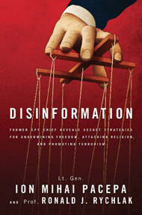
In an op-ed featured today on FoxNews.com, Pacepa summarizes some of the ways the KGB and related communist intelligence services secretly created and fueled modern Arab terrorism:
“In the late 1960s, KGB head Yuri Andropov, with whom I worked at one time, tasked the Soviet bloc’s disinformation machinery with turning the rest of the world against the U.S. by reviving anti-Semitism. Andropov knew that the U.S. would stand with Israel and that he could convince the European leftists and the Islamic world that America was dominated by Jews.
“Andropov’s disinformation came to light in 1969, when Palestinian terrorists – secretly trained at the KGB’s Balashikha special-operations school east of Moscow – hijacked an El Al plane and landed it in Algeria. There its 32 Jewish passengers were held hostage for five weeks, during which time Andropov’s disinformation machinery portrayed Israel and the U.S. as the main dangers to world peace.
“This pattern continued for years, as Andropov expanded his efforts from hijacking Israeli planes into organizing public executions of ‘Zionists.’ Andropov’s puppet, Dr. George Habash, Marxist leader of the Popular Front for the Liberation of Palestine, explained: ‘Killing one Jew far from the field of battle is more effective than killing a hundred Jews on the field of battle, because it attracts more attention.’”
By 1972, writes Pacepa, who lives in the U.S. under a CIA-protective identity due to still-active assassination threats against his life, the KGB’s disinformation machine “was working around the clock to persuade the Islamic world that the U.S. intended to transform the rest of the world into a Zionist fiefdom.”
Andropov, he recalls, was utterly obsessed with convincing Muslims that the United States Congress was conspiring to have the Jews take over the world. “If we whipped up Muslim anti-Semitism,” Andropov would say, “then terrorism and violence against Israel and America would naturally follow.”
Revealing that the KGB and related Soviet bloc intelligence services sent some 4,000 “agents of influence” into the Arab-Muslim Middle East to advance this agenda, Pacepa says he was, unfortunately, involved in spreading the most notorious and enduring piece of anti-Semitic propaganda throughout the Middle East:
… The Romanian DIE (counterpart of KGB foreign intelligence), which I headed, in 1972 received from the KGB an Arabic translation of the old Russian forgery, “The Protocols of the Elders of Zion.” We also received “documentary” material in Arabic produced by the Soviet disinformation “proving” America was a Zionist country whose aim was to transform the Islamic world into a Jewish fief. My DIE was ordered to disseminate these documents within its targeted Islamic countries. During my later years in Romania, the DIE disseminated thousands of copies of “The Protocols” and similar “documents” each month.
The ultimate result of this multi-faceted KGB-led disinformation campaign targeting the Arab-Muslim world, writes Pacepa in his FoxNews article, “was seen on Sept. 11, 2001. The weapon of choice for that horrific act was a hijacked airplane – a concept invented and perfected by Andropov’s disinformation machinery.”
The book “Disinformation” – as well as the feature-length film documentary of the same name, released simultaneously by WND Films – go into much greater depth, exploring disinformation campaigns that turn most conventional geopolitical thinking on its head. For instance, with regard to terrorism, the book shows that Yasser Arafat, widely considered a bigger-than-life Palestinian leader, born in Jerusalem and winner of the Nobel Peace Prize, was actually a creation of the KGB. Arafat was born in Egypt, not Jerusalem (the KGB destroyed his original birth documents and created new ones, reveals Pacepa) and was a committed Marxist who became the father of modern terrorism.
Incredibly, Arafat’s successor, Mahmoud Abbas, was educated in Moscow at a KGB-run school. Iran’s Ayatollah Khomeini was also trained by Moscow. And even the top man in Al-Qaida, Ayman al-Zawahiri, was trained by the KGB, as revealed by KGB defector Alexander Litvinenko, who was assassinated by Polonium poisoning.
“Disinformation” is the first book ever written by a Soviet bloc spy chief whose introduction was written by a former U.S. spy chief – R. James Woolsey, former director of the CIA. Woolsey writes:
“Disinformation” will change the way you look at intelligence, foreign affairs, the press and much else besides. …
[Pacepa] and his distinguished co-author, law professor Ronald Rychlak, do something remarkable in this book. They not only help us understand history and many of the current disinformation operations that we continue to see – especially from Russia and countries in the Mideast – but also give us a good start in learning how to defeat them.
In short, they open a world that many of us didn’t know existed, and almost all of those of us who did know had seriously underestimated.

In “Disinformation,” you’ll discover:
- How destroying the reputation of good leaders has been developed into a high art and science.
- How Pope Pius XII – a generation ago the world’s most high-profile Christian leader, who personally saved countless Jews from Hitler’s Holocaust – was transformed, through the magic of disinformation, into a Nazi sympathizer.
- How Christianity and Judaism have been targeted for constant denigration and defamation through an ongoing campaign of disinformation.
- How the Soviet bloc planted 4,000 agents of influence in the Islamic world, armed with hundreds of thousands of copies of the most infamous anti-Semitic book in history, to fan the flames of ancient Arab resentments against the U.S. and Israel and sow the seeds of anti-Semitism that would later bloom in the form of violence and terror toward Jews and Christians.
- How the defamatory attacks on American soldiers John Kerry made before Congress upon his return from Vietnam – charges later discredited and repudiated – were identical to a contemporaneous KGB disinformation campaign concocted to turn Americans against their own leaders.
- How supposedly respectable institutions like the World Council of Churches have long been infiltrated and controlled by Russian intelligence.
- How much of the world came to believe that the U.S. government itself masterminded the assassination of President John F. Kennedy.
- How the Soviet Union has been transformed into the first intelligence dictatorship in history.
- How disinformation is still very much alive in the age of Obama, remaining a powerful engine in the ongoing socialist transformation of America.

LT. GEN. ION MIHAI PACEPA, the highest-ranking intelligence official ever to defect from the Soviet bloc, served as acting chief of communist Romania’s espionage service and top adviser to President Nicolae Ceauşescu. In December 1989, the dictator Ceauşescu was executed at the end of a trial wherein the accusations came almost entirely from Pacepa’s first book, "Red Horizons," subsequently republished in 27 countries. Today, with assassination threats still hanging over his head because of his defection and continuing fight against socialist dictatorship, Pacepa lives in the U.S. under a protective identity. Still vigorous in his 80s, he remains an astute and uniquely insightful writer on current affairs.

RONALD J. RYCHLAK is the Mississippi Defense Lawyers Association professor at the University of Mississippi School of Law where he teaches constitutional law, criminal procedure, and terrorism and the law. A graduate of Wabash College and Vanderbilt University School of Law, Rychlak practiced law with Jenner & Block in Chicago and served as clerk to the Hon. Harry W. Wellford of the U.S. Sixth Circuit Court of Appeals. Appointed by the Mississippi Supreme Court to a committee to revise that state’s criminal code, he also served on the Mississippi advisory committee to the U.S. Civil Rights Commission. He is the author of several books, including "Hitler, the War and the Pope."

Fire Jihad: Fact or Fiction?
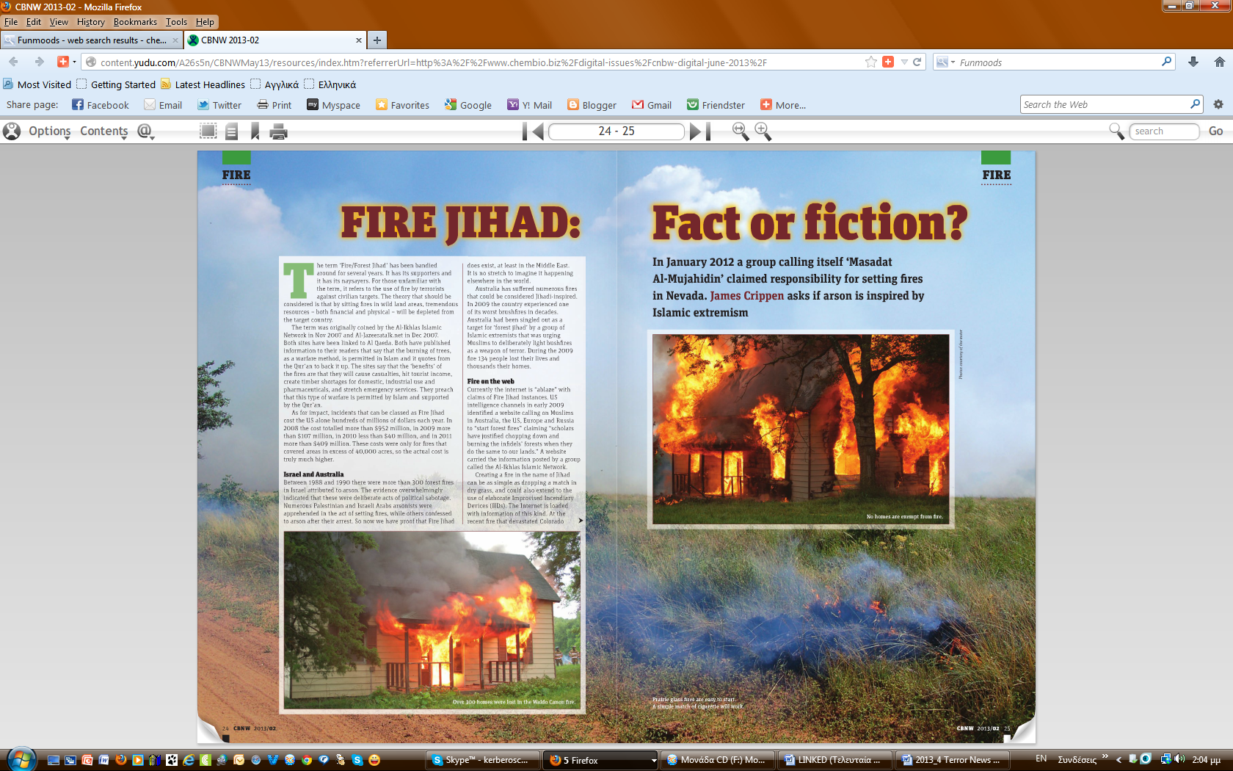
Source:http://content.yudu.com/A26s5n/CBNWMay13/resources/index.htm?referrerUrl=http%3A%2F%2Fwww.chembio.biz%2Fdigital-issues%2Fcnbw-digital-june-2013%2F

From CBNW June 2013 issue (pp.24-26) by James B. Crippin, Director WFLETC/Trainer J6-ICS.

►NOTE: See also June-2013 CBRNE-Terrorism Newsletter’s “Special Collection” on “Pyroterrorism” (available at the “Archives” link of the Newsletter’s website).

The al Qaeda threat in Turkey
By Karen Hodgson
Source: http://www.longwarjournal.org/archives/2013/07/the_al_qaeda_threat_1.php

Introduction
The threat of al Qaeda in Turkey is significantly understudied, considering the nature and number of targets against which the terror group has plotted attacks, including many targets affiliated with the United States. Perhaps this is because the Turkish police are successful in thwarting such attacks; foiled plots are not as sensational as those that are carried out and cause tragedy. Or it could be because terror in Turkey has historically been synonymous with the terrorism of the Kurdistan Workers' Party (PKK), which distracts from the al Qaeda threat. It is also easy to dismiss Turkey as an unlikely target for al Qaeda, given its 99 percent Muslim population and currently Islamic-rooted government.
A look at al Qaeda's targets, which appear to be concentrated on US, Turkish, British, Jewish, and Christian facilities, demonstrates the point. Plots involving American targets include a plan to attack the İncirlik Base in Adana in 2003; a foiled attack on the NATO summit in Istanbul in May 2004 that was to be attended by then-President George W. Bush; and an attack on the US Consulate in Istanbul in July 2008, which killed three policemen. In July 2011, an attack on the US Embassy in Ankara was thwarted just before Secretary of State Clinton's visit. In April 2013, Turkish police found evidence of a new plot linked to al Qaeda to bomb the US Embassy in Ankara. As recently as May 2013, Turkish police uncovered a plot by the al Qaeda-linked Al Nusra Front to conduct sarin gas attacks against Turkish and American targets, a relatively new phenomenon which appears to be a result of the spillover effects of the Syrian war into Turkey.
Other targets include suicide attacks on the British Consulate, the headquarters of British HSBC international bank, and two big synagogues in Istanbul in November 2003, which killed some 60 people and injured at least 700; a possible attack on the Pope during his visit to Turkey in November 2006; and a plot to attack the Bilderberg Summit in Istanbul in June 2007. Turkish authorities have also intercepted al Qaeda plans to conduct attacks on churches and clergy in Ankara, Turkish soldiers in Afghanistan after their takeover of the Kabul Regional Command in November 2009, the Turkish parliament building, and an Israeli cruise ship to Turkey.
These incidents suggest that the al Qaeda threat in Turkey persists. In fact, an al Qaeda-linked document found during a recent raid in Turkey said that it was more beneficial for the group to target Turkey than the West. Routine operations and mass arrests of suspected al Qaeda members and sympathizers indicate the presence of a support network for its cause within Turkey. These indications, combined with the recent emergence of jihadists in Syria, and the presence of Al Nusra Front elements along certain parts of Turkey's 570-mile border with Syria, make this a threat worth examining.
There are challenges in trying to decipher the al Qaeda threat in Turkey, however. Reports based on open sources such as this one have to make analyses based only on the information that is available. The media does not give much attention to thwarted attacks. And the Turkish press does not publish names of people arrested, to protect the privacy of the individuals and investigations; instead, only the suspects' initials are published. Moreover, many al Qaeda operatives have one or more code names. In addition, many of the details of operations or what they reveal is not reported. Nevertheless, some conclusions can still be made about the characteristics of al Qaeda in Turkey today.
Why is Turkey a target? How does al Qaeda view Turkey?
Al Qaeda's narrative on Turkey suggests that it views Turkey as a Muslim traitor that abolished the Caliphate at the end of the Ottoman Empire, which for al Qaeda marks the start of the "Muslim world's humiliation and contempt over the last 80 years." Al Qaeda views Turkey -- a country with free elections and a liberal economy, a member of NATO, and a strategic ally of the United States -- as a US or Western puppet. Turkey was also one of the first countries to recognize Israel, and takes part in the International Security Assistance Force (ISAF) in Afghanistan, which leads al Qaeda to accuse Turkey of "cooperating with Israel" and "killing Muslims in Afghanistan."
In the wake of the Arab Spring, al Qaeda appears to be particularly bothered by Turkey's being hailed as a potential model for Muslim nations in the Middle East today. Turkey stands as an obstacle to al Qaeda's plans to create polarization between Islam and the West. For example, Turkey's participation in ISAF in Afghanistan undermines al Qaeda's rhetoric that ISAF is a "crusader force." Turkey's tolerant interpretation of Islam is also directly opposed to al Qaeda's interpretation, which calls for replacing existing governments in Muslim countries with a single Islamic state or Caliphate and the imposition of a strict form of government based on its specific interpretation of Islam. Al Qaeda calls the Turkish government an "apostate" one that does not adhere to the terror group's definition of "true Islam."
The organization has criticized Turkey's cooperation with the US in fighting al Qaeda. The quote below is a good example of the kind of rhetoric the group uses regarding Turkey's cooperation with the US. In a May 23, 2007 interview which aired on Al Jazeera, Mustafa Abu Al-Yazid, a senior al Qaeda official in Afghanistan, threatened Turkey after it was revealed that Ankara had handed over Abd Al-Hadi Al-Iral Qaedai, an al Qaeda operative, to the US:
Regarding the arrest of the heroic brother Abd Al-Hadi Al-Iral Qaedai.... He was on his way to Iraq.... He was arrested in Turkey and the puppet government in Turkey extradited him to the Americans.... Despite the fact that the brother Abd Al-Hadi had requested political asylum and the Turkish courts had agreed to grant it.... What freedom do they [the Turkish government] claim? What justice do they allege? And to what Islam do they belong? Their punishment from God and from the mujahedeen is coming, God willing.
Similarly, in July and August of 2010, al Qaeda emir Ayman al-Zawahiri, then the group's second in command, warned Turkey twice, accusing it of collaborating with Israel and sending troops to Afghanistan, and killing Muslims in Afghanistan (even though Turkish forces do not participate in combat missions in ISAF). In a 20-minute Arabic video published online, he said, "The Turkish government shows sympathy with the Palestinians through statements or sending some relief aid, but actually recognizes Israel, engages in trade, carries out military training, and shares information with it." He called on Turks to pressure their government to end relations with Israel. Quite interestingly, these warnings came following a severe deterioration in relations between Turkey and Israel after the infamous Mavi Marmara incident.
On the other hand, with its 75 million Muslims, Turkey is also seen as a potential al Qaeda recruitment pool. The Turkish people's proximity to and influence in Central Asia, along with their linguistic, religious, and ethnic affinities with Uzbeks and others in the region, make them a potential target audience for support and recruitment. A large Muslim diaspora in Germany also positions Turks as a recruitment source for other Islamist militant groups operating in Europe.
Turkey’s 9/11: The November 2003 attacks
On Nov. 15, 2003, at 9:30 a.m., two trucks filled with explosives slammed into the Beth Israel and Neve Shalom synagogues in Istanbul. The explosions devastated the synagogues and killed 24 people, most of them Turkish Muslims, and injured more than 300 others.
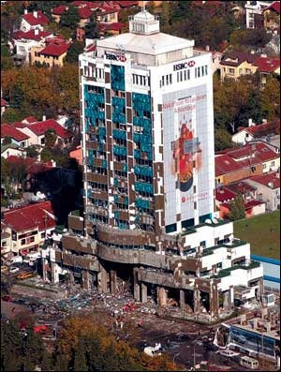
Five days later, on Nov. 20, 2003, at 10:55 a.m., two more simultaneous suicide attacks took place. An attack on the HSBC Bank Central Directorate in Istanbul (photo) killed the bomber and 15 others; five minutes later an attack against the British Consulate in Istanbul killed British Consul Roger Short and 34 others, and injured hundreds. The attacks came as then-US President George Bush was meeting with British Prime Minister Tony Blair in London.
These four attacks, which resonate as a 9/11 for Turks, marked the point at which the al Qaeda presence in Turkey became apparent to the world. Turkish police uncovered the organization quickly, and details of the operations and perpetrators emerged. The bombers had established a detergent company in Turkey six months prior to the attacks, and used it as a front to produce the 12 tons of chemical explosives used in the bombings. They had opened several cell phone stores in order to easily access SIM cards and establish cell phone communication with each other. They also had purchased four trucks, trained the drivers on the attack locations, and practiced the attack many times. The financing for all this, $150,000, had come from Osama bin Laden through a Syrian, Louai Sakka (a Turkish-speaking Syrian, with code name Aladdin).
During the planning stage, other targets were discussed, including the US Consulate in Istanbul (which was attacked five years later, in 2008); the Incirlik Air Base in Adana; and Israeli ships approaching Turkish ports. In fact, initially, the first suicide attack in Turkey was planned for Nov. 7, 2003 against an Israeli ship expected at a port in Alanya, on Turkey's Mediterranean coast. A follow-up attack was planned for the next day, with suicide bombings in two synagogues in Istanbul; and another attack was planned for one week later, with suicide bombings on the HSBC Central Branch in Istanbul. When the expected ship did not arrive in Alanya on that day, however, plans were postponed by a week.
Al Qaeda targets Turkey
The following is a list of all known al Qaeda targets in Turkey, and includes attacks that have been carried out as well as foiled plots.
• Nov. 15, 2003: Suicide bombers attacked two synagogues in Istanbul, killing 24 people and injuring more than 300.
• Nov. 20, 2003: Suicide bombers in Istanbul attacked the British Consulate and the HSBC Bank Central Branch, killing 34 people and injuring at least 400.
• March 9, 2004: Two suicide bombers attacked a Masonic Lodge in Istanbul, killing two people, including one of the suicide bombers.
• May 3, 2004: Turkish authorities thwarted a plot by the al Qaeda-linked Ansar Al-Islam to bomb a NATO summit in Istanbul at the end of June, which was to be attended by President George W. Bush.
• August 2005: A suspected member of al Qaeda, believed to be planning a terrorist attack against an Israeli cruise ship in Antalya, was arrested in the southeastern city of Diyarbakır.
• December 2006: Police arrested 10 people ahead of the Pope's visit to Turkey, based on email exchanges of al Qaeda members they had been tracking. The organization had denounced the visit as part of a "crusader campaign" against Islam.
• May 30, 2007: Turkish police arrested 11 people in Istanbul who were allegedly planning to attack the Bilderberg Summit in Istanbul, a meeting of prominent statesmen and businessmen, sometimes referred to as "covert world government," which took place from May 31 to June 3.
• April 1, 2008: Simultaneous raids in Istanbul, Gaziantep, and Hatay led to the arrests of 45 suspects, including one of the top leaders of al Qaeda in Turkey. The suspects were allegedly planning a high-profile attack.
• July 9, 2008: An attack on the US Consulate in Istanbul killed three police officers and three attackers.
• Jan. 15, 2010: Seven separate raids in Ankara and Adana revealed and foiled a plot to attack Turkish soldiers at the Kabul Regional Command in Afghanistan to protest Turkish soldiers' taking over the command as part of ISAF in November 2009.
• July 13, 2011: Turkish police arrested 15 al Qaeda militants in Ankara, Yalova, and Bursa who had 1,550 pounds of bomb-making explosives, and prevented an attack against the US Embassy in Ankara just ahead of a visit to Turkey by US Secretary of State Hillary Clinton. The indictment report revealed that they were also planning to attack Ankara's churches and Christian clergy, as well as the Turkish Parliament. This foiled plot was speculated to be al Qaeda's revenge for the May 2011 killing of Osama bin Laden in Pakistan.
• Feb. 27, 2013: In a counterterrorism operation against two cells, carried out by the Tekirdağ Police Department, 11 al Qaeda members with explosives were captured after reportedly planning to stage attacks on the US Consulate in Istanbul and a synagogue in Istanbul.
• April 2013: Based on the raid in February 2013, Turkish police also found evidence of a plot linked to al Qaeda to bomb the US Embassy in Ankara.
• May 2013: Seven members of the al Qaeda-linked Al Nusrah Front were detained after police found sarin gas, which was reportedly going to be used in a bomb attack against targets in Turkey, during a search of the suspects' homes in Adana and Mersin.
Background: Radical Islamist communities in Turkey
According to a BBC report from January 2010, "[t]here are pockets of sympathy for jihadist Islam in parts of Turkey, numbering around 5000 Salafi Muslims." This group "serves as a potential recruitment pool for al Qaeda operatives" notes a 2009 report in Eurasia Daily Monitor. Members of these communities have gone to Afghanistan and Pakistan for military training, and to Saudi Arabia for religious training. These groups include members who have fought in Afghanistan, Bosnia, Chechnya, Tajikistan, and Kashmir. The Salafist view sees Turkey as a country that is not ruled according to Islamic laws. Salafists do not believe in praying with an imam who is paid by the government, nor do they believe that the Turkish Ministry of Religious Affairs (Diyanet) represents Muslims. They want to abolish the secular order, bring Islamic law (sharia), and spread the Salafi-Wahhabi version of Islam in Pakistan, Afghanistan, and Saudi Arabia.
How did this demographic base emerge in Turkey? In a 2007 report for the Washington Institute for Near East Policy, Turkish expert on Islamic movements Ruşen Çakır observes that it started in the 1970s, with the influence of the Egyptian Islamist theorist and author Sayyid Qutb. Subsequently, the 1979 Islamic Revolution in Iran opened new horizons for Turkish Islamist ideology. Çakır notes that many young Islamists from Turkey visited Iran and then began to research ways of transforming Turkey into Iran when they returned. Under the influence of the Iranian regime's strategy of "export of revolution," books written by ayatollahs, particularly those of Khomeini, were translated into Turkish.
Çakır writes that the Islamist movement in Turkey started growing stronger in the 1980s, and that in 1983, Turkey transitioned to a democracy and opened up to the world both economically and culturally, allowing its citizens access to translated Islamic publications from around the world. Almost all books written by the world's most prominent Islamic scholars from Egypt, Iran, and Pakistan were translated into Turkish during this period. However, military coups in Turkey prevented this movement from becoming fully politicized, thus forcing it to remain underground as it continued to grow. When al Qaeda emerged on the world stage in 1996-1998, it found a group of Turkish volunteers from within this demographic, which became the organization's base in Turkey in 1999. A 2009 Jamestown Foundation report notes that most raids on al Qaeda in Turkey today take place in cities such as Gaziantep, Konya, or Istanbul, where Salafist communities live, "suggesting the existence of a relationship between al Qaeda members and the Salafi communities within Turkey."
Al Qaeda’s alleged local pertners in Turkey
Three local groups in Turkey stand out as being (or having been) potential collaborators with or 'subcontractors' to al Qaeda in Turkey: the Turkish Hizballah; the Great Eastern Islamic Raiders' Front (IBDA-C); and in the past, the Kurdistan Workers' Party (PKK). The PKK has been designated as a foreign terrorist organization by the US State Department, while the other two are included in the State Department's list of 'Other Terrorist Groups.'

Turkish Hizballah
Turkish Hizballah (TH) is a Kurdish militant radical Islamist group in Turkey which, before going underground in January 2000, sought to set up an Islamic Kurdish state. It is comprised exclusively of Kurds, and has no known associations with the Hizballah organization in Lebanon. Some of the militants from the November 2003 attacks were linked to this group, and there is evidence that suggests a cooperative relationship between TH and al Qaeda operatives in Turkey in recent years. In 2008, police operations in Istanbul, Ankara, and Diyarbakır revealed that high-level TH leaders had cooperated with al Qaeda and had even sent some TH members to Afghanistan for training. Arrests in police raids against al Qaeda in Turkey reveal that many of its members are descendants of TH militants. One of the leaders of al Qaeda in Turkey, Halis Bayuncuk, was also the son of former TH member Haci Bayuncuk. In addition, Gaziantep, which has emerged as an important hub for al Qaeda activity in Turkey, serves also as a major operation center for TH. The US State Department has designated TH as a terrorist group.
It is unclear whether the TH urges its former militants to join forces with al Qaeda, or whether they join by individual choice. During a raid in April 2009, Turkish police discovered that the TH maintains operatives with knowledge of weapons and explosives whom it wants to install in the al Qaeda network.

Great Eastern Islamic Raiders' Front (IBDA-C)
The Great Eastern Islamic Raiders' Front ("İslami Büyükdoğu Akıncılar Cephesi" in Turkish, or IBDA-C) is an Islamist militant organization whose self-proclaimed goal is to create an Islamic federate state in the Middle East and reestablish the Caliphate. Like al Qaeda, IBDA-C considers the Turkish government illegal and has carried out acts of terrorism in Turkey in the past. This group initially claimed responsibility for the November 2003 attacks, but it quickly became apparent that the perpetrators were part of an al Qaeda cell in Turkey.

Kurdistan Workers' Party (PKK)
Although the Kurdistan Workers' Party (PKK) and al Qaeda are not aligned ideologically, there have been claims that al Qaeda has courted the PKK to exploit its knowledge of Turkish security vulnerabilities. Al Qaeda's Kurdish ally Ansar al Islam was based in the same mountains of northern Iraq where the PKK is based. While the geographic proximity and common enemy may have made such cooperation plausible in the past, it should be noted that this is no longer the case, given the PKK's ceasefire and the peace process that is ongoing between the Turkish government and the group as of early 2013.
A 2004 article which appeared in the Turkish mass daily Sabah reported claims that al Qaeda was collaborating with the PKK, and noted: "Some groups from the PKK have started to collaborate with Al-Qaida. The alliance between the PKK and Al-Qaida is a nightmare which is getting stronger in northern Iraq." It is also worth noting that around 2007, the PKK started adopting al Qaeda's tactics, such as simultaneous attacks, suicide bombings, kidnappings, and the use of YouTube videos, suggesting possible cross-pollination between Kurdish insurgents and al Qaeda.
Some reports claim that al Qaeda-PKK cooperation lies behind the July 2008 attack on the US Consulate in Istanbul. Although security sources suggest the attack was carried out by al Qaeda, others noted that it was far from having the hallmarks of that organization. This triggered the intelligence services and security officials to question whether al Qaeda had the support of the PKK. Many alleged that the two organizations, under increasing pressure from both Turkish and American intelligence services, had a cooperative relationship in which al Qaeda had used the PKK as a "subcontractor."
Gaziantep: An important hub
Operations against al Qaeda cells in Turkey reveal that Gaziantep, a city near Turkey's border with Syria, is a logistical and military base for the group. It has also been a way station for al Qaeda militants traveling to Iraq or Afghanistan and, more recently, Syria.
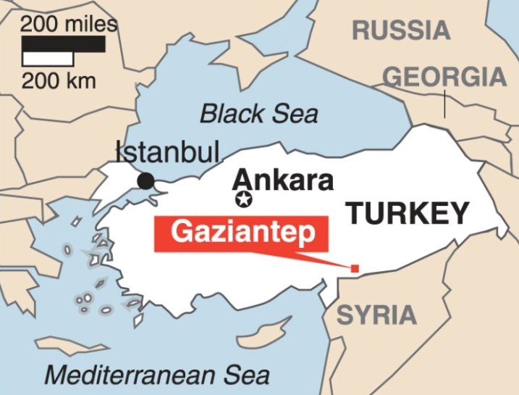
Following the 9/11 attacks, a group of 20 militants departed from Gaziantep to Afghanistan to join the jihad. They were headed by Turkish militant Mehmet Yılmaz and his assistant, Mehmet Reşit Işık, who later resurfaced in Iraq, where the two men were killed by US forces in June 2007. Yılmaz had been facilitating the movement of foreign fighters to Iraq for al Qaeda operations, via the Gaziantep cell. Gaziantep was also a home base for militants returning from Iraq or Afghanistan. On Oct. 29, 2001, 14 militants who had fought with al Qaeda in Afghanistan were captured in Gaziantep.
Writing about Islamic movements in Turkey, Ruşen Çakır discusses the importance of Gaziantep for al Qaeda militants heading to Iraq in 2008:
Al-Qaida prefers the Syrian route to Iraq. Those who cannot get to Syria directly, and who have connections to Al-Qaida, come to Turkey first. Then they go to Gaziantep and contact their Al-Qaida affiliates, and then they get to Syria through illegal ways, and on to Iraq. These include volunteer suicide bombers from Europe and professional teams who are directed to Iraq by Al-Qaida leaders in Pakistan and Afghanistan.
Gaziantep is also the only city where al Qaeda militants have responded with gunfire to Turkish police during a raid, suggesting their strength in that city. On Jan. 24, 2008, Turkish security units conducted an operation against an alleged al Qaeda cell in Gaziantep, amid reports that the cell was planning an operation of "sensational" proportions in Turkey. Suspected militants responded with gunfire to police calls to surrender, resulting in a firefight that led to the deaths of five militants and a policeman, along with the detention of 19 others.
Following the operation, codenamed "Ufuk" (Horizon), intelligence officials from the Gaziantep Anti-Terror Directorate interrogated the suspects and determined that the cell coordinated activities with other al Qaeda cells abroad. The officials further revealed that members of this cell frequently traveled to Pakistan and Afghanistan via Iran with false passports. During these visits they had met with other al Qaeda militants, informed them of their activities in Turkey, and taken directions from them.
Turkey as part of al Qaeda’s global strategy
Al Qaeda's global strategy includes a phase that entailed an expansion into Turkey. The third phase of the group's seven-phase global strategy, called the "Rising and Standing Up" phase, was to begin in 2007 and last until 2010. Militant activities in this phase were planned to concentrate on establishing an al Qaeda presence and influence in the "Land of Sham," corresponding to Turkey, Lebanon, Syria, and northern Jordan. Developments and al Qaeda-related arrests in Turkey between December 2006 and June 2007 (which correspond to the early part of this phase) were consistent with this plan.
Between December 2006 and June 2007, Turkish police arrested over 100 people suspected of having links with al Qaeda, and seized fake documents, weapons, and training manuals related to the organization. An operation in Konya province in January 2007 discovered a villa being used as an al Qaeda base, which housed a school for Turkish children age 12 and under. The school's activities included studying the Quran, and swearing to pursue martyrdom through daily recitations pledging "to give their lives for Shari'a [Islamic law] and being ready to rise to the level of martyrdom." The school also had other sections for recruiting adults, and contained thousands of publications, along with weapons training videos and compact discs. The school's existence demonstrated al Qaeda's longterm goals in recruiting Turkish youth and adults.
Al Qaeda also debuted its Turkish-language website, Sehadetvakti.com (Time for Martyrdom), in early 2007 (the site went offline in mid-2012). Since then, a growing number of similar Turkish websites have emerged, which suggests an increase in Turkish involvement in jihadist activity.
The Time for Martyrdom website advocated a message of militant jihad, and featured an array of violent videos from established al Qaeda media organizations focusing on Iraq and Afghanistan. The website would routinely eulogize fighters killed in jihad and hold them up as role models for others.
Conclusions
The following conclusions can be drawn based on the information known about al Qaeda in Turkey today.
• As Gareth Jenkins, a senior fellow at the Institute for Security and Development Policy's Turkey Initiative, observes, there does not appear to be a Turkish "branch" of al Qaeda with a "country representative" at its head. Instead, the network appears to be run by a few people of similar hierarchical status in different regions. In fact, there are many different networks in the country, Jenkins says, "some of which are in contact with al Qaeda members outside Turkey and others who merely share the same goals but have no direct links."
• Al Qaeda uses elements of local radical Islamist groups in Turkey, and appears to have links with Turkish Hizballah (TH). Some of TH's members are thought to have regrouped under the al Qaeda movement in Turkey. Terror analysts have also alleged past links with the PKK through Ansar al Islam, a former Kurdish al Qaeda unit in northern Iraq near PKK bases.
• Al Qaeda's plans in Turkey are more likely to be carried out in the organization's name as the work of localized networks picking targets of opportunity that they identify, rather than being managed by a senior operational group in Afghanistan.
• Turkish security forces are very efficient in monitoring the activities of Islamist militants and successful in preventing attacks.
• Al Qaeda's violent interpretation of Islam receives no public backing in historically secular Turkey. As Prof. Serhat Erkmen, an al Qaeda researcher notes, Turkey's tolerant understanding of Islam provides a "natural immunization" against al Qaeda. This, coupled with the language barrier (most Turks do not speak Arabic), makes Turkey unlikely to ever become a strong al Qaeda base.
• Gaziantep, the largest city in the southeast, has been used as an important hub for militants traveling to and from Iraq and Afghanistan. Gaziantep is also a major operations center for TH.
• Iraq, an important activity area for al Qaeda, was also where al Qaeda members from Turkey would escape. Some of the main organizers of the attacks in Turkey escaped to Iraq via Gaziantep.
• Several Turkish al Qaeda militants have recently surfaced in Syria.
• As a result of the Syrian war, elements of the al Qaeda-linked Al Nusra Front have surfaced in the border regions between Turkey and Syria, which can tap into the already existing al Qaeda network in Turkey.
• Al Qaeda is still targeting Turkey.

APPENDIX: CHRONOLOGICAL LIST OF AL QAEDA PLOTS, ATTACKS, AND ARRESTS IN TURKEY

Nov. 15, 2003: Suicide bombers attacked two synagogues in Istanbul, killing 24 people and injuring more than 300.
Nov. 20, 2003: Suicide bombers in Istanbul attacked the British Consulate and the HSBC Bank Central Branch, killing 34 people and injuring at least 400.
March 9, 2004: Two suicide bombers attacked a Masonic lodge in Istanbul, killing one person and one of the suicide bombers.
May 3, 2004: Turkish authorities thwarted a plot by Ansar al Islam to bomb a NATO summit in Istanbul at the end of June that was to be attended by President George W. Bush.
August 2005: Syrian national Louai Sakka, (code name 'Syrian Aladdin'), one of the masterminds of the November 2003 Istanbul attacks, was arrested under the false ID of Ekrem Özel in Diyarbakır on charges that he was preparing a bomb attack on Israeli ships arriving in Antalya on Turkey's Mediterranean coast.
December 2006: Police arrested 10 suspected militants before the Pope's visit to Turkey, after determining a potential threat based on email exchanges.
January 2007: In operations around the country, Turkish police arrested 48 people suspected of links with al Qaeda. In Konya province, this operation discovered a villa being used as an al Qaeda base which housed a school for Turkish children age 12 and under. The school's activities included studying the Quran and swearing to pursue "martyrdom" through daily recitations, pledging "to give their lives for Shari'a [Islamic law], and being ready to rise to the level of martyrdom." The school had other sections for recruiting adults, and contained thousands of publications, along with weapons training videos and compact discs.
May 30, 2007: Authorities arrested 11 people in Istanbul who were allegedly planning to attack the Bilderberg Summit in Istanbul, a meeting of prominent statesmen and businessmen, sometimes referred to as "covert world government," that took place from May 31 to June 3.
June 23, 2007: Mehmet Yılmaz and Mehmet Reşit Işık, two Turkish al Qaeda members, were killed by Coalition forces in Baghdad, Iraq.
Dec. 29, 2007: Simultaneous raids in four Turkish cities resulted in the detention of 20 suspected al Qaeda militants. The raids took place in Aksaray, Adana, Ankara, and Istanbul after the Aksaray Gendarmerie Intelligence decided to preempt a planned attack by a sleeper cell in Aksaray that had been under surveillance for several years.
Dec. 31, 2007: An article in the Israeli newspaper Yedioth Ahronoth claimed that Israeli intelligence reports suggested al Qaeda cells in Turkey were preparing for an imminent attack against Israeli and US targets inside Turkey. Israeli institutions and companies in Turkey were issued warnings by the Israeli government.
Jan. 24, 2008: In several simultaneous raids, Turkish security forces arrested members of an al Qaeda cell in Gaziantep. Suspected militants responded with gunfire to police calls to surrender, resulting in a firefight which led to the deaths of four militants and the detention of 19 others.
April 1, 2008: Simultaneous raids in Istanbul, Gaziantep, and Hatay led to the arrests of 45 suspects, including one of the high-level members of al Qaeda in Turkey. The suspects were allegedly planning a large-scale attack to avenge the January 2008 operations against the Gaziantep cell, which had killed four terrorists, including Halis Bayuncuk, said to be one of the senior members of al Qaeda in Turkey. (He was the son of a former Hezbollah member, Hacı Bayuncuk.)
July 9, 2008: Three police officers and three attackers died during an attack on the US Consulate in Istanbul, in which four armed men drove a car up to the high-walled compound. The attackers then jumped out of the car and started firing at police at a guard post. The police officers fired back, killing three of the attackers, as bystanders ran for cover; at least one attacker escaped in the car.
April 9, 2009: Police arrested 28 suspects in Eskisehir. The Eskişehir cell was allegedly organizing discussion groups to recruit new members to its network.
April 22, 2009: Raids in Gaziantep, Konya, Adana, Kahramanmaraş, and Şanlıurfa resulted in the arrest of 37 suspected al Qaeda members believed to be planning attacks on Turkish soil.
Jan. 15, 2010: Seven separate raids in Ankara and Adana resulted in the capture of Ebubekir Aslan, allegedly a top al Qaeda Turkey leader; his assistant Ali Mert; and 30 others, who were reportedly preparing an attack on Turkish soldiers at the Kabul Regional Command in Afghanistan to protest Turkey's taking over the command as part of ISAF in November 2009. (Turkey doubled its troop numbers to about 1,750 at that time.) Aslan had been trained in Afghanistan and Pakistan. This was allegedly the organization's Taifatul Mansura branch. Weapons, al Qaeda-linked documents, and fake IDs and passports were found. Police also found quantities of camouflage clothing to be sent to Serdar Elbaşı (code name Ebu Zer El Turki) in Afghanistan, who was allegedly al Qaeda Turkey's leader in Afghanistan. Another theory was that they were plotting to kill Turkish soldiers in Adana or Ankara, or to murder police in Turkey.
Jan. 15-20, 2010: In countrywide operations, over 100 suspected al Qaeda militants were arrested, 17 of whom were detained for conducting al Qaeda-linked activities under the fake association NIDA-DER, producing fake IDs, and fundraising and recruiting fighters for al Qaeda.
April 2011: In Istanbul, 50 raids resulted in the arrest of 26-year-old Halis Bayancuk, considered one of the ringleaders of al Qaeda in Turkey, along with 42 others. He is the son of Hacı Bayancuk, a former leader of the Kurdish Hezbollah in Turkey. He had been sent to prison in 2008 but released in 2009. In Van, 10 others were arrested.
June 2011: Authorities arrested 10 suspected al Qaeda militants in Adana, home to the İncirlik Air Base, which is used by the US to transfer supplies to Iraq and Afghanistan.
July 13, 2011: Authorities arrested 15 al Qaeda militants in three cities (Ankara, Yalova, and Bursa), and seized 1,550 pounds of bomb-making explosives. The indictment report in December 2011 revealed that the militants were planning to attack Ankara's churches and Christian clergy, as well as the Turkish Parliament and the US Embassy in Ankara, during Secretary of State Hillary Clinton's visit. Documents found said, "It is more advantageous to wage jihad against Turkey than the United States." Among the documents seized was a list of names and addresses of Christian clergy and church workers living in Ankara. This foiled plot was speculated to be al Qaeda's revenge for the May 2011 killing of Osama bin Laden in Pakistan.
Nov. 22, 2011: Authorities arrested 14 al Qaeda militants in Konya.
Dec. 9, 2011: Istanbul authorities confirmed that police were searching for three al Qaeda extremists and five others involved in stealing $3.5 million from a Turkish businessman's account by using false identities and bribing bank employees. The group hoped to use the money to support the al Qaeda cause. This was the first "fiscal terrorism" operation in Turkey.
Dec. 14, 2011: Six militants were arrested in Izmir and Manisa, including group regional leader Erdal Akpınar. They were apparently working for the organization's Turkish leader, Halis Bayuncuk, who had been arrested in April 2011.
Dec. 20, 2011: Authorities arrested 12 suspects in operations in 15 locations in Gaziantep.
June 2012: Authorities arrested 21 suspected al Qaeda members in operations in Bursa, Balıkesir, Gaziantep, and Yalova.
Aug. 3, 2012: Osman Karahan, publicly known as the lawyer defending al Qaeda members in Turkey, was killed in Aleppo, Syria. Karahan had defended Louai Sakka, a Turkish-speaking Syrian and one of the planners of the November 2003 attacks in Istanbul.
Aug. 16, 2012: Metin Ekinci was killed in Syria. One of the trucks used in the November 2003 attacks was registered under his name. He was the brother of suspected al Qaeda member Azad Ekinci, who was one of the planners of the November 2003 attacks. Azad has been wanted in connection with the attacks since then.
Aug. 18, 2012: Baki Yiğit, one of the main planners of the November 2003 attacks, was killed in Aleppo, Syria. Yiğit had been prosecuted for organizing the attacks and was known to have had personal contact with Osama bin Laden in Afghanistan. He had been charged with being a member of al Qaeda, attempting to change the Turkish Constitution, and organizing a bomb attack on synagogues, HSBC bank, and the British Consulate, and had been sentenced to life in prison in February 2007. He was released on Oct. 12, 2010 based on time served, however, and was not prohibited from traveling outside the country.
Aug. 30, 2012: Authorities arrested 13 suspected al Qaeda militants in Kocaeli.
Feb. 27, 2013: In a counterterrorism operation carried out by the Tekirdağ Police Department against two cells, 11 al Qaeda members were captured with explosives after reportedly planning to stage attacks in Istanbul on the US Consulate, a church, and a synagogue.
April 10, 2013: Based on the raid in February 2013, Turkish police also found evidence of an al Qaeda plot to bomb the US Embassy in Ankara.
April 15, 2013: An antiterrorism operation against an al Qaeda cell in in Konya led to the arrest of 10 suspects on charges that they were funneling weapons to the Syrian opposition and recruiting members to send to Syria.
May 30, 2013: Seven members of the al Qaeda-linked Al Nusrah Front were detained after police found sarin gas, which was reportedly going to be used in a bomb attack against targets in Turkey, during a search of the suspects' homes in Adana and Mersin.

Piracy epicentre shifts to West Africa
Source: http://www.thehindu.com/news/international/piracy-epicentre-shifts-to-west-africa/article49214 96.ece

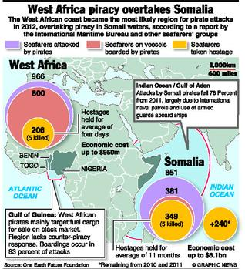
The oil-rich West African Gulf of Guinea is ominously emerging as the epicentre of armed piracy, confirms the half-yearly report released by piracy watchdog International Maritime Bureau (IMB) of the International Chamber of Commerce.
Somali piracy has dipped to an all-time low since 2006 with just four cases reported till June as against 44 in the same period last year, thanks to a concerted counter-piracy campaign by navies from around the world.
Data collated by IMB indicates that there were 138 incidents of piracy in the first six months of 2013 compared to 177 between January and June last year. The number of hijackings this year stood at seven, down from 20 during the corresponding period in 2012. There has also been a welcome fall in the number of sailors taken hostage — 127 so far this year as against 334 in the opening half of 2012.
In Asia, the Indonesian coast witnessed 48 incidents of low-level theft from vessels, mainly at ports and anchorages, in the first half of 2013.
The IMB report registers an alarming surge in piracy and armed robbery in the Gulf of Guinea, mainly off Nigeria, with 31 incidents including four hijackings reported till June this year. The region accounted for all the 30 crew kidnappings reported so far in 2013. The piracy hotspot also saw 56 sailors taken hostage.
Notably, 22 of the 31 piracy incidents and 28 of the kidnappings in the Gulf of Guinea occurred off Nigeria.
“There has been a worrying trend in the kidnapping of crew from vessels well outside the territorial limits of coastal states in the Gulf of Guinea,” said IMB director Pottengal Mukundan.
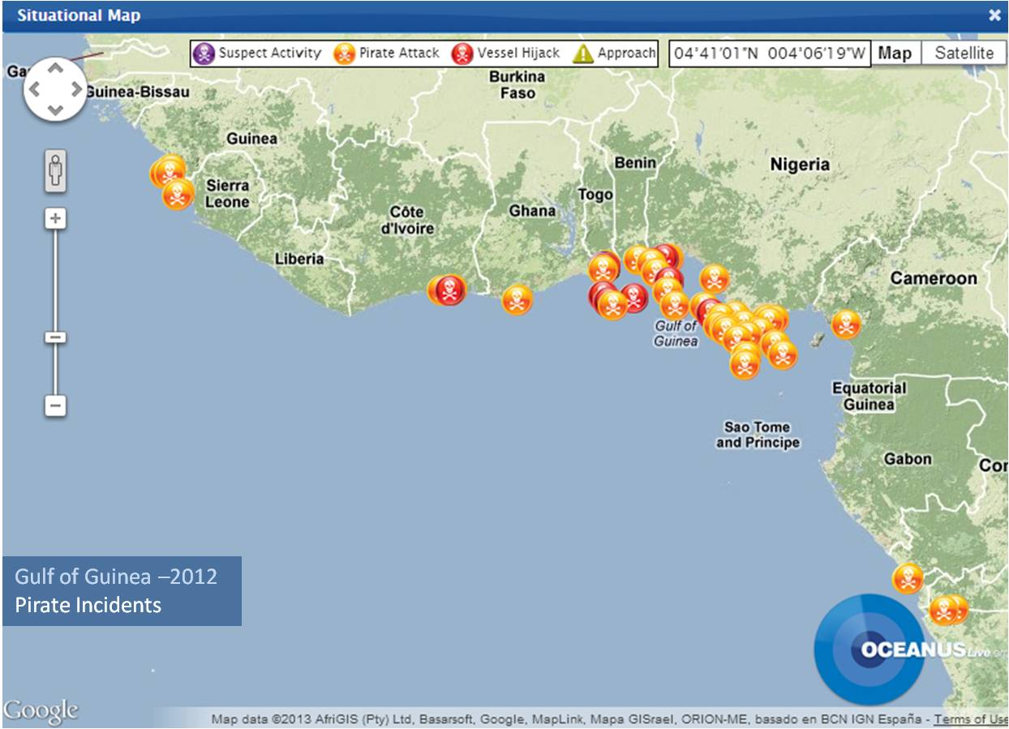
“In April 2013, nine crew members were kidnapped form two container vessels, one of which was 170 nautical miles from the coast. Pirates have used motherships, some of which were smaller off-shore supply vessels hijacked by pirates to conduct the attacks,’ he said. Mr. Mukundan rued that there was “significant under-reporting” of attacks which prevented meaningful response by the authorities.
Rising incidents of piracy in the region forced the heads of states in the Central and West African countries to adopt an anti-piracy code of action last month at the initiative of the U.N. Security Council and various political and economic blocs.
A NATO spokesperson told The Hindu that the group did not intend to expand its counterpiracy operations to the Gulf of Guinea. “It is primarily a national responsibility for a State to ensure that its coastal waters are safe and secure. NATO has no mandate and no intention to intervene in the Gulf of Guinea,” Lieutenant Commander Dave Benham of NATO Allied Maritime Command said in a communication.
“While all piracy represents a costly and deplorable crime, the nature and circumstances in the Gulf of Guinea are entirely different to those in the Somali basin, and so must be the means to deal with the type of piracy (sic). States must take whatever measures are necessary to prevent their own territory becoming a ‘spring- board’ for pirate attacks on innocent trade.”

Global al Qaeda: Affiliates, Objectives, and Future Challenges
By Thomas Joscelyn
18th July 2013 - House Committee on Foreign Affairs, Subcommittee on Terrorism, Nonproliferation, and Trade
Source: http://www.defenddemocracy.org/media-hit/global-al-qaeda-affiliates-objectives-and-future-challenges/?sthash.EbCT6ug2.mjjo&goback=.gde_1528217_member_259592679

Chairman Poe, Ranking Member Sherman and members of the Committee, thank you for inviting me here today to discuss the threat posed by al Qaeda. We have been asked to “examine the nature of global al Qaeda today.” In particular, you asked us to answer the following questions: “What is [al Qaeda’s] makeup? Is there a useful delineation between al Qaeda’s core and its affiliates? If so, what is the relationship? Most importantly, what is the threat of al Qaeda to the United States today?”
I provide my answers to each of these questions in the following sections. But first, I will summarize my conclusions:
- More than a decade after the September 11, 2001, terrorist attacks there is no commonly accepted definition of al Qaeda. There is, in fact, widespread disagreement over what exactly al Qaeda is.
- In my view, al Qaeda is best defined as a global international terrorist network, with a general command in Afghanistan and Pakistan and affiliates in several countries. Together, they form a robust network that, despite setbacks, contests for territory abroad and still poses a threat to U.S. interests both overseas and at home.
- It does not make sense to draw a firm line between al Qaeda’s “core,” which is imprecisely defined, and the affiliates. The affiliates are not populated with automatons, but they are serving al Qaeda’s broader goals. And al Qaeda has dispatched “core” members around the globe. As the 9/11 Commission found, Al Qaeda’s senior leaders have always pursued a policy of geographic expansion. The emergence of formal affiliates, or branches, has been a core al Qaeda objective since the early 1990s. While the affiliates have varying degrees of capabilities, and devote most of their resources to fighting “over there,” history demonstrates that the threat they pose “over here” can manifest itself at any time.
- In addition to its affiliates, al Qaeda operates as part of a “syndicate” in Central and South Asia. As former Secretary of Defense Robert Gates said in 2010, “A victory for one [member of the syndicate] is a victory for all.” Al Qaeda and its allies control territory inside Afghanistan today. If additional parts of Afghanistan fall to the syndicate in the coming years, it will strengthen both al Qaeda’s ideological messaging and operational capability.

What is al Qaeda?
This should be a straightforward question to answer. But in reality there is no commonly accepted understanding of al Qaeda. Writing in 2003, Bruce Hoffman wrote that there was “[d]isagreement over precisely what al Qaeda is.”[1] It is “remarkable,” Hoffman noted, that “al Qaeda remains such a poorly understood phenomenon” even after the 9/11 attacks. Incredibly, any attempt to answer basic questions about al Qaeda’s structure (similar to the ones proposed by this committee), “provokes more disagreement than agreement in government, intelligence, and academic circles.”
Ten years later, Hoffman’s words still ring true. In early 2013, the Canadian Security Intelligence Service (CSIS) commissioned a workshop of experts to assess the future of al Qaeda. CSIS was interested in how al Qaeda will adapt to the “death of Osama bin Laden, the popular uprisings spreading across the Middle East and North Africa, and the global recessionary pressures that are causing governments to re-evaluate their [counterterrorism] strategies.” The final report issued at the conclusion of the workshop reads: “Workshop participants recognized that part of the challenge in imagining AQ’s future lies in the very definition of AQ.” Unsurprisingly, there was a “lack of consensus” among the experts. Echoing Hoffman’s assessment a decade earlier, CSIS found: “How AQ adopts to the challenges and opportunities that will shape its next decade is a source of spirited debate amongst government officials, academic experts, think-tank analysts and private consultants.”[2]
“At its broadest,” the CSIS report’s authors found, “the phenomenon includes a central group of senior leaders commonly referred to as AQ Core, regional affiliates which together with that core make up the AQ network, like-minded groups in the network’s key operating areas (eg, fellow travelers), homegrown Islamist extremists in Western countries, sympathisers across the globe and the AQ ideology itself.” Despite this complex mix, the workshop’s participants concluded that the “AQ Core and its network affiliates” will have “the most profound” impact “on the broader phenomenon’s future prospects.” For the most part, I concur with the CSIS definition of al Qaeda.

The Al Qaeda Network
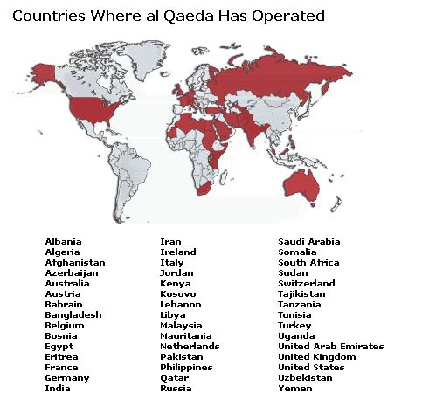
The backbone of today’s al Qaeda consists of its “general command” in Afghanistan and Pakistan (others refer to this as the “AQ Core”) and its formal affiliates. The established al Qaeda affiliates include: Al Qaeda in the Arabian Peninsula (AQAP), Al Qaeda in Iraq (AQI) and its the Islamic State of Iraq (ISI), Al Qaeda in the Islamic Maghreb (AQIM), and Shabaab in Somalia. All of the affiliates have publicly sworn bayat (an oath of fealty) to al Qaeda’s senior leadership. Jabhat al Nusra in Syria should also be included in this list as well, because the group has openly proclaimed its allegiance to Ayman al Zawahiri. Collectively, al Qaeda’s general command and the affiliates form an international terrorist network that is focused on both acquiring territory and executing terrorist attacks against the West. There is evidence showing that al Qaeda’s general command guides the overall strategy pursued by the affiliates and even sometimes gets involved in specific tactical matters. However, the affiliates enjoy a large degree of latitude in deciding how to run their day-to-day operations. Relentless pressure from the U.S. and its allies has repeatedly disrupted the network, making the general command’s job more difficult.
In addition to the established affiliates, there are numerous associated jihadist organizations that the Al Qaeda Network either influences or outright directs without officially recognizing the group as an affiliate. Consider two brief examples. In Mali, AQIM has fought alongside Ansar al-Dine (AAD), which was designated a terrorist organization by the State Department in March.[3] At the time, the State Department noted that AAD “cooperates closely with” and “has received support from AQIM since its inception in late 2011.” AAD “continues to maintain close ties” to AQIM and “has received backing from AQIM in its fight against Malian and French forces.” Similarly, Boko Haram in Nigeria is not a formal al Qaeda affiliate, but according to the U.S. government the group has maintained ties to three affiliates. “There are reported communications, training, and weapons links between Boko Haram, al Qaida in the Lands of the Islamic Maghreb (AQIM), al-Shabaab, and al Qaeda in the Arabian Peninsula, which may strengthen Boko Haram’s capacity to conduct terrorist attacks.”[4]
Still other pro-al Qaeda organizations have emerged since the beginning of the so-called Arab Spring under the name Ansar al Sharia (Partisans of Sharia Law). The very first Ansar al Sharia was simply a rebranding of al Qaeda in the Arabian Peninsula -- that is, it was a new name chosen by an established al Qaeda affiliate.[5] It is hardly surprising, therefore, to learn that other Ansar al Sharia chapters are run by jihadists with known ties to al Qaeda.
Ansar al Sharia Tunisia is headed by Seifallah ben Hassine (also known as Abu Iyad al Tunisi), who has been designated by United Nations as a terrorist.[6] Ben Hassine previously established the Tunisian Combatant Group (TCG), “in coordination with” al Qaeda, according to the UN. Ben Hassine has known ties to a constellation of al Qaeda terrorists, including the group’s senior leaders, and the TCG played a key role in the September 2001 assassination of Northern Alliance leader Ahmed Massoud. Other UN-designated al Qaeda terrorists hold leadership positions within Ansar al Sharia Tunisia, too.[7] Ansar al Sharia Egypt is led by Egyptian Islamic Jihad (EIJ) leaders who have remained loyal to al Qaeda emir Ayman al Zawahiri.[8] Ayman’s younger brother, Mohammed al Zawahiri, has played a starring role at Ansar al Sharia Egypt’s events. Other Ansar al Sharia chapters, including inside Libya, have known al Qaeda ties as well. The groups calling themselves Ansar al Sharia are all open about their support for al Qaeda’s agenda. We cannot rule out that the possibility that these organizations are simply al Qaeda’s attempt at rebranding. It is easy to connect the dots.
The point is that outside of the formal affiliates, the Al Qaeda Network holds sway over dozens of organizations that are, at a minimum, ideological kinsmen. We often cannot see the operational ties between these groups because al Qaeda still maintains a substantial clandestine apparatus that is tasked with hiding such relationships. For some of these organizations, there may very well be no concrete ties and their relationship to al Qaeda’s jihad is purely rhetorical.

The al Qaeda-led ‘syndicate’ in Afghanistan and Pakistan
In Central and South Asia, al Qaeda has forged what former Secretary of Defense Robert Gates has called a “syndicate” of terrorist groups.[9] “What we see is that the success of any one of these groups leads to new capabilities and a new reputation for all,” Gates said during a press conference in 2010. “A victory for one is a victory for all.”
Gates continued: “It's dangerous to single out any one of these groups and say if we could beat that group that will solve the problem. Because they are, in effect, a syndicate of terrorist operators.” Gates blamed al Qaeda for orchestrating the syndicate’s attacks in Afghanistan, Pakistan and India. The “syndicate” description remains apt today, as there is no evidence that this coalition has frayed in the wake of al Qaeda’s senior leadership losses.[10]
Consider this brief sketch of the main groups that belong to the syndicate.
In Afghanistan, al Qaeda has fought alongside the Taliban since the mid-1990s. Before the September 11 attacks, Osama bin Laden established the 55th Arab Brigade to serve as al Qaeda’s contribution to the Taliban’s side in Afghanistan’s bloody civil war. The 55th was crushed during the U.S.-led invasion of Afghanistan in late 2001, but was later reconstituted as part of the Lashkar al Zil, or “Shadow Army.”[11] This paramilitary fighting force is still very much alive. The U.S. has targeted members of the “Shadow Army” in recent weeks.[12] And, in early June, the U.S. Treasury Department added an al Qaeda explosives expert to its list of designated terrorists. This expert, a Libyan, is “in charge of IED component construction at the AQ electronics workshop” and has “provided AQ paramilitary brigades in Afghanistan with timers, circuits, mines, and remote control devices for use in IEDs.”[13] Senior Taliban commanders continue to facilitate al Qaeda operations inside Afghanistan as well.[14]
Other groups fighting in Afghanistan, such as the Islamic Movement of Uzbekistan (IMU), have long been part of al Qaeda’s plan.[15] The IMU operates throughout the country, as well as in Pakistan, and also maintains a facilitation network in neighboring Iran. The Islamic Jihad Union (IJU), a splinter of the IMU, continues to fight alongside other al Qaeda-affiliate parties and take part in anti-Western plotting. Allies such as the Eastern Turkish Islamic Party (ETIP) provide fighters and leaders for the syndicate, too.
In Pakistan, al Qaeda helped establish the Tehrik-e Taliban Pakistan (TTP), or Pakistani Taliban, which has unleashed a prolific terror campaign inside Pakistan, fought in Afghanistan, and even exported its operations elsewhere around the globe. Recent reports indicate that the TTP has sent a contingent to Syria, but some within the TTP have denied that claim. As recognized by the State Department, the TTP is clearly a part of al Qaeda’s camp as the two maintain a “symbiotic relationship.”[16]
The Haqqani Network, straddling the border of Afghanistan and Pakistan, remains one of al Qaeda’s most important allies. The Haqqanis provide not only key logistical support for the syndicate’s Afghan-focused operations, but also a safe haven from which al Qaeda can direct attacks against the West. As the authors of a recent, in-depth profile of the Haqqani Network concluded, “the Haqqani Network has long served as a local enabler of al Qaeda and its global jihad.”[17] A string of plots against Europe and the U.S. have been traced to Haqqani-controlled territory.[18]
Other Pakistan-based, al Qaeda-allied groups include: Harkat-ul-Jihad-al-Islami (HUJI), Harakat-ul-Mujahideen (HUM), Jaish-e-Mohammed (JeM), Lashkar-e-Jhangvi (LeJ), and Lashkar-e-Taiba (LeT). All of these groups have decades-old ties to al Qaeda, and have cooperated with al Qaeda in operations. These organizations have provided al Qaeda with a deep roster of skilled operatives who have replaced fallen terrorist commanders.

What is the relationship between al Qaeda’s “core” and the affiliates?
All of the established al Qaeda affiliates – Al Qaeda in the Arabian Peninsula (AQAP), Al Qaeda in Iraq (AQI), Al Qaeda in the Islamic Maghreb (AQIM), Shabaab and, I would add, Jabhat al Nusra in Syria – have sworn an oath of bayat (loyalty) to al Qaeda’s general command and Ayman Zawahiri. As Osama bin Laden’s chief co-conspirator, Zawahiri was involved in all facets of al Qaeda’s operations, from strategic questions to attack planning. Prior to the slaying of bin Laden: Zawahiri negotiated mergers with al Qaeda affiliates (such as AQIM), reprimanded problematic commanders (such as deceased AQI head Abu Musab al Zarqawi), and oversaw at least parts of al Qaeda’s international operations (from calling off a planned 2003 attack on New York City’s subways to orchestrating other attacks).
It is impossible to assess how frequently the affiliates are in contact with the general command, as much of that data is not available to the outside world. But Zawahiri is in charge of the Al Qaeda Network. The affiliates recognize Zawahiri as their leader, even when they disagree with his decisions. And Zawahiri is still communicating with his subordinates, even if his missives are delayed due to security concerns. For instance, Zawahiri communicated with one of his Egyptian followers, Muhammad Jamal al Kashef, in 2011 and 2012.[19]
In April and May of this year, Zawahiri sent messages to, and received replies from, the heads of al Qaeda’s affiliates in Iraq and Syria.[20] Those communications revealed a serious dispute between the emirs of al Qaeda in Iraq and Jabhat al Nusra over who commands al Qaeda’s growing army in Syria. Zawahiri ruled in Jabhat al Nusra’s favor, but the head of al Qaeda in Iraq subsequently defied Zawahiri’s order.[21] It remains to be seen how this dispute is worked out, but it should be noted that the squabble is over al Qaeda’s successful growth inside Syria. In other words, they are not arguing over who owns an unsuccessful franchise. And even with AQI’s open defiance, Jabhat al Nusra has proven to be extremely deferential to Zawahiri. Despite AQI’s rancor, Al Qaeda’s general command has gained a new affiliate inside Syria since late 2011. To put it another way, suppose Zawahiri were to entirely lose AQI’s loyalty (so far, there is no reason to believe this is the case), he has still gained Jabhat al Nusra.
Another serious dispute has erupted in Somalia, where Shabaab’s leadership has reportedly executed al Qaeda operatives with well-established pedigrees, including Ibrahim al Afghani. This cannot please al Qaeda’s general command, as al Afghani was loyal to al Qaeda during the Battle of Tora Bora and the years that followed.
The Al Qaeda Network is not comprised of automatons. Like all manmade organizations, the terror network houses personalities who may clash and sometimes have competing interests. This does not necessarily mean, however, that the network has “fragmented” or “splintered,” as some analysts contend. Keep in mind this striking example: Prior to 9/11 there was a significant amount of internal dissent over whether al Qaeda should launch its most devastating attack in history. The 9/11 attacks became al Qaeda’s signature strike, and yet several high-level al Qaeda members disagreed with bin Laden’s decision to move forward with the operation. This did not force these senior jihadists outside of al Qaeda’s ranks. In fact, some of them went on to praise the 9/11 attacks after the fact while maintaining their leadership positions.
Since its inception in the late 1980s, al Qaeda has faced substantial hurdles. Yet, the organization has proven to be remarkably adaptive, in part, because its leaders devised a strong plan for broadening their base of support within the jihadist world and beyond. The plan relies upon loyal followers throughout the world, not just in Afghanistan and Pakistan.

The al Qaeda “core” is imprecisely defined.
There is no standardized definition of al Qaeda’s “core.” In general, when U.S. officials and independent analysts use this term, it appears that they are referring to al Qaeda’s senior leadership in Pakistan and Afghanistan, which is headed by al Qaeda emir Ayman al Zawahiri. The al Qaeda honcho is, in turn, served by several committees and an unknown number of advisers. As far as I can tell, this is what is meant by the “core” of al Qaeda. As I’ve made clear in my testimony, I prefer the term “general command” to “core” (which I have used elsewhere) as this is what is used in al Qaeda’s own correspondence.
It does not make any sense to assume that “core” al Qaeda members, as they are commonly referred to, are confined to Pakistan and Afghanistan. We know, for example, that al Qaeda’s senior leaders have dispatched or otherwise rely upon numerous terrorists around the world to do their bidding, both as part of the group’s operational cells, as well as within the Al Qaeda Network’s affiliates. Consider the following examples.
Headquartered in Yemen, Al Qaeda in the Arabian Peninsula (AQAP) is led by Nasir al Wuhayshi, a terrorist who served as Osama bin Laden’s aide-de-camp for several years prior to 9/11. Wuhayshi was bin Laden’s protégé and remained loyal to the al Qaeda master even through the darkest times, including the Battle of Tora Bora in late 2001, when all could have been lost. Bin Laden later returned the favor, rejecting a plea by some AQAP members to replace Wuhayshi as their leader with Anwar al Awlaki, the charismatic al Qaeda ideologue who has since been killed in a drone strike. Some of Wuhayshi’s most trusted lieutenants, including several former Guantanamo detainees, also served al Qaeda in Afghanistan well before the 9/11 attacks. Together, they are advancing al Qaeda’s global jihadist agenda, simultaneously fighting for territory inside Yemen while overseeing plots against the United States.
According to the Obama administration, the terrorist who leads al Qaeda’s network inside Iran today is a Kuwaiti named Muhsin al Fadhli. Few al Qaeda terrorists were trusted with foreknowledge of the 9/11 attacks; al Fadhli was one of them. The network that al Fadhli oversees is the result of an agreement with the Iranian regime that was brokered by Osama bin Laden’s right-hand man, who traveled to and from Iran. This Iran-based network serves as a “core” pipeline for al Qaeda’s senior leadership. At least several important al Qaeda operatives have served this Iran-based network while living in other Gulf countries. After 9/11, numerous al Qaeda leaders, including members of the group’s management and military councils, fled to Iran where some were held under house arrest. One of these senior al Qaeda members is Saif al Adel, who has since been allowed to leave Iran, although it is unclear where he is currently stationed. Al Adel and his ilk did not cease being “core” al Qaeda members simply because they fled to Iran after the fall of the Taliban’s Afghanistan.
A Defense Department report (“Al Qaeda in Libya: A Profile”) published by the Library of Congress in August 2012 identified at least two senior operatives who were dispatched to Libya to oversee al Qaeda’s efforts there. The first is known as Abu Anas al Libi, who was long ago convicted of terrorism charges for his role in al Qaeda’s 1998 embassy bombings in Kenya and Tanzania. Abu Anas is coordinating his efforts with al Qaeda’s senior leadership in Afghanistan and Pakistan. The second terrorist identified in the report, Abd al Baset Azzouz, was sent to Libya by Ayman al Zawahiri. Another al Qaeda terrorist who was not identified in the Defense Department’s report, but is known to operate inside Libya, is Faraj al Chalabi (or al Shibli), who was detained earlier this year after returning to Libya from Pakistan.[22] Al Chalabi may have been involved in the September 11, 2012, terrorist attack in Benghazi.
In March, the State Department offered a $5 million reward for information leading to the capture of an American known as Jehad Mostafa, who is believed to be Ayman al Zawahiri’s emissary to Shabaab, al Qaeda’s affiliate in Somalia. Shabaab is currently engaged in serious infighting and it is not publicly known how Mostafa’s role has been affected.
There are credible reports that senior al Qaeda operatives, including a member of the group’s Shura council, have gone to Syria. And Ayman al Zawahiri has appointed a longtime al Qaeda operative known as Abu Khalid al Suri to resolve the dispute between Jabhat al Nusra and al Qaeda in Iraq.
Other core al Qaeda members have returned to their home countries in the wake of the Arab Spring. One declassified Abbottabad document shows that Osama bin Laden recommended that a terrorist named Mohammed Islambouli leave northern Pakistan for Kunar, Afghanistan. Mohammed’s brother, Khaled Islambouli, was the assassin who killed Egyptian president Anwar Sadat. While bin Laden was willing to lose some al Qaeda leaders, he was not willing to lose Mohammed Islambouli, who is the equivalent of royalty in jihadist circles and is today a free man inside Egypt, where is joined by other Zawahiri loyalists who have either been freed from prison or returned from abroad.
Nasir al Wuhayshi, Muhsin al Fadhli, Abu Anas al Libi, Abd al Baset Azzouz, Jehad Mostafa, Abu Khalid al Suri, Mohammed Islambouli: These are just some of the men who can be counted on to advance al Qaeda’s agenda outside Afghanistan and Pakistan. It does not make sense to consider them anything but “core” al Qaeda members.

Al Qaeda’s Affiliate Strategy
The emergence of al Qaeda’s affiliates is no accident. Al Qaeda has always sought to push forward its agenda by working with, co-opting, or otherwise directing like-minded jihadist groups. The principal Al Qaeda organization – its general command – is itself a joint venture, which bin Laden’s organization and Ayman al Zawahiri’s Egyptian Islamic Jihad (EIJ) forged through a merger.
Al Qaeda began laying the groundwork for the emergence of its affiliates in the early 1990s.[23] Bin Laden was headquartered in Sudan at the time and, according to the 9/11 Commission, “had a vision of himself as head of an international jihad confederation.” Bin Laden established an “Islamic Army Shura,” which “was to serve as the coordinating body for the consortium of terrorist groups with he which he was forging alliances.” The Shura “was composed of his own al Qaeda Shura together with leaders or representatives of terrorist organizations that were still independent.” [24]
As part of this Islamic army, bin Laden “enlisted groups from Saudi Arabia, Egypt, Jordan, Lebanon, Iraq, Oman, Algeria, Libya, Tunisia, Morocco, Somalia, and Eritrea.” The burgeoning al Qaeda network “also established cooperative but less formal relationships with other extremist groups from these same countries; from the African states of Chad, Mali, Niger, Nigeria, and Uganda; and from the Southeast Asian states of Burma, Thailand, Malaysia, and Indonesia.” Al Qaeda also supported efforts in the Balkans, Central Asia, Chechnya, and the Philippines. Bin Laden and al Qaeda pursued a “pattern of expansion through building alliances” and had laid the “groundwork for a true global terrorist network”[25]
In 1996, bin Laden was forced to leave the Sudan for Pakistan and then Afghanistan. But al Qaeda’s strategy of alliance building continued. The 9/11 Commission wrote: “The alliance with the Taliban provided al Qaeda a sanctuary in which to train and indoctrinate fighters and terrorists, import weapons, forge ties with other jihad groups and leaders, and plot and staff terrorist schemes.”[26] In addition to maintaining his own facilities, bin Laden “also provided support to and benefited from the broad infrastructure of such facilities in Afghanistan made available to the global network of Islamist estimates.”[27] During this period in Afghanistan, al Qaeda continued “to collaborate closely with the many Middle Eastern groups – in Egypt, Algeria, Yemen, Lebanon, Morocco, Tunisia, Somalia, and elsewhere – with which it had been linked when Bin Ladin was in Sudan.”[28] And al Qaeda “reinforced” and “bolstered” its ties to still other groups.
It is estimated that from 1996 to September 11, 2001, between 10,000 and 20,000 fighters “underwent instruction in Bin Laden-supported camps in Afghanistan,” with only some becoming full-fledged al Qaeda members. The remaining newly-trained jihadists were a “potential resource for al Qaeda.” [29]
The connection between bin Laden’s original plan, which evolved through the years, and the emergence of al Qaeda’s affiliates has not been lost on outside observers. In 2011, a Congressional Research Service report noted: “In many ways, the dispersion of Al Qaeda affiliates fits into the larger strategy of Bin Laden and his associates. They have sought to serve as the vanguard of a religious movement that inspires Muslims and other individuals aspiring to join a jihadi movement to help defend and purify Islam through violent means.”[30] After all, the name “Qaeda” means “base,” from “which its members hope to build a robust, geographically diverse network.” [31]

What is the threat of al Qaeda to the United States today?
Today, the Al Qaeda Network is more geographically diverse than ever. Al Qaeda and its affiliates are fighting in more countries than at any other time before or after 9/11. It has several established affiliates, which it lacked on September 11, 2001. The ebb and flow of fighting changes the scope of al Qaeda’s footprint on a regular basis, but the network has shown the capacity to challenge for territory across Africa, through the Middle East and into Central and South Asia. Meanwhile, al Qaeda’s general command maintains safe havens in the Kunar and Nuristan provinces of Afghanistan today.
It is true that al Qaeda’s affiliates allocate most of their resources to waging guerilla warfare against their “local” enemies. But if we have learned anything since 9/11 it is that the gains made by al Qaeda “over there” can easily lead to a threat against Americans “over here.”[32] Indeed, al Qaeda’s expansion in recent years has led to more threats against the U.S. Homeland, not less.
Here are four examples.
First, AQAP has emerged as a threat to the U.S. Homeland. AQAP was decimated after 2003 by a relentless counterterrorism campaign. But in early 2009 the group was reborn after al Qaeda’s Saudi and Yemeni wings united. By December 25, 2009, AQAP had placed a suicide bomber on board a Detroit-bound plane. Luck and the vigilance of the passengers on board Flight 253 saved the day. Prior to the Christmas Day bombing attempt, many counterterrorism analysts assumed that AQAP was only interested in attacking targets inside Yemen. Several attempted attacks by AQAP have followed that initial failure.
Second, months later, in May 2010, the Pakistani Taliban (TTP) dispatched a terrorist to Times Square. The SUV bomb did not go off, saving numerous lives. The Pakistani Taliban is the same group, discussed above, that shares a “symbiotic relationship” with al Qaeda. The Pakistani Taliban’s resources are devoted, by and large, to operations inside Pakistan and Afghanistan. And yet the group almost detonated a truck bomb in the heart of New York.
Third, on April 22 of this year, the Royal Canadian Mounted Police (RCMP) announced that they had disrupted an al Qaeda plot to derail a passenger train traveling from New York to Toronto. This was the first known al Qaeda plot against Canada since 9/11. RCMP officials said the plotters received “direction and guidance” from al Qaeda members in Iran.
Fourth, al Qaeda in Iraq (AQI) has had a hand in plots against the West. In 2004, according to the Department of Homeland Security, Osama bin Laden instructed then AQI emir Abu Musab al Zarqawi to assemble a cell capable of striking the U.S. In 2007, failed attacks in London and Glasgow were tied back to AQI.[33] And in June of this year Iraqi officials claimed to have disrupted a sarin and mustard gas plot that was intended to target Iraq, Europe and the U.S.[34]
Luckily, these plots have either been foiled or failed for other reasons. It has always been difficult to mount a large-casualty attack against the U.S. Homeland. But the diversity of attempted attacks against the U.S. Homeland demonstrates that while the Al Qaeda Network is fighting for territory “over there,” it remains a threat to Americans “over here.”

►Notes: Available at source URL

Thomas Joscelyn is a terrorism analyst and writer living in New York. Most of Thomas's research and writing has focused on how al Qaeda and its affiliates operate around the world. He is a regular contributor to The Weekly Standard and its online publications, The Daily Standard and Worldwide Standard. He is the Senior Editor of The Long War Journal. His work has also been published by National Review Online, the New York Post, and a variety of other publications.

Hezbollah's strategic shift: A global terrorist threat
By Roger F. Noriega
Testimony before the House Committee on Foreign Affairs, Subcommittee on Terrorism, Nonproliferation, and Trade
March 20, 2013
Source:http://www.aei.org/speech/foreign-and-defense-policy/regional/middle-east-and-north-africa /hezbollahs-strategic-shift-a-global-terrorist-threat/

Mr. Chairman, I applaud you and other members of the Subcommittee for focusing attention on the global threat posed by the terrorist group Hezbollah and for inviting me to share my insights on that organization’s growing network in the Americas that carries this threat to our doorstep.
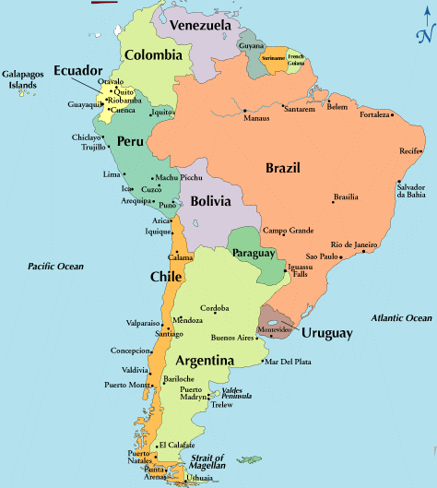
This past weekend marked the 21st anniversary of the 1992 bombing of the Israeli Embassy in Buenos Aires, which murdered 29 people and injured about 250 others. Two years after that attack, the Jewish Community Center in Argentina’s capital city was leveled by another car bomb, leaving 85 persons murdered and hundreds more wounded. Mr. Chairman, this is Hezbollah’s despicable legacy in the Americas. And that terrorist group – along with its sponsor, Iran – has returned to the scene of the crime.
As a visiting fellow at the American Enterprise Institute for Public Policy Research, I head a project to examine and expose the dangerous alliance between the Venezuelan regime of Hugo Chávez and Iran. To date, we have conducted dozens of interviews with experts and eyewitnesses on the ground – including some foreign government officials – from throughout the world and in the region. We also have obtained reams of official Venezuelan and Iranian documents from our sources inside these regimes, only a fraction of which we have published to support our conclusions.
Our principal conclusions reveal why and how Hezbollah has extended its reach in the Americas so substantially and so quickly:

- Hezbollah is not a lone wolf. In this Hemisphere it counts on the political, diplomatic, material and logistical support of governments – principally Venezuela and Iran – that have little in common but their hostility to the United States.
- To facilitate its activities in our neighborhood – including smuggling, money laundering, training and fund-raising – Hezbollah operatives collaborate with well-financed narcotraffickers and guerrilla groups with sophisticated societal, smuggling and money laundering networks in the region.
- Hezbollah networks have extended their reach into at least a dozen countries throughout Latin America.

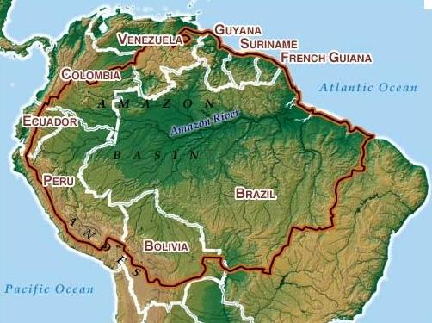
Some may assess this cooperation between “narcos” and terrorists as a marriage of convenience between different criminal elements or just another modus operandi of powerful international drug syndicates that can be tackled by law enforcement. Instead, this criminal activity is the product of a conscious strategy of rogue regimes in Iran and Venezuela to wage asymmetrical warfare against U.S. security, interests and allies close to the homeland. As such, it requires a much more robust analysis and coordinated response – from exposing terrorist groups working within Venezuela, identifying narcoterrorist activities in Central America, imposing sanctions against state-run entities being used to conceal criminal transactions, to dismantling transnational money laundering schemes.
Under bipartisan legislation passed by Congress in December, the Department of State was given six months to provide you with an analysis of and strategy for dealing with Iran’s activities in the Americas. Until now, the State Department has earned a reputation within the U.S. government of minimizing this threat. This Subcommittee will have to press the Department to conduct a thorough and rigorous review of the Iranian and Hezbollah activities in our region and to expose the extraordinary role that is played by Venezuela in this regard. U.S. diplomats will then have to inform our neighbors about this problem and lay the groundwork for a coordinated strategy for dealing with this phenomenon in our Hemisphere.
Mr. Chairman, I fear that these narcoterrorist activities will exact an increasingly terrible price from our neighbors and our nation until our national security establishment recognizes the nature of the threat and fashions an effective response.

KEY OBSERVATIONS
Allow me to describe some of the elements of this narcoterrorist network, followed by a fuller discussion to provide the necessary context to understand why this threat is extraordinarily dangerous.
- Two terrorist networks proselytize, fund-raise, recruit and train operatives on behalf of Hezbollah in many countries in the Americas.
  - One of these parallel networks is operated by a Lebanese-Venezuelan clan, and another is managed by Mohsen Rabbani, a former Iranian diplomat and Muslim cleric who is wanted for his role in the 1992 and 1994 Buenos Aires bombings against the Israeli Embassy and Jewish community center, respectively.
  - Hezbollah operatives and their radical anti-Semitic allies hold important senior positions in the Venezuelan government and run a network that provides logistical and material support to terrorist operatives.
  - In recent years, the Chávez regime has sent weapons to Hezbollah (ammunition, grenades, rockets, etc., intercepted in 2009 by Israeli commandos) and shipped refined fuel to Iran and Syria.
  - Thousands of authentic Venezuelan travel documents have been provided to persons of Middle Eastern descent in the last decade, and numerous Latin American governments have detained many Iranian and Lebanese persons carrying Venezuelan passports.
  - The Venezuelan state-owned airline, Conviasa, operates regular service from Caracas to Damascus and Teheran – providing Iran, Hezbollah, and associated narcotraffickers a surreptitious means to move personnel, weapons, contraband and other materiel.
- Hezbollah conspires with drug-trafficking networks in Mexico and Central and South America as a means of raising and laundering funds, sharing tactics and “reaching out and touching” U.S. territory.
  - Venezuela’s Margarita Island, best known as a Caribbean tourist destination, has become a safe haven for terrorists and drug smugglers. We have published documentary evidence that Hezbollah agents operate numerous businesses and safe houses on the island and elsewhere in Venezuela. In addition to fund-raising activities, Hezbollah has provided terror training in Venezuela for recruits from that country and others in the region.
  - The “Lebanese Cartel” (Cártel Libanés) was formed by the Lebanese-born Venezuelan businessman, Walid Makled García, to transport cocaine from Venezuela in complicity with the military and the Colombian terrorist group known as the FARC (Fuerzas Armadas Revolucionarias Colombianas). Makled also brokered corrupt deals with the Shiite Muslim communities in Venezuela with close ties to Hezbollah.iv Makled is wanted in the United States for cocaine smuggling and has been detained by Venezuelan authorities.
  - The criminal case against Lebanese drug lord Ayman Jouma is very instructive. Jouma was indicted in November 2011 for a sophisticated cocaine smuggling and money-laundering scheme benefiting Hezbollah.v His network involves criminal associates and corrupt businesses in Colombia, the United States, Mexico, Panama, Venezuela and Lebanon. In June 2012, Venezuelan-Lebanese dual citizens Abbas Hussein Harb, Ali Houssein Harb (sic), and Kassem Mohamad Saleh and several Venezuelan and Colombian companies were sanctioned by the U.S. Treasury Department for their role in Jouma’s narcoterrorist operation.
  - In recent years, Mexico has arrested numerous individuals associated with Hezbollah engaging in criminal activities – including smuggling of persons across the U.S. southwest border. For example, in September 2012, a Lebanese-born U.S. citizen, convicted in 2010 for a credit card scheme that raised $100,000 for Hezbollah, was arrested in Merida by Mexican authorities. Rafic Mohammad Labboun Allaboun, an imam from a mosque in San Jose, California, was traveling with a falsified passport issued by Belize. He was extradited to the United States.
- The regime of the late Hugo Chávez was able to broker ties between Hezbollah and narcotraffickers, because it is a narcostate.
  - U.S. officials have fresh, compelling information implicating the late leader, the president of the National Assembly (Diosdado Cabello Rondón), the former Minister of Defense (Henry de Jesús Rangel Silva), the current army chief (Cliver Alcalá Cordones), and the newly appointed deputy Minister of Interior (Hugo Carvajal), and dozens of other senior military officials in trafficking in cocaine.
  - These politicians and active duty and retired military officers are responsible for transporting tons of cocaine to Central America, Mexico, the Caribbean, the United States, west Africa, and Europe. The very conservative estimates released by the State Department say the amount of cocaine transiting Venezuela since Chávez took power in 1998 has more than doubled.
  - Our sources also report that representatives of the Mexican Sinaloa cartel operate in key cocaine transit corridors in Venezuela in close coordination with Venezuelan officials. It is a little known fact that the world’s most powerful cocaine smuggler and head of the Sinaloa cartel, Joaquín Archivaldo “El Chapo” Guzmán conducted his business from Venezuela for much of 2010, living in a suburb of Caracas and on Margarita Island until early 2011 under the protection of Venezuelan security officials working for Chávez.
  - Senior chavista officials engage routinely in lucrative schemes involving Hezbollah front companies, Colombian terrorist groups, narcotraffickers, Venezuelan financial institutions and even powerful state-run entities.
- Today, Venezuela is a key ally of the Islamic Republic of Iran, which is carrying its asymmetrical battle to our doorstep. Since Mahmoud Ahmadinejad paid his first visit to Caracas in September 2006, Venezuela has become one of Iran’s most important allies in the world – certainly Teheran’s closest partner in our neighborhood.
  - Venezuela has helped Iran launder at least $30 billion to evade international sanctions. Seventy Iranian companies – many of them fronts for the IRGC that have been sanctioned by Western governments for their support for Iran’s illicit nuclear program – operate suspicious industrial facilities in Venezuela. The two governments also cooperate in nuclear technology and the exploration for uranium, despite UN sanctions.
DISCUSSION AND BACKGROUND
VENEZUELA’S HEZBOLLAH-NARCO NEXUS
It is said that wherever Iran goes, Hezbollah is not far behind. In the case of Venezuela, Hezbollah blazed the trail in Venezuela, establishing a network of commercial enterprises meant to raise and channel funds and hide its financial tracks. These activities have exploded in the last seven years, as Hezbollah’s activities in the region gained the active complicity of the Venezuelan government, the backing of Iranian security forces and notorious Muslim radicals, and the cooperation of powerful Mexican and narcotrafficking syndicates that reach onto U.S. soil.
Research from open sources, subject-matter experts, and sensitive sources within various governments has identified at least two parallel, collaborative terrorist networks growing at an alarming rate in Latin America. One of these networks is operated by Venezuelan collaborators, and the other is managed by a former Iranian diplomat and infamous Muslim cleric. These networks encompass more than 80 operatives in at least 12 countries throughout the region (with their greatest areas of focus being Brazil, Venezuela, Argentina, and Chile).
The Nassereddine Network. Ghazi Atef Nassereddine Abu Ali, a native of Lebanon who became a Venezuelan citizen about 12 years ago, is Venezuela’s secondranking diplomat in Syria. Nassereddine is a key Hezbollah asset because of his close personal relationship to Chávez’s Justice and Interior Minister, Tarik El Aissami, and because of his diplomatic assignment in Damascus. Along with at least two of his brothers, Nassereddine manages a network to expand Hezbollah’s influence in Venezuela and throughout Latin America.
Nassereddine’s brother Abdallah, a former member of the Venezuelan congress, uses his position as the former vice president of the Federation of Arab and American Entities in Latin America and the president of its local chapter in Venezuela to maintain ties with Islamic communities throughout the region. He currently resides on Margarita Island, where he runs various money-laundering operations and manages commercial enterprises associated with Hezbollah in Latin America. Younger brother Oday is responsible for establishing paramilitary training centers on Margarita Island. He is actively recruiting Venezuelans through local circulos bolivarianos (neighborhood watch committees made up of the most radical Chávez followers) and sending them to Iran for follow-on training.
The Rabbani Network. Hojjat al-Eslam Mohsen Rabbani, who was the cultural attaché at the Embassy of the Islamic Republic of Iran in Buenos Aires, Argentina, oversees a parallel Hezbollah recruitment network. Rabbani is currently the international affairs advisor to the Al-Mostafa Al-Alam Cultural Institute in Qom, which is tasked with propagation of Shia Islam outside Iran. Rabbani, referred to by the important Brazilian magazine Veja as “the Terrorist Professor,”xiii is a die-hard defender of the Iranian revolution and the mastermind behind the two notorious terrorist attacks against Jewish targets in Buenos Aires in 1992 and 1994 that killed 144 people.
At the time, Rabbani was credentialed as Iran’s cultural attaché in the Argentine capital, which he used as a platform for extremist propaganda, recruitment and training that culminated in the attacks in the 1990s. In fact, he continues to exploit that network of Argentine converts today to expand Iran’s and Hezbollah’s reach—identifying and recruiting operatives throughout the region for radicalization and terrorist training in Venezuela and Iran (specifically, the city of Qom).
At least two mosques in Buenos Aires—Al Imam and At-Tauhid—are operated by Rabbani disciples. Sheik Abdallah Madani leads the Al Imam mosque, which also serves as the headquarters for the Islamic-Argentine Association, one of the most prominent Islamic cultural centers in Latin America.
Some of Rabbani’s disciples have taken what they have learned from their mentor in Argentina and replicated it elsewhere in the region. Sheik Karim Abdul Paz, an Argentine convert to Shiite Islam, studied under Rabbani in Qom for five years and succeeded him at the At-Tauhid mosque in Buenos Aires in 1993. Abdul Paz is now the imam of a cultural center in Santiago, Chile, the Centro Chileno Islamico de Cultura de Puerto Montt. Another Argentine convert to radical Islam and Rabbani disciple is Sheik Suhail Assad, who lectures at universities throughout the region and recruits young followers to the cause.
A key target of the Rabbani network—and Hezbollah in general—is Brazil, home to some one million Muslims. Rabbani travels to Brazil regularly to visit his brother, Mohammad Baquer Rabbani Razavi, founder of the Iranian Association in Brazil.
Another of his principal collaborators is Sheik Khaled Taki Eldyn, a Sunni radical from the Sao Paulo Guarulhos mosque. Taki Eldyn, who is active in ecumenical activities with the Shia mosques, also serves as the secretary general of the Council of the Leaders of the Societies and Islamic Affairs of Brazil.xviii A sensitive source linked that mosque to a TBA network cited by the US Treasury Department as providing major financial and logistical support to Hezbollah. As far back as 1995, Taki Eldyn hosted al Qaeda leader Osama bin Laden and 9/11 mastermind Khalid Sheik Mohammed in the TBA region.
According to Brazilian intelligence sources cited by the magazine Veja, at least 20 operatives from Hezbollah, al Qaeda and the Islamic Jihad are using Brazil as a hub for terrorist activity. The fact that Brazil is set to host the FIFA World Cup tournament in 2014 and the Summer Olympics in 2016 makes it an inviting target for international terrorism. U.S. officials should be approaching Brazilian officials to discuss the potential threat of Venezuelan-Iranian support for narcoterrorism. Unfortunately, most U.S. diplomats are as indifferent to this reality as their Brazilian counterparts.

IRAN’S DANGEROUS GAMBIT IN OUR NEIGHBORHOOD
To comprehend what Iran is up to, we must set aside conventional wisdom about its ambitions, strategies and tactics and follow the evidence where it leads. For example, in the aftermath of a brazen plot discovered in October 2011 in which Iranian agents conspired with supposed Mexican drug cartel leaders to commit a terrorist bombing in the heart of our Nation’s capital, Director of National Intelligence, James R. Clapper, revealed that “Iranian officials” at the highest levels “are now more willing to conduct an attack in the United States….” General Clapper also reported that Iran’s so-called “supreme leader” Ali Khamenei was probably aware of this planning.
Iranian officials have made no secret of the regime’s intention to carry its asymmetrical struggle to the streets of the United States. For example, in a May 2011 speech in Bolivia, Iran’s Defense Minister Ahmad Vahidi promised a “tough and crushing response” to any U.S. offensive against Iran. At the same time that Iran caught the world’s attention by threatening to close the Strait of Hormuz, Mahmoud Ahmadinejad announced a five-nation swing through Latin America aimed at advancing its influence and operational capabilities on the U.S. doorstep.
The intelligence community’s fresh assessment of Iran’s willingness to wage an attack on our soil leads to the inescapable conclusion that Teheran’s activities near our homeland constitute a very real threat that can no longer be ignored.
Bracing for a potential showdown over its illicit nuclear program and emboldened by inattention from Washington in Latin America, Iran has sought strategic advantage in our neighborhood. It also is preparing to play the narcoterrorism card—exploiting its partnership with Venezuelan operatives, reaching into Mexico, and activating a decadesold network in Argentina, Brazil and elsewhere in the region.
Today, a shadowy network of embassies, Islamic centers, financial institutions, and commercial and industrial enterprises in several countries affords Iran a physical presence in relatively close proximity to the United States. Iran is well-positioned to use its relationships with these countries to pose a direct threat to U.S. territory, strategic waterways and American allies. Iran also has provided the Venezuelan military with weapon systems that gave Venezuela unprecedented capabilities to threaten its neighbors and the United States.
Notably, a half-dozen Iranian companies sanctioned by U.N., U.S. or European authorities have built suspicious industrial installations at various sites in Venezuela.xxv These facilities were important enough to attract secret visits by Iranian Major General Amir Ali Hajizadeh, the Revolutionary Guard Corps aerospace commander who previously headed Iran’s missile program, in July 2009 and November 2011.

VENEZUELA’S PIVOTAL ROLE SUPPORTING IRAN AND TERRORISM
In recent congressional testimony, investigative journalist Doug Farah describes “the merging of [Hugo Chávez’s] Bolivarian Revolution’s criminal-terrorist pipeline activities and those of the criminal-terrorist pipeline of radical extremist groups (Hezbollah in particular) supported by the Iranian regime.” Such ties are invaluable to groups like Hezbollah, as they afford them protection, safe havens in which to operate, and even diplomatic status and immunity. In short, Venezuela plays a singular role as a platform for the Hezbollah threat in the Americas.
It is important to bear in mind that Venezuela is not just another developing country that is unable to control its territory. Venezuela is an oil-rich state that has collected about $1.1 trillion in oil revenue in the last decade. It also is not just an isolated hostile state: Venezuela has collected $28 billion in loans from China in the last two years, and has purchased at least $9 billion in arms from the Russians in the last decade.
With the success of the U.S.-backed Plan Colombia, about six or seven years ago, South American narcotraffickers had to adjust their smuggling routes. They had to look no farther than Caracas. Chávez doled out lucrative drug trafficking deals as a means to secure the loyalty of military subordinates and to generate billions in revenue and make them complicit in his corrupt regime. As described above, dozens of senior military officials closely associated with Chávez have been implicated in narcotrafficking crimes. The de facto head of the Venezuelan Cártel del Sol is Diosdado Cabello, National Assembly president and ruling party chief.
That military syndicate operates parallel to a civilian network known as the Cártel Libanés, which was formed by the Lebanese-born Walid Makled García. According to journalist and narcoterror expert, Douglas Farah, “The supplier of the cocaine [to the Makled cartel] was the FARC in Colombia….” Farah’s sources also reported that Makled was a key link between various criminal groups and Venezuela’s Shiite Muslim communities that have a strong financial relationship with Hezbollah.” Makled is wanted in the United States for cocaine smuggling; after being detained in Colombia, he gave a series of media interviews implicating dozens of Venezuela officials in cocaine smuggling. Colombia surprised many observers by extraditing Makled to Venezuela, where his closed-door trial began in April 2012.
Even before Chávez won power in 1998, he established intimate links to the Colombian guerrilla group FARC (Fuerzas Armadas Revolucionarias Colombianas) – which wages a terrorist war against a democratic government and ally of the United States. For many years, FARC commanders and troops have operated in and out of Venezuela with the complicity of the Chávez regime. A principal activity of the FARC today is the transportation of cocaine to safe havens operated by the Venezuelan military for transport to the United States and other countries. In September 2012, pursuant to section 706(2)(A) of the Foreign Relations Authorization Act of 2003, President Obama determined that Venezuela was one of three countries in the world (along with Bolivia and Burma) that “failed demonstrably during the previous 12 months to adhere to their obligations under international counternarcotics agreements….”
Venezuela’s internal security apparatus has been organized and directed by Cuba, a country designated by the U.S. State Department as a state sponsor of terrorism. That same report cited Venezuela’s “economic, financial and diplomatic cooperation with Iran….” Chávez’s aides make no secret of ongoing oil shipments to a third terrorist state, Syria. Just as Hezbollah, Cuba, Syria and Iran are considered terrorist threats to U.S. national security interests, Venezuela’s crucial support for each of them should be, too. Although this support may not pose a classical conventional threat, it is precisely the kind of asymmetrical tactics that our enemies favor today.
The chavista regime also has served as the principal interlocutor on Iran’s behalf with other like-minded heads of state in the region, primarily Rafael Correa (of Ecuador) and Evo Morales (of Bolivia), both members of the Chávez-sponsored Bolivarian Alliance for the Peoples of Our America (ALBA) and both of whom have established dubious networks with criminal transnational groups.

CONTINUED CONGRESSIONAL LEADERSHIP REQUIRED
Mr. Chairman, our project has shared substantial information about these aforementioned threats with U.S. government officials—either directly or through Members of Congress. Too often the attitude we have encountered in the executive branch has been one of skepticism or indifference. Apparently, this indifference has left senior U.S. officials uninformed on the subject. For example, President Obama told a Miami journalist in July 2012, “[M]y sense is that what Mr. Chávez has done over the last several years has not had a serious national security impact on us.” U.S. General Douglas Fraser (USAF), the former regional commander of U.S. Southern Command, subsequently supported the appraisal that Venezuela does not represent a threat to U.S. national security.xxxiii “As I look at Iran and their connection with Venezuela,” said Fraser, “I see that still primarily as a diplomatic and economic relationship."
Mr. Chairman, I believe the foregoing discussion of the facts on the ground will lead most reasonable observers to a very different conclusion. Important exceptions to executive branch neglect is the work of the Drug Enforcement Administration (DEA) and the Office of Foreign Assets Control (OFAC) of the Department of the Treasury to sanction numerous Venezuelan officials and entities for their complicity with and support for Iran and international terrorism; in addition, U.S. Attorney for the Southern District of New York, Preet Bharara, has investigated and prosecuted key cases to attack this international conspiracy. Inexplicably, according to law enforcement sources, State Department officers systematically resist the application of sanctions against Venezuelan officials and entities, despite the fact that these suspects are playing an increasingly important role in Iran’s operational capabilities near U.S. territory.
Mr. Chairman, I am convinced that Congressional attention, such as this hearing, is essential to encourage Executive branch agencies to act. For example, sanctions against Venezuela’s state-owned petroleum company for transactions with Iran were the direct result of pressure by the House Committee on Foreign Affairs, acting in part on information uncovered by AEI’s project.
As I mentioned earlier, the “Countering Iran in the Western Hemisphere Act of 2012,” authored by Representative Jeff Duncan (R-SC), passed with strong bipartisan support, require the Executive branch to report to Congress on Iran’s activities in a host of areas and to provide a strategy for countering this threat. I believe that such a thorough, Congressionally-mandated review will require the Executive branch to apply additional needed intelligence resources to collect on subject matters in Venezuela, Mexico, Bolivia, Ecuador, Central America and beyond. Once national security officials study the scope and depth of the problem, I hope for a whole-of-government response to protect our security, our interests and our allies against the threat posed by a narcoterrorist network in the Americas. Once Congress receives this report, perhaps this challenge will be treated as a budgetary priority so that law enforcement and intelligence agencies have the resources to respond urgently and effectively. Of course, our project at AEI is prepared to cooperate with this policy review by providing the Subcommittee documents and analysis regarding suspicious transactions and installations operated by Iran in Venezuela, Mexico, Ecuador, Bolivia and elsewhere in the region.

RECOMMENDATIONS
- The involvement of Venezuelan officials and state-run entitites in drug trafficking, terrorism and/or Iran must be on the table as the State Department presents conditions for normalizing bilateral relations with Chávez’s successor. In the mean time, this involvement must be publicized and punished in the form of federal indictments. Sanctions by the Department of the Treasury’s Office of Foreign Assets Control are good interim measures. However, in the case of Venezuelan officials and state-run entities, indictments are much more meaningful. The Department of Justice headquarters should be asked to explain why such prosecutorial actions have failed to meet this extraordinary lawlessness.
- Congress should demand U.S. diplomats be more cooperative with law enforcement and intelligence efforts aimed at exposing and punishing criminal behavior and terrorist activities in the region. Specifically, the Department of State must be more cooperative in raising this phenomenon with our neighbors. We also must find a way to talk about this problem with our friends in a way that it is not misunderstood as an accusation against those governments as they work with us to confront the problem.
- Congress should give U.S. intelligence and security agencies the resources required to expand their capabilities to confront extra-regional threats and crossborder criminality.
- U.S. national security agencies, led by the Department of State, should increase the dialogue and cooperation with regional and European military, intelligence, and security agencies on the common threat posed by the Hezbollah-Iranian-Venezuelan alliance.
- Congress should use its oversight functions to determine if U.S. Northern and Southern Commands, the U.S. Coast Guard, and the Drug Enforcement Administration have adequate programs and funding to support U.S. anti-drug cooperation with Mexico and Central America.

CONCLUSION
As I stated before another Congressional subcommittee nearly two years ago, the “Hezbollah/Iranian presence in Latin America constitutes a clear threat to the security of the U.S. homeland…. In addition to operational terrorist activity, Hezbollah also is immersed in criminal activity throughout the region – from trafficking in weapons, drugs, and persons…. If our government and responsible partners in Latin America fail to act, I believe there will be an attack on U.S. personnel, installations or interests in the Americas…” as a result of this dangerous conspiracy.
The narcoterrorism on our doorstep, perpetrated by Hezbollah with Iranian and Venezuelan support, demands a response from those whose job it is to keep us safe. Our government must take effective measures—unilaterally and with willing partners—to disrupt and dismantle illicit operations and neutralize unacceptable threats.

Roger F. Noriega is a former assistant secretary of state for Western Hemisphere affairs (Canada, Latin America, and the Caribbean) and a former U.S. ambassador to the Organization of American States. He coordinates AEI's program on Latin America and writes for the Institute's Latin American Outlook series.

Experience
- Assistant Secretary of State for Western Hemisphere Affairs, U.S. Department of State, 2003-2005
- U.S. Ambassador, 2001-2003; Senior Adviser, 1993-94, Organization of American States
- Staff Member, Foreign Relations Committee, U.S. Senate, 1997-2001
- Staff Member, International Relations Committee, U.S. House of Representatives, 1994-97
- Senior Policy Adviser, U.S. Mission to the Organization of American States, 1990-93
- Staff, U.S. Agency for International Development and U.S. Department of State, 1986-90
- Press Secretary and Foreign Policy Adviser, U.S. Representative Robert Whittaker (R-Kans.), 1983-86
- Research Assistant, Kansas Secretary of State, 1981-83
Al Qaeda’s Sinai commander was Bin Laden’s physician
Source: http://www.debka.com/article/23137/Al-Qaeda%E2%80%99s-Sinai-commander-was-Bin-Laden%E2%80%99s-physician-Dr-Ramzi-Mowafi-a-chemical-arms-expert

For more than two and a half years, Dr. Ramzi Mowafi, once Osama bin Laden’s personal physician, has led the most dangerous terrorist group in Sinai, Ansar al Jihad in the Sinai Peninsula, debkafile’s counterterrorism sources reveal. A charismatic figure and able operational commander with good connections across the jihadist world, Mowafi has gathered around this group a legion of 7,000 to 9,000 armed men, a hodgepodge of Bedouin Salafists, Palestinian Hamas and Jihad operatives, Egyptian Muslim Brotherhood adherents and Sudanese and Yemeni radicals in search of jihad.
It is the Mowafi legion which is responsible for the series of deadly attacks on Egyptian military and security targets in Sinai and missile attacks on Israel.
Its deadliest operation was the multiple strike of Aug. 5, 2012, which left 16 Egyptian commandoes dead at their base in Rafah close to the Gazan and Israeli borders. The terrorists then seized their Egyptian victims’ armored vehicles and heavy weapons and used them to slam into the Kerem Shalom border crossing into Israel. One vehicle made it through and reached an IDF command base before a military helicopter destroyed it. That was the only time al Qaeda had attempted and almost managed to attack an Israeli military target.
Israeli officials made light of the incident, referring to “global jihadists” as responsible for the near miss. They were concerned to keep under their hats the identity of the mastermind of the multiple strike after discovering him to be Dr. Ramzi Mowafi, a relative of the Egyptian intelligence chief Gen. Murad Mowafi, then an important contact of Israeli high defense and military officials in the maintenance of border security.
The then President Mohamed Morsi sacked the intelligence chief straight after the attack and replaced him with a Muslim Brotherhood sympathizer.
For now, debkafile’s military sources report that Dr. Mowafi is organizing a large group of terrorists for another attempt to breach the border for a major attack in Israel. Incoming intelligence about his plans and movements has kept the IDF on high alert for the past two weeks along the borders with Egypt and the Gaza Strip.
Only after the Musllm Brotherhood was overthrown on July 3 were Egyptian military sources willing to name Dr. Mowafi as the al Qaeda mastermind who designed and administered the complex underground route smuggling weapons from al Qaeda and Muslim Brotherhood suppliers in Libya to Egyptian destinations, including Sinai, as well as the Gaza Strip.
Those sources also admit now that the Palestinian Hamas and its military arm are his allies and abet him in running that supply route.
Dr. Mowafi joined Osama bin Laden’s service 23 years ago. Our counterterrorism experts disclose that he was spotted by al Qaeda agents during a pilgrimage to Mecca in 1990,
hereupon they moved to the Pakistani town of Peshawar. The Egyptian soon displayed talents over and above his medical training and was given a responsible position with the team developing explosive devices and chemical weapons.
Egyptian intelligence now believes that Mowafi may have planted a dense thicket of roadside bombs along the roads of Sinai to impede the advance of the Egyptian army mounting a large-scale offensive on al Qaeda lairs. According to our military sources, Egyptian security does not rule out the possibility that the Egyptian terrorist chief has armed his followers with chemical weapons imported from Libya or manufactured in local laboratories.

EU adds Hezbollah's military wing to terror list
Source: http://www.longwarjournal.org/archives/2013/07/eu_adds_hezbollah_to.php

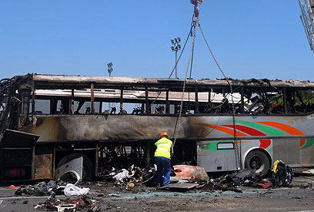
European Union foreign ministers today reached a unanimous decision to designate the military wing of Iranian-backed Hezbollah as a terrorist organization. The move, which will likely lead to travel bans and asset freezes, comes after months of deliberation and compromises between the proponents and opponents of the decision.
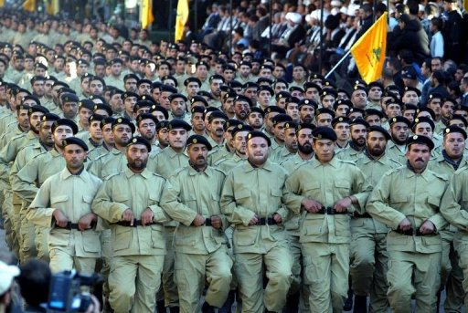
Hezbollah's role in the July 2012 Burgas terror attack (photo) as well as the recent conviction of Hezbollah operative Hossam Taleb Yaacoub in Cyprus are viewed as two of the key pieces of evidence that pushed forward the long-awaited designation. Hezbollah's continued involvement in the Syrian civil war in support of the Assad regime is also seen as a reason for the move.
The US, Israel, and Canada, have long called on the EU to designate Hezbollah. After Bulgaria announced in early February that Hezbollah was responsible for the attack in Burgas that killed five Israeli tourists and a Bulgarian national, Canadian Foreign Minister John Baird called on the EU to designate Hezbollah as a terror organization.
"We urge the European Union and all partners who have not already done so to list Hezbollah as a terrorist entity and prosecute terrorist acts committed by this inhumane organization to the fullest possible extent," Baird said.
Approximately two weeks later, former Obama national security adviser Tom Donilon wrote in the New York Times that "Europe must now act collectively and respond resolutely to this attack within its borders by adding Hezbollah to the European Union's terrorist list."
Israeli Justice Minister Tzipi Livni welcomed the EU's decision. "Finally, after years of deliberations, the claim that Hezbollah is a legitimate political party has rightfully failed. Now it is clear to the entire world that Hezbollah is a terrorist organization," she said. Prime Minister Benjamin Netanyahu similarly welcomed the decision and said he hoped it "will lead to tangible steps against the organization."
The EU's decision to designate only the military wing of Hezbollah has left some disappointed, however. Israeli politician Avigdor Lieberman, for example, said the EU went only half way.
"Any attempt to portray this organization as one that has an extremist side and a more moderate side is like asking whether a cannibal could be a vegetarian," Lieberman said. Similarly, Emile Hokayem, an analyst at the International Institute for Strategic Studies, tweeted that making a distinction between military and political wings within Hezbollah "is an expedient construct, analytically useless and w[ith] no grounding in reality."
In October 2012, Naim Qassem, the deputy secretary general of Hezbollah, repudiated the idea that the group had separate political and military wings.
"We don't have a military wing and a political one; we don't have Hezbollah on one hand and the resistance party on the other," he said.
Three years before, Qassem told the Los Angeles Times that "Hezbollah has a single leadership.... All political, social and jihad work is tied to the decisions of this leadership.... The same leadership that directs the parliamentary and government work also leads jihad actions in the struggle against Israel."

A ridiculous decision that won’t change anything
By Arie Egozi
Source:http://i-hls.com/2013/07/a-ridiculous-decision-that-wont-change-anything/?utm_source= activetrail&utm_medium=email&utm_campaign=English%20Newsletter%2024/7/2013

The European Union again made a decision that is not worth the paper it is printed on. The Foreign Affairs Council of the European Union has designated the military wing of Hezbollah as a terrorist organization.
Monday’s decision in Brussels by 28 European foreign ministers does not extend to the political wing of Hezbollah, which is also a political party in Lebanon.
The United States and Israel are among several countries that consider Hezbollah a terrorist organization without differentiating between the group’s military and political wings.
European Union foreign policy chief Catherine Ashton announced the decision at a news conference in Brussels.
“This is partly a political signal and partly a real signal that we are not prepared to see any terrorist activity as means to achieving … political ends, while we want to be clear, too, in our support for political parties of Lebanon and the people of Lebanon,” she said. “We’ve made the distinction clear.”
The decision “does not prevent continuation of dialogue with all political parties,” Ashton added. “We have also agreed that the delivery of legitimate financial transfers to Lebanon and delivery of assistance from the European Union and its member states would not be affected.”
The Hezbollah controls Lebanon. The organizations’ leaedr sheikh Nasralla takes orders from Iran. So is he a politician or terrorist?
The decision of the EU is a shameful one. It was made as a compromise of politicians from the 28 countries that are members of teh EU and is really worth nothing.
The decision was made by people that decided to close their eyes and consider the smell of blood, perfume. This again makes the EU a worthless body when it comes to effecting the world.

Arie Egozi is Editor-in-Chief of Israeli’s Homeland Security Home (i-HLS)

Suicide bombers break out 500 senior Al Qaeda prisoners from Iraq's Abu Ghraib jail
Source: http://www.dailymail.co.uk/news/article-2373725/Iraqs-Abu-Ghraib-jail-break-frees-500-Al-Qaeda-terrorists-leaving-10-policeman-4-militants-dead.html

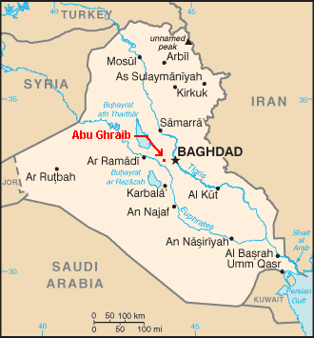
Suicide bombers have freed hundreds of terrorists during a full-frontal assault on Iraq's top-security Abu Ghraib prison.
Gunmen attacked guards with mortar fire as well as rocket propelled grenades while terrorists drove cars packed with explosives at the fortified gates during an attack which left ten policemen dead.
Some of al Qaeda's most senior members were among the 500 inmates thought to have escaped before authorities regained control of the infamous prison on the outskirts of Baghdad in the early hours of Monday morning.
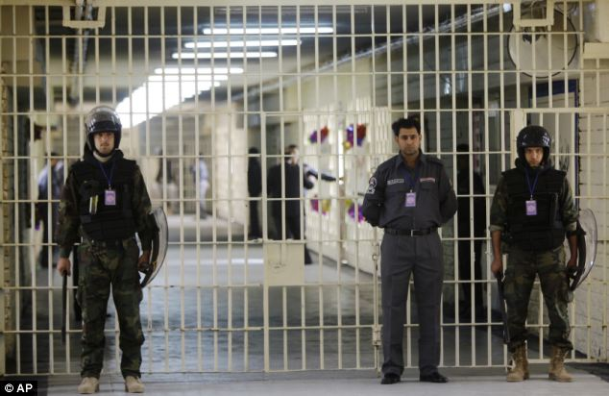
The deadly raid on the high-security jail happened as Sunni Muslim militants are re-gaining momentum in their insurgency against the Shi'ite-led government that came to power after the U.S. invasion to oust Saddam Hussein.
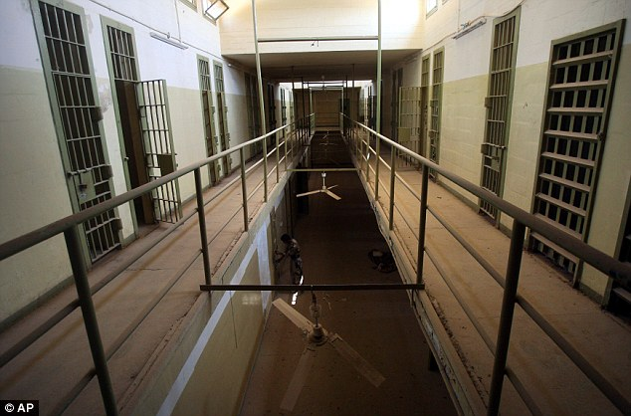
The raid began on Sunday night when suicide bombers attacked the gates with trucks loads with bombs and blasted their way into the compound.
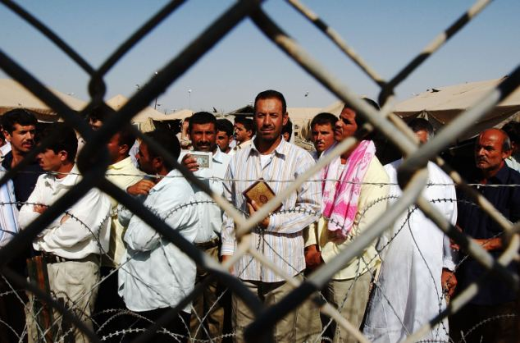
Other militants took up positions near the main road, fighting off security reinforcements sent from Baghdad as several militants wearing suicide vests entered the prison on foot to help free the inmates.
Ten policemen and four militants were killed in the ensuing clashes, which continued until Monday morning, when military helicopters arrived and brought the assault to an end.
By that time, hundreds of inmates had succeeded in fleeing Abu Ghraib, the prison made notorious a decade ago by photographs showing abuse of prisoners by U.S. soldiers.
'The number of escaped inmates has reached 500, most of them were convicted senior members of al Qaeda and had received death sentences,' Hakim Al-Zamili, a senior member of the security and defence committee in parliament, told Reuters.
'The security forces arrested some of them, but the rest are still free.'
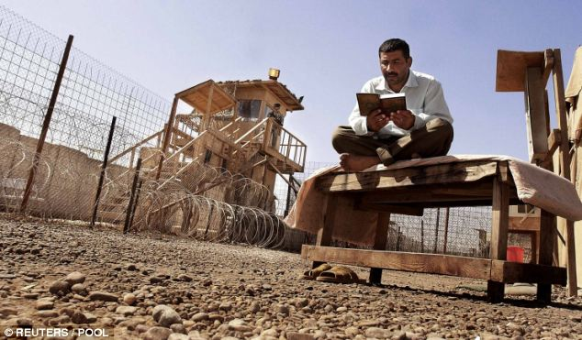
One security official told Reuters on condition of anonymity: 'It's obviously a terrorist attack carried out by al Qaeda to free convicted terrorists with al Qaeda.'
A simultaneous attack on another prison, in Taji, around 20 km (12 miles) north of Baghdad, followed a similar pattern, but guards managed to prevent any inmates escaping. Sixteen soldiers and six militants were killed.
Sunni insurgents, including the al Qaeda-affiliated Islamic State of Iraq, have been regaining strength in recent months and striking on an almost daily basis against Shi'ite Muslims and security forces amongst other targets.
The violence has raised fears of a return to full-blown conflict in a country where Kurds, Shi'ite and Sunni Muslims have yet to find a stable way of sharing power.
In the northern city of Mosul, 390 km (240 miles) north of Baghdad, a suicide bomber detonated a vehicle packed with explosives behind a military convoy in the eastern Kokchali district, killing at least 22 soldiers and three passers-by, police said.
Suicide bombings are the hallmark of al Qaeda, which has been regrouping in Mosul, Iraq's third-largest city and capital of the Sunni-dominated Nineveh province.
A separate attack in western Mosul killed four policemen, police said.
Relations between Islam's two main denominations have been put under further strain from the civil war in Syria, which has drawn in Shi'ite and Sunni fighters from Iraq and beyond to fight against each other.
Recent attacks have targeted mosques, amateur football matches, shopping areas and cafes where people gather to socialise after breaking their daily fast for the holy Muslim month of Ramadan.
Nearly 600 people have been killed in militant attacks across Iraq so far this month, according to violence monitoring group Iraq Body Count.
That is still well below the height of bloodletting in 2006-07, when the monthly death toll sometimes exceeded 3,000.

IDF faces oncoming Al Qaeda tide on three Israeli borders: Golan, Lebanon, Sinai
Source: http://www.debka.com/article/23141/IDF-faces-oncoming-Al-Qaeda-tide-on-three-Israeli-borders-Golan-Lebanon-Sinai

That the Netanyahu government took a wrong turn in its policy of non-intervention in the Syrian conflict was manifested by the warning coming from the IDF’s military intelligence (AMAN) chief Maj. Gen. Aviv Kochavi Tuesday night, July 23, when he said that Syria had become a global battleground for al Qaeda.
Addressing a passing-out ceremony at the IDF’s Officers’ School, Kochavi warned that the thousands of al Qaeda pouring into Syria from around the world are fighting to create an Islamic state there, just as they are in Afghanistan, Pakistan and Yemen. This peril, he said, is closing in on Israel, Lebanon, Jordan and Egypt’s Sinai Peninsula.
At the UN Security Council in New York, his words were echoed by Robert Serry, UN Coordinator of the Middle East peace process, who said Syria “is increasingly turning into a big global battleground.”
It is important to note that Gen. Kochavi issued his warning shortly after returning home from meetings in Washington with senior US military and intelligence officers. He flew to the US on July 17, on the day that hostilities flared between the Israeli and Syrian armies in the southern Golan on a scale which was never released to the public.
That clash marked the bankruptcy of the government and army command’s efforts to stop the tide of violence from reaching Israel’s northern borders by means of a tactic of virtual non-involvement, aside from limited aid to certain Syrian rebel groups, medical care for some of their wounded and certain unreported small-scale operations.
Threats from five separate sources now threaten to swamp those efforts entirely. They are posed by the Syrian army; Hizballah; global jiahdists; armed Syrian rebel militias funded by Saudi Arabia; and Al Qaeda groups bolstered for the first time by the arrival in recent weeks Pakistani Taliban groups of fighters.
Islamist forces are thrusting forward strongly in eastern, northern and western Syria. They murder any non-Islamist rebel chiefs, especial Free Syrian Army commanders, standing in their way and are moving on towards Lebanon and Jordan as well.
What strikes most concern in Jerusalem, are the first signs of a tie-in between al Qaeda in Syria and al Qaeda in Sinai. The intelligence chief’ went to Washington with a report that coordinated terrorist operations against Israel were shaping up for the first time from Syria, Sinai and possibly Lebanon too.
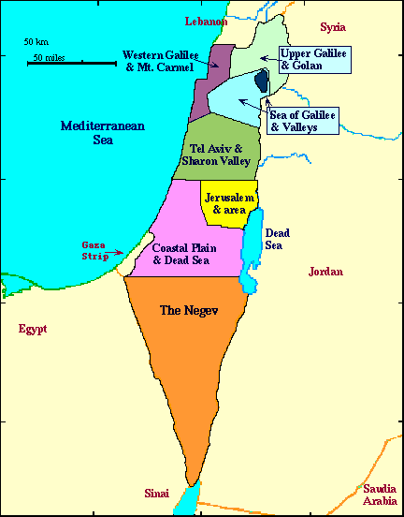
It was suddenly borne in on Israel that its two strikes against Syria’s chemical weapons and the transfer of advanced hardware to Hizballah were wide of the mark. The greatest danger has turned out to be Al Qaeda’s spreading potency. Anyway, chemical warfare has since spread across the Syrian battlefield and Hizballah forces fighting in Syria simply take direct delivery of advanced weapons from the Syrian army, without even trying to transfer them to Lebanon.
The IDF has failed to come to grips with Al Qaeda on the Syrian front no less than the Egyptian army, for different reasons, has succeeded in curbing the jihadist marauders in Sinai.
As the mainstream Syrian rebel movement crumbles, al Qaeda is bolstered by an influx of fighters, weapons and funds from across the Muslim world, including the Persian Gulf. Over the past year, the IDF has had to reconfigure its deployment against Syria – first to contend with the potential of chemical weapons, then Iranian military involvement, followed by Hizballah’s advance towards the Israeli border and now al Qaeda’s inroads.
Gen. Kochavi was not led to expect a sympathetic hearing in Washington for Israel’s concerns.
The Obama administration is up to its neck in its efforts to speed the US military drawdown in Afghanistan and break off contact with the Taliban, whose Pakistani branch has meanwhile turned up in Syria.
The Israeli intelligence chief found Gen. Martin Dempsey, Chairman of the US Chiefs of Staff, fully engaged in phrasing an open letter to senators to rebuff their criticism of President Barack Obama’s decision to stay out of the Syrian conflict:
In his letter, he outlined the five options for involvement with price tags:
1. Training, advising and assisting the opposition;
2. Conducting limited strikes;
3. Establishing a no-fly zone;
4. Creating buffer zones inside Syria;
5. Controlling Damascus’s chemical arms.
Gen Dempsey estimated that the first option would cost about $500m a year, while each of the other four actions would require roughly $1bn a month, i.e., $12bn a year.
The US army chief did not elaborate on the long-term cost to the US treasury of non-involvement in operations to keep al Qaeda at bay as it fights to get a stranglehold on Syria, like in Yemen and North African Sahara.
Israel’s Defense Minister Moshe Ya’alon and its chief of staff Lt. Gen. Benny Gantz are struggling with imperatives to cut down on military outlay at the very moment when they need extra funding too keep the Al Qaeda menace away from Israel’s door. Gen. Dempsey has helped them by calculating costs. But that’s as far as it goes. For the fight, Israel is on its own.

Judith Tebbutt: My six months held hostage by Somali pirates
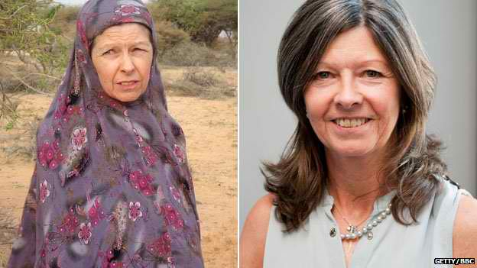
Source:http://www.terrorismwatch.org/2013/07/judith-tebbutt-my-six-months-held.html?utm_source= feedburner&utm_medium=email&utm_campaign=Feed%3A+terrorismwatch%2FJTvK+%28Terrorism+Watch%29&utm_content=Yahoo!+Mail
Judith Tebbutt on the day of her release in Somalia (l) and today (r)

Judith and David Tebbutt were on holiday in Kenya when they were attacked by a group of armed men. David was murdered and Judith was taken to Somalia where she was held hostage for six months. Just over a year after being freed, she describes her extraordinary determination to survive.
You meet Judith Tebbutt - she likes to be called Jude - and you wonder how, after six months in a filthy, cramped room, on starvation rations of potato and rice, insulted, humiliated and occasionally threatened with summary execution, she could appear so untouched and so resilient.
She was determined to survive, and that's her motivation for writing a book about her experience, A Long Walk Home, and for speaking to the BBC in one of her only interviews about the ordeal.
Jude, from Bishop's Stortford, Hertfordshire, wants to be an encouragement and example to others held for ransom.
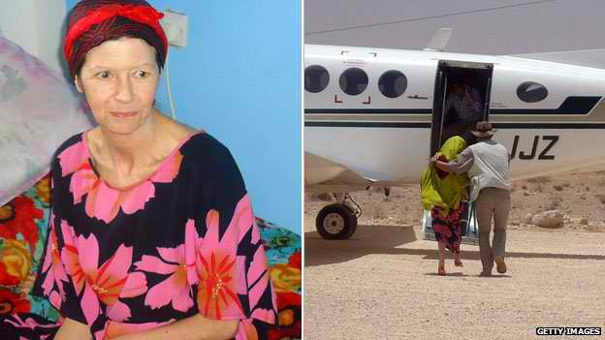
"That is the message," she says. "This is for any hostages, throughout the world, especially in Somalia, because I know the conditions they're going through, not to give up hope. Hope is my saviour."
Jude's nightmare began during what, at first, was a dream holiday with her husband of more than 30 years, David, who was finance director at the publisher Faber and Faber. They had met in Africa, and David loved it there.
Judith Tebbutt was held in captivity for 192 days before her release in March 2012

In September 2011, after a week spent on safari in Kenya's Masai Mara game reserve, they arrived at the Kiwayu Beach Resort - on an island in Kenya's Lamu archipelago, but only 40 km (25 miles) from the coast of Somalia.
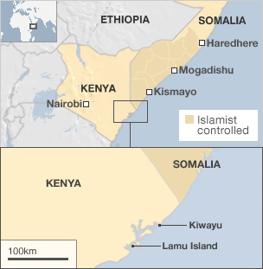
Jude was uncomfortable from the start.
"It felt wrong," she says. "It was completely quiet. When I was told there was nobody there except us, that felt really strange.
"The room we were in was so far away from the rest of the building. But David said 'Don't worry, this will be our Robinson Crusoe experience.'"
But on that first night, she was awoken by the sounds of David struggling with someone in the dark. Then she was jabbed with the barrel of a rifle and dragged down to the beach.
Barefoot and in her pyjamas, she was manhandled into a boat, thrown on top of fuel cans, and the boat sped out to sea.
"I hit my head, which cut my eyebrow. My mind was racing... trying to make sense of this terrifying experience," she says.
It's clear, though, that even from those first shocking moments, Jude, was calculating how she could get some control over the situation. She would smile at her captors, for example - as a way of building a basic level of rapport.
Jude, who had worked as a mental health social worker, believed she needed to engage with the pirates as much as possible.
As her captivity extended into weeks, she taught herself some Somali so she could say "please" and "thank you" and make them see her as a human being - not just a commodity to be sold.
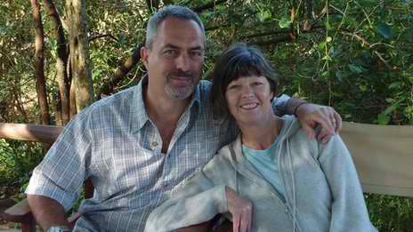
"Even though I despised these people, I knew that if I was going to be in their company for any length of time, I needed to try and build a rapport with them, build a connection."
Jude and her husband David on the morning of their flight to Kiwayu

There were other small victories, like refusing to wear full Somali dress.
"They were trying to get me to dress in the full hijab, jilbab, everything. I put this on, and one of the pirates said 'Ahh, beauty! Beauty Somali woman!'
"I'm not a Somali woman, and I didn't want to be a Somali woman - so I took it off straight away. I felt suffocated covered in all these robes, and completely alien.
"That's really important, not to lose your own identity. However cruel they are to you, however they degrade you, you must remind yourself of who you are, all the time. I was still Jude, and I wanted to come out as Jude. I wanted to find a life for Jude again."
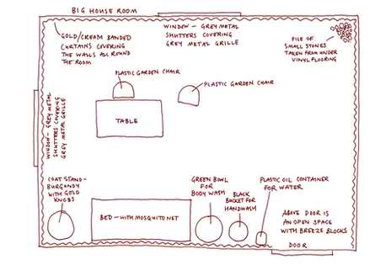
And there was the walking. Confined in a hot, dirty room, Jude was determined to keep herself as fit as possible. So she devised a timetable of exercises - walking half-an-hour in each daylight hour.
She did pilates too - much to the confusion of her captors.
The room where Jude was kept for much of her confinement

She kept up her exercise schedule while she was strong enough - but the poor diet made her too weak by the end of her imprisonment.
Negotiations for her release began within a few days of her arrival in the village where she was to be kept. A few weeks in, her son Ollie was able to reach her on the pirate negotiator's phone.
"I said to Ollie 'How's Dad? How's Dad taking this?'"
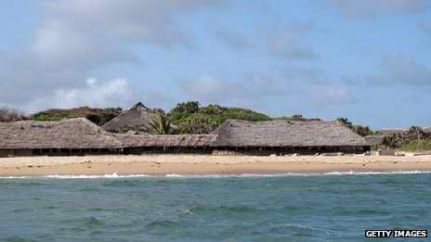
Jude had convinced herself that David had survived and he was out there working for her release.
"But Ollie said 'There's something I must tell you about Dad. He didn't survive his injuries...' I said, 'What are you telling me, are you telling me that Dad's dead?' Then I heard the negotiator's voice: 'Three minutes is up.'

The beachside resort where Judith Tebbutt and her husband were kidnapped

"All the pirates were in the room. I looked at every one of them and said 'You killed my husband!' and 'You killed my husband!'
"One by one, they just filtered out. I was left with the leader man, and I said 'It was you. You killed my husband!' and it was like this face off. I thought 'I'm just going to look at you until you turn your face away.' I just felt such hatred."
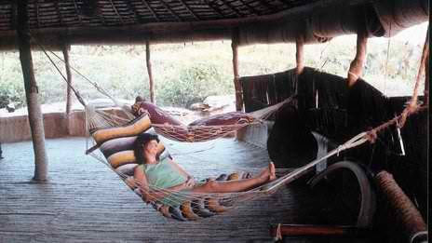
Eventually, he slunk away.
Throughout her captivity, she tried to gather evidence about her captors - making detailed descriptions of them and trying to gather their DNA when they touched her torch, or her notebook - hoping that one day they would be caught and be held accountable.
But she says she does not want her kidnappers dead. And she doesn't want to be consumed by the desire for revenge. "I don't want them to have that power over me. They are only in my head when I want them to be."
After a few weeks, the pirates allowed Jude a radio, and she listened to the BBC World Service - including some programmes broadcast from Somaliland.
A photo of Jude taken just a few hours before her kidnap
"I was sitting in a very dark room listening to you. You have no idea what that means to me, you really don't!
"You interviewed one young woman whose family had gone back to Somaliland from Hertfordshire [in the UK], who was interested and dedicated to making Somaliland better. That needs to happen to the whole of Somalia."
And Jude has a message to others held hostage in Somalia and around the world. "I just really want to tell people 'Do not give up hope, you haven't been forgotten'.
"You may think that you're languishing but there'll be someone somewhere trying to work towards your release."

Doctors among dead in Philippines restaurant blast
Source: http://www.thestar.com.my/News/World/2013/07/27/Doctors-among-dead-in-Philippines-restaurant-blast.aspx

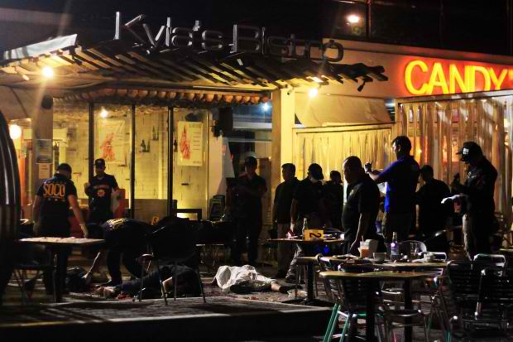
Filipino policemen examine the blast site outside Kyla's Bistro at the Lim Ket Kai Complex, Cagayan De Oro, in Mindanao. –EPA

Six people were killed and at least 48 wounded in the Philippines when a bomb struck a restaurant filled with doctors after a national convention, police said Saturday.
Police said the improvised explosive device went off around midnight (1600 GMT Friday) at a popular restaurant in the southern port city of Cagayan de Oro.
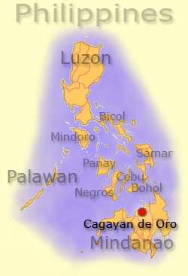
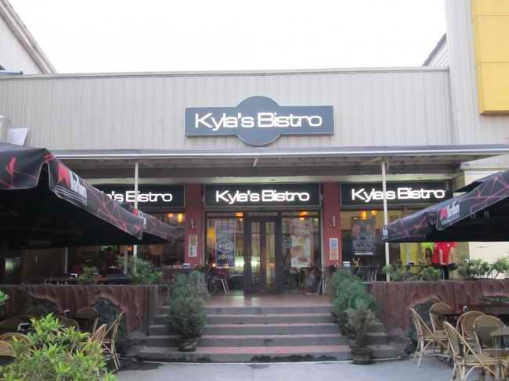
Most of the victims were doctors and pharmaceutical salesmen who had just attended a national convention of lung-disease specialists at a nearby hotel, said the city police chief, Senior Superintendent Graciano Mijares.
"This is one of the busiest areas of Cagayan de Oro.... somebody left a bomb on a chair at the bistro," he told reporters.
He declined to speculate on the motive for the bombing, saying an investigation was under way.
Cagayan de Oro is located on the main southern island of Mindanao, which has been blighted by a decades-old rebellion by elements of the large Muslim minority in the mainly Catholic Asian nation.
Witnesses at the scene described horrific scenes, with the top of the head of one victim blown off and the torso of another hanging limply on a chair as police sifted through the debris for evidence.
Local businessman Noel Arcenas, who owns an electronics shop at the shopping complex where the restaurant is located, said at least 100 people were inside the bistro when the explosion occurred.
"I felt then heard the blast," said Arcenas, who added he was standing about 15 metres (49 feet) away.
"I looked around and saw this ball of white smoke. People were running away bloodied and survivors were dragging at least seven or eight people away from the blast site."
The powerful explosion broke glass panels, upturned tables and chairs, and damaged cars parked up to 30 metres away, reporters at the scene said.
The six dead included two doctors as well as local politician Roldan Lagbas, a member of the provincial executive board of Misamis Oriental province, police said.
Forty-eight other people were taken to area hospitals for treatment, police said in an updated tally.
The city's police bomb squad recovered fragments of a mortar shell and an electronic circuit board on the scene, indicating it was an improvised bomb set off by a mobile phone or radio, according to Superintendent Marino Pongtilan.
President Benigno Aquino's government denounced the attack.
"We deplore this act of violence at this meeting of professionals, the Philippine College of Physicians, whose mission in life is to bring about healing," Aquino spokesman Herminio Coloma told reporters in Manila.
"We will have to look into the matter and ensure there will be no future breaches of security."
Cagayan de Oro Mayor Oscar Moreno told ABS-CBN television network that at least two of the wounded were in critical condition.
"Doctors have been attending to them and we hope their situation will stabilise soon," Moreno told the station.
Asked who he thought was responsible for the attack, he said: "It's hard to speculate at this time."
Muslim groups including the Moro Islamic Liberation Front (MILF) have waged a guerrilla war for a separate Islamic state in Mindanao since the 1970s, a conflict that has claimed an estimated 150,000 lives.
The Aquino government and the MILF signed a preliminary deal in October last year outlining the broad terms for a peace treaty that is expected to be signed before he ends his six-year term in 2016.

September 11th Congressional Report Fast Facts
Source: http://www.cnn.com/2013/07/27/us/september-11th-congressional-report-fast-facts/index.html

Here's a look at what you need to know about the 9/11 Congressional Report, released by Congress on July 24, 2003.
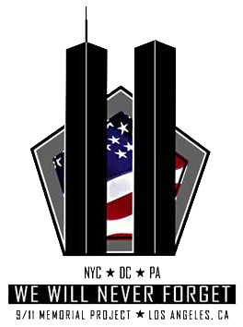
Facts:
The full name of the report is the Joint Inquiry into Intelligence Community Activities Before and After the Terrorist Attacks of September 11, 2001: Report of the U.S. Senate Select Committee on Intelligence and U.S. House Permanent Select Committee on Intelligence.
The report is a result of a 10-month joint investigation by House and Senate intelligence committees. The report is completed in December 2002, but not published until July 2003 because of declassification.
The report is more than 800 pages, and there is a 20-page errata to the report available, which shows corrections made to the original. Twenty-eight pages that allegedly deal with Saudi Arabia's connections to the 19 hijackers remain classified.

Findings of the report:
FBI, CIA and other U.S. intelligence agencies "missed opportunities" to thwart terrorism prior to September 11, 2001.
Although senior military officials were standing ready to strike terrorist Osama bin Laden, of al Qaeda, prior to 9/11, they lacked the intelligence necessary for execution.
According to the report, "various threads and pieces of information" have either been overlooked or not put together.
"No one will ever know what might have happened had more connections been drawn between these disparate pieces of information," the report states. "The important point is that the intelligence community, for a variety of reasons, did not bring together and fully appreciate a range of information that could have greatly enhanced its chances of uncovering and preventing bin Laden's plan to attack the United States on September 11, 2001."
The report is the product of 5,000 interviews and a review of nearly one million documents.
The report includes some 19 recommendations to bolster counterterrorism efforts; those recommendations are originally released in 2002.

From "Abridged Findings and Conclusions":
Finding 1: "While the Intelligence Community had amassed a great deal of valuable intelligence regarding Osama Bin Laden and his terrorist activities, none of it identified the time, place, and specific nature of the attacks that were planned for September 11, 2001. Nonetheless, the Community did have information that was clearly relevant to the September 11 attacks, particularly when considered for its collective significance."
Finding 2: "During the spring and summer of 2001, the Intelligence Community experienced a significant increase in information indicating that Bin Laden and al-Qaeda intended to strike against U.S. interests in the very near future."
Finding 3: "Beginning in 1998 and continuing into the summer of 2001, the Intelligence Community received a modest, but relatively steady, stream of intelligence reporting that indicated the possibility of terrorist attacks within the United States. Nonetheless, testimony and interviews confirm that it was the general view of the Intelligence Community, in the spring and summer of 2001, that the threatened Bin Laden attacks would most likely occur against U.S. interests overseas, despite indications of plans and intentions to attack in the domestic United States."
Finding 4: "From at least 1994, and continuing into the summer of 2001, the Intelligence Community received information indicating that terrorists were contemplating, among other means of attack, the use of aircraft as weapons. This information did not stimulate any specific Intelligence Community assessment of, or collective U.S. Government reaction to, this form of threat."
Finding 5: "Although relevant information that is significant in retrospect regarding the attacks was available to the Intelligence Community prior to September 11, 2001, the Community too often failed to focus on that information and consider and appreciate its collective significance in terms of a probable terrorist attack. Neither did the Intelligence Community demonstrate sufficient initiative in coming to grips with the new transnational threats. Some significant piece of information in the vast stream of data being collected were overlooked, some were not recognized as potentially significant at the time and therefore not disseminated, and some required additional action on the part of foreign governments before a direct connection to the hijackers could have been established. For all those reasons, the Intelligence Community failed to fully capitalize on available and potentially important information."

►Read the full report at: http://www.gpo.gov/fdsys/pkg/CRPT-107srpt351/pdf/CRPT-107srpt351.pdf

British Women Join Jihad in Syria
Source: http://www.israelnationalnews.com/News/News.aspx/170288#.UfXtSazp_wM

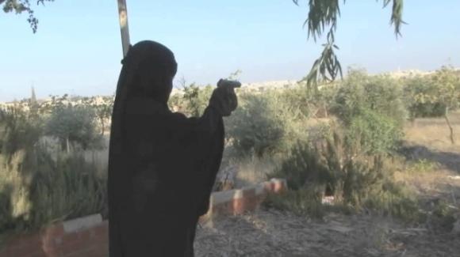
Britain’s Channel 4 aired an exclusive story this week about British citizens who have travelled to join the fight to oust Syrian President Bashar Al-Assad inside rebel-held territory in the country's north.
The story followed a woman calling herself “Maryam” who travelled from Britain to marry a rebel fighter from one of the jihadist rebel groups.
Maryam's marriage to her fighter husband, Abu Bakr, was arranged by his mother three months ago. She didn't meet him until after they were married, according to Channel 4.
Until her recent departure from the UK for Syria she lived what she describes as an okay life.
She and her husband are shown raising a child together, and are now expecting another. They say that their long-term objective is what they see as the liberation of Syria, followed by the establishment of an Islamic caliphate.
Abu Bakr fights with the Sunni jihadi militia known as Katiba al Muhajireen, whose members fight alongside bigger Islamic groups such as Ahrar al-Sham and the al-Qaeda affiliated Jabhat al-Nusra.
The leader of Jabhat Al-Nusra recently declared that his group is in favor of establishing an Islamic caliphate in civil war torn Syria.
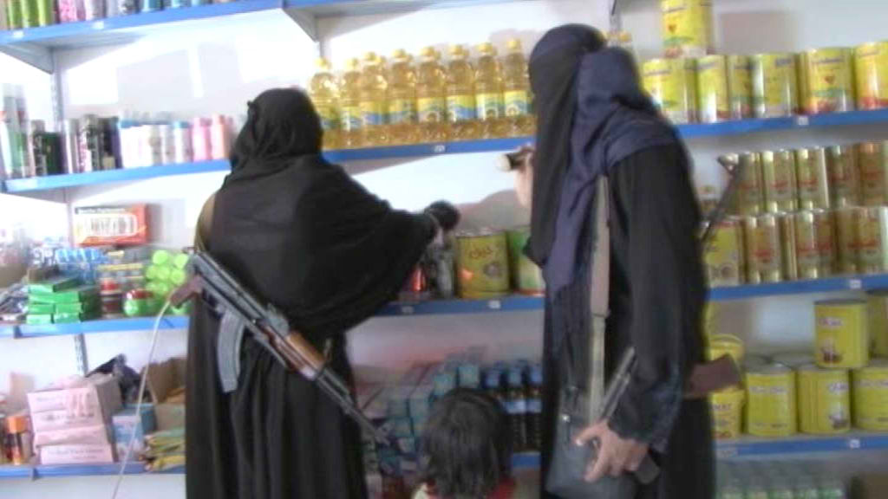
Maryam told Channel 4 she has no plans to return to the UK, ever, even if her new husband is killed in battle.
"I will stay here because I didn't come here for him. I wouldn't like to go back to the UK. I'll stay here, raise my children, focus on the Arabic language to communicate with the Syrian people,” she said.
She called on other Muslims to “wake up and stop being scared of death... we know that there's heaven and hell. At the end of the day, Allah's going to question you. Instead of sitting down and focusing on your families or your study, you just need to wake up because the time is ticking."

New study examines terrorism in Indonesia, the Philippines and Thailand
Source:http://www.start.umd.edu/start/announcements/announcement.asp?id=565&utm_source=START+Announce&utm_campaign=25819ecc40-2013+June+Newsletter&utm_medium=email&utm_term=0_ a60ca8c769-25819ecc40-14081393

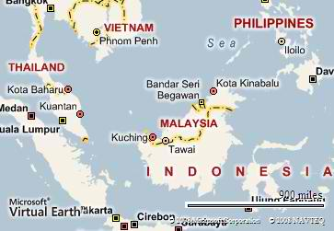
Terrorist attacks in Indonesia, the Philippines and Thailand account for 87.8 percent of terrorist activity in the Association of the Southeast Asian Nations (ASEAN), according to researchers at the National Consortium for the Study of Terrorism and Responses to Terrorism (START). Sixty-three percent of these attacks occurred in the Philippines.
In the article, “Terrorism in Indonesia, the Philippines and Thailand, 1970 to 2008,” START researchers examine three countries in ASEAN, a geo-political and economic organization of 12 countries that seeks to foster economic growth, advance social and cultural development, and facilitate cooperative efforts to protect the peace and stability of the region.
START Director Gary LaFree and researchers Erin Miller and Sue-Ming Yang used data compiled from the Global Terrorism Database to identify characteristics of 4,352 terrorist attacks in Indonesia, the Philippines and Thailand from 1970 to 2008.
The researchers identified five provinces that account for 38 percent of terrorist attacks across the three countries: Aceh (Indonesia), Metropolitan Manila (the Philippines), and Narathiwat, Pattani and Yala (Thailand).
Four perpetrator organizations are primarily responsible for terrorist attacks in the Philippines, with more than 60 percent of all attacks committed by MILF, NPA, ASG and MNLF. Terrorism in the Philippines has been a considerable threat since the late 1970s, with an average of more than 80 attacks annually since 2000. The highest numbers of fatalities were attributed to attacks against military targets, followed by private citizens and property, businesses, government and police.
Private citizens and property and religious figures and institutions are the primary targets for terrorist attacks in Indonesia, according to the data. However, terrorist activity in Indonesia has declined dramatically since the 2002 suicide bombings in a Bali night club.
In Thailand, private citizens and property are more likely to fall victim to terrorist attacks than businesses, government or transportation. The data also shows that a large surge in terrorist activity occurred in Thailand between 2004 and 2008, after a relatively long period that saw only sporadic occurrences.

White Paper: A Multi-Layer Assessment of Terrorism in its Current and Future Manifestation
Source:http://www.start.umd.edu/start/announcements/announcement.asp?id=566&utm_source=START+Announce&utm_campaign=25819ecc40-2013+June+Newsletter&utm_medium=email&utm_term=0_ a60ca8c769-25819ecc40-14081393

START researchers participated in a series of interviews that resulted in a white paper aimed to advance the ongoing national dialogue on terrorism, exploring how scholars, practitioners and operators understand terrorism in both its current manifestation and as anticipated in the future.
The paper, “Over a Decade Later…What Now? What Next?: A Multi-Layer Assessment of Terrorism in its Current and Future Manifestation,” also seeks to better refine and address the "disease" (preconditions, perceptions, and underlying drivers) and not just the "symptoms" (terrorist attacks) of terrorism, and spark new thinking about:
- the merits of a whole-of-nation response to terrorism;
- the value of creating a national defense narrative that is clear, inclusive and helpful for explaining to domestic and international audiences what the U.S. is fighting for; and
- what it means to define our terrorism response in accordance with our nation's values.
Among the social science researchers, interagency analysts and military officers interviewed, START’s Gary Ackerman, Victor Asal, Martha Crenshaw, Clark McCauley and John Sawyer contributed to the report providing their expertise and empirically based research findings.
The white paper was written and published by the Strategic Multi-Layer Assessment office within the Office of the Secretary of Defense.

►Read the full paper at:
http://www.start.umd.edu/start/publications/SMAWhitePaper_MultiLayerAssessmentofTerrorism_July2013.pdf

Discussion Point: It’s not Big Data, but Little Data, that Prevents Terrorist Attacks
By Erik J. Dahl
Source:http://www.start.umd.edu/start/announcements/announcement.asp?id=564&utm_source=START+Announce&utm_campaign=25819ecc40-2013+June+Newsletter&utm_medium=email&utm_term=0_ a60ca8c769-25819ecc40-14081393

Many Americans are worried by what we have been learning about the National Security Agency (NSA) and its extensive surveillance programs. It appears to many of us that the government wants to snoop into every aspect of our lives, including “metadata” about our phone calls, information about our Internet use, and who knows what else. This concern is understandable, because these intelligence collection programs do appear to suck in a tremendous amount of data about ordinary Americans—not to mention about people from other countries. And American history shows that intelligence and law enforcement agencies often start out gathering information for a good purpose, but then mission creep sets in and they collect more, and use it for other purposes, than was originally intended.
What should we make of all this? It helps to start by understanding how the data collected by the NSA programs may be useful to the U.S. intelligence community. We don’t actually know much about these programs, of course, beyond what has been leaked by Edward Snowden and the claims by intelligence community officials that this data has helped to stop a number of terrorist plots. But from what has been revealed publicly, it seems that these collection programs are useful for what is often the first part of any intelligence effort: gathering a lot more information than is actually needed. This first step is sometimes called a broad area search, as intelligence agencies look in a lot of places, gathering a lot of useless information, before they find the clues that help them narrow the search down to the second step, a focused search for useful, actionable intelligence.
This two-step approach was used in the search for Osama bin Laden. After the 9/11 attacks he could have been anywhere, so the intelligence community spent a lot of time running down leads that led to nowhere. But eventually they found the clues that pointed them toward bin Laden’s courier, and that’s where the focused search began, leading them to the compound in Abbottabad, Pakistan.
We have learned from the Snowden leaks and official statements that the U.S. intelligence community, led by the NSA, has found some ingenious and technically legal ways to gather up huge amounts of data that they might need some day to catch terrorists—or better yet, to stop them before they conduct attacks. In other words, intelligence agencies have been collecting big haystacks of data, just in case they need it. And when they want to use it, such as to see what other phone numbers are connected to a number they obtained from a terrorist suspect, they try to use data mining tools to find the needle in that haystack.
How important is that big data? Some critics argue that such vast collection programs are unlikely to be useful, either because the NSA will never be able to make sense of it all, or because these programs are likely to only catch crooks with Yahoo email accounts, or those who are foolish enough to type into Google, “How do I make a bomb?” Others argue the opposite case, that all of this big data—such as the telephone numbers we dial—can enable the intelligence community to pry into the personal lives of millions of Americans.
The truth is probably somewhere in the middle, even assuming intelligence agencies are able to develop data mining tools that allow them to make sense of this flood of information. Amid all the discussion about big data, metadata, and data mining, it’s important to realize that it’s not big data that stops terrorist plots or prevents other bad things from happening. For that, little data is critical: the little pieces of information, usually the actions and behaviors of individuals, that gives something away. Big data is important, and the intelligence community can learn an awful lot about all of us through analyzing our metadata. But terrorist attacks don’t get prevented by computer algorithms, and people don’t get arrested—at least we hope they don’t—on the basis of analysis of their metadata.
Our government hasn’t been able to do a very good job of explaining to the public what it has been doing, partly because intelligence agencies are often unable to talk about their successes for fear of revealing their sources and methods. That’s why officials have said that a number of plots and attacks have been foiled, but they haven’t provided much specific information about those cases that wasn’t already in the public record.
Research I am currently conducting for the National Consortium for the Study of Terrorism and Responses to Terrorism (START), together with my colleagues Martha Crenshaw and Margaret Wilson, can shed some light on how this NSA data may be used. We are studying unsuccessful terrorist plots, in hopes of finding out what tools and techniques are the most useful in preventing attacks.²
One finding supports the NSA’s argument that the data they are collecting can be useful in preventing future attacks. Opponents have suggested that the NSA data might only be useful in tracking down terrorists after the fact; because those haystacks of information are not apparently being looked at in real time, they are unlikely to help prevent future attacks. But the history of terrorist plots and attacks within the United States since 9/11 shows that most plots take a long time to develop. Even terrorist actions involving only one or two people typically take months or even years to plan and attempt. This is good news, because it gives law enforcement time to discover what’s going on, and it also gives the NSA time to search those haystacks it’s been collecting.
But another one of our findings is that the most effective tools in preventing terrorist attacks are relatively simple, old fashioned police methods, such as the use of undercover officers, informants, and tips from the public. This is especially true for domestic plots and attacks: of the 109 failed plots within the United States since 9/11, more than 75 percent were foiled at least in part because of traditional law enforcement methods, and not—from what we can gather—from NSA surveillance. Thus it is not surprising that government officials have said most of the 50 or so plots that have been foiled by the NSA monitoring programs were overseas³. In other countries we can’t necessarily rely on local authorities, and spying—whether conducted by the NSA or the CIA—is a critical tool for our national security. But here in the U.S., the most important terrorism prevention tool remains the country’s 800,000 police officers, deputy sheriffs, and other local law enforcement officials, supported by members of the public who "see something and say something," calling authorities when something doesn’t look right.
These NSA programs do appear to be important for preventing terrorist attacks, and they make sense from an intelligence perspective. But their greatest value concerns threats overseas, and this is probably a good thing, because it means that if the programs are managed properly, and if our intelligence oversight mechanisms work as they should (which are admittedly big ifs), the NSA collection of big data will have relatively little impact on most Americans’ lives.

Erik J. Dahl is an assistant professor of national security affairs at the Naval Postgraduate School in Monterey, California, where he teaches in the National Security Affairs Department and the Center for Homeland Defense and Security. His research and teaching focus on intelligence, terrorism, and international and homeland security, and he is the author of “Intelligence and Surprise Attack: Failure and Success from Pearl Harbor to 9/11 and Beyond” (Georgetown University Press, October 2013). He retired from the U.S. Navy in 2002 after serving 21 years as an intelligence officer, and received his Ph.D. from the Fletcher School of Tufts University.

Tourists From Hell
Source: http://www.strategypage.com/htmw/htterr/articles/20130728.aspx

European countries are paying a lot more attention to the international travel activities of their Moslem citizens. That’s because a growing number of them are being drawn into the uprisings and civil wars that have shaken up the Arab world in the last two years. Some European counter-terror officials are calling it “jihad terrorism” when young (teens to thirties) Moslem men (and a few women) travel to a country suffering unrest and attempt to join one of the violent factions to fight. Often the most attractive options are Islamic radical groups, whose violent and self-righteous image has the most appeal for impressionable young Moslems in the West.
Border controls are being tightened, both in Europe and in countries near the nations mired in turmoil. More and more, governments are telling the border control officers to watch out for the young jihadis and block them from going any farther. Most of the jihad tourists are not too bright, although many have “guides” from back home to help them around these obstacles. The “guides” are increasingly liable to prosecution for recruiting and guiding terrorist recruits to the combat zone.
For years European police monitored but otherwise ignored this activity but with more of these jihad tourists coming back angrier and more enthusiastic about Islamic terrorism, that is changing. As worrisome as those who go are, more troubling are those who return with combat experience and a desire to bring the war back home with them. There has actually been little of that, just enough to keep local police and intelligence officials on their toes.
It’s not just the Islamic radicals police have to keep an eye on as there has been another threat that has been growing even faster, year by year. This threat is largely local; violent leftists. Unlike their predecessors in the 1970s, the current leftist violence is less intense. Few people are killed, but there's a lot of property damage and non-fatal injuries. Leftist politics is very popular and fashionable in Europe, but most leftists try and distance themselves from the violent fringe. This has proved difficult, in part because European leftists tend to back Islamic radicals (especially the Palestinians) that involves some tolerance for having violent terrorists as allies.
Most of the leftist violence is caused by groups calling themselves anarchists. Back in the 19th century, the anarchist movement appeared, as the first modern international terrorist network. This was one of the several collectivist movements to come out of the 19th century (along with the more lethal radical socialist ideologies fascism and communism.) Anarchists believed that "property is theft" and a hundred years ago were killing quite a few crowned and elected heads of state (including U.S. president McKinley) to get their message across. Bombings were also used, against capitalist targets (like Wall Street, where thirty were killed by a 1920 explosion.) Most Anarchists were peaceful (if loud), and the small radical faction had plenty of places to hide. Many innocents were imprisoned and several executed in the mania to suppress the radical anarchists. None of these efforts succeeded. What killed the anarchist movement, and its radicals was old age (the original 1890s crop were not completely replaced), police action (some were caught), improved working conditions, and, finally, Stalin (who ordered the communists to kill their Anarchist allies to eliminate rivals during the Spanish Civil war.) There are still a few anarchists left, but most are academic twits who would rather preach than act, or street thugs who take their anarchy literally, more for thrills than anything else. The street violence attracts the mayhem minded, who adopt the anarchist label for a number of reasons, most having more to do with form than substance. In Europe this sometimes finds Islamic radicals and anarchists trashing the same places. Nothing like a little of the ultra-violence to cultivate some kinship.
While the anarchist violence is a growing problem, police still spend most of their time keeping an eye on Islamic radicals. This is a problem that is actually declining, but not fast enough. A decade ago German police and military intelligence estimated that they had about 3.45 million Moslems in the country, and that about three percent of those supported al Qaeda’s objectives (Islam becoming the only religion on the planet). These Islamic radicals do not support violence, but would give aid to al Qaeda terrorists. More worrisome, the Germans believe that about 3,000 of their Moslem residents would commit terrorist acts to further the al Qaeda cause. The Germans also noted that there were 24 active Islamist groups in the country, with about 31,000 members altogether.
Since then, the numbers have changed a bit. The number of Moslems in Germany, it seems, was underestimated. Because of illegal migration, there are over four million Moslems in the country. Because Islam is not big on getting along with non-Moslem culture, the Moslems in Germany do not integrate as quickly. The children do not take advantage of educational opportunities as much as, say, non-Moslem migrants from East Asia, or Eastern Europe. Thus Islamic conservatism and radicalism has become more popular, and persistent. But at the same time, groups like al Qaeda are less popular (mainly because of how many Moslems these Islamic terrorists have killed.) But the potential for Islamic terrorism in the German Moslem population is still there, and it is potentially much more likely to be lethal, and thus more dangerous than the anarchists.

Americans more concerned about privacy than terrorism - Pew study
Source: http://rt.com/usa/americans-concerned-privacy-terrorism-763/

For the first time in almost a decade, the majority of Americans are more concerned about the government infringing on their civil liberties than about a potential terrorist attack, according to a new poll by Pew Research.
US citizens have traditionally responded to similar polls by saying the government has not yet gone far enough to protect the country from threats. But new results from Pew Research Center reveal that public opinion has drastically shifted - especially in the wake of NSA spying programs leaked by Edward Snowden nearly two months ago.
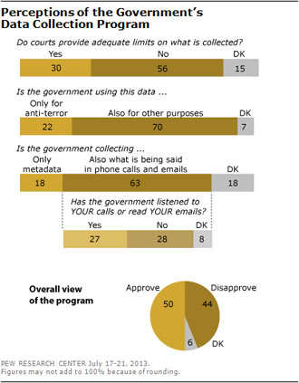
Pew reported (July 30) that “a majority of Americans – 56 per cent – say that federal courts fail to provide adequate limits on telephone and internet data [which] the government is collecting as part of its anti-terrorism efforts.” An even larger percentage – 70 per cent – believes the government uses the data for “purposes other than investigating terrorism.” Another 63 per cent believe “the government is also gathering information about the content of communications.”
“Overall, 47 per cent say their greater concern about government anti-terrorism policies is that they have gone too far in restricting the average person’s civil liberties, while 35 per cent say they are more concerned that the policies have not gone far enough to protect the country,” the authors of the poll wrote. “This is the first time in Pew research polling that more have expressed concern over civil liberties than protection from terrorism since the question was first asked in 2004.”
Prior to Snowden’s disclosures, a 2010 Pew poll found that 58 per cent of Americans felt the government had “not gone far enough to protect the country,” although the NSA surveillance was already underway at that time without the public’s knowledge.
The sea change was reflected in Congress last week when a bill to cut funding to the NSA surveillance program failed to pass by a mere seven votes. Both Democrats and Republicans skirted US President Barack Obama and top leaders of both parties, in an attempt to use legislation as an oversight to the burgeoning intelligence gathering.
Representative Jim Sensenbrenner, a Wisconsin Republican and an author of the original Patriot Act of 2001 which authorized the spying, has publicly advocated repealing the law. He was among those in Congress who voted for an amendment to defund NSA programs.
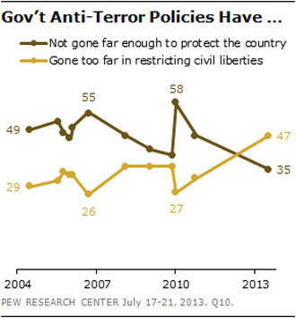
“The time has come to stop it, and the way we stop it is to approve this amendment,” he said, adding days later that he had not planned on speaking. “I was able to say what needed to be said in a minute.”
Image from www.people-press.org
While even lawmakers who are in favor of the NSA’s indiscriminate and warrantless surveillance might recognize that more oversight is inevitable, Glenn Greenwald of the Guardian has suggested that top Democrats and Republicans benefit financially from the unpopular laws.
“But with a few rare and noble exceptions, the Intelligence Committees in both house of Congress are filled with precisely those members who are most slavishly beholden to, completely captured by, the intelligence community over which they supposedly serve as watchdogs,” Greenwald wrote in a column on Monday.
“Many receive large sums of money from the defense and intelligence industries…in particular, the two chairs of those committees – Democrat Dianne Feinstein in the Senate and Republican Mike Rogers in the House – are such absolute loyalists to the NSA and the national security state generally that it is usually impossible to distinguish their behavior, mindset and comments from those of NSA officials.”

Attacks On Sochi Olympics Called For By Chechen Rebel Leader
Source:http://www.huffingtonpost.com/2013/07/03/sochi-olympics-chechen-leader-attacks_n_3541766. html

A leading Chechen rebel on Wednesday called on Islamist militants in Russia's North Caucasus to disrupt the upcoming Olympics in the Black Sea resort of Sochi, reversing his previous appeal not to target civilians in the region.
Sochi is hosting the Winter Games in February, a pet project for President Vladimir Putin, who is determined for them to be a success. The overall bill for the games stands at $51 billion, making them by far the most expensive Olympics in history.
Doku Umarov, a widely known Chechen rebel leader, urged his fighters to "do their utmost to derail" the games, which he described as "satanic dances on the bones of our ancestors."
"We have the obligation to use all means to prevent this," he said in a video posted on a rebel website on Wednesday.
Umarov last year urged his fighters to avoid hitting civilian targets because Russians in Moscow were taking to the streets en masse to protest against Putin.
Security experts have said the Islamic insurgency raging across the North Caucasus mountains that tower over Sochi is a daunting threat to the games – although rebels have not attacked Sochi so far.
Dagestan, which lies about 500 kilometers (300 miles) east of Sochi, has become the center of the insurgency that spread across the North Caucasus region after two separatist wars in the 1990s in neighboring Chechnya. Rebels seeking to carve out a caliphate, or Islamic state, have targeted police and other officials in near-daily shootings and bombings. Umarov is believed to be their most influential leader.
Tamerlan Tsarnaev, the elder of the two ethnic Chechen brothers who are accused of staging the Boston Marathon bombings, spent six months last year in Dagestan.
Jean-Claude Killy, head of the IOC coordination commission for Sochi, said such threats are to be expected.
"We get threats before every Olympics," he told The Associated Press. "This cannot be taken lightly. I think the Russians are well equipped to face the challenge."
The Sochi 2014 Organizing Committee said in an emailed comment that ensuring security at the games is "the responsibility of the state" and will be its priority.
"We are confident that the games will be safe and comfortable for all as guaranteed by the Russian state," the committee said.
Russia's National Anti-Terrorism Committee said in a statement on Wednesday that it is working to eliminate threats at all international sporting events in the country including the Olympics. Officials said that they aim "to identify and avert various threats, including those of terrorism."
Ramzan Kadyrov, a strongman who rules Chechnya, played down the influence of Umarov and promised that his security forces would track him down. "Before the Olympics, I think, I'm sure, that we will destroy him," Kadyrov told the Interfax news agency. "We search for him every day, but he is nowhere to be found."
Press officers for the Interior Ministry in Russia's southern district, which includes the North Caucasus, declined to comment.
An officer of the Interior Ministry's special task force in the North Caucasus, who asked not to be identified because he was not allowed to comment publicly, told The Associated Press that Umarov's statement could prompt Russians to step up their efforts to comb the mountainous areas where Umarov could be hiding.
The United States declared Umarov's group a terrorist organization in 2011 and offered up to $5 million for information leading to his capture.
Umarov's group is blamed for bombing a Moscow airport in January 2011, two subway stations in 2010 and a Russian train in 2009.

NEW BOOK – Branding Terror and the Art of Propaganda
By Dawn Perlmutter
Source: http://frontpagemag.com/2013/dawn-perlmutter/branding-terror-and-the-art-of-propaganda/

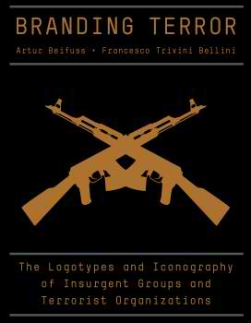
Branding Terror, The Logotypes and Iconography of Insurgent Groups and Terrorist Organizations is a new book that claims to present an objective analysis of terrorist symbols. The authors, Odessa-born, German Artur Beifuss, a former United Nations counter-terrorism analyst, and Italian professional graphic designer Francesco Trivini Bellini, produced a beautiful but biased reference guide for members of the intelligence and law enforcement communities. Merrell, the book’s publishing company, specializes in art, fashion and gardening books, which should be the first clue that the information in this counter terrorism reference guide is problematic. The book’s 60 beautifully illustrated emblems, accompanied by a symbolic analysis and description of each group’s ideology, have a decidedly anti-American, anti-Israel and pro-Palestinian liberal bias that only serves to perpetuate the propaganda issued by the very terrorist organizations that are included in the book.
Beifuss and Bellini are more fascinated with the branding, marketing and visual communication of the terrorist groups than with the ugly realities of what these symbols represent. The book smells of political correctness, beginning with its disclaimers and apologies for the terrorist groups represented in the book, making it clear that the selected emblems were the result of a combination of designated terrorist lists from five countries. As if compensating for having to have to include so many Palestinian terrorist organizations, the authors perpetuate anti-Israel bias in their analysis of five Palestinian group symbols that include the map of Israel in their logo (Palestinian Islamic Jihad p. 173, Palestinian Liberation Front, p. 255, Popular Front for the Liberation of Palestine p. 263, PFLP military wing p. 265 and the PFLP General Command p. 271). In each emblem the authors neglect to identify the obvious image as the map of Israel and choose to refer to it as an outline of Palestine. It is difficult to imagine that Beifuss, who worked for the United Nations as a counter-terrorism analyst, would not be aware of the fact that depicting the map of Israel as Palestine proliferates this classic anti-Semitic propaganda. This is reinforced by their descriptions throughout the book of the perception of Israel as occupying Palestine.
Political correctness is also evident in Beifuss and Bellini’s analysis of the emblems of Islamist jihadist terrorist groups, particularly their choice to camouflage the meaning of very significant concepts such as jihad, dawa, sharia and the phrase “Allahu Akbar.” The phrase “Allahu Akbar” appears in three emblems in the book and in each symbol the authors refer to it as the “takbir” which they define in their glossary as ‘The Arabic term for the Arabic phrase Allahu Akbar (“god is the greatest”) used by Muslims as an expression of faith; in prayer; in times of distress; and to express celebration or victory, determination or defiance” (p. 329). The terrorist organizations in the book that used this phrase in their emblems include: the Libyan Islamic Fighting Group, which is linked with the attack on the American embassy in Benghazi; The Caucasus Emirate, the Chechen group that is likely affiliated with the Boston Marathon bombing; and the Palestinian Islamic Jihad, which committed numerous suicide attacks, killing dozens of civilians. The phrase “Allahu Akbar” in their emblems does not represent a benign expression of faith, it represents the battle cry of the Mujahideen before, during or after they are killing the enemies of Islam.
The Kahane Chai logo, the only Israeli symbol in the book is depicted by a clenched fist inside a Star of David and is described as conveying courage, strength and militancy and illustrating “the violent means Kahane Chai is prepared to use in order to achieve its objectives” (p. 195). Similarly, the clenched fist depicted in the emblem of the Northern Ireland group, the Ulster Freedom Fighters, which interestingly also sits within a six-pointed star (that represents the six counties of Northern Ireland) is described as meaning “courage, strength and militancy, and symbolizing the UFF’s commitment to the use of violence” (p. 305). However, the Palestinian Islamic Jihad emblem that contains two clenched fists, two rifles, the dome of the rock and the map of Israel, are interpreted as justifiable and benign. The fists and rifles are characterized as “a protective frame for the mosque and thus the Palestinian nation; these elements also refer to the group’s militancy and its commitment to jihad in order to liberate Palestine from perceived Israeli occupation” (p. 173).
There are two clenched fists in the emblem of the Communist Party of India (Maoist), which are described as representing “unity and resistance” (p. 103). The other three symbols in the book that have clenched fists all are holding a rifle and are all Iranian groups. In the logo of Iran’s Revolutionary Guards, the clenched fist holding a rifle is described as standing for armed resistance (p. 149); the fist holding an AK47 in the emblem of the Hezbollah Brigades in Iraq is described as a symbol of the group’s militancy (p. 199); and the fist holding the rifle in the logo of Hezbollah is described as emerging “from the letter known as ‘alef’, the first letter of the word Allah” (p. 147). Violence is only associated with the Israeli and Irish emblems, both of which do not have any weapons in their logo.
Anti-Americanism is evident in the authors’ description of al-Qaeda in Iraq, which is characterized as “a reaction to the U.S.-led invasion and occupation of Iraq” (p. 53) instead of as the U.S.-led Coalition Forces. The authors also neglect to mention the dozens of beheadings carried out by al-Zarqawi’s group and misidentify the imagery in the al-Qaeda in Iraq symbol. An image of a hand with the index finger pointing up is described as “a fist with the index finger pointing up to God” (p. 55) and interpreted to simply mean “legitimizing the militant struggle” (p. 55). They do not expand on that very prevalent image of the hand with the index finger pointing up that is found in numerous Salafi jihadist groups and represents their willingness to be killed, attaining martyrdom and entrance into Paradise.
The book “Branding Terror” essentially sugarcoats the jihadist threat by applying a biased interpretation of the emblems, minimizing the iconography of martyrdom and sanitizing obvious violent indicators, such as the black flags of jihad and swords that are depicted in many of the Islamist logos. The sword is described throughout the book as a premodern weapon that represents the historical struggle in early Islam. Two crossed swords in the emblem of the Indonesian group Jemmah Anshorut Tauhid are described as indicating “JAT’s commitment to jihad. As a pre-modern weapon, the sword is linked to early Islamic jihad campaigns; it is also associated with the purity and nobility of early Islamic heroes. By using swords as a design element JAT confers legitimacy on its jihadi activities, and portrays them as a modern extension of historical jihadi campaigns” (p. 187). There is no reference at all to the swords’ significance in representing “the sword verses” in the Quran, which jihadists use to justify their violence or that they represents Jihad by the sword (jihad bis saif), which refers to armed fighting in holy war.
The foreword, written by former New York Times art director Steven Heller, sets the tone for the liberal bias and functions as a disclaimer for the liberal sin of producing a book on terrorism. The first sentence reads: “Any irregular fighting force can technically be seen as a terrorist organization,” and in the next paragraph he writes, “Terrorists (or freedom fighters, depending on one’s perspective).” On the same page Heller says, “Those whom we call terrorists, even the most ragtag rebels, wherever they reside, usually have a cause they are fighting for” (p. 7). This is quite an apologetic foreword to a counter-terrorism reference book. The introduction is even more indicative of the biased and/or bad research in the book, for instance, when the authors describe a cute story about how an Italian amateur football club appropriated the Hezbollah logo for their team in order to frighten their adversaries, and neglect to reveal that the choice also fit in with the center-left Italian government’s policy of encouraging Middle Eastern radicals.
Merrell, the book’s publisher, claims on its website that “Branding Terror does not seek to make any political statements; rather, it offers insight into an understudied area of counter-intelligence, and provides an original and provocative source of inspiration for graphic designers.” The statement that this book’s aim is to be a source of inspiration for graphic designers is truly obscene and makes it clear that the authors have no concept of what these symbols represent. These groups are not selling cereal; they are selling fear and their “brand” is backed up by murder, suicide attacks, beheadings and bombings. They are not misunderstood freedom fighters, or peaceful protestors — they are mass murderers. Sugarcoating the violence minimizes the threat, and referring to their emblems as “brands” also diminishes the seriousness of their violent ideologies.
It is important that these symbols represent a threat to both the public and to law enforcement so that terrorists can be identified. The authors should stick to producing art books, as they have no training in the significant subtleties of the subliminal and covert imagery contained in terrorist propaganda. Unfortunately, the media is now peddling this book as if it is another coffee table fad. The Huffington Post describes how the authors are deconstructing symbols of 60 global terrorist groups, and, more disturbing, the Times of Israel has given it a glowing review without realizing the anti-Israel content. Beifus and Bellini do not demystify the visual imagery of terrorism, they just undermine the threat.
Palestinian terrorist group symbols in the book Branding Terror that have a map of Israel in their logo. The map of Israel is identified as an outline of Palestine in the new book.

Dawn Perlmutter is Director and founder of Symbol & Ritual Intelligence and Associate Fellow at the Middle East Forum is considered one of the leading subject matter experts (SME) in the areas of symbols, unfamiliar customs, ritualistic crimes and religious violence.

Life sentence for Somali pirates who killed Marina del Rey couple
Source:http://www.latimes.com/news/nation/nationnow/la-na-nn-somali-pirates-sentenced-life-20130 802,0,4287193.story
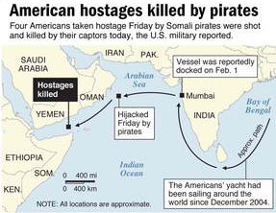

Three Somali pirates were sentenced to life in prison Friday for the shooting deaths of four Americans, including a Marina del Rey couple, in a 2011 hijacking off the coast of East Africa.
A federal jury in Norfolk, Va., decided not to impose the death penalty on Ahmed Muse Salad, Abukar Osman Beyle and Shani Nurani Shiekh Abrar after they each were convicted last month on 26 counts including piracy and murder.
The piracy convictions carry a mandatory life sentence.
Jurors began deliberations Thursday and quickly reached a decision in the first murder involving pirates in the United States in nearly two centuries.
Scott and Jean Adam, retirees from Marina del Rey, were in the middle of an around-the-world voyage aboard their 58-foot sloop, the Quest, with two friends, Robert Riggle and Phyllis Macay of Seattle, when Somalis armed with automatic rifles and grenade launchers captured the boat in February 2011.
Prosecutors argued the Somalis wanted to hold the Americans for ransom, part of a rash of pirate attacks in those years in the waters off of East Africa.
Four U.S. warships patrolling the waters soon encircled the Quest and Navy negotiators attempted to gain the release of the hostages. But with talks breaking down, prosecutors said, the pirates panicked and unleashed a barrage of gunfire, killing the Americans.
Defense attorneys had pleaded with jurors for leniency, describing the Somalis as impoverished men raised in a war-ravaged country who turned to piracy to eke out a living.
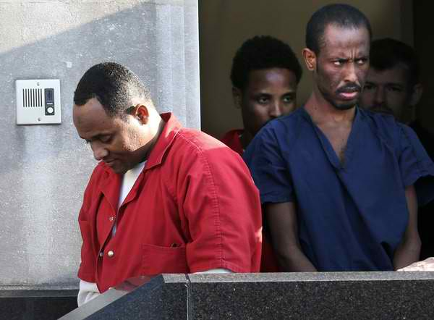
Somalia has been without a functioning central government since 1991, which allowed criminal gangs and pirate networks to operate freely from its remote northern stretches for years. But since 2011, a crackdown by the United States and international navies has dramatically reduced attacks in the Indian Ocean and jailed some 1,150 suspected pirates.

Shani Nurani Shiekh Abrar, left, and Ahmed Muse Salad, right leave the federal courthouse in Norfolk, Va., in June. The two men and a third Somali pirate, Abukar Osman Beyle, were sentenced Friday in the 2011 shooting deaths of four Americans off the coast of Africa. (Steve Earley/AP/June 4, 2013)

Twelve men previously had been convicted of piracy or pleaded guilty to piracy in the Quest incident. All were sentenced to life terms.
Prosecutors sought the death penalty for Salad, Beyle and Abrar, arguing the men fired the fatal shots.
Scott Adam, 70, an assistant director on films and TV shows such as “The Dukes of Hazzard” and “The Love Boat,” had sailed around the world multiple times. He and Jean Adam, 66, a former dentist, had the Quest custom-built in New Zealand and were fond of distributing Bibles when they docked in far-off ports.
They had never before sailed from Mumbai, India, to Salalah, Oman, as they were attempting to do in February 2011, with their friends, Riggle, 67, and Macay, 59, as crew members.
For part of the journey they sailed with a convoy for safety, but for unknown reasons had become separated from the group. The Quest was about 200 miles off the coast of Oman when it was captured.

US to temporarily shut down embassies around the world Sunday amid security concerns
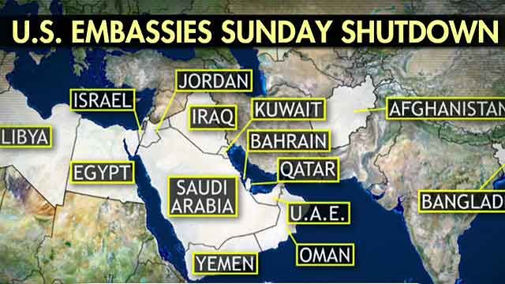
Source: http://www.foxnews.com/politics/2013/08/02/us-to-shut-down-american-embassies-around-world-as-terror-threats-grow/

The United States will temporarily shut down its embassies and consulates around the world Sunday -- including those in Iraq, Afghanistan and Egypt -- as a precautionary measure over terror-related concerns, State Department officials said.
State Department spokeswoman Marie Harf did not say how long the international installations would stay closed -- only that the decision was taken “out of an abundance of caution and care for our employees and others who may be visiting.” Officials would not describe the nature of the threat.
Sunday is a normal workday in many Arab and Middle Eastern countries, meaning that is where the closures will have an impact. Embassies in Europe and Latin America would be shuttered that day anyway.
“We have instructed all U.S. embassies and consulates that would have normally been open on Sunday to suspend operations, specifically on August 4,” a senior State Department official said Thursday night. “It is possible we may have additional days of closing as well.”
Other U.S. officials said the threat was specifically in the Muslim world.
The issue of security abroad has been prominent since the attack on the U.S. compound in Benghazi, Libya, and a string of demonstrations on other U.S. embassies in the Middle East and North Africa.
On Thursday, measures to beef up security at U.S. embassies were passed out of the Senate Foreign Relations Committee. The bill is in response to the Sept. 11, 2012 attack on the diplomatic post in Benghazi, Libya, where Ambassador Chris Stevens and three other Americans were killed.
The Senate bill creates a training center for diplomatic security personnel.
Separately, the House Foreign Affairs Committee authorized full security funding for diplomatic missions -- despite recommending a nine percent cut overall for State Department operations.
The House and Senate have already approved spending bills that cover embassy security. But their budgets differ markedly in other areas.

EDITOR’S COMMENT: Same applies for UK, French and German Embassies in Yemen. The overall reaction was a bit of surprise. I thought that we were winning the war against terrorism! And now a high level telephone conversation resulted in the closure of all these Emabassies. On the other hand is there big difference between an attack against an empty embassy compared with a similar action during working hours? And how long will they remain closed? What about the day after? I have written in the past that “virtual terrorism” is much more effective than real one! You make some plans on paper or you make telephone statements implying terrible actions and let security forces to discover them. That is enough to make everybody run like hell and cost nothing! But if this is the orchestrated reaction of strong nations what should the rest of us do? Find a deep hole and hide there for the rest of our lives? I thought we were on top of things but most probably I was wrong! I only hope that there is good internet connection below earth…

Security Failures in the Caribbean are Posing Serious Threats
By Jerry Brewer
Source:http://mexidata.info/id3671.html?goback=.gde_2311273_member_261449901

Defining the existing risks and threats to the nations of the Caribbean Basin and the United States needs to be more than mere words that scare, intimidate or simply cause one to turn the page and look at something more pleasant.
The dialogue must expand beyond astronomical homicide rates, gang and gun violence, illicit drug trafficking, kidnapping, extortion, human trafficking, and related violence.
What might the other threats consist of and how do they correlate?
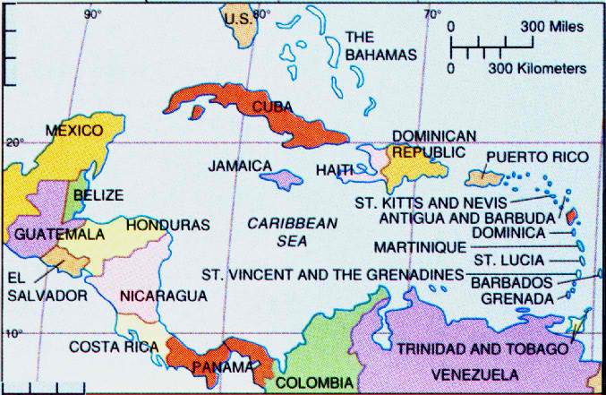
Actually, all of these have the potential to undermine hopes for socio-economic development, while they continue to increase corruption at many levels of government -- including the police and military. This form of criminality is driven by the spokes emanating from a hub of corrupt officials that grease the corridors for illicit behavior.
Within these powerful hidden enclaves of greed and power there are networks of facilitators, service providers and professionals in a blend of illegitimate and legitimate businesses that have actually crippled the development and progress of many nations within the region. Some have professed near social collapse and failed state status.
And it is within these diseased environments of criminality where governments and crime apparently embrace, where transnational organized crime flourishes with worldwide markets that far exceed the gross national product of many nations. This criminal convergence manifests itself through financial and cyber-crimes, and key sectors of economies that encroach upon and influence law and judicial sectors.
Enforcement and security is impacted beyond simple corruption with the quasi-legal facilitation by professionals providing opportunities and legal loopholes, as well as avenues for the laundering of massive illicit proceeds into a free market. The expertise of these unscrupulous and often complicit professionals hinders and undermines true justice.
Nations, especially in the Caribbean Basin that have thrived for decades with proceeds from tourism, have witnessed depleted government revenues from taxes and customs, slow economic growth, and decreased foreign investment due to organized crime.
Consequently, today more than ever, citizens and visitors alike must be shielded by a skilled and effective security infrastructure to help nations and jurisdictions across the hemisphere to reach their full economic and growth potentials. Defining and developing regional joint priorities and strategies to increase security and the safety of the public, while promoting social justice and justice sector reforms, must be top priorities. Too, there must be a keen focus on education, training and anti-corruption initiatives.
Drug traffickers from Venezuela have severely impacted anti-narcotics officials in the Dominican Republic. The National Drugs Control Agency (DNCD) exposed an alliance between military personnel and business interests in October of 2012, with 15 arrests that included the owner of a domestic airline. The Dominican Republic was used as a hub for drug trafficking that included payments to military and air traffic controllers. Six airplanes were also seized as part of the operation.
The corridor between the Dominican Republic and Puerto Rico has given rise to a more focused drug interdiction surveillance, mainly intended to monitor go-fast boats and other vessels.
Although the Royal Bahamian Police Force boasts of an aggressive crime prevention plan to "reduce violence and driving [sic] down the fear of crime," they clearly do not have sufficient resources to effectively patrol their vast chain of islands.
Over 4,000 keys, spanning the 4,800 kilometers of Cuban coastline, provide cover for speedboats and fishing vessels.
Puerto Rico and the US Virgin Islands have been labeled "high intensity drug trafficking areas (HIDTA)." As well, much of the drug interdiction concentrated on Venezuela and Colombia has shifted to drug air transportation routes from the Dominican Republic to the eastern Caribbean. Puerto Rico is a major commercial gateway to the US, both in terms of frequent air traffic and freighter shipments to mainland destinations.
Police Corruption in Puerto Rico has been rampant. The Justice Department recently pledged $10 million to the Puerto Rican government "to combat police corruption, extrajudicial killings and civil rights violations." Justice Department officials reported that from January 2005 to November 2010, there were more than 1,709 arrests of officers for charges that range from theft to murder and drug trafficking.
Transnational organized crime networks are diversifying and always expanding. They continue to destabilize countries and corrupt officials as they leave a trail of death and violence. They are primarily motivated by huge profits, power and prestige. These crime groups operate through fluid networks rather than more formal hierarchies, which provides them increased flexibility, low visibility, diversity and longevity.
The Caribbean Basin must be a strategic security priority, in which threats and risks have to be defined and properly assessed. Regional cooperation will improve the economic viability of the region, as well as the quality of life.

Jerry Brewer is C.E.O. of Criminal Justice International Associates, a global threat mitigation firm headquartered in northern Virginia.

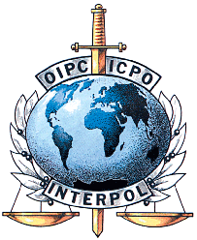
Interpol issues global alert following nine al Qaeda-linked prison breakouts
Source: http://www.homelandsecuritynewswire.com/dr20130804-interpol-issues-global-alert-following-nine-al-qaedalinked-prison-breakouts

Interpol, in a statement issued (Aug 3) from the organization’s headquarters in Lyon, France, urged law enforcement agencies around the world to show “increased vigilance,” following prison breakouts over the past nine month in nine countries, including Iraq (22 July), Libya (27 July), and Pakistan (31 July). More than 2,500 terrorists have escaped in these nine prison breakouts.
The Guardian offers details about the last three prison breakouts:
- About 500 convicts, among them senior al Qaeda operatives, escaped from Abu Ghraib prison in Iraq on 22 July
- More than 1,100 inmates broke out of a prison on the outskirts of Benghazi on 27 July
- More than 300 al Qaeda and Taliban prisoners escaped the prison in the city of Dera Ismail Khan, some 320 km west of Lahore,Pakistan on 31 July in a Taliban-led operation
Interpol, in a statement issued from the organization’s headquarters in Lyon, France, urged law enforcement agencies around the world to show “increased vigilance,” following prison breakouts over the past month in nine countries, including Iraq, Libya, and Pakistan.
“With suspected al Qaeda involvement in several of the breakouts which led to the escape of hundreds of terrorists and other criminals, the Interpol alert requests the organization’s 190 member countries’ assistance in order to determine whether any of these recent events are co-ordinated or linked,” Interpol said.
“Interpol is asking its member countries to closely follow and swiftly process any information linked to these events and the escaped prisoners. They are also requested to alert the relevant member country and Interpol general secretariat headquarters if any escaped terrorist is located or intelligence developed which could help prevent another terrorist attack.”
August is the anniversary of violent terrorist incidents in Mumbai, India and Gluboky, Russia as well as in Jakarta, Indonesia. This week also marks the fifteenth anniversary of the U.S. Embassy bombings in Nairobi, Kenya and Dar es Salaam, Tanzania in which more than 200 mostly African citizens were killed and 4,000 others injured.

Terrorism’s shifting face
By Juan Zarate and Thomas Sanderson
Source: http://washingtonpost.com/opinions/terrorisms-shifting-face/2013/08/05/e610e486-fde3-11e2-96a8-d3b921c0924a_story.html

The new threat warnings of an al-Qaeda-driven plot in the Middle East and North Africahave reminded Americans that the terrorist threat persists even though Osama bin Laden is dead and the core of al-Qaeda is decimated. They are also a timely wake-up call to the broader terrorist threat now entrenched throughout an “arc of instability” — from South Asia to West Africa, where our diplomatic posts have been closed because of the reported threats — that we can’t ignore.
The inability to grasp the gathering threat from al-Qaeda prior to Sept. 11 was deemed a failure of imagination. Given the globalized nature of terrorism and the ability of transnational terrorist, militant and criminal groups to collaborate and morph, we are now at risk of failing to imagine how the terrorist threat may be changing — well beyond the exclusive al-Qaeda prism.
The U.S. government has been surprised by terrorist adaptations including al-Qaeda affiliates and fellow extremist group plots aimed at an airliner flying over Detroit; New York’s Times Square; and Mumbai, India, where an American helped planned the 2008 attacks. Even the fact that the Boston Marathon attackers gained ideological grounding from the violent extremism in the Caucasus seemed to have caught officials and the public off guard.
Though the al-Qaeda core has been decimated, its regional affiliates have adapted — embedding themselves in local insurgencies such as al-Shabab in Somalia; supporting operations between groups, such as al-Qaeda in the Islamic Maghreb and Boko Haram in Nigeria; and engaging in criminality, including smuggling, drug trafficking, bank robberies and kidnapping in the Maghreb, Iraq, Southeast and Central Asia.
Militant groups in this arc of instability exploit havens where weak or corrupt governments have neither the will nor the capacity to constrain their reach. Our recent fieldwork in South and Central Asia — including in Afghanistan and Pakistan — reveals a patchwork of violent extremist groups, fractured yet adapting to wage international plots after years of U.S. counterinsurgency operations. They are waiting for the withdrawal of U.S. troops to energize a narrative of defeat of the world’s remaining superpower — equating 2014 to the Soviet withdrawal from Afghanistan in 1989. Meanwhile, the Internet amplifies terrorist ideologies and messages for a global jihadi community.
Perhaps the most worrisome development is that the Levant is now at the center of this instability. As turmoil, violence and disillusionment grip the region from Tunis to Baghdad, al-Qaeda’s ideological adherents have more political and physical space in which to adapt.
In Syria, al-Qaeda has a new cause to galvanize foreign fighters and fuel its mythology in the region central to its strategy. Groups fighting under the al-Qaeda banner, such as Jabhat al-Nusra, are learning from past mistakes and establishing social services — baking bread and mending wounds — to win the hearts and minds of their constituency. This contrasts with the alienating brutality of Taliban rule and the horrific campaigns by al-Qaeda in Iraq.
Dangerously, the fighting has stirred the historic Sunni extremist funding networks — supported by states and donors from the Arabian Peninsula — with calls from Sunni clerics to send money and manpower to fight Syrian President Bashar al-Assad and the Shiite “devils.”
We therefore cannot assume that the terrorist threat to the United States will manifest itself as it has in the past. Identifying threatening groups or cells will be difficult — as seen in Benghazi. Distinguishing between terrorism, local militancy and criminality will grow more challenging — as seen in West Africa. Predicting which affiliates or groups present an imminent threat to the United States may become a nearly impossible task — as seen in Yemen.

Recognizing the adaptations matters now
Leveraging regional alliances to constrict the reach of regional terror groups is essential. Law enforcement authorities need to aggressively pursue the terror-crime nexus. Our withdrawal from Afghanistan must be calibrated to account for the realities of emerging threats, not just the original threat that caused us to destroy the al-Qaeda haven. Ensuring that Syria does not become the locus for al-Qaeda’s rebirth should also be a principal policy goal, along with the fall of Assad.
The debate around the Authorization for Use of Military Force should address how we define the enemy and preserve the ability to fight whatever emerges from this cauldron of conflict. Just as President Obama was given the tools and strategies needed to fight al-Qaeda — and amplified many of them — his administration must continue to ensure that the country can adapt to looming threats.
Now is the time to shape a counterterrorism approach that is not simply reacting to battles of the past but preparing for the tide of threats that may reach our shores. The fight against the al-Qaeda core may be coming to an end, but we can’t blind ourselves to the terrorist adaptations already underway.

Juan Zarate is a former deputy national security adviser for combating terrorism.

Thomas Sanderson is the co-director of the Transnational Threats Project at the Center for Strategic and International Studies.

Three Things the New Terrorism Threat Does Not Prove
Source: http://swampland.time.com/2013/08/05/three-things-the-new-terrorism-threat-does-not-prove/

The current alert over a suspected al Qaeda terror plot, thought to originate from Yemen, has populated the television airwaves with spokesmen for various political agendas, many of them making arguments that range from tenuous to specious. Here’s a quick crib sheet on some of the most dubious claims you’re likely hearing amid the speculative chatter about what sinister plans al Qaeda may have up its sleeve:

1. The NSA’s entire surveillance program is essential
The New York Times is reporting that the current alert is based on an intercepted electronic communication between Pakistan and Yemen. On Sunday said the top Republican on the Senate Intelligence Committee that intercept was part of the NSA’s overseas activities permitted under Section 702 of the Foreign Intelligence Surveillance Act. But an Associated Press story Monday evening quotes an unnamed intelligence official saying that, in the AP’s words, “the controversial NSA programs that gather data on American phone calls or track Internet communications with suspected terrorists played no part in detecting the initial tip.”
Regardless, it seems clear that the agency’s bulk collection of telephone records for every call made within the United States did not play a role here. Even if the communication was a Section 702 intercept, it’s still might not have required the kind of vast overseas data collection the NSA conducts. For now, defenders of the NSA program should stick to arguing that this alert is a reminder that al Qaeda remains dangerous and that we need to maintain strong defenses, even at some cost to civil liberties.

2. Obama’s “weakness” has emboldened terrorists
Some conservatives have argued that Obama has effectively invited this latest terrorist stirring. Former GOP presidential candidate Rick Santorum says Obama has appeared “timid,” “refused to confront radical Islam” and “won’t even use the word terror.” Santorum allowed that Obama is conducting drone strikes, “but that is not a comprehensive policy against radical Islam.” Former Republican Senator Jim DeMint struck a similar note on Sunday, saying that al Qaeda may be a greater threat than it was before 9/11, in part because Obama has sought to “placate” enemies like Iran and Russia. “The perception of weakness in the administration is encouraging this type of behavior,” DeMint added.
Doubtful. Obama’s foreign policy vision has drawn credible critics and left even some allies frustrated. But chances are slim that al Qaeda really cares whether Obama tried to “reset” relations with Moscow or extend a hand to Tehran. The group’s affiliates in northern Africa and the Middle East are thriving amid the chaos of the Arab Spring, and through a smart understanding that they can be more deadly as semi-autonomous splinter groups now that al Qaeda’s group’s core leadership in Pakistan has been decimated (thanks, by the way, to Obama’s approval of a relentless–and controversial–drone campaign).

3. Obama prematurely declared the war on terror over
After Obama’s broad counter-terrorism address in May, which included modest new restrictions on U.S. drone strikes, conservatives were dismayed: “He has now declared the war on terrorism over,” groused House Armed Services Committee Chairman Howard “Buck” McKeon. Former U.N. Ambassador John Bolton charged that Obama had admitted “defeat” in the fight against al Qaeda.
No, he didn’t. Obama’s speech actually disappointed some liberals actually might like to see Obama declare an end to the terror war–not as a matter of defeatism, but as a step towards policies that rely less on killing and more on capture and prosecution in the criminal justice system.
Instead, Obama warned that the al Qaeda threat “has shifted and evolved from the one that came to our shores on 9/11.” As I noted on Friday, he went on to warn of more localized threats,” as he put it, “against Western diplomats, companies, and other soft targets.” In other words,exactly the kind of threat we facing today.
Perhaps overly inflated expectations with his frequent boasts during last year’s campaign about killing Osama bin Laden and putting al Qaeda “on the run.” But there’s very little sign he’s backed away from the fight against Islamic radicals. (Indeed, the U.S. carried out at least three drone strikes in Yemen late last month.) And why would he? Even if you suspect that Obama, in his gut, doesn’t like killing bad guys overseas, there’s almost nothing a rational president should fear more than presiding over a preventable terrorist attack. It’s silly for his critics to pretend otherwise.

Update: This item has been revised to reflect that the intercepted foreign communication was reportedly electronic and not a “call,” and some related language has been changed. It was further updated to reflect the AP’s subsequent reporting.

Friends, family key motivators for extremist behavior
Source: http://www.abc.net.au/news/2013-08-08/motivations-for-terrorist-radicalisation/4874082

A study of what motivates people in Australia to become terrorists has found friends and family are bigger factors than extremist material posted online.
The four-year project, carried out by Monash University and police, involved more than 100 interviews with extremists in Australia, Indonesia, Europe and North America.
Researchers also spoke to counter-terrorism experts to try to identify ways to prevent violent extremism.
They found Australian militants and terrorists frequently consulted and consumed online extremist material but other factors were more important in radicalising them.
Social networks of friends and family, including contact with people who had fought overseas or been to terrorist training camps, had a stronger influence.
Researcher Debra Smith says the way people join terrorist groups is similar to the way people get involved in other anti-social behaviour, such as drug use.
"It can be very normal people going through very normal processes, but they just happen to get emotional connection to somebody who is involved in violence," she said.
"It can just be frankly bad luck that they they happen to be involved with somebody who perceives violence as legitimate."
Another researcher who worked on the study, Shandon Harris-Hogan, says while terrorism is a relatively small problem in Australia, some people remain attracted to extremism.
"In Australia we haven't really had any example of individuals being recruited into networks," she said.
"We see the dynamic actually works the other way - that it's often people seeking out these kind of movements and individuals and drawing their own sort of social groups together, rather than anybody being actively recruited into terrorism.
"We need to always be alert to the possibility of Ander Breivik or Wade Michael Page from a right-wing ideology actually emerging from within the community."
Heavy-handed policing was found by the report to be a less effective response to countering radicalism than early intervention.
The research showed the prospect of radicalising individuals actually increased, rather than reduced, when "hard" responses were used.
Averting vulnerable people before their views were fully formed was found to better help prevent the slide into criminal behaviour.

Post sheds light on ASIO terror targets
Source: http://www.watoday.com.au/national/post-sheds-light-on-asio-terror-targets-20130810-2rp4y. html

Statistics released by Australia Post have revealed Australia's domestic security agency is concentrating its efforts on a very small number of terrorist and espionage targets.
The Australian Security Intelligence Organisation has been given a 10 per cent budget increase to nearly $370 million for this financial year and has just moved into new $700 million headquarters in Canberra that will house its more than 1700 staff.
But long-ignored statistics suggest that ASIO's primary counter-terrorism and counter-espionage caseload may be focused on as few as 50 suspects who are, or are likely to be, engaged in activity harmful to Australia's security.
Public reporting by Australia Post reveals that in 2011-12 the postal corporation made only 54 disclosures of addresses and other external postal details to the security agency.
Australia Post was not required to disclose to ASIO any ''specially protected'' information that includes the contents of letters and packages. ASIO may only access postal information including the contents of mail under warrants issued by the federal attorney-general.
ASIO does not disclose any statistics on mail interception, or the use of its other special powers that include phone tapping and the use of listening and tracking devices.
But Australia Post's reporting of disclosures of information to security, law enforcement and public revenue agencies provides an indicator of ASIO's operational activity.
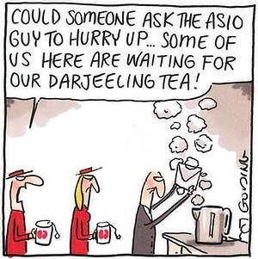
Australia Post statistics over the past 10 years show that ASIO's access to mail has been very limited, with only 57 disclosures in 2002-03, rising to 117 disclosures in 2005-06 and 266 disclosures in 2006-07, before falling to only 27 disclosures in 2010-11 and 56 in 2011-12.
Former ASIO officers who spoke on condition of anonymity said mail interception is of limited and declining cost effectiveness because electronic communication has reduced Australia Post's letter business, but is ''still important as part of comprehensive [surveillance] coverage of high priority targets''.
''Telecommunications interception and data analysis are very cost effective and efficient means of tracking where a person is and what they are doing, down to what they read and buy on eBay, but it can still be important to see what's going into their letter box,'' one former ASIO officer said.
The low level of ASIO mail interception is consistent with other indicators of ASIO's operational activity including a leaked US Embassy cable published by WikiLeaks that revealed in early 2010 ASIO recommended only 23 Australians suspected of terrorism links for inclusion on US no-fly and border-control watch lists. (Nine of the 23 people listed were overseas).
University of New South Wales academic and author of a history of ASIO, Associate Professor David McKnight said the Australia Post statistics suggested the security agency was focusing its investigatory powers on ''the tiny number of people who might wish harm to Australia's security''.
''The threat of terrorism has often been exaggerated, especially by politicians anxious to demonstrate their virility, though one must acknowledge that the potential damage from even one individual could be quite high,'' he said.
The Australia Post statistics show many other federal and state government agencies are still keen to read people's mail, with nearly 3479 disclosures of the contents of mail in 2011-12 and 4644 disclosures of addresses and other postal information.
Government agencies regularly accessing people's mail or else obtaining postal information include the Australian Federal Police and state police forces, the Australian Customs and Border Protection Service, the Australian Crime Commission and state anti-corruption commissions, the Australian Tax Office, Centrelink and Medicare, Australian Defence Force investigators, numerous state government departments and agencies, residential tenancies authorities, racing and gaming authorities, and the RSPCA.

How Colombian FARC Terrorists Mining Tungsten Are Linked to Your BMW Sedan
By Michael Smith (Bloomberg Markets Magazine)
Source: http://www.bloomberg.com/news/2013-08-08/terrorist-tungsten-in-colombia-taints-global-phone-to-car-sales.html

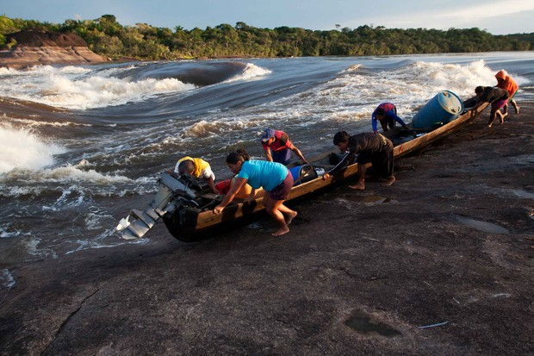
It’s a sweltering day in March, and Javier Garcia slogs through the dense undergrowth in a remote stretch of the Amazon jungle in southeastern Colombia.
He and a friend have hiked all day toward their goal, a mining site 100 kilometers from the nearest town. As the men hack through the thorny brush with machetes, following a narrow, muddy path, Garcia stops in his tracks.
Centimeters away, a venomous snake called four-noses coils up, poised to attack. Garcia says he will be dead within an hour if the pit viper strikes. His friend grabs a long stick and carefully flips the snake into the jungle. They move on, Bloomberg Markets magazine will report in its September issue.
Garcia, a Puinawai Indian, is exhausted. He has been traveling seven hours by boat and foot from Chorro Bocon, his village on the Inirida River. Finally, he and his friend arrive at a small clearing pocked with shallow holes gouged into the sandy, red ground. A torrential rain starts to fall.
Garcia, 30, squats by a stream, takes a shovel out of his pack and scoops dirt into a sifter made from a rusty screen.
Like gold prospectors, the men swish watery red mud around a flat wooden pan until pebbles containing a metal called tantalum appear.

‘Hard Work’
“It’s hard work but worth it,” Garcia says. Amazon Indians like Garcia, who inhabit a Denmark-sized region along the borders with Venezuela and Brazil, have for decades made a living exploring the rain forest for valuable rocks that contain tantalum and tungsten, both of which are used to manufacture smartphones and other mobile devices.
While the Indians do the digging, they rely on another, more powerful group to get the ore to market: the Revolutionary Armed Forces of Colombia, known as the FARC. The rebel army uses the cash it makes from selling metals to help finance one of the world’s longest-running guerrilla wars, the Colombian National Police say.
Garcia says he has mined metals during the past year for the FARC.
“People all over the world seem to want these little stones,” he says. He’s got that right. Tungsten, in particular, is in high demand.
The dark, heat-resistant and super-hard metal is inside the engines of some of the most popular cars in the world. It’s used for screens of computers, phones, tablets and televisions. It helps mobile phones vibrate when they ring. Semiconductor makers use the metal to provide insulation between microscopic layers of circuitry.

Tiger Hill
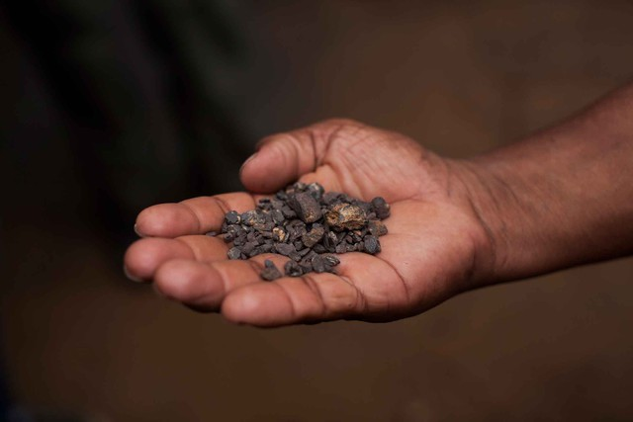
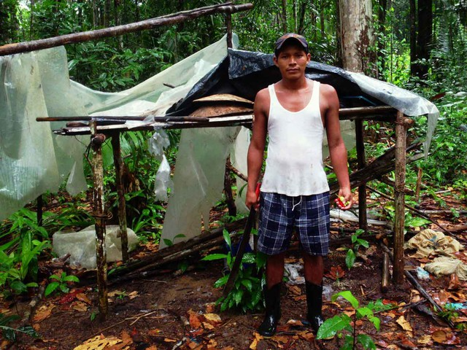
The FARC, in addition to charging Indians like Garcia for the right to mine, operates its own tungsten mine known as Cerro Tigre, or Tiger Hill. Garcia says he and a friend worked there in 2012, earning enough in a week to last several months at home.
Tiger Hill rises above the rain forest in an area ruled by armed FARC fighters more than 220 kilometers (137 miles) from the nearest road, town or police station. On top is the mine, where hundreds of people toil in 6 hectares (15 acres) of muddy pits, according to the National Police.
The mine is illegal in three ways: It’s inside a forest preserve, it’s banned by Colombian law because it’s on an Indian reservation, and it’s run by the FARC, which is classified by Colombia, the U.S. and the European Union as a terrorist organization.
“It’s completely illegal, but we haven’t been able to stop it yet,” says Colonel Luis Montenegro, the National Police commander in Guainia province, where the mine is located. “We don’t control any territory out there; FARC controls it,” says Montenegro, who has studied aerial surveillance photos of Tiger Hill.

LCD Screens
The mine can produce 15 metric tons of wolframite, a rock containing tungsten, in a week, police say. That’s enough to make tungsten parts for hundreds of thousands of liquid-crystal-display screens, smartphones and semiconductors, car parts and pens, according to the International Tungsten Industry Association.
While Tiger Hill is illegal, it’s the only known tungsten mine in Colombia, according to the police and Environment Ministry officials responsible for regulating mining.
And that metal is finding its way onto world markets. Colombia, the third-largest economy in South America, supplied less than 1 percent of the world’s tungsten in 2012, U.S. Geological Survey data show.

Finding Tungsten
Although China produces the most tungsten -- about 85 percent of global output -- authorities there impose tight controls on the metal to assure domestic manufacturers have enough. That’s forcing companies to scour the globe for mines elsewhere, the USGS says.
One company that buys and processes Colombian wolframite, or tungsten ore, supplies some of the world’s leading multinational corporations -- including the makers of BMWs, Ferraris, Porsches and Volkswagens as well as Siemens AG and the producer of BIC pens, these companies say.
Apple Inc., Hewlett-Packard Co. and Samsung Electronics Co. purchase parts from a firm that buys from the company that imports tungsten ore from Colombia, company records show.
Since 2008, there have been 40 shipments of tungsten ore from Colombia by 14 companies, according to government export documents. Although none of the records from these shipments say the tungsten ore comes from FARC-run Tiger Hill, Colombian authorities are convinced that it does.
Cesar Melendez, the Environment Ministry’s director whose jurisdiction includes much of Colombia’s Amazon region, says the shippers are hiding the tungsten ore’s true origins.

‘Launder Tungsten’
“They falsify the source of illegal metals,” Melendez says. “This is how they launder tungsten.”
Buyers negotiate with FARC guards to purchase loads of the ore, according to national and regional police commanders, government officials who oversee mining and interviews with people involved with those transactions.
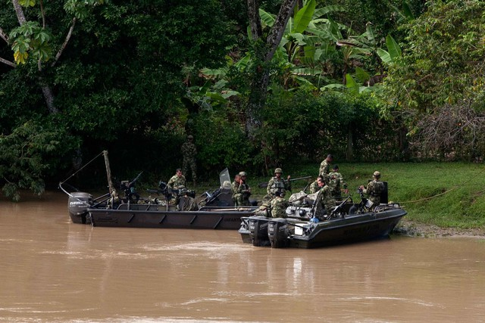
Workers then transport the ore in boats in a weeklong journey -- braving treacherous rapids and police patrols -- from the mine to muddy river landings near San Jose del Guaviare, a city on the edge of the Amazon. Once near San Jose, smugglers load sacks of the rocks on trucks headed for Bogota and later for the Caribbean port of Santa Marta in northern Colombia.
One of the biggest buyers of Colombian tungsten ore has been a U.S. unit of Plansee SE, a Reutte, Austria-based metals processor, according to export records filed with Colombia’s tax agency. In 2012, two Colombian minerals companies, Geo Copper SAS and Minerak SAS, sold seven loads of tungsten ore totaling 93.2 metric tons to Plansee’s U.S. subsidiary, Global Tungsten & Powders Corp., export records show.

Refined Powder
The filings say the Colombian companies shipped the tungsten ore -- valued at $1.8 million -- to Global Tungsten’s plant in Towanda, Pennsylvania, which makes refined powder, wires and chemicals.
On July 2, five days after a Bloomberg Markets reporter questioned Plansee about the FARC origins of its Colombian tungsten ore, Global Tungsten & Powders issued a news release saying it would stop buying tungsten ore from Colombia.
“The tungsten minerals from Colombia may have been mined illegally,” the statement said.
The company said it hadn’t been aware of that possibility until it had been provided information “by a reliable source.” The release said, “Armed groups may be exerting influence over the tungsten mining sites and/or transportation routes.”

Central Africa
Multinational companies that buy parts from a supply chain tainted by Colombian tungsten ore have publicly sworn off the purchase of minerals from another conflict-ridden country, the Democratic Republic of Congo, in Central Africa. For the past 15 years, rebel groups in that country have sold metals to help fund a war against the government, the United Nations says.
As part of the 2010 Dodd-Frank law, the U.S. Securities and Exchange Commission will require publicly traded companies to follow UN guidelines and disclose by May 31, 2014, whether they’re buying gold, tin, tungsten or tantalum from mines that finance war in Central Africa.
There are no such rules for minerals that fund the conflict in Colombia. The FARC is a Marxist group that has taken control of remote mountainous and jungle regions of Colombia and wants to overthrow the elected government.
The rebels say they seek to impose a Cuban-style communist state, break up rural land holdings and expropriate private industry. The FARC has waged a 50-year war, funding itself with cocaine trafficking, extortion, kidnapping and mining, the National Police say. The war has killed 257,000 people and, according to the UN, displaced 3.7 million.

‘It’s Alarming’
As international groups have been monitoring whether companies are buying so-called conflict minerals from Central Africa, there have been no alerts about metals from Colombia, says Sophia Pickles, an investigator for London-based nonprofit group Global Witness.
“It’s alarming this is happening in Colombia,” she says. Pickles has spent five years documenting the role of minerals in financing war in Central Africa. “Conflict scenarios anywhere in the world should raise alarm bells. It’s a very basic principle.”
Companies that have bought parts from a supply chain that included tungsten ore from Colombia say they had been unaware of any possible links to the FARC before they were contacted by Bloomberg Markets. Apple, BIC, BMW, Ferrari, Samsung and Volkswagen say they’re opening investigations to secure their supply lines.
“Apple is committed to using conflict-free minerals, and we are one of the first electronics companies to map our supply chain for conflict minerals,” spokeswoman Kristin Huguet says.

Cocaine Trade
Mining revenue has helped ease the FARC’s loss of control over much of the cocaine trade in Colombia since a U.S.-backed military offensive began in 2002. That effort has cut the FARC’s strength to about 8,000 troops from 18,000, the Colombian government says.
The FARC has been routed from some cocaine-producing regions, depriving it of funds, Colombian President Juan Manuel Santos says.
“They finance themselves more and more with illegal mining,” Santos told Bloomberg News in a December interview in Bogota.
Santos, 62, a Harvard University and London School of Economics-trained economist, took advantage of the FARC’s military defeats to start peace talks in October 2012, two years into his presidency. Government officials and FARC commanders negotiating in Havana, Cuba, have six major items on their agenda, including land use in FARC territory.

19 Killed
Despite government efforts to end the violence, FARC guerrillas ambushed and killed 15 Colombian soldiers who were guarding oil pipelines on July 20, the Santos administration says. On that same day, 750 kilometers southwest of that attack, FARC rebels killed four other Colombian officers who were on patrol.
The FARC’s mining shows how illegal forces continue to wield economic power in one of the most attractive destinations for investors in the developing world. Foreign investment and natural resource exports have helped Colombia’s gross domestic product almost quadruple from 2002 through the end of 2012 to $366 billion, according to the International Monetary Fund.
In May, the Colombian National Prosecutor’s environmental crimes unit opened an investigation into companies that may be buying tungsten ore from Tiger Hill after learning about Bloomberg Markets’ reporting.
Although police and prosecutors have long been aware the FARC is illegally mining, there have been no previous probes into the companies that buy ore from Tiger Hill.

‘Very Seriously’
“We are taking this very, very seriously,” says Gloria Arias, the prosecutor who runs the division that probes illegal mining. “This clearly seems to suggest how a terrorist group can launder minerals.”
One Colombian company that has exported tungsten ore is Cali-based Geo Copper, export records show. Geo Copper Chief Executive Officer Edgar Rengifo, who describes himself as a self-taught mining entrepreneur, helped create the company in August 2010.
Minerak, the other Global Tungsten & Powders supplier in Colombia, was 50 percent owned by Geo Copper when it was started in 2011. Rengifo says the tungsten ore the two companies export comes not from Tiger Hill, but from a licensed mine that Geo Copper co-owns, called Caney de los Cristales, located about 150 kilometers west of Tiger Hill.

‘Only Mine’
“Caney is the only mine where you can export in this country,” Rengifo says. “The only legal title.”
The Caney mine is licensed by the National Mining Agency and Environment Ministry to produce black sands, which are defined as materials that can contain minerals such as tantalum, titanium iron oxide and tungsten, according to licensing documents filed in Bogota.
Although Caney is licensed to produce tungsten ore, no exports are coming from the site -- according to Colombian officials. The National Police, the army and the Environment Ministry say Geo Copper’s tungsten ore actually comes from the FARC’s mine.
“All of that came from Tiger Hill because there is nowhere else producing that metal,” environmental official Melendez says. “And all of it is illegal.”
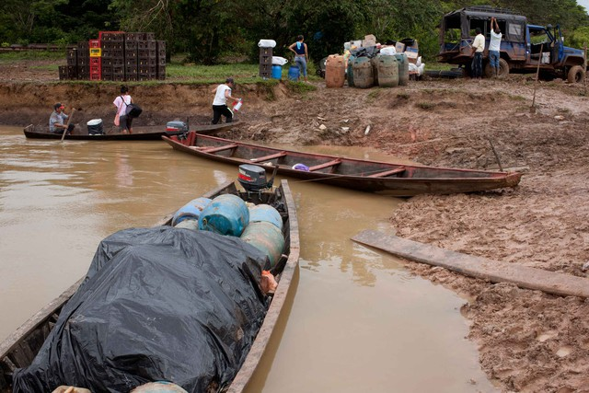
In late January 2010, Rafael Alberto Rodriguez, the primary owner of the Caney mine, invited National University of Colombia professor Thomas Cramer to evaluate its potential. Cramer sent three geology students to the Caney mine site to collect rock samples.

No Tungsten
They analyzed the rocks in university laboratories and published their findings in June 2012. “We didn’t find any sign of tungsten there,” Cramer says.
The underlying rock in the area is called gabbro, which doesn’t contain tungsten, Cramer says. The survey shows the site contains rocks with small amounts of titanium iron oxide and sandstone rock formations.
Colonel Javier Alvarez, the National Police commander in Vichada province, where Caney is located, says aerial photographs and investigations show no signs of a major mining operation there.
“I can tell you there’s nothing there,” Alvarez says.
The FARC, founded in 1964, is one of the world’s longest-surviving guerrilla forces. By the early 2000s, the FARC had taken control of swaths of Colombia’s lower Andes Mountains, jungles and central plains.
In 2002, a FARC unit launched a mortar attack on the presidential palace in Bogota as Alvaro Uribe was being sworn in as president. At least 14 people were killed, police say.

Remote Jungles
FARC spokesman Jesus Emilio Carvajalino didn’t return repeated requests to comment for this story.
Since 2002, the military has pushed the bulk of the FARC’s forces to remote jungles of eastern and southern Colombia, where there are few roads, airstrips, towns or military bases.
One such FARC stronghold is Guainia, the province where Tiger Hill is located. Montenegro, the National Police commander in Guainia, says the government hasn’t been able to stop illegal mining because Tiger Hill is in such a dangerous and difficult-to-traverse region of the jungle.
The mine is guarded by 170 elite FARC troops, Montenegro says. He says police are also worried that local Indians who mine for the FARC would be harmed in an assault on Tiger Hill.
“We want to mount an operation there, but it is very, very complicated because it’s on Indian land,” Montenegro says.

Air Surveillance
The police have been limited to monitoring Tiger Hill by air and gathering information from miners and FARC deserters. Since 2010, the police have seized 29.7 tons of minerals suspected of coming from Tiger Hill, Environment Ministry records show.
Andres Lopez, an evangelical Christian minister who lives in Zamuro, a Curripaco Indian village, says he has been to Tiger Hill before. He says he had to abide by the FARC’s work rules, including giving the group a cut of every kilogram of tungsten ore he mined.
“The guerrillas are in charge of everything, even on our land,” Lopez, 55, says. “They try to show us respect on our ancestral land, but you still have to do what they say.”
Two hours down river from Lopez’s village on a steamy day in mid-March, Sergio Varon, a leader of a miner’s association, and three other men heave an 8-meter (26-foot) boat along the rocky shore of the Inirida River.
They’re headed to Tiger Hill. Drenched in sweat, the men drag the heavy motorboat along the shore, next to rapids where swells crash on huge rocks, creating whirlpools big enough to engulf their craft. After getting past that danger, they push the boat into calm waters upstream.

Hauling Boat
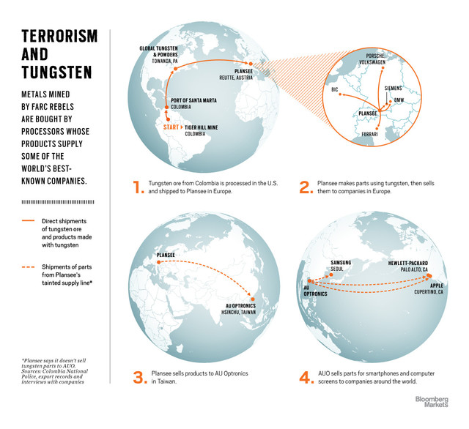
Varon, 26, says the men will have to haul the boat and everything in it -- fuel, food and a 65-kilogram (143-pound) outboard motor -- around six more patches of rough water before they get to Tiger Hill.
On the fourth day of the journey, the crew meets a group of workers heading in the other direction, pushing a boat on the shoreline to avoid rapids. Members of that group say they’re returning from Tiger Hill.
The next day, an Indian leader warns a Bloomberg Markets reporter and a photographer that he’d just spotted an armed, seven-man FARC combat patrol in a cove about 20 minutes upriver. The commander of that unit had sent word to the Indians that the journalists would be violating a military order if they continued to Tiger Hill.
“That makes you a target, so it would be very, very dangerous for you to go,” the Indian leader says. The journalists and miners turn back.

Geo Copper
Varon says he has been to Tiger Hill before at the behest of a man working for Geo Copper, the exporter that says it has made no purchases from the FARC-controlled mine.
In 2011, Raul Linares, then working for Geo Copper CEO Rengifo, sent Varon on a trip to buy tungsten ore, Linares says. Varon and three other men got to Tiger Hill on April 4, 2011, Varon says. Photos from the trip show denuded jungle and miners sitting in gaping, water-filled holes, panning for metals.
Linares says they negotiated a deal with the FARC soldiers overseeing the mine. Linares says he agreed to pay 6,000 pesos ($3.14) per kilogram of tungsten ore to the miners who FARC had authorized to sell. Receipts from April 2011 chronicle 30 separate ore purchases, totaling 52.3 million pesos.
After buying the tungsten ore, the men had to find a way to smuggle it out of the jungle. “We wanted a new route because police were seizing lots of minerals along the river,” Linares says.

Boat, Truck
Once the miners made it out of the jungle with the ore, another crew took the rocks by boat and truck to a Geo Copper warehouse in Bogota, 1,000 kilometers away from the jungle, Linares says.
Rengifo says he didn’t hire Linares to buy tungsten ore from the FARC. Linares’s job was to negotiate with Indian leaders to set up a tin mine on their reservation, Rengifo says.
Linares says Rengifo did ask him to help establish a tin mine. He says his job also was to buy tungsten ore for Geo Copper at Tiger Hill.
“Of course it comes from the FARC mine,” says Linares, 53, speaking at his home in Puerto Inirida, the city closest to Tiger Hill. Bags of tungsten ore are piled in the corner, and a fan rattles away, scattering moldy papers that document work Linares did for Rengifo’s companies. “I know because it was my job to help them get tungsten.”
Regarding the tin mine plan, Linares says, “I quit when I figured out what they really wanted. They wanted to rob the Indian communities.”

Country Club
Rengifo, 46, says his company buys tungsten ore only from the non-FARC Caney mine, which Geo Copper co-owns. Sitting in his office in an apartment building overlooking a country club in Cali, 300 kilometers from Bogota, he says he didn’t falsify the source of the tungsten ore he has exported.
“If we were using a front, we would export more because people offer me minerals every day,” he says.
One place where smugglers load tungsten ore onto trucks bound for Bogota is a muddy landing on Big Creek called Julio Cruz in Guaviare province.
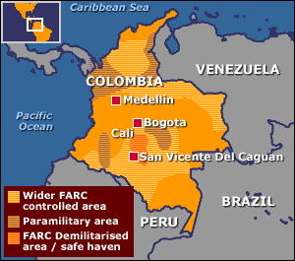
Eduardo Lopez, a porter at the landing, says he helped move 22 tons of tungsten ore that arrived in April onto trucks. The boat captain told him the rocks came from Tiger Hill, says Lopez, 32, resting after hauling supplies onto a boat in the driving rain. Lopez says the truck drivers had papers saying that the ore had been legally mined.

‘FARC Mine’
“Those stones come in all the time,” Lopez says. “They come from the FARC mine.”
(The night after Lopez was interviewed, a Bloomberg Markets reporter encountered a former U.S. soldier in Hotel Las Palmas in San Jose del Guaviare. The veteran, Kevin Sutay, said he planned to hike through the jungle. Hotel employees and police warned him not to go because the region was controlled by the FARC. Five days later, Sutay was kidnapped by FARC guerrillas in the same area where Lopez had been working.)
Plansee, the Austrian company that buys tungsten ore from Geo Copper, supplies leading European automakers. Bayerische Motoren Werke AG, Ferrari SpA, Porsche AG and Volkswagen AG say they buy engine crankshaft parts made of tungsten from Plansee.
Siemens, Europe’s largest engineering firm, says it buys tungsten parts used in X-ray machines called stationary anodes and focal tracks from Plansee. Munich-based Siemens spokesman Matthias Kraemer declined to comment, other than confirming his company buys these tungsten parts from Plansee.

BMW, Ferrari
Munich-based BMW Group spokesman Frank Wienstroth says his company works hard to avoid purchasing anything from tainted suppliers.
“These few grams out of the billions of tons of raw materials passing through the BMW supply chain are of no practical relevance,” he says.
Maranello, Italy-based Ferrari spokesman Stefano Lai confirmed his company buys parts made with tungsten from Plansee and had no further comment. Wolfsburg, Germany-based Volkswagen and its Porsche unit don’t tolerate conflict minerals, VW spokesman Christoph Adomat says.
“We take all information concerning possible infringements very seriously,” he says. “Plansee is a company that supplies Volkswagen with small quantities of tungsten components such as wires for welding or balancing weights.”
Societe BIC SA spokeswoman Priscille Reneaume says the pen maker buys tungsten carbide pellets for ballpoint pens from Plansee unit Ceratizit SA, based in Mamer, Luxemburg. Reneaume says Clichy, France-based BIC will immediately investigate its supply chain and stop buying any material coming from conflict minerals.

Sputtering Targets
Privately held Plansee says on its website that it makes so-called sputtering targets, which are microscopic layers of metals used in screens for smartphones, computers and televisions.
“We recently succeeded in manufacturing the largest single-piece tungsten sputtering target on earth,” the website says. “Wherever you go and touch any devices, you have a relatively high chance that somewhere or somehow Plansee is involved,” Plansee spokesman Denes Szechenyi says.
He declines to name any of the company’s customers.
One link between Plansee and global technology supply lines is AU Optronics Corp., Taiwan’s second-largest maker of liquid-crystal displays. AUO buys sputtering targets from Plansee and sells screens to Apple, Hewlett-Packard and Samsung, according to company documents.

Not Tungsten
Plansee told AUO in a June 27 letter that it sells the Taiwanese company products made with molybdenum, which isn’t a conflict mineral, instead of tungsten. Plansee wrote the letter on the same day Bloomberg Markets asked the company about its Colombian ore purchases.
AUO spokeswoman Katie Chen says the company trusts that Plansee sold it no parts made with tungsten.
“We have declared to our suppliers that we do not accept illegally mined minerals from conflict regions and will continue to do so,” Chen says.
AUO’s supply chain is tainted because it does business with a company that buys minerals from a conflict zone, says Peter Rosenblum, a human rights and international law professor at Bard College in Annandale-on-Hudson, New York.
AUO should be concerned even if it isn’t buying the specific metal sold by the FARC, says Rosenblum, who formerly directed human rights programs at Columbia University and Harvard University. He studies the use of conflict minerals.

‘Corrupt Practices’
“A company’s supply chain is contaminated when it is profiting from conflict minerals,” he says. “You wouldn’t do business with a company that is known to be engaged in corrupt practices somewhere in the world.”
Cupertino, California-based Apple started an investigation after being informed of Bloomberg Markets’ findings and before Global Tungsten & Powders announced it would stop buying from Colombia, spokeswoman Huguet says.
Samsung has opened its own investigation of its supply chain, spokeswoman Eunhee Lee says.
“Samsung strongly supports the ban on conflict minerals,” Lee says. “We are urgently looking into this matter and will take appropriate measures.”
AUO’s annual report lists Samsung Electronics as one of its five biggest customers. In the past year, Palo Alto, California-based Hewlett-Packard bought screens from AUO for its All-In-One Business PC, according to HP’s website. “HP continues to work closely with its suppliers to improve their social and environmental performance,” company spokeswoman Kelli Schlegel says.

Red Earth
Sixty-one hundred kilometers away from the glistening buildings of Silicon Valley, miners in Colombia’s Guainia province dig for tungsten ore on FARC-controlled land. The minerals they extract from the red earth help feed the world’s voracious appetite for luxury cars, smartphones and computers.
Neither the Colombian government nor the world’s most powerful corporations have been able to stop a trade that has helped fund a half-century-long war.
Raul Linares, who has been a miner in the Colombian Amazon jungle for most of his adult life, says illegal activity thrives because no one outside the nation has bothered to notice.
“The FARC and these companies have built an incredibly profitable business,” Linares says. “And the world is buying it.”

Sochi Olympics security: 'We have very serious safety concept' - Sports Minister Mutko
Source: http://voiceofrussia.com/2013_08_16/Sochi-Olympics-security-We-have-very-serious-safety-concept-Sports-Minister-Mutko-6895/

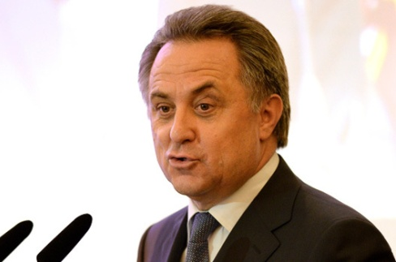
A terrorist threat looms large over Sochi as it prepares to host the 22nd Winter Olympics in 2014, despite the safety precautions the Russian government is putting in place. That’s what the Washington Post wrote with an obvious touch of malice in the middle of this summer. "Intelligence analysts" polled by the newspaper made a startling "revelation", saying that participants and guests of the Sochi Games may see their peace and quiet disrupted by radical Islamists from the North Caucasus and that it takes little experience to build a simple, yet fairly effective explosive device.
The April bomb attacks at the finish line of a marathon race in Boston were referred to as an example. The Boston bombing suspects, the Tsarnayev brothers, had made a pair of bombs from gun powder and pressure cookers, according to the FBI. The tone of the article and the triviality of the arguments cited by the so-called analysts suggest that the newspaper was just looking for a pretext to take a jab at Russia.
Nevertheless, Moscow perceives the Boston bombings, with all due seriousness, as an alarm bell not to be ignored. "Naturally, we are beefing up security. It earns us a snarl from our foreign colleagues sometimes, but that’s what the world is like. We have a very serious safety concept," Sports Minister Vitaly Mutko said. He acknowledged, however, that it’s hard to completely rule out terrorism. The athletes, organizers and personnel undergo special security checks, but there are visitors and fans and "here serious work needs to be done", Mutko said.
Interior Minister Vladimir Kolokoltsev, for his part, deemed it inappropriate to draw a comparison between the Boston marathon and the Olympic Games in terms of security. The level of special security measures that are now being taken in Sochi is incomparably higher. "As for the sad experience of Boston, our effort and our degree of readiness are incomparable," he said.
The Russian police started preparing for the Olympics when the construction of sports facilities in Sochi was only just beginning. The security system meets the demands and recommendations of the International Olympic Committee (IOC).
A special Olympic security police headquarters was set up. In November 2012 and February 2013, it mapped out the areas, both on land and at sea, where tighter security measures are to be introduced for the period of the Olympics. Some of those measures are already in place. The Sochi police have been on higher alert since June 1, 2013. That was one of the additional measures proposed in the wake of the Boston bombings, although the Russian law enforcers have their own experience and reasons to stay alert.
In May 2012, the federal counter-intelligence agency FSB in cooperation with its colleagues from Abkhazia (Sochi is within several kilometers of the Abkhaz border) neutralized a terrorist group. Three people were arrested and ten arms caches were seized. The caches contained three portable Igla and Strela surface-to-air missiles, a mortar and 36 mortar rounds, a Shmel flame thrower, 29 grenade launchers, 15 anti-personnel mines, 12 homemade bombs, a sniper rifle, two submachine guns, 15 kg of trotyl and more than 10,000 rounds of ammunition. The National Anti-Terrorist Committee of Russia said in an official statement that Islamist militants had been plotting to move all those weapons to Sochi for subsequent terrorist attacks during the Olympic Games. Intelligence reports indicate that Georgian secret services and Chechen militant leader Doku Umarov were involved in the plot. The Boston pressure pots pale in comparison to that.
Advanced technologies will be put to work to ensure that nothing will disturb the smooth running of the Olympic events. Unmanned aircraft will fly 24-hour surveillance missions over Sochi and the adjoining areas, high-speed boats will patrol the coastal waters, while mobile robots will search the sports venues for explosives. The mass movement of fans will be easy to monitor thanks to special ID cards, the so-called "fan’s passports".
"We are always ready to adopt advanced experience," Interior Minister Kolokoltsev said. "Our experts travelled to a number of countries and cities where major international sports competitions were held - to Vancouver and Turin, Brazil and China, Warsaw and London."
FSB deputy chief Vladimir Kuleshov told reporters that emphasis would be on making sure that the athletes and fans and, of course, the residents of Sochi feel comfortable during the Games. "There will be no extraordinary security measures," he said, "but our Russian laws will be enforced to enable everyone to feel at home at the Winter Olympics," he said.
Significantly, IOC President Jacques Rogge said after one of his inspection tours of Sochi that he did not doubt Russia’s ability and potential to guarantee that the Olympics will be safe.

Al Qaeda 'targeting European high-speed rail'
Source: http://www.dw.de/al-qaeda-targeting-european-high-speed-rail/a-17028535

Al Qaeda has been plotting attacks on high-speed rail networks in Europe, according to a German media report. The information reportedly came from the US National Security Agency (NSA) listening in on top operatives.
A report by the German daily newspaper Bild on Monday said that al Qaeda leaders have been plotting attacks on high-speed rail networks across Europe.
The group was possibly targeting trains and tunnels or planning to sabotage railway tracks themselves and the electric cabling serving them.
The terrorist attacks were reported to have been a "central topic" of a conference call intercepted by the NSA, involving high-ranking al Qaeda operatives.
German authorities were said to have responded with "unseen measures" such as deploying plain-clothed police officers at main stations and along major routes, the newspaper said.
According to US media reports, a conference call involving al-Qaeda leader Ayman al-Zawahiri and some 20 of the group's operatives was intercepted by intelligence services. On August 1, the US issued a worldwide alert about a terror plot in the Middle East or Africa.
The warning prompted the closure of 19 US embassies, with missions in Yemen viewed to be under the greatest threat. US allies, including Germany, closed diplomatic buildings for almost two weeks.

EDITOR’S COMMENT: This article comes as a possible answer to a question alredy set in current issue of the Newsletter…

Terrorists turn to online chat rooms to evade US
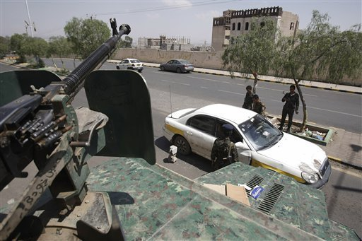
This Aug. 10, 2013 file photo shows Yemeni soldiers inspecting a car at a checkpoint on a street leading to the U.S. and British embassies in Sanaa, Yemen. In secretive chat rooms and on encrypted Internet message boards, al-Qaida fighters have been planning and coordinating attacks _ including a threatened if vague plot that U.S. intelligence officials say closed 19 embassies across Africa and the Middle East for more than a week (HANI MOHAMMED, FILE — AP Photo)

By Adam Goldman and Lara Jakes (The Associated Press)
Source: http://www.thestate.com/2013/08/14/2919105/terrorists-turn-to-online-chat.html

Al-Qaida fighters have been using secretive chat rooms and encrypted Internet message boards for planning and coordinating attacks — including the threatened if vague plot that U.S. officials say closed 19 diplomatic posts across Africa and the Middle East for more than a week.
It's highly unlikely that al-Qaida's top leader, Ayman al-Zawahri, or his chief lieutenant in Yemen, Nasser al-Wahishi, were personally part of the Internet chatter or, given the intense manhunt for both by U.S. spy agencies, that they ever go online or pick up the phone to discuss terror plots, experts say.
But the unspecified call to arms by the al-Qaida leaders, using a multi-layered subterfuge to pass messages from couriers to tech-savvy underlings to attackers, provoked a quick reaction by the U.S. to protect Americans in far-flung corners of the world where the terror network is evolving into regional hubs.
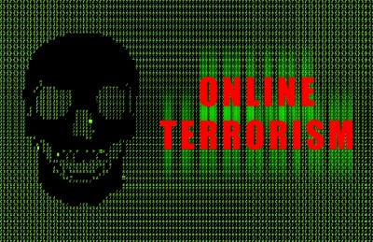
For years, extremists have used online forums to share information and drum up support, and over the past decade they have developed systems that blend encryption programs with anonymity software to hide their tracks. Jihadist technology may now be so sophisticated and secretive, experts say, that many communications avoid detection by National Security Agency programs that were specifically designed to uncover terror plots.
A U.S. intelligence official said the unspecified threat was discussed in an online forum joined by so many jihadist groups that it included a representative from Boko Haram, the Nigerian insurgency that has loose and informal ties to al-Qaida. Two other intelligence officials characterized the threat as more of an alert to get ready to launch potential attacks than a discussion of specific targets.
One of the officials said the threat began with a message from al-Wahishi, head of the Yemen-based al-Qaida in the Arabian Peninsula, to al-Zawahri, who replaced Osama bin Laden as the core al-Qaida leader. The message essentially sought out al-Zawahri's blessing to launch attacks. Al-Zawahri, in turn, sent out a response that was shared on the secretive online jihadi forum.
All three intelligence officials spoke on condition of anonymity because they were not authorized to discuss the threat.
Rita Katz, director of the Washington-based SITE Intelligence Group that monitors jihadist websites, said it's all but certain that neither al-Zawahri nor al-Wahishi would communicate directly online or on the phone.
Al-Zawahri's location is unknown, but he was last believed to be in Pakistan, and al-Wahishi is said to be in Yemen. Given the nearly 2,000 miles between the two men, Katz said it's most likely they separately composed encrypted messages, saved them on thumb drives, and handed them off to couriers who disseminated them on secure websites.
Bin Laden, who was killed in May 2011, issued his messages in much the same way.
"These guys are not living in a bubble," said Katz, who has been watching al-Qaida and other jihadi communications for years. "They live in a reality that is facing the American intelligence interception with the best, most advanced technology that can be created. So they always try to find ways to get away from these interceptions to be able to deliver messages."
She added: "I am sure they are delivering messages, through the message boards or by sending emails that are encrypted. But there is no way in my mind that Zawahri or Wahishi have access to the Internet, and I think Wahishi, at this stage of his life, is even afraid of going outside."
Tracking and eliminating al-Qaida operatives in Yemen hasn't been easy for the U.S. It took years for the CIA finally to kill the cleric Anwar al-Awlaki in a drone strike after an intense manhunt. By staying off the grid, al-Wahishi and other senior al-Qaida leaders in Yemen such as Qassim al-Rimi and top bomb-maker Ibrahim Al-Asiri have managed to remain alive. So frustrated was the CIA at one point, the spy agency considered killing the couriers passing messages in an attempt to disrupt the terrorist group's plans, said a former senior U.S. official.
The idea was dropped because the couriers were not involved in lethal operations.
Exactly how U.S. spy systems picked up the latest threat is classified, and Shawn Turner, spokesman for U.S. National Intelligence Director James Clapper, refused to confirm or deny Katz's analysis on how it might have happened. Intelligence officials have suggested that the plot was detected, in part at least, through NSA surveillance programs that have been under harsh worldwide criticism for privacy intrusions in the name of national security.
It's not clear, however, that even the powerful U.S. spy systems would be able to crack jihadists' encrypted messages without help from the inside.
Earlier this year, an al-Qaida-linked extremist propaganda organization known as the Global Islamic Media Front released an encrypted instant-messaging system known as "Asrar al-Dardashah," or "Secrets of the Chat." It was a texting version of the organization's end-to-end encryption program that followers had been using for years. End-to-end encryption means messages are put into code so that only senders and receivers can access the content with secure "keys."
After the NSA programs were revealed in June, jihadi websites began urging followers to also use software that would hide their Internet protocol addresses and, essentially, prevent them from being tracked online. That aimed to add another layer of security to the online traffic.
An Aug. 5 discussion about the U.S. embassy closings on a jihadi forum that is directly linked to al-Qaida underscored the need for "complete secrecy" in plotting attacks even while jeering the American response to the message between al-Zawahri and al-Wahishi.
In a post on the Shumukh al-Islam online forum, a writer who identified himself as Sayyed al-Mawqif noted American news reports that said the terror threat possibly was intercepted though phone calls or surveillance of jihadist chat rooms or message boards. Shumukh al-Islam is not an encrypted site, but it requires a password to access and does not frequently accept new visitors.
"Even if there will not be a jihadi operation, it is sufficient that the mujahideen brothers succeeded in putting fear in the hearts of the disbelievers and the human devils," al-Mawqif wrote, according to a SITE translation of the transcript. "We hope to hear more about psychological wars like this one if there are no actual jihadi operations on the ground."
Encryption technology was once regulated by the U.S. for national security purposes, but it has been available to the public and used globally since the 1990s, including by human rights and free speech advocates.
"You can encrypt things in such a way that you can assume that even the NSA can't undo them — there's no back door," said Dan Auerbach, a technology expert at the Electronic Frontier Foundation, which is challenging NSA eavesdropping in federal lawsuits.
"We think it is very important to have tools for privacy," Auerbach said. But "when you develop a strong privacy-enhancing tool, it will help everyone - and this may include people considered by many to be 'bad guys.'"
Other technology experts believe the government could access encrypted messages — with the help of Internet providers.
Depending on what software is used, Internet providers theoretically could be compelled to send the coded messages and their decryption keys to the government instead of to the intended recipient. Unknown vulnerabilities in software may also make it possible for hackers to break into computers and obtain messages.
It's also possible that U.S. intelligence officials used a decidedly low-tech method to intercept the message between al-Zawahri and al-Wahishi — by planting a spy in the online forum. That has happened in the past, according to intelligence experts, most recently in a case now in federal court in Miami in which prosecutors say an undercover FBI agent snared two alleged terrorist recruiters in an online chat room by posing as a financial middleman.
Either way, and given al-Qaida's global sprawl and attempts to fly under the radar, it's certain that encrypted chat rooms and online sites are a mainstay for jihadi messages.
"This creates a bit of a cat-and-mouse game between terrorist groups that can buy commercial technology and intelligence agencies that are trying to find ways to continue to monitor," said Seth Jones, a former adviser to U.S. special operations forces and counterterrorism expert at Rand Corp., a Washington-based think tank that receives U.S. funding. "Some of the technology you can buy is pretty good, and it evolves, and it is a game that is constantly evolving."

Associated Press Writer Raphael Satter in London contributed to this report.

Meet al Qaeda’s New General Manager: Nasser al-Wuhayshi
By Eli Lake
Source: http://www.thedailybeast.com/articles/2013/08/09/meet-al-qaeda-s-new-general-manager-nasser-al-wuhayshi.html

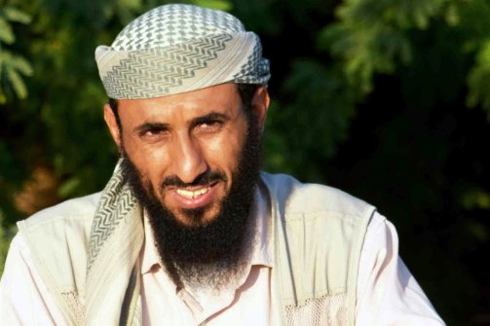
While President Obama has overseen a largely secret war that has killed dozens of top al Qaeda commanders since 2009, one master terrorist has managed to elude U.S. forces: Nasser al-Wuhayshi.
Al Qaeda in the Arabian Peninsula (AQAP) chief Nasser al-Wuhayshi is pictured in the militant stronghold town of Jaar, in the southern Abyan province, on April 28, 2012. (AFP/Getty)

Today, Wuhayshi is a top target for the United States, after intelligence agencies monitored a conference call last week that served as a virtual board meeting for al Qaeda’s central leadership and the group's global affiliates—and in which the Yemeni-born jihadist was promoted to the position of general manager for al Qaeda operations. At the request of its sources, The Daily Beast is withholding details about the technology al Qaeda used to conduct the conference call. U.S. intelligence officers say Wuhayshi is leading an attack plan that could call on resources from al Qaeda’s franchises across North Africa, the Middle East, and Southwest Asia.
Known at times as Abu-Bashir, Wuhayshi was one of Osama bin Laden’s closest associates, a top lieutenant who worked with the terror ringleader in the 1990s. When al Qaeda took up residence in Afghanistan, Wuhayshi was picked to lead of one of the group’s four training camps in Tarnak Farms, where bin Laden himself often stayed. In his 2010 memoir, Guarding bin Laden: My Life in al Qaeda, former bodyguard Nasser al-Bahri wrote that Wuhayshi would often stay with bin Laden in the mornings as he worked in his Tarnak Farms office in the months and years before the September 11, 2001, attacks on the U.S.
Wuhayshi, who had studied Islam in Yemen, was sometimes referred to as bin Laden’s personal secretary during that period. When U.S.-led forces struck Afghanistan, al-Bahri said Wuhayshi and Ayman al-Zawahiri, bin Laden’s deputy at the time and now the leader of al Qaeda, stuck with bin Laden when he was on the run. “During his flight to the caves in Tora Bora, where he would face 12 days of bombardment from the Americans, bin Laden only wanted a tiny number of his most faithful followers with him, to minimize the risk of being spotted,” al-Bahri wrote. “Ayman al-Zawahiri, Nasser al-Wuhayshi, and Hamza al-Ghamdi stayed with him, along with a handful of Saudi guards.”
When al Qaeda’s senior leadership fled the country, Zawahiri and bin Laden holed up in Pakistan. But al-Wuhayshi and others traveled to Iran, according to al-Bahri. While in Iran, al-Bahri wrote that the al Qaeda leaders initially received assistance from Sunni Muslims in the province of Baluchistan, who helped them escape to countries around the gulf region. However, Iranian authorities kept al Qaeda officials in “assigned residences in an area that was under surveillance.” While another al Qaeda leader in Iran, Saif al-Adel, was free to marry an Iranian woman and even publish pieces online, Wuhayshi was not so lucky. The Iranians extradited Wuhayshi to Yemen, where he was arrested and sent to prison.
According to Gregory Johnsen’s 2012 book, The Last Refuge: Yemen, al Qaeda, and America’s War in Arabia, Wuhayshi emerged as something of a spiritual leader to al Qaeda militants in the prison. By 2006, the cell had a plan. Wuhayshi and others began to dig a tunnel out of the prison—to a nearby mosque. Johnsen writes that Wuhayshi and al Qaeda operatives would often loudly recite passages from the Quran to disguise the sound of their makeshift shovels and picks. On February 3, 2006, Wuhayshi and 22 other prisoners emerged from the tunnel and into the neighboring mosque, according to Johnsen, and then filed out into the street in twos and threes.
The jailbreak proved to be the genesis of al Qaeda’s branch in Yemen, now known as al Qaeda in the Arabian Peninsula. In 2007, Wuhayshi was elected as the group’s leader, but he was ready to move on. According to an August 2010 letter found during the U.S. raid on bin Laden’s headquarters in Abbottabad, Pakistan, bin Laden politely rejected Wuhayshi’s request for Anwar al-Awlaki, who became the first American-born member of al Qaeda to be targeted in a drone strike, to be promoted to be the leader of the Yemen affiliate.
Wuhayshi now will be able to call on the resources of al Qaeda’s affiliates throughout the Muslim world.
“How excellent would it be if you ask brother Basir [Wuhayshi] to send us the résumé, in detail and lengthy, of brother Anwar al-‘Awlaqi, as well as the facts he relied on when recommending him, while informing him that his recommendation is considered,” bin Laden wrote, in the letter to Attiya Abdul Rahman, an al Qaeda leader who was killed in an August 2011 drone strike. “However, we would like to be reassured more. For example, we here become reassured of the people when they go to the line and get examined there.”
One U.S. intelligence official told The Daily Beast that Wuhayshi had designs on a more senior role in al Qaeda. The letter that prompted bin Laden’s response has not been declassified.
After bin Laden’s death in 2011, Wuhayshi and his affiliate became one of the first groups within al Qaeda to endorse Zawahiri for the top position. Bruce Riedel, an expert on al Qaeda at the Brookings Institution and a former senior CIA analyst, said Wuhayshi had a connection with the Egyptian-born commander. “He has been loyal to Zawahiri,” Riedel said. “They were quick to endorse him in 2011. I don’t know the grounds for it, those incidents back in Afghanistan before 9/11, but there was a bond between the two of them,” he said.
That bond appears to have paid off. In the virtual meeting the U.S. monitored last week among al Qaeda leaders, Zawahiri promoted Wuhayshi to the post of “Ma’sul al-Amm,” an Arabic phrase that translates to “general manager.” It means Wuhayshi now will be able to call on the resources of al Qaeda’s affiliates throughout the Muslim world, according to one U.S. intelligence official. It also means the U.S. military and the CIA will be redoubling their efforts to find him.

Eli Lake is the senior national-security correspondent for Newsweek and The Daily Beast. He previously covered national security and intelligence for The Washington Times. Lake has also been a contributing editor at The New Republic since 2008 and covered diplomacy, intelligence, and the military for the late New York Sun. He has lived in Cairo and traveled to war zones in Sudan, Iraq, and Gaza. He is one of the few journalists to report from all three members of President Bush’s axis of evil: Iraq, Iran, and North Korea.-

