Bottle Bombs / Drano Bombs
Source: http://urbanlegends.about.com/od/crime/a/bottle_bombs.htm

Viral alerts warn recipients to beware of 'bottle bombs,' homemade explosive devices consisting of water, Drano, and aluminum foil in plastic bottles.
Description: Viral text / Rumor
Circulating since: May 2010
Status: True (see details below)
2013 example:
As posted on Facebook, Feb. 21, 2013:
PLEASE READ. WILL NOT HURT TO AND FORWARD.
Kids are putting Drano, tin foil, and a little water in plastic drink bottles and capping it up - leaving it on lawns, in mail boxes, in gardens, on driveways etc. just waiting for you to pick it up intending to put it in the rubbish, but you'll never make it!!!
If the bottle is picked up, and the bottle is shaken even just a little - in about 30 seconds or less it builds up enough gas which then explodes with enough force to remove some your extremities. The liquid that comes out is boiling hot as well.
Don't pick up any plastic bottles that may be lying in your yards or in the gutter, etc.
Pay attention to this. A plastic bottle with a cap. A little Drano. A little water. A small piece of foil. Disturb it by moving it; and BOOM!!
No fingers left and other serious effects to your face, eyes, etc.
Please ensure that everyone that may not have email access are also informed of this.
2010 example:
Email text contributed by Elliott F., May 20, 2010:
Subject: Fw: Good information for everyone!
Check SNOPES...............
Good safety info that I never heard of; be careful and watch the video if you don't believe it.
Pay attention to this.
1. a plastic bottle with a cap.
2. a little Drano.
3. a little water.
4. a small piece of foil.
5. Disturb it by moving it; and BOOM!!
6. No fingers left and other serious effects to your face, eyes, etc..
People are finding these bombs in mailboxes and in their yards, just waiting for you to pick it up intending to put it in the trash. But, you'll never make it!!! It takes about 30 seconds to blow after you move the thing.
See "SNOPES" below....it's true. This happened a few days ago...April 27, as a matter of fact.
Analysis: Homemade "bottle bombs" have been around for at least two decades, though they've been known by a variety of different names, including "acid bombs," "Drano bombs," "works bombs," "pressure bombs," and "MacGyver bombs." Any number of YouTube videos demonstrate how to construct and detonate them. Because they're made with common household ingredients they're a favorite of teenage pranksters, but police warn that the devices are unpredictable and dangerous. Would-be bottle bomb makers need to be aware that if caught they can be charged with a felony. Penalties can be quite severe if injuries or property damage result.
The way a bottle bomb works is simple. When the aluminum foil comes into contact with the Drano solution a strong chemical reaction occurs, releasing a gas which causes pressure to build up inside the plastic bottle, which eventually explodes. The caustic, boiling liquid thrown off by such an explosion can cause second- or third-degree burns and/or blindness.
News reports of bottle bomb incidents (in which the activity is sometimes described as a "fad") have cropped up regularly since the early 1990s. An article published in the Los Angeles Times in March 1991 claimed at least eight adolescents had been injured in glass bottle bomb explosions after learning how to construct the devices from an episode of the TV show MacGyver.
The 2010 warnings were prompted by specific incidents reported in April 2010, including the discovery of bottle bombs left in the yards of two houses in York Township, Michigan and a "rash" of attempted mailbox bombings in Methuen, Massachusetts.
New alerts began circulating via social media in February 2013 after a rash of Drano bomb mailbox explosions in Kennewick, Washington and the arrest of three people accused of setting off a bottle bomb in Commerce, Georgia.

IEDs a growing threat in U.S.: security experts
Source: http://www.homelandsecuritynewswire.com/dr20130417-ieds-a-growing-threat-in-u-s-security-experts

Improvised explosive devices (IEDs) killed and maimed so many U.S. and coalition soldiers in Iraq and Afghanistan, that the Pentagon was forced to create the Joint Improvised Explosive Device Defeat Organization (JIEDDO). The organization, established to reduce or eliminate the effects of all forms of improvised explosive devices, is credited with helping develop several technologies to thwart IEDs and reduce the damage they cause.
The two pressure-cooker bombs which exploded near the Boston Marathon’s finish line on Monday are, in effect, IEDs.
Terrorism experts say that as al Qaeda and its affiliates find it more and more difficult to engage in more spectacular terrorist attacks such as 9/11 and other attacks on aviation, they may resort to low-tech, IED-based attacks.
Fox News reports that security experts believe that terrorist organizations, but also unaffiliated lone wolves, may begin to use IEDs to target large gatherings in an effort to inflict mass damage and casualties.
“The reason to use an IED or multiple IEDs is that you’re trying to create an oversized impact, and as much panic and disruption as possible,” Bill Braniff, the executive director of the University of Maryland’s National Consortium for the Study of Terrorism and Responses to Terrorism (START), told FoxNews.
On Tuesday, the FBI and DHS circulated an intelligence bulletin to U.S. law enforcement agencies, highlighting the fact that the Boston Marathon attack follows a pattern.
“The activities in Boston highlight the use of improvised explosive devices (IEDs) to target large gatherings, including at special events, in order to inflict mass casualties,” said the bulletin, obtained by Fox News.
IEDs in various forms have been used by terrorists and insurgents for about thirty years now. The first two organizations to use them as an integral part of their campaigns were the Tamil Tigers in Sri Lanka and India, and Hezbollah in southern Lebanon.
Shi’a militias in Iraq, from 2003 to 2007, used advanced and more lethal IEDs against U.S. and coalition forces. These advanced devices were designed and manufactured by Iran.
IEDs, however, have been slow to show up in the United States.
Fox News notes that in recent years, several IED attacks have been planned but not successfully carried out.
The Tuesday DHS/FBI bulletin noted the following plots since 2009:
- In 2011 the police discovered an undetonated IED along the planned Martin Luther King Jr. unity parade route in Spokane, Washington.
- In November 2010 FBI agents and the Portland, Oregon police thwarted a Somali teenager’s plan to blow up a van full of explosives at a Christmas tree lighting ceremony.
- In May 2010 New York authorities thwarted an attempt to detonate an IED left in a smoking Nissan Pathfinder in Times Square.
- Nine months earlier, in 2009, New York City police stopped a plot to blow up the city’s subways using IEDs.
Experts say it was only a matter of time before IEDs made their way to the United States.
“Most people in law enforcement believed we would see these IEDs begin emerging in the U.S.,” Craig Dotlo, a retired FBI agent who helped investigate the 9/11 terrorist attacks, said.
A recent report by START says that IEDs were the most common weapons used in the 207 terrorist plots and attacks in the United States from 2001 to 2011. The study also found that incendiary devices accounted for more than half of all weapons used over the last decade, representing a large increase in the type of weapons used in terror attacks.
START notes that the perpetrators have often been domestic groups — with the environmental Earth Liberation Front and Animal Liberation Front responsible for the most attacks in that 10-year period.
Al Qaeda was involved in four of them. The Pakistani Taliban claimed involvement in the Times Square bombing case — but has said it had no role in the Boston attack Monday.
Experts note that the dual devices used in Monday’s marathon bombing are similar to those used in attacks in Sri Lanka in 2008 as well as a series of blasts in Lahore, Pakistan in 2006.
Dual IED devices were also used in attacks in Ireland in May 1998, May 2003, and May 2005.

Ease of construction makes pressure-cooker bombs popular among terrorists
Source:http://www.homelandsecuritynewswire.com/dr20130417-ease-of-construction-makes-pres surecooker-bombs-popular-among-terrorists

The ease of building pressure-cooker bombs has made them popular among terrorist organizations and insurgent groups. Inspire, the on-line English-language magazine published by Al Qaeda in the Arabian Peninsula (AQAP), three years ago published an article titled “How to Make a Bomb in the Kitchen of Your Mom” by “the AQ Chef,” which contained detailed instructions on building a pressure-cooker bomb.
The issue of al Qaeda's magazine that includes directions for pressure-cooker bomb production // Source: alsumaria.tv
The identity of the individuals who built the bombs which exploded near the finish line of Monday’s Boston Marathon is not yet known, and their organizational affiliation, if any, is not known, either. USA Today reports that terrorism experts say, however, that it would not surprise them if these terrorists were affiliated with, or at least inspired by, al Qaeda or one of its off-shoots. One reason for thinking along these lines is the fact that the glossy, on-line English-language magazine Inspire, published by Al Qaeda in the Arabian Peninsula (AQAP), has published a how-to article containing detailed instructions on how to make bombs using pressure cookers – the same kind of bombs which were used in Boston.
Inspirewas founded by U.S.-born cleric Anwar al-Awlaki, and was edited by Samir Khan, a Saudi-born American citizen. Both were killed on 30 September 2011 in a CIA drone attack on a car in Yemen in which they and their body guards were traveling.
Three years ago, in its summer 2010 issue, Inspire published an article titled “How to Make a Bomb in the Kitchen of Your Mom” by “the AQ Chef.”
The article about pressure-cooker bombs was one of several articles in a special section in the issued, titled “The Open-Source Jihad.”
The ease of building pressure-cooker bombs has made them popular among terrorist organizations and insurgent groups. Experts note that these devices have been used most frequently by Islamic extremists in South Asia.
Military.com notes that the Boston bombs were not the first pressure-cooker bombs to be used in the West. Army Pfc. Naser Jason Abdo was arrested on 28 July 2011 for planning to use a pressure-cooker bomb to blow up a restaurant frequented by fellow soldiers outside Fort Hood, Texas. One of the three explosive devices used in the May 2010 Times Square attempted bombing was a pressure cooker bomb.
Miliitary.comalso notes that in the ten issues it published over the last three years. Inspire has provided detailed instructions, accompanied with diagrams, charts, and photos, on how to use automatic weapons, produce remote control detonators, set fire to a building, create forest fires, set fire to a parked, and how to cause road accidents with oil slicks on a road or tire-bursting spikes.
An Islamic Web site has collected these instructional articles, including the one on pressure cooker bombs, into a small book titled The Lone Mujahed Pocketbook.

Pressure cooker bombs: How Boston blasts are similar to Mumbai 7/11 train bombings
Source:http://www.terrorismwatch.org/2013/04/pressure-cooker-bombs-how-boston-blasts.html?utm_ source=feedburner&utm_medium=email&utm_campaign=Feed%3A+terrorismwatch%2FJTvK+%28Terrorism+Watch%29&utm_content=Yahoo!+Mail

This picture released by the FBI shows the mangled remains of a pressure cooker

The twin blasts at the Boston Marathon this week, that left three people dead and over 170 injured, show how devastatingly effective pressure cooker bombs can be.
The two hand-made bombs were packed with explosives and stuffed with shards of metal, ball bearings and nails and then placed in duffel bags on the ground. Investigators in the US said the explosives were planted inside pressure cookers which were then stuffed with shrapnel to cause maximum injury.
The blasts turned the festive race into a hellish scene of chaos, fear and confusion in Boston.
In India, terror group Lashkar-e-Taiba (LeT) used pressure cookers to kill 200 people in the Mumbai train blasts on July 7, 2007. They placed seven pressure cookers in local train compartments to target peak hour traffic.
The Indian Mujahideen used the pressure cooker bomb in the Varanasi blast in 2006 that killed seven people.
"They don't raise any suspicion and are readily available. They are lethal as the shrapnel stuffed in them can inflict immense injuries because of the pressure," explained AA Khan, former chief of Mumbai's Anti-Terror Squad or ATS.
These bombs have been used by many terror outfits, included the Al-Qaeda, which also had a detailed tutorial in the 2010 issue of its online magazine on how "the pressurised cooker is the most effective method" for making a simple bomb.
There have been pressure cooker bombings in Pakistan and Afghanistan too and a pressure cooker was one of the three devices used in the attempted bombing at Times Square in New York in May 2010.
While American investigators are still trying to figure out whether a foreign or domestic group is responsible for the attack in Boston, the cause of concern is how easily an innocuous pressure cooker can turn into an agent of death in the hands of a terrorist.

EDITOR’S COMMENT: Similar pressure cooker bombs were also used/found in Greek terrorist incidents – one in underground train cart (not exploded) and one in big shopping mall (exploded).

UK Extremists planned to use radio-controlled car in attack on Army base
Source: http://www.independent.co.uk/news/uk/crime/extremists-planned-to-use-radiocontrolled-car-in-attack-on-army-base-court-told-8573697.html

Four Islamic extremists plotted an attack on a Territorial Army base by sending a radio-controlled model car filled with explosives underneath the front gate of the compound, a court heard today.
One of the men was picked up on a secret listening device explaining how a toy car could be sent through the gap, underneath a military vehicle and triggered using a mobile phone detonator, Woolwich Crown Court was told.
The group had discussed attacks against "multiple sites" in Britain after their ambitions to send radicalised young Britons for terror-training abroad was hampered after losing contact with an al-Qa'ida linked fixer in Pakistan. They spoke about the possibility of doing an "inside job" on MI5 and another member of the gang talked of having a cousin in the US Air Force who could do a lot of damage.
The men, all from Luton, Bedfordshire planned to use information downloaded from the extremist magazine Inspire to build a home-made bomb and discussed getting money and guns to carry out their plans.
"They also identified a target for such an attack, namely a Territorial Army base in their locality, although they also discussed targeting multiple sites at one time," said Max Hill, QC, counsel for the prosecution.
Zahid Iqbal, 31; Mohammed Ahmed, 25, Umar Arshad, 24, and Syed Hussain, 21 (photo), have all pleaded guilty to the preparation of terrorist acts. They are due to be sentenced tomorrow.
Iqbal and Ahmed were caught on a recording device - hidden by police and security services in their car - on their way to Argos as they discussed fixing a bomb to a radio control car and setting it off using a mobile phone.
"At the bottom of their gate (The TA centre) there's quite a big gap. If you had a little toy car it drives underneath one of their vehicles or something," said Iqbal.
Ahmed said there were one or two places where they could test it out. He added that "obviously the test run is going to be a bit hot and you need to be careful because you don't want to get caught on a test run."
The court heard that Ahmed travelled to both Pakistan for terror-training and to Snowdonia where he was seen with a group of associates performing press-ups, regimental walking and apparently using logs as firearms.
He went to Pakistan in March 2011 but came back after only six days because of problems speaking Arabic and difficulties in the region. However, he spoke of how being threatened by drones was a life-changing experience but that "afterwards you buzz".
He was told by one of his fellow plotters: "The Muslim is never scared of death. Do not ever fear death and run towards death. That's what you've got to do man."
Ahmed worked to recruit and radicalise young men before passing them to Iqbal to send them abroad, the court was told. When the four men were finally arrested in April the following year, police found 14 laptops and more than 100 smartphones.
The sentencing hearing continues.

Ammonium nitrate fertilizers are inherently risky, but the benefits are many
Source: http://www.homelandsecuritynewswire.com/dr20130421-ammonium-nitrate-fertilizers-are-inherently-risky-but-the-benefits-are-many

The deadly explosion has brought the $10 billion U.S. fertilizer industry to the attention of the mainstream media, but the risks inherent in fertilizer production and storage are not a secret to people close to the industry. Ammonium nitrate may be dangerous, but its benefits cannot be ignored.
Investigators are still trying to determine exactly what caused the explosion at the fertilizer facility in Texas, which killed fifteen people and injured more than 100 more. The deadly explosion has brought the $10 billion U.S. fertilizer industry to the attention of the mainstream media..
The risks inherent in fertilizer production and storage are not a secret to people close to the industry. The Texas plant stored and blended anhydrous ammonia, a pungent gas with suffocating fumes which is used as a fertilizer. Storage tanks on the site contained almost 270 tons of ammonium nitrate, which can explode when mixed with fuel and ignited.
The Washington Post reports that in 2006, the facility, located in the tiny town of West, Texas, was fined $2,300 by the Environmental Protection Agency (EPA) because it did not have a risk-management plan meeting federal safety codes. After the fine, the West Fertilizer Company committed to meeting standards for its ammonia storage tanks.
The facility’s operators say they did not think an explosion could take place. The Dallas Morning News obtained a copy of the of the facility’s internal review for fire or explosive risks. “The worst possible scenario, the report stated, would be a 10-minute release of ammonia gas that would kill or injure no one,” the document said.
Ammonium nitrate may be dangerous, but its benefits cannot be ignored. Brendan Koerner writes in Slate that “[A]mmonium nitrate is in many ways one of the best (and certainly one of the cheapest) sources of crop-nourishing nitrogen available. For starters, ammonium nitrate is inexpensive to manufacture. … Ammonium nitrate is also well-suited to bolstering certain types of crops. It’s quite effective with fruit trees, for example, providing more efficient nitrogen delivery than ammonium sulfate.”
Critics say that oversight for the industry has been lacking because Occupational Safety and Health Administration is understaffed and inspections are infrequent.
Fertilizer facilities in Texas have, on average, been inspected only six times in the last five years. The West Texas Fertilizer Company facility in West was not one of them.
The United States has a significant amount of natural gas, and a large amount of fertilizer is synthesized from atmospheric nitrogen and natural gas, which is likely the way ammonia was stored in the retail facility.
Currently there are forty-four fertilizer production plants in the United States, and thirty of them are nitrogen plants. Retail facilities, like the one in West, Texas, which sell directly to farmers are more numerous, and even less supervised.
“There is no national list of retail facilities, but each state registers and regulates them,” Kathy Mathers, VP of Public Affairs at the Fertilizer Institute told the Washington Post.
Explosions at retail facilities and plants are uncommon, but there have been sixteen documented explosions in fertilizer production plant around the world since 1921. The deadliest blast came in 1947, when a fire on a French vessel which was docked in the Port of Texas City set off more than 2,300 tons of ammonium nitrate. The blast killed 581 people and is still the deadliest U.S. industrial accident.

Introducing SEE-QR™ - The security checkpoint of the future, Today!
Patented explosives detection technology that eliminates privacy concerns on display at Counter Terror Expo at Olympia, London
Source: http://www.seeqrsecurity.com

LONDON, April 24, 2013 – RML Industries Inc. and AMI Research and Development LLC today announced SEE-QR™(pronounced “Seeker”), a breakthrough walk through security checkpoint that uses low-power AM radio waves providing fast, effective detection of explosives.
SEE-QR™ (Stimulated Enhanced Emissions Quadrupole Resonance) works with metal-detector-like efficiency enabling security personnel to quickly identify explosive threats.
“SEE-QR™ is a game-changing product for visitor screening,” said Rob Payne, general manager of RML. “By increasing operational efficiency, strengthening security and improving the visitor experience, we revolutionize the security checkpoint with unmatched detection capability.”
Since SEE-QR™ is not an imaging system; it eliminates privacy issues associated with today’s body-scanning equipment. Instead, SEE-QR™ uses Stimulated Emissions Quadrupole Resonance, a safe, low-power radio frequency technology, capable of detecting the explosive compounds with incredible accuracy.
In practical terms, SEE-QR™ improves security with no need for excessive pat downs, no need to remove shoes and belts, and greatly improved visitor throughput at security checkpoints. Plus, SEE-QR™ is wheelchair accessible, bringing unprecedented convenience and dignity for the screening of visitors with disabilities.
“We designed SEE-QR™ to resolve many of the challenges associated with explosives detection in current security checkpoint technology,” said Bill Mouyos, CEO of AMI and one of the chief
architects of the technology behind SEE-QR™. “Our goal was a, fast, safe, customer-friendly screening experience. SEE-QR™ truly is the breakthrough the visitor-screening industry has been waiting for.”
A SEE-QR™ prototype will be on display at the Counter Terror Expo, April 24-25 at Olympia, London (Booth N40) and the designers of the system will be on hand to demonstrate how the system works.
The SEE-QR™ system is designed to be deployed anywhere explosives detection is a priority, including airports, stadiums, corporate and government facilities, package screening centers and international border checkpoints.
RML is currently seeking test sites for deployment of SEE-QR™ systems in late 2013.
For more information about SEE-QR™ or to inquire about becoming a BETA test site, visit www. seeqrsecurity.com or visit Booth N40 at the Counter Terror Expo.
SEE-QR™ was developed by RML Industries in conjunction with AMI Research and Development. Each system is made at RML’s factory in Grand Haven, Michigan, USA, which meets the strictest engineering and quality requirements, including: Environmental Testing: MIL-STD-810, Calibration: ISO 10012-1, FAA Technical Standard Order (TSO), ISO 9001, ISO 14001, and Government TQM.

SEE-QR Product Description

SEE-QR is the Checkpoint of the Future, Today
- Designed to meet International Air Transportation Association (IATA) criteria for the Checkpoint of the Future
- Works with metal detector-like simplicity and incredible accuracy
- No privacy concerns because SEE-QR is not an imaging system
- Wheelchair accessible, preserving security and dignity for those with disabilities
- Direct threat detection eliminates guess work and subjectivity
- Easy to deploy and train staff for maximum operational efficiency and guest throughput
- Reduces waiting times, improves customer service
- Low-power radio technology means no health or radiation exposure concerns

SEE-QR is ready for deployment
- Test sites going online in Q4 2013
- Small footprint works with existing security installations
- RML is accepting applications to become a test site (info@rml-ind.com)

SEE-QR offers unmatched, reliable detection of explosive compounds, including:
- TNT
- HMX
- PETN
- RDX
- Ammonium Nitrate
- Urea Nitrate

Adaptable technology means future SEE-QR applications could include explosives and narcotics screening at:
- Airports
- Border crossings
- Corporations
- Stadiums
- Sea ports
- Package processing facilities
- Cultural attractions
- High-volume public events
- Virtually anywhere explosives detection is a priority

Libya car bomb wounds French embassy guards
Source: http://www.reuters.com/article/2013/04/23/us-libya-attack-idUSBRE93M05320130423

TRIPOLI | Tue Apr 23, 2013 – A car bomb in Tripoli wounded two French guards at France's embassy in Libya on Tuesday, bringing new violence to a capital that has not seen attacks on diplomats like that which killed the U.S. ambassador in Benghazi last year.
Since Muammar Gaddafi was toppled by Western-backed rebels in late 2011, Tripoli, like the rest of the sprawling desert state, has been awash with weapons and roving armed bands, but violence in the city has not targeted diplomats before in the way Western envoys have been shot at and bombed in the east of the country.
"This is an attack that targets not only France but all countries that fight against terrorist groups," Foreign Minister Laurent Fabius said in Paris before flying out to inspect the damage to the embassy.
One of the two wounded French guards required emergency surgery in Tripoli, he added.
Libyan Prime Minister Ali Zaidan joined him at the scene of the explosion and together they also visited the damaged homes of residents nearby.
Security will be stepped up across a region where France has taken a leading role of late, first in pushing for a NATO air campaign to defend the Benghazi-based rebels from Gaddafi's forces, and most recently mounting its own assault in its former colony of Mali against Islamist insurgents who have profited from arms and fighters coming over the Sahara border from Libya.
President Francois Hollande said: "France expects the Libyan authorities to shed light on this unacceptable act so that the perpetrators are identified and brought to justice."
Libya's government, struggling to exert its authority, said it was a "terrorist act" aimed at destabilizing their country, and ministers said they would work with French investigators.
There was no immediate claim of responsibility in the hours after the early morning blast, which caused extensive damage, but al Qaeda's north African arm, AQIM, threatened retaliation for the French intervention in Mali as recently as last week.
Interior Minister Ashour Shuail told a press conference he could not say whether the strike was linked to the attack on the U.S. embassy in Benghazi last year, but said a commission had been set up to investigate the blast.
The minister added a diplomatic security force would be active in the country within days.

Increased risks
Westerners in the region have been on alert since January's bloody mass hostage-taking at the In Amenas natural gas plant in Algeria, close to the Libyan and Malian frontiers, during which militants demanded Paris halt operations in Mali.
Foreign Ministry spokesman Philippe Lalliot said France had not received any specific threat against the Tripoli embassy but it had been aware of a generally increased risk, adding that the embassy was now out of action and staff would move elsewhere.
He said France had asked Libyan authorities to strengthen security around French institutions, which were now all closed, including a cultural center and a school.
"This is a very worrying sign for the government," one Western diplomat said. "It will be a further deterrent for companies who have so far been reluctant to come to Libya."
In the chaos following Gaddafi's overthrow and death, there have been attacks on diplomats, notably in Benghazi in the east.
In September, the U.S. ambassador to Libya and three other Americans were killed at Washington's consulate in the city, which is the hub for the lucrative oil industry. U.S. officials say militants with ties to al Qaeda were most likely involved in that attack, but no group has credibly claimed responsibility.
British, United Nations and Red Cross missions in eastern Libya have also been the targets of violence.
Most foreign embassy staff and international aid workers have strict security in Tripoli, and Benghazi remains off-limits to many foreigners.

Dawn blast
People living near the French embassy compound, in Tripoli's Hay Andalus area, close to the Mediterranean seafront, said they heard two explosions at around 7 a.m. (0500 GMT).
Tripoli police chief Mohammed Sharif said "an explosive device was planted in a car parked outside the embassy".
A large part of the wall around the compound collapsed, and one corner of the embassy building had caved in. Office cabinets lay scattered on the ground outside and water from a burst pipe ran down the street. Residents pointed to jagged metal fragments which they said came from a car that had exploded.
One neighbor said his young daughter was taken to hospital after she was hit by a falling piece of masonry at home.
The Libyan army cordoned off the compound as dozens gathered outside. An embassy employee arrived at the scene and burst into tears when she saw the destruction. She was allowed inside to join colleagues and French security staff.
"I was in my house sleeping, when I was woken up by a long explosion. I went to my front door and found that it had blasted out," said Osama al-Alam, who lives next door to the embassy.
"I went into the street and saw smoke everywhere. We heard shooting and went inside the house."
Two cars outside the embassy were burnt out, others damaged. A palm tree in one front garden had fallen onto a roof.
Libyan Foreign Minister Mohammed Abdelaziz condemned "a terrorist act" and announced the formation of a French-Libyan investigation team to probe the incident, state media said.
Deputy Prime Minister Awad al-Barasi, as well as the interior and justice ministers, visited the scene.
"We are in a critical stage, and there are some who want to destabilize Libya," Barasi said. "This will not stop us from moving forward, even though it is painful to see the damage."
AQIM - Al Qaeda in the Islamic Maghreb - said on Friday it would retaliate for France's mission to push Islamist fighters out of the large part of northern Mali they seized last year.

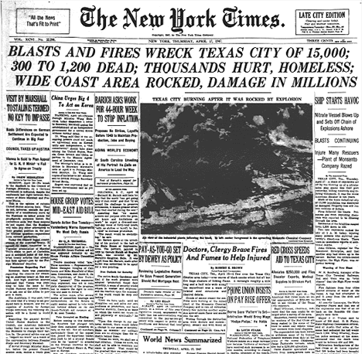
Notice the (same) date (17 Apr 1947) of a similar explosion in the same place!!!

Kenya police: Bomb detectors not fake

Source: http://www.bbc.co.uk/news/world-africa-22306632

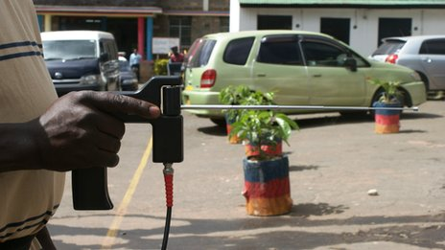
Police in Kenya have sought to reassure the public that their bomb and drug detectors work, after the conviction of a British man for selling fake devices.
They carried out a public demonstration in the capital, Nairobi, in which the detector seemingly located narcotics.
The police refused to divulge where they had purchased their devices from.
But they look identical to the ADE detectors sold by convicted fraudster James McCormick and bear the name of his company, ATSC.
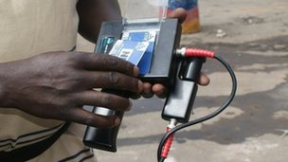
The detectors come with cards which are "programmed" to find items, from ivory to bombs

During his trial, McCormick told the court he had sold his devices to the Kenyan police, in addition to the authorities in Iraq, Hong Kong, Egypt and Thailand.
Asked about McCormick's conviction, Nairobi police chief Benson Githinji told reporters:
"Let me assure Nairobians, the machines in use are serviceable and don't fall short... They are in operation and they work."
He said that one of the reasons why there had not been a successful grenade attack in Nairobi recently was because of the machines.
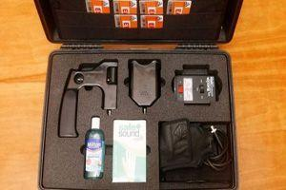
There had been a spate of such attacks since Kenya sent troops into neighbouring Somalia in October 2011 to tackle the al-Shabab militant group.
He did not say how many of the devices had been purchased, or when they were first used, but UK police have told the BBC that 26 were sold to Kenya in May 2004.
During this week's hearing in London, the court was told McCormick's detectors (middle photo), which cost up to $40,000 (£27,000) each, were completely ineffectual and lacked any grounding in science.
Richard Whittam QC, for the prosecution, said: "The devices did not work and he knew they did not work."
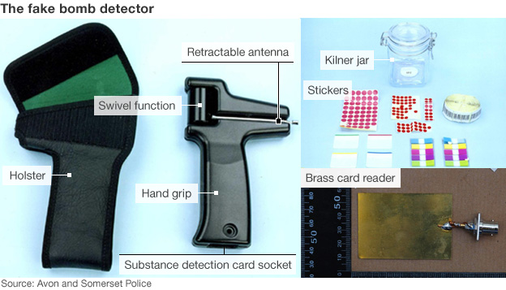
The court heard that the detectors came with cards which were "programmed" to detect a wide array of substances, from ivory to $100 banknotes.
In reality, McCormick's device was based on $20 (£13) golf ball finders which he had purchased from the US and which had no working electronics.

5 million landmines pose threat to civilians’ lives in Amara
Source:http://en.aswataliraq.info/%28S%28z4qu00v0zerf2rqm240sk045%29%29/Default1.aspx?page=article_page&id=147934&l=1

Five million landmines from the Iraqi-Iranian war have not been removed so far as demands are growing on the central government to end this lurking danger that claimed the lives of nearly 6,000 people, according to a local health official in Missan.
“The eastern areas of the city of al-Amara, namely al-Tayyib area, are repeatedly witnessing accidents of blasts of landmines left from the Iraqi-Iranian war,” Maytham Lafta al-Fartusi, the chairman of the Missan Provincial Council’s health & environment committee, told Aswat al-Iraq news agency.
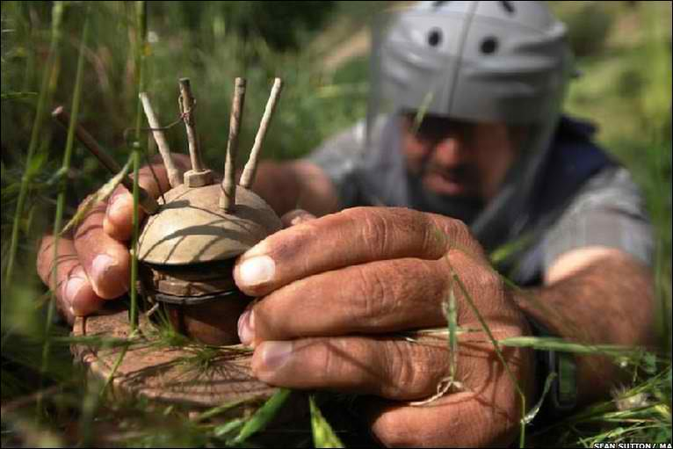
He said about five million landmines left in those areas are jeopardizing the lives of citizens, particularly shepherds and workers for the Missan Oil Company, holding organizations he did not name “legally and humanly responsible” for failing to deliver on pledges to remove landmines in the province.
Ali al-Allaq, the director of the medical operations section in the Missan Health Department, said the recent survey found by the statistical center for landmine victims held that 5,800 persons were killed or maimed by landmine explosions.
Citizen Mohammed Abd al-Zahra, a victim of landmine blasts, told Aswat al-Iraq that a landmine went off near him in the area of al-Tayyib while he was out with his family to celebrate the Nawroz festival.
“The jubilant occasion turned into a real tragedy as I lost one of my legs and was forced to retire on a pension that barely makes both ends meet,” he said.
Abd al-Zahra noted that he was promised an artificial limb by the center, in addition to some limited privileges.

One million landmines pose risks for Kurdish comeback
Source:http://www.terrorismwatch.org/2013/05/one-million-landmines-pose-risks-for.html?utm_source=feedburner&utm_medium=email&utm_campaign=Feed%3A+terrorismwatch%2FJTvK+%28Terrorism+Watch%29&utm_content=Yahoo!+Mail

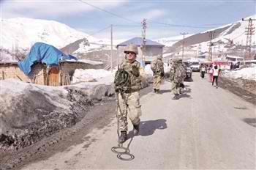
A landmine explosion that killed two Turkish soldiers on May 1, has drawn attention to the mine-clearing problem hanging over Turkey, which has around 1 million mines on its soil.
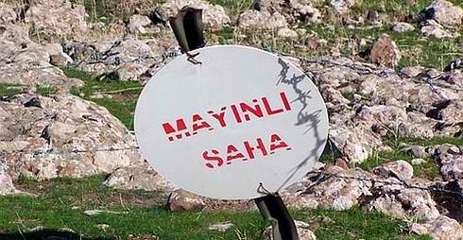
The Peace and Democracy Party (BDP) has called on both the state and the outlawed Kurdistan Workers’ Party (PKK) to announce the areas affected by landmines and demine them.
The blast that caused the killings of two soldiers, Mustafa Altan and İbrahim Özkıdır, raised the issue of landmines near Turkey’s borders and in the rural areas which were planted against the PKK militants or by the PKK itself.
Turkey has around 1 million landmines on its soil, which have to be cleared by March 1, 2014, according to the Ottawa Treaty, the Anti-Personnel Mine Ban Convention. Turkey became a state party to the Ottawa Treaty on March 1, 2004.
“These mines are dangerous for everyone. If we are in a cease-fire and the PKK decided to withdraw, then both sides have duties, “ daily Hürriyet quoted BDP co-leader Selahattin Demirtaş as saying on May 3. “The state has to clean its mines. If the PKK announces the locations of the mines it planted, if they remember them, it would be a significant step for the safety of lives,” he said.
Turkey has a total of 982,777 landmines, of which 818,220 are anti-personnel and 164,497 anti-tank mines and has committed itself to destroying all of them by March 2014.

Turkey demands extra time from UN
However, Turkey will ask the United Nations to delay this target for demining by a further eight more years, said Muteber Öğreten, from an NGO working on demining the Turkish soil. Öğreten, an activist from the Turkey Without Mines Initiative, called on the government to speed up the demining process, saying that many people’s lives would be at risk as the time passes.
Öğreten told Hürriyet Daily News on May 3 that after the withdrawal of the PKK militants from Turkish soil, many people will want to return to their villages which were evacuated due to the clashes between the Turkish army and the PKK. “Many of these villages have landmines. Many people’s lives would be at risk if they returned there without a proper clearing process,” said Öğreten.
The blast occurred after a ceremony held by Iğdır Gov. Ahmet Pek to mark the opening of Mount Ararat to tourism in the Bayraktepe section of a plateau on the famous mountain. “This area was cleared of mines. But some are missed sometimes,” Pek said.
The clearing process is usually under the responsibility of the General Staff, Öğreten noted. “we have to ask how this clearing process took place. The related ministry has to make a statement regarding this issue.”
Turkey had a stockpile of 2,866,818 antipersonnel mines to destroy in 2006. The country accomplished the destruction of its stockpiles of mines by 2011, although it was supposed to have done so by 2008, according to the same treaty. Turkey stated that 3 million mines had been destroyed in total. In Turkey, 1,269 people were killed and 5,091 others were injured by mines as of 2011, according to related reports.

Boston bombings: IED recognition for patrol officers

Source:http://www.policeone.com/terrorism/articles/6199597-Boston-bombings-IED-recognition-for-patrol-officers/

Lessons learned in the “sandbox” in terms of IED recognition may be useful to American Law Enforcement. You may find the following information useful but please be sure to follow your agencies policies, procedures, and training for IED response.
As was tragically demonstrated in Boston on Monday, large sporting events are soft targets. This is not news to U.S. Law Enforcement. Even as we struggle to get a grip on the active shooter problem, another tactical challenge is about to overwhelm us.
You uniformed officers and sergeants are America’s front line and first defense. The Federal agencies have done a great job since 9/11 keeping terrorism at bay and I expect that will continue. However, this bombing in Boston and the trend of violent active shooters is unfortunately just the beginning of what’s to come.
Since 9/11, some law enforcement trainers have been attempting to bring a military mindset to the officers working the streets. We need to transform you college graduates into the mindset of us military veterans. This mindset is very complex; we must be professional cops but at a flip of the switch we need to transition to a combat soldier.
The good news is that men with a combat edge and educated from a university make for an incredible fighting machine. Our combat veterans have learned a lot fighting terrorist overseas.
The unfortunate reality is those battles will most likely start being waged in our cities. That leaves us uniformed officers with the awesome responsibility of combating terrorist on our lands to keep our women and children safe.
I am prepared for that battle. Are you?
These cowardly terrorists should grow a set, and fight us law enforcement officers face to face and leave our women and children alone.

What to Know About IEDs
Improvised explosive devices are the use of a “homemade” bomb or destructive device which can destroy, incapacitate, harass, or distract, used by criminals, vandals, terrorists, and suicide bombers.
Because they are improvised, IEDs can come in many forms, ranging from a small pipe bomb to a sophisticated device capable of causing massive damage and loss of life. IEDs can be carried or delivered in a vehicle, put in place, or thrown by a person, delivered in a package or concealed on the street as we witnessed Monday.
IEDs come in many shapes and forms, only limited by the bombers imagination. Most share a common set of components that consist of the casing or package, initiating system, and a main charge. Packaging can be a vehicle, a pack of cigarettes, pop cans, back packs and vests.
Initiating systems set off the main charge to make it detonate. Items such as a cell phone or a toy car remote control are commonly used. The initiator almost always includes a blasting cap and batteries as a power source for the detonator. Any type of battery can be used such as a 9-volt, AA, or car batteries.
Initiating systems are triggered in three ways:
1. Over time: Timed I.E.Ds are designed to function after a preset delay, allowing the enemy to make his escape or to target his victims.
2. On command: Command initiated IEDs allow the bomber to choose the optimal moment of initiation. They are normally used against targets that are in transit, or where a routine pattern has been established. The most common types of command initiated methods are with wires or radio controlled devices, such as cordless telephones and remote car door openers.
3. Victim: Victim actuated IEDs are initiated by the actions of the victim(s). There are various types of initiation devices to include pull or trip, pressure, pressure release, movement-sensitive, light-sensitive, proximity, and electronic switches.

IED Deployment Techniques
IEDs can be disguised in a variety of things such as trash cans, boxes, backpacks, and placed anywhere potential targets appear. Multiple IEDs have also been linked together with detonation cord or electrical wire so that all charges detonate simultaneously, with the goal to achieve simultaneous explosions.
Bombers often use secondary devices and multiple explosions to further their impact of terrorism by increasing the numbers of victims. Your situational awareness must be at its highest level if you respond to such an event. Bombers are known to use gunfire, small bombs, and other distraction tactics to bait additional victims into the kill zone of a second explosive device.
When you respond, slow your physical actions to the speed no faster than your mind can process the information your senses are absorbing. Scan the crowd, look for additional threats, scan the crowd more and look for potential secondary devices.
Scan the crowd again, look, listen and follow your instincts. That’s what great street cops do on a daily basis so don’t go screaming on your radio like a banshee out of control. This achieves nothing. Remember, this is a combat game of chess.
Your opponent wants you to get sucked into the mindset of that screaming patrolman so that he can kill you, too. We must still do our jobs: Triage victims, coordinate EMS response, establish crime scenes, crowd control just to mention a few. The key now is to conduct police operations with the mindset that our military combat warriors do in the sandbox.
Multiple locations are common with IED bombers so command officers must be mindful of their resources and put a plan into action immediately after the first explosion, to maintain safety in other areas of your city.

Vehicle Borne IEDs and Suicide VBIEDs
A VBIED is a parked vehicle in a high traffic area with the intent of causing the most damage. An SVBIED is when the driver is willing to give their own life in the process of detonating his explosives. SVBIEDs are very hard to detect and stop because the bomber is mobile and is able to choose his time, place and victims at will. This unpredictability makes them difficult to identify.
Suicide Bombers Personal Borne IEDS (PBIED) commonly attack with an explosive vest, belt, or baggage attached to their person. When the charges used by bombers are properly packaged and concealed, a suicide bomber could carry up to 45 pounds of explosives.
However, most suicide belts are designed to hold smaller amounts, up to 12 pounds and incorporate fragment materials into the design of these belts and vests.
Indicators of a potential PBIED attack can include persons attempting to circumvent a security checkpoint or gate at a sporting event, those wearing too much clothing for the weather conditions, or a person with suspicious bulges in his or her clothing.

Suicide Bomber Countering Techniques
Some guidelines to counter the suicide bomber include:
1. Evacuate the area immediately. Safe distances will depend on the amount of explosives carried by the bomber and the amount and type of fragmentation used. More space is better.
2. Close and negotiate tactics should never be attempted, since suicide bombers are usually trained to avoid surrender at all costs. You will end up a victim.
3. A cell phone or radio controlled initiator could be used in the event that the bomber is incapacitated or hesitates. This tactic requires a second perpetrator to initiate the device.
4. The use of deadly force is a tactical conundrum for a uniformed officer. The problems are many and the wrong decision can be catastrophic. Taking a shot may eliminate the threat.
However, it may set off the explosive and cost innocent lives. Only you with the real time intelligence can decide which path to travel. One thing is for sure: Don’t let a bomber flee from the scene.
If deadly force is taken, be mindful that a bullet impact may initiate or detonate the explosive charge. Deadly force on the suspect should only be undertaken from cover. A trained police sniper will need to achieve an instantaneous non reflex kill shot. The same can be achieved with a patrol rifle however, it’s much more challenging. Training with your weapons and knowing you and your rifles limitations will be significant in the decision making process.
5. If the suspect is neutralized and there is no explosion try and fix the bomber in place and request E.O.D. to render the explosive charge safe. Try not to go hands on with the bomber.

The 5 Cs
1. Confirm it is an IED
2. Clear the area at least 300 meters or more as needed
3. Cordon off the area
4. Call the bomb squad and establish incident command
5. Control traffic from entering the area to include both vehicle and pedestrian traffic
If you encounter an IED, the 5-Cs are a simple set of rules to help you navigate the challenge. Always respond with your agencies policies, procedures and training guidelines.
1. Confirm: From a safe distance, look for IED indicators. Use optics to aid your attempt. Then call for a bomb squad. Here’s the obvious: don’t handle the object.
2. Clear: evacuate the area to a safe distance. Provide adequate distance and cover so to remove potential victims from the danger area. Visually sweep the area for any secondary device or even the
bomber for that matter. Once the scene is safe, question, search, and detain people as needed.
3. Cordon: establish an inner and outer perimeter to prevent vehicle and foot traffic from approaching the device.
4. Call: call the bomb squad. Be mindful that if you find an IED, it may be bait for a larger device.
5. Control: control the area until the bomb squad arrives. Set up an entry control point for all first responders. Do not let others go forward to check out or inspect the device. Make contingency plans for secondary or multiple coordinated attacks.
Post blast response is an entirely different topic but I would like to press upon you the need for uniformed officers to get combat casualty training and to carry a tourniquet, and combat gauze on duty at all times.
The Boston bombing occurred when the runners had a large amount of medical support staff already on hand volunteering with the marathon. If this type of bombing would have occurred outside a stadium or in a crowded mall, you cops will need to triage victims with amputations and massive hemorrhage.
Glenn French, a Sergeant with the Sterling Heights (Mich.) Police Department, has 22 years police experience and currently serves as the Team Commander for the Special Response Team, and Sergeant of the Sterling Heights Police Department Training Bureau. He has 14 years SWAT experience and served as a Sniper Team Leader, REACT Team Leader, and Explosive Breacher.

He is the author of the award-winning book “Police Tactical Life Saver” which has been named the 2012 Public Safety Writers Association Technical Manual of the year. Glenn is also the President of www.tacticallifesaver.org. Glenn has instructed basic and advanced SWAT / Tactical officer courses, basic and advanced Sniper courses, Cold Weather / Winter Sniper Operations and Active Shooter Response courses, Tactical Lifesaver Course and others. Sgt French served in the U.S. Army. During his military tenure Sgt French gained valuable experience in C.Q.B., infantry tactics and explosive breaching operations.

Can ammonium nitrate become useless for terrorist bombs?
Source: http://i-hls.com/2013/05/can-ammonium-nitrate-become-useless-for-terrorist-bombs/

Current pressure cooker bombs typically use ammonium nitrate. It’s the single most common base compound for homegrown explosives around the world. About 65 percent of the 16,300 IEDs detonated in Afghanistan in 2012 used it. When Timothy McVeigh bombed the Alfred P. Murrah building in Oklahoma City, he used some 4000 to 5000 pounds of ammonium nitrate. And the explosion that killed 14 people in West, Texason April 17 was the result of 270 tons of ammonium nitrate that had apparently decomposed and ignited, the result of nothing more than time and heat. Ammonium nitrate is now banned in Afghanistan, where it had once been in widespread use by local farmers.
According to Popular Mechanics there may be a way to minimize the use of this fertilizer in terror acts.
The solution may be a slight change in its chemical formula just enough to make it useless in bombs? That’s what Fleming wants to do.
In January 2012, the Joint IED Defeat Organization (JIEDDO), a counter-IED task force within the Pentagon, put out a request for ways to neutralize ammonium nitrate’s effectiveness in explosives. In March, Fleming submitted his proposal: Add iron sulfate. It’s a common enough substance. Iron sulfate is a waste product at steel foundries, for example, which produce 4 to 6 tons of the stuff for every ton of titanium. Iron sulfate is already used as a soil conditioner in the more desert like areas of the American West, where the ground tends toward the overly alkaline. If anything, Fleming says, Afghan farmers should benefit from the additive.
The real reason to do it, though, is this: To unlock the destructive chemical potential of ammonium nitrate, bomb-makers have to process it. (Fleming has asked us not to specify how; suffice it to say, it’s a low-tech procedure.) And if iron sulfate is present when the would-be bombers try to do this chemistry, it sets off an irreversible reaction. The sulfate and the nitrate ions switch places. Iron sulfate becomes iron nitrate, and ammonium nitrate becomes ammonium sulfate. What was once the ready-made bomb fuel is now inert.
Fleming’s proposal wasn’t funded. So he worked on the project on his own time and budget while working at Sandia National Labs (he retired this past January). He ran tests to confirm the mid-processing ion swap, and when his research was ready to be released, Fleming asked Sandia’s lawyers to waive all patent and royalty rights. “There’s nothing in it for me,” he says. “I just don’t want to see any more people die from these things. I’ve seen way too much death and dismemberment in my time at Sandia training soldiers to identify IEDs. Too many kids with their legs gone.”
Of course, Fleming’s proposal is just that-a proposal. Although JIEDDO already passed on the idea once, if that organization, or some other government or private entity picks up where he left off, they’ll have to sort out the proper ratio of iron sulfate to ammonium nitrate, and possibly set up a red team-an expert group that would try its hardest to detonate the compound or extract the iron sulfate, just to see if it can be done. (Fleming isn’t worried about either-all of the chemistry indicates a lack of detonation, and since the soil conditioner is just as water soluble as the fertilizer, it would take an incredibly well-outfitted lab to separate them.)
There are costs to consider, too, and questions of enforcement, and regional logistics. The fertilizer won’t be sold everywhere because the new mix wouldn’t be suitable for less alkaline soil-for instance, iron sulfate might not have been a feasible additive for the ammonium nitrate that ignited in Texas. Unless every fertilizer-maker were to switch over to iron sulfate, it’s conceivable that would-be bomb-makers would just seek out the brands without it.
But anything that lessens the supply of bomb components helps, and it’s hard not to root for Fleming, and for his idea. It’s an open-source idea with no strings attached, and one that could save countless lives. The former government researcher hopes it could improve some lives, too. Fleming runs a 5-acre farm, and he knows soil, and fertilizer.
“On its own, ammonium nitrate is almost like heroin. It damages the soil, and increases soil erosion, and so you have to use more and more of it,” he says. “But those poor farmers in Afghanistan, they can’t even get that anymore. Their choices were even worse. This is the best of both worlds; a reduction of IEDs from ammonium nitrate, and a good fertilizer.”

Possessing a copy of Inspire in U.K. is a criminal offense
Source: http://www.homelandsecuritynewswire.com/seworld20130520-possessing-a-copy-of-inspire-in-u-k-is-a-criminal-offense

The Boston bombers learned how to prepare a pressure-cooker bomb from Inspire magazine — a glossy English-language magazine published by the Yemen-based Al Qaeda in the Arab Peninsula (AQIP). The two Americans who founded and edited the magazine, Anwar al-Awlaki and Samir Khan, were killed by a CIA drone in September 2011.

In the United Kingdom, under Section 58 of the U.K.’s Terrorism Act, a 2000 law giving sweeping powers to the police, it is a criminal offense to download, copy, or otherwise possess Inspire. The law also prohibits the possession of bomb-making instructions, extremist speeches, and other materials which, in the United States, are protected under the First Amendment.

List of common chemicals used to make bombs released in bid to stem terrorism
Source: http://www.abc.net.au/news/2013-05-23/govt-releases-list-of-household-chemicals-used-for-terrorism/4708948

The internet has a new list of readily available chemicals that can be used for terrorism - not in an extremists' instruction manual but rather an Australian Government publication.
Federal Attorney-General Mark Dreyfus and the Australian Federal Police today launched the Chemicals of Security Concern campaign.
In a bid to curb terrorism, the campaign lists 96 substances used for improvised explosive devices (IEDs) and where they are found.
"If you think that I'm being irresponsible in giving away bomb making instructions to terrorists, I can assure you that unfortunately these instructions are already easily accessible via the internet," Mr Dreyfus said.
He says the greatest terrorism threats are posed by individuals manufacturing IEDs and that no scientific laboratory or training is required.
Boston, London, Bali, Oslo and foiled Australian terrorism plots all involved homemade explosives using commonly available chemicals and devices.
Mr Dreyfus wants retailers and community members to use the Government's new chemical security website, brochures, posters and fact sheets to learn about the 96 chemicals.
He has called on Australians to recognise and report suspicious behaviour.
"Drain cleaner and rust remover, some of these products contain nitric or sulphuric acid which are required to make the high order explosive nitro-glycerine," he said.
"Model engine fuel, many model engines run on nitro-methane, a chemical with explosive properties greater than TNT however when mixed with an oxidising agent such as ammonium nitrate, the explosive power is even greater.
"This was the mix that was used to destroy the government quarter in Oslo, Norway in 2011.
"Pool sanitiser, this is a product which contains hydrogen peroxide which is the necessary chemical to make an explosive known as TATP or triacetone triperoxide also known colloquially as Mother of Satan.
"It's called Mother of Satan by terrorists because it is so dangerous to handle. This was the explosive that was used to attack the transport network in London."
With such methods used for terrorism for years, the reason why the so-called campaign is being launched now is unclear.
But Mr Dreyfus says he is concerned about ignorance.
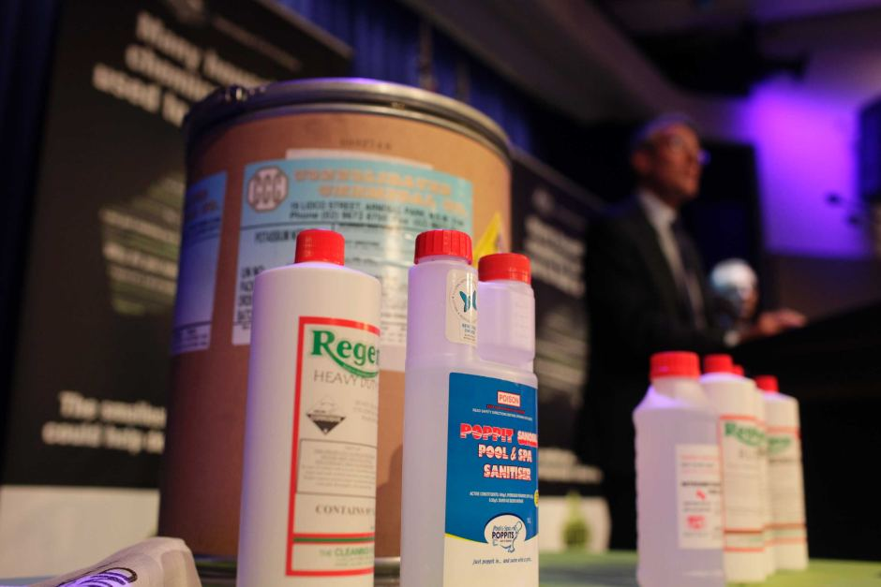
"There has been misconceived mockery from some quarters, including unfortunately the Institute of Public Affairs, of instructions propagated by extremists," he said.
Meanwhile, the Federal Police's deputy commissioner of national security Peter Drennan spelt out behaviours that should raise suspicion.
"A suspicious behaviour in relation to the circumstances in which they are purchased, about the identity, about whether people are using cash or you know, reluctant to use a credit card," he said.
"If there are garbage bins full of chemical containers at a house which doesn't have a swimming pool and there's a whole lot of chlorine there."
Lowy Institute Fellow and terrorism expert Dr Rodger Shanahan points out efforts to raise community awareness are useful - but not only in prevention.
"Logic would probably tell you that, particularly in the UK, where some people have been arrested on suspicion of committing terrorist acts that this kind of information has probably been - would have been - one of the types of information that police had used to put together a case," he said.
Dr Shanahan also says IEDs are more likely to be used as a terrorist's weapon of choice in Australia where gun laws are comparatively tight.

Honeybees Trained in Croatia to Find Land Mines
Source:http://newsfeed.time.com/2013/05/19/honeybees-trained-in-croatia-to-find-land-mines/#ixzz2 UCYM37Tf

Mirjana Filipovic is still haunted by the land mine blast that killed her boyfriend and blew off her left leg while on a fishing trip nearly a decade ago. It happened in a field that was supposedly de-mined.
Now, unlikely heroes may be coming to the rescue to prevent similar tragedies: sugar-craving honeybees. Croatian researchers are training them to find unexploded mines littering their country and the rest of the Balkans.
When Croatia joins the European Union on July 1, in addition to the beauty of its aquamarine Adriatic sea, deep blue mountain lakes and lush green forests, it will also bring numerous un-cleared minefields to the bloc’s territory. About 750 square kilometers (466 square miles) are still suspected to be filled with mines from the Balkan wars in the 1990s.
Nikola Kezic, an expert on the behavior of honeybees, sat quietly together with a group of young researchers on a recent day in a large net tent filled with the buzzing insects on a grass field lined with acacia trees. The professor at Zagreb University outlined the idea for the experiment: Bees have a perfect sense of smell that can quickly detect the scent of the explosives. They are being trained to identify their food with the scent of TNT.
“Our basic conclusion is that the bees can clearly detect this target, and we are very satisfied,” said Kezic, who leads a part of a larger multimillion-euro program, called “Tiramisu,” sponsored by the EU to detect land mines on the continent.
Several feeding points were set up on the ground around the tent, but only a few have TNT particles in them. The method of training the bees by authenticating the scent of explosives with the food they eat appears to work: bees gather mainly at the pots containing a sugar solution mixed with TNT, and not the ones that have a different smell.
Kezic said the feeding points containing the TNT traces offer “a sugar solution as a reward, so they can find the food in the middle.”
“It is not a problem for a bee to learn the smell of an explosive, which it can then search,” Kezic said. “You can train a bee, but training their colony of thousands becomes a problem.”
Croatian officials estimate that since the beginning of the Balkan wars in 1991, about 2,500 people have died from land mine explosions. During the four-year war, around 90,000 land mines were placed across the entire country, mostly at random and without any plan or existing maps.
Dijana Plestina, the head of the Croatian government’s de-mining bureau, said the suspected devices represent a large obstacle for the country’s population and industry, including agriculture and tourism. In the nearly two decades since the end of the war, land mines have taken the lives of 316 people, including 66 de-miners, she said.
“While this exists, we are living in a kind of terror, at least for the people who are living in areas suspected to have mines,” she said. “And of course, that is unacceptable. We will not be a country in peace until this problem is solved.”
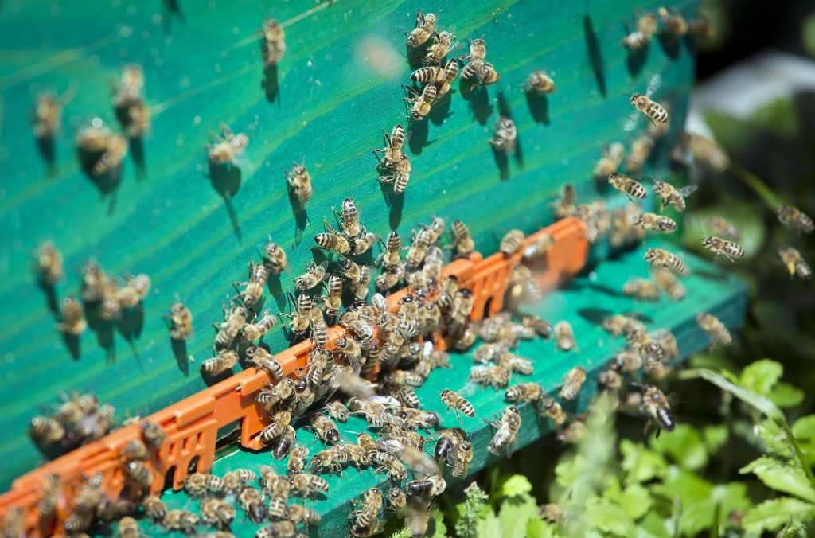
In 2004, Filipovic and her boyfriend were on a fishing trip that took them to a river between Croatia and Bosnia.
“As we were returning hand-in-hand, my boyfriend stepped on a mine,” the 41-year-old Filipovic said. “It was an awful, deafening explosion … thousands of shrapnel parts went flying, hundreds ending up in my body. He was found dead several meters away, while I remained in a pool of blood sitting on the ground.”
She sued the Croatian government, saying the area wasn’t clearly marked as a former minefield.
“At first I thought I was asleep,” she recalled. “Then I heard the voice of my father. I opened my eyes, and saw nothing. I thought I lost my eyes.”
The government admitted guilt in the case for failing to keep the minefield sign, but the court has yet to determine financial compensation.
It may be a while before the honeybees hit real minefields, Kezic said. First, they will conduct controlled tests, with real mines but which are marked.
Kezic said American researchers have in the past experimented with mine-searching bees, but TNT — the most common explosive used in the Balkan wars — wasn’t part of their experiment because its smell evaporates quickly, and only small traces remain after time. Rats and dogs are also used to detect explosives worldwide, but unlike bees, they could set off blasts on the minefields because of their weight.
Even after the de-miners have done their job in an area, some land mines are missed and remain in the soil, and they are most often the cause of deadly explosions. Once the experiment with bees proves scientifically reliable, the idea is to use them in the areas that have already been de-mined, where their movement would be followed with heat-seeking cameras, Kezic said.
“We are not saying that we will discover all the mines on a minefield, but the fact is that it should be checked if a minefield is really de-mined,” he said. “It has been scientifically proven that there are never zero mines on a de-mined field, and that’s where bees could come in.”

Disneyland explosion leads to evacuation
Source: http://www.guardian.co.uk/world/2013/may/29/disneyland-explosion-evacuation

Los Angeles police have evacuated Disneyland's Toontown (Anaheim, CA) after a small explosion in the theme park.
Officers led families and staff out of the attraction on Wednesday afternoon amid reports an improvised device made of dry ice exploded in a plastic bottle. No one was injured.
Bomb disposal experts from the Orange county sheriff's department headed to the scene as local police sealed off the area and gathered evidence.
"As a precaution we have evacuated Toontown," Sergeant Robert Dunn of the Anaheim police department told reporters.
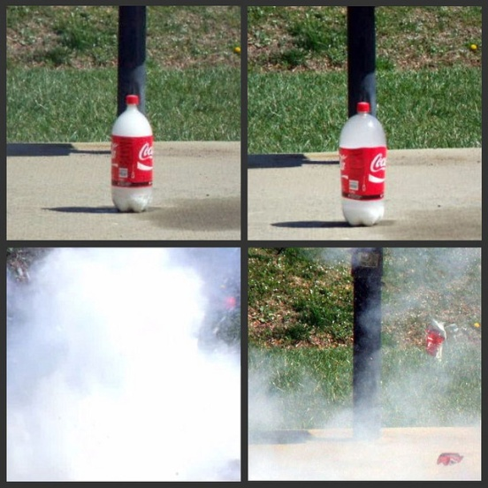
The explosion was in a trashcan, Disneyland said in a statement. "This afternoon a small bang was heard in a trash can at Mickey's Toontown. In an abundance of caution the area was evacuated. There were no injuries and no reported damage. We are working with local authorities who are now on-site and reviewing."
Witnesseses said the bang sounded similar to a gunshot but louder. "Was sitting in Toontown at Disneyland and something exploded in the trash can. I felt the sound waves of it," tweeted Shawna Gonzales.
"It came from a trash can next to the trolley stop in the middle of Toontown," tweeted Allen Wolf. "Everyone stopped and looked around when it happened."
Toontown has cartoon-style architecture and includes the home of Mickey Mouse. It is popular with young children.

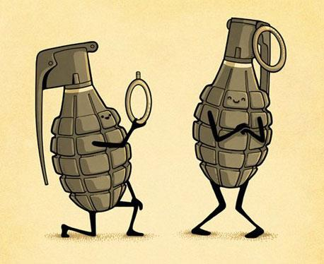

Highly sensitive polymer detects IEDs
Source: http://www.homelandsecuritynewswire.com/dr20130605-highly-sensitive-polymer-detects-ieds

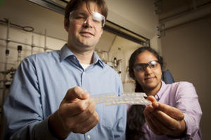
Assistant Professor of Chemistry Will Dichtel, and graduate student Deepti Gopalakrishnan with samples of polymer that can detect the explosive RDX. // Source: cornell.edu

A chemical which is often the key ingredient in improvised explosive devices (IEDs) can be quickly and safely detected in trace amounts by a new polymer created by a team of Cornell University chemists.
The polymer, which potentially could be used in low-cost, handheld explosive detectors and could supplement or replace bomb-sniffing dogs, was invented in the lab of William Dichtel, assistant professor of chemistry and chemical biology. The work was published online in May in the Journal of the American Chemical Society.
A Cornell University release reports that RDX, short for research department explosive, is an explosive material common in military and industrial applications that is also a favorite of bomb-making terrorists. It requires a detonator to explode, but when detonated, it is more powerful than TNT. What is more, RDX’s vapor pressure is 1,000 times lower than TNT’s, making it almost impossible to detect without direct contact with a concentrator, like the swabs used at airport security.
Dichtel and graduate student Deepti Gopalakrishnan made a polymer that uses fluorescence quickly and accurately to ascertain whether RDX is present on a surface or in the air.
“One of the goals is to make detectors that can detect not just explosives on someone’s hands, but in the cloud around them,” Dichtel said — much like the dust cloud surrounding Charlie Brown’s friend Pigpen, he said. “If someone had an IED in their bag, it would be nice to not have to open it.”
The researchers’ work builds on a previously established technology that uses “fluorescence quenching” as the basis for detecting TNT; in the presence of the explosive, the polymer’s fluorescence shuts off.
The polymer has a random, cross-linked structure that allows it to absorb light and transport the resulting energy throughout its structure. After a certain period of time, the polymer releases this energy as light, a process known as fluorescence. If the energy encounters a molecule of explosive as it travels through the polymer, it can be converted into heat instead of light, which causes the polymer to stop glowing. This design allows the polymer fluorescence to sense extremely small amounts of the explosive of interest, enabling identification of IEDs or people who have recently handled them.
The experiments also involved testing a host of other chemicals, such as those found in lipstick and sunscreen, to rule out false positives.
The release notes that Dichtel’s general research interest is in new kinds of polymers, particularly two-dimensional polymers, which are extremely orderly in their molecular pattern, like a city grid. While attempting to discover a new two-dimensional polymer, the researchers found this material, which does not have the same type of orderly structure, but turned out to be a perfect match for RDX.
The research was supported by a National Science Foundation CAREER Award and the Cornell Center for Materials Research, and the researchers used the Cornell High Energy Synchrotron Source.

— Read more in Deepti Gopalakrishnan and William R. Dichtel, “Direct Detection of RDX Vapor Using a Conjugated Polymer Network,” Journal of the American Chemical Society 135, no. 22 (3 May 2013): 8357–62

Abstract
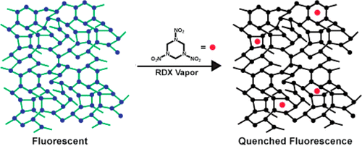
1,3,5-Trinitroperhydro-1,3,5-triazine (RDX) is a principal component of plastic explosives used in acts of terrorism and within improvised explosive devices, among others. Approaches to detect RDX compatible with remote, “stand-off” sampling that do not require preconcentration strategies, such as the swabs commonly employed in airports, will benefit military and civilian security. Such detection remains a significant challenge because RDX is 10³ less volatile than 1,3,5-trinitrotoluene (TNT), corresponding to a parts-per-trillion vapor pressure under ambient conditions. Therefore, while fluorescence quenching of conjugated polymers is sufficiently sensitive to detect TNT vapors, RDX vapor detection is undemonstrated. Here we report a cross-linked phenylene vinylene polymer network whose fluorescence is quenched by trace amounts of RDX introduced from solution or the vapor phase. Fluorescence quenching is reduced, but remains significant, when partially degraded RDX is employed, suggesting that the polymer responds to RDX itself. The polymer network also responds to TNT and PETN similarly introduced from solution or the vapor phase. Pure solvents, volatile amines, and the outgassed vapors from lipstick or sunscreen do not quench polymer fluorescence. The established success of TNT sensors based on fluorescence quenching makes this a material of interest for real-world explosive sensors and will motivate further interest in cross-linked polymers and framework materials for sensing applications.

‘Bomb-making for Beginners’: Inside an Al-Qaeda E-Learning Course
By Anne Stenersen
Source:http://www.terrorismanalysts.com/pt/index.php/pot/article/view/241/html?goback=.gde_4962526_member_248237925

Abstract
This study explores how terrorists utilize the Internet to learn bomb-making skills. Unlike previous studies, it does not focus on assessing the quality of online bomb recipes. Rather, it discusses the efforts being made by on-line jihadists to help others learn by providing so-called “e-learning courses.” As of today, such courses have few active participants yet they tend to attract large interest – indicating that there is a demand among Al-Qaeda’s online sympathizers for developing this concept further.

Introduction
This article discusses how the Internet may assist terrorists in learning how to manufacture explosives. Explosives remain the most common type of weapon for terrorist groups, with bombings accounting for about one-half of all terrorist attacks worldwide.[1] Previous studies of this kind have tended to concentrate on identifying the content of militant web pages, including what kind of “bomb recipes” are being circulated on these pages, and how technically accurate they are.[2] However, few studies have attempted to explain the actual learning process of terrorists who chose to rely on the Internet. How do real-life terrorists utilize online content to become proficient bomb-makers? What major obstacles and challenges do they face? And what efforts are being made by content producers (terrorist groups, forum administrators or “jihobbyists”) to overcome these obstacles today?
The topic has become one of current interest as one of the world’s most dangerous terrorist networks, Al-Qaeda, is increasingly trying to urge its followers to carry out terrorist attacks at their own initiative without first travelling to a foreign country for training, indoctrination and approval. Before 2001, it was relatively easy to travel to Al-Qaeda’s training camps in Afghanistan. In fact, it was a central part of the Al-Qaeda leadership’s training doctrine.[3] After 2001 and until today, it has become extremely risky, not only due to the risk of being compromised by security services, but also due to U.S. drone campaigns against known Al-Qaeda hideouts in the Afghan-Pakistani border areas as well as in Yemen. These drone campaigns have increased drastically since 2008 and have killed a number of high- and mid-ranking Al-Qaeda members. These include not only organisers and leaders of international terrorist operations, such as Hamza Rabia al-Masri and Saleh al-Somali. They also include bomb-makers such as Ibrahim al-Muhajir al-Masri, who helped build the bombs for the 1998 East African embassies bombings, and Midhat Mursi (aka Abu Khabab al-Masri), the Egyptian-born chemist who ran his own explosives training camp in Afghanistan during the Taliban’s reign. He is believed to have continued this effort in the Tribal Areas of Pakistan after 2001 until he was killed in 2008.[4]
The study is divided into five parts. First, it discusses Al-Qaeda’s strategic shift towards “individual jihad.” Second, it explores how terrorists learn bomb-making skills more generally. Third, the article takes us inside an “e-learning course” which was held on Shumukh al-Islam, a well-known jihadi discussion forum, in April and May 2011. Fourth, the article discusses the evolution of Al-Qaeda’s “e-learning tools” more generally, and fifth, it looks at a U.S. cell of would-be terrorists who sought to learn the art of bomb-making online.
Studies of jihadi discussion forums have several limitations. First, the members of a discussion forum are anonymous. All we know is their nickname as well as their status and activity on that particular forum. We do not know who they are and what their real life intentions might be. Second, we must assume that part of the course takes place through private correspondence, which is hidden to the outside observer. Nevertheless, there is much to learn from studying jihadi e-learning courses. The above-mentioned course included ten accessible lessons and more than 300 open comments, questions and suggestions from the participants. It gives us a good idea of the content and the dynamics of the course, as well as the obstacles faced by the participants.

Al-Qaeda’s Shift towards “Individual Jihad”
Due to the extreme pressure on Al-Qaeda’s current sanctuaries abroad, Al-Qaeda leaders seem to be expanding their strategy to include so-called “leaderless jihad.” The concept is not new. The jihadi strategist Abu Mus‘ab al-Suri wrote and lectured on the idea back in the 1990s, and held several lecture series to trainees in jihadi training camps. The strategic concept developed by al-Suri became known as al-muqawama al-islamiyya al-‘alamiyya, “The Global Islamic Resistance.”[5] He praised “lone wolf” terrorist attacks that were conducted by individuals that had no connection to Al-Qaeda Central, but who nevertheless carried out attacks supporting Al-Qaeda’s global ideology. Individuals praised by al-Suri included El Sayyid Nusayr, an Egyptian-American who shot and killed the American-Israeli politician Meir Kahane in New York in 1990, and Ramzi Yusef, who carried out the first bombing of the World Trade Center in 1993.[6]
Al-Suri was never an official member of Al-Qaeda, but his publications are widely read by jihadists across the world, especially after the U.S. State Department announced a US$ 5 million reward on al-Suri’s head in November 2004.[7] Al-Qaeda’s top leadership has later picked up on al-Suri’s ideas. In June 2011, Ayman al-Zawahiri issued a video speech where he encouraged followers of Al-Qaeda to carry out “individual acts of jihad” in the countries in which they reside, rather than going to battlefields abroad.[8] The video states:
“The door of jihad cannot be closed, and he who wants to launch in his midst with determination and honesty, should not stand [back] in the face of security restrictions nor the difficulty of reaching the fighting fronts, as he could make the place he is in one of the battlefields, and that would be through individual jihad ....”[9]
The video praises several individuals who carried out exemplary acts of “individual jihad” in the past, including Mohammad Bouyeri, who killed the Dutch filmmaker Theo van Gogh in Amsterdam in 2004, and Nidal Malik Hasan, who shot and killed fourteen U.S. soldiers at Fort Hood, Texas in 2009. The video acknowledges that such acts are regarded as more controversial than travelling to an occupied Muslim territory to fight so-called “classical jihad,” and spends considerable time arguing that the two should go hand in hand.
The second part of the video contains brief operational guidance that focuses on the types of targets that should be attacked, including “the institutions that shape [the country’s] economic joints,” “influential public figures in the Crusader and Zionist government, industry and media,” and “the headquarters of newspapers and the media outlets that mock our religion and prophet.”[10] In addition, the video encourages disruptive activities by way of hacking, such as denial-of-service (DOS) attacks and hacking to disrupt electric power network systems.
With a few exceptions, the video does not instruct the would-be terrorist in howhe should train or what weapons to use against the preferred targets. It suggests that jihadists based in the United States should attack with firearms, as these are assumed to be easily accessible. Apart from that, security awareness is the most specific operational guideline, and the video points to resources on the Internet:
“[take] advantage of the wide range of resources available today on the Internet, particularly the various manuals, encyclopedias and course [sic] which deal with the Mujahideen’s operational and electronic security, and security in general.”[11]
The lack of detailed operational guidelines is probably intended – the fear and terror created by a campaign of “individual jihad” stems, in part, from not knowing who will attack, at what time and with what means. Al-Qaeda’s video hints that the attacks should be simple – the “role models” presented all used knives, firearms, or, in one instance, homemade explosives (Ramzi Yusef in the 1993 World Trade Center bombing).
It is notable that Al-Qaeda discourages people from seeking training in foreign countries, even if such training increases the terrorists’ chance of succeeding.[12] Instead, the operatives are to take advantage of opportunities in their home countries, such as procuring firearms legally, and to learn from literature on the Internet. Now and probably more so in the future, Internet stands out as a crucial resource for Al-Qaeda to use to train its operatives without risking compromising their security, due to ease of access anywhere in the world, and the possibility of remaining anonymous.
An article published in 2008 argued that while there is an abundance of training literature on radical forums online, the Internet does not function as a “virtual training camp” for Al-Qaeda – mainly, because there is no organized effort on part of Al-Qaeda Central to train people online. Others have argued that Internet training would never really replace real-life training because the Internet training can only transfer implicit but not tacit knowledge, i.e. the skills that can only come from hands-on experience.[13]
This paper argues that Al-Qaeda Central is still not making a determined effort to train followers online. However, online training courses organized by “jihobbyists” and forum administrators have become somewhat more professionalized over the past three years. The e-learning courses are more organized and include, to a greater extent than before, audio-visual learning materials as well as written compendiums. Their main weakness is their reliance on one or very few online instructors who are not always able to contribute on a regular basis, causing the interest to ebb away. It can be argued that if jihadi groups started using the Internet in a more systematic way, similar to commercial “remote learning” courses, the threat of individual terrorism would be greater than it is today. In principle, it should be possible. Academic literature argues that e-learning can be as effective as classroom teaching if conducted the proper way.[14]

How Do Terrorists Learn Bomb-Making Skills?
To discuss whether the Internet would be suitable for teaching bomb-making skills, we first need to establish how terrorists learn. More specifically, what are the conditions that need to be in place for a successful transfer of knowledge? In Al-Qaeda, as well as in other terrorist groups, knowledge has generally been transferred through direct contact, typically, in a training camp or similar settings. In the 1990s, Al-Qaeda started to record and compile knowledge in writing. The first, and most famous of such collections was the Encyclopaedia of Jihad, the purpose of which was to record all the experiences from the Afghan-Soviet jihad and to make sure the knowledge was not lost on future generations.[15] But written records are usually partial – they tell less than what is implicitly known by the practitioners of the craft.[16]
Al-Qaeda sought to transfer such knowledge directly, by establishing “explosives courses” that were taught in the training camps in Afghanistan by skilled experts. In the 1990s, Al-Qaeda’s most famous bomb expert was not Abu Khabab al-Masri, as commonly thought (Abu Khabab was a “freelance trainer” for Al-Qaeda operatives, but was not directly involved in Al-Qaeda’s major international operations). Al-Qaeda had as chief bomb-maker an Egyptian with the nickname Abu Abdul Rahman al-Muhajir (real name Muhsin Musa Matwakku Atwah), who constructed the bombs for the East African Embassy bombings in 1998; later he worked as a trainer and bomb-maker for Al-Qaeda in Afghanistan.[17]
Al-Qaeda’s bomb-making experts transferred their knowledge to new recruits who could then take over their role as trainers in the future. A recruit named Tarek Mahmoud el-Sawah went to Afghanistan during the Taliban’s rule and was hired as a bomb-trainer by Al-Qaeda. Having served in the Afghan-Soviet jihad as well as in Bosnia, he had previous experience with explosives. Nevertheless, once employed by Al-Qaeda, he was able to update and refine his skill, presumably, through
“receiv[ing] specialized explosives training, including instruction in building improvised explosive devices (IEDs) and remote detonation devices, from Abu Abdul Rahman al-Muhajir. He went on to receive advanced explosives/electronics training from Abu Tariq al-Tunisi, learning how to make timers for IEDs using Casio watches as remote detonators. Then, from June 2001, he gave instruction in explosives and wrote a four-hundred-page bomb-making manual.”[18]
After 2001, terrorist groups in Europe have preferred to go to a jihadi training camp, usually in Al-Qaeda’s core areas in the Afghanistan-Pakistan border areas. For example, two of the London 7/7 bombers went to the Afghanistan-Pakistan border areas around 2004. Their training was organized by Al-Qaeda’s then chief of “external operations,” Hamza Rabia’ al-Masri. Yet these training courses were not necessarily run by Al-Qaeda members. Terrorists who attempted to carry out attacks in Europe or the U.S. were trained at various times by Pakistani militant groups (such as Tehrik-e-Taliban Pakistan, Lashkar-e-Tayba, etc.), the Uzbek-dominated Islamic Jihad Union, or by various local “freelancers.” There are many reasons why would-be terrorists chose to go abroad to train – the prospect of receiving high-quality training is probably only one among several motivations. However, this aspect is beyond the scope of this paper, which focuses strictly on the process of transferring technical knowledge, not broader motivators and driving factors for radicalisation.
For Al-Qaeda’s strategy of “individual jihad” to work, individuals are required to acquire the necessary bomb-making skills themselves, without going to a training camp. There are examples of terrorists who have learned how to make powerful bombs based primarily based on their own efforts and experiments. In 1995, Timothy McVeigh constructed a fertilizer truck bomb which demolished the Murray building in Oklahoma City, killing 168 people. McVeigh reportedly acquired the skills to make the bomb by picking up ideas from right-wing literature (among them Hunter, a William Pierce novel from 1989), and by conducting experiments on an abandoned farm.
In July 2011 the Norwegian Anders Behring Breivik constructed a bomb that partly demolished the Government’s head offices in central Oslo, killing seven people. Thereafter he conducted a shooting massacre at a Labour Party youth camp at nearby Utøya, killing 77 more people. Like McVeigh, Breivik is assumed to have acquired the bomb-making skills by his own effort. As Breivik left a detailed diary of all his activities prior to the attack, his case provides rare insight into what it takes to acquire bomb-making skills at one’s own effort, without previous training. Breivik’s case illustrates that success requires more than simply downloading a bomb recipe from the Internet and buying the materials at the nearest grocery store. Rather, it is a meticulous process requiring high motivation, patience, and intelligence. Breivik claimed to have spent a total of 200 hours over two weeks to locate and study explosives recipes on the Internet, and two months to manufacture the explosives themselves.[19]
While the examples here are taken from the right-wing extremism, this is not to say that militant Islamists would also be capable of doing the same, if they have the necessary personal qualities. Jose Padilla is an example of an Al-Qaeda member who did not have the judgmental skills necessary to conduct such an attack alone: in 2001 he suggested to Khalid Sheikh Mohammed to build a nuclear bomb based on recipes found on the Internet. He was instructed to carry out a conventional attack with a better chance to succeed. His final attack plan was designed not by Padilla but by Mohammed Atef. Padilla’s U.S. citizenship was probably the main reason why Al-Qaeda decided to use him - not his scientific knowledge.
Dhiren Barot, a U.K.-based Al-Qaeda member, proved more capable to conduct research and come up with a viable plan. Barot spent months doing research for his plan, the main component of which was to blow up limousines filled with gas tanks in underground parking areas. Many documents were later released by the British police, which give us insight in Barot’s research methods. To devise a viable plan, Barot, like Breivik in Norway, researched multiple sources over a long period of time. Known sources to have been consulted by Barot included scientific articles, books and manuals found in the local library and on the Internet. Barot may have consulted jihadi training literature, but the main source of knowledge appears to have come from other open sources.[20]
This illustrates that a person who is dedicated to learn, and who has the ability to absorb and analyse the knowledge on his own, is not dependent on jihadi forums or Al-Qaeda-produced bomb manuals to find the necessary information. This article argues that the main strength of jihadi forums is not their technical content in itself, but the fact that they offer an interactive learning environment that may attract less dedicated would-be bomb makers - those who do not have the skills and patience to do extensive research on their own. Jihadi e-learning courses remove a major hurdle encountered by most hobbyist bomb-makers, namely, not knowing where to start.

Al-Shumukh’s “Special Explosives Course for Beginners”
On 20 April 2011, a user with the nickname ‘Adnan Shukri’ started a new thread on the Shumukh al-Islam forum. Especially designed to attract newcomers, the thread’s title read, “I am a beginner in the science of explosives and poisons, from where should I start? (Special course for the beginner mujahid).”[21] Over the next month, Shukri posted lessons, assigned ‘homework’ and replied to questions both openly on the forum, and through Personal Messaging (PM) with other forum members.[22]
Shukri’s identity is unknown. On the forum, he claimed to be a middleman between the forum’s members and Abdullah Dhu al-Bajadin, the main instructor of the course. Dhu al-Bajadin’s identity is likewise unknown. The name has been used on various jihadi forums since at least 2006 by one or several people posing as self-proclaimed explosives experts. Dhu al-Bajadin is also known as the author of a number of jihadi bomb-making manuals that have been widely distributed on the Net.[23] Participants in the thread displayed great respect towards “Professor” Dhu al-Bajadin and his assistant Adnan Shukri. It increases the probability that the course is authentic because forum members are generally wary of impostors and ‘spies’ trying to infiltrate them. Another sign of authenticity is the fact that Shukri’s thread was approved by one of Shumukh al-Islam’s web administrators and granted “sticky” status on the forum over a period of several months.
The thread was active for six and a half months – from 20 April to 4 November, 2011. As of 11 November 2011 it had a total of 19,198 viewings and was by far the “most viewed” thread in al-Shumukh’s sub-forum for explosives and preparation.[24] However, the actual course lasted little more than one month – from 20 April to 21 May, 2011. After this, Adnan Shukri disappeared from the forum, ending the organized part of the course. A total of ten lessons were posted – eight lessons in “Part One” and the two first lessons in “Part Two” – before the course was abruptly terminated.
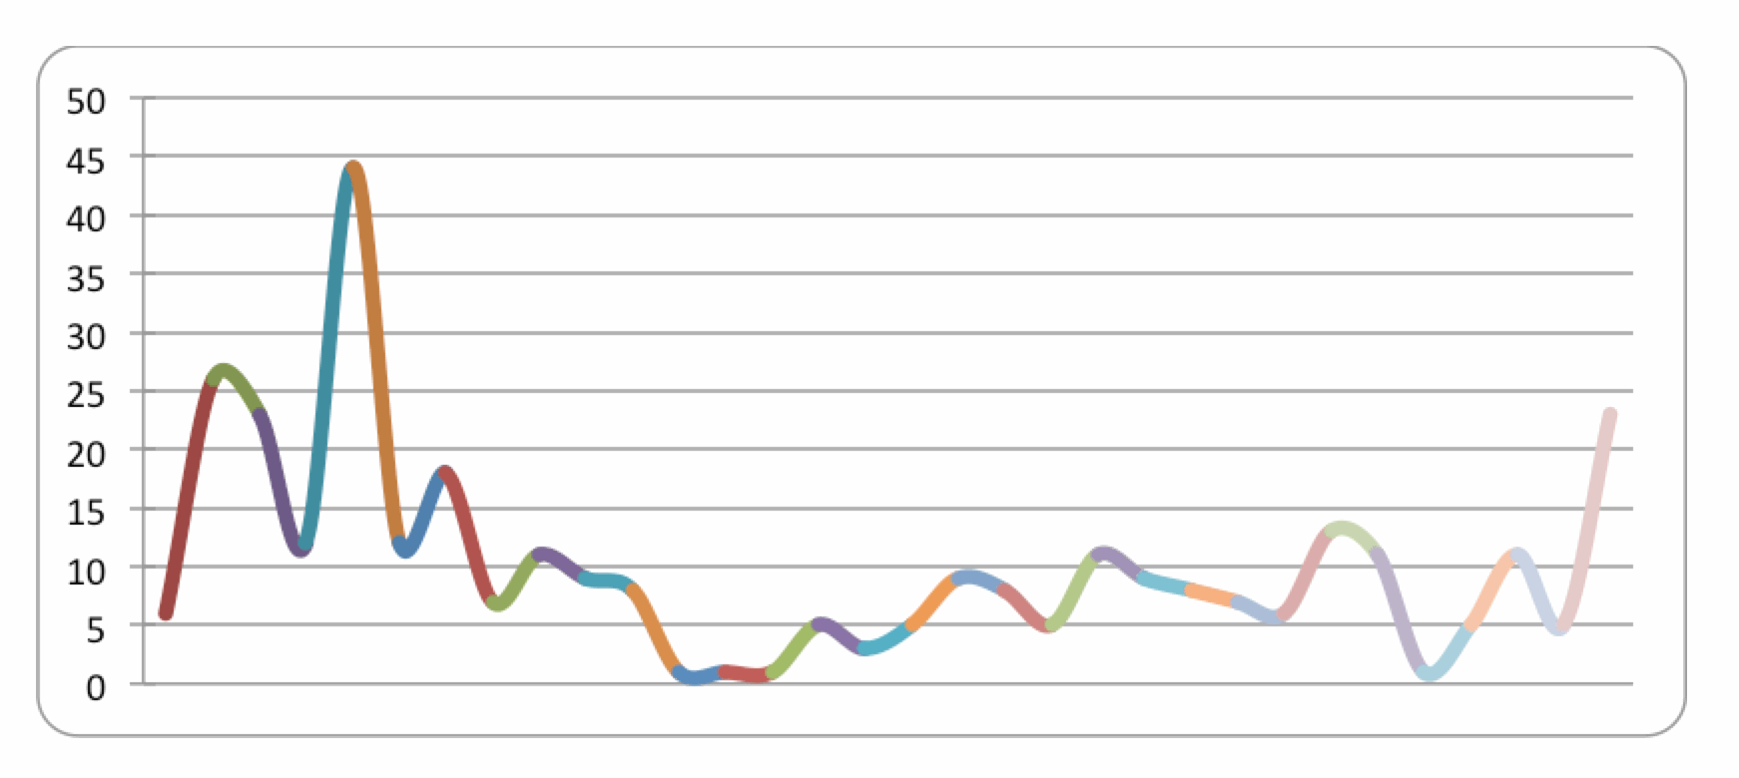
During the first two weeks of the course, Adnan Shukri claimed to post lessons and answers to questions on behalf of Abdullah Dhu al-Bajadin. Then, on 5 May 2011, Shukri announced that Dhu al-Bajadin had lost his access to the Internet, for unspecified reasons, and that there would be a short break in the course. But posting of lessons resumed the next day, as Shukri decided he would carry on with the course on Dhu al-Bajadin’s behalf. Forum members continued to show interest in the course and there was relatively constant activity until Shukri’s departure in the end of May 2011(see Figure 1).
Figure 1: No. of Replies per Day, 20 April - 21 May 2011

By 21 May 2011, the thread had grown to 324 replies, including the comments and lessons posted by Adnan Shukri. A total of 58 forum members had been actively posting within the thread, but only nine out of them were active on a regular basis, i.e. having posted more than ten comments each; and only six of them submitted answers to the “exam” that was given at the end of Part One of the course. Although the thread had been viewed more than 19,000 times in the end, the number of active participants in the course did not seem to exceed ten or twenty at most. This illustrates that jihadi e-learning courses is an extremely marginal phenomenon – on the other hand, they should not be regarded as insignificant. Al-Qaeda sympathisers are becoming more and more proficient at using modern communication technologies, especially for propaganda purposes. But since 2008, important improvements have been done in the field of e-learning as well.

The Evolution of Jihadi E-Learning Courses
The Al-Qaeda network has a long tradition of promoting remote learning courses, even before the age of the Internet. According to high-ranking Al-Qaeda member Fadil Harun, Al-Qaeda started to offer distant learning courses for new cadres already back in 1999-2000. The courses were part of a comprehensive program held within Afghanistan to educate future Al-Qaeda leaders. While practical skills were taught in training camps and at the Taliban’s frontlines, some of the theoretical courses were offered through letter correspondence.[25] After 2001, training courses started to appear on the Internet – the “Al-Battar” series of Al-Qaeda on the Arabian Peninsula (first issued in January 2004) being a prominent example.[26] From around 2006, audio-visual training material started appearing on jihadi websites, including detailed instruction videos on how to manufacture explosives. However, these videos were not produced by the Al-Qaeda network’s official media companies, but by individual jihadi sympathisers or Palestinian groups such as Hizbollah and Hamas. A study published by this author in 2008 concluded that Al-Qaeda was far from utilizing the full potential of the Internet in terms of training potential recruits.[27].
Since 2008, the number of instruction videos on jihadi web pages has increased, but producers and content are largely the same as before. An exception is the inclusion of two videos explaining how to build an improvised Explosively Formed Penetrator (EFP) – a weapon that appeared in the Iraq war after 2005. While most of the EFPs in Iraq were relatively sophisticated weapons – imported from Iran and used by Shia militias – there were attempts at using crude, home-made devices as well. At some point this production method was captured on tape – apparently by a Shia militia, since the salafi-jihadi version of the films refers to the producer as hizb shaytan – “The Party of Satan.” The film eventually made its way to jihadi discussion forums, after being modified by members of the Al-Qaeda affiliated al-Fallujah forum.[28] It was first spotted by FFI researchers in February 2011.[29] The time lapse is worth noting: It took more than five years from a jihadi group started developing the device on the ground in Iraq, until an instruction video on how to manufacture it appeared on a jihadi discussion forum. This may qualify the claim that the Internet plays an important role in transferring insurgent tactics and technologies between battlefields – at least for now – but this could rapidly change in the future, since the infrastructure for doing so is already in place. Most jihadi insurgent groups today have proven themselves capable of video-editing and rapid distribution via the Internet. It is probably a question of intention, rather than capability.
Returning to the topic of “e-learning courses” on jihadi forums the most visible development that has taken place since 2008 is the increased amount of courses being offered, as well as the integration of written and audio-visual learning aids. For example, al-Shumukh’s “Special explosives course for beginners” which was offered in 2011 comprised a number of written compendiums in pdf-format – full of pictures and illustrations – in addition to video clips selected by the instructor to illustrate certain aspects of the lesson such as the effect of an explosion of a particular substance. Back in 2008, there were both audio-visual and written training courses offered on jihadi forums, but seldom a mixture of both. The development may not seem so significant, but at least it illustrates that certain efforts are being made at improving the effectiveness of such courses. Court cases against suspected terrorists in the West confirm that there is an interest among terrorists on the ground for accessing such e-learning material. This will be further detailed in the next section.

An Example of a Would-Be Jihadist Who Sought Online Training
The court case against Mohammad Zaki Amawi et al provides an example of how real-life militant islamists utilize the Internet for learning. Amawi was the leader of a three-member would-be “terrorist cell” in Ohio, USA. In 2004-2005, the cell tried to obtain militant training in the United States before going to Iraq to fight U.S. forces. They sought the assistance of a “trainer,” the former Special Operations Forces soldier Darren Griffin, who in reality worked as an undercover agent for the FBI. The three members of the cell were convicted to lifetime in prison in 2008.[30]
Amawi and one of his co-conspirators, Marwan El Hindi, were both active on jihadi forums on the Internet. Amawi had a large collection of propaganda films from Al-Qaeda, especially from Iraq. The cell’s members met on several occasions and watched videos together. They also attempted to use the Internet to obtain training materials: In early 2005, Amawi downloaded the “Martyrdom operation vest preparation” instruction video (a video originally produced by Hizbullah). Al Hindi also downloaded the video, as well as a slide show entitled “The mujahidin in Iraq and the art of planting explosive charges,” produced by the Islamic Army of Iraq. They also had other, unspecified training manuals on how to make explosives. They discussed the training materials with their “trainer” Darren Griffin, and they expressed interest in learning how to build IEDs.
In February 2005, El Hindi and Griffin visited the al-Ikhlas forum together. The website offered a “Basic training” and an “Advanced training” course. According to the court documents, El Hindi helped Griffin to register for the basic training course. There is no further information as to whether El Hindi or his co-conspirators completed the course, but El Hindi was clearly familiar with its existence.
The case illustrates how real-life radicals may exploit online training material. It is worth noting that Amawi sought to join the jihad in Iraq for the first time between October 2003 and March 2004. It means that he was already radicalised at the time he downloaded the jihadi training materials and accessed the online e-learning course. The purpose of downloading the material was probably to get better prepared before attempting to join the jihad in Iraq a second time. In this case, the jihadi training manuals were not the initial radicalising factor, but they probably served as encouragement in later stages of Amawi’s radicalisation process.
However, the case also indicates that the cell’s members were not able to absorb the online training material on their own – indicated by the fact that they sought help from an external “trainer.” Also, they were not able to judge the quality of the online training material. For example, El Hindi said he wanted to use the “Martyrdom operation vest preparation” video to train new recruits, but the instructions in the video are probably too advanced for a beginner with no experience in explosives. [31] Moreover, the video is not suitable if the purpose is to convince new recruits to become suicide bombers. It is strictly informative, and does not contain any of the emotional persuasion tools typical of Al-Qaeda-style recruitment videos (pictures of dead martyrs, images of paradise, religious hymns, etc.). In the end it was Griffin – the FBI infiltrator – who helped the cell’s members receive proper firearms training by renting a commercial shooting range.[32]

Conclusion
Jihadi e-learning courses are a marginal phenomenon, yet they should not be ignored. While there are still very few active participants in such courses, they attract large interest among online jihadists. The quality of the courses has improved over the last few years, and there are dedicated people online who are interested in developing them further. As training in jihadi conflict areas has become difficult, more recruits are likely to try and obtain paramilitary skills before going abroad – or before attempting to carry out a terrorist attack at home. Some of these would-be jihadists might consider joining regular armed forces or private shooting clubs in their home country. A far less risky venture is to seek out jihadi training courses online, because they allow the participants to remain anonymous while conducting their training.

►Notes are available at source link

Anne Stenersen (M.Phil, PhD) is a research fellow at the Norwegian Defence Research Establishment (FFI), specialising on militant Islamism.

A new method to detect RDX
Source: http://i-hls.com/2013/06/a-new-method-to-detect-rdx/

A chemical which is often the key ingredient in improvised explosive devices (IEDs) can be quickly and safely detected in trace amounts by a new polymer created by a team of Cornell University chemists.
The polymer, which potentially could be used in low-cost, handheld explosive detectors and could supplement or replace bomb-sniffing dogs, was invented in the lab of William Dichtel, assistant professor of chemistry and chemical biology. The work was published online in May in the Journal of the American Chemical Society.
A Cornell University release reports that RDX, short for research department explosive, is an explosive material common in military and industrial applications that is also a favorite of bomb-making terrorists. It requires a detonator to explode, but when detonated, it is more powerful than TNT. What is more, RDX’s vapor pressure is 1,000 times lower than TNT’s, making it almost impossible to detect without direct contact with a concentrator, like the swabs used at airport security.
According to HLS NewsWire Dichtel and graduate student Deepti Gopalakrishnan made a polymer that uses fluorescence quickly and accurately to ascertain whether RDX is present on a surface or in the air.
“One of the goals is to make detectors that can detect not just explosives on someone’s hands, but in the cloud around them,” Dichtel said — much like the dust cloud surrounding Charlie Brown’s friend Pigpen, he said. “If someone had an IED in their bag, it would be nice to not have to open it.”
