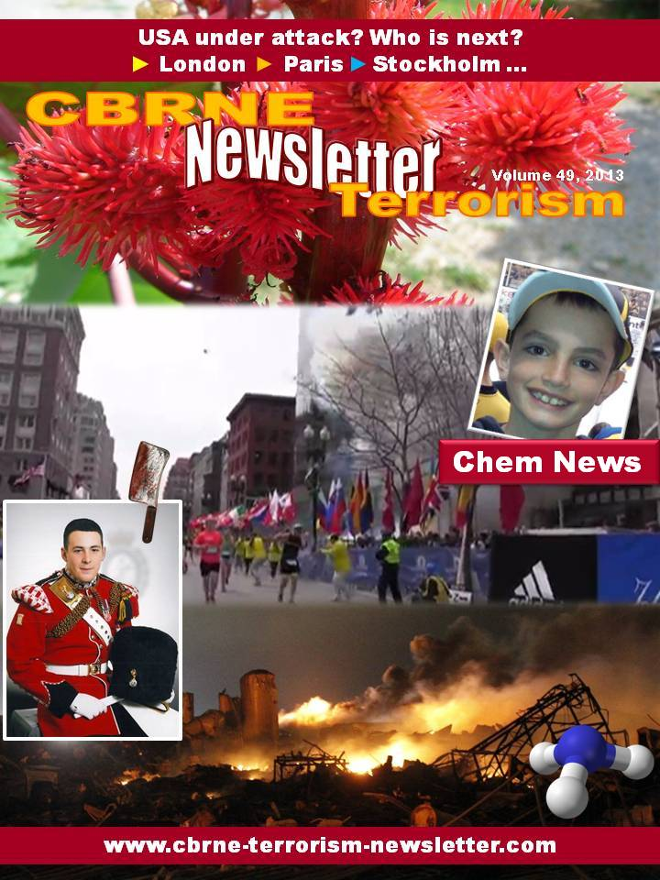

.

Teams search for survivors after massive blast at Texas plant
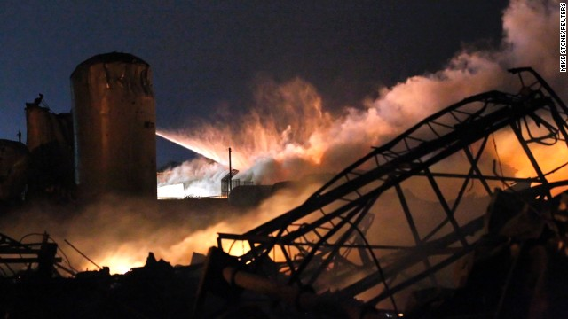
Source: http://www.cnn.com/2013/04/18/us/texas-explosion/index.html

Authorities searched through mounds of rubble Thursday in hopes of finding survivors of the huge, deadly explosion at a fertilizer plant that flattened much of a small Texas town.
The blast, which residents described as "massive" and "overwhelming," left shattered homes and wreckage in a wide swath of West, Texas, a town of only 2,800 people.
"It's overwhelming to us," said George Smith, the town's director of emergency services. As he spoke to CNN affiliate KCEN, blood was spattered on his face from injuries he suffered.
"It was like a nuclear bomb went off," said Mayor Tommy Muska.
On Wednesday evening, a fire at the plant suddenly exploded with a huge, deafening bang, throwing people to the ground blocks away. It measured as a 2.1-magnitude seismic event, according to the United States Geological Survey. Even 50 miles away, homes shook.
The blast came minutes after the fire began, so firefighters were already on the scene. Some may be among the dead, but the casualty count is unclear, Waco Police Sgt. William Patrick Swanton said, estimating that overall, five to 15 people may have lost their lives. Smith said the death toll could spike to 60 or 70. More than 160 people were injured.
"We have two EMS personnel that are dead for sure, and there may be three firefighters that are dead," Smith said.
About half the town was evacuated, including a nursing home with 133 residents. A middle school is also near the plant.
Texas Gov. Rick Perry declared McLennan County a disaster area.

'Roof came in on me'
The explosion tore through the roof of West Fertilizer Co., charring much of the structure and sending massive flames into the air, followed by a plume of smoke bigger than the plant itself. A deafening boom echoed for miles.
It was "massive -- just like Iraq, just like the Murrah (Federal) Building in Oklahoma City," said D.L. Wilson of the Texas public safety department, referring to a bombing that took place 18 years ago Friday.
The blast stripped a nearby apartment complex, with 50 units, of its walls and windows. "It was just a skeleton standing up," Wilson said.
"The windows came in on me, the roof came in on me, the ceiling came," Smith said.
The town, he said, has only three ambulances.
Between 50 and 60 homes in a five-block area sustained damage, officials said.
"It, like, picked you up," a woman told CNN affiliate WFAA. "It just took your breath away. And then it dropped you and it exploded everything around you. ... It was like a suction, and then it just blew it all out. You could feel everything. You could feel it on your skin, your hair was being blown. It was crazy."
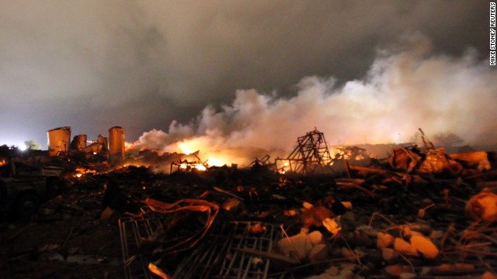
She managed to cover one of her children, she said, and "grabbed my little one and dove through a door. It was chaos. All my windows blew out, my doors off the hinges. All I had were my keys in my hand, and I just threw the dog, everybody, in the car, and we took off."
Video taken by college student Eric Perez -- from what appeared to be a safe distance away from the fire, past a large field -- shows the moment of the blast. In a split second, the fire over the plant bursts into into widespread destruction, knocking Perez over. Bright flames fill the sky.
Perez and his friends were playing basketball when they noticed the flames at the plant. "Nothing ever happens in our small town, so I recorded," he said. "Then the explosion went off. We were thrown into the bed of my truck."
One of his friends suffered a flash burn to his face and broken ribs. Another was burned on his arm and hit with flying shrapnel. A third had a cut to his face.
Brad Smith lives 50 miles away and felt his house shake.
"We didn't know exactly what it was," he said. "The forecast said a line of thunderstorms was going to come through. My wife and I looked up and wondered, 'Did it get here six hours early?'

Cause unknown
"Nothing at this point indicates we have had criminal activity, but we are not ruling that out," Swanton said.
A U.S. intelligence official told CNN there is no indication so far that the blast is related to terrorism.
While state authorities are leading the investigation, the federal government is assisting.
The Federal Bureau of Alcohol, Tobacco, Firearms, and Explosives has a team of 20 agents and forensic specialists assisting, a law enforcement source told CNN.
The Texas National Guard has sent 21 troops from a civil support team to monitor air quality near the blast, the Pentagon said Thursday.
The White House said it is monitoring the situation through the Federal Emergency Management Agency, which is in touch with various agencies involved in the investigation.
"A tight-knit community has been shaken, and good, hard-working people have lost their lives," President Obama said in a statement.
Those affected "will have the support of the American people," he said.
Perry said he appreciated a call from Obama and his "gracious offer of support."

Chemical concerns
With help from heavy rains early Thursday, firefighters managed to quell most of the flames in the area, authorities said.
The rain and heavy winds also helped dissipate chemicals that may have been released.
Swanton emphasized that there was no cause for alarm about the air. There was no "chemical escape" that is "out of control," he said.
Anhydrous ammonia, a gas used in making fertilizer, can cause severe burns if it combines with water in the body. Exposure to high concentrations can lead to death.
The West Fertilizer Co. said it had 54,000 pounds of the chemical, The Dallas Morning News reported.
But doctors reported that the injuries they were treating, in general, came from the blast, not chemical exposure. Many people had cuts and puncture wounds. Some were in critical condition.
Small, smoldering fires remained Thursday, but not enough to halt rescue efforts, police said.
There was one early report of possible looting, but no one was arrested, Swanton said.
Local rail freight service was also being closed to help secure the area, the U.S. Department of Homeland Security said.
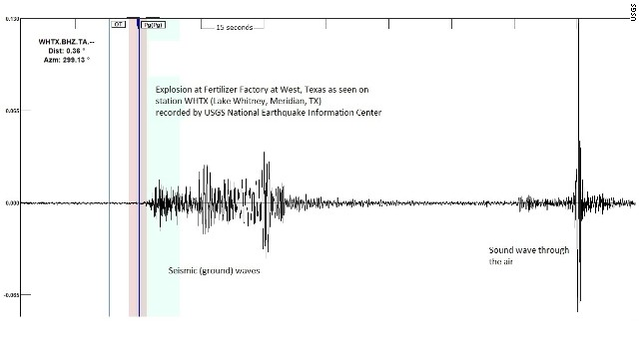
Authorities closed schools for the rest of the week and urged everyone to stay away from school property.
So many firefighters and medics descended on the town to help its all-volunteer force that the Texas public safety department said that no more assistance was needed.
"The firefighters and EMS people are coming from hundreds of miles away to help us," said Wilson of the department. "Right now, we are overflowing with help. "
West is about 75 miles south of Dallas and 120 miles north of Austin. The town's chamber of commerce touts it as "the Czech point of central Texas."
Czech immigrants arrived in the town in the 1880s, and the community still maintains strong ties to their Central European roots, with businesses named "Little Czech Bakery" and "The Czech Inn."

Worst-case scenario
In 2006, West Fertilizer had a complaint filed against it for a lingering smell of ammonia, the Texas Commission on Environmental Quality website shows.
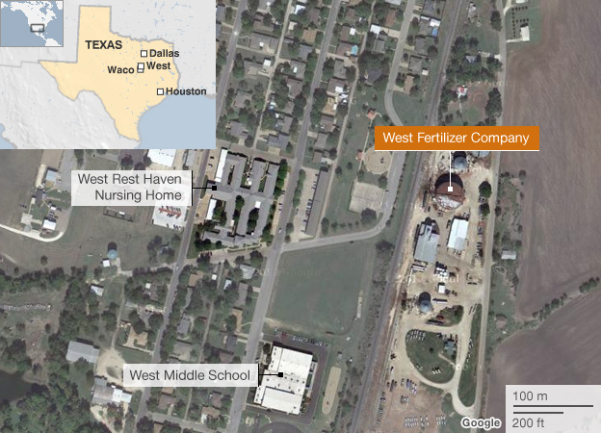
Separately, the plant had informed the Environmental Protection Agency that it presented no risk of fire or explosion, according to The Dallas Morning News. It did so in an emergency planning report required of facilities that use toxic or hazardous chemicals.
The plant's report to the EPA said even a worst-case scenario wouldn't be that dire: There would be a 10-minute release of ammonia gas that wouldn't kill or injure anyone, the newspaper reported.
What happened Wednesday night was much worse.

According to the Centers for Disease Control and Prevention, anhydrous ammonia is a pungent gas with suffocating fumes that is used as a fertilizer.
When exposed to humans, it can cause various problems:
• Anhydrous means without water
• Anhydrous ammonia can rapidly cause dehydration and severe burns if it combines with water in the body
• Symptoms can include breathing difficulty; irritation of the eyes, nose or throat; burns or blisters.
• Exposure to high concentrations can lead to death.
• Victims require treatment with large quantities of water for at least 15 minutes
• It must be stored at high pressure, according to the University of Minnesota.
• It is a low-cost, highly effective nitrogen-based fertilizer, the University of Arkansas said.
• It is one part nitrogen and three parts hydrogen.
• When released, the vapors initially move close to the ground, causing greater risk for exposure.
One of the worst disasters in U.S. history involving a form of ammonia occurred in April 1947 when a ship loaded with ammonium nitrate -- a solid fertlizer composed of ammonia and nitrogen -- caught fire while docked in Texas City, Texas, in April 1947. The fire caused an explosion that damaged more than 1,000 buildings, according to the website of the Texas Historical Association.
The blast ignited a fire on a second ship docked in Galveston Bay that was also loaded with ammonium nitrate. With most of the city's fire fighters killed in the first blast, the fire burned for 16 hours and caused another huge explosion. Volunteers fought to put out subsequent blazes.
The historical association said almost 400 people were killed and more than 175 were listed as missing. Only a few bodies in the dock area were even recovered.

LATEST NEWS
Some 35 people -- including 10 first responders -- died in a massive explosion Wednesday night at a fertilizer plant in West, Texas, Mayor Tommy Muska said, according to USA Today.
The number included five volunteer fire fighters, four emergency responders and an off-duty fire fighter from Dallas who lived in West, the mayor told the newspaper.

WAS IT AN EXPLOSION OR SOMETHING ELSE?

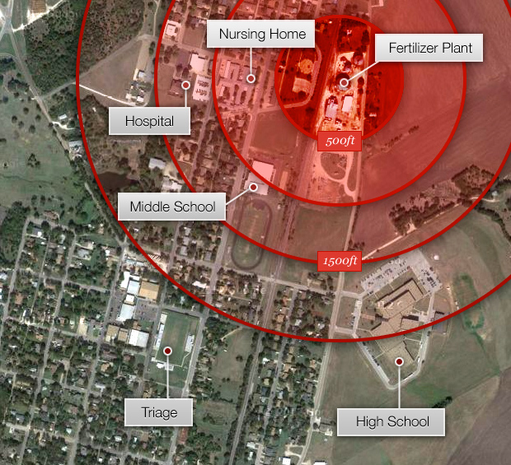
http://www.youtube.com/watch?feature=player_embedded&v=IRIpB2jkCRs

NEW BOOK – CBRN and Hazmat Incidents at Major Public Events: Planning and Response
Author: Dan Kaszeta
Available at: http://www.amazon.com/Hazmat-Incidents-Major-Public-Events/dp/111828819X

Sets forth what to do and what not to do to keep people and property safe
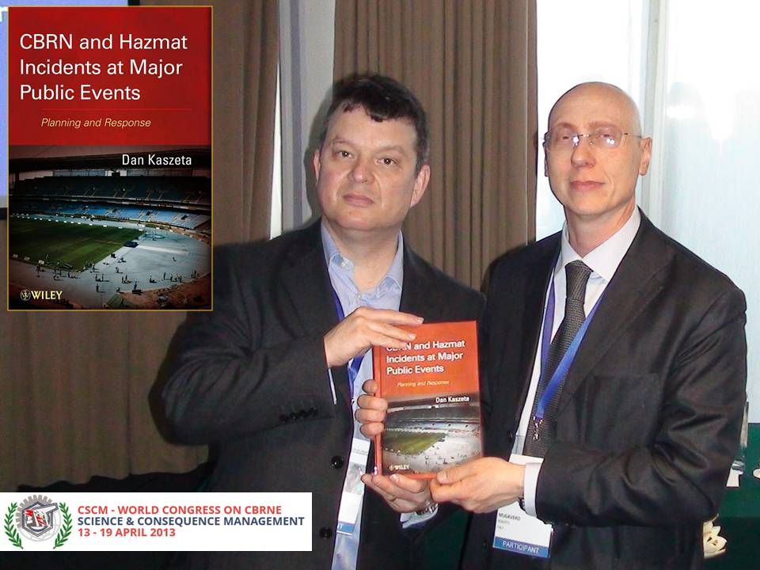
Based on the author's more than two decades of managing core facets of emergency planning and response, this book enables readers to minimize the possibility of a chemical, biological, radiological, or nuclear (CBRN) disaster or a hazardous material (hazmat) incident at public events. Moreover, it sets forth the tools needed to quickly respond to an incident in order to avoid or minimize casualties and damages. With its comprehensive approach, the book equips readers to plan for and manage a multi-disciplinary safety and emergency response team, including police, security, medical, military, and fire and civil protection personnel.
(Photo taken by Editor, during the CSCM World Congress in Croatia – Author (left) with Prof Roberto Mugavero (OSDIFE – Italy)

CBRN and Hazmat Incidents at Major Public Events examines all aspects of security planning and emergency response, including:
- General planning and preparedness procedures such as initial considerations, response network development, and training and exercise
- Planning and preparedness for security and emergency response providers, including medical, fire, police, military, and VIP protection personnel
- Incident response, including initial response, detection and identification, and law enforcement
Lastly, the author provides fourteen specific public event scenarios, explaining what to do and what not to do for effective emergency planning and response to CBRN and hazmat incidents. These scenarios also set the foundation for preparedness training and exercises.
Throughout the book, sidebars summarize the author's extensive operational and managerial experience, helping readers focus on the core tested and proven strategies and techniques needed to prevent or mitigate the impact of a CBRN or hazmat incident. With its unique focus on CBRN and hazmats, this book is essential reading for all personnel charged with protecting lives and property at large public events.

NBC Protective Suit for Medical Decontamination Personnel (SanDeco)
Source: http://www.owrgroup.net/index.php?article_id=113&clang=1

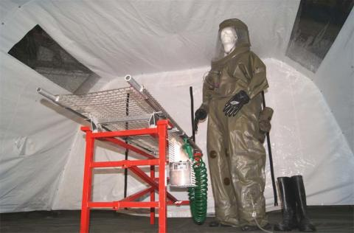
New type of over-pressurized and liquid proof suit especially designed for medical decontamination and laboratory personnel.
The suit is made of military approved, strong rubber coated tarpaulin with a RE-time > 8 hours against all known chemical warfare agents.
The suit has an air ventilation and distribution system to keep the operator cool. Wearing time without heat stress up to 4 hours is no problem. No half mask is required inside.
Absolutely extraordinary feature: you can put your arms out of the sleeves to your body and can do
- answer your telephone – take pictures
- make notices
- even eat and drink
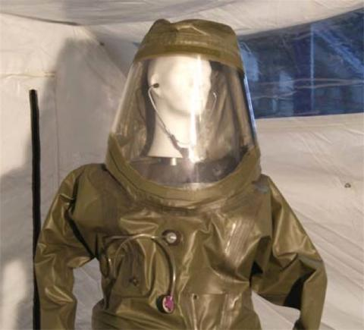
All equipment is stored inside the suit at a wrist belt.

Medical decontamination and treatment of contaminated patients requires different and more difficult capabilities of the operator than any other decontamination task.
The visor gives the personnel the possibility to communicate and work much easier than with a full face mask. For the patient it is less frightening.
This NBC protective suit offers the possibility to use a stethoscope without any risk.
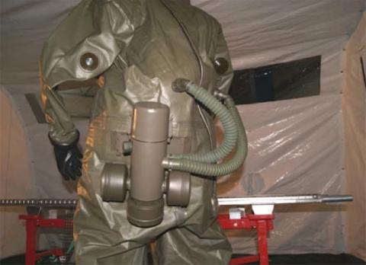
The zipper of the suit is at its back side, the front side is an absolutely sealed part even when a lot of water is used in the decon procedure.

The suit has an battery driven blower unit using 3 standard NBC filter canisters. The blower unit works for at least 4 hours but even when it fails or the batteries are running out, the operator can still breath, perform pre decontamination and drop off the suit in the white zone.
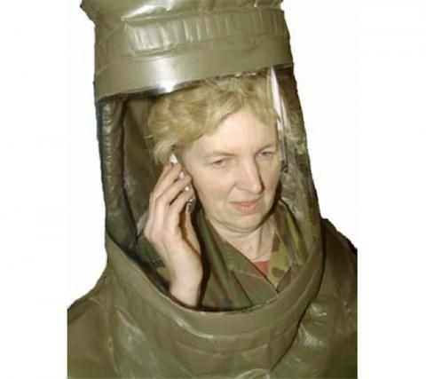
The ventilating unit and air distributing system is equal to heavy NBC-suits but with only two hoses and less shut off valves.
The gloves can be replaced by heavy butyl gloves or thin gloves for medical treatment.

The standard suit is coming with attached butyl socks. Every rubber boot can be used because the protection is coming from the socks.
Options
- suits with fix-tight mounted hazmat boots are available on customers request.
- pre-installed very small radio communication system with head set
- urinating system to be emptied outside (convenient for men only, sorry)
The Suit is registered and covered by patents and is subject to technical changes.

Evacuation Cape – VIP Rescue and Rapid Evacuation Cape
Source: http://www.owrgroup.net/index.php?article_id=114&clang=1
VIP Protection deals mostly with untrained and not pre-protected people. The VIP must be protected by the assistance of security personnel as fast as possible. Minimization of the exposure time and immediate evacuation is more important than a 100% sealed suite. Typical protection equipment consisting of coveralls, boots, gloves and masks can not effectively be used.
The Evacuation Cape is made of several high-tech materials, combining the protection of a person against dangerous substances and protection against heat / flames during a rapid evacuation mission e.g. in case of a fire or CBRN attack.

A helper can cover and protect an untrained person within 5 seconds and assist him for evacuation. The cape is designed like a fire blanket so that the helper can use it to extinguish flames in a safe way. The hood is attached to the cape and it is very easy to use. Finally a covered zipper is closing the cape at the front side within a second. The cape is designed as “one-size-fits-all”, it fits to male/female and can cover people wearing different types of fashion (e.g. Arabic, Asian, Western etc.). The operation time is estimated to 5 – 15 minutes, depending on the environmental conditions.

The Evacuation Cape is designed for
- the fast coverage and protection of untrained persons by helpers independent from the dress of the person (Arabic, Asian or Western style)
- to extinguish burning cloths of a person
- to protect a person against heat and flames during an rapid evacuation
- to minimize the contamination of a person by dust, vapours and gases (TCt50)
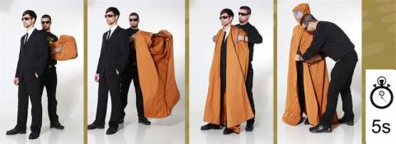
- first respiration protection of the person even without additional air supply
- safe removal after use without displacement of contamination to the person

Technical Data
Triple-Layer Sandwich Fabric
- Highly flame resistance, non-melting at any temperature, inside and outside
- Outstanding resistance to acids, solvents, bleaches, fuels and other chemicals
- Additional absorbing activated carbon layer
- Visor made of temperature resistant polymer (>200C)
- Integrated filter layers in the hood
- Weight (full cape): approx. 3 kg
- Individually packed and vacuum sealed
- Country of Origin: Made in Germany

The Evacuation Cape is registered and covered by patents. and is subject to technical changes.

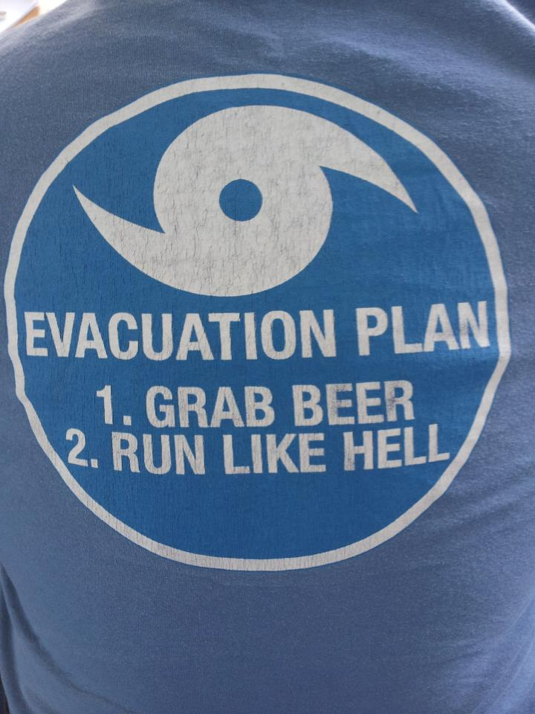

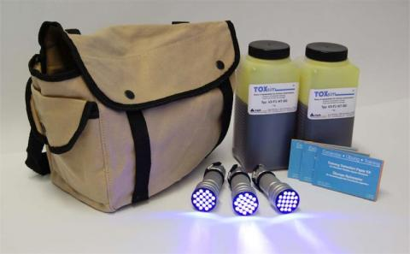
TOXsim kit Field Bag
Source: http://www.owrgroup.net/index.php?article_id=125&clang=1

The TOXsim Field Bag is designed for large applications in field exercises especially the contamination of terrain, vehicles and personnel. It consists of TOXsim (high and/or medium viscosity) in 1 kg bottles, set of UV lamps and training detection paper (EX) for the trainers/umpires.
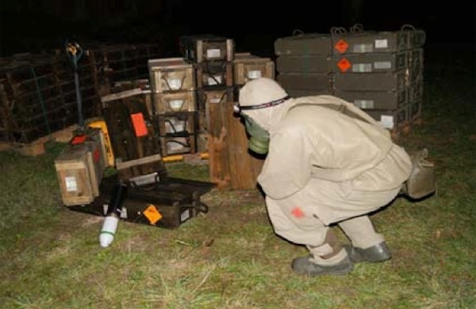
Example from an exercise
Contamination of terrain around a pile of old CWA ammunition. The soldiers must act like as if it is a real contaminated area, executing self-decontamination. After the exercise any displacement of contamination can be detected by umpires using the UV light.
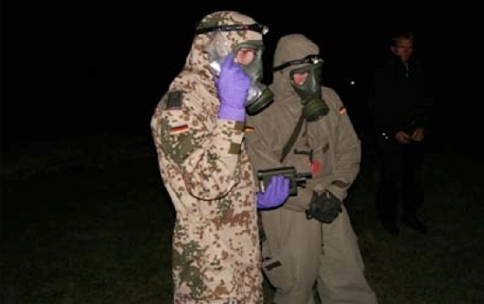
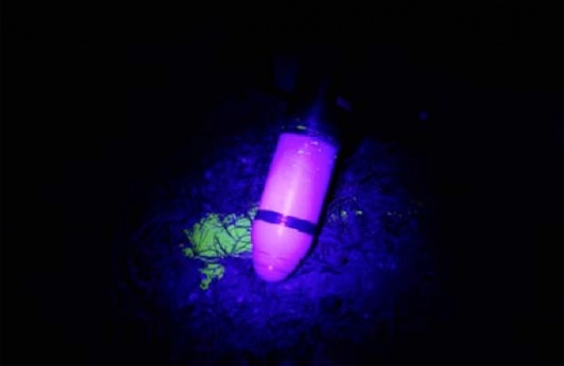
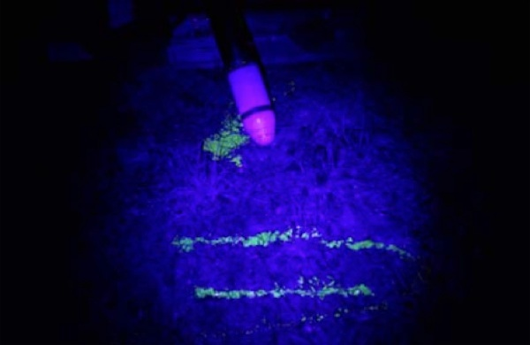

CBRN Filter Fitted Ambulance
Source: http://www.oshodefence.com/CBRNA.php

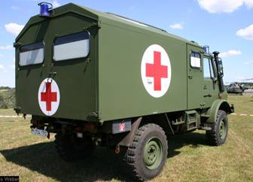 | 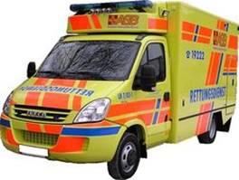
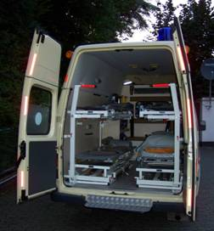 | 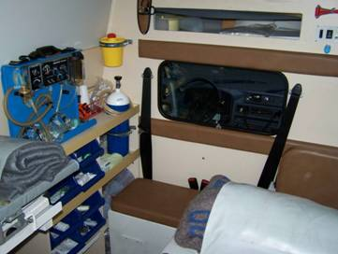
OWR has manufactured CBRN Filter Fitted Ambulances for various clients around the world. Each Ambulance is custom made as per the client’s requirements and needs. Each client has its own technical requirement. Some of the basic features of OWR Filter Fitted Ambulances are as follows:
- CBRN Filter Fitted Ambulance Carrier Vehicle is having gas-tight and over-pressurized box body compartment with CBRN filter and air conditioning system following NATO MIL-STD
- CBRN Filter Fitted Ambulance have Box body with two rear doors (incl. sealed windows) and one side door (incl. sealed window)
- Ambulance is Fitted with CBRN filters (particle and activated carbon) to supply air for minimum 6 people (optional up to 10 people)
- It has Additional Oxygen Cylinder to supply minimum 4 people for minimum 1 h with medical oxygen (treatment of gas intoxications)
- CBRN Filter Fitted Ambulance’s First priority: patient transport under CBRN protected conditions
- CBRN Filter Fitted Ambulance’s Second priority: Medical Treatment during transportation
- CBRN Filter Fitted Ambulance have Storage for Emergency Medical Equipment like Suction apparatus, Resuscitation equipments, First Aid Equipment and Antidote to treat acute intoxications with chemical warfare agents and toxic industry chemicals
- CBRN Filter Fitted Ambulance have 4 stretcher system (up to 4 stretchers can be carried at the same time)
- CBRN Filter Fitted Ambulance can transport 1 critical care patient (laying on vacuum madras, full critical care medical equipment) or 4 medium injured patients (laying, basic medical equipment, oxygen supply)
- CBRN Filter Fitted Ambulance have Set of patient documentation cards to speed up the workflow in the hospitals
- CBRN Filter Fitted Ambulance have Additional sitting capacity for 1 or 2 paramedics inside the care containment
- CBRN Filter Fitted Ambulance Driver and Co-Driver during the operation will be wearing full face protection mask with filter canister (filter mode for low toxic conditions) and optional air supply (SCBA mode for high toxic conditions), additional drinking water supply for long term missions.
- CBRN Filter Fitted Ambulance have Fast Decontamination Equipment to decontaminate the ambulance vehicles (in case of an outside contamination) before reaching the entrance of the hospital. This Equipment can not be part of the vehicle and must be stored in CBRN incident prepared hospitals.
- CBRN Filter Fitted Ambulance have Ruggedized Notebook with extensive HazMat (chemical and biological compounds) and medical database (symptoms and antidote database). Printer to produce attachments out of the database for the patient’s documentation cards to speed up the workflow in the hospitals.
- CBRN Filter Fitted Ambulance have GPS system to locate and co-ordinate the ambulance vehicles from the HQ

Afghan girls' school feared hit by poison gas
Source: http://in.reuters.com/article/2013/04/21/afghanistan-poisoning-idINDEE93K08720130421

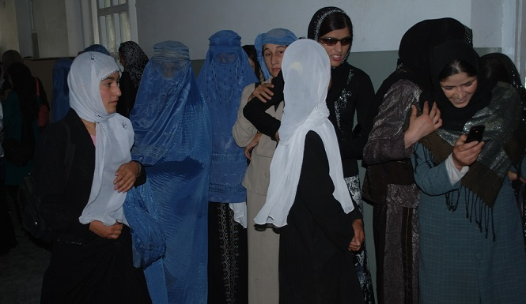
As many as 74 schoolgirls in Afghanistan's far north fell sick after smelling gas and were being examined for possible poisoning, local officials said on Sunday.
While instances of poisoning are sometimes later found to be false alarms, there have been numerous substantiated cases of mass poisonings of schoolgirls by elements of Afghanistan's ultra-conservative society that are opposed to female education.
Local officials said the girls became ill after smelling gas at their school, Bibi Maryam, in Takhar province's capital, Taluqan. The city is about 250 kilometres north of the country's capital, Kabul.
The Takhar governor's spokesman, Sulaiman Moradi, blamed "enemies of the government and the country" for the mass illness and said the aim was to stop girls from going to school.
The girls were taken to the provincial hospital and most were released after being treated, though several remained in a critical condition on Sunday evening, the head of the hospital, Dr Jamil Frotan, said.
"We have already sent samples of their blood to the Ministry of Public Health and it will soon become clear what the reason for their illness was," Frotan said.
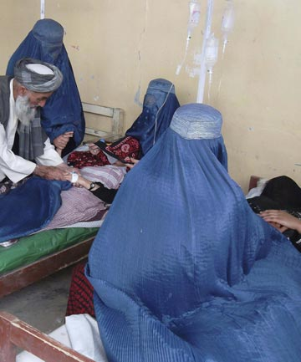
The apparent poisoning came three days after more than a dozen students fell ill in another girls' high school in Taluqan. No-one has claimed responsibility for either incident.
Between May and June last year there were four poisoning attacks on a girls' school in Takhar, prompting local officials to order principals to stay in school until late and staff to search the grounds for suspicious objects and to test the water for contaminants.
Takhar has been a hotbed of militancy and criminal activity since 2009, with groups such as the Taliban and the Islamic Movement of Uzbekistan active.
Since the 2001 ousting of the Taliban, which banned education for women and girls, females have returned to schools, especially in Kabul.
But periodic attacks against female students, their teachers and their school buildings, continue.
Afghan women have won back basic rights in education, voting and employment since 2001, but fears are growing that such gains could be traded away as Western forces prepare to leave and the Afghan government seeks peace talks with the Taliban.

Bruhn NewTech delivers the next generation of its HazKey® Systems
Source:http://www.cbrneworld.com/news/bruhn_newtech_delivers_the_next_generation_of_its_hazkey_systems#axzz2Rg7glP31

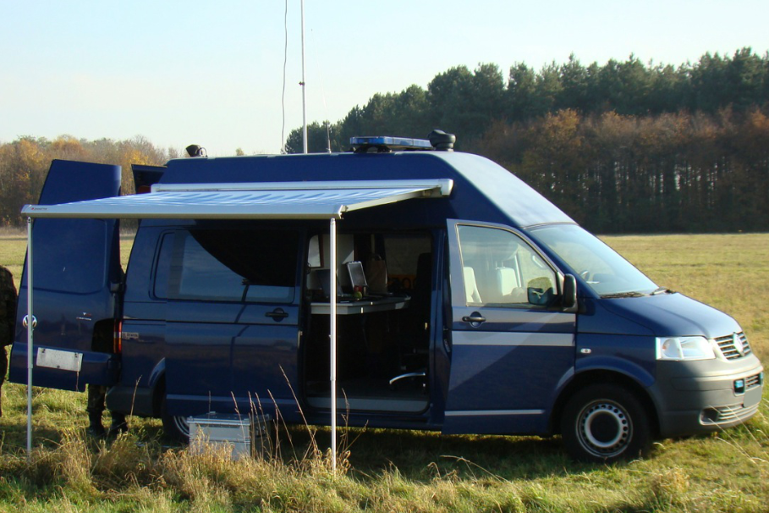
HazKey® is a turnkey CBRNe Hazard Management System, designed to be delivered to the incident scene and deployed by a maximum of a two-person team. The system can be transported as a mounted or dismounted capability, within Fast Response Vehicles, Reconnaissance Vehicles, Aircraft and Marine Vessels. Once deployed, the system will monitor Target Areas of up to 20Km, relaying data back to the Control Point and up through levels of Command to Scientific Support.
HazKey® is designed for use by both Military and Emergency First Responders. It locates and identifies any CBRNe Hazard within the Target Area, monitoring its position and its state according to the prevailing meteorological conditions, providing threat identification, enabling response to incidents that threaten life, property, commerce and the environment.
A spokesman for the Netherlands Military said: “We have used our HazKey® systems in daily operations for several years and it has proven to reduce the risk, complexity and cost of responding to and managing CBRNe hazards. In addition it displays an overall picture that enables Commanders to make decisions for the safety of personnel, infrastructure and the environment. The new HazKey® systems have been designed for the contemporary threat environment; they align well with our operational approach and provide us the stretch-capability we need to continue building and adapting our CBRNe operational capability and capacity, for both our domestic and international operations”.

Links Between Alleged Chemical Attacks In Saraqeb, Idlib, and Sheikh Maghsoud, Aleppo
Source: http://brown-moses.blogspot.gr/2013/04/links-between-alleged-chemical-attacks.html

Today there's been fresh reports of an alleged chemical attack on the town of Saraqeb, Idlib, with photographs and videos from the scene posted online
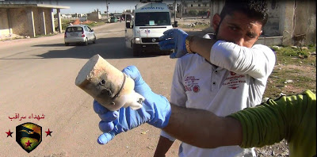
One thing that stood out was this image, of one of devices supposedly used to deliver the chemical

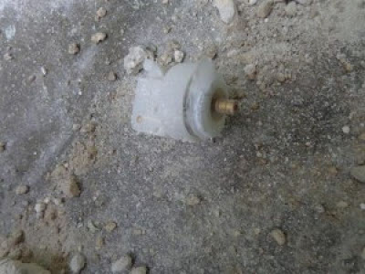
What stands out about this is it appears to be a very strong match to the remnants of devices that were supposedly used in an earlier attack in Sheikh Maghsoud, Aleppo, for example:

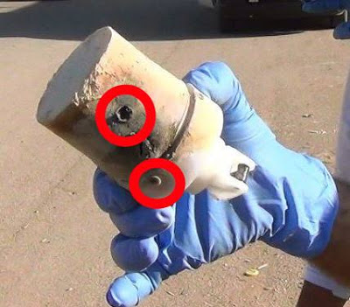
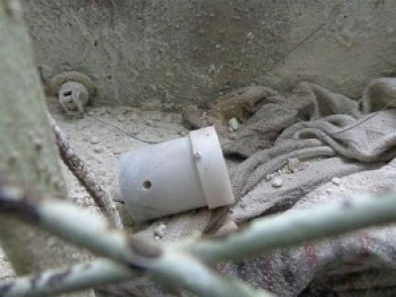
Note the large ridge, and these two features

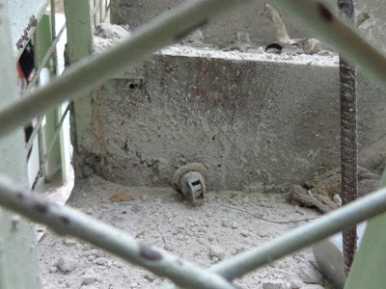
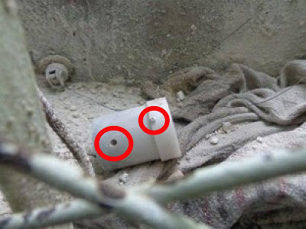
Also note the top of the item in the Saraqeb images, and this image

There's also been a video posted online showing what is supposedly the attack occurring, and this does not appear to match to any form of attack I've seen in Syria before, and looks very much like something falling through the sky producing smoke/gas (h/t James Miller of EA Worldview)
This leads me to believe the same devices and chemical were used in both attacks, but as yet it's unclear what the chemical and device is.
Update April 29th 2013 Something else that links the two attacks is the description of the earlier attack, via Mohammed Aly Sergie
Some survivors said the canisters were dropped from a helicopter, but others didn't hear rotors. Doctors don't know what the chemicals were

Update April 29th 2013 Another video has been uploaded showing the victims, and a much clearer shot of the device used
This extra detail on this video seems to prove that the devices used in both attacks were identical.
Update April 30th 2013 Thanks to Anita McNaught of Al Jazeera English for sending me this new video show the canister much more clearly.

DHS chemical plant security program hobbled by problems, poor oversight
Source: http://www.homelandsecuritynewswire.com/dr20130430-dhs-chemical-plant-security-program-hobbled-by-problems-poor-oversight

A DHS program responsible for the security of chemical facilities such as the West Fertilizer Company plant in Texas has been ineffective owing to a number of issues, leading federal investigators to wonder “whether it can achieve its mission, given the challenges the program continues to face.”
The Austin Statesman reports that DHS inspector general report released in March highlighted alarmingly poor planning and even worse execution in almost every aspect of the Chemical Facility Anti-Terrorism Standards (CFATS) program. Moreover, the IG also fund cases in which congressional overseers were misled when they were told that the program was improving.
The West Fertilizer Company, along with thousands of other chemical facilities, are required to fill out a detailed security survey and send it to DHS so the department can determine the level of terrorist threat risk the facility faces.
West Fertilizer never filled out a survey. DHS points out, though, that its CFATS program would not have prevented the explosion at the plant which killed fourteen people, injured 200 others, and destroyed 142 homes and apartments in the town of West.
“Their mandate has nothing to do with safe storage,” wrote chemical expert Patrick Coyle on his Chemical Facility Security News blog recently. “They are responsible for overseeing the secure storage of the material.”
DHS says that had the chemical plant safety been more tightly implemented and monitored, it could have boosted collaborative efforts between the plant and first responders. Such a plan would require a closer look at “specific threats, vulnerabilities, or risks,” according to DHS.
When CFATS was launched, an academy to train inspectors was opened. The academy was opened, however, before the program’s parameters were determined, and as a result the training conducted was eventually considered ineffective. The training program was shut down in the summer of 2011.
Investigators in the program also had problems with the software used to figure out a facility’s risk level, as well as the data collection methods to determine a facility’s vulnerability. There were also problems with coming up with plans to prevent a theft or attack, and such plans were deemed incomplete.
“A common explanation by program officials for the challenges is that CFATS is a new program,” federal investigators wrote. “However, it has been more than 5 years since the program was created, almost $443 million has been appropriated, and no facility has gone through the entire CFATS regulatory process.”
The lack of information led to significant delays in analyzing and approving responses from facilities across the country. As a result of the delays, the first security plan was not approved until late 2012, although plans were being submitted by plants since 2009. The delays were so bad that a DHS working group estimated that it would take seventy years to work through the security reviews of all chemical plants in the United States.
Program officials said that they have since made a number of changes to their data collection system and analysis and are now approving plant security plans at a much faster pace. Investigators found out, however, that officials used ambiguous language during congressional briefings when it came to saying just how much progress had been made.
The Statesman notes that according to the IG report, officials who were interviewed by investigators said the CFATS program inspectors did not have a full understanding of the chemical business.
“Industry officials said it seemed that people developing the CFATS Program thought chemical facilities were simple; as though each facility had one plant and required one fence,” the report stated. “In reality, there are sites that encompass 10,000 acres, with multiple plants making a variety of products with multiple chemicals.”

Unmanned Syrian Mig-21 fitted for chemical warfare?
Source: http://defense-update.com/20130505_syrian-mig-21-were-fitted-for-chemical-warfare.html

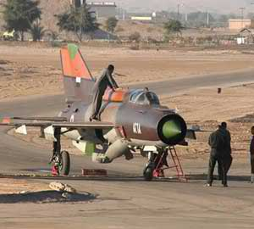
Is this Syria’s “doomsday ” weapon? Intelligence sources say that the Syrian air force has adapted old Russian made MIG-21 fighter aircraft to fly unmanned and carry chemical warfare materials. This information is now being investigated by a number of intelligence organizations i-hls reports.
A Syrian MiG-21, that landed in Jordan in June 2011 flown by a Syrian air force colonel, had been adapted to fly unmanned and carry a “deadly volume of chemical weapons. According to intelligence sources there are indications that Russian engineers helped with the upgrade.
The Syrian pilot colonel Hassan Merei al-Hamada, took off in his MiG-21 from al-Dumair military airport northeast of Damascus and flew to King Hussein Air Base just across Syria’s southern border with Jordan. Upon landing in Jordan, Hamada removed his rank and requested political asylum.
The Syrian regime immediately admitted the pilot had defected and called him a traitor. But unlike in earlier defections Syria has put heavy pressure on Jordan to return the MIG-21.

One dead after Belgian chemical train derailment
Source: http://edition.cnn.com/2013/05/04/world/europe/belgium-train-derailment/?hpt=hp_t2

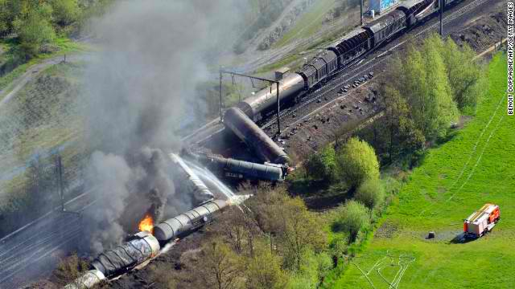
The freight train derailed in the northwestern part of Belgium, between Schellebelle and Wettere.

One person was killed and 49 others injured after a freight train derailed in northwestern Belgium, a local official told CNN.
Several explosions and a fire broke out following the derailment, according to Infrabel, the state-owned company that operates Belgian railways.
The exact cause of the reported death was not immediately known.
The train, owned the by the Belgian freight company SNCB Logistics, derailed between the towns of Schellebelle and Wettere, near Ghent.
Some 350 area residents were evacuated from the area because some of the derailed wagons were carrying the toxic chemical compound acrylonitrile, said Peter Mertens spokesman for the local governor. Mertens reported the casualties.
Exposure to acrylonitrile, can cause mucus membrane irritation, headaches, dizziness, and nausea, according to the U.S. Environmental Protection Agency.
United States Government Accountability Office
Highlights of
Efforts to Address the Medical Needs of Children in a Chemical, Biological, Radiological, or Nuclear Incident
Source:http://www.gao.gov/assets/660/654264.pdf

Why GAO Did This Study
The nation remains vulnerable to terrorist and other threats posed by CBRN agents. Medical countermeasures — drugs, vaccines, and medical devices — can prevent or treat the effects of exposure to CBRN agents, and countermeasures are available in the SNS for some of these agents. Children, who make up 25 percent of the population in the United States, are especially vulnerable because many of the countermeasures in the SNS have only been approved for use in adults. HHS leads the federal efforts to develop and acquire countermeasures. GAO was asked about efforts to address the needs of children in the event of a CBRN incident. This report examines (1) the percentage of CBRN medical countermeasures in the SNS that are approved for pediatric use; (2) the challenges HHS faces in developing and acquiring CBRN medical countermeasures for the pediatric population, and the steps it is taking to address them; and (3) the ways that HHS has addressed the dispensing of pediatric medical counter-measures in its emergency response plans and guidance, and ways that state and local governments have addressed this issue. To address these objectives, GAO reviewed relevant laws, agency documents, and reports, and interviewed HHS officials, industry representatives, and subject-matter experts. GAO also reviewed a stratified sample of emergency response plans from seven state and seven local governments, based on geographic location and population size, to assess how these governments address pediatric dispensing.

What GAO Found
According to the Department of Health and Human Services (HHS), about 60 percent of the chemical, biological, radiological, and nuclear (CBRN) medical countermeasures in the Strategic National Stockpile (SNS) have been approved for children, but in many instances approval is limited to specific age groups. In addition, about 40 percent of the CBRN countermeasures have not been approved for any pediatric use. Furthermore, some of the countermeasures have not been approved to treat individuals for the specific indications for which they have been stockpiled. For example, ciprofloxacin is stockpiled in the SNS for the treatment of anthrax, plague, and tularemia, but is not approved for these indications. Counter-measures may be used to treat unapproved age groups or indications under an emergency use authorization (EUA) or an Investigational New Drug (IND) application submitted to the Food and Drug Administration (FDA). HHS faces a variety of economic, regulatory, scientific, and ethical challenges in developing and acquiring pediatric CBRN medical countermeasures. High costs and the high risk of failure associated with testing and research of pharmaceutical products on children, difficulties in meeting regulatory requirements for approving CBRN countermeasures, and scientific and ethical obstacles to safely evaluating countermeasures for children all pose challenges to developing pediatric countermeasures. Despite these challenges, HHS has taken steps to focus agency efforts on the pediatric population, adapt pediatric formulations from existing medical counter-measures, and prepare and review materials for EUAs and INDs in advance of public health emergencies. HHS addresses dispensing of pediatric medical counter-measures in more than half of its 12 response plans and in its guidance, and seven state and seven local government plans that GAO reviewed included details about pediatric dispensing. Seven of the 12 HHS plans include information about pediatric medical countermeasures; however, HHS officials stated that these plans are intended to provide guidance for emergency response at the federal level, and not at the state or local levels, which is where dispensing would occur. CDC and FDA also provide guidance on pediatric dispensing that state and local governments can use in their planning. For example, CDC developed guidance about receiving, distributing, and dispensing contents from the SNS to help state and local emergency management and public health personnel plan for the use of countermeasures from the SNS. Response plans for all 14 of the state and local governments that GAO reviewed also included details about dispensing to the pediatric population during an emergency. For example, these seven states and seven local governments all adopted some version of a “family member pick-up” policy — sometimes referred to as a “head of household” policy — which would allow adults to pick up medicines for other family members, including children, during an event. In commenting on a draft of this report, HHS concurred with our findings. HHS emphasized that the needs of the pediatric population have been a priority for HHS and that the department is continuously progressing in this area.

Landmark statement from the OPCW issued following the 3rd Review Conference of the States Parties of the Chemical Weapons Convention (CWC)
Source:http://www.underwatermunitions.org/opcw_2013.php?utm_source=IDUM+3&utm_campaign=5ca0a9f095-Side+Event+Agenda&utm_medium=email&utm_term=0_65dba6d847-5ca0a9f095-28520861
Among the positive outcomes resulting from the recent Conference is a landmark decision regarding sea-dumped chemical weapons (referenced in the Final Document), which states:
128. The Third Review Conference noted the United Nations General Assembly resolution “Cooperative measures to assess and increase awareness of environmental effects related to waste originating from chemical munitions dumped at sea”, adopted at its 65th session by consensus, and invited States Parties to support voluntary sharing of information, raising awareness and cooperation on this issue.

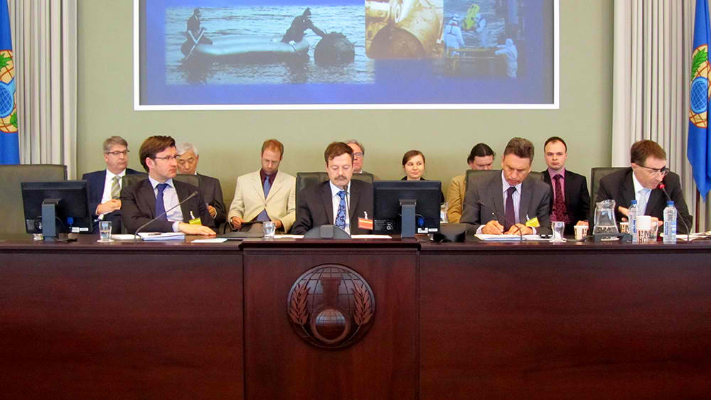
Terrance P. Long chairs the Side Event meeting at the THIRD REVIEW CONFERENCE OF THE STATES PARTIES OF THE CHEMICAL WEAPONS CONVENTION (CWC)

The attached language is a major achievement since it opens, for the first time in the OPCW's history, the possibility to cooperate on sea-dumped chemical weapons by supporting voluntary sharing of information, raising awareness and cooperation on this issue.
It is time to consider the measures to implement these important provisions. This decision assists in using the OPCW as a platform for cooperation on these issues between the governments, international organisations, the relevant industries, academia and NGO's.
The IDUM’s Chairman, Mr. Terrance P. Long, recently chaired a Side Event at the Organisation for the Prohibition of Chemical Weapons (OPCW) Conference of the States Parties, Third Review Conference (April 2013) in cooperation with the Governments of the Republics of Lithuania and Poland; and the International Scientific Advisory Board (ISAB) On Sea Dumped Chemical Weapons (SDWs). The event was well received and attended by diplomats, delegates, government officials, industry, and stakeholders. Presenters discussed SDWs in an open forum to allow everyone's concerns to be addressed as a whole. The event was considered a major success, allowing delegates an opportunity to learn more about the issues and about environmentally-friendly remediation and disposal solutions that relates to SDWs. We are pleased to inform you that there is now a role with the OPCW on SDWs.

Quickly identifying chemical, biological warfare agents
Source: http://www.homelandsecuritynewswire.com/dr20130512-quickly-identifying-chemical-biological-warfare-agents

For more than fifty years, researchers have been studying exactly how aspirin affects the human body. Despite thousands of publications on the topic, our understanding is still incomplete.
Meanwhile, novel chemical and biological weapons have historically been mass produced within a year of discovery. Using current methods and technologies, researchers would require decades of study to gain a robust understanding of how new threat agents exert effects on human biological systems.
A DARPA release reports that capability gap leaves U.S. forces vulnerable, so DARPA’s new five-year program, Rapid Threat Assessment (RTA), sets an aggressive new goal for researchers: develop methods and technologies that can, within thirty days of exposure, map the complete molecular mechanism through which a threat agent alters biochemical processes in human cells. The developed technologies must identify the cellular components and mechanistic events that take place over a range of times, from the milliseconds immediately following exposure to the threat agent, to the days over which alterations in gene and protein expression might occur. The molecular mechanism must also account for molecular translocations and interactions that cross the cell membrane, cytoplasm and nucleus.
DARPA will host a Proposers’ Day on 21 May.
“Understanding the molecular mechanism of a given threat agent would provide researchers the framework with which to develop medical countermeasures and mitigate threats,” said Barry Pallotta, DARPA program manager.
“If the RTA program is successful, potential adversaries would have to reassess the cost-benefit analysis of using chemical or biological weapons against U.S. forces that have credible medical defenses.”
Threat agents, drugs, chemicals, and biologics interfere with normal cell function by interacting with one or more molecules associated with the cell membrane, cytoplasm or nucleus. Since a human cell may contain up to 30,000 different molecules functioning together in complex, dynamic networks, the molecular mechanism of a given threat agent might involve hundreds of molecules and interactions. The technologies sought by RTA would identify the molecular targets of threat agents and the complex interactions that follow.
“Introducing a threat agent into a cell sets off a chain of interactions that propagate throughout the cell much like the pattern of ripples that result from throwing a pebble into a pond,” said Pallotta.
“Unfortunately, current research tends to be highly specialized, examining effects on very specific proteins or lipids and so on, which is why a drug like morphine is still being studied almost 200 years after its introduction. For this reason, DARPA is demanding a comprehensive approach that identifies all of the affected components and interactions at once against a background of inherent complexity.”
The release notes that to help navigate this complexity, program performers will have to discover the series of events in the molecular mechanism at time intervals from initial introduction of a threat agent to a period of several days of exposure. This could be accomplished by freezing cells at various points in time to capture interactions as they unfold. This approach will help researchers discover the actual sequence of molecular events initiated by the threat agent.
While providing a framework for the development of medical countermeasures to chemical and biological weapons, successful RTA technologies would also be readily applicable to drug development and treatments for disease. In both cases, detailed knowledge of molecular mechanism is one of the ingredients that enable new drugs to win approval or diseases to be treated.
DARPA hopes to pair technologies developed during the RTA program with its Microphysiological Systems program, which is building “human-on-a-chip” technology. By introducing threat agents or proposed countermeasures to the human-on-a-chip system, researchers could observe which human cell types are affected, and use RTA technologies to elucidate the specific molecular mechanisms in the affected cells.

Microphysiological Systems

Source:http://www.darpa.mil/Our_Work/DSO/Programs/Microphysiological_Systems.aspx

Recent DARPA research through the Accelerated Manufacture of Pharmaceuticals program has demonstrated the ability to accelerate production of millions of doses of vaccine using novel plant-based methods. Clinical trials, however, for vaccines, drugs or other biologics cannot be initiated without preclinical evidence of their safety in humans. Human safety and drug performance is not always effectively predicted through animal testing. And the Department of Defense needs to rapidly develop and field safe and effective medical countermeasures against biological threats to warfighters.
To create a pathway for the fielding of safe and effective countermeasures, DARPA has launched the Microphysiological Systems program. MPS will develop a platform that uses engineered human tissue to mimic human physiological systems. The interactions that candidate drugs and vaccines have with these mimics will accurately predict the safety and effectiveness that the countermeasures would have if administered to humans. As a result, only safe and effective countermeasures will be fully developed for potential use in clinical trials while ineffective or toxic ones will be rejected early in the development process. The resulting platform should increase the quality and potentially the number of novel therapies that move through the pipeline and into clinical care.
As a force protection measure, DoD has a requirement to protect warfighters from existing or emerging diseases, pandemics and bioterrorism. It has significant interest in developing viable medical countermeasures with an approach that includes aggressive research, removing barriers to innovation and developing capacity to respond quickly to threats.
MPS research expects to concentrate in the following areas: A reconfigurable platform that permits simultaneous study of ten or more in vitro physiological systems, arranged in any sequence. The platform should be a flexible, user-friendly and reliable design that allows biological components to interact in a physiologically relevant manner and able to sustain the resident tissues for up to four weeks. Researchers developing the in vitro mimics should demonstrate that the engineered tissues function together to reproduce each of the human physiological systems. As these system mimics are integrated into a platform of increasing complexity, researchers should demonstrate that the platform reproduces the physiologically-relevant crosstalk between the systems that normally occurs in humans. To validate platform behavior and its potential value for evaluating drugs and vaccines, test compounds with known effects in humans will be applied to the platform. The effects that the test compounds have on the physiological system mimics will then be extrapolated to humans via computer modeling and compared to their health effects previously observed in humans. Research may also demonstrate how an infectious agent might affect the in vitro platform, thus providing an opportunity for scientists to study the infectious agent in a human-relevant manner.
MPS is coordinating efforts with the National Institutes of Health, who is conducting separate but parallel research.
The Food and Drug Administration has been involved from this beginning to help ensure that regulatory challenges of reviewing drug safety and efficacy are considered before and during development.

►Source: https://www.cbrniac.apgea.army.mil/Documents/vol14_num1_lo_res.pdf
US Army Awards $156.6 Million Anti-Nerve Gas Agent Contract
Source: http://www.nextgov.com/defense/2013/05/army-awards-1566-million-anti-nerve-gas-agent-contract/63134/

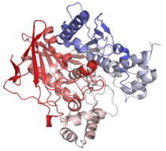
The Army has awarded a $156.6 million contract to the DynPort Vaccine division of Computer Sciences Corp for development of an anti-nerve gas agent that protects against a wide range of nerve gases for up to 60 days. The agent will not be ready to use for at least six years.
The award comes on the heels of news that both the Syrian Army and rebels have used nerve gas and a “red line” warning by President Obama against the use of nerve gas by the Syrian government. Last year the Pentagon projected it could take as many as 75,000 troops to seize and control Syria’s stockpile of chemical weapons.
DynPort started work on the anti-nerve gas agent in 2007 based on human butyrylcholinesterase, a blood or plasma protein that binds and inactivates nerve agents, under a clinical trial contract with Defense Medical Identification and Treatment Systems’ Joint Product Management Office.
The new contract, awarded on Friday, calls for DynPort to develop, test and obtain Food and Drug Administration approval for what MITS calls the “Bioscavenger” nerve gas prophylaxis. This name derives from the fact that butyrylcholinesterase acts as a scavenger by binding nerve agent in the blood stream before it can exert effects in the nervous system.
Maj. Luis Alvarez. MITS assistant told an industry briefing in January 2011 that Bioscavenger is the “first ever nerve agent prophylactc that prevents incapacitation and death from exposure to a broad spectrum of nerve agent[s].” DynPort said preclinical research indicated butyrylcholinesterase inhibits toxicity in nerve agents, including Sarin, Soman and VX.
Defense currently uses atropine as an anti-nerve gas agent, but its use can lead to temporary incapacitation. Alvarez said Bioscavenger will transform how Defense protects troops against nerve gases.
The Centers for Disease Control and Prevention classifies nerve agents as the most toxic and rapidly acting of the known chemical warfare agents, which are similar to but much more potent than than organophosphate pesticides.
Alvarez said Bioscavenger provides “chemical immunity” against all organophosphate nerve agents at lethal dose ranges and helps reduce casualties from a nerve gas attack.
In an industry presentation in October 2011, Alvarez said MITS wanted Bioscavenger to initally provide protection against nerve agents for ten days with a goal of 60 days after treatment. The antidote has already undergone animal tests, but Alvarez said it will also need to be tested on “hundreds to thousands” of human volunteers before it can win FDA approval.

J Mol Neurosci. 2006;30(1-2):145-8.

Bioscavenger for protection from toxicity of organophosphorus compounds.
Saxena A, Sun W, Luo C, Myers TM, Koplovitz I, Lenz DE, Doctor BP.

Source: Walter Reed Army Institute of Research, Silver Spring, MD 20910, USA. ashima.saxena@amedd.army.mil

Abstract
Current antidotal regimens for organophosphorus compound (OP) poisoning consist of a combination of pretreatment with a spontaneously reactivating AChE inhibitor such as pyridostigmine bromide, and postexposure therapy with anticholinergic drugs such as atropine sulfate and oximes such as 2-PAM chloride (Gray, 1984). Although these antidotal regimens are effective in preventing lethality of animals from OP poisoning, they do not prevent postexposure incapacitation, convulsions, performance deficits, or, in many cases, permanent brain damage (Dunn and Sidell, 1989). These problems stimulated the development of enzyme bioscavengers as a pretreatment to sequester highly toxic OPs before they reach their physiological targets. Several studies over the last two decades have demonstrated that exogenously administered human serum butyrylcholinesterase (Hu BChE) can be used successfully as a safe, efficacious, and single prophylactic treatment to counteract the toxicity of OPs. It also has potential use for first responders (civilians) reacting to terrorist nerve gas release, pesticide overexposure, or succinylcholine-induced apnea. A dose of 200 mg of Hu BChE in humans is envisioned as a prophylactic treatment that can protect from exposure of 2-5 x LD50 of nerve agents (Ashani, 2000).

DQE Introduces the Decon Stability Cane
Source: http://www.dqeready.com/deconcane
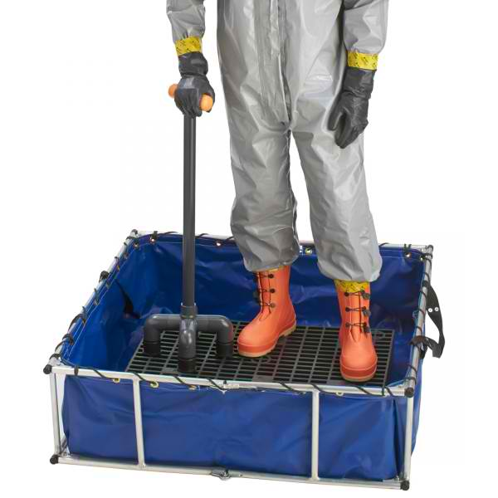
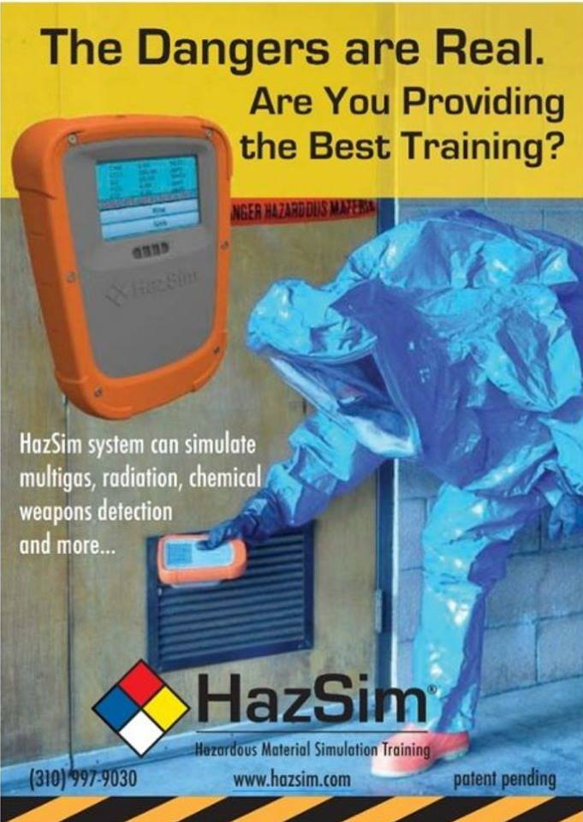
The Decon Stability Cane is an exclusive DQE product that is made of sturdy, high-density, industrial-grade PVC, to withstand years of use in the field. The t-shaped handle is the ideal size for a responder’s gloved hand and the handle’s bright orange color increases visibility among other decon apparatus. The four legs have skid resistant rubber feet that resist slipping in wet environments, such as a decontamination grid. The cane is especially helpful to lean on when washing lower extremities and the soles of boots. Having a Decon Stability Cane for support will assist responders with completing the decon process more quickly and thoroughly.

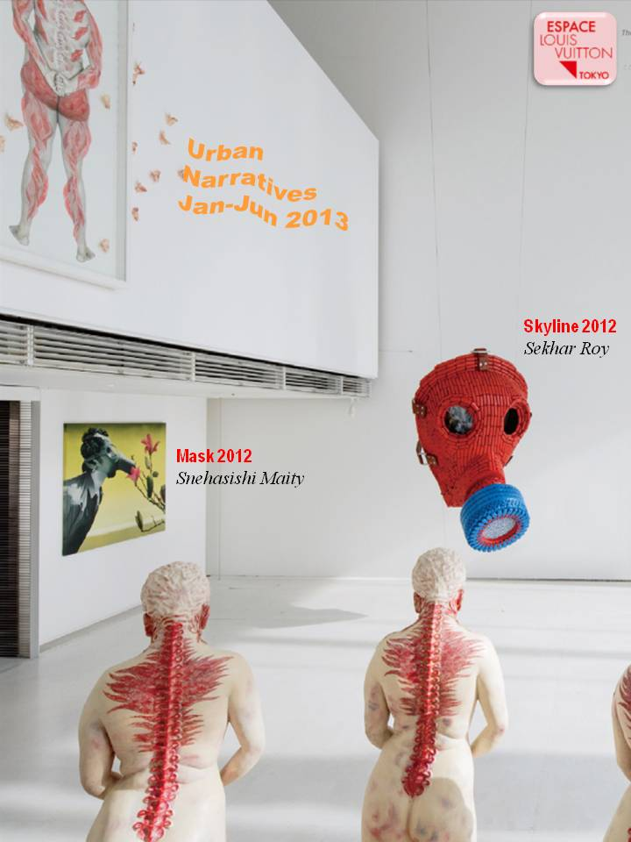

Airborne sensor technology assists emergency responders
Source:http://pearl1.lanl.gov/external/Research/ASPECT.html

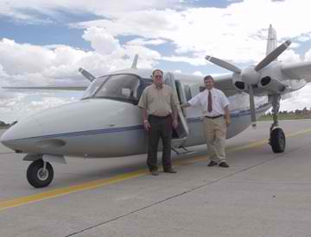
Scientists at the Laboratory and emergency first-responders from the Environmental Protection Agency have developed airborne infrared sensor technology that can aid emergency crews by detecting and mapping hazardous and toxic chemical plumes unleashed by disaster or terrorist acts.
The Airborne Spectral Photometric Collection Technology, known as ASPECT, is a high-tech sensor package on board a small aircraft operated by the EPA that allows for timely surveillance of gaseous chemical releases from a safe distance. ASPECT gives emergency first responders on the ground critical information regarding the size, shape, composition and concentration of gas plumes emanating from disaster scenarios such as a derailed train, factory explosion or terrorist attack.
ASPECT is the result of more than five years of research and development by researchers in Physical Chemistry and Applied Spectroscopy (C-PCS) and the EPA. The project has been supported by the Laboratory's recently created Center for Homeland Security (CHS), which focuses on providing technical support to the U.S. Department of Homeland Security and collaborating agencies.
"Protecting the homeland against terrorist threats is a great challenge that will require development and application of such dual-use capabilities as the EPA ASPECT system," said Gary Resnick, associate CHS director for chemical and biological threat reduction.
ASPECT takes advantage of two sensors mounted aboard an Aerocommander 680 aircraft operated by an EPA disaster first-responder crew. The first sensor, called a Fourier Transform Infrared Spectrometer, detects and locates chemical vapors. It can peer through smoke and dust to get an accurate measurement of the location and concentration of the vapor plume. The second sensor, a high-resolution Infrared Line Scanner, records an image of the ground below and plume information.
Information from both instruments is combined with high-resolution digital imagery and Global Positioning System information to create an accurate map of the land surface and the chemical vapor plume hazard. ASPECT can show the main plume as well as places where gas has collected and settled, such as in low-lying areas or locations where there is little or no air movement. It takes only minutes to produce an image.
The vapor hazard plume map then can be transmitted to emergency response commanders on the ground — usually the local fire chief or emergency manager — by fax, computer or other means. In areas where emergency responders lack computer equipment, ASPECT will drop a working computer via parachute to emergency responders before the plane starts taking measurements.
"By providing a capability to accurately measure and locate hazardous and toxic chemical plumes, emergency responders near disaster plumes will be able to make better decisions regarding civilian evacuations, resource deployments and ensuring the safety of response crews," said Robert Kroutil of C-PCS.
The system has been rigorously tested under stringent real-world conditions and performed admirably. ASPECT also proved its usefulness in public by patrolling the skies over Salt Lake City during the 2002 Winter Olympics on the lookout for potential terrorist attacks.
Most recently, the plane was called into service in the wake of the space shuttle Columbia disaster. ASPECT's crew monitored for extremely hazardous rocket fuels, which fortunately had evaporated before they reached the ground. But in the course of their surveillance, ASPECT's cameras recorded the location of larger pieces of debris, which aided recovery efforts.
An ASPECT system can cover a multistate area, thus reducing the amount of resources needed for an emergency response.

The EPA’s CBRN Consequence Management Advisory Team, the second Partner Organisation supporting CBRNe Convergence, will be bringing their ASPECT aircraft to CBRNe Convergence, 29-31 October 2013, San Diego! (www.cbrneworld.com/convergence2013)

Guerre chimique à Damas
Source: http://www.dailymotion.com/video/x1089jc_guerre-chimique-a-damas_news#.UaN8e9i9bPo
EDITOR’S COMMENT: No protective clothing; gas masks and beards; alleged sarin gas release – it seems that gas nerves are not that lethal at all…

F1D | NPE OpsLite | FM53™
Source: http://www.force1decon.com/products1/products_npeopslite/

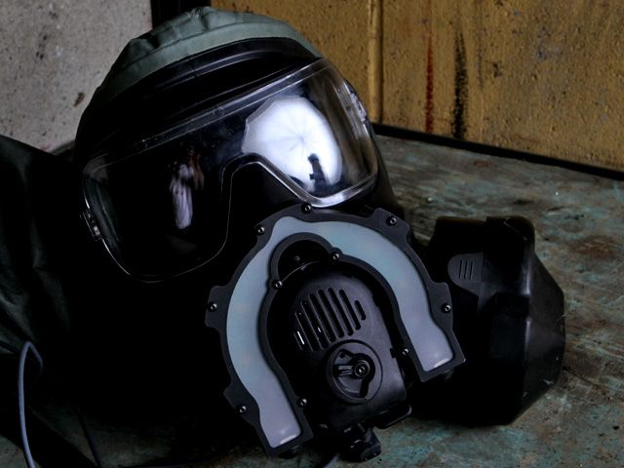

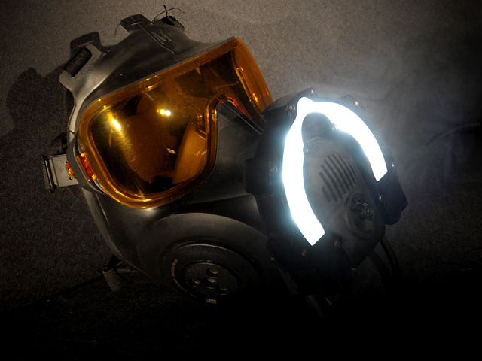
The Non-Permissive Environment (NPE) OpsLite is a lightweight mask mounted LED lighting system providing 2 levels of white light and IR light. The system is designed to be used with Avon's FM53, and locks around the speech module. The OpsLite comes with a 3 second 'press and hold' switch for when inadvertent use might cause a problem. Unit also provides an IR with indicator so Operator knows when IR's are hot. Unit is devised for close and medium distance applications. On-board switching provides 3 light settings – Low white light (174 Lumens) High white light (348 Lumens) and IR (880nm wavelength). Unit is powered by 4 6.6VDC cell (123) batteries via a belt or molle mounted battery pak.

Turkey arrests extremists with sarin gas for Syria – media
Source: http://english.ruvr.ru/news/2013_05_30/Turkey-arrests-extremists-with-sarin-gas-for-Syria-media-0554/

Turkish special anti-terror forces have detained 12 people suspected of having links with Al Nusra Front, the al Qaida-allied Syrian rebel group that has been set to topple President Assad’s regime.
The group was seized in southern Turkey. Local media say they carried a 2kg cylinder with nerve agent sarin.
Turkish authorities haven’t commented on this report.
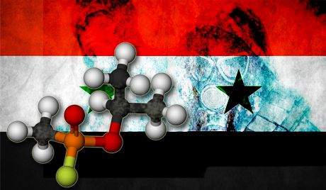

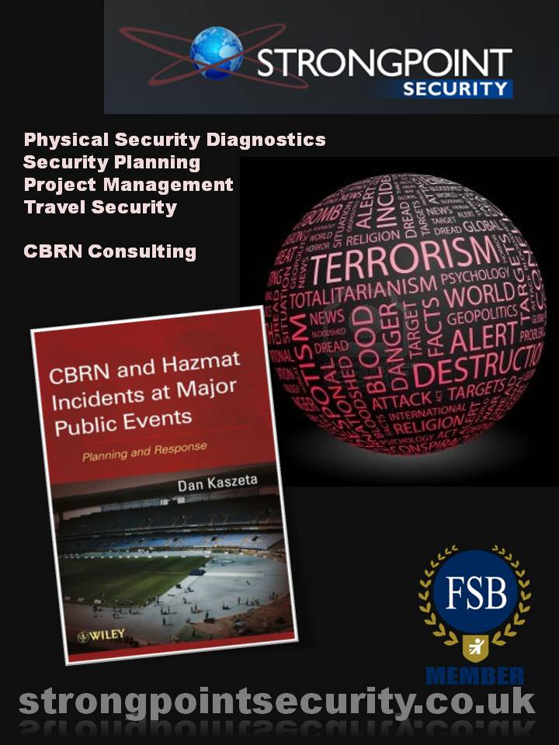

In a hospital parking lot, Israel prepares for chemical war
Source: http://www.timesofisrael.com/in-a-hospital-parking-lot-israel-prepares-for-chemical-war/
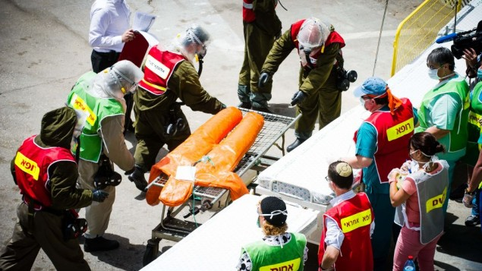
Hadassah Medical Center staff and Home Front Command soldiers during a drill simulating a chemical weapon attack on Israel (Photo credit: David Katz/ The Israel Project)

The IDF’s Home Front Command on Wednesday simulated a chemical weapons missile strike in the capital with thousands of wounded and hundreds of dead.
The nationwide three-day drill, code-named Turning Point 7, which on Wednesday also simulated missile strikes on Israel’s parliament building, has unfolded amid rising tension between Israel and Syria — a country that possesses some 1,000 tons of chemical weapons.
“The things we see here are meant to protect Israel from a horde of new threats,” a watching Prime Minister Benjamin Netanyahu said, as soldiers began the process of triage in one of the capital’s residential neighborhoods.
“We can defend [the citizens of Israel]. It won’t always be perfect; armor is never hermetic, but protection can be provided for the citizens of Israel,” Netanyahu added. “That’s what we’re practicing here and that’s what we’ll continue to do in the coming months and years.”
The “wounded” were brought to the Hadassah Medical Center’s Mount Scopus campus, where the IDF’s Home Front soldiers, male and female, reservists all, congregated at the rear entrance of the hospital.
At 9 a.m., with the heat rising and the drill not yet officially launched, few seemed eager to done their protective attire. “Don’t tell me ‘one more minute,’ a female lieutenant barked into her megaphone at a group of lounging soldiers. “Get ready and get in the shower.”
Slowly, a group of soldiers shed the last of their civilian gear — red felt Adidas sneakers and gold-rimmed shades — donned their many layers of protective gear and hosed themselves down.
As the first ambulances arrived at the scene, Col. Gili Shenhar of the Home Front Command explained the drill. A missile had fallen in the northern neighborhood of Ramot, he said. Soldiers at the scene had already determined that the warhead contained chemical agents and had sent word to the hospital regarding the number of casualties, which stood at a very optimistic 300.
Yaakov Cohen, the hospital’s plumber, had set up several dozen outside shower heads and the wounded — colorful plastic dummies outfitted with army blouses — were stripped, scrubbed and washed.
“The main things are decontamination and speed,” said Minister of Health Yael German, who watched the drill and received a learned explanation from hospital director Dr. Osnat Levzion-Korach.
In Jerusalem there are three hospitals equipped to deal with chemical weapons casualties, Levzion-Korach added.
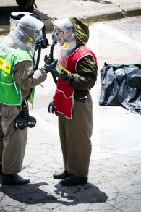
A yellow line divided the yard outside the hospital: contaminated medical crews and patients on one side and other hospital staff on the other.
“The decontamination has to be done outside the hospital,” Shenhar explained. Other armies, he said, decontaminate in the field but “after many years of dealing with trauma, we realize it’s faster this way.”
Each patient was flagged by a doctor upon arrival, with red representing the most severely wounded, yellow moderate, green mild and white the walk-in patients.
“In cases of exposure to chemical weapons there is something called aging,” said Dr. Gaby Polliack, a colonel in reserves and the deputy director of Hadassah’s sister hospital in Ein Kerem. “It means that as time passes, the worse it gets; the damage becomes irreversible.”
For that reason, he said, the mildly wounded had to be decontaminated quickly and rushed into the hospital for treatment.
Home Front Defense Minister Gilad Erdan, in Prada sunglasses and a crisp blue shirt, watched the drill from above and did not stay for long. In the days leading up to the drill he said it was not a question of whether or not Israel’s population centers would be targeted by rocket attack, “but when it would happen.” Asked subsequently about the possibility of Syria attacking Israel with chemical weapons, Erdan said that though there was a higher chance of that happening than in the past, it was still considered a “low-probability scenario.”
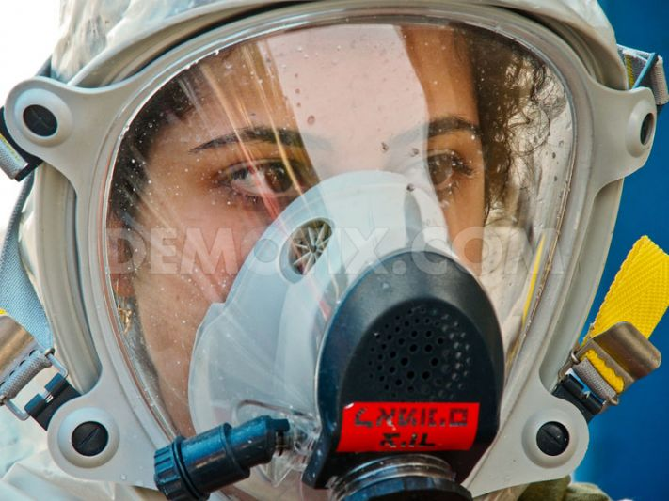
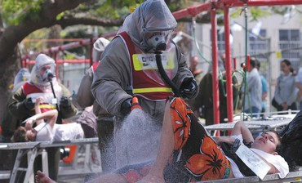
The head of the Home Front Command, Maj. Gen. Eyal Eizenberg, a former commando in the Air Force’s Special Forces unit and a division commander during the Second Lebanon War, struck an offensive tone in advance of the drill. “The weapons in our enemies’ hands are long distance, equipped with large and significant warheads,” he told the army’s Bamachaneh weekly. “There is no doubt that if this sort of campaign develops, the Israeli home front will experience something it has not experienced in the past.
“These will not be easy days, but Israel has a destructive capacity tens of times more great than its enemies, and therefore I recommend to our neighbors that before firing up their engines, they reconsider.”
At the hospital on Wednesday, leading around a group of American officers from the National Guard headquarters in Washington D.C., Eizenberg refused to take questions. But the command’s spokesperson, Col. Shenhar, assured a group of reporters that “when something is real, like Operation Pillar of Defense, the public understands how to act.”

EDITOR’S COMMENT: Good to see an exercise without First Responders in Level-A gear! O fnotice also the transparent hoods that perhaps address effectively the beard issue!

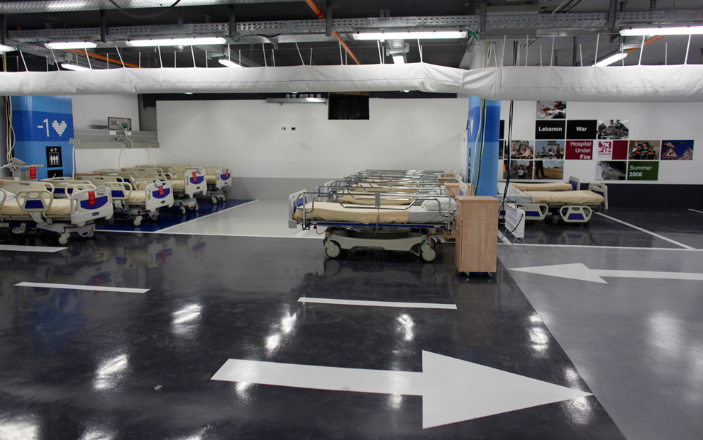
Hospital beds are placed in a parking lot set up for the media as an underground emergency hospital, at Rambam Hospital in the northern Israeli city of Haifa May 31, 2011. The lot, equipped with unique filters and air-conditioning systems for protection from biological and chemical warfare, can accommodate 2,000 beds and will be inaugurated in August 2012. According to the hospital's spokesperson, it will be the world's largest underground emergency hospital. (Reuters/Nir Elias)

Ichilov Hospital, largest bomb-proof emergency facility in Israel
Source: http://www.demotix.com/news/2027719/ichilov-hospital-largest-bomb-proof-emergency-facility-israel#media-2027658

Among talks of a renewed war with Syria, Ichilov Hospital in Tel Aviv completed the largest bomb-proof emergency facility in the country, which includes a four-story, 700-bed emergency emergency structure embedded in the underground parking lot.
Ichilov Hospital in Tel Aviv just unveiled the largest bomb-proof emergency facility in the country, which includes a four-story structure embedded underground in a sleek new building named after billionaire donor Sammy Ofer. The building is designed to hold between 700 and 1,000 hospital beds in case of an emergency. When not under attack, the multi-level underground structure serves as a short-term parking lot for the hospital staff.

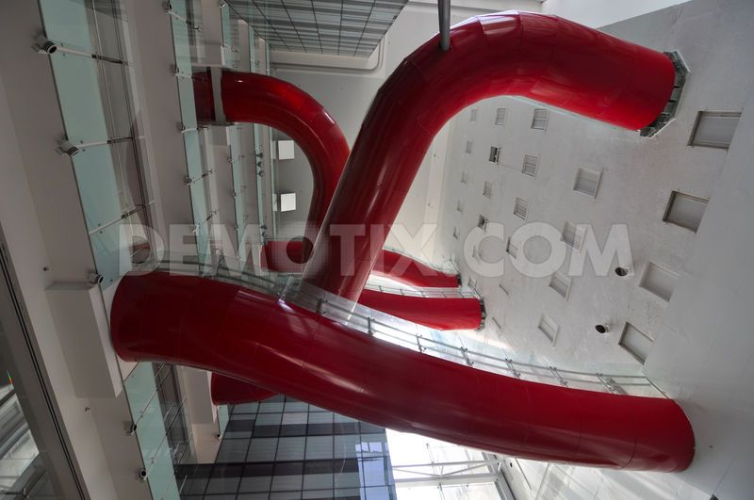

The new facility measures 56,000 square meters, with 13 floors above ground and 4 underground. It was built at an estimated cost of $110 million. The hospital, which provides protection against conventional, chemical, and biological attack, has also been fitted with water pipes, oxygen, electricity, ventilation, and enough fuel for generators to last one week if cut off from the external power grid. An even larger emergency hospital is currently being constructed at Rambam Medical Center in Haifa. It is likely to boast of a capacity of 1,500 hospital beds that would serve residents of the north.
The building is a monolithic glass-covered cube with red, urban windows, visible from afar. The new building is connected to the old hospital by an atrium, within which suspended red bridges run across like blood vessels.

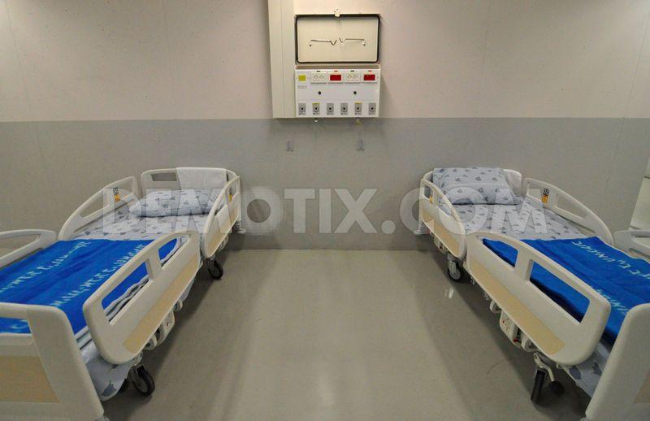 | 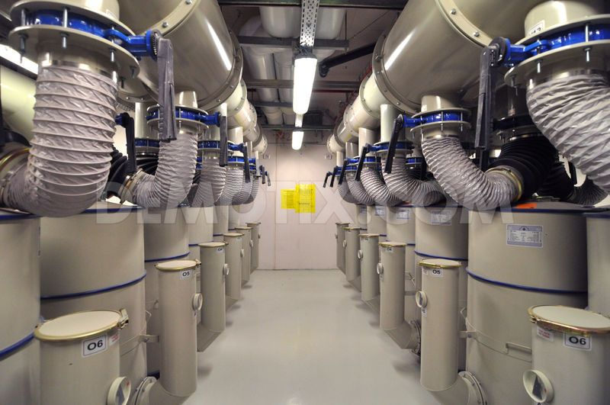

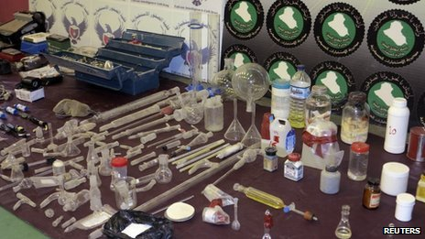
Iraq uncovers al-Qaeda 'chemical weapons plot'
Source: http://www.bbc.co.uk/news/world-middle-east-22742201
The militants allegedly built two facilities to produce sarin and mustard gas

The authorities in Iraq say they have uncovered an al-Qaeda plot to use chemical weapons, as well as to smuggle them to Europe and North America.
Defence ministry spokesman Mohammed al-Askari said five men had been arrested after military intelligence monitored their activities for three months.
Three workshops for manufacturing the chemical agents, including sarin and mustard gas, were uncovered, he added.
Remote-controlled toy planes were also seized at the workshops.
Mr Askari said they were to have been used to release the chemical agents over the target from a "safe" distance of 1.5km (0.9 miles), reports the BBC's Rami Ruhayem in Baghdad.
All of the arrested men had confessed to the plot, and said they had received instruction from another al-Qaeda offshoot, he added.
As the defence ministry spokesman spoke on Iraqi TV, footage was shown of four men with black hoods on their heads, our correspondent adds. Three of them were wearing bright yellow jumpsuits and a fourth was in a brown jumpsuit.
Their arrests were possible because of co-operation between Iraqi and foreign intelligence services, Mr Askari said.
Chlorine bombs
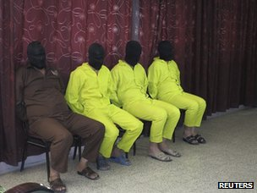
Al-Qaeda in Iraq is believed the only offshoot of the Islamist militant network to have used chemical weapons.
It detonated a 16 crude chlorine bombs in Iraq between October 2006 and June 2007.

All of the arrested men have allegedly confessed

Chlorine inhalation made many hundreds of people sick, but no deaths resulting from exposure to the chemical were recorded, US officials said at the time. Instead, the bomb blasts are believed to have caused the fatalities.
At the time, US officials said al-Qaeda appeared to want to use debilitating agents like chlorine in their bombs to cause casualties beyond those hit by the initial explosion.
US and Iraqi troops subsequently killed or detained many of the militants who were building the chlorine-laced bombs and seized much of their stockpiled chemicals.
A letter written by the late al-Qaeda leader Osama Bin Laden five days before he was killed in a US military raid in Pakistan in 2011 urged members of the group's offshoot in Yemen who he believed were considering using "poison" to be "careful of doing it without enough study of all aspects, including political and media reaction", according to CNN.

France weighing military options after French lab confirms Syrian use of sarin gas
Source: http://www.homelandsecuritynewswire.com/dr20130605-france-weighing-military-options-after-french-lab-confirms-syrian-use-of-sarin-gas

Laurent Fabius, France’s foreign minister, said yesterday (June 4th) that samples taken from Syria and tested in France confirm that sarin gas has been used on several occasions. Fabius said that a French laboratory “proved the presence of sarin in the samples in our possession.” He said France “now is certain that sarin gas was used in Syria multiple times and in a localized way.”
Le Monde reports that the UN panel investigating chemical weapon use in the Syrian conflict has tested blood and urine samples from victims of four attacks by the Syrian army and air force:
- Khan Al-Assal, near Aleppo, on 19 March
- Uteibah, near Damascus, on 19 March
- The neighborhood of Sheikh Makhsoud in Aleppo on 13 April
- The city of Saraqeb on 29 April
Le Monde reports that the French lab examined samples from victims of a government helicopter attacks on Saraqeb on 29 April. Fabius did not elaborate on the findings, but his office reported that metabolized sarin was found in the urine of a female victim, and that elevated levels of regenerated (pure) sarin were found in the blood taken from two other victims (9.5 nanograms/milliliter).
The blood samples were taken from the three victims – one of them was already dead, the two others were in critical conditions — at a hospital at Idlib, and shipped to the Centre de Recherches du Bouchet, located in Vert-le-Petit in the Essonne department in northern France, on 4 May, arriving at the lab on 9 May.
The Bouchet lab used four different analytical techniques to analyze the samples. The complete results of the analysis are confidential, but lab experts told Le Monde that the presence of sarin in the blood is impossible to falsify or manipulate, unlike the presence of sarin in urine, which can be manipulated.
Fabius told France 2 TV that “aucun doute que c’est le régime qui est en cause” (without doubt it is the [Assad] regime which is involved” [in the attack]).
Fabius repeated the same message in an interview with Reuters, saying Syrian president Bashar Assad’s regime was responsible for the use of the gas, and that France was not ruling out a military strike on the place where the gas is being stored.
“It would be unacceptable that those guilty of these crimes benefit from impunity,” Fabius said
The United Kingdom also said that t tests it conducted in British labs on samples from Syria were positive for sarin.
Britain’s ambassador to the United Nations, Mark Lyall Grant, said Britain has evidence suggesting a number of different chemical agents have been used, “sometimes including sarin, sometimes not.”
France and Britain both say they believe the Assad regime first used chemical weapons in an attack on Homs on 23 December 2012, but that French and British labs could not obtain physiological samples from victims of that attack.
Fox News reports that the French and British findings, based on samples taken from Syria, came hours after a UN investigative team said it had “reasonable grounds” to suspect small-scale use of toxic chemicals in at least four attacks in March and April.
The UN investigation was based on interviews with doctors and witnesses, not on physical evidence.
The UN investigative team was appointed by the Human Rights Council has been issuing periodic updates about suspected war crimes in Syria. Tuesday’s report dealt with chemical weapons, among a wide range of topics.
Separately, UN chief Ban Ki-moon appointed a UN team headed by Swedish chemical weapons experts Ake Sellstrom after the Syrian government asked for an investigation of a purported attack by rebels on 19 March on the village of Khan al-Assal, near the northern city of Aleppo.
Syria says that Syrian soldiers were killed in the incident, and the regime insisted that the UN probe be limited to that case.
Ban wants a broader investigation, including the 23 December incident in Homs. Britain and France have also pushed to widen Sellstrom’s mandate, sending Ban information on additional alleged incidents.
Fox news notes that such allegations are based on three types of information that can be obtained without having investigators go into Syria — amateur videos, witness accounts, and physiological samples.
Witnesses and doctors have been interviewed by Skype or after they have fled Syria. Labs in Turkey, Britain, and France have analyzed samples smuggled out of Syria or taken from suspected victims after they were hospitalized outside Syria.

[D4H]™ Hazmat Edition
Source: http://www.d4h.org/blog/post/20130604-Announcing-D4H-Hazmat-Edition

[D4H]™ Hazmat Edition is specialized for hazardous material incidents at industrial facilities, railroads, highways, waterborne, pipelines, ports, aircraft, and clandestine labs including explosives, pharmaceuticals, narcotics, fuels, alcohol distillation, and weapons of mass destruction. Whether spilled or just threatening release; reacting, burning, over-pressurized or an actual explosion - you can now document all materials involved and their behavior within your [D4H]™ incident report.
[D4H]™ Hazmat Edition includes a pre-loaded database of over 700 of the most common chemicals with auto-completion based on chemical name and CAS numbers. Our software allows you to analyze the frequency of hazards to help with decisions in equipment procurement and training by recording chemical formulas, UN numbers, explosive limits (LEL/UEL), flash points, IDLH, ionization, molar mass, specific gravity, solubility, boiling point, and vapor pressure.
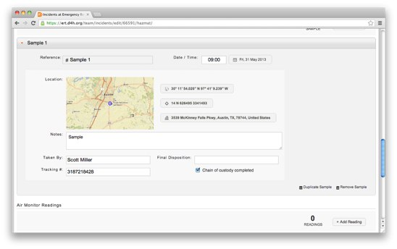
Materials in the physical state of solid, liquid, or gas can be recorded by container type and capacity, noting markings, and transportation type. Vehicles involved in the incident may be added by using detailed pre-loaded categorizations of freight tankers, agricultural vehicles, waterborne vessels, and aircraft. Document licence plates, transportation licences, makes, models, manufacturing years, and notes including the transport providers insurance details.

Record Samples and Air Monitoring
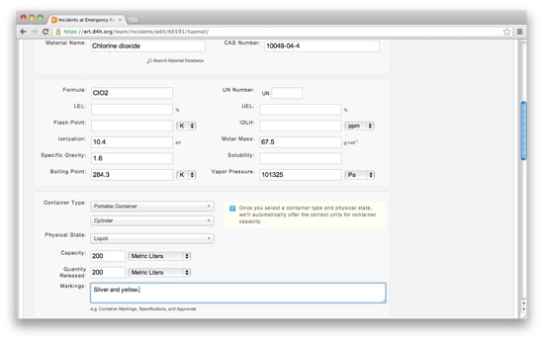
If you have an unknown material on-scene - take a sample for testing and give it a reference number, note the date and time collected, and select the location on a map or enter street address. Document who took the sample, its final disposition, tracking number, and if the chain of custody was completed. In the case of air monitoring record the reading and auto-complete the instrument used to take it from your [D4H]™ Equipment Manager .

Successful Outcome
[D4H]™ will improve your team's overall performance - that may be to make the public safer, make your colleagues safer, save more lives, or to simply respond faster, better, stronger to corporate, industrial, or public safety incidents. We want to work with your team to ensure you operate to maximum capability.

Avon Protection securing Middle East orders for CBRN escape hood
Source: http://www.adsadvance.co.uk/avon-protection-securing-middle-east-orders-for-cbrn-escape-hood.html

Designed specifically for users in CBRN emergency incidents, the NH15 - the world's smallest NIOSH certified CBRN Air Purifying Escape Respirator - recently secured an order from The UAE National Ambulance Company.
NH15’s will be issued to paramedic ambulance staff for use when entering unknown potentially hazardous situations. Avon is confident that further orders will follow and is exhibiting the NH15 escape hood at IDEX 2013.
Made of clear material, the NH15 not only protects against all airborne CBRN threats such as radioactive airborne particles but also protects the face from liquid agent splashes.
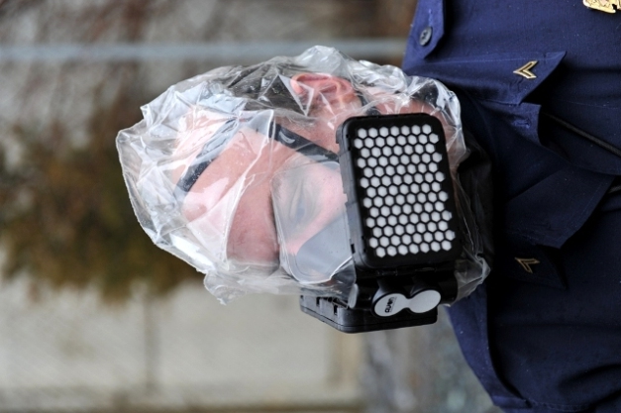
The device can be deployed in under 30 seconds and provides a minimum of 15 minutes CBRN protection, as defined by NIOSH, to get out quickly, safely, anytime, anyplace. Lightweight and easy to use, this device is gaining rapid support amongst VIP security support, police, emergency medical services, fire officers and civilians globally.
Matt Evans, Avon Protection’s development director said: “We understand at Avon the challenges faced by security support, emergency services and civilians in threatening CBRN scenarios. Twin low-profile filters on a unique hinge system feature the latest filtration media which reduces breathing resistance and additionally a front reflector makes it easier to identify colleagues in low light environments. It’s an essential device for anyone faced with a potential CBRN emergency.”
The single use device requires minimal training, no maintenance or fit testing and has a five year shelf life. The NH15 is vacuum sealed in a foil bag and is protected by a durable reinforced pouch small enough to carry on a person via a belt or to be stored in a briefcase, glove compartment or drawer.

HAPSITE Smart Plus Chemical Identification System
Source:http://products.inficon.com/en-us/nav-products/Product/Detail/HAPSITE_Smart_Plus_Chemical _Identification_System?path=Products%2Fpg_ChemicalDetection

Fast On-Scene Detection and Identification of Chemical Threats
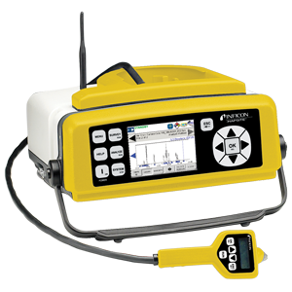
HAPSITE Smart Plus makes it even easier and faster for users to detect, identify and quantify toxic industrial chemicals (TICs) and chemical warfare agents (CWAs) right at the scene. It's the only person- portable gas chromatograph/mass spectrometer (GC/MS) that gives you lab-quality results within minutes - just the kind of reliable data you need to make critical decisions affecting life, health, and safety during emergency situations.
A fully-automatic start-up procedure eliminates the need for emergency responders to monitor the instrument. Easy, one-button operation initiates sample analysis.

Features
- Enhanced startup procedure speeds readiness
- Clear color indicators of sample identity and level of danger
- Improved bright screen display and larger buttons make operation easier
- A CD with self-guided course eliminates cost of retraining HAPSITE Smart operators on HAPSITE Smart Plus
- Eliminating the sample loop and using the concentrator for all readings saves time and money
- Built-in GPS records exact sampling location with date/time stamp for legally defensible data
- Convenient power button is on the front panel

Kenyan Military Trained to Defend Against Chemical Weapons
Source: http://allafrica.com/stories/201306110063.html

Kenya will graduate next week a military unit trained to handle chemical and biological weapons in an effort to boost the country's counter-terrorism abilities, Kenya's Daily Nation reported Monday (June 10th).
"Through the support of the US government, Kenya has made a stride in training a military unit, for the first time in Africa, capable of handling chemical and biological weapons, which have become a terrorism threat," said Colonel Isaac Muchendu, director of the Kenya Rapid Deployment Exercise.
Trainees include members of the Africa Standby Force, an African Union force that remains prepared to intervene in the event of large-scale violence.

Blowfly Protein Key To Terror Poison Antidote
Source: http://www.medicalnewstoday.com/releases/261517.php

The discovery by researchers at The Australian National University (ANU) of the molecular structure of a protein that causes insecticide resistance in the Australian sheep blowfly, resulting in hundreds of millions of dollars damage each year to the sheep industry, may also pave the way to an antidote for chemical warfare agents.
Having a better understanding of this protein will not only benefit farmers by enabling design of more effective pesticides, but is the first step towards creating an antidote for victims of chemical warfare agents, such as sarin gas.
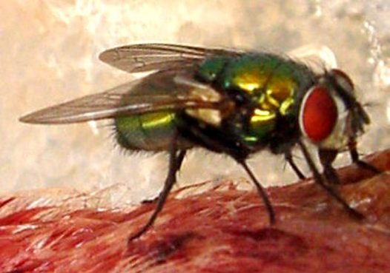
"The silver lining in the development of insecticide resistance in blowflies is that nature might have created a potential treatment for human organophosphate poisoning," said lead author Dr Colin Jackson of the ANU Research School of Chemistry.
Organophosphates are commonly used insecticides which act by blocking nerve signals in insects. The effectiveness of these insecticides has been decreasing in recent years due to insects developing resistance.
"The Australian sheep blowfly has been exposed to organophosphates for decades and now produces a mutated protein, called alpha-esterase-7, which has evolved to soak up and detoxify the organophosphate, so flies can now survive being sprayed," said Dr Jackson.
In addition to their use as insecticides, organophosphates are highly toxic to humans, meaning farmers who are accidentally poisoned and victims of terror attacks using organophosphate-based nerve agents, such as sarin gax or VX, are very difficult to treat. An estimated hundreds of thousands of human fatalities globally occur every year as a result of organophosphate poisoning.
"Even with the very best treatment, the mortality rate for organophosphate poisoning is quite high and we really need more effective treatments," said Dr Jackson.
The research team took the gene for the organophosphate resistant protein from the blowfly and engineered it so that large amounts of the protein could be produced in the bacterium Escherichia coli.
"These bacteria are basically little cellular factories which can make a large amount of protein. We were able to get them to produce large amounts of the resistance protein, which then formed crystals. By analysing how X-rays were scattered by the crystal, we were able to determine the structure of the protein," said Dr Jackson.
"Now that we have the structure of the protein we can design better and more effective insecticides that flies are not resistant to.
"Furthermore, this is a really good starting point towards developing a more effective antidote to organophosphate poisoning. We know this protein breaks down organophosphates in flies so we can use that knowledge to help people."
This research was done in collaboration with CSIRO and was funded by the Defense Threat Reduction Agency of the United States of America and is published in the journal Proceedings of the National Academy of Sciences.

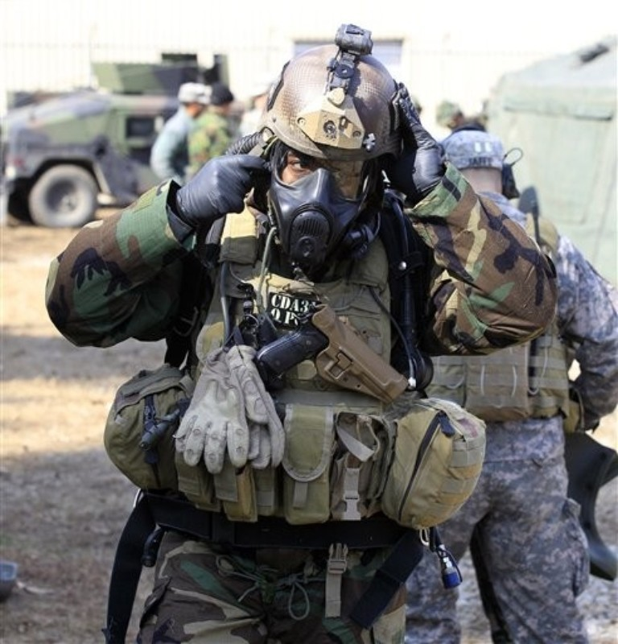
A US soldier wears chemical warfare gear during a joint military exercise with South Korea at a US Army base in Dongducheon, 40kms north of Seoul, on March 3, 2011
(strange breathing apparatus in backpack)

