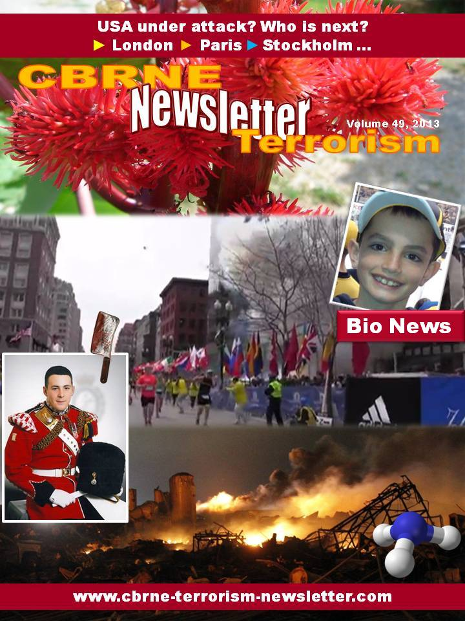

Concerns grow over repeated safety failures at U.S. BioLabs
Source: http://www.homelandsecuritynewswire.com/dr20130409-concerns-grow-over-repeated-safety-failures-at-u-s-biolabs

According to a report that was released by the Government Accountability Office (GAO) late last month, the United States is at a high risk for accidents at laboratories which conduct research on potential bioterror germs such as anthrax because federal officials have failed to develop national standards for lab design, construction, and operation.
USA Today reports that the GAO called for new standards more than three years ago.
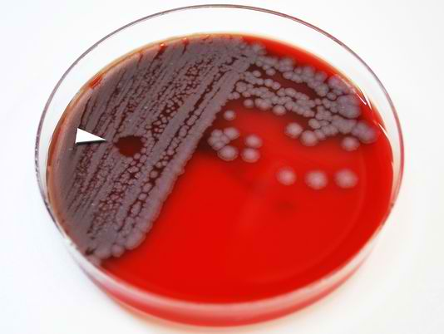
A second government audit found that federal officials have failed to detect security and safety violations during inspections of bioterror labs. The issues in the audit include multiple facilities which allowed workers to remain on the job with expired security risk assessments, and the transfer of anthrax and plague pathogens to an unauthorized facility.
“As a result, there is increased risk of the misuse of select agents and the potential for serious security violations going undetected,” the November 2012 report, conducted by inspector general auditors at the U.S. Department of Agriculture (USDA) states.
USDA inspection officials rejected the auditor’s findings, calling the report’s language “unduly alarming,” and refusing to adopt many of the auditor’s recommendations.
Officials who work in the USDA’s Animal and Plant Health Inspection Service refused an interview with the USA Today, but spokeswoman Lyndsay Cole released a statement in January saying that the inspection program agreed to take actions to address all of the auditor’s concerns.
“Our inspections are effective at identifying deficiencies.”
Representative Fred Upton (R-Michigan) the chairman of the House Committee on Energy and Commerce, said the USDA inspector general’s findings were “very troubling” and said they show the need for oversight and that the committee will be investigating.
“The inadequate and lax inspection practices of USDA raise additional concerns about their ability and independence to conduct effective inspections of Center for Disease Control’s (CDC) labs to ensure safety,” Upton told USA Today.
Representative Henry Waxman (D-California) who is also on the committee is just as upset.
“It is troubling that safety and security risks that were identified years ago have still not been fixed, and that the USDA IG has identified additional new vulnerabilities.”
Richard Ebright, a biosafety expert at Rutgers University, said the repeated failures by USDA inspectors to detect problems are “significant” and “erodes confidence” that regulations are being effectively monitored and enforced. Ebright noted that the USDA “rebuffed” auditors’ recommendations. “This is one of the most striking parts of the report,” Ebright told USA Today.
CDC officials refused to comment but did release a statement.
“The record stands for itself,” noting that the agency has performed more than 1,500 inspections over the past ten years. “The public should be confident that the critical research and development work to treat and prevent disease associated with select agents in the U.S. is done in a safe and secure manner.”
According to a CDC report last year, which was published in the journal Applied Biosafety, between 2004 and 2010 there was not one single report of theft and only one confirmed loss, which took place during the shipment of a fungus that can cause a type of pneumonia called Valley Fever and an FBI investigation of the lost package concluded the package was “apparently destroyed during processing at a commercial shipping facility,” the CDC researchers’ article stated.
Incidents between those years did cause concern however. In 2007 a substandard drainage system was suspected in the release of foot-and-mouth disease virus from a research facility in the United Kingdom according to the GAO.
The disease is a highly infectious livestock disease that can have significant economic consequences.
Agency officials also said that no one has been endangered by the lapses due to the labs having many layers of safety and security to protect employees and the public and when issues do arise, they are solved immediately.
The GAO however said it is still concerned about the fact that there are still no national standards.
“This will make it difficult to be able to assess and guarantee safety,” the report stated.
Officials in the president’s Office of Science and Technology have disputed the GAO’s conclusion and said that actions have been takes since 2009 to strengthen lab security, including new regulations and committees which are focused on managing risks.
Upton was not convinced, however, saying the lack of action is “not acceptable” and that the “GAO recommendations merit action and engagement by the administration.”

Hospital device aimed at detecting bioterrorism agents
Source: http://www.theengineer.co.uk/medical-and-healthcare/news/hospital-device-aimed-at-detecting-bioterrorism-agents/1016000.article

Researchers at Sandia National Laboratories are developing a medical instrument that will be able to quickly detect a suite of biothreat agents, including anthrax, ricin, botulinum, shiga and SEB toxin.
The device is expected to be used in emergency rooms in the event of a bioterrorism incident.
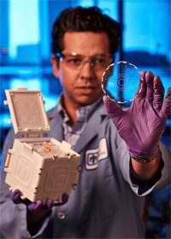
‘This is an unmet need for the nation’s biodefence program,’ said Anup Singh, senior manager for Sandia’s biological science and technology group. ‘A point-of-care device does not exist.’

Sandia device SpinDx features centrifugal microfluidics, or lab-on-a-disk technology, which uses centrifugal forces to manipulate samples and reagents through microfluidic channels implanted on disks that are of the same size as a standard CD or DVD

Sandia’s work is funded by a recent grant worth nearly $4m over four years from the US National Institute of Allergy and Infectious Diseases, part of the US National Institutes of Health.
Sandia’s biosciences and microfluidics program areas have successfully worked on notable projects that include MicroChemLab, a lab-on-a-chip technology developed in the early 1990s; plus the so-called saliva device, an instrument designed primarily to assesses dental disease; and a follow-up technology, RapiDx, developed in the early-to-mid 2000s.
‘This will take things to the next level,’ said Singh in a statement. In addition to the broader suite of toxins and bacterial agents that the device would test for, the project includes comprehensive testing with animal (mouse) samples.
This is an important step, Singh said, since toxins may behave differently in live animals and humans than in laboratory blood samples.
‘We are getting closer and closer to translational elements of research, which involves testing in animal and clinical facilities. This is part of the maturation of our bioresearch activities at Sandia.’
The need for diagnostic devices for biodefence is not going away, Singh said, since there are always new diseases springing up that lack good diagnostic assays.
‘Plus, we want dual-use devices that combat both man-made and nature-made problems,’ he added. ‘We’re not just going to wait for the next anthrax letter incident to happen for our devices to be used and tested; we want them to be useful for other things as well, like infectious diseases.’

Can cancer drugs be used to counter bioterrorist threats?
Source: http://www.digitaljournal.com/article/347548

A research team has been given a grant to see if two cancer medications have the potential of protecting U.S. troops from biological agents that could be unleashed during an attack.
U.S. Defense Threat Reduction Agency (DTRA), part of the U.S. Department of Defense, has hired Mark Buller, Ph.D., professor of molecular microbiology and immunology at the Saint Louis University, to explore antiviral activity of different medications.
The role of the DTRA is to find solutions to protect members of the U.S. military from weapons of mass destruction, including bioterrorism threats.
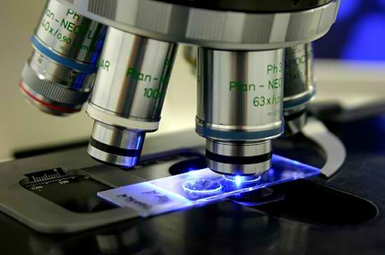
The research will begin with two compounds that are the active ingredients in the FDA-approved oral cancer medicines Gleevec and Tasigna can prevent and treat monkeypox virus infections in a mouse model. Monkeypox is an orthopox virus that has similar characteristics to smallpox (a vaccinia virus) and it can, according to the World Health Organization, often be fatal. According to UAB, monkeypox virus is a potential infectious agent that could be used as biological weapon.
Buller is studying Gleevec and Tasigna because they target the same enzyme that vaccinia virus and ebola virus require in their natural life cycle. These medications are absorbed when given by mouth, and they are highly ‘bioavailable’: in that 98% of an oral dose reaches the bloodstream.
If the drugs are successful against certain viruses then the process for using them will be less in cumbered by regulation given that the medicines are already approved for treating patients.

CDC Fights Plague in Uganda With Eye on Bioterror Threat
Source: http://www.nti.org/gsn/article/cdc-fights-plague-uganda-eye-biodefense/

The Centers for Disease Control and Prevention's work to fight plague outbreaks in Uganda could serve to protect the United States from a biological attack involving the bacteria, the Washington Post reported on Tuesday.
There are on average five incidence of plague annually in the United States, while 1,287 apparent infections have been counted in Uganda since 2003.
The U.S. public health agency in recent years has tried out in the African nation a simple tool to test for infection. The small device would function somewhat like a personal pregnancy test; a minute amount of blood or urine could indicate in minutes whether an individual is infected.
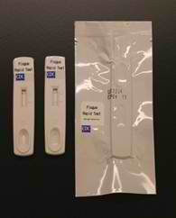
Such a quick-acting diagnostic system would be extremely useful in the face of an act of bioterrorism, said CDC scientist Jeff Borchert.
Scientists are also looking for the Food and Drug Administration to authorize use of the antibiotic ciprofloxacin in treating plague infections. The United States already holds the drug in case of anthrax outbreaks.
A number of Ugandan plague patients received a 10-day regimen of the antibiotic during clinical testing, the newspaper reported.
Plague is listed as a Category A biological agent by the Centers for Disease Control. The intentional release of 100 pounds of an airborne version of the bacteria could infect 150,000 citizens in a city of 5 million residents, the World Health Organization has found.
"It's been on national lists as one of the more serious biological agents for a long time," said Tom Ingelsby, head of the Center for Biosecurity at the University of Pittsburgh Medical Center.

Scientists Develop Hendra Virus Vaccine
Source: http://www.nti.org/gsn/article/australian-scientists-develop-nepah-virus-vaccine/

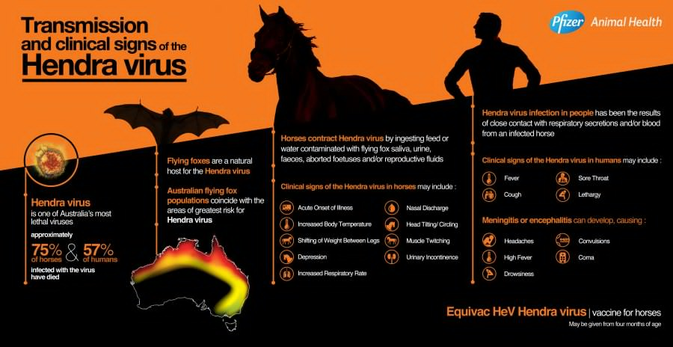
Researchers from Australia and the United States have readied a vaccine against a disease that can be transmitted from horses to humans and is considered a potential bioterrorism tool, the Australian newspaper reported on Thursday.
Development of Equivac will allow for vaccinations of horses across the Australia, where the Hendra virus was first identified in 1994.
"I regard this as a high-impact achievement because it's something that's actually come off the laboratory bench into the Australian community," said Deborah Middleton, a veterinary pathologist with the Commonwealth Scientific and Industrial Research Organization, who headed the joint research project. "We can save not only horses' lives, we can save people's lives."
It is possible that the vaccine could also be used to defend troops from infection by the related Nipah virus, according to the U.S. collaborators. Nipah is also considered a possible bioterrorism agent and, unlike Hendra, is known to be transmissible between humans.

Plant-Based Ebola Drug Tests Well on Monkeys
Source: http://www.nti.org/gsn/article/plant-based-ebola-drug-tests-well-monkeys/

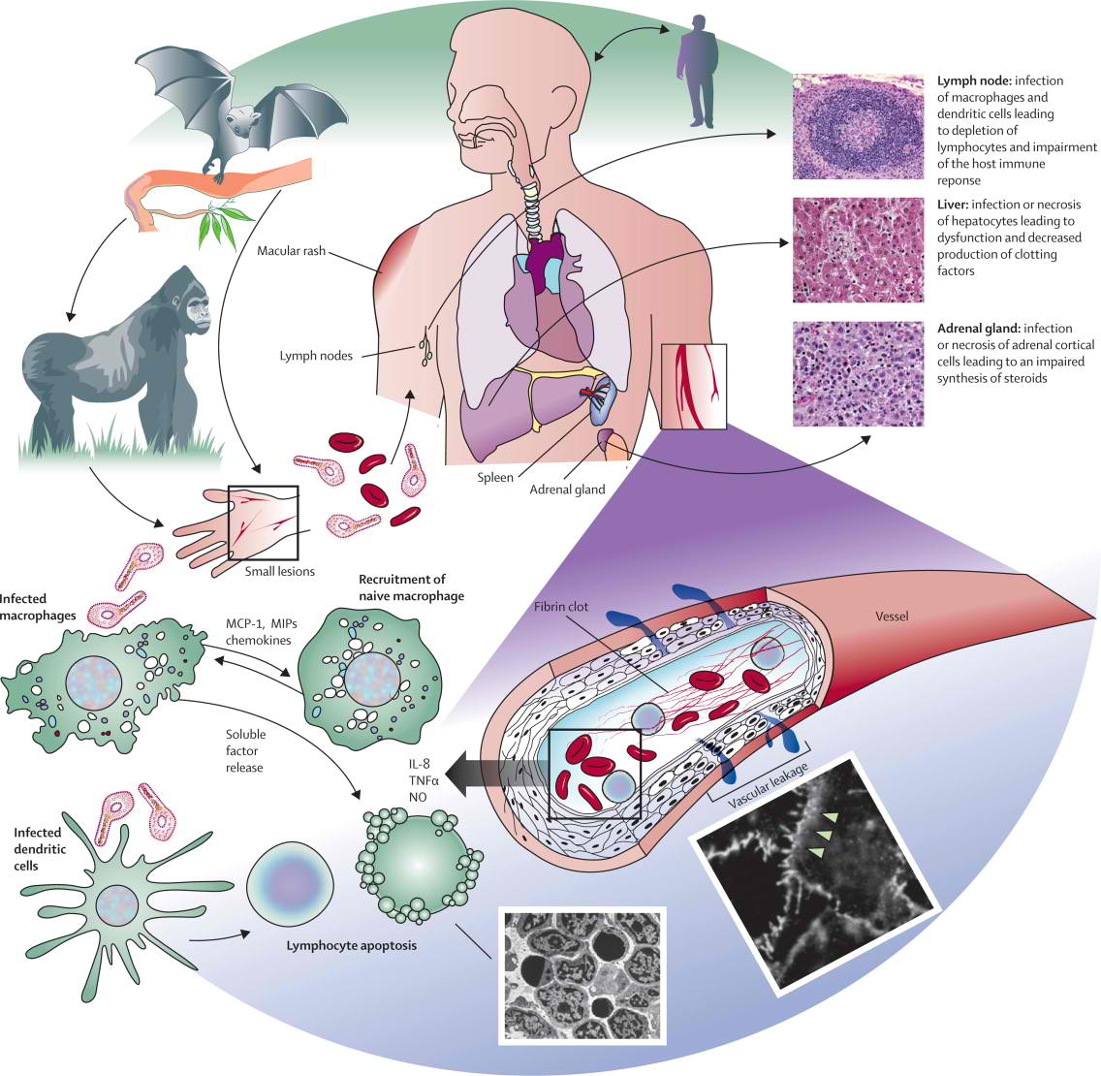
An experimental Ebola drug has demonstrated the ability in laboratory testing to protect monkeys exposed to the lethal fast-acting hemorrhagic fever virus, the U.S. Army Medical Research Institute of Infectious Diseases announced in a recent press release.
None of the rhesus macaques who received the mixture of monoclonal antibodies known as mAbs an hour following exposure to the disease died, according to a new report in the Proceedings of the National Academy of Sciences. When the monkeys received the MB-003 antibiotic "cocktail" two days after their contamination with Ebola, 66 percent survived.
Ebola death rates among humans can be as high as nine out of 10 people. At present there are no antibiotics or vaccines licensed for use against the disease, which is considered a serious potential biological weapon.
"It is rare that an antiviral compound prevents Ebola virus infection with limited to no morbidity in treated animals at any point of treatment following infection by this lethal virus," principal investigator and USAMRIID virologist Gene Olinger said in provided remarks. "Until recently, attempts to utilize antibodies to provide protection against Ebola virus have been met with failure. The level of protection against disease that we saw with MB-003 was impressive."
The antibiotic was generated using tobacco plants -- a method that allows for faster production and at a lower cost, according to Kentucky BioProcessing Chief Operating Officer Barry Bratcher, whose company created the production process.
Financing for research into the experimental Ebola treatment was provided by multiple U.S. government agencies.
KBP chairman Hugh Haydon told the Kentucky Messenger-Inquirer that more studies are needed to determine the drug's effectiveness window after disease exposure, as well as appropriate dosage amounts. "We have to determine the proper mixture," he said. After those issues have been properly assessed, human clinical trials can begin.

Bicycle Reflectors Detect Bioterrorism
Source: http://news.discovery.com/tech/biotechnology/bicycl-reflectors-detect-bioterrorism-130410.htm

Those bright safety reflectors, aka “retroreflectors,” on sneakers, running apparel and bike fenders are taking on an illuminating new role: detecting bioterrorism threats and diagnosing everyday infectious diseases.
Led by Richard Willson of the University of Houston, scientists from the University of Texas and Sandia National Laboratories are developing an ultrasensitive, all-in-one device that utilizes retroreflectors to rapidly tell first-responders exactly which disease-causing microbe has been deployed in a bioterrorism attack.
Additionally, the scientists are also developing technology intended for use in doctors’ offices and clinics where retroreflectors could provide a rapid, on-site diagnosis of common infectious diseases before patients leave, thus eliminating the wait for test results.
Researchers were able to design retroreflectors so small that 200 would fit in the dot over the letter “i.” These microfabricated retroreflectors were given a biochemical surface capable of detecting pathogens, effectively making them a lab-on-a-chip, with minute channels that can process small amounts of blood or other fluids.
For example, as it flows through the channels, a sample fluid containing bacteria would cause parts of the reflectors to go dark, signaling a positive test. If the fluid sample was free of the bacteria or disease-causing virus, the reflectors would shine brightly.
“Right now, we have seven channels in our device,” researcher Balakrishnan Raja, part of Willson’s team, said in a news release. “So we can test for seven different infections at once, but we could make more channels. That’s one of our long-term goals — to multiplex the device and detect many pathogens at once.”
Normally, pathogen detection is an intricate process that involves extracting blood and labeling nucleic acids with special dyes, all of which requires elaborate instrumentation, complex optical equipment and time. Wilson and his colleagues are proposing a device that could provide more immediate results and is small enough to be carried by first responders or doctors.
Researchers clinically demonstrated retroreflectors that were successful at identifying fluid samples containing a bacteria that causes Mediterranean spotted fever. Wilson and his team presented their project this week at the National Meeting and Exposition of the American Chemical Society.

H7N9 bird flu US biological attack: Chinese military official
Source: http://www.presstv.ir/detail/2013/04/10/297603/h7n9-bird-flu-us-biological-attack/

A Chinese military official says a new strain of bird flu which has hit the country and has not been previously seen in humans is a biological attack launched by the United States against people in China.
Air Force officer, Colonel Dai Xu, wrote on Sina Weibo -- a site akin to Twitter -- that the H7N9 virus has been released by the US in an attempt to “destabilize” the Asian country, The Sun reported on Wednesday.
At least 9 people have died of the H7N9 bird flu in China, since the new strain was discovered about two weeks ago.
The Chinese official added that SARS outbreak in 2003 was also an American plot, since “at that time, America was fighting in Iraq and feared that China would take advantage of the opportunity to take other actions.”
Describing SARS and H7N9 bird flu as bio-psychological weapons used by the US against China, Xu said, “All of China fell into turmoil and that was exactly what the United States wanted. Now, the United States is using the same old trick. China should have learned its lesson and should calmly deal with the problem.”

NEW BOOK – Atlas of Mustard Gas Injuries" lessons from the past for the future

Iran has the largest population of Sulfur Mustard exposed in the world.
As the results of gas attacks against Iranian during the Iran Iraq war (1980-1988) tens of thousands of Iranian soldiers and civilian were killed or injured, the survivors are suffering from various long lasting health complications.
On the other hand, thousands of Japanese worked in the poison gas factories of Japanese army from 1929-1945 and majority of them later developed long term health effects as the results of exposure to sulfur mustard.
Because of those experiences, a group of Iranian and Japanese physicians and scientists who have been involved in medical treatment of the SM exposed patients met in 2006 and decided to share their experiences and to publish it to increase knowledge among world medical community how to deal with CWA exposure related illnesses in the future in case of any chemical warfare, terrorist use or industrial accident.
To that end, in 2008 they started a joint project to put all their experiences together and compile what was later called" the "Atlas of Mustard gas injuries".
"Atlas of Mustard gas Injuries" is an exemplary work of international scientific collaboration for the purpose of humanitarian assistance to war victims and to promote CBRN science which makes it a unique book in its field.
It is the result of about 4 years of endeavor and cooperation between Iranian and Japanese researchers and physicians to collect and publish their experiences as a comprehensive study on health impacts of mustard gas, diagnosis and treatment of exposure related illnesses as well as health advice for the survivors and their families; the medical exchange finally led to compilation of the "Atlas of Mustard Gas Injuries" which has been written in three languages (English, Japanese and Persian) and published recently in Japan.
In writing this book, 27 medical doctors (18 Iranians & 9 Japanese) worked together and contributed.
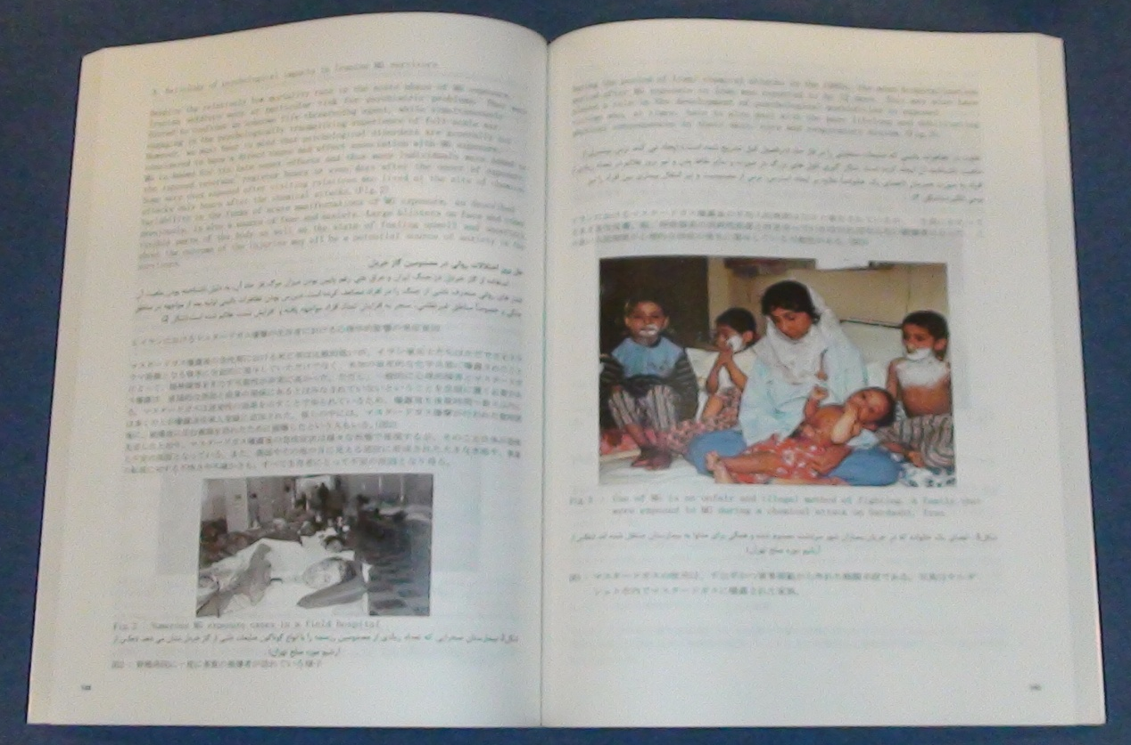
The book consists of 22 chapters of which 14 chapters written by Iranians and 8 chapters by Japanese authors and it contains first hand experiences and the latest findings of researchers from both countries.
It can be used by scientists, health professionals and other interested individuals around the world specially those who are involved in the CBRN and counter terrorism field.

Contact details:
Dr. Shahriar Khateri
Co-author and coordinator of the project
Head of CW Victims Research Department
Janbazan Medical and Engineering Research Center JMERC
19615-616,Tehran; Iran
Shahriar.khateri@gmail.com

EDITOR’S COMMENT: Given the actual experience of Iranian physicians in treating “real” CWA casualties, this book is valuable and need to be part of every medical library – even if never used! Authors are looking for a reliable well-known publisher that will provide a final product worth the contents of gathered experience and expertise. Western medicine is lucking similar publications and this is a good opportunity for an in depth insight of the terror of chemical weapons on humans and life!

Mississippi man arrested for sending ricin letters to Obama, Sen. Wicker
Source: http://www.homelandsecuritynewswire.com/dr20130417-mississippi-man-arrested-for-sending-ricin-letters-to-obama-sen-wicker

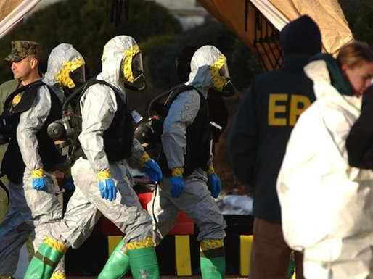
The FBI confirmed yesterday (Wednesday) that a letter addressed to President Obama was found to contain the toxin ricin. As is the case with all the mail sent to the White House, the letter was screened in a remote mail sorting facility in Anacostia, a neighborhood in southeast Washington, D.C., and intercepted. The facility is run by the Secret Service and employs about fifty screeners.
The FBI arrested a man from Tupelo, Mississippi, on suspicion that he was behind the ricin letters to the White House and to Senator Roger Wicker (R-Mississippi), who lives in Tupelo.
The FBI said in a statement that a letter intercepted in the sorting facility contained “a granular substance that preliminarily tested positive for ricin.” The agency said there was “no indication” of any connection to the bombings Monday that killed three spectators at the Boston Marathon.
The Washington Post reports that the police and the FBI were also investigating suspicious packages in and near the offices of several members of Congress.
The letter containing the suspicious substance was sent to a military installation in Maryland where preliminary testing found indications of ricin.
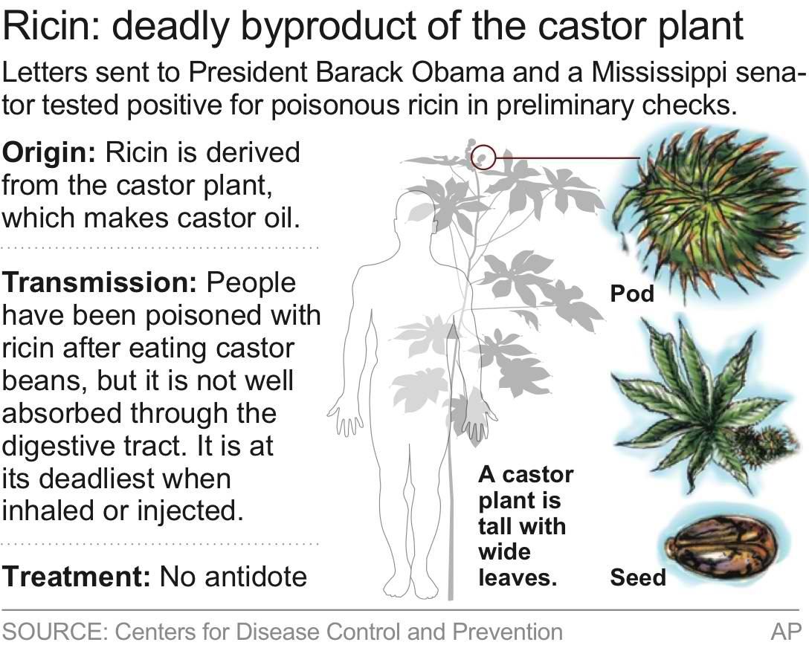
CNN reported that the letters to Obama and Wicker were similar in the language they used and signatures. Each of the letters read: “To see a wrong and not expose it, is to become a silent partner in its continuance.” CNN said the letters were signed: “I am KC and I approve this message.”
On the Hill, the U.S. Capitol Police was investigating suspicious packages delivered to the front office of Senator Richard C. Shelby (R-Alabama) in the Russell Senate Office Building, and also a package left in the atrium of the Hart Senate Office Building.
Jonathan Graffeo, a spokesman for Shelby, said in a statement: “The Capitol Police have given us the all clear. Sen. Shelby and staff are unharmed. Questions relating to any details of the investigation should be referred to the Capitol Police.”
When the letter to the Wicker was detected, the Capitol Police ordered the evacuation of all first-floor offices in the Hart Senate Office Building. Staffers occupying offices located on higher floors were told to stay in their offices.
Senator Carl Levin (D-Michigan) said in a statement that a staffer received “a suspicious-looking letter” Wednesday morning at the senator’s office in Saginaw, Michigan.
“The letter was not opened, and the staffer followed the proper protocols for the situation, including alerting the authorities, who are now investigating,” Levin said. “We do not know yet if the mail presented a threat.”
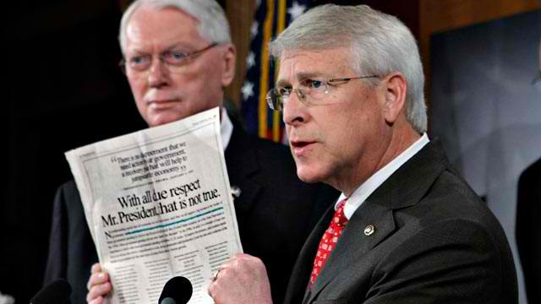
The Post reports that in late morning Wednesday, an envelope was hand-delivered to the third-floor Hart office of Senator Joe Manchin (D-West Virginia), and Capitol Police removed the letter for testing.
In Phoenix, a suspicious letter was discovered Wednesday at the office of Senator Jeff Flake (R-Arizona), according to spokeswoman Genevieve Rozansky.
“There was a suspicious letter intercepted by a member of Senator Flake’s staff at his Phoenix office,” she said in an e-mailed statement. “Law enforcement officials are on the scene, and all staff members are safe. We will release details as we know more.”
The White House receives more than 10,000 letters a week. Since Obama became president in 2009, the Secret Service has intercepted at least half dozen letters that went beyond threatening words – some of these letters contained suspicious powder or HIV-positive blood.
The Post notes that in 2004, three Senate office buildings were closed after preliminary tests of suspicious substance in a letter delivered to the office of the Senate majority leader found the substance to be ricin.
The AP reported that subsequent tests found that the preliminary test may have picked up non-toxic byproducts of the castor bean plant used in paper production.

Ricin And The Risk Of Bioterror: Are We Prepared?
Source:http://www.forbes.com/sites/scottgottlieb/2013/04/17/ricin-domestic-bioterrorism-and-the-lessons-learned-after-9-11-are-we-safer-today-than-we-were-ten-years-ago/

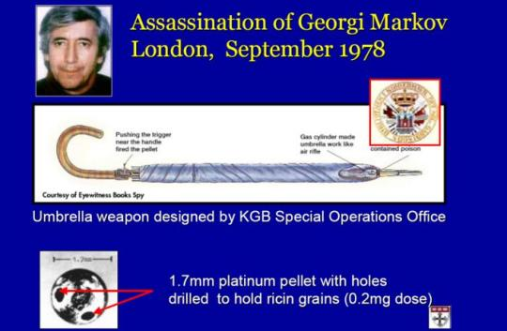
The ghastly bombings in Boston followed by envelopes laced with the lethal poison ricin that were sent to the U.S Capitol and the White House, renew fears about our vulnerability to these kinds of terrorist acts. It invites unwelcome memories of 9-11.
Speculation is widespread about the potential origins of these attacks, and whether they could be related (seems unlikely). Investigations are underway and a suspect in the ricin attacks is now in custody. In time, we also must ask how much safer we’ve made ourselves based on the lessons we learned after 9-11. And whether there are still precautions we should heed.
When it comes to bioterrorism, it’s a mixed bag. Programs enacted after 9-11 helped shore up our defenses. But in their current form, they’re not as well equipped to promote development of the kinds of technologies that we need to thwart modern day threats. These threats may not come from established agents of bioterror, but new strains of bugs engineered for deadly purposes.
Programs were started after 9-11 to underwrite the federal development of medical countermeasures. The centerpiece of the effort was Project Bioshield.
Congress passed the Bioshield Act in 2004. Its aim was to fund the purchase of vaccines and treatments aimed at thwarting bioterrorism. A key element of the Act was to allow stockpiling of countermeasures. Some of these agents would be approved for government purchase based on testing in animals alone. It’s not feasible to infect people with deadly bugs like smallpox just to enable human testing.
Since the 2001 anthrax attacks, the feds have allocated nearly $50 billion to address the threat of biological weapons. A lot of the funding also goes to Biomedical Advanced Research and Development Authority (BARDA), established in 2006 to help companies through the mid (and high risk) stages of drug development.
BARDA is part of the Department of Health and Human Services. It provides funding through contracts to mostly mid and later-stage efforts to develop new types of countermeasures. But the government’s foray into this sort of venture investing has been bumpy.
The Bioshield and BARDA funding has proven useful for scaling up the manufacture of vaccines and other countermeasures that were already in advanced stages of development, but needed additional money to make their manufacture economically feasible or possible in the first place. But these programs have been less successful at financing early stage ventures aimed at developing completely novel agents. It hasn’t really been their mission.
For one thing, taking on the kind of risk inherent in the early stages of drug development is not an exercise well suited to government work, where political pressures often cause an aversion to risk taking.
Some government programs, like the Defense Advanced Research Projects Agency (DARPA) have success at financing innovative, early ventures. But they tolerate a lot of failures along the way. Over the past decade, BARDA and Bioshield have not been so lucky. The intense political scrutiny that these efforts have undergone (often stoked by companies that lose out on contracts and complain to Congress) has made the government executives managing the programs understandably skittish. This has rendered the entire process adverse to the kind of risk taking that’s required for successful drug discovery.
A better approach to stimulating development of the kinds of countermeasures we need to thwart future threats may be a prize-based system.
This isn’t a new idea. It’s been long advocated by left-leaning policy analysts and critics of pharmaceutical patents and the lucrative monopolies that patents confer. The idea is that publicly funded cash awards would be offered for firms that develop products that meet a certain public health purpose.
That sort of system isn’t likely to match the success of our market-based model for ordinary drug development. But when it comes to medical countermeasures, there’s no natural market for the products (the only purchaser is the government). A prize system could work well alongside than contract-based programs under BARDA. The contracts are effective at scaling up established technology. The prizes could be used to create incentives for early-stage endeavors.
For one thing, a prize-based system may be less prone to political intrusion than a grant-making process.
Ideally, lucrative prizes for successful countermeasures would still be coupled to smaller grants or contracts that would offset some of the costs of development. But those small grants could be disbursed more easily since they would be for modest amounts – just enough to get a promising program started. The combination of small seed grants, and rich rewards to successful endeavors, could create the mix of incentives that will entice entrepreneurs to chase these endeavors.
Right now, few companies are dedicated to working in this space. The ones that do often rely on federal money to fund the work, and the promise of stockpiling if they succeed. In many cases, these are companies re-purposing existing technologies rather than developing brand new agents with the singular aim of thwarting bioterrorist threats.
The result is that the companies chasing these high risk, lower reward endeavors are often small firms that are otherwise capital constrained (and need the BARDA funding as a bridge.) Among the firms developing countermeasures to ricin are mostly very small companies like Soligenix. It’s worth noting that — because ricin can’t be easily weaponized — it isn’t on the list of 12 priority agents for which BARDA has been tasked with developing countermeasures. (This list is referred to as the Material Threats Determination).
BARDA and Bioshield have played a highly valuable role in enhancing our preparedness. But we must also re-imagine these programs to confront evolving risks.
The ricin laced envelope sounds like a crude attack based on the public reporting. Ricin is a highly toxic substance. A very small amount can kill an adult. And there’s no reliable test for exposure, no approved vaccine, and no antidote once exposed. But ricin generally has to be injected or ingested to kill. Large quantities would need to be inhaled to cause death. For this reason, it isn’t considered a weapon of mass attack, but has been used as a tool for targeted assassination.
In the future, the real threat may not be established bioweapons like ricin or anthrax. These agents, while deadly, have limitations. To be weapons of mass attack, these agents must be dispersed on a mass scale. That doesn’t only require knowhow with the bioagents, but with the technical means for weaponizing them and dispersing them over a wide area.
In the future, the bigger threat may come from the deliberate misuse of engineered organisms. These are biological agents that can be engineered to spread from person to person, like a deadly form of flu or a re-engineered version of smallpox.
As I noted in a commentary in the Wall Street Journal, DNA synthesizers for making weaponized bugs are small, cheap and easy to procure. The technical means for harnessing these tools is relatively straightforward. The instruction sets for making these kinds of deadly organisms can be found on the Internet.
Rogue regimes and lone villains could exploit these scientific methods for deadly aims. In the extreme, such an attack could play like the creepy plot of the 1995 film “Twelve Monkeys,” where a wicked scientist engineers a virus that nearly drives mankind to extinction.
With the advent of what some have called “garage biology,” such scenarios are no longer wildly implausible. The most recent attacks only serve to reinforce the existence of evil motives that continue to search for these means of wicked ends.

War medicine helping Boston bomb victims
Source: http://www.foxnews.com/health/2013/04/18/war-medicine-helping-boston-bomb-victims/
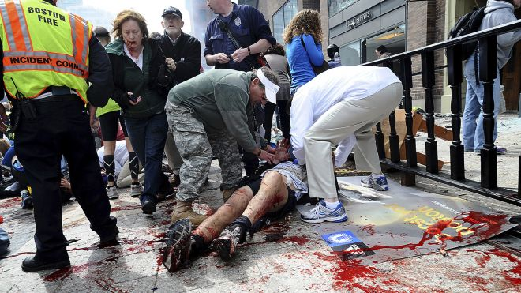
An injured person is helped on the sidewalk near the Boston Marathon finish line following an explosion in Boston, Monday, April 15, 2013. (AP Photo/MetroWest Daily News, Ken McGagh)

The bombs that made Boston look like a combat zone have also brought battlefield medicine to their civilian victims. A decade of wars in Iraq and Afghanistan has sharpened skills and scalpels, leading to dramatic advances that are now being used to treat the 13 amputees and nearly a dozen other patients still fighting to keep damaged limbs after Monday's attack.
"The only field or occupation that benefits from war is medicine," said Dr. David Cifu, rehabilitation medicine chief at the Veterans Health Administration.
Nearly 2,000 U.S. troops have lost a leg, arm, foot or hand in Iraq or Afghanistan, and their sacrifices have led to advances in the immediate and long-term care of survivors, as well as in the quality of prosthetics that are now so good that surgeons often choose them over trying to save a badly mangled leg.
Military doctors passed on to their civilian counterparts a surgical strategy of a minimal initial operation to stabilize the patient, followed by more definitive ones days later, an approach that offered the best chance to preserve tissue from large and complex leg wounds.
At the same time, wartime demand for prosthetics has led to new innovations such as sophisticated computerized knees that work better than a badly damaged leg ever would again.
"This is a clear case where all of the expertise that was gained by prosthetic manufacturers was gained from the wars. It's astonishing how well they function and the things people can do with these prostheses," said Dr. Michael Yaffe, a trauma surgeon at Beth Israel Deaconess Medical Center in Boston.
The hospital has performed amputations on three blast victims so far. A few other patients there may yet need them. Yaffe is a lieutenant colonel in the Army Reserves, and many other doctors treating Boston blast victims also have had military training.
The military partnered with the American Academy of Orthopaedic Surgeons to train doctors throughout the United States on advances learned from the wars, said Dr. Kevin Kirk, an Army lieutenant colonel who is chief orthopedic surgeon at San Antonio Military Medical Center.
Help, too, has come from Israel, which for decades has dealt with the aftermath of Palestinian bombs, like the ones in Boston, often laden with nails, ball bearings and other metals.
"Unfortunately, we have great expertise," said Dr. Pinchas Halpern, director of emergency medicine at Tel Aviv's Sourasky Medical Center.
Halpern, who gave lectures in 2005 at Brigham and Women's Hospital and Massachusetts General about responding to attacks, has been in email contact with doctors in Boston this week.
Among the topics he covered in his lectures were how to coordinate ambulances to distribute the wounded to area hospitals according to their type of injury, performing more CT scans than usual to locate deep shrapnel wounds and ways to identify and classify wounds.
Dr. Paul Biddinger of Mass General's emergency department said the hospital took much of Halpern's advice.
"We improved our plans for triage, site security, reassessment and inter-specialty coordination" following Halpern's visit, Biddinger said.
Blast victims can be challenging to treat because they typically have multiple complex physical injuries that may include loss of limbs, fractures, brain damage, and vision and hearing impairment, said Dr. Paul Pasquina, chairman of physical medicine and rehabilitation at the Uniformed Services University and Walter Reed National Military Medical Center.
"It's very important that during their acute medical and surgical care that rehabilitation is applied early on, to get them up as soon as possible" to reduce risks from being immobile, including blood clots, deconditioned muscles and other problems that will make recovery more difficult," he said.
A multidisciplinary approach that involves everyone from plastic and orthopedic surgeons to therapists is important, said Dr. James Ficke, chairman of the department of orthopedics and rehabilitation at San Antonio Military Medical Center. He also advises the U.S. Army Surgeon General on orthopedics.
"As a doctor, one of the lessons I learned most dramatically is, I don't have any preconceptions of what they can or can't do as a patient. There was a patient who lost his leg completely and had no hip joint and recently did a marathon in Austin in 4:33."
John Fergason, chief prosthetist at Center for the Intrepid, an outpatient rehab center that is part of Brooke Army Medical Center, said advances include computerized knees that allow amputees with above-the-knee amputations to walk down steep ramps, to walk up steps and go from a walk to a run.
After every war, "you see a tremendous spike in prosthetic innovation," largely because of increased research money, said Hugh Herr, a prosthetic expert at MIT and a double-amputee himself. Federal funds let his MIT lab do basic research on a bionic foot-ankle-calf system, and he founded a company that has commercialized that device.
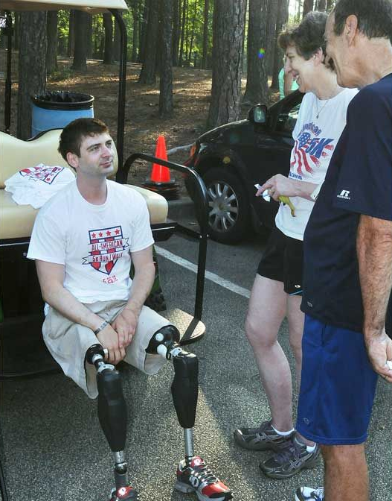
If Boston victims are generally healthy and motivated, and their legs are amputated below the knees, or perhaps even above the knees, "it's possible they could run the marathon a year from now," he said. "It would take a lot of effort, but it's indeed possible with today's technology."

'Very happy with my progress'
One amputee's story is encouraging.
Dan Berschinski, 28, used to run marathons but now works with the Amputee Coalition, an advocacy and support organization based in suburban Washington, D.C. He was an infantry officer in Afghanistan when he stepped on an IED in August 2009. The blast blew off his entire right leg and most of his left leg. After treatment in the field and in Germany, he was sent to Walter Reed.
His biggest initial challenge was intense pain, treated with narcotic painkillers, and phantom leg and foot pain. Doctors used to consider phantom pain a psychological problem but now consider it real, physical pain. Treatment includes nerve blockers.
Recovery and rehab took about three years, including 10 months of daily physical therapy to strengthen his arms and core - muscle power he'd need to learn to walk on prosthetics.
The bionic legs he uses cost $60,000 apiece, are hydraulically operated and equipped with microchips and a gyroscope that sense when to relax and stiffen to help him walk. Walter Reed was involved in developing the legs, said Zach Harvey, former prosthetics chief at Walter Reed.
Berschinski used to run marathons but now competes in triathlons - swimming, biking with his arms and racing in a wheelchair.
"I'm very happy with my progress," he said.

Boston Marathon Bombings Show The Tourniquet Is A Lifesaver
Source:http://latino.foxnews.com/latino/health/2013/04/18/boston-marathon-bombings-prove-tourniquet-is-lifesaver/

Using belts, shirts and other materials, rescuers at the Boston Marathon bombings turned to a millennia-old medical device to save lives — the tourniquet.
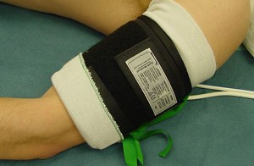
In their fast-acting bids to prevent major blood loss, shock and death, doctors at Boston area hospitals said such fast work no doubt saved many lives.
However as recently as the early 2000s, use of the tourniquet was still enmeshed in a long standing controversy in the medical community about whether they were more trouble than they were worth.
"Some people saw them as lifesaving, and others said they were the instrument of the devil," said Dr. John F. Kragh Jr., an orthopedic surgeon with the U.S. Army's Institute of Surgical Research in Texas.
Although tourniquets have been used to stem blood loss since at least the time of the Roman Empire, modern military surgeons had grown to doubt it. There were no good studies proving their benefit. And there was a common belief that some tourniquets could do more harm than good, cutting off blood and oxygen to limbs and resulting in amputations.
"There are a number of ways to mess it up," said Kragh, who is a leading researcher on methods to control bleeding.
"In Vietnam, tourniquets were not typically used" because it was thought they led to many amputations, said Dr. Kevin Kirk, an Army lieutenant colonel who is chief orthopedic surgeon at San Antonio Military Medical Center.
That's because tourniquets often were placed too high above the injury, leading to loss of tissue that otherwise might be saved, he said. Now they are used lower, and "a lot of lives and limbs have been saved by the use of a tourniquet," Kirk said.
The American Red Cross came to call tourniquets a last resort for stemming severe bleeding.
The dust settled only in the last decade, according to some experts, following publication of studies from the Iraq war by Kragh and others that showed tourniquets were clear-cut lifesavers. Those studies showed timely use of tourniquets could raise survival rates as high as 90 percent. Tourniquets are now routinely issued to soldiers.
However, some experts remain cautious about their use. The Red Cross, for example, continues to worry that tourniquets may be used improperly or in situations when blood loss is not great enough to warrant their use.
"Clearly, if a leg is blown off, it's OK to go straight to tourniquet," said Dr. Richard Bradley, a member of the Red Cross's scientific advisory council.
But the Red Cross continues to advise that direct pressure be applied to a wound in less extreme situations.
Tourniquets should be at least 1½ inches wide, and pulled very tight, to properly shut off blood flow. Medical supply companies make tourniquets that do the job best.
Bradley also stressed that it's important to use a real tourniquet if possible. News coverage of the Boston tragedy describes emergency responders using all sorts of things as makeshift tourniquets, including neck lanyards.
"Is a lanyard better than nothing? Probably," Bradley said. But other kinds of care, and rapid transport to hospitals, may have been at least as important as tourniquets, he added.
Monday's blasts injured at least 170 people near the finish line of the Boston Marathon. Three spectators died and 13 people lost one or more limbs.
Nicholas Yanni of Boston was with his wife and friends watching another friend cross the finish line when the explosion occurred. Yanni's wife had an injury to her lower left leg. Another woman with them had a leg injury, too. Yanni ducked into a nearby sports store for T-shirts that they tore to create a tourniquet.
At Tufts Medical Center, surgeons fixed the smaller of the two bones in her lower left leg that was apparently shattered by shrapnel from the blast.
"My worst fear was that I could have lost my wife. Other than that it was autopilot, adrenaline, chaos. There was a lot of just 'not-even-thinking,' sort of animalistic, you know, thought. What needs to be done, you do it," Yanni said.

Ricin Poisoning Symptoms: How to Deal with Exposure to the Bioterrorism Toxin
Source:http://www.medicaldaily.com/articles/14699/20130416/ricin-poisoning-symptoms-deal-exposure-bioterrorism-toxin.htm

Ricin poisoning has federal authorities on alert after the deadly toxin was intercepted this afternoon in an envelope addressed to Mississippi's Republican Senator Roger Wicker.
In the wake of yesterday's Boston Marathon bombing, the American public is especially attuned to any news of possible terrorism- soon after reports of the tainted letter broke, "ricin" jumped to the top of trending keywords on Google and other search engines. So what is ricin?
Ricin is a highly toxic poison that occurs naturally in castor beans, and can be cheaply and simply produced from the leftover paste that comes from processing the beans into castor oil. Though it is deadly in large quantities, the Centers for Disease Control and Prevention (CDC) ranks ricin as a Class B bioterrorism agent, behind more deadly toxins like anthrax, smallpox, and botulism.
Unintentional exposure to ricin is highly unlikely, according to the CDC. Though castor beans can poison people if swallowed, it typically takes a deliberate act to to produce ricin into a powder, mist, solution, or pellet that can act as a bioterror agent. Actual incidents of death by ricin exposure are rare— most notoriously, Georgi Markov, a Bulgarian journalist in London, was killed in 1978 after being poisoned by an assassin who injected him with a pellet of the toxin in a syringe-rigged umbrella.
The symptoms of ricin poisoning depend on whether the toxin was inhaled, injected, or ingested. Depending on the route of exposure, symptoms can begin as early as four hours after exposure and death can occur within 36 to 72 hours of exposure. As little as 350 micrograms can kill an adult weighing 70 kilograms, though exposure is not always fatal. Ricin victims typically live if they survive past five days after exposure, according to a Cornell University factsheet.
Ricin works by permeating the cells of a person's body and inactivating ribosomes, the complex molecules that create other proteins, leading to quick cell death. Inhalation and injection are the most hazardous modes of exposure.
When ricin is inhaled, people typically experience difficulty breathing, fever, nausea, and coughing, typically within 10 hours, followed by fluid buildup in the lungs and heavy sweating. As the symptoms progress, low blood pressure and respiratory failure can cause death.
If ingested in large enough amounts, ricin causes bloody diarrhea and vomiting, which lead to severe dehydration and low blood pressure, followed by seizures. Within several days, the symptoms can lead to liver, spleen, and kidney failure, leading to death. Children are especially susceptible to death from fluid loss, according to Cornell.
According to the CDC, ricin poisoning is not contagious from person-to-person and skin and eye contact unlikely methods of transmission. These routes typically cause redness and pain at the site of contact, though touching ricin with the hands can lead to ingesting it, and exposure to someone with ricin on their body or clothes can lead to inhalation.
There is no ricin antidote, so the CDC's most effective method of treating symptoms of exposure is to remove the toxin from the body as soon as possible. Victims of ricin poisoning may be treated with intravenous fluids, flushing their stomachs and ventilation to suport breathing.
If exposed to ricin, the CDC recommends seeking fresh air immediately; removing clothing that might be tainted with the toxin by cutting it off the body and sealing it in a plastic bag, and washing skin with soap and water. Potential victims should seek medical attention as soon as possible.

START – Ricin background report
Source:http://www.start.umd.edu/start/publications/br/STARTBackgroundReport_RicinMailings_April2013.pdf?utm_source=START+Announce&utm_campaign=09ca5b5b64-Boston+Marathon+Background +Report&utm_medium=email

Obama's DHS ignores security breaches at biochemical laboratories
Source: http://www.examiner.com/article/obama-s-dhs-ignores-security-breaches-at-biochemical-laboratories

The U.S has been at risk of a weapon of mass destruction (WMD) attack for years because the government bureaucrats responsible for the security and safety at thousands of laboratories that conduct research with deadly chemicals and bacteria fail to perform their duties, according to a report released on Wednesday by non-partisan watchdog group that investigates and exposes government corruption and abuse.
"Apparently too busy targeting patriots, DHS ignores security lapses At biochemical labs, putting America at risk of a bioterrorism attack," said investigative journalist Pat Dollard.
"Unbelievable, but true; while the government meddles in areas that it shouldn’t, it fails miserably to fulfill its duties," noted Judicial Watch officials.
Critical safety and security risks identified at labs that deal with deadly germs have been largely ignored by President Barack Obama's leaders at the Department of Homeland Security (DHS), leaving the nation dangerously vulnerable to a chemical or biological attack.
There are upwards of 3,500 locations within the continental United States that conduct research with potential bioterror germs and a DHS branch called Infrastructure Security Compliance Division (ISCD) is responsible for assuring that they are secure under a special program known as Chemical Facilities Anti-Terrorism Standards (CFATS). This has not happened, according to several federal audits that date back to 2007 during the Bush Administration.
It will take Homeland Security up nine years at its current rate to complete the approval process of the security plans submitted via the Chemical Facility Anti-Terrorism Standards program, the Government Accountability Office stated.
In the latest probe, released just weeks ago, investigators from the Government Accountability Office (GAO), the investigative arm of Congress, revealed that the DHS has essentially been derelict in its duties.
"Despite previous reports exposing serious security problems at the facilities, DHS has done little to address the issue," according to the recently released (and redacted) GAO report.
Facilities that produce, store, or use hazardous chemicals could be of interest to terrorists intent on using toxic chemicals to inflict mass casualties in the United States. As required by statute, DHS issued regulations that establish standards for the security of high-risk chemical facilities.
DHS established the CFATS program in 2007 to assess the risk posed by these facilities and inspect them to ensure compliance with DHS standards. ISCD, which manages the program, places high-risk facilities in risk-based tiers and is to conduct inspections after it approves facility security plans.
Based on GAO's ongoing work conducted for several congressional committees and subcommittees, the report provides preliminary observations regarding the extent to which DHS has assigned chemical facilities to tiers and assessed its approach for doing so.
GAO advised DHS to revamp its process of reviewing facility security plans, and to communicate and work with owners and operators to improve security. To conduct this ongoing work, GAO reviewed DHS reports and plans on risk assessments, security plan reviews, and facility outreach and interviewed DHS officials.

Forensic scientists recover fingerprints from foods
Source: http://www.homelandsecuritynewswire.com/dr20130412-forensic-scientists-recover-fingerprints-from-foods
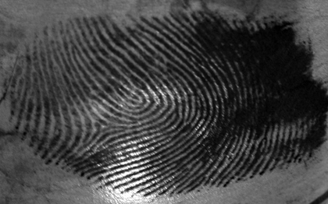

Researchers have developed a method to recover fingerprints from food // Source: cuny.edu
Forensic scientists at the University of Abertay Dundee have recovered latent fingerprints from foods — publishing the U.K.’s first academic paper on this subject.
Only two other studies have ever reported successfully recovering fingerprints from foods, but the research for these took place in India and Slovenia using chemical substances that are not routinely used in Britain. An Abertay University release reports that foods are notoriously difficult surfaces to recover prints from, so are often overlooked as items of evidence. By modifying an existing technique that was initially designed to recover fingerprints from the sticky side of adhesive tape, however, the team at Abertay has shown that this need no longer be the case.
The publication of their research – in the forensic science journal Science & Justice — means that others will now be able to replicate their results.
Dennis Gentles, a former crime scene examiner and forensic scientist who has worked at Abertay University for the past ten years, explains why this is so significant:
“Although there are proven techniques to recover fingerprints from many different surfaces these days, there are some surfaces that remain elusive, such as feathers, human skin, and animal skin.
“Foods such as fruits and vegetables used to be in that category, because their surfaces vary so much — not just in their color and texture, but in their porosity as well. These factors made recovering fingerprints problematic because some techniques, for example, work on porous surfaces while others only work on non-porous surfaces.
“Using the right technique is of the utmost importance because if you use the wrong one, it can damage the print and destroy what could have been a vital piece of evidence.
“The fact that we’ve managed to successfully recover prints from such difficult surfaces as foods is another step forward in the fight against crime. It may not seem like much, but a piece of fruit might just be the only surface that has been handled in a crime scene so developing a trusted and tested technique to recover fingerprints from such surfaces is something to be valued by crime scene examiners.”
Because of the differences between the substances available in the UK and those used in the other studies, the team at Abertay began by testing a selection of the techniques currently recommended by the Home Office for recovering fingerprints.
Disappointingly, their results showed that few of these techniques — when applied to foods including apples, tomatoes, onions and potatoes — produced a print of high enough quality for it to be presented as evidence in court.
When they modified a substance known as Powder Suspension (PS) — a thick, tar-like substance – they found, however, that it produced a clear, high-quality mark on the smooth-surfaced food items such as the onions, apples and tomatoes.
Dennis Gentles continues:
“There are about 15 techniques that are currently recommended by the Home Office for recovering prints — from a variety of surfaces — and research teams are constantly refining them and developing new ones so that the police can get as much evidence of as high a quality as possible to help with an investigation.
“Although Powder Suspension was initially developed to recover prints from the sticky side of adhesive tape, it’s since been found to work on other surfaces, so we wondered whether it would work on foods, as this was something it hadn’t been tested on before.
“The smooth surface of an apple is very different from that of sticky tape though, so such a thick substance wasn’t going to produce the same results on such a different surface. So we tried altering the formulation a bit, making it more dilute than that suggested by the Home Office, and found that it out-performed all the other methods we tested.
“Although there’s still a considerable amount of research to do before we can recommend techniques for all types of foods, we’ve shown for the first time that it really is possible to recover fingerprints from them — something that was previously thought to be unachievable. This means the police will now be able to gather even more evidence to present in court, adding more weight to their investigations.”
The release notes that forensic scientists at Abertay University have made a number of forensics breakthroughs in recent years, notably recovering latent (or invisible) fingerprints from fabrics for the very first time in 2011.
The university is currently offering an artist-in-residency opportunity within its forensic science department, as part of the inaugural Print Festival Scotland which will run alongside the renowned Impact 8 International Printmaking Conference in Dundee this September.

— Readmore in Sarah Ferguson et al., “A preliminary investigation into the acquisition of fingerprints on food,” Science & Justice 53, no. 1 (March 2013): 67–72

Bird flu mutation study offers vaccine clue
Source: http://www.homelandsecuritynewswire.com/dr20130412-bird-flu-mutation-study-offers-vaccine-clue
A small genetic mutation allows the H5N1 virus to spread among ferrets // Source: walla.co.il

Scientists have described small genetic changes that enable the H5N1 bird flu virus to replicate more easily in the noses of mammals.
So far there have only been isolated cases of bird flu in humans, and no widespread transmission as the H5N1 virus cannot replicate efficiently in the nose. The new study, using weakened viruses in the lab, supports the conclusions of controversial research published in 2012 which demonstrated that just a few genetic mutations could enable bird flu to spread between ferrets, which are used to model flu infection in humans.
An Imperial College London release reports that researchers say the new findings could help to develop more effective vaccines against new strains of bird flu that can spread between humans.
“Knowing why bird flu struggles to replicate in the nose and understanding the genetic mutations that would enable it to happen are vital for monitoring viruses circulating in birds and preparing for an outbreak in humans,” said Professor Wendy Barclay, from the Department of Medicine at Imperial College London, who led the study.
“The studies published last year pointed to a mechanism that restricts replication of H5N1 viruses in the nose. We’ve engineered a different mutation with the same effect into one of the virus proteins and achieved a similar outcome. This suggests that there is a common mechanism by which bird flu could evolve to spread between humans, but that a number of different specific mutations might mediate that.”
The release notes that bird flu only rarely infects humans because the human nose has different receptors to those of birds and is also more acidic. The Imperial team studied mutations in the gene for haemagglutinin, a protein on the surface of the virus that enables it to get into host cells. They carried out their experiments in a laboratory strain of flu with the same proteins on its surface as bird flu, but engineered so that it cannot cause serious illness.
The research found that mutations in the H5 haemagglutinin enabled the protein to tolerate higher levels of acidity. Viruses with these mutations and others that enabled them to bind to different receptors were able to replicate more efficiently in ferrets and spread from one animal to another.
The results have important implications for designing vaccines against potential pandemic strains of bird flu. Live attenuated flu vaccines (LAIV) might be used in a pandemic situation because it is possible to manufacture many more doses of this type of vaccine than of the killed virus vaccines used to protect against seasonal flu. LAIV are based on weakened viruses that don’t cause illness, but they still have to replicate in order to elicit a strong immune response. Viruses with modified haemagglutinin proteins induced strong antibody responses in ferrets in this study, suggesting that vaccines with similar modifications might prove more effective than those tested previously.
“We can’t predict how bird flu viruses will evolve in the wild, but the more we understand about the kinds of mutations that will enable them to transmit between humans, the better we can prepare for a possible pandemic,” said Professor Barclay.
The research was funded by the Medical Research Council and the Wellcome Trust.

— Read more in Holly Shelton et al., “Mutations in hemagglutinin that affect receptor binding and pH stability increase replication of a PR8 influenza virus with H5 HA in the upper respiratory tract of ferrets and may contribute to transmissibility,” Journal of General Virology (13 March 2013)

New technology could improve food safety, defend against bioterrorism
Source: http://www.upi.com/Science_News/2013/04/18/New-technology-could-improve-food-safety-defend-against-bioterrorism/UPI-23641366315013/

An improved detection method could improve food safety and also bolster defenses against bioterrorism, researchers at the University of Missouri reported.
A technique developed by a team headed by engineering Professor Shubhra Gangopadhya may make food contamination testing more rapid and accurate and also could accelerate warnings after bioterrorism attacks, a university release said Thursday.
"Quickly stopping the spread of toxins saves lives, whether those toxins are from natural processes or enemy attacks, post doctorate fellow Sangho Bok said. "Our technique uses nanoparticles to make detection one hundred times more sensitive than the standard method now used, known as ELISA.
"We have also reduced the time needed to detect a threat to only one hour, compared to four to six hours for ELISA."
Bok said the team's current testing of the technology focused on Clostriudium botulinum neurotoxin A, a toxin that causes food poisoning, but that engineers and biologists at the university are working to adapt the test to detect many other dangerous chemicals.
The Missouri study has been published in the journal Biosensors and Bioelectronics.

N.J. biopharma company seeks more funding for ricin vaccine after tainted letters
Source: http://www.njbiz.com/article/20130419/NJBIZ01/130419739/NJ-biopharma-company-seeks-more-funding-for-ricin-vaccine-after-tainted-letters

Soligenix, a biopharmaceutical company in Princeton, received new attention this week after ricin was found in letters mailed to several government officials including President Obama.
Soligenix is actively working to develop vaccines for bioterrorism agents such as ricin, but funding the research remains a challenge, according to company president and CEO, Christopher J. Schaber.
“Every biodefense program needs to be sponsored by the government,” said Schaber. “We don’t spend our own money on biodefense. The company could not take off with biodefense unless we secure a large procurement contract from the government, which are typically in the hundreds of millions of dollars.
“Because of the incident on Capitol Hill, we hope there is a heightened interest in support,” Schaber said.
Currently, there is no vaccine available to protect against ricin exposure or reverse its effects once a person is exposed. Ricin is a byproduct of the castor bean, so it’s easy to obtain in large quantities, said Schaber. Once a person is exposed to lethal doses of ricin, Schaber said, death is irreversible after four hours and the person will die in three to five days.
“It’s not as contagious as anthrax or smallpox because you actually have to ingest it, but it’s still very dangerous,” he said.
Soligenix is operating under a $9.4 million grant award from National Institute of Allergy and Infectious Diseases, which will fund the development of formulation and manufacturing processes for vaccines, including RiVax, and VeloThrax, an anthrax vaccine. One human clinical trial has been completed, and a second trial is currently being conducted on small animals and non-human primates.
Soligenix has been working on RiVax for nine years, and Schaber is hoping for another $25-$35 million in funding to keep the study going.
The RiVax vaccine, when available, would likely not be given to the masses, but would be administered to those who are highly susceptible, such as mailroom workers, first responders, government officials and the military.
Less than 50 percent of the company’s development pipeline is in biodefense. The rest is biotherapeutics, where Soligenix is working on medications for pediatric Crohn’s disease and chronic gastrointestinal disease.
Soligenix’s share price rose 20 percent this week after the ricin-laced letters to government officials were publicized.
Soligenix would make money if the government stockpiles the vaccine, but the research has to be funded and it has to get FDA approval before the company can procure a government contract.
“We’ve taken this very far with the support of the NIH (National Institutes of Health), but we really need to get a larger contract with more funding to allow us to move forward,” Schaber said. “The government many times doesn’t move that quickly on these things, especially because a lot of people haven’t died. But it’s better to be proactive than reactive, and move this forward before there are casualties.”

Tragedy in Boston: Nursing Students Get Unexpected Education
Source:http://www.medscape.com/viewarticle/802816?nlid=30585_1362&src=wnl_edit_medn_emed&uac=82598DG&spon=45

On Monday, April 15, Adrienne Wald, EdD, BSN, director of undergraduate nursing at the College of Nursing and Health Sciences at the University of Massachusetts in Boston, along with her faculty colleague, Kathleen Kafel, MS, RN, and their 25 nursing and 5 exercise science students planned to spend a peaceful, fun, and educational day at the Boston Marathon.
They were working on a medical sweep team, where their job was to identify and aid those with common running injuries or conditions, transporting runners needing attention to the medical care tents. The day was going along uneventfully, but then the unexpected and unimaginable happened, and 2 bombs exploded near the finish line.
Dr. Wald was a few blocks from the finish line when the bombs exploded, but some of her students were near the explosions. "The medical tent is right by the finish line and directly across the street from the tent is where the first bomb went off. Some students were right there and they saw everything," she explained.
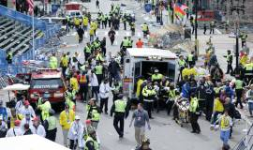
All undergraduates, many of the students were quite young and had not yet had any emergency or critical care training. One student, located near the finish, "had to climb over a victim who was clearly not going to make it and help someone else whose leg was hanging. It was horrific. I'm very thankful none of the students were injured."
When asked what the students' assignments were, Dr. Wald explained, "the medical sweep teams man wheelchairs and they were assigned to different zones around the finish line. The runners come pouring over the finish line, they get their food, they get their medal, and they get their water and that's where we see all the common medical conditions after a marathon."
She went on, "We work the chutes and the finish area for a couple of blocks all around, helping the runners, assessing them, and if somebody looks wobbly or looks like they're going to collapse, or is cramping up, we get them in a wheelchair, and get them to a medical tent if they need to go or just help them get to their dry clothes and walk with them a little bit, to keep an eye out and be sure they're not falling over."
Dr. Wald has run the Boston Marathon herself many times in the past. But this year she had a ski injury and couldn't run. "I thought it would be great for the students to volunteer, it would be a great opportunity for them."

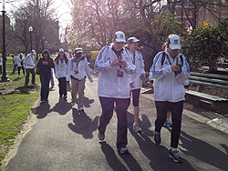
Trying Not to Cause Panic
During the aftermath of the 2 explosions, Dr. Wald described the chaos. "I was a couple of blocks away and my only concern was for the safety of my students at that point. I'm from New York and I was having 9/11 flashbacks. I truly thought that the Prudential Center was going to come down or the John Hancock Building."
She described how everyone was trying to text each other. "There was a communications person assigned to every zone and I kept saying, 'Andy, what are you getting? What's going on? What should we do?' And of course I was texting the other faculty person there to see if she was okay, if she knew where some of our students were, because all of us were in these different zones."
Dr. Wald explained that she was still a few blocks away from the explosions. "Runners were still coming across and we were trying not to cause any panic because we didn't know what was going on, we didn't know if we needed to get people out of there, we didn't want to cause a stampede."
It was difficult because at first they couldn't get any information about what had happened. "It was eerie. And it was surreal to have these runners elated about finishing the marathon and looking for their families. We just didn't know what was going on."
Dr. Wald went on, "About that time, most students had joined together and we decided to get a few blocks away. Authorities were saying that maybe it wasn't safe and it looked like it was a smart thing to leave. We went all together to the Boston Commons as a group and then we started to make sure that we knew where everybody else was. We checked off everyone. As we left, I kept counting the students. That was my way of coping." They decided that there was nothing more they could do on the scene.
Dr. Wald said one student, who had been near the finish line, said he "couldn't believe how the nurses from the medical tent all ran out just took charge and were so competent and under control and professional."

Debriefing Session
They then moved together to a nearby apartment. Dr. Wald described the time they spent talking. "I did have 2 students who were RN to BSN online students and one of them is an EMT and is an older student who had experience with debriefing, so the two of us led a debriefing session, just what you might expect."
She went on to say that while she was worried that this event might change how students felt about emergency medical care and that they might even think about changing their majors, instead students expressed a lot of conviction that they were in the right place and that they were happy to be able to help.
A follow-up email message from one student, Megan Croake, summed up the feelings of the students. Megan wrote, "I've never been prouder to be a future nurse and a helper. Instead of letting this event make me weaker or timid toward my career choice, I intend to only let it make me that much stronger."
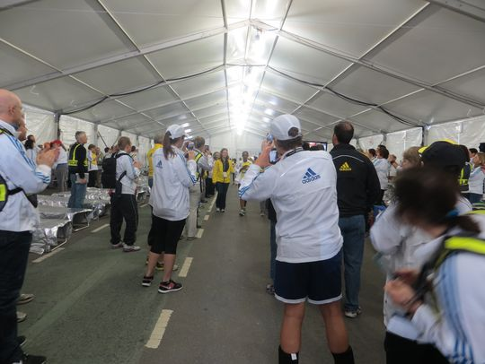
Dr. Wald is suffering herself in the aftermath of this event. She explained, "My colleague and I shared the same feelings — we felt like we didn't do enough. We had all this guilt that we should have gone to the area and been more helpful, but we all did what we were told, which was to stay in our zones and just wait for more information. I knew that there were hundreds of trained people at the medical tent, so I didn't feel like I should run down there."
In the few days that have elapsed, Dr. Wald has been able to find a bit of perspective. She wanted to tell her story, she said, "because I am so proud to be a nurse and so proud of the students that we're producing here. First of all, I was just so impressed that on a holiday at 7:00 in the morning these 30 students got out of bed to go help runners, let alone to be involved in what happened. They're going to be wonderful nurses and they did with their training what they could do."
She was so proud, Dr. Wald said, at how " they were able to use their training and to cope with something that no one could ever have foreseen."
Dr. Wald said she hopes that all the nurses involved will be remembered. "There were nurses who had to immediately respond with all of their skills and then afterwards nurses will care for all these people who have lost limbs and who are completely traumatized.
"Victims will have to rehab for months and there are just going to be so many nurses involved in their care for such a long amount of time. My hats off to all of them for the work they do every single day. We sort of take it for granted but times like this we really just so appreciate each other."

Food Safety and Bioterrorism Defense May Benefit from Improved Detection Test Developed at MU
Source: http://munews.missouri.edu/news-releases/2013/0418-food-safety-and-bioterrorism-defense-may-benefit-from-improved-detection-test-developed-at-mu-2/

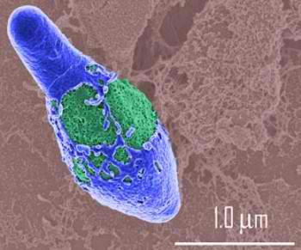
Sales of chicken products in China plummeted recently during an outbreak of a deadly new strain of bird flu. From bird flu to mad cow disease, numerous food scares have made global headlines in recent years. A technique developed by University of Missouri Professor of Engineering Shubhra Gangopadhyay’s group may make food contamination testing more rapid and accurate. The detection test also could accelerate warnings after bioterrorism attacks.
“Quickly stopping the spread of toxins saves lives, whether those toxins are from natural processes or enemy attacks,” said lead author Sangho Bok, postdoctoral fellow working under the supervision of Shubhra Gangopadhyay in MU’s College of Engineering. “Our technique uses nanoparticles to make detection one hundred times more sensitive than the standard method now used, known as ELISA. We have also reduced the time needed to detect a threat to only one hour, compared to four to six hours for ELISA.”
Currently, Bok’s testing method detects a toxin that causes food poisoning, a chemical known as Clostriudium botulinum neurotoxin A. Engineers and biologists at MU now seek to adapt the test to detect many other dangerous chemicals.
Beyond helping protect people from deadly toxins, Bok’s technique may bring jobs and foreign investment to America. Study co-author and MU research professor, Keshab Gangopadhyay, hopes to open a factory in Missouri that will manufacture the nanoparticles used in the detection technique. To achieve this goal, Gangopadhyay founded Nanos Technologies LLC.
“Science, employment and economic development are all tied together,” said Gangopadhyay. “Food safety testing presents a large market that is growing quickly in developing nations like China and India. MU engineering research helps Missouri tap into that market while creating local jobs and attracting the attention of investors.”
The study “Femtogram-level detection of Clostridium botulinum neurotoxin immunoassay using nanoporous substrate and ultra-bright fluorescent suprananoparticles,” was published in Biosensors and Bioelectronics.

Interventions to Mitigate Emergency Department and Hospital Crowding During an Infectious Respiratory Disease Outbreak: Results from an Expert Panel
Authors: Andrea Freyer Dugas; Melinda Morton ; Raphaelle Beard ; Jesse M. Pines ; Jamil D. Bayram; Yu-Hsiang Hsieh ;Gabor Kelen ; Lori Uscher-Pines ; Kevin Jeng ; Gai Cole ; Richard Rothman
Source: http://currents.plos.org/disasters/article/interventions-to-mitigate-emergency-department-and-hospital-crowding-during-an-infectious-respiratory-disease-outbreak-results-from-an-expert-panel/

Abstract
Objective: To identify and prioritize potential Emergency Department (ED) and hospital-based interventions which could mitigate the impact of crowding during patient surge from a widespread infectious respiratory disease outbreak and determine potential data sources that may be useful for triggering decisions to implement these high priority interventions.
Design: Expert panel utilizing Nominal Group Technique to identify and prioritize interventions, and in addition, determine appropriate “triggers” for implementation of the high priority interventions in the context of four different infectious respiratory disease scenarios that vary by patient volumes (high versus low) and illness severity (high versus low).
Setting: One day in-person conference held November, 2011.
Participants: Regional and national experts representing the fields of public health, disease surveillance, clinical medicine, ED operations, and hospital operations.
Main Outcome Measure: Prioritized list of potential interventions to reduce ED and hospital crowding, respectively. In addition, we created a prioritized list of potential data sources which could be useful to trigger interventions.
Results: High priority interventions to mitigate ED surge included standardizing admission and discharge criteria and instituting infection control measures. To mitigate hospital crowding, panelists prioritized mandatory vaccination and an algorithm for antiviral use. Data sources identified for triggering implementation of these interventions were most commonly ED and hospital utilization metrics.
Conclusions: We developed a prioritized list of potentially useful interventions to mitigate ED and hospital crowding in various outbreak scenarios. The data sources identified to “trigger” the implementation of these high priority interventions consist mainly of sources available at the local, institutional level.

Funding Statement
This work was supported by the Department of Homeland Security (PACER: National Center for Study of Preparedness and Response [2010-ST-061-PA0001]).

Introduction
As the safety net of the U.S. healthcare system, emergency departments (ED) are responsible for managing the large influx of patients, commonly referred to as a “surge”, resulting from a disaster or pandemic outbreak. However, EDs are already stretched to near-capacity and are routinely overcrowded.¹ ED crowding itself, apart from disasters, is associated with decreased quality of care, including delays in critical treatments and increased risks of in-hospital mortality.^{2,3,4,5} This crowding is exacerbated by seasonal influenza, and many hospitals and EDs are unprepared to manage the surge in patient volumes which occur during a large scale infectious respiratory disease outbreak.¹ Even during the 2009 H1N1 pandemic influenza outbreak, when the majority of patients were not critically ill and did not require intensive ED or hospital services, many EDs and hospitals across the U.S. were overwhelmed and unable to meet patient care demands in a timely manner.^{6,7,8,9,10}
To maintain high-quality care and manage the increase in ED volumes during an infectious respiratory disease outbreak, hospitals and EDs must have a response plan with the ability to implement timely and effective interventions designed to increase capacity and diminish the effects of crowding which can directly impact patient safety and quality of care. Although there are numerous reports in the literature describing various interventions designed to mitigate ED and hospital crowding due to infectious respiratory disease outbreaks, it is difficult to compare the impact of interventions across sites due to lack of standardized outcome measures, as well as variability in medical center structure, patient populations, and the particular characteristics and dynamics of an individual outbreak.^{11,12,13,14} Furthermore, medical centers tend to implement multiple responses during an outbreak to help control both short and long-term patient surges, further complicating attempts to independently and accurately evaluate the impact of any individual intervention on the outcomes of interest, namely maintaining timely care within the ED and hospital.
While many hospitals across the U.S. have preparedness plans and protocols for dealing with emerging infections, not all outbreaks are the same. For example, outbreaks can manifest as high or low severity of illness, and high or low levels of contagion, which ultimately contributes to the volume of patients seeking care. Hence, it is unclear if a single set of preparedness protocols would address varying types of outbreaks with differential volume of patients and severity of illness. Given the inherent difficulty of analyzing the published literature, and lack of differentiation in the operational approach to the various types of major emerging infectious outbreaks, it is necessary to approach this problem through a mixed methods approach.
Utilizing the opinions of an expert panel, we compared and prioritized ED and hospital interventions to mitigate the impact of a surge due to infectious respiratory disease outbreaks with varying patient volume and severity of illness. A secondary objective was to prioritize potential data sources which might trigger the decision to implement ED or hospital-based interventions for each of the outbreak types.

Methods
Expert Panel Selection
We convened an expert panel for a one-day conference on November 4th, 2011 in Baltimore, Maryland. Panelists with direct experience and expertise in fields which contribute to the guidance, decision-making, and implementation of local and national interventions associated with mitigation of ED and/or hospital surge were selected by the advisory panel based upon their expertise in the field as evidenced by their record of publication, speaking engagements at national meetings, impact on national or regional policy, or representation of a directly related governmental organization. Of the 66 panelists invited, 34 (52%) attended the one day conference and were offered financial reimbursed for basic travel expenses only. To ensure appropriate representation, participants were selected from all key geographic areas of the U.S., and if a representative of a directly related governmental organization was unable to attend, they were asked to select a replacement to represent that organization. The panelists represented the fields of public health (8), disease surveillance (15), clinical medicine (13), emergency medicine operations (8), hospital operations (6), and systems experts (7), with some panelists representing more than one field. Representatives included those from the federal organizations (2), state and city health departments (6), corporate and non-profit organizations (2), and academic institutions (24). This study was reviewed and approved by the Institutional Review Board with a waiver of consent.

Initial Survey
To accomplish our objectives, we used a mixed-methods design, involving an initial survey instrument followed by in-person discussion utilizing nominal group technique.^{15,16} Prior to the conference, the study team members (AD, MM, RB, KJ, RR) performed a review of the existing academic literature to identify potential ED and hospital-based interventions to manage crowding from a respiratory infectious disease outbreak.
This initial list of potential interventions was distributed to the 34 invited panelists who committed to attend the conference one month in advance. In addition, study investigators distributed definitions and brief descriptions of four types of infectious respiratory disease outbreaks to allow the panelists the opportunity to express their varied opinions on interventions relative to expected patient volume and severity of illness. These four scenarios were: 1) low volume/low severity (e.g. seasonal influenza), 2) high volume/low severity (e.g. 2009 H1N1), 3) low volume/high severity (e.g. Severe Acute Respiratory Syndrome [SARS]), and 4) high volume/high severity (e.g. 1918 H1N1).
Panelists were instructed to separately rate each intervention by both ease of implementation and importance for each of the four infectious respiratory disease outbreak scenarios using a 1-5 Likert scale. Ease of implementation included: consideration of factors such as cost, operational complexity, facility (time) of setup, and intensity of resource utilization. Importance was defined as the likely effectiveness of the intervention in reducing ED or hospital crowding or augmenting surge. Panelists were encouraged to suggest additional “write-in” interventions not already listed. Results were tallied in advance of the conference.

Conference Proceedings
A full 1-day conference was held at the National Center for the Study of Preparedness and Catastrophic Response (PACER).¹⁷ Overview presentations were conducted by selected experts summarizing the current state of emergency department and hospital crowding, existing and novel surveillance mechanisms, and potential interventions to mitigate crowding as published in the peer-reviewed literature. The conference leaders then presented the results of the pre-conference survey and distributed these results to the panelists in tabular form. After these initial presentations, the panelists completed two exercises for which they were assigned to one of two equally sized groups, based upon panelists’ relevant expertise. One group evaluated ED-based interventions, and one evaluated hospital-based interventions. Each group was co-moderated by two subject matter experts (AD, MM, JP, JB, GK) with previous training through numerous instructional meetings and two mock moderation sessions to ensure uniform and unbiased facilitation of the proceedings.
During Exercise One, panelists were asked to prioritize potential interventions to mitigate surge in response to an infectious respiratory disease outbreak for each of four defined scenarios. Interventions were separated into two groups; those specifically for patients presenting with influenza-like illness (ILI) and those for patients without ILI. Infection control measures were included among the proposed interventions to focus efforts toward reducing disease spread and potentially reducing future patient volume. Using the nominal group technique, each of the two break-out groups (i.e. ED and hospital) was asked to discuss each associated intervention, (including the pre-panel “write-in” interventions), and suggest and similarly discuss any additional interventions not yet considered. Panel members were then asked to anonymously and independently categorize each intervention as low, medium, or high priority. Panelists were asked to consider both the ease of implementation and importance for a final overall priority consideration specific for each of the four respiratory infection outbreak scenarios.
In Exercise Two, panelists were asked to identify key data sources to trigger the implementation of a specific intervention in a given respiratory virus illness scenario. Considering the worst case scenario (high volume and high severity) and the recent 2009 H1N1 scenario (high volume, low severity), each group was given one intervention, which was highly rated in Exercise One, for each of the four scenarios. Additionally, each group was given a list of potential data sources based on those used in the literature, current medical practice, and current surveillance systems, but was also encouraged to consider and suggest alternate data sources that may serve as a “trigger” for implementation of the selected intervention. Examples of such data sources included ED wait times, hospital volume, laboratory data, syndromic and laboratory-based surveillance systems, and novel data sources that might be used to indicate increasing respiratory disease (e.g. Twitter). Panelists were asked to individually select the top three data sources that could be useful to ED or hospital leaders to “trigger” the decision to implement the top-rated interventions to mitigate ED or hospital crowding due to a respiratory infection outbreak. Similarly, using the nominal group technique, panelists proposed other potential data sources. All potential data sources were discussed and each panel member anonymously rated them on a 1-5 Likert scale with 1 being “not at all important” as a trigger and 5 as “very important” for a trigger for the selected interventions.

Data Analysis
To evaluate data from Exercise One, final categorization data were assigned a numerical score where Low Priority = 1, Medium Priority =3, and High Priority =5. These numerical scores were averaged by scenario to obtain a numerical final score for each intervention in each scenario. These final means were then categorized as either, Low Priority (1.0-2.0), Medium Priority (2.1-4.0), or High Priority (4.1-5.0). Additionally, numerical scores were averaged across all scenarios to obtain a total prioritization score for each intervention across all scenarios. Finally, scores for each intervention within a scenario were averaged to obtain a scenario prioritization score. For Exercise Two, the individual resultant ratings for each potential data source were averaged to obtain a mean “importance” score for each potential data source.

Results
Among all of the potential interventions to mitigate ED crowding, the following interventions had the highest priority across all four outbreak scenarios: standardizing ED discharge and admission criteria for patients with respiratory symptoms (4.0), informing patients of the most appropriate setting for care either through a website (4.0) or telephone call center (3.9), and instituting infection control measures including hand sanitizers and masks (4.1), cohorting patients with ILI (4.0), or ED signage (3.9). Tables 1 and 2 demonstrate the final ED scenario-based prioritization for each potential intervention for both ILI patients (Table 1), and non-ILI patients (Table 2).
When considering a low volume/low severity scenario such as Scenario 1/Seasonal Influenza, no individual ED intervention ranked above medium priority which included standardization ED discharge and admission criteria for patients with respiratory symptoms (3.1), setting up a website to advise patients on the most appropriate setting for care (3.1), using hand sanitizer and masks (3.1), and ED signage for influenza (3.1). In the scenario with the highest volume and severity, Scenario 4/1918 H1N1, many interventions received high priority even if they had received a lower priority in all previous scenarios, such as; Opening an annex areas for patient care (4.7), coordination of influenza surge plans with the public health department (4.6), and protocols for non-medical volunteers (4.6).
Panelist ratings for hospital interventions identified the following as highest priority across all four outbreak scenarios: mandatory vaccinations (4.9), coordinating a public health message (4.1), creating a treatment algorithm for antiviral use (3.8), modifying visitation policies (3.7), screening employees (3.6), setting up alternate care systems (3.6), stockpiling isolation equipment (3.5), and setting up an inpatient quarantine area (3.5). Individual scenario-based ratings for the hospital interventions are shown in Tables 3 and 4.
The only hospital intervention to receive high priority in the low volume/low severity scenario, Scenario 1/Seasonal Influenza, was mandatory vaccinations (4.6). The remaining interventions received moderate or low prioritization. For the worst scenario with high volume/high severity, Scenario 4/1918 H1N1, all hospital interventions received high priority with the following interventions receiving the highest score of 5.0; modifying visitation policies, stockpiling isolation equipment for inpatient staff, creating a triage protocol for ventilator use, rescheduling or canceling elective procedures, and “double-bunking” inpatient rooms.
Overall, most individual ED-based interventions had higher priority ratings for scenarios which generated high patient volumes, such as Scenario 2/2009 H1N1 (3.6) and Scenario 4/1918 H1N1 (4.0), versus those with lower patient volumes, such as Scenario 1/Seasonal Influenza (2.0) and Scenario 3/SARS (3.0). Conversely, hospital-based interventions had higher priority ratings for scenarios with a high severity such as Scenario 3/SARS (3.8) and Scenario 4/1918 H1N1 (4.8) versus Scenario 1/seasonal influenza (1.8) and Scenario 2/2009 H1N1 (3.1).
The highest ranked interventions noted above were chosen for subsequent prioritization of potential data elements to employ as triggers (Table 5). ED interventions selected were: (1) establishing an ED annex (1918 H1N1 Scenario), and (2) constructing a website to advise patients on the most appropriate setting for care (2009 H1N1 Scenario). The hospital interventions selected were: (1) developing and implementing a ventilator triage protocol (1918 H1N1 Scenario), and (2) establishing alternate care sites (2009 H1N1 Scenario). The main data sources identified to serve as triggers came largely from medical center level crowding data as can be seen in Table 5. Top rated data sources consisted mainly of patient volume metrics (hospital volume, ED volume, boarding time in the ED, percent of patients with ILI, hospital capacity), patient acuity metrics (acuity ratio, ED admission rate, number of low acuity ILI patients), as well as measures of resource availability (ventilator supply, and staff availability).

Discussion
Many EDs and hospitals are currently operating at or over capacity much of the time, where even small increases in patient volumes, such as those seen during seasonal influenza, worsen ED crowding and further prolong patient waiting times, which has been shown to be associated with untoward patient outcomes.^{1,6,7,8,9,10,18,19,20} A large-scale infectious respiratory disease outbreak requires advanced medical center planning and response in order to maintain good ED and hospital flow, and avoid any associated adverse impacts on patient care or outcomes. Although some interventions to manage ED and hospital crowding can be carried out at the institutional level, others, as noted by our expert panelists, require coordination with the local public health department, neighboring medical centers, or state and federal government to ensure alignment with the existing level of regulatory standards (e.g. suspension of the emergency medicine treatment and labor act [EMTALA]). Communication and coordination between all of these stakeholders increases the breadth of potential response options, and the overall effectiveness. Beyond the individual responses, these same organizations, with appropriate and timely sharing of data, combined with current surveillance systems, can inform the timing of when to implement the appropriate response. This expert panel sought to combine knowledge and experience of leaders in each of these fields to provide initial broad guidance and recommendations for prioritization and implementation of responses to mitigate crowding in the event of an infectious respiratory disease outbreak.
For ED settings, panelists gave overall higher priority to interventions in outbreak scenarios with high volume of patient visits, indicating the greatest concern for addressing outbreaks where ED crowding caused by sudden increased patient volume might worsen regardless of disease severity. To address a high patient volume outbreak, panelists prioritized several interventions, such as creating a website or telephone call center, to advise patients when to seek medical care and what the most appropriate setting for that care would be. Other highly ranked ED interventions were simple precautionary measures to protect non-ILI patients from being infected, such as hand sanitizers, masks, and cohorting infected patients, which are likely to have a delayed impact on ED crowding. Placing these highly rated interventions in the context of the often used ED crowding model of input, throughput and output, the majority of highly rated interventions focused on ED input, or reducing the number of patients presenting to the emergency department.²¹ Conversely, the majority of interventions presented in the peer-reviewed literature focus on interventions to impact ED throughput, or the speed at which ED patients are managed.²² Most of the literature evaluating the impact of interventions evaluates the combined impact of multiple interventions, making it difficult to isolate the effect of a single intervention. To our knowledge, only one paper isolates an ED input intervention showing that an ED vaccination campaign reduces ED visits for respiratory illness by 34%.²³ Despite this evidence, this particular input intervention (ED vaccination) was rated lower by this expert panel, suggesting that cost and ease of implementation were important factors considered by the panel.
When considering hospital crowding, the panelists overall prioritized measures aimed at outbreaks with high severity. Unlike ED volume issues which are more related to overall patient volume, severity of illness, even with low volume of patients, stressed demand for inpatient resources such as hospital beds, intensive care unit (ICU) space and ventilators. Here, the highly rated interventions also focused on measures to protect staff and non-ILI patients from disease transmission, including setting up an inpatient quarantine area and stockpiling isolation equipment. This is consistent with previous task force recommendations to maximize ICU resources (both beds and staffing) as well as maintain strict infectious control policies.²⁴ Additionally, a treatment algorithm for antiviral use rated highly, as antivirals would likely be in short supply and would require appropriate, scenario-driven allocation management.
For the low volume, low severity outbreak scenario (i.e. seasonal influenza), respondents gave higher prioritization to interventions that would be easier to implement (e.g. hand hygiene and masks), both for the ED and hospital. However, for either increased volume or severity outbreaks, respondents shifted prioritizations to those interventions requiring more intensive resources. For example, for the high-volume, high severity outbreak scenario (1918 pandemic), establishing an ED annex, stockpiling equipment, and adding staff were rated as highest priority.
This study evaluates the priority of interventions across a variety of potential infectious respiratory disease outbreak scenarios encompassing a range of patient volumes and disease severities. Although the exercise was designed to assess multiple epidemiological scenarios, it is often the case that the exact parameters of the outbreak (i.e. disease severity and patient volume) are not completely known at the outset of the outbreak. Thus, information gleaned from this exercise may be most helpful for understanding overall priority of interventions rather than their priority in a specific artificial scenario. However, given that there is often some advanced indication of the nature of an impending outbreak, and outbreak characteristics such as volume and severity affect prioritization of resulting interventions, detailed prioritization based on the volume and severity of an outbreak may prove beneficial.
Similar to other group consensus methods, results can vary based on the composition of the group. To mitigate this potential selection bias, we selected individuals across a wide range of expertise who are integral to the process of disease surveillance and implementation of clinical interventions. These selected individuals represented those in decision making positions from numerous geographic regions and organizations, academic institutions and levels of government. However, the results represent panelist’s opinions, and not the results of a formal literature meta-analysis or quantitative data analysis of U.S. hospitals; the inherent difficulty of which was described earlier in this article. Although further breakdown of the rankings according to the panelists self-identified expert group category would be an interesting analysis, this was not possible as several panelists identified themselves as belonging to more than one expert group, preventing clear categorization.
Information generated from these exercises may serve to guide ED and hospital administrators to focus on the highest-priority interventions for a particular scenario, based on anticipated patient volumes or disease severity. However, there is a need for more formal methods of assessing intervention quality and efficacy. Although conducting randomized controlled trials may not be possible for public health interventions, standardizing reporting and assessment of interventions could provide a framework for describing and comparing interventions which could be reported in the literature.
Although many of the highly rated interventions require, or would benefit from, coordination with departments of public health, local medical centers, and local and federal governments, the decision of whether and when to implement many of these interventions currently appears to occur at the medical center level. Further, virtually all of the most highly rated data sources to trigger the decision of when to implement these interventions are collected directly by individual hospitals or EDs. These data sources, such as ED and hospital volume and admission rates, and ED waiting times, are institutional data, monitored closely at the institutional level, but frequently have lags before reporting and analysis at the public health level. Despite emphasis on infectious respiratory disease surveillance, surveillance tools did not rank in the top three triggers for any of the four included scenarios. These recommendations highlight the importance of advancing capabilities of surveillance systems to collect and coalesce institutional data sources in a timely manner, to provide both public health departments and medical institutions with better situational awareness which could improve the timeliness and effectiveness of planned responses.

Conclusion
Expert panelists placed highest priority on ED interventions to mitigate surge in the setting of an infectious respiratory disease outbreak scenario with high patient volume, indicating the greatest concern for addressing outbreaks where ED crowding caused by sudden increased patient volume might worsen regardless of disease severity. Disease severity, in and of itself, was felt to be a lesser issue in the ED setting. Conversely, panelists concluded that interventions addressing disease severity were the most important for inpatient management, operations and resource distribution, with less emphasis decreasing total numbers affected in the population. Data useful for setting triggers to implement high priority measures were predominantly those available at the local institutional level. Strikingly, public health surveillance data were not considered as one of the top triggers to operationalize any of the priority measures, either for the ED or the inpatient services. We believe this study represents the first step in delineating high impact interventions according to hospital service (ED verses inpatient) and infectious disease outbreak characteristics.

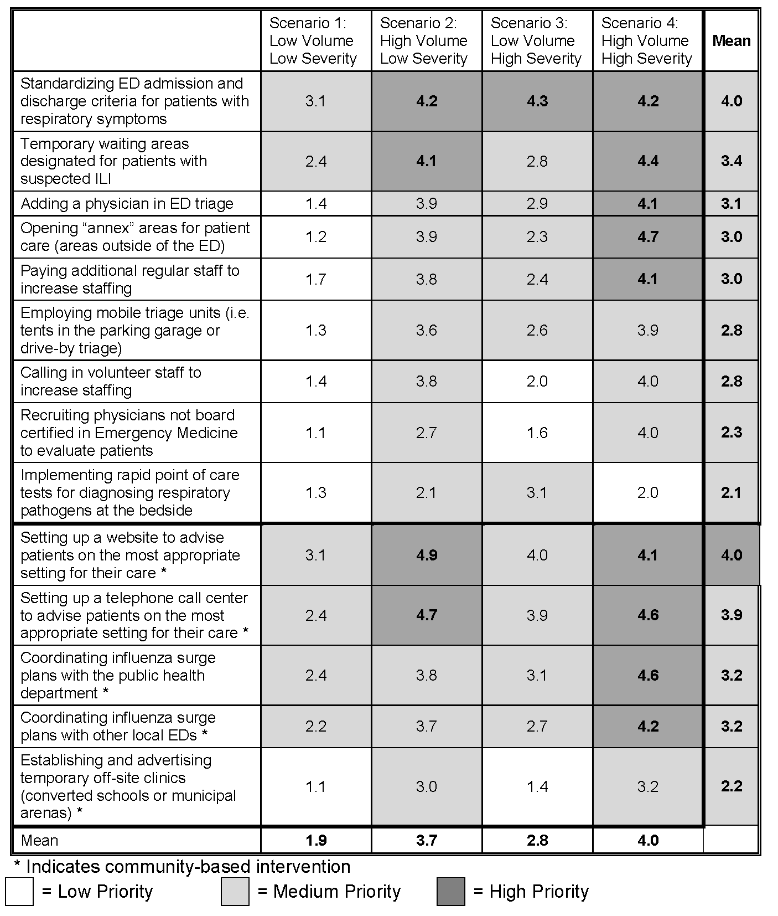
Fig. 1: Scenario based prioritization for interventions to mitigate emergency department (ED) crowding in the event of an infectious respiratory virus outbreak designed to impact patients presenting with influenza-like illness (ILI)

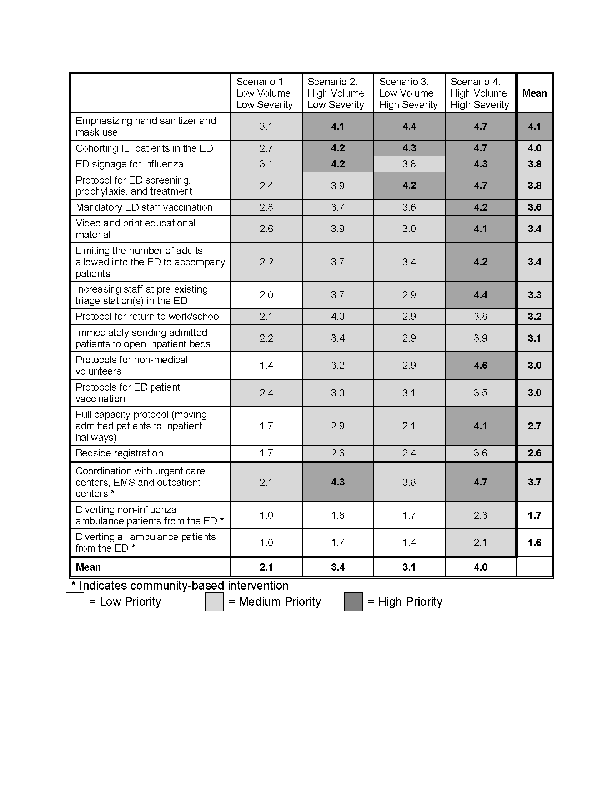
Fig. 2: Scenario based prioritization for interventions to mitigate emergency department (ED) crowding in the event of an infectious respiratory virus outbreak designed to impact patients without influenza-like illness (ILI)

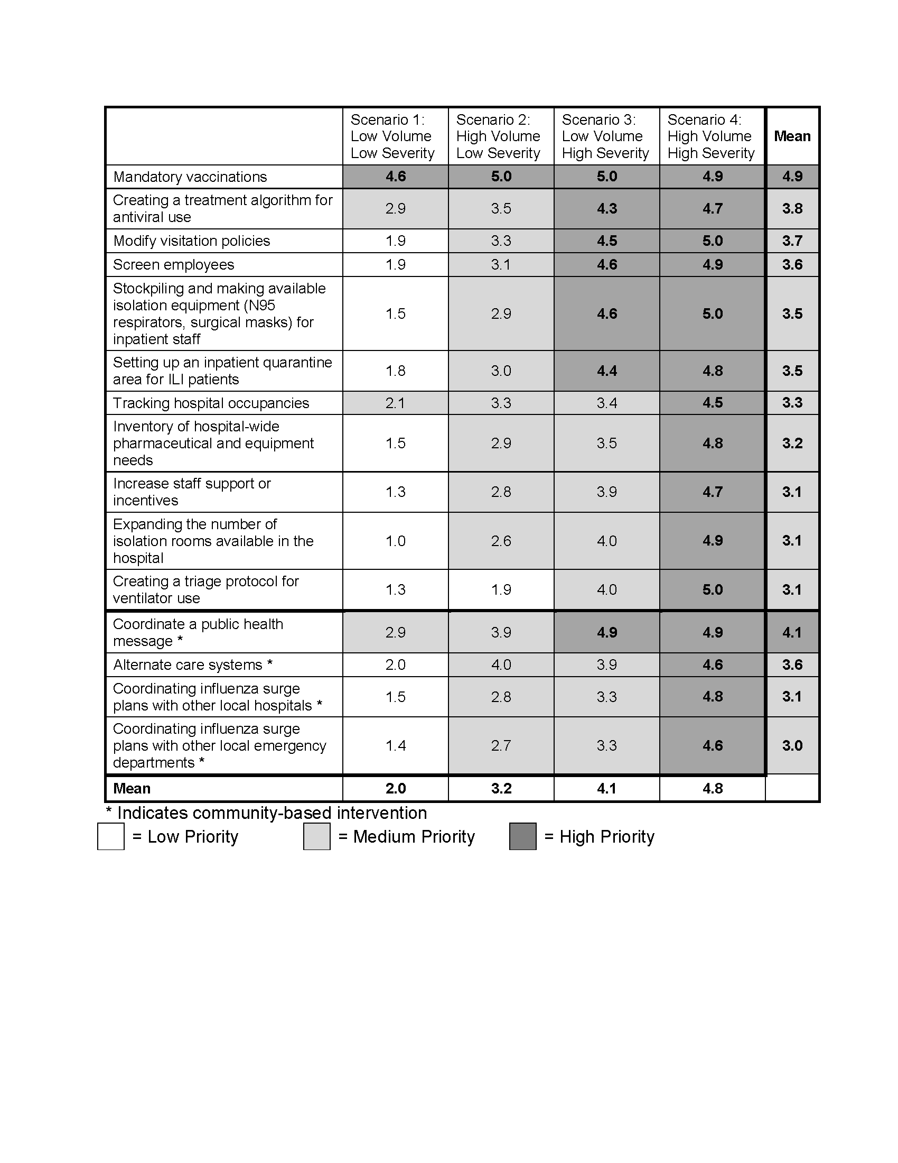
Fig. 3: Scenario based prioritization for interventions to mitigate hospital crowding in the event of an infectious respiratory virus outbreak designed to impact patients presenting with influenza-like illness (ILI)

Fig. 4: Scenario based prioritization for interventions to mitigate hospital crowding in the event of an infectious respiratory virus outbreak designed to impact patients presenting without influenza-like illness (ILI)

Fig. 5: Linking Data Sources to Intervention Implementation

Competing Interests
The author have declared that no competing interests exist

Acknowledgements
PACER Expert Surge Panel Members (Panel members did not contribute to study design, analysis, interpretation, or manuscript preparation.): Atar Baer, Ph.D., MPH; Douglas Baker, MD; John Brownstein, Ph.D.; Howard Burkom, Ph.D.; Neil Cohen, MBA; Sylvain Delisle, MD, MBA; John Donohue; Ashley Fowlkes, MPH; Joel C. Gaydos, MD, MPH; Rebecca Gluskin, MS, Ph.D.; Mitchell Goldstein, MD; Julia Gunn, RN, MPH; Howard Gwon, MS; Daniel Hager, MHA; Dan Hanfling, MD; Peter Hill, MD; Darren Mareiniss, MD; Jennifer Martin, JD; Larissa May, MD, MSPH; Mark McClelland, DNP, RN; Kompan Ngamsnga, MPH; Don Olson, MPH; Julie Pavlin, MD, MPH; Trish Perl, MD, MS; Philip Polgreen, MD, MPH; Mustapha Saheed, MD; Jim Scheulen, PA-C, MBA; Michael Silverman, MD; Michael Stoto, Ph.D.; Dianne Whyne, RN, MS; Lucy Wilson, MD; Ying Zhang, PhDc. Disclaimer: The findings and conclusions in this report are those of the authors and do not necessarily represent the views of the Centers for Disease Control and Prevention (CDC).

References
- Institute of Medicine. The future of emergency care in the United States health system. Ann Emerg Med 2006; 48(115-20).
- Bernstein SL, Aronsky D, Duseja R, et al.: The effect of emergency department crowding on clinically oriented outcomes. Acad Emerg Med. 2009; 16(1): 1-10.
- Pines JM, Hollander JE, Localio AR, et al.: The association between emergency department crowding and hospital performance on antibiotic timing for pneumonia and percutaneous intervention for myocardial infarction. Acad Emerg Med. 2006; 13(8): 873-878.
- Pines JM, Pollack CV, Dierks DB, et al.: The association between emergency department crowding and adverse cardiovascular outcomes in patients with chest pain. Acad Emerg Med. 2009; 16(7): 617-625.
- Pines JM, Shofer FS, Isserman JA, et al.: The effect of emergency department crowding on analgesia in patients with back pain in two hospitals. Acad Emerg Med. 2010; 17(3): 276-283.
- Sills MR, Hall M, Fieldston ES, et al.: Inpatient capacity at children’s hospitals during pandemic (H1N1) 2009 outbreak, United States. Emerg Infect Dis. 2011; 17(9): 1685-1691.
- Graham J, Shirm S, Storm E, et al.: Challenges and solutions: pandemic 2009 H1N1 influenza A in a pediatric emergency department. Am J Disaster Med. 2011; 6(4): 211-218.
- Sugerman D, Nadeau KH, Lafond K, et al.: A survey of emergency department 2009 pandemic influenza A (H1N1) surge preparedness--Atlanta, Georgia, July-October 2009. Clin Infect Dis. 2001; 52(Suppl 1): S177-182.
- Miroballi Y, Baird JS, Zackai S, et al.: Novel influenza A(H1N1) in a pediatric health care facility in New York City during the first wave of the 2009 pandemic. Arch Pediatr Adolesc Med. 2010; 164(1): 24-30.
- Sills MR, Hall M, Simon HK, et al.: Resource burden at children's hospitals experiencing surge volumes during the spring 2009 H1N1 influenza pandemic. Acad Emerg Med. 2011; 18(2): 158-166.
- Scarfone RJ, Coffin S, Fieldston ES, et al.: Hospital-based pandemic influenza preparedness and response: strategies to increase surge capacity. Pediatr Emerg Care. 2011; 27(6): 565-572.
- Cooper MC, Walz K, Brown MG, et al.: Boston Medical Center Pediatric Emergency Response to H1N1. J Emerg Nurs. 2009; 35(6): 580-583.
- Weiss EA, Ngo J, Gilbert GH, et al.: Drive-through medicine: a novel proposal for rapid evaluation of patients during an influenza pandemic. Ann Emerg Med. 2010; 55(3): 268-273.
- Cruz AT, Patel B, DiStefano MC, et al.: Outside the box and into thick air: implementation of an exterior mobile pediatric emergency response team for North American H1N1 (swine) influenza virus in Houston, Texas. Ann Emerg Med. 2010; 55(1): 23-31.
- Teijlingen E, Pitchforth E, Bishop C, et al.: Delphi method and nominal group technique in family planning and reproductive health research. J Fam Plann Reprod Health Care. 2006; 32(4): 249-252.
- Uscher-Pines L, Babin S, Farrell C, et al.: Research Priorities for Syndromic Surveillance Systems Response: Consensus Development Using Nominal Group Technique. Journal of Public Health Management and Practice. 2010; 16(6): 529-534.
- National Center for the Study of Preparedness & Catastrophic Event Response (PACER): Available at: http://www.pacercenter.org/. Accessed May 26th, 2012.
- Kelen GD, Kraus CK, McCarthy ML, et al.: Inpatient disposition classification for the creation of hospital surge capacity: a multiphase study. Lancet. 2006; 368(9551): 1984-1990.
- Glaser CA, Gilliam S, Thompson WW, et al.: Medical care capacity for influenza outbreaks, Los Angeles. Emerg Infect Dis. 2002; 8(6): 569-574.
- Schull MJ, Mamdani MM, Fang J. Community influenza outbreaks and emergency department ambulance diversion. Ann Emerg Med. 2004; 44(1): 61-67.
- Asplin BR, Magid DJ, Rhodes KV, Solberg LI, Lurie N, Camargo CA. A conceptual model of emergency department crowding. Ann Emerg Med. 2003;42(2):173-180.
- Morton M, Jeng K, Beard R, Dugas AF, Pines JM, Rothman R. Systematic Review of Interventions to Mitigate the Effect of Emergency Department Crowding in the Event of a Respiratory Disease Outbreak. Acad Emerg Med. 2012;19(4):Supp 1, Abstract 114.
- Parry MF, Grant B, Iton A, Parry PD, Baranowsky D. Influenza vaccination: a collaborative effort to improve the health of the community. Infect Control Hosp Epidemiol. 2004;25(11):929-932.
- Sprung CL, Zimmerman JL, Christian MD, et al. Recommendations for intensive care unit and hospital preparations for an influenza epidemic or mass disaster: summary report of the European Society of Intensive Care Medicine's Task Force for intensive care unit triage during an influenza epidemic or mass disaster. Intensive Care Med. 2010;36(3):428-443.

Prince William lab helps fight bioterrorism
Source: http://www.connect2mason.com/content/prince-william-lab-helps-fight-bioterrorism
The biodefense lab at Mason's Prince William Campus researches infectious diseases and bioterrorism (photo courtesy of NCBID).

During the week of April 17, 2013, a man mailed ricin-laced letters to a congressman and the president of the United States. Ricin is highly toxic and is often fatal to humans. While no one was injured in the incident, it was highly reminiscent of the 2001 anthrax letters that killed five and stunned the nation.
In lieu of these attacks, new facilities were created between 2001 and 2005 to investigate bioterrorism and to fortify national defense against viral agents. One of these facilities was the National Center for Biodefense and Infectious Diseases (NCBID), founded in 2001 and located at George Mason University’s Prince William Campus.
From a distance, the facility is as intimidating as the title sounds. Entry to the lab requires passage through a checkpoint, beyond a barbed wire fence, and past another few layers of security. The extensive security is entirely necessary because inside the center are some of the world’s deadliest pathogens.
The NCBID was founded to research and counter the potential threat of bioterrorism in the United States, which largely consists of sending a host infected with a deadly and contagious disease. NCBID researches a variety of diseases and their potential as weapons, learning to combat any disease that poses a threat.
Given the domestic security aspects of their work, the facility is largely funded through government grants. However, the facility occasionally tests products for private industry. When asked about the recent letters, the facility’s Executive Director Charles Bailey clarified that while ricin, derived from castor beans, is a biological threat, most of their research involves viral agents. While certainly toxic, ricin is not a disease and is not treated in the same capacity.
“Right now we’re doing anthrax, plague…” Bailey said. “A lot of people don’t realize that people still get bubonic plague every year. We also work on Tularemia (rabbit fever), Rift Valley fever, Venezuelan Equine Encephalitis virus and Dengue fever.”
Recently, NCBID has investigated various medical properties of curcumin, a rather popular household spice that could potentially be used to fight cancer.
Kylene Kehn-Hall also explained some of the specifics of the viral research at the NCBID. Kehn-Hall is one of the researchers at the lab and is currently a tenure-track assistant professor. Like the other researchers at the facility, she deals directly with Biosafety Level 3 bacteria and viruses, which causes diseases that are fatal to humans but are treatable.
Kehn-Hall explained how the researchers induce mutations into the virus and shift the genetic sequence over time. This very gradual process renders a virus harmless but keeps it similar enough to be developed as a vaccine.
“Through research we can understand why this virus causes diseases and that virus doesn’t—what makes a vaccine a good vaccine,” Kehn-Hall said.
The lab is currently investigating how viruses affect the growth of cells. Discoveries in infected cell growth have proven similar to developments in cancerous cells and have opened new opportunities for the NCBID.
“We can take advantage of the advances in cancer research now and utilize similar drugs,” Kehn-Hall said.
Ultimately, the team at the NCBID hopes their research can help manage diseases abroad while limiting the potential domestic threat.
“We’re working towards better, faster diagnoses,” Bailey said. “A diagnosis before symptoms even occur.”

WHO: H7N9 virus 'one of the most lethal so far'
By Peter Shadbolt, CNN
April 26, 2013
Source: http://edition.cnn.com/2013/04/24/world/asia/china-birdflu/index.html

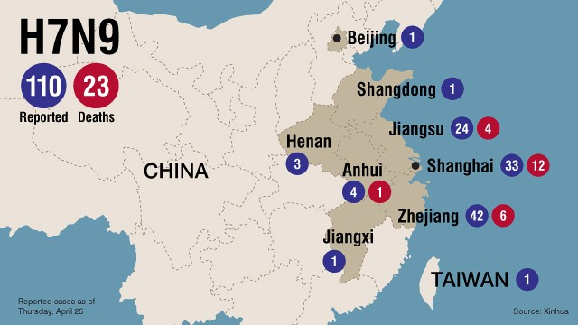
Hong Kong (CNN) -- On the same day yet another death was reported in China's bird flu outbreak, the World Health Organization warned the H7N9 virus was one of the most lethal that doctors and medical investigators had faced in recent years.
"This is an unusually dangerous virus for humans," Keiji Fukuda, WHO's assistant director-general for health, security and the environment told a news conference in Beijing Wednesday.
"We think this virus is more easily transmitted from poultry to humans than H5N1," he added, referring to the bird flu outbreak between 2004 and 2007 that claimed 332 lives.
"This is definitely one of the most lethal influenza viruses that we have seen so far."
As investigations continue into the possible sources of infection, Fukuda warned that authorities were still struggling to understand the virus. The WHO said China must brace for continued infections.
Fukuda's warning came as Taiwanese health authorities said they've confirmed the first human case of H7N9 in Taiwan -- one they said was imported from China.
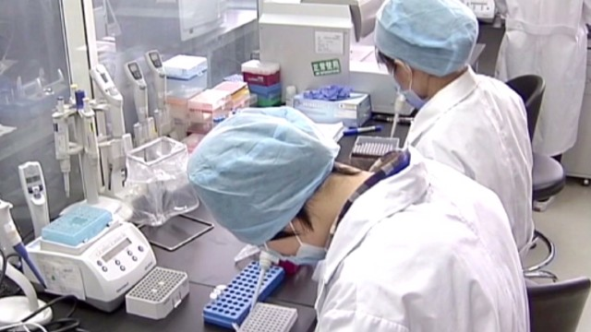
A 53-year-old Taiwanese man who worked in eastern China was confirmed to have H7N9 on Wednesday, the Taiwanese Centers for Disease Control said. His condition was described to be severe.
He had been traveling back and forth regularly between China's Jingsu province and Taiwan, health officials said.
"According to the case, he had not been exposed to birds and poultry during his stay in Suzhou (in Jingsu province) and had not consumed undercooked poultry or eggs," the Taiwanese CDC said.
Taiwanese health officials said they are screening travelers arriving from China for signs of H7N9.
Fukuda, meanwhile, said WHO officials "are at the beginning of our understanding of this virus."
"(The situation remains) complex, difficult and it is evolving," he said.
So far there is no evidence of sustained human-to-human transmission, the authorities say.
"We do want to note, however, that if limited person-to-person transmission is demonstrated in the future, this really will not be surprising," Fukuda warned, adding that it was critical to remain vigilant, monitoring the virus's spread and mutation.
"We are not sure that the clusters were caused by common exposure to a source of the virus or were due to limited person-to-person transmission," he said. "Moreover we have not seen sustained person-to-person transmission."
While some elements of the outbreak have baffled investigators -- specifically why the virus tends to target an elderly demographic and the fact that it is asymptomatic or mild in some cases and lethal in others -- authorities have claimed some significant victories in the fight against a pandemic.
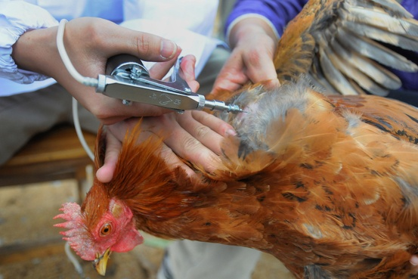
Anne Kelso, the director of a WHO-collaborating research center, said researchers had seen a "dramatic slowdown" in human cases in Shanghai after the city's live poultry market was shut on April 6. Describing the finding as "very encouraging," she said evidence suggests the closure of live poultry markets is an effective way to stop the spread of the virus.
The joint inspection team from China's National Health and Family Planning Commission and the World Health Organization also found that, so far, no migratory birds have tested positive for the virus, taking another worrying route of transmission out of the equation.
It said the H7N9 virus is only being found in chickens, ducks and pigeons at live poultry markets.
WHO officials said there are already efforts underway in other countries to develop a vaccine after Chinese officials admitted international help would be needed with this.
Meanwhile, the National Health and Family Planning Commission said in its daily update on H7N9 cases that a total of 109 H7N9 cases have been reported within mainland China, including 23 deaths. Most cases have been confined to Shanghai and neighboring provinces in eastern China.

New Bird Flu Is a U.S. Conspiracy, Chinese Military Official Says
Source: http://blogs.wsj.com/chinarealtime/2013/04/08/new-bird-flu-is-a-u-s-conspiracy-chinese-military-official-says/

While Chinese and World Health Organization experts continue to search for the source of a new strain of bird flu that has infected at least 23 and led to seven deaths in eastern China, one senior Chinese military official says he knows what’s going on.
According to Dai Xu, a Chinese Air Force colonel and military strategist, the H7N9 virus is part of a U.S. conspiracy to sow panic in the world’s most populous nation that Chinese authorities should simply ignore.
A hawkish commentator known for making inflammatory statements, Col. Dai publicized his bird flu theory in a message posted to the popular Twitter-like microblogging site Sina Weibo late Saturday night. The post, (April 8) since forwarded more than 30,000 times, goes as follows:
As for this recent bird flu fad, China’s top government departments shouldn’t talk it up, otherwise it will be just like SARS in 2003! At the time, the U.S. was fighting Iraq and feared China might take advantage of the situation, so it deployed a bio-psychological weapon against China. The country was thrown into turmoil, just as the U.S. had hoped. Now, the U.S. is trying the same old trick. China should take a lesson from before and respond calmly.
An earlier version of the post, since deleted but preserved in screenshots by multiple other users, ended on a different note: “A few may die, but that’s not even one-thousandth of the deaths from car accidents in China.”

It is so easy…
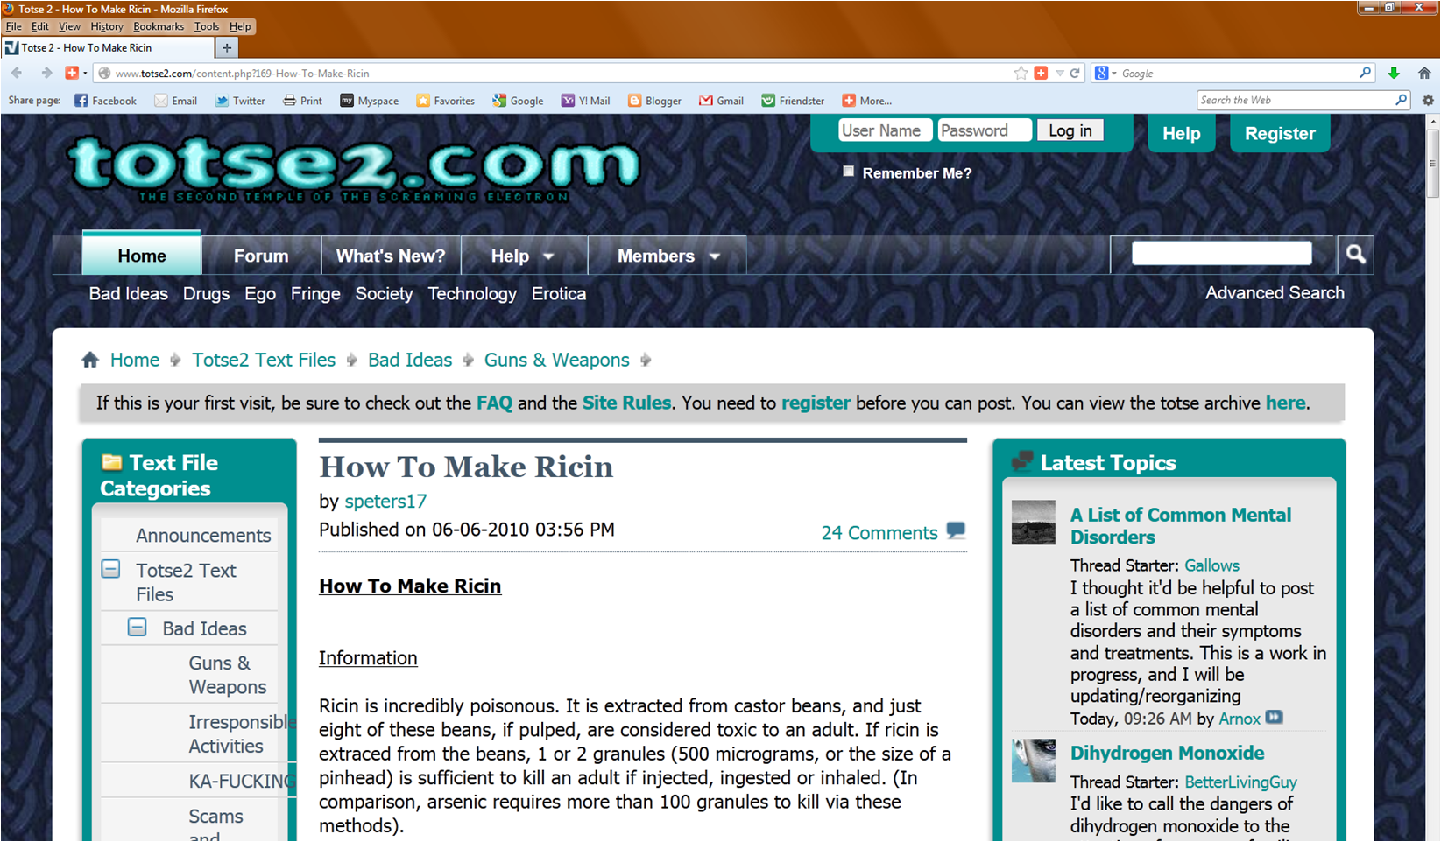
And if you want instructions…

How To Make Ricin
Source: http://www.totse2.com/content.php?169-How-To-Make-Ricin
Information
Ricin is incredibly poisonous. It is extracted from castor beans, and just eight of these beans, if pulped, are considered toxic to an adult. If ricin is extraced from the beans, 1 or 2 granules (500 micrograms, or the size of a pinhead) is sufficient to kill an adult if injected, ingested or inhaled. (In comparison, arsenic requires more than 100 granules to kill via these methods).
Victims often manifest nausea, emesis, diarrhea, tachycardia, hypotension and seizures persisting for up to a week. Ricin also causes severe diarrhea and victims can die of shock. Because ricin inhibits the creation of proteins, it can take several hours for symptoms to manifest, and if not treated extremely quickly, a decent dose will almost certainly kill. Long term organ damage is likely in survivors.
Precautions
A solution of saline and glucose has been used to treat a ricin overdose (there seems to be no reliable formula for this, however). You should probably have one ready if you are even attempting to make ricin by this or any other formula. Also, gloves, a face mask, goggles and a secluded area are highly, highly advised. If any of this gets in the air or remains lying around, you can easily receive a fatal dose, and any pets will almost certainly die in a huge amount of pain.
Procedure
1. Obtain some castor beans from a garden supply store.
2. Put about 4 tablespoons of hot water into a glass jar and add a teaspoon full of lye. Mix it thoroughly.
3. Wait for the lye/water mixture to cool
4. Place 60g of the beans into the liquid and let them soak for one hour.
5. Pour out the liquid being careful not to get any on exposed skin (or wear gloves).
6. Rinse the beans off with cool water and then remove the outer husks with tweezers.
7. Put the bean pulp into a blender or coffee grinder (which you must dispose of after, preferably destroying it in the process) with 8 tablespoons of acetone for every 30g of beans.
8. Blend the pulp/acetone until it looks like milk.
9. Place the milky substance in a glass jar with an airtight lid for three days.
10. At the end of three days shake the jar to remix everything that’s started to settle then pour it into a coffee filter. Discard the liquid.
11. When no more liquid is dripping through the filter, squeeze the last of the acetone out of it without losing any of the bean pulp.
12. Spread the filter out on a pan covered with newspaper and let it dry stand until it is dry.
13. The final product must be as free of acetone and other contaminants as possible. If it is not powdery but still sort of moist and pulpy it must be combined with the appropriate amount of acetone again and let sit for one day.
14. Then repeat steps 9-12 again until a nice dry powder is produced.
So now you have ricin. I wouldn't recommend making this, and would argue strongly against using it if you do make it. This is merely for informational purposes only. If you're looking for revenge against someone, I would use something that will just make them violently ill, rather than dead.

13 plants that could kill you
Source: http://www.mnn.com/your-home/organic-farming-gardening/photos/13-plants-that-could-kill-you/deadly-plants

Apples
An apple a day might keep the doctor away, but the same can't be said for apple seeds. The seeds contain cyanogenic glycosides, and if you consume enough of the seeds, you could ingest a fatal dose. If you cut up apples for your children or prefer to eat whole apples down to the core, make sure you remove those seeds.

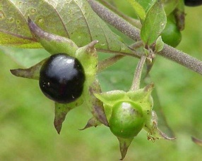
Deadly nightshade
The name says it all — both the foliage and the berries of this plant are extremely toxic. Deadly nightshade has a long, colorful history of use as a poison, but what many people don't realize is that the nightshade family includes common food plants, including potatoes, tomatoes, eggplants and chili peppers. In fact, all of these plants contain toxins — usually in their foliage — that can be harmful. In particular, humans and pets should avoid potato and tomato foliage and vines in the garden.

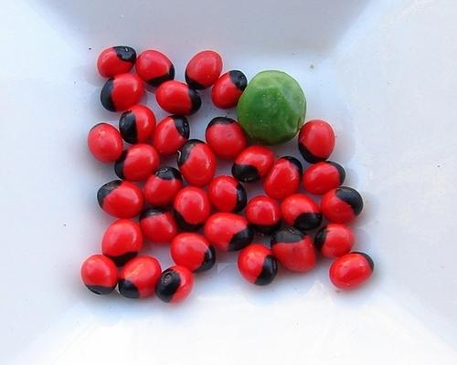
Rosary pea
This plant may sound pious, but it's actually deadly. Rosary peas got their name from their traditional use as ornamental beads for rosaries. They are used in jewelry around the world. Many jewelry makers have died after pricking a finger while handling a rosary pea. The poison contained within the seed is abrin — a close relative of ricin and one of the most fatal toxins on Earth.

Oleander

Oleander is one of the most toxic, commonly grown garden plants in the world — and oddly enough, it's often found in schoolyards. Ingesting any part of this plant can be deadly, especially for children. Even smoke from burning oleander can be fatal. In fact, according to the Toxic Exposure Surveillance System (TESS), there were 847 known human poisonings in the United States related to oleander in 2002. Contains: digitoxigenin, neriin, oleandrin and oleondroside.

European yew
Relatively common in Europe, northwest Africa and the Middle East, nearly all parts of this slow-growing tree can be poisonous. The exception is the red fleshy aril that surrounds the toxic seeds. The aril is frequently eaten by birds. Some people have chosen to commit suicide by ingesting the leaves or the seeds, both of which contain a poison called taxanes.

Daffodils
Prized for their beauty, daffodils grow from bulbs that could be mistaken for an edible food, like an onion. Daffodils — also known by their Latin name Narcissus — are common ornamental plants with a bright, cheery and mostly toxin-free flower. Most daffodils are deer- and vermin-resistant, but gardeners shouldn't overlook the dark side of this plant. The Greek philosopher Socrates sometimes referred to daffodils as the "Chaplet of the infernal Gods" because of the plant's numbing effect.

Doll's Eye
It's a good thing the creepy-looking berries of this plant aren't enticing, because consuming the fruit of a doll's eye plant (or white baneberry) could kill you. The berries contain cardiogenic toxins that can have an immediate sedative effect on cardiac muscle tissue. Ingestion of the berries can lead to cardiac arrest and death.
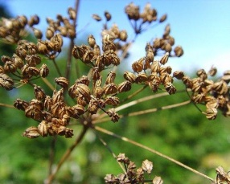

Hemlock
This is one of the most famous poisonous plants in history — it's the flora responsible for killing Socrates. All parts of the plant contain the relatively simple alkaloid coniine which causes stomach pains, vomiting and progressive paralysis of the central nervous system. Hemlock is also known by several common names, including devil's porridge, beaver poison or poison parsley. Eight piperidinic alkaloids have been identified in this species. Two of them, gamma-coniceine and coniine are generally the most abundant and they account for most of the plant's acute and chronic toxicity.

Stinging tree
Found in forests in Queensland in Australia and Indonesia, Dendrocnide moroides is the deadliest and most potent stinging nettle in the world. Accidentally brushing past any part of this plant can deliver a potent toxin that will cause a painful stinging sensation lasting for days or even months. A severe sting from this plant has been known to kill humans, and it is certainly deadly to pigs, horses, dogs and most other animals.
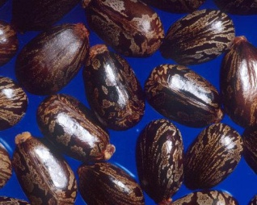

Castor beans
If you have consumed castor oil before, you might be surprised to learn that castor beans contain one of the most poisonous substances in the world, ricin. Just one castor bean has enough ricin to kill an adult within a few minutes. Despite this grim quality, castor bean plants are frequently grown for decorative purposes.

Angel's trumpet
Angel's trumpets are woody-stemmed bushes with pendulous flowers that hang like bells. They are prized as decorative additions to the garden because of their elegant flowers. The catch is that all parts of these plants contain dangerous levels of poison and may be fatal if ingested by humans or animals. Angel's trumpets have occasionally been used to create a recreation drug, but the risk of overdose is so high that these uses often have deadly consequences. Brugmansia are rich in scopolamine (hyoscine), hyoscyamine, and several other tropane alkaloids.

Monkshood
Monkshood has a long tradition as a deadly plant and was used by ancient warriors to poison the water of their enemies (aconitine is a potent neurotoxin). It was once used as a popular werewolf-detection tool. The flower was held near the alleged wolf’s chin, and if a yellow-tinged shadow appeared, that was confirmation that the person was a werewolf.

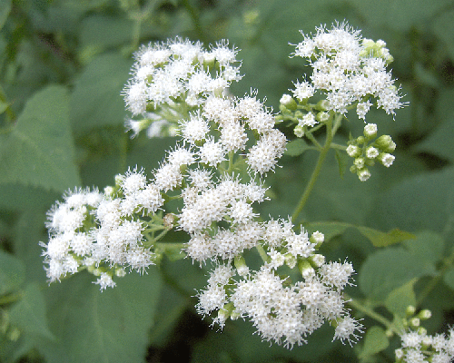
White snakeroot
White snakeroot contains the toxin tremetol, which can be poisonous if consumed directly or second-hand. When snakeroot is consumed by cattle, the animals' beef and milk become contaminated with the toxin, and ingesting those substances can lead to a condition called milk sickness. Abraham Lincoln's mother, Nancy Hanks, reportedly died after swallowing snakeroot-contaminated milk. Human disease is uncommon today because of current practices of animal husbandry and the pooling of milk from many producers, but milk sickness does still occur.
►Read also: http://en.wikipedia.org/wiki/List_of_poisonous_plants

Preserving biological evidence
Source: http://www.homelandsecuritynewswire.com/dr20130501-preserving-biological-evidence

A new handbook by the National Institute of Standards and Technology (NIST) and the Department of Justice’s National Institute of Justice (NIJ) provides forensic laboratories, law enforcement agencies, and the judicial system with state-of-the-art guidelines and recommended best practices for preserving biological evidence so that it is available at any time to solve “cold cases,” confirm the guilt of criminals or exonerate the innocent.
Biological evidence refers to two types of evidence commonly recovered from crime scenes or collected during criminal investigations: samples of biological material — blood, semen, and other bodily fluids; hair; tissue; bones and teeth — or items containing biological material such as a bloody T-shirt. A NIST release reports that The Biological Evidence Preservation Handbook: Best Practices for Evidence Handlers (NIST Interagency/Internal Report 7928) is designed to help ensure that this evidence has been properly stored to avoid contamination, premature destruction or degradation, and accurately tracked to prevent loss. It was authored and edited by the Technical Working Group on Biological Evidence Preservation, a group of twenty experts from various forensic, law enforcement, and scientific disciplines, as well as legal scholars, medical personnel, and representatives of relevant profess-sional organizations.
The handbook is divided into five main sections that explain the issues, offer guidelines and make recommendations related to:
- Retention — identifying what biological evidence should be kept and for how long;
- Safe handling — including the use of protective equipment, the management of spills or accidents, and methods for properly disposing waste;
- Packaging and storing — outlining the conditions for storage and how to properly package biological evidence to maintain its integrity;
- Chain of custody and tracking — a review of the different evidence-tracking methods available and procedures for improving all aspects of chain-of-custody record-keeping; and
- Disposition — summarizing the best practices for disposing of biological evidence once retention is no longer required by law.
The release notes that while most of its recommendations concern the physical storing, preserving and tracking of evidence at a specific storage facility, the handbook also covers transferring material between a storage facility and other locations and discusses how evidence should be handled at these different sites.
Complementing the five main sections of the handbook are a summary of all recommendations made, a table showing the functions and capabilities of evidence tracking and management systems, a state-by-state listing of evidence retention laws, a sample chain-of-custody report and a glossary.

►Download the book at: http://nvlpubs.nist.gov/nistpubs/ir/2013/NIST.IR.7928.pdf

PathSensors, Inc. specializes in technology that can monitor, detect and identify the toxin RICIN
Source:http://www.cbrneworld.com/news/pathsensors_inc._specializes_in_technology_that_can_monitor_detect_and_iden#axzz2S9tgA626

The presence of Ricin, a biological toxin derived from Castor beans remains difficult to detect in a timely manner. The Center for Disease Control and Prevention (CDC) ricin website indicates that the most rapid detection tests take between 6 – 8 hours for initial findings and confirmatory analysis can take up to 48 hours.
The BioFlash-E® Biological Identifier, manufactured by PathSensors, Inc., can detect and identify the presence of Ricin in less than 3 minutes. Based upon the CANARY® (Cellular Analysis and Notification of Antigen Risks and Yields) biosensor technology, BioFlash-E® offers a complete, stand-alone solution for biological detection and identification of toxins, bacteria, and viruses. Developed and tested with MIT Lincoln Labs and licensed exclusively by PathSensors, Inc., the CANARY® technology has been tested at Dugway Proving Ground, Edgewood Chemical and Biological Center and Battelle Memorial Labs. It is currently in use at several large government facilities as part of their building security, mail screening and biomonitoring systems.
The BioFlash-E® delivers Speed in Efficiency, Reliability, Value, and Convenience.
• Less than 3 minutes for results
• Particle collection of 1-10 microns
• Low operational and maintenance costs
• Easy to use – self guided menu walks the user through the analysis
• Compact and lightweight design
• Can be used as stand-alone detection or part of a more complex system
• Aerosol sampling capability
The BioFlash-E® Biological Identifier is portable and incorporates a high-volume, high-performance aerosol sampler for both indoor and outdoor applications. It is possible to detect and identify up to 21 biological and toxin threat agents. Designed specifically for the BioFlash-E® is the BioDiscTM; a unique disposable integrated collection, reagent storage and test chamber disc. The operator inserts the BioDiscTM and BioFlash-E® Identifier automatically collects and identifies up to 21 potentially hazardous biological agents and toxins. The simple and safe “remove and replace” procedure takes less than 2 minutes to complete, requiring minimal user training and making it a perfect addition for military force protection, security monitoring of biohazards and the biological identifier for reconnaissance vehicles, unmanned ground vehicles and mobile labs.

Ebola's secret weapon revealed: its ability to short-circuit the immune system
Source: http://www.homelandsecuritynewswire.com/dr20130507-ebolas-secret-weapon-revealed-its-ability-to-shortcircuit-the-immune-system

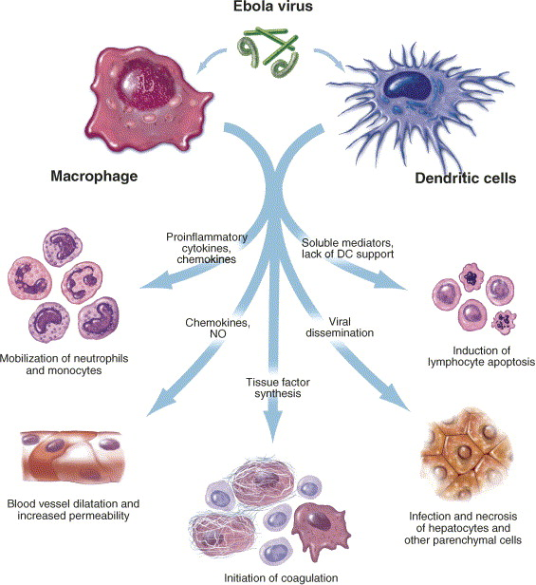
Researchers have discovered the mechanism behind one of the Ebola virus’ most dangerous attributes: its ability to disarm the adaptive immune system.
A University of Texas Medical Branch at Galveston release reports that UTMB scientists determined that Ebola short-circuits the immune system using proteins that work together to shut down cellular signaling related to interferon. Disruption of this activity, the researchers found, allows Ebola to prevent the full development of dendritic cells that would otherwise trigger an immune response to the virus.
“Dendritic cells typically undergo a process called ‘maturation’ when they’re infected by a virus — they change shape and present antigens on their surface that tell T-cells to attack that particular virus, thus generating an adaptive immune response,” said UTMB professor Alexander Bukreyev, senior author of a paper on the discovery now online in the Journal of Virology. “But Ebola prevents dendritic-cell maturation and produces a severe infection without an effective adaptive immune response. We found that its ability to do this depends on several specific regions of two different proteins.”
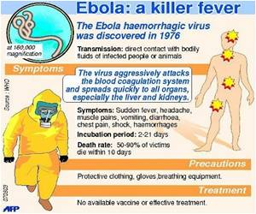
Bukreyev’s research group made the discovery after a series of procedures that started with a clone of the Ebola Zaire virus strain. Working under maximum-containment conditions in a biosafety Level 4 facility in UTMB’s Galveston National Laboratory, the team introduced mutations into the virus’ genetic code at four locations thought to generate proteins that affected immune response.
They then infected human dendritic cells with each of the resulting new strains and compared the results with those produced by unmutated Ebola Zaire. Each of the four new viruses, they found, was unable to suppress dendritic-cell maturation.
“We saw two very interesting things,” Bukreyev said. “First, that these mutations restore maturation of dendritic cells very effectively, and second, that a mutation in even one of these genetic domains makes the virus unable to suppress maturation. That means that the virus needs multiple combined effects in order to undermine the immune system in this way.”
Ebola’s ability to evade the human immune response is one of the factors that accounts for its high mortality rate — up to 90 percent in humans — and the notoriety that it gained after its first appearance in Zaire in 1976, in an outbreak that killed 280 people. Zaire — now the Democratic Republic of the Congo — is the home country of Ndongala Lubaki, lead author on the paper and a postdoctoral fellow at UTMB.

— Read more in Ndongala M. Lubaki et l., “The Lack of Maturation of Ebola Virus-Infected Dendritic Cells Results from the Cooperative Effect of at Least Two Viral Domains,” Journal of Virology 87, no. 8 (24 April 2013)

ABSTRACT
Ebola virus (EBOV) infections are characterized by deficient T lymphocyte responses, T lymphocyte apoptosis and lymphopenia, in the absence of direct infection of lymphocytes. In contrast, dendritic cells (DC) are infected but fail to mature appropriately, thereby impairing the T cell response. We investigated the contribution of EBOV proteins in modulating DC maturation by generating recombinant viruses expressing enhanced green fluorescent protein and carrying mutations affecting several potentially immunomodulating domains. These included envelope glycoprotein (GP) domains as well as innate response antagonist domains (IRADs) previously identified in the VP24 and VP35 proteins. GP expressed by an unrelated vector, but not the wild-type EBOV, was found to strongly induce DC maturation, and infections with recombinant EBOV carrying mutations disabling GP functional domains did not restore DC maturation. In contrast, each of the viruses carrying mutations disabling any IRAD in VP35 induced a dramatic upregulation of DC maturation markers. This was dependent on infection, but not interaction with GP. Disabling of IRADs also resulted in a several hundred fold increase in secretion of cytokines and chemokines. Furthermore, these mutations induced formation of homotypic DC clusters, which represent close correlates of their maturation, and presumably facilitate transfer of antigen from migratory DC to lymph node DC. Thus, an individual IRAD is insufficient to suppress DC maturation; rather, the suppression of DC maturation and the “immune paralysis” observed during EBOV infections results from a cooperative effect of two or more individual IRADs.

FOODSNIFFER PROJECT

Source: http://www.foodsniffer.eu/

Concern for our food is growing in Europe, driven by industrialised food production and repeated crises. Current analytical technology is too expensive and bound to the laboratory to test more than a small fraction of 1% of the EU’s food. This problem requires more massive screening of food and water extending from the source to the point of consumption. A low-cost and portable system delivering analytical data to a central location would help to prevent or identify early any food safety threat outbreaks and thereby massively reduce human suffering and its associated financial cost on both sides of the global divide.

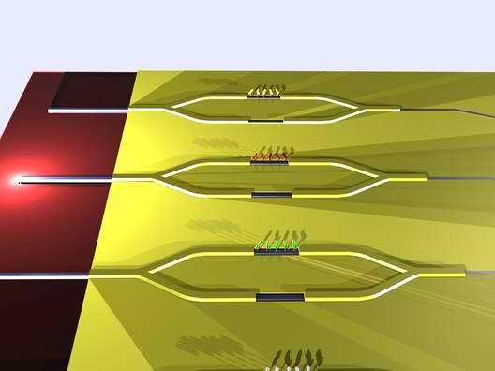
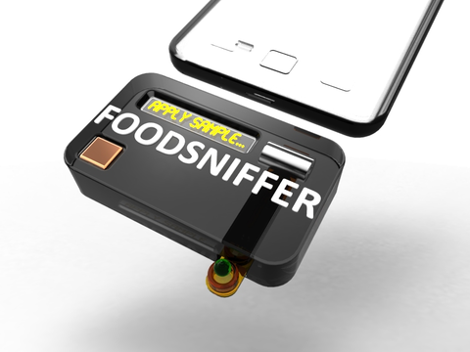
FOODSNIFFER is field-deployable and simple-to-use as a result of the integration of three major innovations: (i) the transducer itself, an all- silicon fully integrated optoelectronic platform based on Broad-Band Mach- Zehnder Interferometry capable of synchronous highly-sensitive label-free multi-analyte detection. This ultimately-integrated transducer due to the incorporation of the light-sources, sensing elements, spectral analyzer and photodetectors, in a single chip, can be used in single-shot cartridges. (ii) the innovative design of the wafer-scale microfluidics and filtration systems that unburden the reader of external pumps/valves, and intensive sample preparation. (iii) the development of a low-power reader controlled by a smartphone through a custom-produced application. The software controls the sensor and also processes its signal and then sends the results securely via the internet during the on-the-spot food safety analysis.

Immunoanalysis on nano-scale, the diagram shows sensor and reference arms

FOODSNIFFER is a complete business solution which will be demonstrated in three areas of great importance to European society and regulators, viz. the detection of pesticide residues, mycotoxins and allergens in selected food categories in order to demonstrate field-based detection of harmful species at low concentrations, which is a feat unattained so far by any point-of-need system.

►Project Coordinator: Ioannis RAPTIS; NCSR ‘Demokritos’, Greece
raptis@imel.demokritos.gr

Yersinia pestis DNA from Skeletal Remains from the 6th Century AD Reveals Insights into Justinianic Plague

Source: http://www.plospathogens.org/article/info%3Adoi%2F10.1371%2Fjournal.ppat.1003349

Abstract
Yersinia pestis, the etiologic agent of the disease plague, has been implicated in three historical pandemics. These include the third pandemic of the 19th and 20th centuries, during which plague was spread around the world, and the second pandemic of the 14th–17th centuries, which included the infamous epidemic known as the Black Death. Previous studies have confirmed that Y. pestis caused these two more recent pandemics. However, a highly spirited debate still continues as to whether Y. pestis caused the so-called Justinianic Plague of the 6th–8th centuries AD. By analyzing ancient DNA in two independent ancient DNA laboratories, we confirmed unambiguously the presence of Y. pestis DNA in human skeletal remains from an Early Medieval cemetery. In addition, we narrowed the phylogenetic position of the responsible strain down to major branch 0 on the Y. pestis phylogeny, specifically between nodes N03 and N05. Our findings confirm that Y. pestis was responsible for the Justinianic Plague, which should end the controversy regarding the etiology of this pandemic. The first genotype of a Y. pestis strain that caused the Late Antique plague provides important information about the history of the plague bacillus and suggests that the first pandemic also originated in Asia, similar to the other two plague pandemics.

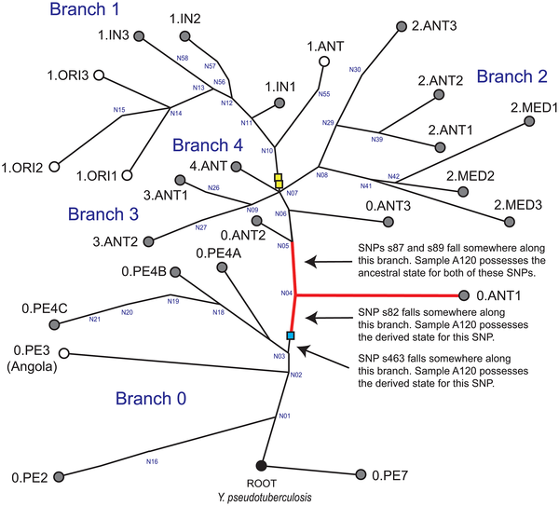
Global phylogeny for Y. pestis.

Author Summary
Plague is a notorious and fatal human disease caused by the bacterium Yersinia pestis that is endemic in many countries around the world. Three of the most devastating pandemics in human history have been associated with plague. The second pandemic originated in central Asia and peaked in Europe between 1348 and 1350 (a period of time known as the Black Death). The third pandemic began in the Yunnan province of China in the mid-1850s and subsequently spread to Africa, the Americas, Australia, Europe, and other parts of Asia. The second and third pandemics are well documented and scientifically proven. However, the first pandemic, which began in the 6th century and is also known as Justinianic Plague, is still a matter of controversy. Recently it has been suggested that Justinian's plague was not caused by Y. pestis. We detected Y. pestis DNA in samples obtained from multiple 6th century skeletons from Germany. This confirms that Justinianic Plague crossed the Alps and affected local populations there, including current day Bavaria. Furthermore, we used DNA fingerprinting approaches to determine Asia as the likely geographic origin for these strains.

Citation: Harbeck M, Seifert L, Hänsch S, Wagner DM, Birdsell D, et al. (2013) Yersinia pestis DNA from Skeletal Remains from the 6th Century AD Reveals Insights into Justinianic Plague. PLoS Pathog 9(5): e1003349. doi:10.1371/journal.ppat.1003349

Protecting the Water Supply Requires a Multipronged Approach
By Margaret Steen
Source: http://www.emergencymgmt.com/safety/Protecting-the-Water-Supply.html

Threats to water, a requirement for life, make for compelling story lines. The movie Batman Begins includes a poisoned water supply as a plot point, for example. But threats to the water supply aren’t just the stuff of modern fiction.
Government officials are expressing concern about cyberattacks as a threat to the United States’ infrastructure. Water systems are no exception.
With cyberattacks, “you can do it to multiple water systems at the same time, and you don’t have to be local,” said Joe Weiss, managing partner of Applied Control Solutions, a cybersecurity consulting company.
And attacks by other nations aren’t the only issue. Some cybersecurity problems reported so far have been unintentional.
Weiss said that with the proper training, policies and system architecture, the water infrastructure can be protected in most cases from unintentional cybersecurity problems, disgruntled employees and unsophisticated hackers.
Protecting the water supply from the most sophisticated cyberattacks — such as those from a foreign government — is more difficult because most countries use similar equipment, so they all know its vulnerabilities. On the other hand, Weiss said, because the U.S. could launch similar attacks, countries may be less inclined to start this kind of conflict.
There is always a trade-off between performance and security. “For performance, you want to have everybody able to talk to each other,” Weiss said. “For security, it’s exactly the opposite: You want the system as closed as you can make it.”

“The idea of poisoning drinking water goes back a long way,” said James Salzman, a professor of law and environmental policy at Duke University and author of Drinking Water: A History. The Roman emperor Nero is said to have poisoned his enemies’ wells in the first century. J. Edgar Hoover obsessed over threats to the water supply during World War II.
For all the drama of someone slipping poison into a reservoir, however, the reality is that many of the threats to both drinking water and wastewater are more mundane, ranging from wildfires to maintenance issues.
The infrastructure for drinking water is massive. From treatment plants to the distribution network, it consists of millions of miles of pipes and has millions of access points. “When you just look at the numbers, it’s obvious that the drinking water system is impossibly big to completely protect,” Salzman said. “That’s the bad news. The good news is that our systems are designed intentionally to protect against threats.”
The myriad threats eventually creep into the emergency management realm. During a disaster, it’s imperative to have access to potable water. There are instances where a hazard — natural or man-made — can turn into a disaster because of contamination to drinking water.
There are, of course, small-scale “instances every year where the system fails, and there are boil water alerts,” Salzman said. “In terms of drinking water, we can get that into a disaster area quickly. The concern is sanitation: How do you get the waste away?” If sewage contaminates the water supply, there’s a risk of cholera, typhoid and other diseases. “You’re basically back in the 19th century.”
There are many sources of threats to the water supply, some caused by humans, either intentionally or unintentionally, and some natural. Although in movies, the villain may sneak up to a reservoir and pull a test tube full of poison out of his coat, the reality is that with most chemicals in most reservoirs, it would not be nearly that easy.
“You’d need several dump trucks of cyanide or arsenic to poison a large water supply,” Salzman said. It would be difficult to acquire that much poison without attracting notice, let alone get it into the reservoir. Then there’s the fact that the reservoir water is monitored, so authorities would realize something was wrong.
Wildfires are becoming more intense and causing many different problems for water systems, which requires a varied approach to problem solving.
The fire itself can damage treatment plants or other infrastructure. Denver Water’s structures have been spared by recent fires it’s faced, said Ken Pollock, Denver Water’s superintendent of water quality. “But other utilities in the area have had the fire literally at their water treatment plant door.”
This first stage of the crisis is resolved usually within days, but that doesn’t end the threat to the water supply.
“The bigger challenge is changes to the watershed,” Pollock said. “You have all the ash. All vegetation is gone. That creates a problem when it rains, particularly if you have a big rainstorm, because there’s nothing to hold the soils in place.”
In Colorado, afternoon thunderstorms can be intense. When a storm dumps a lot of rain quickly on an area already hit by a fire, sediment, ash and burned trees can clog the waterways.
“During the floods that follow the fires, treatment plants can become overwhelmed very quickly with sediment,” Pollock said. Treatment plants must add more chemicals to the water to treat it effectively and sometimes must decrease production at the affected plant or shift that load to unaffected facilities.
To address these problems, Denver Water works to alleviate the immediate impact and prevent problems. For prevention, Denver Water teamed with the local U.S. Forest Service region to improve forest and watershed conditions.
The utility hired Becky Martinez as manager of emergency response in 2012 to help coordinate its disaster response with other entities. Denver Water must coordinate with 12 county emergency management offices, and this communication hasn’t always been a focus.
“I’m observing that all of our water systems are kind of a separate entity,” Martinez said. “We’re making great strides in contacting all of the [local] emergency managers.”

The system is constantly under attack from biological threats, Salzman said. Whether the problem happens naturally or is introduced intentionally, the water system has built-in protections such as chlorination. “Cholera is bad whether it occurs naturally or is put into the reservoir, and the system is designed to neutralize that,” he said.
Governments are increasingly concerned about cyberattacks. “Cybersecurity remains a concern across all of the critical infrastructure areas,” said Terry Clawson, a spokesman for the Texas Commission on Environmental Quality (TCEQ). “In the last 18 months, there have been two cybersecurity incidents reported to the TCEQ.”
Still, disrupting the water supply via a cyberattack “would require a very high level of sophistication,” Salzman said. One of the easiest ways to disrupt any type of infrastructure would be to blow it up. The water system is as vulnerable as other types of infrastructure.
Wildfires can cause runoff that pollutes the water supply. Earthquakes can break pipes and shut off electricity, preventing the movement of water. Hurricanes and even droughts can wreak havoc on water systems.
“Texas has seen significant and widespread damage to both wastewater and drinking water facilities as a result of hurricanes,” Clawson said. “As a result of Hurricane Ike in 2008, some residents in the Houston area were without power and water for up to four weeks.” (Subsequent legislation requires public drinking water systems in specific Texas counties to develop plans to demonstrate how they will operate in emergency conditions.)
A slow-moving natural disaster, drought is nonetheless a major problem in some areas. The drought that started in 2011 caused some systems in Texas to experience a significant decrease in their water supply. To address drought-related problems, the TCEQ works with other state agencies on state-level emergency assistance. “As an example, state agency partners developed the Emergency Drinking Water Annex, a document that details management and response for public water systems with 180 days or less of water supply,” Clawson said. In addition, “the TCEQ intensively monitors a targeted list of public water systems that have either limited or an unknown supply of water remaining.”
The U.S. does a poor job of maintaining its water infrastructure, according to the 2013 Report Card for America’s Infrastructure, released in March by the American Society of Civil Engineers (ASCE).
The group rated several U.S. infrastructure types, and the ratings for the water-related categories were poor: D for dams, D for drinking water, D- for levees, and D for wastewater.
Issues can arise from the age of the nation’s water infrastructure. There are places in the U.S. where the pipes were laid just after the Civil War, Salzman said.
“We as Americans need to be proactive in monitoring and taking care of our infrastructure so that it will be here not only for us, but for our children and our grandchildren,” said ASCE President Gregory E. DiLoreto in a statement.
But as with other types of infrastructure, it can be difficult to persuade the public to spend money to upgrade and maintain water pipes and the rest of the infrastructure. “We don’t want to pay for upgrading infrastructure,” Salzman said. “We don’t think about our infrastructure, for water particularly, because it’s buried.”
This may be a larger threat than terrorist attacks or natural disasters (though older infrastructure could be more vulnerable to these).
“I think they’re doing a good job at addressing external threats,” Salzman said. “The overall integrity of the system is a serious issue. Our system is aging, and we’re paying the price. We can pay now or we can pay later, but the system is aging.”
Infrastructure concerns don’t end with the water system. “Roughly 20 percent of California’s electricity is used to move water,” Salzman said. “When you knock out electricity, you’re also knocking out the water supply system.”
One of the biggest roadblocks to addressing these threats, especially infrastructure, is money — because there are “so many competing interests,” said Jeff Crockett, water treatment manager for the Colorado Springs Utilities. “We have aging infrastructure; we’re dealing with all the different strains on our time and resources.”
Water resource managers and emergency managers must balance many considerations in addressing these risks. “Magnitude and probability of the risks is central in how we plan to further develop our system and manage our system to maintain reliable water service,” said Mark Shea, watershed planning supervisor of the Water Services Division of the Colorado Springs Utilities.
There are two main strategies, Salzman said: Harden the system against intentional or naturally occurring threats, and have a back-up plan. “When the system goes down, how quickly is it back up?” Salzman said. “What’s your Plan B?”
For Colorado’s large, diverse system, Plan B often means relying on a different part of the system. “When we get runoff from the Waldo Canyon Fire, we can shut off the pump station and divert the water so we do not bring that poor-quality water into the treatment plant,” Crockett said.
This redundancy, though it adds to the cost and complexity, is very helpful for emergency planning. However, some water systems’ geography does not allow for this kind of response.
“We’ve spent considerable effort on reviewing every piece of infrastructure that we can protect from security threats,” said Andy Funchess, field operations manager for the Colorado Springs Utilities. And the organization rehearses its Plan B. “We’ve also performed various exercises through the Business Continuity Group to be able to properly react to these sorts of things should they happen.”
Drills and planning are an integral part of many emergency managers’ water plans. California is planning a statewide drill in May, Golden Guardian, that will simulate a catastrophic earthquake. For Santa Clara County officials, the focus will be on water.
The county’s emergency managers are using the exercise to activate a water management plan that’s been in the works for the past year, said Cindy Stewart, emergency planning coordinator of Santa Clara County. The exercise will highlight the interdependence of different parts of the infrastructure. “We’re going to play that one of our water retailers has lost power and has a backup generator that’s not working.” The portable generator that could restore water service to several cities is the size of a semitruck.
“We’ll have to figure out how to get it here past roads and bridges that are closed,” Stewart said.
Emergency responders have concerns beyond getting power back to the water suppliers. Public health officials must determine whether the water is safe and for what type of activity. (It could be safe for watering lawns, for example, but not for drinking.)

Environmental health officials need to contact restaurants and other food providers after a disaster that affected the water supply. “[It’s necessary to] make sure they’re storing food properly, using whatever water they have properly, not washing dishes twice in the same water,” Stewart said.
Communicating with the public is also a huge part of an emergency official’s job — and a big challenge, especially when the power has gone out.
The TCEQ has various information available before events, if they’re predicted, and also after. Topics include getting safe drinking water, determining if water is safe to drink, disinfecting private wells and boil water notices.
“In a disaster, there may be power outages and lack of Internet access in impacted areas. To provide necessary information to the public and regulated entities, TCEQ will determine and activate other means of distributing information,” Clawson said. This could include phone calls or onsite visits.
Texas learned from reviews of how it handled Hurricane Ike in 2008 that while the response was successful in many areas, the state could benefit from better data management, coordination and reporting. Working with federal partners, Texas created a Natural Disaster Operational Workgroup to establish common protocols for multi-agency disaster response. The group developed standardized procedures, forms and data collection standards, which were used successfully during the 2010 Rio Grande Valley flooding.
For local officials, the message that goes out to the public may vary depending on what’s wrong with the water and who’s affected.
“The first messaging issue is, when you turn on your faucet and no water comes out, what do you do?” Stewart said. “If you can’t flush your toilet, what do you do? In a major, catastrophic earthquake, after two weeks that could be a huge issue.”
Local emergency management officials have several ways to tell people, for example, that they need to boil their water. They can broadcast on TV and radio (they encourage people to have battery-operated radios), use the emergency alert phone system or send workers door to door if necessary. Santa Clara County has a strong network of volunteer ham radio operators who also can help deliver the message.
Crafting the message also is critical. “If there’s no water in Los Altos but there is in Saratoga, how do we handle letting the public know without creating a mad rush from one city to another?” Stewart said. “We have to be sure we don’t create chaos in the middle of a disaster.”
Beyond the immediate messages about whether the water is safe and where to get some, it would help for more members of the public to understand what goes into making sure that every time they turn on the tap, safe drinking water comes out.

Margaret Steen is a contributing writer for Emergency Management magazine.

Simultaneous Detection of Salmonella typhi, Bacillus antheracis, and Yersinea pestis by Multiplex PCR
By Safari Foroshani N, Karami A*, Pourali F, Aeidi A, Fatemeh tavana BS
Source: http://www.zums.ac.ir/journal/browse.php?a_id=2145&sid=1&slc_lang=en
Abstract (paper is in Persian)
Background and Objectives: Salmonella typhi, Bacillus anthracis, and Yersinia pestis are potent human pathogenic bacteria that cause typhoid fever, anthrax, and plague, respectively. The classic microbiological methods for detection and identification of these agents are laborious and time consuming. Therefore, developing an accurate method for rapid detection of these potent human pathogens is important, especially due to their potential use as Bioterrorism agents. We have designed a new rapid molecular detection method by using multiplex PCR in a single reaction.
Materials and Methods: PCR was carried out using specific primers for the virulence factor of S. typhi, hp and invA, B. anthracis virulence factors, chr and pa, and Y. pestis toxin, pla. The primer sets were tested for cross reactivity with individual DNA strains and mixtures in a multiplex PCR format. For determination of sensitivity of the method, we used colony counting and genomic DNA dilution.
Results: The result with standard strains revealed that primers are specific for each strain as they have successfully amplified the desire products. The sensitivity analysis showed a 1-10 CFU and 1-10 copies of the genomes. In this respect, the accuracy of the result was checked by sequencing of the 1083-bp PCR products, except for anthrax, which was determined by enzymatic digestion.
Conclusion: We have found a rapid, specific, sensitive, and a non-expensive molecular method for detection of three potent human pathogens. This finding provides an efficient diagnostic tool to determine these bacteria in bioterrorism samples.

*Dr. Ali Karami, Ph.D, is Associate Professor of Medical Biotechnology, Genetic Engineering and Molecular Biology Research Center of Molecular Biology Baqiyatallah University of Medical Science, Tehran, Iran.

West Nile virus (WNV) activity reported to ArboNET, by state, United States, 2012
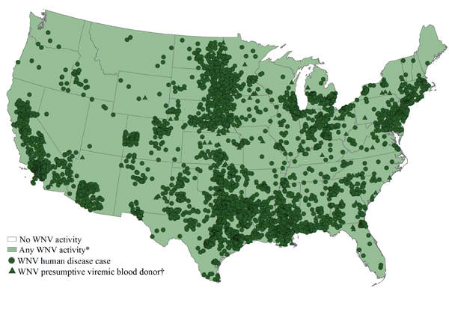
Source:http://www.cdc.gov/ncidod/dvbid/westnile/Mapsactivity/surv&control12MapsAnybyState.htm

* Includes WNV human disease cases, presumptive viremic blood donors, veterinary disease cases and infections in mosquitoes, birds, and sentinel animals.
† Presumptive viremic blood donors have a positive screening test which has not necessarily been confirmed.
Map shows the distribution of WNV activity* (shaded in light green), human infections (dark green circles), and presumptive viremic blood donors (dark green triangles) occurring during 2012 by state. If West Nile virus infection is reported from any area of a state, that entire state is shaded.

Data table
Non-human West Nile virus infections have been reported to CDC ArboNET from the following states:
Alabama, Arizona, Arkansas, California, Colorado, Connecticut, Delaware, District of Columbia, Florida, Georgia, Idaho, Illinois, Indiana, Iowa, Kansas, Kentucky, Louisiana, Maine, Maryland, Massachusetts, Michigan, Minnesota, Mississippi, Missouri, Montana, Nebraska, Nevada, New Hampshire, New Jersey, New Mexico, New York, North Carolina, North Dakota, Ohio, Oklahoma, Oregon, Pennsylvania, Rhode Island, South Carolina, South Dakota, Tennessee, Texas, Utah, Vermont, Virginia, Washington, West Virginia, Wisconsin, and Wyoming.

Six thousand two hundred and seventy nine human West Nile virus infections were reported to CDC ArboNET from Alabama, Arizona, Arkansas, California, Colorado, Connecticut, Delaware, District of Columbia, Florida, Georgia, Idaho, Illinois, Indiana, Iowa, Kansas, Kentucky, Louisiana, Maine, Maryland, Massachusetts, Michigan, Minnesota, Mississippi, Missouri, Montana, Nebraska, Nevada, New Hampshire, New Jersey, New Mexico, New York, North Carolina, North Dakota, Ohio, Oklahoma, Oregon, Pennsylvania, Puerto Rico, Rhode Island, South Carolina, South Dakota, Tennessee, Texas, Utah, Vermont, Virginia, Washington, West Virginia, Wisconsin, and Wyoming.

Bioterrorism: Unthinkable but Insurable
By Anthony Wagar
Source: http://blog.willis.com/2013/05/bioterrorism-unthinkable-but-insurable/

The bombings in Boston on April 15 re-kindled concern about a type of risk no one likes to think about: bioterrorism. Risk managers, however, must think about it and prepare to mitigate as much of the human, environmental and financial fallout from such an event as possible. This preparation includes considering bioterrorism-specific insurance coverage that is, in fact, currently available.
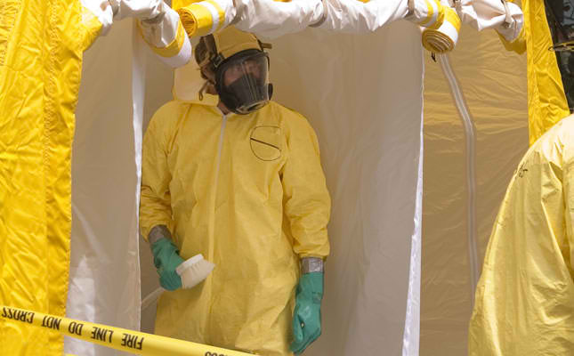
“Terrorism refers to the use or threat of force or violence against people or property. A bioterrorist attack releases viruses, bacteria, or other germs to cause illness or death,” as defined by the U.S. Centers for Disease Control and Prevention. Biological agents can be spread through the air, in food and can be directed against environmental resources, such as reservoirs, waterways, and potable drinking water supplies.
Recent reports indicate that bioterrorism is more than just a hypothetical scenario—it is a real and evolving risk. Because of the significant third-party damage potential, many of different types of businesses could be targets of a bioterrorism attack, e.g.:
- facilities or buildings in densely populated areas
- water treatment or distribution facilities
- hospital and health care facilities
- chemical companies
- large stadiums or arenas, etc.
Prudent risk management often includes prevention protocols, a response plan and working to mitigate the financial risk of a catastrophe that has the potential to bankrupt a company.

Bioterrorism Can Be Covered
Fortunately, biological terrorism coverage is available from almost all the carriers offering environmental insurance. Most markets offer this coverage through an endorsement via inclusion of bioterrorism agents in the definition of pollution conditions. “Bioterrorism agents” in most environmental policies means the deliberate release, discharge or dispersal of viruses, bacteria or other agents—living or dead—by a third party.
While terrifying to think about, the catastrophic potential is real and, unfortunately, proper preparedness, biosurveillance, response planning and prevention measures will only get you part of the way there, which is why it’s imperative that you put additional risk management measures in place to help transfer the risk of for a bioterrorism event

Anthony Wagar is Executive Vice President and the National Sales Leader for Willis' Environmental Practice based in New York. He has close to 20 years of experience from a regulatory, underwriting and brokerage perspective. He blogs on matters relating to environmental risk, exposures and insurance.

New malaria test kit would help global elimination efforts
Source: http://www.homelandsecuritynewswire.com/dr20130519-new-malaria-test-kit-would-help-global-elimination-efforts

A new, highly sensitive blood test that quickly detects even the lowest levels of malaria parasites in the body could make a dramatic difference in efforts to tackle the disease in the United Kingdom and across the world, according to new research published in the Journal of Infectious Diseases.
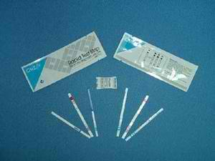
A London School of Hygiene and Tropical Medicine release reports that in two studies led by researchers in the United Kingdom and Switzerland, the new LAMP (loop-mediated isothermal amplification) test was compared to existing methods in London laboratories that deal with imported cases of malaria to the United Kingdom, and to diagnostic methods used in the field in Uganda, where malaria is a leading cause of illness and death.
The simple test, which can be performed by a non-specialist health worker and does not need refrigerating like other tests, requires a sample of blood to be processed and placed in a test tube with a reactive powder then heated. If the malaria-causing Plasmodium parasites are present, the tube glows green. The whole process takes less than an hour.
The first study, led in London by the Hospital for Tropical Diseases (HTD), the Foundation for Innovative New Diagnostics, and the London School of Hygiene & Tropical Medicine, compared LAMP to existing laboratory diagnostic methods on 705 blood samples of suspected imported malaria cases in the United Kingdom.
Dr. Colin Sutherland, clinical scientist at HTD and reader in Parasitology at the Malaria Reference Laboratory at the London School of Hygiene & Tropical Medicine, said: “According to data collected for Public Health England by the London School of Hygiene & Tropical Medicine, the U.K. treats at least 1,500 cases of imported malaria every year. Despite the very best efforts of the NHS, a handful of malaria related deaths still occur annually in U.K. hospitals. The new LAMP test for malaria performed very well when tested in the parasite reference laboratory at HTD, and correctly identified every malaria patient out of 705 malaria tests performed.
“An important advantage of LAMP is that non-specialist staff in any hospital in the U.K. will be able to accurately and rapidly detect the presence of malaria parasites, and immediately begin treatment without waiting for confirmation from local experts or specialist laboratories. This speed of diagnosis can make the difference between an uncomplicated episode of malaria that rapidly responds to treatment, and progression to severe disease, organ failure and heightened risk of death. It could also save the NHS a significant amount of money from having to treat the complications of malaria.”
The release notes that LAMP was faster than PCR (polymerase chain reaction) tests, which require specialized laboratory equipment, costly reagents and advanced training. It was also more accurate than microscopic examination of blood slides, which require a trained specialist to identify the malaria parasites.
In the second study, researchers from HTD, the Foundation for Innovative New Diagnostics, Switzerland, the London School of Hygiene & Tropical Medicine and the Uganda Ministry of Health, Kampala, looked at the accuracy of the test at a rural clinic in Uganda.
Blood samples from 272 patients with suspected malaria were tested using LA MP using a simple generator to provide electrical current. These results were compared with expert microscopy and PCR performed at central reference laboratories. LAMP detected cases of low-level malaria parasite infection that were missed by expert microscopy, and achieved accuracy similar to that of PCR down to very low levels. The researchers say these findings have important implications for eliminating malaria, which causes an estimated 660,000 deaths worldwide every year.
Sutherland, who worked on both of the studies, said: “Patterns of malaria disease in Africa and elsewhere across the tropics are becoming much less predictable, and control of malaria needs an appropriate test to identify infected individuals in the populations at risk. These people may not display any malaria symptoms.
We have begun using LAMP as a new tool for identifying “hot spots” of malaria infections which can be mopped up quickly through a combination of drug treatment, house spraying and distribution of bed-nets.
“LAMP will potentially contribute to saving many families and communities from the blight of a disease that keeps children from succeeding at school, prevents adults from growing food or working, holds back regional economies and exacts an annual death toll in the hundreds of thousands.”
The LAMP malaria test will now be used in the Malaria Reference Laboratory at the London School of Hygiene & Tropical Medicine to help identify imported cases of malaria in the UK as well as being used by health workers in the field in malaria endemic countries.
The LAMP malaria test is commercially available and was developed by the Foundation for Innovative New Diagnostics, the Hospital for Tropical Diseases, London and Eiken Chemical Company Ltd, Japan. The studies were funded by the Bill and Melinda Gates Foundation, the Ministry of Foreign Affairs of the Government of The Netherlands, and the UK Department for International Development.

— Read more in Spencer D. Polley et al, “Clinical Evaluation of a LAMP test kit for Diagnosis of Imported Malaria,” Journal of Infectious Diseases (30 April 2013); and Heidi Hopkins et al., “Highly sensitive detection of malaria parasitemia in an endemic setting: Performance of a new LAMP kit in a remote clinic in Uganda,” Journal of Infectious Diseases (30 April 2013)

Clinical Evaluation of a LAMP test kit for Diagnosis of Imported Malaria

Abstract
Background. Diagnosis of malaria relies on parasite detection by microscopy or antigen detection; both fail to detect low density infections. New tests providing rapid, sensitive diagnosis, with minimal need for training would enhance both malaria diagnosis and malaria control activities. We determined the diagnostic accuracy, in febrile returned travelers, of a new malaria LAMP kit.
Methods. The kit was evaluated in sequential blood samples from returned travelers sent for pathogen testing to a specialist parasitology laboratory. Microscopy was performed, then malaria LAMP using Plasmodium genus and P. falciparum-specific tests in parallel. Nested PCR was performed on all samples as the reference standard. Primary outcome measures for diagnostic accuracy were sensitivity and specificity of LAMP results compared to nested PCR.
Results. 705 samples were tested in the primary analysis. Sensitivity and specificity of the LAMP P. falciparum primers were 98.4% and 98.1%, respectively, and 97.0% and 99.2% for the genus primers. Post-hoc repeat PCR analysis of all 15 discrepant tests resolved four of these in favor of LAMP, suggesting that the primary analysis had underestimated diagnostic accuracy.
Conclusions. Malaria LAMP performed with similar diagnostic accuracy to nested PCR, with greatly reduced time to result, and was superior to expert microscopy.

Specific Technologies Detects and Identifies Potential Bioterrorism Pathogenic Bacteria
Source: http://www.sacbee.com/2013/05/20/5434290/specific-technologies-detects.html

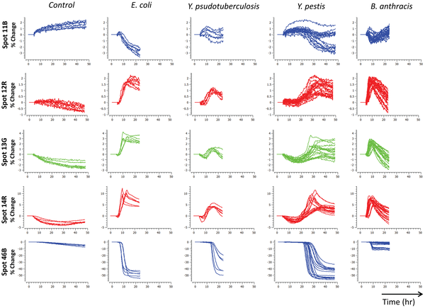
Specific Technologies, today (May 20) announced the publication of results of the first study demonstrating detection of pathogenic bacteria, including potential bioterrorism agents such as Yersinia pestis and Bacillus anthracis which feature on the Center for Disease Control and Prevention's list of potential bio-threats. This seminal study, conducted in collaboration with the Defence Science and Technology Laboratory, Salisbury (DSTL), United Kingdom, researchers reported 100% bacterial identification accuracy at inoculum concentrations as low as 8 colony-forming units. The study also demonstrated a simple method to differentiate strains of the same species, including 5 strains of Yersinia pestis and Bacillus anthracis.
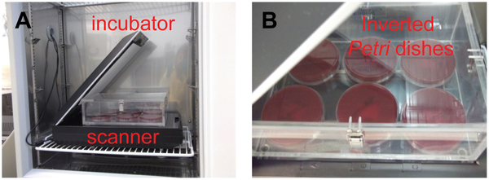
Current standard practice for identification of pathogenic bacteria requires completion of a culture and then requires additional time consuming molecular or chemical analysis. Specific Technologies has developed a system for identifying microorganisms from their metabolic signature during culture saving precious hours during potentially deadly incidents.
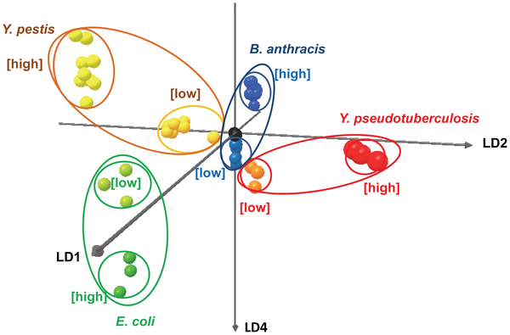
In the event of a suspected release, a rapid and reliable method to identify potential bioterrorism agents would allow a faster public health response. Current bacterial identification methods can be slow and require highly trained personnel to operate sophisticated instruments that are generally too expensive, delicate, or bulky to deploy outside of a dedicated laboratory facility.
Ray Martino a founder and COO of Specific Technologies, commented, "Microorganisms produce a complex mixture of volatile metabolites unique to their species and strain. Specific Technologies has developed a system for identifying the species and strain from their metabolic signature during culture, saving the delay and cost of molecular or chemical methods that follow culture"
Mr. Martino continued, "The Specific Technologies sensor is small and disposable. The instrumentation is no more than what is found in common smart phones enabling the use of the solution in the field."

The Use of Colorimetric Sensor Arrays to Discriminate between Pathogenic Bacteria
Claire L. Lonsdale, Brian Taba, Nuria Queralto, Roman A. Lukaszewski, Raymond A. Martino, Paul A. Rhodes, Sung H. Lim

Abstract
A colorimetric sensor array is a high-dimensional chemical sensor that is cheap, compact, disposable, robust, and easy to operate, making it a good candidate technology to detect pathogenic bacteria, especially potential bioterrorism agents like Yersinia pestis and Bacillus anthracis which feature on the Center for Disease Control and Prevention’s list of potential biothreats. Here, a colorimetric sensor array was used to continuously monitor the volatile metabolites released by bacteria in solid media culture in an Advisory Committee on Dangerous Pathogen Containment Level 3 laboratory. At inoculum concentrations as low as 8 colony-forming units per plate, 4 different bacterial species were identified with 100% accuracy using logistic regression to classify the kinetic profile of sensor responses to culture headspace gas. The sensor array was able to further discriminate between different strains of the same species, including 5 strains of Yersinia pestis and Bacillus anthracis. These preliminary results suggest that disposable colorimetric sensor arrays can be an effective, low-cost tool to identify pathogenic bacteria.

Bioweapons Country Report: India
BioWeapons Monitor 2012
By Animesh Roul
Source: http://news.cbrnresourcenetwork.com/newsDetail.cfm?id=172

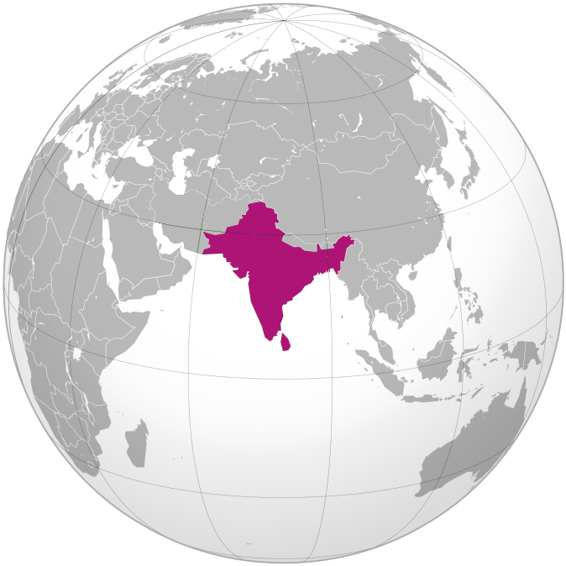
India participated in the BWC Meeting of Experts held in Geneva (July 16-20, 2012). It had earlier agreed in principle to the Final Document of the BWC Seventh Review Conference which includes the following declarations:
‘to include in 2012 – 2015 intersessional programme a standing agenda item on developments in the field of science and technology related to the Convention. to take all necessary safety and security measures to protect human populations and the environment, including animals and plants, when carrying out destruction and/or diversion of agents, toxins, weapons, equipment or means of delivery as prohibited by Article I of the Convention. to adopt legislative, administrative, judicial and other measures, including penal legislation, to enhance domestic implementation of the Convention, ensure the safety and security of microbial or other biological agents or toxins in laboratories, facilities, and during transportation and to prevent unauthorized access to and removal of such agents or toxins.
to adopt positive measures to promote technology transfer and international cooperation on an equal and non-discriminatory basis to continue supporting, directly and indirectly, capacity-building in States parties in need of assistance in the fields of disease surveillance, detection, diagnosis and combating of infectious diseases and related research to promote the development and production of vaccines and drugs to treat infectious disease through international cooperation and, as appropriate, public-private partnerships.(1)
India has neither the military intention nor the political will to develop and use bioweapons against an enemy target. In October 2002, then Indian President A.P.J. Abdul Kalam asserted that ‘we [India] will not make biological weapons. It is cruel to human beings’.(2) India takes the bioweapons threat seriously, especially after the anthrax cases of 2001 in the United States. The Defence Research and Development Organisation (DRDO), under the Ministry of Defence, places a high priority on the development of biological and chemical defence systems to combat the challenges of biological/ chemical terrorism. Indian intelligence agencies issue intermittent warnings to the Ministry of Home Affairs of possible biological terror attacks in different parts of the country. For example, in September 2003, the Indian security agencies issued an alert regarding terrorists making toxins after noticing instructions on how to produce ricin among al-Qaeda training materials.(3) In 2007, Prime Minister Manmohan Singh underscored the fact that the Government of India is working towards mitigating bioweapon threats.(4) In July 2008, India devised a draft plan to counter the threat of biological disaster. According to this plan, biological disasters are scenarios involving disease, disability or death on a large scale among human beings, animals and plants due to toxins or disease caused by live organisms or their products. Such disasters may be natural in the form of epidemics or pandemics of existing, emerging or re-emerging diseases or human-made through the intentional use of disease-causing agents in biowarfare operations or bioterrorism incidents.(5)

Status of the Life Science and Biotechnology Industry
India has an important life science and biotechnology community. In absolute terms, India ranks thirteenth globally; in its geographical sub-region, South Asia, it ranks first. More specifically, globally, India ranks sixth in terms of publications and twenty-third in terms of patents.(6)
The ninth annual survey conducted by the Association of Biotechnology Led Enterprises (ABLE) in collaboration with BioSpectrum notes that India’s life-science and biotechnology industries experienced the fastest rate of growth in the past five years in 2010–11, achieving revenues of USD 4 billion.(7) Of this, the biotech industry contributed approximately USD 45 million, while the life-science education market shares USD 27 million.(8) In 2012 a governmentindustry joint report has predicted if a favourable business environment is created. , the biotechnology and healthcare sectors combined will be able to grow at a rate of 25-30% and have the potential to generate revenues of US $100 billion by 2025.(9)
India’s biotech sector is the third largest in the Asia- Pacific region, after those of Australia and China.(10) The biotech industry in India is composed mainly of five distinct segments: bioagriculture, bioindustrial, bioinformatics, biopharma, and bioservices. Nearly 40 per cent of the biotech companies operate in the biopharma sector, followed by the bio services (21 per cent), bioagriulture (19 per cent), bioinformatics (14 per cent) and the bioindustrial sector (5 per cent).(11) While many ministries are involved in governing and promoting India’s biotech industry, the Department of Biotechnology in the Ministry of Science and Technology is generally responsible for promoting research and development (R&D), catalysing human resource development at diverse levels in the biotech industry, and recommending policy measures to stimulate growth.
A 2010 estimate suggests that about 380 biotech companies are operating in India, of which 198 are in Karnataka, with 191 in Bangalore alone.(12)
The BioPharma segment continues to dominate biotech industry with 61.77% share in the overall revenue. There is a speculation that India’s biopharma sector may see a surge in R&D spending to about USD 25 billion in the next 15 years.(13) According to one assessment, during 2009–10, some USD 700 million was spent on major life-science agencies in India, almost 3.7 times higher than expenditure on life-science agencies such as the Department of Biotechnology (DBT) and the Indian Council of Medical Research (ICMR) in 2000–01.(14) In 2010, the Government of India announced plans to set up an INR 100 billion (USD 2.2 billion) venture fund to support drug discovery and research infrastructure development projects. Furthermore, in collaboration with private players and state governments, it is continuing to fund infrastructure investment through biotech parks.

Biodefence Activities and Facilities
India is using its growing biotech infrastructure to support biodefence R&D, including the development of countermeasures—civilian and military—ranging from protective equipment to pharmaceuticals to vaccines. India’s biodefence programme dates back to at least 1973.(15)
The DRDO is spearheading biodefence R&D for civilian and military purposes. It has been working on detection, diagnosis and decontamination measures, such as unmanned ground vehicles and robots that could be sent into contaminated zones. Medical management during biological and chemical attacks also is being investigated. Other methods of defence currently under development include inflatable structures that can serve as shelter during a biological attack. The focus until now has been on underground facilities.(16)
In July 2010, India’s Cabinet Committee on Security (CCS) approved a project under which the DRDO has been tasked with developing swift detection systems in case of an NBC (nuclear, biological, chemical) attack on the country’s vital installations and cities or leakage in any of the installations dealing with these materials.(17) The DRDO, which caters primarily to the Armed Forces, unveiled plans in 2010 to upgrade its existing biotech products and to customise them for civilian use. It has budgeted more than USD 60 million for upgrading biotech products for both the Armed Forces and civilians, including intensive-care units, ready-to-eat food products, and clothing that can be worn during NBC warfare.(18) The Defence Acquisition Council has cleared orders for anti-NBC warfare products worth another USD 367 million in early 2011.(19)
In the life-science sphere, DRDO products under manufacture are valued at USD 110 million (approx INR 600 crore). Technologies developed against NBC warfare agents include water-purification filters, nerve-agent detectors, and underground shelters.
The BioWeapons Monitor 2012 could not find any information on funding levels for the DRDO biodefence programme.
However, it was able to identify three facilities involved in DRDO biodefence activities: the Defence Research and Development Establishment (DRDE) in Gwalior; the Defence Materials and Stores Research and Development Establishment (DMSRDE) in Kanpur; and the Defence Bioengineering and Electromedical Laboratory (DEBEL) in Bangalore. In addition, it pinpointed at least four private industrial agencies that have been working in collaboration with the DRDO on the development of biodefence mechanisms.
The DRDE in Gwalior (Madhya Pradesh), particularly its microbiology and virology divisions, is the primary military biodefence establishment. It is involved in studies of toxicology and biochemical pharmacology and in the development of antibodies for several bacterial and viral agents. It is actively engaged in research on biological agents and toxins and has developed diagnostic kits for certain biological agents.(20)
Scientists at the establishment also are researching new methodologies to defend the country against a range of potentially lethal agents categorised as Class A, B and C pathogens, nanotechnology-based sensors, unmanned robot-operated aerial and ground vehicles fitted with NBC detection sensors, laser-based detection for chemical clouds, and selfcontained NBC shelters and hospitals to handle NBC victims. The Indian Army has already inducted an NBC reconnaissance vehicle and ordered eight such vehicles to counter future threats posed by hostile state and non-state actors.(21) According to reports, it has introduced more than USD 140 million of NBC defence equipment and an additional USD 400 million is in the pipeline.(22)
Work at the facility focuses on countering bioweapons-related disease threats, such as anthrax, botulism, brucellosis, cholera, plague, smallpox and viral haemorrhage fevers.(23) The DRDE has advanced diagnostic facilities for bacterial, viral and rickettsial diseases. Among other activities undertaken or supported by the DRDE is outbreak investigation support.(24)
The DRDE’s laboratory is involved in developing NBC detection and protection systems. Some of its research products have been used by the Armed Forces.
No estimated figures are available on project funding. Funding normally comes from the R&D budget allocated to the DRDE, which stood at USD 150 million in 2007–08.(25) How much of it is spent on scienbiodefence is unknown. The only number available is in India’s 1997 CBM declaration: during fiscal year 1994–95, INR 2 million (approximately USD 60,000 at the time) was spent on biodefence activities at the Gwalior facility.(26) Exact figures are not available on the size of the laboratories and the workforce at the Gwalior facility. Again, the only numbers available are in India’s 1997 CBM. At that time, biodefence activities at Gwalior involved a staff of 25 civilians and 1,080 square metres (sqm.) of laboratory space with a maximum containment level of BSL- 2.(27) Collaborative projects receive funding from the Council for Scientific and Industrial Research, Department of Health, the All India Institute of Medical Sciences, and other life-science laboratories under the DRDO, as well as allocated funding from various life-science departments at universities. In the words of William Selvamurthy, Chief Controller, Research & Development (R&D), DRDO, the DRDE, Gwalior is one of the few laboratories in the world where world class research on Nuclear, biological and chemical safety is being carried on [...]at a cost of USD 52.294 million (approx INR 285 Crore) .(28)
India has recently established a state of the art Biological and Chemical sensor facility at the DRDE, Gwalior.(29) DRDO is also investing USD 18.349 million (approx INR 100 crore) for setting up a national center at Panipat in Haryana to train armed forces and para-military personnel as ‘first responders’ in Chemical, Biological, Radiological and Nuclear CBRN) emergencies.(30)
The DMSRDE in Kanpur (Uttar Pradesh) specialises in the manufacture of protective suits, gloves and boots. According to its present Director, Arvind Kumar Saxena, the ongoing project on the biological suit is likely to be completed by 2013.(31)
The DEBEL in Bangalore (Karnataka) manufactures such items as canisters, face masks, and NBC filter fitted casualty evacuation bags, based on technology provided by the DRDE. The DRDE and DEBEL have together developed a Respiratory Mask that provides protection against bacteria, radioactive dust, smoke, toxic gases, and vapour. This was utilised in the civil sector during the SARS (severe acute respiratory syndrome) epidemic in 2003.(32) Under the auspices of DEBEL, India has initiated building bio-radars to mitigate any future threat of bioterrorism. It is conceived to act as an early warning system. According to DEBEL’s Director V. Padaki, bio-radar’s components will be able to detect the existence of dangerous chemical and biological material and then communicate that information to a central control room. This would give an indication of the quarantine material and also prepare to counter a biological or chemical attack.(33)
The Defence Food Research Laboratory (DFRL) located in Mysore (Karnataka) under the aegis of the DRDO provides logistical support in the area of food supplies and to help meet the varied food challenges of the Indian Army, Navy, Air Force and other paramilitary entities. In 2011, the DFRL has devised an ‘Anthra-check Sand-E kit’ that provides a fast, reliable, and cost-effective method of detecting anthrax, to ensure food safety due to possible bioterrorism.(34)
In addition, there are at least three private actors with whom the DRDO is actively involved in developing biodefence infrastructures:
Titagarh Wagons Ltd. (TWL, West Bengal) is a leading private-sector wagon manufacture in India. TWL is engaged in manufacturing specialised equipment for the defence sector, such as integrated field shelters (IFS) to combat NBC warfare, in collaboration with the DRDO.(35)
Dass Hitachi Ltd., a Gaziabad-based private company, has developed integrated NBC protection systems, IFS, NBC filtration systems, and ruggedised scooping devices for the Armed Forces. The company has invented an antigen-based diagnostic kit to aid diagnosis of anthrax, dengue, H1N1, leptospirosis, malaria, plague, typhoid, and other diseases.(36) Joseph Leslie Drager Mfg Pvt Ltd. has successfully developed items that provide troops with individual protection from toxic gases, radioactive dust and bacterial micro-organism. It was the first private organisation in India to obtain Defence Approvals for NBC respirators.
All three wings of the Armed Forces have their own NBC training centres: at Pune (Army), Delhi (Air Force), and Lonavla (Navy). Military exercises regularly include NBC scenarios. To maintain a high degree of preparedness and coordination by different agencies during a chemical, biological, radiological and nuclear (CBRN) emergency or disaster, Indian Army’s Vajra Corps (a striking force the Indian Army) holds mock drills time to time to help civil authority during CBRN emergency . In March this year (2012) similar drill exercise, ‘Vajra Sahayta’ was held at a Market place (Ansal Plaza) located on the Jalandhar- Phagwara highway with an aim to synergise the efforts of all stakeholders and check their preparedness to face CBRN crisis. The exercise witnessed participations of the 8th battalion of the National Disaster Response Force (NDRF), Ghaziabad (Uttar Pradesh), a 22-member team of the Nuclear Biological & Chemical (NBC) Quick Reaction Team (QRT) platoon of the Vajra Corps and the local administration.(37)
The Vajra Corps holds regular military exercise also to fine tune interoperability of other armed forces (e.g. Air force) and its NBC warfare techniques as part of Integrated Theatre Battle. In Late May 2012 a four day exercise was concluded in Punjab to boost swift mobilization of units and formations and to practice offensive manoeuvres.(38)
Under the auspices of the National Disaster Management Authority (NDMA),(39) Ministry of Home Affairs, the Government of India also is conducting civilian biodefence and disaster management activities. Most importantly, it has devised a draft plan to counter the threat of biological disaster, both natural and human-made, including bioterrorism.(40)
NDMA often conducts training programmes for specialised agencies and first responders including police and doctors for creating awareness and sensitization in collaboration with DRDO, ICMR (Indian Council of Medical Research) and NDRF (National Disaster Response Force). Most recently, in October 2012, the NDMA, had conducted NBCR (Nuclear, Biological Chemical and Radiological) training programmes for Indian Parliament’s security personnel.(41) Through this eight course programme nearly 400 security personnel have been trained to handle any man made emergencies in and around the Parliament House Complex (PHC) which came under terrorist attack on December 13, 2001.
The National Industrial Security Academy (NISA) in Hyderabad (Andhra Pradesh) is a regional-level institution that conducts training for the rapidresponse units, especially on NBC emergencies.(42) Since 2002, the National Civil Defence College (NCDC) at Nagpur (Maharatsra) has been recognised as a nodal training institute for NBC emergencies training by the Ministry of Home Affairs. Both the DRDO and the NDMA, with major funding from the Ministry of Home Affairs, will soon be building a multipurpose NBC institute in Nagpur (Maharashtra) to engage in research, development and training for the military and to support the security forces (other than formal military and state police), as well as to meet civilian needs. The institute is expected to be operational by 2016.(43)

Maximum and High Biological Containment Laboratories
India has one operational BSL-4 facility, which is located at the High Security Animal Disease Laboratory (HSADL) in Bhopal (Madhya Pradesh). The laboratory was established in 1998; the biocontainment facility became operational in 2000. The HSADL conducts research on animal diseases such as avian influenza, Nipah virus infection, rabbit haemorrhagic fever, and swine flu.(44)
Another BSL-4 facility is scheduled to be operational at the National Institute of Virology (NIV) Pune. The facility will be located at the Microbial Containment Complex of NIV, situated at its Pashan campus. NIV is one of the major life-science institutes of the ICMR. According to D.T. Mourya, senior scientist and presently heading the group in charge of the new laboratory, the BSL-4 laboratory will be equipped to deal with bioterrorism in the country.(45) Similar concerns have been aired by NIV Director A.C. Mishra, who stated that ‘viruses can be used as a bioterrorism agent and the BSL-4 laboratory has been designed in such a way that it can detect the virus and counter any bio-terror attack’.(46) This USD 10 million (approx INR 55-crore) laboratory, according to Mishra, which will be commissioned later in 2012 is supposed to deal with highly infectious pathogenic agents of diseases like ebola, anthrax, lassa, haemorrhagic fever and smallpox (variola virus).(47)
India has a number of operational BSL-3 facilities (see Table 3).

Vaccine Production Facilities
Vaccines and recombinant therapeutics are two leading sectors reportedly driving the growth of the biotech industry in India. Both these sectors are estimated to reach USD 20 billion in 2012.(48) Mostly to tackle public health challenges, India has been conducting research on vaccines for various naturally-occurring diseases and accords high priority to vaccine manufacturing in the public and private sector (see Tables 4 and 5). The country produces a range of vaccines to counter infectious diseases. India is one of six countries in the world recognised by the World Health Organization (WHO) as a manufacturer of avian influenza vaccine and capable of manufacturing pandemic influenza vaccine. Serum Institute is the world’s 5th largest vaccine producer and supplies almost 50% of all vaccines to UNICEF/WHO.
Research and Policy Issues Regarding Smallpox
Smallpox has been eradicated in India—the last cases were reported in 1975. India has been critical of the ‘deliberate’ delaying of the destruction of the remaining samples of smallpox virus.(49) Although the WHO declared India a smallpox-free country in 1977, smallpox rumours continue to haunt Indian health agencies on occasion.

Disease Outbreak Data
With regard to particular dangerous agents, the following disease outbreaks were recorded in 2012.(50)
Anthrax: the country is considered an endemic region for animal anthrax in general and south India is considered an endemic region for human anthrax.(51) This deadly anthrax bacteria also found in the ground water in some areas of Andhra Pradesh state. Sporadic cases were reported in livestock and wildlife in 2012. There have been at least 6 reported deaths out of 10 cases of animal anthrax in the current year.
- Botulism: none.
- Lassa/Ebola/Marburg: none.
- Plague: none.
- Smallpox: none.
- Tularaemia: none.

Relevant National Laws, Regulations and Guidelines
India has created a broad-based legislative framework to prevent the misuse of micro-organisms and to regulate biomedical research:(52)
The Weapons of Mass Destruction and their Delivery System (WMD) Act 2005. This is the only piece of all-encompassing legislation in India, preventing the manufacture, export, transfer, transit and transhipment of WMD (weapons of mass destruction) material, equipment, technology and the means of delivery. The Act is a major export control tool under which any form of proliferation is considered a criminal offence. Penalties range from five years in jail to life imprisonment, along with fines.

The Foreign Trade Development Regulation Act of 1992. This regulates the import and export of microorganisms and toxins and covers plant pathogens and genetically-modified organisms. The export of dual-use items and technologies (special chemicals, organisms, materials, equipments and technologies (SCOMET), which includes micro-organisms (bacteria, fungi, parasites, viruses, plant pathogens, and genetically-modified organisms) and toxins), is either prohibited or is permitted only with a license.

The Disaster Management Act of 2005. Indian Environment Protection Act (1986). This prescribes procedures and safeguards for the handling of hazardous substances. A hazardous substance is any substance or preparation that, by reason of its chemical or physico-chemical properties or handling, is liable to cause harm to human beings, other living creatures, plants or micro-organisms.
National biosafety and biowaste disposal activities are governed by legislation issued by State Pollution Control Boards.
While there are a number of general and specific ethical guidelines for life scientists, the BioWeapons Monitor 2012 could not identify any codes of conduct that address specifically the misuse of life-science activities for bioweapons purposes. In addition, there is no indication of specific education on and awareness-raising of these issues in India. The Indian Journal of Medical Research is reported to be working on a policy and the uniform practice of publication of dual-use research results.(53)

CBM Participation
India submitted CBM declarations only in 1997, 2007, 2009, 2010 and 2011. It has not made any of its CBM declarations publicly available.

Participation in BWC Meetings
India participates regularly in BWC-related meetings in Geneva, Switzerland. Since the Sixth BWC Review Conference in 2006, India has taken part in all relevant meetings (see Table 5).

Past biological weapons activities and accusations. In its 1997 CBM, India did not say anything about the existence or non-existence of past offensive bioweapons activities. In 2003, the United States Congressional Research Service asserted that there is a danger that India may develop a bioweapons programme. It claimed that ‘India is believed to have an active biological defence research program as well as the necessary infrastructure to develop a variety of biological agents’.54 However, there is no evidence in the public domain of India ever having pursued an offensive bioweapons programme.

►Endnotes & Tables: Available at source link at the bottom of the article

Animesh Roul is the Executive Director of the Society for the Study of Peace and Conflict (SSPC) in New Delhi, India.

Bio-weapons Monitor: http://www.bwpp.org/documents/BWM%202012%20WEB.pdf

Film reveals new footage of Soviet bioweapons program
By Linda B. Glaser
Source:http://news.cornell.edu/stories/2013/05/film-reveals-new-footage-soviet-bioweapons-program? goback=%252Egde_3904448_member_241972586
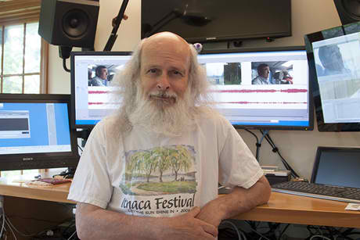
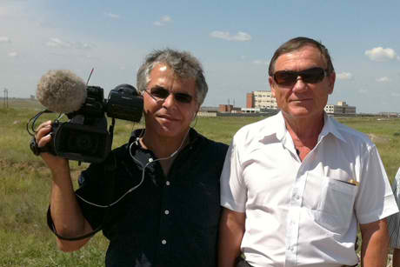
Filmmaker Slawomir Grunberg, left, with Gennadiy Lepeshkin outside the former anthrax plant.

Slava Paperno, director of Cornell’s Russian Language Program, in his studio.

The purpose of a secret Soviet facility was to produce tons of anthrax bacteria to kill Americans, according to a U.S. government official.
The facility was capable of producing 300 metric tons of anthrax in 10 months – more capacity than the entire Iraqi biological weapons program. “The scale is just chilling,” Andrew Weber ’82 said.
Weber was part of a group of U.S. experts the Kazakhstan government called in after the fall of the Soviet Union to dismantle Soviets bioweapons-manufacturing facilities the Soviets left behind. Weber, now assistant secretary of defense for nuclear, chemical and biological defense programs, is a featured expert in “The Anthrax Diaries,” a 26-minute pilot documentary film about the Soviet bioweapons program. Also featured is the man who ran the anthrax factory, Gennadiy Lepeshkin.
The film is by Slava Paperno, director of Cornell’s Russian Language Program in the Department of Comparative Literature; Kathleen Vogel, associate professor in the Department of Science and Technology Studies and the Reppy Institute for Peace and Conflict Studies; and bioweapons expert Sonia Ben Ouagrham-Gormley. Award-winning filmmaker Slawomir Grunberg is director of photography.
The U.S. offensive biological weapons program ended in 1969; the USSR and the United States agreed to outlaw development and stockpiling of biological weapons in 1972. All the bioweapons work Lepeshkin led occurred after the USSR signed the treaty.
Making the film has not been without risk. Three months after “The Anthrax Diaries” was posted online, Lepeshkin was named a traitor in an anti-American video posted by a state-run TV studio in Russia.
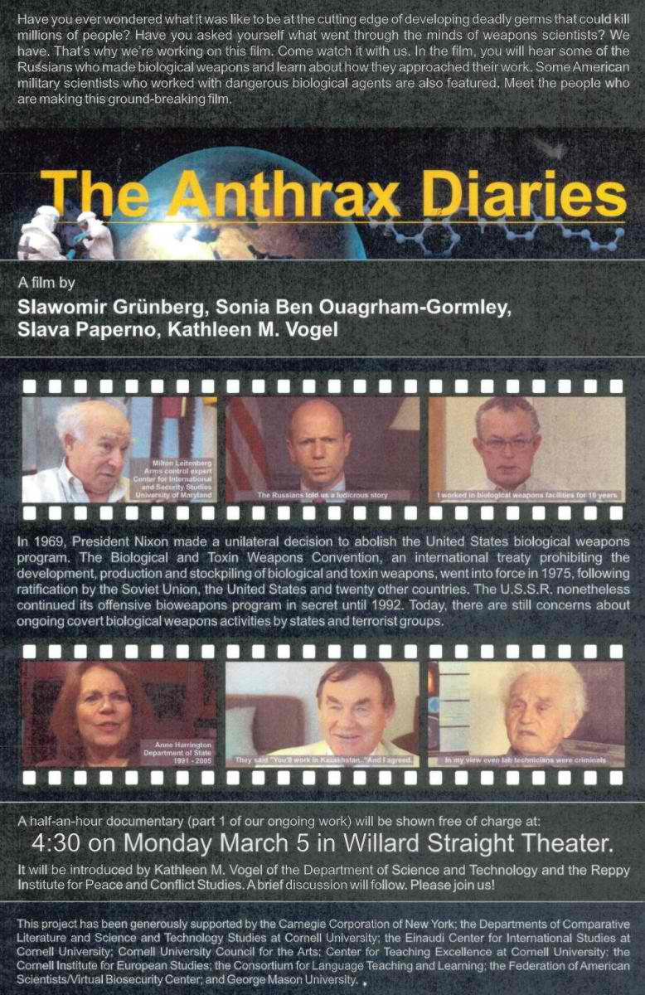
“This was really a return to the bad old Stalin days,” said Paperno. “We remain concerned for Lepeshkin’s future.”
The filmmakers’ goal is to produce a PBS-style documentary and accompanying educational website that will inform the broader public on the ethical, moral, social and security issues of biological weapons, including what happens when weapons experts lose their jobs.
“The Anthrax Diaries” is part of a decades-long Russian Language Program tradition of producing documentaries for language and culture studies. The documentaries are designed to provoke strong intellectual and emotional reactions. According to Paperno, the theme of biological weapons, with its broad range of ethical, political and historical situations, seemed perfect to stimulate discussion.
“Language teaching is inseparable from teaching about culture,” noted Paperno, “and students learn the language best when they’re excited about the issues being discussed.”
The filmmakers are building a website that includes more than 40 hours of interview and location footage, articles, photos and personal stories.
“This project has many different elements that serve the educational mission of the university, and it also helps inform the larger public,” said Vogel, who has been researching the proliferation of former Soviet bioweapons pathogens and personnel since she was a postdoctoral associate at Cornell. She’s given talks at the Cornell Center for Teaching Excellence on how she and Paperno have used the project in their classes.
Vogel and Paperno have applied for funding to continue their examination of the moral dimensions of the weapons scientists.
Lepeshkin, for example, grew up on a military base. He objected when they told him to close the anthrax facility and when the Communist Party folded. “Gorbachev said to turn in your card but I didn’t. In my heart I’m still a Communist,” Lepeshkin said.
Paperno, a St. Petersburg native, comes from a dissident family. “Lepeshkin was my first real close contact with the kind of ideal Soviet person that the Soviet propaganda machine was trying to create,” said Paperno. “It’s been an eye opener for me.”

Linda B. Glaser is staff writer for the College of Arts and Sciences.

GlaxoKlineSmith Signs Deal To Develop Bioterrorism Antibiotics
Source: http://latino.foxnews.com/latino/health/2013/05/22/glaxoklinesmith-signs-deal-with-hhs-to-develop-antibiotics/

London-based pharmaceutical company GlaxoSmithKline signed a $200 million agreement with the United States government to produce new antibiotics.
These new antibiotics are expected to overcome resistance and fight diseases associated with bioterrorism.
According to Reuters, this agreement is “the first of its kind between Washington and a drug company and will allow funding to move around GSK's antibiotics portfolio rather than focusing on a single drug candidate.”
A release by the company noted that under the terms of the agreement, Health and Human Services will provide $40 million for the initial 18-month agreement and up to a total of $200 million if the agreement is renewed over five years.
The statement also noted that drug resistant bacterial infections are expected to become a global crisis.
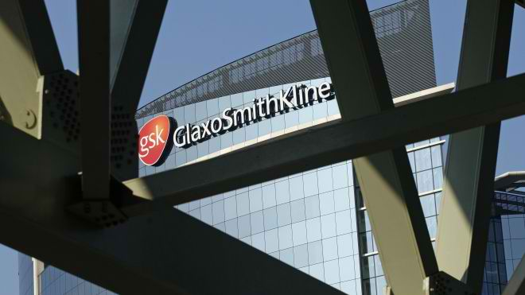
"There is an urgent need to address antibiotic resistance and new models are needed to deal with this challenging area of drug development," said David Payne, head of GSK's Antibacterial Discovery Performance Unit in the press release.
According to the press release, many companies have in recent years withdrawn from antibacterial R&D due to the scientific challenges and a lower return on investment, affecting the ability to treat bacterial infections and compromising our preparedness to tackle biothreat pathogens.
GlaxoSmithKline is one of the world's leading research-based pharmaceutical and healthcare companies.
Biomedical Advanced Research and Development Authority (BARDA), a division of Health and Human Services, and GlaxoSmithKline will have a joint oversight committee that will monitor progress, make decisions on the allocation of funds and decide on the addition or removal of drug candidates from the portfolio.

Smartphone turned into handheld biosensor
Source: http://www.homelandsecuritynewswire.com/dr20130524-smartphone-turned-into-handheld-biosensor

Researchers and physicians in the field could soon run on-the-spot tests for environmental toxins, medical diagnostics, food safety and more with their smartphones.
University of Illinois at Urbana-Champaign researchers have developed a cradle and app for the iPhone that uses the phone’s built-in camera and processing power as a biosensor to detect toxins, proteins, bacteria, viruses, and other molecules.
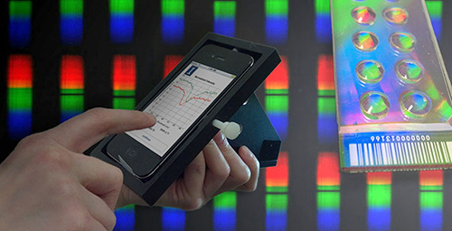
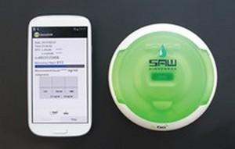
A University of Illinois Urbana-Champaign release reports that having such sensitive biosensing capabilities in the field could enable on-the-spot tracking of groundwater contamination, combine the phone’s GPS data with biosensing data to map the spread of pathogens, or provide immediate and inexpensive medical diagnostic tests in field clinics or contaminant checks in the food processing and distribution chain.
“We’re interested in biodetection that needs to be performed outside of the laboratory,” said team leader Brian Cunningham, a professor of electrical and computer engineering and of bioengineering at the U. of I. “Smartphones are making a big impact on our society – the way we get our information, the way we communicate. And they have really powerful computing capability and imaging. A lot of medical conditions might be monitored very inexpensively and non-invasively using mobile platforms like phones. They can detect molecular things, like pathogens, disease biomarkers or DNA, things that are currently only done in big diagnostic labs with lots of expense and large volumes of blood.”
The wedge-shaped cradle contains a series of optical components — lenses and filters — found in much larger and more expensive laboratory devices. The cradle holds the phone’s camera in alignment with the optical components.
At the heart of the biosensor is a photonic crystal. A photonic crystal is like a mirror that only reflects one wavelength of light while the rest of the spectrum passes through. When anything biological attaches to the photonic crystal — such as protein, cells, pathogens, or DNA — the reflected color will shift from a shorter wavelength to a longer wavelength.
For the handheld iPhone biosensor, a normal microscope slide is coated with the photonic material. The slide is primed to react to a specific target molecule. The photonic crystal slide is inserted into a slot on the cradle and the spectrum measured. Its reflecting wavelength shows up as a black gap in the spectrum. After exposure to the test sample, the spectrum is re-measured. The degree of shift in the reflected wavelength tells the app how much of the target molecule is in the sample. See here a video of the app in action.
The entire test takes only a few minutes; the app walks the user through the process step by step. Although the cradle holds only about $200 of optical components, it performs as accurately as a large $50,000 spectrophotometer in the laboratory. So now, the device is not only portable, but also affordable for fieldwork in developing nations.
The release notes that in a paper published in the journal Lab on a Chip, the team demonstrated sensing of an immune system protein, but the slide could be primed for any type of biological molecule or cell type. The researchers are working to improve the manufacturing process for the iPhone cradle and are working on a cradle for Android phones as well. They hope to begin making the cradles available next year.
Cunningham’s group is now collaborating with other groups across campus at the U. of I. to explore applications for the iPhone biosensor. The group recently received a grant from the National Science Foundation to expand the range of biological experiments that can be performed with the phone, in collaboration with Steven Lumetta, a professor of electrical and computer engineering and of computer science at the U. of I. They are also are also working with food science and human nutrition professor Juan Andrade to develop a fast biosensor test for iron deficiency and vitamin A deficiency in expectant mothers and children.
In addition, Cunningham’s team is working on biosensing tests that could be performed in the field to detect toxins in harvested corn and soybeans, and to detect pathogens in food and water.
“It’s our goal to expand the range of biological experiments that can be performed with a phone and its camera being used as a spectrometer,” Cunningham said. “In our first paper, we showed the ability to use a photonic crystal biosensor, but in our NSF grant, we’re creating a multi-mode biosensor. We’ll use the phone and one cradle to perform four of the most widely used biosensing assays that are available.”

— Read more in Dustin Gallegos et al., “Label-free biodetection using a smartphone,” Lab on a Chip 13 (4 April 2013): 2124-32

Abstract

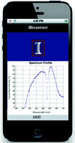
Utilizing its integrated camera as a spectrometer, we demonstrate the use of a smartphone as the detection instrument for a label-free photonic crystal biosensor. A custom-designed cradle holds the smartphone in fixed alignment with optical components, allowing for accurate and repeatable measurements of shifts in the resonant wavelength of the sensor. Externally provided broadband light incident upon an entrance pinhole is subsequently collimated and linearly polarized before passing through the biosensor, which resonantly reflects only a narrow band of wavelengths. A diffraction grating spreads the remaining wavelengths over the camera's pixels to display a high resolution transmission spectrum. The photonic crystal biosensor is fabricated on a plastic substrate and attached to a standard glass microscope slide that can easily be removed and replaced within the optical path. A custom software app was developed to convert the camera images into the photonic crystal transmission spectrum in the visible wavelength range, including curve-fitting analysis that computes the photonic crystal resonant wavelength with 0.009 nm accuracy. We demonstrate the functionality of the system through detection of an immobilized protein monolayer, and selective detection of concentration-dependent antibody binding to a functionalized photonic crystal. We envision the capability for an inexpensive, handheld biosensor instrument with web connectivity to enable point-of-care sensing in environments that have not been practical previously - Lab Chip, 2013,13, 2124-2132

New Medical Discovery

Source: http://www.techwench.com/scientists-invent-oxygen-particle-that-if-injected-allows-you-to-live-without-breathing/

A team of scientists at the Boston Children’s Hospital have invented what is being considered one the greatest medical breakthroughs in recent years. They have designed a microparticle that can be injected into a person’s bloodstream that can quickly oxygenate their blood. This will even work if the ability to breathe has been restricted, or even cut off entirely.
This finding has the potential to save millions of lives every year. The microparticles can keep an object alive for up to 30 min after respiratory failure. This is accomplished through an injection into the patients’ veins. Once injected, the microparticles can oxygenate the blood to near normal levels. This has countless potential uses as it allows life to continue when oxygen is needed but unavailable. For medical personnel, this is just enough time to avoid risking a heart attack or permanent brain injury when oxygen is restricted or cut off to patients.
Dr. John Kheir, who first began the study, works in the Boston Children’s Hospital Department of Cardiology. He found inspiration for the drug in 2006, when he was treating a girl in the ICU who had a severe case of pneumonia. At the time, the girl didn’t have a breathing tube, when at the time she suffered from a pulmonary hemorrhage. This means her lungs had begin to fill up with blood, and she finally went into cardiac arrest. It took doctors about 25 minutes to remove enough blood from her lungs to allow her to breath. Though, the girl’s brain was severely injured due to being deprived of oxygen for that long and she eventually died.

Microparticle Composition
The microparticles used are composed of oxygen gas pocketed in a layer of lipids. A Lipid is a natural molecule that can store energy and act as a part of a cell membrane, they can be made of many things such as wax, vitamins, phospholipids, and in this case fat is the lipid that stores the oxygen.
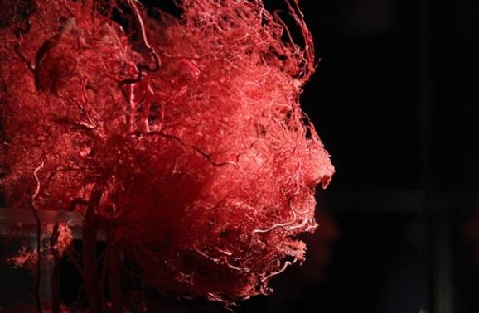
These microparticles are around two to four micrometers in length and carry about three to four times the oxygen content of our own red blood cells. In the past, researchers had a difficult time succeeding as prior tests caused gas embolism. This meant that the gas molecules would become stuck trying to squeeze through the capillaries. They corrected this issue by packaging them into small deformable particles rather ones where the structure was rigid.

Potential Future Uses
Medical: There is the obvious medical uses where the microparticles can be used to save off death from a restriction in breathing due to inflammation of the lungs, collapsed lungs, and the like. It would be good to have these injections ready in hospitals and ambulances for when the time is needed.
Military: Can you imagine a navy seals capability when they wouldn’t need to surface for air and could stay underwater for over 20 minutes? If a boat was to begin to sink, you could shoot yourself as the boat is going down to ensure you aren’t drowned in the under current of the sinking vessel. How about for toxic gases when a facemask is unavailable. The military could have a number of uses for such a medical advancement.
Private Sector: Really this can be used as a precaution for anything nautical where the potential to drown is a real danger. Deep sea rescue crews could inject themselves prior to making a rescue, underwater welders can use it in case they become stuck or air is lost to their suits. The potential use for anything water related seems extremely worthwhile.

Conclusion
In the end, this is an amazing medical advancement and I cant help but recall the movie the Abyss when they took the pill, their helmets filled with air, and they were told they can breathe the water. Well what if they really couldn’t “breathe” water” but since the urge to breathe is natural, that must take place… even if you’re not breathing air per se. But your body was provided with enough oxygen for a time period by taking a pill. It’s just goes to show that anything, absolutely anything that can be thought up, can potentially one day become reality. Thank you scientists, for reminding me that people and their ingenuity are nothing short of awesome.

The author of this article is Damien S. Wilhelmi, an SEO tactician and SEM strategist. If you enjoyed this article, you can follow me on twitter @JakabokBotch. I am writing on behalf of Wilderness Aware Rafting who offer some of the best Colorado White Water Rafting trips in the state.

5 things to know about new coronavirus
Source: http://www.cnn.com/2013/05/17/health/coronavirus-5-things/index.html

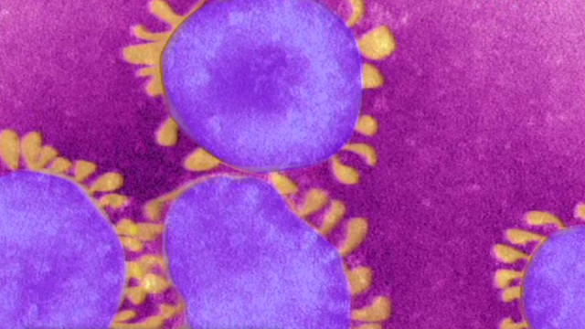
A new virus in the same family as SARS -- found for the first time in humans in the past year -- has infected 49 people, most of them in the Middle East.
Of those, 27 people have died, the World Health Organization said Wednesday.
The virus previously was called the novel coronavirus, or nCoV. However, the WHO this week gave it a new name: Middle East respiratory syndrome coronavirus, or MERS-CoV.
It's part of a family called coronaviruses, which cause illnesses ranging from the common cold to SARS, or severe acute respiratory syndrome, as well as a variety of animal diseases. However, the new virus is not SARS.
The virus acts like a cold and attacks the respiratory system, the Centers for Disease Control and Prevention has said. But symptoms, which include fever and a cough, are severe and can lead to pneumonia and kidney failure. Gastrointestinal symptoms such as diarrhea have also been seen, according to the WHO.
MERS-CoV has been detected in humans in eight countries, the WHO said last week -- Saudi Arabia, Jordan, Qatar, the United Arab Emirates, France, Germany, Tunisia and the United Kingdom.
Earlier this month, the WHO reported two health care workers in Saudi Arabia became ill while treating patients.
Here are five things you need to know about MERS-CoV:

Widespread transmission hasn't been seen
All the clusters of cases seen so far have been transmitted between family members or in a health care setting, the WHO said in a May 17 update. "Human-to-human transmission occurred in at least some of these clusters; however, the exact mode of transmission is unknown."
That means it's not yet known how humans contract MERS-CoV. But experts said there has been no evidence of cases beyond the clusters into communities.
Dr. William Schaffner, an infectious disease specialist at Vanderbilt University Medical Center in Nashville, has said the infection is "very serious" but appears "very difficult to acquire."
According to the WHO, "The recent increase in cases may in part be related to increased awareness among the medical community; however, the demonstrated ability of this virus to transmit between humans and to cause large outbreaks has increased concerns about the possibility of sustained transmission."

Cases are connected to the Middle East
"All of the European cases have had a direct or indirect connection to the Middle East," the WHO said in the May 17 statement. "However, in France and the United Kingdom, there has been limited local transmission among close contacts who had not been to the Middle East but had been in contact with a traveler recently returned from the Middle East."
Most of the cases so far are seen in older men with other medical conditions, experts have said. Precise numbers are difficult to ascertain as officials don't know how many people might contract a mild form of MERS-CoV.
Saudi Arabia leads the number of laboratory-confirmed cases, with 32 as of Tuesday, the CDC said.
No cases have been reported in the United States, but infectious disease experts have said they would not be surprised if it happens.

Underlying health conditions may make you more susceptible
A large number of patients have another condition, the WHO said, suggesting "increased susceptibility from underlying medical conditions may play a role in transmission." In addition, the infection has shown up "atypically" and without respiratory symptoms in people whose immune systems are compromised.

No travel warnings have been issued
The WHO and CDC have not issued travel health warnings for any country related to the novel coronavirus.
But, in a travel notice, the CDC said it recommends that "U.S. travelers to countries in or near the Arabian Peninsula monitor their health and see a doctor right away if they develop fever and symptoms of lower respiratory illness, such as cough or shortness of breath. They should tell the doctor about their recent travel."
In addition, those who traveled to the Middle East should see their health care provider if they develop a fever and respiratory symptoms such as a cough or shortness of breath within 10 days of returning from the Arabian Peninsula or surrounding nations, according to the CDC.

There are no treatments and no vaccine
So far, those with MERS-CoV have received supportive treatments to relieve their symptoms.

Experimental drug could treat child bioterrorism victims
Source: http://www.nextgov.com/health/2013/05/experimental-drug-could-treat-child-bioterrorism-victims/63836/
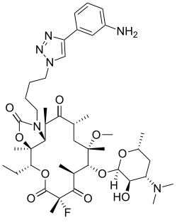

The United States on Friday announced a $17.7 million push to secure federal licensure of an experimental antibiotic officials believe could treat young victims of anthrax or tularemia bacteria.
Announcement of the two-year research and development deal with a North Carolina pharmaceutical firm came weeks after congressional investigators warned that minors could have only limited access to 40 percent of the medicines stockpiled for use in a chemical, biological, radiological or nuclear strike. The Centers for Disease Control and Prevention has warned an attacker could disperse either anthrax or tularemia into the air in breathable form, producing potentially deadly results.
“The needs of special populations including children are paramount in public health emergency preparedness,” said Robin Robinson, who heads the Health and Human Services Department's Biomedical Advanced Research and Development Authority. “The development of this new antibiotic could help address a gap in our nation’s preparedness and could bolster clinicians’ ability to treat drug-resistant bacterial infections,” he added in an HHS statement.
The medicine, called solithromycin, falls within a category of drugs deemed particularly safe for children, though it could have "broad utility in all age groups," Cempra Pharmaceuticals CEO Prabhavathi Fernandes said in a press release issued on Tuesday.
The drug has been under development since 2006 and can be taken by mouth, a key feature "for administering antibiotics to kids," Fernandes told Global Security Newswire. The drug acts against bacteria now resistant to other antibiotics, and it "reaches concentrations needed to treat infections in the tissues as well as intracellularly where some pathogens hide," she stated by e-mail.
Cempra said initial funding under the deal would support phase 1 tests of the drug in children, and Fernandes indicated that "other pediatric studies are expected to follow." Phase 1 trials administer drugs to healthy participants to gather safety information such as possible side effects; no humans would be exposed to a bioterrorism agent.
Health and Human Services said animal trials of the medicine's effectiveness against anthrax and tularemia could support an eventual bid for licensing from the Food and Drug Administration while also supplying "additional treatment options for clinicians’ use in a public health emergency."
Cempra declined to state when it plans to file for FDA approval. The company could receive up to $58 million if the contract is extended for a full five years, but the firm refused to say whether the initial $17.7 million award would cover any animal tests involving anthrax or tularemia.
"The full funding, if received, will support phase 1, phase 2, and the majority of the phase 2/3 studies on a pediatric oral suspension, oral capsules and the intravenous formulation" for lung infections acquired outside of hospitals, according the company's press release. "The contract should also fund nonhuman primate pilot studies of activity against biothreat pathogens, anthrax and tularemia, placing Cempra's lead product on the pathway to other indications."
Anthrax and tularemia are both seen as likely agents for an act of bioterrorism. The federal government has spent billions of dollars since the Sept. 11 attacks and the anthrax mailings that followed to prepare the nation for such an act.

Ricin letters

By Editor and Dan Kaszeta*

We all read about recent ricin letters posted to various recipients in the United States. What we haven’t read is the form ricin was incorporated to these letters and the lethal potential if any.

There is no answer in the first question – wonder why? Generally in the past, it has been powder as revealed in the following stories:
• 2002: Ricin was discovered in the apartment of six terrorist suspects arrested in Manchester, England.
• 2003: An envelope containing a sealed container of ricin and a note threatening to contaminate water supplies was processed at a mail facility in Greenville, South Carolina.
• 2004: Traces of ricin were discovered in the mail room of the Dirksen Senate Office Building in Washington, DC.

As for the second question: Ricin extracted from the mash of castor beans is a sludge that will dry out. It needs some means of dissemination in order to be an inhalation hazard, and letters generally don't have much scope for that. The main concern is not so much about inhalation, but ingestion, because it takes very little ricin on a persons hands, who then eats or drinks.
CDC’s website writes on “ricin”: (1) Inhalation: Provokes symptoms within a few hours of inhaling significant amounts of ricin; (2) Ingestion: If someone swallows a significant amount of ricin…; (3) Skin and eye exposure: Ricin is unlikely to be absorbed through normal skin. Contact with ricin powders or products may cause redness and pain of the skin and the eyes. But how one defines "significant amounts"?
Animal studies indicate that clinical signs and pathological changes in ricin intoxication are largely route specific. Ingestion causes gastrointestinal symptoms including hemorrhage and necrosis of liver, spleen, and kidneys; intramuscular intoxication causes severe localized pain, muscle and regional lymph node necrosis, and moderate systemic symptoms; inhalation results in respiratory distress with airway and pulmonary lesions. Transient leukocytosis appears to be a constant feature in humans, whether intoxication is by injection or oral ingestion. Leukocyte counts 2- to 5-fold above normal are characteristic findings among cancer patients receiving ricin immunotoxin therapy, and also in the case of the Bulgarian dissident Georgi Markov during his agonizing death after a successful assassination attempt [1].

Toxicity [1]
Ricin is a 66-kd globular protein that typically makes up 1% to 5% of the dry weight of the castor bean, although the yield can be highly variable. The toxic form is a heterodimer consisting of a 32-kd A chain connected to the 32-kd B chain through a single disulfide bond. As such, it is a member of the type II family of ribosome-inactivating proteins (RIPs), which possess enhanced in-vivo toxicity because of the presence of the B chain that facilitates uptake by the cell. Type I RIPs lack the B chain, and cellular toxicity is much less; uptake depends on endocytosis. Both chains are glycoproteins containing multiple mannose residues on their surfaces; association of both chains is required for toxicity.
Ricin is recognized as one of the most exquisitely toxic plant-derived RIPs identified to date. However, considerable variation in potency exists among species. For instance, on a mg/kg basis, potency varies over two orders of magnitude between species of domestic and laboratory animals; chickens and frogs are the least sensitive, and horses are the most sensitive. Potency also varies greatly with route of administration. In laboratory mice, approximate median lethal dose values and time to death are, respectively, 5 μg/kg and 90 hours by intravenous injection, 22 μg/kg and 100 hours by intraperitoneal injection, and 24 μg/kg and 100 hours by subcutaneous injection. Ricin is extremely toxic by inhalation; median lethal dose estimates range from 3 to 15 μg/kg in rodents and primates. In contrast, ricin is least potent by the oral route; median lethal dose estimates in mice are approximately 20 mg/kg. Low potency by the oral route likely reflects poor absorption and possibly partial degradation in the gut. Higher potency by other routes may be related to the ubiquitous nature of toxin receptors among cell types. In skin tests on mice, no dermal toxicity was observed at 50 μg/spot, suggesting poor dermal absorption of this large, highly charged protein.

Case study: Georgi Markov
The lethal injected dose was estimated to be as much as 500 μg. This resulted in almost immediate local pain, followed by general weakness within about 5 hours. Fifteen to 24 hours later, he exhibited elevated temperature, nausea, and vomiting. Thirty-six hours after the incident, he was admitted to the hospital feeling ill and exhibiting fever and tachycardia. Blood pressure was normal. Lymph nodes in the affected groin were swollen and sore, and a 6-cm diameter area of induration was observed at the injection site on his thigh. Just over 2 days after the attack, he suddenly became hypotensive and tachycardic. His pulse rate increased to 160 beats per minute, and white blood count rose to 26,300/mm³. Early on the third day, he became anuric and began vomiting blood. An electrocardiogram demonstrated complete atrioventricular conduction block. Markov died shortly thereafter. At the time of death, his white blood count was 33,200/mm³. A mild pulmonary edema was thought to have been secondary to cardiac failure.

Detection
The antibody-based testing for ricin is very sensitive (ie. small nanogram quantity). It is possible that the perpetrator only needs to rub a few raw castor beans on the envelope to get enough ricin for a positive response.
Confirmation of inhalational intoxication in humans would most likely be through immunological analysis of a swab sample from the skin or nasal mucosa. Ricin can be identified from such samples by immunoassay for at least 24 hours postexposure. Because ricin is extremely immunogenic, individuals surviving a ricin attack would likely have circulating antibody within 2 weeks of exposure. Therefore, serum samples should be obtained from survivors. Immunoassay of blood or other body fluids may be useful for confirming ricin intoxication. This test can accurately measure ricin to less than 1 ng/mL in clinical matrices. However, because ricin is bound very quickly regardless of exposure route and metabolized before excretion, identification in body fluids or tissues is difficult.

Commercially there are quite many field detection kits available (i.e. Ricin toxin detection kit by Cole-Palmer; SMART™ II Ricin by New Horizons Diagnostic Corporation; BioCheck™ Kit by Laurus Systems; BADD Ricin Toxin Threat Detection Kit by ADVNT Biotechnologies; Ricin detection kit by Universal Detection Technology – just to mention a few).

Source

[1] Mark A. Poli, Chad Roy, Kermit D. Huebner, David R. Franz, and Nancy K. Jaax (2007). Medical Aspects of Biological Warfar; Walter Reed Army Medical Center Borden Institute; Chapter 15: Ricin (pp. 323-335.

* Dan Kaszeta is Managing Director at Strongpoint Security Limited, London, UK (www.strongpointsecurity.co.uk) and author of “CBRN and Hazmat Incidents at Major Public Events: Planning and Response”.

BOOK – Wicked Plants: The Weed That Killed Lincoln's Mother and Other Botanical Atrocities

Source:http://books.google.gr/books/about/Wicked_Plants.html?id=0pak4RWkdAwC&redir_esc=y

A tree that sheds poison daggers; a glistening red seed that stops the heart; a shrub that causes paralysis; a vine that strangles; and a leaf that triggered a war. In Wicked Plants, Stewart takes on over two hundred of Mother Nature’s most appalling creations. It’s an A to Z of plants that kill, maim, intoxicate, and otherwise offend. You’ll learn which plants to avoid (like exploding shrubs), which plants make themselves exceedingly unwelcome (like the vine that ate the South), and which ones have been killing for centuries (like the weed that killed Abraham Lincoln's mother).

Menacing botanical illustrations and splendidly ghastly drawings create a fascinating portrait of the evildoers that may be lurking in your own backyard. Drawing on history, medicine, science, and legend, this compendium of bloodcurdling botany will entertain, alarm, and enlighten even the most intrepid gardeners and nature lovers.

Briony Morrow-Cribbs (who illustrated the book) studied art at the Emily Carr Institute of Art and Design in Vancouver, British Columbia, and currently lives in Brattleboro, Vermont, where she owns and operates Twin Vixen Press.

Amy Stewart is the award-winning author of six books on the perils and pleasures of the natural world. She is the cofounder of the popular blog Garden Rant and is a contributing editor at Fine Gardening magazine. She and her husband live in Eureka, California, where they own an antiquarian bookstore called Eureka Books.
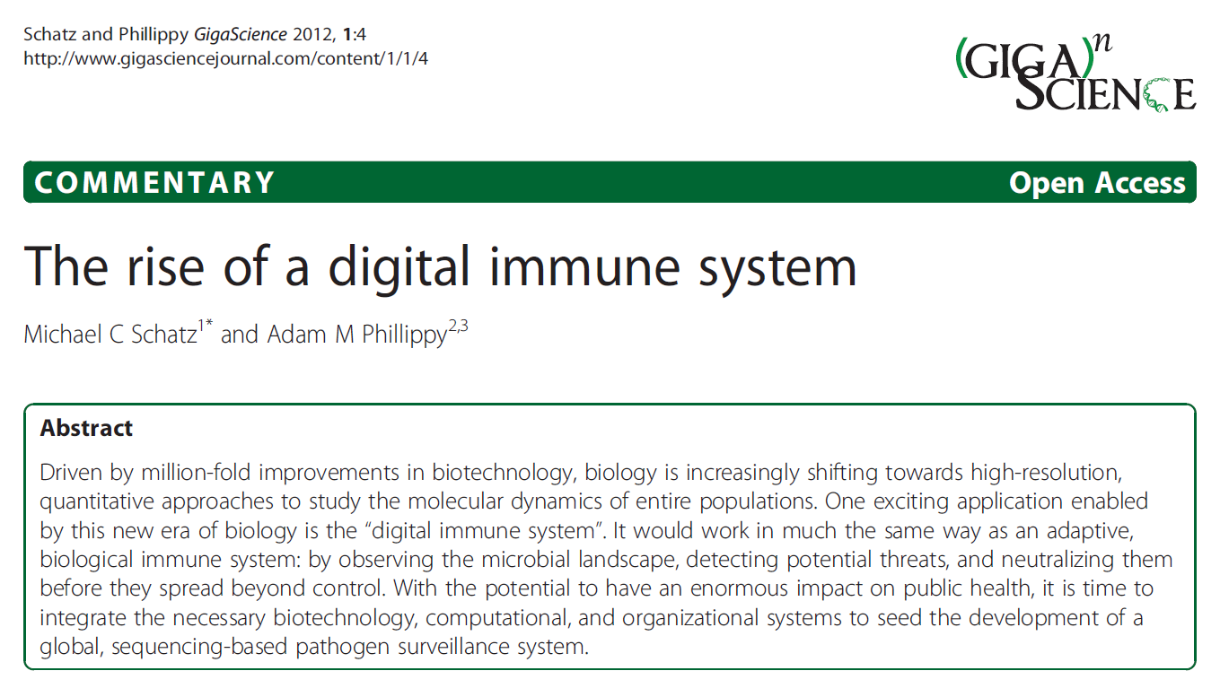

Studying the deadly secrets of flu, Ebola, West Nile viruses
Source: http://www.homelandsecuritynewswire.com/dr20130610-studying-the-deadly-secrets-of-flu-ebola-west-nile-viruses

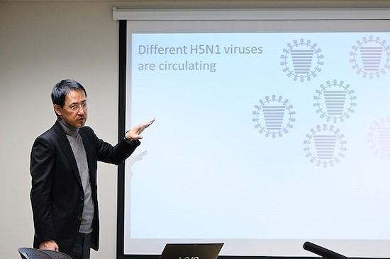
In an effort to sort out why some viruses such as influenza, Ebola, and West Nile are so lethal, a team of U.S. researchers plans a comprehensive effort to model how humans respond to these viral pathogens.
The study will be led by Yoshihiro Kawaoka (photo), a University of Wisconsin-Madison School of Veterinary Medicine professor of pathobiological sciences and an expert on influenza and Ebola viruses. Teams from Washington University in St. Louis and the Pacific Northwest National Laboratory (PNNL) in Richland, Washington, also will play key roles in the new $18.13 million National Institutes of Health-funded study.
A University of Wisconsin release reports that the goal of the study will be to provide a detailed molecular understanding of what occurs when these viruses infect their hosts, providing a foundation for the design and development of a new generation of drugs to thwart infection by some of the world’s most serious pathogens.
“When an animal is infected with a virus, all kinds of things happen during the course of infection,” explains Kawaoka, “so the host response is a very important component of the study.”
The study design entails measuring many parameters of infection, including those intrinsic to the virus and to the host, using high-throughput screening, an emerging technology that employs sophisticated instrumentation with sensitive detection systems and advanced data processing methods to make thousands of measurements in a single experiment. The results of the high throughput screening experiments will be used to model what happens during the infection and to make predictions about the causes of disease, which will then be tested in animal models.
The release notes that the work on avian influenza and Ebola viruses will be conducted at UW-Madison and Rocky Mountain Laboratories in Hamilton, Mont., while studies on West Nile virus will be led by Michael Diamond at Washington University. The high-throughput technology team will be directed by Richard D. Smith of the Pacific Northwest National Laboratory and the computational modeling team will be led by Katrina Waters, also of PNNL.
The results of the new initiative, according to Kawaoka, will underpin the development of new agents to both prevent and treat potentially lethal viral infections. This is extremely important for human health, he notes, as no antiviral agents are approved for use against Ebola or West Nile viruses, and because there are indications that currently available drugs used to treat influenza virus are losing their effectiveness as it evolves to evade drug activity.
The advantage of studying influenza, West Nile, and Ebola, notes Kawaoka, is that the viruses all target different cells and organs for infection. A systematic exploration of how the different pathogens affect their hosts may help identify both common and pathogen-specific response circuits, which could be commandeered as chokepoints to snuff out infection.
“By understanding the disease process and understanding the host response, we can identify new targets for drug development,” says Kawaoka. “It is necessary that we find new agents to protect us from these diseases.”

